Service and Support Portal User Guide Administrator Functions for NATSIFACP

This user guide assists the National Aboriginal and Torres Strait Islander Flexible Aged Care Program (NATSIFACP) providers in performing the Administrator role in the My Aged Care Service and Support Portal.
This guide must be used in conjunction with “My Aged Care – Service and Support Portal user guide – Part 1: Administrator functions”.

Contents
1 Service and Support Portal 2
1.1 Temporary Arrangements 2
1.2 Extra Information for NATSIFACP users of the Portal 2
2 The Administrator Role 2
2.1 Service Delivery Outlets 2
2.1.1 Information Usage 2
2.1.2 Minimum Requirements 2
2.1.3 Creating outlets 3
2.1.4 Inactivating outlets 3
2.1.5 Viewing outlets 3
2.1.6 Editing Outlets 4
2.2 Service Items 4
2.2.1 Adding a service item 4
2.2.2 Editing a service item 5
3 Extra Information for NATSIFACP Users of the Portal 5
3.1 Managing Service Referrals 5
3.2 Client Service Delivery information 5
3.3 Tasks and Notifications 6
3.4 Client Records 6

Service and Support Portal

Temporary Arrangements
! | The National Aboriginal and Torres Strait Islander Flexible Aged Care Program is referenced by the abbreviation NATSIFACP within this guide.
The purpose of this guide is to explain temporary arrangements that are in place to enable creation of NATSIFACP outlets and service items. These temporary arrangements are in place until further notice.
Section 2.1 (Service Delivery Outlets) and Section 2.2 (Service Items) in this guide replace the corresponding sections in ‘My Aged Care – Service and Support Portal user guide – Part 1: Administrator functions’.
Both guides are part of the Service and Support Portal Resources collection. It enables the user to access a range of Service and Support Portal resources (including fact sheets, guides, quick reference guides and videos).

Extra Information for NATSIFACP users of the Portal
Section 3 of this guide provides NATSIFACP users with extra information that will assist them in performing functions using the Service and Support Portal.

The Administrator Role

Service Delivery Outlets
These instructions in this section supersede those contained in Section 2.1 (Creating service delivery outlets) of ‘My Aged Care – Service and Support Portal user guide – Part 1: Administrator functions’.

Information Usage
Service delivery outlet information is publicly displayed in the My Aged Care service finder on the My Aged Care website.
My Aged Care contact centre staff and assessors use this service information to send referrals.
Potential My Aged Care recipients and their support network use this service information to research and access services.
It is the Administrator’s responsibility to set up and maintain this information to ensure accurate referrals.

Minimum Requirements
A National Aboriginal and Torres Strait Islander Flexible Aged Care Program (NATSIFACP) provider will have at least one outlet (either a Help at Home outlet, or an Aged Care Home outlet).
Some providers will have one of each type, if they offer both types of services.
A provider can have more than one outlet of the same type.
For an Aged Care Home type outlet, each outlet will have a distinct address (i.e. the address of each Aged Care Home).
For Help at Home, each outlet will have a set of suburbs and postcodes serviced by that outlet.

Creating outlets
At present, the department will perform the outlet adding task on behalf of the provider.
To add an outlet and to make it ‘Active’, the provider needs to tell the department the following information:
- The outlet’s address; and
- A primary contact’s details; and
- The service details, including the name to be associated with the service (refer to the Service Items section below).
For a Help at Home outlet, its service delivery area is based on a set of suburbs and postcodes. The provider will need to advise the department if there are to be any changes to the set of suburbs (either by adding or removing).
For an Aged Care Home outlet, each outlet’s address is based on the street address of the Aged Care Home.
Once activated, the outlet name and service names will have extra text displaying after the name, depending on the type of outlet. For example:
- Aussie Healthcare (Help at Home)
- Wombat Cottages (Aged Care Home).

Inactivating outlets
At present, the department will perform the outlet inactivation task on behalf of the provider.
Please note that an outlet cannot be made ‘Inactive’ if there are service referrals associated with the outlet.

Viewing outlets
To view outlets, including those added by the department, follow the procedure below.
- Select Outlet administration tile from the homepage.
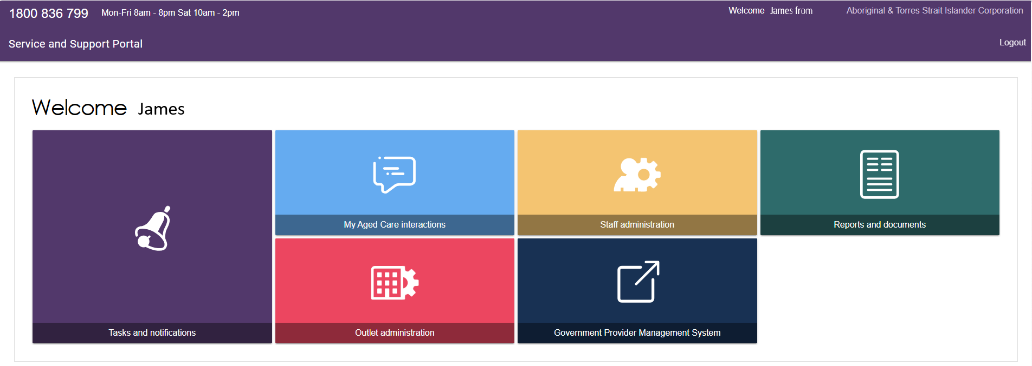
- All outlets for your organisation will be displayed (including both ‘Active’ and ‘Inactive’ ones, and new outlets that the department has created for you).
Then, select the tile of the outlet that you wish to view.
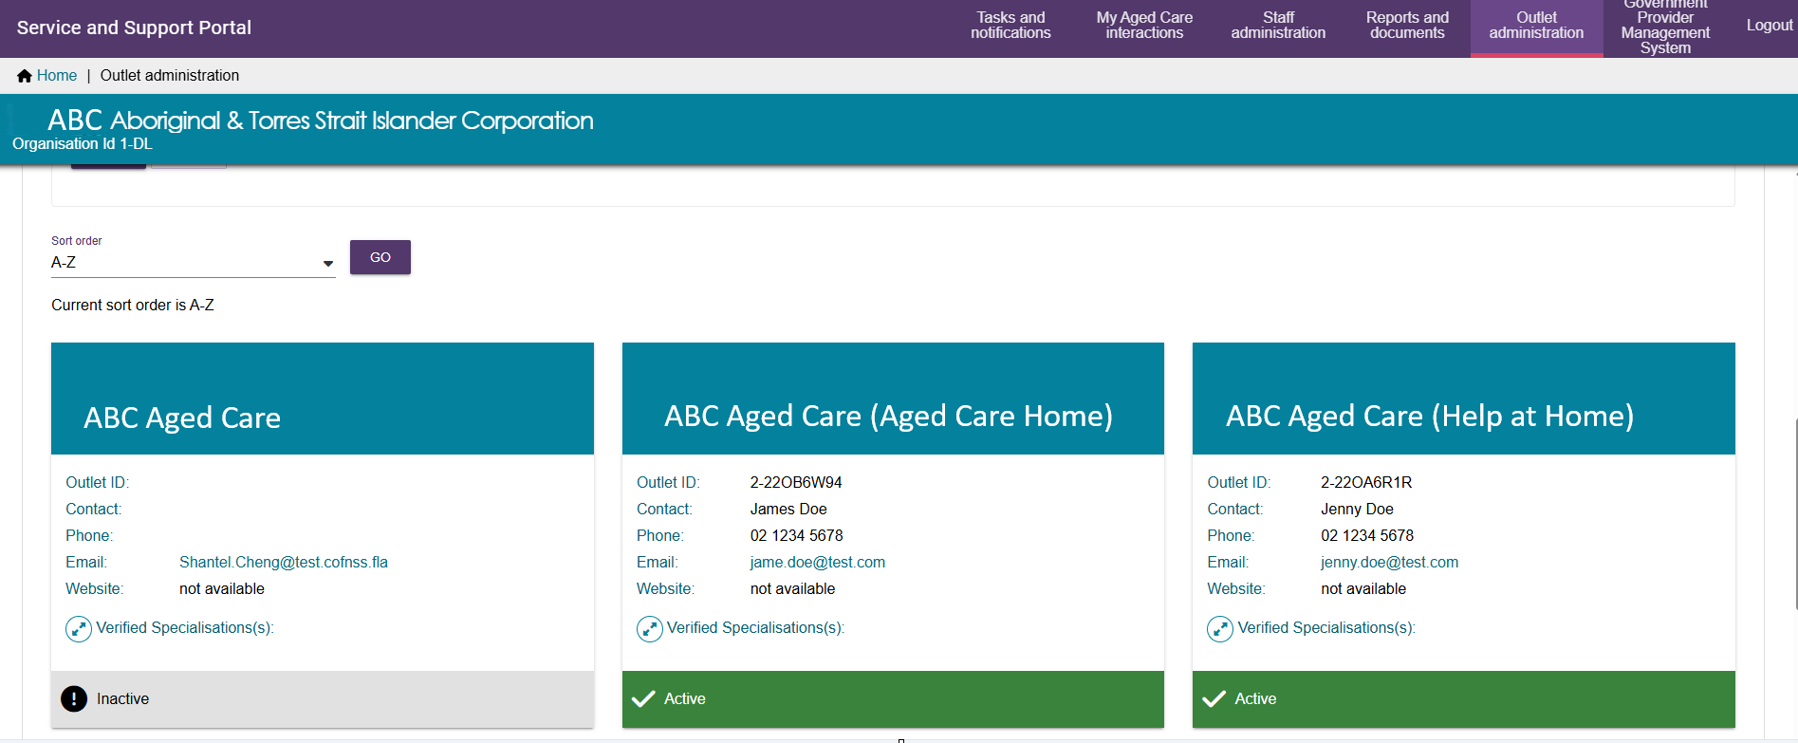

Editing Outlets
Please only edit the Organisation Philosophy or the Diverse Needs Specialisations sections of your outlet.
The editing instructions are located within Section 2.1.3 (Editing the Organisation philosophy) and Section 2.1.4 (Diverse Needs Specialisations) of ‘My Aged Care – Service and Support Portal user guide – Part 1: Administrator functions’.

Service Items
These instructions in this section replace those contained in Section 2.2 (Service Items) of ‘My Aged Care – Service and Support Portal user guide – Part 1: Administrator functions’.

Adding a service item
At present, the department will perform the service item adding task on behalf of the provider.
To add the service item, the provider needs to tell the department the following information:
- The Outlet name to which the service item will go
- Program – ‘Flexible Aged Care Programme’
- Service Type – ‘National ATSI Aged Care Programme'
- Type of service item to select
  - Help at Home (At Client Location); or
  - Aged Care Home (At Provider Location)
- Service Item Name
This is the minimum set of information required to enable the Service Item to be added to the Outlet.
The initial status of the just added Service Item will be ‘Offline’.

Service Delivery Area
For an ‘At Client Location’ type service item, its service delivery area is based on a set of suburbs and postcodes. The provider will need to advise the department if there are to be any changes to the set of suburbs (either adding or removing).

Service Delivery Address
For an ‘At Provider Location’ type service item, its service address is based on the street address of the Aged Care Home.

Editing a service item
Service item editing instructions are contained within section 2.2 (Service Items) of the ‘My Aged Care – Service and Support Portal user guide – Part 1: Administrator functions’.
Specifically, sections 2.2.3 to 2.2.9 cover the following:
- Editing availability and waitlists for a service
- Editing service delivery area
- Attachment promotional material
- Removing a service sub-type
- Service attributes
- Transferring service items
- Activating or deactivating a service item.

Extra Information for NATSIFACP Users of the Portal
NATSIFACP users of the Service and Support Portal will find the following extra information sections and links valuable when using the portal.
The guide references contained in the sub-sections below can be found within the Service and Support Portal resource collection.

Managing Service Referrals
Each provider outlet needs at least one person assigned the 'Team Leader' role in the portal.
This person will be responsible for managing referrals for service (accepting, accepting to waitlist, rejecting referrals and revoking referrals after acceptance) within the portal.
Refer to Service and Support Portal user guide – Manage referrals for service for further details.

Client Service Delivery information
Service delivery information must be recorded on the My Aged Care client record for all clients accepted for service.
The following user guide explains the procedures for recording and updating service delivery information in the client record. A Team Leader can manage referrals, as well as all the functions of a Staff Member.
Refer to My Aged Care Service and Support Portal user guide – Recording and updating client service delivery information for further details.

Tasks and Notifications
On the Service and Support portal, a provider’s staff member would get tasks assigned (such as a referral to action). There will also be notifications informing the provider of an event.
Refer to My Aged Care – Service and support portal user guide – Tasks and notifications for further details.

Client Records
The client record contains client details, service referral details, assessment information, documents attached to the client record, care approval information, service delivery information, client interactions with My Aged Care and all notes created about the client.
Staff Members or Team Leaders of a provider within the My Aged Care Service and Support Portal can search for and view the client record.
Refer to My Aged Care Service and Support Portal user guide – The client record for further details.

