Independent Review of Residential Aged Care Accommodation Pricing
A report to the Australian Government by:
Mr Nigel Ray PSM and Associate Professor Nicole Sutton

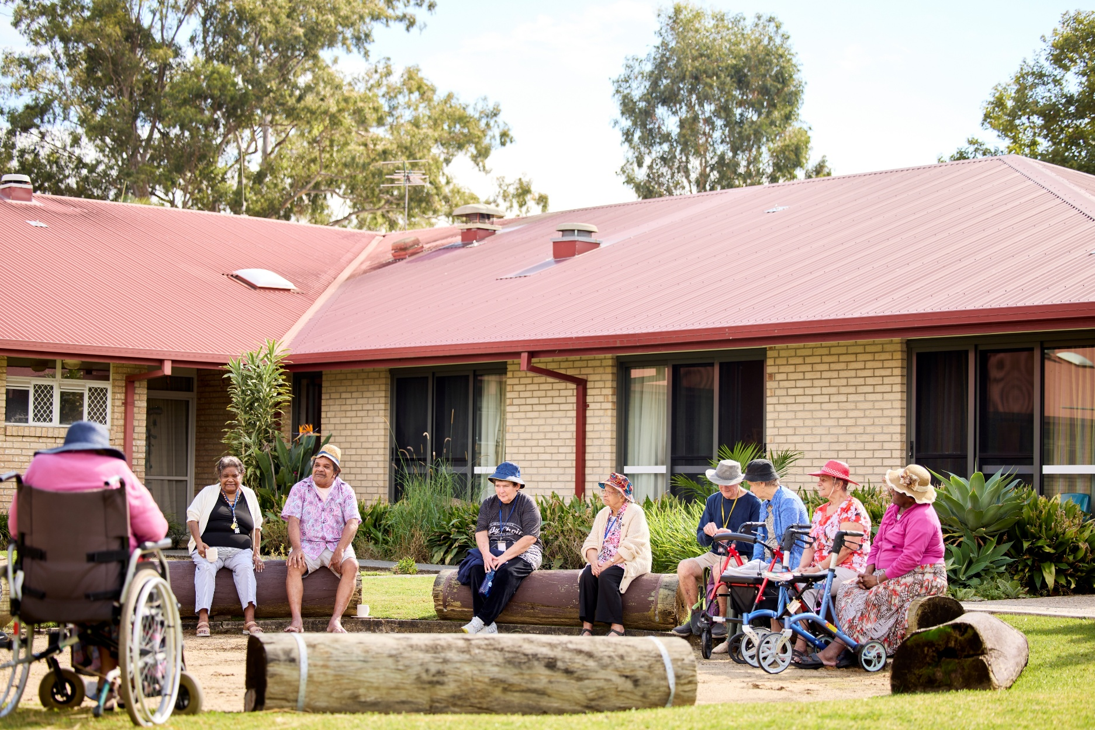
April 2026

Creative commons license

This publication is licensed under the Creative Commons Attribution 4.0 International Public License available from https://creativecommons.org/licenses/by/4.0/legalcode (“License”). You must read and understand the License before using any material from this publication.
Restrictions
The License may not give you all the permissions necessary for your intended use. For example, other rights (such as publicity, privacy and moral rights) may limit how you use the material found in this publication.
The License does not cover, and there is no permission given for, use of any of the following material found in this publication:
- the Commonwealth Coat of Arms (by way of information, the terms under which the Coat of Arms may be used can be found on the Department of Prime Minister and Cabinet website at https://www.pmc.gov.au/honours-and-symbols/commonwealth-coat-arms);
- any logos and trademarks;
- any photographs and images;
- any signatures; and
- any material belonging to third parties.
Attribution
Without limiting your obligations under the License, the Department of Health, Disability and Ageing (department) requests that you attribute this publication in your work. Any reasonable form of words may be used provided that you:
- include a reference to this publication and where practicable, the relevant page numbers;
- make it clear that you have permission to use the material under the Creative Commons Attribution 4.0 International Public License;
- make it clear whether or not you have changed the material used from this publication;
- include a copyright notice in relation to the material used. In the case of no change to the material, the words “© Commonwealth of Australia (Department of Health, Disability and Ageing) 2026” may be used. In the case where the material has been changed or adapted, the words: “Based on Commonwealth of Australia (Department of Health, Disability and Ageing) material” may be used; and
- do not suggest that the department endorses you or your use of the material.
Enquiries
Enquiries regarding any other use of this publication should be addressed to the Branch Manager, Communication Branch, Department of Health, Disability and Ageing, GPO Box 9848, Canberra ACT 2601, or via e-mail to copyright@health.gov.au.

Letter of transmittal
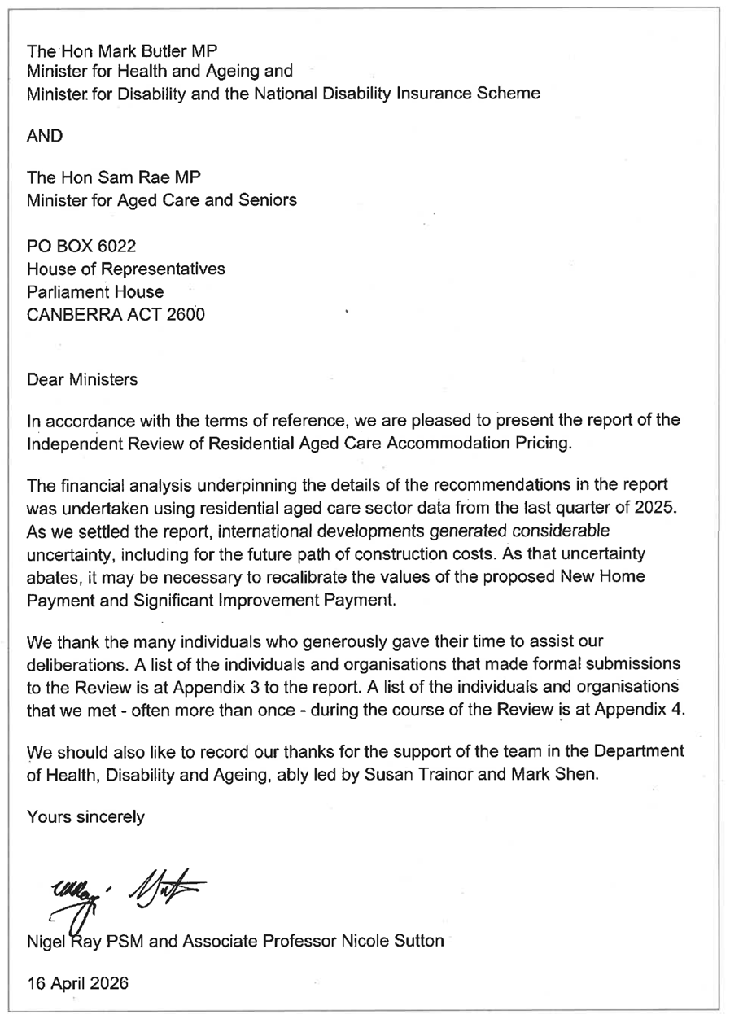

Contents

Creative commons license ii
Letter of transmittal iii
Contents iv
Executive summary vi
The challenge for residential care accommodation vi
Guiding principles and objectives vii
Addressing the challenge viii
List of recommendations x
Supporting capital investment to ensure equity of access x
Non-supported resident accommodation payments xii
Preserving equity of access for low means residents xii
Improving consumer information and protection xiii
Chapter 1: Current trajectory of supply and demand in the residential aged care sector 1
Demand for residential aged care will continue to grow 1
Supply is not growing at the pace needed 5
Supply constraints reduce equity of access 8
Implications for residents and families 8
Healthcare system impacts 9
Chapter 2: Capital financing and funding for accommodation 10
How accommodation is funded 10
How accommodation is financed 12
Current challenges in the funding and financing of accommodation 13
Poor financial returns from investments in residential care 13
Inadequacy of the funding for supported residents 14
Narrowness of the current capital funding model 15
Regulatory uncertainty 16
Alternative approaches to improving supply 16
Increasing the higher accommodation supplement 16
Linking the accommodation supplement to accommodation prices 17
Cross-subsidising supported residents via an increase in the value of RADs and DAPs 18
Chapter 3: Supporting capital investment to ensure access 19
Interest free loan program 19
Capital subsidies 22
Capital grants 24
Streamlining building approvals 26
Improving information about supply gaps 27
Chapter 4: Non-supported resident accommodation payments 29
Cease using the MPIR as the equivalence mechanism between RADs and DAPs 29
Maximum accommodation price 32
Consideration of a floor price 34
Chapter 5: Preserving equity of access for low means residents 36
Overview of current arrangements 36
Increase to the accommodation supplement 41
Restructuring the higher accommodation supplement 42
High supported resident ratio loading 46
Summary of payments for supported residents 47
Maintaining access for supported residents 49
Chapter 6: Improving consumer information and protection 50
Informing older Australians before they need residential aged care 50
Ensuring timely access to government assistance with information 52
Chapter 7: Areas for further work 54
Innovation of the built environment 54
Harmonisation with retirement living 54
Ensuring private sector financial advice is up to date and independent 55
Appendices 56
Appendix 1: Cameos on accommodation supplement and capital subsidies changes 56
Appendix 2: Terms of Reference 60
Appendix 3: Written submissions to the consultation paper 62
Appendix 4: List of stakeholders consulted 64
Appendix 5: Glossary of terms 65

Executive summary

The challenge for residential care accommodation
Australia faces a widening gap between the demand for and supply of residential aged care places, with capacity growth failing to keep pace with the expected needs of an ageing population. Ensuring sufficient and sustainable supply has become one of the most pressing challenges for the sector. Without decisive action to expand and maintain the sector’s accommodation capacity, older people will face increasing difficulty accessing care, and the system risks becoming less affordable and less equitable.
The Department of Health, Disability and Ageing forecasts that the number of older people using residential care will more than double from 198,302 people in 2024 to 409,677 in 2044. In the short and medium term, demand is likely to increase rapidly, at a much faster rate than in the past, as the baby boomer generation reaches an age range when residential care needs typically intensify. Much of this growth reflects rising numbers of older people living with dementia who reach a point where it is no longer safe to remain at home, or where formal and informal carers are unable to provide the constant, high level support required. While the continued expansion of the Support at Home program is critical to enabling older people to age in place, it cannot substitute for residential care for those with more complex needs requiring around-the-clock support.
To meet anticipated demand, the sector needs to expand substantially, requiring an additional 10,600 places per year, each year, for the next 20 years. This equates to a new average-sized aged care home opening every 3 days – a rate the sector has never achieved. In 2024, new beds amounted to fewer than 10 average-sized homes. While projects due for completion in the coming years should add capacity, annual net growth will still fall far short of what is needed. Simultaneously, a large proportion of existing residential infrastructure requires urgent upgrading or refurbishment to remain fit for purpose and ensure existing places remain online.
The effects of the COVID-19 pandemic, which saw the use of residential care stall and then decline, likely masked the emergent supply challenge. Although occupancy rates fell during the pandemic, they have since risen and are at historically high levels across most locations. Providers, sector analysts and peak bodies, including those representing older Australians, report that in some parts of the country, the system is already struggling to provide timely residential aged care where and when it is needed. Without policy intervention, these stresses will become more widespread.
As the market tightens, prospective residents are experiencing longer wait times, applying to multiple homes in the hope of securing a place, or relocating to residential aged care homes far from their family and community. Compounding these pressures, older people are confronted with a highly complex and confusing funding system that undermines their ability to make informed choices. Given that many people seeking support are under immense stress, timely access to quality, locally available residential aged care is critical.
These pressures fall disproportionately on low means residents and those with higher acuity care needs, as providers preference residents who can pay more for their accommodation and need less intensive support. Supply shortages are also impacting the hospital system, with some older Australians who are clinically ready for discharge into residential aged care unable to secure a residential aged care place or find a provider willing to accept them.
The residential aged care sector faces significant constraints in expanding supply, with poor financial returns and regulatory uncertainty limiting capital investment. Under current policy settings, new developments are typically only financially viable when they can attract a high proportion of incoming residents willing and able to pay a refundable accommodation deposit (RAD). This capital financing model effectively concentrates new investment in areas with a sufficient density of wealthier older people able to pay RADs, limiting the feasibility of developments in communities with fewer residents of means.
Daily accommodation payments (DAPs) cannot play a meaningful role in financing new developments because their value fluctuates with the maximum permissible interest rate (MPIR), preventing DAP revenue from being treated as a reliable or bankable cashflow. The volatility of the MPIR incentivises providers to retain financial assets to buffer against declines in RAD inflows, further limiting funds available for investment.
Also, funding for supported residents has not kept pace with rising construction and accommodation costs. Around 43 per cent of residents rely on the government to pay some or all of their accommodation costs, a proportion expected to remain stable over the coming decades. Although more Australians are expected to retire with substantial superannuation balances in the coming two decades, many individuals are likely to have depleted their balance by the time they enter residential care. Ensuring equity of access for this cohort will therefore require government support that can meet both the capital and operational costs of their accommodation and allow efficient providers to earn a reasonable margin.

Guiding principles and objectives
This Review established a series of guiding principles and objectives to ensure, consistent with the Terms of Reference, that it provided advice to support the residential aged care sector’s meeting the needs of older Australians in coming decades, regardless of their circumstances.
The residential aged care system should:
- Ensure sufficient quality and availability of residential aged care accommodation to meet the needs of older Australians into the future.
- Ensure equity of access to quality and locally available residential care, particularly for individuals of low means.
- Support residents and their families in making informed choices in selecting accommodation services and mode of payment.
Therefore, accommodation pricing and funding should:
- Support the capacity of providers to invest in and deliver places in residential aged care homes to meet the needs of Australia’s ageing population.
- Allow efficient providers to earn a reasonable margin in delivering quality residential care services, sufficient to support viability, innovation and investment.
- Be fiscally sustainable.
In addition, regulatory settings should:
- Avoid unnecessary regulatory uncertainty, complexity, or disparities.
- Ensure appropriate consumer protections to mitigate risk of discriminatory or exploitative pricing practices.

Addressing the challenge
Australia’s residential aged care system faces a challenge of scale and complexity that cannot be resolved through any single policy lever. A multi-faceted approach is required to support the step-change in supply needed over the next two decades.
To meet growing demand and support equitable access, the sector requires a more flexible capital model that can support viable investments across a wider range of geographic and market contexts, and a sustainable funding model that allows providers to generate investable returns in providing accommodation to all residents.
There is also a need to simultaneously ensure equity of access between individuals with different capacities based on their capacity to pay, while delivering supply increases over the short, medium and longer term to ensure beds are available for older Australians where and when they are needed.
The Review has developed a package of recommendations designed to support stronger growth in supply, preserve existing capacity, and ensure equity of access. The recommended reforms aim to improve access to capital, particularly for providers serving low means residents, while creating a more flexible capital model overall. By reducing reliance on high RAD uptake for new developments, the package is intended to unlock viable investment across a wider range of geographic and market contexts, thereby enabling growth in both supported and non‑supported places.
The package is built around 6 pillars:
- Establish a zero-interest loan scheme for new builds, significant expansions and refurbishments, to finance capital investment on behalf of supported residents.
- Introduce two new capital subsidies, for supported residents housed in newly built or significantly expanded or refurbished homes.
- Expand the Aged Care Capital Assistance Program (ACCAP) grants scheme to fund more new and refurbished beds in homes for under-serviced cohorts, including rural and remote communities, Aboriginal and Torres Strait Islander peoples, and those at risk of homelessness.
- Reduce volatility in accommodation pricing by allowing providers greater control in how they price daily payments relative to lump sums and streamlining the maximum approval process.
- Preserve equity of access through a restructured accommodation supplement, including a modest increase, an additional loading to homes with high proportions of supported residents, and a temporary regulatory mechanism requiring homes to maintain their supported resident ratios from 2025.
- Enhance government support for older people and their families to plan for residential aged care and navigate payment options.
The proposed investments are substantial, reflecting the scale of the challenge and the importance of ensuring older people in Australia can access the care they need, when and where they need it, regardless of their financial and other circumstances. Importantly, it will require direct government involvement, including funding, to ensure a modest but necessary level of excess capacity across the system to ensure choice, timely access, and mitigate supply gaps arising from development lags.
While some stakeholders argued for much larger increases to the accommodation supplement and grants schemes, the Review concluded that these options would come at a much greater cost to Australian taxpayers without guaranteeing better outcomes than the more targeted package proposed.
New developments take time and supply constraints are likely to intensify before the recommended reforms take full effect. To limit the impact on supply and equity of access, there is an urgent need to bring forward the proposed measures to address current supply shortages and meet the rapidly growing needs of Australia’s ageing population.

List of recommendations

Supporting capital investment to ensure equity of access
- To assist in the provision of residential aged care accommodation required over the next ten years, the government should introduce an interest free loan program to provide takeout financing for viable residential care homes with low means residents.
    - It is recommended that up to $2 billion per year is made available for ten years to be committed to interest free loans to providers of residential aged care.
    - The loans should be linked to the expected proportion of low means residents for the places that are being built or refurbished, i.e. for a service expecting 50 per cent low means residents, the loan could be for a principal up to 50 per cent of the construction costs of the service.
    - Failure to meet the agreed proportion of low means residents should require a penalty interest rate to be applied to the outstanding loan amount until such time as the required proportion of low means residents is met, at which point the penalty interest rate would be removed.
    - The loan scheme should be open to registered providers to enter contracts over the period 2026–27 to 2036–37, for loan terms up to 25 years.
    - Priority should be given to providers who have development approval, a qualified builder, and construction finance.
    - In order to streamline contract negotiations, the loan provider should work with banks and other lenders to develop default standard intercreditor arrangements. More complex capital stacks might require exceptions to the standard arrangements.
    - The loan provider should take into account the Commonwealth’s aggregate exposure to an entity or group.
    - The loans could be provided on completion of a new or significantly refurbished service, with straight line amortisation to commence two years later (i.e. over years 3 – 25 of the term of the loan).
    - Loans should be limited to providing funding for the creation of new accommodation places or to assist in ensuring current stock is of an appropriate level of quality and meets required safety standards.
    - The Minister should provide guidance to the loan issuer on priority needs, including alignment with the National Aged Care Design Principles and Guidelines, geographical or service types.

- The government should introduce a new home payment of $30 per supported resident per day for residential care homes that are newly constructed with a first day of operation after 1 November 2025. The payment should be available to providers for 25 years and subject to the same indexation mechanism as the accommodation supplement.
The new home payment should not be available to homes that have received an ACCAP Grant to assist with building the facility.

- The government should introduce a significant improvement payment of $15 per supported resident per day for residential care homes with a first day of operation after 1 November 2025 that:
- have increased the supply of places in a home by at least 40 per cent, either through an extension or significant refurbishment of offline beds; or
- have undertaken significant refurbishment of a home that was at risk of being taken permanently offline.
The payment should be available to providers for 15 years, and subject to the same indexation mechanism as the accommodation supplement.
The significant improvement payment should not be available to homes that have received an ACCAP Grant to assist with improving the facility.

- To ensure the provision and continuation of residential aged care in non-metropolitan areas and for specialised services, the government should expand the Aged Care Capital Assistance Program (ACCAP). Priority should be given to homes in MM 3-7, as well as those in other thin markets, including all residential care homes with specialised services status.
  - It is recommended that at least $600 million a year for the next 10 years be made available to residential aged care homes unlikely to qualify for commercial loans, that are seeking to offer additional beds, bring offline beds back online, or undertake a significant refurbishment of existing stock to ensure it meets an appropriate level of quality and meets required safety standards.
  - Funds should also be available to residential care homes seeking to build or purchase accommodation for staff use.
  - The Minister could provide guidance on priority needs, including alignment with the National Aged Care Design Principles and Guidelines, geographical, or service types.
  - Working with state and territory governments, ACCAP funding should be made available for the expansion residential care capacity under the Multi-Purpose Service Program (MPSP).

- As an immediate priority, the government should work with state and territory governments to identify shared opportunities for increasing supply, including:
- options to streamline building approvals for residential aged care homes; and
- options to encourage more builders to complete the qualifications needed to construct residential aged care homes.

- The Department of Health, Disability and Ageing should commission a census of residential aged care accommodation as soon as possible, which includes: the location of all online beds; the age and appropriateness of current stock; the number of offline beds; the work needed to bring offline beds online; and the capacity to increase beds on existing sites.
The census should include the creation of a database of beds, which should be kept up to date by the department going forward.

Non-supported resident accommodation payments
- The government should remove the MPIR as the required conversion rate between refundable accommodation deposits (RADs) and daily accommodation payments (DAPs).
- Providers should be able to set DAPs and RADs.
- Providers should be required to publish a conversion rate between DAPs and RADs for each room type on the My Aged Care website to ensure transparency and ease of comparison for consumers.
- Providers should be required to give prospective residents a standardised price offer letter that details the proposed DAP, RAD and conversion rate.
- Providers and consumers should be able to negotiate an agreed DAP or RAD price below but not exceeding the published price.
- The agreed DAP, RAD and conversion rate should be included in the Accommodation Agreement.
- The agreed conversion rate would be applied when determining the value of partial RAD/DAP combination payments.
- The conversion rate would also be applied when determining the value of refundable accommodation contribution (RAC) payments.
- The MPIR should continue to be used to calculate the interest incurred by providers when refunding lump sums outside of the standard refund period.

- The approved room price cap should be expressed as a maximum DAP instead of a maximum RAD.

- The government should simplify the process by which registered providers apply for prices above the maximum accommodation price. Consideration should be given to whether the Independent Health and Aged Care Pricing Authority (IHACPA) is the most appropriate body to administer applications.

- The need for registered providers to reapply for approval for prices above the maximum accommodation price every four years should be removed. Once a room price has been approved, the value of that room should increase by the Consumer Price Index (CPI) going forward, unless:
- The registered provider lowers the price for a room and advertises the new price on the My Aged Care website; or
- The registered provider seeks to increase the price of the room beyond the CPI adjustment. At this point a new application would be required.

- The government should not introduce mandatory minimum room prices for non-supported residents.

Preserving equity of access for low means residents
- The government should set the base accommodation supplement at a rate $5 higher than the maximum amount payable to homes that meet building requirements as set out in section 230-15 of the Aged Care Rules 2025 ($52.15) and remove all existing tiers below that value.

- The higher accommodation supplement (HAS) should be increased by $5 per day. The HAS should have three tiers, based on the proportion of supported residents within a residential care home:
- 0–29 per cent – new rate of $59.23
- 30–39 per cent – new band set at $66
- 40 per cent or greater – new rate of $77.30

- Partially supported residents should be asked to pay the lesser of:
- $52.15 for homes not eligible for the higher accommodation supplement and $77.30 for homes that are eligible for the higher accommodation supplement; or
- the amount determined by their means test for accommodation; or
- the price they agreed with the provider.

- A new payment should be introduced for residential aged care homes with a high proportion of supported residents, namely 60 per cent or greater. It is recommended that the loading should be valued at $20 per supported resident per day and subject to the same indexation mechanism as the accommodation supplement.

- The government should introduce a requirement whereby the proportion of supported residents within a residential care home, averaged over the year, does not fall below 5 percentage points of the home’s average proportion of supported residents in 2024-25.
- This requirement should be in place for an initial period of three years, and renewable, during the period that significant growth in supply is required.
- This requirement will apply only to residential aged care homes operating prior to 1 July 2025.

Improving consumer information and protection
- The government should develop a booklet for older Australians outlining the way accommodation pricing in residential care works, the choices available to them in terms of paying for their accommodation, and the assistance available to them in making that choice.
The booklet should be available in both print and electronic form and updated as appropriate.

- The government should consider:
- expanding the Aged Care Specialist Officer (ACSO) and Financial Information Service (FIS) programs, to ensure it can meet the needs of older Australians entering into the aged care system, given the substantial increase in aged care system clients expected over the next 20 years; and
- ensuring that when FIS personnel provide information on retirement, preliminary information on aged care is also offered to encourage Australians to begin thinking about the costs of aged care.

Chapter 1: Current trajectory of supply and demand in the residential aged care sector

Demand for residential aged care will continue to grow
Given Australia’s demographic profile, there will be substantial growth in the demand for residential care over the next 20 years, as the number of older people with care needs requiring ‘around the clock’ care increases. In the short and medium term, demand is likely to increase rapidly, at a much faster rate than in the past, as the baby boomer generation reaches an age range when residential care needs typically intensify.
Much of this demand will be driven by older Australians living with dementia, many of whom will reach a stage where it is no longer safe for them to remain alone in their homes, or where a partner or family member is unable to provide the constant high level of care required. In 2025, there were an estimated 176,438 people living with dementia aged 85 and above, this is forecast to increase to 422,142 by 2045.
In aggregate, the Department of Health, Disability and Ageing forecasts the projected use of residential care to more than double from 198,302 people in 2024 to 409,677 in 2044 (see Figure 1.1). On an annual basis, this represents an average increase of approximately 10,600 additional residents each year over the coming 20 years.
Figure 1.1 Actual and projected use of residential aged care places 2016–2044
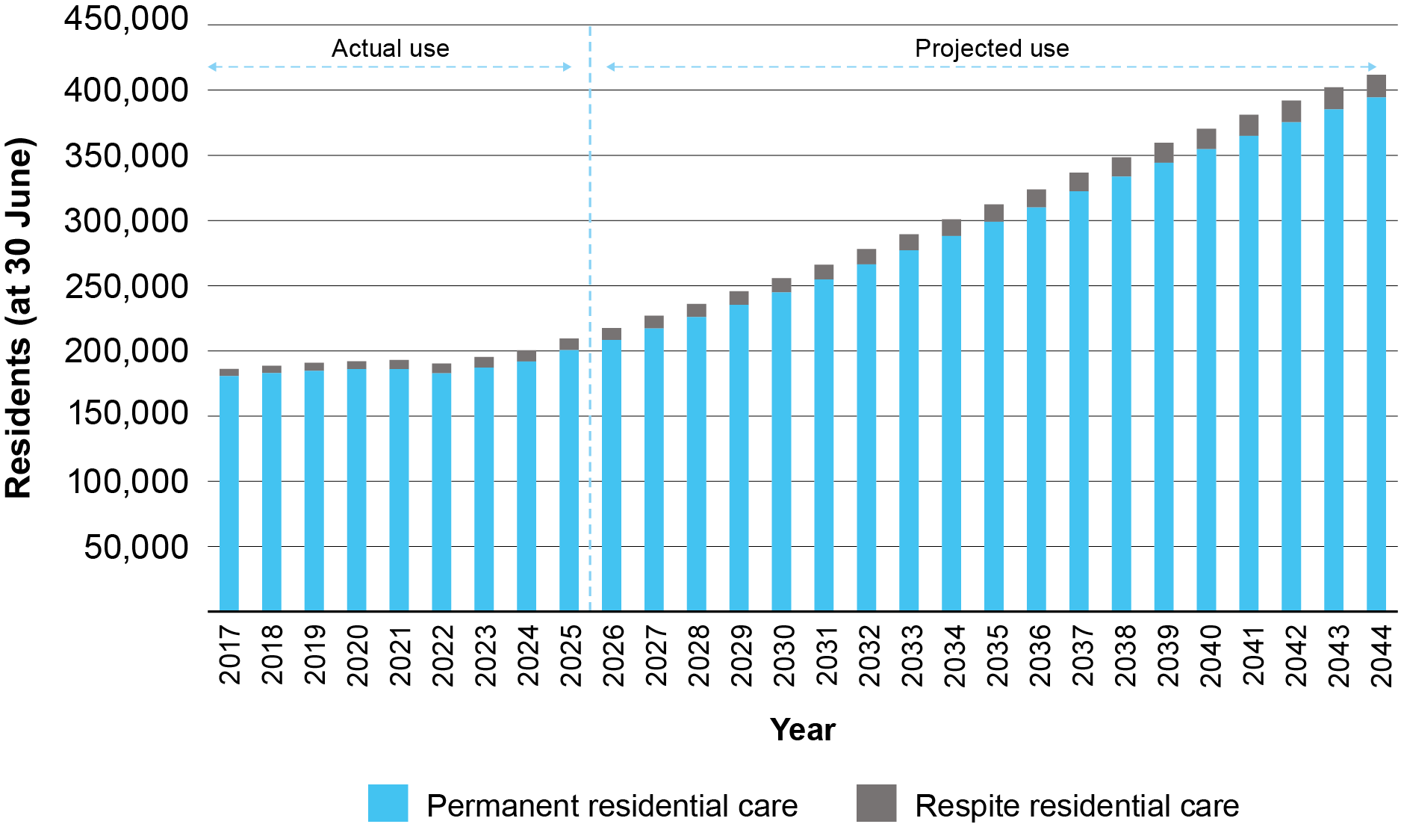
Source: Department of Health, Disability and Ageing

The continued expansion of the Support at Home program is critical for enabling older people to age in place. However, it will not be able to mitigate the demand for residential care. Support at Home services cannot substitute for the level of care required by people with complex needs, as cost, quality and safety requirements limit the extent of government‑funded care that can be delivered in the home, particularly where around‑the‑clock support is needed. As shown in Table 1.1, over the past 3 years, approximately 90 per cent of newly admitted residents have care needs that require more intense forms of support.
Table 1.1 Proportion of new entrants to residential care, with certain care needs (2022–25)
Condition | Proportion of new entrants
Are they unable to get out of bed on their own? | 28.60%
Are they unable to go to the toilet on their own? | 64.88%
Are they unable to dress themselves on their own? | 78.80%
Have they been assessed as intermittently aggressive, or a danger to themselves or others? | 34.40%
Have they been assessed as being unable to independently function with regard to memory, problem solving, or comprehension? | 69.02%
Total proportion of new entrants with any of the above conditions? | 89.74%
Source: Department of Health, Disability and Ageing

The provision of home care supports has enabled people with lower care needs to remain at home longer, delaying, but not substituting for, entry into residential care. As shown in Figure 1.2, the expansion of the Home Care Package program following the Living Longer Living Better reforms coincided with a decline in the proportion of older people using residential care. However, more recent growth in the program has not produced further substantial reductions.
If the expansion of in‑home supports under the new Support at Home program enables people to remain living in the community even longer, it will likely continue to delay, but not eliminate, the need for residential care. As a result, demand for residential care will continue, with new entrants entering later in life with more complex needs and possibly shorter stays.
Figure 1.2 Proportion of older people using home care and residential aged care services (2012–2024)
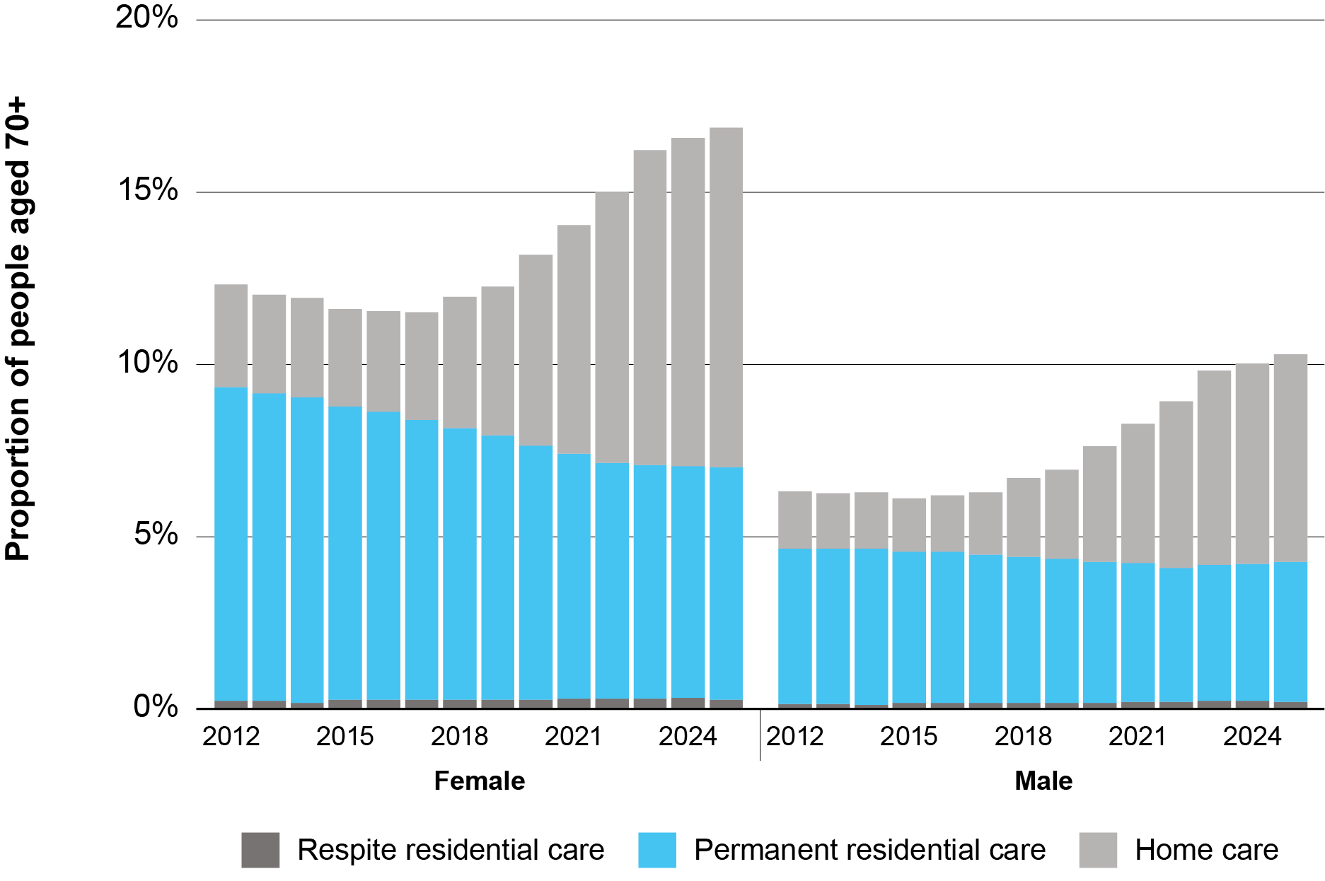
Source: Department of Health, Disability and Ageing

A substantial proportion of people entering residential aged care will continue to require government support to meet their accommodation costs. Currently, the government pays some or all accommodation costs for around 43 per cent of residents, and this share is expected to remain relatively stable over the next two decades. Although more Australians are expected to retire with substantial superannuation balances in the coming two decades, many individuals are likely to have depleted their balance by the time they enter residential care (typically aged 85 and older).
It is also possible that future demand for residential care may be more acute among people with fewer economic or social resources to support ageing in place. Individuals with greater financial capacity are generally better placed to access services (such as home modifications and assistive technologies) that help them remain at home longer. Conversely, home modifications are often less readily available for renters, who are typically of lower means than their home-owning peers.
An important dimension of demand for residential care is its location‑specific nature. Most people want access to residential aged care in a home that is close to their family and community connections. As a result, the distribution of future demand is expected to relatively closely mirror the geographic distribution of the older population across both metropolitan, regional, rural and remote locations. This also means that considering the supply of residential aged care at a national level is insufficient, as it does not show how well available beds match local demand.

Supply is not growing at the pace needed
Meeting the expected demand will require a substantial increase in the supply of residential care places, at a much faster rate than the past decade.
To meet projected demand, the sector will need at least 10,600 additional operational places per year over the next two decades. Based on an average home size of 83 places, this level of growth is equivalent to opening a new residential aged care home every three days.
This figure represents net growth only. It does not account for beds leaving the system through home closures, nor any additional capacity that would be desirable to reduce the time it takes prospective residents to secure a place in a home near where they currently live.
The projected growth task stands in stark contrast to recent trends in supply. Over the past decade, the number of net operational places increased by an average of 3,212 per year (32,123 in total) from 192,370 in 2015 to 224,493 in 2025. Growth has slowed significantly in the past five years, with only 7,348 additional net places since 2020, at an average of 1,470 per year. In 2024–25, the net increase was just 802 places (see Figure 1.3).
Figure 1.3 Residential aged care new beds and bed closures 2018–2025
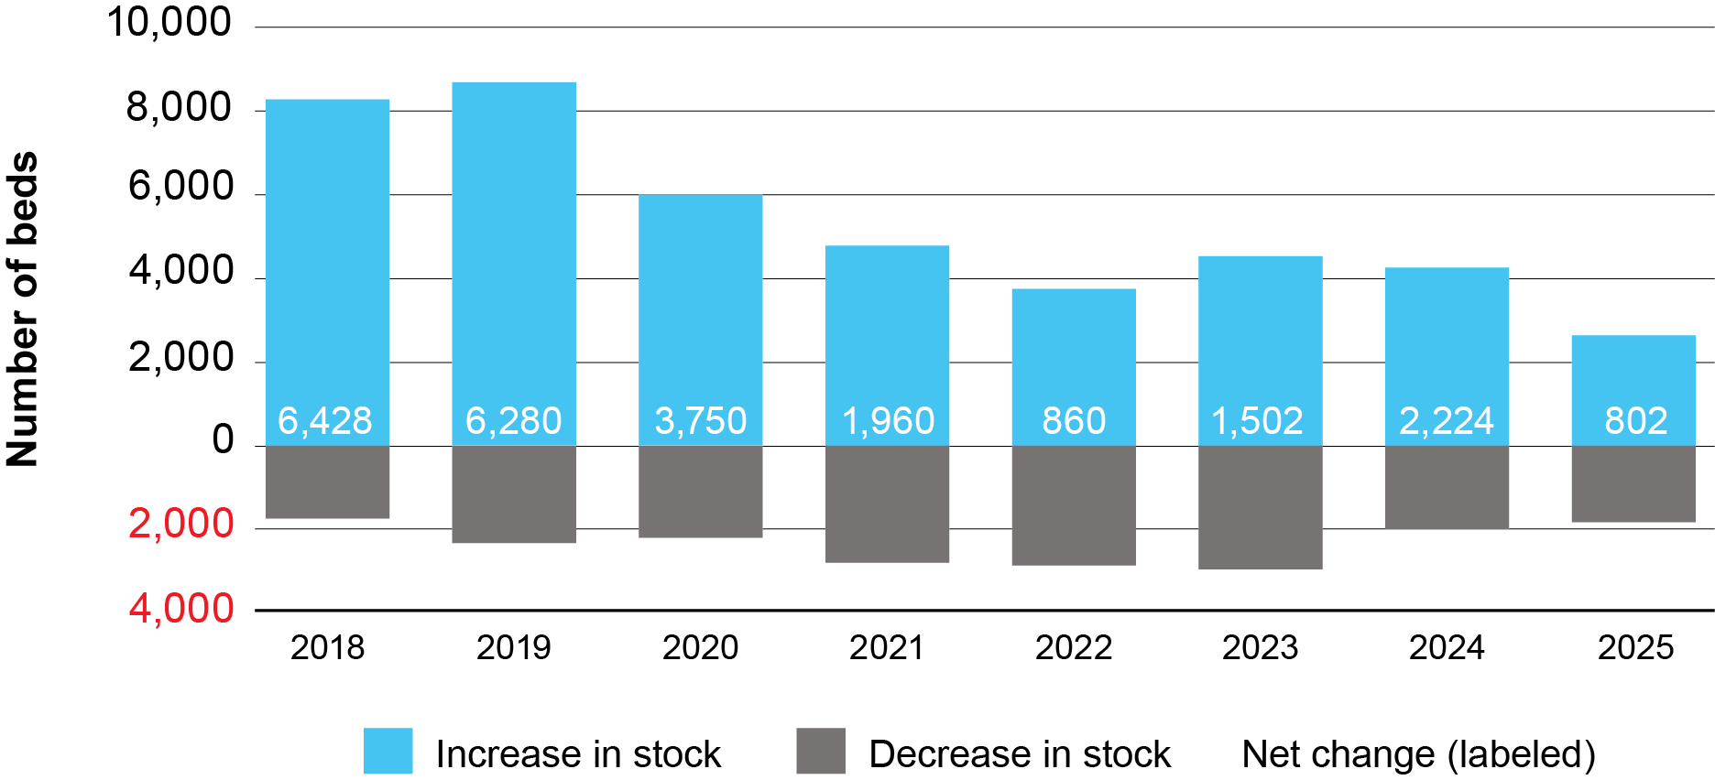
Source: Department of Health, Disability and Ageing
The Review notes that there has been a significant slowdown in indicators regarding the current supply pipeline for residential care. After peaking in 2017-18, the value of building activity in aged care has declined (see Figure 1.4).

Figure 1.4 Value of residential aged care building activity by quarter, 2000–2025
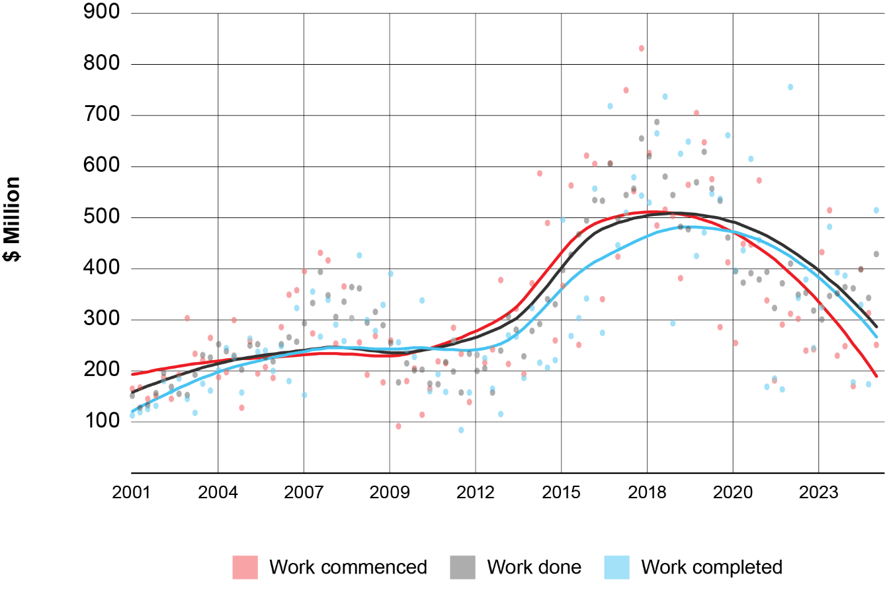
Source: ABS Building Activity, Australia (ABS Cat no. 8752.0)
The aged care sector’s share of all non-residential building commencements has also declined during the same period, indicating that the slowdown in construction is partly driven by industry-specific factors (see Figure 1.5).
Figure 1.5 Aged care share of building work commenced 2001–2025
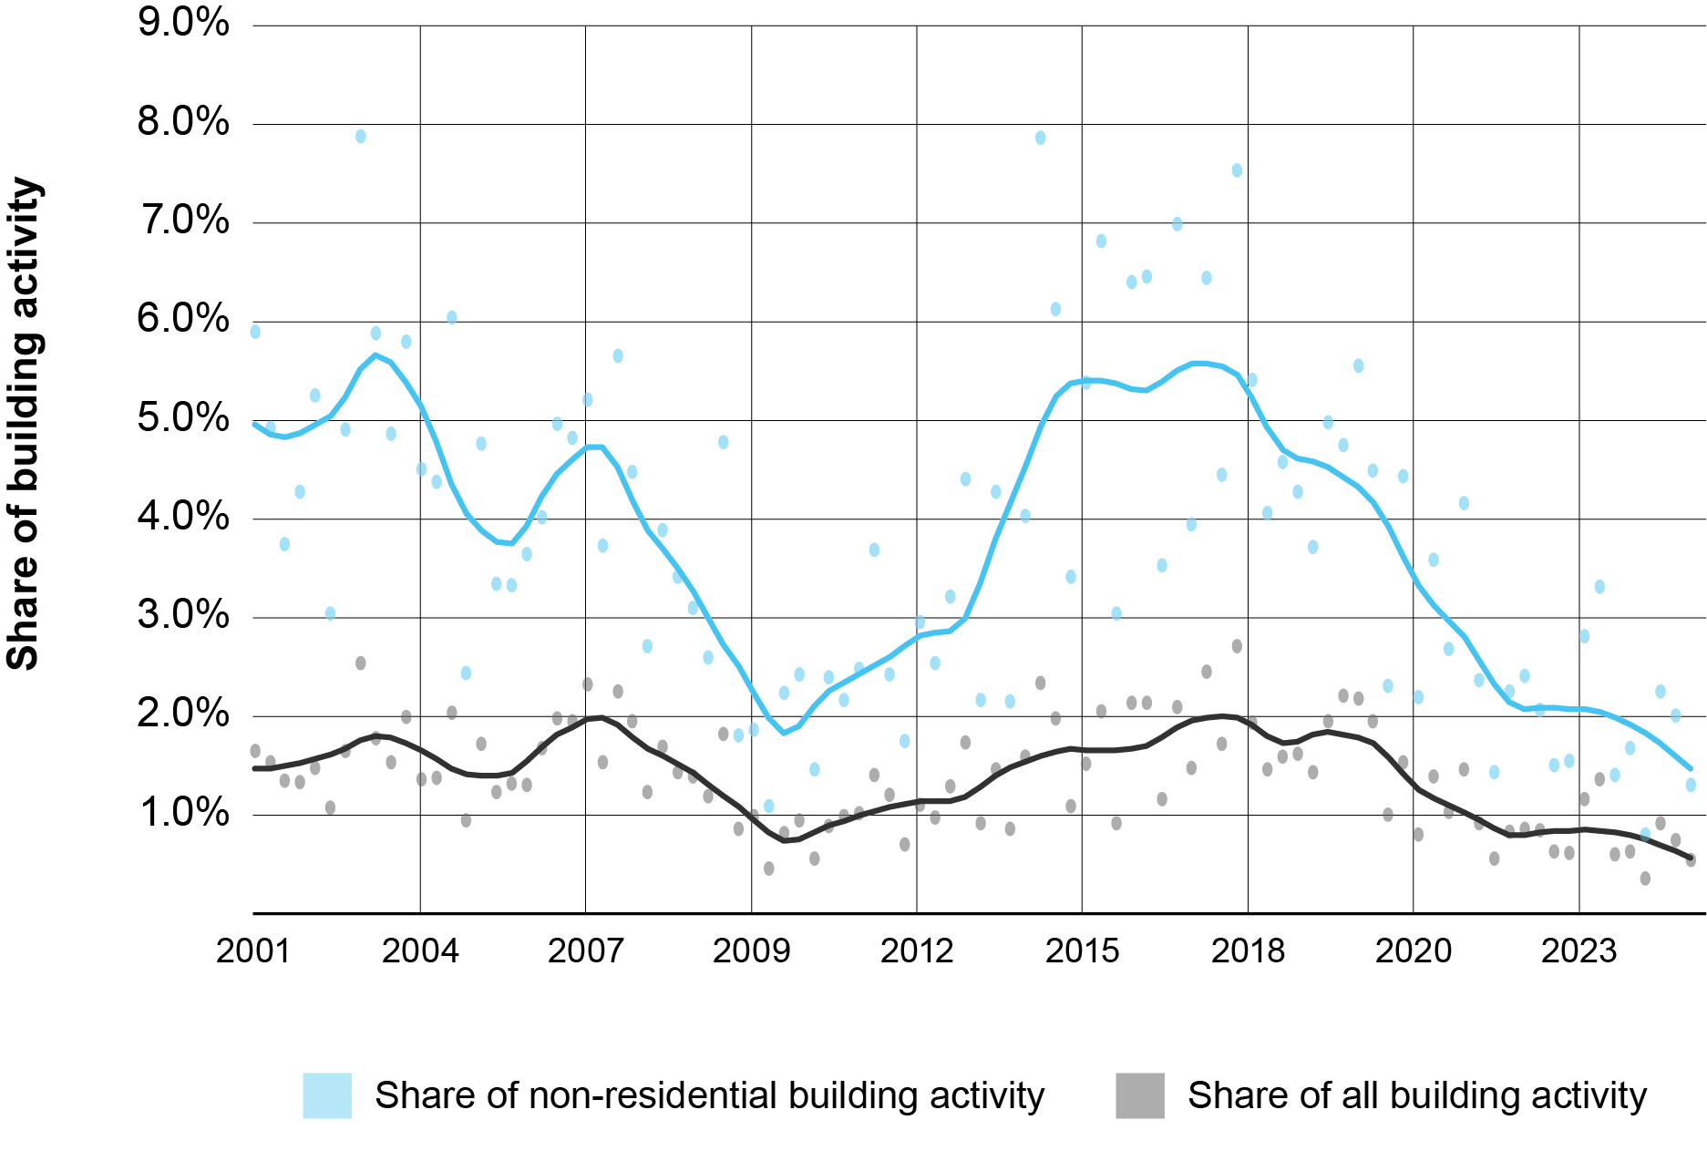
Source: ABS Building Activity, Australia (ABS Cat no. 8752)

Another critical dimension of the supply challenge in residential aged care is the need to upgrade and refurbish ageing infrastructure to ensure homes remain fit for purpose and existing places remain online. Places in older homes will be taken offline if they no longer meet required safety and quality standards or if they are no longer viable to operate. Providers reported that older infrastructure can generate increasing maintenance expenses or necessitate major capital works, at levels beyond what can be recovered through accommodation‑related revenue streams, including the base accommodation supplement and low‑value DAP or RAD payments.
There is limited data available on the condition of existing residential aged care homes, which makes it difficult to assess the scale of the refurbishment task. In 2023, a small sample analysis was carried out for the Department of Health and Aged Care, based on unverified self-assessed data from providers. The analysis found that 60 per cent of the homes surveyed required major bedroom upgrades to be able to achieve single bedrooms with private ensuites of a suitable size for all beds. Further, 68 per cent of the homes surveyed reported requiring major works associated with heating and cooling systems.
Consultation feedback received by the Review also indicates a widespread and pressing need to refurbish, upgrade or replace ageing facilities, particularly in non‑metropolitan areas. Sector estimates suggest that between 60,000 and 90,000 places will require urgent refurbishment over the next decade to remain operational.

Supply constraints reduce equity of access
The Review heard consistent evidence from providers, consumer representatives, state governments and sector analysts that Australia’s residential aged care system is already in a state of constrained supply, which is expected to tighten in coming years. StewartBrown reports that in 2024-25, occupancy rates averaged 94.4 per cent nationally (higher in major cities), 2 percentage points higher than in 2023-24. Sector-wide data from the Department of Health, Disability and Ageing indicates that occupancy levels are at historically high levels across most locations, and estimated in January 2026 to be in the order of 95 per cent nationally.
The effects of the COVID-19 pandemic, which saw the use of residential care stall and then decline, likely masked the emergent supply challenge. Although occupancy rates fell during the pandemic, they have since risen and now exceed their pre-pandemic levels.
Many providers reported that they were operating at or near full occupancy:
- One large provider noted that over the last two years occupancy had increased from what was considered a low level to a state of over 99 per cent full in Western Australia, Queensland, and South Australia.
- Other providers also indicated that they considered themselves to be full, with 96 per cent to 98 per cent occupancy across multiple homes and increasing demand.
- While some providers operating in rural and remote areas may have beds available, it was noted that staffing is an issue and without the necessary staff they were unable to offer places, thereby adding an additional constraint to supply.
Throughout the consultation, the Review heard consistent feedback from stakeholders, including older people, consumer advocates, providers and state governments, that a supply-constrained residential aged care system poses several adverse implications across the system.

Implications for residents and families
Limited supply makes it more difficult for a person in need of a bed to find a place and undermines consumer choice. It often requires older Australians to accept the first available place, which may not suit their needs and preferences. Older people and their carers can incur substantial search costs attempting to locate a suitable option near their vicinity, particularly when there is limited transparency around vacancies and length of individual homes’ waitlists.
The adverse impacts of supply shortages are not borne equally. They fall most heavily on people with low means and those with high or complex care needs. Anecdotal evidence heard by the Review suggests that these groups already face increasing difficulty accessing residential care, particularly where vacancies are scarce. This is because aged care providers have discretion to whom they offer an available bed. It can be financially advantageous for providers to prioritise residents who can pay higher accommodation prices and have less complex care needs. Providers have greater latitude to preference certain residents when demand for care exceeds the number of available beds in a local area.
As demand outstrips supply, older Australians have little ability to negotiate with providers on room price, while providers are able to increase their prices without impacting demand for available beds. This may make it harder for those who are non-supported residents, but with relatively modest means, to find a room they can afford.

Healthcare system impacts
Limited availability of residential aged care places can lead to significant strain upon the health system. Older Australians who are clinically ready to leave hospital may remain there solely because no suitable residential care place is available. These delays of discharge place strain on hospital capacity. Anecdotally, those who experience delayed discharge while awaiting residential aged care are more likely to be those who have greater difficulty accessing residential aged care more broadly, such as those with low means and complex behaviours.
While there is no one set of agreed estimates between stakeholders on the exact impact of delays of discharge to residential care, there is general agreement that the issue is material to the health system, both in terms of hospital system capacity and providing aged care services in a more expensive hospital setting.

Chapter 2: Capital financing and funding for accommodation

How accommodation is funded
Accommodation costs in residential aged care are funded through a combination of resident payments and, for eligible individuals, government contributions. Residents who have the financial means are expected to cover their own accommodation costs. Upon entry, all residents undergo a means test that assesses their income and assets.
Residents with income or assets above the low means thresholds are classified as non-supported and pay the room price agreed with their provider. There is no limit on the price that can be agreed; however, any price above the maximum accommodation payment amount must first be approved by the Independent Health and Aged Care Pricing Authority (IHACPA). The maximum amount is expressed as a lump sum and is currently $758,627.
Those assessed as low means receive government support through the accommodation supplement, which covers some or all of their accommodation costs. Currently, around 22 per cent of residents have their full accommodation costs covered by the government as fully supported residents and a further 21 per cent are partially supported. For partially supported residents, the amount they pay is determined by the means test, with the government paying the balance up to the value of the supplement. As a result, the accommodation revenue for low means residents is capped at the value of the accommodation supplement applicable to the home, which can be significantly lower than the room prices providers can negotiate with non-supported residents.
Accommodation payments can be made in a number of ways. Residents that pay or contribute to their accommodation costs can choose to pay as:
- a refundable lump sum (a RAD for non-supported residents or refundable accommodation contribution (RAC) for partially supported residents)
- a daily accommodation payment (DAP) for non-supported residents or daily accommodation contribution (DAC) for partially supported residents)
- any combination of the two.
A legislated formula converts lump sum amounts to daily payments through the maximum permissible interest rate (MPIR) which is updated quarterly. This ensures that for every lump sum amount there is an equivalent daily payment amount. The MPIR that applies for any particular resident is set at their entry and, generally, does not change while they remain in the same aged care home.
As shown in Figure 2.1 the distribution of payment methods differs between supported and non-supported residents. Non-supported residents are more likely to pay via refundable deposit, while partially supported residents predominantly rely on daily accommodation contributions. This largely reflects differences in assets.
Changes in the MPIR also influence residents’ choice between lump‑sum and daily payments, particularly for non-supported residents. For example, the decline in the proportion of DAP-paying residents observed in Figure 2.1 coincided with an increase in the MPIR over the same period, which raised the price of DAPs relative to RADs.

Figure 2.1: Accommodation payment methods for new entrants into care by supported status 2020–21 to 2024–25
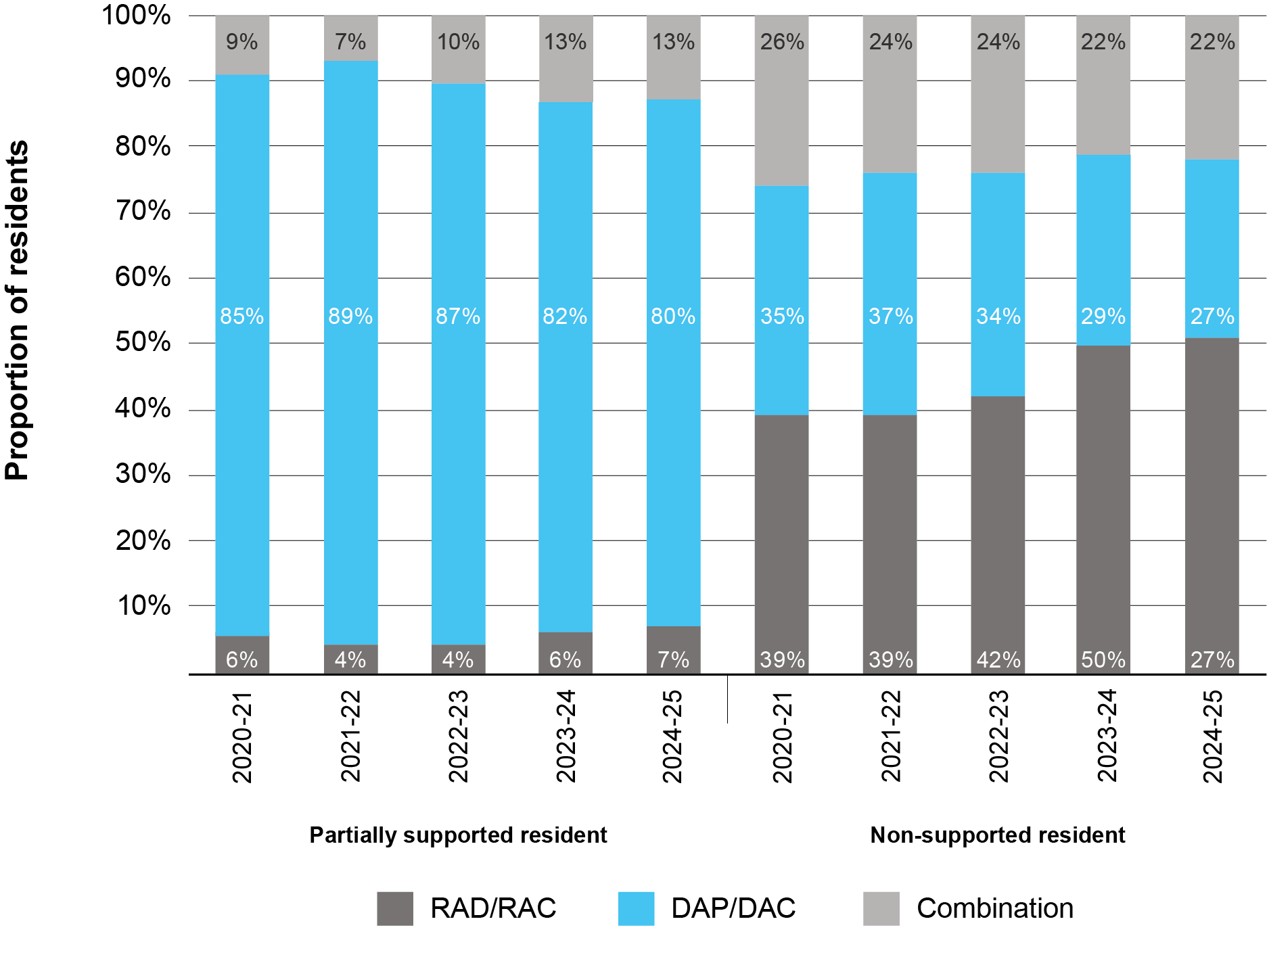
Source: Department of Health, Disability and Ageing

Following the Aged Care Taskforce, several changes to accommodation payment arrangements were introduced under the Aged Care Act 2024:
- from 1 January 2025, the maximum room price was lifted from the previous $550,000 to $750,000, with indexation applied annually on 1 July
- from 1 November 2025, incoming residents paying via a refundable lump sum are to be charged RAD or RAC retention fees, equivalent to 2 per cent per annum, applied to the value of the lump sum balance, up to a maximum of 5 years
- from 1 November 2025, the DAPs paid by incoming residents are indexed throughout the duration of their stay.

How accommodation is financed
Financing residential aged care accommodation, be it new builds or significant refurbishments, relies on a limited set of capital financing mechanisms. While providers hold a mix of assets across their balance sheets, only a subset of these can be deployed to fund incremental capital investment in new or refurbished accommodation.
Australia’s RAD financing model remains the primary mechanism underpinning investment in new residential aged care infrastructure. Providers may use a portion of RADs contributed by existing residents to support development of new homes. However, because RADs are refundable liabilities owed back to residents when they leave care, providers must maintain sufficient liquidity to meet refund obligations. This limits the proportion of RAD balances that can be used to finance marginal capital expansion.
Even providers with large RAD balances are often unable to redeploy these funds for new developments, as they have already been used to fund existing assets or need to be retained to refund outgoing RADs. Sector analysis indicates that providers hold approximately 18 per cent of assets as financial holdings (e.g. cash or term deposits), suggesting only a modest level of deployable liquidity. The largest RAD balances are concentrated within the largest providers, which are highly leveraged and have limited liquidity.
As a result, most new homes are financed through short‑term bank loans for the construction phase, which are repaid using RADs from incoming residents once the home opens. Some providers, particularly not-for-profits, may draw on internal capital to fund construction, with incoming RADs subsequently used to replenish that capital.
A small number of mostly not-for-profits occasionally receive capital endowments or bequests, often from current or former residents. However, these funds are irregular and unpredictable, meaning they cannot serve as a reliable source of capital for planning or financing large‑scale developments.
Direct government capital investment plays an important role in supporting developments that would not proceed under standard commercial financing, particularly in thin markets. The Aged Care Capital Assistance Program (ACCAP) provides grants to build, extend or upgrade residential aged care homes, to maintain or increase access to quality aged care services in thin markets. This includes for people in Aboriginal and Torres Strait Islander communities, regional, rural and remote areas, those experiencing homelessness and individuals with diverse needs. Preferential treatment is often given to applications that can supply matching funds. As at 31 December 2025, $1,388 million in ACCAP funding was available for the period from 1 July 2025 to 30 June 2030. While ACCAP funding and expenditure will vary from year to year, including where additional commitments are made by Government, at least $172 million is currently made available for the program each financial year.
State and territory governments also undertake some capital investment in aged care, either through capital grant or loan projects, or less frequently by directly building and operating services. State and territory capital spending in the aged care sector is estimated at $230 million each year, with large variation across jurisdictions.

Current challenges in the funding and financing of accommodation

Poor financial returns from investments in residential care
Providers must generate margins to remain financially viable and to attract the investment required to build and upgrade accommodation. However, low margins in residential care continue to limit the sector’s ability to attract external investment or compete for internally generated resources. In 2023-24, providers reported an average Earnings Before Interest, Tax, Depreciation and Amortisation (EBITDA) margin of 8.1 per cent and a Net Profit Before Tax margin of 1.3 per cent. Feedback to the Review indicated that, in many cases, returns from residential care do not meet external or internal hurdle rates for investability. Even providers with sufficient land assets to expand their portfolio of homes reported weighing other, more viable uses.
The structure of the residential aged care funding model constrains margins on care and everyday living, with funding based on the costs of providing these services. As a result, opportunities to generate margins are largely limited to the provision of additional services, i.e. Higher Everyday Living Fee services or accommodation services.
However, at present, providers typically operate accommodation at a loss. In 2023-24, providers reported an average deficit of $8.44 per resident per day for accommodation, noting this figure includes an apportionment of administration expenses (see Figure 2.2).
Figure 2.2: 2023-24 Sector reported accommodation result
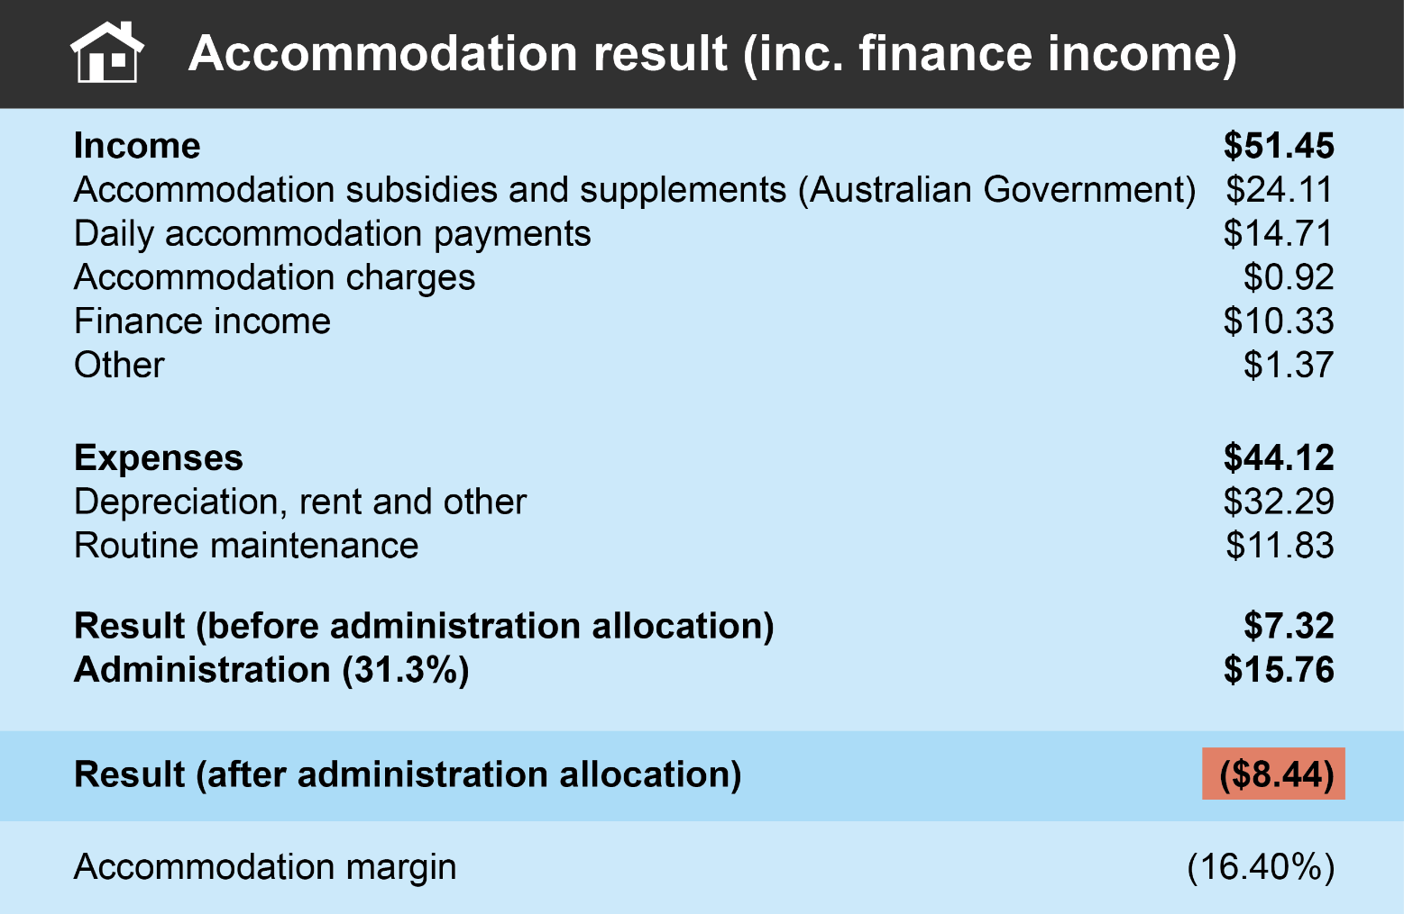
Source: Financial Report on the Australian Aged Care Sector 2023-24

These results should be interpreted with caution, as several factors may distort the extent of the apparent deficit in accommodation. Accommodation income does not fully reflect the benefits providers receive from interest free RAD contributions, backed by Commonwealth guarantee, which may also be obscured by related-party transactions. The reported expenses also include a sizable allocation of administrative overheads, which can vary significantly across providers and may not accurately reflect the costs attributable to accommodation services. Depreciation expenses also differ widely depending on the age of buildings, their history of capital upgrades, as well as providers’ accounting policies, including assumptions about useful life and asset revaluations.
In addition, the financial results from 2023–24 do not reflect the effects of recent changes that relate to accommodation viability, including the increase in the maximum room price, the indexation of DAPs, and the introduction of RAD retention. The impact of most of these reforms will only be observable after the 2025–26 financial year, and possibly only mostly realised in 5 years, noting they generally only apply to incoming residents. Nonetheless, the Review expects that these changes will have a material and positive effect on the funding for service provision and capital upgrades for non-supported residents, especially in metropolitan areas.

Inadequacy of the funding for supported residents
Capital investment has also been undermined by the inadequacy of funding for supported residents, particularly in terms of covering the capital costs of their accommodation. Introduced in 2014, the higher accommodation supplement (HAS) is designed to provide additional funding to house supported residents in newly built and significantly refurbished homes. While the HAS has been indexed annually, it has not kept pace with the rise in construction costs over the past decade.
Rising construction costs without corresponding increases in funding make it difficult for providers to commit to new developments with confidence that they will be financially viable. Feedback to the Review indicated that build costs vary significantly across the country: one Victorian provider suggesting an average room cost of $432,000, while a Western Australian provider estimated between $570,000 and $620,000 per bed, and the WA Government noted an average cost of more than $500,000 per bed. These figures relate solely to construction and exclude the cost of land. Costs tend to be higher in rural and remote areas, with Caulfield Krivanek Architecture (CKA) suggesting a loading of between 5 and 15 per cent depending on distance from major cities.
Although refurbishment costs are generally lower than those of a new build, they remain substantial. The Review heard estimates ranging from $90,000 per room for the renovation of bedrooms and bathrooms through to $183,000 per room for a whole of facility refurbishment. The process also involves additional complexities: many older homes are likely to contain rooms with multiple beds and shared bathrooms, and converting these to single or dual‑occupancy rooms with ensuites usually reduces the number of places. Major refurbishments often require residents to be temporarily relocated, creating additional costs and operational disruptions. These activities cannot be funded solely through the HAS and require access to additional capital and appropriate funding mechanisms.
A related concern raised by stakeholders is that while the HAS initially provided a strong incentive to prompt capital investment in improving the quality and availability of supported places, the strength of that incentive has weakened over time. With most existing homes now qualifying for the HAS, current settings provide little marginal funding incentive to support further investment in improving accommodation quality for supported residents, even when such improvements are warranted.

Narrowness of the current capital funding model
Sector feedback indicates that, while capital is available to finance additional supply, current policy settings create significant barriers to its deployment for new developments in many communities.
Under existing arrangements, new developments can generally only access finance when they can attract a high proportion of incoming residents willing and able to pay a refundable accommodation deposit (RAD). Providers relying on bank finance to fund construction reportedly need at least 60 per cent of all incoming residents to be RAD-payers, in order to repay the construction loans. Daily accommodation payments (DAPs) cannot play a meaningful role in financing new developments because their value fluctuates with the maximum permissible interest rate (MPIR), thus preventing DAP revenue from being treated as a reliable or bankable cashflow. Although supported residents are funded through a government-backed revenue flow, as described above, current funding levels are not sufficient to meet the capital costs of accommodation. Given the expected distribution of resident payment choices, the need for incoming RAD-payers effectively caps the supported resident ratio in new developments at approximately 17 per cent.
This capital funding model concentrates new investment in areas with a sufficient density of wealthier older people, limiting the viability of developments in communities with fewer residents of means. Also, because providers need to maintain sufficient liquidity to refund outgoing RADs, there is a structural barrier to accepting more supported or DAP-paying residents in RAD-financed new builds. This essentially ‘locks in’ a RAD-focused resident mix for years after the home becomes operational.
The narrowness of the capital funding model for new developments has led providers in less affluent areas to expand primarily through lower‑cost acquisitions rather than new construction. This has contributed to significant sector consolidation, with small and medium‑sized providers increasingly absorbed by larger organisations that can leverage economies of scale. While acquisitions may help prevent the closure of existing homes, they do not increase the overall supply of residential aged care places.

Regulatory uncertainty
Stakeholders reported to the Review that ongoing regulatory change has had a chilling effect on investment. The sector has undergone a sustained period of major regulatory reform, including the commencement of the AN-ACC pricing model and the significant reforms associated with commencement of the Aged Care Act 2024 on 1 November 2025.
During this period, both providers and financial markets have faced ambiguity about how AN-ACC would operate and the implications for the sector’s ability to generate margins. The model was only fully implemented in October 2024, when the final sector-average care minute targets were implemented. During consultation, the Review heard that uncertainty persists, in part due to IHACPA’s most recent pricing advice, which recommended a smaller increase in care funding than providers anticipated.
Providers also emphasised that, given the sector’s reliance on RADs, the ongoing regulatory uncertainty flowing from the Royal Commission’s recommendation to phase out RADs has affected investor sentiment. While the government’s response to the Aged Care Taskforce deferred the potential timing of any RAD phase out to no sooner than 2035, and subject to a legislated review, the long-term outlook for RADs remains a concern in investment decisions.

Alternative approaches to improving supply

Increasing the higher accommodation supplement
Many submissions highlighted that, with rising construction costs, the current payment model for supported residents is no longer sufficient to meet the capital costs associated with new developments or major refurbishments.
The most frequently suggested recommendation for stimulating capital investment was an increase to the higher accommodation supplement (HAS) to a level sufficient to meet the full cost of accommodation, inclusive of both operational and capital components. Estimates of the required uplift varied ranging from $30 to $95 per day, which would increase the HAS from $72.30 to between $100 and $165.
While the Review acknowledges that the current value of the HAS is insufficient to meet the cost of new construction in many circumstances, a large across-the-board increase is not a preferred approach.
Such an uplift would require considerable additional recurrent funding and yet be poorly targeted in achieving the requisite increases in supply. Such an approach would provide additional capital-related funding to all homes, including those that do not require any upgrades, and without any assurance that the additional funds would be directed toward improved infrastructure. In effect, it would result in the government funding rising construction costs even in homes where no capital works are planned.
Furthermore, there could be unintended consequences in terms of means testing for residents, which could lead to some non-supported residents becoming partially supported, limiting the amount providers can charge for this group.

Linking the accommodation supplement to accommodation prices
Some stakeholders suggested improving equity of access for residents with low means by linking the higher accommodation supplement (HAS) to the prices paid by non‑supported residents. Variations on this proposal were raised, with the most common being to set the HAS at the daily equivalent of the median value of incoming refundable accommodation deposits (RADs) across the sector. Proponents argue that aligning the HAS with prevailing prices could narrow funding differences between supported residents and those paying via a daily accommodation payment (DAP) and reduce incentives for providers to prioritise residents able to pay higher prices.
While the intent is to promote equity, the Review considers this approach to carry significant risks and potential unintended consequences:
- Distortions to means-testing and equity. By definition, benchmarking at the median would see taxpayers fund accommodation at a rate higher than that paid by half of all non-supported residents who have greater capacity to contribute. This runs counter to the funding principles established by the Aged Care Taskforce. It may also result in partially supported residents paying more than some non-supported residents.
- Embedding market-based logic in taxpayer funding. Providers typically set RAD and DAP prices based on what the market will bear, influenced in part by local housing values. It is not clear what policy benefit would be achieved by linking the value of taxpayer-funded subsidies to housing-market dynamics rather than to the actual cost of delivering a reasonable standard of accommodation.
- Large fiscal impact with unclear outcomes. Setting the HAS at the median incoming DAP would require an uplift of approximately $28 per resident per day, amounting to around $1 billion in additional taxpayer funding each year. However, as outlined above, increasing the value of accommodation supplement payments alone would not ensure any additional supply of accommodation, nor would it guarantee improvements in the quality of accommodation available to residents of low means. As a result, this approach would impose substantial fiscal costs without necessarily delivering better outcomes.
- Price ratcheting. Tying subsidies to prevailing prices could strengthen incentives for providers to increase accommodation prices for non-supported residents, reducing affordability and compounding fiscal exposure.
The Review’s view is that taxpayer‑funded accommodation is better set using a cost‑plus approach, whereby funding covers the efficient cost of delivering a reasonable standard of quality, plus a reasonable margin. This approach better supports equity, value for money, and fiscal sustainability.
Provided there is sufficient supply of residential places, providers would retain a financial incentive to accept residents with low means rather than leave places unfilled. Where higher‑priced, market‑based offerings are available, providers would need to demonstrate the value of any prices above the cost‑plus level to non‑supported residents.

Cross-subsidising supported residents via an increase in the value of RADs and DAPs
Another option is for providers to increase the prices paid by non-supported residents to a level sufficient to fund the sector’s capital investment needs, including the development of additional places for low means residents. This could be facilitated, for example, by removing all regulation regarding the maximum room price– a suggestion offered by several providers during the Review consultation.
This approach is unlikely to be feasible as there is a limited number of older people that may be willing or able to pay much higher prices for accommodation. It is also not preferred, and it would effectively create a policy of cross-subsidisation, in which part of the cost of providing accommodation to low means residents is met through higher payments from non-supported residents. This would raise concerns about fairness and may distort provider behaviour.
Such a shift would also exacerbate equity of access issues. If providers could attract enough residents willing to pay inflated prices, they may be incentivised to preference non-supported residents over low means residents, given the higher revenue and liquidity that could be generated. As a result, access for low means residents could become increasingly constrained.
In addition, significantly higher room prices risk making accommodation unaffordable for many non-supported residents. Modelling by StewartBrown indicates that, under current parameters including the MPIR, supported resident ratios, RAD retention and payment mix, a metropolitan provider would need to set an average RAD of $1,080,000 to achieve a 4.5 per cent return on a residential care place costing $500,000 to build. This figure is close to, or above, the median home price in many capital cities, and would place residential aged care beyond the reach of many, including homeowners.

Chapter 3: Supporting capital investment to ensure access
Meeting the future accommodation needs of Australia’s ageing population will require a significant uplift in capital investment across the residential aged care sector. Given the challenges outlined in the previous chapter, this uplift will require a more flexible capital model capable of supporting viable investments across diverse geographic and market contexts, together with a sustainable funding model that enables efficient providers to generate investable returns in providing accommodation to all residents.
As a substantial proportion of people entering residential care over the coming two decades are expected to be classified as low means, additional Commonwealth support will be required to fund new and refurbished places for this cohort and to ensure equity of access regardless of financial circumstances. Direct government involvement, including through targeted capital funding, will be necessary to maintain a modest but essential level of excess capacity across the system, enabling choice, timely access and the mitigation of supply gaps arising from development lags.
Some stakeholders argued for much larger increases to the accommodation supplement and grants schemes. However, the Review concluded that such measures would impose substantial fiscal costs without guaranteeing improved outcomes for residents or increasing supply where it is most needed.
Instead, the Review proposes a package of interrelated recommendations designed to support stronger growth in new supply while preserve existing capacity. The package has been structured to improve access to capital, particularly for providers serving low means residents, and to complement rather than displace existing sources of finance. It includes an interest free loan program, new capital subsidies and an expanded capital grants program. Together, these measures provide a coherent and targeted policy response that strengthens access to capital and creates a more flexible financing model capable of supporting growth across both supported and non‑supported places.

Interest free loan program
Many providers, particularly those in thin markets or lower socioeconomic areas, are unlikely to have a high share of RAD payers, and as a result have difficulty obtaining capital to finance expansion or refurbishment and often rely on government grants. The Review recognises that the HAS covers the cost of providing accommodation services to low means residents plus a margin but does not cover the cost of constructing a new or refurbished home. However, it is unlikely to be fiscally sustainable to set the HAS at a level that covers construction costs.
Several submissions to the Review recommended that it consider some form of concessional loans scheme. Consultations with providers, banks and superannuation funds reinforced this view.
The Review recommends that the government support the construction of new residential aged care beds for low means residents with an interest free loan scheme, effectively to mirror the model that providers use to finance the construction of beds for non-supported residents.
Under the scheme, the Commonwealth would provide take out finance proportionate to the expected ratio of low means residents in a new home to creditworthy borrowers and against appropriate security. Such a scheme would effectively allow banks to be more ambivalent about the actual share of residents that may pay a RAD, and finance against the certainty that the government would take out the proportion of the bank loan that matched the proportion of low means residents being admitted to the new home.
In addition, the Review recommends that the government make interest free loans available to creditworthy borrowers for significant refurbishments that ensure existing beds remain available for low means residents.
The proposed interest free loans scheme would not replace existing sources of finance. Indeed, it is expected to support additional private sector construction finance for the sector. To achieve this, the interest free loans would need to be subordinate to senior finance such as bank loans.
By providing take out finance, the Commonwealth would not be exposed to construction risk, leaving banks and providers that are better placed to price, understand, and manage that risk. The loans could be drawn when a service commences operation, with a two-year period before repayments commence to give providers opportunity to admit residents and build a financial buffer, with straight line amortisation after that time.
Loan terms should include a condition that the provider must maintain the agreed upon supported resident ratio in the home over the period of the loan. This would protect against providers offering places to supported residents to secure a loan, and then when those residents exit replacing them with non-supported RAD payers.
The Review recommends that the proposed interest free loans scheme be supported by new capital subsidies that, together with the higher accommodation supplement (HAS), should enable providers to repay the loans.
The Review’s recommendations are structured around terms of 25 years for new homes and 15 years for significant refurbishments. Shorter loan terms would necessitate larger capital subsidies (see below) to ensure loans could be repaid.
Given the trajectory of future demand for residential aged care by low means residents, the Review recommends that the government make up to $2 billion of interest free loans available to be contracted a year for the next 10 years in the first instance. The operation of the program and trajectory of aged care bed supply could then be reassessed to determine whether there remains a need for the program.
The intent of the loan scheme is to enable capital financing for providers that offer care to a larger share of supported residents. It is generally difficult to attract finance with a supported resident ratio of greater than 15 per cent, yet only 5.2 per cent of aged care homes have a supported resident ratio below this. It is the view of the Review that this proportion should not increase significantly. By assisting with the financing for supported residents, the loan scheme is designed to enable development of residential aged care homes in more areas of need, and reduce the imperative for new builds to focus in areas with high proportions of wealthy individuals.
The Review’s consultations confirmed that there are alternative sources of capital potentially interested in Australia’s residential aged care sector. If the market develops as some participants expect, there should be less need for government finance over time. The Department of Health, Disability and Ageing should monitor market developments.
The Minister should have the capacity to establish priorities for loans periodically (e.g. to support new homes in geographic areas with shortages in supply or to support new homes that specialise in care for residents with complex care needs).
The loan scheme could also prioritise developments that align with the National Aged Care Design Principles and Guidelines to provide incentives for providers to propose developments that better meet community expectations.
Recommendation 1
To assist in the provision of residential aged care accommodation required over the next ten years, the government should introduce an interest free loan program to provide takeout financing for viable residential care homes with low means residents.
- It is recommended that up to $2 billion per year is made available for ten years to be committed to interest free loans to providers of residential aged care.
- The loans should be linked to the expected proportion of low means residents for the places that are being built or refurbished, i.e. for a service expecting 50 per cent low means residents, the loan could be for a principal up to 50 per cent of the construction costs of the service.
- Failure to meet the agreed proportion of low means residents should require a penalty interest rate to be applied to the outstanding loan amount until such time as the required proportion of low means residents is met, at which point the penalty interest rate would be removed.
- The loan scheme should be open to registered providers to enter contracts over the period 2026–27 to 2036–37, for loan terms up to 25 years.
- Priority should be given to providers who have development approval, a qualified builder, and construction finance.
- In order to streamline contract negotiations, the loan provider should work with banks and other lenders to develop default standard intercreditor arrangements. More complex capital stacks might require exceptions to the standard arrangements.
- The loan provider should take into account the Commonwealth’s aggregate exposure to an entity or group.
- The loans could be provided on completion of a new or significantly refurbished service, with straight line amortisation to commence two years later (i.e. over years 3 – 25 of the term of the loan).
- Loans should be limited to providing funding for the creation of new accommodation places or to assist in ensuring current stock is of an appropriate level of quality and meets required safety standards.
- The Minister should provide guidance to the loan issuer on priority needs, including alignment with the National Aged Care Design Principles and Guidelines, geographical or service types.

Capital subsidies
To assist in meeting the costs associated with bringing new homes online or undertaking significant refurbishment and thereby ensuring that supported residents have an avenue to access new and higher quality services, the Review recommends the introduction of two new, time limited capital subsidies.
The first is a new home payment of $30 per supported resident per day. The payment would be available for 25 years, the same length of time the interest free loans will be made available. While the new home payment could be used toward paying off an interest free loan, it could also be used as a mechanism to service more traditional borrowings, from banks for example.
The second recommended new capital subsidy is the significant improvement payment of $15 per supported resident per day. This payment, available for 15 years, is designed to help assist with repayments for extensions and significant refurbishments that increase the availability of beds or ensure old stock is updated and remains fit for purpose.
As newly built homes are expected to remain fit for purpose and be maintained to an appropriate standard, providers will not be able to receive both types of capital subsidies for the same home at the same time.
These capital subsidies are part of a package designed to ensure providers will not need to be reliant on a resident profile highly skewed towards residents with means, and in particular, RAD payers, to convince lenders they will be able to service their borrowings. While paid on the basis of the providers’ supported resident cohort, both capital subsidies would sit outside the accommodation supplement framework, to ensure they do not affect means testing and are time limited.
By applying time limits on the capital subsidies, the government may ensure that funding is provided only for the period required to repay the capital investment and prevent government support from exceeding what is required.
To avoid duplicating government support, homes that obtain an ACCAP grant for construction or refurbishment should not also receive the capital subsidies.
Recommendation 2
The government should introduce a new home payment of $30 per supported resident per day for residential care homes that are newly constructed with a first day of operation after 1 November 2025.
The payment should be available to providers for 25 years, and subject to the same indexation mechanism as the accommodation supplement.
The new home payment should not be available to homes that have received an ACCAP Grant to assist with building the facility.

Recommendation 3
The government should introduce a significant improvement payment of $15 per supported resident per day for residential care homes with a first day of operation after 1 November 2025 that:
- have increased the supply of places in a home by at least 40 per cent, either through an extension or significant refurbishment of offline beds; or
- have undertaken significant refurbishment of a home that was at risk of being taken permanently offline.
The payment should be available to providers for 15 years, and subject to the same indexation mechanism as the accommodation supplement.
The significant improvement payment should not be available to homes that have received an ACCAP Grant to assist with improving the facility.

Capital grants
Across Australia, there are thin markets in the aged care system where mainstream policies and market operations may result in a lack of suitable services. These homes are often located in rural and remote settings, or offer specialised services, for example, programs supporting residents with a history of homelessness or homes catering to cohorts that predominantly identify as Aboriginal or Torres Strait Islander.
These homes frequently have a high proportion of supported residents, which limits their ability to build capital reserves and makes accessing commercial finance more difficult. In some cases, larger providers operating multiple homes may be able to use capital reserves or surpluses from other homes or services to cross-subsidise capital expenditure in thin market locations. However, this is not an option for providers operating only one or a small number of homes.
Several of these homes are not currently eligible for the higher accommodation supplement and have struggled to accumulate sufficient funding from the base rate to undertake essential remediation works. As a result, a number of these homes require substantial capital investment to remain fit for purpose and operational. Additionally, many are located in areas of unmet demand that can only be addressed through expansion or the construction of new homes.
Given these constraints, providers in thin markets are unlikely to be able to access private finance, even with the interest free loan program. A different approach is therefore required to enable capital investment in these parts of the sector.
The Aged Care Capital Assistance Program (ACCAP) grants scheme is designed to assist the construction of new residential care homes, the upgrading and improvement of existing homes, and the provision of accommodation for aged care workers.
Demand for the ACCAP has consistently exceeded available funding and competitive rounds have been heavily oversubscribed since the program’s inception. In the most recent round, announced in September 2025, 367 applications sought more than $2.4 billion for the $300 million allocated, with 66 grants awarded.
Consultations indicated strong support for expanding the ACCAP to ensure continuity of care and the ability to meet future demand for residential care for older Australians in thin markets.
Stakeholders also highlighted the desirability of expanding the Multi-Purpose Service Program (MPSP). More than 180 multi-purpose services currently operate across Australia, the majority of which are in areas that cannot sustain both a hospital and a separate aged care home. Residential aged care within a multi-purpose service allows older Australians to stay within their own communities and closer to their family and friends, rather than having to move to larger towns or cities. The program is a joint initiative between the Commonwealth and the state and territory governments.
A number of providers proposed extending grants to metropolitan homes specialising in high-needs dementia care. This Review considered this option; however, the recommended loan scheme and capital subsidies should enable providers in metropolitan areas to build new dementia-focused homes or to refurbish existing homes without requiring a dedicated capital grant.
The Review recognises the critical importance of ACCAP in maintaining and expanding residential aged care supply in thin markets. Given the demonstrated and ongoing need, the Review recommends a significant expansion of the program for the next 10 years to ensure an adequate supply of quality residential aged care in thin markets.
The expanded ACCAP program could also prioritise developments that align with the National Aged Care Design Principles and Guidelines.
Recommendation 4
To ensure the provision and continuation of residential aged care in non-metropolitan areas and for specialised services, the government should expand the Aged Care Capital Assistance Program (ACCAP). Priority should be given to homes in MM 3-7, as well as those in other thin markets, including all residential care homes with specialised services status.
- It is recommended that at least $600 million a year for the next 10 years be made available to residential aged care homes unlikely to qualify for commercial loans, that are seeking to offer additional beds, bring offline beds back online, or undertake a significant refurbishment of existing stock to ensure it meets an appropriate level of quality and meets required safety standards.
- Funds should also be available to residential care homes seeking to build or purchase accommodation for staff use.
- The Minister could provide guidance on priority needs, including alignment with the National Aged Care Design Principles and Guidelines, geographical, or service types.
- Working with state and territory governments, ACCAP funding should be made available for the expansion residential care capacity under the Multi-Purpose Service Program (MPSP).

Streamlining building approvals
When meeting with the Review, providers and sector analysts and other experts noted that projects were being delayed during the application process by lengthy development approval processes. Many providers operate in multiple states, and approval processes across states are not uniform. The approval process required can add up to two years to the time taken to develop a new home. Given the recent period of inflation, the delays can have a significant impact on the cost of development and can lead to a development being halted as the budget may no longer be feasible.
The Review noted South Australia’s 2025 amendments to the Planning, Development and Infrastructure Act 2016, which redefined aged care facilities falling within the ambit of essential infrastructure. The definition extends to retirement villages that are co-located with residential aged care facilities. In South Australia, applications for essential infrastructure are assessed by the Planning Commission for ministerial approval. While still a new policy development, the change in approval processes aims to reduce development approval times.
The Review was told that in some states new builds were being delayed by a lack of qualified builders able to build residential care homes, particularly within rural and remote areas. For developments in receipt of direct funding valued at over $4 million or indirect funding valued at over $6 million, the Review notes that only builders accredited under the Work Health and Safety (WHS) Accreditation scheme can enter into head contracts for building work. Builders must apply for accreditation through the FSC Online portal. The application process includes submitting documentation and undergoing on-site audits to assess workplace health and safety systems. There are no fees for lodging an application or undergoing the accreditation audit process, and no ongoing fees are required once a company is accredited.
Given supply constraints, adding new beds that meet care and safety requirements as quickly as possible is important. State and territory governments could play a role in identifying existing buildings that could be transformed into residential aged care. Noting that adaptive reuse can be a difficult process, quick wins in appropriate settings, with a streamlined development approval approach could be useful in increasing residential aged care supply.
Recommendation 5
As an immediate priority, the government should work with state and territory governments to identify shared opportunities for increasing supply, including:
- options to streamline building approvals for residential aged care homes; and
- options to encourage more builders to complete the qualifications needed to construct residential aged care homes.

Improving information about supply gaps
Given the supply issues the sector currently faces, the likelihood that supply will tighten further in coming years while new beds are being built, and the need to prioritise the allocation of loan and grant funding, there is a strong case for enhancing the government’s understanding of emerging supply gaps.
The Review noted the limited systematic information currently available on areas of supply constraints, as well as the absence of whole-of-system data on the types and condition of residential aged care accommodation. Information on the quality of existing beds and the expected future supply (quantity and quality) must be pieced together using multiple sources, reducing its usability for analytical and decision-making purposes.
To improve information about current and future supply gaps, the Review recommends that the Department commission a national census of existing residential aged care accommodation infrastructure. This census should be accompanied by a national database of residential aged care places, to be maintained on an ongoing basis.
The understanding of supply gaps should also be informed by continued improvements in the Department’s capacity to undertake demand forecasting, including forecasting at sub-national levels.
A more systematic and detailed understanding of supply in the residential aged care sector would also enable the government to develop more useful information products for providers and consumers to support their decision-making processes.
Recommendation 6
The Department of Health, Disability and Ageing should commission a census of residential aged care accommodation as soon as possible, which includes: the location of all online beds; the age and appropriateness of current stock; the number of offline beds; the work needed to bring offline beds online; and the capacity to increase beds on existing sites.
The census should include the creation of a database of beds, which should be kept up to date by the Department going forward.

Chapter 4: Non-supported resident accommodation payments
While RADs are consistently seen as a form of accommodation payment that can be used to support capital investment, this is not true of DAPs because of the volatility caused by the MPIR. There is a need to ensure that policy settings create an environment where DAP revenue is reliable and consistent, such that this form of payment can also be used to support capital investment in residential care accommodation.
Some providers during consultation indicated that one option would be to increase the rate of RAD retention to improve the return on accommodation. The Review does not recommend this, noting that it would exacerbate the existing incentives to pursue RAD payers in preference to DAP payers or supported residents.
Removal of the maximum room price restrictions were also suggested during review consultation, noting the restraint the current approval and renewal process places on pricing certainty. This would remove the regulatory barrier to charging higher room prices. However, this is unlikely to be feasible because many residents have a limited capacity to pay, and removal of the restrictions could exacerbate equity of access issues in favour of higher means residents. It would also effectively create a policy of cross-subsidisation, in which part of the cost of providing accommodation to low means residents is met through higher payments from non-supported residents. This would raise concerns about fairness and may distort provider behaviour.
The Review instead recommends measures that improve flexibility in the relationship between RAD and DAP payers, and proportionate approaches to reduce the regulatory burden of the maximum room price.

Cease using the MPIR as the equivalence mechanism between RADs and DAPs
Since 2014, all residents have had the choice of payment method between lump sum, daily payment or a combination of the two. Given that choice, a mechanism was created to set the relationship, or ‘equivalence’, between lump sums and daily payments so that residents and providers could work out the daily payment that corresponds to any given lump sum.
Rather than create a new measure to set equivalence, the existing maximum permissible interest rate (MPIR) was used for this purpose, according to the formula:
Daily payment = Lump sum* MPIR/ 365
Prior to that, the MPIR had only been used to determine the amount of interest payable on overdue amounts and refunds. The MPIR that applies is the MPIR on the price agreement day for non-supported residents or on the date of entry for supported residents.
The MPIR is set quarterly based on the general interest charge (GIC) in taxation legislation and tends to increase and decrease in line with movements in short-term interest rates.
Figure 4.1: Maximum permissible interest rate (MPIR) July 2006–June 2026
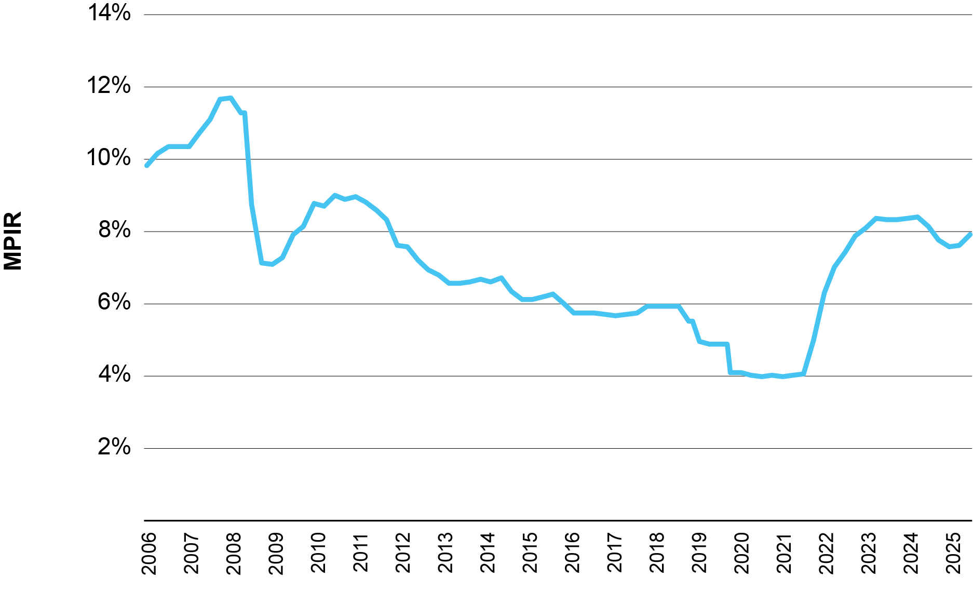
Source: Department of Health, Disability and Ageing www.agedcare.health.gov.au

Fluctuations in the MPIR create avoidable volatility and liquidity risks for providers, undermining confidence in capital investment. As described earlier, volatility in daily accommodation payments (DAPs) prevents this revenue from being treated as a reliable or bankable cashflow, limiting its role in financing new developments. Furthermore, because MPIR movements influence residents’ choice between lump‑sum and daily payments, declines in the MPIR can reduce incoming RAD inflows, increasing the risk that providers will face liquidity shortfalls when refunding RADs to departing residents. Consequently, the uncertainty arising from the MPIR incentivises providers to retain a higher proportion of financial assets to hedge against future declines in RAD inflows. It also creates inequitable outcomes between residents, as they can pay vastly different DAPs for the same room based on the MPIR when they entered care.
Submissions and consultations have suggested a fixed MPIR be adopted or, alternatively, that there be a floor set on the MPIR to ensure the DAP amount does not fall below a minimum level.
Previous reviews have cited potential problems with the MPIR but have not recommended an alternative amount or formula. One of the concerns in setting an alternative rate has been that there is no single rate that accurately reflects equivalence for all providers. Different providers have different capital structures, including different priorities and different costs of capital.
Given the limitations of the MPIR in setting equivalence and the fact that each provider faces different circumstances, the Review recommends an alternative approach. It is recommended that providers, instead, be able to set their own ‘conversion rate’ to define the relationship between the price of the lump sum and daily payment for a given room type.
Recommendation 7
The government should remove the MPIR as the required conversion rate between refundable accommodation deposits (RADs) and daily accommodation payments (DAPs).
- Providers should be able to set DAPs and RADs.
- Providers should be required to publish a conversion rate between DAPs and RADs for each room type on the My Aged Care website to ensure transparency and ease of comparison for consumers.
- Providers should be required to give prospective residents a standardised price offer letter that details the proposed DAP, RAD and conversion rate.
- Providers and consumers should be able to negotiate an agreed DAP or RAD price below but not exceeding the published price.
- The agreed DAP, RAD and conversion rate should be included in the Accommodation Agreement.
- The agreed conversion rate would be applied when determining the value of partial RAD/DAP combination payments.
- The conversion rate would also be applied when determining the value of refundable accommodation contribution (RAC) payments.
The MPIR should continue to be used to calculate the interest incurred by providers when refunding lump sums outside of the standard refund period.
This approach would give providers flexibility to match conversion rates to their own circumstances to better reflect their own costs of capital and relative preferences for lump sums or daily payments at any given time. For example, providers that are actively seeking to develop new homes may wish to attract more residents willing to pay a refundable deposit and so may set a higher conversion rate compared to those providers that are seeking to maximise cashflow by attracting DAP payers.
Under this approach, providers would be required to publish the price for their rooms as a refundable accommodation deposit and a daily accommodation payment on My Aged Care. The corresponding conversion rate would also be published on My Aged Care.
Importantly, the payment method would remain the choice of the resident. Existing rules that prevent providers from asking a resident to pay a lump sum prior to entry would remain in force. The government should also consider additional measures to prevent providers from pressing residents to pay by lump sum before or during their stay.
Residents and providers would continue to have the freedom to negotiate agreed room prices as long as the agreed price was less than the published price. This requirement would apply to both the lump sum and daily payment amount. Price negotiation may result in a change to the conversion rate from the published conversion rate. This is acceptable, as otherwise price negotiation would need to take place on both the RAD and the DAP rate even if the individual has a clear preference. It should be a requirement that the agreed price expressed as a RAD, the agreed price expressed as a DAP and the agreed conversion rate are all recorded in the accommodation agreement between the provider and the resident. The agreed conversion rate would then be applied in any future calculations of resident contributions, for example, if the resident opted to make a larger lump sum contribution in their combination payment.
No maximum or minimum conversion rate is proposed. Instead, it is proposed that market forces be relied upon to ensure that providers do not set very high or very low conversion rates that would greatly disadvantage residents that prefer to pay by one payment method over another. The government should ensure that there are sufficient tools and information available to support residents and should monitor the conversion rates published on My Aged Care.
Conversion rates would also apply to low means residents required to contribute to their accommodation costs rather than pay for them in full. As outlined above, all residents would be required to agree to a RAD, DAP and conversion rate prior to entry with this corresponding to an agreed conversion rate for that resident. If the resident is low means, which may not be known at the time of reaching the agreement, the daily accommodation contribution (DAC) they would be required to pay would be as determined by the means test with the required refundable accommodation contribution (RAC) worked out by applying the agreed conversion rate as follows:
RAC = DAC * 365 / CR
This approach has an advantage over current arrangements in that the conversion rate cannot change between the day the price agreement is made and the date of entry.
The MPIR should continue to be used for non-equivalence functions, including determining the interest payable by providers when refunding a lump sum. The Base Interest Rate applies when a provider refunds a RAD on time; if the refund is late, interest is paid at the higher MPIR for the period of delay.

Maximum accommodation price
The maximum accommodation price acts as a ‘soft cap’ on accommodation prices, requiring providers to seek approval for rooms above a legislated threshold. On 1 January 2025, following the Aged Care Taskforce final report, the government increased the maximum price that providers could charge for accommodation without approval from $550,000 to $750,000. This amount is to be indexed on 1 July each year, with the amount set to $758,627 from 1 July 2025 to 1 July 2026.
These were the first increases to the maximum price since it was introduced in 2014. This has significantly reduced regulation and red tape for providers: applications reduced from 770 in 2023–24 to 568 in 2024–25.
The Taskforce suggested this change would be a ‘prudent first step’ in reforming the maximum price. An argument could be put forward to remove the concept of a maximum price because it provides protection for those with greater capacity to pay. However, given the rapid growth in rooms priced above the previous threshold and the role that the maximum price may play in providing a pricing reference for the rest of the sector, the Review does not recommend removing the maximum price.
Currently, the maximum price is expressed as a RAD but flows through to DAP pricing through the MPIR that is applicable at the time. Given the recommendation of the Review to allow providers to set their own conversion rate, a reconsideration of the operation of the maximum price was required. Various options were considered, including:
- setting a maximum RAD only
- setting a maximum DAP only
- setting a maximum for both with the relationship defined by the MPIR or some other fixed or variable rate.
Of these options, setting a maximum DAP was the preferred approach. The Review considered it most appropriate to apply the protection to DAP prices because residents with insufficient assets to pay a RAD typically have fewer choices in both providers and payment method, making them more vulnerable to disadvantageous pricing behaviour. Given the limitations previously outlined in setting an equivalence rate for the whole sector, the Review also ruled out the option of setting maximum amounts for both.
Recommendation 8
The approved room price cap should be expressed as a maximum DAP instead of a maximum RAD.
The Review heard stakeholder feedback that changes to streamline the price approval process would reduce costs and provide greater confidence in the returns on investments in capital infrastructure.
Currently, approvals for prices above the maximum remain current for 4 years with the approved amount being indexed every year during that time. Providers are required to reapply for approval before the end of the 4-year period and these approvals are not always granted. The Review heard feedback of occasions where providers have sought to have a price renewed, which when rejected, caused the room price to revert to the maximum accommodation price.
It is recommended that the 4-year approval period be abolished with approvals lasting indefinitely with annual indexation. This will significantly cut unnecessary red tape for providers and give them greater confidence of the lifetime return on their investment when assessing prospective new builds. The government should also consider whether there are other ways to streamline the approvals process.
Recommendation 9
The government should simplify the process by which registered providers apply for prices above the maximum accommodation price. Consideration should be given to whether the Independent Health and Aged Care Pricing Authority (IHACPA) is the most appropriate body to administer applications.

Recommendation 10
The need for registered providers to reapply for approval for prices above the maximum accommodation price every four years should be removed. Once a room price has been approved, the value of that room should increase by the CPI going forward, unless:
- The registered provider lowers the price for a room and advertises the new price on the My Aged Care website; or
- The registered provider seeks to increase the price of the room beyond the CPI adjustment. At this point a new application would be required.

Consideration of a floor price
As requested in the Terms of Reference, the Review considered whether there is a need for a mandated minimum room price (a ‘floor’) for non‑supported residents. Currently, while price regulation establishes a soft cap on the maximum amount a resident can be charged, there is no corresponding minimum price.
In some instances, this can result in non‑supported residents paying less for accommodation than the contribution required of a partially supported resident, or less than the amount the government pays on behalf of a fully supported resident occupying the same room.
Such pricing may also be financially unsustainable if providers agree to prices below the cost of delivering accommodation services, which can exacerbate viability challenges. Where prices fall below the value of the accommodation supplement, the supplement is effectively cross-subsidising non-supported residents.
The Review received mixed feedback from the sector regarding the introduction of a mandatory floor price. Submissions in favour argued that a floor price could promote equity of contributions between non-supported and supported residents and reduce instances of cross-subsidisation. Those opposed noted that a floor price may create unintended and adverse consequences for both providers and residents. For example, a minimum price would reduce pricing flexibility, may not adequately account for legitimate cost variations in accommodation offerings, and could inadvertently limit access to quality accommodation for non-supported residents by increasing prices beyond affordability, particularly in rural or remote areas.
Given that instances of providers charging prices below the level of the accommodation supplement are likely to be concentrated within a small subset of homes, the Review considers that introducing an across-the-board floor price would be an unnecessarily broad market intervention that carries risks of unintended consequences, particularly in older and more rural homes. As such, the Review does not recommend introducing a floor price.
The Review also notes that the number of providers publishing and agreeing prices below the accommodation supplement amount may decrease as a result of a recent change implemented under the Aged Care Act 2024. Under this change, residents entering care on or after 1 November 2025 cannot be required to pay more than the amount they initially agreed. This is expected to increase the focus on pricing among homes with high proportions of supported residents, thereby further weakening the case for a floor price.
Nonetheless, providers are expected to set accommodation prices for non‑supported residents at levels that appropriately cover the cost of delivering accommodation services. Where providers choose to price below cost, it would be unreasonable for the government to provide additional viability support. Where the full cost of accommodation is beyond a resident’s means, the Department should ensure the appropriate application of hardship provisions for non‑supported residents who are unable to meet their accommodation costs.
In addition, to support the monitoring of appropriate pricing practices, any future data collections on accommodation services, including a proposed census, should prioritise reviewing homes that do not qualify for the higher accommodation supplement.
Recommendation 11
The government should not introduce a mandatory minimum room price for non-supported residents.

Chapter 5: Preserving equity of access for low means residents
Ensuring older people of varying financial means can access residential aged care requires that homes have both the financial capacity and the incentive to admit supported residents. This depends on government funding that adequately covers the efficient cost of providing accommodation for supported residents.
Over time, expectations of the accommodation supplement have expanded. It is now implicitly relied upon to:
- cover the daily cost of accommodation, including maintenance of rooms and shared infrastructure
- support long-term capital refurbishment and replacement
- enable efficient providers to earn a reasonable margin
- provide incentives for providers to admit supported residents.
The Review considers that a single policy instrument cannot feasibly or efficiently meet this diversity of objectives, particularly as capital costs and market‑based accommodation prices have risen.
Following consultation, the Review concluded that the capital costs for supported residents should not be met through a large increase in the accommodation supplement, as this would be a poorly targeted means of increasing supply. Instead, capital support should be delivered through dedicated mechanisms, including zero-interest loans, capital subsidies and targeted grants (see Chapter 3).
At the same time, some adjustments to the accommodation supplement are warranted to ensure efficient providers can sustainably meet the operating costs of accommodating supported residents. The Review proposes that such adjustments include the removal of the lower tiers, a modest increase in the base rates and HAS and an additional loading for homes with high proportions of supported residents.
Finally, to preserve equity of access, the Review recommends introducing an additional tier to the HAS to strengthen incentives for admitting supported residents. Over the longer term, equitable access should be sustained through adequate supply and appropriate funding arrangements, including capital subsidies and a restructured accommodation supplement. In the interim, while supply remains constrained, the Review proposes a temporary regulatory mechanism requiring existing homes to maintain supported‑resident ratios at levels consistent with 2024–25.

Overview of current arrangements
The accommodation supplement is a central taxpayer-funded mechanism within Australia’s residential aged care system, designed to support equitable access for older people who cannot afford the full cost of accommodation. It is paid to approved providers on behalf of residents who have been assessed as not being able to meet all or part of their own accommodation costs.
Currently, the government pays some or all the accommodation costs for around 43 per cent of residents. This proportion is relatively consistent across the sector, with about 50 per cent of homes operating with a supported resident ratio between 40 and 60 per cent (see Figure 5.1). It is also consistent among provider types (see Figure 5.2).
Figure 5.1 Distribution of homes, by proportion of low means residents
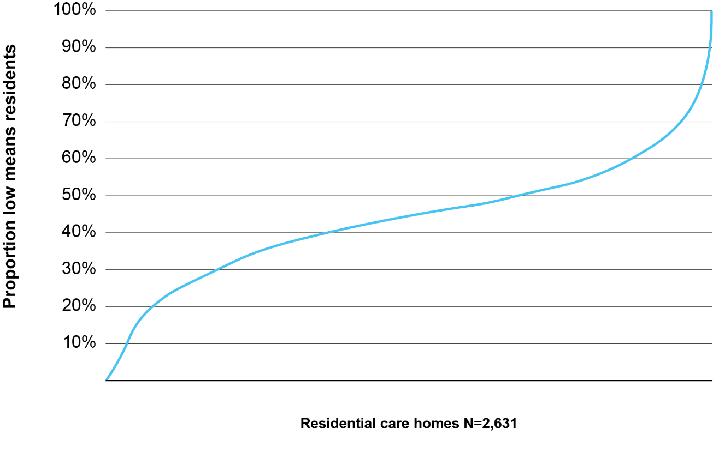
Source: Department of Health, Disability and Ageing

Figure 5.2 2024–25 Proportion of low means residents by provider type
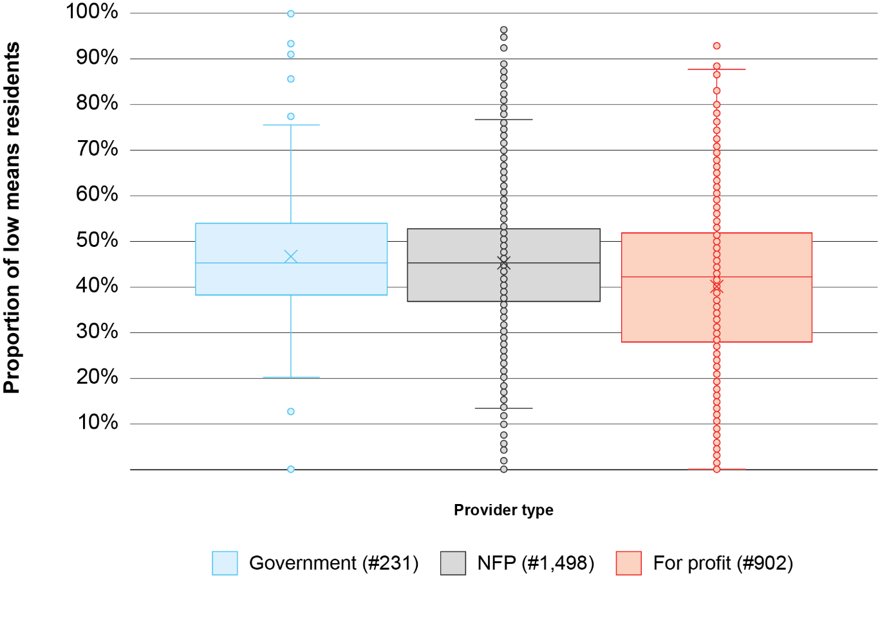
Source: Department of Health, Disability and Ageing
Eligibility for the accommodation supplement is determined based on the resident's financial circumstances at the time of entry into care. Residents entering care on or after 1 July 2014 are assessed using a combined assets and income means test, which calculates their daily means-tested amount at their entry date. If this amount is less than the maximum accommodation supplement rate applying on that day, the resident qualifies for the supplement and is classified as a low means resident.
There are currently three maximum daily rates of accommodation supplement that a provider may receive for eligible residents. Within each of the three rates, the maximum rate payable is reduced by 25 per cent if, over a calendar month, fewer than 40 per cent of residents in the home are supported residents. This 40 per cent supported resident rule was designed to strengthen incentives for providers to admit residents of low means. The rates are based on the building status of the residential aged care home:
- a higher accommodation supplement rate is payable in homes that have been significantly refurbished or newly built on or after 20 April 2012
- a standard accommodation supplement rate is payable in homes that are neither significantly refurbished, nor newly built, but which meet the building requirements set out in Schedule 1 of the Aged Care (Transitional Provisions) Principles 2014
- a lower accommodation supplement rate is payable in homes that do not meet these two requirements.
Table 5.1 shows the proportion of homes receiving each rate, as of 30 June 2025. This shows that 86 per cent of residential aged care homes currently receive one of the two HAS rates, a further 14 per cent receive the standard base rates and no homes receive the lowest tier. Furthermore, 72 per cent of homes have a supported resident ratio of at least 40 per cent.

Table 5.1 Accommodation supplement rates and proportion of homes receiving each rate (maximum)
Eligibility | Daily supplement rates  (applicable from  20 March 2026) | Proportion of homes  (among those receiving the accommodation supplement at  30 June 2025)
If the service is significantly refurbished or newly built on or after 20 April 2012
40% or more of the permanent residents in the facility in the relevant payment period are low means care recipients, supported residents, or residents for whom concessional resident supplement is payable | $72.30 | 62%
Less than 40% of the permanent residents in the facility in the relevant payment period are low means care recipients, supported residents, or residents for whom concessional resident supplement is payable | $54.23 | 24%
If the service meets building requirements in Schedule 1 of the Aged Care (Transitional Provisions) Principles 2014
40% or more of the permanent residents in the facility in the relevant payment period are low means care recipients, supported residents, or residents for whom concessional resident supplement is payable | $47.15 | 10%
Less than 40% of the permanent residents in the facility in the relevant payment period are low means care recipients, supported residents, or residents for whom concessional resident supplement is payable | $35.36 | 4%
If the service does not meet those requirements
40% or more of the permanent residents in the facility in the relevant payment period are low means care recipients, supported residents, or residents for whom concessional resident supplement is payable | $39.60 | –
Less than 40% of the permanent residents in the facility in the relevant payment period are low means care recipients, supported residents, or residents for whom concessional resident supplement is payable | $29.70 | –
Source: Department of Health, Disability and Ageing

Increase to the accommodation supplement
To assess whether the accommodation supplement adequately covers the costs of accommodation for supported residents, the Review analysed sector-wide expense data from the Department of Health, Disability and Ageing. Accommodation expenses were disaggregated into three categories, consistent with the Financial Report on Aged Care Services:
- routine maintenance costs
- depreciation, rent and interest
- an allocation of administrative costs to accommodation services.
Assessing the total cost of accommodation, including depreciation, is important when considering the adequacy of the higher accommodation supplement. Many existing homes have previously undertaken capital works with the expectation that the HAS would contribute to funding those costs, with the depreciation expense reflecting the capital cost of these works, spread over the useful life of the assets.
The analysis showed substantial variability in cost estimates, particularly in the allocation of administrative overheads. For this reason, median values, rather than averages, were used to represent sector‑wide cost distributions.
In 2024–25, the median total cost of accommodation for homes qualifying for the HAS was $57.36 per resident per day. The median routine maintenance costs were $12.54, with a further $21.61 for depreciation, rent and interest and $16.81 for the allocation of administration. These costs were generally consistent with median estimates for the remaining homes that did not qualify for the HAS in 2024–25.
Based on this analysis, the Review concluded that the current value of the higher accommodation supplement is inadequate for homes receiving the lower rate due to not having a supported resident ratio of 40 per cent or greater. To address this, it recommends a $5 per resident per day increase to the HAS rates.
To maintain the existing relativity between the HAS and the base accommodation supplement, this $5 increase should also be applied to the base supplement (i.e. lifted to $52.15). The Review recommends removing all existing tiers below that value.
The Review acknowledges that a portion of homes receiving the base supplement may have accommodation costs greater than $52.15 per day. As part of the census described in Chapter 3, the government should prioritise identifying opportunities to upgrade the capital infrastructure of these homes, if necessary, enabling them to qualify for the HAS.

Restructuring the higher accommodation supplement
During the consultation period, stakeholders raised concerns about the effectiveness of the 40 per cent supported resident ratio rule as an incentive to ensure access for supported residents.
The single threshold was seen as a blunt and sharp incentive structure. Homes that fall just short of the 40 per cent threshold due to small, uncontrollable fluctuations in their resident mix could face a substantial loss of accommodation funding. This issue can be particularly acute for smaller homes, where the proportion of supported residents can shift significantly when one or two supported residents leave care and are not immediately replaced by supported residents. In 2015–16, 15.3 per cent of homes fluctuated either above or below the 40 per cent supported resident ratio during the year.
Also, in some areas, local socio‑economic factors make achieving the 40 per cent threshold difficult or unrealistic, weakening the intended effect of the rule. As shown in Figure 5.3, there are several local areas in Australia (measured at the Statistical Area Level 3), in which the average supported resident ratio is below 30 per cent.
The current structure also targets incentives too narrowly. The financial incentive to admit supported residents is strongest for homes at or near the 40 per cent threshold. Homes well below 40 per cent may have limited incentive to lift their ratios and may instead opt to maximise their proportion of RAD or DAP payers. Likewise, homes already above the threshold may have little financial incentive to increase their ratio further.
To address these issues, the Review recommends introducing an additional tier in the HAS for homes with between 30 and 39 per cent supported residents. This would create a three-tiered HAS, which, in combination with the recommended $5 increase, would be initially set at:
- $59.23 for homes with a supported resident ratio of 0–29 per cent
- $66.00 for homes with a supported resident ratio of 30–39 per cent
- $77.30 for homes with a supported resident ratio of 40 per cent or higher.
A three-tiered HAS would reduce the financial impact for homes falling marginally below the 40 per cent threshold and provide more graduated incentives for homes below 30 per cent to increase their supported resident ratio. A summary of the proposed changes to the accommodation supplement structure and rates is provided in Table 5.2.
Recommendation 12
The higher accommodation supplement (HAS) should be increased by $5 per day. The HAS should have three tiers, based on the proportion of supported residents within a residential care home:
- 0–29 per cent – new rate of $59.23
- 30–39 per cent – new band set at $66.00
- 40 per cent or greater – new rate of $77.30

Recommendation 13
The government should set the base accommodation supplement at a rate $5 higher than the maximum amount payable to homes that meet building requirements as set out in section 230-15 of the Aged Care Rules 2025 ($52.15) and remove all existing tiers below that value.

Figure 5.3 Proportion of supported residents by SA3 in 2024–25
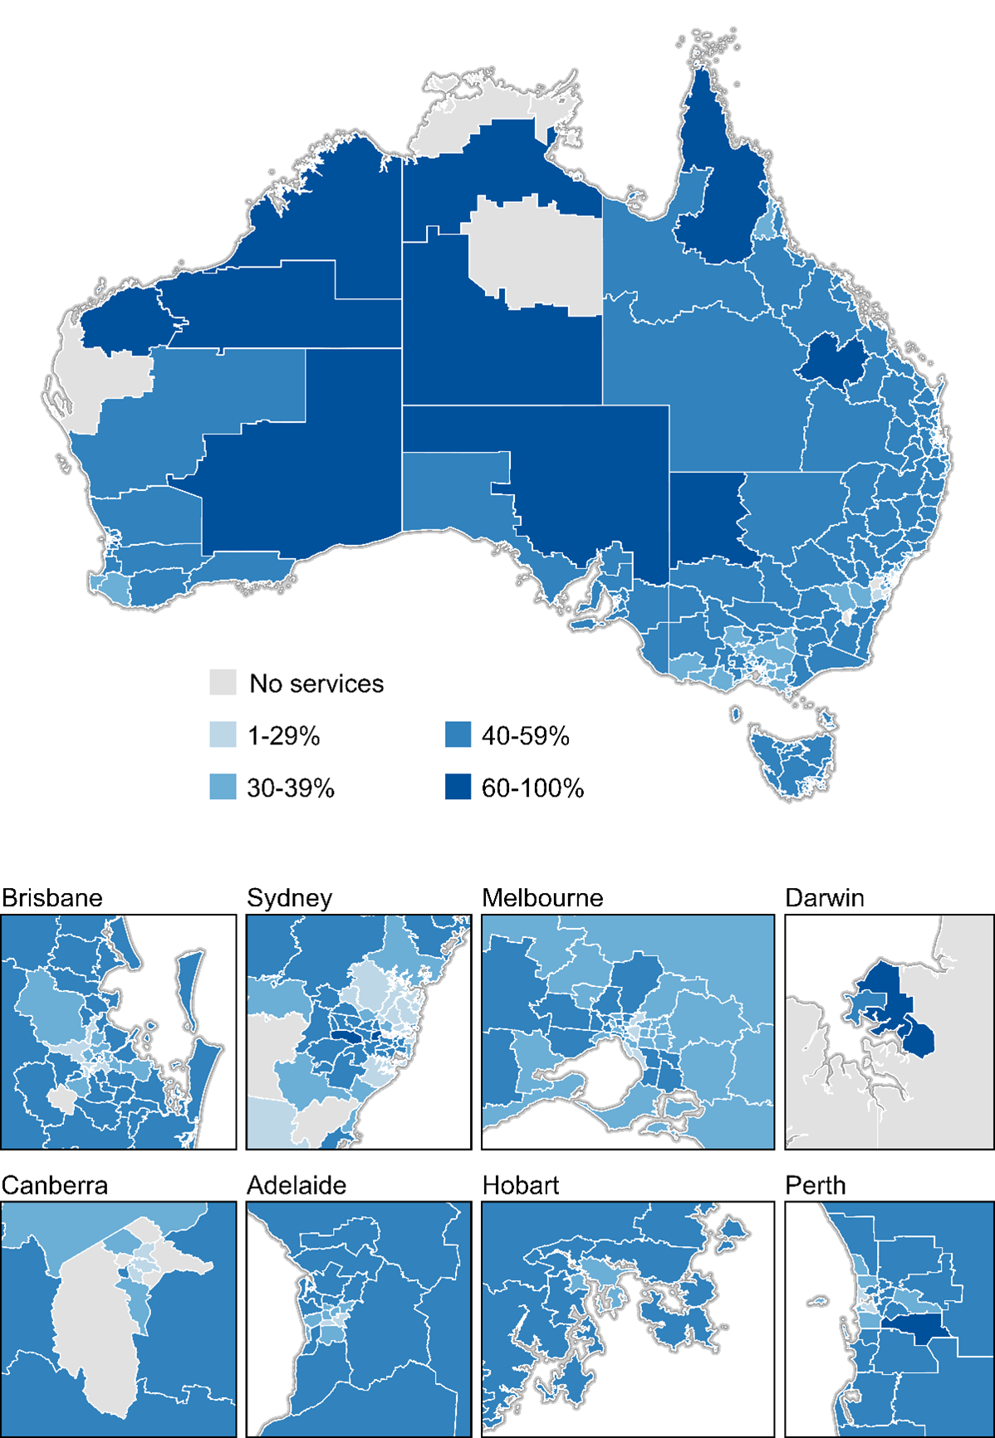
Source: Department of Health, Disability and Ageing

Table 5.2 Proposed changes to the accommodation supplement structure and rates
Higher accommodation supplement
Eligibility | Proportion of homes (among those receiving  the accommodation supplement on  30 June 2025) | Daily supplement rates  (applicable from  20 March 2026) | Recommended supplement rates from 1 July 2026
If the service is significantly refurbished or newly built on or after 20 April 2012
40% or more of the permanent residents in the facility in the relevant payment period are low means care recipients, supported residents, or residents for whom concessional resident supplement is payable | 62% | $72.30 | $77.30
30–39% of the permanent residents in the facility in the relevant payment period are low means care recipients, supported residents, or residents for whom concessional resident supplement is payable | 12% | $54.23 | $66.00
below 30% of the permanent residents in the facility in the relevant payment period are low means care recipients, supported residents, or residents for whom concessional resident supplement is payable | 12% | $54.23 | $59.23
Base accommodation supplement
Eligibility | Proportion of homes (among those receiving  the accommodation supplement on  30 June 2025) | Daily supplement rates  (applicable from  20 March 2026) | Recommended supplement rates from 1 July 2026
If the service is not significantly refurbished or newly built on or after 20 April 2012
Permanent residents in the facility in the relevant payment period are low means care recipients, supported residents, or residents for whom concessional resident supplement is payable | 14% | $47.15 | $52.15
Source: Department of Health, Disability and Ageing
The Review also considered calculating supported‑resident ratios quarterly rather than monthly to smooth fluctuations. Feedback from stakeholders indicated that this change would not materially resolve the volatility experienced by some homes.
Nonetheless, under current arrangements, fluctuations of a home’s supported resident ratio around the 40 per cent threshold can change the amount of accommodation contribution a partially supported resident can be asked to pay. This is because the maximum daily accommodation contribution a partially supported resident can be charged is limited to the lesser of the agreed price, the amount determined by the means test or the amount of accommodation supplement the home would be entitled to if the resident was fully supported. In some cases, the amount a partially supported resident can be asked to pay may change month-to-month because of fluctuations in the resident mix of the home. These fluctuations also complicate the administration of accommodation contributions for providers, particularly where a resident has paid by a refundable accommodation contribution that needs to be partially refunded when the amount of accommodation supplement the home is entitled to is reduced.
A three-tiered HAS may increase these adverse effects, as homes’ supported resident ratio may fluctuate around both the 30 and 40 per cent thresholds.
To reduce the effect of ratio fluctuations for partially supported residents and the related administration for providers, the Review recommends simplifying the determination of daily accommodation contributions. Specifically, the maximum amount of accommodation contribution a person can be asked to pay should no longer be linked to the proportion of supported residents in the home. This change would result in an increase in accommodation contributions for some residents, but contributions would continue to be limited by the means-test. It is appropriate that government structure its payments to incentivise providers taking in supported residents but a reduction in supported residents does not represent a reduction in quality of accommodation that should be reflected in resident contributions.
Recommendation 14
Partially supported residents should be asked to pay the lesser of:
- $52.15 for homes not eligible for the higher accommodation supplement and $77.30 for homes that are eligible for the higher accommodation supplement; or
- the amount determined by their means test for accommodation; or
- the price they agreed with the provider.

High supported resident ratio loading
During the consultation, stakeholders raised concerns about the adequacy of accommodation funding for homes with very high supported resident ratios. Specialised service providers noted that these homes often faced higher operational costs of providing accommodation, particularly for routine maintenance. Residential aged care homes located in remote communities may also be more exposed to extreme weather events and face higher capital upgrade costs due to their geographic location. Neither the base accommodation supplement nor the HAS may be sufficient to support the maintenance required to keep these homes fit for purpose and operational.
In addition, due to their resident mix, these homes are unlikely to benefit materially from the recent changes to accommodation payment arrangements under the Aged Care Act 2024, including RAD retention, DAP indexation and increases in the maximum room price.
The Review also recognises that additional financial support may be required to encourage some homes to accept significantly more supported residents above the 40 per cent threshold and to cater for particular cohorts, such as people experiencing homelessness and residents in remote communities.
Currently, 16 per cent of homes have a supported resident ratio of 60 per cent or greater. While these homes tend to service communities in more remote areas (see Figure 5.3 above), there are residential aged care homes above this threshold operating in every major city. This distribution indicates that a location‑based funding mechanism would not be sufficiently targeted.
The Review recommends introducing a new payment for residential aged care homes with a supported resident ratio of 60 per cent or greater, to assist with accommodation expenses. This payment should be a loading that is fully funded by government, not subject to the means test, and paid in addition to the applicable base accommodation supplement or HAS rate for the home. It is recommended that the initial value of this payment be set at $20 per supported resident per day.
Recommendation 15
A new payment should be introduced for residential aged care homes with a high proportion of supported residents, namely 60 per cent or greater. It is recommended that the loading should be valued at $20 per supported resident per day and subject to the same indexation mechanism as the accommodation supplement.

Summary of payments for supported residents
In combination, the recommended changes to the government’s contributions for supported residents, including the $5 increase, restructure of the HAS, high supported resident loading and new capital subsides, will significantly increase the accommodation payments for supported residents, across both existing homes and those newly built or refurbished.
As shown in Table 5.3, total payments will increase by $5 to $25 for existing homes that make no further capital upgrades, and by $20 to $55 for homes that are newly built, significantly refurbished or extended from 2025 onwards. Together, these changes will result in total payments for supported residents ranging from $52.15 to $127.30 per resident per day
Although not the specific intent of the reforms, which are designed to meet targeted policy objectives, the combined effect of these payments will indirectly and materially narrow the gap between funding for supported residents and the prices paid by non‑supported residents in many homes at different stages of their capital lifecycle.
Table 5.3 Summary of changes in payments for supported residents
 | Supported resident ratio | Current accommodation payment |  | New accommodation payments |  |  |  |  | Change in funding
 | Supported resident ratio |  |  | Accommodation supplement | Loading for 60%+ |  | Capital subsidy | New total accommodation payment | Change in funding
Existing home,  not refurbished | <40% | $35.36 |  | $52.15 |  |  |  | $52.15 | $16.79
Existing home,  not refurbished | 40–59% | $47.15 |  | $52.15 |  |  |  | $52.15 | $5.00
Existing home,  not refurbished | >60% | $47.15 |  | $52.15 | $20.00 |  |  | $72.15 | $25.00
Existing home, already significantly refurbished | <30% | $54.23 |  | $59.23 |  |  |  | $59.23 | $5.00
Existing home, already significantly refurbished | 30–39% | $54.23 |  | $66.00 |  |  |  | $66.00 | $11.77
Existing home, already significantly refurbished | 40–59% | $72.30 |  | $77.30 |  |  |  | $77.30 | $5.00
Existing home, already significantly refurbished | >60% | $72.30 |  | $77.30 | $20.00 |  |  | $97.30 | $25.00
Existing home, significantly refurbished after 2025 | <30% | $54.23 |  | $59.23 |  |  | $15.00 | $74.23 | $20.00
Existing home, significantly refurbished after 2025 | 30–39% | $54.23 |  | $66.00 |  |  | $15.00 | $81.00 | $26.77
Existing home, significantly refurbished after 2025 | 40–59% | $72.30 |  | $77.30 |  |  | $15.00 | $92.30 | $20.00
Existing home, significantly refurbished after 2025 | >60% |  | $72.30 | $77.30 | $20.00 | $15.00 |  | $112.30 | $40.00
Newly built home | <30% |  | $54.23 | $59.23 |  | $30.00 |  | $89.23 | $35.00
Newly built home | 30–39% |  | $54.23 | $66.00 |  | $30.00 |  | $96.00 | $41.77
Newly built home | 40–59% |  | $72.30 | $77.30 |  | $30.00 |  | $107.30 | $35.00
Newly built home | >60% |  | $72.30 | $77.30 | $20.00 | $30.00 |  | $127.30 | $55.00
Source: Department of Health, Disability and Ageing

Maintaining access for supported residents
Ensuring that supported residents can continue to access residential aged care while supply remains constrained is a key concern of the Review. Even with the proposed payment uplifts, supply pressures may create incentives for providers to prioritise access to non-supported residents in their existing homes, particularly over the short to medium-term.
During consultations, stakeholders raised concerns that the removal of supported resident minimum ratios for Aged Care Planning Regions (ACPRs) under the Aged Care Act 2024 could risk a decline in the proportion of supported residents across the sector. Against this, internal Department of Health, Disability and Ageing data shows that these ratios have consistently been met or exceeded at the regional level. The Review also acknowledges that enforcing regional-level thresholds is challenging where multiple providers operate within the same area.
In the longer term, increasing the supply of residential aged care places is the most effective mechanism to ensure equity of access for residents of differing means. In the near term, given continued supply constraints and the time lags required for new supply to become operational, the Review considers that a temporary regulatory mechanism is warranted to safeguard access for older people of low means.
To prevent a decline in the proportion of supported residents, both at the sector level and within each geographical location, the Review recommends that the government require existing homes to maintain their average 2024–25 supported resident ratio for an initial period of at least 3 years. To account for natural variation within a home, particularly in a smaller home where the departure of even a single resident can materially affect supported‑resident proportions, this requirement should be assessed on an annual average basis and include a five‑percentage‑point buffer.
Recommendation 16
The government should introduce a requirement whereby the proportion of supported residents within a residential care home, averaged over the year, does not fall below 5 percentage points of the home’s average proportion of supported residents in 2024–25.
- This requirement should be in place for an initial period of three years, and renewable, during the period that significant growth in supply is required.
- This requirement will apply only to residential aged care homes operating prior to 1 July 2025.

Chapter 6: Improving consumer information and protection
Throughout the consultation period, the Review heard that many older Australians have not planned for aged care costs and have limited knowledge about aged care pricing when they find themselves in need of a place.
There are many pathways into residential aged care. For a significant number of older Australians, their entry into aged care is precipitated by a sudden unexpected event, for example a significant fall or a stroke, which makes a return to their home untenable. These people can often find themselves needing to make quick decisions about how to finance the accommodation element of residential aged care during intensely stressful periods.
The Review heard that some older people are not aware that there are different payment options for aged care available and believe that a RAD payment is the only way to pay for aged care. This leads to concerns they will not be able to pay a RAD and will either not be able to afford residential care, or their children will be forced to pay for them. Beyond the option of a DAP, or a combined payment, some older Australians are also unaware of the fact if they are deemed to be of low means, the government will provide for some, if not all, of their accommodation costs.
Recent changes to residential aged care accommodation have improved the sustainability and viability of residential care funding. However, these changes have added to the complexity of decision making for incoming residents. For example, because of the introduction of RAD retention, incoming residents and their families may need to undertake complex calculations to determine their preferred payment method.
Due to the complexity of funding arrangements, in addition to the limited knowledge many Australians have in relation to aged care accommodation pricing, and the fact that a significant proportion of people entering into residential aged care do so at times of intense stress with time pressures applying, it is critically important that appropriate protections and accessible and reliable information for consumers are in place.

Informing older Australians before they need residential aged care
The Review heard that many older people have not planned for their potential future entry into residential aged care. Consequently, they confront the complexities of the system, including the payment alternatives for accommodation, at a time of great stress and vulnerability.
Providing older people at an early stage with written materials, explaining how the aged care system works and what they may be required to pay, as well as the way those payments can be made, would assist in ensuring people could develop a plan prior to entry into aged care.
The Western Australian Government’s Time to Think program provides support and resources for older people discharged from hospital to understand and consider their options. The Review encourages other jurisdictions to consider the applicability of similar programs.
The Review acknowledges that there is significant material provided by the Department of Health, Disability and Ageing regarding residential aged care accommodation pricing, which is available online. However, the Review notes many older Australians are not comfortable online (see Figure 6.1).

Figure 6.1 Proportion of respondents accessing government services using an app in the last 6 months by age group
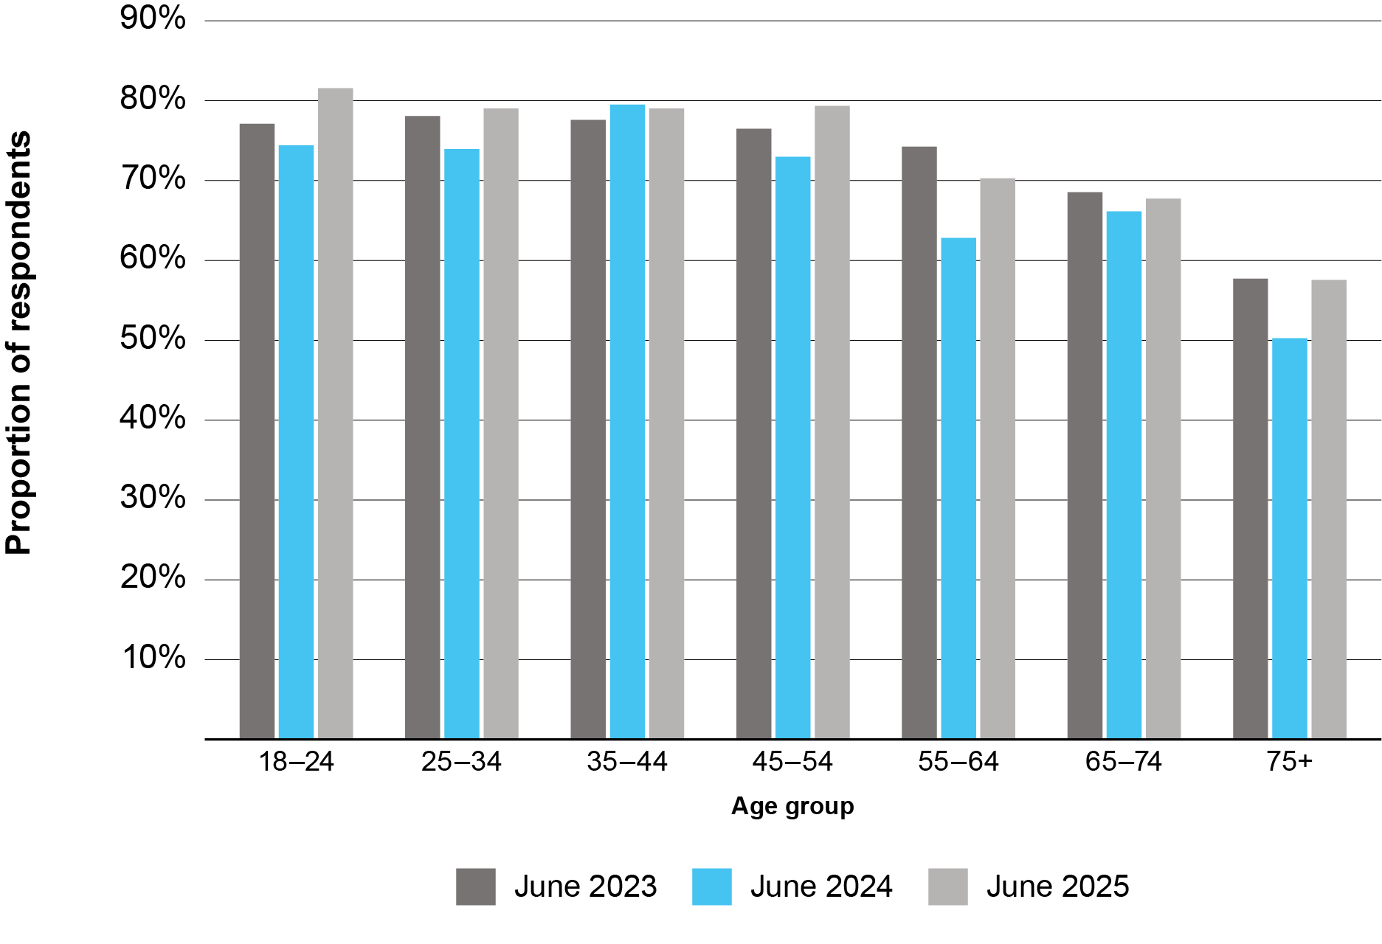
Source: Australian Communications and Media Authority (2026), Communications and media in Australia: How we use the internet | ACMA

The Review considers that it would be preferable to provide an older person with material well in advance of their entry into residential care. Either the first time an individual accesses the aged care system for an assessment, or at the time an individual meets with their GP for a 75+ health assessment, are potentially appropriate times. The material should include information on the payment choices people will need to make on entering residential care, and the guidance and assistance available to assist them in making that decision, including:
- their contributions to the costs of the aged care services they receive
- the various payment methods for residential aged care accommodation
- guidance on accessing independent financial advice
- accessing information and cost calculations through Services Australia
- the need to ensure supported decision-maker arrangements are in place
- their rights under the Aged Care Act 2024.

Recommendation 17
The government should develop a booklet for older Australians outlining the way accommodation pricing in residential care works, the choices available to them in terms of paying for their accommodation, and the assistance available to them in making that choice.
The booklet should be available in both print and electronic form and updated as appropriate.
The government should consider which is the most appropriate time to provide older Australians with a hard copy of the booklet.

Ensuring timely access to government assistance with information
Services Australia offers a free Financial Information Services (FIS) to Australians. Services Australia staff can explain how:
- financial products work
- a change to a person’s circumstances can affect their financial circumstances, in both the short and long term
- to find resources to help with financial matters.
FIS personnel can only provide information, not financial advice.
Services Australia also provides Aged Care Specialist Officers (ACSOs), as part of the My Aged Care face-to-face services. Appointments are available in-person or via video chat. ACSOs can assist by:
- providing in-depth information on the different types of aged care services
- referring an older Australian to an assessment organisation for an aged care assessment
- helping an older Australian appoint a registered supporter for My Aged Care
- providing financial information about aged care services
- connecting an older Australian to local support services.
As with FIS personnel, ACSOs can only provide information, not financial advice.
Through the consultation period, the Review received submissions that these independent sources of financial information are valuable, but not available in all locations.
Recommendation 18
The government should consider:
- expanding the Aged Care Specialist Officer (ACSO) and Financial Information Service (FIS) programs, to ensure they can meet the needs of older people in Australia; and
- ensuring that when FIS personnel provide information on retirement, preliminary information on aged care is also offered to encourage Australians to begin thinking about the costs of aged care.

Chapter 7: Areas for further work
Through its consultations and the submissions received, the Review was presented with a range of adjacent issues relating to the operation of the aged care system as a whole. These included: margins in residential aged care (including care services); infrastructure that goes across residential care, home care and retirement living; and the ability of the sector to adapt to future challenges given workforce constraints and an evolving technological horizon.
While not exhaustive, the Review considers that the following issues are sufficiently related to its scope to suggest that the Department of Health, Disability and Ageing consider undertaking further work including, where appropriate, with colleagues at state/territory level.

Innovation of the built environment
The Review notes that the built environment of residential aged care homes plays a significant role in supporting high quality care, providing a comfortable home for residents to live in, and improving the working environment for care workers. This fact is already reflected in Australian Government policy through the National Aged Care Design Principles and Guidelines and Standard 4: The Environment, of the aged care quality standards.
As noted by Royal Commission into Aged Care Quality and Safety, the government has a key role to play in supporting innovation through its policy and funding arrangements and should engage with the sector to explore opportunities to support and implement innovation. These activities are also consistent with the government’s existing overarching agenda for the care and support economy.

Harmonisation with retirement living
While the retirement living sector is predominantly regulated through state and territory legislation, the Review acknowledges it forms a key part of the ageing system in Australia, with many residential aged care providers operating in all three major aged care areas (i.e. in-home care, retirement living and residential aged care). Many residents in retirement living settings receive Australian Government funded or subsidized in-home care services, which is expected to continue under the newly implemented Support at Home program. There is also shared jurisdiction between the Commonwealth and States and Territory governments, particularly in the areas of consumer protection and the National Construction Code, which defines the building specifications that facilities need to meet to be classified as residential care or residential aged care.
Further, there is a significant and growing proportion of aged care homes co-located with retirement living villages. The growing integration of the residential aged care sector and the retirement living sector can also be seen in the recent changes introduced by the South Australian Government, which redefined residential aged care homes as essential infrastructure and included co-located retirement villages in that definition.
As shown in the 2011 Productivity Commission report Caring for Older Australians, the retirement living sector can form a key middle part of the ageing journey. The Retirement Living Council (RLC) estimating that around 250,000 Australians live in these settings, making it larger by population than the residential aged care sector. The RLC also estimates that the retirement living sector could delay the need for residential aged care services by up to two years for 11,600 residents..
These facts indicate that at the sector level, capital investment decisions in the retirement living sector impact those made in the residential aged care sector, and that there are synergies and opportunities for the government to consider how the two can be better integrated in a holistic aged care system.

Ensuring private sector financial advice is up to date and independent
The Review acknowledges that the challenges older people face in understanding the costs and financial impact of residential aged care accommodation can lead to situations in which providers and their staff are asked for information similar to the provision of financial advice. It is the responsibility of providers to both ensure their staff do not provide financial advice to prospective and current residents or their families and representatives, and that information provided in relation to aged care costs is accurate.
The Review acknowledges that the Financial Advisers Association of Australia offers an aged care specialist designation for financial planners who complete the Aged Care Steps Accredited Aged Care Professional program. To maintain the designation, an adviser must complete nine continuing professional development (CPD) hours in the area of aged care. These nine hours are part of the required 40 hours of CPD training required annually for financial advisers. The complexity of accommodation pricing and the impact the method of payment can have on an individual, is such that the Review considers that financial advice should only be offered by independent financial advisers with an aged care specialist designation.
Further, the Department should work with the Financial Advisers Association of Australia to ensure that the Aged Care Steps Accredited Aged Care Professional program, and the specific aged care elements of the continuing professional development for financial advisers, contain accurate and up to date information regarding aged care costs, choices available to older Australians in terms of options for residential accommodation payment methods, and the possible financial impacts of those options.

Appendices

Appendix 1: Cameos on accommodation supplement and capital subsidies changes

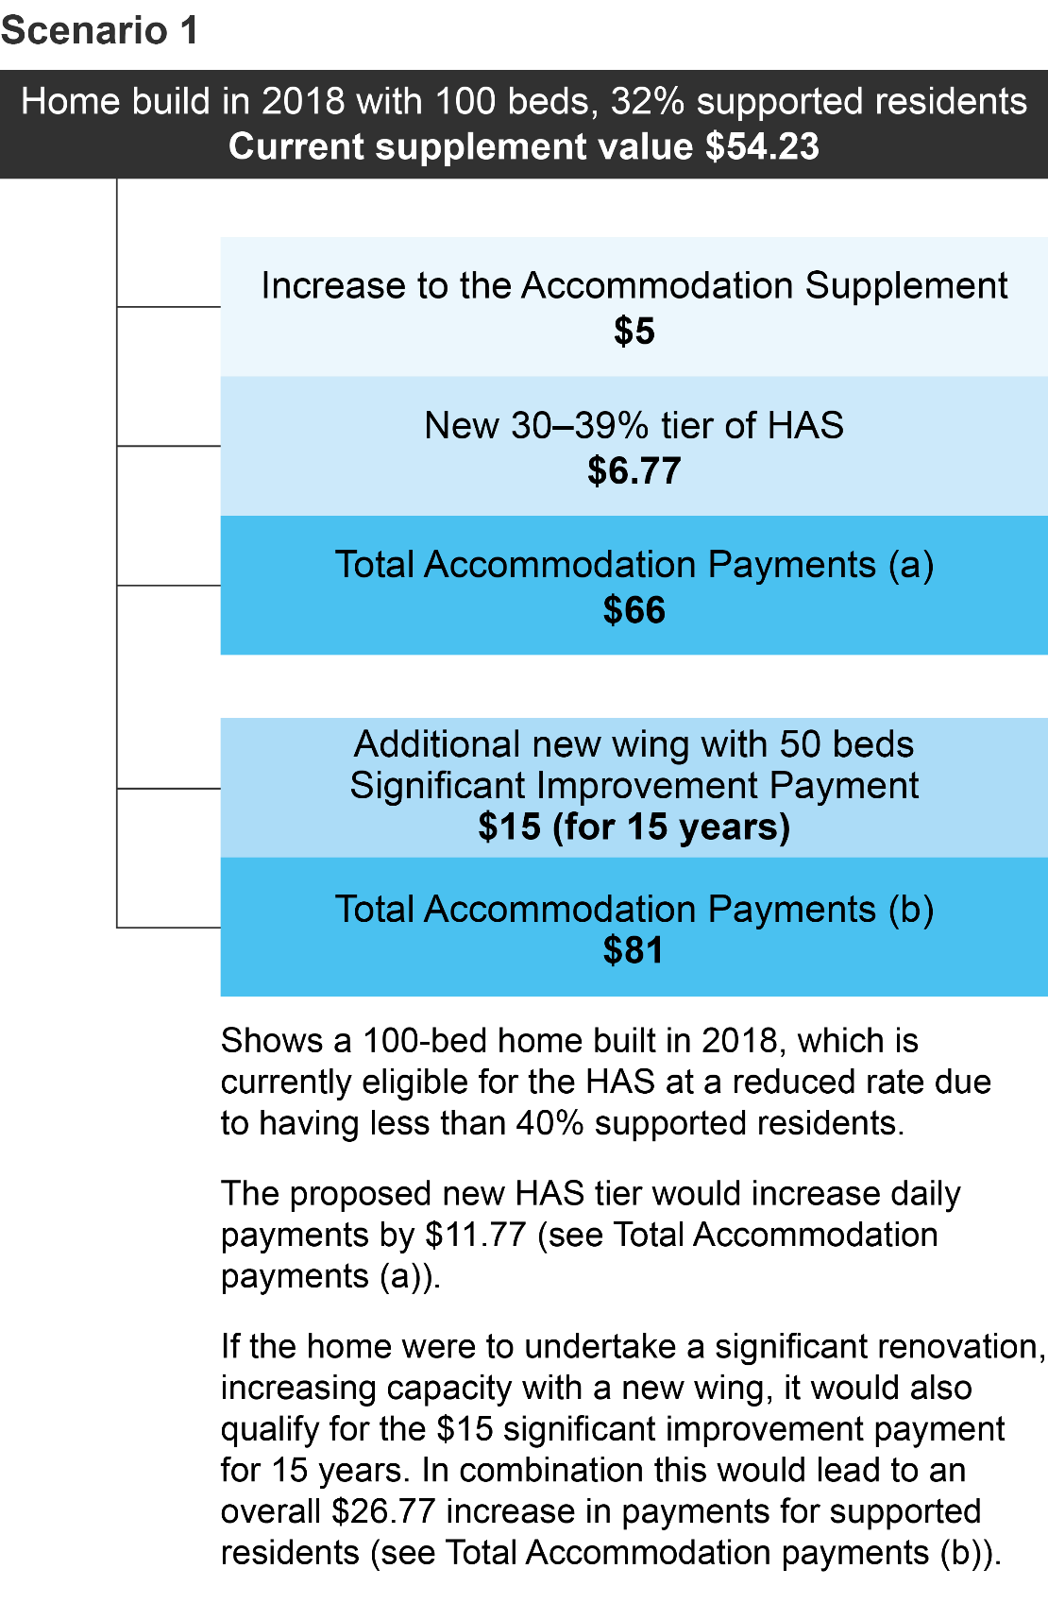
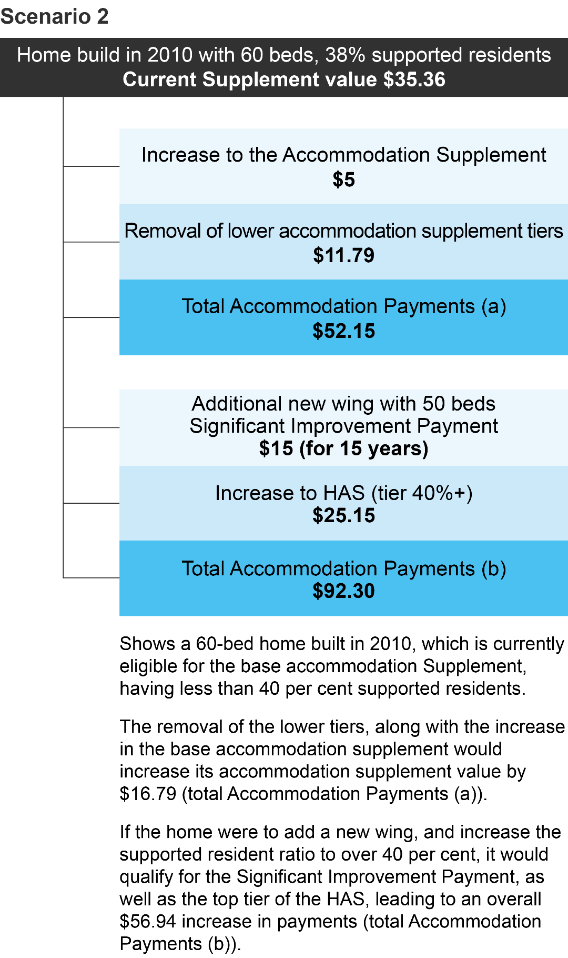
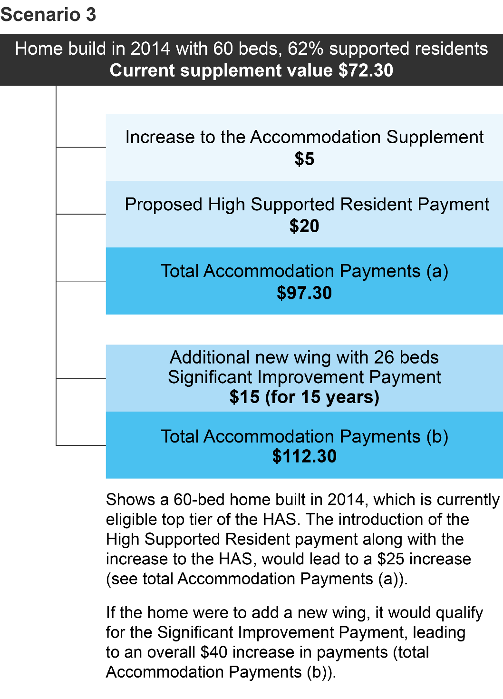
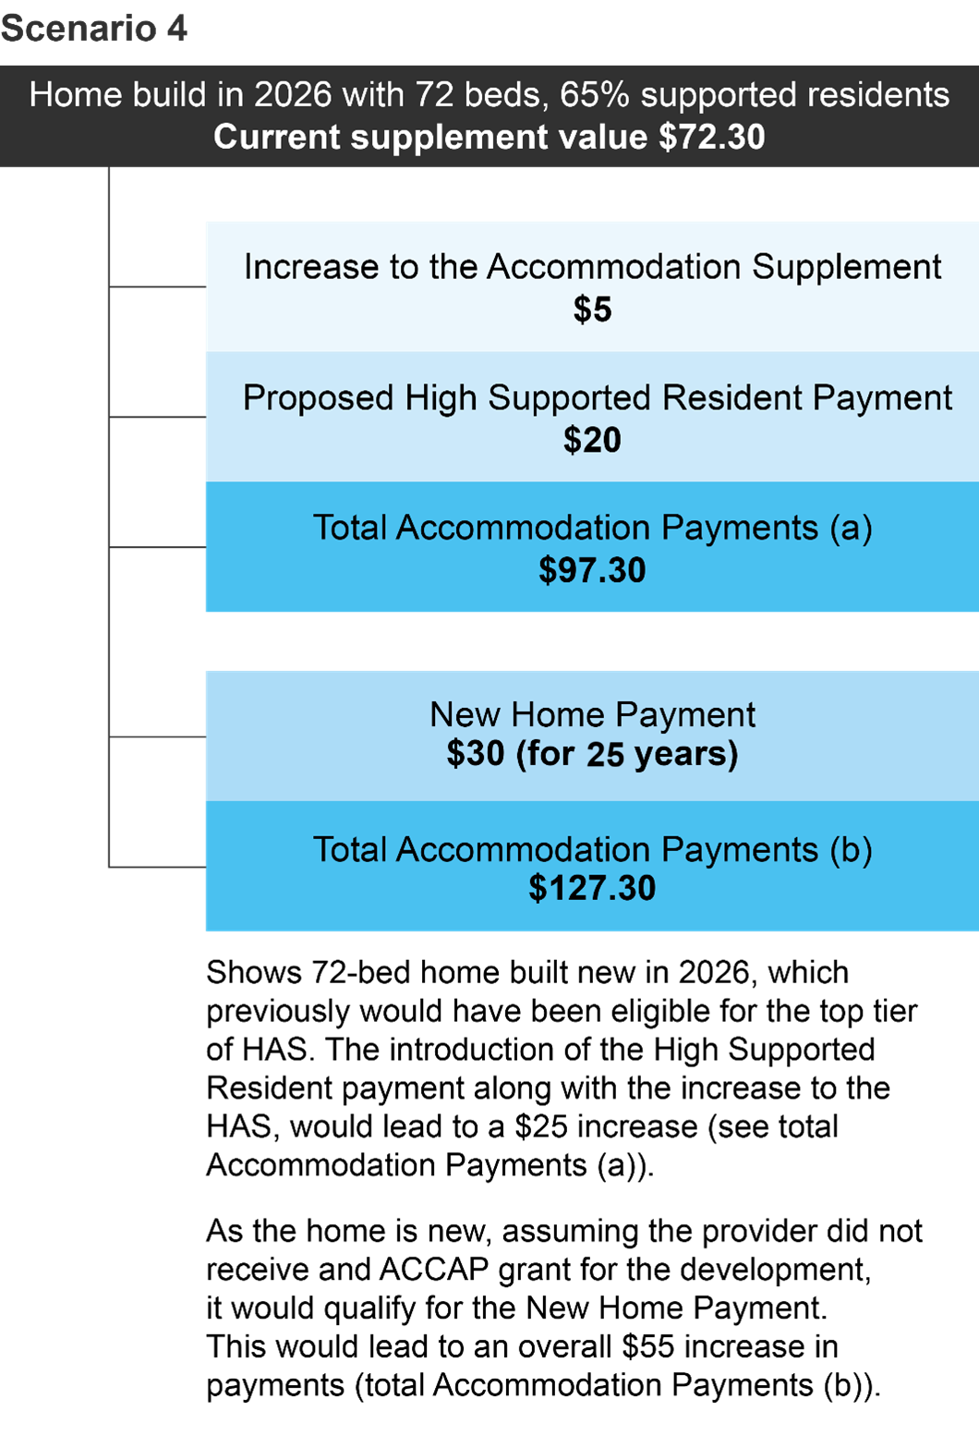

Appendix 2: Terms of Reference
Purpose
On 12 September 2024, the Australian Government released its response to the Aged Care Taskforce (Taskforce) final report which included a number of reforms to ensure the viability and quality of aged care. As part of that response, the government committed to a review of Accommodation Pricing, which has been legislated in the Aged Care Act 2024 (Act).
The Taskforce, established in 2023, was tasked with developing options for a fair and sustainable funding model for aged care, to ensure older people in Australia can access safe, high quality, person-centred care. The Taskforce final report made a number of recommendations to strengthen accommodation funding arrangements, recognising the need to improve the financial viability of providers in relation to accommodation.
The Accommodation Pricing Review (the Review) will consider the appropriateness of current settings for the accommodation supplement and accommodation pricing. In doing so, the Review will take a resident-focused approach in line with the Statement of Rights as per Part 3.1.23 of the Aged Care Act 2024; and also have regard to the ongoing sustainability of the aged care sector, the fiscal impact of reforms, and the efficient delivery of aged care services over the short and long term.
The Review will provide advice on policy, program, funding, and administrative settings that should:
- provide equity of contribution and outcomes regardless of how a particular individual’s aged care accommodation costs are met or where they are located;
- ensure that low means residents have access to high quality accommodation within residential aged care;
- support the capacity of providers to invest in and deliver places in high quality residential aged care homes that will meet the needs of Australia’s ageing population;
- foster a sector able to innovate and attract investment; and
- examine the adequacy of accommodation revenue, including the supplement, having regard to the impact of recent reforms, including changes to the refundable accommodation deposits (2 per cent retention and increasing the maximum room price from $550,000 to $750,000 on 1 January 2025).
Accommodation supplement design and incentives
The Review will consider the rate and design of the accommodation supplement to offer high quality accommodation and provide incentives for access, including:
- Whether the current rates are adequate to cover providers’ capital and operational costs (including to support worker capability and development) in delivering quality accommodation to supported residents, accounting for differences in operating environments.
- The suitability of the current incentive structure to encourage providers to accept low means residents (a discount on the accommodation supplement based on a single threshold of 40 per cent supported residents).
- The case to reform quality incentives in the accommodation supplement to support an uplift in the quality of accommodation so that it better meets community expectations, including the potential to introduce incentives linked to the National Aged Care Design Principles and Guidelines.
- The impact of the accommodation supplement pricing on incentives for capital investment in residential aged care.
- Ensuring Commonwealth funding remains equitable, effective and sustainable.
Accommodation pricing
At the same time as the supplement settings are reviewed, broader consideration will be given to accommodation price settings. Several factors will be considered, including:
- The case for using daily prices as the default way to express accommodation prices (reversing the refundable accommodation deposit (RAD)/daily accommodation payment (DAP) relationship). This would make prices easier to understand for incoming residents and simplify price setting for providers.
- The appropriateness of the maximum permissible interest rate (MPIR) as the metric for setting the relationship between the price of RADs and DAPs.
- Whether there is a need for a mandated minimum room price for non-supported residents.
Independent Panel
The Minister will appoint an Independent Panel of eminent persons to conduct the review.
- The independent panel will be provided with secretarial support from within the Department of Health, Disability and Ageing.
Public consultation
Public consultation will be completed during the review on the substance of the issues outlined in the Terms of Reference. The Independent Reviewer/s may invite and publish submissions and seek information from any persons or bodies. The reviewer/s may seek meetings with key stakeholders, which can be held either in person or online. The reviewer/s may seek comment on draft aspects of the report.
Consultation will take place with:
- Key community and stakeholder organisations reflecting a diversity of backgrounds
- Experts in both residential aged care and the housing sector
- Providers of residential aged care
- Members of the public
Timing
The Review will report to the Minister by no later than May 2026 and be tabled in the Parliament no later than 1 July 2026.

Appendix 3: Written submissions to the consultation paper
Submission # | Organisation | Stakeholder Type
24 | Advance Ageing Western Australia | Representative Organisation
16 | Aegis Aged Care Group | Provider
6 | Aged Care Crisis Inc. | Representative Organisation
44 | Aged Care Steps | Advisory services
18 | Aged Care Workforce Remote Accord | Representative Organisation
3 | Ageing Australia | Representative Organisation
25 | Anglicare | Provider
10 | ANMF | Representative Organisation
26 | Anthony Asher | Personal Submission
4 | Baptist Care | Provider
27 | Beacon Aged Care & Retirement Advisers | Workforce and Professional
28 | Blue Care | Provider
29 | Bolton Clarke | Provider
30 | BSL | Provider
23 | BUPA | Provider
21 | C Lim | Personal Submission
31 | Carnegie Catalyst | Advisory services
46 | Catholic Health Australia | Provider
47 | COTA | Representative Organisation
7 | Dementia Australia | Representative Organisation
17 | Department of Health SA | State Government
45 | Department of Health Tasmania | State Government
19 | Department of Health VIC | State Government
32 | Director, Aged Care | Health and Social Policy Branch NSW | State Government
48 | Estia Health | Provider
22 | Financial Advice Association Australia | Advisory services
33 | For Purpose Aged Care | Provider
34 | Forgedale | Personal Submission
15 | Hall and Prior | Provider
1 | Hammond Care | Provider
2 | Ian D Smith | Personal Submission
11 | IHACPA | Commonwealth agency
5 | Medical & Aged Care Group | Provider
20 | Minister for Creative Industries; Heritage; Industrial Relations; | State Government
12 | Mirus Group | Advisory services
49 | National Aboriginal & Torres Strait Islander Ageing and Aged Care Council | Representative Organisation
13 | OPAN | Representative Organisation
35 | Peter Willcocks | Personal Submission
36 | Pride Aged Living | Provider
50 | Queensland Health | State Government
9 | Regis | Provider
37 | RSL Life Care | Provider
38 | Salvation Army | Provider
14 | St Andrews - Comfort Care Community | Provider
39 | Stewart Brown | Advisory services
40 | Uniting Care | Provider
8 | Uniting Church Homes WA Juniper | Provider
41 | Uniting NSW ACT | Provider
42 | UTS Ageing Research Collaborative (UARC) | Advisory services
43 | Wintringham | Provider

Appendix 4: List of stakeholders consulted
Stakeholder Type | Stakeholder
Advisory groups | Council of Elders, National Aged Care Advisory Council
Banks | ANZ, Commonwealth Bank, Westpac
Industry Experts / others | Nick Merisades, Jane Bonny, Lynelle Briggs, Roger Fisher, Financial Advice Association Australia, Brendan Coates- Grattan Institute, Mike Woods - UTS Ageing Research Collaborative, Tony Richards -AHURI, Robert Caulfield - Caulfield Krivanek Architecture
Government agencies | ACQSC, IHACPA, Intergovernmental Health and Aged Care Senior Officials Group, PM&C, Treasury, WA Health
Sector Analysts/Strategic Services | Digital Finance CRC, EY, StewartBrown, Grant Thorton, Mirus, McGrath Nicol, EY-Parthenon
Legal services for providers | Russell Kennedy
Peak Bodies, including – representing consumers | Ageing Australia, COTA, OPAN, NACA
Providers | Aegis, Arcare, Amana Living Incorporated, Apollo Care Operations, Anglican Community Services, Australian Regional and Remote Community Services (ARRCS), BaptistCare, Bupa, Bolton Clarke, Booroongen Djugun Limited, Calvary, CapeCare, Clayton Church homes, Dillons, ElderCare Australia Ltd, Estia, Fresh Fields / Hall and Prior, For Purpose Aged Care, HammondCare, Illawarra Retirement, Jewish care, Mutkin Residential and Community Care Indigenous Corporation, MECWA, MyVista, Opal (DPG Services Group), Ozcare, Oryx, Palm Lake, Respect, Regis Aged Care Pty Ltd, RFBI (Royal Freemasons' Benevolent Institution), RSL Care RNDS Limited (now Bolton Clark), Southern Cross Care QLD, Southern Cross Care (WA) Inc, Sundale Ltd, Swan Care, The Bethanie Group, The Salvation Army NSW (Property Trust), The Uniting Church in Australia Property Trust (NSW), Uniting Church Homes WA (Juniper), Uniting AgeWell Limited, Tricare, Villa Maria Catholic Homes, Warrigal Care Limited, Wickro Pty Ltd, Wintringham, Yaandina Community Services Limited, Yura Yungi Medical Service Aboriginal Corporation
Superannuation funds | Australian Retirement Trust, AustralianSuper, Aware Super, HESTA, ANMF

Appendix 5: Glossary of terms
Term | Definition
Accommodation Agreement | A formal contract between a residential aged care provider and a resident, outlining the accommodation arrangements. The agreement must include, amongst other things, the agreed Refundable Accommodation Deposit (RAD), Daily Accommodation Payment (DAP), conversion rate, and any combination payment arrangements.
Accommodation Pricing Review (APR) | An independent Australian government review examining the sustainability and appropriateness of current accommodation pricing, including the accommodation supplement and payment arrangements.
Accommodation supplement | The Accommodation Supplement is payable on behalf of residents receiving permanent residential aged care who do not have the capacity to contribute to all or part of the cost of their accommodation.
Aged Care Planning Regions (ACPRs) | 73 distinct geographical areas across Australia used by the Commonwealth government to plan, fund, and map the delivery of aged care services. Effective since April 2018, these regions are based on Statistical Area Level 2 (SA2) boundaries from the 2016 ABS Australian Statistical Geography Standard (ASGS).
Aged Care Quality and Safety Commission (ACQSC) | The ACQSC is an Australian Government statutory authority within the Health and Aged Care portfolio. It is the national regulator of aged care services and the primary point of contact for older Australians and providers in relation to quality and safety.
Aged Care Steps Accredited Aged Care Professional | A designation for financial advisers who complete the Aged Care Steps Accredited Aged Care Professional program, demonstrating specialist knowledge in aged care financial matters.
Annual indexation | The yearly adjustment of approved higher accommodation payment amounts in line with movements in the consumer price index (CPI) as per section 290-40 of the Aged Care Rules 2025.
Approved Provider | An organisation approved under aged care legislation to deliver aged care services.
Approved Room Price | Approved Room Price – The maximum price that a provider may charge for accommodation in a residential aged care facility, set either as a RAD or a DAP.
Australian National Aged Care Classification (AN-ACC) | The government provides subsidies to approved residential aged care providers through the AN-ACC funding model. The AN-ACC model began in October 2022.
Base accommodation supplement | The minimum accommodation supplement payable to supported residents, set to cover daily operational and maintenance costs.
Basic Daily Fee (BDF) | Home Care Packages Program: A daily fee anyone can be asked to pay toward their care. This fee is set by the government at a percentage of the single basic Age Pension, and it varies depending on the participant’s package level. Residential aged care: A daily fee payable by all residents as a contribution towards their daily living costs in residential care. The Basic Daily Fee is set at 85per cent of the single basic Age Pension.
Capital component | The portion of accommodation payments, including RADs, DAPs, or government supplements, that is allocated to capital costs such as construction, refurbishment, or major repairs.
Capital financing | The funding sources and financial structures used by providers to build, acquire or upgrade residential aged care facilities.
Capital stack | The combination of funding sources a provider may use to finance residential aged care accommodation, including RADs, DAPs, government funding, loans, subsidies, and grants.
Choice of payment method | The resident's ability to select between lump sum or daily payments or a combination; choice remains protected and cannot be forced by providers.
Combination payment | A payment arrangement in which a resident contributes to accommodation costs through both a lump sum (RAD or RAC) and a daily payment (DAP or DAC).
Commonwealth Home Support Programme (CHSP) | This program provides entry-level support services designed to help frail older people stay in their homes. It was introduced on 1 July 2015, consolidating 4 former programs: Commonwealth Home and Community Care (HACC); the National Respite for Carers Program (NRCP); Day Therapy Centre (DTC); and Assistance with Care and Housing for the Aged (ACHA).
Consumer Price Index (CPI) | A statistical estimate of the level of prices of goods and services bought for consumption purposes by households.
Conversion rate | The proposed rate used to convert between a Refundable Accommodation Deposit (RAD) and a Daily Accommodation Payment (DAP) for a given room type, allowing greater flexibility in the relationship between lump sums and daily payments than is currently possible with the MPIR.
Daily accommodation contribution (DAC) | A government-regulated, non-refundable daily fee partially supported residents pay for aged care accommodation.
Daily accommodation payment (DAP) | An amount paid by a non-supported resident towards their accommodation costs in a residential aged care facility calculated daily and paid periodically.
Daily accommodation payment indexation | The mechanism to periodically adjust DAP amounts in line with indexation settings.
Daily Means-Tested Amount | The outcome of a resident’s combined assets and income assessment, used to determine eligibility for low means status, the amount of accommodation contribution payable and the amount of means tested fees payable.
Daily payment | A daily payment in residential aged care means: (a) a daily accommodation contribution (DAC); or (b) a daily accommodation payment (DAP).
Financial Information Service (FIS) | A free service offered by Services Australia providing general information on financial products, including preliminary information on aged care costs and payment options.
General interest charge (GIC) | Taxation legislation reference rate used to set the quarterly MPIR.
Grandparenting arrangements | Grandparenting is a provision where an old rule continues to apply to some existing situations while a new rule will apply to all future cases. Participant co-contribution arrangements are often grandparented in aged care, particularly residential aged care, recognising that people made decisions on entry based on rules that were previously in place.
Higher accommodation supplement (HAS) | The rate of accommodation supplement payable to providers for homes that have been newly built or significantly refurbished after 20 April 2012.
Hotelling supplement | A supplement paid to residential care providers on behalf of all residents as a contribution towards their daily living costs. The supplement is paid by government. Residents under the 1 November 2025 means testing arrangements make a means tested hotelling contribution. The hotelling contribution proportionally reduces the amount of hotelling supplement paid by Government.
Income tested care fee | A daily fee payable by home care participants based on an assessment of their income.
Independent Financial Advice | Professional financial advice provided to older Australians, required to be given by advisers with an aged care specialist designation and independent from the provider or facility under consideration.
Independent Health and Aged Care Pricing Authority (IHACPA) | The IHACPA is an independent government agency that assists the government to fund hospital and aged care services more efficiently by providing evidence-based pricing determinations and pricing advice. In the aged care context, IHACPA provides residential aged care and respite care pricing and costing advice, RAD approvals for higher accommodation payment amounts.
Low means participant | This refers to recipients of residential care who, because of their means, are eligible for Government assistance with their accommodation costs.
Market Forces (in Conversion Rate) | Providers are expected to set conversion rates that reflect their costs and preferences without disadvantaging residents; oversight occurs via published My Aged Care rates and complaints.
Maximum accommodation price | Maximum accommodation prices are set by residential care providers for a room (or bed in a shared room) and published on My Aged Care. These are maximum prices (providers and residents may agree to lower amounts), that apply to residents who are not eligible for government support for their accommodation costs.
Maximum permissible interest rate (MPIR) | The MPIR is a government-set interest rate used for a number of purposes in aged care including to determine equivalence between a daily payment and a refundable lump sum deposit, giving residents a choice in how to pay.
Means Assessment | A combined income and asset assessment undertaken by Services Australia that determines whether a resident is eligible for Government assistance with their accommodation costs, and if so, the amount the resident may be asked to contribute to their accommodation costs, and the amount of means tested fees.
Means tested care fee | A daily contribution towards the cost of residential care made by residents based on an assessment of their combined income and assets.
Modified Monash Model | A classification system used to determine whether a location is metropolitan, rural, remote or very remote. The model uses a scale from Modified Monash (MM) category 1 (major city) to MM 7 (very remote). MM categories are used to target additional assistance in certain aged care and health programs.
My Aged Care | The main online entry point to the aged care system in Australia. My Aged Care aims to make it easier for older people, their families, and carers to access information on ageing and aged care, have their needs assessed and be supported to find and access services.
Non-supported residents | Non-supported residents are those who have been assessed (based on a means test) as able to pay the full cost of their accommodation.
Partially supported residents | Partially supported residents are those who have been assessed (based on a means test) as eligible for full or partial government assistance with their accommodation costs.
Price Approval Process | The administrative process by which a provider applies for approval to charge a price above the maximum accommodation price.
Refundable accommodation contribution (RAC) | A government determined lump sum contribution paid by partially supported residents towards accommodation.
Refundable accommodation deposit (RAD) | An amount paid as a lump sum by a non-supported resident for their accommodation costs in a residential aged care facility.
Regional | Geographic region outside of a major city and classified by the Australian Bureau of Statistics as inner regional, outer regional, remote and very remote.
Residential aged care | A program that provides a range of care options and accommodation for older people provided in a residential aged care home rather than in the personal own home or in a community setting.
Services Australia Aged Care Specialist Officer (ASCO) | Staff providing face-to-face or virtual support to older Australians, offering information on aged care services, assessments, financial contributions, and local support connections.
Support at Home Program | A new home care program that replaces the current Home Care Packages Program and the Short-term Restorative Care Programme from 1 November 2025, and the Commonwealth Home Support Programme no earlier than 1 July 2027.
Supported Decision-Maker | A person appointed to assist residents who require help making informed decisions in My Aged Care.
Supported resident ratio | The proportion of residents within a facility who receive government support for accommodation costs.
Supported residents | Supported residents are those who have been assessed (based on a means test) as eligible for full or partial government assistance with their accommodation costs.

All information in this publication is correct as at 16 April 2026

Australian Institute of Health and Welfare (2025), Dementia in Australia Cat no. DEM 2, S2.5, Canberra: AIHW.
Department of Health, Disability and Ageing (2025), Financial Report on the Australian Aged Care Sector 2023-24, Canberra, p. 89.
Australia Government (2023), Final Report of the Aged Care Taskforce, Canberra, p. 53.
Anglicare, Australia-Fair-Ageing-in-Place.pdf (2022).
https://hellocare.com.au/ageing-without-assets-the-challenges-for-renters-in-need-of-aged-care-services/ (2025).
Department of Health (2015), 2014-15 Report on the Operation of the Aged Care Act 1997, Canberra, p.54.
Department of Health, Disability and Ageing (2025), 2024-25 Report on the Operation of the Aged Care Act 1997, Canberra, p. 52.
StewartBrown (November 2025), Residential Aged Care Accommodation Pricing Review Submission.
Cutler, H., Gu, Y., Gu, M., Aghdaee, M., Hasan, M., & Shen, C. (2021), The role of refundable accommodation deposits. Macquarie University, https://www.health.gov.au/sites/default/files/documents/2021/03/the-role-of-refundable-accommodation-deposits.pdf.
Department of Health, Disability and Ageing (2025), Financial Report on the Australian Aged Care Sector 2023-24, Canberra, p. 25.
Submission: For Purpose (2025),
Submission: Juniper (2025).
Submission: WA Government submission (2025).
Caulfield Krivanek Architecture (CKA) https://caulfieldkrivanek.com/aged-care-building-cost-indicator/
Planning, Development and Infrastructure (General) (Essential Infrastructure and State Agency Development) Amendment Regulations 2025.
McSweeny, N., “What’s old is new again: how this international trend could ease Australia’s housing crunch”, API Magazine, 7 May 2025.
See The Final Report of the Aged Care Taskforce (2024), p. 34; Royal Commission into Aged Care Quality and Safety Final Report: Care, Dignity and Respect (2021), Vol 3b, Chapter 18, pp. 725-726.
Aged Care Financing Authority (2017), Report on access to care for supported residents, p. 12.
See also: Hosking, D., Minney, A. and McCallum J., (2021), “Planning for aged care costs: Hesitancy, ignorance and denial”, National Seniors Australia and Challenger, Canberra, p. 9.
Care and support economy – state of play | PM&C
Retirement villages | ACCC Retirement villages | ACCC
Planning, Development and Infrastructure (General) (Essential Infrastructure and State Agency Development) Amendment Regulations 2025
Better Housing for Better Health - Property Council Australia

