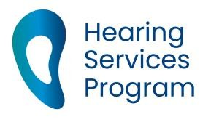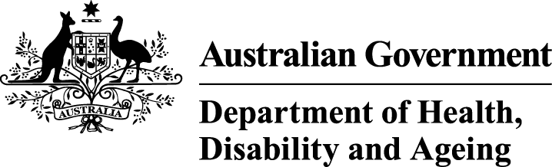
Cultural Competency resources
This fact sheet outlines opportunities to support people from multicultural communities in accessing and receiving hearing health services. Not all people from these diverse communities will require this support, but these resources aim to assist those more vulnerable members of Australia’s multicultural communities.

Culturally safe hearing services
Receiving culturally safe health care is important for people who engage with hearing health services. This can improve hearing health results for people from diverse backgrounds.

Background
Individual issues such as limited access to education, employment and safe housing options can affect the health of people from multicultural communities. Lower levels of proficiency with the English language, combined with limited knowledge about health and/or health services can mean people from multicultural communities miss out on culturally safe health care. ‘System’ issues such as poor cultural competency skills of clinicians and limited information to help make decisions makes this even more difficult.
People from multicultural communities hold a range of health beliefs and cultural practices. Some of these beliefs may also come with a high level of stigma for certain health conditions, for example mental health illness.
These beliefs can affect:
- perceptions of major life events
- uptake of preventive health care
- help-seeking behaviour, and
- understanding and following treatment plans.
Challenges apply to hearing health care as they do to other health services. These challenges are increased by:
- ‘systems issues’ such as a lack of access to health services, poor cultural competency skills of clinicians and lack of appropriate information to make informed decisions
- inconsistent identification of ethnicity, and
- limited access to interpreters and to translated health information.

Resources

1. Competency Standards Framework
The Migrant and Refugee Women’s Health Partnership has developed the Competency Standards Framework. The Framework:
- establishes standards for clinicians in all healthcare settings as they develop clinical education, training and professional development curricula
- accompanies the Guide for Clinicians Working with Interpreters in Healthcare Settings, which provides advice on engaging and working with interpreters.

2. Aged Care Learning Modules
The University of Tasmania developed Equip Aged Care Learning modules with funding from the Department of Health and Aged Care. It includes introduction and refresher modules, with modules on Hearing Health and Cross - Cultural Awareness. They include information for:
- personal care workers
- nurses
- allied health professionals, and
- volunteers and families.

3. Online training courses
The Centre for Culture, Ethnicity and Health’s Introduction to Cultural Competence is a series of online training courses that give staff the key skills and knowledge to work with people from different cultures.

4. CALD Webinars
The Multicultural Communities Council of Illawarra (MCCI) created CALD webinars for elderly Australians, including those with dementia and who identify as LGBTQIA+. They cover information on:
- how to address the needs of elderly people from multicultural communities
- advice for caring for people from multicultural communities with dementia
- looking after carers of people from multicultural communities with dementia and the unique challenges they face, and
- practical ideas to help aged care providers in supporting LGBTQIA+ consumers from multicultural communities.

5. Professional standards
Audiology Australia has the following standards to assist with culturally safe care:
National Competency Standards for Audiologists lays out the minimum skills, knowledge and behaviours required for ‘entry level’, independent practice for audiologists in Australia in Competency 2.1.
Accreditation Standards for Audiology Programs ensure all audiology university graduates have the knowledge, skills and attributes needed to practise audiology safely and competently in Australia.

Riggs E. et al (2015) Breaking Down the Barriers: A Qualitative Study to Understand Child Oral Health in Refugee and Migrant Communities in Australia. Ethnicity & Health
Khatri, R.B and Assefa Y (2022) Access to health services among culturally and linguistically diverse populations in the Australian universal health care system: issues and challenges BMC Public Health 22, 880
Komaric N. et al (2012)Two Sides of the Coin: Patient and Provider Perceptions of Health Care Delivery to Patients from Culturally and Linguistically Diverse Backgrounds. BMC Health Services Research

