Health Technology Assessment Committee Member Conflicts of Interest Process Guide
  - March 2026

Copyright
© 2025 Commonwealth of Australia as represented by the Department of Health, Disability and Ageing
This work is copyright. You may copy, print, download, display and reproduce the whole or part of this work in unaltered form for your own personal use or, if you are part of an organisation, for internal use within your organisation, but only if you or your organisation:
(a) do not use the copy or reproduction for any commercial purpose; and
(b) retain this copyright notice and all disclaimer notices as part of that copy or reproduction.
Apart from rights as permitted by the Copyright Act 1968 (Cth) or allowed by this copyright notice, all other rights are reserved, including (but not limited to) all commercial rights.
Requests and inquiries concerning reproduction and other rights to use are to be sent to the Corporate Communication Branch, Department of Health, Disability and Ageing, GPO Box 9848, Canberra ACT 2601, or via e-mail to copyright@health.gov.au.

Contents
Purpose 1
What is a conflict of interest 1
Significance of managing conflicts of interest 1
Obligations to manage conflicts of interest 2
Committee management group 2
Declaration of interests 3
Key concepts for managing potential conflicts of interest 5
Nomination interest management 5
Manual declaration of interests 5
Review of nominee declared interests 5
Management of nominee declared interests 6
Recording of nominee interest management 6
Annual interest declaration process 6
Committee meeting conflict of interest management 7
Pre-meeting declaration of potential conflicts 7
HTA confidential document protection 7
Review of conflicts prior to meetings 7
Management of potential conflicts prior to and during meetings 8
In-meeting conflict of interest processes 9
Opportunity to declare conflicts at meetings 9
In meeting management of identified conflicts 9
Conflicts of interest processes for guest participants 9
Conflict of interest record keeping 9
Appendix A. Conflict of Interest Management Flowchart 10
Appendix B. Decision Framework 11
Glossary 14
Version Control 15

Purpose
This guide provides a consistent framework for assessing, declaring, and managing conflicts of interest (CoI) during nomination, reappointment, and terms of committee members. It applies to members of Health Technology Assessment (HTA) committees, their sub-committees and working parties (herein referred to as committees).
These guidelines were developed by the Department of Health, Disability and Ageing (the department). They are intended for departmental staff as well as committee members (members) or persons nominated to join a committee (nominees). They provide guidance relating to:
- declaration of interest (DoI) requirements for members
- management of interests during member nomination and appointment
- management of interests in relation to items coming before the committees
CoIs for members are managed through a committee management group (CMG). Terms used within this document are defined in the Glossary.
Nominees and members can use this guide to identify interests that may cause a conflict and to understand the decision- making and management process that occurs for identified interests. An overview of the process is provided as a CoI Management Flowchart in Appendix A.
Departmental staff, including those from HTA secretariats and/or CMG participants, can use this guide to evaluate declared CoIs and advise the relevant delegate on nominee suitability and on CoI management for committee meetings and processes. It provides principles and examples to support consistent decision-making. This guide supports, but does not replace, standard meeting procedures.
What is a conflict of interest?
A CoI occurs when a member’s personal interests could affect, or appear to affect, their public duties. Personal interests include financial matters (like owning shares, running a business, or holding a directorship) and non-financial matters (like involvement in a clinical trial).
A CoI can be:
Real – where the interest does affect the member’s decisions or actions;
Apparent – where it appears to any reasonable observer that there is an interest that could affect the member’s decisions or actions.
These interests may belong to the member (direct interest) or to people they are closely connected with, such as a spouse, partner, relative, or close friend (indirect interest).

Significance of managing conflicts of interest
Managing conflicts of interest ensures members act independently and fairly. It helps prevent situations where personal interests may compromise, or appear to compromise, objectivity.
Committee advice and recommendations might be challenged if any participating member had a CoI, either real or apparent. Strong CoI management protects the reputation and integrity of committees by ensuring they are impartial and independent.
This makes certain the recommendations and advice of committees, which inform the Australian Government’s final decisions on HTA matters, reflect the highest standards of professionalism and independence.
CoI thresholds vary by committee type, with the bodies that make recommendations to the minister, such as the Pharmaceutical Benefits Advisory Committee (PBAC) and the Medical Services Advisory Committee (MSAC), requiring stricter standards and transparency. Unmanaged or undisclosed CoIs can compromise the integrity of committee recommendations. This can erode public trust in the HTA process and damage the department’s reputation.

Obligations to manage conflicts of interest
The department is obliged to address CoIs under legislative requirements set out in the:
- Public Service Act 1999;
- Public Governance, Performance and Accountability Act 2013.
In addition to these Acts, PBAC members should be aware of statutory requirements under the National Health Act 1953 and Section 94 of the National Health (Pharmaceutical Benefits) Regulations 2017 (the Regulations). These require annual written disclosure and meeting specific disclosures of pecuniary interests which may conflict with committee duties. The Australian Public Service Code of Conduct and the department’s Conflict of Interest Policy provide clear guidance on this topic.
For all committees, it is the responsibility of the nominee or member to identify and declare all potential and actual CoIs.
Nominees and members should be aware that failing to disclose interests (without a reasonable excuse) may result in the termination of their appointment. If unsure, members should consult the relevant secretariat or the Committee Management Group (CMG) about when to disclose an interest.
It is a requirement for all nominees and members to sign the Deed of Undertaking in Relation to Confidential Information and Conflict of Interest (Deed of Undertaking), which sets out the obligations of appointed members.

Committee management group
The Committee Management Group (CMG) is an overarching body within the department, made up of the committee chairs, deputy chairs and departmental delegates (usually executive level 1 or above) of key HTA committees. A subset of 3, or more where required, CMG participants will manage conflicts for each individual committee.
When a potential CoI is declared, 3 or more CMG participants who are directly associated with the committee the member is appointed, or nominated for appointment, to are responsible for making the CoI management decision.
This group will include, at minimum: the committee chair / deputy chair / nominated committee member, the director of the committee secretariat / committee secretary, and the director from the HTA - Membership and Logistics Section (HTA-ML), as demonstrated in Figure 1.

Figure 1. Structure of the CMG.

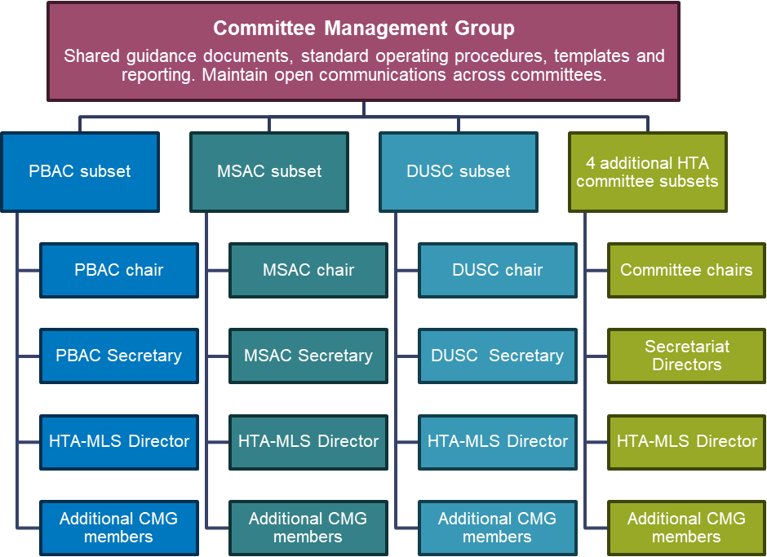

Additional members of the secretariat, an associated secretariat or staff from the HTA-ML may be included in the CMG subset to support decision-making, as needed. The relevant CMG subset will review and deliberate on interests which may cause a CoI and provide directives on their management for the member.
The CMG manages conflicts for members across all stages of their appointment and term, including prior to and during each meeting. The CMG also ensures CoI management outcomes and actions are appropriately recorded.
Most CoIs can be managed. It is important for committee integrity that records show how this was achieved.

Declaration of interests
Committee nominees and members must declare all interests which may result in CoIs. A DoI must be completed:
- when applying to be a member
- annually, through the Health Products Portal (HPP)
- before each committee meeting or activity, through HPP
- on an ad hoc basis in HPP, if the circumstances of the member change.
Interests are declared through the use of 2 forms, the DoI form and the private interest declaration (PID). These forms are provided manually through the nomination process and via HPP upon appointment of a member to a committee.
The CMG reviews both these declarations to determine if CoIs can be managed and to set out how that will be achieved.
The department requires members to disclose relevant interests from the past 5 years. This includes any interests that could influence, or appear to influence, the committee member’s impartial decision-making or their ability to carry out their duties effectively.
Nominees and members are encouraged to use common sense when deciding how much detail to include when declaring their interests. For example, it is correct to list major business activities, but transient business contacts would rarely need to be detailed. However, in any case of doubt, members should provide more detail rather than keep matters to themselves.
When declaring interests, members must declare both direct and indirect interests. When assessing indirect interests, members should consider whether the relationship in question could reasonably be seen by any external party or person as affecting their ability to be independent, objective, and impartial in their role on the committee.
Members are obliged to disclose any interests which may lead to a real or apparent CoI under the Deed of Undertaking, which they sign during the committee appointment process. Under the Deed, the department can take any necessary action, including legal steps, to deal with any liability caused by a member breaching their obligations. Table 1 provides examples of declarable interests.

Table 1. Examples of interests which may give rise to a Conflict of Interest
Direct financial interests | Other financial interests | Work or professional interests | Other interests
Shares, other investments | Paid travel/conference expenses | Federal government position/role | Strong personal, religious or philosophical beliefs
Grants, fellowships or sponsorships | Hospitality or benefit from a company or organisation in a relevant industry | Involvement or participation in a clinical trial | Public statements relating to matters before the committee
Employment, contracts, or consultancies | Research or other grants to employer or institution the member is associated with | Roles as a researcher, expert adviser or investigator | Medical conditions
Commissioned fee-paid work, paid retainer, paid speaking or advising roles ​ | A financial interest held by a relative, e.g. they work for a pharmaceutical company | Ongoing or ad hoc support for a patient or student | Personal interest in a particular product, e.g. if a relation has a specific condition
Directorships, partnerships, board memberships, trusts |  | Advisory board role​ | Investigation by a safety body (i.e. Australian Health Practitioner Regulation Agency)
Patent rights |  | Sponsorship of an event
Any other financial involvement or payment in relation to products, services or other matters connected with therapeutic goods |  | Membership or other professional link to a company or organisation involved with medical products or services

Key concepts for managing potential conflicts of interest
- The HTA CoI Decision Framework (Appendix B) is derived from previous precedents to guide CoI management.
- The CMG is to be guided by the circumstances of the case, committee terms of reference, and precedents when considering CoI management.
- Committee procedures and outputs may impact CMG recommendations. This can lead to perceived variations in CoI management across committees.
For all CoIs, the CMG assesses:
the nature of the conflict;
the committee and its role;
whether the CoI can be managed.
In all cases, the CMG must document, using appropriate government systems, the CoI and agreed management of it.
- It is not necessary to show that a member’s conduct is affected by a CoI, only that a conflict could be perceived between the member’s interests and their committee obligations.
- There must be agreement by 3 or more CMG participants as to the appropriate management of any given CoI.
- Where the committee chair declares a CoI, the chair must be excluded from all decisions for the relevant item. A committee chair’s CoIs will be managed by a different CMG member (the deputy chair or chair of a related committee).
- When relevant CMG participants determine that a CoI needs to be managed, they inform the member of how this will be achieved.
- Advice from the CMG must always be clear, consistent, and defensible.
CoIs regularly require ongoing management. Members are obliged to continue to declare interests, even where previously declared.

Nomination interest management

Manual declaration of interests
During the appointment process, the nominee must declare all interests which may lead to a real or apparent CoI. This is done using the DoI and the PID forms, which capture different but complementary information on nominee personal interests.
Review of nominee declared interests
As part of the wider analysis of nominee eligibility, departmental members of the relevant committee’s CMG subset (led by HTA-ML members) review the declared interests (DoIs and PIDs) against the department’s CoI decision framework. The HTA-ML and secretariat then decide whether the nominee should proceed to be recommended for appointment.
Nominees or members with serious, ongoing CoIs that cannot be managed will not be appointed unless they agree to resolve the matter causing the CoI.
For major committees, members are appointed by Prime Minister and Cabinet (PM&C), while for sub-committees and working parties, members are appointed by the respective major committee. For major committees, the People, Communication and Parliamentary Division may provide input on CoI management requirements.

.

Management of nominee declared interests
Under the decision framework (Appendix B), CoIs at nomination can be categorised as:
Not acceptable (or must cease the conflict). The CMG will inform the nominee that the nomination cannot proceed to appointment and the person cannot be recommended for appointment due to a specific interest. The secretariat or CMG will inform the nominee that the situation causing the CoI must be resolved before a recommendation for appointment is possible. The nominee must make a declaration which covers themselves or their close relatives setting out the action they will take to resolve the CoI and confirm that they will not enter into any similar situation during the term of appointment. Where the CoI cannot be resolved and the nominee was nominated by an organisation, the nominating organisation/body will be informed that the nomination will not proceed.
Acceptable with strict conditions. The preferred approach to resolve this situation is for a nominee to cease or divest the interest prior to appointment. Where the CMG has determined that the nominee’s expertise is crucial, appropriate future management measures are identified and agreed to in writing by the nominee. After this, the nomination can proceed and a recommendation for appointment made to the PM&C or committee. Management of this type of CoI is required prior to any related meeting or activity.
Acceptable with conditions. Appropriate future management measures must be identified by the CMG and agreed to in writing by the nominee for a CoI in this category. After this, the nomination can proceed and a recommendation for appointment made to the PM&C or committee. Management of this CoI is required prior to any related meeting or activity.
Acceptable with no conditions. The nomination can proceed and a recommendation for appointment made to the PM&C or committee. Management of this CoI may be required prior to any related meeting or activity.
CoI cannot be determined. Where a CoI cannot be accurately reviewed, the secretariat or HTA-ML will request further information relating to this CoI to enable a final decision.

Recording of nominee interest management
CoI management related documents for the nomination and member appointment period are stored by the HTA-ML in the approved government repository. This includes the member’s DoI and PID as well as all mitigation strategies approved and agreed to between the department and the member to avoid future CoIs.
Before making a recommendation to appoint, the HTA-ML checks whether the nominee’s CoI declaration is consistent with previous declarations, where present.

Annual interest declaration process
Members must make a DoI and PID through the HPP upon their appointment to a HTA committee. These forms must be updated at least annually, or sooner if the member’s circumstances change.
An update will be due 12 months after the last update. There is no fixed date to update DoIs for committees other than the PBAC, whose members are obliged (under section 94(1) of the Regulations) to update their DoI as soon as practicable after the beginning of each financial year.
Members are required to update their HPP DoIs and PIDs whenever their interests change in a way that may lead to a real or apparent CoI. The HPP DoI form is the basis for declaring specific pre-meeting CoIs. These declarations are reviewed by the HTA-ML who liaise with the respective CMG subset where CoI management will be required.
If a member gains a new interest that could affect their appointment, they are expected to report it through their DoI or PID and accept any proposed management. If the CMG determines that an interest requires a member to leave the committee, the member must resign from that committee.

Committee meeting conflict of interest management

Pre-meeting declaration of potential conflicts
Prior to each committee meeting, an agenda will be uploaded into HPP. Members are required to identify potential CoIs against individual agenda items.
Where the member has an interest to declare, this interest must be selected from previously declared interests on their HPP DoI. Where there is no potential conflict, members must declare that they have “no interest” to declare against that item. Select agenda items that have no potential for conflicts, such as the committee chair’s report, do not require this process.
If the interest against a specific agenda item is not listed in the member’s DoI, the member must update their DoI to declare the interest and then select it against the agenda item in question.
Members must disclose any CoI. If they fail to do so without a valid reason, their appointment may be terminated. Members should ask the secretariat or CMG for advice if unsure.
Where members have a CoI that they do not wish to disclose the specifics of, they are entitled to inform the committee chair and/or CMG that they will absent themselves from that agenda item and will receive no related documents or materials.
HTA confidential document protection
Committee documents or materials related to a specific agenda item will not be released to any member until:
the member confirms they have no conflict against that item; or
the member declares a conflict and either the CMG and member agree on a management strategy, or the CMG determines the conflict cannot be managed. In the latter case, no documents or materials will be released to, or be accessible by, the member.

Review of conflicts prior to meetings
Prior to the release of documents to members for a HTA committee meeting:
- members declare all potential CoIs against specific agenda items;
- All CoIs for that meeting are reviewed by the CMG, with at least 3 participants of the CMG associated with that specific meeting;
- The CMG agrees on whether the CoI requires management and, if so, the strategy.

Where they are aware of it, the CMG may raise a member’s perceived CoI if the member has not declared it.
The specifics of individual CoI management will be made clear to the member involved prior to the meeting. This will primarily be communicated via HPP or email.
A designated member of the CMG is responsible for ensuring that CoI management decisions, the key CMG participants who approved them and final recommendations are entered into HPP and recorded appropriately in Content Manager.

Management of potential conflicts prior to and during meetings
Under the decision framework (Appendix B), CoIs for meetings can be categorised as:
No CoI is identified. The member is provided full access to documents and able to participate fully in the deliberations, including in decision-making.
Acceptable with no conditions. The member is provided full access to documents and able to participate fully in the deliberations, including in decision-making and/or voting. The member agrees to continue to disclose this CoI before future meetings.
Acceptable with conditions. The member is provided full access to documents. In-meeting participation may be either:
- the member is present and can answer questions or provide advice on matters of a technical nature, but will not participate in decision-making and/or voting
- the member can be present but is not to lead the discussion or participate in decision-making and/or voting
- where the committee chair has the CoI they may have to relinquish the chair role for that specific agenda item
The member must agree to manage the CoI and to continue to disclose this CoI before future meetings. Failure to disclose may result in termination.
Not acceptable. The member is advised that they will be wholly excluded from consideration of the specific agenda item. The member will not be provided access to documents or materials and must leave the meeting room during discussion of the item. The member must agree to manage the CoI and continue to disclose this CoI before future meetings. Failure to disclose may result in termination.
Cannot be determined. The secretariat requests more information from the member.

In-meeting conflict of interest processes

Opportunity to declare conflicts at meetings
At the start of every HTA meeting, members have the opportunity to declare previously undeclared interests which may cause a CoI. The committee chair (or acting chair) will manage these in-meeting CoIs in collaboration with the committee secretary / secretariat director. All declarations and management activities in these cases will be recorded in the meeting minutes. For the PBAC, it will be additionally recorded that all members have disclosed CoIs and these have been managed prior to the meeting in accordance with Section 94(6) of the Regulations.
Members are strongly encouraged to declare any last-minute interests or potential CoIs prior to the meeting through HPP (or as a last resort by email). This includes cases where there is a change in circumstances after agenda item related documents have already been released.
It may only be when a matter is under committee consideration that a member becomes aware of their interest (where for instance, unanticipated issues arise in the discussion). In such a case the member must disclose it to the committee chair without delay. If you are unsure whether something is a conflict, declare it or ask the committee chair or secretariat for advice.

In meeting management of identified conflicts
Where members have been informed by the CMG that they are not to participate in specific agenda items due to a CoI they are to absent themselves when that agenda item arises.
The committee chair may request that the member follow the determined procedure where not done by the member voluntarily.
Where the member disclosing the interest is the committee chair, the CMG may determine as part of CoI management that the chair must stand aside, and the deputy chair or a presiding member will be nominated as acting chair for consideration of that item.
Members are expected to always follow CMG guidance in management of CoIs.

Conflicts of interest processes for guest participants
Guest observers do not receive papers or participate in discussions within HTA committee meetings. They are required to sign the Deed of Undertaking, which instructs them in their responsibilities for both confidentiality and CoIs.
Guest discussants are to follow member guidelines regarding CoI declaration and management. This will occur through HPP using normal member procedures.

Conflict of interest record keeping
The secretariat will keep records of every declared CoI, the decision made and the persons making up the CMG for that decision. The meeting minutes will reflect items where members were absent or had reduced participation. This information will be recorded in accordance with government approved policies. Record keeping will include commentary as to why each decision was made, along with the final management actions for any CoI decision.

Appendix A. Conflict of Interest Management Flowchart
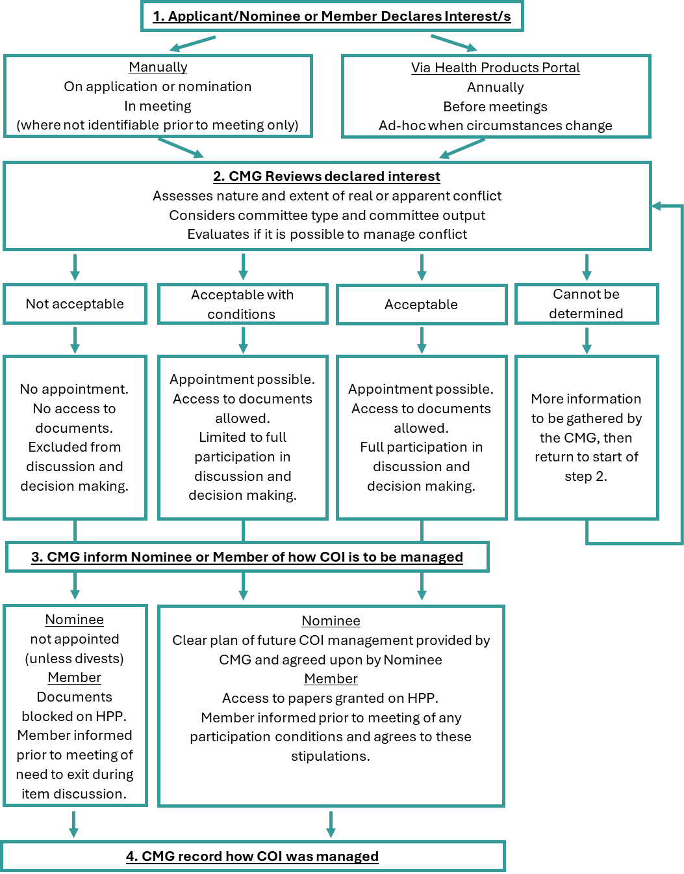

Appendix B. Decision Framework
Conflict of Interest | Acceptability | Action Required for Nomination / DOI Review | Action Required for pre and during meeting processes
Direct and Indirect Financial Interests
Investments (excluding non-self-managed superannuation) | Not acceptable if linked to relevant companies or organisations | Nomination cannot proceed or member must resign, unless the member ceases or divests the interest. | Member must not receive papers and must exit discussion on related items.
Shareholdings (member-controlled or influence over fund decisions)
Trusts (member-controlled or influence over decisions)
Partnerships
Directorships
Board memberships (executive or advisory)
Direct employment (self or close family)
Expert advisory fees (regular)
Retainer
Education grants (both in support of further education and teaching stipends)
Patent ownership (direct holder and receiving royalties)
Associations with charities or NGOs (senior role or direct benefit from funding) | Not acceptable unless approved by CMG (acceptable with strict conditions) | Preferred approach is for nominee to cease or divest interest prior to appointment or for member to cease or divest the interest as soon as possible. Where the CMG has determined that the nominees’ or members’ expertise is crucial, member must agree to CoI being managed on an ongoing, meeting-by-meeting basis. | Where the CMG has agreed to manage under strict conditions, this may vary meeting by meeting. Management can include a) not receiving papers and needing to exit discussion on related items, b) receiving papers but not able to lead discussion, c) able to receive papers and fully included in discussion.
Current consultancies
Commission fee-paid work
Paid speaker fees (regular)
Financial interests held by family
Direct employment for commonwealth or state government (self) | Acceptable with conditions | Nomination / membership can proceed. Member must agree to CoI being managed on an ongoing, meeting-by-meeting basis. | Management can involve a) receiving papers but not able to lead discussion, b) able to receive papers and fully included in discussion.
Associations with charities or NGOs (non-senior role and no benefit from funding) | Acceptable with conditions
Past consultancies | Acceptable with conditions
Expert advisory fees (one-off) | Acceptable with conditions
Paid speaker fees (one-off) | Acceptable with conditions
Current fellowships | Acceptable with conditions
Current research grants | Acceptable with conditions
Patent ownership (royalties go to institution) | Acceptable with conditions
Inventor (not patent holder) | Acceptable with conditions
Travel grants (flights, accommodation, conference fees) | Acceptable with conditions
Food and beverage (e.g. corporate dinners) | Acceptable with conditions or with no conditions | Nomination / membership can proceed. Member must agree to CoI being reviewed on an ongoing basis. | Member can receive items and fully participate in discussions.
Financial interests held by close friends | Acceptable with conditions or with no conditions
Professional Interests
Investigation by regulatory body (e.g. Australian Health Practitioner Regulation Agency) | Not acceptable | Nomination cannot proceed or member must resign, unless the member ceases or divests from the interest. | Member must not receive papers and must exit discussion on related items.
Member of advisory board (non-paid) | Acceptable with conditions | Nomination / membership can proceed. Member must agree to CoI being managed on an ongoing, meeting-by-meeting basis. | Management can involve a) receiving papers but not able to lead discussion, b) able to receive papers and fully included in discussion.
Principal investigator in clinical trials | Acceptable with conditions
Member (not senior) of NGO or professional body receiving industry support | Acceptable with conditions
Ad-hoc patient support (e.g. access to medicines via compassionate schemes) | Acceptable with conditions
Participant in clinical trials (not principal investigator) | Acceptable with conditions or with no conditions | Nomination / membership can proceed. Member must agree to CoI being reviewed on an ongoing basis. | Member can receive items and fully participate in discussions.
Personal Interests
Public statements (professional or personal) | Not acceptable if frequent and strongly support or oppose relevant companies or products | Nomination cannot proceed or member must resign, unless the member ceases or divests from the interest. | Member must not receive papers and must exit discussion on related items.
Medical condition | Acceptable with conditions | Nomination / membership can proceed. Member must agree to CoI being managed on an ongoing, meeting-by-meeting basis. | Management can involve a) receiving papers but not able to lead discussion, b) able to receive papers and fully included in discussion.
Personal beliefs | Acceptable with conditions or with no conditions | Nomination / membership can proceed. Member must agree to CoI being reviewed on an ongoing basis. | Member can receive items and fully participate in discussions.

Glossary
Committee management group (CMG) is the group identified by the department to oversee conflicts of interest management. It includes participants from each HTA committee including the committee chair, deputy chair (or a nominated presiding member when there is no deputy chair or one of these 2 persons is not available), secretary or secretariat director and additional relevant persons in each secretariat. Additional members can include the directors of the 2 HTA Support Unit Sections and the Consumer Evidence and Engagement Section, along with other relevant departmental support staff from these sections. Subset groups of the CMG will be responsible for conflict of interest management for each individual committee.
Relevant CMG participants refers to a subset of 3 or more members of the CMG who are responsible for reviewing and managing conflicts of interest for a specific committee. Each subset will include the committee chair, deputy chair (or a nominated presiding member or an associated committee chair, if required), committee secretary or secretariat director and one HTA Support Unit director. Other relevant staff or committee members are included as needed.
Committee secretariat are departmental staff who are responsible for supporting the committee, including liaising with members, preparing agenda papers in consultation with the committee chair, deputy chair (if relevant) and members and preparing outcome reports of each meeting.
Confidential information means any information or document made available to a member of a committee by the department that is by its nature confidential, is designated by the Commonwealth as confidential, or the member knows or ought to know is confidential. It does not include information which is in the public domain or becomes public knowledge other than by a member breaching their obligations of confidentiality under the Deed.
Conflict of Interest includes, but is not limited to, any situation where a person has a direct or indirect material personal interest which, taking into account the nature of the committee’s role, functions and responsibilities, may influence or may appear to influence the independent, fair and proper consideration by the committee or participation by the member otherwise in the work of the committee.
“Direct” interest includes, but is not limited to, an interest or a liability held or owned by the person, whether financial or non-financial.
Declaration of interests (DoI) is a formal disclosure of targeted direct and indirect financial and other interests which, through having a connection between the interest and the member’s duties, lead to a real or perceived conflict of interest
“Indirect” interest includes, but is not limited to, an interest or liability owned or held indirectly by the person (for example through a trust or a partnership) and includes any interest, of which the person is aware of, held by someone whom the person is closely associated.
Member is a person currently appointed to a committee.
Nominee is a person nominated, or seeking, to join a committee as a member.
Private interest declaration (PID) is a formal disclosure of broad personal interests, including those relating to current and historical employment, legal and financial matters.
PM&C refers to the Prime Minister and Cabinet.

Version Control
Version | Date | Author | Change description
1.0 | 24 June 2020 | Technology Assessment and Access Division
2.0 | 03 March 2026 | Technology Assessment and Access Division | Substantial revision of text for clarity and conciseness and to expand document use to include both departmental staff and committee members. Strengthened description of CMG. Highlighted different activities involved in pre- and post-membership appointment DoIs and management of CoIs.

Health.gov.au
All information in this publication is correct as at March 2026

