Framework for consumer engagement in HTA

Contents
1. Purpose 2
2. Stakeholders 2
3. Guiding Principles 3
4. Focus areas and actions 3
4.1 Raise Awareness 3
4.2 Build capability 4
4.3 Elevate engagement 4
4.4 Strengthen partnerships 7
4.5 Evaluate impact 8

1. Purpose
This framework explains how consumer engagement happens across health technology assessment (HTA) processes in Australia. It sets out guiding principles, focus areas and actions to support better consumer engagement in HTA.
Consumer engagement is essential to ensure consumer input and lived experience inform HTA decisions, and reflect the needs and priorities of patients and the community.
Below are some definitions used in the document:
Health technology
Something used to prevent, diagnose or treat a medical condition, or to improve a person’s quality of life. This includes medicines, vaccines, tests, imaging, surgeries, procedures and implants.
HEALTH TECHNOLOGY ASSESSMENT (HTA)
A process that helps the government decide if a health technology should be funded.
consumers
Someone who uses health technologies. This includes patients, their families, carers, members of the public, communities, and representatives from consumer organisations.

2. Stakeholders
This framework is relevant to everyone involved in HTA. We all have a role in supporting consumer engagement and applying the framework in our work. ‘We’ includes:
- consumers
- consumer organisations
- government
- health professionals
- HTA advisory committees
- industry
- researchers

3. Guiding Principles
These principles guide how we approach consumer engagement in HTA.
Transparency
We explain how HTA decisions are made, when consumers can get involved, and how their input will be used.
Timeliness
We involve consumers early and throughout the HTA process.
Recognition
We recognise the experiences, values and preferences of consumers are important.
Partnership
We work together to support consumer involvement in HTA processes.
Inclusion
We include a diverse range of consumers and communities, with a focus on equity, so that different experiences and needs are represented.

4. Focus areas and actions
The framework identifies 5 focus areas that describe how consumer engagement is strengthened across the HTA system.

4.1 Raise Awareness
Consumers have clear and accessible information about HTA, and how and when they can be involved.
Key actions include:
- Use digital channels – use online platforms to share information about HTA and opportunities to get involved.
- Provide centralised resources – provide a single place where information is accessible and easy to find.
- Use plain language – use clear, simple language to explain HTA processes, decisions and outcomes.
- Share information – share opportunities to contribute to the HTA process, with clear timelines for input.

4.2 Build capability
Stakeholders have the knowledge and skills to support consumer engagement in HTA.
Key actions include:
- Provide support and guidance - strengthen understanding of HTA processes and support meaningful consumer engagement.
- Offer resources and training - provide tailored resources, mentoring and training for all stakeholders to build knowledge and confidence.
- Share practical examples – show examples of effective consumer engagement across the HTA process.
- Support continuous learning – reflect on and learn from consumer engagement activities.

4.3 Elevate engagement
Consumers have clear opportunities to contribute across the HTA process.
Key actions include:
- Define engagement pathways - clearly explain when and how to participate in the HTA process.
- Enable accessible participation - offer different ways to participate in the HTA process based on needs and preferences.
- Set clear expectations – explain the purpose of consumer engagement and how consumer input will be used.
- Engage early and regularly – engage consumers early and at relevant stages of the HTA process.
Consumer input informs HTA at multiple stages in the lifecycle of a health technology. This framework identifies opportunities for consumer engagement across the 5 key stages of the HTA lifecycle:
- Stage 1: Research & development
- Stage 2: Regulatory decision
- Stage 3: Health technology assessment
- Stage 4: Health technology funded
- Stage 5: Monitoring use
Boxed text represents opportunities for consumer engagement.

Stage 1: Research & development
A health technology is discovered and tested.
Consumers help define research priorities and trial designs, and participate in clinical trials.

Stage 2: Regulatory decision
Therapeutic Goods Administration (TGA) assesses if the health technology is safe and works as intended.
Consumers are members of TGA advisory committees. Consumer experiences and outcomes may be part of the evidence provided by a sponsor.

Stage 3: Health Technology Assessment (HTA)
Health outcomes and value for money of the health technology are compared to current options to inform government funding decisions.
Given the focus of this framework is on HTA, more information on consumer engagement opportunities for different steps in the HTA process are described.

3.a Scoping
Key questions are defined for the HTA, including who the technology is for, what it is compared to, and which outcomes matter.
Consumers identify unmet clinical need and outcomes that matter; helping to focus the assessment on what is important to them.

3.b Evidence Submission
Stakeholders submit evidence to inform the HTA.
Consumers provide input and evidence that inform the HTA, including lived experience, preferences, needs and expectations for the health technology, helping to shape how the evidence is interpreted.

3.c Evidence Evaluation
All available evidence is reviewed by the department and its evaluators. Expert subcommittees provide advice to inform the assessment.
Consumers are members of expert subcommittees, ensuring consumer input informs the review of evidence.

3.d Committee Recommendation
HTA advisory committees discuss the evidence and make recommendations about if the health technology should be funded.
Consumers are members of HTA advisory committees, ensuring consumer input informs recommendations to government.

3.e Publication of Outcomes
A summary of the assessment and outcomes is published to explain the reasons for the recommendation. Consumers see how their perspectives and experiences were considered.

4: Health Technology Funded
The government subsidises the health technology for eligible patients. Some health technologies are not funded if they do not provide clear benefit or value to patients.

5: Monitoring Use
The health technology is monitored over time to assess how it is being used and to ensure it remains safe, effective and provides value for money.
Consumers share their experiences with the health technology helping to inform understanding of the long-term benefits, risks and real-world outcomes.
Figure 1 is a visual representation of stages 1-5.
Figure 1
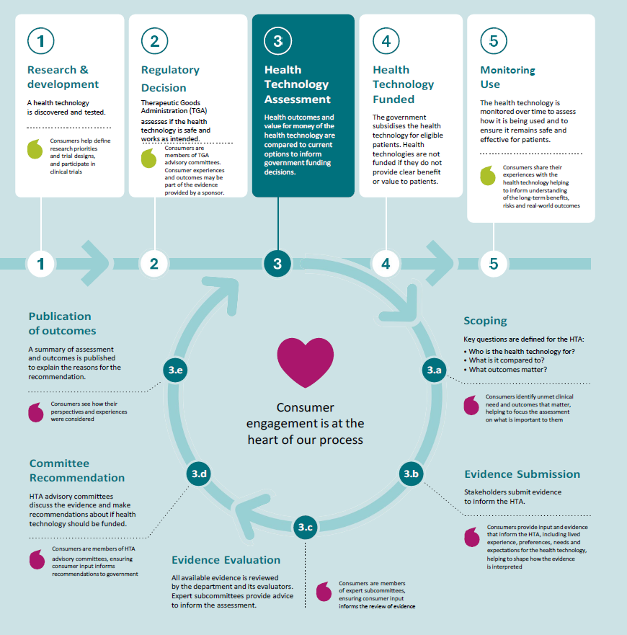

4.4 Strengthen partnerships
Stakeholders partner with consumers and prioritise those most impacted by decisions, to improve HTA processes and outcomes.
Key actions include:
- Engage priority populations – actively include and support diverse participation from priority populations through tailored approaches.
- Build and sustain relationships – develop ongoing, respectful relationships with consumer organisations and communities to reach and engage consumers.
- Create engagement opportunities – provide regular forums for dialogue, feedback and collaboration.
- Develop shared approaches – work together to develop consumer engagement activities, processes and resources.

4.5 Evaluate impact
Stakeholders use feedback and data to improve consumer engagement and its impact.
Key actions include:
- Monitor engagement - track consumer engagement in HTA activities and use of consumer resources.
- Assess consumer impact – assess how consumer perspectives inform HTA discussions and decisions.
- Provide and invite feedback – explain how consumer input was considered and invite feedback from consumers on their engagement experience.
- Improve over time – use feedback and work with consumers to strengthen engagement approaches.

