
Finding a bulk billing GP is getting easier
1
Finding a bulk billing GP is getting easier
Stakeholder information kit – Error! No text of specified style in document.
Stakeholder information kit
April 2026

Contents
Introduction 2
About this stakeholder kit 2
More information 2
Communication resources 3
Sample social media posts 6

Introduction
Following a $7.9 billion investment from the Australian Government, bulk billing is now becoming more accessible for all Australians. This funding is part of a broader commitment to strengthen Medicare and improve access to affordable health care.
As part of this investment, the Australian Government has expanded eligibility for the Medicare Benefits Schedule (MBS) bulk billing incentives and established the Bulk Billing Practice Incentive Program (BBPIP). These measures are designed to support general practices to offer bulk billing to more patients and reduce out-of-pocket costs.
All Medicare-eligible patients can access bulk billed appointments at general practices that offer bulk billing, but not all GPs bulk bill all the time. General practices participating in the BBPIP will bulk bill every Medicare-eligible patient, for every eligible service.
The Australian Government’s Bulk Billing for all Australians Campaign aims to inform people about their options for bulk billed healthcare, encourage them not to delay seeing a GP due to cost concerns, and help them find bulk billing services in their area.

About this stakeholder kit
This kit has information and resources you can share with your members, patients, clients, staff, networks and/or local communities, to let them know about the recent changes to bulk billing, and how to find their nearest bulk billing GP practice.
The kit contains:
- Communication resources – including a poster, fact sheets, videos and an animated explainer
- Sample social media posts.

More information
For more information on bulk billing, and how to find a local bulk billing GP, visit health.gov.au/bulkbilling
If you have questions, require further information, or would like to discuss opportunities to promote the campaign further, please email the Department of Health, Disability and Ageing at enquiries@health.gov.au.

Communication resources
The table below outlines the resources available to support communication and engagement with your community.
Resource | Preview | Link | Suggested use
A consumer fact sheet outlining common items and GP services that patients are often bulk billed.  There will also be an Easy Read version of this fact sheet. | 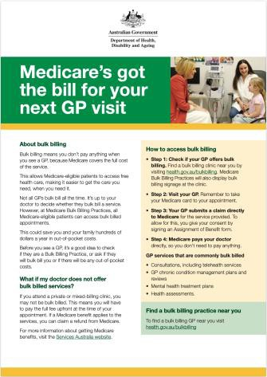 | Download here. | Refer people to the fact sheet on the website or print and hand out hard copies.
A poster for community spaces about how to find a bulk billing GP. | 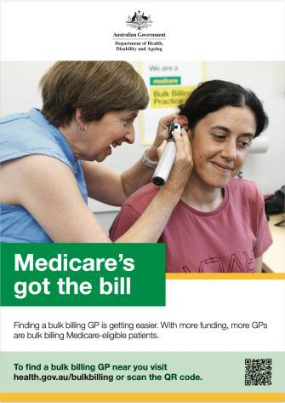 | Download here. | Print and display posters for the community in waiting areas or on community noticeboards.
A postcard that outlines how to access free healthcare with your Medicare card and how to find a local bulk billing GP. | 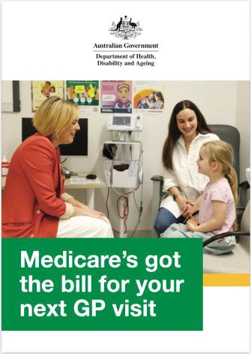 | Download here. | Place in waiting rooms or common areas, or print and hand out at events.

Resource | Preview | Link | Suggested use
Understanding Medicare bulk billing explainer animation on how bulk billing works for Medicare-enrolled patients, as well as the steps to make a claim when a general practice does not bulk bill. | 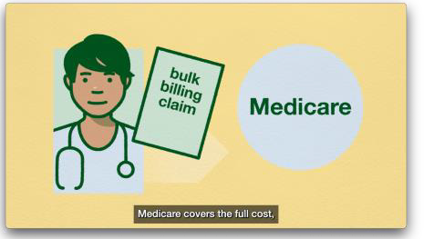 | Watch here. | Refer people to the animated video on the website or use on your own social channels.
An explainer animation on how to access bulk billing – what bulk billing is and how to find a bulk billing practice. | 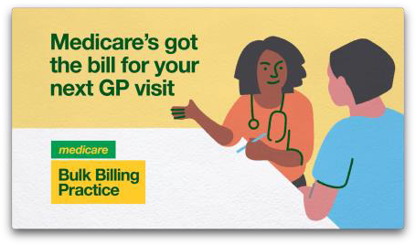 | Watch here. | Refer people to the animated video on the website or use on your own social channels.
A compilation video with patient testimonies about the bulk billing changes. | 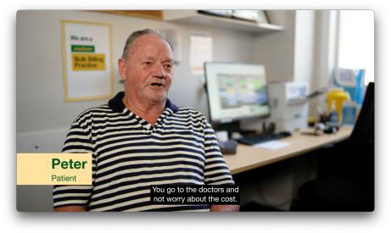 | Watch here. | Refer people to the video on the website or use on your own social channels.
A patient-focused video features staff from Wyndham House Clinic in Shepparton Victoria, discussing the benefits of bulk billing for patients, and the importance of not delaying health care. | 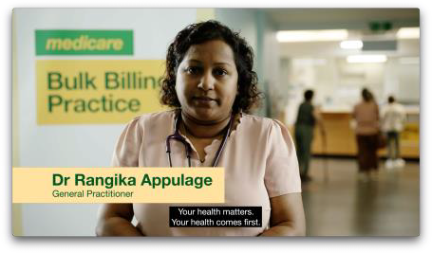 | Watch here. | Refer people to the video on the website or use on your own social channels.

The full range of community information resources on bulk billing are available at: health.gov.au/bulkbilling/resources.
The bulk billing poster, consumer fact sheet and postcard have been translated into the following languages:
- العربية (Arabic)
- 简体中文 (Chinese Simplified)
- 繁體中文 (Chinese Traditional)
- Ελληνικά (Greek)
- Italiano (Italian)
- Khmer
- 한국어 (Korean)
- ਪੰਜਾਬੀ (Punjabi)
- Español (Spanish)
- Tiếng Việt (Vietnamese).
Translated resources can be downloaded from health.gov.au/bulkbilling/translated-resources

Sample social media posts
These social posts and images can be shared on your social channels, such as Instagram and Facebook, to explain the recent changes to bulk billing and how to find a bulk billing GP.
Channel | Copy | Image or video
Facebook / Instagram | Finding a bulk billing GP is getting easier.  The Australian Government has expanded eligibility for Medicare Benefits Schedule bulk billing incentives. This supports general practices to bulk bill.  Ask your GP if they will bulk bill you. To find a bulk billing GP near you visit health.gov.au/bulkbilling | 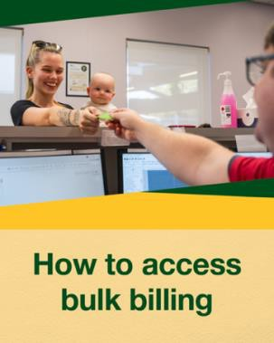
Facebook / Instagram | Bulk billing is growing, making GP visits more affordable for Australians.  GP services that are often bulk billed include:  - Consultations  - GP chronic condition management plans  - Mental health treatment plans  - Health assessments.  Check with your local clinic if they’re part of the Bulk Billing Practice Incentive Program or ask whether you’ll be bulk billed and if any out-of-pocket costs apply.  To find a bulk billing GP near you visit health.gov.au/bulkbilling | 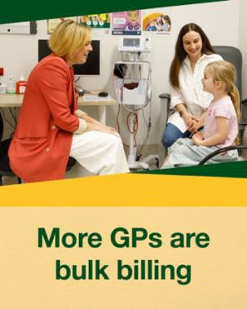
Facebook / Instagram | Did you know bulk billing means Medicare pays the cost when you see a GP?  When your doctor bulk bills, Medicare-eligible patients can access bulk billed care with their Medicare card.  To find a bulk billing GP near you visit health.gov.au/bulkbilling | 