BONDED RETURN OF SERVICE SYSTEM (BROSS)
Participant User Guide April 2026

Table of Contents
1 Introduction 3
1.1 Purpose 3
1.2 What is BRoSS 3
2 Program Information 4
2.1 Participants Obligations 4
2.2 Completing your RoSO 4
2.3 Notifiable Events 5
2.4 Eligible RoSO Locations 5
3 Login 6
3.1 How to log into BRoSS 6
3.2 Accepting your Firm Offer Place 10
4 BRoSS Dashboard 15
4.1 Navigating your Participant Dashboard 15
5 RoSO 18
5.1 Entering a RoSO activity 18
5.2 Multiple location RoSO event 22
5.3 Edit a planned RoSO activity 22
5.4 Activating your planned RoSO activity 25
5.5 Edit your current Activated RoSO activity 28
5.6 Entering Per-Day RoSO in a current RoSO activity 29
5.7 Completing current RoSO event 33
6 Phases 36
6.1 Entering Medical Course duration changes 36
6.2 Completing Student Phase 37
6.3 Entering your Internship Information 39
6.4 Completing your Internship Phase 41
6.5 Commencing your Prevocational training Phase 43
6.6 Commencing your Vocational Phase 44
6.7 Attaining Fellowship – Completing your Vocational Phase 47
7 Managing your Agreement 52
7.1 Requesting an Extension to Program timeline 52
7.2 Withdrawing from the Program 56
7.3 Withdrawing as a former Bonded Medical Rural Bonded Scholarship (MRBS) scheme participant 57
7.4 Withdrawing as a former Bonded Medical Places (BMP) Scheme Participant who has opted-in 62

Introduction

Purpose
While this guide provides information that will support you to meet your obligations, it is not intended as a substitute for you reviewing and understanding your obligations under Part VD of the Health Insurance Act 1973 and Health Insurance (Bonded Medical Program) Rule 2020.

What is BRoSS
BRoSS is the web portal which allows you, as a Program participant, to plan, record and manage your Return of Service Obligation (RoSO) and notifiable event reporting requirements under the Program.
As a Program participant you are responsible for ensuring your BRoSS record is kept up to date and contains true and correct personal details and information about the milestones and events you have achieved.
BRoSS has extensive in-system guidance, notifications, and alerts to support you in meeting your obligations under the Program.

Program Information

Participants Obligations
The Program is delivered and supported by the following legislation:
- Part VD of the Health Insurance Act 1973 (the Act).
- Health Insurance (Bonded Medical Program) Rule 2020 (the Rule).
More information about the Program is available on the Department of Health, Disability and Ageing (the department) website.
Once you are a Program participant, you must adhere to the obligations listed in the relevant legislative instruments. These include:
- completing your Return of Service Obligations (RoSO) in an eligible regional, rural, or remote (Modified Monash Model (MMM) 2-7) area
- informing us about your RoSO in accordance with subsection 16(1) of the Rule.
- ensuring all notifiable events and milestones are up to date in BRoSS, in accordance with subsection 15(1-4) of the Rule.
- keeping your personal details up to date, as per subsection 15 (1-2) of the Rule, so you continue to receive all necessary correspondence.
- logging into BRoSS at least every 6 months. If no changes are necessary, you can log out of BRoSS without editing any information. We will be able to see that you have met this requirement as your log in date and time are recorded in BRoSS.

Completing your RoSO
As stated in section 124ZF of the Act, as a Program participant you have 18 years to complete your RoSO from the date you complete your medical course.
If you joined the Program as a new student, you must enter at least one RoSO plan in BRoSS prior to completing your medical course. If you joined the Program from a legacy program, you must enter at least one RoSO plan in BRoSS within 3 months from the date you entered the Program. The 156 weeks of RoSO can be completed over an 18-year period and can be undertaken in the following ways:
- full-time, part-time or on a per-day basis.
- as a fly-in/fly-out doctor in eligible locations.
- on-call services in an eligible location.
- paid leave that is accrued from the rendering of such a professional service.
- outreach services in an eligible location.
- aeromedical evacuation and retrieval services to patients in an eligible location; and
- telehealth services in an eligible location and delivered to patients in an eligible location.

Under section 9(3) of the Rule, you are only able to reduce your RoSO by up to 78 weeks prior to fellowship or within the first 12 years of your 18-year period. Once you attain fellowship or where you have commenced the 13th year of your 18-year period, whichever occurs first, can you complete the remaining 78 weeks, totalling 156 of RoSO. All completed RoSO plans, and uploaded evidence, will be reviewed by us. If required, further evidence will be requested to determine eligibility.

Notifiable Events
As a Program participant you are required to regularly review section 15 of the Rule to assess whether any notifiable events are applicable given your circumstances. You must update your BRoSS record within 6 months of a notifiable event occurring.
Notifiable events include:
- Any change in name (marriage or deed poll certificate).
- Any change in your primary or secondary contact details, including your phone number, email address or postal address.
- Any change which impacts on the completion time of your course of study in medicine.
- Completion of course of study in medicine.
- Provisional registration with AHPRA.
- Commencement of an internship.
- Completion of an internship.
- General registration with AHPRA.
- Commencement of vocational training.
- Attainment of medical specialisation.

Eligible RoSO Locations
When seeking confirmation on eligible locations, we recommend that you use BRoSS. BRoSS will advise you immediately if the location is eligible while accounting for your individual circumstances. Refer to section 11 of the Rule ‘Entering a planned RoSO event’ for more information.

Login

How to log into BRoSS
You will need to have a myGov account to log in to BRoSS. Go to myGov Home.
- If you do not have a myGov account, please go to 'Create account' and follow the prompts to create an account. Log into your myGov account.
- If you do have a myGov account, go to ‘Sign in.’
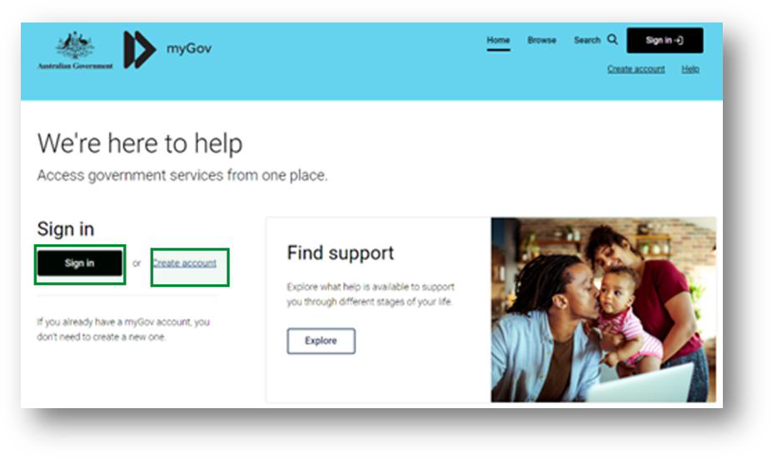
Sign in with your myGov details.
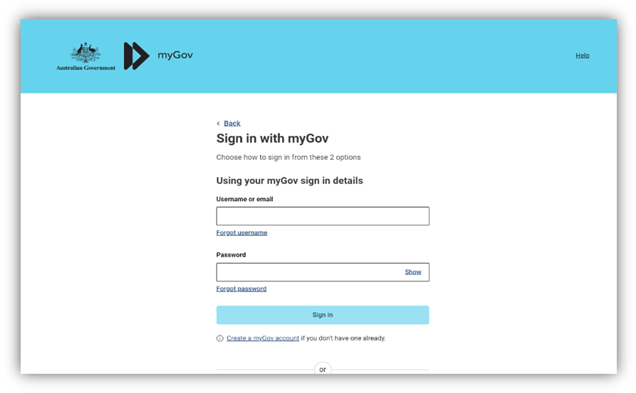

Authenticate your login.
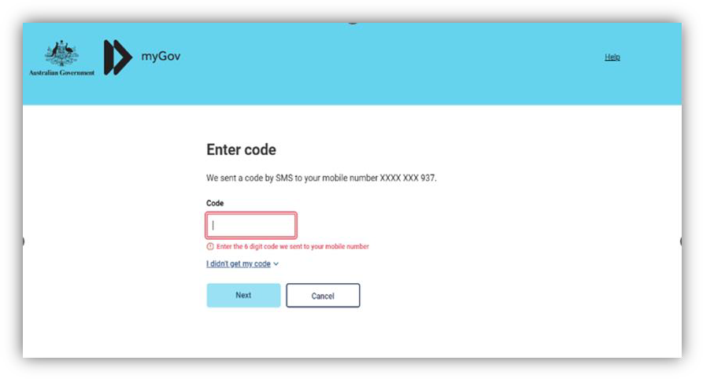
You will need to link the ‘Department of Health Applications Portal’ to your services by clicking the ‘View and link services’.
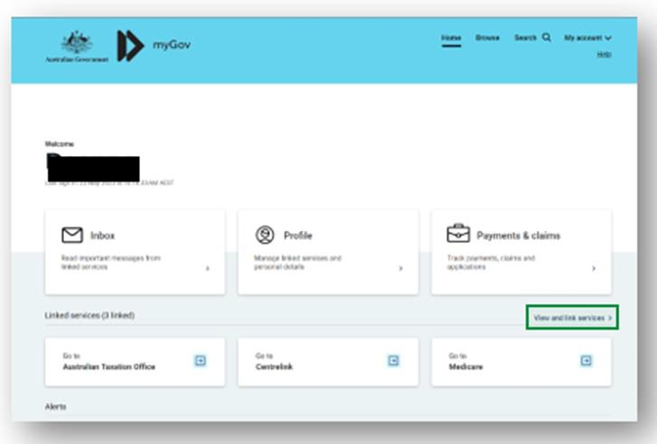

Scroll to the service and click ‘Link’.
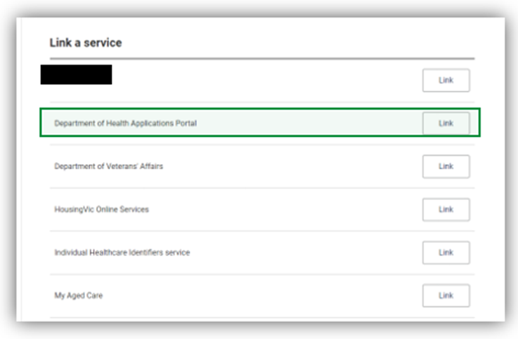
You will be taken to the Health Data Portal page, click ‘Log in’.
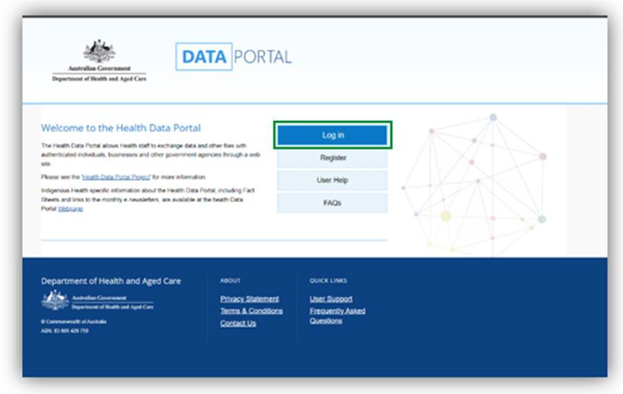

Select ‘Login with myGov’ as your log-in credential choice.
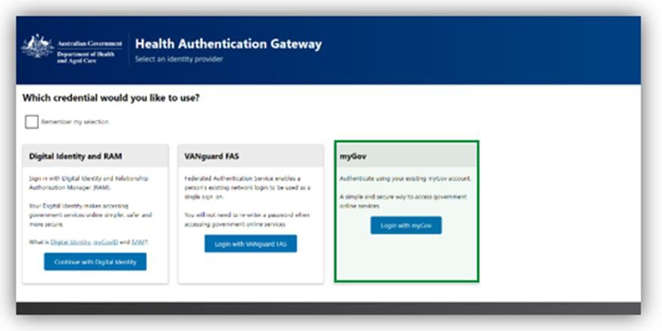
Enter your BRoSS user ID (username) and your linking code (password) on the 'Health Authentication Gateway' page. Your BRoSS user ID and linking code can be found within your ‘Firm offer’ email or the ‘Welcome to the Bonded Medical Program’ email sent to your primary email address.
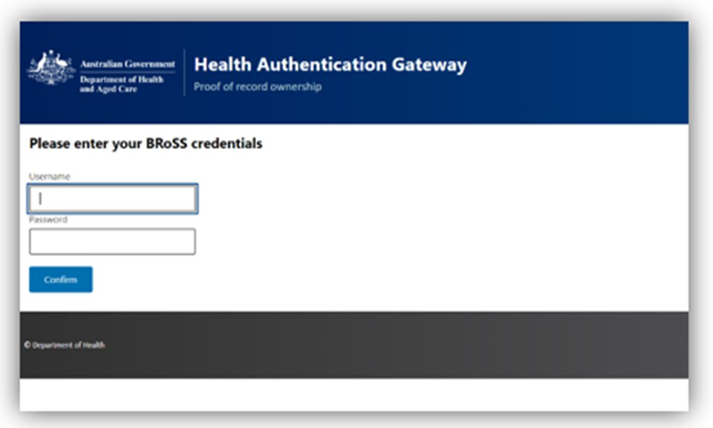
This will be a once-off action. Once you have linked 'Department of Health Applications Portal' as a service, the next time you try to sign in to BRoSS you will not be required to enter your BRoSS User ID (Username) and linking code or Temporary Password (Password).

You will be taken to the Health Data Portal, on the menu bar, select 'BRoSS'. Your dashboard will open.
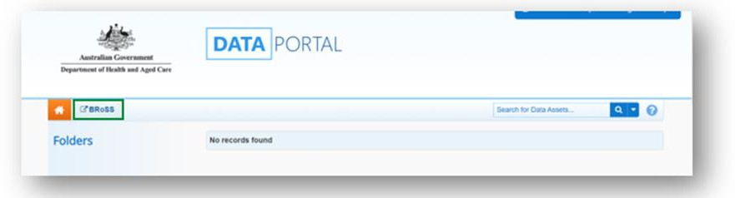
Occasionally, you may experience log in issues such as seeing an account inactive message, an error message, or BRoSS may not display correctly. These are usually due to a cache or browser issue.
If you experience log in issues, please:
- Do not unlink the Department of Health Applications Portal service from your myGov account. Doing so will require you to be issued with a new temporary password, delaying access to your BRoSS record.
- Clear your cache, as this should clear any previously saved data which may be causing your BRoSS log in issues (if you need assistance on how to do this, you can google ‘[Your browser name] clear browser cache’).
- Try a different browser if you continue to experience log in issues.
If the issue persists, please reach out to our Contact Centre for assistance on 1800 987 104 (Monday-Friday, 8:30am to 5:00pm AEST/AEDT).

Accepting your Firm Offer Place
Once your university position has been confirmed, you will receive an email titled - ‘FIRM OFFER APPLICANT – BONDED MEDICAL PROGRAM’ which will contain information on the Program including your BRoSS User ID and Temporary Password to log in to the system.
After logging in to your BRoSS record following the steps in the ‘How to Log in to the Bonded Return of Service System (BRoSS)’. Your ‘My dashboard’ page will open.
Review all the information on the left-hand side of the page by opening the accordions.

Under ‘Update your details’ accordion, review and update your ‘Personal contact details’, ‘Contact email’ and ‘Mailing address’ information by clicking on the ‘Edit’ button on the bottom of the page. Ensure all mandatory fields (marked orange in the Edit pages) are correct and click ‘Save’.
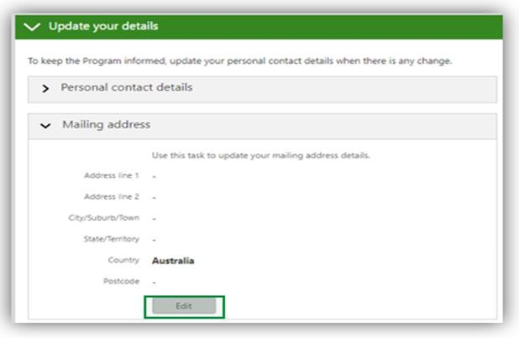
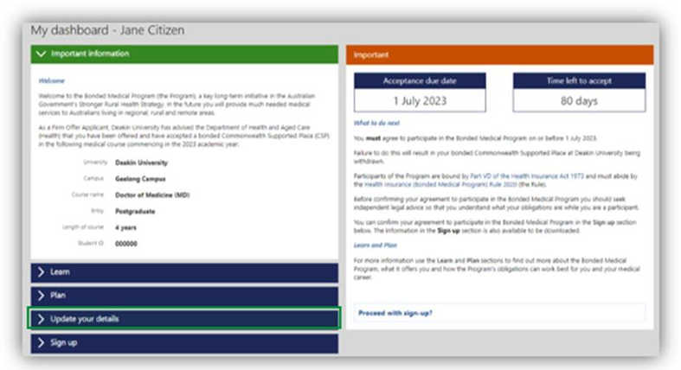

Once your details are updated either click on the ‘Proceed with Sign-up’ link or open the ‘Sign- up’ accordion to see your ‘Agreement to Participate’.
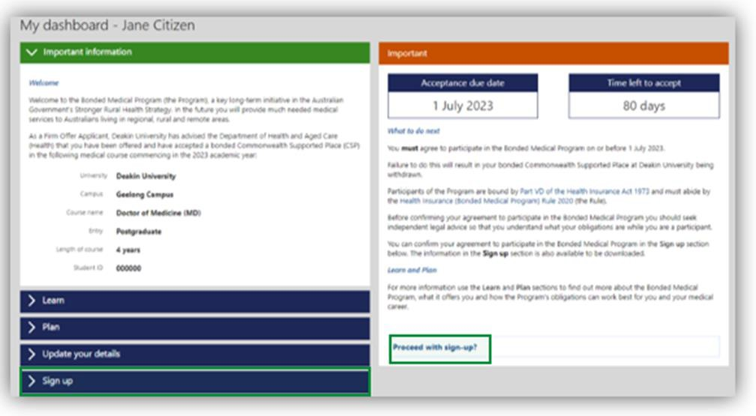
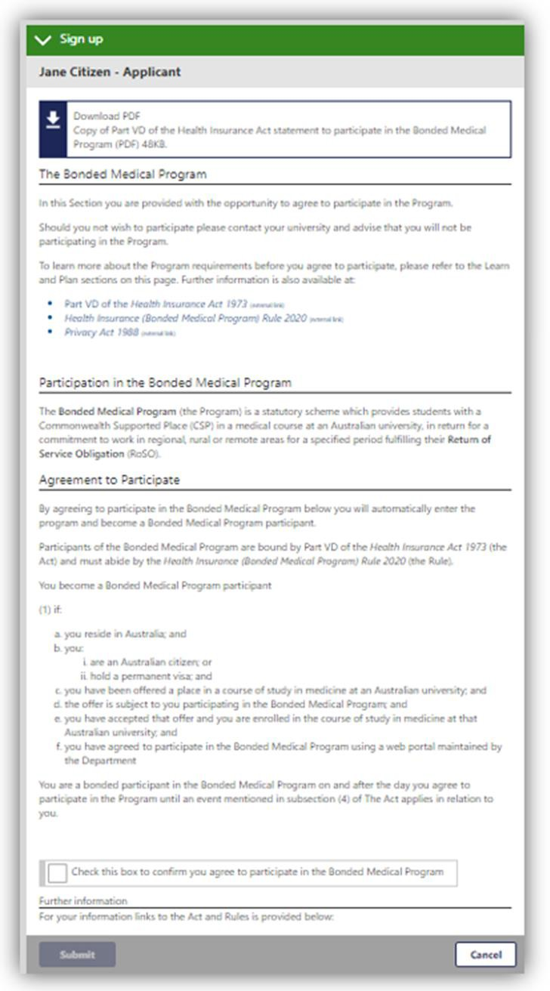
Read the information and if you agree, check the ‘tick box’ and click ‘submit’.
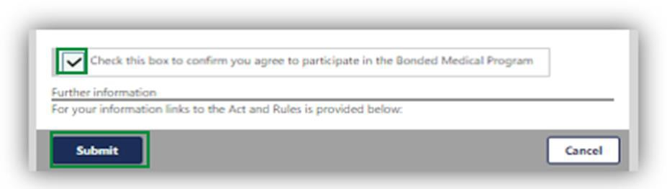
A pop-up page will confirm your acceptance into the Program. Click ‘Go’.
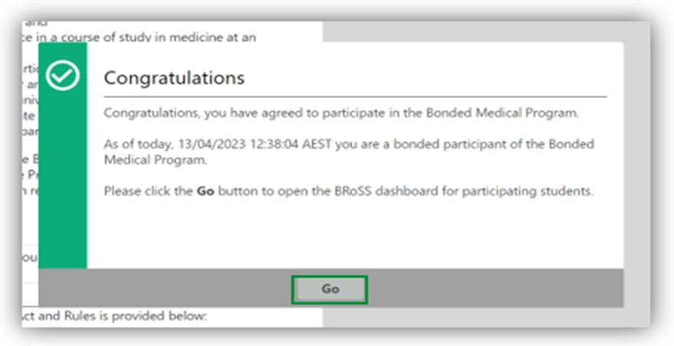
Once you click ‘Go’, you will be redirected to the BRoSS dashboard.
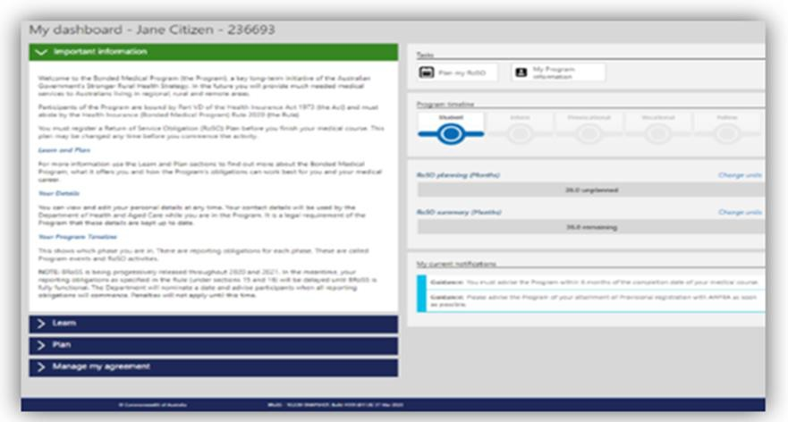

BRoSS Dashboard

Navigating your Participant Dashboard
When logging in after accepting your place in the Program or where you have opted in from a Medical Rural Bonded Scholarship Contract or Bonded Medical Places Agreement, your personal dashboard will contain information to guide you through your obligations under the Program.
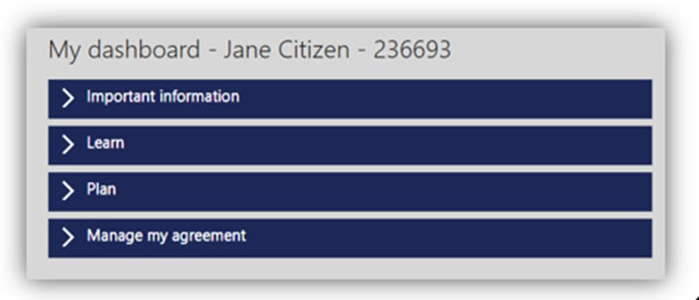
Important information: is used to communicate key messages about the Program.
Learn: contains helpful information about the Program and your obligations, including your reporting requirements from the time you join the Program to the time you exit. BRoSS will assist you in managing your reporting requirements and advise what support is available to you to answer any Program questions.
BRoSS allows you to self-manage your reporting obligations, and uses in-built messaging, guidance and emails to alert you.
As a Program participant you are required to log in every 6 months and ensure all your information is up to date and adheres to the Program’s reporting requirements.
Plan: contains helpful information about the Program and your RoSO obligations, including eligible work types, how and when you can complete your RoSO, and what tools are available in BRoSS to help you plan, activate, and complete your RoSO.
Manage my agreement: contains a couple of key functions. Here you can download a copy of your agreement to participate, which includes the date you joined the Program. You can also request a Program extension or a Program withdrawal quote calculation.
Tasks: will change depending on the phase you are currently in your medical career. The task banner will allow you to quickly jump straight to planning your RoSO, managing your RoSO activities, notifiable events and updating your personal details.
Student phase tasks: As a new student, you must enter at least one RoSO plan in BRoSS prior to completing your medical course.
Internship to fellow phase tasks: have planning dates set within BRoSS. If your plans change, review your record and amend your planned start or finish dates.
Program timeline: shows your last updated phase. You can click directly on your current phase or previous phase, to take you to the related notifiable events and any RoSO activities.

A green icon with a tick indicates that this phase of the timeline has been completed, a blue icon indicates that the phase is still underway, and the greyed-out icons represent the phase(s) yet to be commenced.
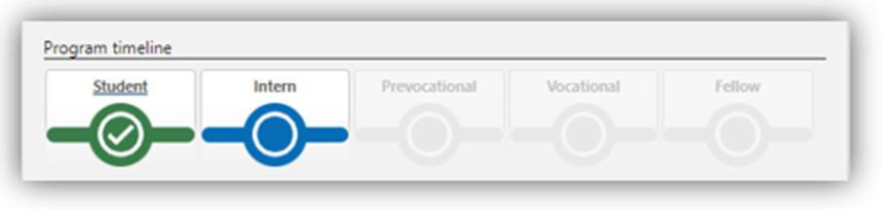
RoSO planning and summary bar: show the amount of RoSO you have planned (orange), current/commenced (blue), completed (green) and remaining RoSO balance (grey).
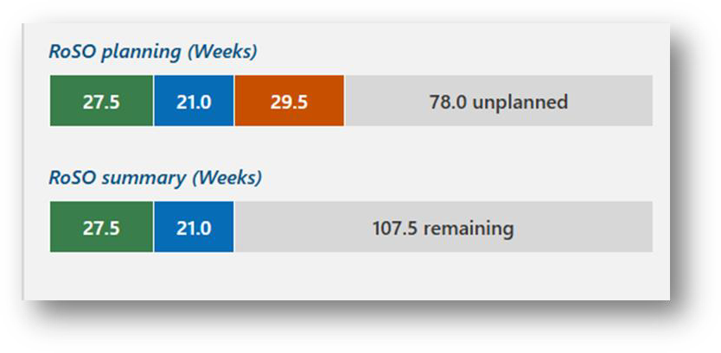
My current notifications: provides guidance on actions that are required to be undertaken in BRoSS. It will also let you know if you are approaching a reporting deadline.
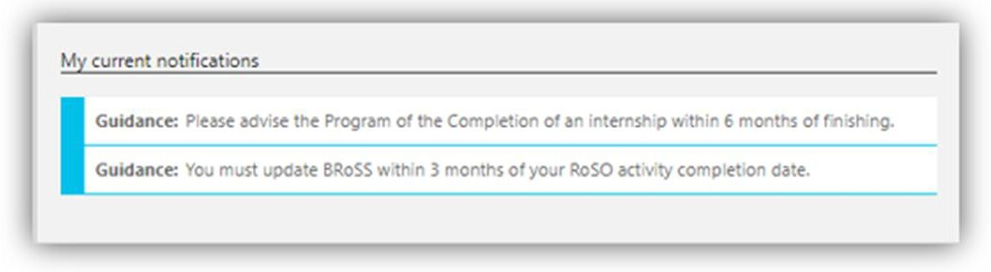

BRoSS guidance bar: is an in-system guidance feature built into every page on the right-hand side listed as ‘Guidance’. Click on the arrow to read about the current page. To close the ‘Guidance’ bar click on the arrow and it will close.
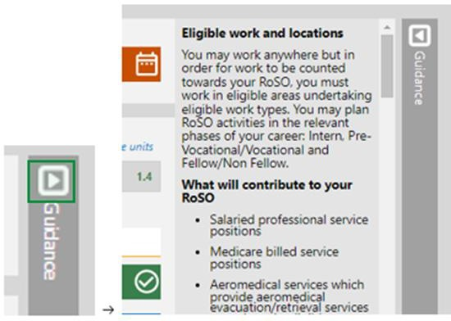

RoSO

Entering a RoSO activity
As outlined in section 16 (1) of the Rule, you must meet the following legislated requirements when recording RoSO:
- It must be eligible work in an eligible location.
- You must plan, activate and complete your RoSO activity via your BRoSS record.
- RoSO activation and completion evidence must meet the requirements outlined in the Rule.
For participants joining as a new student: you must register a planned RoSO activity after you have completed your course of study in medicine.
For opted-in former legacy scheme participants: you must register a planned RoSO activity once you have been opted in to the Program.
For all participants, after commencing eligible work you must confirm the eligible location and start date of your planned RoSO activity in BRoSS. This RoSO activity may be changed any time before you activate it in BRoSS, under ‘Plan my RoSO’.
Within a year of completing work at an eligible location, you must complete the corresponding RoSO activity by confirming the end dates of the work period and uploading sufficient evidence to confirm you have completed work in accordance with your planned RoSO activity.
To plan a RoSO activity, click on the ‘Plan my RoSO’ button on your ‘Dashboard’, this will take you to the ‘RoSO activity planning’ accordion on the ‘Manage my RoSO’ page.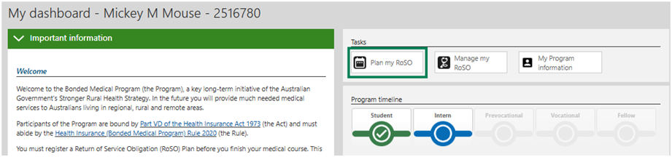
Click the ‘Plan a RoSO activity’ button to commence planning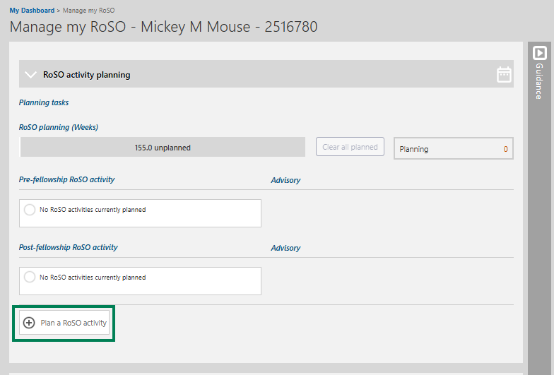
The ‘Plan a RoSO’ activity page will open, complete the mandatory fields (marked in orange)
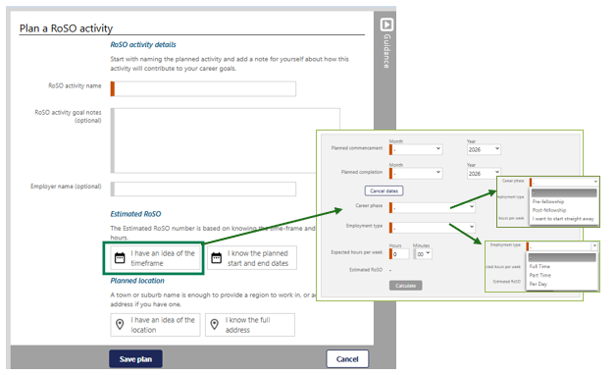
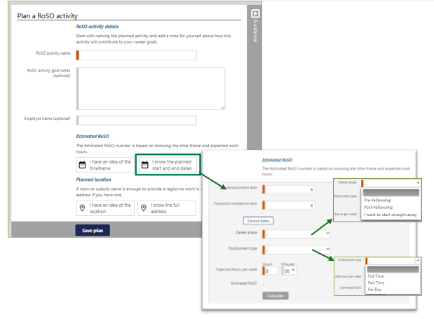

RoSO activity name: when naming your RoSO activity use a descriptive title specific to the work being undertaken, such as including the practice name and location.
Career Stage: as RoSO activities can be planned in advance, the career stage selection is to identify the stage in which the RoSO activity may be completed in.
We removed the requirement that you had to complete at least half of your RoSO after you became a Fellow or 12 years after finishing your medical course – whichever occurred first. You can now complete all your RoSO as soon as you become a medical practitioner. However, that work will not be reflected in your RoSO progress bar until July 2026.
The fellowship or 12-year requirement will be removed from BRoSS by July 2026. Once implemented, BRoSS will automatically recalculate your RoSO, and all work completed prior to fellowship will count towards your RoSO.
Visit our webpage for more information regarding changes to the Bonded Medical Program.
Employment Type: you can select one of 3 following employment types, this will need to match your ‘Expected hours per week’ entered in the estimated RoSO information.
You can work:
- full-time – if a bonded participant is employed in eligible work for at least 35 hours or more in that week. Hours worked above 35 hours in a week will not further reduce your RoSO.
- part-time – if a bonded participant is employed in eligible work for at least 20 hours, but less than 35 hours, in that week
- per-day – if a bonded participant is employed in eligible work on 2 or more days with a total of at least 20 hours. There is no ‘in that week’ requirement – so the days worked do not need to have been worked in a single week.
RoSO does not have to be completed continuously. If you work variable hours, you must record your RoSO as a per-day plan. BRoSS will accurately calculate the RoSO accrued for weeks where you meet the per day, part-time or full-time definition.
BRoSS calculates one week as 7 days, from Sunday through to Saturday.
BMP Scheme 2016–2019 participants
If you are a participant in the BMP Scheme with a 52-week obligation, you can now complete your RoSO pro-rata, either part-time or by the day. You no longer must do it in full-time blocks of at least 10 weeks. You must now complete a total of 1820-hours of RoSO, and only the first 35 hours worked per week count toward that total.
This functionality has not yet been added to BRoSS. For now, if you have completed 52 weeks on a part-time or pro-rata basis, please send us your evidence so we can assess whether you have met the Program requirements.
We can only assess your RoSO once you have provided all required evidence. If your evidence does not meet the requirements, we will ask you to submit your documentation again. Visit our webpage for more information regarding changes to the Bonded Medical Program.
Work that counts towards your RoSO:
- Paid leave from providing professional services to patients in eligible locations.
- Telehealth services provided from an eligible location.
- Fly in/fly out and outreach services to eligible locations.
- Evacuation and retrieval of patients from an eligible location.
- Time spent on call in an eligible location.
Work that does not count towards your RoSO:
- Clinical research.
- Academic teaching.
- Medical administration or organisational work.
- Paramedical work.
- Clinical practice in a discipline other than medicine. For example, if you were a nurse prior to medical school, doing locums as a remote area nurse will not count towards RoSO.
Planned location can either be searched by selecting ‘I have an idea of the location’ button, or, by selecting ‘I know the full address’ and entering the work location address.
BRoSS must be used to check the eligibility of a location, as it contains an in-bult eligible location search function. Participants can enter a town, suburb, or the full street address, and BRoSS will return an immediate assessment of the location eligibility based on your individual circumstances.
BRoSS will also let you know if that location is eligible for use towards scaling benefits. If you exclusively work full-time in MM4 to 7 locations for 104 weeks and attain fellowship, each week of service over 104 weeks will reduce your RoSO by 2 weeks. This is called scaling and could enable you to complete your RoSO in 2 years and 6 months instead of 3 years.
When using the ‘I have an idea of the location’ option, enter the suburb or town to get the planned MMM classification location eligibility.
When using the ‘I know the full address’ option, start entering the full address of the location into the ‘Find an address’ bar and pre-filled results will show below the bar, click on the correct address from the drop-down menu.
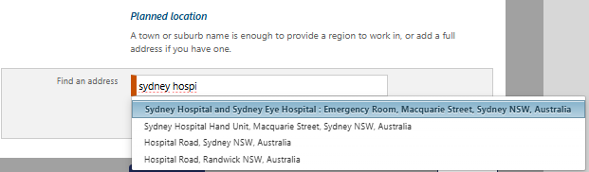
Once you have selected the location, BRoSS will inform you if the location is eligible by displaying a red, orange or green automated banner.
Once you have reached your Vocational phase, you can review your eligible District of Workforce Shortage (DWS) or Distribution Priority Area (DPA) locations for your specialty in BRoSS.
If BRoSS returns an ineligible location assessment, dual fellowship holders, or participants who are working in locations recently re-classified (e.g. before BRoSS is updated with new classifications), may request a review of a location’s eligibility by selecting ‘location override’. This will automatically generate a BRoSS case ticket for us to review. These location override requests are individually assessed and verified before the location override is accepted.

Location override requests outside of these limited circumstances will be declined. Please note that all MM1 inner metropolitan locations are ineligible under the Program.
Estimated RoSO: once you have confirmed a location is eligible you must enter the dates for correct eligibility assessment for the RoSO activity. You can do this by entering proposed dates for planning future RoSO (i.e., dates not yet confirmed) by selecting the ‘I have an idea of the timeframe’ button. Or, if you know the exact dates, by selecting the ‘I know the planned start and end dates’ button.
You will be required to enter the ‘Commencement date’, the ‘Proposed completion date’ and the ‘Expected hours per week’. Once these mandatory orange fields are completed select ‘Calculate’ to display the amount of RoSO that can potentially be reduced from your obligation for this period of work.
To finalise the RoSO activity, select ‘Save Plan’ at the bottom of the page.
BRoSS calculates a week from Sunday to Saturday. If your start date or end date falls on a day different to these, you will be asked to enter your ‘Partial week’ hours for a specific period.

Multiple location RoSO event
Under the Program, you can complete RoSO in any eligible location. This means that you may choose to work in more than one eligible location over the same period. For example:
- you regularly work hours in eligible location A and eligible location B.
- you undertake ongoing locum and/or on call work across multiple eligible locations.
- you deliver telehealth services from an eligible location.
In these circumstances, it is recommended that you record your RoSO in BRoSS as a single RoSO activity with multiple locations which will ensure the RoSO displayed in BRoSS is calculated correctly.
When you register a RoSO activity in BRoSS, it will only allow you to enter a single location. However, after activating your RoSO activity in BRoSS, you can enter additional locations to your plan. Your activation evidence will need to detail your work for each location entered.
When activating or editing a current RoSO activity, click on ‘Add a full address’ to enter additional locations.

Edit a planned RoSO activity
You can edit a ‘Planned RoSO activity’ at any time by clicking on the RoSO activity name in blue text in the ‘RoSO Activity planning’ accordion.
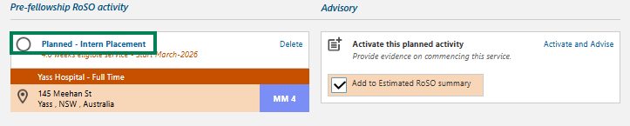

Click the ‘Edit’ button on the ‘Planned RoSO activity’ page to edit the details, then click ‘Save’ to update the ‘Planned RoSO activity’.
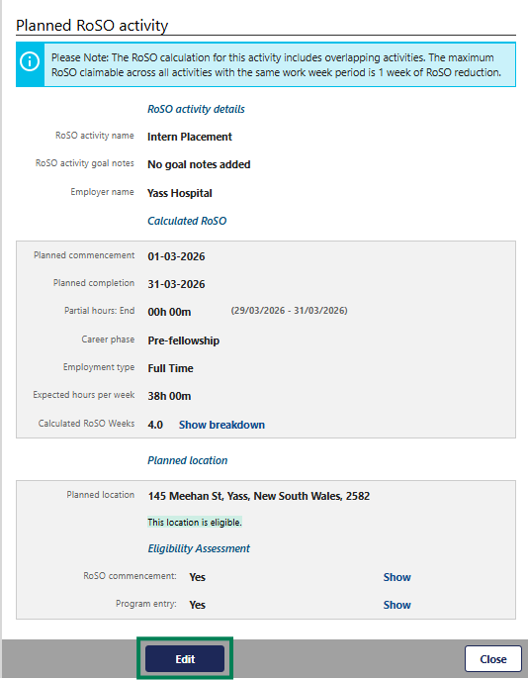

Edit all the required information and click ‘Update plan’.
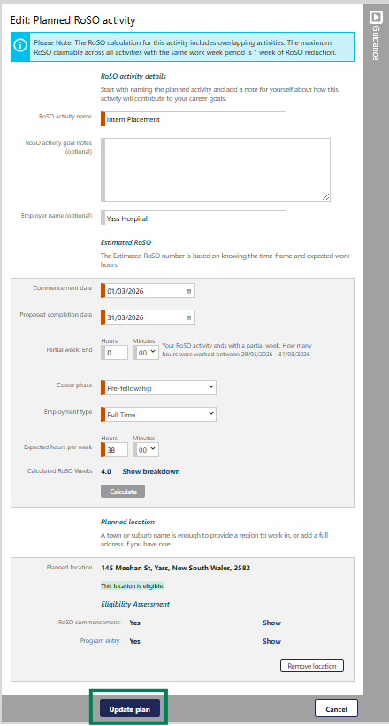

Activating your planned RoSO activity
To activate a previously planned RoSO activity, open your ‘Manage my RoSO’ page by clicking on the ‘Plan my RoSO’ button.
Evidence to be uploaded must be either a signed contract or a signed letter of agreement from your employer that confirms an eligible location has been selected, and includes the following information:
- name of the bonded participant.
- commencement date.
- expected completion date of employment.
- position name.
- employer name.
- employer address.
- primary locations of work.
- number of hours employed each week.
If you are unable to provide the evidence outlined, you may provide a statutory declaration that includes all the required information.
All your planned RoSO activities are shown under the ‘RoSO activity planning’ accordion. When you are ready to activate/commence your RoSO activity, click on the ‘Activate and Advise’ link.
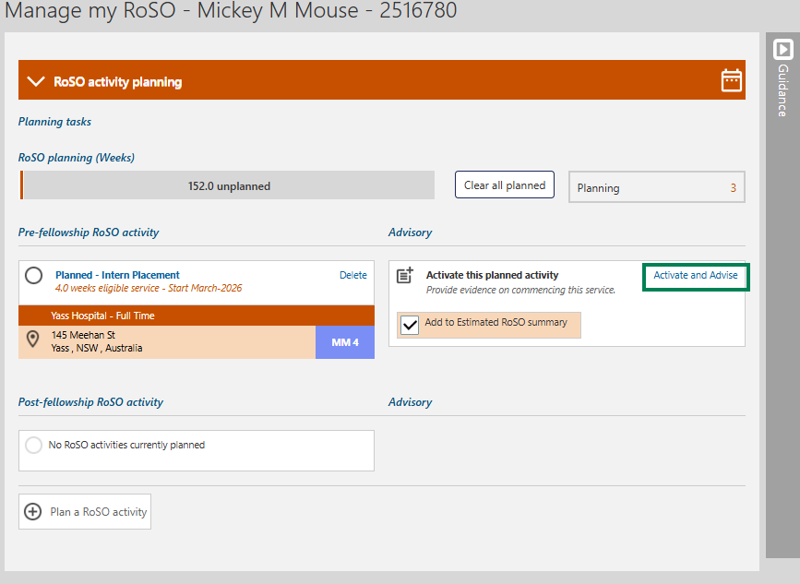
A pop-up window will show to confirm you wish to activate this RoSO activity, click ‘OK’.
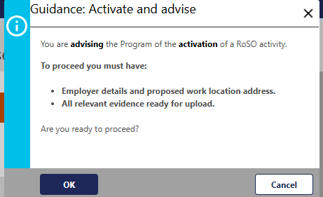

The ‘Advisory: Activate a RoSO activity’ page will open for you to update and enter additional information into the mandatory orange fields and upload relevant evidence before submitting the activity/event.
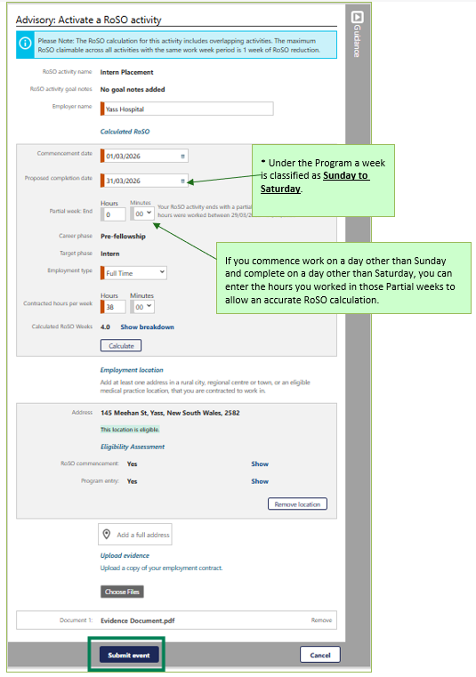

Edit your current Activated RoSO activity
You can edit your current activated RoSO activity at any time by clicking on the applicable blue RoSO activity name in the relevant phase accordion.
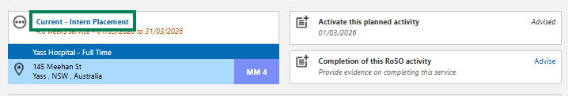
Click the ‘Edit’ button on the ‘Activated RoSO activity’ page to edit the details, then click ‘Save’ to update the Activated RoSO activity.
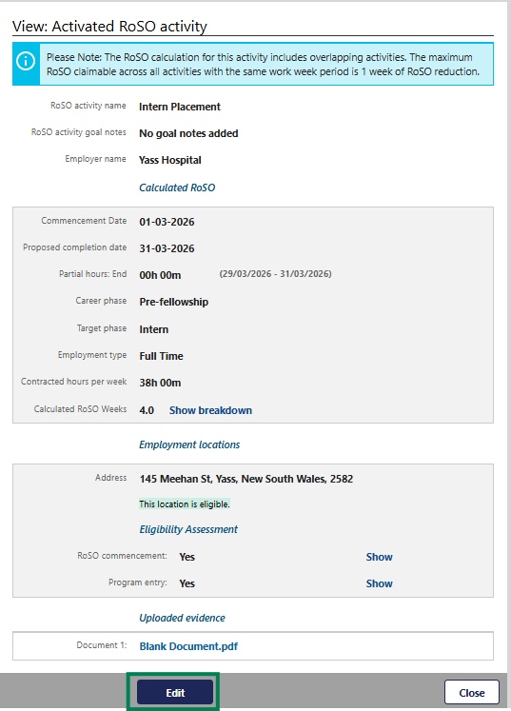

Entering Per-Day RoSO in a current RoSO activity
Under the Program, you can complete your RoSO on a full time, part time, or per day basis. The type of RoSO activity you create and how you record your work hours will depend on how you are employed and how many hours you work each week.
Per day RoSO activities can be entered when:
- you regularly work less than 20 hours per week in an eligible location.
- you work fluctuating hours, and do not consistently meet the definition of part time or full time.
- you work as a contractor or locum, with periods of unpaid leave that is not counted as RoSO.
- you work in a telehealth role, delivering services to patients provided from an eligible location, so the amount of work considered eligible for RoSO can fluctuate daily.
To update a per day basis activity, open your ‘Manage my RoSO’ page, open the relevant Phase accordion and click on the blue RoSO activity title of the event
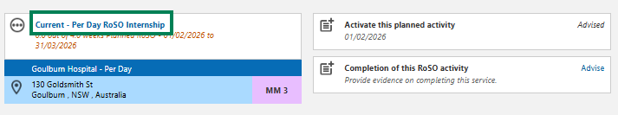

This will allow you to update your daily hours and locations via the ‘View: Activated RoSO activity’. Scroll to the bottom to view the ‘Hours by week’ section. Click ‘Edit’ against your current week to enter your hours and locations.
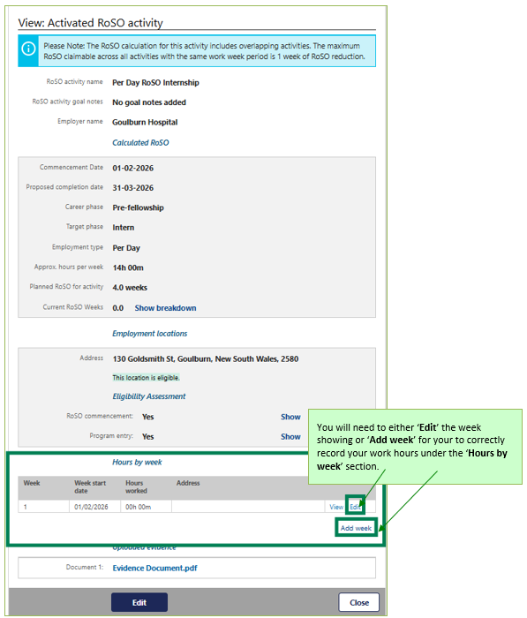
If your work week does not show, you can add additional weeks by clicking ‘Add week’ link.

Click on the ’Edit’ link of the week you need to update.
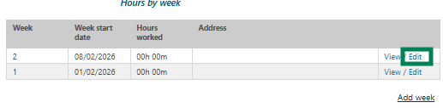
The ‘Edit week entry’ page will open.
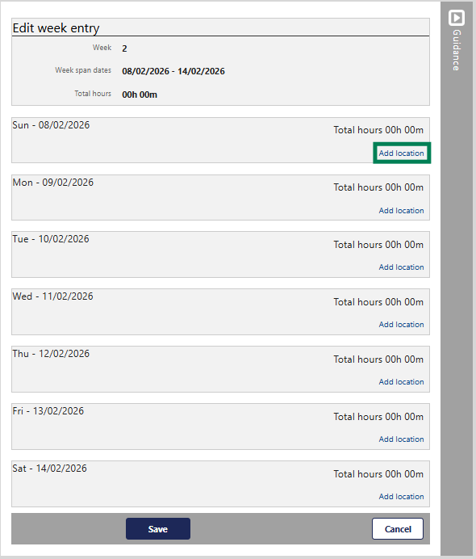
Click on the ‘Add location’ link and enter the location(s) and hours worked that day from the dropdown menus.
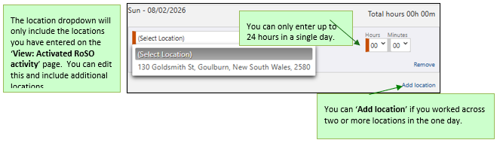

Once you have entered all your data for the day(s)/week, click ‘Save’ at the bottom of the page. You will be taken back to your ‘View: Activated RoSO activity’ page.
Your ‘Current RoSO weeks’ will update once you have accumulated greater than 20 hours of RoSO.
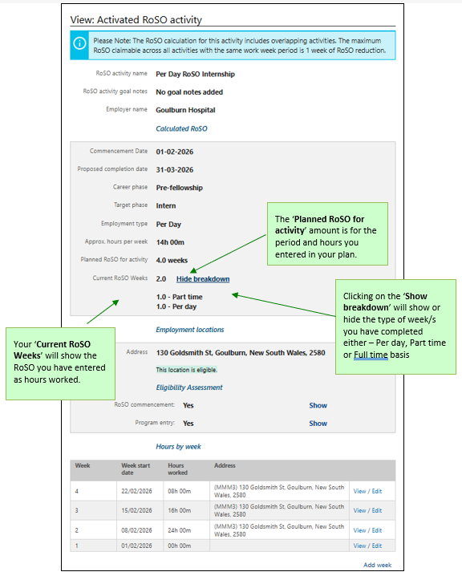

Completing current RoSO event
You must upload evidence and complete RoSO activities within a year of completing work at an eligible location. To do this, go to your ‘Manage my RoSO’ page and open the relevant phase accordion for your RoSO activity. Uploaded evidence must confirm you have completed work in accordance with your RoSO activity.
Your completion evidence to be uploaded must be either:
- a signed letter from your employer dated after your RoSO activity completion date, or
- a statutory declaration dated after your RoSO activity completion date.
Once you have your current RoSO activity on the page, click the ‘Advise’ link on the ‘Completion of this RoSO activity’ tile.
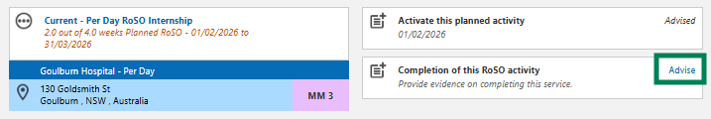
A pop-up for the ‘Guidance: Completion of this RoSO activity’ page will show to ensure you have the correct information before you proceed. If you are ready to proceed, click ‘OK’.
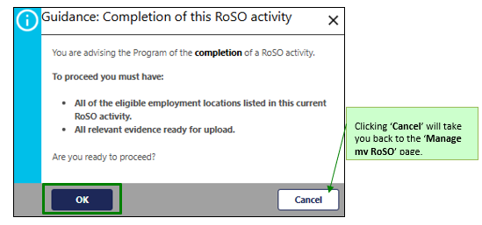

In the ‘Advisory: Completion of this RoSO activity’ complete the mandatory orange fields and upload the relevant evidence. Once updated click the ‘Submit’ button to complete this RoSO activity.
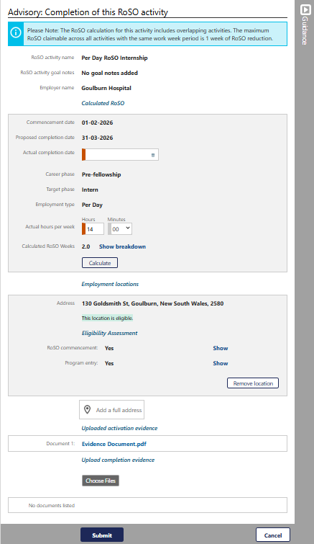

The view page will then show, and you can ‘Edit’ the information if required or click ‘Close’ to exit the page.
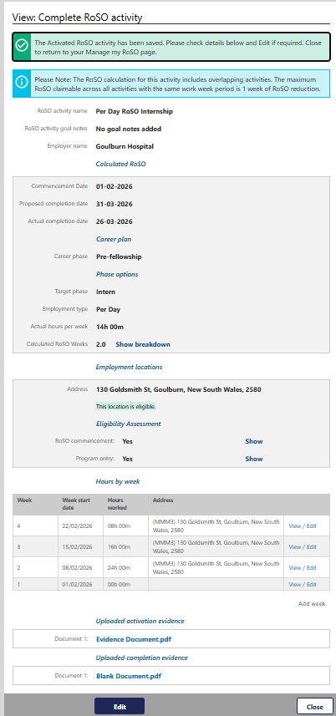
Your RoSO activity will now show as green as it has been completed. This activity will reflect in your RoSO summary bar in green.
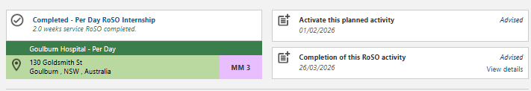
All completed RoSO will be reviewed by the department to confirm eligibility.

Phases

Entering Medical Course duration changes
To update your ‘Prevocational’ phase with your APHRA registration and Medicare provider number, go to your ‘Manage my RoSO’ page and then under the ‘Prevocational’ accordion.
You can get to your ‘Manage my RoSO’ page from your dashboard by clicking on either the ‘Manage my RoSO’ button or the ‘Prevocational’ button under the Program timeline.
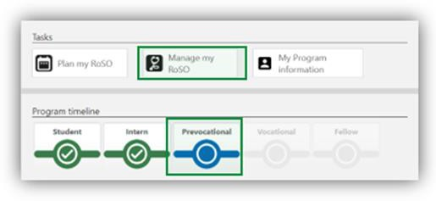
To enter your ‘APHRA registration’ click on the ‘Advise’ link under the ‘Prevocational’ accordion.
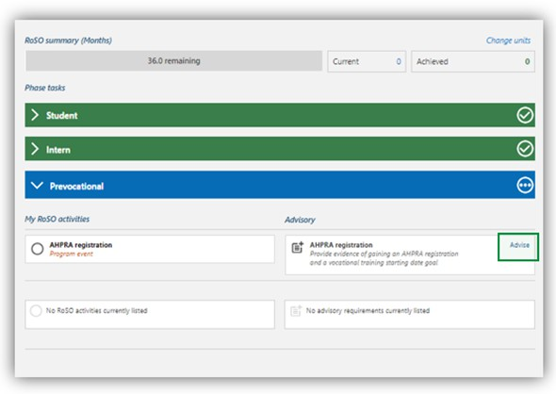
In the ‘Advisory: General registration with AHPRA’ page, complete all mandatory orange fields and upload the required evidence from AHPRA that general registration has been attained. If you are unable to provide the evidence outlined, you may provide a statutory declaration that includes all the required information.
The final field ‘Vocational training goal’ is the future date that you think you will commence training with your specialty college, which can be changed at any time. If you do not intend to undertake vocational training, enter a date that falls after your Program completion date to avoid receiving automated reminders.

Click ‘Submit’ once completed.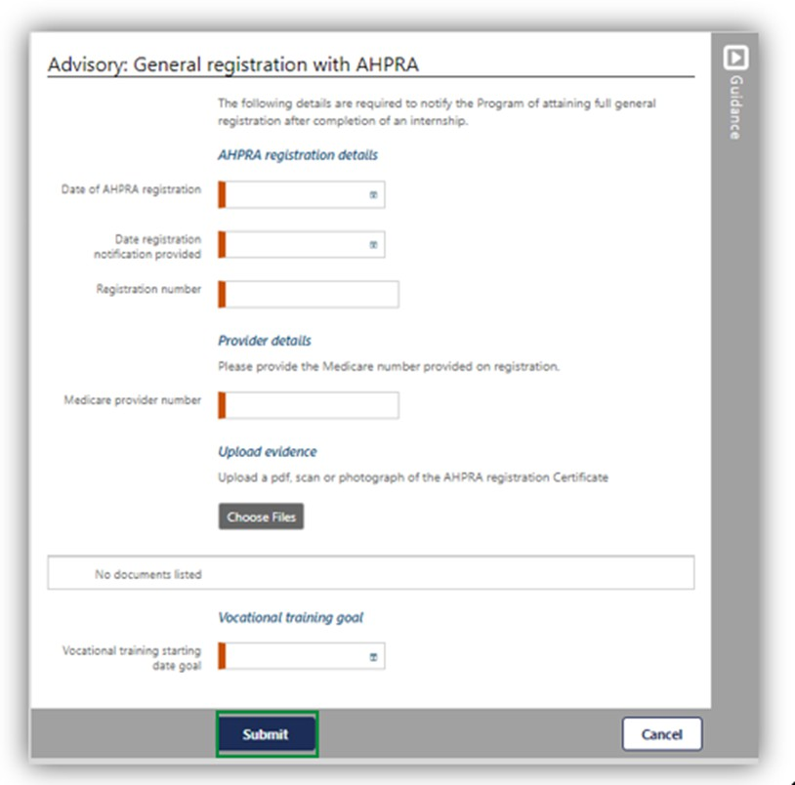

Completing Student Phase
To update your ‘Student’ phase with your medical course completion, go to your ‘Manage my RoSO’ page and select the ‘Student’ accordion.
You must update in BRoSS any change which impacts on the completion time of your course of study in medicine. Evidence must be from the university confirming the change and including the following information:
- name of the bonded participant.
- date of the evidence.
- date on which the change takes effect.
- date on which the approved change of circumstances has been completed.
If you are unable to provide the evidence outlined, you may provide a statutory declaration that includes all the required information.

You can get to your ‘Manage my RoSO’ page by clicking on the ‘Student’ button under the Program timeline.
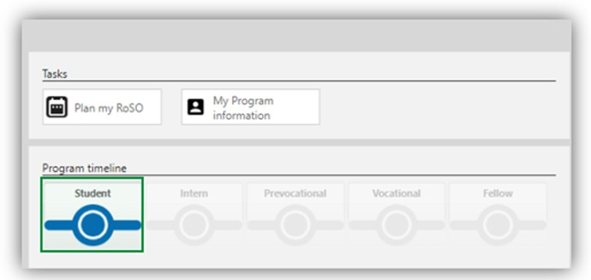
On the ‘Completion of medical course’ tile click the ‘Advise’ link.
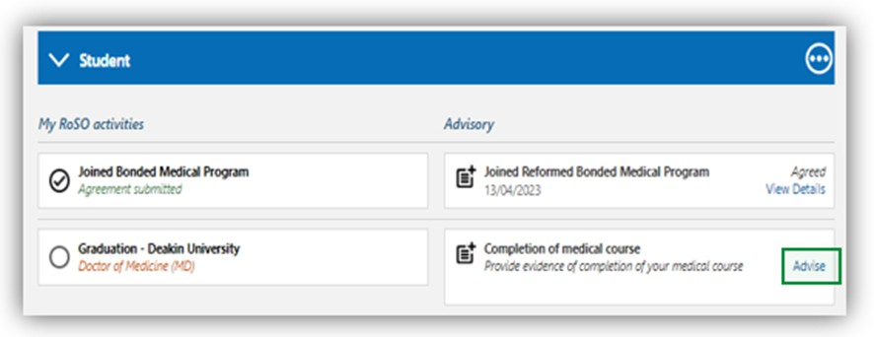
In the ‘Advisory: Completion of medical course’ fill in the required information, upload your evidence and click ‘Submit’.
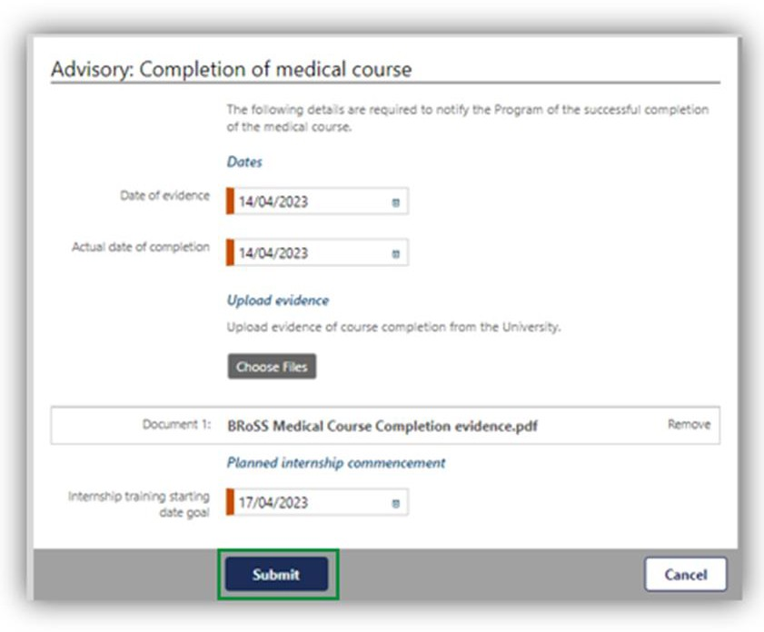

After submitting this advisory, your ‘Student’ accordion will change to green with a tick and the ‘Intern’ accordion will now be blue.
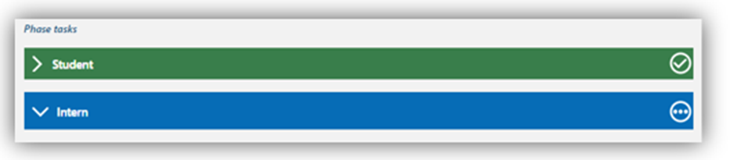

Entering your Internship Information
To update your ‘Intern’ phase with your APHRA registration and internship details, go to your ‘Manage my RoSO’ page and then select the ‘Intern’ accordion. Internship and vocational training sections also have planning dates set within BRoSS. If your plans change, review your record, and amend your planned start or finish date.
You can get to your ‘Manage my RoSO’ page from your dashboard by clicking on either the ‘Manage my RoSO’ button or the ‘Intern’ button under the Program timeline.
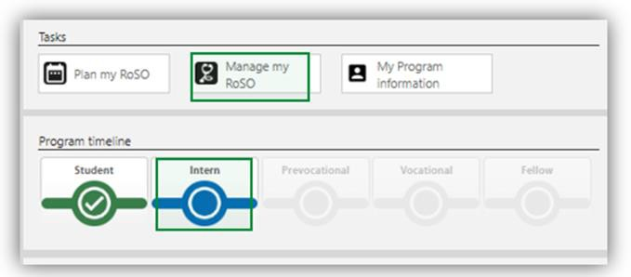
To enter your ‘Provisional registration with APHRA’ click on the ‘Advise’ link.
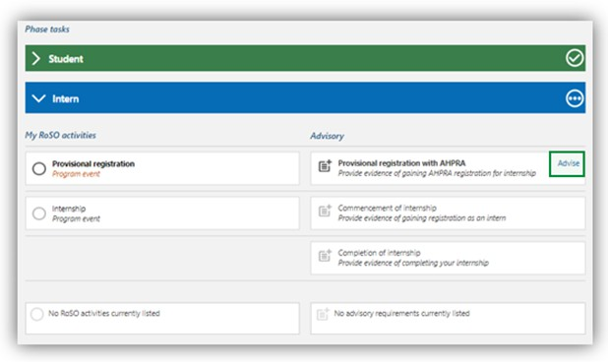

In the ‘Advisory: Provisional registration with APHRA’ complete the mandatory orange fields and upload the required evidence from APHRA showing that provisional registration has been attained.
Click ‘Submit’ once completed.
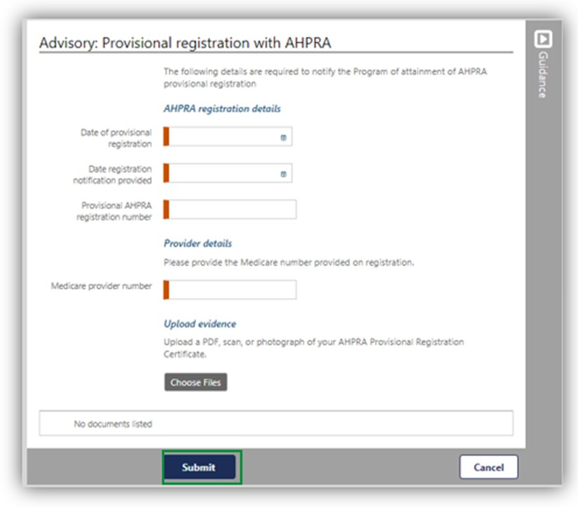
You will be taken back to the ‘Manage my RoSO’ page, there will now be green text with a tick next to the event tile.
To enter your ‘Commencement of internship’ details click the ‘Advise’ link.
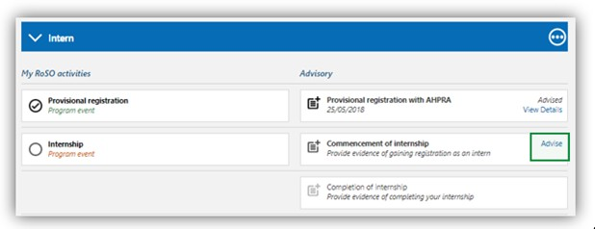
In the ‘Advisory: Commencement of internship’ complete the mandatory orange fields, adding your facility address and upload a signed contract of employment or letter of agreement from your employer, including:
- name of the bonded participant.
- commencement date of the internship.
- expected completion date of the internship.
- position name.
- facility name.
- facility address.
- number of hours employed each week.
If you are unable to provide the evidence outlined, you may provide a statutory declaration that includes all the required information.
Click ‘Submit’ once completed.
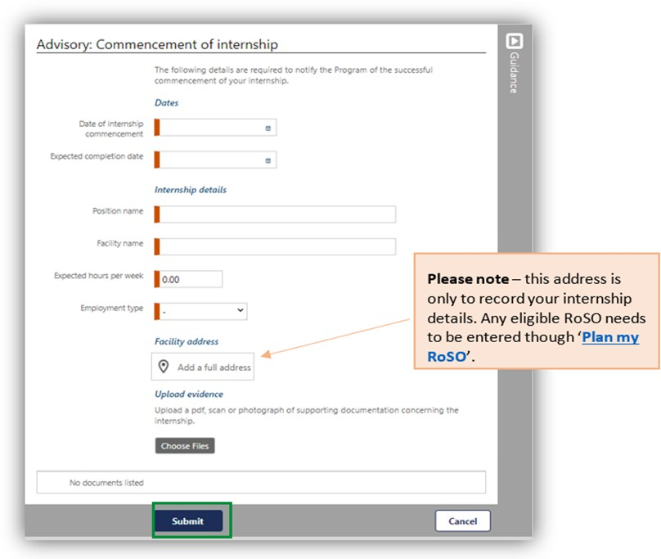
You will be taken back to the ‘Manage my RoSO’ page, there will now be three dots next to the event title that indicate your internship is activated.
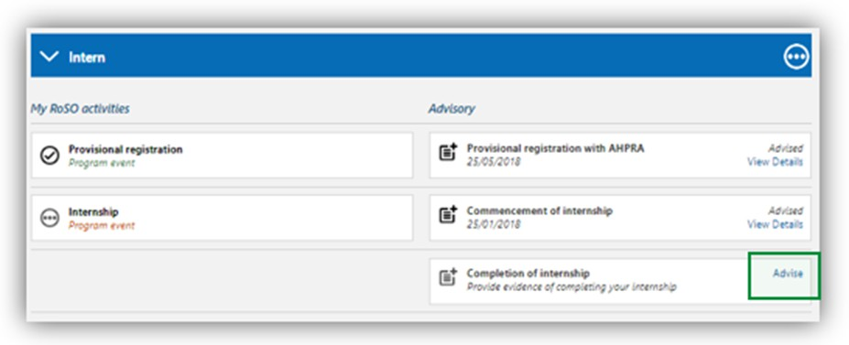

Completing your Internship Phase
On the completion of your internship training, you will need to update your BRoSS ‘Intern’ phase on your ‘Manage my RoSO’ page.
You can get to your ‘Manage my RoSO’ page from your dashboard by clicking on either the ‘Manage my RoSO’ button or the ‘Intern’ button under the Program timeline.
Click on the ‘Advise’ link on the ‘Completion of internship’ tile.
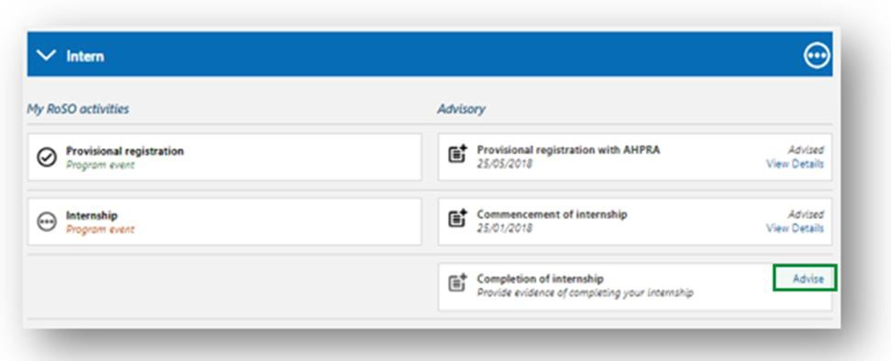
Enter the date you completed your internship and click ‘Submit’.
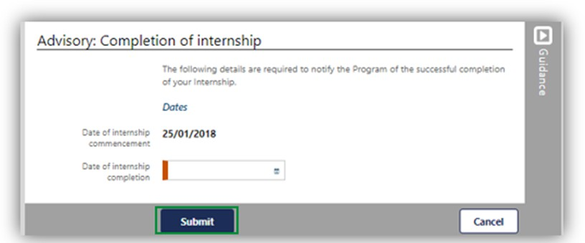
Your ‘Manage my RoSO’ page will update so your ‘Intern’ phase will now be green, and your ‘Prevocational’ phase will be blue.
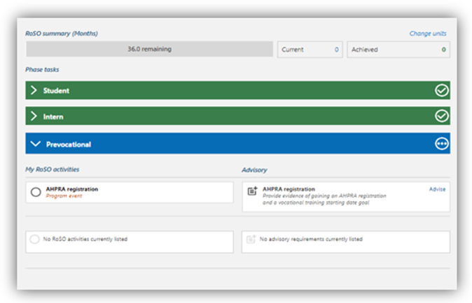

Commencing your Prevocational training Phase
To update your ‘Prevocational’ phase with your APHRA registration and Medicare provider number, go to your ‘Manage my RoSO’ page and then under the ‘Prevocational’ accordion.
You can get to your ‘Manage my RoSO’ page from your dashboard by clicking on either the ‘Manage my RoSO’ button or the ‘Prevocational’ button under the Program timeline.
To enter your ‘APHRA registration’ click on the ‘Advise’ link under the ‘Prevocational’ accordion.

In the ‘Advisory: General registration with AHPRA’ page, complete all mandatory orange fields and upload the required evidence from AHPRA that general registration has been attained. If you are unable to provide the evidence outlined, you may provide a statutory declaration that includes all the required information.
The final field ‘Vocational training goal’ is the future date that you think you will commence training with your specialty college, which can be changed at any time. If you do not intend to undertake vocational training, enter a date that falls after your Program completion date to avoid receiving automated reminders.
Click ‘Submit’ once completed.
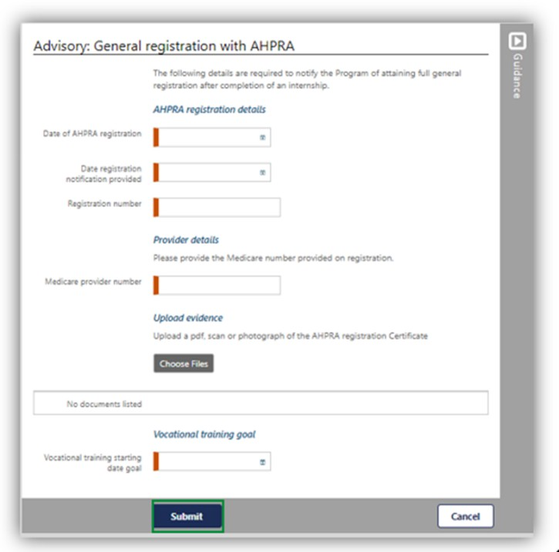

Commencing your Vocational Phase
To update your ‘Vocational’ phase with your training college details, go to your ‘Manage my RoSO’ page and then under the ‘Vocational’ accordion.
You can get to your ‘Manage my RoSO’ page from your dashboard by clicking on the ‘Manage my RoSO’ button or the ‘Prevocational’ phase under the Program timeline.
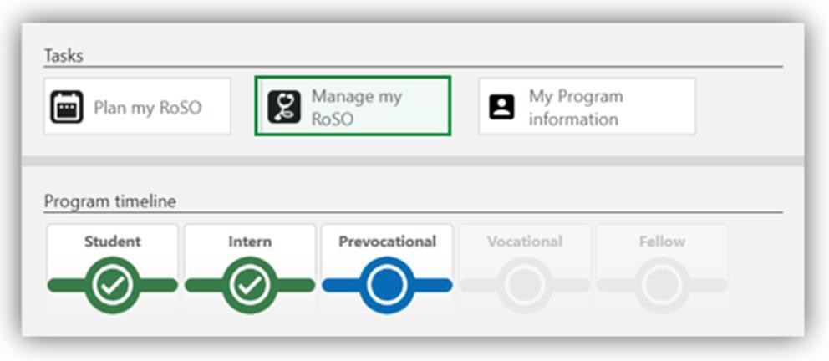

The ‘Vocational’ accordion will be greyed out until you ‘Advise’ of your ‘Commencement of vocational training’ by clicking on the ‘Advise’ link.
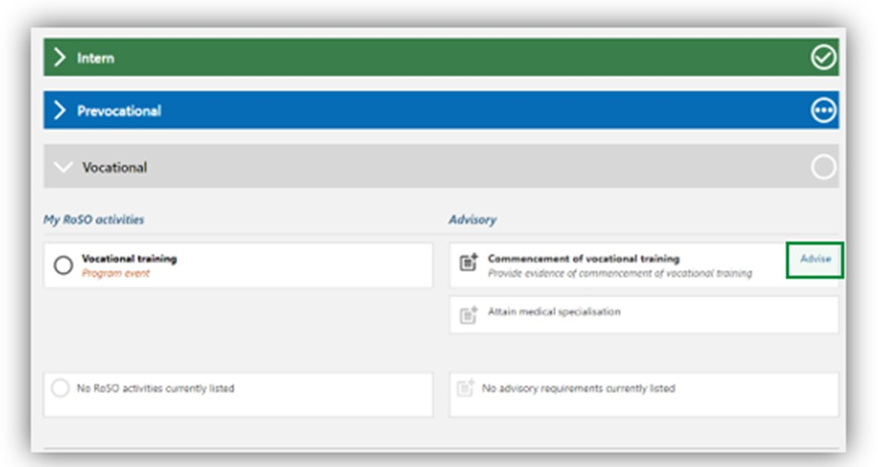
In the ‘Advisory: Commencement of vocational training’ page, complete all mandatory orange fields and upload evidence from both the medical college that you have enrolled in vocational training and evidence from your employer. Evidence must include both of the following:
- information from the medical college, including:
  - date of commencement of vocational training.
  - anticipated date of completion.
  - name of the medical college.
  - type of specialisation; and
- a signed employment contract or signed letter of agreement from your employer, including the following information:
  - name of the bonded participant.
  - employment commencement date.
  - expected employment completion date.
  - position name.
  - facility name.
  - facility address.
  - number of hours employed each week.
When entering your specialty work placement details, you are required to provide your work contract or Medicare provider number (including location specific provider number).
If you are unable to provide the evidence outlined, you may provide a statutory declaration that includes all the required information.

Click ‘Submit’.
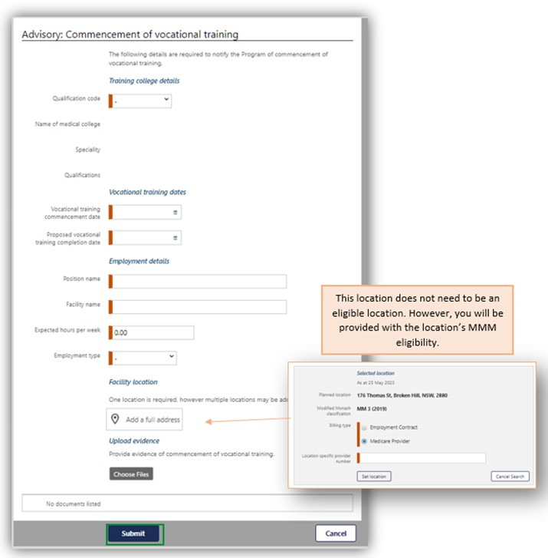

Once completed, the accordion will change to blue as it is now your current phase.
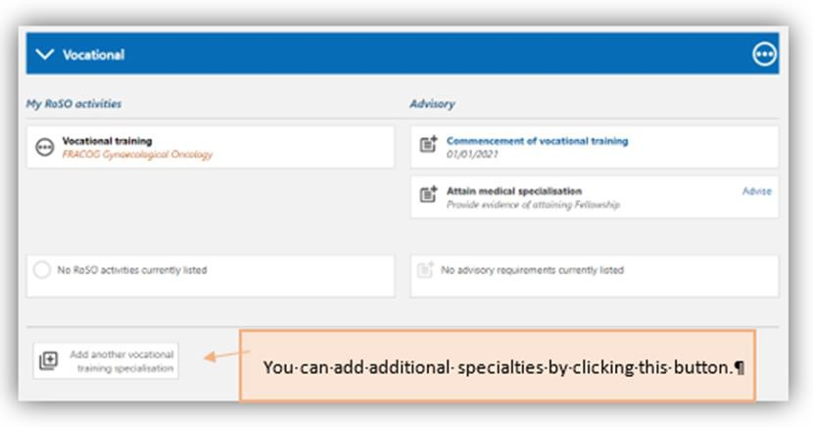

Attaining Fellowship – Completing your Vocational Phase
To update your ‘Vocational’ phase with your fellowship details, go to your ‘Manage my RoSO’ page and then under the ‘Vocational’ accordion.
You can get to your ‘Manage my RoSO’ page from your dashboard by clicking on either the ‘Manage my RoSO’ button or the ‘Vocational’ button under the Program timeline.
Under the ‘Vocational’ accordion, click on the ‘Advise’ link on the ‘Attain medical specialisation’ tile.
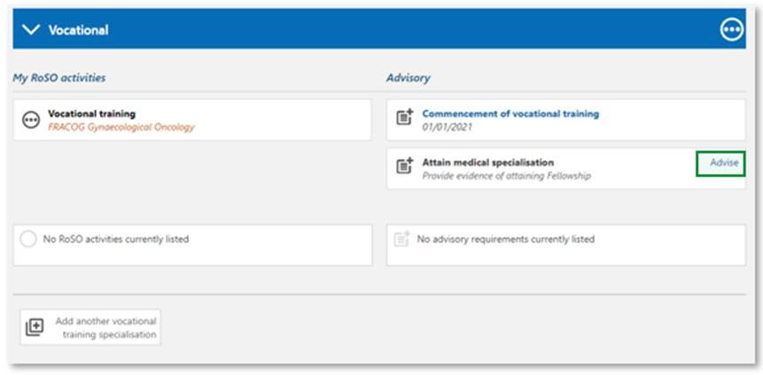
The ‘Advisory: Attain medical specialisation’ page will open. Enter the date you attained your Fellowship and upload your evidence. Evidence must be from the relevant medical college and include:
- name of the bonded participant.
- name of the medical college.
- type of specialisation.
- date the specialisation was attained.
If you are unable to provide the evidence outlined, you may provide a statutory declaration that includes all the required information.
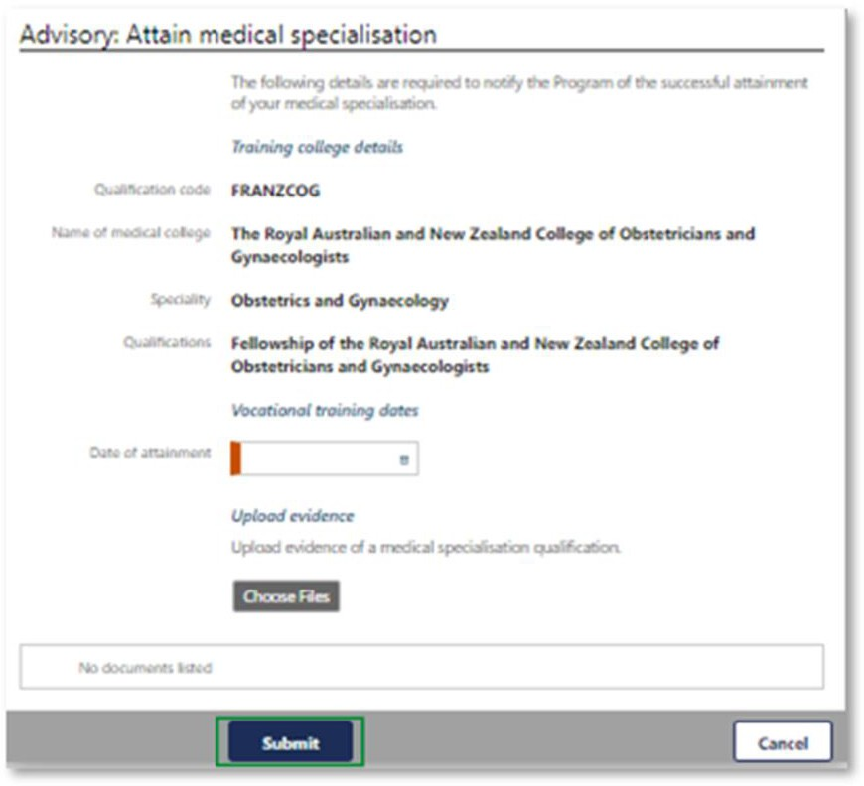
Then click ‘Submit’.

If you are undertaking a dual speciality, you can add a second vocational training specialisation in BRoSS. To add this, under your Vocational or Fellow phase accordion, select Add another vocational training specialisation.
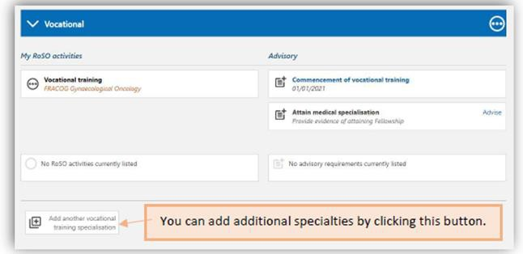
Once you begin your training for your second specialty, you will need to ‘Advise’ your Commencement of vocational training.
Locations that are eligible under your second speciality may require you to lodge a location override request. Refer to the location override section for information on how to do this.
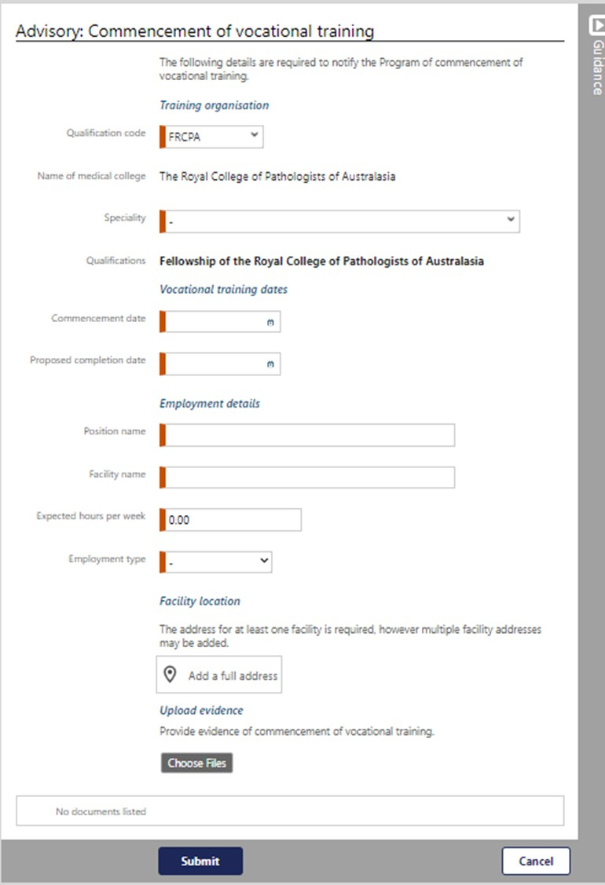
To advise your commencement of vocational training, input your information into the mandatory orange fields. You must also add your facility location/s and upload evidence. Once completed, click Submit.
Both specialties will now appear on your BRoSS record.
Your ‘Manage my RoSO’ page will update so your ‘Fellow’ phase will now be blue, and your ‘Vocational’ phase will be green.
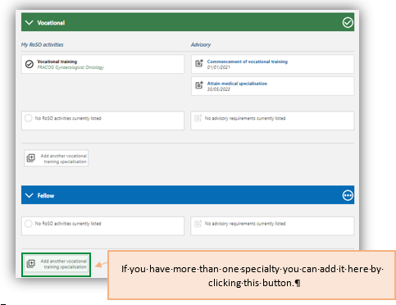
Once you have attained fellowship, BRoSS will allow you to complete the final 78 weeks of your RoSO as per section 9(3) of the Rule. If you do not attain fellowship, you will able to complete the final 78 weeks on the day 12 years after the day you completed your course of study in medicine.

Managing your Agreement

Requesting an Extension to Program timeline
A participant may apply for an extension to program if the participant, or a member of the bonded participant’s family, has a medical condition that prevents the bonded participant from completing their RoSO within the 18-year period required by paragraph 124ZF(2)(a) of the Act.
A member of your family is defined as a partner, child, grandchild, parent, grandparent or sibling of the bonded participant; or a person who satisfies the following criteria:
- the person is a relation of the bonded participant;
- the bonded participant has significant responsibility for the care of the person;
- there are no family members (other than the bonded participant) who are able to provide care to the person;
- the person is not on a temporary visa; and
- the person has not been provided with an assurance of support in relation to the grant of a visa.
The medical condition must not have been reasonably foreseen when you entered the Program, and must either:
- Require treatment or care for which Medicare benefits are payable, or
- Require treatment of care for which pharmaceutical benefits are payable, or
- Require treatment of care in a hospital.
You must also upload evidence of the medical condition from a treating practitioner dated within 3 months from the date of your application. The treating practitioner must:
- have sufficient expertise, qualifications and specialist registration to provide the medical evidence; and
- state for how long they have known you or your family member, as the case may be; and
- state that they do not have a personal or professional relationship with you or any potential conflicts of interest; and
- state why the bonded participant cannot complete their return of service obligation within the 18 year period.
These extension of time requirements are outlined in section 11 - 13 of the Rule.

To submit your request, click on the ‘Manage my agreement’ accordion on the bottom left side of the ‘My dashboard’ page.
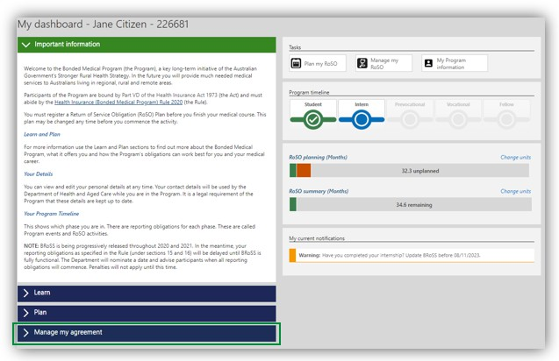
The ‘Manage my agreement’ accordion will open. Click on the ‘Program extension’ button.
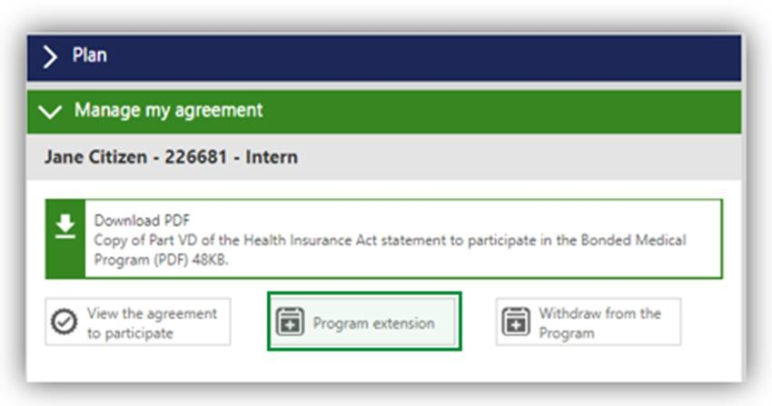

This page will show your current Program completion date.
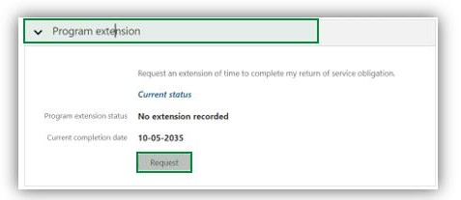
Click the ‘Request’ button, enter your ‘Proposed completion date’. The new completion date should not extend the period to complete your RoSO by more than 2 years. Ensure the evidence you upload meets the requirements outlined in section 13 of the Rule.
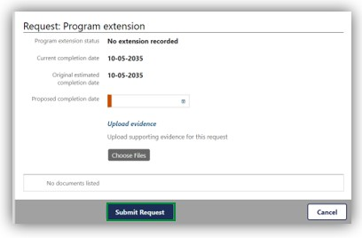
Once you click on the ‘Submit Request’ button, the below ‘Warning’ page will show, click ‘OK’ to continue with your extension request.
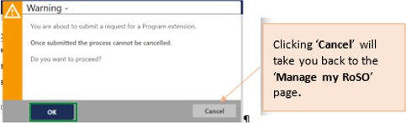

Your ‘Program extension’ accordion will update to ‘Pending’ status and show your extension request and ‘Status’. The ‘View/Edit’ button will enable you to amend your request.
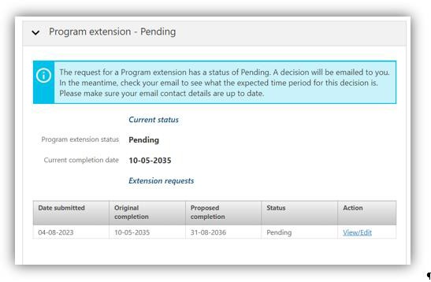
Your request will be reviewed and you will be contacted if additional evidence is required, or when a decision has been made.
If you would like to cancel your request, please email the BondedMedicalProgram@health.gov.au providing your details and the reason for cancellation.

Withdrawing from the Program
Once you have agreed or opted in to the Program you can withdraw at any time. You can request a ‘Withdrawal Repayment estimate’ report by clicking the ‘My dashboard’ page, open the ‘Manage my agreement’ accordion on the bottom left side of the dashboard.
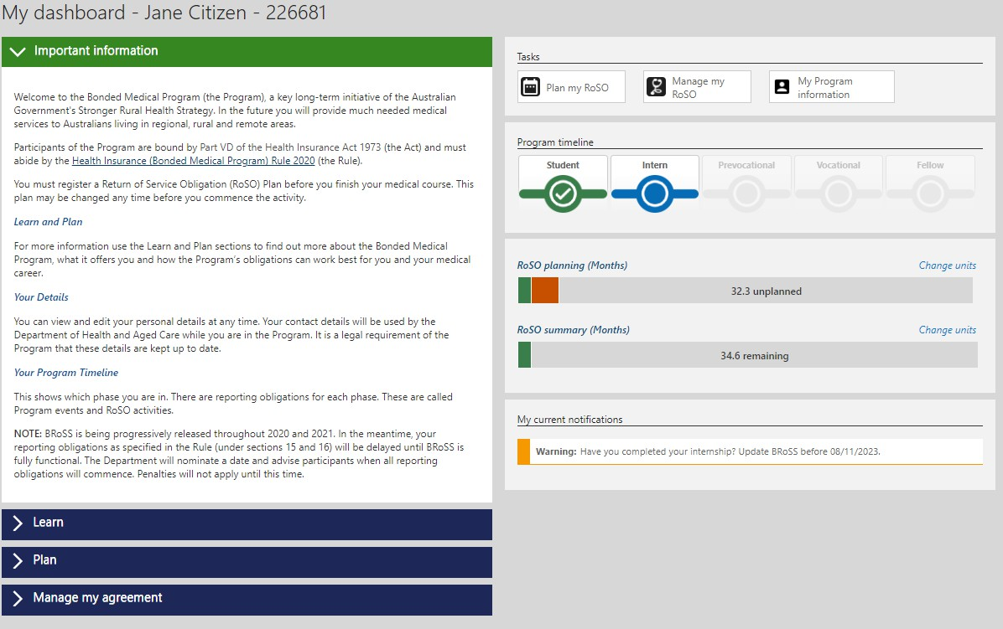
The ‘Manage my agreement’ accordion will open. Click on the ‘Withdraw from the Program’ button.
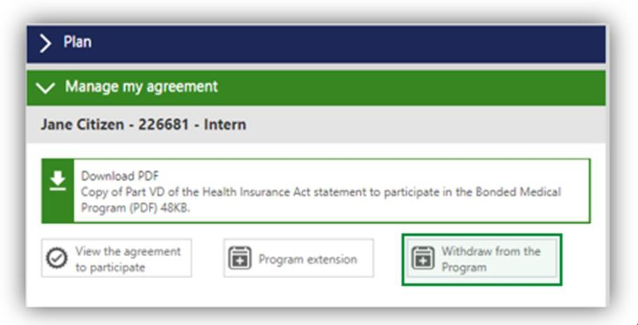
The opening pages will be different depending on whether you have opted-in to the Program via the BMP Scheme the MRBS Scheme or began with the Program. These processes are detailed in the following sections.

Withdrawing as a former Bonded Medical Rural Bonded Scholarship (MRBS) scheme participant
If you withdraw prior to your second-year census date you are not required to repay the CSP amount.
Once you have clicked on the ‘Withdraw from the Program’ button the ‘Estimate: Withdraw from the Program’ page will open. Enter the ‘Proposed withdrawal date’ and click ‘Next’.
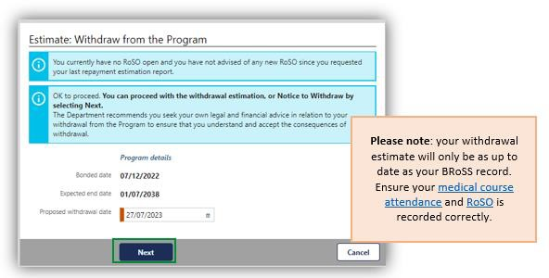

In the ‘Estimated: Withdraw from the Program’ page, you can download a repayment estimation report that contains information about your withdrawal. Click ‘Close’ once reviewed.
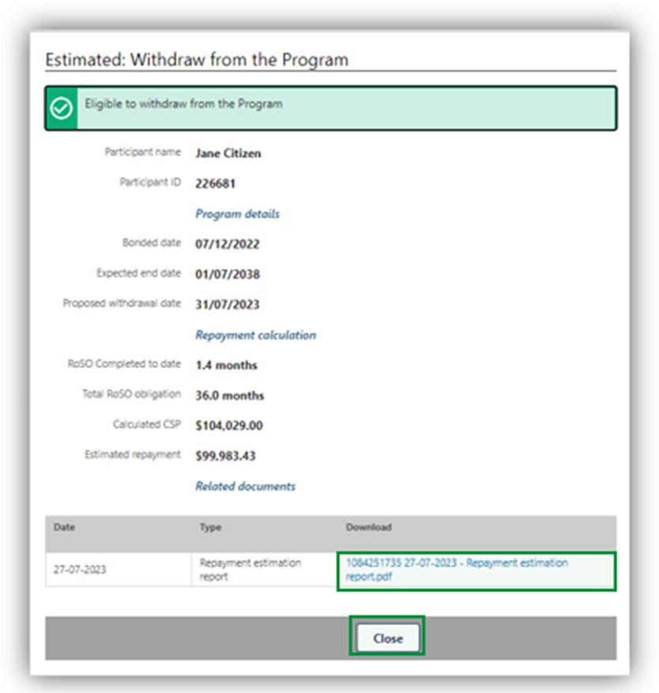
You will return to the ‘My dashboard’ page. If you would like to continue with your withdrawal request or get an updated withdrawal repayment estimate, open your ‘Manage my agreement’ accordion and then click on the ‘Withdraw from the Program’ button.

The ‘View: withdraw from the Program’ page will open. There are two options available on this page:
- you can get a new withdrawal repayment estimate by clicking on the ‘Re-estimate’ button. This will update your ‘Estimate: Withdraw from the Program’ page and provide a new repayment figure and report as detailed above.
- continue with your withdrawal by clicking on the ‘Withdraw’ button, which will take you to the ‘View: Withdraw from the Program’ page.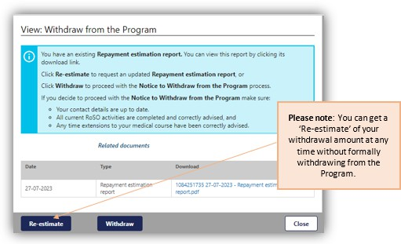
After clicking on the ‘Withdraw’ button, the pop-up ‘Warning’ page will show. Click ‘OK’ to continue with your withdrawal from the Program.
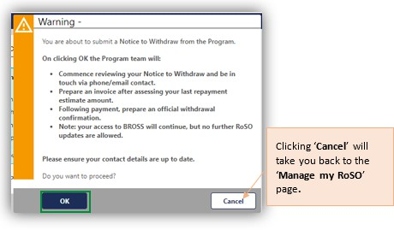
The ‘Advise: Withdraw from the Program’ page will allow you to update and complete your withdrawal request. Once completed click ‘Next’ to submit the request.
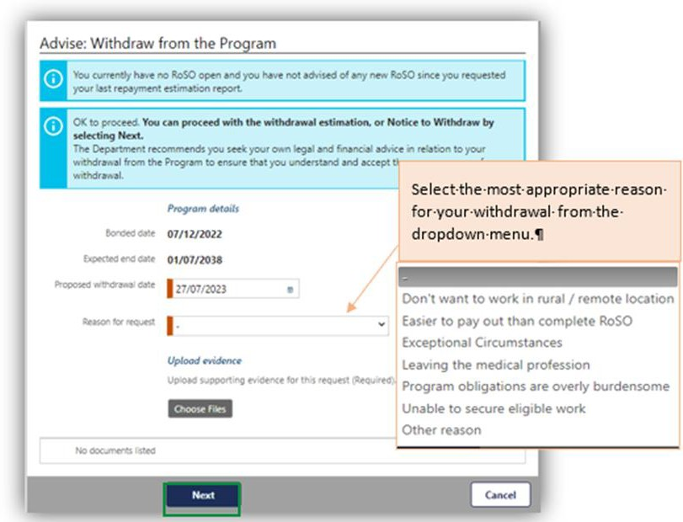
If you select the ‘Exceptional Circumstances’ – you will be required to provide sufficient evidence and documentation to enable the Secretary (or Delegate) to make an informed decision.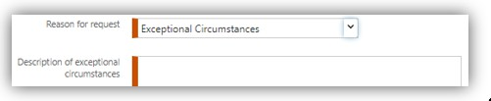
If you select ‘Other reason’ you will also be required to provide additional information in the new field.
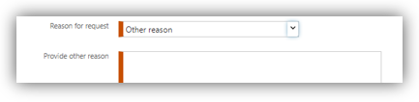

After clicking ‘Next’ the ‘Advised: Withdrawal from the Program’ page will show your withdrawal information that has been submitted for assessment.
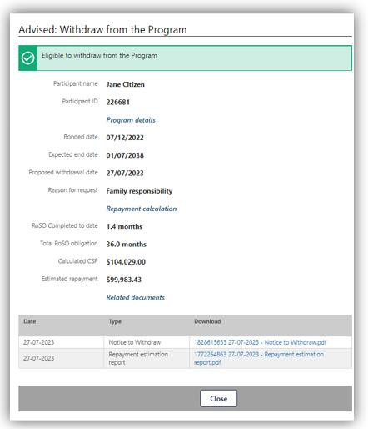
Your withdrawal request will be reviewed and you will be contacted if additional evidence is required. You will be provided with an invoice when your withdrawal request is processed.
For ‘Exceptional Circumstances’, we will send you an email with the decision outcome.
If you would like to cancel your withdrawal request, please email the BondedMedicalProgram@health.gov.au providing your details and the reason of cancellation.

Withdrawing as a former Bonded Medical Places (BMP) Scheme Participant who has opted-in
Withdrawing from the Program as an opted-in MRBS participant will mean Medicare benefits are not payable for a period of six (6) years from the date you withdraw, in accordance with section 124ZQ(4) of the Act.
Once you have clicked on the ‘Withdraw from the Program’ button the ‘Estimate: Withdraw from the Program’ page will open. Enter the ‘Proposed withdrawal date’ and click ‘Next’.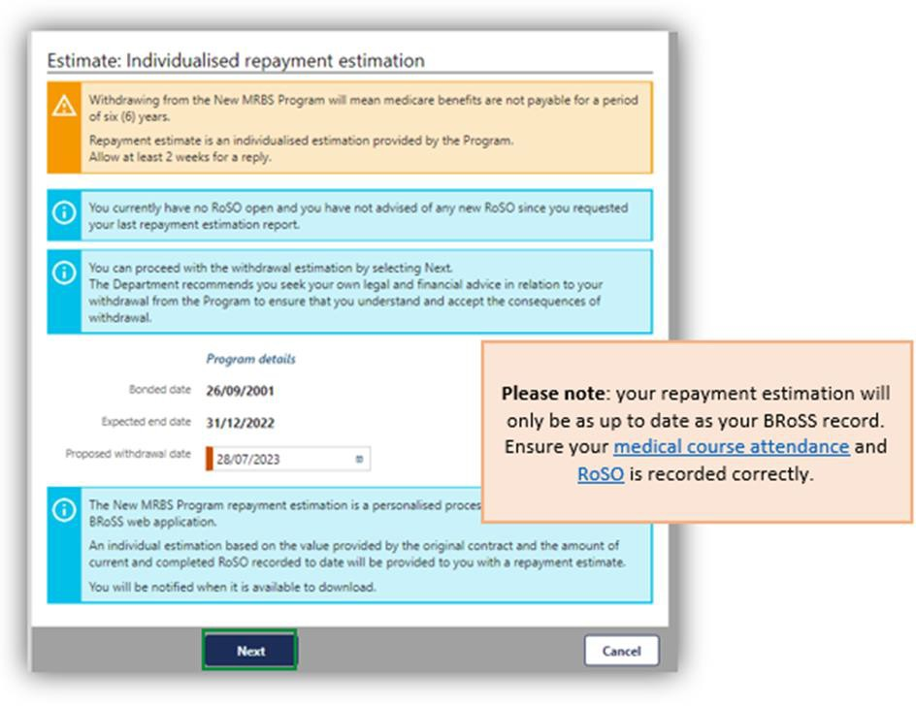

After clicking on the ‘Next’ button the pop-up ‘Warning’ page will show, click ‘OK’ to continue with your withdrawal request from the Program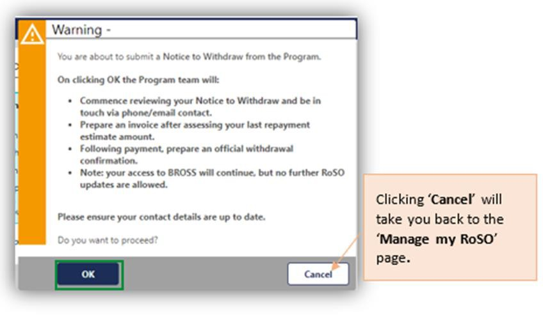
The ‘Estimated: Withdraw from the Program’ page will open with your ‘Repayment estimation request’ document used to provide an estimate of your repayment amount.
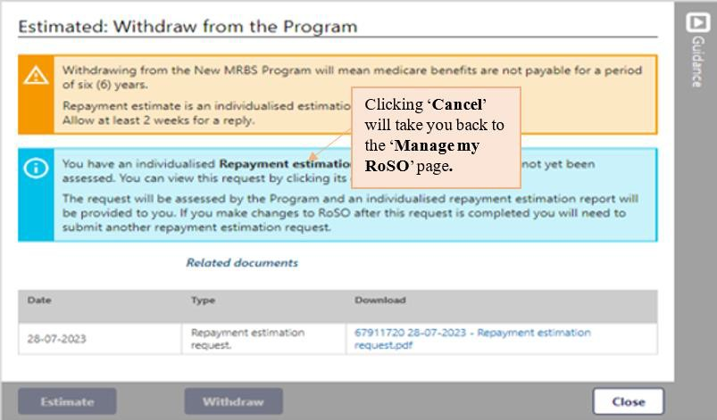
Once your request is submitted, an estimate of your repayment amount will be emailed to you within 4 weeks, based on your BRoSS record. The estimate will account for all currently active and completed RoSO activities up to the proposed withdrawal date.
Once you receive your estimate, go to the ‘My dashboard’ page.

Open your ‘Manage my agreement’ accordion and then click on the ‘Withdraw from the Program’ button to open the ‘View: Withdrawal from the Program’ page. Your ‘New MRBS repayment estimation.pdf’ can be downloaded from here.
There are two options on this page:
- You can get a new withdrawal repayment estimate by clicking on the ‘Re-estimate’ button, this will take you back to the ‘Estimate: Withdraw from the Program’ page as detailed above.
- Continue with your withdrawal by clicking on the ‘Withdraw’ button which will take you to the ‘View: Withdraw from the Program’ page.
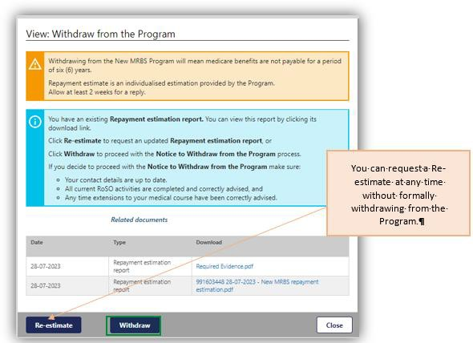

After clicking on the ‘Withdraw’ button the pop-up ‘Warning’ page will show. Click ‘OK’ to confirm and continue with your withdrawal from the Program.
The ‘Advise: Individualised repayment estimation’ page, will show for you to update and complete for your withdrawal request, once completed click ‘Next’ to submit your withdrawal.
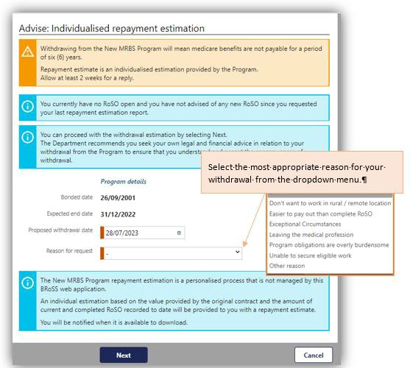

If you select the ‘Exceptional Circumstances’ – you will be required to provide additional information in a new field and upload any evidence to support your request.
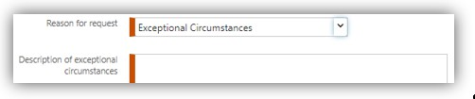
If you select ‘Other reason’ you will also be required to provide additional information in the new field.
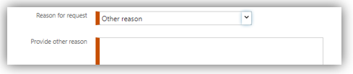
After clicking ‘Next’ the ‘Advised: Withdrawal from the Program’ page will show your withdrawal information that will be used for your withdrawal request.
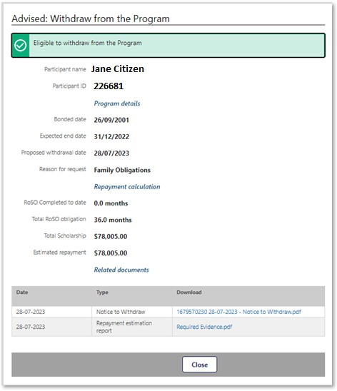
Your withdrawal request will be reviewed and you will be contacted if additional evidence is required. You will be provided with an invoice once your withdrawal request is processed.
For ‘Exceptional Circumstances’ we will send you an email with the decision outcome.
If you would like to cancel your withdrawal request, please email BondedMedicalProgram@health.gov.au providing your details and the reason of cancelation.
- (Monday-Friday, 8:30am to 5:00pm AEST/AEDT).

