BONDED RETURN OF SERVICE SYSTEM (BROSS)
Participant User Guide Return of Service Obligation (RoSO) April 2026

RoSO

Entering a Return of Service Obligation (RoSO) activity
As outlined in section 16 (1) of the Health Insurance (Bonded Medical Program) Rule 2020 (Rule), you must meet the following legislated requirements when recording RoSO:
It must be eligible work in an eligible location.
- You must plan, activate and complete your RoSO activity via your BRoSS record.
- RoSO activation and completion evidence must meet the requirements outlined in the Rule.
For participants joining as a new student: you must register a planned RoSO activity after you have completed your course of study in medicine.
For opted-in former legacy scheme participants: you must register a planned RoSO activity once you have been opted in to the Program.
For all participants, after commencing eligible work you must confirm the eligible location and start date of your planned RoSO activity in BRoSS. This RoSO activity may be changed any time before you activate it in BRoSS, under ‘Plan my RoSO’.
Within a year of completing work at an eligible location, you must complete the corresponding RoSO activity by confirming the end dates of the work period and uploading sufficient evidence to confirm you have completed work in accordance with your planned RoSO activity.
To plan a RoSO activity, click on the ‘Plan my RoSO’ button on your ‘Dashboard’, this will take you to the ‘RoSO activity planning’ accordion on the ‘Manage my RoSO’ page.
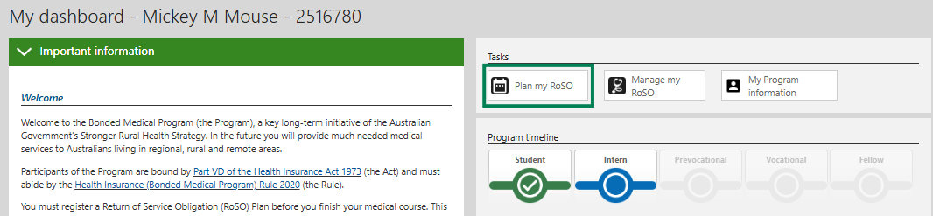
Click the ‘Plan a RoSO activity’ button to commence planning.
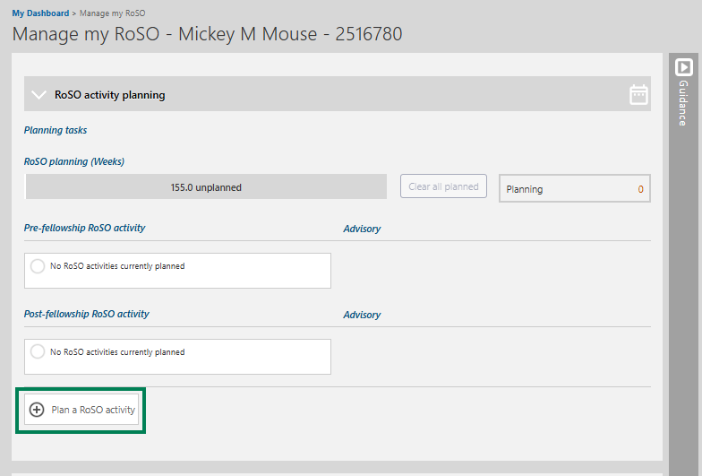
The Plan a RoSO activity page will open, complete the mandatory fields (marked in orange).
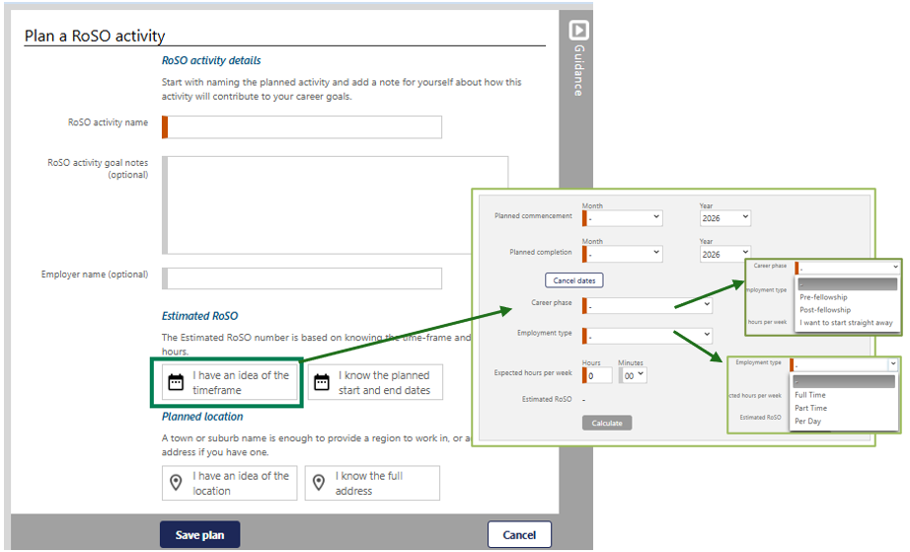
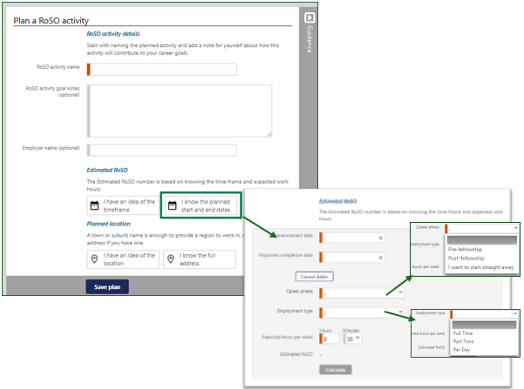
RoSO activity name: when naming your RoSO activity use a descriptive title specific to the work being undertaken, such as including the practice name and location.
Career Stage: as RoSO activities can be planned in advance, the career stage selection is to identify the stage in which the RoSO activity may be completed in.
We removed the requirement that you had to complete at least half of your RoSO after you became a Fellow or 12 years after finishing your medical course – whichever occurred first. You can now complete all your RoSO as soon as you become a medical practitioner. However, that work will not be reflected in your RoSO progress bar until July 2026.
The fellowship or 12-year requirement will be removed from BRoSS by July 2026. Once implemented, BRoSS will automatically recalculate your RoSO, and all work completed prior to fellowship will count towards your RoSO.
Visit our webpage for more information regarding changes to the Bonded Medical Program.
Employment Type: you can select one of 3 following employment types, this will need to match your ‘Expected hours per week’ entered in the estimated RoSO information.
You can work:
- full-time – if a bonded participant is employed in eligible work for at least 35 hours or more in that week. Hours worked above 35 hours in a week will not further reduce your RoSO.
- part-time – if a bonded participant is employed in eligible work for at least 20 hours, but less than 35 hours, in that week
- per-day – if a bonded participant is employed in eligible work on 2 or more days with a total of at least 20 hours. There is no ‘in that week’ requirement – so the days worked do not need to have been worked in a single week.
RoSO does not have to be completed continuously. If you work variable hours, you must record your RoSO as a per-day plan. BRoSS will accurately calculate the RoSO accrued for weeks where you meet the per day, part-time or full-time definition.
BRoSS calculates one week as 7 days, from Sunday through to Saturday.

BMP Scheme 2016–2019 participants
If you are a participant in the BMP Scheme with a 52-week obligation, you can now complete your RoSO pro-rata, either part-time or by the day. You no longer must do it in full-time blocks of at least 10 weeks. You must now complete a total of 1820-hours of RoSO, and only the first 35 hours worked per week count toward that total.
This functionality has not yet been added to BRoSS. For now, if you have completed 52 weeks on a part-time or pro-rata basis, please send us your evidence so we can assess whether you have met the Program requirements.
We can only assess your RoSO once you have provided all required evidence. If your evidence does not meet the requirements, we will ask you to submit your documentation again. Visit our webpage for more information regarding changes to the Bonded Medical Program.

Work that counts towards your RoSO:
- Paid leave from providing professional services to patients in eligible locations.
- Telehealth services provided from an eligible location.
- Fly in/fly out and outreach services to eligible locations.
- Evacuation and retrieval of patients from an eligible location.
- Time spent on call in an eligible location.

Work that does not count towards your RoSO:
- Clinical research.
- Academic teaching.
- Medical administration or organisational work.
- Paramedical work.
- Clinical practice in a discipline other than medicine. For example, if you were a nurse prior to medical school, doing locums as a remote area nurse will not count towards RoSO.
Planned location can either be searched by selecting ‘I have an idea of the location’ button, or, by selecting ‘I know the full address’ and entering the work location address.
BRoSS must be used to check the eligibility of a location, as it contains an in-bult eligible location search function. Participants can enter a town, suburb, or the full street address, and BRoSS will return an immediate assessment of the location eligibility based on your individual circumstances.
BRoSS will also let you know if that location is eligible for use towards scaling benefits. If you exclusively work full-time in MM4 to 7 locations for 104 weeks and attain fellowship, each week of service over 104 weeks will reduce your RoSO by 2 weeks. This is called scaling and could enable you to complete your RoSO in 2 years and 6 months instead of 3 years.
When using the ‘I have an idea of the location’ option, enter the suburb or town to get the planned MMM classification location eligibility.
When using the ‘I know the full address’ option, start entering the full address of the location into the ‘Find an address’ bar and pre-filled results will show below the bar, click on the correct address from the drop-down menu.
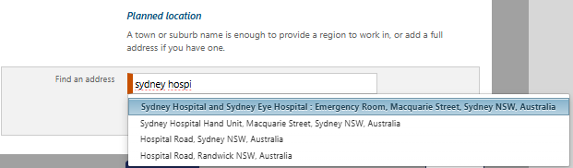
Once you have selected the location, BRoSS will inform you if the location is eligible by displaying a red, orange or green automated banner.
Once you have reached your Vocational phase, you can review your eligible District of Workforce Shortage (DWS) or Distribution Priority Area (DPA) locations for your specialty in BRoSS.
If BRoSS returns an ineligible location assessment, dual fellowship holders, or participants who are working in locations recently re-classified (e.g. before BRoSS is updated with new classifications), may request a review of a location’s eligibility by selecting ‘location override’. This will automatically generate a BRoSS case ticket for us to review. These location override requests are individually assessed and verified before the location override is accepted.
Location override requests outside of these limited circumstances will be declined. Please note that all MM1 inner metropolitan locations are ineligible under the Program.
Estimated RoSO: once you have confirmed a location is eligible you must enter the dates for correct eligibility assessment for the RoSO activity. You can do this by entering proposed dates for planning future RoSO (i.e., dates not yet confirmed) by selecting the ‘I have an idea of the timeframe’ button. Or, if you know the exact dates, by selecting the ‘I know the planned start and end dates’ button.
You will be required to enter the ‘Commencement date’, the ‘Proposed completion date’ and the ‘Expected hours per week’. Once these mandatory orange fields are completed select ‘Calculate’ to display the amount of RoSO that can potentially be reduced from your obligation for this period of work.
To finalise the RoSO activity, select ‘Save Plan’ at the bottom of the page.
BRoSS calculates a week from Sunday to Saturday. If your start date or end date falls on a day different to these, you will be asked to enter your ‘Partial week’ hours for a specific period.

Multiple location RoSO event
Under the Program, you can complete RoSO in any eligible location. This means that you may choose to work in more than one eligible location over the same period. For example:
- you regularly work hours in eligible location A and eligible location B.
- you undertake ongoing locum and/or on call work across multiple eligible locations.
- you deliver telehealth services from an eligible location.
In these circumstances, it is recommended that you record your RoSO in BRoSS as a single RoSO activity with multiple locations which will ensure the RoSO displayed in BRoSS is calculated correctly.
When you register a RoSO activity in BRoSS, it will only allow you to enter a single location. However, after activating your RoSO activity in BRoSS, you can enter additional locations to your plan. Your activation evidence will need to detail your work for each location entered.
When activating or editing a current RoSO activity, click on ‘Add a full address’ to enter additional locations.

Edit a planned RoSO activity
You can edit a ‘Planned RoSO activity’ at any time by clicking on the RoSO activity name in blue text in the ‘RoSO Activity planning’ accordion.
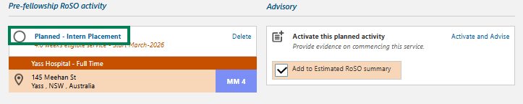
Click the ‘Edit’ button on the ‘Planned RoSO activity’ page to edit the details, then click ‘Save’ to update the ‘Planned RoSO activity’.
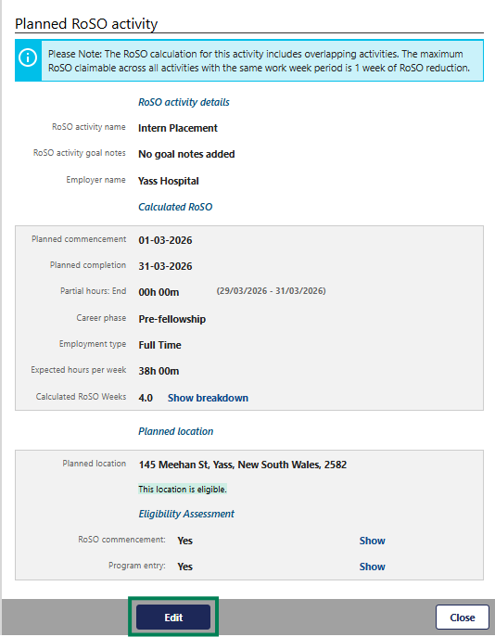
Edit all the required information and click ‘Update plan’.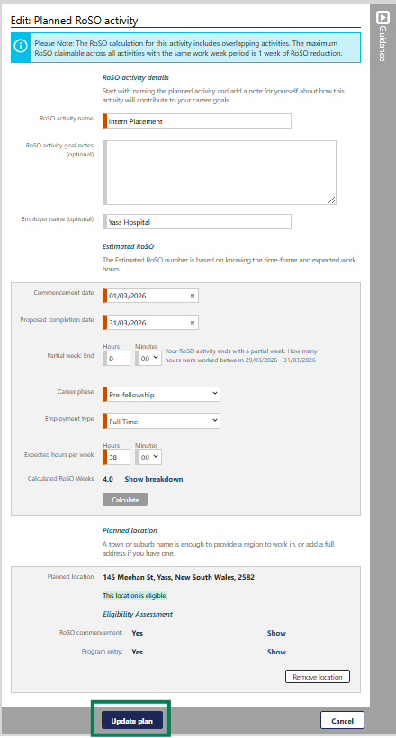

Activating your planned RoSO activity
To activate a previously planned RoSO activity, open your ‘Manage my RoSO’ page by clicking on the ‘Plan my RoSO’ button.
Evidence to be uploaded must be either a signed contract or a signed letter of agreement from your employer that confirms an eligible location has been selected, and includes the following information:
- name of the bonded participant.
- commencement date.
- expected completion date of employment.
- position name.
- employer name.
- employer address.
- primary locations of work.
- number of hours employed each week.
If you are unable to provide the evidence outlined, you may provide a statutory declaration that includes all the required information.
All your planned RoSO activities are shown under the ‘RoSO activity planning’ accordion. When you are ready to activate/commence your RoSO activity, click on the ‘Activate and Advise’ link.
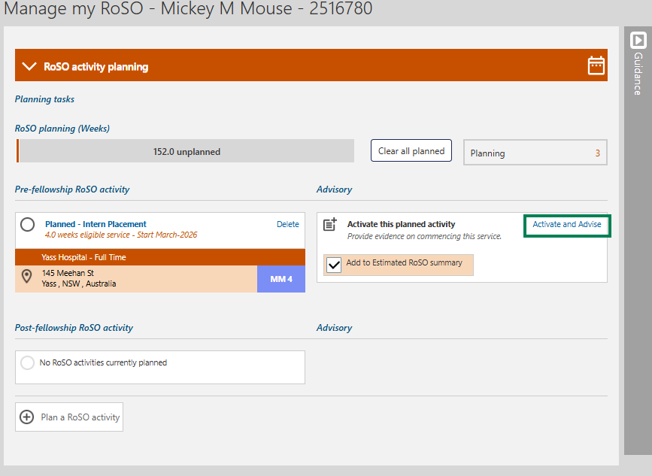
A pop-up window will show to confirm you wish to activate this RoSO activity, click ‘OK’.
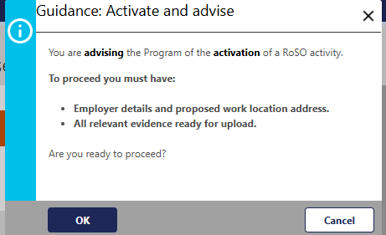
The ‘Advisory: Activate a RoSO activity’ page will open for you to update and enter additional information into the mandatory orange fields and upload relevant evidence before submitting the activity/event.
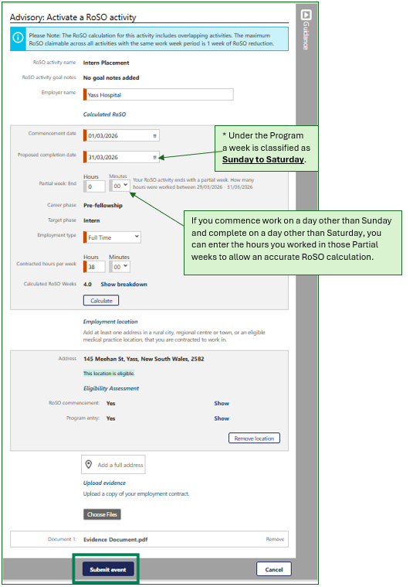

Edit your current Activated RoSO activity
You can edit your current activated RoSO activity at any time by clicking on the applicable blue RoSO activity name in the relevant phase accordion.
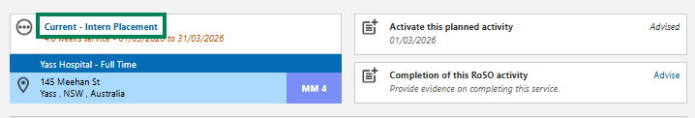
Click the ‘Edit’ button on the ‘Activated RoSO activity’ page to edit the details, then click ‘Save’ to update the Activated RoSO activity.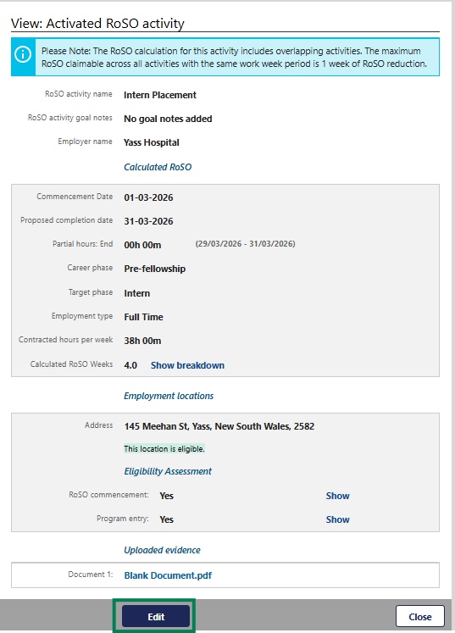

Entering Per-Day RoSO in a current RoSO activity
Under the Program, you can complete your RoSO on a full time, part time, or per day basis. The type of RoSO activity you create and how you record your work hours will depend on how you are employed and how many hours you work each week.
Per day RoSO activities can be entered when:
- you regularly work less than 20 hours per week in an eligible location.
- you work fluctuating hours, and do not consistently meet the definition of part time or full time.
- you work as a contractor or locum, with periods of unpaid leave that is not counted as RoSO.
- you work in a telehealth role, delivering services to patients provided from an eligible location, so the amount of work considered eligible for RoSO can fluctuate daily.
To update a per day basis activity, open your ‘Manage my RoSO’ page, open the relevant Phase accordion and click on the blue RoSO activity title of the event.
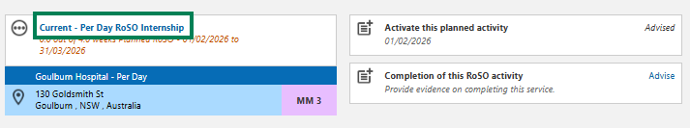
This will allow you to update your daily hours and locations via the ‘View: Activated RoSO activity’. Scroll to the bottom to view the ‘Hours by week’ section. Click ‘Edit’ against your current week to enter your hours and locations.
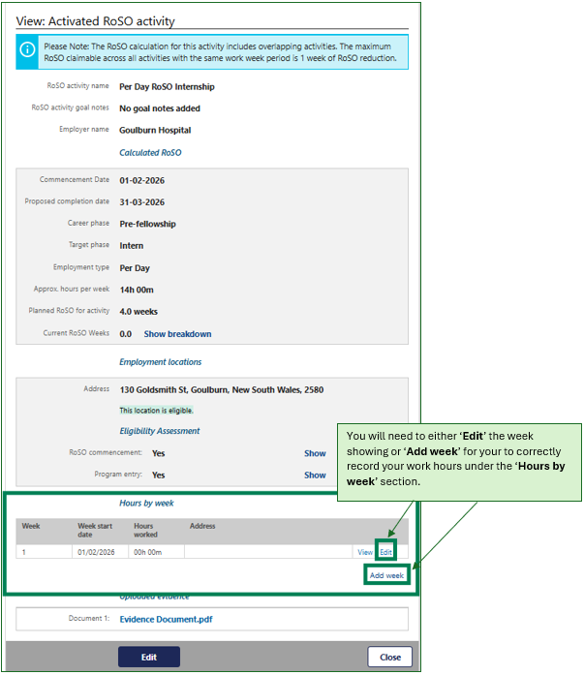
If your work week does not show, you can add additional weeks by clicking ‘Add week’ link.
Click on the ’Edit’ link of the week you need to update.
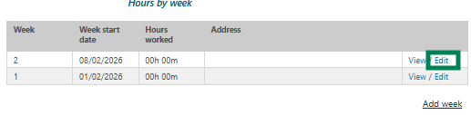
The ‘Edit week entry’ page will open.
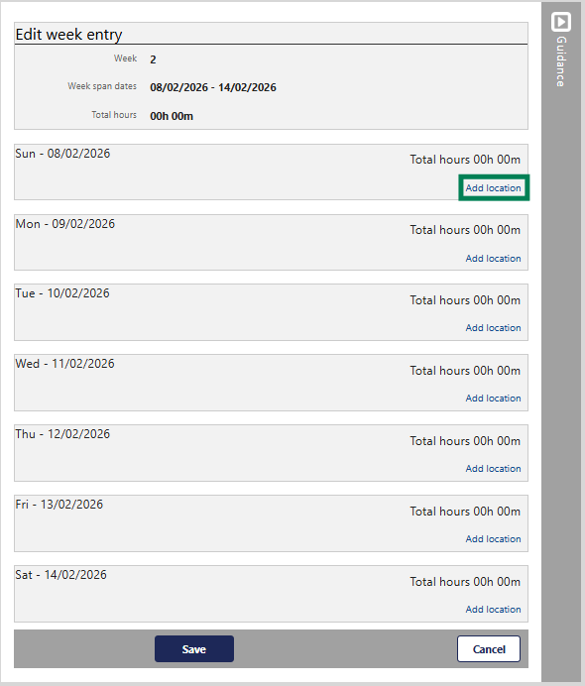
Click on the ‘Add location’ link and enter the location(s) and hours worked that day from the dropdown menus.
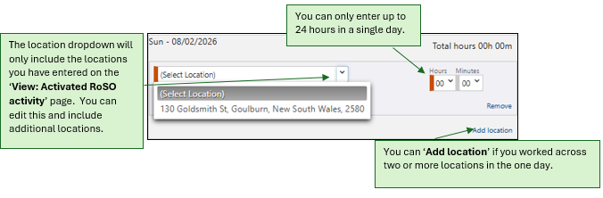
Once you have entered all your data for the day(s)/week, click ‘Save’ at the bottom of the page. You will be taken back to your ‘View: Activated RoSO activity’ page.
Your ‘Current RoSO weeks’ will update once you have accumulated greater than 20 hours of RoSO.
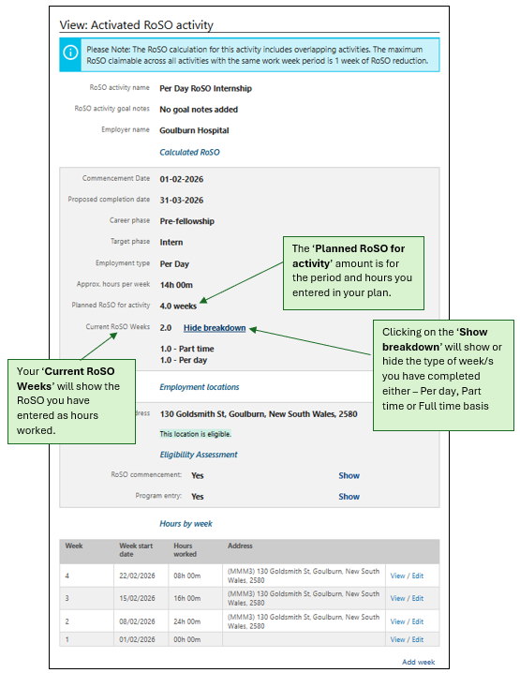

Completing current RoSO activity
You must upload evidence and complete RoSO activities within a year of completing work at an eligible location. To do this, go to your ‘Manage my RoSO’ page and open the relevant phase accordion for your RoSO activity. Uploaded evidence must confirm you have completed work in accordance with your RoSO activity.
Your completion evidence to be uploaded must be either:
- a signed letter from your employer dated after your RoSO activity completion date, or
- a statutory declaration dated after your RoSO activity completion date.
Once you have your current RoSO activity on the page, click the ‘Advise’ link on the ‘Completion of this RoSO activity’ tile.
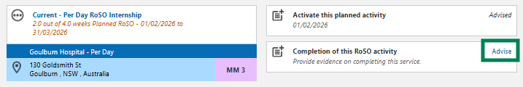
A pop-up for the ‘Guidance: Completion of this RoSO activity’ page will show to ensure you have the correct information before you proceed. If you are ready to proceed, click ‘OK’.
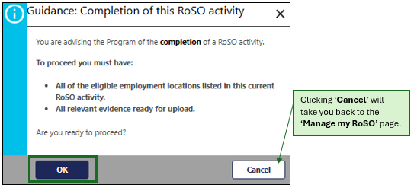
In the ‘Advisory: Completion of this RoSO activity’ complete the mandatory orange fields and upload the relevant evidence. Once updated click the ‘Submit’ button to complete this RoSO activity.
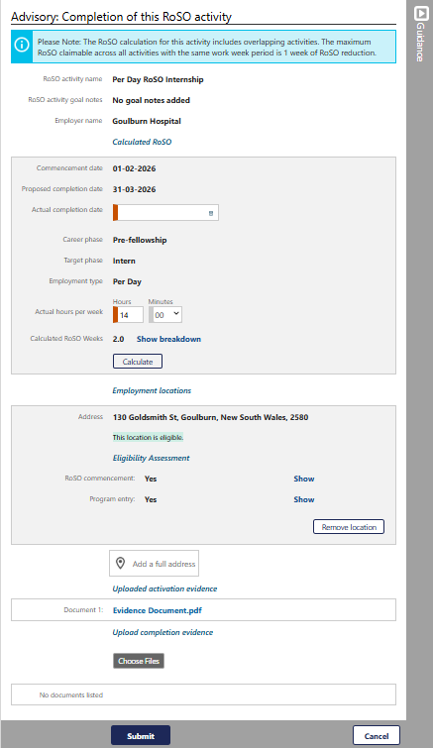
The view page will then show, and you can ‘Edit’ the information if required or click ‘Close’ to exit the page.
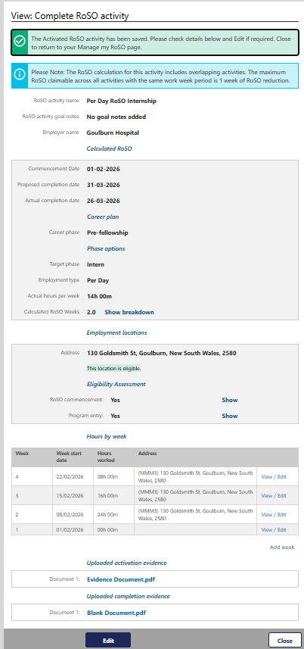
Your RoSO activity will now show as green as it has been completed. This activity will reflect in your RoSO summary bar in green.
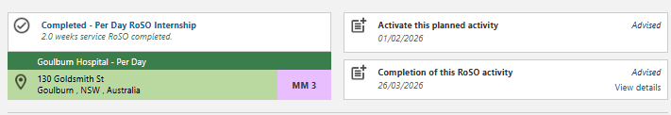
All completed RoSO will be reviewed by the department to confirm eligibility.

