BONDED RETURN OF SERVICE SYSTEM (BROSS)

Participant User Guide
Login Guide
April 2026

Login

How to log into BRoSS
You will need to have a myGov account to log in to BRoSS. Go to myGov Home.
    - If you do not have a myGov account, select 'Create account' and follow the prompts. Log into your myGov account.
    - If you already have a myGov account, select ‘Sign in.’
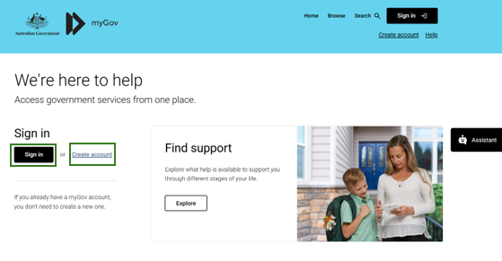
Sign in with your myGov details.
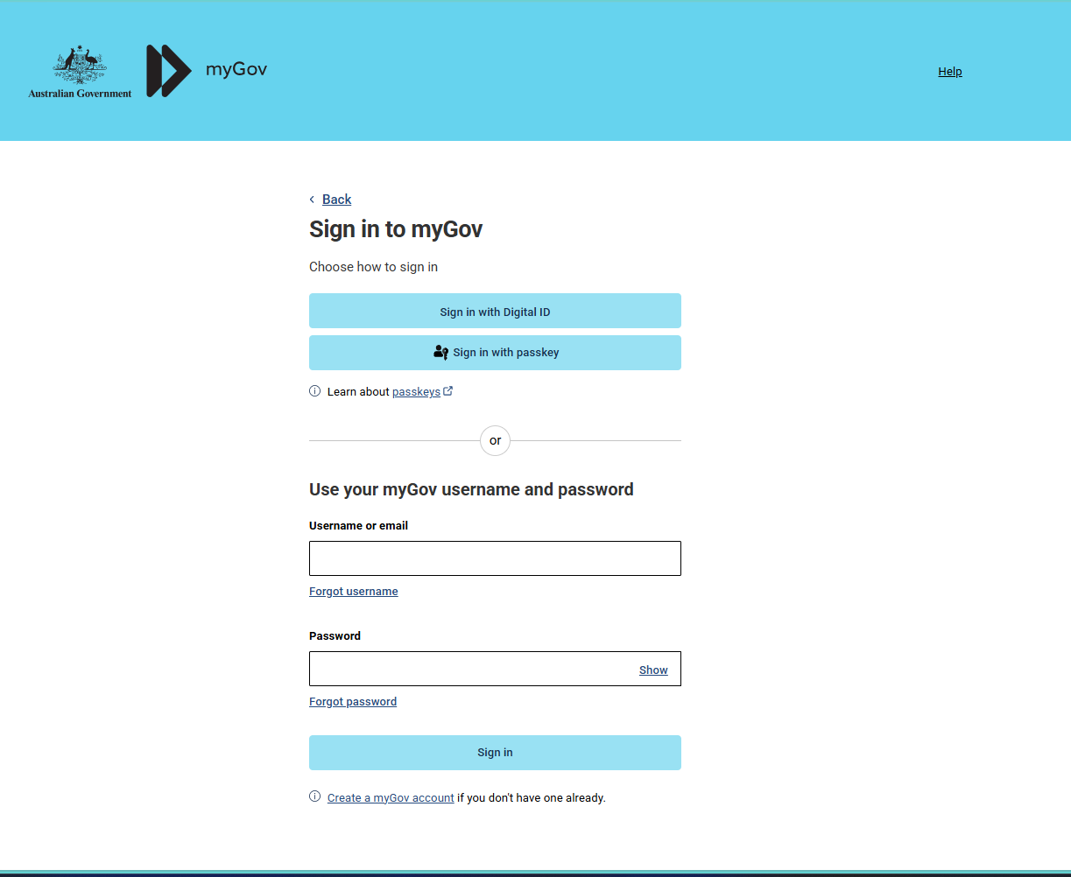

Authenticate your login.
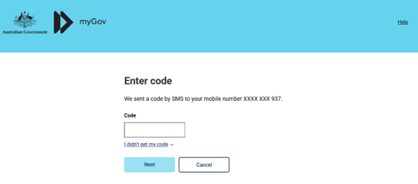
You will need to link the ‘Department of Health Applications Portal’ to your myGov services by clicking ‘View and link services’.
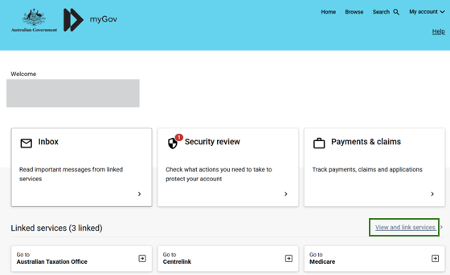

Scroll to the ‘Department of Health Applications Portal’ service and click ‘Link’.
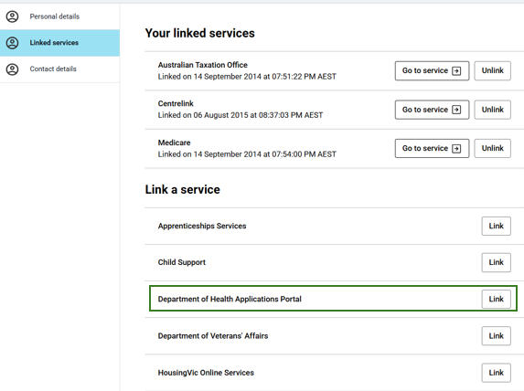

You will be taken to the Health Data Portal page, click ‘Log in’.
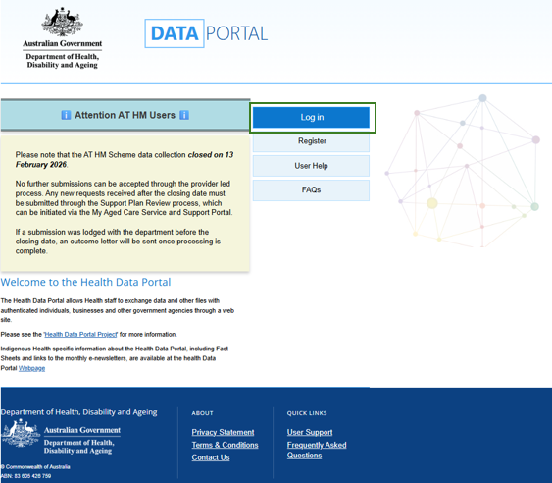

Select ‘Login with myGov’ as your log-in credential choice. We recommend you tick the checkbox located in the upper left of the page to remember your selection.
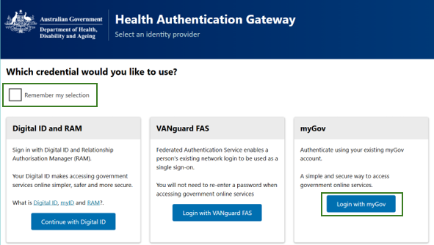
Enter your BRoSS user ID (username) and your linking code (password) on the ‘Health Authentication Gateway' page. Your BRoSS username and Temporary password can be found within the ‘BONDED MEDICAL PROGRAM - Agree to Participate’ or ‘Welcome to the Bonded Medical Program’ emails sent to your primary email address.
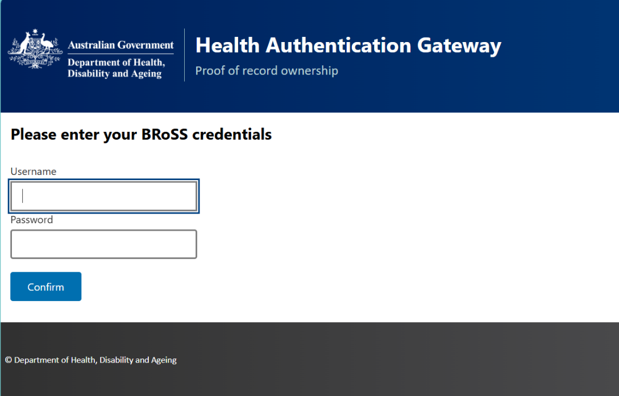

This will be a once-off action. Once you have linked 'Department of Health Applications Portal' as a service, the next time you sign in to BRoSS you will not be required to enter your BRoSS Username and Temporary password.

You will be taken to the Health Data Portal, on the menu bar, select 'BRoSS'. Your BRoSS dashboard will open.
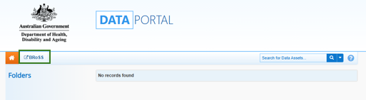
Occasionally, you may experience log in issues such as seeing an account inactive or error message, or BRoSS may not display correctly. This is usually caused by a cache or browser issue.
If you experience log in issues, please:
- Do not unlink the Department of Health Applications Portal service from your myGov account. Doing so will require you to be issued with a new temporary password, delaying access to your BRoSS record.
- Do clear your cache, as previously saved data may be causing your BRoSS log in issues (if you need assistance on how to do this, you can google ‘[Your browser name] clear browser cache’).
- Do try a different browser if you continue to experience log in issues.
If the issue persists, please phone our Contact Centre for assistance on 1800 987 104 (Monday-Friday, 8:30am to 5:00pm AEST/AEDT).

