BONDED RETURN OF SERVICE SYSTEM (BROSS)
Participant User Guide
BRoSS Dashboard
April 2026

BRoSS Dashboard
Navigating your Participant Dashboard
Your BRoSS dashboard contains information and guidance to help you self-manage your obligations and navigate BRoSS.
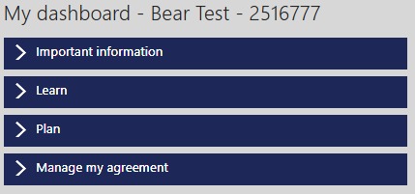
Important information: used to communicate key messages about the Bonded Medical Program (Program).
Learn: contains helpful information to assist you in managing your reporting requirements and advise what support is available for any questions you may have.
BRoSS allows you to self-manage your reporting obligations, and uses in-built messaging, guidance, and emails to alert you of upcoming reporting requirements.
As a Program participant you are required to log in every 12 months to ensure your information is up to date.
Plan: contains helpful information about the Program and your RoSO obligations, including eligible work types, how and when you can complete your RoSO, and what tools are available in BRoSS to help you plan, activate, and complete your RoSO.
Manage my agreement: contains a couple of key functions. Here you can download a copy of your agreement to participate, which includes the date you joined the Program. You can also request a Program extension or a Program withdrawal quote calculation.
Tasks: will change depending on your current medical career phase. Allows you to quickly jump to planning and managing your RoSO activities or notifiable events and updating your personal details.
Student phase tasks: as a new student, you must enter at least one planned RoSO activity in BRoSS prior to completing your medical course.
Internship to fellow phase tasks: set up planned RoSO activities with estimated dates in your BRoSS record. If your plans change, review your record and amend your planned start or finish dates as required.

Program timeline: shows your last updated phase. Click on your current or previous phase to take you to the corresponding notifiable events and RoSO activities.
A green icon with a tick indicates that this phase of the timeline has been completed, a blue icon indicates that the phase is underway, and the greyed-out icons represent the phase(s) yet to be commenced.
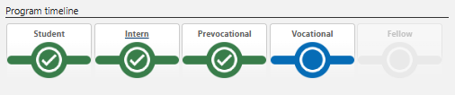
RoSO planning and summary bar: shows the amount of RoSO you have planned (orange), current/commenced (blue), completed (green) and remaining RoSO balance (grey).
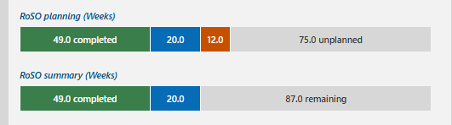
My current notifications: provides guidance for items that require your action in BRoSS. It will also let you know if there’s a reporting deadline approaching.
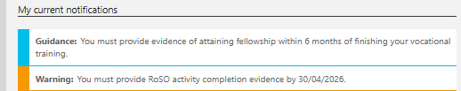

BRoSS guidance bar: an in-system guidance feature on the right-hand side of every BRoSS listed as ‘Guidance’. Click on the arrow to see guidance for the current page. Click on the arrow again to close the ‘Guidance’ bar.
