Youth Vaping Education Campaign
Stakeholder kit
March 2026
Contents
Introduction 2
Frequently asked questions 4
Communication resources 8
Newsletter articles 16
Social media posts 19

Introduction

Support for young Australians to quit vaping
Vaping is a serious health threat for young Australians and can cause damage to health now and in the future. Today’s 14 to 24-year-olds are the first generation to be exposed to nicotine largely through vaping rather than cigarettes.

Campaign to encourage young people not to vape
The Australian Government’s Youth Vaping Education Campaign encourages young people to give up vaping – or not take it up in the first place.
The campaign explains that ‘it can be easier to quit with a friend’, highlighting the social benefits of quitting together while also raising awareness of the physical and mental health harms of vaping.
Targeting young people aged 14 to 24, the campaign aims to build confidence in their ability to quit and empower them to take control of their health recognising that both short and long-term vaping can impact young people’s health and wellbeing.
Those who vape may experience:
- lung inflammation and throat irritation
- persistent coughing
- breathing problems such as shortness of breath and wheezing, which can also decrease physical performance
- feeling nauseous
- swelling, bleeding and redness of the gums
- dizziness and light headedness
- seizures from inhaling too much nicotine or swallowing e-liquid
- burns or injury if a vape overheats or explodes
- becoming dependent on the nicotine in vapes
- feeling anxious or irritable because of nicotine withdrawals
- permanent lung damage
- a temporary loss of or change in taste
- trouble with asthma.
Vaping and nicotine can also affect wellbeing and mental health, including:
- mood, particularly when nicotine levels in the body drop, and may make mental health issues like anxiety and depression worse
- the brain, which is still developing until our mid to late 20s. It can harm parts of the brain that control attention, learning and memory.

About this Stakeholder kit
This kit has information and resources you can share with young people in your community. Resources available to help raise awareness of the harms of vaping and help young people quit include:
- downloadable posters
- frequently asked questions
- a conversation guide for parents or carers
- fact sheets
- newsletter articles
- social media posts
- explainer animations
- expert videos.
This kit includes information and resources for young people and the adults in their lives, however the Australian Government’s ‘Give Up For Good’ campaign also targets adults who currently vape and/or smoke or are at risk of vaping and/or smoking. More information on the campaign for adults can be found at health.gov.au/GiveUpForGood.

How to use this kit
You can share information about vaping with young people in your community by:
- including an article in your newsletters and/or websites
- publishing social media posts
- displaying resources such as a poster
- encouraging people to access the resources online.

Further information
For more information and resources visit: health.gov.au/vaping.
If you have questions, require further information, or would like to discuss opportunities to promote the campaign further, please email the Department of Health, Disability and Ageing at preventivehealthcomms@health.gov.au.

Frequently asked questions
The following frequently asked questions and answers are provided as background and can be used in your communications.

What is vaping?
Vaping is the use of an e-cigarette, or ‘vape’, a battery-operated device that comes in all shapes and sizes and can look like a cigarette, cigar, pipe, or a common item like a highlighter or USB.
Vapes are often small enough to fit into a pocket or pencil case. The aerosol (mist or vapour) from vapes is made by heating up liquid chemicals that are breathed in.
Vapes deliver nicotine to the person who is using them and mimics the actions and sensations of smoking. This is commonly referred to as ‘vaping’.
Vapes, mods, tank systems, e-cigs and vape pens are all forms of e-cigarettes.
Therapeutic vapes can be purchased at pharmacies under the direction of a health professional. These have limited flavours and must meet enhanced safety standards.

What’s in e-liquid?
The e-liquid in vapes, also known as ‘vape juice’, contains dangerous substances. Over 200 unique chemicals have been found, including those found in nail polish remover and plastics.
Most vapes in Australia contain nicotine – even when the packaging says they don’t.
Illegal vapes can contain high levels of nicotine and are unlikely to state how much nicotine they contain.
Vapes can have dangerous substances in the liquids and vapour. Some chemicals found in vapes are known or suspected to cause cancer, such as:
- formaldehyde (used in industrial glues and for preserving corpses in hospitals and funeral homes)
- acetaldehyde (used in chemicals, perfumes, and plastics)
- acrolein (commonly found in weedkiller)
- heavy metals like nickel and lead.
For more information about e-liquids and therapeutic vapes, visit the Therapeutic Goods Administration’s vaping hub.

Is the vapour created by vapes safe?
No. Calling the emissions from vapes ‘vapour’ gives the impression it is just steam. This is not the case. The ‘cloud’ or aerosol that is exhaled while vaping is a mix of gases and tiny droplets of chemicals. When people vape, this fine spray of chemicals enters the body through the lungs and can cause many health impacts.

What do illegal vapes smell like?
Illegal vapes often have flavours added to the e-liquid and this can make them smell and taste sweet. Flavours designed to appeal to young people can include fairy floss, fruit punch and cola (but the list of flavours is extensive).

Why do young people vape?
Illegal vapes often have sweet flavours that may appeal to young people. They also come in youth-friendly packaging that might include bright colours, cartoons or be made to look like lollies.
Vape advertising is often designed to give young people the impression that vapes are fun, cool and a lower risk option to smoking.
Research has shown vape retailers are intentionally promoting vaping to young people on social media. Read more here (https://www.vichealth.vic.gov.au/news-publications/research-publications/how-vaping-advertisers-target-young-people) on how social media is being used to promote vaping to young people.
Some of the reasons young people may try vaping include:
- curiosity
- a desire to fit in with their friends
- attractive flavours, colours or shapes
- to imitate actors, models or influencers in movies, video games or social media
- a desire to appear grown up and assert independence
- copying adults or older siblings who smoke or vape
- a misguided view that vaping is safer than smoking.

Can vaping lead to nicotine dependance?
Yes. Most vapes in Australia contain nicotine, which is highly addictive because it triggers the release of dopamine in the brain, which makes you feel good.
Nicotine is highly addictive and one of the most toxic poisons. It can:
- harm brain development in young people
- affect attention, learning, and memory
- affect mood.
As the nicotine levels in the body fade, the brain craves more dopamine. The longer someone has been using nicotine, the more dopamine they need to feel good.
When someone stops vaping, the nicotine level in their bloodstream drops. Their dependency on nicotine may make it hard to concentrate, they may experience changes in their mood and might even feel irritable, frustrated, angry or anxious. This is nicotine addiction.
Nicotine dependence can develop quickly. Once people are dependent on nicotine, they will experience withdrawal symptoms without it. This includes difficulty concentrating and feeling nervous, restless, irritable, or anxious.

Are people who use vapes more likely to take up tobacco cigarettes?
Yes. Research shows young people who vape, but have never smoked, are more likely to take up tobacco smoking compared to young people who have never vaped.

What are the laws on vapes?
http://www.tga.gov.au/The Australian Government wants to protect young people from the harms of vaping and nicotine dependence.
In 2024, the law changed so that all vapes and vaping products, regardless of whether they contain nicotine or not, can only be sold in a pharmacy for the purpose of helping people quit smoking or manage nicotine dependence. These are called therapeutic vapes.
It is illegal for any other business, such as tobacconists, vape shops and convenience stores, to sell any type of vape or vape product.
People 18 years and older can buy therapeutic vapes from participating pharmacies with a nicotine concentration of 20 mg/mL or less without a prescription, subject to certain conditions being met and where state and territory laws allow.
They must talk with the pharmacist before purchasing. This includes:
- discussing the product and dosage
- discussing other options to quit smoking and/or manage nicotine dependence
- providing identification (for proof of age purposes only).
People under 18 years need a prescription to access therapeutic vapes, where clinically appropriate and where state and territory laws allow, to ensure they get appropriate medical advice and supervision.
More information is available at the Therapeutic Goods Administration website.http://www.tga.gov.au/

How to support a young person to quit vaping
Research shows that many young people are becoming increasingly concerned about the health effects of vaping, and a significant number of those who vape want to quit. So talking openly and clearly about the health risks of vaping is really important.
Escape the vape: a conversation guide for parents and carers can help parents and carers start conversations with young people about quitting vaping. You can share this resource with the parents and carers you engage with.
It includes information on how adult behaviour may impact young people, as well as how their environment can influence behaviour. For example, research has shown that vaping and smoking rates for young people are higher when parents or older siblings also smoke or vape.
It also includes tips when talking to young people about vaping, including trying to:
- listen and talk without judgement
- be curious and interested in their thoughts and feelings
- provide a safe environment for two-way conversation – the safer they feel, the better the conversation will go and the more helpful it can be.

What’s the best way to support young people to quit?
There are lots of options to support young people to quit vaping.
- Quitline is a confidential phone service that offers support to young people, and parents and carers. Young people can talk to a professional counsellor about ways to quit and in some states and territories, they can chat to a counsellor online. Quitline can also help guide parents and carers through conversations about quitting and provide advice on what you can do.
To contact Quitline:
- call 13 7848
- start a webchat – you may need to check if webchat service is accessible in your region
- request a callback.
- A doctor or trusted health professional can provide helpful advice on how to quit.
- Encourage them to share their quitting journey with friends who support their decision.
- Download the My QuitBuddy app. The free My QuitBuddy app includes great features to help people plan and quit successfully. Age restrictions may apply – check the app store for details.
- Download the Pave app. The free Pave app has been developed for young people to help them make a plan and track their progress to become vape-free.
There are also a range of mental health supports for young people such as:
- Kids Helpline (1800 551 800) offers a free, private and confidential phone and online counselling service for young people aged from 5 to 25.
- Beyond Blue (1300 22 4636) provides information and support to help everyone in Australia achieve their best possible mental health, whatever their age and wherever they live.
- headspace (1800 650 890) is a mental health support service for young people and their families with a focus on early intervention.
Remember that it may take a few tries before they are completely vape-free. It’s important to encourage them to keep trying, even if it takes them a few goes before they quit completely. You can also suggest they buddy up with a friend and quit together; they can support and motivate each other along the way.
For more information and resources visit health.gov.au/vaping.

Communication resources
The table below outlines the resources available to support communication and engagement.
Resource | Preview | Link | Suggested use
‘Escape the vape: a conversation guide’ is designed to help parents and carers start a conversation about vaping with a young person that they care about. | 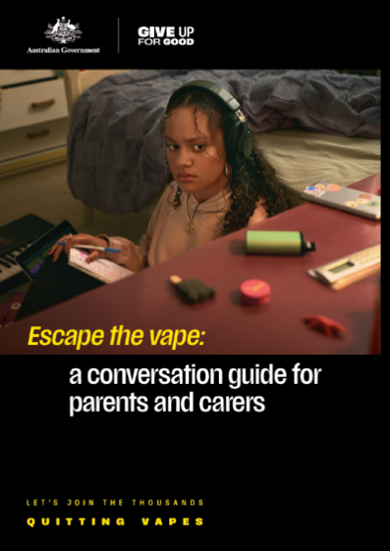 | Download here | Refer parents or carers to the conversation guide on the website or print and hand out hard copies.
‘What you need to know about vaping’ is a fact sheet for parents and carers to provide the facts about vaping. | 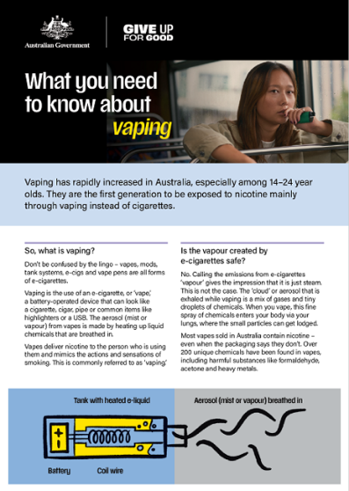 | Download here | Refer parents or carers to the fact sheet on the website or print and hand out hard copies.
Frequently asked questions (FAQs) for parents and carers is designed to help answer some common questions about vaping. | 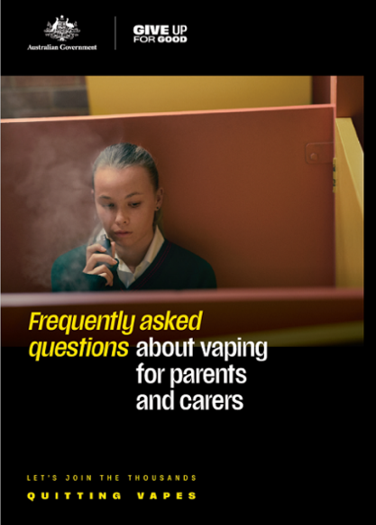 | Download here | Refer people to the FAQs on the website or print and hand out hard copies.
‘Escape the vape: a conversation guide for parents and carers’ is an animated video to help parents and carers start a conversation about vaping with young people. | 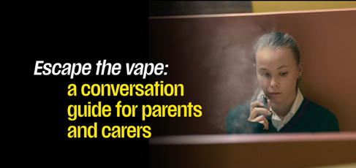 | Watch here | Refer parents or carers to the animated conversation guide on the website or use on your own channels.
‘Escape the vape: Let’s get the facts about vaping’ is a short animation that focuses on the facts about vaping. | 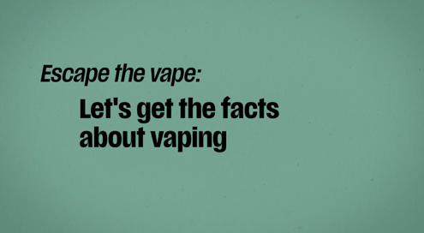 | Watch here | Refer parents or carers to the animated video on the website or use on your own channels.
‘Escape the vape: Support to quit vaping’ is a short animation about the support available to help young people quit vaping. | 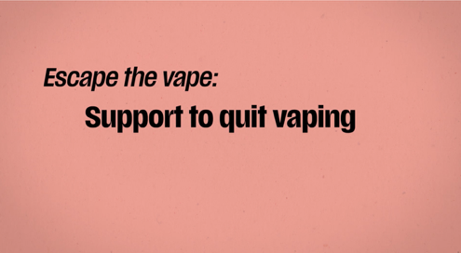 | Watch here | Refer parents or carers to the animated video on the website or use on your own channels.
‘Escape the vape: Four tips for talking about vaping’ is a short animation that provides useful tips for talking to young people about vaping. | 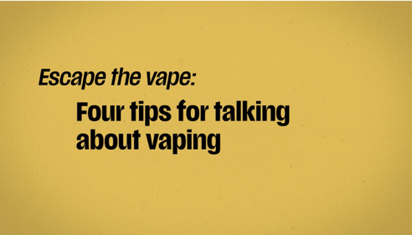 | Watch here | Refer parents or carers to the animated video on the website or use on your own channels.
‘Escape the vape: Having the conversation about vaping’ is a short animation to help parents and carers start a conversation about vaping. | 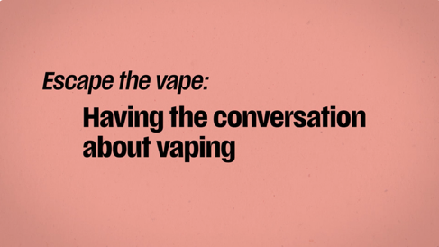 | Watch here | Refer parents or carers to the animated video on the website or use on your own channels.
‘Dr Anthea Rhodes on the harms of vaping’ video | 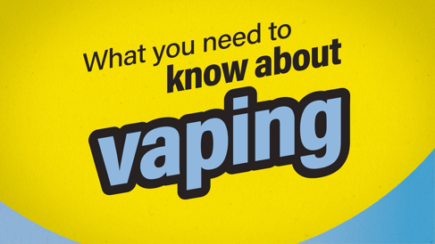 | Watch here | Refer young people, parents and carers to the video or use on your own channels.
‘Dr Anthea Rhodes on nicotine addiction and withdrawal’ video | 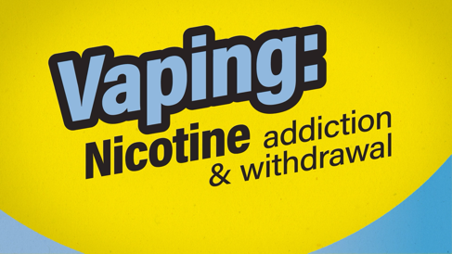 | Watch here | Refer young people, parents and carers to the video or use on your own channels.
‘Dr Anthea Rhodes shares advice for finding support to quit vaping’ video | 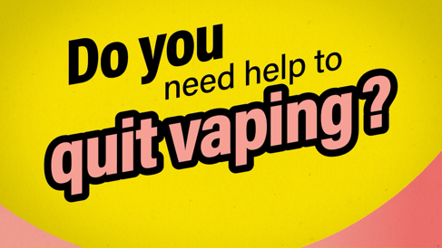 | Watch here | Refer young people, parents and carers to the video or use on your own channels.
Poster 1 | 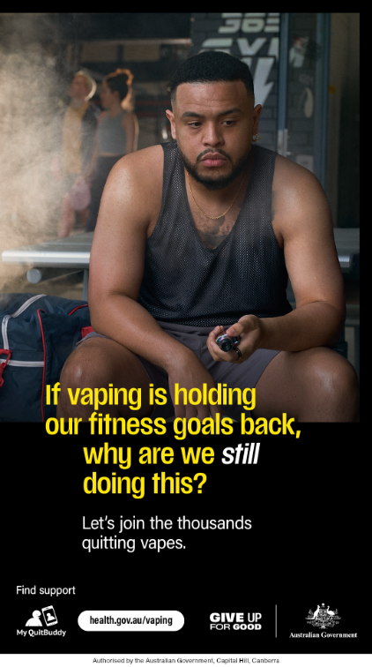 | Download here | Print and display posters for young people in community waiting areas or on community noticeboards.
Poster 2 | 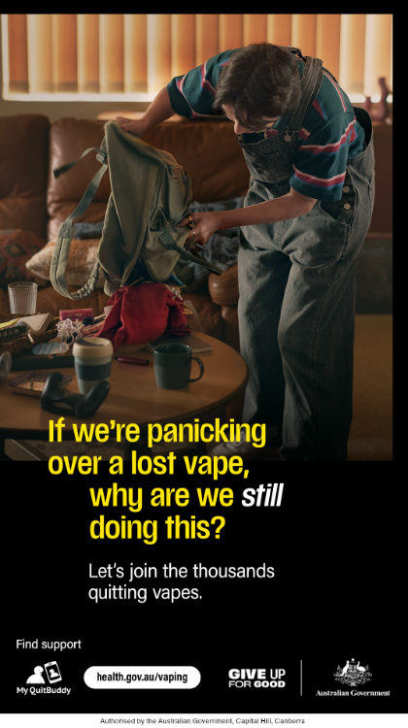 | Download here | Print and display posters for young people in community waiting areas or on community noticeboards.
Poster 3 | 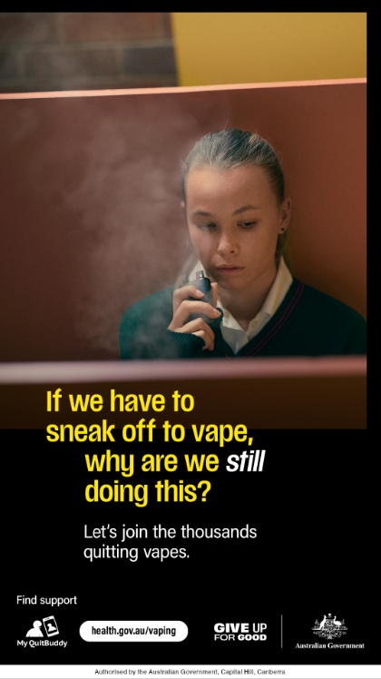 | Download here | Print and display posters for young people in community waiting areas or on community noticeboards.
Poster 4 | 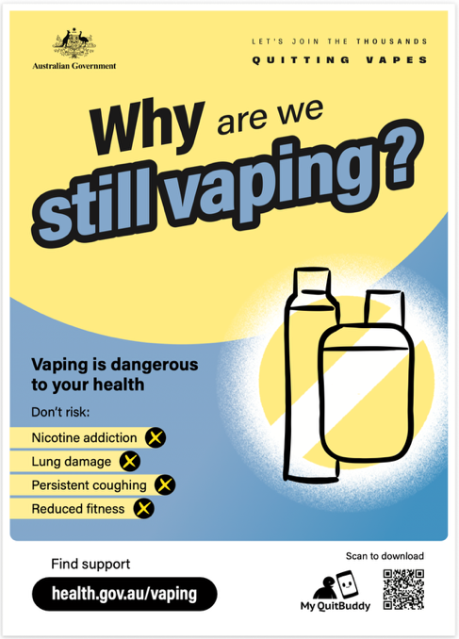 | Download here | Print and display poster for young people in community waiting areas or on community noticeboards.
Poster 5 | 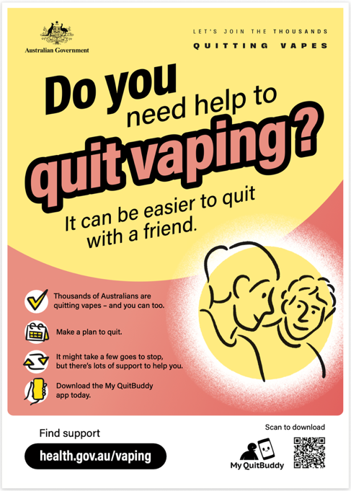 | Download here | Print and display poster for young people in community waiting areas or on community noticeboards.
Social media video – Cost of Vaping |  | Watch here | Share video on social media channels.
Social media video – Shortness of breath | 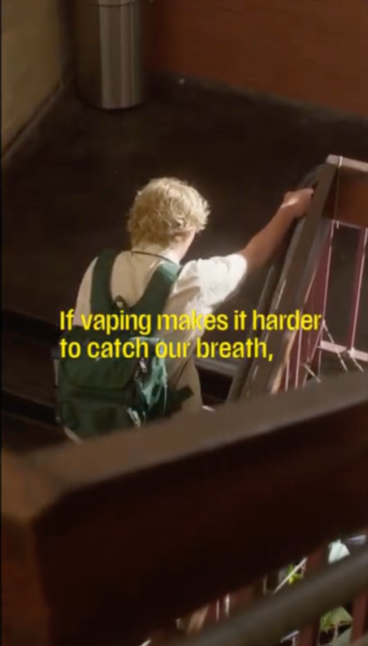 | Watch here | Share video on social media channels.
Social media video – Impact on sport | 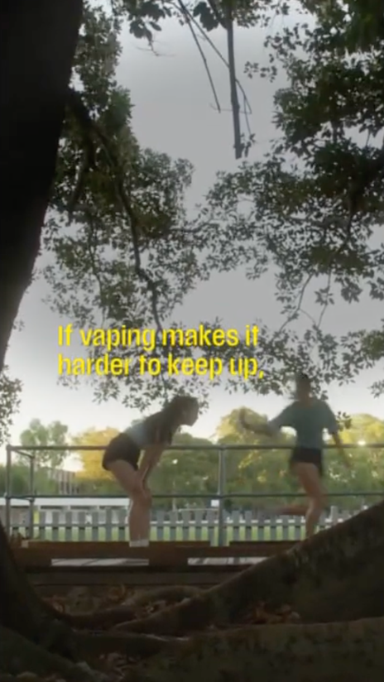 | Watch here | Share video on social media channels.
Social media video – Cough | 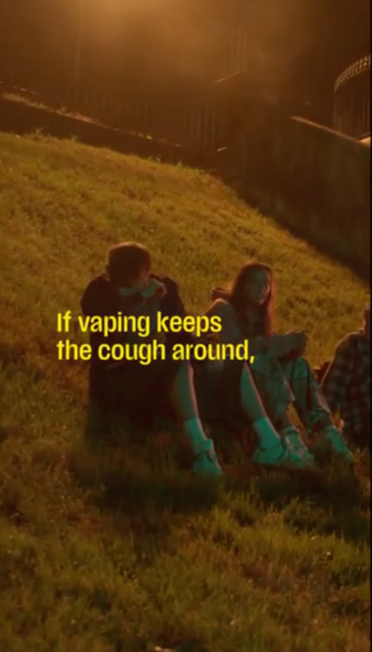 | Watch here | Share video on social media channels.
Spotify stage | 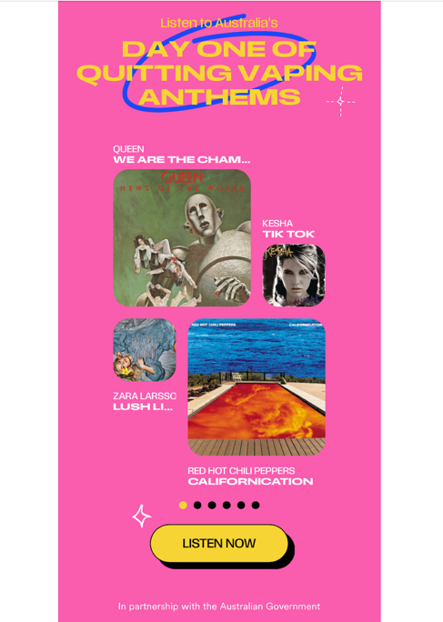 |  | Place QR code in common areas for young people to scan and add their hype song to Spotify’s Day One of Quitting Vapes Anthems and start their quit journey.
All materials can be downloaded from health.gov.au/vaping.
Resources for First Nations audiences can be downloaded from health.gov.au/vaping/first-nations.
The youth vaping conversation guide, fact sheet, FAQ and animated videos have been translated into the following languages:
- العربية (Arabic)
- 简体中文 (Chinese Simplified)
- 繁體中文 (Chinese Traditional)
- Ελληνικά (Greek)
- 한국어 (Korean)
- ภาษาไทย (Thai)
- Tiếng Việt (Vietnamese).
Translated resources can be downloaded from health.gov.au/vaping/translated.

Newsletter articles
Two articles have been provided below that can be used on your website news or in an electronic newsletter. One is written for parents and carers and one is written for young people.
[For a parent and carer audience]

Vaping and young people – what you need to know
Don’t be confused by the lingo – vapes, mods, tank systems, e-cigs, and vape pens are all forms of e-cigarettes, and they are harmful to your health.
Most vapes contain nicotine – even when the packaging says they don’t. Over 200 unique chemicals have been found in vapes, including harmful substances like formaldehyde, acetone and heavy metals.
When a person vapes, a fine spray of chemicals enters their body via the lungs, where small particles can get lodged.
Short-term and long-term vaping is dangerous to a young person’s health.
Those who vape may experience:
- lung inflammation and throat irritation
- persistent coughing
- breathing problems such as shortness of breath and wheezing, which can also decrease physical performance
- feeling nauseous
- swelling, bleeding and redness of the gums
- dizziness and light headedness
- seizures from inhaling too much nicotine or swallowing e-liquid
- burns or injury if a vape overheats or explodes
- becoming dependent on the nicotine in vapes
- feeling anxious or irritable because of nicotine withdrawals
- permanent lung damage
- a temporary loss of or change in taste
- trouble with asthma.

Vaping and nicotine can also affect wellbeing and mental health, including:
  - mood, particularly when nicotine levels in the body drop, and may make mental health issues like anxiety and depression worse
  - the brain, which is still developing until your mid to late 20s. It can harm parts of the brain that control attention, learning and memory.
There are lots of options to support young people to quit vaping:
- The My QuitBuddy app is your free, pocket-sized support crew to help you quit vaping for good. Whether you're just getting started or staying on track, it’s like having your best friend in your pocket, offering tips, motivation, and support whenever you need it. Age restrictions may apply – check your app store for details.
- Pave app is a free app to help young people make a plan and track their progress to become vape-free.
- Quitline (13 7848) is a confidential phone service. They can talk to a professional counsellor about ways to quit. In some states and territories, they can also chat to a counsellor online.
- A doctor or a trusted health professional can give them helpful advice on how to quit.
- Encourage them to share their quitting journey with friends who support their decision.
Remember lots of people have found it takes a few tries before they are completely vape-free. It’s important that they keep trying, even if it takes a few goes before they quit completely.
For more information and resources visit health.gov.au/vaping.
[For a young person audience]

It can be easier to quit with a friend
Thinking about quitting vapes? You don’t have to do it alone. Quitting alongside a friend can make a real difference – giving you motivation, encouragement and someone who understands what you’re going through.
When you vape, you’re inhaling a fine spray of chemicals directly into your lungs, where tiny particles can get stuck and cause serious damage. Whether you’ve just started or have been vaping for a while, it’s important to know the risks.
Here’s what vaping can impact:
- Your breathing and fitness – vaping can cause shortness of breath, coughing and wheezing, which could make it harder to exercise.
- Your lungs – vaping can lead to long‑term or permanent lung damage.
- Your mental health – nicotine can increase feelings of anxiety and irritability, especially when cravings or withdrawals hit.
- How you feel day‑to‑day – you may start experiencing nausea, dizziness and headaches.
- Your bank account – buying vapes regularly adds up quickly, think of all the things you could buy instead!
Vaping and nicotine can also affect your wellbeing and mental health, including:
- your mood, particularly when nicotine levels in your body drop, and may make mental health issues like anxiety and depression worse
- your brain, which is still developing until your mid to late 20s. It can harm parts of the brain that control attention, learning and memory.
But here’s the good news – you don’t have to do it alone. There are plenty of ways to get support:
- My QuitBuddy app: Your free, pocket-sized support crew to help you quit vaping for good. Whether you're just getting started or staying on track, it’s like having your best friend in your pocket, offering tips, motivation, and support whenever you need it. Age restrictions may apply – check your app store for details.
- Pave app: A free app to help young people quit vaping.
- Quitline (13 7848): Want to talk? Quitline is a confidential phone service where you can chat with a professional counsellor about how to quit. In some places, you can even chat online.
- Doctor or trusted health professional: Your doctor or a health expert can give you solid advice on quitting.
- Lean on friends: Sharing your quitting journey with friends who support your decision can make a big difference.
- Spotify stage: Scan the QR code below to add your hype song to Spotify’s Day One of Quitting Vapes Anthems and start your quit journey.
If you’re currently trying to quit, you might be having cravings. Dealing with cravings can be challenging, but they usually only last a few minutes and it gets easier with time. There are things you can do to help resist the urge to vape and keep you on track to quit.
- Delay acting on the urge to smoke or vape – after a few minutes the craving will decrease.
- Deep breathe – take 3 long slow breaths.
- Distract yourself – take your mind off smoking or vaping by listening to music, exercising or chatting to a friend.
- Drink water – sip it slowly and savour the taste.
Quitting isn’t easy, and it might take a few tries before you’re completely vape-free. But don’t give up – each attempt gets you closer to a healthier, vape-free life.
For more information and support, visit health.gov.au/vaping.

Social media posts
The posts and image tiles below can be published on your preferred social channels.
Post | Image or video
Targeted at youth audiences
If you’re thinking about quitting vaping, there is support available to help you quit 🫶.  The free My QuitBuddy app provides personalised information and advice to help you on your quit journey .  Remember it’s okay if it takes a few tries to be completely vape-free, and you don’t have to do it alone .  To find out more about the My QuitBuddy app visit https://www.health.gov.au/resources/apps-and-tools/my-quitbuddy-app | Social media tile ‘My QuitBuddy’  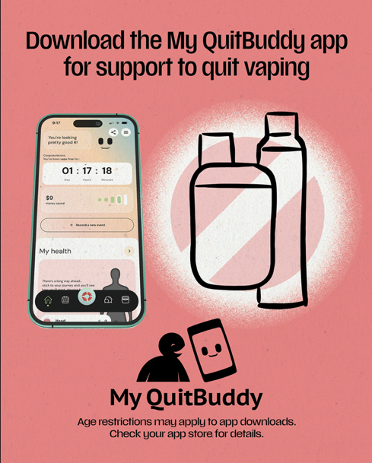
Are you vaping? Nicotine is highly addictive.  You may experience nicotine withdrawal symptoms that include mood changes, difficulty concentrating and feeling nervous, restless, irritable and/or anxious.  Quitting alongside someone you trust can help you push through the tough moments.  For more information and help to quit visit health.gov.au/vaping, download the My QuitBuddy app or talk to a health professional ️. | Social media tile ‘Most vapes contain nicotine’  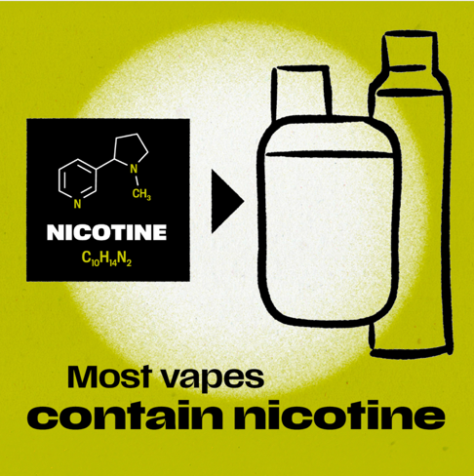
Did you know our brains are still developing until we reach our late 20s?  ‍️ Vaping can harm parts of the brain that control attention, learning, memory and mood.  For more information and help to quit visit health.gov.au/vaping, download the My QuitBuddy app or talk to a health professional ️. | Social media tile ‘Vaping impacts’  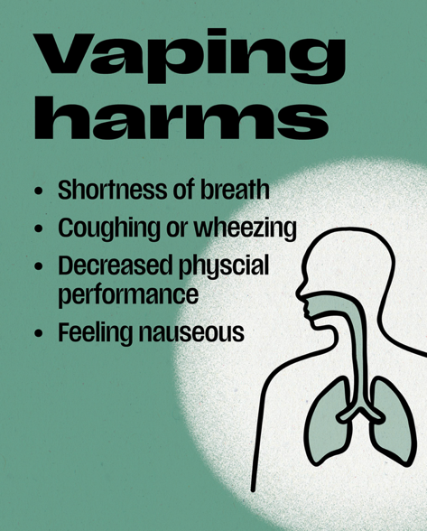
🪜Quitting vaping is a major step towards improving your physical and mental wellbeing.  Join the thousands quitting vapes.  For more information and help to quit visit health.gov.au/vaping, download the My QuitBuddy app or talk to a health professional ️. | Social media video ‘Fitness goals’  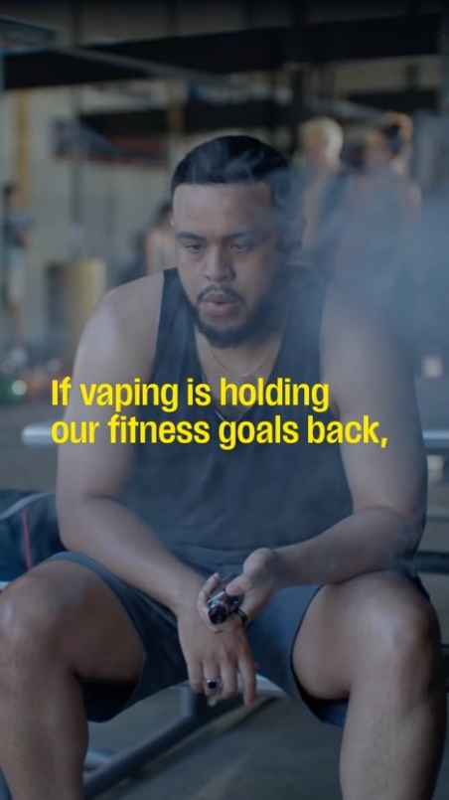
⚠️ The nicotine in vapes means you may find vaping hard to resist, but the harmful chemicals may affect your health.  🫶 Many Australians are quitting or planning to quit. Quitting with support can help and it can be easier to quit with a friend.  For more information and help to quit visit health.gov.au/vaping, download the My QuitBuddy app or talk to a health professional ️. | Social media video ‘Vaping in the bedroom’  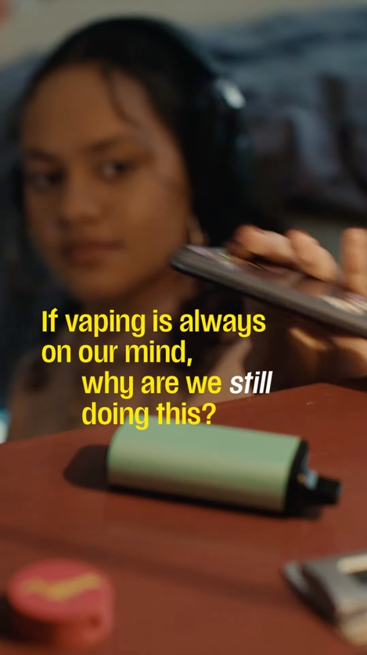
‍️ There is no such thing as safe vaping.  Thinking about giving up vaping?  🫶 It can be easier to quit with a friend – find help and support at health.gov.au/vaping, via the My QuitBuddy app or by speaking to a health professional. | Social media video ‘Vaping in the bathroom’  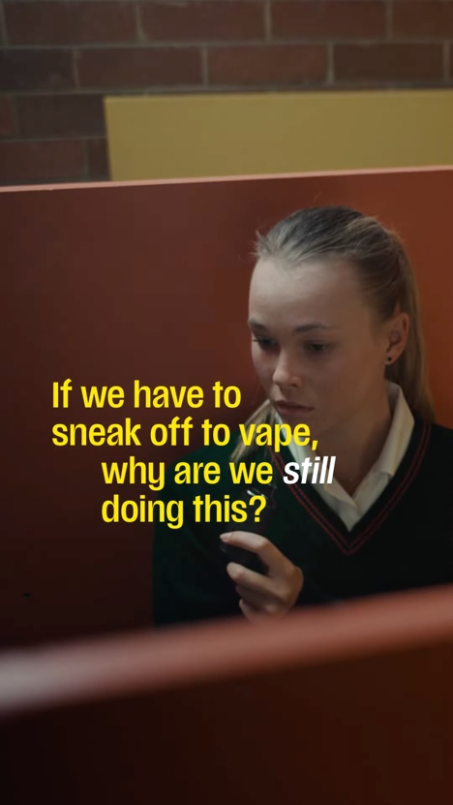
When you quit vaping, you’ll break your body’s dependence on nicotine. You’ll feel more in control and have more freedom to make choices about your life that don’t revolve around vaping.  Sharing the journey with someone you trust can help you stay on track.  For more information and help to quit visit health.gov.au/vaping, download the My QuitBuddy app or talk to a health professional ️. | Social media video ‘Wake and vape’  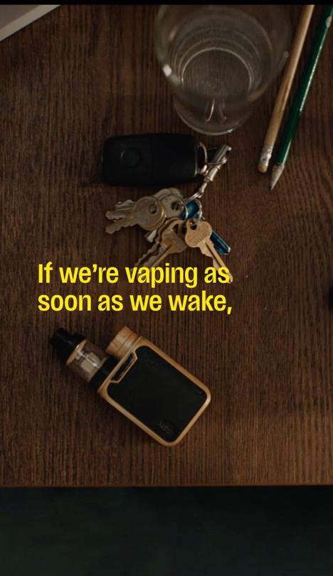
If you’re thinking about quitting vaping, there is support available to help you.  The first week can be the hardest as cravings can be frequent and intense but they usually only last a few minutes and get easier with time . Identifying your triggers can help you plan how to deal with them.  Try the 4 Ds when you have a craving:  - Delay acting on the urge to vape ⏯️ – after a few minutes the craving will decrease.  - Deep breathe – take 3 long, slow breaths.  - Distract yourself – take your mind off smoking or vaping by listening to music, exercising or chatting to a friend.  - Drink water – sip it slowly and savour the taste.  For more information and help to quit visit health.gov.au/vaping, download the My QuitBuddy app or talk to a health professional. | 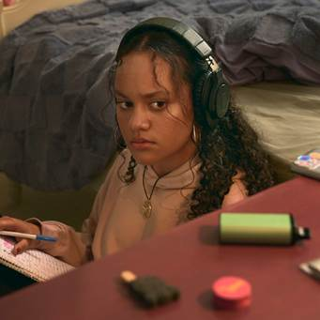
Targeted at parent and carer audiences
⁉️Did you know today’s 14 to 24-year-olds are the first generation to be exposed to nicotine largely through vaping rather than cigarettes.  There are helpful resources available that provide guidance to parents and carers wanting to talk to their young person about vaping at health.gov.au/vaping | Social media tile ‘Talking to a young person about vaping’  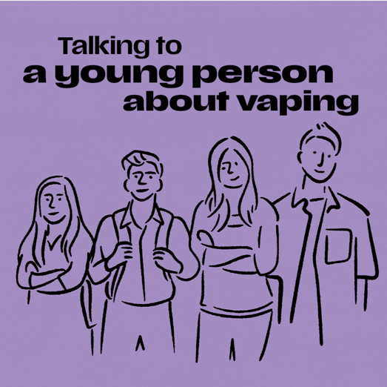
️ Having a conversation about vaping might feel tricky but it’s important to do. Here are 4 tips to help you start talking about vaping with a young person you care about.  There are helpful resources available that provide guidance to parents and carers wanting to talk to their young person about vaping at health.gov.au/vaping | Escape the vape: tips for talking about vaping  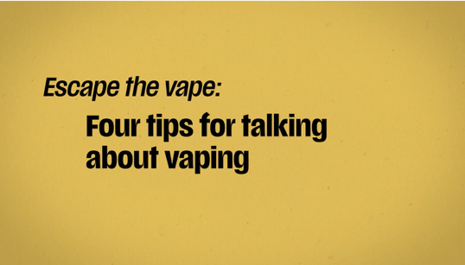
If a young person wants to quit vaping, accessing support can help them succeed .  Resources like the My QuitBuddy app provide personalised information and advice . Age restrictions may apply.  They can also talk to a Quitline counsellor about vaping and how to quit ️.  There are helpful resources available that provide guidance to parents and carers wanting to talk to their young person about vaping at health.gov.au/vaping | Escape the vape: support to quit vaping  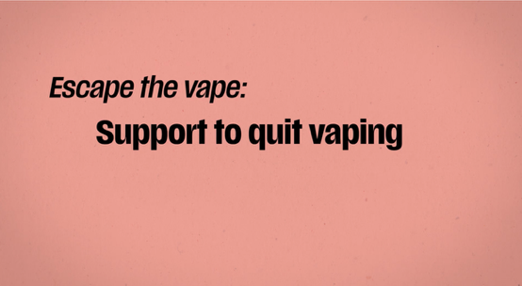
Let’s get the facts about vaping ⬇️  💨 Illegal vapes can look like a cigarette, cigar, pipe or common items like a highlighter or USB.  🧪 Over 200 unique chemicals have been found in illegal vapes, including formaldehyde, nicotine and heavy metals.  ⚠️ Most illegal vapes in Australia contain nicotine – even when the packaging says they don’t.  To find out more about vaping, visit health.gov.au/vaping | Escape the vape: get the facts about vaping  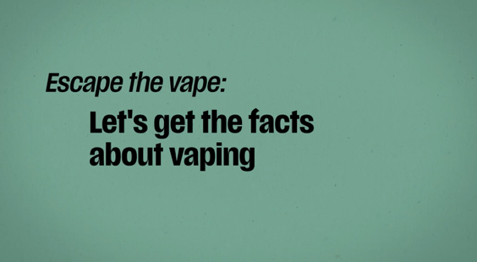
️Talking to a young person about vaping? Think of your conversations as a work in progress – like quitting vaping, it might take a few tries, but it gets easier.  There are helpful resources available that provide guidance to parents and carers wanting to talk to their young person about vaping at health.gov.au/vaping | Escape the vape: having the conversation about vaping  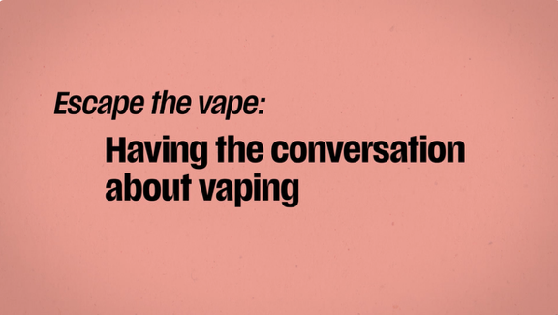
If a young person wants to quit vaping, accessing support can help them succeed .  The first week can be the hardest as cravings can be frequent and intense, but they usually only last a few minutes and get easier with time .  Suggest they try the 4 Ds to help deal with a craving:  - Delay acting on the urge to vape ⏯️– after a few minutes the craving will decrease.  - Deep breathe – take 3 long slow breaths.  - Distract themselves – encourage them to take their mind off vaping by listening to music, exercising or chatting to a friend.  - Drink water – sip slowly and savour the taste.  For more information and help to quit visit health.gov.au/vaping, download the My QuitBuddy app or talk to a health professional. | 

