Support at Home program assurance framework

Disclaimer
The Department of Health, Disability and Ageing has exercised due care and skill in preparing and compiling the information and data in this publication. Notwithstanding, the Department of Health, Disability and Ageing, its employees and advisers disclaim all liability, including liability for negligence and for any loss, damage, injury, expense or cost incurred by any person as a result of accessing, using or relying on any of the information or data in this publication to the maximum extent permitted by law.
It is the Support at Home registered provider’s (provider’s) responsibility to understand and meet their obligations as they relate to all applicable legislation when delivering funded aged care services. Providers should consider obtaining their own legal or professional advice relevant to their circumstances, especially in relation to requirements and obligations for delivering funded aged care services that may be new or different under the new Act and related rules.
Providers are responsible for complying with all relevant legislation when delivering funded aged care services. In addition to legislation referred to in this Guide, other Australian Government portfolios and state and territory jurisdictions may have separate legislation relevant to providers’ operations as a registered provider.

Acknowledgement of Country
We, the Department of Health, Disability and Ageing, proudly acknowledge the Traditional Owners and Custodians of Country throughout Australia, and pay respect to those who have preserved and continue to care for the lands and waters on which we live and, work, and from which we benefit each day. We recognise the strengths and knowledge Aboriginal and Torres Strait Islander peoples provide to the health, disability and aged care system and thank them for their ongoing contributions to those systems and the wider community. We extend this gratitude to all health, disability and aged care workers who contribute to improving health and wellbeing outcomes with, and for, First Nations peoples and communities.

Contents
Disclaimer 3
Acknowledgement of Country 4
Executive summary 6
Introduction 8
Legislative framework 8
Rights-based model 8
System Governor 9
The Aged Care Quality and Safety Commission 10
Assurance powers 10
Other relevant powers 12
Other underlying legislation 12
Context 13
System Governor aged care compliance framework 14
Assurance framework overview 15
A focus on payment integrity 15
Managing fraud 15
Principles 16
Benefits 17
Governance 17
Three Lines Model 17
Assurance roles and responsibilities 19
Assurance approach 22
Phase 1: Identify assurance needs 22
Phase 2: Understanding existing assurance 23
Phase 3: Risk prioritisation 23
Phase 4: Undertaking assurance 24
Phase 5: Report and monitor 25
Procedural fairness 26
Phase 6: Implement and refine 26
Internal continuous improvement 27
Appendix A 28

Executive summary
The Support at Home program supports growing numbers of older people in Australia to remain in their homes as they age. It is established under the Aged Care Act 2024 (the Act) in response to the Royal Commission into Aged Care Quality and Safety.
The Act creates a modern, rights-based framework. It prioritises older people's safety, health, and wellbeing, placing their needs at the heart of aged care. It introduces a Statement of Rights that a participant is entitled to when accessing, or seeking to access, funded aged care services. Support at Home providers must take reasonable and proportionate steps to ensure their services align with a participant’s rights under the aged care legislation. To support the rights-based model, the Act introduces the System Governor role, performed by the Secretary of the Department of Health, Disability and Ageing (the department). The System Governor is responsible for the operations and oversight of the aged care system including:
- facilitating equitable access to funded aged care services for older people
- supporting the continuity of funded aged care services
- providing stewardship of the aged care system
- protecting and upholding the integrity of the aged care system
- monitoring and encouraging the training and development of aged care workers
- reviewing the Australian Government’s administration of the aged care system.
Sections 508-513 of the Act provide for the powers of the System Governor to conduct assurance activities in respect of the System Governor’s functions. This Support at Home program assurance framework (assurance framework) outlines the department’s approach to conducting Support at Home program assurance activities under the Act.

Support at Home program assurance framework
Purpose
To outline a risk-based assurance approach to provide confidence in the integrity of the Support at Home program in keeping with the System Governor’s obligations under the Act.
Vision
A future where Support at Home funding is used with integrity and transparency, assurance efforts enable value for money, and public trust is upheld.
Principles
Continuous improvement
Risk-based and data driven
Collaboration, engagement, and trust
Key Risks
Support at Home program does not achieve value for money for participants and/or the Australian public because of one or more of the following:
Participants cannot appropriately exercise their right to choice
Support at Home program funds are fraudulently used
Support at Home program funds are inappropriately, or inadvertently used (i.e., used in error)
Figure 1: Overview of the assurance framework
The assurance framework outlines the purpose and benefits of program assurance, roles and responsibilities.
The department will also publish a Support at Home program assurance plan (assurance plan) which will outline Support at Home program assurance priorities. The assurance framework and assurance plan will be reviewed regularly.
The assurance framework applies the Three Lines Model. This globally recognised model for organisational governance, assurance and risk management underpins the department’s corporate assurance framework. This assurance framework primarily focuses on second line activities conducted by the department.
The assurance framework aligns with the System Governor aged care compliance framework (compliance framework). Both frameworks are driven by continuous improvement and a graduated compliance approach. Collaboration with providers is prioritised with the aim to seek resolution, understand how the issue has arisen and provide opportunities to self-correct where appropriate. The department will implement program improvement opportunities resulting from assurance activities as required.
Procedural fairness will be afforded to providers. Repeated or deliberate non-compliance may result in compliance action in line with the compliance framework and the System Governor’s powers under the Act.

Introduction
Support at Home brings together in-home aged care programs. It is established under the Act in response to the recommendations from the Royal Commission into Aged Care Quality and Safety. The new aged care system puts older people at its centre. It strengthens transparency, accountability, and regulation for the aged care sector.
Key stakeholders for this assurance framework and their roles are:
- the department is the policy and program lead, and the Secretary is the System Governor
- Services Australia is responsible for payments
- providers deliver aged care services
- participants access care and support through a rights-based model
- the Commission is the national regulator.

Legislative framework
The Act establishes a modern rights-based legislative framework that focuses on the safety, health, and wellbeing of older people and places their needs at the centre of the aged care system.
From 1 November 2025, the Support at Home program replaces the Home Care Packages (HCP) Program and the Short-Term Restorative Care Program (STRC). The Commonwealth Home Support Program (CHSP) will transition to Support at Home no earlier than 1 July 2027.

Rights-based model
The Act introduces a Statement of Rights that a participant is entitled to when accessing or seeking to access funded aged care services. The Statement of Rights helps to ensure that older people and their needs are at the centre of the new aged care system. Providers delivering funded aged care services must take all reasonable and proportionate steps to act compatibly with the rights. Figure 2 summarises the Statement of Rights.
Participants accessing funded aged care services have the right to:
 | Independence, autonomy, empowerment and freedom of choice
 | Equitable access
 | Quality and safe funded aged care services
 | Respect for privacy and information
 | Person-centred communication and ability to raise issues without reprisal
 | Advocates, significant persons and social connections
Figure 2: Statement of Rights

System Governor
The Royal Commission into Aged Care Quality and Safety Final Report: Care Dignity and Respect identified system governance and stewardship as critical elements needing reform. To address this, the Act introduces the role of the System Governor.
The System Governor is responsible for the operations and oversight of the aged care system including:
- facilitating equitable access to funded aged care services for older people
- supporting the continuity of funded aged care services
- providing stewardship of the aged care system
- protecting and upholding the integrity of the aged care system
- monitoring and encouraging the training and development of aged care workers
- reviewing the Australian Government’s administration of the aged care system.
To deliver on these responsibilities, the System Governor must also ensure all parts of the aged care system work together effectively. This supports an important shift towards a system wide approach to oversight for aged care.
This assurance framework focusses mainly on System Governor powers to protect and uphold the integrity of the Australian Government’s administration of and investment in the aged care system. However, the department may, as the System Governor, undertake assurance activities across any of its functions outlined above.
The System Governor role is separate to the role of the Aged Care Quality and Safety Commission (the Commission) although they work closely together. Further information is available on the department’s website: aged care regulatory and governance roles.

The Aged Care Quality and Safety Commission
The Commission is responsible for protecting and enhancing the safety, health, wellbeing and quality of life of older people receiving aged care. The Commission upholds older people’s rights and ensures providers and workers comply with their obligations under the Act. This includes those relating to quality and safety, governance, and financial and prudential management.
The Commission performs its functions by:
- engaging with older people, families, registered supporters and carers to ensure their voices and experiences inform regulation and to promote rights and transparency in the aged care system
- registering providers to deliver funded aged care services and ensuring they have the capability and commitment to meet their obligations
- monitoring compliance with obligations under the Act, including the Aged Care Code of Conduct, the Aged Care Quality Standards, and the Financial and Prudential Standards
- taking proportionate regulatory action where providers, responsible persons or workers fail to meet their obligations, including responding to non-compliance and serious risk
- resolving complaints about the conduct of providers, responsible persons, and aged care workers, and using complaints intelligence to inform risk-based regulation
- building sector capability by supporting providers, responsible persons, and aged care workers to understand and meet their responsibilities and driving continuous improvement in the quality of care
- working with government and stakeholders to strengthen the regulatory system and contribute to broader policy outcomes working alongside the department to implement additional protections for Support at Home program participants.
Where providers are subject to activities by both the department and the Commission, they will work together to minimise unnecessary burden on providers.

Assurance powers
Access to relevant assurance information is crucial for the System Governor to be able to effectively conduct assurance activities for the purposes of its functions.
This is reflected in sections 508 to 513 of the Act, which provide the System Governor with certain powers to conduct assurance activities.
This document provides a framework for the conduct of assurance activities under sections 508 to 513 of the Act. Table 1 describes the System Governor’s assurance powers under the Act and their relevance to the assurance framework.
Table 1: Assurance powers under the Act
Section | Description | Relevance
508 | System Governor may conduct assurance activities for the purposes of their functions. | The assurance framework outlines the department’s approach to conducting assurance activities.
509 | System Governor may specify terms of reference for assurance activities. | The assurance framework provides guidance on how assurance topics will be identified and prioritised which will inform terms of reference for specific activities.
510 | System Governor may prepare and publish reports on assurance activities. | The assurance framework outlines the department’s approach to assurance reporting.
511 | System Governor may be assisted in the conduct of assurance activities by Australian Public Service employees or other persons engaged by contract. | The assurance framework defines roles and responsibilities relating to assurance, including those of the Provider Payments Assurance Branch.
512 | Providers must provide reasonable facilities and assistance for assurance activities. | The assurance framework outlines the requirement for providers to cooperate with assurance activities including timely access to requested information and facilities (where requested).
513 | System Governor may request information and the production of documents relevant to the subject matter of assurance activities. | The assurance framework outlines how participants may be asked to provide information and documents to support assurance activities.

Other relevant powers
Chapter 6 of the Act provides for a range of ‘regulatory mechanisms’. The assurance powers and functions in sections 508 to 513 of the Act are a subset of the powers in Chapter 6. Other powers under Chapter 6 may also be relevant for conducting assurance activities. These functions will generally be exercised by ‘authorised System Governor officers’ appointed under section 526 of the Act, and subject to any directions made by the System Governor under section 528 of the Act.

Other underlying legislation
In addition to the legislative basis for assurance activities provided for in the Act, the department has important responsibilities under the:
- Public Governance, Performance and Accountability (PGPA) Act 2013 (PGPA Act)
- PGPA Rule 2014 (PGPA Rule)
- Commonwealth Fraud and Corruption Control Framework 2024 (fraud and corruption control framework)
- Commonwealth Grants Rules and Principles 2024 (CGRPs).
The PGPA Act establishes requirements for Commonwealth entities to establish and maintain systems of risk oversight and management including internal controls. It requires government funded programs such as Support at Home to be delivered in an efficient, effective, economical and ethical manner.
The PGPA Rule mandates Australian Government entities to take all reasonable measures to prevent, detect, and respond to fraud and corruption.
The fraud and corruption control framework, under the PGPA Act, supports Australian Government entities to effectively manage the risks of fraud and corruption. It comprises the following core elements:
- governance and oversight
- targeted and rigorous risk assessments
- informed and targeted control plans
- effective controls encompassing appropriate prevention, detection, investigation, referral and reporting mechanisms.
The fraud and corruption framework allows Commonwealth entities to manage relevant risks in a proportionate way and suited to the individual circumstances of an entity.
The CGRPs establish the policy framework for grants administration and outline requirements to administer grants effectively and transparently.
Ongoing assurance is needed to demonstrate compliance with these broader requirements. Assurance activities conducted under this assurance framework will also provide confidence around compliance with relevant PGPA obligations.

Context
The Support at Home program and this assurance framework exist within a broader context of the aged care system and the department’s purpose and objectives. Figure 3 summarises where this assurance framework sits within and supports this broader context.
RELEVANT DEPARTMENTAL FRAMEWORKS
- Corporate Assurance Framework
- System Governor Compliance Framework
- Fraud and corruption control plan
LEGISLATION
- Aged Care Act
- PGPA Act
- PGPA Rule
- Fraud and Corruption Control Framework
- CGRPs
SUPPORT AT HOME ASSURANCE FRAMEWORK
DEPARTMENT PRIORITIES
Vision: Better health and wellbeing for all Australians, now and for future generations
Outcome 3: Ageing and Aged Care
Program 3.2 Aged Care Services
Figure 3: Assurance framework context

System Governor aged care compliance framework
There is strong alignment and interaction between this assurance framework and the compliance framework. Support at Home program assurance is driven by continuous improvement in line with the graduated compliance approach outlined in the compliance framework. This is summarised in Figure 4.
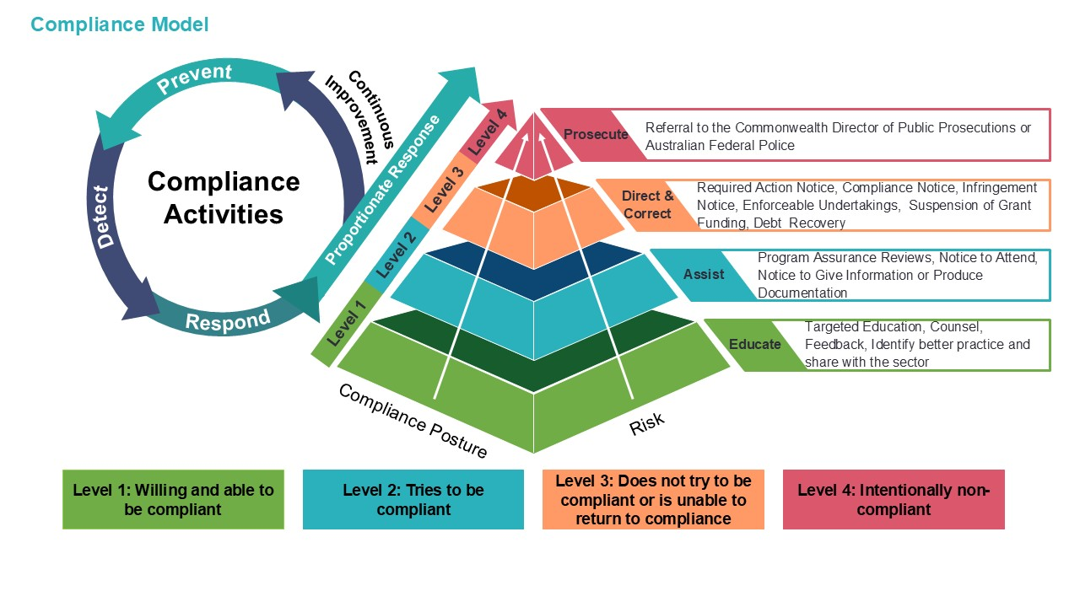Figure 4: Aged care compliance model from the System Governor aged care compliance framework (see Appendix A for a larger scale version of this diagram).
The System Governor’s compliance functions are articulated in the compliance framework. The compliance framework outlines prevention, detection and response strategies to address situations where a provider:
- has failed (or potentially failed) to comply
- is unwilling to meet its obligations.
The intent of the graduated compliance model is to support voluntary compliance and continuous improvement where possible. Assurance activities covered by this assurance framework sit under level 2- Assist, in the compliance model.

Assurance framework overview
The purpose of this assurance framework is to outline a risk-based assurance approach to provide confidence in the integrity of Support at Home. This assurance framework and related activities will ultimately support informed choice and value for money for participants in the Support at Home program. It will also protect the public’s investment in the program and support the System Governor to fulfil its obligations under the Act.
This document outlines the department’s approach to conducting Support at Home program assurance activities. It specifies the purpose, benefits, roles and responsibilities.

A focus on payment integrity
This assurance framework has a particular focus on provider payment integrity to minimise payment misuse, fraud and error. Payment integrity refers to the management, administration, accounting, and reporting of aged care funding, in line with applicable legislation, funding or other program requirements. This includes any self-reporting from providers that ultimately impacts their Support at Home funding.
Under the Act, assurance activities may focus on any aspect of the System Governor’s functions, including but not limited to how providers:
- use subsidy or grants and charge for services, including justification for costs charged
- structure their financial accounting for delivery of services
- deliver funded aged care services
- work with the participants to whom they deliver funded aged care services
- keep records and information
- apply and document procedures.
It should also be noted that assurance measures related to aged care needs assessments are conducted separately under its own assurance framework.

Managing fraud
A key risk to payment integrity is fraud. The Support at Home assurance program will work closely with the Fraud and Integrity Branch to prevent and detect potential instances of fraud. Program assurance will include ‘follow the money’ activities to confirm there is evidence that goods or services are delivered to participants. Program assurance will also look to assure that funds are being used for intended purposes.
The department’s fraud detection capabilities in aged care programs include strategic data and intelligence sharing initiatives, including collaboration with key government agencies. The department is also a member and plays an active role in the Fraud Fusion Taskforce.
The department takes its obligations in relation to fraud and corruption allegations seriously. Processes are in place to ensure all allegations of fraud and corruption are appropriately managed and investigated. The department manages allegations of fraud in aged care in accordance with the fraud and corruption control framework. Anyone wishing to report concerns relating to an aged care provider, can do so anonymously, by submitting information through the department’s fraud reporting channels:
Telephone: 1800 829 403 (this hotline is open 9am to 5pm Australian Eastern Standard Time, Monday to Friday)
Email: reportfraudorcorruption@health.gov.au
Website: Report suspected fraud form

Principles



Figure 5 summarises the core principles that underpin this assurance framework.
Continuous Improvement
The assurance program is driven by an intent to continuously improve performance, capability and culture of providers as well as the assurance approach itself. This is in line with a graduated approach to compliance and the Statement of Principles under the Act.
Risk-based and data driven
The department will manage risks proportionately, maintaining essential safeguards while minimising administrative burden. Data and digital technology will be leveraged to inform Support at Home assurance activities.
Collaboration, engagement, and trust
The department will be a transparent and responsive communicator in conducting assurance activities to build trust and confidence in the assurance of Support at Home.
Figure 5: Assurance framework principles

Benefits
Program assurance provides objective insights into the effectiveness, progress, and financial integrity of Support at Home. It prevents, detects, and responds to non-compliance in line with the compliance framework and fosters continuous improvement for the sector and the department.
An effective assurance program builds confidence that Support at Home is operating as intended. It helps manage risks and identifies opportunities to improve outcomes.

Governance

Three Lines Model
The assurance framework applies the Three Lines Model. This is a globally recognised model for organisational governance, assurance, and risk management and underpins the department’s corporate Assurance Framework. Using this model, there are ‘three lines’ that each play a different role in providing assurance over Support at Home where the:
- first line refers to operational management
- second line refers to risk management and oversight functions
- third line refers to independent audit.

First line | Second line | Third line
The first line refers to those who are directly involved in delivering Support at Home. The first line is responsible for administering the program (including monitoring, managing provider and sector behaviour and program risk management), engaging with the sector for program management purposes and implementing program improvements resulting from program administration and assurance activities. | The second line refers to program assurance staff. Responsibilities include establishing the Support at Home assurance framework, developing an assurance plan, conducting assurance activities and communicating outcomes to relevant stakeholders.  Second line also covers assurance over Support at Home assessments conducted by the Access and Home Support Division. | The third line refers to independent assurance functions that provide objective observation and advice on the effectiveness of Support at Home. An internal function delivered by the department’s corporate Assurance Branch. Assurance may also be provided by external parties.
 | Department roles
Access and Home Support Division | Provider Payments Assurance Branch | Internal Audit
 | Fraud and Integrity Branch
Executive Committee | Executive Committee
 | Audit and Risk Committee | Audit and Risk Committee
Delivery Committee | Delivery Committee
Senior Responsible Owners and relevant Governance Boards | Senior Responsible Owners and relevant Governance Boards
 | External
Providers |  | External Assurance
Services Australia
 | Regulators
Aged Care Quality and Safety Commission and other Regulators | Aged Care Quality and Safety Commission and other Regulators | Aged Care Quality and Safety Commission and other Regulators
Figure 6: Overview of the Three Lines Model in the context of Support at Home
For assurance to best achieve its purpose, information needs to be effectively communicated between key stakeholders across the three lines. For this assurance framework, all relevant assurance information needs to be shared with the System Governor. This supports effective execution of the System Governor’s role in upholding the integrity of the aged care system.
This assurance framework primarily focuses on the second line activities conducted by the Provider Payments Assurance Branch. It also considers all other assurance roles within the aged care system to ensure a coordinated approach. In addition to the Support at Home Policy and Operations Branch, the department relies on providers and Services Australia to conduct and be accountable for first line assurance relating to their areas of responsibility.

Assurance roles and responsibilities
Table 2 outlines the roles and responsibilities of key stakeholders as they relate to this assurance framework.
Table 2: Assurance roles and responsibilities
Department of Health, Disability and Ageing
Role | Responsibility
Provider Payments Assurance Branch | - Assist the System Governor to plan, conduct, and report on assurance activities in line with this assurance framework.  - Develop an assurance plan and regularly review and update the assurance framework as needed.  - Engage with relevant internal stakeholders (including the Support at Home Policy and Operations Branch, and the Fraud and Integrity Branch), providers, Services Australia and the Commission as appropriate to inform scope and planning of assurance activities.  - Communicate assurance outcomes to relevant stakeholders including the System Governor and other parties such as providers, Fraud and Integrity Branch, Access and Home Support Division and the Commission. Share intelligence with the Commission in line with their remit as the national regulator.  - Consider intelligence from the department as appropriate.  - Communicate about program assurance activities through the Support at Home Community of Practice and other channels as appropriate.
Access and Home Support Division | - Conduct first line assurance and assurance over assessments.  - Conduct program administration activities including monitoring, managing provider and sector behaviour and program risk management.  - Convene the Support at Home Community of Practice to facilitate ongoing engagement between key stakeholders. The Community of Practice promotes improved understanding of program requirements and better practices including where common themes have emerged through assurance activities.  - Provide data and information as requested to support assurance activities.  - Implement program improvement opportunities resulting from assurance activities including re-considering program settings, enhanced documentation and education to support sector compliance.
Fraud and Integrity Branch | - Regularly engage with Provider Payments Assurance Branch to share intelligence to inform the planning and conduct of assurance activities and relevant fraud investigations where appropriate.
External stakeholders
Role | Responsibility
Services Australia | - Conduct relevant first line assurance activities to provide confidence over the integrity of claims processing for Support at Home.  - Regularly engage with the department to support the resolution of any issues, ensure compliance with program requirements, and work together towards continuous improvement.
The Aged Care Quality and Safety Commission | - Regularly engage with the department to share intelligence to inform planning for assurance activities and ensure clear roles and responsibilities, and referral pathways to avoid duplication.  - Refer identified issues relating to system integrity to the System Governor.  - Consider intelligence from the department as appropriate.  - Receive and action referrals from the department for issues relating to quality and safety.  - Undertake compliance action in line with powers under the Act as needed.
Providers and the sector | - Conduct relevant first line assurance activities to provide confidence that services are being provided in line with Support at Home program requirements.  - Cooperate with assurance activities conducted by the department including timely provision of requested information.  - Action recommendations from relevant assurance activities to support continuous improvement and to address identified risks and concerns.  - Facilitate participants to exercise their rights, including through supported decision making, and in collaboration with participants’ supporters.  - Inform participants their personal information may be used for the purposes of assurance.  - Sector takes a continuous improvement approach, using program assurance learnings shared by the department through the Community of Practice and published reports.
Participants | - Cooperate with providers to support proper use of program funds.  - May be asked to provide information or documents to support assurance activities.

Assurance approach
An assurance plan will be published for Support at Home outlining assurance priorities and a range of potential assurance activities. Assurance activities will be used flexibly, based on risk and available resourcing.
The approach to developing the assurance plan follows the assurance lifecycle outlined in the department’s corporate Assurance Framework and is summarised below in Figure 7.
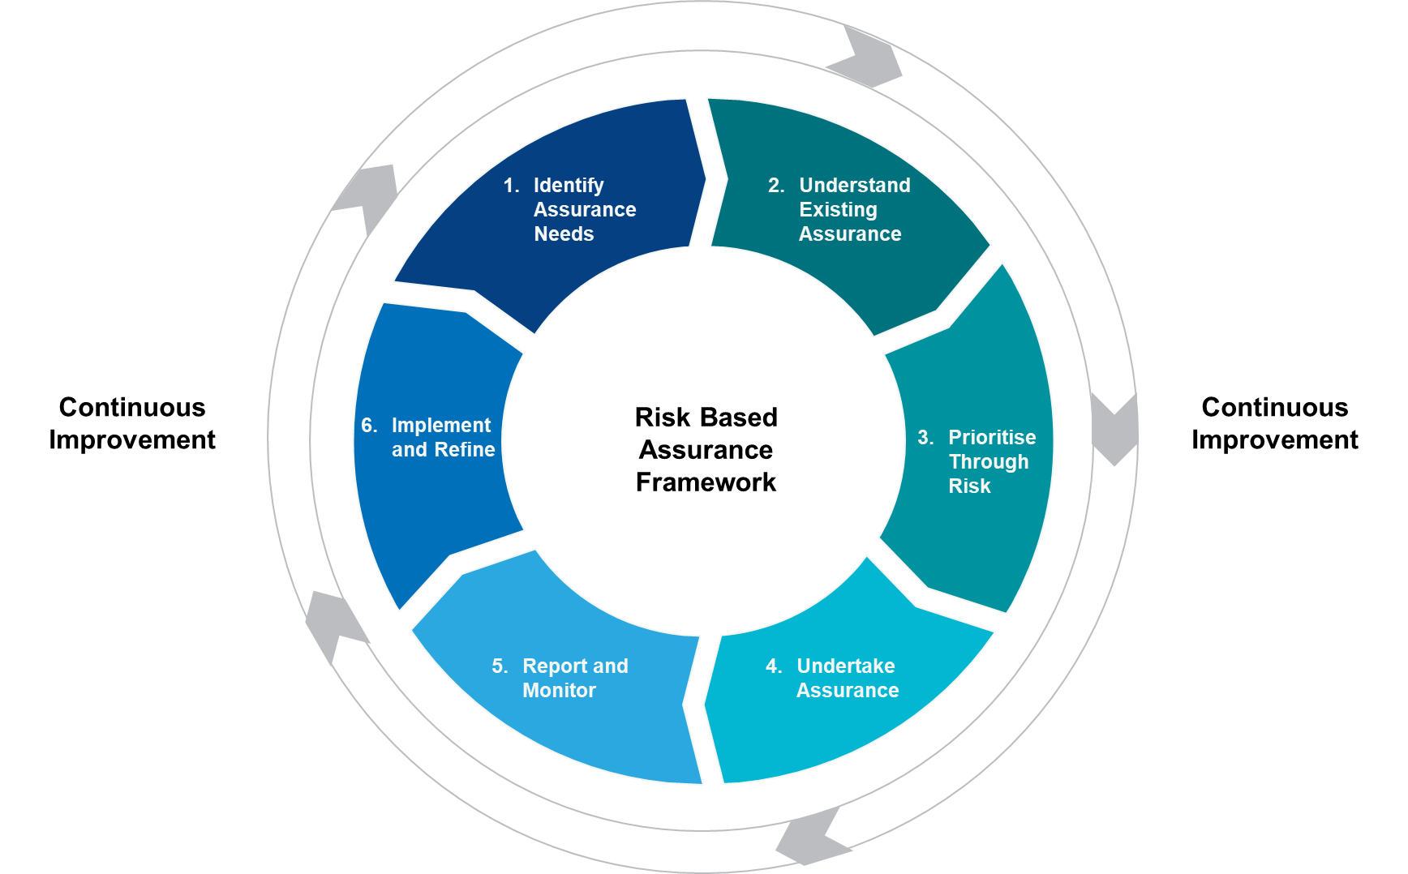
Figure 7: The assurance lifecycle

Phase 1: Identify assurance needs
The first step in the assurance lifecycle is to identify where there are needs for assurance.
It is expected that by 2035, Support at Home will help around 1.4 million people stay in their homes as they age. The significant scale of and investment into the program establishes a clear need for assurance activities for Support at Home.
This assurance framework and the related program of assurance activities in the assurance plan, are designed to address this assurance need. The following steps outline how specific focus areas and methodologies for assurance will be identified and prioritised as part of the assurance plan.

Phase 2: Understanding existing assurance
A variety of mechanisms will be used to identify and prioritise focus areas for program assurance activities.
In reviewing the assurance environment, the department will consider:
- Current controls – What controls are in place and have these been recently tested?
- Recent assurance – What assurance activities have recently taken place (both internal and external) and what were the outcomes of those activities?
- Planned assurance – What other assurance activities (both internal and external – if any) are planned for the next 12 months and what coverage do they provide?
- Other intelligence – Any other relevant intelligence from across the aged care system that provides insight into the current state of Support at Home. Includes broader intelligence relating to fraud management across the Commonwealth.
This information will inform the assessment of risk and the prioritisation that occurs in the next step.

Phase 3: Risk prioritisation
A risk-based approach will prioritise the allocation of resources to the assurance activities that will be of greatest value to the department. The following risk themes will inform Support at Home program assurance activities:
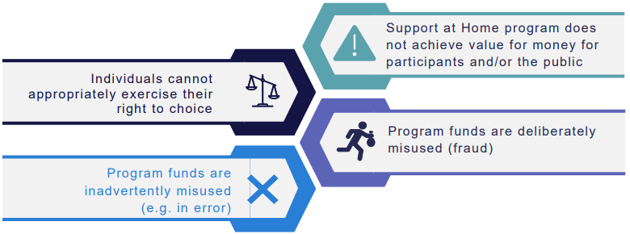
Figure 8: Support at Home program assurance risk themes

Phase 4: Undertaking assurance
The assurance plan will set out activities to assure the integrity and transparency of Support at Home funding. It aims to minimise the risk of provider payment errors, misuse and fraud. To achieve this, different types of assurance activities will be available to the department.
Assurance activities will be conducted under Part 12, Chapter 6 of the Act in conjunction with providers. The department will also undertake related activities to inform the planning and targeting of program assurance.
Table 3 provides a summary of the types of assurance activities available to the department. Table 3: Summary of assurance activities
Assurance activities
Activity | Description
Provider Rolling Review (PRR) | Ongoing rolling reviews of providers will deliver a series of consistent checks across the provider cohort to verify compliance with relevant responsibilities and legislated requirements. This review will systematically test whether goods and services claimed under the program are in line with the intent and scope of the program.  This review will analyse program data and information from providers. This may include monthly statements, invoices, service agreements, and evidence supporting individual transactions.
Deep dives | Deep dives of one or more identified risk areas related to Support at Home will help understand causes and identify areas for improvement.
Surveys | Set of targeted questions for providers or participants will elicit feedback on topics related to key focus areas. Surveys can be delivered as an online or paper form, or as an interview where more detailed feedback is required.

Related activities
Activity | Description
Desktop discovery | Standalone desktop analyses of program data and publicly available information will help identify insights, trends, patterns and anomalies. Analysis may warrant further targeted investigation as part of provider rolling reviews or deep dives.
Intelligence gathering | This activity will leverage the department's program administration and other second line functions. It will also consider intelligence from relevant inter-agency capabilities. This will help collect insights, knowledge and findings around specific areas relevant to the program to assist with targeting areas of assurance. This activity will consider how findings and insights can be shared with stakeholders to enhance effectiveness of assurance and investigations.
The selection of assurance activities depends on the level of identified risk and the level of ’assurance confidence’ required. Assurance confidence refers to the level of confidence in the accuracy and completeness of the assurance information. Using a mix of assurance activities helps the department gain confidence across a variety of focus areas and providers, proportionate to risk and available resources.
Regardless of the type of assurance activity selected, the methodologies used will align with the following International Organisation for Standardisation (ISO) standards, where appropriate:
- AS/NZS ISO 19011:2019 Guidelines for auditing management systems
- AS/NZS ISO 9001:2016 Quality management systems.
The assurance plan provides flexibility to adjust activities as required to respond to changing risks and resource availability. Each primary assurance activity will be guided by terms of reference detailing the selected methodology, the scope of the activity and approach to provider selection.

Phase 5: Report and monitor
Primary assurance activities may include the development of individual provider reports and/or review-wide summary reports containing key findings, conclusions and recommendations. A version of these reports may be published under section 510 of the Act. Published reports may include personal information about a provider to which the report relates. Published reports will comply with the department’s legal obligations, including its obligations under the Privacy Act 1988.

Procedural fairness
If the System Governor is considering including a finding, conclusion or recommendation, in a report under subsection 510(3), that is critical (either expressly or impliedly) of a provider, the System Governor must give the provider a statement setting out the finding, conclusion or recommendation; and a reasonable opportunity to respond to the finding, conclusion or recommendation.
The department will take a constructive and transparent approach to determining and communicating findings, conclusions and recommendations with providers. This reflects the assurance framework’s principles of continuous improvement, collaboration, engagement and trust. As part of the reporting process the department will aim to maintain effective relationships throughout the process.

Phase 6: Implement and refine
When issues are identified through assurance activities, the priority will be to work with providers to seek resolution and provide the opportunity to self-correct. Where opportunities to implement better practices are identified through assurance activities they will be shared promptly with providers to support continuous improvement.
This approach is designed to promote constructive working relationships with providers and encourage a culture of transparency and accountability across Support at Home. The approach will be particularly collaborative in the early stages of the program to support providers to adapt to the new legislative requirements.
However, there will be consequences for repeated or deliberate non-compliance. Compliance action will be in line with the compliance framework and System Governor powers under the Act as needed. Providers will be referred to the Commission for relevant issues. Where necessary, matters may also be referred to other external parties such as law enforcement, Services Australia, the Department of Social Services, the Australian Taxation Office and the Australian Consumer and Competition Commission. The principles of procedural fairness outlined in the compliance framework will be applied for all assurance activities.
Figure 9 summarises the general approach that will be taken by the department where issues are identified through an assurance activity.
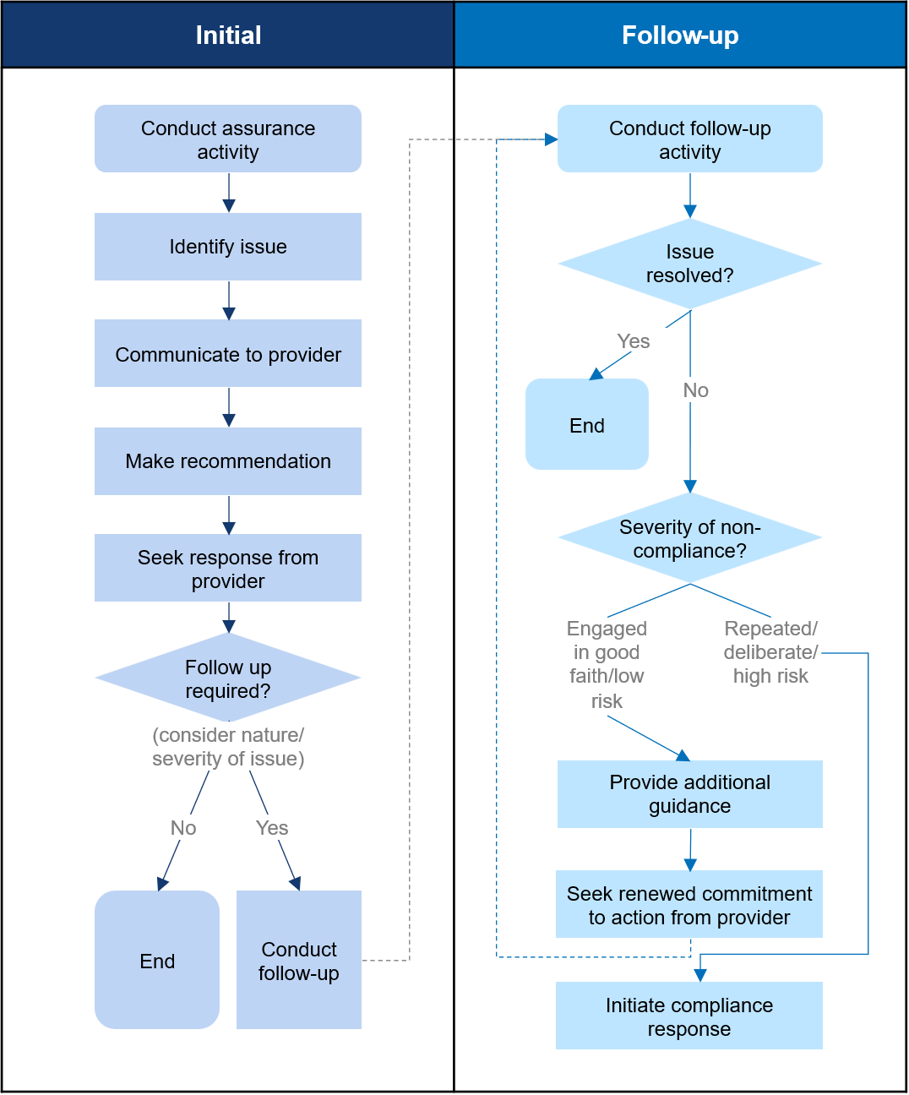
Figure 9: Department approach where issues are identified through assurance activities

Internal continuous improvement
The department will identify and address any gaps in guidance to support continuous improvement in sector performance. The department will also seek feedback from reviewed providers to enhance its approach to how it undertakes program assurance reviews.

Appendix A

Support at Home is the programmatic name for funded aged care services delivered through the service groups home support, assistive technology and/or home modifications.
Under the Act and associated Rules, the legal term for people who access funded aged care services is ‘individuals’. For the purposes of this document, to support readability and alignment with the Support at Home program manual, we use the term ‘participants’ when referring to people accessing Support at Home.
Program assurance reviews support enhanced transparency for participants and minimise payment misuse, error and fraud. This contributes to participants being able to make informed choices about using their Support at Home budget to meet their accessed needs.
In addition to regular review the department will closely monitor feedback of these documents within the first 12 months of publication and update as required.
Information about the roles of the System Governor and the Aged Care Quality and Safety Commission is detailed in the legislative framework section of this assurance framework, on pages 10 - 11.
Subsection 25(12) of the Aged Care Act 2024 also provides that the Commonwealth aged care system is to be managed to ensure that it is, and remains, sustainable and resilient, and that the Commonwealth’s investment represents value for money. This includes ensuring that public resources are used in the most efficient, effective, ethical and economic manner.
Relevant information for Support at Home assurance purposes may include program data, participants’ monthly statements, invoices, service agreements and supporting evidence to substantiate transactions and service prices.
Department priorities are detailed in its Corporate Plan 2025-26.
Preventing leakage of program funds through addressing payment misuse, error and fraud results in better value for money for participants and the taxpayer. For this framework, value for money is defined as: - efficient: the achievement of the maximum value for the resources used - effective: the extent to which the intended outcomes or results are achieved - justified: providers are able to justify (through verifiable information provided to a review team) their charges to care recipients.
Including subsidy/grant funding
Non-compliance can mean not fully engaging with the assurance process when notified to do so or not implementing required actions arising from an assurance process.
The role of the Aged Care Quality Safety Commission is outlined on page11. For further information see the aged care regulatory and governance roles.

