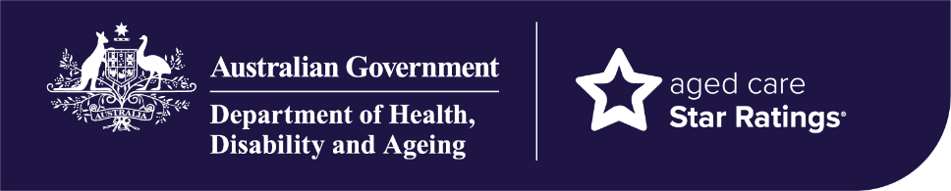


Star Ratings for residential aged care homes
Information for older people in, or going into, residential aged care homes
Star Ratings help you compare the quality of aged care homes using the ‘Find a provider’ tool on the My Aged Care website.

What are Star Ratings?
Star Ratings help you understand the quality of care at aged care homes. This information can be used along with other information to find a home to suit your needs including specialised care, languages spoken, location, availability and cost.
Aged care homes receive an Overall Star Rating and a rating against four sub-categories:
- Residents’ Experience – how people feel about the care they get. An independent third-party team surveys at least 20% of all residents every year about their overall experience at their home. Residents’ Experience makes up 33% of the Overall Star Rating.
- Compliance – how well a home is meeting its obligations to provide safe, quality care and services including, graded assessment against the strengthened Aged Care Quality Standards and the type of regulatory decisions. Compliance makes up 30% of the Overall Star Rating.
- Staffing – measures the average amount of care time residents get from nurses and care workers compared with care minute targets. Staffing makes up 22% of the Overall Star Rating.
- Quality Measures – based on information about 5 crucial areas of care, including falls and major injury, unplanned weight loss, pressure injuries, medication management and the use of restrictive practices. Quality Measures makes up 15% of the Overall Star Rating.

What do the stars mean?
Aged care homes get a rating between 1 and 5 stars. More stars mean a home provides higher quality care across the 4 sub-categories:
- 5 stars – an ‘excellent quality of care’
- 4 stars – a ‘good quality of care’
- 3 stars – an ‘acceptable quality of care’
- 2 stars – ‘improvement needed’
- 1 star – ‘significant improvement needed’.

How often are Star Ratings updated?
Star Ratings are based on the most recent available data and are updated at various times:
- Residents’ Experience Rating – updated quarterly, based on surveys completed annually
- Compliance Rating – updated daily, once information is received by the issuing authority
- Staffing Rating – updated quarterly
- Quality Measures Rating – updated quarterly
The Overall Star Rating automatically recalculates when new data is available.

Why do we need Star Ratings?
Star Ratings is a critical reform recommended by the Royal Commission into Aged Care Quality and Safety.
Star Ratings are based on measurable information about the quality of care in aged care homes. Data is updated when new information is available.
Star Ratings delivers a range of benefits, including:
- transparency about the quality of care in aged care homes
- an easy way to compare the quality of aged care homes
- nationally consistent quality measures to monitor, compare and improve residential care
- support for providers to improve their Star Ratings and the quality of care for residents.

Where do I find Star Ratings?
Star Ratings are available through the ‘Find a provider’ tool on the My Aged Care website. Visit MyAgedCare.gov.au/find-a-provider/search or scan the QR


Where can I find more information about Star Ratings?


For more details about Star Ratings for residential aged care homes, visit www.health.gov.au/star-ratings.
Phone 1800 200 422
(My Aged Care’s free call phone line)
Visit MyAgedCare.gov.au/find-a-provider
For translating and interpreting services, call 131 450 and ask for My Aged Care on 1800 200 422. To use the National Relay Service, visit nrschat.nrscall.gov.au/nrs or call 1800 555 660.

