

Places to people: embedding choice in residential aged care
Residential aged care places are allocated directly to older people rather than to providers. This change gives you more choice and control in finding the right residential care home.

Frequently asked questions

What do I need to do if I am planning on entering residential care after 1 November 2025?
To access government-funded aged care services from 1 November 2025, all older people must be registered with My Aged Care and have an aged care assessment.
To be eligible for an assessment, older people must be:
- aged 65 years and over
- Aboriginal or Torres Strait Islander and aged 50 years or over
- homeless or at risk of homelessness and aged 50 years or over.
If you are considering moving to a residential care home, you must first be assessed and approved for a place in residential care. To arrange an assessment, you need to:
- contact My Aged Care on 1800 200 422
- arrange a face-to-face appointment with a Aged Care Specialist Officer
- ask your General Practitioner (GP) to submit a referral on your behalf
- apply online at MyAgedCare.gov.au/Apply-Online.

What does it mean when you have been allocated a residential care place?
Once you are approved for residential aged care, you will be allocated a residential care place. This is your entitlement for government-funded residential aged care. When you receive your place, you can choose an aged care home that is right for you.
How will I know if I have been allocated a residential care place?
Once you have been assessed and approved for residential care, you will be notified of your place in your Notice of Decision letter and in your My Aged Care Online Account.

What does my priority category mean in my Notice of Decision letter?
Your priority category is used for internal reporting purposes only and does not impact your ability to access care. If you are assessed and approved for residential care, you will be allocated a place immediately and can enter care when you choose to.
The priority category is calculated based on your answers to questions you are asked during your assessment, as well as your level of urgency to enter into residential aged care, determined by your assessor.

Does a residential care place mean a bed is automatically allocated to me at a residential aged care home?
Being allocated a place does not mean a bed is available in your preferred residential care home. If you have been allocated a place, you will be able to choose a residential care home that best suits your needs.
However, you will still need to talk to providers about your care needs and see which residential care home is right for you. You may need to be put on a waiting list if there are no vacant rooms at your preferred residential care home.

If I am allocated a residential care place, will my place expire if I don’t take it up by a certain time?
Residential care places do not expire. There are no time limits for you to access care. Once you have your place, it stays with you, even if you are accessing other aged care services at home.
Additionally, you will be able to move between different aged care services (for example, Support at Home) and continue to keep your place if you wish to enter residential aged care in the future.

If I am approved and allocated a residential care place, will I get direct access to funds?
The Australian Government provides funding directly to your chosen residential aged care provider on your behalf, once you have accepted your referral.
Once you have moved into a residential care home, you will have a residential aged care funding assessment to work out the level of funding you need to meet your care needs.

How can I share my referral code with a residential aged care provider?
When you are approved for residential care, you are allocated a place. Your Support Plan will be attached in your Notice of Decision letter and will contain your referral code/s.
Each referral code is a unique number linked to a service type used to connect with your chosen provider and start receiving care.

There are several ways to share your referral code with a provider:
- Assessors: Your assessor will be able to send your referral code to one or more Australian Government funded service providers of your choice.
- Self-service: You can use the referral code/s in your support plan and self-manage your referrals if you wish. Your referral code/s can be shared directly with any of your preferred providers.
- My Aged Care: The My Aged Care team can send a referral code on your behalf to your preferred provider.

What happens if I want to move to a different residential care home?
If you are currently in a residential care home and want to move to a different residential care home, you can use your allocated residential care place. Your residential care place belongs to you and will move with you to other residential care homes.
To engage with new providers, you will need to re-activate your referral code and share it with a new provider. It can be reactivated while you are in care with an existing provider. Your referral code can be re-activated in your My Aged Care Online account, or you can call My Aged Care.

Finding help
We are here to support and help you and your family to understand what these changes mean and the options available to you.
Visit MyAgedCare.gov.au to find information about how to access aged care services. You can apply for an assessment online and search for local aged care providers who meet your needs. Call 1800 200 422 from 8:00 am to 8:00 pm Monday to Friday and 10:00am to 2:00pm Saturday (local time) or visit MyAgedCare.gov.au/Contact-Us.
My Aged Care have made more information available about aged care providers to help you make informed choices about where to access the care that’s right for you. This includes publishing Star Ratings for residential aged care providers and more transparent accommodation information on MyAgedCare.gov.au/Find-A-Provider.
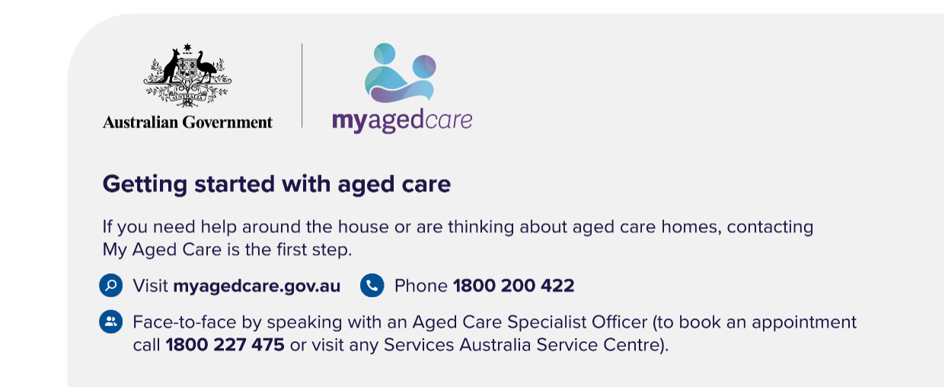
For general aged care information, you can speak to someone face-to-face at any Services Australia centres. For more complex aged care enquires, book a face-to-face or video chat appointment with an Aged Care Specialist Officer by calling 1800 227 475 or visiting ServicesAustralia.gov.au/Aged-Care-Specialist-Officer-My-Aged-Care-Face-To-Face-Services.

