






National Carer Strategy 2024-2034

Improving the lives

of Australia’s unpaid carers

Resource Toolkit | Department of Health, Disability and Ageing

New resources to support unpaid carers

Welcome to the National Carer Strategy toolkit.
Across Australia, there are more than 3 million unpaid carers.
Unpaid carers provide care for someone living with disability, a medical condition, mental illness or frailty. An unpaid carer can be a family member, friend or neighbour, young or old and of any gender. Carers come from diverse cultural and socio-economic groups.
The National Carer Strategy 2024-2034 (the Strategy) is an initiative of the Australian Government that aims to drive positive change for carers. The Strategy is centred on a vision in which all carers are recognised, valued and empowered with the support they need to participate fully in society and fulfil their caring role.
This toolkit has a variety of digital resources that you can share among your networks to communicate about the Strategy.



Resource Toolkit | Department of Health, Disability and Ageing 2

Help us spread the message

Most unpaid carers don’t see themselves as ‘carers’ - it’s just something they do for a family member, friend, neighbour or loved one.
A lack of knowledge in the community about unpaid care means many carers are going without the support they need.
Having a national plan aims to ensure carers are recognised and supported now and into the future.
Share the assets in this kit with your networks to help us increase awareness about the Strategy and the support available to carers. For ease of sharing, you can also view the resources on the Department of Health, Disability and Ageing’s website: https://www.health.gov.au/topics/disability-and-carers/supporting-carers

What’s included in this kit

In this kit you will find a range of materials you can distribute across your internal and external audiences.
These include a variety of highly visual digital assets. The assets are all designed to be easily shared on your website, social media platforms, newsletters and noticeboards, or integrated into ongoing activities and discussions within your audience and community.
The kit contains:
- Key messages
- A brochure
- A poster
- Social media content and tiles
- Newsletter content
- Webpage content.

Key messages and proof points

A sample of key messages have been included below. These will:
- Support the overarching communication activities
- Help unpaid carers recognise that they are carers
- Introduce the Strategy
- Direct carers to seek support from Carer Gateway.

Who are carers?
- An unpaid carer is a person who looks after someone living with disability, a medical condition, mental illness or frailty. Anyone can become an unpaid carer, even temporarily.
- An unpaid carer might be a family member, friend or neighbour, young or old and of any gender.
- There are many different ways to care for someone. It might mean helping them with day-
to-day activities such as personal care, taking them to and from appointments and managing medication. It often involves providing essential emotional and social support.

What is the Strategy and how does it help carers?
- The Strategy aims to drive positive change for carers. It is centred on a vision in which all carers are recognised, valued and empowered, with the support they need to participate fully in society and fulfil their caring role.
- The Strategy was co-designed with carers across Australia to reflect their vast diversity, needs and challenges.
- The Strategy aims to ensure carers:
» Are recognised as carers
» Can access supports and services at the right time and in the right way
» Have more opportunities for work, education and training
» Access supports that safeguard their physical and mental health
» Have a social life and access to rest and recreation
» Are valued by government, the community and service providers, and recognised for their expertise and contribution.

Where can carers get support?
Carer Gateway (CarerGateway.gov.au) is a key source of information about supports and services available to unpaid carers.


Print-ready resources

Our print-ready brochure and poster contain information to help unpaid carers identify that they are a carer, along with information about the Strategy.
These resources can be used digitally and uploaded on your website or printed and distributed as a physical asset.
Download a high-resolution version of the DL brochure by clicking here. health.gov.au/resources/publications/national-carer-strategy-supporting-carers-brochure?language=en Download a high-resolution version of the poster by clicking here.
health.gov.au/resources/publications/national-carer-strategy-supporting-carers-poster?language=en

Resource Toolkit | Department of Health, Disability and Ageing 5

Newsletter and website

The below content is for you to share in your newsletter or on your website.
The content aims to help people recognise that they are carers and introduces the Strategy. Feel free to alter it to suit your preferred style.

Do you know an unpaid carer?
There are 3 million people across Australia who care for someone living with disability, a medical condition, mental illness or frailty. They are known as unpaid carers.
There are many different ways to care for someone. A carer might look after someone a few hours a week or every day, help them with day-to-day activities such as personal care, take them to appointments or manage medication.
Taking on a caring role can affect a person’s quality of life. It can have an impact on their career, social life, education and financial security.
A lack of knowledge in the community about unpaid care means many carers are going without the support they need. The National Carer Strategy 2024-2034 aims to ensure carers are recognised now and into the future.
The Strategy was co-designed with carers across Australia to reflect their vast diversity, needs and challenges. The Strategy aims to ensure carers:
- Are recognised
- Can access supports and services at the right time and in the right way
- Have more opportunities for work, education and training
- Have access to supports that safeguard their physical and mental health.
The Strategy also aims to improve awareness of the services available to carers, such as those offered through Carer Gateway. If you care for a family member or friend, Carer Gateway can help you with free emotional and practical support.
To learn more about the Strategy, visit health.gov.au/topics/disability-and-carers/supporting-carers
To find out more about the services and supports available for unpaid carers, visit
health.gov.au/topics/disability-and-carers/supporting-carers

Social media content and tiles

A selection of social media tiles and accompanying content have been developed for you to share on your channels, which you can tweak to suit your organisation’s style.
Download the social tiles here.

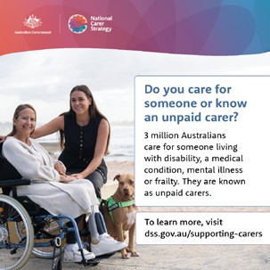
Social Post 1
Topic: What does an unpaid carer look like?
Many people who provide care don’t identify themselves as carers. These ‘hidden’ carers may not be aware of, or seek, support.
A lack of knowledge in the community about unpaid care means many carers are going without the support they need. The National Carer Strategy 2024-2034 aims to ensure carers are recognised now and into the future.
To learn more about the National Carer Strategy,
visit: health.gov.au/topics/disability-and-carers/supporting-carers.
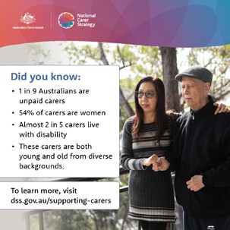
Social Post 2
Topic: Key facts and stats about carers
Across Australia, millions of people are going to extraordinary lengths to care for someone they love.
They’re called unpaid carers, and they come from diverse cultural groups and backgrounds.
An unpaid carer can be a family member, friend or neighbour, young or old and of any gender.
A lack of knowledge in the community about unpaid carers means many of them are going without the support they need.
Find out more about the supports and services available to unpaid carers at health.gov.au/topics/disability-and-carers/ supporting-carers

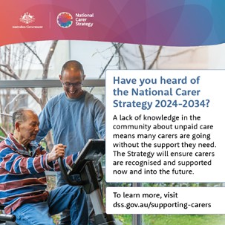
Social Post 3
Topic: What is the Strategy?
The National Carer Strategy 2024-2034 was co-designed with carers across Australia to reflect their vast diversity, needs and challenges.
The strategy aims to improve awareness of unpaid carers and the services available to them, such as those offered through Carer Gateway.
If you care for a family member or friend, Carer Gateway can help you with free emotional and practical support. To find out more about Carer Gateway, visit: CarerGateway.gov.au
To learn more about the strategy,
visit: health.gov.au/topics/disability-and-carers/supporting-carers
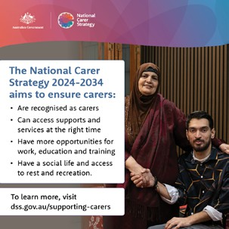
Social Post 4
Topic: How the Strategy will help carers
The National Carer Strategy 2024-2034 is helping to support unpaid carers now and into the future.
It will be realised through the Action Plan, which outlines how the Government will work to improve the wellbeing of carers.
It highlights actions that will have an immediate impact, such as building on the services Carer Gateway offers.
For example, Carer Gateway’s operating hours will be extended and more phone counselling services provided.
To find out more about the Strategy or the Action Plan,visit:health.gov.au/topics/disability-and-carers/supporting-carers



Resource Toolkit | Department of Health, Disability and Ageing
9

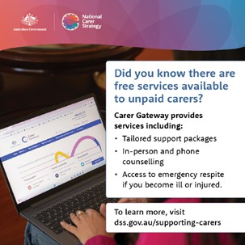
Social Post 5
Topic: The services and supports available for carers
Carer Gateway is a key source of information about supports and services available to unpaid carers.
If you care for a family or friend, Carer Gateway can help you with free emotional and practical support.
To find out more, visit health.gov.au/topics/disability-and-carers/supporting-carers

Want to know more? Contact us

NationalCarerStrategy@Health.gov.au

