Guide to report offline beds in residential aged care
An operational bed is considered ‘offline’ when it is temporarily unavailable for use by an older person to enable them to live at your residential care home. This guide provides clear and practical instructions for residential aged care providers on how to report offline beds.

Provider requirements
Residential care homes are approved through the Aged Care Quality and Safety Commission (the Commission) as part of the aged care regulatory model.
The Commission approves the total number of beds at each residential care home and is responsible for overseeing changes to bed numbers.
The Aged Care Rules 2025 (sections 167-5-70) require registered providers to notify the Commission when beds in a residential care home are offline and not available for:
- a period of at least 3 months for homes in Modified Monash (MM) 1-5 regions
- any period of time for homes in MM 6 and 7 regions
For beds that are offline for 2 years or more, this is considered a variation to the approval of a residential care home. If required, lodge a variation request with the Commission.

Why it’s important
Reporting offline beds helps the Department of Health, Disability and Ageing (the department) monitor bed availability in aged care homes across Australia and inform future planning.

How to report offline beds
As of 23 March 2026, residential aged care providers can report changes to operational beds in the Government Provider Management System (GPMS).
Log on to the GPMS Registered Provider portal, and follow step-by-step instructions to:
- report beds as offline (pages 2-7)
- make offline beds available for use (pages 8-10)

User guide: To report beds as offline
1 | Log into the GPMS Registered Provider portal using your usual way of logging in via VANguard or Digital ID.  GPMS Portal - Registered Provider Portal login  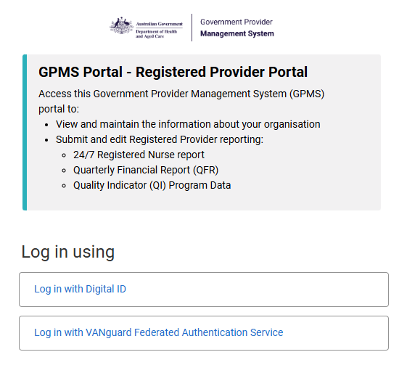
2 | Click on the Manage your organisation tile:  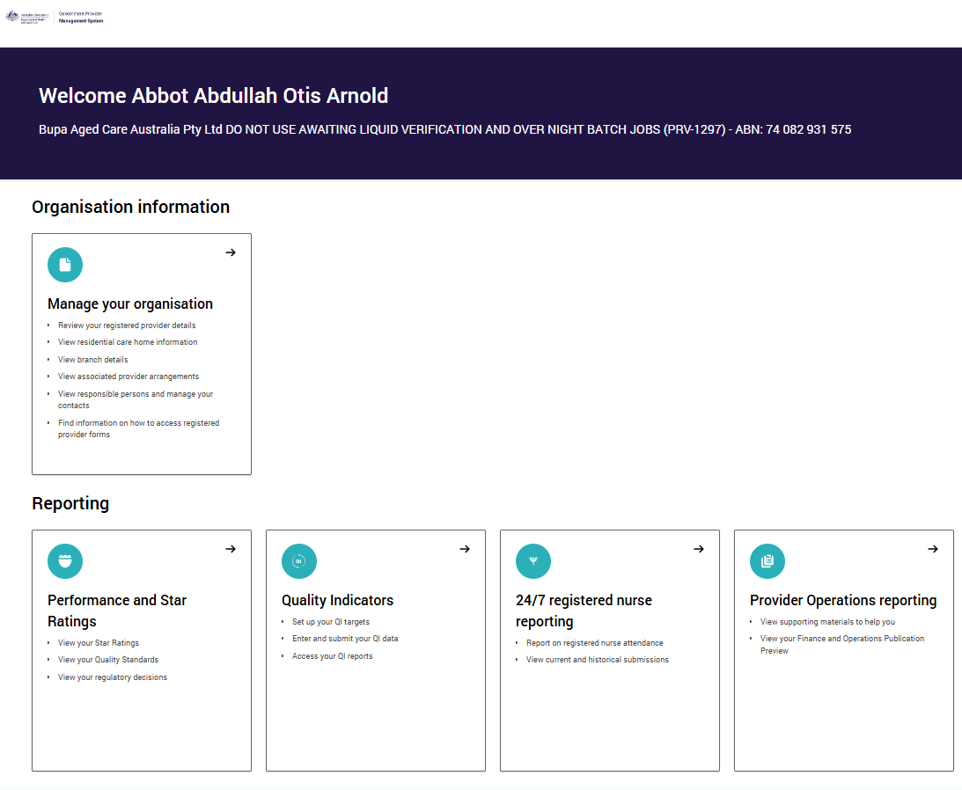
3 | 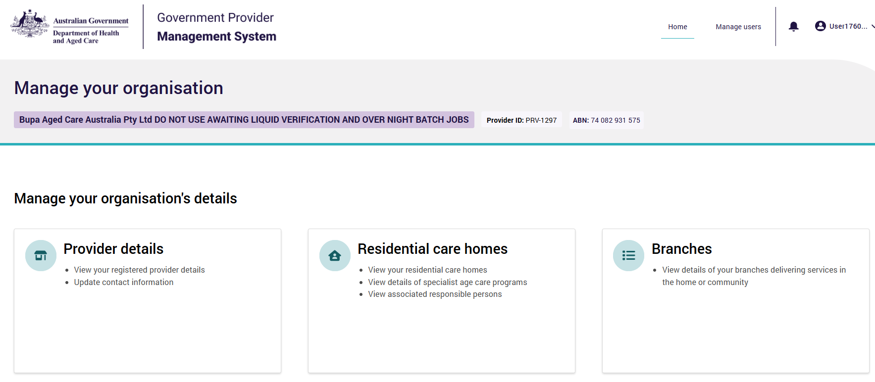  Click on the Residential care homes tile:
4 | Find the residential care home you are wanting to make changes to the offline beds and click the drop down on right hand side and click on View home details:  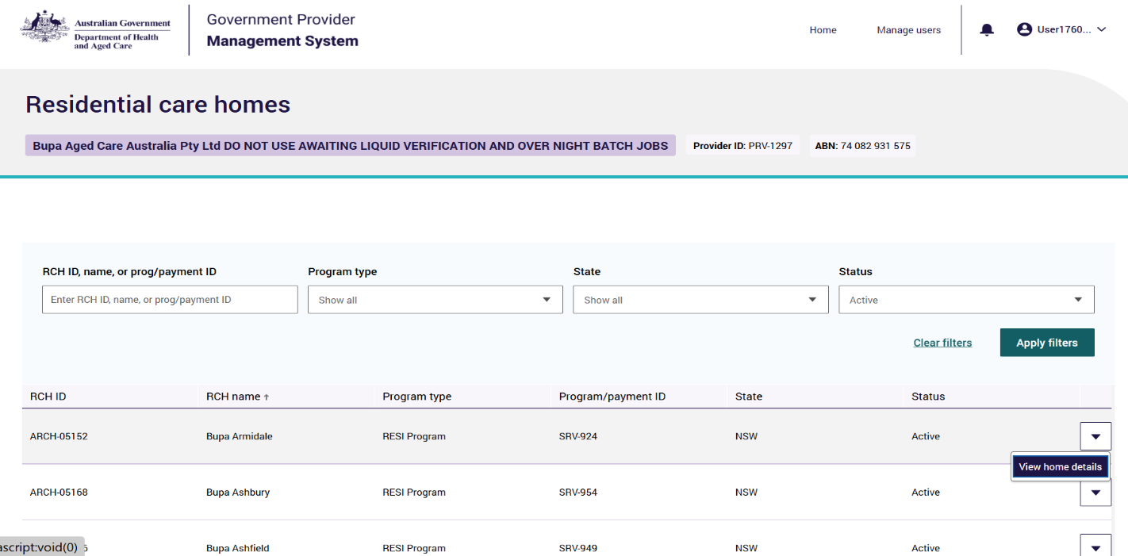
5 | When you click into your Residential Care Home, the Details tab will open.  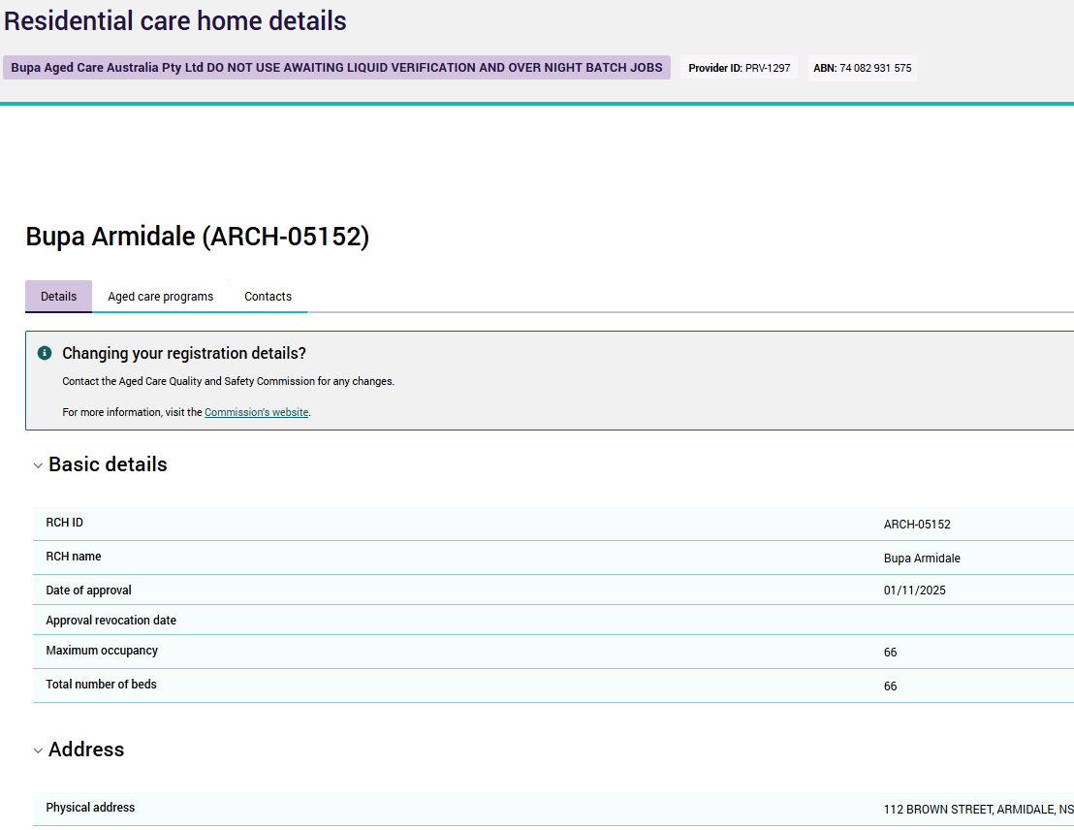  Click on the Aged care programs tab:
6 | At the bottom of the aged care programs tab, click the Manage offline beds button:  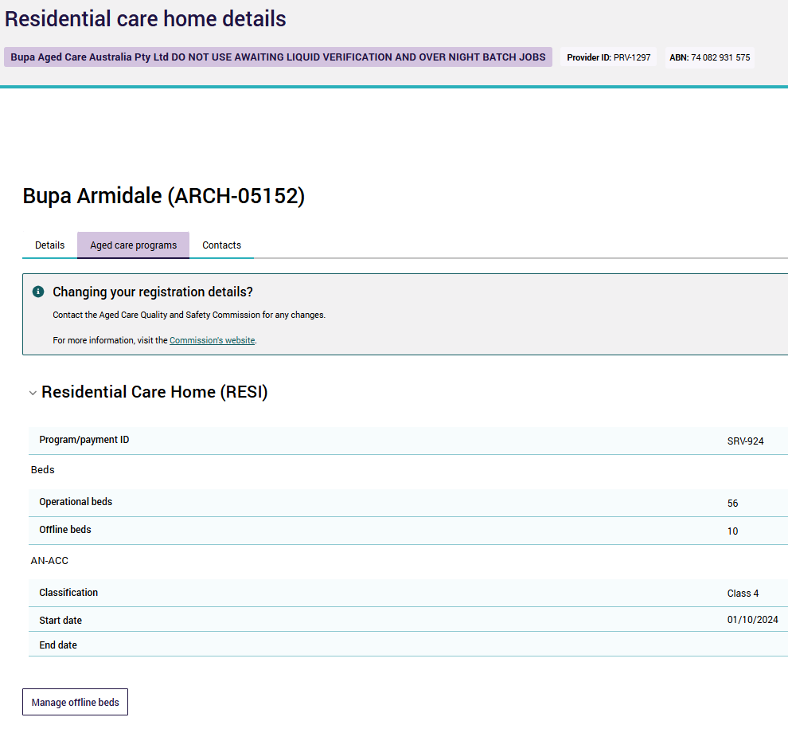
7 | Find the relevant reason your beds are being taken offline and click Edit:  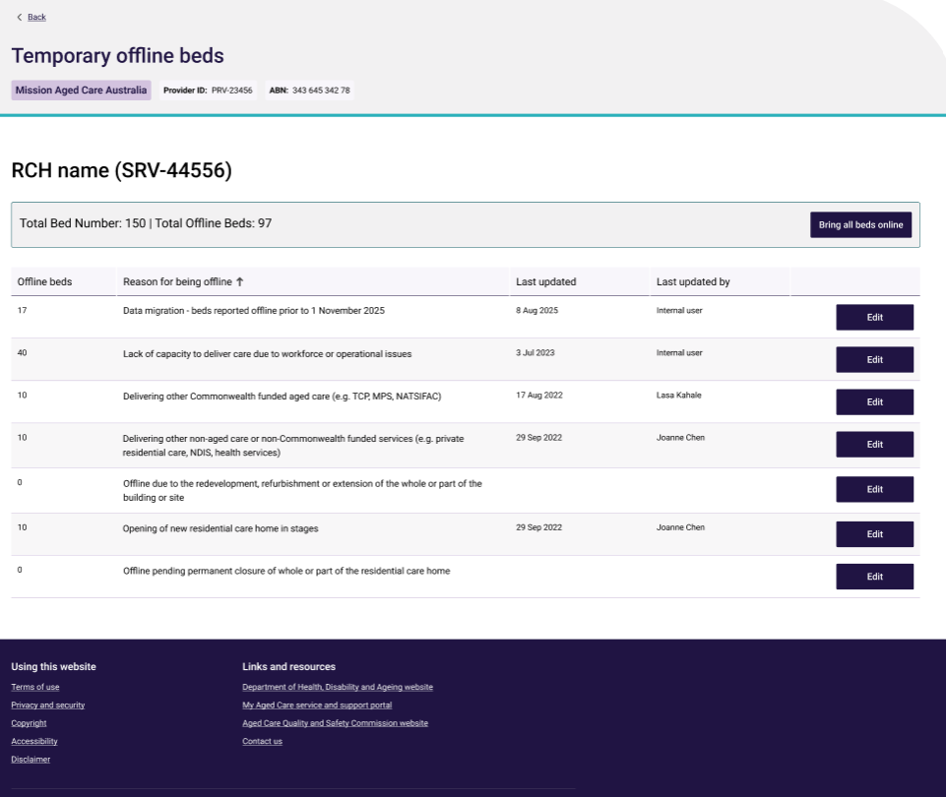  Reasons for taking beds offline include:  - Lack of capacity to deliver care due to workforce or operational issues  - Delivering other Commonwealth funded aged care (e.g. TCP, MPS, NATSIFAC)  - Delivering other non-aged care or non-Commonwealth funded services (e.g. private residential care, NDIS, health services)  - Offline due to the redevelopment, refurbishment or extension of the whole or part of the building or site  - Opening of new residential care home in stages  - Offline pending permanent closure of whole or part of the residential care home  Note: You may have an additional category ‘Data migration – beds reported as offline prior to 1 November 2025’. This category was used to migrate existing offline bed data to the new GPMS. Offline beds in this category can be brought online as operational or be moved to a different category. Beds will not be able to be reported as offline for this category.
8 | Enter the number of beds you would like to be made offline for the reason selected. Click Submit:  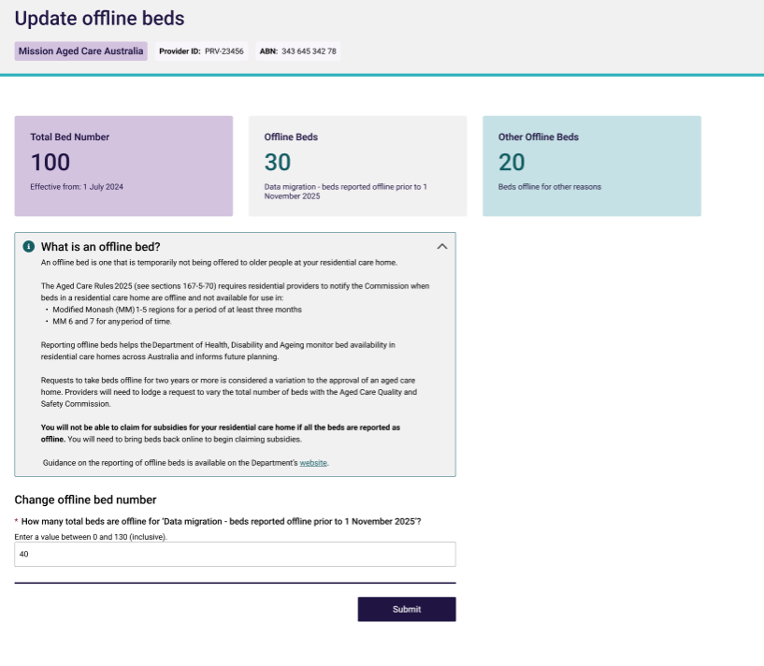  Notes:  - Offline bed entries cannot exceed your total number of beds at your Residential care home.  - Offline bed entries will be effective from the date of submission. If you require date adjustments, please contact support (details provided below).  - You will not be able to claim for subsidies for your residential care home if all beds are reported as offline. You will need to bring beds back online to begin claiming subsidies.
9 | Confirm the number of beds to report offline and click Ok. Your offline bed entry will be saved.  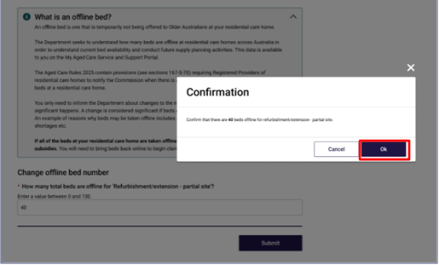
10 | Submitted updates in GPMS will send an update to Services Australia and the Commission systems.  Note - Changes to offline beds will change the number of operational beds that your service can claim subsidies for. Making all beds offline will change the status of the residential service to ‘inactive’ and claims will not be able to be made against that service.
11 | A confirmation email will be sent to your responsible person or points of contact.  Please ensure your contact details are up to date, so you can receive this information.

User guide: To bring beds back online (make operational):
1 | Follow steps 1-6 as per above instructions.
2 | Find the relevant reason beds are being brought back online (operational) and click Edit.  For example, redevelopment works at your residential service have completed and an area or wing of the service is ready to be re-opened.
3 | Enter in the updated offline bed number and click Submit.  Note – You can either reduce the number of beds offline (i.e 10 beds offline to 5) or you can bring all beds back online by entering zero.  Notes:  - Offline bed entries cannot exceed your total number of beds at your Residential care home.  - Offline bed entries will be effective from the date of submission. If you require date adjustments, please contact support (details provided below).
4 | A confirmation will appear to confirm you are bringing beds back to operational status.  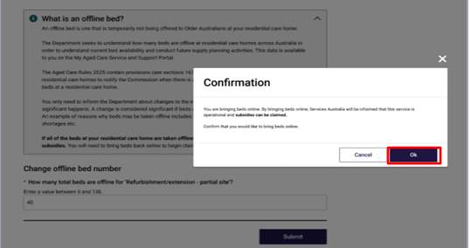
5 | You can also bring all beds back online from all categories. This can be done from the temporary offline beds page by clicking Bring all beds online. 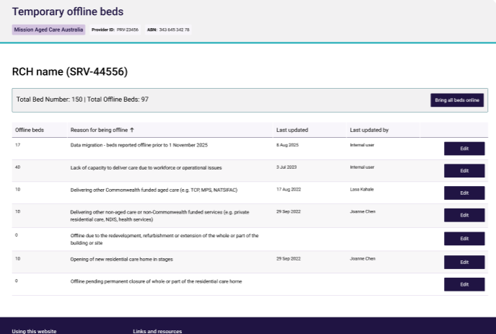  Note – the offline beds value has to be greater than zero for the ‘Bring all beds online’ field to be editable.
6 | In the confirmation, click Ok to confirm bringing the beds back online. 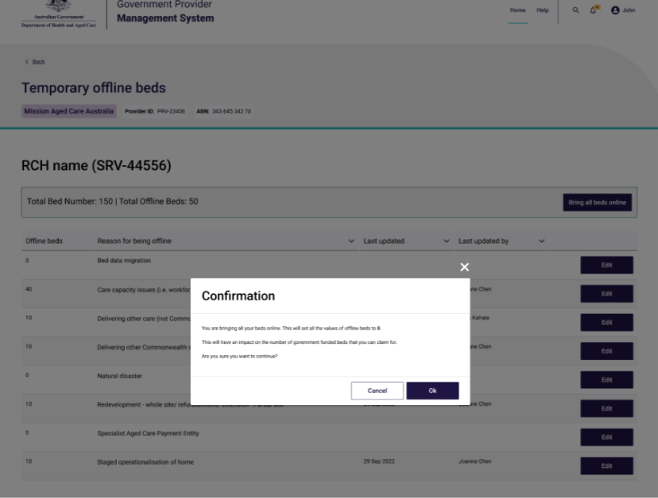
7 | Submitted updates in GPMS will send an update to Services Australia and the Commission systems.  Note - Changes to offline beds will change the number of operational beds that your service can claim subsidies for. Making all beds offline will change the status of the residential service to ‘inactive’ and claims will not be able to be made against that service.
8 | A confirmation email will be sent to your responsible person or points of contact.  Please ensure your contact details are up to date, so you can receive this information.

Need help?
If you experience technical difficulties with GPMS, please contact the My Aged Care service provider and assessor helpline on 1800 836 799.
Alternatively, your Local network will also be able to assist:
- New South Wales/Australian Capital Territory – NSWPlaces@health.gov.au
- Northern Territory – EngagementNT@health.gov.au
- Queensland – Engagement.QLD@health.gov.au
- South Australia – SAPlaces@health.gov.au
- Tasmania – Tas.office@health.gov.au
- Victoria – VICPlaces@health.gov.au
- Western Australia – WAPlaces@health.gov.au

Learn more
- Places to people – Embedding choice in residential aged care
- GPMS User Guide - Manage Your Organisation tile
- GPMS FAQs - New Act 2025 System Changes
- New aged care regulatory model
- Aged Care Quality and Safety Commission.

