Government Provider Management System – Quick Reference Guide: Finance and Operations Publication Preview

Introduction
Additional information about the finances and operations of residential care and Support at Home providers published on the My Aged Care website.
The information is to provide greater transparency about providers’ finances and operations and help older people, their families and carers to make informed decisions about their care and in selecting the right provider.
Providers are able to preview their reported information about their organisation on the Government Provider Management System (GPMS) – Registered Provider Portal, before it is published on the My Aged Care website.
Please note
From March 2026, the provider preview functionality will be available in the GPMS – Registered Provider Portal.
Data extracted from the Quarterly Financial Report will be updated quarterly. Providers will be advised when the information is available for preview each quarter.
- Should you have any concerns regarding the information presented in GPMS, providers must act as soon as practical.
- If you believe the information presented in your Finance and Operations: Publication Preview is not consistent with your self-reported information, please first check your previously submitted data.
- For any finance or operations data concerns or queries, please contact ACFRQFRQueries@health.gov.au

Accessing GPMS, Provider Operations Reporting tile and Publication Preview
Finance and Operations: Publication Preview is accessed in the GPMS portal, through the Provider Operations Reporting tile.
- To access the Provider Operations Reporting tile:
Log into the GPMS Registered Provider Portal.
For assistance logging in to GPMS refer to the GPMS Logging in to the Aged Care Systems.
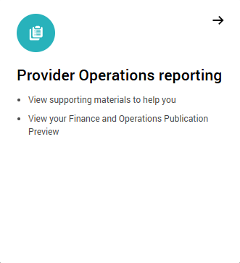
- On the GPMS home page select the Provider Operations Reporting tile.
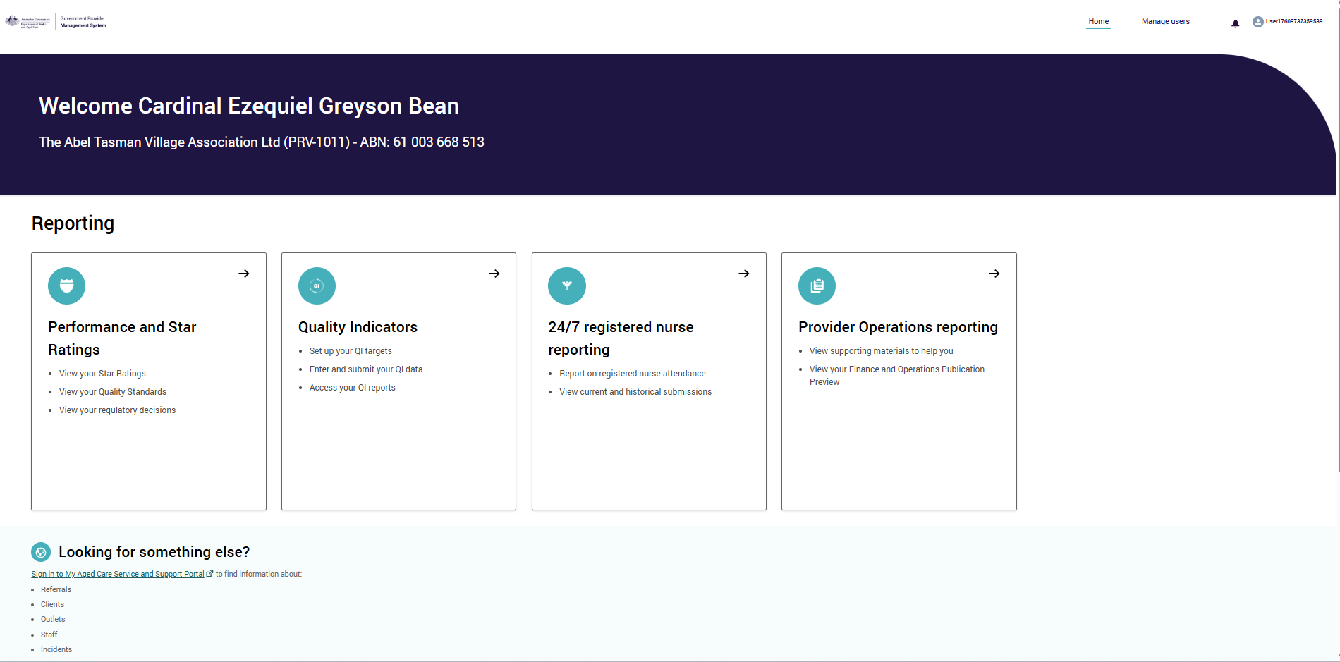
- On the Provider Operations Reporting home (submission) page select the Publication Preview tab on the top right of the page.

- Select the provider organisation and/or its residential or home care service in the left side-bar to preview information.
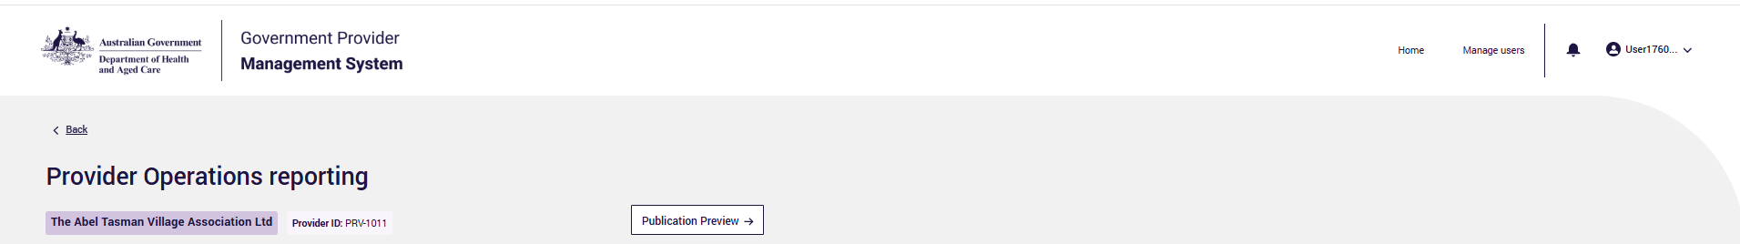
Please note:
- Publication Preview is a good opportunity for providers to get a feel for how the financial and operational data will be displayed prior to publication on the My Aged Care website.
- It is not mandatory for providers to preview reported data prior to publication on the My Aged Care website. It is not an opportunity to amend previously submitted financial and operational information.
- Publication Preview also provides an opportunity for providers to prepare for any questions on published financial and operational data from residents, prospective residents and their families.

Provider information
For convenience, in the GPMS Publication Preview, the preview information is shown once for the provider, rather than replicated under each service (as will occur in the My Aged Care website).
Data available to preview at the Provider organisation level include:
- Wages – source: Quarterly Financial Report
- Provider finances – source: Aged Care Financial Report
- Key personnel – source: Provider Operations Collection Form
- Performance report (compliance) – source: Provider Operations Collection Form
- Board diversity – source: Provider Operations Collection Form.

Residential care service
Data available to preview at the Residential care service level include:
- Food and preparation – source: Quarterly Financial Report
- Quarterly care and nursing – source: Quarterly Financial Report
- Annual financial information – source: Aged Care Financial Report
- Provider operations (diversity, feedback, complaints and improvements) – source: Provider Operations Collection Form
- Service usage – source: Aged Care Management Payment System

Support at Home service
Data available to preview at the Support at Home/home care service level:
- Provider operations (diversity, feedback, complaints and improvements) – source: Provider Operations Collection Form
- Service usage – source: Aged Care Management Payment System
Please note:
- The Sector Median will be published on the My Aged Care website but will not be displayed in Publication Preview on GPMS.
- The My Aged Care website includes contextual information to support users to understand and use the information. Publication Preview on GPMS only displays the data that will be published.
- The My Aged Care website shows non-compliance information at the service level. The GPMS Publication Preview shows non-compliance information at the provider level. Services that the non-compliance relates to are listed against the non-compliance itself.
- Please report any IT or technical errors to the My Aged Care service provider and assessor helpline on 1800 836 799 (Option 5). The helpline is open Monday to Friday between 8am-8pm and Saturday between 10am-2pm (local time across Australia).

Further information and support

- Finances and Operations Publication Preview on GPMS and Publication on the My Aged Care webpage and training resources
- Government Provider Management System webpage and training resources

