Government Provider Management System – Quick Reference Guide: Finance and Operations Publication Preview

Introduction
Information about the finances and operations of residential care and home care providers is now being published on the My Aged Care website.
The information provides greater transparency about providers’ finances and operations and helps older people, their families and carers to make informed decisions about their care and in selecting the right provider.
Providers are able to preview their reported information about their organisation on the Government Provider Management System (GPMS) – Registered Provider Portal, before it is published on the My Aged Care website.
Please note
From March 2026, the Provider Preview functionality will be available in the GPMS – Registered Provider Portal.

Accessing GPMS, Provider Operations Reporting tile and Publication Preview
Finance and Operations: Publication Preview is accessed through the Provider Operations Reporting tile.
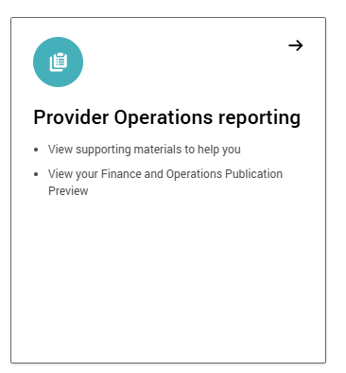
To access the Provider Operations Reporting tile:
- Log into the GPMS Portal.
For assistance logging in to GPMS refer to the GPMS General Resources web page.
- On the GPMS home page select the Provider Operations Reporting tile.
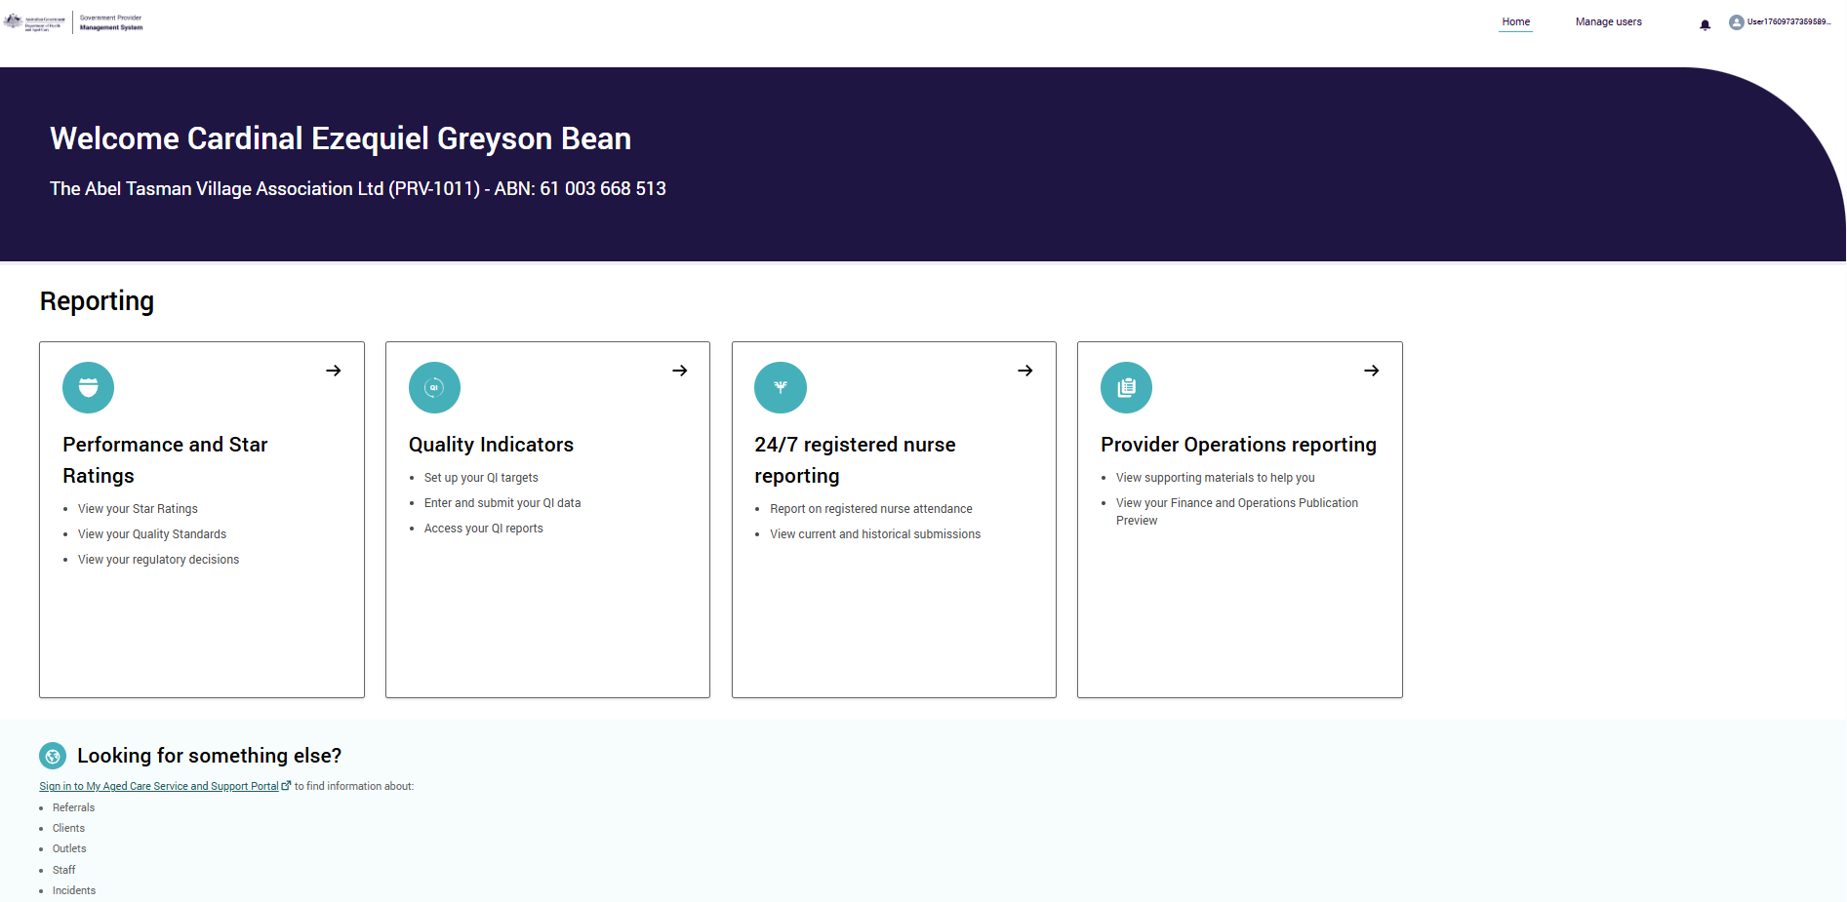

- On the Provider Operations Reporting home (submission) page select the Publication Preview tab on the top right of the page.
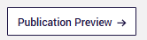
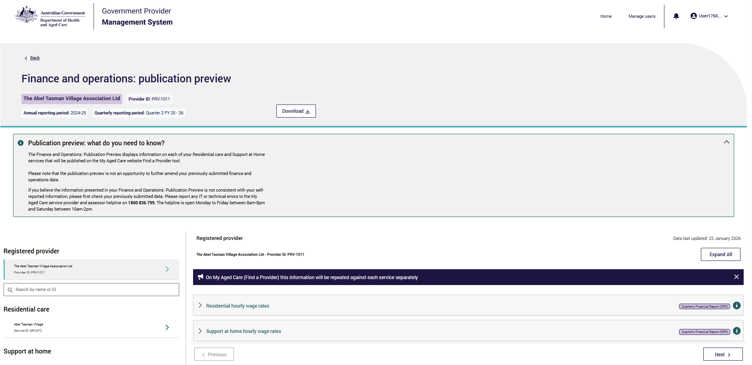
- Select the provider organisation and/or its residential or home care service in the left side-bar to preview information.

Provider information
For convenience, in the GPMS Publication Preview, the preview information is shown once for the provider, rather than replicated under each service (as will occur in the My Aged Care website).
Data available to preview at the Provider organisation level include:
- Wages – source: Quarterly Financial Report
- Provider finances – source: Aged Care Financial Report
- Key personnel – source: Provider Operations Collection Form
- Performance report (compliance) – source: Provider Operations Collection Form
- Board diversity – source: Provider Operations Collection Form.

Residential aged care service
Data available to preview at the residential aged care service level include:
- Food and preparation – source: Quarterly Financial Report
- Quarterly care and nursing – source: Quarterly Financial Report
- Annual financial information – source: Aged Care Financial Report
- Provider operations (diversity, feedback, complaints and improvements) – source: Provider Operations Collection Form
- Service usage – source: Aged Care Management Payment System

Support at Home/Home Care services
Data available to preview at the Support at Home/Home Care service level:
- Provider operations (diversity, feedback, complaints and improvements) – source: Provider Operations Collection Form
- Service usage – source: Aged Care Management Payment System
Data queries
- Should you have any concerns regarding the information presented in GPMS, providers must act within 14 days from date of notification via GPMS.
- If you believe the information presented in your Finance and Operations: Publication Preview is not consistent with your self-reported information, please first check your previously submitted data.
- Please report any IT or technical errors to the My Aged Care service provider and assessor helpline on 1800 836 799 (Option 5). The helpline is open Monday to Friday between 8am-8pm and Saturday between 10am-2pm (local time across Australia).
- For any finance or operations data concerns or queries, please email ACFRQFRQueries@health.gov.au

Further information and support

- Finances and Operations Publication Preview on GPMS and Publication on the My Aged Care webpage and training resources
- Government Provider Management System webpage and training resources

