Government Provider Management System Quick Reference Guide: How to edit a user in the GPMS Approved Provider portal
In the GPMS Approved Provider portal, Organisation Administrators have the ability to edit user accounts. This Quick Reference Guide aims to show Organisation Administrators how to make these updates.

Editing user roles
To edit a user’s roles, complete the following actions:
- In the Manage users screen, locate the user to edit, and click the Manage link.
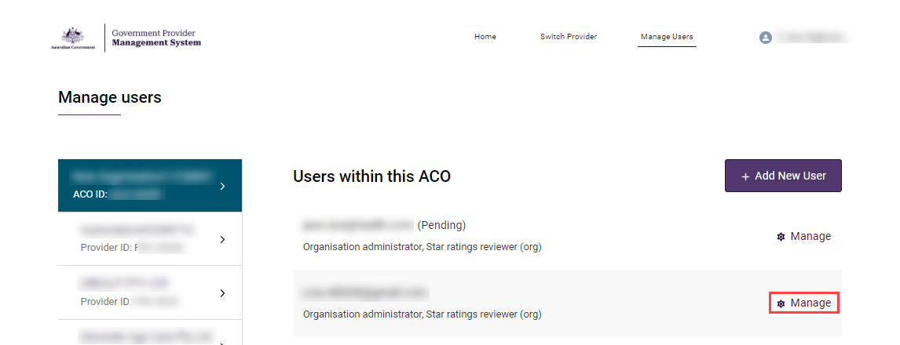
- The editable options will differ depending on if the user was created at the organisation or provider level.
To edit a user’s roles:
- To edit a user at the organisation level, check or uncheck the boxes next to the roles relevant to the user.
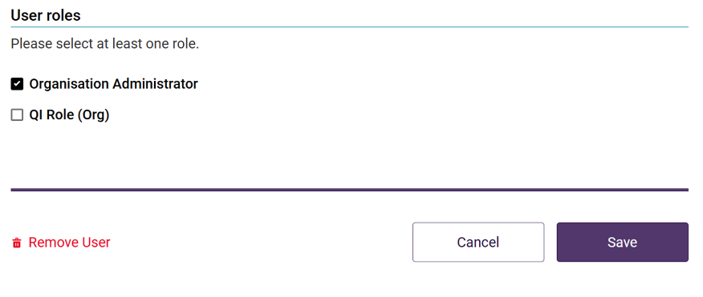
- To edit a user at the provider level, check or uncheck the boxes next to the roles relevant to the user, then, if required, check or uncheck the boxes for all services the user should be linked to for each role.
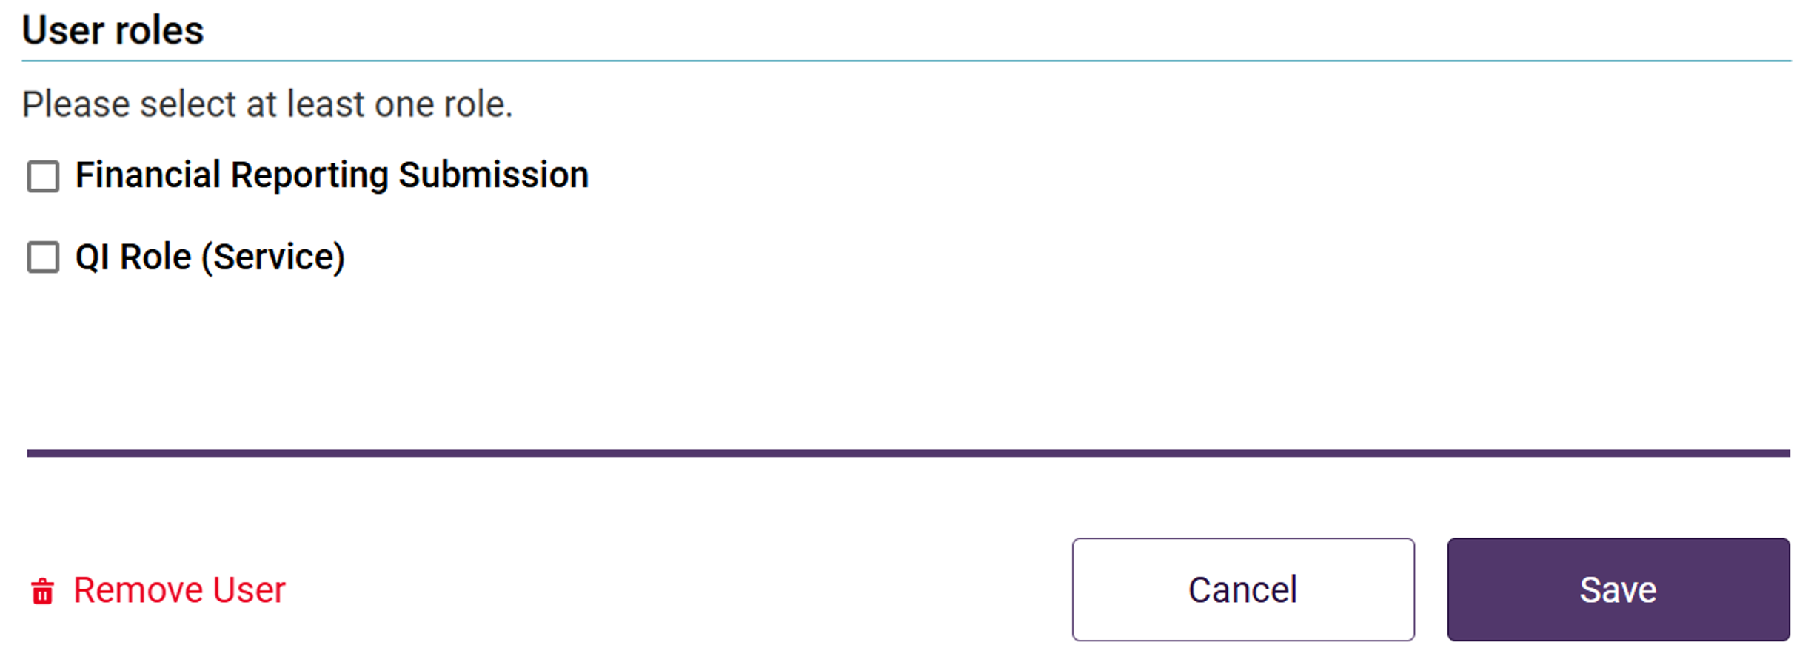
- Click the Save button.
Once saved, the Manage Users screen will display. The user will receive an email notification, advising their access roles have been changed.

Removing a user from GPMS
To remove a user from GPMS, complete the following actions:
- On the Manage users screen, locate the user to remove, and click the Manage link.
- Scroll to the bottom of the User Details screen and click the Remove user link.
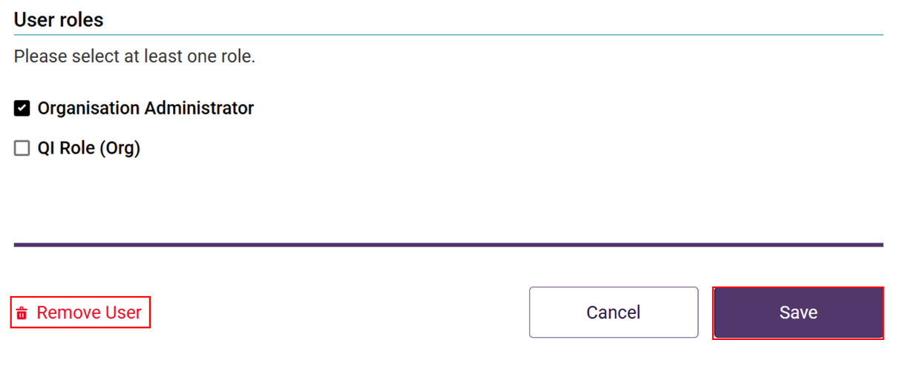
- A modal will display advising the selected user will be removed at the current level of the organisation and that the action cannot be undone. Click the Remove button to proceed.
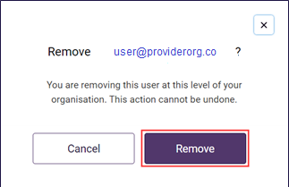
Once removed, the Manage users screen will display and the user will no longer be listed.
If users require further assistance with GPMS, please contact the My Aged Care service provider and assessor helpline on 1800 836 799, Monday to Friday (8am to 8pm) and Saturday (10am to 2pm) local time across Australia.
For translating and interpreting services, call 131 450 and ask for My Aged Care on 1800 836 799.
To use the National Relay Service, visit About the National Relay Service (NRS) | Access Hub or call 1800 555 660.
To access sign language interpreting and captioning services through Deaf Connect, call 1300 773 803 or email interpreting@deafconnect.org.au.

