Government Provider Management System Quick Reference Guide: How to add a user in the GPMS Approved Provider portal
Organisation Administrators can add new users to the GPMS Approved Provider portal. These new users can be added either at the organisation level or at the provider level. The level the new user is added to will determine what kind of access roles can be attributed to them.

Adding a user at the organisation level
To add a new user at the organisation level, complete the following actions:
- In the Manage users screen, ensure the ACO account is highlighted, and click the + Add New User button.
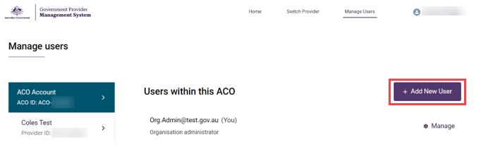
- In the Add new ACO user screen, enter the new user’s company email address and click the Next button.
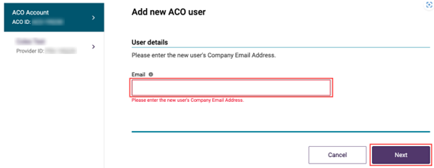
- In the Select user section, select the radio button option to ‘Create a new contact record’, then click the ‘Next’ button.
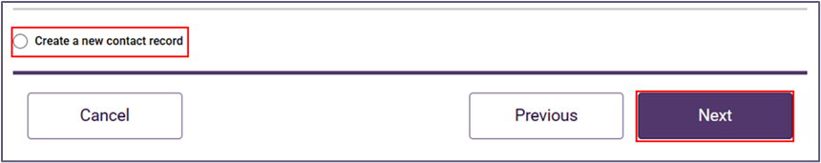
- Add the new user’s Salutation, First name, Surname, and Date of birth. If the date of birth is not provided, a default date of 19/01/1900 can be entered for the user.
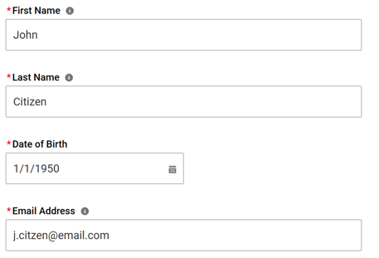
- Check or uncheck the boxes next to the relevant roles(s) to be assigned to the new user.
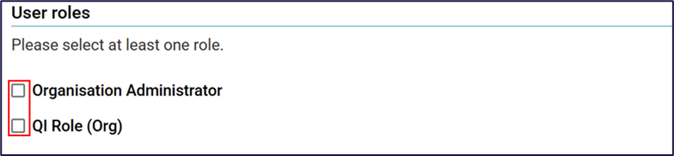
- Click the checkbox to confirm agreement with the declaration and click Add User button.
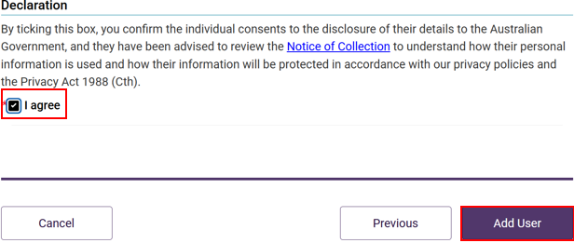
A green banner will display, informing that an invitation email has been sent to the new user.
The newly added user will have a status of (Pending).
This status will remain until the newly added user receives their notification email and selects the link to login to the GPMS Approved Provider portal for the first time.
Once their first login has been completed the Pending status will disappear.

Adding a user at the provider level
To add a new user at the provider level, complete the following actions:
- In the Manage users screen, ensure the provider account is highlighted, and click the + Add New User button.
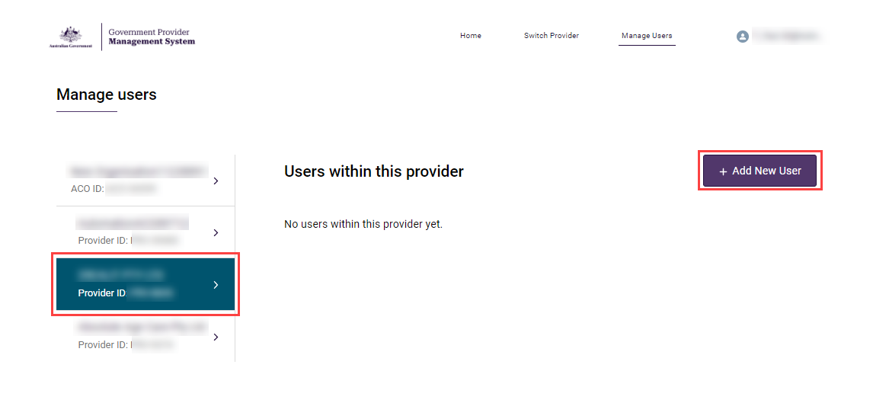
- In the Add new provider user screen, enter the new user’s company email address and click the Next button.
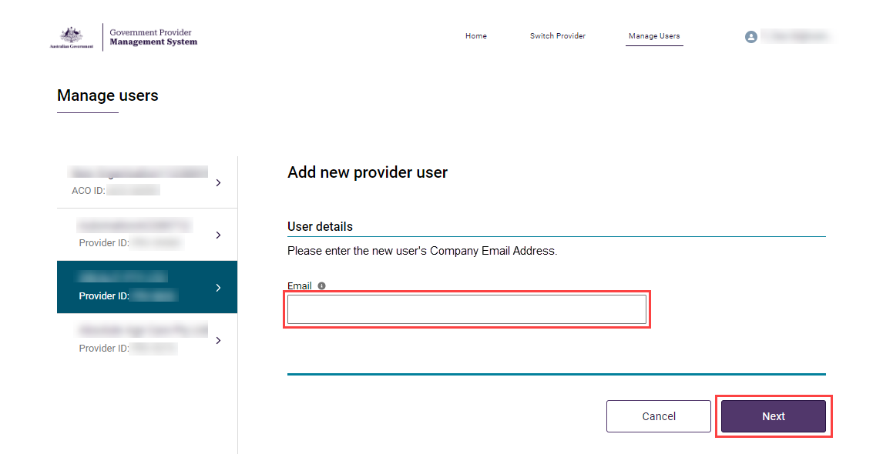
- In the Select user section, select the radio button option to ‘Create a new contact record’, then click the ‘Next’ button.
- Add the new user’s Salutation, First name, Surname, and Date of birth.
- Check or uncheck select the check boxes next to the relevant user of the access roles to be assigned to the user.
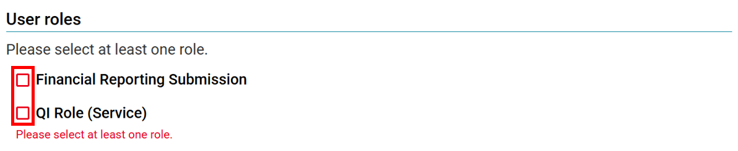
- Check or uncheck the boxes of the relevant services that the user should have access to.
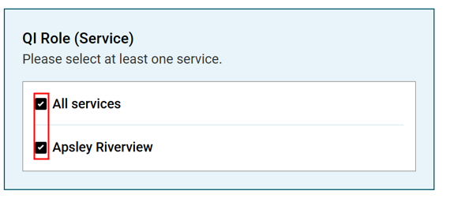
- Click the checkbox to confirm agreement with the declaration and click Add User button.
The Manage Users screen will display again. A green banner will display at the top of the screen advising an invitation has been sent to the new user. The new user will need to select the link in the email and log into GPMS to complete their registration.
If users require further assistance with GPMS, please contact the My Aged Care service provider and assessor helpline on 1800 836 799, Monday to Friday (8am to 8pm) and Saturday (10am to 2pm) local time across Australia.
For translating and interpreting services, call 131 450 and ask for My Aged Care on 1800 836 799.
To use the National Relay Service, visit About the National Relay Service (NRS) | Access Hub or call 1800 555 660.
To access sign language interpreting and captioning services through Deaf Connect, call 1300 773 803 or email interpreting@deafconnect.org.au.

