Government Provider Management System Quick Reference Guide: Logging into GPMS Approved Provider and Registered Provider Portal
Since the commencement of the new Act in November 2025, the GPMS Registered Provider Portal has been made available to providers, enabling them to:
- manage their organisation’s details,
- submit Registered Nurse (RN) reports,
- submit Quarterly Financial Reports (QFR),
- submit Quality Indications (QI) data,
- preview Star Ratings data, and
- preview Finance & Operations
Registered providers can continue to use the GPMS Approved Provider to access all other reporting applications.

Accessing the GPMS Approved Provider portal or Registered Provider portal
Access the Approved Provider portal to view information about your Approved Provider entity, as it existed under the Aged Care Act 1997.  Here you can:  - View previous information about your organisation:  - Quality Indicator Program data  - Provider Operations report  - Quarterly Financial Report | Access the Registered Provider portal to view information about your Registered Provider entity, as it exists under the Aged Care Act 2024.  Here you can:  - View and maintain the information about your organisation including:  - View provider details  - View Residential Care Homes  - View Branches  - View Associated Provider Arrangements  - View Contacts (including Responsible Persons and Point of Contacts)  - Manage Provider Aboriginal Community Controlled Health Organisation details  - Manage provider business contact details  - Create, update and cease Point of Contacts  - view compliance information, including performance against the strengthened Aged Care Quality Standards, regulatory decisions and Star Ratings  - Submit and edit Registered Provider reporting:  - 24/7 Registered Nurse (RN) report  - Quality Indicator (QI) Program data  - Quarterly Financial Report (QFR)  - Preview information before it is published for the next period:  - Finance & Operations  - Star Ratings, including the metrics used to calculate the ratings  As GPMS is enhanced, additional applications will be introduced through future updates.
To access the GPMS portals, complete the following steps:
- Select the GPMS log in page link. You will be taken to the GPMS login landing page on the Department’s website.
- Click on either button labelled Log in to GPMS - Approved Provider or Log in to GPMS – Registered Provider to be taken to the respective portal login page.
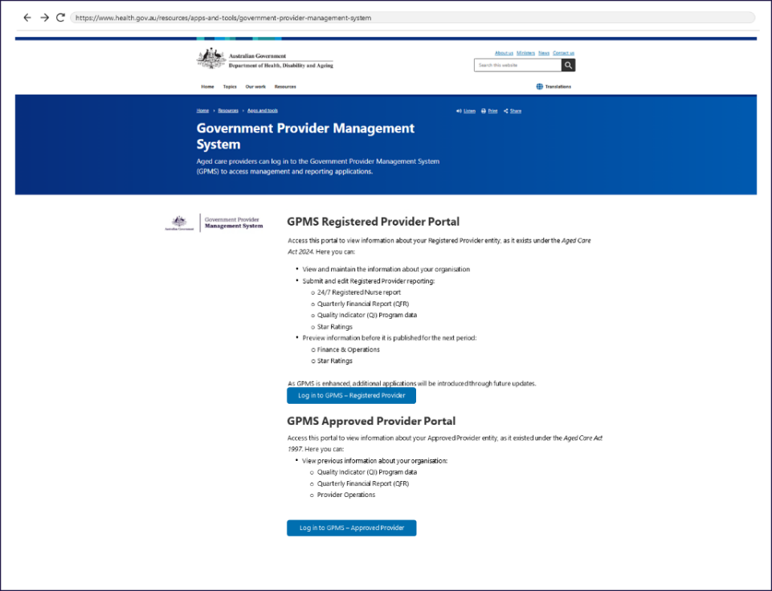
The Log in using screen will be displayed that offers buttons to log in with VANguard Federated Authentication Service or myID Digital Identity.
- To log in using VANguard Federated Authentication Service, continue to Step 3.
- To log in using myID Digital Identity, go to Step 5.
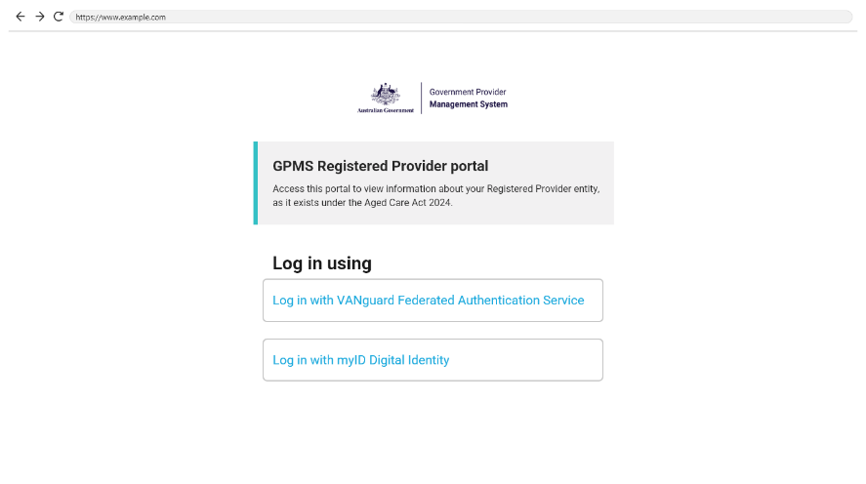
- To log in using VANguard Federated Authentication Service, select Log in with VANguard Federated Authentication Service.
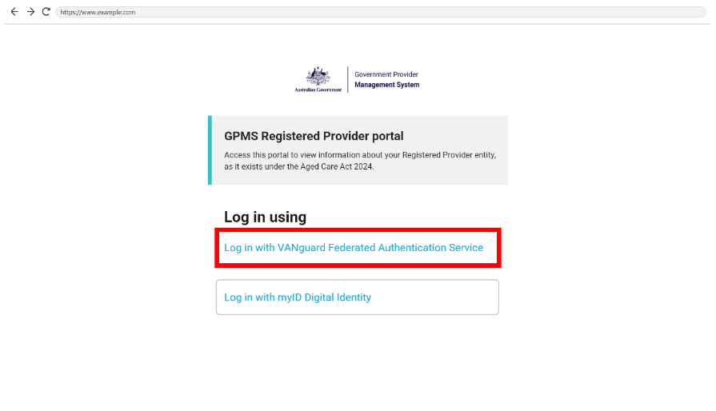
- A page will be displayed requiring the user to choose to authenticate using either a local system, or by using the VANguard Federated Authentication Service. Select VFAS Authentication from the dropdown menu, then select the Next button.
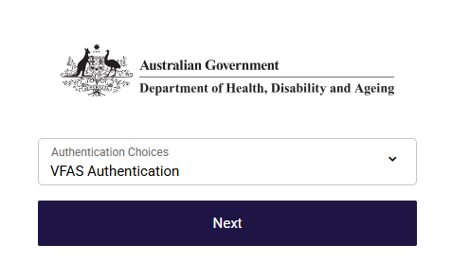
The Authentication Service page will be displayed.
- In the search field, enter the name of the organisation and then select the correct value from the suggestions in the drop-down. Once the organisation is selected, select the Continue button.
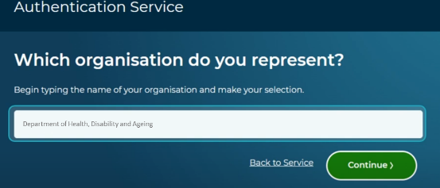
The relevant GPMS provider portal landing page will be displayed.
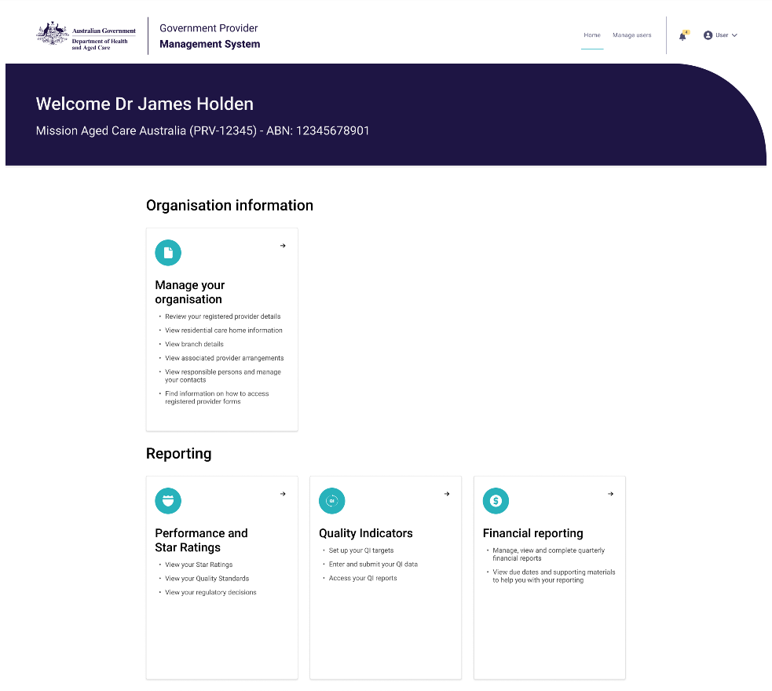
Please note:
If this is the first time the user is logging into GPMS, the user must follow the screen instructions to agree to the GPMS Terms of Use and enter a verification code sent to their email.
- To log in using myID Digital Identity, select Log in with Digital ID.
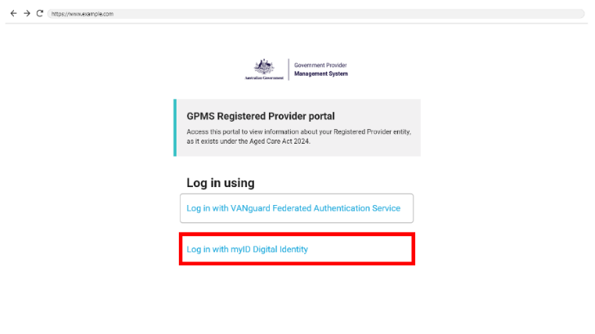
A page to select authentication method will be displayed.
- Ensure Digital ID Authentication is selected, then select the Next button.
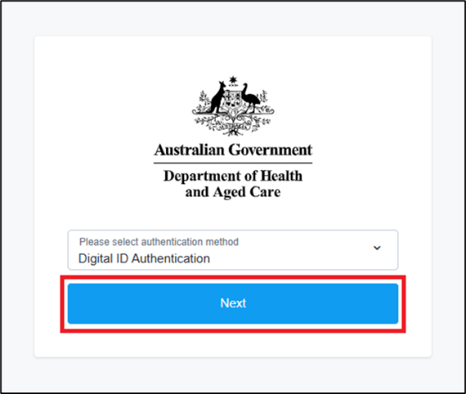
The Select your identity provider page will be displayed.
- Click the button labelled Select myID.
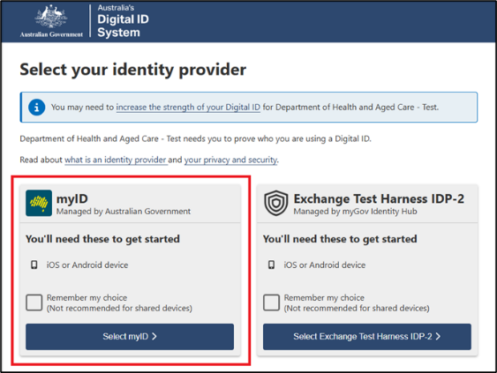
The myID page will be displayed.
- In the myID email field, the user enters their email address utilised for myID, then click the Get code button.
- The myID page will display an authorisation code. Log in to the myID app on a mobile device and enter the code displayed on the screen.
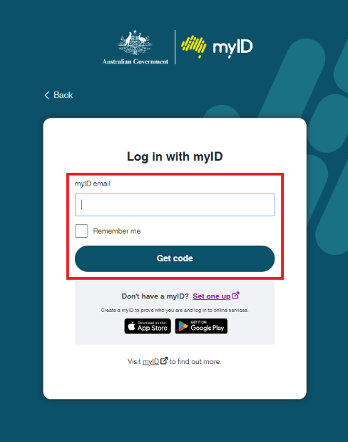+
If the user works for more than one organisation, the Relationship Authorisation Manager screen will be displayed.
- Select the radio button of the organisation that the user would like to access, then click the Continue button.
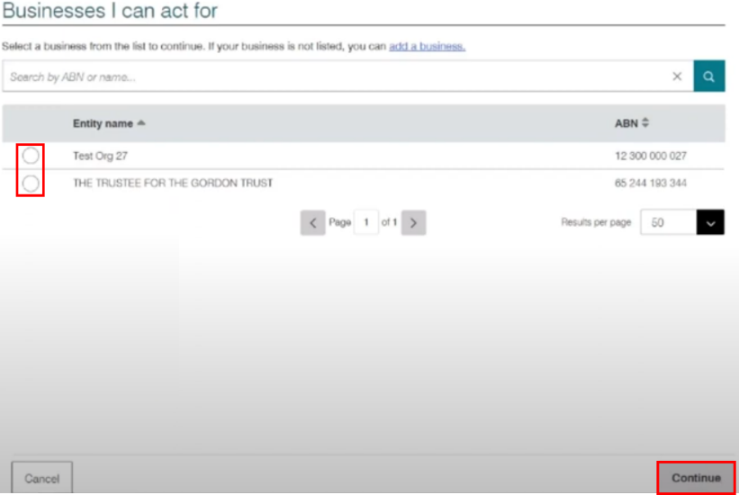
The relevant GPMS provider portal landing page for the provider will be displayed.
Please note:
If this is the first time the user is logging into GPMS, the user must follow the screen instructions to agree to the GPMS Terms of Use and enter a verification code sent to their email.
If users require further assistance to login to GPMS please contact the My Aged Care service provider and assessor helpline on 1800 836 799, Monday to Friday (8am to 8pm) and Saturday (10am to 2pm) local time across Australia.
For translating and interpreting services, call 131 450 and ask for My Aged Care on 1800 836 799.
To use the National Relay Service, visit About the National Relay Service (NRS) | Access Hub or call 1800 555 660.
To access sign language interpreting and captioning services through Deaf Connect, call 1300 773 803 or email interpreting@deafconnect.org.au.

