Government Provider Management System Quick Reference Guide: How to add a user in the GPMS Registered Provider portal
Organisation Administrators can add new users in the GPMS Registered Provider portal. These new users can be added either at the organisation level or at the provider level. The level the new user is added to will determine what kind of access roles can be attributed to them.

Adding a user at the organisation level
To add a new user at the organisation level, complete the following actions:
- In the Manage users screen, ensure the Organisation account is highlighted, and click the + Add new portal user button.
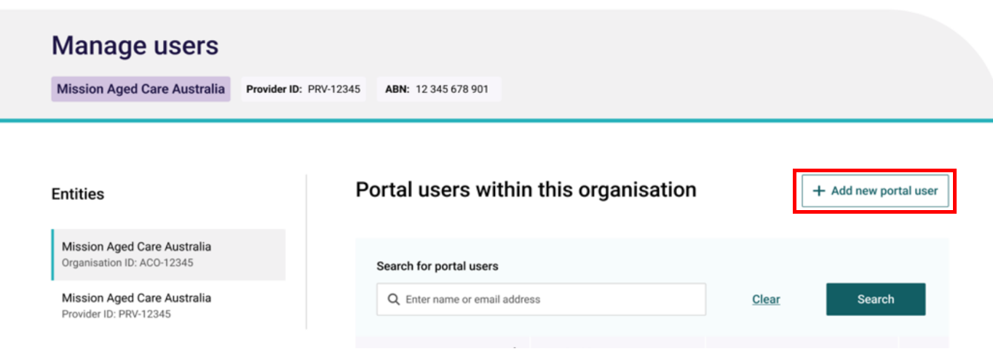
- To confirm whether the new user already has an existing contact record, in the Search for individuals field, enter the user’s name and click the Search button.
- If the user does exist within the organisation and does not have a portal account, go to step 3.
- If the contact already has a portal account, follow the steps within the ‘How to edit a contact’ Quick Reference Guide.
- If the search did not find an existing contact, go to step 4.
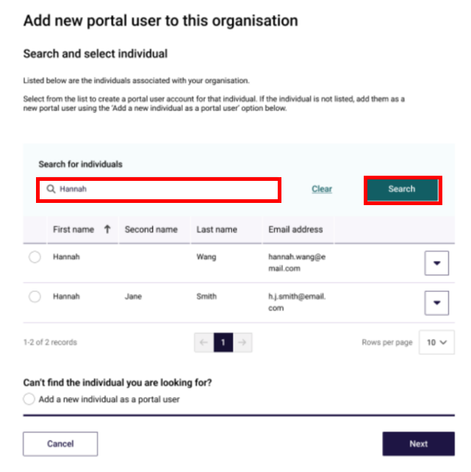
- Select the radio button next to the contact record and click the Next button. Go to step 5.
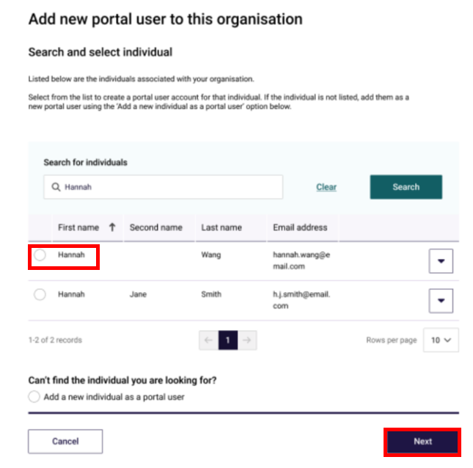
- If no contacts are found, select the Add a new individual as a portal user radio button, then click the Next button.
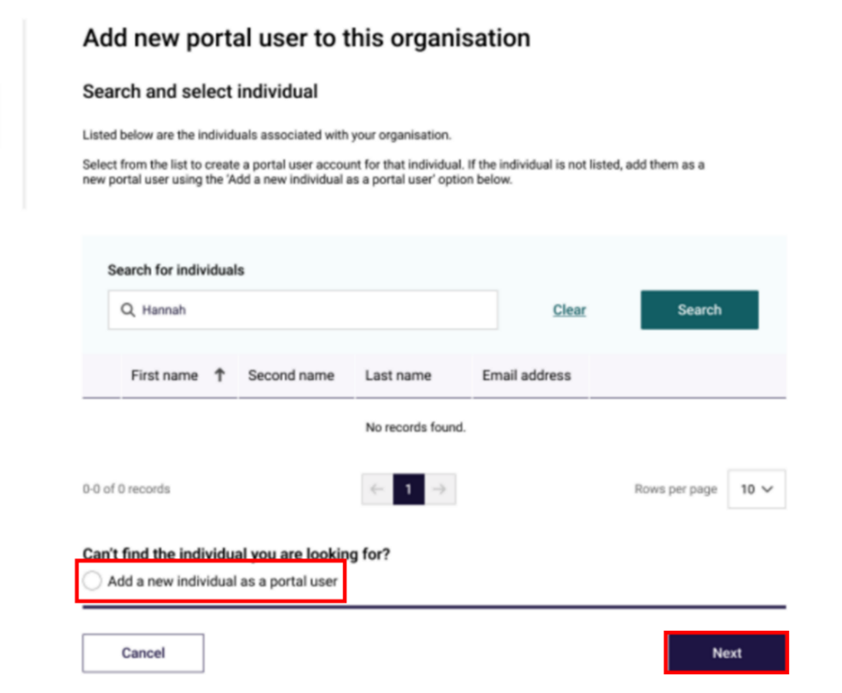
- In the User details section, enter the user’s details within the fields. Under User roles, check the boxes next to the access roles to be assigned to the user. In the Declaration section, select I agree, then click the Add user button.
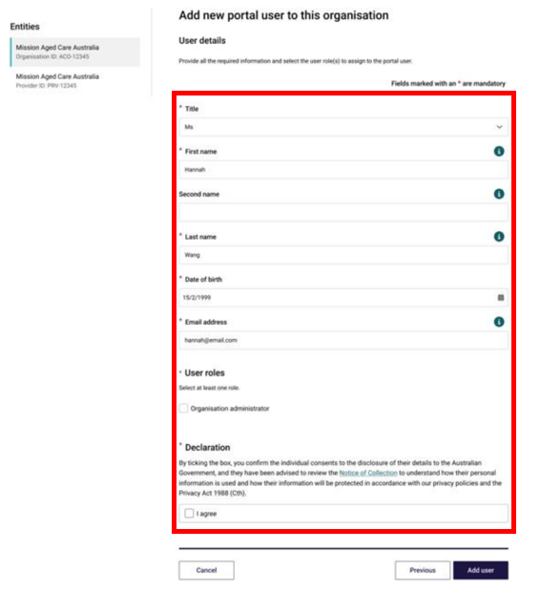
The GPMS portal will display a green banner informing that an invitation email has been sent to the new contact or portal access for the contact has been successfully updated.
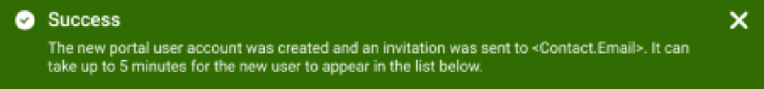

Adding a user at the provider level
To add a new user at the provider level, complete the following actions:
- On the Manage users screen, ensure the provider account is highlighted, and click the + Add new portal user button.

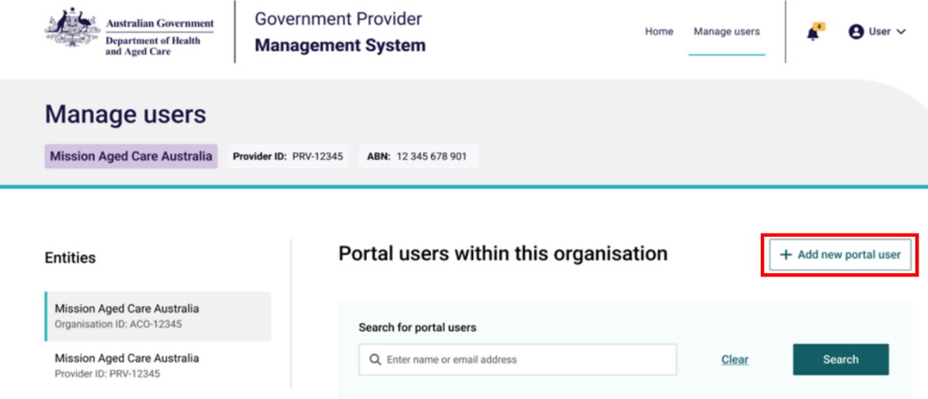
Mission Aged Care Australia
Organisation ID: ACO-12345
Mission Aged Care Australia
Provider ID: PRV-12345

- To confirm whether the new user already has an existing contact record, in the Search for individuals field, enter the user’s name and click the Search button.
- If the contact does exist within the organisation but does not have a portal account, go to step 3.
- If the contact already has a portal account, follow the steps within the ‘How to edit a contact’ Quick Reference Guide.
- If the search did not find an existing contact, go to step 4.
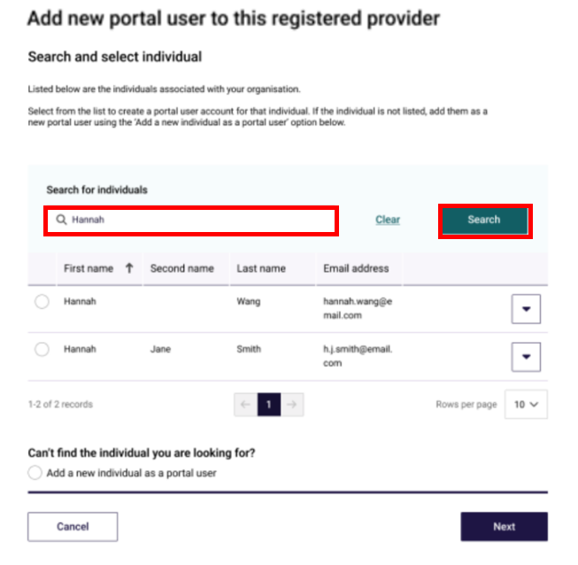
- Select the radio button for the contact record and click the Next button. Go to step 5.
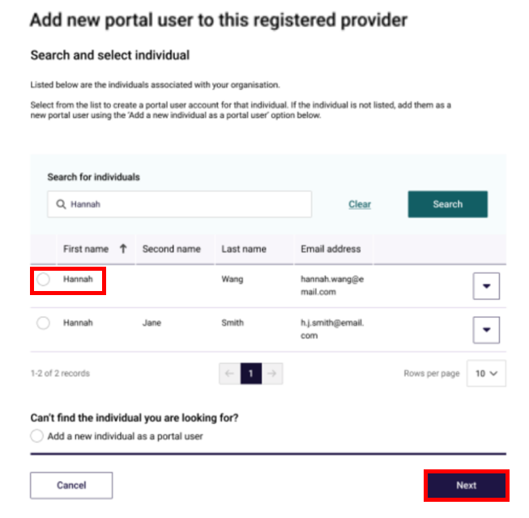
- If no contacts are found, select the Add a new individual as a portal user radio button and click the Next button.
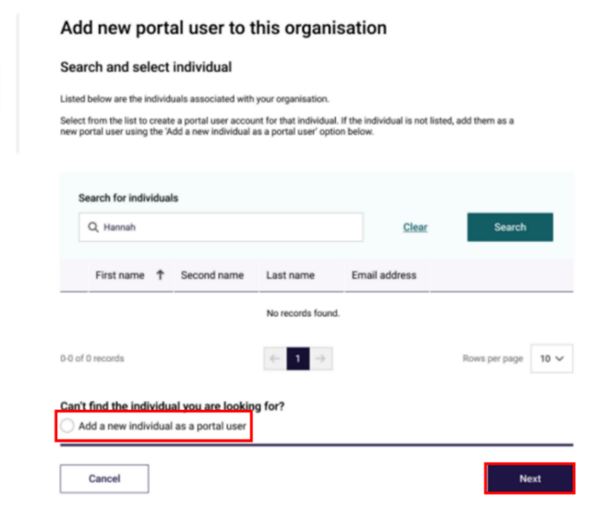
- In the User details section, enter the user’s details within the fields (if not already populated). Under User roles, select the boxes next to the access roles to be assigned to the user.
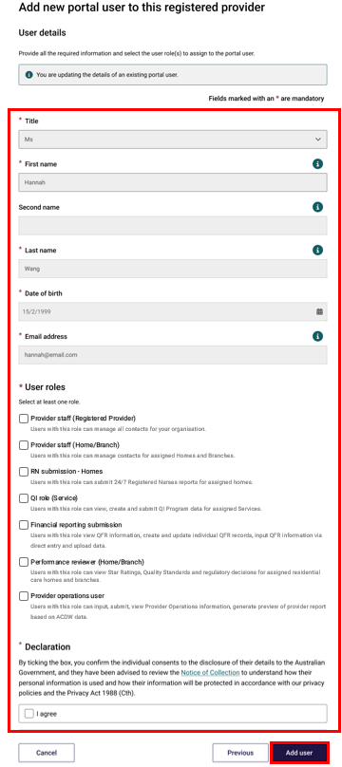
- Some access roles will require additional information to be entered. For example, a user with the access role of ‘Provider staff (Home/Branch)’ will also list residential homes and/or branches operated by the selected provider. Check the check boxes of the services the user should have, to allow them access for that specific role.
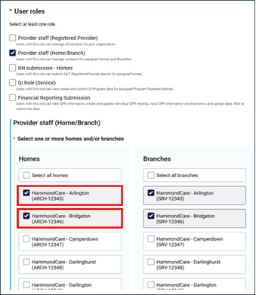
- In the Declaration section, click the I agree checkbox, then click the Add user button.
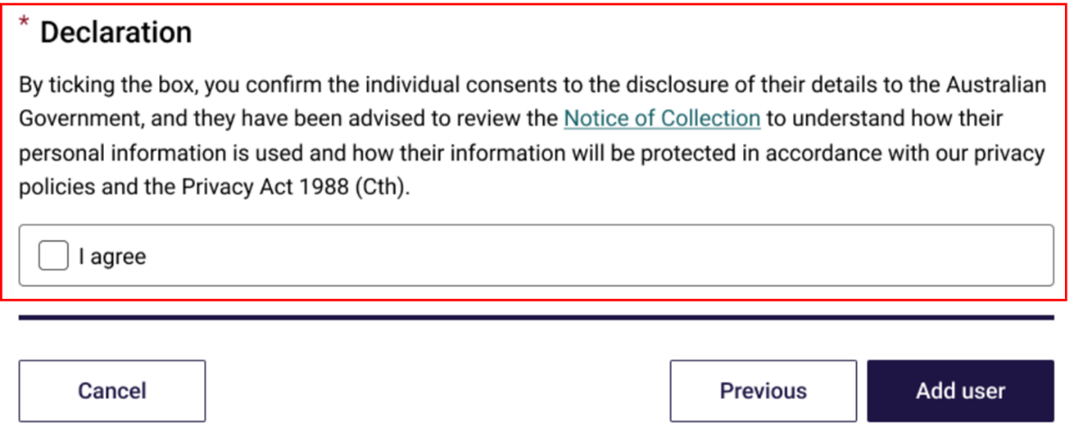
The GPMS portal will display a green banner informing that an invitation email has been sent to the new user, or to inform that portal access for the user has been successfully updated.
If users require further assistance with GPMS, please contact the My Aged Care service provider and assessor helpline on 1800 836 799, Monday to Friday (8am to 8pm) and Saturday (10am to 2pm) local time across Australia.
For translating and interpreting services, call 131 450 and ask for My Aged Care on 1800 836 799.
To use the National Relay Service, visit About the National Relay Service (NRS) | Access Hub or call 1800 555 660.
To access sign language interpreting and captioning services through Deaf Connect, call 1300 773 803 or email interpreting@deafconnect.org.au.

