Government Provider Management System – Registered Provider Portal User Guide
March 2026
Version 5.6
This Government Provider Management System (GPMS) User Guide provides users with an overview of how to login to the GPMS Registered Provider portal and outlines how Organisation Administrators can add, edit and remove user roles.

Contents
1. Introduction 3
1.1 Purpose 3
1.2 Before proceeding 3
1.3 Log in to the GPMS Registered Provider portal 4
2. GPMS Registered Provider Portal Access 4
2.1 Troubleshooting myID or VANguard issues 4
2.2 Terms of use 4
3. Organisation Administrators 7
3.1 The Manage users page 8
3.2 Adding a new user 9
3.2.1 Adding a user at the organisation level 9
3.2.2 Adding a user at the provider level 13
3.3 Search for existing contacts 19
3.4 Editing or removing contact access roles 19

Introduction
The Government Provider Management System (GPMS) is a flexible IT (Information Technology) system which is a critical part of the Aged Care Digital Transformation Initiative, underway to support aged care reform through better technology.
GPMS provides greater connectivity and data sharing between aged care providers and government.

Purpose
This User Guide has been designed to support providers in understanding how to access and login to the GPMS Registered Provider portal for the first time.
It also provides an overview of the Organisation Administrator role and associated functionality, including the ability to:
- add users to the GPMS portal; and
- edit or remove user roles which allows users to access applications within the GPMS portal.

Before proceeding
Please be advised of the following:
The Department of Health, Disability and Ageing will retain records of users’ access to GPMS and when prompted, the user must accept the GPMS Terms of Use to be able to access the system.
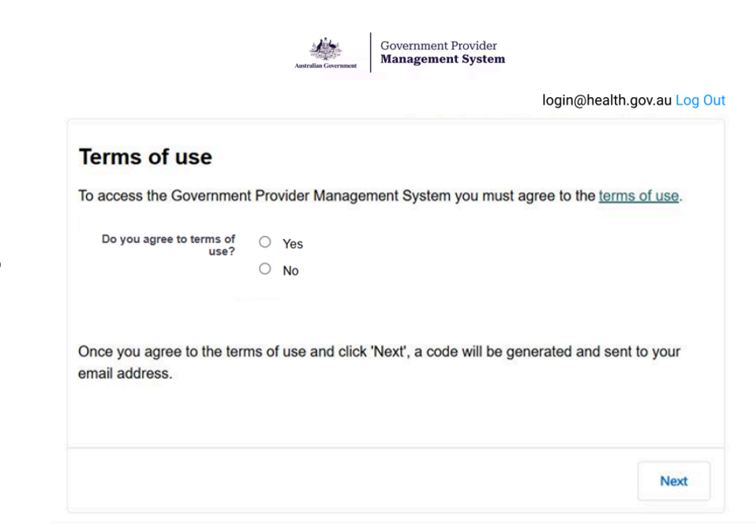

1.3 Log in to the GPMS Registered Provider portal
Users can log in to the GPMS Registered Provider portal to view and manage organisation details, submit and edit 24/7 registered nurse reporting, Quarterly Financial Reporting, Quality Indicator Program reporting, Star Ratings Reporting, and preview Finance & Operations.
If you require assistance to login to the GPMS portal, please refer to the Logging in to Aged Care Systems user guide.

GPMS Registered Provider Portal Access
To access the GPMS Registered Provider portal, each staff member must have a My Aged Care portal user account linked to a supported third-party authentication service.
For more information regarding setting up users and logging into the system please refer to the Logging in to Aged Care Systems user guide.

Troubleshooting myID or VANguard issues
If users encounter any issues with logging in with myID or VANguard, refer to the Logging in to Aged Care Systems user guide.
If issues persist, users should contact their organisation’s technical support for assistance or call the My Aged Care service provider and assessor helpline on 1800 836 799. This helpline provides technical support and general information to registered providers, assessors, and hospital staff using our reporting systems and portals. Call from 8am to 8pm Monday to Friday or 10am to 2pm Saturday (local time).

Terms of use
When logging in for the first time, the user will need to agree to the Government Provider Management System - Terms of Use (Terms of Use) and enter a Verification Code.
To agree, complete the following steps:
- Click the terms of use link to read the Terms of Use.
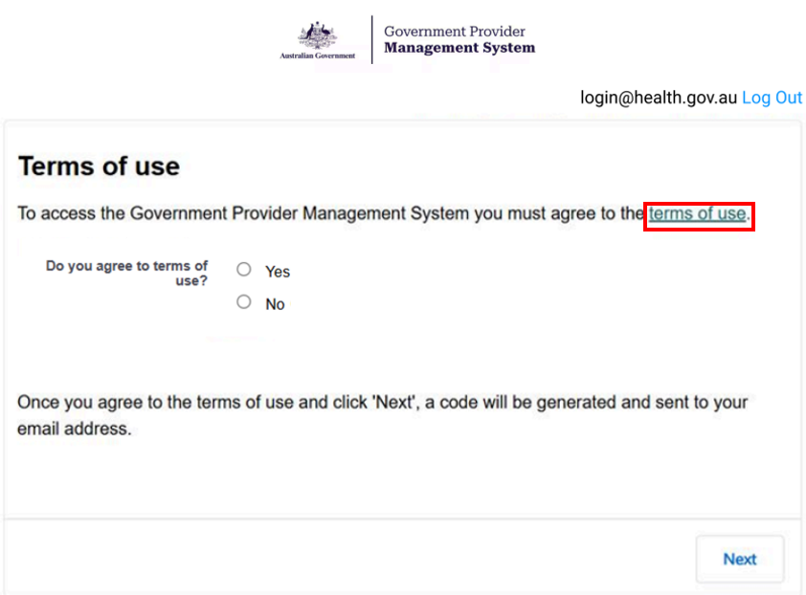
- If the terms of use are agreed to, select the Yes radio button, then click Next.
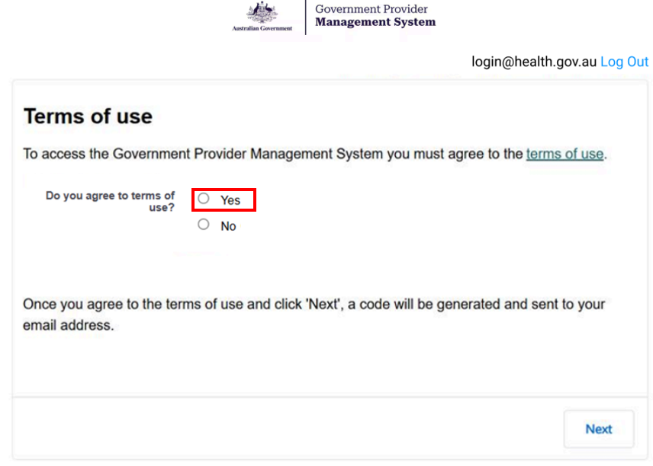
Please note:
If the user does not agree to the terms of use, selecting No will prevent them from having access to the portal.
By agreeing to the Terms of Use, the user also agrees to the handling of their Personal Information in accordance with the GPMS Privacy Notice and the website privacy policy.
- If the user accepts the GPMS Terms of Use by selecting Yes, the Verification Code screen will be displayed.
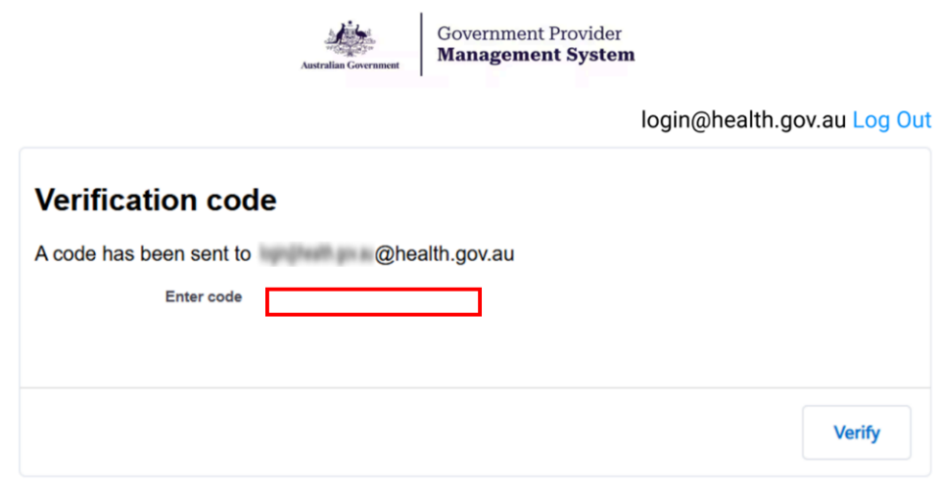
An eight-digit verification code will be sent to the user’s company email address.
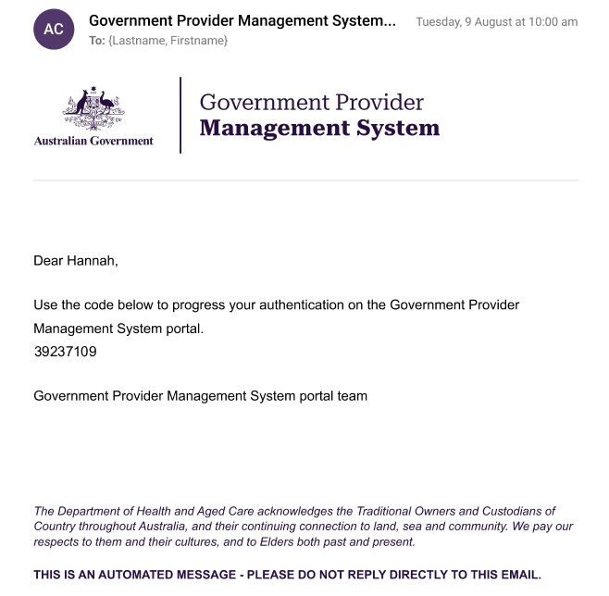
- In the Enter code field, the user should enter the eight-digit code received in the notification email and select Next.
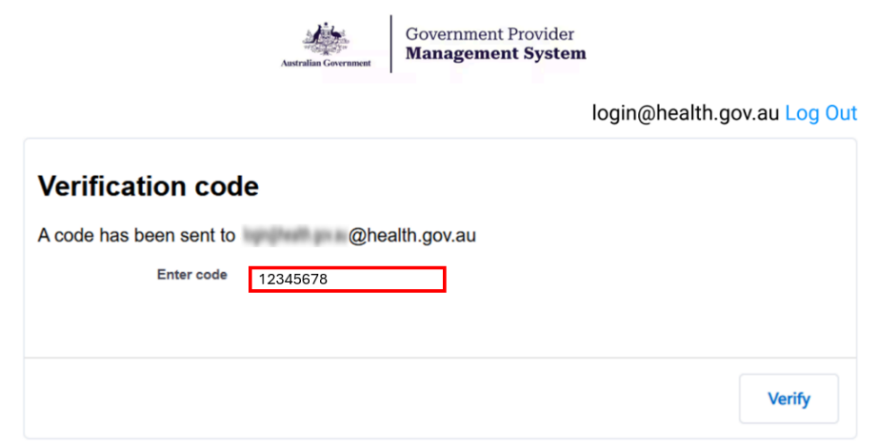
The GPMS Registered Provider portal landing page will be displayed.
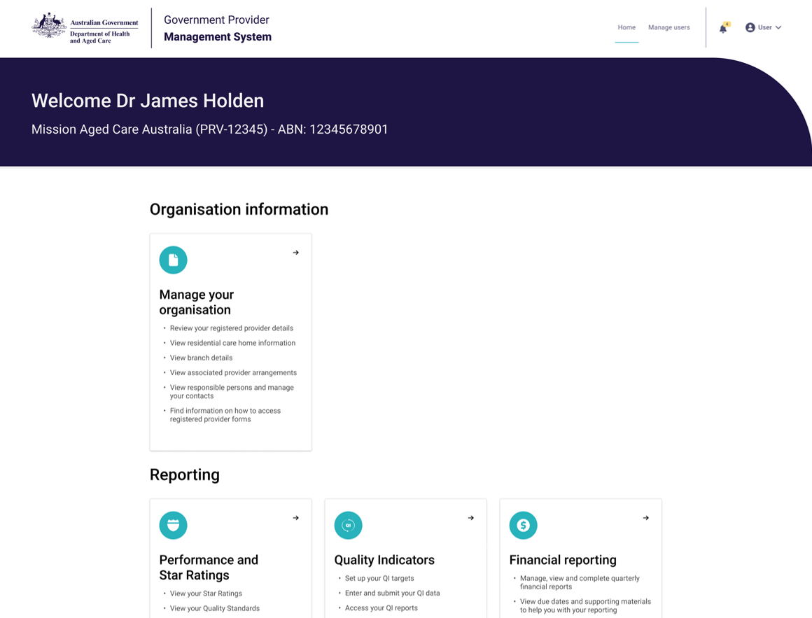
If users require further assistance to login to GPMS please contact the My Aged Care service provider and assessor helpline on 1800 836 799, Monday to Friday (8am to 8pm) and Saturday (10am to 2pm) local time across Australia.
For translating and interpreting services, call 131 450 and ask for My Aged Care on 1800 836 799.
To use the National Relay Service, visit About the National Relay Service (NRS) | Access Hub or call 1800 555 660.
To access sign language interpreting and captioning services through Deaf Connect, call 1300 773 803 or email interpreting@deafconnect.org.au.

Organisation Administrators
An Organisation Administrator is nominated by the organisation as someone who can perform the following administrative functions:
- Add additional users
- Edit user access roles
- Remove access roles for users who no longer require GPMS portal access
The Organisation Administrator role in the My Aged Care system or GPMS Approved Provider portal is not interchangeable with the Organisation Administrator role in the GPMS Registered Provider portal.
If a user with the Organisation Administrator role is not set up for GPMS for the user’s organisation, the organisation will need to nominate an Organisation Administrator for GPMS.
The following information relates to tasks that the Organisation Administrator can undertake in the GPMS portal.
Please note:
An Organisation Administrator will only be able to add, edit and remove portal users within the GPMS Registered Provider portal

The Manage users page
The Manage users page is where Organisation Administrators will perform administrative functions, such as adding users and editing user access roles.
Only users assigned Organisation Administrator access to the GPMS portal will be able to carry out these functions.
To access the Manage users functionality, select Manage users in the top menu on the portal landing page.
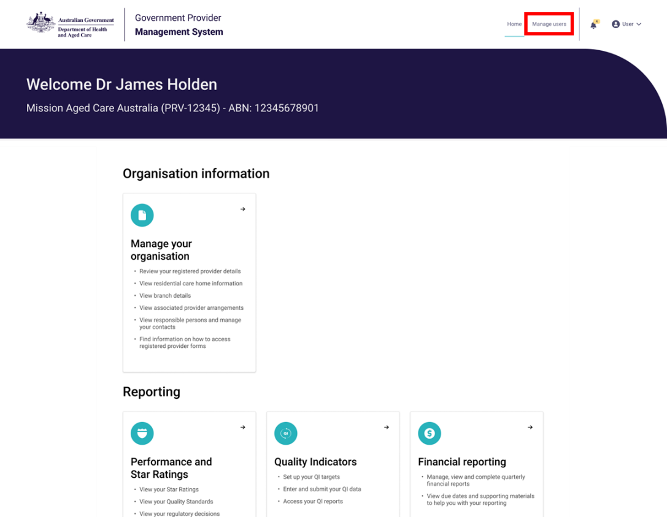
The Manage users page will be displayed.
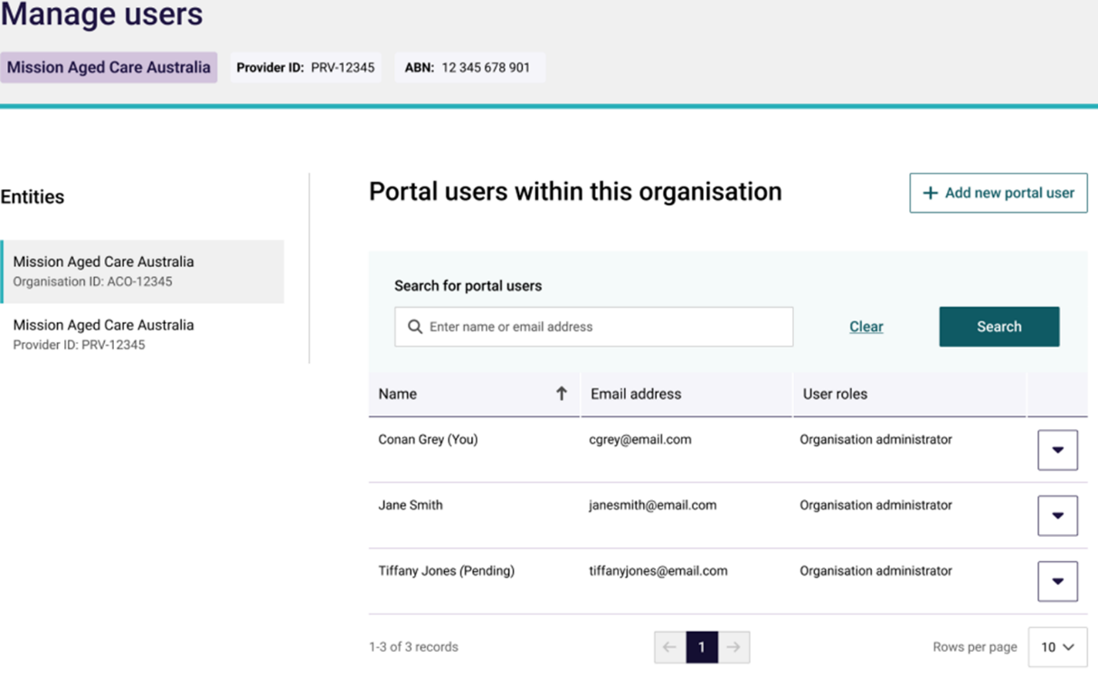

Adding a new user
Organisation Administrators can add new users to the GPMS portal. These users can be added either at the organisation level or at the provider level.
The level the new users are added to will determine what kind of access roles can be attributed to them.
Please note:
Before users login to GPMS for the first time, they must ensure they have completed the necessary steps to verify their identity in the myID or Vanguard FAS systems, in accordance with their organisation’s IT policies.
For further information please refer to the Logging in to Aged Care Systems user guide.
When adding a user as an Organisation Administrator in GPMS, it is important the user is also set up as an Organisation Administrator in the My Aged Care Service and Support Portal.
This will need to be done manually by the Organisation Administrator in the My Aged Care Service and Support portal.

Adding a user at the organisation level
Users added at the organisation level can be given the Organisation Administrator role access as well as other access roles.
To add a new user at the organisation level, complete the following steps:
- In the Manage users screen, select the + Add new portal user button.
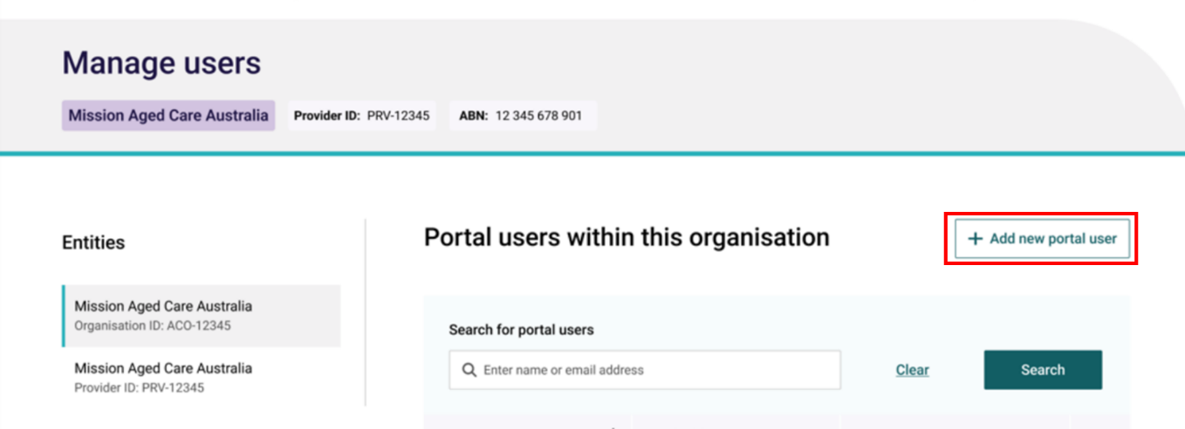
The Add new portal user to this organisation screen will be displayed.
- To confirm whether the new user already has an existing contact record, in the Search for individuals field, enter the user’s name and click the Search button.
- If the user does exist within the organisation and does not have a portal account, go to step 3. If the contact already has a portal account, follow the steps within the Editing or removing contact access roles section.
- If the search did not find an existing contact, go to step 4.
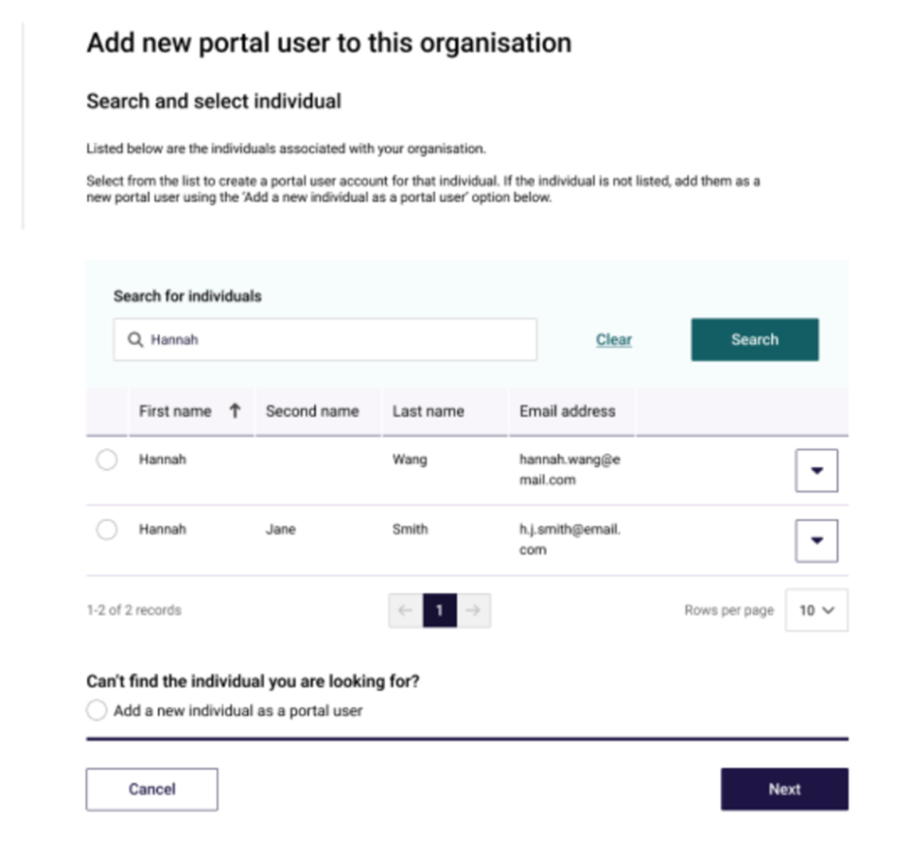
- Select the radio button next to the contact record and click the Next button, then go to step 5.
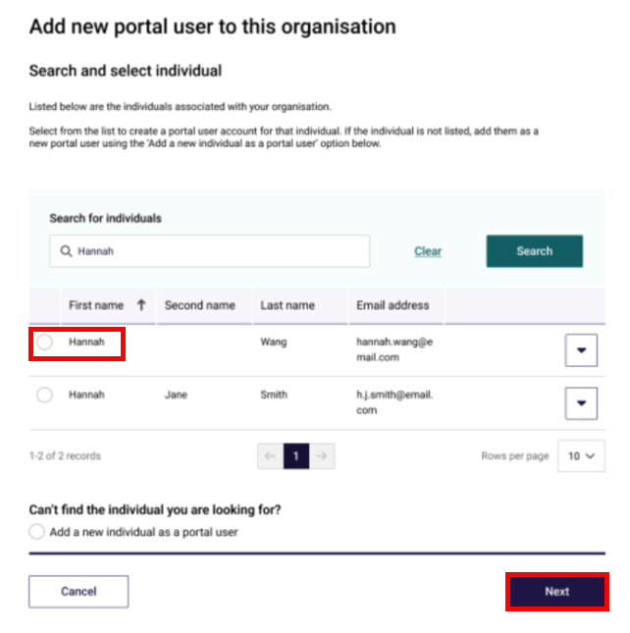
The User details screen will be displayed.
- If no contacts are found, select Add a new individual as a portal user radio button and click the Next button.
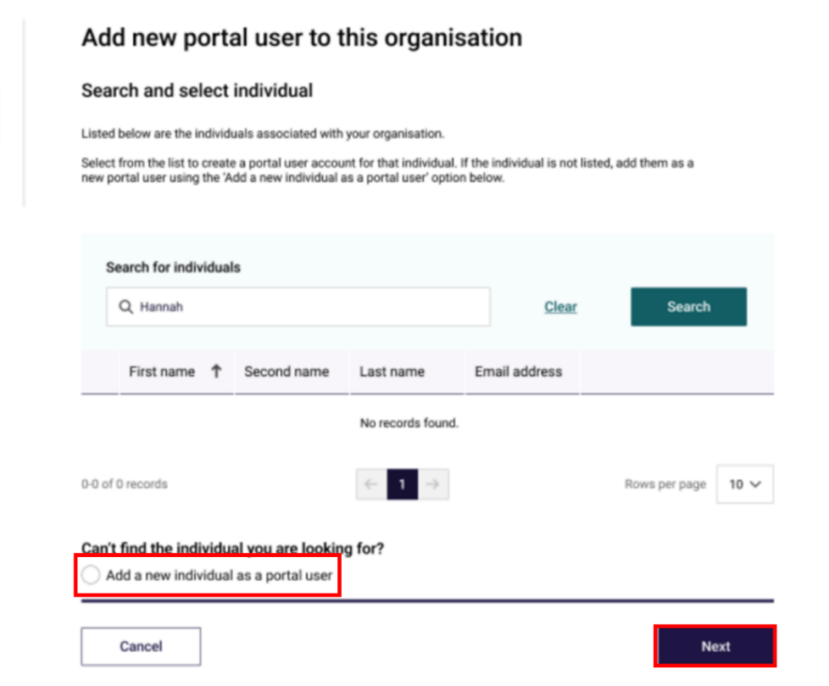
The User details screen will be displayed.
- In the User details section, enter the user’s details within the fields. Under User roles, check the boxes next to the access roles to be assigned to the user.
The table below lists the available user roles and descriptions:
Role | Description
Organisation level user roles
Organisation administrator | Can perform the following administrative functions:  - Add additional users  - Edit user access roles  - Remove access roles for users who no longer require GPMS portal access
QI Role (Org) | Can view, create and submit QI program data on behalf of their organisation.
Performance reviewer (Org) | Can view Star Ratings, Quality Standards and regulatory decisions for their organisation.
- In the Declaration section, select I agree, then click the Add user button.
Please note:
It is important the new user’s company email address is entered correctly.
If the email address is entered incorrectly, it will prevent the user from being able to access the portal.
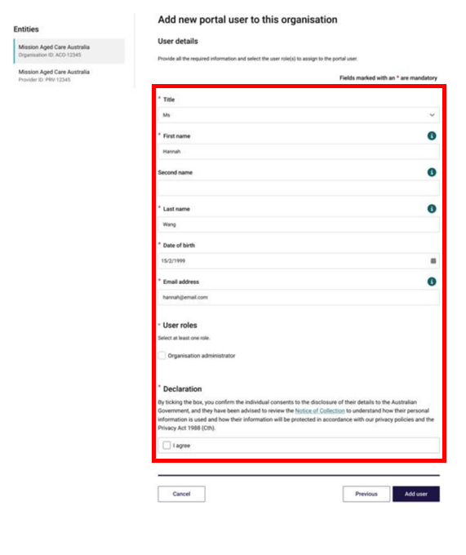
The Registered Provider portal will display a green banner informing that an invitation email has been sent to the new user or portal access for the user has been successfully updated.
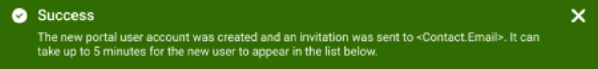
Newly added contacts will have a status of (Pending). This status will remain until the newly added contact receives their notification email and selects the link to login to the portal for the first time.
Once their first login has been completed the (Pending) status will disappear.
Please note:
Organisation Administrators can add, manage and remove user access.
The Organisation Administrator role can only be added to users at the Organisation level.
The Organisation Administrator role does not automatically provide access to other GPMS applications on its own; the Organisation Administrator user will need to be allocated additional access roles if they require access to other GPMS applications.

Adding a user at the provider level
An Organisation Administrator may give a user access against a specific provider. This limits their access to those providers only.
Please note:
Organisation Administrators can only be allocated at the Organisation level. Provider level users cannot be Organisation Administrators.
To add a new user at the provider level, complete the following steps:
- On the Manage Users screen, select the Provider from the panel on the left that the user should be added to, then click the + Add new portal user button.
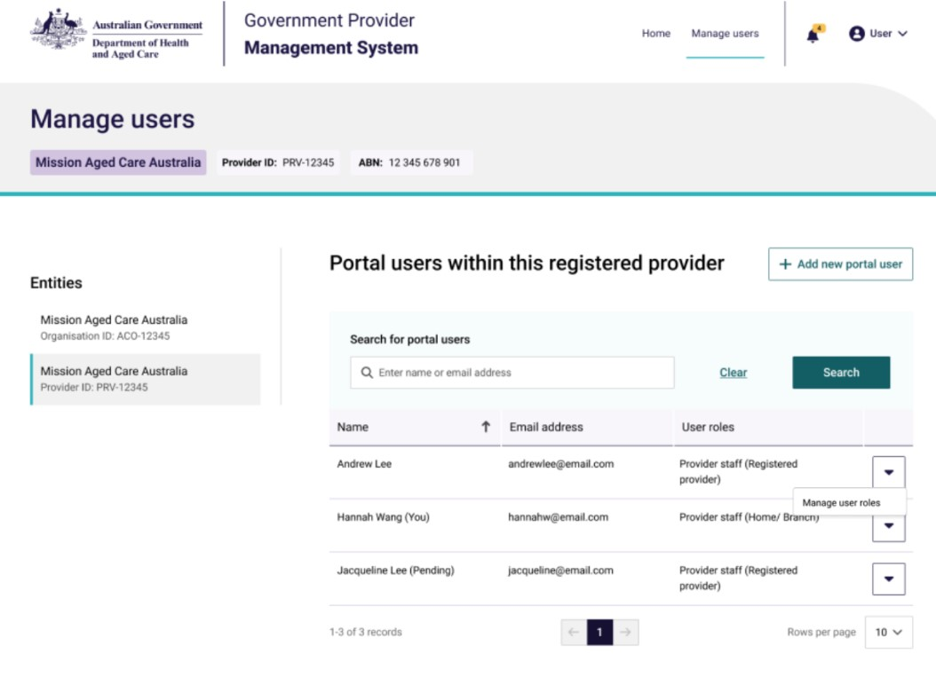
The Add new portal user to this registered provider page will be displayed.
- To confirm whether the new user already has an existing contact record, in the Search for individuals field, enter the user’s name and click the Search button.
- If the contact does exist within the organisation, but does not have a portal account, go to step 3. If the contact already has a portal account, follow the steps within section 3.4: Editing or removing contact access roles.
- If the search did not find an existing contact, go to step 4.
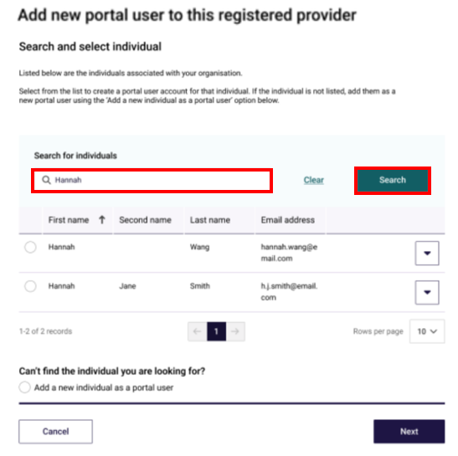
- Select the radio button for the contact record and click the Next button. Proceed to step 5.
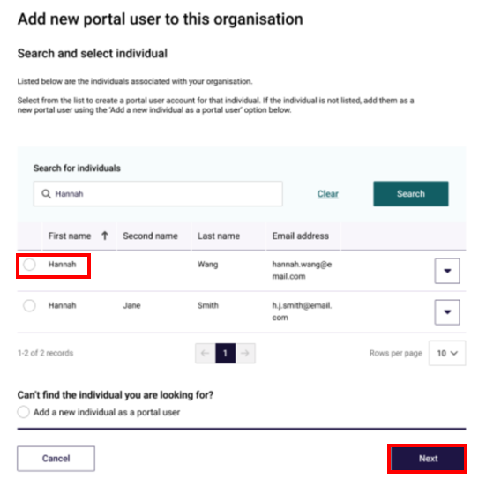
- If no contacts are found, select the Add a new individual as a portal user radio button, then click the Next button.
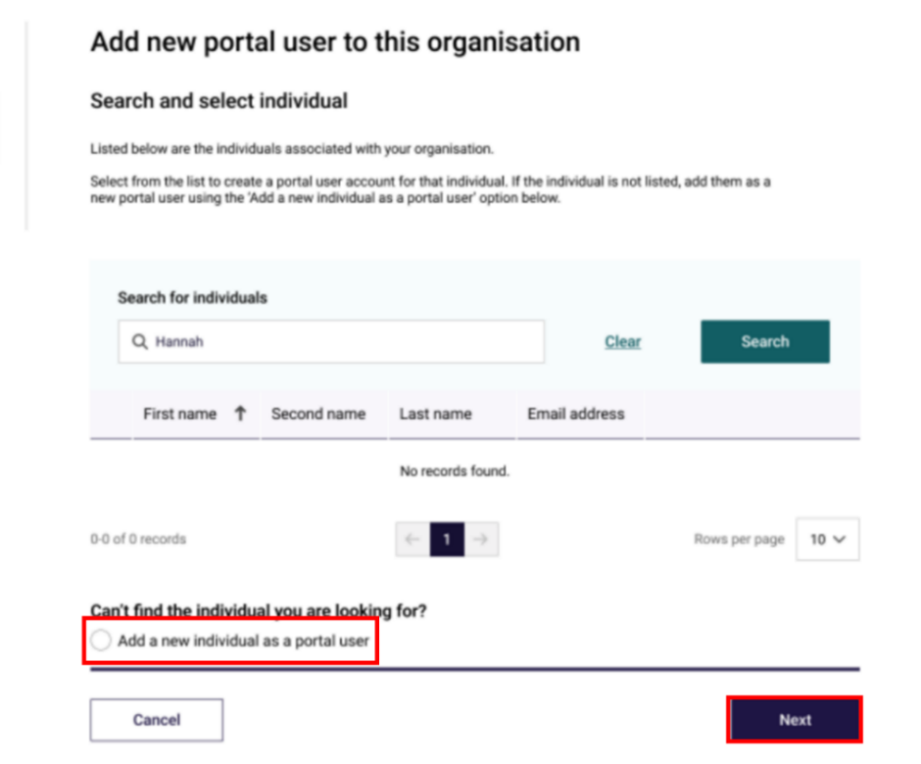
The User details screen will be displayed.
- In the User details section, enter the user’s details within the fields (if not already populated). Under User roles, select the boxes next to the access roles to be assigned to the user.
The table below lists the available user roles and descriptions:
Role | Description
Provider level user roles
Provider Staff (Registered Provider) | Can manage all contacts for their organisation.
Provider Staff (Home/Branch) | Can manage contacts for assigned Homes and Branches
RN Submission - Service | Can submit 24/7 RN reporting on behalf of their organisation.
QI Role (Service) | Can view, create and submit QI program data for assigned Program Payment Entities
Financial Reporting Submission | Can view QFR information, create and update individual QFR records, input QFR information via direct data entry and upload.
Performance reviewer (Home/Branch) | Can view Star Ratings, Quality Standards and regulatory decisions for assigned residential care homes and branches.
SSP Provider Operations User | Can input, submit and view Provider Operations information, and generate previews of provider report based on ACDW data.
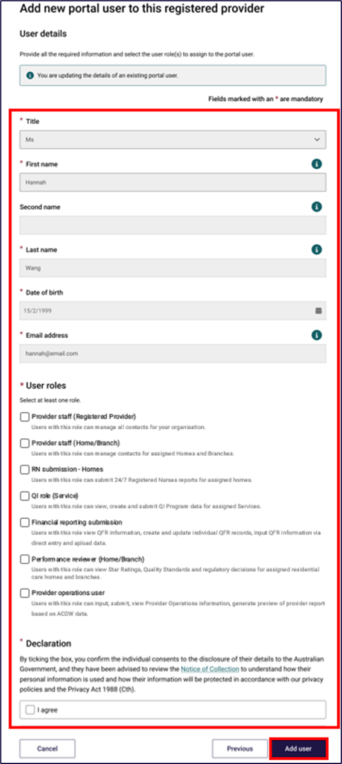
Please note:
It is important the new user’s company email address is entered correctly.
If the email address is entered incorrectly, it will prevent the user from being able to access the portal.
- Some access roles will require additional information. For example, a user with the access role of Provider staff (Home/Branch) will also list residential homes and/or branches operated by the selected provider. Check the boxes of the services the user should have access to for that specific role.
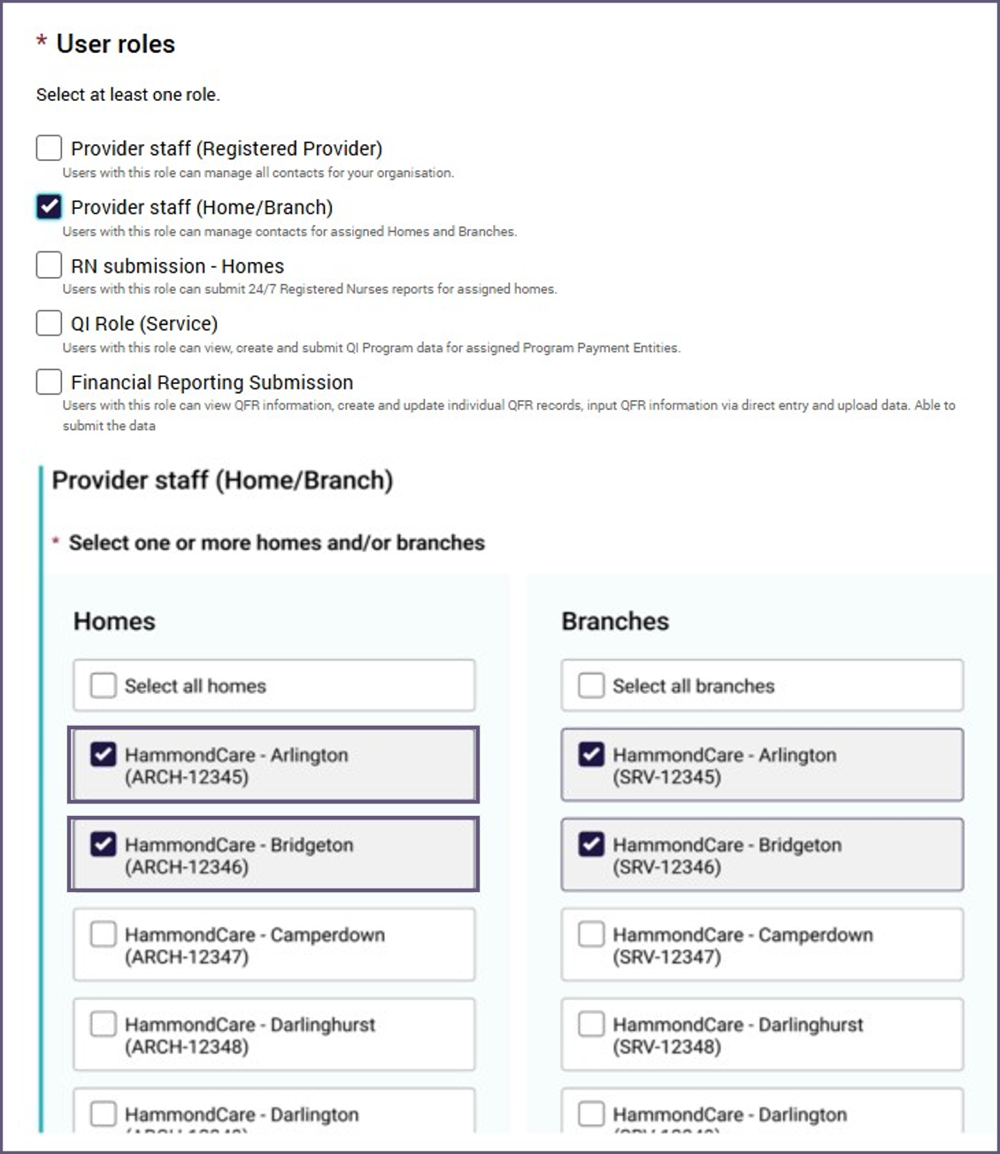
- In the Declaration section, click the I agree checkbox, then click the Add user button.
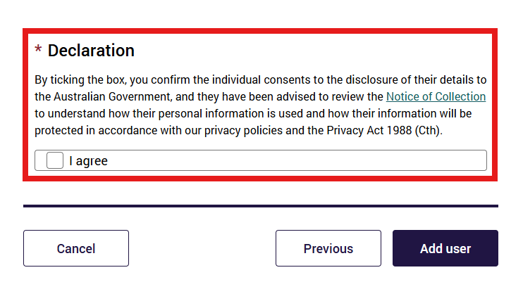
The GPMS portal will display a green banner informing that an invitation email has been sent to the new contact or portal access for the contact has been successfully updated.

Search for existing contacts
Organisation Administrators have the ability to search for existing GPMS contacts.
- In the Manage Users screen, enter the contacts email in the Search for portal users field, then click the Search button.
If the contact already exists, their profile will display within the table.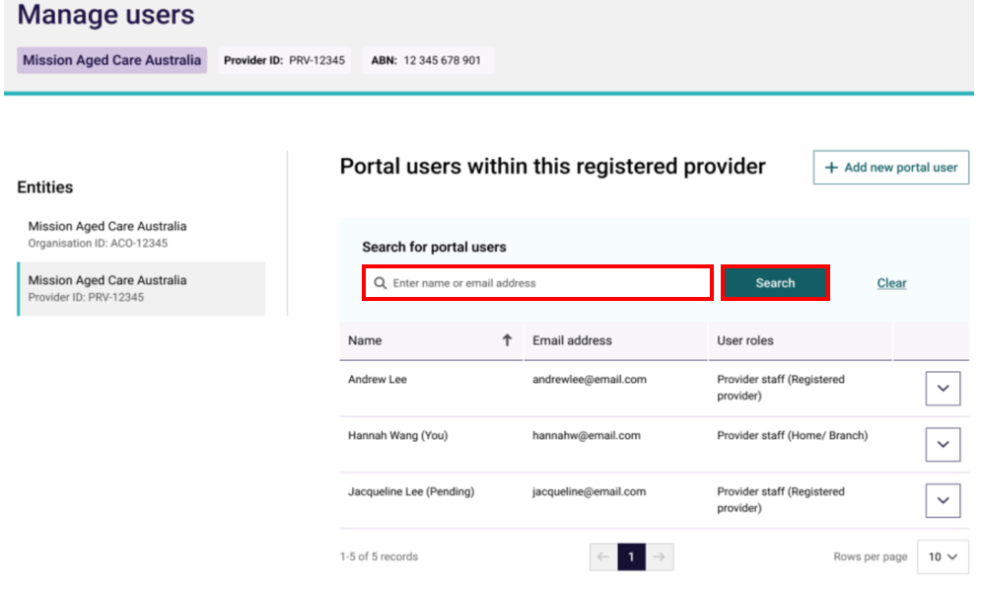

Editing or removing contact access roles
Organisation Administrators are able to edit or remove contacts’ access roles at any time.
To edit or remove access roles, complete the following steps:
- Search for the contact using the Search for portal users field, then click the down arrow on the right side of the contact record to be edited. Next, click Manage user roles.
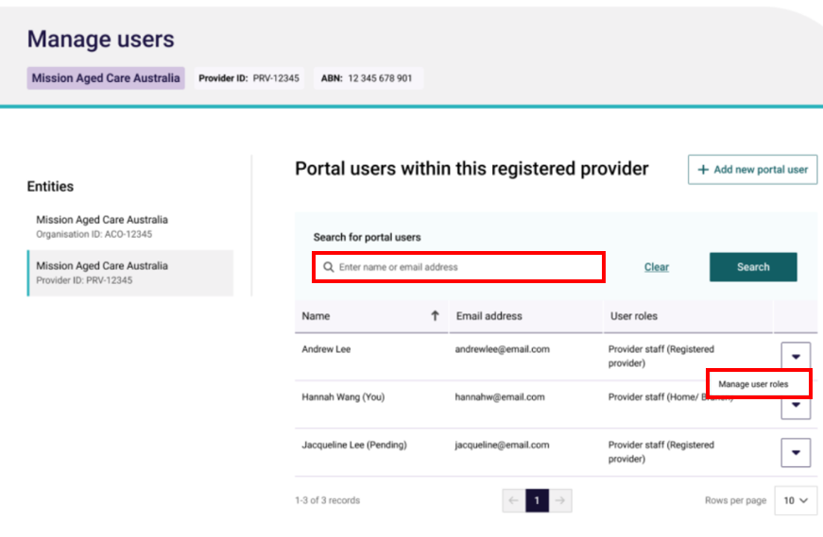
The Managing: [user name] screen will be displayed.
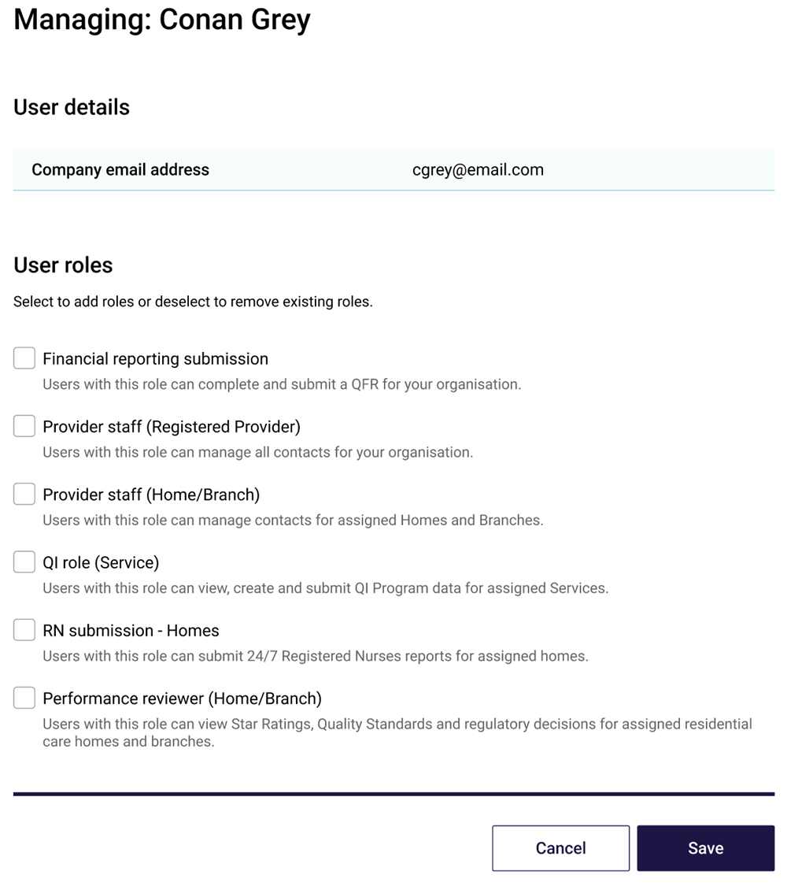
- Check or uncheck the boxes next to the user roles and/or homes and branches that require editing. This will either grant the user with additional roles or remove existing access the user previously had.
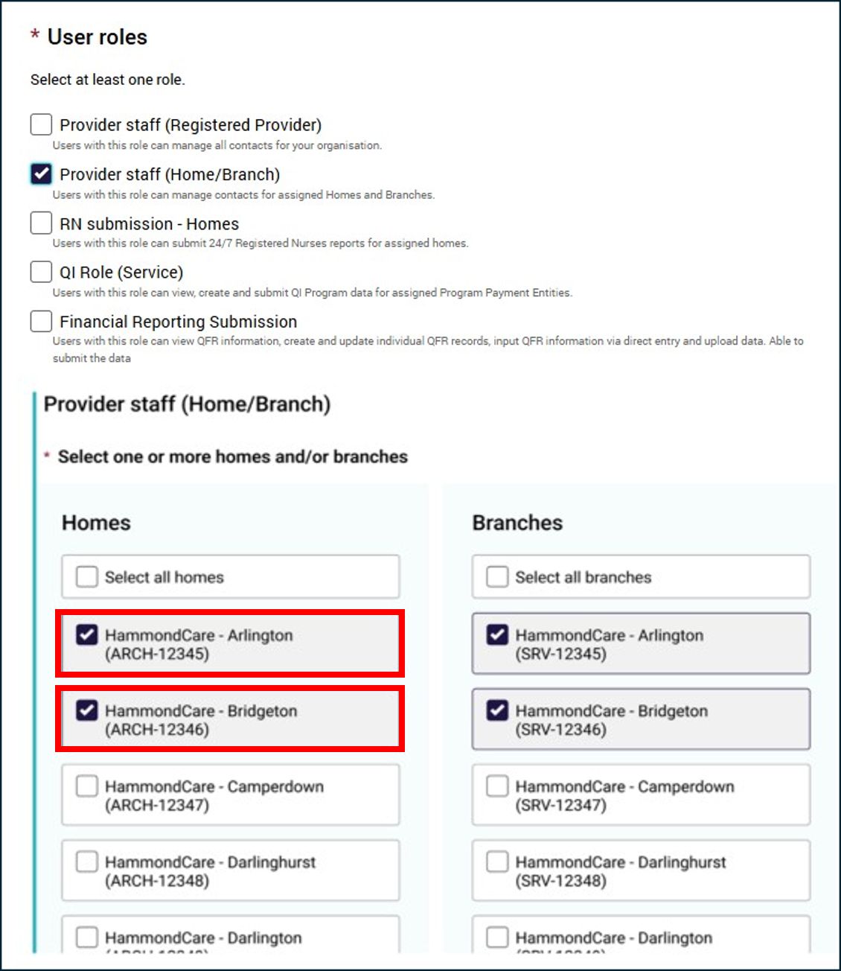
- Select the Save button.
- The modal to confirm the contact’s role update will be displayed. Click Update to confirm the contact’s role update.
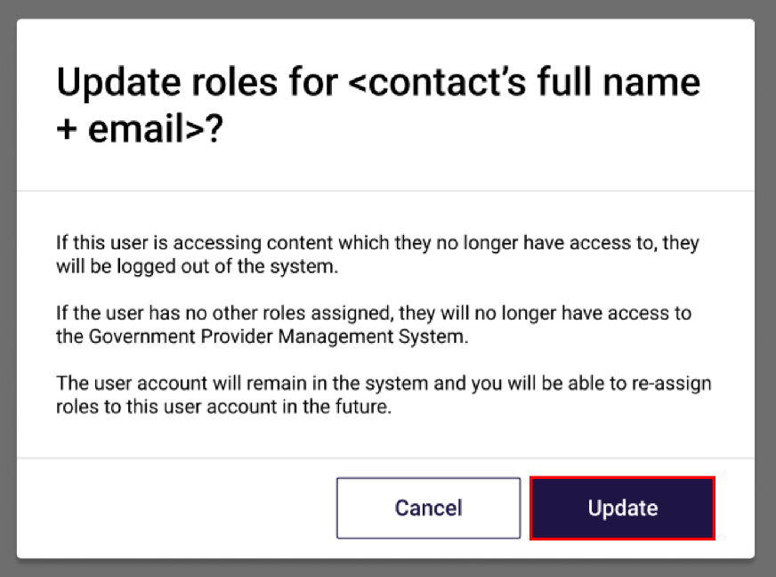
The GPMS portal will display a green banner informing that portal access for the user has been successfully updated.
An email notification will be sent to the contact with the edited roles advising a change has been made.
