Government Provider Management System – Approved Provider Portal
User Guide
March 2026
Version 5.3
This Government Provider Management System (GPMS) User Guide provides users with an overview of how to log in to the GPMS Approved Provider portal and outlines how Organisation Administrators can add, edit and remove users.

Contents
1. Introduction 3
1.1 Purpose 3
1.2 Before proceeding 3
1.3 Login to the GPMS portal 4
2. GPMS Portal Access 4
2.1 Troubleshooting myID or VANguard issues 4
2.2 Terms of use 5
3. Organisation Administrators 7
3.1 The Manage Users screen 7
3.2 Adding a new user 8
3.2.1 Adding a user at the Organisation level 9
3.2.2 Adding a user at the Provider level 11
3.3 Existing users 17
3.4 Editing access roles 17
3.5 Removing Users 19
4. Switching providers 21

Introduction
The Government Provider Management System (GPMS) is a flexible IT (Information Technology) system which is a critical part of the Aged Care Digital Transformation Initiative underway to support aged care reform through better technology.
GPMS provides greater connectivity and data sharing between aged care providers and government.

Purpose
This User Guide has been designed to support providers in understanding how to access and login to the GPMS Approved Provider portal for the first time.
It also provides an overview of the Organisation Administrator role and associated functionality, including the ability to:
- add or remove users to the Approved Provider portal; and
- edit user roles to allow users access to applications within the Approved Provider portal.

Before proceeding
Please be advised of the following:
The Department of Health, Disability and Ageing will retain records of users’ access to GPMS and, when prompted, the user must accept the GPMS Terms of Use to be able to access the system.
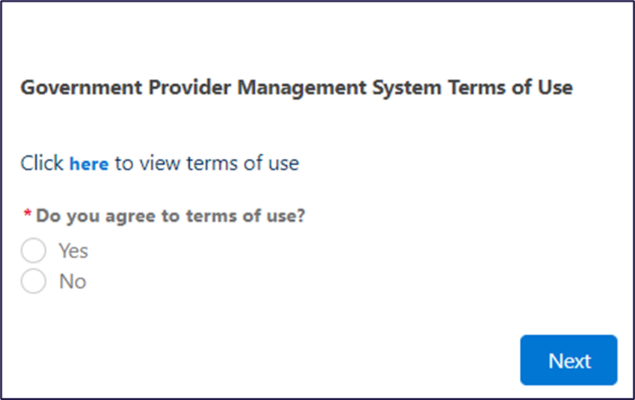

1.3 Login to the GPMS portal
To login to the GPMS Approved Provider portal, please visit the Log in to GPMS webpage.
If you require assistance with logging in to the GPMS portal, please refer to the Logging in to Aged Care Systems user guide.

GPMS Approved Provider Portal Access
Access the Approved Provider portal to view information about your Approved Provider entity, as it existed under the Aged Care Act 1997. Here you can:
- View previous information about your organisation:
  - Quality Indicator (QI) Program data
  - Provider Operations
  - Quarterly Financial Report (QFR)
To access the GPMS portal, each staff member must have a My Aged Care portal user account linked to a supported third-party authentication service.
For more information regarding setting up users and logging into the system please refer to Logging in to Aged Care Systems.

Troubleshooting myID or VANguard issues
If users encounter any issues with logging in with myID or VANguard, refer to Logging in to Aged Care Systems.
If users require further assistance to login to GPMS, please contact the My Aged Care service provider and assessor helpline on 1800 836 799, Monday to Friday (8am to 8pm) and Saturday (10am to 2pm) local time across Australia.
This helpline provides technical support and general information to registered providers, assessors, and hospital staff using and the GPMS portals.
For translating and interpreting services, call 131 450 and ask for My Aged Care on 1800 836 799.
To use the National Relay Service, visit About the National Relay Service (NRS) | Access Hub or call 1800 555 660.
To access sign language interpreting and captioning services through Deaf Connect, call 1300 773 803 or email interpreting@deafconnect.org.au.

Terms of use
When logging on for the first time users will need to agree to the Government Provider Management System - Terms of Use (Terms of Use) and enter a Verification Code.
To agree, complete the following steps:
- Click the terms of use link to read the Terms of Use.
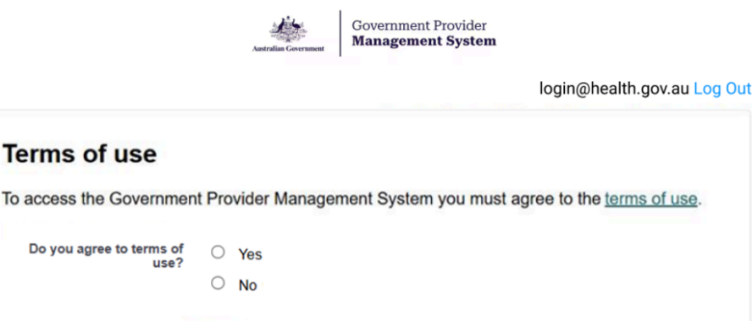
- Select the Yes radio button and then click Next.
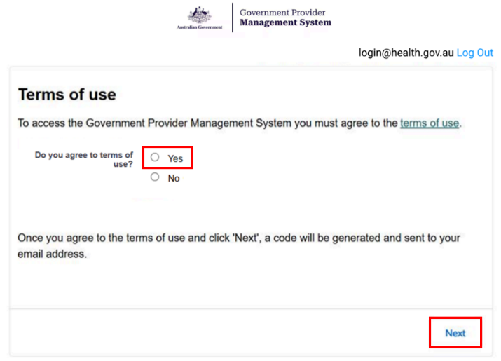
Please note:
If the user does not agree to the terms of use, selecting No will prevent access to the portal.
Once the GPMS Terms of Use have been accepted, the Enter Verification Code screen will be displayed.
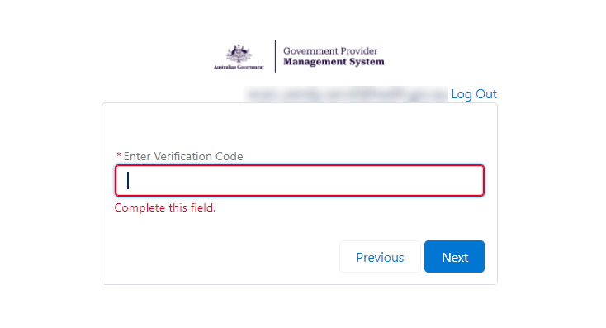
An eight-digit verification code will be sent to the user’s company email address.
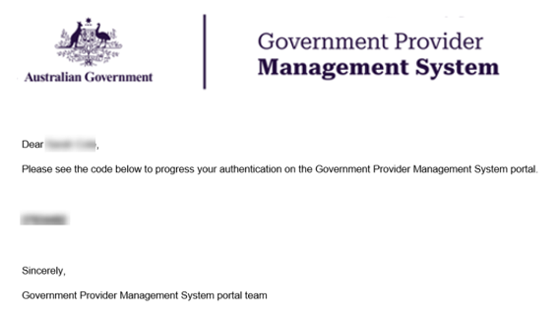
- In the Enter Verification Code field, enter the eight-digit code that the user will have received in the notification email, and click Next.
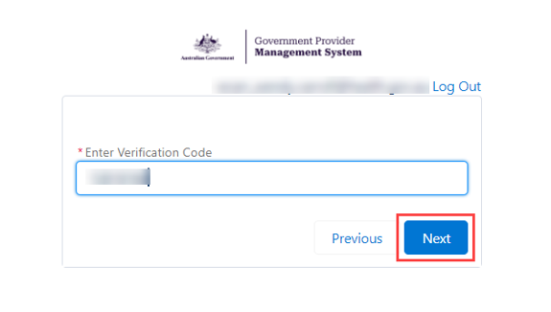
The GPMS Approved Provider portal landing page will be displayed.
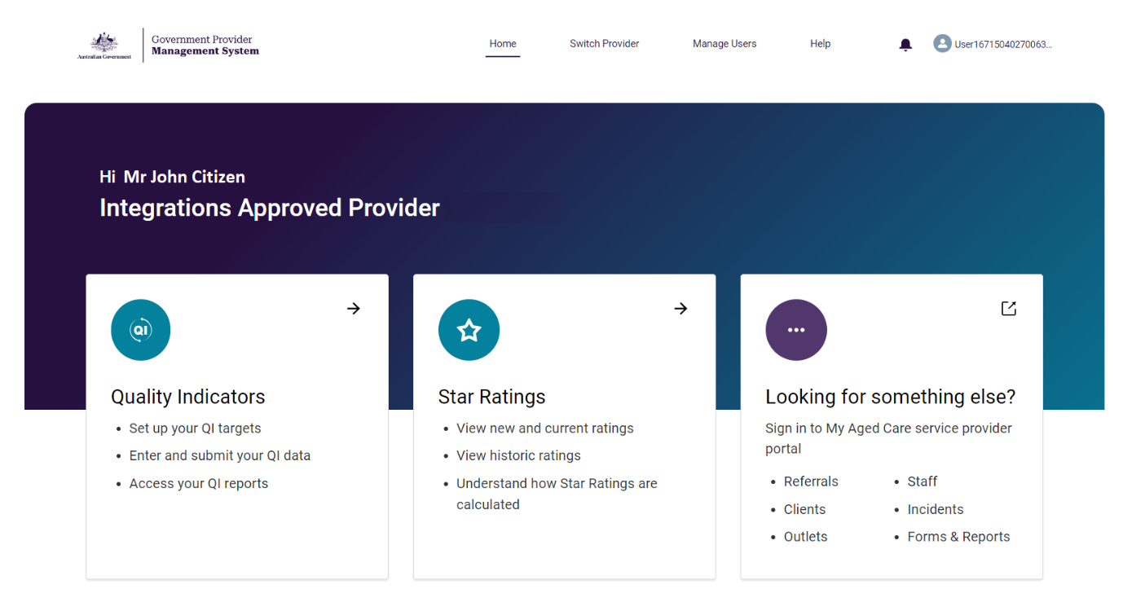

Organisation Administrators
The Organisation Administrator is nominated by the organisation as someone who can perform the following administrative functions:
- Add additional users
- Edit user access roles
- Remove users who no longer require GPMS portal access
The Organisation Administrator role in the My Aged Care system is not interchangeable with the Organisation Administrator role in the GPMS System.
If this role is not set up in GPMS Approved Provider portal for the organisation, the organisation will need to nominate an Organisation Administrator for this portal.
The following information relates to tasks that the Organisation Administrator can undertake in the GPMS Approved Provider portal.

The Manage Users screen
The Manage Users tab is where Organisation Administrators will perform administrative functions, such as adding users and editing user access roles.
Only users assigned with the “Organisation Administrator” role in the GPMS Approved Provider portal will be able to carry out these functions.
Click the Manage Users tab in the top menu on the GPMS portal landing page to access the administrative functionality.
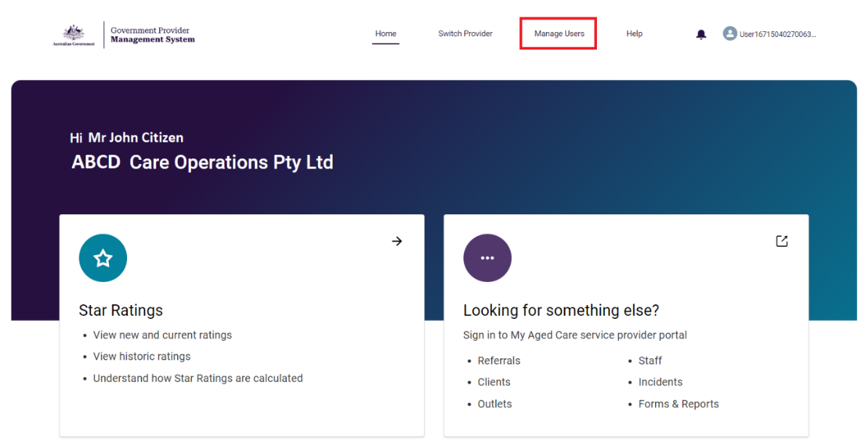
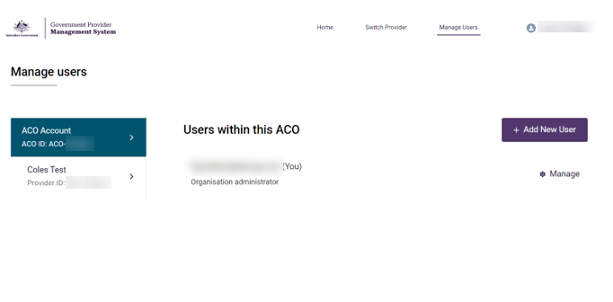
The Manage users screen will be displayed.

Adding a new user
Organisation Administrators can add new users to the GPMS portal. These users can be added either at the organisation (org) level or at the provider (service) level.
The level the new users are added to will determine what kind of access roles can be attributed to them.
Please note:
Before users login to GPMS for the first time, they must ensure they have completed the necessary steps to verify their identity in the MyID or Vanguard FAS systems in accordance with their organisation’s IT policies.
For further information please refer to: Logging in to Aged Care Systems
When adding a user as an Organisation Administrator in GPMS, it is important the user is also set up as an Organisation Administrator in the My Aged Care Service and Support Portal.
This will need to be done manually by the user in the My Aged Care Service and Support portal.

Adding a user at the organisation level
Users added at the organisation level can be given the Organisation Administrator role, in addition to other user roles that grant access to.
To add a new user at the organisation level, complete the following steps:
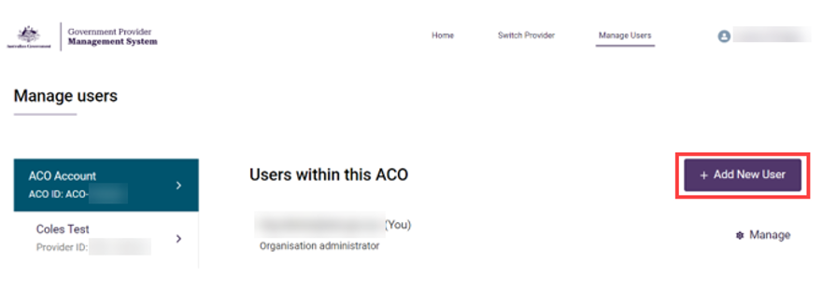
In the Manage users screen, click the + Add New User button.
The Add new ACO user screen will be displayed.
- In the User details section, enter the user’s company email address in the Email field, then click the Next button.
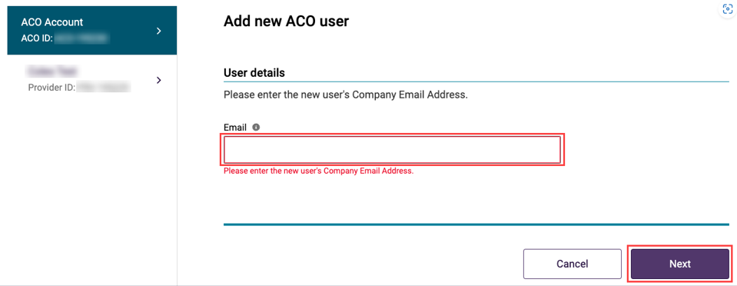
Please note:
It is important the new user’s company email address is entered correctly.
If the email address is entered incorrectly, it will prevent the user from being able to access the portal.
- In the Select user section, select the radio button option to ‘Create a new contact record’, then click the ‘Next’ button.
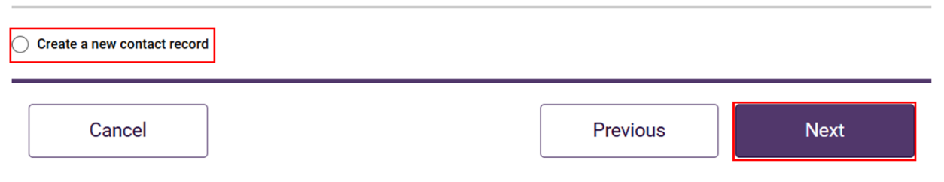
Additional fields will display to add the new user’s information.
- Add the new user’s Salutation, First name, Surname and Date of birth details.
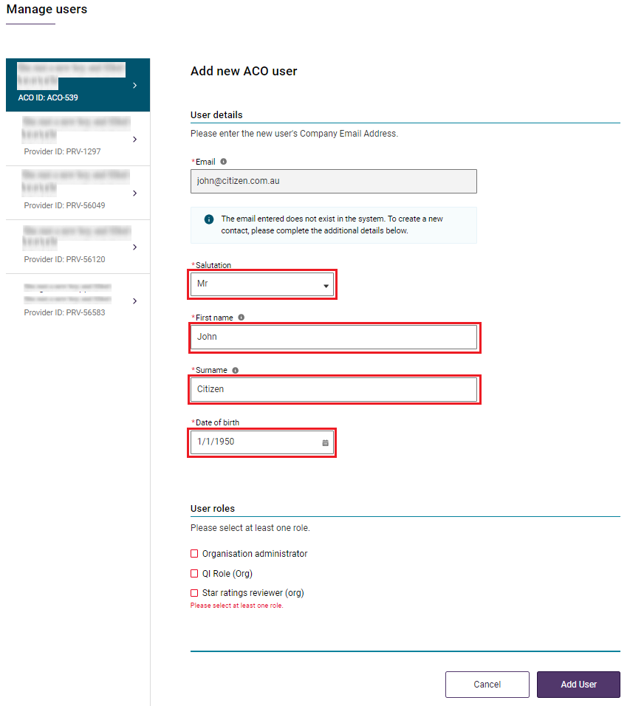
Please note:
Organisation Administrators can add, manage and remove users.
The Organisation Administrator role can only be added to users at the Organisation level.
The Organisation Administrator role does not automatically provide access to other GPMS applications on its own. The Organisation Administrator user will need to be allocated additional access roles if they require access to other GPMS applications.
Any changes performed by the Organisation Administrator in the Approved Provider portal will not be reflected in the Registered Provider portal.
- Check or uncheck the boxes next to the relevant roles to be assigned to the new user. Next, click the checkbox to confirm agreement with the declaration, and click Add User.
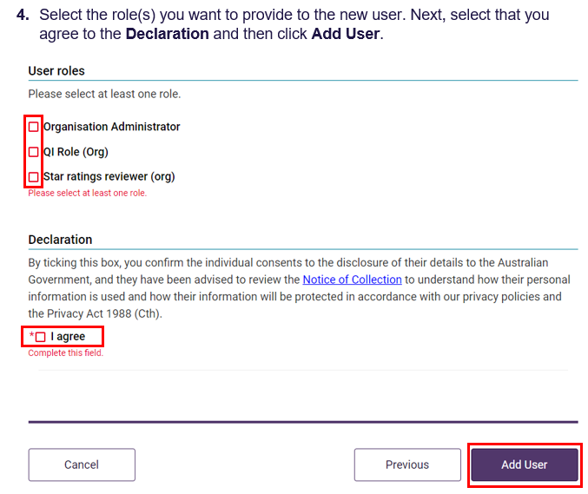
The Manage user screen will be displayed.
The GPMS portal will display a green banner informing that an invitation email has been sent to the new user.
The newly added user will have a status of (Pending).
This status will remain until the newly added user receives their notification email and selects the link to login to the GPMS portal for the first time.
Once their first login has been completed the Pending status will disappear.

Adding a user at the provider level
Organisation Administrators can give user access against a specific provider. This ensures their access is limited to those services only.
Please note:
Organisation Administrators must be allocated at the Aged Care Organisation (ACO) level. Provider level users cannot be Organisation Administrators.
To add a new user at the Provider level, complete the following steps:
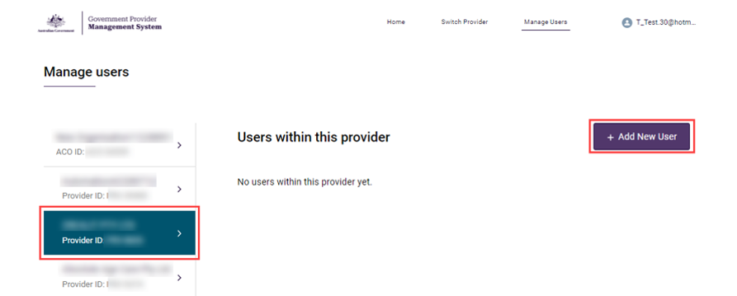
- On the Manage Users screen, select the Provider from the panel on the left that the user should be added to, then click the Add New User button.
The Add new provider user screen will be displayed.
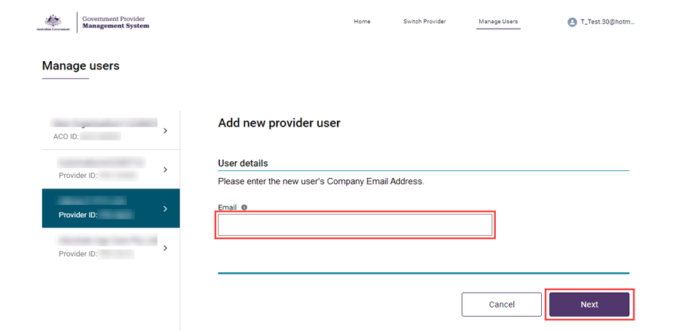
- In the User details section, enter the user’s company email address in the Email field, then click the Next button.
Please note:
It is important the new user’s company email address is entered correctly.
If the email address is entered incorrectly, it will prevent the user from being able to access the portal.
- In the Select user section, select the radio button option to ‘Create a new contact record’, then click the ‘Next’ button.
Additional fields will display to add the new user’s information.
- Enter all additional user information, then in the User roles section, check or uncheck the boxes next to the relevant user roles to be assigned to the user.
The table below lists the available user roles and descriptions:
Role | Description
Financial Reporting Submission | - Responsible for submitting the Quarterly Financial Report (QFR).  - Entering data and submitting the completed QFR.  - Ensuring compliance with financial and prudential reporting obligations under aged care legislation.  - Downloading and previewing submitted reports for record-keeping and audit purposes
QI Role (Service) | - Can submit Quality Indicator Program (QI Program) reports on behalf of the residential aged care services that they have been associated with.  - Submitting and updating quarterly QI Program data  - Setting quality indicator targets.  - Viewing submission status and error messages.  - Viewing historical trends QI Program data via QI Reporting Dashboards.
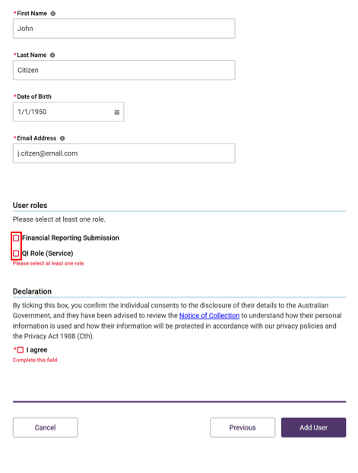
Some access roles will require additional information. For example, a user with the access role of Star ratings reviewer (service) will also list residential services operated by the selected provider.
- Check or uncheck the boxes next to the relevant roles to be assigned to the new user. Next, click the checkbox to confirm agreement with the declaration, and click Add User.
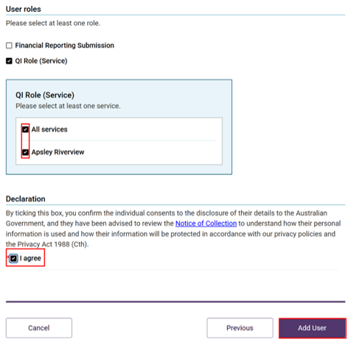
The Manage users screen will be displayed again and the GPMS portal will display a green banner informing that an invitation email has been sent to the new user.

Existing users
If an email address is entered for a user who has already been added to the GPMS Approved Provider portal, the following message will be displayed:
User roles for this email already exist at this level in your organisation. Go back to the previous page to manage this user or add another email.
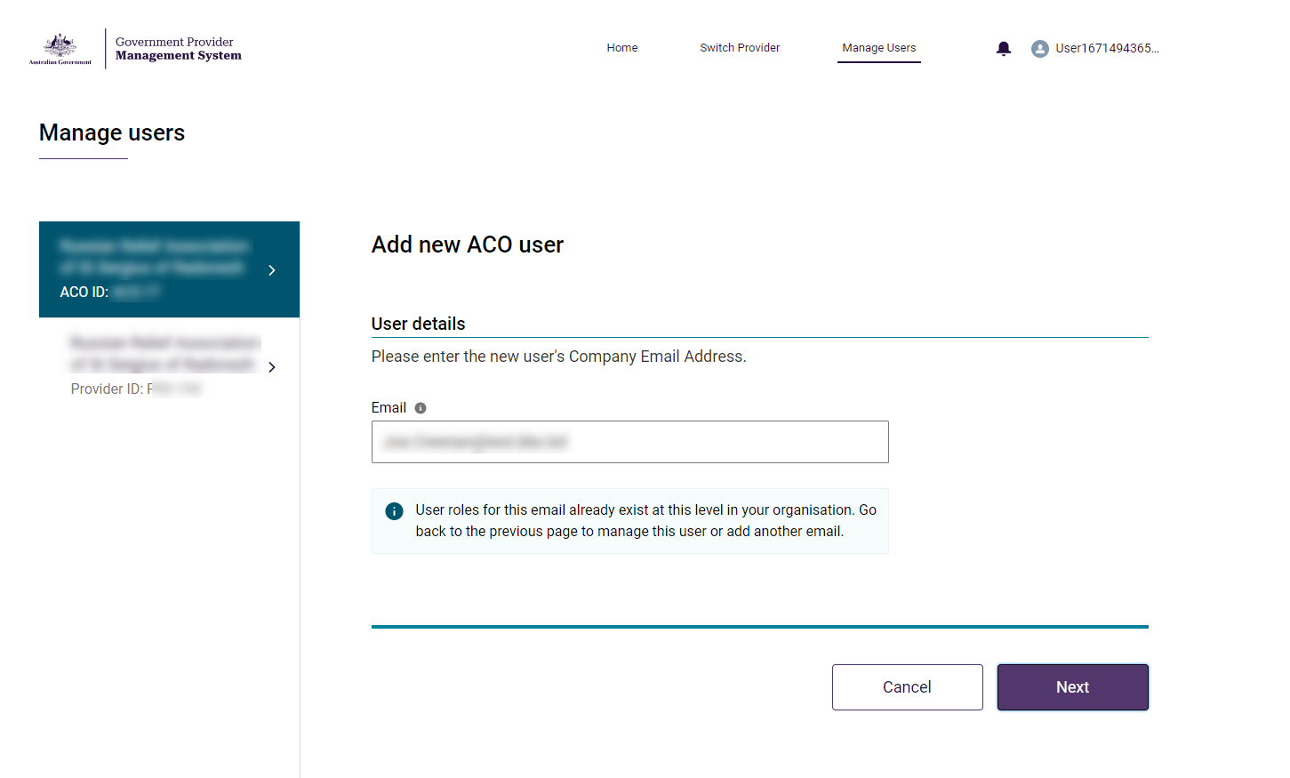
In the case that the user already exists, the user’s profile will need to be located and their access roles edited instead.

Editing access roles
Organisation Administrators have the ability to edit user’s access roles at any time.
This process to edit access roles is the same for users at both the Organisation level and the Provider level.
To edit access roles, Organisation Administrator users must complete the following steps:
- Locate the user whose access needs to be edited, then click the Manage button on their user record.
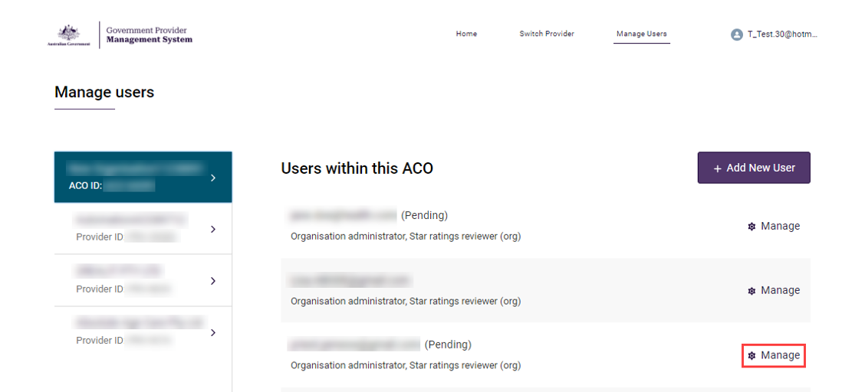
The Managing: [user name] screen will be displayed.
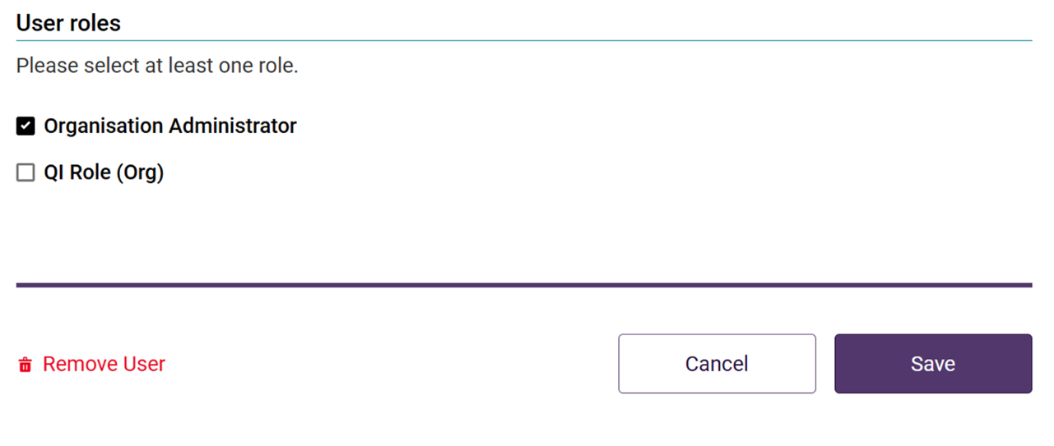
- Scroll down to the User roles section, then check or uncheck the relevant boxes next to each of the roles to be added and/or removed.
- Click the Save button.
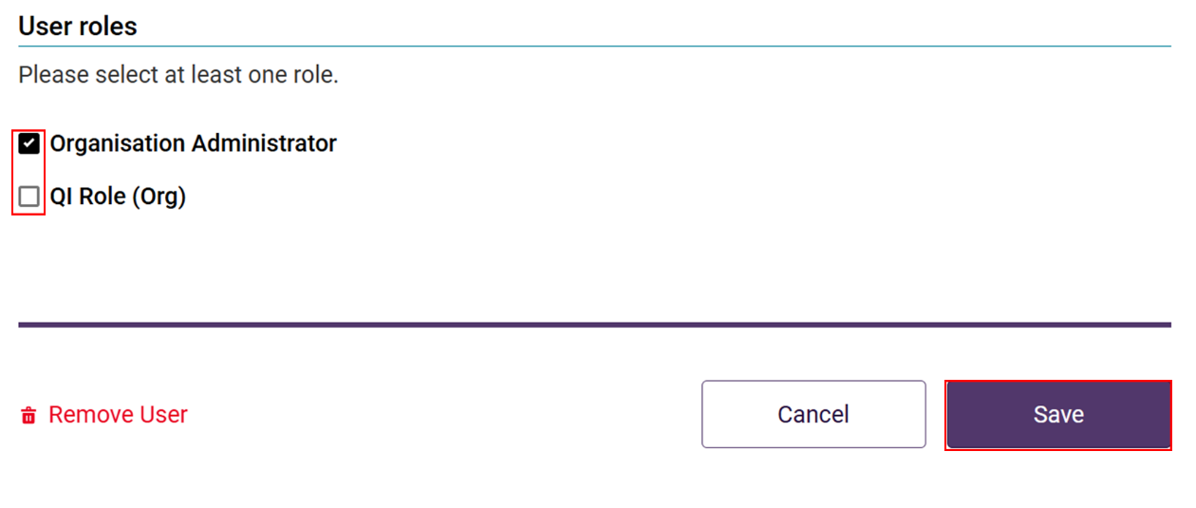
The Manage users screen will be displayed again. An updated list of roles will now be displayed underneath the edited user.
An email notification will be sent to the user with the edited roles advising a change has been made.
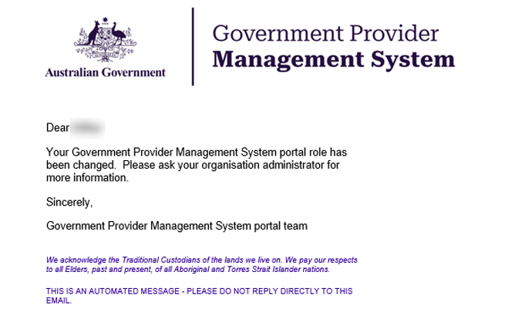

Removing Users
Organisation Administrator users can remove users from the GPMS Approved Provider portal. Removing a user removes their ability to access the GPMS portal
Please note:
The user’s account details and action history will be retained in system audit history.
To remove a user, complete the following steps:
- Locate the user to be removed, then click the Manage link on their user record.
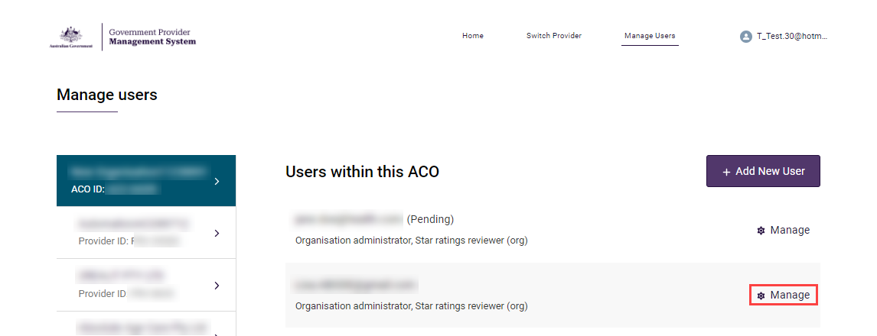
The Managing: [user name] screen will be displayed.
Please note:
Provider users will appear under the Service/Provider they have been granted access to in their user roles.
The Provider can be selected from the panel on the left side of the screen.
- On the Managing: [user name] screen, scroll down to the bottom, then click the Remove User link.
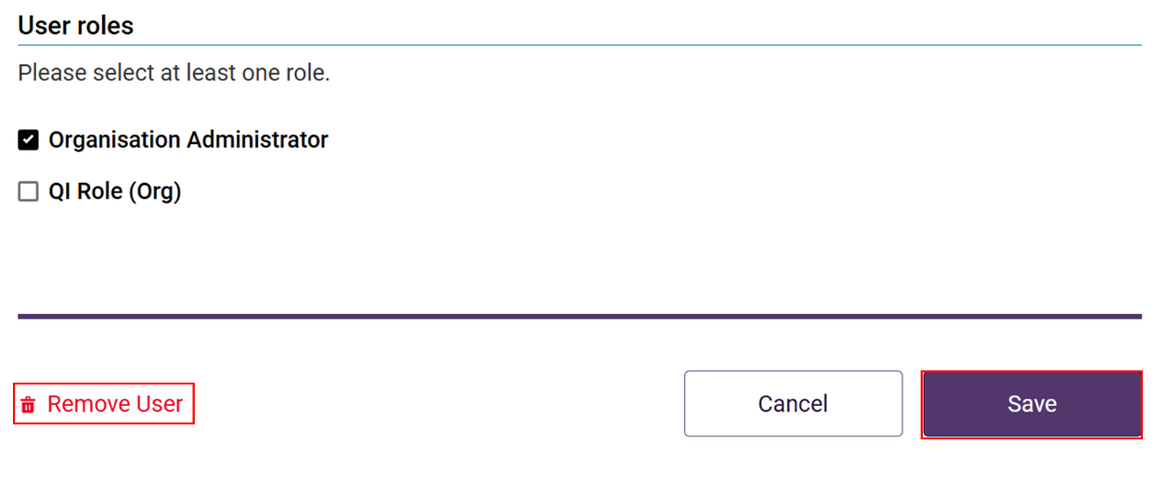
A pop-up will be displayed to confirm whether the user should removed and to inform that the action cannot be undone.
- Click the Remove button to confirm the action to remove the user.
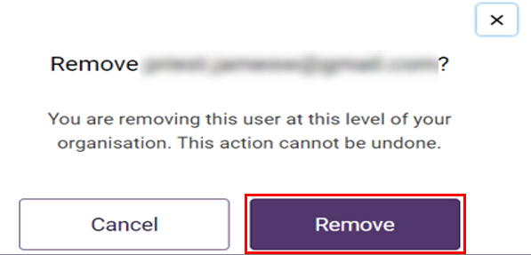
The Manage users screen will display.
The user will no longer be listed against that provider.

Switching providers
To standardise user security and authentication across GPMS, from 1 November 2025 providers will be required to have a unique email when accessing GPMS on behalf of an organisation.
The department completed a review of user access and as part of this review, identified users who had one email address linked to multiple organisation accounts. These users were contacted by the department and advised of the steps required to undertake to establish a unique account for each organisation they access in GPMS.
This included arranging for new GPMS accounts to be set up in GPMS for each organisation.
To switch between organisations, users are required to log out of GPMS then log in using the details for the organisation they wish to access.

