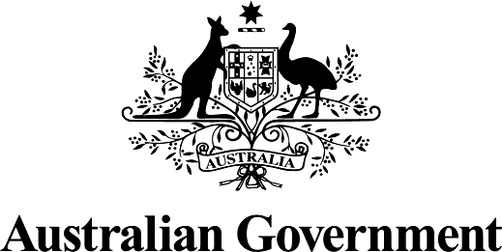

Australian Government response to the House of Representatives Standing Committee on Health, Aged Care and Sport Report: Issues Paper relating to the health impacts of alcohol and other drugs in Australia
MARCH 2026

The Australian Government thanks the House of Representatives Standing Committee on Health, Aged Care and Sport (the Committee) for its work to conduct a wide-ranging Inquiry into the health impacts of alcohol and other drugs in Australia. Australia faces growing health and social harms from alcohol and drug use, highlighting the need for a more coordinated, health-focused approach that addresses stigma, service gaps, and the needs of priority populations through prevention, treatment and harm reduction.
The Government provides the following response to the Committee’s recommendations contained in the Issues Paper:

Recommendation 1
6.11 The Committee suggests that the successive Standing Committee on Health, Aged Care and Sport (or equivalent) in the 48th Parliament consider completing a full inquiry report into the health impacts of alcohol and other drugs in Australia.
The Australian Government notes this recommendation.

Recommendation 2
6.12 The Committee recommends that the Department of Health and Aged Care consider public submissions and evidence received by this inquiry as it prepares advice to Government on revisions to the National Drug Strategy.
The Australian Government agrees to this recommendation.
The Department of Health, Disability and Ageing (formerly known as Department of Health and Aged Care) agrees to consider public submissions and evidence received by the Inquiry into the health impacts of alcohol and other drugs (AOD) in Australia when providing advice to government on the National Drug Strategy (NDS).
The department notes that the NDS is a whole-of-government document with shared responsibility between health and law enforcement agencies, across Australian, state and territory governments and that questions about future iterations of the NDS are yet to be tested with all governments and relevant agencies.
In addition, it is important that any advice aligns with the Government’s commitments under the National Agreement on Closing the Gap. First Nations people experience a disproportionately higher burden of harm from AOD compared to other Australians due to complex factors including intergenerational trauma, social disadvantage, and limited access to culturally appropriate services.

