24/7 Registered Nurse Requirement in the Multi-Purpose Service Program (MPSP)
REPORTING GUIDE
March 2026 Version 1.3
This Guide provides multi-purpose services (MPS) with information regarding the extension of the 24/7 RN trial to 30 June 2026 and reporting requirements to support the trial.

Contents
1 Contents 2
2 Introduction 3
2.1 Purpose 3
3 Further information and support 3
4 MPSP 24/7 RN requirement – Reporting 3
4.1 Overview of reporting for the trial 3
4.2 Important information 4
4.3 Completing the 24/7 RN report 4
4.4 Submitting the MPSP 24/7 RN trial report 7

Introduction
From 1 July 2023, registered providers of mainstream residential aged care must have at least one RN on site and on duty at each residential aged care home they operate 24 hours a day, 7 days a week. This will provide residents with better access to clinical care in facilities and improve resident safety.
The 24/7 RN requirement was introduced to MPSP on a trial basis from 1 July 2024. The trial was phased with limited MPS trial sites participating in phase 1. Phase 2 ran from 1 January 2025 to 30 June 2025 and included all MPS sites.
Formal implementation of the 24/7 RN requirement in MPSP was originally scheduled to occur on 1 July 2025. This was postponed until 1 July 2026 to allow essential IT works to be undertaken facilitating reporting online via GPMS.
It was agreed to extend the trial until 30 June 2026 with all MPS to continue to submit reports via the supplied reporting spreadsheet for the months of September 2025 and February and April 2026.

Purpose
This User Guide has been designed to support MPSP providers participating in the 24/7 RN trial to:
- access the 24/7 RN report spreadsheet when required
- complete a 24/7 RN report when required
- submit a 24/7 RN report when required

Further information and support
If you need to re-submit a report because it was submitted incorrectly or are unable to complete a report due to exceptional circumstances, please contact mpsreforms@health.gov.au.

MPSP 24/7 RN requirement – Reporting

Overview of reporting for the trial
24/7 RN reporting is to be completed using the MPS 24/7 RN trial Excel spreadsheet and submitted to MPSReforms@health.gov.au. This spreadsheet will allow MPS to report on how they are meeting the 24/7 RN requirement during the reporting period.
Phase 2 involve 3 reporting periods namely:
- September 2025
- February 2026 and
- April 2026.
Consistent with current mainstream 24/7 reporting reports are expected to be submitted within 7 days of the end of the relevant reporting period.

Important information
- It is up to your MPS whether you choose to complete the report in ‘real time’ or whether you complete at the end of the reporting month.
- You can add entries at any time during the month. However, you should not submit the report until after the end of the reporting month.
- You have between the 1st and 7th of the following month to submit the report.
- If you have any overdue reports, you should submit them prior to the submission of the current report.

Completing the 24/7 RN report
Open the MPSP 24/7 RN trial reporting spreadsheet, ensuring you have opened the appropriate workbook for the month you are reporting against.
Steps | Description
- Site Information  Enter relevant information about the service and who is completing the report. | 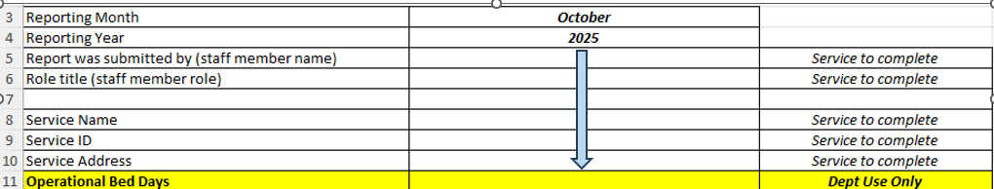
- RN on site and on-duty  For each day of the month indicate whether your service had an RN on site and on-duty for the entire day (being a 24 hour period).  Note: YES, has been prepopulated. You must change this to NO if you did not have an RN on site and on-duty for the full day. | 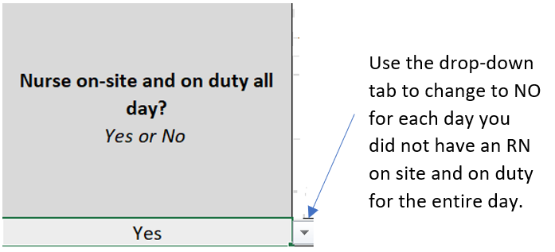
On site - Under current policy settings, a MPS is treated as a single residential care home for regulatory and reporting purposes, regardless of the number or location of buildings through which care is delivered.
On-duty - Under current policy, on duty means the RN must be available to provide care to care recipients and oversight of the care provided by other care staff as needed
For more information refer to the MPSP 24-7 RN Trial Policy Guidelines.
If you answered ‘YES’ for every day of the month you may proceed directly to submitting the Report – refer to Section 3.2
If you answered ‘NO’ for any day, please complete the remaining steps.
- Time Period  For each day that you did not have at least one RN on site and on-duty for 30 minutes or more you must complete the time period of the absences.  The time must be entered in 24 hour time format. | 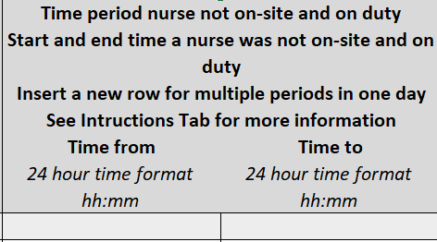
- Absence  For each day that you recorded NO, use the drop-down tab to indicate whether the absence was planned or unplanned. | 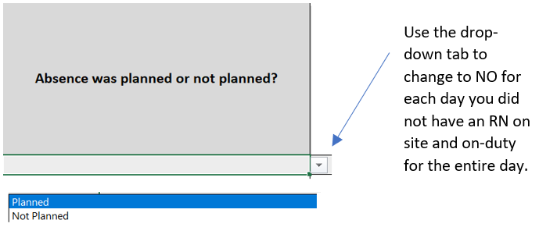
- Delegated responsibility  For each day that you recorded NO, identify who had delegated responsibility during the RNs absence. | 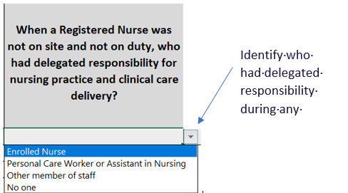
- Support for person with delegated responsibilty  Identify who the person with delegated responsility had access to support them during the time they were responsible.  Select the highest ranked option if more than one. | 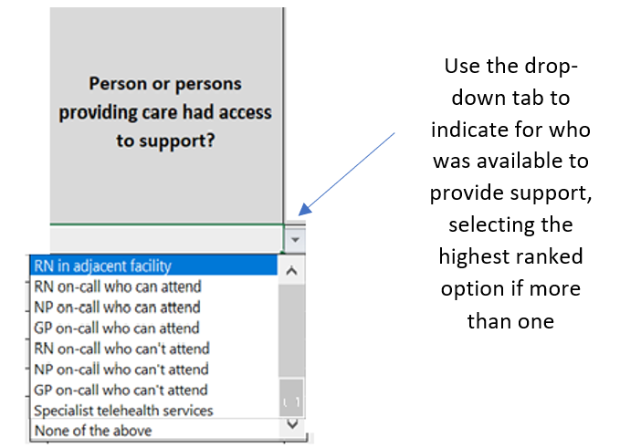
- Access to clinical records  If a person was providing on-call support, identify whether they had access to the resident’s clinical records | 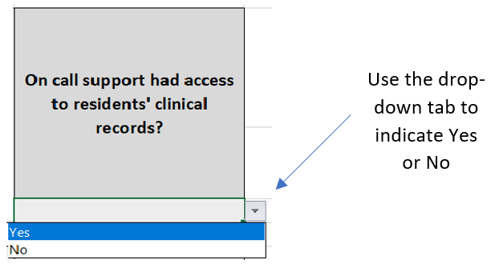
- Alternative arrangements  During the reporting month indicate whether you had alternative arrangements in the absence of an RN including transfer to local facility (including by ambulance) | 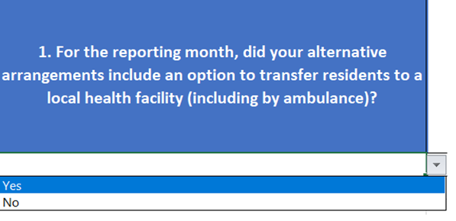
If you answered ‘NO’ proceed to Step 10 (Question 2a in the worksheet)
If you answered ‘YES’ continue.
- Local health facility  Identify what local health facilities your MPS had as an option to transfer residents to.  Note: where more than one alternative arrangement applies choose the alternative arrangement you consider to be the most important | 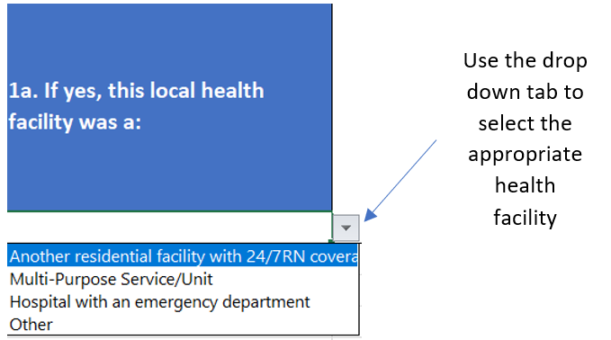
If you answered ‘OTHER’ please identify what the other local health facility was by entering text in Q1a.
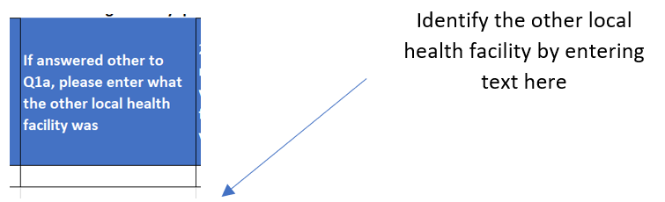
- Recruitment  For the reporting month indicate whether you were actively recruiting to fill the RN vacancy (Q2a in the worksheet) | 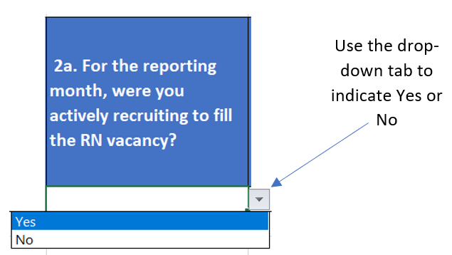
- Filling vacancy  If you answered ‘NO’ to Step 10 (Question 2a) please indicate whether you were able to fil the vacancy. | 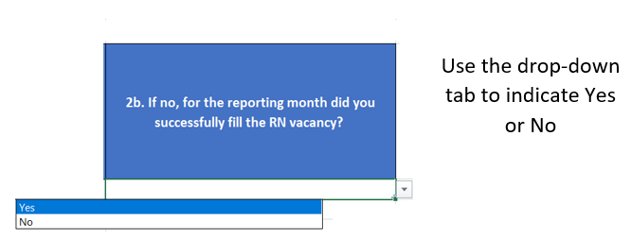
Note:
- For recording multiple periods where a nurse was not on site and on duty:
- for the relevant date, right click the row number and select insert
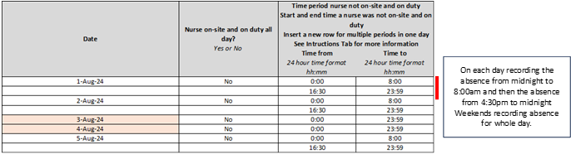insert new information into the new row including the date (see below example).
- To delete a row - for the relevant date, right-click the row number and then select Delete.
Guidance on what is considered to be on site and on duty, including a number of examples, is contained in the 24/7 Registered Nurse Requirement: Policy guidelines for MPS sites.

Submitting the MPSP 24/7 RN trial report
Within the 7 days following the end of the reporting period, send a copy of the 24/7 RN reporting template to mpsreforms@health.gov.au.
Please use the following Subject Line: MPSP 24/7 RN Trial – [Name of MPS]

