Thriving Kids

Advisory Group Report

Summary

Part 1
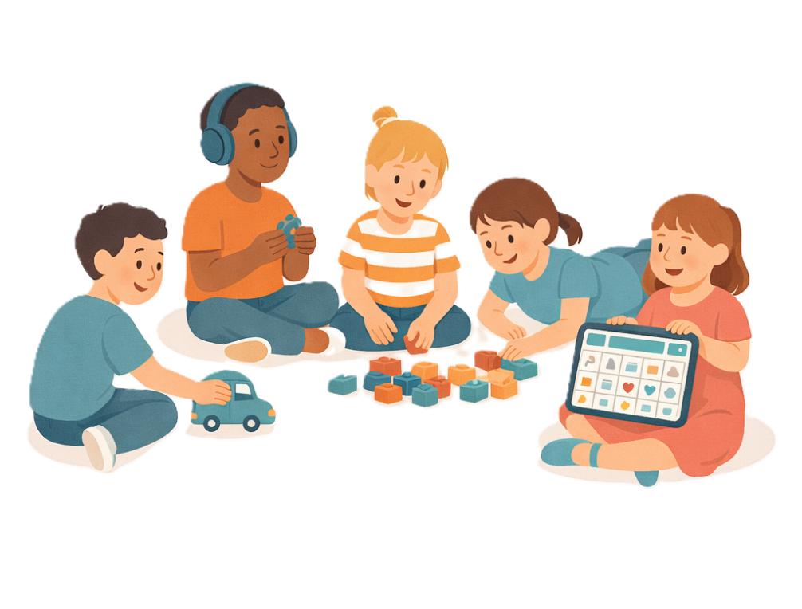
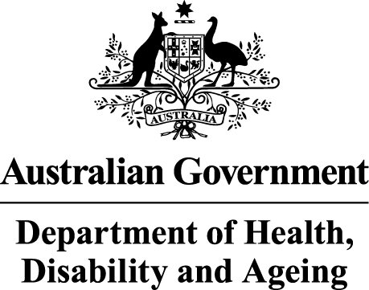 | The Australian Government Department of Health Disability and Ageing wrote this.  We say DHDA for short.  When you see the word we it means DHDA.
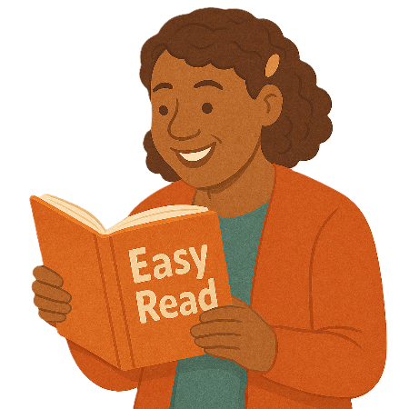 | We wrote this in an easy to read way.  We use pictures to explain some ideas.
 | We have some words in bold.  This means the letters are thicker and darker.  These are important words.
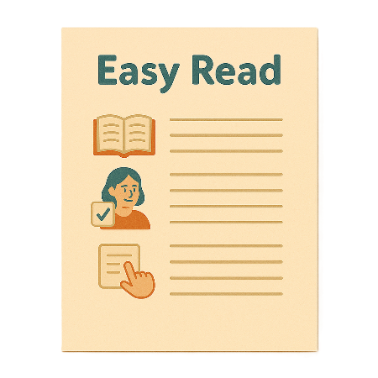 | This is an Easy Read summary of another document.  This means it has the most important ideas.
 | We can answer any questions by email.  Email us  thrivingkidssecretariat@health.gov.au
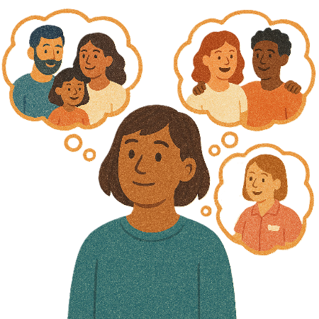 | You can ask for help to read this document.  You can ask  - A friend  - Family members  - A support person.
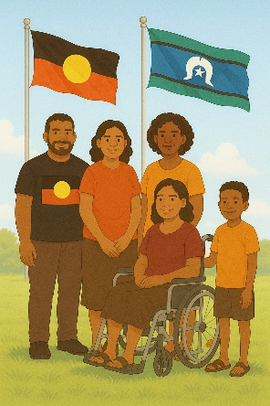 | We recognise Aboriginal and Torres Strait Islander people as the Traditional Owners of the land we live on.
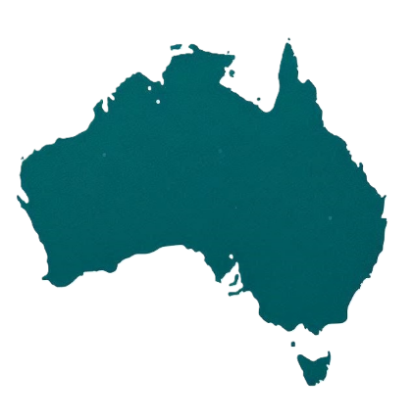 | They were the first people to live on and use the  - Land  - Waters.

Contents

About this document | 5
Why we need Thriving Kids | 9
Funding for Thriving Kids | 14
Advisory Group | 16
Recommendations | 22
Contact us | 24

About this document

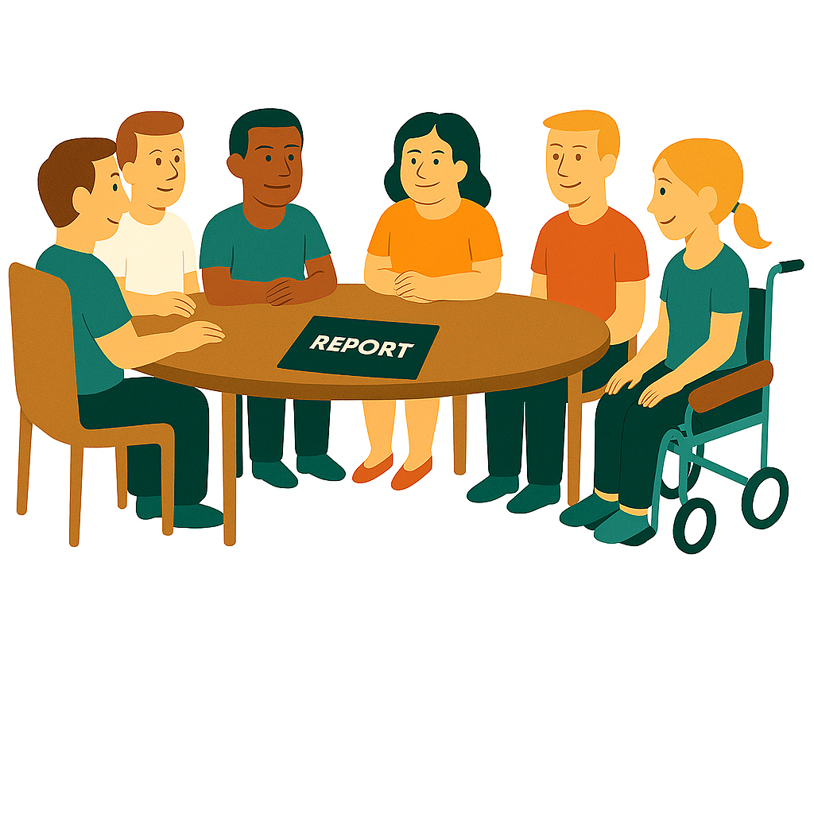 | This is a summary of the Thriving Kids Advisory Group report.  We call them the Advisory Group for short.
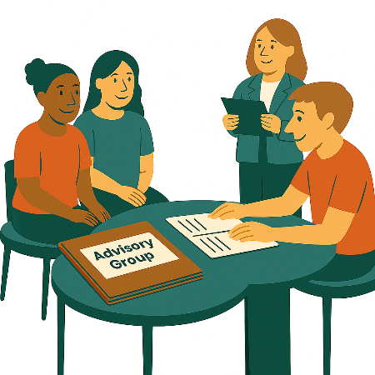 | An advisory group is a group of people who  - Share their expertise  - Go to meetings  - Help make decisions.  Expertise is knowing a lot about something.
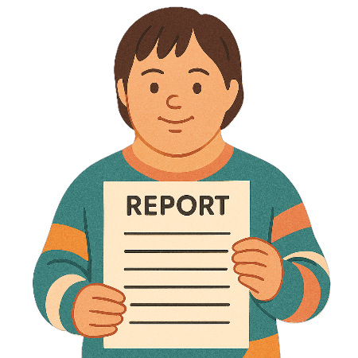 | The Advisory Group wrote a report about Thriving Kids.
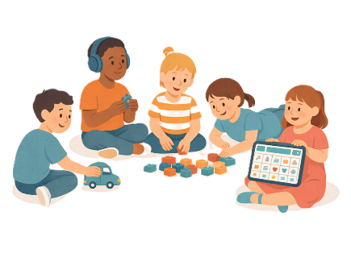 | Thriving Kids  - Are new supports  - Will be different to the NDIS.  It will support children who  - Are 8 years old and younger  - Have developmental delays  - Have autism  - Need some support.  It will also support families and carers.
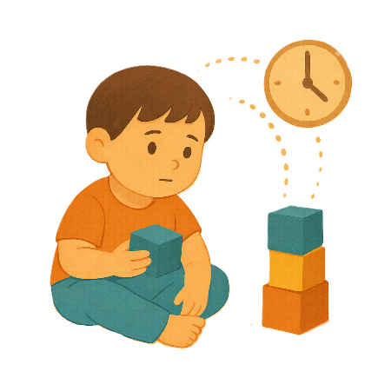 | Developmental delays are when  - Someone might be slower to develop than other people their age.  Develop means learning how to do things.  They might need extra help with  - Talking  - Moving  - Their emotions.
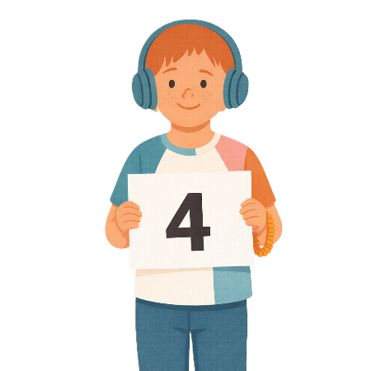 | This document is split into 4 parts.
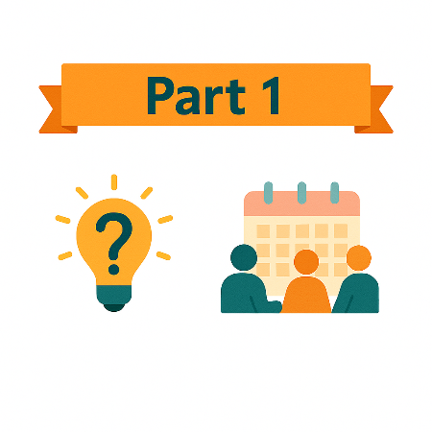 | Part 1 talks about  - Why we need Thriving Kids  - The Advisory Group.
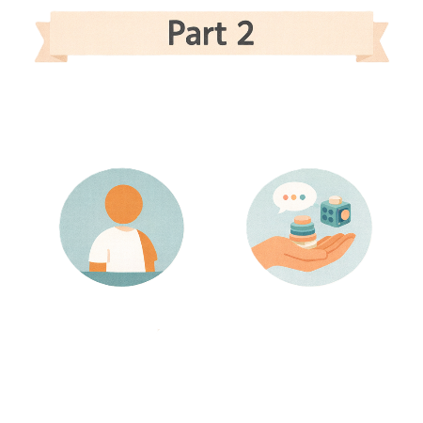 | Part 2 talks about  - Who Thriving Kids is for  - Knowing when children need support.
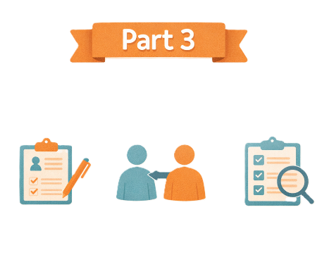 | Part 3 talks about  - Different kinds of Thriving Kids supports.
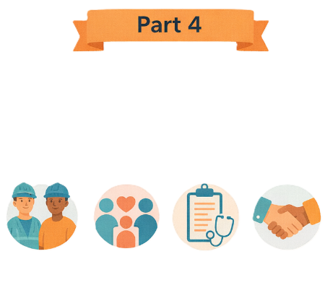 | Part 4 talks about  - Key workers  - Important community groups  - Other things that will work to help Thriving Kids.
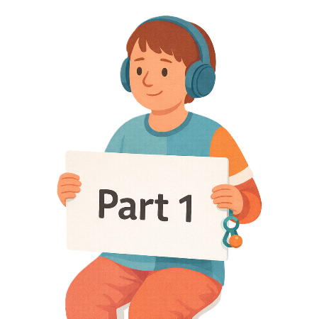 | This is Part 1.

Why we need Thriving Kids

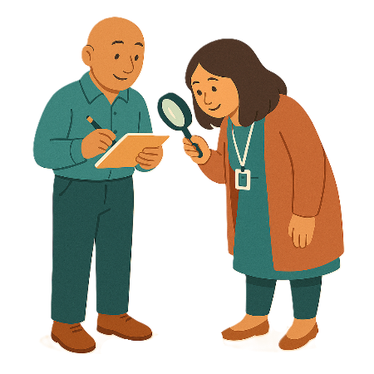 | The government did a review of the NDIS.  A review is when you check what  - Works  - Needs to change.
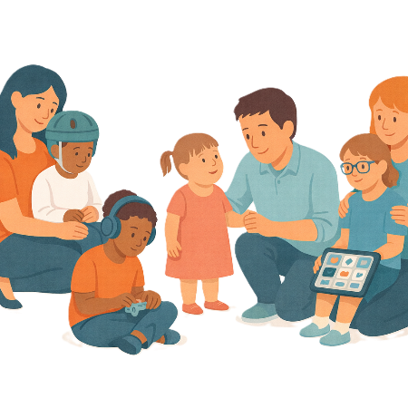 | The review found that some  - Children  - Families  Need support sooner than they can get at the moment.
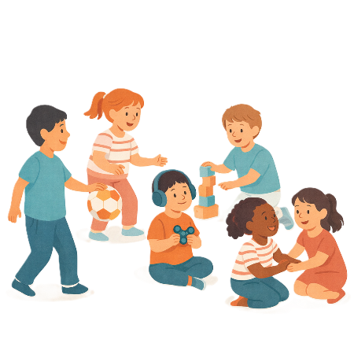 | The review found that some children need support.  But they do not need the support of the NDIS.
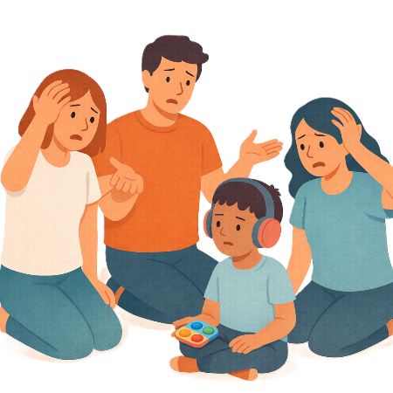 | Families looking for supports now can find it  - Confusing
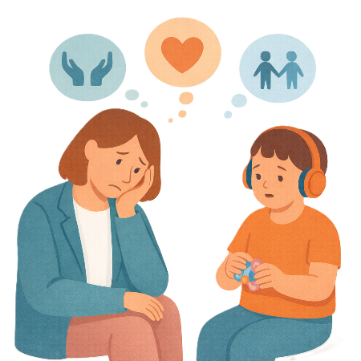 | - Hard to get
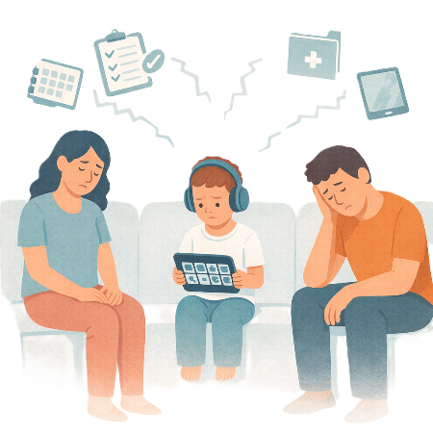 | - Services do not work well together.
 | The review gave recommendations.  Recommendations are ideas to do things better.
 | Some of the recommendations were  - For the government to have more mainstream supports
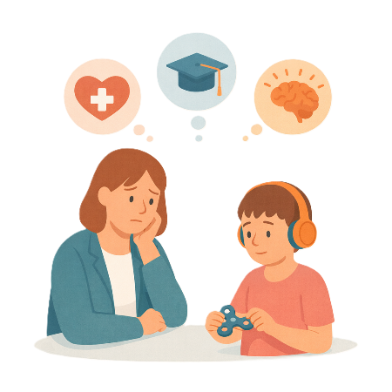 | Mainstream supports are other supports you get from government services like  - Health  - Education  - Mental health services.  Mainstream supports are supports everyone can access.
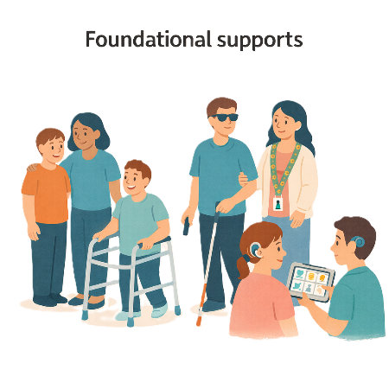 | - Making Foundational Supports  Foundational Supports are supports that are for all people with disability.  It is not part of the NDIS.  These would be new supports.
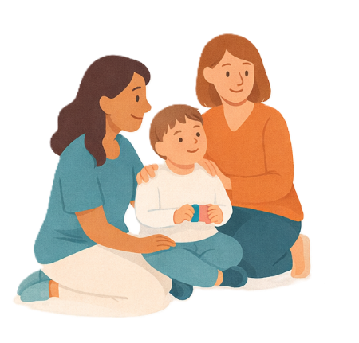 | - Making it easier for children and families to get support.
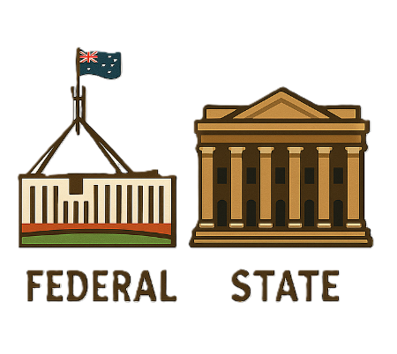 | Governments agreed to work together on Foundational Supports in December 2023.  This includes  - The Australian Government  - All state and territory governments
They have been working on supports for children who

- Are 8 years old and younger
- Have a developmental delays
- Have autism
- Need some support.
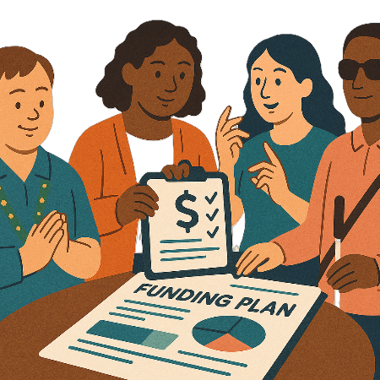 | Governments will work together to give funding for Thriving Kids.  Funding is money from the government to provide services.

Funding for Thriving Kids

 | The Australian Government will give money for Thriving Kids.  State and territory governments would give the same amount.  This money will be used to fund more services.
 | The  - Australian Government  - State and territory governments  Will all be responsible for Thriving Kids.  Being responsible means the things that you need to do.
 | This means they will all  - Give funding for Thriving Kids
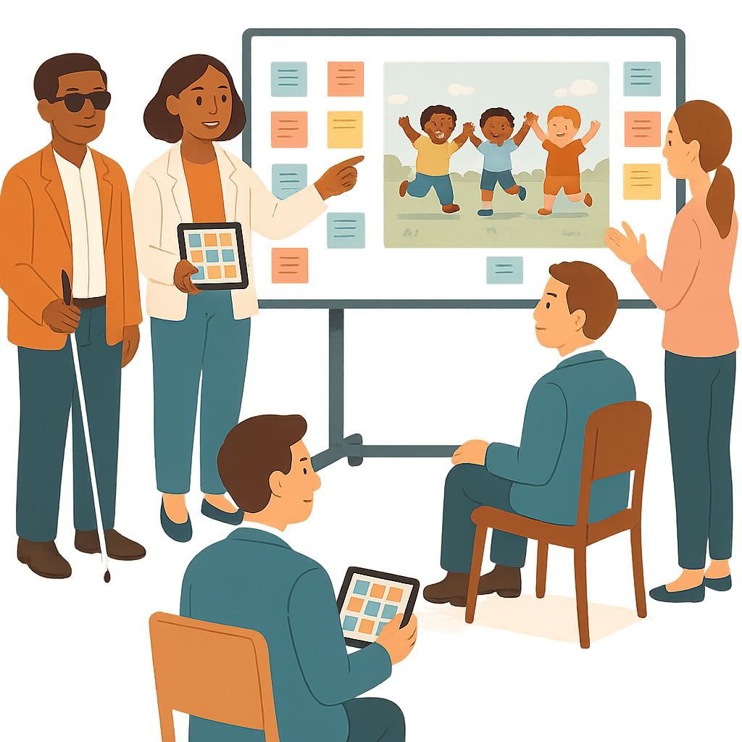 | - Set up Thriving Kids
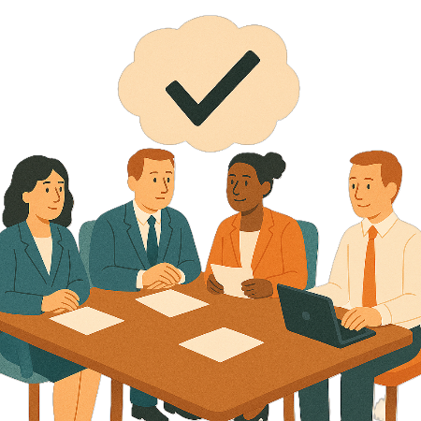 | - Make Thriving Kids work.
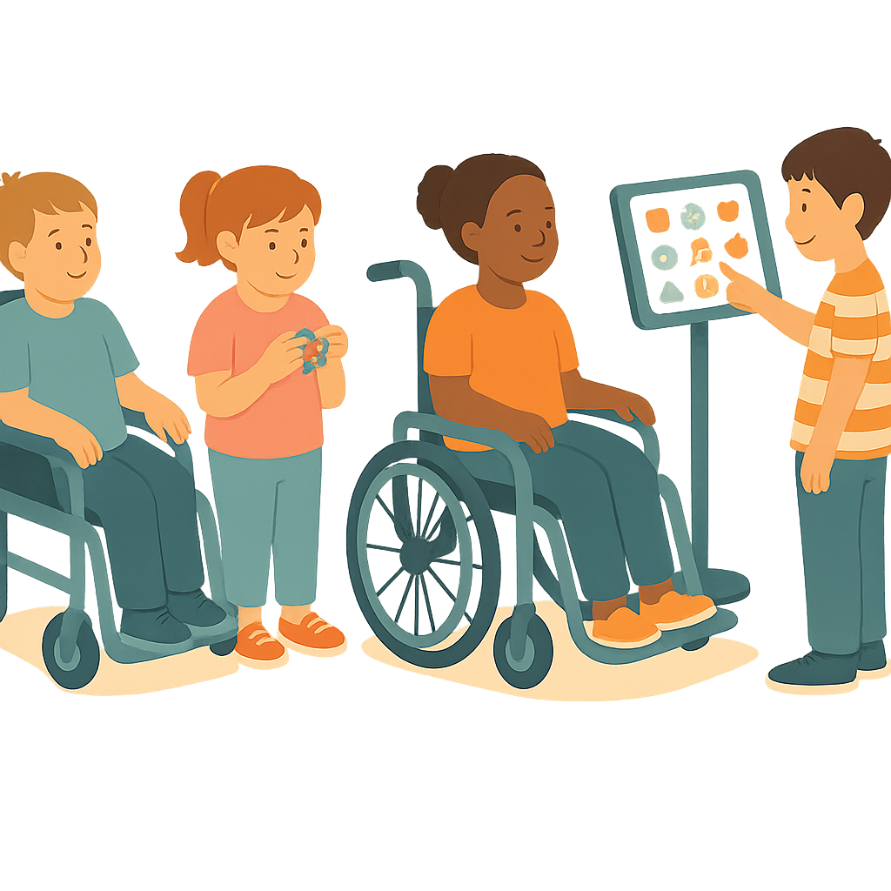 | Children who need lots of support will still use NDIS.

Advisory Group

To help make Thriving Kids the

- Minister for Health and Ageing
- Minister for Disability and the NDIS

Set up an Advisory Group.

It was called the Thriving Kids Advisory Group.
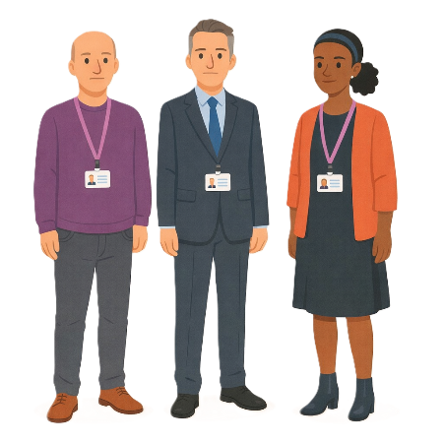 | Ministers are leaders in an area of the government.
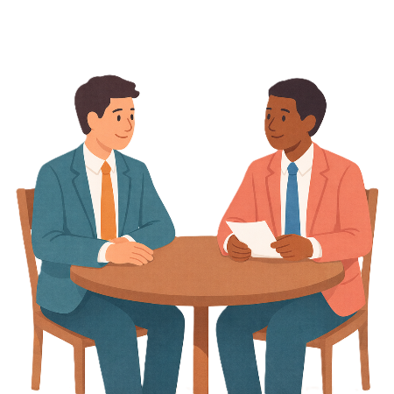 | The Thriving Kids Advisory Group had Co Chairs.  The Co Chairs are the leaders of the group.
 | The Co Chairs were  - Minister Mark Butler
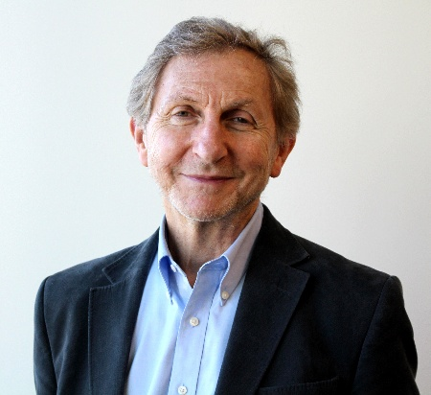 | - Professor Frank Oberklaid.
There were lots of people on the Advisory Group.

Like people who knew a lot about
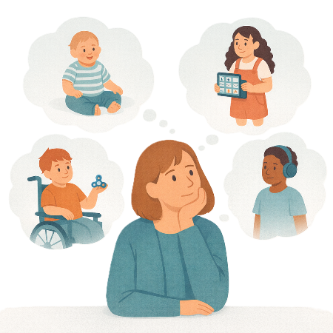 | - Children
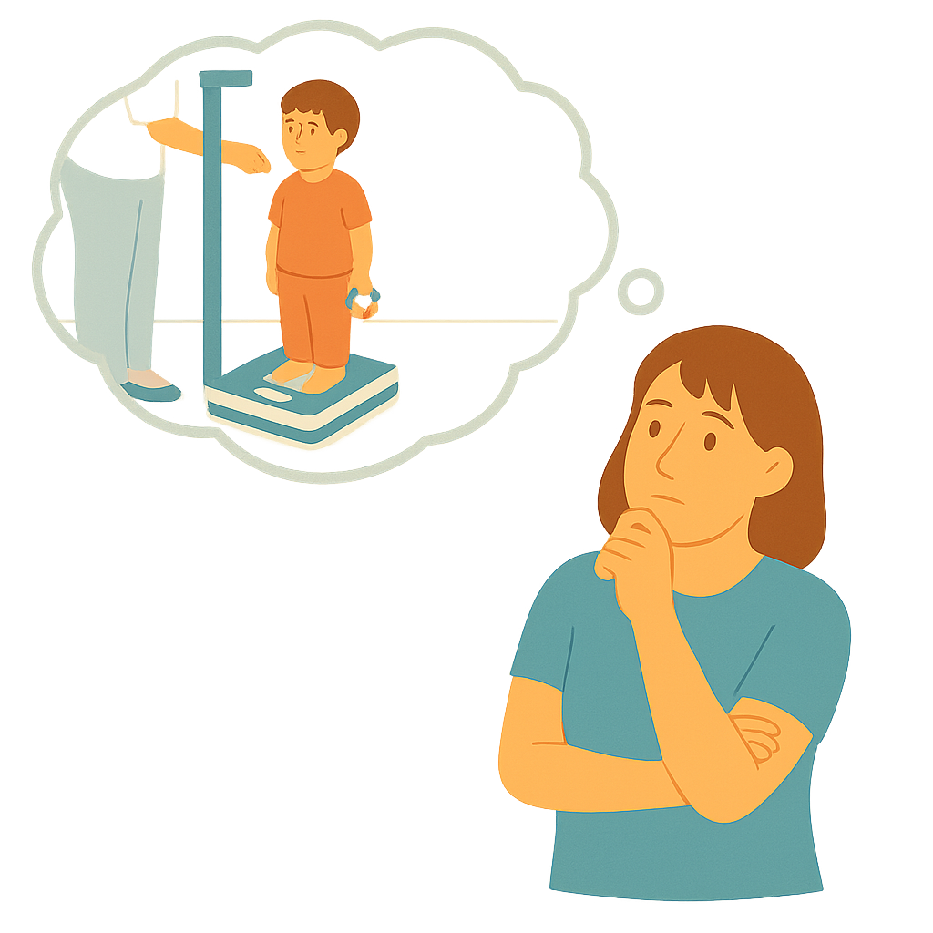 | - The way children grow
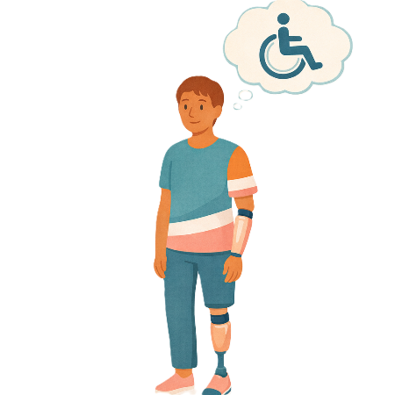 | - Disability
 | - Research  Research means  - Finding out what people think about things  - Using the information to help others.
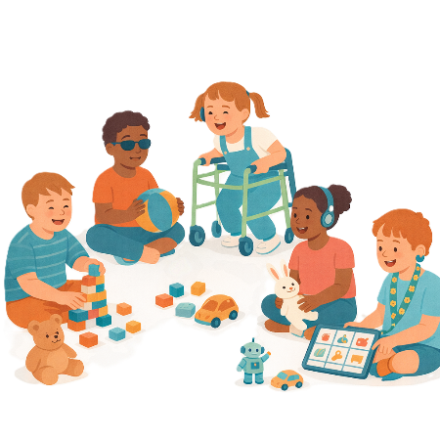 | - Early childhood education  This means learning for children before they go to school.
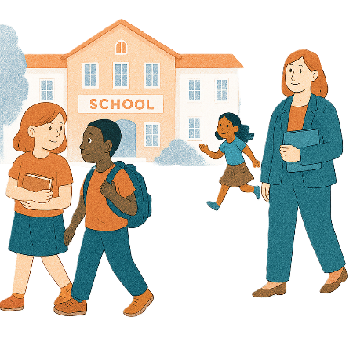 | - Schools
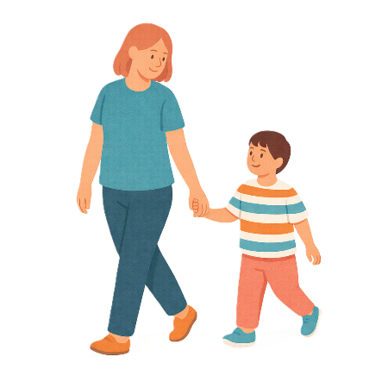 | - Being a parent
 | - Healthcare
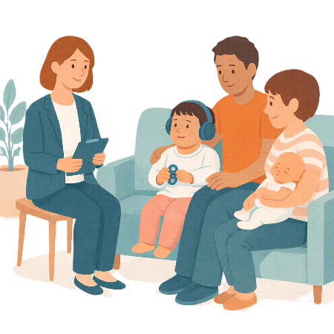 | - Child and family services  These are services that help families  - Stay safe  - Be healthy  - Grow  - Get the support they need.
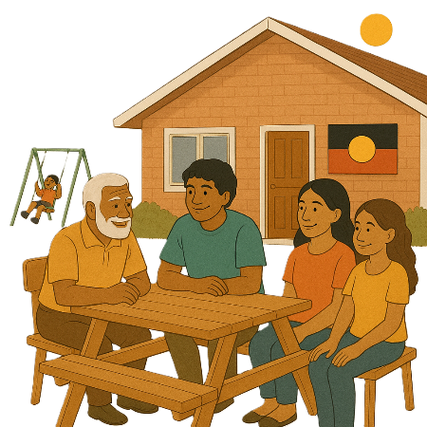 | The Thriving Kids Advisory Group also had  - First Nations people
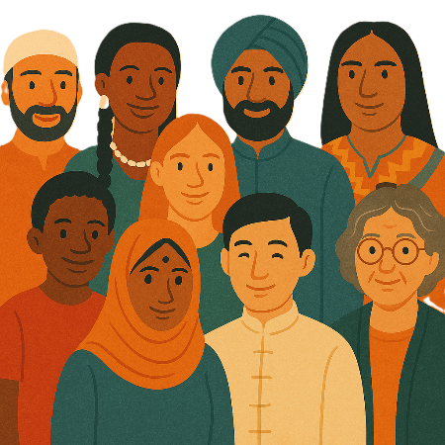 | - People from different cultures
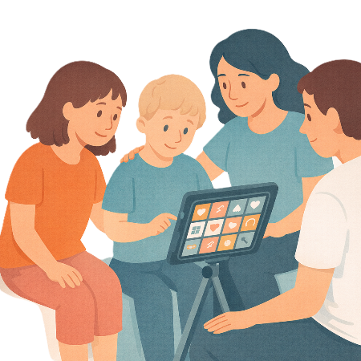 | - People with lived experience  Lived experience is when you know what  - It feels like to have a disability  - Helps  - Makes it harder.  This can include  - Parents  - Carers
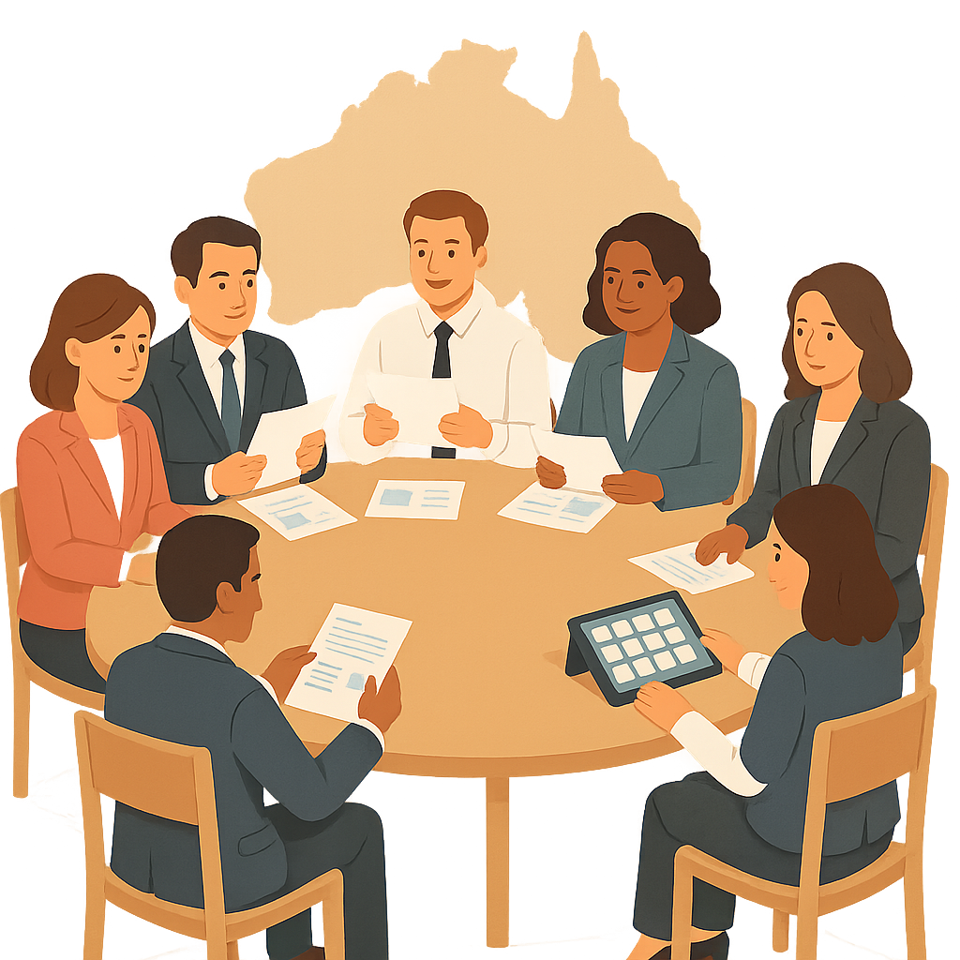 | - People from some state and territory governments.

Recommendations

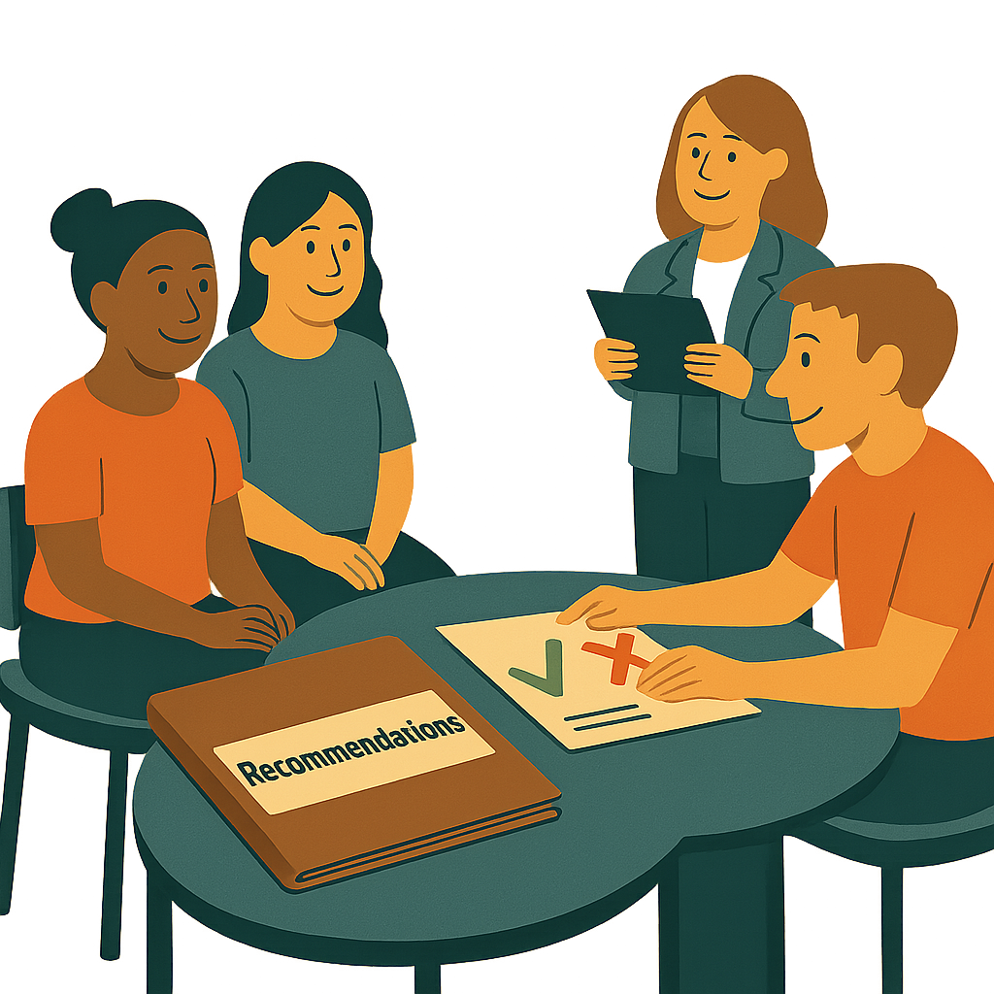 | The Thriving Kids Advisory Group gave recommendations to governments.  The recommendations said how Thriving Kids could work.  They tested their ideas before they gave their recommendations.  They tested them with
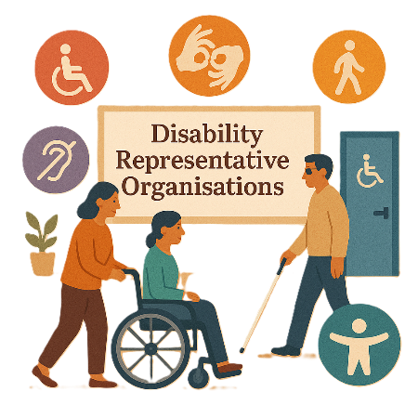 | - Disability Representative Organisations  We call them DROs for short.  DROs speak up for people with disability.
 | - People with lived experience
 | - First Nations people
 | - People from different cultures
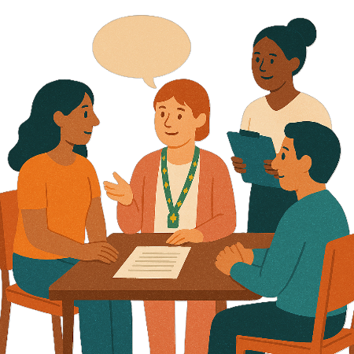 | Governments will keep talking with  - People with disability  - The community  As they start to set up Thriving Kids.  This will help them share what Thriving Kids will be like.

Contact us

 | You can contact us if you need more information.
 | You can send us an email.  thrivingkidssecretariat@health.gov.au
 | You can look at our website.  www.health.gov.au/committees-and-groups/thriving-kids-advisory-group

Some images in this Easy Read were made using AI.
You must not share or copy any of the images without permission.
January 2026.

