
Review of marketing of infant formula by retailers
Department of Health Disability and Ageing
26 September 2025


Nous Group acknowledges Aboriginal and Torres Strait Islander peoples as the First Australians and the Traditional Custodians of Country throughout Australia. We pay our respect to Elders past and present, who maintain their culture, Country and spiritual connection to the land, sea and community.
This artwork was developed by Marcus Lee Design to reflect Nous Group’s Reconciliation Action Plan and our aspirations for respectful and productive engagement with Aboriginal and Torres Strait Islander peoples and communities.
Disclaimer:
Nous Group (Nous) has prepared this report for the benefit of the Department of Health, Disability and Ageing (the Client).
The report should not be used or relied upon for any purpose other than as an expression of the conclusions and recommendations
of Nous to the Client as to the matters within the scope of the report (Permitted Purpose). Nous and its officers and employees expressly disclaim any liability: (i) to any person other than the Client, and (ii) to the Client to the extent the report is used or relied upon for any purpose other than the Permitted Purpose.
Nous has prepared the report with care and diligence. The conclusions and recommendations given by Nous in the report are given in good faith and in the reasonable belief that they are correct and not misleading. The report has been prepared by Nous based on information provided by the Client and by other persons. Nous has relied on that information and has not independently verified or audited that information.
© Nous Group
Contents
1 Executive Summary 1
2 Introduction 4
Purpose of this review 6
3 Methodology/approach 7
3.1 Literature review 7
3.2 Stakeholder consultation 8
3.3 Price tracker data 9
3.4 Site visits and online research 9
4 Findings 11
4.1 How does marketing in general influence decision making? 11
4.1.1 Marketing can impact decisions and attitudes towards using infant formula, but it is one of many factors 11
4.2 What is best practice marketing in the retail environment? 14
4.2.1 The WHO International Code of Marketing of Breastmilk Substitutes is the primary guideline that countries have used to inform their regulatory approach 14
4.2.2 Countries with similar public health systems to Australia have varied approaches to controls on marketing of infant formula by retailers 16
4.3 What is currently happening in the Australian market? 19
5 Options 31
5.1 The policy problem being solved - is intervention needed? 31
5.2 Regulatory Burden 32
5.3 Regulatory costs and benefits 33
5.4 Regulatory options 34
5.5 Key features and considerations for options 35
5.5.1 Option 1: Retain Status Quo 35
5.5.2 Option 2: Facilitate Industry-led regulation 37
5.5.3 Option 3: Quasi Regulation 38
5.5.4 Option 4: Full Regulation 40
5.6 Next steps 42
Appendix A – Analysis of Price Tracker Data 44
Reference list 47

Executive Summary
The importance of breastfeeding is universally acknowledged. Its role in ensuring that babies have the best possible start in life has been proven in numerous international studies, where it is evidenced that breastfeeding is the best and most nutritious method for feeding babies under the age of six months. Its importance is also emphasised at a global level by the World Health Organization (WHO) and within Australia through the Australian National Breastfeeding Strategy: 2019 and beyond. It is, of course, acknowledged that whilst breastfeeding is encouraged as the first best option, there are certain circumstances where families cannot, or, do not breastfeed, meaning infant formula is essential.
Given its key nutritional role in development, it is crucial that consumers are not subject to marketing or advertising that may imply that breastmilk substitutes are an equivalent or superior substitute for breastmilk. Breastmilk substitutes are subject to stringent safety and regulatory oversight, given the vulnerability of babies in the first months of life. Regulations governing manufacturer composition and labelling of infant formula products have been in place for many years through the Food Standards Code. In respect of marketing activities Australia has limited regulations specifically on the marketing of infant formula with no mandatory regulations for retailers including supermarkets, pharmacies and online retailers. Regulation needs to strike the right balance acknowledging that whilst infant formula products should not be promoted as superior to breastfeeding, they still need to be available to families who may not be able or want to breastfeed. Reasons for this choice can vary, including medical issues and pain preventing breastfeeding, the need to return to work and individual preferences.
Under the former Marketing in Australia of Infant Formulas: Manufacturers and Importers (MAIF) Agreement, manufacturers were prevented from marketing infant formula products (although this restriction did not apply to toddler milks), and there are continuing strict controls through the food regulation system on the labelling of infant formula products to ensure they are not promoted as being superior to breastfeeding. In 2024, an independent review of the MAIF Agreement concluded that its voluntary, self-regulatory nature was no longer suitable for addressing inappropriate marketing practices. The review found insufficient evidence to justify expanding regulation to include retailers or additional products but recommended further investigation into retailer marketing. Following this, the Australian Government announced plans to introduce mandatory controls on infant formula marketing by manufacturers over a two-year period.
On 6 February 2025, the Australian Competition and Consumer Commission (ACCC) declined to reauthorise the MAIF Agreement due to concerns about its limited scope, voluntary nature, and inability to regulate digital marketing. As a result, there is currently no operational code governing infant formula marketing in Australia, although the government has committed to developing a new mandatory policy framework.

Scope of this review
Given the MAIF review did not specifically look at the evidence around retailers, Nous Group (Nous) was engaged by the Department to:
- Review the scale and impact of marketing of infant formula by retailers, including supermarkets and pharmacies (both in person and online).
- Assess the marketing practices utilised by retailers.
- Assess the benefits, costs and any limitations of changes to any regulatory responses.
This was done through detailed review of domestic and international standards and a review of available literature on the impact of marketing activities; a series of interviews and focus groups with key stakeholders; analysis of the price tracker database held by Deakin University; and a survey distributed through online forums and stakeholder groups. While this methodology provided some useful insights into the impact of retailer activities, it is important to acknowledge the limitations of the available evidence base. The sample size from the survey was small and the number of retailers engaged was outweighed by other public interest groups consulted. Responses indicated that some responders had not accurately identified the source of the promotional activity. Careful attention was paid to ensure that no bias was introduced to the questions for stakeholders.
The scope of this review is focused specifically on retailer (supermarkets and pharmacies, both in store and online) marketing practices for infant formula products. Toddler milks, while frequently raised by stakeholders, were out of scope of this review. The scope of the review was not to provide recommendations but to present a range of regulatory options. As such, the review is structured into two main sections:
- Review findings | This section brings together data and insights from stakeholder consultation, a literature/desktop review, consumer survey, price tracking data and site visits. This section does not make a judgement call on what is ‘appropriate’ marketing but reflects the key perspectives from stakeholder groups and international literature.
- Options | This section uses the regulatory impact analysis process to step through the key policy questions the Department needs to answer and present a range of regulatory options including high-level costs and benefits.

Summary of review findings
The review has found that there is retailer marketing of infant formula products occurring within Australia. This activity exists in both the physical and online retail areas and takes a variety of forms. Most of the retailer activity is related to price discounting. Such activity is contrary to the WHO International Code of Marketing of Breastmilk Substitutes (WHO Code) which forms an internationally agreed set of guidelines based upon public health outcomes around improving breastfeeding rates.
The degree to which retailer marketing activities are directly correlated with decisions relating to mothers’ decisions around breastfeeding is difficult to ascertain and there is a paucity of relevant Australian literature in this area. The evidence suggests that marketing activity in general (including the marketing activities of manufacturers) does have an impact but is weighed up alongside other factors which include separation of mother and baby, sub-optimal support, maternal lack of confidence, infant attributes and lack of maternity protection and workplace barriers. There is a lack of evidence to attribute the impact of retailer, distinct from manufacturer, marketing to breastfeeding rates specifically.
The review found there are differing views amongst stakeholder groups about the impact of retailer marketing. Public health groups and academics put forward a strong position that Australia needs to fully align to the WHO Code through mandatory regulation which includes retailer price promotion, given the significant public health cost of lower breastfeeding rates. Industry bodies and retailers were more agnostic on whether regulation was required. While they largely agreed that targeted advertising was not appropriate, their view was that retailer price promotion primarily drove competition between brands rather than influencing a mother to use formula rather than breastfeed and so should not be included within any future regulation. The degree of price promotion seems to be limited and focussed upon competition between retailers. The review notes that the Australian Government has not implemented any pricing policy for any consumer product outside tobacco.

Summary of regulatory options
There are four overarching approaches that the Government could take to regulating retailer marketing activities:
- Status quo | Maintain the current approach of not regulating retailer marketing of infant formula. Some changes could be made including providing additional education to retailers.
- Industry-led regulation | Adopt a voluntary regulatory approach that would be led by retailers, for example a code of conduct for retailer marketing activities. There is a limited role for Government in this option, it could, however, maintain a watching brief.
- Quasi-regulatory approach | Government could take a more interventionist approach by adopting expectations and guidelines for retailers – this option would not include enforceable powers in legislation or regulations.
- Full regulation | Fully regulate retailer marketing of infant formula, probably by including retailers within the new compulsory regulation for manufacturers and importers. This option could either include or exclude price promotion.
The option chosen will depend upon the balance between achieving public health goals and minimising regulatory burden on the retail sector and government. The government could also consider increased communication campaigns relating to the benefits of breastfeeding; however this has not been addressed within this report.

Introduction
The importance of breastfeeding is universally acknowledged. Its role in ensuring that babies have the best possible start in life has been proven in numerous international studies, where it is evidenced that breastfeeding is the best and most nutritious method for feeding babies under the age of six months. Its importance is also emphasised at a global level by the WHO and within Australia through the National Breastfeeding Strategy. This is a perspective which is shared by all stakeholders consulted as part of this review process.
The Australian Institute of Health and Welfare (AIHW) has also highlighted the economic and environmental benefits of breastfeeding over infant formula. This points to a comprehensive set of benefits for society through the adoption of breastfeeding and in this light official Australian guidance is to emphasise breastfeeding over the use of infant formula. It is, of course, acknowledged that whilst breastfeeding is encouraged as the first best option, there are certain circumstances where families cannot, or do not breastfeed, meaning infant formula is essential.
Given its key nutritional role in development, it is crucial that consumers are not subject to marketing or advertising that may imply that breastmilk substitutes are an equivalent or superior substitute for breastmilk. Breastmilk substitutes are subject to stringent safety and regulatory oversight, given the vulnerability of babies in the first months of life.

Current guidelines or regulations that govern the marketing of infant formula
In response to the issues raised above there are a variety of international and national agreements that relate to the marketing of infant formula. The key international agreement is the WHO Code, which sets international standards aimed at protecting breastfeeding. Countries adopt and enforce these guidelines differently, with some implementing stricter regulations than others. Jurisdictions considered similar to Australia, such as New Zealand, the UK, Canada and the EU have varied approaches to regulation of infant formula, with some including retailers within scope.
Within Australia, regulatory oversight of nutritional content and labelling of infant formula products falls under the remit of Food Standards Australia New Zealand (FSANZ), which has recently completed work on the regulation of infant formula (Proposal 1028).
The marketing of infant formula by manufacturers and importers was previously covered by the voluntary self-regulated MAIF Agreement.
The MAIF Agreement previously aimed to:
- ensure safe and adequate nutrition for babies.
- encourage breastfeeding as the first option for babies.
- protect parents from advertising that could affect their judgement.
- ensure the proper use of breastmilk substitutes.
The voluntary nature of the MAIF agreement was deemed no longer appropriate in 2024, and it was recommended that the scale and impact of retailer marketing should be further investigated
In April 2024 the Department published an independent review of the MAIF Agreement (the MAIF Review), which was commissioned to help understand if the MAIF Agreement was effective in achieving its aims, the appropriateness of its scope, processes and the self-regulatory approach. The MAIF Review also sought to investigate the benefits, costs or limitations of changes to the scope, alternative regulatory models and the MAIF Agreement processes. Relevant conclusions included:
- The voluntary, self-regulated nature of the MAIF Agreement was no longer appropriate to address marketing of infant formula and the government should develop a stronger regulatory framework to restrict inappropriate marketing.
- There was no compelling rationale to increase the scope of parties who are regulated beyond manufacturers and importers. There was insufficient evidence regarding the scope and impact of marketing by retailers that might warrant inclusion in regulation.
- A lack of evidence associated with potential benefits of expanding the scope of regulated products that would justify the costs.
One of the recommendations that came from these conclusions was to conduct a review of the scale and impact of inappropriate marketing of infant formula by retailers to understand whether a regulatory framework should include retailers within scope. This recommendation has led to this review of infant formula marketing by retailers.
In October 2024 the Australian Government announced its intention to develop and implement mandatory controls on infant formula marketing by manufacturers. It was estimated that this would take place over two years.
A decision was made to not reauthorise the MAIF Agreement on 6 February 2025 meaning there is currently no operational code of infant formula marketing
The MAIF Agreement was subject to authorisation by the Australian Competition and Consumer Commission (ACCC) as it involved an agreement which sought to restrict marketing of products by companies that would otherwise compete. In 2024, the Infant Nutrition Council (INC) lodged an application to re-authorise the MAIF Agreement to continue for a further five years.
Following the MAIF Review and subsequent consultation by the ACCC with stakeholders and interested parties, the ACCC was concerned that there were several factors, including scope, the voluntary nature of the agreement, and inability to address digital marketing practices, that limited the effectiveness of the MAIF Agreement on public benefits such as protecting breastfeeding rates. On 6 February 2025, the ACCC announced its decision to deny authorisation of the MAIF Agreement. Subsequently, there is currently no operational code of marketing (outside of the scope of the Food Standards Code) in Australia, but the Government has announced that the Department will develop and implement a new mandatory policy.

Purpose of this review
The aim of this review is to collate evidence of retailer marketing activities of infant formula, assess its impact and understand the degree to which retailers are abiding by policy and international guidance. This will provide information to allow the Department to make informed policy recommendations to government on different regulatory responses in relation to retailers.

Methodology/approach
Figure 1 sets out the high-level approach taken to developing the findings and options contained in this report. The section below sets out more detail on the data collection and analysis approach used for each data source.
As a caveat, the scope of this review was focussed exclusively on infant formula marketing by retailers. The overlap of broader types of marketing; both toddler milks and manufacturer marketing, were frequently brought up by stakeholder groups. These have been addressed where relevant, but as they were outside of the scope of this review have not been included within options.
This report has been limited to infant formula products which are recommended for babies under 12 months of age. These products are designed to provide full nutritional ingredients for babies up to 12 months of age. They also include follow-on formula products (designed for babies aged between six and 12 months) and special medical purpose products which are used under medical supervision. The review has not considered toddler milk products that are typically aimed at children aged 1 to 3 years of age.
Figure 1 | Summary of review approach
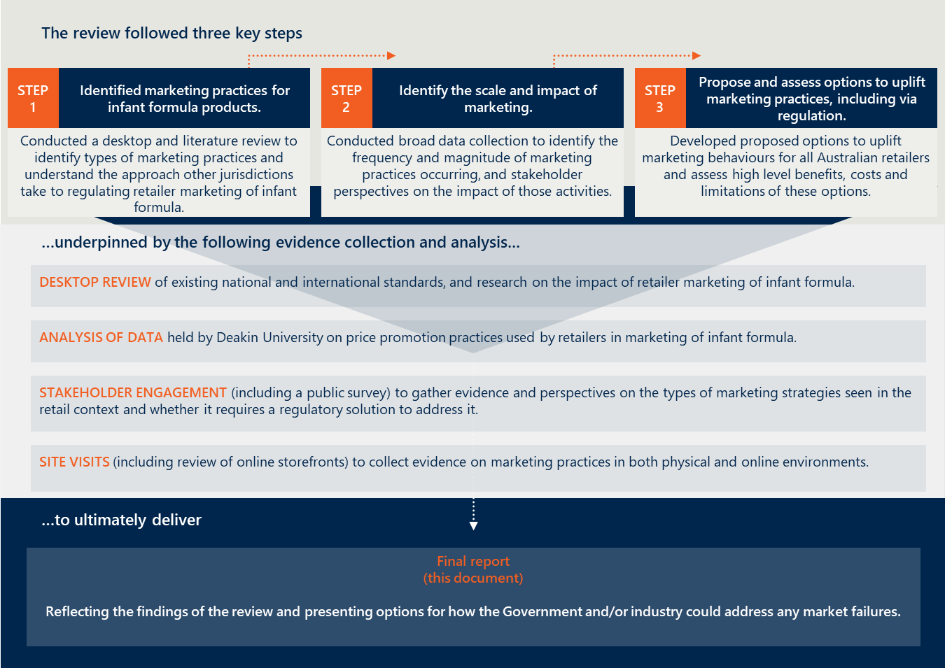

Literature review
The purpose of the literature and desktop review was to understand what national and international guidelines existed for marketing of infant formula and what was considered by experts to be ‘best practice’. Another purpose was to understand what evidence there was of the impact of retailer marketing of infant formula on infant feeding decisions.
The following methodology was undertaken to conduct a rapid literature review:
- A set of research questions were developed from the key lines of enquiry for the overall review into retailer marketing, to inform the literature search.
- Keywords and phrases were established from these questions and used to create search terms for the areas of interest.
- Databases including Google scholar and EBSCO Host were primarily used to search for relevant literature.
- Grey literature was also reviewed, as well as sources from relevant articles in a snow-balling approach.
- Literature obtained was assessed for relevance and findings synthesised.
Nous obtained recommendations on relevant literature and sense checked the reference list with academics who were interviewed as part of the broader review into marketing by retailers. The full reference list of sources drawn on for this review can be found at the end of this report.

Stakeholder consultation

Targeted stakeholder consultation
The purpose of stakeholder engagement was to understand the perspectives of public health groups, industry, retailers and government agencies to help develop future regulatory options grounded in best practice and which accurately reflect current marketing practices. A total of 23 individuals/organisations were consulted as part of the review, including public health groups and academics, manufacturers and retailers, and government. Whilst consumers were not included in this process their views were gathered through a separate consumer survey.
Stakeholder engagements were focused on three main questions:
- What does best practice marketing of infant formula by retailers look like (if it can exist)?
- What current marketing practices are retailers using to market infant formula?
- What should future regulatory approaches to retailer marketing of infant formula look like?
Participants were contacted by the Department by email with a request for consultation and were provided with an interview guide. Consultations were a mixture of interviews and focus groups to balance breadth of input with detailed discussions. There was mixed uptake of interview invitations, with a high response rate from academics and public health groups. While there was lower uptake from retailers, the review still includes some insights directly from retailers as well as the views of the National Retailers Association who canvased the views of their members before providing input.
Discussion questions were focused on marketing of infant formula by retailers, however many stakeholders raised issues outside of this scope. These topics included the risks and difficulties of separating how infant formula and toddler formula are marketed/regulated, highlighting the similarity of formula products.

Public survey
An online public survey was conducted to provide an opportunity for members of the public (or organisations) to provide examples of infant formula marketing by retailers, and to report any impacts that marketing had on their purchasing decisions.
This survey was carefully worded to avoid any perceptions of bias or preconceived conclusions and did not ask individuals to make a value judgement on whether the marketing practice was appropriate. The survey was in the form of a survey template that asked for specific examples of retail marketing behaviour, including the specific source. Given the very wide reach of the retail sector, this allowed an opportunity for broad consumer input into the review.
The survey was developed to capture:
- what retailer marketing activities consumers had seen over the last 6-12 months, and
- whether they felt it had influenced their decision to purchase infant formula.
Nous distributed the survey through multiple channels including the Department’s website, public health groups and a large infant formula feeding Facebook group. The purpose of this was to maximise the reach of the survey and encourage a balanced group of consumers to respond. The survey was open for eight weeks with 124 respondents. Respondents were a mixture of parents who currently had infants or were expecting a child, and consumers who had a child in the past. There was also a mixture of parents who had and had not used/were currently using formula to feed their child.

Survey limitations
Survey results should be interpreted with appropriate caution throughout this report. While there were 124 individuals who attempted to complete the survey, the number of respondents for most questions are substantially lower. For example, 79 respondents had reported having seen retailer marketing, and even fewer completed all relevant questions. As a result of this small sample size, the survey findings are not statistically representative and cannot be generalised. The nature of the sampling can also be considered not representative of the broader target population, such as distribution through public health channels which may present skewed views.
The qualitative responses from the consumer survey showed that some respondents had not accurately identified the source of different promotions or were including toddler milk advertisements in their assessments. This is likely to have skewed results on the proportion of respondents who had seen particular advertisements or were influenced by them in relation to retailer specific activities.

Price tracker data
Deakin University’s Price tracker dataset captures prices and discounts for infant formula at Coles and Woolworths over the last five years. Data includes promotions on ‘infant formula’ (0-6 and 0-12 months) products as well as follow-on formula (6-12 months) products to capture the full scope of products included under the Food Standards Code and former MAIF Agreement. This data captures the frequency, types and average magnitude of price promotion.

Site visits and online research
Site visits to supermarkets and pharmacies, as well as periodic reviews of online storefronts, was used as a mechanism to validate findings from other data collection methods. The review team conducted site visits to supermarkets and pharmacies across the review period, collecting evidence of different price promotions, product placement and sponsored advertising. Site visits were conducted across Melbourne, Sydney, Canberra, Adelaide and Darwin. Five individuals completed the site visits, visiting 5-10 stores each including a range of supermarkets and pharmacies (both major competitors and independent retailers). An online scan of promotions was undertaken on two separate occasions, including signing up to loyalty programs and mailing lists where possible.
A limitation of this data collection method for online advertising is that it relies on targeted advertising, a key marketing tactic reported by public health groups. However, review team members were not within this target demographic.

Findings
The purpose of this review was to identify what practices retailers in Australia are currently using to market infant formula, and to conduct a consultation and research process to understand whether this behaviour aligns to good practice. The overall policy objective of any future regulation would be to reduce the impact of retail marketing on decisions about breastfeeding, with the ultimate aim of increasing breastfeeding rates. This section of the report provides the main findings of the review based upon the evidence sources highlighted in the previous section.
This section highlights:
- How does marketing in general influence decision making?
- What does best practice marketing look like? (with reference to the WHO Code as international best practice.)
- What are the current marketing activities observed in the Australian retail sector for infant formula?
The findings reflect differing views on the level and impact of retail marketing activities for infant formula and are used as input into potential regulatory options in Section 5.

How does marketing in general influence decision making?
This section sets out how marketing in general, inclusive of retailer and manufacturer marketing, impacts decisions about using infant formula. It then provides more specific insight on the impact of retailer marketing on decision making.

Marketing can impact decisions and attitudes towards using infant formula, but it is one of many factors
There are multiple factors that can influence infant feeding decisions and infant formula marketing may exacerbate these
In Australia, research shows that the majority of women intend to, and do initiate breastfeeding (97%). Exclusive breastfeeding rates do however drop off over time, with some research reporting that 46% of mother’s cease breastfeeding by 52 weeks of infant age. Similarly, the National Health Survey 2022 reported that 90.6% of children aged 0-3 years had received breastmilk, with 70.1% still receiving breastmilk at six months of age and 37.5% exclusively breastfed at this age. The last Australian National Infant Feeding Survey was conducted in 2010 and although it may not provide certainty of the current breastfeeding rates, it did provide baseline data on key infant feeding indications. These include that 96% of babies in Australia in 2010 were initially breastfed, with 60% still receiving breastmilk at six months of age but only 15% being exclusively breastfed at less than six months of age. These statistics indicate an overall decrease from 2010 to 2022 in the percentage of children who had ever received breastmilk, but an increase in those receiving or being exclusively breastfed by six months of age. However, the methodological differences in the surveys may limit the validity of any comparisons.
Multiple factors can influence infant feeding decisions, including marketing, separation of mother and baby, sub-optimal support, maternal lack of confidence, infant attributes and lack of maternity protection and workplace barriers. In Australia, challenges with breastfeeding, maternal concerns regarding breast trauma, milk supply and infant satiety were common reasons reported that affect breastfeeding duration., These may be tackled through the provision of breastfeeding support in the early postpartum period, with support tailored to the person’s age and education level.
This combination of factors can then affect how influential marketing is in decision-making, where mothers can become vulnerable to aggressive marketing of infant formula and toddler milk. Research indicates that internal fears and doubts can be echoed in marketing messages, undermining a mother’s confidence and lead to more favourable attitudes towards formula. Marketing can also exploit and pathologise normal patterns of infant development that exacerbate parents’ insecurities or lead to mis-interpretation of issues such as breastmilk supply, which can prompt cessation of breastfeeding.
Some literature describes the effect marketing has on selecting an infant formula brand, as opposed to directly causing breastfeeding cessation. A study conducted in South Africa highlighted that promotion of infant formula, both by manufacturers and retailers, may not be a key driver of a families’ decision on whether to breastfeed. It found that the primary reason women decided to stop breastfeeding and start formula feeding was due to the challenges they experienced when breastfeeding. The study however identified influences in choosing a formula brand to address breastfeeding challenges included marketing, in particular branding and advertising of growing-up milk, in promoting brand recognition, and influence by health professionals.
Industry bodies asserted during consultations that there has been substantial research conducted by manufacturers that indicates there is not a meaningful link between marketing activities such as price promotion and choice, brand or amount of formula purchased. They indicated that the main intended and actual impact of promotion, even where such promotions are effectively funded by manufacturers, relates to retailer competition, particularly influencing the consumer’s decision about who they purchase infant formula from. Industry bodies attributed effects on breastfeeding rates to predominantly psychological, medical and cultural factors rather than price promotions discounting, claiming that retailer competition has no impact on public health outcomes and has a small benefit for consumers who have access to lower prices. This research was not provided to the review team on the basis that it was confidential. It therefore cannot be verified.
There is evidence that advice from health professionals can be highly influential for pregnant women and parents and impact infant feeding attitudes and decisions., Stakeholders noted that there were some activities being conducted by manufacturers to educate pharmacists on their products with the intention of driving further sales, however as this is a manufacturer activity it is out of scope for this review.
Some industry representatives raised that, because pharmacists engage with consumers to provide advice, such as on specialist infant formula products, pharmacies should be considered differently to other retailers, like supermarkets, as their impact on consumers may be different. In their view, the abundance of evidence on the influence of health professionals on decision making is not comparable to the role of supermarket staff, which is not to provide advice on specific products.
Studies show that marketing impacts women’s attitudes, but the distinction between manufacturer and retail marketing is unclear
The potential impact on breastfeeding rates due to marketing activities is recognised internationally by the existence of the WHO Code. There are also multiple studies, including those set out below, which demonstrate that marketing in general has an impact on attitudes and feeding behaviours. However, because most studies do not distinguish between manufacturer and retailer marketing, there is a gap in the research on the extent to which retailer marketing impacts decision making.
Marketing in general can influence social norms and attitudes on the safety and benefits of infant formula. Research has found that women exposed to formula milk advertisements and promotions were more likely to have favourable attitudes towards formula milk, such as increased beliefs that formula provides more comprehensive and balanced nutrition. This research indicates that a woman’s chosen feeding behaviours are also substantially related to exposure to marketing.
Public health advocacy groups interviewed as part of the review agreed with this stance in the literature. They asserted that whilst infant formula is necessary and important for some consumers, marketing in general creates the risk of positioning formula as equal to or better than breastfeeding which has ongoing negative public health outcomes.
The WHO identifies four main themes as dominant marketing strategies or messaging that can influence decision making and attitudes:
- Product options, such as toddler and growing up formula milks, strategically marketed together.
- Science-based marketing messages, such as scientific imagery, language and scientific claims.
- Common infant behaviours, or pain points, with the infant formula products positioned as solutions (e.g. colic).
- Trust and connections, such as through formula company run baby clubs and 24/7 carelines.
Much of the international literature describes manufacturers using these marketing strategies, such as labelling, messaging and non-factual claims, rather than retailer activities which predominantly focuses on price promotion.

What is best practice marketing in the retail environment?

The WHO International Code of Marketing of Breastmilk Substitutes is the primary guideline that countries have used to inform their regulatory approach
The WHO and the United Nations Children’s Fund (UNICEF) have consistently emphasised the importance of breastfeeding for newborn health and nutrition and have developed guidelines and initiatives to increase the prevalence of breastfeeding where it is declining. WHO Member States, including Australia, have been encouraged to adopt these guidelines through regulation or other suitable measures.
One of these sets of guidelines is the WHO Code, published in 1981, which was created to:
“Contribute to the provision of safe and adequate nutrition for infants, by the protection and promotion of breastfeeding and by ensuring the proper use of breastmilk substitutes, when they are necessary, on the basis of adequate information and through appropriate marketing and distribution.”
The WHO Code covers a broad scope of marketing activities
The WHO Code has a broad scope which applies to:
- The marketing of breastmilk substitutes, including infant formula, other milk products, foods and beverages for infants and young children including bottle-fed complementary foods, when marketed or represented as suitable for partial or full replacement of breastmilk.
- Feeding bottles and teats.
- Quality, availability and information concerning the use of these products.
The WHO Code is universally applicable to manufacturers, importers and distributors. A distributor is an all-encompassing term that is used to include retailers, defined as:
“A person, corporation or any other entity in the public or private sector engaged in the business (whether directly or indirectly) of marketing at the wholesale or retail level a product within the scope of this Code.”

The WHO Code is seen as the primary reference point for best practice marketing internationally for retailers and manufacturers
The WHO Code sets out clear guidelines for regulation of marketing of infant formula by both manufacturers and retailers (referred to as ‘distributors’ in the Code).
The WHO Code states under Article 5 that any product that functions as a breastmilk substitute should not be promoted or advertised to the general public by distributors (retailers and manufacturers). Under the Code, marketing includes:
- free samples
- point-of-sale advertising
- special displays
- discount coupons
- premiums
- special sales
- loss-leaders
- tie-ins sales.
Whilst most WHO Member States have partially adopted the WHO code, the extent to which national legal measures align with the WHO Code varies significantly
The WHO Code is not legally enforceable until adopted by Member States into national legislation. The extent to which Member States have implemented legislation, regulation or other legally binding measures that align with the WHO Code is reviewed on a regular basis. National legal measures of Member States are scored and classified into the following categories:
- Substantially aligned with the WHO Code: Member States have enacted legislation or adopted regulations, decrees or other legally binding measures encompassing a significant set of provisions of the Code.
- Moderately aligned with the WHO Code: Member States have enacted legislation or adopted regulations, decrees or other legally binding measures encompassing a majority of provisions of the Code.
- Some provisions of the WHO Code included: Member States have enacted legislation or adopted regulations, decrees or other legally binding measures covering less than half of the provisions of the Code.
- No legal measures: Member States have taken no action or have implemented the Code only through voluntary agreements or other non-legal measures.
The most recent review conducted in 2024 shows 146 WHO Member States had enacted legal measures to adopt at least some of the provisions of the WHO Code, but only 33 of these Member States had legal measures that were substantially aligned. Australia was categorised as having “some provisions of the code”. The Food Standards Code (Standards 2.9.1, 1.2.1 and 1.2.7) was the only legal measure that contributed towards the scoring of Australia’s alignment to the WHO Code’s provisions.
The WHO’s review is useful for understanding which of the WHO Code’s recommendations and subsequent resolutions different Member States have prioritised. The review did not specifically investigate the scope of parties (retailer, manufacturer or both) that Member States include within their legal measures. The alignment with a provision relevant to retailers, namely ‘promotion to the general public’ was reviewed however, which includes marketing activities of any party such as:
- advertising
- promotional devices at point of sale
- provision of free samples and gifts.
The majority of WHO Member States (132) had some legal measures that related to promotion to the general public in 2024, 43 of which had legal measures that were substantially aligned to the WHO Code’s provisions. Australia’s legal measures did not score any points relating to this article on promotion to the general public. Most countries that are aligned to the WHO Code’s Articles on promotion to the general public, such as India, Uganda and Brazil, include both manufacturers and distributors in their regulation, as the regulation speaks to what marketing activities are prohibited in general language without referring to the party conducting the advertising.

Countries with similar public health systems to Australia have varied approaches to controls on marketing of infant formula by retailers
Comparable overseas jurisdictions to Australia, such as the United Kingdon (UK), European Union (EU), New Zealand and Canada, have either some provisions of the WHO Code in place, or no legal measures. The EU and UK have some legal measures that restrict advertising and prohibit specific promotional activities, including by distributers. New Zealand has a voluntary self-regulatory code for the marketing of infant formula, which is similar to Australia’s previous MAIF Agreement (and does not include retailers). Canada has no legal measures in place to regulate the marketing of infant formula. Table 1 provides some examples of the types and extent of regulations on the marketing of infant formula by these countries.
Table 1 | Examples of international regulation
Country | Legal status of the WHO Code (2024) | Measures relating to marketing of infant formula | Scope of parties | Relevant examples from legal measure or commentary
UK | Some provisions of the WHO Code | Assimilated direct EU legislation - Commission Delegated Regulation (EU) 2016/127 | References manufacturers and distributors | “Article 6 (6): The labelling, presentation and advertising of infant formula and follow-on formula shall provide the necessary information about the appropriate use of the products, so as not to discourage breastfeeding.  Article 10 (1): Advertising of infant formula shall be restricted to publications specialising in baby care and scientific publications.  Article 10 (2): There shall be no point-of-sale advertising, giving of samples or any other promotional device to induce sales of infant formula directly to the consumer at the retail level, such as special displays, discount coupons, premiums, special sales, loss-leaders and tie-in sales.  Article 10 (3): Manufacturers and distributors of infant formula shall not provide, to the general public or to pregnant women, mothers or members of their families, free or low-priced products, samples or any other promotional gifts, either directly or indirectly via the health care system or health workers.”
EU | Some provisions of the WHO Code | Commission delegated regulation (EU) 2016/127 | References manufacturers and distributors | As above
New Zealand | Some provisions of the WHO Code included | The Infant Nutrition Council (INC) Code of Practice for the Marketing of Infant Formula in New Zealand | Manufacturers and importers that are members of the INC | A voluntary, self-regulatory code of conduct is in place applying to the manufacturers and importers of infant formula (product suitable for infants up to 12 months of age) who are members of the Infant Nutrition Council. It is not considered a legal measure contributing to the alignment to the WHO Code.
New Zealand | Some provisions of the WHO Code included | FSANZ Food Standards Code - Standard 2.9.1 | Any business or activity involved in handling or selling of food | Standard 2.9.1 regulates the composition, labelling and sale of infant formula products. It should be noted that New Zealand has an opt out clause, unlike Australian states and territories and has subsequently opted out of the revised infant formula standard, amended through proposal P1028.
Canada | No legal measures related to marketing | N/A | N/A | Infant formula nutritional content and labelling is regulated under the Food and Drugs Act that supports the WHO Code, but marketing is not directly regulated. The Canadian Food Inspection Agency and Health Canada urges the infant formula industry to apply the principles of the WHO Code.

There are differing views on the extent to which the WHO Code should be implemented at a national level in Australia
The former MAIF Agreement was one of Australia’s primary responses to the WHO Code but did not represent full implementation of the WHO Code and relevant WHA resolutions. A 2022 review of the national implementation of the WHO Code found that the Food Standards Code (Standards 2.9.1, 1.2.1 and 1.2.7) was the only legal measure that contributed towards Australia’s alignment to the WHO Code’s provisions.
International literature broadly supports the general restriction on promotion of infant formula and full implementation with the WHO Code., Literature generally focusses on manufacturer marketing activities or references marketing in general terms not specifying the party conducting particular activities. Specific research on retailer, rather than manufacturer, promotion activities is lacking, although some promotional activities could be inferred as practices of both retailers and manufacturers.
Stakeholder perspectives differ on the extent to which the WHO Code should be implemented in any future regulation in Australia.
There is a high level of consensus amongst public health advocacy bodies and academics that Australia should fully adopt the WHO Code and relevant WHA resolutions, which would include bringing retailers into any new regulation and prohibiting any promotional marketing activities. This aligns to some approaches taken internationally, including by the EU, which bans nearly all marketing practices of infant formula by manufacturers and retailers alike, except for long-term price reductions.
The driver for this perspective is the view that marketing practices can only be balanced with public health goals where greater sales benefit public health- which given the importance of breastfeeding it does not. The risk of negative impacts of marketing on public health were cited by these groups as a primary reason there should be total cessation of promotional activities. These impacts are explored further in Section 4.3.
Many public health groups also reinforce that because manufacturers and retailers are so intertwined it is not effective to regulate one and not the other, as it creates loopholes in the regulation which it is easy to exploit. A consistent approach is easier to understand and enforce.
Other stakeholders suggest the former MAIF Agreement was in line with what could be considered best practice in Australia, and therefore future regulation would not need to include retailers. Industry representatives provided the following insights:
- They refute that retailer promotions, such as short-term price promotions, are a primary driver for consumers choosing to use infant formula.
- They argue that under the former MAIF Agreement manufacturers could not use a proxy to advertise, and therefore retailers should not be marketing in a way that manufacturers would not be allowed to. All forms of marketing other than price promotion should therefore not be conducted by retailers, even without bringing retailers directly into any new regulation.
They were generally agnostic about whether retailers were included in any new regulation unless it prohibited price competition in which case it would not be supported.

What is currently happening in the Australian market?
Until early 2025, manufacturer marketing was governed by the voluntary MAIF Agreement. This agreement had some flow on effect to retailer marketing as manufacturers consulted emphasised that they would not want retailers to market their product using methods which were not permissible under the MAIF Agreement. It should be noted none of these activities are in breach of any current or former Australian regulation as retailers were not included under the former MAIF Agreement. However, the WHO Code states that none of the forms of marketing below should be permissible.
Caveat: The qualitative responses from the public survey showed that some respondents (at least 8 based on free text responses) had not accurately identified the source of different promotions or were including toddler milk advertisements in their assessments. This is likely to have skewed results on the proportion of respondents who had seen particular advertisements or were influenced by them. However, it does also support the public health view that individuals struggle to differentiate between toddler milk and infant formula advertising. Results from the survey should also be interpreted with caution due to the small sample size and limited representativeness (see Section 3.2 for survey limitations).
Current retailer marketing activities
A broad range of current retailer marketing activities that are being used to promote infant formula were identified through stakeholder interviews, surveys results, analysis of price tracking data from two major supermarkets, and online and physical site audits of retailers. Some stakeholders, including public health advocacy bodies and academics sourced their own evidence from a public survey, site audits, online price tracking and extended research studies.
Commonly reported across stakeholder interviews, survey results and literature was that infant formula marketing by retailers is difficult to review and analyse in isolation. Many stakeholders, including within the public survey, referenced the marketing of other formula milk products such as toddler milks or were unable to distinguish between the two, despite explicit and targeted questions. Similarly, feedback often conflated manufacturer marketing and retailer marketing. This may support the argument that people are not sufficiently able to distinguish marketing campaigns across the different types of formula products or who is advertising it, and the effects of cross-promotion. Results in this section should be interpreted carefully, considering the potential of stakeholders blurring the lines between retailer and manufacturer activities.
Retailer marketing activities identified and discussed in this section include:
- price promotions and reductions, both short and long term
- product placement within stores
- advertisements in-store, in the media and at events
- digital marketing, such as use of social media, emails and product recommendations.
Most respondents to the survey carried out as part of this review [65% (79)] reported seeing retailer advertisements or promotions of infant formula in the last six months (both in store and online). Only 21% (n=26) of respondents had a child under the age of 12 months and 6% were pregnant or expecting a child (7). However, over half of respondents [58% (72)] had either used formula in the past or were currently using it.
The limited evidence available makes it difficult to draw conclusions about the effect retailer marketing has on decision making to purchase infant formula. Although the evidence base is limited, the available indications are that the impact of retailer marketing appears to be relatively low with only 17% (n=12) of all survey respondents reporting that retailer advertising/promotion had greatly (4%, n=3) or somewhat (13%, n=9) influenced them to consider purchasing or purchase infant formula. A quarter of survey respondents reported being at least slightly influenced to purchase or consider purchasing infant formula due to retailer marketing. It should be noted that the sample size for this survey was small, with only 79 respondents who reported having seen retailer marketing, and even fewer responding to individual questions, which limits confidence in findings based on the survey.
Respondents who were expecting a child, or had a child aged under 12 months also did not report being greatly influenced by retailer marketing. However, the percentage of these respondents who were influenced somewhat (15%, n=3) or slightly (20%, n=4) by retailer marketing was higher compared to those who were not expecting a child and did not have a child under 12 months (9%, n=4 and 5%, n=2 respectively). The majority of this cohort (65%, n=13) were not influenced by retailer marketing to purchase or consider purchasing infant formula.
For those who were using infant formula or had previously used infant formula, the level of influence seen is similar. Most of this cohort reported not being influenced by retailer marketing (69%, n=25). However, this influence was 18% higher compared to respondents who had never purchased infant formula, showing retailer marketing may have some effect on purchasing decisions for the target population. However, only 3% (n=1) of respondents who were using infant formula or had previously used infant formula were greatly influenced by retailer marketing. Again, limitations in sample size mean definitive conclusions are difficult to draw.
Figure 2 shows the reported influence to purchase or consider purchasing infant formula because of retailer marketing of infant formula by these different cohorts.
Figure 2 | Reported influence retailer marketing had on decision making to purchase or consider purchasing infant formula (n=72) - percentage of respondents who had seen retailer marketing of infant formula in the last six months
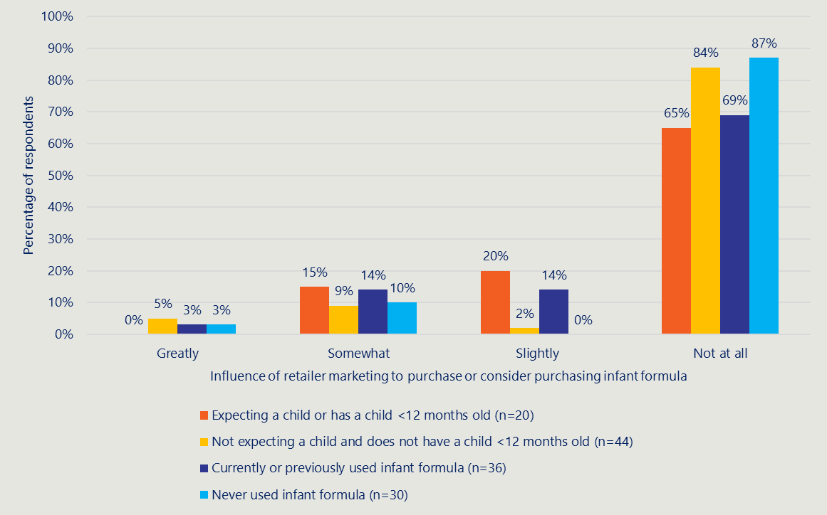

Price promotion

There is evidence that retailers are primarily and frequently marketing infant formula through temporary price promotion
Price promotion was permitted in Australia under the former MAIF Agreement. Survey results, site visits and online audits, and stakeholder views from both public health and industry representatives suggest that price promotion is the most frequently used marketing activity by retailers.
The main types of price promotion identified in Australia were:
- Price dropped
- Special
- Multi-save
- Longer-term price promotions (i.e. Everyday low prices/down down/ low price always).
Survey results found that most people (79%, n=62) had seen some sort of price promotion online or in-store in the last six months. Price discounts (or short-term price drops) were the most frequent price promotion (54%, n=42), with clearance sales (31%, n=24) the second most frequent price promotion. 21% (n=16) of respondents had not seen price promotions in the last six months.
Some supermarkets indirectly promote the purchase of infant formula through their bonus programs, for example providing bonus points for purchase of a particular infant formula. 24% (n=19) reported seeing loyalty program discounts or rewards related to infant formula.
Table 2 | Percentage of survey respondents who reported seeing retailer marketing in the past six months and responded to the types of price promotions seen (n=78)
Type of promotion | % of survey respondents
Discounts | 54%
Clearance sale | 31%
Loyalty program discounts or rewards related to infant formula | 24%
A free gift with purchase of infant formula | 18%
A bundle or offer of multiple related baby products | 17%
Sales related to specific seasons or holiday periods | 12%
Coupons or vouchers for infant formula | 10%
Time-limited offers, such as a flash sale | 9%
Buy-one-get-one-free offers | 8%
Did not see price promotions | 21%
Not sure | 18%
The Deakin University PRICE Tracker dataset, which tracks promotions of infant formula suitable for ages 0-12 months from two major supermarkets, found that on average over the last five years (2019-2024) 18-32% of infant formula products had a temporary price reduction (excluding everyday low prices and other zero discount promotional offers) in any given quarter, with an average discount of between 11.1% to 19.9%. These discounts remain relatively small compared to discounts applied to unhealthy foods (25.9%), but are similar to discounts applied to healthy, core foods (15.1%). This trend may reflect pricing strategies aimed at maintaining perceived value, but without substantial price reductions. See Appendix A for further analysis of the PRICE Tracker dataset.
Results from the survey suggest that price promotion has somewhat of an effect on decision making to purchase or consider purchasing infant formula. Of all respondents who answered the question, 30% (n=15) indicated that in store price promotion somewhat (n=4) or greatly (n=11) influenced them to purchase or consider purchasing infant formula. For all respondents, price promotion was reported as the retailer marketing activity with the greatest influence comparatively to other physical or digital strategies.
Figure 3 compares the percentage of people who reported the level of influence in-store price promotion had on decision making to purchase or consider purchasing infant formula, across different population cohorts of interest. It shows that the percentage of those who were expecting a child or had a child under 12 months who reported being greatly influenced by price promotion (31%, n=4) was higher compared to those who were not expecting a child and did not have a child under 12 months (13%, n=4). Likewise, the percentage of those who reported being greatly influenced by price promotion and were currently or had previously used infant formula was 10% higher than the respondents who had never used infant formula. These results indicate a higher level of influence of price promotion within the target population cohort for retailer marketing.
Figure 3 | Reported influence in-store price promotion had on decision making to purchase or consider purchasing infant formula - percentage of respondents who had seen retailer marketing of infant formula in the last six months
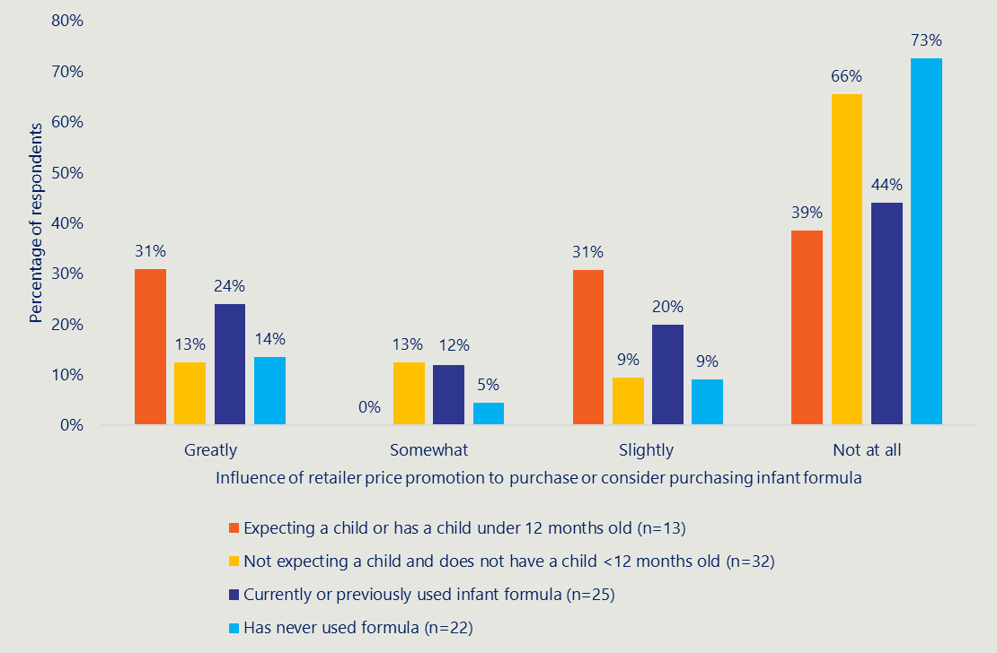

There are polarised opinions as to whether short-term price promotions should remain
Highlighted in UNICEF’s 2024 report on Countering Industry Arguments Against Code Implementation was that industry stakeholders may argue “a ban on promotion restricts access to and affordability of products.” UNICEF provides a response to this argument that the WHO Code does not interfere with the establishment of pricing or practices to provide products at lower prices on a long-term basis. Rather, short-term special sales and price reductions are prohibited because of the potential risks, such as:
- parents may be enticed into purchasing products because of reduced pricing.
- some parents may no longer be able to afford the product once it returns to its normal price.
- families may look for alternatives to formula that are cheaper and unsuitable for feeding infants.
A high-level review of the literature found that pricing strategies can influence decisions around infant formula purchasing. A study found that whilst affordability was a factor in choosing a formula brand, most women felt that the more expensive formula brands were better and therefore would not consider cheaper brands. The influence instead on selecting a particular brand of infant formula was due to brand loyalty, either having used a particular brand previously or being recommended a brand by their family or health professional. Negative effects of pricing strategies have been found, including emphasising a sense of premiumisation, exploiting mother’s guilt and causing incentivisation of purchase.
A market study conducted in the UK in 2024 suggested that parents and carers have been faced with significant price increases in recent years. The study recommended neither reducing current regulations on pricing, nor increasing regulations to cap infant formula prices, but that action should be taken to “improve the design, effectiveness and enforcement of existing regulations to create a more balanced decision-making environment” and enable government understanding of appropriate trade-offs in public health and consumer goals.
The review found a lack of agreement between public health groups and manufacturers on whether this form of marketing is appropriate. Public health groups argued that all provisions of the WHO Code should be applied in national regulation. The WHO Code states that infant formula should not be promoted, with Article 5.3 mentioning that “this provision should not restrict the establishment of pricing policies and practices intended to provide products at lower prices on a long-term basis.”
Public health representatives reported that price promotion could encourage women to buy formula and be a predatory marketing practice which built a family’s commitment to a more expensive brand of formula than they needed. The latter consideration is not relevant to retailers or the impact of price promotions on the cessation of breastfeeding, as it concerns manufacturers and brand competition. Some of these stakeholders also flagged marketing such as “everyday low prices” as being potentially misleading advertising to consumers even if they did not represent an actual discount, as reflected in the PRICE Tracker dataset. Long-term price reductions, however, were generally seen as acceptable to ensure infant formula remains affordable for those it is essential for.
Industry representatives asserted that there is research to indicate there is not a meaningful link between price promotion and choice, brand or amount of infant formula purchased. Although they did not provide their research evidence, they commonly reported that they did not believe that the magnitude of the discounts applied in price promotions would have an impact on breastfeeding rates directly. They argued the main intended and actual impact of price promotion relates to retailer competition: i.e. price promotions can dictate where the consumer decides to purchase their chosen infant formula brand. As industry representatives did not provide this research. the review cannot confirm this claim is true. This research has not been relied on as an evidence point in this review.
Industry stakeholders suggested price promotions do not impact choices to breastfeed and associated public health outcomes but do have a small benefit for consumers who have access to their desired infant formula products at lower prices. They singled out price promotion as the only acceptable form of marketing on the basis that it helped consumers in a cost-of-living crisis.
Public health representatives discussed the potential equity issue price promotions can create. They reported that price promotions can negatively impact consumers once the price of their chosen infant formula returns to normal, leading to adverse pressure to pay more than they can afford or switch brands, which can have negative effects on infants. Although a potential negative impact of price promotion, this does not relate to decision making on breastfeeding choices. UNICEF UK reports that there is no health requirement for parents to stick to one brand.

Discounting of damaged tins or near-expiry products were reported
Two public health groups raised the practice of discounting damaged or near expired products, presenting a health risk for the infant. This may fall outside the scope of marketing and is a practice that could be addressed separately to marketing regulation.

In store product placement

There is some evidence of retailers using the location of infant formula products as a marketing activity
Evidence captured through site visits and from survey responses suggests that infant formula is very frequently placed next to other formula milks on the shelf (87%, n=68). Although site visits did not find any evidence of end of aisle displays, 38% (n=30) of survey respondents reported seeing this type of promotion. Site visits found no evidence of infant formula being placed near checkout or payment areas, with only 9% (n=7) of survey respondents reporting seeing this type of activity. Table 3 provides a further breakdown of types of in-store product placement seen by survey respondents.
Some stakeholders interviewed also provided evidence of supermarkets and pharmacies using prominent placement, end of aisle displays and shelf talkers (small, printed tickets attached to a shelf) to draw the eye to infant formula products.
Table 3 | Percentage of respondents who reported seeing retailer marketing of infant formula in the last six months and who responded to where they had reported seeing it in a physical store (n=78)
Type of marketing | % of survey respondents
Placed directly next to follow-on formula or toddler milks | 87%
End of aisle display | 38%
Near the checkout or payment areas | 9%
Not sure | 6%
I have not seen infant formula in a retailer store | 1%

The location of infant formula in proximity to other formula milk products is considered by some as cross promotion
Cross promotion is defined as “activities that use one product to advertise another”. Manufacturers are reported to commonly use this strategy to link infant formula with other formula milk products designed for older infants or children, such as toddler milks. The use of line extensions with similar packaging and logos, means that some products can be promoted knowing others with a similar identifier will benefit, as consumers take what they know about the familiar brand to a new product. The FSANZ’s P1028 Infant Formula Review has recently made changes to tighten such labelling provisions that link to cross-promotion, with all products expected to meet the new standard by 2029.
The WHO’s guidance recommends that “there should be no cross-promotion to promote breastmilk substitutes indirectly via the promotion of foods for infants and young children.” This specifically references complementary products that need to have a different design and label than those used for breastmilk substitutes. A study conducted in Australia echoed this stance, suggesting that toddler milk promotion could be seen as indirect advertising for infant formula and therefore should be prohibited.
Some consider that a line of formula milk products shelved side-by-side is cross promotion of infant formula and can contribute to misconceptions about formula milks. A recent market study conducted in the UK recommended that all infant formula brands should be shelved together, with follow-on and other formula milks in a separate cluster to equip parents to make strong choices in retail settings.
Stakeholders interviewed during this review reinforced that marketing of toddler milks creates brand loyalty, and consumers understand that a brand’s marketing of toddler milk is promoting both products. Some stakeholders also raised that the framing of formulas as a continuum from infant to toddler milks can mean parents use them for longer, despite there being no proven benefit or need for toddler milk. They also argue that placing infant formula next to toddler milk and other baby products makes those products seem equivalent or like a standard ‘baby product.’
Toddler milks were not included within the scope of this review or the former MAIF Agreement. They were considered by some public health advocates interviewed as a proxy for advertising infant formula within Australia and many of these groups noted that best practice should also incorporate toddler milks into regulation of marketing. They generally suggested that infant formula products should not be shelved next to or near other milk products, to avoid the risk of promotion by proxy.

Other physical marketing activities

There is some evidence of other physical retailer marketing activities
Most evidence of physical retailer marketing activities was found in the survey and as reported by public health representatives during consultations. Survey respondents identified they had most frequently seen in-store advertisements such as a banner, poster or strip on a shelf within the last six months (85%, n=48). Retail media advertisements (such as on the television, in magazines/newspapers and flyers/catalogues) were the second most common activity. It is possible that reporting on this activity may not differentiate between manufacturer and retailer marketing. Table 4 provides a breakdown of the percentage of respondents who had seen different physical retailer marketing activities.
Table 4 | Percentage of survey respondents who reported seeing physical marketing of infant formula by retailers in the last six months and who responded to the type of physical marketing seen (n=58)
Type of marketing | % of survey respondents
In-store advertisements, such as a banner, poster, or strip on a shelf promoting infant formula | 83%
Media advertisement such as on television, in magazines/newspapers and flyers/catalogues | 50%
Event sponsorships (such as retailer sponsorship advertisements promoting infant formula at local or sporting events) | 31%
An outdoor advert on a billboard or poster | 22%
Not sure | 7%
Other | 5%
In-store product sampling or demonstration of infant formula | 3%
Site visits found very limited evidence of in-store print advertising. There was some evidence of shelf talkers seen, mostly in pharmacies rather than supermarkets. No posters, separate stands or other print marketing material were found.

Digital marketing
Digital marketing strategies can dramatically increase the reach and impact of infant formula promotion, and has recently been addressed in the WHO Code
Manufacturers and retailers of infant formula can collect or purchase consumer data, utilise ad-targeting services and use this information about consumers in order to tailor their marketing efforts to their target audiences and maximise consumers’ exposure to and influence of marketing content., ,
The WHO published guidance in 2023 on regulatory measures aimed at restricting digital marketing of breastmilk substitutes. 11 recommendations were made, some of which relate to retailers, including that regulatory measures should prohibit the use of digital marketing tools, including but not limited to:
- promotional content on social media, podcasts or video content, display, banner or pop-up advertisements, search engine advertisements and influencer marketing.
- offering of gifts, discounts or samples directly or through providing a link or code to obtain them online.
- any other digital marketing practices including cross-promotions used to promote breastmilk substitutes or establish relationships between consumers and manufacturers or distributors.
Subsequently the WHO has recently agreed (May 2025) to expand the provisions of the WHO Code to tackle the digital marketing of formula milk and baby foods.
It is recognised that public health responses have struggled to address the influence of digital strategies, with the global nature of technology making digital marketing particularly difficult to monitor and regulate, resulting in greater use. There is a need to comprehensively understand the digital marketing environment in order to design an effective regulatory framework.

Digital marketing is becoming progressively more prevalent, with the use of social media the most frequently reported marketing activity
Digital marketing practices in Australia found in this review include online baby clubs with promotions and give aways or free delivery deals, paid social media influencers, sponsored ads and targeted advertising/use of social media algorithms. It is important to understand the extent to which this is retailer activity, rather than manufacturer marketing,
This type of marketing was frequently raised as an area of concern by public health groups because it can reach target demographics very easily including people who were not otherwise looking for it. Some stakeholders, including advocacy and industry groups interviewed identified online marketing, including sponsored and targeted ads, are especially effective and pervasive and highlighted that best practice approaches to regulating infant formula need to include digital and online marketing in their remit.
The (former) MAIF Complaints Committee database and other Australian studies show that there have been examples of manufacturers using digital marketing channels to promote infant formula, including using health and nutrition claims on websites, which are already prohibited under the Food Standards Code., The complaints database also references manufacturers using social media and mailing lists to promote infant formula. As some manufacturers are also considered retailers, as they sell direct to customers, this suggests some retail digital marketing in Australia and that the line between what is considered retailer marketing and manufacturer marketing may not be as easy to distinguish or review in isolation.
In the survey conducted for this review, 67% of respondents reported seeing some form of online infant formula marketing in the last six months (81). The breakdown of the type of marketing seen is shown in Table 5 below.
Table 5 | Percentage of survey respondents who saw digital marketing of infant formula by retailers in the last six months and who responded to where online they had seen this type of marketing (n=77)
Type of marketing | % of survey respondents
On social media (platforms like Facebook, Instagram, TikTok, X etc.) | 69%
Through online content such as a blog, YouTube video or podcast | 36%
A banner or advertisement on a website or app | 38%
An advertisement on a search engine | 35%
Infant formula product recommendations on a retailer’s website (based on searches or historical orders) | 34%
Other | 19%
An email from a retailer | 18%
Not sure | 11%

Social media is the most common form of digital marketing seen by survey respondents. The most common social media marketing as reported in the survey that is conducted by retailers includes:
- an advertisement on a social media platform
- an influencer or celebrity collaboration with a retailer promoting infant formula
- social media content from members of the public featuring infant formula that had been shared on a retailer’s social media.
Despite being the most prevalent form of digital marketing seen, it was not reported as the most influential by survey respondents. Figure 4 presents the reported influence different digital marketing strategies had on decision making to purchase or consider purchasing infant formula. The majority of respondents reported that digital marketing did not influence their decision making.
Price promotion was the most influential retailer marketing practice, both online and in-store, with 35% (n=21) of respondents reporting that the marketing greatly or somewhat influenced whether they purchased or considered purchasing infant formula online. The second most influential digital marketing practice was retailer website product recommendations, with 30% (n=18) of respondents reporting being greatly or somewhat influenced through this form on marketing. Banners or advertisements on websites or apps were the third most influential, with 27% (n=16) being greatly or somewhat influenced by this marketing strategy.
Figure 4 | Reported influence digital marketing strategies had on decision making to purchase or consider purchasing infant formula - percentage of respondents who had seen retailer marketing of infant formula in the last six months (n=60)
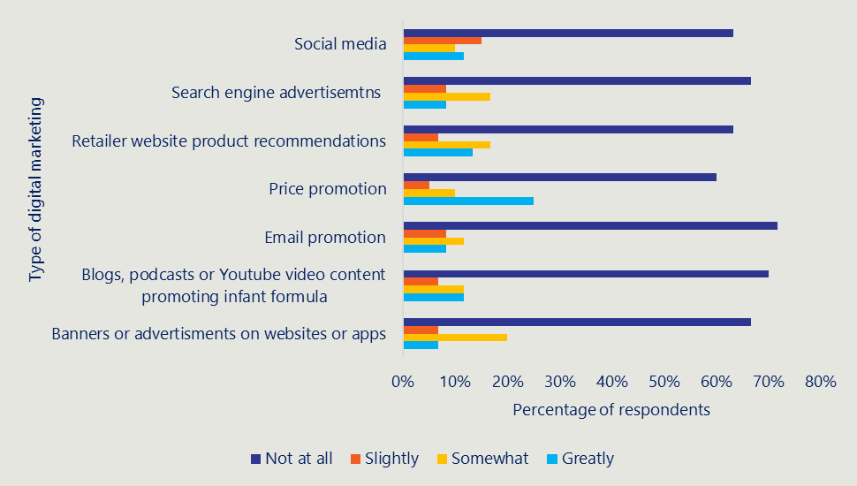

Options
This section uses key aspects of the Impact Analysis (IA) process to provide a framework and articulate a set of options that the Government can consider for its future approach to retailer marketing of infant formula. It should be noted that the approach adopted in this report is to set out options, including a high-level assessment of the merits of each option, and not to make a recommendation on which option should be taken forward. It is outside the scope of this report to undertake a full cost benefit analysis, but high-level costs and benefits associated with options have been identified. The assessment of each option has been informed by inputs from stakeholder engagement and from research on approaches taken internationally as outlined in earlier chapters.
In considering any new regulatory scheme the IA guidance outlines three threshold principles applying to any proposed new regulation, namely that:
- Policy makers should clearly demonstrate a public policy problem necessitating Government intervention and should examine a range of genuine and viable options, including non-regulatory options, to address the problem.
- Each proposal must include a clear set of objectives. These are used to select the best option and to shape evaluation.
- Regulation should not be the default option: the policy option offering the greatest net benefit for Australia — regulatory or non-regulatory — should always be the recommended option.
These three principles have guided the analysis in this section.
The Government could also consider other non-regulatory interventions such as increased communication campaigns relating to the benefits of breastfeeding in addition to or instead of any of the options proposed in this section to promote and protect breastfeeding.

The policy problem being solved - is intervention needed?
Before setting out options for regulation it is important to establish whether a threshold has been reached to require government intervention. The most important threshold question is to demonstrate a public policy problem necessitating Government intervention (regulatory or otherwise). In carrying out this review it is apparent that there are several questions that may need to be addressed, and the appropriate regulatory response depends upon the degree to which these problems are considered true market failure issues. Three problem areas have been consistently highlighted in this review, as shown in Table 6 below.
Table 6 | Policy issues informing options for intervention
Policy issue | Comment
Marketing activities of retailers are negatively impacting upon breastfeeding rates in Australia which can lead to poorer health outcomes for babies and infants. | The degree to which retailer marketing activities are directly correlated with decisions relating to mothers’ decisions around breastfeeding is difficult to ascertain and there is a paucity of relevant Australian literature in this area.  Marketing activities may impact these decisions, however there are also other contributory factors which affect decision making and it is difficult to isolate one individual factor. See Section 4.1 for more details. Quantifying the level of impact of retailer marketing on breastfeeding rates would be critical to conducting a full cost-benefit analysis as the relative cost and benefit to public health outcomes of intervention/non-intervention is directly based on how much marketing is impacting breastfeeding rates.
Current policy settings are not consistent with the WHO Code. | We would note that this is not necessarily a market failure issue but is a policy issue relating to the extent to which the Government should align to the WHO Code taking account of other factors. See Section 4.2 for more details.
Price promotion presents an equity issue if mothers make a decision to move to a particular brand of formula product based on a short-term price reduction which may subsequently rise in price. | Whilst this may be an issue, there is no direct evidence to demonstrate this effect. The degree of price promotion seems to be limited and focussed upon competition between retailers. See Section 4.2 for more details. The Australian Government has not implemented any pricing policy for any consumer product outside tobacco.

A policy position on the questions highlighted above is required before a final decision can be made about the appropriate regulatory response. If the Government is not convinced of the link between retailer marketing and breastfeeding rates, it is unlikely that the threshold will have been met to justify government intervention/regulation.

Regulatory Burden
A key consideration in considering appropriate regulation is the regulatory burden that is created by the number of regulated entities; there are approximately 9640 supermarkets and 4191 pharmacies in Australia. Whilst many of these sits within the dominant supermarket or pharmacy chains, the in-store behaviour of individual stores would still need to be monitored. In addition, competition, especially price competition, is an important aspect of the retail sector in Australia. The importance of value for money for consumers is even more important given significant concerns around cost-of-living increases. In considering the importance of price competition the ACCC Supermarkets Inquiry noted that:
Effective competition – including in the context of supermarkets – leads to lower prices, better quality products and services and increased retail choice for consumers. It also typically leads to more innovation by businesses. Groceries are essential goods, with the price of groceries affecting all Australians. Grocery price inflation weighs more heavily on households with low incomes, who spend a higher proportion of their incomes on groceries compared with other households. Competition between supermarkets also impacts farmers, manufacturers and wholesalers that supply supermarkets. Where suppliers have more choice about which retailers they provide goods to, this will typically improve their bargaining power and their long-run profitability.
This illustrates the complexity of this issue and the need to balance public health aims with commercial issues for retailers and affordability issues for consumers. Complex motivations are also particularly relevant in the case of pharmacies who retail infant formula – as discussed earlier, they are both a retailer and a health service provider for many families.

Regulatory costs and benefits
Costs
Direct costs associated with a regulatory impact can be assigned into those that fall on Government and those that fall onto the regulated entity.
For Government the costs would include those associated with the establishment of any regulatory scheme plus costs associated with its ongoing operation. In this case ongoing costs would be determined by the level of regulation but may include costs associated with inspection, infractions and complaints. These costs could be minimised (but not eliminated) by building infant formula checks into existing regulatory checks that take place in supermarkets and pharmacies to reduce the need for additional monitoring resources.
For the regulated entity, costs typically fall into one of two areas:
- Administrative costs – those costs that the regulated entity would need to put into place to demonstrate compliance to the regulator. These may include, for example, any reporting requirements that the regulator put in place.
- Compliance costs - costs associated with ongoing operation of the policy – for example ensuring that staff are fully trained in requirements.
In terms of indirect costs there is a cost associated with lower breastfeeding rates due to associated health benefits not being achieved. This cost would be borne by the Australian health system. Increased regulation may also be passed onto consumers in the form of higher prices.
A further issue that is of relevance is that, in common with many health interventions, the additional costs of initiatives to increase breastfeeding rates would be incrementally higher as diminishing returns set in.
Benefits
As stated above the policy aim that would be paramount here is to introduce regulation to increase breastfeeding rates and to not encourage mothers to use infant formula in the first 12 months of their baby's life. Benefits here would be accrued to individuals, and Government.
- Individuals – benefits would include improved health of children and mothers that are associated with breastfeeding. International research has shown reduced levels of morbidity in areas such as gastroenteritis, and respiratory infections for breastfed babies. There is also evidence of longer-term protection for breastfed babies such as reduced risk of chronic disease such as diabetes, obesity and hypertension., For mothers there are several well-established relationships on the protective effects of breastfeeding on a mother’s health.
- Government – at a national level increased breastfeeding rates are associated with reduced healthcare expenditure with some studies estimating significant reductions in healthcare expenditure associated with increased breastfeeding rates.

Regulatory options
There are four regulatory options that are considered within this report, namely:
- Retain the status quo.
- Stakeholder led regulation also known as self-regulation.
- Quasi Regulation where Government establishes voluntary codes of practice that entities sign up to.
- Full Government regulation.
In looking at these different options, the cost of regulation on the regulated entity and the cost of enforcement to Government increases the higher the level of regulation. Key to determining the appropriate option is an assessment of the benefits that would accrue to society from each and comparing that to the costs incurred.
Key attributes or features of each option are summarised in Table 7 below and are examined in greater detail in the following section.
Table 7 | Features of the regulatory options
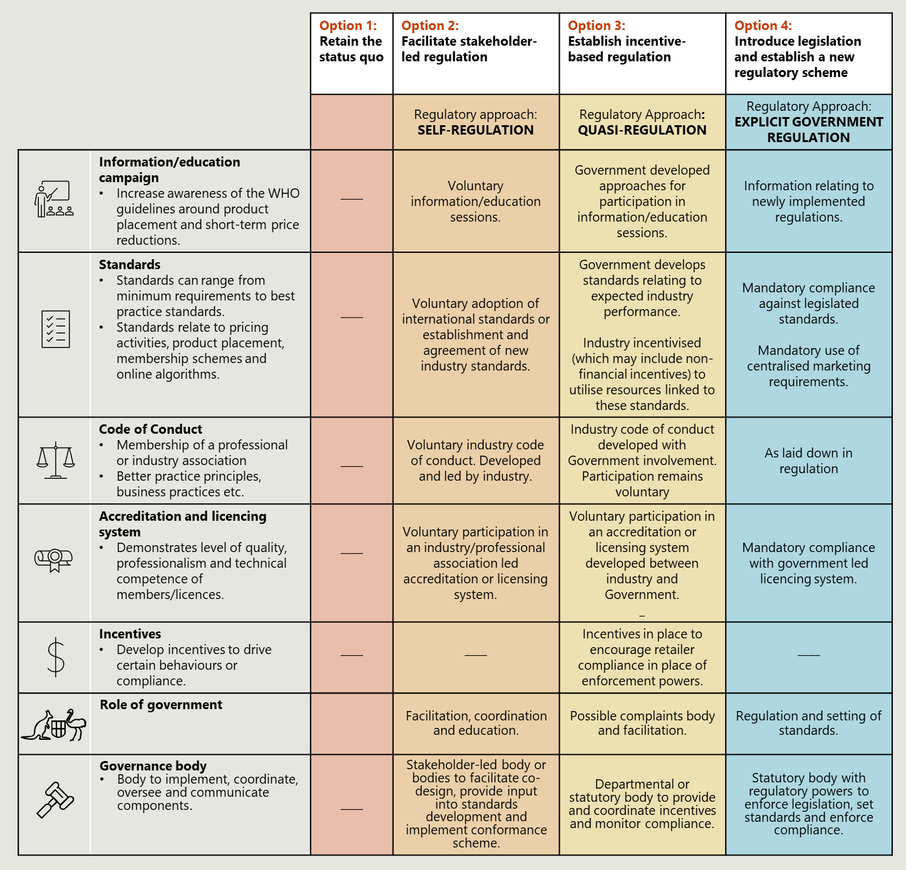

Key features and considerations for options
This section provides a summary of each of the options. It commences with a brief description of each option and is then followed by a table outlining the main costs and benefits.

Option 1: Retain Status Quo

Summary of option
Any proposed change in a regulatory scheme or introduction of new regulations should consider a ‘do nothing’ option which retains the status quo. In this case retailers would continue to operate as they do now irrespective of changes in the regulatory regime for manufacturers.
This is clearly the lowest cost option in terms of regulatory impost on private sector businesses and cost of monitoring by regulators. It would allow retailers to continue to undertake price competition and would be consistent with a policy direction to minimise red tape burden.
This option would not address an objective of eliminating retailer marketing activities if these were determined to be acting against the public interest. As noted previously in this report we have found a lack of evidence to show that in Australia, marketing of infant formula by retailers in isolation actively impacts a woman’s decision to move from breastfeeding to infant formula. Some results from this review may be difficult to generalise, such as survey results investigating the impact on decision making, where a small sample size is noted.
It should be noted that this option does not necessarily imply that Government would undertake no activities here as there could be regular monitoring of activities in marketing to determine whether activities were occurring that are acting against the public interest. This could be done through consumer reporting of activities or a monitoring role within Government.
One area that is developing quickly is that of online marketing, and particularly the use of personalised algorithms. Whilst we have found no evidence that retailers employ algorithms to deliberately target mothers with babies the use of AI may increase the likelihood of this occurring, and this would be an area that the Department may wish to monitor.
Table 8 | Costs and benefits of the status quo
Aspect | Benefits | Costs and Limitations
Public Health | There are limited benefits from a public health perspective as the system remains the same. | Will not address concerns relating to marketing activities of retailers. Will not align with the WHO Code, which is considered international public health best practice.
Consumers | There are limited benefits for consumers noting that this option continues to allow price competition which may benefit consumers if it leads to lower prices. | Given that the system does not change there are minimal additional costs to Consumers.
Industry | This approach would not introduce any new administrative or compliance costs for retailers. | No cost impact to retailers.
Market Dynamics | The continued use of price competition amongst retailers encourages a positive market dynamic. | No impact.
Government / Regulatory Oversight | No additional costs to Government or taxpayers as there will be no requirement for regulatory oversight by an external agency. | Will not address concerns relating to marketing activities of retailers. Will not align with the WHO Code, which is considered international public health best practice.

Implementation considerations
As this opportunity would be largely maintaining the status quo, there would be minimal implementation considerations. This would be dependent on the monitoring program put in place, which may require some level of design and ongoing government funding to maintain.

Option 2: Facilitate Industry-led regulation
Industry-led regulation would involve retailers collaborating to set up self-regulatory processes regarding marketing activities. This would be a light-touch regulatory option which would primarily be led by retailers themselves. The role of the Government would be to facilitate negotiations between stakeholders and propose a way forward. It is only effective when retailers understand the purpose for the regulation and agree on the scope and benefits.
Within this self-regulatory approach, retailers would voluntarily sign on to comply with a code of practice or similar voluntary mechanism. It would then be monitored and enforced by retailers. This may be appropriate if the Government determines that the risks and costs of mandatory compliance outweigh the benefits but that it would still be beneficial to have some controls in place. Some industry representatives engaged suggested they were open to regulation or a code of conduct if it excluded price promotions, so it is possible that this approach would be well received by retailers.
It should be noted that public health groups felt strongly that voluntary or stakeholder regulation was not an effective mechanism for the former MAIF Agreement and should not be used to regulate either manufacturers or retailers. The MAIF Review also deemed the voluntary, self-regulated nature of the MAIF Agreement to no longer be appropriate to address marketing of infant formula and the Government should develop a stronger regulatory framework to restrict inappropriate marketing. The conclusions of the MAIF Review subsequently led to the ACCC’s decision to not re-authorise the MAIF in February 2025.The Government has since committed to introducing mandatory regulation for manufacturers and importers to replace the former MAIF Agreement.
Adherence to the WHO Code would remain voluntary but could be encouraged by Government. The information shown in Table 9 below assumes that price competition would remain.
Table 9 | Costs and benefits of industry-led regulation
Aspect | Benefits | Costs and Limitations
Public Health | The public health benefits would depend upon the degree of marketing that would remain under this option. | If marketing activity is not changed, then this option will not address concerns relating to marketing activities of retailers. However, there is lack of evidence that retailer marketing activity, which is largely price promotion, impacts breastfeeding rates. This option does not align with the WHO Code, which is considered international public health best practice.
Consumers | Given that price competition remains under this option then there would be minimal impact from a cost-of-living perspective due to minimal price changes of formula. | Industry may seek to pass on self-regulatory costs in the form of higher prices which would counteract the benefits of price competition.
Industry | Supports buy in from regulated entities who have been involved in the design and scoping of the regulation, and who are more likely to understand the rationale behind it as it would encourage clarity in reasoning from industry bodies on scope, standards and governance. | Costs associated with setting up voluntary scheme and ongoing monitoring and the establishment of a complaints process.
Market Dynamics | The continued use of price competition amongst retailers encourages a positive market dynamic. | Industry may seek to pass on higher regulatory costs in the form of higher prices which may counteract the benefits of price competition. Different levels of adherence to a voluntary scheme may create confusion in the market and there may be a ‘free rider’ issue where some retailers do not adhere to a voluntary scheme but take any benefits that may accrue.
Government / Regulatory Oversight | Minimal additional costs to Government or taxpayers as there will be no requirement for regulatory oversight by an external agency. | Will not address concerns relating to marketing activities of retailers and does not align with the WHO Code.

Implementation considerations
The key implementation consideration would be developing the right scope to maximise impact whilst getting infant formula retailers to sign on. Stakeholder feedback strongly suggests that retailers would not support including price promotion within the regulation. If the Government considers it is important that price promotion is not allowed under the regulation, it should not take this option forward.
The Department’s role would be to support retailers to develop principles for self-regulation and help to assess the willingness of groups to sign up to the agreement. Experience from the MAIF Agreement suggests it may be easier to get larger retailers to sign on, as some smaller organisations may not have the willingness or extra capacity to take on additional administrative burden. It should be noted, however, that given the concentrated levels of ownership in the supermarket and pharmacy sector the vast majority of sales would be covered which would reduce the risk of inconsistency in marketing.
This option could be taken up by/applied to all retailers or could be used by a specific subsection - for example, as they develop principles for self-regulation supermarkets and pharmacies may decide that they need different controls and monitoring in place.

Option 3: Quasi Regulation
Option three is to take a quasi-regulatory approach which is characterised by voluntary compliance to Government initiated codes of conduct. Under such an approach there would be no formal regulation so there would be limited enforcement powers by Government. This approach could include incentives for compliance but does not include any coercive enforcement powers. There are examples of the use of quasi regulation in Australia with the most pertinent here being the previous MAIF Agreement, although this form of voluntary regulation was found not to be fit for purpose by the ACCC when it denied reauthorisation of the MAIF in February 2025. Other examples include the Health Star Rating System for voluntary front of pack nutrition labelling. Whilst under this option the Government would not have coercive powers to enforce the agreement, there is a significant degree of moral authority when retailers sign up to the code. An option could be for the Government to state that they expect retailers to abide by the WHO Code with or without the inclusion of price controls.
The information given in Table 10 below assumes that price competition would remain.
Table 10 | Costs and benefits of quasi regulation
Aspect | Benefits | Costs and Limitations
Public Health | The public health benefits would depend upon the degree of marketing that would remain under this option. | If marketing activity is not changed, then this option will not address concerns relating to marketing activities of retailers. However, there is lack of evidence that retailer marketing activity, which is largely price promotion, impacts breastfeeding rates. This option does not align with the WHO Code, which is considered international public health best practice.
Consumers | Given that price competition remains under this option then there would be minimal impact from a cost-of-living perspective due to minimal price changes of formula. If a voluntary agreement reduced marketing, then this may increase breastfeeding rates with associated health benefits for mother and child. | Industry may seek to pass on higher regulatory costs in the form of higher prices which may counteract the benefits of maintaining price competition.
Industry | Supports greater buy-in from regulated entities who have been involved in the design scoping of the regulation, and who are more likely to understand the rationale behind it as it would encourage clarity in reasoning from industry bodies on scope, standards and governance. | Costs associated with setting up the scheme, compliance activities and ongoing monitoring.
Market Dynamics | Such a scheme may incentivise innovation as retailers may seek to demonstrate adherence to high levels of standards to stay competitive. | Industry may seek to pass on higher regulatory costs which may increase prices for consumers. Different levels of adherence to a voluntary scheme may create confusion in the market and there may be a ‘free rider’ issue where some retailers do not adhere to a voluntary scheme but take any benefits that may accrue.
Government/Regulatory Oversight | Public health benefits would depend upon the degree of marketing that would remain under this option. | Would require oversight from a regulatory agency including the need for a complaints process. This option does not align with the WHO Code, which is considered international public health best practice.

Implementation considerations
The implementation considerations for this option are similar to option 2 but would require a more formal and in-depth process to develop a scheme which all, or the majority of, retailers would be willing to sign on to. In comparison to option 2, for this option the Government would likely need to take the lead in designing the scheme. It should be noted that the scheme would remain voluntary and may not prove to be effective. This was identified as an issue with the previous MAIF agreement, and its voluntary status was one aspect in the decision to move to a stronger regulatory scheme. Some stakeholders raised the point that the MAIF Agreement demonstrated that often only medium to large entities tend to sign on to such voluntary agreements, meaning that the requirements in place are not always consistently applied across the sector.
Some stakeholders commented on the viability of such a scheme and those that supported this type of regulation suggested that delivery of the scheme, including monitoring and enforcement, could rest with a body such as the ACCC as they already have the structures and resources in place to regulate similar products.

Option 4: Full Regulation
Under this option Government would introduce new legislation to enforce restriction of infant formula marketing by retailers. The most practical way to do this would be to include retailers within the proposed new regulation for manufacturers and importers. There is precedent for doing this as the WHO Code considers ‘distributors’, which covers the entire supply chain for relevant products.
Exactly what was permissible under this legislation would need to be determined by the Government, but through consultation two main options emerged:
- A ban on all forms of retailer marketing of infant formula, consistent with the WHO code
- A ban on all retailer marketing of infant formula, with the exception of price promotion.
Each of these options is considered below.
The review heard from many industry stakeholders that price promotion is an important element of fair competition between retailers, and industry representatives claimed that it had no significant impact on breastfeeding rates. Industry representatives made it clear that they were supportive or neutral towards being included in regulation but only on the condition that it did not include price promotion. The survey results should also be considered here. Although the results have limited representativeness owing to the small sample size for individual questions, they found that price promotion was the most influential retailer marketing practice, both online and in-store, with 35% (n=21) of respondents reporting that the marketing greatly or somewhat influenced whether they purchased or considered purchasing infant formula online.
Table 11 below outlines the costs and benefits of full regulation and assumes full compliance with the WHO code.
Table 11 | Costs and benefits of full regulation
Aspect | Benefits | Costs and Limitations
Public Health | Better alignment with the WHO code may lead to public health benefits. | Absence of price competition may lead to price increases which may impact individuals who choose to or need to use infant formula products and impact on health equity.
Consumers | Will reduce exposure to marketing materials for infant formula and may improve breastfeeding rates with associated health benefits for mother and child. | Absence of price competition may lead to higher prices, impacting individuals who choose to or need to use infant formula products.
Industry | Minimal benefits for retailers. Such a scheme may incentivise innovation as retailers may seek to demonstrate adherence to high levels of standards to stay competitive. | Costs associated with setting up the scheme and ongoing compliance and monitoring activities.
Market Dynamics | It would create consistency between all aspects of the infant formula supply chain in what marketing is permissible. | Absence of price competition may impact the market by affecting individuals who choose to or need to use infant formula products.
Government / Regulatory Oversight | Better alignment with the WHO Code may lead to public health benefits and reduced health system costs. | Costs associated with setting up the scheme and ongoing monitoring and enforcement.

Table 12 below outlines the costs and benefits of full regulation, excluding price promotion. This approach assumes partial implementation of the WHO Code.
Table 12 | Costs and benefits of full regulation, excluding price promotion
Aspect | Benefits | Costs and Limitations
Public Health | Some public health benefit associated with partial implementation of the WHO Code. | Does not fully align with the WHO Code and does not address all concerns with retailer marketing activities. However, there is lack of evidence that retailer marketing activity, which is largely price promotion, impacts breastfeeding rates.
Consumers | Will reduce exposure to marketing materials for infant formula and may lead to some public health benefit. Price competition may lead to reduced prices for those that choose to or need to use infant formula and greater innovation. | Some exposure to retailer marketing activities. Industry may seek to pass on higher regulatory costs in the form of higher prices.
Industry | Minimal benefits for retailers. Such a scheme may incentivise innovation as retailers may seek to demonstrate adherence to high levels of standards to stay competitive. Competition between retailers is maintained. | Costs associated with setting up the scheme and ongoing compliance and monitoring activities.
Market Dynamics | Price competition encourages low prices and incentivises innovation. | Industry may seek to pass on higher regulatory costs to consumers in the form of higher prices.
Government / Regulatory Oversight | Some public health benefit and reduced health system costs associated with partial implementation of the WHO Code. | Costs associated with setting up the scheme and ongoing monitoring and enforcement.

Implementation considerations
There are a number of implementation considerations the Department and Government would need to take into account.
Scope of the regulation. The Government would need to determine what type of marketing practices are included under the regulation, and the appropriate mechanisms and penalties for non-compliance. If price promotion is included under the regulation, it is highly likely that retailers will oppose it, although if it is not included it may be opposed by public health groups. The regulation will also need to strike the right balance in its enforcement mechanism, noting that a standardised penalty may not be appropriate given the different sized organisations subject to the compliance.
Determining which body would be responsible for administering the regulation. Public health groups had a strong view that FSANZ should not be responsible as under its existing legislation they do not have the appropriate remit, and it would take a long time to scale up. An agency such as the ACCC or the Department of Health, Disability and Ageing would be better suited.
Monitoring and enforcement of the regulation. Given the high volume of retailers in the sector, the differing marketing practices used and the increased use of online marketing and sales, enforcement would be difficult. There may be some capacity to use AI to monitor online sales prices, but the number of supermarkets and pharmacies mean that monitoring behaviours such as shelf placement would be extremely difficult. Physical inspections of retail premises would be very time intensive. It should be noted that one option is to not do formal monitoring by regulatory agencies but instead put in place a complaints mechanism as existed under the previous MAIF Agreement, noting this would likely reduce both the costs and benefits of the regulation.
Some of these implementation considerations would need to be aligned to decisions on how to regulate manufacturers if they were to be included under the same regulation. However, because there is a much larger number of retailers the monitoring and enforcement considerations and costs should still be considered separately.

Next steps
The next step will be for the Government to consider the findings and options within this report and come to a stance on the policy questions set out in Table 6. From there, the Government will be in a better place to come to a decision on the best option.
This review sits alongside two upcoming pieces of related work: development of new mandatory regulation for manufacturers on marketing of infant formula, and the FSANZ review of toddler milk. There are a range of non-regulatory options that the Government could consider including, for example, communication campaigns around the benefits of breastfeeding. This could be done instead of, or alongside any regulatory changes highlighted in this report.
The Government should take this work into consideration when choosing the most appropriate option to take forward as it may influence implementation costs and difficulties, as well as presenting opportunities to create consistency across the sector.

Appendix A – Analysis of Price Tracker Data
This appendix outlines further analysis conducted by Deakin University of PRICE Tracker, a database containing the price of foods and beverages – including infant formula – sold online by Coles and Woolworths stores in Sydney, NSW, from January 2019 to March 2024. Price data was collected weekly using automated data web scraping techniques and initially stored in Microsoft Excel spreadsheets. These were subsequently collated and cleaned in Stata to create a complete dataset of weekly infant formula products available for sale.
Figure 5 shows the trends in the frequency infant formula price promotions (excluding zero-dollar promotions) from 2019-2024 per quarter. The frequency of price promotions for infant formula showed some fluctuation over time. On average, 18-32% of these products were price promoted each quarter. Peak frequency was observed in quarter 4 of 2021 (32%), with an overall decline since then, and the lowest frequency observed in quarter 3 of 2023 (14.6%). The association between the year and the frequency of price promotions was statistically significant (p = 0.001), suggesting that the frequency of promotions was not random and may be driven by strategic shifts in pricing and promotion policies.,
Figure 5 | Trends in frequency of infant formula price promotions from 2019-2024, quarterly (n=3,629)
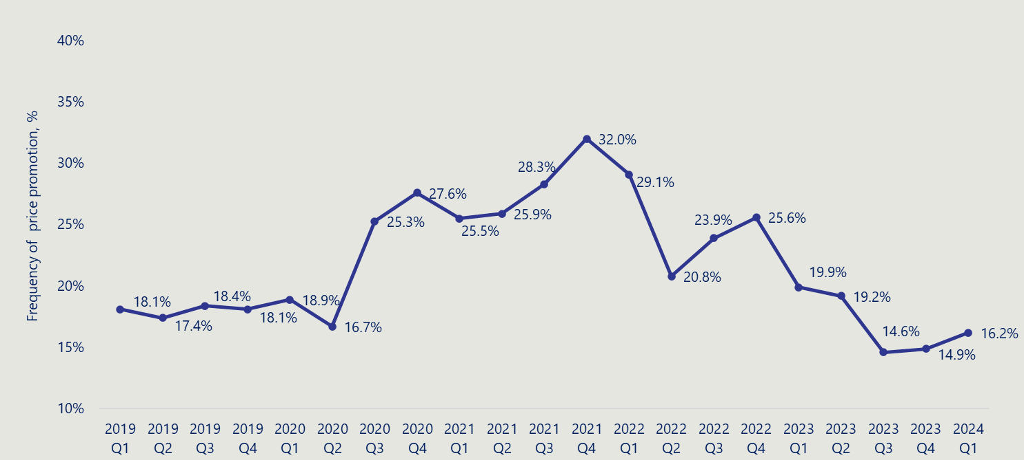

Figure 6 shows the trends in the magnitude of infant formula price promotions (excluding zero-dollar promotions) from 2019-2024 per quarter. The magnitude of price promotions remained relatively stable over the years, ranging from 11.1% to 19.9%, however a sharp decline was observed from quarter 1 in 2023 (17.4%) to quarter 3 in 2023 (11.1%) A linear regression analysis confirmed a statistically significant association between year and discount magnitude (p <0.001), suggesting that the observed decline in discount levels over time was not random and may be driven by strategic shifts in pricing and promotion policies.
Figure 6 | Trends in infant formula price promotions magnitude from 2019-2024, quarterly (n=3,629)
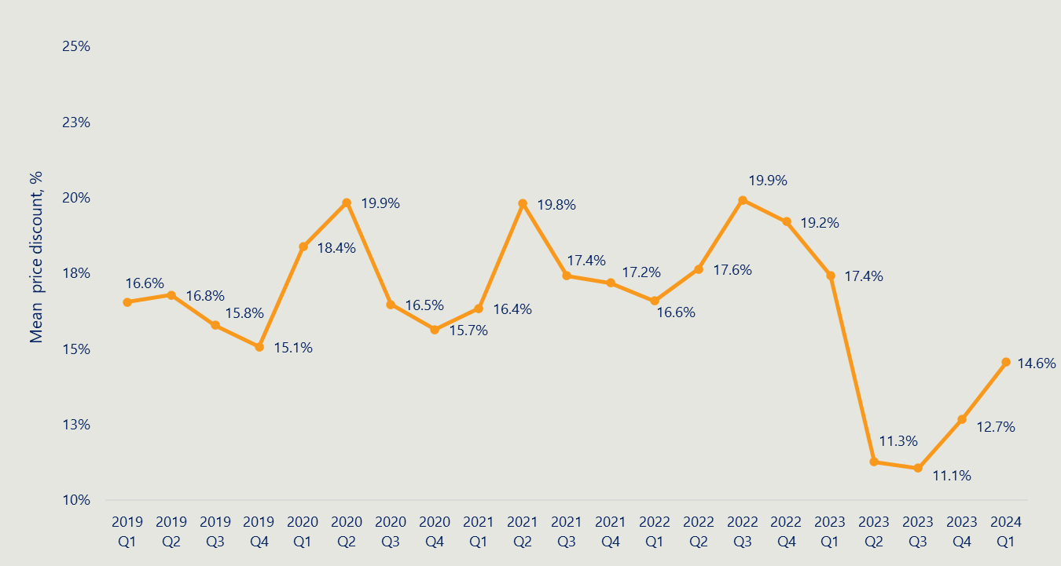

Reference list
Alexandra Jones et al, Digital Marketing of Breastmilk Substitutes: a Systematic Scoping Review, Current Nutrition Reports, 11, pp 416-430, 2022 (accessed 21 February 2025) https://link.springer.com/article/10.1007/s13668-022-00414-3
Allen + Clarke Consulting, Review of the Marketing in Australia of Infant Formulas: Manufacturers and Importers Agreement – Final Report, 11 April 2024 (accessed 19 February 2025) https://www.health.gov.au/sites/default/files/2024-04/review-of-the-marketing-in-australia-of-infant-formulas-manufacturers-and-importers-maif-agreement-final-report_1.pdf
Andy Emannuel, A Literature Review of the Factors That Influence Breastfeeding: An Application of the Health Belief Model, International Journal of Nursing and Health Science, 2015, pp. 28-36 (accessed 19 February 2025) (PDF) A Literature Review of the Factors That Influence Breastfeeding: An Application of the Health Belief Model
Australian Breastfeeding Association, Breastfeeding – for a healthy baby and mum, December 2024 (accessed 3 July 2025) Breastfeeding - for a healthy baby and mum | Australian Breastfeeding Association
Australian Competition and Consumer Commission, ACCC Supermarkets Inquiry, Issues Paper, 29 February 2024 (accessed 3 July 2025) https://www.accc.gov.au/system/files/supermarkets-inquiry-issues-paper_0.pdf
Australian Competition and Consumer Commission, Marketing in Australia of Infant Formula Agreement to continue pending review, 14 August 2024 (accessed 20 February 2025) Marketing in Australia of Infant Formula Agreement to continue pending review | ACCC
Australian Competition and Consumer Commission, Determination, 6 February 2025 (accessed 19 February 2025) Final Determination - 06.02.25 - PR - AA1000665 INC.pdf
Australian Government, Department of the Primary Minister Cabinet, Australian Government Guide to Policy Impact Analysis, 17 February 2023 (accessed 3 July 2025) https://oia.pmc.gov.au/resources/guidance-impact-analysis/australian-government-guide-policy-impact-analysis
Bernardo Lessa Horta and Natalia Peixoto de Lima, Breastfeeding and Type 2 Diabetes: Systematic Review and Meta-Analysis, Current Diabetes Report, 14;19(1), 2019 (accessed 3 July 2025). Breastfeeding and Type 2 Diabetes: Systematic Review and Meta-Analysis - PubMed
Catherine Pereira-Kotze et al, Exploring women’s exposure to marketing of commercial formula products: a qualitative marketing study from two sites in South Africa, Global Health Action, 15(1), 2022 (accessed 5 March 2025) https://www.researchgate.net/publication/362608654_Exploring_women%27s_exposure_to_marketing_of_commercial_formula_products_a_qualitative_marketing_study_from_two_sites_in_South_Africa
Cambridge Dictionary, Cross-promotion, no date, (accessed 4 March 2025) CROSS-PROMOTION | English meaning - Cambridge Dictionary
Christiane Horwood et al, An exploration of pregnant women and mothers’ attitudes, perceptions and experiences of formula feeding and formula marketing, and the factors that influence decision-making about infant feeding in South Africa, BMC Public Health, 22, 393, 25 February 2022 (accessed 6 March 2025) https://link.springer.com/article/10.1186/s12889-022-12784-y
Christine Horwood et al, Women’s exposure to commercial milk formula marketing: a WHO multi-country market research study, Globalization and Health, 20, 85, 2024 (accessed 21 May 2025) Women’s exposure to commercial milk formula marketing: a WHO multi-country market research study | Globalization and Health | Full Text
C.K.Lutter et al, Violations of the International Code of Marketing of Breastmilk Substitutes: a multi-country analysis, BMC Public Health, 22:2336, 2022 (accessed 19 February 2025) https://link.springer.com/article/10.1186/s12889-022-14503-z
COAG Health Council, The Australian National Breastfeeding Strategy: 2019 and Beyond, 2019 (accessed 4 March 2025) Australian National Breastfeeding Strategy: 2019 and beyond
Competition & Markets Authority, Infant Formula and Follow-on Formula Market Study – Final Report, 14 February 2025 (accessed 19 February 2025) https://assets.publishing.service.gov.uk/media/67b5b9cad15c152ea555bf8e/___Final_report.pdf
Deakin University, PRICE Tracker dataset 2019-2024 - Analysis of price and discounts at Coles and Woolworths for infant formula products for 0-12 months, 2025.
Department of Health and Social Care, Commission Delegated Regulation (EU) 2016/127 (supplementing Regulation (EU) No 609/2013: guidance, 14 March 2022 (accessed 4 March 2025) Commission Delegated Regulation (EU) 2016/127 (supplementing Regulation (EU) No 609/2013): guidance - GOV.UK
Ellen G. Piwoz and Sandra L. Huffman, The Impact of Marketing of Breastmilk Substitutes on WHO-Recommended Breastfeeding Practices, Food and Nutrition Bulletin, pp 373-386, 2015 (accessed 21 February 2025) https://journals.sagepub.com/doi/full/10.1177/0379572115602174
European Commission, Commission Delegated Regulation (EU) 2016/127, 25 September 2015 (accessed 19 February 2025) https://www.legislation.gov.uk/eur/2016/127
Fiona Thatcher, Million dollar baby: advertising infant formula in Australia, 19 July 2022 (accessed 19 February 2025) Million dollar baby: advertising infant formula in Australia - Lexology
Food Standards Australia New Zealand, Australia New Zealand Food Standards Code – Standard 2.9.1 – Infant formula products, 13 September 2024 (accessed 20 February 2025) https://www.legislation.gov.au/Details/F2015C00252
Food Standards Australia New Zealand, P1029 – Infant Formula, 26 July 2023 (accessed 20 February 2025) P1028 - Infant Formula | Food Standards Australia New Zealand
Food Standards Australia New Zealand, What we do (and don’t do), 21 January 2019 (accessed 5 March 2025) What we do (and don't do) | Food Standards Australia New Zealand
Frances Fleming-Milici et al, Marketing of sugar-sweetened children’s drinks and parents’ misperceptions about benefits for young children, Maternal & Child Nutrition, 2022 (accessed 5 March 2025) Marketing of sugar‐sweetened children's drinks and parents' misperceptions about benefits for young children - Fleming‐Milici - 2022 - Maternal & Child Nutrition - Wiley Online Library
Francisco Javier Moreno Arboleda et al, Supermarket Product Placement Strategies Based on Association Rules, IAENG International Journal of Computer Science, June 2024 (accessed 7 March 2025) articulo
Gerad Hastings et al, Selling second best: how infant formula marketing works, Globalization and Health, 16(1), August 2020 (accessed 20 February 2025) https://www.researchgate.net/publication/343950094_Selling_second_best_how_infant_formula_marketing_works
Government of Canada, Labelling requirements for infant foods, infant formula and human milk, 2018 (accessed 19 February 2025) Labelling requirements for infant foods, infant formula and human milk - inspection.canada.ca
Infant Nutrition Council, Code of Practice for the Marketing of Infant Formula in Aotearoa, 2023, New Zealand (accessed 20 February 2025) INC-Booklet-2023_Web.pdf
Julie P Smith, Markets, breastfeeding and trade in mothers’ milk, International Breastfeeding Journal, 10:9, 2015 (accessed 9 April 2024) Markets, breastfeeding and trade in mothers’ milk | International Breastfeeding Journal
Mary Champeny et al, Point-of-sale promotion of breastmilk substitutes and commercially produced complementary foods in Cambodia, Nepal, Senegal and Tanzania, Maternal & Child Nutrition, 2016 (accessed 3 March 2025) https://onlinelibrary.wiley.com/doi/full/10.1111/mcn.12272
National Health and Medical Research Council, Infant Feeding Guidelines: Information for health workers, December 2012 (accessed 20 February 2025) Infant-feeding-guidelines-info-for-health-workers (1).pdf
Nicole M Frank et al, The relationship between breastfeeding and reporting respiratory and gastrointestinal infection rates in young children, BMC Pediatrics, 18;19:339, 2019 (accessed 3 July 2025) The relationship between breastfeeding and reported respiratory and gastrointestinal infection rates in young children - PMC
Nigel Rollins et al, Marketing of commercial milk formula: a system to capture parents, communities, science and policy, Lancet, 401: 486-502, 2023 (accessed 11 April 2025) Marketing of commercial milk formula: a system to capture parents, communities, science, and policy
Nina J. Berry and Karleen D. Gribble, Health and Nutrition content claims on websites advertising infant formula available in Australia: A content analysis, Maternal and Child Nutrition, 13(4), 2018 (accessed 8 May 2025) Health and nutrition content claims on websites advertising infant formula available in Australia: A content analysis
Nina J Berry et al, It’s all formula to me: women’s understandings of toddler milk ads, Breastfeeding review, 2010, (accessed 3 March 2025) https://pubmed.ncbi.nlm.nih.gov/20443436/
Nina J Berry et al, Toddler milk advertising in Australia: Infant formula advertising in disguise? Australian Marketing Journal, 2012 (accessed 3 March 2025) Toddler milk advertising in Australia: Infant formula advertising in disguise? - ScienceDirect
Nisachol Cetthakrikul et al, Effect of baby food marketing exposure on infant and young child feeding regimes in Bangkok, Thailand, International Breastfeeding Journal, 2022 (accessed 5 March 2025) Effect of baby food marketing exposure on infant and young child feeding regimes in Bangkok, Thailand | International Breastfeeding Journal
Rafael Perez-Escamilla et al, Breastfeeding: crucially important, but increasingly challenged in a market-driven world, Lancet, 01: 472-85, 2023 (accessed 11 April 2025) Breastfeeding: crucially important, but increasingly challenged in a market-driven world
Renee Reynolds et al, Breastfeeding practices and associations with pregnancy, maternal and infant characteristics in Australia: a cross-sectional study, International Breastfeeding Journal, 18(8), 2023 (accessed 11 April 2025) Breastfeeding practices and associations with pregnancy, maternal and infant characteristics in Australia: a cross-sectional study - PubMed
Riesenberg et al. Price Promotions by Food Category and Product Healthiness in an Australian Supermarket Chain, 2017-2018, American Journal of Public Health, 2019 (accessed 29 September 2025) https://pmc.ncbi.nlm.nih.gov/articles/PMC6727276/
RM Newby & PSW Davies, Why do women stop breast-feeding? Results from a contemporary prospective study in a cohort of Australian women, European Journal of Clinical Nutrition, 70, pp.1428-1432, 2016 (accessed 11 April 2025) https://pubmed.ncbi.nlm.nih.gov/27623979/
Statistica, Number of supermarkets and grocery stores in operation in Australia in financial year 2024, by state or territory, 12 June 2025 (accessed 3 July 2025) https://www.statista.com/statistics/932677/australia-number-supermarket-and-grocery-stores-by-state/
The MAIF Agreement, Marketing of Marketing in Australia of Infant Formulas: Manufacturers and Importers Agreement, 1992 (accessed 19 February 2025) D15+143530.pdf
UNICEF, Countering Industry Arguments against Code Implementation: Evidence and Right-Based Responses, 2024 (accessed 8 April 2025) https://www.globalbreastfeedingcollective.org/media/2581/file/Addressing-Industry-arguments-Code.pdf.pdf
World Health Organization, Global breastfeeding scorecard, 2019: increasing commitment to breastfeeding through funding and improved policies and programmes, 23 July 2019 (accessed 3 July 2025) Global breastfeeding scorecard, 2019: increasing commitment to breastfeeding through funding and improved policies and programmes
World Health Organization, Guidance on ending the inappropriate promotion of foods for infants and young children, 13 May 2016 (accessed 20 February 2025) https://apps.who.int/gb/ebwha/pdf_files/WHA69/A69_7Add1-en.pdf?ua=1
World Health Organization, Guidance on regulatory measures aimed at restricting digital marketing of breastmilk substitutes, 2023 (accessed 19 February 2025) https://iris.who.int/bitstream/handle/10665/374182/9789240084490-eng.pdf?sequence=1
World Health Organization, International Code of Marketing of Breastmilk Substitutes, 1981 (accessed 19 February 2025) https://iris.who.int/bitstream/handle/10665/40382/9241541601.pdf?sequence=1
World Health Organization, Scope and Impact of Digital Marketing Strategies for Promoting Breastmilk Substitutes, 2022 (accessed 19 February 2025) 9789240046085-eng.pdf
World Health Organization, Seventy-eighth World Health Assembly concludes: historic outcomes, consequential highlights, May 2025. https://www.who.int/news/item/28-05-2025-seventy-eighth-world-health-assembly-concludes--historic-outcomes--consequential-highlights?utm_source=chatgpt.com (accessed 26 June 2025)
World Health Organization and United Nations Children’s Fund, Cross-promotion of infant formula and toddler milks, no date (accessed 6 March 2025) information-note-cross-promotion-infant-formula.pdf
World Health Organization and United Nations Children’s Fund, How the Marketing of Formula Milk Influences Our Decision on Infant Feeding, 2022 (accessed 21 February 2025) Multi-country study examining the impact of BMS marketing on infant feeding decisions and practices, UNICEF, WHO 2022.pdf
World Health Organization and United Nations Children’s Fund, National implementation of the International Code, status report, 2024 (accessed 19 February 2025) https://iris.who.int/bitstream/handle/10665/376854/9789240094482-eng.pdf?sequence=1
World Health Organization European Region, Effective regulatory frameworks for ending inappropriate marketing of breastmilk substitutes and foods for infants and young children in the WHO European Region, 2022 (accessed 8 April 2025) WHO-EURO-2022-4885-44648-63367-eng.pdf

https://www.who.int/health-topics/breastfeeding#tab=tab_1
https://www.health.gov.au/resources/publications/australian-national-breastfeeding-strategy-2019-and-beyond
https://www.who.int/health-topics/breastfeeding#tab=tab_1
https://www.health.gov.au/resources/publications/australian-national-breastfeeding-strategy-2019-and-beyond
https://www.aihw.gov.au/reports/mothers-babies/breastfeeding-practices
https://www.foodstandards.gov.au/food-standards-code/proposals/P1028
https://www.health.gov.au/topics/pregnancy-birth-and-baby/breastfeeding-infant-nutrition/marketing-infant-formula
Allen + Clarke Consulting, Review of the Marketing in Australia of Infant Formulas: Manufacturers and Importers Agreement – Final Report, 11 April 2024 (accessed 19 February 2025) https://www.health.gov.au/sites/default/files/2024-04/review-of-the-marketing-in-australia-of-infant-formulas-manufacturers-and-importers-maif-agreement-final-report_1.pdf
Allen + Clarke Consulting, Review of the Marketing in Australia of Infant Formulas: Manufacturers and Importers Agreement – Final Report, 11 April 2024 (accessed 19 February 2025) https://www.health.gov.au/sites/default/files/2024-04/review-of-the-marketing-in-australia-of-infant-formulas-manufacturers-and-importers-maif-agreement-final-report_1.pdf
Ibid.
Australian Competition and Consumer Commission, Determination, 6 February 2025 (accessed 19 February 2025) Final Determination - 06.02.25 - PR - AA1000665 INC.pdf
Australian Competition and Consumer Commission, Marketing in Australia of Infant Formula Agreement to continue pending review, 14 August 2024 (accessed 20 February 2025) Marketing in Australia of Infant Formula Agreement to continue pending review | ACCC
Australian Competition and Consumer Commission, Determination, 6 February 2025 (accessed 19 February 2025) Final Determination - 06.02.25 - PR - AA1000665 INC.pdf
RM Newby & PSW Davies, Why do women stop breast-feeding? Results from a contemporary prospective study in a cohort of Australian women, European Journal of Clinical Nutrition, 70, pp.1428-1432, 2016 (accessed 11 April 2025) Why do women stop breast-feeding? Results from a contemporary prospective study in a cohort of Australian women - PubMed
Ibid.
Australian Bureau of Statistics, Breastfeeding, 2023 (accessed 29 May 2025) Breastfeeding, 2022 | Australian Bureau of Statistics
Australian Institute of Health and Welfare, 2010 Australian national infant feeding survey: indicator results, 2011 (accessed 29 May 2025) 2010 Australian national infant feeding survey: indicator results, Summary - Australian Institute of Health and Welfare
Ellen G. Piwoz and Sandra L. Huffman, The Impact of Marketing of Breast-Milk Substitutes on WHO-Recommended Breastfeeding Practices, Food and Nutrition Bulletin, pp 373-386, 2015 (accessed 21 February 2025) https://journals.sagepub.com/doi/full/10.1177/0379572115602174
Renee Reynolds et al, Breastfeeding practices and associations with pregnancy, maternal and infant characteristics in Australia: a cross-sectional study, International Breastfeeding Journal, 18(8), 2023 (accessed 11 April 2025) Breastfeeding practices and associations with pregnancy, maternal and infant characteristics in Australia: a cross-sectional study - PubMed
RM Newby & PSW Davies, Why do women stop breast-feeding? Results from a contemporary prospective study in a cohort of Australian women, European Journal of Clinical Nutrition, 70, pp.1428-1432, 2016 (accessed 11 April 2025) Why do women stop breast-feeding? Results from a contemporary prospective study in a cohort of Australian women - PubMed
Renee Reynolds et al, Breastfeeding practices and associations with pregnancy, maternal and infant characteristics in Australia: a cross-sectional study, International Breastfeeding Journal, 18(8), 2023 (accessed 11 April 2025) Breastfeeding practices and associations with pregnancy, maternal and infant characteristics in Australia: a cross-sectional study - PubMed
Julie P Smith, Markets, breastfeeding and trade in mothers’ milk, International Breastfeeding Journal, 10:9, 2015 (accessed 9 April 2024) Markets, breastfeeding and trade in mothers’ milk | International Breastfeeding Journal
World Health Organization and United Nations Children’s Fund, How the Marketing of Formula Milk Influences Our Decision on Infant Feeding, 2022 (accessed 21 February 2025) Multi-country study examining the impact of BMS marketing on infant feeding decisions and practices, UNICEF, WHO 2022.pdf
Rafeal Perez-Escamilla et al, Breastfeeding: crucially important, but increasingly challenged in a market-driven world, Lancet, 01: 472-85, 2023 (accessed 11 April 2025) Breastfeeding: crucially important, but increasingly challenged in a market-driven world
Christiane Horwood et al, An exploration of pregnant women and mothers’ attitudes, perceptions and experiences of formula feeding and formula marketing, and the factors that influence decision-making about infant feeding in South Africa, 25 February 2022 (accessed 6 March 2025) https://link.springer.com/article/10.1186/s12889-022-12784-y
Christiane Horwood et al, An exploration of pregnant women and mothers’ attitudes, perceptions and experiences of formula feeding and formula marketing, and the factors that influence decision-making about infant feeding in South Africa, 25 February 2022 (accessed 6 March 2025) https://link.springer.com/article/10.1186/s12889-022-12784-y
Ellen G. Piwoz and Sandra L. Huffman, The Impact of Marketing of Breast-Milk Substitutes on WHO-Recommended Breastfeeding Practices, Food and Nutrition Bulletin, pp 373-386, 2015 (accessed 21 February 2025) https://journals.sagepub.com/doi/full/10.1177/0379572115602174 28 World Health Organization and United Nations Children’s Fund, How the Marketing of Formula Milk Influences Our Decision on Infant Feeding, 2022 (accessed 21 February 2025) Multi-country study examining the impact of BMS marketing on infant feeding decisions and practices, UNICEF, WHO 2022.pdf
World Health Organization and United Nations Children’s Fund, How the Marketing of Formula Milk Influences Our Decision on Infant Feeding, 2022 (accessed 21 February 2025) Multi-country study examining the impact of BMS marketing on infant feeding decisions and practices, UNICEF, WHO 2022.pdf
Ellen G. Piwoz and Sandra L. Huffman, The Impact of Marketing of Breast-Milk Substitutes on WHO-Recommended Breastfeeding Practices, Food and Nutrition Bulletin, pp 373-386, 2015 (accessed 21 February 2025) https://journals.sagepub.com/doi/full/10.1177/0379572115602174
Nisachol Cetthakrikul et al, Effect of baby food marketing exposure on infant and young child feeding regimes in Bangkok, Thailand, International Breastfeeding Journal, 2022 (accessed 5 March 2025) Effect of baby food marketing exposure on infant and young child feeding regimes in Bangkok, Thailand | International Breastfeeding Journal
World Health Organization and United Nations Children’s Fund, How the Marketing of Formula Milk Influences Our Decision on Infant Feeding, 2022 (accessed 21 February 2025) Multi-country study examining the impact of BMS marketing on infant feeding decisions and practices, UNICEF, WHO 2022.pdf
World Health Organization and United Nations Children’s Fund, How the Marketing of Formula Milk Influences Our Decision on Infant Feeding, 2022 (accessed 21 February 2025) Multi-country study examining the impact of BMS marketing on infant feeding decisions and practices, UNICEF, WHO 2022.pdf
World Health Organisation, International Code of Marketing of Breast-milk Substitutes, 1981 (accessed 19 February 2025) https://iris.who.int/bitstream/handle/10665/40382/9241541601.pdf?sequence=1
World Health Organization and the United Nations Children’s Fund, National implementation of the International Code, status report, 2024 (accessed 19 February 2025) iris.who.int/bitstream/handle/10665/376854/9789240094482-eng.pdf?sequence=1
World Health Organization, International Code of Marketing of Breast-milk Substitutes, 1981 (accessed 19 February 2025) https://iris.who.int/bitstream/handle/10665/40382/9241541601.pdf?sequence=1
World Health Organization and United Nations Children’s Fund, National implementation of the International Code, status report, 2024 (accessed 19 February 2025) iris.who.int/bitstream/handle/10665/376854/9789240094482-eng.pdf?sequence=1
Ibid.
Ibid.
Ibid.
Ibid.
Ibid.
World Health Organization and United Nations Children’s Fund, National implementation of the International Code, status report, 2024 (accessed 19 February 2025) iris.who.int/bitstream/handle/10665/376854/9789240094482-eng.pdf?sequence=1
European Commission, Commission Delegated Regulation (EU) 2016/127, 25 September 2015, (accessed 19 February 2025) https://www.legislation.gov.uk/eur/2016/127
Infant Nutrition Council, Code of Practice for the Marketing of Infant Formula in Aotearoa, New Zealand, INC-Booklet-2023_Web.pdf
Food Standards Australia New Zealand, Australia New Zealand Food Standards Code – Standard 2.9.1 – Infant formula products, 13 September 2024 (accessed 20 February 2025) Federal Register of Legislation - Australia New Zealand Food Standards Code – Standard 2.9.1 – Infant formula products
Food Standards Australia New Zealand, P1029 – Infant Formula, 26 July 2023, (accessed 20 February 2025) P1028 - Infant Formula | Food Standards Australia New Zealand
Government of Canada, Labelling requirements for infant foods, infant formula and human milk, 2018 (accessed 19 February 2025) Labelling requirements for infant foods, infant formula and human milk - inspection.canada.ca
World Health Organization and United Nations Children’s Fund, National implementation of the International Code, status report, 2024 (accessed 19 February 2025) iris.who.int/bitstream/handle/10665/376854/9789240094482-eng.pdf?sequence=1
Gerad Hastings et al, Selling second best: how infant formula marketing works Globalization and Health, 2020 (accessed 20 February 2025) https://www.researchgate.net/publication/343950094_Selling_second_best_how_infant_formula_marketing_works
Mary Champeny et al, Point-of-sale promotion of breastmilk substitutes and commercially produced complementary foods in Cambodia, Nepal, Senegal and Tanzania, Maternal & Child Nutrition, 2016 (accessed 3 March 2025) https://onlinelibrary.wiley.com/doi/full/10.1111/mcn.12272
European Commission, Commission Delegated Regulation (EU) 2016/127, 25 September 2015, (accessed 19 February 2025) https://www.legislation.gov.uk/eur/2016/127
Survey results do not distinguish if this influence is in relation to transitioning from breastfeeding to using infant formula, or influence over selection of a particular brand.
Deakin University, PRICE Tracker dataset 2019-2024 - Analysis of price and discounts at Coles and Woolworths for infant formula products for 0-12 months, 2025.
Riesenberg et al. Price Promotions by Food Category and Product Healthiness in an Australian Supermarket Chain, 2017-2018, American Journal of Public Health, 2019 (accessed 29 September 2025) https://pmc.ncbi.nlm.nih.gov/articles/PMC6727276/
UNICEF, Countering Industry Arguments against Code Implementation: Evidence and Right-Based Responses, 2024 (accessed 8 April 2025) https://www.globalbreastfeedingcollective.org/media/2581/file/Addressing-Industry-arguments-Code.pdf.pdf
UNICEF, Countering Industry Arguments against Code Implementation: Evidence and Right-Based Responses, 2024 (accessed 8 April 2025) https://www.globalbreastfeedingcollective.org/media/2581/file/Addressing-Industry-arguments-Code.pdf.pdf
Christiane Horwood et al, An exploration of pregnant women and mothers’ attitudes, perceptions and experiences of formula feeding and formula marketing, and the factors that influence decision-making about infant feeding in South Africa, 25 February 2022 (accessed 6 March 2025) https://link.springer.com/article/10.1186/s12889-022-12784-y
Christiane Horwood et al, An exploration of pregnant women and mothers’ attitudes, perceptions and experiences of formula feeding and formula marketing, and the factors that influence decision-making about infant feeding in South Africa, 25 February 2022 (accessed 6 March 2025) https://link.springer.com/article/10.1186/s12889-022-12784-y
Nigel Rollins et al, Marketing of commercial milk formula: a system to capture parents, communities, science and policy, Lancet, 401: 486-502, 2023 (accessed 11 April 2025) Marketing of commercial milk formula: a system to capture parents, communities, science, and policy
Competition & Markets Authority, Infant Formula and Follow-on Formula Market Study – Final Report, 14 February 2025 (accessed 19 February 2025) https://assets.publishing.service.gov.uk/media/67b5b9cad15c152ea555bf8e/____Final_report_.pdf
World Health Organization, International Code of Marketing of Breast-milk Substitutes, 1981 (accessed 19 February 2025) https://iris.who.int/bitstream/handle/10665/40382/9241541601.pdf?sequence=1
UNICEF, A guide to infant formula for parents who are bottle feeding: the health professionals’ guide, no date) (accessed 21 May 2025) https://www.unicef.org.uk/babyfriendly/wp-content/uploads/sites/2/2016/12/Health-professionals-guide-to-infant-formula.pdf
Cambridge Dictionary, Cross-promotion, no date, (accessed 4 March 2025) CROSS-PROMOTION | English meaning - Cambridge Dictionary
World Health Organization and United Nations Children’s Fund, Cross-promotion of infant formula and toddler milks, no date (accessed 6 March 2025) information-note-cross-promotion-infant-formula.pdf
World Health Organization and United Nations Children’s Fund, Cross-promotion of infant formula and toddler milks, no date (accessed 6 March 2025) information-note-cross-promotion-infant-formula.pdf
Food Standards Australia New Zealand, P1028 – Infant Formula, 2023 (accessed 11 April 2025) P1028 - Infant Formula | Food Standards Australia New Zealand
World Health Organization, Guidance on ending the inappropriate promotion of foods for infants and young children, 13 May 2016 (accessed 20 February 2025) https://apps.who.int/gb/ebwha/pdf_files/WHA69/A69_7Add1-en.pdf?ua=1
Nina J Berry et al, It’s all formula to me: women’s understandings of toddler milk ads, Breastfeeding review, 2010, (accessed 3 March 2025) https://pubmed.ncbi.nlm.nih.gov/20443436/
Frances Fleming-Milici et al, Marketing of sugar-sweetened children’s drinks and parents’ misperceptions about benefits for young children, Maternal & Child Nutrition, 2022 (accessed 5 March 2025) Marketing of sugar‐sweetened children's drinks and parents' misperceptions about benefits for young children - Fleming‐Milici - 2022 - Maternal & Child Nutrition - Wiley Online Library
Competition & Markets Authority, Infant formula and follow-on formula market study final report, 2024 (accessed 7 March 2025) https://www.gov.uk/government/publications/infant-formula-and-follow-on-formula-market-study-final-report/overview
World Health Organization, Scope and Impact of Digital Marketing Strategies for Promoting Breastmilk Substitutes, 2022 (accessed 19 February 2025) 9789240046085-eng.pdf
Alexandra Jones et al, Digital Marketing of Breast-Milk Substitutes: a Systematic Scoping Review, Current Nutrition Reports, 11, pp 416-430, 2022 (accessed 21 February 2025) https://link.springer.com/article/10.1007/s13668-022-00414-3
World Health Organization, Scope and Impact of Digital Marketing Strategies for Promoting Breastmilk Substitutes, 2022 (accessed 19 February 2025) 9789240046085-eng.pdf
Nigel Rollins et al, Marketing of commercial milk formula: a system to capture parents, communities, science and policy, Lancet, 401: 486-502, 2023 (accessed 11 April 2025) Marketing of commercial milk formula: a system to capture parents, communities, science, and policy
World Health Organization, Guidance on regulatory measures aimed at restricting digital marketing of breast-milk substitutes, 2023 (accessed 19 February 2025) https://iris.who.int/bitstream/handle/10665/374182/9789240084490-eng.pdf?sequence=1
World Health Organization, Seventy-eighth World Health Assembly concludes: historic outcomes, consequential highlights, May 2025 (accessed 26 June 2025). https://www.who.int/news/item/28-05-2025-seventy-eighth-world-health-assembly-concludes--historic-outcomes--consequential-highlights?utm_source=chatgpt.com
Nigel Rollins et al, Marketing of commercial milk formula: a system to capture parents, communities, science and policy, Lancet, 401: 486-502, 2023 (accessed 11 April 2025) Marketing of commercial milk formula: a system to capture parents, communities, science, and policy
Nigel Rollins et al, Marketing of commercial milk formula: a system to capture parents, communities, science and policy, Lancet, 401: 486-502, 2023 (accessed 11 April 2025) Marketing of commercial milk formula: a system to capture parents, communities, science, and policy
Nina J. Berry and Karleen D. Gribble, Health and Nutrition content claims on websites advertising infant formula available in Australia: A content analysis, Maternal and Child Nutrition, 13(4), 2018 (accessed 8 May 2025) Health and nutrition content claims on websites advertising infant formula available in Australia: A content analysis
Department of Health, Disability and Ageing, Marketing in Australia of Infant Formulas (MAIF) Complaints Committee, 2025 (accessed 25 June 2025) Marketing in Australia of Infant Formulas (MAIF) Complaints Committee | Australian Government Department of Health, Disability and Ageing
Ibid.
Australian Government, Department of the Primary Minister Cabinet, Australian Government Guide to Policy Impact Analysis, 17 February 2023 (accessed 3 July 2025) https://oia.pmc.gov.au/resources/guidance-impact-analysis/australian-government-guide-policy-impact-analysis
Statistica, Number of supermarkets and grocery stores in operation in Australia in financial year 2024, by state or territory, 12 June 2025 (accessed 3 July 2025) https://www.statista.com/statistics/932677/australia-number-supermarket-and-grocery-stores-by-state/
Australian Competition and Consumer Commission, ACCC Supermarkets Inquiry, Issues Paper, 29 February 2024 (accessed 3 July 2025) https://www.accc.gov.au/system/files/supermarkets-inquiry-issues-paper_0.pdf
Nicole M Frank et al, The relationship between breastfeeding and reporting respiratory and gastrointestinal infection rates in young children, BMC Pediatrics, 18;19:339, 2019 (accessed 3 July 2025) The relationship between breastfeeding and reported respiratory and gastrointestinal infection rates in young children - PMC
Ibid.
Bernardo Lessa Horta and Natalia Peixoto de Lima, Breastfeeding and Type 2 Diabetes: Systematic Review and Meta-Analysis, Current Diabetes Report, 14;19(1), 2019 (accessed 3 July 2025). Breastfeeding and Type 2 Diabetes: Systematic Review and Meta-Analysis - PubMed
Australian Breastfeeding Association, Breastfeeding – for a healthy baby and mum, December 2024 (accessed 3 July 2025) Breastfeeding - for a healthy baby and mum | Australian Breastfeeding Association
World Health Organization, Global breastfeeding scorecard, 2019: increasing commitment to breastfeeding through funding and improved policies and programmes, 23 July 2019 (accessed 3 July 2025) Global breastfeeding scorecard, 2019: increasing commitment to breastfeeding through funding and improved policies and programmes
Deakin University (2025), PRICE Tracker analysis 2019-2024. Analysis of price and discounts at Coles and Woolworths for infant formula products for 0-12 months.

