  -  MONASH PUBLIC HEALTH AND PREVENTIVE MEDICINE

REPORTING PATIENT REPORTED MEASURES IN CLINICAL QUALITY REGISTRIES TO CONSUMERS: A GUIDE

2025

Publication Details
Publication Title: Reporting Patient Reported Measures in Clinical Quality Registries to Consumers: A Guide
Published: 2025
Publisher: Monash University
Doi: 10.26180/29615735
Suggested Citation: Reporting Patient Reported Measures in Clinical Quality Registries to Consumers: A Guide. Monash University. 2025, Version 1.
Copyright
Except as otherwise stated, all material is © Monash University
All material presented in this publication is provided under a Creative Commons Attribution NonCommercial-NoDerivatives 4.0 International Licence (www.creativecommons.org.au), with the exception of all images (including background images, logos and illustrations) and any content identified as being owned by third parties. The details of the relevant licence conditions are available on the Creative Commons website (www.creativecommons.org.au), as is the full legal code for the CC BY-NC-ND 4.0 International Licence https://creativecommons.org/licenses/by-nc-nd/4.0/deed.en
Attribution
Creative Commons Attribution NonCommercial-NoDerivatives 4.0 International Licence is a standard licence agreement that allows you to copy and distribute this publication provided that you attribute the work, do not use the material for commercial purposes and do not distribute modified work.
Monash requests that you attribute this publication (and any material sourced from it) by using the following wording: Source: Monash University
Use of Images
Unless otherwise stated, all images (including background images, icons and illustrations) are copyrighted by their original owners.
Contact Us
For further information or to provide feedback about the Guide, please contact:
E: med-clinicalregistries@monash

Contents
Foreword 4
Australian Government Department of Health, Disability and Ageing Preface 4
Introduction 5
Purpose 5
Target Audience 6
How this guide was developed 6
Findings from the Literature 6
Focus Group Discussions 7
Principles and Recommendations for Reporting CQR-PRMs to Patients/Registry Participants 8
Patient Involvement in CQR-PRMs Programs 8
PRMs Selection 8
PRMs Administration 9
Ethics and Consent 9
General PRMs Data Reporting Principles 10
PRMs in CQR Annual Reports 10
PRMs in Site/Provider Reports 11
PRMs Data Visualisation for Patients/Registry Participants 11
Individual Patient Data Reporting 17
PRMs Reports for Benchmarking and Quality Improvement 19
Real-time PRMs Data Reporting and Dashboards 20
Conclusion 22
Acknowledgements 23
Useful Resources and References 24

Foreword

Australian Government Department of Health, Disability and Ageing Preface
The National Clinical Quality Registry Program (the Program) aims to improve the quality of health care and ensure better health outcomes for Australian patients.
As part of this Program, the Department is leading a range of activities under the National Strategy for Clinical Quality Registries and Virtual Registries 2020–2030 (the Strategy).
Increasing use of patient‐reported outcome and experience measures in national Clinical Quality Registries is a key priority of the Strategy. These measures tell us about people’s health outcomes and quality of life post treatment, and whether our health care system is responding to the preferences, needs and values of patients.
The new ‘Reporting Patient Reported Measures in Clinical Quality Registries to Consumers: A Guide’ provides a set of national principles for how Clinical Quality Registries can support consumers to better access and use patient reported information in their health care decision making. This guide complements the ‘Using Patent Reported Measures in Clinical Quality Registries for Healthcare improvement: A Guide’ and forms part of a suite of best practice materials being developed under the Program.
We thank Monash University for partnering with us on this important initiative.

Andrew Lalor
Assistant Secretary
Health Modelling, Partnerships and Evaluation Branch
Date: 24/07/2025

Introduction
Clinical quality registries (CQRs) are organisations that monitor the quality of health care by collecting information from patients who are diagnosed with specific conditions or who undergo certain medical procedures. Patient-reported measures (PRMs) have been used extensively in research and are increasingly being used in quality improvement activities including clinical registries. These measures capture the patient's perspective on their health and treatment outcomes and can help to assess various aspects of health, including symptoms, quality of life, daily functioning and treatment experiences.
PRMs allow for the comparison of health outcomes across different healthcare providers or institutions, facilitating benchmarking and identifying best practices. PRMs can be used at different levels, from reviewing individual patient interactions to monitoring overall system performance and health outcomes. By incorporating PRMs data, CQRs and participating healthcare providers can gain a more comprehensive understanding of patient experiences and outcomes to inform both individual care and broader health service improvements. However, many CQRs do not routinely provide PRMs data back to patients and registry participants. This may be because CQRs may not have the resources nor expertise needed for collecting and analysing PRMs data and providing meaningful feedback to patients. In addition, patients/registry participants may not be empowered to seek or ask questions about their data.
CQRs that collect and report PRMs should do so with the aim of engaging patients/registry participants in their health care, and confirming that their perspectives are valued. CQRs may collect PRMs information directly from patients/registry participants or indirectly from carers or parents. Reporting PRMs from CQRs may include presenting patients’ perspectives regarding their health, quality of life, any pain, and symptom experiences not only to healthcare providers but also to patients themselves. This may facilitate tailored, shared decision-making between patient and care providers, leading to improved quality of care.
Purpose
The purpose of this document is to provide guiding principles and resources for CQRs when transparently reporting PRMs data to patients/registry participants. This document serves as
a supplementary resource to the guide ‘Using Patient Reported Measures in Clinical Quality Registries for Healthcare Improvement: A Guide’. It provides additional information and support related to the use and reporting of PRMs within CQRs to drive healthcare improvement.
This document includes practical resources, examples of good practices, and guidance for CQRs on how to engage with patients/registry participants in the PRMs reporting process.
The goal of this document is to support transparency in PRMs reporting, patient engagement with PRMs data, and the use of this data for improving healthcare quality and outcomes.

Target Audience
- CQR staff involved in PRMs data analysis and reporting;
- Clinicians and health services who are involved in PRMs data collection and reporting to patients/registry participants;
- Healthcare quality and safety roles and professionals, hospital managers, researchers;
- Patients, registry participants and consumer representatives;
- Staff working in clinical registries that are not CQRs (e.g., research-focused clinical registries) and are interested in PRMs data collection and reporting.

How this guide was developed
The information presented in this document is based on the findings from a literature review of patient/consumer preferences for PRM data reporting and focus group discussions with patients and registry participants to determine their views and perceptions on reporting, using and interpreting PRMs data collected by CQRs.

Findings from the Literature
The aim of the literature review was to investigate and describe views and perceptions of patients around PRM data reporting. To identify relevant publications, we searched MEDLINE and EMBASE databases. Additionally, a grey literature search was performed in Google Scholar. Studies with all types of designs were eligible if they discussed patient/consumer
involvement in the reporting and interpretation of PRM data. The search of databases resulted in 1632 documents. The screening of full-texts resulted in 22 studies, describing PRMs captured in clinical practice. All studies assessed patients’ interpretation of PRMs data and their preferred methods for PRMs reporting. No studies relating specifically to CQRs were identified.
The literature review identified that many patients found that seeing their own PRMs results helped them better understand their health status, facilitated discussions with their healthcare providers, and ultimately empowered them in their care journey. Graphical presentation (such as line graphs and bar charts) for visualising PRMs data and using lay language summaries were most preferred amongst patients. There were mixed views about dashboard reporting and access to real-time data from participants. Some participants with limited health literacy found dashboard reports hard to read while others with higher health literacy preferred this method for PRMs reporting. Patients who received PRM data reports regularly were better able to reflect on their health and identify problems which they discussed with clinicians during consultations.

Focus Group Discussions
Fifteen people participated in five focus groups conducted at Monash University via Zoom teleconference software. The participants were past or current patients from five Australian CQRs collecting medical device, cancer and chronic disease data. The main topics discussed at the focus group discussions included: 1) PRMs collection and reporting, 2) Privacy and consent for PRM data reporting, 3) PRMs data visualisation and presentation for patients, and 4) Accessibility of PRM data reports.
Focus group participants expressed their preference for being informed about how their PRMs data was used. Overall, they were supportive of receiving PRM reports. Participants suggested to use clear terminology, lay language, simple fonts, colours and pictograms to demonstrate the impact of PRMs. They also suggested tailoring PRMs data reports for people from diverse backgrounds, Indigenous populations, older patients, populations with low literacy levels and people with vision impairment where practical and achievable. Focus group participants also believed that PRMs reports and feedback on their own data should be made available on regular basis where possible as it would improve their participation rates in CQR-PRMs programs.
Findings from the literature review and focus group discussions were reviewed by the working group and then combined to develop a set of recommendations and guiding principles for PRMs data reporting to patients and registry participants.

Principles and Recommendations for Reporting CQR-PRMs to Patients/Registry Participants

Patient Involvement in CQR-PRMs Programs
Designing a PRM program in CQRs requires careful planning. For CQRs, PRMs are complementary to clinical data. At the time of planning, decisions should be made regarding how the PRMs and clinical data are integrated to provide the greatest impact.
The CQR should have a governing group that oversees the PRMs program. A designated person within the CQR should be appointed to oversee the PRM program to maximise chances for successful PRMs implementation.
Patients, carers and their families and registry participants are important partners in PRM programs and should be involved in the PRMs governing group.
The PRM governing group should include representatives from patients with lived experience, First Nations and culturally and linguistically diverse (CALD) communities. It is important to acknowledge that this might be challenging for CQRs. This is due to a combination of factors, including language barriers, lack of culturally appropriate materials, and limited awareness of research opportunities within these communities.

PRMs Selection
When selecting PRMs in CQRs, patients/ registry participants should be involved to:
- Ensure cultural appropriateness, response burden, appropriate literacy level (e.g., in languages other than English, cultural relevance), and the real-world context in which people with lived experience and their families live, work, and play;
- Confirm that selected instruments address health outcomes or experiences that are relevant to patients and registry participants and capture these in a comprehensive and understandable manner.

PRMs Administration
When considering the frequency for data collection, successful PRM initiatives should take into consideration the burden of data collection on patients, healthcare professionals, CQR staff, and it should be guided by patients/registry participants.
The CQRs should be mindful of several factors that contribute to lower motivation among patients/registry participants to participate in PRM programs including lack of awareness/poor quality information about the survey's purpose; sensitivity of questions; and lack of perceived benefits or incentives.
CQRs should recognise the emotional impact for patients and should provide understanding and empathetic communication in their patient communications via their websites, communiques and newsletters.
PRMs may be administered via multiple methods to increase response rates. The mode of PRMs administration should take into consideration patient factors, such as the age, gender and digital literacy. Digital data collection methods (e.g., text, QR code, email) should be encouraged. Paper forms should be used only when necessary (e.g., for older people or people without digital access).
The time taken to complete PRMs should be considered for PRMs instrument selection in CQRs to maximise response rates and minimise responder burden.

Ethics and Consent
Providing patients/registry participants with information about why and how their personal health information is being used is an important privacy consideration and can be an opportunity to talk to patients/registry participants about the value of PRM data to guide patient care and improve the quality of care provided.
CQRs must inform patients/registry participants upfront about how their data is going to be used and reported back to them. They should explain the reasons for the data collection and reporting, the information to be used, who it will be shared with, and for what purposes.
Patients/registry participants must be informed if their collected data will be held as identified or de-identified, and how their privacy would be protected.
When PRM data are collected and used in the course of routine care, for quality improvement or healthcare delivery, ethical approval and participant consent may not be required. CQRs use a range of consent models including opt-in or implied consent. Opt-in consent requires an affirmative action from the individual, such as checking a box or signing a form, to agree to data collection or processing. Implied consent, on the other hand, is inferred from the individual's actions or circumstances, like providing an email address during a purchase.

General PRMs Data Reporting Principles
Our focus groups indicated that patients and registry participants are interested in receiving reports comparing their individual data with overall cohort PRM data. They would like to know how their experiences compare to others, and whether their responses contribute to comparing the performance of different healthcare services or different treatment approaches. When this is the case, they feel heard, valued, and empowered, contributing to a more patient-centred approach to care.
Where possible, these reports could be made available to patient/participants such as via SMS or email, noting that patients/registry participants should be able to opt-out or unsubscribe from registry communications. Alternatively, these reports could be publicly accessible, such as via the CQR website.

PRMs in CQR Annual Reports
CQRs should generate routine data reports that include PRM data, and ensure that these are accessible to patients/registry participants. PRMs data can be included in an annual report or standalone infographics to provide insights into patient experiences and outcomes.

PRMs in Site/Provider Reports
PRMs can also be included in health service/provider reports. In this situation, time intervals for PRM aggregate data reporting should, in general, align with the frequency of reporting of clinical data to sites, as well as taking into consideration the volume of PRMs data available for each time period.
CQRs should have a PRM program contact person who can answer any patient/participant questions in relation to the PRMs data collection and reporting.
Reports and communications for patients/registry participants should use lay language to ensure patients understand the information being shared. To improve accessibility of the information, all language and medical terms need to be understandable by patients. Plain language should be used. This includes using simple sentences, common words, and avoiding complex medical terms unless clearly defined.
PRMs reports and data presented to patients/registry participants should be clearly presented and include both qualitative and quantitative interpretation of the data.

PRMs Data Visualisation for Patients/Registry Participants
Findings of the literature and stakeholder consultations recommend that reports and communications to patients/registry participants should include visual aids, clear layout and organisation of the data.
When presenting PRMs results, it is important to demonstrate the impact of the data. Where possible, the clinical importance of the findings can be compared to relevant benchmarks or previous data. Data presented solely through numbers and plots may result in some patients/registry participants being unable to perceive the meaning of the data.
CQRs can present PRM data in a creative way (Example 1) that is easily interpretable by patients. Explaining the significance and relevance of data and making it clear how the data addresses the research question or problem will enable easier interpretation of data by patients/registry participants.
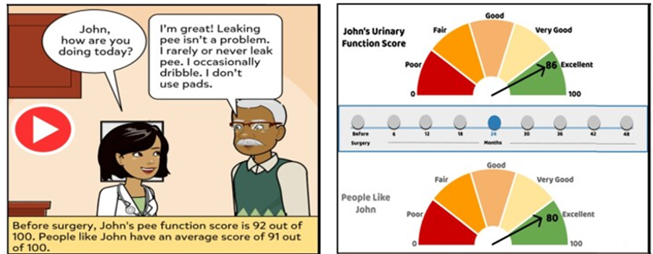
Example 1. Data presented in an image format (left) and meter format (right) (Source: Snyder et al (2022). Comprehension, utility, and preferences of prostate cancer survivors for visual timelines of patient-reported outcomes co-designed for limited graph literacy: meters and emojis over comics. J Am Med Inform Assoc 29(11): 1838-1846)
PRM data may be presented visually in tables, graphs/figures or pictographs. In general, when displaying PRM data in figures/graphs, the following should be included:
- Clear figure title
- Both axes are labelled, with units shown (if appropriate)
- There is a key/description of the PRMs tool that clearly indicates how to interpret high vs a low score and what this means clinically (e.g., good vs poor outcome)
- Keep figures simple where possible
A very brief explanation with the interpretation of the data is recommended. (e.g. a simple basic line graph, Example 2).
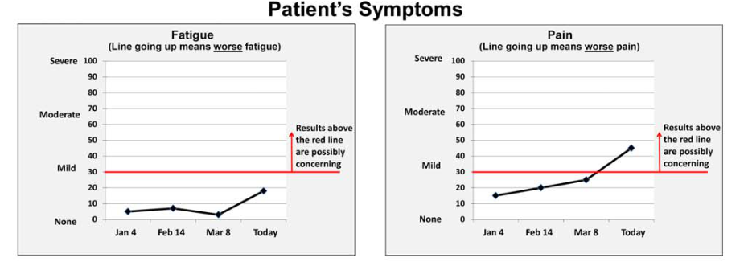
Example 2. Data presented in a simple line graph format for easier interpretation (Source: Snyder et al (2017). What do these scores mean? Presenting patient-reported outcomes data to patients and clinicians to improve interpretability. Cancer 123(10): 1848-1859)
Pictograms offer a visual representation of data that connects with people’s everyday understanding (Example 3). Further, pictograms depicting people make data visualisation more relatable in comparison to traditional clinical depictions of data. For example, showing data as figures of people, coloured differently to the others to represent different outcomes (e.g. 91% of people reported fatigue, therefore 91 of the 100 small figures are coloured in red).
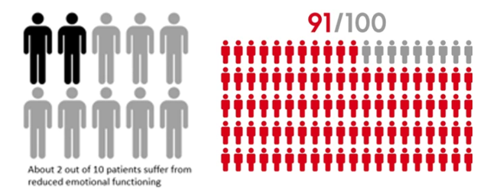
Example 3. A Pictogram method used to represent clinical data (Source: Albers et al (2022). Visualisation formats of patient-reported outcome measures in clinical practice: a systematic review about preferences and interpretation accuracy. J Patient Rep Outcomes 6(1):18)
By using colour in data presentation, CQRs should guide patient’s/registry participant’s attention to the most prominent elements of the data (Example 4). People tend to gravitate towards the most colourful or brightest elements on a page and often it is then assumed as the most important information by the reader.
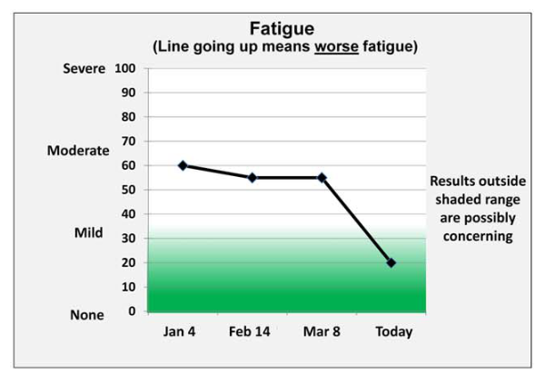
Example 4. Used of a “relaxed” colour to present data (Source: Snyder et al (2017). What do these scores mean? Presenting patient-reported outcomes data to patients and clinicians to improve interpretability. Cancer 123(10): 1848-1859)
Lines, colour, bolding and symbols can be used to draw attention to aspects of the PRM data display:
- Lines on the graph can be used to visualise discrimination of scores (e.g., lines can indicate the threshold for mild, moderate, severe scores) and to reflect reference values such as those from the general population/another comparator group;
- Traffic light colours (green, yellow, red) can be used to designate severity. Pairings of colour and shading should consider the needs of people with visual impairments such as colour blindness/colour confusion;
- Cultural associations of patient populations should be considered when relevant as colours may have different meanings in different cultures.
Colours should be selected with careful consideration. For instance, red colour could be used to highlight a patient's pain score that exceeds a certain level, indicating a need for pain management intervention. Using colours from the "relaxing" part of the rainbow, like blues and greens, can be used to reflect desirable or positive outcomes (Example 5).
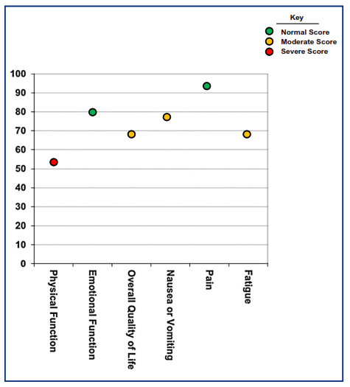
Example 5. Use of a bubble plot with traffic light colours to depict a range of data. Severe data is presented in colours with negative connotations such as red, while normal scoring is presented in more “relaxing” colours such as green (Source: Brundage al (2015). Communicating patient-reported outcome scores using graphic formats: results from a mixed-methods evaluation. Quality of Life Research 24(10): 2457-2472)
Colours with negative connotations such as red may depict worse results (Example 6).
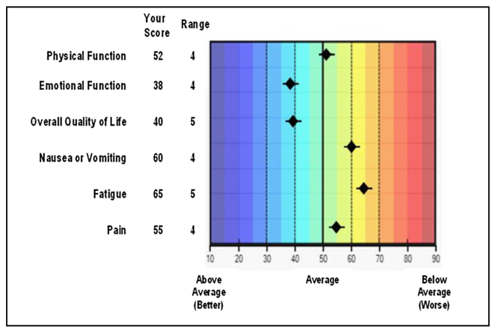
Example 6. Use of a colour gradient in rainbow colours to display a range of data. Colours with negative connotations such as red, depict worse results, while more “relaxing” colours depict better results. (Source: Brundage et al (2015). Communicating patient-reported outcome scores using graphic formats: results from a mixed-methods evaluation. Quality of Life Research 24(10): 2457-2472)
PRMs scores could be presented in a similar form to blood count results, showing reference ranges (Example 7). Patients can also refer to previous results. The range is presented, so patients can see if their data are outside the normal range.
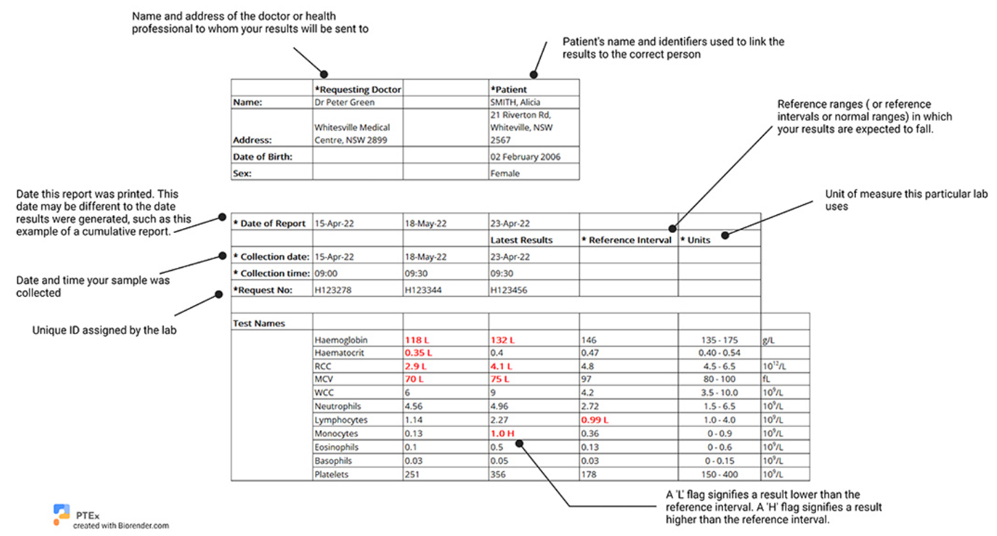
Example 7. An example of blood test results. (Source: https://pathologytestsexplained.org.au/pages.php?page=Tips%20on%20reading%20your%20results)
People/registry participants with vision impairment or people who may need the assistance of a screen reader should be considered. The information should be presented in such a way that is accessible to these populations. For example, larger fonts, generally 14-16 points of higher are easier to read and more accessible. Simpler sans-serif fonts like Arial or Helvetica are also recommended as more accessible.
Stylised fonts, block capital letters and underlining should be avoided as these formats are considered as difficult to read for vision impaired individuals and for individuals using screen readers. Additionally, structured content with proper headings, semantic HTML tags, and alternative (alt) text for images should be considered for easier accessibility for individuals with screen readers (Example 8). To make data reporting accessible to colour-blind individuals, a combination of colour, patterns, and shapes to convey information should be used, ensuring sufficient contrast between elements.

Example 8. Data presented in image format and with Alt Text for easier accessibility when using a screen reader. (Source: Snyder et al (2005). Audio description: The visual made verbal. International Congress Series 1282: 935-939)

Individual Patient Data Reporting
Being able to see their own PRMs data enables patients and registry participants to understand how their results compare with results for people undergoing the same treatment and/or procedure, or with the same condition. Patients/registry participants should be able to receive their individual data reports upon request. This can be enabled if registry resources allow through a patient opt-in process, or submitting a specific registry data access request.
CQRs should consider setting up a report template that can be prefilled quickly for greatest efficiency. A template provides a consistent structure and format, allowing for faster report creation. When possible, CQRs should be able to generate automated PRMs reports to reduce staff workload and to increase accuracy of the data.
When appropriate, CQRs should tailor individual PRMs reports for people from diverse backgrounds, including CALD and Indigenous populations. This is to ensure that data are accessible, inclusive and culturally appropriate to these individuals.
However, individual reporting should be taken with caution as some patients could be tracking much lower than the average, which can be perceived with stress. CQRs may
consider providing a statement with advice for patients/registry participants to contact their healthcare provider, especially when the PRMs data reveals potential issues or areas where a patient's individual circumstances may warrant further investigation by their treating clinician.
The reports may show individual’s PRM scores against larger groups of people with same age, condition, and treatment categories. The number of people included in the report should be stated for context.
Individual reports should be tailored by using colours, emojis and simple descriptors of the data for elderly people, people with lower literacy skills or those with learning disabilities as they may have challenges in reading or understanding the information (Example 9).
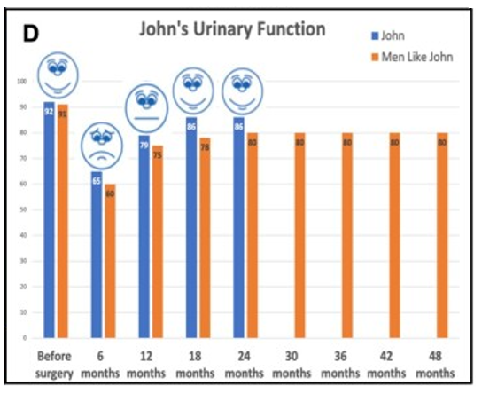
Example 9. Data tailored to individuals with low literacy levels by using colours, emojis and simple descriptors of the data. (Source: Snyder al (2022). Comprehension, utility, and preferences of prostate cancer survivors for visual timelines of patient-reported outcomes co-designed for limited graph literacy: meters and emojis over comics. J Am Med Inform Assoc 29(11): 1838-1846)
If available, where PRMs are collected at multiple time points, CQRs should provide longitudinal reports that allow patients and registry participants to track their own progress over time (Examples 9, 10 & 11).
Both line charts and bar charts can effectively display progress over time. Line charts are generally better for showing trends and continuous changes, while bar charts are useful for comparing values at specific points in time or across different categories.
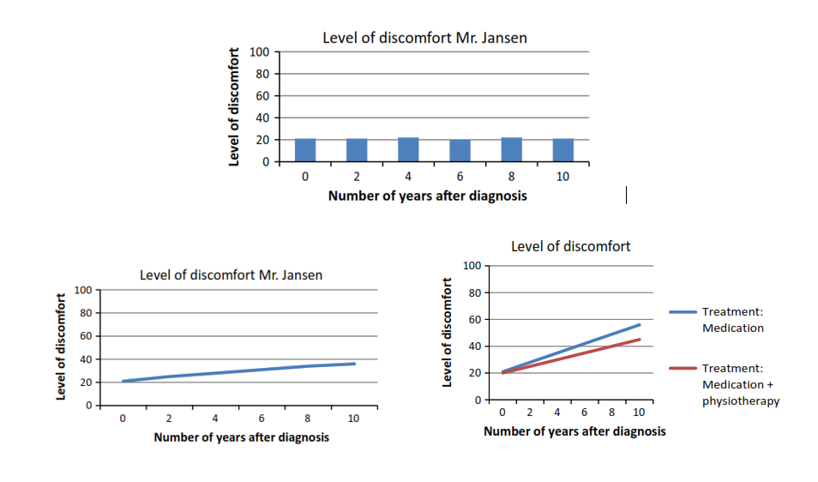
Example 10. Individual data presented in a bar chart or simple line graph format. (Source: Damman et al (2019). Using PROMs during routine medical consultations: The perspectives of people with Parkinson's disease and their health professionals. Health Expect 22(5): 939-951)
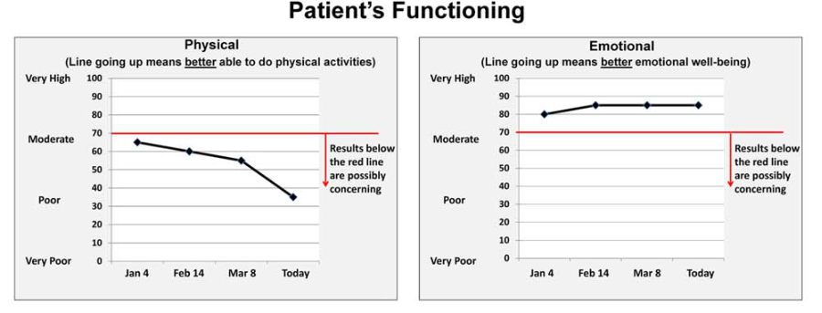
Example 11. Simple graphs with a description of interpreting the data. (Source: Snyder et al (2017). What do these scores mean? Presenting patient-reported outcomes data to patients and clinicians to improve interpretability. Cancer 123(10): 1848-1859)

PRMs Reports for Benchmarking and Quality Improvement
CQRs can track patient-reported outcomes, experiences, function and quality of life over time, allowing hospitals to compare their outcomes with national benchmarks and identify areas for improvement in patient care. From our focus group work, it is evident that patients, registry participants and consumer representatives would like to be informed on their site's
performance. By understanding site-level outcomes, consumer representatives can advocate for improvements based on evidence and best practices, ultimately leading to better quality of care. There are however potential risks with providing comparative site reports to patients, particularly when they do not have a choice of healthcare provider.
Benchmarking hospital performance against the average across a range of hospitals/sites is commonly visualised using bar graphs where the average is represented by a line and individual hospital performance is represented by bars. Bars extending above the average line indicate better-than-average performance, while those below indicates below-average performance. Each bar on the graph represents a hospital or a group of hospitals, and its height corresponds to their performance on the chosen metric (Example 12).
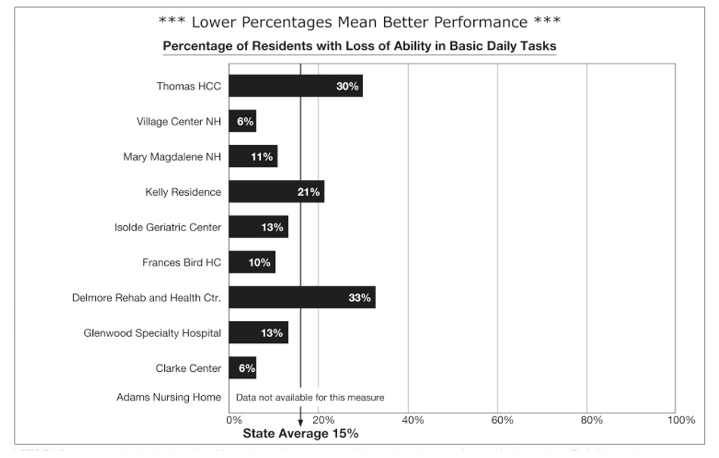
Example 12. Simple bar graph showing centre’s performance. (Source: Gerteis et al (2007). Testing consumers' comprehension of quality measures using alternative reporting formats. Health Care Financing Review 28(3): 31-45)

Real-time PRMs Data Reporting and Dashboards
While the concept of patients viewing and generating their own PRMs reports from registry dashboards is becoming popular, it is not yet widespread in practice. However, there is growing interest in empowering patients with access to their own data and allowing them to track their progress and participate more actively in their care.
When possible, patients/registry participants should have an opportunity to generate their own PRMs reports through the registry dashboards. Again, this could be via an opt-in approach.
It is crucial for patients/registry participants to have the skills to interpret and utilise the data effectively. Robust security measures must be in place to protect sensitive, identifiable data. This includes implementing strong access controls, encryption, regular audits employing best practices for cybersecurity.
The dashboard and reporting features need to be intuitive and easy to navigate for patients/registry participants of varying technical abilities. Patients/participants may require support and guidance on how to access and interpret PRM data however clinical interpretation should be undertaken by a clinician. Patients may need guidance on how to interpret PRMs results and utilise the reports effectively. CQR consumer representatives can assist with interpreting the data, describing results in a way that is meaningful to patients, and communicating results in patient-friendly language.
Patients may wish to visualise their own dashboard data to gain a better understanding of trends, progress, and potential relationships between different measurements (Example 13). If this option was available, the PRMs data presented in the registry would need to be representative or at least the current participation rate specified.
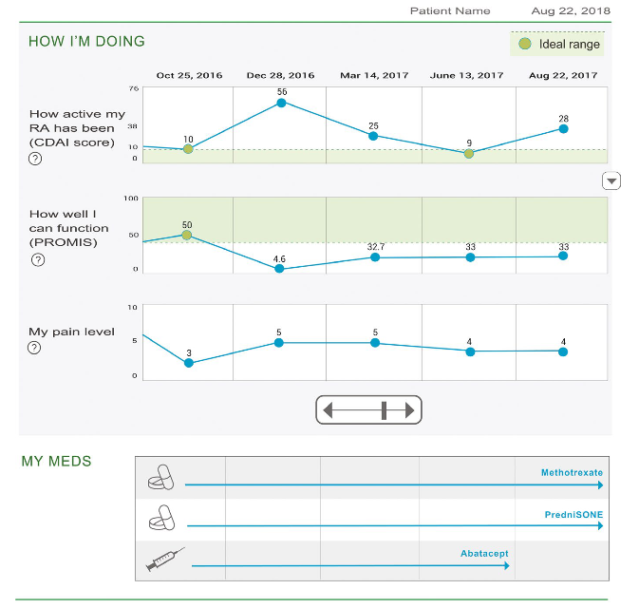
Example 13. An example of real-time data presented in a dashboard format
(Source: Liu et al. (2020). Patient and clinician perspectives on a patient-facing dashboard that visualises patient reported outcomes in rheumatoid arthritis. Health Expectations 23(4): 846-859.)

Conclusion
This project has developed a set of guiding principles and recommendations for CQRs collecting and reporting PRMs data to patients/registry participants and consumer organisations.
This document serves as a supplementary resource to the guide ‘Using Patient Reported Measures in Clinical Quality Registries for Healthcare Improvement: A Guide’. It provides additional information and support related to the use and reporting of PRMs within CQRs to drive healthcare improvement.
Developed in collaboration with patients and registry participants, these practical recommendations can guide the analysis and reporting of data for patients, and can be used to support communication with healthcare providers and facilitate shared decision-making.

Acknowledgements
We acknowledge the funding provided by the Australian Government Department of Health, Disability and Ageing for this project. We acknowledge the participants of focus groups for sharing their perspectives and views. We also thank patients and consumers for their guidance and assistance in reviewing the draft of this document.

Useful Resources and References
- Using Patient Reported Measures in Clinical Quality Registries for Healthcare Improvement: A Guide. Monash University. 2025, Version 1. Doi: 10.26180/28801313
- Recommendations for safe use of medicines terminology. November 2024. Australian Commission on Safety and Quality in Health Care 2024. https://www.safetyandquality.gov.au/sites/default/files/2024-12/recommendations-for-safe-use-of-medicines-terminology.pdf
- Aiyegbusi OL, Roydhouse J, Rivera SC, Kamudoni P, Schache P, Wilson R, Stephens R, Calvert M. Key considerations to reduce or address respondent burden in patient-reported outcome (PRO) data collection. Nature Communications. 2022 Oct 12;13(1):6026.
- Albers EAC, Fraterman I, Walraven I, Wilthagen E, Schagen SB, van der Ploeg IM, et al. Visualization formats of patient-reported outcome measures in clinical practice: a systematic review about preferences and interpretation accuracy. J Patient Rep Outcomes. 2022;6(1):18.
- Bantug ET, Coles T, Smith KC, Snyder CF, Rouette J, Brundage MD. Graphical displays of patient-reported outcomes (PRO) for use in clinical practice: What makes a pro picture worth a thousand words? Patient Educ Couns. 2016;99(4):483-90.
- Brundage MD, Smith KC, Little EA, Bantug ET, Snyder CF, Board. PDPSA. Communicating patient-reported outcome scores using graphic formats: results from a mixed-methods evaluation. Quality of Life Research. 2015;24(10):2457-72.
- Chan EKH, Edwards TC, Haywood K, Mikles SP, Newton L. Implementing patient-reported outcome measures in clinical practice: a companion guide to the ISOQOL user's guide. Qual Life Res. 2019;28(3):621-7.
- Damman OC, Verbiest MEA, Vonk SI, Berendse HW, Bloem BR, de Bruijne MC, et al. Using PROMs during routine medical consultations: The perspectives of people with Parkinson's disease and their health professionals. Health Expect. 2019;22(5):939-51.
- Franklin P. Ask Patients Now: Amplifying the Patients Voice in Healthcare 2025 [Available from: https://www.askpatientsnow.com/new-page.
- Gerteis M, Gerteis JS, Newman D, Koepke C. Testing consumers' comprehension of quality measures using alternative reporting formats. Health Care Financing Review 2007;28(3):31-45.
- Haverman L, van Oers HA, Limperg PF, Hijmans CT, Schepers SA, Sint Nicolaas SM, Verhaak CM, Bouts AH, Fijnvandraat K, Peters M, van Rossum MA. Implementation of electronic patient reported outcomes in pediatric daily clinical practice: The KLIK experience. Clinical Practice in Pediatric Psychology. 2014 Mar;2(1):50.
- Haverman, L., van Oers, H.A., van Muilekom, M.M. MSc, Grootenhuis, M.A. Options for the Interpretation of and Recommendations for Acting on Different PROMs in Daily Clinical Practice Using KLIK. Medical Care 57():p S52-S58, May 2019. DOI: 10.1097/MLR.0000000000001061
- International Society for Quality of Life Research (prepared by Aaronson N, Elliott T, Greenhalgh J, Halyard M, Hess R, Miller D, Reeve B, Santana M, Snyder C). User’s Guide to Implementing Patient-Reported Outcomes Assessment in Clinical Practice, Version: January 2015.Brundage et al
- Liu LH, Garrett SB, Li J, Ragouzeos D, Berrean B, Dohan D, et al. Patient and clinician perspectives on a patient-facing dashboard that visualizes patient reported outcomes in rheumatoid arthritis. Health Expectations. 2020;23(4):846-59.
- Loth FL, Holzner B, Sztankay M, Bliem HR, Raoufi S, Rumpold G, et al. Cancer patients' understanding of longitudinal EORTC QLQ-C30 scores presented as bar charts. Patient Educ Couns. 2016;99(12):2012-7.
- NSW Agency for Clinical Innovation. Patient-reported outcome measures: Methods for analysis and reporting. Sydney: ACI; 2023
- Painter E, Zwar J, Carino S, Kermonde Z. Best practice data visualisation: guidelines and case study. Monash University Monash Climate Change Communication Research Hub 2021
- Shi Q, Mendoza TR, Cleeland CS. Interpreting patient-reported outcome scores for clinical research and practice: definition, determination, and application of cutpoints. Medical care. 2019 May 1;57:S8-12.
- Smith KC, Brundage MD, Tolbert E, Little EA, Bantug ET, Snyder CF, PRO Data Presentation Stakeholder Advisory Board. Engaging stakeholders to improve presentation of patient-reported outcomes data in clinical practice. Supportive Care in Cancer. 2016 Oct;24:4149-57.
- Snyder J. Audio description: The visual made verbal. International Congress Series. 2005;1282:935-9.
- Snyder CF, Blackford AL, Aaronson NK, Detmar SB, Carducci MA, Brundage MD, Wu AW. Can patient-reported outcome measures identify cancer patients’ most bothersome issues?. Journal of Clinical Oncology. 2011 Mar 20;29(9):1216-20.
- Snyder CF, Smith KC, Bantug ET, Tolbert EE, Blackford AL, Brundage MD, et al. What do these scores mean? Presenting patient-reported outcomes data to patients and clinicians to improve interpretability. Cancer. 2017;123(10):1848-59.
- Snyder C, Smith K, Holzner B, Rivera YM, Bantug E, Brundage M. Making a picture worth a thousand numbers: recommendations for graphically displaying patient-reported outcomes data. Qual Life Res. 2019;28(2):345-56.
- Snyder C, Brundage M, Rivera YM, Wu AW. A PRO-cision Medicine Methods Toolkit to Address the Challenges of Personalizing Cancer Care Using Patient-Reported Outcomes: Introduction to the Supplement. Med Care. 2019 May;57 Suppl 5 Suppl 1(Suppl 5 1):S1-S7. doi: 10.1097/MLR.0000000000001089. PMID: 30985589; PMCID: PMC7400766.
- Snyder LE, Phan DF, Williams KC, Piqueiras E, Connor SE, George S, et al. Comprehension, utility, and preferences of prostate cancer survivors for visual timelines of patient-reported outcomes co-designed for limited graph literacy: meters and emojis over comics. J Am Med Inform Assoc. 2022;29(11):1838-46.
- The PROTEUS Guide to Implementing Patient-reported Outcomes in Clinical Practice. A synthesis of resources. Prepared by Crossnohere N, Brundage M, Snyder C, and the Advisory Group, 2023. Available at: TheProteusConsortium.org.
- Tilford S. Blood Test 2013 [Available from: https://stevetilford.com/2013/11/20/doctors/bloodtest-5/.
- van der Willik EM, Terwee CB, Bos WJW, Hemmelder MH, Jager KJ, Zoccali C, et al. Patient-reported outcome measures (PROMs): making sense of individual PROM scores and changes in PROM scores over time. Nephrology (Carlton). 2021;26(5):391-9
- Wu AW, Jensen RE, Salzburg C, Snyder C. Advances in the use of patient reported outcome measures in electronic health records: including case studies. Landscape review prepared for the PCORI national workshop to advance the use of PRO measures in electronic health records. Atlanta, GA. 11/19-20/13. Available at: http://www.pcori.org/assets/2013/11/PCORI-PRO-Workshop-EHR-Landscape-Review-111913.pdf.

- Schultz M, Verlis K, Nicke B, McCaffery K, Copp T, Laidsaar-Powell R. Do Australian health consumers understand and intend to use Patient Reported Experience Measures (PREMs) when selecting a hospital?: A qualitative exploration of online hospital report cards. Health Literacy and Communication Open, 2(1). 2024; https://doi.org/10.1080/28355245.2024.2425162
- Lloyd S, Cliff C, FitzGerald G, Collie J. Can publicly reported data be used to understand performance in an Australian rural hospital? Health Information Management Journal. 2020;50(1-2):35-46. doi:10.1177/1833358320948559
- Zwijnenberg NC, Hendriks M, Damman OC, Bloemendal E, Wendel S, de Jong JD, Rademakers J. Understanding and using comparative healthcare information; the effect of the amount of information and consumer characteristics and skills. BMC Med Inform Decis Mak. 2012 Sep 7;12:101. doi: 10.1186/1472-6947-12-101. PMID: 22958295; PMCID: PMC3483238.

