Quarterly Financial Snapshot
Aged Care Sector

Quarter 1 2025-26
1 July to 30 September 2025

Contents

Introduction 3
Aged care reform priorities 4
Residential care 7
Home care 9
Residential aged care 11
Financial performance 11
Average care minutes 17
Staff cost and time 19
Hourly rates 22
Food and nutrition 24
Home care 25
Financial performance 25
Staff cost and time 30
Hourly rates 31
Care and package management 33
Unspent funds 34
Glossary 35
Appendix 37

Introduction
The Australian Government is committed to transparency in aged care. The publication of financial information gives valuable insights to the sector and community.
The Department of Health, Disability, and Ageing (the department) publishes a Quarterly Financial Snapshot (QFS) on the Australian aged care sector. The QFS:
- provides transparency about providers’ finances and operations and helps older people and their families make informed decisions about their care
- provides information for aged care providers to compare and benchmark their performance with sector-level results
- supports the monitoring of critical financial metrics across the aged care system
- complements other publications such as:
- the annual Financial Report on the Australian Aged Care Sector (FRAACS)
- registered nurse coverage in aged care dashboard
- care minutes in residential aged care dashboard
- the quarterly reporting of service-level financial and operations information on My Aged Care through the ‘Find a Provider’ tool.
This QFS covers 1 July to 30 September 2025 (Q1 2025-26). It has three sections:

The Appendix contains tips on how to read the QFS, including provider type definitions, information about data sources, and methodologies used.
An Excel data extract containing all headline figures from QFS reports published to date is available on the department’s website. It includes a breakdown of results by provider types.
The department would like to thank all aged care providers who completed the Quarterly Financial Report (QFR) and helped develop the QFS.

Aged care reform priorities
The Australian Government is continuing to develop programs and initiatives that underpin high quality and safe aged care in Australia. These reforms strengthen choice and transparency for older people, their families and carers.

Data reference: Timeframes and acronyms used in this report
Report timeframes
- The financial results presented in this report are year-to-date (YTD) results for the three-month period ending 30 September 2025 or quarter 1 (Q1) 2025-26.
- Descriptive comparisons are provided to YTD results for the three-month period ending 30 September 2024, and graphic comparisons are provided to YTD results for the three-month period ending 30 September in 2022, 2023, and 2024. For readability, results are presented as being for ‘Q1’, for example, ‘Q1 2025-26’.
- This is also the final quarter of Quarterly Financial Reporting prior to the introduction of the Aged Care Act 2024 on 1 November 2025, and terminology in this report will therefore reflect operations under the Aged Care Act 1997.
Acronyms
- prpd (residential care) refers to ‘per resident per day’. Dividing sector results by the total number of residents and days allows the data to be standardised. This is calculated by the total dollar amount divided by the care payment entitlement days (as reported by Services Australia).
- pcrpd (home care) refers to ‘per care recipient per day’. This standardised result is derived by dividing sector results by the total claim days. This is calculated by the total dollar amount divided by the total claim days.
- pp refers to ‘percentage point’. This is the difference between two percentages, used to avoid confusion with a relative percentage change. For example, a 0.3 percentage point change is observed when a value moves from 2.0% to 2.3%.
- NPBT and EBITDA refer to net profit before tax and earnings before interest, taxes, depreciation, and amortisation, respectively. These indicators are monitored to understand changes in financial performance.

Reform impacts on Q1 2025-26 results
The Q1 2025-26 results show the impact on providers of the following initiatives:
- additional investment to fund the Fair Work Commission’s (FWC) further decisions in the Aged Care Work Value Case:
- $3.8 billion from 1 January 2025 for the Stage 3 decision, which increased the award wages for approximately 340,000 aged care workers
- $2.6 billion from 1 March 2025 for the aged care nurse’s decision, increasing award wages for approximately 60,000 enrolled and registered nurses employed in aged care
- an increase of 2.8% to the 24/7 registered nurse (RN) supplement on
1 March 2025 to assist providers to meet the FWC’s Stage 3 decisions
- an increase to Home Care Package (HCP) subsidy rates by 0.93% and 0.10% on 1 January 2025 and 1 March 2025, respectively, to assist providers to meet the FWC’s Stage 3 decisions.
- consecutive increases in the AN-ACC price, from $253.82 to $280.01 from
1 October 2024, and to $282.44 from 1 March 2025.
- consecutive increases to the hotelling supplement from $13.46 to $15.60 from
1 July 2025, and to $22.15 from 20 September 2025. These uplifts support residential aged care providers to meet increased costs.
- The hotelling supplement will be indexed annually on 20 September, following consideration of pricing advice provided by the Independent Health and Aged Care Pricing Authority (IHACPA).
- an increase in mandatory care minutes to an average of 215 care minutes per resident per day from 1 October 2024. This includes 44 minutes of registered nurse care, of which up to 10% can be met by enrolled nurses.
- an increase to the maximum room prices a provider can charge without approval from IHACPA from $750,000 to $758,627 on 1 July 2025.
- the release of an additional 20,000 HCPs in September 2025.
Future reform impacts
In future QFS reports the department expects to see further operational and financial impacts on the sector following the introduction of the following initiatives:
- provider preparation for the implementation of the Aged Care Act 2024 from
1 November 2025, including implementation of the new regulatory model and transition of HCP providers to the Support at Home Program.
- The implementation of the Support at Home Program includes the introduction of pooled care management funding.
  - Under Support at Home, 10% of each participant’s quarterly budget for ongoing services will be deducted and allocated to their provider as care management funding.
  - There is no package management funding under Support at Home, with providers to incorporate all costs into their service prices. Providers cannot charge separate administration or travel fees or claim them from the care management account.
  - The shift to pooled, upfront care management funding is expected to influence providers’ financial performance, cash flow management, service delivery models and cost structures as they adjust to the new funding model and manage care management resources across their participant cohorts.
- an estimated 3.3% increase in the average Australian National Aged Care Classification (AN-ACC) funding, with the price rising from $282.44 in March 2025 to $295.64 in October 2025, and adjustments to the class and base care tariff weights.
- the implementation, from April 2026, of the new care minutes supplement, which will see non-specialised residential care homes in MM1 areas receive their full care minutes funding only if they meet care minutes targets in Q2 2025-26.
- annual pricing decisions, which take into account advice from IHACPA. Consistent with government policy, AN-ACC and the hotelling supplement, which supports Everyday Living costs, will continue to be funded based on actual costs (cost-based funding model). This is designed to encourage efficiency and the fiscal sustainability of aged care funding into the future.
- measures announced in the Government response to the Aged Care Taskforce.
- requiring providers to permanently retain 2% per annum of Refundable Accommodation Deposits and Refundable Accommodation Contributions (capped at five years of retentions) from 1 November 2025, and
- requiring providers to index Daily Accommodation Payments twice per year by the consumer price index for residents that enter care on or after
1 November 2025.
More information on aged care reform is available on the department’s website.

Residential care
Overview of financial performance
The EBITDA margin for the residential care sector was broadly consistent between Q1 2024-25 and Q1 2025-26. However, there was a small improvement in the NPBT margin, driven by lower non-operating expenses as providers finalised the write-off of bed license amortisation expenses in 2024-25 (Figure 1).
Figure 1: Summary of financial performance for residential aged care providers at Q1 2025-26, and comparison with Q1 2024-25
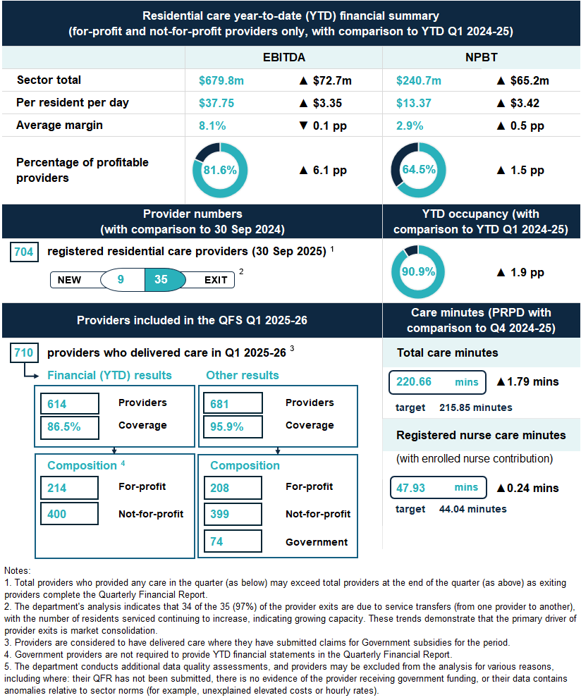
Key insights
- The average sector EBITDA margin was largely unchanged when comparing Q1 2024-25 and Q1 2025-26, as revenue growth marginally outpaced operating expense growth.
The sector recorded EBITDA of $679.8 million in Q1 2025-26, an increase of $72.7 million (12.0%) from 12 months prior. However, the average EBITDA margin decreased by 0.1 percentage points to 8.1%, because sector revenue grew by 13.9%, which was slightly higher than EBITDA growth of 12%.
Sector revenue growth was driven by an 11.7% increase in AN-ACC funding and a 2.0% increase in claim days. Meanwhile, growth in sector operating expenses was attributed to increased direct care labour costs, driven by:
- increased wages for direct care staff, following the FWC decisions
- increased direct care staff time, as providers improved compliance with care minute and 24/7 registered nursing requirements.
There was a disproportionate increase in operating expenses for for-profit providers (compared to not-for-profit providers). This may indicate for-profit providers are increasing direct care staff time to meet care minutes targets, in the lead up to care minute funding changes, that will link care funding to the delivery of care minutes for providers of non-specialised homes in metropolitan areas from Q2 2025-26.
Despite these results, four in every five providers reported a positive EBITDA result in Q1 2025-26, an increase of 6.1 percentage points from 12 months prior.
- Total care minutes delivered increased between Q4 2024-25 and Q1
2025-26, however, compliance remains short of targets for many homes.
In Q1 2025-26, providers delivered an average of 220.66 care minutes prpd (up
1.79 minutes from Q4 2024-25) and exceeded the target for the quarter
(215.85 minutes) by 4.81 minutes. This included 47.93 minutes prpd delivered by a registered nurse (including the enrolled nurse contribution) (up 0.24 minutes from
Q4 2024-25).
Sector-wide, 60.0% of homes now meet both their service level total care and registered nurse care minute targets (with enrolled nurse contribution), up
5.8 percentage points from Q4 2024-25. While this marks another strong improvement in compliance, many homes continue to fall short of targets.
Further trends in compliance with care minutes responsibilities can be found in the Residential aged care section of this QFS, below.

Home care
Overview of financial performance
The financial performance of the home care sector was broadly consistent between Q1 2024-25 and Q1 2025-26, with no changes recorded in the average EBITDA and NPBT margins (Figure 2).
Figure 2: Summary of financial performance for HCP providers at Q1 2025-26, and comparison with Q1 2024-25
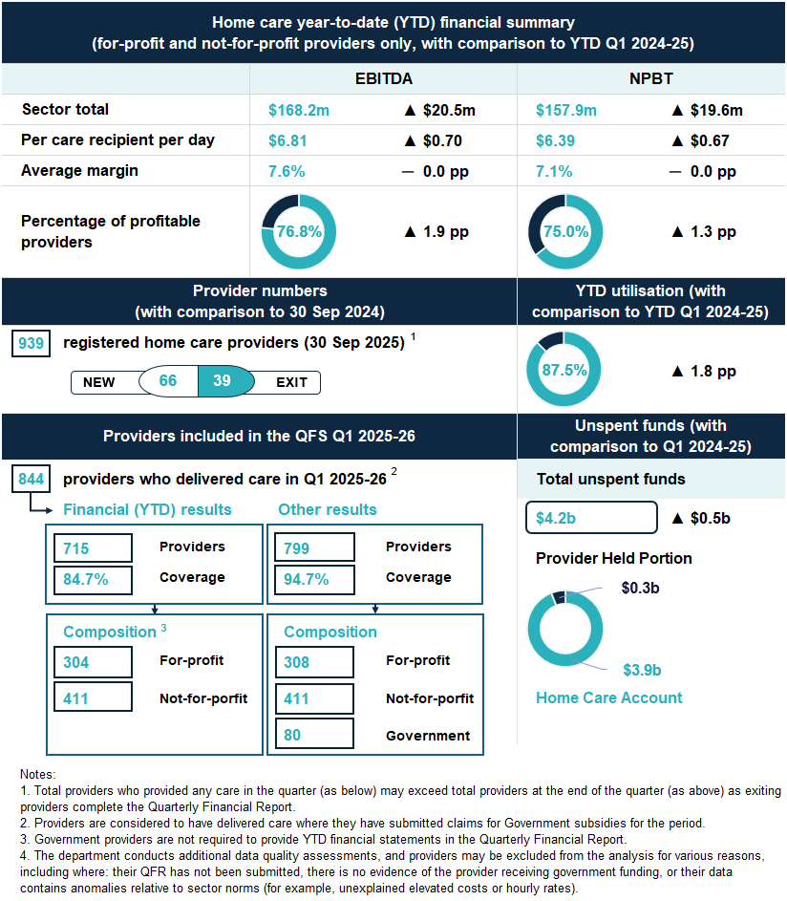

Key insights
- The increase in the sector’s EBITDA and NPBT results in Q1 2025-26, when compared to Q1 2024-25, was driven by increased service delivery.
In Q1 2025-26, the total EBITDA for the sector was profit of $168.2 million, an increase of $20.5 million (13.9%) from Q1 2024-25. Similarly, NPBT for the sector also increased by $19.6 million (14.2%) over the same time, totalling $157.9 million in Q1 2025-26. Despite these increases, the EBITDA and NPBT margins remained consistent at 7.6% and 7.1%, respectively, as both revenue and expenses grew at the same rate, offsetting any improvement in margins.
Instead, the increase in total sector EBITDA and NPBT was driven by an increase in services delivered, with a 2.2% increase in claim days from 12 months prior. This is consistent with the release of additional packages in the intervening period. There was also an increase in the utilisation of HCPs from 85.7% in Q1 2024-25 to 87.5% in Q1 2025-26. The change in expenses was driven by an increase in labour costs, up 10.1% between Q1 2024-25 and Q1 2025-26.

Residential aged care

Financial performance

Financial summary
The net profit position of the residential aged care sector improved between Q1 2024-25 and Q1 2025-26 (Table 1). In Q1 2025-26:
- Sector EBITDA was $679.8 million, with an average EBITDA margin of 8.1% (down from 8.2% in Q1 2024-25).
- Sector NPBT was $240.7 million, with an average NPBT margin of 2.9% (up from 2.4% in Q1 2024-25).
- Revenue grew by $48.68 prpd (up 11.7%). This was primarily driven by a $0.8 billion increase in AN-ACC funding, from $5.3 billion in Q1 2024-25 to $6.1 billion in Q1 2025-26.
- Expenses grew by $45.26 prpd (up 11.1%). This was driven by higher labour costs, specifically, increased wage costs and care time delivered.
Table 1: Q1 2025-26 and comparison with Q1 2024-25, summary of financial performance of residential for-profit and not-for-profit aged care providers
 | Total | PRPD | Change from Q1  2024-25 PRPD
Revenue | $8,392.2m | $466.09 | ▲ $48.68
Operating expenses | $7,712.4m | $428.34 | ▲ $45.33
EBITDA | $679.8m | $37.75 | ▲ $3.35
Average EBITDA margin | 8.1% | 8.1% | ▼ 0.1  percentage point
Non-operating expenses | $439.1m | $24.38 | ▼ $0.07
NPBT | $240.7m | $13.37 | ▲ $3.42
Average NPBT margin | 2.9% | 2.9% | ▲ 0.5  percentage points

Note: The average EBITDA and NPBT margins (which indicate the EBITDA and NPBT returns on revenue) are calculated by dividing the sector EBITDA and NPBT results by the sector total revenue.

Profitable providers
At Q1 2025-26:
- 64.5% of providers were profitable (defined by NPBT) (up 1.5 percentage points from Q1 2024-25) (Figure 3).
- profitable providers serviced 67.4% of residential care recipients
(up 0.3 percentage points from Q1 2024-25).
Figure 3: Percentage of profitable providers and percentage of residents serviced by profitable providers at Q1 2025-26, and comparison with Q1 2024-25
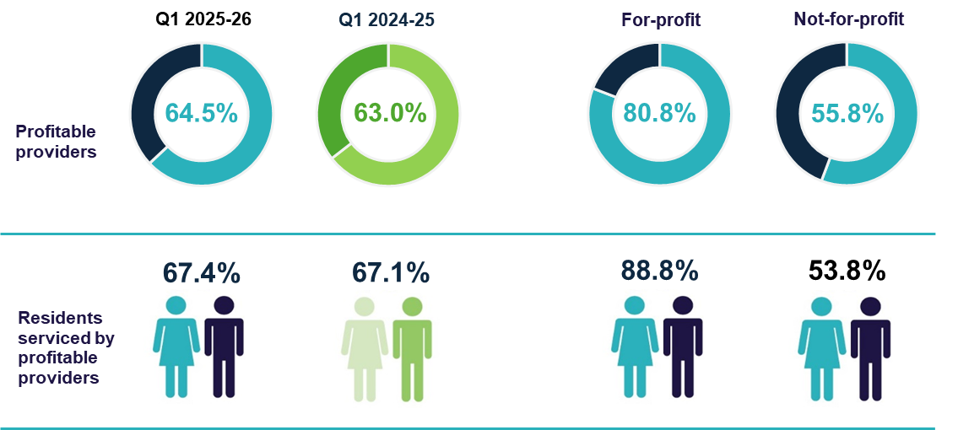

Median EBITDA and NPBT margin
In Q1 2025-26:
- the median EBITDA margin for the sector was 7.0% (up 0.2 percentage points from Q1 2024-25), which means an EBITDA return of $7.00 for every $100 of revenue earned (Chart 1).
- the median NPBT margin for the sector was 3.4% (up 0.8 percentage points from Q1 2024-25), which means a NPBT return of $3.40 for every $100 of revenue earned (Chart 2).
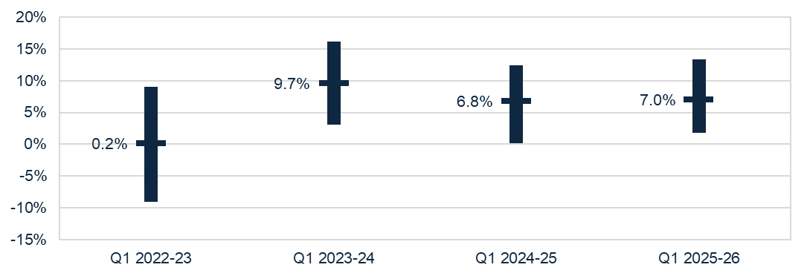
Chart 1: Median and quartile EBITDA margin (Q1 2022-23, Q1 2023-24, Q1 2024-25, Q1 2025-26)

Chart 2: Median and quartile NPBT margin (Q1 2022-23, Q1 2023-24, Q1 2024-25, Q1 2025-26)
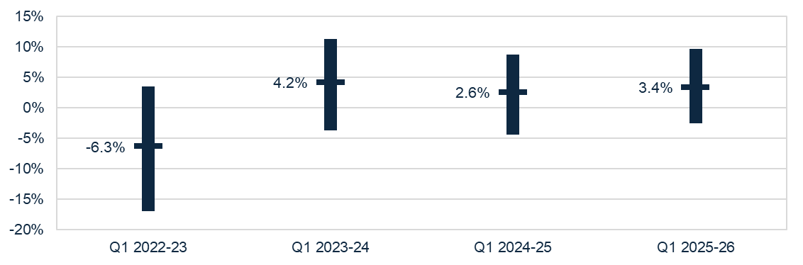

Occupancy
In Q1 2025-26, the average occupancy rate was 90.9% (up 1.9 percentage points from Q1 2024-25) (Chart 3).
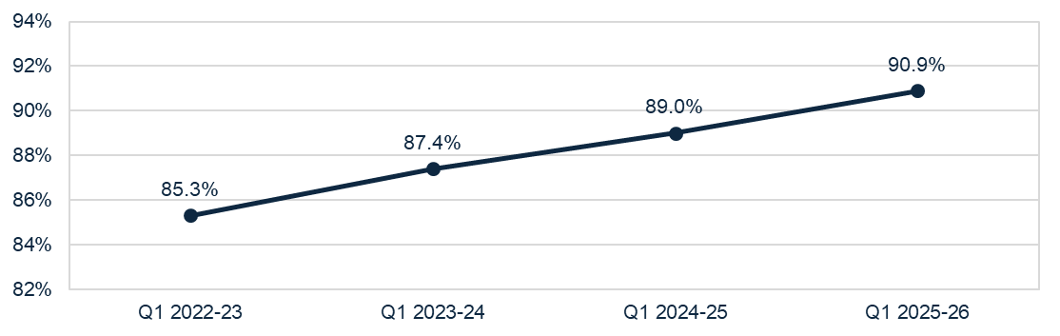
Chart 3: Average occupancy rate (Q1 2022-23, Q1 2023-24, Q1 2024-25, Q1 2025-26)

Occupancy rate = occupied bed days ÷ operational bed days
Note: Occupancy rates include mainstream operational places only. They exclude flexible places under the National Aboriginal and Torres Strait Islander Flexible Aged Care Program, Innovative Pool programs, and care provided by Multi-Purpose homes. They also exclude allocated places that are not operational (e.g. due to workforce shortages or site redevelopments), as reported by providers to the Aged Care Quality and Safety Commission.
It is expected that the accuracy of non-operational beds, and consequently occupancy reporting, will improve with the changes introduced on 1 November 2025 with the Aged Care Act 2024.

Liquidity
In Q1 2025-26, the median liquidity ratio for the sector was 0.45 (Chart 4), meaning providers had cash and financial assets available equivalent to slightly less than half of their short-term liabilities. The liquidity position of the residential aged care sector has steadily improved since Q1 2022-23, with a further improvement in Q1 2025-26, even after allowing for the recalculation of liquid assets. (Insight 1).
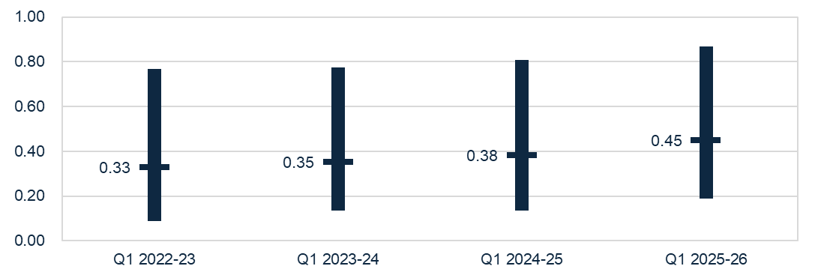
Chart 4: Median and quartile liquidity ratio (Q1 2022-23, Q1 2023-24, Q1 2024-25, Q1 2025-26)
Note: From Q1 2025-26, the liquidity formula includes trade receivables as liquid assets. This is aligned with the Aged Care Quality and Safety Commission’s Financial and Prudential Standards.


Insight 1: Impact of change to the liquidity calculation
From the commencement of the Aged Care Act 2024 on 1 November 2025, residential aged care providers have been required to comply with the Aged Care Quality and Safety Commission’s (Commission) Financial and Prudential Standards. This includes a new Liquidity Standard which makes sure that providers have systems and strategies to manage cash flow and financial risks. The Standard also enables providers to classify trade receivables as liquid assets.
To ensure alignment, the liquidity calculation has been revised to include trade receivables for the purposes of QFS reporting. This is a departure from the previous calculation for liquid assets, which included cash and cash equivalents, and financial assets only. To illustrate the true trends in liquidity, without the impact of the change in methodology, the comparative chart below shows the liquidity results over time, with and without trade receivables (Chart 5).
Chart 5: Median liquidity ratio including and excluding trade receivables (Q1 2022-23, Q1 2023-24, Q1 2024-25, Q1 2025-26)
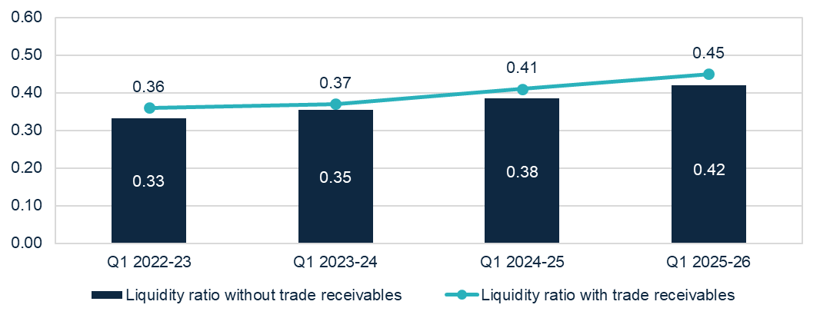

Capital adequacy
In Q1 2025-26, the median capital adequacy ratio for the sector was 0.29 (up 0.01 percentage point from Q1 2024-25) (Chart 6), meaning for every $100 of assets owned, $29 was funded through equity and $71 through debt or other liabilities.
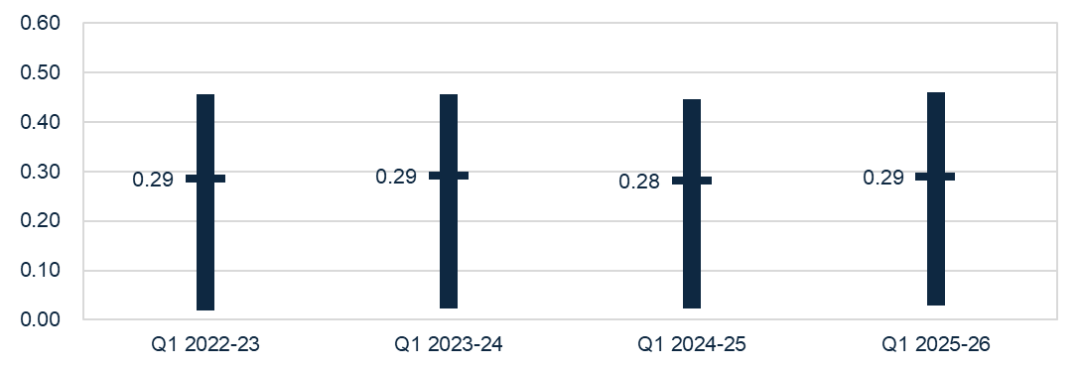
Chart 6: Median and quartile capital adequacy ratio (Q1 2022-23, Q1 2023-24, Q1 2024-25,
Q1 2025-26)

Capital adequacy ratio = (net assets - intangible assets) ÷ (total assets - intangible assets)
Note: Intangible assets are removed from the calculation as they are not considered to have value in the event of insolvency. This more realistically reflects the available capital to absorb unforeseen circumstances.

Wages to revenue
In Q1 2025-26, wages as a proportion of revenue for the sector was a median of 72.1% (down 0.2 percentage points from Q1 2024-25) (Chart 7). Wages are inclusive of all residential aged care employees.
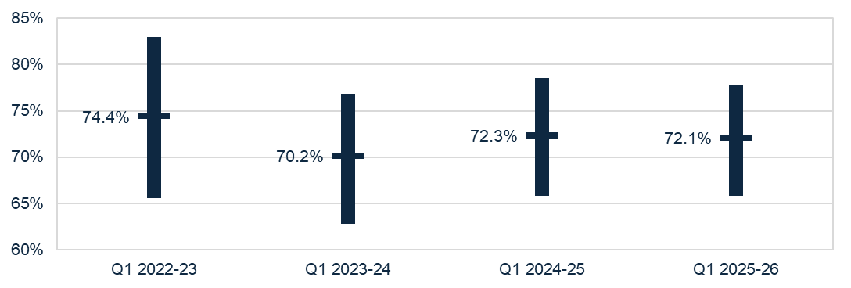
Chart 7: Median and quartile wages to revenue percentage (Q1 2022-23, Q1 2023-24, Q1
2024-25, Q1 2025-26)

Average care minutes
In Q1 2025-26, the sector average target for total care minutes was 215.85 minutes prpd, and 44.04 minutes prpd for registered nurse care time.
- The sector delivered above the care minute targets with residents receiving an average of 220.66 total care minutes prpd (up 1.79 minutes prpd, or 0.8% from Q4 2024-25) (Table 2).
- This includes 47.93 minutes delivered by a registered nurse (up 0.24 minutes prpd, or 0.5% from Q4 2024-25). This includes enrolled nurse time, which can contribute up to 10.0% of the registered nurse care minutes target.
- 67.4% of homes met their service-level total care minutes targets, up
5.0 percentage points from Q4 2024-25.
- 80.9% of homes met their service-level registered nurse targets (with enrolled nurse contribution), up 2.3 percentage points from Q4 2024-25.
- 60.0% of homes met both their service-level total care and registered nurse care minute targets (with enrolled nurse contribution), up 5.8 percentage points from Q4 2024-25.
Table 2: Q1 2025-26 and comparison with Q4 2024-25, average care minutes met prpd (sector and by provider type) ¹
 | Sector | Change from Q4 2024-25 | For-profit | Not-for-profit | LST government
Registered nurses | 44.93 | ▲0.22 | 42.85 | 44.57 | 76.29
Registered nurses  (with enrolled nurse contribution) | 47.93 | ▲0.24 | 46.12 | 47.32 | 80.52
Enrolled nurses | 12.16 | ▲0.18 | 8.91 | 10.30 | 84.20
Personal care workers & assistants in nursing | 163.57 | ▲1.39 | 166.38 | 166.08 | 85.01
Total ² | 220.66 | ▲1.79 | 218.13 | 220.95 | 245.50
Notes:
1. Average care minutes prpd is calculated by dividing total care minutes delivered by occupied bed days (not claim days).
2. The total sector care minutes result does not equal the sum of care minutes by role due to rounding. Minor discrepancies may also exist between the results above and those published in the Care minutes in residential aged care dashboard due to timing of data extraction.

Insight 2: Trends in compliance with care minutes responsibilities
- Increasing care minutes compliance from providers in MM1 areas.
For Q1 2025-26, 60.0% of homes met both their service-level total care minutes and registered nurse care minute targets, up from 54.2% in Q4 2024-25.
The largest improvement in performance has been in metropolitan (MM1) homes, which improved from 54.2% of homes meeting both targets in Q4 2024-25, to 60.6% in Q1 2025-26 (up 6.4 percentage points). In comparison, 58.9% of regional providers (MM2 – MM7) met both targets in Q1 2025-26 (up 4.7 percentage points). The larger increase in compliance in MM1 homes has occurred following the announcement in December 2024 that care minutes delivered from October 2025 (Q2 2025-26) will be linked to funding.
- Increasing registered nurse minutes compliance (sector level).
From 1 October 2024 (Q2 2024-25), the sector-wide average target for registered nurse care minutes increased from 40 minutes to 44 minutes. From this time, providers have also been able to meet up to 10% of their registered nurse care minutes target with care time delivered by enrolled nurses. This adjustment was informed by sector feedback and recognises the important role of enrolled nurses and improves recruitment and retention of these skilled workers. It also helps providers meet their care minutes if they face registered nurse workforce shortages.
Chart 8 highlights the positive impact of this policy change on compliance with registered nurse care minutes requirements.
Chart 8: Registered nurse minutes delivered (Q1 2024-25 to Q1 2025-26)
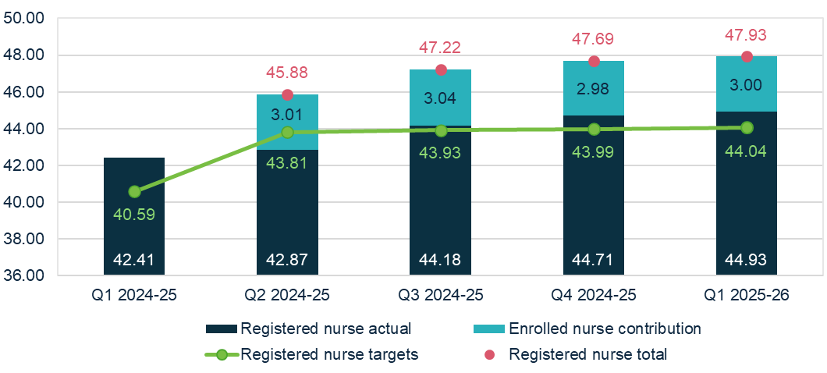

Staff cost and time

Total median staff cost and time
Total median staff costs and time increased from Q1 2024-25 to Q1 2025-26.
Costs were $252.93 prpd (up $28.59 or 12.7% from Q1 2024-25) and total time was 239.59 minutes prpd (up 10.79 minutes or 4.7% from Q1 2024-25) (Table 3).
Personal care workers and assistants in nursing saw the largest proportionate change over the past 12 month, with an:
- increase in costs of $19.48 (14.7% increase)
- increase in minutes delivered of 6.31 minutes (4.0% increase).
This growth, along with that in registered nurse costs and time, was expected with the increase in the mandatory care minutes responsibility from Q2 2024-25.
Table 3: Q1 2025-26 and comparison with Q1 2024-25, median staff cost and time prpd ¹
 | Cost  PRPD | Change from  Q1 2024-25 | Minutes PRPD | Change from Q1 2024-25
Registered nurses | $64.36 | ▲ $6.86 | 45.04 | ▲3.14
Enrolled nurses | $10.88 | ▲ $0.17 | 10.43 | ▲0.05
Personal care workers & assistants in nursing | $152.42 | ▲ $19.48 | 162.48 | ▲6.31
Allied health staff | $5.97 | ▲ $0.41 | 4.25 | ▼0.00
Diversional, lifestyle, recreation or activities officers | $7.08 | ▲ $1.24 | 8.65 | ▲0.80
Care management staff | $6.32 | ▲ $0.15 | 3.71 | ▼0.04
Total median ² | $252.93 | ▲ $28.59 | 239.59 | ▲10.79
Notes:
1. Direct labour costs include all on-costs for engaging staff (such as superannuation, leave, allowances), whereas the hourly rates presented in this QFS are the base gross hourly rates of pay and do not include on-costs.
2. Total median staff cost and time is derived from the totals calculated in the individual QFR submissions and is not the sum of the medians in the sub-categories listed above. Local, state and territory government providers are included in this data.

Agency staff cost and time
In Q1 2025-26:
- agency staff costs represented 6.5% of total direct care labour costs (down
1.8 percentage points from Q1 2024-25) (Table 4).
- agency staff hours represented 5.0% of total direct care labour hours (down
0.8 percentage points from Q1 2024-25).
Agency staff costs and hours decreased for all staff roles.
Table 4: Q1 2025-26 and comparison with Q1 2024-25, agency staff costs and hours as a percentage of direct care costs and hours
 | Agency costs as % of total | Change from Q1 2024-25 | Agency hours as % of total | Change from Q1 2024-25
Registered nurses | 7.5% | ▼ 3.9  percentage points | 5.7% | ▼ 2.2  percentage points
Enrolled nurses | 4.8% | ▼ 2.1  percentage points | 3.5% | ▼ 1.2  percentage points
Personal care workers & assistants in nursing | 4.4% | ▼ 0.6  percentage points | 3.6% | ▼ 0.3  percentage points
Total direct care | 6.5% | ▼ 1.8  percentage points | 5.0% | ▼ 0.8  percentage points

Allied health median staff cost and time
In Q1 2025-26, 99.0% of providers delivered allied health services (consistent with 98.7% in Q1 2024-25). As shown in Table 3, the median total cost and time for allied health services prpd were $5.97 and 4.25 minutes, respectively.
The highest median allied health cost and time prpd was for physiotherapists.
The median cost was $3.67 prpd (up $0.15 or 4.3% from Q1 2024-25) (Table 5).
The median cost prpd equates to a median spend on physiotherapy of $337.64 per resident per quarter (up $13.52 from Q1 2024-25). The median minutes delivered by physiotherapists was 2.66 minutes prpd (down 0.02 from Q1 2024-25). The median minutes prpd equates to 244.72 minutes per resident per quarter (down 1.45 minutes from Q1 2024-25).

Table 5: Q1 2025-26 and comparison with Q1 2024-25, median allied health cost and time prpd
 | Cost  PRPD | Change from  Q1 2024-25 | Minutes PRPD | Change from Q1 2024-25
Physiotherapist | $3.67 | ▲ $0.15 | 2.66 | ▼0.02
Podiatrist | $0.35 | ─ $0.00 | 0.22 | ▼0.02
Dietetic care | $0.30 | ▲ $0.03 | 0.16 | ▲0.01
Speech pathologist | $0.20 | ▲ $0.04 | 0.09 | ▲0.02

Note: Results for occupational therapists, allied health assistants, and other allied health have not been included as over half of QFR respondents did not report expenditure for these categories. Local, state and territory government providers are included in this data.

Hourly rates
In Q1 2025-26, median sector hourly rates increased for all direct care staff compared to Q1 2024-25. The sector median of the average hourly rate was:
- $52.26 for registered nurses (up $1.89 or 3.8% from Q1 2024-25) (Chart 9)
- $39.00 for enrolled nurses (up $2.31 or 6.3% from Q1 2024-25) (Chart 10)
- $33.95 for personal care workers and assistants in nursing (up $2.03 or 6.4% from Q1 2024-25) (Chart 11).
These average hourly rates are for staff employed per the employee award, enterprise agreement or contract. It does not include on-costs, penalty rates or casual rates. Nil-value responses are excluded.
Note for all charts that data collection for highest and lowest median hourly rates commenced in Q4 2022-23. As such, these figures are not available for Q1 2022-23.
Chart 9: Highest, average, and lowest hourly rates (medians) paid to registered nurses
(Q1 2022-23, Q1 2023-24, Q1 2024-25, Q1 2025-26)
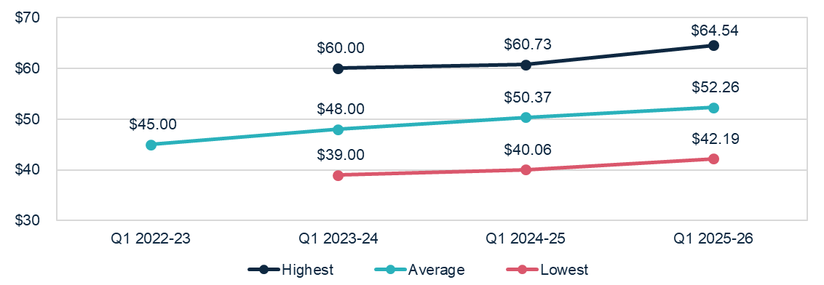

Chart 10: Highest, average, and lowest hourly rates (medians) paid to enrolled nurses
(Q1 2022-23, Q1 2023-24, Q1 2024-25, Q1 2025-26)
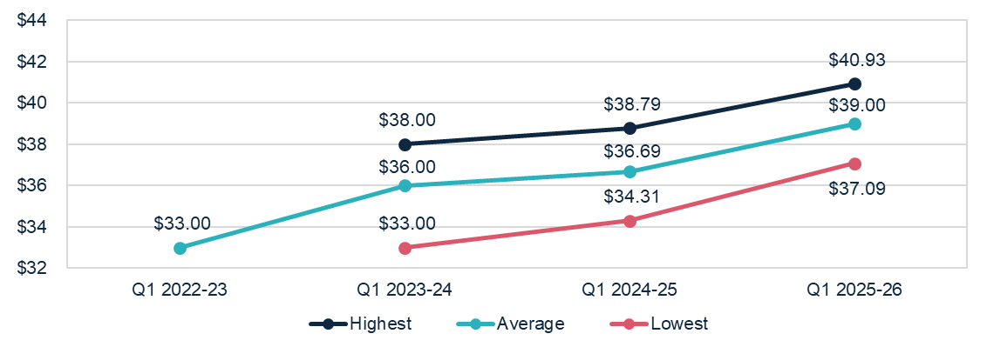

Chart 11: Highest, average, and lowest hourly rates (medians) paid to personal care workers and assistants in nursing (Q1 2022-23, Q1 2023-24, Q1 2024-25, Q1 2025-26)
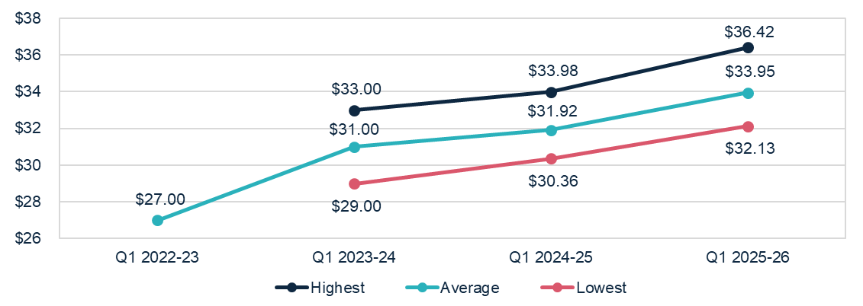

Food and nutrition
In Q1 2025-26, at a sector level:
- the median total cost of food and ingredients was $15.81 prpd (up $0.89 or 6.0% from Q1 2024-25) (Chart 12).
- the proportion of the total cost of food and ingredients spent on fresh food and ingredients (foods free of GST as per itemised purchase receipts) was 84.3%
(up 0.6 percentage points from Q1 2024-25).
The amount spent on food and ingredients prpd is only one indicator of food quality. It should not be taken in isolation, as it does not consider factors such as residents’ satisfaction, cooking preparation method and overall nutritional status.
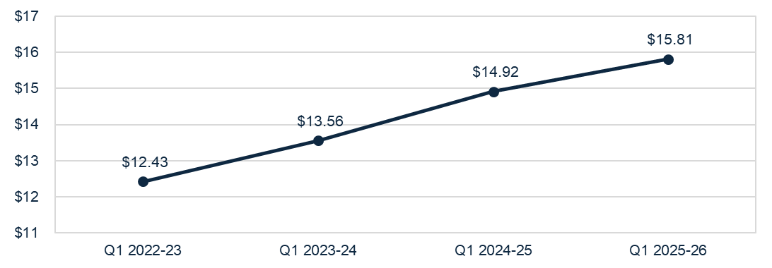
Chart 12: Median food and ingredients cost prpd (Q1 2022-23, Q1 2023-24, Q1 2024-25,
Q1 2025-26)

Home care

Financial performance

Financial summary
The EBITDA and NPBT position of the home care sector was broadly consistent between Q1 2024-25 and Q1 2025-26 (Table 6). In Q1 2025-26:
- Sector EBITDA was $162.8 million, with an average EBITDA margin of 7.6% (consistent with Q1 2024-25).
- Sector NPBT was $157.9 million, with an average NPBT margin of 7.1% (consistent with Q1 2024-25).
- Revenue grew by $9.24 pcrpd (up 11.5%). This was driven by the annual indexation of home care subsidy and supplement rates and increased utilisation of HCPs from 85.7% in 2024-25 to 87.5% in 2025-26.
- Expenses (operating and non-operating) grew by $8.57 pcrpd (up 11.5%). This was driven by an increase in labour costs, due to the associated increase in labour hours (higher claim days and utilisation) and increase in hourly pay rates for home care workers.
Table 6: Q1 2025-26 and comparison with Q1 2024-25, summary of financial performance of home care for-profit and not-for-profit aged care providers
 | Total | PCRPD | Change from Q1  2024-25 PCRPD
Revenue | $2,218.2m | $89.82 | ▲ $9.24
Operating expenses | $2,050.1m | $83.01 | ▲ $8.54
EBITDA | $168.2m | $6.81 | ▲ $0.70
Average EBITDA margin | 7.6% | 7.6% | ─ 0.0  percentage points
Non-operating expenses | $10.2m | $0.42 | ▲ $0.03
NPBT | $157.9m | $6.39 | ▲ $0.67
Average NPBT margin | 7.1% | 7.1% | ─ 0.0  percentage points

Note: The average EBITDA and NPBT margins (which indicate the EBITDA and NPBT returns on revenue) are calculated by dividing the sector EBITDA and NPBT results by the sector total revenue.

Profitable providers
At Q1 2025-26:
- 75.0% of providers were profitable (defined by NPBT) (Figure 4). This was an increase of 1.3 percentage points from Q1 2024-25.
- profitable providers serviced 80.3% of HCP recipients. This was an increase of
1.5 percentage points from Q1 2024-25.
Figure 4: Percentage of profitable providers and percentage of home care recipients serviced by profitable providers at Q1 2025-26, and comparison with Q1 2024-25
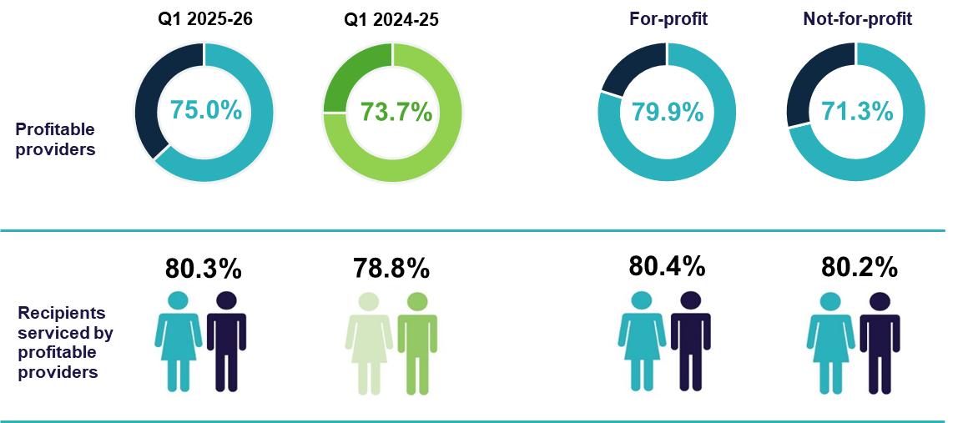

Median EBITDA and NPBT margin
In Q1 2025-26:
- the median EBITDA margin for the sector was 7.0%, a 0.4 percentage point increase on the Q1 2024-25 result, which means an EBITDA return of $7.00 for every $100 of revenue earned (Chart 13).
- the median NPBT margin for the sector was 6.7% (up 0.7 percentage points from Q1 2024-25), which means a NPBT return of $6.70 for every $100 of revenue earned (Chart 14).
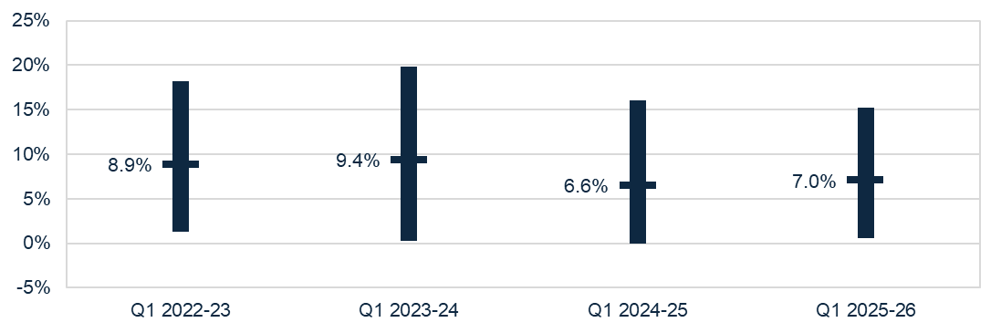
Chart 13: Median and quartile EBITDA margin (Q1 2022-23, Q1 2023-24, Q1 2024-25, Q1 2025-26)

Chart 14: Median and quartile NPBT margin (Q1 2022-23, Q1 2023-24, Q1 2024-25, Q1 2025-26)
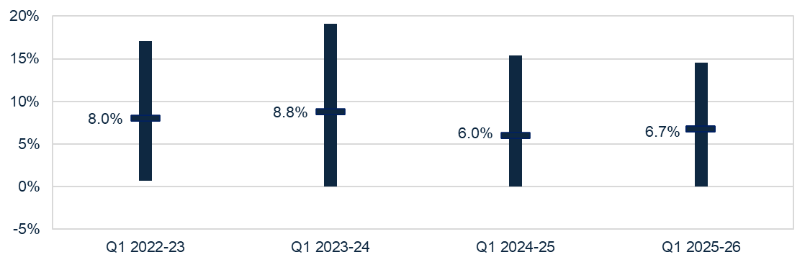

Utilisation
In Q1 2025-26, the average utilisation rate was 87.5% (up 1.8 percentage points from Q1 2024-25) (Chart 15).
Chart 15: Average utilisation rate (Q1 2022-23, Q1 2023-24, Q1 2024-25, Q1 2025-26)
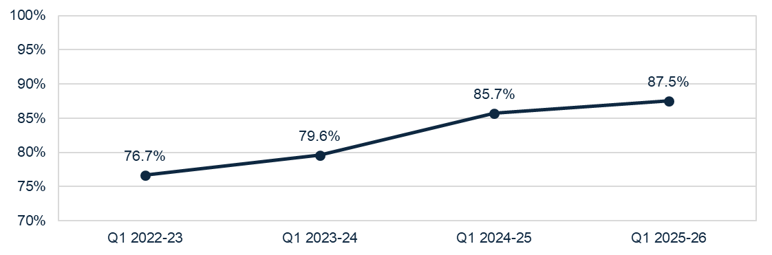
Utilisation rate = total Government funding paid to HCP providers ÷ total Government funding providers were eligible to receive (subsidies and supplements) (based on HCP entitlements)
Note: Participant contributions and other income sources are not included in the maximum Government funding entitlement. The published utilisation rate covers all providers in the sector (including those who do not submit a Quarterly Financial Report).

Liquidity
In Q1 2025-26, the median sector liquidity ratio was 1.13 (Chart 16). This means for every $100 of debt obligations, providers had $113 in liquid assets. While the liquidity position of the sector has remained consistent since Q1 2022-23, there was an improvement following the recalculation of liquid assets in Q1 2025-26 (Insight 3).
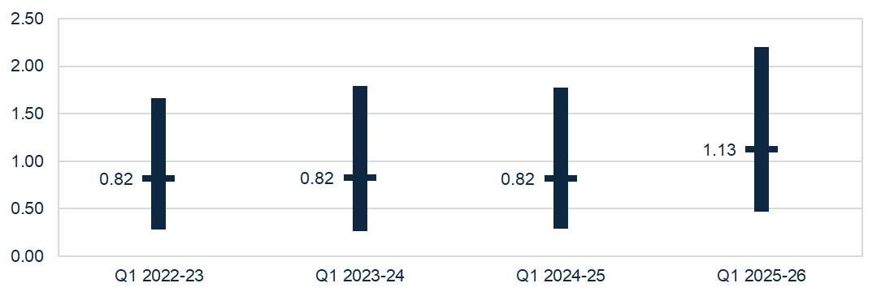
Chart 16: Median and quartile liquidity ratio (Q1 2022-23, Q1 2023-24, Q1 2024-25 and Q1 2025-26)
Note: From Q1 2025-26, the liquidity formula includes trade receivables as liquid assets. This is aligned to the Aged Care Quality and Safety Commission’s Financial and Prudential Standards.
Insight 3: Impact of change to the liquidity calculation
As noted earlier in this report, the formula used for QFS reporting of residential aged care liquidity has been revised to include trade receivables as liquid assets. This supports alignment to the Commissions’ new Liquidity Standard for residential aged care providers. While home care providers are not subject to the same Liquidity Standard requirements, the formula has also been revised for QFS home care liquidity reporting to ensure consistency. Chart 17 shows the liquidity results over time, with and without trade receivables, and indicates that the home care liquidity position has been broadly consistent over the past three financial years.
Chart 17: Median liquidity ratio including and excluding trade receivables (Q1 2022-23, Q1 2023-24, Q1 2024-25, Q1 2025-26) 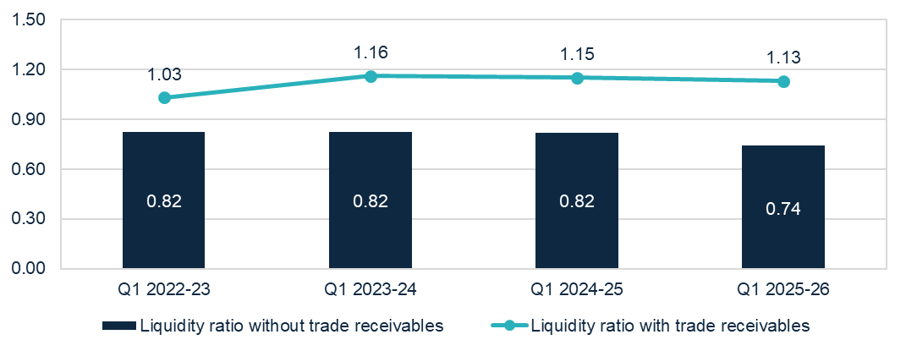

Capital adequacy
In Q1 2025-26, the sector median capital adequacy ratio was 0.53 (Chart 18), an increase of 0.02 on the Q1 2024-25 position. This means for every $100 of assets owned, $53 was funded through equity and $47 through debt or other liabilities.
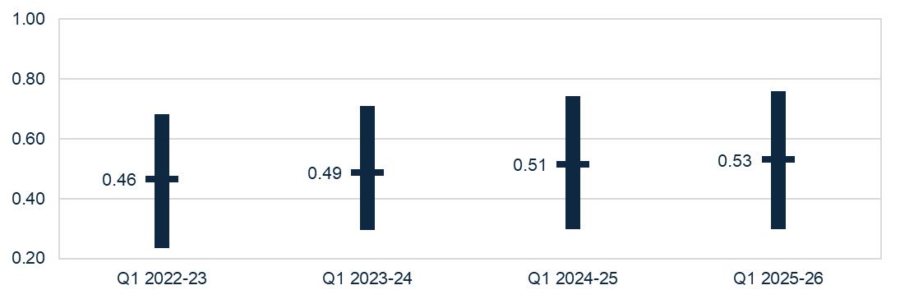
Chart 18: Median and quartile capital adequacy ratio (Q1 2022-23, Q1 2023-24, Q1 2024-25,
Q1 2025-26)

Capital adequacy ratio = (net assets - intangible assets) ÷ (total assets - intangible assets)

Wages to revenue
In Q1 2025-26, wages as a proportion of revenue for the sector was a median of 58.8% (Chart 19), a decrease of 1.9 percentage points from Q1 2024-25.
Wages include salaries and employment benefits, agency and subcontractor costs, and management fees. Wages do not include staff training and development.
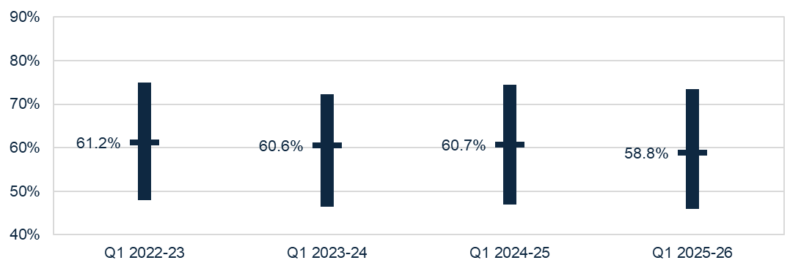
Chart 19: Median and quartile wages to revenue percentage (Q1 2022-23, Q1 2023-24,
Q1 2024-25, Q1 2025-26)

Staff cost and time
In Q1 2025-26:
- total median staff costs increased to $59.61 pcprd (up $5.49 or 10.1% from Q1 2024-25) (Table 7).
- total median time increased to 58.30 minutes pcrpd (up 0.67 minutes or 1.2% from Q1 2024-25).
The increase in median staff costs, without a proportionate increase in median staff time, is driven by increased wages after the FWC decisions. These wage increases were supported by additional Government revenue, resulting in minimal impacts on the wages to revenue ratio (Chart 19).
Table 7: Q1 2025-26 and comparison with Q1 2024-25, median staff cost and time pcrpd ¹
 | Cost  PCRPD | Change from  Q1 2024-25 | Minutes PCRPD | Change from Q1 2024-25
Registered nurses ² | $1.27 | ▲ $0.20 | 0.86 | ▲0.07
Personal care staff | $29.22 | ▲ $2.93 | 31.90 | ▲1.32
Allied health staff | $5.01 | ▲ $1.02 | 2.24 | ▲0.46
Other direct care staff | $0.16 | ▼ $0.28 | 0.15 | ▼0.14
Care management staff | $7.93 | ▲ $0.23 | 8.04 | ▼0.07
Administrative & non-care staff | $7.43 | ▲ $0.03 | 7.65 | ▼0.26
Total median ³ | $59.61 | ▲ $5.49 | 58.30 | ▲0.67

Notes:
1. Staff travel, or work done on administration tasks during care staff paid hours, is included in the results of Chart 19, which shows the median wages to revenue percentage. All provider types are included in this data, including local, state and territory government providers.
2. Data for enrolled nurses has not been included as 69.0% of home care providers did not report expenditure in this category.
3. Total median staff cost and time is derived from the totals calculated in the individual QFR submissions and is not the sum of the medians in the sub-categories listed above.

Hourly rates
In Q1 2025-26, the sector median of the average hourly rates increased for all direct care staff in comparison to Q1 2024-25:
- $53.49 for registered nurses (up $2.49 or 4.9% from Q1 2024-25) (Chart 20)
- $39.85 for enrolled nurses (up $1.36 or 3.5% from Q1 2024-25) (Chart 21)
- $35.42 for personal care staff (up $1.05 or 3.1% from Q1 2024-25)
(Chart 22).
Average hourly rates are for staff employed per the employee award, enterprise agreement or contract. These do not include on-costs, penalty rates, casual rates, agency fees and subcontracting arrangements. Nil-value responses are excluded.
Note for all charts that data collection for highest and lowest median hourly rates commenced in Q4 2022-23. As such, these figures are not available for Q1 2022-23.
Chart 20: Highest, average, and lowest hourly rates (medians) paid to registered nurses
(Q1 2022-23, Q1 2023-24, Q1 2024-25, Q1 2025-26)
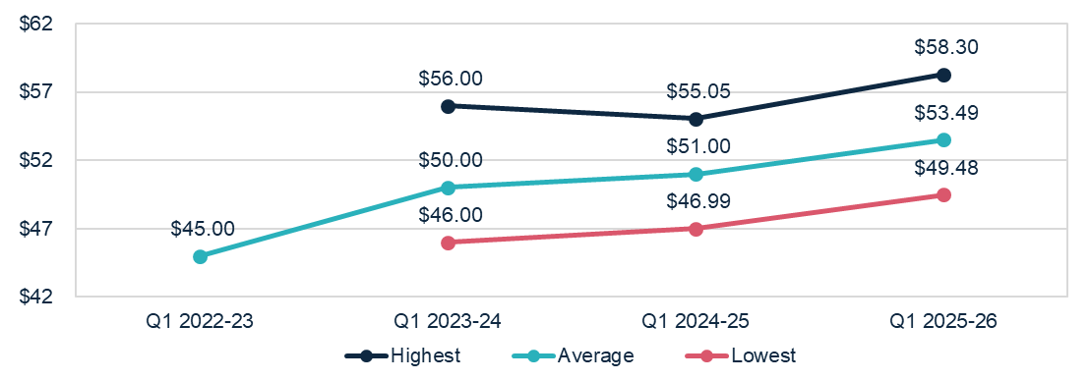

Chart 21: Highest, average, and lowest hourly rates (medians) paid to enrolled nurses
(Q1 2022-23, Q1 2023-24, Q1 2024-25, Q1 2025-26)
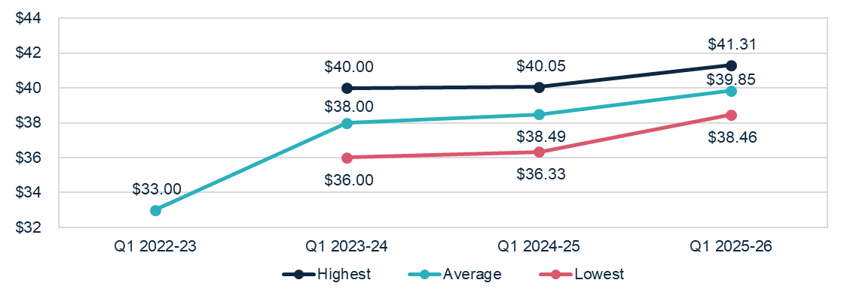

Chart 22: Highest, average, and lowest hourly rates (medians) paid to personal care staff
(Q1 2022-23, Q1 2023-24, Q1 2024-25, Q1 2025-26)
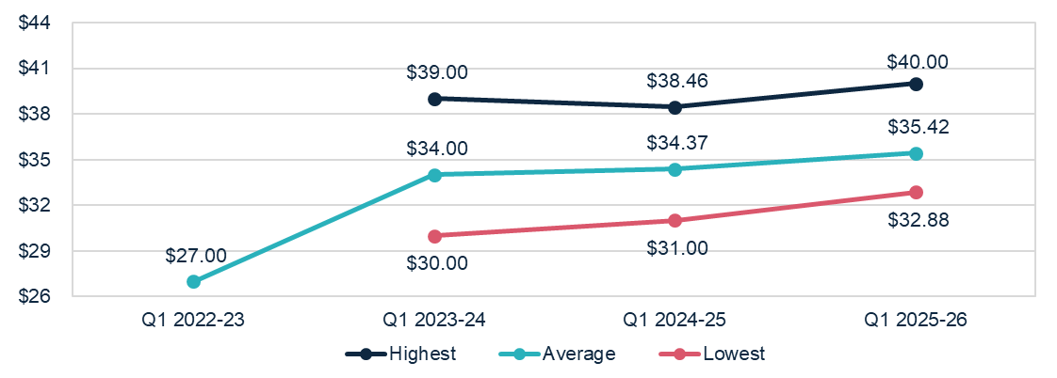

Care and package management
In Q1 2025-26:
- all HCP levels had a median care management percentage of 17%. This was consistent with 12 months prior for all levels except for level 2 which decreased by 1.0 percentage point (Chart 23).
- all HCP levels had a median package management percentage of 12%. This was consistent with 12 months prior for all levels except for level 2 which decreased by 1.0 percentage point (Chart 24).
Chart 23: Median care management percentage per HCP level (Q1 2022-23, Q1 2023-24,
Q1 2024-25, Q1 2025-26)
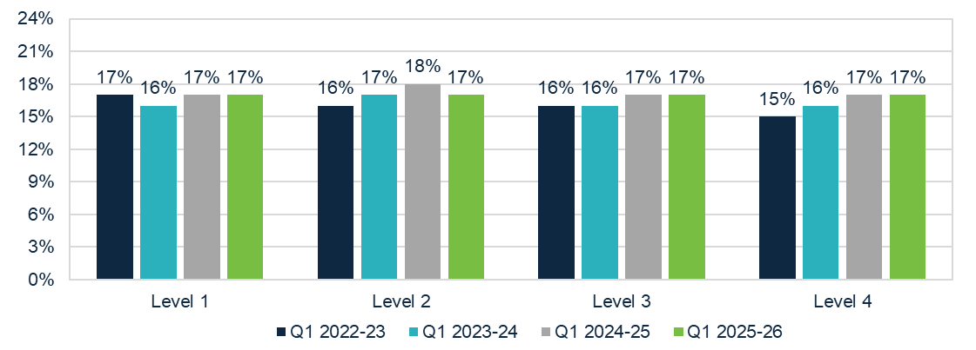
Chart 24: Median package management percentage per HCP level (Q1 2022-23, Q1 2023-24,
Q1 2024-25, Q1 2025-26)
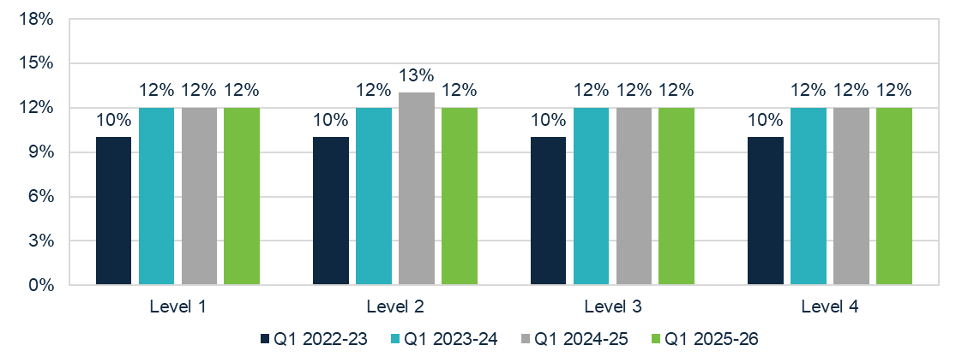

Care management percentage = published fortnightly national median price for care management (for each level) ÷ subsidy per fortnight (for each level)
Package management percentage = published fortnightly national median price for package management (for each level) ÷ subsidy per fortnight (for each level)
Insight 4: Care management fees and expenses
Reporting through the Financial Report on the Australian Aged Care Sector (FRAACS) between 2020-21 and 2023-24 has shown that while care management charges represent 16.5% – 18.0% of total revenue for providers, the cost to providers of delivering care management services is between 10.5% – 11.0%.
These results indicate that providers may be using margins on care management services to cross-subsidise losses in other services. The department will continue to monitor prices set by providers to ensure they are reasonable and transparent.

Unspent funds
At 30 September 2025, there was $4.2 billion in unspent HCP funds (up $0.5 billion from 30 September 2024) (Chart 25). This includes:
- $3.9 billion of unspent funds in the Home Care Account (up $0.6 billion)
- $0.3 billion in the Provider Held Portion of unspent funds (down $0.1 billion).
While the total unspent funds balance has continued to grow, the rate of this growth has decreased over time. A participant’s unspent funds balance was retained in the transition to the Support at Home Program, and can be used to fund assistive technology, home modifications, and/or pay approved services once their quarterly budget has been fully exhausted.
Chart 25: Unspent funds (Q1 2022-23, Q1 2023-24, Q1 2024-25 and Q1 2025-26)
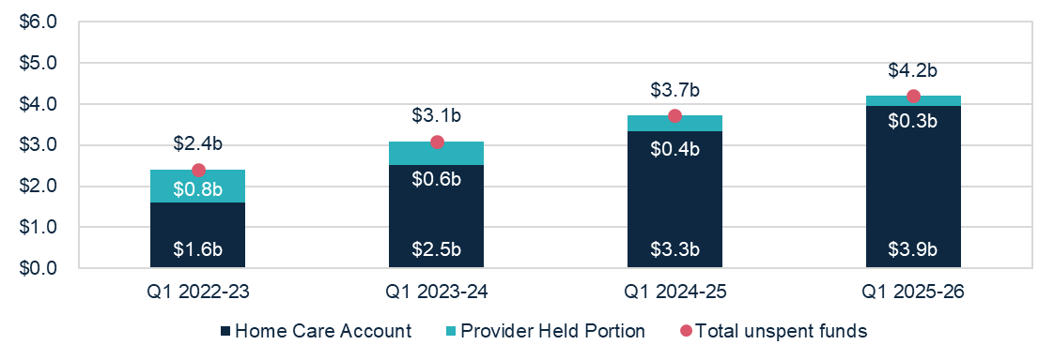

Glossary
Term | Description
Australian National Aged Care Classification  (AN-ACC) funding model | Is a case mix funding model that represents the care component of residential aged care funding. AN-ACC is designed to provide equitable care funding to approved residential aged care homes, by linking subsidy to characteristics of homes and residents. The Independent Health and Aged Care Pricing Authority provides annual pricing advice to the Minister for Aged Care, Disability and Seniors on the AN-ACC model. This ensures funding is based on advice on the actual cost of care.
Care management | Is a service that home care providers must deliver to all care recipients to ensure recipients receive the appropriate level of support in a way that meets their care needs. As at Q1 2025-26, home care providers were not to charge more than 20% of the Australian Government Subsidy for care management.
Care minutes | Refers to the amount of care time people in government-funded residential aged care homes receive from registered nurses, enrolled nurses, personal care workers and assistants in nursing.  From 1 October 2024, sector-wide care minutes requirements are 215 total care minutes prpd, including 44 minutes of registered nurse time prpd. Providers can meet up to 10% of their registered nurse targets with care time provided by enrolled nurses. Approved providers of residential care homes have a responsibility to meet service-level care minutes targets for each service.  Allied health, diversional / lifestyle / recreation / activities officer and care management staff minutes do not contribute to care minute targets. Providers must, however, continue to deliver allied health and lifestyle services to their residents in line with requirements under the Aged Care Act 2024 and Aged Care Rules 2025.
Capital adequacy ratio | Measures a provider's net asset position divided by total asset position (not including intangibles). This ratio can be used as an indicator of a provider's ability to absorb unexpected losses through their net asset position (also known as an asset buffer).  If a provider has a stronger (higher) capital adequacy ratio, they will be able to fund and absorb the impacts of unforeseen circumstances by using business equity. Intangible assets are removed as they are not considered to have value in the event of insolvency.
EBITDA margin | Is used as an indicator of a provider’s financial performance and underlying profitability before accounting for depreciation assumptions, tax obligations or financing choices.  EBITDA margins focus on a provider’s operating profitability and cash flow. The higher the EBITDA margin is, the lower operating expenses are in comparison to total revenue.
Fair Work Commission (FWC) decisions | The Australian Government is providing funding to support the FWC’s decisions under the Aged Care Work Value Case. The Government also provides funding to support FWC decisions relating to Annual Wage Reviews through usual program funding arrangements. Annual Wage Review increases take effect on 1 July each year. These decisions are collectively referred to as ‘FWC decisions’ in this report.
Hotelling supplement | Supports residential aged care providers to meet Everyday Living costs for services such as catering, cleaning, and laundry. The supplement is indexed on 20 March and 20 September each year.
Total labour (staff) costs | Includes salaries for all care and non-care staff, superannuation, bonuses and incentives, allowances, termination payments, value of fringe benefits, salary sacrifice and leave entitlements. Training costs for all employment categories are included under ‘Administration and non-care staff’ costs. Total worked staff hours excludes leave and training hours and only includes the time spent delivering care.
Liquidity ratio | Measures the availability of cash and financial assets to cover providers' debt obligations (without raising external capital) if they were to become immediately due and payable. If the ratio result is greater than 1.0, the provider has more cash and financial assets than their debt obligations.  If the ratio result is less than 1.0, the provider’s debt obligations are more than their cash and financial assets.
Package management | The ongoing administration and organisational activities associated with ensuring the smooth delivery of a Home Care Package. As at Q1  2025-26, home care providers were not to charge more than 15% of the Australian Government subsidy for package management.
Support at Home Program | The Support at Home program replaced the HCP Program and the  Short-Term Restorative Care Programme on 1 November 2025.  The Commonwealth Home Support Programme will transition to the program no earlier than 1 July 2027. More information on the program can be found in the Support at Home program manual. https://www.health.gov.au/resources/publications/support-at-home-program-handbook?language=en.
Unspent funds | Since 1 September 2021, unspent Government subsidy for HCPs has accrued in a Home Care Account set up for care recipients by Services Australia. These funds are available for providers to use for care and services provided to the care recipient.  Some providers also have access to the Provider Held Portion of unspent funds accrued prior to 1 September 2021. These funds can be used towards a care recipient’s care and services.

Appendix

How to read the QFS

Comparison data
Charts include a comparison with the same quarter across four financial years to highlight trends in performance over time. Results and comparisons are reported at the sector-level to understand the change in performance, excluding seasonality. The exception is data presented in relation to the average care minutes delivered by residential aged care providers (sector and by provider type), which compares to the immediate prior quarter.
Data notes: Throughout the document, this grey box gives guidance on calculations, data notes and caveats, to support aged care providers to interpret the results and benchmark their performance against sector-level results.
Quartile charts show the median, and the upper quartile (50th to the 75th percentile) and lower quartile (25th to the 50th percentile). This highlights the spread of reported results.

Insights
Insights
Throughout the document, these boxes are used to highlight key findings in relation to the data presented, including the trend in the data over time.

Provider type definitions
Percentage of services is calculated using the proportion of claim days from a provider.
Provider type | Definition
Sector | Consolidated view of the provider types shown in the chart, figure or table.
For-profit | Providers that are either a Private Incorporated Body or a Publicly Listed Company.
Not-for-profit | Providers that are either charitable, community based or religious organisations.
Local, state and territory government | Providers owned by a local, state and territory government. This acronym is used in tables and charts. These providers are included in labour cost and hours, Home Care Account balance, unspent funds, and food and nutrition data only.

Data sources and method
The QFS primarily draws on data collected from aged care providers through the QFR.
Collection and analysis notes
- QFR data published in this QFS report was extracted from the department’s Ageing and Aged Care Data Warehouse (CASPER).
- QFR data is unaudited but must be authorised by a director of a provider’s board, a member of the governing body, or one of the provider’s Key Personnel (for government providers). The department undertakes data validation processes, and providers may be invited to re-submit data if anomalies are identified.
- The department conducts additional data quality assessments, and providers may be excluded from the analysis for various reasons, including where:
- their QFR has not been submitted
- there is no evidence of the provider receiving government funding, or
- their data contains anomalies relative to sector norms (for example, unexplained elevated costs or hourly rates).
- The QFS presents the financial summary, wages to revenue percentage, EBITDA margin and percentage of profitable providers in YTD format. This ensures information is presented the way it has been collected, and consistent with standard accounting practices. Care minutes, labour costs and food and nutrition are reported as quarter-specific results only.
- Provider entry and exit data is extracted from the GPMS. Some providers may be counted in both residential and home care for entry and exit data.
- The QFS draws on data collected through My Aged Care and other departmental sources. Sector-level results published in the QFS may differ from information on the My Aged Care website. The QFS presents median results at the provider-level, while the My Aged Care website presents median results at a service-level.

Previous snapshots and feedback
Previous QFS publications are available on the department’s website. The QFS will evolve over time, and the department is committed to working with the sector to inform future publications. Feedback is welcome and should be directed to QFS.FRAACS@health.gov.au.

