NDIS Evidence Advisory Committee member biographies

NDIS Evidence Advisory Committee
Name |  | Biographies
Associate Professor Jill Duncan OAM (Chair) | 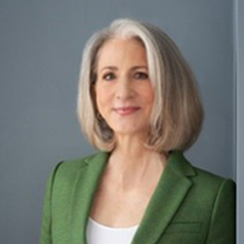 | Jill, an academic at the University of Newcastle, advances equity and inclusion through systemic transformation in education, public administration and research. Her experience caring for her disabled mother shaped her commitment to improving inclusive systemic frameworks. Jill has a permanent conductive hearing loss and uses a hearing implant.
Professor Angus Buchanan | 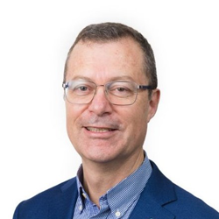 | Leader in allied health tertiary education, research and disability services. Angus has led major reforms in therapy and community coordination. His work reflects a lifelong dedication to inclusion and advocacy for people with intellectual disability and their families.
Ms Melanie Eagle | 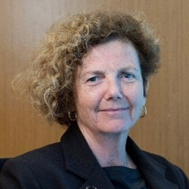 | Governance strategist and policy advisor with expertise in reform and strategic leadership. Melanie chairs the Disability Worker Registration Board and the Royal Victorian Eye and Ear Hospital, has served on ethics panels and has driven change across health, disability and local government.
Mr Matt Formston AM | 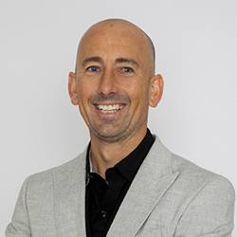 | Matt is a seasoned business executive, Paralympian and multi-sport world champion. He featured in Netflix's The Blind Sea and his children’s book Surfing in the Dark, combining braille, text and illustrations, is a world-first. Blind since youth, he brings decades of lived experience and global recognition.
Ms Clare Gibellini | 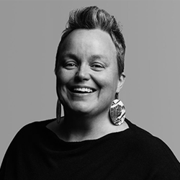 | Disability and human rights advocate with lived experience of disability, including Autism. As Chair of the National Disability Research Partnership, Clare focuses on climate change, disaster preparedness and gender equality. She has represented Australia at United Nations forums advocating for disability and gender equity.
Professor Tammy Hoffman OAM | 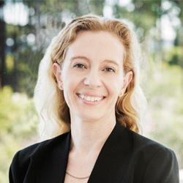 | Expert in evidence-based healthcare. Tammy’s research covers evidence-based practice, shared decision-making and helping health professionals, patients and the public use evidence to make informed health decisions. She also brings lived experience as a carer for a family member with severe disability.
Dr Robyn Mildon PhD | 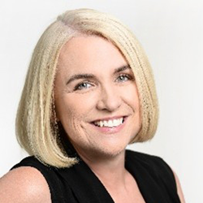 | Global expert in research translation, implementation science and policy evaluation. Robyn is the founding CEO of the Centre for Evidence and Implementation, working across 18 countries to improve health, education and human services.
Mr Andrew Moffat | 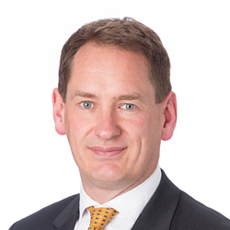 | Extensive experience in the disability sector since 2001, including 8 years as Chair of Vision Australia. Andrew is an NDIS participant due to his congenital low vision. He practices as a mediator resolving commercial, legal and governance disputes. He brings professional and personal experience to his work in disability and governance.
Ms Mary Sayers | 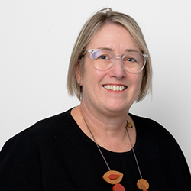 | CEO of the National Disability Research Partnership, which aims to transform national policy and practice through disability-led research. Mary has a career spanning research, policy and advocacy for children and young people and served on boards and government advisory committees. She has family and personal experience of disability.

Assistive Technology and Capital Subcommittee
Name |  | Biographies
Dr Lisa Chaffey (Co-Chair) | 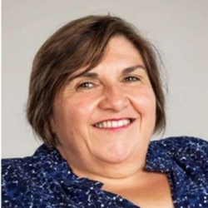 | Occupational therapist, Paralympian and governance leader with over 20 years in disability advocacy, inclusive service design and assistive technology (AT). Lisa is passionate about ensuring AT and therapy is safe, cost-effective, and enhances independence and participation. Her work is informed by her lived experience as a wheelchair user.
Professor Alistair McEwan (Co-Chair) | 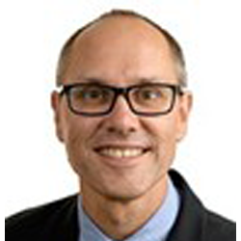 | Biomedical engineer and Cerebral Palsy Chair of Technology and Engineering at the University of Sydney. Alistair leads research on prevention, early intervention and lifelong support for people with disability. He works with clinicians, industry and people with disability to ensure innovations are practical, scalable and transformative.
Dr Sharon Boyce | 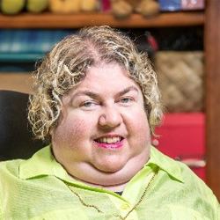 | Educator, author, speaker and disability advocate. Sharon is the founder of Discovering DisAbility & Diversity, an initiative that drives positive change in community attitudes across government, health and education sectors. She has dedicated her life to promoting understanding of disability, diversity and complex health issues.
Professor Josh Byrnes |  | Health economist and President of the Australian Health Economics Society. Josh's research focuses on designing and analysing studies that support evidence-based decisions in health policy and practice. His work has shaped major health policies including plain packaging for tobacco and pregnancy warning labels on alcohol.
Professor Libby Callaway | 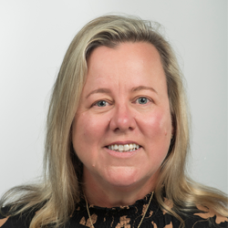 | Registered occupational therapist. Libby works at the Rehabilitation, Ageing and Independent Living Research Centre and Occupational Therapy Department at Monash University and clinically in her occupational therapy practice. She was recently a Board Member and advisor of the Australian Rehabilitation and Assistive Technology Association.
Adjunct Professor Michael Dillon | 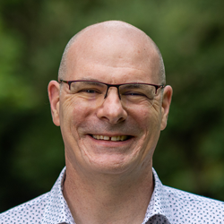 | Prosthetics and orthotics expert at La Trobe University. Michael's research focuses on outcomes after lower limb amputation. He led the development of the Amputation Decision Aid project, a shared decision-making tool for people facing difficult decisions about partial foot amputation due to peripheral vascular disease.
Ms Deborah Hammond | 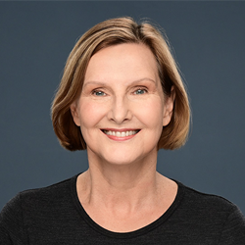 | Occupational therapist with 43 years’ experience working with adults with congenital and acquired disabilities in acute and community rehabilitation settings. Deborah has extensive experience in insurance schemes and provides expert opinions in courts and tribunals.
Mr Scott Harding | 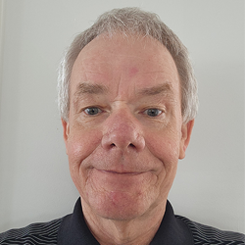 | A dedicated consumer advocate drawing on his lived experience of stroke and aphasia. Scott has an engineering background and brings strong problem-solving and evidence-based skills to roles that strengthen rehabilitation, communication access and inclusive policy.
Dr Beth Johnson | 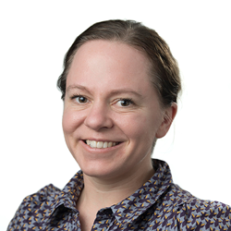 | Senior Research Fellow at Monash University. Beth is a queer, hard of hearing person, parent and passionate advocate for inclusive research and systems of care. They are committed to creating inclusive systems in education, health and policy that support individuals and families to lead fulfilling lives on their own terms.
Dr Kirsty McDonald | 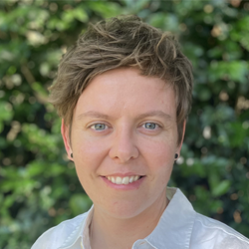 | Senior Lecturer in the School of Medical and Health Sciences at Edith Cowan University. Kirsty's interdisciplinary research program spans biomechanics, physiology and motor control, with a focus on disability and assistive technology. Kirsty has a strong background in lower limb prosthetic devices and has published widely in this space.
Professor Rachael McDonald | 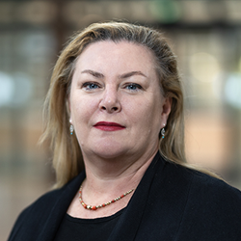 | Founding Director of MedTechVic at Swinburne University, Rachel is an occupational therapist and academic leader. Her work focuses on disability, assistive tech, inclusive co-design and turning research into real-world impact. She is recognised for driving cross-sector partnerships and shaping disability and assistive tech policy and practice.
Dr Kristen Morris | 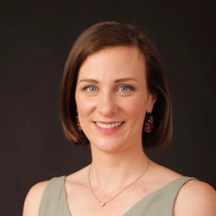 | Chartered engineer, nationally recognised in disability, health and assistive technology. Kristen has over 15 years' experience across clinical, technical, policy and strategic roles. She is a trusted voice in the sector and a passionate advocate for inclusive, fit-for-purpose solutions with lasting impact.
Associate Professor David Silvera | 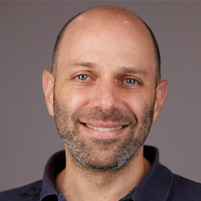 | Specialist in responsible innovation in AI, robotics and emerging technologies. At CSIRO, he leads a team driving innovation in digital care, with a strong focus on disability and aged care. His work spans from concept development to commercialisation, translating complex research into real-world impact and shaping national health policy.

Capacity Building and Therapies Subcommittee
Name |  | Biographies
Dr Walid Jammal (Co-Chair) | 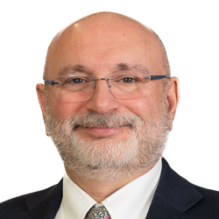 | General Practitioner in Western Sydney for 30 years. Walid has a keen interest in quality, safety, health economics and value-based care. He has experience on various national and state boards and committees. Walid cares deeply about improving systems and health reform to improve the wellbeing and lives of all Australians.
Professor Yasmine Probst (Co-Chair) | 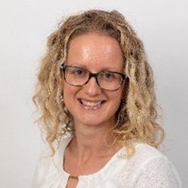 | Associate Dean for Equity, Diversity and Inclusion at the University of Wollongong. Yasmine has lived with multiple sclerosis (MS) for over 20 years. Her research focuses on nutrition care for people living with MS. She leads the Eatright MS team, including people with lived experience in planning and contributing across the entire research cycle.
Professor Garry Allison | 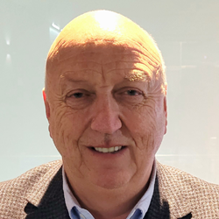 | Leader in rehabilitation and health innovation with expertise in neuroscience, biomechanics and trauma physiotherapy. Garry has held governance roles in health and sport, chaired major research committees. Through his career, Garry has driven social impact with research excellence, clinical care and leadership to improve rehabilitation and health.
Professor Helen Bourke-Taylor | 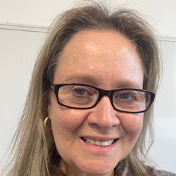 | Occupational therapist with 35 years’ clinical and academic experience. Helen has worked with children and young people with disability and their families in schools, clinics and research. Her research promotes evidence-based, culturally sensitive practices that consider the perspectives and needs of families of children with disability.
Dr Pat Bradley | 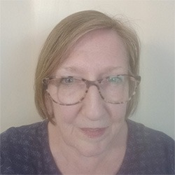 | Credentialed Mental Health Nurse, Fellow and Life Member of the Australian College of Mental Health Nurses, Pat works as an independent consultant on policy and professional matters. A full-time carer for her partner with Young Onset Dementia, Pat advocates for person-centred, evidence-based and culturally sound support for people with disability.
Ms Jane Corless | 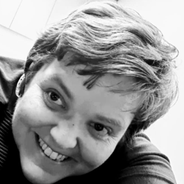 | Audiologist with over 10 years' experience in clinical practice, education and advisory roles in the hearing health sector. Living with hearing loss herself, Jane brings both professional expertise and personal insight to promote accessibility, equity and improved outcomes in hearing health care.
Professor John Gilroy | 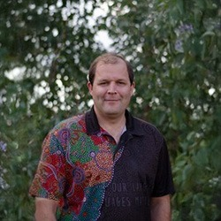 | A Yuin man from NSW South Coast and professor of Indigenous health and disability specialising in disability studies. John has pioneered Indigenous methodologies in disability research and leads projects across urban and remote communities. John is passionate about Aboriginal owned and driven research as means to influence policy.
Clinical Associate Professor Heather Mack AM | 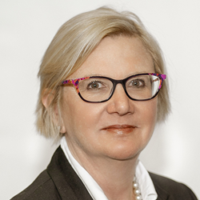 | Australian-trained ophthalmologist (medical eye specialist) with over 25 years of experience. Heather has worked directly with people with visual disability and helped them apply for NDIS support. She has experience in assessing impairment for compensation and strong skills in generating and reviewing scientific evidence.
Ms Carolyn O’Mahoney | 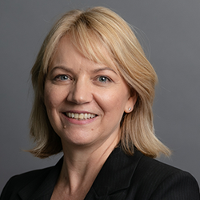 | A paediatric physiotherapist with 27 years’ clinical experience. Carolyn works clinically in paediatric development and disability. Carolyn has over a decade of experience managing multidisciplinary therapy teams and has worked in most states and territories across Australia. Carolyn has family members with physical disability and neurodivergence.
Associate Professor Jessica Paynter PhD, FAPS | 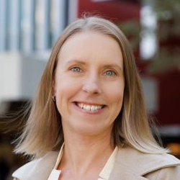 | Academic and clinical psychologist at Griffith University. Jessica has worked with neurodivergent people, their schools, families and other supporters for over 20 years. Her research focuses on developing, evaluating and sharing evidence-based assessments, supports and practices to support the goals of autistic people and their supporters.
Emeritus Professor Deborah Theodoros AO | 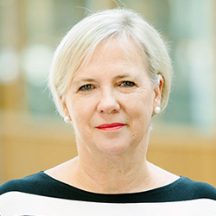 | Retired Emeritus Professor of Speech Pathology from the University of Queensland (UQ), with 45 years in clinical and academic roles. Deborah has lived experience of disability through her adult son with severe intellectual and physical disabilities who requires full-time care. She brings professional expertise and personal experience to her role.
Professor Katrina Williams | 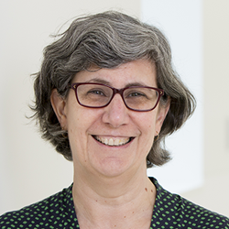 | Professor Katrina Williams is a paediatrician and public health physician. She has 30 years of experience working in child health care and research with a focus on child development and disability. Each week she works in partnership with professionals from many disciplines and with families with lived experience.

Economics Subcommittee
Name |  | Biographies
Professor Liliana Bulfone (Co-Chair) | 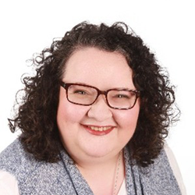 | Health technology assessment specialist with over 25 years’ experience across government, universities and the private sector. Liliana (Lili) brings together clinical, population and economic evidence to support fair and consistent decisions. She values plain English, transparent methods, and working with people from different fields.
Professor Rob Carter (Co-Chair) | 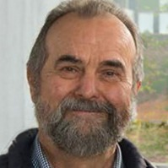 | Leader in health economics in Australia for over 50 years. Rob helped shape how health economics is taught and used in research. He continues to be involved in disability-related research projects and building disability economics as a field. He focuses on how economic thinking can support fairness and better outcomes in the disability sector.
Dr Joe Carrello |  | Physiotherapist-turned-health economist, Joe evaluates new health technologies under consideration for government funding through the MBS and PBS. He is skilled in Health Technology Assessment, economic evaluation and modelling, with research interests in chronic disease prevention, socio-economic determinants of health and health equity.
Dr Phillip Carson | 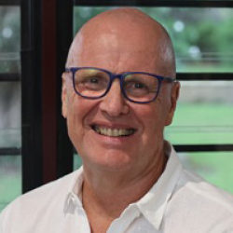 | Retired surgeon who has served the Northern Territory community most of his working life. Phillip has a passion to overcome barriers posed by distance and culture and to provide excellent surgical services to all Australians. He has lived experience of disability through his daughter who lives with an acquired brain injury.
Dr Jade Chang | 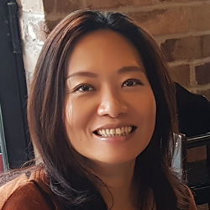 | Health and social care economist at the Centre for Disability Research and Policy, the University of Sydney. As a researcher with lived experience, Jade's work focuses on disability epidemiology, choice experiments and the economic evaluation of complex programs that require a ‘whole-system approach’ and integrate health and social care.
Associate Professor Martin Downes |  | Professor at the Centre for Applied Economics. Martin conducts strategic research and policy synthesis across health technology assessment, funding models and regulatory frameworks. He is committed to mentoring emerging scholars and shaping interdisciplinary approaches that reconcile clinical guidelines with real-world complexity.
Dr Laura Edney | 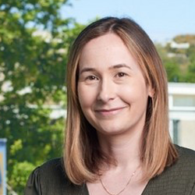 | Senior Research Fellow in Health Economics at Flinders University. Laura's research interests broadly include mental health care and the analysis of large, linked administrative datasets to inform national evidence-based funding decisions in health and disability care.
Dr Sonĵ Hall | 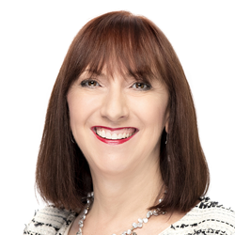 | CEO of the Australian College of Audiology with over 40 years of experience in health, ageing and disability. Sonĵ has worked in public service, universities, clinical care, not-for-profit and private sectors. Known for her collaborative style and strong ethics, she supports practical, evidence-based decisions.
Associate Professor Michael Palmer |  | Associate Professor in Economics at the University of Western Australia. Michael's research focuses on the economic and social consequences of ill-health and disability and examines how public policy can improve equality of opportunity. He is passionate about using economics to improve the lives of people with disabilities.
Dr Russell Taylor | 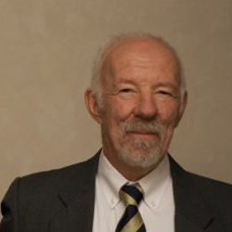 | Former clinical psychologist working in behavioural and health economics. Russell brings lived experience of disability to his work and uses economic and causal analysis to improve social policy. He helps identify programs that are proven to work by building libraries of reliable and effective interventions.

