National Tobacco & E-Cigarette Campaign
Stakeholder kit
February 2026
Contents
Introduction 2
Communication resources 4
Newsletter article 12
Social media posts 13

Introduction

Campaign background
Tobacco smoking remains the leading cause of preventable death in Australia. It is estimated that around 66 Australians die every single day from tobacco related causes. This equates to 1 tobacco-related death every 22 minutes.
Vaping harms your health and it can lead to nicotine addiction, shortness of breath, cause persistent coughing, wheezing and leave you feeling nauseous and dizzy. It may also cause damage to your lungs. People who vape, even occasionally, may not realise they’re dependent on nicotine.
The National Tobacco & E-Cigarette campaign aims to contribute to a reduction in smoking and vaping prevalence, particularly among priority and at-risk populations aged 18-55 years. These at-risk groups include:
- First Nations people
- people in low socioeconomic areas
- people in rural and remote areas
- people who identify as LGBTQIA+
- some multicultural communities.
Since it commenced in 2024, the campaign has successfully engaged Australians who smoke and vape, encouraging them to consider quitting or take action to reduce or stop vaping or smoking.
Phase 1 of the ‘Give Up For Good’ campaign was delivered throughout 2024 and 2025. It achieved strong initial engagement and awareness amongst people who smoke and vape, successfully moving people along the path to behaviour change. It delivered increases in quit attempts, perceived capacity and confidence to quit, and awareness and use of cessation support and tools.
This new phase of the campaign responds to recent research showing Australians are now seeking more information on the health harms of vaping and the supports available to quit both smoking and vaping – many of which are free to access, like the My QuitBuddy app.
Tailored advertising and information has been developed for key audiences – adults who vape, adults who smoke, and First Nations adults who smoke. A suite of complementary creative streams will continue to work together in market to drive quit attempts, prevent uptake, deter product switching, and highlight support services for people who smoke or vape.
Information is being translated into a range of languages, and advertising is supported by public relations, community activities and media partnerships.
The campaign aligns with the National Tobacco Strategy 2023-30 and complements other tobacco control measures that have been delivered to prevent tobacco and vape related harms, such as world-leading legislative reforms and increased support for quit programs.

About this Stakeholder kit
This kit has information and resources you can share with your community to learn more about the harms of smoking and vaping and the supports available to help people quit, including:
- Fact sheets
- Downloadable posters
- Videos
- Newsletter articles
- Social media posts.
This kit includes information and resources for adult audiences, however the ‘Give Up For Good’ campaign also targets 14- to 24-year-olds who currently vape or are at risk of vaping. More information on the campaign for young people can be found at health.gov.au/vaping.

How to use this kit
There are many organisations across the community sector, health services, education, sport, councils, workplaces and peak bodies who play a critical role in encouraging and supporting people to quit smoking and vaping, and in influencing others not to start. By sharing these resources, you can help create an environment where quitting is supported and celebrated. Your efforts can have a lasting impact on reducing nicotine addiction and improving public health.
You can share information about quitting smoking and vaping with people in your community by:
- including an article in your newsletters and/or websites
- publishing social media posts
- displaying resources such as the posters
- encouraging people to access resources online.

Further information
For more information and resources visit the campaign website: health.gov.au/GiveUpForGood.
If you have questions, require further information, or would like to discuss opportunities to promote the campaign further, please email the Department of Health, Disability and Ageing at NTEC@health.gov.au.

Communication resources
The table below outlines the resources available to support communication and engagement.
Resource | Preview | Link | Suggested use
Poster 1 – Resist cravings | 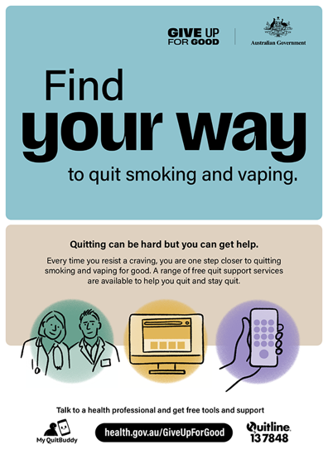 | Download here | Print out and display in areas such as a waiting room, community noticeboard or staff area.
Poster 2 –  My QuitBuddy app | 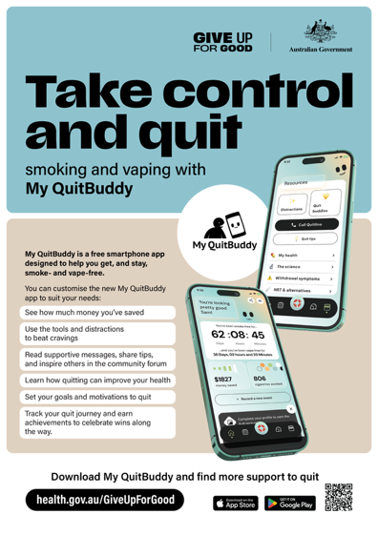 | Download here | Print out and display in areas such as a waiting room, community noticeboard or staff area.
Poster 3 – Tools and support across Australia | 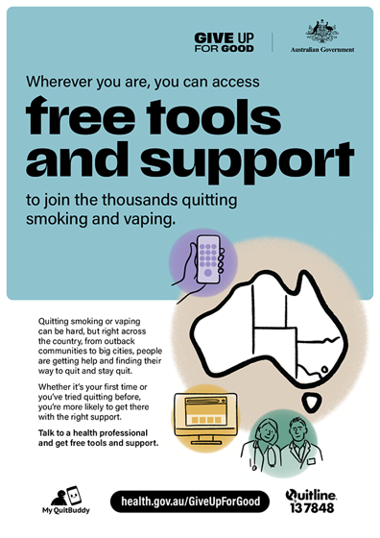 | Download here | If you’re regionally based, print out and display in an area with high foot traffic such as a foyer or a waiting room.
Poster 4 – Pregnancy | 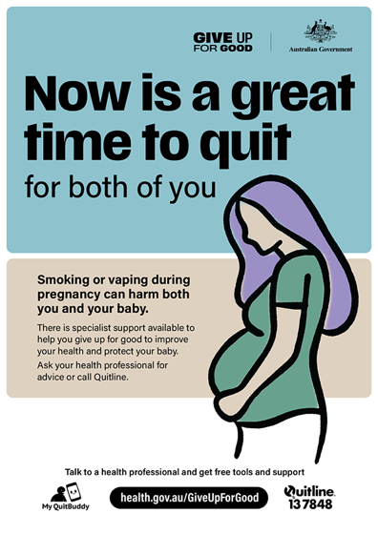 | Download here | If your organisation works with women who are pregnant or planning pregnancy, print out and display in an area with high foot traffic such as a foyer or a waiting room.
Fact sheet – Smoking | 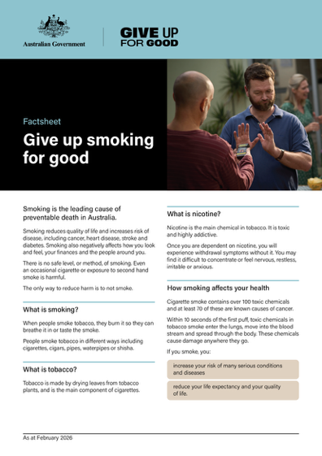 | Download here | Refer people to the fact sheet on the website or print and hand out hard copies.
Fact sheet – Vaping | 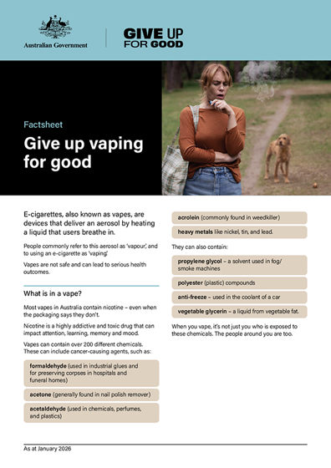 | Download here | Refer people to the fact sheet on the website or print and hand out hard copies.
Fact sheet – Tips for supporting someone to quit | 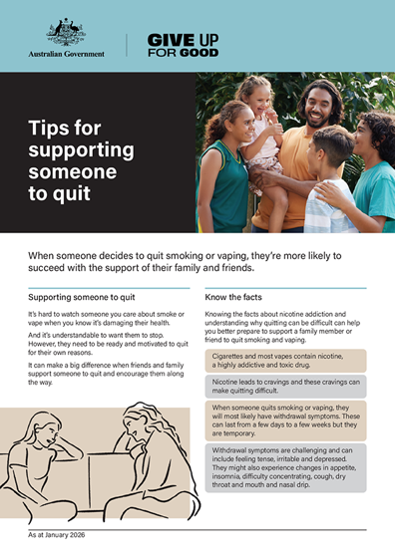 | Download here | Refer people to the fact sheet on the website or print and hand out hard copies.
Frequently Asked Questions (FAQs) – Smoking and quitting | 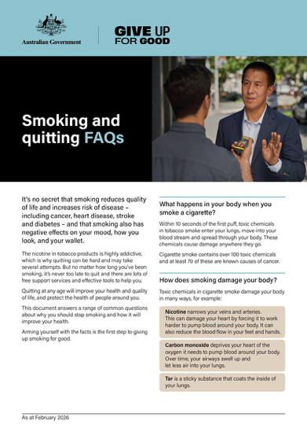 | Download here | Refer people to the FAQs on the website or print and hand out hard copies.
Frequently Asked Questions (FAQs) – Vaping and quitting | 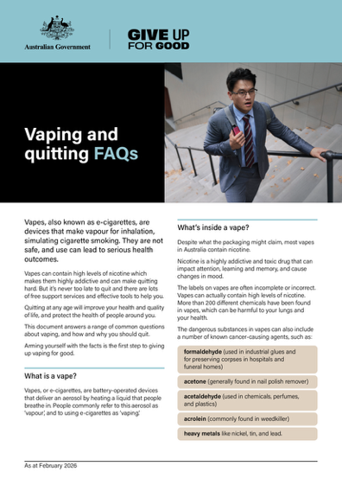 | Download here | Refer people to the FAQs on the website or print and hand out hard copies.
Explainer animation video – My QuitBuddy app | 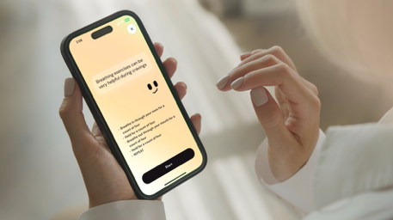  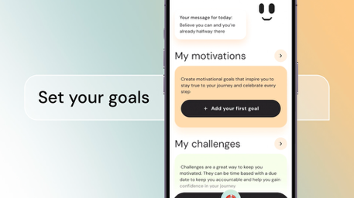  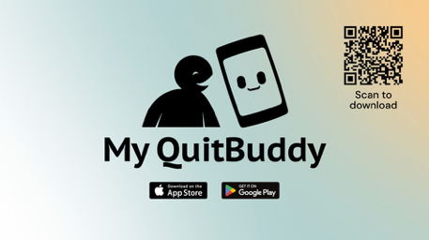 | Watch here | Link to the animated explainer video on websites, newsletter articles or social posts or share with relevant audiences in presentations.
Explainer animation video – Quit support options |   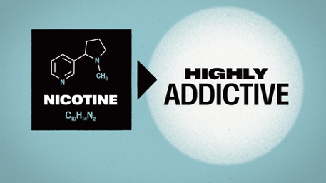  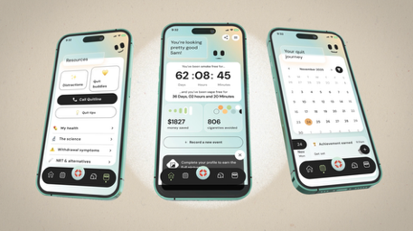 | Quit support services are proven to help people quit both vaping and smoking, and to stay quit. There is no one way to quit, and for many people a combination is most successful – choose the ways that work for you.  Watch here | Link to the animated explainer video on websites, newsletter articles or social posts or share with relevant audiences in presentations.
Explainer animation video – Benefits of quitting |     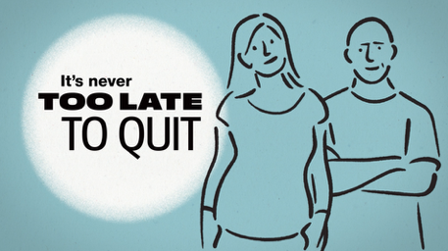 | It’s no secret that quitting smoking and vaping can be hard. The good news is that from the moment you quit, you’ll feel the benefits. Find the right support to help you quit successfully.  Watch here | Link to the animated explainer video on websites, newsletter articles or social posts or share with relevant audiences in presentations.
Quitline support video – Behind the scenes with a Quitline counsellor |  | Quitline counsellor, Teresa, talks about what Quitline is and the support it can offer people who are trying to quit smoking or vaping.  Watch here | Link to the video on websites, newsletter articles or social posts or show to relevant audiences in presentations.
Health expert video – Smoking | 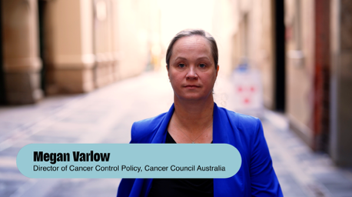 | Megan Varlow is the Director of Cancer Control Policy at Cancer Council Australia. In this video Megan talks about the health benefits of quitting smoking and what support services are available to help you give up for good.  Watch here | Link to the video on websites, newsletter articles or social posts or show to relevant audiences in presentations.  A series of cutdown versions are available here.
Health expert video – Vaping | 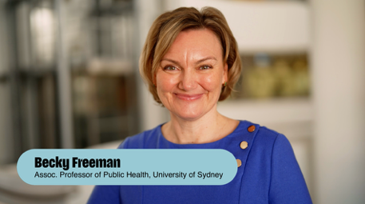 | Associate Professor Becky Freeman explains the health risks associated with vaping and what support services are available to help you give up for good.  Watch here | Link to the video on websites, newsletter articles or social posts or show to relevant audiences in presentations.  A series of cutdown versions are available here.
Case study: How I quit smoking for good – Sarah’s journey | 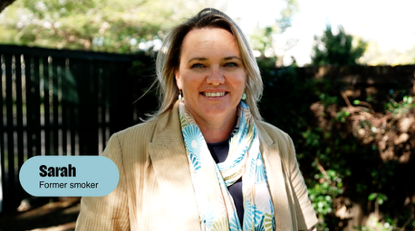 | Join Sarah as she shares her journey to quit smoking and the challenges she faced along the way. She talks about the strategies that helped her succeed and offers tips for anyone trying to quit.  Watch here | Link to the video on websites, newsletter articles or social posts or show to relevant audiences in presentations.  A series of cutdown versions are available here.
Case study: Keep at quitting the vapes – Kedea’s story | 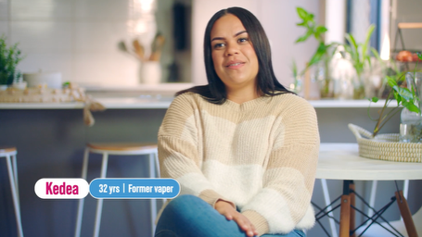 | Kedea recently quit vaping to help improve her physical and mental wellbeing. It took a few attempts, and she encountered setbacks along the way, but eventually Kedea was able to quit the vapes for good.  Watch here | Link to the video on websites, newsletter articles or social posts or show to relevant audiences in presentations.  A series of cutdown versions are available here.
Case study: Christina: Give up vaping for good – My story |  | Former vaper, Christina, talks about her path to quitting vaping, including the health and financial impacts vaping had on her life, what quit methods she used, and the benefits she has experienced since quitting. Christina also shares how falling pregnant impacted her quit journey.  Watch here | Link to the video on websites, newsletter articles or social posts or show to relevant audiences in presentations.  A series of cutdown versions are available here.
Case study: Quitting smoking and vaping for good – Ellen's journey |  | After a health scare, Ellen decided to make a change and quit vaping for good. In this video, Ellen shares her story about quitting smoking and vaping, the benefits of her new healthy lifestyle, and encourages others to seek support.  Watch here | Link to the video on websites, newsletter articles or social posts or show to relevant audiences in presentations.
Case Study: Quitting vaping for a healthier future for her family – Han’s Story  (spoken in Mandarin with translated captions available) |  | When Han decided to start a family, she chose to quit vaping and focus on creating healthier habits. Now as a mother, she’s confident that quitting was the best choice for her health and the health of her daughter.  Watch here | Link to the video on websites, newsletter articles or social posts or show to relevant audiences in presentations.
Case study: Giving up smoking for good health – Ken’s story  (spoken in Mandarin with translated captions available) |  | When a persistent cough began affecting his life, Ken knew it was time to quit smoking. After quitting, his health improved and he felt better physically and mentally. Now he’s sharing his story to inspire others to quit.  Watch here | Link to the video on websites, newsletter articles or social posts or show to relevant audiences in presentations.

All materials can be downloaded from health.gov.au/give-up-for-good/resources.
Resources for First Nations audiences can be downloaded at health.gov.au/give-up-for-good/first-nations-resources.
Fact sheets, videos, and FAQs have been translated into the following languages:
- Arabic – العربية
- Chinese Simplified – 简体中文
- Chinese Traditional – 繁體中文
- Korean – 한국어
- Vietnamese – Tiếng Việt
Translated resources can be downloaded at health.gov.au/give-up-for-good/translated-resources.

Newsletter article
The article below can be published on your website or in an electronic newsletter.
********

Give up smoking or vaping for good with support on your side
If you have been thinking about giving up smoking or vaping, you’re not alone.
Quitting can be hard, but many people have successfully quit, and you can too.
Every attempt is progress. Each time you try, you learn more about what works for you, bringing you one step closer to quitting for good.
There is more support available than ever before, with a wide range of updated resources and services designed to help you succeed. These services can help you quit smoking and vaping, no matter how long you’ve been doing it.
- Talk to your doctor or pharmacist for support and advice on the different options available to you, including medications that can reduce cravings and feelings of withdrawal.
- You can call Quitline on 13 QUIT (13 7848) for confidential advice and support from professional counsellors on how to quit smoking or vaping. You can even request a free callback for a time that works for you.
- Visit Quit.org.au for tips and strategies to help you quit and information on what to expect during the quitting process.
- Download the free and newly updated My QuitBuddy app to access the support you need to quit smoking or vaping. You can set personal goals, track your progress and see how much money you’ve saved.
For more information visit: health.gov.au/GiveUpForGood.

Social media posts
The posts below and any of the image tiles can be published on your preferred social channels.
Suggested copy for social post
Quitting smoking and vaping can be hard, but possible with support on your side.
There is more quit support available than ever before, with a wide range of updated resources and services designed to help you succeed:
- Talk to your doctor or pharmacist about support options
- Call Quitline on 13 7848 for confidential advice and support, or visit quit.org.au
- Download the free and updated My QuitBuddy app.
For more information, visit health.gov.au/GiveUpForGood.

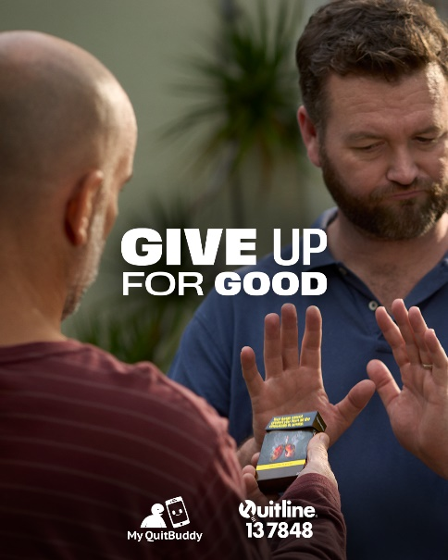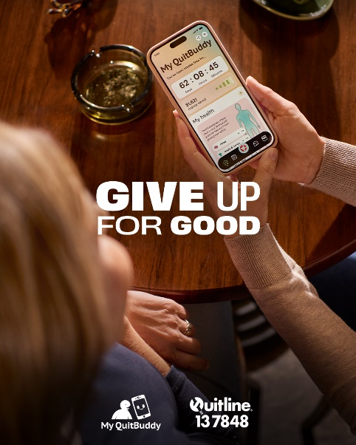
To download a range of social media images, visit health.gov.au/give-up-for-good/resources/social-media.

