

A simple bowel test could save your life Information booklet
  - National Bowel Cancer Screening Program

This information booklet cannot be completely comprehensive and is intended as a guide only. It should not replace individual medical advice. If you have any concerns about your health, or further questions, you should raise them with your doctor.

Copyright
© Commonwealth of Australia 2026

The material in this information booklet is licensed under a Creative Commons Attribution-NonCommercial-NoDerivatives 4.0 (CC BY-NC-ND 4.0) licence, with the exception of:
- the Commonwealth Coat of Arms
- this Department’s logo
- any third party material
- any material protected by a trademark, and
- any images and/or photographs.
More information on this license is set out at the Creative Commons Website. Enquiries about this license and any use of this information booklet can be sent to: Communication Branch, Department of Health and Aged Care, GPO Box 9848, Canberra ACT 2601, or via e-mail to copyright@health.gov.au.

Attribution
Use of all or part of this guide must include the following attribution: © Commonwealth of Australia 2026.
Published February 2026.

Contents
About the National Bowel Cancer Screening Program 4
Your test kit 8
What your result means 14
If you get a positive result 16
About bowel cancer 18
How to lower your risk of bowel cancer 22
About your privacy 23
Information in your language 26
Need help? 27

About the National Bowel Cancer Screening Program
The National Bowel Cancer Screening Program aims to reduce deaths from bowel cancer by detecting the early signs of the disease.
Eligible people aged 45 to 74 can screen with the program.
The program is supported by the National Cancer Screening Register which invites and reminds people to screen and to take the next steps on their screening journey.
Your next test kit will automatically be mailed to you every 2 years after your last screening test is completed. You can also ask your doctor about getting a kit.
70% of people who develop bowel cancer do not have a family history of the disease.


Who should do the test
- All eligible people aged 45 to 74.
- Even fit and healthy people. Age is the biggest risk factor for bowel cancer.
- People who have done it before – screening is recommended every two years.

Why you should do the test
- It could save your life.
- Bowel cancer can develop without you noticing the early signs.
- The risk of bowel cancer increases with age.
- If found early, over 90% of bowel cancers can be successfully treated.
- Doctors recommend people aged 45 to 74 screen every two years.
If you have signs, symptoms or a family history of bowel cancer, this test may not be suitable for you (see The signs and symptoms of bowel cancer, page 20). You may not need to do the test if you have had a colonoscopy in the last two years or are seeing a doctor about bowel problems. Talk to your doctor about your options.

What the test is looking for
The test is called an immunochemical faecal occult blood test or iFOBT. It checks for tiny traces of blood in your bowel motion (poo). This blood is often invisible or very hard to see.
Bowel cancer or polyps (small lumps) can grow on the inside wall of the bowel. Often tiny amounts of blood leak from these growths and can be found in poo before other signs are noticed.
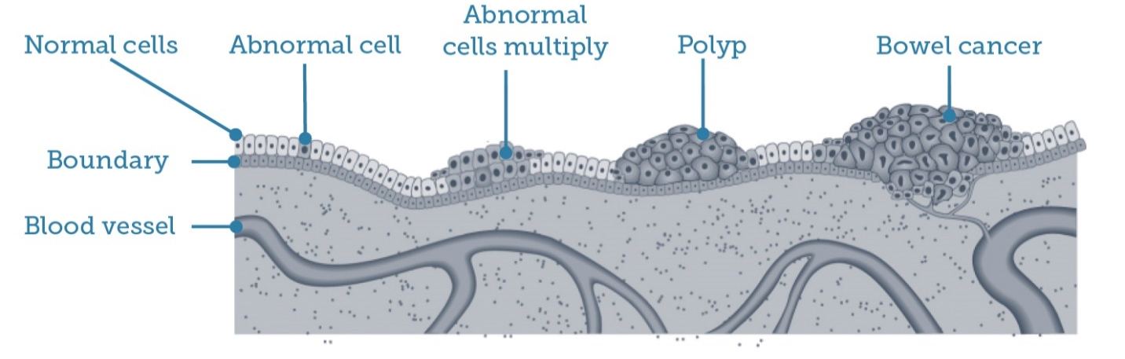
Figure 1: How bowel cancer can develop.

Reducing the risk of bowel cancer developing
Polyps are not cancers but may turn into cancer over time. They can be easily removed, reducing the risk of bowel cancer developing.
A positive test result is not a cancer diagnosis. If blood is found in your poo samples you will need to see your doctor to discuss the result as soon as possible. Your doctor may recommend a colonoscopy or another diagnostic test to find the cause of the bleeding (see What your result means, page 14).

Your test kit
Your at-home screening test is free, simple and could save your life.
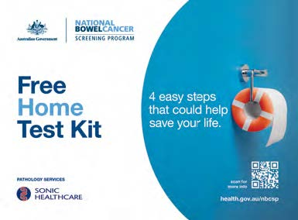

Tips to remember to do the test
- Put it next to the toilet.
- Complete it within the next 2 weeks.
- Set a reminder for the days you will take your samples.

How to do the test
The test involves taking two tiny samples from two different poos using the collection tubes included in the kit.
Fill in the participant details form with the dates you took the samples, sign the form and include it in the reply paid envelope with your collection tubes. Mail it all off to the pathology laboratory.
See the included step-by-step instructions, or watch a video on how to do the test at www.health.gov.au/nbcsp-kit-video.
You can also call the Test Kit Helpline on 1800 930 998 between 7.30am and 10pm Monday to Friday, and weekends between 9am and 7pm.

Getting an accurate result
The test detects tiny amounts of blood in the poo. If there is blood in your samples, it can decay over time.
To ensure the test is accurate:
- wait three days after finishing your period before doing the test
- try to collect both samples within 3 days of each other
- mail your samples as soon as possible – samples need to be received by the lab within 14 days of the first sample being taken
- store your samples in the fridge (or somewhere cool) until you’re ready to post them
- when returning samples in the reply paid envelope, post it in the cooler part of the day (or take it to a post office)
- keep taking any medication you are on and eat as you normally would before you do the test.

Keeping your samples cool
Prior to posting, the fridge is the best place for your samples. Put the tubes in the supplied plastic bag. Don’t worry, it is clean as the bag zips shut. Do not freeze the samples.

I don’t want to receive the kit again
While regular bowel screening over the age of 45 is strongly encouraged, it is your choice.
You can delay getting your test kit or opt out of the program. You can re-join at any time.
- If you delay participation, you can choose a date you wish to re-join.
- If you opt out, you will not receive any further free test kits or correspondence from the program. You will receive a letter confirming your choice to opt out.
To delay or opt-out, contact the National Cancer Screening Register at www.ncsr.gov.au or by calling 1800 627 701.

Can I give my kit to another person?
If you don’t want to do the test, put the unwanted kit in the rubbish bin. Please do not give your kit to another person or return it via the mail.

If you know someone who wants to do the test
If they are aged 45 to 74, are an Australian resident with an Australian mailing address, they can request a bowel screening kit be mailed to them at www.ncsr.gov.au/boweltest or by calling 1800 627 701. They can also visit www.health.gov.au/nbcsp for more information or talk to their doctor about getting a kit.
People not eligible for the program who have concerns about bowel health, should discuss screening options with their doctor. Their doctor may recommend a non-program kit covered by Medicare.
Non-program screening kits can also be purchased online or from a chemist.

Receiving your result
Your result will be mailed to you and your doctor (if you nominated one) within four weeks of posting your samples for testing.
Your result will also be sent to your My Health Record if you are registered. If you don’t want this to happen, you can indicate this on your participant details form when you return the samples.
If your result is sent to My Health Record and you decide you want it removed, you can do this by logging into My Health Record or phoning the help line, available 24/7 on
1800 723 471.
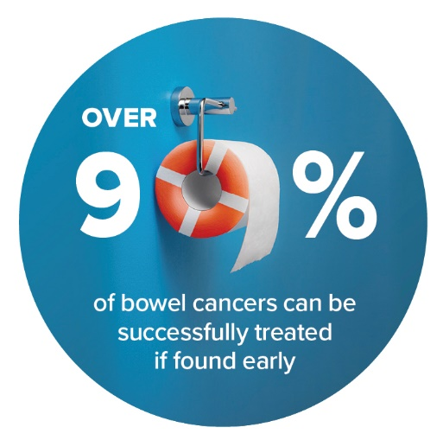

What your result means

Negative result
A negative result means no blood was found in your samples. Do the test again in two years.
As some bowel cancers do not bleed or only bleed on and off, the test can detect most bowel cancers. That’s why it is important to screen every two years and to talk to your doctor if you develop signs or symptoms after receiving a negative result (see About bowel cancer on page 18).

Positive result
A positive result means blood was found in your samples. You will need to discuss the result with your doctor as soon as possible.
A positive result does not mean you have cancer. It may be due to other conditions such as polyps, haemorrhoids or inflammation of the bowel, but it is important to investigate.
Your doctor may recommend you do a further diagnostic test to find the cause of the bleeding, such as a colonoscopy.

Inconclusive or no result
An inconclusive or no result means one or both samples were unable to be tested by the laboratory and you need to complete the test again. You will automatically be sent another test kit within a few weeks.
An inconclusive result can occur when the:
- sample had too much or not enough poo
- collection tube was damaged
- kit is expired (check the ‘use by’ date on the back)
- samples were not tested within 14 days of the first collection
- there were no collection dates on the tubes or participant details form.

If you get a positive result
If your test result is positive your doctor may refer you for a colonoscopy.

What is a colonoscopy
A colonoscopy is a procedure to look inside your bowel while you are under sedation (asleep). The doctor inserts a narrow flexible tube with a tiny camera attached into the rectum to look for polyps or cancerous growths.
The process is quick and usually takes between 20 to 45 minutes. Your doctor can advise you on the benefits and risks associated with this procedure.

Cost of a colonoscopy
There is no cost for a colonoscopy as a public patient. You may have to pay if you have your colonoscopy as a private patient. You should talk with your doctor about any costs before the colonoscopy.

If something is found during a colonoscopy
If polyps or other growths are found, the doctor will usually remove them immediately. They will be sent to a laboratory to be tested.
You may need surgery if a bowel cancer is found. If it is found at an early stage, bowel cancer can be successfully treated in more than 90% of cases. Most cancers found through the program are at an early stage.
You should talk to your doctor if you develop any signs of bowel cancer before you are next due to screen (see The signs and symptoms of bowel cancer, page 20).

Screening again after a colonoscopy
If polyps or other growths ARE found during a colonoscopy your doctor will advise on further testing and treatment and whether continuing bowel cancer screening is right for you.
If NO polyps or other growths are found during a colonoscopy you can skip your next screening round and instead start screening again four years after your last colonoscopy. This is based on current clinical advice. We will send you a letter about this ‘skip round’ two years after you did your last test as a reminder – but you can still request a kit be sent to you if you prefer not to skip a screening round.

About bowel cancer
Bowel cancer most commonly develops inside the colon or rectum (large bowel).

What your bowel does
Your bowel is part of your digestive system. This part of your body breaks down food and passes it out of your body in a bowel motion (poo).

Your bowel has three parts
- Colon – mainly absorbs water.
- Small bowel – absorbs nutrients from broken-down food.
- Rectum – stores poo until it is passed from the body through the bottom (anus).

How bowel cancer develops
- Most bowel cancers develop from small lumps called polyps in the bowel lining.
- Not all polyps turn into cancer.
- Removing polyps reduces your risk of bowel cancer.

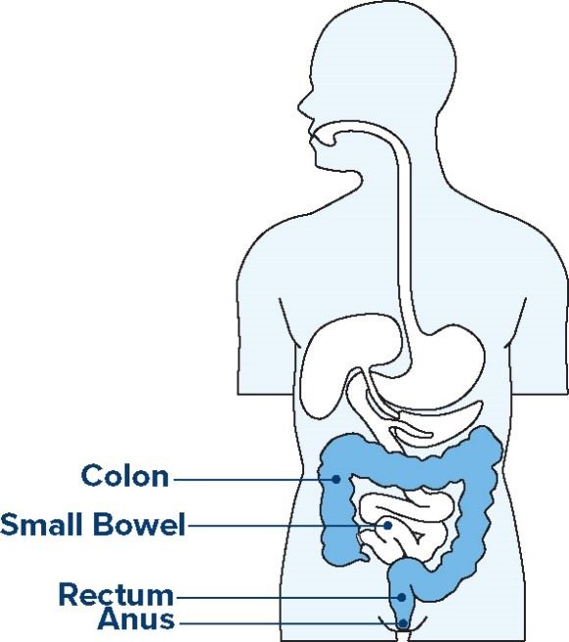
Figure 2: Human body showing the parts of the bowel

The signs and symptoms of bowel cancer
Bowel cancer can develop without you noticing the early signs. Signs can include:
- blood in your poo or in the toilet bowl
- changes in your normal toilet habits, such as looser poos, severe constipation and/or needing to poo more often than usual
- stomach pain
- feeling tired for no reason
- unexplained weight loss.
If you have any of these signs, it does not mean you have bowel cancer, but it is important to talk to your doctor.
The majority bowel cancer cases occur in people aged over 45, but it can affect anyone. Encourage family and friends to talk with their doctor if they are concerned.
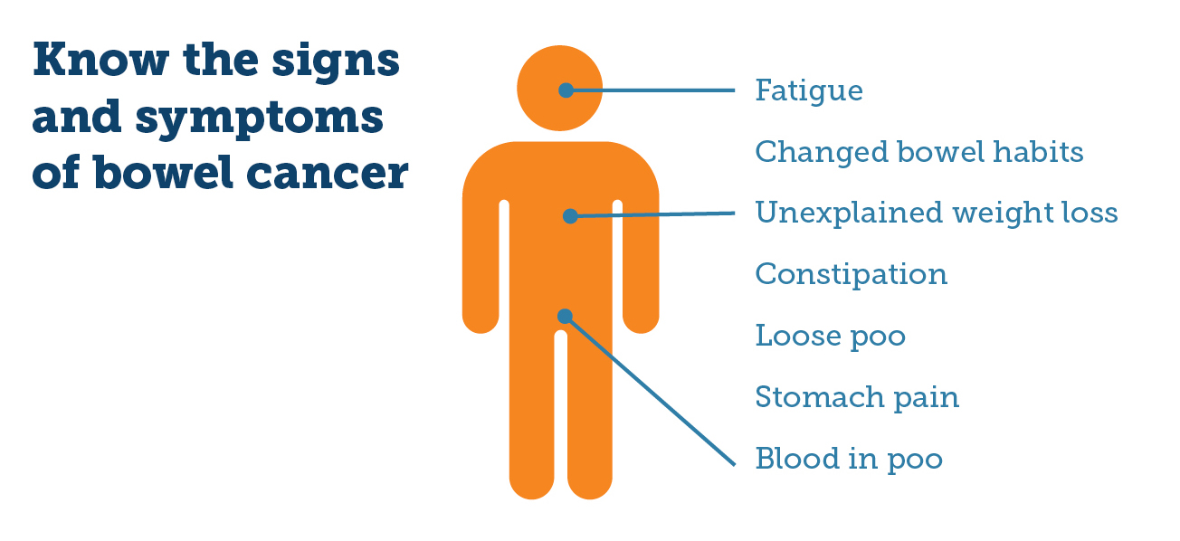

What might increase your risk of bowel cancer
People who smoke, are overweight, have a diet low in fresh vegetables and fruit, and high in red and processed meats, are at increased risk of several cancers, including bowel cancer.
Talk to your doctor about your risk of getting bowel cancer and what testing is right if you have:
- an inflammatory bowel disease such as Crohn’s disease or ulcerative colitis
- previously had non-cancerous tumours in the bowel
- a family history of bowel cancer. This includes one close relative who developed bowel cancer under 60 years of age (for example, a parent, brother, or sister); or you have more than one close relative who had bowel cancer at any age.

How to lower your risk of bowel cancer
To stay healthy and strong and lower your risk of bowel cancer:
- screen every two years to help detect bowel changes early when they are easier to treat
- eat a healthy diet of more vegetables, fruits, grains, and legumes (beans)
- eat less red meat and processed meat, such as bacon, ham and some sausages
- be physically active for at least 30 minutes every day, and sit less
- reduce the amount of alcohol you drink
- don’t smoke.
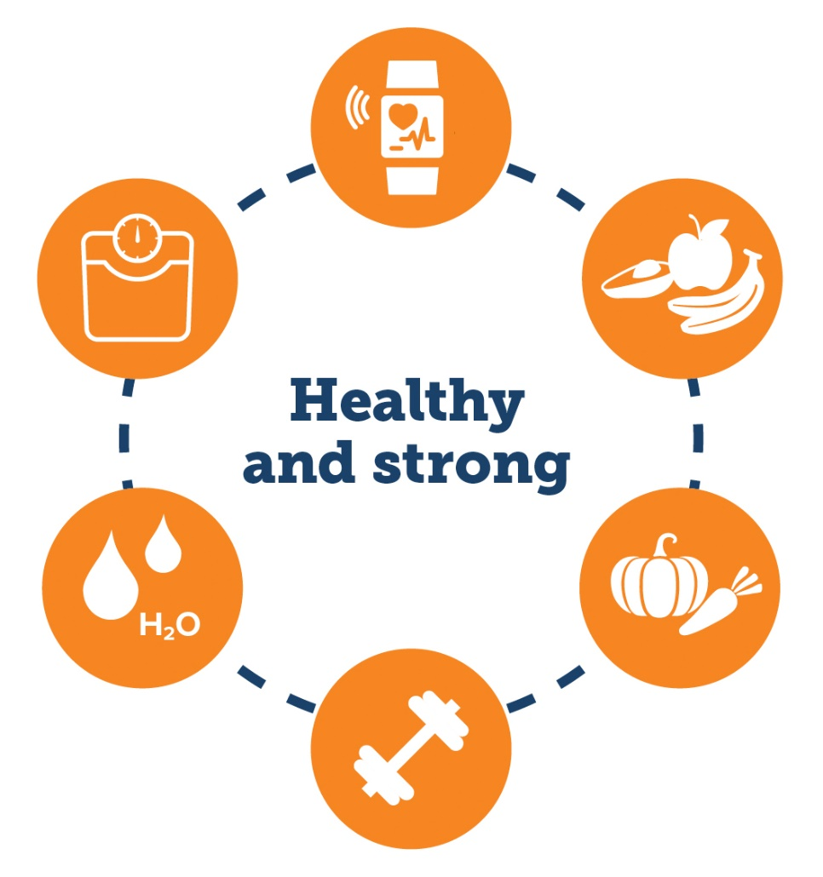

About your privacy

Information that is kept by the National Cancer Screening Register
The National Cancer Screening Register is administered by Telstra Health on behalf of the Australian Government Department of Health and Aged Care. It holds personal information such as:
- your contact details
- results of your program screening test
- the name of your nominated doctor
- results of further tests you may have after your program screening test (such as a colonoscopy)
- any correspondence between yourself and the register.

How this information is used
This information will be used to:
- remind you to do your test kit
- assist you to receive follow up and access to health services
- invite you to do another test kit in the future
- contact the program’s pathology provider to request your test results
- monitor and evaluate the program and its impact on bowel cancer in Australia.

Who will see my information?
Personal information kept on the register may be provided to the Australian Government Department of Health and Aged Care and professionals who provide services under the program, such as:
- your nominated doctor
- medical specialists
- the pathology laboratory responsible for testing your samples
- employees and contracted service providers of state and territory health departments
- the Australian Institute of Health and Welfare
- authorised third party service providers
- any authorised third party you nominate.

Privacy statement
Your personal information is protected by law, including the Privacy Act 1988 and the National Cancer Screening Register Act 2016, and is being collected for the Department of Health and Aged Care for the purpose of including information about you on the National Cancer Screening Register (NCSR) as part of the National Bowel Cancer Screening Program. Personal information about you has also been collected from Services Australia (Medicare and Department of Veterans’ Affairs) as part of the process of inviting you to undergo screening and may be collected for follow-up after you have had a screening test. Your information may be used by the NCSR or given to other parties to provide you with healthcare, for the purpose of research, investigation or where it is required or authorised by law or court or tribunal order.
Further information is available at: www.ncsr.gov.au/about-us/privacy-policy.

Information in your language
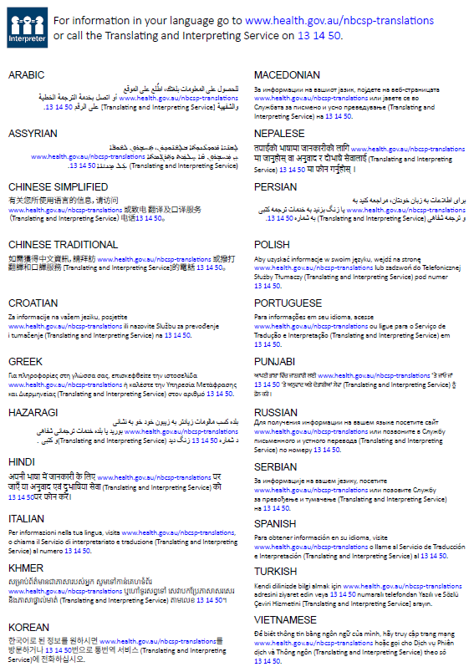

Need help?
If you want to… | Organisation | Contact
Update your details, manage participation, view screening information | National Cancer Screening Register | 1800 627 701  www.ncsr.gov.au
Find out how to do the test kit | Test Kit Helpline | 1800 930 998  or watch a short video at  www.health.gov.au/nbcsp
Access resources for people with low vision | National Bowel Cancer Screening Program | www.health.gov.au/nbcsp-resources-low-vision
Access services to help with a hearing impairment | National Relay Service | 1800 555 660  www.accesshub.gov.au
Talk to trained staff about cancer and local cancer services | Cancer Council Australia | 13 11 20  www.cancer.org.au
Access translated materials and letters | National Bowel Cancer Screening Program | www.health.gov.au/nbcsp-translations
Access interpreter services | Translating and Interpreting Service | 13 14 50  www.tisnational.gov.au  
Find out more about the National Bowel Cancer Screening Program www.health.gov.au/nbcsp.

