Service and Support Portal User Guide Part 2: Team Leader and Staff Member Functions

1. Background and overview 3
1.1 Purpose of the Guide 3
1.2 Service and Support Portal 3
2. Accessing the Service and Support Portal 3
3. Roles in the Service and Support Portal 4
3.1 Administrator homepage 5
3.2 Team Leader homepage 6
3.3 Staff Member homepage 7
3.4 Homepage for person assigned multiple roles 7
4. Managing Referrals 7
4.1 Clients with existing approvals for services under the Aged Care Act 2024 8
4.2 Electronic referrals for service 8
4.2.1 Viewing referrals 9
4.2.2 Accepting or rejecting a referral for service 12
4.2.3 Revoking a referral after acceptance 19
5. Clients and Services 21
5.1 Find a client 21
5.2 Viewing client information 22
5.2.1 Client Summary 25
5.2.2 Client Details 26
5.2.3 Support Network 27
5.2.4 Referrals for My Organisation 28
5.2.5 Plans 28
5.2.6 Attachments 29
5.2.7 Approvals 30
5.2.8 Services 31
5.2.9 My Aged Care Interactions 32
5.2.10 Notes 32
5.2.11 Tasks and Notifications 33
5.3 Viewing tasks and notifications 34
5.4 Completing identity verification 37
5.5 Adding service information 40
5.6 Updating service information 44
5.6.1 Record a note of changes made to client service information 46
5.6.2 Request an extension to the client’s care 48
5.6.3 Request a Support Plan Review (SPR) to meet changing needs 51
5.6.4 Checking the status of a Support Plan Review 58
6. Generating reports and accessing forms 60
6.1 Generating reports 60
6.2 Viewing reports 62
6.3 Accessing forms 63
7. Serious Incident Response Scheme (SIRS) 63
8. Residential Client Classifications and Reassessments 64
8.1 Viewing residential clients and their residential funding classification 64
8.2 Filtering the Care Recipients lists 66
8.2.1 Advanced Search 67
8.3 Requesting Residential Funding Reassessments 68
8.4 Requesting Residential Funding Reconsiderations 72
8.5 Recalling a Residential Funding Reassessment or Reconsideration request 75
8.6 Notify Client is Available for Assessment 77
8.7 Request Tab and Request Status Definitions 79
8.8 Palliative Care 79
8.8.1 View Clients Marked Palliative on Entry 79
8.8.2 Upload Palliative Care Documents 80
8.8.3 Palliative Care Status Form Outcomes 84

Background and overview

1.1 Purpose of the Guide
The My Aged Care Service and Support Portal User Guide - Part 2 (Service and Support Portal User Guide) outlines how Commonwealth-funded registered providers (providers) use the My Aged Care Service and Support Portal for their organisation. This portal is previously known as the My Aged Care Service Provider Portal.
The Service and Support Portal User Guide is split into two parts as follows:
- Part One provides an overview of the portal and describes the functions that an individual with the Administrator role in the Service and Support Portal will perform.
- Part Two (this document) provides an overview of the portal and describes the functions that an individual with the Team Leader or Staff Member role in the Service and Support Portal (‘you’) will perform.
This guide does not cover:
- Detailed instructions on how to obtain a myID (which can be found in the user guide Logging in to the Aged Care Systems.
! This symbol is used to highlight important information.

1.2 Service and Support Portal
The Service and Support Portal is used to:
- Manage information about the services you provide
- Manage referrals for service(s) issued by My Aged Care contact centre staff or assessors by accepting, rejecting, or placing on a waitlist
- Update client records with information about services being delivered
- Request that an assessor undertakes a Support plan review for a client
- Report Serious Incident Response Scheme (SIRS) Priority 1 and Priority 2 incidents in residential, in-home, and Support at Home aged care services.
- Generate reports.
- Manage residential clients’ classifications, reassessments, reconsiderations, and palliative care administration.

Accessing the Service and Support Portal
To access the Service and Support portal, each staff member must have a My Aged Care portal user account linked to a supported third-party authentication service.
For more information regarding setting up users and logging into the system please refer to Logging in to the Aged Care Systems.

3. Roles in the Service and Support Portal
The person nominated as the My Aged Care Organisation Administrator needs to be the first person from your organisation to log into the Service and Support Portal. How to nominate your first Organisation Administrator is detailed in the Logging in to the Aged Care Systems guide.
The Organisation Administrator will be responsible for assigning roles to other staff. This can include assigning other staff the administrator role to help set up and maintain information about your organisation in the Service and Support Portal. Roles should be assigned in accordance with the duties the person performs within your organisation.
! If you are assigned more than one role, this access will apply across all outlets you have been granted access to in the Service and Support Portal.
The following tables outline the functions for each role within the Service and Support Portal. It includes both client-focussed and organisation-focussed tasks.
Client Focussed key functions of the Service and support portal
Key Functions | Organisation Administrator | Outlet Administrator | Team Leader | Staff Member
Search for a client record  (for referred clients) | ü |  | ü | ü
View client records (for referred clients) |  |  | ü | ü
View referrals |  |  | ü | ü
Accept, reject, and revoke referrals |  |  | ü
View tasks and notifications | ü | ü | ü | ü
Manage organisation preferences for tasks and notifications | ü
Manage outlet preferences for tasks and notifications | ü | ü
View My Aged Care interactions | ü | ü | ü | ü
Add client service information |  |  | ü | ü
Transfer clients between services | ü
View list of residential care recipients and their residential funding classifications |  |  | ü | ü
View list of requests for residential funding assessments and reassessment |  |  | ü | ü
Request Residential Funding Reassessments |  |  | ü
ORGANISATION FOCUSSED KEY FUNCTIONS OF THE SERVICE AND SUPPORT PORTAL
Key Functions | Organisation Administrator | Outlet Administrator | Team Leader | Staff Member
View Palliative Care recipients |  |  | ü | ü
Upload Palliative Documentation |  |  | ü | ü
Submit notifications under the  Serious Incident Response Scheme | ü
Request change to contractual information |  | ü
Add outlets | ü
Manage outlets: edit, activate, deactivate, remove | ü | ü
Manage services: add, edit, activate, transfer (organisation administrator only) or deactivate | ü | ü
Manage staff (organisation level): add, edit, deactivate, remove | ü
Manage staff (outlet level): add, edit, deactivate, remove | ü | ü

3.1 Administrator homepage
! Go to Service and support portal user guide – Part 1: Administrator functions for more information for Administrators.
People assigned an administrator role at an organisation level can view and manage information for the entire organisation in the portal. People assigned an administrator role for one or more outlet(s) in the organisation will only be able to view and manage information for the outlet(s) they have been assigned.
If you log in to the Service and Support Portal as an administrator, Tasks and notifications, My Aged Care interactions, Reports and documents, Government Provider Management System, Outlet administration, and Staff administration tiles will appear on your homepage. If you have been assigned the SIRS role by your Organisation Administrator, a SIRS Notice tile will also display.
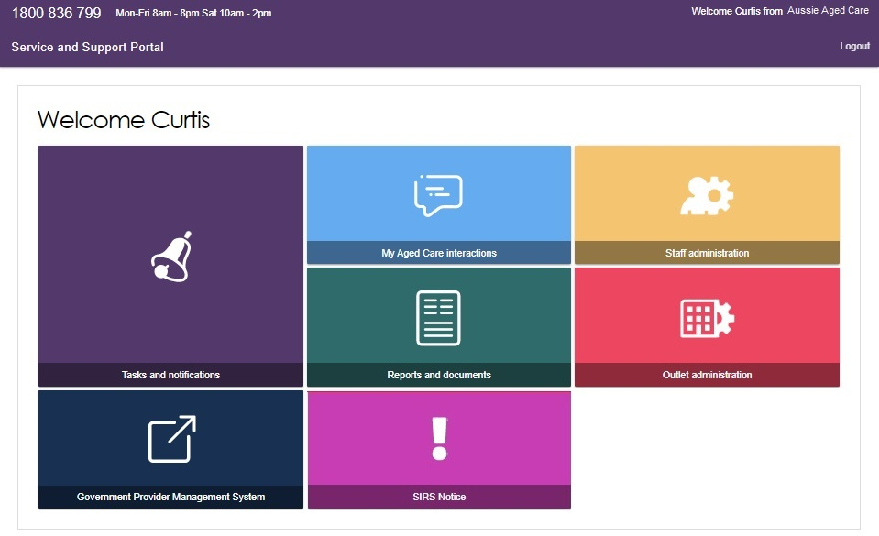

3.2 Team Leader homepage
People assigned the Team Leader role in the Service and Support Portal have the same functions as the Staff Member role and are also responsible for managing referrals for service(s) and residential funding reassessment requests.
If you log into the Service and Support Portal as a Team Leader, Service referrals, Find a client, Tasks and notifications, My Aged Care interactions, Reports and documents, Retrieve a referral code, Residential Care, and Government Provider Management System tiles will appear on your homepage.
If you have been assigned the SIRS role by your Organisation Administrator, a SIRS Notice tile will also display.
For information on how to add the SIRS application for staff members please refer to the following guide: Service and Support Portal User Guide - Serious Incident Response Scheme (SIRS) Portal
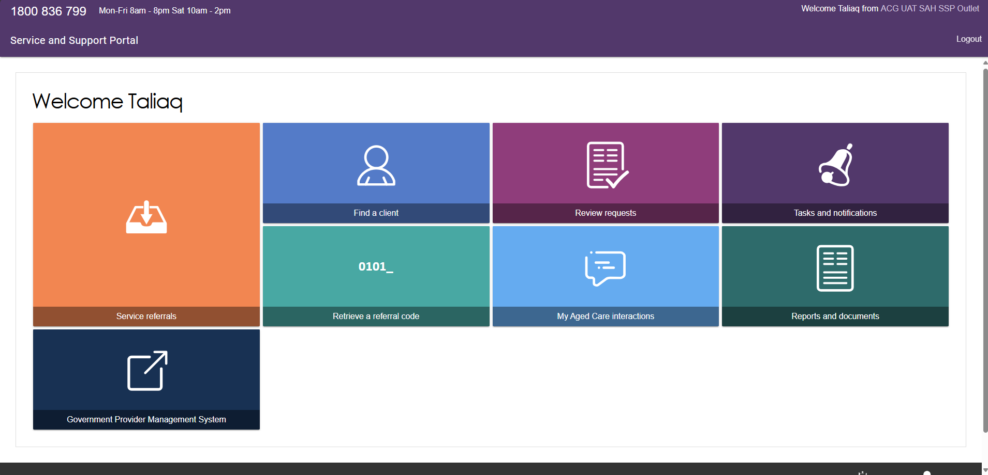

3.3 Staff Member homepage
People assigned the Staff Member role in the Service and Support Portal are responsible for adding and updating client service information in the client record.
Your organisation may also give you responsibility for submitting notifications under the Serious Incident Response Scheme (SIRS). As a Staff Member you can also view the clients in your residential facility, their current and historical classifications in the Residential Care tile.
If you log in to the Service and Support Portal as a Staff Member, Service referrals, Find a client, Review requests, Tasks and notifications, My Aged Care interactions, Residential Care, Government Provider Management System and Reports and documents tiles will appear on your homepage. If you have been assigned the SIRS role by your Organisation Administrator, a SIRS Notice tile will also display.
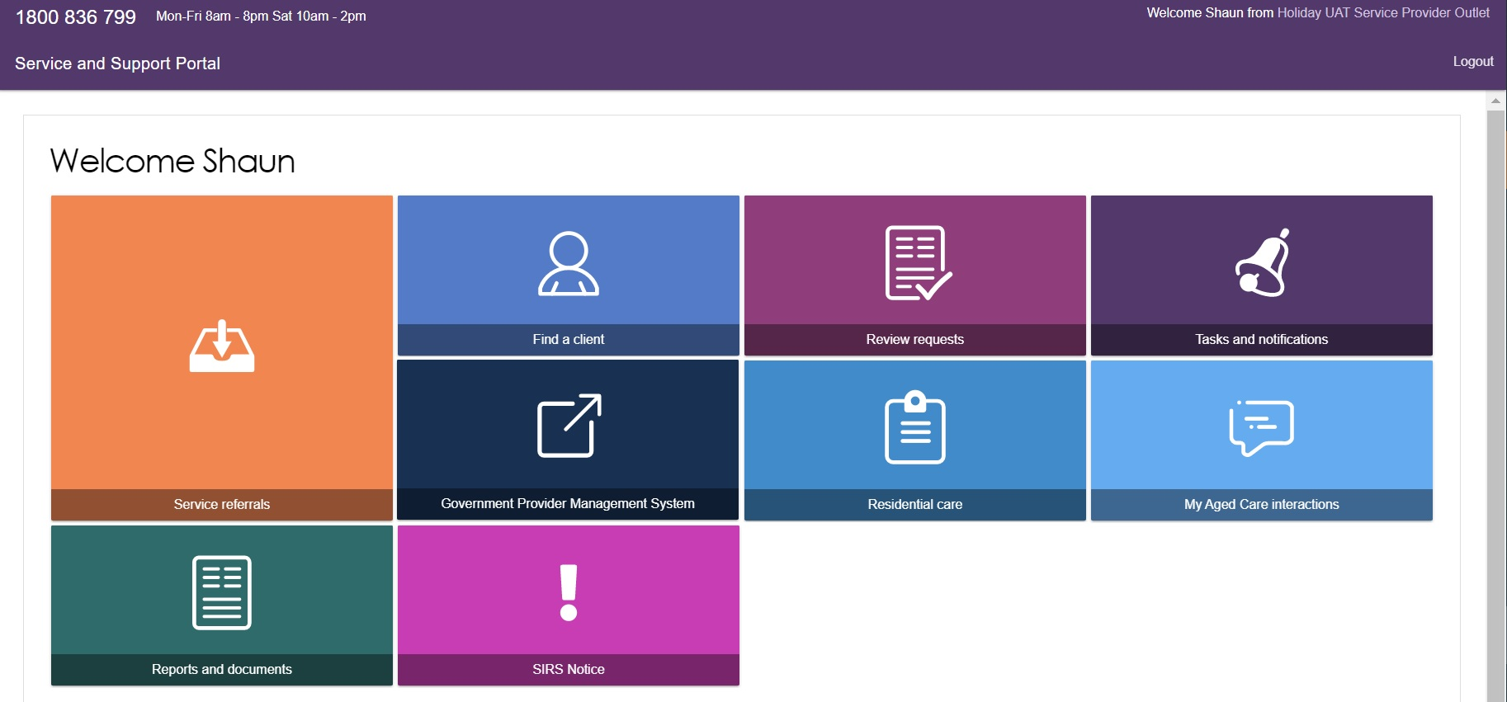

3.4 Homepage for person assigned multiple roles
If you log in to the Service and Support Portal as a user with Administrator, Team Leader, and Staff Member roles, the functions for all these roles will be displayed on the homepage.

4. Managing Referrals
! Referrals for service mentioned in this chapter are for Support at Home referrals, which may include multiple service types and services. Providers either receive referrals electronically or via a referral code, depending on the client’s preferences, and incoming referrals have a priority status (low, medium, high).
For more information about Residential Funding and Residential Respite referrals, refer to Residential Client Classifications and Reassessments.

Providers may receive referrals for services via four different pathways:
- Clients with existing approvals for care types under the Aged Care Act 2024 can approach service providers directly (these clients must be registered with My Aged Care).
- Providers can receive electronic referrals for service via the Service and Support Portal.
- Clients can approach providers directly with a referral code issued by assessors or the My Aged Care contact centre.
- Providers can accept electronic referrals for service to a provider’s waitlist if a waitlist is available.
Each provider outlet needs at least one person assigned the Team Leader role in the portal. This person will be responsible for managing referrals for service. Below is an outline of the roles assigned.
Roles | Team Leader | Staff Member
View Referral | ü | ü
Accept Referral | ü | X
Accept to Waitlist | ü | X
Reject Referral | ü | X
Revoke Referral after Acceptance | ü | X
Request urgent referral | ü | X
Manage referral notifications | ü | X

4.1 Clients with existing approvals for services under the Aged Care Act 2024
All clients with valid approvals must be registered within the My Aged Care system.
If it is established that the client must be registered and already has an approval, providers should facilitate a review or reassessment of the client’s care needs by calling the My Aged Care contact centre or via the online web referral form available on the My Aged Care website at https://www.myagedcare.gov.au/make-a-referral.

4.2 Electronic referrals for service
Providers can receive electronic referrals for service for clients registered with My Aged Care via the Service and Support Portal.

4.2.1 Viewing referrals
- Select Service referrals from the homepage.
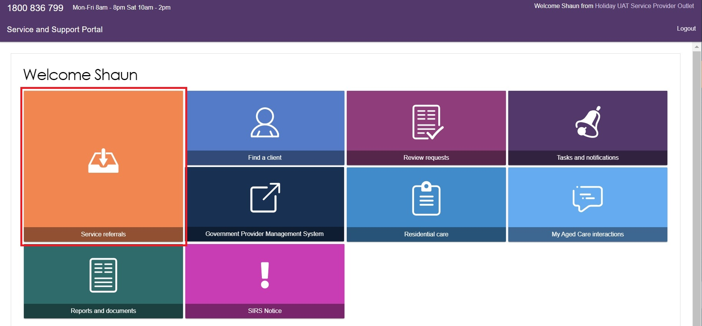
Alternatively, from any other page in the Service and Support Portal, you can choose the Service referrals option from the tool bar displayed at the top of the portal.
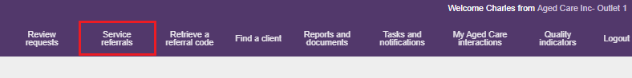
You will need to select the relevant outlet name to ensure that you are looking for referrals in the correct outlet. This can be done by selecting the outlet name from the top right corner of the portal, above Logout.
- The Incoming referrals page will now display a list of incoming referrals (those that have not been actioned). You can alternate between card and list view by using the toggle at the top of the page.
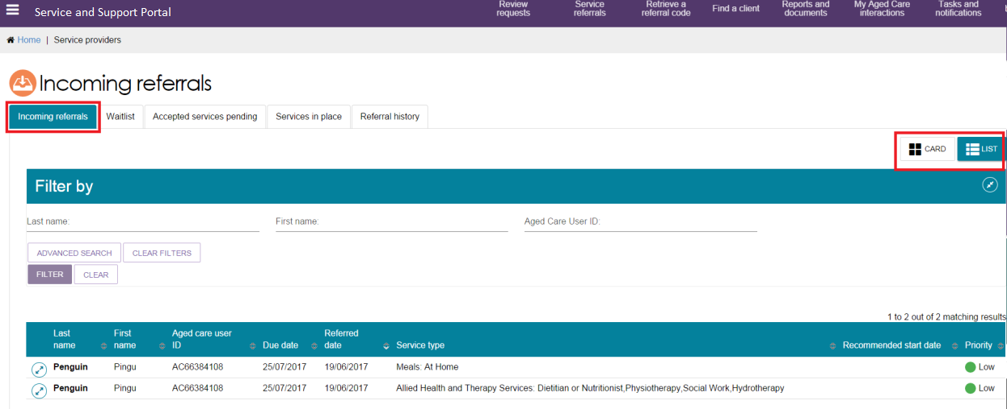
You can refine the search results by entering a client’s First name, Last name, or Aged Care User ID. Display the filter option by selecting the expanding arrows at the right of the filter bar.
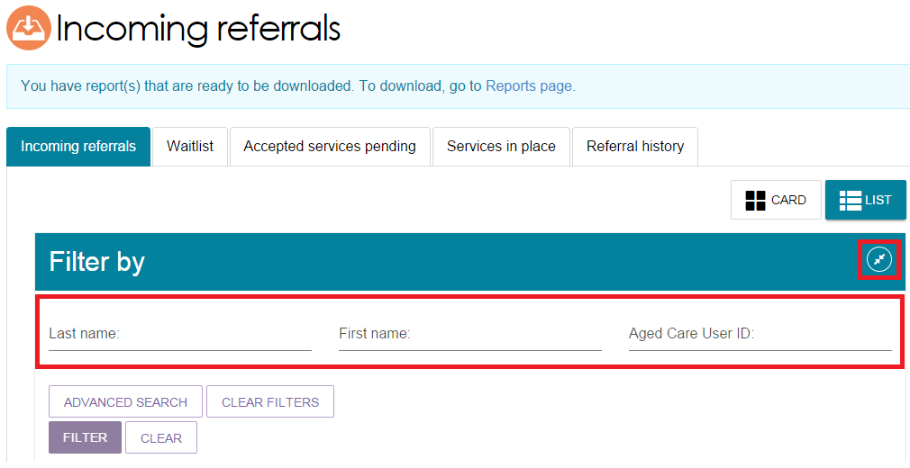
Select the ADVANCED SEARCH button to set filter options.
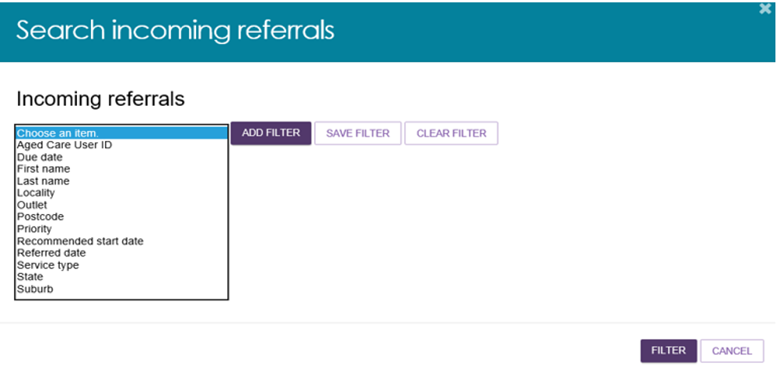
The following search filters can be chosen from the Optional Filter Field drop down menu and applied to your search by selecting ADD FILTER.
- Aged Care User ID
- Due date
- First name
- Last name
- Locality
- Outlet
- Postcode
- Priority
- Recommended start date
- Referred date
- Service type
- State
- Suburb.
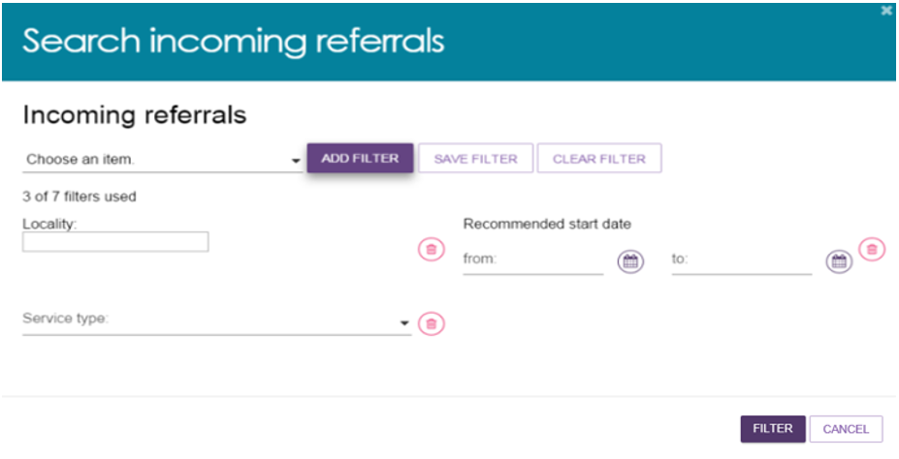
You can save any filters that have been applied by selecting SAVE FILTER, so that they may be quickly used again through the ADVANCED SEARCH option. Alternatively, these referrals can also be sorted by the following fields, in either ascending/descending or alphabetically:
- Client Last Name
- Client First Name
- Aged Care User ID
- Suburb
- State
- Postcode
- Locality
- Date Referred
- Due Date
- Recommended Start Date
- Priority
- Service Type.
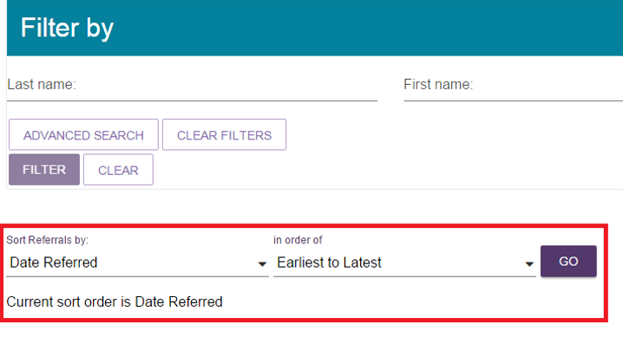

4.2.2 Accepting or rejecting a referral for service
To accept a referral for service, select Service referrals from the home page, the toolbar at the top of the portal, or the sidebar from the Menu option at the top left of the portal and follow the procedure below.
For Support at Home services, once funding has been assigned, providers can view the provision of a referral code to the client. Providers should note the take up deadline by which they must have commenced services with a client, or else funding will be withdrawn.
! Referrals for waitlists are not sent as a specific waitlist referral. If a waitlist is available for the referred service, staff or team leaders can accept referral to the waitlist, depending on permissions.
- From the Incoming referrals tab in Service referrals select the expanding arrows at the top right of the referral in card view, or to the left of the referral in list view, that you wish to view to display information about the referral.
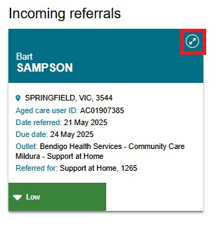
Or in list view, select the expanding arrows to the left.
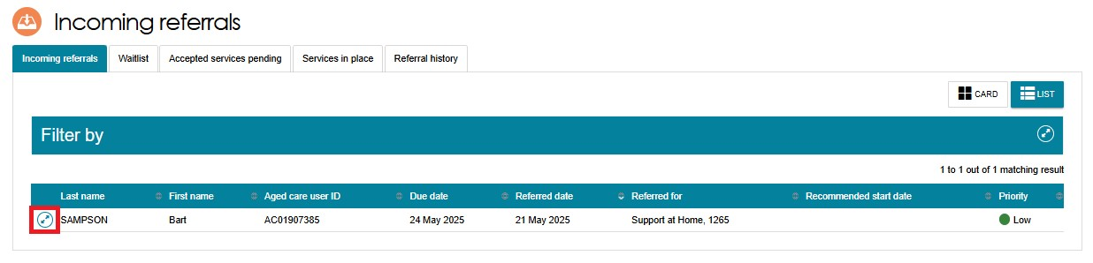
- The expanded information will provide, in addition to what was already visible, any referral comments made by the assessor or contact centre, and whether the client has multiple referrals for additional service types to your outlet.
You may decide to accept, reject, or waitlist referrals based on the information available on the referral card. However, if you want to view more client information prior to accepting a referral, select VIEW REFERRAL SUMMARY AND CLIENT RECORD to view details of the referral, the client’s assessment and assessment outcomes and more detailed information about the client.

The below image shows the detailed referral view of a Support At Home service, including the place assigned information (i.e. MSO / FSO) for both SaH and AT / HM. Where there are two active classifications in the same Service Group, then details for both classifications will be presented.
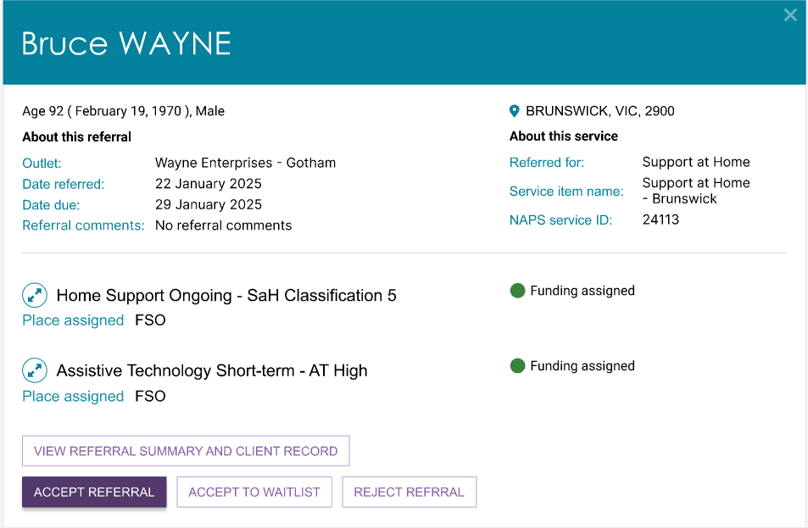
The image below shows the alternate list view of the card view presented above.
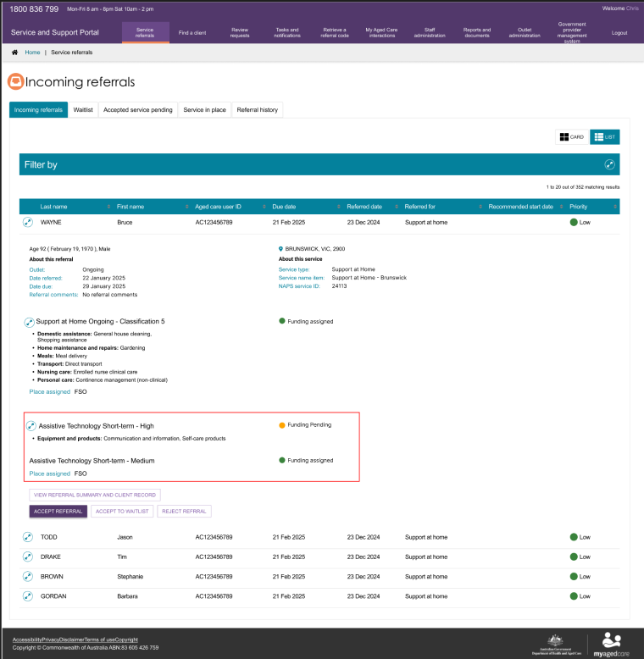
! For Support at Home services, the detailed referral view will display the recommended frequency and intensity.
This information is a recommendation only and is intended to support discussions with the client and assist providers when considering service options. This information is also available in the Services and Referrals for my Organisation tabs in the client record.
- If you select VIEW REFERRAL SUMMARY AND CLIENT RECORD, the Referrals for my organisation screen will display. Any referrals issued to your organisation for the client will be displayed.
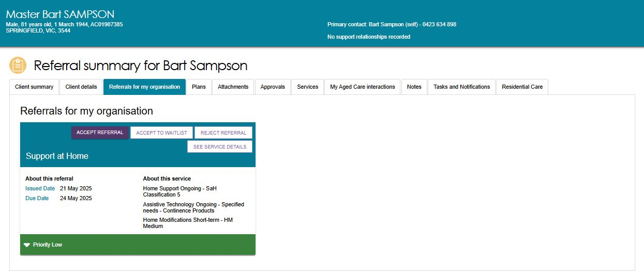
You can view the following information in the Client summary tab (client contact details and full address details can only be viewed once a referral has been accepted):
- Personal information
- Primary contact person
- Identity information and status of identity check
- Communication requirements
- Address details (Suburb, State/Territory and postcode only)
- Payment details
- Health insurance details
- Service information
- Current notes.
You can view the following information on the other tabs of the client record:
- Support plan
- Attachments
- Approvals under the Act
- Services in place
- Tasks and notifications for that client
- Current and previous assessment and support plan review information
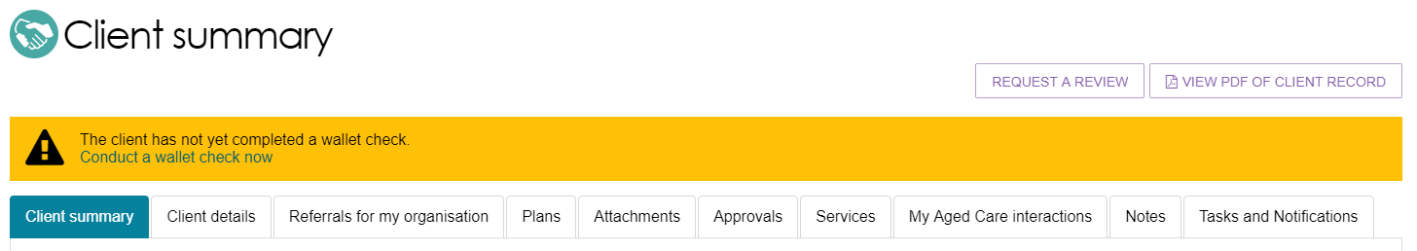
To accept the referral, refer to Step 4.
To reject the referral, refer to Step 5.
To accept the referral to waitlist, refer to Step 6.
The Service and Support Portal User Guide – The Client Record contains further information about navigating the client record and what information can be viewed.
- To accept the referral, select ACCEPT REFERRAL from the Referral summary page or from the expanded card or list view in Incoming referrals tab.
! It is critical that you review the referral and client information and that you have decided to provide services to the client prior to accepting the referral.
Only accept the referral once the provider has confirmed the capacity to deliver the required services. Client agreement to proceed should also be confirmed prior to acceptance.
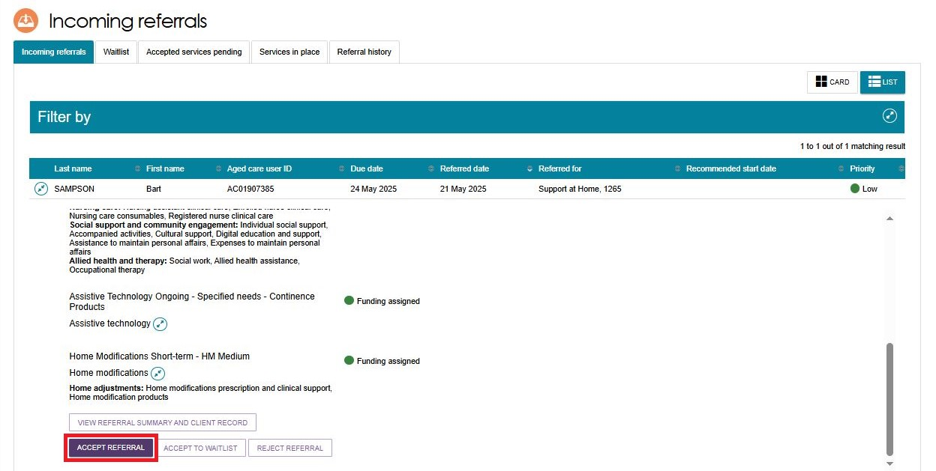
Select the correct service item name or NAPS Service ID (if your organisational has more than one service or NAPS ID available for the service type) you wish to link the referral to. Confirm that you want to accept the referral by selecting ACCEPT.
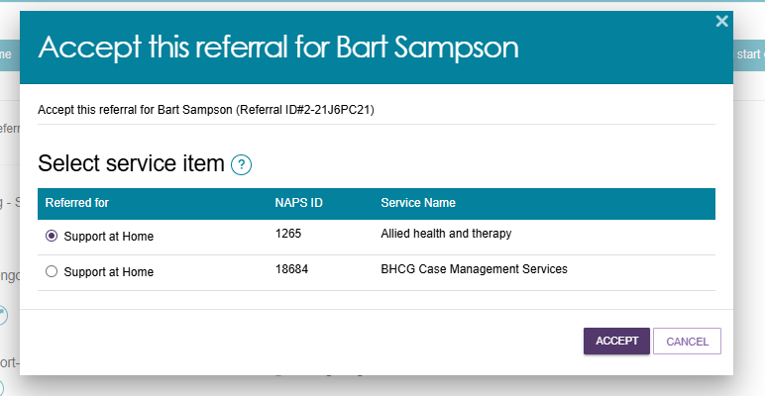
A confirmation banner will appear at the bottom of your screen confirming your acceptance of the referral and advising that the referral, and access to the client’s full record including complete address and contact information, will be available through the Accepted services pending tab.
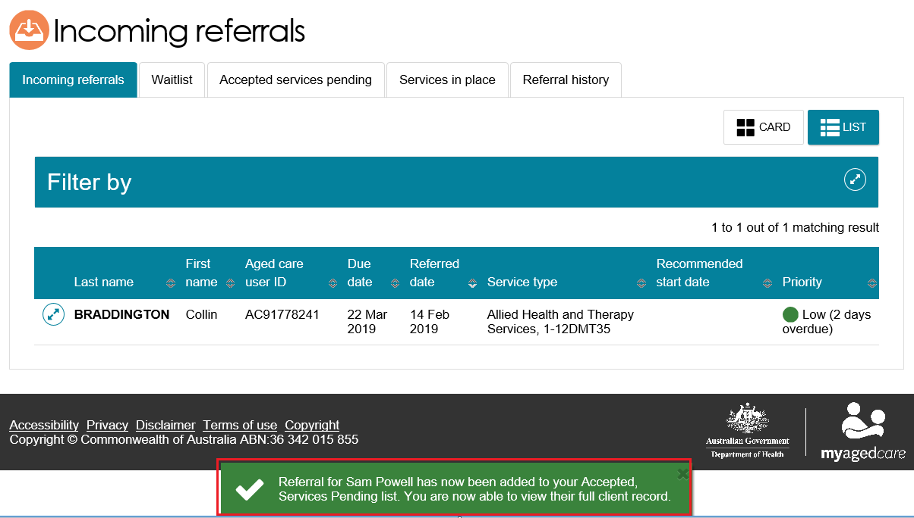
! Once a referral has been accepted, service delivery information must be provided within the priority status timeframes; details regarding this can be found in the My Aged Care - Service and Support Portal Resources page on the Department’s Website.
- To reject the referral, select REJECT REFERRAL located next to ACCEPT REFERRAL on the referral card or Referral summary page.
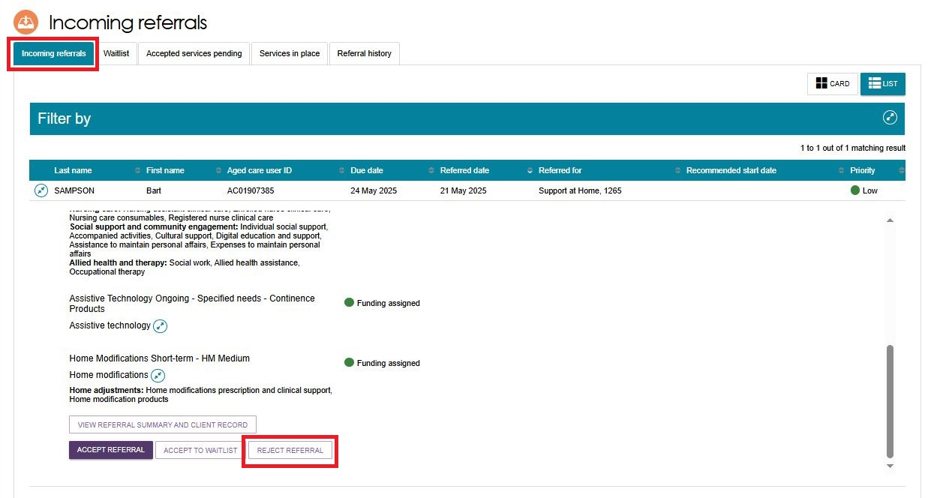
You will be asked to select a reason for rejecting the referral from a drop-down list. You may also choose to enter additional information in the Rejection reason free text field.
Comments regarding the Rejection reason are displayed to other My Aged Care users but not in the client’s My Aged Care Online account. Providing a rejection reason assists assessors and the My Aged Care contact centre to support clients in accessing services.
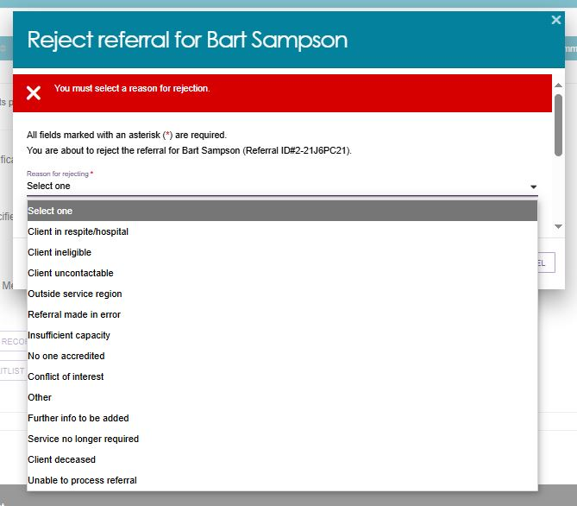
! Rejecting a referral with the reason of Client deceased will change the client’s status to Deceased and make the client record read-only.
Any unaccepted service referrals will be recalled, services in place will be ceased, assessments will be cancelled and the client’s access to the client portal will be revoked.
My Aged Care will not send correspondence to the client or their registered supporters and/or appointed decision makers after the status is changed to Deceased.
Where a client is active in the Support at Home Priority System or has been assigned Support at Home funding, this will remove the client from the Support at Home Priority System and withdraw any assigned Support at Home funding.
Upon rejection, a confirmation banner will appear at the bottom of the screen.
! If you do not have capacity to provide the service/s, your administrator should update your service availability and information in the portal. This is described in Service and Support Portal User Guide Part 1 – Administrator Functions.
- If you are unable to provide the service at the time and you have a waitlist available, you can accept the referral to your waitlist.
The referral will appear in your outlet’s Waitlist tab. Note that this option is only available if the service is configured by your Organisation Administrator to offer waitlist.
This process is described in Service and Support Portal User Guide Part 1 – Administrator Functions.
! Support at Home Waitlists
Placing a participant on a provider waitlist does not pause the Support at Home place take-up deadline. If the take-up deadline expires while the participant remains waitlisted, the allocated place will lapse and be automatically withdrawn. Providers should avoid waitlisting participants once funding has been allocated and ensure timely acceptance and commencement of services.

4.2.3 Revoking a referral after acceptance
There may be circumstances after you have accepted a referral for service that affect your ability to provide services to that client. For example, the client withdraws their consent for service provision, or their circumstances change.
You can only revoke accepted referrals where service delivery information has not been entered and/or services haven’t commenced.
The department will monitor the use of this functionality, and notifications will be sent to service providers where 20% or more of referrals issued to the outlet over a period of 12 months have been revoked after acceptance.
When a referral is revoked after acceptance, other referrals (such as from a broadcast or preference referral) will be automatically issued.
Follow these steps to revoke a referral after acceptance:
- Navigate to the Accepted services pending tab in the Service referrals section of the Service and Support Portal and locate the accepted referral that you wish to revoke.
You can filter the results by expanding the Filter functionality, sort the results by editing the sort order and selecting GO, or change the display of information between Card or List views.
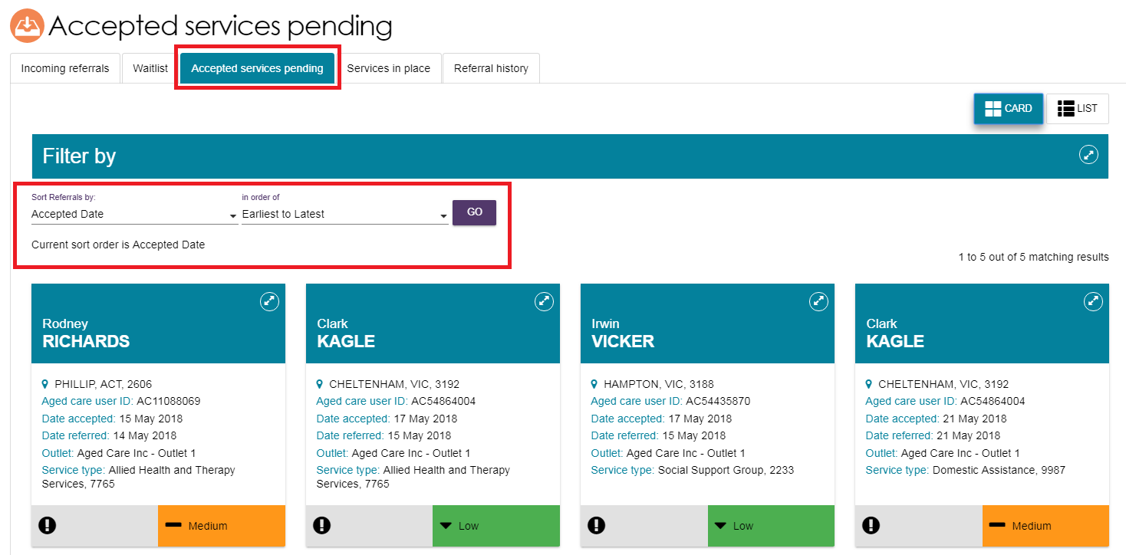
- Select the accepted referral you wish to revoke and expand the information. You are then able to select REVOKE REFERRAL.
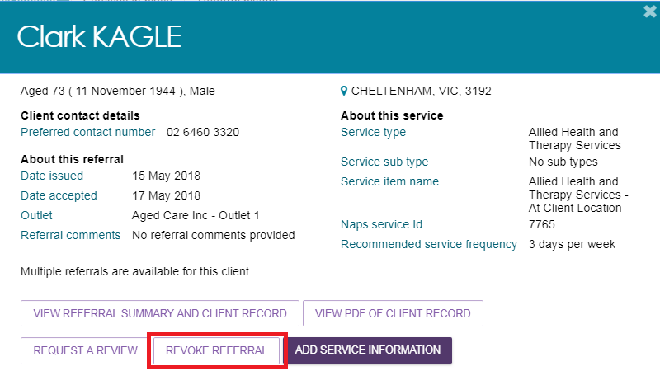
- Select the reason for revocation from the drop-down menu and enter detailed information in the Comments section to explain why you are revoking the referral after acceptance.
Select REVOKE REFERRAL.
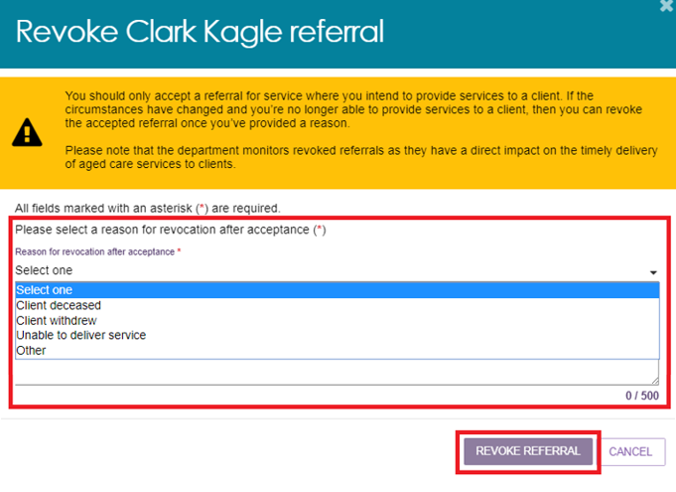
- You will receive confirmation that the referral has been revoked, and it will no longer appear in your Accepted services pending tab.

5. Clients and Services
Follow these steps to find a client who has been referred to or accepted to service by your organisation.

5.1 Find a client
- Select Find a client from the home page.
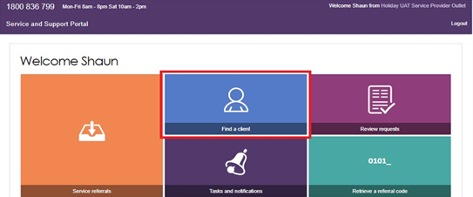
Alternatively, from any page in the Service and Support Portal, you can choose the Find a client option from the tool bar at the top right-hand corner of the page to find the referral for that client.
- On the Find a client page, you can search for a client by entering the first name and/or last name of the client.
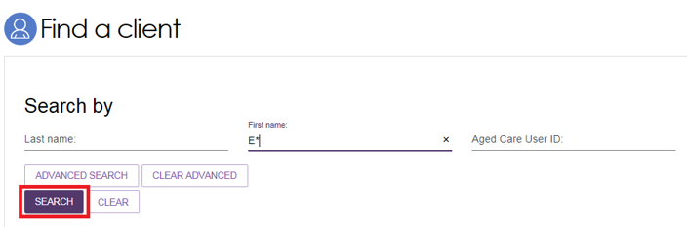
Any matching results will be displayed.
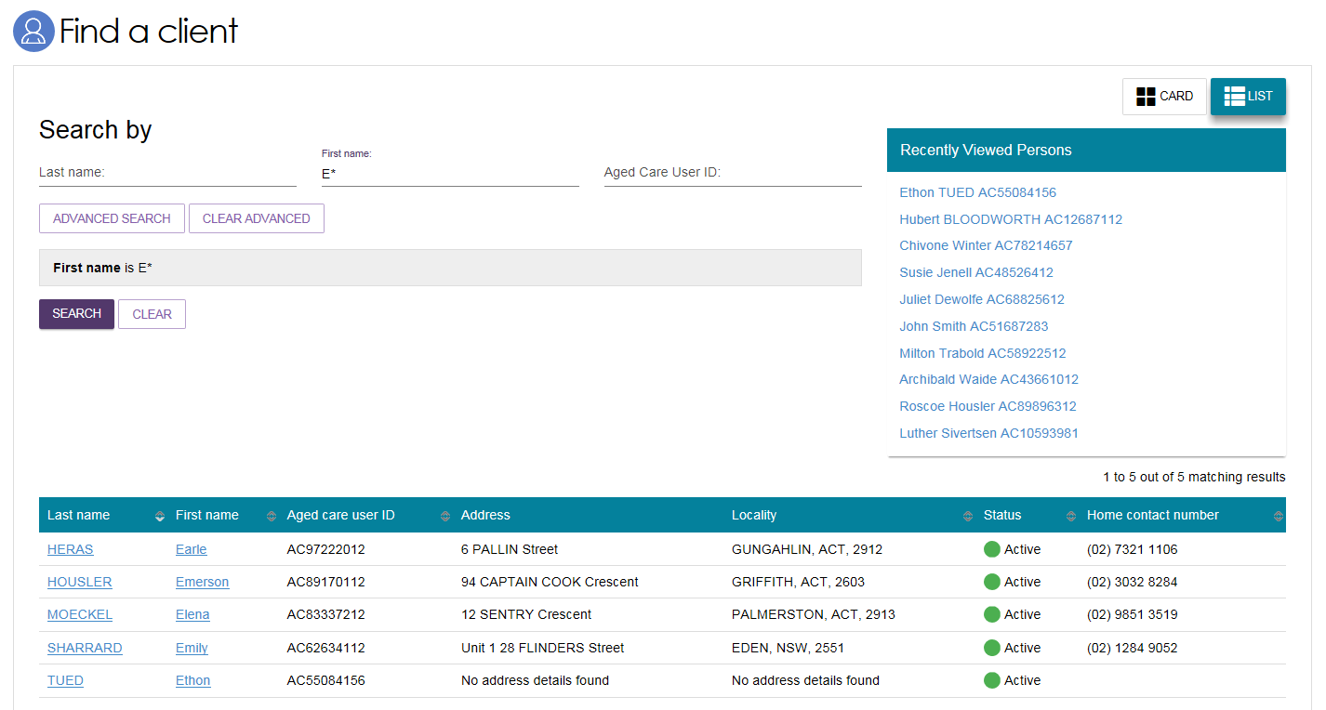
- You can also select ADVANCED SEARCH. Advanced Search options available for Find a client include:
- Aged Care Payment Management System (ACMPS) number
- Aged Care User ID
- Centrelink Customer Reference number (CRN)
- Client Status
- Date of Birth
- Department of Veterans’ Affairs (DVA) card number
- First name
- Home contact number
- Last name
- Locality
- Medicare Card Number
- Postcode
- Preferred name
- State
- Suburb
- System for the Payment of Aged Residential Care (SPARC) number.

5.2 Viewing client information
You can only view information about clients that have been referred to your organisation.
Once you have found a client, you can view information contained in the client record.
You can view all information about a client, apart from their full address and contact details, prior to accepting a referral.
Follow these steps to view client information:
- Select the client’s name from the list of search results.
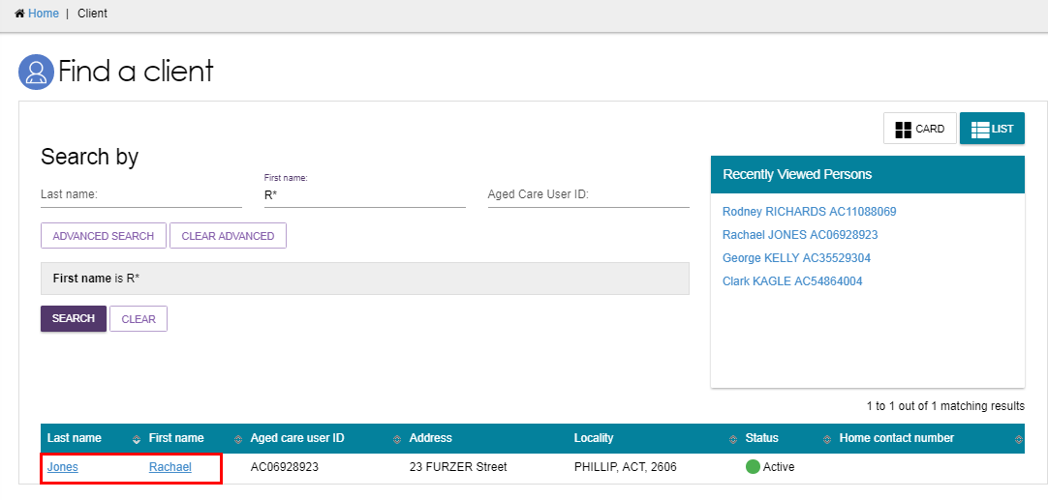
Alternatively, select Service referrals, select the expansion arrow on the client card in card view of expanded record in list view, and then select VIEW REFERRAL SUMMARY AND CLIENT RECORD.
CARD VIEW
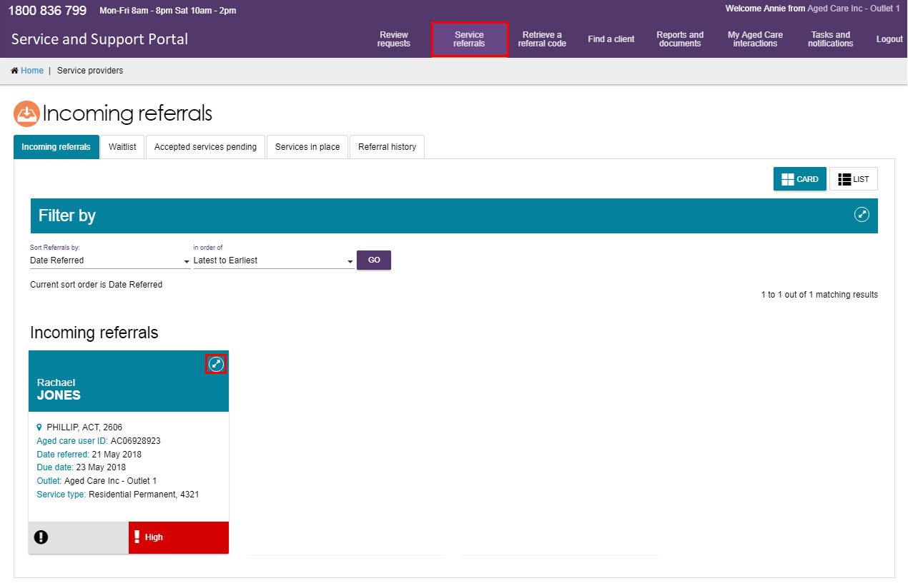
LIST VIEW
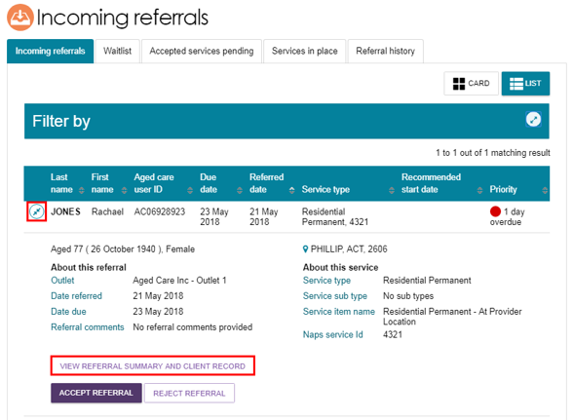
- The Referrals for my organisation’ page will be displayed.
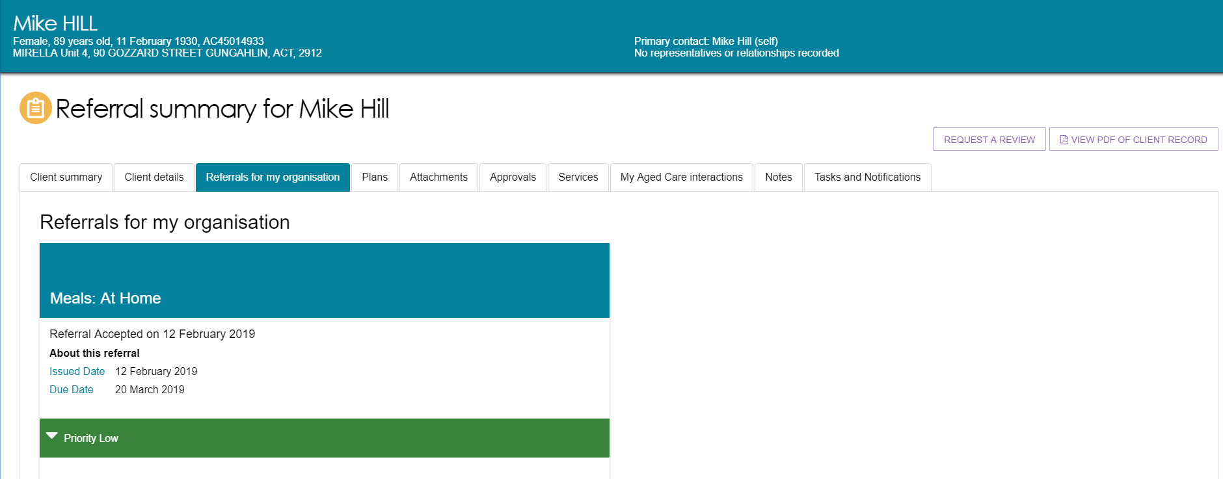
- A summary snapshot of the client record is also available in PDF format by selecting the VIEW PDF OF CLIENT RECORD from any tab in the client record, and includes client details, support network details, notes, assessment history, care approvals and the client’s interactions with My Aged Care.
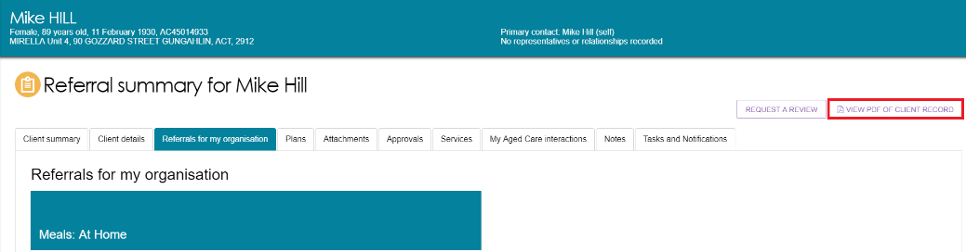
The client record contains client information displayed across eight tabs, which are described in more detail below.
The client record contains tabs with the following information:
- Client summary
- Client details
- Support Network
- Approvals
- Plans
- Attachments
- Services
- My Aged Care interactions
- Notes
- Task and Notifications

5.2.1 Client Summary
The Client summary tab contains a dashboard of key information (Client summary) about the client’s interactions with My Aged Care.
The Client summary provides information about the client’s interactions with My Aged Care, including: Assessments, Approvals, Service recommendations, Service delivery status, Client goals, and Reablement and linking support periods (where available).
This image shows multiple classifications for both Support at Home and Assistive Technology.
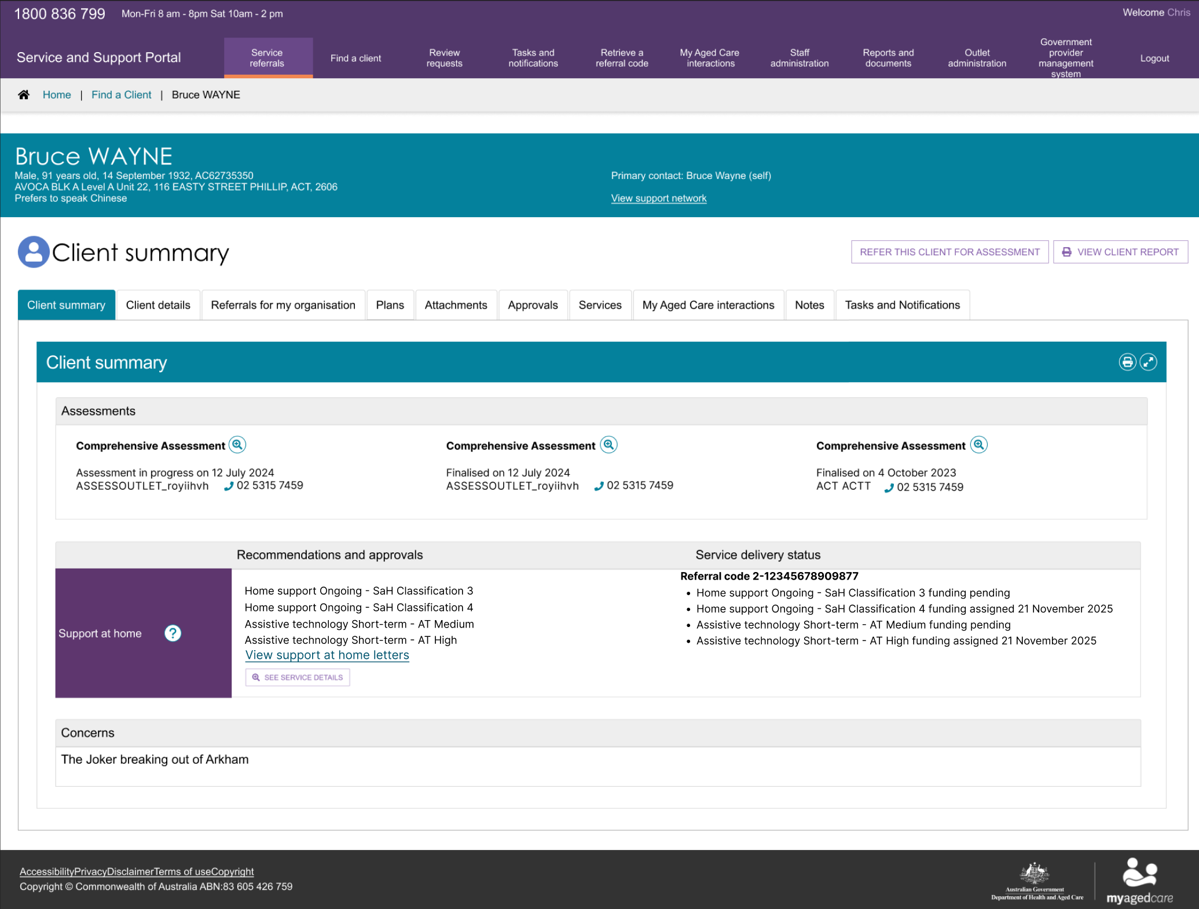
Client summary information can be printed in a similar format as it is displayed within the portal by using the print page button on the right-hand side of each heading.
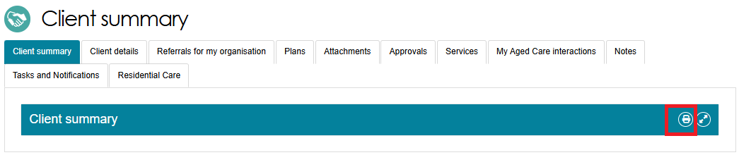

5.2.2 Client Details
The Client details tab contains basic demographic and contact information about the client.
Clients and their support network (including registered supporters, agents and/or appointed decision makers) may automatically be opted in to receive copies of Support at Home letters. At the same time, they may also receive notifications in the portal.
Registered supporters who are Supporter Lite should not automatically receive information or documents that are given to the client under the Aged Care Act (2024).
Registered supporters and Organisation agents can opt out of receiving copies of Support at Home letters by calling My Aged Care.
Supporter guardians can opt the client out from receiving Support at Home letters but they themselves cannot opt out.
The Client Details tab also has links to current notes, the client’s current support plan, and any services that are in place.
Providers may report that the client is now deceased using the NOTIFY MY AGED CARE OF A DEATH button on this page.
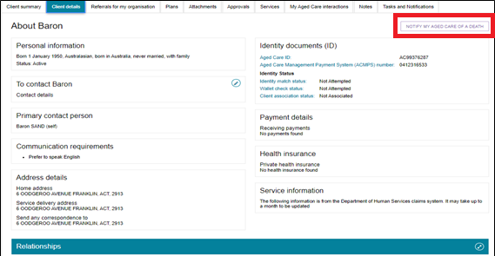
! If a client’s status is Deceased, the client’s record will be read-only, and you will not be able to make any edits. Additional notes and attachments can be attached to the client record for 14 days after ceasing services. Providers will also receive notifications reminding them to close or finalise any in-progress tasks relating to the client.
A banner will be displayed on all tabs of a Deceased client record.
If the client’s status is incorrect, please contact the My Aged Care service provider and assessor helpline on 1800 836 799.

5.2.3 Support Network
The Support Network tab displays details about the client’s support network, such as the client’s primary contact, registered supporters and/or appointed decision maker, agent (organisation) GP, carer, emergency contact, or other support person.
This tab will only appear at a client’s record if there are supporters registered under the new Aged Care Act and recorded in My Aged Care. Refer to the Assessor Portal guide on Registering Support People and Adding Relationships for further information on how to add relationships.
If this tab is not available, the VIEW SUPPORT NETWORK link will instead go to the Client Details tab. The Primary Contact details will always show above this link. It will also show the Primary Contact’s relationship/s with the client.
Providers may report that a client’s support person is now deceased using the NOTIFY MY AGED CARE OF DEATH button on this page.
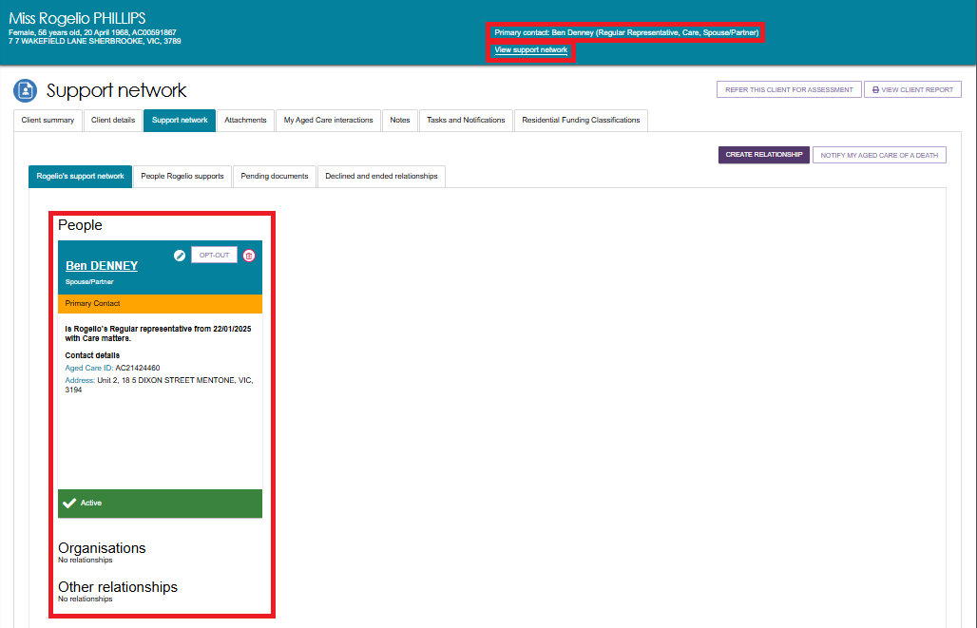
In the Support Network tab, you can do the following:
- View the client’s support network, divided into the People, Organisations and Other Relationships categories. The People cards show the support person’s name, relationship to client, whether they are the primary contact, date of relationship, contact details, and whether the relationship is active.
- Depending on the status of the relationship/s, you could Activate the relationship, Delete the relationship, Edit relationship details, or (for Carers) start a Call Back Request from Carer Gateway and/or Dementia Australia Helpline. For more information on these functions, refer to Assessor Portal guide on Registering Support People and Adding Relationships.
- If the client also supports other people in My Aged Care, there will be another tab called People <Client> supports next to the <Client’s support network>.

5.2.4 Referrals for My Organisation
The Referrals for my organisation tab display service referrals that have been issued to or accepted by your organisation.
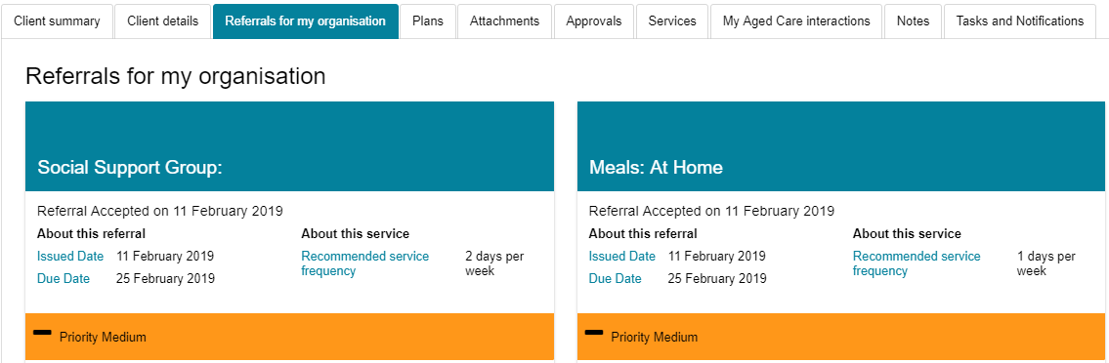

5.2.5 Plans
The Plans tab contains detailed information about current and previous screening and assessments the client may have had, including client goals, recommendations and motivations, as well as the resulting support plan. Select the double arrow icon next to each heading to display detailed information captured during the assessment.
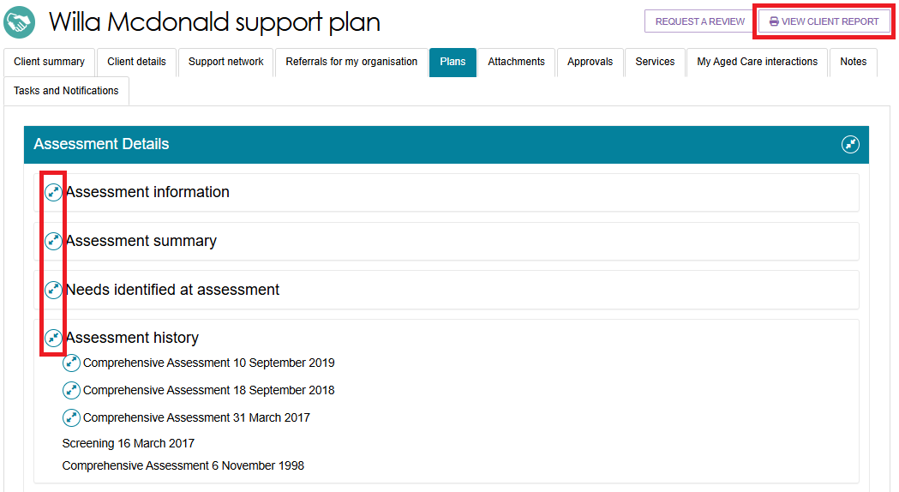
Providers will be able to access read-only versions of a client’s support plan and previous screening and assessments. This information can be downloaded and printed if required – select the View Client Report button on the top right of the Plans page to generate a RTF (Rich Text Format) version of the report.
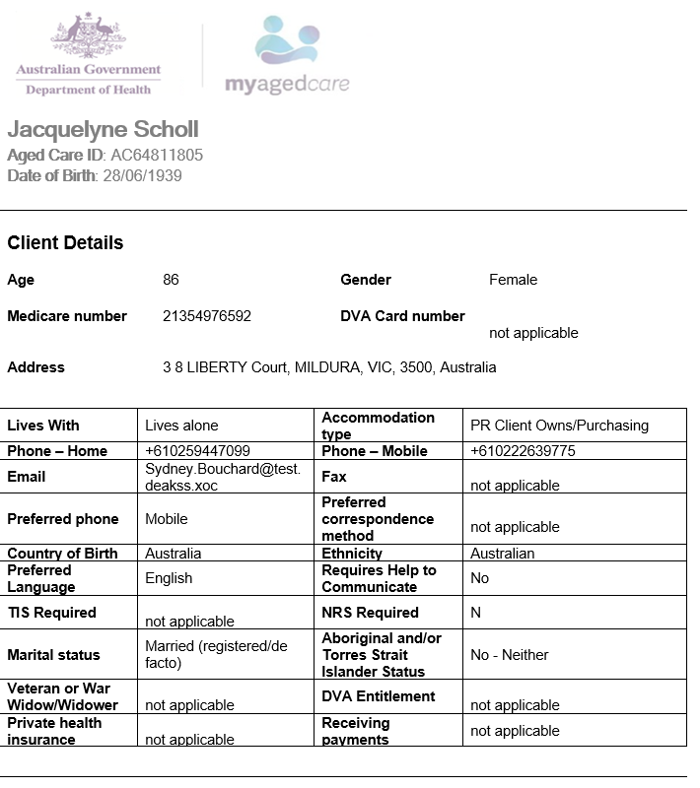

5.2.6 Attachments
The Attachments tab contains documents that have been attached to the client record. To upload an attachment to the client record, select ADD AN ATTACHMENT from this tab.
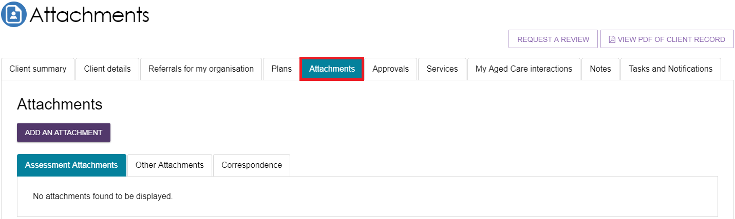
There are four different attachment types that can be added to a client’s record:
- Assessment Attachments are any documents that are relevant to the client’s assessment, for example, clinical notes or a discharge summary. Staff Members and Team Leaders can view the Notice of Decision letter/s in this section.
- Other Attachments are documents that relate to the client’s general circumstances, for instance, documents related to the nomination of a support person (including legal documents), Occupational Therapist drawings used in home modifications.

- Correspondence includes documents or letters generated in My Aged Care for various programs, including Support at Home and others, at different stages of service delivery.
- Sensitive Attachments are documents for clients of a sensitive nature. Where a client record has a Sensitive Attachment, provider(s) who have received a referral for or are providing services to a client will be notified that a Sensitive Attachment exists for the client. Contact the last assessment organisation, or the My Aged Care service provider and assessor helpline to access information within the Sensitive Attachment.
! If an attachment has been uploaded in error, please contact the My Aged Care service provider and assessor helpline on 1800 836 799 for deletion.

5.2.7 Approvals
The Approvals tab contains a view of a client’s approvals for aged care services under the Aged Care Act 2024.
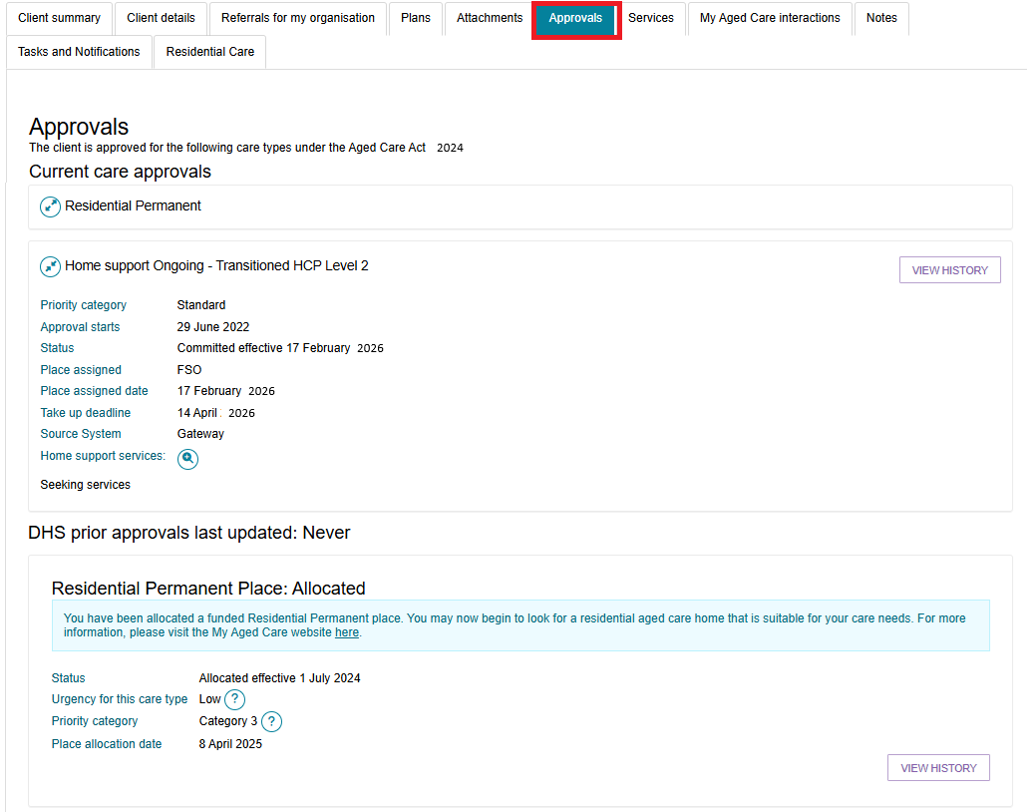
If a client has an approval for an Aged Care service or classification, the details of pending funding and assigned funding will be displayed underneath Current care approvals.
! If there has been a previous assessment, the approved classification that hasn't ceased will also display under the client record.
The below image shows an example of Home Support’s Assistive technology and Home modifications classifications.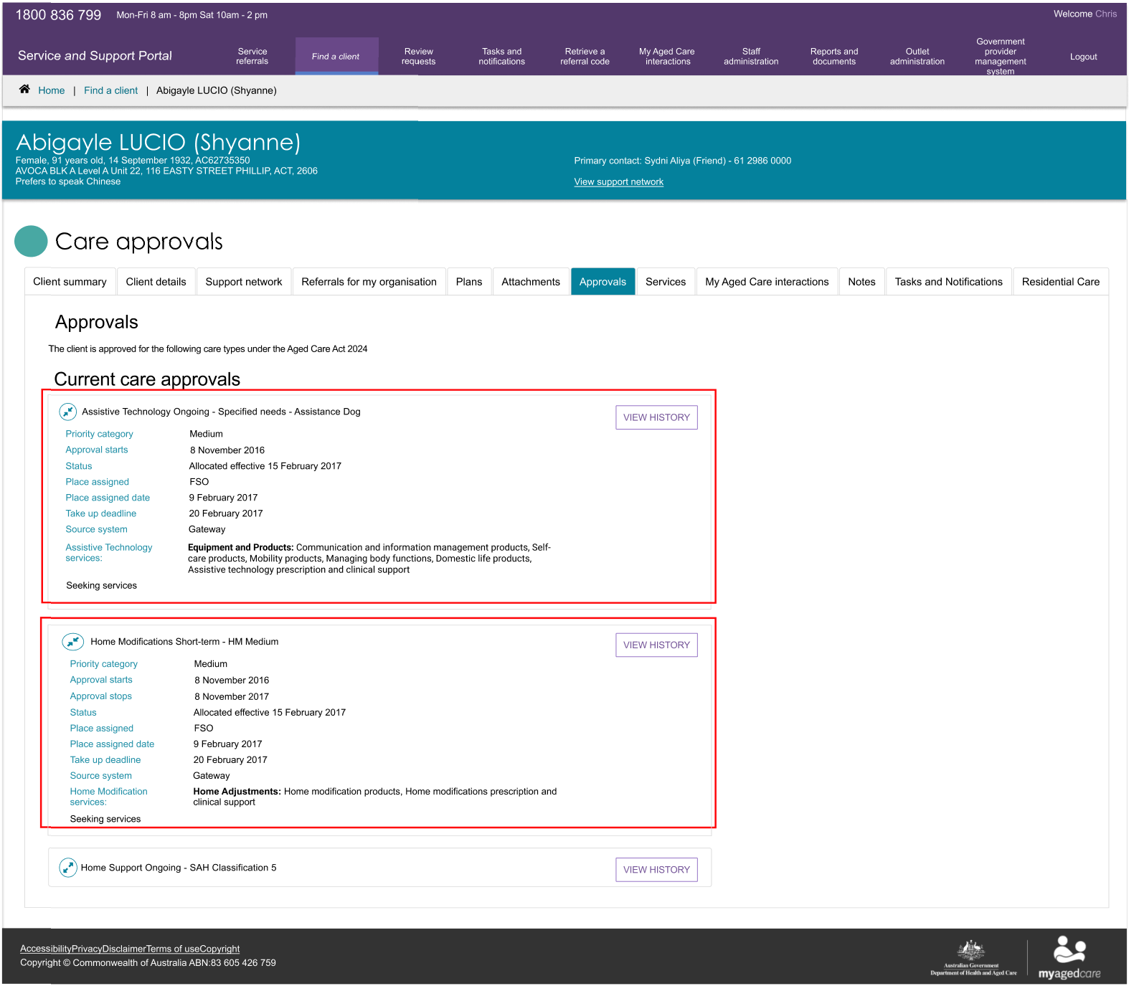

5.2.8 Services
The Services tab contains a record of:
- Services the client is currently receiving
- Services that are pending (Not yet in place)
- Service referrals yet to be accepted
- Previous services the client has received.
The below images show Home Support services. When they are in place, this section will also show the funding status (eg. Pending) or when the funding was assigned, when the service started, and the full name of the service that was approved.

Services Not in Place
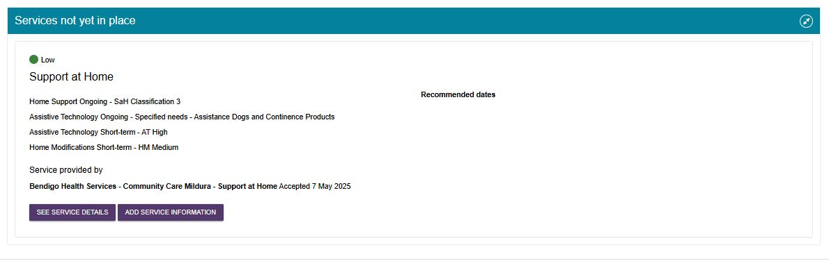
Services in Place
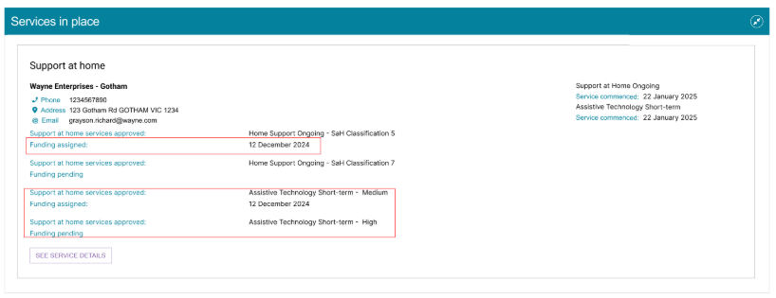

5.2.9 My Aged Care Interactions
The My Aged Care interactions tab will show the client’s history of interactions with My Aged Care, for example, a phone call to the My Aged Care contact centre, or (for carer relationships) a history of call back requests to the Carer Gateway or Dementia Australia Helpline.

5.2.10 Notes
The Notes tab contains notes that have been created about the client.
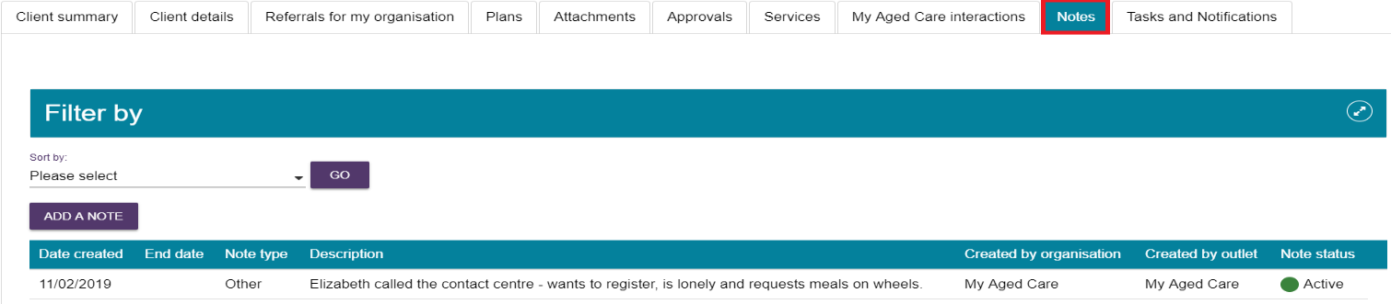
There are different types of notes in the Notes tab of the client record, listed in the table below:
Note type | Who can add? | Who can view? | Description | Examples
Client Story | Assessor | Client Provider Assessor | A summary of the client’s current circumstances. | Mrs Jones has just been discharged from hospital and is seeking help at home.  Lives with her husband and has early onset dementia.
Observations | Provider Assessor | Provider Assessor | Observations from service provider and/or assessors’ interactions with clients. | There is a dog on the property.  Mrs Smith seems more energetic than she did during my last visit.
Other | Client Provider Assessor | Client Provider Assessor | Additional information about the client. | Jennifer has planned respite on 01/08/2017.
! When the My Aged Care contact centre staff or assessors add a Sensitive note about a client, there will be a flag informing service providers that there is a sensitive note about the client and instructing them to call the My Aged Care contact centre for more information.

5.2.11 Tasks and Notifications
The Tasks and Notifications tab will display all tasks and notifications for a singular client.
You can only view tasks and notifications that are associated to your outlet and for clients you are providing services to.
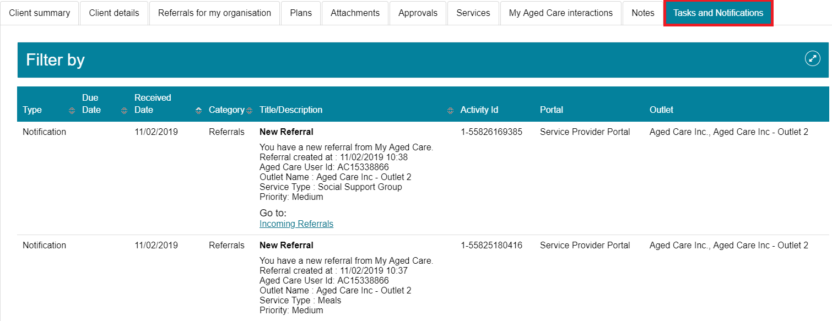

5.3 Viewing tasks and notifications
You can view tasks and notifications in the Service and Support Portal. The steps to view tasks and notifications are outlined below.
- From the Service and Support Portal homepage select Tasks and notifications.
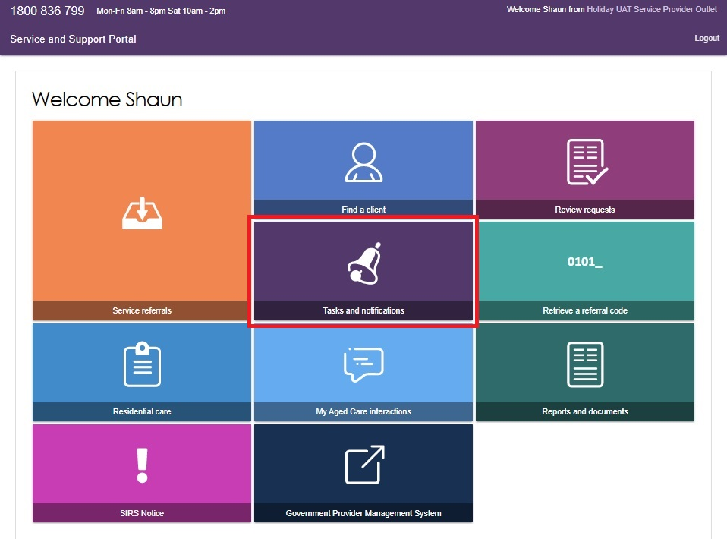
- In the Notifications tab, you will be able to view notifications from the last 30 days that are relevant to your role.
The earliest date that the notifications are displayed from is visible under the filter options.
Any notifications older than 30 days will be removed and will no longer be visible in the portal.
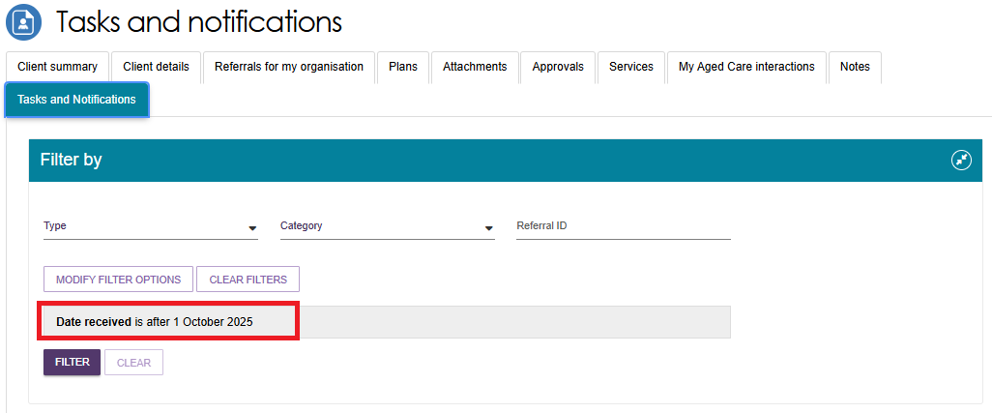

Alternatively, if you want to view all tasks and notifications for a singular client, navigate to the Tasks and Notifications tab in the client’s record to view all relevant tasks and notifications for that client.
You will only be able to view tasks and notifications that are associated to your outlet and for clients you are providing services to. In the Notifications tab, you can sort notifications by: Received date, Category, Title/Description, Aged Care User ID, and Client name.
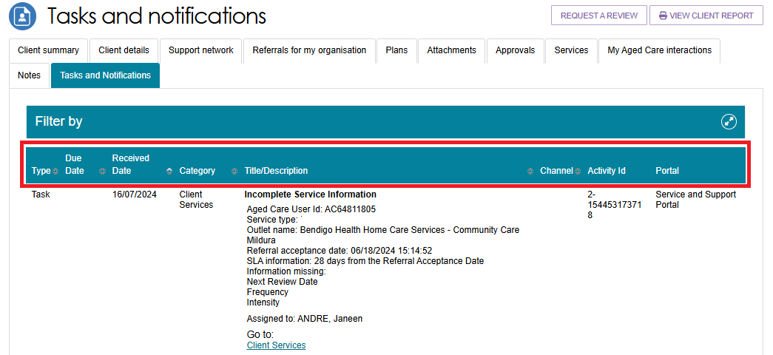
! Notifications that have been marked as important for your outlet by your outlet administrator will be displayed with a visual indicator.
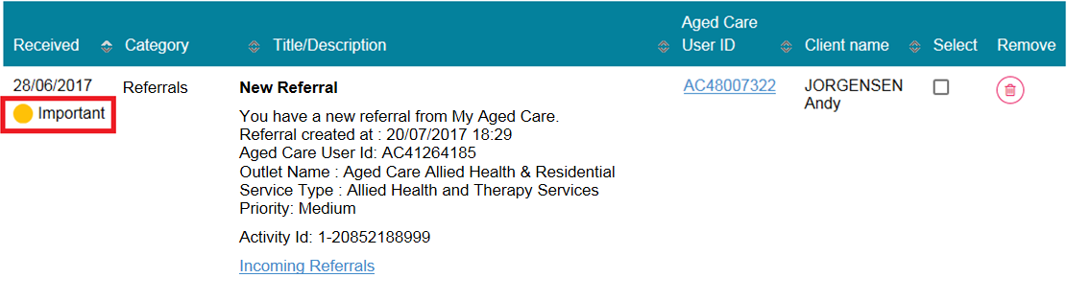
You can also remove individual or bulk notifications from your portal by selecting the rubbish bin icon.
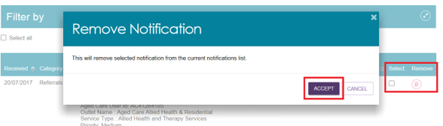
- You can search for specific notifications using the filter options or using custom filters in ADVANCED SEARCH. Select the arrows to the right to expand or collapse the filter options.
You can filter notifications by Date received and navigate directly to the associated client record by selecting View client record
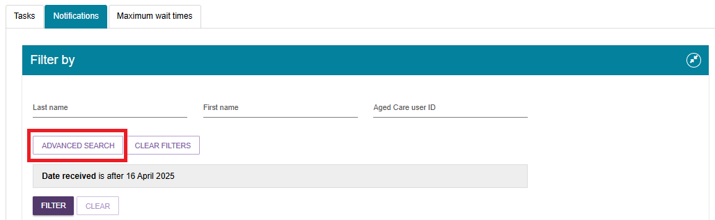
To apply custom filters, select ADVANCED SEARCH and choose filters from the drop-down menu and select ADD FILTER for each filter you want to apply.
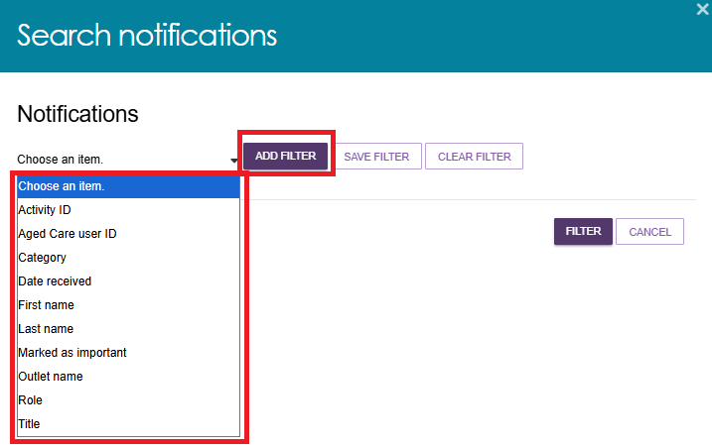
- The hyperlink under the notification description will take you directly to the individual record and the section of the portal where you can view more information about the notification or complete any action that may be required.

For example, selecting the Incoming referrals link in a New referral notification will take you directly to the Incoming referrals tab where you can view and action the new referral.
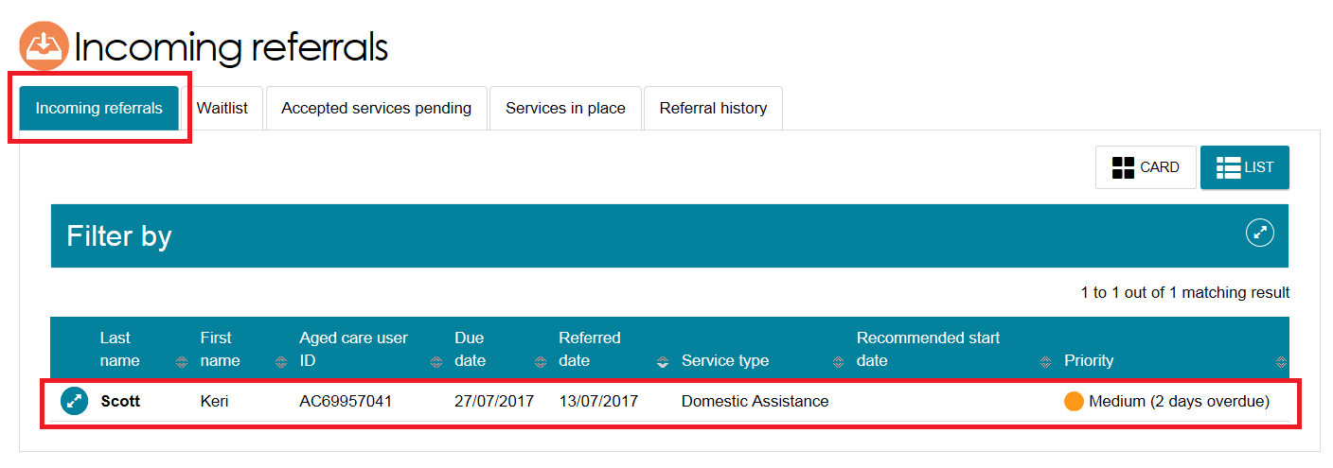

5.4 Completing identity verification
To complete the identity verification process, it is expected that whoever has contact with the client in the first instance (that is, an assessor or service provider) will sight the client identification and record this information on the client record via the Assessor or Service and Support Portal.
The steps for recording that client identification have been sighted are outlined below.
- From the Service and Support Portal homepage, select Find a client.
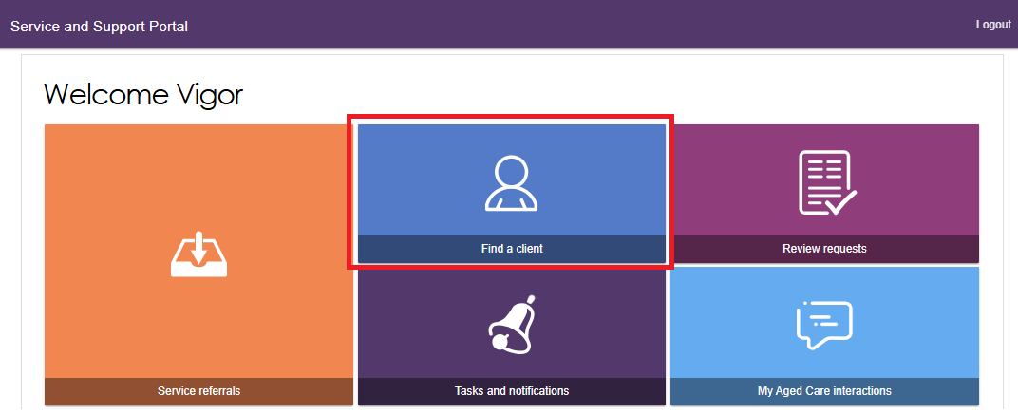

- You can search for a client by their first name, last name or by the client’s Aged Care ID.
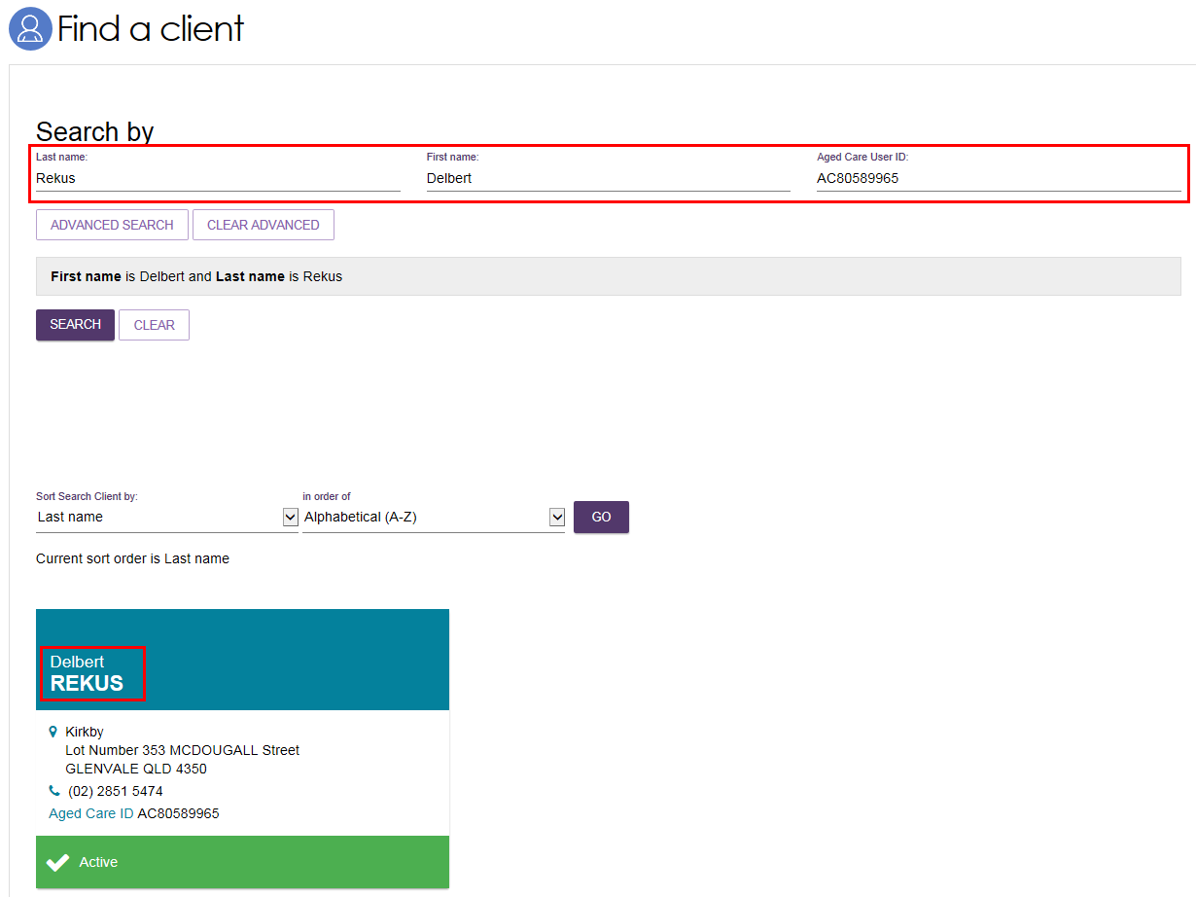
Alternatively, you can access the client record from your Accepted services pending tab in the Service referrals section.
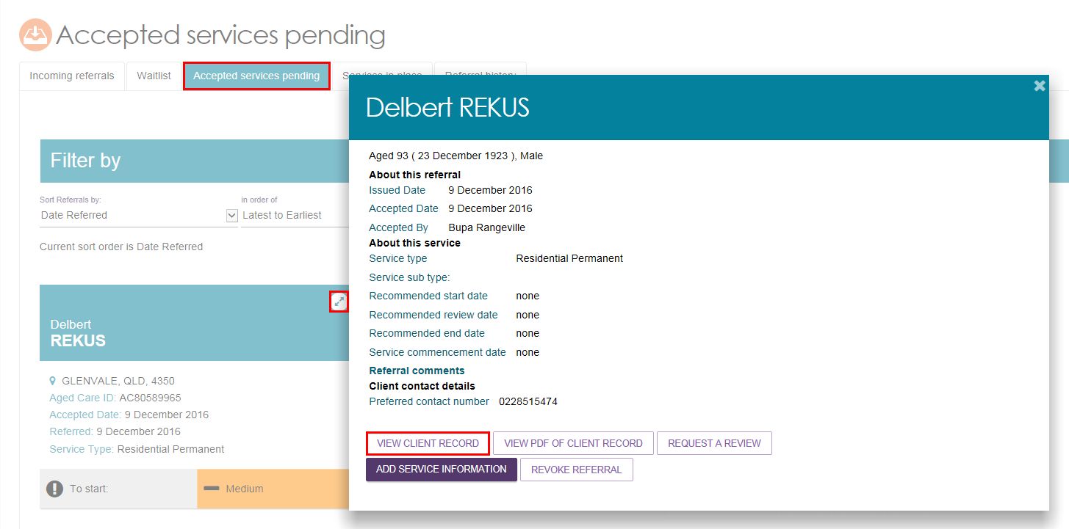
- Once you have navigated to the client record of the client for whom you wish to conduct a wallet check, select Conduct a wallet check now.
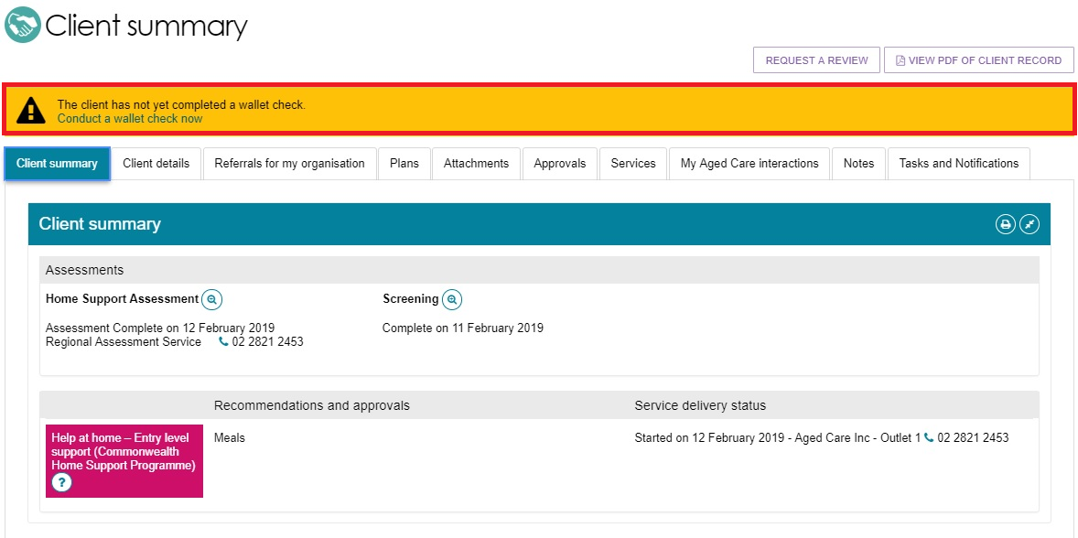
- A Wallet Check pop up appears. Select the appropriate option from the list:
- My client has identification
- My client has no valid identification this time
- My client will be unable to produce valid identification.
If your client can provide you with identification, select My client has identification. select at least two types of identification documents that you sighted from the list provided and enter the date you performed the wallet check. Finally, select SAVE DETAILS.
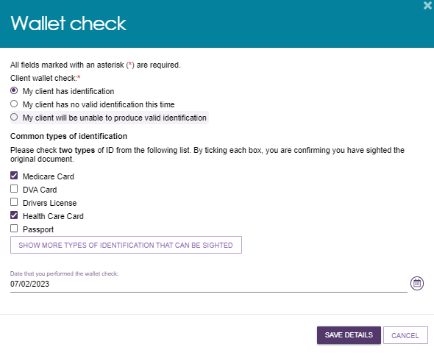
If your client is unable to provide you with identification, you can select My client has no valid identification this time, or My client will be unable to produce valid identification and select SAVE DETAILS and this information will be updated on the client record.
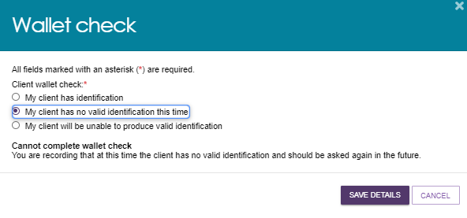
! The status of the Wallet Check on the client record will remain incomplete until client identification documents have been sighted.

5.5 Adding service information
Service delivery information should be recorded on the My Aged Care client record for all clients accepted for service. This includes service commencement date, service frequency, intensity and service end dates where a service has ceased.
This information should be recorded within 14 calendar days of acceptance, and providers will receive notification reminders prompting them to enter this information if it is not completed within this timeframe.
For Home Support and Residential Care Permanent services, the service commencement date will be automatically populated from Service Australia’s records and will be read-only.
Follow these steps to add information about the services being delivered to the client:
- Select Service referrals from the Service and Support Portal homepage.
Alternatively, if you know the client’s name you can use the Find a client tile.
- Select the Accepted services pending tab.
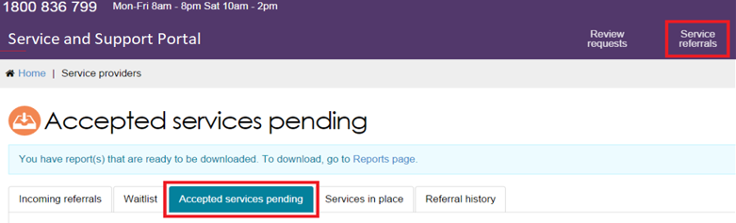
Once you have located the relevant client’s service referral in the Accepted services pending tab, you can add service delivery information for the service.
Select the arrow on the Client card to view the expanded client card view and select ADD SERVICE INFORMATION.
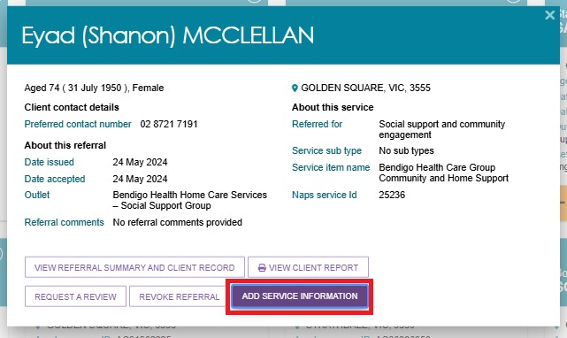
Alternatively, you can select ADD SERVICE INFORMATION in the expanded list view.
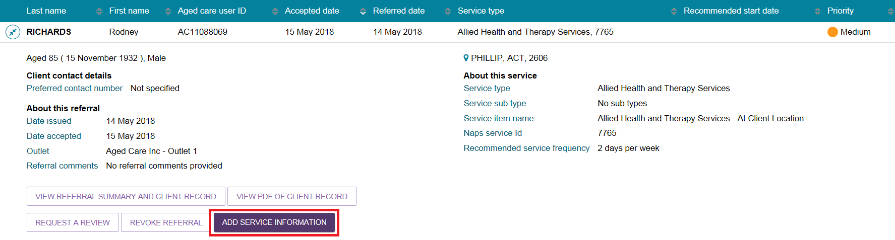
The Add service information screen will be displayed.
- When adding service information for Residential Care Respite, Transition Care, and Commonwealth Home Support Program services you must enter the Service start date, input a Frequency, and select an Intensity from the drop-down list (all three inputs are mandatory). Enter any additional information in the remaining fields and select SAVE CHANGES.
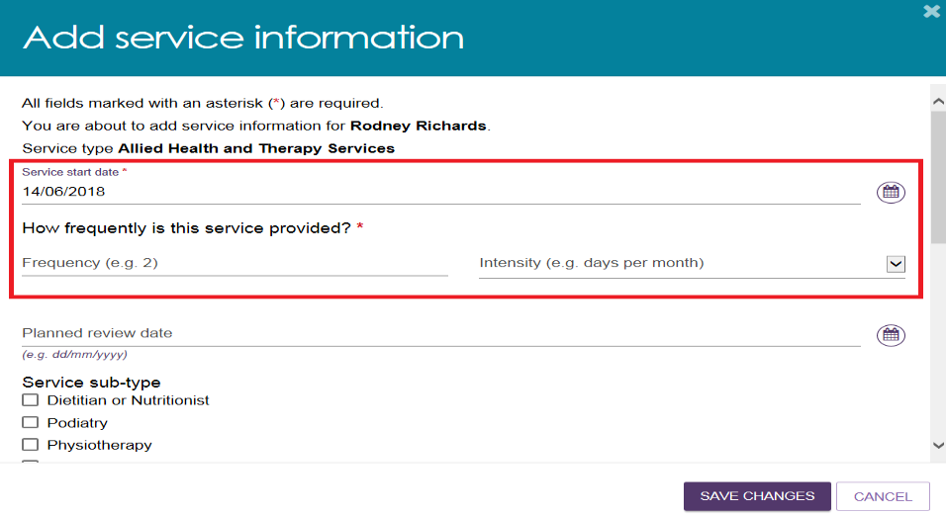
To supply specific service delivery information, select Other – Specify and enter additional service delivery information in the free text field.
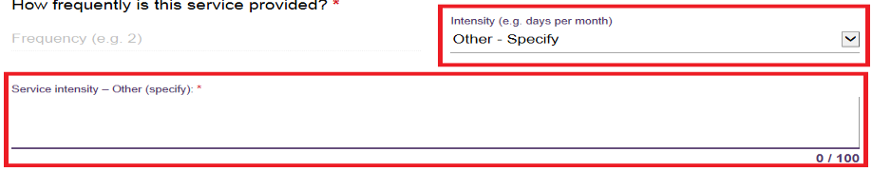
- Once saved, the client will move from the Accepted services pending tab to the Services in place tab, and the populated service information will display under the Services section within the client record.
The Service start date will update once the commencement date has been received from Services Australia.
! For Support at Home and Residential Care referrals, the Add Service Information button will not be visible until the referral has been recommended and approved during assessment. This ensures the correct services are confirmed before being entered into the client record.
For other programs, this button may be available earlier depending on the referral setup.
Enter any additional information in the remaining fields and select Save changes.
Once saved, the client will only move from the Accepted services pending tab to the Services in place tab if a Service start date is present. The populated service information will now display under the Services section within the client record.
The below image shows a Support at Home service displayed under the client’s Services tab, under the Current services in place section. It contains a service start date which is displayed on the right hand side.
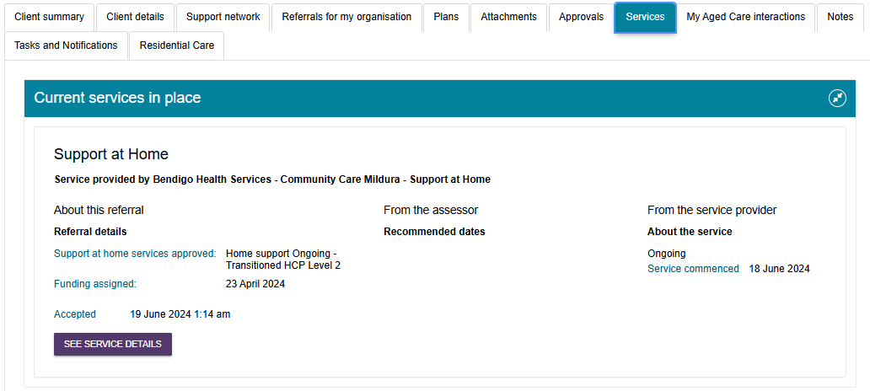
- For all referrals, the Add Service Information button will be displayed once the service has been recommended and approved during assessment. This ensures accurate and up-to-date commencement information is recorded.
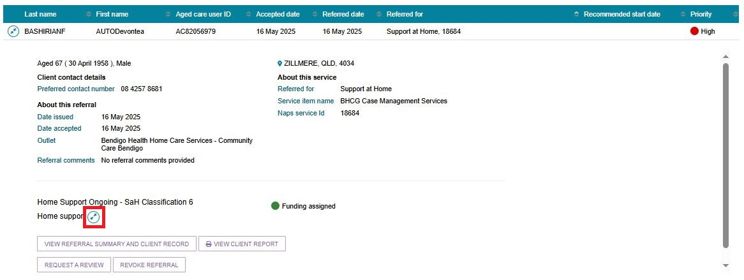
- The Expanded view will show the recommended Support at Home services.
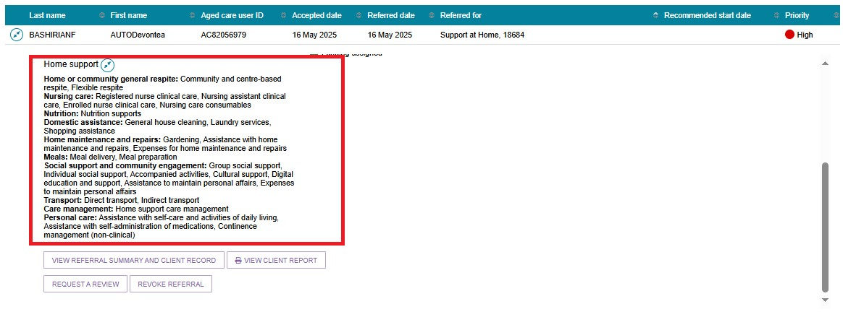
! The service start date is automatically updated when the Aged Care Entry Record (ACER) is processed by Services Australia. To avoid errors in receipt of your funding, you must ensure you have accepted a referral for service for a client prior to submitting the ACER. Once the ACER is completed, this will move the service referral from the Accepted services pending tab to the Services in place tab.

5.6 Updating service information
The Services in place tab in the Service referrals section of the Service and Support Portal displays accepted services that have service delivery information recorded.
! For the Support at Home program, updating service information will not be available as the services required are approved by an assessor. As a provider, you can request a Support Plan Review when the participant’s needs, goals or circumstances change or the participants needs additional services. Refer to the section Requesting a Support Plan Review (SPR) to meet changing needs.
- Navigate to the Services in place tab by selecting Service referrals from the home page, the banner at the top of the screen from any page within the portal, or the menu bar in the top left.
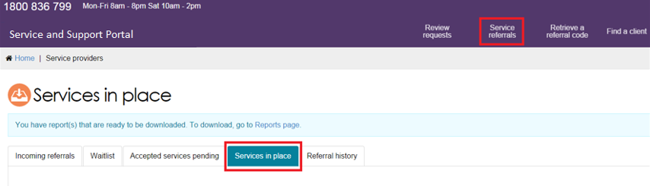
For the service you are updating, expand the Client list to view the expanded client list view and select UPDATE SERVICE INFORMATION.
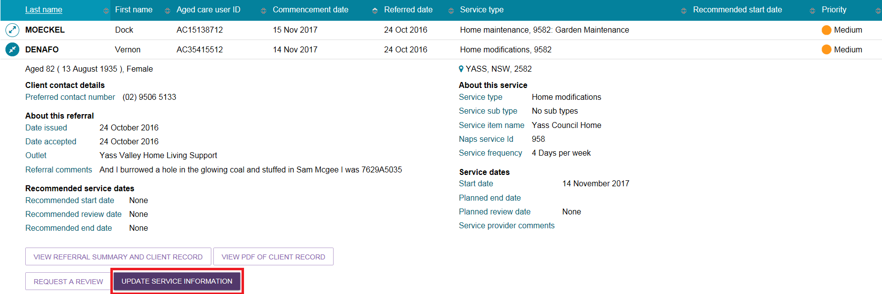
Alternatively, you can select UPDATE SERVICE INFORMATION in the expanded card view.
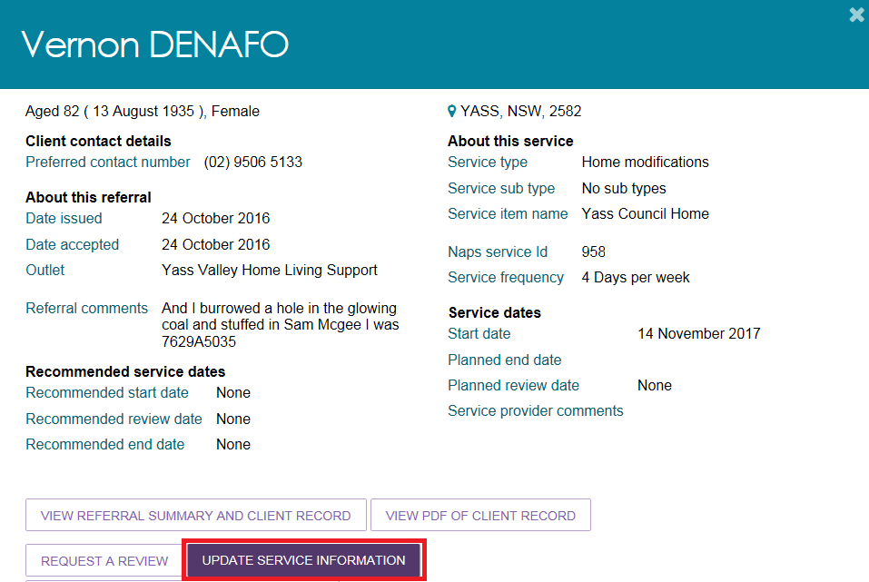
Update service information and select SAVE CHANGES. This information will now be updated on the Services in place tab and the Services tab in the client record.
- Service delivery information can also be updated from the Services tab in the client record by selecting UPDATE SERVICE INFORMATION for the relevant service.
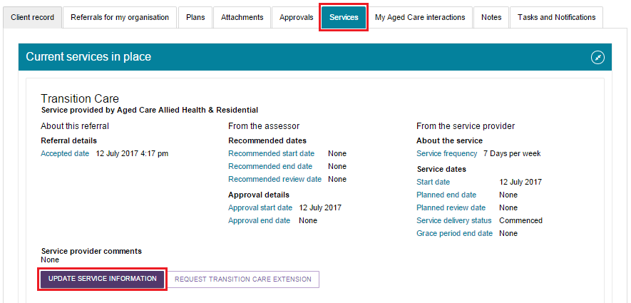
! Ceasing a client’s service with the reason of Client deceased will change the client’s status to Deceased and make the client record read-only. Any unaccepted service referrals will be recalled, services in place will be ceased, assessments will be cancelled and the client’s access to the client portal will be revoked.
My Aged Care will not send correspondence to the client or their support network after the status is changed to Deceased. However, providers will be sent a notification reminding them to close or finalise any in-progress activities relating to the client.
Where a client is active in the Support at Home Priority System or has been assigned a Support at Home classification, this will remove the client from the Support at Home Priority System and withdraw any assigned Support at Home funding.

5.6.1 Record a note of changes made to client service information
My Aged Care contact centre staff, assessors and providers can view and add different types of notes about clients in the My Aged Care portals.
If there is significant change to a client’s service delivery information, it is recommended that providers update the service information and add a note to the client record.
! If a client’s needs or circumstances have changed since their last assessment, a review of the client’s Support plan may be required. The process for requesting a review of a client’s Support plan is described in the Request a Support Plan Review (SPR) to meet changing needs section. For clients that need to be reclassified for residential funding purposes, refer to the Requesting Residential Funding Reassessments section.
Providers can add the following notes to the client record:
- Observations: Observations from service provider and/or assessors’ interactions with the client. Assessors and providers can view these notes.
- Other: Additional information about the client. Assessors, providers and clients can view these notes.
Providers can only view notes of type Client story, Other and Observations.
When My Aged Care contact centre staff or assessors adds a Sensitive note about a client, a banner will appear on the client record advising providers to call the My Aged Care contact centre for more information. Information on the content of the sensitive note will only be provided where relevant to the provider.
Follow these steps to add a note to the client record:
- Navigate to the client record (refer to the guide Service and Support Portal User Guide - The Client Record for more details) and select Notes.
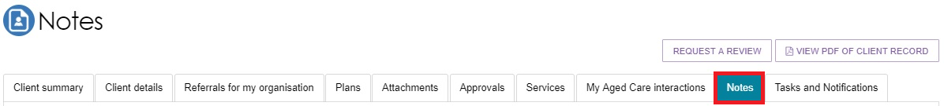
Notes on the client record will be displayed.
- Select ADD A NOTE and choose the note type and a description. Once this information is filled out, you add the note to the client’s record by selecting SAVE.
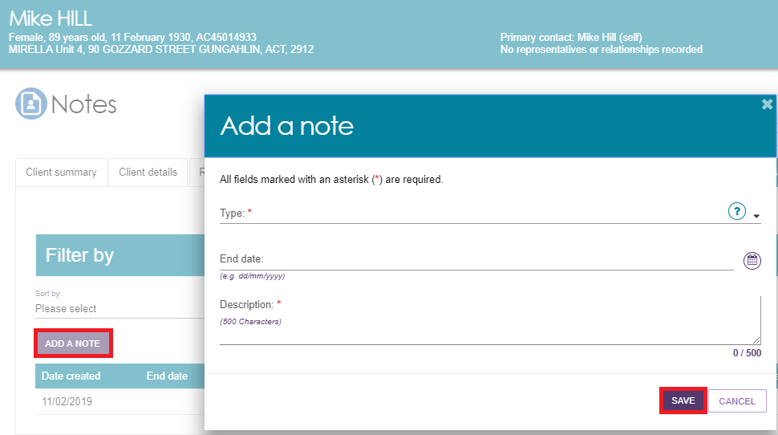
Alternatively, from the Client details tab, select ADD A NOTE from the Current notes section.
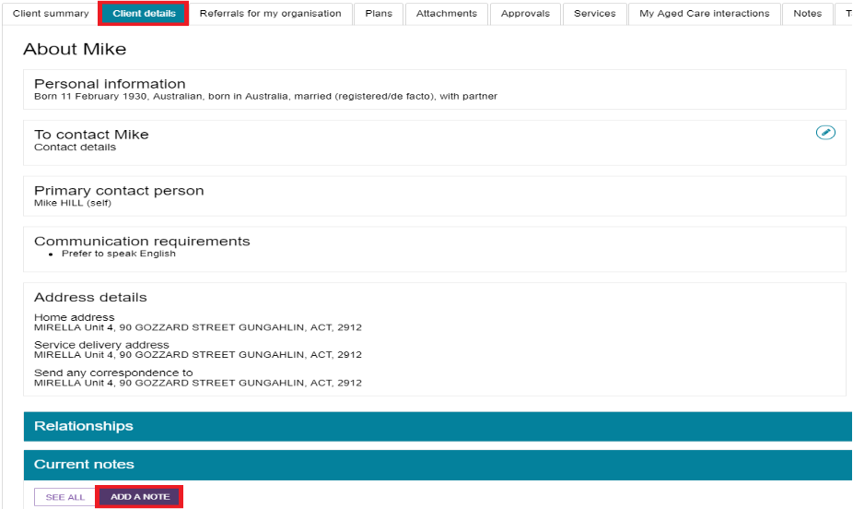
You can add notes of type Other and Observations to the client record of any clients that have been referred to your outlet. For example, clients in your Incoming referrals tab. These notes will be visible to My Aged Care contact centre staff, assessors, and other providers delivering services to that client.
The blue question mark symbol is a help hint which explains the various note types and who can view them, as there is a different audience per note type.
For further information about note types and who can view them, refer to the guide Service and Support Portal User Guide - The Client Record available on the Department’s website.

5.6.2 Request an extension to the client’s care
Care extension requests, including respite care, can be actioned through the Service and Support Portal. This request will be sent to the Delegate for approval. If you are unable to complete a care extension request for a client via the Portal, call the My Aged Care service provider and assessor helpline on 1800 836 799.
Periods of Transition Care can be extended to a maximum of 42 consecutive days; whilst periods of Residential Respite care can be extended for a maximum of 21 non-consecutive days.
Care extensions are effective from the commencement date within the request pending the Delegate’s approval. Extension requests cannot be backdated, except in special cases. For more information please refer to the My Aged Care Assessment Manual.
! Extension requests through the My Aged Care Service and Support Portal must be requested on, or before, the number of entitled days ending if the client requires additional care.
Follow these steps to request a care extension:
- Find the client you wish to request a care extension for, by navigating to the Services in place tab and expanding the card or list view for the client. Select REQUEST [CARE TYPE] EXTENSION. The following two images show examples of a transition care extension, and a residential respite care extension.
Transition care extension example
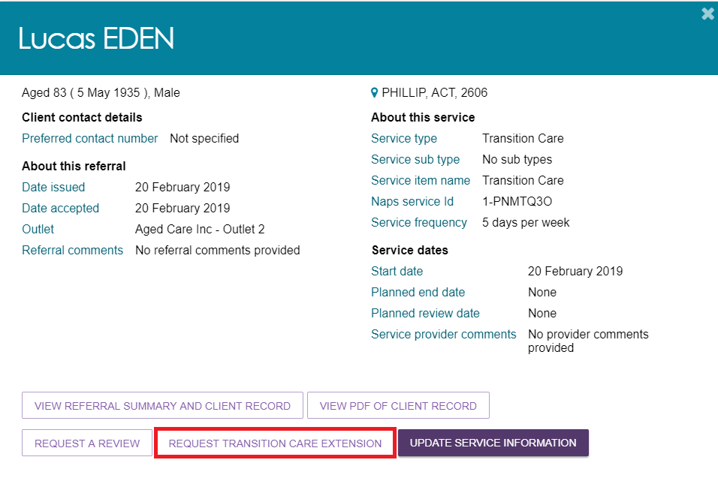

RESIDENTIAL RESPITE CARE EXTENSION EXAMPLE
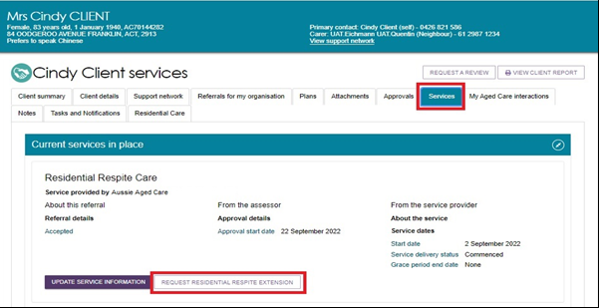
Alternatively, locate the client through the Find a client functionality, and navigate to either the Services or Approvals tab of the client record and select REQUEST [CARE TYPE] EXTENSION.
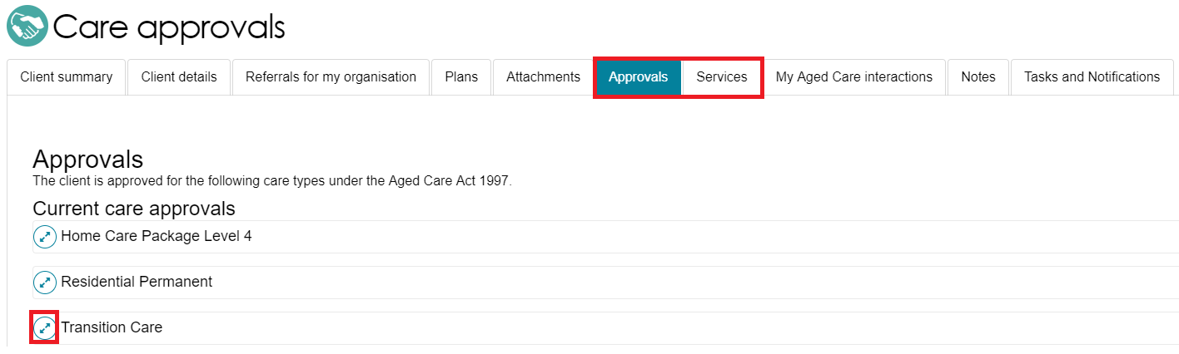
- Complete all mandatory information indicated in the extension request pop up. The mandatory information will depend on the care type the extension relates to.
Once completed, select SUBMIT REQUEST.
! To assist the delegate, when submitting an extension request you are required to include the paid days balance from the Services Australia Aged Care Payment system and the date when the balance was calculated.

Transition care extension example:
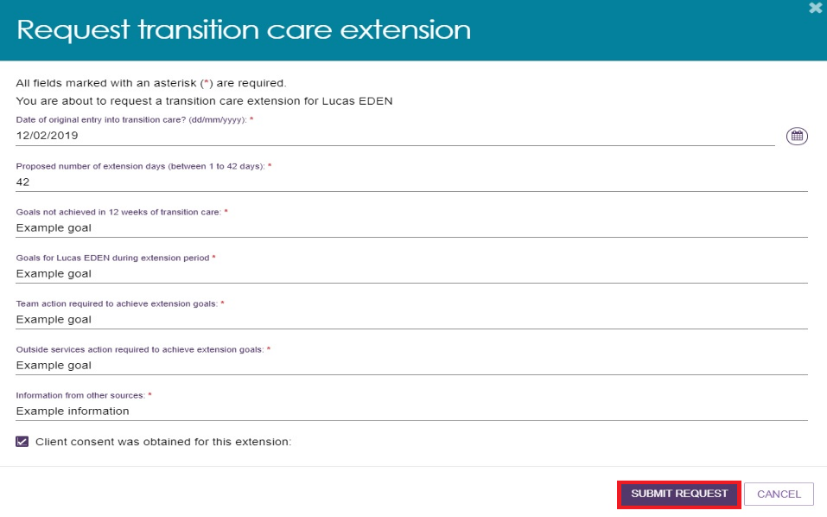
RESPITE EXTENSION EXAMPLE:
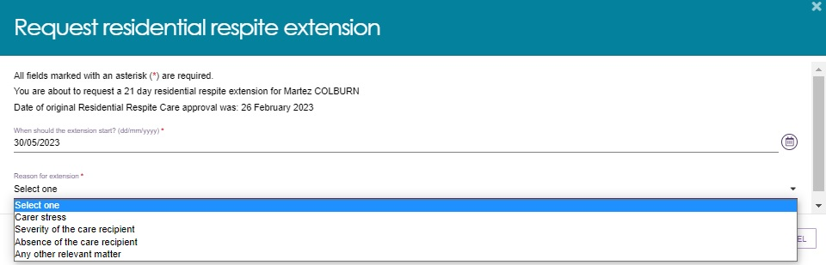
- You will receive confirmation that the care extension request has been submitted to the Delegate.
You will also receive a notification that the request has been submitted.
You will receive an email notification when the Delegate has made a decision on the care extension request.
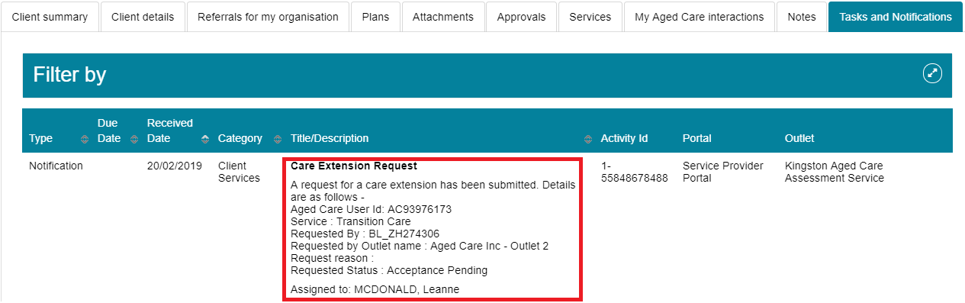

5.6.3 Request a Support Plan Review (SPR) to meet changing needs
This functionality is for any client receiving subsidised aged care referred through the Assessor Portal.
! If your residential care client’s care needs have changed and they need to be reclassified for residential funding purposes, refer to Requesting Residential Funding Reassessments.
A provider can ask for a Support Plan Review (SPR) through the Services and Support portal when:
- their needs, goals, or circumstances have changed since their last assessment,
- their support plan no longer reflects their current situation,
- they need additional services, or
- a time-limited service has ended.
The assessor will then review the client’s situation, which may lead to a new assessment of the client’s needs.
The introduction of Support at Home services has expanded the circumstances under which an SPR can be submitted. SPRs are most likely initiated by the older person’s provider (with consent), who can submit a request through the My Aged Care service and support portal. When requesting SPRs, providers must attach supporting documentation about the participant’s current care arrangements, such as their quarterly budget and/or care plan.
Providers are encouraged to provide as much information as possible to inform of the client’s need for, and urgency of, a support plan review or new assessment.
This information is available in the detailed assessment history information in the client’s support plan in the Plans tab of the client record.
If a client has not previously had an assessment through My Aged Care, contact the My Aged Care service provider and assessor helpline on 1800 836 799 to request a new assessment.
Follow these steps to request a review of a client’s support plan:
- Check the client’s assessment information. Refer to the Plans tab of the client record for more detailed assessment history information.
A request cannot be submitted for review if there is already an existing assigned review for the client in the assessor portal or an assessment is currently being undertaken. Check for this prior to starting a review request.
If you have any concerns, contact the assessment organisation who conducted the client’s most current assessment (details included in the Plans tab).
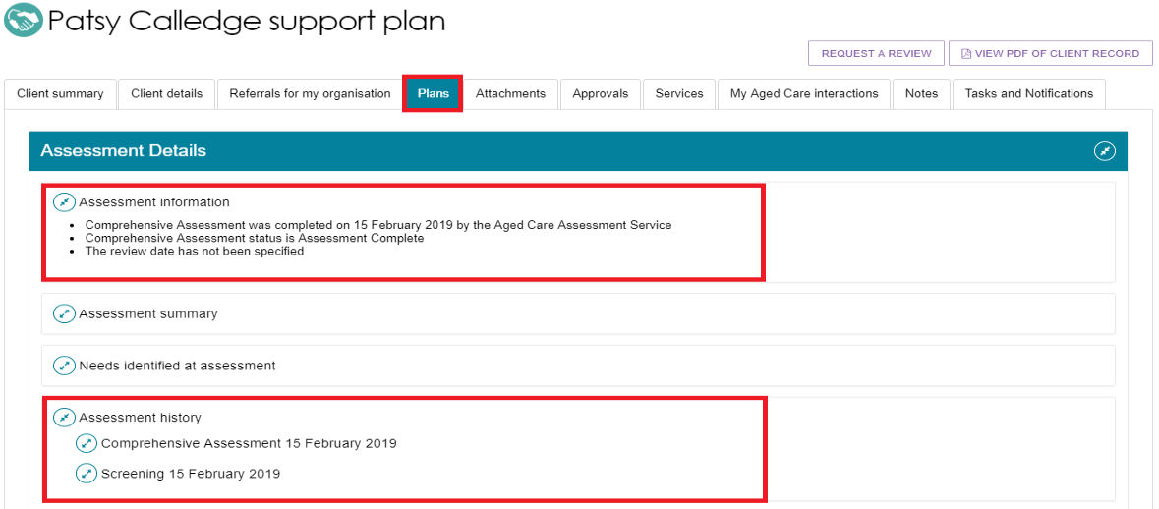
- Select Service referrals from the homepage.
- Select Services in place. Locate the client for whom you wish to request a review and select REQUEST A REVIEW.
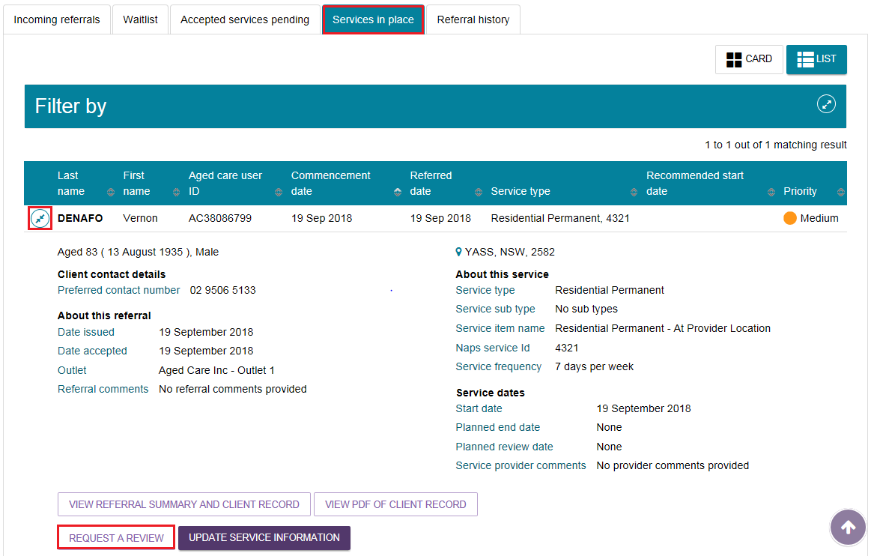
Alternatively, a link to request a review will display at the top of any page in the client’s record.
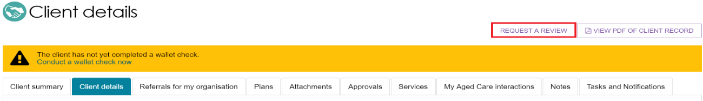
- (Service Providers only) In the Request A Review screen, there is a checkbox that asks whether your client meets the requirements for a direct comprehensive assessment. After ticking Yes, you will be prompted to call the My Aged Care Service Provider and Assessor Helpline on 1800 836 799 to request the Contact Centre staff to issue a direct referral for you.
This will then be sent to the assessment organisation to review. A banner will be displayed on client records indicating a direct referral.
The Request a referral screen for service FOR providers (example)
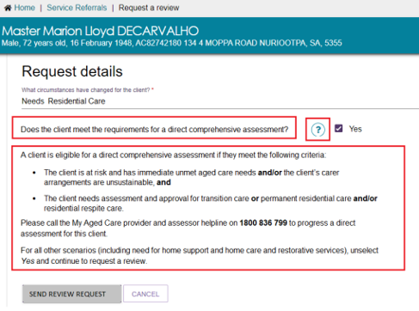
- Complete all mandatory fields within the review request.
Once you select a subsidised care type under What type of subsidised aged care is the client receiving? a second list for Primary reason for Support Plan Review Request will display.
The below image shows example reasons for a client’s SPR request. Different questions will need to be completed at this step depending on which option is selected.
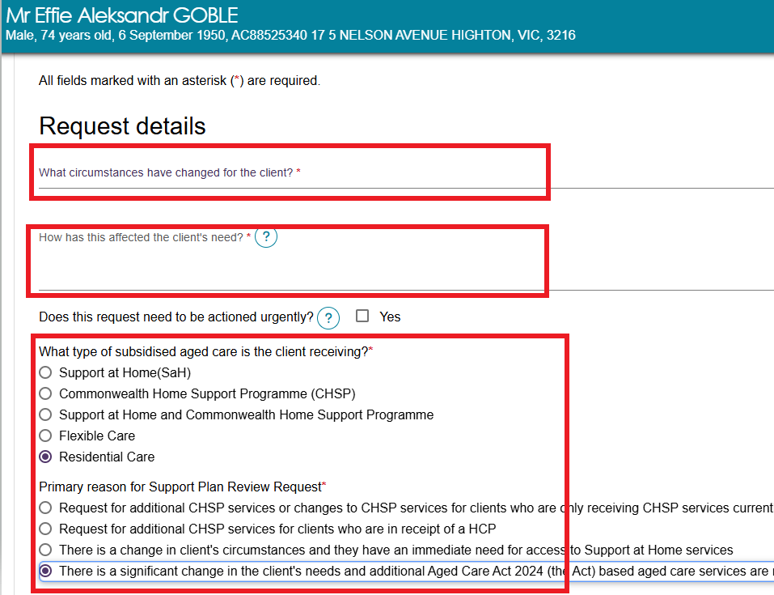
The table below outlines the circumstances that can be used to request a support plan review, as well as the circumstances in which a new assessment (instead of an SPR) will be required.
Circumstance | Definition
Hospital Discharge | Client has been discharged from hospital and requires a review of their current care needs and the type and level of support that will be required.
Fall(s) or risk of falling | Client has had a recent fall or is at risk of falling.
Change in medical condition | Client has had a recent change in a medical condition.
Change in cognition status | Client has had a recent change in their cognition status.
Change in care needs | Client has had a recent change in their care needs.
Increasing frailty | Client has increased in frailty.
Change in caring arrangements | Client has had a recent change in their caring arrangements.
Change in living arrangements | Client has had a recent change in their living arrangements.
Review service recommendations | Client is receiving Support at Home services and requires an additional service type within their current Support at Home classification.
Vulnerable client | Client is now vulnerable (e.g. experiencing or at risk of domestic or family violence or elder abuse, at risk of hospitalisation, primary carer is absent or non-existent).
Needs Transition Care program | If the client receiving other aged care services enters hospital and needs Transition Care program (TCP), a new assessment is required.
Needs Residential Care Permanent (N/A) | Clients needing residential care who have not had residential care added as a care type to their support plan will require a new assessment.
Needs Residential Respite (N/A) | Clients needing residential care who have not had residential respite care added as a care type to their support plan will require a new assessment.
Client has relocated | Client has moved or relocated.
Needs End-of-Life Pathway (high priority) | - Request a high priority SPR to be assessed for End-Of-Life (EoL) pathway if the person is already on Support at Home or CHSP ongoing classification  - A person new to the aged care system who has not yet been assessed for aged care services will need a reassessment to be approved for the EoL pathway.
Review End-of-Life Pathway (high priority) | Request a high priority SPR to move to an ongoing SaH classification if the person need services beyond the EoL pathway funding period.
Review existing  AT-HM funding tier | - To request a higher Assistive Technology-Home Modifications (AT-HM) funding tier  - If participant’s technology or equipment have repair or maintenance needs
Needs AT-HM funding tier | - Addition of new Assistive Technology (AT) or Home Modification (HM) funding tier for participants with restorative care or End-of-Life classifications  - For existing HCP care recipients, providers can identify their AT and/or HM needs through the AT-HM scheme data collection. This is the preferred method for accessing AT-HM funding for this group. All transitioned HCP care recipients will have approval to access the AT-HM scheme without a new aged care assessment. Alternatively, you can request a support plan review by an aged care assessor.
Needs Restorative Care | If participant is already approved for a Support at Home classification and needs access to a period of restorative care in order to improve level of function, they will need a new assessment conducted.
Review existing Restorative Care | Approval for additional services during the restorative care period, or provide evidence that additional funding is required.
Needs additional CHSP services (for existing CHSP participants) | To meet changing needs which may require additional CHSP services (when participant has already been approved for CHSP ongoing)
Needs CHSP ongoing | To close off a period of reablement support and/or meet changing needs which may include needing an ongoing service type after the episode of reablement has finished.
Immediate need for access to Support at Home | Participant has finished their End-of-Life period of support and needs to transition to an ongoing Support at Home classification.
Ongoing Support at Home (for existing participants) | Additional services within a service type that has already been included in the individual’s support plan and is within the current Support at Home classification. This will be submitted by the individual’s Support at Home provider.
If the client needs require urgent review, tick the Yes box next to Does this request need to be actioned urgently? and provide information in the reason field. This will help the assessor or contact centre to prioritise the client’s support plan review request.
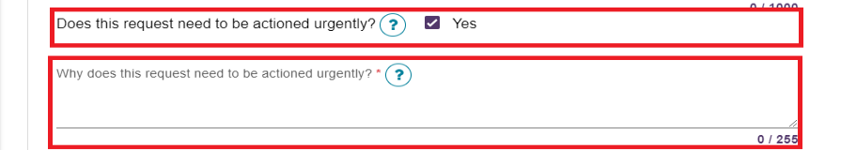
- If a client is receiving Support at Home or combination of Support at Home and Commonwealth Home Support Programme (CHSP) services, it is mandatory for a care plan and budget to be attached to the review request. The request cannot be submitted without this information.
! A provider may receive a request from the My Aged Care contact centre where they have received a web referral request from a health professional for a clinical aged care needs reassessment for an existing Support at Home participant.
The Support at Home providers should review the client’s situation, care plan and budget and if a reassessment is required for change to Support at Home classification and/or priority, submit the support plan review request to the assessor.
If the provider is not proceeding with the support plan review request as the client is already supported by the existing Support at Home classification, they should liaise with the health professional to advise them why the reassessment request is not proceeding.
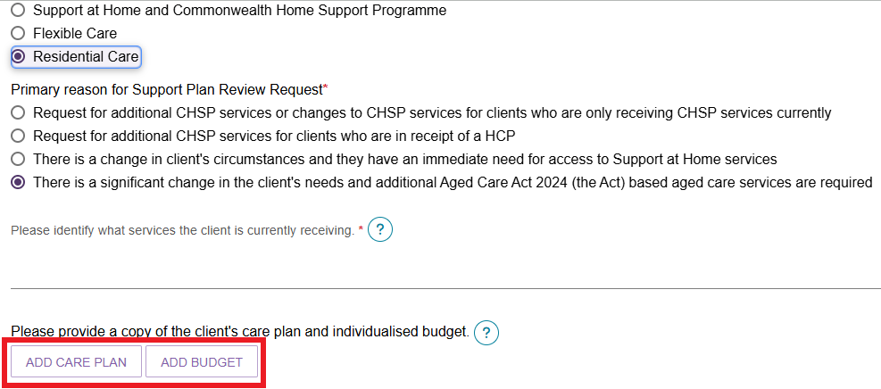
- Select the Browse button to choose a document for upload. Complete all mandatory fields and select UPLOAD to complete.
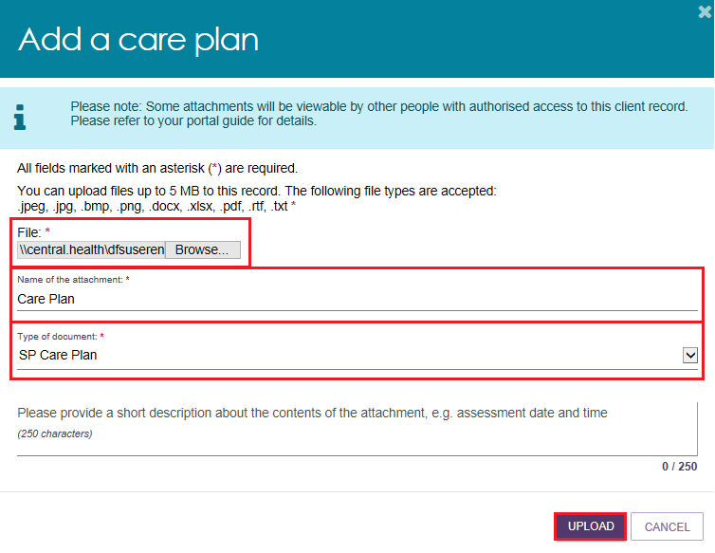
Once the documents are successfully uploaded, they will display in the review request.
Selecting on the rubbish bin icon next to the attachment name will delete the attachment.
! A confirmation message will not be displayed.
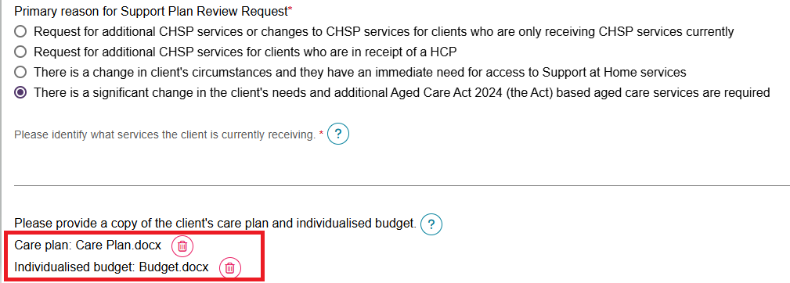
- Once all mandatory fields have been completed, tick I have reviewed the information on this page, and I confirm that it is correct then continue to SEND REVIEW REQUEST.
A confirmation will display if the request is submitted successfully.
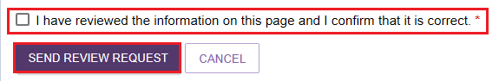

5.6.4 Checking the status of a Support Plan Review
- If a client, provider or aged care needs assessor has requested that a client’s support plan be reviewed, it will be referred to an aged care needs assessor to complete. A service provider staff member with the team leader role is then able to check the status of this review via the Service and Support portal.
This can be done by selecting the Review requests tile.
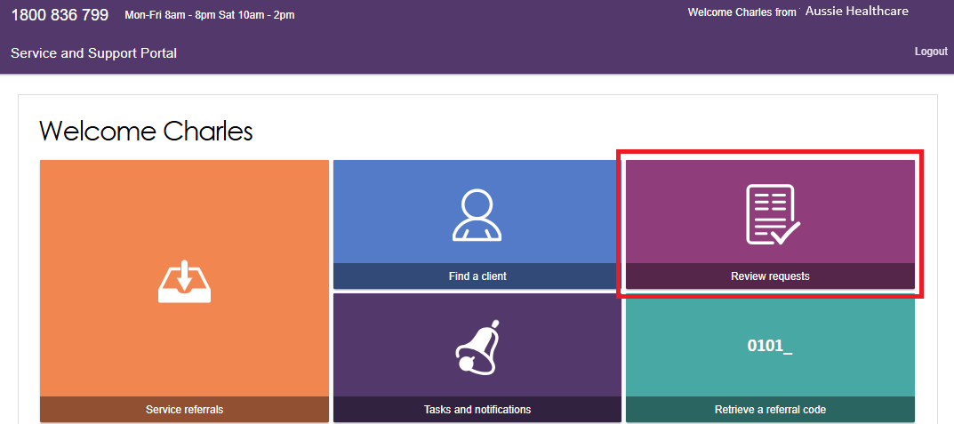
- On the Review requests page, select the Request history tab to view the status of any reviews.
If a review has recently been conducted, there will be a green Review complete bar across the bottom of the client record.
Select the icon to expand the card to view details of the request in more detail.
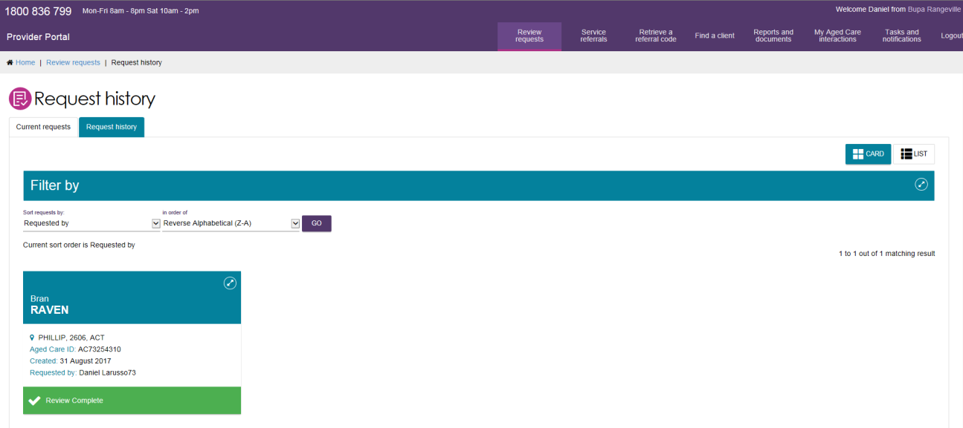
- You will then be able to view the outcomes of the review.
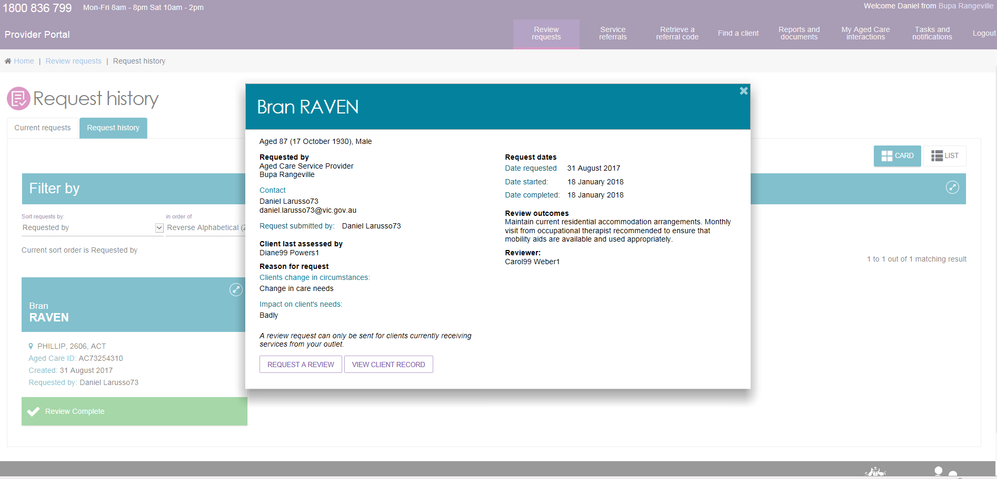
Depending on the outcome, you may need to make changes to the way you deliver services
Information is recorded on the client record to assist providers in understanding what or if any changes need to be made to better support the client.
The outcome of a review by an aged care needs assessor may be:
- no change
- an increase or decrease in services within the scope of the current approval
- a referral to for a comprehensive assessment for services under the Aged Care Act 2024.
Where the review outcome affects the current delivery of services to the client, the aged care needs assessor may contact the service provider and discuss the results of the review and the recommendations that apply to that provider’s services.
If the support plan review results in an increase or decrease in services, the provider should update the service delivery information in the client record.
Where a new assessment is initiated and results in a different service type being approved, the provider will be either:
- notified that they have a new referral to accept in the Portal (or in the case of Support at Home Classifications, they will have to wait until the client is assigned a classification), or
- contacted by the client to discuss arrangements for ceasing care with that provider (for example if the current provider is unable or not approved to provide the type of care for the new referral).
Funding and classification details are assigned at the point of service recommendation and are visible in the client record.

6. Generating reports and accessing forms
Providers can generate reports and access forms via the Service and Support Portal.
You are also able to use the Reports feature to print documents, including completed Integrated Assessment Tool (IAT) PDF reports and client record PDFs.

6.1 Generating reports
Team Leaders and Staff Members can generate reports. Follow these steps to generate a report.
- Select Reports and documents from the homepage. The Reports and documents page will be displayed.
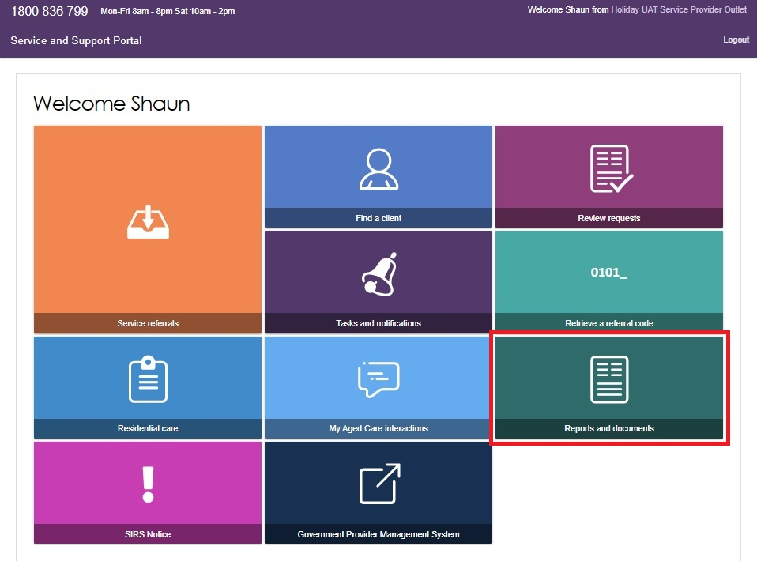
- The Reports and documents page features a Reports tab, a Forms tab and a Links tab. The Reports tab displays a list of Recently Requested Reports and Reports.
The Recently Requested Reports will display client record PDFs or IAT reports that have been generated by the user.
The Workload Management report is available from the Reports tab.
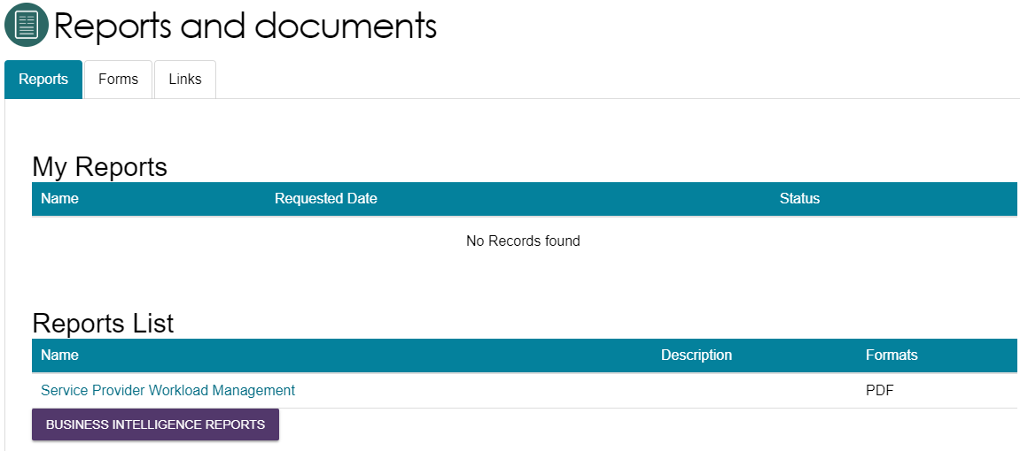
- To generate a report, select the name of the report in the Reports List.
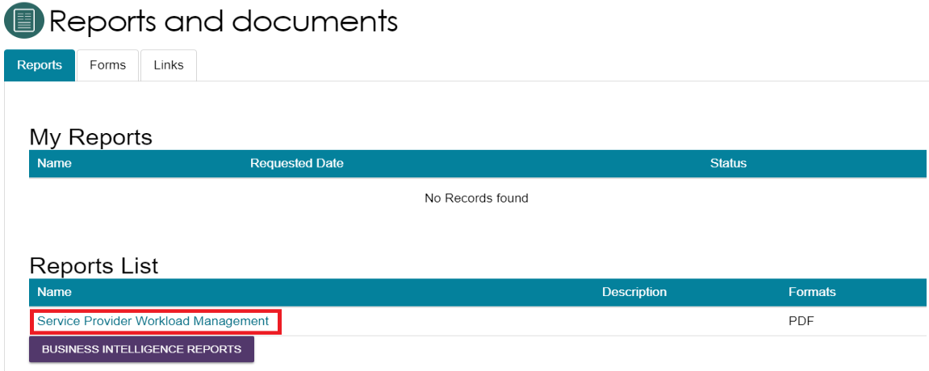
- Select the Outlet ID, enter a start and end date, and an output type (CSV or PDF), then select REQUEST REPORT. If you do not want to generate the report, select CANCEL.
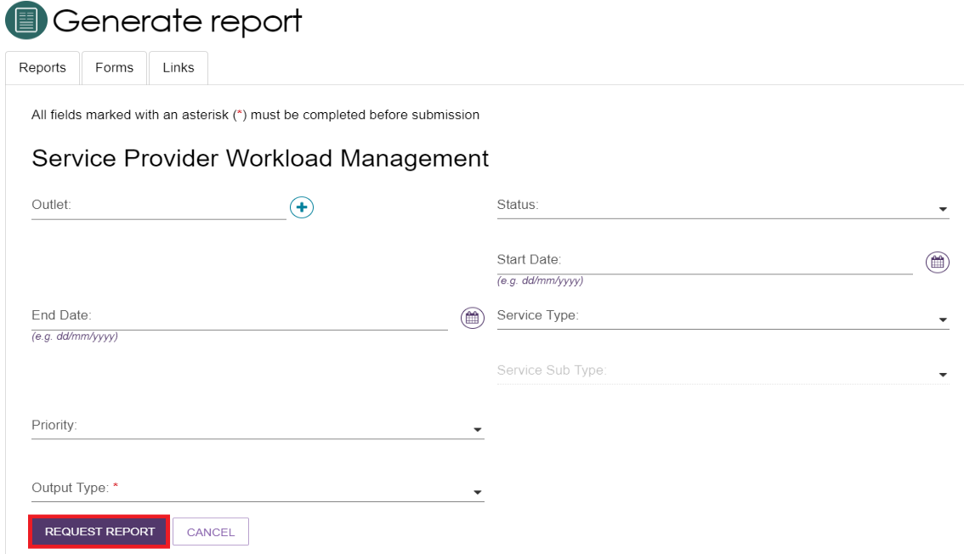

6.2 Viewing reports
Follow these steps to view reports:
- Select Reports and documents from the homepage. The Reports and Documents page will be displayed.
- In the My Reports section, select View beside the report you would like to view.
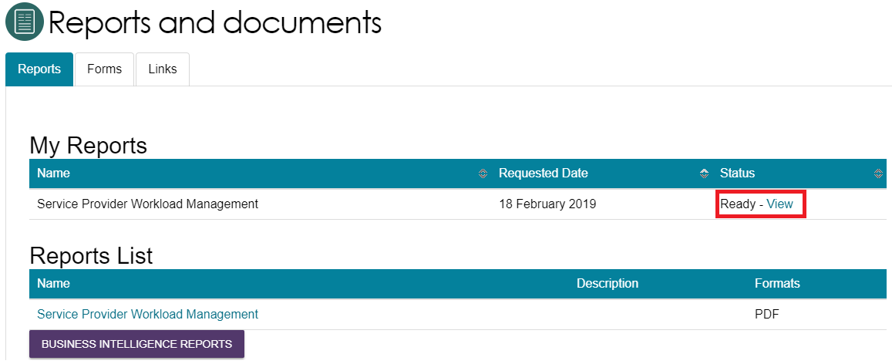

6.3 Accessing forms
Follow these steps to access forms.
- Select Reports and Documents from the homepage.
- Select the Forms tab. A list of all forms available will be displayed.
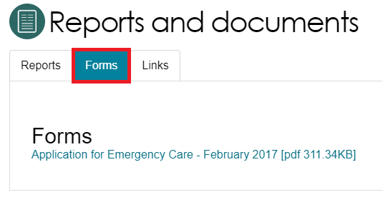

7. Serious Incident Response Scheme (SIRS)
SIRS notifications can be created, viewed and managed at the individual user level by users assigned the Staff Member or Team Leader role in the Service and Support Portal if they have been assigned the SIRS role by the Organisation Administrator.
Detailed instructions on SIRS functions can be found in Service and Support Portal User Guide - Serious Incident Response Scheme (SIRS) Portal

8. Residential Client Classifications and Reassessments
Residential Providers with the role of Team Lead or Staff Member can view the Residential Care Tile. By selecting the Residential Care tile, you can navigate to 3 tabs:
- The Care Recipient tab will list all clients receiving residential permanent and respite care.
- The Requests tab will contain a list of all current and historical requests for initial assessments, reassessments and reconsiderations.
- The Palliative Care tab will contain a list of clients that were entered into permanent residential services for palliative care.

8.1 Viewing residential clients and their residential funding classification
- On the Home screen, select the Residential Care tile.
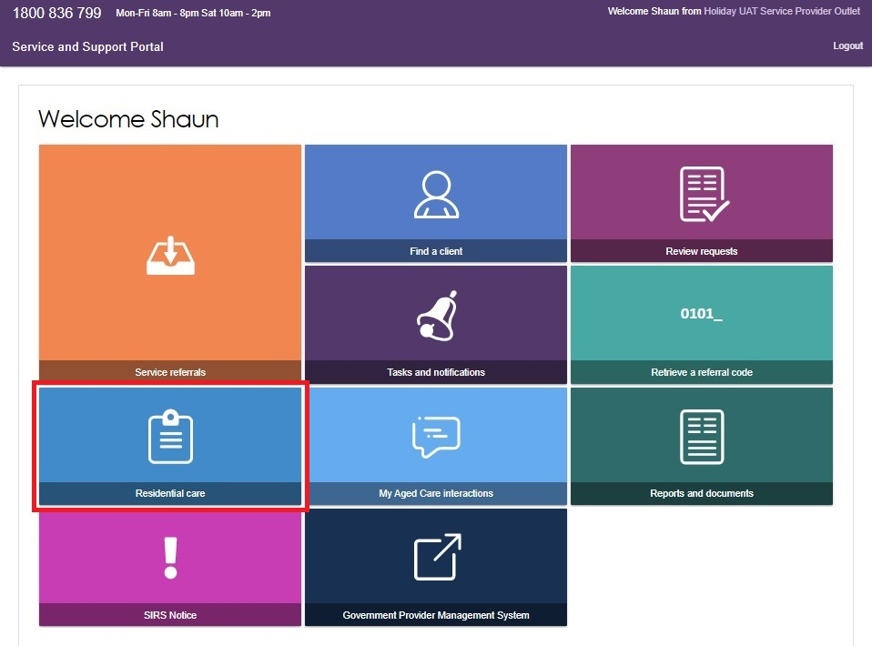
The Care Recipient tab will list all clients receiving permanent residential care and details of their residential funding classification.
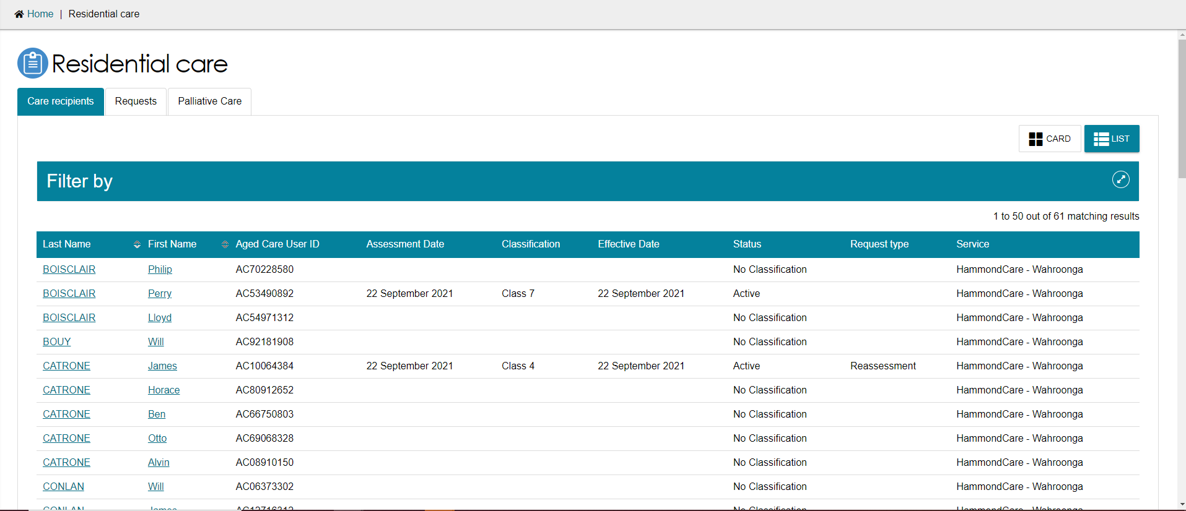
The Request Type column displays information when the care recipient has an in-progress palliative care status form approval, initial assessment, reassessment or reconsideration.
- Selecting a client will navigate to the client’s current and historical classification(s).
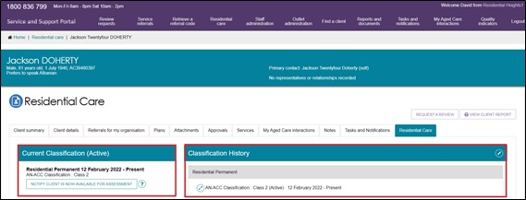
Residential funding classifications can appear in the following different ways:
- Active indicates that the client has had a Residential Funding Assessment and has an active classification associated with their record.
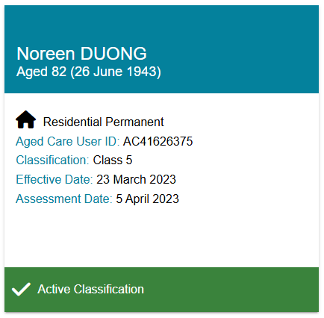
- Pending indicates that a Residential Funding assessment has been completed and is pending a classification status. This pending status will be displayed for 1 day after assessment completion or when the assessment is uploaded.
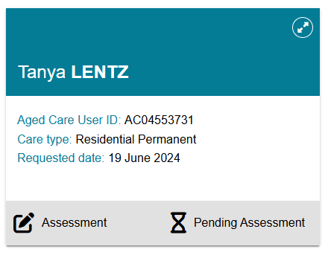
- Default Classification indicates that a Residential Funding Assessment is yet to be completed for this client. Clients with default classifications can be distinguished from clients with assessed classifications by their classification code. Most residential permanent care clients with a default class will be coded Class 99, while those who entered to receive palliative care and have not yet been confirmed as eligible will be Class 98. The default classification for residential respite care clients is Class 100.
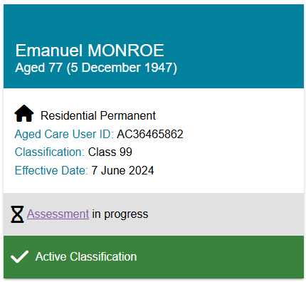

8.2 Filtering the Care Recipients lists
The Care Recipients list can be filtered using Last Name, First Name, Request Type or Aged Care User ID. You can also select ADVANCED SEARCH to reveal additional criteria to filter with, such as Classification.
- Expand the Filter by section.
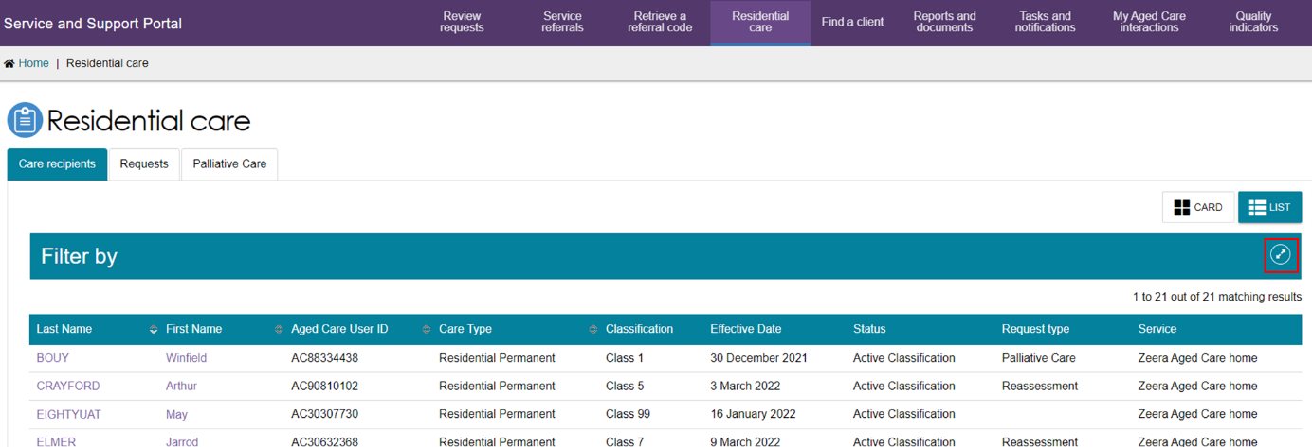
- Enter search criteria and select the FILTER button.
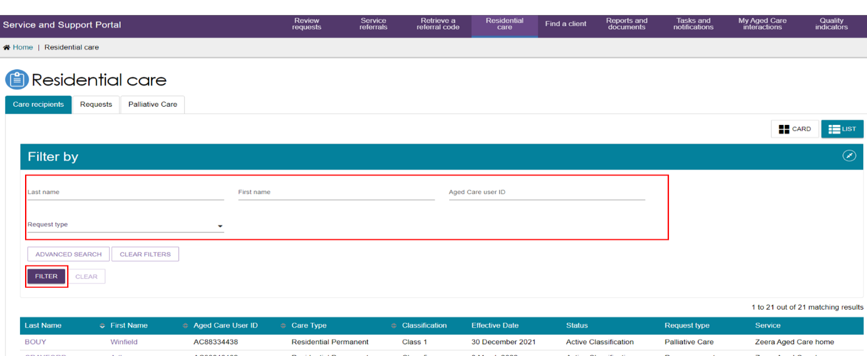

8.2.1 Advanced Search
Use Advanced Search to use other criteria to search the care recipients list. Up to seven filters can be used to refine search results.
- Select ADVANCED SEARCH
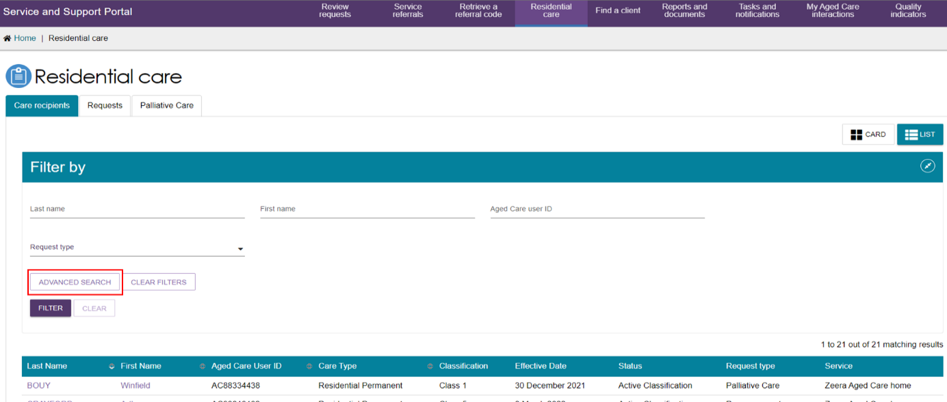
- Choose the item you wish to add e.g. classification and select ADD FILTER.
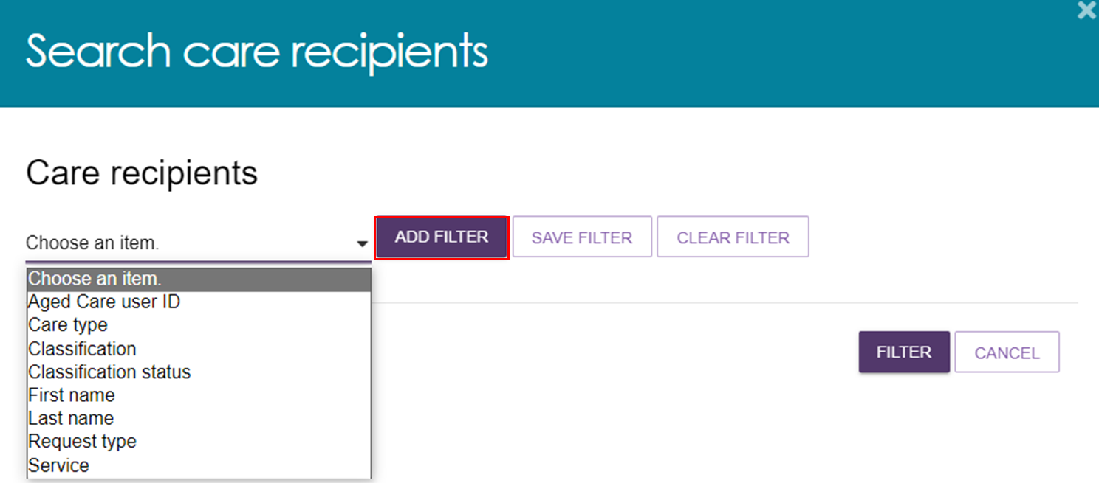
- Select a classification (e.g. Class 4) and select the FILTER button. The Care Recipient list is now filtered accordingly.
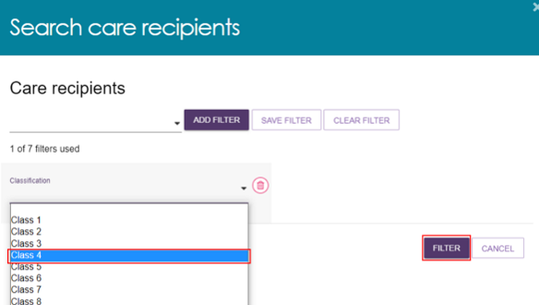
- You can select SAVE FILTER for future use or CLEAR FILTER to start again.
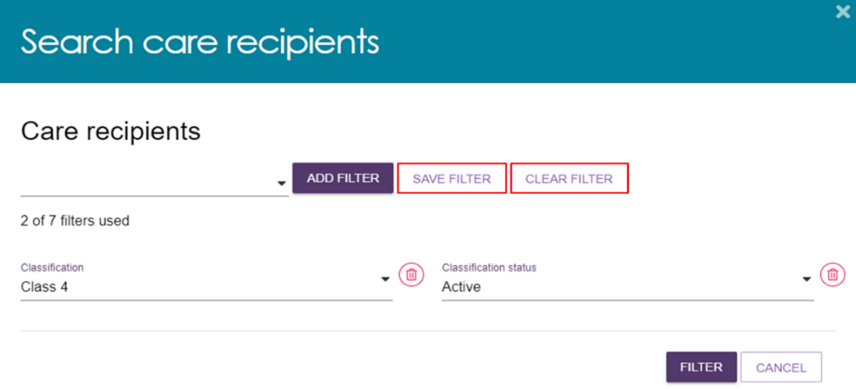
- Once the filters are applied, you will be able to view the number of clients that fit within the category.
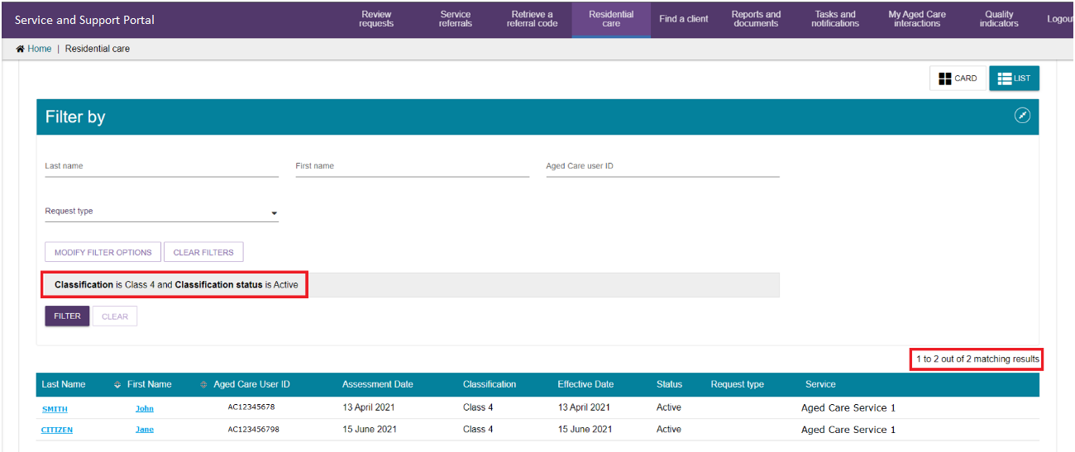

8.3 Requesting Residential Funding Reassessments
! Residential Funding Reassessments should only be requested if the client’s care needs have significantly changed.
Reassessment requests can only be requested for clients whilst in your care.
Reassessment requests can only be made by users assigned Team Lead access.
- On the Home screen, select the Residential Care tile.
- On the Care Recipients screen, select the client that requires a reassessment.
! You cannot request a reassessment when the client has an initial assessment, reassessment or reconsideration in-progress. Check the Requests tab for in-progress assessments.
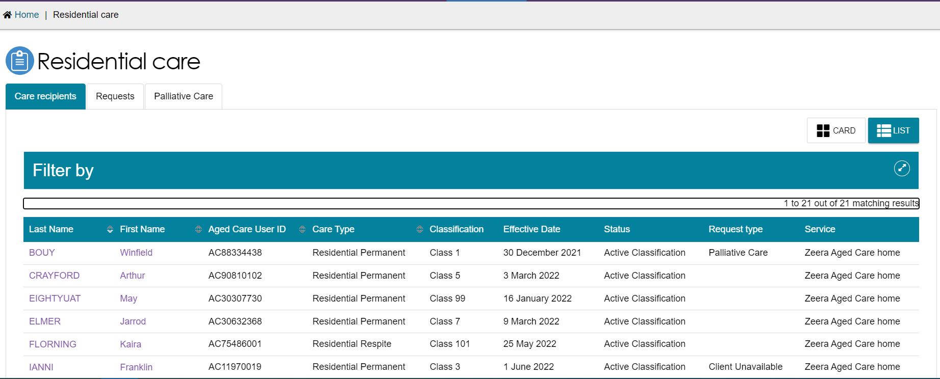
On the Client Record screen, within the Residential Care tab you can view the client’s current Residential Permanent and/or Respite Classification and request a reassessment for the client:
- For residential permanent reassessment requests, select the REQUEST REASSESSMENT button where the current residential permanent classification is shown.
- For residential respite reassessment requests, select the REQUEST REASSESSMENT button where the current residential respite classification is shown.
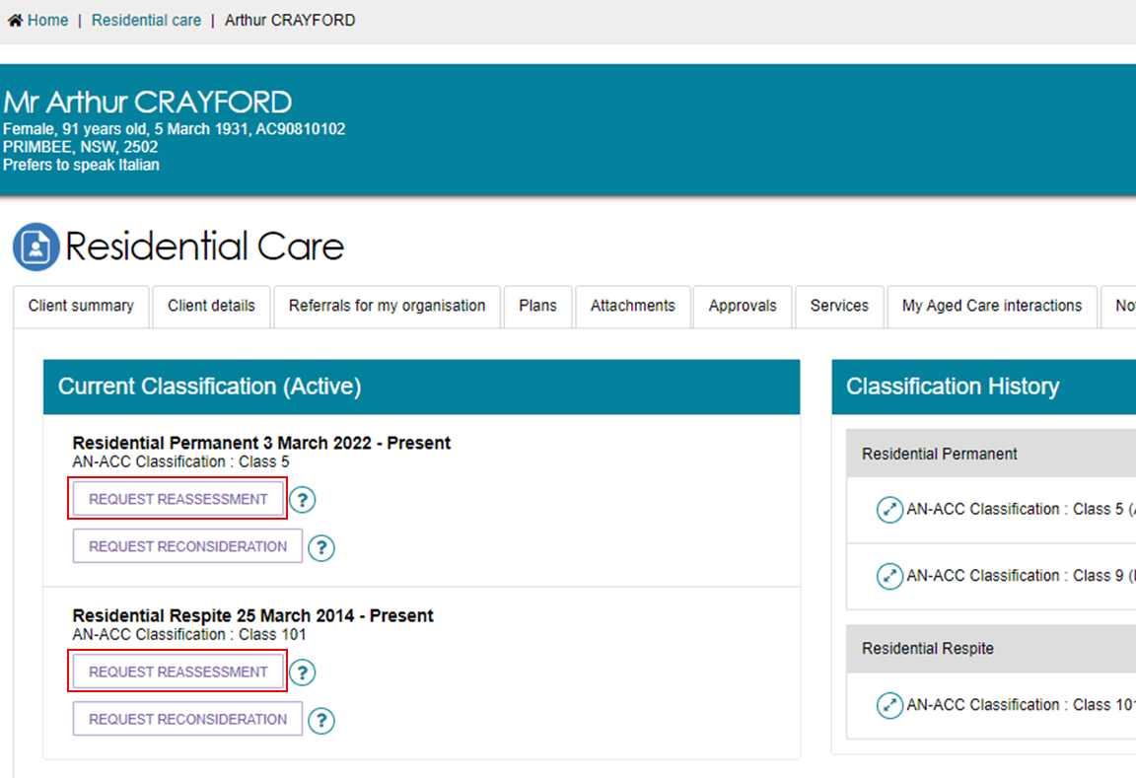
- Select Yes if there has been a significant change in care needs.
Then, select CONFIRM REASSESSMENT button.
For Residential Permanent requests only: you can also request it to be Urgent, if the care recipient is at imminent end of life and has a documented care plan in place that has been communicated with the resident and their family and/or carers.
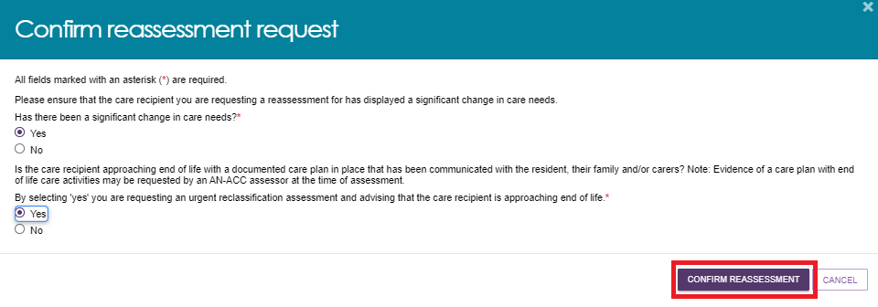
Select the criteria the client meets for reassessment, then select the REQUEST REASSESSMENT button.
For reassessments of residential permanent clients, if the time based criteria is not met, the criteria will be displayed in light grey text and cannot be selected.
For residential respite clients, the expected departure date from residential respite care is required.
Residential Permanent Example:
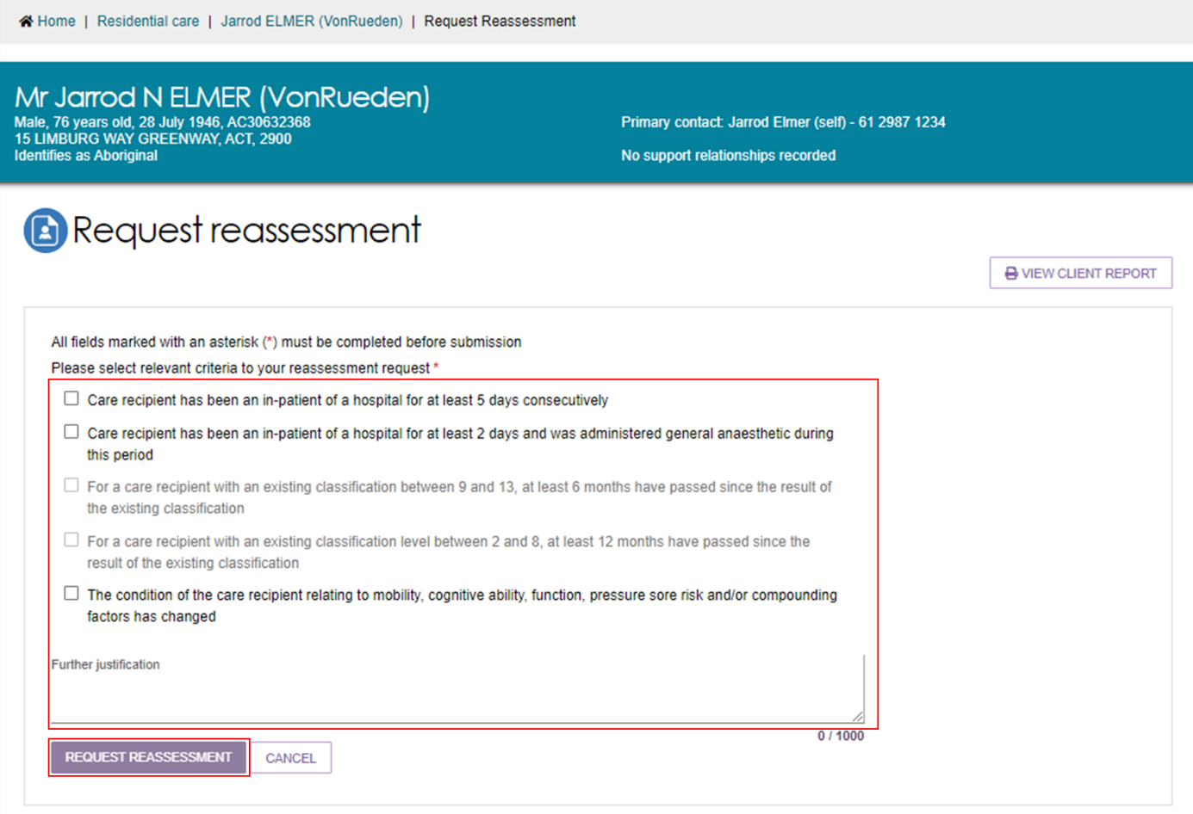
Residential Respite example:
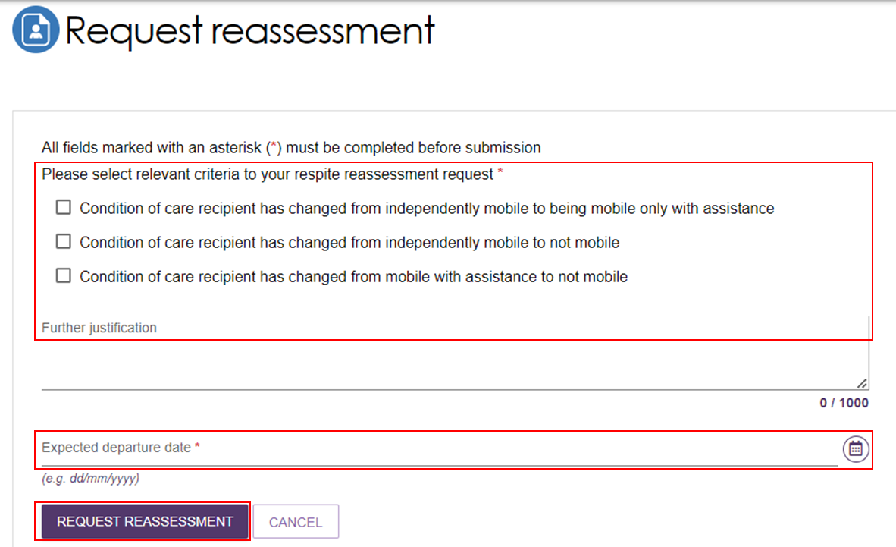
- The reassessment has been successfully requested when a green banner (below) is shown. There is also a banner at the top of the screen, and it notifies the timeline of when new classification details are expected to appear.
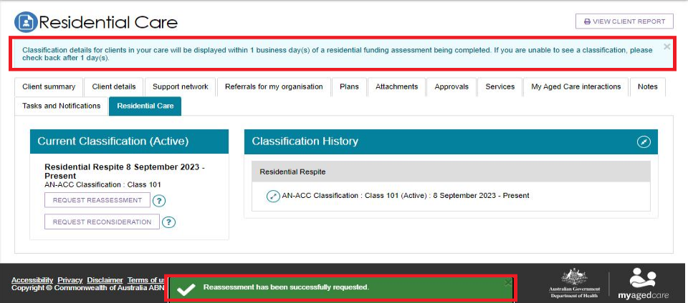
The progress of reassessment requests can be viewed on the Requests tab, for more details refer to Request Tab and Request Status Definitions.
Notifications are generated about new classification decisions after the assessment is completed, for more details refer to Viewing Tasks and Notifications.
! Residential funding reconsiderations should only be requested if you do not agree with the classification that has resulted from an assessment or reassessment.
Reconsiderations must be requested within 28 days of being notified about the new classification.
Reconsideration requests can only be raised while the client is in your care.
Reconsideration requests can only be raised by users assigned Team Lead access.

8.4 Requesting Residential Funding Reconsiderations
- On the Home screen, select the Residential Care tile.
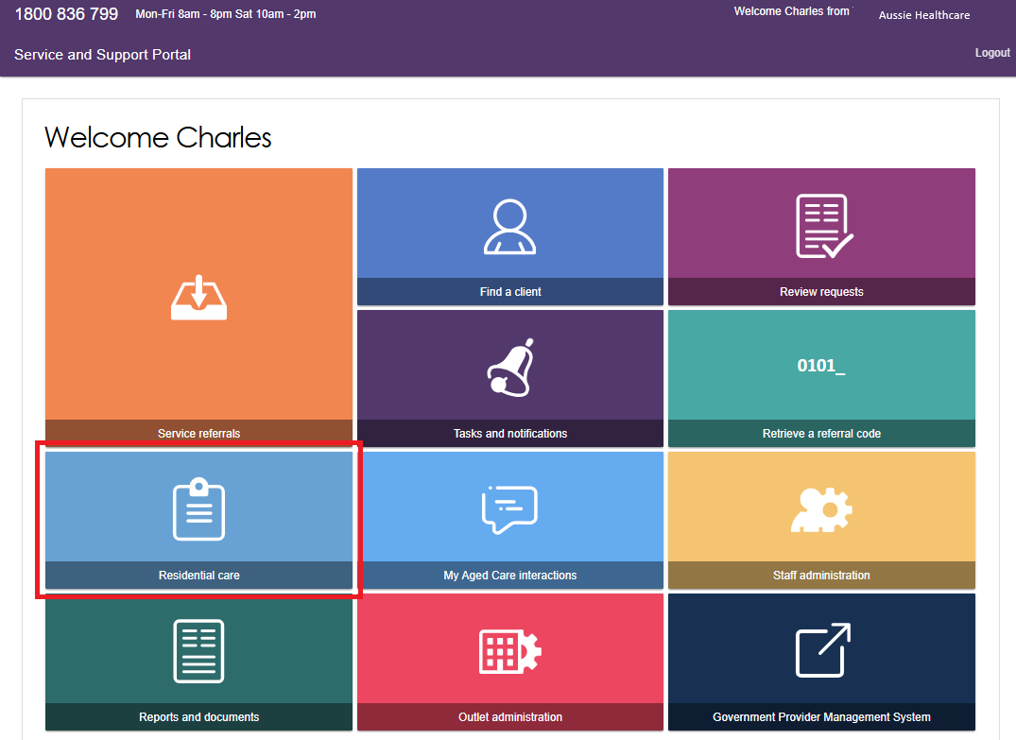
- On the Care Recipients screen, select the client whose classification requires reconsideration.
! You cannot request a reconsideration if the client has an initial assessment, reassessment or reconsideration in-progress. Check the Requests tab for in-progress assessments.
- On the Client Record screen, within the Residential Care tab you will be able to view the client’s current Residential Permanent and/or Respite Classification and request a reconsideration:
- For residential permanent reconsiderations requests, select the REQUEST RECONSIDERATION button where the current residential permanent classification is shown.
- For residential respite reconsideration requests, select the REQUEST RECONSIDERATION button where the current residential respite classification is shown.
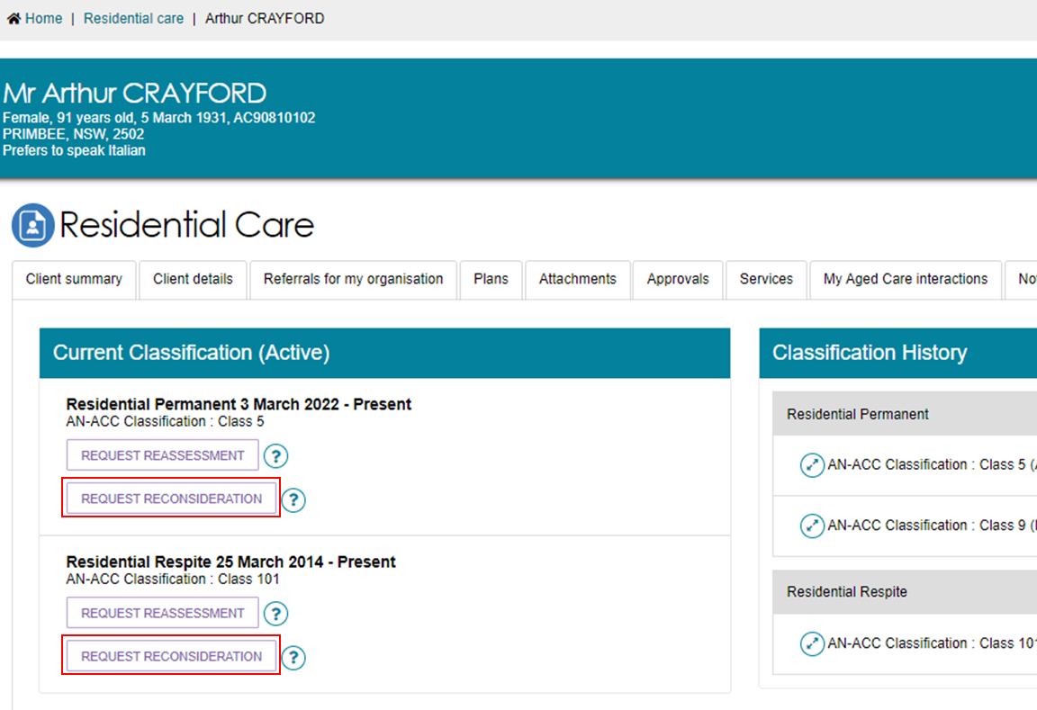
Select Yes if you disagree with the current classification and select the CONFIRM RECONSIDERATION button.
For Residential Permanent requests only: you can also request it to be Urgent, if the care recipient is at imminent end of life and has a documented care plan in place that has been communicated with the resident and their family and/or carers.
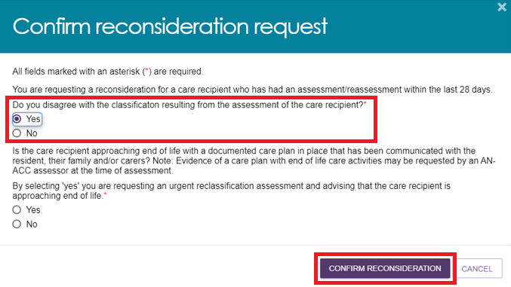
- Select the criteria for your reconsideration request, then select REQUEST RECONSIDERATION.
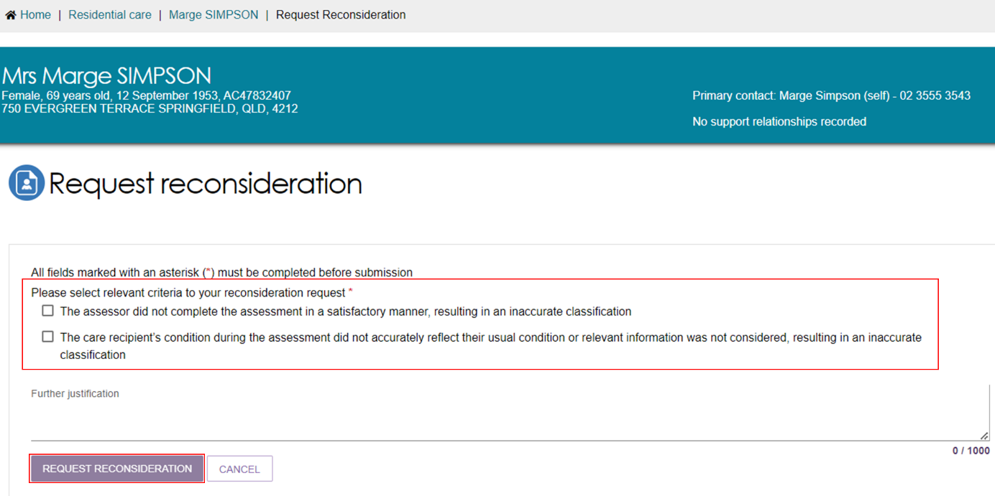
For reconsideration of residential respite clients, the expected departure date from residential respite care is required.
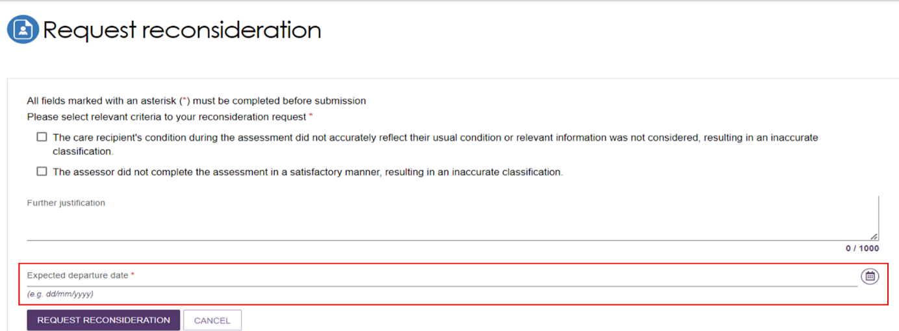
- The reconsideration has been successfully requested when a green banner appears.

The progress of reconsideration requests can be viewed on the Requests tab, for more details refer to section Request Tab and Request Status Definitions.
Notifications are generated about new classification decisions after the assessment is completed, for more details refer to Viewing tasks and notifications.

8.5 Recalling a Residential Funding Reassessment or Reconsideration request
If you have incorrectly requested a reassessment for a client, or you have become aware that a client is no longer available for reassessment (for example, they are on social/emergency leave) you are able to recall your request.
- On the Home screen, select the Residential Care tile.
- From the Requests tab, scroll or filter the list to find the client reassessment or reconsideration request that you wish to recall and expand the client.
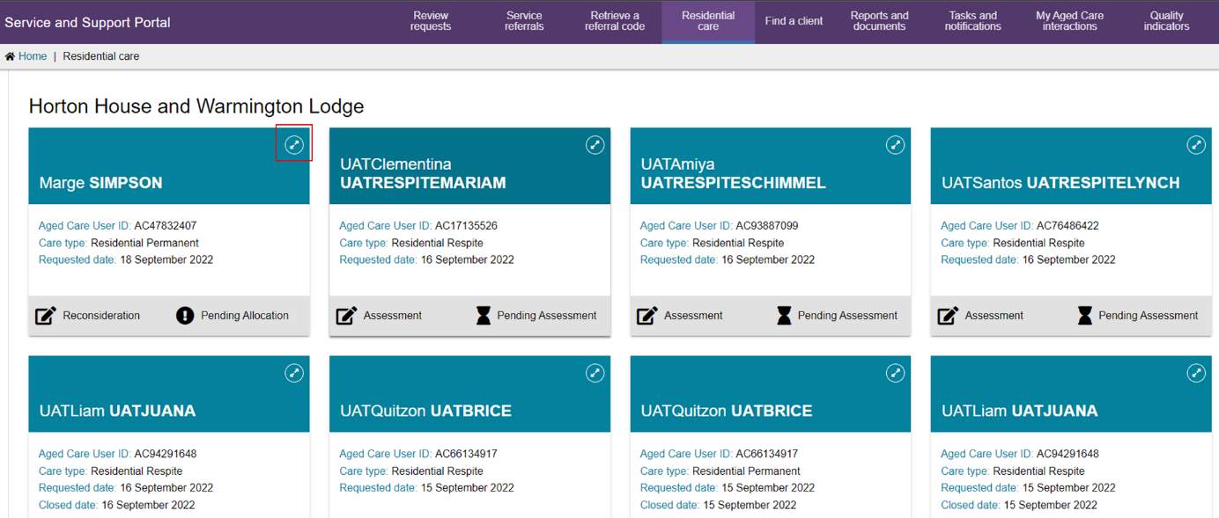
- A pop-up will appear where you can select the RECALL REASSESSMENT REQUEST or RECALL RECONSIDERATION REQUEST button.
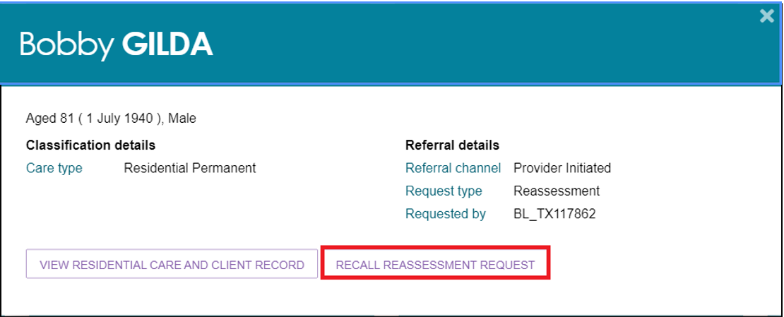
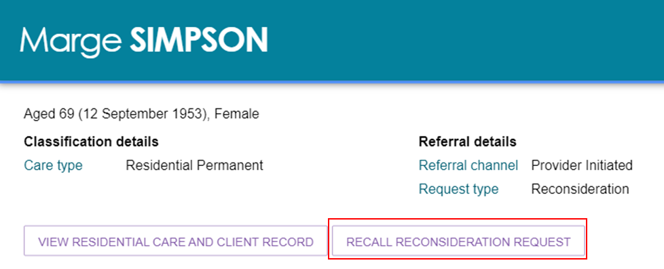
! Selecting reason Client Unavailable will allow you to notify the Department when the client becomes available for assessment which can automatically request another reassessment for you.
Selecting Client Deceased will mark the client as deceased in Department records, please ensure you have confirmed before submitting. The reassessment request will be closed. Selecting Other will require you to enter a reason. The reassessment request will be closed.
- Select the recall reason from the drop down and select RECALL REASSESSMENT REQUEST or RECALL RECONSIDERATION REQUEST button.
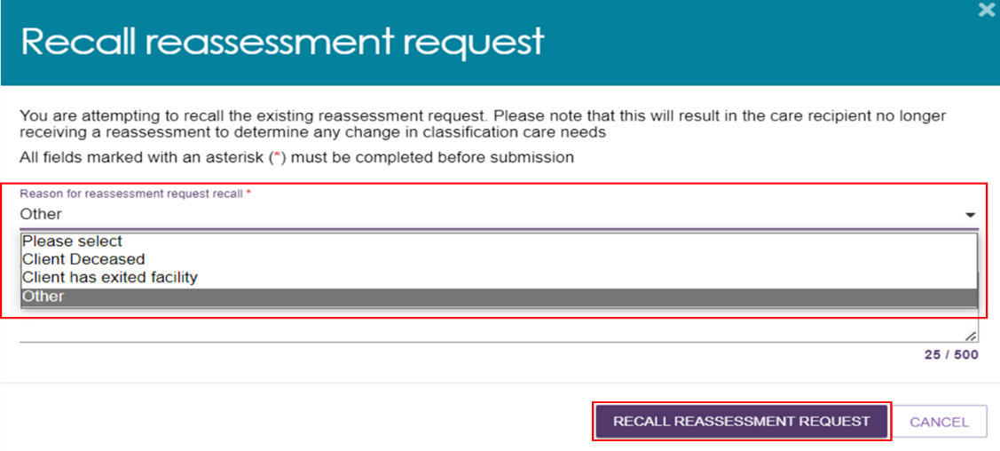
- The reassessment or reconsideration request will now be recalled when the below green banner appears.


8.6 Notify Client is Available for Assessment
Team Leaders will be able to notify the department that a client is available for assessment once the client has returned to your residential facility.
The Notify client is now available for assessment option is available to Team Leads if the client’s previous residential funding assessment referral was rejected or recalled with the reason Client Unavailable.
- On the Home screen, select the Residential Care tile.
- On the Care Recipients screen, select the client you wish to notify is available for assessment.
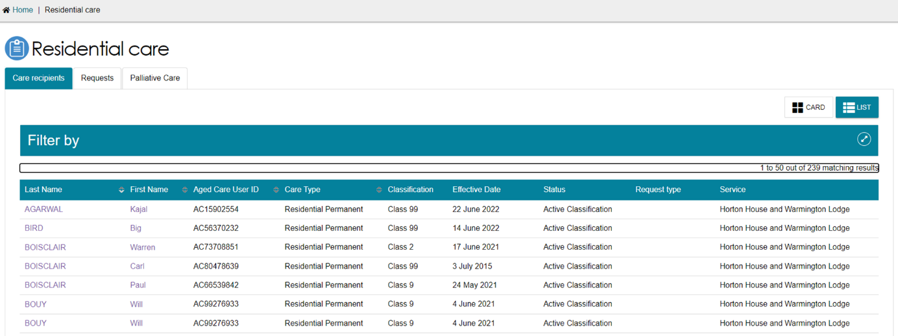
- On the Client Record – Residential Care tab, select the NOTIFY CLIENT IS NOW AVAILABLE FOR ASSESSMENT button.
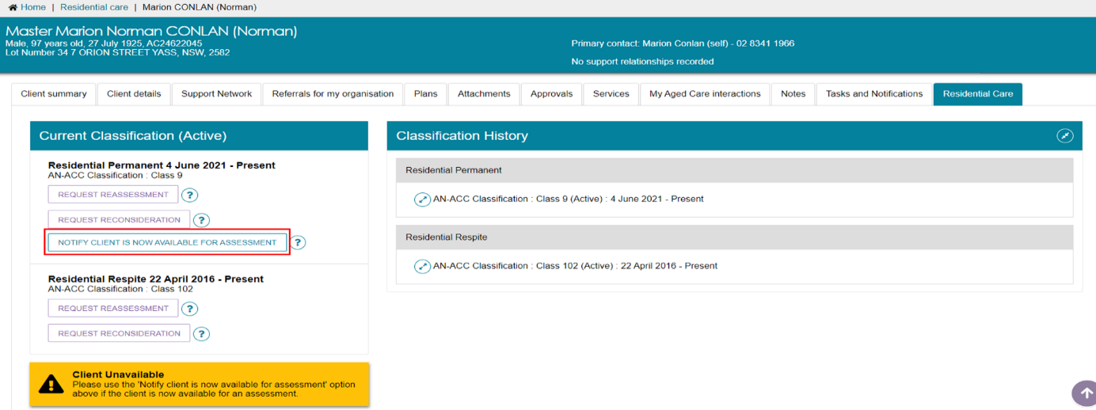
- A pop-up will appear to confirm the client is now available for assessment. If you would like a reassessment request to be automatically triggered select REQUEST REASSESSMENT AND CONFIRM CLIENT IS AVAILABLE.
Optionally, select CONFIRM CLIENT IS NOW AVAILABLE FOR ASSESSMENT allows you to manually request a reassessment later as needed.
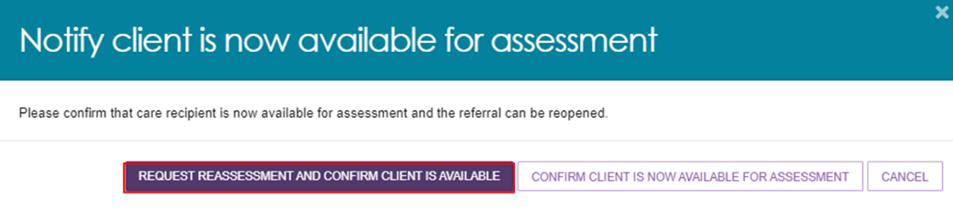
- The client will now be available for assessment and a request is automatically triggered, when the following green banner appears.


8.7 Request Tab and Request Status Definitions
The Requests tab within the Residential Care tile lists all residential funding assessment requests including initial assessments, reassessments and reconsiderations. The Request status indicates the progress of the assessment referral. The table below lists the statuses in order of progress along with a description of the status.
! Reference to the term Assessment includes initial assessments, reassessments and reconsiderations.
REQUEST STATUS DEFINITIONS
Status | Description
Pending Allocation | A referral for a residential funding assessment has been created and is yet to be issued to a residential funding assessment organisation.
Pending Assessment | A referral for a residential funding assessment has been issued to a residential funding assessment organisation and the assessment is yet to be completed.
Finalised | The assessment has been completed and uploaded by the assessor.
Rejected | The request for assessment has been rejected for reasons the client is unavailable for assessment i.e., in hospital or on leave
Recalled | The request for assessment has been recalled for reasons the client is unavailable for assessment i.e., the client is deceased

8.8 Palliative Care

8.8.1 View Clients Marked Palliative on Entry
For clients who entered into a residential facility for permanent palliative care, the Palliative Care tab will display the list of clients and any actions to be completed to validate their palliative status. Forms submitted will be reviewed by the Department and actioned based on the result.
Once validation is completed, the client record will still be available in this tab.
Select the Palliative Care tab to view all clients that were marked Palliative on Entry.
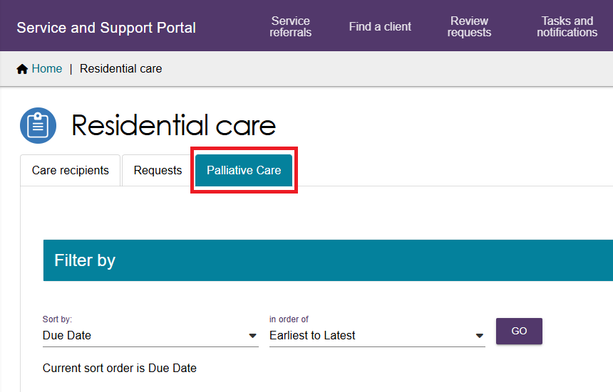

8.8.2 Upload Palliative Care Documents
For a client who was marked as palliative on entry, their status will be set to Pending Upload.
- Expand the client and select Upload Palliative Documents.
! The Palliative Care Status Form must be submitted within 14 days of notification of entry to the Department via the My Aged Care Service and Support Portal. Once the entry is processed, a notification will be generated, please refer to Viewing tasks and notifications for more information.
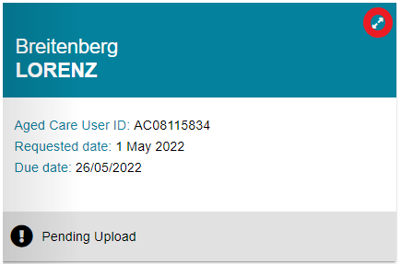
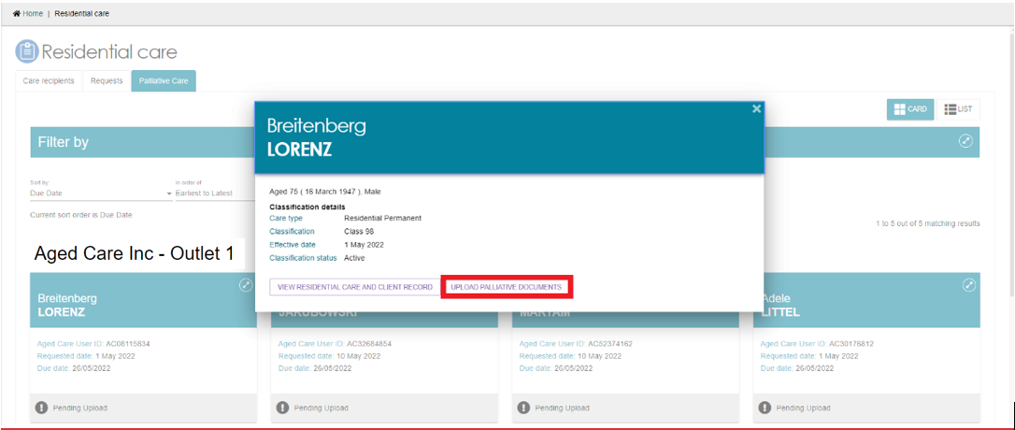
- Upload completed Status Form to the portal and submit within the due date.
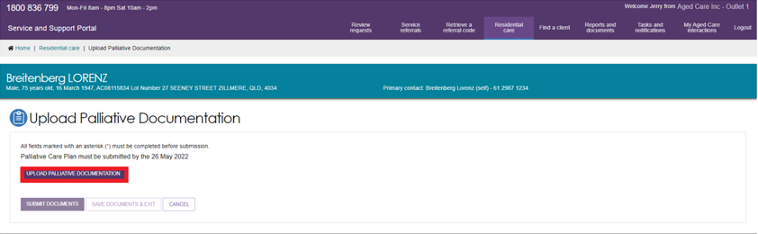

Select UPLOAD PALLIATIVE DOCUMENTATION, this will provide a pop up to allow the upload of the form saved on your laptop/computer.
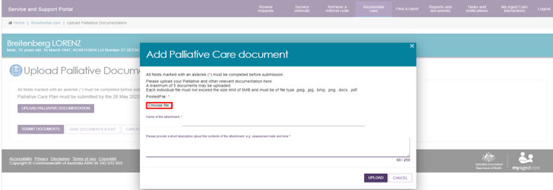
! Only one file may be uploaded each time, as each file requires an individual name and description.
- Fill out the file name and provide a short description. For the File Name as well as the name of the file uploaded in the system, please follow the naming convention: [Client Last Name] PCSF [Date Uploaded – DDMMYY].
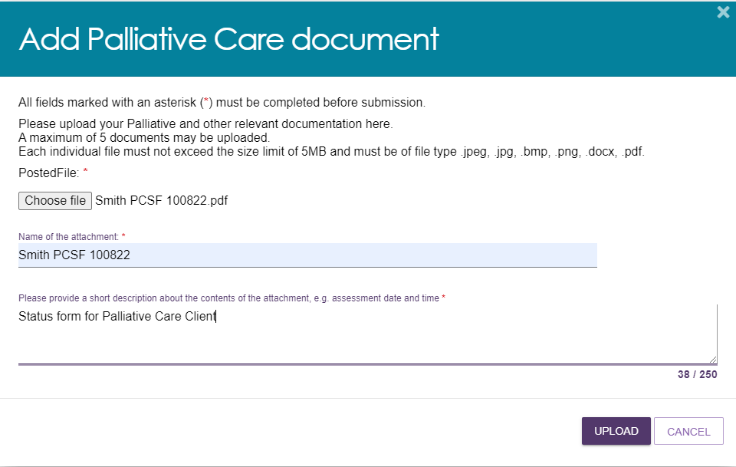
Optionally, you may upload additional information (if previously discussed with the Department) as necessary by selecting UPLOAD PALLIATIVE DOCUMENTATION and repeating the steps above.
- If you wish to come back and upload at a later time, select SAVE DOCUMENTS & EXIT. Documents will not be reviewed by the department, until submitted.
If you have reviewed documents and are ready to submit to the department, select SUBMIT DOCUMENTS.
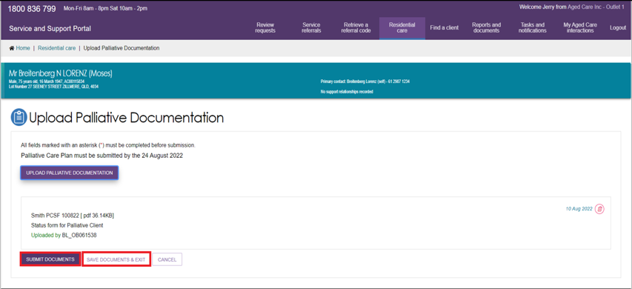
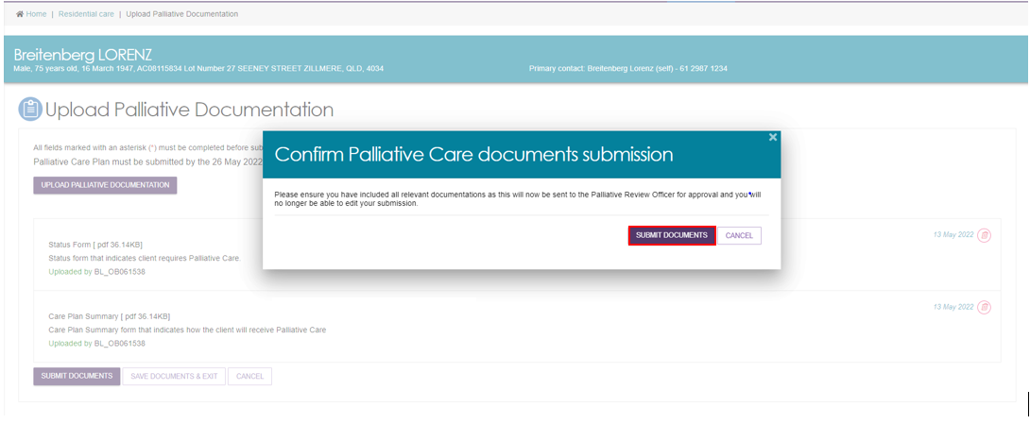
The status of this client will now change to Pending Approval, and a Palliative Review Officer from the Department will review the documents.
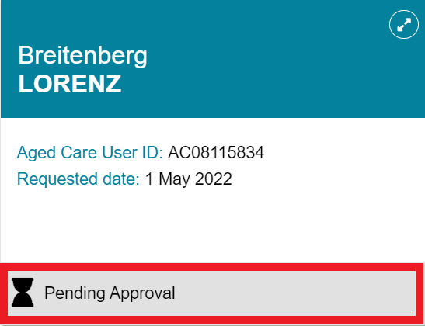

8.8.3 Palliative Care Status Form Outcomes
There are three possible outcomes of a submitted Palliative Status Form: More Information Requested, Approved, or Rejected.

8.8.3.1 More Information Requested
If the palliative review officer finds that there is insufficient information for them to action the Palliative Care Form, they will request more information with a description on what is required.
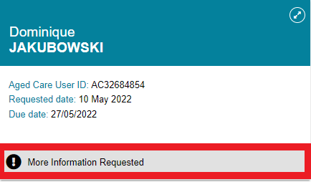
! You will receive 14 additional days from the date the Palliative Review Officer requested more information to upload additional documents. This extension will only occur once per resident, so please include all information required to validate the resident’s palliative care status.
When more information is requested, a notification will be generated, please refer to Viewing tasks and notifications for more information.
- Expand the client tile and select VIEW MORE DETAILS to read guidance text from the palliative review officer.
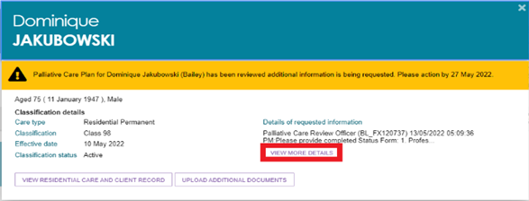
! The existing document will no longer be viewable or editable and a new version of the document will need to be uploaded.
The latest date should be included in the name of the file to align with the naming convention: [Client Last Name] PCSF [Date Uploaded – DDMMYY]
- If necessary, provide a response by selecting ADD RESPONSE, update new documents and resubmit.
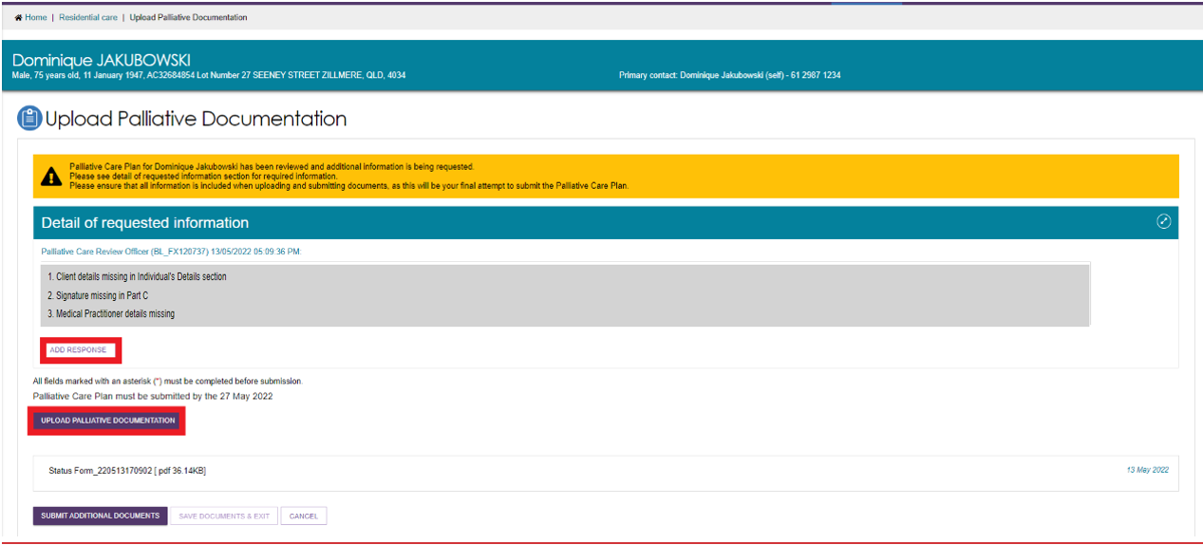
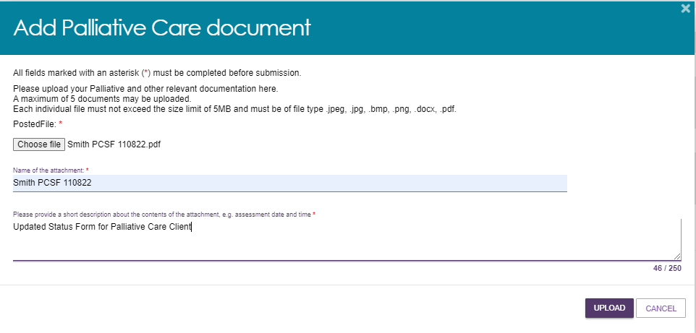

8.8.3.2 Approved and Rejected Palliative Care Status Forms
Once a Palliative Care Status Form is approved, you will receive a notification, and the status of the client will change to Approved. The client/resident will be assigned AN-ACC class 1 and will be eligible for subsidy at that rate.
If, after requesting additional information, the Palliative Review Officer finds that the documents uploaded do not provide sufficient evidence for a client to be deemed palliative, they will reject the request for palliative status.
You will receive a notification, the status on the palliative care tile for the client will change to Rejected, and a referral generated for an AN-ACC assessment to determine the client/resident’s AN-ACC Classification.
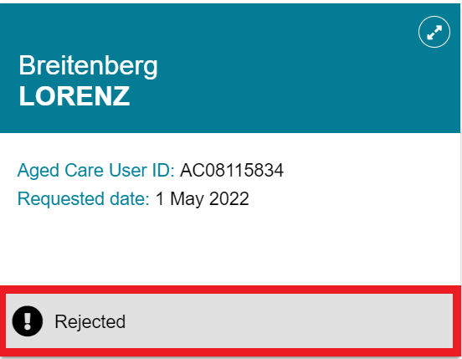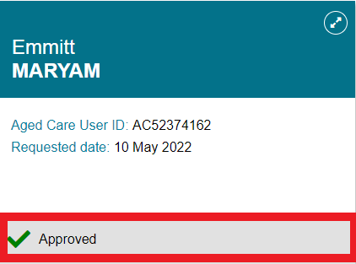
If you wish to appeal the decision, please contact My Aged Care at myagedcare@health.gov.au with evidence regarding the reasons for your appeal.

