Assessor Portal User Guide 6 – Completing an Assessment
This user guide outlines the different assessors’ roles during an Aged Care assessment using My Aged Care. This includes non-clinical (who are able to complete home support assessments) and clinical (who are able to complete comprehensive assessments) assessor roles in the system.
Aged care needs assessors (assessor) can conduct assessments using the Integrated Assessment Tool (IAT) via:
- the assessor portal (this guide),
- the Aged Care Assessor app and uploading information onto the assessor portal when the assessor next has internet connectivity, or
- a printed or blank copy of the IAT and entering information onto the assessor portal after the assessment has been undertaken.
If you have only been assigned an organisation or outlet administrator role, you will not be able to view or complete assessments in the assessor portal. For more information about completing an assessment, refer to the Integrated Assessment Tool (IAT) User Guide.
! | On 1 November 2025, the Aged Care Act 2024 and the Support at Home program come into effect with significant change to support plans in the IAT.  To ensure the right IAT is used, and triage can continue for priority referrals, any assessments in the following statuses already started prior to 1 November 2025 and in progress on 1 November 2025 must be restarted:  - Triage complete, main assessment not started  - Triage complete, main assessment in progress (includes incomplete support plan)  - Main assessment completed, awaiting delegate decision (comprehensive assessments).  For information on the Restart Assessment Process, please refer to Management of active assessments for 1 November 2025 transition – Standard Operating Procedure and Restarting In Progress Assessments for Support at Home (instructional video).
CONTENTS
Viewing assessments 3
Starting an assessment 4
Completing an assessment 13
Assessment features 14
Clinical attendance (for non-clinical assessors) 15
Viewing and adding carers in the assessment 19
Adding a Sensitive Attachment in the assessment 22
Navigating the Validated Assessment Tools 26
Modified de Morton Mobility Index (DEMMI) and Residential Respite Care (Clinical assessor) 28
Saving an assessment 31
Finalising an assessment 32
Accepting or Overriding an Assessment 37
Converting to Comprehensive Assessment 40
Flagging an Assessment as End of Life 41
Cancelling an assessment 45

Viewing assessments
Follow these steps to view an assessment:
- Select Assessments on the homepage.
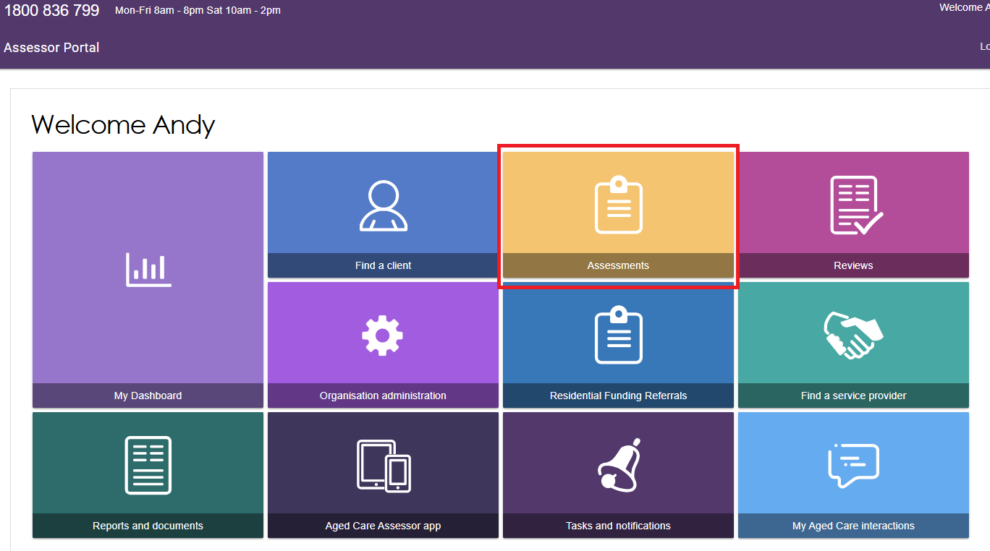
- From the Assessments page, needs assessors will be able to view the assessments assigned to them in Current assessments.The Current assessments tab contains assessments that may have the following statuses:
- Triage not started
- Assessment not started
- Assessment in progress
- Assessment completed but not yet finalised
- Assessment awaiting delegate decision (not applicable for reviews)
- Delegate decision completed but not finalised (not applicable for reviews).
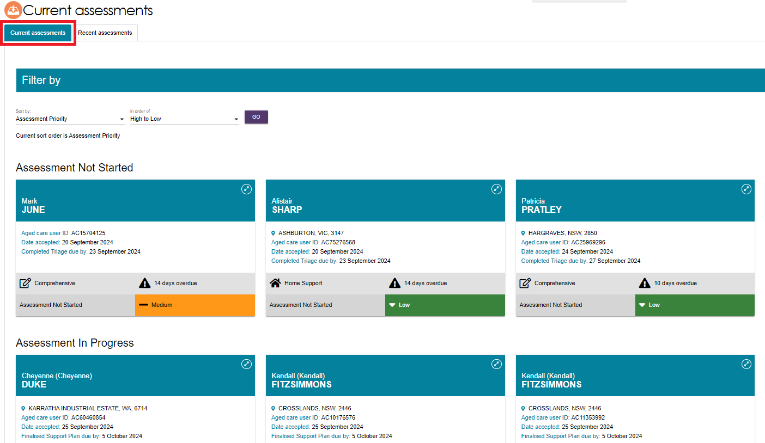
! | To view the next Key Performance Indicator milestone (for example, Finalised Support plan) and due date for an assessment, go to the client’s referral card.
- The Recent assessments tab contains finalised, cancelled and/or closed assessments. It also contains completed and cancelled Support Plan Reviews.
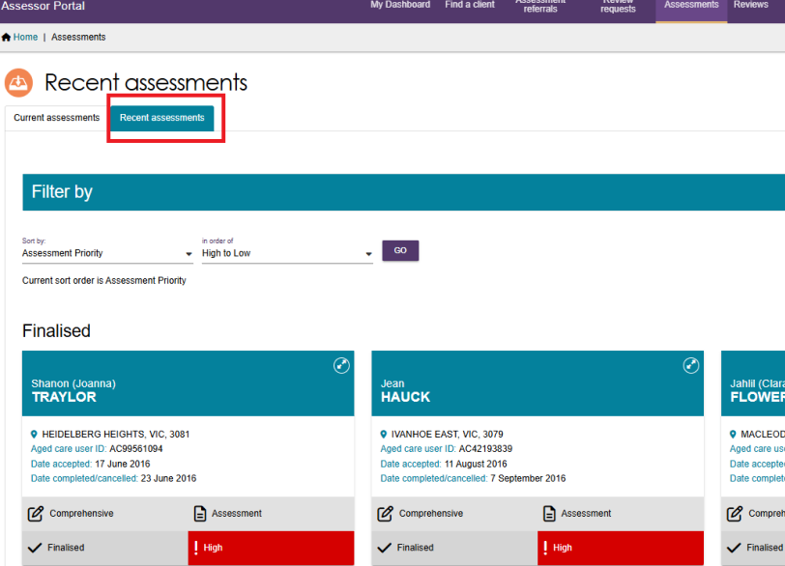
! | Further information about using the sort and advanced filter functions can be found in the My Aged Care – Assessor Portal User Guide 3 – Managing Referrals for Assessment and Support Plan Reviews.

Starting an assessment
- To start an assessment, select a client from the Assessment Not Started heading, and then select the double arrow icon on the top right-hand corner of the Client card.
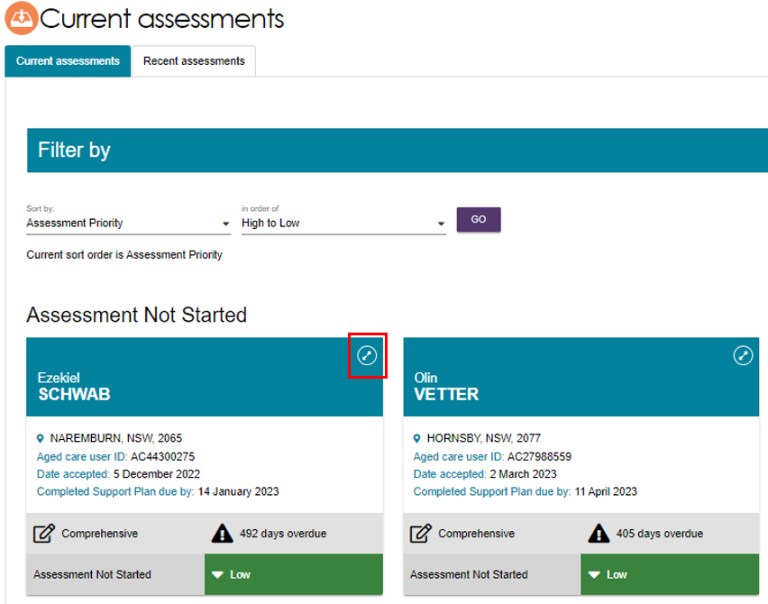
- A summary of client information will be displayed. Assessors can access read-only versions of previous screening, triage and assessments, attachments relevant to the client’s referral, and the client’s support plan, if available.
! | When opening the client card, the Support plan status will be marked as Triage Completed. Assessors will also be able to view relevant details of both triage and screening by selecting the magnifying glass icon. For comprehensive assessments, clinical assessors will be able to indicate the assessment setting before starting the assessment.  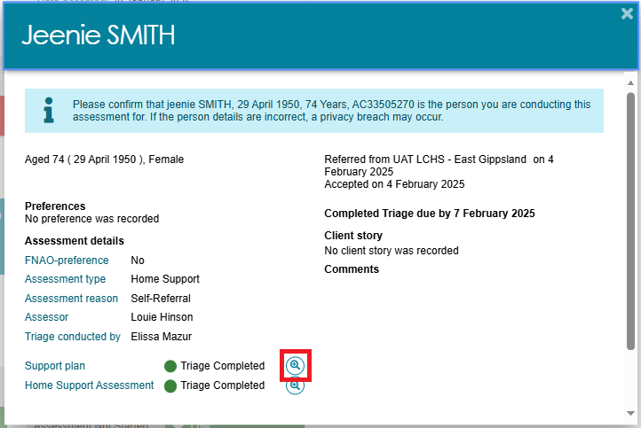
- To change the assessment setting, select the Edit (pencil) icon next to Assessment Setting when the client information is expanded.
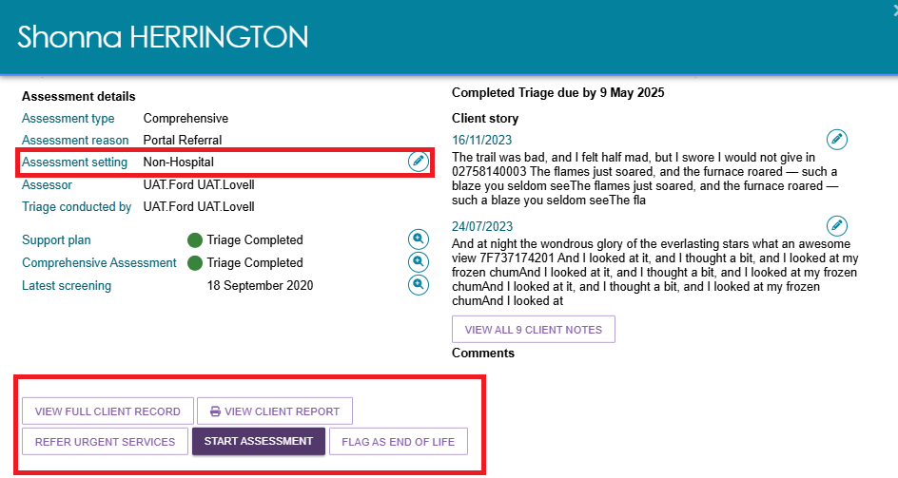
- The Assessment setting pop up will appear. Select Hospital or Non-Hospital and select Save.
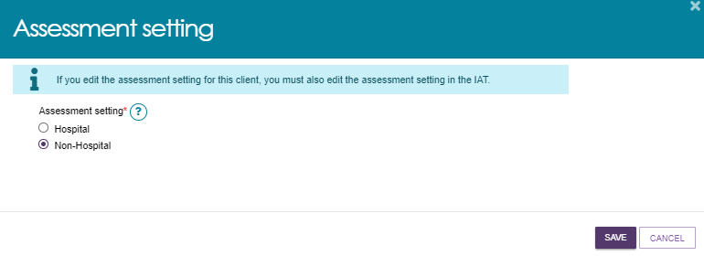
- The Assessment setting that is filled out here must match the value recorded in the IAT. Clinical assessors must ensure that both fields are manually updated to reflect the same value if one is changed.
Clinical assessors will have the ability to convert Home Support Assessments to Comprehensive Assessments prior to commencing an assessment.
To change the assessment type select CONVERT TO COMPREHENSIVE ASSESSMENT.
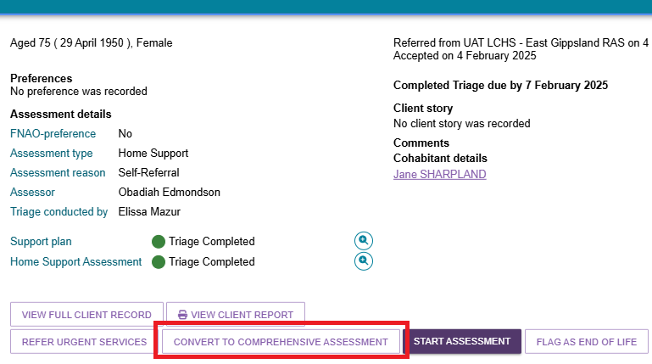
- The reason for the change will be automatically filled. Enter your Reason or comments about converting the assessment.
Non-clinical assessors who wish to convert the home support assessment to a comprehensive assessment will also be required to enter the name of the supervising clinical assessor.
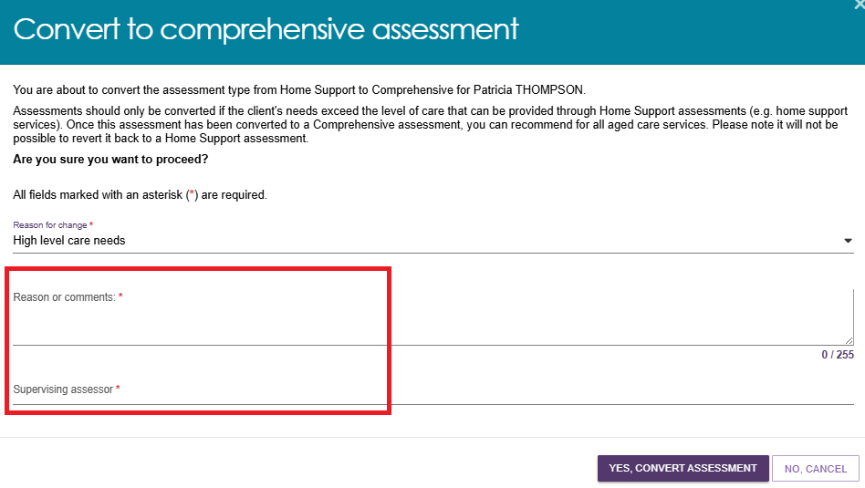
- Once completed, select YES, CONVERT ASSESSMENT to continue. Once you convert to a comprehensive assessment you cannot change it back to a home support assessment. The assessment type will now reflect as Comprehensive Assessment.
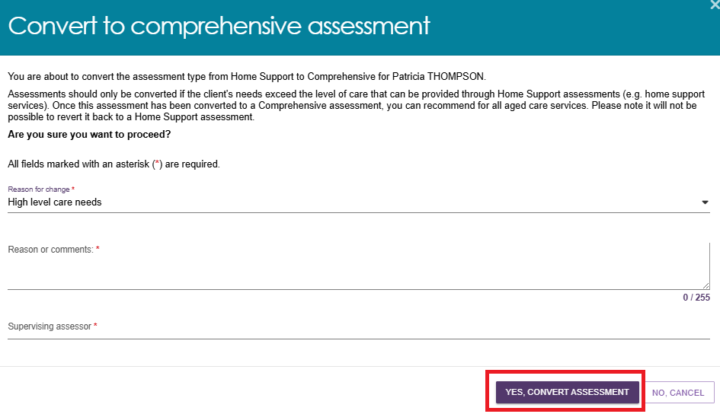
- The assessment type will now reflect a Comprehensive Assessment. When you are ready to start the assessment, select START ASSESSMENT.
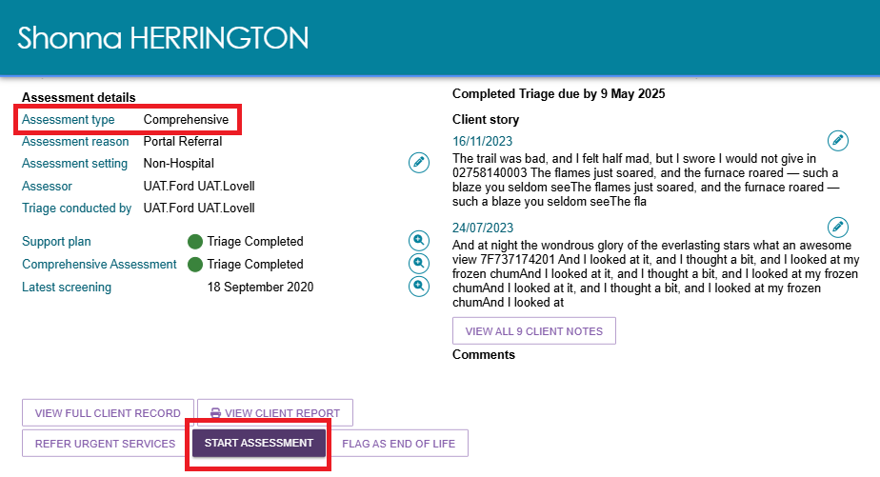
- You will then be asked to record client consent.
To do this, you will be required to read the relevant consent script, which is in the My Aged Care Assessment Consent Form, to the individual and record their response.
If there is a suggestion that the client lacks capacity for consent, complete this form with the client’s confirmed supporter-guardian in My Aged Care. The My Aged Care Assessment Consent Form is available for download from the Reports & Documents tile of the assessor portal.
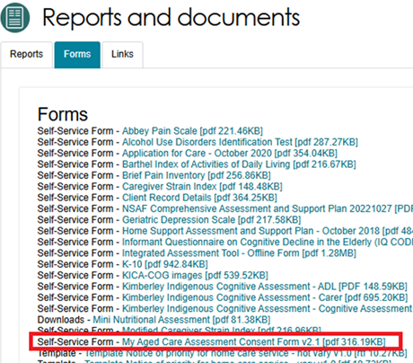
- If consent is given, select the applicable consent options and then select CONTINUE. A signed copy of the Aged Care Assessment Consent form should be obtained during this step.
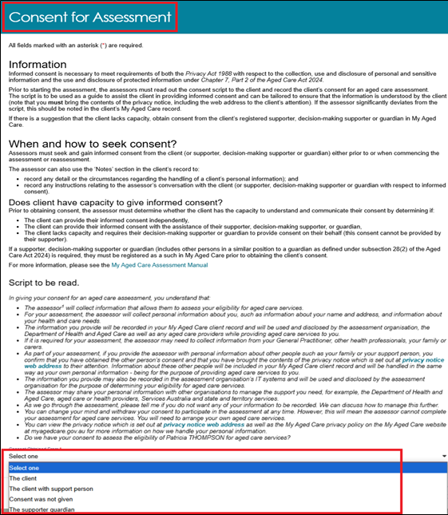
! | If a client does not provide consent, a warning message will display advising assessors that the assessment cannot proceed.  If this is the case, you must enter a reason as to why the assessment could not be completed. If the response is Other, please specify you will be required to enter free text.  Selecting SAVE AND CLOSE will then cancel the assessment.  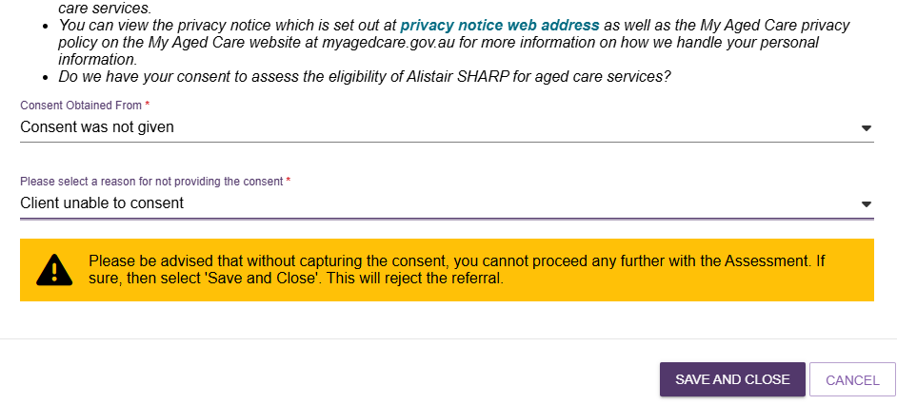
- Before you start the assessment, you will be given the option to Pre-populate the IAT.
For new clients who have not undertaken screening or have a previous assessment, you will have the option to pre-populate the IAT with their information from triage only.
If the client has undergone screening, you can also select to pre-populate the IAT with their previous screening. Similarly, if the client has had a previous assessment you can select to pre-populate the IAT using that information.
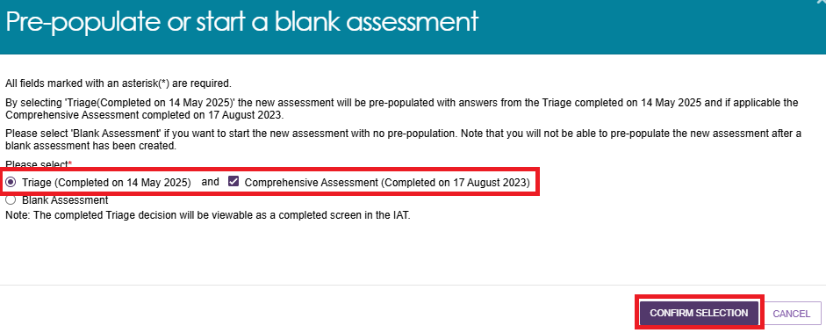
- Once you have selected the relevant pre-population options, select CONFIRM SELECTION. If you do not wish to pre-populate the IAT select Blank Assessment.
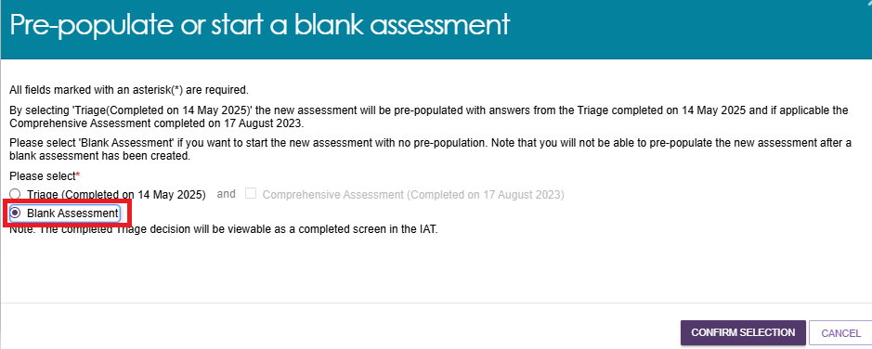
! | If you select Blank Assessment, you cannot reverse this decision during the assessment.
- You will then be prompted to review and update information regarding the client’s Demographic details, including whether this is a remote assessment, the client’s personal details and background, if the client would prefer a First Nations Assessment Organisation for their assessment (if available) and any Government ID references such as the client’s Medicare card number.
These details will be pre-populated from triage but can be edited if required.
After confirming the correct details are entered, select SAVE AND CONTINUE TO ASSESSMENT.
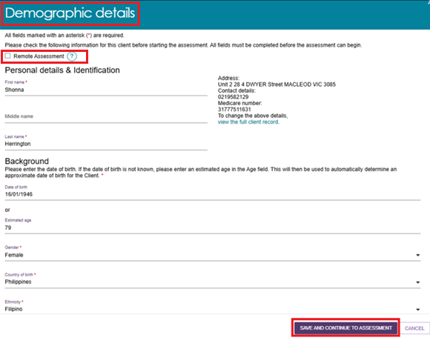
! | It is important to ensure that the client’s Aboriginal or Torres Strait Islander identity is accurately captured, as this will trigger the system to display Validated Assessment Tools that are appropriate to use with First Nations people if required.  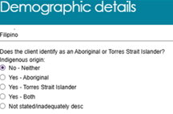  A client’s Medicare card number must be correctly entered to ensure that their My Health Record can be successfully linked if they consent to do so.  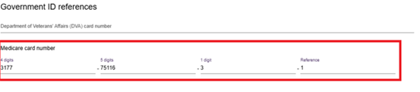
! | Remote assessment should be selected when an assessment is conducted in a remote area. This is to help improve reporting and inform future decision making in consideration of this client demographic. Geographical remoteness is defined using the Modified Monash Model (MMM). Based on this, remote assessments should only be selected where a face-to-face assessment is undertaken in a remote (MM6) or very remote (MM7) area. You can check the MMM classification of a client’s address on the Health Workforce Locator. From the homepage select Start the locator now and enter the client’s address. The MM will then be displayed in the Summary section.  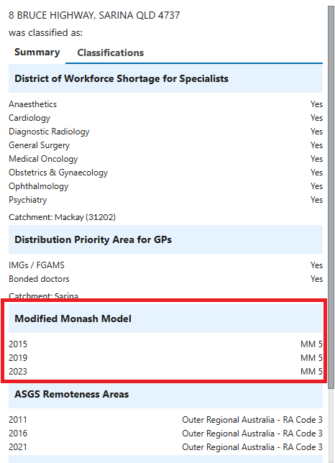
- If an assessor needs to update a client’s demographic details after they have commenced the assessment, they can do so from the CLIENT DETAILS tab of the Client Record by navigating through the FIND A CLIENT tile from the homepage.
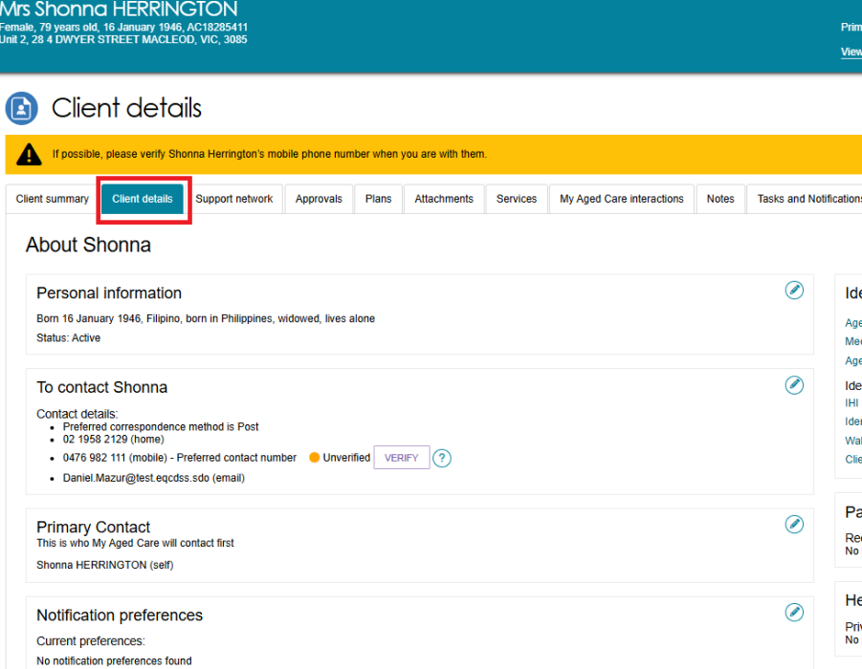
- A record of any previous screenings or assessments will be accessible through the PLANS tab of the client record under ASSESSMENT HISTORY.
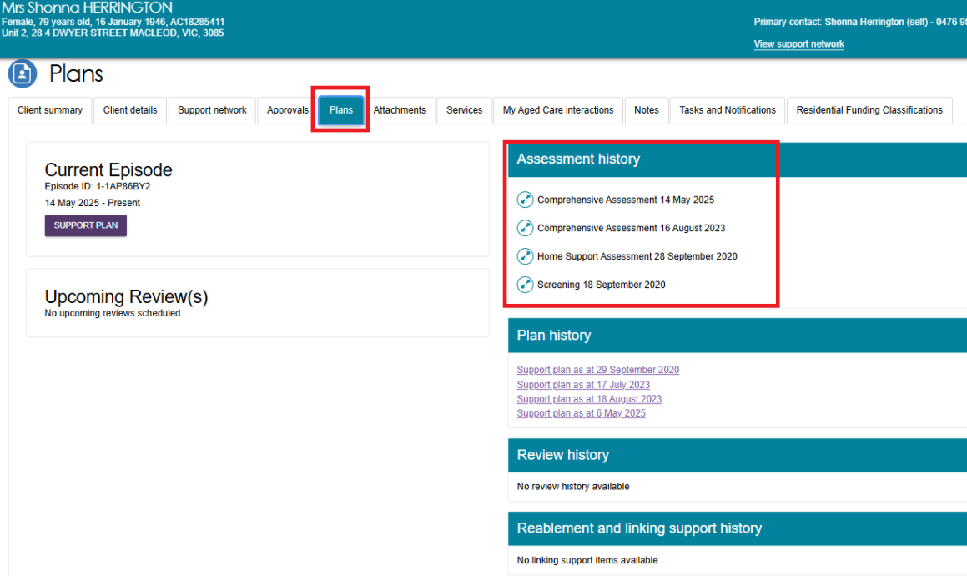

Completing an assessment
! | The IAT contains an algorithm to ensure consistent client outcomes based on their needs. The algorithm will draw on assessment responses and the client's current care approvals and recommend an aged care service. This will display in the SUPPORT PLAN AND SERVICES PAGE under the GOALS AND RECOMMENDATIONS tab after an assessor finalises the IAT.
- Once you have commenced an assessment, the ASSESSMENT DETAILS page will display. Key client information will be displayed at the top of each page of the assessment.
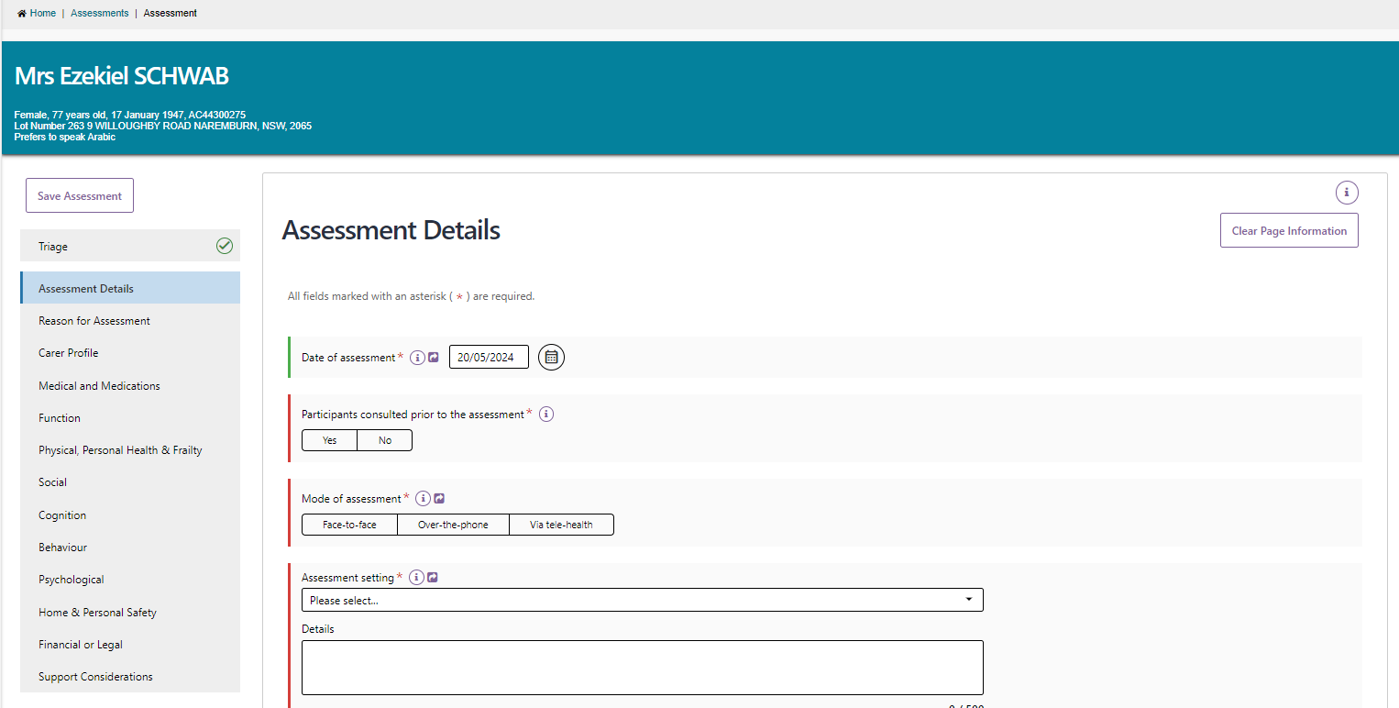
- To view information that was collected during triage, you can select TRIAGE from the navigation bar. This will open a read-only screen for viewing.
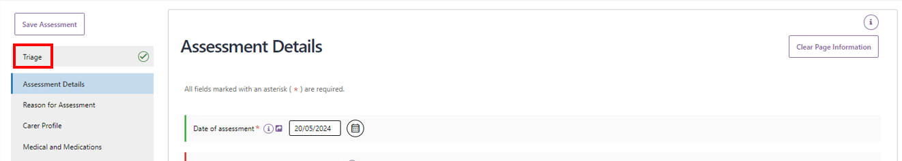
- The navigation bar will move up and down the page as you scroll. A tick will display in the navigation bar to confirm completion.
! | The system will time out due to inactivity if unused for a period to maintain the privacy of the information in the system. A warning banner will display if the session has been left unattended for 25 minutes. If the system remains inactive for a following 5 minutes you will automatically be logged out and will need to log in again to restart the assessment.

Assessment features
- On each page of the assessment, you can clear entered information. This can be done by selecting the Clear Page Information on the top left-hand side.
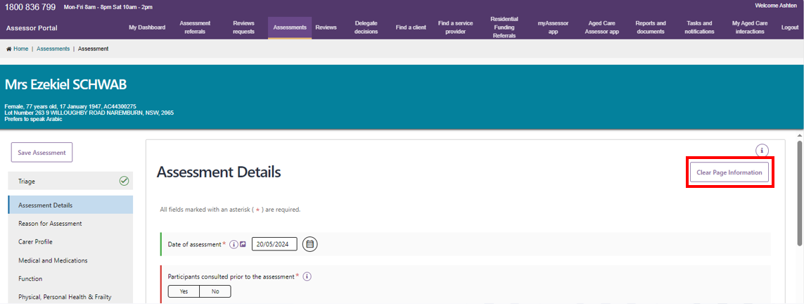
- A pop-up will then display. Select Yes, clear page information.
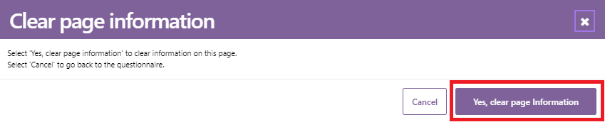
! | Pages that do not contain Validated Assessment Tool triggering questions will only have the option to Yes, clear page and cancel. However, pages with Validated Assessment Tools trigger questions, will have a fourth option to Clear all.  Selecting Clear page will trigger an in-action symbol which demonstrates that the clearing is in progress. Selecting Clear page information will also remove the check box that triggers the display of Validated Assessment Tools.  If an assessor wants to clear the information relating to the Validated Assessment Tools, they can select Clear all or navigate to the page the Tool is on and select Clear page information.
- There are visual cues to assist with completing the form. When mandatory questions have not been answered, a red line is displayed on the left of the field. When the mandatory questions are answered, this line turns green.
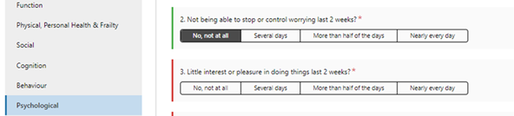

- Some questions will require additional mandatory details depending on the answer. In these cases, an asterisk will appear next to the details section to indicate that it is now mandatory to complete.
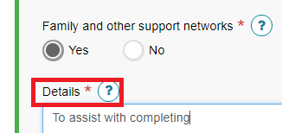
- Additional questions may also display if triggered by an answer given to a base IAT question. These questions are used to capture additional information about the client’s needs as indicated by the answer given within the base questions.

Clinical attendance (for non-clinical assessors)
- Threshold questions are also used throughout the IAT to trigger moving the assessment into clinical/comprehensive areas. These questions are identified by a blue banner. For example, if you answer No to the question ‘is the client managing urinary incontinence issue?’ then additional questions will be displayed that require clinical attendance to complete.
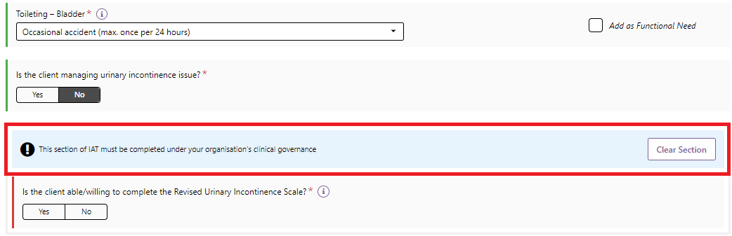
- For non-clinical assessors, these questions can only be completed under the clinical attendance process which is supported by an assessment organisation’s clinical governance framework. To proceed in answering these questions, the clinical supervisors (clinical assessor) details, who has provided clinical attendance, must be selected from the drop-down menu and SAVE DETAILS selected.
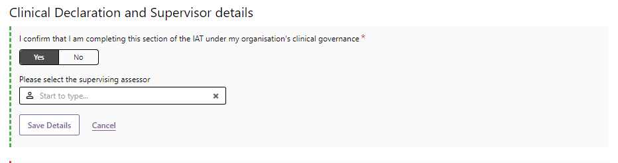
- Once the details have been saved, they will display in the IAT, and the non-clinical assessor can proceed with clinical supervision.
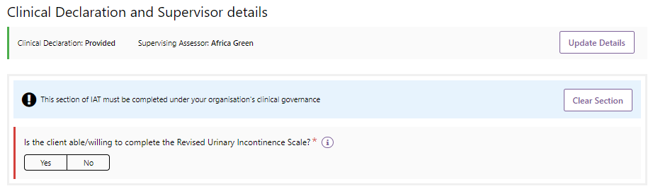
- View on-screen help text for each question by selecting the Information icon next to the question. Help text can be moved around the screen by dragging the text with the cursor and will remain visible until the X is selected, or a new help text box is opened.
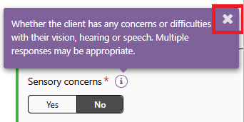
- A mandatory confirmation box must be completed at the bottom of each section, then you can navigate to the next assessment page by selecting the NEXT button at the bottom right-hand corner or by selecting the relevant section from the navigation bar. Assessment information will also be saved.
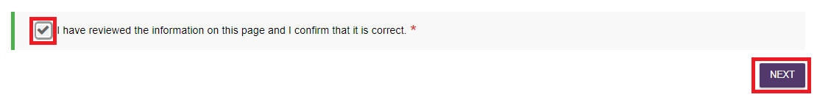
- When all mandatory questions (marked with an asterisk and red line) on a page have been completed, a green tick will appear on the navigation bar.
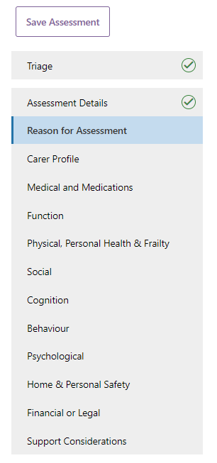
- In the Medical and Medications section you can enter health conditions into the assessment by name or code.
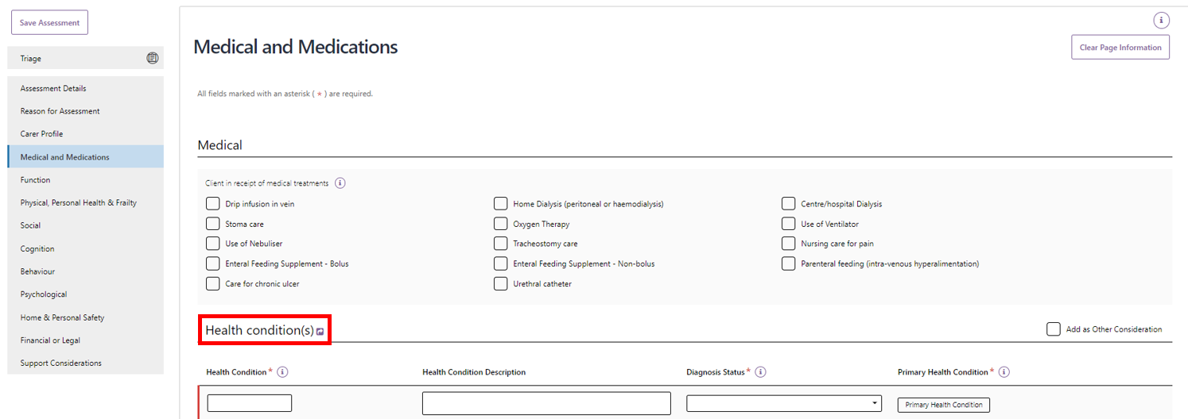
A maximum of ten health conditions can be added for each assessment. Start typing into the free text field to display health condition options.
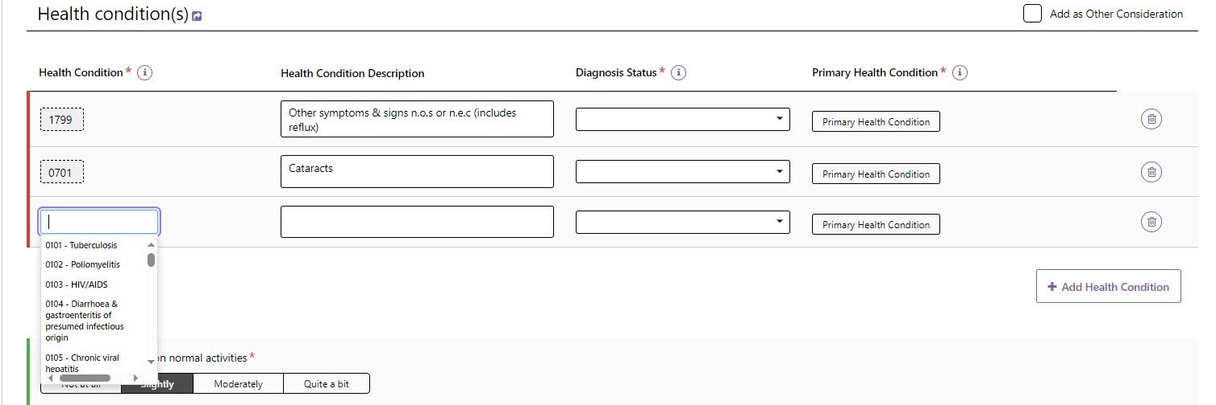
Once you select a health condition, the description can be edited specific to the client’s health condition and select the appropriate Diagnosis Status option.
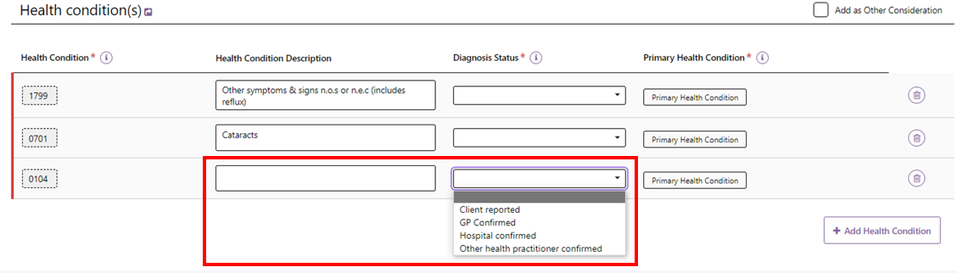
Additional health conditions can be added by selecting + Add Health Condition or removed by selecting the bin icon.
Assessors can also indicate whether the health condition is the Primary Health Condition, or whether to as an Other Consideration in the client’s Support Plan.
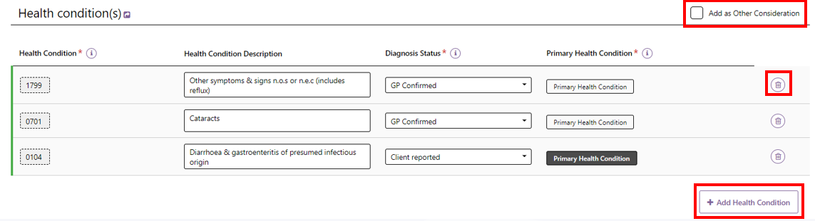
- When completing the assessment, assessors will be able to select to Add as Functional Need, Add as Complexity Indicator, Add as Other Considerations and Add as recommendation.
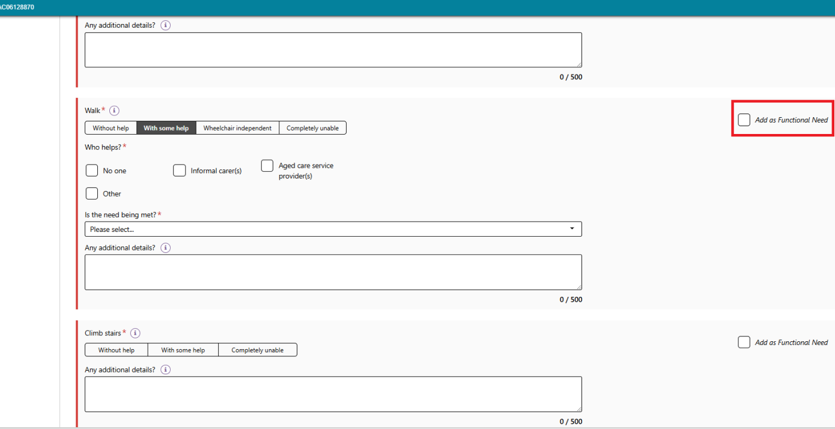
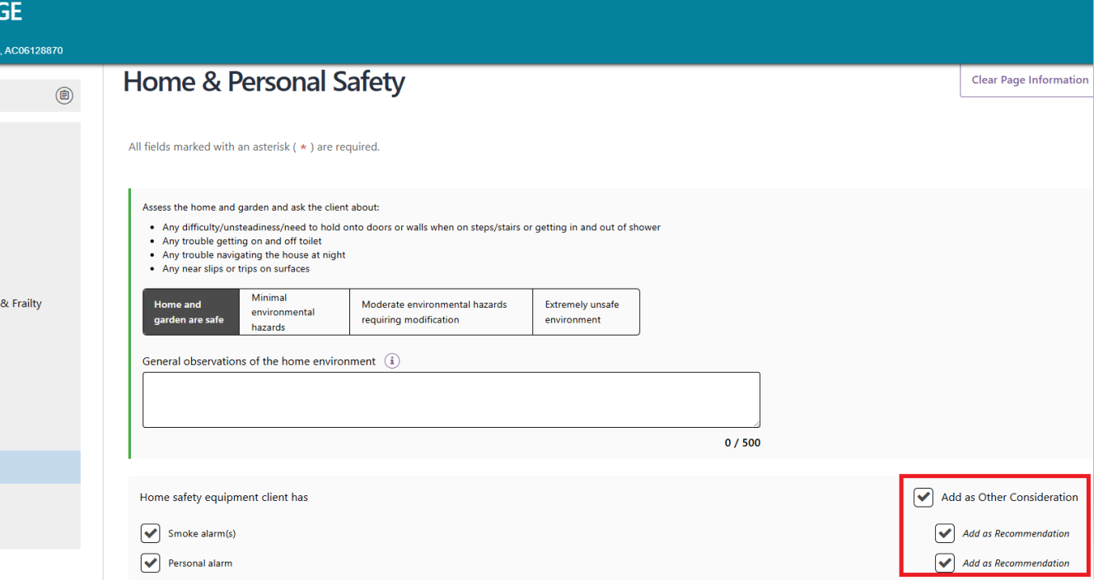
- Upon selecting the checkbox, the Needs will appear on the Identified needs tab of the Support Plan. Recommendations will appear in the Goals & recommendations tab.
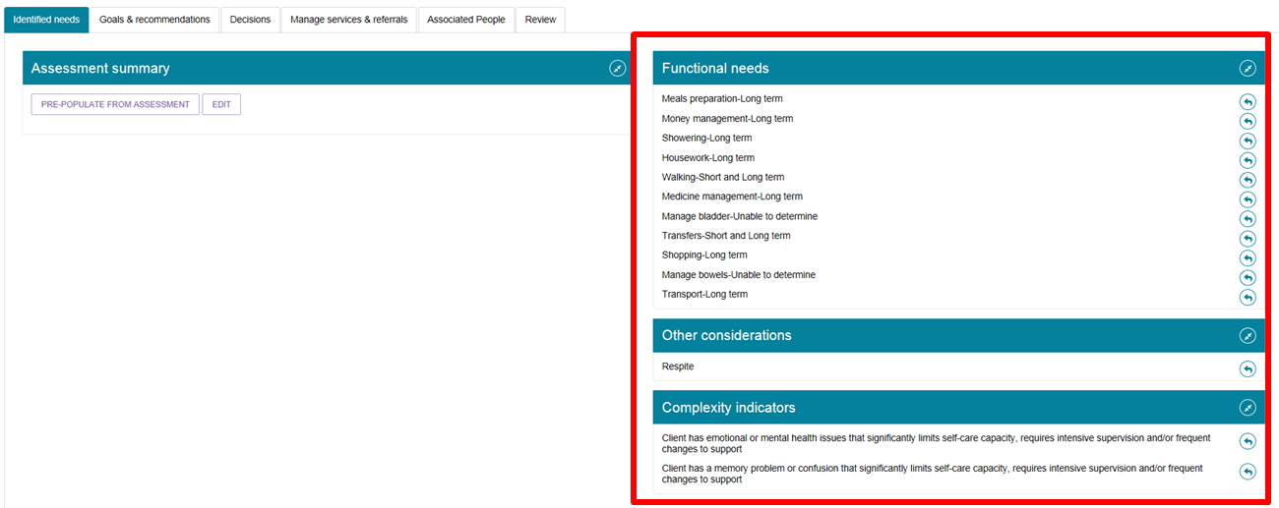

Viewing and adding carers in the assessment
You can view and add information about carers from the assessment, without having to navigate back to the client record.
- Select the Carer Profile section of the assessment from the navigation menu and then select View/add carers.
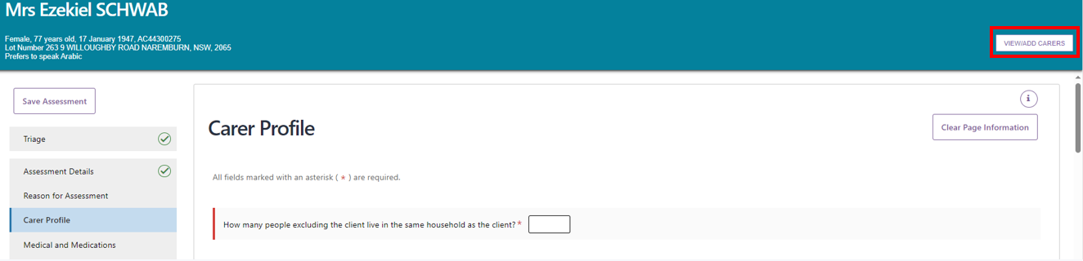
- A pop-up box will display. Any carers that are already associated with the client will be displayed. If you want to add a new carer select ADD A CARER.
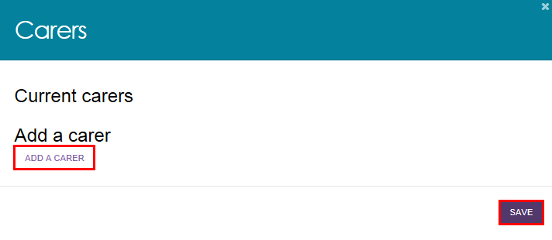
- Enter the first and last name of the person and select Search. You can search with more details by selecting Show more search fields and populating the appropriate fields.
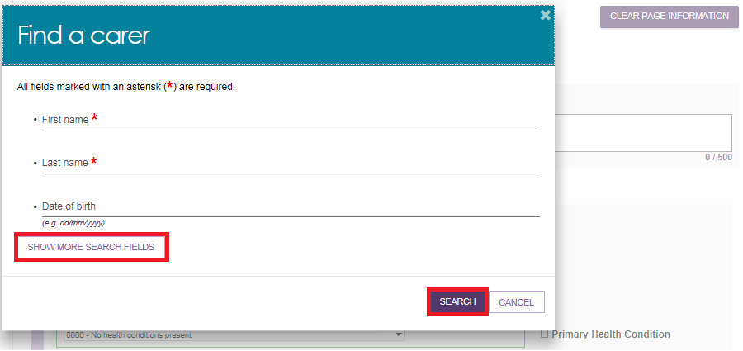
- If there is already a record for the person, they will be displayed in matching results. By selecting the radio button next to the person’s name, it will open more fields including both client and carer consent to the relationship, and the relationship of the user to the client. Select ADD.
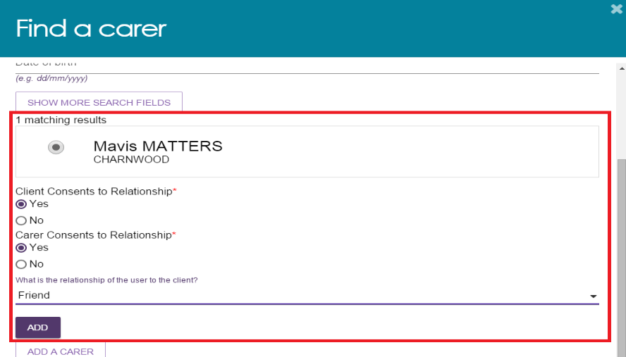
- You will receive a confirmation message on screen, notifying that You have successfully added a Carer. Select SAVE to save changes.
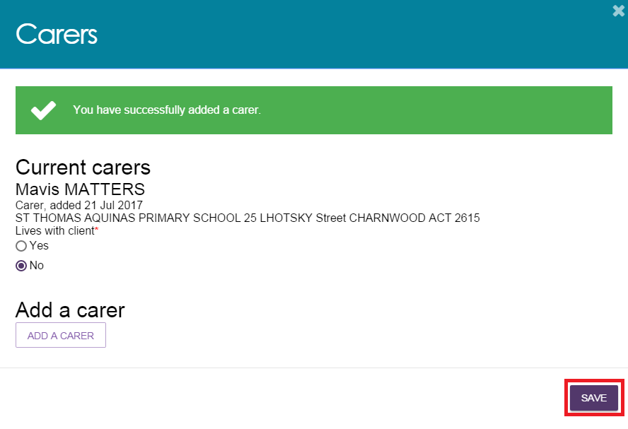
- If there are no results, or you want to add a different carer, select ADD A CARER.
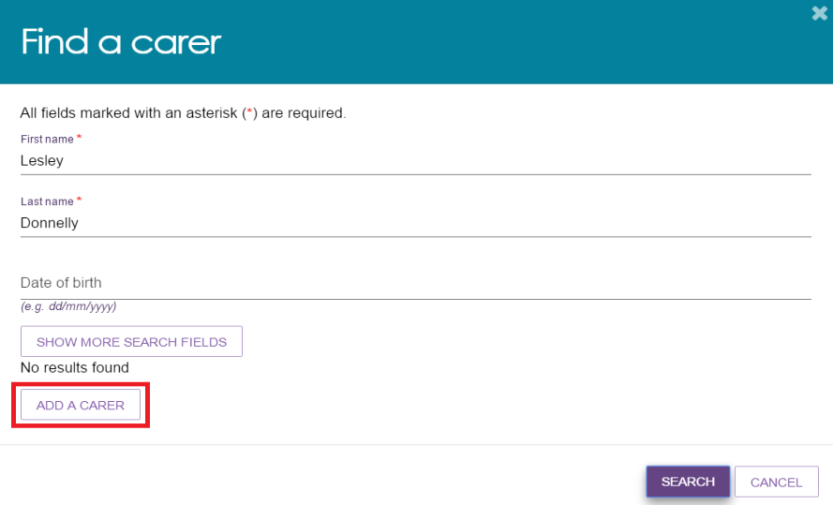
- Enter mandatory information about the person, including consent for the relationship from both the client and the carer. Select SAVE.
! | The consent for registration during this stage is solely to create the client-carer relationship within the My Aged Care system. By creating this relationship, the carer will display in the client’s support network and also appear as an option to be added to the client’s support plan at a later stage. Consent will be sought for any changes to this carer relationship throughout the process. For information on how to capture a client and carer’s consent for call-backs from the Carer Gateway and/or National Dementia Helpline, go to Assessor Portal User Guide 2 – Registering support people and adding relationships.  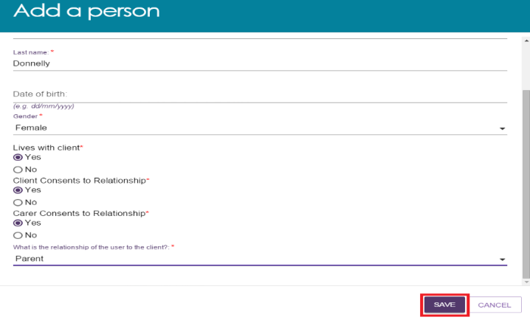
- You will receive a confirmation message on the screen, notifying that You have successfully added a Carer. Select SAVE to save changes.
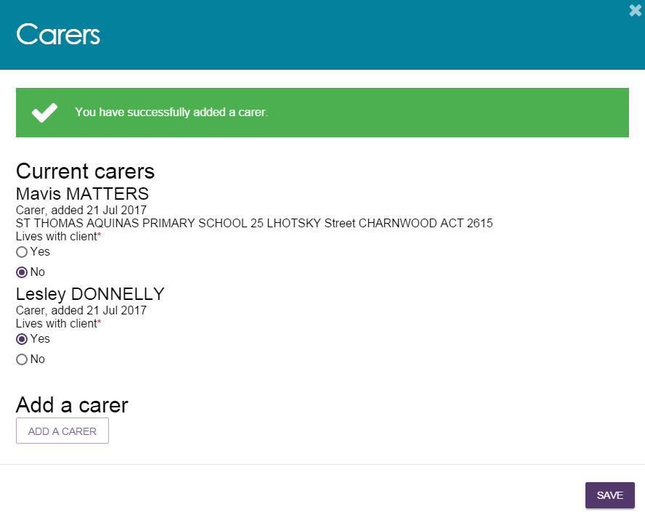

Adding a Sensitive Attachment in the assessment
Assessors can add attachments for client information of a sensitive nature as part of the assessment.
- To download the Sensitive Attachment form from the assessment, select Download Sensitive Attachment Form on the Support Considerations page.
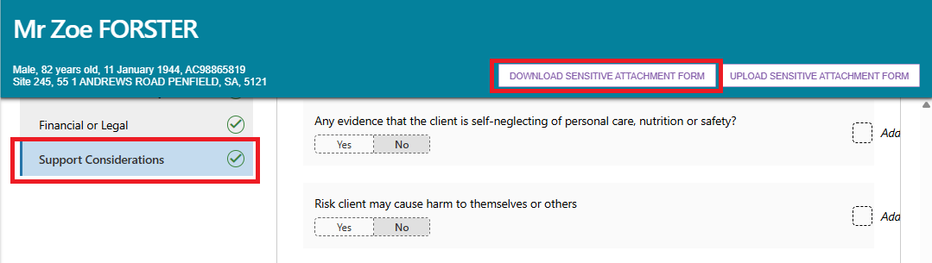
- The Sensitive Attachment form can also be downloaded from the FORMS tab in the REPORTS AND DOCUMENTS section of the portal.
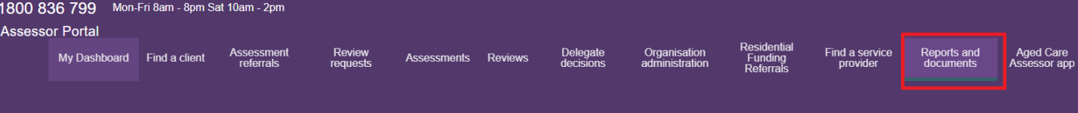
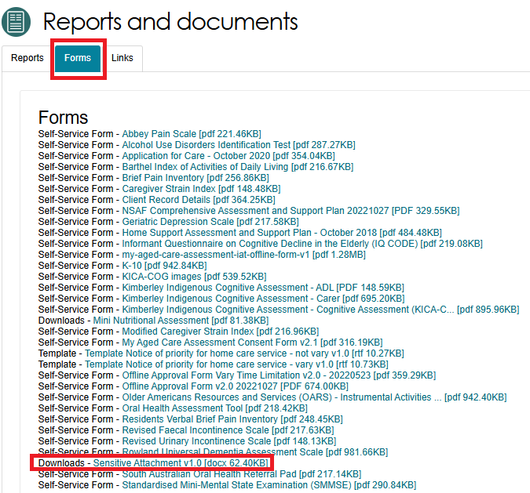
Once downloaded, the Sensitive Attachment form will display.
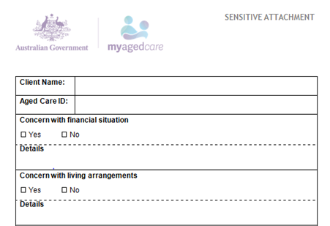
- When you have completed the form, select Upload Sensitive Attachment Form from the Support Considerations page. Alternatively you can attach it in the Attachments page via Add An Attachment.
Support Considerations page of the IAT assessment
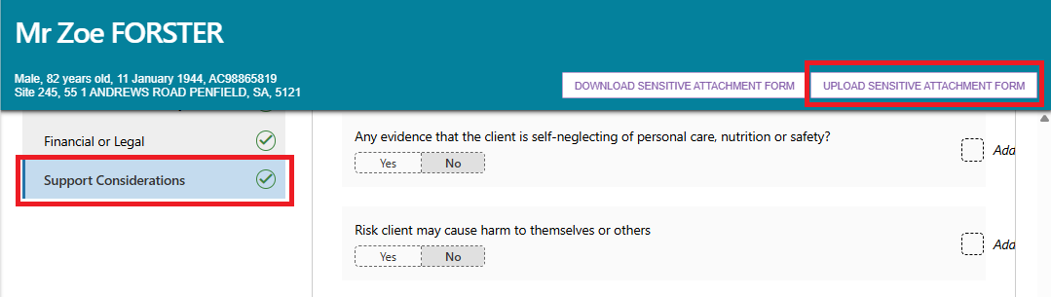
Attachments Page
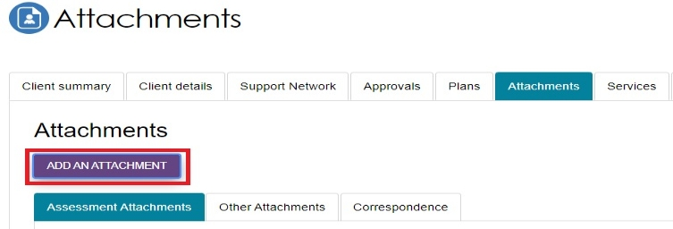
- The Upload sensitive attachment pop up, or the Add an attachment pop up, appears. You will be prompted to enter information relating to the Sensitive Attachment. For the Add an attachment pop up, select the attachment type: ‘Sensitive attachment’ or Sensitive client status’.
Once you have entered this information select Upload.
Upload sensitive attachment pop up
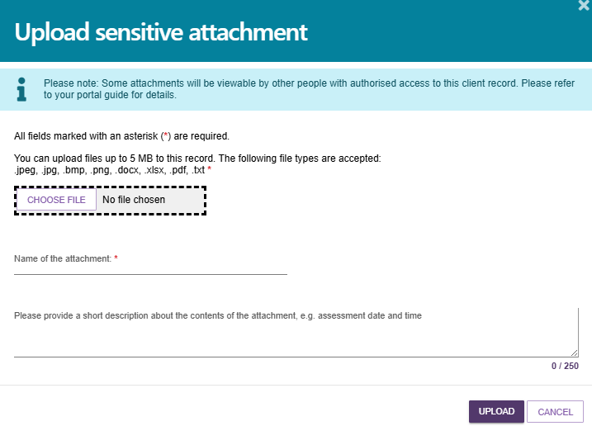
Add an attachment pop up with the Type Of Attachment drop down expanded
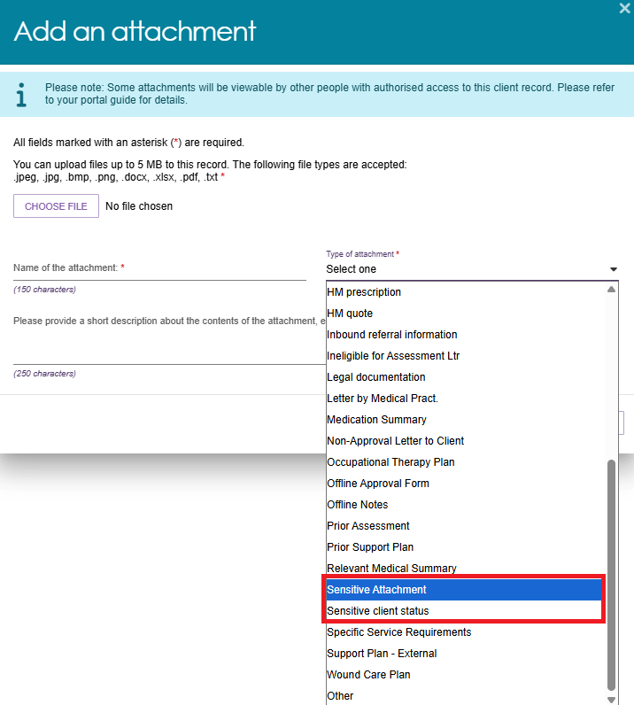
- Once successfully uploaded, a green banner will display at the bottom of the screen.
- The Sensitive Attachment will then appear under OTHER ATTACHMENTS tab on the ATTACHMENTS screens of the Client record.
There will also be ‘Sensitive attachment’ text underneath the client’s personal details.
Select HIDE FROM VIEW if you do not want to display the sensitive attachment file and details in the Attachments page.
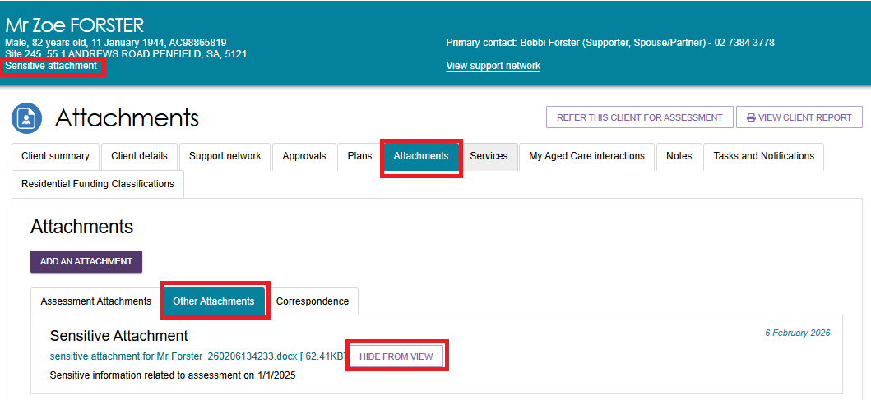
! | If you have added a Sensitive Attachment as part of the assessment, you should record this in the Support Considerations page. Sensitive attachments will not display to providers or to clients viewing their information through the My Aged Care online account. The My Aged Care contact centre and assessors will be able to view this attachment. Service providers who have accepted a client’s referral will receive an alert notifying them that sensitive information is available and are advised to contact the client’s assessor or My Aged Care contact centre to access this information.  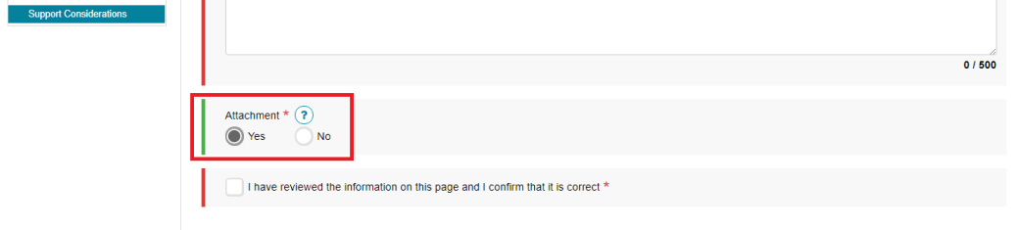

Navigating the Validated Assessment Tools
- There are a range of Validated Assessment Tools (VATs) available for assessors to help support a client assessment. A number of these are either embedded within the IAT itself or are available as prompts to be utilised as needed. For example, the Duke Social Support Index is incorporated in the IAT under the Social section.
Social section of the IAT
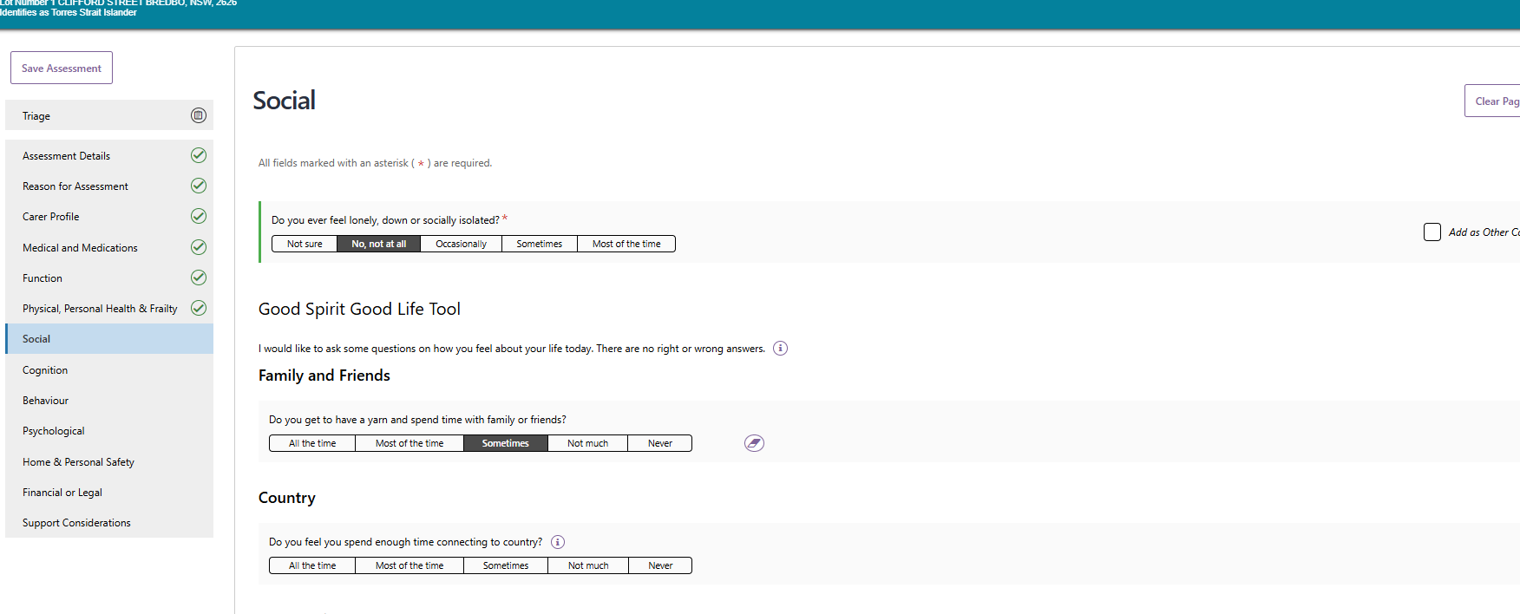
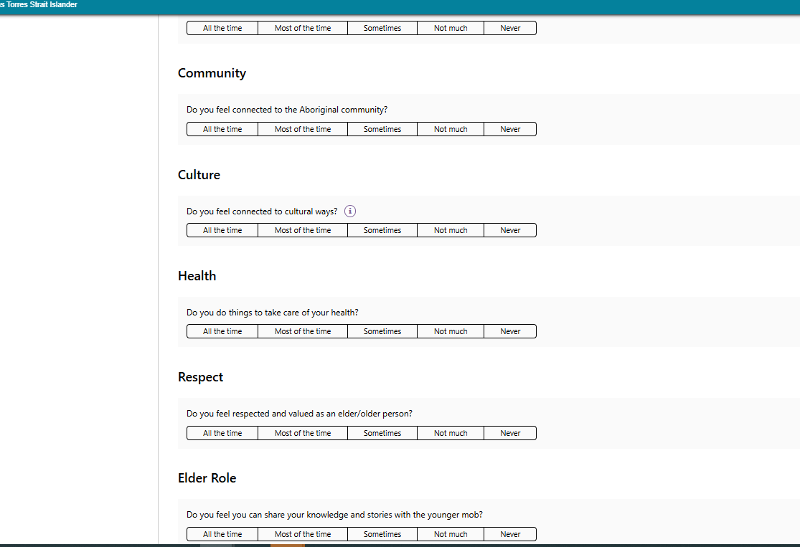
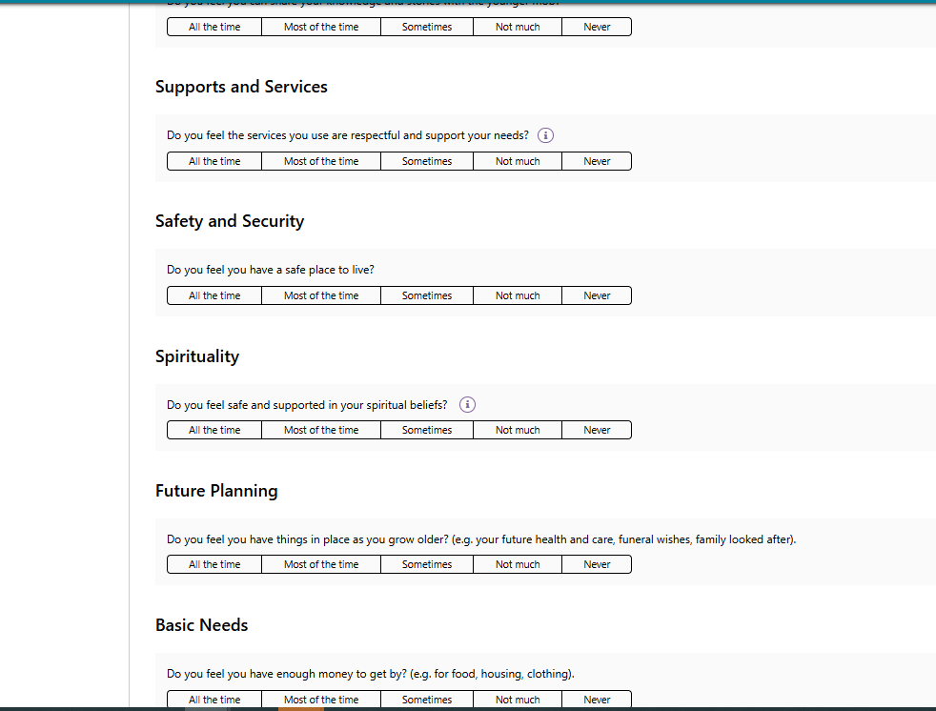
Duke Social Support Index
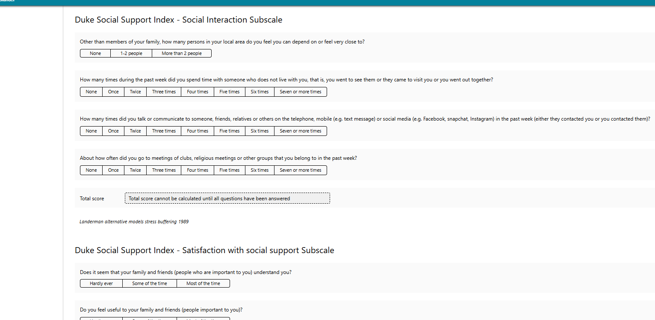
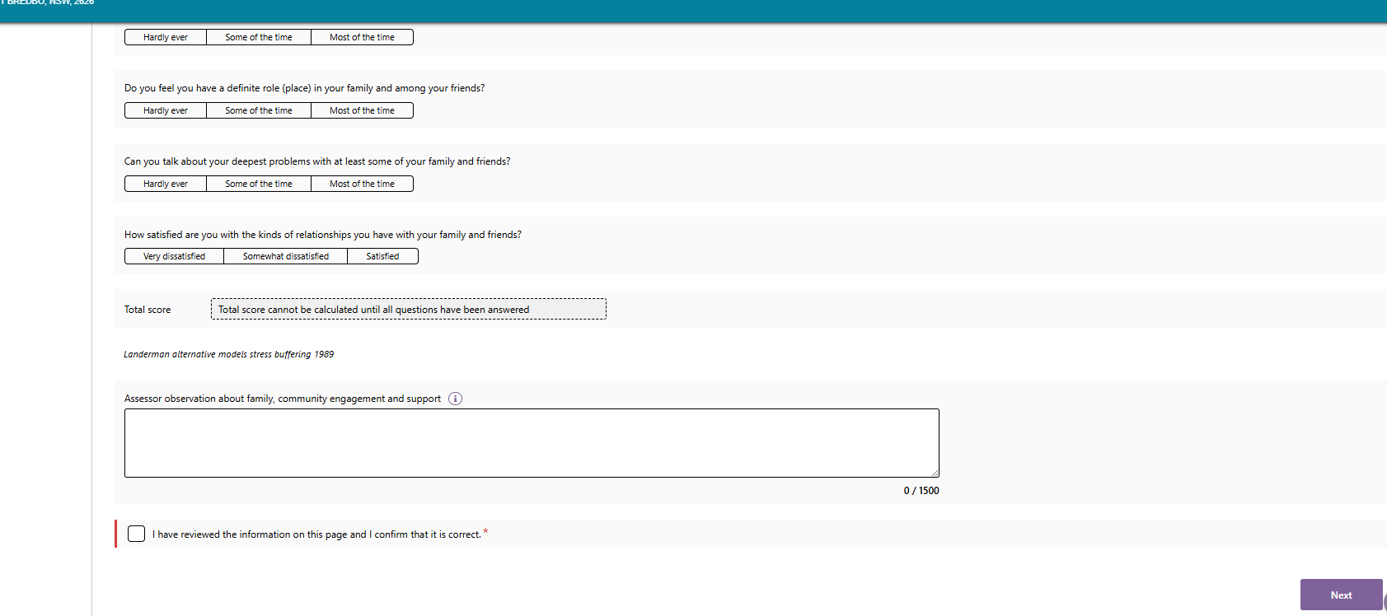
- Other Validated Assessment Tools within the IAT will only display if required and agreed to by the client. For example, the Step 1 GP Cog tool is available under the Cognition section of IAT assessment.
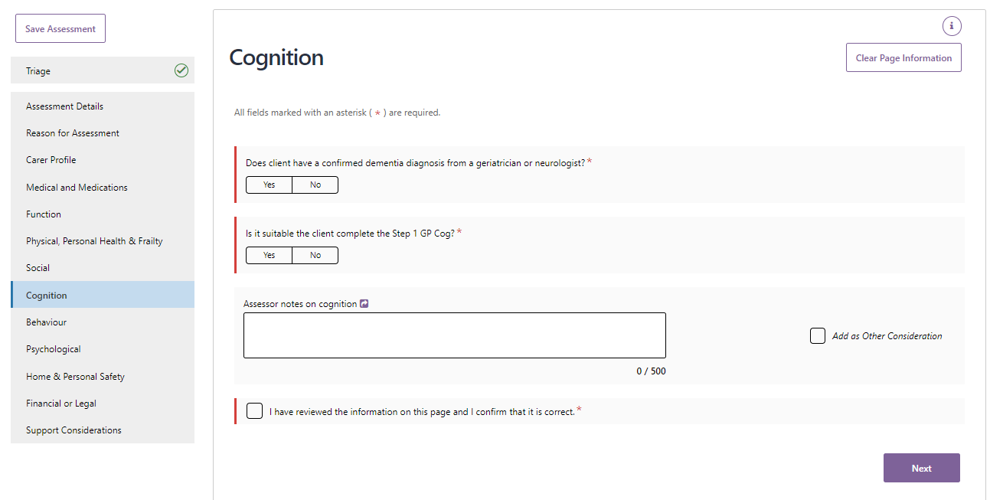
If the answer is YES to the question “Is it suitable the client complete the Step 1 GP Cog?” another set of questions will then be displayed as shown in the example below.
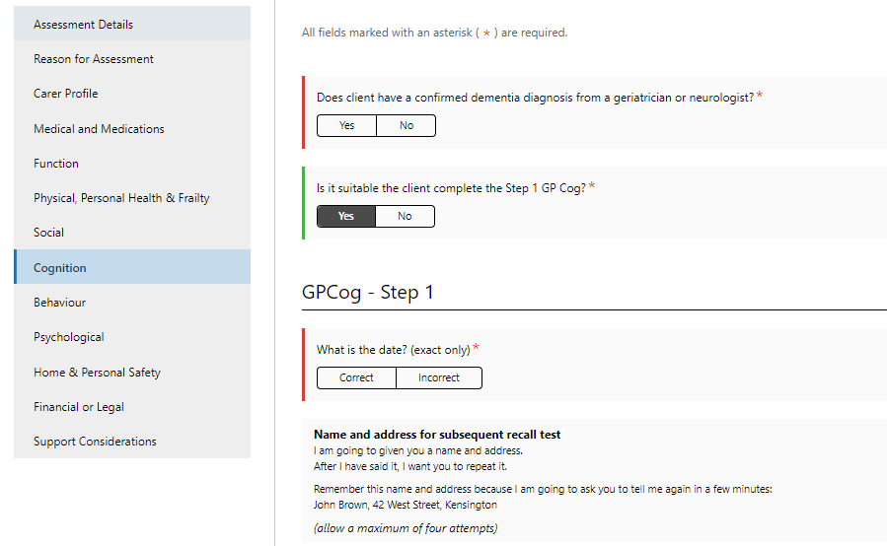
- The total score for these validated assessment tools will be auto generated based on the client’s answers. Use of validated assessment tools that are not included in IAT is at the discretion of the assessment organisation. If used, you can upload the completed tools as attachments to the client record. Blank versions of these tools are available in the Reports and Documents section in the assessor portal.
- The eraser button can be used to clear the responses of Validated Assessment Tools if required.

Modified de Morton Mobility Index (DEMMI) and Residential Respite Care (Clinical assessor)
The IAT includes a validated assessment tool called the DEMMI-Modified, that may only be used by clinical assessors in a face-to-face setting when assessing individuals’ care needs for residential respite services.
Non-clinical assessors should not complete the DEMMI-Modified tool even with clinical attendance. The responses captured as part of the Modified de Morton Mobility Index (DEMMI) tool becomes part of the Australian National Aged Care Classification (AN-ACC) initiative.
- Under the Function section of the IAT, clinical assessors will be asked Are you likely to recommend residential respite care? Answer Yes or No.
If you answer Yes to this question, you will be prompted with a new question: De Morton Mobility Index? Answer Yes or No.
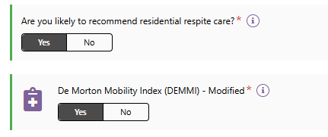
- If you are a clinical assessor and answer Yes to the above question, you must complete the DEMMI assessment tool.
The De Morton Mobility Index (DEMMI) Modified will appear in the navigation bar below the Function section.
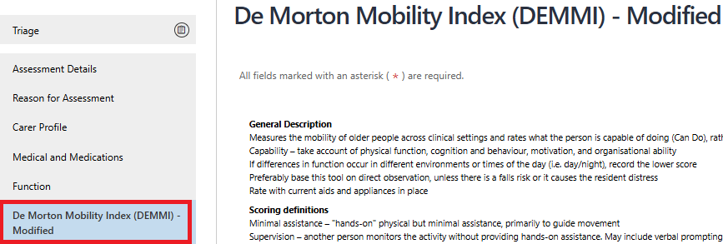
- Work through the questions associated with the 4 sections of the DEMMI-Modified as listed below by selecting the radio box that most reflects the client's mobility:
- Bed;
- Chair;
- Static balance – no gait aid; and
- Walking.
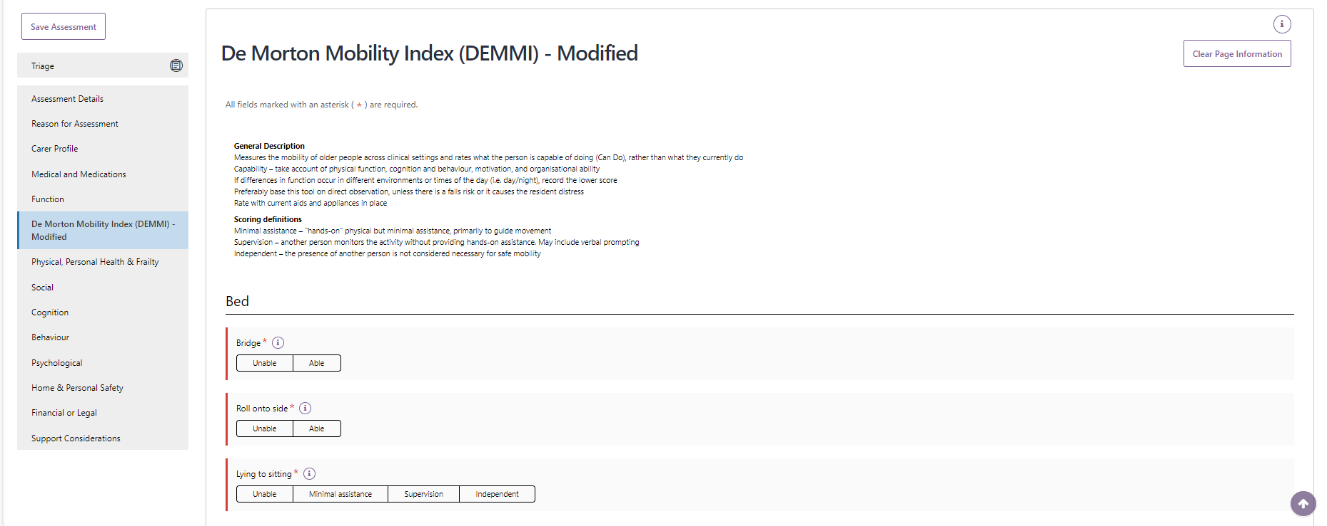
- Once you have completed the required sections select NEXT.
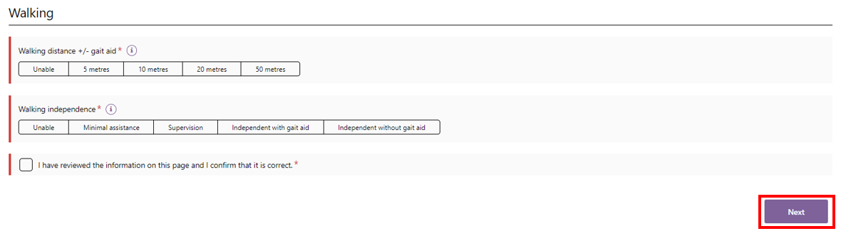
- You should then progress with completing the assessment and submitting your recommendation for residential respite care for Delegate approval.
If the Modified DEMMI has not been completed and Residential Respite Care is recommended, you will be prompted that you will need to tick a declaration and to add a reason for not completing the Modified DEMMI.
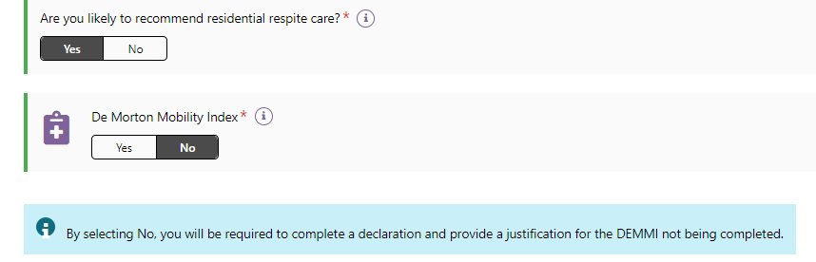
- This screenshot shows the declaration and the text field for not completing the DEMMI in the ADD CARE TYPE FOR DELEGATE DECISION pop up.
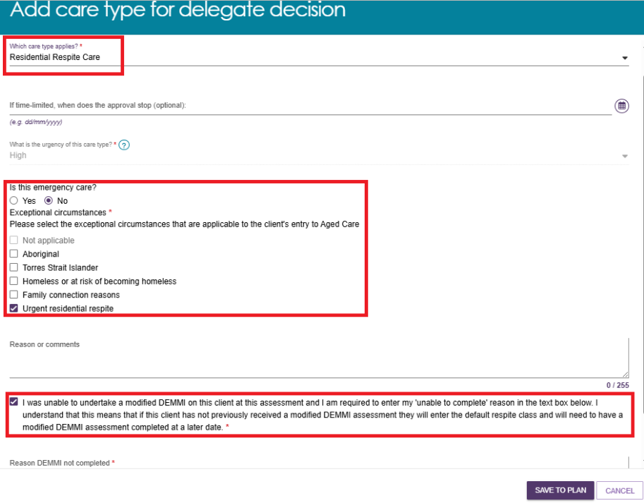

Saving an assessment
- If you have not finished completing the assessment and want to complete it later, you can select Save Assessment.
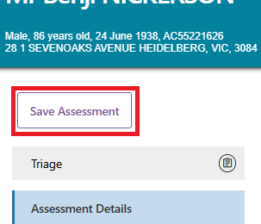
- A green banner will then display at the bottom of your screen advising of the successful save.
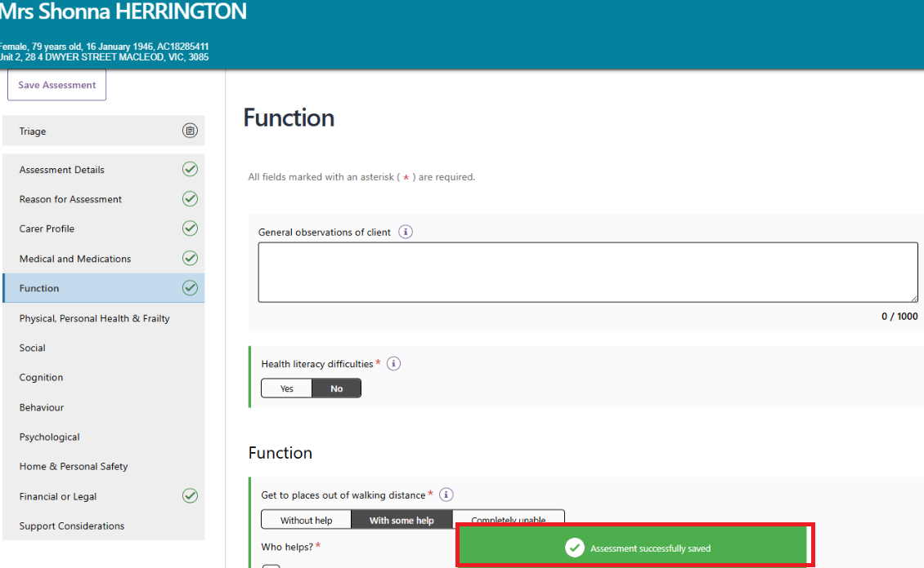
- You can then continue completing the assessment with the client at another time. You can also select SAVE QUESTIONNAIRE AND CONTINUE TO SUPPORT PLAN down the bottom of the assessment if you wish to navigate to the support plan but are not yet finished with the assessment.
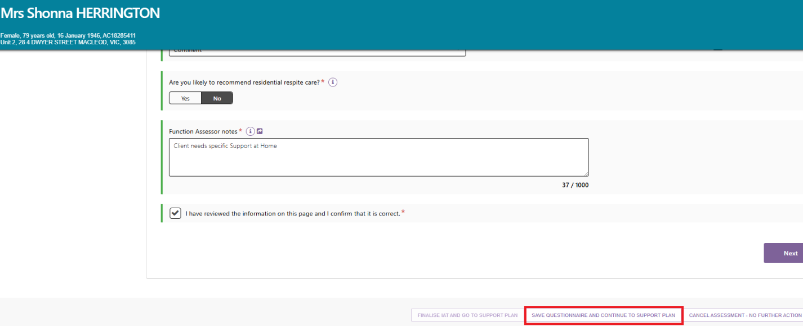
- The record will appear under Assessment In progress in your Current assessments tab. To prevent any potential loss of information captured during the assessment, or when the portal is idle, the assessment will auto-save regularly.
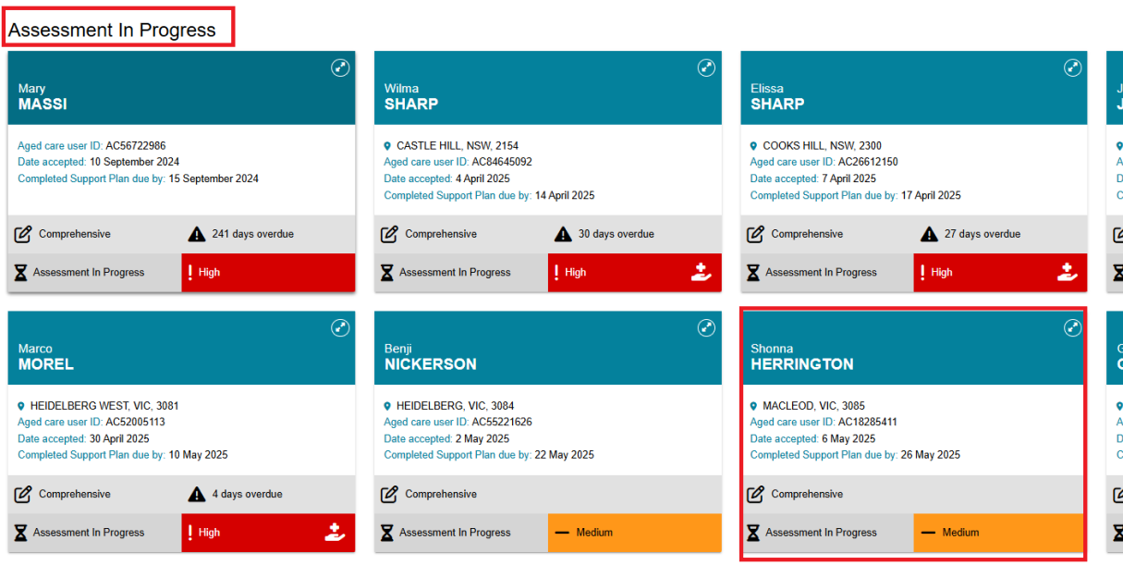

Finalising an assessment
- Once you have completed the assessment, select FINALISE IAT AND GO TO SUPPORT PLAN.
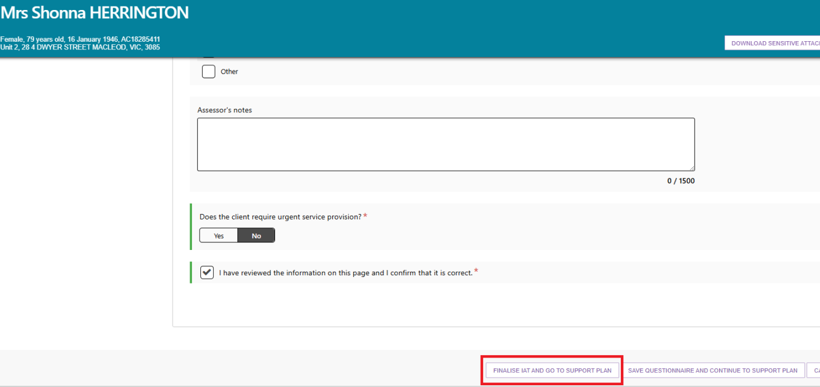
- A pop-up will then display asking for consent to share their support plan via their My Health Record.
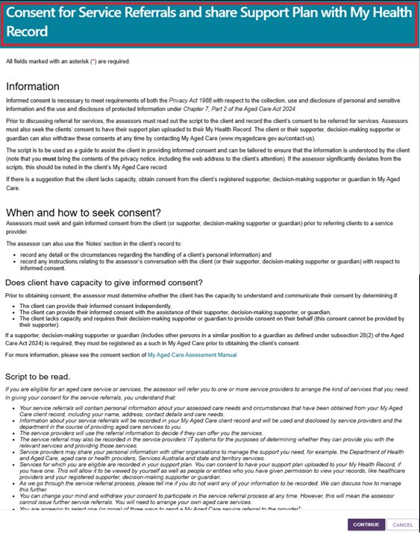
! | A client can withdraw their consent at any time by calling the My Aged Care Contact Centre on 1800 200 422. A client’s consent can also be updated by an assessor via the Client details tab in the client record. For more information regarding this please refer to the My Aged Care – Assessor Portal User Guide 4 – Navigating and updating the client.
- After reading the Consent to Service Referrals information to the client or their supporter, select the applicable consent option based on their consent decision.
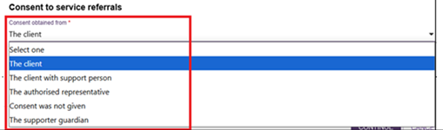
- If consent is provided select Yes and then select CONTINUE.
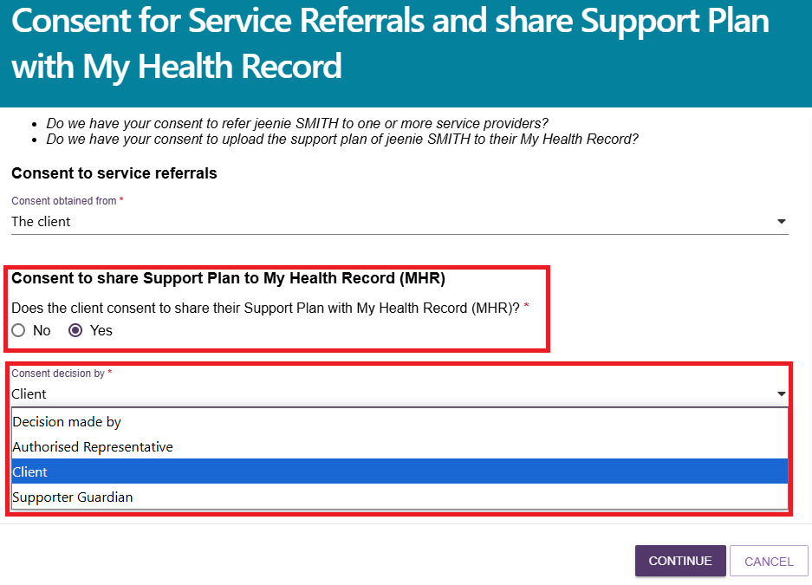
If consent has not been provided, select No. You will then be required to select a reason for the decision not to provide consent from the drop-down menu. Next, select CONTINUE.
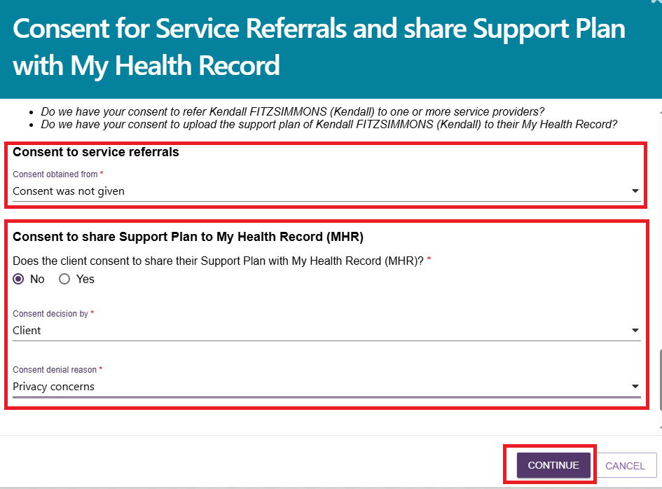
- If the consent decision has been made by a Supporter guardian, then the Supporter guardian’s first name must be entered before selecting CONTINUE.
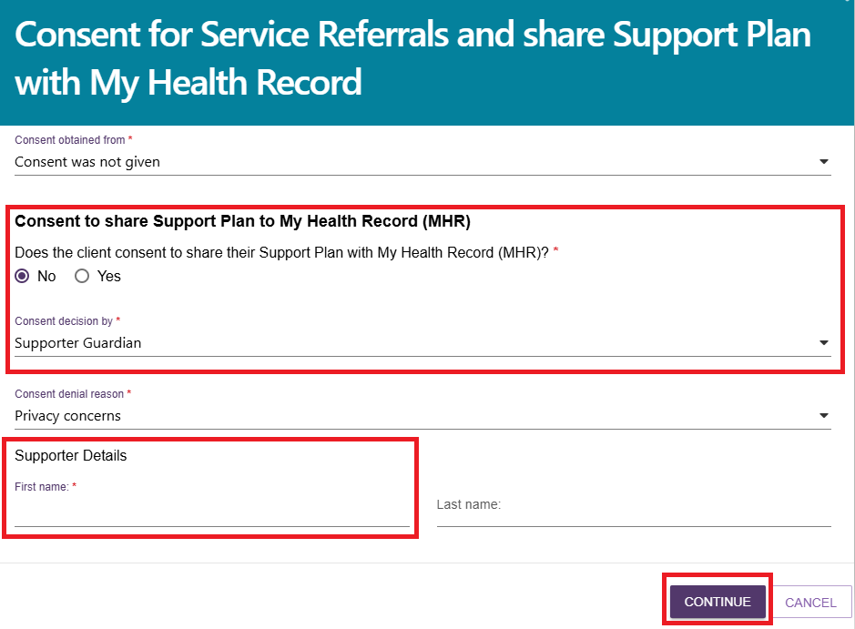
- Another pop-up will then display. Select FINALISE IAT to complete the assessment.
! | Once the IAT has been finalised it cannot be edited. Therefore, it is important to ensure all information has been correctly captured before selecting FINALISE IAT.
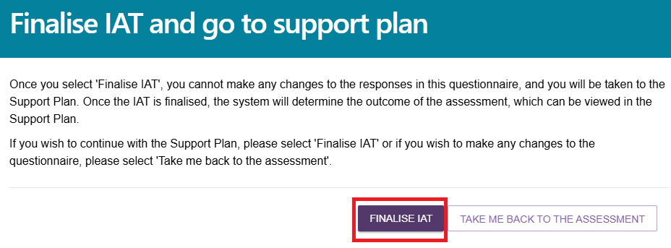
- A green banner “Consents for Service Referrals and My Health Record were updated successfully” will appear at the bottom of the screen confirming that the save was successful.
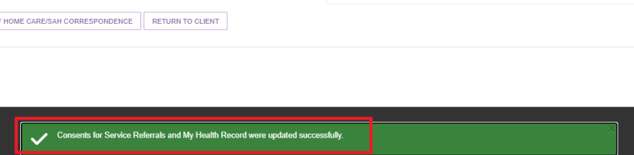

- You will then be re-directed to the client’s Support plan and services page to complete the client’s support plan. If the client consented to sharing their support plan via their My Health Record, a green banner will display at the bottom of the Support plan and services page if this was successfully linked.
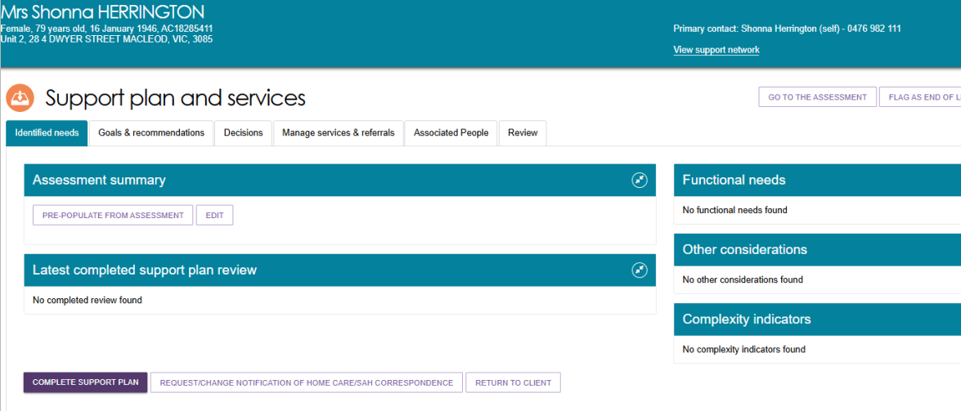
! | If the client’s My Health Record is not successfully linked an amber error banner will display in place of the green banner. If the ‘Unable to share data as the system could not find an active My Health Record’ error message displays the assessor should inform the client that their support plan will not be uploaded to their My Health Record and that they should contact the My Health Record helpline on 1800 723 471 for assistance if required.  If the ‘Unable to retrieve the client's Healthcare Identifier, so we cannot match them with their My Health Record. Their Support Plan cannot be made available in their My Health Record’ error message displays the assessor should call the My Aged Care service provider and assessor helpline on 1800 836 799.  In both instances, you will still be able to proceed with the development of the Support Plan, but it will not be uploaded to My Health Record upon finalisation.
- From the Support plan and services page, you can reopen the assessment by selecting GO TO ASSESSMENT button on the Identified needs tab.
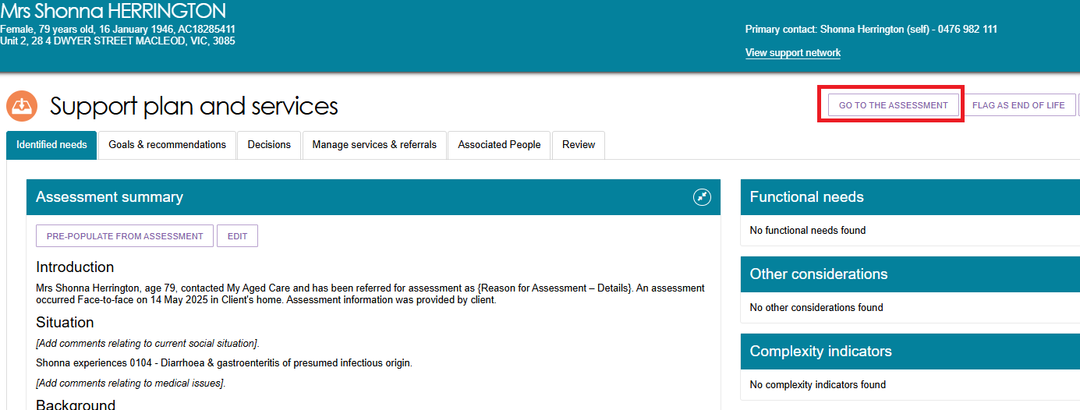
- You can also re-open the Functional needs, other considerations, complexity indicators from the Support plan and Services page by selecting the return arrow.
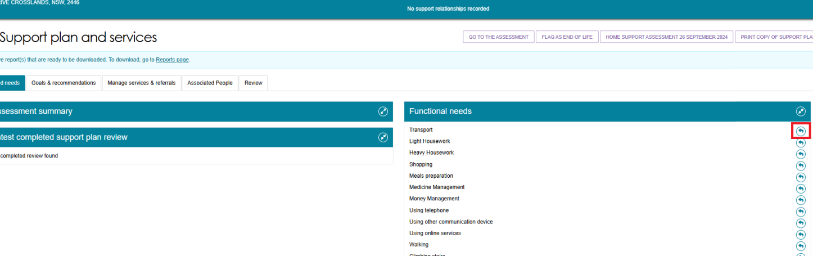
- The IAT outcome will be displayed in the GOALS AND RECOMMENDATIONS tab.
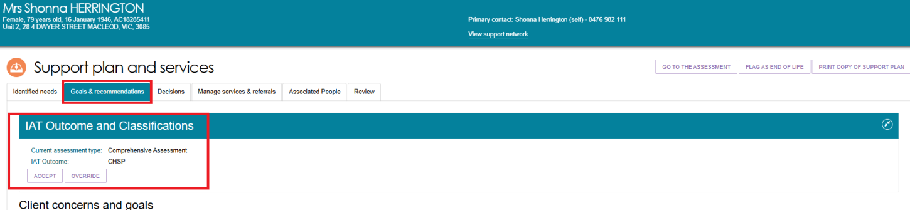

Accepting or Overriding an Assessment
- Assessors will have the option to either ACCEPT or OVERRIDE the IAT outcome once it is displayed
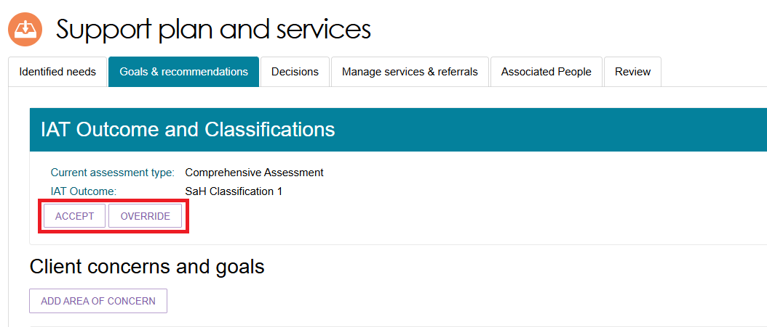
! | The IAT will allow an ongoing Support at Home Classification to be overridden to a different ongoing classification level. However, assessors must not undertake this action and delegates must not approve assessments where this occurs. An ongoing SaH classification outcome cannot be overridden to an ongoing lower or higher SaH classification outcome (in line with section 81-10 of the Aged Care Rules).
- Selecting ACCEPT will bring up the Accept IAT outcome pop-up box as a final clarification of your decision. Then select the ACCEPT if you still wish to proceed.
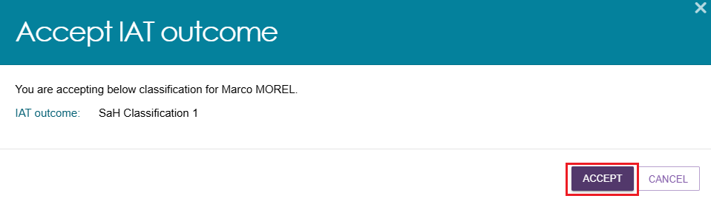
! | When completing a reassessment for a Transitioned client, if the IAT (Integrated Assessment Tool) outcome recommends a classification of Transitioned HCP Level 1-4 a warning message will appear in the Accept IAT Outcome screen.  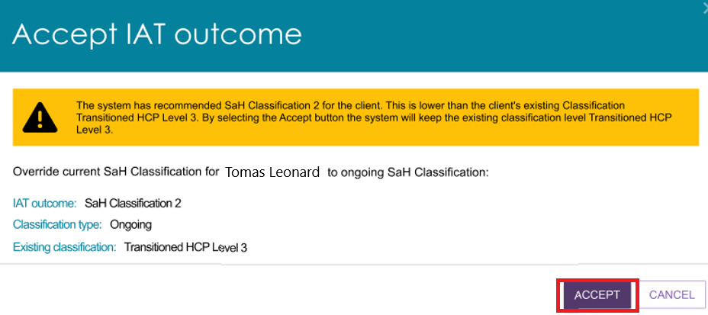
- Selecting OVERRIDE will bring up the Override IAT outcome pop-up box in which you will need to provide the information to Override IAT outcome to, the Override reason and Override reason description and then select SAVE TO PLAN.
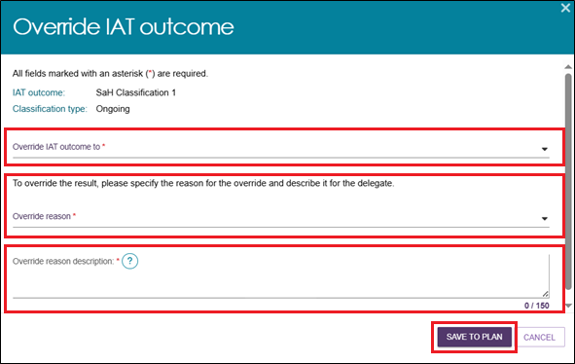
- If the recommended classification is Support at Home Classification, End of Life or a Residential Care Program you will be navigated to the Add Home support services page to then select on the services you wish to accept or override.
! | Overriding from CHSP to Restorative Care Pathway  The IAT also allows a CHSP classification to be overridden to RCP during a comprehensive assessment. However, assessors must not undertake this action and delegates must not approve assessments where this occurs. Where a CHSP classification outcome is generated, RCP cannot be recommended for approval (in line with section 81-15 of the Aged Care Rules). An ongoing SaH classification must be generated to override and recommend RCP for approval.
a) Assessors can override an IAT outcome (i.e. Ineligible for CHSP/SaH, and SaH Classifications 1–8) to SaH Restorative Care Pathway (RCP). This applies to both initial assessments and reassessments, and to transitioned and non-transitioned clients.
For transitioned clients undergoing reassessment:
- The dropdown displays all SaH classifications that are equal to or higher than the client's Active Transitioned Classification.
- It also includes SaH Restorative Care Pathway and SaH End-of-Life Pathway.
- The current IAT outcome is excluded from the dropdown.
- If the IAT outcome is higher than the Active Transitioned Classification, the dropdown also includes the Active Transitioned Classification.
- When SaH End-of-Life Pathway is selected and the override is confirmed, the system sets the latent classification according to the rules defined in the Override Classification Table.
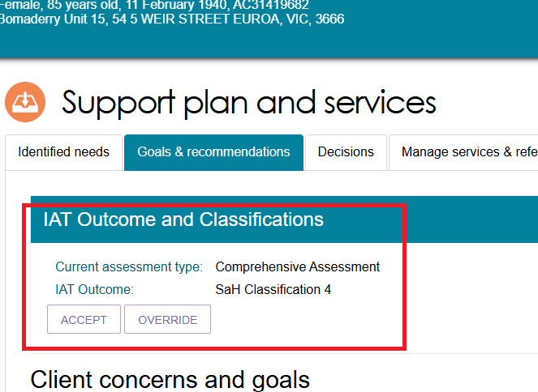
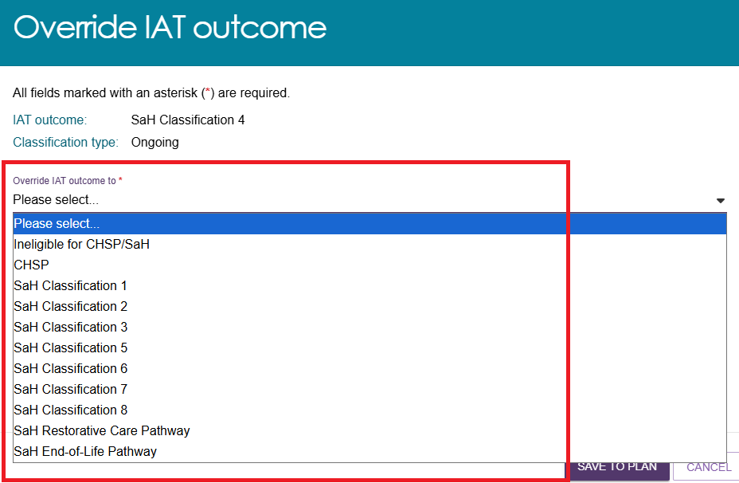

Converting to Comprehensive Assessment
Non-clinical assessors will have the option to change the assessment from Home Support to Comprehensive once the IAT has been finalised and the algorithm has determined an outcome recommendation. This can only be done if the outlet supports both types of assessments.
- From the Goals & recommendations tab select CONVERT TO COMPREHENSIVE ASSESSMENT from the top right-hand side.
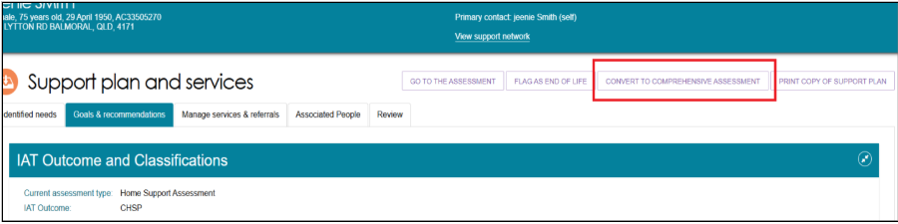
- The reason for this change will be pre-selected to High level care needs. Enter in the reason or comments for converting the assessment and then select YES, CONVERT ASSESSMENT.
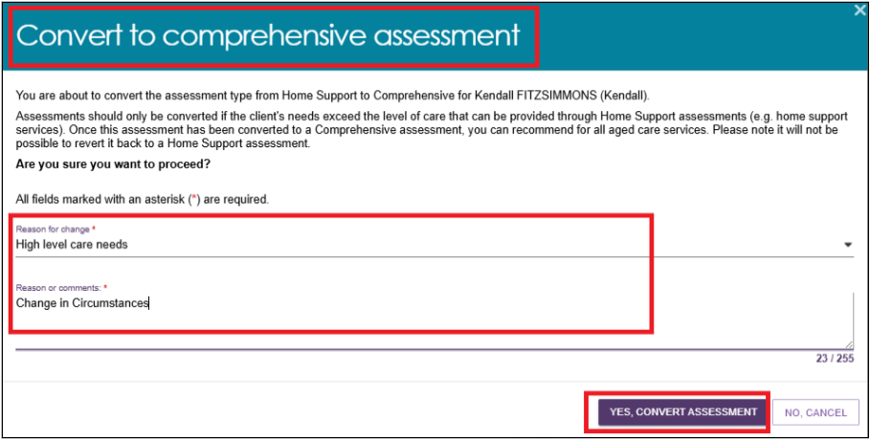
- A green banner will then be displayed at the bottom of the screen confirming the assessment has been successfully changed. The IAT outcome will now also reflect that a comprehensive assessment has been completed.
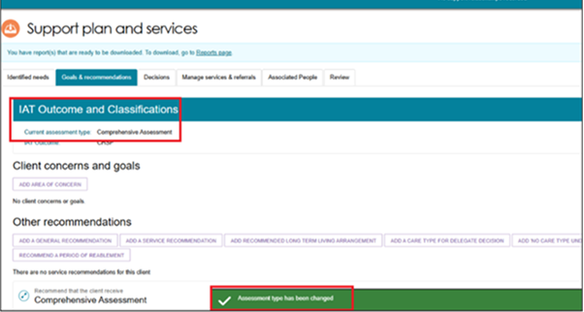

Flagging an Assessment as End of Life
Based on the clinical assessment and supporting documentation from a qualified health professional that a client is approaching End of Life, the assessor can flag the client as End of Life.
- From the CURRENT ASSESSMENTS tab, under Assessment Not Started section select the expand card icon of the client to the flagged as End of Life.
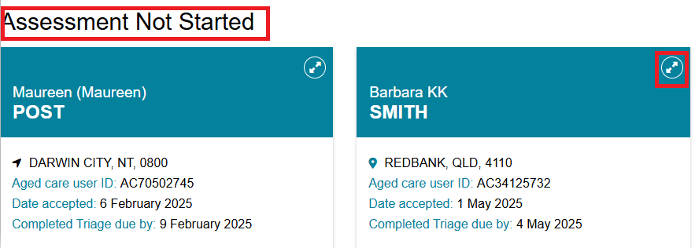
- From the pop-up screen, Select FLAG AS END OF LIFE button.
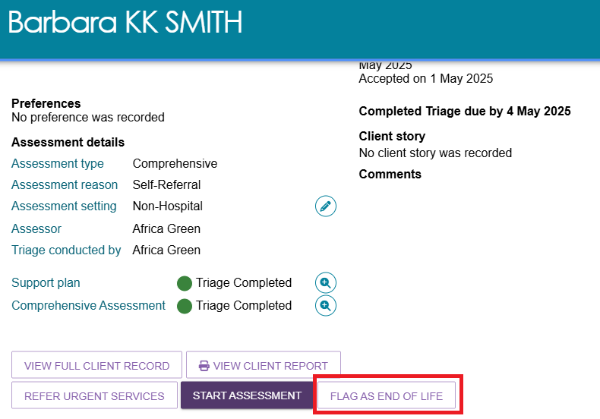
! | The END-OF-LIFE process can also be initiated when an assessment is in progress.  From the client’s GOALS AND RECOMMENDATIONS tab, select the FLAG AS END OF LIFE button and continue through the following steps.  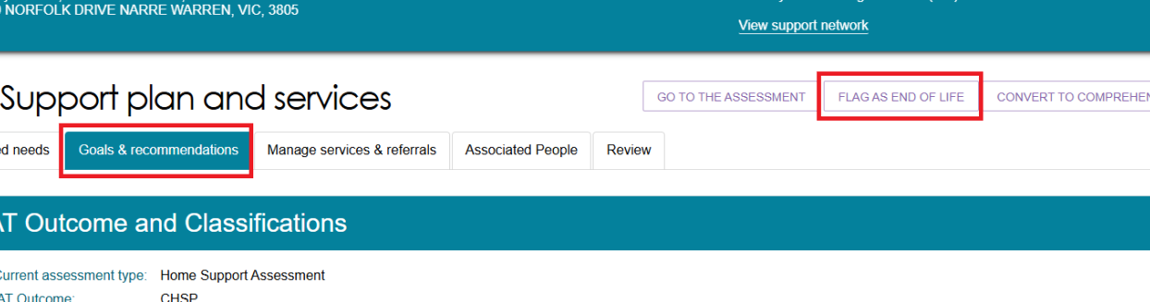
- A pop-up screen will open prompting END OF LIFE VERIFICATION. Based on the documents verified, chose the relevant selection from the dropdown list.
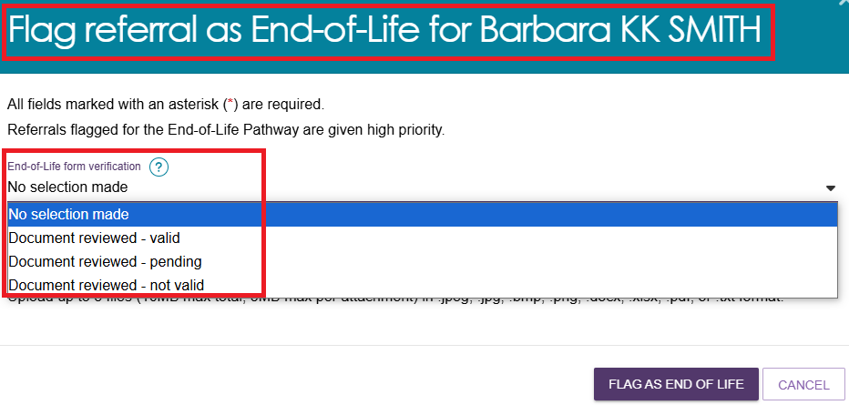
- Select the UPLOAD ATTACHMENT button.
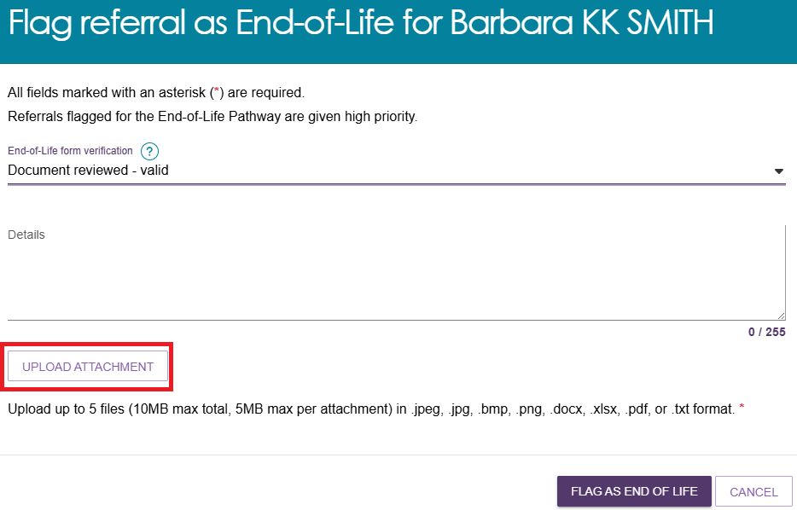
! | If the relevant verification documents are not produced by the client or the produced documentations are not valid, verification process can be performed from the GOALS AND RECOMMENDATIONS tab by selecting VERIFY END OF LIFE FORM button from the top right-hand corner of the screen.  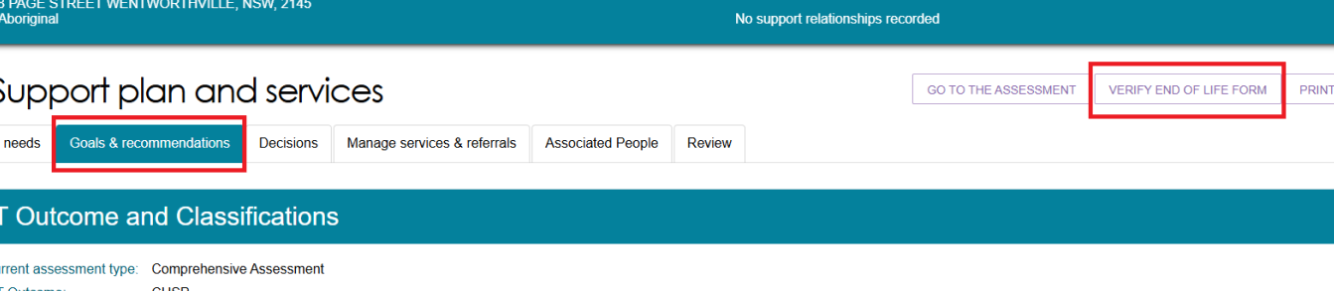
- A Pop-up screen ADD ATTACHMENT will appear to add the relevant documentation supporting the Client’s diagnosis by a qualified medical professional. Select CHOOSE FILE button to attach the documentations (Please ensure the document meets all the criteria described on the screen).
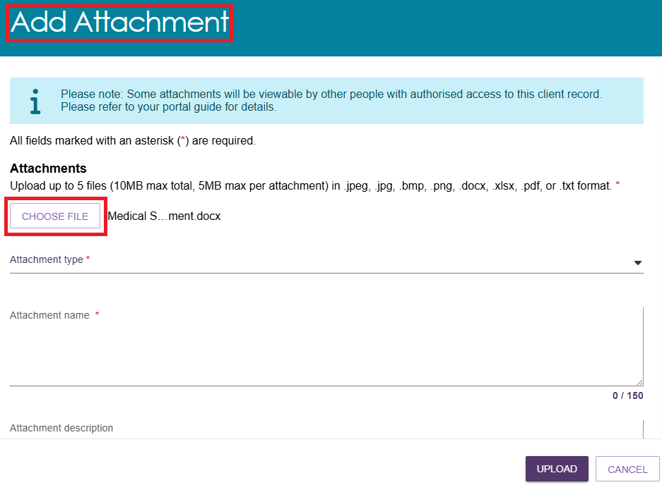
- Select ATTACHMENT TYPE from the dropdown list and type the ATTACHMENT NAME.
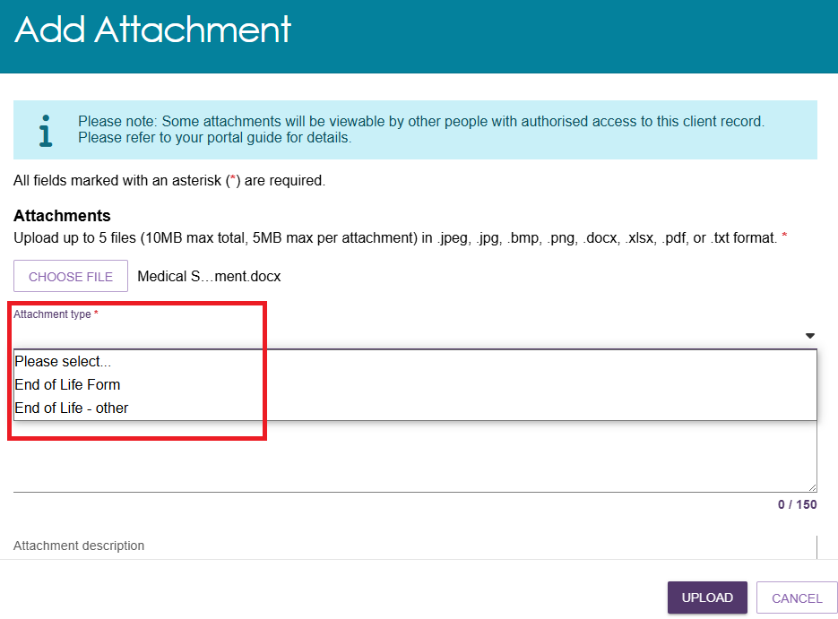
- Select UPLOAD
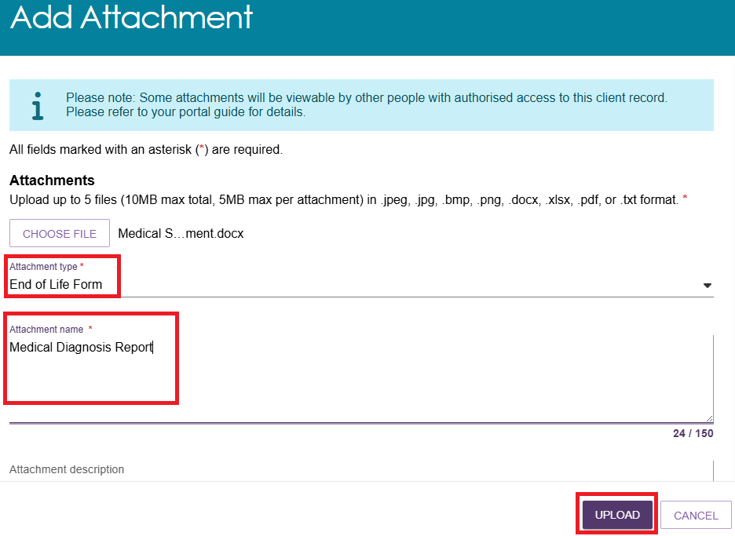
- A pop-up screen will appear with the document attached. To attach more documentation, select UPLOAD ATTACHMENT (up to 5 files can be attached. Please ensure the attachments meets all the required criteria).
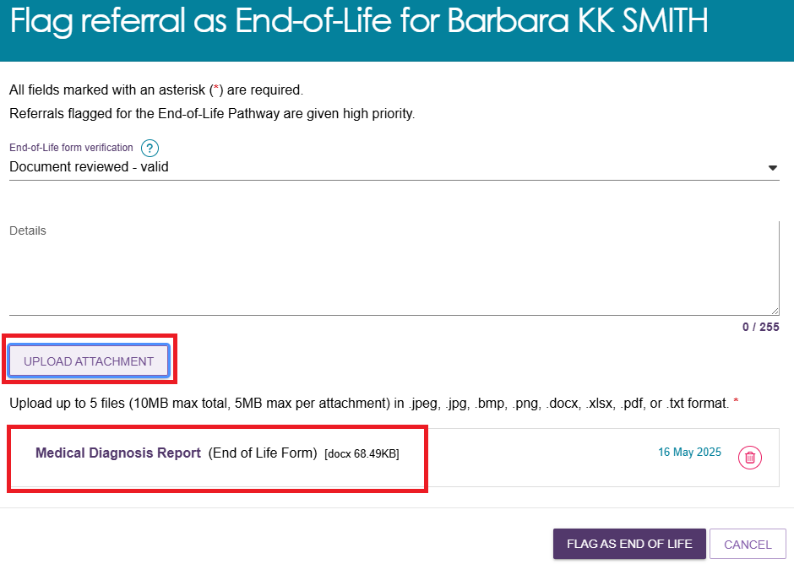
- Once all relevant documents are attached, Select FLAG AS END OF LIFE.
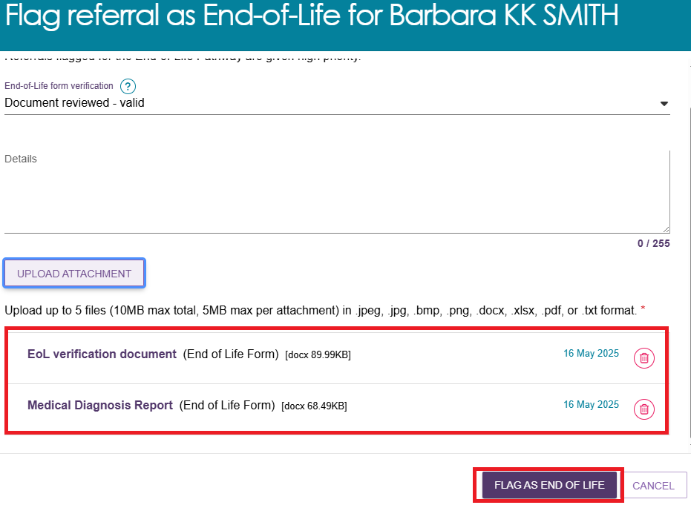
- On the CURRENT ASSESSMENTS screen, the client will be displayed under ASSESSMENT NOT STARTED section with a red HAND icon with a cross as shown in the example below.
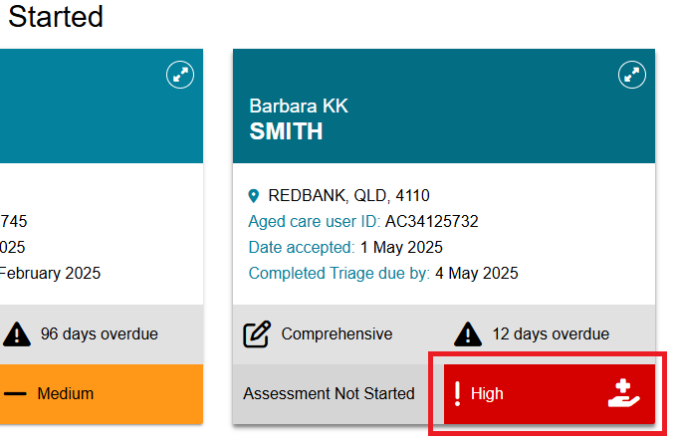
! | More information on flagging a referral as End of Life can be found in Assessor Portal – User Guide 7 – Completing a Support Plan and Support Plan Review.

Cancelling an assessment
If you need to cancel an assessment for a client, you can do so within the assessment. Assessors should add a note or an interaction to the client record explaining the reason for cancelling the assessment.
- To cancel an assessment, Select CANCEL ASSESSMENT- NO FURTHER ACTION REQUIRED in the assessment.
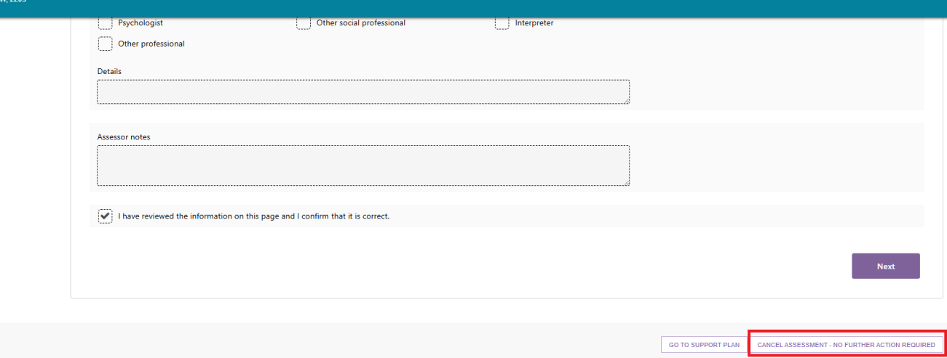
- Record the reason for cancelling the assessment.
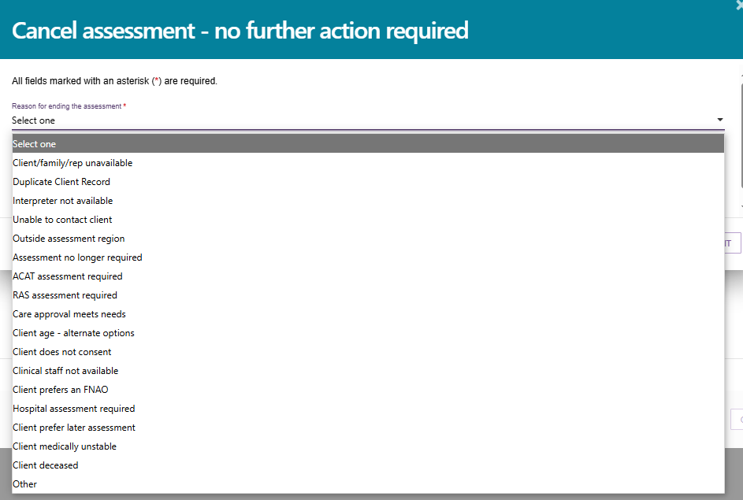
- If you cancel an assessment because a client is deceased, you will need to supply the following:
- Who, when and how were you informed that this person is deceased. For example, “Mrs. Smith rang to inform us that Mr. Smith has passed away on Saturday.”
- Date of Death (if known)
- Any Attachments such as Death Certificate, Hospital Discharge documents.
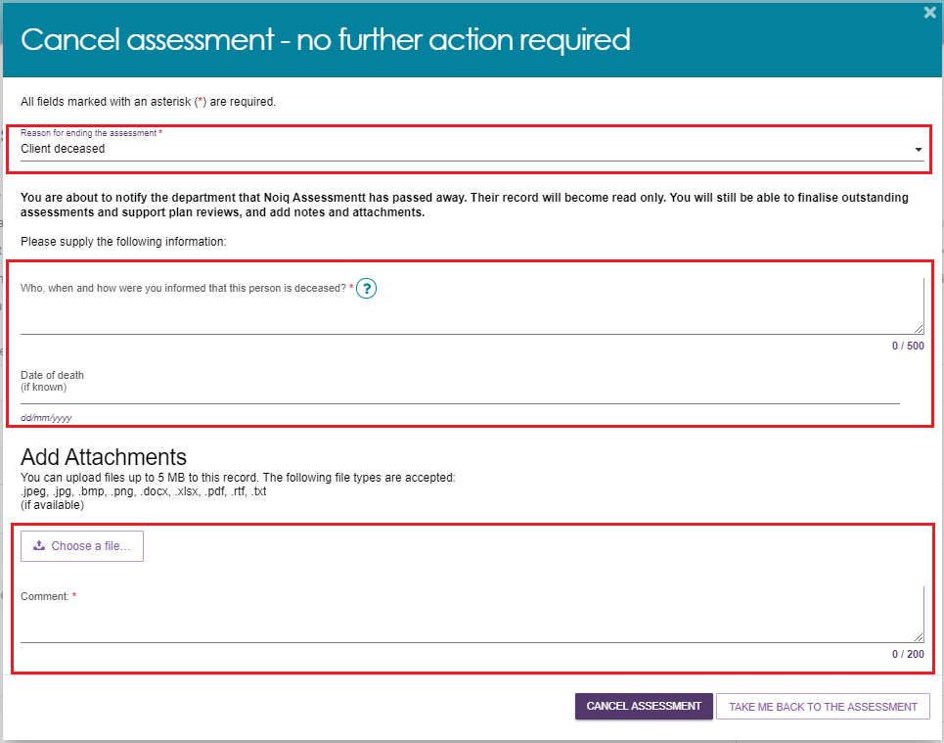
! | Cancelling an assessment with the reason of Client deceased will change the client’s status to Deceased and make the client record read-only. Any unaccepted service referrals will be recalled, services in place will be ceased and the client’s access to the client portal will be revoked. My Aged Care will not send correspondence to the client or their supporters after the status is changed to Deceased.  Where a client is active in the Support at Home Priority System or has been assigned an aged care service, this will remove the client from the Support at Home Priority System and withdraw any assigned services.
- A confirmation message will be displayed on screen that the assessment has been cancelled. You will then be taken to the Client summary page which will confirm the cancelled status.
After cancelling an assessment, the client information will appear in the assessor’s recent assessments tab. Assessors will still be able to search for the client using the Find a client functionality.

