Assessor Portal User Guide 4 – Navigating and updating the client record
This guide outlines the contents and functions of the client record at a high level. Client records grant aged care needs assessors (assessors), providers, and My Aged Care staff with a single point of reference for client information.
The client record is also a valuable tool for easily setting up emergency contacts, disseminating important information between client , and facilitating the assessment of clients.
After a client and/or their support network has provided consent to enable their personal details to be appropriately recorded in My Aged Care and shared with assessors and Aged Care service providers, you will be able to interact with the many tabs of the client record elements as described in this guide.
If the client and/or their carer request a call back from Carer Gateway and/or the National Dementia Helpline, assessors will need to obtain further consent in the relevant area in the assessor portal.

Contents
Assessor Portal User Guide 4 – Navigating and updating the client record 1
Accessing the client record 3
Accessing a Sensitive Client Record 5
Accessing the client record of a client assigned to me 5
The Client Summary tab 9
The Client Details tab 11
Adding a Post Office Box address 13
Recording consent to share information with My Health Record 14
Notifying My Aged Care that the client is deceased 16
The Support Network tab 18
The Approvals tab 18
The Plans tab 20
The Attachments tab 20
The Services tab 23
The My Aged Care interactions tab 23
The Notes tab 24
Note Types 25
Note Add & View permissions 26
Adding client notes 26
Viewing and editing client notes 27
The Tasks and Notifications tab 29
The Residential Funding Classifications tab (clinical needs assessors) 29
More Information 29

Accessing the client record
The Find a client function enables assessment organisations to search for all clients registered with My Aged Care. Assessment Organisations can only search for clients who have been referred to, and accepted by, their organisation.
- Log in to the My Aged Care assessor portal. From the home screen select the Find a client tile.
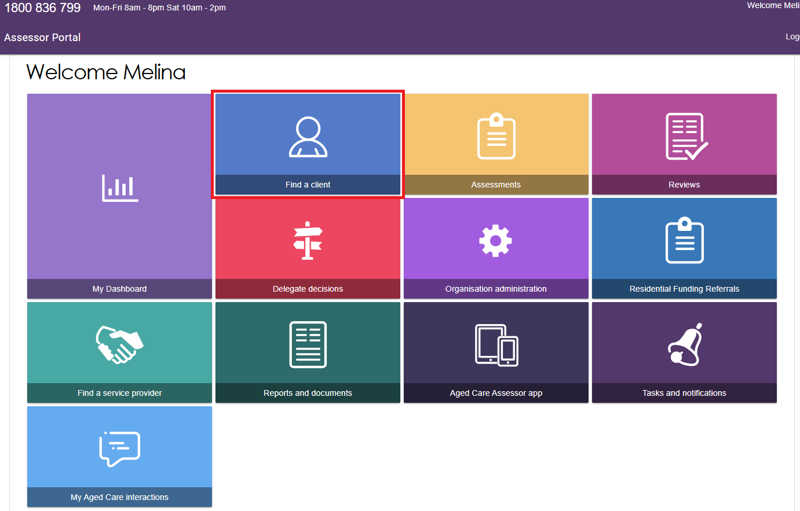
- You can do a basic search by entering the First Name, Last Name, or Aged Care User ID into the fields, and then selecting the SEARCH button.
To go directly to a recently viewed client, use the links under Recently Viewed Persons heading on the right.
You can also switch how the results are displayed between CARD view and LIST view by selecting the appropriate button at the right.
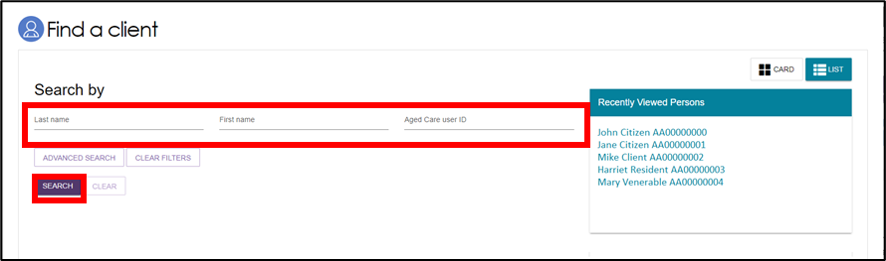
! | The Find a client function enables assessment organisations to search for all clients registered with My Aged Care. Service providers can only search for clients who have been referred to, and accepted by, their organisation.
- Alternatively, you can do an advanced search. Advanced search works by applying filters to the list of clients. These filters include options such as First Name, Home Contact Number, Postcode etc. By adding multiple filters together, specific groups of clients can be found.
Select the ADVANCED SEARCH button. A pop-up window will open. Use the drop-down arrow to choose the kind of filter you wish to add. Then, select the ADD FILTER button to reveal the input field for that filter.
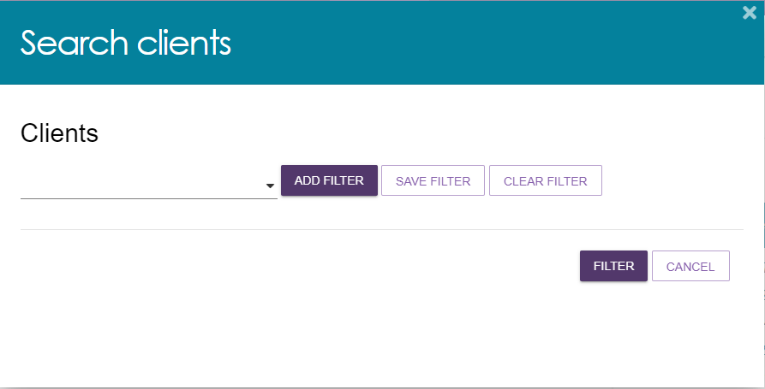
- Fill in the input field with the information required. You can repeat the process above to add additional filters to the advanced search. A maximum of 7 filters can be applied at once. Once you have finished adding filters, select the FILTER button to begin your advanced search.
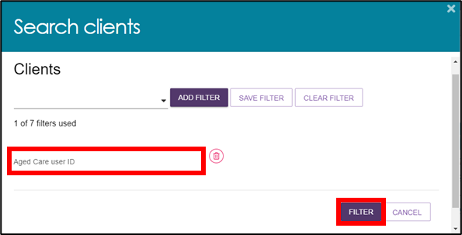
- Select the name of your chosen client to proceed to their client record.
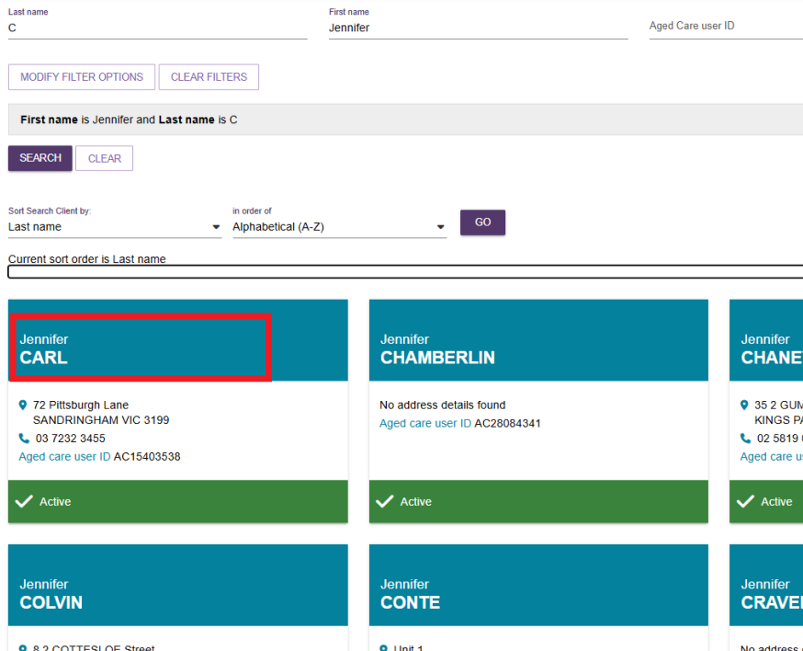

Accessing a Sensitive Client Record
A sensitive client record may contain one or more:
- sensitive attachment
- sensitive client status
- sensitive notes.
In the Client Record, the client details banner will have wording to this effect underneath the client’s address, to identify that this record contains sensitive information.
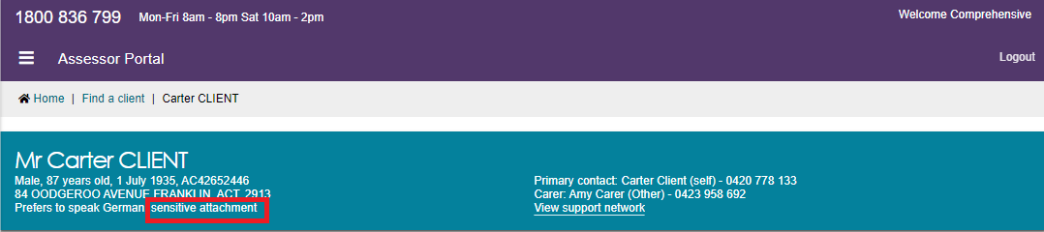
To access the sensitive information, refer to the Attachments tab and the Notes tab for more details.

Accessing the client record of a client assigned to me
- Log in to the My Aged Care assessor portal and select the Assessments tile.
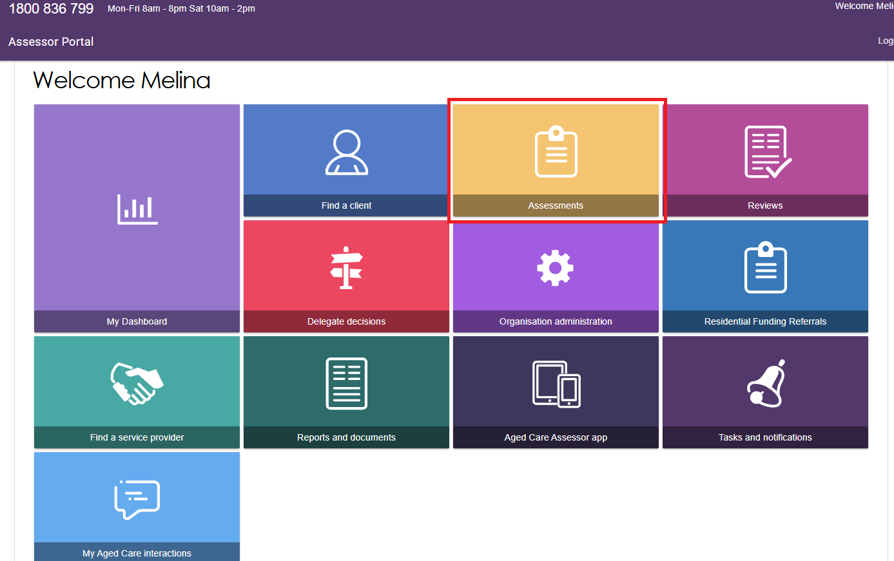
- If you have access to multiple outlets, you will be prompted to select the assessment outlet where the client you are working on is linked to. Use the drop-down list to choose an assessment outlet, then select SELECT OUTLET to proceed.
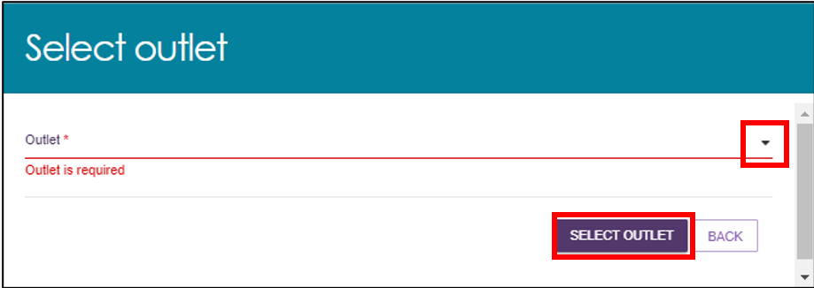
- Using the filter headings to sort your assigned clients by Last Name, Aged Care ID, Locality etc. Once you have found the appropriate client, use the expand button on the left to view more details.
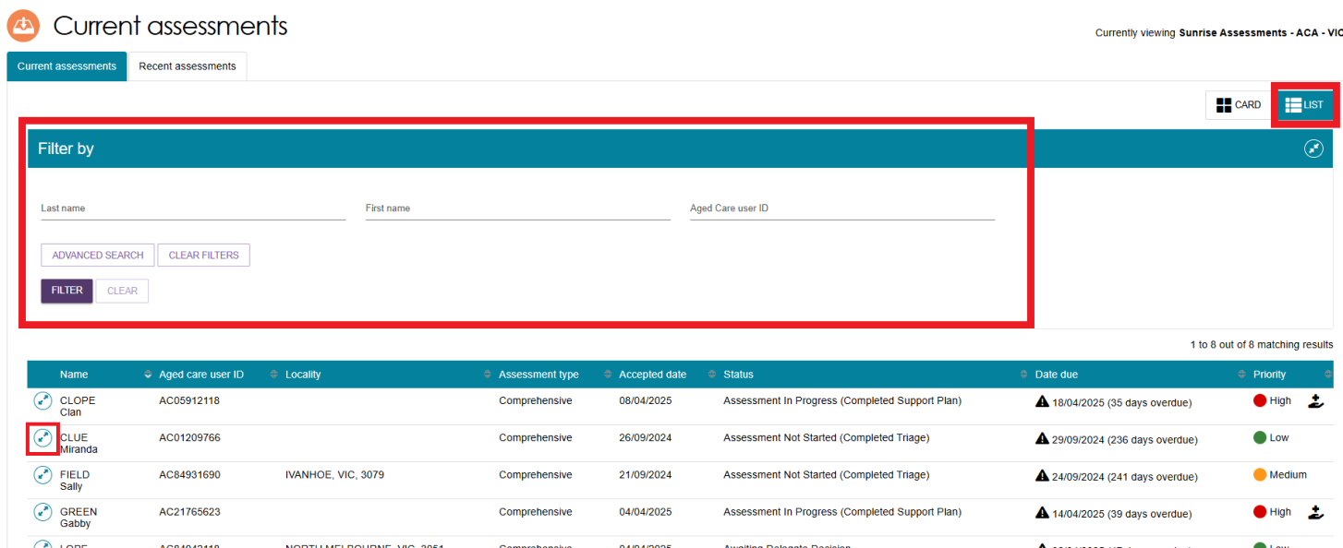
- The CARD view will look as shown below. Select the expand button to view the client information.
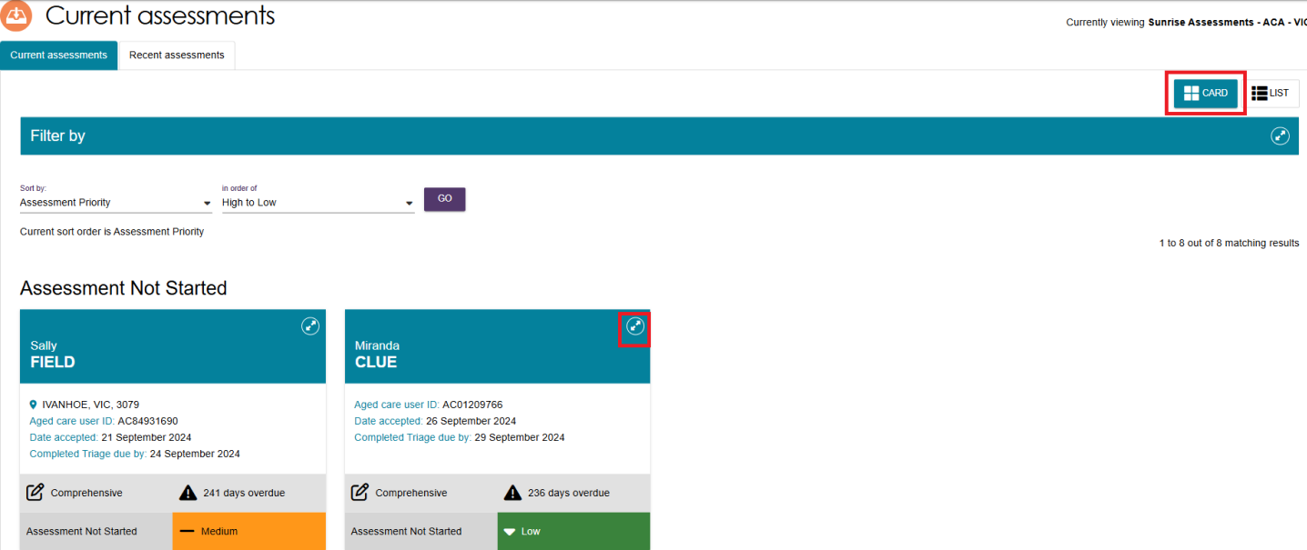
- A pop-up will then display with expanded details for that client.
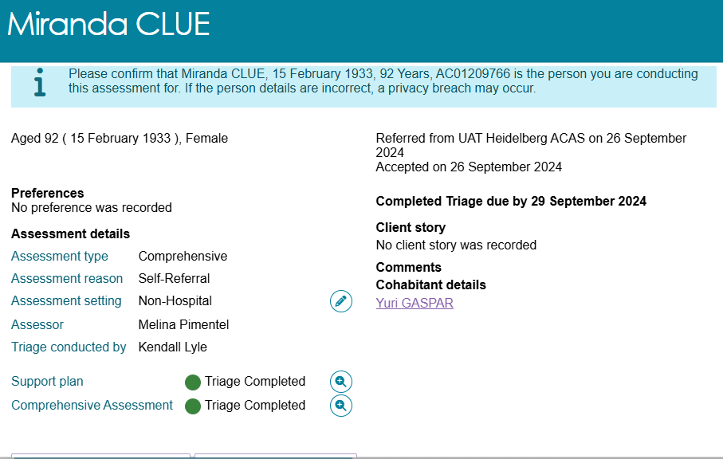
- From this pop-up you can view the statuses of client’s support plan and assessment. Further information can be viewed by selecting the magnifying glass next to status as shown in the below example.
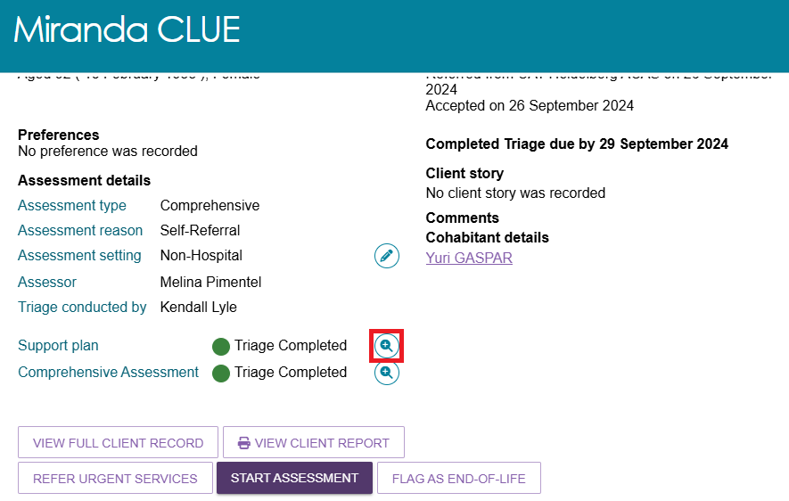
- You can view Cohabitant details if applicable. A cohabitant refers to another aged care client who lives at the same address as the client undergoing assessment and has a recorded active relationship with the client. Up to two cohabitants will be listed under this heading.
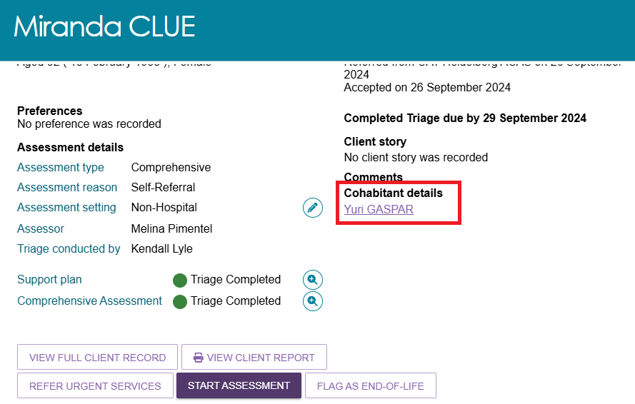
- Select the VIEW FULL CLIENT RECORD button to navigate to the client record page.
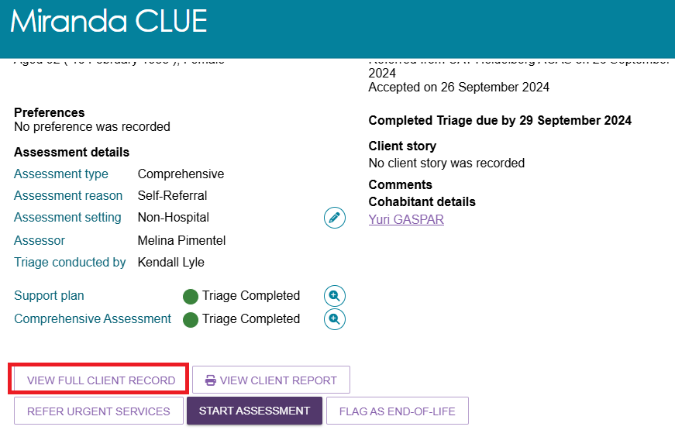
- Additionally, a summary PDF report of the client record containing client details, support network details, notes, assessment history, care approvals, and the client’s interactions with My Aged Care, can be generated without needing to navigate to the client record page. Select the VIEW CLIENT REPORT button to generate this summary report.
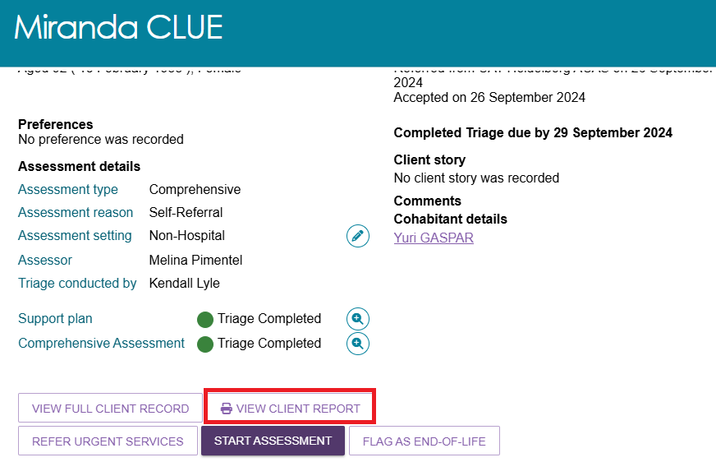

The Client Summary tab
- Select the VIEW FULL CLIENT RECORD button to navigate to Client summary screen. The Client summary tab provides an overview of the client’s completed and in-progress assessments. The Client summary tab serves as the primary location for assessors to quickly access client information and coordinate care effectively.
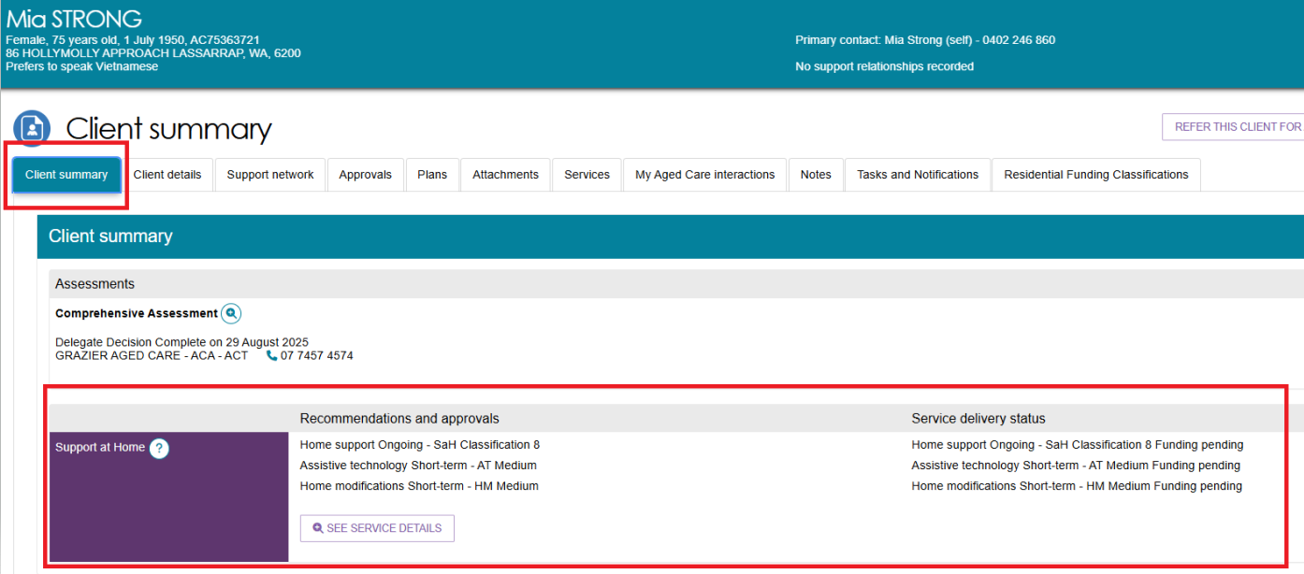
The below image shows an example of client transitioned from a Home Care Package (HCP) classification.
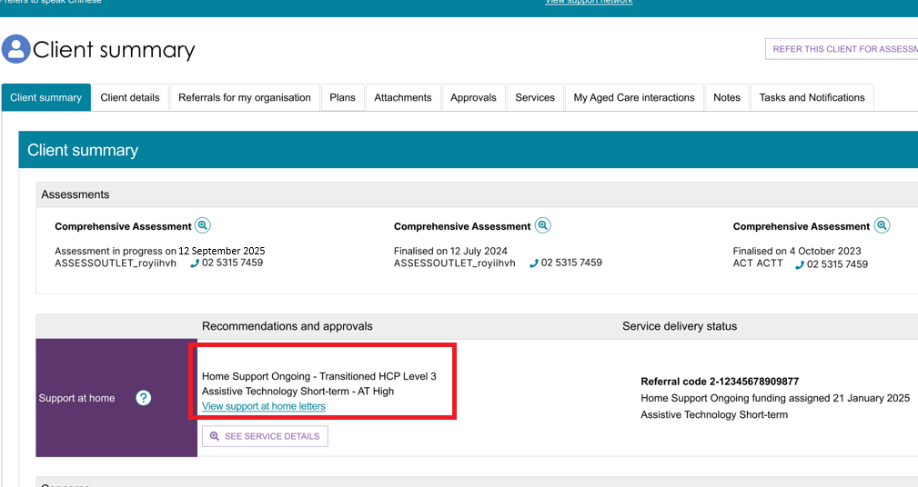
- The See Service Details Button in the Client Summary screen provides assessors with a detailed view of the services linked to a client. It displays information such as service provider details, referral history, funding status, service delivery status, and any short-term support arrangements like reablement. This feature helps assessors monitor service progress and ensure alignment with the client’s support plan.
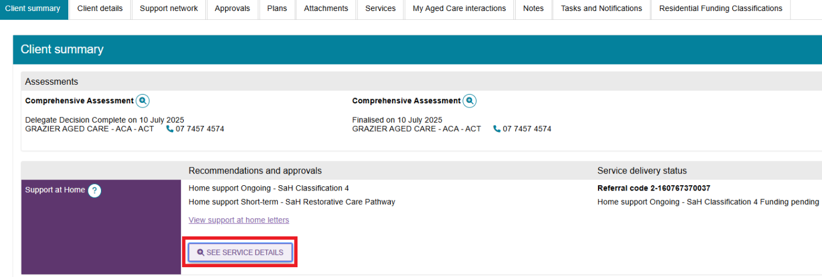
- A pop-up window will open which displays all the recommended services. Select the Expander icon to view more details. The user will also be able to know the funding status of the recommended service.
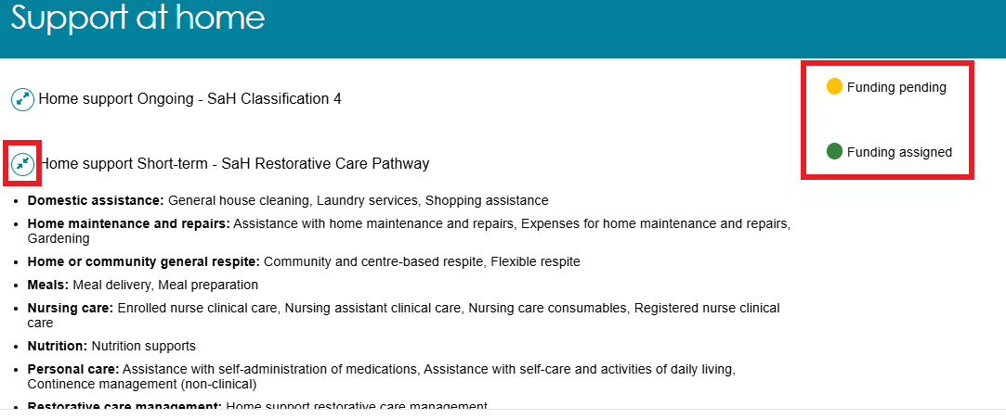
The below image shows an example of same page for a client with Transitioned Home Care Package (HCP) classification.
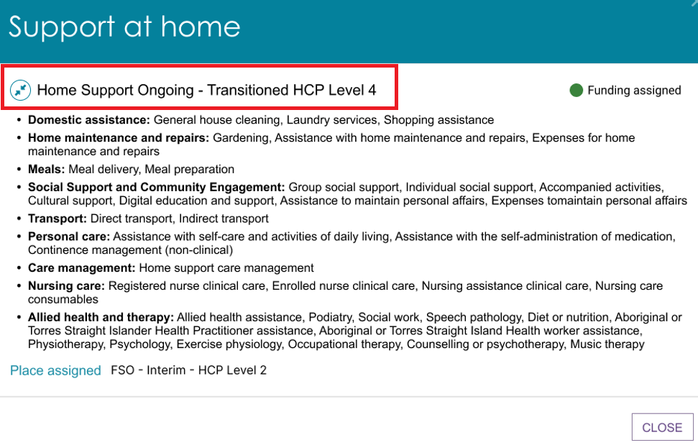
- The Client summary information can be printed by using the Print Page button on the right-hand side of each heading.
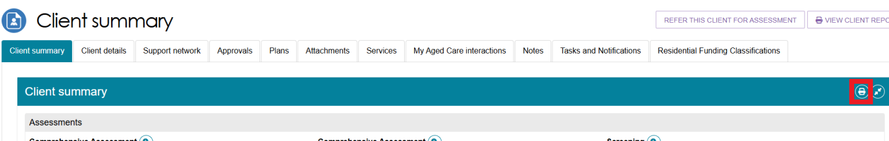

The Client Details tab
The Client details tab displays a detailed profile of the client. It includes essential personal and demographic information used to support assessment and care planning. This tab ensures assessors have a comprehensive and up-to-date profile to inform decision-making and support accurate, person-centered care planning. Assessors can update any information by selecting the Edit (pencil) icon. The page also contains an option to notify My Aged Care when the client is deceased. Refer to Notifying My Aged Care that the client is deceased for more information.
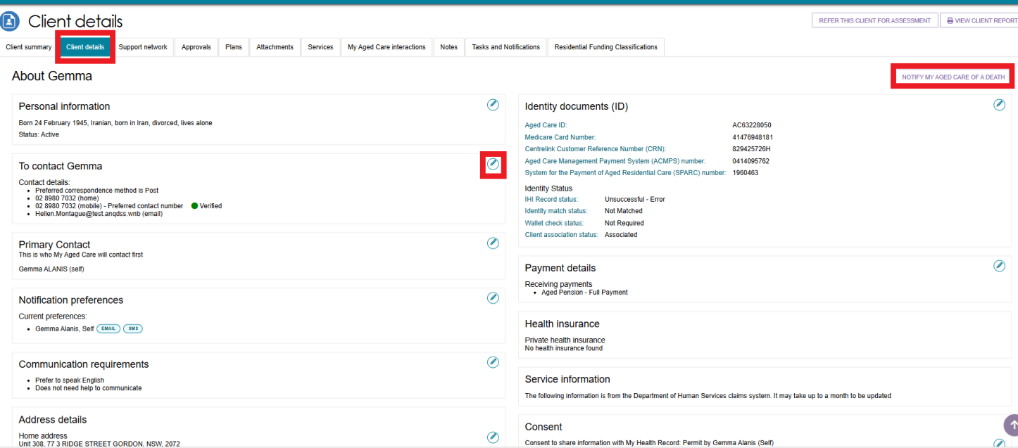
! | The Primary Contact can be nominated by the client or a person in their support network. This information allows assessors, My Aged Care contact centre staff and service providers to identify the key contact details for a client. This field does not impact on any system generated mail correspondence that the client may receive in relation to their care.  The Find a client function enables assessment organisations to search for all clients registered with My Aged Care. Service providers can only search for clients who have been referred to, and accepted by, their organisation.  When adding or editing address details, it is important to validate the address by selecting the VALIDATE THIS ADDRESS button prior to saving. This ensures that the client and their support network can receive communication from the My Aged Care system.  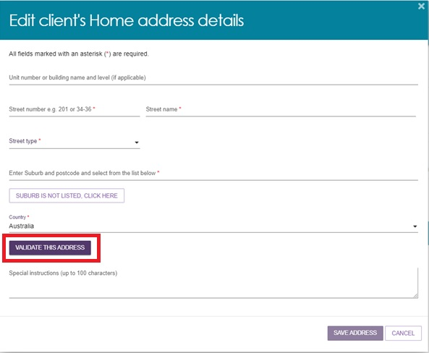  My Aged Care clients and their support network can also receive email and/or SMS notifications when a client reaches the following key stages of their My Aged Care journey:  - client registration is complete  - the client’s assessment is finalised  - the client is approved for care after a Comprehensive assessment  - a client is assigned a Support at Home service and at any stage that a letter is generated for a client such as an assignment letter or withdrawal letter  - a Support Plan Review request has been submitted  - a support relationship is activated, declined, inactivated or expiring, and the submission or actioning of documents relating to support relationships.  For more information about setting up and configuring notifications for clients and/or their support network, refer to My Aged Care – Assessor Portal User Guide 2 – Registering support people and adding relationships.

Adding a Post Office Box address
Only Clinical assessors and assessment delegates can add a Post Office Box address to a client record as the preferred address for all correspondence.
This is completed on the Client details tab in the client record.
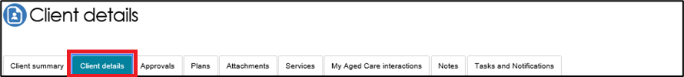
- In the Address details section, select the edit icon next to Send any correspondence to.
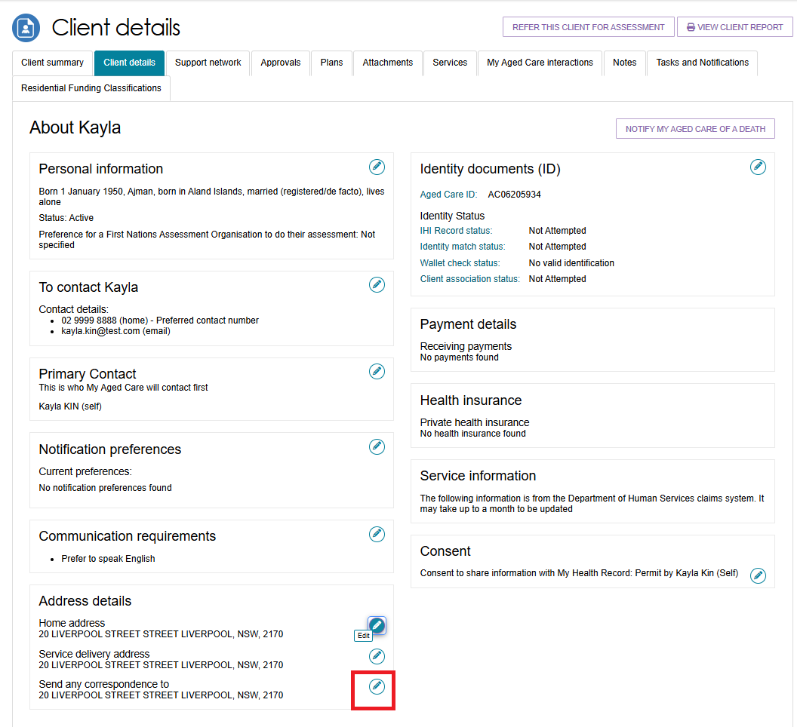

- Select Postal address.
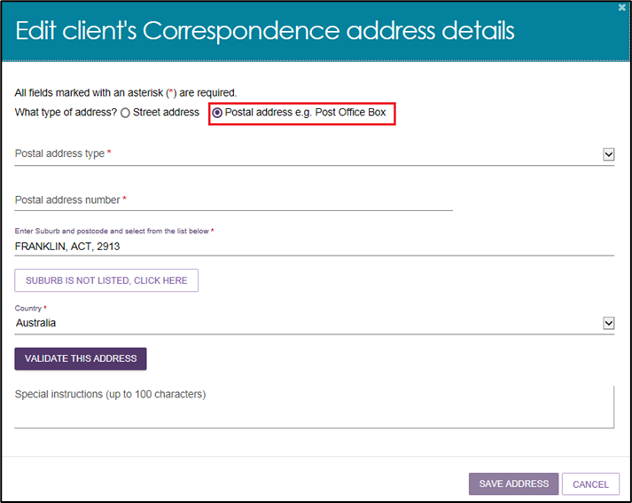

Recording consent to share information with My Health Record
- Within the client details tab, you can also view and update the client’s consent status to share information with My Health Record via the Consent section. To update a client’s consent, select the EDIT (pencil) icon.
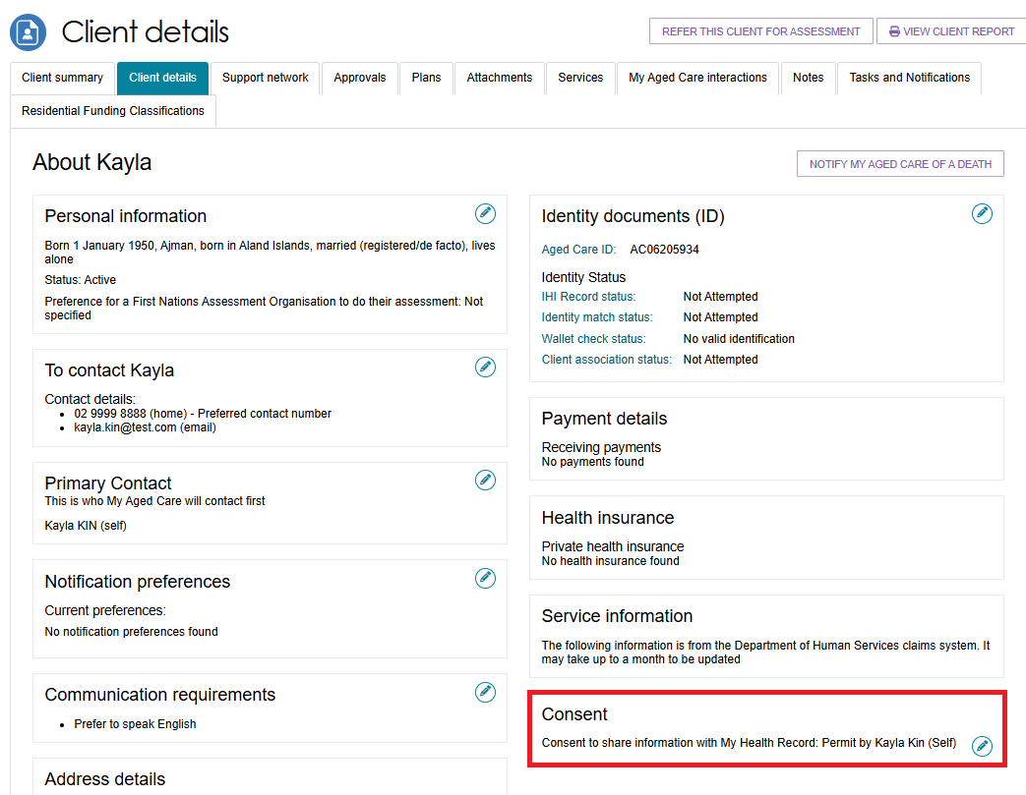
- A pop-up will display. If the client consent’s to sharing their information with My Health Record, select Yes, answer if the consent was provided by either the client or their supporter-guardian, and select SAVE.
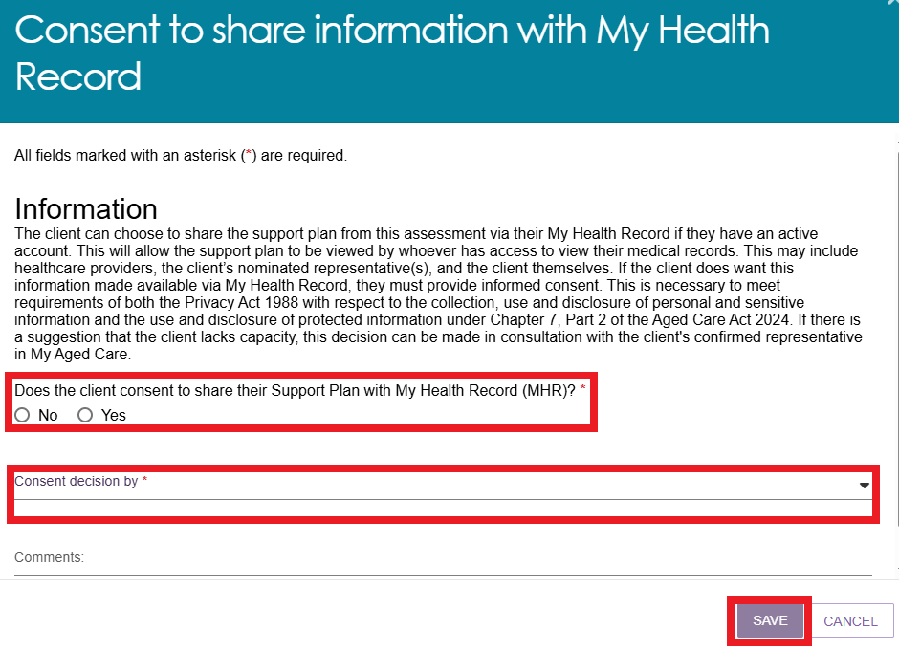
If the answer is No and the client or their supporter-guardian is withdrawing their consent, then any previously shared support plan details will be removed from the client’s My Health Record. Select a consent denial reason from the drop-down list and then select SAVE.
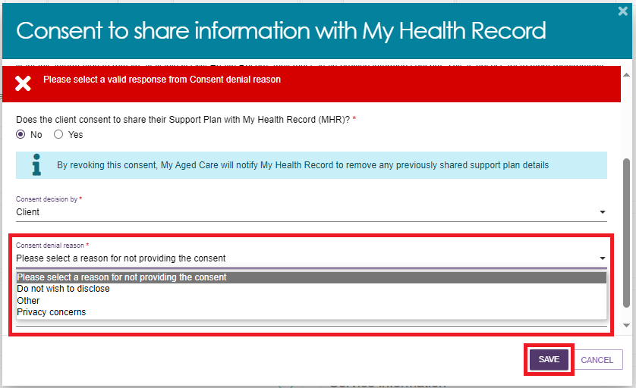
! | If the consent decision has been made by a supporter-guardian then you will be required to enter the supporter’s FIRST NAME before proceeding.  If the consent denial reason is OTHER, a comment about the denial MUST be entered before selecting SAVE.  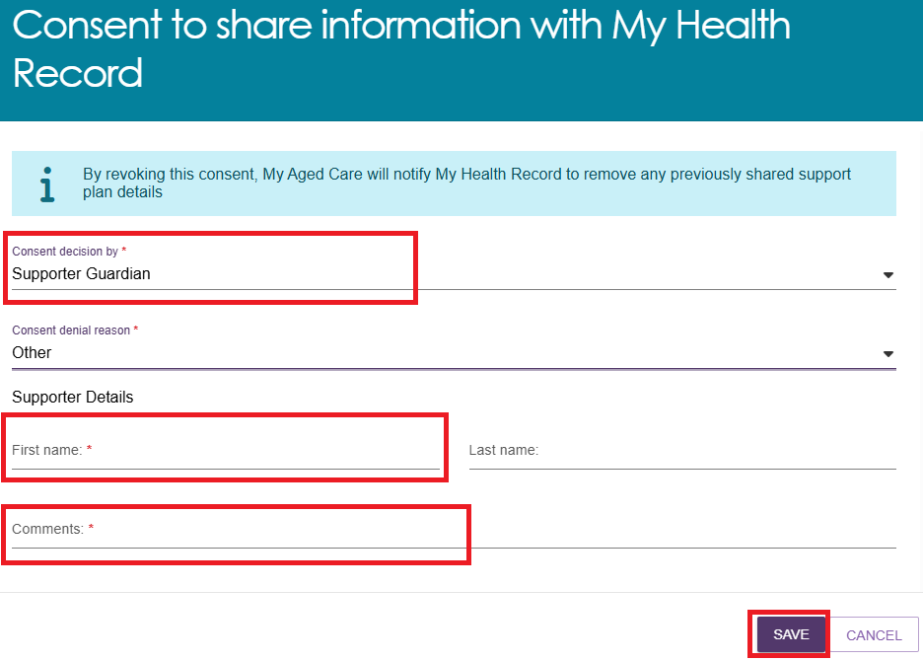

Notifying My Aged Care that the client is deceased
If a client’s status is Deceased, the clients record will be read-only, and you will not be able to edit any client information. Once this status is updated in My Aged Care, the clients support network will no longer have access to the clients’ record. A notification will be sent to the client’s assessor and provider advising them to close or finalise any in-progress tasks. Additional notes and attachments can be attached to the client record and assessments can be finalised after the status is changed.
A banner will be displayed on all tabs of the client record. If the client’s status is incorrect, please contact the service provider and assessor helpline on 1800 836 799.
- Select the NOTIFY MY AGED CARE OF A DEATH button in the Client Details page of the client record.
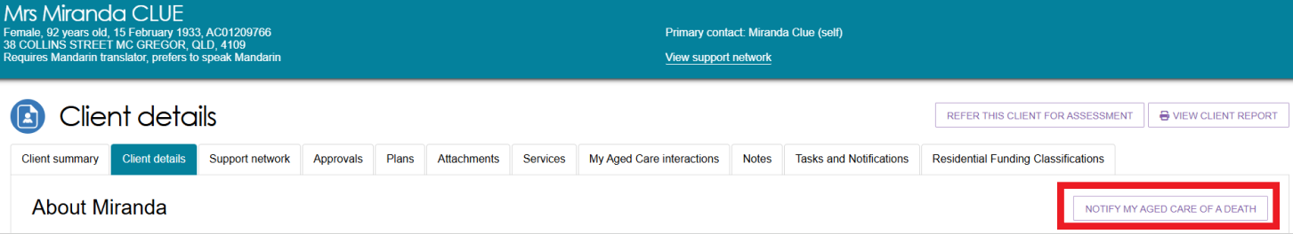
- A pop-up screen will prompt you to input all information and upload the supporting documents as required. Select SAVE.
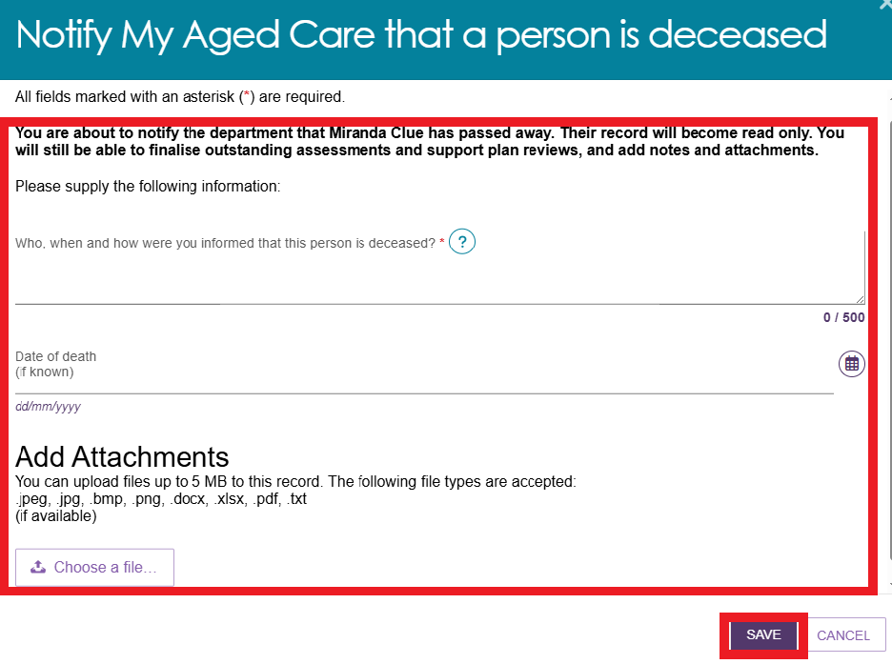
- A dialogue box will be displayed. To confirm, select OK.
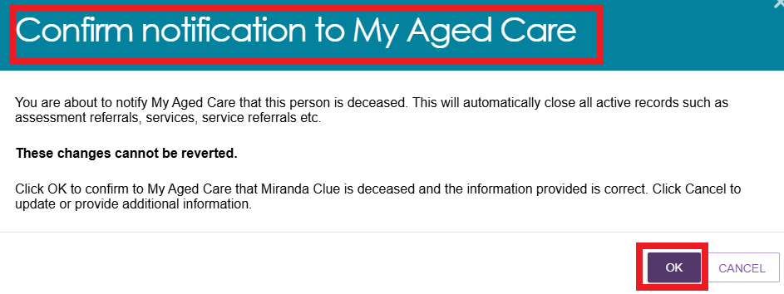
- You will be directed to the CLIENT DETAILS page where the following banners will be displayed.
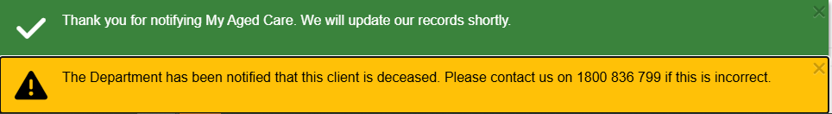
- The client status will be updated to deceased on the records. The client card will appear as shown below. If there are any in-progress assessments for the client, a notification will be sent to the associated assessor and provider advising them to close or finalise the in-progress tasks.
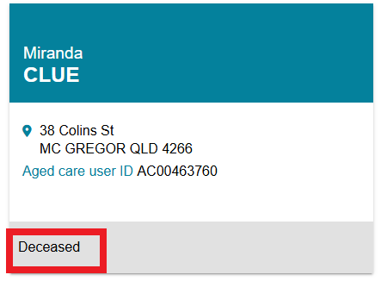

The Support Network tab
The Support Network tab provides a summary of the people and relationships that play a role in supporting the client. This includes informal support such as family members, friends, or neighbours, as well as formal supporters like carers, supporter guardians or supporter organisations. The tab outlines each person’s relationship with the client, their role in the client’s care, and their contact details if relevant. This information helps assessors understand the client’s current support structure and identify any gaps in care or additional support needs.
For more information about creating a supporter relationships, refer to My Aged Care – Assessor Portal User Guide 2 – Registering support people and adding relationships | Australian Government Department of Health and Aged Care.
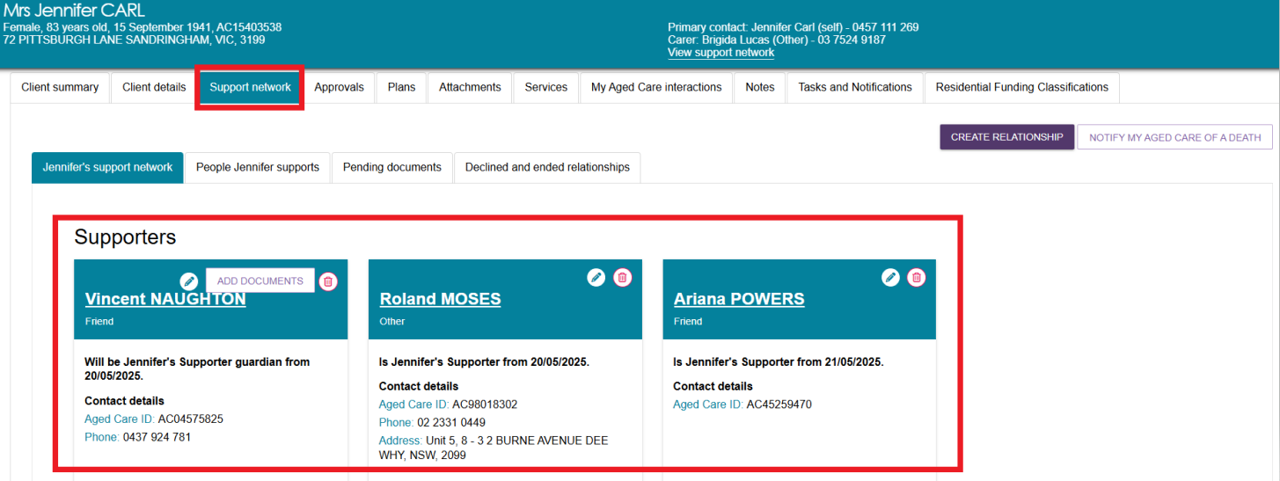

The Approvals tab
The Approvals tab displays the outcomes of a client’s assessments, and the types of government funded services they have been approved to receive. The information on this page helps assessors, clients, and service providers understand what care options the client is eligible for and guides service referrals and care planning accordingly. Additional approval details, such as status and priority category can be viewed by selecting the expand buttons next to each approval. These include setting up who to notify to receive correspondence.
- Select the Approvals tab to navigate to the approvals page of the client record.
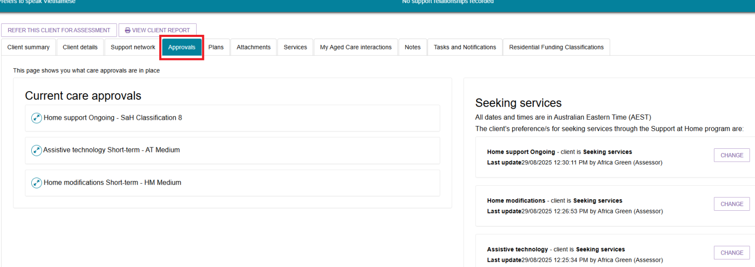
The below image shows an example of a client who was previously approved for a Home Care Package. They will have a new status of ‘Transitioned HCP Level [number]’
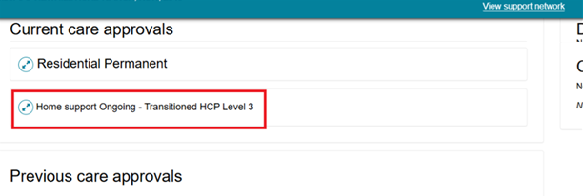
- Select the expand icon  next to the relevant care approval to view more details.
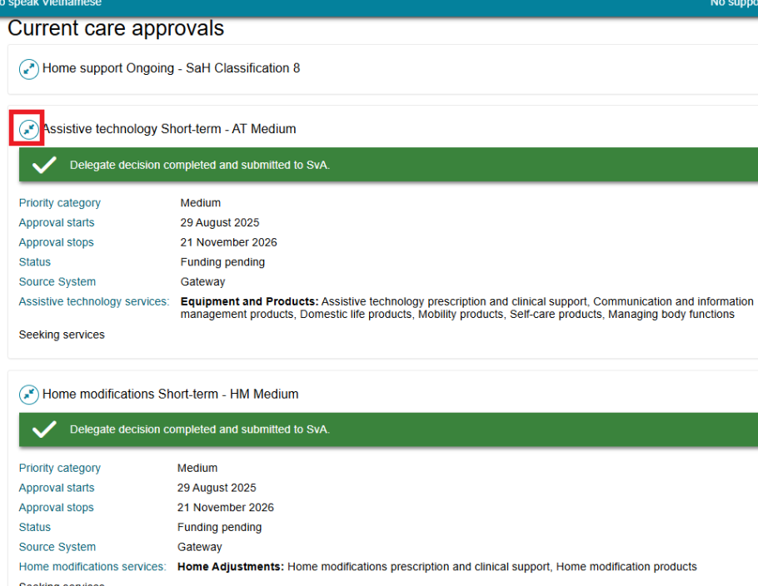
- If the clients' circumstances change, and they want to amend the services from Seeking to Not Seeking, this can be performed through the CHANGE button. Please note this process is required for all Support at Home service types that the client is approved for. If the client’s place has previously been “withdrawn” please advise them to call My Aged Care to be opted back into the Support at Home Priority System.
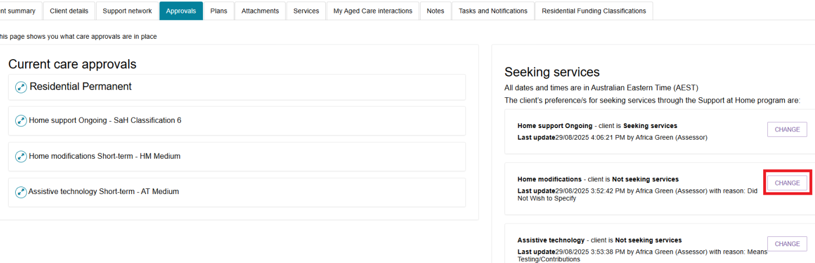

The Plans tab
The Plans tab provides a summary of the client’s support plan, outlining the outcomes of their assessment and the services or goals identified to meet their needs.
- Select the Plans tab to navigate to the plans page of the client record.
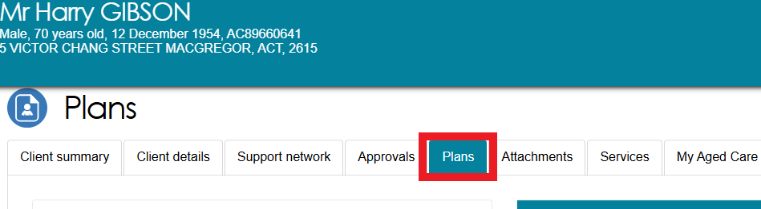
- Additional assessment details can be viewed by selecting the expand buttons next to each item under the Assessment history header.
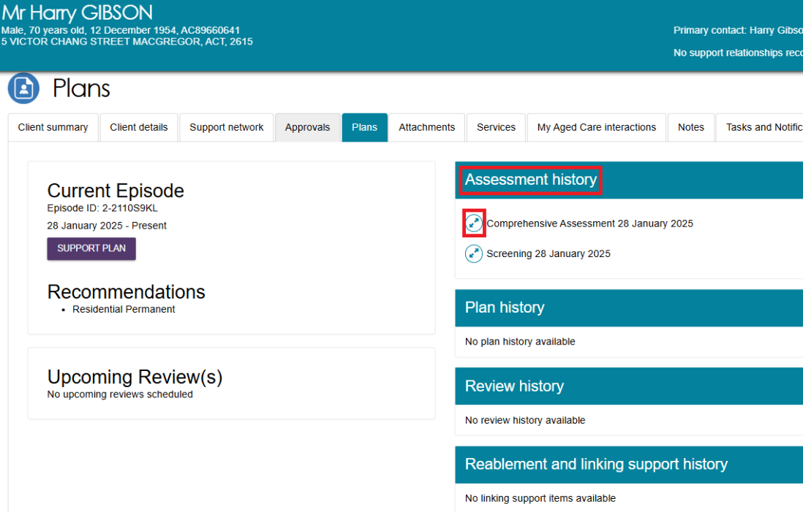

The Attachments tab
The Attachments tab allows assessors to upload, view, and manage documents related to a client’s assessment and care planning. The attachments tab contains documents that have been attached to the client record, including attachments that have been uploaded using the Aged Care Assessor App. This is also where assessors can add an attachment to the client record.
- Select the Attachments tab to navigate to the attachments page of the client record.
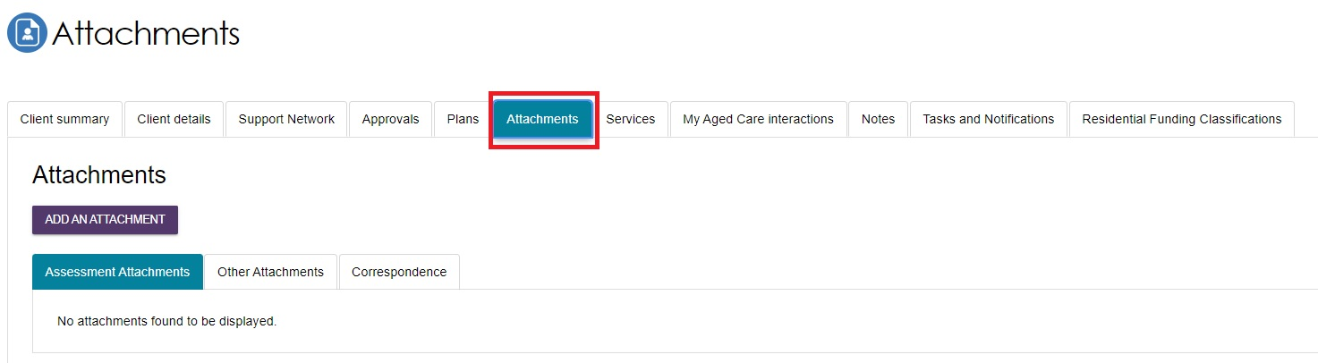
- Assessment Attachments are any documents that are relevant to the client’s assessment, for example, clinical notes or a discharge summary. This includes Notice of Decision (approval or non-approval) letters that assessors can generate and upload.
- Other Attachments are documents that relate to the clients’ general circumstances, for instance, documents related to the establishment of a support relationship (including legal documentation), and Occupational Therapist drawings used in home modifications.
- Correspondence are documents/letters that are generated in My Aged Care, related to Support at Home services. There are several letters sent to clients related to their Support at Home service at different stages. Copies of these letters will also be sent to their support person(s).
- Sensitive Attachments are documents that contain client information of a sensitive nature. For example, documents about a client’s financial situation, safety concerns and legal issues that may impact the provision of services.
- To add an attachment, select the ADD ATTACHMENT button.
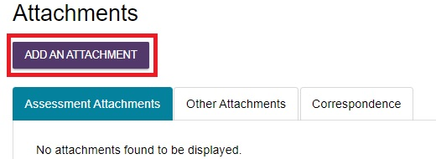
- A pop-up window will appear, prompting you to find and upload the desired attachment. Search your computer for the document you wish to attach by selecting the Choose file button. Provide additional details by inputting the Name of the attachment, choosing the Type of attachment from the drop-down lists, and providing a short description. Finally, select the UPLOAD button to save your attachment to the client record.
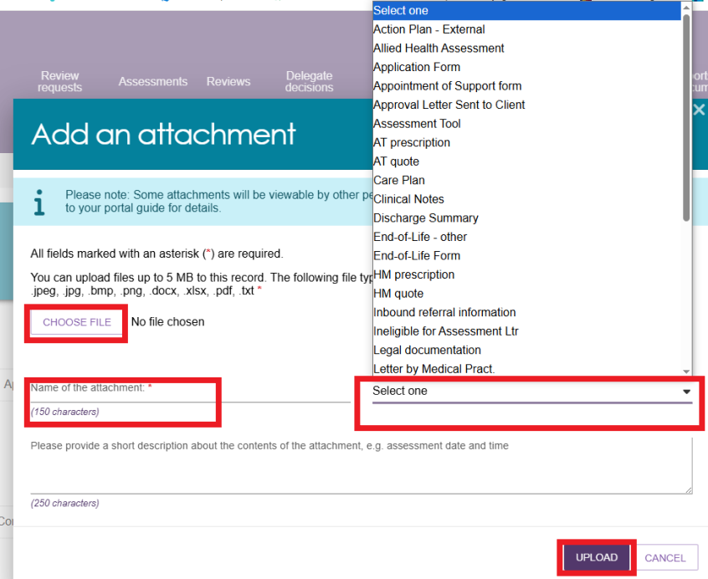
! | Where a client record has a Sensitive Attachment and the client is referred for service provision, service provider(s) will be notified that a Sensitive Attachment exists for the client. Service providers cannot view sensitive attachments; they will be directed to contact the assessor who conducted the last assessment, or the My Aged Care Service Provider and Assessor Helpline on 1800 836 799 to access information within the Sensitive Attachment.  Sensitive attachments are not visible through the My Aged Care online account and will be visible only to assessors and My Aged Care contact centre staff.
- Your attachment will appear in the Assessment Attachment tab, or the Correspondence tab.
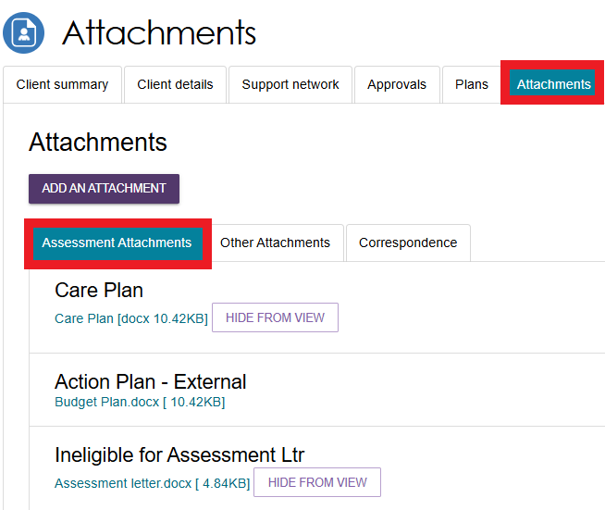
- Sensitive attachments will appear in the Other Attachments tab.
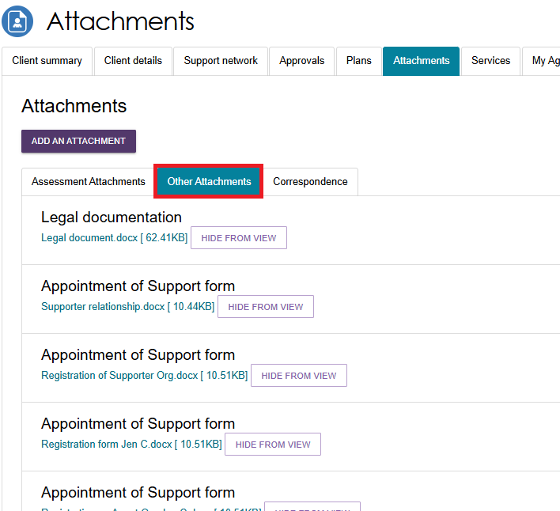

The Services tab
The Services tab provides a central view of the client’s current and past interactions with aged care services. It helps assessors track referrals, service uptake, and provider engagement. This section is crucial for ensuring service continuity, preventing duplication of referrals, and monitoring whether the client is receiving appropriate support based on their assessed needs.
- Select the Services tab to navigate to the services page of the client record.
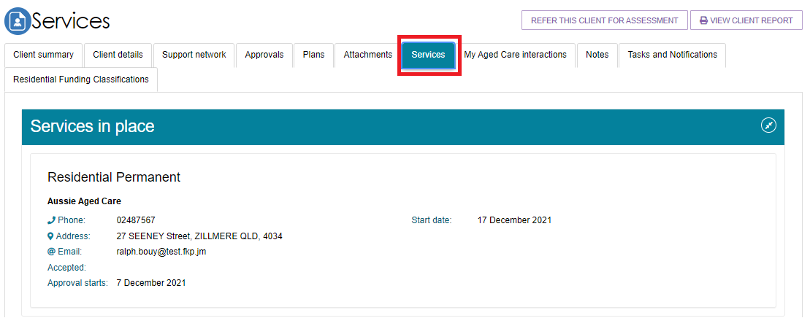
- The Services tab contains sections which host the following records:
- Previous services a client may have received (from other systems). For example, Clients that were transitioned from Short Term Restorative Care services (STRC) can view their STRC approval records and subsidised care records under the Services from other systems sub-section.
- Services that are not yet in place
- Services that are currently in place.
Sections which do not contain any records will not be displayed. Select the expand buttons on the right-hand side of each section header to display the records.
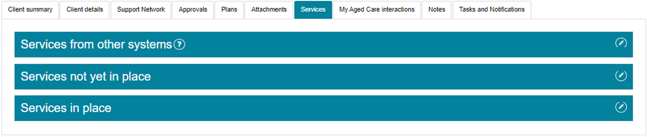

The My Aged Care interactions tab
The My Aged Care Interactions tab displays the client’s history of interactions with My Aged Care. This includes face-to-face appointments with Aged Care Specialist Officers, phone calls with My Aged Care Contact Centre staff, and capturing of consent for call back requests to be sent to Carer Gateway and/or National Dementia Helpline. Through this section, the assessors can stay informed about the client’s ongoing involvement with My Aged Care, supports continuity of care, and ensures no important communications are missed or duplicated.
For more information about the Carer Gateway and National Dementia Helpline referrals, go to My Aged Care – Assessor Portal User Guide 2 – Registering support people and adding relationships.
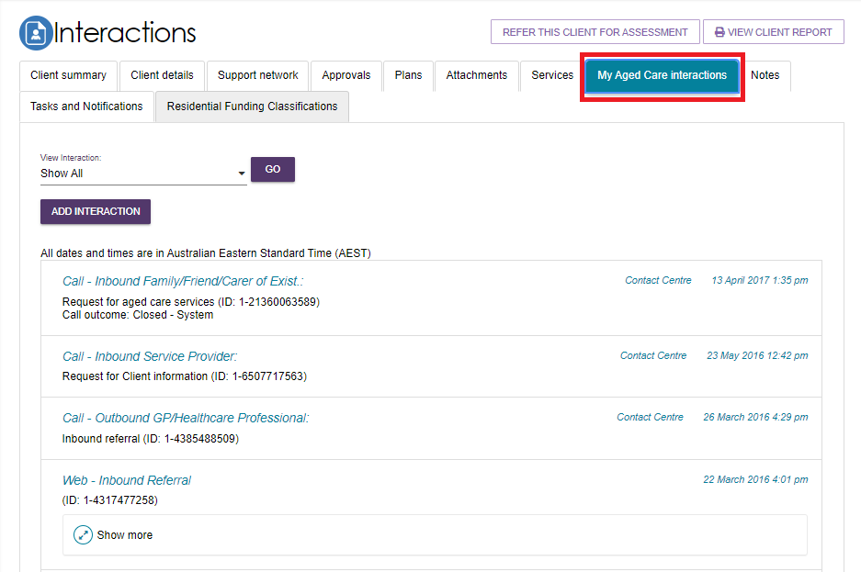

The Notes tab
! | Department staff can transfer client records linked to an inactive assessment outlet to an active assessment outlet in the same assessment organisation or to another assessment organisation. This means that you may view client records that were transferred from another assessment outlet. You will view a note of the transfer in the clients My Aged Care record.
- Select the Notes tab to navigate to the notes page of the client record.
The Notes tab contains notes that have been created about the client. Assessors can add new notes about the client from this tab.
! | It is recommended that Triage Delegates review the notes tab prior to completing the triage process as not all information captured from screening is pre-populated.
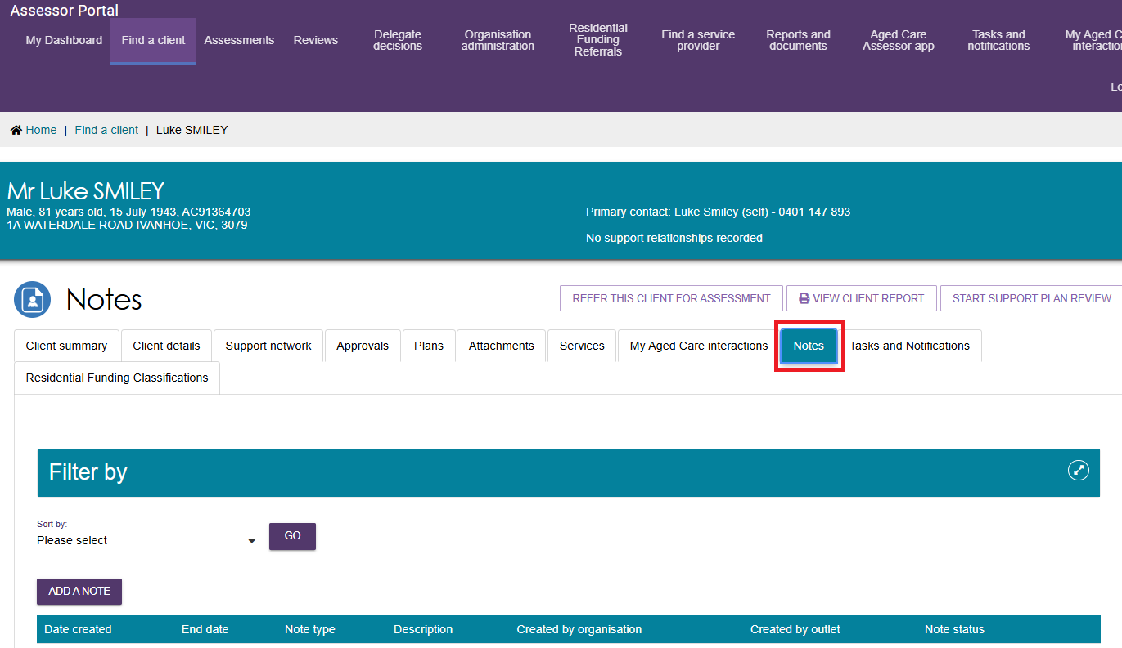
! | All notes will be subject to Freedom of Information legislation.

My Aged Care contact centre staff, Aged Care Specialist Officers, assessors and service providers can view and add different types of notes about clients through the My Aged Care portals. Assessors can also view and add these notes in the Aged Care Assessor App. Refer to the following tables for information about note types and permissions according to role.

Note Types
This table shows a selection of important note types, their description and example text.
Note type | Description | Examples
Client story | A summary of the client’s current circumstances. Assessors, My Aged Care contact centre, service providers and clients can view these notes. | Mrs Jones has just been discharged from hospital and is seeking help at home. She lives with husband and has early onset dementia.
Sensitive notes | Information of a sensitive nature about the client that needs to be available for assessment or provision of some services. A sensitive note will display a flag on the portal for the service provider against the client. They may contact the My Aged Care contact centre or assessor for additional information, which will only be provided to them if relevant to their service provision. This note will not be displayed to service providers or clients in their portals. | Mr Smith is HIV positive.  Mrs Johns has an abusive relationship with son.
Preference | Clients stated service provision preferences. Assessors and My Aged Care contact centre staff can view these notes. | Mrs Marten would prefer a Catholic provider.  Mr Dobruk is affiliated with the Croatian community.
Observations | Observations from service provider and/or assessor’s interactions with the client. Assessors, My Aged Care contact centre staff and service providers can view these notes. | There is a dog on the property.  Mrs Shean seems more energetic than she did during my last visit.
Referral Note | Notes accompanying a client’s referral. This can be an initial referral, subsequent referral or referral from one assessment outlet to another. | This client record has now been transferred from Outlet A to Outlet B on 01/01/2024.
Other | Additional information about the client. Assessors, My Aged Care contact centre staff, service providers and clients can view these notes.  Examples of other notes include: Client Story - Returned mail, Cultural/Religious, History of Experiences, Gender Identity/Sexual Pref notes. | Mrs Jones has planned respite on 01/08/2017.

Note Add & View permissions
The below table shows each role in the assessor portal and their permissions to add or view a selection of note types.
Role | Add Note Types | View Note Types
Assessors | All | All
Service Providers | Observations  Other | Other  Client Story  Observations  Sensitive (Flag only, no content)
Clients (and their support network) | Other | Other  Client Story
My Aged Care  Contact Centre Staff | Client Story, Sensitive Notes, Preference, all “Other” notes except Observations. | All
Aged Care Specialist Officers  (Face to face support in Services Australia centres) | All | All
! | When My Aged Care contact centre staff or assessors add a sensitive note about a client, all service providers who are sent a referral will view a flag informing them that there is a sensitive note about the client and instruct them to call the My Aged Care contact centre or the assessor for more information.

Adding client notes
The following section outlines how to add client notes using the assessor portal. For instructions on how to add notes in the Aged Care Assessor App, please refer to the Aged Care Assessor App User Guide.
- Select the Notes tab to navigate to the notes page of the client record. Then, select the ADD NOTE button to start creating a new note.
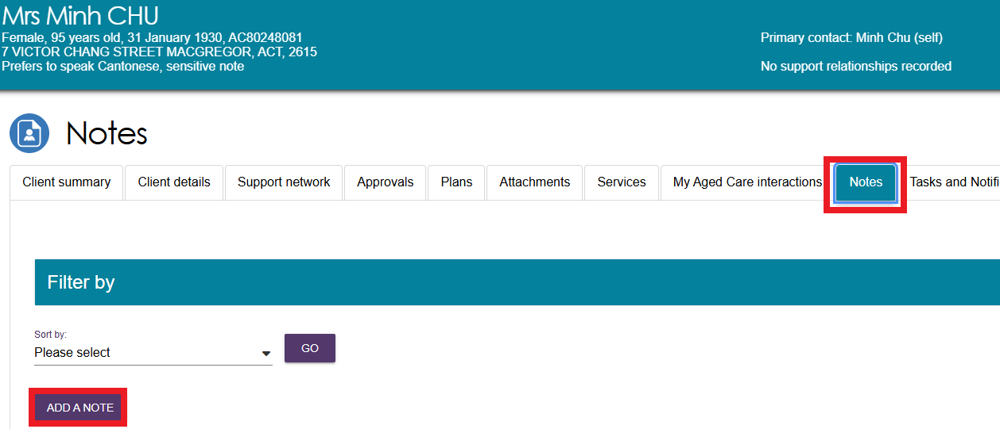

- A pop-up box will appear. Select the Type of the note you wish to add using the drop-down list, and input the Description (i.e. the content of the note itself). You can hover over the help icon  in the pop-up box for additional information about the different types of notes. If you are unsure which category is most appropriate, please refer to the information in the help icon.
! | You cannot delete a note once saved. Quality check that the information is correct before saving.
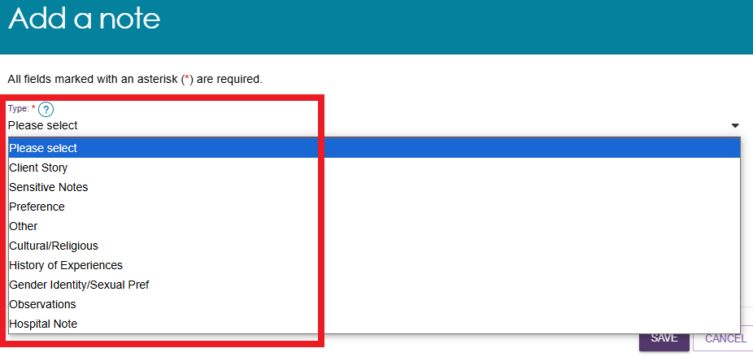
- Select SAVE to finish your note.
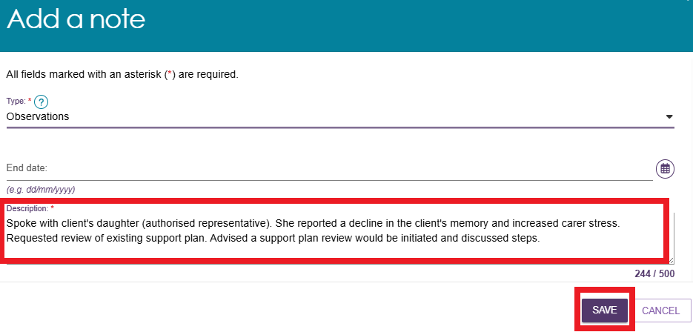

Viewing and editing client notes
The following section outlines how to view and edit client notes using the assessor portal. For instructions on how to view and edit notes in the Aged Care Assessor App, please refer to the Aged Care Assessor App User Guide.
- Select the Notes tab to navigate to the notes page of the client record. Then, select the Edit (pencil) icon to the right of the note you wish to edit. Note that there is no Edit icon available for Client Story notes.
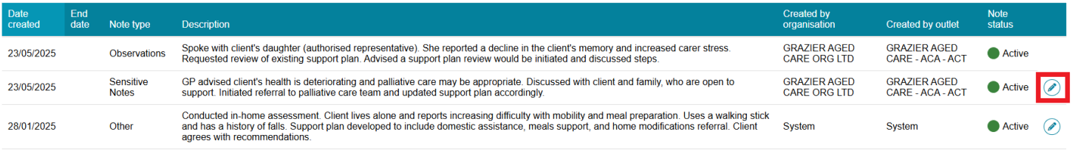
- A pop-up box will appear. To make a note Active or Inactive, use the drop-down list to select the desired status. Then, select SAVE to finish your note.
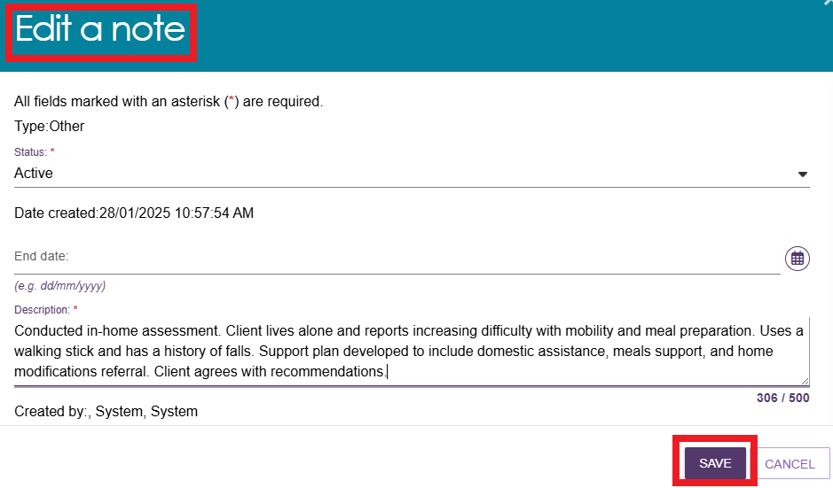
- Client Story notes can also be viewed by assessors in the Assessments section of the assessor portal. Select the link to the Assessments section of the assessor portal at the very top the page. Then, select expand a client summary using the expand icon on the left of the row.
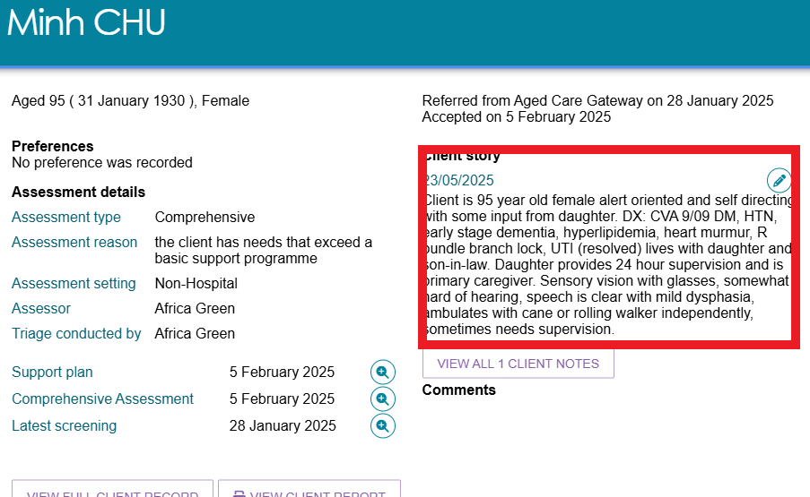
! | In order to ensure records are never lost, assessors and providers cannot edit the contents of a client story note once it is created. Instead, assessors and providers can make the original note Inactive and create a new one in its place.  If there are errors in the information which you are concerned about being on the records, contact the My Aged Care service provider and assessor helpline on 1800 836 799.

The Tasks and Notifications tab
All tasks and notifications relevant to the client will be displayed in this page. Assessors will be able to view all tasks and notifications relevant to the client. Providers will only be able to view tasks or notifications that are associated to their assessment outlet, for clients that they are providing services to. Select the Tasks and Notifications tab to navigate to the interactions page of the client record.
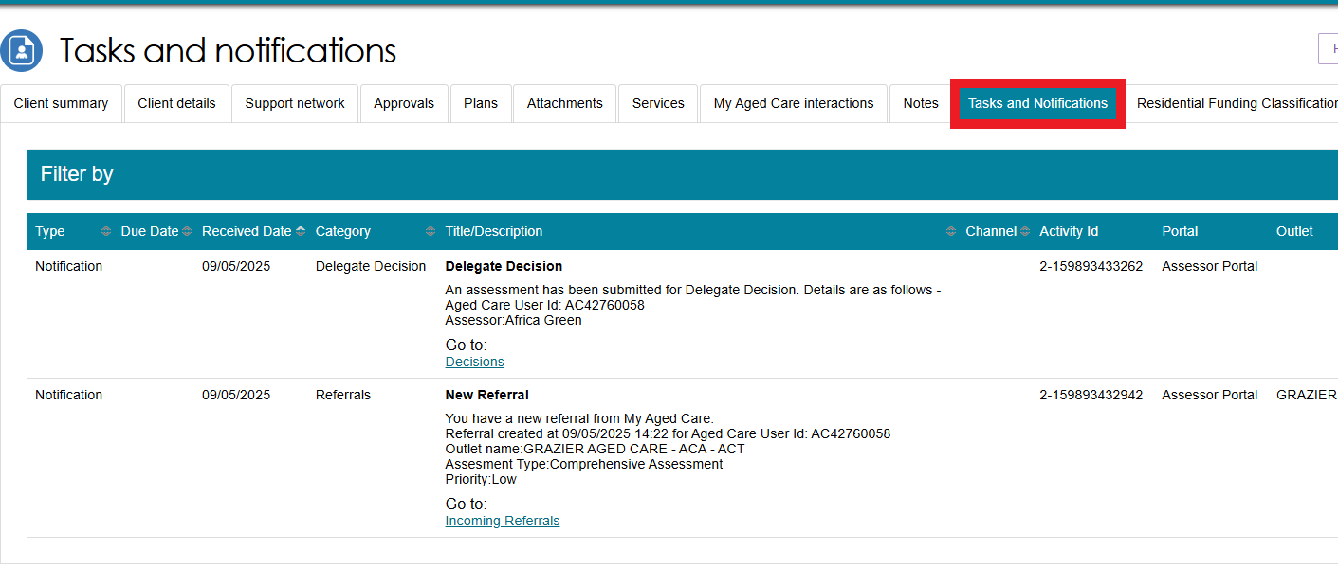
For a complete view of all tasks and notifications, refer to the Tasks and Notifications tile assessable from the assessor portal front page.

The Residential Funding Classifications tab (clinical needs assessors)
Residential Funding Classifications are part of the Australian National Aged Care Classification (AN-ACC) system, designed to replace the Aged Care Funding Instrument (ACFI) for the purposes of allocating government funding for residential aged care. Clinical needs assessors can view the clients current AN-ACC classification, and classification history using this tab.
Select the Residential Funding Classifications tab to navigate to the classifications page of the client record. For more information about the Residential Funding Classifications refer to the residential aged care funding reform page on the Departments website.
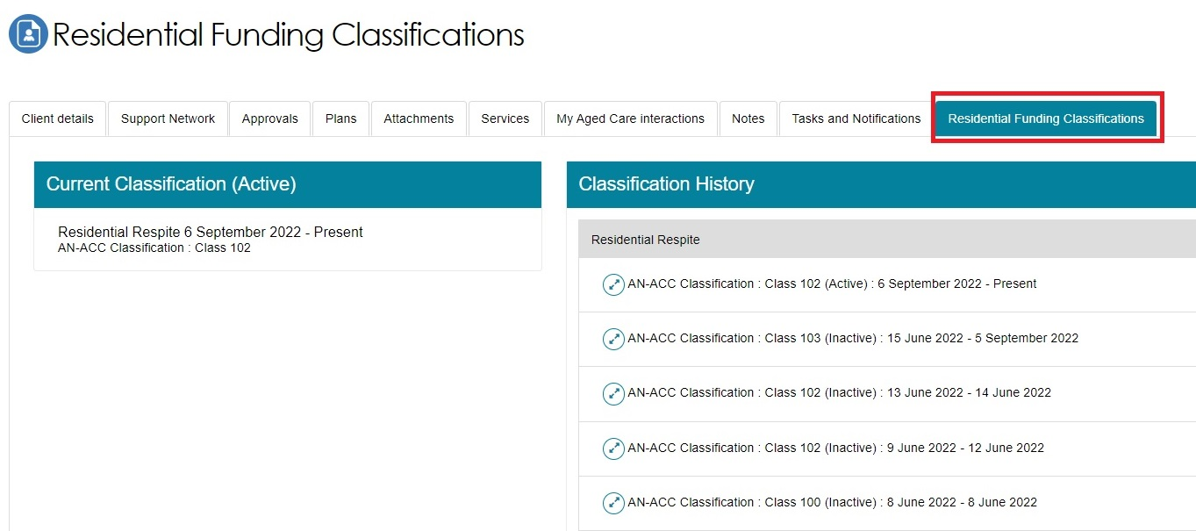

More Information
For further assistance, you can call the My Aged Care service provider and assessor helpline on 1800 836 799.

