Assessor Portal User Guide 11 – Assessment Delegate Support Role
The Delegate Support role in the My Aged Care assessor portal (assessor portal) enables anyone assigned the role to perform administrative functions to support the Assessment Delegate. For example, the Assessment Delegate Support will be able to print support plans, as well as generate, print and upload referral code letters and approval letters. The Assessment Delegate Support operates under the instructions of the Assessment Delegate.
Clinical Assessment Delegates are able to approve an older person for all service groups, classification types and classification levels under the Aged Care Act 2024. Non-clinical assessment delegates are restricted to approving entry level home support, Assistive Technology (AT) or Home Modification (HM) services (i.e. with classification levels of CHSP class, AT CHSP or AT-HM).
! | From 1 November 2025, there are changes to assessment delegations under the Aged Care Act 2024, for both Clinical and Non-clinical Assessment Delegates.  To understand Assessment Delegate changes, refer to ‘Chapter 7: Delegations and Approvals under the Act’ of My Aged Care Assessment Manual.  For guidance on the interim process explaining Manual Delegate Approval for CHSP only for comprehensive and home support assessments, and how it impacts Clinical and Non-clinical Assessment Delegates from 1 November 2025, refer to Manual Delegate Approval for CHSP – Standard Operating Procedure and instructional videos for comprehensive and home support assessments.  Note: This process was updated to align with recent changes effective from 23 February, the updated approach now applies.
This guide contains the following topics:
Accessing client information 3
Printing the support plan and generating referral code letters 5
Notice of Decision Letters 6
Uploading Approval Letters 6
Uploading Non-Approval Letters 11

Accessing client information
- To locate information about a client and print a copy of the client record, select the Find a client tile from your homepage.
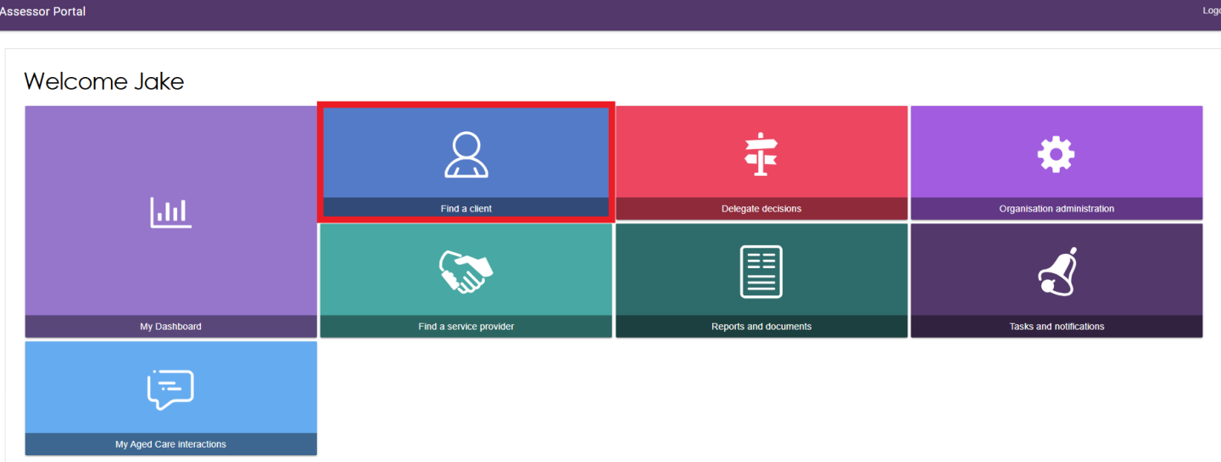
- Use the Find a client function to search for the client. Client records you have recently viewed will appear in the Recently Viewed Persons section, and depending on your browser, this will either appear on the right side or the bottom section of the page.
The ADVANCED SEARCH functionality allows you to search by additional fields. Refer to the My Aged Care – Assessor Portal User Guide 1 – Registering and referring clients for more information on using this functionality.
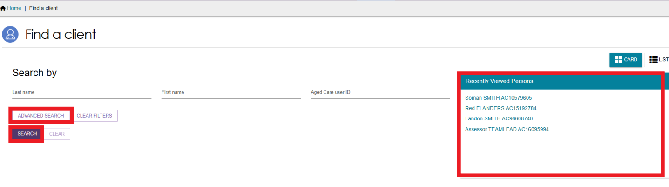
- Any matching search results will be displayed. Select the client’s name.
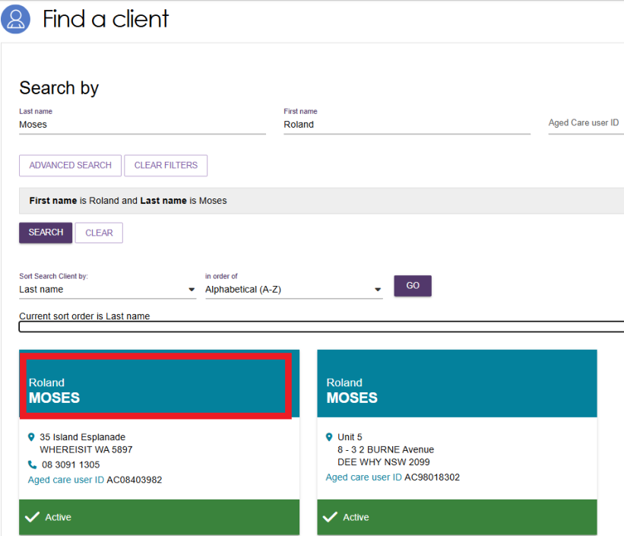
- You will be able to sort the matching results by a number of criteria including last name, first name, Aged Care User ID, suburb, state, post code, date of birth and more. Select the criteria, the order of display as required and select GO.
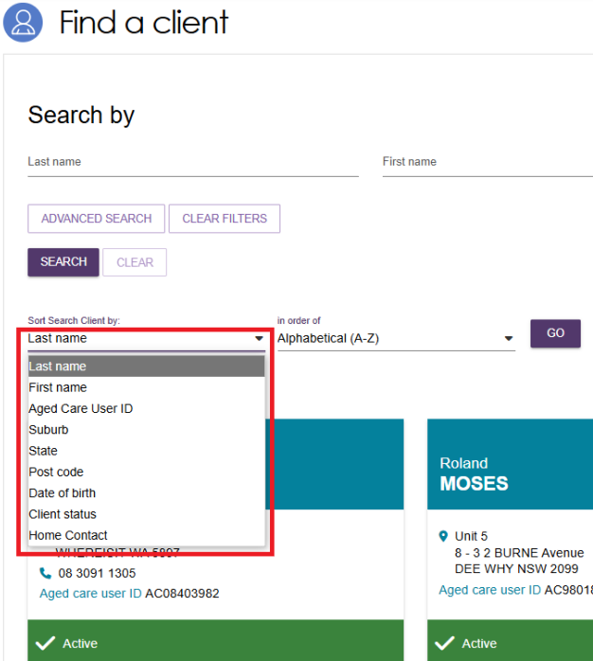
- Selecting the client’s name tile will take you to the Client Summary. You can view and print a RTF (Rich Text File) of the client record by selecting the VIEW CLIENT REPORT button.
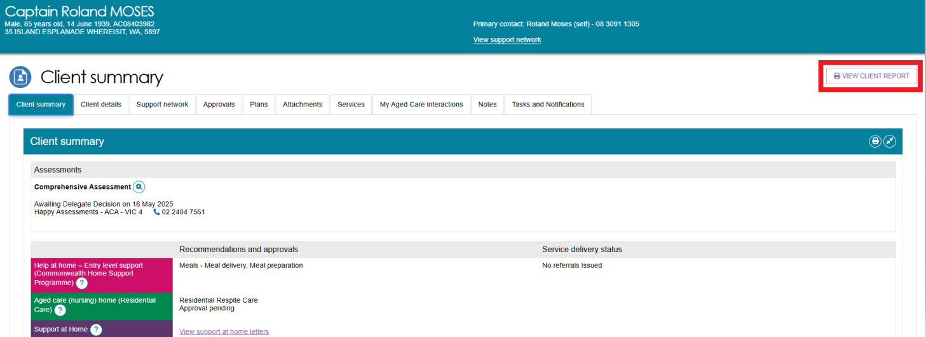
- A Generating Report pop up appears, then the Rich Text File (RTF) appears on your browser ready to be downloaded or opened.
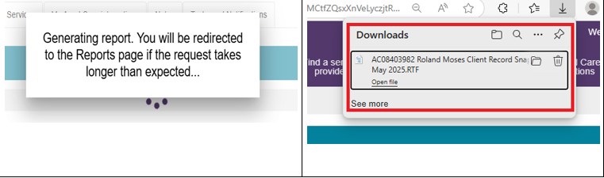
- Opening the RTF shows a Copy of the Client Record.
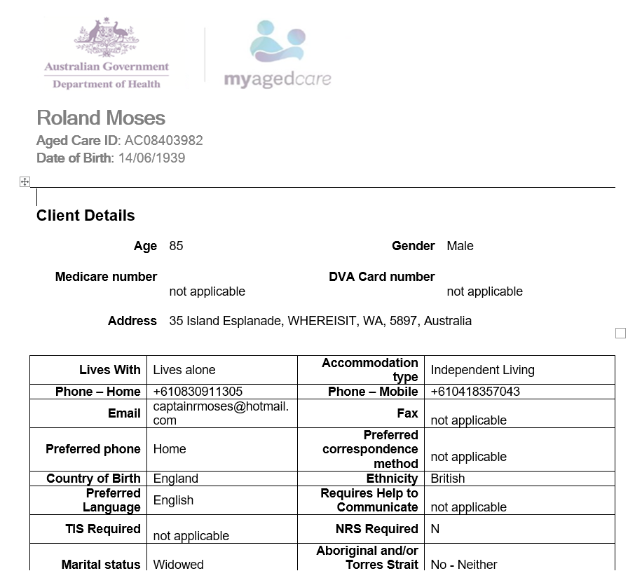

Printing the support plan and generating referral code letters
- To view and print the support plan, navigate to the Plans tab in the client record. From here, select SUPPORT PLAN.
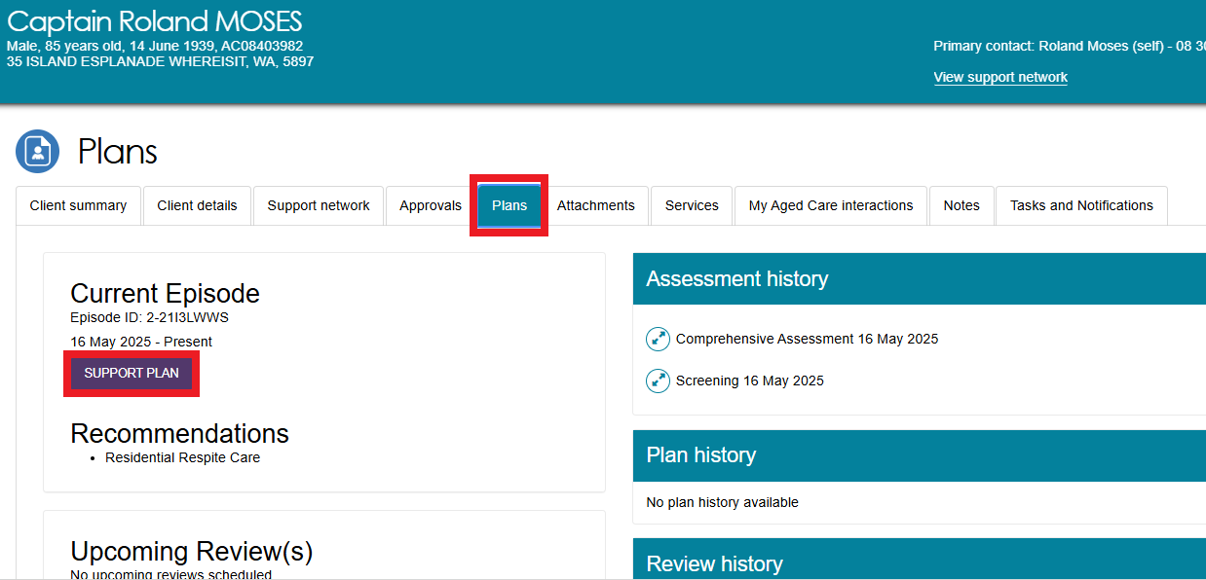
- The Goals & recommendations tab will be displayed. You can print a copy of the support plan by selecting PRINT COPY OF SUPPORT PLAN.
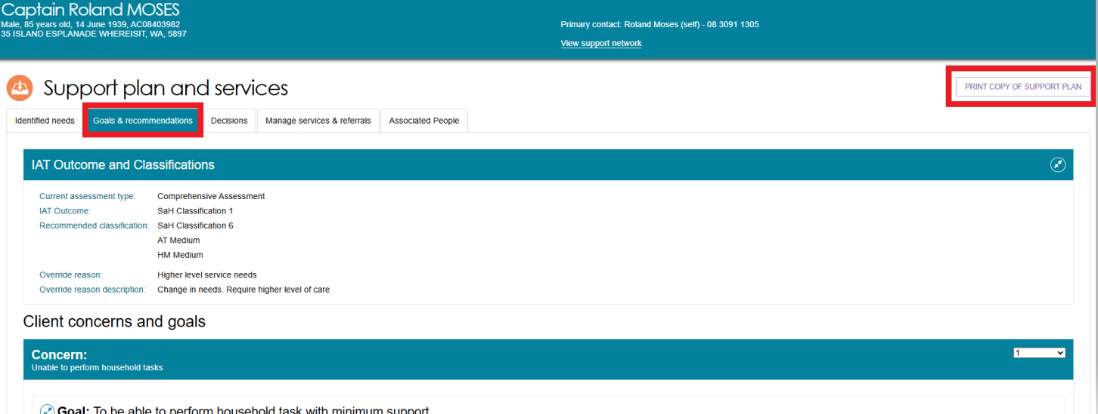
- Navigate to the Manage services & referrals tab. From here, you can view the client’s service referrals and generate a copy of the referral code letter.
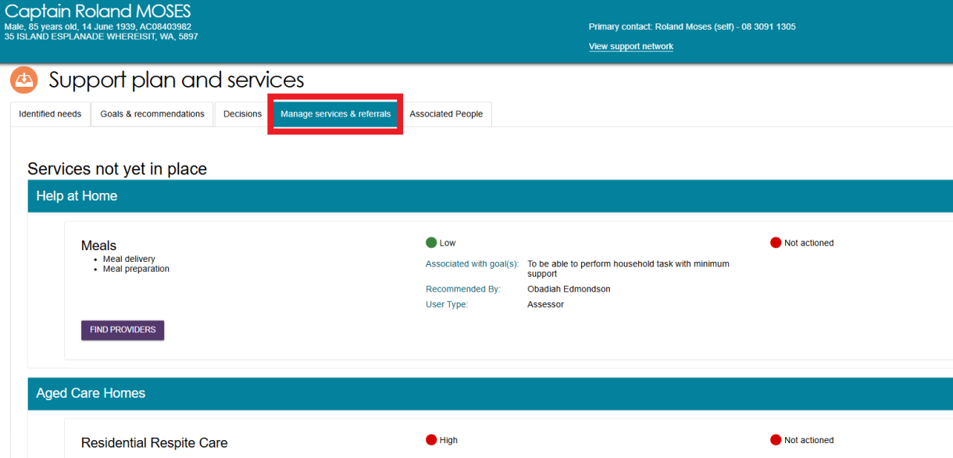

Notice of Decision Letters
The Delegate Support can upload the Notice of Decision (NoD) letter, after the delegate decision is completed. This applies to both Approval letters and non-Approval letters.
NoD Letters are also sent to any of the older person’s registered supporters (except for supporters-lite). Refer to My Aged Care – Assessor Portal User Guide 2 – Registering support people and adding relationships | Australian Government Department of Health, Disability and Ageing for more information.
! | For CHSP only approvals: From 1 November 2025, there are manual changes introduced to the process for generating and uploading the Notice of Decision (Approval) letter for CHSP only for comprehensive assessments.  For more information, please refer to Support at Home – Manual Delegate Approval for CHSP – Standard Operating Procedure and instructional videos for comprehensive assessments.  Note: This process was updated to align with recent changes effective from 23 February, the updated approach now applies.

Uploading Approval Letters
Once the Assessment Delegate has signed the letter, you can use the Upload approval letter button in the Decisions tab of the support plan to upload the letter to the client’s record. Alternatively, you can upload this by using the Add An Attachment button in the Attachments tab on the client record.
For CHSP only recommendations, NoD letters can also be uploaded from the Goals & Recommendations tab.

From the support plan
- Go to the Client’s profile and select the Plans tab. In the Plans page select the Support Plan button.
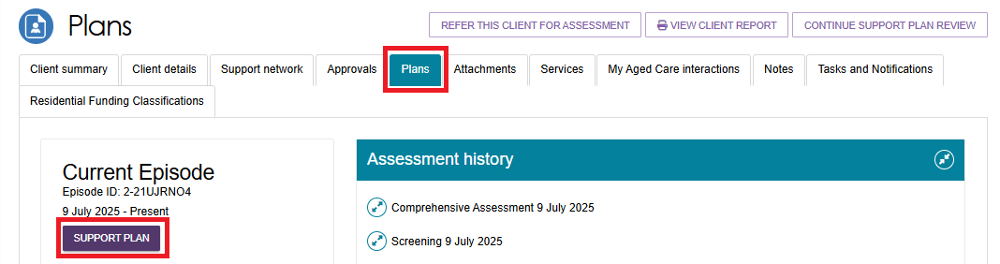
- The Support Plan and Services page appears.
Select the Decisions tab, then Select Upload Approval Letter from the bottom of the page, underneath Delegate decisions and comments.
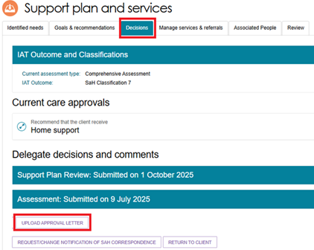
Alternatively, select the Goals & Recommendations tab, then select Upload Approval or Non-approval letter for CHSP only recommendations.
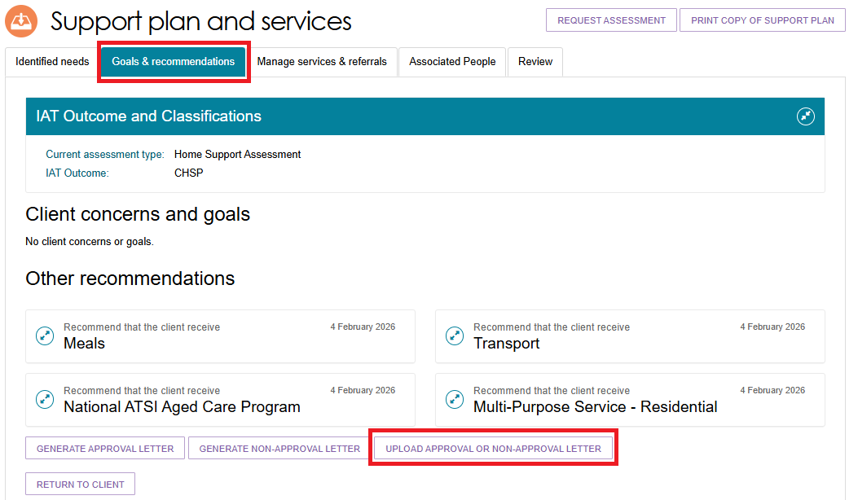
- The Upload Approval Letter pop up appears (or ‘Upload approval or non-approval letter’, for CHSP only recommendations).
Choose the approval letter file to upload. Enter the name of the attachment. Ensure the attachment type is ‘Approval letter sent to client’. Optionally provide a short description about the contents of the attachment.
Finally, select UPLOAD.
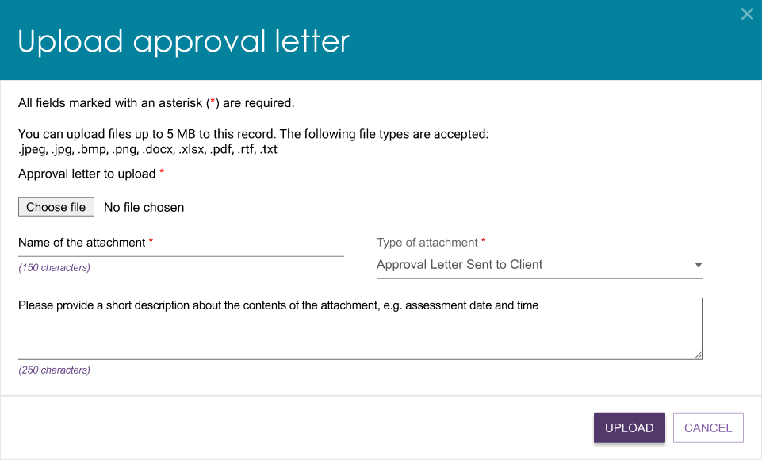
- Choose the letter and then select Open.
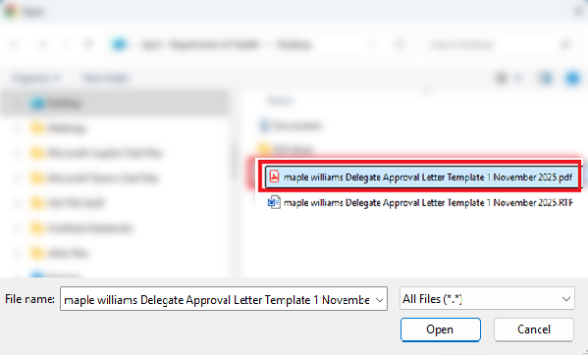
- The letter name will appear next to the Choose File button.
Select Upload.
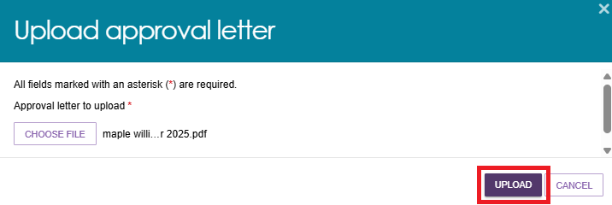
- A success message appears saying that the attachment is now uploaded onto the Attachments page of the client record.


From the attachments tab
Alternatively, you can upload the letter by using the Add An Attachment button in the Attachments tab on the client record:
- Select the client’s record and go to the Attachments tab. Then, select Add An Attachment.
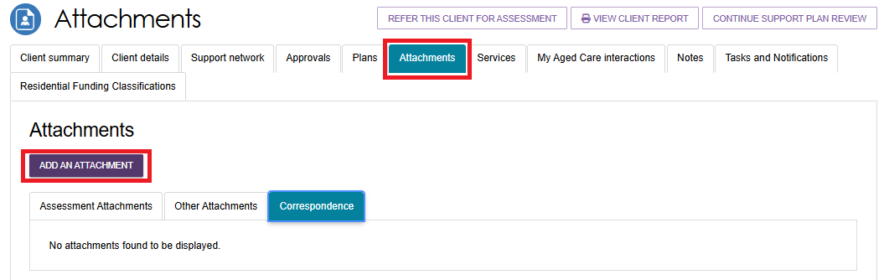
- Select Choose File
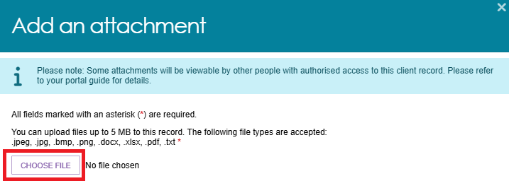
- Select the approval letter and then select Open.

! | The system supports a maximum file size of 5MB.  Only the following file types are accepted: jpeg, jpg. bmp, png, docx, slsx, pdf, or txt.  The approval letter will automatically download as Rich Text Format (rtf), which means you will need to convert to one of the above accepted file types prior to uploading.
- The attachment’s name will display next to the Choose File button.
Next, enter the Name of the attachment, and select the Type of attachment as Approval Letter Sent to Client.
Optionally you can provide a short description about the contents of the attachment such as assessment date and time.
Then, select Upload.
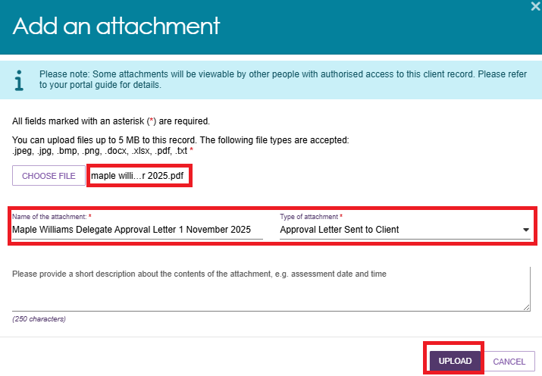
- The letter now appears under the Assessment Attachments tab of the Attachments page.
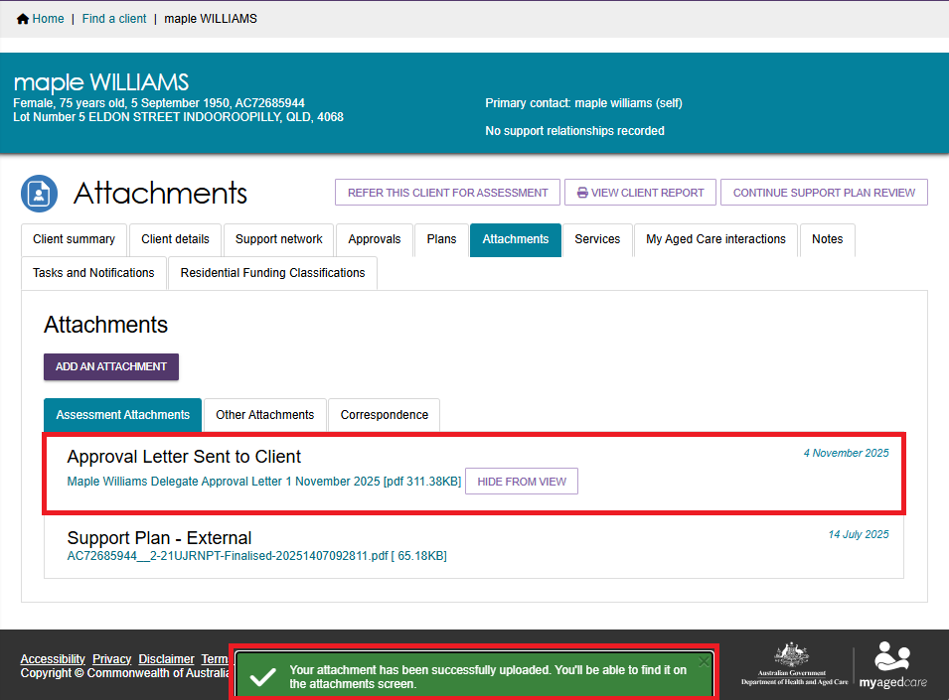

Uploading Non-Approval Letters
Once the Assessment Delegate has signed the letter, you can use the Upload Non-Approval letter button in the Decisions tab of the support plan to upload the letter to the client’s record. Alternatively, you can upload this by using the Add An Attachment button in the Attachments tab on the client record.
For Comprehensive assessments, uploading non-approval letter buttons are only available for No Care Approval (or similar).
For CHSP only recommendations, NoD letters can also be uploaded from the Goals & Recommendations tab.

From the support plan
- Go to the Client’s profile and select the Plans tab. In the Plans page select the Support Plan button.
- The Support Plan and Services page appears.
Select the Decisions tab, then Select Upload Non-Approval Letter from the bottom of the page, underneath Delegate decisions and comments.
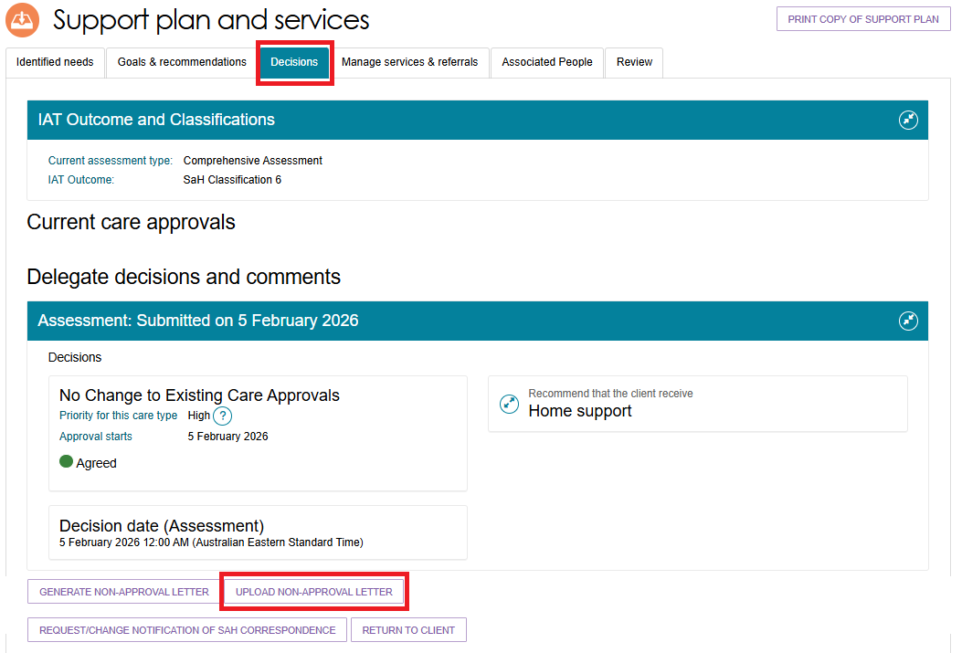
Alternatively, select the Goals & Recommendations tab, then select Upload Approval or Non-approval letter for CHSP only recommendations.

- Select Choose File at the pop up that appears.
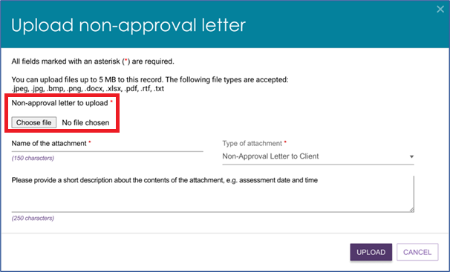
- Choose the letter and then select Open.
- The letter name will appear next to the Choose File button.
Enter the name of the letter. Ensure the type of attachment is ‘Non-Approval Letter to Client’. Optionally you can provide a short description about the contents of the letter.
Finally, select UPLOAD.
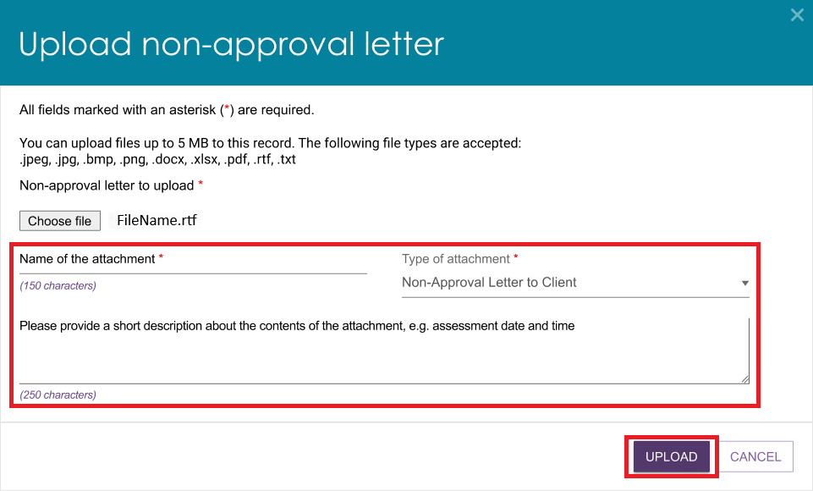
- A success message appears saying that the attachment is now uploaded onto the Attachments page of the client record.

From the attachments tab
Alternatively, you can upload the letter by using the Add An Attachment button in the Attachments tab on the client record:
- Select the client’s record and go to the Attachments tab. Then, select Add An Attachment.

- The Add an attachment pop up appears. Select Choose File.
- Select the approval letter and then select Open.
! | The system supports a maximum file size of 5MB.  Only the following file types are accepted: jpeg, jpg. bmp, png, docx, slsx, pdf, or txt.  The approval letter will automatically download as Rich Text Format (rtf), which means you will need to convert to one of the above accepted file types prior to uploading.
- The attachment’s name will display next to the Choose File button.
Next, enter the Name of the attachment, and select the Type of attachment as Approval Letter Sent to Client.
Optionally you can provide a short description about the contents of the attachment such as assessment date and time.
Then, select Upload.
- The letter now appears under the Assessment Attachments tab of the Attachments page.

