Assessor Portal User Guide 10 – Clinical Assessment Delegate Processes
This user guide is to assist Clinical Assessment Delegates in performing and range of functions in the My Aged Care assessor portal (assessor portal) that relate to the requirements set out in the Aged Care Act 2024 as the role of System Governor. This includes viewing and actioning delegate decisions, as well as requesting corrections to care approval decisions and care extensions.
Clinical assessment delegates can approve an older person for all service groups, classification types and classification levels under the Aged Care Act 2024. Non-clinical assessment delegates are restricted to approving entry level home support, Assistive Technology or Home Modification services (i.e. with classification levels of CHSP class, AT CHSP or AT-HM).
! | From 1 November 2025, there are changes to assessment delegations under the Aged Care Act 2024, for both Clinical and Non-clinical Assessment Delegates.  To understand Assessment Delegate changes, refer to ‘Chapter 7: Delegations and Approvals under the Act’ of My Aged Care Assessment Manual.  For guidance on the interim process explaining Manual Delegate Approval for CHSP only for comprehensive assessments, and how it impacts Clinical Assessment Delegates, refer to Manual Delegate Approval for CHSP – Standard Operating Procedure and instructional videos for comprehensive assessments.  Note: This process was updated to align with recent changes effective from 23 February, the updated approach now applies.

This user guide contains the following topics:
The Clinical Assessment Delegate home screen 3
Assessment history 3
Viewing an item for decision 4
Assigning an item for decision 6
Reassigning for Decision 8
Recording a delegate decision 9
Viewing Decisions information 10
Editing a Recommended Classification 11
Viewing details about the Decision 14
Return to a clinical assessor 15
No Decision 15
Agreeing with recommendations 16
Disagreeing with recommendations 17
Agreeing or disagreeing with a Support at Home Recommendation 20
Editing a recommendation 24
Adding a care type 24
Recommending a Home Modification Service 26
Recommending an Assistive Technology Service 27
Recommending a second Restorative Care Pathway unit 29
Changing a decision 30
Finalising your decision 31
Correspondence Notifications 33
Notice of Decision (approval or non-approval) letter 35
Approval Letters 35
Non-approval Letters 39
Requesting correction to care approval decision 42
Making changes to the commencement date of the delegate decision 43
Requesting the removal and addition of different care classification within a care type within the same correction request 45
Requesting and Approving Care Extensions 51

The Clinical Assessment Delegate home screen
If you are both a clinical aged care needs assessor (clinical assessor) and a Clinical Assessment Delegate in the Assessor portal, your home screen will look like the following.
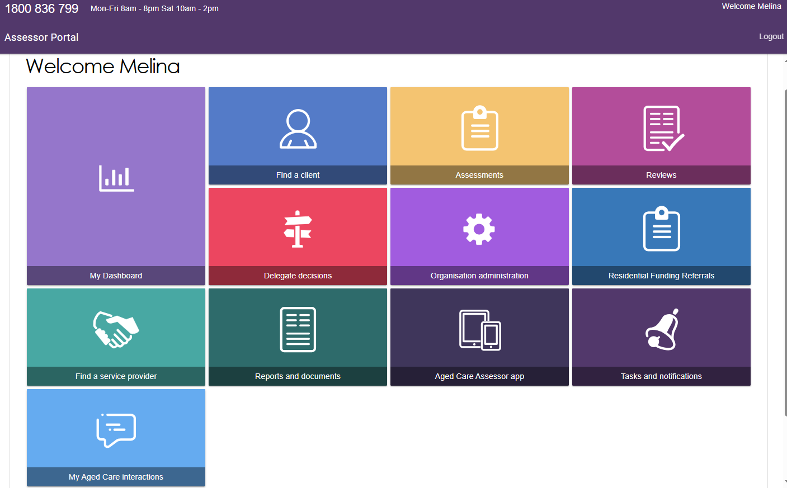
For more information regarding applying to be a Clinical Assessment Delegate please refer to the My Aged Care Assessor Portal User Guide 12 – Managing Delegate Roles.

Assessment history
To assist Clinical Assessment Delegates with understanding and actioning delegate approvals, Clinical Assessment Delegates can view a client’s assessment history via the Plan tab of the client record. Within the Assessment history section, it will outline key information such as if the assessment has been completed by a non-clinical needs assessor who then converted the assessment from a home support assessment to a comprehensive assessment, as well as the details of the clinical supervising assessor.
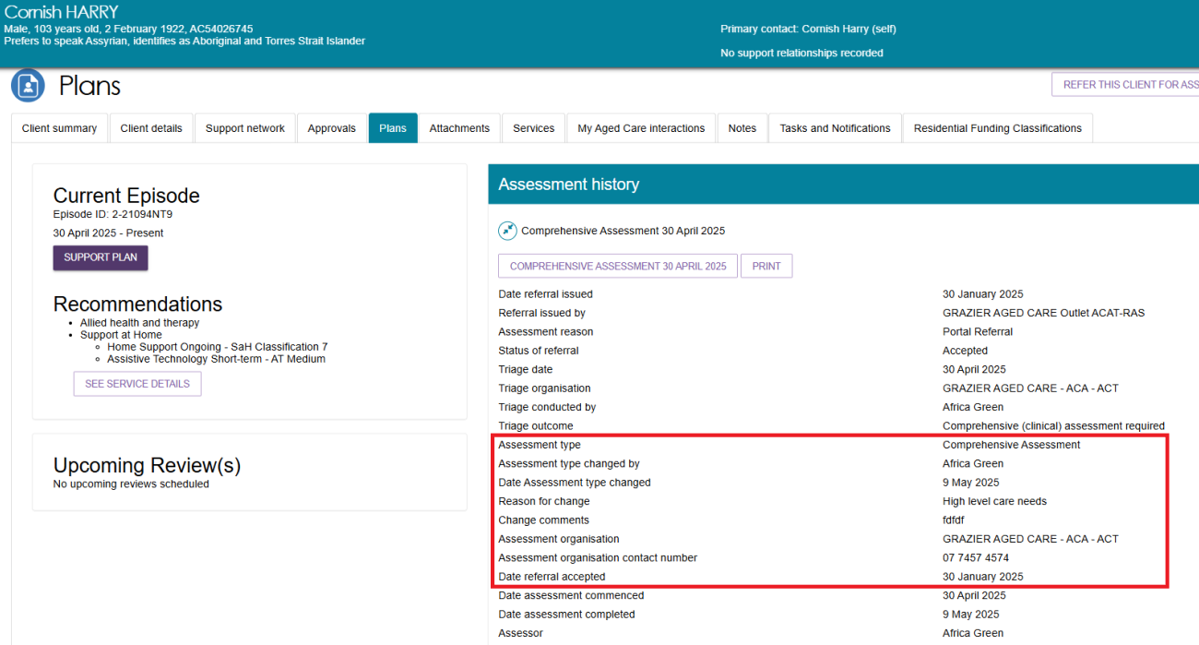

Viewing an item for decision
As a Clinical Assessment Delegate, follow the steps below to assign items for decision.
- Select Delegate decisions from the homepage.
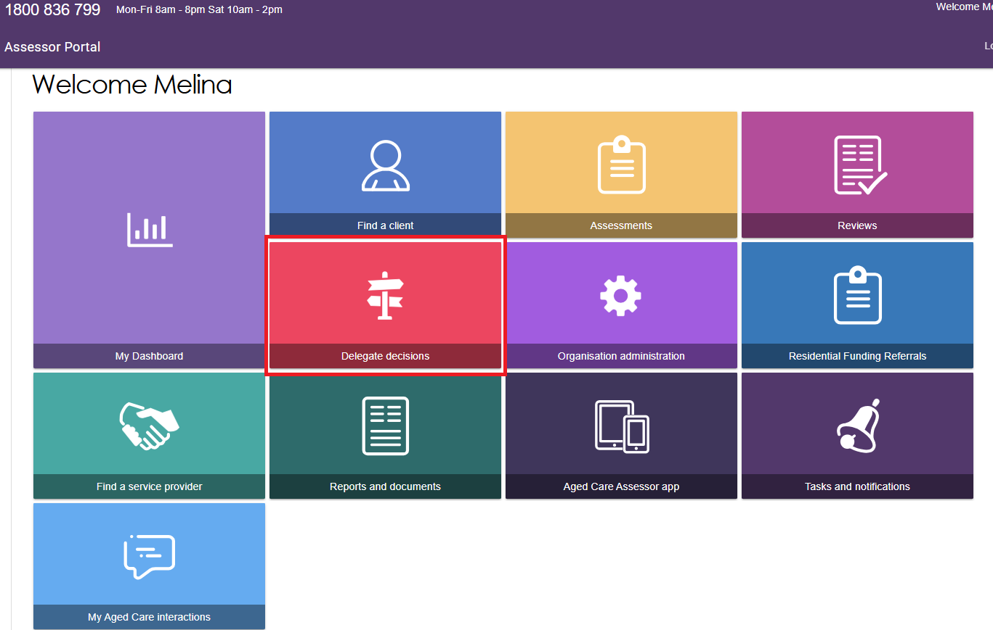
- The queue containing assessments awaiting Clinical Assessment Delegate decision will be displayed in the Decision pending tab.
You can use the filter options (First Name, Last Name, and Aged Care User ID) to refine your results. To show additional filter options select Advanced Search.
You can also use the sort function to sort by assessment status, as well as other categories such as last name, first name, Aged Care ID, date submitted, priority (or urgency), assessor and delegate names and due date. The order in which the results are displayed can also be set.
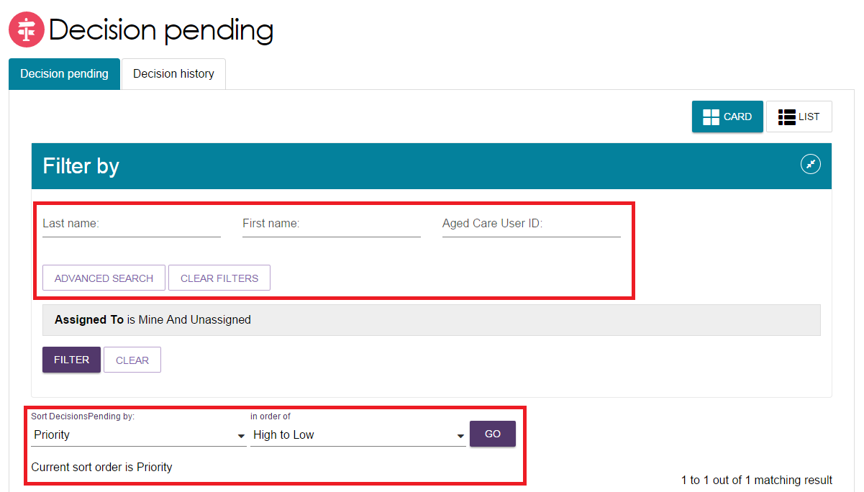
The due date against each assessment waiting for delegate decision will be visible to the Clinical Assessment Delegate in both the Card and List View. The pending decisions can be sorted and filtered by date due.
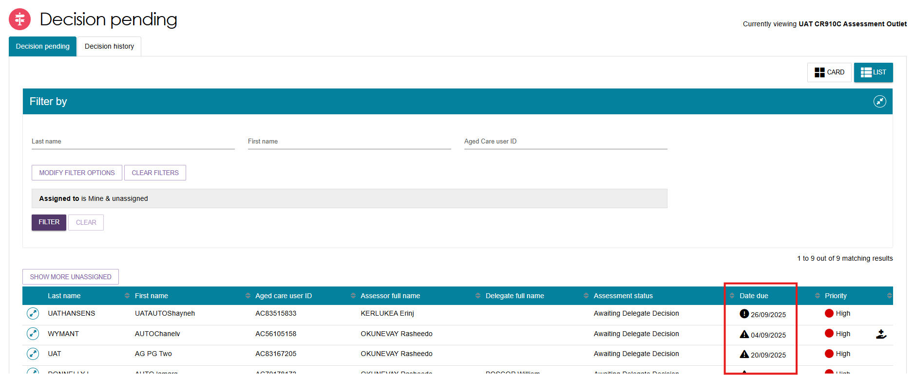
- On this page is also the Decision history tab, which will display decisions that you have made previously.
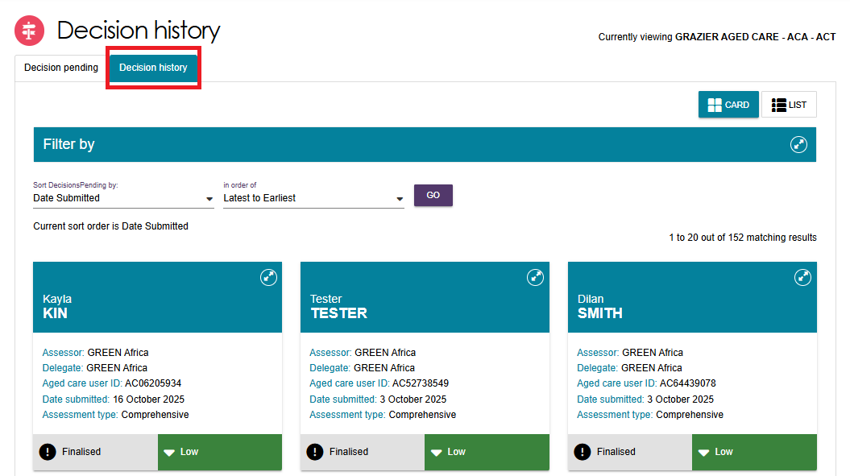
- For both the Decision Pending and the Decision History tabs, you can toggle between the card view and the list view (shown below) to display the clients.
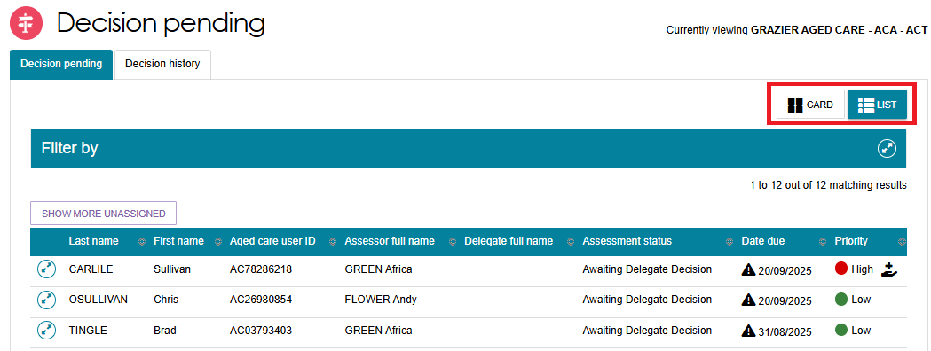

Assigning an item for decision
To assign a client to yourself:
- If using the card view, select the expand arrows on the Client card to display a summary of the client’s information in a pop-up. Select ASSIGN to allocate that item to yourself or to another Clinical Assessment Delegate within the team.
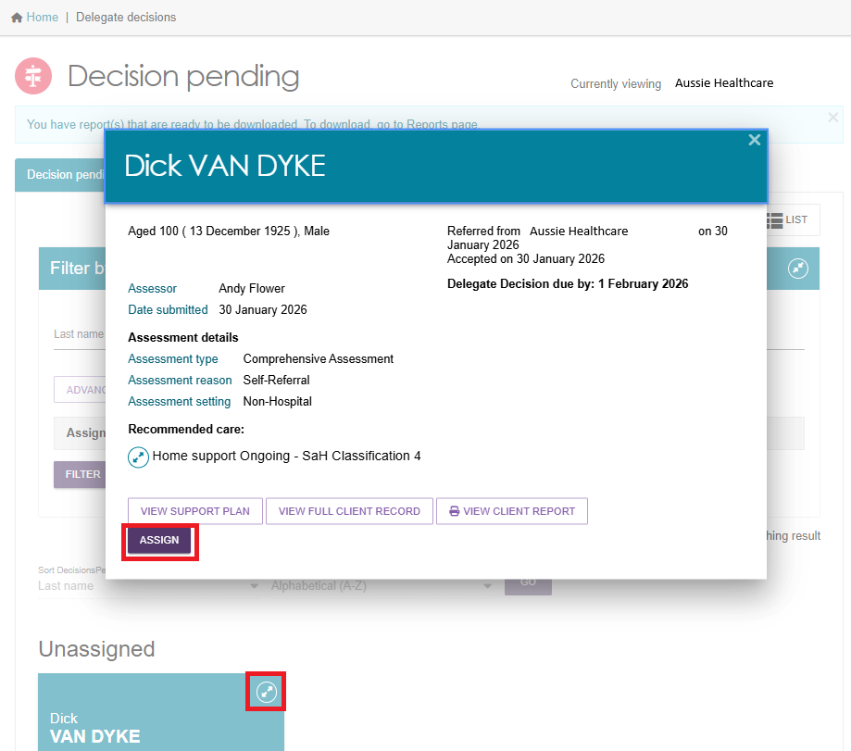
- If using the list view, select the expand arrows for the client to display a summary of the client’s information in an expanded view.
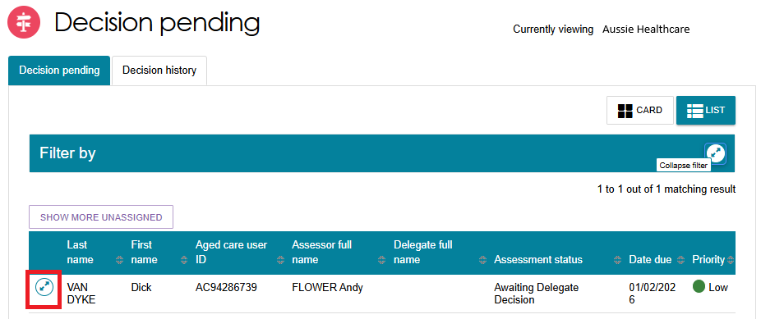
- Select ASSIGN to allocate that item to yourself or to another Clinical Assessment Delegate within the team.
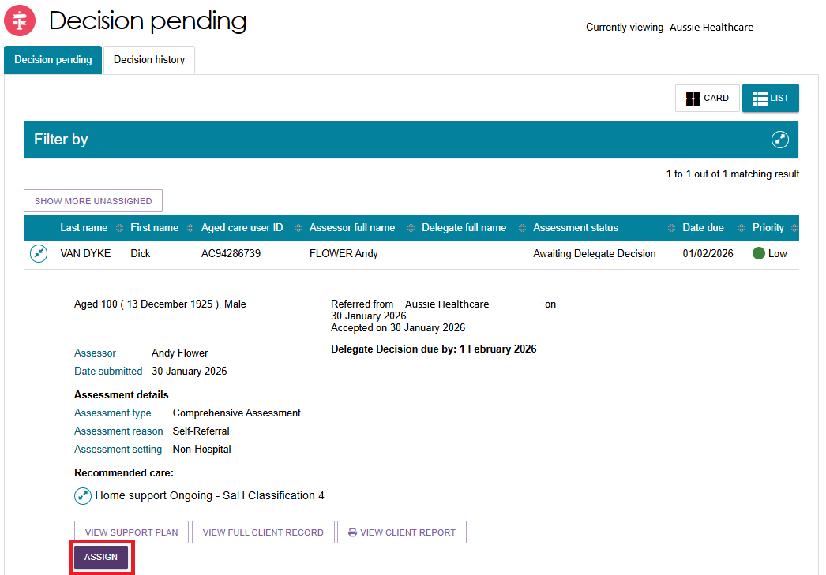
- In the pop-up box, select a Clinical Assessment Delegate (or yourself – ‘me’), and select ASSIGN.
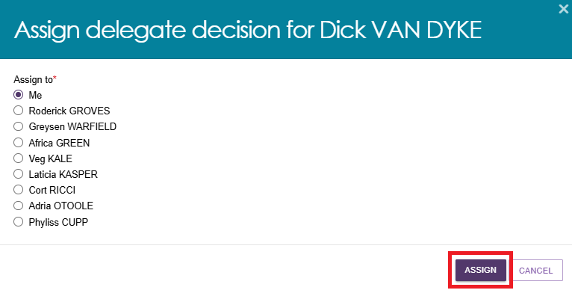
- A confirmation message will appear. The client will appear in the queue of the Clinical Assessment Delegate they were assigned to, or under ‘My Decisions’ if assigned to yourself.
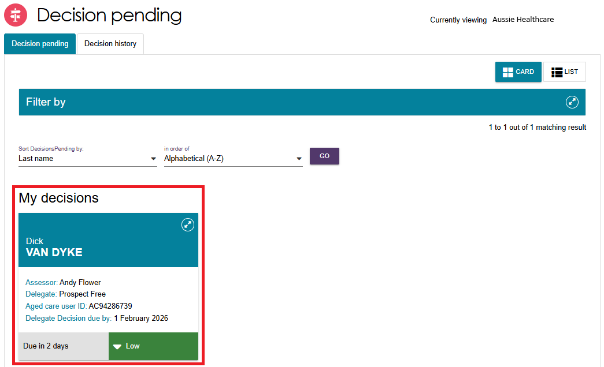

Reassigning for Decision
Follow these steps to reassign an item for decision:
- Select the expand arrow on the Client card to display a summary of the client’s information. Select REASSIGN.
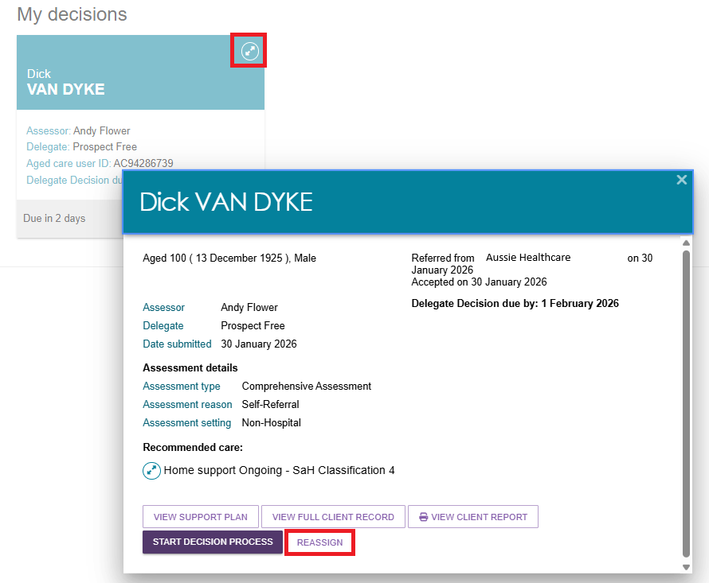
If using the list view, select the expand arrow next to the client’s name to see more information, and select REASSIGN.
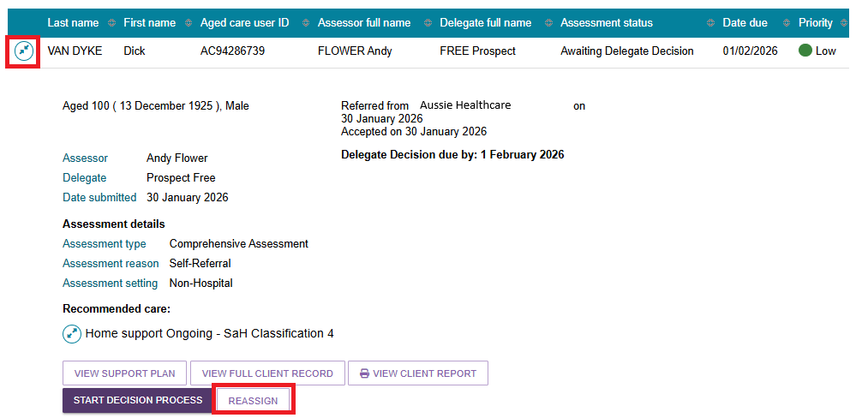
- Nominate another Clinical Assessment Delegate to assign the item to or select the option Place back in delegate queue if you want to un-assign it. Select REASSIGN.
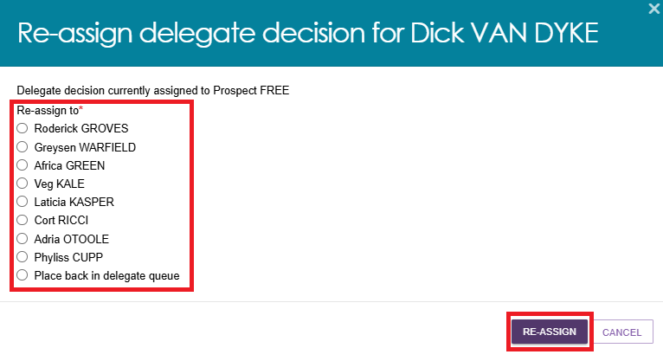
- You will receive a confirmation message that you have either re-assigned or un-assigned the queue item.


Recording a delegate decision
Prior to making any delegate decisions you must view the entire client record, assessment and support plan and attached information to ensure you have all the necessary evidence to support your decisions. The assessment summary prepared by the clinical assessor can be accessed through the Identified needs tab of the support plan.
Follow these steps to record your delegate decision:

Viewing Decisions information
- Go to the Delegate Decisions tile form the home page. Then, select the Decision Pending tab.
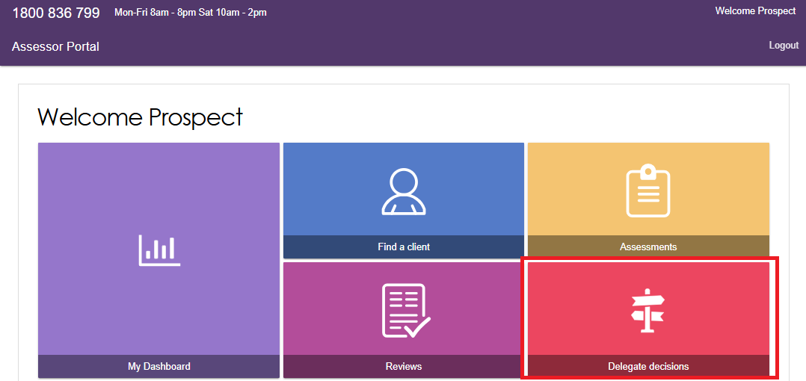
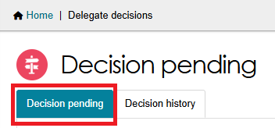
- From the Decision pending tab, select the expand arrow on the Client card to display a summary of the client’s information. Select START DECISION PROCESS. If using list view, this option is available from the expanded client information section. Select START DECISION PROCESS in the pop-up box.
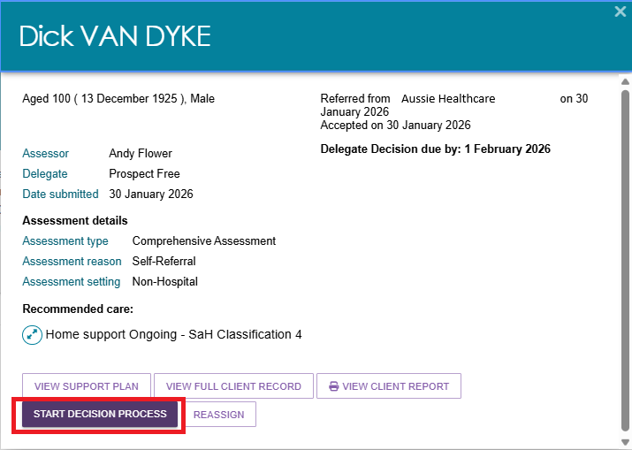
- You will be taken to the Decisions tab on the client’s support plan. The recommendations made by the clinical assessor will be displayed for your review.
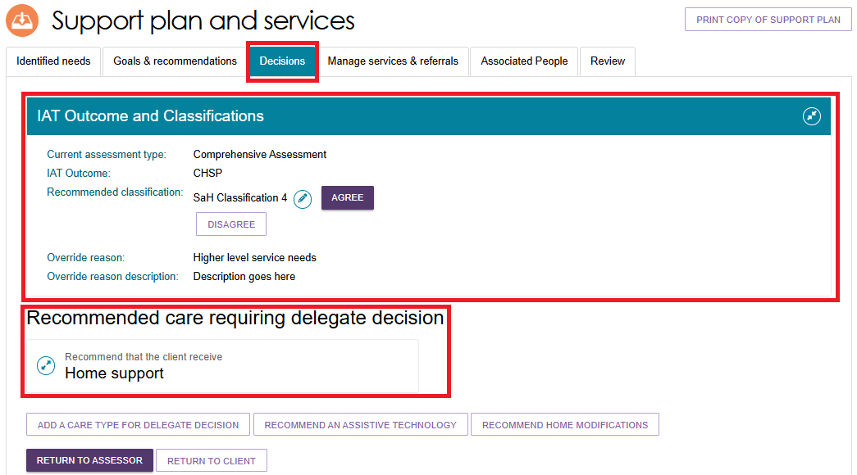
As a Clinical Assessment Delegate, you can:
- agree with a recommendation
- disagree with a recommendation
- edit a recommendation (edit and/or add Emergency Care Indicator and dates, priority and time-limitation of approval etc. Note that priority is not applicable for Support at Home.)
- add a care type for Delegate decision. These will be automatically agreed to.
- remove a care type
- change your decision prior to finalisation from agree to disagreed, or disagreed to agreed
- select to be notified of any home care correspondence for a client that you have approved for home care and may need monitoring going forward. Note that only one person from your outlet can receive these notifications.

Editing a Recommended Classification
- Go to the Delegate Decisions tile, and select the client’s card or listing as per the process in Viewing Decisions information.
- Select on the pencil icon next to the current recommended classification.
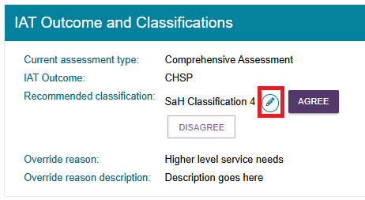
- The Edit Recommended Classification pop up appears.
! | An ongoing SaH classification outcome cannot be overridden to an ongoing lower or higher SaH classification outcome (in line with section 81-10 of the Aged Care Rules). Assessors must not undertake this action and delegates must not approve assessments where this occurs, or override and select a lower or higher classification.
Select the new recommended classification, along with the override reason and description.
Pay attention to any warning messages that may appear.
Complete any other mandatory fields that appear, for example the client’s preference for seeking Home support services.
Finally, select SAVE TO PLAN.
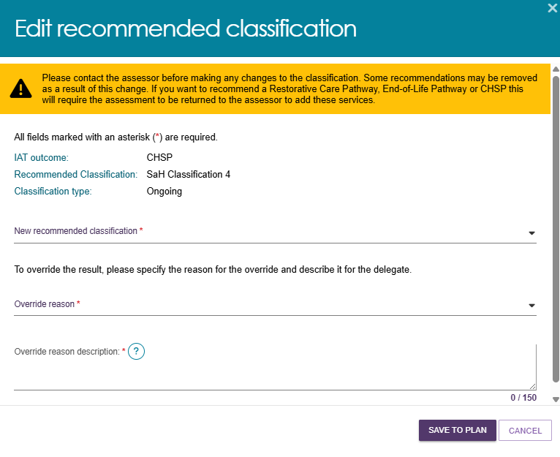
- For Support at Home classifications, the Edit Home Support Services Screen displays. A truncated version of this page is shown below.
The default services for your edited classification appear on this page. Confirm or change the service, frequency and intensity details. Then, select SAVE TO PLAN at the bottom of the page.
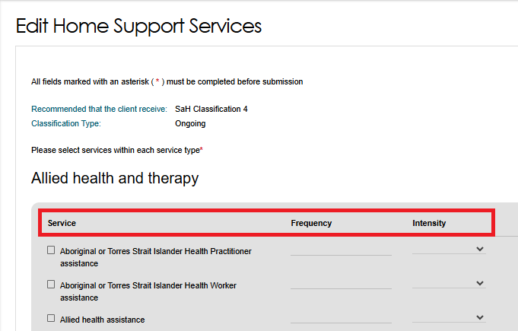
- The screen under the decisions tab will show the updated Recommended classification under IAT Outcome and Classifications. It is estimated to take up to 60 seconds for the update to take effect.
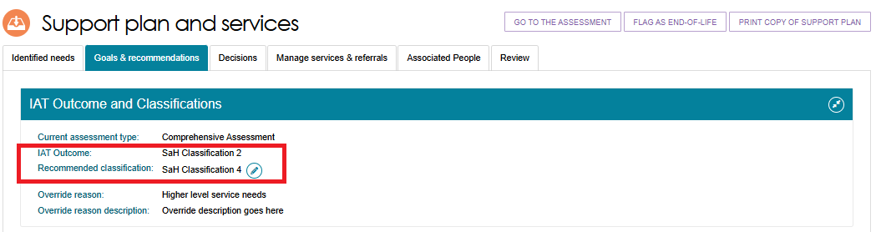
- For High priority Support at Home recommendations, you should review the reasoning provided by the clinical assessor and make an independent determination as to whether the priority given for the recommendation is appropriate.
- For Residential Permanent recommendations, a Clinical Assessment Delegate can make corrections to their decisions within 43 days. During the correction you can:
- add a residential permanent recommendation
- remove a residential permanent recommendation
- update urgency
- update approval expiry date
- update emergency needs
- update Delegate date (approval start date).

Viewing details about the Decision
- To view details and status of the decision for a recommended service, navigate to the Decisions tab and scroll to the Current care approvals section. Select the expander icon next to the service and select the blue magnifier icon to view.
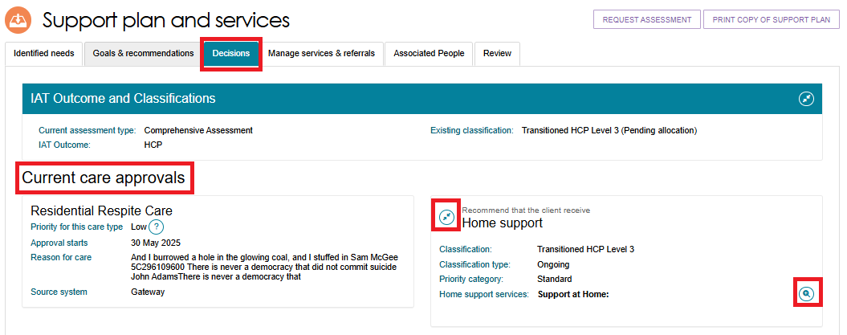
- A pop-up screen will open listing the classification and the type along with the list of all approved services.
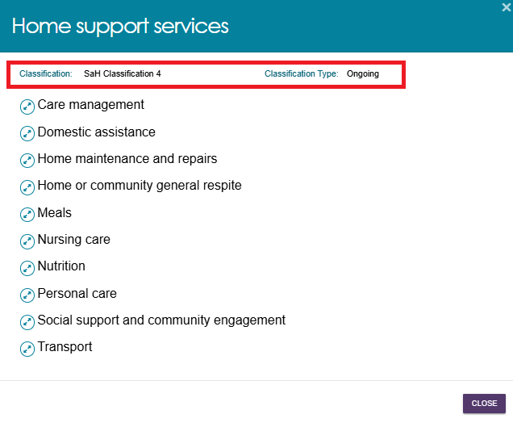
- Select the expander icon to view the details such as services included, approval start date and ceasing date.
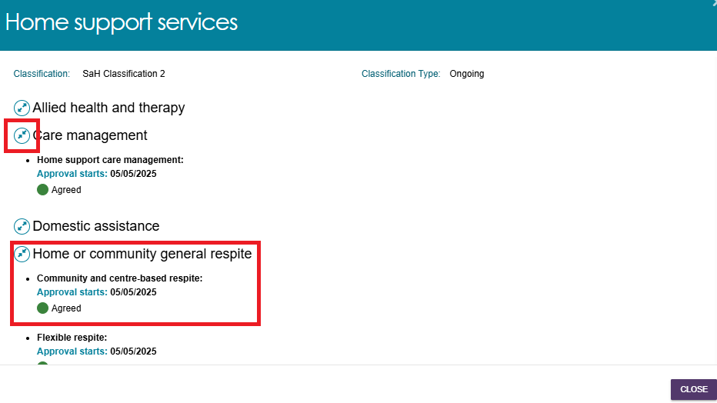

Return to a clinical assessor
There are circumstances in which you may wish to send the client’s Decision workflow back to the clinical assessor. For example:
- more evidence is required
- the care level is not appropriate or sufficient
- amendments needed to be made (such as to correct spelling errors)
By selecting RETURN TO ASSESSOR, the original clinical assessor can then make necessary changes before re-submitting for decision.
Note that you only have the option to return the assessment to the clinical assessor prior to agreeing or disagreeing to any recommendations. If you select RETURN TO CLIENT, you will navigate back to the client’s record.
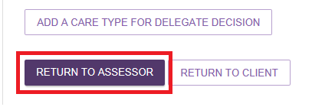

No Decision
Clinical Assessment Delegates will not need to make decisions for clients where No Care Approval or No Care Type Under the Act is recommended.
A clinical assessor can recommend and match and refer a client for Support at Home services and finalise the support plan without needing to submit to the Delegate for decision if the client:
- Withdraws their application for care but is eligible for SaH services; or
- Does not wish to apply for care under the Act but would like to receive SaH services.
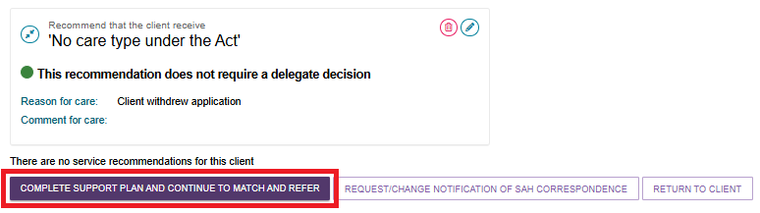
! | For CHSP only: From 1 November 2025, there are changes to how the ‘No Care Approval’ option is used under the interim Manual Delegate Approval process for CHSP only for comprehensive assessments.  For more information, please refer to Manual Delegate Approval for CHSP – Standard Operating Procedure and instructional videos for comprehensive assessments.  Note: This process was updated to align with recent changes effective from 23 February, the updated approach now applies.

Agreeing with recommendations
- To agree with the clinical assessor’s recommendation for a non Support at Home recommendation, select AGREE below the recommended care type. If multiple care types were recommended, you will need to repeat this process for each care type.
To agree with a Home support service recommendation, refer to Agreeing or disagreeing with a Support at Home Recommendation.
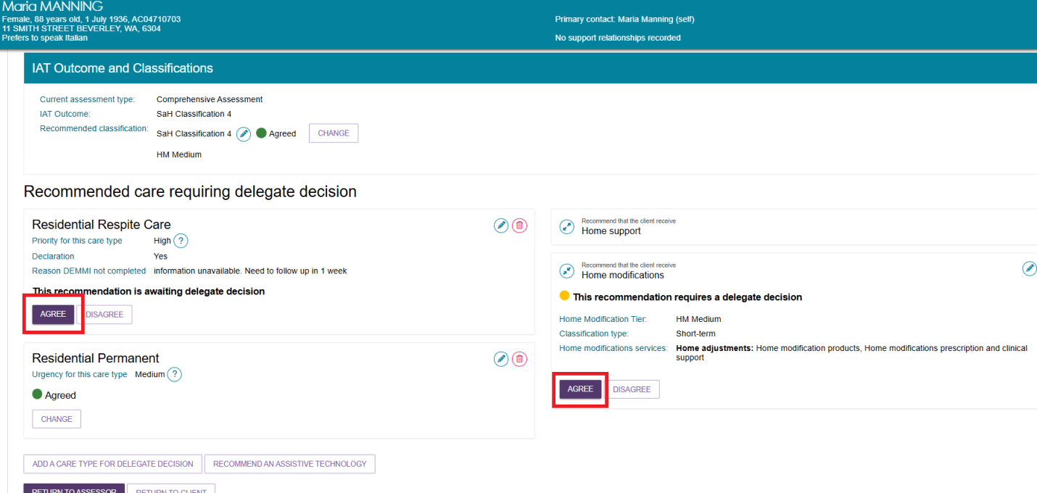
- You will be asked to confirm that you agree with the recommendation in a pop-up box. If required, you can enter an approval cease date and add comments. Select AGREE. If required, you are now able to set an approval cease date for Permanent Residential Care through the assessor portal.
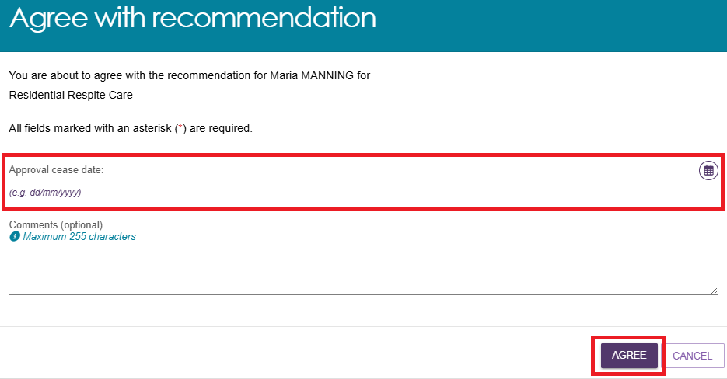
- A confirmation message will display, and the status of the recommendation will display as Agreed.
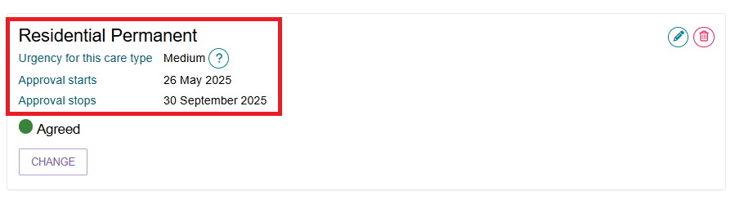

Disagreeing with recommendations
Disagreeing with a recommendation will result in a non-approval of that recommended care type.
If a recommendation is mistakenly added by the clinical assessor, the Clinical Assessment Delegate can disagree with the clinical assessor’s recommendation, and/or add their own recommendation.
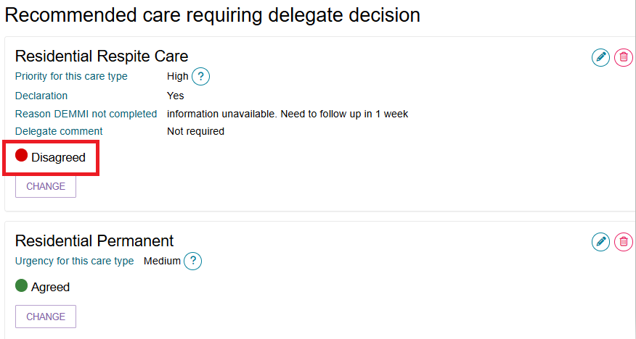
Follow the steps below to disagree with a recommendation:
- Select the expander button to show the recommended care type for approval.
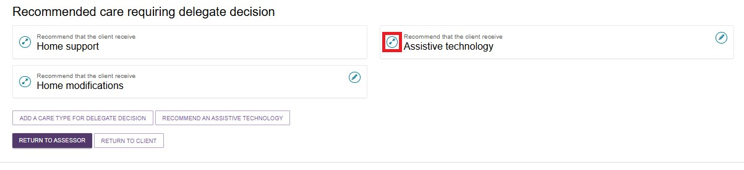
- Select DISAGREE below the recommended care type. You will need to repeat this process for each care type that you disagree with.
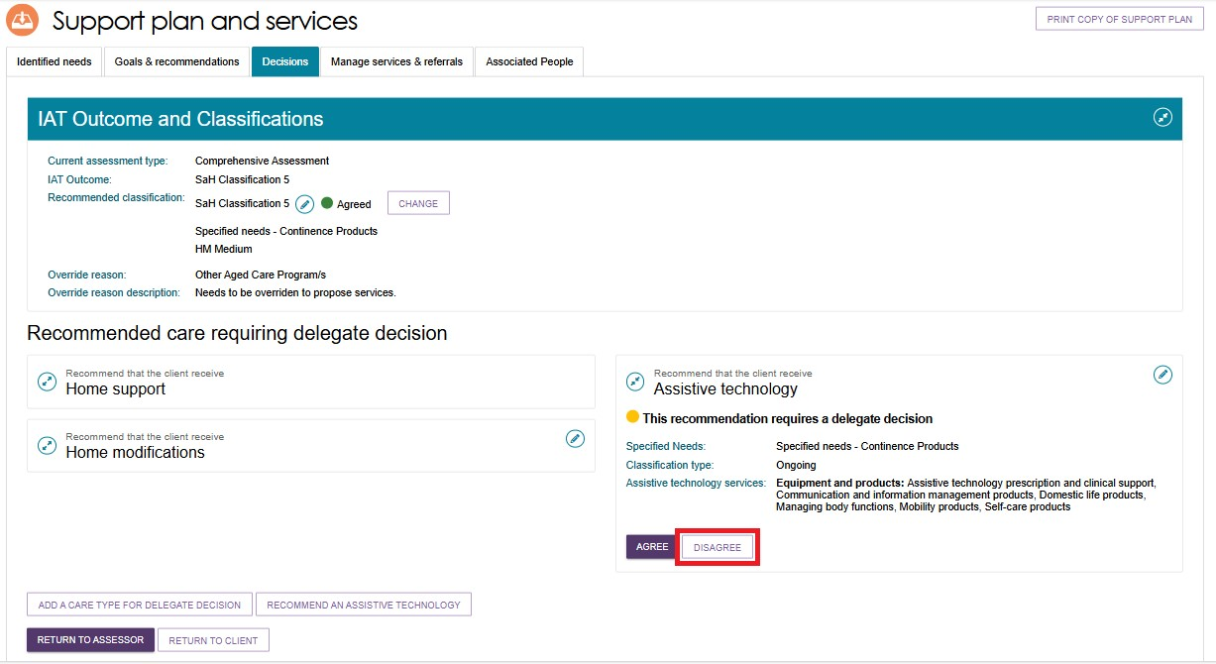
- You will need to provide a comment about your reason for disagreeing with the recommendation, then select DISAGREE.
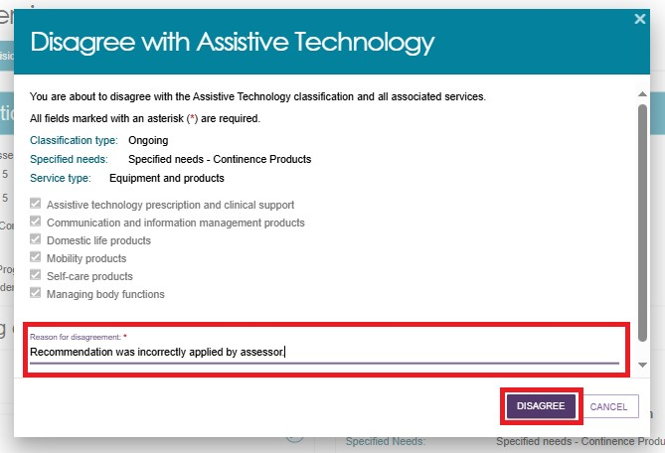
- A confirmation message will display, and the status of the recommendation will change to Disagreed.
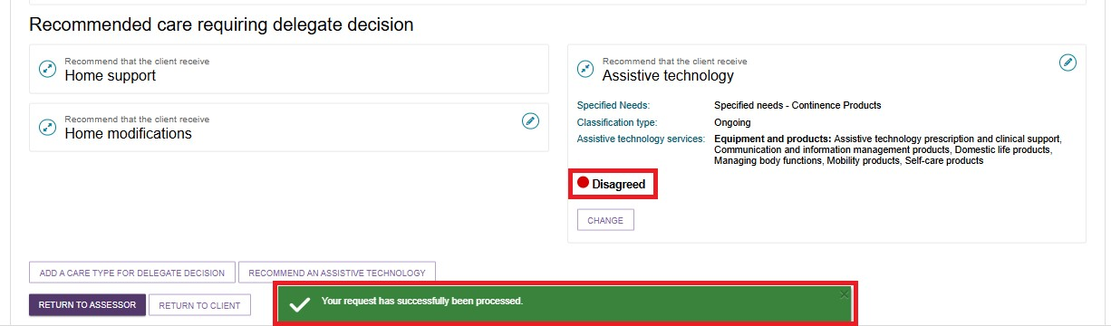
- If you need to change your decision, you can select CHANGE. This option will only be available prior to saving and completing the approval process by selecting Save and Delegate. Refer to the Changing a Decision section for more details.
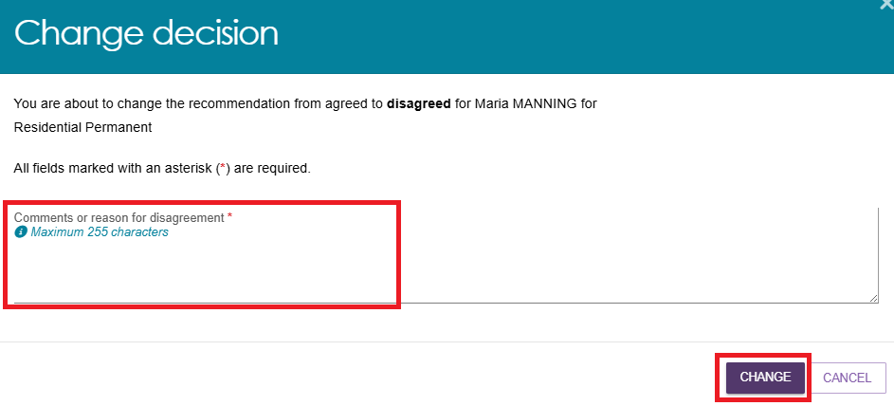
- If you disagree with all recommendations and you do not add any new approval decisions, you may be prompted to select “No Care Approval” as a service type during the Save Decision and Delegate pop-up in order to complete the delegate decision. Go to Adding a Care Type for more information.
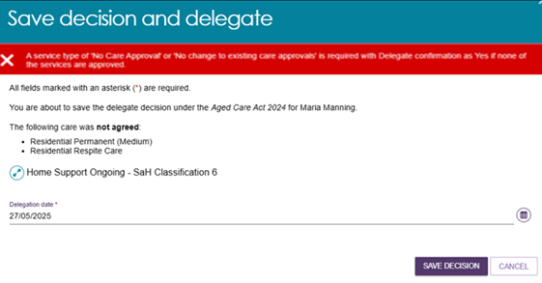

Agreeing or disagreeing with a Support at Home Recommendation
- For a client that has been recommended for an ongoing Support at Home classification, you will be required to select APPLY DELEGATE DECISION.
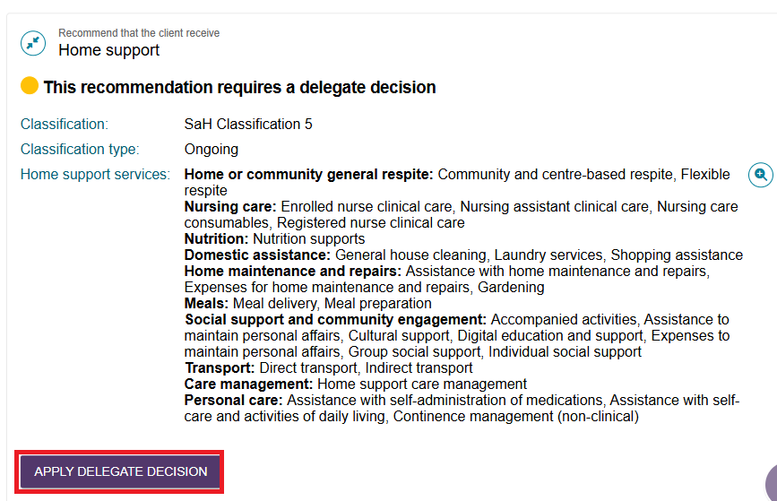
- You will be shown all the assessors’ recommended service type/s, service/s, frequency and the intensity of the services. You can either agree or disagree by selecting individual service/s or selecting the Select all toggle.
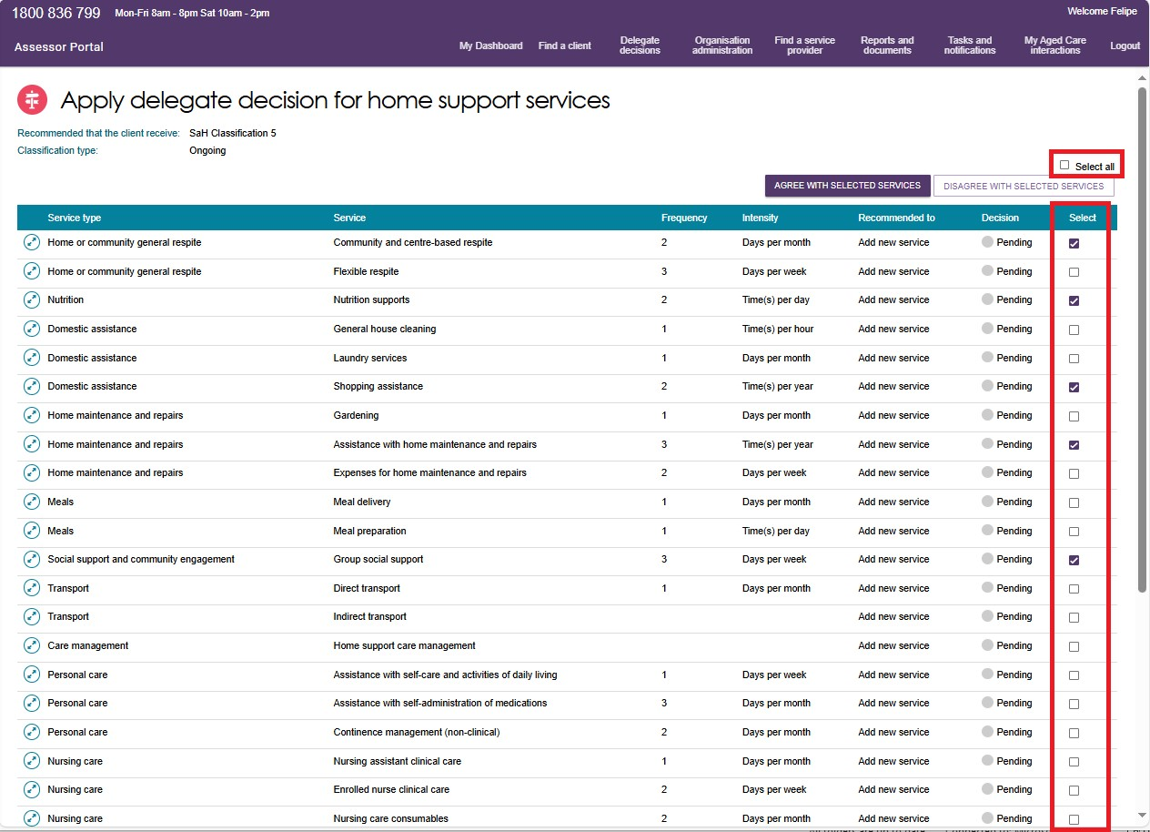
- If you disagree with the service/s that the assessor has recommended, you will be asked to provide the reason for your disagreement.
Then, select DISAGREE.
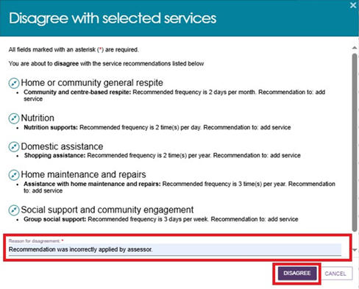
- If you are agreeing with the recommendations by the assessor, tick the services’ checkbox and select AGREE WITH SELECTED SERVICES button. It should be noted that if you select a service that you have previously disagreed with, it will override your decision.
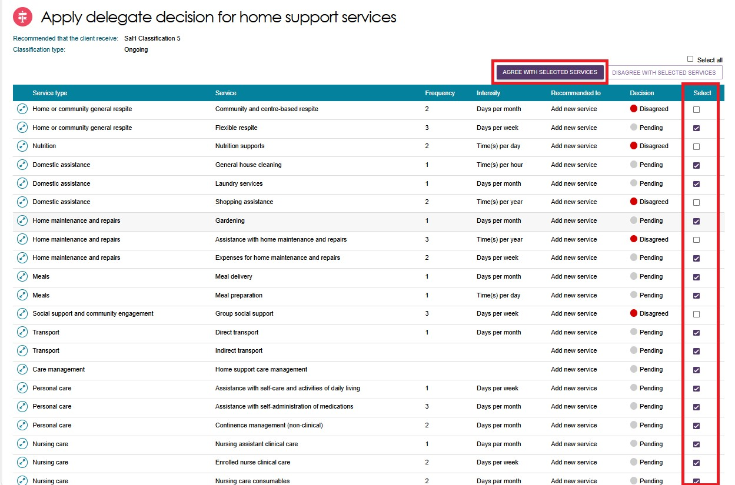
Then, you will be asked to confirm by selecting the AGREE button.
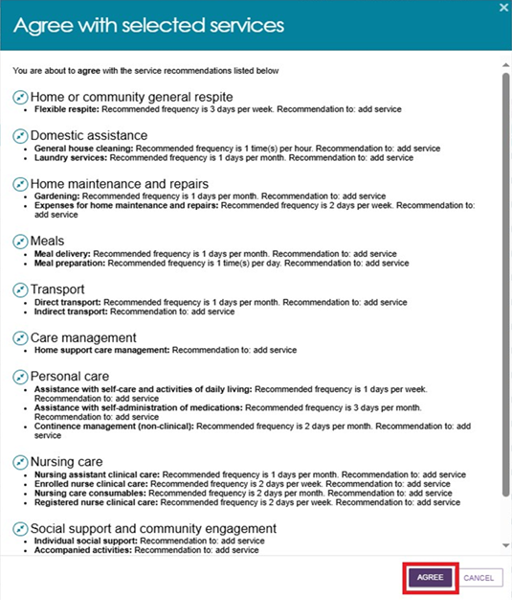
- During this process, you can add additional Support at Home services by selecting the ADD HOME SUPPORT SERVICES button at the bottom of the page.
- The Add Home Support services page appears, where you can add Support at Home Service/s, Frequency and Intensity. Add the additional service/s and select the SAVE TO PLAN button.
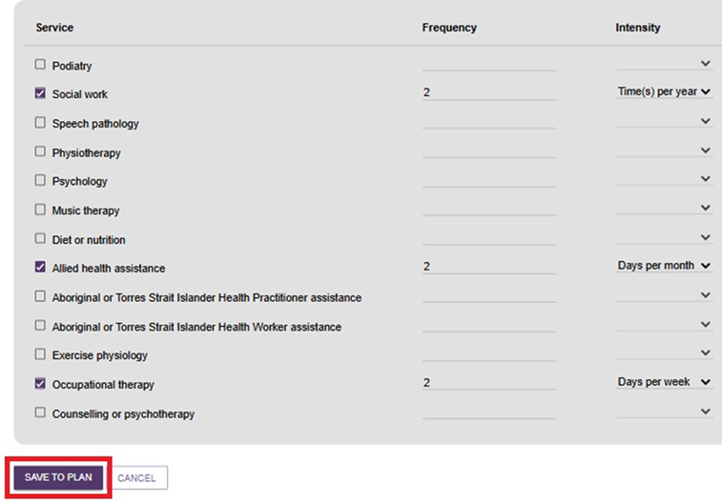
- Review the services you have added and select FINISH once you are ready to proceed to delegate.
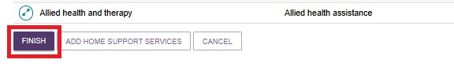
- Once a decision has been recorded and finalised by the delegate, the recommendations will be displayed as below:
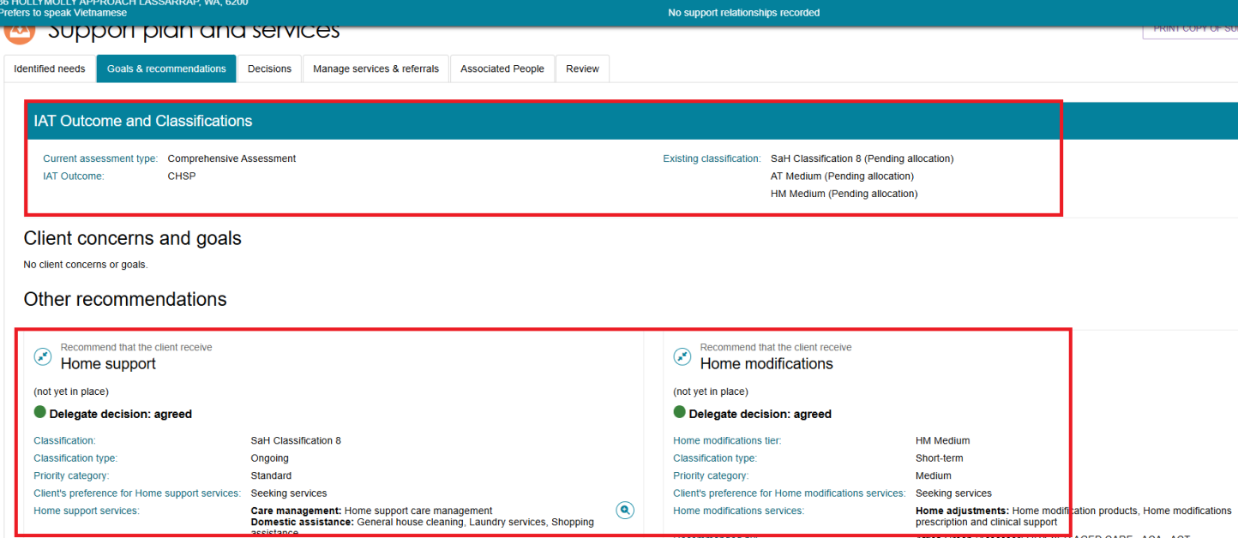

Editing a recommendation
- To edit a care type or level of care recommended by a clinical assessor, select the Edit icon to the right of the recommendation.
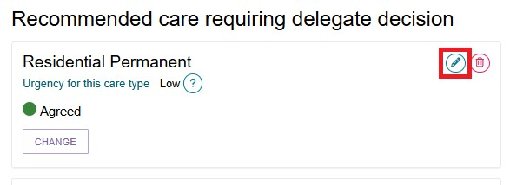
- The Edit a care type pop up will be displayed, and you will be able to make any changes required. Select SAVE TO PLAN to save the changes.
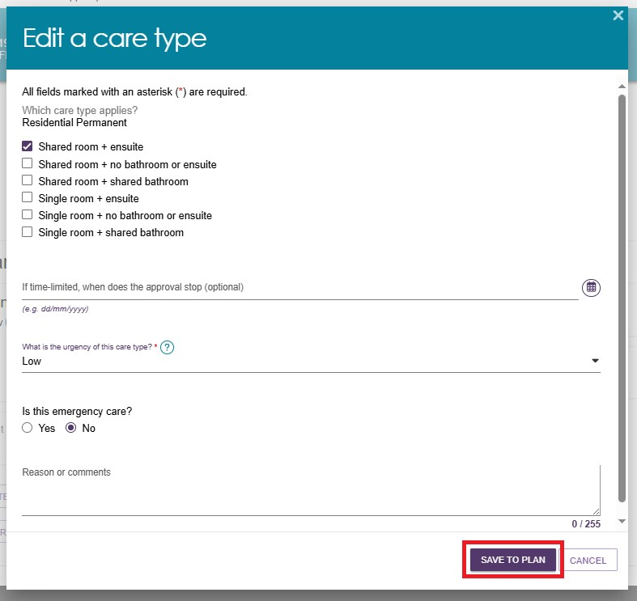

Adding a care type
Clinical Assessment Delegates can add another care type for delegate decision for the client, if required.
- At the bottom of the client’s Decisions tab of the Support Plan and Services page, select ADD A CARE TYPE FOR DELEGATE DECISION.
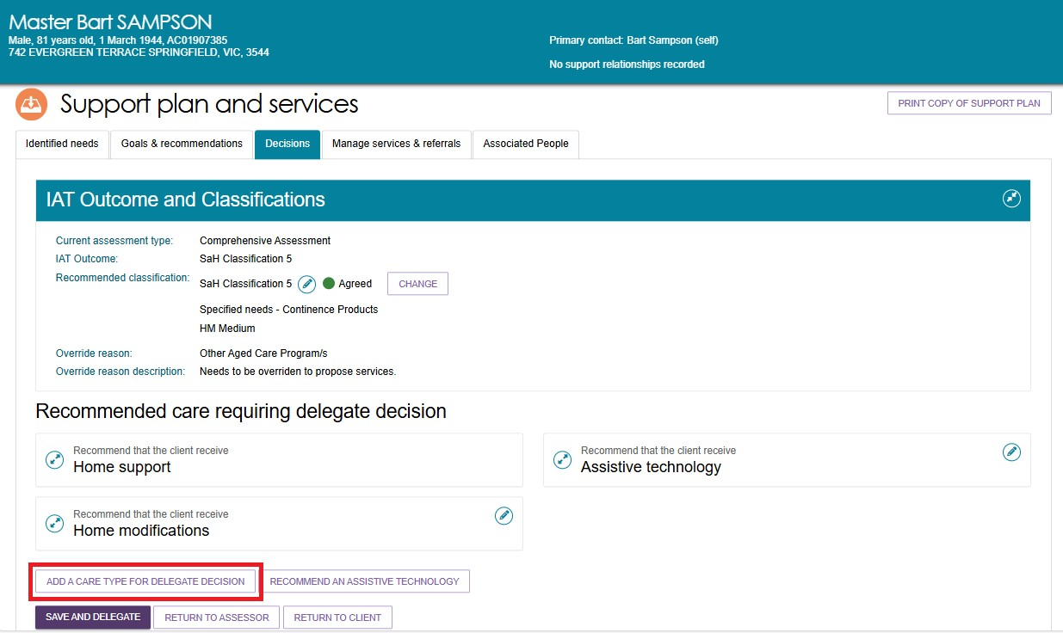
- In the pop-up box, select the care type that applies from the drop-down box. You will need to select the priority for the care type. Please note that there are historical care types in this section, which should only be used in prescribed situations.
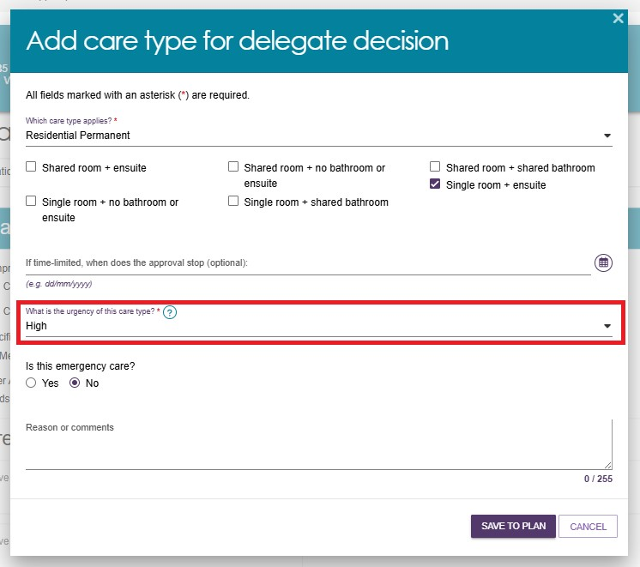
- The care type will be added to the Recommended care requiring delegate decision list with a decision of Agreed.
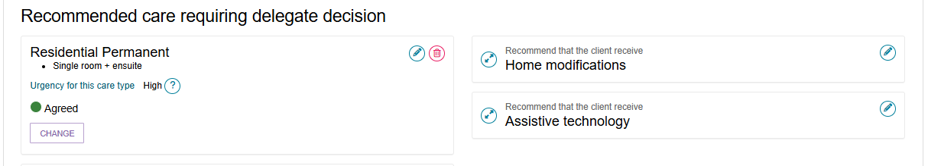

Recommending a Home Modification Service
! | When considering adding/editing Home modifications care recommendations, refer to:  - Support Plan section of My Aged Care – Integrated Assessment Tool (IAT) User Guide  - Approving AT and HM under Support at Home and Approving AT and HM under CHSP sections under Chapter 8 of the My Aged Care Assessment Manual  - Delegate training.
As a delegate you can recommend a Home modification (HM) service when the assessment identifies that changes to the client’s living environment are necessary to support their safety, independence, or ability to remain at home.
- From the Decisions tab, select the RECOMMEND HOME MODIFICATIONS button.
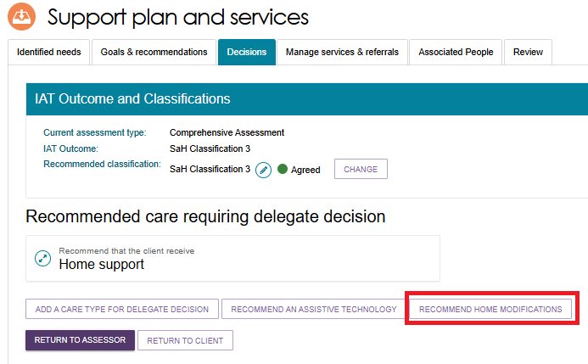
- The ADD HOME MODIFICATIONS RECOMMENDATION screen appears. Select the home modification tier (Low, Medium, or High) from the drop-down list.
The Service Type section will be pre-filled and greyed out.
Choose whether the client want to seek Home modifications services through the Support at Home program.
Then, select SAVE TO PLAN.
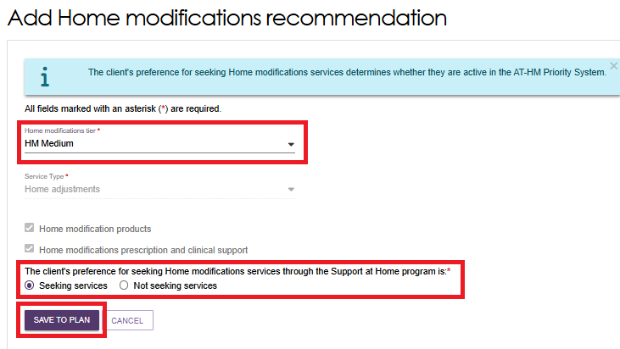

Recommending an Assistive Technology Service
! | When considering adding/editing Assistive technology care recommendations, refer to:  - Support Plan section of My Aged Care – Integrated Assessment Tool (IAT) User Guide  - Approving AT and HM under Support at Home and Approving AT and HM under CHSP sections under Chapter 8 of the My Aged Care Assessment Manual  - Delegate training.
As an assessment delegate, you can recommend an Assistive technology service when the client’s assessment indicates a need for equipment or devices that support daily living, safety, or independence to ensure the right equipment is provided to enhance the client’s ability to live safely and independently at home.
Please note that Assistance dogs are classified under the Ongoing classification type of assistive technology. It is known as ‘Specified Needs – Assistance Dogs’.
- From the Decisions tab, select the RECOMMEND AN ASSISTIVE TECHNOLOGY button.
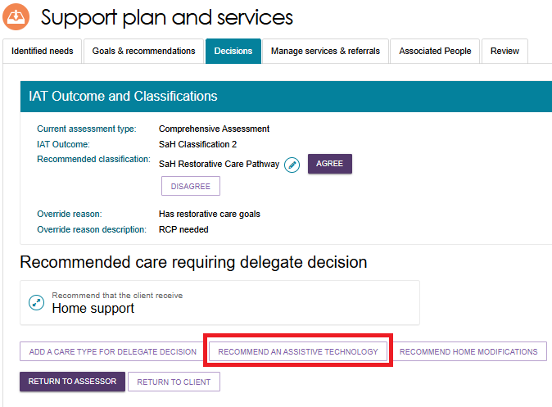
- The Add Assistive technology recommendation screen appears.
Select the classification type from the drop down list.
If the classification type is Short-term, select the technology tier from the drop-down list. If it is Ongoing, assistance dogs is available under the Specified Needs section.
Choose whether the client want to seek Assistive technology services through the Support at Home program.
Then, select SAVE TO PLAN.
Assistive Technology Short Term example
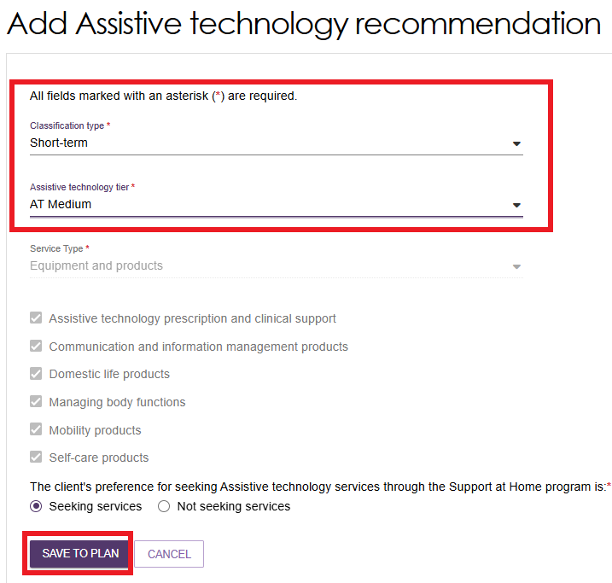
Assistive Technology Ongoing example
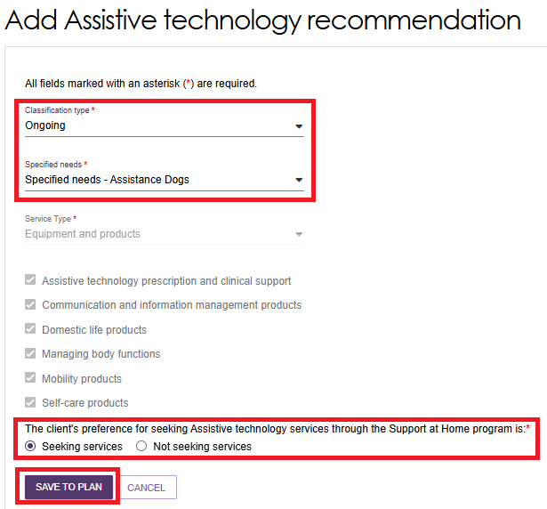
- The recommendation will be displayed within the Decisions tab under Recommended care requiring delegate decision section. Expand the item to view the details. Select AGREE or DISAGREE. You can also edit the recommendation using the Edit (Pencil) icon as shown in the example below.
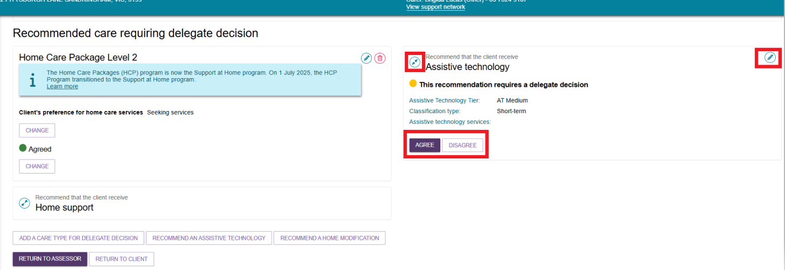

Recommending a second Restorative Care Pathway unit
Delegates can add a second unit of Restorative Care Pathway (RCP) during the Decision process. This is subject to the number of places available during the financial quarter when the second unit is requested. If there are no RCP units available, the second unit cannot be added.
- Go to the Decision Tile from the assessor portal home page.
- Select the client to add the second unit. This client must already have RCP approved and active.
- Go to the client’s support plan, then the Decision tab, then the IAT Outcome and Classification section.
- Select ADD SECOND UNIT OF RESTORATIVE CARE PATHWAY.
- The ‘Add second unit of Restorative Care Pathway’ pop up appears. Read the confirmation text, then select ADD SECOND UNIT.
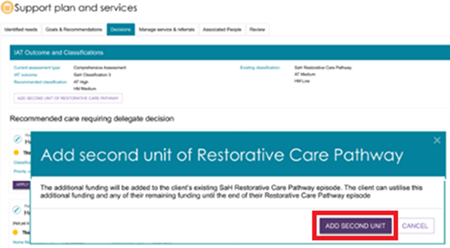

Changing a decision
- If you need to change your decision from Agreed to Disagreed, or Disagreed to Agreed, you can select the CHANGE button.
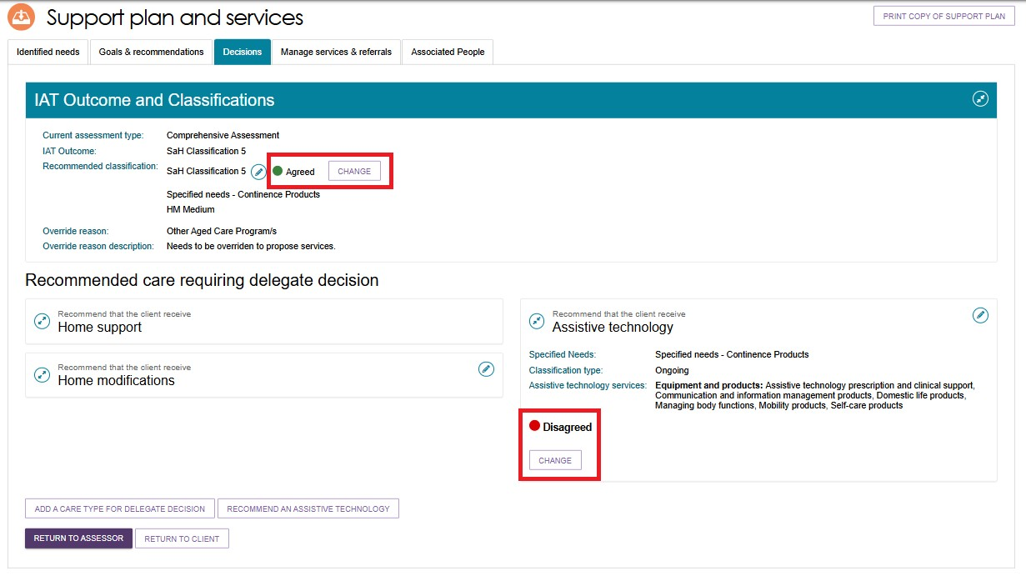
- You will be able to add approval cease dates and comments where appropriate in the pop-up.
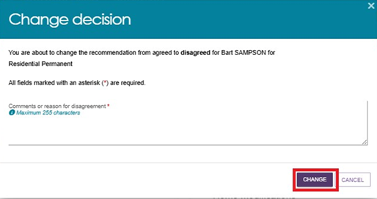
- If you are changing the decision from Agreed to Disagreed, you will need to provide a reason for the change. Please note, this option will only be available prior to saving and completing the approval process.
- A confirmation message will display.


Finalising your decision
! | For CHSP only: From 1 November 2025, there are interim and manual changes to the Delegate Approval process for CHSP only, and how it impacts the Notice of Decision letter generation, completion and upload. For more information on the process and Notice of Decision letter generation, please refer to Support at Home – Manual Delegate Approval for CHSP – Standard Operating Procedure and instructional videos for comprehensive and home support assessments. Note: This process was updated to align with recent changes effective from 23 February, the updated approach now applies.
- Once the decision has been made, select SAVE AND DELEGATE.
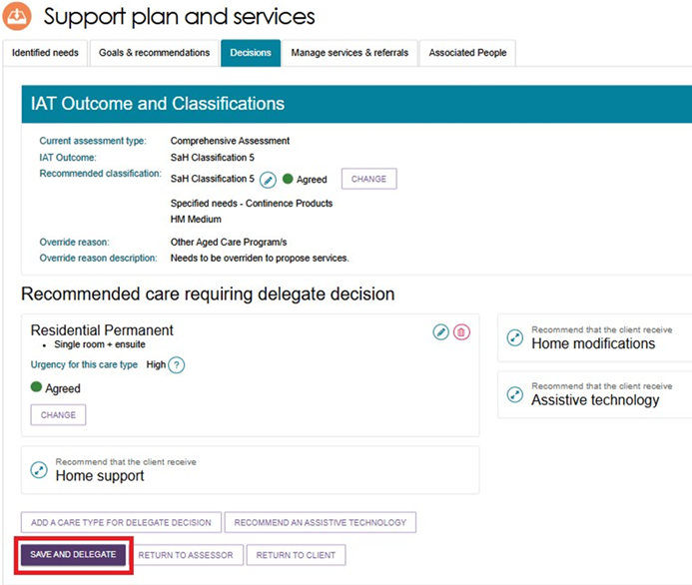
- A pop-up will display, confirming the care types that were agreed and not agreed. If you need to make any changes to your decision, select CANCEL. Ensure the date of the delegation is correct. For certain types of care, you can expand to see more information by using the expander button.
If you are satisfied with the decision and the date, select SAVE DECISION.
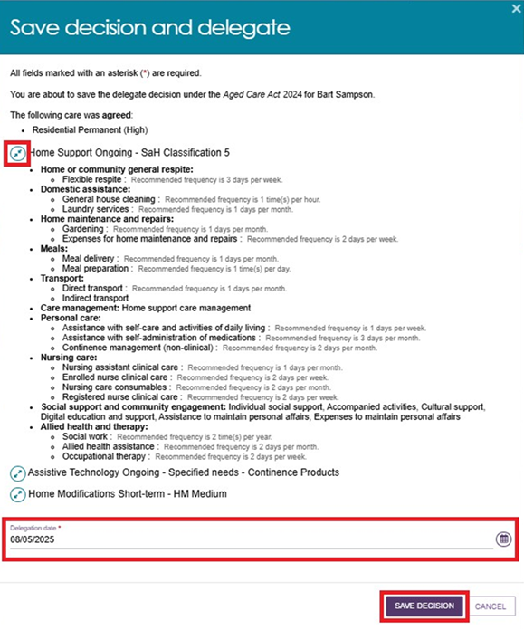
! | If the approval was actioned off-system earlier than the day that the delegation is completed via the portal, you can set the date of delegation to the earlier date as reflected on the Approval Form. It is available for download from the Reports and Documents tile of the assessor portal. This form is evidence that you made the approval decisions prior to the date you are making the entry on the system. You must attach the Approval Form to the Attachments tab.  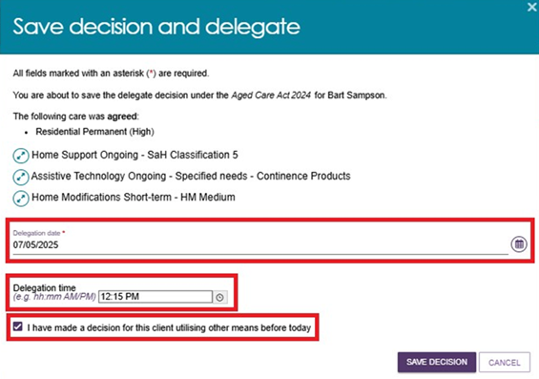
- A confirmation message will display stating that the approvals have been submitted to Services Australia to process, and that the decision has been recorded and sent to the clinical assessor to finalise the client’s support plan and match and refer for service.

Correspondence Notifications
If you have approved a Support at Home Classification or a Residential Care classification, you can request to receive notifications of any Support at Home or Residential Care correspondence received by that client from the department.
For Support At Home, this may be required in circumstances where the client is considered to be a vulnerable client that may require assistance from a clinical assessor to link to Home Support services.
Examples of Residential Care correspondence include:
- permanent residential care is allocated
- approval about to expire.
For general information about notifications and tasks in the assessor portal, please refer to My Aged Care – Assessor Portal User Guide 9 – Tasks and notifications.
- To receive notifications, go to the Approvals tab in the client record under the Current care approvals section by selecting the expand button next to the Support at Home or Residential Care classification name. You can select one person from an outlet to receive this notification.
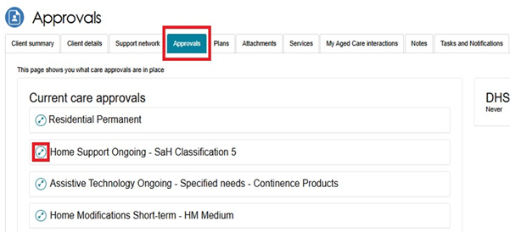
- The below screenshot shows the expanded view – Select the edit button underneath Notify of [Program] Correspondence to specify the staff member and refer to the help text for guidance.
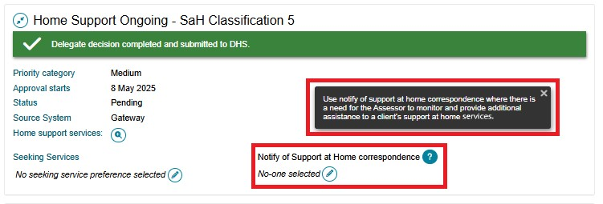
- Complete the information required and choose a Recipient from the list of staff members in the outlet. Select SAVE to return.
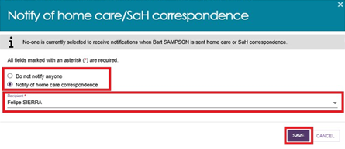
- You should be able to see your nominated Recipient of the notification on the Approvals tab.
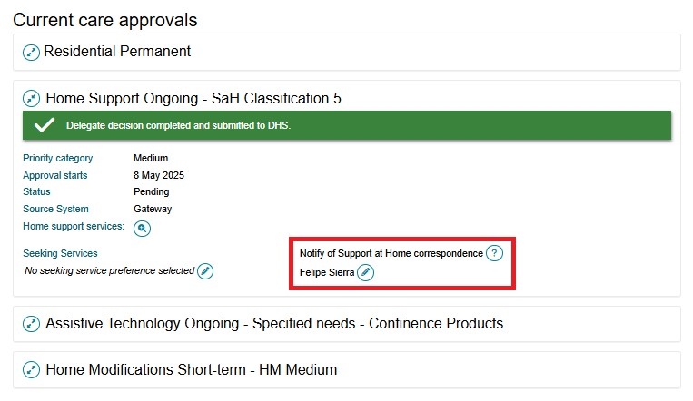
- The clinical assessor will be able to see the client under the Delegate decision complete section of their Current assessments tab. The clinical assessor will then need to match and refer for services and finalise the support plan.
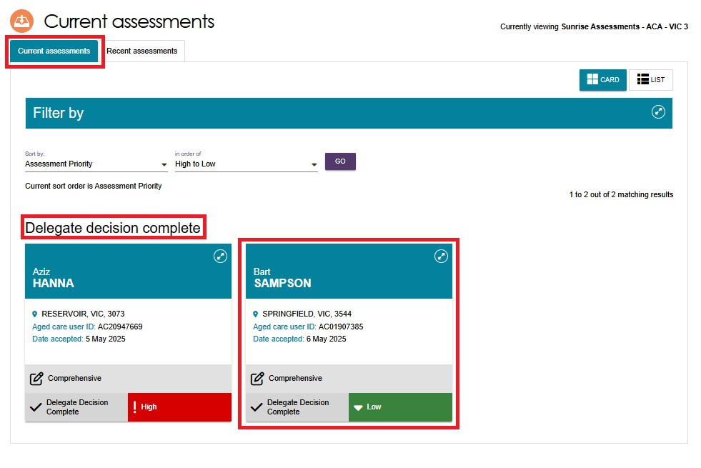
- The clinical assessor will receive a notification in the Task and notifications page that the delegate has completed their decision, and they will be able to navigate to the client record and directly to match and refer for services from this page.
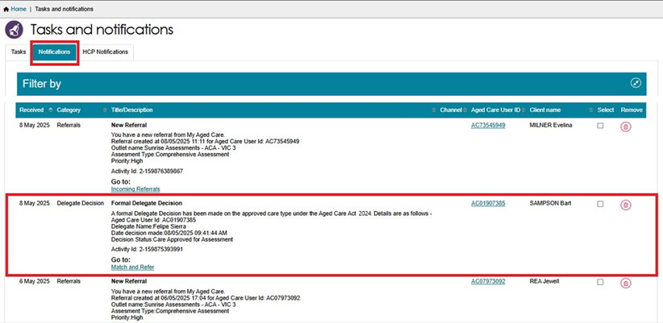

Notice of Decision (approval or non-approval) letter
The assessment delegate can generate and upload the Notice of Decision (NoD) letter, after the delegate decision is completed. This applies to both Approval letters and non-Approval letters.
To generate, print and upload approval or non-approval letters, navigate to the client’s support plan, then the Decisions tab.
You can also upload NoD letters via the Attachments tab.
If you have agreed to more than one care type recommendation for the client, you only need to generate, upload and print one approval letter to send to the client. The information about all agreed care types will appear on this letter.
A person assigned the Delegate Support role will also be able to print and upload these letters.
! | For CHSP only approvals: From 1 November 2025, there are manual changes introduced to the process for generating and uploading the Notice of Decision (Approval) letter for CHSP.  For more information, please refer to Support at Home – Manual Delegate Approval for CHSP – Standard Operating Procedure and instructional videos for comprehensive assessments.  Note: This process was updated to align with recent changes effective from 23 February, the updated approach now applies.

Approval Letters
! | Any decision completed by a Clinical Assessment Delegate (System Governor) must contain the following in the Notice of Decision letter:  - the approved service groups (and service types and services, where applicable)  - the approved classification type for each service group  - the approved classification levels (which can indicate the level of funding)  - the approved priority category (where applicable)  - the reasons and evidence supporting the delegate’s decision  - the older person’s rights of review, should they wish to query or dispute the decision.  This is to ensure high quality and consistency in letters that clients receive.
- Go to the Client’s profile and select the Plans tab. In the Plans page select the Support Plan button.
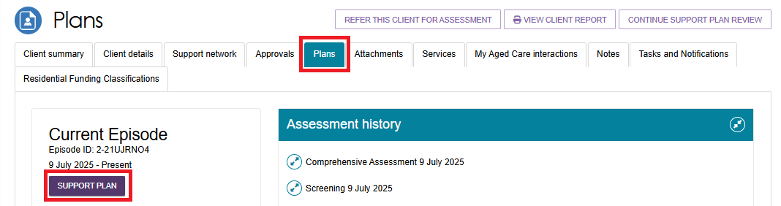
- The Support Plan and Services page appears. Select the Decisions tab. At the bottom of the page, you will be able to select GENERATE APPROVAL LETTER.
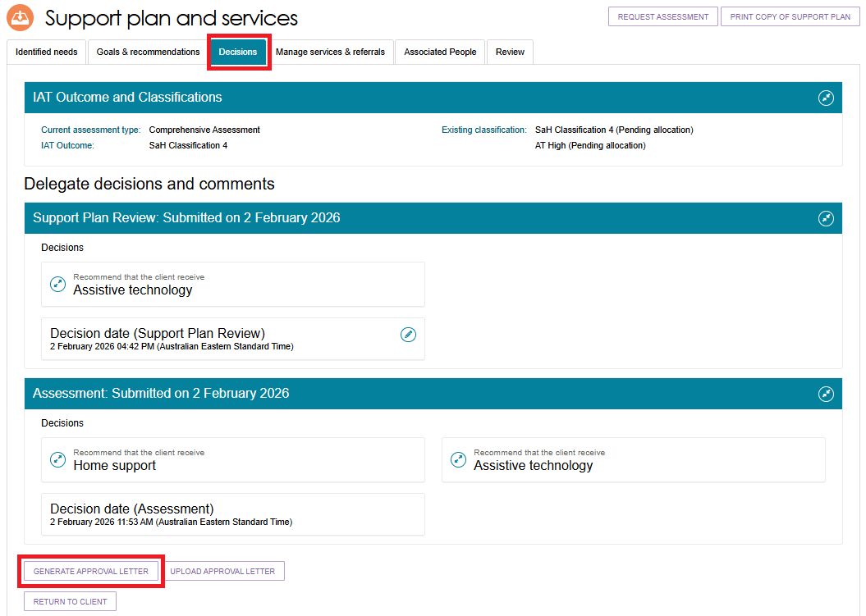
- The Generate Approval Letter pop up appears. Ensure you are generating the letter for the correct client, then select GENERATE APPROVAL LETTER.
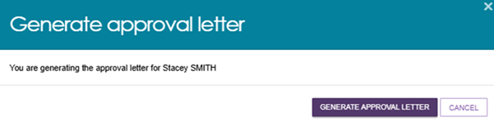
- If the Approval letter takes too long to generate, you will be re-directed to the Reports tab where you will be able to select View to open a copy of the letter. Certain user generated documents, including NoD letters and Referral Code letters, will be retained in Recently Requested Reports for seven days, after which they will be cleared from this screen. They can be regenerated as per the original process.
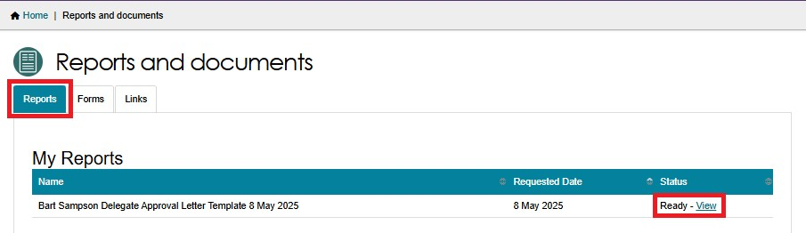
- When you have signed the letter, you can use the UPLOAD APPROVAL LETTER button in the Decisions tab of the support plan to upload the letter to the client’s record. Alternatively you can upload it via the Attachments tab.
Decisions Tab
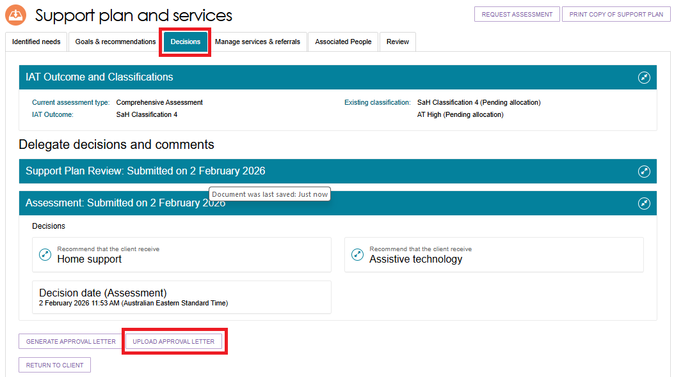
Attachments tab
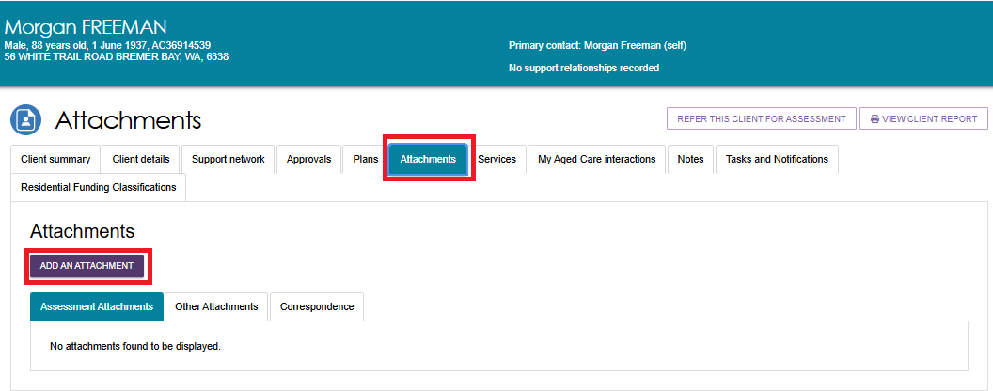
- The Upload approval letter, or the Add an Attachment pop up appears. Choose the approval letter file to upload.
Acceptable file types are: .jpeg, .jpg, .bmp, .png, .docx, .xlsx, .pdf, or .txt. Please note that .rtf is not acceptable.
Enter the name of the attachment.
If you are attaching the letter, ensure the attachment type is Approval letter sent to client.
Optionally provide a short description about the contents of the attachment.
Finally, select UPLOAD.
UPLOAD APPROVAL LETTER EXAMPLE
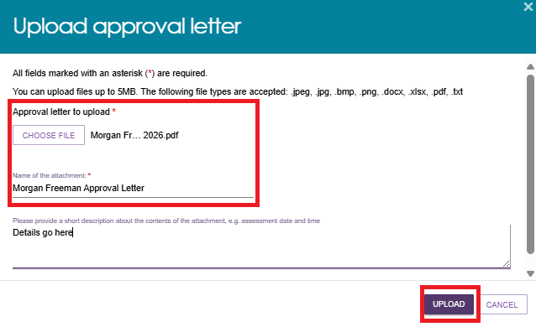
ADD AN ATTACHMENT EXAMPLE
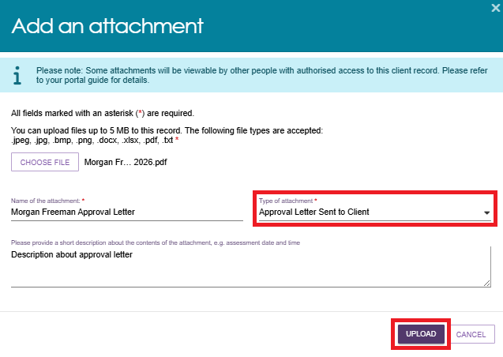

- The uploaded letter will display in the Attachments tab.
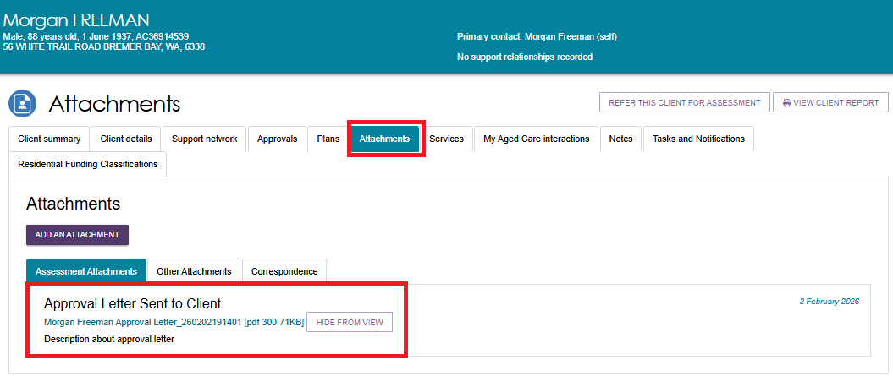

Non-approval Letters
Delegates can only generate non-approval letters when the delegate decision contains ‘No care approval’ or ‘No change to existing care approvals’.
      - Go to the Client’s profile and select the Plans tab. In the Plans page select the Support Plan button.
      - Navigate to the Decisions tab of the support plan.
At the bottom of the page, you will be able to select GENERATE NON-APPROVAL LETTER.
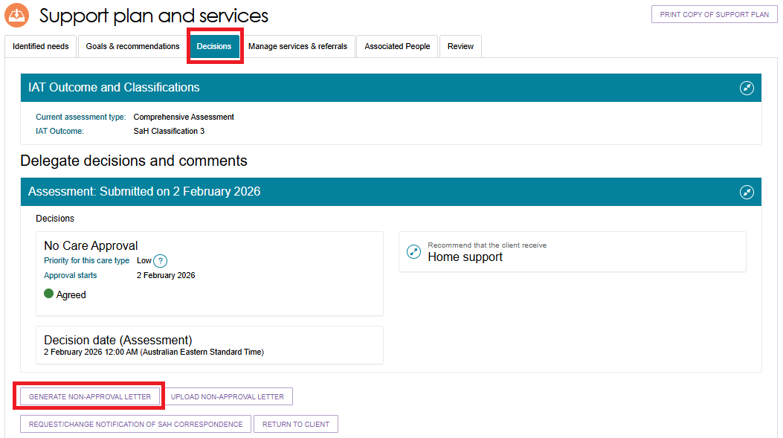
      - The Non-approval letter generates automatically with no confirmation pop ups.
If the Non-Approval letter takes too long to generate, you will be re-directed to the Reports tab where you will be able to select View to open a copy of the letter.
Certain user generated documents, including NoD letters and Referral Code letters, will be retained in Recently Requested Reports for seven days, after which they will be cleared from this screen. They can be regenerated as per the original process.
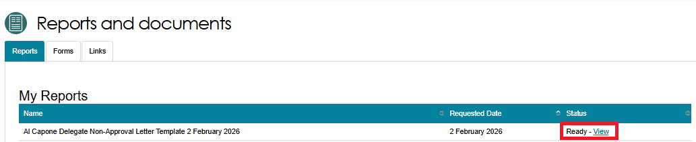
      - When you have signed the letter, you can use the UPLOAD NON-APPROVAL LETTER button in the Decisions tab of the support plan to upload the letter to the client’s record. Alternatively, you can upload this through the Attachments tab on the client record.
DECISIONS TAB OF THE SUPPORT PLAN
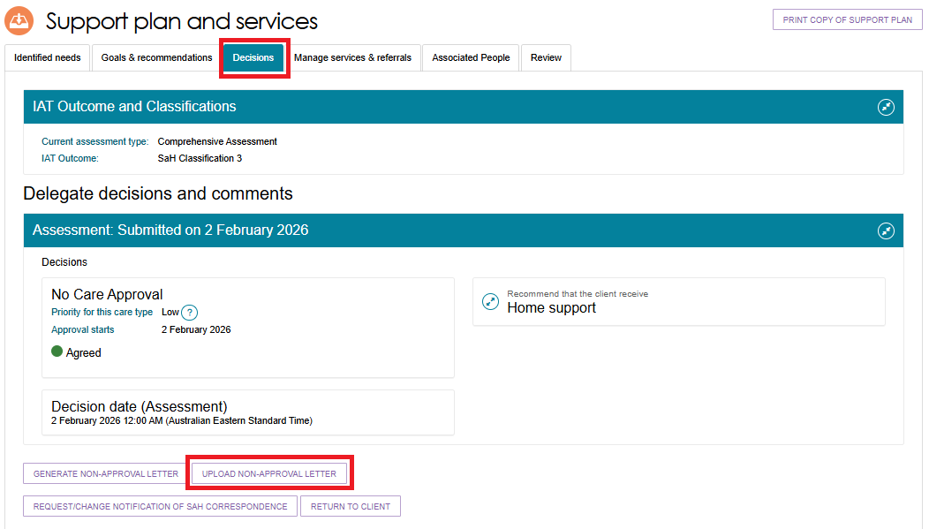
ATTACHMENTS TAB OF CLIENT RECORD
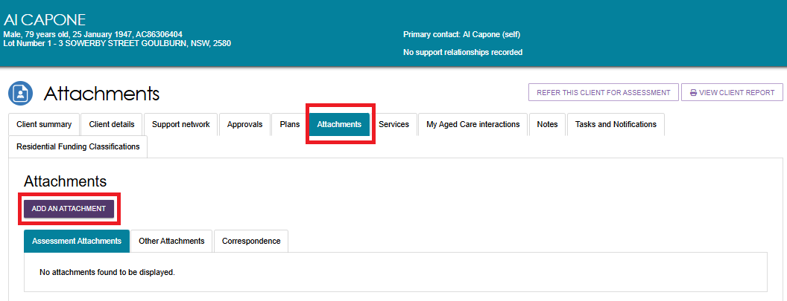
      - The Upload non-approval letter pop up, or the Add an attachment pop up appears. Choose the Non-approval letter file to upload or attach.
Acceptable file types are: .jpeg, .jpg, .bmp, .png, .docx, .xlsx, .pdf, or .txt. Please note that .rtf is not acceptable.
Enter the name of the attachment.
If you are attaching the letter, ensure the attachment type is Non-approval letter sent to client.
Optionally provide a short description about the contents of the attachment.
Finally, select UPLOAD.
UPLOAD NON-APPROVAL LETTER EXAMPLE
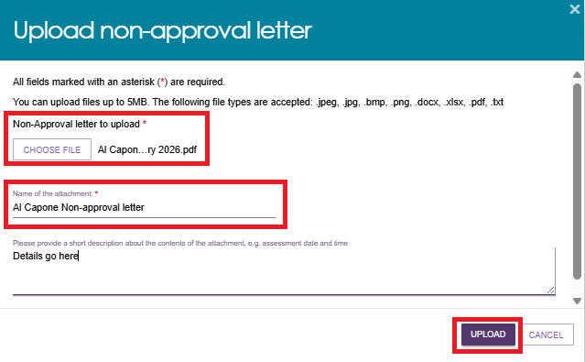
ADD AN ATTACHMENT EXAMPLE
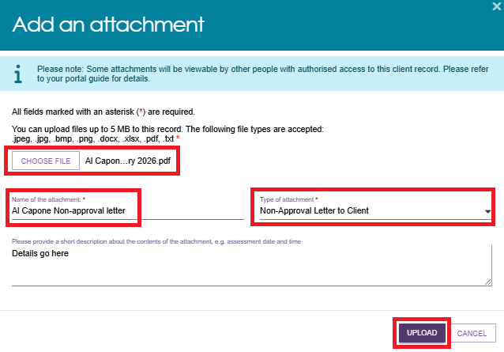

      - The uploaded non-approval letter will display in the Attachments tab.
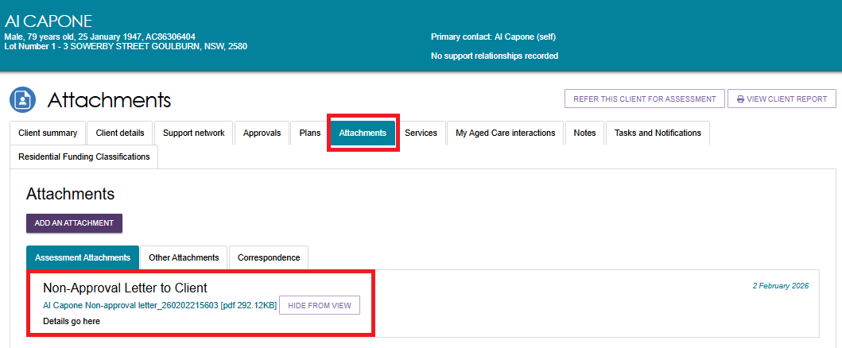

Requesting correction to care approval decision
A corrections process is available where you have made an error in recording a decision.
Correction requests can be submitted up to 42 days after initial delegation, where there are no active or commenced service referrals.
! | From 1 November 2025, an interim process is in place to request correction to Support at Home decisions. For more information on the process, please refer to Support at Home – Interim Request Correction Process – Standard Operating Procedure.  Note: This process was updated to align with recent changes effective from 23 February, the updated approach now applies.
Follow these steps to request a correction to care approval decisions:
- In the Delegate Decisions tab of the portal, navigate to the Decision history tab.
Select the expand arrow on the client card to display a summary of the client’s information in the pop-up.
Select REQUEST CHANGES TO CARE APPROVAL DECISION.
If you are using list view, this option will be available from the expanded client information section.
Card View
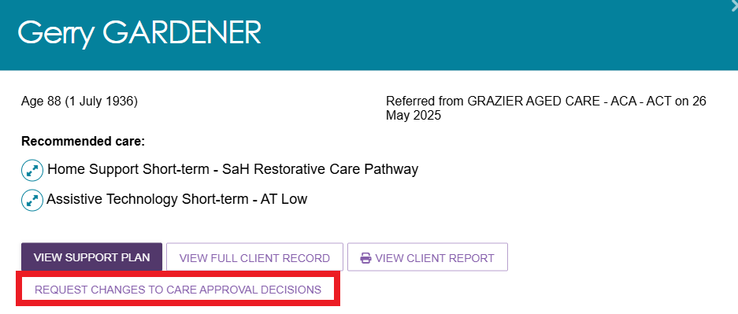
List View
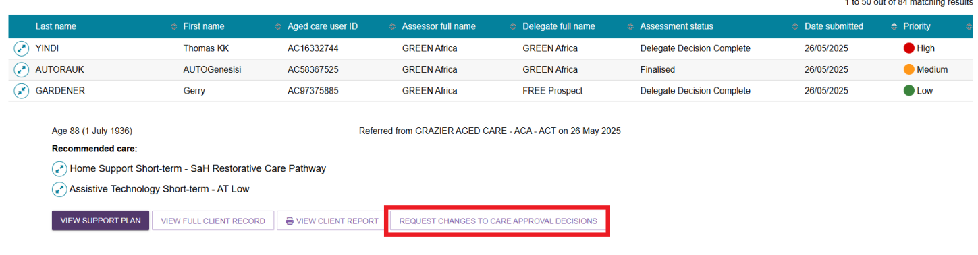
- Record a reason for the change and provide appropriate reasons for the request, then select OK, START CHANGES. Your reasons need to be consistent with the assessment information on the client record.
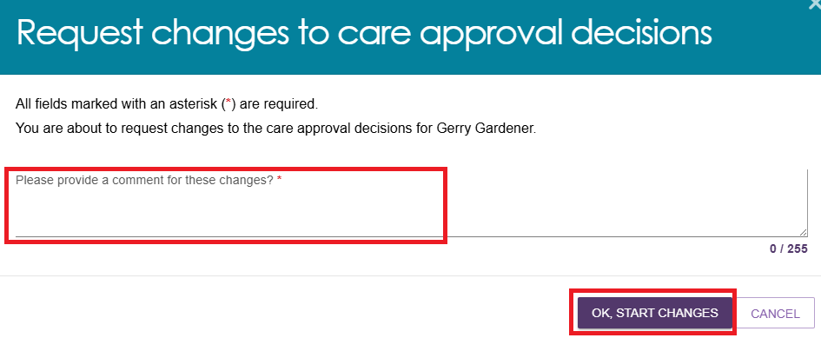
- You will be redirected to the client’s support plan and services page, where you will receive a confirmation message of your change request, and that the correction is in progress.
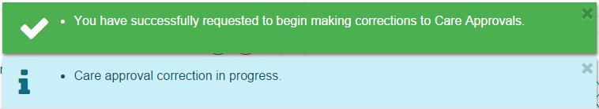
- While on the same screen, you will be able to make edits to, remove, and/or add care types, including:
- making changes to the commencement date of the delegate decision
- requesting the removal and addition of different care classification within a care type within the same correction request.

Making changes to the commencement date of the delegate decision
- Before making changes to the start date of the delegate decision, the declarations must be ticked and the Offline approval form must be attached.
- Go to Delegate Decisions and Comments and select the assessment listing, then select the Edit (pencil) button next to the Decision Date (Assessment) section.
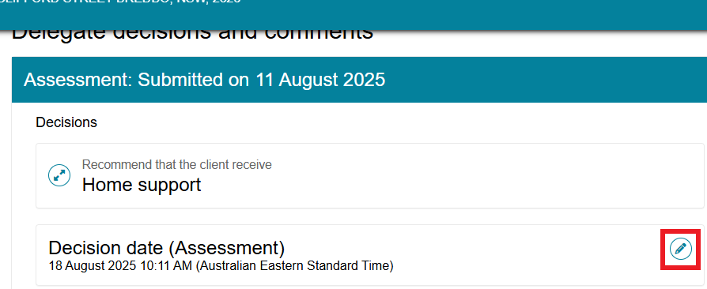
- A Pop-up screen prompting to Edit delegation date will appear. Enter all the required information and Select SAVE TO PLAN.
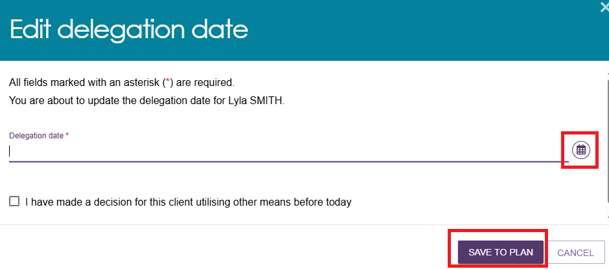
- You will notice two banners (Green and Blue) confirming the action and status.
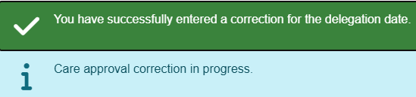
- You can view the changes in the same screen where you get the above confirmation messages.
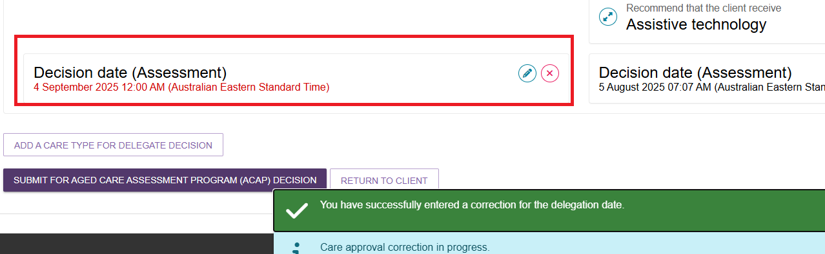
- Select SUBMIT FOR AGED CARE ASSESSMENT PROGRAM (ACAP) DECISION.
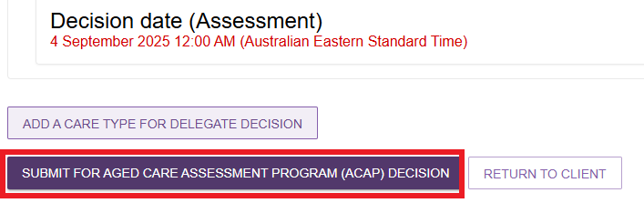

Requesting the removal and addition of different care classification within a care type within the same correction request
- To request to remove a classification or service approval that you have entered incorrectly, select the remove (bin) button next to the decision.
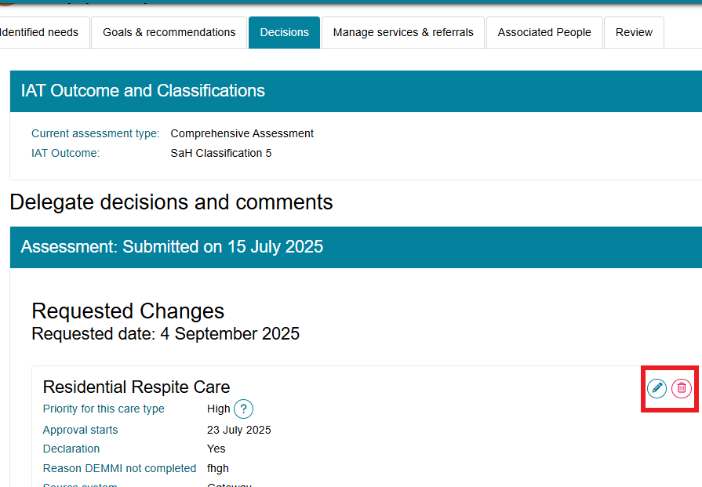
- A pop-up will display. Confirm your request to remove the incorrect record by selecting REMOVE RECOMMENDATION.
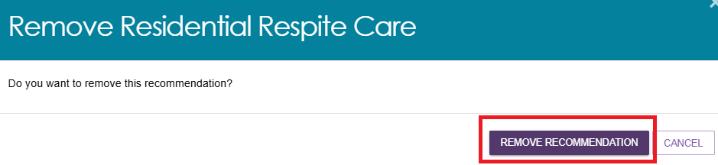
- A green banner will then display to confirm that the care approval has been successfully removed.
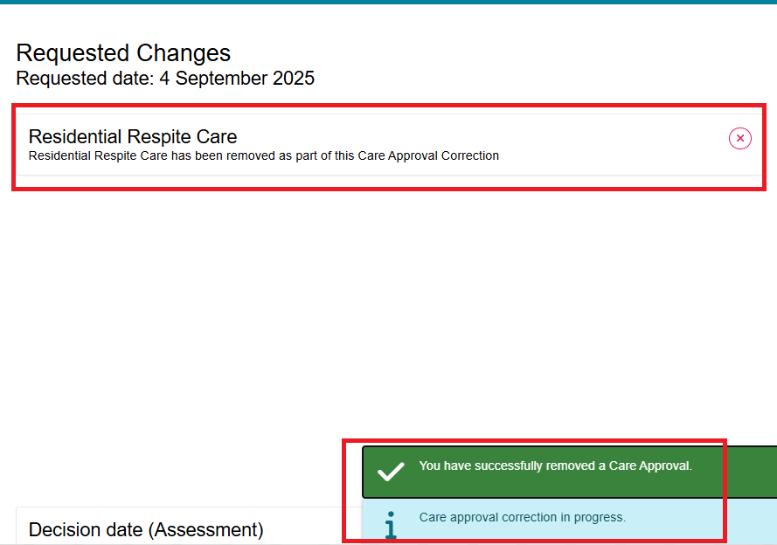
- To then add the correct program or service approval as intended by the clinical assessor and the Clinical Assessment Delegate, select ADD A CARE TYPE FOR DELEGATE DECISION.
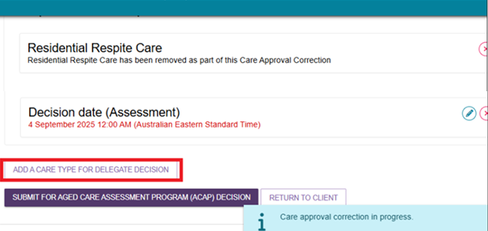
- In the pop-up, add the care type, including the correct service level and priority for the Clinical Assessment Delegate decision. Once you have successfully completed the required fields (marked by an red asterisk *) select SAVE TO PLAN.
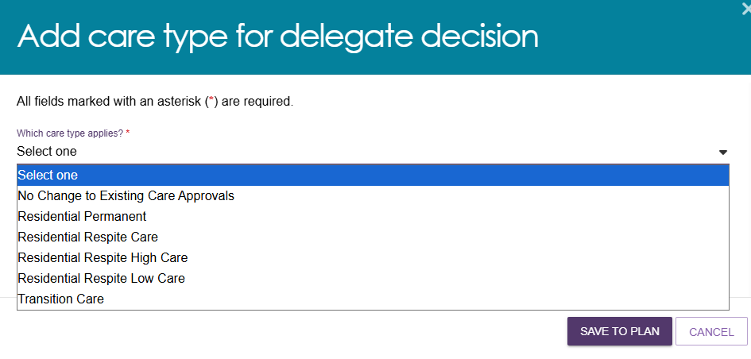
- After successfully saving the changes to the approval, a blue banner will apply outlining that the care approval correction is in progress.
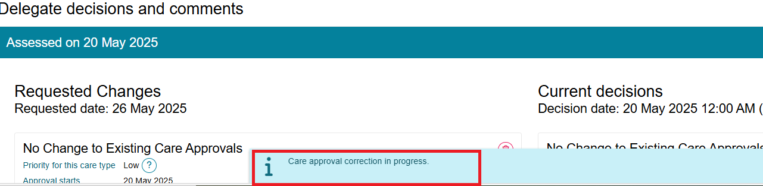

- If you had to exit the correction screen before submitting for decision, you can navigate back to the DECISION HISTORY tab under Delegate Decisions and select the client. The client will have an UPDATE PENDING status.
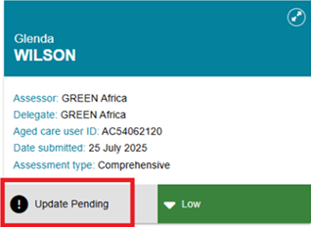
- Select CONTINUE MAKING CHANGES TO CARE APPROVAL DECISIONS button in the expanded client card on the Decision History page.
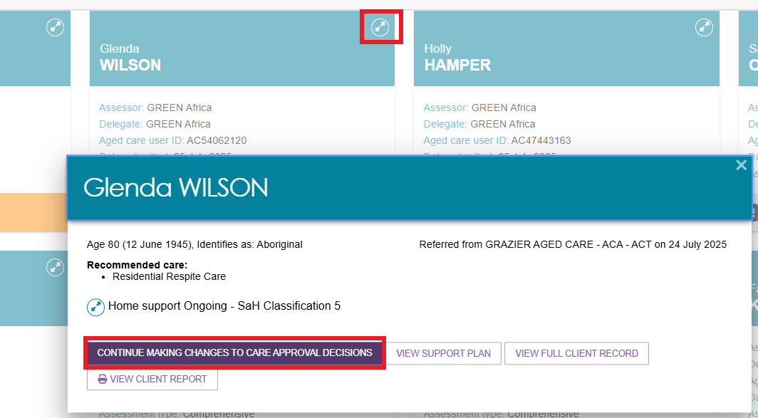
- You will be able to see the requested changes displayed. When you have made the required changes to the care approval decisions, select SUBMIT FOR AGED CARE ASSESSMENT PROGRAM (ACAP) DECISION.
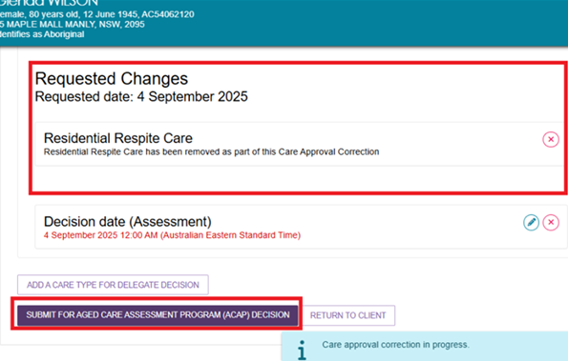
A pop-up message will display requesting confirmation to proceed. Select SUBMIT.
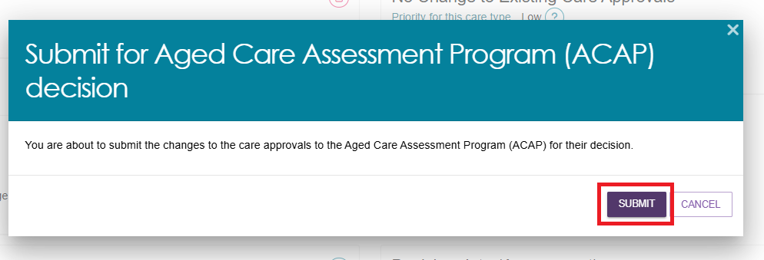
- You will receive a confirmation message that the correction of the request will be received by the Department’s Aged Care Assessment Program (ACAP) delegate.
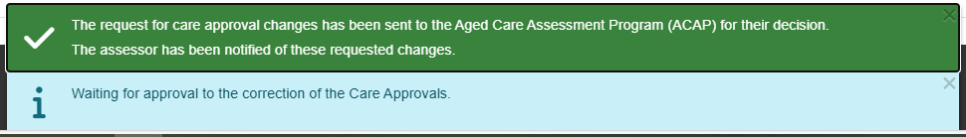
- The client will be displayed in the Decision history tab with a status of ACCEPTANCE PENDING.
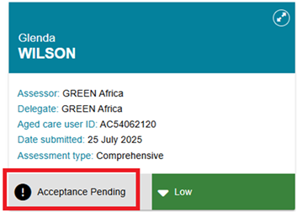
- Once the AGED CARE ASSESSMENT PROGRAM (ACAP) decision has been actioned and finalised by the delegate (in staff portal), the status will be updated accordingly.
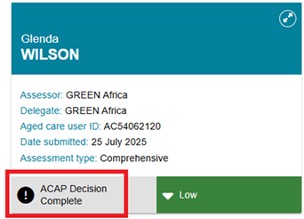
- There will also be a notification advising of the decision in your Tasks and notifications page. You will be able to filter by last name, first name and Aged Care User ID as well as use Advanced Search functionality to help you find notifications for certain clients.
The notification itself will contain links back to the client record and the correction request. It will also allow you to remove the notification from the page.
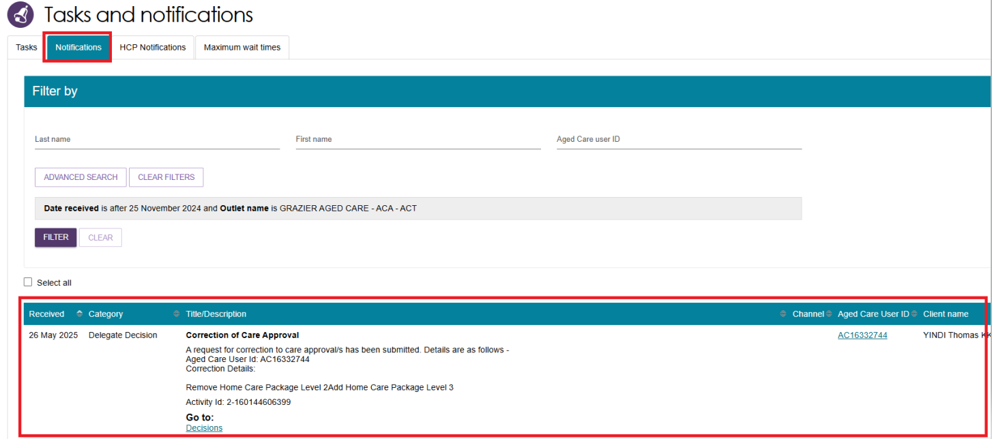
- Once the Clinical Assessment Delegate has made their decision on the correction, you will receive another notification advising that the correction has been completed.
- You will also be able to see the assessment status reflect this when it changes to ACAP Decision Complete in your Decision history tab. Additional information regarding the correction decision will be visible by selecting the expand arrow, including the date and details of the correction.
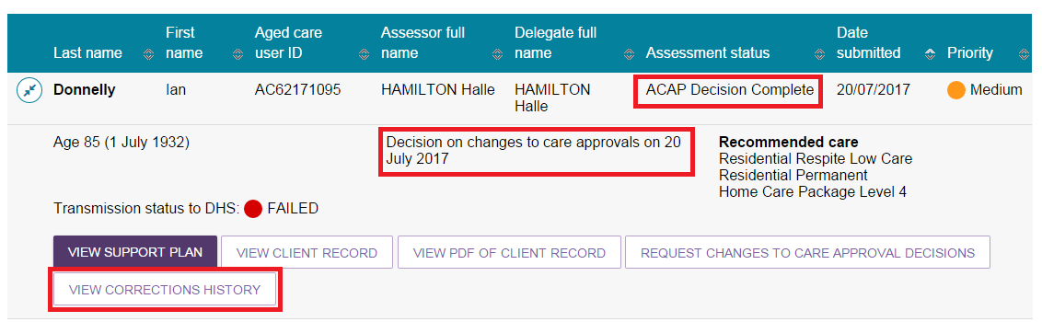
- A record of the corrections history for the client can be viewed by selecting VIEW CORRECTIONS HISTORY.
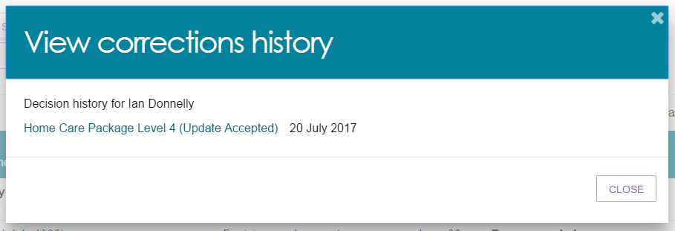

Requesting and Approving Care Extensions
Care extensions can be requested by clinical assessors or service providers as follows:
- For Residential Respite Care and Transition Care approvals, service providers can request care extensions on behalf of the client through the My Aged Care Services and Support Portal.
- For Residential Respite Care, clinical assessors can also generate a care extension for a person living in the community who requires additional respite through the assessor portal.
In cases where a client has a valid Residential Respite Care approval and requires additional Residential Respite days but is currently living at home and not currently receiving residential aged care services, a service provider will not be able to request an extension on behalf of the client. The Clinical Assessment Delegate will instead be able to initiate the care extension on behalf of the client.
If you are unable to complete a care extension request for a client via the assessor portal, you should call the Aged Care Service Provider and assessor Helpline on 1800 836 799.
To make a decision about care extensions, follow the steps below.
- The extension request will appear in the Decision pending tab under unassigned. It will have a status of Acceptance Pending. Open the client’s card in card or list view by selecting the Expand icon.
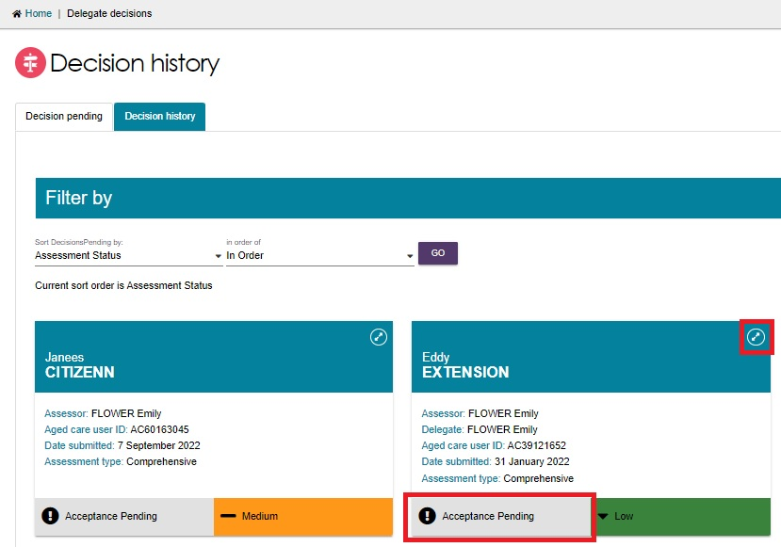
Assign the client to yourself if not already done, then the client will now appear under My Decisions. Select START DECISION PROCESS.
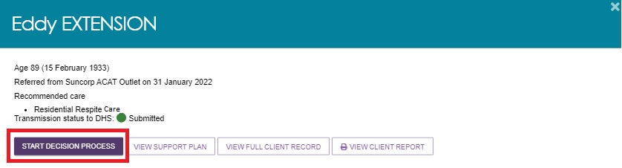
- You will see the care extension request. Review the information and select MAKE EXTENSION DECISION.
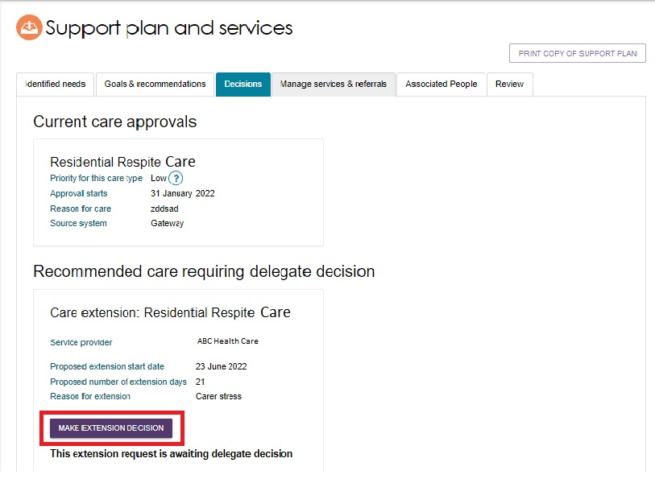
In the pop-up, select Yes or No with regards to granting the extension, and fill out the other fields.
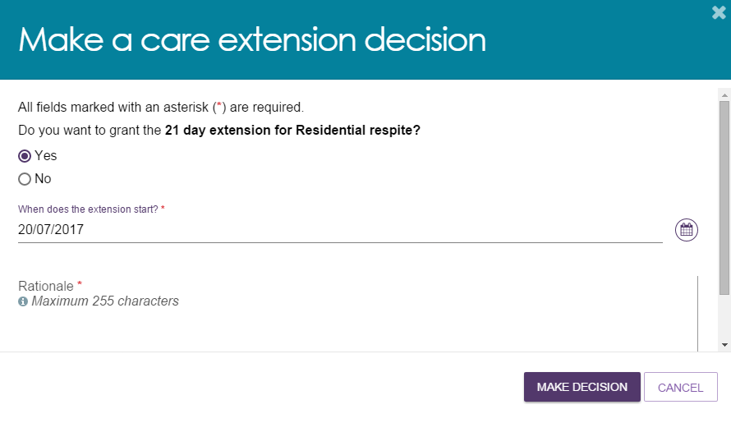
- A notification will be displayed, and the extension request will show with a status of Granted or Not Granted.
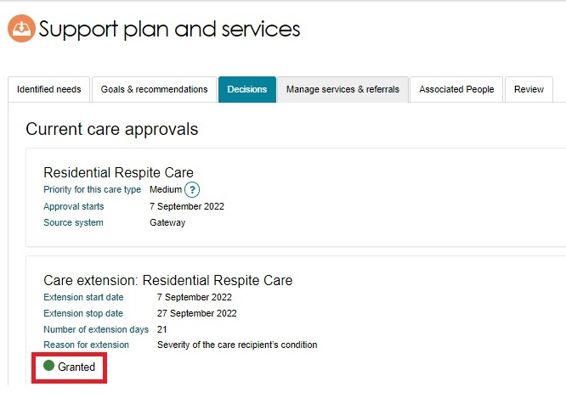
- If the service provider requested the extension, they will receive a notification advising them of the decision in their Tasks and Notifications in the Services and Support Portal.
