
Evaluation of the Medicare Urgent Care Clinics: Interim Evaluation Report 2
Medicare
2 December 2025
Nous Group acknowledges Aboriginal and Torres Strait Islander peoples as the First Australians and the Traditional Custodians
of Country throughout Australia. We pay our respect to Elders
past and present, who maintain their culture, Country and
spiritual connection to the land, sea and community.
This artwork was developed by Marcus Lee Design to reflect Nous Group’s Reconciliation Action Plan and our aspirations for respectful and productive engagement with Aboriginal and Torres Strait Islander peoples and communities

Disclaimer:
Nous Group (Nous) has prepared this report for the benefit of the Department of Health, Disability and Ageing (the Client).
The report should not be used or relied upon for any purpose other than as an expression of the conclusions and recommendations of Nous to the Client as to the matters within the scope of the report. Nous and its officers and employees expressly disclaim any liability to any person other than the Client who relies or purports to rely on the report for any other purpose.
Nous has prepared the report with care and diligence. The conclusions and recommendations given by Nous in the report are given in good faith and in the reasonable belief that they are correct and not misleading. The report has been prepared by Nous based on information provided by the Client and by other persons. Nous has relied on that information and has not independently verified or audited that information.
© Nous Group
Contents
Abbreviations 4
Executive summary 6
1 Introduction, purpose and methodology 18
1.1 About the Medicare Urgent Care Clinics program 18
1.2 Evaluation purpose and methodology 21
2 Interim Evaluation Report 2 findings against the nine Measures of Success 26
2.1 Timely treatment 26
2.2 Safe and quality treatment 35
2.3 Coordinated care 44
2.4 Patient and carer experience 50
2.5 Experience of providers at Medicare UCCs, partner hospital EDs and local GP practices 56
2.6 ED presentations at partner hospitals 69
2.7 Consumer behaviour 79
2.8 Coordinated care within the health ecosystem 88
2.9 Cost effectiveness 97
3 Improvement opportunities 106
3.1 Ongoing opportunities to improve data collection 112
Appendix A Evaluation methodology 114
A.1 Theory of change and program logic 114
A.2 Nationally agreed Measures of Success of the Medicare UCC program 116
A.3 Evaluation phases 116
Appendix B Data sources for Interim Evaluation Report 2 118
B.1 Data sources 118
B.2 Data limitations 119
Appendix C List of external stakeholders consulted for Interim Evaluation Report 2 121
Appendix D Supplementary table 124
Appendix E ITS and DiD analyses 125
E.1 Data sources and steps preparing these for analysis 126
E.2 ITS analysis 131
E.3 DiD analysis 137
E.4 DiD results 142
E.5 Overview of results 147
E.6 Additional tables 149
Appendix F Methodology for cost effectiveness analysis 160
F.2 Calculation of unit costs per presentation for Medicare UCCs 163
F.3 Assigning Medicare UCC presentations to AECC classes and pricing 166

Abbreviations
Abbreviation | Meaning
ABS | Australian Bureau of Statistics
ACCHO | Aboriginal Community Controlled Health Organisations
ACCRM | Australian College of Rural and Remote Medicine
ACT | Australian Capital Territory
AECC | Australian Emergency Care Classification
AGPT | Australian General Practice Training
AIHW | Australian Institute of Health and Welfare
AMA | Australian Medical Association
AMI | Acute myocardial infarction
DMO | District Medical Officer
ECDG | Emergency Care Diagnosis Groups
ED | Emergency Department
EN | Enrolled Nurse
FTE | Full time equivalent
GP | General Practitioner
HPA | Health Policy Analysis
IHACPA | Independent Health and Aged Care Pricing Authority
IRSD | Index of Relative Socio-economic Disadvantage
ITS | Interrupted Time Series
MBS | Medicare Benefits Schedule
MMM | Modified Monash Model
MHR | My Health Record
NAPEDC | National Non-Admitted Patient Emergency Department Care
NEP | National Efficient Price
NMDS | National Minimum Dataset
NSW | New South Wales
NT | Northern Territory
NWAU | National Weighted Activity Unit
PHN | Primary Health Network
RAN | Remote Area Nurse
RACGP | Royal Australian College of General Practitioners
RN | Registered Nurse
SA | South Australia
SA2 | Statistical Area 2
UCC | Urgent Care Clinic

Executive summary
This is the second interim evaluation report of the Medicare Urgent Care Clinics (Medicare UCC) pilot program, based on program implementation from 30 June 2023 to 30 September 2025 (with a cut-off date of 10 August 2025 for data analysis in this report). The evaluation is being independently undertaken by Nous Group (Nous) on behalf of the Department of Health, Disability and Ageing (the Department).

Background to the Medicare UCC program
The Australian Government is investing $1.4 billion over seven years from 2022-23 for the implementation and operations of 137 Medicare UCCs across Australia. Of these, 87 clinics were established by 31 December 2024 (including 58 clinics in Tranche 1 and a further 29 in Tranche 2). These 87 clinics are in scope for this evaluation, with the data used for analysis varying depending on data availability.0F0F
The program was launched by the Australian Government in 2023 with the aim of alleviating pressure on hospital emergency departments (EDs), by offering short-term, episodic care for urgent but non-life-threatening conditions. The program is part of the Australian Government’s broader response to recommendations of the Strengthening Medicare Taskforce and was initially launched as a pilot through to 2026.

The evaluation
This evaluation addresses the nine Measures of Success that were agreed by the Australian and state and territory governments. These measures have informed the key questions to be considered for the evaluation. The evaluation is being conducted between 2024 and 2026 and will provide two Interim Evaluation Reports and a Final Report in late 2026.
Across its three phases, the evaluation is using a mixed-methods approach drawing on a range of data sources. Interim Evaluation Report 2 builds on Interim Evaluation Report 1 and includes a more comprehensive range of data sources, including surveys of Medicare UCC staff and patients, wider engagement with peak bodies, patients, clinic managers and staff, and local ecosystem stakeholders, as well as the National Non-Admitted Patient Emergency Department Care (NAPEDC) database. Further detail on the methodology is provided in section 1.2.3, Appendix A (evaluation methodology), Appendix B (data sources) and Appendix C (external stakeholders consulted).

Interim Evaluation Report 2: Findings against the nine Measures of Success
Findings and improvement opportunities have been provided for each of the nine Measures of Success that were agreed by Australian, state and territory governments. The opportunities for improvement are also summarised in section 3.
Measure of Success 1: Timely treatment
“Patients receive timely treatment for urgent non-life-threatening conditions in Medicare UCCs.”
The evaluation is assessing Measure of Success 1 through:
- Consideration of patient waiting times at Medicare UCCs and comparison with public hospital EDs for patients in triage categories 4 and 5.
• Patient perception of timeliness of treatment received at Medicare UCCs.
This second Interim Evaluation Report has found that median wait times at Medicare UCCs has decreased from Interim Evaluation Report 1 and, acknowledging some differences in counting methods, compares favourably with waiting times for category 4 and 5 patients in EDs. With the addition of more qualitative data, the evaluation has also identified that patients generally view the wait time at Medicare UCCs as acceptable. Commissioners and providers reported some challenges managing patient expectations that they would receive immediate attention. Better communication about the triage process and greater visibility of wait times will improve perceptions of timeliness going forward.
Interim Evaluation Report 2 key findings
1.1 In the period from 30 June 2023 to 10 August 2025, the median wait time at Medicare UCCs was 13.2 minutes. This represents a decrease from Interim Evaluation Report 1 (14.5 minutes). Wait times are shorter than the median wait times at EDs for triage categories 4 (29 minutes) and 5 (23 minutes), noting that wait times are recorded differently for Medicare UCCs and EDs and are therefore not directly comparable.
1.2 A small proportion of Medicare UCC patients (11 per cent) waited longer than 60 minutes to be seen. In EDs, 30 per cent of patients in triage category 4 are seen outside of the 60-minute benchmark and 11 per cent of category 5 patients are seen outside the 120-minute benchmark. These findings are consistent with Interim Evaluation Report 1.
1.3 Most respondents (83 per cent) to the evaluation’s patient survey, reported wait times at Medicare UCCs are acceptable, with some need for the clinics to better manage patient expectations about the triage process and realistic treatment times.
1.4 Flexibility in clinic opening hours is needed to ensure clinics align with local demand and resourcing availability. Recent updates to the Operational Guidance requiring Medicare UCCs to operate 14 hours a day (unless written approval is given by the Department based on unique local context and demand) will need to be managed in light of these considerations.
1.5 Some clinics are trialling different approaches to streamline patient flow and meet demand, such as use of appointments, two-stage triage and overlapping shifts in peak periods.
Improvement opportunities
1.1 As identified in Interim Evaluation Report 1, there remains opportunity for the Medicare UCC Module data to more accurately monitor and report wait times, through splitting triage time from clinical commencement time. This would align more closely with the ED definition and establish more consistent monitoring and reporting opportunities.
1.2 Ongoing education and awareness surrounding the Medicare UCC model is required to support more realistic patient expectations about immediacy of care received at Medicare UCCs. This can be enabled through clear and consistent on-site signage regarding the triage process and expected wait-times, as well as broader health service and community clarity surrounding the Medicare UCC model of care.
1.3 There is opportunity for more consistent visibility across Medicare UCCs of live wait times and clinical capacity on websites and digital platforms to enhance system navigation and demand management.

Measure of Success 2: Safe and quality treatment
“Medicare UCCs provide safe and quality treatment to patients.”
The evaluation is considering safety and quality across six commonly accepted dimensions. The dimensions of safety, appropriateness and equity (including equitable access for priority populations) are considered under this Measure of Success with the dimensions of timeliness, patient-centred care and efficiency addressed in other Measures of Success.
This second Interim Evaluation Report found positive support by staff that the clinics provide safe and high-quality care, with most conditions treated at the Medicare UCCs falling within the scope of the Operational Guidance. Access for First Nations patients has been improved through development of a local and culturally tailored approach, but questions were raised about whether the model improves access in some rural situations – this will be investigated further in the Final Report.
Interim Evaluation Report 2 key findings
2.1 Most respondents (88 per cent) to the evaluation’s staff survey agreed or strongly agreed that their Medicare UCC provides safe and high-quality care. Nearly four-fifths (89 per cent) of respondents agreed or strongly agreed that if a friend or relative needed treatment they would be happy with the standard of care their Medicare UCC provided.
2.2 As of 10 August 2025, Medicare UCCs continue to primarily treat conditions that fall within the scope of services and conditions in the Operational Guidance, with 89 per cent of presentations related to an acute illness or injury (89 per cent in Interim Evaluation Report 1). Most (89 per cent) staff surveyed for the evaluation reported that their Medicare UCC provides appropriate care to patients.
2.3 As of 10 August 2025, the proportions of presentations that are referred to an ED (5 per cent) or redirected to the usual general practitioner (GP) (8 per cent) when appropriate, are consistent with the previous reporting period (Interim Report 1), with only a small proportion of presentations needing redirection. Based on feedback from Medicare UCC staff during consultations, this may underrepresent the proportion of presentations with lower acuity needs that are more suited to be seen by their regular GP but are nevertheless treated at the Medicare UCC rather than being turned away.
2.4 Use of Medicare UCCs by Aboriginal and/or Torres Strait Islander peoples remains consistent with Interim Evaluation Report 1. Some clinics, such as those in remote Northern Territory (NT) communities, are strongly supporting a local and culturally tailored approach.
Improvement opportunities
2.1 There is an ongoing opportunity to explore improved data collection for culturally and linguistically diverse patients. This applies both to the methods of data collection (i.e. variables collected) and how consistently they are collected by staff.

Measure of Success 3: Coordinated care
“Medicare UCCs deliver coordinated care for Medicare UCC patients.”
The evaluation is assessing Measure of Success 3 through consideration of:
- Effectiveness and consistency of clinical handover with a patient’s usual primary care provider.
- Patient experience of care coordination from Medicare UCCs, including receiving clear care summaries, feeling supported in follow-up arrangements and being connected to a regular GP if they lack one.
- Provider experience of care coordination from Medicare UCCs, including receiving care summaries.
- Access to multidisciplinary and diagnostic services that support efficient, coordinated care and allow Medicare UCCs to address patient needs more comprehensively.
Overall, the evaluation found that while a high percentage of clinical handovers and discharge summaries are provided, there is further room for improvement in the coordination of care for patients who use a Medicare UCC. In particular, access to imaging and pathology services across all hours of operation remained a key gap for many Medicare UCCs during this period.
Interim Evaluation Report 2 key findings
3.1 In the period to 10 August 2025, 87 per cent of presentations had a clinical handover provided either directly to their usual GP, uploaded to My Health Record (MHR) or given as a paper copy to the patient. These findings are consistent with Interim Evaluation Report 1.
3.2 Available data indicates a slightly lower proportion (65 per cent) of presentations had a handover provided directly back to the patient’s usual GP/practice between 30 June 2023 and 10 August 2025 compared with Interim Evaluation Report 1 (68 per cent). A further 12 per cent of presentations had information uploaded to MHR (but not provided to the patient’s usual GP). Approximately 10 per cent of presentations received a hard copy of the discharge summary only, which is lower than the proportion of Medicare UCC patients that did not identify a usual GP/practice (13 per cent). Commissioners reported receiving fewer complaints from local GPs regarding handovers.
3.3 Patients reported feeling supported by staff to arrange follow up care when required. Lack of access to Medicare Benefits Schedule (MBS) items to fund telehealth to convey test results at Medicare UCCs was identified by some clinics as a constraint in streamlining the provision of radiology and pathology results back to patients following their visit.
3.4 Medicare UCCs face ongoing barriers with offering access to imaging and pathology services across all or most hours of operation (as per the Operational Guidance) and ED continues to be the only option for after-hours imaging in many areas.
Improvement opportunities
3.1 There is ongoing need for Medicare UCCs to increase the proportion of patients who receive clinical handover directly to their usual GP/practice, to improve communication and coordination of care.
3.2 There is ongoing need for Medicare UCCs to expand access to imaging and pathology services across all hours of operation, this may include bringing imaging services on-site.

Measure of Success 4: Experience for patients and carers
“Medicare UCCs provide a positive experience for patients and carers.”
Measure of Success 4 was assessed through the evaluation’s patient survey, conducted between July and August 2025, with 816 responses as well as qualitative insights from consumer focus groups with Medicare UCC patients and carers.
Both forms of feedback demonstrated overall satisfaction with the care provided at Medicare UCCs and indicated perceptions that the quality of care is high. Ongoing community awareness about the role of the clinics and improvements to physical layout for some clinics will enhance patient and carer experience.
Interim Evaluation Report 2 key findings
4.1 Patients and carers engaged for Interim Evaluation Report 2 reported positive experiences at Medicare UCC services. Ninety-five per cent of respondents to the evaluation’s patient survey rated the care they received as good or very good and 92 per cent of respondents reported they would speak highly or very highly of their experience to friends and family. Satisfaction appears to be driven by quality of staff interactions and support with understanding and arranging follow up care when required.
4.2 Some consumers expressed frustration with being turned away from clinics near closing time, when demand exceeds capacity and Medicare UCCs are forced to stop accepting patients. A variety of strategies are being implemented in clinics to enhance demand management and reduce wait times.
Improvement opportunities
4.1 There is ongoing opportunity to improve patient experience through enhanced communication about the care and treatment offered locally at clinics to better manage expectations.
4.2 There is ongoing opportunity to improve patient experience through upgrades to physical infrastructure at some clinics, including branding, parking and physical layouts, to ensure adherence to accessibility requirements outlined in the Operational Guidance, noting that existing clinics have until 30 June 2026 to comply.

Measure of Success 5: Experience for providers at Medicare UCCs, partner hospital EDs and local GP practices
“Medicare UCCs provide a positive experience for providers at Medicare UCCs, in partner hospital EDs and in local GP practices.”
The evaluation is assessing Measure of Success 5 through consideration of:
- Experiences of Medicare UCC staff providing services.
- Experiences of providers in partner hospital EDs and local GP practices with Medicare UCC services.
- The impact of Medicare UCCs on other GP practices and workforce availability.
A key data source used to understand provider experience was a staff survey available to all Medicare UCC staff working at the clinics between June and July 2025. The survey received 474 responses (188 from nursing staff and 87 from medical staff). The evaluation also conducted interviews with Medicare UCC managers and staff from seven clinics, commissioners, peak bodies, and a small sample of local GPs and ED representatives who made themselves available.
As highlighted in the key findings below, the Medicare UCC workforce was generally positive about their experience and their opportunities for professional development. However, workload pressures and recruitment remained significant issues. The evaluation noted an increasing recognition by local GPs and ED clinicians of the role and value of the Medicare UCCs, which was influenced by the development of strong relationships and trust amongst the players, as well as consistent referral patterns.
Interim Evaluation Report 2 key findings
5.1 Providers reported that many staff enjoy the variety of working part-time across Medicare UCCs and regular general practices, with positive workplace cultures characterised by high trust and meaningful work. Medical staff reported better opportunities for professional development and working to their full scope than nursing staff. Workload pressures remain a concern, with only 52 per cent of nursing and 59 per cent of medical staff finding their workload manageable, reflecting wider trends in Australian primary care.
5.2 Recruitment of appropriately qualified GPs and nurses to achieve the minimum workforce requirements outlined in the Operational Guidance across extended hours remains an ongoing challenge for providers and is particularly significant in regional and rural areas. Changes to the Operational Guidance in August 2025 enhanced flexibility of the minimum workforce to include paramedics, nurse practitioners and Registered Nurses (RNs). Systemic barriers, such as MBS billing restrictions and trainee accreditation constraints, need to be overcome to successfully implement flexible workforce models across clinics.
5.3 Factors influencing positive experiences for local GPs and hospital staff with Medicare UCC services include comprehensive and timely handovers, strong relationships and trust, shared workforce and balanced remuneration structures. To enhance their experiences of Medicare UCC services, local health system stakeholders are seeking better visibility of referrals subsequently diverted to ED and clinic wait times/capacity.
5.4 While there remains opposition to the Medicare UCC model from GP peak bodies and local GPs on the grounds of perceived deskilling and fragmentation of care, there is growing awareness among GPs and hospital services of the role and value of the model, which is increasingly recognised as part of the urgent and primary care landscape. GPs highlighted the need for improved continuity of care and health system integration. Many GPs remain concerned about the potential for workforce and funding to be redirected away from general practice.
5.5 The evaluation has identified the need to further explore stakeholder perspectives on how the Medicare UCC model fits into the existing network of primary and emergency healthcare services in rural and remote areas.
Improvement opportunities
5.1 There is opportunity for Medicare UCCs to enhance support for nurses to work to the top of their scope of practice and access appropriate learning and development resources and programs, in line with the findings of the Scope of Practice Review.

Measure of Success 6: ED presentations at partner hospitals
“Medicare UCCs reduce pressure on hospital ED presentations at partner hospitals.”
Interim Report 2 has assessed Measure of Success 6 through a range of analyses that estimate the impact of Medicare UCCs on urgent-care-equivalent presentations to partner hospital EDs and wait times. The definition of urgent-care-equivalent ED presentations is drawn from the National Healthcare Agreement Indicator definition for potentially avoidable GP-type presentations to public hospital EDs. The analyses use data from the NAPEDC along with summary data provided through data sharing agreements entered into with states and territories under the Medicare UCC program.
Methods used in the analyses are described in detail in Appendix E including the justification for interpreting the results of these analyses as causal effects of the Medicare UCC program. The methods include:
- Analysis of the Medicare UCC Module data item which reported where a patient would have sought care if the Medicare UCC was not available.
- An interrupted time series (ITS) analysis that estimates how trends in urgent-care-equivalent ED presentations changed in partner hospitals following the commencement of Medicare UCCs based on a comparison of an estimate of what would have happened if trends from the pre-implementation period for the partner EDs/hospitals continued – a counterfactual drawn from the partner EDs/hospitals themselves.
- A Difference in Differences (DiD) analysis at the ED/hospital level that estimates the change in urgent-care-equivalent ED presentations in partner EDs/hospitals following the commencement of Medicare UCCs, compared with what would have happened in the absence of a Medicare UCC – a counterfactual based on observations from comparator EDs/hospitals. Adjustments are made to ensure the comparator EDs/hospitals are similar to the partner hospitals across a range of characteristics.
- A DiD analysis at the postcode level, which estimates the change in urgent-care-equivalent ED presentations in postcodes that form the catchment of the Medicare UCCs, compared with what would have happened in the absence of a Medicare UCC – a counterfactual based on observations from comparator postcodes. Adjustments are made to ensure the comparator postcodes are similar to the partner hospitals across a range of characteristics.
From these analyses, the evaluation has drawn the findings outlined below.
Interim Evaluation Report 2 key findings
All the above methods provide reasonably strong evidence that the availability of Medicare UCCs caused a reduction in ED presentations as a result of Medicare UCC availability, although the extent of the reduction varies dependent on the methodology used.
6.1 In the period from 30 June 2023 to 10 August 2025, 45 per cent of patients who presented to Medicare UCCs reported an intention that they would have sought care at an ED if the Medicare UCC was unavailable, according to Medicare UCC Module data. This reported intention increased to 48 per cent after hours and is consistent with findings from Interim Evaluation Report 1 (46 per cent overall and 49 per cent after hours). However, these proportions should be considered with caution as there are many limitations associated with reporting against the question “Where would the patient have gone otherwise?” These include incomplete data, who records the intention (self or other), variable interpretations by the respondent and the acknowledgment that some patients might still attend ED or be referred to one, regardless of their reported intentions at the start of their Medicare UCC visit.
6.2 The results from the ITS and DiD causal inference analyses support a conclusion that the availability of Medicare UCCs has reduced urgent-care-equivalent ED presentations by around 10 per cent. A lower but still significant estimate (4.6 per cent) is generated when analysing Medicare UCC catchments. There are specific issues with the DiD based on the postcode of the ED patient's residence, which would imply the estimates for this analysis potentially results in an under-estimate of the effect.
6.3 The causal inference estimates are lower than the analysis of patient intentions captured in the Medicare UCC Module data, with the Medicare UCC Module data suggesting an estimated reduction of around 23 per cent in ED presentations due to the availability of Medicare UCCs. However, the estimates from the Medicare UCC Module data relate to patient intentions and should be interpreted with caution. The DiD and ITS analyses at the ED/hospital level provide more statistically valid estimates of the impact but, as noted, these estimates may under or overestimate the effect.
6.4 There is no clear evidence that waiting times and the proportion of patients seen on time has changed for urgent-care-equivalent ED presentations as a result of the availability of Medicare UCCs.

Measure of Success 7: Consumer behaviour
“There is a change in consumer behaviour over time to use Medicare UCCs where available instead of EDs for urgent non-life-threatening conditions.”
The evaluation is assessing Measure of Success 7 through consideration of:
- Presentations to Medicare UCCs.
- Use of Medicare UCCs instead of EDs for urgent non-life-threatening conditions.
- Factors influencing use of Medicare UCC services for consumers over other services.
The number of patients accessing Medicare UCCs grew across the reporting period, with over 1.8 million presentations. This was largely driven by an increase in the number of clinics and sustained modest growth in presentations to Medicare UCCs that opened before 30 June 2024.
Interim Evaluation Report 2 key findings
7.1 The proportion of presentations (45 per cent) where it was reported that patients would have attended ED or called an ambulance has remained stable since August 2024. Medicare UCCs that transitioned from a previous state arrangement persistently reported higher proportions of presentations that would have otherwise attended ED or called an ambulance than newly established clinics.
7.2 The evaluation’s patient survey identified the top three reasons patients attended a Medicare UCC instead of an ED were perceived urgency (condition not urgent enough for ED), anticipated timeliness (would be seen more quickly at ED) and referral by another service. Whereas the top three reasons patients attended a Medicare UCC instead of their regular GP were anticipated timeliness (would be seen more quickly at a UCC), after-hours access and the expectation that Medicare UCCs are better equipped to manage their condition.
7.3 Medicare UCCs exist alongside a variety of urgent care services delivered through GPs, hospitals, after-hours services, other state, territory and Primary Health Network (PHN) programs, and the services delivered by healthdirect Australia (healthdirect1F1F). Patients and carers are experiencing ongoing challenges navigating the complex urgent care landscape and understanding the differences between primary care, urgent care and emergency care.
Improvement opportunities
7.1 There is opportunity for ongoing locally led communications to the community about the spectrum of health services available, including when to attend a Medicare UCC and the role of healthdirect, to support patients navigating the complex and varied urgent care landscape.

Measure of Success 8: Coordinated care within the health ecosystem
“Medicare UCCs, PHNs, healthdirect, jurisdictions and the health ecosystem have established an effective coordinated care option for people with urgent non-life-threatening conditions.”
This Measure of Success assesses collaboration between various groups in the health ecosystem (including Medicare UCCs, PHNs, state and territory run health services, and healthdirect) and the extent to which Medicare UCCs:
- communicate and collaborate with other health services to streamline care, enhance information sharing and reduce likelihood of duplicated tests and procedures
- establish clear roles and referral pathways with other health services to provide a coordinated care option for people with urgent non-life-threatening conditions.
Consistent with Interim Evaluation Report 1, Interim Evaluation Report 2 found that active and ongoing collaboration, including through PHNs and local integration working groups, is vital in building relationships and trust and integrating Medicare UCCs into the health ecosystem. For this second report the evaluation had a particular focus on the range of factors impacting development and use of referral pathways within the local health ecosystem. Overall, while referral pathways are developing, there is still a need for further development and for greater use of them. Integration with state and territory systems and policies remains a particular challenge.
Interim Evaluation Report 2 key findings
8.1 Formal collaboration mechanisms, such as PHN led integration working groups, lead to better relationships and integration between Medicare UCCs and other health services. The longer the Medicare UCCs operate within a local ecosystem and engage with established integration working groups, the more effective the relationships can become.
8.2 Differences across and within state and territory-run health systems impact the integration of Medicare UCCs into local health systems, with key factors including varying jurisdictional policies (such as ambulance triage policies that prevent referral pathways diverting patients to Medicare UCCs), system-wide approaches (such as appointment bookings for some state-run urgent care services via the healthdirect Helpline) and executive level engagement.
8.3 As of April 2025, at least 76 per cent Medicare UCCs had referral pathways to local hospitals and 60 per cent had referral pathways from local hospitals, including EDs. The proportion of presentations referred to Medicare UCCs from EDs (1.3 per cent) remains low and has not improved since the Interim Evaluation Report 1.
8.4 As of April 2025, at least 68 per cent of clinics had referral pathways for ambulance services to divert patients to the Medicare UCC, however presentations diverted from ambulance services remains low (0.6 per cent), consistent with Interim Evaluation Report 1 (0.8 per cent).
8.5 The proportion of Medicare UCC presentations referred by healthdirect has not increased since Interim Evaluation Report 1, remaining at just 2.6 per cent. Commissioners reported issues (for example, inappropriate referrals and unrealistic wait time expectations) are easier to resolve when there is a coordinated jurisdiction-level communication approach to healthdirect and other phone triage providers.
8.6 Commissioners reported enhanced willingness of surrounding general practices to refer to Medicare UCCs, which they attribute to improved awareness, relationships and collaboration between services.
8.7 Key enablers for effective referral pathways with other health services include phone handovers, education and promotion of Medicare UCC services, shared staffing and established governance frameworks which authorise tailoring of local pathways. Key barriers for effective referral pathways include incompatible IT systems, lack of awareness or understanding of services and perceived medico-legal issues with diverting patients.
Improvement opportunities
8.1 There is opportunity for enhanced coordination and collaboration across PHNs, states and territories to support integration at a local and jurisdictional level with state and territory funded health services, particularly ambulance policies and ED referrals to Medicare UCCs, so that the urgent care ecosystem works together at a local level.
8.2 There is opportunity to strengthen the relationships and more consistently operationalise referral pathways between jurisdictional ambulance services and Medicare UCCs to increase the proportion of Medicare UCC presentations diverted from ambulance services. This should also include further consideration of the kinds of services that would be appropriate to divert to a Medicare UCC.
8.3 Communication and feedback mechanisms between commissioners and healthdirect/other phone triage providers could be streamlined to refine referral pathways.
8.4 Medicare UCCs should engage more proactively with local general practice managers and administration staff about the role and scope of Medicare UCCs to support appropriate referrals, particularly in the after-hours period.

Measure of Success 9: Cost effectiveness
“Medicare UCCs are cost effective.”
The cost effectiveness analysis undertaken for this Interim Evaluation Report 2 aims to estimate cost/cost savings per avoided ED presentation. The modelling has focussed on the 2024-25 financial year and the Tranche 1 Medicare UCCs for which data is available. Methods applied are described in Appendix F.
To undertake this analysis, the report assesses Measure of Success 9 through:
- Unit cost per Medicare UCC presentation. Costs assessed for this measure are the costs to the Australian Government2F2F, based on grants made to Medicare UCCs, aggregate counts of presentations at each Medicare UCC, other Medicare UCC data and MBS data.
- The estimated reduction in urgent-care-equivalent ED presentations using the results from Measure of Success 6 for the points estimates and levels of uncertainty.
- Unit costs for avoided ED presentations. Costs assessed for this measure are the costs to the Australian and state/territory governments, based on funding at the National Efficient Price (NEP) recommended by the Independent Health and Aged Care Pricing Authority (IHACPA).
The Australian Government is investing $1.4 billion over seven years from 2022-23 for the implementation and operations of 137 Medicare UCCs across Australia. As noted earlier, 87 clinics were established by 31 December 2024 and are in scope for this evaluation. Of these, 58 clinics were implemented by 31 December 2023 and fully operational through the 2024-25 financial year. The analysis of costs used in the comparison with ED costs avoided presented below is focused on 53 of these 58 clinics, where a full year of data post-establishment was available and excluding the five ACT clinics. Due to the difference in available data and specific funding arrangements for ACT clinics, analysis for the five ACT clinics has been presented separately.
Interim Evaluation Report 2 key findings
9.1 The estimate of Australian Government funding during the 2024-25 financial year across the 75 Medicare UCC clinics established before 30 September 2024 is $206 per Medicare UCC presentation. This represents a reduction from the comparable estimate in Interim Evaluation Report 1 of $216. The decrease is largely due to the increase in presentation volumes as individual clinics grow towards capacity.
  - Across the 53 Tranche 1 Medicare UCCs in which Module data is reported (and excluding the ACT clinics) Australian Government funding is estimated to be $236 per presentation where it was reported the patient would have otherwise attended an ED or called an ambulance if the Medicare UCC was not available (according to Medicare UCC Module data).
  - The average funding for avoided presentations to ED (that were avoided due to the availability of Medicare UCCs) is estimated to be $617 per urgent-care-equivalent ED presentation. On this basis, subtracting the cost of $236 per Medicare UCC presentation, the savings per avoided ED presentation is $381 per presentation.
  - The report has assessed the annual net savings per ED presentation avoided based on two estimates of effect. Both methods consistently show a cost saving compared to the costs of an ED presentation, based on analysis of data for 53 clinics:
  - Using the Medicare UCC Module data and the associated estimate of avoided ED attendances of approximately 260,000, the estimated savings of $381 per presentation results in total net annual savings of $99 million3F3F.
  - Using the DiD/ED/hospital analysis yields a lower estimate of avoided ED attendances (around 95,000) and as a result a lower estimate of annual savings: $36.2 million (CI $25.4 million-$48.1 million).
The Final Evaluation Report will consider these estimates in more detail and will undertake a range of sensitivity analyses to assess their robustness. The Final Evaluation Report will also consider other benefits in addition to avoided ED presentations.

Introduction, purpose and methodology

About the Medicare Urgent Care Clinics program
The Australian Government is investing $1.4 billion over seven years from 2022-23 to establish and operate 137 Medicare UCCs across Australia.4F4F The Department is implementing the program in three phases:
- Phase one: 58 clinics established between 30 June 2023 and 31 December 2023.
- Phase two: 29 clinics established between 1 July 2024 and 31 December 2024.
- Phase three: 50 clinics to be established between 1 July 2025 and 30 June 2026.
The Medicare UCC program was established by the Australian Government with the aim of improving access to urgent care and alleviating pressure on hospital EDs by offering short-term, episodic care for urgent but non-life-threatening conditions and diverting triage categories 4 (semi-urgent) and 5 (non-urgent) urgent-care-equivalent presentations away from ED settings. The Medicare UCC program was implemented to provide a coordinated, system-level response to improving access to urgent care while maintaining efficient use of ED resources. It forms part of the Australian Government’s broader response to recommendations of the Strengthening Medicare Taskforce.5F5F
Medicare UCCs are staffed and equipped to provide treatment for urgent non-life-threatening conditions, including access to diagnostic services. They are open for extended hours, offer walk-in services without the need for appointments and provide care with no out-of-pocket costs for patients. The intended Medicare UCC patient journey is illustrated in Figure 1.
The clinics are predominantly partnered with existing general practices, Aboriginal Community Controlled Health Organisations (ACCHOs) and other community health services. Each Medicare UCC has a local partner public hospital ED and is expected to integrate with local health services.
Medicare UCCs refer patients to their usual primary care provider for follow up care and/or where presentations are out of scope of the Medicare UCC and can be safely and more appropriately managed by the usual primary care provider.

Medicare UCC Operational Guidance
The Department developed the Operational Guidance,6F6F in consultation with state and territory governments, to set the minimum requirements for Medicare UCCs including activities, infrastructure and staffing while allowing sufficient flexibility for services to adapt to local conditions and needs.
Updated Medicare UCC Operational Guidance was released by the Department in August 2025, subsequent to much of the consultation for this report. There is currently a transitional period in place for existing Medicare UCCs, with full compliance to the new guidelines expected by 30 June 2026. The Department advised that the updated Operational Guidance is designed to address some of the improvement opportunities identified in Interim Evaluation Report 1, such as through clarifying requirement for handover to a patient’s regular GP and enhancing flexibility in the minimum staffing requirements. Given the recency of release of the updated Operational Guidance, the Final Evaluation Report will more closely examine its effect.

Figure 1 | The intended Medicare UCC patient journey
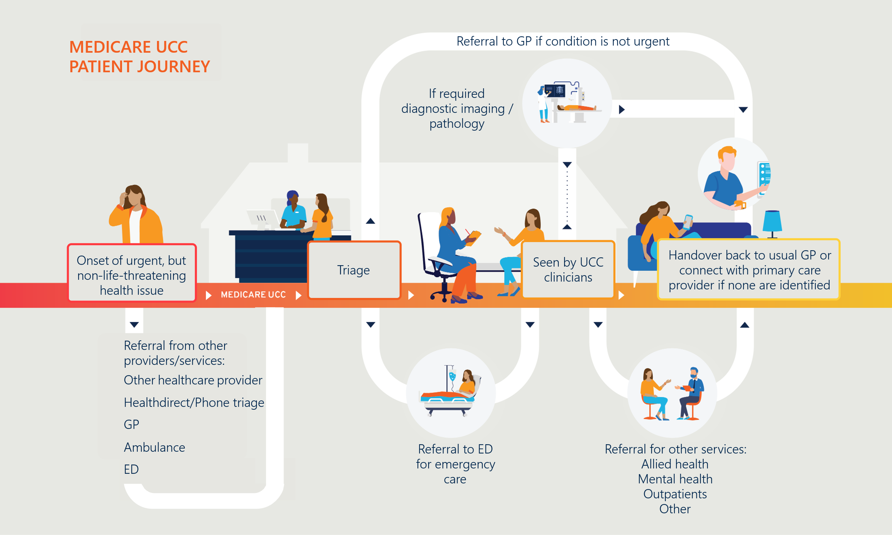

Evaluation purpose and methodology

Evaluation purpose
The Department commissioned Health Policy Analysis (HPA) to conduct an independent evaluation of Phases 1 and 2 (encompassing 87 clinics) of the Medicare UCC program from 2023 to 2026. HPA was subsequently acquired by Nous in August 2024 and the evaluation team was integrated into Nous.
The evaluation assesses the program against the nine Measures of Success (Figure 2) that were agreed by Australian, state and territory governments, and provides evidence-based recommendations to inform future health policy decisions. The Measures of Success form the key evaluation questions considered for this evaluation.
Figure 2 | Nationally agreed Measures of Success of the Medicare UCC program
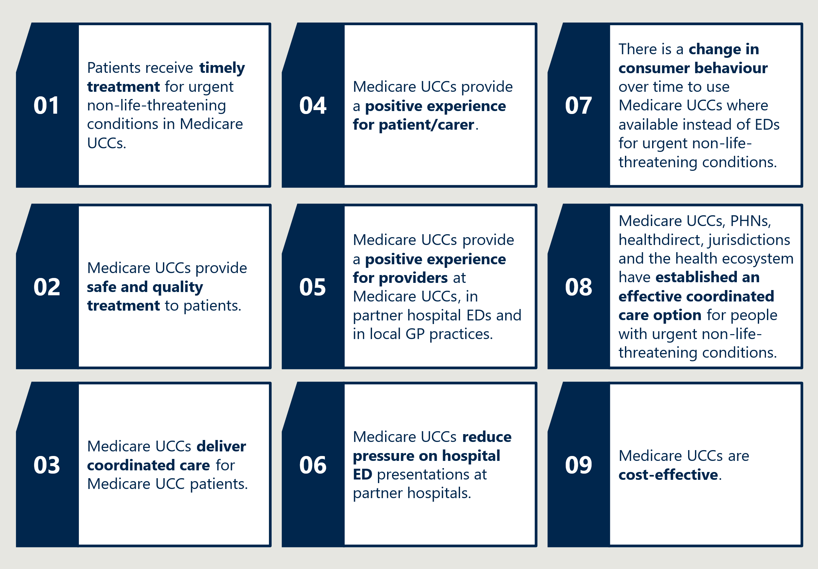

Evaluation progress
The evaluation is being conducted between 2024 and 2026 and provides two interim reports and a final report. Interim Evaluation Report 1 covered the program period from 30 June 2023 to 30 September 2024, during this time a total of 75 Medicare UCCs had opened. As of 31 December 2024, a further 12 clinics had opened, totalling 87 clinics.

Interim Evaluation Report 17F7F was published in early 2025 and covered the program period from 30 June 2023 to 30 September 2024. Interim Evaluation Report 1 identified key program and data improvement opportunities. High level improvement opportunities related to:
- Improving care coordination, through partnerships, referral pathways and consistent handover to GPs.
- Implementing consistent approaches to data capture, including a standardised mechanism for collecting patient feedback.
- Encouraging uptake of flexible workforce models.
- Enhancing both national and local community awareness and understanding of the Medicare UCC model and service availability.
- Improving the quality and accuracy of data reported through the Medicare UCC Module.
These improvement opportunities are also summarised in section 3.
Interim Evaluation Report 2 (this report) provides insights for each Measure of Success to inform ongoing program improvement, with additional data to inform findings. It builds on Interim Evaluation Report 1 findings and extends the analysis to include program delivery between 30 June 2023 and 30 September 2025. It also includes additional stakeholder engagement (described below), enabling additional qualitative insights from key stakeholders. Additional quantitative analysis was undertaken with additional data sources and updated data, to answer more complex questions through data analytics, as described below.
The Final Evaluation Report will be delivered at the end of 2026. It will provide a summative evaluation, examining the overall effectiveness of the Medicare UCC program in achieving each of the nine Measures of Success and will provide strategic recommendations for the program.

Evaluation methodology
The evaluation is using a mixed-methods approach with a convergent parallel design, enabling simultaneous collection and comparison of quantitative and qualitative data to provide a comprehensive analysis of findings.

Data sources
A summary of the data sources used for this Interim Evaluation Report 2 is provided below. Further detail on data sources is detailed in Appendix B. Stakeholders consulted for Interim Evaluation Report 2 are listed in Appendix C.
Data sources marked below with an * represent a data source new to the evaluation in Interim Evaluation Report 2.

Stakeholder consultation
The evaluation conducted one-on-one or small group interviews and focus groups with key stakeholders across July and August 2025. The full list of specific organisations consulted for Interim Evaluation Report 2 is provided in Appendix C.
Stakeholder groups engaged include:
- Medicare UCC commissioners
- managers and staff from a sample of Medicare UCCs
- local ecosystem stakeholders (corresponding to the sample of Medicare UCCs)*
- peak body representatives*
- healthdirect*
- the Medicare UCC Operational Advisory Group8F8F
- patient representatives.*9F9F

Staff and patient surveys*
As part of the reporting period for Interim Evaluation Report 2, the evaluation ran two surveys to receive feedback and input on the experiences of staff and patients engaging with Medicare UCCs.
The staff survey was open for a period of six weeks between 20 June and 1 August 2025 and examined the perspectives and experience of clinic staff, and the capacity for staff to access and provide coordinated care and care referrals. The staff survey was distributed to all Medicare UCCs through commissioners and received responses from 474 staff in Medicare UCCs, including 188 nursing staff, 87 medical staff and 144 administration staff. The survey received responses from all states and 90 per cent (78 clinics) of all Medicare UCCs.
The patient survey was open for a period of seven weeks between 3 July and 24 August 2025 and examined patient experiences with Medicare UCCs, including overall experience, reasons for coming to the clinic, waiting times, and perspectives and experiences with clinic staff. The patient survey received responses from 816 patients and carers. The survey received responses from all states and 64 per cent (56 clinics) of all Medicare UCCs. However, Victorian respondents were overrepresented (63 per cent of all respondents), with 49 per cent of all respondents coming from four Victorian clinics. A poster and patient handout with a QR code to access the survey was distributed to all Medicare UCCs via commissioners. Clinics were instructed to print and display the poster/handout.

Quantitative Data
The evaluation has collected quantitative data from the following sources:
- Medicare UCC Module data (i.e. Medicare UCC program data) and data extracts implemented prior to the Module being implemented
- Medicare UCC aggregate presentation counts
- MBS data
- Publicly available ED data
- NAPEDC data*
- Other publicly available data.

Program information
The Department provided program information to the evaluation, which included Medicare UCC characteristics, maturity of referral pathways, grants provided, funding agreements and Medicare UCC policies to support priority populations.

Overview of approach to data analysis
Quantitative methods have been used to measure service outputs, evaluate Measures of Success, and determine the overall effectiveness and cost-efficiency of the program. Within this, a quasi-experimental design has been used to measure program effectiveness. This includes:
- Time series (post-implementation only) analysis. Monthly count of attendance at Medicare UCCs filtered to the variable “Where patient would have gone otherwise”.
- DiD analysis. Trends in ED use in Medicare UCC catchment areas compared with changes in similar catchment areas without Medicare UCCs.
- ITS analyses. Trends in urgent-care-equivalent activity and waiting time in partner hospital EDs before and after the commencement of a Medicare UCC.
Qualitative methods provide insights into implementation of the program and explore stakeholder perspectives on the timeliness, coordination, and quality of care and the impact of Medicare UCCs on providers in the local health ecosystem. Analysis of qualitative data involves initial review, identification and testing of key themes, and triangulation with broader evaluation data sources.
Further details on the evaluation design and methodology are provided in Appendix A.

Limitations to the Data
The evaluation has identified some limitations to the data. These are described in detail in Appendix B. At a high level, limitations include:
- The Medicare UCC Module data. Some data is non-mandatory, poorly completed or missing; Module data items are variably interpreted across clinics; data is only available as aggregate counts for some presentations; and there is limited data available to measure equity of access.
- The patient survey data is limited by the overrepresentation of some clinics, and respondents from Victoria. The patient survey is also subject to selection bias due to the nature of voluntary survey recruitment.

Table 1 | Key dates for quantitative data
Item | Reporting period
Clinic opening windows
Tranche 1 clinics (58) establishment window | 30 June 2023 – 31 December 2023
Tranche 2 clinics (29) establishment window | 1 July 2024 – 31 December 2024
Data periods
Medicare UCC Module data overall window | 29 August 2023 – 10 August 2025
Medicare UCC aggregate presentation counts | 30 June 2023 – 10 August 2025
All open Medicare UCCs | 30 June 2023 – 30 June 2024
ACT and remote NT clinics only | 1 July 2024 – 10 August 2025
NAPEDC overall window | January 2022 – March 2025
 | Pre-Implementation
Tranche 1 | January 2022 – June 2023
Tranche 2 | January 2022 – June 2024
 | Post-implementation11F11F
Tranche 1 | July 2023 – March 2025
Tranche 2 | July 2024 – March 2025

Interim Evaluation Report 2 findings against the nine Measures of Success
The nine Measures of Success were developed and agreed by the Australian, state and territory governments, and form the key evaluation questions for this evaluation. These measures will be assessed again for the Final Evaluation Report. Interim findings and improvement opportunities have been identified, based on the qualitative and quantitative evidence available. The opportunities for improvement are also summarised in section 3.
MEASURE OF SUCCESS 1

Timely treatment
Measure of Success 1 agreed by the Australian, state and territory governments is:
“Patients receive timely treatment for urgent non-life-threatening conditions in Medicare UCCs.”
The evaluation is assessing Measure of Success 1 through consideration of:
- Patient waiting times at Medicare UCCs and comparison with public hospital EDs for patients in triage categories 4 and 5.
- Patient perception of timeliness of treatment received at Medicare UCCs.
For Interim Evaluation Report 2, Measure of Success 1 is informed by analysis of Medicare UCC Module data, interviews with a broader range of stakeholders (including Medicare UCC commissioners and providers, patients and carers) and a patient survey conducted for the evaluation, with 816 responses.

The median wait time for triage at Medicare UCCs is decreasing
The national median waiting time at Medicare UCCs was 13.2 minutes from program initiation until 10 August 2025 (see Table 2). During this time there were 1,820,138 patient presentations. This represents a decrease from the median wait time identified in Interim Evaluation Report 1 (14.5 minutes from 30 June 2023 and 30 September 2024, across 784,041 presentations), noting the number of clinics has expanded.
Waiting time at Medicare UCCs represents the interval between the patient’s initial registration and the time at which a clinical workforce member first opens the patient record, as indicated by a timestamp linked to that workforce member. The clinical workforce member may be a nurse responsible for triage.
The evaluation conducted additional analyses to understand differences in wait times across a range of variables. Findings indicate that longer wait times were associated with:
- Mondays, compared with all other days of the week
- 9:00 am to 12:00 pm, compared with all other three-hour periods of the day
- in-hours presentations compared with after-hoursF12F presentations
- Modified Monash Model (MMM) 1 (Metropolitan) compared with all other MMM categories13F13F
These associations are to be expected as they reflect busier days or periods and/or areas with higher populations. See Appendix D for a table of these findings.
Table 2 | Wait times at Medicare UCCs, 30 June 2023 to 10 August 2025
Waiting time category | Presentations (a) |  | Mean waiting time (minutes) | Median waiting time (minutes)
Waiting time category | Number | Percentage | Mean waiting time (minutes) | Median waiting time (minutes)
<15 minutes | 581,614 | 53.5% | 5.4 | 4.3
15 to <30 minutes | 209,280 | 19.3% | 21.6 | 21.2
30 to <60 minutes | 180,126 | 16.6% | 42.4 | 41.1
60 to <120 minutes | 94,058 | 8.7% | 81.5 | 78.1
120+ minutes | 21,840 | 2.0% | 165.2 | 146.5
Total(a) | 1,086,918 | 100.0% | 24.4 | 13.1
Notes: Table reflects data from 30 June 2023 to 10 August 2025 and extracted on 13 August 2025.
Waiting time calculated as the difference in minutes between the time of presentation and the first interaction (episode) recorded in the practice management system involving a clinician (GP, other doctor, nurse or allied health professional), which is based on a time-stamped interaction with the patient's records in the practice management system. Waiting times reported here should be interpreted with caution. In some instances, the interaction with a clinician may be related to the process of triage. In other instances, clinical care may have commenced prior to an interaction with the patient's record.
(a) Derived from presentations recorded in the Medicare UCC Module data. Excludes 153,469 presentations (137,452 where there was no valid waiting time and 16,017 where the end status was ‘Did not wait’).

Median wait times at Medicare UCCs continue to be lower than ED waiting times for national public hospital ED triage categories 4 and 5 presentations
As identified in Interim Evaluation Report 1, comparisons between Medicare UCC wait times and ED wait times must be interpreted with caution, as they are recorded differently in each setting and are therefore not directly comparable. At Medicare UCCs, wait time is defined as the interval between the patient’s initial registration and the time at which a clinical workforce member first opens the patient record (which may indicate the commencement of triage or treatment). For EDs, wait time is defined as the interval between the patient’s presentation and the commencement of clinical care, marked by the initiation of investigation and/or treatment.14F14F
Noting the differences in counting methods, the median waiting time at Medicare UCCs (13.2 minutes) compares favourably with waiting times for treatment for triage category 4 and 5 presentations in EDs. In 2023/24, median waiting time at EDs for category 4 presentations was 29 minutes and 23 minutes for triage category 5 presentations. In the same period, 70 per cent of triage category 4 ED presentations were seen within the clinically recommended one hour, while 89 per cent of triage category 5 ED presentations were seen within the clinically recommended two hours.15F15F At Medicare UCCs, nearly three quarters of presentations (73 per cent) have a recorded waiting time of less than 30 minutes. A small proportion of presentations to Medicare UCCs (11 per cent) waited longer than one hour and 2 per cent of patients waited longer than two hours (Table 2).
Interim Evaluation Report 2 key finding 1.1
In the period from 30 June 2023 to 10 August 2025, the median wait time at Medicare UCCs was 13.2 minutes. This represents a decrease from Interim Evaluation Report 1 (14.5 minutes). Wait times are shorter than the median wait times at EDs for triage categories 4 (29 minutes) and 5 (23 minutes), noting that wait times are recorded differently for Medicare UCCs and EDs and are therefore not directly comparable.

Interim Evaluation Report key finding 1.2
A small proportion of Medicare UCC patients (11 per cent) waited longer than 60 minutes to be seen. In EDs, 30 per cent of patients in triage category 4 are seen outside of the 60-minute benchmark and 11 per cent of category 5 patients are seen outside the 120-minute benchmark. These findings are consistent with Interim Evaluation Report 1.

Improvement opportunity 1.1
As identified in Interim Evaluation Report 1, there remains opportunity for the Medicare UCC Module data to more accurately monitor and report wait times, through splitting triage time from clinical commencement time. This would align more closely with the ED definition and establish more consistent monitoring and reporting opportunities.

Most Medicare UCC patients find their wait time acceptable
The evaluation’s patient survey (with 816 responses) identified that most respondents (83 per cent) found the wait time from arrival to treatment acceptable. This was supported by feedback from the consumer focus groups. In the patient survey and focus groups, wait time was defined as the time between arrival at the clinic to being seen by the treating doctor/nurse (as opposed to time to triage as per the Medicare UCC Module Data).
Patient reported waiting times reported in the evaluation’s patient survey are displayed in Table 3 overleaf. According to the survey data, 32 per cent of patients reported that they were seen in less than 15 minutes and 22 per cent of patients waited longer than 60 minutes to be seen by the doctor or nurse who treated them.
Table 3 | Patient survey reported waiting times
Waiting time category | Presentations (a)
Waiting time category | Number | Percentage
<15 minutes | 264 | 32.4%
15 to <30 minutes | 211 | 25.9%
30 to <60 minutes | 150 | 18.4%
60 to <120 minutes | 113 | 13.9%
120+ minutes | 66 | 8.1%
Other (b) | 11 | 1.3%
Total (a) | 815 | 100.0%
- Number of patient survey respondents who provided an answer the question: From when you arrived at the clinic, how long did you wait before seeing the doctor or nurse who treated you? Please note: This does not include the first staff member you may have spoken to for triage or additional questions.
- Other includes “I decided to leave before I was seen”, “I could not be seen because the clinic was at capacity” and “Don’t know / can’t remember”.

Medicare UCC providers and commissioners indicated that some patients expect to be treated immediately on arrival or misunderstand the triage process. Additionally, providers reported a need to manage expectations regarding clinic capacity, as periods of high demand may require clinics to close early and/or redirect patients to other services following initial triage. In some cases, unmet expectations surrounding wait times or clinic capacity cause confusion or frustration for patients.
“One of the biggest challenges is people not understanding the triage process.”
– Medicare UCC Manager
Medicare UCC commissioners and providers emphasised the importance of ongoing education and communication for patients as well as referring health services to improve understanding of the triage process at Medicare UCCs and clarify that the services are designed to provide urgent, not instant care.

Medicare UCC providers and commissioners emphasised the importance of managing patient expectations about timely treatment
While most patients are triaged promptly at Medicare UCCs, managing expectations about timely treatment remains a challenge. Medicare UCC Operational Guidance16F16F requires Medicare UCCs to implement a triage system and inform patients of expected waiting times. Recent updates to Operational Guidance in August 2025, have clarified that Medicare UCCs are required to maintain a system, which includes clear and accessible signage, that informs patients of the triage system and waiting times and that this is subject to change based on the clinical urgency of other patients. The impact of this change will be assessed in the Final Evaluation Report.
Interim Evaluation Report 2 key finding 1.3
Most respondents (83 per cent) to the evaluation’s patient survey, reported wait times at Medicare UCCs are acceptable, with some need for the clinics to better manage patient expectations about the triage process and realistic treatment times.

Improvement opportunity 1.2
Ongoing education and awareness surrounding the Medicare UCC model is required to support more realistic patient expectations about immediacy of care received at Medicare UCCs. This can be enabled through clear and consistent on-site signage regarding the triage process and expected wait-times, as well as broader health service and community clarity surrounding the Medicare UCC model of care.

Updated Medicare UCC Operational Guidance strengthens expectations on key demand management mechanisms
Updates to the Operational Guidance17F17F in August 2025 (towards the end of the consultation period for this Interim Evaluation Report 2) have clarified demand management protocols and introduced mechanisms to respond to increasing service demand. These updates, which allow a transitional period of 12 months to meet the updated requirements, include the expectation that Medicare UCCs have implemented processes to minimise closures and manage reaching capacity, including through adjusting staffing levels. Where closure is unavoidable or capacity has been reached, Medicare UCCs must notify relevant stakeholders and continue to triage and redirect patients to accessible alternative care.
Additionally, the August 2025 updates to the Operational Guidance will require Medicare UCCs to operate 14 hours per day (previously ‘extended hours of operation’), to meet service demand.18F18F The Guidance provides that where unique local context and needs require different operational parameters, the Department’s written approval must be sought prior to implementation.
“By helping [clinics] match workforce supply with patient demand, we saw a much larger number of patients, than we perhaps would have seen opening 8:00 am to 10:00 pm.”
– Commissioner
Medicare UCC commissioners and providers shared the view that flexibility in opening hours is required to ensure clinics align with local demand and resourcing availability. For example, one Queensland PHN had completed modelling demonstrating higher throughput of patients was achieved by overlapping medical shifts during peak periods, rather than extending hours of operation. Other commissioners raised concerns regarding workforce resourcing, indicating that the 14 hours of operation effectively doubles the workforce requirement and may be difficult to sustain. This is explored in more detail in Measure of Success 5 (section 2.5).
Interim Evaluation Report 2 key finding 1.4
Flexibility in clinic opening hours is needed to ensure clinics align with local demand and resourcing availability. Recent updates to the Operational Guidance requiring Medicare UCCs to operate 14 hours a day (unless written approval is given by the Department based on unique local context and demand) will need to be managed in light of these considerations.

Medicare UCCs are trialling different triage approaches to streamline patient flow
Some Medicare UCCs are trialling different approaches to improve patient flow and support the provision of timely treatment. Some examples include:
- Positioning enrolled nurses at the registration desk – commissioners and providers reported advantages including the application of a clinical lens to prioritise care during registration and streamlining of patient flow. In a few cases, paramedics or RNs were used in this role.
- A two-stage triage process – an initial screening upon arrival conducted by a nurse at the front desk, followed by full clinical triage in a separate room where another nurse assesses patient needs and takes vitals if required.
- Overlapping staff shifts – several Medicare UCCs overlap medical and nursing staff’s shifts to provide additional service capacity during periods of high demand.
The use of flexible workforce models to meet demand within workforce constraints is explored in further detail in Measure of Success 5 (section 2.5).
Interim Evaluation Report 2 key finding 1.5
Some clinics are trialling different approaches to streamline patient flow and meet demand, such as use of appointments, two-stage triage and overlapping shifts in peak periods.

Visibility of wait times and clinic capacity may support system navigation and distribute demand
Commissioners and providers identified improved visibility of live wait times and clinical capacity information on websites and digital platforms as an enabler for managing demand, particularly in metropolitan regions where multiple options for urgent care exist. Several stakeholders identified that system-wide visibility of wait times and indicative clinic capacity is an effective strategy to manage demand proactively, enabling patients and referring services to make informed decisions before presenting to a clinic. Live ED wait time and clinical capacity dashboards are available in all states and territories, except for the NT.19F19F,20F20F,21F21F,22F22F,23F23F In the ACT, the Canberra Health Services website24F24F displays a dashboard of number of patients waiting, average waiting time, treatment time and total time spent at Medicare UCCs alongside ED average waiting time statistics for non-critical patients. This enables patients to make decisions informing their timely access to urgent care. There may be opportunity for a similar approach to be applied to other state and territory health authority websites in the future to enhance system navigation and distribution of demand.
Some clinics have implemented or trialled an appointment system to manage demand and provide visibility to patients about their expected wait time, noting that clinics are required to accept walk-in patients and must continue to triage according to clinical urgency. The benefits and limitations of this approach are explored in the case study presented in Figure 3. Healthdirect advised that better visibility of wait times and service capacity would improve their ability to support user navigation across the urgent care environment. Healthdirect’s clinical incident management system is available for clinics to communicate when they close unexpectedly, or experience long wait times. It is unclear the extent to which this is currently used.
In Victoria, some clinics have begun using a digital widget to display estimates of current wait time in waiting rooms and online. However, commissioners note that this requires manual updates by receptionists which is not always feasible during peak periods.
“[The wait-time widget] has been really helpful to manage expectations and to have a display in the waiting room.”
– Medicare UCC Manager
One patient during the consumer focus group described being turned away from a Medicare UCC at capacity and advised to travel 30 minutes to another Medicare UCC, where they were seen almost immediately. They noted that if wait time visibility had been available, they would have chosen the second clinic initially.
“[Wait-time visibility across clinics] could help to balance the load, we would have driven the extra time straight to [Clinic 2] if we had known.”
– Patient
The evaluation notes that in any enhancement to public communication regarding wait time it would be important to appropriately caveat any wait-time estimates to manage patient expectations, as triage-based care may alter estimated wait times.
Improvement opportunity 1.3
There is opportunity for more consistent visibility across Medicare UCCs of live wait times and clinical capacity on websites and digital platforms to enhance system navigation and demand management.

Figure 3 | Case study: Appointment system for demand management
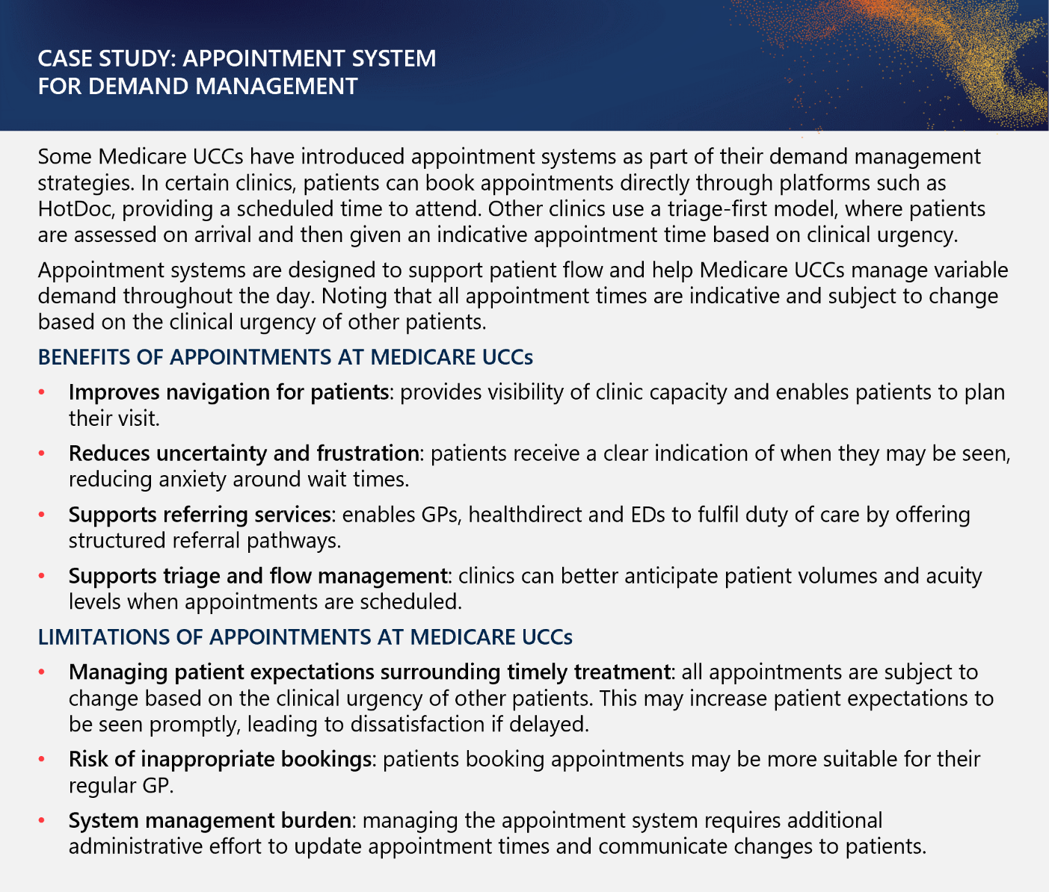

MEASURE OF SUCCESS 2

Safe and quality treatment
Measure of Success 2 agreed by the Australian, state and territory governments is:

“Medicare UCCs provide safe and quality treatment to patients.”
As outlined in Interim Evaluation Report 1, the evaluation is considering safety and quality across six commonly accepted dimensions:
- Safety
- Appropriateness
- Timeliness (see Measure of Success 1 – section 2.1)
- Patient-centred (see Measure of Success 4 – section 2.4)
- Equity
- Efficiency (see Measure of Success 9 – section 2.9).
Of these six dimensions, this section focuses on evaluation of the dimensions of safety, appropriateness and equity (including equitable access for priority populations.) Timeliness, patient-centred care and efficiency are addressed in other Measures of Success (as noted above).
Additional data sources available for Interim Evaluation Report 2, including the evaluation’s staff survey and consultations with a wider range of stakeholders have provided a deeper understanding of perceptions of safety, quality and equitable access to care compared to Interim Evaluation Report 1. The survey is described in further detail Appendix B.

Medicare UCC staff perceive overall safety and quality of care positively
Feedback provided through the evaluation’s staff survey (with 474 respondents) demonstrates staff are happy with the safety and quality of care at Medicare UCCs (see Figure 4). Over four-fifths (88 per cent) of respondents agreed or strongly agreed that their Medicare UCC provides safe and high-quality care and 89 per cent of respondents agreed or strongly agreed that if a friend or relative needed treatment they would be happy with the standard of care their Medicare UCC provided.
Staff feel less confident that their clinic is adequately resourced to manage demand whilst ensuring quality treatment and safety. Only 40 per cent of survey respondents agreed or strongly agreed that their Medicare UCC has enough staff to meet demand whilst providing safe and quality treatment. This proportion was consistent across medical and nursing respondents. Workload concerns are discussed further Measure of Success 5 in section 2.5.
Most respondents to the evaluation’s staff survey agreed or strongly agreed that their Medicare UCC encourages incident reporting and takes action to prevent future incidents (see Figure 4). Most also perceived their Medicare UCC is receptive to feedback, though a higher proportion agreed or strongly agreed their Medicare UCC would address concerns raised by patients (80 per cent) than by staff (71 per cent). A higher proportion of medical staff (82 per cent) agreed or strongly agreed that their Medicare UCC acts in response to incident reporting and would address their concerns (75 per cent) compared with nursing staff (72 per cent and 65 per cent respectively). The proportion of staff who disagreed, strongly disagreed or neither agreed nor disagreed with such statements (between 17 and 29 per cent across the four questions) suggests there is some room for clinics to improve staff confidence that they will address incidents and complaints. This may include reinforcing to staff a commitment to addressing incidents and complaints or improving visibility of procedures.
Figure 4 | Staff survey responses regarding incident and complaints reporting
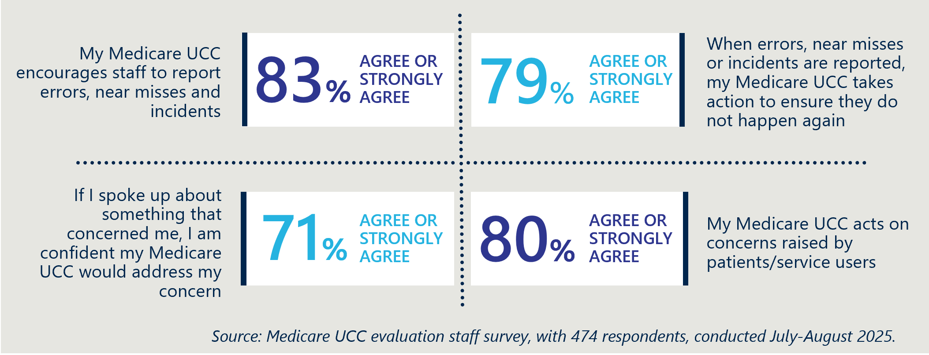

Interim Evaluation Report 2 key finding 2.1
Most respondents (88 per cent) to the evaluation’s staff survey agreed or strongly agreed that their Medicare UCC provides safe and high-quality care. Nearly four-fifths (89 per cent) of respondents agreed or strongly agreed that if a friend or relative needed treatment they would be happy with the standard of care their Medicare UCC provided.

The RACGP and the Australian College of Emergency Medicine have proposed establishment of a dedicated urgent care standard for accreditation of Medicare UCCs
The Operational Guidance25F25F stipulates that all Medicare UCCs must be co-located or partnered with a general practice that is accredited to a recognised and relevant standard, such as the RACGP Standards for General Practice.26F26F
These Colleges as well as some Commissioners and PHNs emphasised that urgent care is materially different from general practice. Their reflections reiterate views from an RACGP roundtable conducted in June 2025 – while urgent care is a core component of general practice and all GPs have the capacity to provide urgent care, Medicare UCCs are materially different from general practices.27F27F For example, there can be variation in Medicare UCC protocols, triage processes and capacity to manage complex patients which makes the Medicare UCC context meaningfully unique. Some GPs suggested their experience working at a Medicare UCC has refined their perceptions about the similarities and differences between general practice and urgent care.
Based on their view of the distinct nature of urgent care, RACGP and Australian College of Emergency Medicine have expressed their support for the development of standards that are specific to urgent care, for accreditation of Medicare UCCs. Stakeholders suggested this may help to increase the appropriateness and consistency of clinic activities as they relate to urgent care specifically.

Most patient presentations to Medicare UCCs continue to align to the Scope of Services
Consistent with Interim Evaluation Report 1, most presentations to Medicare UCCs continue to align with the scope of conditions defined by the Operational Guidance. In this reporting period, minimal changes in the proportion of presentations related to an acute illness (62 per cent) or acute injury (27 per cent) were identified compared with Interim Evaluation Report 1 (63 per cent and 26 per cent respectively). Most respondents (89 per cent) to the evaluation’s staff survey agreed or strongly agreed that their Medicare UCC provides appropriate care to patients. These findings suggest that most patients continue to present with conditions that are within scope for the Medicare UCCs to manage and are provided with appropriate care.
Interim Evaluation Report 2 key finding 2.2
As of 10 August 2025, Medicare UCCs continue to primarily treat conditions that fall within the scope of services and conditions in the Operational Guidance, with 89 per cent of presentations related to an acute illness or injury (89 per cent in Interim Evaluation Report 1). Most (89 per cent) staff surveyed for the evaluation reported that their Medicare UCC provides appropriate care to patients.

Most patients return home after their visit to the Medicare UCC
Medicare UCC data indicates that the proportion of presentations to Medicare UCCs that return home at the end of their visit (83 per cent) is consistent with Interim Evaluation Report 1. The numbers referred to a GP (9 per cent) or referred to an ED (5 per cent), are also consistent with Interim Evaluation Report 1 (Table 4).
Table 4 | Episode end status of Medicare UCC presentations
Episode end status | Presentations | Percentage of presentations that recorded a response
Did not wait28F28F | 16,017 | 1.4%
Referred home | 953,811 | 83.5%
GP referral | 97,935 | 8.6%
Referred to ED | 60,583 | 5.3%
Referred to hospital ward | 1,012 | 0.1%
Left at own risk29F29F | 888 | 0.1%
Other | 11,672 | 1.0%
Not recorded | 98,469
Total excluding “Not recorded” (from 76 Medicare UCCs) | 1,141,918 | 100.0%
Total including “Not recorded” (from 76 Medicare UCCs) | 1,240,387
Aggregate and other unit records counts30F30F | 579,751
Total presentations (from 87 Medicare UCCs) | 1,820,138
Notes: Table reflects data from 30 June 2023 to 10 August 2025 and extracted on 13 August 2025.

A small proportion of Medicare UCC presentations continue to need redirection or education about more appropriate healthcare settings for their needs
The Medicare UCC Module data may underrepresent the proportion of presentations with lower acuity needs that are more suited to be seen by the patient’s regular GP. Only 46 per cent of medical respondents and 54 per cent of nursing respondents to the evaluation’s staff survey indicated that their Medicare UCC always redirects patients to other healthcare settings when their needs are more appropriate to be managed by other services (Figure 5). Medicare UCC staff interviewed during site visits emphasised that when some patients present with lower acuity conditions, they provide education on more appropriate settings and services for patients’ future needs.
Figure 5 | Medicare UCC staff survey responses about redirection of patients to other settings
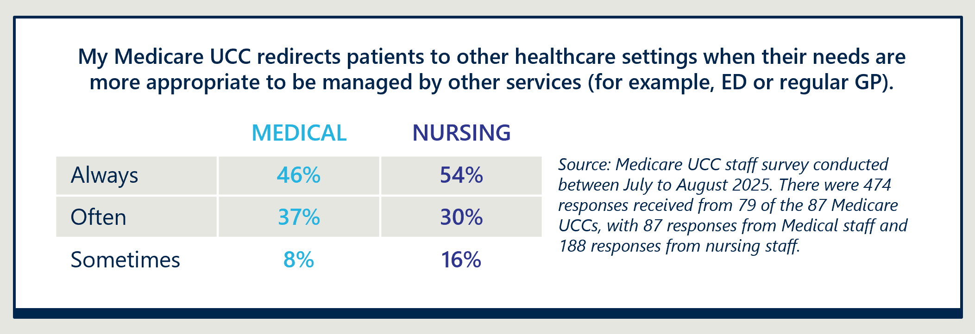

Some conditions require clinical judgement about their appropriateness to be treated at a Medicare UCC
Operational Guidance indicates that clinics should not treat lower acuity patients who technically sit outside the Scope of Services, except under certain conditions (for example, if a patient is unable to see a GP within an appropriate timeframe). Examples of potentially inappropriate presentations highlighted by commissioners and providers in consultations are listed below.
Ongoing care for chronic wounds. Commissioners and providers reported that chronic wound care has become an unexpected need that Medicare UCCs are seeing. Patients are frequently presenting to Medicare UCCs for support with dressings and management of chronic wounds, which commissioners attribute to the high cost of wound consumables and known gaps in state and territory funded community health services for wound care. General practices are reportedly prohibited from charging bulk-billed patients for wound consumables, and many people cannot afford the cost of wound consumables and regular attendances at fee paying clinics. Providers reported significant financial pressures associated with the cost of wound consumables for this cohort.31F31F
“We quickly identified whatever we’re budgeting for consumables, we need to triple it.”
– Medicare UCC Manager

It is possible that some of this chronic wound care falls within the appropriate Scope of Services. Updated Operational Guidance (effective from towards the end of the reporting period) enables treatment of chronic wounds where clinical judgement determines that a wound requires urgent care, including where timely access is a consideration. In this scenario, though a patient with chronic wounds should receive ongoing care in other settings, it is acceptable for their wound to be treated at a Medicare UCC if at the time the wound requires urgent treatment. Regardless, commissioners and providers have reported demand for such care as higher than anticipated and there may be a need to consider further guidance or support on chronic wound care. The evaluation will review clinic experience with chronic wound care in the Final Report.
Non-urgent overflow from other settings. Providers reported that many patients are presenting at Medicare UCCs for non-urgent routine care because their regular GP is not available. This was particularly reported in regional areas with known GP shortages where there may be wait lists of several weeks to obtain an appointment with their regular GP. Providers reported that whilst these patients’ conditions may not be perceived as urgent (for example, a repeat script or back pain), they may be unable to delay care until their GP next has availability. It is expected that patients will seek any form of care accessible to them, including from a nearby Medicare UCC, where there are large wait times in general practice for non-urgent care. Operational Guidance acknowledges this challenge and indicates that staff should consider timely access to other services in their consideration of a patient’s eligibility for care that may technically be considered non-urgent (see section 2.3.6 of the Operational Guidance).
Interim Evaluation Report 2 key finding 2.3
As of 10 August 2025, the proportions of presentations that are referred to an ED (5 per cent) or redirected to the usual general practitioner (GP) (8 per cent) when appropriate, are consistent with the previous reporting period (Interim Report 1), with only a small proportion of presentations needing redirection. Based on feedback from Medicare UCC staff during consultations, this may underrepresent the proportion of presentations with lower acuity needs that are more suited to be seen by their regular GP but are nevertheless treated at the Medicare UCC rather than being turned away.

Medicare UCCs access for First Nations patients is higher than the national prevalence of First Nations people, consistent with Interim Evaluation Report 1
The proportion of patients attending Medicare UCCs who identify as Aboriginal and/or Torres Strait Islander (7.4 per cent)32F32F has not changed since the first interim reporting period (7.5 per cent). It continues to be slightly lower than the proportion of patients presenting to EDs who identify as Aboriginal and/or Torres Strait Islander (9 per cent),33F33F but higher than the Australian Aboriginal and Torres Strait Islander population prevalence (3.2 per cent).3
Operational Guidance requires clinics to provide services within a culturally safe environment for First Nations peoples.35F35F Some commissioners shared examples of external engagement by the PHN or Medicare UCC with local Aboriginal and Torres Strait Islander communities to promote access and understanding of the clinics.36F36F These include:
- Collaboration with a PHN’s Aboriginal Health Liaison Team to identify strategies to improve accessibility of clinics.
- Engaging an Aboriginal Health Project Officer to conduct ‘kitchen table discussions’ to identify and enhance local community understanding of the Medicare UCC.
Peak body representatives noted anecdotal examples of good relationships between ACCHOs and some Medicare UCCs and shared the view that most Aboriginal and Torres Strait Islander people will only use health services that they trust. Almost all respondents to the evaluation’s patient survey who identify as Aboriginal and/or Torres Strait Islander37F37F reported having confidence and trust in Medicare UCCs staff, which was consistent with the wider group of respondents.
At a program level, three additional Medicare UCCs commenced operations in remote communities in the NT since the first evaluation interim reporting period. Figure 6 presents a case study on the enablers and barriers for effective service delivery to Aboriginal and/or Torres Strait Islander people in remote Medicare UCCs.
Interim Evaluation Report 2 key finding 2.4
Use of Medicare UCCs by Aboriginal and/or Torres Strait Islander peoples remains consistent with Interim Evaluation Report 1. Some clinics, such as those in remote NT communities, are strongly supporting a local and culturally tailored approach.

Figure 6 | Case study of remote Medicare UCCs in NT
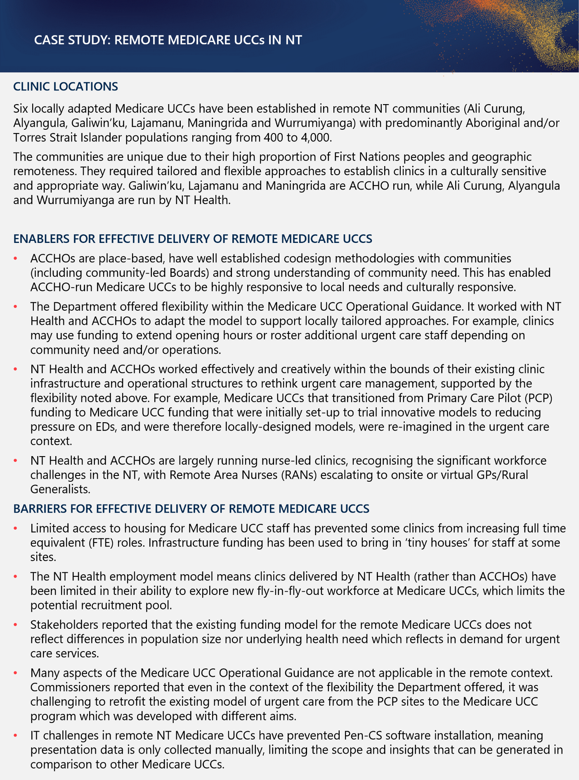

Access by priority populations
Available data on use of Medicare UCCs by other priority populations, including culturally and linguistically diverse communities and people with a disability, remain consistent with Interim Evaluation Report 1. There continues to be a variety of data issues impacting reliability of Medicare UCC program data regarding these groups, limiting insights able to be drawn by the evaluation. Currently, data collected about culturally and linguistically diverse patients includes a mix of ethnicity, country of birth, language spoken at home and requirement for an interpreter38F38F. Interim Evaluation Report 1 (limitations section) identified that these variables are relatively poorly reported and this has not changed in this reporting period.39F39F
Improvement opportunity 2.1
There is an ongoing opportunity to explore improved data collection for culturally and linguistically diverse patients. This applies both to the methods of data collection (i.e. variables collected) and how consistently they are collected by staff.

MEASURE OF SUCCESS 3

Coordinated care
Measure of Success 3 agreed by the Australian, state and territory governments is:
“Medicare UCCs deliver coordinated care for Medicare UCC patients.”
The evaluation is assessing Measure of Success 3 through consideration of:
- Effectiveness and consistency of clinical handover with a patient’s usual primary care provider.
- Patient experience of care coordination from Medicare UCCs, including receiving clear care summaries, feeling supported in follow-up arrangements and being connected to a regular GP if they lack one.
- Provider experience of care coordination from Medicare UCCs, including receiving care summaries.
- Access to multidisciplinary and diagnostic services that support efficient, coordinated care and allow Medicare UCCs to address patient needs more comprehensively.
For Interim Evaluation Report 2, Measure of Success 3 is informed by analysis of Medicare UCC Module data, a patient survey conducted for the evaluation (with 816 responses) and interviews with a broader range of stakeholders (including Medicare UCC commissioners, providers, patients and carers).
Factors affecting the delivery of coordinated care for Medicare UCC patients with other health system partners (including EDs, ambulances, state urgent care services and healthdirect) are explored in Measure of Success 8 (section 2.8).

Medicare UCCs continue to provide discharge summaries for most presentations via various channels
In the period to 10 August 2025, 87.4 per cent of Medicare UCC presentations had a discharge summary provided either directly to their GP, uploaded to MHR and/or provided as a paper copy to the patient, which is consistent with Interim Evaluation Report 1 (89 per cent).
A small proportion (12.6 per cent) of presentations continued to have a discharge summary provided by ‘other’ means, which is not well defined and may be subject to variable interpretation. The evaluation continues to suggest refinement of this Medicare UCC Module item to improve the quality of reporting and provide clearer insights.
Table 5 identifies the channels used by Medicare UCCs for clinical handover to patients’ usual primary care provider, noting more than one channel can be used and recorded per presentation.

Table 5 | Channel of clinical handover provided back to patient's usual primary care provider
Clinical handover | Presentations | Percentage of presentations that recorded a response
Electronic provision to usual GP +/- upload to MHR and/or provided to patient | 753,646 | 65.2%
Electronic provision to usual GP/primary care provider only | 550,183 | 47.6%
Electronic provision to usual GP + upload to MHR | 147,215 | 12.7%
Electronic provision to usual GP + provided to patient | 29,108 | 2.5%
Electronic provision to usual GP + upload to MHR + provided to patient | 27,141 | 2.4%
Upload to MHR only | 123,725 | 10.7%
Upload to MHR + provided to patient | 16,380 | 1.4%
Provided to patient only | 115,731 | 10.0%
Other (a) | 145,226 | 12.6%
Total excluding “Not recorded” (from 76 Medicare UCCs) | 1,154,709 | 100.0%
Not recorded | 85,678
Total including “Not recorded” (from 76 Medicare UCCs) | 1,240,387
Aggregate and other unit records counts | 579,751
Total presentations (from 87 Medicare UCCs) | 1,820,138
Notes: Table reflects data from 30 June 2023 to 10 August 2025 and extracted on 13 August 2025. More than one method for handover can be reported for a single presentation. Mutually exclusive categories have been reported to provide insights into where multiple handover methods have been used. Reported values of “Other” were ignored when another value was available for the same presentation.
(a) “Other” is not well defined and may be open to variable interpretation.

Interim Evaluation Report 2 key finding 3.1
In the period to 10 August 2025, 87 per cent of presentations had a clinical handover provided either directly to their usual GP, uploaded to MHR or given as a paper copy to the patient. These findings are consistent with Interim Evaluation Report 1.

Consistent electronic provision of discharge summaries remains an area for improvement
Interim Evaluation Report 1 suggested that commissioners and Medicare UCCs should work together to increase the proportion of patients who receive a handover directly back to their usual GP/practice above 68 per cent.
The evaluation notes that updates to the Operational Guidance40F40F in August 2025 clarified expectations that Medicare UCCs are required to provide discharge summary for all patients within 24 hours, including case notes, referrals and requested tests, unless otherwise specified by the patient. The patient’s regular GP must also be copied into all diagnostic requests and other referrals. Previously, these were recommendations only in the Operational Guidance.41F41F The impact of these updates to the Operational Guidance will be assessed in the Final Report.
Available data indicates that direct handover to regular GP has not improved since Interim Evaluation Report 1 – a slightly lower proportion (65 per cent) of presentations had a handover provided directly back to the patient’s usual GP/practice between 30 June 2023 and 10 August 2025 (see Table 5). Commissioners, local ecosystem stakeholders and peak bodies reiterated views provided in Interim Evaluation Report 1 that electronic provision of a discharge summary to a patient’s regular GP within 24 hours is the preferred method of receiving handovers from Medicare UCCs. Most commissioners reported receiving fewer complaints from local GPs regarding discharge summaries in this reporting period, however some peak body representatives shared anecdotal reports of handovers occurring inconsistently.
“What I'm hearing on the ground and what I'm experiencing is [the provision of discharge summaries] is hit and miss.”
– Peak body representative

In the period to 10 August 2025, a small proportion of presentations (12 per cent) had a discharge summary uploaded to MHR but not provided directly to the patient’s usual GP. This is consistent with findings from Interim Evaluation Report 1 (11 per cent). RACGP representatives nominated a potential benchmark of 85 to 90 per cent presentations having a discharge summary uploaded to MHR in addition to direct handover to the GP. However, the RACGP’s 2024 Health of the Nation survey identified that 31 per cent of GPs rarely or never use MHR.42F42F NSW commissioners indicated the sub-optimal number of patients who have MHR is a barrier to consistent upload, especially where the Medicare UCC services a high proportion of people from culturally and linguistically diverse communities and non-Medicare card holders.
The proportion of patients who were provided with a paper copy of the discharge summary only (10 per cent) was slightly lower than the proportion of presentations where it was reported that the patient does not have a regular GP (13 per cent).

Interim Evaluation Report 2 key finding 3.2
Available data indicates a slightly lower proportion (65 per cent) of presentations had a handover provided directly back to the patient’s usual GP/practice between 30 June 2023 and 10 August 2025 compared with Interim Evaluation Report 1 (68 per cent). A further 12 per cent of presentations had information uploaded to MHR (but not provided to the patient’s usual GP). Approximately 10 per cent of presentations received a hard copy of the discharge summary only, which is lower than the proportion of Medicare UCC patients that did not identify a usual GP/practice (13 per cent). Commissioners reported receiving fewer complaints from local GPs regarding handovers.

Improvement opportunity 3.1
There is ongoing need for Medicare UCCs to increase the proportion of patients who receive clinical handover directly to their usual GP/practice, to improve communication and coordination of care.

Patients reported that coordination of follow-up care is generally well supported by Medicare UCC staff
Medicare UCC staff are supporting patients to arrange follow-up care where it is required. Results from the evaluation’s patient survey indicate that 89 per cent of respondents who required follow up care felt supported by Medicare UCC staff to arrange it. Support arranging follow up care is a key aspect of positive patient experience and is explored further in Measure of Success 4 (section 2.4).
A small proportion (12 per cent) of respondents to the evaluation’s patient survey indicated that they do not have a regular GP/practice. This aligns with reporting in the Medicare UCC Module data (13 per cent). Around two-fifths of survey respondents (39 per cent) without a regular GP/practice, reported clinic staff offered to connect them in with a regular GP/practice. Comparable reporting is not available from Interim Evaluation Report 1.
Several consumer focus group participants indicated a positive experience of care coordination where a discharge summary/clinical handover was provided to their usual GP. Participants expressed that discharge summaries provided clear articulation of what had happened and advice they had received regarding follow up care.
“When I went to the GP they had a really good and full copy of everything that had happened, that was very helpful.”
– Patient

Opportunities exist to improve communication of imaging and pathology results by some clinics
The Operational Guidance43F43F stipulates the expectation for a clinician from the Medicare UCC to review test results, notify patients of any abnormal findings and share results with the patient’s usual GP.
“If they had said to me in the morning ‘I cannot read the results’, I would have gone straight to the ED and said I need an X-ray today.”
– Patient
Consumer focus group participants shared examples of communication breakdowns regarding pathology and imaging test results following their visit to a Medicare UCC. These include:
- Needing to contact the Medicare UCC they attended multiple times to obtain imaging/pathology results.
- Delays to imaging reporting being available to the Medicare UCC staff to support clinical decision making and timely treatment.
- Instances where the patient’s regular GP was not included on imaging referrals resulting in delays for their regular provider to obtain access to reporting.
“Radiology and pathology results has been a tricky issue that urgent care clinics are working through, about who's responsible and because some say ‘go and see your GP for your results’ but, if the GP didn't order those tests, they shouldn't be following up.”
– Commissioner
Several commissioners reported working closely with providers to establish consistent processes for follow up of radiology and pathology results. Medicare UCCs are required to convey test results to patients, however commissioners reported that lack of access to MBS items for telehealth made it more difficult to provide coordinated care from a financial perspective and sometimes required patients to return in person to the clinic, which they saw as inefficient.
Interim Evaluation Report 2 key finding 3.3
Patients reported feeling supported by staff to arrange follow up care when required. Lack of access to MBS items to fund telehealth to convey test results at Medicare UCCs was identified by some clinics as a constraint in streamlining the provision of radiology and pathology results back to patients following their visit.

Limited after-hours access to imaging and pathology services continues to be a challenge
The Operational Guidance44F44F identifies that clinics should have an X-ray facility on-site or easily accessible across all hours of operation, access to ultrasound and CT across the majority of hours of operation and timely access to laboratory-based pathology (at a minimum basic results available same day).
“Access to after-hours imaging has been a significant issue for the Medicare UCC program across the country. When we're talking about referrals to the ED from the Medicare UCC, particularly after hours, I think you'll find a significant number would be those patients that require some form of imaging.”
– Commissioner
Currently, very few Medicare UCCs have imaging and/or pathology available across all opening hours. Most clinics offer imaging onsite or nearby on weekdays between 8:00 am and 5:00 pm and pathology between 8:00 am and 6:00 pm. Ancillary service availability is significantly reduced in the evenings and on weekends, especially Sundays. Commissioners, peak bodies and providers identified access to imaging and pathology after hours as a key challenge of the program, with the only option for imaging being a referral to ED. These findings are consistent with Interim Evaluation Report 1.
Where possible, Medicare UCCs are negotiating with local imaging service providers to bring imaging services on-site. While Medicare UCCs may access specialist equipment funding to purchase imaging equipment, there are a range of requirements to be resolved. Staff are required to complete additional training to operate the imaging equipment and specialist training is required to interpret results. In some cases, state/territory specific legislative or regulatory barriers may prevent on-site imaging capability, for example the Radiological Council of Western Australia requires that only medical imaging technologists (i.e. radiographers) are to provide Xray examinations in the Perth metro area. On-site imaging also requires sufficient physical space to accommodate imaging rooms, which is not always available in existing clinics.
One solution being implemented by some Medicare UCCs is the development of pathways for urgent care patients to bypass the ED and go straight to imaging when imaging services must be delivered at partner hospitals due to the lack of on-site availability.
Interim Evaluation Report 2 key finding 3.4
Medicare UCCs face ongoing barriers with offering access to imaging and pathology services across all or most hours of operation (as per the Operational Guidance) and ED continues to be the only option for after-hours imaging in many areas.

Improvement opportunity 3.2
There is ongoing need for Medicare UCCs to expand access to imaging and pathology services across all hours of operation, this may include bringing imaging services on-site.

MEASURE OF SUCCESS 4

Patient and carer experience
Measure of Success 4 agreed by the Australian, state and territory governments is:
“Medicare UCCs provide a positive experience for patients and carers.”
In Interim Evaluation Report 1, the evaluation did not have sufficient evidence to provide a balanced assessment of the extent to which Medicare UCCs provide a positive patient experience.
For Interim Evaluation Report 2, additional data sources are available to assess patient and carer experience, including:
- Qualitative insights from three consumer focus groups45F45F with Medicare UCC patients and carers.
- Results of the evaluation’s patient survey, conducted between July and August 2025, with 816 responses.
Results of the patient survey should be interpreted with some caution as a large proportion of survey responses (49 per cent) came from four clinics and 31 per cent of clinics did not receive any responses.

Patients and carers reported high satisfaction and beneficial experiences with clinics
Feedback provided through the evaluation’s patient experience survey demonstrated overall satisfaction with the care provided at Medicare UCCs and indicate perceptions that the quality of care is high. Patient surveys identified:
- Almost all respondents (95 per cent) rated the care they received as ‘very good’ or ‘good’. Only a small minority (5 per cent) shared neutral or poor ratings of the care provided by clinics.
- Almost all respondents (92 per cent) would speak highly or very highly of their experience to friends or family.
- Patients and carers overwhelmingly reported their visit was helpful, with 83 per cent of survey respondents reporting that their visit helped a lot and a further 12 per cent reported that it helped to some extent.
By comparison, a NSW ED patient survey46F46F conducted in 2023-24 (with 21,359 respondents) found that 88 per cent of patients rated the care they received at the ED as ‘very good’ or ‘good’. This suggests higher overall levels of satisfaction in Medicare UCC services (where 95 per cent of all respondents rated the care received ‘very good’ or ‘good’). The evaluation notes that this comparison is limited to NSW EDs, whereas the Medicare UCC survey was conducted Australia-wide and the ED survey drew on a substantially larger sample than the Medicare UCC survey and used a different sampling approach. Nevertheless, the evaluation believes this is a useful comparison of patient satisfaction.

Interactions with Medicare UCC staff are a key driver of positive patient experiences
Patients perceived the quality of Medicare UCC staff as high. The evaluation’s patient survey identified:
- Most respondents (86 per cent) reported that the doctor or nurse treating them explained their condition or treatment in a way that they could completely understand.
“The doctors and nurses were exemplary; I cannot fault them at all … This was the best experience I have had with medical services in a long time.”
– Patient
- Most respondents (86 per cent) had confidence and trust in the doctor or nurse treating them.
- Almost all respondents (98 per cent) felt they were treated with dignity and respect whilst at the clinic.
This appears favourable with reference to the 2023-24 Australian Bureau of Statistics (ABS) Patient Experience Survey results,47F47F where 74 per cent of people reported that ED nurses always showed respect, 67 per cent for ED doctors and 72 per cent for GPs.48F48F
Consumer focus group participants expressed that the quality of medical professionals and interactions with staff were a key driver of their positive experiences at the Medicare UCCs. Multiple participants reflected that their experience with Medicare UCC staff was among their best experiences with any health care professional.
“The care, the thoughtfulness, the consideration was amazing.”
– Patient

Patients feel supported by clinics’ efforts to arrange follow up care
The capacity for clinics to provide advice and support with arranging follow up care is identified in the Operational Guidance49F49F as an integral part of the service provided. As identified previously in Measure of Success 3 (section 2.3), most respondents to the patient survey who required follow up care, reported being supported by the Medicare UCC to arrange it. Of survey respondents that required follow up care, 89 per cent indicated that clinic staff helped with arranging it.
Patients who participated in focus groups reported appreciating clear advice on next steps, including when to return to the Medicare UCC (if required) or escalate to ED. Patients also appreciated clinic staff following up with test results efficiently, although a few reported having to actively follow up results with the clinic despite being told they would be contacted. Improved clarity around what clinics can provide in terms of results and follow-up to testing would be valuable, with patients seeing some inconsistencies between what they were told and actual capability. As noted in Measure of Success 3 (section 2.3) in relation to Coordinated Care, some clinics advocated for access to telehealth funding to streamline providing results to patients.
“The advice I received was to follow up with my GP and if I couldn’t get a GP appointment then to come back to urgent care, and if it gets worse then go to ED. I was able to get a GP booking which was good, but I did appreciate the advice and option to return.”
– Patient

Further detail on how Medicare UCCs coordinate follow-up care is provided in Measure of Success 3 (section 2.3).

A limited number of consumer complaints were made to the Department
In the period 1 October 2024 to 30 April 2025, 41 complaints relating to Medicare UCCs were raised with the Department and actively followed up50F50F. The number of complaints from the previous reporting period is not available for comparison.
Of the 41 complaints received, 38 per cent related directly to patient experience, including wait times, customer service and quality of care, and a further 38 per cent related to patients being turned away from the service, due to ineligibility or clinics being at capacity.
Several commissioners and clinic managers reported that the number of patient complaints has decreased since the early stages of the Medicare UCC program. Incomplete understanding of the role and capabilities of the Medicare UCCs is a key theme in complaints still occurring, and commissioners and managers attribute the decrease in complaints over the past 12 months to improved understanding and public awareness of the clinics purpose.
“In the second 12 months the complaints have dried up significantly, I can’t remember more than a few… [this] is reflective of how these clinics have integrated themselves and how the public understanding of what they do has improved.”
– Commissioner

Interim Evaluation Report 2 key finding 4.1
Patients and carers engaged for Interim Evaluation Report 2 reported positive experiences at Medicare UCC services. Ninety-five per cent of respondents to the evaluation’s patient survey rated the care they received as good or very good and 92 per cent of respondents reported they would speak highly or very highly of their experience to friends and family. Satisfaction appears to be driven by quality of staff interactions and support with understanding and arranging follow up care when required.

Reducing wait times and managing high demand continues to be a priority for clinics
Interim Evaluation Report 1 outlined early opportunities to improve patient experiences at Medicare UCCs by managing demand for services and reducing wait times. As outlined in Measure of Success 1 (section 2.1), the national median wait time at Medicare UCCs is 13.2 minutes and most respondents (83 per cent) to the evaluation’s patient experience survey reported their wait time was acceptable.
Some consumer group participants expressed frustrations with being turned away from clinics near closing time, when demand exceeds capacity and Medicare UCCs are forced to stop accepting patients. Feedback from clinics and commissioners demonstrated a variety of strategies are being implemented in clinics to enhance demand management and reduce wait times. These are explored in Measure of Success 1 (section 2.1).
“Even though they were busy, they didn't rush you through. Once you were with the doctor or the nurse, they took their time to listen and check things, which was good.”
– Patient
The evaluation assesses that while there is room for improvement to address wait times, patients largely reported overall satisfaction with their experience and not feeling rushed or dismissed by staff. The quality of care provided is perceived to be consistently high even in peak demand periods.
Interim Evaluation Report 2 key finding 4.2
Some consumers expressed frustration with being turned away from clinics near closing time, when demand exceeds capacity and Medicare UCCs are forced to stop accepting patients. A variety of strategies are being implemented in clinics to enhance demand management and reduce wait times.

Patient expectations can be managed through clear communication
Commissioners reported there has been significant effort and progress by many clinics in enhancing clarity of communications about care and treatment local Medicare UCCs offer, to better manage patient expectations and experience of care.
Consumer focus group participants nonetheless identified clarity of local communications as an area for improvement. Examples participants provided include:
- Types of conditions/presentations that Medicare UCCs have the capacity to manage locally, particularly where this differs from national standards, such as capacity to treat children under six months of age.
- Local imaging pathways, such as the need for imaging reporting prior to further management and anticipated timelines for reporting.
- Enhanced visibility of expected wait times at the Medicare UCC and other Medicare UCCs in the surrounding area, noting accurate estimations are challenging to keep up to date as new patients present and are triaged. See Measure of Success 1 (section 2.1).
Approaches that address confusion and enhance public knowledge of Medicare UCCs would help to alleviate tensions from misinformed expectations and ensure patients know what to expect from engagement with the clinics. Commissioners emphasised this was particularly important in areas that have both a Medicare UCC and a state funded urgent care service. Impacts of the complex landscape on patient navigation is explored further in Measure of Success 7 (section 2.7).
Improvement opportunity 4.1
There is ongoing opportunity to improve patient experience through enhanced communication about the care and treatment offered locally at clinics to better manage expectations.

There are ongoing opportunities to improve physical infrastructure and signage at some clinics
“There was no parking at all, only one hour street parking and that was metred, which was definitely an issue.”
– Patient
The infrastructure and signage of Medicare UCCs continues to present as a barrier to positive experiences for some patients.51F51F Feedback from consumer focus groups on the infrastructure of Medicare UCCs included barriers finding accessible parking, small waiting rooms, uncomfortable seats and confusing clinic layouts. Some commissioners and providers attributed the infrastructure barriers at some clinics to the short-term funding model and are not purpose built to be Medicare UCCs.
Some patients and commissioners also raised concerns about difficulties differentiating Medicare UCCs from co-located private practices, particularly those that are managed under the same name. Patients reported experiences of waiting at the wrong check in desk and experiencing frustrations at being redirected from room to room. Improving the signage and branding of the Medicare UCCs would improve accessibility and identification of clinics, and reduce confusion associated with co-located clinics.
“There was a GP clinic by the same name in the building, this created confusion as we were sent from room to room.” – Patient
Improvement opportunity 4.2
There is ongoing opportunity to improve patient experience through upgrades to physical infrastructure at some clinics, including branding, parking and physical layouts, to ensure adherence to accessibility requirements outlined in the Operational Guidance, noting that existing clinics have until 30 June 2026 to comply.

There continues to be support for a national patient experience survey to facilitate benchmarking and continuous improvement
Interim Evaluation Report 1 identified that a national patient experience survey could be implemented by the program to support benchmarking and continuous improvement activities by Medicare UCCs. Updates to the Operational Guidance52F52F in 2025 have clarified the requirement for Medicare UCCs to have systems in place to improve clinical quality and safety including collection of patient-reported experience measures.
Whilst feedback from clinics and commissioners shows that some Medicare UCCs have implemented patient feedback surveys in clinics, Medicare UCC commissioners continue to seek a consistent national approach. The Department has indicated that it has engaged a service provider to design and deliver a national patient and staff experience survey in Medicare UCCs to promote continuous program and quality improvement. This project commenced in late 2025 and will continue through 2026.

MEASURE OF SUCCESS 5

Experience of providers at Medicare UCCs, partner hospital EDs and local GP practices
Measure of Success 5 agreed by the Australian, state and territory governments is:
“Medicare UCCs provide a positive experience for providers at Medicare UCCs, in partner hospital EDs and in local GP practices.”
The evaluation is assessing Measure of Success 5 through consideration of:
- Experiences of Medicare UCC staff providing services.
- Experiences of providers in partner hospital EDs and local GP practices with Medicare UCC services.
- The impact of Medicare UCCs on other GP practices and workforce availability.
For Interim Evaluation Report 1, there was limited direct consultation with Medicare UCC staff, local GPs and ED representatives, and the evaluation was unable to draw conclusions as to their overall experiences at or with Medicare UCC services.
For Interim Evaluation Report 2, the evaluation conducted a staff survey that was available to all Medicare UCC staff working at the clinics between June and July of 2025. The survey received 474 responses, with 188 from nursing staff and 87 from medical staff. The evaluation also conducted interviews with Medicare UCC managers and staff from seven clinics, commissioners, peak bodies, and a small sample of local GPs and ED representatives.

Staff survey responses indicate that meaningful and varied clinical work are key benefits of working in Medicare UCCs
Results of the evaluation’s staff survey indicate a positive experience working within Medicare UCCs, which was supported by interviews with staff. Most survey respondents (86 per cent) agreed or strongly agreed that their Medicare UCC offers them meaningful work and most (94 per cent) agreed or strongly agreed that they are trusted to do their job, their individual differences are respected (86 per cent) and they can make suggestions to improve their workplace (see Figure 7).
Figure 7 | Staff survey responses regarding workplace culture and experience
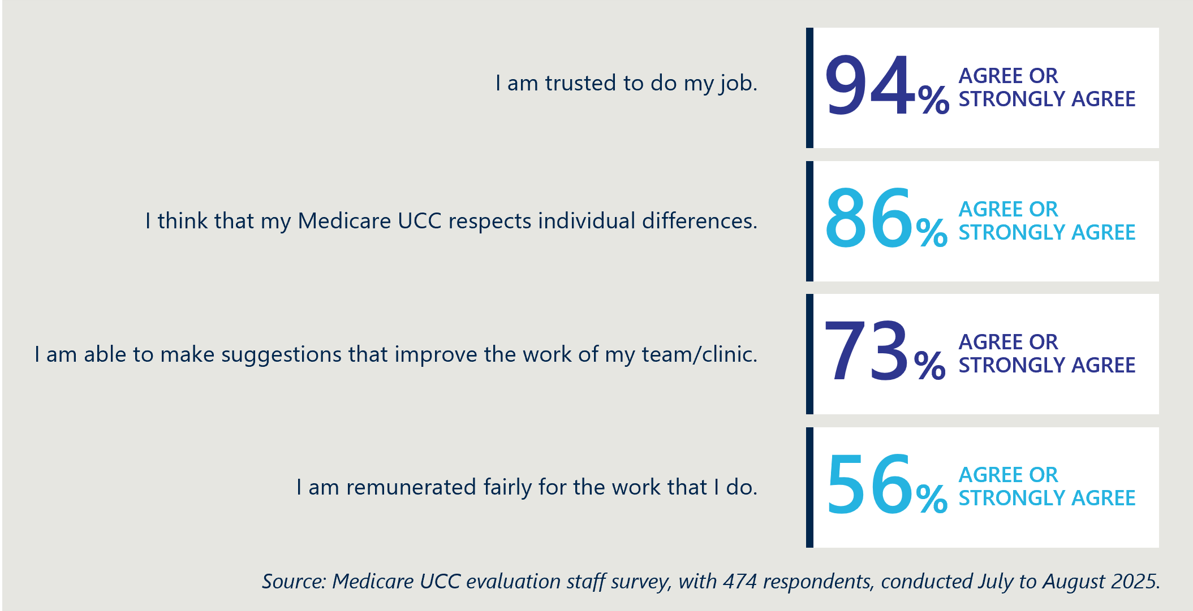
A moderate proportion of medical respondents (68 per cent) and nursing respondents (66 per cent) would recommend their Medicare UCC as a place to work.
Providers and peak body interviews reported that medical staff value the varied clinical environment working in Medicare UCCs. Some of these stakeholders noted that the work within Medicare UCCs offers GPs exposure to a broader range of acute presentations and involves less of the “chronic condition paperwork” or administrative work that is typical of a general practice clinic where there is a greater presentation of people with chronic conditions.
Commissioners and providers anecdotally reported that many GPs working in Medicare UCCs continue to work in local general practices, which provides variety in their working week. One provider described a model where each of the GPs from the co-located general practice worked one day a week in the Medicare UCC and indicated this arrangement was viewed positively by GPs and enabled the clinic to attract senior doctors. Workforce data available for Interim Evaluation Report 1 identified that most medical practitioners work in Medicare UCCs on a part time basis, with a mean of 2.8 FTE medical practitioners and a headcount of 8.8 per clinic. Further analysis of the extent to which Medicare UCC medical staff are also working as GPs in the local area (either during or prior to working at the Medicare UCC) will be undertaken for the Final Report.
“Urgent care has helped us get good doctors; one day a week they can do a bit more than day-in-day-out GP work.”
– Medicare UCC manager

Opportunities to work to top of scope of practice are strong for GPs but additional effort is required to extend similar opportunities to nursing staff
Opportunity to work to top of scope has been identified as a key benefit for GPs. Four-fifths of medical staff survey respondents (80 per cent) agreed or strongly agreed that they have opportunity to work to the top of their scope of practice within Medicare UCCs. A smaller proportion of nursing staff, 63 per cent, agreed or strongly agreed with the same statement, with a quarter of respondents disagreeing or strongly disagreeing.
“It isn't just doctors who need to work to full scope, it's really all of us, all the health professionals.”
– Peak body representative
Nursing peak bodies emphasised that there is opportunity to better enable nurses to work to the top of their scope of practice within Medicare UCCs. They shared the view that empowering the nursing workforce would relieve workload pressure from GPs and enable the delivery of timely and effective patient care.
One nursing peak body indicated that in some cases the ability of nurse practitioners to independently lead care was limited by the design of the Medicare UCC model as a GP-led model. They argued that the participation of nurse practitioners is also limited by MBS funding as nurse practitioners can only claim a subset of MBS items.
Exceptions to the GP-led model within the program include five nurse-led Medicare UCCs in the ACT and six nurse-led Medicare UCCs in remote NT communities (which have escalation pathways to on-call GPs and/or the NT District Medical Officer). These clinics had a strong emphasis on training to ensure ongoing skills uplift.
Peak body representatives reported that in the hospital environment nurses regularly perform procedures such as applying a back slab, dressing wounds or providing immunisation without direct medical oversight, however within the Medicare UCC environment such care is almost always provided by GPs.
These perspectives align with findings of the 2024 Scope of Practice Review,53F53F which found widespread restrictions or barriers for health professionals within the primary care sector to work at full scope of practice, unrelated to their education or competence. The Scope of Practice Review, which is currently being examined by a Taskforce54F54F, found key barriers include limited awareness of scope of practice across the multidisciplinary primary care team, fee-for-service payment systems, legislative and regulatory constraints, and culture/leadership.

Training programs and opportunities to upskill are generally strong, but could be uplifted for nursing staff
Training and opportunities to upskill are strong for medical staff and moderate for nursing staff across Medicare UCCs. The evaluation’s staff survey data showed that 77 per cent of medical staff and 67 per cent of nursing staff agree or strongly agree that they can access the right learning and development opportunities when they need to. Additionally, 77 percent of medical staff and 75 per cent of nursing staff agree that they have opportunities to improve their knowledge and skills.
Providers and commissioners indicated that PHNs are actively facilitating Medicare UCC staff’s access to training and opportunities to upskill and network, which is consistent with findings from Interim Evaluation Report 1. Commissioners and providers shared examples of Medicare UCC staff training opportunities, including:
- Annual emergency skills sessions coordinated with the local health system to support clinical safety and preparedness of urgent care staff.
- One clinic has a co-located advanced practice physiotherapist who supports staff training and delivery of care to people with musculoskeletal injuries and fractures.
- Micro-credentialling courses developed by the University of the Sunshine Coast which are designed to equip GPs and nurses with key clinical skills required for urgent care, such as suturing and plastering.
Some peak body representatives identified an opportunity to establish a College of Urgent Care (akin to the Royal New Zealand College of Urgent Care) that recognised, supported and represented the unique skillset required for the urgent care landscape. They advocated that such a College would be able to set standards for education and practice, and develop resources and guidelines in the same way as other medical Colleges. However, there were mixed views on whether this would fill a void in the current Australian healthcare environment, as some stakeholders believe the current bodies adequately cover the landscape. As previously identified in Measure of Success 2 (section 2.2), the RACGP is seeking a dedicated Urgent Care Standard to support accreditation, emphasising that Medicare UCCs are materially different from general practice.
““It’s not quite ED, not quite GP.”
– Peak body representative
Improvement opportunity 5.1
There is opportunity for Medicare UCCs to enhance support for nurses to work to the top of their scope of practice and access appropriate learning and development resources and programs, in line with the findings of the Scope of Practice Review.

The workload at the Medicare UCCs is high and service demand can exceed capacity
Commissioners and providers identified that there is high workload at Medicare UCCs and demand often exceeds workforce capacity. They emphasised that the minimum staffing model outlined in the Operational Guidance55F55F of one vocationally registered GP, one RN/nurse practitioner/or paramedic and one staff member undertaking administration duties, is often insufficient to meet clinic demand, with additional staff funded through the MBS. Beyond the minimum staffing requirement, the Operational Guidance requires that there are sufficient staff on-site for the Medicare UCC to meet its core functions and operational parameters.
“To be honest here every day is a period of high demand… [Clinics] do tend to reach capacity at 3:00 pm.”
– Commissioner interviews
Though most patients are treated in a timely manner (see Measure of Success 1, section 2.1), commissioners and providers reported that the high workload can sometimes lead to extended wait times for a small proportion of patients or clinic closures in some circumstances (as described in Measure of Success 1, section 2.1).
Workload pressures are a concern for many staff. Approximately half (52 per cent) of nursing respondents and 59 per cent of medical respondents to the evaluation’s staff survey indicated their workload is manageable. Only 40 per cent of respondents to the evaluation’s staff survey agreed or strongly agreed that there are enough staff to meet demand whilst providing safe and quality treatment, as discussed in Measure of Success 2 (section 2.2). This challenge is consistent with broader trends in Australian primary care, where workforce shortages and increasing demand are prevalent. The RACGP’s 2024 Health of the Nation Survey identified that the main reasons non-practicing GPs had stepped away from active medical practice (apart from retirement) were burnout and high workload/patient demand.56F56F
In response, some clinics are increasing medical and/or nursing shifts beyond the minimum staffing model requirements, leveraging additional MBS billings from higher throughput to support increased staff levels. Other strategies reported by clinics to manage demand include increasing opening hours or staying open past scheduled hours and trialling different approaches to triaging. These are explored in detail in Measure of Success 1 (section 2.1).
Despite these strategies, commissioners and providers reported instances of patient frustration and aggression towards staff, compromising staff safety and wellbeing. Some clinics have introduced security cameras and/or security guards to mitigate risks of operational violence to staff. Based on these reports, further examination of this issue will be undertaken for the Final Report.
Interim Evaluation Report 2 key finding 5.1
Providers reported that many staff enjoy the variety of working part-time across Medicare UCCs and regular general practices, with positive workplace cultures characterised by high trust and meaningful work. Medical staff reported better opportunities for professional development and working to their full scope than nursing staff. Workload pressures remain a concern, with only 52 per cent of nursing and 59 per cent of medical staff finding their workload manageable, reflecting wider trends in Australian primary care.

Recruitment of Medicare UCC staff to adequately fulfill workforce requirements and meet patient demand remains a challenge
The availability of appropriately qualified staff continues to be a challenge within Medicare UCCs, consistent with Interim Evaluation Report 1. While some clinics can adjust their staffing levels to meet demand, many, particularly in regional and rural areas, reportedly still struggle to maintain a sufficient pool of qualified staff to meet operational requirements, resulting in intermittent clinic closures. As identified in Interim Evaluation Report 1, this aligns with broader Australian primary care challenges, with government projections indicating GP workforce demand will continue to outpace supply over the next two decades.57F57F
“The rise in demand is exponentially growing, faster than we can keep up.”
– Medicare UCC provider

Many clinics depend on locum staff to fill rostering gaps or cover for illness. Some commissioners reported that accessing agency staff can be convoluted, costly and result in variability in care standards. One advantage of corporate providers identified by commissioners was a streamlined efficient system to manage access to workforce. This was supported by one larger corporate provider who reported benefiting from larger staffing networks shared across several clinics, including supporting medical and nursing staff to travel between states to ensure shifts are filled when required. Independent providers do not have the same resourcing pool to draw from when responding to workforce shortages.
Whilst workforce challenges identified in Interim Evaluation Report 1 focussed on GPs, commissioners and providers now report that recruitment of nurses is also challenging, particularly those with urgent care or ED experience. The larger corporate Medicare UCC providers almost exclusively employ ED trained nurses and shared the view that the core nursing skillset required to work in Medicare UCCs was more aligned with ED than primary care nursing. In some jurisdictions, hospitals and state-run urgent care services are offered higher pay and better benefits for nursing staff, making it difficult for Medicare UCCs to attract the workforce they need.
“I want really high skilled nurses so that they call things early, I don't want them to get into the predicament where they are out of their scope.”
– Medicare UCC provider
The evaluation notes that the Operational Guidance has been updated to allow providers the option to choose between RNs, paramedics or nurse practitioners to meet minimum staffing requirements. There is also flexibility above the minimum staffing requirements, as discussed below, as well as opportunities for training.

Commissioners flagged resourcing constraints may affect the 14-hour operating model
Recent updates to the Operational Guidance58F58F (not in effect through this reporting period) have clarified the expectation for Medicare UCCs to open for 14-hours per day, rather than offering ‘extended opening hours’.59F59F As discussed in Measure of Success 2 (section 2.2), commissioners emphasised the need for flexibility to align with service demand and cautioned that resourcing constraints may be exacerbated in the context of the 14-hour opening model. Providers reported that many GPs are willing to work up to 12 hours, but the 14-hour opening model requires two GPs to be rostered, effectively doubling the workforce pool required. Recruitment of staff willing to work in the after-hours period was cited as a key barrier to opening until 10:00 pm.

Commissioners are concerned about resourcing the additional 50 clinics
“Nursing is a big issue… which is going to be an even bigger concern having two urgent care facilities coming on board in the region. [It's] actually going to be a bit of a nightmare.”
– Commissioner
Commissioners have raised concerns about the ability to adequately resource the 50 additional clinics to be commissioned in the 2025-26 financial year. They highlighted particular concern for regional areas and/or locations where the existing workforce is already stretched. As the Medicare UCC footprint expands, there is growing apprehension that the same pool of staff will be expected to support additional sites. There is concern that this expansion may increase reliance on locums and a casual workforce in some areas, contributing to higher operational costs and service instability. These concerns were echoed in a RACGP NewsGP poll conducted in March 2025 which found 80 per cent of respondents (1,213 of 1,536) think the plan to rollout extra Medicare UCCs will place ‘additional strain’ or negatively impact the already limited GP workforce.60F60F The evaluation notes that this concern should be seen in the light of overall GP workforce demand.

Flexible workforce models offer opportunity to increase service capacity
Interim Evaluation Report 1 identified the opportunity for more widespread exploration and uptake of flexible workforce models by Medicare UCCs to meet demand whilst adhering to minimum program requirements. Commissioners, clinics and peak bodies have welcomed changes to the Operational Guidance61F61F in August 2025, that enhance flexibility of the minimum staffing requirements. Flexible workforce models include the use of RNs, paramedics and nurse practitioners as part of the minimum staffing requirements, expanding the range of staff that can be employed by the Medicare UCC to deliver core clinical services. Commissioners reported that many clinics have introduced nurse practitioners and replaced the reception role with an additional nurse. There has been interest from commissioners and peak bodies in the use of paramedics but limited uptake at this stage.
“Nurse practitioners are a fantastic resource, both clinics really value that additional workforce.”
– Commissioner
Clinics have identified a strong interest in expanding the workforce to include trainees, such as GP registrars, to support service delivery and manage demand. Clinics are required to meet the requirements of the Colleges for trainee positions: accreditation for Australian General Practice Training (AGPT) registrars to be placed in the discipline of Urgent Care commenced in April 2025. The approval of training positions is viewed as a potential strategy to manage demand and improve service continuity, particularly in areas with workforce shortages.

Systemic barriers need to be overcome to successfully implement flexible workforce models across clinics
Flexible workforce models are enabled through the operational guidance. The program was not intended to depend only on MBS funding, with some flexibility enabled through the provision of blended funding. However, commissioners and clinics have reported that there are barriers that prevent uptake. These barriers include:
- Funding and payment mechanisms. Paramedics are unable to bill the MBS for care delivered and nurse practitioners have lower MBS billing rates compared with GPs, with no adjustments available for after-hours care and no bulk billing incentives. Stakeholders proposed urgent care exemptions, urgent care-specific item numbers and activity-based funding (similar to ED models) to address these limitations. Flexible use of funding pools enables clinics to take on additional staff, for example one clinic used equipment funding to recruit a nurse practitioner for 12 months. The 2024 Scope of Practice Review62F62F found that that health professionals practicing and remunerated via a predominantly fee-for-service payment system faced more significant barriers to working to full scope of practice as part of a multidisciplinary team than those working in a non-fee-for-service payment system.
- Clarifying clinical governance and accreditation requirements. As noted above, Medicare UCCs are currently limited in their ability to support trainees due to licensing and accreditation constraints. GP registrars require RACGP accreditation to work in Medicare UCCs. One clinic is working with the RACGP to secure accreditation for a six-month GP registrar placement. A clinic in Queensland is successfully supporting nursing students through a rotation model with the partner general practice. One PHN indicated that despite strong interest in hosting nursing students at their clinics, it was not yet possible as the corporate provider’s legal team needed to determine how it would fit into their clinical governance.
Interim Evaluation Report 2 key finding 5.2
Recruitment of appropriately qualified GPs and nurses to achieve the minimum workforce requirements outlined in the Operational Guidance across extended hours remains an ongoing challenge for providers and is particularly significant in regional and rural areas. Changes to the Operational Guidance in August 2025 enhanced flexibility of the minimum workforce to include paramedics, nurse practitioners and Registered Nurses (RNs). Systemic barriers, such as MBS billing restrictions and trainee accreditation constraints, need to be overcome to successfully implement flexible workforce models across clinics.

Partner hospital staff and local GPs increasingly recognise Medicare UCCs as a key part of the urgent and primary care landscape
Medicare UCCs are increasingly embedded in the local health ecosystem. Providers and local ecosystem stakeholders identified several factors which contribute to the positive experience of partner hospital staff and local GPs. These include:
- Comprehensive and timely handovers from Medicare UCCs. Clear and timely transfer of patient discharge information from the Medicare UCC to other health services contributes to the positive experience of health professionals outside of the Medicare UCC. As identified in Measure of Success 3 (section 2.3), there is room to improve the consistency of clinical handovers to patients’ regular GPs. Representatives from the Australian College of Emergency Medicine also identified opportunity to enhance consistency of handovers from Medicare UCCs to EDs. They indicated that while patients occasionally present with a summary letter from the clinic, generally the ED staff rely on the patient to advise of their visit to the clinic.
- Strong relationships and trust. A relationship of trust and collaboration between the staff at Medicare UCCs, hospitals and general practices are consistently identified as enablers of positive experience for health service providers outside of the Medicare UCC. This was often identified in regional areas where staff had pre-existing relationships that supported effective communication and problem-solving between services. Many stakeholders identified that local working groups facilitated the development of strong relationships between Medicare UCC staff and external health service providers, particularly during the clinic’s establishment where they help embed relationships, clarify roles and troubleshoot. This is explored in further detail in Measure of Success 8 (section 2.8).
- Shared workforce. Staff working across Medicare UCCs, surrounding general practices and local EDs contribute to enhanced professional relationships, shared understanding of service operations and capabilities, and the positive experiences of external providers.
“I would suggest that having staff who work across both centres would be advantageous because the doctors working in the Medicare UCC understand the department, systems and processes. Those relationships that the ED would then have with the general practices linked to the Medicare UCCs, are invaluable in patient care and sharing.”
– Local ecosystem stakeholder
- Balanced remuneration structures. Providers emphasised that careful attention to Medicare UCC staff remuneration is essential to balancing recruitment needs of the clinic and relationship with surrounding health services so that salary considerations do not create unhelpful incentives within the system. Interim Evaluation Report 1 identified concerns expressed by some general practices that they would lose staff to Medicare UCCs that were able to offer more competitive wages. As described above, the evaluation has not identified widespread evidence of this occurring.
Opportunities to enhance external providers’ experience of Medicare UCC services were also identified by some local ecosystem stakeholders. These include:
- Feedback loops regarding patient diversions. External providers expressed the desire for timely feedback when patients referred to the Medicare UCC are redirected to ED. They indicated that ongoing dialogue between local service providers and the Medicare UCC would help to clarify expectations regarding appropriate referrals, rather than relying on patients to recount their experience. In the absence of formal feedback loops or forums, GPs may be hesitant to refer patients to Medicare UCCs, particularly if previous experiences have not been positive or well-communicated.
- Enhanced visibility of wait times and capacity. Representatives from partner hospital EDs and healthdirect reported that improved visibility of wait times and capacity of Medicare UCCs would support more informed referrals and reduce likelihood of patients bouncing back. See Measure of Success 1 (section 2.1) for further detail.
See Measure of Success 8 (section 2.8) for further details about collaboration with other services.
Interim Evaluation Report 2 key finding 5.3
Factors influencing positive experiences for local GPs and hospital staff with Medicare UCC services include comprehensive and timely handovers, strong relationships and trust, shared workforce and balanced remuneration structures. To enhance their experiences of Medicare UCC services, local health system stakeholders are seeking better visibility of referrals subsequently diverted to ED and clinic wait times/capacity.

Views on the impact of Medicare UCCs on the local GP workforce remain mixed but are changing
Stakeholders continue to hold mixed views about the impact of Medicare UCCs on surrounding general practices and have cited a range of both advantages and disadvantages through consultation and surveys. The evaluation undertook consultations across health ecosystem stakeholders to gain insights from local GPs, EDs and other providers (such as ambulance services) and has also drawn on relevant external surveys.
Overall, the timelines of findings presented below indicates that there is growing appreciation for the role of Medicare UCCs in the urgent care landscape, but some GPs and GP peak bodies continue to reference a range of reservations. In particular they have emphasised that attention to continuity of care and health system coordination is required for effective integration with the broader health ecosystem.
Early concern regarding the Medicare UCC model related to the potential for the fragmentation of care and the creation of competition within an already stretched workforce supply. As identified in Interim Evaluation Report 1, this view was reflected in the National Council of Primary Care Doctors’63F63F position statement64F64F on urgent care released in November 2024. Following the Australian Government’s proposal for 50 additional clinics in March 2025, the RACGP issued a statement indicating that it remained “concerned that these new clinics will capture [the] limited general practice workforce away from regular GP clinics where they are needed most.”65F65F
Among broader health system stakeholders, there is growing recognition of the role and advantages of the Medicare UCCs model within the primary care landscape. A Healthed survey of 1,200 GPs published in March 2025 reported that 65 per cent of the GPs surveyed supported Medicare UCCs in principle.66F66F Key advantages of Medicare UCCs identified by the Healthed survey respondents67F67F as well as commissioners, providers and GPs consulted during the evaluation include:
- capacity to manage patients’ urgent conditions after hours and on weekends, providing timely care
- pressure taken off GPs to be available for extended hours
- increased opportunities for training and upskilling of the GP workforce in a different area, while continuing to maintain a presence in general practice.
However, while recognising the advantages of Medicare UCCs, some stakeholders have continued to raise concerns regarding the general urgent care model, as well as the integration of Medicare UCCs with the broader primary care landscape. Key ongoing concerns primarily revolve around:
- continuity of care for patients and care coordination with the broader health system
- impact on the GP workforce
- the cost-effectiveness of the model.
The RACGP’s 2025 Health of the Nation survey68F68F conducted in April/May 2025 and published in October 2025, highlighted that among the 2,416 practising GPs surveyed most were concerned about care continuity for patients (79 per cent) and agreed that collaboration and integration between Medicare UCCs and general practice needs to improve (76 per cent). Few respondents (14 per cent) indicated that they “believe UCCs improve patient health outcomes”. A majority (72 per cent) do not consider Medicare UCCs to be a cost-effective model, while a smaller majority (59 per cent) agreed that Medicare UCCs place additional strain on GP and other health professional workforce shortages.
The Australian Medical Association (AMA) continues to express concern that Medicare UCCs contribute to the deskilling and demoralisation of GPs in the local area. In their view, Medicare UCCs attract the more satisfying, episodic care, while general practices are left to manage complex, chronic conditions.
In June 2025 the RACGP held a roundtable69F69F on urgent care which focused on the future of urgent care as a fixed component of the health system and recognised the benefit of increased investment in urgent care for many across Australia. Roundtable participants emphasised the need to set clear standards for urgent care and to focus on continuity of care, particularly as patients transition between urgent care and general practice. The roundtable acknowledged that GP views on Medicare UCCs are mixed – many GPs working in the clinics report success, while others remain concerned about added strain on the GP workforce and overall cost-effectiveness of the model.
To date, the evaluation has not identified any evidence through consultations of a widespread shift of staff from general practices to Medicare UCCs. While the practice of local GPs working one or two shifts a week in a Medicare UCC was frequently encountered, no other evidence is available at this stage to assess the extent to which Medicare UCCs are impacting workforce in the surrounding area.
Interim Evaluation Report 2 key finding 5.4
While there remains opposition to the Medicare UCC model from GP peak bodies and local GPs on the grounds of perceived deskilling and fragmentation of care, there is growing awareness among GPs and hospital services of the role and value of the model, which is increasingly recognised as part of the urgent and primary care landscape. GPs highlighted the need for improved continuity of care and health system integration. Many GPs remain concerned about the potential for workforce and funding to be redirected away from general practice.

Some stakeholders queried the role of Medicare UCCs in rural and remote areas
A small number of clinics are located in rural and remote regions. Of the 87 clinics currently in operation, 16 are located in MM3-7 categories70F70F, with eight of these in MM3 and MM4 (i.e. rural) and a further eight in MM6 and MM7 (i.e. remote).
Representatives from the Australian College of Rural and Remote Medicine (ACCRM) shared the perspective that the Medicare UCC program model is more appropriate for metropolitan and regional contexts. They emphasised that Medicare UCCs in rural and remote areas are serviced by the same staff as the local ED, hospital or multipurpose service and rather than increasing access to urgent care, it is usually just the same staff providing care in a different setting. In their view, introducing a third urgent care funding stream was fragmenting, rather than integrating care.
“[The Medicare UCCs] shouldn't be in smaller rural towns because you have a rural hospital that's already supplied with doctors and a mini emergency, which is essentially urgent care… it should be for the bigger outer metropolitan places who are struggling... It's adding money without adding service essentially.”
– Peak body representative

As identified in the case study in section 2.2, the Medicare UCC model has been adapted significantly for delivery in remote areas, for example, Medicare UCC funding is used by one remote clinic to extend urgent care access to the existing health service after-hours with staff onsite overnight, rather than just on-call. NT Health reported that many of the remote Medicare UCC providers experienced barriers with retrofitting their existing model of urgent care delivery to the Medicare UCC program model. This will be examined in more detail for the Final Report, once the additional three NT Medicare UCCs have been in place for a longer period.
Interim Evaluation Report 2 key finding 5.5
The evaluation has identified the need to further explore stakeholder perspectives on how the Medicare UCC model fits into the existing network of primary and emergency healthcare services in rural and remote areas.

MEASURE OF SUCCESS 6

ED presentations at partner hospitals
Measure of Success 6 agreed by the Australian, state and territory governments is:
“Medicare UCCs reduce pressure on hospital ED presentations at partner hospitals.”
The evaluation is assessing Measure of Success 6 through:
- Analysis of reported responses to ‘Where patient would have gone otherwise’, captured through the Medicare UCC Module data.
- The impact of Medicare UCCs on urgent-care-equivalent presentations to partner hospital EDs and wait times.
Based on the publicly available data available at the time, Interim Evaluation Report 1 could not draw conclusions about the impact of the program on triage categories 4 and 5 presentations and wait times at partner hospital EDs. Additional data available for Interim Evaluation Report 2 from the NAPEDC along with summary data provided through data sharing agreements entered into with states and territories under the Medicare UCC program has enabled the evaluation to conduct analyses, based on causal inference methods, to estimate the impact of the Medicare UCCs on hospital ED presentations and wait times.
Methods used to estimate the impact of Medicare UCCs on urgent-care-equivalent ED presentations are:
- Analysis of the Medicare UCC Module data item which reported where a patient would have sought care if the Medicare UCC was not available.
- An ITS analysis that estimates how trends in urgent-care-equivalent ED presentations changed in partner hospitals following the commencement of Medicare UCCs based on a comparison of an estimate of what would have happened if trends from the pre-implementation period for the partner EDs/hospitals continued – a counterfactual drawn from the partner EDs/hospitals themselves.
- A DiD analysis at the ED/hospital level that estimates the change in urgent-care-equivalent ED presentations in partner EDs/hospitals following the commencement of Medicare UCCs, compared with what would have happened in the absence of a Medicare UCC – a counterfactual based on observations from comparator EDs/hospitals. In this analysis, adjustments are made to ensure the comparator EDs/hospitals are similar to the partner hospitals across a range of characteristics such as remoteness, socioeconomic and demographic variables and the peer group of the hospital.
- A DiD analysis at the postcode level, which estimates the change in urgent-care-equivalent ED presentations in postcodes that form the catchment of the Medicare UCCs, compared with what would have happened in the absence of a Medicare UCC – a counterfactual based on observations from comparator postcodes. In this analysis, adjustments are made to ensure the comparator postcodes are similar to the partner hospitals across a range of characteristics such as remoteness, socioeconomic and demographic variables, and distance from the nearest ED.
The ITS and DiD analyses are described in detail in Appendix E, including the justification for interpreting the results of these analyses as causal effects of the Medicare UCC program.
The definition of urgent-care-equivalent ED presentations used in this analysis was drawn from the National Healthcare Agreement Indicator71F71F definition for potentially avoidable GP-type presentations to public hospital EDs where the patient:
- was allocated a triage category 4 or 5 on the Australasian Triage Scale
- did not arrive by ambulance, police, or correctional vehicle
- was not admitted to hospital, not referred to another hospital, or did not die.
The indicator is included in the suite of performance measures published by the Australian Institute of Health and Welfare (AIHW).

Based on the Medicare UCC Module data 45 per cent of patients reported that they would have sought ED care if the Medicare UCC was not available
In the period from 30 June 2023 to 10 August 2025, if the Medicare UCCs were not available, 50 per cent of patients reported that they would have sought care from a local GP and 45 per cent from a local ED. This data is based on Medicare UCC Module data and includes both self-reports and reports entered by staff on behalf of the patient (Table 6). After hours, the proportion of patients reporting they would have sought care from a GP decreased from 50 to 46 per cent and the proportion indicating they would have sought care at a local ED increased from 45 to 48 per cent, likely reflecting limited alternative service options during this time. These findings are consistent with the reported proportions in Interim Evaluation Report 1 (50 per cent would have sought care at a GP and 46 per cent would have sought care at a local ED) (see Table 6).
Table 6 | Where patient would have otherwise gone, including when presentation was after hours
Where patient would have gone otherwise | Presentations: |  | After hours ^{(a)}
Where patient would have gone otherwise | Number | Per cent with a recorded response | Yes | No
Would not have sought medical care | 16,374 | 1.4% | 1.3% | 1.6%
GP | 590,561 | 49.5% | 51.8% | 45.5%
Telephone or virtual triage service | 8,561 | 0.7% | 0.6% | 0.9%
Other health professional | 23,675 | 2.0% | 2.1% | 1.9%
Ambulance | 3,604 | 0.3% | 0.3% | 0.3%
Local ED | 532,144 | 44.6% | 42.5% | 48.0%
Other | 18,254 | 1.5% | 1.4% | 1.7%
Not recorded | 47,214 |  | 3.5% | 4.1%
Total excluding Not recorded (from 76 Medicare UCCs) | 1,193,173 | 100.0%
Total including Not recorded (from 76 Medicare UCCs) | 1,240,387
Aggregate and other unit records counts | 579,751
Total presentations (from 87 Medicare UCCs) | 1,820,138
Notes: Table reflects data from 30 June 2023 to 10 August 2025 and extracted on 13 August 2025.
The responses captured under the variable "Where would the patient have gone otherwise?" should be interpreted with caution, for several reasons, including:
- Responses may be overstated or understated depending on how the question was phrased for patients and how they interpreted it. There are various ways in which the item could be interpreted by patients and staff. For example, patients may report that they would have used an alternative (such as seeing their GP) but mean that they would have taken this action after a delay in time, for example, waiting until they could get an appointment. Additionally, patients may report that hypothetically they would take a particular action, but in practice would not have actually taken that action. The responses also do not account for the fact that some patients might present with conditions that would be inappropriate for GP treatment so would have been re-directed to an ED anyway.
- Although this information is intended to be collected by asking patients where they would have gone or sought advice from if a Medicare UCC was not available, some commissioners reported that clinic staff sometimes make this assessment on behalf of the patient.
- Some patients who reported they would have gone to an ED might still attend or be referred to one following their Medicare UCC visit. As noted in Measure of Success 2 (section 2.2), 5 per cent of patients at Medicare UCCs were referred to EDs.
- Similarly, some patients who reported they would have sought care from a GP might also have been referred (or self-present) to an ED.
- Data is incomplete, covering only 1,193,173 of 1,820,138 presentations (65 per cent of total presentations). The missing data is not expected to significantly impact the findings presented here. Detailed data is unavailable for the six small remote clinics in the NT and five ACT Medicare UCCs. Some other clinics provided aggregate counts of activity prior to implementation of the Medicare UCC Module data. Additionally, aggregate counts are provided where the patient specifically requested that data not be released through the Medicare UCC Module. See Appendix B and separate supplementary report for further information regarding data issues.
Interim Evaluation Report 2 has identified similar patterns of patients who would have attended ED if the Medicare UCC was not available across categories of socio-economic disadvantage and rurality, as the previous reporting period.
- Socioeconomic disadvantage. In the period from 30 June 2023 to 10 August 2025, the proportion of patients who would have attended an ED if the Medicare UCC was not available was higher in areas of median socio-economic disadvantage (ABS Index of Relative Socio-economic Disadvantage (IRSD) Quintile 3) (47 per cent) and high socio-economic disadvantage (Quintiles 1 and 2) (46 per cent) compared with areas of low socio-economic disadvantage (Quintiles 4 and 5) (37 per cent). These findings are consistent with Interim Evaluation Report 1.
- Rurality. In the period from 30 June 2023 to 10 August 2025, the proportion of patients who would have attended an ED if the Medicare UCC was not available was higher in regional centres (50 per cent) and rural and remote areas (49 per cent) compared with metropolitan areas (42 per cent). The proportion of patients who would have attended an ED in regional areas is slightly higher compared with the previous reporting period (48 per cent). Other proportions are consistent with Interim Evaluation Report 1.
Interim Evaluation Report 2 key finding 6.1
In the period from 30 June 2023 to 10 August 2025, 45 per cent of patients who presented to Medicare UCCs reported an intention that they would have sought care at an ED if the Medicare UCC was unavailable, according to Medicare UCC Module data. This reported intention increased to 48 per cent after hours and is consistent with findings from Interim Evaluation Report 1 (46 per cent overall and 49 per cent after hours). However, these proportions should be considered with caution as there are many limitations associated with reporting against the question “Where would the patient have gone otherwise?” These include incomplete data, who records the intention (self or other), variable interpretations by the respondent and the acknowledgment that some patients might still attend ED or be referred to one, regardless of their reported intentions at the start of their Medicare UCC visit.

There is evidence that urgent-care-equivalent presentations at partner hospital EDs reduced following the commencement of Medicare UCCs
As outlined above, three different analyses were conducted to investigate the impact of Medicare UCCs on ED attendances, using data from the NAPEDC along with summary data provided through data sharing agreements entered into with states and territories under the Medicare UCC program72F72F. Figure 8 and Figure 9 present trends in the average monthly presentations per ED by state/territory, triage categories 4 and 5. The data is limited to the ED/hospitals that are partners for Medicare UCCs and the charts also show separate trends for where the Medicare UCC was newly established or transitioned from another arrangement.
The trends shown in these charts suggest a trend downward, although not for all jurisdictions and results are mixed across triage category. The ITS and DiD analyses provide a basis to estimating whether these trends can be interpreted as being causally related to the commencement of Medicare UCCs and whether these are statistically significant.
Figure 8 | Mean monthly ED presentations per partner ED/hospitals by triage category, state and Medicare UCC establishment status – NSW and Victoria, July 2022 – June 2025
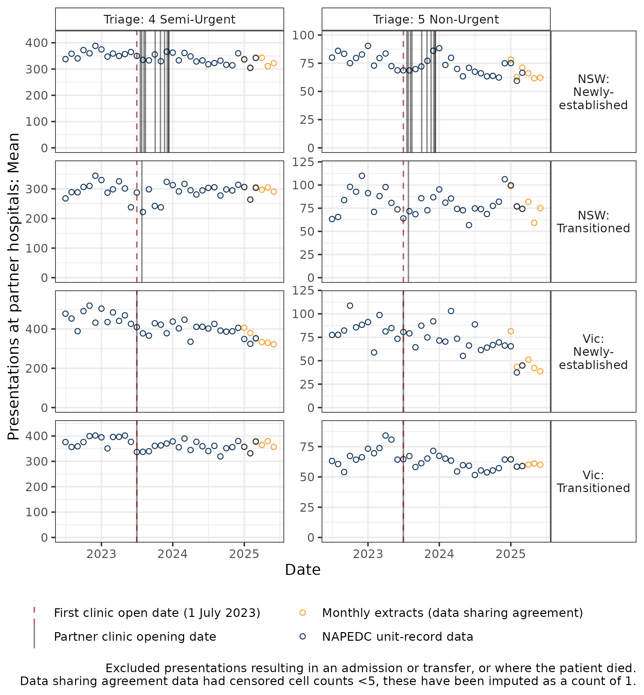
Figure 9 | Mean monthly ED presentations per partner ED/hospitals by triage category, state and Medicare UCC establishment status – Queensland, South Australia (SA) and Tasmania, July 2022 – June 2025
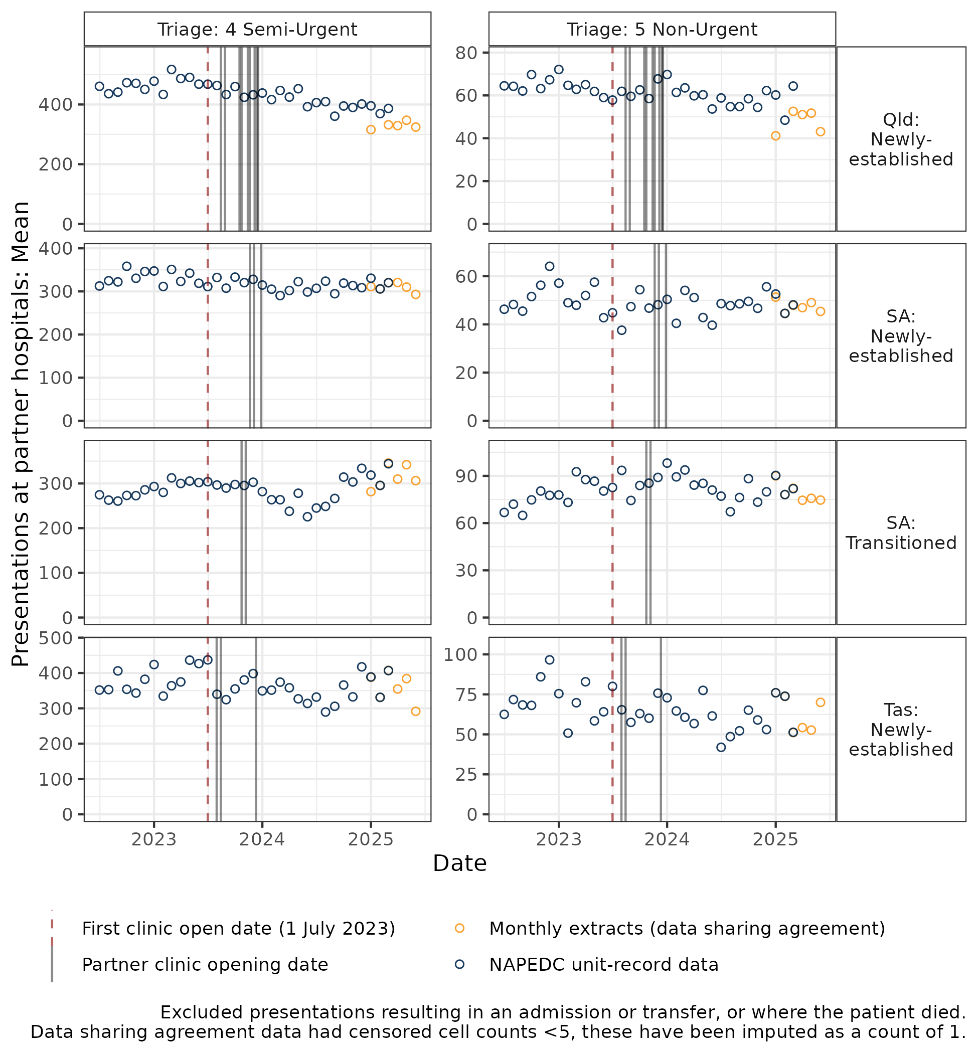
Excludes presentations resulting in an admission or transfer, or whether the patient died. Data sharing agreement data had censored cell counts <5, these have been imputed as a count of 1.

Findings from the ITS and DiD analyses
This evidence from the ITS analysis and the DiD analyses is described in the technical appendix and summarised in Table 7. The focus of these analyses has been on the impact of the first Tranche of Medicare UCCs, the 58 clinics that commenced between July 2023 and December 2023 that were newly established through the Medicare UCC program. Medicare UCCs that transitioned from a previous arrangement may also have had an impact on ED attendances, but only to the extent to which they expanded services delivered from a previous base. The estimates for the newly established Medicare UCC give a more accurate estimate of the overall impact on urgent-care-equivalent ED attendances. Appendix E provides additional analysis of the impact for all Medicare UCCs. Analysis was not conducted for the additional 29 clinics established between July 2024 and December 2024 (Tranche 2), due to the relatively small window in which post implementation effects could be observed.
To facilitate comparison of results between the methods, estimates have been calculated for the period April 2024 to March 2025, the latest full year of data available from the NAPEDC, for the Tranche 1 newly established Medicare UCCs. Table 7 shows the estimated percentage reduction in urgent-care-equivalent ED presentation.73F73F
Table 7 | Estimates of impact on urgent-care-equivalent ED presentations from ITS and DiD models: Based on partner ED/hospitals or catchment postcodes for newly established Tranche 1 Medicare UCCs: April 2024 to March 2025
Analysis approach | Change in urgent-care-equivalent ED attendances: April 2024 to March 2025
Analysis approach | Percentage | Lower CI | Upper CI
ITS | -10.6% | -16.8% | -4.6%
DiD: ED/Hospital analysis | -9.8% | -13.1% | -6.9%
DiD: Postcode analysis | -4.6% | -8.3% | -0.05%
Table 8 provides an analysis of the implications for each of the methods in terms of the number of avoided urgent-care-equivalent ED presentations between April 2024 and March 2025, including the (non-statistical) analysis of the module data (column A). It is important to note that each method implies a different counterfactual, that is, the number of urgent-care-equivalent ED presentations that would have occurred in the absence of the availability of Medicare UCCs. The counterfactual for each method is shown in Column B of the table. Column C provides the reduction in urgent-care-equivalent ED presentations as a percentage of the counterfactual.
The final column in Table 8 (Column D), expresses the estimate of the reduction in urgent-care-equivalent ED presentations as a percentage of the number of reduced urgent-care-equivalent ED presentations implied by the Medicare UCC Module data (that is 209,753 presentations). This percentage can be applied to reported Module data to generalise estimates to the broader set of Medicare UCCs, including Medicare UCCs that transitioned from another arrangement.
Table 8 | Estimates of number of avoided urgent-care-equivalent ED presentations for April 2024 to March 2025: Based on partner ED/hospitals or catchment postcodes for newly established Tranche 1 Medicare UCCs
Analysis approach | A: Reduced presentations (n) | B: Implied counterfactual (what would have occurred) (n) | C: Reduction as percentage of B counterfactual (%) | D: Reduction as percent of Module data estimate  (%)
Module data | 209,753 | 913,619 | 23.0% | 100.0%
ITS | 83,821 | 787,687 | 10.6% | 40.0%
DiD: ED/Hospital analysis | 76,480 | 780,346 | 9.8% | 36.5%
Postcode analysis: UCC catchments7
Module data (UCC catchments) | 129,097 | 662,856 | 19.5% | 100.0%
DiD: Postcode analysis | 25,976 | 559,735 | 4.6% | 20.0%

Implications of the various analyses for estimating the impact of Medicare UCCs on presentations to ED
The implications of these analyses are as follows:
- Medicare UCC Module data: There were 209,753 presentations at the 58 newly established, Tranche 1 clinics between April 2024 and March 2025, where it was reported that the patient would have attended ED or called an ambulance if the Medicare UCC was not available. In that time the number of urgent-care-equivalent presentations at partner ED/hospitals was 703,866. If the 209,753 presentations at Medicare UCCs all related to avoidable ED presentations, then the total number of urgent-care-equivalent presentations that would occur in the absence of Medicare UCCs (the counterfactual) would have been 913,619. This suggests a 23 per cent reduction in ED presentations due to Medicare UCCs. For alignment in scope with the causal analyses below, Module data for 58 newly established Medicare UCCs opened before 31 December 2023 analysed in the same way implied a 19.5 per cent reduction in ED presentations.
- ITS analysis: Medicare UCC commencement was associated with an immediate 2.6 per cent reduction in urgent-care-equivalent ED presentations (IRR, 0.97; 95 per cent CI 0.958-0.991) and a further 0.6 per cent decrease per month thereafter (IRR/month 0.994; 95 per cent CI 0.993-0.996). This implies a 10.6 per cent decrease in urgent -care-equivalent ED presentations for the period April 2024 and March 2025, relative to the counterfactual continuation of pre-opening trends. This implies there were approximately 83,821 fewer urgent-care-equivalent ED presentations April 2024 to March 2025 at 44 partner hospitals of newly established clinics that opened before 31 December 2023. This point estimate is approximately 40 per cent of the estimate based solely on the Medicare UCC Module data.75F75F
- DiD: ED/Hospital analysis: Medicare UCC commencement was associated with a 9.8 per cent decrease (CI: 6.85-13.10 per cent) in urgent-care-equivalent ED presentations in the last 12 months of observed data (March 2023 to April 2024). This implies there were approximately 78,480 (CI: 48,060-110,640) fewer urgent-care-equivalent ED presentations April 2024 to March 2025 at 44 partner hospitals of newly established clinics that opened before 31 December 2023. This point estimate is approximately 36.5 per cent of the estimate based solely on the Medicare UCC Module data.76F76F
- DiD: Postcode analysis: Medicare UCC commencement was associated with a 4.6 per cent decrease (CI: 0.05-8.26 per cent) in urgent-care-equivalent ED presentations in last 12 months of observed data (March 2023 to April 2024) for postcodes that formed the catchments of Medicare UCCs. This implies there were approximately 25,976 (CI: 256- 48,559) fewer urgent-care-equivalent ED presentations April 2024 to March 2025 at 44 partner hospitals of newly established clinics that opened before 31 December 2023. This point estimate is approximately 20 per cent of the estimate based solely on the Medicare UCC Module data for those catchments. This postcode-based analysis may bias the results of the DiD analysis towards a lower level of effect because the DiD at the postcode level is based on a different perspective. By focussing on the catchment postcodes, it recognises that Medicare UCCs may have impact on presentations beyond the partner ED/hospitals, as it includes presentations from each catchment at all EDs. However, this approach excludes ED attendances where the patient’s usual place of residence could not be assigned to a valid postcode which account for around 2.5 per cent of urgent-care-equivalent ED presentations. Additionally, patients residing in non-catchment postcodes may also be impacted by the availability of Medicare UCCs. As discussed in Appendix E, identification of catchments using postcodes is suboptimal and not aligned with the original Evaluation Plan which anticipated data being provided at the SA2 level of geography. ED data with SA2 was not available for this Interim Evaluation Report 2 but is expected to be available for the Final Report.

There is no clear evidence on the impact of availability of Medicare UCCs on ED waiting times or the proportion of patients seen on time for urgent-care-equivalent ED presentations
The methods described above were applied, with relevant modifications, to explore changes in wait times and the proportion of patients seen on time for urgent-care-equivalent ED attendance at the 44 partner hospital EDs of newly established Tranche 1 clinics. There was no clear evidence that these measures have changed following the commencement of Medicare UCCs.

Interim Evaluation Report 2 key finding 6.2
The results from the ITS and DiD causal inference analyses support a conclusion that the availability of Medicare UCCs has reduced urgent-care-equivalent ED presentations by around 10 per cent. A lower but still significant estimate (4.6 per cent) is generated when analysing Medicare UCC catchments. There are specific issues with the DiD based on the postcode of the ED patient's residence, which would imply the estimates for this analysis potentially results in an under-estimate of the effect.

Interim Evaluation Report 2 key finding 6.3
The causal inference estimates are lower than the analysis of patient intentions captured in the Medicare UCC Module data, with the Medicare UCC Module data suggesting an estimated reduction of around 23 per cent in ED presentations due to the availability of Medicare UCCs. However, the estimates from the Medicare UCC Module data relate to patient intentions and should be interpreted with caution. The DiD and ITS analyses at the ED/hospital level provide more statistically valid estimates of the impact but, as noted, these estimates may under or overestimate the effect.

Interim Evaluation Report 2 key finding 6.4
There is no clear evidence that waiting times and the proportion of patients seen on time has changed for urgent-care-equivalent ED presentations as a result of the availability of Medicare UCCs.

MEASURE OF SUCCESS 7

Consumer behaviour
Measure of Success 7 agreed by the Australian, state and territory governments is:
“There is a change in consumer behaviour over time to use Medicare UCCs where available instead of EDs for urgent non-life-threatening conditions.”
The evaluation is assessing Measure of Success 7 through consideration of:
- Presentations to Medicare UCCs.
- Use of Medicare UCCs instead of EDs for urgent non-life-threatening conditions.
- Factors influencing use of Medicare UCC services for consumers over other services.
For Interim Evaluation Report 2, Measure of Success 7 is informed by analysis of Medicare UCC data, interviews with a broader range of stakeholders (including representatives from local EDs, patients and carers) and a patient survey conducted for the evaluation, with 816 responses.

There were 1,820,138 presentations to Medicare UCCs between June 2023 and August 2025
Rapid program-level growth in presentations to Medicare UCCs continued to be primarily driven by new clinics opening from 1 July 2024 (see Figure 10). Medicare UCCs that opened before 30 June 2024 also experienced a modest growth in presentations throughout the 2024-25 financial year. Growth in presentations generally stabilises between 18 to 24 weeks after opening for newly established clinics as well as for those that transitioned from previous state arrangements (Figure 11).
Figure 10 | Presentations to Medicare UCCs per week 30 June 2023 to 10 August 202577F77F
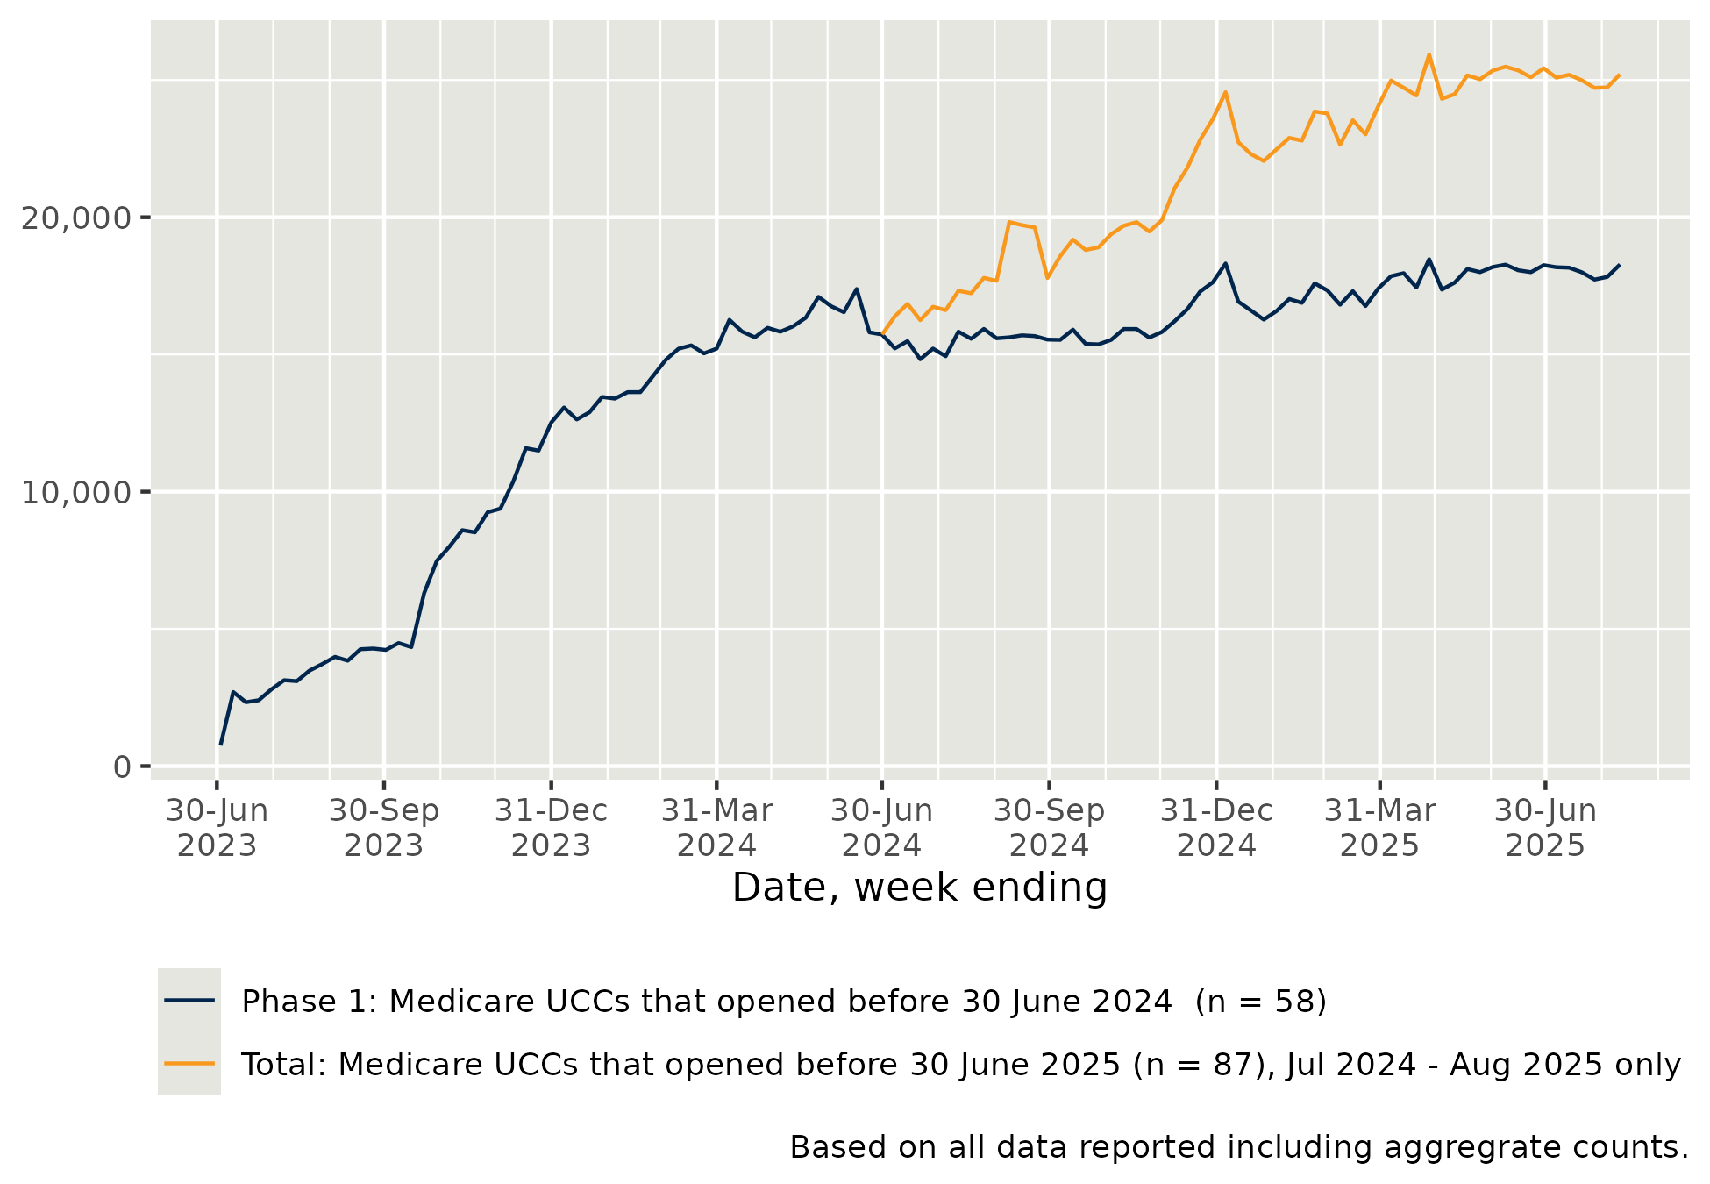
Notes: based on all data reported between 30 June 2023 and 10 August 2025, including aggregate counts. Data extracted 13 August 2025.
Figure 11 | Mean weekly presentations to Medicare UCC from date of opening or transitioning: Medicare UCCs open for at least 38 weeks, 30 June 2023 to 10 August 202578F78F
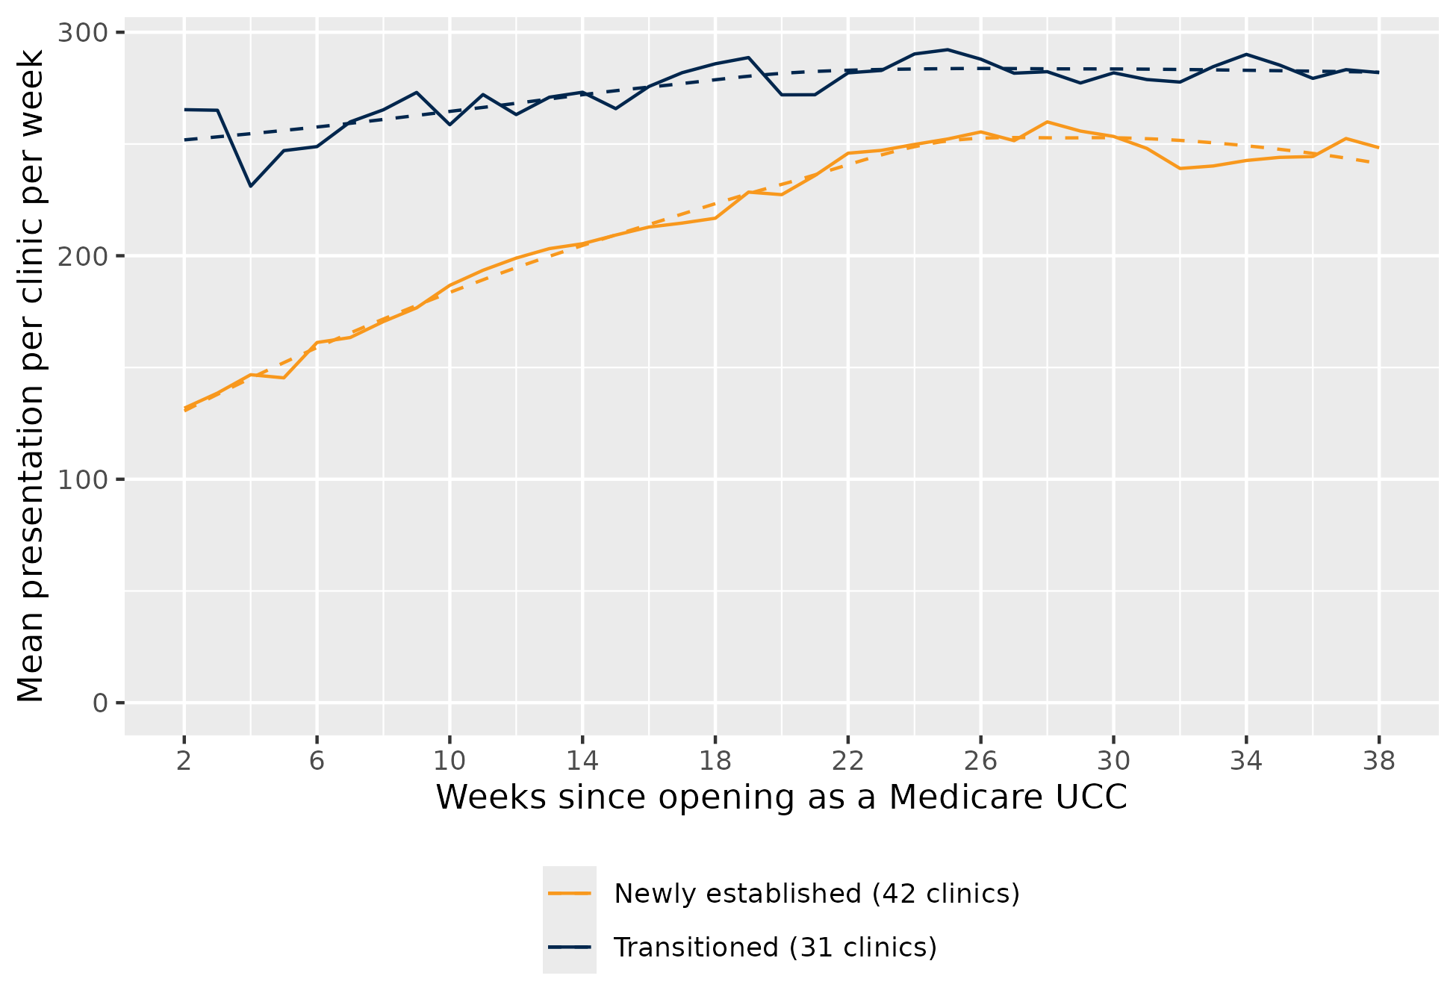
Notes: Based on data for the period 30 June 2023 to 10 August 2025, extracted 13 August 2025, for 73 clinics that opened between 30 June 2023 and 10 August 2025, that were open at least 38 weeks as of 10 August 2025. The busiest days for Medicare UCCs continue to be Sunday and Monday and this is similar to Interim Evaluation Report 1.
Mean presentations to Medicare UCCs per day are consistent with Interim Evaluation Report 1, ranging between 36.4 to 41.4 (compared with 36.2 to 40.5), with the busiest days being Sundays and Mondays (see Figure 12). Medicare UCCs continue to experience stable volumes of presentations throughout the day and a drop off after 5:00 pm, in contrast to ED triage category 4 and 5 presentations which peak around 10:00 am then gradually decline.79F79F
Medicare UCCs are a walk-in model, meaning patients will present when they require care. While Medicare UCCs are required to have processes in place to manage demand, including sufficient staffing on site, this is not necessarily predictable or possible within workforce resourcing constraints The number of patients seen each day is therefore limited by the number of staff rostered to work at the Medicare UCC and length of time to treat each patient. Commissioners reported that when clinics reach capacity near closing time, they stop accepting patients and redirect them to other services if required. The evaluation does not have sufficient data to assess the number of patients being turned away when clinics are at capacity.
Figure 12 | Mean presentations per clinic by day of the week, 1 February 2024 to 10 August 2025
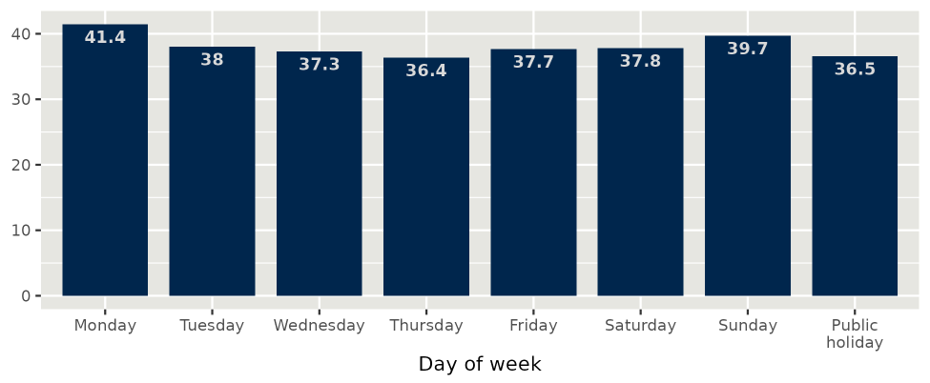
Notes: Based on all data reported from 1 February 2024 to 10 August 2025 for 87 Medicare UCCs, including aggregate counts for clinics where unit record data was not reported. This period was chosen to provide a more accurate reflection of activity once clinics were established.

The proportion of presentations where it was reported that patients would have otherwise gone to an ED or called an ambulance has stabilised
Available Medicare UCC Module data for the period 30 June 2023 to 10 August 2025 indicates that 45 per cent of patients would have sought help from an ED if the Medicare UCC was not available. In the observation period for Interim Evaluation Report 1, this proportion was fluctuating over time and appeared to be declining for newly established clinics.
As shown in Figure 13, the proportion of presentations where it was reported that the patient would have otherwise attended ED or called an ambulance has been stable since August 2024. This applies to both newly established sites and those that transitioned from a previous state arrangement.
Medicare UCCs that transitioned from a previous state arrangement continue to record higher proportions of patients who would have attended an ED or called an ambulance. This may reflect the locations of these Medicare UCCs, which were chosen by state health authorities to offset ED demand, prior to transition into the program.
Patients residing in non-Metropolitan areas, presenting after hours or presenting in the morning were more likely to report that they would have otherwise attended ED or called an ambulance.80F80F See Appendix D for a table detailing this finding in greater detail.
As previously outlined in Measure of Success 6 (section 2.6), caution should be applied when considering responses captured under the variable "Where would the patient have gone otherwise?", for a range of reasons, including:
- Responses may be overstated or understated depending on how the question was phrased for patients and how they interpreted it.
- Although this variable is intended to be collected by asking patients where they would have gone or sought advice from if a Medicare UCC was not available, some commissioners reported that clinic staff sometimes make this assessment on behalf of the patient.
- Some patients who reported they would have gone to an ED might still attend or be referred to one following their Medicare UCC visit. Similarly, some patients who reported they would have sought care from a GP might also be referred (or self-present) to an ED.
- Data is incomplete, covering only 1,240,387 of 1,820,138 presentations (i.e. 68 per cent of total presentations). See Appendix B for further details.
Figure 13 | Proportion of presentations where it was reported that the patient would have otherwise attended ED or called an ambulance, by week, February 2024 to June 202581F81F
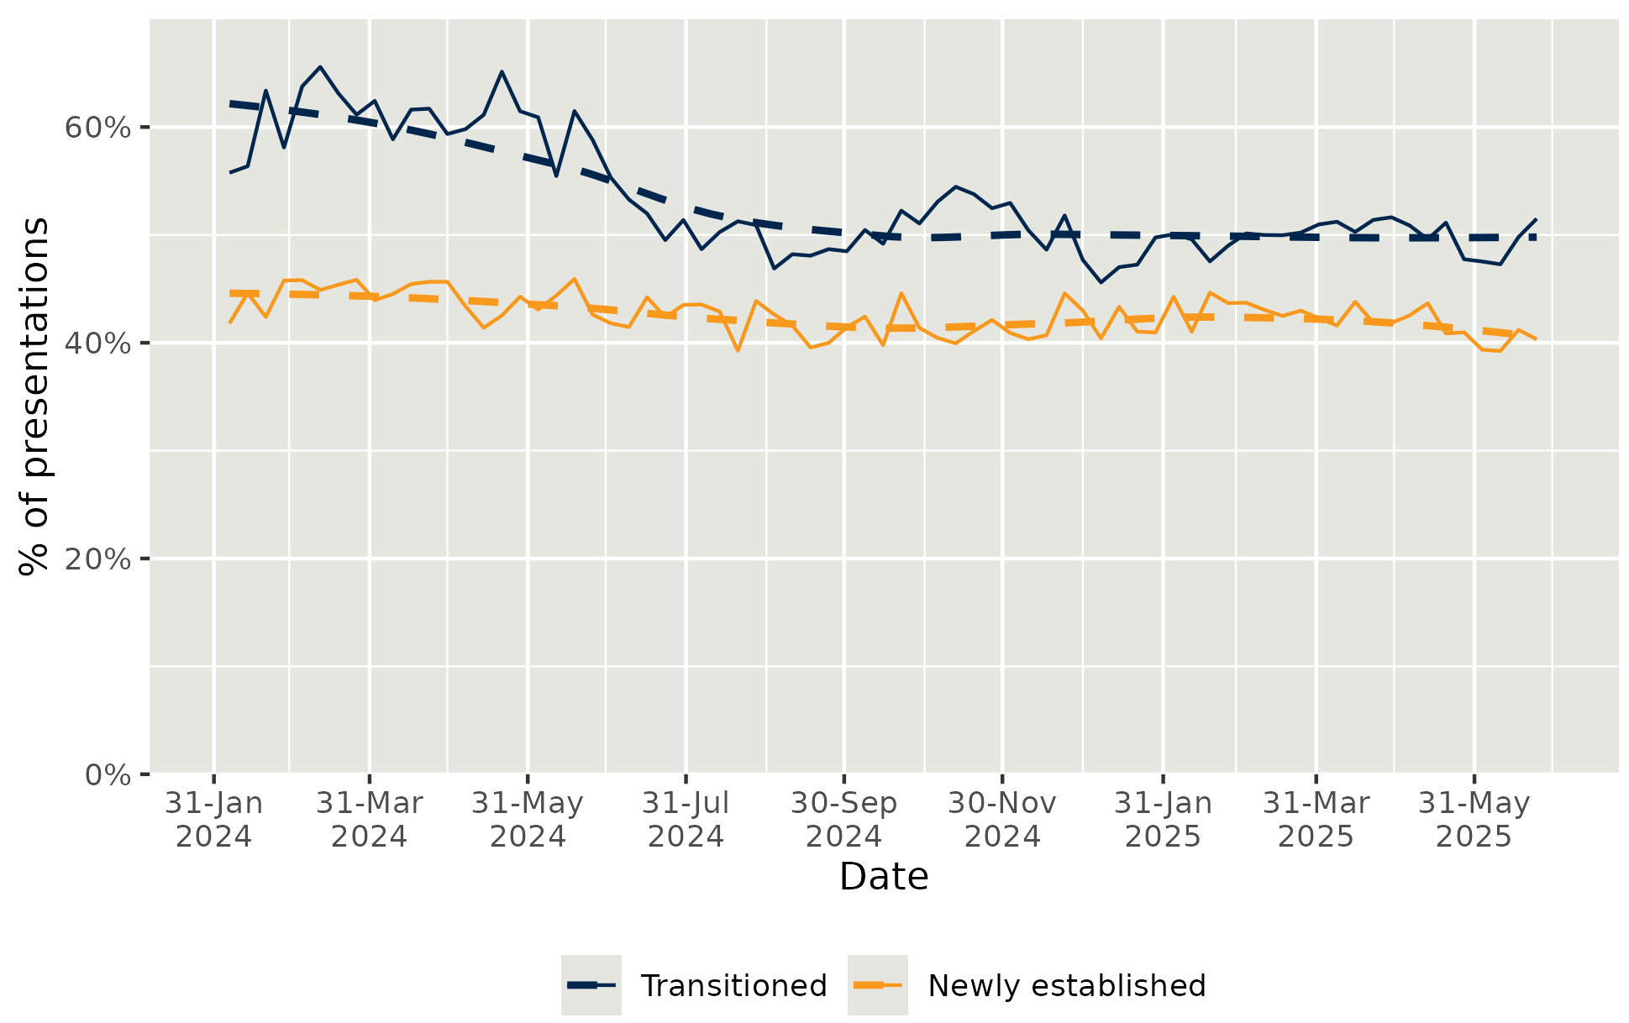Notes: Based on data from 76 Medicare UCCs that opened before 30 June 2025 and had Module data available. Trends shown by week from 1 February 2024 to 30 June 2025, extracted 13 August 2025. The period was chosen to provide a more accurate reflection of activity once clinics were established.

Interim Evaluation Report 2 key finding 7.1
The proportion of presentations (45 per cent) where it was reported that patients would have attended ED or called an ambulance has remained stable since August 2024. Medicare UCCs that transitioned from a previous state arrangement persistently reported higher proportions of presentations that would have otherwise attended ED or called an ambulance than newly established clinics.

Most patients continue to present directly to Medicare UCCs rather than via other pathways
As found in Interim Evaluation Report 1, patients continue to primarily present as walk-ins (87.3 per cent), with minimal diversions from general practices (3.2 per cent), healthdirect (2.6 per cent) and EDs (1.3 per cent). Data on point of entry should be interpreted with caution because:
- patients may be advised about the availability of the Medicare UCC by their regular general practice or local ED, but not formally referred to the Medicare UCC by a health professional at one of these settings
- patients may under or over report health services they have attended previously when seeking care at the Medicare UCC
- commissioners and clinics have advised that clinic staff often make this assessment on behalf of the patient.
Referral pathways to Medicare UCCs are explored in detail in Measure of Success 8 (section 2.8).

Timeliness, appropriateness and availability are key reasons consumers choose Medicare UCCs over other services
“I contacted another general practice first, but they couldn’t provide stitches and advised me to visit the Medicare UCC.”
– Patient
Results of the evaluation’s patient survey showed that the top three reasons patients attended a Medicare UCC instead of an ED were perceived urgency, anticipated timeliness of Medicare UCC care and referral by another service (see Figure 14).
“I couldn’t get in to my regular doctor, or the nearest local doctor. Everywhere was booked out, so it was either that [the Medicare UCC] or the hospital.”
– Patient
In contrast, the top three reported reasons patients attended a Medicare UCC instead of their regular GP were anticipated timeliness of care, needing care after hours and expectations that Medicare UCCs are better equipped to manage their urgent needs (see Figure 15). Just 2 per cent of survey respondents indicated they had attended a Medicare UCC instead of their regular GP because they did not want to pay out of pocket costs. This aligns with findings from a recent scoping review of urgent care literature82F82F, which identified the key reasons people choose urgent care centres are easier access and lack of availability of doctors or appointments elsewhere.
“I knew I’d be able to get into the Medicare UCC really quickly and easily.”
– Patient

Figure 14 | Top reasons for visiting the Medicare UCC instead of a local ED provided by respondents to the evaluation’s patient survey
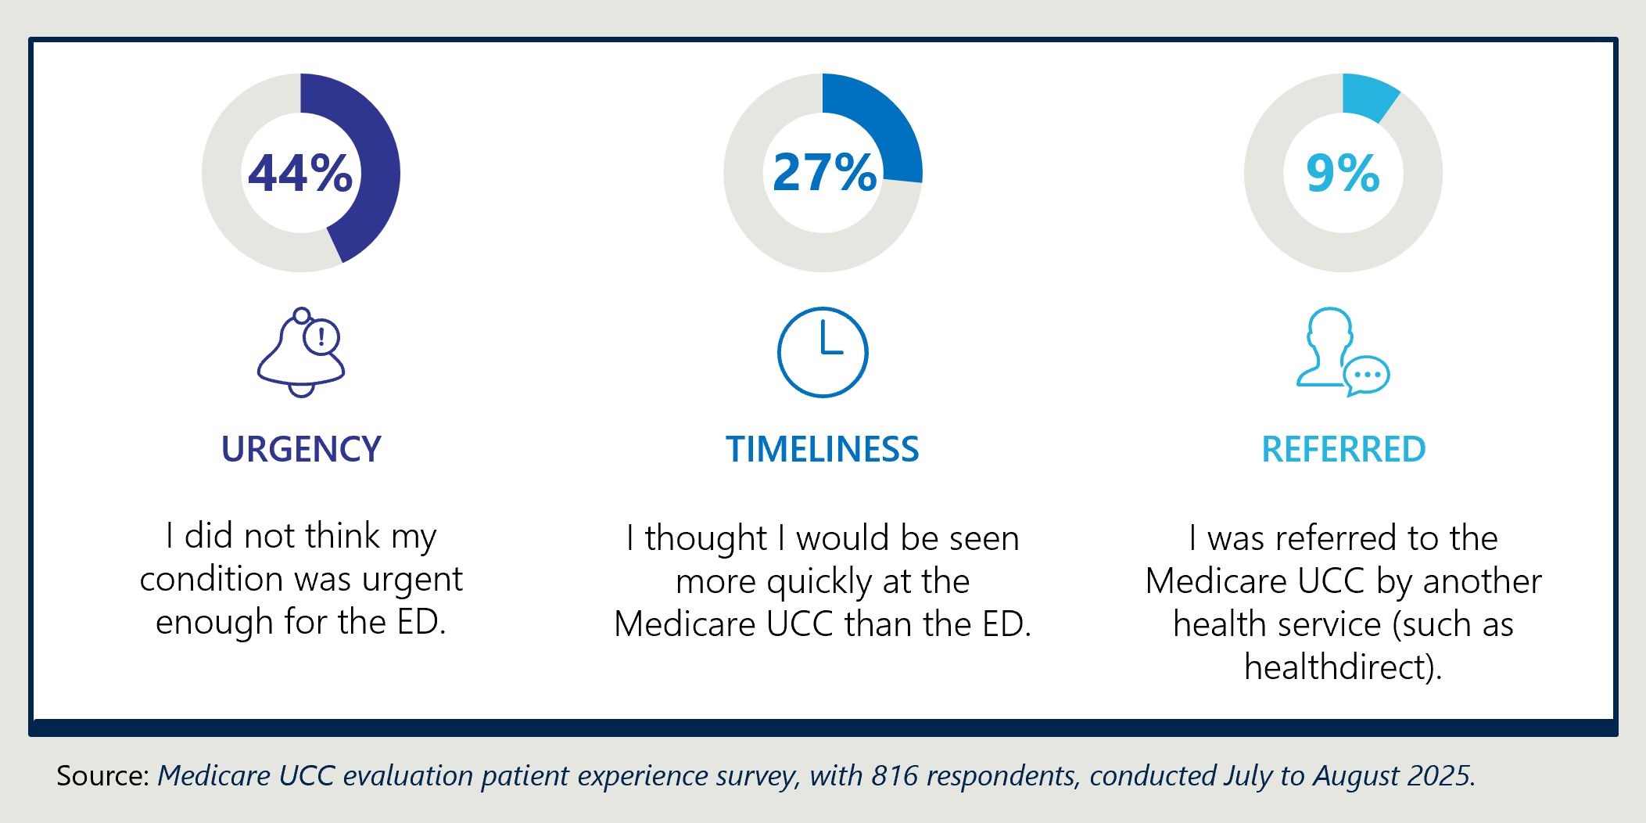
Figure 15 | Top reasons for visiting a Medicare UCC instead of a regular GP practice provided by respondents to the Medicare UCC evaluation’s patient survey
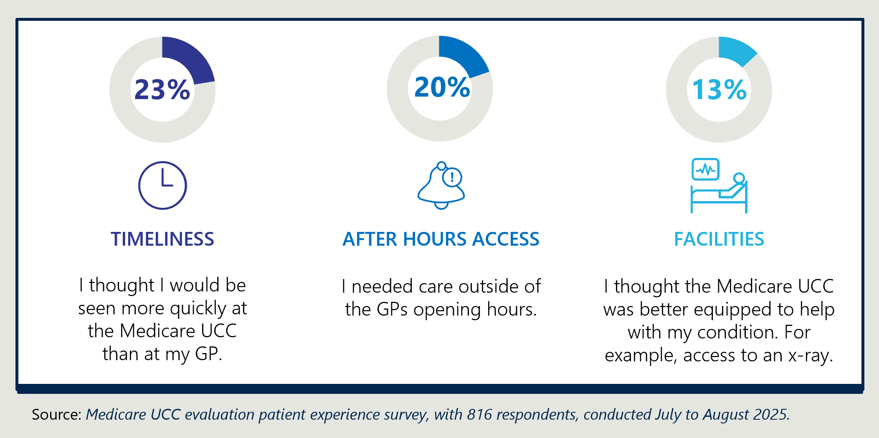

Interim Report 2 key finding 7.2
The evaluation’s patient survey identified the top three reasons patients attended a Medicare UCC instead of an ED were perceived urgency (condition not urgent enough for ED), anticipated timeliness (would be seen more quickly at ED) and referral by another service. Whereas the top three reasons patients attended a Medicare UCC instead of their regular GP were anticipated timeliness (would be seen more quickly at a UCC), after-hours access and the expectation that Medicare UCCs are better equipped to manage their condition.

Patients and carers are experiencing ongoing barriers with navigating the complex urgent care landscape
As identified in Interim Evaluation Report 1, the Medicare UCC program operates alongside a variety of urgent care services delivered through GPs, hospitals, after-hours services and other state, territory and PHN programs. Some Medicare UCCs transitioned from pre-existing programs (many of which are still active), including NSW Urgent Care Services, Victorian Urgent Care Clinics83F83F, SA Priority Care Centres, ACT Walk-in Centres and NT Primary Care Pilots. Urgent care services operating separate to the Medicare UCC program have different jurisdictional funding arrangements, operational requirements and in some instances, different eligibility criteria.
Consumer focus groups identified the need for ongoing education and communication about Medicare UCCs and what they provide, to support patients and carers to make informed decisions about where to seek urgent assistance.
Patient confusion about the difference between primary care, urgent care and emergency care continues to limit the appropriateness of presentations. Medicare UCC providers reported that in areas with lower socio-economic populations and lower levels of health literacy, patients often misunderstand the role of the Medicare UCC, resulting in higher proportions of patients requiring ambulance transfers to hospital and inappropriate non-urgent presentations where the patient was seeking bulk-billed care.
The complexity of the urgent care landscape creates barriers for patients trying to access appropriate care. The final report of this evaluation will include further discussion in relation the complex landscape and its impact on patient care.
Commissioners identified the need for ongoing communication campaigns beyond the establishment phase of the program and shared examples of local communication campaigns that have been delivered over the past 12 months:
- One Queensland PHN reported distributing communication materials in different languages with simplified messaging at local multicultural events.
- A NSW PHN had developed an urgent care strategy in collaboration with the local health district which positioned Medicare UCCs amongst the broader range of urgent care services available, to support navigation.

Interim Evaluation Report 2 key finding 7.3
Medicare UCCs exist alongside a variety of urgent care services delivered through GPs, hospitals, after-hours services, other state, territory and PHN programs, and the services delivered by healthdirect. Patients and carers are experiencing ongoing challenges navigating the complex urgent care landscape and understanding the differences between primary care, urgent care and emergency care.

Improvement opportunity 7.1
There is opportunity for ongoing locally led communications to the community about the spectrum of health services available, including when to attend a Medicare UCC and the role of healthdirect, to support patients navigating the complex and varied urgent care landscape.

MEASURE OF SUCCESS 8

Coordinated care within the health ecosystem
Measure of Success 8 agreed by the Australian, state and territory governments is:
“Medicare UCCs, PHNs, healthdirect, jurisdictions and the health ecosystem have established an effective coordinated care option for people with urgent non-life-threatening conditions.”
Measure of Success 8 focuses on collaboration between various groups in the health ecosystem (including Medicare UCCs, PHNs, state and territory run health services and healthdirect) and the extent to which Medicare UCCs:
- communicate and collaborate with other health services to streamline care, enhance information sharing and reduced likelihood of duplicated tests and procedures
- establish clear roles and referral pathways with other health services to provide a coordinated care option for people with urgent non-life-threatening conditions.
Interim Evaluation Report 1 found that PHNs and local integration working groups play a key role in building relationships and trust between Medicare UCCs and other health services. These findings remain consistent at Interim Evaluation Report 2. Interim Evaluation Report 2 explores the range of factors impacting development and use of referral pathways within the local health ecosystem, based on additional data available to the evaluation, including:
- program data on referral pathways
- the evaluation’s staff and patient surveys
- interviews with peak bodies and local ecosystem stakeholders, including representatives from EDs, ambulance services and some local GPs.

Active and ongoing collaboration is essential for Medicare UCC integration within the local health ecosystem
Commissioners and providers reported that the more proactively they engage and the longer the Medicare UCCs are operating in a local ecosystem, the more effective the relationships with other services can become. As identified in Interim Evaluation Report 1, proactive and ongoing relationship building between Medicare UCCs and other health services through formal collaboration mechanisms is consistently reported as the key enabler for integrating Medicare UCC services within the local health ecosystem. Effective integration requires trust and close relationships at both a management and staffing level, as well as reliable, timely and informative communication and information sharing.
“I think the level of coordination has improved significantly over the last year or so... we've seen quite a significant maturing over the last year in terms of the service relationships between key individuals in those services. I think there is now much more acceptance and much more trust.” – Commissioner
Commissioners and local health ecosystem stakeholders reiterated that establishing local working groups with Medicare UCCs, EDs and other surrounding health services has been a highly effective tool for developing referral pathways, data sharing and fostering relationships. This has enabled many Medicare UCCs to develop coordinated pathways and be responsive to emerging health trends, as they receive consistent feedback and updates from surrounding health networks.
“The Medicare UCC can't be seen as a stand-alone service. It's fitting into a broader system.”
– Commissioner
Around two-thirds (67 per cent) of respondents to the evaluation’s staff survey reported that they can access appropriate referral pathways within local ecosystems for patients when they are needed. This suggests there is still room for expanding or further operationalising referral pathways from the Medicare UCCs to local health services to support effective coordinated care as the clinics and program mature. Some commissioners identified that whilst integration working groups were set up and effective during early implementation, they have dropped away over the past 12 months as other priorities have arisen. Commissioners emphasised that established pathways still require active and ongoing collaboration from health system partners to remain operational and relevant, and could not be a ’set and forget.’
Interim Evaluation Report 2 key finding 8.1
Formal collaboration mechanisms, such as PHN led integration working groups, lead to better relationships and integration between Medicare UCCs and other health services. The longer the Medicare UCCs operate within a local ecosystem and engage with established integration working groups, the more effective the relationships can become.

Jurisdictional policy and system differences impact the integration of Medicare UCCs
Successful integration of Medicare UCCs into local health systems is influenced by the nature of Australia’s federal health system, with differences in jurisdictional policies, systems and executive level engagement. As described in Measure of Success 7 (section 2.7) Medicare UCCs exist within a complex landscape alongside alternative models of state-funded urgent care. These services deliver similar types of care but have different eligibility criteria and delivery models. The variety of urgent care services available across different jurisdictions is creating confusion for both the community and other health services. Providers reported this impacts appropriateness of referrals and accuracy of information provided to patients, hindering health system partner efforts to create an effective coordinated care system. For example:
“[We are] trying to bring the state and federal urgent care [models] together wherever we can, it feels pretty impossible at times, but we need to try and get greater reconciliation between the two types of urgent care in our region… It would make it much easier if we had one system.”
– Commissioner

- Some state based urgent care models such as Priority Care Centres in SA and Urgent Care Services in NSW, require an appointment, while Medicare UCCs are intended to be a walk-in service and do not require appointments (although some Medicare UCCs have implemented appointments as a way of better managing patient wait times (discussed in Measure of Success 1, section 2.1). Services such as the healthdirect Helpline, which routinely schedules appointments and provide handovers for patients attending state-funded urgent care services in SA and NSW, are unable to provide the same consistency and coordination when referring to Medicare UCCs.
“One of the challenges we have found is the (state government) health service wanting consistency across the state when it comes to ED referrals… so if we’re trying to do any changes directly between the Medicare UCCs and EDs, it can be tricky… the challenge isn’t the ED’s willingness to work with us.”
– Commissioner
- Some jurisdictional ambulance services have contracts and funding agreements that require patients to be transported to hospitals, preventing development of referral pathways to divert patients to Medicare UCCs.
- Some jurisdictional ambulance services and health authorities are requesting a consistent approach to referral pathways across Medicare UCCs. However, PHNs (apart from Victoria) do not have established state networks to facilitate coordination across regions.
Providers reported that the above issues relate both to within a jurisdiction (for example, some Local Health Districts in NSW have different systems and processes to each other) and also across jurisdictions, where bigger Medicare UCC providers who run more than one clinic need to grapple with different referral rules, ED avoidance services, etc.
These barriers, along with other factors that influence successful collaboration and development of referral pathways with other health services are explored further below.
Interim Evaluation Report 2 key finding 8.2
Differences across and within state and territory-run health systems impact the integration of Medicare UCCs into local health systems, with key factors including varying jurisdictional policies (such as ambulance triage policies that prevent referral pathways diverting patients to Medicare UCCs), system-wide approaches (such as appointment bookings for some state-run urgent care services via the healthdirect Helpline) and executive level engagement.

Improvement opportunity 8.1
There is opportunity for enhanced coordination and collaboration across PHNs, states and territories to support integration at a local and jurisdictional level with state and territory funded health services, particularly ambulance policies and ED referrals to Medicare UCCs, so that the urgent care ecosystem works together at a local level.

A range of factors are influencing uptake of hospitals and EDs referral pathways with Medicare UCCs
Commissioners reported that in many areas, the relationship and number of referral pathways between Medicare UCCs and hospitals had improved over the past 12 months. As of April 2025, at least 76 per cent Medicare UCCs84F84F reported having formalised or developed referral pathways to local hospitals, including EDs, and 60 per cent reported having formalised or developed referral pathways from local hospitals. Other referral pathways have also been developed: for example, to bypass the ED and access the digital imaging provider at the hospital outside business hours. See Figure 1 for an illustration of common referral pathways in and out of Medicare UCCs through the intended patient journey.
“We have daily communications directly between [the hospital] and the Medicare UCC, so they'll ring and say ‘who has capacity’ and refer people backwards and forwards. So, if the ED is flat out… they will send them over [to the Medicare UCC] and it works both ways.”
– Commissioner
As identified in Measure of Success 7 (section 2.7), the proportion of presentations referred to Medicare UCCs from EDs (1.3 per cent) remains low and has not improved since the Interim Evaluation Report 1, despite the presence of formalised pathways. Commissioners, Medicare UCC providers and other local health services identified a range of enablers and barriers (illustrated in Figure 16) to effective integration and the capacity of Medicare UCCs and EDs to provide an effective coordinated care pathway.
Figure 16 | Enablers and barriers reported by commissioners, Medicare UCC providers and local ecosystem stakeholders to effective coordination of care between Medicare UCCs and EDs
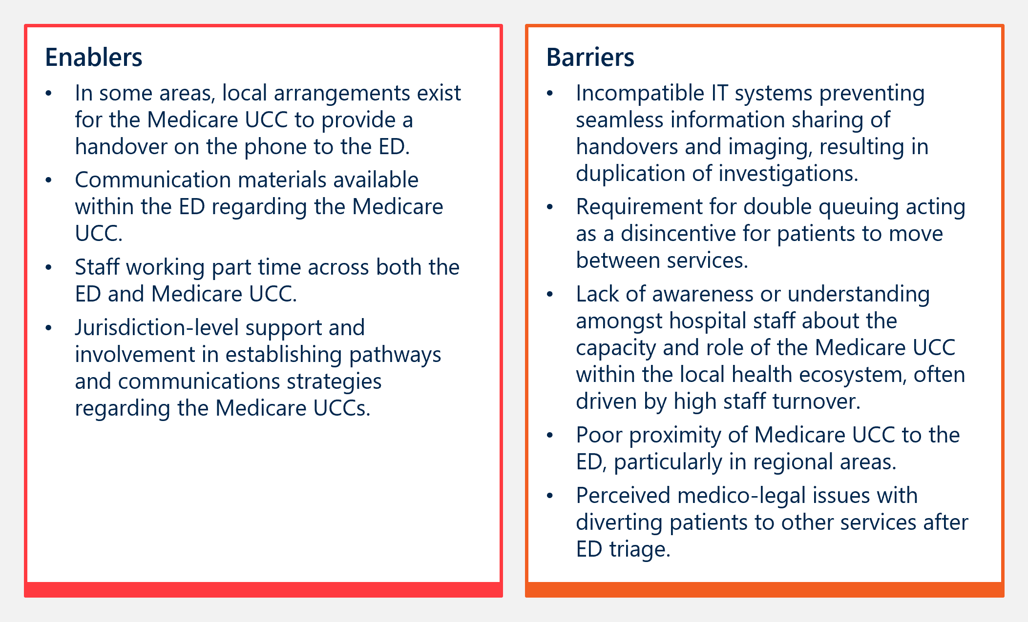
Commissioners also reported persistent variability in referral pathways to hospital outpatient services (for example fracture clinics) across different jurisdictions and hospital networks. They attributed this to varied criteria, willingness and capacity of local hospitals to accept referrals from Medicare UCCs and other primary care providers. Whilst there is a role for enhanced jurisdiction level support, local negotiation remains critical for successfully developing and operationalising pathways.
Interim Evaluation Report 2 key finding 8.3
As of April 2025, at least 76 per cent Medicare UCCs had referral pathways to local hospitals and 60 per cent had referral pathways from local hospitals, including EDs. The proportion of presentations referred to Medicare UCCs from EDs (1.3 per cent) remains low and has not improved since the Interim Evaluation Report 1.

There is increasing appetite to operationalise ambulance referral pathways to Medicare UCCs
The evaluation identified enthusiasm amongst program and local ecosystem stakeholders for improving ambulance referral pathways to Medicare UCCs. Paramedics and peak bodies described Medicare UCCs as a ‘desirable alternative’ for ambulance services to divert lower urgency patients that would otherwise be transported to EDs. Commissioners and providers shared the view that many Medicare UCCs have developed robust referral pathways with jurisdictional ambulance services, enabled by strong relationships, and increasing trust and confidence in Medicare UCCs.
“Whenever I get the chance to take a patient there [the Medicare UCC], I will.”
– Paramedic

“Paramedics are... really keen to take their patients to the Medicare urgent care clinic because it's better for the patient.”
– Peak body representative
As of April 2025, at least 68 per cent of clinics had formalised or developed referral pathways for ambulance services to divert patients to the Medicare UCC.85F85F However the uptake of referral pathways is not reflected in the proportion of presentations diverted from ambulance services, which sits at 0.6 per cent, and remains consistent with the findings from Interim Evaluation Report 1 (0.8 per cent). Nationally in 2023-24, 31.6 per cent of the 4.4 million incidents reported to ambulance service organisations were prioritised as urgent (defined as an unrelated response required without lights and sirens) and 25 per cent of incidents were prioritised as non-emergency (non-urgent response required).86F86F This suggests there is further scope to strengthen relationships and more consistently operationalise the already established referral pathways with jurisdictional ambulance services to increase the proportion of Medicare UCC presentations diverted from ambulance services.
Figure 17 illustrates a range of enablers and barriers to effective collaboration and referral pathways between Medicare UCCs and ambulance services, identified by peak bodies, jurisdictional ambulance service representatives and providers. Further detail regarding variations in jurisdictional policy and engagement as a key factor influencing effective collaboration and referral pathways with Medicare UCCs is provided above.
Figure 17 | Enablers and barriers to effective collaboration and referral pathways between Medicare UCCs and ambulance services.
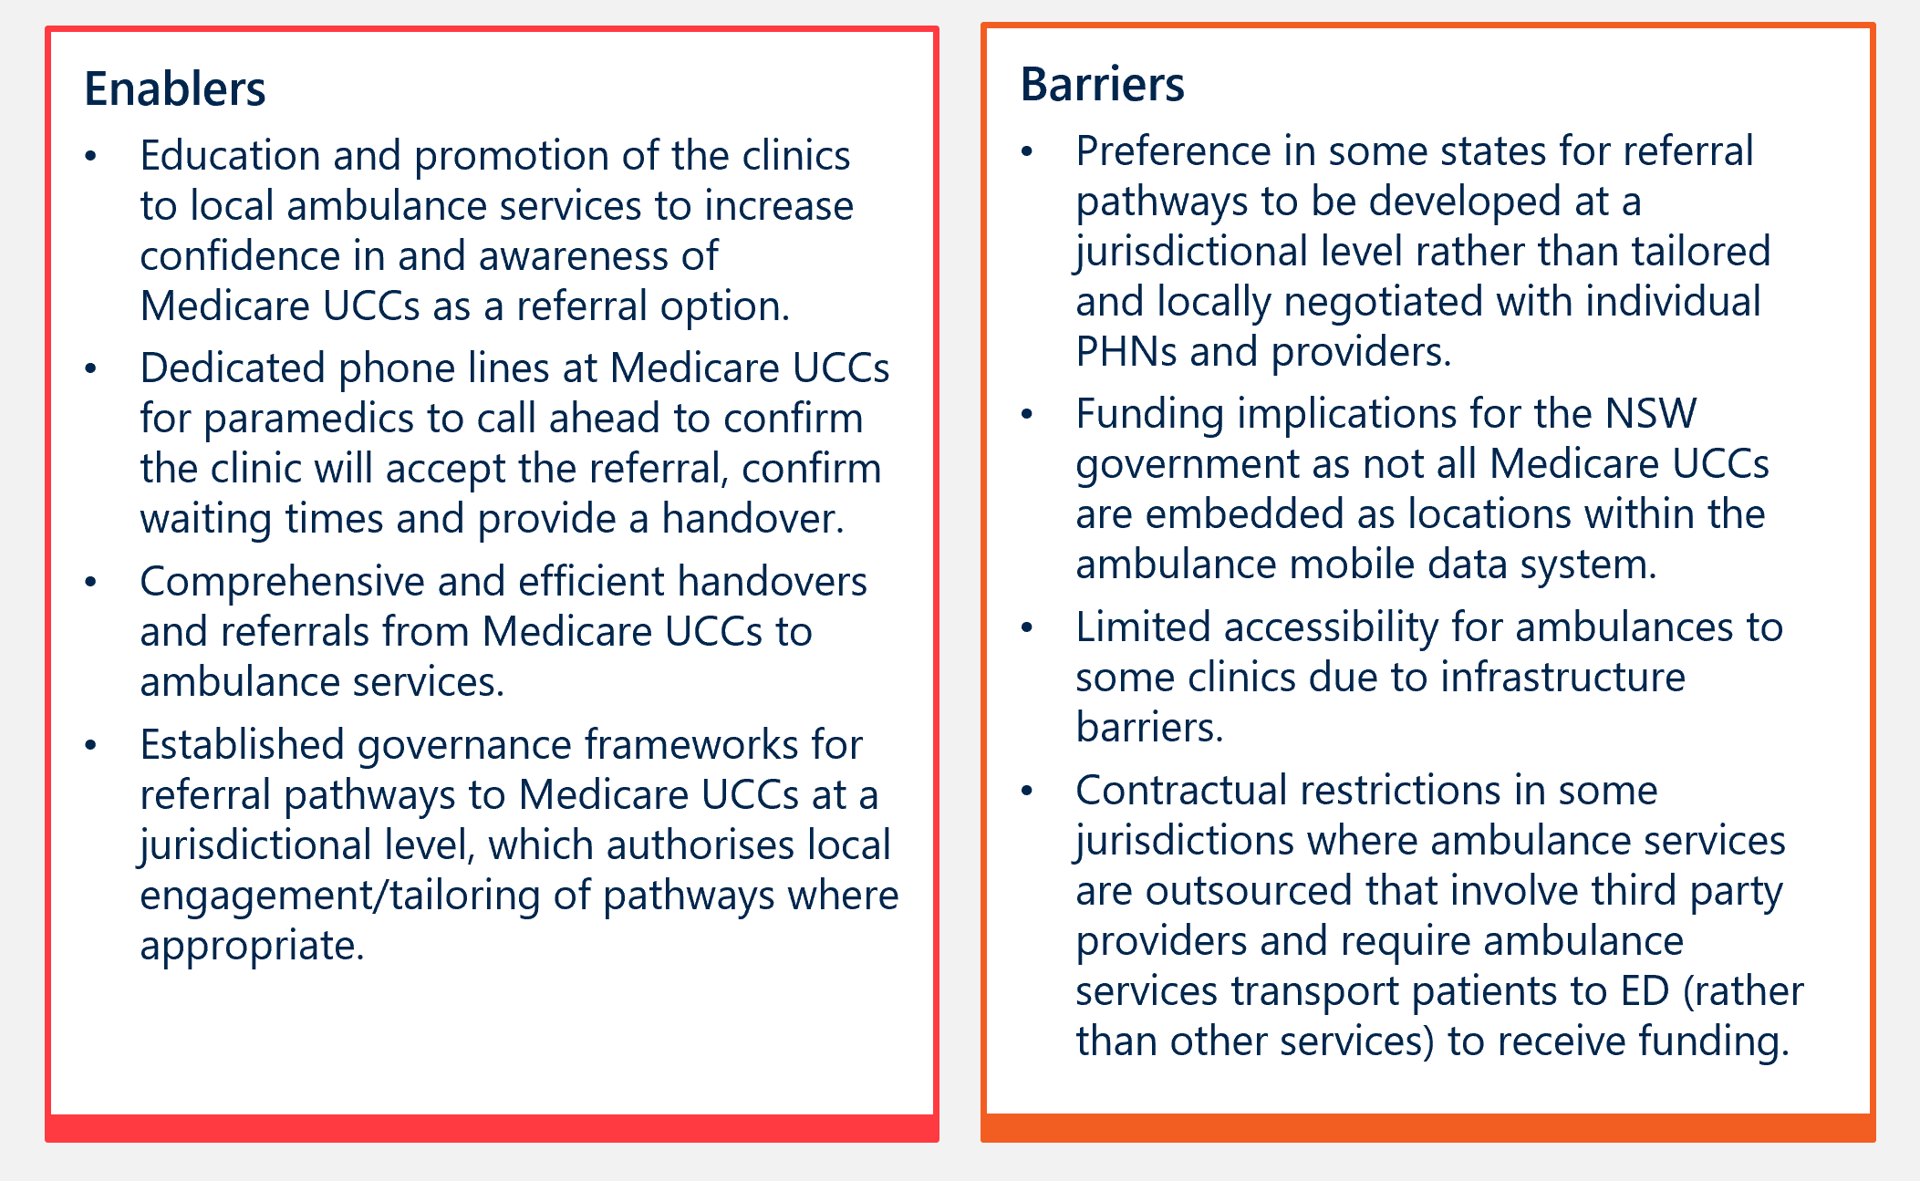
Interim Evaluation Report 2 key finding 8.4
As of April 2025, at least 68 per cent of clinics had referral pathways for ambulance services to divert patients to the Medicare UCC, however presentations diverted from ambulance services remains low (0.6 per cent), consistent with Interim Evaluation Report 1 (0.8 per cent).

Improvement opportunity 8.2
There is opportunity to strengthen the relationships and more consistently operationalise referral pathways between jurisdictional ambulance services and Medicare UCCs to increase the proportion of Medicare UCC presentations diverted from ambulance services. This should also include further consideration of the kinds of services that would be appropriate to divert to a Medicare UCC.

Regular feedback between healthdirect and Medicare UCCs enables effective referral pathways
Medicare UCCs offer healthdirect and other phone triage services a critical offramp alternative to EDs when in-person assessments are required of urgent but non-life-threatening conditions. As of April 2025, two-thirds (66 per cent) of clinics reported having formalised or developed pathways with healthdirect and other phone triage services to Medicare UCCs, while a further 14 per cent are developing pathways.87F87F However, the proportion of Medicare UCC presentations reported as referred by healthdirect (based on the Medicare UCC Module data) has not increased since Interim Evaluation Report 1, remaining at just 2.6 per cent.
Some commissioners and Medicare UCC providers consulted for the evaluation noted that while referral pathways are available and being used, clinics regularly receive inappropriate referrals from healthdirect and other phone triage services, that should be redirected back to their regular GP or escalated to ED for emergency care. Some Medicare UCC providers attributed this to identification of secondary issues or complexities that may not have been captured within the phone triage call algorithm. They also referenced confusion about the complex landscape of different urgent care service types across the country with different eligibility criteria.
Healthdirect advised that while they work very closely on urgent care in some jurisdictions, there is very little engagement in other jurisdictions, which creates challenges for healthdirect as a national service. Healthdirect has a clinical information management system to capture feedback from health services, which some PHNs have identified as beneficial. Overall, commissioners reported greater success with resolving issues related to inappropriate referrals when there was a coordinated state/territory level engagement approach with healthdirect and other phone triage providers rather than individual engagement by PHNs or clinics. For example, in Victoria, North-West Melbourne PHN provides a state-level coordination function and collates feedback and emerging trends around referrals.
Other opportunities to improve coordination and referral pathways for patients between healthdirect and other phone triage providers and Medicare UCCs include:
- Communication and visibility around clinic wait times and capacity to avoid callers being referred to Medicare UCCs that are already at capacity.
- Education for healthdirect and other phone triage services staff around setting patient expectations of wait times at Medicare UCCs, avoiding telling patients that they will be seen within two hours.
- Provision of a handover to Medicare UCCs to avoid patients having to repeat their story multiple times.
Interim Evaluation Report 2 key finding 8.5
The proportion of Medicare UCC presentations referred by healthdirect has not increased since Interim Evaluation Report 1, remaining at just 2.6 per cent. Commissioners reported issues (for example, inappropriate referrals and unrealistic wait time expectations) are easier to resolve when there is a coordinated jurisdiction-level communication approach to healthdirect and other phone triage providers.

Improvement opportunity 8.3
Communication and feedback mechanisms between commissioners and healthdirect/other phone triage providers could be streamlined to refine referral pathways.

Commissioners reported enhanced willingness of surrounding general practices to refer to Medicare UCCs
Commissioners reflected that the volume of complaints raised from local general practices about the potential fragmentation of care have significantly decreased over the past 12 months and they appear to be more willing to refer or suggest patients attend nearby Medicare UCCs. Commissioners attributed this to improved awareness, relationships and collaboration between services. Changes in the volume of referrals from surrounding general practices to Medicare UCCs is yet to be seen within the available data. As previously identified in Section 2.7, 3.2 per cent of Medicare UCC presentations were referred or advised to attend the Medicare UCC by their general practice, which is consistent with Interim Evaluation Report 1 (3.8 per cent).
“When they're not open they're [local GPs] saying go to the Medicare UCC, which is just not appropriate because they're not all meeting the guidance criteria.”
– Commissioner
There are opportunities to improve communication and awareness of Medicare UCC services in some areas, and to enhance appropriateness of general practice referrals. Commissioners and providers reported that in some areas, general practices were putting up signs advising that the local Medicare UCC is available after hours, resulting in frequent presentations by patients with non-urgent needs. Peak body representatives emphasised that it was usually general practice managers and administration staff who redirected patients to Medicare UCCs when their practices were at capacity or closed, but reported direct engagement and education with practice managers had been overlooked. This suggests that there is opportunity for further engagement with general practice managers and administrative staff regarding communication and promotion of the Medicare UCCs scope and role.
Interim Evaluation Report 2 key finding 8.6
Commissioners reported enhanced willingness of surrounding general practices to refer to Medicare UCCs, which they attribute to improved awareness, relationships and collaboration between services.

Improvement opportunity 8.4
Medicare UCCs should engage more proactively with local general practice managers and administration staff about the role and scope of Medicare UCCs to support appropriate referrals, particularly in the after-hours period.

Shared staffing models between local general practices and Medicare UCCs foster mutual understanding and collaborative relationships within the local health ecosystem
Providers reported that employing clinical staff part time from local general practices enables enhanced mutual understanding and relationships with other services. This has a beneficial effect on the quality of referrals and handovers between general practices and Medicare UCCs, and improves the coordination of care between services. This approach mirrors GP cooperative arrangements seen in the Commonwealth After-Hours Primary Care Program, where local GPs often participate in a roster to fill slots at after-hours practices, so they do not have to open their own practice after hours every day. Other benefits of shared staffing between the Medicare UCC and other health services in the surrounding area are explored in Measure of Success 5 (section 2.5). See Figure 18 for other factors which influence success of referral pathways with local general practices.
Figure 18 | Enablers and barriers to effective collaboration and referral pathways between Medicare UCCs and general practices
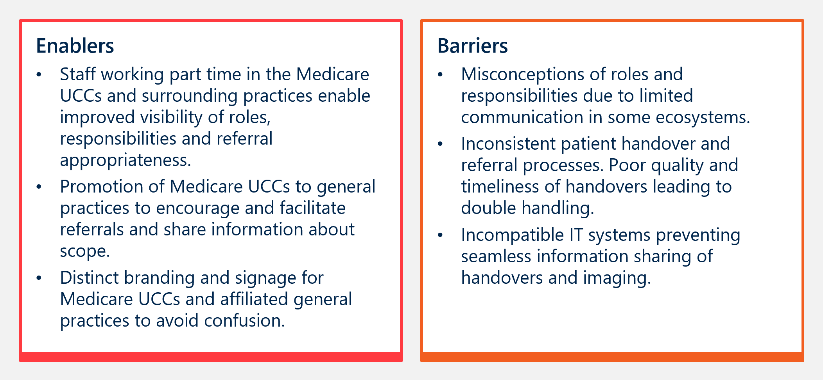
“We’ve seen a big change in the signage and things that are done within the clinic to differentiate between the Medicare UCC and the actual practice… this has strengthened local general practices willingness to refer in because they can see the distinction between the clinic {Medicare UCC] and the general practice.” – Commissioner

Interim Evaluation Report 2 key finding 8.7
Key enablers for effective referral pathways with other health services include phone handovers, education and promotion of Medicare UCC services, shared staffing and established governance frameworks which authorise tailoring of local pathways. Key barriers for effective referral pathways include incompatible IT systems, lack of awareness or understanding of services and perceived medico-legal issues with diverting patients.

MEASURE OF SUCCESS 9

Cost effectiveness
Measure of Success 9 agreed by the Australian, state and territory governments is:
“Medicare UCCs are cost effective.”
The Australian Government is investing $1.4 billion over seven years from 2022-23 for the implementation and operations of 137 Medicare UCCs across Australia. As noted earlier, 87 clinics were established by 31 December 2024 and are in scope for this evaluation. Of these, 58 clinics were implemented in Tranche 1 by 31 December 2023 and were fully operational through the 2024-25 financial year. The analysis of costs used in the comparison with ED costs avoided is focussed on 53 of these 58 clinics, where a full year of data post-establishment was available. The five ACT clinics are excluded from the Tranche 1 numbers due to the difference in available data and specific funding arrangements for ACT clinics. Analysis of the five ACT clinics has been presented separately.
Under the program, grants have been made to Medicare UCCs through Medicare UCC commissioners. As described previously, in some jurisdictions, the state or territory government has taken on the role of Commissioner (VIC, TAS, NT and ACT), while in the remainder of the states, PHNs have taken on this role. Grants to the Medicare UCCs cover operational costs, and capital and equipment costs. Medicare UCCs may also receive funding support from state or territory governments, and for one Medicare UCC, the operational funding grant is provided by the state government.
In addition to grants, clinicians at Medicare UCCs may be able to submit MBS claims through exemptions under s19(2) of the Health Insurance Act 1973. These claims are limited to specified MBS items and, since there is no patient co-payment for Medicare UCCs, they are required to be bulk billed. Section 19(2) exemptions have not been made for some Medicare UCCs, including the ACT Medicare UCCs.
In addition to grants to Medicare UCCs, PHN commissioning fees have also been allocated to facilitate implementation of other aspects of the program. This includes allocations to PHNs for managing funding, monitoring and ongoing management of the relationships with Medicare UCCs.
For Interim Evaluation Report 2, Measure of Success 9 is assessed through:
- Unit cost per Medicare UCC presentation. Costs assessed for this measure are the costs to the Australian Government, based on grants made to Medicare UCCs, aggregate counts of presentations at each Medicare UCC and MBS data.
- The estimated reduction in urgent-care-equivalent ED presentations using the results from Measure of Success 6 for the points estimates and levels of uncertainty.
- Unit costs for avoided ED presentations. Costs assessed for this measure are the costs to the Australian and state/territory governments, based on funding at the NEP recommended by the IHACPA.
These estimates have been used in a cost effectiveness analysis that aims to estimate cost/cost savings per avoided ED presentation, together with uncertainty around this estimate. The modelling has focussed on the 2024-25 financial year and the Tranche 1 Medicare UCCs for which data is available. Methods applied are described in Appendix D.

Estimating the Australian Government’s funding contribution for Medicare UCCs
The Australian Government's funding for Medicare UCCs consists of grants and MBS payments, with grants making up the largest share. For example, the analysis below indicates that across all Medicare UCCs, $134.10 per presentation comes from grants, while the remaining amount represents the estimated MBS costs for items billed by the clinic, and pathology and imaging services billed by providers outside of the Medicare UCCs. For this analysis, pathology and imaging billing is averaged across all patients, although it is recognised that not every patient undergoes diagnostic testing. About 157,500 Medicare UCC presentations (19.6 per cent) had an additional pathology or diagnostic imaging item claimed on the same day as the Medicare UCC presentations under a provider number that was not associated with a Medicare UCC.
Grants to Medicare UCCs commenced in 2022-23 and continue through to 2025-26, with extension subject to government decisions.8 The grants are for operational expenses, equipment and capital. There is currently variation in the level of Australian Government funding per clinic. This is driven by:
- The level of activity at each Medicare UCC. Medicare UCCs with lower levels of activity have higher levels of grant funding per presentation.
- Medicare UCC location. From 2024-25, selected Medicare UCCs operating in regional, rural and remote regions received additional funding – an MMM adjustment – that recognises higher costs for workforce and extended opening hours in these regions. Location also impacts the level of demand for Medicare UCCs, with those located in rural and remote locations generally having lower levels of activity.
- Medicare UCCs that transitioned from a previous arrangement did not receive equipment or capital grants. This recognised that required infrastructure to operate as a Medicare UCC was generally in place for these services.
- Access to MBS. For example, the ACT Medicare UCCs do not claim MBS, as the services receive additional state funding contributions through the National Health Reform Agreement.
The figures above do not include grants or other financial contributions made by state and territory governments. Details of these were not available at the time this report was prepared.
Table 9 shows the estimates of Australian Government funding for Medicare UCCs for the 2024-25 financial year. The overall estimate per presentation across all 75 Medicare UCCs open before 30 September 2024 is $206 per presentation. This estimate is lower than the estimate in Interim Evaluation Report 1 for the equivalent set of Medicare UCCs ($215.70 per presentation). This is because the share of grant funding per presentation has reduced as presentation volumes increase towards individual Medicare UCC capacity. Further reductions in per presentation cost may be expected as the program matures.
Estimates in Table 7 are shown separately for the 58 Tranche 1 Medicare UCCs (those that commenced operations prior to 31 December 2023). The 58 Tranche 1 Medicare UCCs were operating through the whole of the 2024-25 financial year. Excluding the five ACT Medicare UCCs, the average Australian Government funding per presentation for the 53 clinics used in the cost estimates analysis is $224.80, made up of $140.70 for grants and $84.10 in MBS payments.
ACT Clinics
Separate analysis was undertaken for the five ACT clinics due to the different arrangements in place. No MBS benefits can be claimed for attendances at ACT Medicare UCCs. ACT clinics also receive support through the ACT Government under the National Health Reform Agreement; however, the extent of funding provided to the clinics through this source was not available to the evaluators. As a result, the estimate for the ACT only reflects the specific Medicare UCC grants that have been provided by the Australian Government. For these ACT Medicare UCCs the average funding per presentation is $28.90. This analysis is presented separately below.
Tranche 2 clinics
Estimates for 17 Tranche 2 Medicare UCCs that commenced operation during the 2024-25 financial year are shown separately in Table 9. Most of these Medicare UCCs commenced operating part way through the 2024-25 financial year. Consequently, the estimates shown in Table 7 are likely to overstate the average funding per presentation once these clinics are fully operational. Excluding the three NT Remote clinics, the average Australian Government funding per presentation for the remaining 14 Tranche 2 Medicare UCC is $246.20, made up of $166.90 in grants and $79.30 in MBS payments.
NT clinics
Analysis was also undertaken for the three remote NT Medicare UCC clinics where there are no separate subsection 19(2) directions under the Medicare UCC program. These are shown separately in Table 9. For these clinics the average funding per presentation is $395.30.
Cost of Medicare UCC clinic presentations where it was reported the patient would otherwise have attended an ED
For the purposes of estimating the cost of avoided ED admissions, a subset of Medicare UCC presentations is used, that is those Medicare UCC presentations where it is reported the patient would have attended an ED or called an ambulance if the Medicare UCC was not available. Across the 53 Tranche 1 Medicare UCCs in which Module data is reported (and excluding the ACT clinics) it is estimated that Australian Government funding is $236 per presentation where it is reported the patient would have attended an ED or called an ambulance if the Medicare UCC was not available, compared with $220 for other presentations. These two figures are both higher than the $205.60 program-level per presentation cost due to the exclusion of ACT Medicare UCCs, where Module data (including reported patient action had the Medicare UCC not been available) was not available
Table 9 | Estimates of Australian Government funding support per presentation for Medicare UCCs, 2024-25
Medicare UCC group | Clinics | Presentations | Australian Government funding per presentation $
Medicare UCC group | Clinics | Presentations | Grants | MBS | Total
58 Medicare UCCs that opened prior to 31 December 2023
Medicare UCCs where module and MBS was reported | 53 | 727,631 | 140.7 | 84.1 | 224.8
ACT Medicare UCCs | 5 | 134,345 | 28.9 | 0.0 | 28.9
17 Medicare UCCs that opened between 1 July 2024 and 30 September 2024
Medicare UCCs where module and MBS was reported | 14 | 172,115 | 166.9 | 79.8 | 246.7
Remote NT Medicare UCCs | 3 | 14,167 | 395.3 | 0.0 | 395.3
Total
Total | 75 | 1,048,258 | 134.1 | 71.5 | 205.6
The mean value of MBS benefits is estimated based on data reported in the Medicare UCC Module, plus an estimate of pathology and diagnostic imaging provided on the same day and billed under a provider number that was not a Medicare UCC ($16.17 per presentation). MBS benefits are not claimed for ACT nurse-led walk-in Medicare UCCs and the remote NT Medicare UCCs. The estimate of MBS benefits per presentation shown in this table are based on the Module data and are close to the estimate derived directly from analysis of MBS data for Medicare UCC provider numbers. Some minor adjustments were made to the Module data to take account of situations in which an MBS item was reported but was unlikely to have been claimed. Reported MBS items and benefits were set to zero for presentations where the episode end status was “Did not wait” and where it was reported the patients did not have a Medicare Card. Where more than one consultation item was reported in the Module data (i.e. consultations Levels A-D), the item with the highest benefit level was included in the analysis and other consultations items set to zero. Additional variation arises from estimating the value of MBS benefits where this was missing in the Module data. The mean from available data for each Medicare UCC was applied to presentations in which MBS data was not available, for example, where aggregate counts of activity only were available.

Interim Evaluation Report 2 key finding 9.1
The estimate of Australian Government funding during the 2024-25 financial year across the 75 Medicare UCC clinics established before 30 September 2024 is $206 per Medicare UCC presentation. This represents a reduction from the comparable estimate in Interim Evaluation Report 1 of $216. The decrease is largely due to the increase in presentation volumes as individual clinics grow towards capacity.

Interim Evaluation Report 2 key finding 9.2
Across the 53 Tranche 1 Medicare UCCs in which Module data is reported (and excluding the ACT clinics) Australian Government funding is estimated to be $236 per presentation where it was reported the patient would have otherwise attended an ED or called an ambulance if the Medicare UCC was not available (according to Medicare UCC Module data).

Estimation of the funding that would have been required for ED presentations avoided due to the availability of Medicare UCCs
This section addresses the question of what Australian and state/territory government funding is saved as a result of ED presentations avoided due to the availability of Medicare UCCs.
Our approach to estimating cost effectiveness for the Medicare UCC program is to estimate the cost per avoided ED attendance.
Information about the reason for Medicare UCC visit supplied in the Module data was used to assign presentation to a class within the Australian Emergency Care Classification (AECC) (see Appendix D). The subset of these presentations in which it was indicated the patient would have attended an ED or called an ambulance was analysed to determine the level of funding the presentation would attract if it had occurred at an ED. This required assigning a National Weighted Activity Unit (NWAU) to each episode based on the AECC class and applying the NEP. Table 10 illustrates the results of this approach with a sample of the ten most frequent Emergency Care Diagnosis Groups (ECDG). (The ECDG are groupings of the AECC classes, without a complexity split). Presentations have been excluded from this analysis where the patient did not wait or was subsequently referred to an ED. Subtracting the estimated cost of $236 for a Medicare UCC presentation from the estimated $617 per avoided ED presentation results in an estimated saving of $381 per avoided ED presentation.
Presentations have been excluded from this analysis where the patient did not wait or was subsequently referred to an ED.

Table 10 | Medicare UCC presentations and ECDG and assigned NWAU: Ten most frequent groups excluding error classes, 2024-25
ECDG | Total |  | Would have attended local ED or call ambulance |  |  |  | Other action (includes not recorded)
ECDG | Presentations | % | Presentations | % | NWAU | Mean NWAU | Presentations | %
Total | 867,194 | 100.00% | 372,971 | 100.00% | 26,299.1 | 0.07 | 494,223 | 100.00%
E0440 Upper respiratory tract infections | 72,931 | 8.41% | 24,122 | 6.47% | 2,637.0 | 0.11 | 48,809 | 9.88%
E2030 Injuries, other | 68,915 | 7.95% | 36,606 | 9.81% | 3,221.4 | 0.09 | 32,309 | 6.54%
E2040 Finger, toe and superficial injuries | 58,692 | 6.77% | 33,095 | 8.87% | 3,089.9 | 0.09 | 25,597 | 5.18%
E0310 Ear, nose, mouth and throat disorders | 43,451 | 5.01% | 15,189 | 4.07% | 1,253.4 | 0.08 | 28,262 | 5.72%
E0890 Musculoskeletal and musculotendinous disorders | 40,266 | 4.64% | 17,744 | 4.76% | 1,811.1 | 0.10 | 22,522 | 4.56%
E0990 Skin disorders, other | 36,480 | 4.21% | 12,821 | 3.44% | 1,157.7 | 0.09 | 23,659 | 4.79%
E0910 Skin and subcutaneous tissue infections | 34,584 | 3.99% | 13,034 | 3.49% | 1,301.2 | 0.10 | 21,550 | 4.36%
E0490 Respiratory disorders, other | 23,342 | 2.69% | 8,473 | 2.27% | 939.3 | 0.11 | 14,869 | 3.01%
E1130 Kidney and urinary tract infections | 23,282 | 2.68% | 7,785 | 2.09% | 813.3 | 0.10 | 15,497 | 3.14%
E6090 Other factors influencing health status | 22,882 | 2.64% | 9,832 | 2.64% | 868.6 | 0.09 | 13,050 | 2.64%

Interim Evaluation Report 2 key finding 9.3
The average funding for avoided presentations to ED (that were avoided due to the availability of Medicare UCCs) is estimated to be $617 per urgent-care-equivalent ED presentation. On this basis, subtracting the cost of $236 per Medicare UCC presentation, the savings per avoided ED presentation is $381 per presentation.

Application of the estimated per presentation savings to assess overall cost impact
The estimate of $617 for the avoided ED funding per presentation provides a reasonable basis for cost effectiveness modelling. It is important to note that this is an estimate of the impact on government funding, not necessarily the cost of the avoided presentation. The NWAU and NEP calculations themselves are based on estimates of average cost across ED as reported through the National Hospital Cost Data Collection, with adjustments for cost escalation. However, it can be argued that the marginal cost savings of reduced emergency care equivalent ED presentations may be lower than the average cost. Economic theory suggests that this may be the case in the short term, but as organisations (in this case EDs) adjust to changing volumes/demand marginal costs will trend towards average costs. However, for the cost effectiveness analysis, the basis for estimating the cost of avoided ED presentations as described above is reasonable. Uncertainty around this estimate has been included in the cost effectiveness analysis.
There are two considerations that have a material impact on this cost-effectiveness analysis.
The first consideration is whether the estimate be restricted to costs related only to those presentations in which the Medicare UCC attendance is associated with an avoided ED attendance or should consider the broader costs of the program including the cost of Medicare UCCs that are not a substitute for an ED attendance. In the analysis presented below we have taken the former approach. Our rationale is that Medicare UCC attendances that are not related to ED avoidance deliver benefits to patients, but need to be assessed on an alternative basis, potentially with a different comparator.
The second consideration in applying the estimated cost per avoided ED presentations is what basis should be adopted to estimating the level of ED avoidance, and therefore the size of the impact. As discussed under Measure of Success 6 (section 2.6), there is reasonably strong evidence that the availability of Medicare UCCs results in reduced urgent-care-equivalent ED presentations. However, there is uncertainty around the size of this impact. The upper end of these estimates is provided through the analysis of the Medicare UCC Module data which implies a 23 per cent reduction in urgent-care-equivalent ED presentations. The DiD and ITS methods suggest a reduction of around 10 per cent. The cost per ED presentation avoided presented below is based on two estimates of effect:
- Medicare UCC Module data analysis. The analysis from the Medicare UCC Module data for patients in which it is indicated that they would have called an ambulance or attended an ED if the Medicare UCC were not available. This approach is not based on a statistical analysis and consequently there are no uncertainty limits included .
- DiD: ED/hospital data analysis. The results of the analysis from the DiD analysis at the hospital level, using estimates from the newly established Medicare UCCs. These have been expressed as a percentage of the Medicare UCC Module data estimate. This is 36.5 per cent of the Module data estimate (95 per cent CI 25.7-48.7 per cent) (see Table 6 from Measure of Success 6).
Table 11 shows the key results. The estimates are based on the Medicare UCCs that commenced before 31 December 2023 (Tranche 1), for which Module data and MBS data were available (a total of 53 Medicare UCCs, which excludes the five ACT Medicare UCCs and Medicare UCCs where Module data including associated MBS items was not available).
As described above, the DiD estimates are based on modelling of newly established Medicare UCCs and these have been generalised to apply to other Medicare UCCs that have transitioned from another arrangement. The proportions were used to generate a random sample of presentations within the Module data, where it is indicated the patient would have called an ambulance or attended a local ED. As the Module data is a large sample (259,941 presentations), the resulting mean for the average costs of Medicare UCC attendances and avoided ED costs are very similar.
As identified above, the net saving per avoided ED presentations is $381. Using the Module data, it is estimated there would be close to 260,000 avoided ED presentations in 2024-25. This yields an estimated total net savings of $99.1 million for the financial year. The DiD analysis yields a lower estimate of avoided ED attendances (around 95,000) and as a result a lower estimate of annual savings: $36.2 million (CI $25.4 million-$48.1 million).
Table 11 | Estimates of cost per avoided ED presentation avoided and net savings, 2024-25
Estimates basis | Medicare UCCs | Estimates avoid ED presentations 2024-25 (CI) | Cost per Medicare UCC attendance | ED avoided costs per presentation | Net saving per avoided ED presentation | Total net savings $million (CI)
Module data analysis | 53 | 259,941 | $236 | $617 | $381 | $99.1m
DID: ED/Hospital analysis | 53 | 94,973 (66,580-126,543) | $236 | $617 | $381 | $36.2m ($25.4m-$48.1m)
There are several caveats to this analysis, which include:
- The estimates have focused only on the 53 Medicare UCCs for which relevant data is available and for which a full year of data for 2024-25 was available.
- Some cost estimates are based on an average across all patients within a Medicare UCC. There is likely to be greater variability in actual costs for individual patients within a clinic.
- As discussed above the estimates do not include the cost of patients who would not have attended an ED.
Interim Evaluation Report 2 key finding 9.4
The report has assessed the annual net savings per ED presentation avoided based on two estimates of effect. Both methods consistently show a cost saving compared to the costs of an ED presentation, based on analysis of data for 53 clinics:
- Using the Medicare UCC Module data and the associated estimate of avoided ED attendances of approximately 260,000, the estimated savings of $381 per presentation results in total net annual savings of $99 million89F89F.
- Using the DiD/ED/hospital analysis yields a lower estimate of avoided ED attendances (around 95,000) and as a result a lower estimate of annual savings: $36.2 million (CI $25.4 million-$48.1 million).
The Final Evaluation Report will consider these estimates in more detail and will undertake a range of sensitivity analyses to assess their robustness. The Final Evaluation Report will also consider other benefits in addition to avoided ED presentations.

Improvement opportunities
The evaluation has identified a range of improvement opportunities through Interim Evaluation Reports 1 and 2. These are summarised in Table 12 and in section 3.1, which references improvements for data collection. This section additionally outlines three specific actions taken by the Department to address improvement opportunities from Interim Evaluation Report 1.:
- Delivered awareness campaign | A two-phase national communication campaign to support the establishment and operation of Medicare UCCs (Phase 1 occurred in 2023-24 and Phase 2 in 2024-25). This involved local advertising, public relations and community engagement aiming to increase awareness of Medicare UCCs and appropriate use. Evaluation of the campaign reportedly suggests the campaign led to improved awareness of Medicare UCCs.
- Updated minimum signage and branding requirements | In June 2025 the Department released minimum signage and branding requirements to ensure national consistency in communication and visibility across all Medicare UCCs. All Medicare UCCs are required to install and maintain Medicare UCC branding and signage.
- Updated Operational Guidance | Operational Guidance was updated, including to provide clarity that patients must be informed of the triage system and waiting times and that they are subject to change based on the clinical urgency of other patients, and that patients should be informed of changes in expected waiting times.
Table 12 | Summary of program improvement opportunities with relevant context, excluding data collection opportunities
Measure of Success | Interim Evaluation Report 1 opportunity | Action taken to address opportunity | Interim Evaluation Report 2 opportunity
MOS 1 | N/A | N/A | Some patients expect instant treatment at Medicare UCCs, or do not understand that there is a triage process.  1.2 Ongoing education and awareness surrounding the Medicare UCC model is required to support more realistic patient expectations about immediacy of care received at Medicare UCCs. This can be enabled through clear and consistent on-site signage regarding the triage process and expected wait-times, as well as broader health service and community clarity surrounding the Medicare UCC model of care.
MOS 1 | N/A | N/A | A moderate proportion of patients are receiving wait time information and this is a key enabler to support patients with system navigation and manage demand in clinics. A small number of Medicare UCCs have implemented wait-time management systems that include displaying expected wait-times/relative capacity levels on screens in the clinics and on local navigation websites. The Department additionally reported that some clinics have improved their wait time management and signage to patients.  1.3 There is opportunity to improve visibility of Medicare UCCs’ live wait times and clinical capacity on websites and digital platforms to enhance system navigation and demand management. This could be implemented in a coordinated way between clinics, in addition to further encouraging individual sites to improve wait time information.
MOS 3 | The proportion of patients who receive a handover directly back to their usual GP/practice should be increased. Commissioners and Medicare UCCs should consider working together to achieve this, informed by learnings from other clinics. | Operational Guidance (page 11) has been updated to strengthen handover requirements. It states: “Medicare UCCs must provide discharge summary/clinical handover to the patient’s usual GP within 24 hours (through electronic transfer), unless requested otherwise by the patient.“ | Despite updated Operational Guidance, handovers directly back to patients’ GP remain moderate.  3.1 There remains ongoing need for Medicare UCCs to increase the proportion of patients who receive clinical handover directly to their usual GP/practice, to improve communication and coordination of care.
MOS 3 | N/A | N/A | Access and referrals to imaging and pathology services is currently inconsistent.  3.2 There is ongoing need for Medicare UCCs to expand access to imaging and pathology services across all hours of operation, this may include bringing imaging services on-site.
MOS 4 | A consistent, standardised mechanism for collecting patient experience feedback (patient reported experience measures – PREMs) across Medicare UCCs should be established at a national level. | The Department has ​engaged a service provider to design and deliver a national patient and staff experience survey in Medicare UCCs, to promote continuous program improvement and quality service delivery. This project commenced late 2025 and will continue through 2026. This evaluation will have access to this survey. | N/A
MOS 4 | There is opportunity for clinics to enhance their communications to the community about local Medicare UCC service offerings, for example, opening hours of affiliated diagnostic imaging services, and the distinction between fee structures at the Medicare UCC and co-located services. |  | Inappropriate presentations to clinics and misunderstandings about service availability continue.  4.1 There is ongoing opportunity to improve patient experience through enhanced clarity of communications about care and treatment offered locally at clinics to better manage expectations.
MOS 4 | Upgrades to physical infrastructure (such as security lighting, parking and wheelchair access) to support accessibility could be considered at some clinics, to ensure adherence to accessibility requirements outlined in the Operational Guidance. | The Department noted that it undertakes continuous efforts with commissioners to ensure appropriate access across all clinics. | There are ongoing accessibility and infrastructure barriers, particularly around parking, building layouts and confusion in co-located clinics. Other affiliate organisations, most notably ambulance services, also reflected barriers relating to physical infrastructure.  4.2 There is ongoing opportunity to improve patient experience through upgrades to physical infrastructure at some clinics, to ensure adherence to accessibility requirements outlined in the Operational Guidance.
MOS 5 | N/A | N/A | Some nurses at Medicare UCCs do not yet work to the top of their scope of practice or have access to learning and development opportunities.  5.1 There is opportunity for Medicare UCCs to enhance support for nurses to work to the top of their scope of practice and access appropriate learning and development resources and programs, in line with the findings of the Scope of Practice Review.
MOS 7 | There is ongoing need for continued clear communications both nationally and locally about what urgent care is and to assist with service navigation. | The Department reported that it undertook a two-phased national and local communications campaign and associated evaluation. | Patients and carers continue to report barriers navigating the complex urgent care landscape, including the different types of urgent care and how urgent care fits within the broader spectrum of care from primary care through to emergency.  7.1 There is opportunity for ongoing locally led communications to the community about the spectrum of health services available and when to attend a Medicare UCC, to support patients navigating the complex and varied urgent care landscape.
MOS 8 | Ongoing work is required by Medicare UCCs and commissioners to strengthen awareness, relationships and trust of key local stakeholders (including local ED and ambulance staff) in Medicare UCC services. | The evaluation found that progress has occurred in the development of relationships between Medicare UCCs and key local stakeholders. | Despite progress, there are ongoing barriers to integration at a jurisdictional level.  8.1 There is opportunity for enhanced coordination across PHNs to support integration at a jurisdictional level with state and territory funded health services.
MOS 8 | N/A | N/A | Relationships between jurisdictional ambulance services and Medicare UCCs can be strengthened, and more consistency is needed to operationalise referral pathways to divert lower urgency patients from EDs.  8.2 There is opportunity to strengthen the relationship and more consistently operationalise referral pathways between jurisdictional ambulance services and Medicare UCCs to increase the proportion of Medicare UCC presentations diverted from ambulance services.
MOS 8 | N/A | N/A | State and territory level approaches to resolve inappropriate phone service referral barriers, particularly from healthdirect, is most effective.  8.3 Communication and feedback mechanisms between commissioners and healthdirect/other phone triage providers could be streamlined to refine referral pathways.
MOS 8 | Addressing barriers to effective referral pathways will increase efficiency and effectiveness of care. This requires continuous engagement, education and efforts to ensure that all staff members understand and follow agreed pathways. | The evaluation found that relationships between medical staff in general practice and Medicare UCCs has improved the uptake and consistency of referral pathways. | Ongoing issues around inappropriate after-hours and redirected referrals persist.  8.4 Medicare UCCs should engage more proactively with local general practice managers about the role and scope of Medicare UCCs to support appropriate referrals, particularly in the after-hours period.

Ongoing opportunities to improve data collection
A range of data improvement opportunities (listed below) were identified in Interim Evaluation Report 1. Most of these opportunities remain required to enhance the quality of data reported through the Medicare UCC Module. The evaluation notes that the Department has undertaken work to address issues with data, including:
- Issued a Frequently Asked Questions document to commissioners to support clinics in how to interpret some fields and enter data correctly. This includes clarity regarding the definition of disability for the purposes of the Module data, advice for asking patients about where they would have otherwise gone and advice for completing ‘Reason for visit’ field.
- Regularly monitors completion rates of fields and raises with relevant commissioners, where particular clinics have low reporting rates, to encourage improved reporting rates. Regular clinic reports are also provided to commissioners with various data (e.g. completion rates, First Nations status, etc).
Remaining data opportunities include:
- Module data could more accurately monitor and report wait times, through splitting triage time from clinical commencement time. This would align more closely with the ED definition and establish more consistent monitoring and reporting opportunities.
- There is an ongoing opportunity to explore improved data collection for culturally and linguistically diverse patients. This applies both to the methods of data collection (i.e. variables collected) and how consistently they are collected by staff.
- Identify Medicare UCCs with low reporting of Indigenous status, country of birth, language spoken at home and interpreter use and request that commissioners troubleshoot the reasons for low reporting with these Medicare UCCs and identify steps to improve reporting.
- Explore with Medicare UCCs and clinicians the data items within the Module data that are the most challenging to capture, seeking their views on improvements that could be made.
- Review and refine definitions of key data items and add guidance for interpreting areas identified as problematic within the Medicare UCC data dictionary. This would be particularly useful on ‘Reason for visit’ and ‘Where patient would have gone otherwise.’
- Develop a short list of ‘Reasons for visit’ that could be implemented in the Module data. A starting point for this could be the ED ICD-10-AM Diagnosis Short List, but this will need to be modified to be more suitable for urgent care settings. This could be provided as a pick list for clinicians to select the appropriate reason(s) for visit. The Department could explore whether and how this could be made comparable to ED triage categories to enable clearer understanding of the move from EDs to UCCs.
- Associated with the short list, explore opportunities to implement an approach to flag reasons for visit that relate to a prior condition or medical events that may be relevant to the current presentation, but are not the reason for the current presentation.
- For more accurate monitoring and reporting of waiting times, triage time should be split out from clinical commencement time in the Medicare UCC Module data. This will also allow a more accurate comparison with ED waiting times.
- There is an opportunity to improve the accuracy of reporting and provide clearer insights into utilisation of Medicare UCCs by priority populations. Refining the response options for ‘country of birth’ and enhancing consistency of reporting processes for ‘language spoken at home’ and ‘disability status’ by Medicare UCCs will assist with this.
- In the Medicare UCC Module data, consider refining the definition of the ‘other’ response option for the question, ‘How was a clinical handover provided to the patient’s usual GP?’ Alternatively, consider introducing additional categories to more precisely capture alternative handover methods. This will improve the quality of reporting and provide clearer insight into referrals back to patients’ GPs.

- Evaluation methodology
- Theory of change and program logic
The evaluation is guided by an evaluation plan, which includes the theory of change and logic model developed to guide the evaluation.
The theory of change for the Medicare UCC program is based on the hypothesis that patients with urgent but non-life-threatening conditions attend or are referred to EDs due to a lack of accessible, affordable and trusted service alternatives. By providing this alternative, Medicare UCCs may result in more effective management of patients with these conditions, potentially reducing waiting times, alleviating pressure on EDs and improving the overall efficiency of the healthcare system. The theory of change is summarised in Figure 19.
Figure 19 | Theory of change for the Medicare UCC program
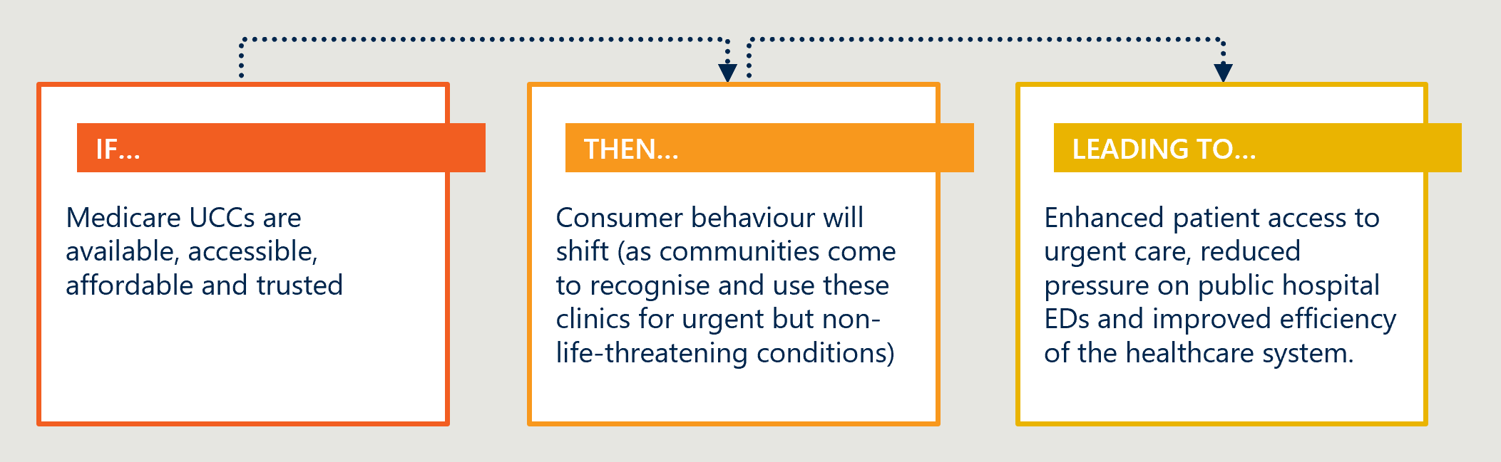
The logic model (Figure 20) complements this theory by mapping the inputs, activities, outputs and outcomes of the Medicare UCC program. It includes key program components such as staffing, resources, operational activities and the strategic deployment of services that contribute to the desired change. All relevant aspects of the program are considered, from initial service design to outcomes, including the enhancement of patient pathways and the integration of services within local healthcare ecosystems.

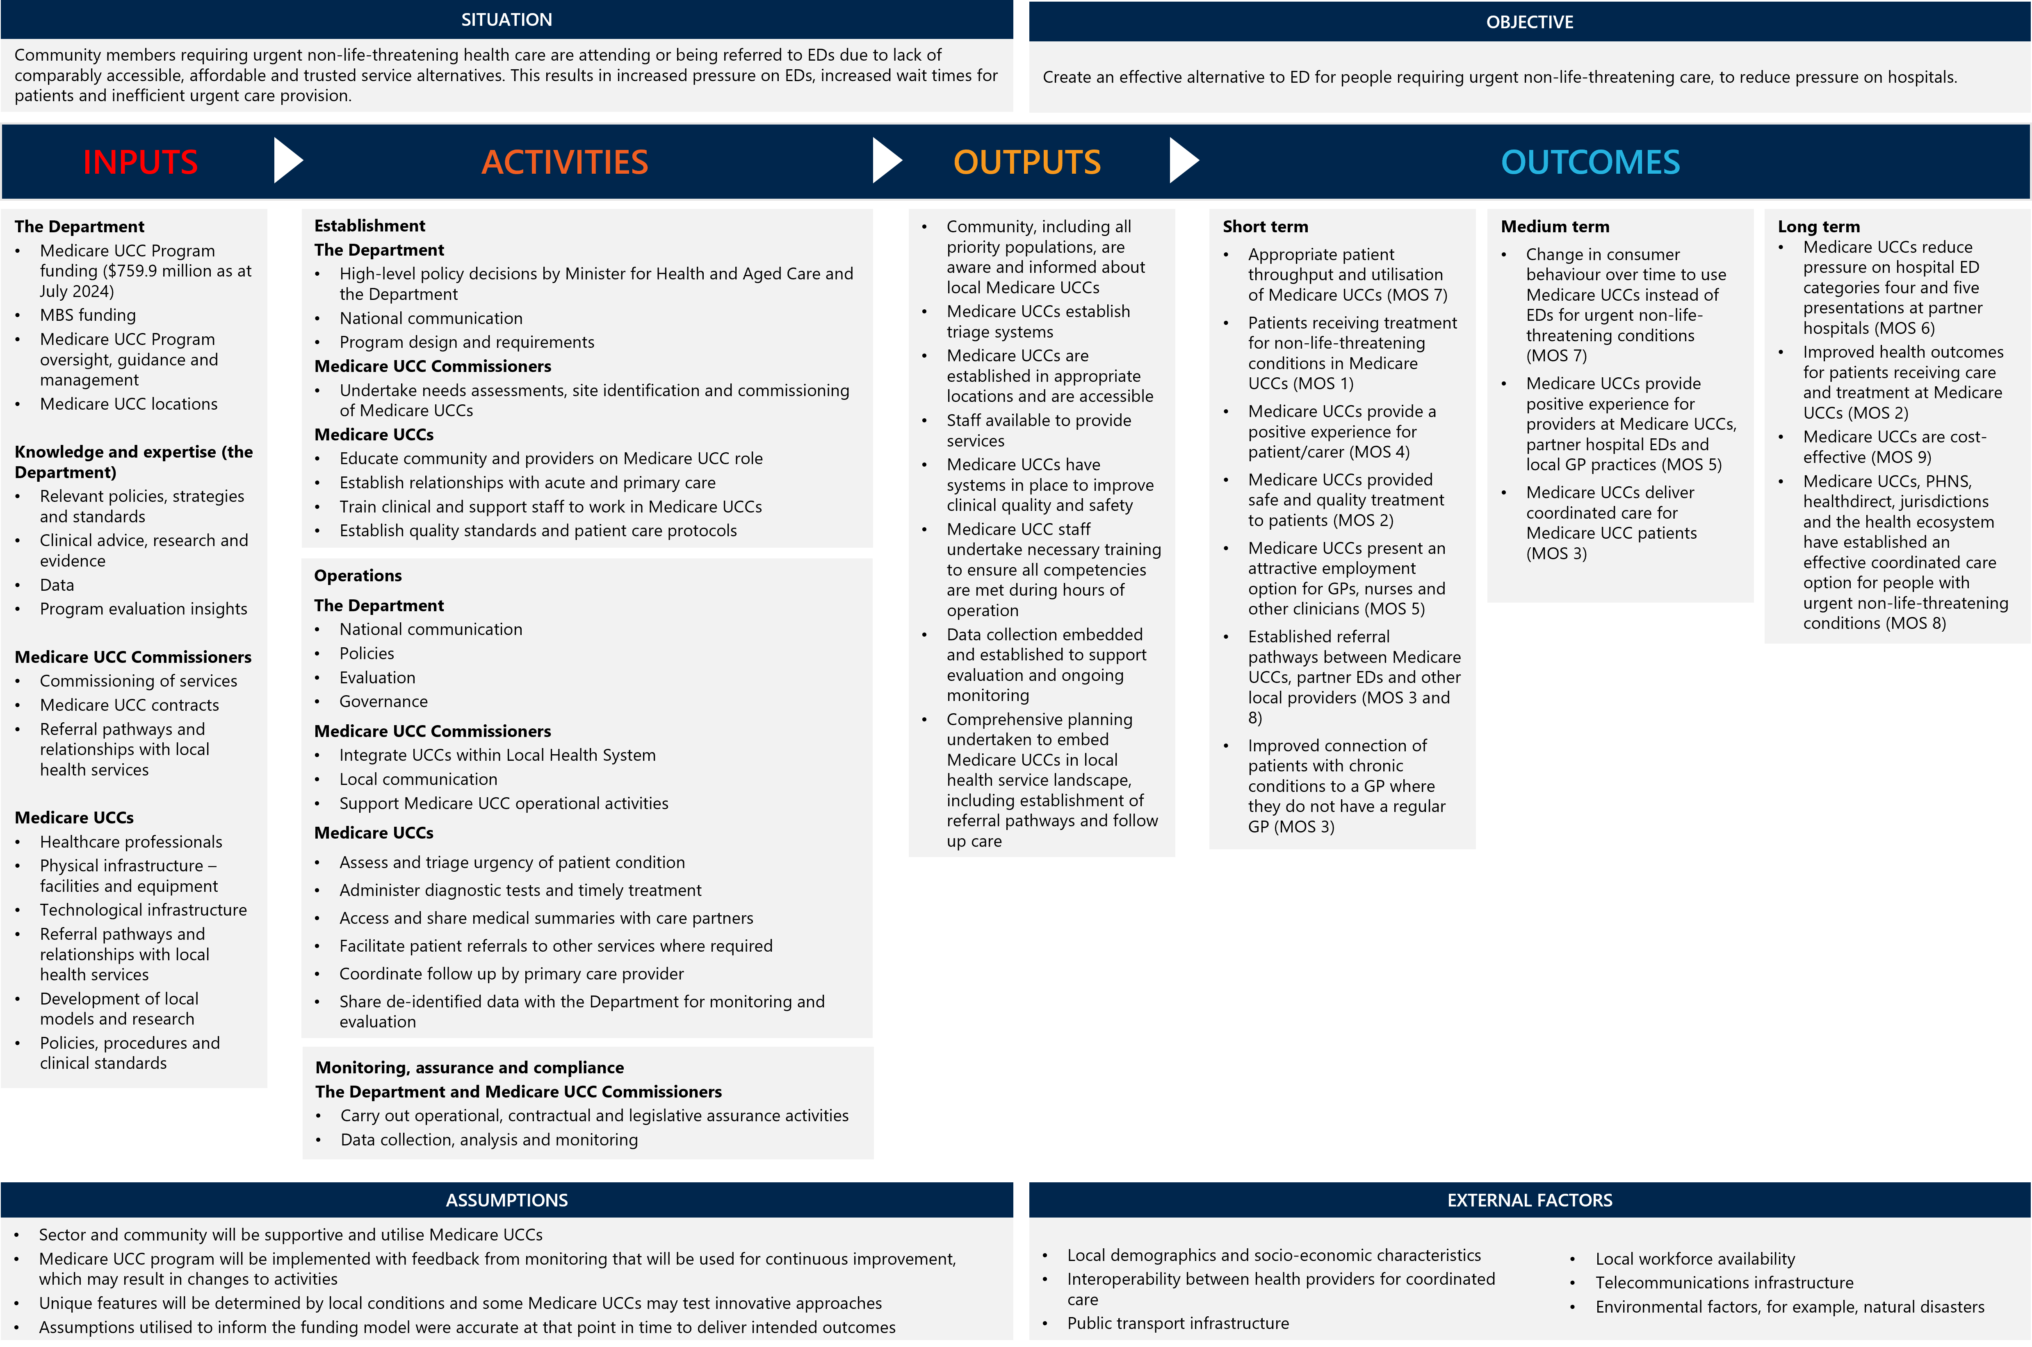
Figure 20 | Medicare UCC logic model

- Nationally agreed Measures of Success of the Medicare UCC program
The key evaluation questions for this evaluation are based on the nine Measures of Success that were agreed by the Australian, and state and territory governments (Figure 1Figure 21).
The Measures of Success were designed to assess the quality of care, accessibility of services and cost-efficiency in Medicare UCCs, as well as their impact on consumer behaviour and the extent to which they alleviate demand pressures on hospital EDs. The measures acknowledge the necessity for Medicare UCCs to be integrated effectively into the broader health ecosystem. This includes seamless connections with local GPs and other primary care services, and partner EDs, ensuring a comprehensive and coordinated approach to patient care.
Figure 21 | Measures of Success for the Medicare UCC program
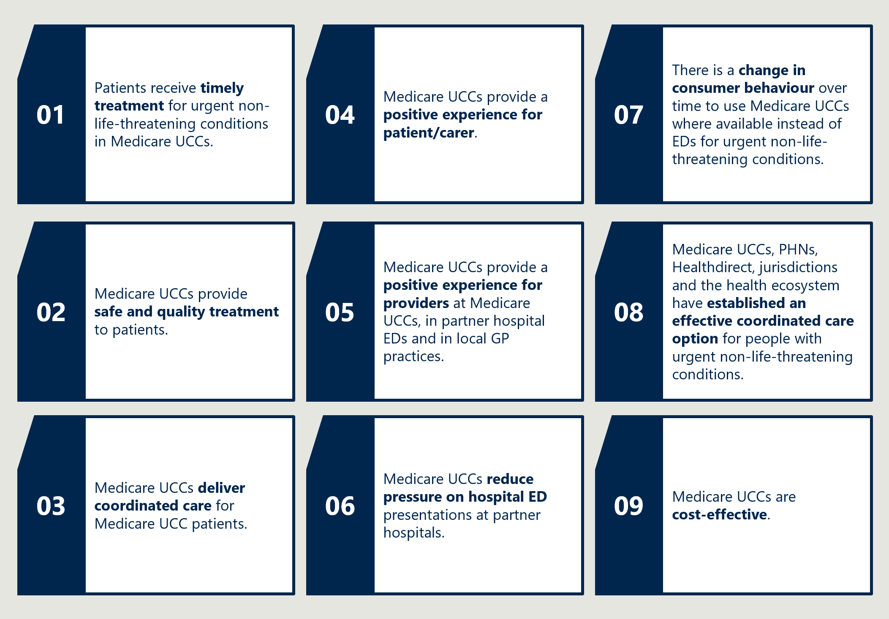
- Evaluation phases
The evaluation is being conducted from 2023 through to 2026. Interim Evaluation Report 1 was delivered at the end of 2024 and a Final Evaluation Report will be delivered in late 2026. Figure 22 illustrates anticipated outputs for each phase and report in the evaluation.
Figure 22 | Phases of the Medicare UCC evaluation
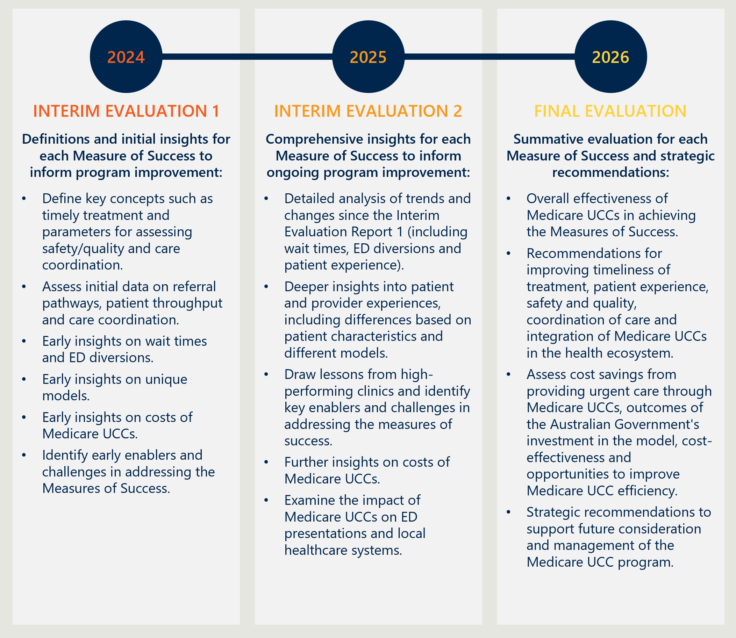
- Data sources for Interim Evaluation Report 2
- Data sources
The data sources used for this Interim Evaluation Report 2 are listed below.
Stakeholder engagement. Stakeholder engagement was a focus through the second phase of the evaluation. For this Interim Evaluation Report 2, stakeholder engagement included:
- consultations with all the Medicare UCC commissioners across Australia, including PHNs and the state and territory health authorities
- interviews with managers and staff from seven Medicare UCCs to understand operations in various local contexts, including Medicare UCCs from each state and territory
- focus group with local ecosystem stakeholders corresponding to seven Medicare UCCs
- interviews with representatives from nine peak bodies
- interviews with three focus groups of patients and carers who attended a Medicare UCC
- an interview with healthdirect
- consultation with the Medicare UCC Operational Advisory Group, which advises the Department on program operations and policy.
There were nine total participants who consented to participate in the patient focus groups. This included representation from all states/territories except for Western Australia and the ACT. Participants predominantly came from metropolitan areas (MM1) and regional centres (MM2), with one participant from a large rural town (MM3). One South Australian clinic was overrepresented, with four focus group participants attending that clinic. Focus group participants predominantly identified as women.
A list of specific organisations consulted for Interim Evaluation Report 2 is provided in Appendix C.
Survey responses. The evaluation ran two surveys to receive feedback and input to the experiences of staff and patients engaging with Medicare UCCs. The two surveys were:
- A staff survey which received responses from 474 staff in Medicare UCCs, including 188 nursing staff, 87 medical staff and 144 administration staff. The survey examined the perspectives and experience of clinic staff, and the capacity for staff to access and provide coordinated care and care referrals. The survey received responses from all states and 90 per cent (78 clinics) of all Medicare UCCs. The survey was distributed to all Medicare UCCs through commissioners. Clinics were instructed to provide the survey to staff via email. The staff survey was open for a period of six weeks between 20 June and 1 August 2025.
- A patient survey which received responses from 816 patients and carers. The survey examined patient experiences with Medicare UCCs, including overall experience, reasons for coming to the clinic, waiting times, and perspectives and experiences with clinic staff. The survey received responses from all states and 64 per cent (56 clinics) of all Medicare UCCs. However, Victorian respondents are overrepresented (63 per cent of all respondents), with 49 per cent of all respondents coming from four Victorian clinics. A poster and patient handout with a QR code to access the survey was distributed to all Medicare UCCs via commissioners. Clinics were instructed to print and display the poster/handout. The patient survey was open for a period of seven weeks between 3 July and 24 August 2025.
- Program information provided by the Department, including:
  - characteristics of Medicare UCCs, their location, opening hours, workforce details, radiology and pathology arrangements
  - maturity of referral pathways between Medicare UCCs and other health services
  - grants provided to Medicare UCC commissioners
  - federation funding agreement Medicare UCC performance reports
  - Medicare UCC policies to support priority populations.
- Medicare UCC aggregate presentation counts. Each Medicare UCC reported an aggregate count of presentations for each day from the date it opened, up to 30 June 2024. From 1 July 2024 the Medicare UCC Module is the only form of data reporting for most Medicare UCCs, including newly onboarded Medicare UCCs. At 10 August 2025, the five ACT Medicare UCCs and six remote NT Medicare UCCs continued to report aggregate data rather than through the Medicare UCC Module.
- Medicare UCC Module data and data extracts implemented prior to the Module being implemented. Unit record data is available for 76 Medicare UCCs, whereas for another 11 clinics, only aggregate counts of presentations are available. These include the five ACT Medicare UCCs and the six remote NT Medicare UCCs.
- MBS data. For claims related to provider numbers associated with the Medicare UCCs.
- Publicly available ED data. Aggregate ED data reported by the AIHW and state and territory health departments, derived from NAPEDC data.
- NAPEDC data. National ED data set used for ITS and DiD analyses.
- Other publicly available data. A range of external data sources are used for comparisons, designed to provide a deeper understanding of the Medicare UCCs. They are used for example to compare demographic characteristics of patients attending Medicare UCCs with the general population and the geographic distribution of the Medicare UCCs compared with the distribution of the Australian population.
- Data limitations
For Interim Evaluation Report 2 the evaluation has identified the following data limitations which were also present in Interim Evaluation Report 1:
- Recency of program implementation. The second phase of 29 Medicare UCCs were established between 1 July 2024 and 30 June 2025, meaning many clinics have not yet completed 12 months of operation at the time data was gathered and analysed for this report. As a result, the available data may be insufficient to fully assess the clinics’ performance or comprehensively measure their impact.
- Data is only available as aggregate counts for some presentations, including those from the remote NT and ACT Medicare UCCs, presentations prior to implementation of the Medicare UCC Module in some clinics, where the patient has specifically requested data not be released through the Medicare UCC Module, and where an interim data extract was implemented prior to the availability of the Medicare UCC Module. In the tables throughout this report ‘Aggregate and other unit records counts’ have been used as appropriate.
- Missing data. Some variables collected through the Medicare UCC are non-mandatory, poorly completed or missing. For example, Aboriginal and Torres Strait Islander status and reason for visit.
- Variation in the interpretation of several mandatory and non-mandatory data items in the Medicare UCC Module. Several items may be interpreted and reported differently by Medicare UCC staff (for example, where the patient would have gone otherwise and reason for visit). Analyses based on these items should be treated with caution.
- Data availability to measure equity of access for priority populations. Data to measure clinic usage by priority populations (for example, information on country of birth, language spoken at home and interpreter usage) is poorly reported, limiting insights able to be drawn.
Additional data limitations related to the evaluation’s patient survey have been identified:
- Overrepresentation of some clinics. The evaluation’s patient survey received responses from 64 per cent (56 of the 87 Medicare UCCs) with high representation (49 per cent) of respondents in the top four clinics. Responses were received from all states and territories, but Victorian respondents are overrepresented. Analyses based on these items should be treated with caution due to the uneven response rate.
- Selection bias in the surveys. Individuals with particularly positive or negative experiences may be more likely to complete the survey, given its voluntary recruitment style. Additionally, the patient survey is likely to underrepresent some presentation types, such those presenting in more pain or with unwell children. Interim Evaluation Report 1 used the Medicare UCC Module item ‘Where would you have gone otherwise’ and publicly available ED data to assess the impact on partner hospital EDs. Whilst these data provided valuable insights, a range of limitations were identified including the ability to apply robust methods for assessing causal relationships. For Interim Evaluation Report 2, the evaluation has applied an ITS and DiD analyses to strengthen causal inferences, using data from the NAPEDC.
- List of external stakeholders consulted for Interim Evaluation Report 2
A range of stakeholders were consulted for this evaluation report and are detailed in Table 13.
Table 13 | External stakeholders consulted for Interim Evaluation Report 2
Stakeholder group | Organisation
Consumer representatives | N/A – patients and carers recruited to participate in focus groups via expression of interest form at the end of the evaluation’s patient survey.
Peak bodies | Royal Australian College of General Practitioners  Australian Medical Association  Australian College of Rural and Remote Medicine  Australian College of Nursing  Australian Nursing and Midwifery Federation  Australian College of Emergency Management  Australian College of Paramedicine  Australian Practice Nurses Association  Australian Association of Practice Managers
Commissioners | Northern Queensland PHN  Darling Downs and West Moreton PHN  Central Queensland, Wide Bay, Sunshine Coast PHN  Brisbane North PHN  Brisbane South PHN  Gold Coast PHN  Central and Eastern Sydney PHN  WentWest (Western Sydney PHN)  Sydney North Health Network  South Western Sydney PHN  South Eastern NSW PHN  Hunter New England and Central Coast PHN  Wentworth Health Care (Nepean Blue Mountains PHN)  Healthy North Coast (Mid North Coast PHN)  Victorian Department of Health  Murray PHN  WA Primary Health Alliance  Adelaide PHN  Country South Australia PHN  Northern Territory Health  Australian Capital Territory Health  Department of Health Tasmania
Phone triage services | Healthdirect
Medicare UCC Managers and staff | Site visits to:  Bendigo Medicare UCC  Cairns South Medicare UCC  Devonport Medicare UCC (virtual meeting only)  Elizabeth Medicare UCC  Maroubra Medicare UCC  Palmerston Medicare UCC  Perth City Medicare UCC
Local ecosystem stakeholders corresponding to site visit locations | Corresponding to site visit locations:  Bendigo  - Bendigo UFS Pharmacy  Cairns South  - North Queensland Ambulance  - Cairns Hospital  Devonport  - Northwest Regional Hospital  - Mersey Community Hospital  - Primary Health Tasmania  Elizabeth  - Department of Health SA  - Central Adelaide Local Health Network  Europa Medical Centre Maroubra  - NSW Ambulance  Palmerston  - Team Health  - I-Med radiology  - NT health  Perth City  - Royal Perth Hospital
Non-commissioning PHNs | ACT PHN  Tasmania PHN  South East Melbourne PHN  West Victoria PHN  North West Melbourne PHN  East Melbourne PHN
Medicare UCC Operational Advisory Group | N/A

- Supplementary table
This appendix reports results for two regression analyses the evaluation conducted on wait times and patients who reported they would have otherwise gone to ED.
Table 14 | Results of regression analysis to identify factors affecting wait times and whether patient would have gone to ED had the Medicare UCC not been available
Model | Covariate | Estimate | Std.error | P.value | Conf.low | Conf.high
Wait times (mins)
 | Regionality – Metro/MM1 | 4.228 | 0.067 | <0.0001 | 4.095 | 4.361
 | After hours | -1.010 | 0.177 | <0.0001 | -1.357 | -0.663
 | Time of day – Morning | 6.229 | 0.172 | <0.0001 | 5.891 | 6.567
 | Day of week – Monday | 4.309 | 0.215 | <0.0001 | 3.479 | 4.309
Would have gone to ED (odds ratio)
 | Regionality-Metro/MM1 | 0.845 | 1.002 | <0.0001 | 0.841 | 0.848
 | After hours | 1.144 | 1.002 | <0.0001 | 1.139 | 1.150
 | Time of day – Morning | 1.074 | 1.004 | <0.0001 | 1.065 | 1.083
 | Day of week – Monday | 0.991 | 1.005 | 0.3092 | 0.981 | 1.001
Source: Medicare UCC Module data. Generalised linear mixed effects regression with adjustment for clinic-level mean. After preliminary modelling to identify relevant covariates and levels, data was re-categorised such that each of the covariates above was binary. That is, Morning (9:00 am to 12:00 pm) was compared with all other times of day, MM1: was compared against all other MMM levels and so on. Regionality/MMM determined by patient postcode.
- ITS and DiD analyses
This appendix provides details on methods and results of analyses of the impact of Medicare UCCs on urgent-care-equivalent ED presentations, using data up to March 2025. The analyses followed the Medicare UCC Evaluation Plan, which included a statistical analysis plan, agreed with the Department prior to the conduct of this analysis. The description of DiD methods in Appendix E.3 includes details of variation from the original plan. Other variations from the original evaluation plan are noted at relevant sections in this appendix.
This appendix starts with a description of data sources and definitions (Appendix E.1). It then presents details of each of the analysis approaches and the results. These methods are referred to as causal inference methods. The intention is to conduct statistical analyses for which there are good reasons to identify estimated coefficients as representing causal effects. The methods applied include:
- ITS (Appendix E.2), where the unit of observation is the ED/hospital.
- DiD (Appendix E.3), where two approaches were applied with alternative units of observation, specifically:
  - EDs/hospitals – where partner EDs/hospitals were compared with other EDs/hospitals
  - Postcodes – where the postcodes that formed the catchments of Medicare UCCs were compared with other postcodes.
Table 21 in Appendix E.5.1 provides details of the methods, including the nature of the causal effect that the analysis is intended to estimate (the ATT – the average treatment effect for the treated units), weighting methods (which are equivalent to the propensity score approach) applied to achieve balance between the treatment and control units, definitions of treatment and control units and exclusions applied, the primary and secondary outcomes, and models estimated.
Analyses were conducted with units related to:
- Tranche 1 Medicare UCCs (58 clinics), that is those that commenced operation between July and December 2023. Analyses of Medicare UCCs that commenced later (in 2024 and 2025) have been excluded at this stage, as there are insufficient observations for the post-implementation period.
- A subgroup of 44 newly established Tranche 1 Medicare UCCs. These were new services that commenced operations between July and December 2023, whereas other Tranche 1 Medicare UCCs, transitioned from a prior arrangement. The primary analysis of impacts has been focused on this subgroup of newly established Medicare UCCs and these are the focus of results described in the following sections. It was reasoned that these units provide the best basis for estimating the impact of Medicare UCCs, as transitioning Medicare UCCs will have had an impact on ED activity prior to the program’s commencement.
Additional analyses of all Tranche 1 Medicare UCCs are presented in Appendix E.5. This incorporates additional tables, including comparisons of treatment and control units pre-intervention, the results of weighting units and analyses of secondary outcomes.
In addition to presenting the estimates of relevant effects and their 95 per cent confidence interval, additional analyses were conducted to estimate the number of reduced urgent-care-equivalent ED presentations for the last 12 months of observed ED data, that is, between April 2024 and March 2025. These estimates have also been expressed as the per cent reduction in urgent-care-equivalent ED presentations.
- Data sources and steps preparing these for analysis
Data from the NAPEDC held by the Department was extracted by Departmental staff. This dataset was obtained from IHACPA using data supplied by states and territories to IHACPA and the AIHW.
The data extracted included ED presentations that occurred between 1 July 2021 and 31 March 2025. Analysis was largely conducted on data from 1 January 2022 to 31 March 2025, due to issues identified in the data for the last six months of 2021 related to inclusion of COVID-19 testing.
Additional aggregate data for partner EDs/hospitals has been provided up to 30 June 2025 under a data sharing agreement. Trends for partner EDs/hospitals derived from the data sharing agreement data and the NAPEDC data have been presented in Section 2.6. While the data sharing data could not be included in the analysis presented below, the trends observed largely confirm that there have been no changes in the April to June 2025 period that would materially affect the analysis described in this appendix.
National Minimum Dataset (NMDS) for ED care, except Statistical Area 2 (SA2) of the patient’s residence and “source of funding, patient funding source. SA2 was excluded as this was not specified within the Medicare UCC data sharing agreement developed between the Department and states and territories. The absence of SA2 created complexities for the data analysis, with postcode of the patient’s residence (which was specified in the data sharing agreement) used in the DiD analysis described below.90F90F
The primary analysis described below was conducted on a subset of the NAPEDC dataset, as specified in the evaluation plan, referred to in this appendix as urgent-care-equivalent ED presentations. The definition for this activity was drawn from a National Healthcare Agreement indicator91F91F definition, which is described in Figure 23.
The data item for “source of funding, patient funding source” (METEOR Identifier 780491), was not included in the dataset provided. It is possible the data was restricted to a subset of the whole data based on this data item. Although this could not be verified, any exclusions based on this item are likely to be immaterial.
Figure 23 | Primary definition of ED urgent-care-equivalent activity used for analysis
- Triage category (METEOR identifier 799815) of 4 or 5 on the Australasian Triage Scale.
- Transport mode (arrival) (METEOR identifier 746114) does not include 1 (Ambulance air ambulance or helicopter rescue service), or 2 (Police/correctional services vehicle).
- Type of visit to ED (METEOR 799764) is 1 (Emergency presentation) – excludes 2 (Return visit, planned), 3 (Pre-arranged admission), 5 (Dead on arrival).
- Episode end status (METEOR 796802) does not include 1 (Transferred for admitted patient care in this hospital), 3 (Non-admitted patient ED service episode completed – referred to another hospital for admission), 6 (Died in ED), 7 (Dead on arrival).
Reconciliation with published AIHW data
The NAPEDC dataset supplied did not fully reconcile with data published by the AIHW, although, as described below, the reasons for differences have been explored and addressed. The AIHW published summary tables in Emergency department care 2023-24: Australian hospital statistics, that include the total number of EDs reporting data (specifically Table A3 Public hospital EDs, by public hospital peer group, states and territories, 2023-24) and the count of ED presentations (specifically Table 2.3 ED presentations, by public hospital peer group, states and territories, 2023-24). The AIHW also published hospital (ED) level counts of presentations.92F92F The datasets we refer to in this section as the NAPEDC and AIHW data are separate datasets held by IHACPA and AIHW respectively, albeit drawn from the same primary data collection. The main reasons for discrepancies between these two datasets are outlined below.
The AIHW analysis excludes several EDs that were included in the NAPEDC data supplied for this project. The excluded hospitals are largely based in Queensland and Western Australia, and mostly related to hospitals that are allocated to “Public Acute Peer Group D” or a peer group of “Other”. Additionally, the AIHW did not report on Queensland hospitals in “Public Acute Peer Group C”.
Hospitals in Hospital Peer Group D and Other tend to be located in outer regional and remote areas, or to have a specific role. Many of these are referred to as Emergency Services, according to definitions developed by the Australian College of Emergency Medicine as they do not have the full capacity to operate as EDs, including the required 24-hour availability of medical staff. In contrast, EDs are typically located within larger hospitals and provide comprehensive 24/7 emergency care, including resuscitation, stabilisation and initial management of all emergencies. The partner hospitals for Medicare UCCs all have EDs.
For several analyses, hospitals allocated to Peer Group D or Other have been excluded from analysis, as they are generally not located in the catchments within which Medicare UCCs are located. Analyses in which matching or weighting is undertaken have generally resulted in a similar outcome, as discussed below.
Table 15 provides a reconciliation between the NAPEDC dataset supplied for this analysis and the AIHW published data, focussing on 2023-24. Table 16 provides more detail on the reconciliation between these two data sources.
Table 15 | Emergency department presentations, supplied NAPEDC extracts vs AIHW published data, by hospital – and presentation-level inclusions, financial year 2023-24
 |  | NAPEDC extract:  A: All hospitals (a) (n = 442) | NAPEDC extract:  B: Hospitals included in AIHW reports (a) (n = 293) | AIHW data (d):  C: All hospitals included in reports (a) (n = 293) | NAPEDC extract:  D: Selected hospital peer groups (n = 232) | NAPEDC extract:  E: Selected hospital peer groups, also reported in AIHW data (b) (n = 207) | AIHW data:  F: Selected hospital peer groups (b) (n = 207)
 | Total | 9,858,456 | 9,051,296 | 9,015,450 | 9,158,832 | 8,813,747 | 8,779,225
 | Triage 4 or 5 | 4,263,346 | 3,742,930 | 3,711,436 | 3,810,333 | 3,590,427 | 3,559,878
 | Primary analysis dataset (c) | 3,321,626 | 2,875,829 |  | 2,933,565 | 2,748,888
Notes:
        - For 2023-34, the NAPED extract included 442 hospitals and the AIHW reports included 293 hospitals. The main differences relate to hospitals in Queensland and Western Australia that were not included in AIHW reports. These largely relate to the AIHW not including Hospital Peer Group D hospitals and (for Queensland) Hospital Peer Group C. When the NAPEDC extract was limited to the 293 hospitals included in AIHW reports, there was a discrepancy of 35,846 episodes (Column B vs Column C).
        - When the NAPEDC extract was limited to the 207 hospitals included in AIHW reports that were used for primary analysis, that is, excluding Hospital Peer Group D and the Other Peer Group, there was a discrepancy of 34,522 episodes (Column E vs Column F), which reduced to 30,549 when only triage categories 4 and 5 are considered. Comparison of hospital level presentation totals suggests that presentations with episode end status of 8: Registered, advised of another health care service and left the emergency service without being attended by a health care professional are omitted from published AIHW data for Victorian hospitals in 2023-24. There were 29,904 presentations in total with this end status for Victoria in 2023-24 and 29,108 presentations with this end status and triage category of 4 or 5. The remaining 1,441 presentation difference between the supplied NAPEDC data and published AIHW data represent 0.4 per cent of comparable data from 207 hospitals and may be explained by a combination of: small cell suppression in AIHW data, inconsistent determination of financial year, variation in the inclusion of presentations by funding source.
        - Excludes presentations: with triage categories of 1, 2, 3 or 9 (not recorded); that were planned or pre-arranged; that arrived by ambulance or police/correctional services vehicle; that ended in admission to hospital; where the patient died in emergency or was dead on arrival.
        - AIHW totals are summed from hospital-level data. AIHW also publish a national total of 9,015,545 presentations in 2023-24. This difference, of 95 presentations, is due to censored small cell counts in hospital level data.

Table 16 | Reconciliation between provided NAPEDC data and published AIHW data, financial year 2023-24
 | Hospitals (n) | Presentations (n)
NAPEDC extract provided for evaluation | 442 | 9,858,456
Restricted to hospitals in AIHW data | 293 | 9,051,296
AIHW published data | 293 | 9,015,450
Difference: See note (a) | 0 | 35,846
Selected hospital peer groups See note (a)
NAPEDC extract provided for evaluation | 232 | 9,158,832
Restricted to hospitals in AIHW data | 207 | 8,813,745
AIHW published data | 207 | 8,779,225
Difference: See note (b) | 0 | 34,520
Hospitals within selected peer groups not included in AIHW data. See note (a) | 25 | 345,087
Notes: (a) Principal referral, public acute group A, B or C, Womens and Childrens hospitals. (b) Comparison of hospital totals suggests that presentations with episode end status of 8: Registered, advised of another health care service and left the emergency service without being attended by a health care professional are omitted from published AIHW data for Victorian hospitals in 2023-24. There were 29,904 presentations with end status of 8 in the provided data for Victoria in 2023-24.

Additional steps to subset the NAPEDC dataset
For several analyses described below, subsets of the data were used. Where these exclusions have been applied, this is highlighted in table titles and notes. Key issues include the following:
- The time period for analysis was truncated to 1 January 2022 to 31 March 2025. It was observed that some EDs had included patients presenting for COVID-19 testing, generally assigned to triage categories 5, during the July to December 2021 period and there was no feasible way in which these could be excluded.93F93F
- Patients with an Episode end status (METEOR 796802) of 4 (Did not wait to be attended by a health care professional) and 8 (Registered, advised of another health care service and left the ED prior to commencement of clinical care) were excluded from some analyses.
- For the DiD analysis where ED attendances by postcode were analysed, postcodes largely located in MMM categories of 4, 5, 6 and 7 have been excluded. This is for the following reasons:
  - There are very few (nine) Medicare UCCs located in these regions and those Medicare UCCs that are located in those regions have particular characteristics that mean that relevant comparisons are not feasible.
  - In most instances postcodes in MMM categories 6 and 7 cover large geographic areas well beyond the locality in which remote Medicare UCCs are located.
  - In most instances there is no ED or emergency service in or near to these localities, and patients requiring ED care have to travel long distances or require aeromedical evacuation.

Postcodes
There are several technical challenges in using postcode data in geo-statistical analysis. These include:
- Postcodes can include both codes that correspond to a geographical postal delivery area and codes that relate to PO Boxes or an institution such as a university, or location for which there is no resident population. The postcodes reported in the NAPEDC data include codes that do not relate to a postal delivery area. There are also postcodes that may be missing, sometimes for a legitimate reason. For example, that patient may not be an Australian resident, or may not have a fixed address.
- Postcode boundaries are defined by Australia Post for mail delivery purposes, not for statistical consistency. Boundaries can change frequently, with new postcodes created and others retired as delivery routes are adjusted. Over time, this undermines comparability in longitudinal analyses unless historical postcode concordances are carefully applied.
- Postcodes can vary greatly in geographic size and population density. In metropolitan areas, a postcode may represent a few city blocks; in remote regions, it may cover hundreds of square kilometres.
- Because postcodes are not designed for statistical purposes, denominator data (population counts) must be estimated via concordances from ABS Statistical Areas.
To address these issues, reported postcodes were mapped to an appropriate geographic postal delivery area, where this was feasible. Otherwise, postcodes were assigned to:
- 97 Not applicable
- 98 Unknown
- 99 Not stated/inadequately described
- Invalid.

Population data
Population data was sourced from several public datasets to estimate monthly population at the postcode level. With the exception of census night counts, population estimates are not generally available at the postcode level. Postcode estimates were produced in a two-step process:
- Monthly resident population estimates were sourced or estimated for the period 30 June 2021 to 31 March 2025 at the SA2 level.
- SA2 population estimates were distributed to postcodes based on the proportion of population of each SA2 in each postcode in census night counts.
The ABS publishes inter-census population estimates regularly at different cadences depending on geography. Additionally, the ABS have produced SA2 population projects irregularly (see Table 17).
Table 17 | ABS population data
Description | Data period | Date of most recent available data | Publication date of most recent available data
SA2 population by age and sex | Annual | 30 June 2024 | 28 August 2025
Population estimates by SA2 and above | Annual | 30 June 2024 | 27 March 2025
State and territory population by sex | Quarter | 31 December 2024 | 29 May 2025
Mesh block counts, 2021 | Census years | 10 August 2021 | 28 June 2022
SA2 population projections, by age and sex | Annual | 30 June 2022 (base) to 2032 | 14 June 2024
Comparison of most recent available population estimates at SA2 and state/territory level showed a significant divergence between the projection data, for which the base period data was 30 June 2022 and more recent between-census estimated resident population counts. Quarterly state and territory estimated resident population was extrapolated to 30 June 2025 based on the growth rate from 30 June 2024 to 31 December 2024. SA2 population was extrapolated to 30 June 2025 based on the growth rate from 30 June 2023 to 30 June 2024. SA2 population estimates were then multiplied by a state-level factor to ensure both data sets had the same state level totals. Finally, monthly estimates were determined from annual totals by interpolation, assuming consistent growth rates for all months in each quarter.
Using census night meshblock population counts, monthly postcode population estimates were calculated using the proportion of the population of each SA2 within each postcode.
- ITS analysis
- ITS methods
In this series of analyses, an ITS framework was used to estimate the causal effect of Medicare UCC commencement on urgent-care-equivalent ED presentations within partner hospital EDs.
The ITS analysis was limited to the partner EDs/hospitals of Medicare UCCs. ITS did not involve a comparison with EDs in other hospitals.
For Interim Evaluation Report 2, the ITS analysis is limited to the Tranche 1 of Medicare UCCs, that is, those that commenced between July and December 2023. The analysis was not conducted for the second Tranche of Medicare UCCs, which commenced operations from between July and December 2024, due to the relatively small window in which post implementation trends could be observed. (A longer period of implementation will be available for analysis in the Final Report). As described in the introduction, the main focus was on ITS analysis for newly established Tranche 1 Medicare UCCs, altogether additional analyses are presented for all Tranche 1 Medicare UCCs.
Characteristics of partner EDs that have been included in the ITS analysis are provided in Appendix E.5.2 (Table 22). Data was analysed from 1 January 2022 to 31 March 2025. The ITS method uses pre intervention trends to estimate a counterfactual reflecting what would have happened absent the intervention. This enables estimation of (i) an immediate level change at the time of UCC opening and (ii) a post opening change in slope.
The models were estimated using monthly data, with sensitivity analysis conducted on weekly data. The impact of Medicare UCC commencement was estimated for three outcomes:
- Monthly count of urgent-care-equivalent ED presentations.
- Monthly mean waiting time (minutes) for urgent-care-equivalent ED presentations.
- Monthly percentage of urgent-care-equivalent presentations that are seen on time. Seen on time is defined to be a waiting time of within one hour for triage category 4 and within two hours for triage category 5.
Models were estimated separately for two models:
- An aggregated ITS analysis – using the monthly total across partner hospitals in scope (i.e. one record per month). For the aggregated ITS analysis an implementation point of July 2023 was used to define pre and post periods. For the aggregated model heteroskedasticity and autocorrelation consistent robust (HAC/Newey–West) standard errors have been reported.
- A pooled ITS analysis using hospital level data, that is, one record per hospital per month. For the pooled ITS analysis, the month of the first commencement date of associated Medicare UCCs was used to define pre and post periods. The pooled data included hospital specific effects and cluster robust standard errors were estimated.
The basic ITS model specification adopted was as follows:
Y_{it} = β₀ + β₁T_{i} + β₂X_{j} + β₃(T_{i} × X_{j}) + β₄(Sine term) + β₅(Cosine term) + offset
Where T_{i} represents time, X_{j} the intervention indicator and the interaction term (T_{i} × X_{j}) captures the differential post-intervention slope. Seasonal fluctuations were accounted for through sine and cosine terms, while an offset was included to adjust for the number of days within each month. The offset was dropped for the analysis of waiting times and per cent seen on time. The pooled model included a hospital specific term.
A negative binomial model was used to estimate for count data models, a linear model for mean waiting models and a binomial model with log odd (logit) for percentage seen on time models.
Models were estimated for partner EDs/hospitals of all Medicare UCCs from Tranche 1 and separately for partner hospitals of newly established Medicare UCCs. We expected estimates related to newly established Medicare UCCs to provide the best estimate of the impact of Medicare UCCs.
For the mean wait time and percentage seen on time models, presentations were excluded from the analysis if they had an episode end state of “4: Did not wait to be attended by a health care professional” (approximately 10 per cent of urgent-care-equivalent presentations). Episodes were also excluded if they had a wait time longer than 48 hours (approximately 1 per cent of urgent-care-equivalent presentations) since the very long wait times appeared to be a result of issues with the data.
- ITS results
Urgent-care-equivalent presentations
Figure 25 shows the coefficient estimates for the intercept change and slope changes from the ITS models for the count of presentations. The main model of interest is the pooled monthly model. Additional details of estimates for these models are shown in Section E.2.1.
The main model of interest was pooled ITS model for newly established Tranche 1 Medicare UCCs estimated with monthly data. This yielded an estimated change in intercept of -0.026 (CI: -0.043 to -0.009) and a change in slope of -0.006 (CI: -0.007 to -0.004). Both estimates are statistically significant. The change in intercept suggests an overall ‘once-off’ change in ED presentations following the commencement of Medicare UCCs. The change in slope suggests a gradual, ongoing decline in the outcome measure following the commencement of Medicare UCCs.
These results imply a 10.6 per cent94F94F decrease in urgent-care-equivalent ED presentations for the period April 2024 to March 2025, relative to the counterfactual continuation of pre-opening trends. This implies there were approximately 83,821 fewer urgent-care-equivalent ED presentations in this 12 month period.
Models based on weekly data were broadly consistent with the monthly data. The aggregate analysis is generally consistent with the pooled analysis, but coefficient estimates are mostly not statistically significant for the aggregate models.
Figure 24 | ITS: comparison of estimates across models: presentation counts
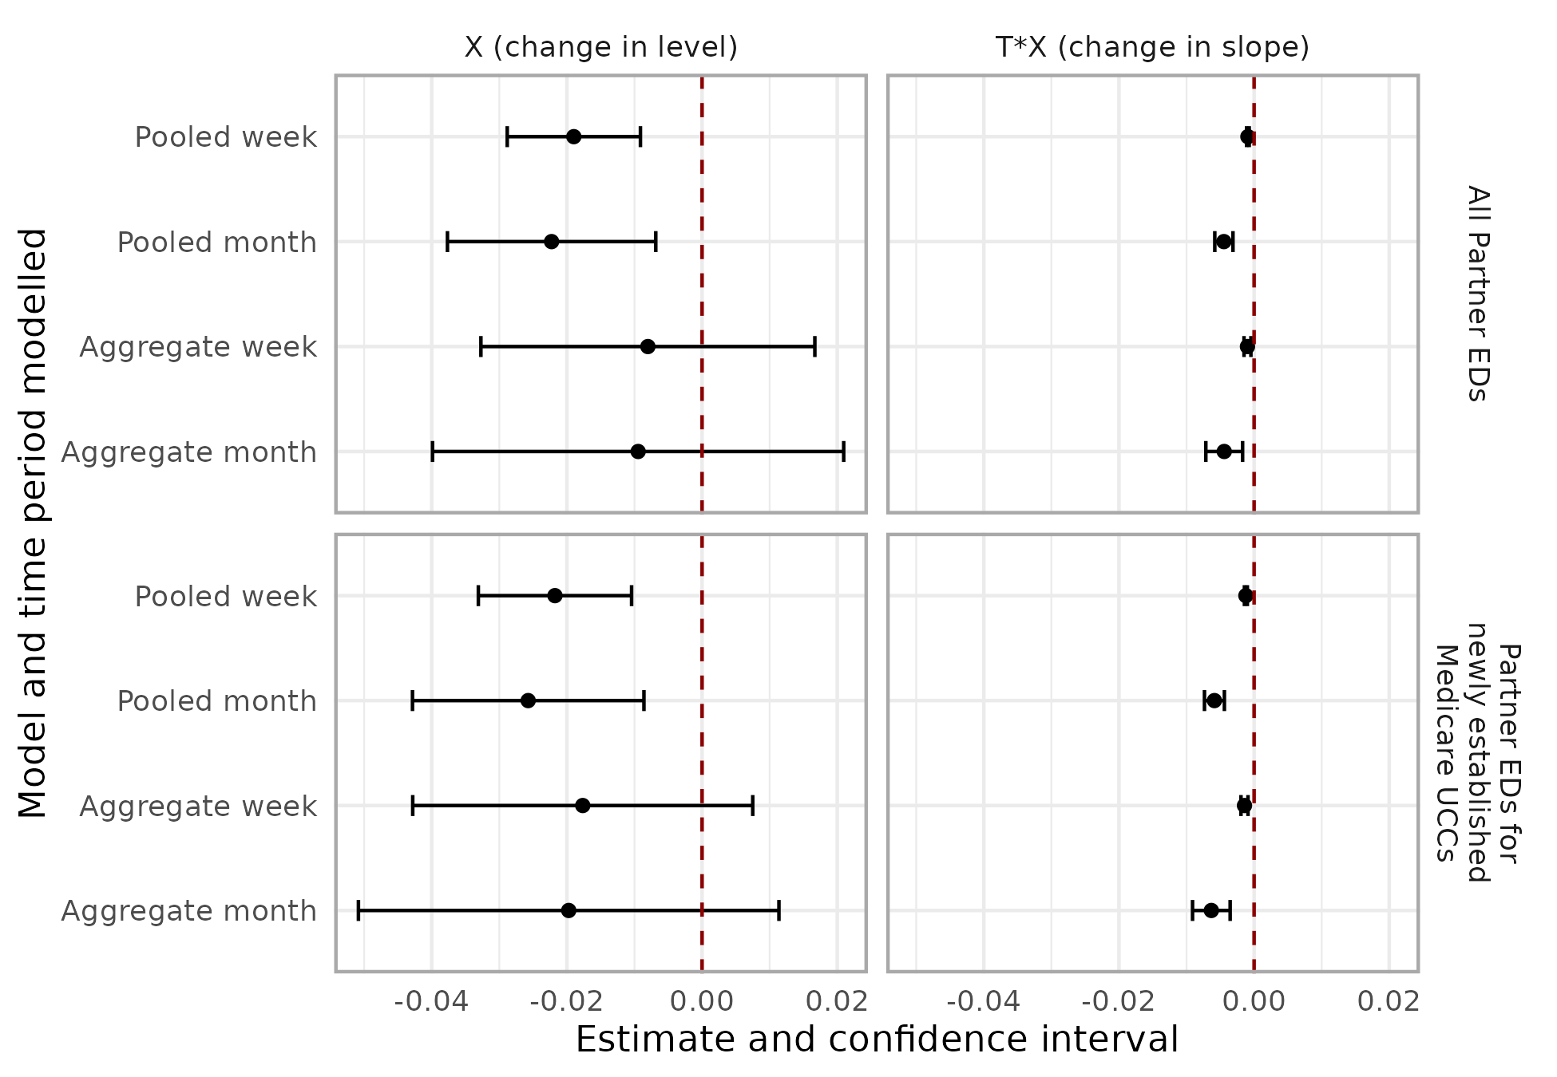
Taken together, these results suggest that the commencement of Medicare UCCs was associated with both an immediate reduction and a sustained downward trend in the outcome across hospitals.
Figure 25 provides a graphical display of the ITS analysis results. To avoid complexity in the presentation, this is based on the aggregate model related to newly established Medicare UCCs, but the chart helps highlight key aspects of these findings. Observed and counterfactual outcome trajectories were plotted, with smoothed monthly values included for both. These charts suggest a divergence between the observed data and counterfactual projections in the post-intervention period.
In summary, the ITS analysis suggests commencement of Medicare UCCs resulted a statistically significant and sustained reduction in urgent-care-equivalent ED presentations.
Figure 25 | ITS analysis: aggregated model with monthly observations: partner EDs/hospitals for newly established Medicare UCCs
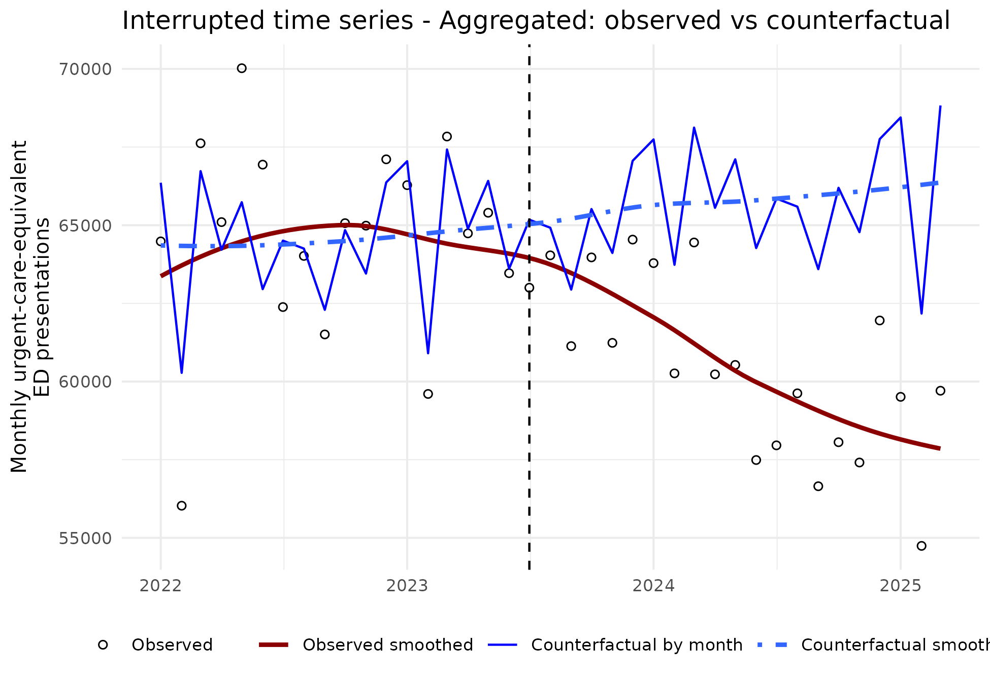

Secondary outcomes
Details of estimates for models for the secondary outcomes – mean waiting times and proportion seen on time – are shown in Table 23. These models provide a mixed picture of the impact of outcomes. While the intercept estimates are statistically significant for some models, this is typically counteracted by a non-significant slope change in the opposite direction.

Summary of key findings from ITS analysis
In pooled hospital-month negative-binomial ITS models related to newly established Medicare UCC, the availability of the Medicare UCC was associated with a general 2.6 per cent reduction in urgent-care-equivalent ED presentations (IRR 0.98; 95 per cent CI 0.958–0.991) and a further 0.6 per cent decrease per month thereafter (IRR/month 0.994; 95 per cent CI 0.993–0.996).
These estimates imply an approximately 9.2 per cent reduction in monthly urgent-care-equivalent ED presentations at 12 months post-commencement of Medicare UCCs (July 2024), relative to the counterfactual continuation of pre-opening trends. Compared with the counterfactual continuation of pre-opening trends, there were 83,821 fewer urgent-care-equivalent ED presentations in the most recent 12 months (April 2024 to March 2025) at the 57 partner hospitals of clinics that opened before 31 December 2023.
The key assumptions in ITS that justify identifying the results of the analysis as estimates of causal effects include (a) outcomes would have continued along the pre-intervention trajectory in the absence of Medicare UCCs and (b) no other relevant changes in policy or context happened during the pre and post implementation periods. While both these assumptions may be problematic, we were not aware of specific policy or service model changes at a national or local level that will have had major direct impacts of the observed outcomes. However, it is important to acknowledge that the health system is very dynamic with many changes occurring at a national, jurisdictional and local level, some of which may indirectly impact the observed outcomes. It is not feasible to gauge the extent to which these other developments have biased the estimate of effect, nor to estimate the direct of any bias.
The potential presence of other factors influencing trends was the reason that the original evaluation plan proposed triangulating the ITS results with a DiD analysis. As discussed below, the DiD analysis, particularly the analysis that focussed on the comparison of partner hospitals with other EDs/hospitals not exposed to Medicare UCCs, provides some additional strength to the conclusions drawn from the ITS analysis, as policy changes will have equally impacted both intervention and control EDs/hospitals.
Another issue to consider in the interpretation of the ITS analysis is whether the commencement of Tranche 2 Medicare UCCs in the second half of 2024 may have impacted the observed trends in the outcome. If this was the case, the ITS may have biased the result towards an over-estimate of the effect. This would be a violation of the no interference assumption discussed in the context of the DiD analysis The issue was considered by examining the geographic location of Tranche 2 Medicare UCCs. In all instances the Medicare UCCs in Tranche 2 were located at least 20 kilometres from Tranche 1 Medicare UCCs and in most instances that distance exceeded 30 kilometres. On this basis it was concluded that the potential impact of Tranche 2 Medicare UCCs on observed trends was very low and that any bias due to this would be relatively minor.
Another issue is that Medicare UCCs may impact ED presentations for both partner and nearby non-partner hospitals. The locations of partner and non-partner hospitals were analysed. While it was observed that in a small number of instances there are nearby non-partner hospitals this was not the case for most Medicare UCCs. It was concluded that the impact on non-partner hospitals would be small.

- DiD analysis
- DiD methods
A DiD design was used to develop additional evidence around the impact of Medicare UCCs on ED outcomes. Specifically, we applied an event study design,95F95F with weighting of observations to balance treatment units and control units across covariates.96F96F The methods adopted are consistent with estimation of an average treatment effect for treated units (ATT). The ATT is the revenant estimand of interest, since the goal of this analysis was to quantify the change in the outcome variables for those units exposed to Medicare UCCs.
The DiD method is appropriate in this context because it allows comparison between EDs/populations exposed to a Medicare UCC (treatment units) and ED/populations not exposed to a Medicare UCC (control units), before and after the implementation of the program. By focusing on changes over time and differences between treated and control units, DiD helps to control for both baseline differences across areas and for time-invariant unobserved confounders. Weighting of observations also improves the comparability of treatment and control groups across potential confounders for which data is available. This strengthens the validity of causal interpretation of analysis, particularly when compared to the before-after comparisons underpinning the ITS analysis.

Model specifications
The primary specification used for DiD modelling was an event study design estimated using two-way fixed effects97F97F through the relevant functions from the fixest package in R,98F98F including fepois() for count outcomes, feols() for the waiting time outcome and feglm() for the proportion of presentations involving long waits. The following shows the key components of the model specification:
$${Y }_{it}= {α }_{i}+ {δ }_{t}+ \sum_{l ≥ t*}{β_{l}}D_{I}^{*}1(t=l) + μ_{it}$$
Where:
- The subscript i designates a unit of observation, which is either an ED or postcode depending on the DiD.
- The subscript t designates the time period. For the primary analysis described below, which was based on Tranche 1 Medicare UCCs, time periods were centered around July 2023. July 2023 was assigned a time value of zero and months prior to July 2023 assigned a negative value and months after July 2023 assigned a positive value.
- Y_{it} is the outcome of interest for unit i in time period t. In this case for primary outcomes – reflecting the count of urgent-care-equivalent episodes – either (a) the number of urgent-care-equivalent presentations at an ED of (b) the number of urgent-care-equivalent presentations for a postcode.
- α_{i} is a fixed effect for unit i. This reflects the extent to which the measure for EDs and postcodes varies from the overall mean for the outcome.
- δ_{t} is a fixed effect for time period t. This reflects the extent to which the measure for time period t varies from the overall mean for the outcome.
- D_{l} is a set of indicator variables representing whether the unit of observation is in the treated group post the commencement of the intervention (value of one) or the control group (value of zero). All indicator variables take the value zero in the periods prior to the intervention.
- β_{ℓ} is the estimate of the treatment effect in period l. In the simultaneous adoption model β_{ℓ} is a DiD estimator between each post period (ℓ ≥ t∗) and the combined pre period.
- µ_{it} is the residual error for unit i in time period t.
For the primary outcome analysis, offset terms were included in the specification. For the ED analysis this was the log of the number of days in the month. For the postcode analysis offsets including both the log of the number of days in the month and the log of the population of the postcode.
Weights for each observation were calculated, consistent with the ATT estimand (see next section) and incorporated into model estimation. Standard errors for estimates for the causal parameter estimate (D_{t}) were generated directly from the model for each post implementation period t.
To estimate an annual effect and confidence intervals, a G-computation method was applied using the model predictions for the latest 12-month period (April 2024 to March 2025). In this approach the estimated model and data for the treated units is used to predict (a) values of the outcome assuming the units are exposed to the intervention and (b) values of the outcome assuming the treated units were not exposed to the intervention (the counterfactual). The difference between these predictions is then calculated and summed across the 12-month period. Bootstrap confidence intervals were then estimated for these differences using the boot package with 1,000 iterations.99F99F

Weighting to achieve balance between treatment and control units
A set of weights were derived to achieve balance between the treatment ED and postcodes, and the control EDs and postcodes. These were derived using the weightit() function from the WeightIt package in R.100F100F The weights were derived to ensure that comparisons account for features of ED or postcodes that may confound comparisons, specifically the following covariates.
Table 18 | DID analysis: covariates included in weighting treatment and control units
A: DiD at hospital level | B: DiD at postcode level
Percentage of patients aged < 15 years  Percentage of patients aged > 75 years  Percentage of patients who are female  IRSD quintile of ED  MMM category of ED (categories 1 to 7)  Peer group of hospital: Principal Referral (including Womens and Childrens), Peer Group A; Peer Group B; Peer Group C; Other) | Percentage of population aged < 15 years  Percentage of population aged > 75 years  Percentage of population who are female  IRSD quintile of postcode  MMM category of postcode (categories 1 to 3)  Distance to nearest ED.

To address limitations of relying on a single parametric model to estimate weights, we used a SuperLearner (ensemble) model101F101F that included the following constituent models: SL.glm, SL.glm.interaction, SL.ranger, SL.xgboost, SL.gam, SL.sda, SL.knn, SL.mean.
The adequacy of overlap, covariate balance and effective sample size for the treatment and control groups were assessed and have been reported below.

Causal inference assumptions
Interpretation of statistical analyses as reflecting causal effects, requires consideration of several assumptions. Our causal interpretation of the event‐study estimates as reflecting causal effects, relies on several standard identification assumptions. First, consistency requires that each unit’s observed outcome under its actual treatment history corresponds to its potential outcome under that same treatment history. Second, the no interference assumption requires that treatment assignment for one unit does not affect the potential outcomes of other units, so that outcomes depend only on the unit’s own treatment status. This assumption is potentially problematic in our analysis as Medicare UCCs can potentially share catchment areas and partner hospitals.
As discussed above in the context of the ITS analysis we considered the issue of the geographic location of Tranche 1 and Tranche 2 Medicare UCCs and their partner hospitals/EDs and reasoned that there was sufficient geographic separation for the potential of interference to be minimal. It is also possible that the catchment areas for ‘treatment’ UCCs and their partner hospitals overlap with each other and with the catchment areas of ‘control’ Medicare UCCs hospitals/EDs. It is also the case that patients will sometimes seek treatment outside their local area. To assess these issues, the catchment postcodes of Medicare UCCs and partner hospitals/EDs were analysed. Our initial conclusion suggests that while spillover patterns can be observed, their size and potential impact on estimated effects is likely to be relatively small. Additionally, it is not clear which direction these spillover patterns will have on estimated effects. This preliminary analysis was based on the postcode of the patient residence, which provides a relatively weak basis for conducting analysis of catchments. In the final evaluation report, a sensitivity analysis will be undertaken to further examine these issues.
Third, exchangeability (or conditional ignorability) assumes that, conditional on observed covariates and fixed effects, treatment assignment is independent of the potential outcomes. With DiD designs, this condition is addressed by the weaker parallel trends assumption, which requires that in the absence of treatment, the average outcomes for treated and untreated units would have followed the same trajectory over time. In the study we aimed to strengthen the plausibility of the parallel trends assumption, by weighting observations to obtain a comparison group that was similar to the treatment group across a range of covariates that may have had an influence on the outcomes observed and the selection into the treatment group. The approach follows the suggestions of Abadie102F102F and subsequent developments.103F103F Covariate balance checks were undertaken to assess the extent to which weights for treatment and control units resulted in equivalence across the identified covariates and variance in numeric covariates. To assess support for the parallel trends assumption we examined graphical and statistical evidence from pre‐treatment trends. We also undertook placebo outcomes analysis using ED presentations assigned to triage categories 1, 2 and 3.104F104F
Fourth, positivity requires that, within the support of the covariates, all units have a positive probability of being assigned to either the treatment or comparison groups. Which is required to ensure meaningful counterfactual comparisons. Weighting of observations included in the analysis partially addresses this issue. We also decided to restrict analysis of postcodes to the geographic regions in which the Medicare UCCs have been mostly located. While there are some Medicare UCCs located in remote communities and very small rural towns, these models are very different to the Medicare UCCs in rural larger towns and cities. We excluded postcodes principally covering population in MMM categories of 4, 5, 6 and 7. This decision was also impacted by pragmatic considerations about the postcodes for these regions, which mostly cover large geographic areas and hence do not precisely identify Medicare UCC catchments.

Comparison groups and outcomes
Two sets of DiD analyses were conducted as described (see Table 21). The first approach applied DiD analysis using the hospital/ED as the unit of analysis – comparing partner hospitals/EDs with other hospitals/EDs. The second approach used postcodes as the unit of observation – comparing postcodes that formed the catchments of the Medicare UCCs with other postcodes. The methods or assigning ED and postcodes to treatment and control groups are also described in Table 21, along with a description of how units were excluded from analysis. The analysis focuses on units that were exposed to the first tranche of Medicare UCCs, that is, those that commenced prior to 31 December 2023. Units exposed only to the second and third tranche of Medicare UCCs have been excluded from the analysis, as there were insufficient observations post their commencement to conduct the DiD analysis. These may be included in DiD analysis undertaken for the final evaluation report. Some additional units were excluded from the analysis for the reasons provided in Table 21.
The primary and secondary outcomes that were analysed are also described in Table 21. The main data sources for the DiD analysis have been described in Appendix E.1. They include outcome measures derived from the NAPEDC which have been summarised by month for each ED and each patient postcode.

Variations from original evaluation plan
The analysis approach here varies from the original evaluation plan in several respects, as follows:
- The original analysis plan did not describe the conduct of DiD analysis at the hospital/ED level. In subsequent discussions the potential to undertake this set of analyses was identified.
- The secondary outcome related to patients seen on time was not included in the original evaluation plan. It was subsequently considered important to investigate whether there were impacts of the proportion of ED presentations seen on time.
- The original evaluation plan specified that catchments for Medicare UCCs and comparator catchments would be defined by SA2 and/or SA3. Due to data governance and approval issues, the SA2 and SA3 of patient residence was not available for this analysis. Therefore, analysis was conducted at the postcode level. This required additional steps which are described earlier in this report. DiD analysis for the final evaluation report will be based on SA2/SA3 geographic units, subject to governance approvals.
- Exclusion from the postcode analysis of postcodes assigned to MMM categories 4, 5, 6 and 7. The exclusion of these geographic areas was not described in the original evaluation plan. However, on review of the issues described above and the overlap between intervention and control postcodes, it was decided that this exclusion was appropriate.
- The original evaluation plan anticipated calculation of age/sex adjusted rates for urgent-care-equivalent ED attendances. Given issues around accuracy of population estimates at the sex and age group at the postcode level, it was considered that this was not appropriate. As an alternative, the methods were applied to achieve balance between the intervention and control postcodes, included demographic characteristics such as the proportion of the population under 15 years, proportion of the population aged 75 and over, and the proportion of the population female. This was considered a more appropriate method, that also allowed incorporation of a broader range of factors impacting comparability of postcodes including socio-economic disadvantage and remoteness.
- The original evaluation plan did not describe in detail options for achieving balance between intervention and control groups, although the exploration of propensity score weighting was flagged. Following discussions with experts in the Department and Australian Government and a review of contemporary methods, it was decided that this would improve the credibility of the DiD analysis.
- The G-computation and bootstrap methods used for estimating annual effects were not described in the evaluation plan. On reviewing the issues, it was decided this would be an appropriate approach to deriving these estimates and robust confidence intervals.
- DiD results

Balance between treatment and control units
This section summarises the characteristics of treatment and control units prior and the results of methods to achieve balance between the treatment and control groups across the specified covariates. Table 24, (Appendix E.6.3) shows some key details of treatment, control and excluded units, in the 12 months prior to the commencement of the Medicare UCC program. Further details of the excluded can be supplied if required.
Balance between treatment and control units was achieved by applying weights derived using the methods described above. Table 25 and Table 26 show three key statistics used to assess balance across the specified covariates. The impact for one of these measures, standardised mean differences, is also shown in the love plots below (Figure 26 and Figure 27). Overall, a good level of balance was achieved across the covariates, with a very small number of covariates having a standardised mean difference beyond recommended levels.
The weighting of control group observations, results in a lower effective sample size for control groups, which is shown in Table 27 (Appendix E.6.3).
Figure 26 | DiD analysis hospital level: Love plot to show impact of differences between treatment and control groups before (unadjusted) and after (adjusted) weighting derived from the Superlearner method: Based on partner EDs/hospitals for newly established Medicare UCCs
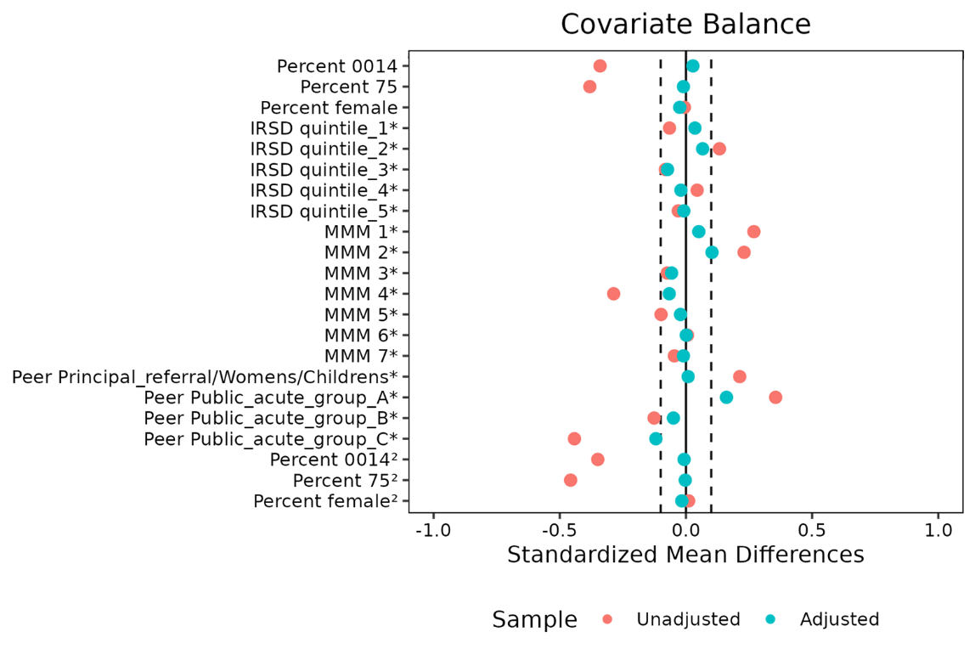
Note: The aim of weighting is to reduce the standardised mean difference between treatment and control groups to close zero (or between -0.1 and 0.1), after weighting.
Figure 27 | DiD analysis hospital level: Love plot to show impact of differences between treatment and control groups before (unadjusted) and after (adjusted) weighting derived from the Superlearner method: Based on postcodes of the catchments for newly established Medicare UCCs
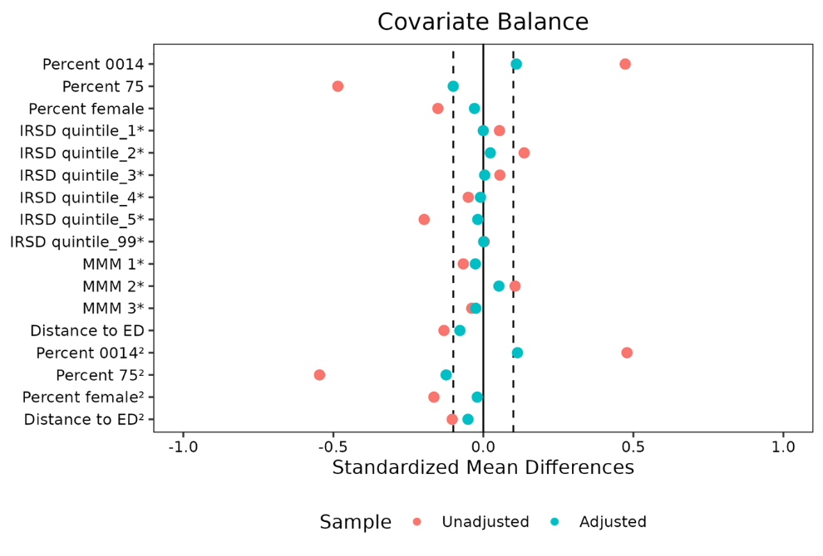
Note: The aim of weighting is to reduce the standardised mean difference between treatment and control groups to close zero (or between -0.1 and 0.1), after weighting.

Time-event model estimates
Figure 28 is a standard plot used for describing the results of a time-event model. The intervention commencement (July 2023) is shown as time zero on this plot. The plot shows the modelled differences between the intervention group and the counterfactual. A point estimate is provided for each time period together with a confidence interval. Ideally the plot should show that there are no (statistically significant) differences in the pre-intervention period. This is the case for the analysis presented in Figure 28. The plot also shows that there are differences emerging the post intervention periods, although statistical significance occurred around six months after the intervention commencement.
Figure 28 is based on the hospital level analysis where the treatment group includes the partner EDs/hospitals of newly established Medicare UCCs. The plot provides support for the hypothesis that there was a meaningful and statistically significant reduction in urgent-care-equivalent ED presentations at the partner EDs/hospitals post Medicare UCC implementation.
Figure 28 | DiD with Event Study design: Poisson model: Differences between observed and modelled counterfactual: Based on partner EDs/hospitals: Newly established Tranche 1 Medicare UCCs
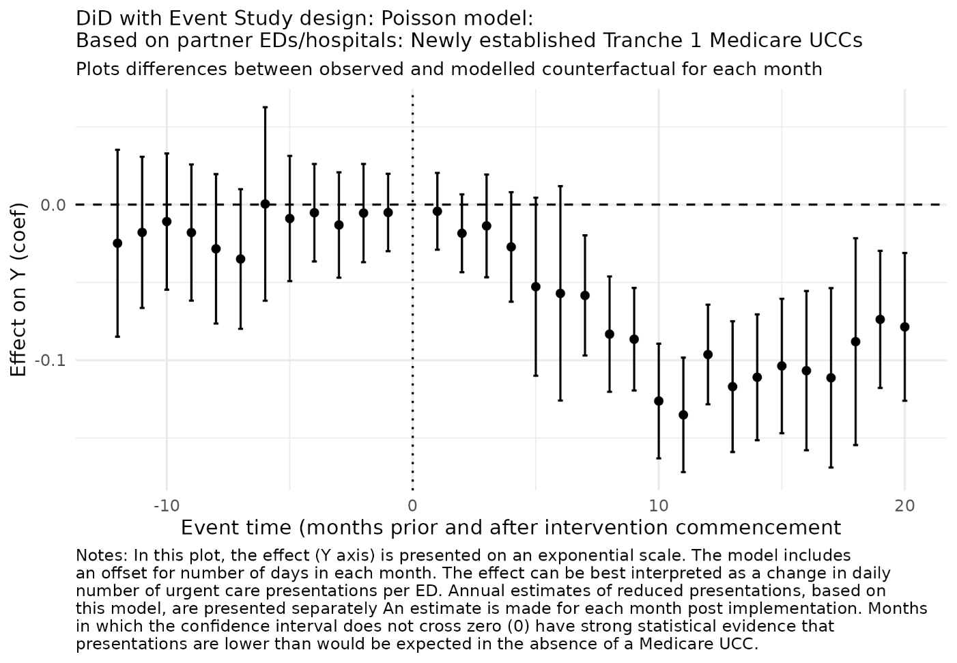
Figure 29 is a plot of the DiD model of postcodes where the treatment group is defined as the catchments of the newly established Medicare UCCs. This plot shows a trend towards reduced urgent-care-equivalent ED presentations, although for most individual months this does not reach statistical significance.

Figure 29 | DiD with Event Study design: Poisson model: Differences between observed and modelled counterfactual: Based on postcodes of the catchments of newly established Tranche 1 Medicare UCCs
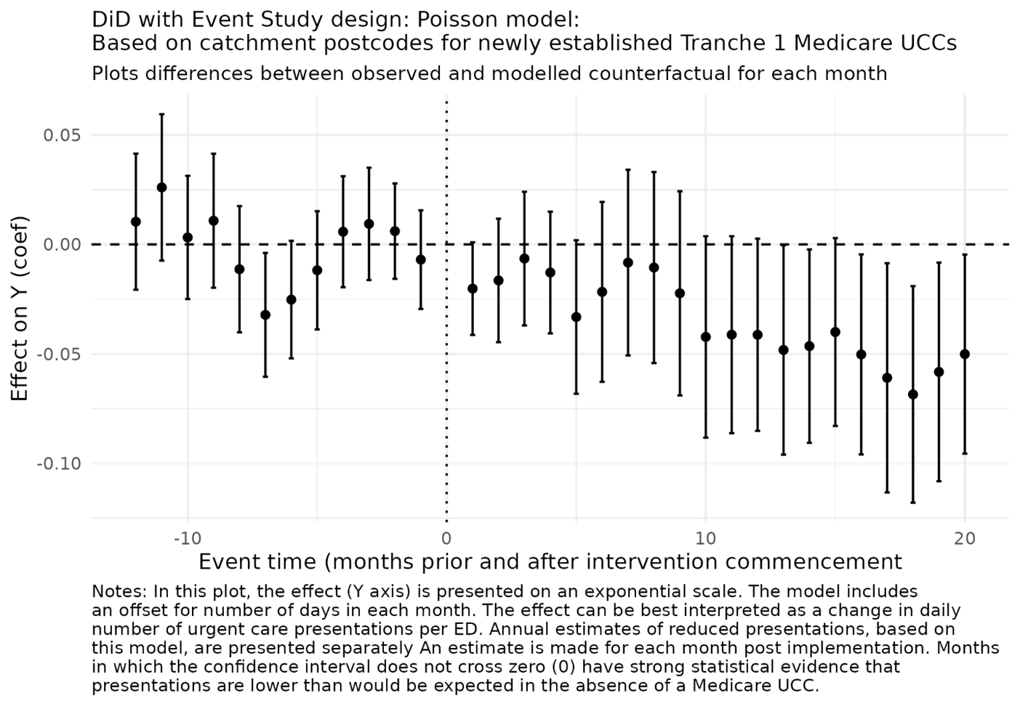
As described above, the G-computation method was used with the models described to estimate implied reduction in urgent-care-equivalent ED presentations for April 2024 to March 2025. The results together with bootstrap derived confidence intervals are shown in Figure 30. These results and the implied percentage reduction are also described in Table 19.
Based on the ED/hospital model it is estimated that there was a reduction of 9.8 per cent in urgent-care-equivalent ED presentations at the partner EDs/hospitals for newly established Medicare UCCs. This is equivalent to around 76,500 presentations. There is a reasonably wide confidence interval for this estimate (48,060 to 110,640 presentations).
The postcode-based model yields lower overall estimates, although it should be emphasised the reference for these is different. Based on the postcode analysis it is estimated there was reduction of 4.6 per cent in urgent-care-equivalent ED presentations for the catchments of newly established Medicare UCCs. This is equivalent to around 26,000 presentations. There is a reasonably wide confidence interval for this estimate (250 to 48,500 presentations). See Appendix E.4 for further discussion on the difference between these models.

Figure 30 | DiD analyses: Plot of estimated reduction in urgent-care-equivalent ED presentations (95 per cent CI) for latest 12 months included in analysis (April 2024 to March 2025)
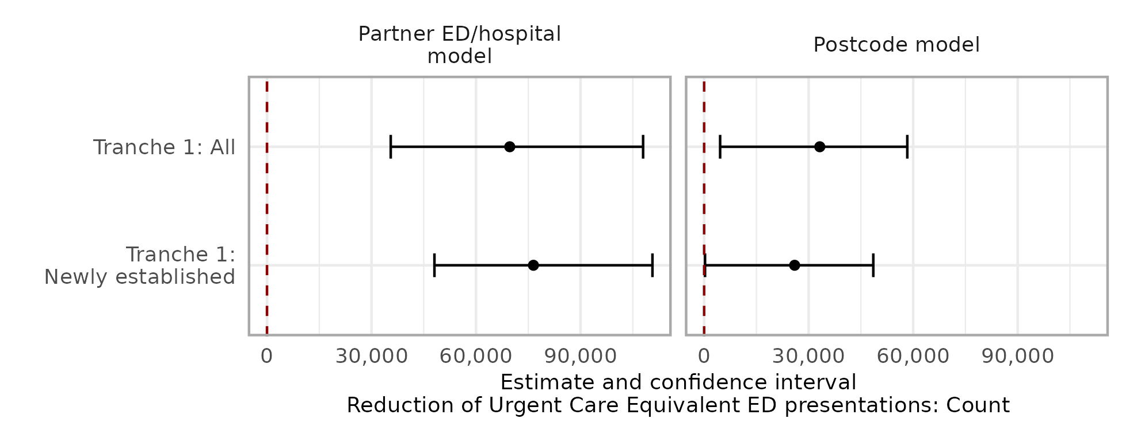

Table 19 | DiD analyses: Estimated reduction in urgent-care-equivalent ED presentations and percentage reduction (95 per cent CI) for April 2024 to March 2025
DiD model/  treatment groups | Treatment units | Control units (effective sample size) | Months | Reduced  presentations:  Count (CI) | Reduced  presentations:  Per cent (CI)
Partner ED/hospital models
Tranche 1: All | 57 | 48 | 12 | 69,681  (35,516-107,959) | 7.1%  (3.8%-10.5%)
Tranche 1: Newly established | 44 | 36 | 12 | 76,480  (48,060-110,640) | 9.8%  (6.9%-13.1%)
Postcode model
Tranche 1: All | 279 | 529 | 12 | 33,199  (4,590-58,315) | 4.4%  (0.6%-7.5%)
Tranche 1: Newly established | 197 | 489 | 12 | 25,976  (256-48,559) | 4.6%  (0.0%-8.3%)

Secondary outcomes
Details of estimates for the DID models of the secondary outcomes – mean waiting times and proportion seen on time – are outlined in Section E.3.1. These models provided no statistical evidence of a difference in these outcomes after the commencement of Medicare UCCs.

Sensitivity analysis
Various sensitivity analyses have been undertaken and will be reported in the Final Report. These include:
- Alternative definitions of the treatment group. For example, we tested alternative approaches to identifying catchments for Medicare UCCs.
- Inclusion of all Tranche 1 Medicare UCCs. Results for these analyses are shown in some tables and charts.
- Inclusion of Tranche 2 Medicare UCCs.
- Investigation of Placebo outcomes.
These did not materially impact the conclusions described above.
- Overview of results
To facilitate comparison, these estimates have been calculated for the period April 2024 to March 2025, that latest full year of data available from the NAPEDC. These results are summarised in Table 20. For each method we show, for the Tranche 1 newly established Medicare UCCs:
- What the method implied in terms of reduced urgent-care-equivalent ED presentations.
- What the method implied in terms of the number of urgent-care-equivalent ED presentations. That would have occurred in the absence of the availability of Medicare UCCs (the counterfactual): note that the counterfactual varies between these methods.
- The reduction in urgent-care-equivalent ED presentations as a percentage of the counterfactual (what would have occurred) and the actual observed number of urgent-care-equivalent ED presentations.
- The reduction in urgent-care-equivalent ED presentations as a percentage of the number of Medicare UCC implied using the Module data. This percentage can be applied to reported Module data to generalise estimates to the broader set of Medicare UCCs, including Medicare UCCs that transitioned from another arrangement.
Table 20 | Estimates of number of avoided urgent-care-equivalent ED presentations for April 2024 to March 2025: Based on partner ED/hospitals or catchment postcodes for newly established Tranche 1 Medicare UCCs
Analysis approach | A: Reduced presentations (n) | B: Implied counterfactual (what would have occurred) (n) | C: Reduction as percentage of B counterfactual (%) | D: Reduction as percent of Module data estimate  (%)
Module data | 209,753 | 913,619 | 23.0% | 100.0%
ITS | 83,821 | 787,687 | 10.6% | 40.0%
DiD: ED/hospital analysis | 76,480 | 780,346 | 9.8% | 36.5%
Postcode analysis: UCC catchments
Module data (UCC catchments) | 129,097 | 662,856 | 19.5% | 100.0%
DiD: Postcode analysis | 25,976 | 559,735 | 4.6% | 20.0%
It is important to consider that the DiD analysis at the postcode level was based on a different perspective. By focussing on the catchment postcodes, it recognises that Medicare UCC may have an impact on presentations beyond the partner ED/hospitals. However, this approach excludes ED attendances where the patient’s usual place of residence could not be assigned to a valid postcode which account for around 2.5 per cent of urgent-care-equivalent ED presentations. Additionally, patients residing in non-catchment postcodes may also be impacted by the availability of Medicare UCCs. For these reasons the postcode-based analysis may bias the results of the DiD analysis towards a lower level of effect.

- Additional tables
- Overview of methods
Table 21 | Overview of causal inference methods applied to outcomes related to urgent-care-equivalent ED presentations
Description | ITS | DiD: ED/hospital level | DiD: postcode level
ED presentations included in analysis | Urgent-care-equivalent ED presentations (see Figure 23). | Urgent-care-equivalent ED presentations (see Figure 23). | Urgent-care-equivalent ED presentations (see Figure 23) that can be assigned to a postcode of residence of ED patients.
Treated units | Partner hospitals EDs for Tranche 1 Medicare UCCs: post Medicare UCC commencement. | Partner hospitals EDs for Tranche 1 Medicare UCCs. | The Tranche 1 Medicare UCC was located within the postcode OR the postcode was adjacent to a postcode in which the Tranche 1 Medicare UCC was located105F105F AND the centroid of the postcode was less than 15 kilometres from the Medicare UCC postcode AND the adjacent postcode was not an island.
Comparison units | Partner hospitals EDs for Tranche 1 Medicare UCCs: pre Medicare UCC commencement. | Other EDs in-scope (Principal Referral, Womens and/or Childrens, or Peer Groups A, B or C). | Other postcodes.
Excluded units: | - EDs of partner hospitals for Tranche 2 and 3 Medicare UCCs, that were not also in partner hospitals for Tranche 1 Medicare UCCs. These will be included in DiD analysis undertaken for the Final Evaluation Report, subject to there being a sufficient sample of post-implementation months. | - EDs of partner hospitals for Tranche 2 and 3 Medicare UCCs, that were not also in partner hospitals for Tranche 1 Medicare UCCs. These will be included in DiD analysis undertaken for the Final Evaluation Report, subject to there being a sufficient sample of post-implementation months.  - Comparator ED/hospitals not assigned to the following: Principal Referral, Womens and/or Childrens, or Peer Groups A, B or C.  - ACT hospitals. | - Postcodes that formed the catchment for Tranche 2 and 3 Medicare UCCs, that were not also in catchments for Tranche 1 Medicare UCCs. These will be included in DiD analysis undertaken for the Final Evaluation Report, subject to there being a sufficient sample of post-implementation months.  - Postcodes located in MMM categories 4, 5, 6 or 7 have been excluded for the reasons described above.
Main method to ensure treated units and comparison units are similar | Not required. | Weighting to achieve balance between treatment and control units using hospital peer group, MMM category of hospital location, and IRSD quintile of hospital. | Weighting to achieve balance between treatment and control units using per cent of population aged under 15 years, per cent of population aged 65 years and over, MMM category and IRSD quintile of postcode, and distance to nearest ED.
Primary unit of time | Monthly value. Sensitivity analysis with weekly values. | Monthly value adjusted for number of days in month. | Monthly value adjusted for number of days in month.
Causal effect estimated: the Estimand | Average treatment effect in the treated group (ATT) where the treated group includes EDs of partner hospitals for Medicare UCCs. | Average treatment effect in the treated group (ATT) where the treated group includes EDs of partner hospitals for Medicare UCCs. | Average treatment effect in the treated group (ATT). The treated groups are postcodes within the catchment areas of the Medicare UCC.
Primary outcome | - Count of urgent-care-equivalent ED presentations. | - Count of urgent-care-equivalent ED presentations.  Converted to a count for the last 12 months of observation. | - Count of urgent-care-equivalent ED presentations.  Modelled using an offset for population as well as offset for days in month.  Converted to a count for the last 12 months of observation.
Secondary outcomes |  | - Mean waiting times for urgent-care-equivalent ED presentations, measured in minutes. | - Mean waiting times for urgent-care-equivalent ED presentations, measured in minutes.
Secondary outcomes |  | - Proportion of urgent-care-equivalent ED presentations seen on time. | - Proportion of urgent-care-equivalent ED presentations seen on time.
Outcome 1: Presentation count
Modelling approach (estimators) | Negative binomial regression.  Offset for number of days in month where monthly counts are used. | Two-way fixed effects using a Poisson model with an offset for number of days in month – fepois(). | Two-way fixed effects using a Poisson model with offsets for population and number of days in month – fepois().
Subgroups for which models were estimated | - All partner hospitals.  - Partner hospitals for new established Medicare UCCs. | - All partner hospitals.  - Partner hospitals for new established Medicare UCCs. | - Postcodes that form the catchments of all Tranche 1 Medicare UCCs.  - Postcodes that form the catchments of newly established Tranche 1 Medicare UCCs.
Interpretation of estimates | Change in the level (intercept) and the rate of change (slope) of trends in the outcome, following the commencement of Medicare UCCs. | Average difference in outcome in the partner EDs occurring due the availability of Medicare UCCs. | Average difference in outcome in the catchments of Medicare UCCs occurring due to the availability of Medicare UCCs.
Outcome 2: Mean waiting time
Modelling approach (estimators) | Linear (OLS) model. | Two-way fixed effects using an OLS model – feols(). | Two-way fixed effects using an OLS model – feols().
Outcome 3: Proportion of urgent-care-equivalent ED presentations seen on time
Modelling approach (estimators) | Logistic regression. | Two-way fixed effects using a logistic regression model – feglm(family = quasibinomial(link = "logit")). | Two-way fixed effects using a logistic regression model – feglm(family = quasibinomial(link = "logit")).

- ITS analysis – additional tables and charts
Table 22 | Characteristics of partner hospitals for Medicare UCCs
 | Partner hospital: Medicare UCC Tranche 1 (N=57) | Partner hospital: Medicare UCC Tranche 2 (N=23) | Partner hospital: Medicare UCC other (N=1) | Not partner hospital  (N=367) | Overall (N=448)
Total | 57 (100%) | 23 (100%) | 1 (100%) | 367 (100%) | 448 (100%)
Medicare UCC type
- Newly established | 44 (77.2%) | 7 (30.4%) | 1 (100%) | 0 (0%) | 52 (11.6%)
- Transitioned | 13 (22.8%) | 16 (69.6%) | 0 (0%) | 0 (0%) | 29 (6.5%)
- Not partner hospital | 0 (0%) | 0 (0%) | 0 (0%) | 367 (100%) | 367 (81.9%)
Peer Group
- Principal referral including Womens and Childrens | 20 (35.1%) | 4 (17.4%) | 0 (0%) | 16 (4.4%) | 40 (8.9%)
- Public acute group A | 27 (47.4%) | 11 (47.8%) | 1 (100%) | 21 (5.7%) | 60 (13.4%)
- Public acute group B | 6 (10.5%) | 4 (17.4%) | 0 (0%) | 33 (9.0%) | 43 (9.6%)
- Public acute group C | 4 (7.0%) | 4 (17.4%) | 0 (0%) | 86 (23.4%) | 94 (21.0%)
- Other hospitals | 0 (0%) | 0 (0%) | 0 (0%) | 211 (57.5%) | 211 (47.1%)
Remoteness Area
- 0 Major Cities | 35 (61.4%) | 17 (73.9%) | 1 (100%) | 46 (12.5%) | 99 (22.1%)
- 1 Inner Regional | 16 (28.1%) | 3 (13.0%) | 0 (0%) | 97 (26.4%) | 116 (25.9%)
- 2 Outer Regional | 4 (7.0%) | 0 (0%) | 0 (0%) | 128 (34.9%) | 132 (29.5%)
- 3 Remote | 2 (3.5%) | 1 (4.3%) | 0 (0%) | 43 (11.7%) | 46 (10.3%)
- 4 Very Remote | 0 (0%) | 2 (8.7%) | 0 (0%) | 41 (11.2%) | 43 (9.6%)
- Missing | 0 (0%) | 0 (0%) | 0 (0%) | 12 (3.3%) | 12 (2.7%)
State
- NSW | 14 (24.6%) | 9 (39.1%) | 0 (0%) | 152 (41.4%) | 175 (39.1%)
- Victoria | 9 (15.8%) | 7 (30.4%) | 0 (0%) | 24 (6.5%) | 40 (8.9%)
- Queensland | 12 (21.1%) | 3 (13.0%) | 0 (0%) | 106 (28.9%) | 121 (27.0%)
- Western Australia | 7 (12.3%) | 0 (0%) | 1 (100%) | 74 (20.2%) | 82 (18.3%)
- SA | 7 (12.3%) | 1 (4.3%) | 0 (0%) | 10 (2.7%) | 18 (4.0%)
- Tasmania | 3 (5.3%) | 0 (0%) | 0 (0%) | 1 (0.3%) | 4 (0.9%)
- ACT | 2 (3.5%) | 0 (0%) | 0 (0%) | 0 (0%) | 2 (0.4%)
- NT | 3 (5.3%) | 3 (13.0%) | 0 (0%) | 0 (0%) | 6 (1.3%)
Table 23 | ITS analysis: Coefficient estimates for models estimated for urgent-care-equivalent ED presentation count by month
Model | Term | Estimate | Std.error | P.value | Conf.high | Conf.low
All partner EDs
Aggregate | X (change in level) | -0.009 | 0.016 | 0.542 | 0.021 | -0.040
Aggregate | T*X (change in slope) | -0.004 | 0.001 | 0.001 | -0.002 | -0.007
Pooled | X (change in level) | -0.022 | 0.008 | 0.005 | -0.007 | -0.038
Pooled | T*X (change in slope) | -0.004 | 0.001 | 0.000 | -0.003 | -0.006
Partner EDs for newly established Medicare UCCs
Aggregate | X (change in level) | -0.020 | 0.016 | 0.213 | 0.011 | -0.051
Aggregate | T*X (change in slope) | -0.006 | 0.001 | 0.000 | -0.004 | -0.009
Pooled | X (change in level) | -0.026 | 0.009 | 0.003 | -0.009 | -0.043
Pooled | T*X (change in slope) | -0.006 | 0.001 | 0.000 | -0.004 | -0.007
Table 24 | ITS analysis: Coefficient estimates for models estimated for urgent-care-equivalent presentation mean waiting times by month
Model | Term | Estimate | Std.error | P.value | Conf.high | Conf.low
All partner EDs
Aggregate | X (change in level) | -4.683 | 2.520 | 0.072 | 0.444 | -9.811
Aggregate | T*X (change in slope) | 0.464 | 0.225 | 0.047 | 0.923 | 0.006
Pooled | X (change in level) | -3.485 | 1.313 | 0.008 | -0.911 | -6.059
Pooled | T*X (change in slope) | 0.490 | 0.115 | 0.000 | 0.715 | 0.265
Partner EDs for newly established Medicare UCCs
Aggregate | X (change in level) | -4.091 | 2.287 | 0.083 | 0.562 | -8.744
Aggregate | T*X (change in slope) | 0.392 | 0.205 | 0.064 | 0.808 | -0.024
Pooled | X (change in level) | -2.673 | 1.379 | 0.053 | 0.032 | -5.377
Pooled | T*X (change in slope) | 0.351 | 0.119 | 0.003 | 0.584 | 0.118
Table 25 | ITS analysis: Coefficient estimates for models estimated for urgent-care-equivalent presentation seen on time by month
Model | Term | Estimate | Std.error | P.value | Conf.high | Conf.low
All partner EDs
Aggregate | X (change in level) | 0.086 | 0.005 | 0 | 0.096 | 0.076
Aggregate | T*X (change in slope) | -0.008 | 0.000 | 0 | -0.007 | -0.009
Pooled | X (change in level) | 0.088 | 0.005 | 0 | 0.098 | 0.077
Pooled | T*X (change in slope) | -0.012 | 0.000 | 0 | -0.011 | -0.013
Partner EDs for newly established Medicare UCCs
Aggregate | X (change in level) | 0.078 | 0.006 | 0 | 0.089 | 0.067
Aggregate | T*X (change in slope) | -0.005 | 0.001 | 0 | -0.004 | -0.006
Pooled | X (change in level) | 0.072 | 0.006 | 0 | 0.084 | 0.059
Pooled | T*X (change in slope) | -0.009 | 0.001 | 0 | -0.008 | -0.010

- DiD analysis – additional tables and charts
Table 26 | DiD: Pre-intervention characteristics of treatment, control and excluded units: Analyses based on newly established Tranche 1 Medicare UCCs
Characteristics | A DiD at hospital level |  |  | B DiD at postcode level
Characteristics | Treatment | Control | Excluded | Treatment | Control | Excluded
Units
Number of units | 44 | 152 | 251 | 197 | 888 | 1,940
Population denominator
Total |  |  |  | 4,845,960 | 12,474,109 | 9,037,299
Mean (SD) |  |  |  | 24,599 (20,570) | 14,047 (12,963) | 5,838 (12,421)
Urgent-care-equivalent presentations
Total | 772,395 | 1,610,902 | 790,792 | 551,409 | 1,283,154 | 1,339,526
Mean (SD) | 1,463 (489) | 883 (607) | 263 (499) | 233 (227) | 120 (163) | 58 (135)
Per cent seen on time (SD) | 62.7 (17.1) | 81.1 (13.2) | 91.6 (13.6) | 65.1 (17.9) | 69.9 (17.7) | 76.9 (23.1)
Mean wait time in min (SD) | 69.6 (30) | 39.4 (21) | 22.8 (26) | 64.8 (30) | 58.2 (30) | 47.1 (38)
Triage category 5 (%) | 14.7% | 19.3% | 22.7% | 14.7% | 16.8% | 22.9%
Triage category 4 (%) | 85.3% | 80.7% | 77.3% | 85.3% | 83.2% | 77.1%
Note: Values derived from 1 July 2022 to 30 June 2023.

Table 27 | Balance Table – Superlearner, ATT: Based on partner EDs/hospitals: Newly established Tranche 1 Medicare UCCs
Covariates | Type | Diff.Adj | V.Ratio.Adj | KS.Adj
Propensity score | Distance | 0.586 | 1.156 | 0.334
Per cent 0014 | Contin. | 0.027 | 0.789 | 0.138
Per cent 75 | Contin. | -0.010 | 1.034 | 0.105
Per cent female | Contin. | -0.025 | 1.705 | 0.144
IRSD quintile_1 | Binary | 0.036 |  | 0.036
IRSD quintile_2 | Binary | 0.066 |  | 0.066
IRSD quintile_3 | Binary | -0.073 |  | 0.073
IRSD quintile_4 | Binary | -0.020 |  | 0.020
IRSD quintile_5 | Binary | -0.009 |  | 0.009
MMM 1 | Binary | 0.051 |  | 0.051
MMM 2 | Binary | 0.103 |  | 0.103
MMM 3 | Binary | -0.057 |  | 0.057
MMM 4 | Binary | -0.066 |  | 0.066
MMM 5 | Binary | -0.022 |  | 0.022
MMM 6 | Binary | 0.001 |  | 0.001
MMM 7 | Binary | -0.010 |  | 0.010
Peer Principal_referral/Womens/Childrens | Binary | 0.009 |  | 0.009
Peer Public_acute_group_A | Binary | 0.160 |  | 0.160
Peer Public_acute_group_B | Binary | -0.050 |  | 0.050
Peer Public_acute_group_C | Binary | -0.119 |  | 0.119
Per cent 0014² (variance of covariate) | Contin. | -0.007 | 0.842 | 0.138
Per cent 75² (variance of covariate) | Contin. | -0.003 | 0.749 | 0.105
Per cent female² (variance of covariate) | Contin. | -0.016 | 1.495 | 0.144
Notes: Diff.Adj is the standardised mean difference between the treatment and control groups after adjustments. Ideally, values should be close to zero. V.Ratio.Adj is the ratio of the variances between the control and treated groups after adjustments. Ideally the value should be close to one. The Kolmogorov-Smirnov statistic is the distance between the distribution of the covariate in the control group and the treated group after adjustments. Ideally the value should be close to zero.

Table 28 | Balance Table – Superlearner, ATT: Based on catchment postcodes for newly established Tranche 1 Medicare UCCs
Covariates | Type | Diff.Adj | V.Ratio.Adj | KS.Adj
Propensity score | Distance | 2.224 | 1.589 | 0.808
Per cent 0014 | Contin. | 0.110 | 0.991 | 0.087
Per cent 75 | Contin. | -0.100 | 0.837 | 0.069
Per cent female | Contin. | -0.030 | 1.988 | 0.091
IRSD quintile_1 | Binary | 0.000 |  | 0.000
IRSD quintile_2 | Binary | 0.023 |  | 0.023
IRSD quintile_3 | Binary | 0.004 |  | 0.004
IRSD quintile_4 | Binary | -0.010 |  | 0.010
IRSD quintile_5 | Binary | -0.019 |  | 0.019
IRSD quintile_99 | Binary | 0.001 |  | 0.001
MMM 1 | Binary | -0.027 |  | 0.027
MMM 2 | Binary | 0.052 |  | 0.052
MMM 3 | Binary | -0.025 |  | 0.025
Distance to ED | Contin. | -0.078 | 0.971 | 0.065
Per cent 0014² (variance of covariate) | Contin. | 0.114 | 0.997 | 0.087
Per cent 75² (variance of covariate) | Contin. | -0.124 | 0.619 | 0.069
Per cent female² (variance of covariate) | Contin. | -0.020 | 1.675 | 0.091
Distance to ED² (variance of covariate) | Contin. | -0.051 | 1.113 | 0.065
Notes: Diff.Adj is the standardised mean difference between the treatment and control groups after adjustments. Ideally, values should be close to zero. V.Ratio.Adj is the ratio of the variances between the control and treated groups after adjustments. Ideally the value should be close to one. The Kolmogorov-Smirnov statistic is the distance between the distribution of the covariate in the control group and the treated group after adjustments. Ideally the value should be close to zero.

Table 29 | Effective sample size for DiD models
Model | Sample | Control | Treated
Partner ED/hospital models
Tranche 1: All | Unadjusted | 152 | 57
Tranche 1: All | Adjusted | 48 | 57
Tranche 1: Newly established | Unadjusted | 152 | 44
Tranche 1: Newly established | Adjusted | 36 | 44
Postcode models
Tranche 1: All | Unadjusted | 888 | 279
Tranche 1: All | Adjusted | 529 | 279
Tranche 1: Newly established | Unadjusted | 888 | 197
Tranche 1: Newly established | Adjusted | 498 | 197
- Methodology for cost effectiveness analysis
  - Overview of methods
Cost effectiveness analysis is an economic evaluation approach through which alternatives are compared considering the costs and outcomes, with outcomes measured across a single important dimension. For the Medicare UCC evaluation, the two main options being compared are:
- Absence of a Medicare UCC within the local community.
- The availability of a Medicare UCC within the local community.
Interim Evaluation Report 1 focused on setting the foundations for conducting an economic evaluation, specifically developing estimates of the cost to the Australian Government of urgent care being delivered through Medicare UCCs and estimating the cost savings to the Australian Government where a patient would have attended an ED had the Medicare UCC not been available.
Interim Evaluation Report 2 has extended this analysis to estimate the cost per ED attendance avoided. Interim Evaluation Report 2 has also provided initial estimates of reduced waiting time at a Medicare UCC compared with an ED (see Measure of Success 1, section 2.1). The intention is that the final evaluation report will extend estimates of the impact of time savings to consider travel time to the Medicare UCC vs ED.
The key features and scope of the analysis for Interim Evaluation Report 2 and the Final Evaluation Report are shown in Table 28.
This appendix includes details of the analysis of costs conducted for Interim Evaluation Report 2.
Table 30 | Medicare UCC evaluation: Economic evaluation components
Components | Interim Evaluation Report 2 | Final Evaluation Report
Perspective | Government funders, with separate analysis for federal and state/territory funders. | Government funders, with separate analysis for federal and state/territory funders.  Whole population.
Population | People requiring urgent-care-equivalent services. | People requiring urgent-care-equivalent services.
Comparator | Absence of a Medicare UCC within the local community. | Absence of a Medicare UCC within the local community.
Intervention | Presence of a Medicare UCC within the local community. | Presence of a Medicare UCC within the local community.
Evaluation period | Data from the first 15 months of the Medicare UCC program.  Annualised estimates have been developed for each measure and results are presented on an annualised basis. | From the first 27 months (Interim Evaluation Report 2) and 36 months (Final Evaluation Report) of the Medicare UCC program.  Annualised estimates will be developed for each measure and results presented on an annualised basis.
Time adjustments | The value of capital and equipment grants have been converted to annualised values.  Benefits and costs of the program largely occur within the same time period, so a discounting factor is not required to reflect time preferences. | The value of capital and equipment grants have been converted to annualised values, guided by the Australian Taxation Office guidance on depreciation rates.  Costs will be adjusted to a single period using an agreed price index.  Benefits and costs of the program largely occur within the same time period, so a discounting factor is not required to reflect time preferences.
Cost estimates | Commonwealth grants to Medicare UCCs.  MBS payments.  For avoided ED: federal and state/territory contributions for public hospital EDs.  Exclusions:  - State/territory contribution to Medicare UCCs, which are not available for Interim Evaluation Report 1.  - PBS payments.  - Out-of-pocket expenses related to travelling to a Medicare UCC will be excluded. | Broader administrative costs to government of establishing and maintaining the Medicare UCC program.  Commonwealth grants to Medicare UCCs.  MBS payments.  State/territory contribution to Medicare UCCs are not available.  For avoided ED: federal and state/territory contributions for public hospital EDs.  Costs of alternative actions by patients that would be taken if the Medicare UCC were not available.  Out-of-pocket expenses for patients related to travelling to a Medicare UCC.
Clinical outcomes | Clinical outcomes have been assumed to be equivalent between the alternatives. | Later evaluation reports will consider whether any available evidence of differences in clinical outcomes.
Non-clinical outcomes | ED presentations avoided. | ED presentations avoided.
Non-clinical outcomes | Non-clinical outcomes have been assumed to be equivalent between the alternatives. | Value of time savings for patients in accessing care, both in terms of waiting times at a Medicare UCC compared with an ED and in travel to the location of the service. Expressed in dollar terms.  Value to patients of being able to see a GP immediately vs with delay. Expressed in dollar terms.
Sensitivity analysis | Nil. | Assumptions underpinning cost estimates for Medicare UCCs.  Range of estimates of effectiveness in avoiding ED attendances.  Assumptions related to time savings for patients and travel costs.

- Calculation of unit costs per presentation for Medicare UCCs
This report has focused on Australian Government funding contribution for Medicare UCCs. These have been shown below as a funding contribution per Medicare UCC presentation. The focus has been on contribution to the Medicare UCC services through grants to the Medicare UCCs and through access to the MBS. The basis for these estimates is described in the following sections.
For Interim Evaluation Report 1, estimates were developed for three periods:
- January to June 2024: Covering the first six months after 31 December 2023 and reflecting the 58 Medicare UCCs that had opened by this date.
- July to September 2024: Covering the first quarter of 2024-25 and reflecting the 75 Medicare UCCs that had opened by 30 September 2024.
- Annualised estimates: Representing estimated costs if Medicare UCCs were operating at their stabilised activity levels across a full financial year. The methodology for estimating stabilised activity is outlined in a following section of this appendix.
For Interim Evaluation Report 2 data for the full 2024-25 financial year was available. This provides an accurate representation of the full year experience of the 58 Medicare UCCs that commenced operation between July and December 2023 (Tranche 1). Consequently, the focus of analysis has been on the 2024-25 financial year.

Australian Government grants to Medicare UCCs
Grants to Medicare UCCs have been made or are planned between 2022-23 and 2025-26. Grants were made to cover operational expenses, equipment and capital costs. Operational grants for the 75 Medicare UCCs that opened prior to 30 September 2024 totalled $2.8 million in 2022-23 (eight Medicare UCCs received operational grants in late 2022-23), $89.2 million in 2023-24 and $124.2 million in 2024-25. From 2024-25, the additional costs of some Medicare UCCs operating in rural and remote regions has been recognised through an MMM adjustment grant, which totalled $8 million in 2024-25.
Capital and equipment grants were $23.5 million and $17.3 million respectively and were not identified against a specific financial year. The equipment and capital grants were amortised across three years of the program. Including the amortised value of the capital and equipment grants adds around $17 to the estimate of the average Australian Government funding per presentation for the annualised estimates. The capital and equipment grants were largely allocated to newly established Medicare UCCs.

MBS payments associated with presentation to Medicare UCCs
MBS related payments for presentations to Medicare UCCs were derived from two sources:
- The Medicare UCC Module data.
- The MBS dataset extract held by the Department.
The Medicare UCC Module data was available for 77 Medicare UCCs. Items reported were mapped to the benefit level defined in the MBS. Using the Module data, the average MBS payment was $71.10 per presentation, based on around 1.04 million presentations (Table 29). The Module data indicates that on average, 1.5 items were claimed per Medicare UCC presentation.
Where more than one MBS item was claimed, a primary MBS item was identified by selecting first a consultation item (Levels A-E) (if reported), then an after-hours item (if reported).
The most common combination of items was a consultation item plus a bulk billing incentive item. Table 29 summarises the MBS claims, using the primary MBS item claimed for a presentation. This is generally a consultation item, the most common of which are Level B Standard (76 per cent) and Level C Long (18 per cent).
Table 31 | MBS benefit payments by the primary item claimed: Medicare UCC Module data, 2024-25
Primary MBS item (grouped) (a) | Number of presentations (b) | % of presentations (b) | Mean items per presentation | Mean benefit per presentation ($)
Level A Brief | 12,683 | 1.7% | 1.5 | $31.8
Level B Standard (6-20 minutes) | 563,841 | 76.1% | 1.5 | $61.5
Level C Long (20+ minutes) | 132,133 | 17.8% | 1.6 | $103.5
Level D Prolonged (40+ minutes) | 11,214 | 1.5% | 1.6 | $145.0
Level E (60+ minutes) | 2,321 | 0.3% | 1.7 | $223.2
After hours | 8,031 | 1.1% | 1.5 | $154.4
Other non-referred (c) | 680 | 0.1% | 1.8 | $200.5
Nurse practitioners | 9,000 | 1.2% | 1.0 | $36.1
Other items (d) | 1,373 | 0.2% | 1.2 | $73.6
Total (77 clinics) | 741,276 | 100.0% | 1.5 | $71.1
Note: Table reflects data from 1 July 2024 to 30 June 2025 and extracted on 13 August 2025. Data was available from 77 clinics open at 30 September 2024. (a) Where more than one MBS item was claimed, the primary MBS items was identified by selecting first a consultation item (Levels A-E) (if reported), then and an after-hours item (if reported) and then the item with the largest associated benefit. The most common pairing of items was a consultation item with a bulk billing incentive item. (b) Presentations where at least one MBS item was recorded. (c) "Other non-referred" includes 681 presentations made up of: A5 Prolonged attendances to which no other item applies (361 presentations), A20 GP mental health treatment (209 presentations), A7 Acupuncture and non-specialist practitioner items (28 presentations) and items from other MBS groups (83 presentations) (d) "Other" includes 1,376 claims made up of T8 Surgical operations (940 presentations), A3 Specialist attendances to which no other item applies (306 presentations), D1 Miscellaneous diagnostic procedures and investigations (46 presentations) and items from other MBS groups (84 presentations).
For the MBS dataset Medicare UCC presentations were identified through MBS provider and provider location numbers that have been assigned specifically to Medicare UCC clinicians. There were 78 Medicare UCCs with 2054 unique provider/provider location numbers specified. In analysing the data, there were 666 provider/provider location number combinations for which no claims could be identified in the 2024-2025 financial year.
Using this source, it was estimated that the average MBS benefit paid was $71.69 per presentation, based on around 802,323 presentations.
The two estimates are close. The small differences will arise due to fact the Medicare UCC data reflects a subset of presentations. Using the aggregate counts for each Medicare UCC, weights were developed and applied to observations within Module data so that analyses could be conducted that reflected the total of reported activity for each Medicare UCC. This provided an opportunity to undertake a broader range of analyses related to characteristics of the patient and presentations that were not feasible were the MBS data to be used. Therefore, the analysis presented below is based on the Module data, with the one exception related to estimating the value of diagnostic services ordered by Medicare UCC clinician but provided by non-Medicare UCC services.

MBS payments associated with diagnostic services ordered for Medicare UCC clinicians and delivered by non-Medicare UCC providers
Through the MBS data set, additional diagnostic services could be identified for services ordered or referred by the Medicare UCC clinicians, but not delivered by Medicare UCC clinicians. Around 157,500 presentations (19 per cent) had an additional pathology and/or diagnostic imaging item claimed on the same day as the Medicare UCC presentations under a provider number that was not associated with a Medicare UCC in the 2024-25 financial year. When averaged across all presentations, these additional claims account for an additional $16.2 per presentation.

Combined grants and MBS payments
Table 9 summarises the estimates of Australian Government funding per presentation across the periods. The results for the Medicare UCC have been broken down to show the ACT Medicare UCCs and remote NT Medicare UCCs separately. In addition, there were four other Medicare UCCs in which Module and MBS data was not reported, where estimations have been made for the MBS components of costs.
Across the periods observed, MBS payment rates increased slightly. However, the mix of Medicare UCCs also changed, which meant the average MBS payment in the annualised data is slightly lower than the value in 2023-24 quarters three and four.
It should be noted that not all Medicare UCC presentations have an associated MBS benefit, this includes presentations to clinics where MBS cannot be claimed, presentations where the patient is not eligible for Medicare and presentations where there is certain social circumstances where claiming Medicare is problematics, for example a patient is homeless and does not have access to their Medicare card.
- Assigning Medicare UCC presentations to AECC classes and pricing
This section describes how Medicare UCC presentations were priced to calculate the costs of avoided ED presentations to government.

Step 1: Coding reason for visit
Medicare UCCs recorded a reason for visit for each patient presentation. While multiple reasons could be recorded per presentation, around 200,000 presentations (24 per cent of all those with Medicare UCC Module unit records) in 2024-25 had no reason recorded.
The reasons were recorded as text, resulting in 10,598 unique entries across 867,194 presentations. Many reasons represented the same diagnosis in various formats, such as "abdo pain", "abdominal pain" and "acute abdominal pain for investigation."
The International Classification of Diseases, 10th Revision, Australian Modification (ICD-10-AM), Twelfth Edition, was used to code the reasons for visit. The coding was undertaken by clinical coders credentialled in ICD-10-AM coding. It involved manual coding of each reason for visit recorded for each presentation. Of the approximately 18,000 ICD-10-AM codes available, the reasons for visit used about 2,000 unique codes.
A qualified Health Information Manager working as part of the evaluation team mapped the ICD-10-AM codes to the ED ICD-10-AM Principal Diagnosis Short List, which has approximately 1,300 codes. Medicare UCC Reasons for Visit were mapped to 820 of these codes.
Challenges in coding the reasons for visit included:
- Ineligible ICD-10-AM codes. About 5,000 ICD-10-AM codes are not eligible as ED principal diagnoses. Examples include external causes of injury (for example, motor vehicle accident), personal factors affecting health status (such as a history of cancer or current smoker), presentations for medical care without the reasons for the visit being specified (for example, check up – well adult) and presentations for preparation of a certificate/report (for example, for disabled parking, pre-employment) and preparation of care plans (GP management plan, Team Care Arrangement review, GP Mental Health Plan).
Where possible, a diagnosis was inferred. For example, external causes such as motor vehicle accident were inferred as injuries (for example, coded as T14.9 Injury, unspecified). Overall, 259,274 presentations (30 per cent) could not be assigned an eligible ED Short List code.
- Procedures instead of diagnoses. Many reasons for visit were procedures that were unlikely to have been undertaken at the Medicare UCC. For example, appendicectomy, angioplasty and total abdominal hysterectomy. These were coded to Z09.9 Follow-up examination after unspecified treatment for other conditions. For other procedures that were likely to have been undertaken at the Medicare UCC, a diagnosis was inferred. For example, syringe ear and variations were coded as H61.2 Impacted cerumen.
- Multiple diagnoses within a single field. When multiple diagnoses were recorded within a single field (for example, "UTI, abdo pain"), the most definitive diagnosis was coded.
- Diagnoses that may have been part of a patient’s history. Many presentations also had reasons for visit where it was not possible to tell whether the diagnosis was current, or part of the patient’s history. This included diagnoses such as acute myocardial infarction (AMI), stroke, various forms of cancer, chronic kidney failure/disease and dementia. Where there was a string of these for a single presentation (for example, stroke, diabetes, cancer), it is likely that it was the patient’s history that was being recorded using this field rather than the reason for visit. However, where only one diagnosis was recorded for a presentation, it was not possible to tell whether it was a current diagnosis or part of the patient’s history. On examining the Episode End Status, patients with these acute diagnoses were only sometimes referred to a hospital ED or ward, indicating that they were unlikely to be presenting for a current stroke or AMI to the Medicare UCC. Nevertheless, they were coded as represented. These have implications for pricing the Medicare UCC presentations, described below.

Step 2: Grouping presentations to AECC classes
Members of the evaluation team with extensive experience in activity-based funding and classification systems grouped the presentations into AECC classes. The following variables are required to group presentations to AECC classes:
- ED Short List code
- arrival by ambulance
- age group
- triage category
- departure status.
Triage category was not available from the Medicare UCC Module. However, the AECC does not differentiate between triage categories 4 and 5, therefore, all presentations were set to triage category 5. Departure status was set to “Discharged home” for all Medicare UCC patients.
Where multiple reasons for visit were recorded, the code leading to the lowest NWAU AECC class was selected (see next step). This was because in most of these instances, the string of diagnoses appeared to be part of the patient’s history rather than the reason for visit to the Medicare UCC (for example, stroke plus diabetes plus cancer reported together and alongside other diagnoses).

Step 3: Assigning NWAUs and pricing
NWAUs were assigned for each AECC class using IHACPA’s National Efficient Price Determination.106F106F,107F107F As per the NEP policy, the NWAU for by AECC class was adjusted for the following factors:
- 4 per cent uplift for Aboriginal and/or Torres Strait Islander patients.
- 30 per cent uplift for patients from remote areas.
Records missing valid AECC groupings were assigned the NWAU for "Other factors influencing health status Complexity level B" (0.0805 NWAU).
For a summary of assigned NWAU by AECC class overall and for the most common assigned AECC classes, see Table 10, Section 2.9 in section 2.9.
NWAUs were multiplied by the NEP to derive the price per presentations.

Limitations
The price implied by the AECC NWAU may be higher or lower than calculated due to the following reasons:
- Despite the steps taken to reduce the influence of diagnoses that may have been part of a patient’s history rather than the reason for visit to the Medicare UCC, in many instances it was not possible to differentiate between a historical and current diagnosis. There remained records in the dataset where patients with a reason for visit of stroke or AMI were discharged home and not referred to an ED, which are unlikely. In these cases, the NWAU may have been higher than what would have been estimated for the actual reason for visit.
- Presentations with Ineligible ED Short List codes (such as "preparation of care plans" or "certificate preparation") were assigned to an AECC class with a relatively high NWAU (0.0805), also possibly inflating the price.
- Where diagnoses were inferred (for example, external causes coded as injuries or a diagnosis inferred from a procedure), they may have overestimated or underestimated the NWAUs.


See Table 1.
The evaluation acknowledges that healthdirect Australia uses a capital ‘H’ when referring to the company, but a lowercase ‘h’ when referring to a specific service (i.e. healthdirect Helpline). For consistency in this report, ‘healthdirect’ is used throughout.
Funding from states and territories (which are ultimately funded by the Australian Government, for example through Federal Financial Agreements) have been excluded from this calculation. As the unit cost per avoided ED presentation includes state and territory contributions, these cost estimates are not like-for-like comparisons.
The estimated cost presented here is based on the estimation of the National Weighted Activity Unit (NWAU) for the avoided presentation as described in Appendix F.3. The method assumes a triage category of 5, noting that the allocation of episodes to a class within the Australian Emergency Care Classification (AECC) makes no distinction between triage categories 4 and 5, and therefore does not impact the assignment of an NWAU.
Department of Health, Disability and Ageing, About the Medicare Urgent Care Clinics, 18 July 2025 (accessed 16 August 2025), https://www.health.gov.au/our-work/medicare-urgent-care-clinics/about-medicare-urgent-care-clinics
Department of Health, Disability and Ageing. Strengthening Medicare Taskforce Report, 2023, https://www.health.gov.au/sites/default/files/2023-02/strengthening-medicare-taskforce-report_0.pdf
Department of Health, Disability and Ageing, Medicare UCC Operational Guidance, August 2025, https://www.health.gov.au/resources/publications/medicare-ucc-operational-guidance?language=en
Nous Group, Medicare UCC program Evaluation: Interim Report 1, 27 March 2025, pp 45, https://www.health.gov.au/resources/publications/medicare-urgent-care-clinics-program-evaluation-first-interim-report?language=en
The Medicare UCC Operational Advisory Group Membership includes representatives from: the Department, each state/territory jurisdictional health department, a selection of peak body organisations and some PHNs.
A total of nine participants consented to join the patient focus groups. This included representation from all states/territories except for Western Australia and the ACT. Participants predominantly came from metropolitan areas (MM1) and regional centres (MM2), with one participant from a large rural town (MM3). One South Australian clinic was overrepresented, with four focus group participants attending that clinic. Focus group participants predominantly identified as women.
Excludes remote NT and ACT clinics who only report aggregate presentation count.
Data for ITS and DiD was modelled from July 2023 Tranche 1. Recognising that Medicare UCCs were implemented across a window of time ending in December 2023 for Tranche 1, and that there was a period required for scaling up of services, estimates of effect were based on the final year for which data was available – April 2024 to March 2025. For Tranche 2, the Medicare UCCs opening window extended between July to December 2024, which meant there were insufficient post implementation observations to estimate a full year effect post implementation, not to take account of scaling up of Tranche 2 clinics.
After hours is defined as presentation time before 8:00 am or after 6:00 pm Monday to Friday, before 8:00 am or after 12:00 pm Saturday, any time Sunday or Public Holidays.
Linear mixed effect regression, adjusting for service level mean. Monday (+4.3 minutes, 95 per cent CI: 3.5-4.3), Metropolitan (4.2, CI: 4.1-4.4), Mornings (6.2, CI: 5.9-6.6). Association between waiting time and after-hours care (-1.0, CI:-1.4-0.6) was also significant but considered irrelevant due to the small effect size. See Table 7 for more detail.
Emergency department stay – waiting time, total minutes NNNNN, see https://meteor.aihw.gov.au/content/7461
Australian Institute of Health and Welfare, Emergency Department Care, 14 May 2025 (accessed 1 September 2025). https://www.aihw.gov.au/hospitals/topics/emergency-departments
Department of Health, Disability and Ageing, Medicare UCC Operational Guidance, August 2025, https://www.health.gov.au/resources/publications/medicare-ucc-operational-guidance?language=en
Department of Health, Disability and Ageing, Medicare UCC Operational Guidance, August 2025, pp ii, https://www.health.gov.au/resources/publications/medicare-ucc-operational-guidance?language=en
Transitional arrangement in place for clinics commissioned prior to 1 July 2025 (aiming for full compliance by 30 June 2026).
NSW Health, Emergency Department waiting times in major NSW Hospitals, 2025 (accessed 29 August 2025), https://www.emergencywait.health.nsw.gov.au/
Queensland Health, Emergency department waiting times in Queensland’s major public facilities, 2025 (accessed 29 August), 2025, https://openhospitals.health.qld.gov.au/
Western Australian Department of Health, Emergency department live activity, 2025 (accessed 29 August 2025), https://www.health.wa.gov.au/Reports-and-publications/Emergency-Department-activity/
SA Health, Emergency Department Dashboard, 2025 (accessed 29 August 2025), https://www.sahealth.sa.gov.au/wps/wcm/connect/public+content/sa+health+internet/about+us/our+performance/our+hospital+dashboards/about+the+ed+dashboard/emergency+department+dashboard
Tasmanian Department of Health, Emergency Department Average Wait Times, 2025 (accessed 20 August 2025), https://www.health.tas.gov.au/patients/going-hospital/emergency-departments/emergency-department-waiting-times-tasmanias-public-hospitals#free-advice-from-a-health-professional
Canberra Health Services, Emergency Department waiting times, 2025 (accessed 29 August 2025), https://www.canberrahealthservices.act.gov.au/before,-during-and-after-your-care/coming-to-the-emergency-department/before-you-arrive/emergency-department-waiting-times
Department of Health, Disability and Ageing, Medicare UCC Operational Guidance, August 2025, https://www.health.gov.au/resources/publications/medicare-ucc-operational-guidance?language=en
Royal Australian College of General Practitioners, Standards for general practices (5th edition), 24 February 2023 (accessed 27 August 2025), https://www.racgp.org.au/getattachment/ece472a7-9a15-4441-b8e5-be892d4ffd77/Standards-for-general-practices-5th-edition.aspx. The RACGP roundtable brought together members, government representatives, key stakeholders and RACGP Board directors to discuss the impact Medicare UCCs are having on general practice and their potential role in the healthcare system. The roundtable included reflections from GPs who have been involved in Medicare UCCs.
Karen Burge, RACGP leaders discuss future of UCCs, newsGP, 17 June 2025 (accessed 16 August 2025), https://www1.racgp.org.au/newsgp/professional/racgp-leaders-discuss-future-of-uccs
Did not wait to be attended by a health care professional.
Left at own risk after being attended by a health care professional but before the service episode was completed.
‘Aggregate and other unit record counts’ are a count of the remaining presentations where the categorisation of episode end status is not provided.
The Australian Government has acknowledged this gap and has introduced a Chronic Wound Consumables Scheme that will cover the full cost of wound consumables for eligible patients. The scheme is new and has not been assessed as part of this evaluation (Department of Health, Disability and Ageing, Medicare UCC Operational Guidance, August 2025, https://www.health.gov.au/resources/publications/medicare-ucc-operational-guidance?language=en)
This percentage excludes records for which Indigenous status was not recorded.
AIHW, Emergency Department Presentations, 2023-24, 14 May 2025 (accessed 16 August 2025), https://www.aihw.gov.au/hospitals/topics/emergency-departments/presentations
Australian Bureau of Statistics, Census of Population and Housing – Counts of Aboriginal and Torres Strait Islander Australians, 2023 (accessed 16 August 2025), https://www.abs.gov.au/statistics/people/aboriginal-and-torres-strait-islander-peoples.
Section 3.3 in the Operational Guidance includes providing culturally safe and responsive care, developing and maintaining linkages with Aboriginal Community Controlled Health Services and staff undertaking cultural awareness training.
Medicare UCC program policies to support provision of culturally safe care by Medicare UCCs were described in detail in Interim Evaluation Report 1.
Noting there was a very small sample size, with patient survey respondents who identified that they were of Aboriginal and/or Torres Strait Islander origin making up 4 per cent of total responses.
There is no nationally agreed or definitive metric for cultural and linguistic diversity. The evaluation will seek to collect qualitative information regarding culturally and linguistically diverse people for the Final Report to complement any quantitative data.
For example, ‘ethnicity’ was taken from clinics’ various Patient Management Software that had a large variety of responses and it appears to inconsistently represent a mix of ethnicity, language spoken and/or country of birth. Likewise, language spoken at home was collected as a free text input which has reduced the quality/completeness of the data collected.
Department of Health, Disability and Ageing, Medicare UCC Operational Guidance, August 2025, https://www.health.gov.au/resources/publications/medicare-ucc-operational-guidance?language=en
Noting that Interim Evaluation Report 2 data on the consistency of clinical handover pre-dates the release of updated Operational Guidance in August 2025, and there is currently a transitional period aiming for full compliance to updated guidelines by 30 June 2026.
Royal Australian College of General Practitioners, General Practice Health of the Nation 2024, October 2024 (accessed 28 August 2025), https://www.racgp.org.au/FSDEDEV/media/documents/Health-of-the-Nation-2024.pdf
Department of Health, Disability and Ageing, Medicare UCC Operational Guidance, August 2025, https://www.health.gov.au/resources/publications/medicare-ucc-operational-guidance?language=en
Ibid.
See methodology for information on the consumer focus groups.
Bureau of Health Information, Survey results – Patients’ experiences in emergency departments in 2023-24, 2024 (accessed 26 August 2025), https://www.bhi.nsw.gov.au/__data/assets/pdf_file/0009/973899/BHI_PSR_EDPS_2023-24_Report.pdf
Australian Bureau of Statistics, Patient Experiences, 18 November 2024 (accessed 27 August 2025), https://www.abs.gov.au/statistics/health/health-services/patient-experiences/latest-release
The evaluation notes that direct comparison to the Medicare UCC patient survey cannot be made due to the different phrasing of questions, sampling approach and sample size across surveys.
Department of Health, Disability and Ageing, Medicare UCC Operational Guidance, August 2025, https://www.health.gov.au/resources/publications/medicare-ucc-operational-guidance?language=en
The Department advised that it works closely with commissioners to ensure they are meeting their obligations and actively encourages direct feedback to clinics to support quality improvement.
The Updated Guidance addresses this issue. Existing Medicare UCCs have until 30 June 2026 to comply.
Department of Health, Disability and Ageing, Medicare UCC Operational Guidance, August 2025, https://www.health.gov.au/resources/publications/medicare-ucc-operational-guidance?language=en
McCormack, M, Unleashing the Potential of our Health Workforce – Scope of Practice Review Extract of Final Report, November 2024, pp14, https://www.health.gov.au/resources/publications/unleashing-the-potential-of-our-health-workforce-scope-of-practice-review-final-report
Department of Health, Disability and Ageing. Primary Care and Workforce Reviews Taskforce. 12 June 2025. Primary Care and Workforce Reviews Taskforce | Australian Government Department of Health, Disability and Ageing
Department of Health, Disability and Ageing, Medicare UCC Operational Guidance, August 2025, https://www.health.gov.au/resources/publications/medicare-ucc-operational-guidance?language=en
Royal Australian College of General Practitioners, General Practice Health of the Nation 2024, October 2024 (accessed 28 August 2025), https://www.racgp.org.au/FSDEDEV/media/documents/Health-of-the-Nation-2024.pdf
Department of Health, Disability and Ageing, GP Supply and Demand Study, August 2024 (accessed 31 August 2025), https://hwd.health.gov.au/supply-and-demand/gp-supply-demand-study.html
Department of Health, Disability and Ageing, Medicare UCC Operational Guidance, August 2025, https://www.health.gov.au/resources/publications/medicare-ucc-operational-guidance?language=en
Transitional arrangement in place for clinics commissioned prior to 1 July 2025 (aiming for full compliance by 30 June 2026).
Royal Australian College of General Practitioners, NewsGP poll: help us help Australia’s GPs, 10 March 2025 (accessed 31 August 2025), https://www1.racgp.org.au/newsgp/poll
Department of Health, Disability and Ageing, Medicare UCC Operational Guidance, August 2025, https://www.health.gov.au/resources/publications/medicare-ucc-operational-guidance?language=en
McCormack, M, Unleashing the Potential of our Health Workforce – Scope of Practice Review Extract of Final Report, 5 November 2024, pp 14, https://www.health.gov.au/resources/publications/unleashing-the-potential-of-our-health-workforce-scope-of-practice-review-final-report.
The National Council of Primary Care Doctors represents the interests of general practice and primary care in Australia, comprising leaders from the Australian Medical Association, RACGP, Rural Doctors Association of Australia, Australian College of Rural and Remote Medicine, General Practice Supervisors Australia, General Practice Registrars Australia and Australian Indigenous Doctors Association.
National Council of Primary Care Doctors. (2024). Urgent Care Centres Position Statement
Royal Australian College of General Practitioners, RACGP questions further urgent care clinic investment, 02 March 2025 (accessed 31 August 2025), https://www.racgp.org.au/gp-news/media-releases/2025-media-releases/february-2025/racgp-questions-further-urgent-care-clinic-investment
Healthed. 60% of GPs would back more UCCs, if… 5 March 2025 (accessed 7 November 2025). https://www.healthed.com.au/clinical_articles/60-of-gps-would-back-more-uccs-if/
Healthed Shock poll: Most GPs support urgent care clinics?!, 30 November 2024 (accessed 27 August 2025), https://www.healthed.com.au/clinical_articles/most-gps-support-urgent-care-clinics-poll/
Royal Australian College of General Practitioners, General Practice Health of the Nation 2025, October 2025 (accessed 5 November 2025), https://www.racgp.org.au/FSDEDEV/media/documents/Health-of-the-Nation-2025.pdf
Karen Burge, RACGP leaders discuss future of UCCs, newsGP, 17 June 2025 (accessed 16 August 2025),
The Modified Monash Model (MMM) defines whether a location is metropolitan, rural, remote or very remote. https://www.health.gov.au/topics/rural-health-workforce/classifications/mmm?l
Australian Institute of Health and Welfare, National Healthcare Agreement: PI 19–Selected potentially avoidable GP-type presentations to emergency departments, 2022 (accessed 25 August 2025), https://meteor.aihw.gov.au/content/740847. See Appendix E.1 for more detail on this definition.
The data sharing agreement data have been reported up to June 2025, whereas the NAPEDC data was only available to March 2025. The data supplied through the data sharing agreements does not fully align with definition of the urgent-care-equivalent ED presentations described above, although there is close alignment.
Further details are provided in Appendix E. For the ITS analysis, these estimates have been generated by applying model results to estimate the reduction in urgent-care-equivalent ED attendances at each partner ED/hospital in each month between April 2024 to March 2025, together with confidence limits on the estimate for each month. These have then been aggregated for the full year. The DiD models are both a direct estimate and confidence interval for the reduction in urgent-care-equivalent ED attendances at each partner ED/hospital in each month between April 2024 to March 2025.
The postcode analysis was based on analysis of catchment areas for Medicare UCCs. As described in Appendix E.1 there were a range of issues in analysing with postcodes reported in the NAPEDC Data Collection. These include that a high proportion of postcodes reported are invalid, not related to geographic populations, or reported as Unknown.
See Appendix E.2 for discussion of the limitations and caveats around the ITS analysis.
See Appendix E.3 for discussion of the limitations and caveats around the DiD analysis.
Speculatively, reasons for the variation in attendance across week or months could be seasonal or related to school holidays. The evaluation suggests any variation around June 2024 when newly established clinics commenced likely does not indicate substitution effect (whereby patients may have shifted from a transitioned clinic to a newly established one) given clinics are part of different catchments and there is limited geographic overlap.
Speculatively, it is likely transitioned clinics that had higher average presentations per week at commencement because they were already operating and had existing community awareness. Overall average presentations per clinic became more even between transition and newly established clinics as newly established clinics’ operations grew. Newly established clinics included some very small remote locations and it is possible this explains their lower average presentations (in the latter weeks since opening).
Australian Institute of Health and Welfare, Emergency Department Care, 2024 (accessed 30 August 2025), https://www.aihw.gov.au/hospitals/topics/emergency-departments
Generalised linear mixed effects regression adjusting for clinic mean. Metropolitan MM1 vs all other MMM categories (Odds Ratio 0.85, 95per cent CI (0.84-0.85); Morning, 9:00 am to 12:00 pm vs all other three-hour windows (1.07, CI 1.07-1.08); After-hours vs in-hours presentations (1.14, CI 1.14-1.15). See Table 7 for more detail.
Speculatively, the reduced proportion of presentations for transitioned clinics could be explained by changes to target patient populations and/or changes to clinicians’ judgement of whether the patient would have otherwise gone to ED.
Feby Savira, Madison Frith, Clarissa J Aditya, Sean Randall, Naomi White, Andrew Giddy, Lauren Spark, Jamie Swann and Suzanne Robinson, Urgent care centres for reducing demand on emergency departments: a scoping review of published quantitative and qualitative studies, Med J Aust, 2025; 222 (9): 450-461 (accessed 21 August 2025), https://www.mja.com.au/journal/2025/222/9/urgent-care-centres-reducing-demand-emergency-departments-scoping-review
Previously called Priority Primary Care Centres.
Data was captured by the Department of Health, Disability and Ageing and is available for 82 clinics only. The Department notes that this may be an underestimate as reporting of referral pathways was not mandatory. Example pathway provided by the Department.
Data was captured by the Department of Health, Disability and Ageing and is available for 82 clinics only. The Department notes that this may be an underestimate as reporting of referral pathways was not mandatory.
Australian Government Productivity Commission, Report on Government Services 2025 – Part E Section 11: Ambulance Services, 6 February 2025 (accessed 27 August 2025), https://www.pc.gov.au/ongoing/report-on-government-services/2025/health/ambulance-services
Data was captured by the Department of Health, Disability and Ageing and is available for 82 clinics only.
The evaluation understands that a new funding model is under design for the future.
The estimated cost presented here is based on the estimation of the National Weighted Activity Unit (NWAU) for the avoided presentation as described in Appendix F.3. The method assumes a triage category of 5, noting that the allocation of episodes to a class within the Australian Emergency Care Classification (AECC) makes no distinction between triage categories 4 and 5, and therefore does not impact the assignment of an NWAU.
The Department has advised that the DSA specific variables were selected to allow impact analysis and evaluation of the Medicare UCC initiative. The data was to consider the impact of Medicare UCCs on EDs at a more granular level particularly as it relates to demographic and clinical makeup of the two health service types.
Australian Institute of Health and Welfare. (2023). National Healthcare Agreement: PI 19–Selected potentially avoidable GP-type presentations to emergency departments, 2022. https://meteor.aihw.gov.au/content/740847
Australian Institute of Health and Welfare, Emergency department care. https://www.aihw.gov.au/hospitals/topics/emergency-departments. Updated 14 May 2025, Accessed 3 August 2025.
NSW Bureau of Health Information, Data Portal Report, selected hospitals. For example, in October to December 2021 in Northern Beaches Hospital, it is reported that 92.1 per cent of triage 5 attendance were identified as likely to be only for a COVID-19 test.
Note the period April 2024 to March 2025 begins nine months after the commencement of Medicare UCCs. Due to rounding of the change in both the intercept (0.026) and the slope (0.006), calculation from these estimates does not give exactly 0.894 (10.6 per cent decrease). The calculation is: $(1-0.026)/12\sum_{t=9}^{20}{(1-0.006)^t}$
Callaway, B., & Sant’Anna, P. H. C. (2021). "Difference-in-Differences with Multiple Time Periods." Journal of Econometrics, 225(2): 200–230.
Abadie, A. (2005). “Semiparametric Difference-in-Differences.” Review of Economic Studies, 72(1): 1–19; Stuart, E. A., Huskamp, H. A., Duckworth, K., Simmons, J., Song, Z., Chernew, M., & Barry, C. L. (2014). “Using propensity scores in difference-in-differences models to estimate the effects of a policy change.” Health Services and Outcomes Research Methodology, 14(4): 166–182.
Imai, K., & Kim, I. S. (2021). On the use of two-way fixed effects regression models for causal inference with panel data. Political Analysis, 29(3), 405-415.
Bergé, Laurent. fixest: Fast Fixed-Effects Estimations (R package version 0.13.2). CRAN package. 2018. CREA Discussion Papers, No. 13; Sun, Liyang, & Abraham, Sarah. Estimating Dynamic Treatment Effects in Event Studies with Heterogeneous Treatment Effects. Journal of Econometrics, Volume 225, Issue 2, 2021, Pages 175-199.
Canty, A. and Ripley, B. (2025). boot: Bootstrap R (S-Plus) Functions. R package version 1.3-31.
Greifer, N. (2023). WeightIt: Weighting for Covariate Balance in Observational Studies. R package version 0.14.2. Available at: https://CRAN.R-project.org/package=WeightIt
Polley, E., LeDell, E., Kennedy, C., Lendle, S., & van der Laan, M. (2019). SuperLearner: Super Learner Prediction. R package version 2.0-26. CRAN; Greifer op cit.
Abadie op cit.
Callaway & Sant’Anna op cit.; Arkhangelsky, Dmitry; Athey, Susan; Hirshberg, David A.; Imbens, Guido W.; and Wager, Stefan. “Synthetic Difference-in-Differences.” American Economic Review, Vol. 111, No. 12 (December 2021): 4088-4118.
Wing, C., Simon, K., & Bello-Gomez, R. A. (2018). “Designing Difference in Difference Studies: Best Practices for Public Health Policy Research.” Annual Review of Public Health, 39: 453–469; Roth, J., Sant’Anna, P. H. C., Bilinski, A., & Poe, J. (2023). “What’s Trending in Difference-in-Differences? A Synthesis of the Recent Econometrics Literature.” Journal of Econometrics, 235(2): 2218–2244.
Using the Queen’s case for identifying adjacency.
Independent Health and Aged Care Pricing Authority (IHACPA), 2023. National Efficient Price Determination 2023-24. For Australian public hospital services. Appendix L – Price weights for emergency department patients – AECC V1.0.
Independent Health and Aged Care Pricing Authority (IHACPA), 2024. National Efficient Price Determination 2024-25. For Australian public hospital services. Appendix L – Price weights for emergency department patients – AECC V1.0.

