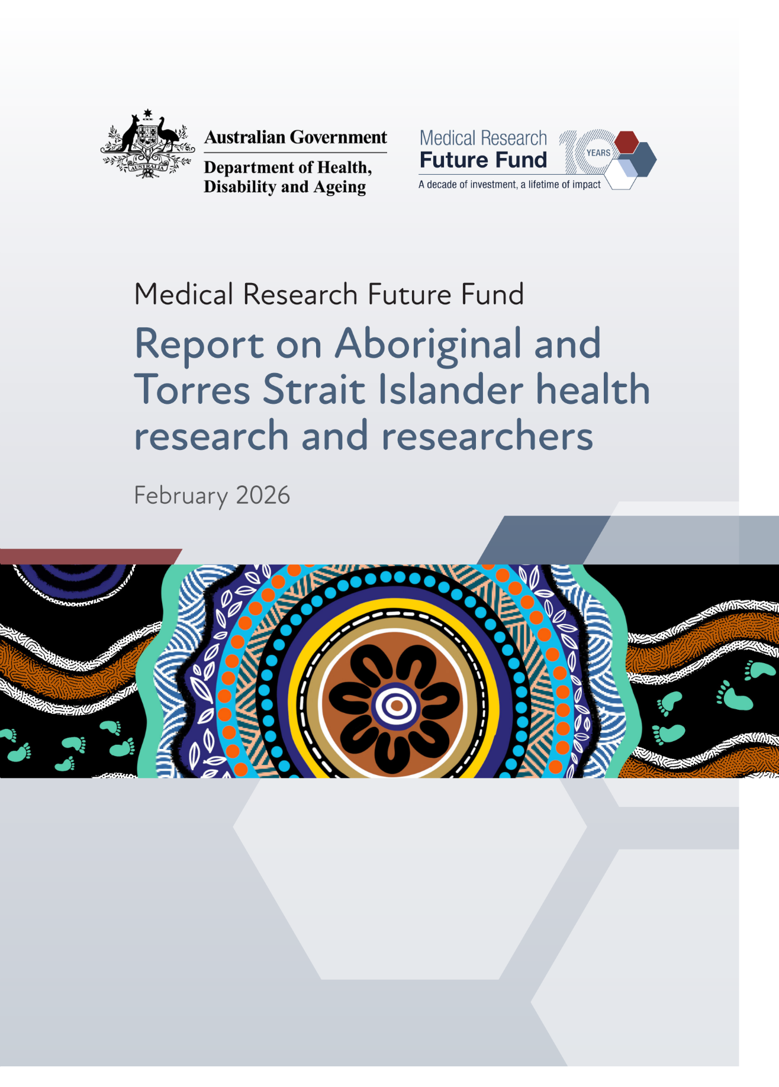
Figure 1 Cover art: Walking together for infectious disease by artist Mel Fernando, a proud Wiradjuri/Kamilaroi/Yuwaalaraay/Euahlayi woman from Dubbo, Western New South Wales. She currently lives and works on Birpai Country.
From the artist: In the cover artwork (Figure 1, above), a meeting place in the very centre signifies the AMS or Clinic to show Community and Patients are the most important part of the First Nations Molecular Point of Care Program.
It shows the Yarning taking place around Point of Care Testing and Research, the listening and learning taking place. It also represents where Point of Care testing occurs and shows people sitting around it, who access these services.
The first white circle represents the partnerships The Kirby Institute have already fostered in communities, this is the first gold circle, it is a solid line that shows how strong this institution is, leading the way to eliminate infectious diseases globally and in Aboriginal and Torres Strait Islander Communities in Australia.
The broken white lines show partnerships The Kirby Institute has with communities, health services, stakeholders, and other Universities.
The black solid circle with broken white lines signifies the relationship The Kirby Institute has with Flinders University International Centre for Point of Care Testing, there is open communication back and forth, it shows there is a strong relationship with both Institutions working alongside each other for Point of Care Testing and Research.
The blue and orange dots represent the consultations between communities, the striped lines which sits between them, represent conversations in all different directions and paths with transparency and respect at every part.
The outer four lines represent Research, Infectious Diseases, Indigenous Methodologies and most importantly building and fostering relationships within communities.
Footprints are the coming and going between clinic and community showing the strong pathways, importance, and the need for Point of Care testing in health services and communities.
The long lines on each side of the footprints represent the paths we take as individuals but also as family, kinship and community for our health.
The top and bottom of the artwork signifies the Remote, Regional & Urban Communities in which the point of care testing and research sits. The paths with striped lines represent each journey of a patient into the community and their connection to their family, family kinship and wider community.
The blue circles within each other represent Communities and the Yarning that occurs.
The blue and orange dots/strokes represent Aboriginal and Torres Strait Islander people within community, their family structures and most importantly their holistic view of health, the social, emotional, and cultural wellbeing of oneself and the wellbeing of their community.
The vision of this artwork represents “Walking Together” for a common need, which is preventing infectious disease.
Walking hand in hand as community members, health service clinicians, and researchers learning, sharing, having open communication, building rapport with each other, and changing the way that point of care testing is done within communities for the benefit of eliminating infectious disease.
Aboriginal and Torres Strait Islander people are advised that this document may contain images of deceased persons.

Contents
Introduction 6
Investment in Aboriginal and Torres Strait Islander health research and researchers 6
MRFF prioritisation of Aboriginal and Torres Strait Islander health 7
Report overview 8
Approach 9
Funding insights 11
All MRFF Aboriginal and Torres Strait Islander health research 12
Indigenous Health Research Fund 15
All MRFF Aboriginal and Torres Strait Islander researchers 19
Facilitators and barriers for Aboriginal and Torres Strait Islander health research 22
Facilitators 22
Barriers 22
Impact of investment in Aboriginal and Torres Strait Islander researchers and health research 24
Impact stories 25
Conclusions 43

Introduction
The Australian Government provides direct support for health and medical research through the Medical Research Future Fund (MRFF) and the National Health and Medical Research Council (NHMRC). These funds are complementary: the MRFF funds priority-driven research with a focus on research translation, whereas the NHMRC primarily focuses on investigator-led research. They work together to support a diversity of Australian health and medical research and researchers.
The MRFF is a $24.5 billion (as at 30 June 2025) long-term investment supporting Australian health and medical research. It was established in 2015 and, at present, is providing $650 million in annual health and medical research and innovation funding. The MRFF aims to support Australian research and innovation to improve health outcomes, build the economy and contribute to health system sustainability. The Department of Health, Disability and Ageing (the department) is responsible for the overall administration of the MRFF, with grants and selection processes administered via 2 grant hubs: the NHMRC, and the Business Grants Hub (BGH) at the Department of Industry, Science and Resources.

Investment in Aboriginal and Torres Strait Islander health research and researchers
For clarity and consistency, this report uses the term Aboriginal and Torres Strait Islander peoples as the primary descriptor, hereafter respectfully referred to as Indigenous when used in its Australian context.
Australia’s Indigenous peoples carry deep, continuous traditions of health science, governance and innovation that have sustained communities, Country and kinship systems for tens of thousands of years. These knowledge systems continue to guide contemporary health practice, community-led research and emerging models of care that benefit all Australians.
The MRFF recognises that achieving stronger health futures for Indigenous peoples requires investment in research that honours these strengths and is governed, conceptualised and led by Indigenous communities. This reflects a growing national shift towards Indigenous data sovereignty, community-controlled research governance, and long-term partnerships built on respect, trust and shared authority.
Together, the MRFF and NHMRC support a research ecosystem in which Indigenous researchers, Aboriginal Community Controlled Health Services and community knowledge holders are central to shaping priorities and driving system reform. These funding mechanisms help grow a skilled and sustainable Indigenous research workforce, strengthen the translation of community-led innovation into policy and practice, and support models of care grounded in culture, Country, place and kinship.
Both the MRFF and NHMRC are committed to improving Indigenous health via support for health and medical research. For the MRFF, Indigenous health and wellbeing has been a priority since the first MRFF 10-year Investment Plan For the NHMRC, this commitment is outlined in the Road Map 3 strategic framework of the 2021–2024 Action Plan, and includes regular reporting of progress against Road Map 3.

MRFF prioritisation of Aboriginal and Torres Strait Islander health
Indigenous peoples are a priority population for the MRFF. The MRFF contributes to the National Agreement on Closing the Gap and its priority reforms and targets. Also, numerous MRFF initiatives have funded grants that focus on Indigenous health and wellbeing, including a dedicated initiative, the Indigenous Health Research Fund (IHRF). Through the IHRF and other initiatives, the MRFF has supported Indigenous health research in numerous areas including chronic and infectious disease, mental health, cultural safety in health care, primary health care, exercise and nutrition preventive health, genomics, vaccine development, and maternal and infant health.

Indigenous Health Research Fund
Established in 2018–19, the MRFF IHRF is investing $160 million over 11 years into Indigenous-led research that focuses on health issues facing Indigenous peoples. The objectives of the IHRF are to support the improved health outcomes of Indigenous peoples through:
supporting Indigenous-led research practice and governance
translating knowledge
implementing evidence-based structural change in Indigenous health practice
building on the unique knowledge, strengths and endurance of communities, with particular reference to Country, culture and spirituality.
IHRF projects must meet the following criteria:
addresses the objectives of the grant opportunity and will deliver against the desired outcomes
demonstrates leadership of Indigenous peoples, communities and organisations in the conceptualisation, design and implementation of the program of research
significantly addresses a key health issue facing Indigenous peoples for which there has been limited progress
progresses the area of research towards an effective solution
has the broad and meaningful involvement of relevant partners that will support implementation of findings into culturally appropriate approaches that are acceptable to the community
is highly feasible and, if successful, will rapidly and significantly improve healthcare practice, policy and/or system effectiveness
reports outcomes in the measures of success statement that are highly relevant and meaningful to the goal and aims of the IHRF.

Other ways the MRFF supports Indigenous health research
The MRFF has increased Indigenous leadership in MRFF grants through refinements to the application assessment process for the IHRF and other grant opportunities, with the percentage of grants led by Indigenous Chief Investigators increasing over time (see Funding insights). The refinements to the assessment process included the following:
From the 2020 Indigenous Health Research grant opportunity onwards, the assessment criteria were modified so that a project must demonstrate Indigenous leadership and community involvement.
From the 2021 Indigenous Health Research grant opportunity onwards, the scoring matrices covering the assessment criteria used by Grant Assessment Committees (GAC) were updated to include guidance on assessing Indigenous leadership and community involvement. Efforts were also made to ensure that the GAC membership mostly comprised Indigenous peoples.
In addition to the IHRF, substantial funding has been provided for Indigenous health research through other MRFF initiatives, notably:
Emerging Priorities and Consumer-Driven Research
Preventive and Public Health Research
Rapid Applied Research Translation
Cardiovascular Health Mission.
Also, the 2021 Improving the Health and Wellbeing of Aboriginal and Torres Strait Islander Mothers and Babies grant opportunity (delivered under the MRFF Emerging Priorities and Consumer-Driven Research initiative) aimed to support research that would improve access to culturally safe care during pregnancy, birthing and the postnatal period. Examples include on-Country birthing and continuity of family and midwifery care.

Report overview
This report outlines how the MRFF is supporting Indigenous health research and researchers, highlights examples of Indigenous sovereign governance and community-led innovation (see Impact stories), and identifies opportunities to strengthen the long-term impact of these investments for communities and the broader health system.
This report has been co-designed with the NHMRC Principal Committee Indigenous Caucus (2021–2024) and had input from the joint NHMRC–MRFF Indigenous Advisory Group (2024–2027).
Regular reporting of this type is in line with the MRFF Monitoring, Evaluation and Learning Strategy. Data analysis, reporting and data-informed decision making are critical for the MRFF to achieve its strategic objectives, namely:
equitable health outcomes through research-informed preventive health and health care, from primary to tertiary care
health and economic benefits from the translation of innovative research into policy and practice, and the commercialisation of new diagnostics, therapeutics and preventive health interventions
a skilled and sustainable health and medical research workforce with expertise in research translation, innovation and commercialisation
a health and medical research sector and a health system that are positioned to respond to emerging and future challenges.

Approach
The following should be noted regarding the funding statistics and insights presented in this report:
Reportable MRFF data dates are from 2017 onwards, when the first grant opportunities became available. IHRF data are only available from 2020 onwards, when outcomes from the first 2019 competitive grant opportunities became available. Data are current as at September 2025.
For data presented per year, grants are allocated to a year based on the closure date of the grant opportunity. Data for some grant opportunities closing in 2024 and 2025 are incomplete due to outcomes being unavailable.
Chief Investigator characteristics (including Indigenous status) are based on self-reported data provided to the grant hubs at the time of application. Some Chief Investigator data may be incomplete due to lack of reporting or data not being collected at the time. For some grants, data on Chief Investigator roles are unavailable, so the number of lead Chief Investigators may be underestimated. Additionally, there are no data for Indigenous lead Chief Investigators before 2019, either because data were not available (for BGH and NHMRC grants) or no lead Chief Investigators indicated they were Indigenous (NHMRC grants).
Funded rates are calculated based on competitive grant opportunities only, for which outcomes are available as at September 2025.
Reporting on location (state or territory) is based on the address of the lead or administering organisation. Grants can be collaborations of several organisations, which are not captured in this reporting.
- A grant is classified as having a focus on Indigenous health if
- for funded grants under the IHRF, it was determined by the grant assessment panel to be fundable under the IHRF
- for funded grants under other MRFF initiatives, it was determined by the department to be relevant for Indigenous health based on its title, keywords and project summary
for applications, it was submitted to one of the grant opportunities within the IHRF.
A review of progress and final reports from funded projects was supported by a thematic analysis using artificial intelligence (Microsoft 365 Copilot). This analysis identified broad themes such as the facilitators of and barriers to research as reported by grantees. Themes were checked for consistency by manual review and consultation with the Indigenous Advisory Group.
Impact stories were selected through review of progress and final reports submitted by grant recipients. The selection criteria were co-developed with the Principal Committee Indigenous Caucus. Eligible grants were those that, based on material provided by the Chief Investigators as well as review by an evaluation team within the department’s Health and Medical Research Office:
- achieved significant progress aligned with the objectives of the IHRF, namely
- leadership by Indigenous researchers as Chief Investigators
- involvement of Indigenous individuals, communities and organisations in the conceptualisation, design and implementation of the program of research
- knowledge translation
- evidence-based structural change in Indigenous health practice
building on the unique knowledge, strengths and resilience of Indigenous communities (particularly to overcome common barriers in conducting research)
achieved significant progress aligned with at least one MRFF measure of success as defined in the MRFF Monitoring, Evaluation and Learning Strategy
supported projects that had an impact beyond the stated objectives of the grant.

Funding insights
This section outlines the main insights for Indigenous researchers and health research funded through the MRFF, as well as the main funding outcomes for the MRFF IHRF initiative.
The funding insights under ‘All MRFF Aboriginal and Torres Strait Islander health research’ and ‘All MRFF Aboriginal and Torres Strait Islander researchers’ cover MRFF funding for all Indigenous research and researchers, including through the IHRF.
The insights under ‘Indigenous Health Research Fund’ only cover grants and applicants funded through the IHRF.

All MRFF Aboriginal and Torres Strait Islander health research
Key statistics:
209 grants with an Indigenous health focus across 15 out of 22 initiatives
$436 million in funding received
31.6% of funded Indigenous health grants have an Indigenous lead investigator and 80.3% have an Indigenous researcher on the team
10.0% of total MRFF funding has gone to Indigenous health research
50.7% of grants with an Indigenous health focus had an intersectional focus on regional, rural and remote health
$221 million in funding was received for regional, rural and remote health.
The number of funded Indigenous health grants has generally increased each year (Figure 2).
Figure 2 Number of funded Indigenous health grants each year from 2017 to 2025
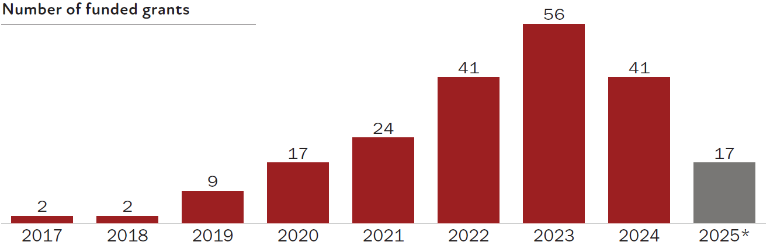
* Data from 2025 are incomplete as some outcomes are not yet available.
The funded amount for Indigenous health grants has also generally increased each year (Figure 3).
Figure 3 Funded amount for Indigenous health grants each year from 2017 to 2025
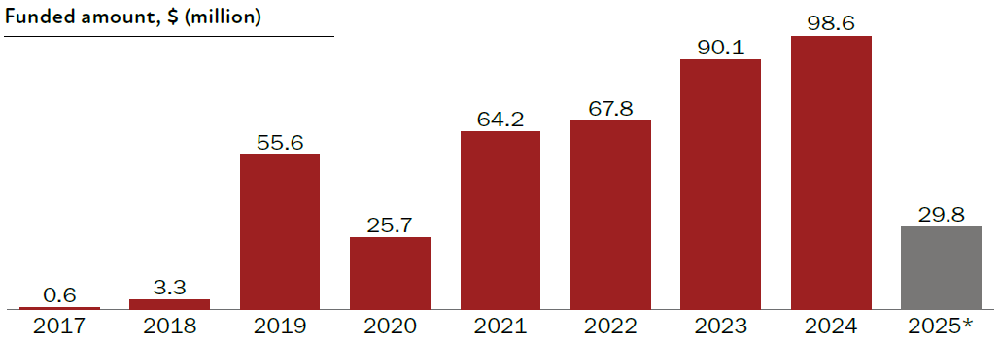
* Data from 2025 are incomplete as some outcomes are not yet available.
New South Wales administering organisations have the highest number of funded Indigenous health research grants (Figure 4).
Figure 4 Number of funded Indigenous health grants by location of the administering organisation, since 2017
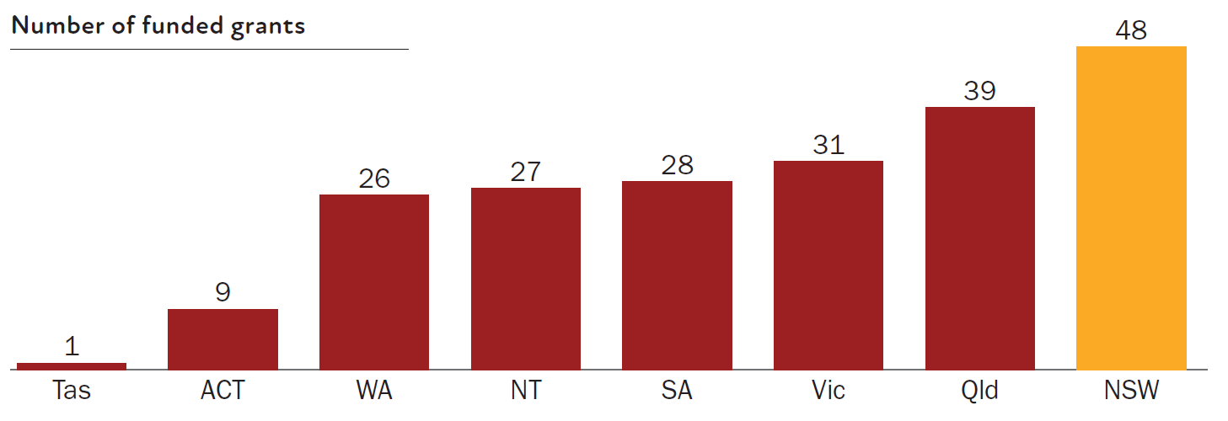
New South Wales administering organisations also received the highest amount of funding for Indigenous health research (Figure 5).
Figure 5 Funded amount for Indigenous health grants by location of the administering organisation, since 2017
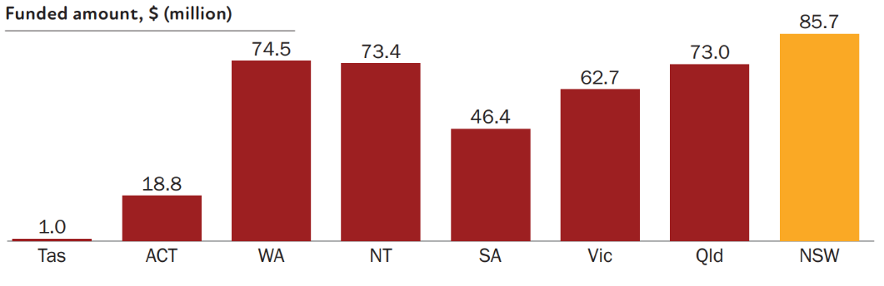
The Indigenous Health Research Fund (IHRF) initiative has the highest number of funded Indigenous health research grants (Figure 6).
Figure 6 Number of funded Indigenous health grants from the top 6 MRFF initiatives
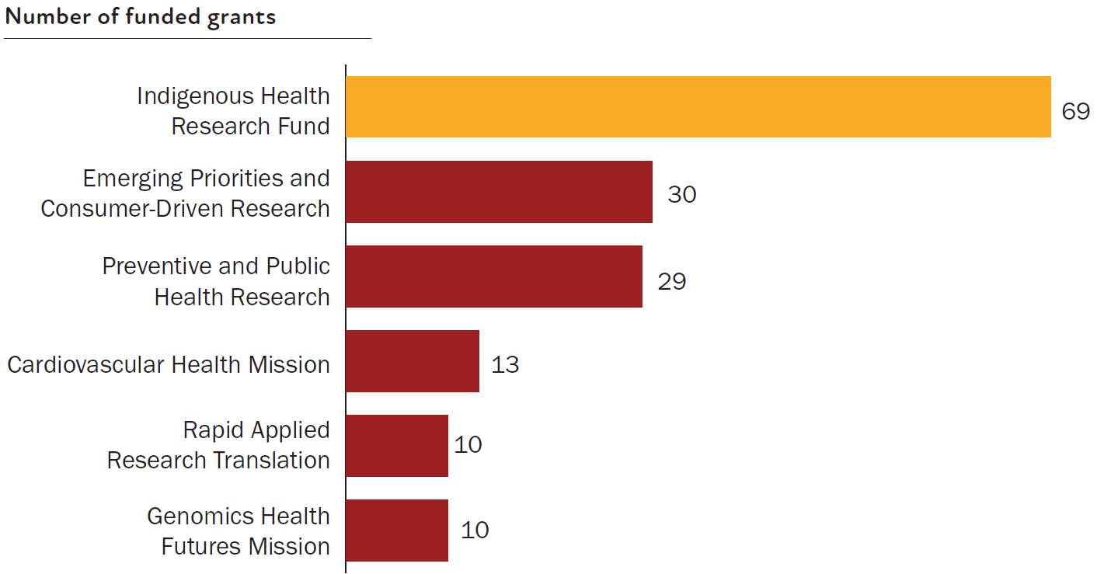
Note: Top 6 initiatives listed, based on the number of funded grants.
The IHRF is also the highest funder of Indigenous health research (Figure 7).
Figure 7 Funded amount for Indigenous health grants from the top 6 MRFF initiatives
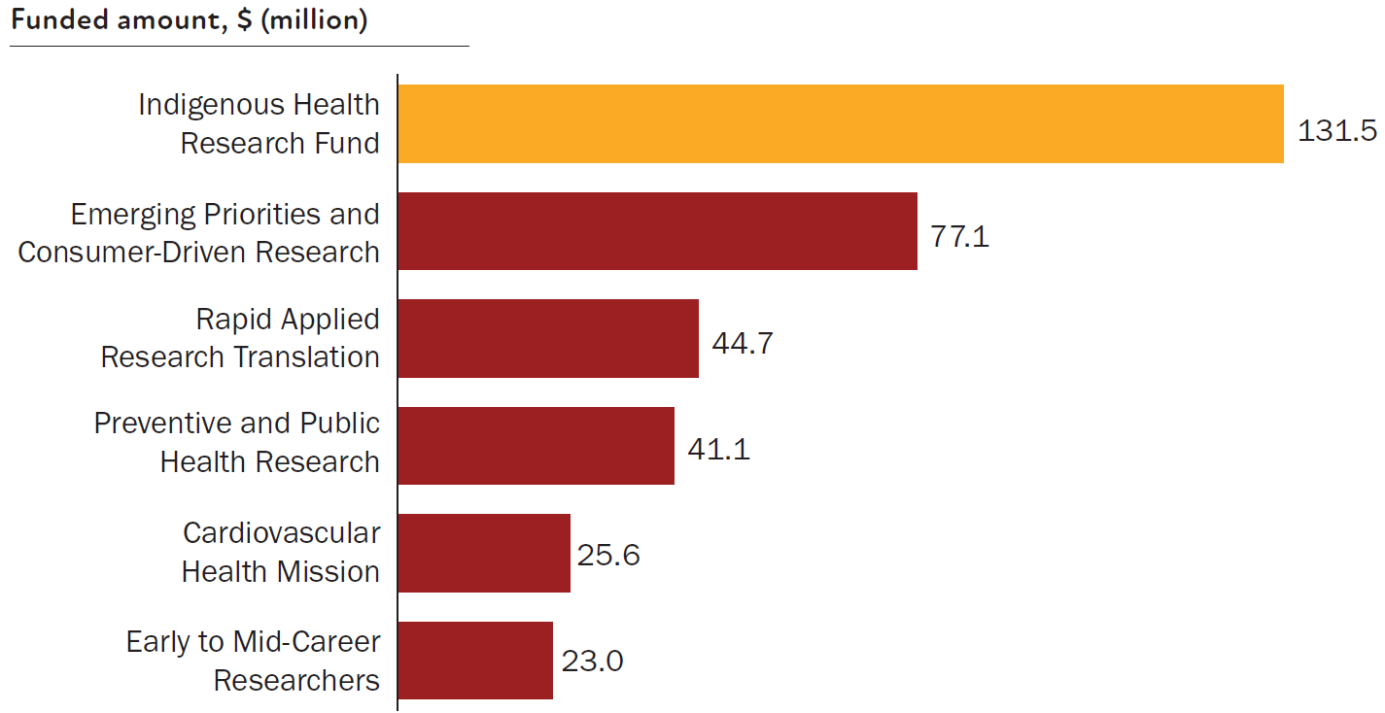
Note: Top 6 initiatives listed, based on the funded amounts.

Indigenous Health Research Fund
Key statistics:
69 grants funded through the IHRF, with a 38.9% funded rate
98.6% of IHRF-funded grants have involved an Indigenous researcher and 56.5% of grants have been led by an Indigenous researcher
$131.5 million in funding has been disbursed.
The number of grants funded through the IHRF has generally increased (Figure 8).
Figure 8 Number of grants funded through the IHRF each year, from 2020 to 2024
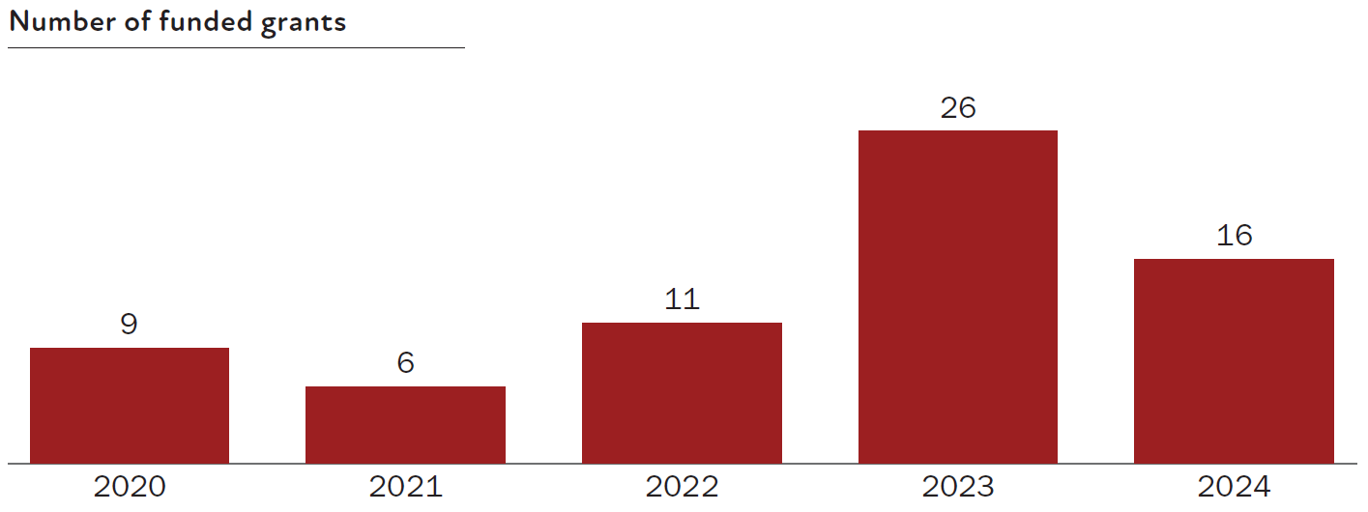
Note: Does not include a non-competitive grant (worth $35 million) awarded in 2019 before the establishment of the IHRF Roadmap and Implementation Plan.
The funded rate has been variable (Figure 9).
Figure 9 Funded rate for IHRF grants each year, from 2020 to 2024
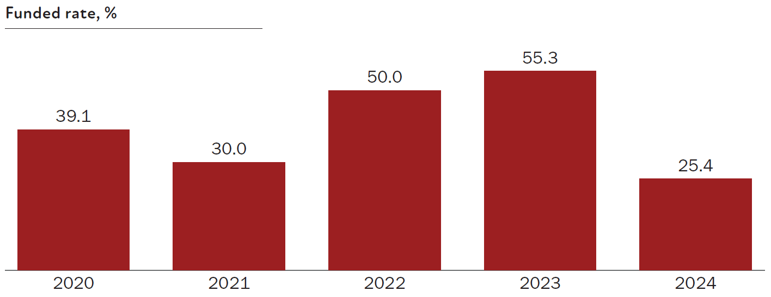
Note: Does not include a non-competitive grant (worth $35 million) awarded in 2019 before the establishment of the IHRF Roadmap and Implementation Plan.
The amount funded through the IHRF has generally increased each year (Figure 10).
Figure 10 Funded amount for IHRF grants each year, from 2020 to 2024
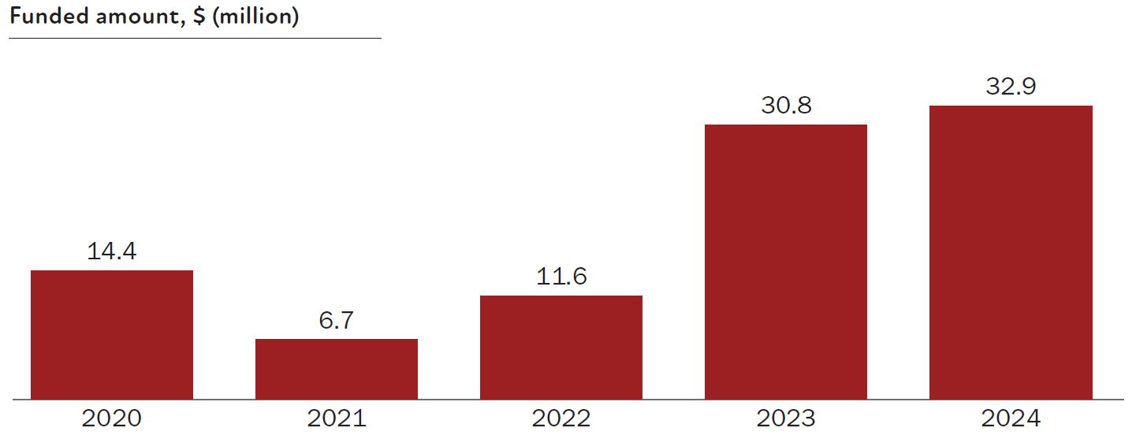
Western Australian administering organisations receive the highest amount of IHRF funding of all states and territories (Figure 11).
Figure 11 Funded amount for IHRF grants by location of the administering organisation, since 2020
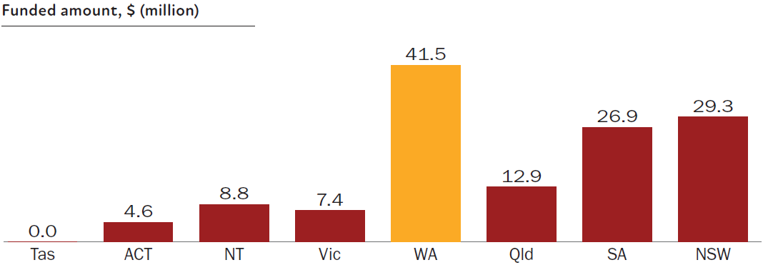
New South Wales administering organisations have the highest number of funded grants through the IHRF (Figure 12).
Figure 12 Number of IHRF-funded grants by location of the administering organisation, since 2020
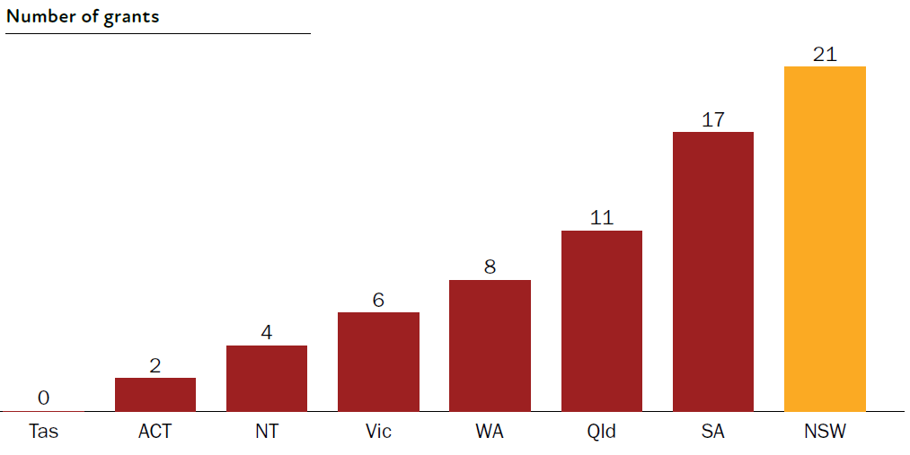
Grants from South Australian administering organisations have the highest funded rates (Figure 13).
Figure 13 Funded rate for IHRF grants by location of the administering organisation, since 2020
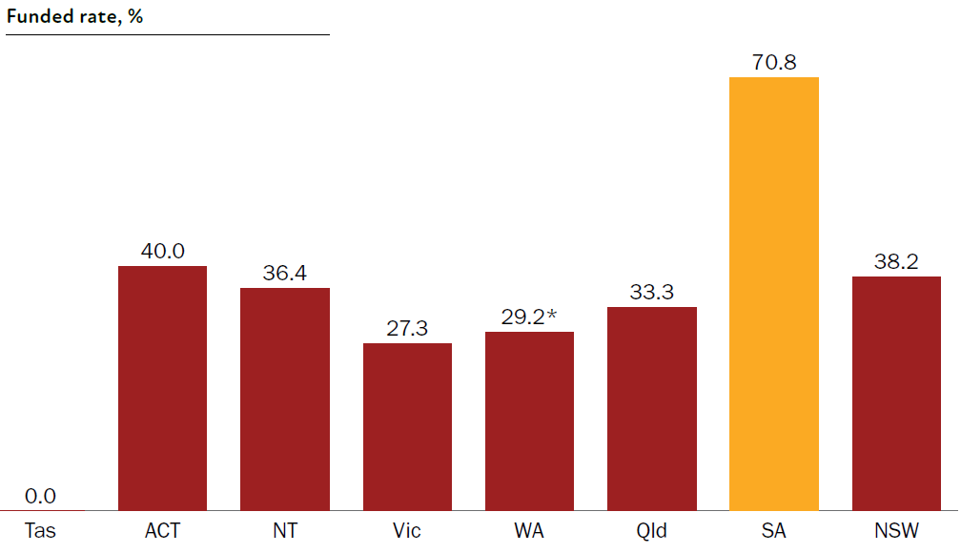
* Excludes one ad-hoc grant/application.
Most IHRF-funded Indigenous lead investigators are 6–10 years post-PhD (Figure 14).
Figure 14 Number of lead investigators funded through the IHRF by number of years post-PhD, since 2020
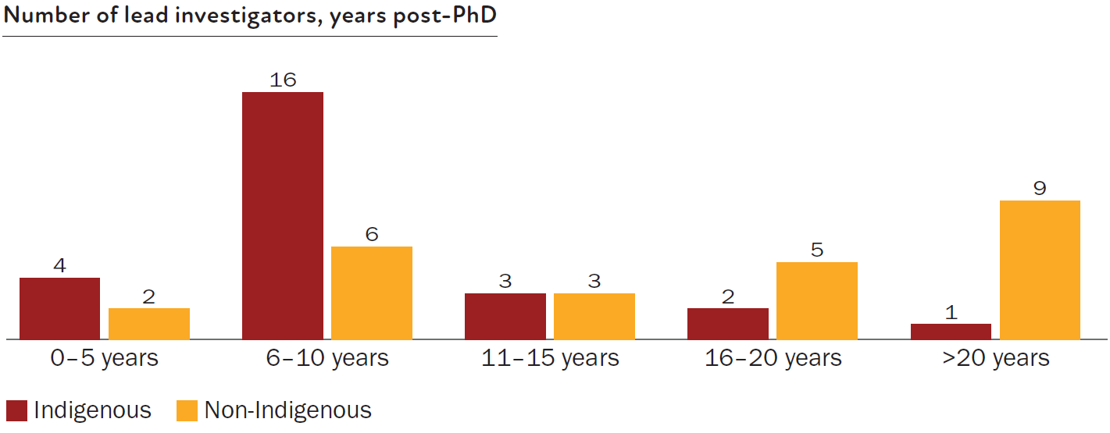
Note: Grants for which the career stage of the lead investigator is unknown (either due to them not having a PhD or PhD data not being available) are not included.
Lead investigators who have received the most IHRF funding are 6–10 years post-PhD (Figure 15).
Figure 15 Funded amount for lead investigators under the IHRF by number of years post-PhD, since 2020
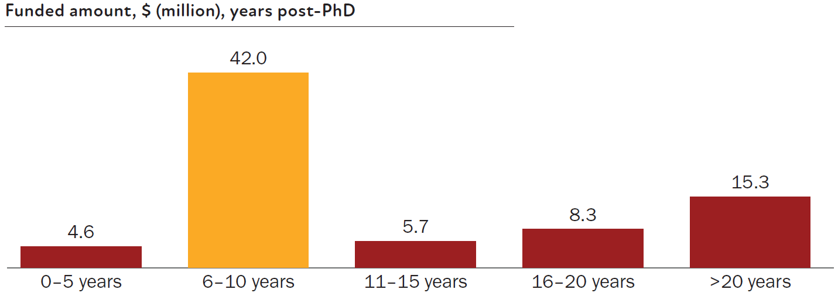
Note: Grants for which the career stage of the lead investigator is unknown (either due to them not having a PhD or PhD data not being available) are not included.

All MRFF Aboriginal and Torres Strait Islander researchers
Key statistics:
68 funded grants had distinct Indigenous lead investigators
44.5% funded rate for Indigenous-led research, which is higher than the general MRFF funded rate of 21.2%
$130.2 million in funding received by Indigenous lead investigators
Indigenous researchers were involved in 248 funded grants, including 80 not focused on Indigenous health.
The number of applications and funded grants led by Indigenous researchers have generally increased each year (Figure 16).
Figure 16 Number of applications and funded grants led by Indigenous researchers each year, from 2019 to 2024
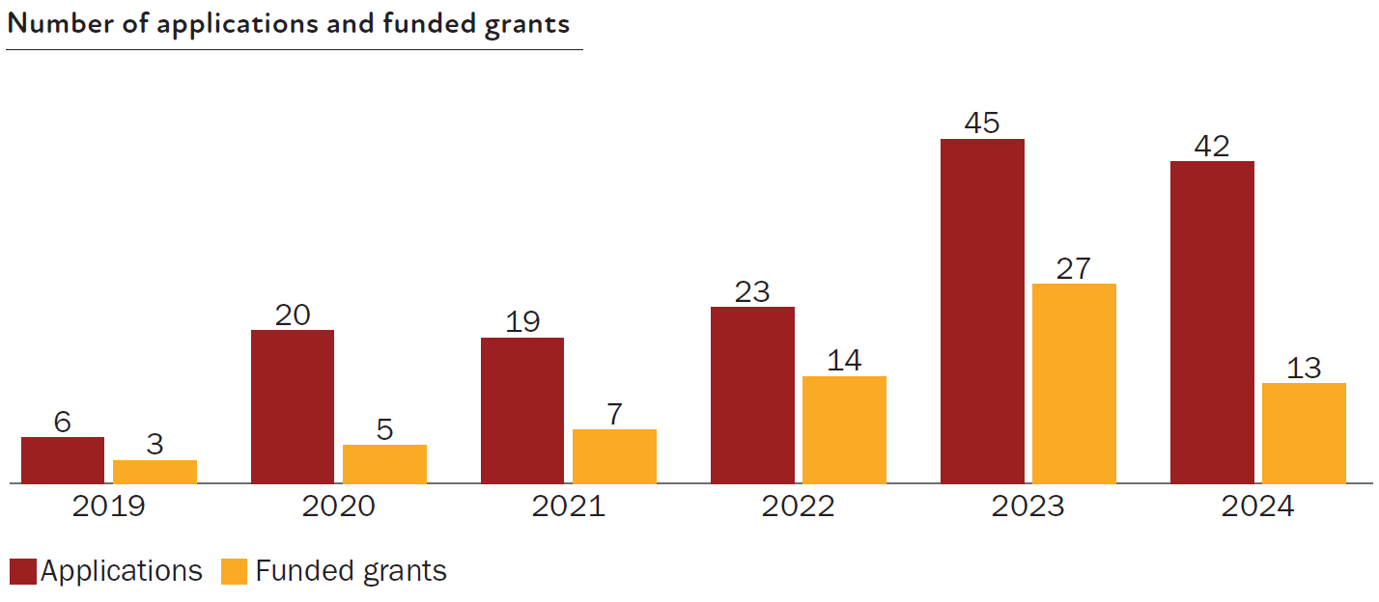
Indigenous researchers who lead Indigenous health grants tend to be 6–10 years post-PhD (Figure 17).
Figure 17 Number of MRFF-funded lead investigators for Indigenous health grants by number of years post-PhD, since 2019
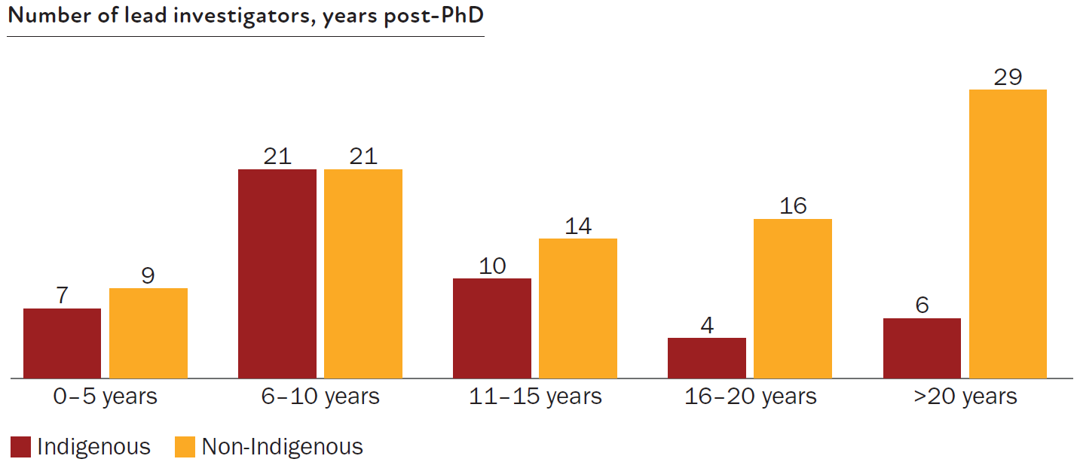
Note: Grants for which the career stage of the lead investigator is unknown (either due to them not having a PhD or PhD data not being available) are not included.
Indigenous lead investigators who receive the highest amount of funding tend to be 6–10 years post-‍PhD (Figure 18).
Figure 18 Funded amounts for Indigenous lead investigators through the MRFF by number of years post-PhD, since 2019
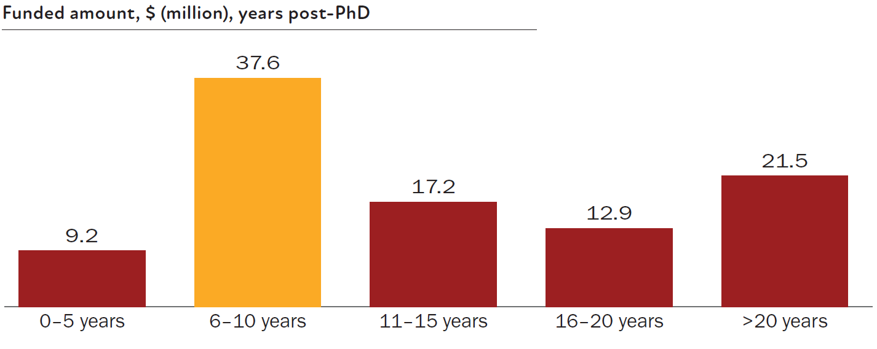
Note: Grants for which the career stage of the lead investigator is unknown (either due to them not having a PhD or PhD data not being available) are not included.
More women than men Indigenous researchers have been funded lead investigators and women Indigenous researchers have a higher funded rate than men (Figure 19).
Figure 19 Left: Number of MRFF-funded women and men Indigenous researchers since 2019. Right: Funded rates for women and men Indigenous researchers since 2019
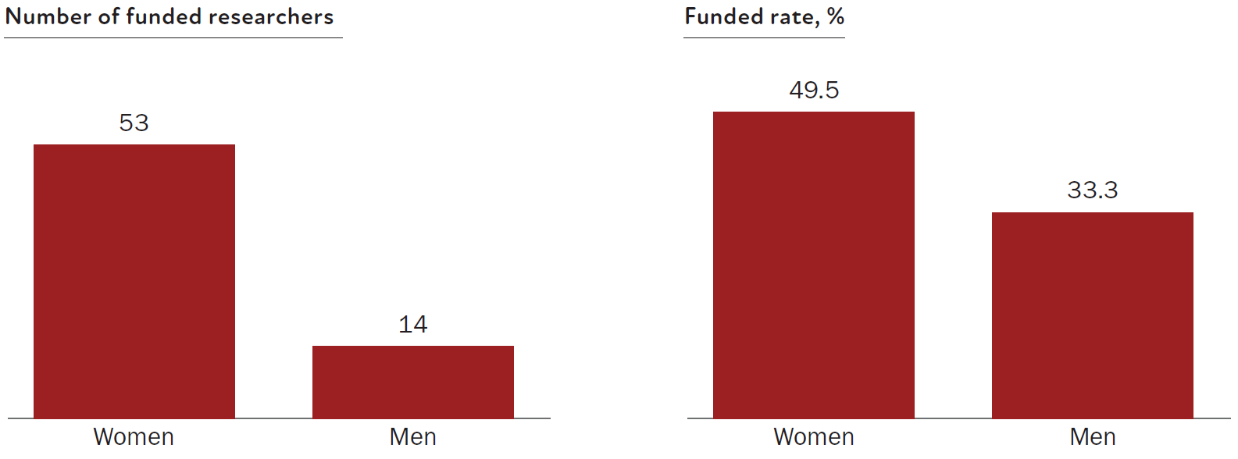
Note: Does not include applications for which gender data were unknown.

Facilitators and barriers for Aboriginal and Torres Strait Islander health research
An analysis of MRFF projects to date that focus on Indigenous health research has revealed common facilitators and barriers, as cited by researchers, that affect successful research implementation and progress.

Facilitators
Working closely with Indigenous peoples was the most common facilitator to successful Indigenous health research. Specifically, co-design and early and sustained community engagement build trust with Indigenous communities and ensure the projects are relevant to their needs, while strong Indigenous governance structures and leadership (including from Aboriginal Community Controlled Health Organisations) ensure cultural integrity and accountability within projects. Similarly, embedding cultural safety in research design and service delivery was identified as essential for participation and trust of Indigenous peoples.
Other identified facilitators include:
forming multi-institutional collaborations (including with Aboriginal health services), for resource sharing and capacity building
adopting flexible and adaptive project management practices, including the ability to revise timelines and vary grants, to adapt to challenges such as workforce shortages
using existing infrastructure and data systems, for efficient data collection and analysis.

Barriers
The analysis revealed that many of the challenges encountered in Indigenous health research arise not from communities themselves but from structural, regulatory and funding systems that are not yet aligned with Indigenous governance cycles, on-Country contexts or community-led research methods. These structural constraints can slow research momentum, limit flexibility and reduce the feasibility of translation activities.
Key structural barriers include:
contracting and funding delays, particularly where multi-agency processes or lengthy approvals limit the ability of community partners to commence work in a timely manner
complex ethics and governance pathways, which, while essential for cultural safety and accountability, often involve several jurisdictions and duplicative requirements that place administrative burden on Aboriginal Community Controlled Health Services and researchers
workforce instability generated by system design, including reliance on short-term funding, high turnover created by competitive recruitment environments, and limited support for localised career pathways in remote regions
digital and infrastructure limitations that reflect broader inequities in telecommunications access, data systems and place-based research infrastructure
system-driven pressures on community organisations, including service delivery demands, emergency responses and policy shifts that re-prioritise community time, labour and attention away from research activities.
Despite these constraints, Indigenous communities consistently show extraordinary adaptability, innovation and relational strength. Many projects reported that strong cultural governance and early community engagement, along with the leadership of Elders, Aboriginal Community Controlled Health Services and local research partners, helped navigate system pressures and maintain project continuity. These examples emphasise the need for structural reform to match the capability, innovation and commitment already present among Indigenous communities.

Impact of investment in Aboriginal and Torres Strait Islander researchers and health research
The MRFF measures of success are set out in the monitoring, evaluation and learning conceptual framework that is part of the MRFF Monitoring, Evaluation and Learning Strategy (Figure 20). These measures support achieving MRFF outcomes and reflect MRFF’s vision, aims and objectives, which are articulated through 5 impact measures:
better health outcomes for patients
beneficial change to health policy and practice
increased efficiency in the health system
increased job and export potential
economic growth from the commercialisation of health research outcomes.
Figure 20 MRFF outcomes
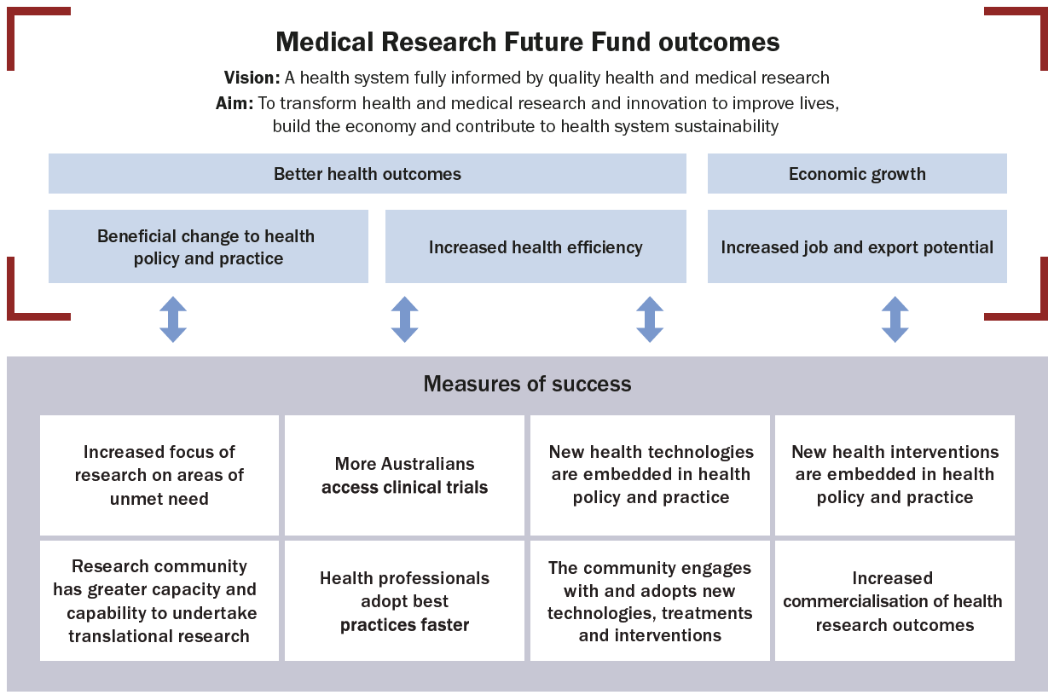

Impact stories
MRFF funding has supported many researchers, including Indigenous researchers, in delivering health projects that align with the needs and draw on the unique knowledge of Indigenous communities. The projects highlighted are only a selection of those that met the criteria. They are presented in no particular order.

Co-designed sleep health program to achieve better sleep and improved mental health in Indigenous adolescents
Lead investigator: Professor Yaqoot Fatima, University of Queensland; Professor of Sleep Health, Thompson Institute, University of the Sunshine Coast
Initiative: Indigenous Health Research Fund
Grant opportunity: 2019 Indigenous Health Research
Project highlights
Involvement of Indigenous communities (Elders, adolescents, parents, carers, other stakeholders) in governance, co-design, implementation, evaluation and dissemination
Knowledge translation
Evidence-based structural change in the health practice of Indigenous adolescents
Building on the unique knowledge, strengths and resilience of Indigenous communities
Impact beyond the intended grant objectives
Figure 21 MRFF measures of success met (orange border) and not met (shaded grey) for the project ‘Co-designed sleep health program to achieve better sleep and improved mental health in Indigenous adolescents’
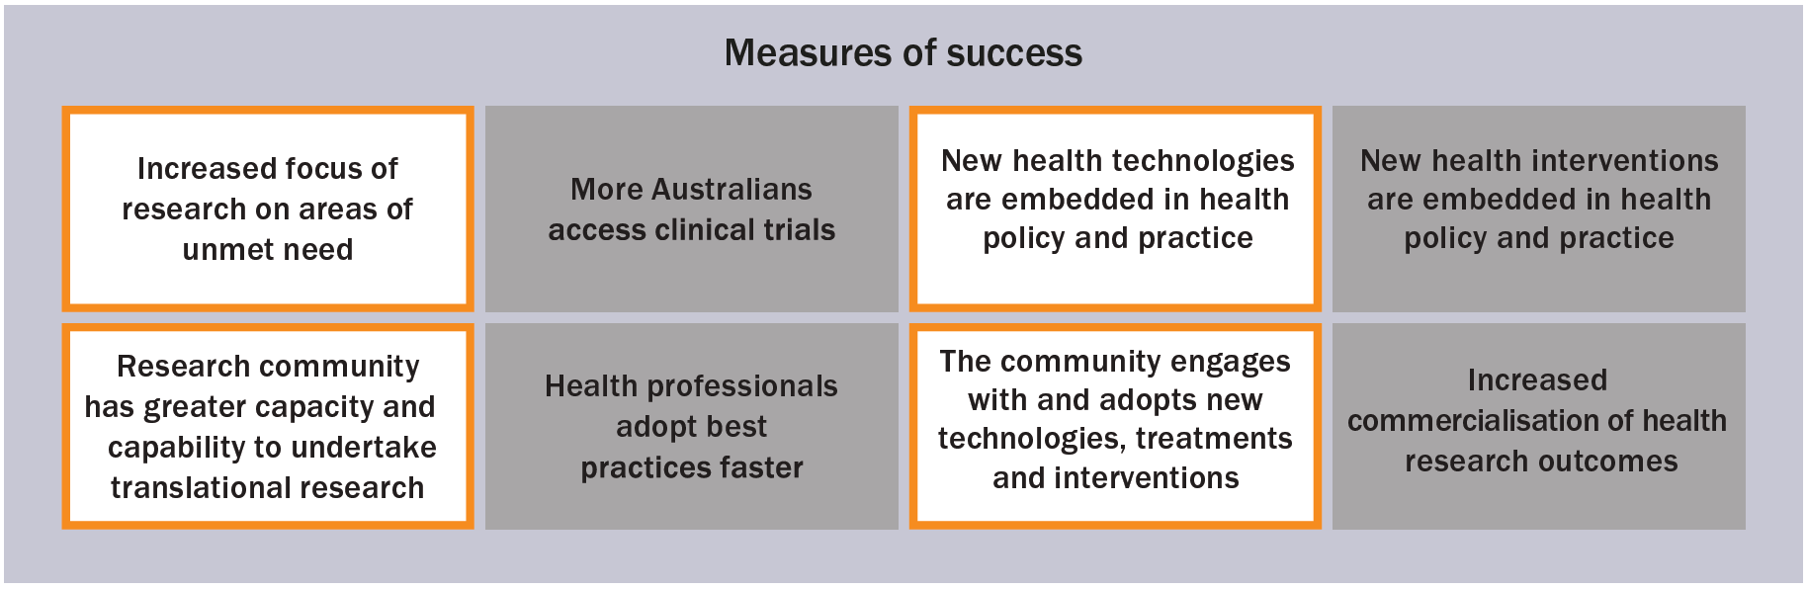

The project
In partnership with Indigenous peoples, Professor Fatima and her team co-designed and delivered Australia’s first sleep health program for Indigenous adolescents, ‘Let’s Yarn About Sleep’. The program was rooted in the Indigenous conceptualisation of sleep health; strengthened the capacity of Indigenous youth workers; and brought together Indigenous communities, mental health and primary care services, and advocacy partners to co-design a solution for improving the mental health of Indigenous adolescents through healthy sleep.
In developing the sleep program, Professor Fatima worked closely with Indigenous communities to gain a culturally grounded understanding of sleep and identify community priorities. This ensured that the program aligned with local values and strengths. Six Indigenous community members were trained as sleep coaches to deliver the program to 70 Indigenous adolescents in the Mount Isa region. This was aided by strong partnerships with health services, schools, advocacy groups and local stakeholders.
The ‘Let’s Yarn About Sleep’ community steering group members, who played a vital role in ensuring the program was culturally grounded.
Professor Fatima said, ‘Training was shaped by community Elders and embedded with cultural protocols, ensuring the program remained grounded in local knowledge and practices.’
The adolescents who participated in the program had improved overall sleep health, including better sleep routines, longer sleep, fewer night-time disruptions and feeling more rested during the day. The program also appeared to help reduce stress and support emotional wellbeing of participants.

The outcome
The community-led approach helped Professor Fatima learn that sleep is more than a biological process for Indigenous peoples.
‘Dreaming is deeply connected to culture, identity, creativity and spiritual health. This brought an important shift in how we think about sleep health in First Nations contexts.’
The program has also influenced how sleep health is assessed in clinical and community settings. Not only has it led to broader recognition of how poor sleep impacts physical and emotional health and the social lives of young people, but it has also raised important questions about whether existing diagnostic tools are appropriate for Indigenous peoples. The program’s culturally responsive resources have been adopted by the Royal Australian College of General Practitioners and other health services.

The impact of MRFF funding
Professor Fatima believes that MRFF funding enabled a level of collaboration with Indigenous communities that would not have been possible otherwise.
‘It has enabled us to centre community leadership by supporting the participation of First Nations researchers, community members and Elders throughout all stages of the research … Their leadership, generosity and guidance have strengthened the research’s quality and cultural responsiveness and made my work more meaningful, grounded and aligned with real-world priorities.’
MRFF funding also supported the establishment of the ‘Let’s Yarn About Sleep’ research group, which includes more than 90 researchers, 19 of whom identify as Indigenous.
Professor Yaqoot Fatima (left) and Kalkadoon Elder Aunty Joan Marshall (right), Chair of the Community Steering Group, with her artwork symbolising how ‘Let’s Yarn About Sleep’ brought together Western and Indigenous knowledges to advance sleep health equity.

Scaling up infectious disease point-of-care testing for Indigenous people
Co-lead investigators:
Professor Rebecca Guy, Head of the Surveillance and Evaluation Research Program, the Kirby Institute, University of New South Wales
Dr Dawn Casey, Deputy CEO, the National Aboriginal Community Controlled Health Organisation
Program manager: Emily Phillips
Initiative: Rapid Applied Research Translation
Grant opportunity: 2020 Rapid Applied Research Translation
Project highlights
Co-leadership by Indigenous researchers as Chief Investigators
Involvement of Indigenous individuals, communities and organisations in co-design, practice, governance and implementation
Evidence-based structural change in Indigenous health practice
Building on the unique knowledge, strengths and endurance of Indigenous communities, particularly to overcome common/unique challenges in conducting research
Figure 22 MRFF measures of success met (orange border) and not met (shaded grey) for the project ‘Scaling up infectious disease point-of-care testing for Indigenous people’
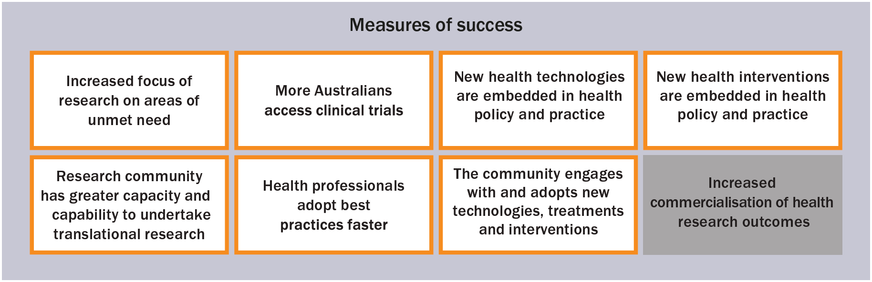

The project
Diagnostic testing with fast turnaround of results is critical for infectious disease management and prevention. Delays in testing and results can lead to serious adverse health consequences including hospitalisations, cancer and death. However, rapid testing and results are not uniformly accessible for Indigenous people living in rural and remote areas. Professor Guy, Dr Dawn Casey and the project team aim to scale up infectious disease point-of-care (POC) testing in primary care services, to shape infectious disease diagnostic practice and policy for rural and remote Indigenous communities in Australia and improve health outcomes through early intervention.
This project involves Indigenous investigators and is co-led by the National Aboriginal Community Controlled Health Organisation. The research has been co-designed with Indigenous peoples and communities at every stage. Building on 10 years of past collaborative POC programmatic work and research, this new research included a co-design workshop to set priorities and guide the overall direction of the projects. More than half of the workshop participants were Indigenous.
This workshop was followed by more than 12 months of ongoing stakeholder engagement to ensure the study protocols aligned with community needs. To ensure cultural governance across the projects, the team also established a First Nations Point of Care and Research Governance Group. Additionally, all participating health services received funding in recognition of their expertise and contributions as research partners. These strategies have helped ensure the research is community-led, better aligned to real-world service delivery and positioned for long-term sustainability.
Through the co-design workshop, the research team identified early in the project the need to address workforce challenges, which would impact the successful implementation of POC testing programs. The team adapted the project to explore alternative workforce models. This resulted in the project piloting the training of non-clinical staff as POC operators, with the aim of easing the burden on already-stretched clinical teams. This training also has the potential to strengthen health service capacity and, over time, create local education and employment pathways within communities.
Professor Guy said, ‘The project had a substantial consultation phase to build on past relationships and develop new ones with Aboriginal and Torres Strait Islander health services, researchers and stakeholders. Investing in early and ongoing engagement helps to build trust, align priorities, and shape research that is culturally appropriate, practical and meets community needs.’
Stacey Foster-Rampant (left) and Glen Duncan (right) from the Yandamanjang First Nations Health Research Program and Surveillance and Evaluation Research Program at the Kirby Institute.

The outcome
A significant outcome of the project has been the implementation of group A streptococcus (strep A) POC testing in remote communities. Strep A is a precursor infection for acute rheumatic fever and rheumatic heart disease, and Australia has some of the highest rates of rheumatic heart disease in the world, with Indigenous children having the highest risk. This sub-project, led by Professor Asha Bowen, will support 30 health services (mostly Aboriginal Community Controlled Health Services) across Australia to offer strep A POC testing in areas with the highest rates of acute rheumatic fever and rheumatic heart disease. The aim is to detect more cases of strep A and contribute to a reduction in disease.
Walking together for infectious disease by artist Mel Fernando, a proud Wiradjuri/Kamilaroi/ Yuwaalaraay/Euahlayi woman from Dubbo, Western New South Wales. She currently lives and works on Birpai Country.

The impact of MRFF funding
MRFF funding allowed the project team, managed by Emily Phillips, to create and strengthen relationships with key partners and collaborators. They could explore innovative and co-design strategies that support the prevention, diagnosis and management of infectious disease in Indigenous communities. The funding also allowed the team to expand the scope of research and implement POC testing for 2 new infections: strep A for the prevention of acute rheumatic fever and rheumatic heart disease, and human papillomavirus (HPV), a sub-project led by Associate Professor Lisa Whop.

Birthing on Country: RISE SAFELY in rural, remote and very remote Australia
Lead investigator: Professor Yvette Roe, Director of the Molly Wardaguga Institute for First Nations Birth Rights, Charles Darwin University, Northern Territory
Initiative: Emerging Priorities and Consumer-Driven Research
Grant opportunity: 2021 Improving the Health and Wellbeing of Aboriginal and Torres Strait Islander Mothers and Babies
Project highlights
Leadership by Indigenous researchers as Chief Investigators
Involvement of Indigenous individuals, communities and organisations in co-design, practice, governance and implementation
Knowledge translation through implementation and adaptation across several sites, as well as national dissemination activities to ensure culturally safe, effective and sustainable maternity care
Evidence-based structural change in Indigenous health practice
Building on the unique knowledge, strengths and endurance of Indigenous communities, particularly to overcome common/unique challenges in conducting research
Impact beyond the intended grant objectives towards Closing the Gap socioeconomic target outcome 2: ‘Aboriginal and Torres Strait Islander children are born healthy and strong’
Professor Yvette Roe and the team from the Molly Wardaguga Institute for First Nations Birth Rights.
Figure 23 MRFF measures of success met (orange border) and not met (shaded grey) for the project ‘Birthing on Country: RISE SAFELY in rural, remote and very remote Australia’
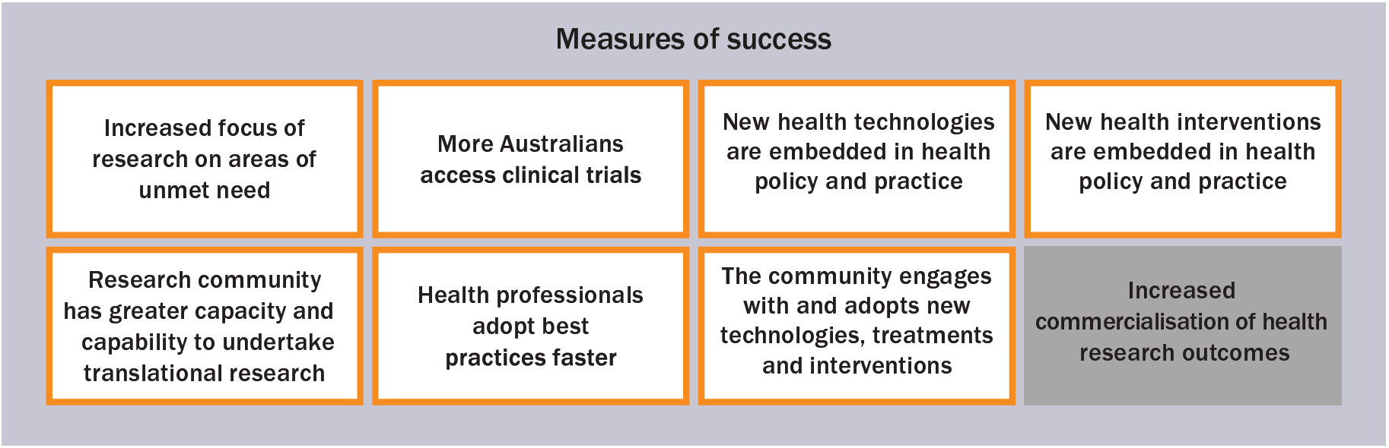

The project
Indigenous mothers are 3–5 times more likely to die during childbirth than other mothers. Their babies are almost 2 times more likely to die during their first year, often because they were born too early. Improving these statistics forms Closing the Gap socioeconomic target outcome 2: ‘Aboriginal and Torres Strait Islander children are born healthy and strong’.
This Indigenous-led, co-designed and staffed study aims to establish exemplar Birthing on Country maternity and child health services across 3 sites in rural (Nowra, New South Wales), remote (Mparntwe [Alice Springs], Northern Territory) and very remote (Galiwin’ku, Northern Territory) Australia within 5 years, to improve outcomes for Indigenous mothers and babies. Professor Roe, a proud Njikena Jawuru woman from the West Kimberley, Western Australia, and her team are working side by side with Indigenous communities and stakeholders and have Aboriginal Community Controlled Health Organisations as primary research partners. Collective governance and Community Participatory Action Research (CPAR) have guided the research process and milestones. The CPAR approach uplifts the voices and aspirations of community research partners and provides a mechanism that allows adaptation to the local context.
Maternity and child health services are redesigned using the RISE SAFELY implementation framework, which is underpinned by Indigenous values and ways of seeing, doing and being. It includes using an Indigenous workforce and operating out of community hubs created by community-controlled services.
‘Feedback from the women about the hub was it “feels like home” and “feels like a black space” … Birthing on Country gives First Nations mothers and mothers carrying First Nations babies cultural safety where they give birth.’
An exemplar Birthing in Our Community service that was established in Brisbane reduced Indigenous preterm births from 14.3% to 8.9%. There were also other improvements, including more Indigenous women being seen early in their pregnancy, women needing less intervention during birthing, more mothers breastfeeding and fewer babies being admitted to neonatal units. Professor Roe is working with several partners to translate the knowledge gained from the Birthing in Our Community service for use in rural, remote and very remote settings.

The outcome
Professor Roe and the team at the Molly Wardaguga Institute for First Nations Birth Rights have developed A National Roadmap for Birthing on Country Services 2025–2035. This co-designed, first-‍of-its-kind roadmap sets out a 10-year plan for redesigning maternity services in Australia to better serve Indigenous mothers and babies.
Birthing on Country, delivered by My Midwives Alukura Midwifery Group Practice, won the Australian College of Midwives Maternity Service of the Year in 2025.

The impact of MRFF funding
Professor Roe said that MRFF funding supported genuine collaboration and co-creation with community partners, which was critical in the development and delivery of the grant. MRFF funding also allowed for innovation and flexibility to respond to community needs and aspirations.
‘Demonstrating good custodianship and supporting Indigenous data sovereignty that [is] guided by the governance structure is core to our research methods and having long-term relationships with our partners.’
Additionally, the grant provided an opportunity to support community research partners in building organisational research capacity with Indigenous staff. It also created opportunities to engage Indigenous scholars who are at various points in their academic careers and elevate community knowledge holders who may not be recognised under traditional academic titles.

Moving together towards the elimination of chronic hepatitis B in the Northern Territory
Lead investigator: Professor Jane Davies, Menzies School of Health Research, Northern Territory
Initiative: Clinician Researchers
Grant opportunity: 2019 Investigator Grants: MRFF Priority Round
Project highlights
Involvement of Indigenous individuals, communities and organisations in co-design, practice, governance and implementation
Knowledge translation
Evidence-based structural change in Indigenous health practice
Building on the unique knowledge, strengths and endurance of Indigenous communities, particularly to overcome common/unique challenges in conducting research
Impact beyond the intended grant objectives
Figure 24 MRFF measures of success met (orange border) and not met (shaded grey) for the project ‘Moving together towards the elimination of chronic hepatitis B in the Northern Territory’
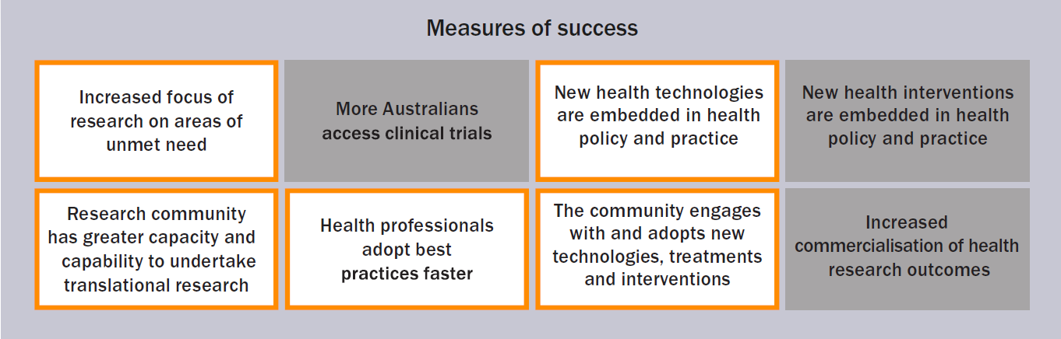

The project
Compared to other Australians, Indigenous peoples are disproportionately affected by chronic hepatitis B infection and liver cancer. For this project, Professor Davies worked with Indigenous peoples to improve culturally safe care for Indigenous peoples living with hepatitis B. This work was then extended to researching immunity and vaccine responses and developing evidence-based vaccine information for Indigenous peoples during the COVID-19 pandemic.
The Hep B PAST research program followed participatory action research principles, constantly involving consultation, co-design, 2-way listening and adaptation to setting and resources. The 3 main phases were the foundation step, capacity building of the health workforce, and the supported transition of care for people with chronic hepatitis B to primary care/on-Country care. Professor Davies used a similar methodology to enable the co-design, development and distribution of COVID-19 vaccine information in Indigenous languages, and to enable Indigenous peoples in the Northern Territory to be involved in cutting-edge research investigating immunological responses to COVID-19 infection and vaccination.
Both the hepatitis B and COVID-19 work were driven by the Menzies Infectious Diseases Indigenous Reference Group, which represents more than 8 remote communities. The Indigenous Reference Group set priorities and provided advice on culturally safe research methods, community consultation, co-design and knowledge translation. As part of phase 2 of the Hep B PAST program, a conceptual process model for the development of culturally safe training of the health workforce was co-designed with Indigenous health practitioners (Figure 24). This process model was then used by the broader health setting to develop culturally safe training packages for health workers during the COVID-19 pandemic.
Figure 25 A conceptual process model for the development of culturally safe training
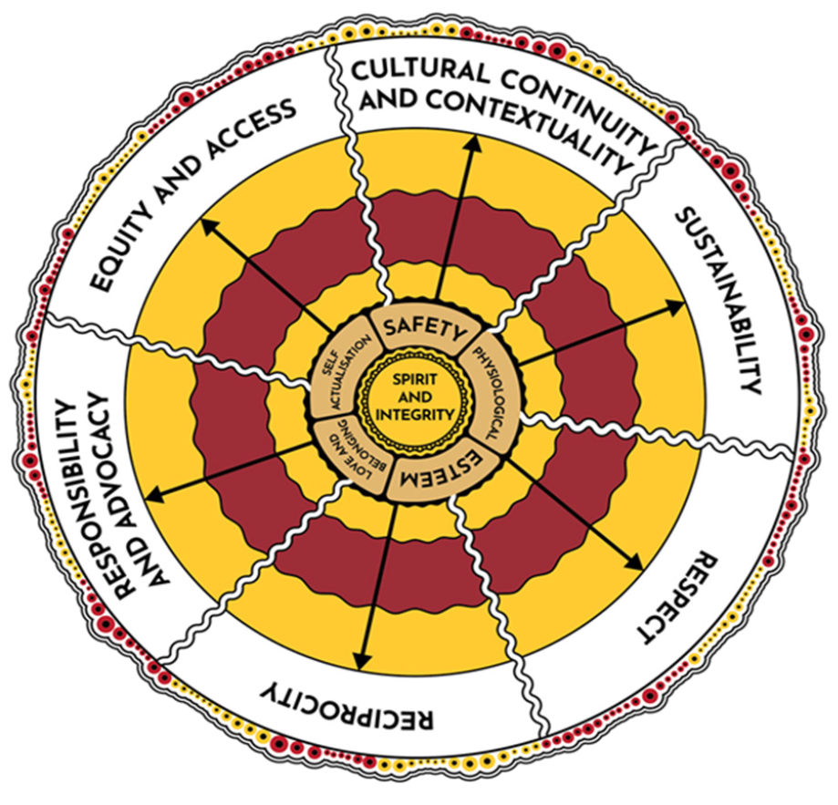

The outcome
Professor Davies’ research resulted in the Northen Territory being the only state or territory in Australia to have closed the gap in engagement in care for Indigenous peoples living with chronic hepatitis B. Additionally, the services involved in the Hep B PAST program have exceeded the national targets for hepatitis B care and are meeting the national strategy targets for elimination of chronic hepatitis B as a public health problem by 2030. The program has also led to the model of care being named in the Fourth National Hepatitis B Strategy 2023–2030 as a model to be rolled out across Australia.
Other outcomes for the project include the release of the Hep B Story app in 11 Indigenous languages, establishment of a Hep B Hub, and training of Indigenous health staff, medical practitioners and nurses in hepatitis B management to support transition to a primary care hub.
‘Be humble, listen and actively take part in 2-way learning, communicate well and often, let the pace be dictated by the community/Indigenous reference group/First Nations mentors even when that feels uncomfortable … Most of all, be positive, persistent and passionate about really using research to improve clinical outcomes and to strive for equity.’
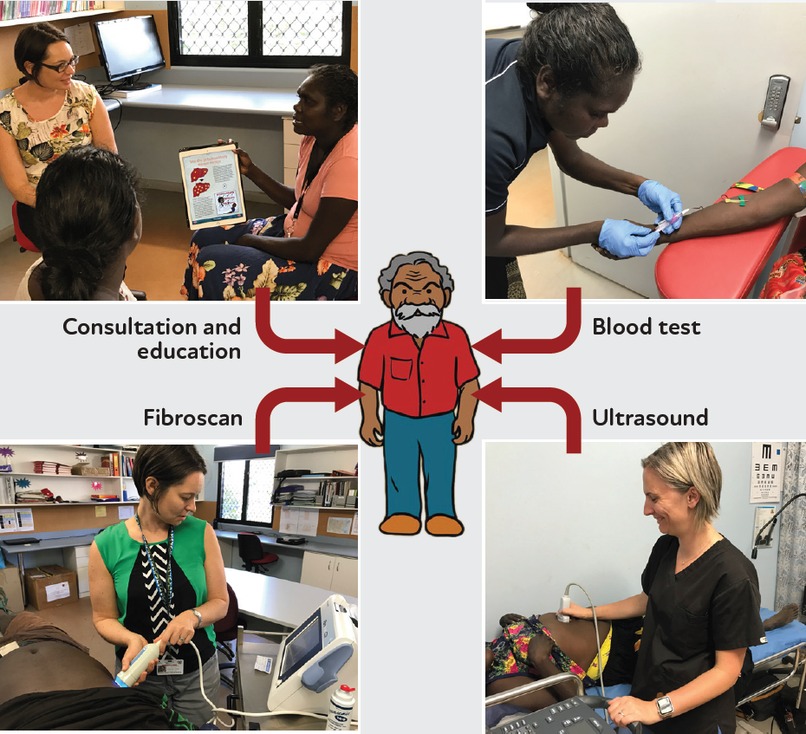
The liver ‘one stop shop’ in action.

The impact of MRFF funding
MRFF funding enabled Professor Davies to build on and enhance elements of the research and establish wide-ranging collaborations across the Northern Territory, Australia and internationally, including with the World Health Organization Collaborating Centre for Viral Hepatitis. It also enabled her to pivot to the COVID-19–related work.

Co-designing a coordinated, sustainable and supportive patient navigator program to improve kidney health outcomes
Lead investigator: Kelli Owen, South Australian Health and Medical Research Institute
Initiative: Indigenous Health Research Fund
Grant opportunity: 2021 Indigenous Health Research
Project highlights
Leadership by Indigenous researchers as Chief Investigators
Involvement of Indigenous individuals, communities and organisations in co-design, practice, governance and implementation
Knowledge translation
Evidence-based structural change in Indigenous health practice
Building on the unique knowledge, strengths and endurance of Indigenous communities, particularly to overcome common/unique challenges in conducting research
Impact beyond the intended grant objectives
Figure 26 MRFF measures of success met (orange border) and not met (shaded grey) for the project ‘Co-designing a coordinated, sustainable and supportive patient navigator program to improve kidney health outcomes’
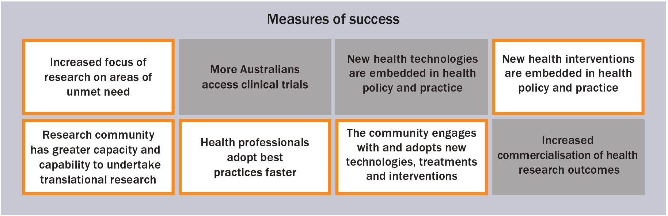

The project
Indigenous peoples rely on each other and networks across Country to feel safe in the Australian health system. For kidney patients, this is especially important as the treatment journey is complex, confusing and often unsafe. This co-designed project titled COMPASS (Connecting Our Mob: Patient navigators As Sustainable Supports) seeks the best ways to integrate ‘patient navigators’ (people with lived experience of kidney disease and/or transplantation) into the health system to provide safe care and better outcomes for Indigenous kidney disease patients.
Patient navigators advocate for patients’ needs, improve cultural awareness within the health system, translate health knowledge, and provide culturally safe support and understanding for Indigenous patients. Patient navigator programs currently run in 4 locations: Port Augusta, Adelaide, Alice Springs and Darwin. The project is led by Kelli Owen, a Kaurna, Narungga and Ngarrindjeri woman, kidney transplant recipient, and National Community Engagement Coordinator for the National Indigenous Kidney Transplantation Taskforce. The research team comprises renal health professionals and academics, as well as patient navigators as Chief Investigators.
As part of the project, the team undertook a series of yarns with patients, health professionals and executives to map patient journeys and capture patient experiences of care. Kidney patients could share their stories of kidney disease in a setting without power imbalances and where they felt comfortable. Yarns also identified what patient navigators needed to feel supported and safe in their work environment. This ensured that the project was informed by lived experiences, research expertise and voices of Community.
The project has experienced barriers such as bureaucratic challenges and illnesses that affected the ability of patient navigators to fulfil their roles. However, the team have used these experiences as opportunities for knowledge translation, documenting the barriers (and project enablers) to share with Aboriginal Community Controlled Health Organisations, clinicians and researchers.
Kelli Owen and the Darwin COMPASS team.
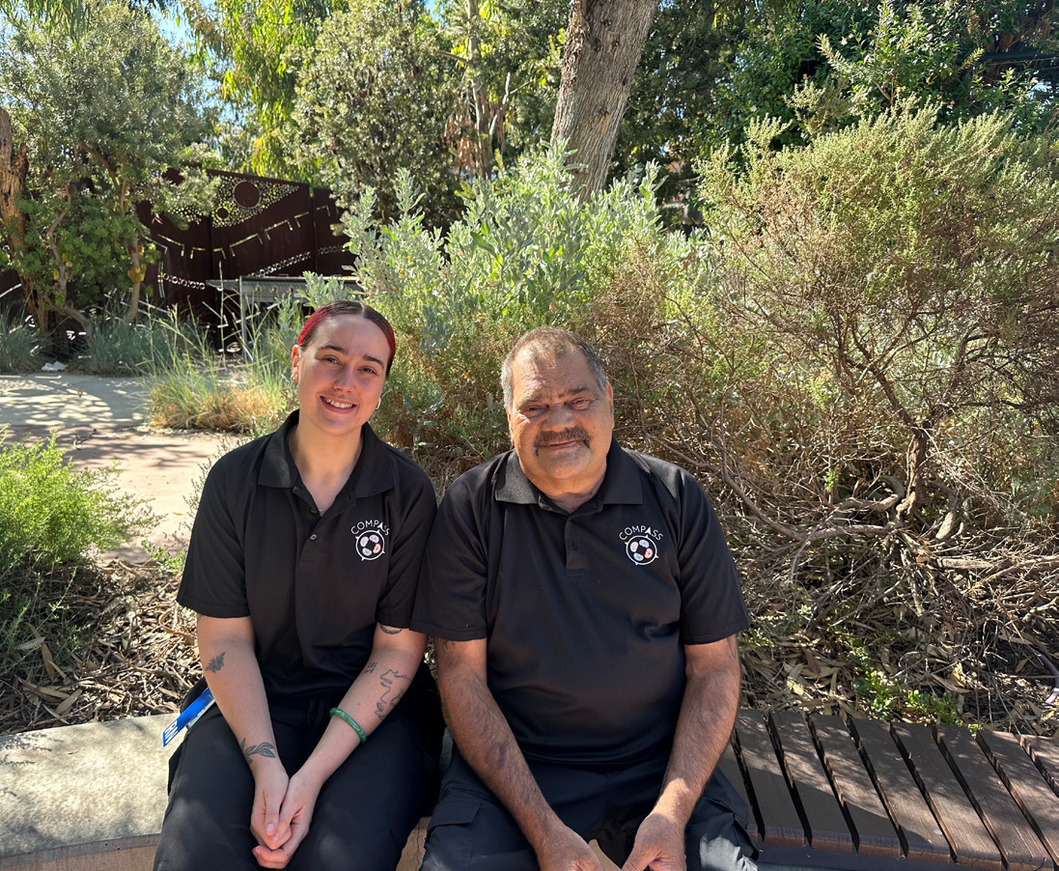
Arna (left), a Latje Latje woman and Patient Navigator Coordinator, and Richard (right), a Ngarrindjeri man and patient navigator, from the Royal Adelaide Hospital.

The outcome
Interviews with patients who have been part of the project show that patient navigators provide culturally safe emotional support and guidance throughout the kidney disease journey. This support has even had a life-saving impact, successfully encouraging some complex or high-risk patients to begin treatment or undergo necessary procedures. The project team has also received positive feedback and support from clinical staff and caregivers, which will strengthen the case for a sustainable, coordinated model of kidney care for Indigenous peoples.

The impact of MRFF funding
Ms Owen credits the MRFF funding her team received for helping turn their vision of the patient navigator support system into a reality.
‘MRFF funding believed in us to create the support model I needed during my own kidney journey. We encourage other kidney health services to take what we’ve learnt and develop a place-based “patient navigators” program, to make sure our people are never alone.’
Kelli Owen and the Royal Adelaide Hospital COMPASS team.

Royal Adelaide Hospital COMPASS team.

Conclusions
Since 2017, the MRFF has expanded its commitment to Indigenous health research, supporting a growing body of Indigenous-led innovation, governance and workforce development. These investments have generated new models of care, strengthened cultural governance mechanisms and amplified the leadership of Indigenous researchers across Australia’s health research ecosystem.
The insights in this report highlight the importance of sustained, long-term investment that aligns with Indigenous governance, supports community-controlled research and strengthens the sovereign capability of Indigenous organisations and researchers. The insights also signal opportunities for structural reform – particularly in data governance, ethics processes, contracting cycles and infrastructure investment – to further embed Indigenous leadership in national research systems.
With continued commitment from the MRFF (including in its implementation of the priority reforms of the National Agreement on Closing the Gap) and complementary funding from the NHMRC, Australia is well positioned to support a future in which Indigenous knowledge systems, scientific practice and community governance shape national health priorities and deliver benefits across the country. This approach not only contributes to the outcomes of the National Agreement on Closing the Gap, but strengthens Australia’s entire health research sector through innovation, cultural rigour and relational accountability.
The department will continue to monitor progress and impact of its investments and improve the availability and transparency of MRFF funding statistics and evaluation data.

‘Lead Chief Investigator’ refers to Chief Investigator A on grants or applications.
All files were analysed within the department’s enterprise environment; no data were shared outside of the department’s Health and Medical Research Office.
This was also applied to grants funded outside of the IHRF, as the IHRF objectives represent best practice for all grants with a focus on Indigenous health.
This was also applied to grants that predated the publication of the strategy, so were therefore not mandated to report against the MRFF measures of success.

