
Evaluation of younger people in residential aged care initiatives

Final Evaluation Report
19 August 2024


Nous Group acknowledges Aboriginal and Torres Strait Islander peoples as the First Australians and the Traditional Custodians of country throughout Australia. We pay our respect to Elders past, present and emerging, who maintain their culture, country and spiritual connection to the land, sea and community.
This artwork was developed by Marcus Lee Design to reflect Nous Group’s Reconciliation Action Plan and our aspirations for respectful and productive engagement with Aboriginal and Torres Strait Islander peoples and communities.
Disclaimer:
Nous Group (Nous) has prepared this report for the benefit of The Department of Social Services (the Client).
The report should not be used or relied upon for any purpose other than as an expression of the conclusions and recommendations of Nous to the Client as to the matters within the scope of the report. Nous and its officers and employees expressly disclaim any liability to any person other than the Client who relies or purports to rely on the report for any other purpose.
Nous has prepared the report with care and diligence. The conclusions and recommendations given by Nous in the report are given in good faith and in the reasonable belief that they are correct and not misleading. The report has been prepared by Nous based on information provided by the Client and by other persons. Nous has relied on that information and has not independently verified or audited that information.
© Nous Group

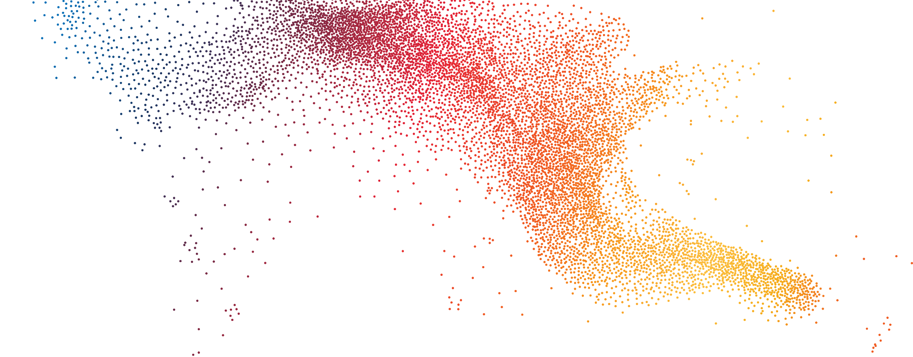
Acknowledgements
The evaluation team would like to acknowledge and thank the hundreds of individuals who have given their time to this evaluation. Their openness, honesty and passion has been invaluable in providing us with a rich understanding of the impact of the government-funded initiatives on the Younger People in Residential Aged Care (YPIRAC) cohort.
Their willingness to share their time, experience and perspectives so generously has been integral to the evaluation and has helped to shape the recommendations presented in this report.
The evaluation team would specifically like to thank:
- Younger people, their families and carers who completed our surveys and participated in interviews.
- The disability, health and aged care service providers who attended our focus groups and helped to spread the word about this research to younger people, their families and carers.
- Members of the YPIRAC Stakeholder Reference Group (SRG) for their continuous advocacy for younger people entering and living in residential aged care and for their engagement in workshops throughout the evaluation process.
- Australian Government departments and agencies that have supported this evaluation, including Department of Social Services, Department of Health and Aged Care and the National Disability Insurance Agency.
It has been a privilege to learn from each of you. Thank you.

Contents
Executive summary 1
Glossary and key terms 12
1 Background and context 14
1.1 Residential Aged Care is not appropriate for most younger people 14
1.2 Governments have taken action to reduce the number of younger people in RAC 14
1.3 Significant progress has been made but challenges remain 16
2 Methodology 20
2.1 An evaluation framework guided the evaluation 20
2.2 Several data sources were used to answer the key evaluation questions 24
2.3 There are several limitations to the evaluation findings 25
3 Evaluation Findings 27
3.1 There are gaps and inconsistencies in implementation that affect appropriateness 27
3.2 The initiatives have contributed to reducing the number of younger people in RAC 38
4 Future actions 73
4.1 The YPIRAC cohort has changed substantially 73
4.2 Broader system reforms may have an impact but will take time 78
4.3 Recommendations will support an ideal experience for younger people 80
Appendix A Key Evaluation Questions 91
Appendix B Program logics 93
Appendix C Stakeholder engagement 99
Appendix D Description of data analysis 105
Appendix E Department of Health and Aged Care Initiatives 107
Appendix F NDIA YPIRAC Planners and Accommodation Team 109
Appendix G Ability First Australia (AFA) System Coordinator Program 112
Appendix H Royal Commission recommendations 116

Executive summary

The Australian Government responded to the Royal Commission’s findings
The Royal Commission into Aged Care Quality and Safety (the Royal Commission) inquired into the issue of younger people with disability residing in residential aged care (RAC). The Royal Commission found RAC was not an appropriate place for a vast majority of younger people and that younger people in RAC experienced ‘social isolation, neglect, loss of function, sense of hopelessness and grief associated with their time in aged care’.
No younger person should have to live in residential aged care. Many younger people living in residential aged care experience isolation, desperation and loneliness. Australia’s Disability Discrimination Commissioner, Dr Ben Gauntlett, put it well: “Younger people in Australia living in old age care institutions, because of their disability or medical condition, is a dark and inappropriate circumstance for this country to have allowed to occur. It is a significant human rights issue that we allow this position to be maintained.” This quote was sourced from the Royal Commission into Aged Care Quality and Safety, Final Report: Care, Dignity and Respect. Volume 1: Summary and recommendations, p. 121.
The Australian Government responded to this by announcing a target of ‘no people under the age of 65 living in residential aged care by January 2025’. The following initiatives were funded to help achieve that target:
- $27.6 million for Ability First Australia (AFA) to the Younger People in Residential Aged Care (YPIRAC) System Coordinators Program.
- $21.6 million to provide additional capacity to the National Disability Insurance Agency (NDIA) to support younger people.
- $2.4 million to undertake public reporting about younger people living in RAC.
- $3.6 million to deliver targeted education and training packages for general practitioners, clinicians, social workers, families and carers, and others that support and influence the decision making of YPIRAC.
- $2.4 million to strengthen entry requirements for RAC, ensuring it is only ever a last resort.
- $1.3 million for the Department of Social Services (DSS) to commission an evaluation.
The introduction of the NDIS has also increased the availability of age-appropriate accommodation and support for younger people with disability. Funding for disability supports have increased substantially under the NDIS. According to recent data, there is almost $400 million for Specialist Disability Accommodation (SDA) and $8.8 billion paid for supported independent living (SIL).

Progress has been made but there is still further work to be done
The number of younger people in RAC has reduced (Figure 1) from 5,513 in September 2018 to 1,470 in December 2023. This has been driven by a reduction in the number of younger people entering RAC for the first time from 440 during July to September 2018 to 42 during September to December 2023. A substantial proportion of people exiting either died or aged out. That is not to say the initiatives had any impact on the number of younger people that died in RAC during this period.
Although there have been significant efforts to reduce the number of people entering and living in RAC, the target of ‘no people under the age of 65 living in residential aged care by January 2025’ is unlikely to be achieved.
Figure 1 | A line graph detailing the number of younger people living in and entering RAC from 2018 to 2023
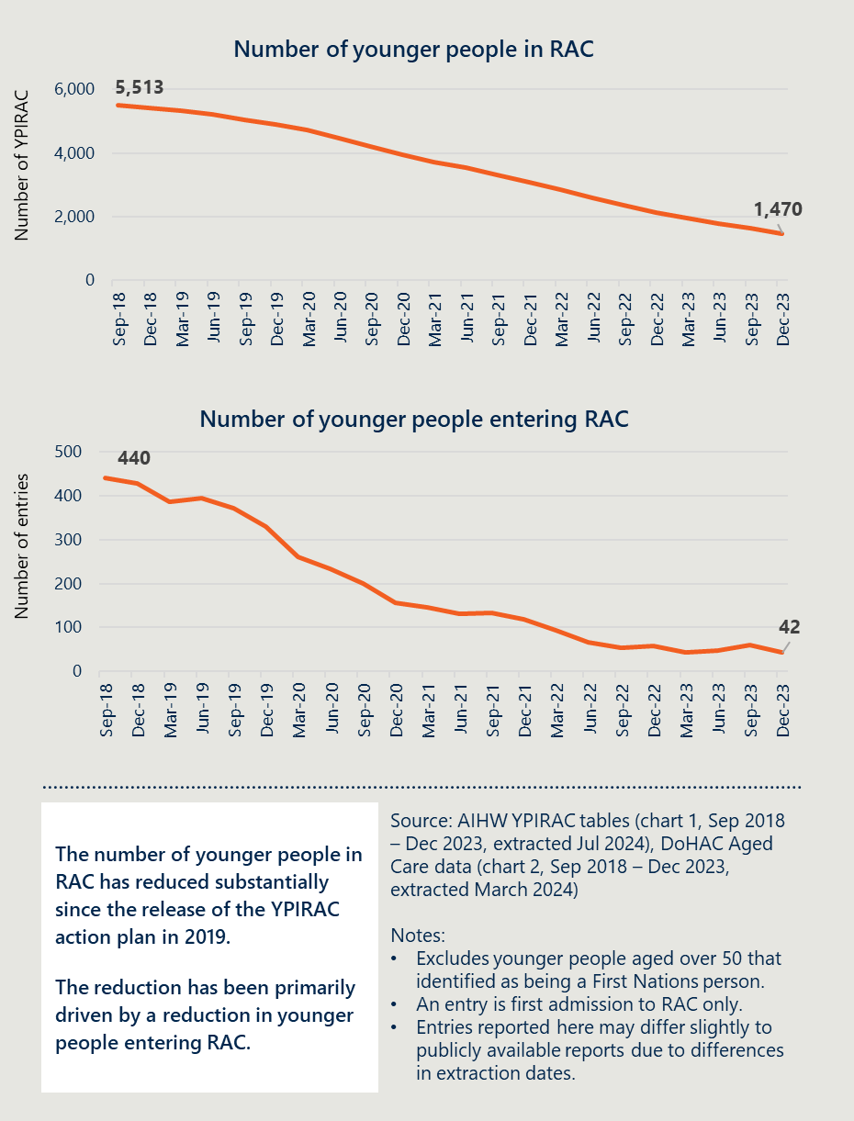
[Image description: A white box states ‘The number of younger people in RAC has reduced substantially since the release of the YPIRAC action plan in 2019. The reduction has been primarily driven by a reduction in younger people entering RAC.’
Notes: Excludes younger people aged over 50 that identified as being a First Nations person. An entry is first admission to RAC only. Entries reported here may differ slightly to publicly available reports due to differences in extraction dates.]

This evaluation sought to understand what worked to inform future actions
Nous Group (Nous) was engaged by DSS to understand the impact of government-funded initiatives introduced since 2019, on reducing the number of younger people in permanent residential aged care and lessons learned to inform future policy considerations. The evaluation sought to determine the appropriateness, effectiveness and sustainability of the initiatives.
The evaluation was guided by a theory of change. Below also lists the YPIRAC initiatives, and their intended interim, medium- and long-term outcomes.
Activities and Outputs:
The YPIRAC Initiatives:
- AFA System Coordinator Program
- NDIA YPIRAC Planners and Accommodation Team
- Changes to the Principles and Guidelines for a younger person’s access to commonwealth funded aged care services
- Changes to the MAC Contact Centre’s processes for younger people at risk of entry to RAC
- Improved governance and reporting to support collaboration and accountability
In the short term, the activities and outputs aim to:
- Reduce the number of people living in RAC
- Help individuals to understand and explore alternative options
- Support improved connectivity across health care, aged care, and disability service systems
- Improve understanding of who is in RAC and what they need
In the medium-term, the activities and outputs contribute to:
- Reducing the number of younger people entering aged care
- Supporting younger people in RAC to move into alternative accommodation and support
- Supporting younger people to experience the benefits of age-appropriate accommodation and support
In the long-term, the activities and outputs aim to result in:
- Zero younger people in RAC apart from those in exceptional circumstances
- Younger people experiencing the benefits of age-appropriate accommodation and supports and achieving a better quality of life
The evaluation engaged over 300 stakeholders including younger people, their families, disability workers, health workers, aged care workers, aged care assessors and states and territories. The evaluation also analysed aged care data, and data from NDIA and AFA on the initiatives.

There were gaps and inconsistencies in implementation that impacted appropriateness
In Recommendation 74, the Royal Commission suggested a series of action to deliver the YPIRAC target. These actions fell into the following categories:
- Change policies and processes to direct people to navigation services
- Establish navigation services that help people find accommodation and support
- Enhance reporting arrangements
- Take actions to improve access to and availability of SDA
- Establish short- and long-term accommodation options.
However, the focus of the Australian Government’s response was on initiatives to help younger people navigate the system and enhance reporting arrangements. There has been growth in the number of SDA and SIL services available through growth in the NDIS but limited actions were taken to expand the availability of short- and long-term accommodation options.
A lack of clearly documented processes may have led to inconsistent experiences. While there are operational guidelines for the NDIA planning function and the YPIRAC teams are an extension of this function, there are no YPIRAC specific guidelines. It should be noted that there is substantial training and documentation available on the NDIA planning function more broadly. However, stakeholders engaged in this evaluation also reported inconsistent experiences and a lack of clarity about YPIRAC specific processes when working with the NDIA YPIRAC teams.

The initiatives have contributed to reducing the number of younger people in RAC
The evaluation undertook a time series linear model to estimate the impact of the YPIRAC initiatives on the number of younger people entering RAC (Figure 2). The model adjusts for other known factors that could have had an impact on the number of younger people entering RAC outside of the initiatives. Based on this analysis, it is estimated the YPIRAC initiatives helped reduce the number of people going into RAC by between 2,198 and 3,842 at a confidence interval of 80 per cent.
Figure 2 | A line graph showing the number of younger people entering RAC in a time series linear model, July 2016 to December 2023
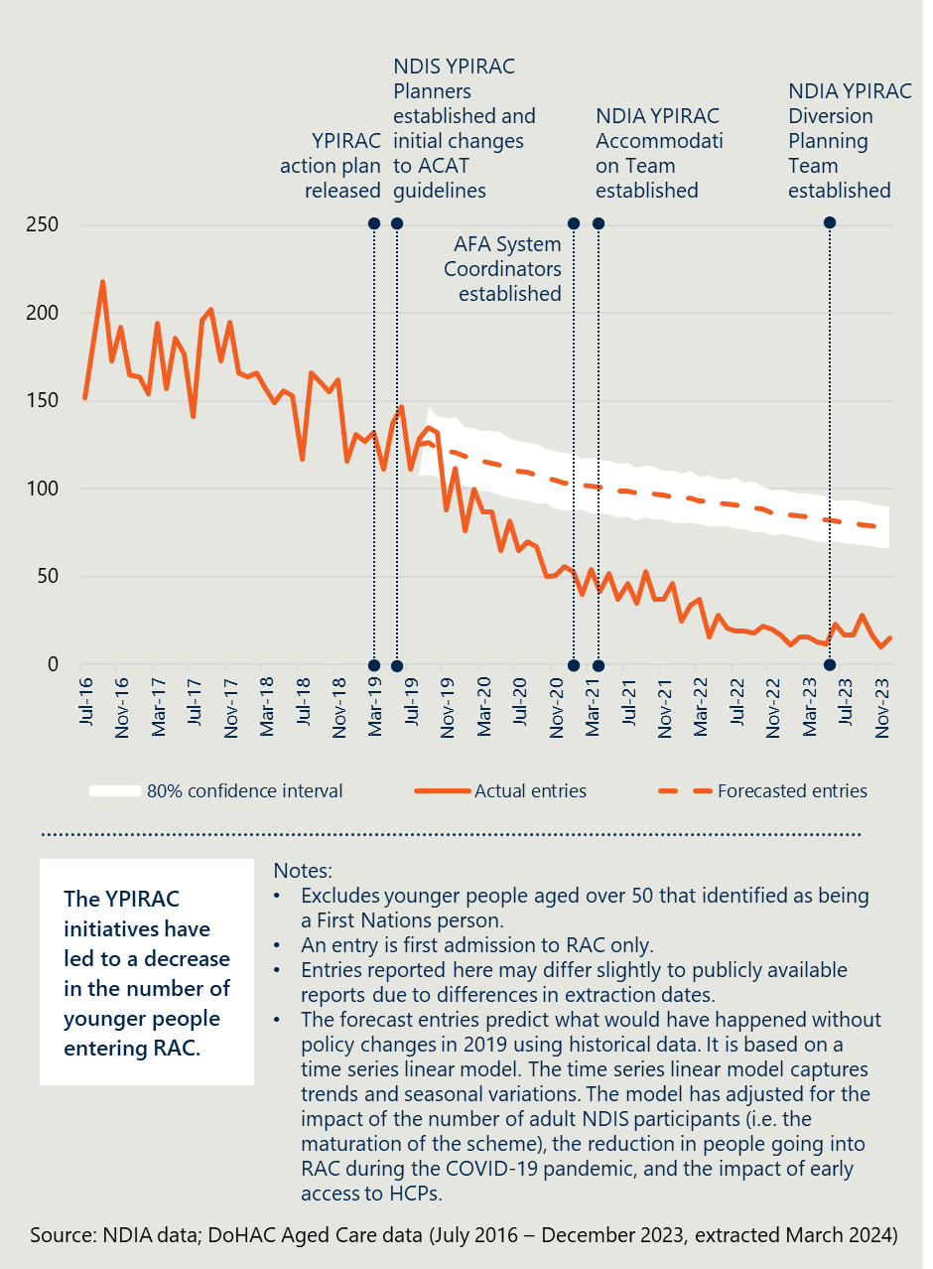
[Image description: A white box contains the text ‘The YPIRAC initiatives have led to a decrease in the number of younger people entering RAC.’
Notes: Excludes younger people aged over 50 that identified as being a First Nations person. An entry is first admission to RAC only. Entries reported here may differ slightly to publicly available reports due to differences in extraction dates. The forecast entries predict what would have happened without policy changes in 2019 using historical data. It is based on a time series linear model. The time series linear model captures trends and seasonal variations. The model has adjusted for the impact of the number of adult NDIS participants (i.e. the maturation of the scheme), the reduction in people going into RAC during the COVID-19 pandemic, and the impact of early access to HCPs.]
Based on feedback from stakeholders and analysis of the data, the following three changes have contributed to this reduction:
- Changes to policies and processes to direct people to navigation services
- Establishment of navigation services that help people find accommodation and support that meets their needs
- Growth in alternative accommodation and support options through the NDIS
The YPIRAC initiatives have also helped individuals explore and understand alternatives. Changes to the Principles and Guidelines for a younger person’s access to commonwealth funded aged care services (Principles and Guidelines) have required younger people to explore alternative options and navigation supports have helped many younger people to understand and explore alternative options.
While there has been progress in the reduction of entries, only a small proportion of younger people have been supported to exit RAC. According to aged care data, in the period from July 2016 to July 2019, before the establishment of the YPIRAC initiatives, an average of 20 younger people were transitioned out of RAC to alternative accommodation arrangements each month. Since the establishment of the initiatives, the average has been 22 per month. While continuing to support a substantial number of people to exit RAC represents progress, it is not sufficient to achieve the target by 2025.
There are several factors impacting the ability to reduce the number of younger people in RAC and support younger people to move out of RAC. Access to alternative options to RAC is the most critical barrier. This was particularly the case for people with a chronic or life-limiting illness, and people living in regional, rural and remote areas.
While there has been progress, it has not been the same for all groups. The cohorts of younger people entering RAC prior to establishment of the initiatives has been compared to recent data. Younger people entering RAC in 2023 were more likely to be aged over 60, have a co-occurring mental illness, not be eligible for the NDIS, live in a regional or remote area, or have life-limiting conditions.
Another factor impacting the ability to reduce the number of younger people living in RAC are younger people with “no goal to move.” For example:
- two out of three younger people that are NDIS participants in RAC do not have a goal to move
- two out of five younger people in RAC contacted by AFA System Coordinators were not able to be contacted or did not consent to work with the System Coordinator.
There are many reasons people did not want to move out of RAC. These included not wanting to move away from family members, the perception that other services cannot provide the same level of care, and because there was no equivalent service available.
Younger people in RAC, their families and carers, were far less satisfied with their living arrangements. However, it should be noted that some family members in particular told the evaluation team about their loved ones experiencing high quality and safe care from experienced aged care staff. The evaluation team also heard about the benefits of the tailored care being provided in several specialist facilities designed for younger people based on their circumstances or medical condition. For example, facilities that catered to younger people with specific neurological conditions.
Several stakeholders also reported that RAC was not an ideal setting for younger people but the best option available for some. This was particularly the case for family members that wanted their loved ones to be close to them and lacked safe alternatives to RAC in their areas. This was particularly the case for families of younger people with high clinical care needs that noted their concerns about whether disability services could provide the same level of care as an aged care facility.
The evaluation also asked younger people and their families and carers whether they were satisfied with their living arrangements. Younger people in SDA arrangements, their families and carers were satisfied with their living arrangements, stating that staff had the relevant skills, the facility and supports had been tailored to meet their needs and they had autonomy and were able to socialise with people their own age.
YPIRAC initiatives have supported some improvements in coordination and provided more information about younger people in or at-risk of entry to RAC, and what they need. The initiatives have resulted in establishment of new referral pathways that have helped younger people find alternatives. But challenges with poor collaboration across service systems remain. Improved collection and reporting on data and completed research projects have helped provide greater understanding of the supports younger people need.
The states and territories are not members of the Joint Agency Taskforce (JATF) and are not included in YPIRAC strategic and operational governance arrangements. During consultations, states and territories raised frustration with the level of engagement from the Australian Government, including the lack of access to data to support planning and commissioning of services for younger people at-risk of entry or living in residential aged care within their jurisdiction.

An individualised, collaborative approach will help find options for younger people still entering RAC
The evaluation makes eight recommendations to inform policy decisions to continue to reduce the number of younger people in RAC. The recommendations are mutually reinforcing and should be considered together, rather than in isolation.
To deliver on the government’s commitment of no younger person living in RAC, a targeted case management approach is required. As the number of younger people in RAC continue to reduce, these younger people have diverse and complex needs that require focused and coordinated intervention. As such, a more tailored and targeted case management approach is required to help find age-appropriate accommodation and supports and allow for planning and coordination of services to meet the diverse needs of the younger person.

A case management approach will continue to reduce the number of younger people in RAC
The evaluation makes eight recommendations to deliver on the government’s commitment to reduce the number of younger people in RAC. Central to these recommendations is the establishment of a multi-agency case management panel, convened by a YPIRAC coordination function in each jurisdiction. This will facilitate meaningful engagements with states and territories to ensure stronger accountability for outcomes.
The principles to guide future action by the Australian Government are described in Figure 3 overleaf.
Figure 3 | An infographic showing the recommendations to guide future action by the Australian Government
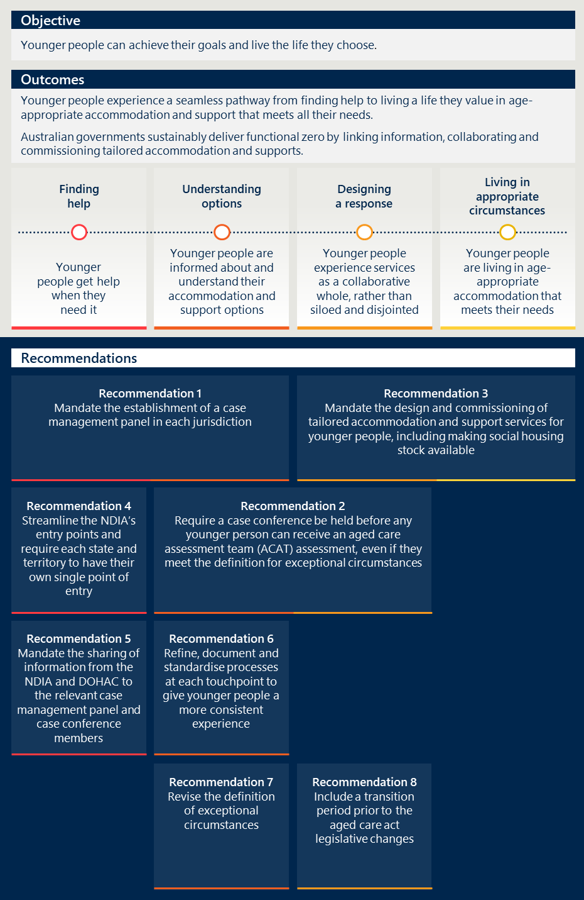
[Image description:
Objective: The infographic sets a clear objective: “Younger people can achieve their goals and live the life they choose.”
Outcomes: The outcomes section details a seamless pathway for younger people, from finding help to living in age-appropriate accommodation that meets their needs. It emphasises the role of Australian governments in sustainably delivering functional zero by linking information, collaborating, and commissioning tailored accommodation and supports. The outcomes are divided into four key areas:
- Finding help, meaning younger people get help when they need it.
- Understanding options, meaning younger people are informed about and understand their accommodation and support options.
- Designing a response, meaning younger people experience services as a collaborative whole, rather than siloed and disjointed.
- Living in appropriate circumstances, meaning younger people are living in age-appropriate accommodation that meets their needs.
Recommendations: The recommendations section provides eight specific suggestions to improve the system:
- Mandate the establishment of a case management panel in each jurisdiction.
- Require a case conference be held before any younger person can receive an Aged Care Assessment Team (ACAT) assessment, even if they meet the definition for exceptional circumstances.
- Mandate the design and commissioning of tailored accommodation and support services for younger people, including making social housing stock available.
- Streamline the NDIS’s entry points and require each state and territory to have their own single point of entry.
- Mandate the sharing of information from the NDIA and DoHAC to the relevant case management panel and case conference members.
- Refine, document and standardise processes at each touchpoint to give younger people a more consistent experience.
- Revise the definition of exceptional circumstances.
- Include a transition period prior to the Aged Care Act legislative changes.]

Glossary and key terms
Term | Definition
ACAT | Aged Care Assessment Team
AFA | Ability First Australia
AIHW | Australian Institute of Health and Welfare
DoHAC | Department of Health and Aged Care
DSS | Department of Social Services
Functional zero | A future aspiration where there are no younger people in RAC that want to move into alternative accommodation.
HACC | Home and Community Care
HACC PYP | Home and Community Care Program for Younger People
HCPP | Home Care Packages Program
HLO | Hospital Liaison Officer
JATF | Joint Agency Taskforce
MAC | My Aged Care
MYEFO | Mid-Year Economic and Fiscal Outlook
NDIA | National Disability Insurance Agency
NDIS | National Disability Insurance Scheme
NGTM | Younger people living in residential aged care with no goal to move
RAC | Permanent residential aged care
Royal Commission | The Royal Commission into Aged Care Quality and Safety
SDA | Specialist Disability Accommodation
SIL | Supported Independent Living
STRC | Short-Term Restorative Care Programme
SRG | Stakeholder Reference Group
Younger people | People aged under 65
YPINH National Alliance | Younger People in Nursing Homes National Alliance
YPIRAC | Younger People in Residential Aged Care. This covers both younger people living in permanent residential aged care and younger people at-risk of entering permanent residential aged care. The term is used to describe the cohort as a collective, or in a policy context.

Background and context

Residential Aged Care is not appropriate for most younger people
“Such an inquiry first begs a different question: should younger people be in residential aged care in the first place? Having regard to that and other evidence before the Royal Commission, the answer to this question must, in the vast majority of circumstances, be ‘no’.” This quote was sourced from the Royal Commission in Aged Care Quality and Safety, Interim Report - Volume 1: the current system, 2019, p. 234.

The Royal Commission found residential aged care (RAC) was inappropriate for a vast majority of younger people
The Royal Commission highlighted that younger people in RAC experienced ‘social isolation, neglect, loss of function, hopelessness and grief associated with their time in aged care’. The Commissioners also stated it was inappropriate from a human rights perspective ‘insofar as younger people with disabilities are compelled to live in inappropriate institutional settings in residential aged care’. The Commissioners’ findings underscored the urgent need for a more tailored and supportive approach for younger people with disabilities, emphasising that RAC was not an appropriate place for a vast majority of younger people.
Younger people in RAC generally fit into three groups:
- people with disability who do not have timely access to suitable housing options
- people with life-limiting conditions
- people with a complex health or mental health condition who require ongoing medical supervision, supportive environments or other care support.

Governments have taken action to reduce the number of younger people in RAC

Efforts have been made for almost 20 years to reduce the number of younger people in RAC
As shown in Figure 4 overleaf, since 2006, significant efforts have been made to help reduce the number of younger people in RAC.
Figure 4 | A timeline of efforts to help reduce the number of younger people in RAC
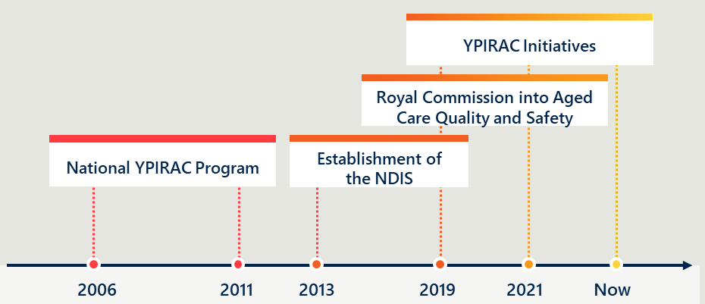
[Image description: Key Events
2006: The timeline begins with the introduction of the National YPIRAC Program, indicated by a red dotted line dropping from a label to a point on the timeline.
2011: The next major event is the establishment of the NDIS (National Disability Insurance Scheme), marked similarly with a red dotted line and label.
2013: This year is not associated with a specific event but is marked on the timeline.
2019: The Royal Commission into Aged Care Quality and Safety is noted, with its label connected to the timeline by an orange dotted line.
2021: The timeline features additional YPIRAC Initiatives, with the label connected by an orange dotted line.
Now: The current point in time is marked on the timeline, indicating the timeline is up to date.]
In 2006, the Australian Government provided $122 million, which was matched by the states and territories for a total of $244 million, over five years for the national YPIRAC program. The program was intended to provide people with disability living in RAC with a care needs assessment and alternative accommodation and support. According to the evidence provided to the Royal Commission, this program moved approximately 500 people out of RAC in the five-year period.
The introduction of the NDIS has increased the availability of age-appropriate accommodation and support for younger people with disability. The NDIS first commenced in 2013. All jurisdictions, except Western Australia, entered the full scheme in 2019. Funding for disability supports has increased substantially under the NDIS. According to recent data, there is almost $400 million for SDA and $8.8 billion for SIL.

Investment was made to respond to the Royal Commission
In 2019, the Australian Government responded to the Royal Commission by committing to a target of reducing the number of younger people living in RAC to zero by January 2025. To achieve this, the following initiatives were announced between 2020 and 2021, and through the 2023-24 budget:
- $27.6 million for AFA to the YPIRAC System Coordinators Program.
- $21.6 million to provide additional capacity to the NDIA to support younger people.
- $2.4 million to undertake public reporting about younger people living in RAC.
- $3.6 million to deliver targeted education and training packages for general practitioners, clinicians, social workers, families and carers, and others that support and influence the decision making of YPIRAC.
- $2.4 million to strengthen entry requirements for RAC, ensuring it is only ever a last resort.
- $1.3 million for DSS to commission an evaluation.
These initiatives, described further in this report, are the focus of this evaluation.

Significant progress has been made but challenges remain

The number of younger people in RAC has reduced
As shown in Figure 5 below, the number of younger people in RAC decreased from 5,513 in September 2018 to 1,470 in December 2023. Similarly, the number of younger people entering RAC for the first time has reduced from 440 during July to September 2018 to 42 during September to December 2023.
The progress made in reducing the number of younger people living in RAC has predominantly been driven by a reduction in the number of younger people entering RAC. While fewer younger people have been entering RAC, the overall numbers have also been reducing as younger people living in RAC have died or aged out (turned 65). Based on separate data published by the Australian Institute of Health and Welfare (AIHW), between 1 July 2016 and 30 June 2020, deaths accounted for 36 per cent of exits and younger people that turned 65 accounted for 34 per cent.
These numbers do not account for those entering RAC or living in RAC who meet the criteria for an exceptional circumstance, as defined by the Principles and Guidelines. They do exclude those over the age of 50 who identify as being First Nations.
Figure 5 | A line graph showing number of younger people living in and entering RAC from 2018 to 2023
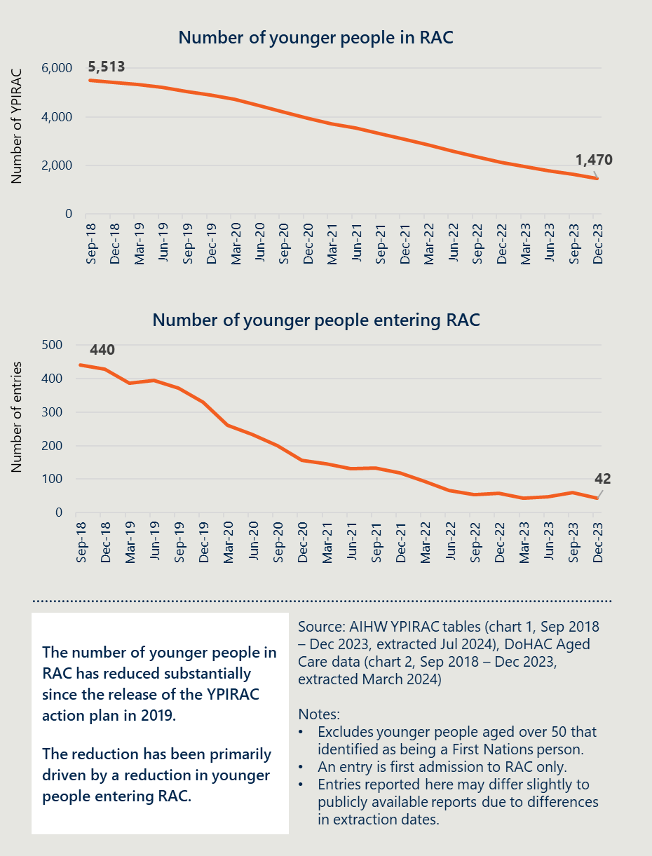
[Image description: A white box states ‘The number of younger people in RAC has reduced substantially since the release of the YPIRAC action plan in 2019. The reduction has been primarily driven by a reduction in younger people entering RAC.’
Notes: Excludes younger people aged over 50 that identified as being a First Nations person. An entry is first admission to RAC only. Entries reported here may differ slightly to publicly available reports due to differences in extraction dates.]

There is further work to do
Despite this progress, there continues to be several younger people in RAC and younger people entering RAC each month. On 31 December 2023, there were 1,470 number of younger people in RAC. During this month, 15 people entered RAC. It is unlikely that the Australian Government’s target of no younger people living in RAC by January 2025 will be achieved.
For younger people that remain in RAC who have a preference to live in age-appropriate accommodation, the reduction in entries provides little comfort. The below case study provides an example of the experience of a younger person who entered RAC.
It should be noted not everyone in RAC experiences the same level of frustration and many receive high quality care and are having their needs met. These differences are further discussed in this report.

Case study 1: Bennet is open to moving out of RAC into SDA but there are no suitable alternatives.
Bennet is in his 60s with a disability and high care needs. He has been in RAC for over ten years.
Bennet moved into RAC with his parents over ten years ago when they were too frail to live at home. His parents were his carers. Since his parents’ deaths, Bennet has remained in RAC because he considers it home.
Bennet's needs have grown increasingly complex over the years. RAC has been able to manage his evolving and increasing needs effectively.
NDIS-funded supports have played a crucial role in supplementing Bennet's care in RAC. He benefits from NDIS-funded support workers who assist with various activities and outings, such going to the cinema.
Each year, during Bennet's plan review, the NDIS planners suggest moving out of RAC to more age-appropriate accommodation. Bennet is open to moving out but is always dissatisfied with the options provided as they are not tailored to his complex needs.
Bennet's brother has been a strong advocate for his needs, frequently engaging in discussions with NDIA about potential alternatives. They highlight a significant issue: there are insufficient options in their locality that provide the one-to-one care Bennet requires. There is a strong desire for a model that combines high quality, safe and round-the-clock elements of RAC with specialised disability care.
Bennet's experience underscores the need for innovative care models that address the specific needs of younger people with disabilities who are aging with complex medical needs that require round-the-clock care.

This evaluation helps guide government action to continue reducing the number of YPIRAC
DSS commissioned an evaluation to understand the impact of the YPIRAC initiatives on reducing the number of younger people in residential aged care and leverage the lessons learned to inform future policy considerations. This evaluation aimed to provide a set of actionable recommendations to improve YPIRAC initiatives and further reduce the number of younger people in RAC.

Methodology

An evaluation framework guided the evaluation
An evaluation framework guided the evaluation. Figure 6 below provides an overview of the approach.
Figure 6 | An infographic overview of the conceptual approach to the evaluation
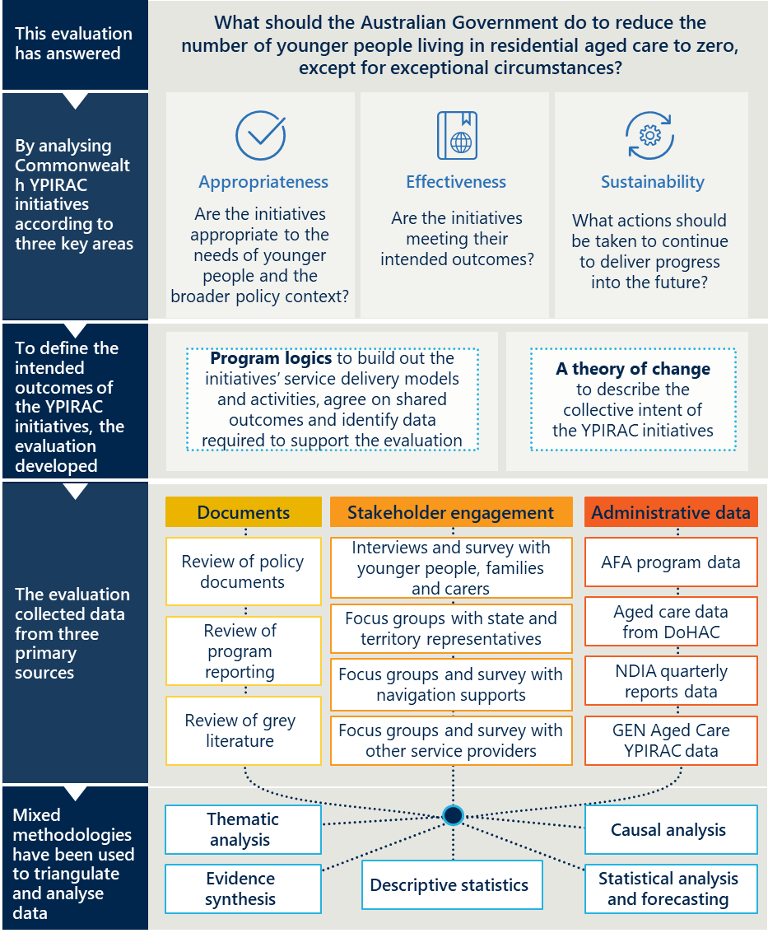
[Image description: Key Evaluation Questions
- Appropriateness: Are the initiatives appropriate to the needs of younger people and the broader policy context?
- Effectiveness: Are the initiatives meeting their intended outcomes?
- Sustainability: What actions should be taken to continue to deliver progress into the future?
To define the intended outcomes of the YPIRAC initiatives, the evaluation plan was developed using:
- Program logics to build out the initiatives’ service delivery models and activities, agree on shared outcomes, and identify data required to support the evaluation.
- A theory of change to describe the collective intent of the YPIRAC initiatives.
The evaluation collected data from three primary sources:
- Documents:
  - Review of policy documents
  - Review of program reporting
  - Review of grey literature
- Stakeholder Engagement:
  - Interviews and surveys with younger people, families, and carers
  - Focus groups with state and territory representatives
  - Focus groups and surveys with navigation supports
  - Focus groups and surveys with other service providers
- Administrative Data:
  - AFA program data
  - Aged care data from DoHAC
  - NDIA quarterly reports
  - GEN Aged Care YPIRAC data
Mixed methodologies were used to triangulate and analyse the data. This included:
- Thematic analysis
- Evidence synthesis
- Descriptive statistics
- Causal analysis
- Statistical analysis and forecasting]

Key evaluation questions helped shape the collection of data
The evaluation is underpinned by three Key Evaluation Questions (KEQs), each with a series of research questions that have guided the research and data collection. The KEQs and research questions are shown in Table 1 overleaf. A detailed version of the KEQs is included in the Appendices.
Table 1 | Key evaluation questions
Category | Key evaluation question | Research questions
1. Appropriateness   | Were the initiatives appropriate to the needs of younger people and the broader policy context? | - What are the current Commonwealth funded initiatives to reduce YPIRAC?  - Were the initiatives designed appropriately to help reduce the number of younger people in RAC?  - Were the initiatives implemented as intended?
2.  Effectiveness   | Are the initiatives meeting their intended outcomes? | - To what extent are the initiatives achieving the following outcomes? Outcomes include:  - Reducing the number of younger people entering RAC  - Supporting younger people in RAC to move into alternative accommodation and support arrangements  - Helping individuals to understand and explore alternative options  - Supporting younger people to experience the benefits of age-appropriate accommodation and support  - Supporting improved connectivity across health care, aged care and disability service systems  - Improving understanding of who is in RAC and what they need  - How do the outcomes differ for different groups of people?  - What factors have enabled or impeded achieving the intended outcomes?
3. Sustainability   | What actions should be taken to continue to deliver progress into the future? | - What action should be taken in relation to the existing initiatives to continue making progress?  - What other actions should be taken?

A theory of change and series of program logics were used through the evaluation
To define the intended outcomes of the YPIRAC initiatives, the evaluation developed a theory of change and a program logic for each group of initiatives to describe the collective intent of the initiatives.
A theory of change is a description of how and why an expected change is supposed to happen in a particular context. The theory of change for the selected YPIRAC initiatives is discussed below.
Activities and Outputs:
- The YPIRAC Initiatives:
- AFA System Coordinator Program
- NDIA YPIRAC Planners and Accommodation Team
- Changes to the Principles and Guidelines for a younger person’s access to commonwealth funded aged care services
- Changes to the MAC Contact Centre’s processes for younger people at risk of entry to RAC
- Improved governance and reporting to support collaboration and accountability
In the short term, the activities and outputs aim to:
- Reduce the number of people living in RAC
- Help individuals to understand and explore alternative options
- Support improved connectivity across health care, aged care, and disability service systems
- Improve understanding of who is in RAC and what they need
In the medium-term, the activities and outputs contribute to:
- Reducing the number of younger people entering aged care
- Supporting younger people in RAC to move into alternative accommodation and support
- Supporting younger people to experience the benefits of age-appropriate accommodation and support
In the long-term, the activities and outputs aim to result in:
- Zero younger people in RAC apart from those in exceptional circumstances
- Younger people experience the benefits of age-appropriate accommodation and supports and achieve a better quality of life
A program logic outlines the connections between the activities, outputs, outcomes, and impacts of an initiative. It shows how the initiative’s resources and activities are expected to lead to desired outcomes and create the positive impact that is outlined in the theory of change.
Indicative program logics are provided in the Appendices for initiatives introduced by the NDIA, AFA and the Department of Health and Aged Care (DoHAC).

Several data sources were used to answer the key evaluation questions

Stakeholder engagement
As described in Figure 7 below, over 300 stakeholders have been engaged as part of the evaluation (a comprehensive list is included in the Appendices). Stakeholders have been engaged through a variety of methods, including face-to-face and virtual interviews, focus groups, workshops and surveys.
Figure 7 | An infographic showing the stakeholder engagement undertaken
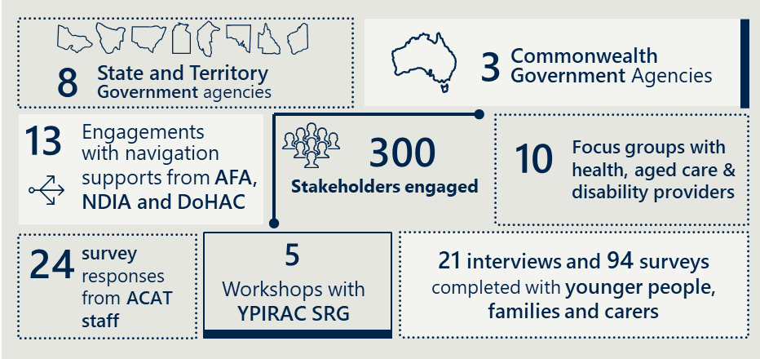
[Image description:
- State and Territory Government Agencies: The infographic indicates that there were 8 engagements with these agencies, represented by icons of Australia’s states and territories.
- Commonwealth Government Agencies: There were 3 engagements with Commonwealth Government agencies, as indicated by an icon of Australia.
- Stakeholders Engaged: A total of 300 stakeholders were engaged, as highlighted by a network icon.
- Focus Groups: There were 10 focus groups conducted with health, aged care, and disability providers.
- ACAT Staff: 24 survey responses were received from ACAT (Aged Care Assessment Team) staff.
- YPIRAC SRG: 5 workshops were held with the YPIRAC (Younger People in Residential Aged Care) Stakeholder Reference Group.
- Interviews and Surveys: Younger People, Families, and Carers: There were 21 interviews and 94 surveys completed with younger people, families, and carers.
- Engagements with Navigation Supports: 13 engagements were conducted with navigation supports from AFA, NDIA, and DoHAC.]

Quantitative and qualitative analysis
The following data was analysed to understand the effectiveness and sustainability of the initiatives:
- AFA System Coordinator Program data
- NDIA participant data for younger people in RAC
- NDIA YPIRAC teams program data
- DoHAC aged care data for younger people in RAC
The evaluation team performed the following analysis of this data:
- Descriptive analysis to understand changes in younger people in RAC over time and the activities of the individual programs
- Causal analysis including a time series linear model to understand the effectiveness of the programs in reducing the number of YPIRAC.
- Forecasting using a proportions hierarchical model to understand what future need there will be for YPIRAC initiatives.
The evaluation team also performed analysis on the qualitative data collected through the document review and engagement. This included:
- Thematic analysis to identify, interpret and present the key themes that emerged
- Evidence synthesis to develop a comprehensive set of recommendations by integrating the findings from multiple sources, summarising and evaluating the best available evidence.
A detailed description of the data analysis methodology can be found in the Appendices.
Desktop review
This report also reviewed publicly available documentation related to the YPIRAC cohort, in addition to documents and information provided by stakeholders.

There are several limitations to the evaluation findings

Potential bias
There are a number of biases that may arise from the surveys, interviews and focus groups which may impact the findings.
Younger people, their families and carers were recruited using a convenience sampling method. This involved individuals choosing to participate based on whether they saw the evaluation promoted, or whether they received the information from the NDIA or a service provider.
This could introduce some selection bias. People that chose to participate may have had a very positive or very negative experience. It may have also excluded people that have difficulty filling out online forms or communicating.
Additionally, stakeholders may not remember certain things about their experience leading to recall bias.
It is difficult to estimate the impact of these biases on the findings. As such, quantitative information from the survey and qualitative information from interviews and focus groups are presented alongside findings from analysis of DoHAC and NDIA data.

Data limitations
There are several limitations to the data used in this evaluation.
NDIA participant data for younger people in RAC was not available prior to July 2021. Where historical data was required, the evaluation used publicly available data from NDIA reports.
The aged care data from DoHAC provided estimates for the total number of younger people in RAC and the total number of exits, which differ from publicly reported numbers. The differences are because aged care providers are able the change their data at any time. The data available to the evaluation was taken at a point in time, as is data used in each public report. As a result, there are minor differences in the data presented in this report and what is reported publicly.
There were also limitations in the data available about certain demographic characteristics. For example, the DoHAC aged care dataset does not have information available about the number of younger people in RAC that were homeless or at risk of homelessness. There is also limited data available about the complexity of people’s needs through all datasets.

Data analysis limitations
There are also several limitations in interpreting some of the analysis presented.
The causal analysis in this report estimates what the number of entries into RAC might have been in the absence of the YPIRAC initiatives, while controlling for external variables such as the COVID-19 pandemic and the maturation of the NDIS. There may be additional influences on RAC admissions that are not captured or modelled in this analysis.
The forecasting technique used is predicated on the assumption that past trends will predict future events. There are many other factors that could impact the number of younger people in RAC in the future which are not yet clear. If the future deviates substantially from historical trends, these predictions may prove to be imprecise. The reader should be aware of these limitations when making use of the analyses in this report.

Evaluation Findings

There are gaps and inconsistencies in implementation that affect appropriateness

Summary of findings from the review
This sub-section presents findings for the following key evaluation questions:
- Were the initiatives appropriate to the needs of younger people and the broader policy context?
  - What are the current Commonwealth funded initiatives to reduce younger people in RAC?
  - Were the initiatives designed appropriately to help reduce the number of younger people in RAC?
  - Were the initiatives implemented as intended?
Key findings from the evaluation about the appropriateness of the initiatives include:
- Initiatives operate within a broader system of supports
- Initiatives fall into four categories
- Initiatives only responded to some Royal Commission recommendations
- Inconsistent implementation led to varying experiences

Initiatives operate within a broader system of supports
This evaluation has reviewed the impact of four Australian Government initiatives aimed at reducing the number of younger people entering and living in RAC. These initiatives do not operate in isolation. They interact within a system of services that aim to collectively provide suitable accommodation and support to younger people living in or at-risk of entering RAC.
This system of services and supports can be described using the pathway a young person at-risk of entering or living in RAC experiences. This pathway includes four activity groups. The activity groups may not be followed in order, may be repeated or may not all be completed. An overview of this is shown in Figure 8.
Figure 8 | A table showing the system of services and supports experienced by younger people in or at-risk of entering RAC
Finding help | Understanding options | Designing a response | Living in appropriate circumstance
- Referral from MAC to AFA System Coordinators or NDIA YPIRAC teams  - Referral within the NDIA including from HLO or from NDIA Support Coordinator to NDIA YPIRAC teams | - Support from NDIA YPIRAC Accommodation Team and  NDIA YPIRAC Planners, or  AFA System Coordinators to understand and explore alternate options | - NDIA YPIRAC Planners work with the NDIA YPIRAC Accommodation Team to identify appropriate accommodation and supports  - AFA System Coordinators work with state and territory funded services to identify appropriate accommodation and supports | - NDIS-funded options include SDA, SIL and short- and medium-term accommodation options  - State and territory funded services include bespoke YPIRAC initiatives, community support services (inc HACC), supported mental health housing, social housing, palliative care, aids and equipment, level 3 accommodation  (inc SRS) and transition accommodation  - If there are no alternatives, the younger person is admitted into RAC or continues to live in RAC

Initiatives fall into four categories
The YPIRAC initiatives fall into four categories as shown in Table 2 below. Table 2 The YPIRAC initiatives
Categories | YPIRAC initiatives
Changes to policies and processes to direct younger people to navigation services | - Changes to the Principles and Guidelines for a younger person’s access to Commonwealth-funded aged care services  - Changes to the My Aged Care (MAC) Contact Centre’s processes for YPIRAC
Establishment of navigation services that help younger people find age-appropriate accommodation and support that meets their needs | - NDIA YPIRAC Planners and Accommodation Team  - AFA System Coordinator Program  - Efforts to help people with no goal to move to find alternative options
Enhanced governance and reporting arrangements to improve collaboration and accountability | - Collaborative governance  - Enhanced reporting
New research to better understand the preference, needs and motivations of younger people in RAC | - Commissioned research

Changes to policies and processes to direct people to navigation services
Younger people at-risk of entering RAC, or their family and carers, interact with a system of supports, including:
- directly contacting the MAC Contact Centre and being referred to the AFA System Coordinator Program or NDIA YPIRAC teams depending on their NDIS status
- directly contacting the AFA System Coordinator program
- being referred to the NDIA YPIRAC teams by another team in the NDIA, including a Hospital Liaison Officer (HLO) or general planning team, or a NDIS-funded Support Coordinator
The Australian Government has established two initiatives through DoHAC to connect younger people at-risk of entering RAC to appropriate navigation services: a) Changes to the Principles and Guidelines for a younger person’s access to Commonwealth funded aged care services and b) changes to the MAC Contact centre processes for YPIRAC.

Changes to the Principles and Guidelines for a younger person’s access to Commonwealth funded aged care services (Principles and Guidelines)
The Australian Government has made three revisions since 2019 to the Principles and Guidelines to ensure younger people explore alternative options before they are referred for an aged care assessment.
The first change was with the Aged Care Assessment Supplementary Guidelines for Younger People published in July 2019, followed by a second change to the Supplementary Guidelines in January 2020 which was replaced by the Principles and Guidelines for a Younger Person’s access to Commonwealth funded aged care services when the Modified Process was introduced in February 2022. Further detail on these changes is included in the Appendices.
In the current May 2023 iteration, an aged care assessment can only be undertaken once all age-appropriate accommodation and supports have been explored. Evidence of the options considered by the younger person (and/or their family and carers) is a key requirement of being eligible for an assessment for aged care. This evidence includes either a NDIA Exploration of Home and Living Supports document or an AFA Summary Report of – Younger People at-risk of Entering Residential Aged Care.
The current Principles and Guidelines outline three exceptional circumstances that allow a person under 65 to receive an Aged Care Assessment Team (ACAT) assessment. These circumstances are:
- Aboriginal or Torres Strait Islander people aged 50-64;
- A person who is homeless, or at risk of becoming homeless, and aged 50-64; or
- Maintaining Family connection reasons (such as a person who has been cared for by ageing parents who are now moving into aged care)
Documented evidence of the alternatives explored is required for a younger person to maintain family connections to receive an ACAT assessment. A person aged 50-64 that is a First Nations person or experiencing homelessness or at-risk of becoming homeless does not require documented evidence of alternatives explored, to minimises potential barriers for these cohorts to receiving care services.

Changes to the MAC Contact Centre’s processes for YPIRAC
To support changes to the Principles and Guidelines, a new process was introduced into the MAC Contact Centre for people under 65 years of age. When someone contacts the Centre’s general enquiries line, regarding a younger person for an ACAT assessment, the Contact Centre will determine whether they are under 65, fit the definition of exceptional circumstances, and whether they have the required documentation. If the required documentation is not available, they are referred to either the NDIA YPIRAC Accommodation Team or the AFA System Coordinator Program. Further detail is described in the Appendices.

Establishment of navigation services that help people find accommodation and support that meets their needs
The Australian Government has funded navigation services to help younger people find age-appropriate accommodation and support. This includes establishing teams within the NDIA and the AFA System Coordinator Program.

NDIA YPIRAC Planners and NDIA YPRAC Accommodation Team
The Australian Government allocated $21.6 million combined from the 2020-21 Budget and 2021-22 Mid-Year Economic and Fiscal Outlook to provide additional capacity within the NDIA to help younger people who are NDIS participants identify age-appropriate accommodation and support.
The NDIA used this funding to establish NDIA YPIRAC Planners and the NDIA YPIRAC Accommodation Team. There are currently 118 roles across the teams: 44 in the Accommodation team, 51 YPIRC planners and 23 diversion planners. Funding ceases in June 2025.
The NDIA YPIRAC Planning Team was established in June 2019. The NDIA YPIRAC Planners transitioned younger people out of RAC and helped divert younger people at-risk of entering RAC into suitable alternatives until the establishment of NDIA YPIRAC Diversion Planning Team in May 2022.
The NDIA YPIRAC Accommodation Team was established in June 2021 with the objective of working with NDIS participants to explore and make informed decisions based on their accommodation and support options. Further detail is described in the Appendices.
These teams operate within the broader infrastructure of the NDIA and are governed by its legislation, rules and processes. The National Disability Insurance Scheme Act 2013 sets out the objectives and principles under which the NDIS operates, how a person becomes a NDIS participant, and how a participant’s goal-based plan is prepared and reviewed, including how the NDIA approves the funding of supports. Two important objectives of the NDIS Act that inform what services the NDIS funds for younger people include:
- Provide reasonable and necessary supports, including early intervention supports, for participants in the NDIS.
- Enabling people with disability to exercise choice and control in the pursuit of their goals and the planning and delivery of their supports.
The processes to help younger people find alternative accommodation arrangements vary depending on whether the person is living in RAC or at-risk of entering RAC.
NDIS participants in RAC are allocated a NDIA YPIRAC Planner and where they have a goal to move, they are also allocated a NDIA YPIRAC Accommodation Officer. The teams work collaboratively to understand the person’s circumstances, needs and history, to encourage the younger person to explore and access age-appropriate accommodation and supports. If suitable alternatives are found, the NDIA YPIRAC Accommodation Team will help the younger person move into the accommodation. If no suitable alternatives are found, or the younger person does not have a goal to move, the younger person will remain in RAC. The NDIA YPIRAC teams continue to check in on the younger person living in RAC and when consent is received, continue to explore options. NDIS participants are typically diverted or transition from RAC into SDA with SIL supports.
Younger people at-risk of entering RAC, or their family or carer, or their NDIS Support Coordinator may contact the NDIA directly or be referred to the NDIA by the MAC Contact Centre, a NDIA HLO, or through the relevant health service discharge officers. Similar to the process outlined above, the NDIA YPIRAC teams will work with NDIS participants to assess and document their needs and commence actively exploring options. Younger people unable to find a suitable alternative will be referred for an ACAT assessment and they need to obtain a NDIA Exploration of Home and Living Supports document from the NDIA teams which outlines the range of accommodation options that have been explored. They can submit this to the MAC Contact Centre along with a request for an ACAT assessment.
The NDIA YPIRAC teams work collaboratively with the younger people, their families and carers to identify a solution that meets their preferences, needs and goals. The NDIA YPIRAC teams help the younger person, their families and carers to understand their options while retaining their right to exercise their choice and control over their accommodation and support.
Further information about the process can be found in the Appendices.

Ability First Australia (AFA) System Coordinator Program
AFA was funded by DoHAC in 2021 to design, implement and deliver the System Coordinator Program. System Coordinators work with younger people who are in or at-risk of entering RAC and not eligible for the NDIS to find age-appropriate accommodation and support. AFA received a total of $27.6 million combined from the 2020-21 Budget and 2021-22 Mid-Year Economic and Fiscal Outlook. This funding will end in December 2025.
The processes to help younger people find alternative accommodation arrangements vary depending on whether the person is living in RAC or at-risk of entering RAC.
A younger person not eligible for the NDIS is allocated an AFA System Coordinator. Assuming the person consents to participate in the AFA program, The System Coordinator works with the younger person, their family and carers to understand the person’s circumstances, needs and history, and to encourage the younger person to explore age-appropriate accommodation and support options. They will also seek to understand whether the person is eligible for the NDIS and if so, the System Coordinator will refer the younger person to the NDIA YPIRAC teams.
If suitable alternatives are found, the AFA System Coordinator will help the individual move into the accommodation. If no suitable alternatives are found, the younger person will remain in RAC. Younger people not eligible for the NDIS receive supports from state or territory funded services, if they are available.
Individuals at-risk of entering RAC who are not eligible for the NDIS: Younger people at-risk of entering RAC, or their family or carer, may contact the AFA directly or be referred to the AFA by the MAC Contact Centre or through in the health service discharge officers. Similar to the process outlined above, the AFA System Coordinators will work with the younger person to understand their needs, preferences and goals before exploring and accessing age-appropriate options.
Younger people that are unable to access a suitable alternative to RAC and are referred to an ACAT assessment will be referred to an ACAT via the MAC Contact Centre with a Summary Report of – Younger People at-risk of Entering Residential Aged Care document that provides evidence that age-appropriate options have been explored and exhausted.
Further detail is provided in the Appendices.

Efforts to help people with no goal to move to find alternative options
In 2022, the NDIA undertook a project with AFA to work with younger people, under the age of 45, living in RAC with no goal to move (NGTM). The project involved working with 27 NDIS participants in RAC for 11 weeks and then a further 12 months. Phase two of NGTM project launched in the beginning of April 2024 and will be engaging with approximately 150 people aged 45-60 with NGTM. Further information about the outcomes of this effort is described on page 64.

Enhanced governance and reporting arrangements to improve collaboration and accountability

Collaborative governance
The Australian Government has made several changes to strengthen system oversight, monitoring and collaboration. This includes the establishment of the JATF and continuing to hold meetings of the YPIRAC Stakeholder Reference Group (SRG) to ensure work is informed by the experts working in the sector.
The JATF was established to support the achievement of the Australian Government’s YPIRAC targets. It has senior representation from DSS, who chairs, DoHAC and the NDIA.
The SRG provides input and advice on service and policy responses for younger people in or at-risk of entering RAC. Members include representatives from the NDIA, DSS, DoHAC, AFA, Summer Foundation, Younger People in Nursing Homes National Alliance (YPINH National Alliance), Synapse, YoungCare, Specialist Disability Accommodation Alliance, Australian Healthcare and Hospitals Association, Aged and Community Care Providers Association, and Uniting Communities.

Enhanced reporting
Efforts have also been made to improve public reporting about younger people in RAC and the evidence-base about their experience and needs.
Information related to the YPIRAC cohort dating back to 2016 is now publicly available through the GEN Aged Care Data website, established and managed by the Australian Institute of Health and Welfare (AIHW). The website contains historical data and factsheets on the progress towards the three YPIRAC targets, the average length of stay in RAC and exit from RAC figures. Demographic breakdowns of the data such as state and territory, age group, gender and First Nations status is also available.
The AIHW has also delivered two public reports, Exploring pathways for younger people living in residential aged care and Health services used by younger people living in residential aged care. The first publication explored the characteristics of younger people entering RAC, and their journey through the system, using a combination of linked data sources to determine the impact of initiatives over time. The second investigated younger people’s access to health services outside of aged care to better understand their needs.

New research to better understand the preference, needs and motivations of younger people in RAC

Commissioned research
Several key pieces of research have been undertaken to better understand the experiences of younger people in or at-risk of entering RAC. These include:
- Home and Living Options for People with Disabilities Report, undertaken by the Brain and Mind Centre at the University of Sydney, and commissioned and funded by NDIA, to examine the methods and approaches that assist individuals in transitioning from RAC to more independent and personalised living arrangements, and to determine which ones most effectively facilitate this transition.
- A collaboration between the University of Melbourne and Scope to investigate the experiences of younger people, who are not NDIS participants, either currently living in or at-risk of entering RAC. The research focussed on this cohort because of the limited research undertaken previously.
- A collaboration between AFA and La Trobe University (which is ongoing at the time of reporting) to evaluate factors that support younger people with life-limiting conditions remaining in the community. The work is exploring the factors that both support and hinder individuals’ ability to remain in the community.
It is also important to recognise the many non-government organisations that have also contributed to enhanced understanding of the needs of this cohort. This includes the Summer Foundation, the YPINH National Alliance and YoungCare, who have undertaken various projects and prepared information for government and the public on the needs and experience of younger people in or at-risk of entering RAC.

Initiatives only responded to some Royal Commission recommendations

Focus was on designing initiatives to help younger people navigate the system rather than establishing and growing alternative options
The Royal Commission’s findings underscored the urgent need for a more tailored and supportive approach to establishing age-appropriate alternatives for younger people with disabilities, emphasising that the existing systems were not adequately meeting their needs. The recommendations provided the Australian Government a series of actions to reduce the number of younger people living in RAC. The Royal Commission’s recommendations (see Appendices) fall into the following five categories:
- change policies and processes to reduce access to aged care
- establish navigation services that help people find accommodation and support
- enhance reporting arrangements
- take actions to improve access to and availability of SDA
- establish short- and long-term accommodation options.
The introduction of YPIRAC initiatives helped respond to the first three categories of recommendations. Changes to the Principles and Guidelines and MAC procedures were process changes to reduce access to aged care. The NDIA YPIRAC Planners and Accommodation Officers and the AFA System Coordinators provide support for younger people to navigate the service systems. The Australian Government has also improved reporting on the number of YPIRAC and their circumstances. Separate to the YPIRAC initiatives, effort has also been made to improve access to and availability of SDA. For example, the NDIA now reports publicly on the demand for SDA in each SA3-level area in Australia.
None of the YPIRAC initiatives respond to the final category of recommendations to establish short- and long-term accommodation options. However, there has been growth in the availability of accommodation and support options funded through the NDIS as the scheme has matured.
Under the National Health Reform Agreement state and territory governments are responsible for home and community care services for people under 65 who are not eligible for the NDIS. However, there has been limited efforts by states and territories to establish new models or grow existing models.

Limited engagement with stakeholders and access to data and information about younger people needs and preferences impacted the design of the initiatives
The evaluation team heard there was limited engagement with stakeholders during the design phase of the YPIRAC initiatives. It should be noted that DSS, DoHAC and the NDIA regularly engage with stakeholders in a more general way. For example, the Australian Government engages with key stakeholders through the YPIRAC SRG, and the NDIA engages with participants through the Independent Advisory Council and other mechanisms.
State and territory governments and health care, aged care and disability services providers also told the evaluation team about issues with the design of the YPIRAC initiatives. These stakeholders noted YPIRAC initiatives were established with limited consideration of how the initiatives would interact with existing services and processes and did not address gaps in the availability of accommodation and support options available outside RAC.
Stakeholders also reflected there was limited engagement with younger people, their families or carers to inform the design of initiatives. AFA attempted to set up a consumer reference group when designing the System Coordinator program but struggled to recruit younger people, their families and carers. They have since set up several consumer groups to inform the development of consumer facing content. The consumer groups provide a range of advice to AFA including helping to develop information guides for younger people.
Availability of granular data on the YPIRAC cohort during the design of the initiatives was limited. As is discussed in this report, there is now substantially more data and information about younger people living in and at-risk of entering RAC and their needs, preference and goals. One example of this is the data now collected by the NDIA YPIRAC teams and the AFA System Coordinators about the characteristics and needs of younger people in or at-risk of entering RAC. A lack of availability to this information may have impacted the design of the initiatives and created the observed gaps.

Inconsistent implementation led to varying experiences

Stakeholders reported varying experiences when interacting with the initiatives
Younger people and their families and carers described varying experiences with the NDIA YPIRAC teams, AFA System Coordinators and MAC Contact Centre. For example, some people in RAC described being asked frequently asked whether they wanted to explore alternative options to RAC despite saying they did not, while other people described never having been presented with an alternative option.
Many stakeholders including health services also described inconsistent experiences. Despite working with many younger people in or at-risk of entering RAC, several service providers said they had not heard of the NDIA YPIRAC teams.

Implementation may have been inconsistent due to a lack of clearly documented processes
While there are operational guidelines for NDIS planners to develop a plan that specifies how supports will be funded for NDIS participants, there are limited YPIRAC specific practice guidance. It should be noted that there is substantial training and documentation available on the NDIA planning function more broadly. This broader planning function also has a range of quality assurance and oversight. There is also some documentation available on the NDIA’s website for younger people about how the process is intended to work.
The AFA System Coordinators have documented YPIRAC processes. The AFA undertook a comprehensive process to design the System Coordinator program. The design was informed by an industry reference group. Based on discussions with System Coordinators and other services providers, the AFA System Coordinator Program is operating consistent in the processes described in the operating manual.

The initiatives have contributed to reducing the number of younger people in RAC

Summary of findings from the review
This sub-section presents findings from the evaluation to answer the following key evaluation questions:
- Are the initiatives meeting their intended outcomes?
  - To what extent are the initiatives achieving the following outcomes?
- Reducing the number of younger people entering RAC
- Helping individuals to understand and explore alternative options
- Supporting younger people in RAC to move into alternative accommodation and support arrangements
- Supporting younger people to experience the benefits of age-appropriate accommodation and support
- Supporting improved connectivity across health care, aged care and disability service systems
- Improving understanding of who is in RAC and what they need
  - How do the outcomes differ for different groups of people?
  - What factors have enabled or impeded achieving the intended outcomes?
Key findings from the evaluation about the effectiveness of the initiatives include:
- Several factors helped reduce younger people living in RAC but not to zero
- Initiatives have helped individuals explore and understand alternatives
- Initiatives have supported a small proportion of YPIRAC to exit
- Younger people vary in their satisfaction with living arrangements
- Initiatives have supported some improvements in coordination, but challenges remain
- There is greater understanding of the supports younger people need
- There are several barriers impacting the effectiveness of the initiatives
Outcomes vary for different groups.

Several factors helped reduce younger people entering RAC but not to zero

Initiatives have helped reduce the number of younger people entering RAC where options are available
The progress made in reducing the number of younger people living in RAC has predominantly been driven by a reduction in the number of younger people entering RAC. While fewer younger people have been entering RAC, the overall numbers have also been reducing as younger people in RAC have died or aged out (turned 65 and were no longer considered a young person). A small proportion of younger people have exited to alternative accommodation and support services which is discussed in further detail on page 48.
Other factors, in addition to the initiatives, may have contributed to a reduction in the number of younger people entering RAC during this period. These include:
- a reduction in all people entering RAC, not just those under 65, during the COVID-19 pandemic
- an increase in the number of younger people receiving early access to home-care packages
- an increase in the availability of SDA and SIL as the NDIS has matured
A time series linear model was used to estimate the impact of the YPIRAC initiatives on the number of younger people entering RAC. The results from this model are shown in Figure 9 below.
The analysis was done using a time series linear model. The model adjusts for the three factors described above that could have had an impact on the number of younger people entering RAC outside of the initiatives.
Figure 9 | A line graph showing the number of younger people entering RAC and time series linear model, July 2016 to December 2024
[Image description: A white box contains the text ‘The YPIRAC initiatives have led to a decrease in the number of younger people entering RAC’.
Notes:
- Excludes younger people aged over 50 that identified as being a First Nations person. An entry is first admission to RAC only.
- Entries reported here may differ slightly to publicly available reports due to differences in extraction dates.
- The forecast entries predict what would have happened without policy changes in 2019 using historical data. It is based on a time series linear model.
- The time series linear model captures trends and seasonal variations.
- The model has adjusted for the impact of the number of adult NDIS participants (i.e. the maturation of the scheme), the reduction in people going into RAC during the COVID-19 pandemic, and the impact of early access to HCPs.]
Based on this analysis, it is estimated the YPIRAC initiatives helped reduce the number of people entering RAC by 2,994 people. During the period between August 2019 and December 2023, it is estimated that 5,434 younger people would have entered RAC without the impact of the initiatives, however, only 2,440 entered. Using an 80 per cent confidence interval, it is estimated the difference between what happened and what the model predicted could range from 2,198 fewer people entering RAC to 3,842 fewer people entering RAC.
Based on this analysis, the evaluation team can be 80 per cent confident that the initiatives contributed to some of the observed reductions in younger people entering RAC.

Navigation supports, growth in options through the NDIS and changes to the Principles and Guidelines have had an impact
Based on feedback from stakeholders and analysis of the data, the following three changes have helped reduce the number of younger people entering RAC:
- Changes to policies and processes to direct people to navigation services
- Establishment of navigation services that help people find accommodation and support that meets their needs
- Growth in alternative accommodation and support options through the NDIS

Changes to policies and processes have required younger people to explore alternative options
It is clear from engagement and analysis of the data that changes to the Principles and Guidelines have had an impact on the number of younger people entering RAC.
Figure 10 below shows a substantial reduction in the number of younger people receiving an ACAT assessment following the changes. The changes took time to have their intended effect, which aligns with feedback the evaluation team heard about the work required to train ACAT assessors to consistently implement the changes. This is supported by feedback received from stakeholders in public hospitals that said the changes to the Principles and Guidelines had an impact on how they identified age-appropriate options for this cohort.
Figure 10 | A bar graph showing the number of younger people receiving an ACAT assessment each month, January 2018 to December 2023
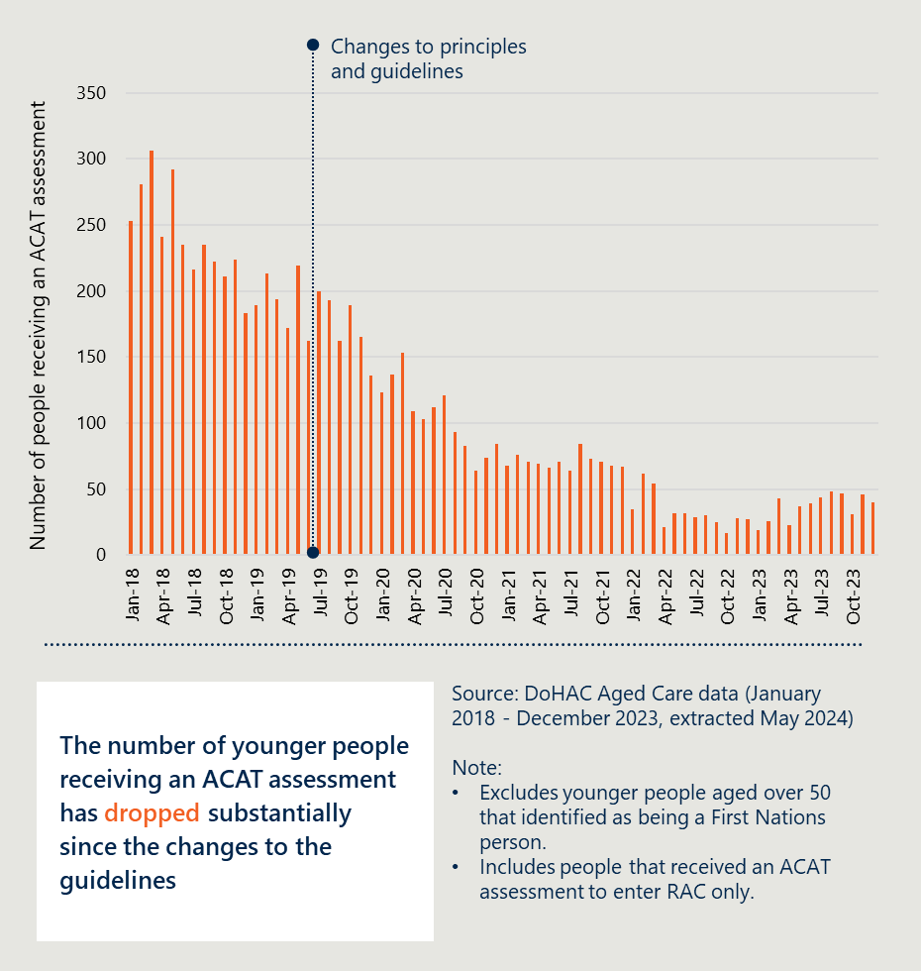
[Image description: A white box contains the text ‘The number of younger people receiving an ACAT assessment has dropped substantially since the changes to the guidelines.’
Notes: Excludes younger people aged over 50 that identified as being a First Nations person. Includes people that received an ACAT assessment to enter RAC only.]
ACAT assessors also reported the changes to the Principles and Guidelines had an impact on reducing the number of younger people entering RAC. As shown in Figure 11 overleaf, 63 per cent of respondents either agreed or strongly agreed that changes to the Principles and Guidelines had reduced admissions to RAC.
Figure 11 | A bar chart showing responses from ACAT assessors regarding the impact of changes to the Principles and Guidelines
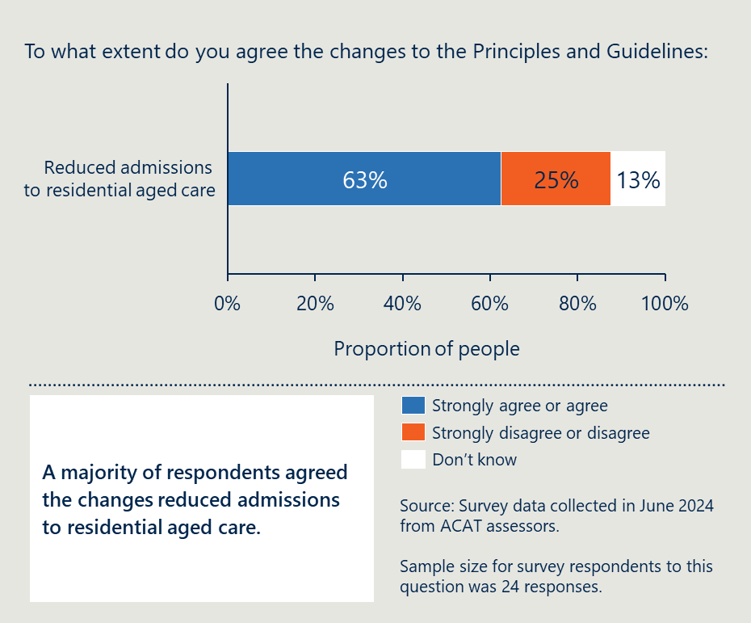

Growth in alternative accommodation and support options through the NDIS has provided more options
Growth in NDIS-funded accommodation and support options resulted in younger people eligible for the NDIS being more likely to find an alternative arrangement to RAC. As shown in Figure 12 below, the NDIS YPIRAC teams worked directly with 1,019 people (at-risk of entry to RAC) between November 2021 and March 2024. Of these people, they helped divert around 550 of them. This includes 229 that entered other group residential settings, 153 that moved into SDA, 139 that returned home or stayed in previous accommodation with increased support, 25 that entered a private rental, and less than 5 that entered a multi-purpose centre. It should be noted the NDIA YPIRAC teams were working with younger people at risk of entering RAC before this time, however data is not available.
Figure 12 | A Sankey diagram showing the number of people diverted by NDIA YPIRAC teams between November 2021 and March 2024
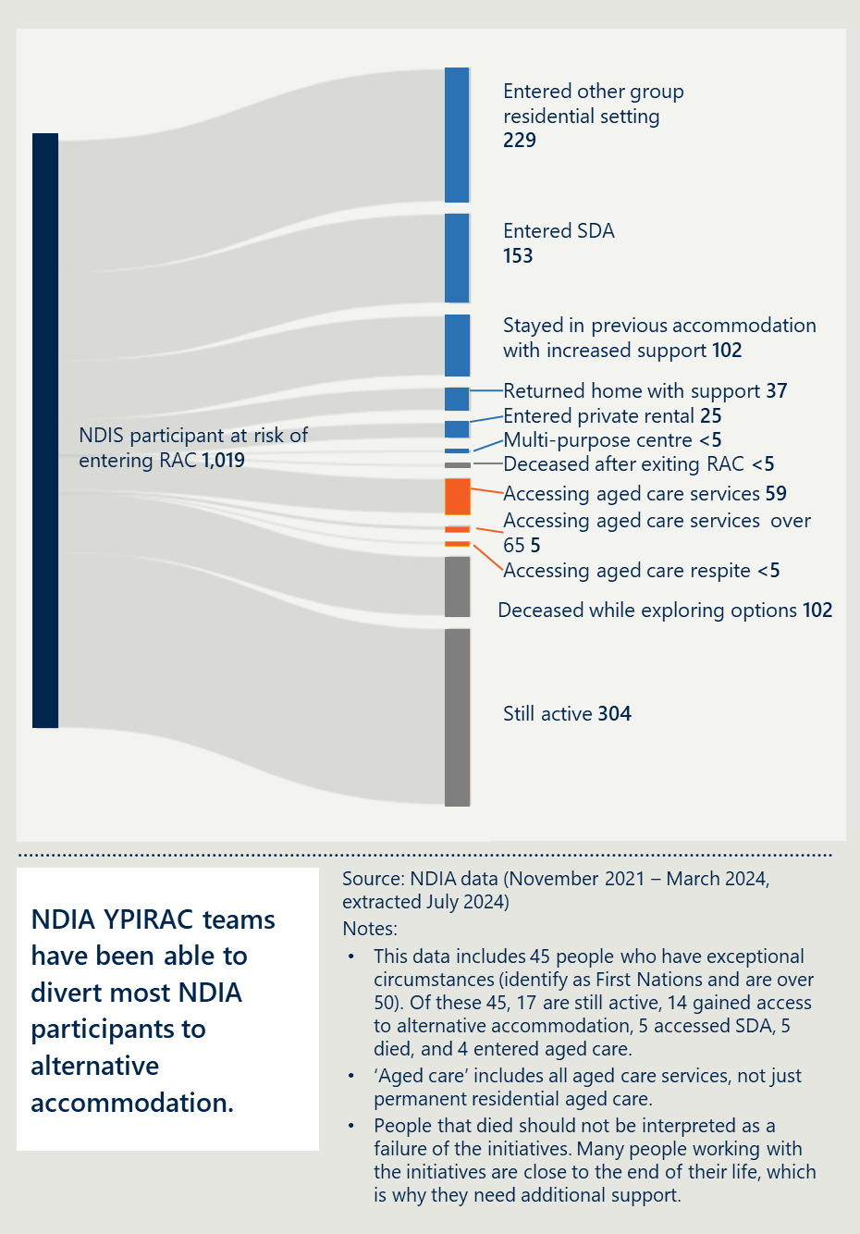
[Image description:
Participant Outcomes:
- NDIS participant at risk of entering RAC: 1,019 participants were at risk
- Entered other group residential setting: 229 participants moved into different group residential settings
- Entered SDA (Specialist Disability Accommodation): 153 participants accessed SDA
- Stayed in previous accommodation with increased support: 102 participants remained in their prior accommodation but received additional support
- Returned home with support: 37 participants were able to return to their homes with the necessary support
- Entered private rental: 25 participants moved into private rental housing
- Multi-purpose centre: Fewer than 5 participants entered a multi-purpose centre
- Deceased after exiting RAC: Fewer than 5 participants passed away after leaving RAC.
- Accessing aged care services: 59 participants accessed aged care services
- Accessing aged care services over 65: 5 participants over the age of 65 accessed aged care services
- Accessing aged care respite: Fewer than 5 participants accessed aged care respite services
- Deceased while exploring options: 102 participants passed away while they were exploring their options
- Still active: 304 participants are still actively engaged with the YPIRAC initiative.
Additional Information:
- The source of the data is from NDIA, covering the period from November 2021 to March 2024, with the data extracted in July 2024.
- The notes clarify that the data includes 45 people with exceptional circumstances, such as identifying as First Nations and being over 50. Of these, 17 are still active, 14 accessed alternative accommodation, 5 accessed SDA, 5 passed away, and 4 entered aged care.
- The term ‘aged care’ encompasses all aged care services, not just permanent residential aged care.
- It is noted that the death of participants should not be viewed as a failure of the initiatives, as many individuals involved are nearing the end of their lives, which is why they require additional support.
Notes:
- This data includes 45 people who have exceptional circumstances (identify as First Nations and are over 50). Of these 45, 17 are still active, 14 gained access to alternative accommodation, 5 accessed SDA, 5 died, and 4 entered aged care.
- ‘Aged care’ includes all aged care services, not just permanent residential aged care.
- People that died should not be interpreted as a failure of the initiatives. Many people working with the initiatives are close to the end of their life, which is why they need additional support.]
The number of NDIS participants diverted from RAC can be contrasted to the number of younger people who are not eligible for the NDIS being diverted. The outcomes for younger people not eligible for the NDIS are shown in Figure 13 below.
The AFA System Coordinators worked with 2,298 younger people at-risk of entering RAC not eligible for the NDIS between October 2021 and March 2024. Of these younger people, only 152 were helped to find alternative accommodation and support outside of RAC. A further 291 were supported to gain access to the NDIS and may have subsequently found alternative accommodation and support. Information about where they were diverted to is only available as part of the free text fields and was not able to be analysed in detail for this evaluation.
A far greater number of people accessed aged care services (822). It should be noted this includes all aged care services, not just permanent RAC as is shown in the data above.
Figure 13 | A Sankey diagram showing the outcomes for younger people at-risk of entering RAC working with AFA System Coordinators between October 2021 and March 2024
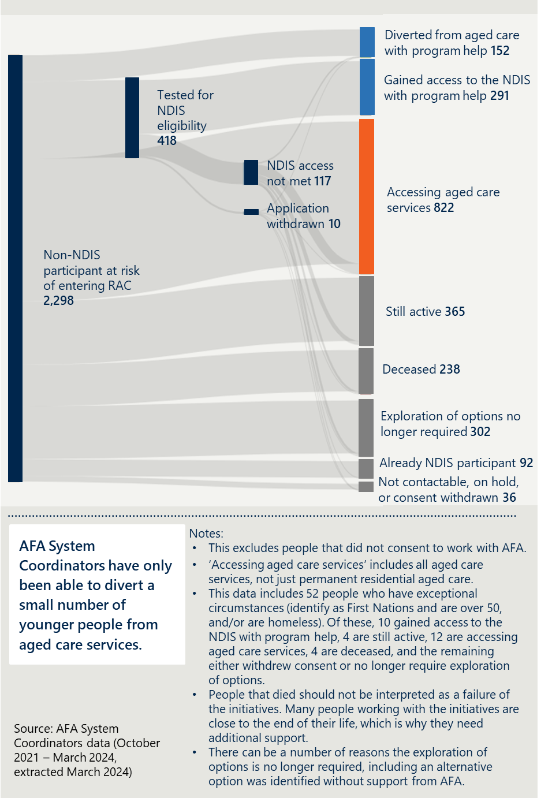
[Image description:
The Sankey diagram is divided into several segments, each representing a different outcome for younger people in relation to aged care services:
- Tested for NDIS eligibility: 418 individuals
- NDIS access not met: 117 individuals
- Application withdrawn: 10 individuals
- Non-NDIS participant at risk of entering RAC: 2,298 individuals
- Diverted from aged care with program help: 152 individuals
- Gained access to the NDIS with program help: 291 individuals
- Accessing aged care services: 822 individuals
- Still active: 365 individuals
- Deceased: 238 individuals
- Exploration of options no longer required: 302 individuals
- Already NDIS participant: 92 individuals
- Not contactable, on hold, or consent withdrawn: 36 individuals
Notes:
- This excludes people that did not consent to work with AFA.
- ‘Accessing aged care services’ includes all aged care services, not just permanent residential aged care.
- This data includes 52 people who have exceptional circumstances (identify as First Nations and are over 50, and/or are homeless). Of these, 10 gained access to the NDIS with program help, 4 are still active, 12 are accessing aged care services, 4 are deceased, and the remaining
either withdrew consent or no longer require exploration
of options.
- People that died should not be interpreted as a failure of the initiatives. Many people working with the initiatives are close to the end of their life, which is why they need additional support.
- There can be a number of reasons the exploration of options is no longer required, including an alternative option was identified without support from AFA.]
While there has been significant effort and progress, entries have not been reduced to zero and the Australian Government’s target of ‘no people under the age of 65 living in residential aged care by 2025’ will not be met. There were 104 younger people that entered RAC between July and December 2023, excluding First Nations people that were aged between 50 and 64. Only 27 per cent of these people were NDIS participants.

Initiatives helped individuals explore and understand alternatives

Changes to the Principles and Guidelines have required younger people to explore alternative options
Following the most recent changes to the Principles and Guidelines, younger people are only able to receive an ACAT assessment if they have documented evidence from the NDIA or AFA that they have explored alternative options. This requirement has clearly resulted in more younger people, their family and carers exploring alternative accommodation and support options to RAC.
Hospital staff engaged in the evaluation acknowledged these changes have led to cultural and practice changes. They noted that historically, clinicians and hospital discharge planners may have assumed RAC was the only option for people with high care needs. The increasing availability of NDIS-funded accommodation and support options has also enabled this change.
Despite the benefits of these changes to the Principles and Guidelines, stakeholders also reflected on some of the challenges and unintended consequences. Some stakeholders told the evaluation team the changes have resulted in delays to people being discharged from hospital.
This was further demonstrated by responses from ACAT assessors to the evaluation survey. As shown in Figure 14 below, a majority of ACAT survey respondents agreed or strongly agreed that the changes to the Principles and Guidelines had increased hospital length of stay and administrative demands on hospital staff.
Figure 14 | A bar graph showing responses from ACAT assessors regarding the impact of changes to the Principles and Guidelines
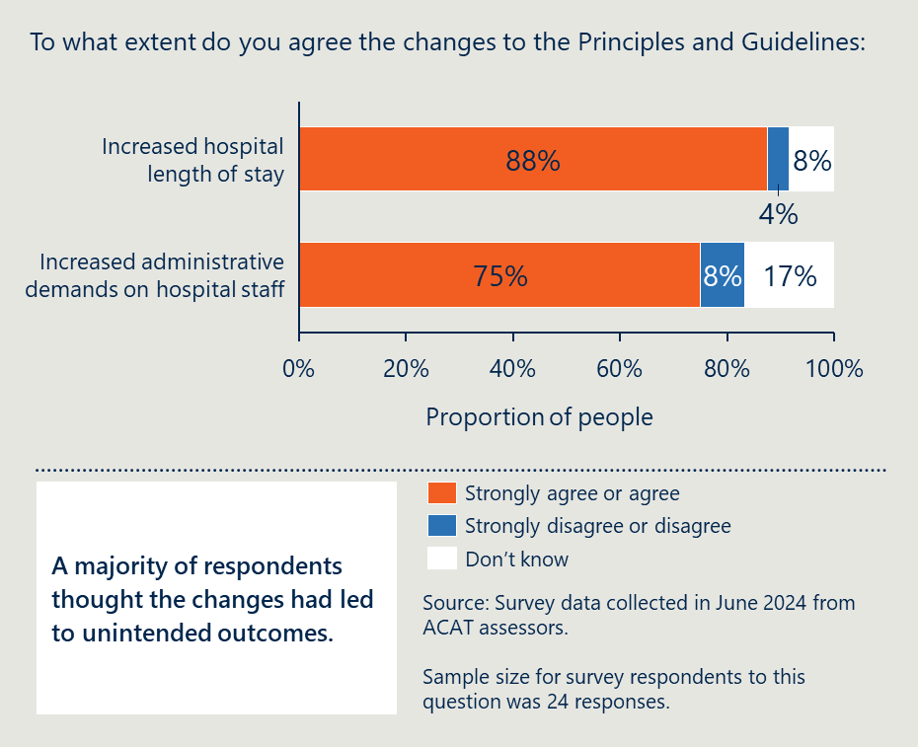
[Image description:
Bar graph showing majority agreement that changes to the Principles and Guidelines has increased hospital stay and administrative demands, with a note on unintended outcomes.
Increased hospital length of stay: 88% of respondents agree or strongly agree that the changes have led to longer hospital stays, while 8% disagree or strongly disagree, and 4% are unsure.
Increased administrative demands on hospital staff: 75% agree or strongly agree that the changes have increased administrative work for hospital staff, 17% disagree or strongly disagree, and 8% are unsure.
A text box highlights that a majority of respondents believe the changes have resulted in unintended outcomes.
Sample size for survey respondents to this question was 24 responses.]

Initiatives helped many younger people to understand and consider alternatives
Both the AFA System Coordinators and NDIA YPIRAC teams have helped younger people understand alternative options to RAC. In many cases, as described in the section above, younger people, their family and carers are choosing to explore their options and are being diverted away from or transitioned out of RAC after working with these teams.
Figure 15 provides data from a survey of younger people in or at-risk of entering RAC, their families and carers. It shows that most survey respondents agreed that the initiatives helped them understand and find age-appropriate accommodation and supports.
Figure 15 | A bar graph showing the responses from younger people in or at-risk of entering RAC, and their families and carers regarding the impact of YPIRAC initiatives
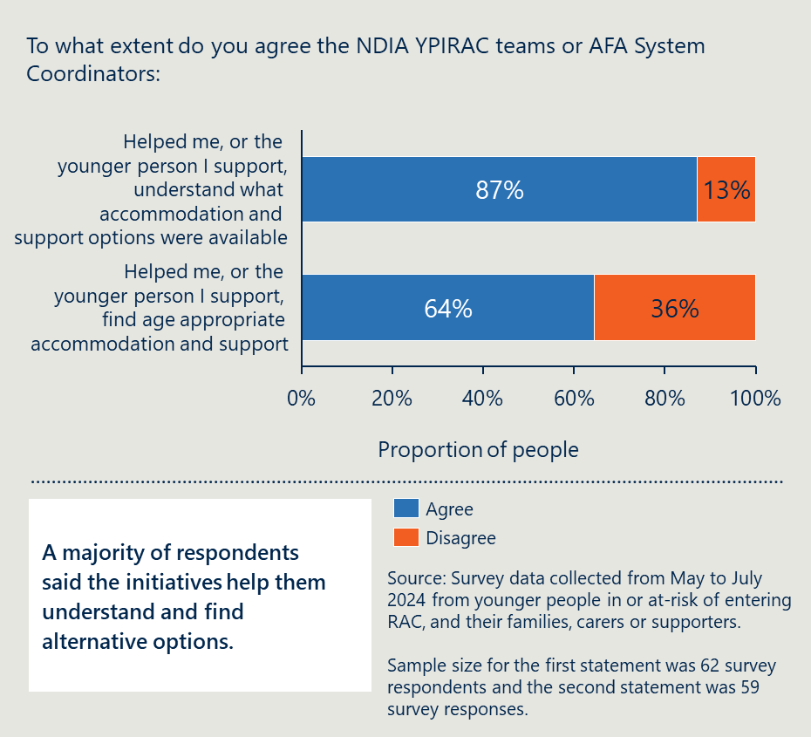
[Image description: Bar graph showing survey results: 87% agree NDIA teams helped understand options, 64% agree they helped find age-appropriate support.
Sample size for the first statement was 62 survey respondents and the second statement was 59 survey responses.]
However not all younger people have been supported to understand their alternatives. The evaluation team spoke to several younger people (NDIS participants and those not eligible for the NDIS), their family members and carers that had not had this support. This reflected some discrepancies with how consistently the AFA System Coordinators and NDIA YPIRAC teams are working. There may be other factors leading to inconsistent practices that have not been identified through this evaluation.
Although not the core focus of this evaluation, other organisations who are working to support younger people, their families and carers may have also contributed to helping people understand and find alternative options. This includes the Summer Foundation’s work to deliver their Aged Care to Home and Hospital to Home programs, in addition to the Housing Hub. It also includes work delivered by YPINH National Alliance to support younger people, their families and carers to understand their accommodation and support options and be empowered in the decision they make about where they want to live.

Initiatives have supported a small proportion of YPIRAC to exit
The number of younger people exiting RAC each month has not changed substantially since the introduction of the initiatives. This is shown in Figure 16 overleaf.
According to aged care data, in the period from July 2016 to July 2019, before the establishment of the YPIRAC initiatives, an average of 20 younger people were transitioned out of RAC to alternative accommodation arrangements each month. Since the establishment of the initiatives, the average has been 22 per month. There has been limited change in the proportion of people exiting RAC each month.
Figure 16 | A column graph showing the number of younger people exiting RAC each month to alternative accommodation arrangements, July 2016 to December 2023
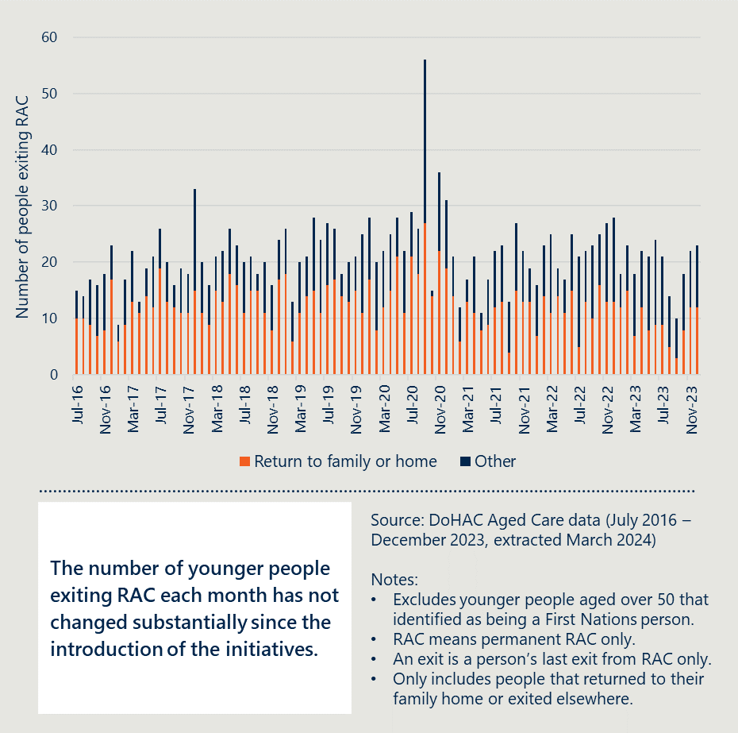
[Image description: A white box contains the text 'The number of younger people exiting RAC each month has not changed substantially since the introduction of the initiatives'.
Notes: Excludes younger people aged over 50 that identified as being a First Nations person. RAC means permanent RAC only. An exit is a person’s last exit from RAC only. Only includes people that returned to their family home or exited elsewhere.]
This analysis aligns with feedback from key stakeholders. Stakeholders reflected that the YPIRAC initiatives had not increased exits from RAC. There are several reasons for difficulties in supporting people to transition to age-appropriate alternatives which is discussed in further detail on page 64.
The NDIA YPIRAC teams worked with 3,925 NDIS participants who lived in RAC between June 2021 and March 2024. The NDIA YPIRAC teams helped 16 per cent of these NDIS participants move to age-appropriate alternatives including: 373 younger people to other group residential settings, 165 to SDA, and over 70 to their own or family home, independent living options, or medium-term accommodation. Further details are shown in Figure 17 below.
Figure 17 | A Sankey diagram showing the number of NDIS participants exiting RAC by type of accommodation between June 2021 and March 2024
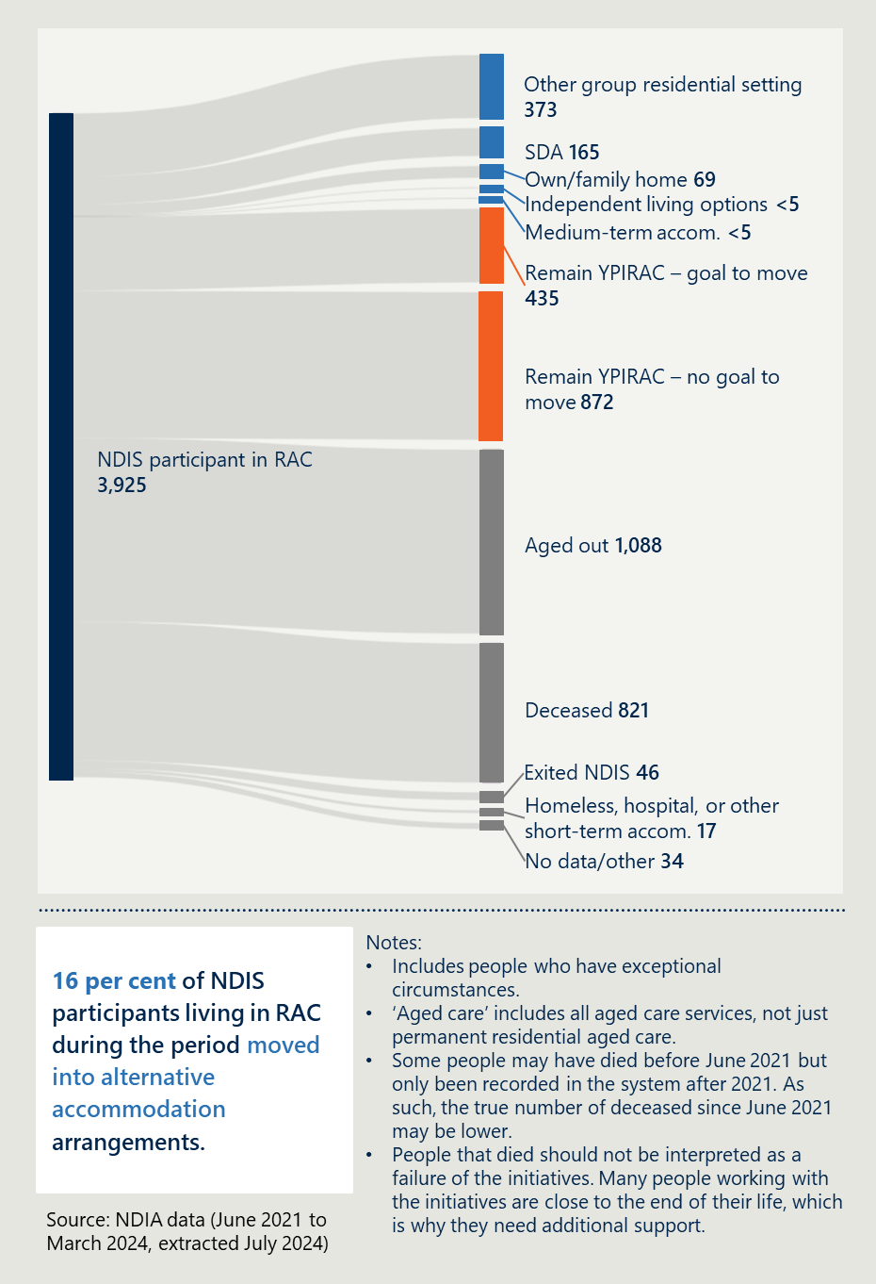
[Image description:
The Sankey diagram is divided into several segments, each representing a different exit out of aged care for 3925 NDIS participants RAC between June 2021 and March 2024:
Other group residential setting: 373 individuals
SDA: 165 individuals
Own/family home: 69 individuals
Independent living options: <5 individuals
Medium-term accom: <5 individuals
Remain YPIRAC – goal to move: 435 individuals
Remain YPIRAC – no goal to move: 872 individuals
Aged out: 1088 individuals
Deceased: 821 individuals
Exited NDIS: 46 individuals
Homeless, hospital, or other short term accom: 17 individuals
No data/other: 34 individuals
Notes
- Includes people who have exceptional circumstances.
- ‘Aged care’ includes all aged care services, not just permanent residential aged care.
- Some people may have died before June 2021 but only been recorded in the system after 2021. As such, the true number of deceased since June 2021 may be lower.
- People that died should not be interpreted as a failure of the initiatives. Many people working with the initiatives are close to the end of their life, which is why they need additional support.]
The AFA has only supported four younger people not eligible for the NDIS into alternative accommodation arrangements. The AFA System Coordinators contacted the RAC facilities for 634 younger people and were able to work with 400 younger people between October 2021 and March 2024. Of these, only four have exited RAC, 1 per cent of the total. 122 of these people continue to live in RAC. During the same period, System Coordinators helped 130 enter the NDIS who may have subsequently exited with support from the NDIA. Further detail is shown in Figure 18 below.
Figure 18 | A Sankey diagram showing the number of people supported by AFA to exit RAC between October 2021 and March 2024
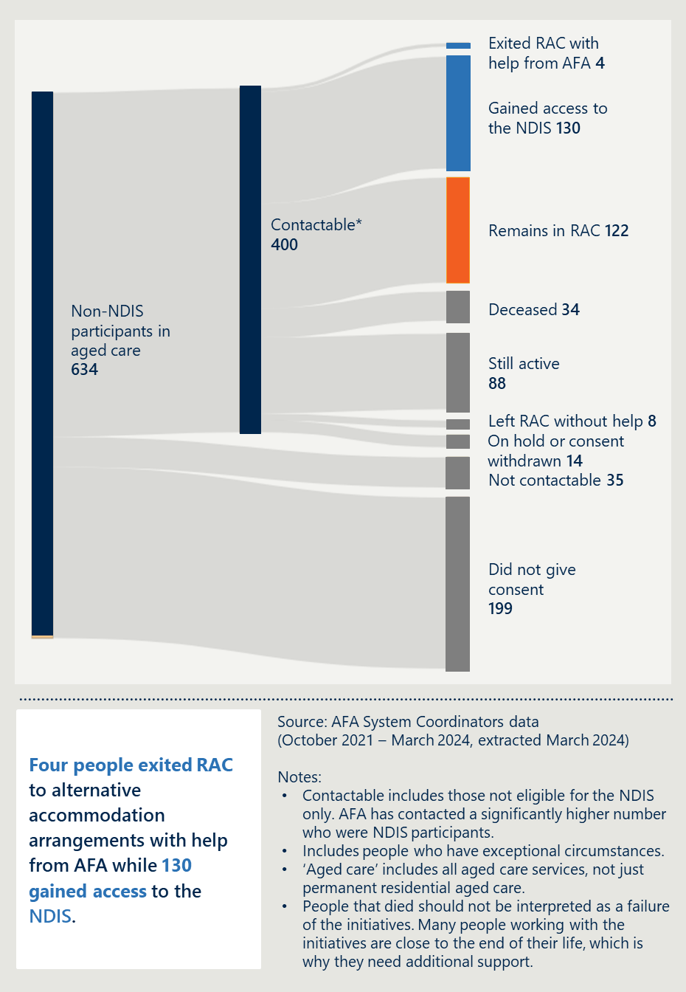
[Image description:
A Sankey diagram and accompanying notes detailing the outcomes for non-NDIS participants in aged care. Sankey diagram is divided into several segments, each representing a different outcome for the 634 non-NDIS participants in aged care:
- Contactable (400): This segment is the largest and indicates the number of individuals who could be contacted.
- Exited RAC with help from AFA (4): A small segment representing those who left residential aged care with assistance from AFA.
- Gained access to the NDIS (130): A significant portion showing the number of people who gained access to the National Disability Insurance Scheme.
- Remains in RAC (122): This segment shows those who continue to reside in residential aged care.
- Deceased (34): A segment representing individuals who have passed away.
- Still active (88): This segment indicates the number of people who are still active within the system.
- Left RAC without help (8): A small segment for those who left residential aged care without assistance.
- On hold or consent withdrawn (14): This segment represents individuals whose process is on hold or who have withdrawn consent.
- Not contactable (35): A segment for those who could not be contacted.
- Did not give consent (199): The second-largest segment representing individuals who did not give consent to be contacted or participate.
Notes:
- Contactable includes those not eligible for the NDIS only. AFA has contacted a significantly higher number who were NDIS participants.
- Includes people who have exceptional circumstances.
- ‘Aged care’ includes all aged care services, not just permanent residential aged care.
- People that died should not be interpreted as a failure of the initiatives. Many people working with the initiatives are close to the end of their life, which is why they need additional support.]

Younger people vary in their satisfaction with living arrangements

It is important to understand whether alternative living and support arrangements are appropriate
It should be noted that the YPIRAC initiatives do not directly contribute to the overall outcome of supporting younger people to experience the benefits of age-appropriate accommodation and support that meets all their needs. As described in the theory of change, the intent is that by helping younger people to understand, explore and access alternatives, they will contribute to this outcome as the ultimate end goal.
Many stakeholders stressed the importance of this evaluation in exploring not just whether there are fewer people in RAC but whether they are better off in alternative accommodation arrangements. Other stakeholders also pointed out that some younger people can have all their needs met while living in RAC and this should be explored.

Younger people in SDA are satisfied but other groups may not be
The evaluation asked younger people and their families and carers whether they were satisfied with their living arrangements through a survey. The results are presented in Figure 19 overleaf. Younger people in SDA arrangements are satisfied with their living arrangements while the findings are mixed for younger people in RAC, living at home or in other living arrangements, including temporary arrangements.
Almost all younger people living in SDA, their families and carers were satisfied with their living arrangements. Through the survey, respondents provided a variety of reasons for this level of satisfaction:
- Staff have the relevant skills and experience and are available all day, every day
- The facility and the supports have been tailored to meet the specific needs of the individual
- A homely environment is provided where younger people have independence, control and autonomy
- Younger people are able to socialise with other residents or housemates that are their own age.
Figure 19 | A bar chart showing the percentage of survey respondents that are satisfied with their living arrangements
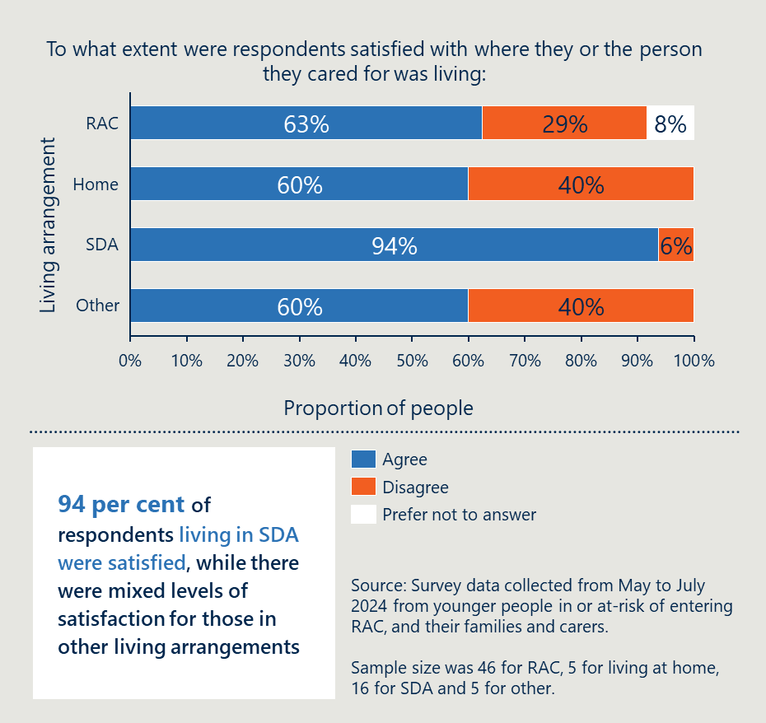
[Image description: A white box contains the text ‘94 per cent of respondents living in SDA were satisfied, while there were mixed levels of satisfaction for those in other living arrangements’.
Sample size was 46 for RAC, 5 for living at home, 16 for SDA and 5 for other.]
The following case study has been compiled based on accounts provided by younger people during the evaluation. It depicts a younger person who was assisted by the AFA and the NDIA to move out of RAC into SDA.

Case study 2: Judy became a NDIS participant and was moved out of RAC into SDA.
When Judy was 37, she had a stroke that led to an inability to move one side of her body. Judy was unable to perform everyday tasks like dressing herself or eating.
Judy required support and was unable to live independently, so she moved into residential aged care. Judy did not mind living in RAC because she felt taken care of. But she felt lonely at times because other residents were a lot older than her.
Judy was approached by AFA to move out of RAC. Judy was resistant at first, she had lived in RAC for 12 years and it felt like home. But she eventually decided she wanted to explore other options.
Judy was referred to the NDIA by AFA and was deemed eligible for the NDIS. The YPIRAC NDIA Planning and Accommodation Teams worked with Judy to find suitable alternative accommodation. They had regular family meetings with Judy and her parents to explore other options.
After six months, Judy was moved into SDA close to her parents with funding for a support worker. The support worker helps Judy with the tasks she cannot do herself, but she is also able to exercise with more autonomy than in RAC. She is very happy with this outcome, and grateful for the efforts of everyone that helped.
Not all younger people in RAC, their families and carers, feel that aged care is an inappropriate place to live and receive support. Families and carers of younger people that require round-the-clock care, constant supervision or specialised support, stated that aged care facilities delivered safe and high quality care. The evaluation team also heard about tailored care being provided in several specialist facilities designed for people with specific neurological conditions.
The following case study has been compiled based on accounts provided by younger people during the evaluation. It depicts a younger person who was diverted from entering RAC and lives in a specialised group facility.

Case study 3: Matteo avoided RAC by entering a specialist facility for people with early onset dementia
When Matteo was 42 years old, he started experiencing memory loss and a decrease in cognitive function.
Matteo’s memory loss started to impact his job and his relationships, as he was constantly forgetting things and repeating himself. At 44, Matteo was diagnosed with early onset Alzheimer disease.
Matteo’s cognitive function continued to worsen after his diagnosis. He stopped driving and he was forced to retire early from a career in local politics at 45 years of age.
Kim, his wife, could not look after him while she was working full-time and it was unsafe for Matteo to be at home alone while she was at work, in case he had a fall. Kim had to stop work to look after Matteo.
As the disease progressed, Matteo required increasingly high intensity cognitive supports to maintain cognitive function and assistance with daily activities such as dressing, washing and eating. This became too much for Kim, and she wanted to move Matteo into a local RAC in an attempt to try to get the support he needed.
Instead, Matteo and Kim got involved with Dementia Australia and heard about a specialist facility 20 minutes from their family home. After touring the facility, they applied, and Matteo moved in the following month.
Now Matteo receives the care and support he needs and can socialise with the other residents. Kim has returned to work, and visits Matteo every day.

Initiatives have supported some improvements in coordination, but challenges remain

New referral pathways have helped younger people find help
The initiatives have resulted in new referral pathways between aged care, health and disability systems.
Referral pathways have been established to help more younger people at-risk of entering or living in RAC find age-appropriate supports. As an example, where hospital staff would have previously considered aged care options for younger people post-discharge with ongoing support needs, they now work with NDIA Hospital Liaison teams and AFA to explore suitable alternatives.
The evaluation team has also received feedback that further work is required to streamline this referral process. Health and aged care stakeholders have said the referrals from the MAC Contact Centres are sometimes inconsistent and unreliable and do not always link people with the NDIA YPIRAC teams or AFA System Coordinators.

AFA System Coordinators have helped connect more people not eligible for the NDIS to a range of services
Younger people who are not eligible for the NDIS can have difficulty navigating a range of service systems to find age-appropriate accommodation and supports that meet their needs, preferences and goals. Depending on the younger person’s circumstances, this might involve navigating the health, mental health and housing systems. AFA System Coordinators have been able to generate knowledge and understanding about the services and supports available in each jurisdiction to support these younger people.
Feedback from stakeholders suggest that this has also helped improve the way different services work together. AFA System Coordinators and NDIA YPIRAC teams have worked closely with service providers across sectors and educated them about alternative options for younger people.

There continues to be examples of poor collaboration across service systems
For younger people in or at-risk of entering RAC to access age-appropriate accommodation and support requires collaboration across multiple service systems: health services including hospital services and primary and community care services, aged care, disability, and housing.
The challenges experienced by younger people, their family and carers of navigating these service systems has been noted in other reviews and reports. For example, the recent NDIS review noted ‘there remain significant problems with how the NDIS interacts with specific mainstream service systems’.
These challenges are particularly evidenced by younger people with co-occurring mental illness or chronic health conditions or life-limiting or palliative care needs. Engagement with stakeholders provided examples of these challenges:
- Gaps in health, aged care and disability collaboration: Aged care providers noted that in some cases the NDIA YPIRAC teams and AFA System Coordinators did not collaborate with them while they worked to transition the younger person out of RAC.
- Lack of understanding of roles and responsibilities: Health care workers were unclear about roles and responsibilities between the NDIA YPIRAC teams, HLOs and Home and Living teams and unclear how to contact the respective teams.
- Lack of consistent communication: Stakeholders that support younger people, their families and carers, also reported not knowing or having worked with the AFA and the NDIA YPIRAC teams. The evaluation team investigated this closely during consultations to ensure stakeholders were sure they had not heard of them.
The following case study has been compiled based on accounts provided by health providers and navigation supports. It depicts the frustrations of a younger person trying to access supports between the aged care, health and disability systems.

Case study 4: Taj is in RAC and needs occupational therapy to regain strength to be able to walk without falling.
Taj is 44 and has physical disability. Over time, Taj has lost strength in his left leg. He is currently in a wheelchair however with some additional support from an occupational therapist, could be able to walk around his house safely. He requires support to be able to get out of bed and to the bathroom safely in the RAC facility.
Taj is a NDIS participant so he asked the NDIA if they would fund some occupational therapy. The NDIA said that because he is in RAC, the facility should pay for the therapy. When Taj asked the facility, they said this should be paid for as part of his NDIS plan. Both the NDIA and the RAC agreed this was something that would help Taj and they would have paid for if he was not a joint aged care and NDIS funding recipient.
With help from his sister, Taj was eventually able to organise an occupational therapist to come once a week. Taj’s sister had to pay for this service from a private organisation.

Collaborative governance arrangements have brought government agencies closer but there are shortcomings
Although the JATF has been effective in maintaining a focus on this important issue, stakeholder consultations have identified two areas for improvement: including state and territory representatives on the taskforce, and cross-agency information sharing.
The states and territories are currently not represented on the JATF. However, as is discussed on page 67, the proportion of younger people entering RAC that are not eligible for the NDIS has been increasing. Where these people can be diverted from RAC, they are predominantly accessing services funded by states and territories. As this cohort increases as a proportion of total YPIRAC, it is important states and territories are involved in service planning.
There are barriers to sharing information between agencies that limit collaboration. The evaluation team has observed challenges in getting access to current, relevant and granular information about younger people in RAC from both DoHAC and the NDIA.
States and territories reflected that it would be helpful to receive more regular and current information from the NDIA or DOHAC to understand how many younger people not eligible for NDIS were in RAC, their location, circumstances, needs and preferences. The evaluation team notes that while the states and territories receive some of this information, information sharing is inconsistent or not always reaching the right people.
Some barriers relate to legislative requirements detailed in privacy legislation and the Aged Care Act. It is important that younger people’s privacy is protected but should not be a barrier to government agencies collaborating to deliver the services and supports for younger people.

There is greater understanding of the supports younger people need

Published research has improved understanding about what younger people need
Targeted efforts across the system have helped to better define the needs of younger people in or at-risk of entering RAC. New commissioned research has highlighted the factors influencing the decision making of younger people, the types of supports required to live outside of RAC and the availability of alternative options across each state and territory. Findings from this work are outlined below.

The below is an overview of findings from AFA commissioned research.
AFA has commissioned two research projects and is working with the University of Melbourne, Scope and Latrobe University to deliver these projects.
Research by the University of Melbourne and Scope helped provide information on the barriers to moving out of RAC. The research indicated that for younger people who are not NDIS participants, several factors are beneficial in aiding them to exit or avoid entering RAC. These include access to funding for services and suitable housing, assistance with exploring alternative options, guidance in navigating funding and services, family support, and collaboration across services and sectors. The research team identified significant service gaps for people with life-limiting or palliative care needs, gaps in services in rural, regional and remote areas, in addition to gaps in transitional programs and housing.
Research by Latrobe University is starting to identify enablers to people living independently. The research is still ongoing but is evaluating factors that support younger people with life-limiting conditions to remain in the community. They note the funding limitations in existing programs, often leading to unmet need.

The below is an overview of findings from AIHW research.
AIHW has published two research reports that provide insights from aged care, healthcare and disability data.
Key findings include:
- Younger people in RAC have co-occurring health conditions, including 91 per cent who have at least one health condition recorded and 65 per cent that have multiple health conditions recorded. Dementia was the most prevalent health condition reported, accounting for 18 per cent of the cohort. For those under 45 living in RAC, injuries to the head accounted for 17 per cent, the highest of any presentation in this cohort.
- Younger people in RAC are in contact with the health system at a higher rate than the general population in their age bracket. This includes visiting the GP at a rate 3.5 times higher than the general population. Nearly two-in-five had an emergency department visit in 2020-21, with 75 per cent requiring emergency care in the year before entry to RAC. Almost half were prescribed antipsychotics in 2020-21.

The below is an overview of findings from NDIA commissioned research.
NDIA research report examines options for independent living.
The University of Sydney was commissioned by the NDIA to examine effective interventions for transitioning individuals with disabilities from institutional care to individualised home settings. The study reviewed a wide range of materials, including academic and grey literature, and conducted an environmental scan for both Australian and international interventions. The report authors note that well-supported transitions lead to better well-being, independence, and choice, with a distinct trend towards mainstream housing options with support. While the report suggests pathways to independent living, it also points out knowledge gaps, especially regarding effective supports for diverse groups.

Regular reporting against targets has provided accountability
DoHAC commissioned AIHW to publish quarterly data on the number of younger people in RAC to contribute to improved accountability. The number of younger people admitted and living in RAC are reported by state and territory and age groups (under 45 and under 65 years old).
This regular reporting provides an opportunity for government to chart progress against the YPIRAC target. It also enables stakeholders (public, researchers, and policymakers) to access and interpret data, thereby fostering greater transparency.

There are several barriers impacting the effectiveness of the initiatives

Access to alternative options is the most critical barrier
While substantial progress has been made in reducing the number of younger people in RAC, as at December 2023 there were still 1,470 younger people in RAC. One of the barriers to reaching the target of “no younger people living in RAC by January 2025” is the lack of age-appropriate accommodation and support options available as alternatives. This is relevant to both younger people at-risk of entering RAC and those living in RAC.
This can be seen in the comparison of progress for younger people in or at-risk of entry to RAC who are not eligible for the NDIS. As has been discussed (see page 37), the NDIA YPIRAC teams have been able to divert more people away from entering RAC than the AFA System Coordinators because there are more alternative options for NDIS participants. According to available data, approximately 73 per cent of younger people entering RAC between July and December in 2023 were not NDIS participants.
Research conducted by the University of Melbourne and Scope supported this finding about the reasons people were in RAC. The research found that many younger people were in RAC because of a lack of funding to live elsewhere in the community and a lack of appropriate housing. The research noted significant gaps for younger people:
- with life-limiting illness or palliative care needs
- in regional, rural and remote areas
- requiring transitional support and housing.
Access to suitable alternative options was also the most common reason for entering or remaining in RAC given by younger people and their families to the evaluation team.
Finding age-appropriate accommodation and supports in the right geographic area was the most common challenge cited. Multiple family members reflected on the challenges finding suitable alternatives close to where they lived so they were able to easily visit their family member, and the younger person could maintain connected to their community. This was particularly the case for family members living in regional and rural areas.
Access to specialist NDIS-funded services was also a challenge for some cohorts of younger people. The evaluation team spoke to several family members of younger people with neurological conditions and high-intensity support needs. Many were living in specialist RAC facilities. Family members told the evaluation team the specialist care options were not currently available outside the aged care system even if they did want to move.
The following case study has been compiled based on accounts provided by younger people. It depicts a younger person who was not eligible for the NDIS but needed support accommodation due to a physical disability.

Case study 5: Ola was not eligible for NDIS and did not have an alternative to RAC.
Ola lives in a regional town. Ola is 59 and lives with a complex medical condition.
Ola has lived alone for most of her adult life but in recent times, her care needs increased and she was admitted to hospital. A social worker in the hospital tried to find accommodation for Ola before she was discharged.
Ola was not NDIS eligible. Ola and the social worker applied several times but were declined each time. As she was not eligible for the NDIS, Ola could not access the specialist disability accommodation facility in the neighbouring town. This meant she had to explore state-funded social housing options, but there was nothing suitable in her area.
The hospital social worker suggested Ola apply to live in RAC. When applying, they were met with resistance because Ola was under the age of 65. Ola’s sister and social worker had to work hard to prove there were no alternative accommodation options available in their area.
Ola was granted entry to RAC after seven weeks of being in hospital. RAC provides Ola with the basic care she needs, but she is not completely satisfied with the arrangements. She does not socialise with the older residents and the facility is understaffed, meaning it often takes a few hours for her requests to be met. She used her life savings to fund RAC, meaning she does not have much disposable income to spend on activities.

Many younger people have indicated they do not want to move
As at June 30, 2024, 67 per cent of younger people in RAC that are NDIS participants do not have a goal to move out of RAC. Similarly, of the 634 younger people in RAC that are not NDIS participants contacted by the AFA System Coordinators, 248 were not able to be contacted or did not consent to work with the System Coordinator.
It should be noted not having a goal to move does not necessarily mean the person is not open to moving out of RAC. It is clear from engagement with younger people, their families and carers that some people may not want to move out now because there are no better alternatives but if a suitable alternative came up or their circumstances changed, they may consider these alternatives.
There are multiple reasons younger people might not want to move out of RAC.
Researchers from the University of Melbourne and Scope sought to understand why younger people that were not eligible for the NDIS were reluctant to move out of RAC. The researchers identified two reasons:
- younger people choose to remain in RAC because they feel safe, secure and well cared for
- there is not the equivalent level or type of care for some younger people outside of RAC.
Stakeholders engaged as part of this evaluation noted similar reasons younger people, their families or carers, did not want to move out of RAC. This included not wanting to move away from family members or not wanting to move if there was not a suitable option that would meet all their needs.
A related issue is the perception that other services are not able to provide the same level of care as RAC. Some family members of younger people with high intensity or specialist needs told the evaluation team they did not think other services could safely provide the care to meet the younger person’s needs, preferences and goals.
Work by the NDIA and AFA has demonstrated that younger people with no goal to move can be supported to reconsider alternative options. The NDIA and AFA have worked on a joint project with NDIS participants under 45 years of age in RAC with no goal to move. The project was run as a trial in 2022, working with 27 people for 11 weeks. By the end of the period, five people had changed their goal. The project has been extended and expanded to work with 150 people aged 50-64 over 12 months.

States and territories have not been involved in governance arrangements
As previously discussed, states and territories are not involved in YPIRAC governance arrangements. States and territories raised frustration with the level of engagement they had from the Australian Government. Accessing current and consistent data and information about the YPIRAC cohort in their jurisdiction was uniformly flagged as a challenge.
Younger people that are not eligible for the NDIS currently only have access to state and territory funded services as an alternative to entering or living in RAC. As a result, it is important to involve states and territories in work to reduce the number of younger people in or at-risk of entry to RAC. States and territories already offer some supports that may be used by younger people. However, these programs are limited, are not consistently delivered in each jurisdiction and do not provide a comprehensive suite of accommodation and support alternatives for at-risk groups. These are described in further detail below.
There are multiple services and supports funded by state and territory governments for younger people not eligible for the NDIS.
One common example is Home and Community Care (HACC) programs that are available for younger people. The Victorian Government funds the HACC Program for Younger People which supports younger people if their capacity for independent living is at-risk. This could be because they have a chronic health condition, mental health issue, disability or other condition needing one-off, intermittent or ongoing support to undertake activities of daily living. The Tasmanian Government provides a similar service through the Tasmanian Home and Community Care program and South Australian government officials said they have historically provided support to younger people through a similar program. However, the Victorian Government announced a reduction in funding for their HACC Program for younger people in the 2024-25 Budget.
Queensland Government officials talked about an 11-place program offered to people that are not eligible for the NDIS because they are not Australian residents. The program provides in-home accommodation and support for people with disability. Several jurisdictions have also created short-term accommodation for people in hospital who are clinically ready for discharge and waiting for supports in the community. This helps reduce pressure on the hospital and allows time for the assessments and preparation needed for some people before they can go into their existing or new accommodation. An example is Victoria’s Pathways to Home program that helps patients with a disability transition home or a home-like environment once they are medically fit for discharge while they await their permanent accommodation plans through the NDIS.
Other state and territory-funded services that have provided alternatives include:
- Palliative care (including community-based palliative care) – programs and services delivered by health care providers designed to provide health services to people close to the end of their life.
- Nursing and care supports (including HACC programs) – for those with complex and chronic medical conditions, and where a person’s health condition does not meet the criteria for supports under the NDIA, there are often no funding options for care in the home.
- Aids and equipment programs – these services provide individuals with chronic health conditions with specialist equipment or aids that assist them to live safely and increase their independence.
- Social housing – state and territory governments provide social housing to people on low incomes who need housing.
- Level 3 Accommodation (including Support Residential Services) – supported accommodation that provides higher level of care and support for people with particular needs.

Outcomes vary for different groups

There has been less progress for some groups
While there has been a reduction in the number of younger people entering RAC, the progress has not been the same for all groups.
The cohorts of younger people entering RAC prior to establishment of the initiatives has been compared to recent data. As shown in Figure 20 below, people entering RAC in 2023 are more likely to:
- be aged over 60
- have a co-occurring mental illness
- not be eligible for the NDIS
- live in a regional or remote area
- die within 12 months of entering RAC.
Figure 20 | Bar charts showing the demographics of people entering RAC, 2023 versus 2017
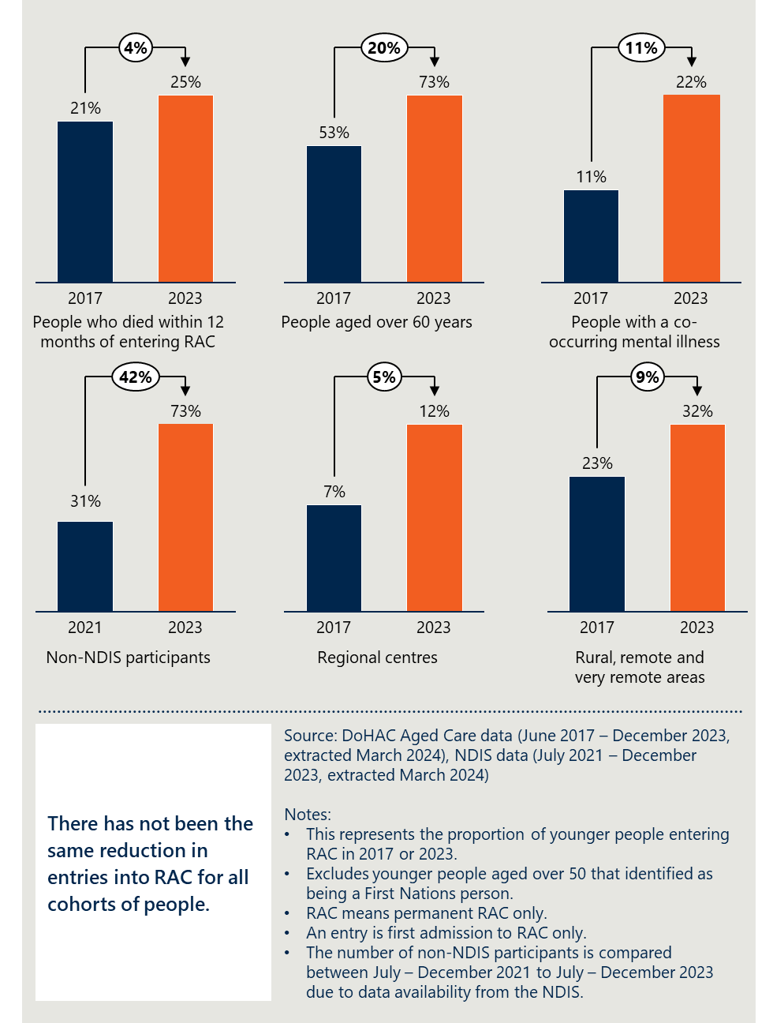
[Image description: Bar chart comparing the percentage of various cohorts entering residential aged care in 2017 and 2023, with a note on unequal reduction across groups.
A white box contains the text ‘There has not been the same reduction in entries into RAC for all cohorts of people’.
Notes:
- This represents the proportion of younger people entering RAC in 2017 or 2023.
- Excludes younger people aged over 50 that identified as being a First Nations person.
- RAC means permanent RAC only.
- An entry is first admission to RAC only.
- The number of non-NDIS participants is compared between July – December 2021 to July – December 2023 due to data availability from the NDIS.]
There is a cohort of younger people living in the community who were found eligible for entry to RAC prior to the introduction and implementation of the modified process in March 2022. These people can enter care at any time using those approvals and are known as ‘legacy assessment approvals’. Data on younger people entries into RAC between January to December 2023, indicates that approximately 20 per cent of monthly entries are done so using a legacy assessment approval.

There are only a small proportion of First Nations people in RAC that do not meet exceptional circumstances
Figure 21 overleaf shows the number of people identifying as First Nations people in RAC at 31 December 2023. Under the current Principles and Guidelines, if a First Nations person is 50 or over, they meet the definition for exceptional circumstances and are able to enter RAC without exploring alternative options. This leaves only a very small number of First Nations people, who are under 50 years of age, in RAC that do not meet the definition of exceptional circumstances.
Figure 21 | A graph showing the number of First Nations younger people in RAC on 31 December 2023
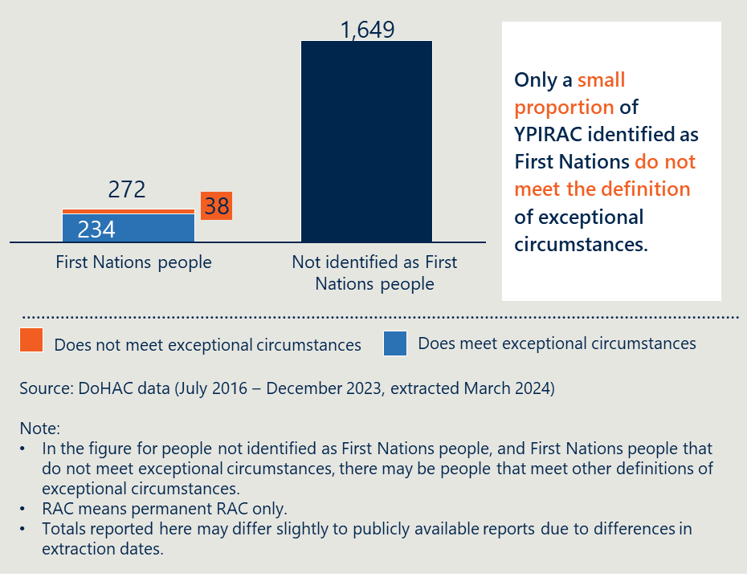
[Image notes:
- In the figure for people not identified as First Nations people, and First Nations people that do not meet exceptional circumstances, there may be people that meet other definitions of exceptional circumstances
- RAC means permanent RAC only
- Totals reported here may differ slightly to publicly available reports due to differences in extraction dates]
Because these numbers are small, it is difficult to make any conclusions about the experience of First Nations people.
However, some stakeholders told the evaluation team that being close to family and to country is an important consideration for First Nations people. Often this means finding age-appropriate alternatives in rural and remote locations where there are limited options. The evaluation team also heard there are several specialist First Nations RACs that provide culturally safe care. There is a perception among some stakeholders that this specialised delivery of culturally safe, inclusive care may not be available in the disability system.

Future actions

Summary of findings from the review
This sub-section presents findings from the evaluation to answer the following key evaluation questions:
3. What actions should be taken to continue to deliver progress into the future?
3.1 What action should be taken in relation to the existing initiatives to continue making progress?
3.2 What other actions should be taken?
Key findings from the evaluation that should be considered in informing future action:
- The YPIRAC cohort has changed substantially
- Broader system reforms underway will have an impact
- Recommendations support the Government’s commitment of no younger people in RAC apart from exceptional circumstances
- Recommendations aim to enable younger people to achieve their goals and live the life they choose

The YPIRAC cohort has changed substantially

The number of younger people is expected to keep declining
The evaluation has modelled the expected number of younger people in RAC out to December 2028 using historical data. The model used is called a proportions hierarchical model. The model estimates the future attributes of the dataset using proportions, for example, the proportion of people living in regional, rural and remote areas. The model puts more weight on recent data which is why it expects a slowing down in the reduction of younger people in RAC.
As shown in Figure 22 overleaf, the model estimates the number of younger people in RAC will decrease to 310 by December 2028. The model estimates 634 younger people will have a first entrance into RAC during the five-year period, excluding First Nations people between 50 and 65 years. It would include people that meet the definition of other exceptional circumstances. The model is not able to consider what impact proposed changes to the legislation would have.
The model estimates 2,422 will either leave RAC or turn 65 during the five-year period. This includes 487 that will turn 65 and 426 that will pass away. The remainder would exit to other living arrangements.
This reflects continued progress in relation to reducing the number of younger people in RAC. However, it shows the target of reaching zero will not be reached within the next five years without additional effort.
Figure 22 | A line graph showing the predicted number of younger people in RAC, December 2023 to December 2028
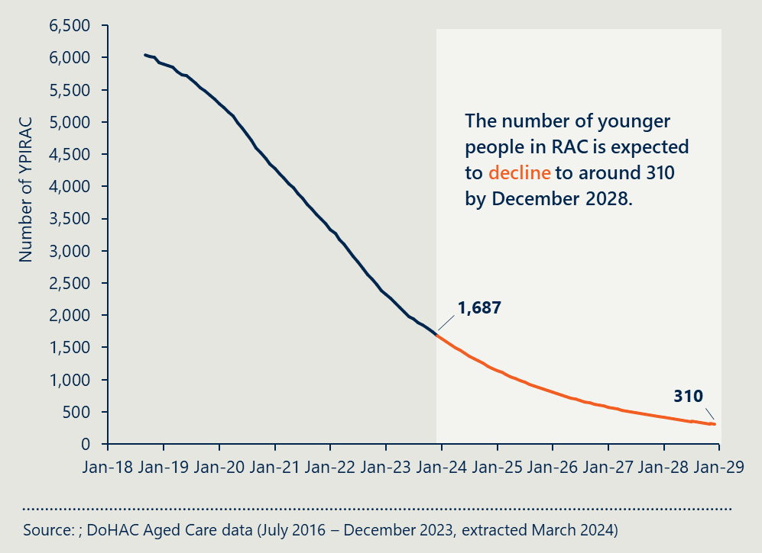
[Image notes:
- This model uses historic data on the number of younger people in RAC to forecast the future number of younger people in RAC. It is based on current policies, entry rates, and exit rates
- Excludes younger people aged over 50 that identified as being a First Nations person
- The number of 1,687 used here differs from the number of 1,470 used in other parts of report because a different dataset has been used with slightly different figures, the differences are a result of extracting the dataset at different times]

Younger people remaining or continuing to enter RAC will be older, living in regional areas and not eligible for the NDIS
The modelling also involved estimating the change in the proportions of different cohorts of younger people in RAC. As shown in Figure 23 overleaf, the cohort of younger people in RAC by 2028 will be older, more likely to live in regional, rural and remote areas, and less likely to be a NDIS participant.
Figure 23 | An infographic showing forecasted future demographics of younger people in RAC, December 2023 versus December 2028
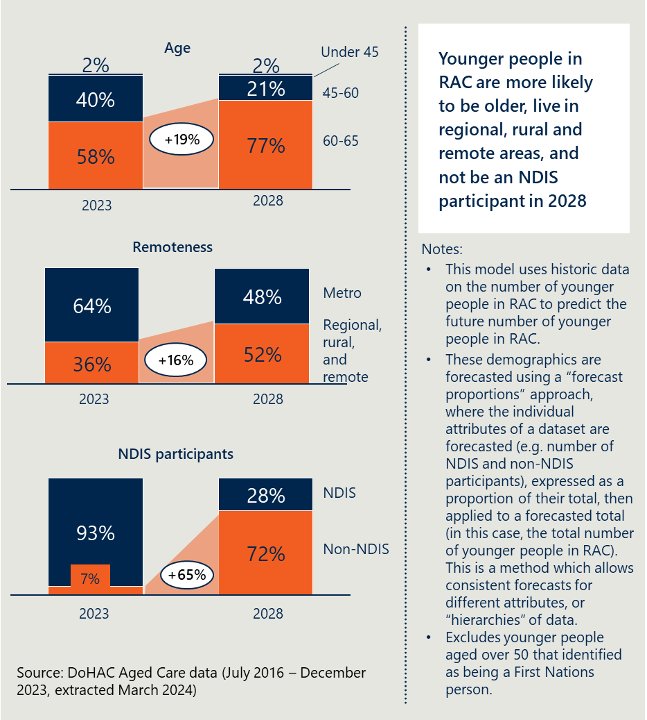
[Image description:
Age Distribution
2023: The majority (58%) of younger people in RAC are under 45, with 40% aged 45-60, and a small fraction (2%) aged 60-65.
2028: A significant increase of 19% is projected in the 45-60 age group, resulting in 21% under 45, 77% aged 45-60, and 2% aged 60-65.
Remoteness
2023: 64% of younger people in RAC live in metro areas, while 36% are in regional, rural, and remote areas.
2028: A shift of 16% is expected towards regional, rural, and remote areas, with 48% in metro and 52% in non-metro areas.
NDIS Participants
2023: A vast majority (93%) are not NDIS participants, with only 7% participating.
2028: There is a projected increase of 65% in non-NDIS participants, leading to 28% NDIS and 72% non-NDIS participants.
Notes:
- This model uses historic data on the number of younger people in RAC to predict the future number of younger people in RAC
- These demographics are forecasted using a “forecast proportions” approach, where the individual attributes of a dataset are forecasted (e.g. number of NDIS and non-NDIS participants), expressed as a proportion of their total, then applied to a forecasted total (in this case, the total number of younger people in RAC). This is a method which allows consistent forecasts for different attributes, or “hierarchies” of data
- Excludes younger people aged over 50 that identified as being a First Nations person]

Solutions exist but are not always available
This evaluation has shown there are solutions that exist for younger people in or at-risk of entering RAC. This involves providing accommodation that meet people’s needs alongside tailored support. For example, there have been NDIS participants that have received SDA alongside SIL supports, and those not eligible for the NDIS that have received social housing alongside support from Home and Community Care Program for Younger People (HACC PYP).
The evaluation team has also reviewed what is happening in other countries for younger people in or at-risk of entering RAC. Most countries provide some version of supported disability accommodation and supported social housing models. The below provides an example of a model from Canada.
In Canada, supported disability accommodation models are designed to provide various levels of assistance while promoting independence and community integration. These models aim to balance independence with the necessary support, ensuring that people with disabilities can live in a manner that meet their personal needs and preferences. Each model is designed to cater to different levels of support required, from full-time care to more independent living with occasional assistance. Common SDA models include:
- Group Homes: Residential facilities where individuals with disabilities live together with support staff available 24/7 or on a scheduled basis. Group homes provide a structured environment with staff support for daily living activities, medical care, and socialisation. Group homes are often small homes or apartments.
- Assisted living: Facilities that offer a combination of housing, support services, and personal care to people who need help with daily activities but do not require intensive medical care. This model provides help with daily activities like bathing, dressing, and medication management while allowing for a degree of independence. Facilities are often apartments or communities.
- Transitional Housing: Short-term housing solutions that help individuals with disabilities transition to more permanent housing or independent living.
- Family home programs: Individuals with disabilities live with families who provide care and support in a home setting. These programs offer a family-like environment and personalised support while integrating individuals into community life.
- Independent Living Centres (ILCs): Organisations that provide support and resources to people with disabilities to help them live independently in the community. ILCs focus on empowering individuals with disabilities to manage their own lives with available resources and community support.

Broader system reforms may have an impact but will take time

Reforms are underway in the aged care system which will affect younger people
In December 2023, the Australian Government released an exposure draft for a new aged care bill. The proposed changes would eliminate the ability for people under 65 years old to be referred for an ACAT assessment, apart from exceptional circumstances. In the exposure draft, exceptional circumstances are defined as First Nations people over 50 years old, and people experiencing homelessness or at risk of homelessness over 50 years old.
There are a variety of concerns from different stakeholders about the proposed changes. Some stakeholders raised concerns that the changes would create a service gap for people under 65 who would not be eligible for aged care under the proposed changes. Many stakeholders are also concerned the definition of ‘homelessness and at risk of homelessness’ provides too much opportunity for younger people to be moved into RAC, particularly when there are pressures in hospital to support discharge.
The Australian Government is also in the process of consolidating and growing the availability of home-based aged care which currently provides an alternative for some younger people. The Support at Home program will commence from 1 July 2025 and replace the Home Care Packages Program (HCPP) and the Short-Term Restorative Care Programme (STRC).
There is a commitment by the Australian Government to improve older Australians’ quality of life and support them to remain in their homes and remain active and connected to their communities. This is demonstrated by a 10 per cent increase in the number of people on Home Care Packages to 273,306 people in the 12 months to 31 March 2024 and the Government’s budget pledge to invest another $531.4 million to release an additional 24,100 Home Care Packages in 2024–25.

NDIS reforms may help but not in the short-term
In October 2022, the Australian Government announced a review of the NDIS. An independent panel was established to examine:
- the design, operations and sustainability of the NDIS
- how a more responsive, supportive and sustainable market and workforce could be built.
The panel provided the report to the Australian Government in October 2023. The report provides a blueprint to realising the original intent of the NDIS through collaboration across governments, providers and with people with disability, their carers and families.
Most relevant to this evaluation are the findings in relation to foundational supports and the interface between disability services and mainstream service systems.
The panel found there were a lack of accessible and affordable foundational supports for people outside the NDIS. The panel made a number of recommendations to both the Australian Government and states and territories, including to:
- design, fund and commission an expanded and coherent set of foundational disability supports
- invest in navigation support for people with disability outside the NDIS
- invest in community care support programs, including for people with chronic health conditions
- develop a nationally consistent approach for the delivery of aids and equipment
- invest in psychosocial supports outside the NDIS.
The panel found that progress to make mainstream services inclusive for people with disability had been slow. The panel made a number of recommendations to both the Australian Government and states and territories, including to:
- better clarify responsibilities of the NDIS and other service systems
- improve coordination between complex mainstream settings and the NDIS
- allow NDIS participants over 65 to continue to receive NDIS supports and aged care supports concurrently.

There are efforts to increase housing options, but few targeted at younger people
Substantial efforts are being made to increase the supply of housing across the spectrum of social and affordable housing. Through the National Housing Accord, the Australian Government and all states and territories have signed up to build 1.2 million new, well-located homes over five years from mid-2024. All governments have signed up and committed substantial funding to growing the availability of social and affordable housing.
Few of these efforts are specifically targeted at people with disability or for younger people at-risk of entering residential aged care. However, some states and territories have made commitments to grow the availability of supported disability accommodation as part of individual projects.
Many stakeholders have noted a lack of access to affordable housing options has made it challenging for some younger people to find age-appropriate accommodation. This includes people living in regional and rural areas where there are also few supported disability accommodation options.
Without being more formally mandated to support the delivery of tailored supply options with appropriate support for this cohort, states and territories will continue to argue they are on the periphery of this issue. Confusion over who is responsible for providing tailored supply will get in the way of achieving better outcomes for younger people and functional zero. This means aiming to have no younger people in RAC that want to move into alternative accommodation.

Bilateral negotiations offer an opportunity, but this cohort will not be prioritised without joint commitment and targeted funding
There are several funding agreements between the Australian Government and states and territories that are due to expire shortly. This includes funding agreements for the NDIS and hospital services. The evaluation team understands the Australian Government is currently in the process of negotiating new agreements with states and territories.
Given this is a relatively small cohort in the scheme of large funding agreements, it is unlikely they will be prioritised as part of negotiations or reform initiatives. Without prioritisation, and without funding from the Australian Government to states and territories, it is unlikely new agreements will provide a clear solution.

Recommendations will support an ideal experience for younger people
It will be important that future action taken by the Australian Government is driven by what younger people want and need to live their best lives. To do this, policymakers should be driven by outcomes that matter to people.
Based on engagement undertaken through this evaluation, this report provides the following objective and four outcomes to guide future work in relation to younger people. This is shown in Figure 24 overleaf. The evaluation team has considered these outcomes in developing the recommendations outlined in this section.
The recommendations have been developed to achieve the current objective of having zero younger people in RAC, apart from exceptional circumstances. This includes introducing the concept of functional zero, which means aiming to have no younger people in RAC that want to move into alternative accommodation.
There is a need to shift focus from what the Australian Government can do, to the importance of collaboration and how Australian governments, including state and territory governments, can collectively reduce the number of younger people in RAC.
The recommendations are outlined below under the following three headings:
- Establish a case management approach
- Improve current processes
- Prepare for legislative changes
Figure 24 | An infographic showing principles to guide future action by the Australian Government
[Image description:
Objective: The infographic sets a clear objective: “Younger people can achieve their goals and live the life they choose.”
Outcomes: The outcomes section details a seamless pathway for younger people, from finding help to living in age-appropriate accommodation that meets their needs. It emphasises the role of Australian governments in sustainably delivering functional zero by linking information, collaborating, and commissioning tailored accommodation and supports. The outcomes are divided into four key areas:
1. Finding help, meaning younger people get help when they need it.
2. Understanding options, meaning younger people are informed about and understand their accommodation and support options.
3. Designing a response, meaning younger people experience services as a collaborative whole, rather than siloed and disjointed.
4. Living in appropriate circumstances, meaning younger people are living in age-appropriate accommodation that meets their needs.
Recommendations: The recommendations section provides eight specific suggestions to improve the system that are detailed in the text below]

Establish a case management approach

Recommendation 1: Mandate the establishment of a case management panel in each jurisdiction
DSS should establish a case management panel for each state and territory. Membership of the panel should include:
- Australian Government representatives from DSS, DoHAC and NDIA
- A collection of appropriate state and territory representatives from health, mental health, housing and disability
Each panel will have the objective of reaching and maintaining a target of ‘functional zero’. This means aiming to have no younger people in RAC that want to move into alternative accommodation. Any younger person who wants to move or who is at-risk of entry to RAC will be reviewed by the case management panel, irrespective of whether they meet the criteria for exceptional circumstances.
Each panel will achieve its objective by:
- receive a quarterly report about each younger person under 65 in RAC, their preference for moving, barriers to moving, and proposed action plan including any plan to help the younger person move out of RAC
- approve any funding required to help move a younger person out of RAC into more suitable accommodation and support arrangements
- receive as soon as possible a report (compiled at case conference meetings) about each younger person at-risk of entering RAC that is not eligible for the NDIS and does not have alternative accommodation and support arrangements with an action plan to divert the person from RAC
- receive as soon as possible a report (compiled at case conference meetings) about each younger person at-risk of entering RAC that is eligible for the NDIS but does not have alternative accommodation and support arrangements with an action plan to divert the person from RAC
- approve funding required to help provide the younger person with age-appropriate accommodation and support arrangements that meet their needs
- share information, as required, to ensure decision-making is based on available information about the younger person’s needs
- approve the younger person receiving an ACAT assessment if the panel members agree this is the only course of action, including for people that meet the definition of exceptional circumstances
- follow-up with the individual one month, six months and 12 months after a decision has been made to track their outcomes
A key part of this recommendation is establishing a YPIRAC coordination function in each state and territory health department, as described in recommendation 4. The coordination function will help prepare documentation for the case management panel.
DSS should chair these panels. Given there is no one agency accountable for this cohort, DSS should be responsible for holding all the individual agencies accountable by facilitating the panels. DSS will be able to hold each agency accountable because they are not responsible for delivering services to younger people.
Decisions should be made collectively by members of the case management panel. This will ensure there is no cost shifting from one system to another and facilitates positive outcomes for the younger person.
This will also require clear processes for understanding people’s preferences for moving out of RAC. This will need to be applied consistently, regardless of whether the person is a NDIS participant. The NDIA will need to consider how they identify, document and distinguish between people that do not have a goal to move but would like to move if the right alternative became available, and people who never want to move. This same standard will need to be applied to younger people in RAC not eligible for the NDIS.
Figure 25 below provides an overview of the case management approach.
Figure 25 | A flowchart providing an overview of case management approach
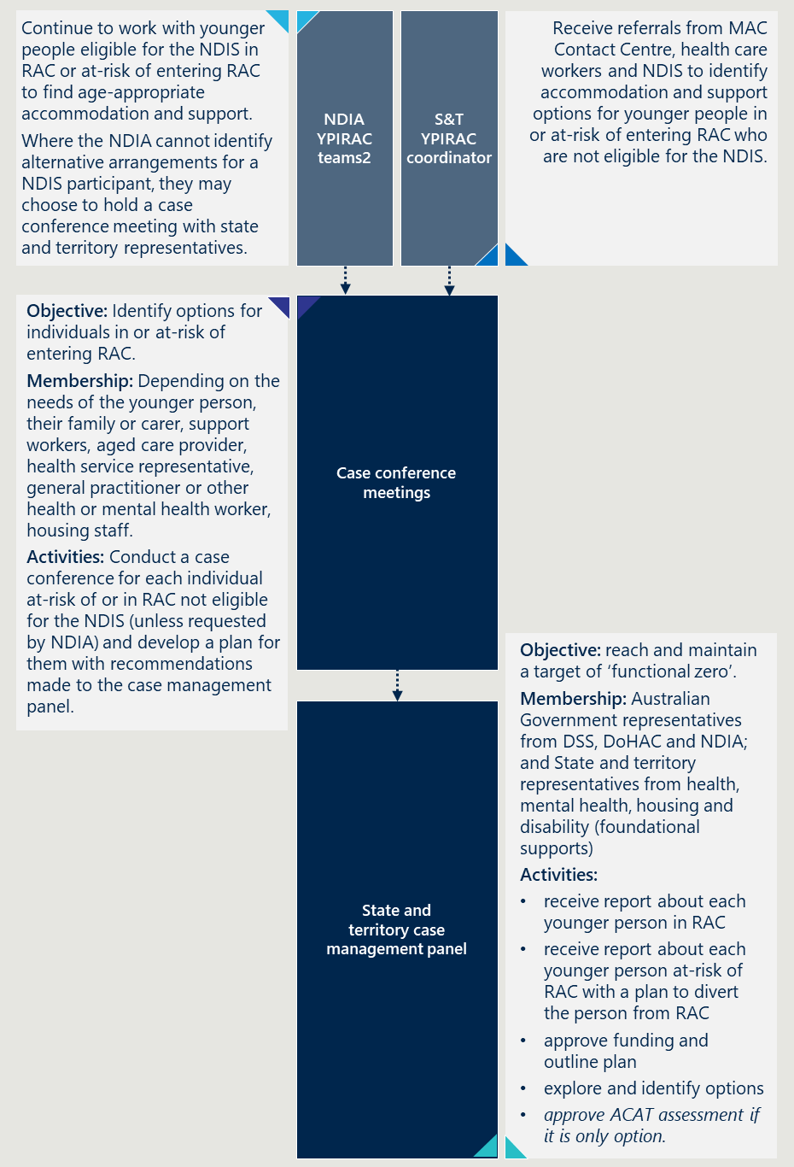

Recommendation 2: Require a case conference be held before any younger person can receive an ACAT assessment, even if they meet the definition for exceptional circumstances
Each case management panel should facilitate a case conference meeting to discuss and identify service responses for each younger person at-risk of entering RAC or living in RAC that do not have an alternative option and who are not eligible for the NDIS.
The NDIA YPIRAC teams may also seek a response through this process if there is a participant that requires a combined disability and health response. For all other NDIS participants, the NDIA should continue existing processes with changes proposed in Recommendation 4 and Recommendation 6.
The make-up of the conference should include all relevant stakeholders and service providers. This might include:
- the younger person, their family or carer
- support workers
- aged care provider
- health service representative, general practitioner or other health or mental health worker
- housing staff
- aboriginal health worker
The conference will identify a solution for the younger person that does not involve them entering RAC. If the solution involves existing funded programs, the conference will prepare a report to the case management panel for noting. The report will detail the solution identified and action being taken by members of the conference.
If the solution requires additional funding, the conference will make a recommendation to the case management panel for the approval of funding. The recommendation will be detailed in a report to the panel that will include a detailed implementation plan. Once the panel has approved funding, the conference will implement the identified solution.
The conference will not be able to recommend a younger person enters RAC. The conference will have to identify a solution and make this recommendation to the case management panel. If the case management panel determines RAC is more appropriate than the identified solution and the person meets the definition of exceptional circumstances, the case management panel could refer the younger person to receive an ACAT assessment for entry to RAC.
Figure 26 overleaf provides an example of how the proposed approach would occur for different personas of people.

Figure 26 | An infographic showing an overview of the process for different personas
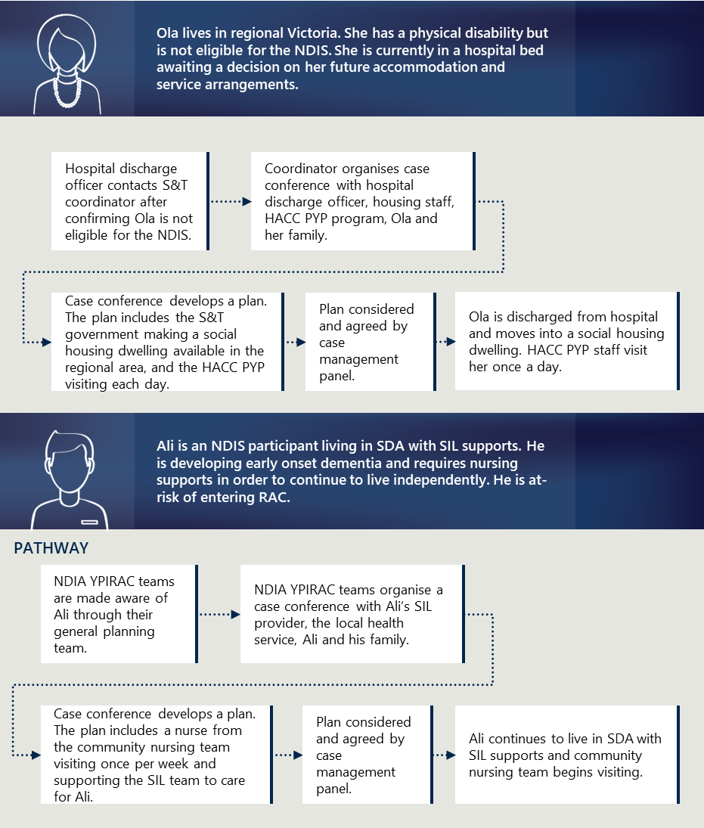
[Image description:
Ola’s Pathway
- Initial Situation: Ola lives in regional Victoria with a physical disability and is not eligible for the National Disability Insurance Scheme (NDIS). She is in a hospital bed awaiting a decision on her future accommodation and service arrangements.
- Hospital Discharge: A hospital discharge officer contacts the Support and Transition (S&T) coordinator, confirming Ola is not eligible for the NDIS.
- Case Conference: The coordinator organises a case conference with hospital discharge officer, housing staff, Home and Community Care Program for Younger People (HACC PYP) program, Ola, and her family.
- Plan Development: A plan is developed during the case conference, which includes the government making a social housing dwelling available in the regional area and the HACC PYP visiting each day.
- Plan Approval: The plan is considered and agreed upon by the case management panel.
- Outcome: Ola is discharged from the hospital and moves into a social housing dwelling. HACC PYP staff visit her once a day.
Ali’s Pathway
- Initial Situation: Ali is an NDIS participant living in Specialist Disability Accommodation (SDA) with Supported Independent Living (SIL) supports. He is developing early-onset dementia and requires nursing supports to continue living independently, at risk of entering Residential Aged Care (RAC).
- NDIA Notification: The National Disability Insurance Agency (NDIA) Younger People in Residential Aged Care (YPIRAC) teams are made aware of Ali through their general planning team.
- Case Conference: The NDIA YPIRAC teams organise a case conference with Ali’s SIL provider, the local health service, Ali, and his family.
- Plan Development: A plan is developed that includes a nurse from the community nursing team visiting once per week and supporting the SIL team to care for Ali.
- Plan Approval: The plan is considered and agreed upon by the case management panel.
- Outcome: Ali continues to live in SDA with SIL supports, and the community nursing team begins visiting.]

Recommendation 3: Mandate the design and commissioning of tailored accommodation and support services for younger people, including making social housing stock available.
The case management panel should commission services for younger people based on the recommended plan from case conference. This includes designing and commissioning an individual response for younger person at-risk of entering RAC who are not eligible for the NDIS.
The NDIA may seek a response through this process if there is a participant that requires a combined disability and health response. For all other NDIS participants, the NDIA should continue existing processes with changes proposed in Recommendation 4 and Recommendation 6.
Some examples of some solutions the case management panel may approve include:
- designing and commissioning a service for a group of younger people currently in RAC. As an example, if there are a group of younger people with a neurological condition living in RAC in a certain area, the panel may design and commission a specialised shared home for this cohort.
- making existing social housing stock available to someone at-risk of entering RAC as a priority alongside community-based health services provided through the state government or disability services provided through NDIA’s foundational supports.
- requiring a component of a future round of funding through the National Housing Accord be targeted for younger people at-risk of entering RAC.
- commissioning a transitional accommodation and support arrangement until an enduring solution can be identified.
The Australian Government should commit funding for two years to allow each case management panel to commission services for people who do not currently have alternative options to RAC.
After two years, the Australian Government should negotiate an enduring funding agreement with states and territories which acknowledges the relevant roles and responsibilities of state and territory governments, and the role of the NDIA in relation to foundational supports and supports for people eligible to the NDIS.

Recommendation 4: Streamline the NDIA’s entry points and require each state and territory to establish their own single point of entry
The NDIA should ensure there is clear information available about how people can contact the NDIA YPIRAC teams and enter the YPIRAC pathway. This includes having a phone number and email address on their webpage, and ensuring this information is available to hospital discharge workers. It should also be available to the MAC Contact Centre and they should have clear processes for referring younger people to the NDIA, noting that this is already being done but not consistently.
Each state and territory health department should establish a YPIRAC coordination function. The function could be an extension of an existing role. This function will:
- receive referrals regarding people at-risk of entering RAC that are not eligible for the NDIS
- coordinate case conferences
- prepare reports for the case management panel
Until the funding ceases, AFA System Coordinators could provide this function. Depending on the work volume, states and territories may choose to create a new, stand-alone function, or include this function within an existing team.
The MAC Contact Centre should have clear processes for referring younger people to the state and territory YPIRAC coordination function.

Recommendation 5: Mandate the sharing of information from the NDIA and DoHAC to the relevant case management panel and case conference members
DoHAC and the NDIA should work together to provide information with states and territories on younger people in or at-risk of entering RAC. This includes all information required by the case management panels and for the purposes of case conferences.
Examples of this are shown in Table 3.
Table 3 | Information that might be shared by the NDIA, DoHAC and states and territories
Younger people at-risk of entering RAC | Younger people in RAC
- Relevant health information from the hospital discharge plan  - Previous RAC history (if they have been a resident previously)  - Alterative options explored previously (if any)  - NDIS information (if they are a participant) | - YPIRAC needs, preferences and goals  - Health information/patient history  - NDIA information  - AFA information (if they have worked with them previously)
It should be noted that there are privacy and legislative impediments to sharing personal information. DoHAC and the NDIA should work through these issues and identify a solution that is consistent with legislation and privacy principles and promotes the best interest of the individual.

Improve current processes

Recommendation 6: Refine, document and standardise processes at each touchpoint to give younger people a more consistent experience
The NDIA should consider opportunities to improve their processes to provide younger people with a more consistent experience. It should be noted the NDIA YPIRAC teams are already considering opportunities for enhancements as part of existing quality improvement activities. The evaluation team encourages them to consider the below as part of this work.
To provide a more consistent experience, the NDIA should continue to refine their operational guidelines to include a detailed procedural manual for their YPIRAC teams and provide specific training on how to support younger people.
The YPIRAC specific operational guidelines should provide key guidance on each formal stage from assessing, planning, implementing, monitoring, transitioning and evaluation in relation to the younger person at-risk of entry or living in RAC. It should also include a clear description of the roles and responsibilities of NDIA YPIRAC planners and accommodation officers.
The YPIRAC specific operational guidelines should also include:
- Mechanisms for directly contacting the YPIRAC teams
- Procedures for supporting younger people with time sensitive needs for accommodation and supports
- Processes to respond to different preferences of moving out of RAC.
Many stakeholders reflected that although they do not have a documented goal to move, if an appropriate alternative accommodation option became available, they would consider it. This perspective sits between two commonly reported positions: having a goal to move and having no goal to move at all. The operational guidelines should adequately capture this spectrum and outline how to respond accordingly.

Prepare for legislative changes

Recommendation 7: Revise the definition of exceptional circumstances
DoHAC should consider whether there can be further refinements to the definition of exceptional circumstances proposed for the new Aged Care Act. This could include clarifying the definition of homelessness and including allowing people to enter RAC to be close to their family as proposed by the Royal Commission.
The revised act should also detail the need for younger people that meet the definition of exceptional circumstances to have had been reviewed by the case management panel before being referred for an ACAT assessment as described in Recommendation 2.

Recommendation 8: Include a transition period prior to the Aged Care Act legislative changes
The Australian Government, with DoHAC as the lead supporting department, should seek to pass legislative changes as proposed in the recent exposure draft and with revisions to definitions. The intention to make these legislative changes should be clearly communicated to the states and territories with sufficient time to prepare.
DoHAC should implement changes to the MAC Contact Centre processes. This would involve continuing to refer younger people under 65 seeking an aged care assessment to the NDIA or relevant state or territory body as determined with states and territories.
DoHAC should cease funding the AFA System Coordinator program once the changes to the Aged Care Act have been implemented. Following changes to the legislation, the states and territories should be responsible for helping younger people not eligible for the NDIS to find alternative accommodation and support.
The plan to end funding should be communicated in advance to allow time to plan to terminate the program and transfer AFA’s knowledge and expertise to states and territories’ YPIRAC coordinator function.

Appendix A: Key Evaluation Questions
The evaluation is underpinned by three Key Evaluation Questions (KEQs), each with a series of research questions that have guided the research and data collection, outlined in Table 4 below, one for each category.
Table 4 | A series of tables showing key evaluation questions and research questions
4.1 Appropriateness
Were the initiatives appropriate to the needs of younger people and the broader policy context?
Research question level 1 | Research question level 2
1.1 What are the current Commonwealth funded initiatives to reduce YPIRAC? | 1.1.1 How are they funded, how much funding is available now and into the future?  1.1.2 How do the initiatives worth together and other available supports?
1.2 Were the initiatives designed appropriately to help reduce the number of younger people in RAC? | 1.2.1 What was the process to design the initiatives?  1.2.2 Were the initiatives designed with younger people?  1.2.3 What are the inputs, activities, outputs, and intended objectives, impacts and outcomes of the initiatives?  1.2.4 Does the design of the initiatives support the intended objectives? Why or why not?  1.2.5 Is the design appropriate for all individuals?
1.3 Were the initiatives implemented as intended? | Nil
4.2 Effectiveness
Are the initiatives meeting their intended outcomes?
Research question level 1 | Research question level 2
2.1 To what extent are the initiatives achieving the following outcomes? | 2.1.1 What outcomes are being achieved? (including unintended consequences)  - Reducing the number of younger people entering RAC  - Helping individuals to understand and explore alternative options  - Supporting younger people in RAC to move into alternative accommodation and support arrangements  - Supporting younger people to experience the benefits of age-appropriate accommodation and support  - Supporting improved connectivity across health care, aged care and disability service systems  - Improving understanding of who is in RAC and what they need
2.2 How do the outcomes differ for different groups of people? | Nil
2.3 What factors have enabled or impeded achieving the intended outcomes? | Nil
3.1 What action should be taken in relation to the existing initiatives to continue making progress? | 3.1.1 Should the existing initiatives receive further funding?  3.1.2 What improvements should be made to the existing initiatives?
3.2 What other actions should be taken? | 3.2.1 Are there other initiatives the Australian Government should consider?  3.2.2 Are there opportunities to work with states and territories to reduce barriers for younger people?
4.3 Sustainability
What actions should be taken to continue to deliver progress into the future?
Research question level 1 | Research question level 2
3.1 What action should be taken in relation to the existing initiatives to continue making progress? | 3.1.1 Should the existing initiatives receive further funding?  3.1.2 What improvements should be made to the existing initiatives?
3.2 What other actions should be taken? | 3.2.1 Are there other initiatives the Australian Government should consider?  3.2.2 Are there opportunities to work with states and territories to reduce barriers for younger people?

Appendix B: Program logics
Figure 27 | A table showing Indicative program logic - NDIA Initiatives
Inputs | Activities | Outputs | Outcomes | Impact
- $21.6 million to the National Disability Insurance Agency’s YPIRAC initiatives  - Additional contributions from the NDIA and AFA.  - De-identified administrative datasets  - Existing policies and program objectives, procedures, funding and activity and service level reporting  - Existing research and reviews inc. information from various Royal Commissions and the NDIA review  - Education and training to support program delivery | - YPIRAC Planners work with younger people who are NDIS participants to make funding decisions to enact a plan to utilise and purchase services  - YPIRAC Diversion Planners rapidly work with younger people who are NDIS participants and at risk of entry to RAC to make funding decisions to enact a plan to utilise and purchase services  - YPIRAC Accommodation Team works with younger people who are NDIS participants to explore and make informed decisions based on their accommodation and support options.  - NDIA project with younger people under 45 with no goal to move partners with AFA to perform a 12-month research piece working with younger people under 45 years old with no goal to move | - NDIS plan, describing the types of supports a younger person can purchase with their NDIS package  - NDIS assessment, describing a younger person’s circumstances, needs and preferences  - Guidance to the participant, their families and carers on age-appropriate accommodation and support options based on their needs, and preferences  - Research paper regarding younger people under 45 years old with no goal to move | Individual level  - Younger people who are NDIS participants, their families and carers are aided with informed and supported decision-making and have a clear understanding of age-appropriate alternatives to RAC  - Younger people, their families and carers who are NDIS participants are aware of and encouraged to explore age-appropriate accommodation and support options  - There is a reduction in the number of younger people who are NDIS participants living in RAC  Service-level  - The NDIA works with NDIS service providers to consistently build their understanding of what is required to divert younger people away from RAC or transition younger people out of RAC  - NDIS registered service providers work collaboratively with Government and younger people  - NDIS registered services are connected with younger people who they can support appropriately  System level  - The health, disability, housing and aged care systems are well-coordinated, more responsive and deliver age-appropriate outcomes suited to the needs and preferences of younger people at risk of entry or living in RAC | Individual  - Reduction in the number of younger people who are NDIS participants (other than exceptional circumstances) entering RAC  - Younger people are able to experience the benefits of age-appropriate services and achieve a better quality of life – they can live where and how they choose  Service level  - Services are better integrated within the system and consequently better able to respond to the needs of younger people  - The burden on hospitals is alleviated due to reduced lengths of stay  System level  - RAC is universally understood as inappropriate for younger people across the health, disability, housing and aged care systems  Younger people are supported by fit-for-purposes services, alleviating key system pressure points
Figure 28 | A table showing indicative program logic - AFA System Coordinator Program
Inputs | Activities | Outputs | Outcomes | Impact
- $27.6 million to AFA to establish and operate the YPIRAC System Coordinator Program from July 2021 to Dec 2025  - Recruitment of up to 36 FTE Systems Coordinators and a Leadership team to manage the operational activities of a remote workforce | - Engagement with younger people and those at-risk to gain consent to join the program  - Assisting younger people to imagine and explore alternatives to living in RAC and assisting, if appropriate, to test their NDIS eligibility  - Completing comprehensive exploration reports of the service systems to identify funding, programs and supports that may assist with leaving RAC or prevent entry into RAC  - Staff training and support and participation in professional development opportunities and Communities of Practice  - Promote the program to a range of stakeholders to raise awareness of the unmet need for younger people who are not eligible for the NDIS | - Younger people provide consent to join the program  - System Coordinators understand the will and preference of the younger person and whether they wish to pursue, if appropriate, a NDIS pathway  - Summary Reports or Exploration of Options submitted to My Aged Care for ACAT assessment consideration  - Identification of appropriate levels of supports and programs that support younger peoples’ will and preferences  - Highly capable and competent workforce able to work effectively with younger people and alongside other providers | Individual  - Younger people have a positive engagement experience, understand the AFA program and develop trusting relationships  - Some younger people, and those at risk, are successful in gaining a NDIS pathway  - As a last resort, those unable to find suitable care and accommodation are appropriately referred onto MAC and subsequently ACAT for approval to access aged care services  - Younger people are connected with services and supports  Service level  - Service providers work collaboratively with each other and younger people to find pathways and solutions  System level  - The health, disability, housing and aged care systems are well-coordinated, more responsive and deliver age-appropriate outcomes suited to the needs and preferences of younger people at-risk of entry or living in RAC - regardless of their NDIS status | Individual  - Reduction in the number of younger people who are not NDIS participants (other than exceptional circumstances) entering RAC  - Younger people are able to experience the benefits of age-appropriate services and achieve a better quality of life – they can live where and how they choose  Service level  - Services are better integrated within the system and consequently better able to respond to the needs of younger people  - An increase in the pathways and solutions at a state level to support non-NDIS participants to successful transition from RAC  - The burden on hospitals is alleviated due to reduced lengths of stay  System level  - RAC is universally understood as inappropriate for younger people across the health, disability, housing and aged care systems  - Younger people are supported by fit-for-purposes services, alleviating key system pressure points

Figure 29 | A table showing indicative program logic - DoHAC initiatives
Inputs | Activities | Outputs | Outcomes | Impact
- Review of previous Principles and Guidelines  - Recommendations to alter Principles and Guidelines to stem the flow of younger people into RAC  - Three iterations of changes to Principles and Guidelines  - Investment in the My Aged Care contact centre to introduce a new process for younger people  - New training materials and guidance to support new process | Principles and Guidelines for a younger person’s access to Commonwealth funded aged care services  - Revision of Principles and Guidelines to ensure younger people must explore all other age-appropriate options before assessment for entry to RAC  - Training of ACAT teams in new Principles and Guidelines  My Aged Care contact centre YPIRAC process  - Issue a referral to the ACAT for younger people who contact the MAC contact centre and have the requisite AFA or NDIA documentation  - Determine whether a younger person is a NDIS participant and refer them to the NDIS or AFA if requisite documentation for ACAT assessment is incomplete | - New Principles and Guidelines for a younger person’s access to Commonwealth funded aged care services  - ACAT teams are trained in the new Principles and Guidelines  - Referrals issued to the ACAT  - Younger peoples’ NDIS status determined  - Younger people referred to NDIA or AFA to explore options and/or complete documentation | Individual level  - Younger people explore their options for alternative, age-appropriate accommodation and supports before consideration for RAC  - There is a reduction in the number of younger people entering and living in RAC  Service-level  - Aged care services experience reduced entries of younger people and can focus on providing care to older people  System level  - The health, disability, housing and aged care systems are well-coordinated, more responsive and deliver age-appropriate outcomes suited to the needs and preferences of younger people at risk of entry or living in RAC  - The hospital to RAC pathway is only available to younger people that fit the exceptional circumstances criteria | Individual  - Reduction in the number of younger people (other than exceptional circumstances) entering RAC, regardless of their NDIS status  - Younger people are able to experience the benefits of age-appropriate services and achieve a better quality of life – they can live where and how they choose  Service level  - Aged care services are able to focus on providing high-quality care to older people, for whom they are designed  System level  - RAC is universally understood as inappropriate for younger people across the health, disability, housing and aged care systems  - Younger people are supported by fit-for-purposes accommodation and support options, alleviating key system pressure points

Appendix C: Stakeholder engagement
Over 300 stakeholders were engaged in the evaluation. Table 5 below provides a description of those involved.
Table 5 | A series of tables detailing the stakeholders engaged to date
5.1 Younger people, families and carers
Department/  Organisation | Number of representatives | Date of engagement
N/A | 94 surveys completed  21 interviews completed | May 21 2024 – July 26 2024
5.2 State and territory government representatives
Department/  Organisation | Number of representatives | Date of engagement
Queensland Health | 3 | 19 February 2024
NT Health | 3 | 22 February 2024
ACT Health | 6 | 27 February 2024
WA Health | 6 | 1 March 2024
NSW Health | 11 | 4 March 2024
SA Health | 6 | 5 March 2024
Tasmanian Department of Health | 3 | 8 March 2024
Department of Health Victoria | 7 | 14 March 2024
5.3 Navigation supports
Department/  Organisation | Number of representatives | Date of engagement
AFA System Coordinators | 16 | 23 February 2024
AFA Regional Managers | 4 | 8 March 2024
AFA YPIRAC Program Director | 1 | 12 March 2024
ACAT team members (via survey) | 24 | 6 June – 30 June 2024
MAC Contact Centre | 7 | 27 February 2024  15 March 2024
Assessment Delivery Team, DoHAC | 2 | 14 March 2024
NDIA YPIRAC Planners | 6 | 14 March 2024
NDIA YPIRAC Accommodation Team | 5 | 20 March 2024
5.4 Health providers
Department/  Organisation | Number of representatives | Date of engagement
Southeastern Sydney LHD | 2 | 11 April 2024
Central QLD HHS | 1 | 11 April 2024
Metro North HHS | 1 | 11 April 2024
NT Health | 1 | 23 April 2024
SA Health | 3 | 2 May 2024
Department of Human Services (DHS) | 1 | 2 May 2024
Alfred Health | 1 | 17 May 2024
Eastern Health | 1 | 17 May 2024
Latrobe Regional Health | 2 | 17 May 2024
Monash Health | 2 | 17 May 2024
St Vincent's Hospital | 1 | 17 May 2024
5.5 Aged care providers
Department/  Organisation | Number of representatives | Date of engagement
Opal Healthcare | 1 | 16 April 2024
Eldercare | 1 | 16 April 2024
Sacred Heart Mission | 1 | 19 April 2024
St Agnes Paris | 1 | 19 April 2024
Anglicare Southern QLD | 1 | 19 April 2024
Regis | 2 | 19 April 2024
Corpus Christi Community | 1 | 19 April 2024
Jewish Care | 1 | 19 April 2024
Ralac | 2 | 24 April 2024
Baptist care | 1 | 24 April 2024
Hammond | 1 | 24 April 2024
Mission Australia/Benjamin Short Grove | 1 | 24 April 2024
Aboriginal and Torres Strait Island Community Health Brisbane | 2 | 24 April 2024
Southern Cross Care QLD | 3 | 24 April 2024
5.6 Disability providers
Department/  Organisation | Number of representatives | Date of engagement
Youngcare | 1 | 10 April 2024
Liverty Housing | 2 | 10 April 2024
Apollo SDA | 1 | 10 April 2024
Blue CHP | 1 | 19 April 2024
My Choice Supports | 1 | 19 April 2024
Access Recreation | 1 | 19 April 2024
Greenlight HC | 1 | 23 April 2024
Yooralla | 1 | 23 April 2024
Life Without Barriers | 1 | 23 April 2024
SDA Plus | 1 | 23 April 2024
5.7 Peak bodies
Department/  Organisation | Number of representatives | Date of engagement
Dementia Australia | 1 | 28 June 2024
Palliative Care Australia | 2 | 1 July 2024
5.8 YPIRAC SRG members
Department/  Organisation | Number of representatives | Date of engagement
ACCPA | 2 | 14 December 2023  28 February 2024  1 March 2024  18 March 2024  25 March 2024  22 April 2024  25 June 2024
Summer Foundation | 1 | 14 December 2023  1 March 2024  12 March 2024  25 March 2024  22 April 2024  25 June 2024
SDA Alliance | 2 | 14 December 2023  8 March 2024  25 March 2024  22 April 2024  25 June 2024
AFA | 1 | 14 December 2023  1 March 2024  25 March 2024  25 June 2024
NDIA | 3 | 14 December 2023  1 March 2024  25 March 2024  25 June 2024
Youngcare | 1 | 14 December 2023  1 March 2024  25 March 2024  22 April 2024  25 June 2024
YPINH National Alliance | 2 | 14 December 2023  1 March 2024  25 March 2024  22 April 2024  25 June 2024
DoHAC | 4 | 14 December 2023  1 March 2024  25 March 2024  22 April 2024  25 June 2024

5.9 Commonwealth Government representatives
Department/  Organisation | Number of representatives | Date of engagement
YPIRAC Branch, DoHAC | 4 | 17 January 2024  22 January 2024  15 February 2024  25 March 2024  16 April 2024  8 May 2024  3 June 2024  25 June 2024
Aged Care and Hospital Interface Branch, NDIA | 7 | 17 January 2024  22 January 2024  15 February 2024  7 March 2024  25 March 2024  16 April 2024  22 May 2024  29 May 2024  5 June 2024  25 June 2024  23 July 2024

Appendix D: Description of data analysis
Nous conducted technical modelling to estimate the impact of the initiatives and understand the future demographics of younger people in RAC. We engaged two modelling techniques:
- Time series linear model
- Forecast proportions hierarchical modelling

Time series linear model
The evaluation team forecasted the number of entries into RAC using a time series linear model. This model was used to understand what would have happened to entries into RAC without policy changes in 2019, using historical data.
The model captures the previous trends in the number of people entering RAC, then forecasts it into the future. The model estimates number of entries into RAC from 2019 onwards, then compares this to the actual number of entries to understand what the impact of the policy would be.
This model was chosen because:
- it captures trends and seasonal variations in the data, such as ageing out and dying
- it allowed the ability to control for other impacts on the number of younger people entering RAC, including the growth of the NDIS, the reduction in people going into RAC during the COVID-19 pandemic, and the impact of early access to HCPs.
This analysis was conducted in R using the following data sources:
- Data on younger people entering RAC since 2016 provided to the evaluation team by DoHAC
- Data on the overall NDIS participants between 18 and 65
- Data on the number of home-care packages.
The evaluation team tested a number of models and chose this particular model because it was the best fit on the data across all models tested.

Forecast proportions hierarchical modelling
The evaluation team modelled the expected number of younger people in RAC and their demographics using a forecast proportions methodology. This method forecasts individual attributes of a dataset (for example, number of NDIS versus younger people not eligible for NDIS in RAC), expresses them as a proportion of the total, then applies these proportions to a forecasted total (in this case, the total number of younger people in RAC).
This is a method which allows consistent forecasts for different attributes, or “hierarchies” of data. The approach also puts more weight on recent data points in the time series.
This analysis was conducted in R using DoHAC data on the number of younger people in RAC since 2016 and NDIA’s publicly available reports on the number of younger NDIS participants in RAC.
A number of different models were tested. This model was selected as it was the best-fitting to the data.

Appendix E: Department of Health and Aged Care Initiatives
As part of the Budget 2023-24, the Australian Government announced $2.4 million to establish a national central function to support consistent decision-making on the eligibility of younger people seeking to enter RAC. The aim was to strengthen entry requirements for RAC to ensure all other options are investigated before granted entry.
The Australian Department of Health and Aged Care has changed the way younger people can enter RAC by revising the Principles and Guidelines. There were three phases of changes to the Principles and Guidelines between 2019 and 2023 to reduce the number of younger people that are able to receive an aged care assessment. These changes are outlined below.
Aged Care Assessment Supplementary Guidelines for Younger People with Disability – July 2019: ACAT assessors are responsible for determining whether or not a person, including those under the age of 65, or 50 for Aboriginal and Torres Strait Islander people, is eligible to receive aged care services under the Aged Care Act 1997 (the Aged Care Act). Before ACAT refuses to approve a person who is not an aged person for care types under the Aged Care Act, aged care legislation requires that they investigate if more appropriate care facilities or care services are available to meet the person’s needs (the Approval of Care Recipient Principles 2014). This includes the exploration of age-appropriate accommodation and support options and a younger person’s eligibility for the NDIS.
ACAT Supplementary Guidelines for younger people – January 2020: For an ACAT to approve a person who is not an aged person for care types under the Aged Care Act, aged care legislation requires that they must investigate and document whether more appropriate care facilities or care services are available to meet the person’s needs (Section 6(1)(b) and 7(1)(e)-(4)(e)) of the Principles). This means if an ACAT was to refuse a person, the Aged Care Act requires the ACAT to investigate age-appropriate options, including documenting that all options for age-appropriate accommodation and supports have been explored and whether the younger person is eligible for the NDIS.
Principles and Guidelines for a younger person’s access to Commonwealth funded aged care services – May 2023: An aged care assessment should only be undertaken once all age-appropriate accommodation and supports have been explored. Evidence of the options that have been considered by the younger person (and/or their guardian/nominee) is a key requirement of being eligible for residential aged care and should be provided by the individual seeking the aged care assessment. Evidence must include either a NDIA Exploration of Home & Living Supports document or an AFA Summary Report of Options Explored document.
The My Aged Care (MAC) Contact Centre Team processes have been changed to implement the changes to the Principles and Guidelines.
The MAC Contact Centre’s revised process is shown in Figure 30 overleaf. The process now involves diverting people under the age of 65 years seeking an ACAT to either the NDIS YPIRAC teams or the AFA System Coordinators. They also now seek and confirm there is appropriate documentation of options explored before referring someone to an ACAT assessor.
Figure 30 | A flowchart showing the MAC Contact Centre's YPIRAC process
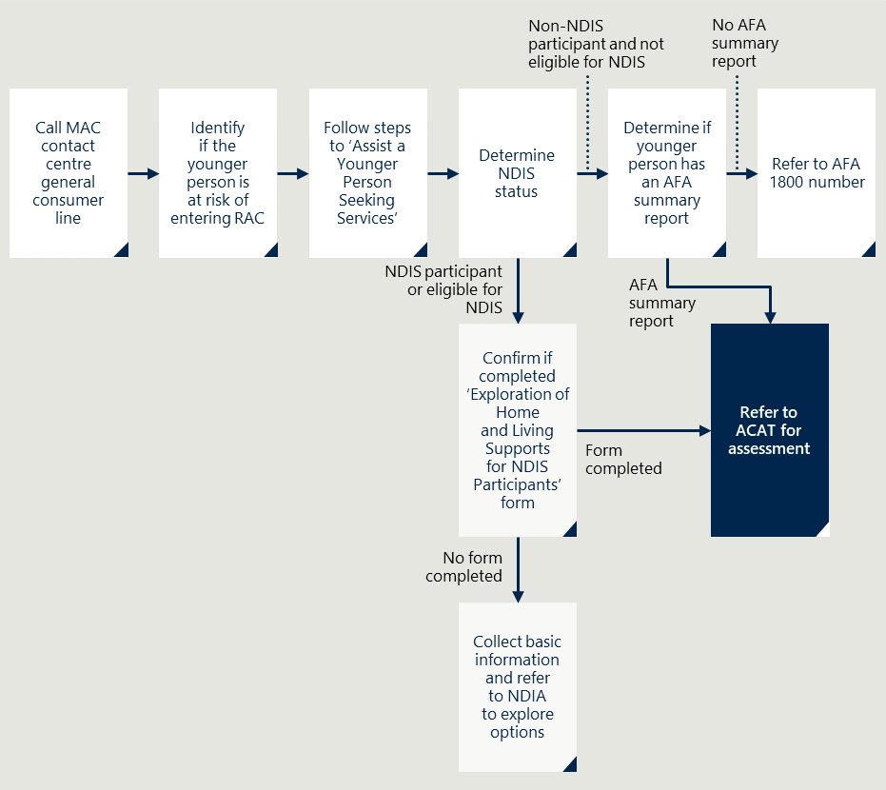
[Image description:
The process is as follows:
- The process begins with a call to the MAC (My Aged Care) contact centre consumer line.
- The next step is to identify if the younger person is at risk of entering RAC.
- Follow the steps outlined in ‘Assist a Younger Person Seeking Services’.
- Determine the individual’s NDIS status. If the person is an NDIS participant or eligible for NDIS, confirm if they completed the ‘Exploration of Home and Living Supports for NDIS Participants’ form. If the form is not completed, collect basic information and refer to NDIA (National Disability Insurance Agency) to explore options.
- For those not eligible for the NDIS, determine if the younger person has an AFA (Aged Care Assessment Team) summary report. If there is no AFA summary report, refer to the AFA 1800 number.
- If there is an AFA summary report and the form is completed, refer the individual to ACAT (Aged Care Assessment Team) for assessment.]

Appendix F: NDIA YPIRAC Planners and Accommodation Team
The Australian Government allocated $21.6 million to provide additional capacity to the NDIA to help younger people who are NDIS participants to identify age-appropriate accommodation and support. This funding includes $18.9 million in the 2021-22 Mid-Year Economic and Fiscal Outlook (MYEFO) to establish the accommodation team.
The NDIA established two specific YPIRAC functions, and have undertaken a further project with AFA:
- YPIRAC planners including YPIRAC diversion planners
- YPIRAC accommodation team
- Efforts to help people with no goal to move to find alternative options
The process for the YPIRAC diversion planners and Accommodation team to divert younger people at-risk of entering RAC is shown in Figure 31 overleaf.

Figure 31 | A flowchart showing the NDIA Diversion Planners and Accommodation team's process for younger people at-risk of entering RAC
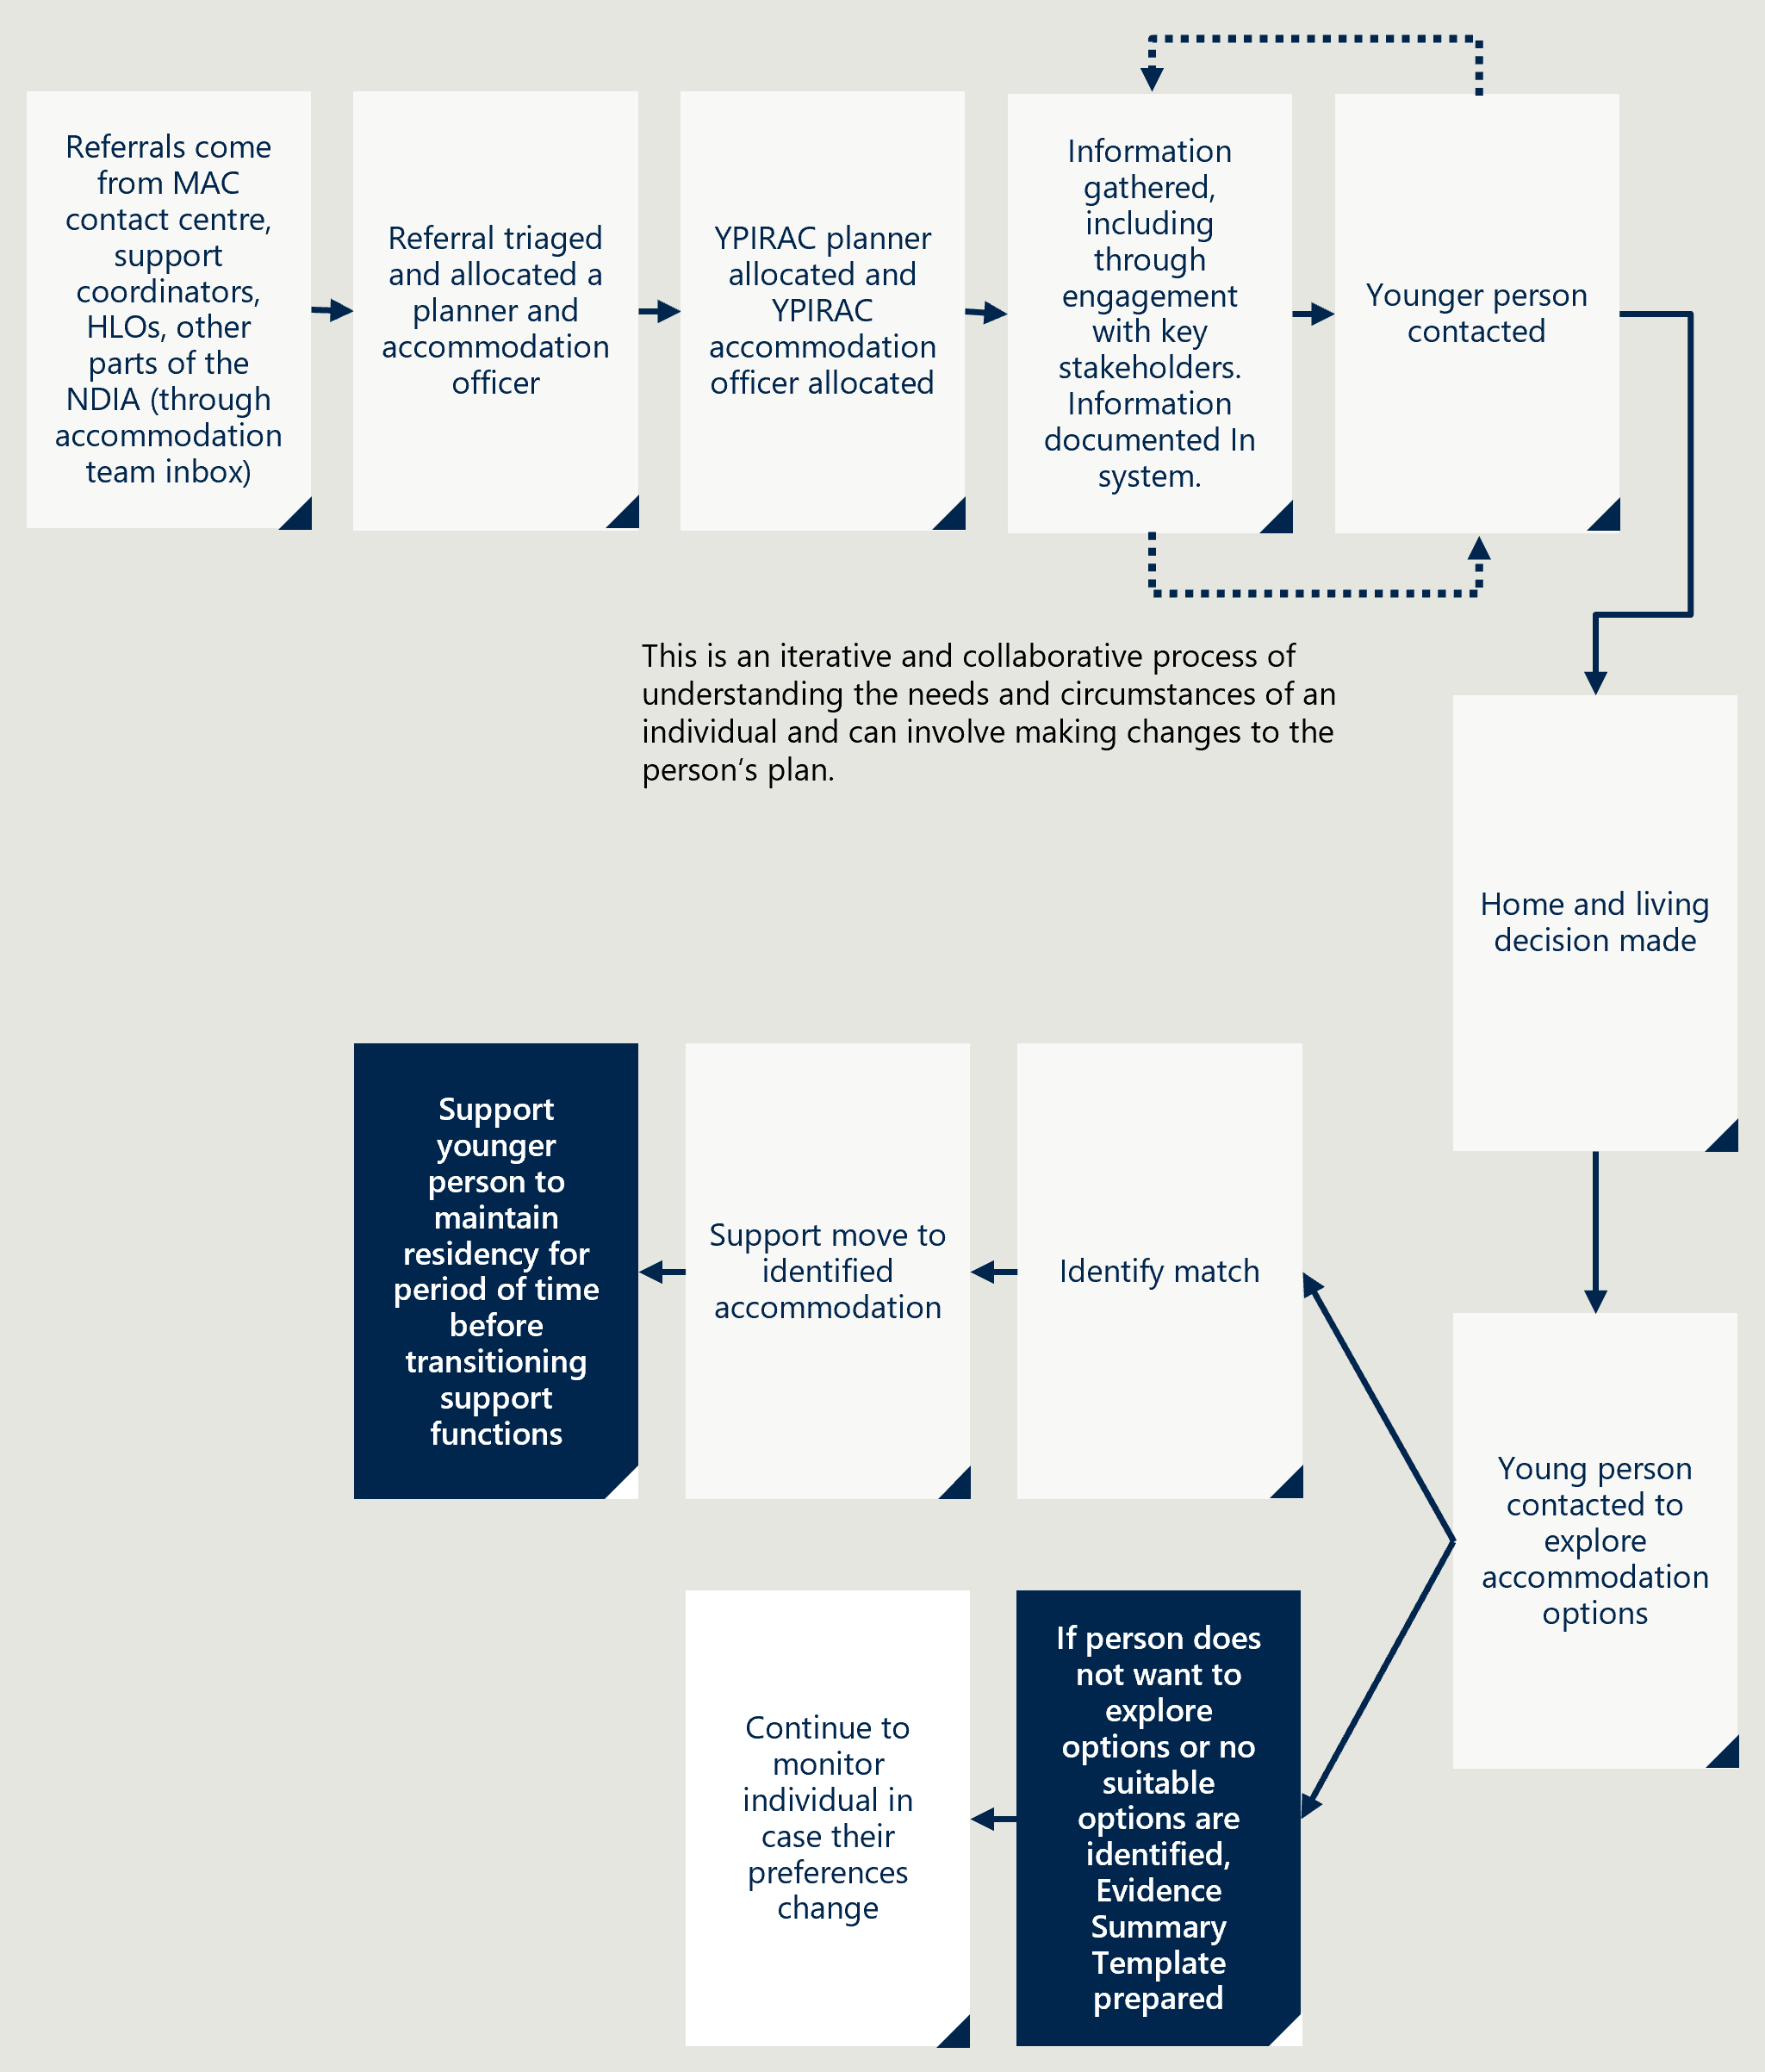
[Image description:
The process is as follows:
- Referrals are received from MAC contact centre, support coordinators, HLOs, other parts of the NDIA (through accommodation team inbox).
- The referral is triaged and allocated a planner and accommodation officer.
- A YPIRAC planner and accommodation officer are allocated.
- Information is gathered, including through engagement with key stakeholders. This information is documented in the system.
- The younger person is contacted.
- A home and living decision is made.
- If the young person agrees to explore options, a match for identified accommodation is sought.
- The young person is supported to move to the identified accommodation.
- Support is provided to the young person to maintain residency for a period before transitioning support functions
- If the person does not want to explore options or no suitable options are identified, a summary template is prepared, and the individual is continuously monitored in case their preferences change.]

Appendix G: Ability First Australia (AFA) System Coordinator Program
AFA were allocated $27.6 million to run the System Coordinator Program from June 2021 to Dec 2025. AFA was selected by DoHAC to design, implement and deliver the System Coordinator Program. The program aims to help younger people who are at-risk of or already in RAC and not eligible for the NDIS, find age-appropriate accommodation.
The program was established with five key objectives:
- Engage with younger people to understand their accommodation and support needs.
- Assist younger people to navigate existing federal, state and territory systems.
- Find alternative accommodation and support services that best meets their needs.
- Support younger people who wish to leave RAC.
- Report on barriers to younger people obtaining age-appropriate accommodation and supports.
- Provide two research projects on outcomes and associated issues.
The AFA System Coordinator Program helps younger people explore alternative options to RAC. The program has a director that leads a team of four regional managers and 34 System Coordinators. The System Coordinators cover all of Australia, working with younger people in RAC and at-risk of entering RAC.

Figure 32 and Figure 33 overleaf provide an overview of the process for younger people at-risk of entry to RAC and for those currently living in RAC.
Figure 32 | A flowchart showing the AFA process for supporting younger people at-risk of entering RAC
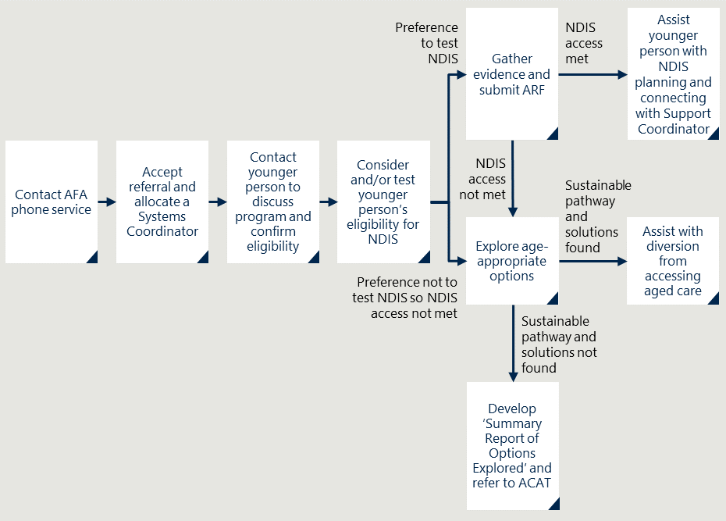
[Image description:
The process is as follows:
- The process begins with the individual contacting the AFA phone service.
- The referral is accepted, and a Systems Coordinator is allocated.
- The Systems Coordinator contacts the younger person to discuss the program and confirm eligibility.
- The younger person’s eligibility for NDIS is considered and/or tested.
- If there is a preference to test NDIS access, evidence is gathered, and an Access Request Form (ARF) is submitted.
- If NDIS eligibility is met, the individual is assisted with NDIS planning and connecting with a Support Coordinator.
- If NDIS access is not met, age-appropriate options are explored.
- If there is a preference not to test NDIS access, or if access is not met, the flowchart diverges into two pathways:
  - A sustainable pathway and solutions are found.
  - A sustainable pathway and solutions are not found.
- If a sustainable pathway is found, assistance is provided with diversion from accessing aged care.
- If no sustainable pathway is found, a ‘Summary Report of Options Explored’ is developed and the individual is referred to ACAT (Aged Care Assessment Team).]
Figure 33 | A flowchart showing the AFA process for supporting younger people in RAC
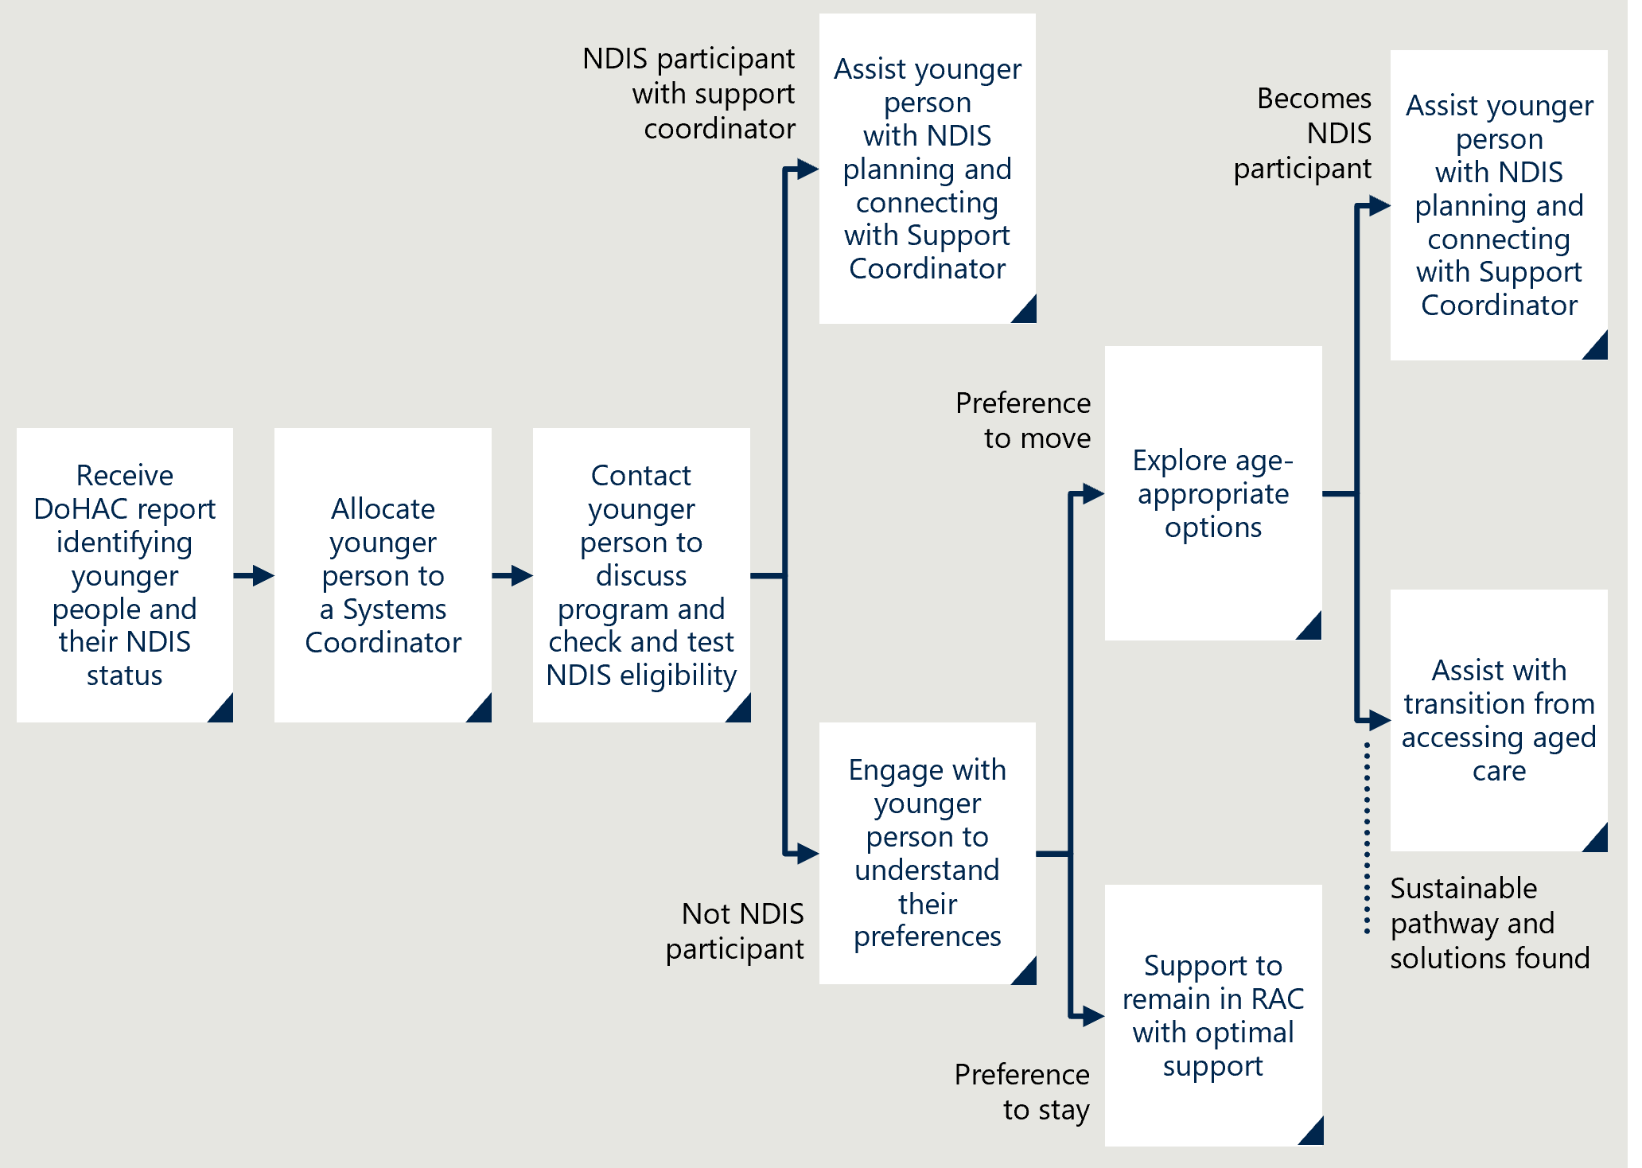
[Image description:
The process is as follows:
- Receive Department of Health and Aged Care (DoHAC) report identifying younger people and their NDIS status.
- Allocate younger person to a Systems Coordinator.
- Contact younger person to discuss the program and check and test NDIS eligibility.
- If the person is an NDIS participant, the process continues as follows:
  - Assist younger person with NDIS planning and connecting with Support Coordinator.
  - If the person has a preference to move, the NDIS would explore age-appropriate options.
  - If the person has a preference to stay, the NDIS would support to remain in Residential Aged Care (RAC) with optimal support.
- If the person is not an NDIS-participant, the process continues as follows:
  - Engage with younger person to understand their preferences.
  - If the person has a preference to move, the AFA will explore age-appropriate options.
  - If the person has a preference to stay, the AFA will support to remain in RAC with optimal support.]

Appendix H: Royal Commission recommendations
The Royal Commission made a series of other recommendations to the Australian Government, and the states and territories. Some of these have been addressed in different ways but there are others that have not yet progressed. Further information is described in Table 6 below.
Table 6 | Actions to respond to the Royal Commission’s recommendations
Royal Commission recommendation | More detail | Relevant YPIRAC initiative
Process changes to reduce access to aged care | Referring for assessment by the agency most appropriate for the assessment of the person concerned, such as the National Disability Insurance Agency, and not an Aged Care Assessment Team or Aged Care Assessment Service, any younger person who is at risk of entering residential aged care | - YPIRAC initiative 4: Changes to the Principles and Guidelines.
Process changes to reduce access to aged care | Ensuring that a younger person will only ever live in residential aged care if it is in the demonstrable best interests of the particular person (and is independently certified to be such by someone with suitable skills, experience, training and knowledge of the person) in limited and exceptional circumstances such as, for instance, where:  - the person will turn 65 years within a short period of time, being no more than three months, after entering into residential aged care  - the person’s close relatives over 65 years live in a residential aged care facility and the person would suffer serious hardship on being separated from those relatives  an Aboriginal or Torres Strait Islander person between the age of 50 and 64 years elects to live in residential aged care. | - Proposed changes to Aged Care Act in recent exposure draft would implement part of this.
Establishing short- and long-term accommodation options | Developing, funding and implementing with State and Territory Governments programs for short-term and long-term accommodation and care options for any younger person who is:  - living in or at risk of entering residential aged care and  not eligible to be a participant in the National Disability Insurance Scheme | - Some states and territories have options available, but most have not been specifically designed for the YPIRAC cohort and are not consistently available or appropriate.
Actions to improve access to and availability of SDA | Requiring the National Disability Insurance Agency to publish an annual Specialist Disability Accommodation National Plan setting out, among other things, priority locations and proposed responses to thin or underdeveloped markets | - The NDIA regularly publishes SDA demand data disaggregated by jurisdiction and SA3 region. The data includes the number of participants:  - eligible for SDA  - accessing SDA  - funded for SDA but not yet accessing it.
Actions to improve access to and availability of SDA | Providing directly for, where appropriate and necessary, accommodation in the Specialist Disability Accommodation market, particularly in thin or underdeveloped markets | - NDIA has made some reforms to SDA but has not explicitly addressed this recommendation.
Support to navigate the health care, aged care and disability service systems | Developing hospital discharge protocols with State and Territory Governments to prevent discharge into residential aged care of any younger person | - NDIA has published a hospital discharge process and introduced Hospital Liaison Officers to provide nationally consistent support to public hospitals and discharge practices.
Support to navigate the health care, aged care and disability service systems | Funding dedicated and individualised advocacy services for younger people who are living in, or at risk of entering, residential aged care | - YPIRAC initiative 2: NDIA YPIRAC Planners and Accommodation team.  - YPIRAC initiative 3: AFA System Coordinator Program.
Improved reporting and accountability | Collecting data on an ongoing basis, and publishing up-to-date collected data each quarter, on, for each State and Territory, the number of younger people living in residential aged care and, among other things:  - their age ranges  - the average length of time in residential aged care  - the numbers of admissions into and discharges from residential aged care, and  the reasons for younger people exiting from residential aged care, such as death, turning 65 years or moving into the community | - GEN Aged Care data captures age, length of stay and reason for exits.  - AIHW has published a report exploring hospital use of YPIRAC.
Improved reporting and accountability | Having the responsible Minister report to the Parliament every six months about progress towards achieving the announced commitments | - Public reporting released quarterly regularly updated on the GEN Aged Care website.

Royal Commission in Aged Care Quality and Safety, Interim Report - Volume 1: the current system, October 2019, pp. 239-240. https://www.royalcommission.gov.au/aged-care/interim-report
Australian Government Department of Health and Aged Care, Younger people in residential aged care – Priorities for action, March 2024. https://www.health.gov.au/our-work/younger-people-in-residential-aged-care/priorities-for-action
NDIS Property Australia, NDIS Quarterly Report 2023-2024: An Overview of Specialist Disability Accommodation in Australia, December 2023. https://www.ndispropertyaustralia.com.au/ndis-quarterly-report-2023-2024-an-overview-of-specialist-disability-accommodation-in-australia#:~:text=The%20total%20SDA%20support%20within,suitable%20and%20high%2Dquality%20accommodation
Independent Review into the National Disability Insurance Scheme, Working together to deliver the NDIS, Final report, October 2023, p. 138. https://www.ndisreview.gov.au/sites/default/files/resource/download/working-together-ndis-review-final-report.pdf
Australian Institute of Health and Welfare, Exploring pathways for younger people living in residential aged care, February 2023, p. 23. https://www.aihw.gov.au/reports/aged-care/younger-people-living-residential-aged-care/summary
Royal Commission into Aged Care Quality and Safety, Final Report: Care, Dignity and Respect. Volume 1: Summary and recommendations, March 2021, pp. 256-257. https://www.royalcommission.gov.au/aged-care/final-report
Australian Government Department of Health and Aged Care, Principles and Guidelines for a younger person’s access to commonwealth funded aged care services, May 2023, p. 1. https://www.health.gov.au/sites/default/files/2023-04/principles-and-guidelines-for-a-younger-person-s-access-to-commonwealth-funded-aged-care-services.pdf
Australian Government Department of Health and Aged Care, Aged care dataset, July 2016 to December 2023 (extracted March 2024).
Royal Commission in Aged Care Quality and Safety, Interim Report - Volume 1: the current system, October 2019, pp. 239-240. https://www.royalcommission.gov.au/aged-care/interim-report
Royal Commission in Aged Care Quality and Safety, Interim Report - Volume 1: the current system, October 2019, pp. 241-242. https://www.royalcommission.gov.au/aged-care/interim-report
Royal Commission in Aged Care Quality and Safety, Interim Report - Volume 1: the current system, October 2019, p. 234. https://www.royalcommission.gov.au/aged-care/interim-report
Royal Commission in Aged Care Quality and Safety, Interim Report - Volume 1: the current system, October 2019, pp. 234-236. https://www.royalcommission.gov.au/aged-care/interim-report
Australian Government, Media Release by Mal Brough MP, $244m to aid younger people in aged care, 13 February 2006 (accessed 24 April 2024). https://formerministers.dss.gov.au/3483/aged_care_13feb06/
Royal Commission into Aged Care Quality and Safety, Transcript of proceedings, Melbourne, 10 September 2019, p. 4944. https://webarchive.nla.gov.au/awa/20210603073246/https://agedcare.royalcommission.gov.au/hearings/document-library?f[0]=document_type%3A751
NDIS Property Australia, NDIS Quarterly Report 2023-2024: An Overview of Specialist Disability Accommodation in Australia, December 2023. https://www.ndispropertyaustralia.com.au/ndis-quarterly-report-2023-2024-an-overview-of-specialist-disability-accommodation-in-australia#:~:text=The%20total%20SDA%20support%20within,suitable%20and%20high%2Dquality%20accommodation
Independent Review into the National Disability Insurance Scheme, Working together to deliver the NDIS, Final report, October 2023, p. 138. https://www.ndisreview.gov.au/sites/default/files/resource/download/working-together-ndis-review-final-report.pdf
Australian Government Department of Health and Aged Care, Younger people in residential aged care – Priorities for action, March 2024. https://www.health.gov.au/our-work/younger-people-in-residential-aged-care/priorities-for-action
Australian Institute of Health and Welfare, Exploring pathways for younger people living in residential aged care, February 2023, p. V. https://www.aihw.gov.au/reports/aged-care/younger-people-living-residential-aged-care/summary
Australian Government Department of Health and Aged Care, Principles and Guidelines for a younger person’s access to commonwealth funded aged care services, May 2023, p. 7. https://www.health.gov.au/sites/default/files/2023-04/principles-and-guidelines-for-a-younger-person-s-access-to-commonwealth-funded-aged-care-services.pdf
Australian Government Department of Health and Aged Care, Aged care dataset, July 2016 to December 2023 (extracted March 2024).
Australian Government Department of Health and Aged Care, Younger people in residential aged care – Priorities for action, March 2024. https://www.health.gov.au/our-work/younger-people-in-residential-aged-care/priorities-for-action
National Disability Insurance Agency, Legislation: The NDIS Act, July 2024 (accessed 29 July 2024). https://www.ndis.gov.au/print/pdf/node/334
National Disability Insurance Agency, Supplementary budget estimates 2019-20, 2019, p. 1. https://www.aph.gov.au/-/media/Estimates/ca/supp1920/AddInfo_3.pdf?la=en&hash=E3BAB7F00E4CCC922818652A9197E318EC7C8A83
Australian Institute of Health and Welfare, GEN Aged Care Data, Younger people in residential aged care. Last updated 30 May 2024 (accessed 27 July 2024). https://www.gen-agedcaredata.gov.au/resources/younger-people-in-residential-aged-care
Australian Institute of Health and Welfare, Exploring pathways for younger people living in residential aged care, February 2023. https://www.aihw.gov.au/reports/aged-care/younger-people-living-residential-aged-care/summary
Australian Institute of Health and Welfare, Health services used by younger people living in residential aged care, April 2024. https://www.aihw.gov.au/reports/aged-care/health-services-younger-people-living-in-aged-care/summary
The University of Sydney, Home and Living Options for People with Disabilities, 11 March 2021 (accessed 30 May 2024). https://www.sydney.edu.au/brain-mind/news-and-events/news/disability-research-collaboration-independent-living.html
Dr Caroline Hart, Dr Stella Koritsas, Dr Barrie Shannon and Prof Keith McVilly, Younger people living in, or at-risk of entering residential aged care who are not NDIS participants: Towards living a better life, January 2023 (accessed April 2024). https://www.scopeaust.org.au/uploads/documents/Research-project-summary-reports/YPIRAC-Summary-of-Results-002-1.pdf
La Trobe University, Evaluation of the Younger People in Residential Aged Care System Coordinator (YPIRAC SC) Program: Factors that support young people with life-limiting conditions remaining in the community, January 2024
Royal Commission into Aged Care Quality and Safety, Final Report: Care, Dignity and Respect. Volume 1: Summary and recommendations, March 2021, pp. 256-257. https://www.royalcommission.gov.au/aged-care/final-report
Australian Government Department of Health and Aged Care, 2020-25 National Health Reform Agreement (NHRA), May 2024. https://www.health.gov.au/our-work/2020-25-national-health-reform-agreement-nhra
National Disability Insurance Agency, Independent Advisory Council, July 2023. https://www.ndis.gov.au/about-us/governance/independent-advisory-council
This includes all aged care services, not just permanent residential aged care. This outcome code is used by the AFA when someone receives an ACAT assessment after the AFA System Coordinator has finished working with them.
Australian Institute of Health and Welfare, GEN Aged Care Data, Younger people in residential aged care, Last updated 30 May 2024 (accessed 27 July 2024). https://www.gen-agedcaredata.gov.au/resources/younger-people-in-residential-aged-care
Australian Government Department of Health and Aged Care, Aged care dataset, July 2016 to December 2023 (extracted March 2024).
National Disability Insurance Agency, NDIS participant dataset, June 2021 to December 2023 (extracted July 2024).
Australian Government Department of Health and Aged Care, Aged care dataset, July 2016 to December 2023 (extracted March 2024).
Australian Government, NDIS Review, Working together to deliver the NDIS, December 2023. https://www.ndisreview.gov.au/resources/reports/working-together-deliver-ndis
Australian Institute of Health and Welfare, GEN Aged Care Data, Younger people in residential aged care. Last updated 30 May 2024 (accessed 27 July 2024). https://www.gen-agedcaredata.gov.au/resources/younger-people-in-residential-aged-care
National Disability Insurance Agency, Participants datasets, Participant numbers and plan budgets data (December 2019 to December 2023, extracted June 2024). https://dataresearch.ndis.gov.au/datasets/participant-datasets
Dr Caroline Hart, Dr Stella Koritsas, Dr Barrie Shannon and Prof Keith McVilly, Younger people living in, or at-risk of entering residential aged care who are not NDIS participants: Towards living a better life, January 2023 (accessed April 2024). https://www.scopeaust.org.au/uploads/documents/Research-project-summary-reports/YPIRAC-Summary-of-Results-002-1.pdf
Data provided to the evaluation team by the NDIA, July 2024; AFA, AFA System Coordinators dataset (October 2021 - March 2024, extracted March 2024)
Dr Caroline Hart, Dr Stella Koritsas, Dr Barrie Shannon and Prof Keith McVilly, Younger people living in, or at-risk of entering residential aged care who are not NDIS participants: Towards living a better life, January 2023 (accessed April 2024). https://www.scopeaust.org.au/uploads/documents/Research-project-summary-reports/YPIRAC-Summary-of-Results-002-1.pdf
Australian Government Department of Health and Aged Care, Exposure Draft: Aged Care Bill 2023, December 2023, p. 51. https://www.health.gov.au/resources/publications/exposure-draft-aged-care-bill-2023?language=en
Australian Government Department of Health and Aged Care, A new Aged Care Act: exposure draft, Consultation feedback report, May 2024, p. 13. https://www.health.gov.au/resources/publications/a-new-aged-care-act-exposure-draft-consultation-feedback-report?language=en; The Saturday Paper, Exclusive: New laws to push people with disability into nursing homes, August 2024 (accessed 10 August 2024). https://www.thesaturdaypaper.com.au/news/politics/2024/08/10/exclusive-new-laws-push-people-with-disability-nursing-homes#hrd
Australian Government Department of Health and Aged Care, About the Support at Home program, February 2024 (accessed 12 June 2024). https://www.health.gov.au/our-work/support-at-home/about
Australian Government Department of Health and Aged Care, Home Care Packages Program, Data Report 3rd Quarter 2023-2024, June 2024. https://www.gen-agedcaredata.gov.au/getmedia/447b425c-63d6-4b96-a1fc-4dac805066ba/Home-Care-Packages-Program-data-report-1-January-%E2%80%93-31-March-2024
Australian Government, Budget 2024-25, Strengthening Medicare and the care economy, May 2024 (accessed 14 June 2024). https://budget.gov.au/content/04-medicare.htm#:~:text=More%20Home%20Care%20Packages,they%20prefer%20to%20do%20so
Australian Government, NDIS Review, About the NDIS Review, October 2022. https://www.ndisreview.gov.au/about
Australian Government, NDIS Review, Working together to deliver the NDIS, December 2023. https://www.ndisreview.gov.au/resources/reports/working-together-deliver-ndis
NDIS Review, Working together to deliver the NDIS: Independent Review into the National Disability Insurance Scheme, Final Report, October 2023, pp. 54, 60, 62, 63. https://www.ndisreview.gov.au/sites/default/files/resource/download/working-together-ndis-review-final-report.pdf
NDIS Review, Working together to deliver the NDIS: Independent Review into the National Disability Insurance Scheme, Final Report, October 2023, pp. 65, 76. https://www.ndisreview.gov.au/sites/default/files/resource/download/working-together-ndis-review-final-report.pdf
Australian Government, The Treasury, Delivering the National Housing Accord, October 2022. https://treasury.gov.au/housing-policy/accord
National Disability Insurance Agency, Participants datasets, Participant numbers and plan budgets data (December 2019 to December 2023, extracted June 2024). https://dataresearch.ndis.gov.au/datasets/participant-datasets
Australian Institute of Health and Welfare, GEN Aged Care Data, People using aged care, Age care use in Australia, Last updated April 2024 (accessed May 2024). https://www.gen-agedcaredata.gov.au/topics/people-using-aged-care
Australian Government Department of Health and Aged Care, Younger people in residential aged care – Priorities for action, March 2024. https://www.health.gov.au/our-work/younger-people-in-residential-aged-care/priorities-for-action
Australian Government, Budget 2021-22 – Mid-Year economic and fiscal outlook, December 2021. https://archive.budget.gov.au/2021-22/myefo/download/myefo-2021-22.pdf

