Council of Elders Year in Review Report 2025
Established in December 2021 in response to Recommendation 9 of the Royal Commission into Aged Care Quality and Safety Final Report, the Council of Elders provides high-level, strategic advice to Commonwealth Ministers responsible for aged care and senior executives in the Australian Department of Health, Disability and Aged Care.
Council members offer a direct voice from older Australians, drawing on diverse backgrounds, life experiences, and perspectives. Their trusted, expert advice has helped shape aged care reform with a strong focus on the needs of vulnerable and disadvantaged individuals. Insights are informed by engagement with older people, families, carers, community groups, providers, and workers.
Throughout 2025, the Council continued to play a critical advisory role, contributing to the implementation of the Aged Care Act 2024 and reforms commencing on 1 November 2025. Through ongoing engagement with senior departmental leaders, external stakeholders, and the Minister for Aged Care and Seniors, the Council ensured that the voices and lived experiences of older Australians remained central to reform efforts.
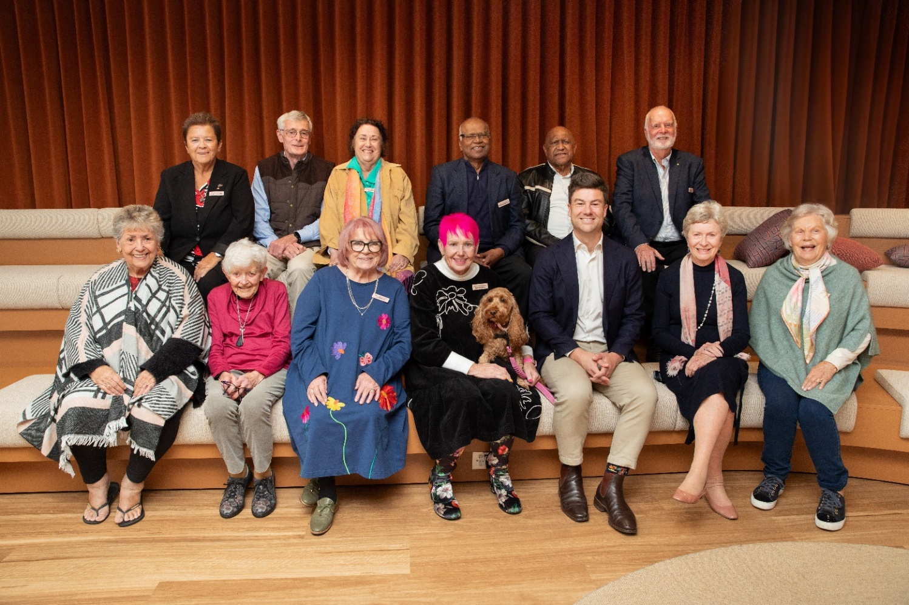

Overview
The Council convened eight formal meetings during 2025, with Minister Rae attending two. Throughout the year, members provided strategic, rights-based advice to guide the design and delivery of major aged care reforms. This included input on the Aged Care Act 2024, the Support at Home program, fees and contributions, workforce readiness, and system quality and safety. The Council also examined emerging issues such as hospital discharge delays, the introduction of a single assessment system, and the development of national aged care design principles and guidelines.
Discussions were grounded in the lived experiences of older Australians and their families, advocating that reforms remain practical, accessible, and transparent. Members considered implementation strategies for the new Aged Care Act and Support at Home program, provided advice on market and workforce challenges, and explored priorities for First Nations aged care. The Council reviewed engagement and communication approaches, updates from the Inspector-General of Aged Care, and initiatives to strengthen supported decision-making. Broader priorities included improvements to My Aged Care and the Commonwealth Home Support Program.
Key additional agenda items included:
- Communication and engagement strategies
- Supported decision-making and consumer rights
- Department’s regional role
- Higher Everyday Living Fee
- National Aged Care Design Principles and Guidelines
- Update on disability sector priorities
- Healthy Ageing
- State level stewardship in the implementation
Members also addressed emerging challenges, including improving communication and understanding of the Support at Home and CHSP programs, tackling workforce shortages particularly the availability of GPs in aged care settings integrating technology to enhance care delivery and reduce administrative burden, ensuring cultural safety and inclusivity for First Nations and diverse communities, strengthening quality and safety oversight informed by presentations from the Quality and Safety Commissioner and the Interim First Nations Commissioner, and ensuring sustainability of funding models and their impact on smaller providers.

External Presentations
The Council of Elders engaged with several external organisations to broaden their understanding of innovative approaches and emerging issues in aged care. New Direction visited in March to showcase progressive models of aged care, highlighting how different ways of working can enhance both care quality and lifestyle outcomes for older Australians. Dementia Australia provided insights into current initiatives in dementia care and workforce development, outlining strategies to improve support for people living with dementia. The Human Services Skills Organisation (HSSO), led by Jodi Schmidt, discussed workforce challenges and barriers within the sector, while also presenting new approaches to training and skills development. In addition, the Aged Care Quality and Safety Commission shared an overview of its role in safeguarding standards, addressing complaints, and adapting to the implementation of the new Aged Care Act, offering the Council a clear picture of the regulatory landscape and community feedback. The Council met regularly with Natalie Siegel-Brown, the Aged Care Inspector-General, to provide feedback on what Council is hearing from older people about systems issues. To maintain confidentiality, Council members receive papers directly from the Office of the Inspector-General ahead of meetings.

Liaison with the National Aged Care Advisory Council
The Council of Elders maintained a strong collaborative relationship with the National Aged Care Advisory Council (NACAC), which provides independent advice to Government on aged care reform from the perspectives of providers, consumers, workers, clinicians, and sector experts.
Throughout 2025, both Councils engaged in joint discussions on key reform priorities, sharing insights to strengthen policy development and implementation. These deep-dive conversations supported a more comprehensive understanding of Government directions and identified opportunities for improvement. Collaboration between the Councils ensures that advice to Government reflects diverse perspectives, upholds the rights of older people, and promotes quality, safety, and accessibility across the aged care system.

Council of Elders Events and Engagement
The Council of Elders has participated in 57 engagements across Australia in 2025.
These engagements spanned a diverse range of formats, including radio interviews, community group visits, keynote addresses, panel discussions Round tables, webinars, podcasts, aged care home visits, expos, and major sector conferences. This strong and varied engagement reflects the Council’s commitment to amplifying the voices of older Australians, fostering community connections, providing information for older people and influencing aged care policy and service design through active representation and advocacy.
These activities have informed advice to the Department and ensured communication remains relevant and accessible.
Council members participated in major sector events such as:
- Aged & Community Care Provider Conferences
- Department-sponsored consultation forums and webinars
- Residential aged care site visits and community consultations
- Expos, library events and conferences
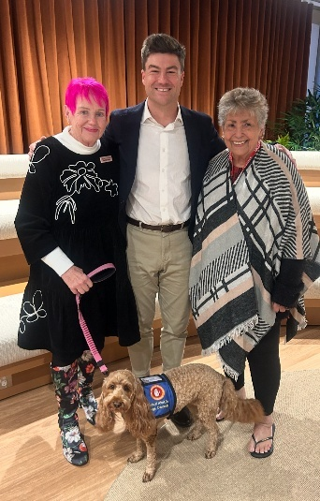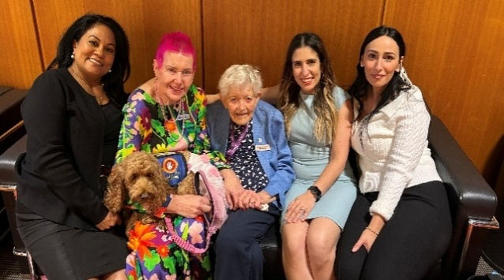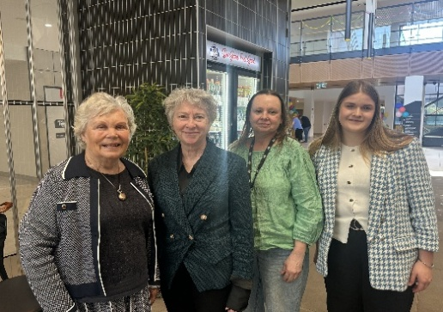

Looking ahead
Following implementation of the Aged Care Act 2024 on 1 November 2025, Council will continue to monitor the impact on older people, advise on communication and implementation, and support the Department’s ongoing work to embed the rights based Aged care system to achieve better outcomes for older people.
