National Dementia Action Plan
  - Collective Priority Framework
2025-2027
Contents
Endorsement of Health Ministers 3
Background 4
What is a Collective Priority Framework? 5
The priority actions 6
How the priority actions were chosen 16
Reporting 19
Governance 21
Measuring the impact of the first Collective Priority Framework 22

Endorsement of Health Ministers

Hon Mark Butler MP
Minster for Health and Ageing
Minister for Disability and the National Disability Insurance Scheme
Hon Sam Rae MP
Minister for Aged Care and Seniors
Hon Ryan Park MP
New South Wales
Minister for Health
Minister for Regional Health
Hon Mary-Anne Thomas MP
Victoria
Minister for Health
Minister for Ambulance Services
Leader of the House
Hon Timothy Nicholls MP
Queensland
Minister for Health and Ambulance Services
Hon Meredith Hammat MLA
Western Australia
Minister for Health; Mental Health
Hon Chris Picton MP
South Australia
Minister for Health and Wellbeing
Hon Bridget Archer MP
Tasmania
Minister for Health, Mental Health and Wellbeing
Minister for Ageing
Minister for Aboriginal Affairs
Ms Rachel Stephen-Smith MLA
Australian Capital Territory
Minister for Health
Minister for Mental Health
Minister for Finance
Minister for the Public Service
Hon Steven Edgington MLA
Northern Territory
Minister for Health
Minister for Mental Health
Minister for Alcohol Policy
Minister for Aboriginal Affairs
Minister for Housing, Local Government and Community Development
Minister for Essential Services

Background
The National Dementia Action Plan 2024-2034 (the Action Plan) was released on 5 December 2024. It builds on the previous National Framework for Action on Dementia which expired in 2019.
The Action Plan is a joint initiative between the Australian Government and state and territory governments.
The Action Plan sets out 8 actions aimed at increasing dementia awareness, reducing the Australian population’s risk of dementia and driving better coordinated services for people living with dementia, their families and carers.
This Collective Priority Framework outlines the national approach to implementation of the Action Plan for the 3 years from 2025 to 2027.
The 8 actions of the Action Plan are:
Action 1 | Promote equity and human rights
Action 2 | Tackle stigma, improve awareness and promote inclusivity
Action 3 | Empower individuals and communities to minimise risk where they can, and delay onset and progression
Action 4 | Improve dementia diagnosis and post-diagnostic care and support
Action 5 | Improve treatment, coordination and support for people living with dementia
Action 6 | Support carers of people living with dementia
Action 7 | Build capability of the workforce to care for and support people living with dementia
Action 8 | Improve dementia data, maximise the impact of dementia research and promote innovation

What is a Collective Priority Framework?
Implementing the Action Plan requires collaboration across all levels of government.
To support aligned and focused action, the Australian Government and state and territory governments have worked together to develop an approach to implementation called ‘Collective Priority Frameworks’ (framework).
This framework is the first of 3 that will be developed over the 10 years of the Action Plan. Each one will detail the specific actions that will be prioritised by governments to progress the Action Plan over smaller, specific periods of time.
The framework is a document that helps governments across Australia focus and align their efforts on specific priority actions to implement the Action Plan over the next 3 years. It reflects input from dementia experts and people with lived experience of dementia.
Governments already support a range of services to help people living with dementia, their carers and families. Taking a phased approach to implementation, with 3 frameworks over the life of the Action Plan, ensures that all governments can be responsive to evolving community needs and reflect any advances in technology and treatments.
Governments will review progress made under the Action Plan to identify next steps for the second framework. A mid-point review and final evaluation will assess the success of the Action Plan and the frameworks.
This document should be read with the Monitoring and Reporting Framework, developed by the Australian Institute of Health and Welfare (AIHW) in partnership with the Australian Government. The Monitoring and Reporting Framework outlines how all governments will monitor and report on progress against the Action Plan’s 8 actions. It is available on the Department of Health, Disability and Ageing’s website.

The priority actions
Governments have agreed on 3 initial priority actions that will guide implementation of the Action Plan for the next 3 years.
National data, a strong governance framework, and annual reporting requirements for all governments, will provide transparency and accountability to the public and measure the impact of progress.
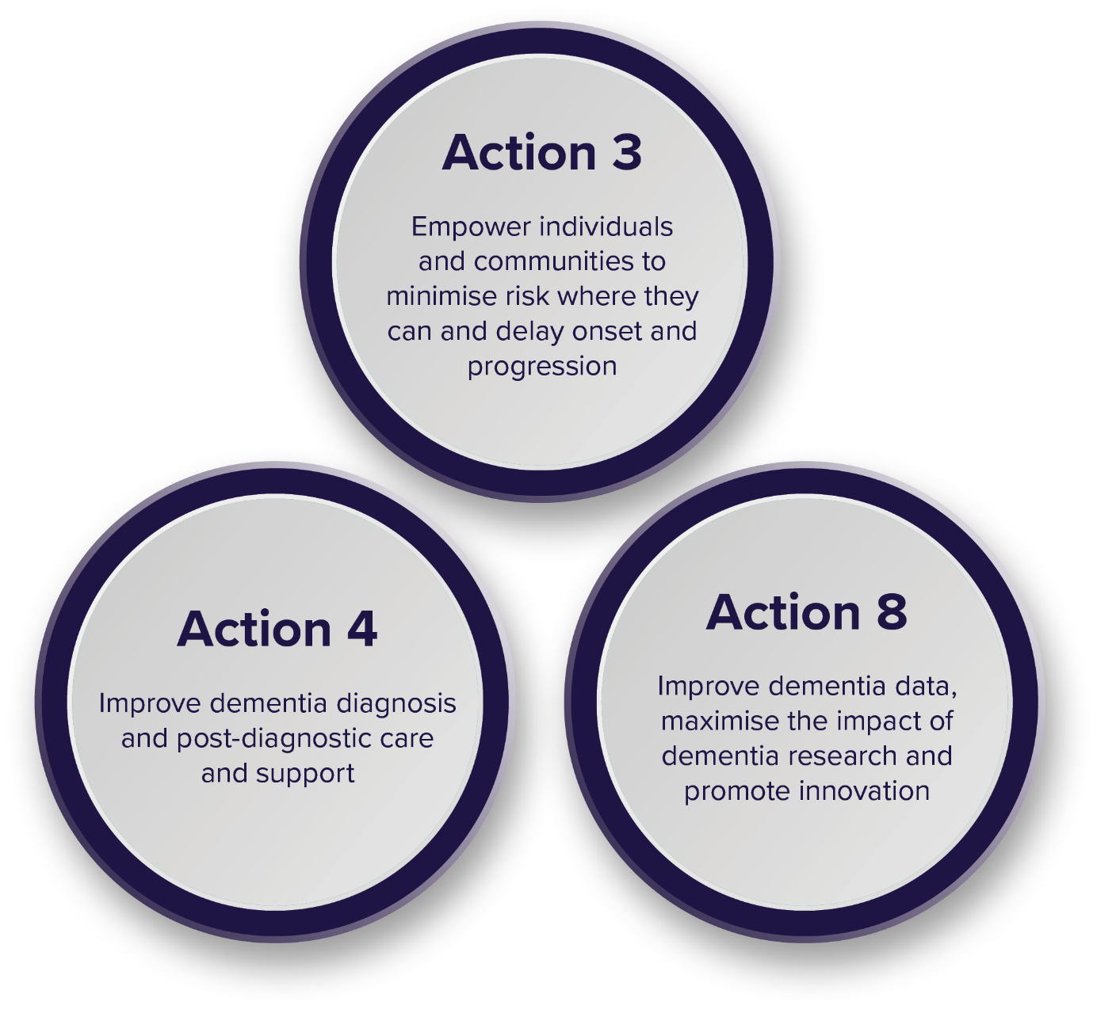
Action 3: Empower individuals and communities to minimize risk where they can, and delay onset and progression
How are we going to make a difference?
- Improve Australians’ awareness of risk factors and preventive actions that can be taken to reduce the risk of developing, delay the onset or slow the progression of dementia. This includes health promotion and prevention programs which support overall health.
- Promote the brain health benefits of people regularly and safely participating in sports, exercise and movement.
- Increase awareness of strategies to improve brain health and establish whole of population brain health approaches for earlier dementia detection and intervention.
- Develop targeted strategies and messages for people from diverse communities or at higher risk of developing dementia in partnership with relevant communities.
- Implement evidence-based interventions to reduce the risk of dementia, including for higher risk populations and people with mild cognitive impairment (MCI).

Why this is a priority action
While the likelihood of developing dementia increases with age, dementia is not an inevitable or normal part of ageing. Minimising modifiable risk factors is currently the best way to prevent dementia.
By focusing on prevention and risk reduction, we can minimise the impact of dementia. Raising community awareness and promoting preventive actions can help reduce demand on resources needed for long-term dementia care. Improving brain health reduces the need for medical intervention and allows people to remain independent for longer.
Empowering individuals and communities to focus on dementia prevention and risk reduction carries important benefits. It can improve quality of life and reduce reliance on the healthcare system. Addressing risk factors early supports healthier and more resilient communities.

Where are we now?
Examples of activities currently underway to minimise risk and delay onset of dementia by the Australian Government and state and territory governments are provided in the table below.
Table of activities – Priority Action 3
Australian Government
The National Ageing Research Institute is delivering the MindCare4Women: Co-designing dementia risk reduction education programs with culturally and linguistically diverse women activity between 2024 and 2027.
The activity is co-designing and evaluating a dementia risk reduction community education program for women from culturally and linguistically diverse backgrounds.
The program will contain evidence-based gender-specific information about dementia risk reduction through the life course to empower women to take positive action for better brain health and reduce their dementia risk, which is the leading cause of mortality in Australian women.
New South Wales
The Sydney Local Health District’s Dementia Active Healthcare Framework and Roadmap 2024-30 includes a range of strategies to increase dementia awareness and empower individuals and communities to minimise risk. These include programs, plans and services targeting chronic disease and modifiable risk factors, healthy ageing strategies, representation on community groups and associations, and community stalls and celebrations for Dementia Action Week. Activities to date have included strengthening partnerships with the Inner West Region and Canterbury Bankstown Community Alliances, with the development of information on local dementia services and promotion of healthy brain ageing at healthy ageing hubs and community events.
Queensland
EAT WALK ENGAGE™ is a multi-disciplinary program that aims to improve care for older people in hospital, prevent delirium and promote faster recovery. EAT WALK ENGAGE™ supports hospitals to be older-person friendly through engaging older consumers and carers, improving team communication, empowering local leadership, supporting education and training, and advocating for environmental redesign. The program focuses on improving mobility, cognitive engagement and nutrition of patients to reduce the likelihood of patients developing delirium, a condition known to increase the risk of developing dementia or worsening pre-existing dementia.
Western Australia
The Western Australian Future Health Research and Innovation Fund provided grant funding in 2024 for Curtin University to undertake a project to build a predictive algorithm for dementia called Dementia Risk Prediction and Risk Reduction in Western Australia: DEMRISK WA.
The research will develop an electronic Healthy Brain Ageing Resource Pack to improve public awareness of key modifiable risk factors associated with dementia.
Tasmania
Tasmania is working to create more awareness around the complexities and risks associated with dementia through its ongoing partnership with the University of Tasmania (UTAS). UTAS’s Wicking Dementia Research and Education Centre provides a range of comprehensive, free resources and courses to raise awareness and dementia literacy levels. A key example of this is UTAS’s Preventing Dementia Massive Open Online Course (MOOC), which provides university-quality education about the latest research in dementia risk and protective factors.
Northern Territory
The Northern Territory Seniors Policy 2021-2026 focuses on activities that will have the most impact on improving the quality of life of older people as they age. To encourage social participation in the community and reduce the risk of dementia, programs were introduced for older people which included walking netball, social bowls, masters squash events, social table tennis and aqua aerobics sessions.
The NT Government also provide funding to its seniors’ peak body, Council on the Ageing NT, for healthy ageing activities including pilates, tai chi, seated aerobics and dementia-friendly line dancing, choir singing and seated fitness.

Action 4: Improve dementia diagnosis and post-diagnostic care and support
How are we going to make a difference?
- Review and update clinical practice guidelines and principles of care for people living with dementia every 3 to 5 years.
- Review how the Medicare Benefits Schedule (MBS) and Pharmaceutical Benefits Scheme (PBS) support effective dementia diagnosis and ongoing management every 3 to 5 years.
- Clarify pathways for dementia screening, assessment and diagnosis across the country, including identification of best practice.
- Increase the capacity and reach of memory clinics and review the funding model.
- Embed memory clinics in targeted Aboriginal Community Controlled Health Organisations (ACCHOs) and Aboriginal Community Controlled Organisations (ACCOs) to support improved access, diagnosis and care for First Nations people.
- Develop and promote culturally appropriate cognitive assessment tools in partnership with diverse communities and experts, and support training for clinicians to use these tools.
- Improve support, care coordination and planning for people living with dementia and their carers following a dementia diagnosis, including models for First Nations, CALD and other diverse communities.
- Improve diagnostic and post-diagnostic services and supports for groups facing additional barriers to care, such as people living with younger onset dementia and children living with dementia and their families.
- Improve and embed supports for people living with dementia in disability support services.

Why this is a priority action
Timely diagnosis is crucial for people living with dementia as it allows earlier access to treatments and support that can improve quality of life and slow disease progression. However, getting a diagnosis can be challenging for some people. Limited availability of services and the varied needs of people living with dementia can result in a lack of clear treatment or management pathways. Lack of awareness can also make it harder to find the support needed. These challenges are even greater for those in regional and rural areas.
People living with dementia often need to navigate different services from across health, aged care, and disability support systems. Navigating these systems is complex and it can be harder for someone with cognitive impairment. Improving information about, and access to, services and support is essential.
Post-diagnostic care and support empowers people living with dementia to live well by providing strategies to better navigate daily life, access appropriate services, manage medications, and plan for the future. Strengthening post-diagnostic support improves quality of life for people affected by dementia by offering practical tools and meaningful guidance

Where are we now?
Examples of activities currently underway to improve dementia diagnosis and post-diagnostic care and support by the Australian Government and state and territory governments are provided in the table below.
Table of activities – Priority Action 4
Victoria
Victoria's cognitive dementia and memory service (CDAMS), delivered by 18 Victorian public health services, is a specialist multidisciplinary diagnostic, referral and education service for people experiencing memory loss or changes to their thinking, and for those who care about them.
Services are generally delivered face to face with the client and, with consent, the family or carers. Some contacts may be delivered via telephone or using telehealth.
Queensland
The Older Persons Enablement and Rehabilitation for Complex Health Conditions (OPEN ARCH) model of care enables a direct path from GPs to a community-based geriatrician for comprehensive interdisciplinary assessment and care management. OPEN ARCH then facilitates timely access to the most appropriate care in the community to enable the older person to be supported so they can remain living in the community and reduce the risk of hospital attendance or admission. The program is targeted as an early intervention service for clients with complex conditions, including dementia, who are at risk of hospitalisation or significant deterioration.
South Australia
Developed in partnership with SA Health, Adelaide Primary Health Network and Country SA Primary Health Network, Health Pathways SA provides comprehensive evidence-based guidelines to assist healthcare professionals in diagnosing and managing dementia. The updated pathways emphasise timely diagnosis, detailed assessments, and the importance of screening for cognitive decline, ensuring patients receive appropriate post-diagnostic support and referrals.
Tasmania
Under the Older Person Mental Health Reform program, Tasmania is piloting the Rapid Access Service, which aims to reduce avoidable hospital admissions for clients in residential aged care facilities who are experiencing behavioural and psychological symptoms of dementia. The pilot, which commenced in January 2024, provides intensive behavioural and psychiatric support to residents, as well as providing education to staff in residential aged care facilities to build their capability and capacity to manage the behavioural and psychological symptoms of dementia. While the pilot was initially limited to the north of Tasmania, it has been recently expanded in the north west, given the community uptake and success of the service.
Australian Capital Territory
The Sustainable Personalised Interventions for Cognition, Care and Engagement (SPICE) program is a 12-week therapeutic intervention for people living with dementia and their carers that combines multiple evidence-based components. The program includes cognitive stimulation therapy through a group activity program, home visits by an occupational therapist, appointments with a dietitian, including a comprehensive nutritional assessment, and tailored physical activities. The SPICE program aims to provide participants with a toolkit of strategies and resources for the future.

Action 8: Improve dementia data, maximise the impact of dementia research and promote innovation
How are we going to make a difference?
- Encourage investment in research, innovation and research translation on prevention, risk reduction, diagnosis, treatments (including a cure), holistic care and management for all types of dementia.
- Improve alignment of Australian dementia research priorities and funding sources and include people living with dementia and their carers in setting future research priorities.
- Improve understanding of outcomes for people living with dementia from First Nations, CALD and other diverse communities.
- Promote whole-of-system approaches to improve dementia data, (e.g. through clinical quality registries).
- Improve health, social and aged care data collection, accessibility and integration to support research, inform policy and service planning, monitor improvements and reporting on outcomes for all types of dementia.

Why this is a priority action
There is limited data on dementia prevalence, service use, and if interventions are working. This limits the ability of governments to plan and improve supports. Reliable data are essential to design policies and programs that meet the needs of people living with dementia, their families and carers.
Enhanced data collection and monitoring can provide the information needed to plan and improve services. Robust data also helps measure whether programs are meeting the needs of people living with dementia, their families and carers.
Research and innovation support the development of new tools and approaches to better understand, prevent and manage dementia in the future. This can improve care and treatment, slow disease progression and enhance quality of life.

Where are we now?
Examples of activities currently underway to improve dementia data, research and innovation by the Australian Government and state and territory governments are provided in the table below.
Table of activities – Priority Action 4
Australian Government
The National Centre for Monitoring Dementia (NCMD) at the Australian Institute of Health and Welfare monitors and reports on dementia data, and aims to address data gaps to provide more accurate information to inform policy development and service delivery.
The NCMD produces the Dementia in Australia online report that provides a comprehensive picture of dementia in Australia. In 2024, the NCMD published summary findings from their Dementia Awareness Survey which collected information on Australians’ knowledge of dementia, modifiable risk factors for dementia, and Australians’ attitudes towards dementia and people living with dementia. The 2023 survey is the first Dementia Awareness Survey of this kind.
New South Wales
NSW Health Extreme Behavioural and Psychological Symptoms of Dementia (BPSD) Project. This project examined the prevalence, characteristics, needs and health service utilisation of people experiencing extreme BPSD, and made recommendations to improve service responses for this vulnerable group with complex needs. The project has led to a number of innovative initiatives to support people experiencing extreme BPSD, their families and carers, and the NSW Health staff who care for them. This includes the Statewide Extreme BPSD Consultation/Liaison Service, which has now been funded for a further 3 years.
Victoria
Through Victorian Government funding, the National Ageing Research Institute (NARI) in partnership with Victorian health services, undertook a comprehensive review of the prevalence, impact and management of patients with dementia in hospitals.
The findings are being used to improve dementia care in Victorian hospitals through actions including promotion of dementia friendly environmental design, workforce skills and training delivered by Dementia Australia, and improved delirium identification and care.
Western Australia
The South Metropolitan Health Service Clinical Excellence Unit has created a dashboard for patient activity and performance against Delirium Clinical Care Standards, and dementia care. The internal dashboard was co-designed with the Coordinator of Cognitive Care and is used by clinicians to monitor performance and activity, maintain clinical excellence and drive education and training across hospitals. This dashboard provides disaggregation of data by ward and location, demographics, length of stay, safety and quality indicators, and staff performance, and is informed by rolling patient audits.
South Australia
The South Australian Government is partnering with the Little Heroes Foundation to provide a joint commitment of $500,000 for research into Childhood Dementia. The funding supports the Childhood Dementia Research Group in the Flinders Health and Medical Research Institute at Flinders University in developing new treatments.
Australian Capital Territory
A pre-feasibility/scoping study was completed with the Dementia Health Experts Network to guide future service planning for people living with dementia and experiencing severe to extreme changed behaviours (BPSD). This includes various research projects with a focus on consumers, carers and health professionals and a dementia technical document with data analysis.
The Dementia Health Experts Network is developing a plan to care for people with different levels of BPSD and their carers in the ACT. The document integrates extensive feedback from stakeholders to ensure it meets safety and functional requirements in both hospital and community environments.
Northern Territory
The Northern Territory Government’s Health Statistics and Informatics unit provides leadership in health statistics and analysis to inform and improve health service delivery and planning, health outcomes, and wellbeing for older Territorians across the life-course. The statistical analysis provided by the unit informs NT programs and guides future policy design, supports evaluation, and improves health care knowledge. Current research by the unit on dementia prevalence, ageing population and aged care servicing will inform dementia strategy and policy and services to older Territorians.
A comprehensive summary of current activities across all jurisdictions will be published annually on the Department of Health, Disability and Ageing’s website. These reports will include detailed updates on progress, achievements and key insights related to these priority actions. See the ‘Reporting’ section of this document for more information on annual activity reporting.

How the priority actions were chosen
To ensure all 8 actions are implemented, governments have agreed that the 3 frameworks will each identify 2 or 3 actions as priorities.
Governments will ensure that all 8 actions are supported throughout the life of the Action Plan. For example, any initiatives to improve dementia diagnosis and post-diagnostic support under Action 4 will be informed by Action 1 in upholding the dignity of people living with dementia.
The Australian Government developed criteria to support the identification of priority actions in collaboration with dementia experts. These criteria are:

Priority actions should align with those areas identified as priorities by stakeholders, particularly people with lived experience of dementia
- Throughout the development of the Action Plan there have been several areas, such as post-diagnostic support, that stakeholders have consistently identified as a priority.
- In some of these areas, action is already planned or underway.

Priority actions should build on existing systems, programs and infrastructure
- Effective actions that support people living with dementia and their carers are already supported by all governments.
- For efficiency, priority actions should consider existing systems, programs and infrastructure.

Priority actions should balance the needs of people living with dementia now and in the future
- Implementation of the Action Plan should aim to improve outcomes and reduce the prevalence and risk of dementia in the future.

Priority actions should have a strong evidence-base
- Implementation of the Action Plan should be based on evidence of what is effective in supporting positive outcomes for people living with dementia.

Priority actions should support system readiness for disease modifying therapies
- It is important that implementation of the Action Plan can respond to advances in technology and disease modifying therapies as they become available in Australia.

Priority actions should address the needs of the most vulnerable cohorts
- The Action Plan identifies groups at higher risk of developing dementia or facing barriers to equal access. These include:
- older people
- women
- people from culturally and linguistically diverse backgrounds
- people living in regional, rural and remote areas
- people with disability
- people living with younger onset dementia
- children living with dementia
- people from the LGBTIQA+ community
- veterans
- people at higher risk of repeated head injuries
- people experiencing (or at risk of) homelessness.
The Action Plan also identifies specific considerations for First Nations people living with dementia and their communities. Implementation of the Action Plan must consider the diverse needs of priority populations.

Priority actions should be those where governments each play a clear role and there is a need for coordinated efforts
- For coordinated efforts to occur, collaboration, coordination and integration should be considered between different levels of government for the implementation of the Action Plan.

Reporting
For the first time, all governments across Australia have committed to report annually on dementia-related initiatives. This landmark step ensures that each jurisdiction reports on activities that support the priority actions identified in each framework using an agreed template. It marks a critical milestone in coordinated efforts to address dementia on a national scale.
Governments may also choose any sub-action to report on. This approach allows governments to report on activities that are relevant to their local needs and may already be underway.
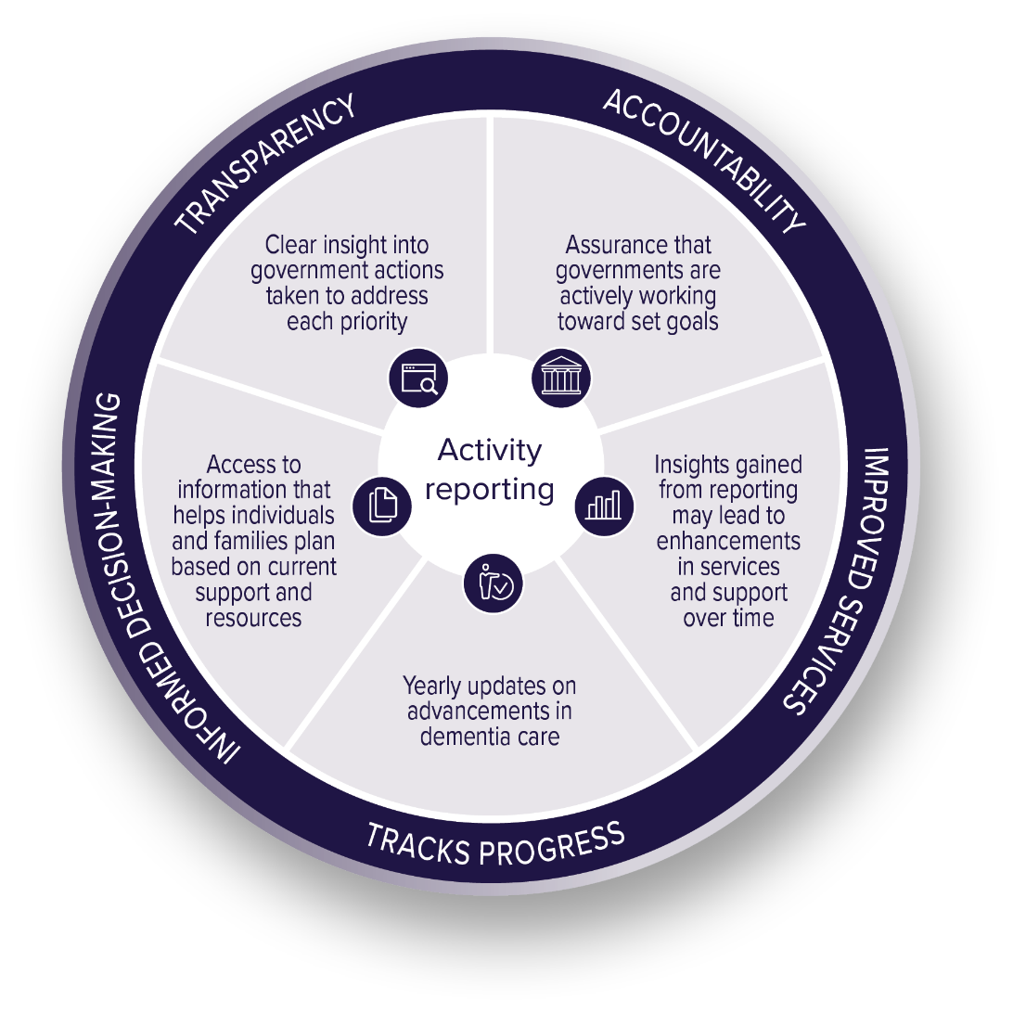
There are many benefits to annual activity reporting, including transparency, accountability, and informed decision-making. All benefits are highlighted below.
Governments may also report on broader actions underway that relate to the Action Plan. This approach ensures all efforts being made to support people living with dementia and their carers are reflected.
Reports will be published on the Department of Health, Disability and Ageing’s website.

Governance
Implementation of the Action Plan will be overseen by a National Dementia Action Plan Implementation Group (Implementation Group) consisting of Australian, state and territory government officials and people with lived experience of dementia.
The Implementation Group will consult with:
• the Dementia Expert Reference Group (DERG) consisting of clinicians, researchers and people with lived experience of dementia who provide specialist advice, guidance, and recommendations on dementia policies, programs and initiatives
• community representatives who can provide specific insights and feedback on particular issues, including:
– the Aged Care Diversity Consultative Committee (ACDCC)
– Department of Health, Disability and Ageing’s Council of Elders
– Department of Health, Disability and Ageing Quality Consumer Reference Group
– Older Persons Advocacy Network (OPAN)
– Carers Australia
– other relevant non-government organisations and consumer advocacy bodies.
A collaborative approach to governance ensures that dementia subject matter experts, those impacted by dementia, including carers, and those from various backgrounds and all age groups are represented and involved in the progress and evaluation of the Action Plan.
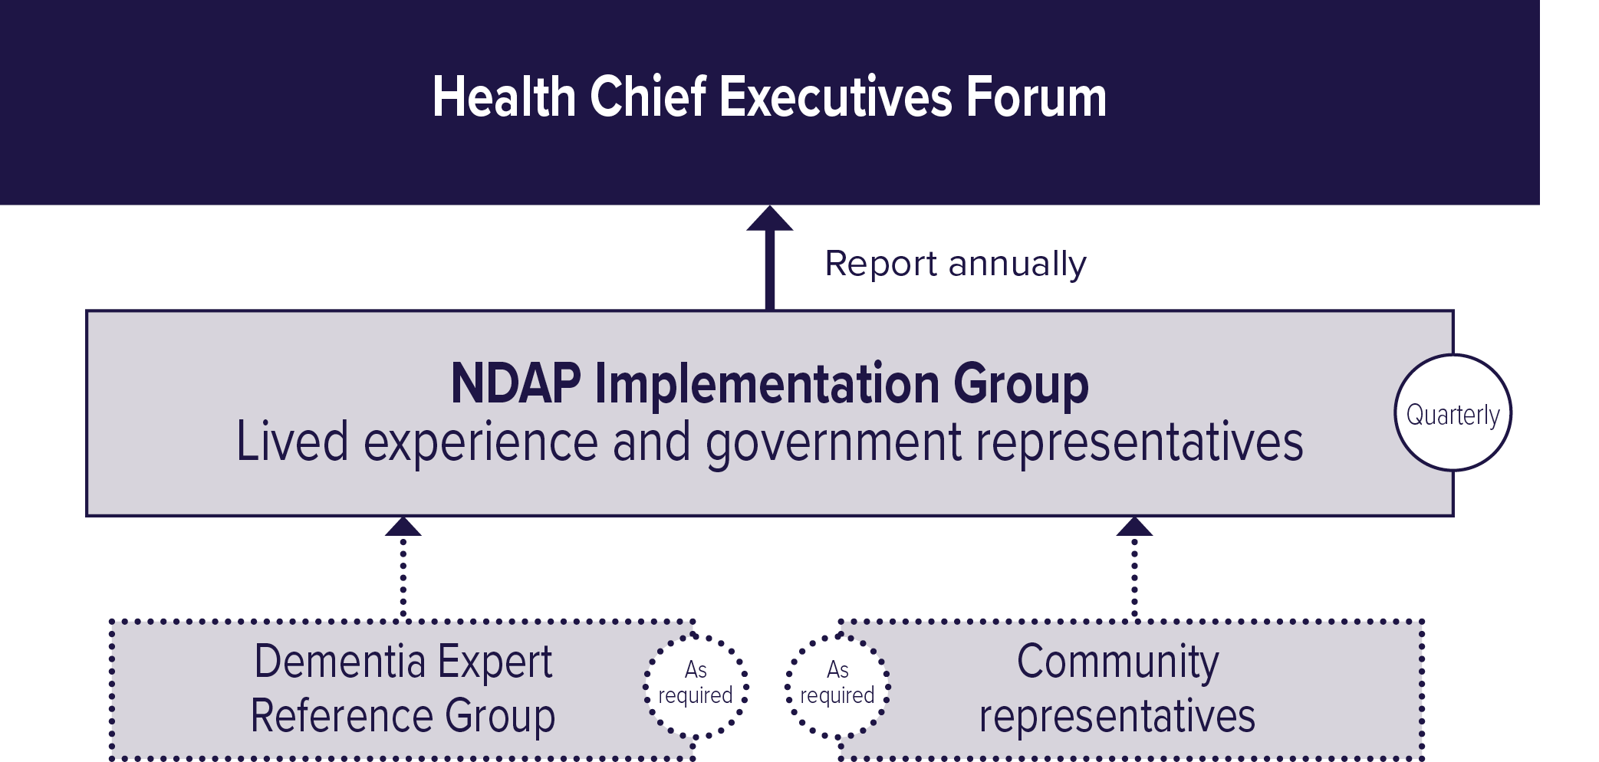

Measuring the impact of the first Collective Priority Framework
To ensure that all governments remain accountable, progress on key dementia indicators will be publicly tracked and reported for the first time. This makes it possible to see how actions are making a difference for people living with dementia. It represents a major step forward in building accountability and transparency, ensuring efforts are impactful and measurable.
The AIHW, through its National Centre for Monitoring Dementia, will report on how the Action Plan is making a difference to improve outcomes for people living with dementia. Progress will be monitored through an online data dashboard called the National Dementia Action Plan indicators dashboard (dashboard) on the AIHW website.
The dashboard will report on the measures of progress set out in the Action Plan in the ‘How will we know if the National Dementia Action Plan has made a difference?’ statement under each action. These are known as indicators. Annual updates will show how the Action Plan is tracking to meet its vision. As data availability improves, the dashboard will provide a better picture of the Action Plan’s impact.
The dashboard is available to everyone. It can be used by people living with dementia, carers, families, the dementia workforce, academics and any other interested stakeholders.

Australian Institute of Health and Welfare (AIHW) (2024). Dementia in Australia Dementia in Australia, Summary - Australian Institute of Health and Welfare, accessed 11 March 2025.

