Changes coming to care minutes funding – fact sheet
The Australian Government is introducing changes to the way it funds the delivery of care minutes for approved residential care homes in metropolitan areas. This fact sheet explains how it will work and when the changes will begin.
For more information, refer to the Frequently Asked Questions.

Key information
- Care funding will be linked to the delivery of care minutes in residential care homes in metropolitan areas.
- Residential care homes with specialised homeless funding status and those in regional, rural and remote areas will not be impacted by this change.
- To make sure providers are meeting care minute targets and funding is used for its intended purpose, non-specialised residential care homes in Modified Monah (MM) 1 areas not meeting their targets will receive less than the maximum possible amount of funding from the April 2026 claim month.
- For the April – June 2026 quarter, the funding amount will depend on the homes’ care minutes performance from the October – December quarter of 2025 onwards.

Who will the funding change apply to?
This funding change will apply to residential care homes in metropolitan areas.
Metropolitan areas are defined by residential care homes operating in (MM) 1 areas. Over 60% of residential care homes are located in MM1.
This change does not apply to residential care homes:
- in MM1 areas with specialised homeless funding status.
- operating in regional, rural and remote areas (MM2-7).

What is the funding change, and how will it work?
From April 2026, care funding will be linked to the delivery of care minutes through a new care minutes supplement.
The Australian National Aged Care Classification (AN-ACC) funding model is how the Government funds providers to deliver care, including delivering their care minutes.
Under this funding change, the amount of Base Care Tariff (BCT) funding for MM1 non-specialised homes will change from 0.5 National Weighted Activity Unit (NWAU) to 0.387 NWAU. The remainder of the 0.113 NWAU in BCT funding will be redirected into a new care minutes supplement. This amounts to $33.41 per resident per day based on the AN-ACC price from 1 October 2025 of $295.64.
You will receive some or all of the new care minutes supplement from the April 2026 claim month, depending on care minutes performance. You do not need to apply for the care minutes supplement. Services Australia will automatically pay the relevant supplement amount each month over quarter.
You will not see any change in the funding you receive if you meet your care minute targets.

Why is this change being introduced?
Overall average care funding for each day of care has increased substantially to fund increased care minutes. However, care time reporting shows a significant proportion of residential care homes are not meeting their care minutes targets. In the July – September quarter of 2024, only 45% of all homes met both their care minute targets. Compliance rates were even lower for homes in MM1 areas (43%). This is despite consistent feedback from the sector that workforce shortages are most acute in regional, rural and remote areas.
This change aims to increase MM1 residential care homes’ compliance with care minutes requirements and ensure the government’s substantial investment in residential aged care leads to more care for residents as intended. It will also ensure the government is not providing funding for care minutes not being delivered.

When will the funding change start?
You will begin to see funding changes from the April 2026 claim month. That is, in May 2026 when you have finalised your April claim.
Your rate for the April – June 2026 quarter will be based on care minutes reported for the October – December quarter 2025 in the Quarterly Financial Report (QFR). For example, care time data for the October – December 2025 quarter will determine the supplement payable for April, May and June 2026 (see Illustration 1).
Illustration 1 – Timeline of changes to care minutes funding
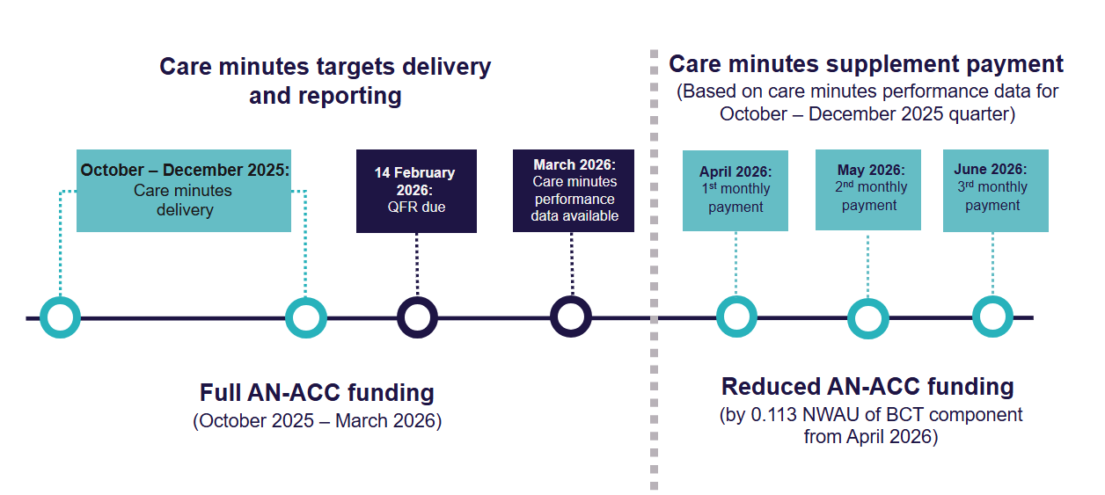

What are the supplement rates?
The new care minutes supplement works on a sliding scale. You will receive more funding the closer you were to delivering your care minutes targets in the previous quarter.
For example, if you meet 100% or more of both your total care minute and registered nurse (RN) care minutes targets, you will receive the maximum supplement of $33.41 per resident per day. This is the full value of your reduced BCT funding.
Your percentage of RN care minutes delivered will include care time from enrolled nurses (EN) of up to 10% of your target. This is in addition to actual care time delivered by RNs only.
If you do not meet one or both of your targets, you will not get the maximum possible amount of care minutes supplement and therefore receive less overall funding.
Table 1 (below) outlines the matrix for the supplement rates payable using current AN-ACC pricing, based on the percentage of care minutes delivered in the relevant period.
Table 1 – Care minutes supplement
 | % of RN Care Minutes Delivered
% of Total Care Minutes Delivered | <85% | ≥85% - <87.5% | ≥87.5% - <90% | ≥90% - <92.5% | ≥92.5% - <95% | ≥95% - <97.5% | ≥97.5% - <100% | ≥100%
<85% | $0 | $0.59 | $1.18 | $1.77 | $2.37 | $2.66 | $2.96 | $2.96
≥85% - <87.5% | $5.62 | $6.21 | $6.80 | $7.10 | $7.69 | $8.28 | $8.28 | $8.57
≥87.5% - <90% | $10.94 | $11.53 | $12.12 | $12.71 | $13.30 | $13.90 | $13.90 | $14.19
≥90% - <92.5% | $16.56 | $17.15 | $17.74 | $18.33 | $18.92 | $19.51 | $19.51 | $19.81
≥92.5% - <95% | $22.17 | $22.76 | $23.36 | $23.95 | $24.24 | $24.83 | $24.83 | $25.13
≥95% - <97.5% | $27.79 | $28.09 | $28.68 | $29.27 | $29.86 | $30.45 | $30.45 | $30.75
≥97.5% - <100% | $28.38 | $28.97 | $29.56 | $29.86 | $30.45 | $30.75 | $31.04 | $31.34
≥100% | $30.45 | $31.04 | $31.63 | $32.22 | $32.52 | $32.82 | $33.11 | $33.41
Rate for homes that open, transfer to another provider, return to operational, or changes BCT from 1 November 2025* | $ 33.41
+ The rates in the table are based on the $295.64 AN-ACC price (from 1 October 2025)
* Rate applicable for up to 4 quarters (inclusive)

Online estimator
You can use the online care minutes supplement estimator to check the funding you may receive from April 2026. This is an estimation only.
The actual amount of care minutes supplement will vary based on different factors, including the AN-ACC price at the time and your care minutes performance data.

Example
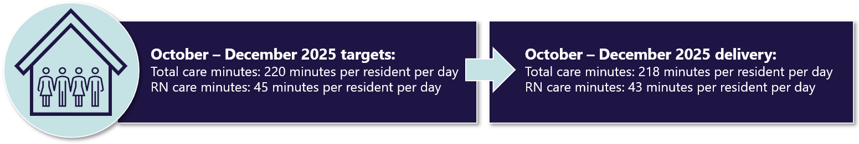
Illustration 2 – care minutes supplement applying to a residential care home

 | % of RN Care Minutes Delivered
% of Total Care Minutes Delivered | <85% | ≥85% - <87.5% | ≥87.5% - <90% | ≥90% - <92.5% | ≥92.5% - <95% | ≥95% - <97.5% | ≥97.5% - <100% | ≥100%
<85% | $0 | $0.59 | $1.18 | $1.77 | $2.37 | $2.66 | $2.96 | $2.96
≥85% - <87.5% | $5.62 | $6.21 | $6.80 | $7.10 | $7.69 | $8.28 | $8.28 | $8.57
≥87.5% - <90% | $10.94 | $11.53 | $12.12 | $12.71 | $13.30 | $13.90 | $13.90 | $14.19
≥90% - <92.5% | $16.56 | $17.15 | $17.74 | $18.33 | $18.92 | $19.51 | $19.51 | $19.81
≥92.5% - <95% | $22.17 | $22.76 | $23.36 | $23.95 | $24.24 | $24.83 | $24.83 | $25.13
≥95% - <97.5% | $27.79 | $28.09 | $28.68 | $29.27 | $29.86 | $30.45 | $30.45 | $30.75
≥97.5% - <100% | $28.38 | $28.97 | $29.56 | $29.86 | $30.45 | $30.75 | $31.04 | $31.34
≥100% | $30.45 | $31.04 | $31.63 | $32.22 | $32.52 | $32.82 | $33.11 | $33.41
In this example, the residential care home has a target of 220 total care minutes per resident per day for the October – December 2025 quarter. This includes an RN specific target of 45 minutes per resident per day.
At the end of the quarter, the provider reports the RN, EN, personal care worker (PCW) or Assistant in Nursing (AIN) labour costs and hours in the relevant categories of the QFR.
Based on this, the department calculates that the residential care home:
- delivered an average of 218 total care minutes per resident per day, including an average of 43 RN care minutes during the quarter
- met 99.09% of its total care minutes target and 95.55%1 of its RN care minutes target.
The residential care home will receive a supplement of $30.75 per resident per day for the months of April, May and June 2026, based on their care minutes performance for the October – December 2025 quarter. This is in addition to BCT funding of $114.41 per resident per day that applies from 1 April 2026 (0.387 NWAU multiplied by the AN-ACC price of $295.64).

Will there be any impact on funding of other residential care homes such as allied health and lifestyle/recreational services?
No. The government will continue to fund the delivery of required allied health and lifestyle/recreational services in full through AN-ACC funding.
Providers must ensure they continue to provide allied health and lifestyle/recreational services that meet their obligations under the relevant legislation.

Are there exemptions for some residential care homes?
There are no exemptions from these funding changes, however the maximum rate payable ($33.41 per resident per day) will apply in certain circumstances. This ensures providers are not financially disadvantaged and continue to receive their funding in full until the care minutes performance of their residential care homes can be assessed.
The maximum rate will be paid to providers under the following circumstances:
- a new home becomes operational for the first time
- an existing home is transferred to another provider
- a home goes offline (0 operational beds) and is not operational for a certain period, before becoming operational again. This occurs when a home closes temporarily (exiting all residents from care), generally to undertake a renovation
- a home that had a change to their BCT category (specifically, a home that loses their specialised homeless status and becomes a standard MM1 home).

How long will the maximum rate apply for?
The maximum rate will apply for 4 quarters, inclusive of the quarter when the event occurs.
In the case of transferred residential care homes, it will only apply for 3 quarters immediately after the quarter the transfers take place. These durations are based on the amount of time it takes to ensure care minutes performance data is available.
See below are scenarios of when the maximum rate will apply and the duration for which it will remain in effect.

Scenario 1 – new residential care home becomes operational
If a residential care home becomes operational on 15 March 2027, the maximum rate will apply from Quarter 3 2026-27 (starting from 15 March 2027) through to end of Quarter 2 2027-28 (ending 31 December 2027). This covers 4 quarters, including the quarter the home was opened. From 1 January 2028, the care minute supplement will be paid based on the total care minutes and RN care minutes delivered to residents in Quarter 1 2027-28 (see Illustration 3).
Illustration 3 – maximum rate scenario for a new home that becomes operational
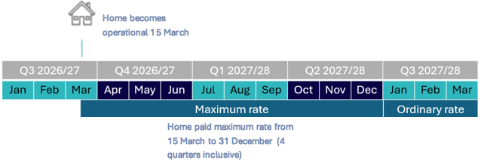

Scenario 2 – residential care home is transferred from a different provider
If a residential care home is transferred to a different provider on 15 March 2027, the home will continue to receive its current care minutes supplement rate until the end of Quarter 3 on 31 March 2027. The maximum rate will then apply for 3 quarters from Quarter 4 2026-27 (starting from 1 April 2027) through to end of Quarter 2 2027-28 (ending 31 December 2027). From 1 January 2028, the care minute supplement will be paid based on the total care minutes and RN care minutes delivered to residents in Quarter 1 2027-28 (see Illustration 4).
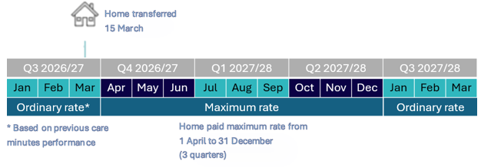
Illustration 4 – maximum rate scenario for a transferred home

Scenario 3 – MM1 residential care home loses homeless specialised status
If a MM1 residential care home loses its homeless specialised BCT status on 1 January 2027, the maximum rate will apply for Quarter 3 2026-27 (starting from 1 January 2027) through to the end of Quarter 2 2027-28 (ending 31 December 2027). This covers 4 quarters, including the quarter they became a standard MM1 residential care home. From 1 January 2028, the care minute supplement will be paid based on the total care minutes and RN care minutes delivered in Quarter 1 2027-28 (see Illustration 5).
Illustration 5 – maximum rate scenario for a home that loses homeless specialised status
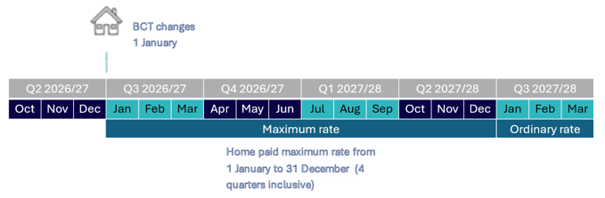
Changes to homes before 1 November 2025
The maximum rate will not apply to any homes that open, transfer or return from being offline before 1 November 2025, which is when the maximum rate rules take effect.
However, for residential care homes that open, transfer or return from being offline in September and October 2025 only, they will have a zero care minutes target for the October – December 2025 (in line with current care minutes arrangements). This means the residential care home will receive 100% funding for the April – June 2026 quarter only.
Funding from July 2026 onwards will be based on care minutes reported in the QFR from the January – March 2026 quarter.

Care Minutes Performance Statement
Starting as part of their 2025-26 Aged Care Financial Report (ACFR), all residential aged care providers will be required to prepare and submit a new Care Minutes Performance Statement.
The statement includes information about:
- direct care minutes delivered
- associated labour hours and costs
- RN coverage
- occupied bed days.
All providers must engage a registered company auditor to complete an audit of their Care Minutes Performance Statement. You will need to submit the audited statement in the ACFR.
To better understand new reporting requirements, refer to Care Minutes Performance Statement guidance.

Percentage truncated to 2 decimal places rather than rounded to the nearest 2 decimal places.

