Aged Care Assessor App User Guide
This Aged Care Assessor App (the App) user guide outlines essential information for both aged care needs assessors (needs assessors) who use the Integrated Assessment Tool (IAT) and/or residential aged care funding assessors (RAC funding assessors) who use the Australian National Aged Care Classification (AN-ACC) assessment tool.
The user guide will walk users through how the App can be utilised both online and offline, allowing for users to use the App in different situations.
This user guide has been split into the following sections:
- Part A is for needs assessors and/or RAC funding assessors who complete assessments using either AN-ACC or IAT.
- Part B is for needs assessors who complete assessments using the IAT.
- Part C is for RAC funding assessors who complete assessments using the AN-ACC assessment tool.
! | On 1 November 2025, the Aged Care Act 2024 and the Support at Home program come into effect with significant change to support plans in the IAT.  To ensure the right IAT is used, and triage can continue for priority referrals, any assessments in the following statuses already started prior to 1 November 2025 and in progress on 1 November 2025 must be restarted:  - Triage complete, main assessment not started  - Triage complete, main assessment in progress (includes incomplete support plan)  - Main assessment completed, awaiting delegate decision (comprehensive assessments).  For information on the Restart Assessment Process, please refer to Management of active assessments for 1 November 2025 transition – Standard Operating Procedure and Restarting In Progress Assessments for Support at Home (instructional video).
! | From 1 November 2025, there are changes to assessment delegations under the Aged Care Act 2024, for both Clinical and Non-clinical Assessment Delegates.  To understand Assessment Delegate changes, refer to ‘Chapter 7: Delegations and Approvals under the Act’ of My Aged Care Assessment Manual.  For CHSP only: For guidance on the interim process explaining Manual Delegate Approval for CHSP only for comprehensive and home support assessments, and how it impacts assessors during support plan completion and finalisation (including issuing referral code(s) from 1 November 2025, refer to Manual Delegate Approval for CHSP – Standard Operating Procedure and instructional videos for comprehensive and home support assessments.
Version 5.1 – February 2026
Contents
Part A – Needs assessors and RAC funding assessors 5
1. Introduction 5
2. Minimum requirements for devices to run the App 5
3. Setting Up the App 6
3.1 Downloading and Installing the App 6
3.2 Activating the App 7
3.3 Uninstalling the App 12
3.4 First time access following a reinstall of the App 13
3.5 Reactivating the App 13
4. Launching and closing the App 14
4.1 Login to the App 14
4.2 Inactivity time-out 15
4.3 Generating an Unlock Code 15
4.4 Closing the App 15
4.5 Logging out of the App 15
5. App symbols 17
Part B – IAT Assessments 19
6. Registering a client, self-referring for assessment, starting triage and starting a review 19
6.1 Finding a client 20
6.2 Registering a client 22
6.3 Potential Duplicates 24
6.4 Self-referring for assessment 25
6.5 Starting Pre-Triage questions with consent for a client using the IAT (Self-Referral) 27
6.6 Refer urgent services before completing Triage 29
6.7 Starting Triage questions with client (Self-Referral) 32
6.8 Converting assessments after completing Triage 33
7. Referrals, reviews and creating an offline client for assessment 34
7.1 Navigating between referrals and reviews 35
7.2 Downloading a client’s referral or review 37
7.3 Creating an offline client 40
8. Viewing and adding client information 43
8.1 Contact Details 45
8.2 Support Network and Cohabitants 46
8.3 Wallet Check 47
8.4 Event Summary and Approvals 47
8.5 Attachments 49
8.6 Notes 52
9. Registering a support person 54
9.1 Creating a relationship for an individual supporter or supporter lite 54
9.2 Creating a relationship for a supporter guardian 65
9.3 Creating a relationship for a supporter organisation 74
9.4 Creating a relationship for an agent organisation 83
9.5 Creating a relationship for a carer or other support people 89
9.6 Creating a relationship in offline mode 95
9.7 Establishing an offline relationship 97
9.8 Activating a pending relationship 101
9.9 Removing a support relationship 103
10. Completing identity verification 105
11. Undertaking assessments 108
12. Developing a support plan 118
13. IAT outcome and classifications 120
13.1 Convert to Comprehensive Assessment 124
13.2 Edit (Override) Recommended Classification 125
14. Adding concerns, goals and recommendations 128
14.1 Recommendation Types 136
14.2 Support At Home Service Recommendations 137
14.3 Adding Seeking Services Preferences 144
14.4 Editing a Goal 147
14.5 Linking Goals to Recommendations 149
15. Uploading assessment and support plan information to the assessor portal 154
15.1 Uploading assessment and support plan information for downloaded assessments 154
15.2 Uploading assessments for offline clients 156
15.3 Locally registering an offline client 157
15.4 Linking offline clients and assessments 160
16. Conducting Support Plan Reviews 161
16.1 Downloading a Support Plan Review 162
16.2 Completing a Support Plan Review 163
17. Completing the match and refer process and finalising the assessment or completing the review 165
18. Removing assessments and reviews from the device 165
19. Completing a Residential Respite Classification Assessment 167
19.1 Refer for a Residential Respite Assessment 167
19.2 Starting an assigned Residential Respite Assessment Referral 170
19.3 Completing a Residential Respite Assessment 171
19.4 Rejecting a Residential Respite Assessment 173
Part C – Residential aged care funding assessments (RAC funding assessors) 174
20. Conducting an RAC funding assessment 174
20.1 Find a client 174
20.2 Self-Referral 177
20.3 Undertaking Assessments 180
21. Undertaking Quality Assurance and Training Assessments 184
21.1 Sharing referral details with the assessor undertaking the assessment 184
21.2 Scanning referral QR code or entering the referral ID 187
21.3 Local (Offline) Assessments 188
22. Completing, re-opening and uploading assessments 190
22.1 Completing an assessment 190
22.2 Re-opening a completed assessment 192
22.3 Re-opening an uploaded assessment 194
22.4 Uploading Assessments 194
23. Removing Assessments and Clearing Assessment Data 195
23.1 Removing an uploaded assessment 195
23.2 Removing an in-progress assessment 196
23.3 Clear Uploaded and Not Started assessments 197
23.4 Rejecting a Referral 197
24. Appendices 200
24.1 Sideloaded App for Organisations 200
24.2 End-of-Life Pathway 201
24.3 Troubleshooting and diagnostics 206

Part A – Needs assessors and RAC funding assessors

Introduction
The Aged Care Assessor App (the App) enables both needs assessors and Residential Aged Care (RAC) funding assessors to assess an older Australians’ aged care needs while offline. The App allows users to perform a subset of the functions available in the assessor portal, including the ability to conduct an assessment using the Integrated Assessment Tool (IAT) or Australian National Aged Care Classification (AN-ACC) assessment tool, under the Aged Care Act (2024).
Needs assessors and RAC funding assessors can undertake these processes using the App:
- search for existing and register new clients
- create offline clients
- self-refer for assessment
- view and search assigned referrals
- download a client’s referral for assessment
- download a client’s support plan review (needs assessors only)
- view and add information about a client
- complete identity verification (wallet check)
- undertake assessments using IAT (needs assessors only)
- undertake assessments using AN-ACC (RAC funding assessors only)
- undertake support plan reviews (needs assessors only)
- commence development and update a client’s support plan
- upload assessment and review information to the My Aged Care assessor portal
- view and upload client attachments
- manually remove or cancel assessments from the App
- view and set up supporter relationships
- complete Residential Respite Classification Assessments (clinical needs assessors only).

Minimum requirements for devices to run the App
The App is supported on the following operating systems:
Operating System | Minimum | Recommended
Android | V14, 6GB RAM | V16 and up, 8GB RAM
Apple iOS | V18, 6GB RAM | V18, 8GB RAM
Windows | 10, 8GB RAM | 11, 16 GB RAM
Please note the screenshots in this guide feature the app version 34 on iPadOS 18.7.
If you are using another device, the App will appear slightly differently.
! | The App will time out if inactive for 15 minutes and you will need to log in again.  If you do not use the App for 14 days, you will be locked out of the app. You will require an unlock code, which can be generated from the app section in the My Aged Care Assessor Portal.

Setting Up the App
! | Prior to using the App, you will need to:  - Download the App from your device’s application store.  - Have an active role in the assessor portal (you must ensure your registered email address is current and up to date).  - Have an activation code, that can be obtained either via the App section of the assessor portal or by calling the My Aged Care service provider and assessor helpline (1800 836 799). The activation code will be active for 24 hours from the time it is issued. If your code expires, select Get Activation Code in the App section of the assessor portal or call 1800 836 799 to have another code issued. For RAC funding assessors, they can call the AN-ACC Operational Support Line on 02 6289 7190 between 8am - 6pm AEST Monday to Friday to request an activation code.

3.1 Downloading and Installing the App
Before downloading the App, depending on the device you are using, you will need to have an active:
- Microsoft account (for Windows device)
- Apple account (previously known as Apple ID) (for Apple iPad), or
- Google account (for Samsung or Android).
! | A sideloaded version of the Windows App is available to assessment organisations that have a restricted IT environment.  For instructions on how to download the sideloaded version of the App, please refer to the section Sideloaded App for Organisations.
- Once you have an active account, navigate to your device’s application store (Microsoft store, Apple App Store or Google Play Store).

- Search for the App by entering ‘Aged Care Assessor App’ in the search box and select the App icon to open the App details.


- Select Install to download the App to your device. Once successfully downloaded, it will display on your device.
! | The App will be located where your device stores its applications. This will differ between the supported devices.  If you have difficulties downloading the App onto your device, contact your organisation administrator or relevant IT area.
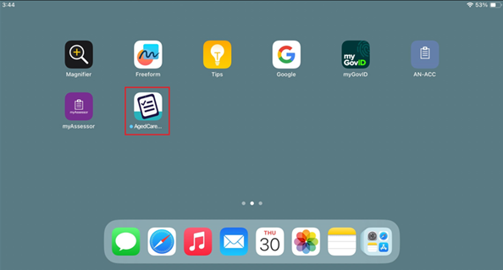

3.2 Activating the App
Once the App has been downloaded to your device, follow the steps below to activate the App.
- Log onto the Assessor Portal, then navigate to the Aged Care Assessor app tile.
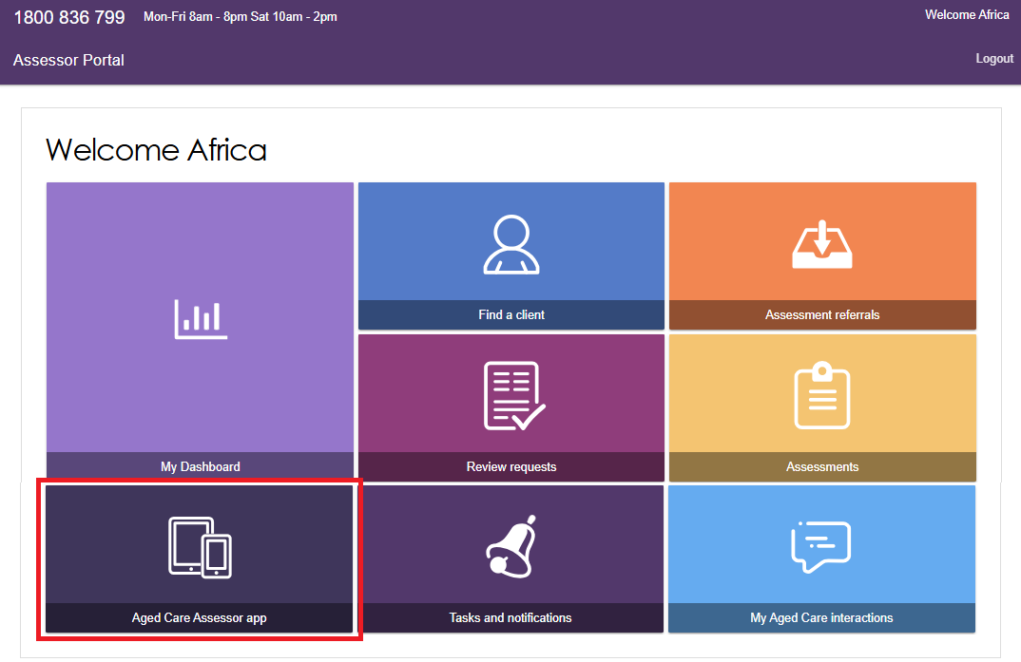
In this section, you will be able to view your App activation status, any referrals downloaded to your device, and generate a code to unlock, activate or reactivate your device.
Select Get Activation Code to send an activation code to your registered email address.
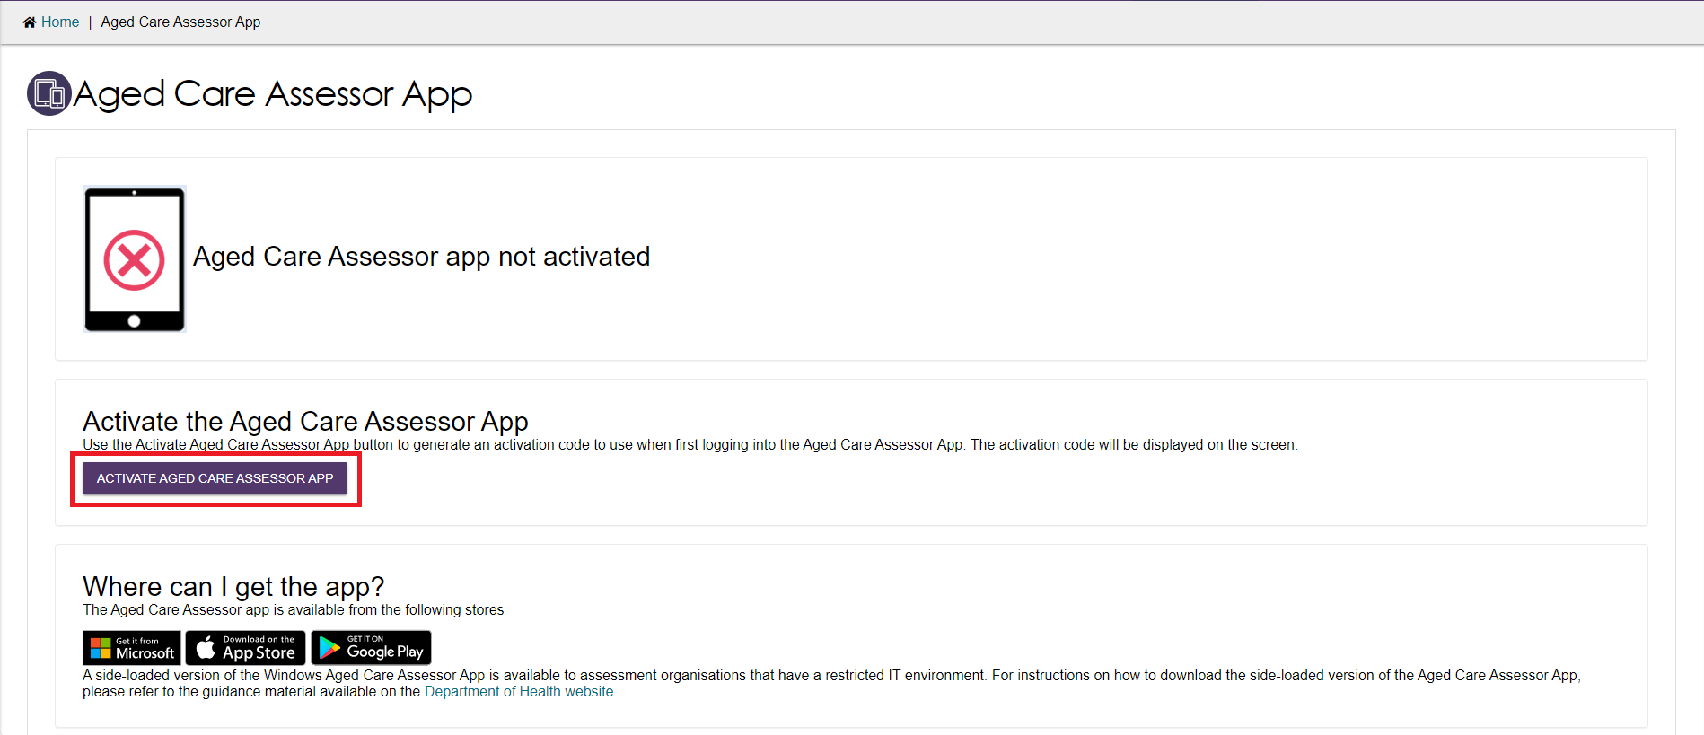
- Select Activate to generate the code.
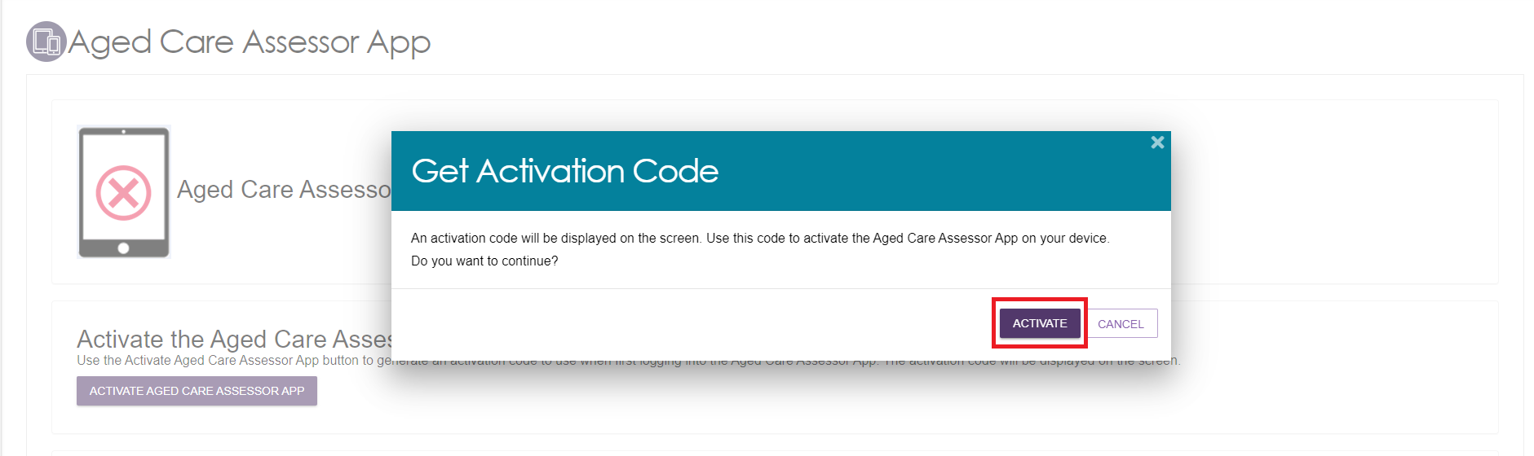
- Open the App from your device.

- Enter the email address associated with your staff account in the Assessor Portal and your activation code, and then select Activate Application.
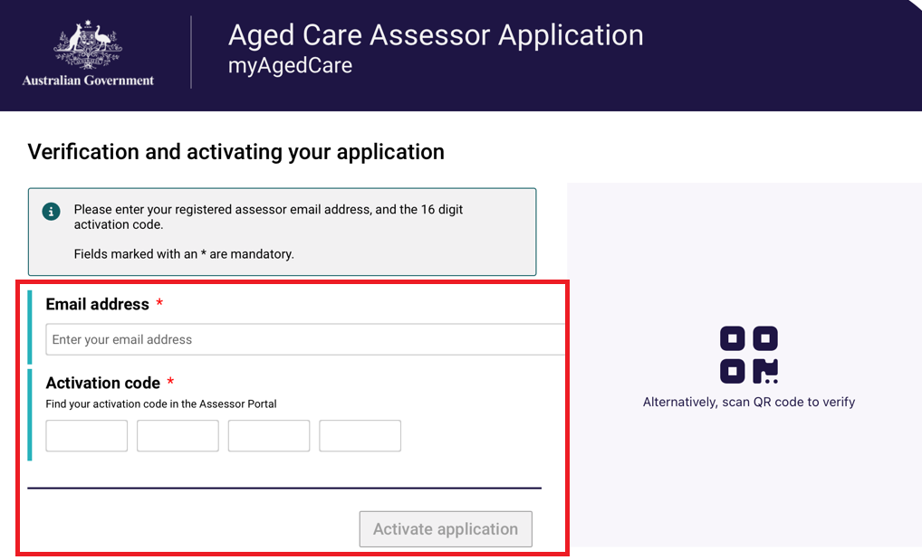
Or you can select Alternatively, scan QR code to verify and scan the QR code shown on the Assessor Portal.
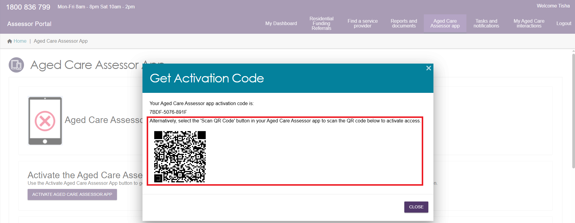
! | The email entered will be verified against the information held in My Aged Care.  If the information is incorrect, an error message will be displayed.
- The Terms of Use will be displayed.
Read the Terms and Conditions and if you agree, select the Accept terms and continue button, to proceed.
If you do not accept, you will not be able to use the App.
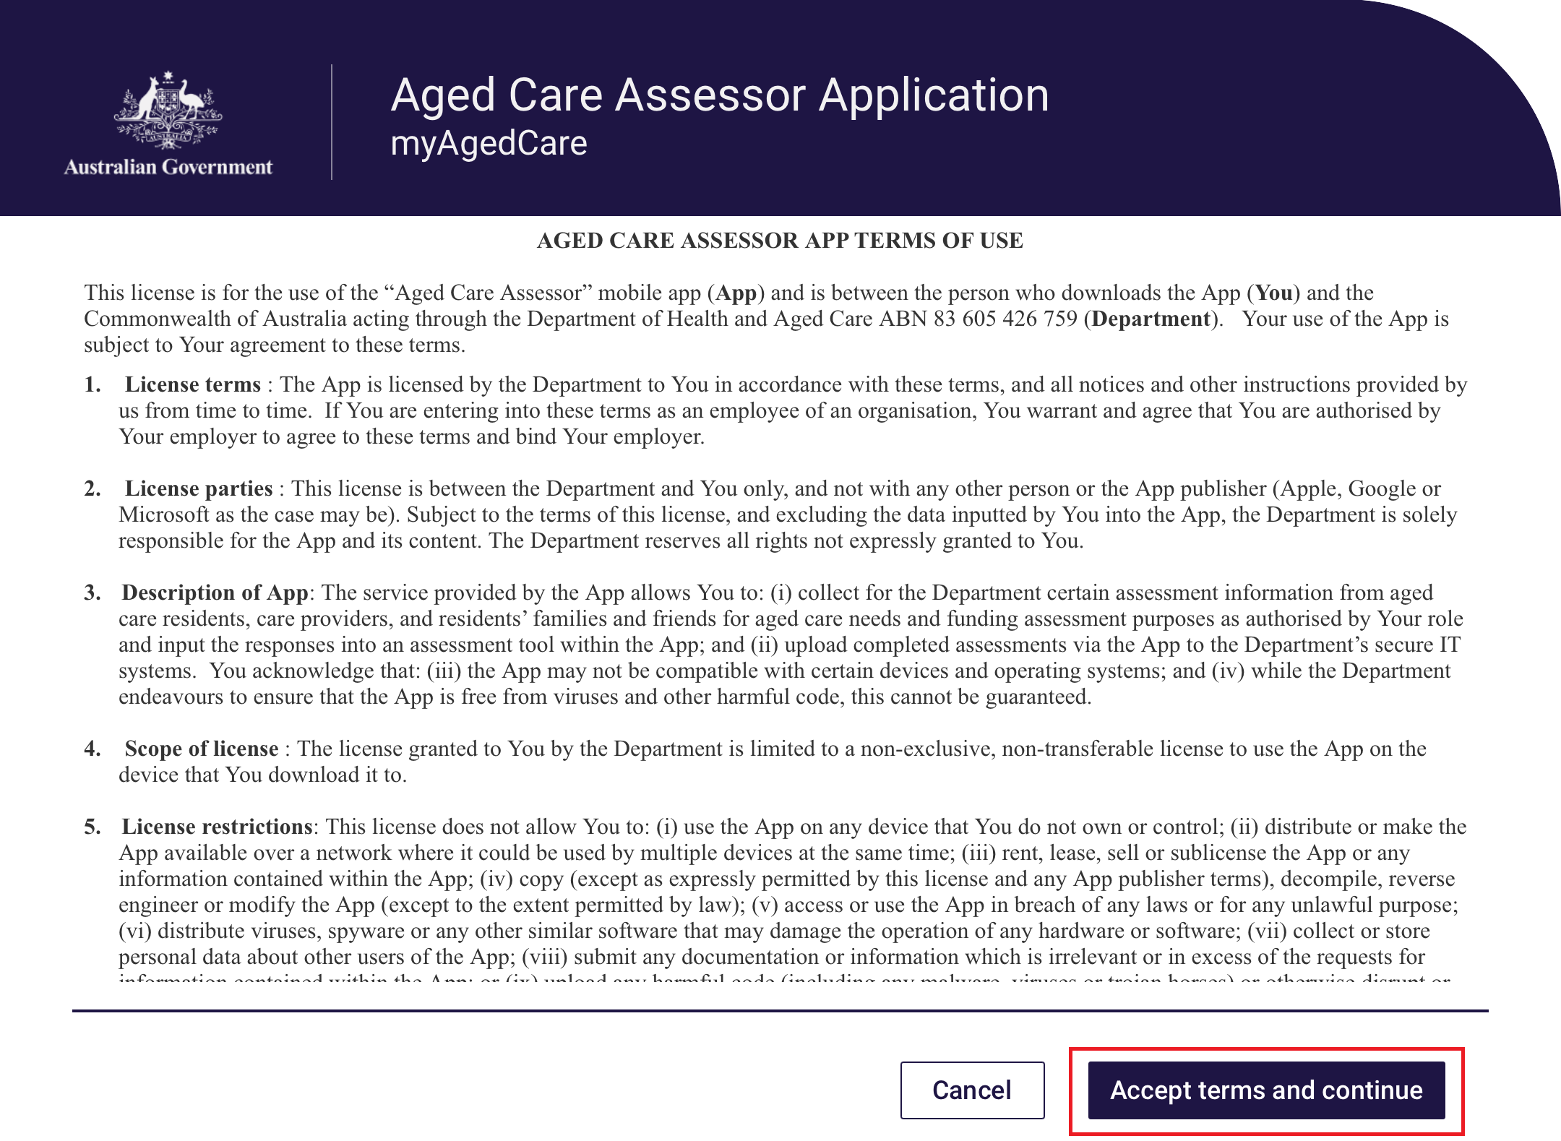
- Once you have accepted the terms, the Privacy notice for the App will appear. Read the notice and then select the Continue button, to proceed.
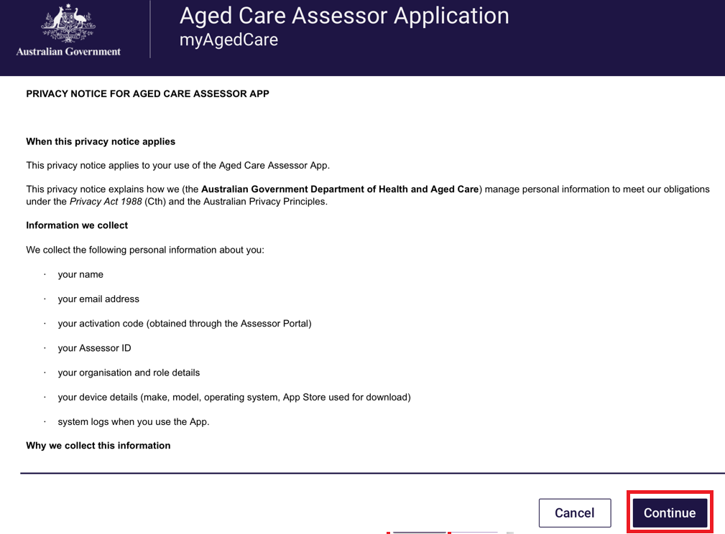

- Once the App’s Terms of Use has been accepted, you will be presented with the password screen. Create a password according to the rules displayed. You will be asked to enter the password a second time to ensure it is correct.
Use this password to unlock the App each time it is opened.
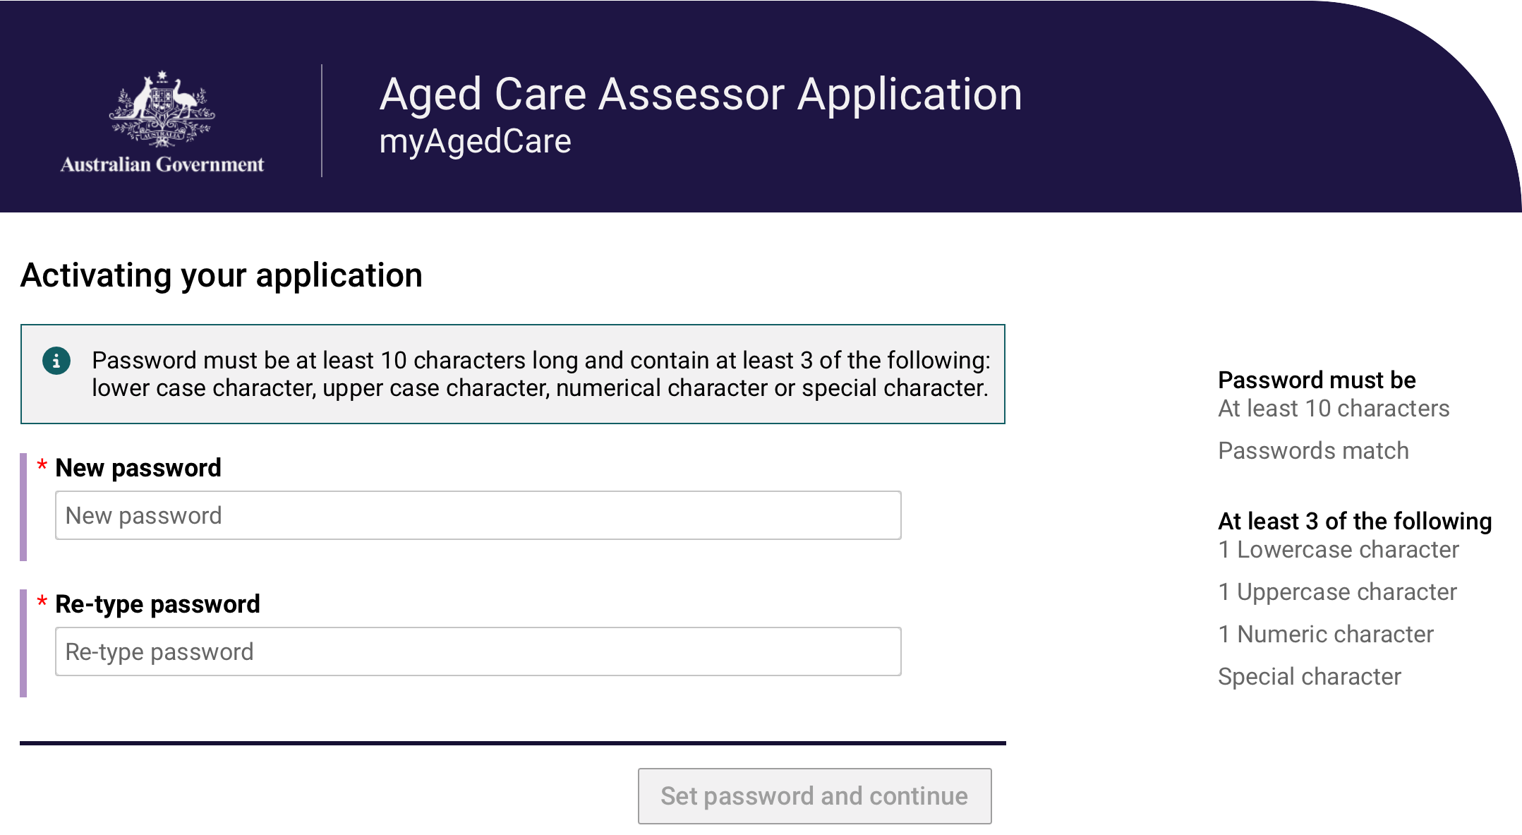
- After setting your new password, the App will complete a first time setup such as your profile and your assessment organisations information. Once the setup is complete, select the Continue button.
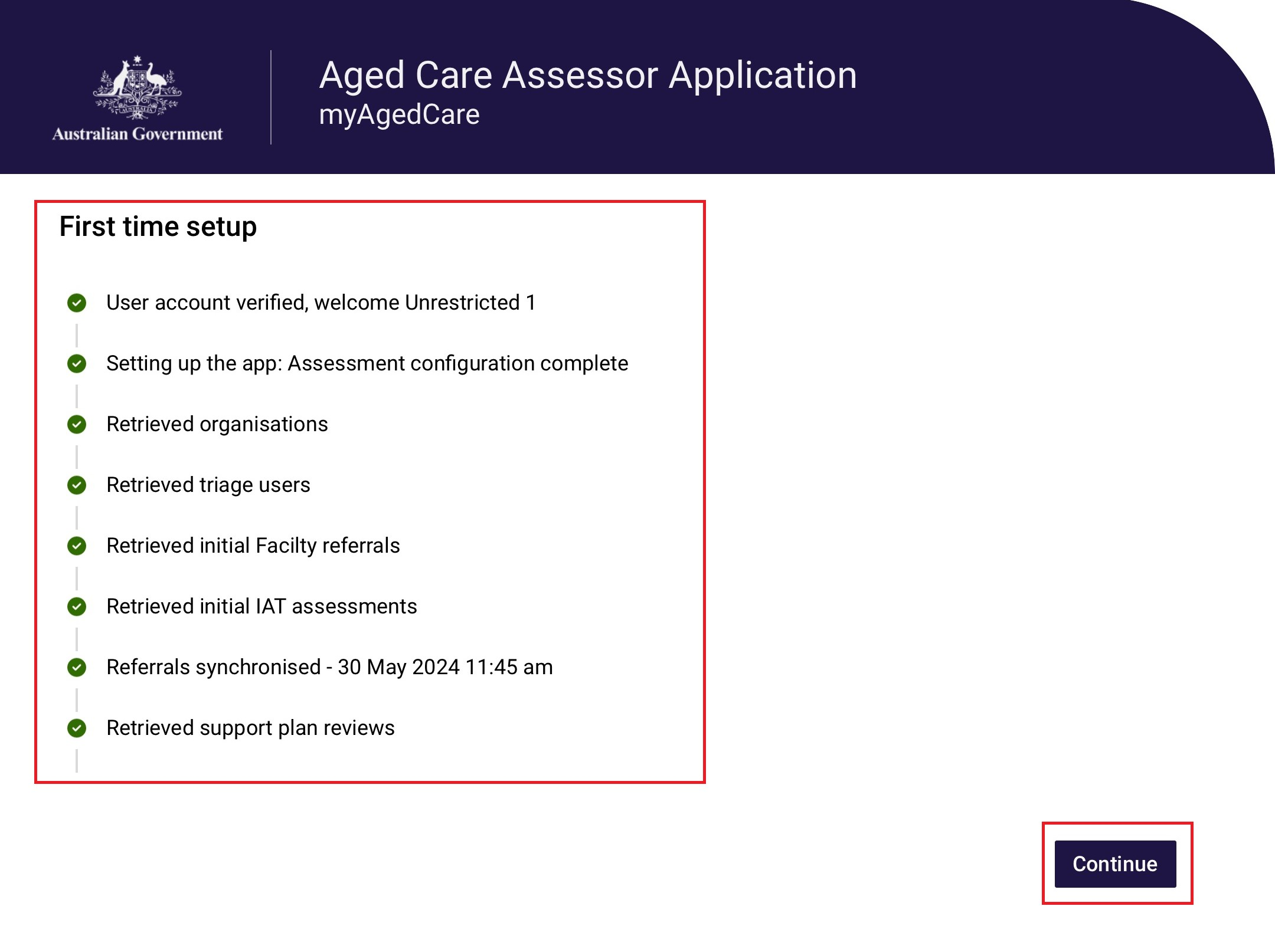

- You have now successfully completed the activation process. The next time you sign in to the App, follow the steps outlined below in the Login to the App section.
10. After successfully logging in, the home page (dashboard) will display.
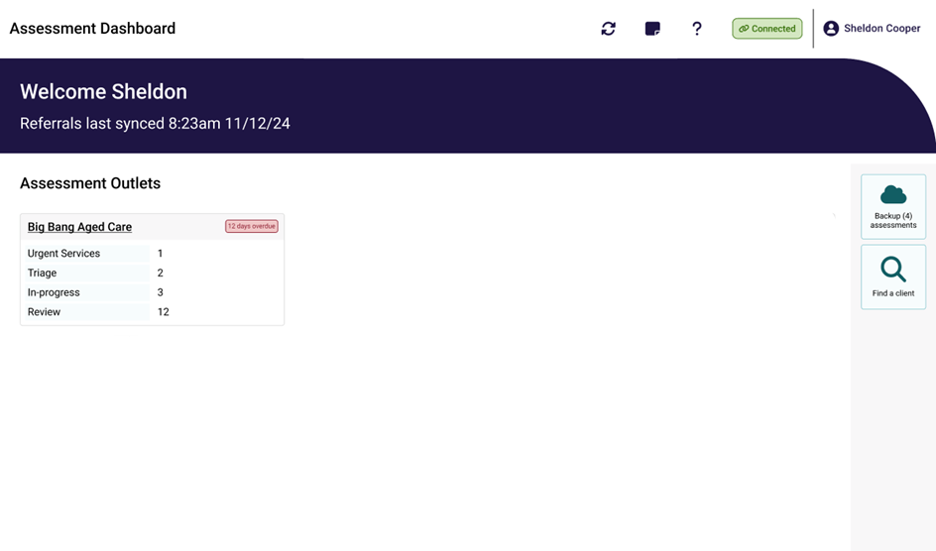
! | The first time you log in to the App you may not see any referrals.  Select Refresh referrals to load assessment referrals assigned to you.  If you experience issues with refreshing referrals, follow the steps in Troubleshooting and Diagnostics to diagnose issues experienced with the App.

3.3 Uninstalling the App
If you experience any issues with the App, you may be instructed to uninstall and then reinstall the App. Follow the steps to uninstall the app depending on the operating system you use.
Android
1. Touch and hold the App icon.
2. Tap App Info.
3. Tap Uninstall and confirm the prompt.
iOS
1. Touch and hold the App.
2. Tap Remove App.
3. Tap Delete App, then tap Delete to confirm.
Windows 10+
1. Select Start and look for the app or program in the list shown.
2. Press and hold (or right-click) on the App, then select Uninstall.

3.4 First time access following a reinstall of the App
If you wish to reinstall the App after uninstalling, you will need to activate your App status again. To do this please refer to Activating the App.

3.5 Reactivating the App
The App can only be used on one device by one user at any one point in time, and access cannot be shared. If the device needs to be assigned to another user, select the Logout button from the sign in screen in the app.
Alternatively, the user that now has the device can reactivate the app:
- Log onto the Assessor Portal and go to the Aged Care Assessor app tile.
- Select RE-ACTIVATE AGED CARE ASSESSOR APP. This will deactivate the App and send a new activation code to the user’s registered email address. Please note that this will remove all client and user data from the device.
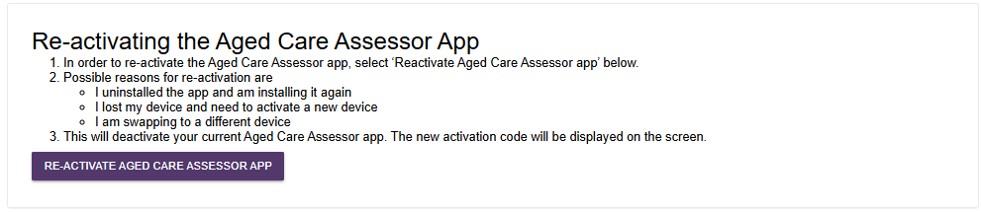
- Select Re-activate Aged Care Assessor App at the pop up.
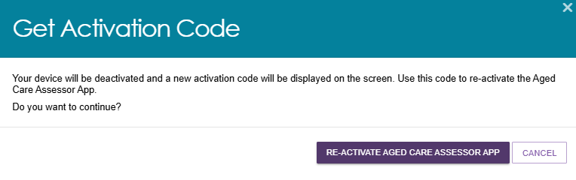
- The Get Activation Code pop up appears. Follow the rest of the steps in the section Activating the App.
The new user can also get the Activation code by calling the My Aged Care service provider and assessor helpline (1800 836 799).

4. Launching and closing the App

4.1 Login to the App
To launch the App after the first-time activation process you should:
- Open the App from your device. The password page will display, and you will be prompted to enter your password and then select Login.
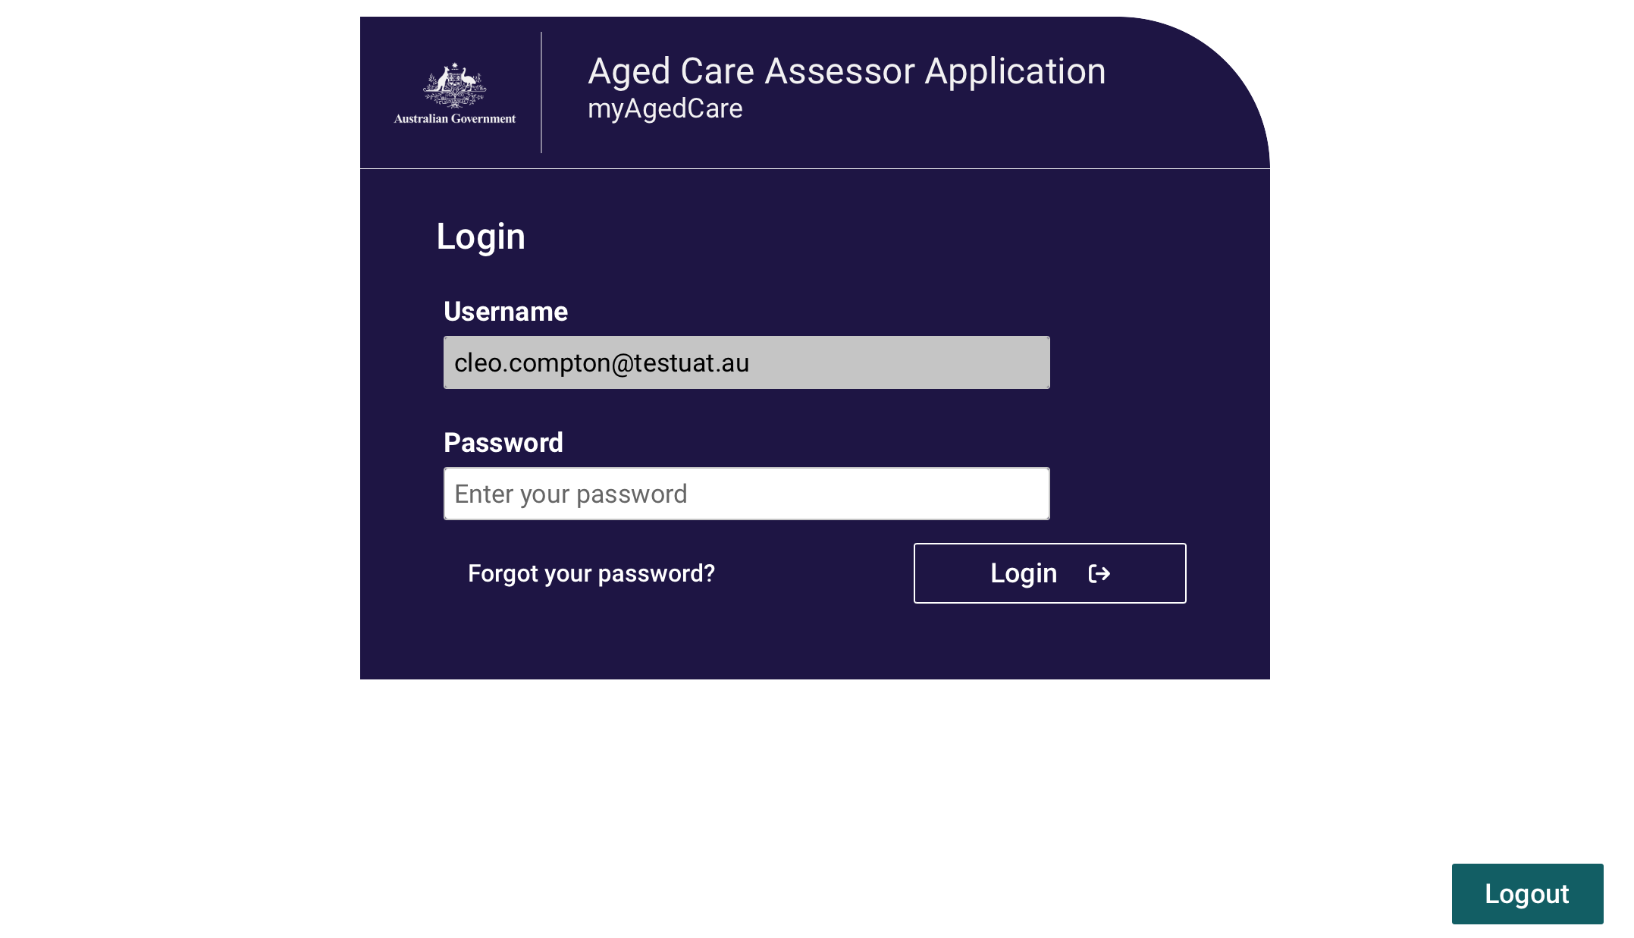
- The Dashboard displays, and you can view the list of outlets or facilities that you have been assigned to assess. If you have any assessments assigned to you then you will also see these under the related outlet or facility.
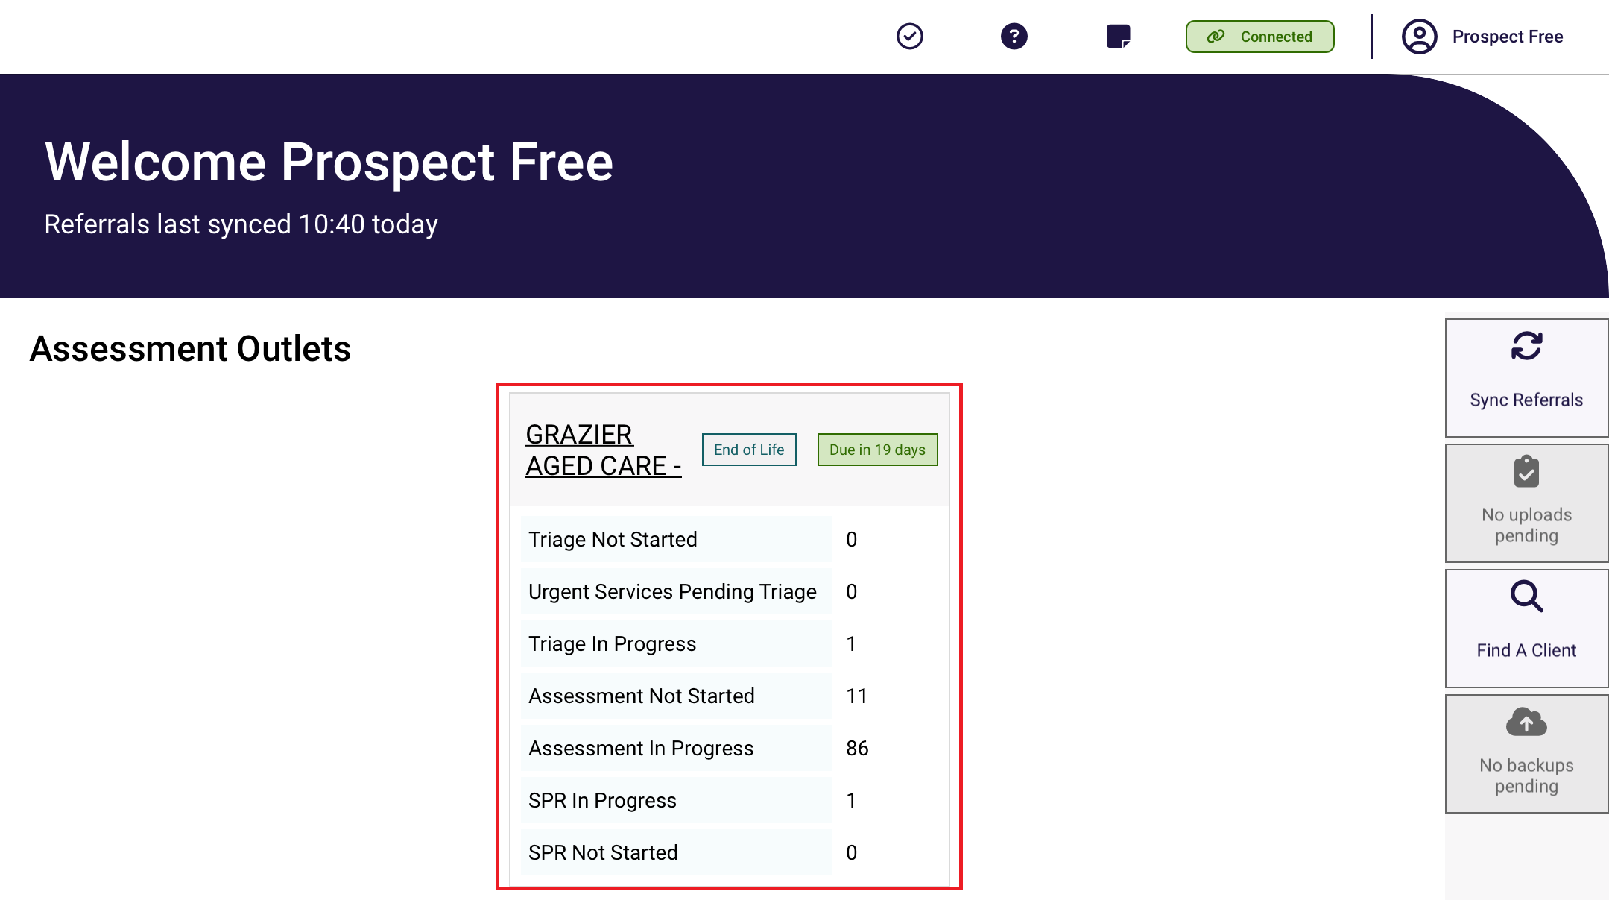

4.2 Inactivity time-out
The App will timeout if there is no activity for 5 minutes and you will be required to login to the app again. Provided you have been working in an online mode, all data you have been working on will be auto-saved every 15 minutes. If you are working in offline mode and are logged out of the app due to inactivity, data you have entered will not be backed up to My Aged Care but will be available on the device still.

4.3 Generating an Unlock Code
You will be locked out of the App if you forget your password, enter your password incorrectly five times, or do not use the App for 14 days.
You can regain access in the App section of the assessor portal. To do so, select Generate an Unlock Code. Enter this code into your device and you will then be able to reset your password and log in.
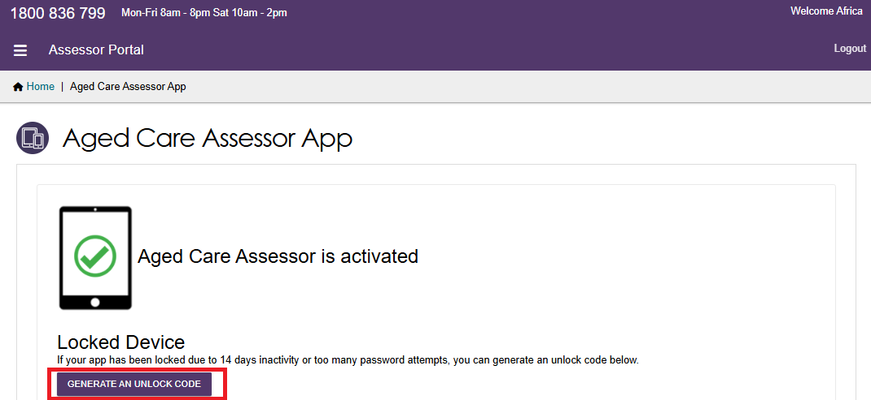
If the portal is unavailable, you can also call the My Aged Care service provider and assessor helpline on 1800 836 799 to generate an unlock code.

4.4 Closing the App
To close the App, you can either navigate to the top right of the screen and close the App window (Windows), or swipe up from the bottom of your screen (most iOS and Android versions).

4.5 Logging out of the App
This will remove your current activation and will require a new code to be entered.
- Select your profile button from the dashboard menu screen.
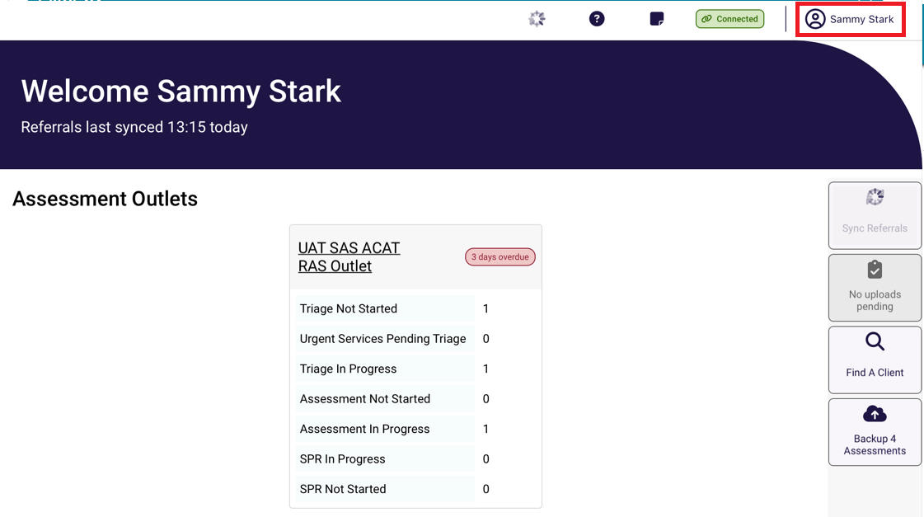
- Select the Logout button.
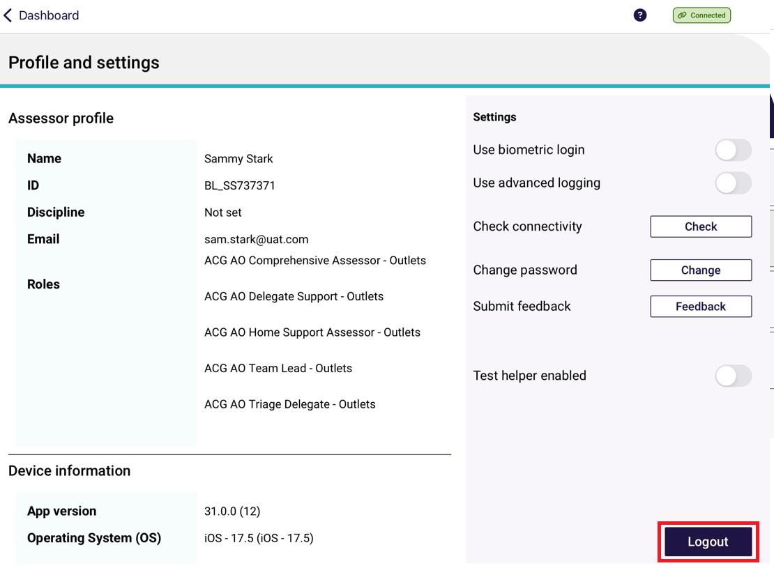
- Confirm that you wish to logout.
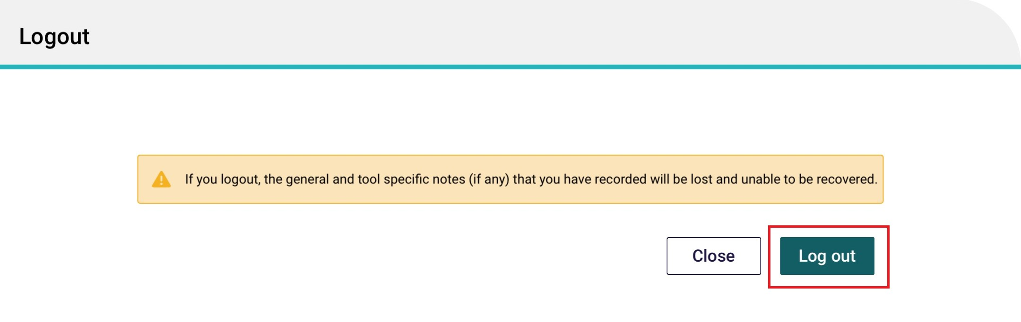

App symbols
Symbol | Definition
 | Sync - Starts a sync to gather user profile data and assigned referrals. Use this if after a few minutes on first log in you still do not see any referrals.
 | No uploads pending – means that there are no assessments that are pending to be uploaded via the internet.  Click this to upload referrals when they are in Completed status.
 | Find a Client – Opens the Find a Client page to start a search.
 | Backup Assessment – click this button to backup all assessments.
 | Quick Notes – Opens the Quick Notes page to quickly access a free text field for general purpose comments. This is a feature which allows notes to be recorded on the App.
 | Help and Support - Shows links to Aged Care Assessor App User Guide, My Aged Care Assessment Manual, AT User Guide, Terms of Use and Privacy.
 | Profile and settings – view your profile, settings and connectivity.
 | Connected – means you have connectivity to the internet. You are in an online state.
 | Not connected - means you do not have connectivity to the internet. You are in an offline state. App is limited to offline functions.
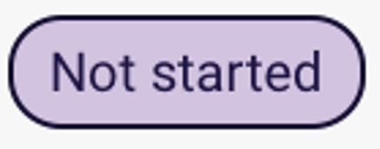 | Not started – indicates the assessment has not commenced.
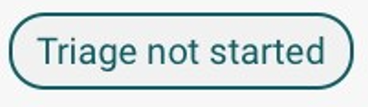 | Triage not started – indicates triage has not commenced.
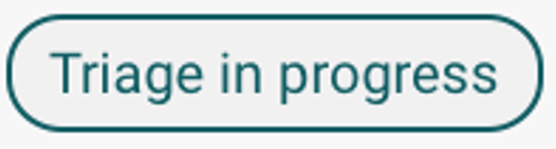 | Triage in progress – indicates the assessment referral has entered the stage of triage.
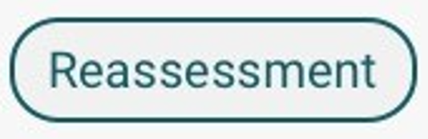 | Reassessment – indicates the assessment referral is a reassessment.
  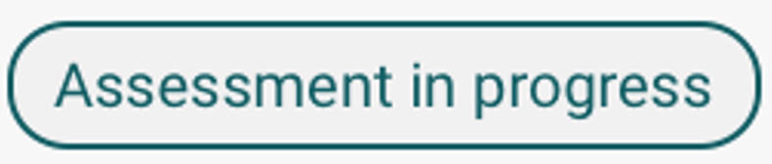 | In progress or Assessment in progress - indicates the assessment has been started and not completed.
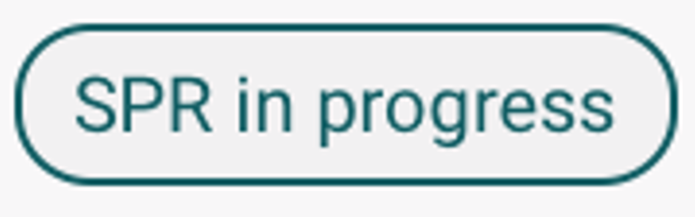 | SPR in progress – indicates the Support Plan Review has been started.
 | Self-referral – indicates the assessment referral is a self-referral that you have referred to yourself.
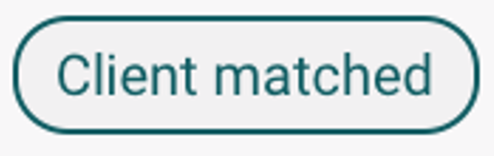 | Client matched – indicates you have matched an offline client to an existing client once you have regained internet connection.
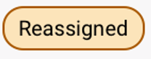 | Reassigned – indicates the assessment referral has been reassigned in the Assessor portal to another user.
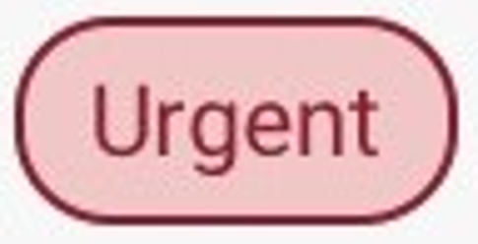  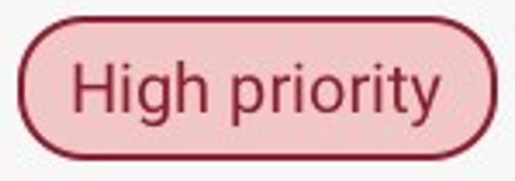  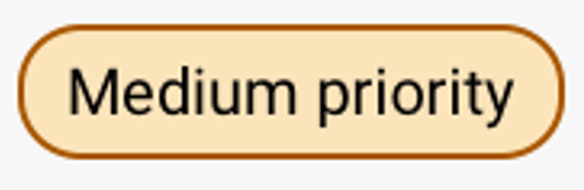  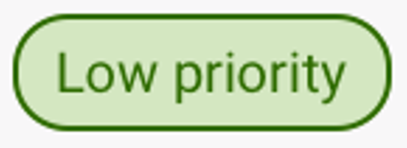 | Priority – depending on the client care needs, a priority for assessment is set.
 | End-Of-Life – flags any IAT assessment or Support Plan Reviews that are on the End-of-life pathway.
 | Aboriginal and Torres Islander Assessment Organisation – flags any client’s IAT assessment or Support Plan Review that has a preference to be assessed or reviewed by such an Assessment Organisation.
 | Hospital assessment - flags any IAT assessment of Support Plan Reviews that are assessed or reviewed in a hospital.
 | Clear answers or page information – selecting Clear page information will clear any information entered on the current page of the assessment that the assessor is working on.
 | Help - displays more detailed information about that page or tool.
 or  | More information – in certain areas within the app, these icons will appear to provide further information on particular questions.
 or  | Assessor comments or Quick notes is a feature, which allows notes to be recorded on the App.  These notes could be sensitive in nature or may be notes that are for later reference during the assessment process.
 | Double Chevrons – these will allow you to open the side panel.
 | Requires action – indicates the section of the assessment is incomplete.
 | Complete – indicates the section of the assessment is completed.
 | Download assessment – indicates the assessment had not been downloaded to the device yet. When downloaded, this icon will disappear.
 | Upload assessment – this will upload the assessment to the My Aged Care Assessor Portal.
 | Online Client - when an assessment has been matched online.
 | Offline Client – when an assessment is created offline and is not matched.
 | Error uploading – there has been an error during the uploading of the assessment referral.

Part B – IAT Assessments
! | ‘Assessment’ in Part B refers to aged care needs assessments completed by aged care needs assessors who complete assessments using the Integrated Assessment Tool (IAT).

Registering a client, self-referring for assessment, starting triage and starting a review
Needs assessors can register a new client within the App.
You must be connected to the internet to view and perform any of the functions referenced below.
If you are not connected to the internet, follow the steps to Create an offline client.
Following online client registration:
- Needs assessors can self-refer clients for assessment if the reason for assessment is In-hospital, remote assessment, First Nations, Homeless or at risk of, or the client is considered vulnerable.
- Referrals for reason outside of those listed above must be facilitated prior to linking to the registered client (refer to Linking offline clients and assessments).
! | The following functionalities cannot be completed offline:  - registering clients (online)  - self-referring for assessment  - downloading a client’s referral for assessment  - uploading assessment information to the My Aged Care assessor portal  - sharing device log data to the department.
Once the needs assessor has internet connectivity, client assessment and support plan information can be uploaded to the assessor portal.
The needs assessor can then submit to the delegate for approval (where necessary) or continue to match and refer, sending any necessary referrals for service. The client’s consent must be obtained prior to any referrals being sent.
The App also enables needs assessors to register a person who may not have previously registered with My Aged Care and conduct an assessment.
! | These functions are available in the assessor portal, please refer to:  My Aged Care – Assessor Portal User Guide 1 – Registering and referring clients.

6.1 Finding a client
Before you register a person, you need to confirm that they do not already have a client record.
! | If you are not connected to the internet, the Find a client function will not be available, and you can follow the steps in the Creating an offline client section to create a client via the Create Offline Client functionality.  You will then need register the client or link to an existing client when connected back to the internet.
- Select Find a client from the dashboard of the App.
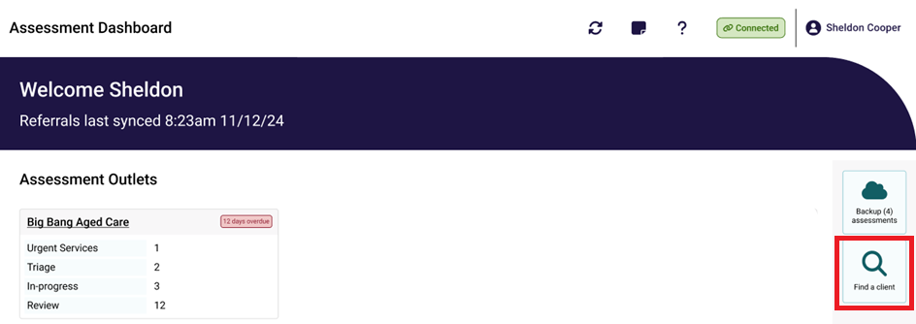
- Enter the client's first name, last name and/or Aged Care User ID and select Search.
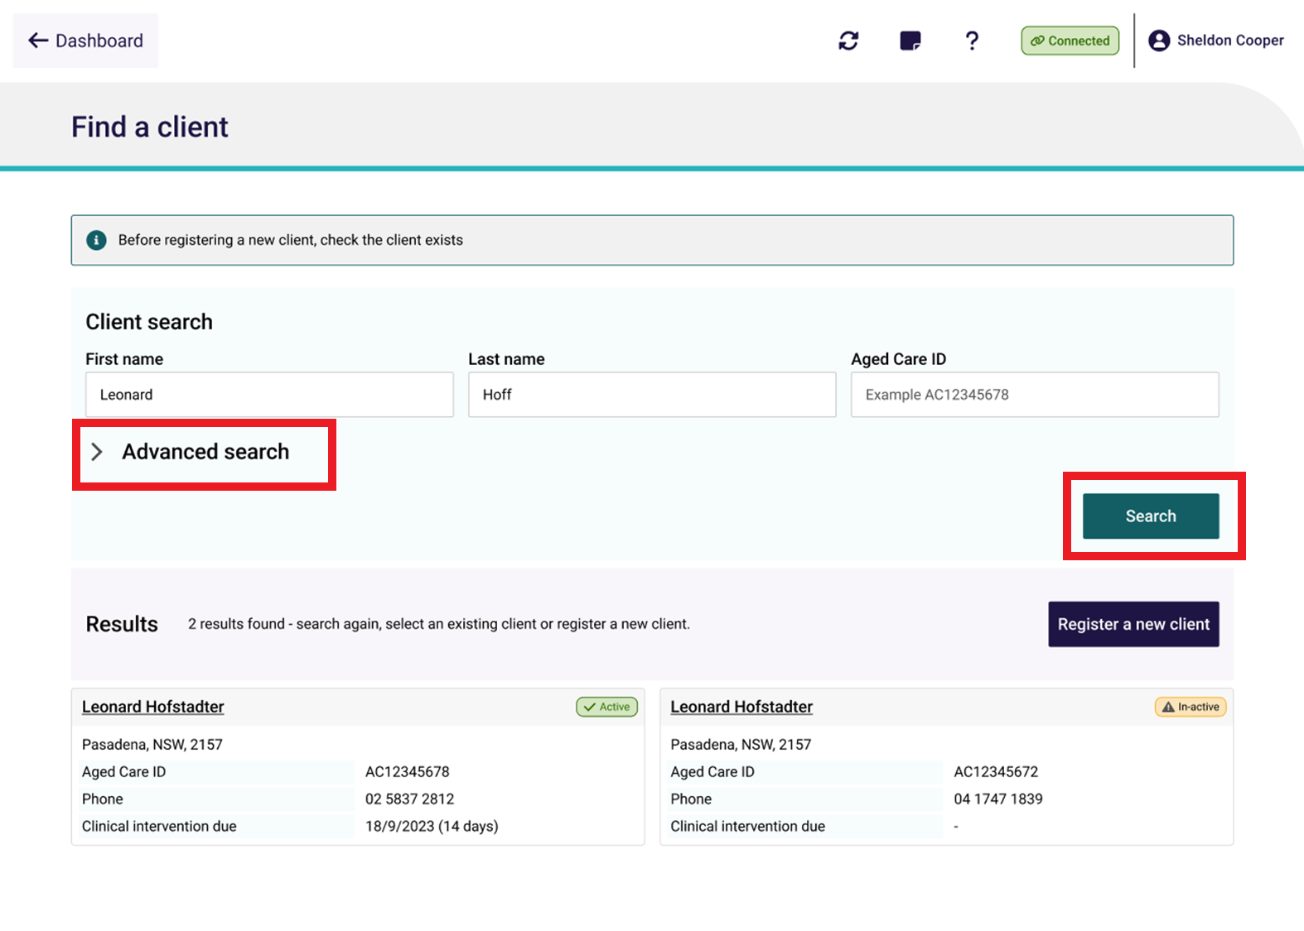
You can select Advanced search to conduct a custom or refined search.
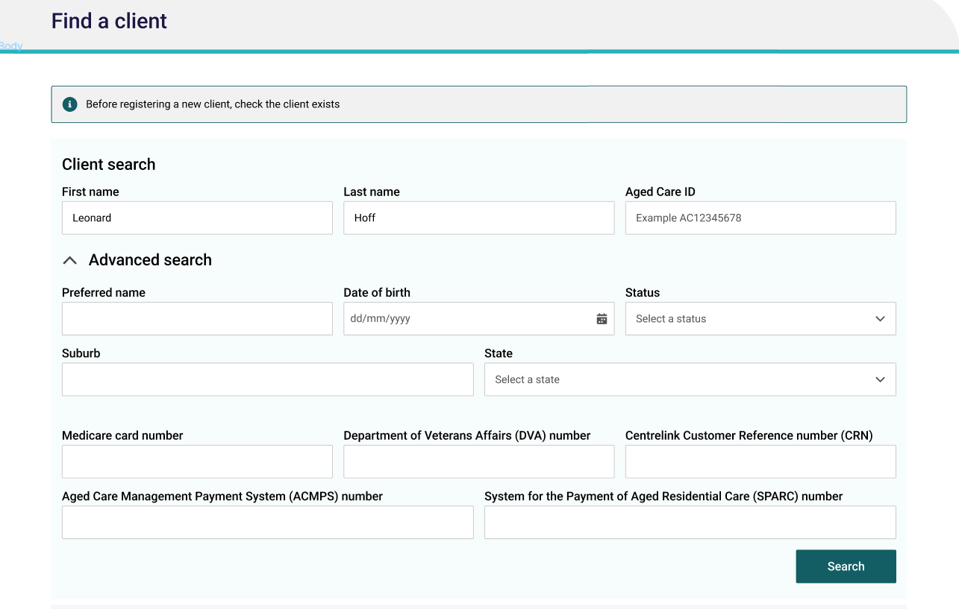
- Any matching search results will display.
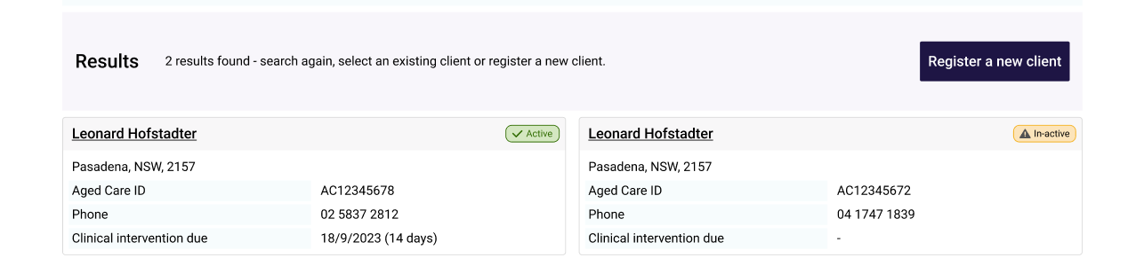
- If there is already an existing client record, select the appropriate record and continue from Self-referring for assessment to create a referral.
If there are No records found or the client record searched for is not returned in the search results, you can select Register a new client.
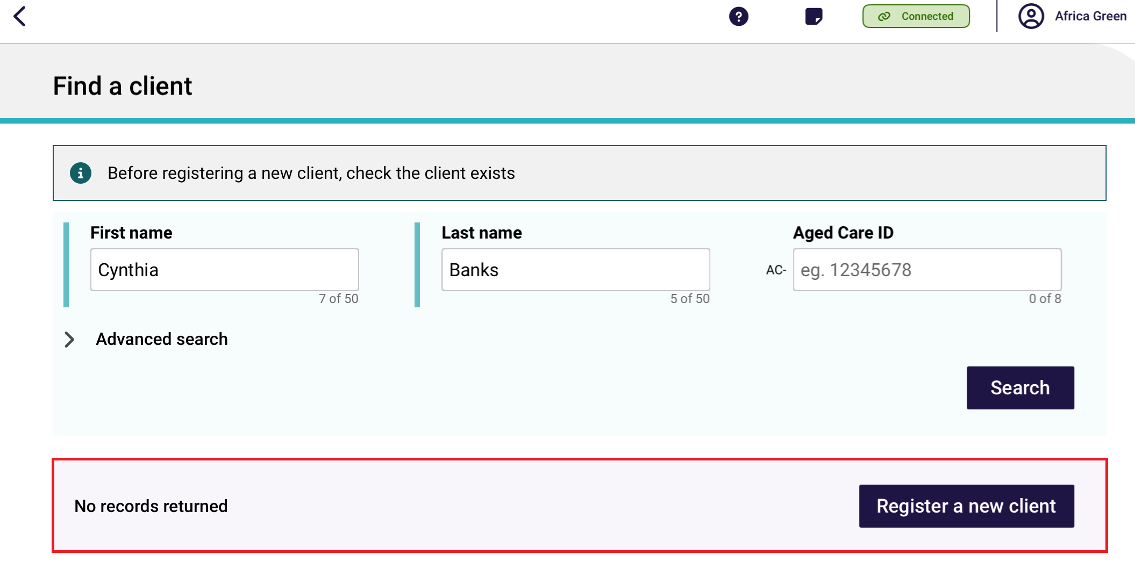

6.2 Registering a client
Follow the steps below to register a new client in the App. You must be connected to the internet.
- On the Personal details page, enter the client’s personal information. Fill out all mandatory fields. These are shown by red asterisk next to the field. Red boxes provide advice on what information is required.
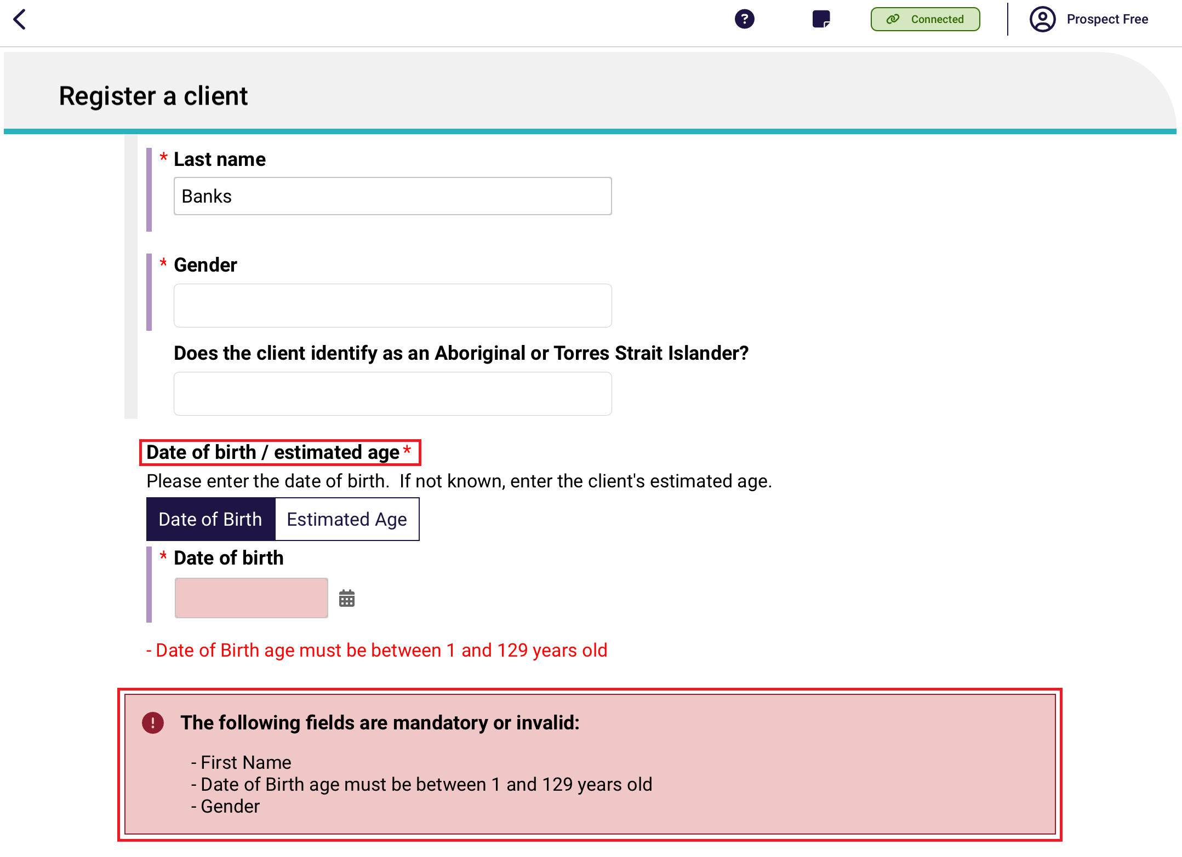
- On the Address details page, you can search for the client’s address. If the client’s address is not available from the drop-down list, you can select to enter the address manually.
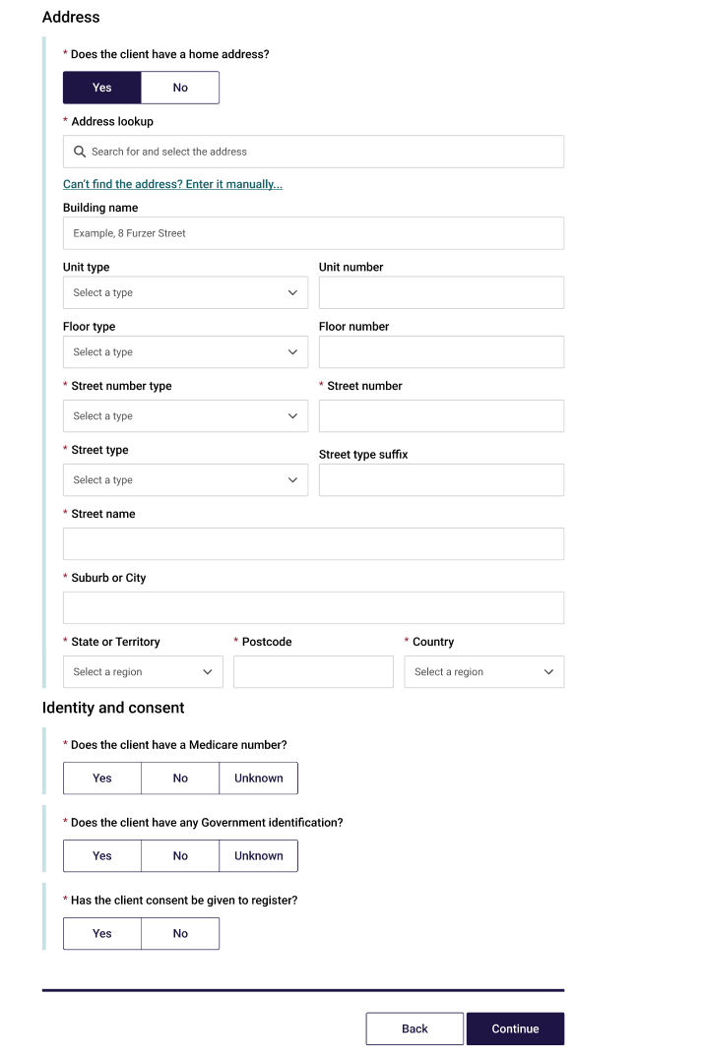
! | While you are entering client information in the Personal details, Address details and Identity Match/Consent sections, the App will check in real time for potential duplicate records.  Refer to Potential Duplicates for more details.
- On the Identity Match page, enter in any Government ID information that the client has provided. Once all mandatory client information has been entered, select Continue.
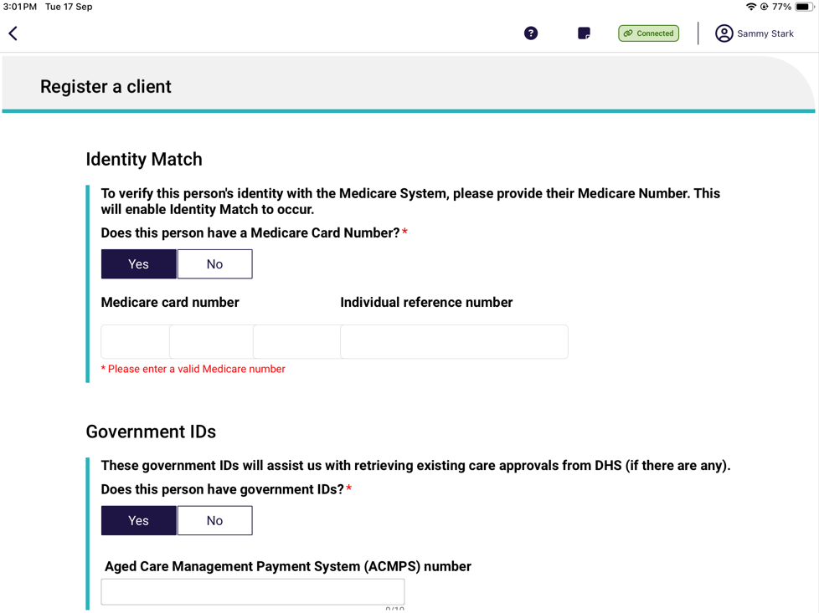
- You will be required to confirm the client’s consent to be registered with My Aged Care.
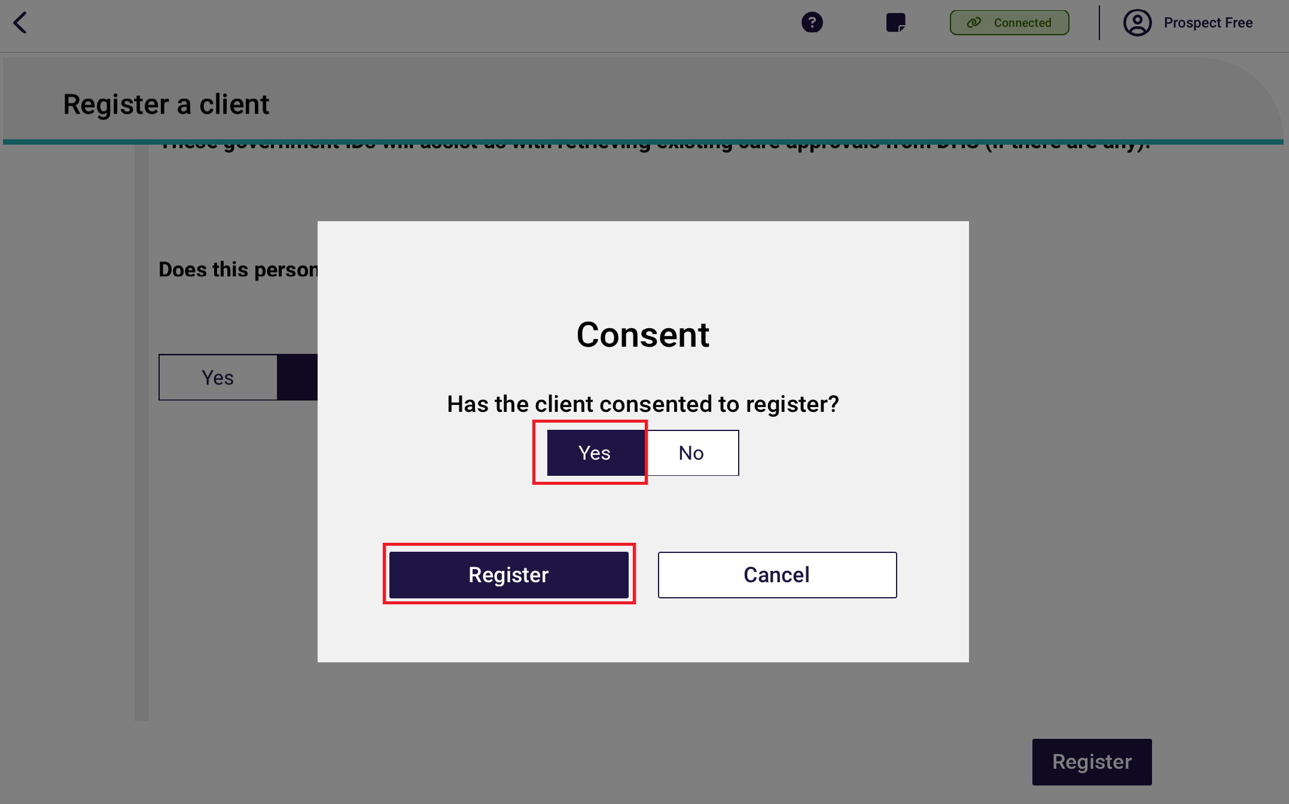
! | The Register button will not be enabled until all mandatory client information has been entered on the Personal details, Address details and Identity Match pages.
If registration is successful, you will be taken to the Client details page.
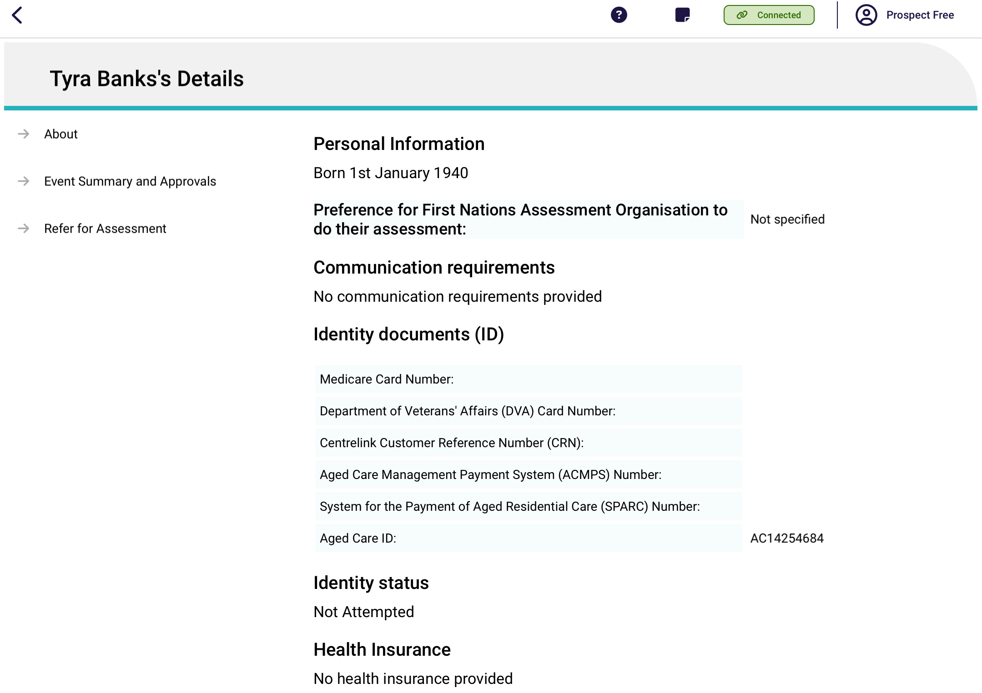

6.3 Potential Duplicates
While you are entering client information prior to registration, the App will check for any potential duplicates.
Select Review duplicate clients to view the possible matching client records.
! | If there are any potential duplicate matches found, you will be required to view these records prior to registering the new client to avoid creating a duplicate client record in My Aged Care.
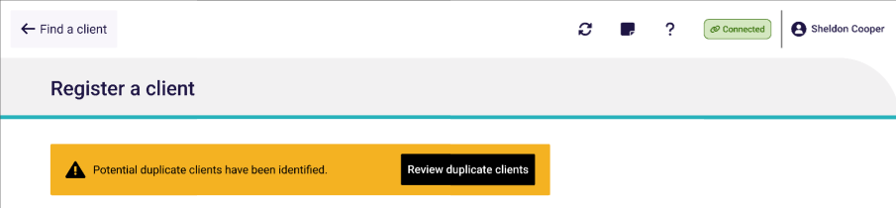

The list of potential duplicate matches will be displayed on the left side of the screen in list view. Select each record to see a visual comparison of client details against the client record being registered.
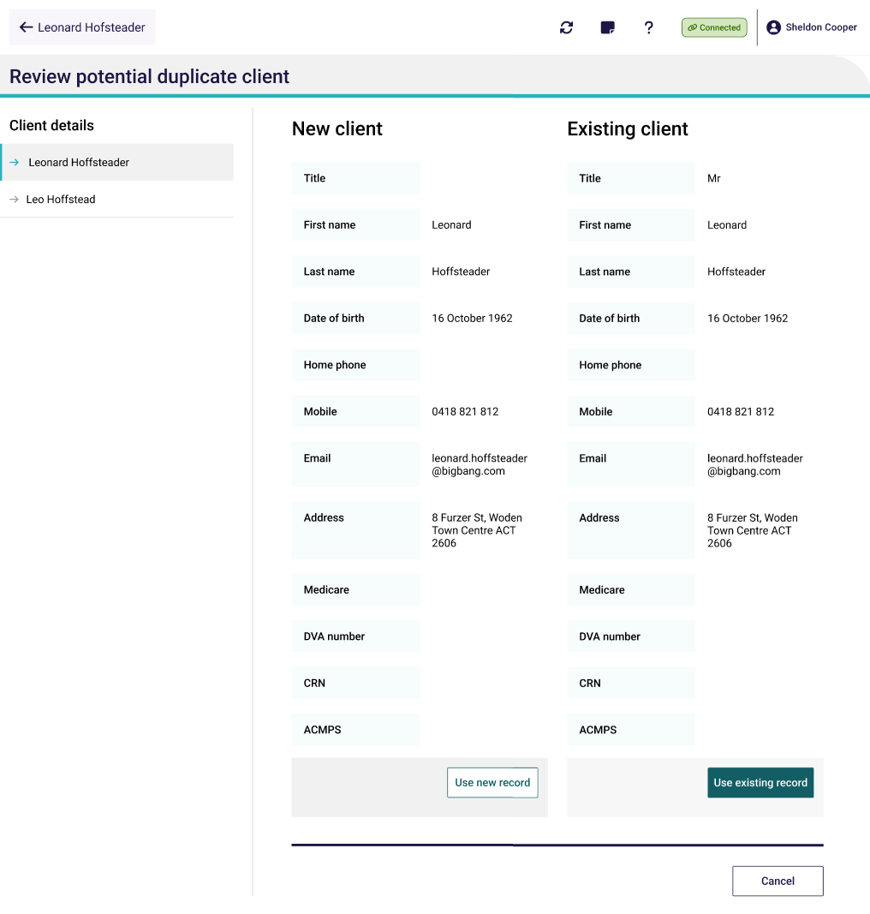
If you choose to Use new record, continue to Self-referring for assessment or facilitate a referral for assessment.
If none of the potential duplicate matches are the client you are registering, select Use new record to complete the registration process.
! | It is important to view any potential duplicate records prior to registering a new client to prevent the creation of duplicate client records in My Aged Care.

6.4 Self-referring for assessment
When you self-refer a client for assessment in the App, the client’s referral will be assigned to you. You must be connected to the internet.

! | Needs assessors can only self-refer clients if they are:  - in hospital  - conducting a remote assessment  - first Nations; or  - homeless or at risk of  - vulnerable groups.  If the client is not being self-referred for one of these reasons, the needs assessor must facilitate a referral by contacting the My Aged Care service provider and assessor helpline on 1800 836 799.
- When you have found or registered the client you wish to self-refer for an assessment, select Refer for assessment from the client’s record in the App.
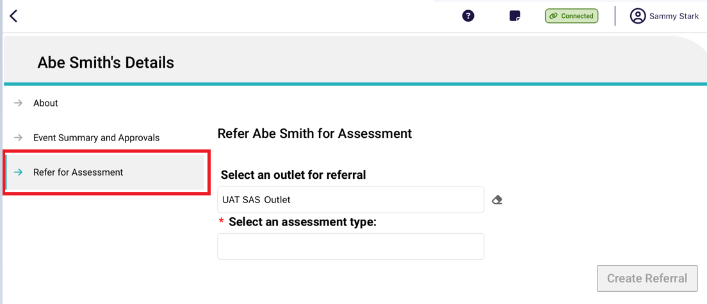
- Select the outlet that the assessment will be associated to (if you are assigned to multiple outlets), and the assessment type. Depending on the assessment type selected additional information may be required such as the assessment setting, priority, assessment date and reason for self-referral. Once all information has been entered select Create referral.
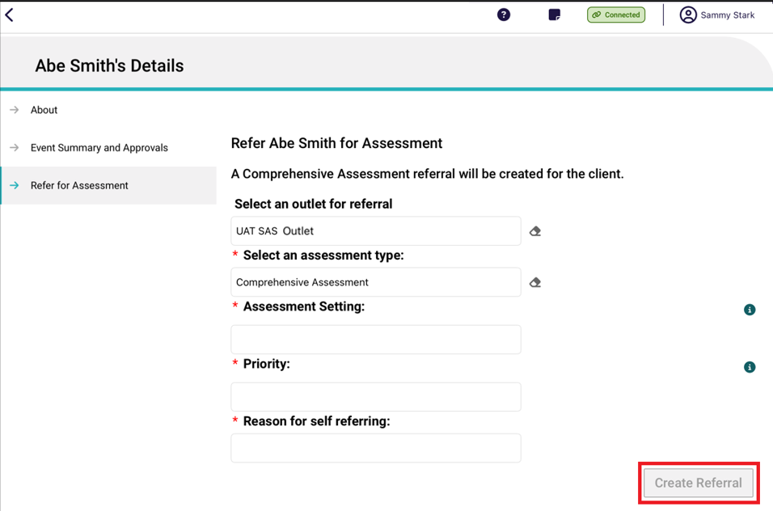

! | If the client is undergoing an assessment, an error message will display, and you will be unable to refer the client for the assessment.
- If the referral is created successfully, you can select Go Back to go to the Dashboard to download the client’s record.
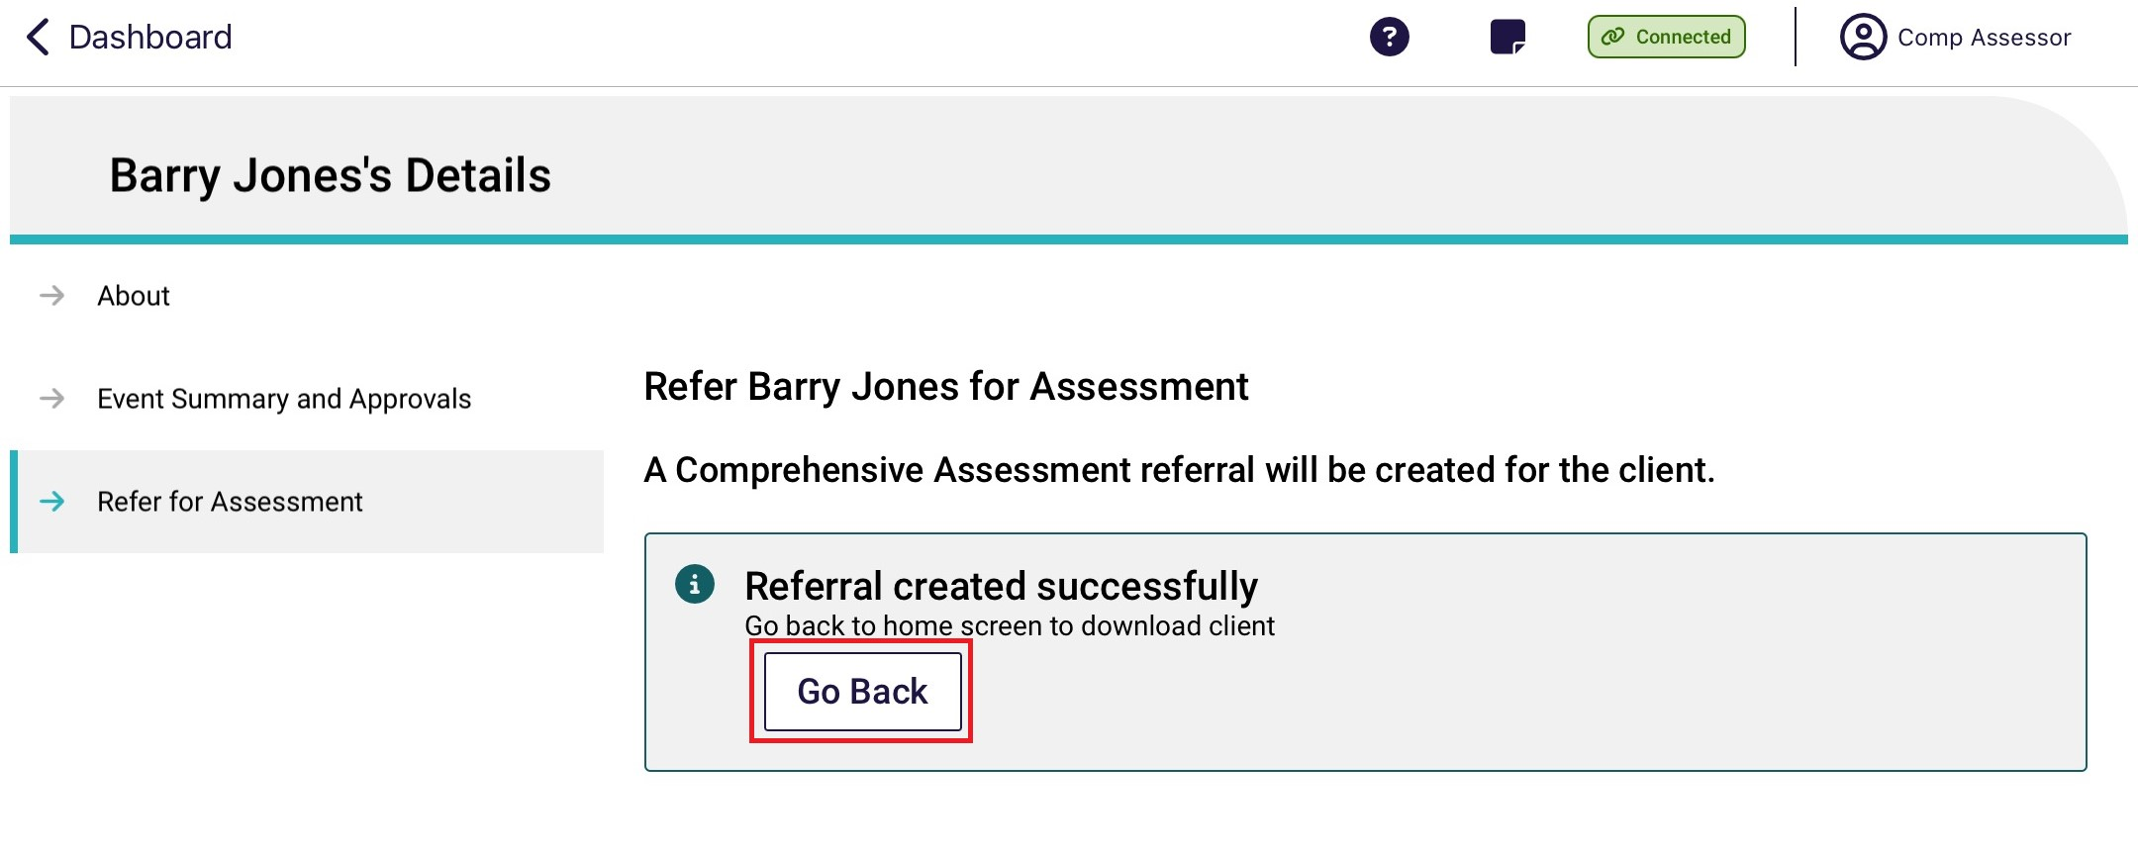

6.5 Starting Pre-Triage questions with consent for a client using the IAT (Self-Referral)
- Before commencing an assessment, you will be required to gain consent to complete the Triage questions with the client.
- Self-Referrals will require the Triage questions to be completed by a Triage Delegate. If you are not a Triage Delegate, you will be required to have triage supervised by a Triage Delegate.
! | Assessment Organisation Triage Delegates will need to be assigned to the Triage Delegate role in the assessor portal and hold certain qualifications and certifications. For more information regarding assigning a Triage Delegate role please refer to My Aged Care – Assessor Portal User Guide 12 – Managing delegate roles
- If there appears to be a record of the client completing the triage or screening questions previously, you can use the ‘pre-populate’ feature as the basis of the triage.
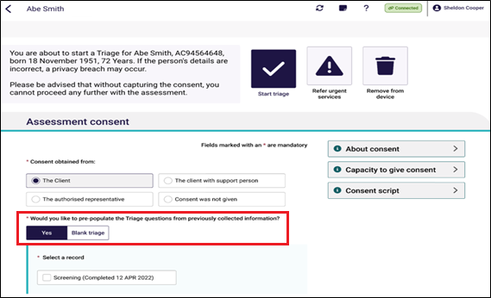
- If during the triage process, the client does not provide consent to proceed, you should record this in the Why was consent not provided? section.
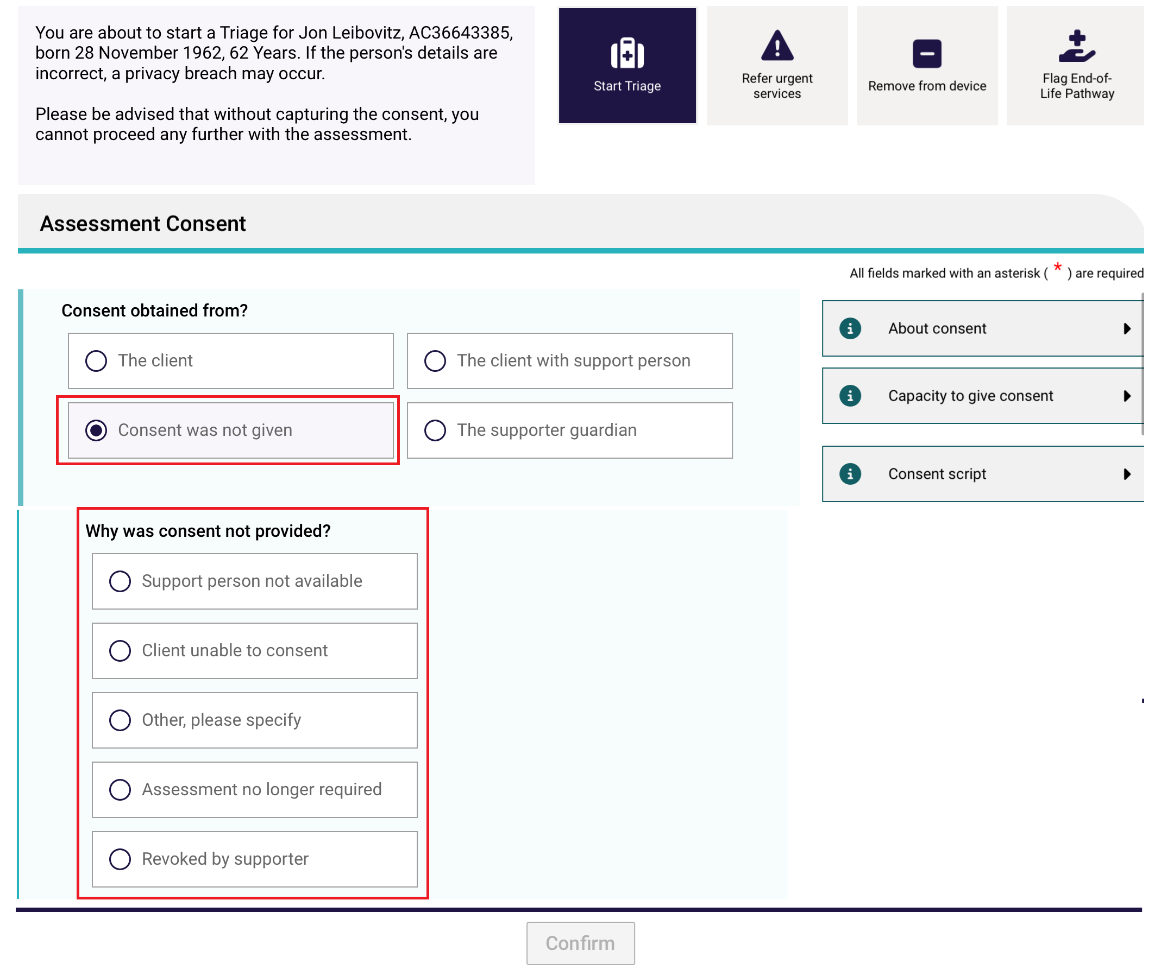
- You will also need to confirm that you have confirmed with the client that if consent is not provided, that the assessment will not be continued and that the assessment referral will be rejected.
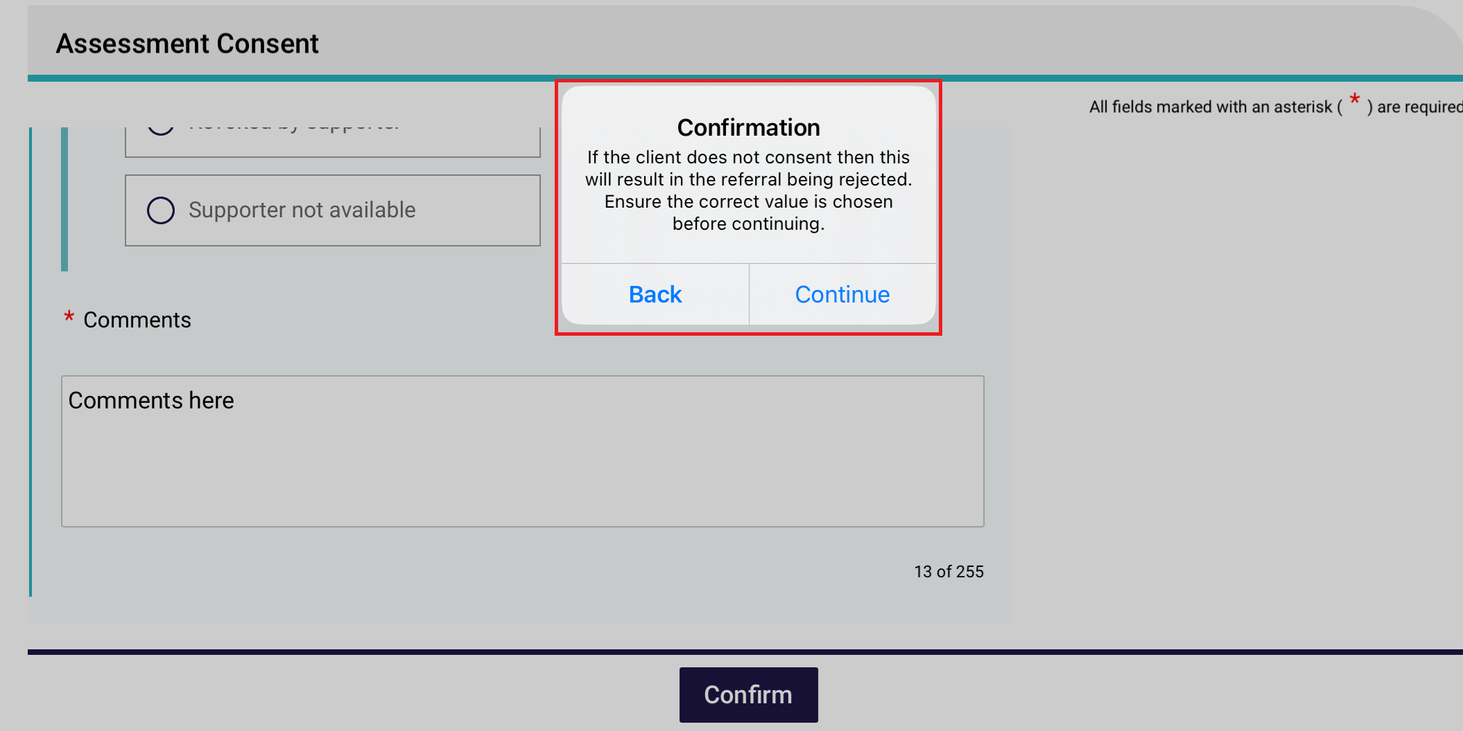

6.6 Refer urgent services before completing Triage
Before commencing the Triage questions, you will have the option to refer the client for urgent services before you can recommend for Support at Home and other services if required.
- Before starting a triage, select the Refer Urgent Services button.
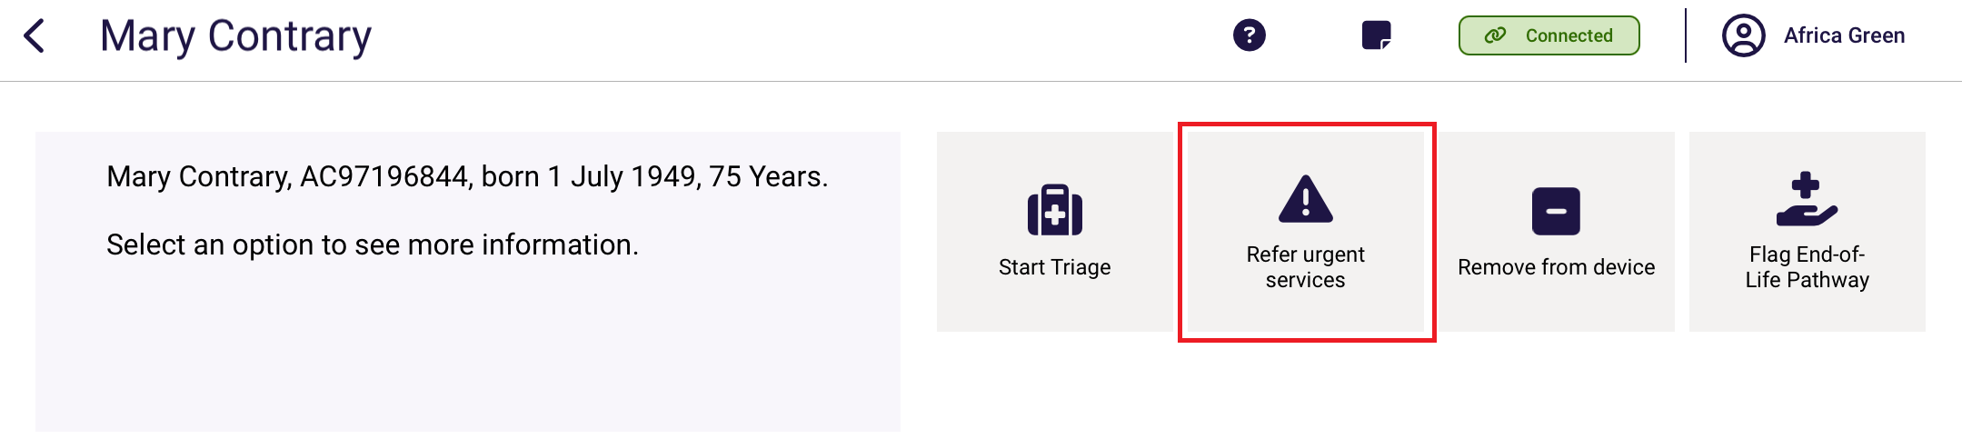
Alternatively, once the triage has started, in the Triage page, Select Yes to Does the client require urgent service provision (direct to service)?
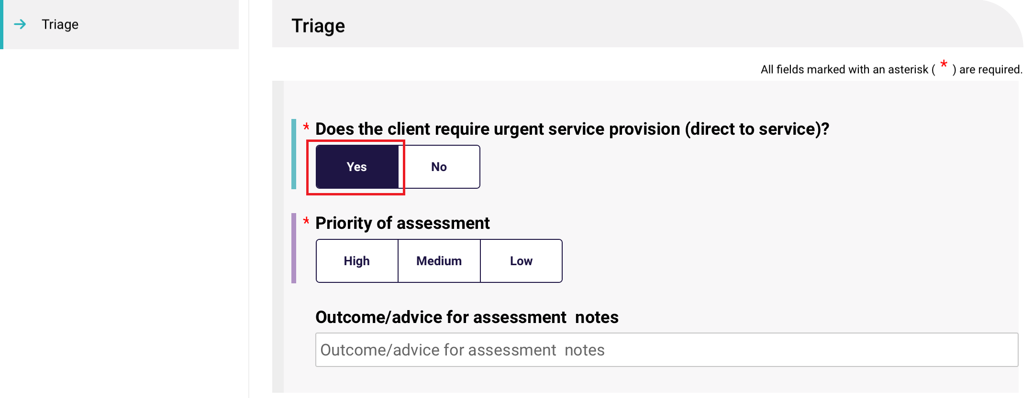
- Once you have selected the button, you will be asked to Confirm that you are wanting to proceed to refer the client for urgent services without progressing an assessment. Please note that you can start and complete the triage questions later.
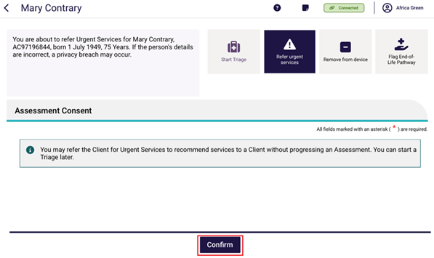
- Once you have selected Confirm, the support plan’s Recommendations section will appear where you can select + Add a recommendation.
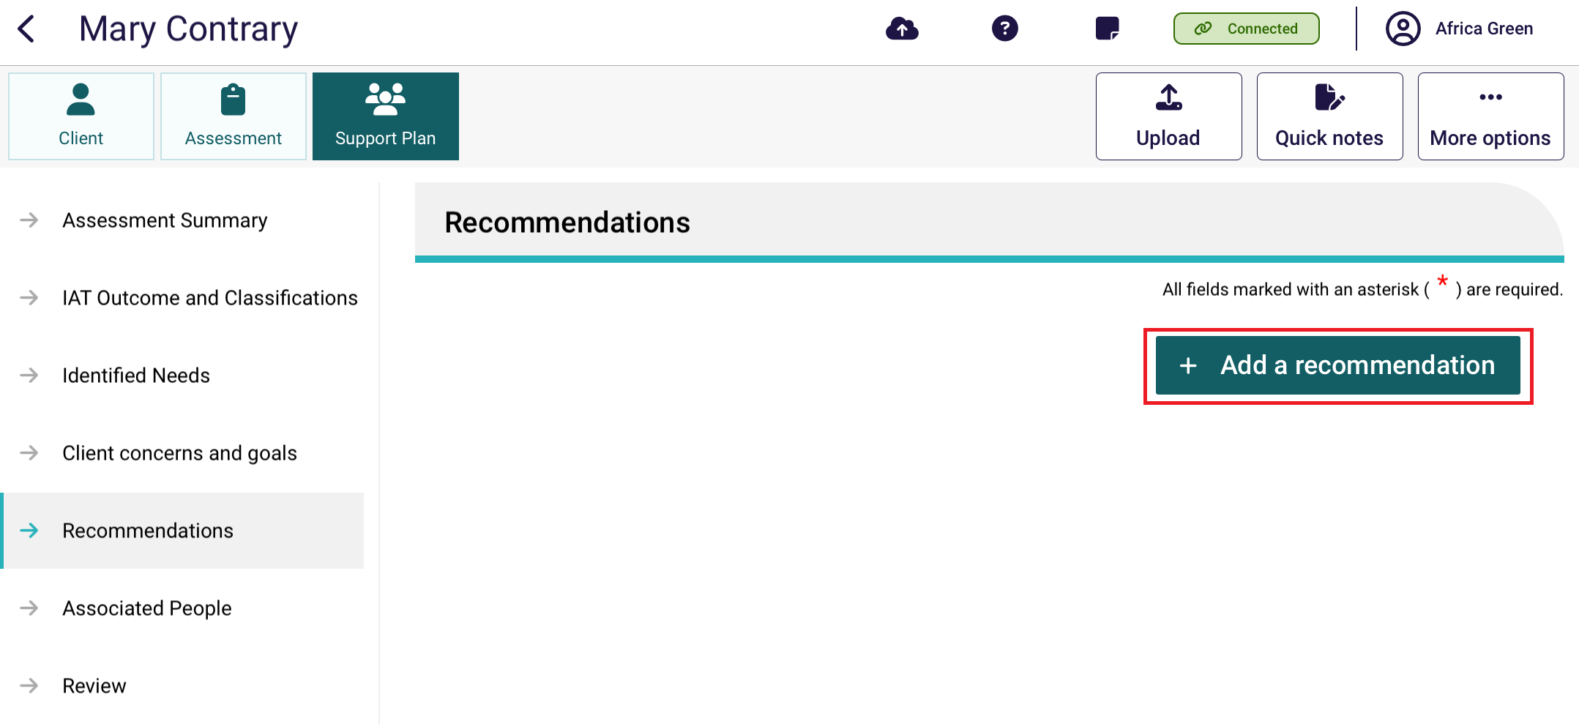
- Select the hyperlink Recommend next to Service Recommendation.
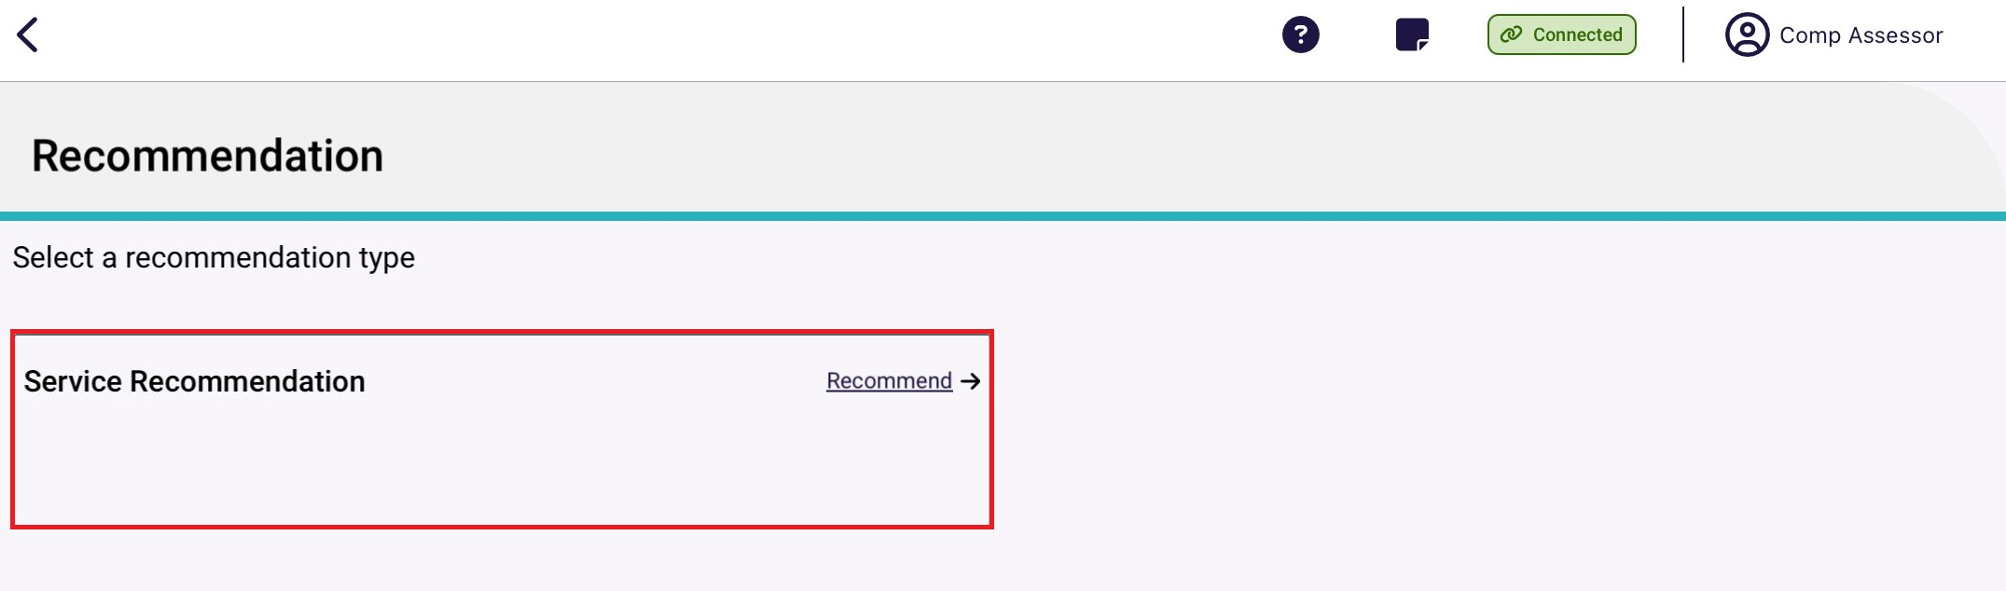
- Select Service type to display a drop down menu, then from the list displayed, select the service type required for urgent services.
Once a service type is selected, the services related to that service type is displayed. For example, Nursing Care contains three services: Registered nurse clinical care, Enrolled nurse clinical care, and Nursing assistant clinical care. Select one or more services required.
! | For more information on the services available in the Aged Care Act (2024) refer to New Aged Care Act resources for aged care assessors | Australian Government Department of Health, Disability and Ageing .
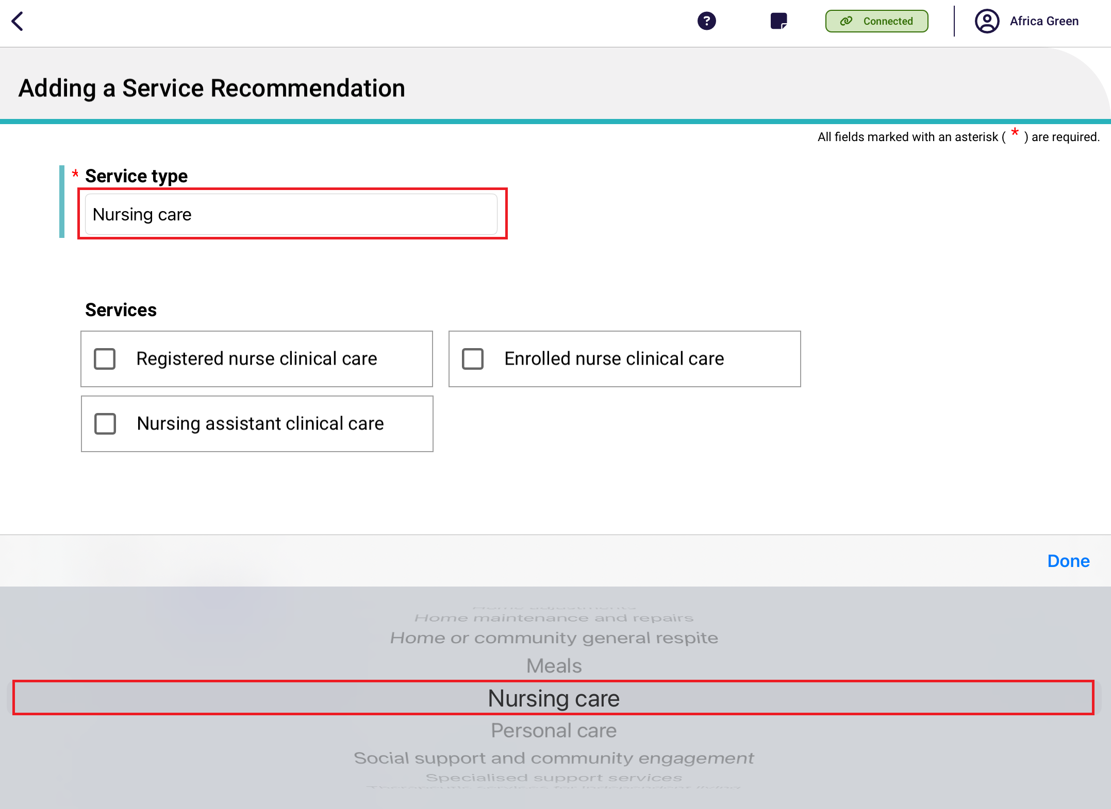
- Complete all mandatory fields for the service recommendation, including: Service type, Priority, Recommended start date, Recommended review date, and Recommended end date.
- Fields marked with a red asterisk are mandatory. After completing all relevant fields, select Save.
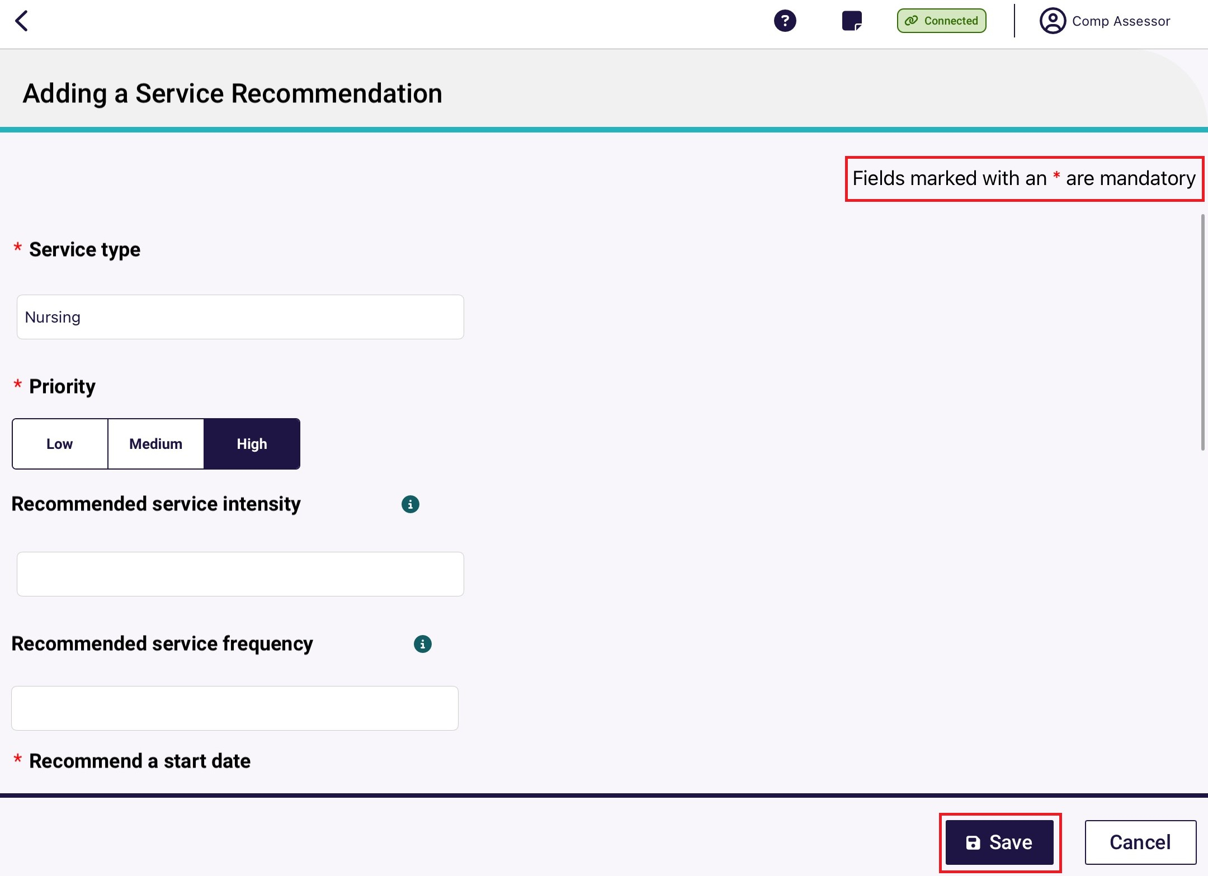

6.7 Starting Triage questions with client (Self-Referral)
- To complete the Triage stage, select Assessment. Complete the triage questions based on the information provided to you by the client.
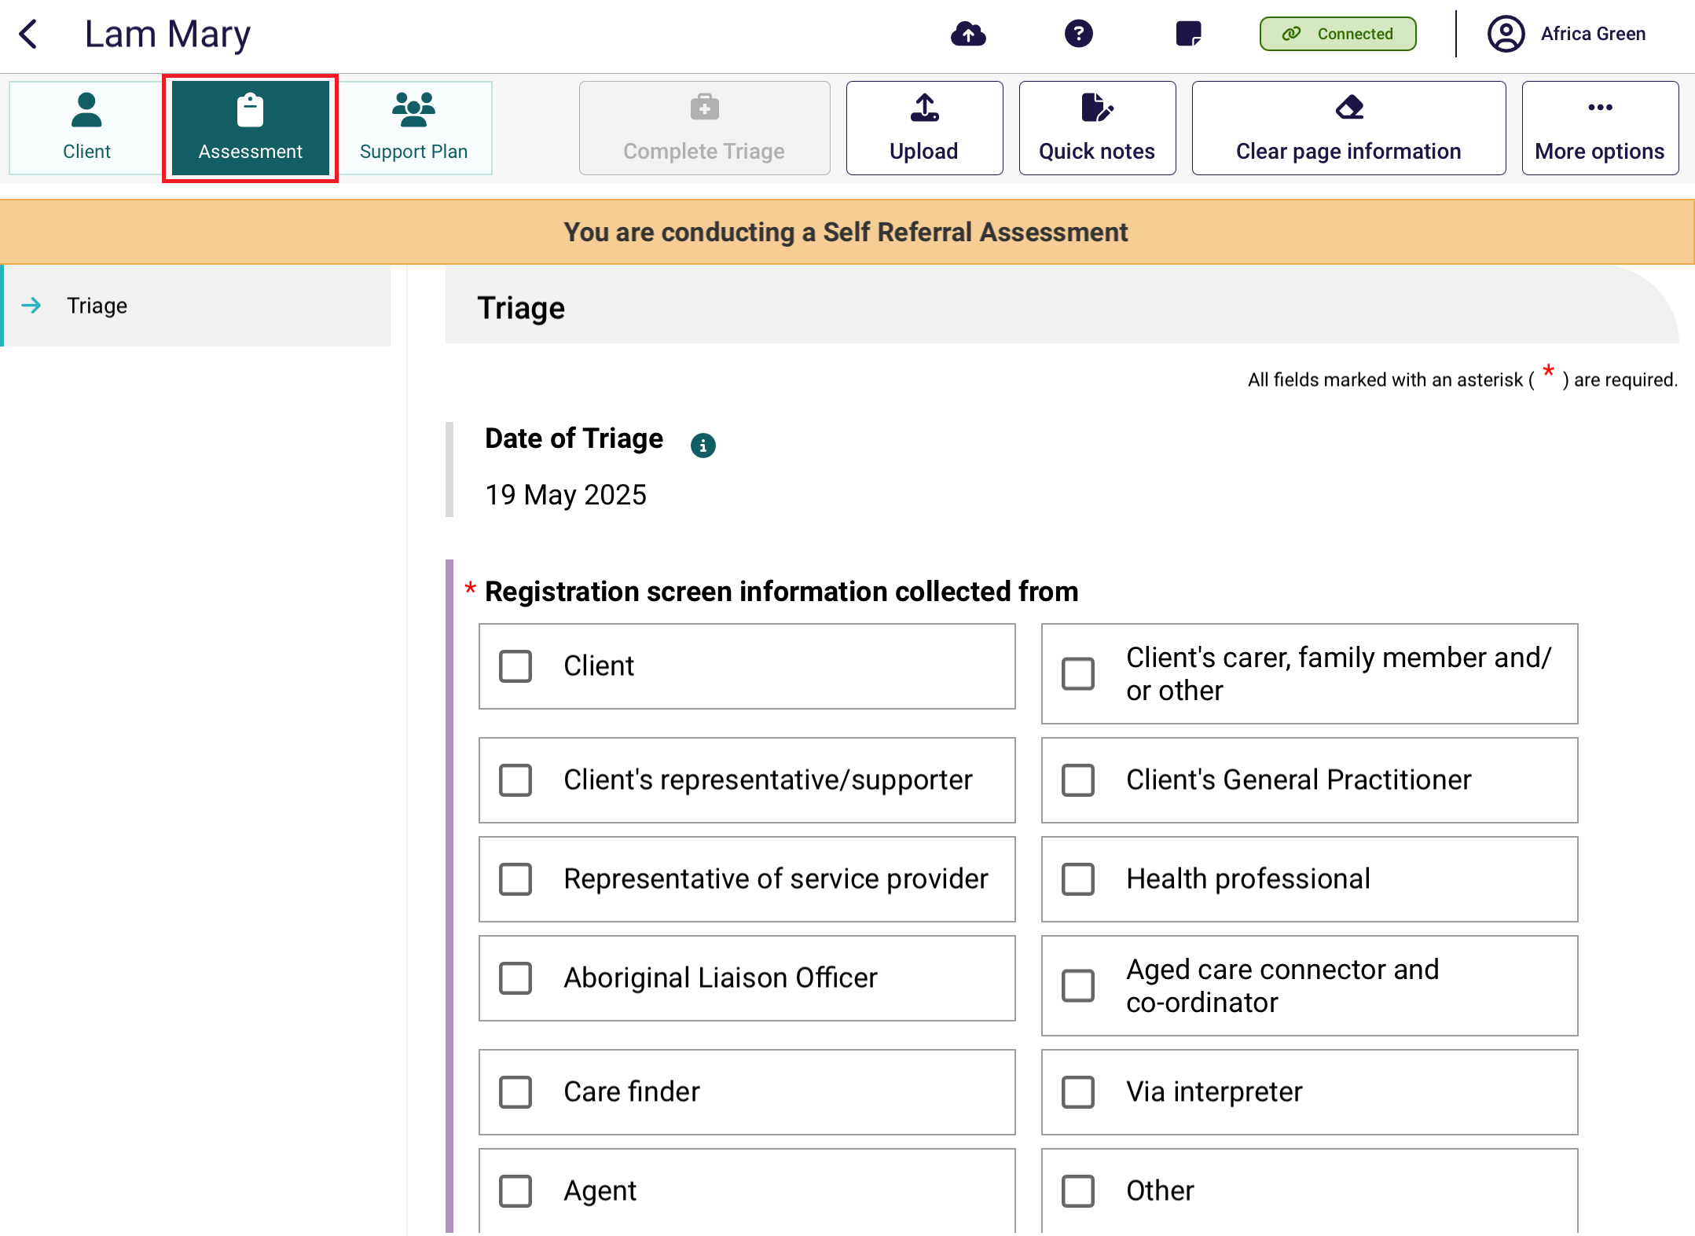
- If you do not hold a Triage Delegate role, enter the details of the Triage Delegate who supervised you to complete triage.
Then select Complete Triage.
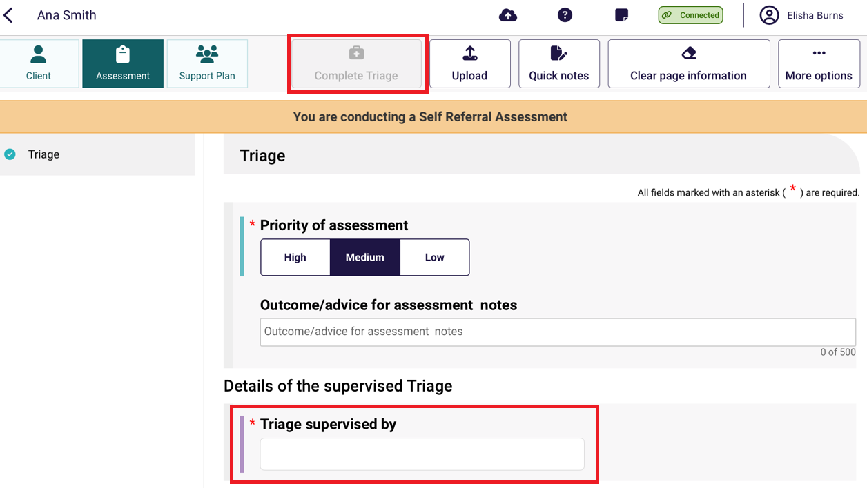

Converting assessments after completing Triage
After triage has been completed, needs assessors will have the ability to convert a home support assessment recommendation to a comprehensive assessment if it is in their expert opinion that the client requires it based on the information provided during triage.
- After completing triage select Convert to Comprehensive.
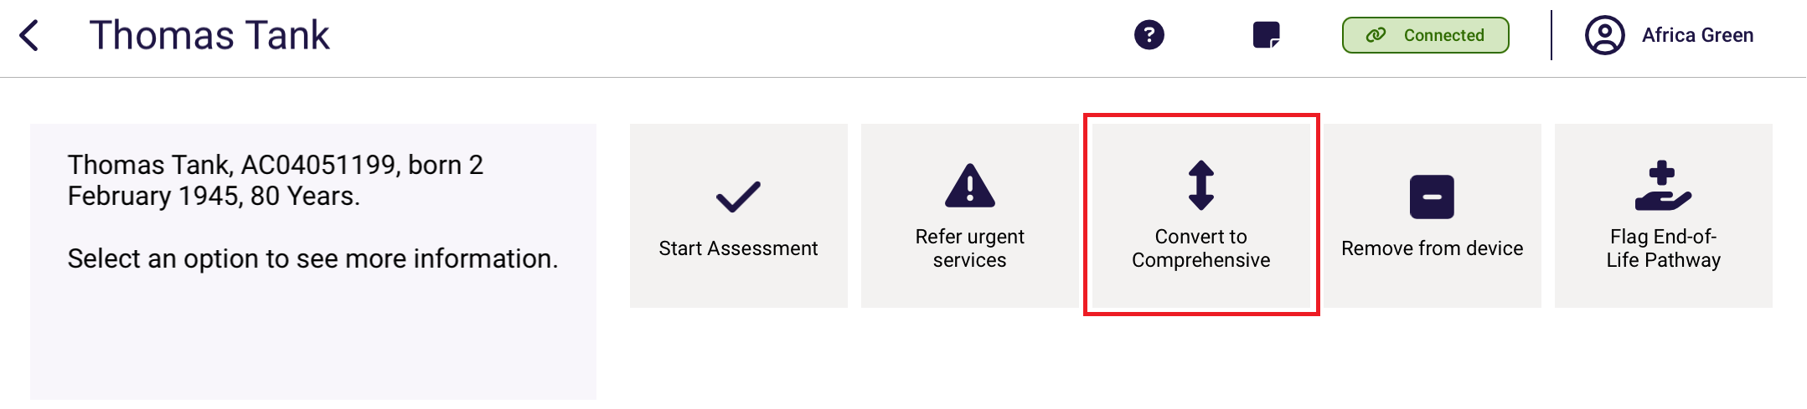
- The reason for change will be defaulted to High level care needs. Enter additional information regarding the reason in the Reason or comments field and then select Confirm.
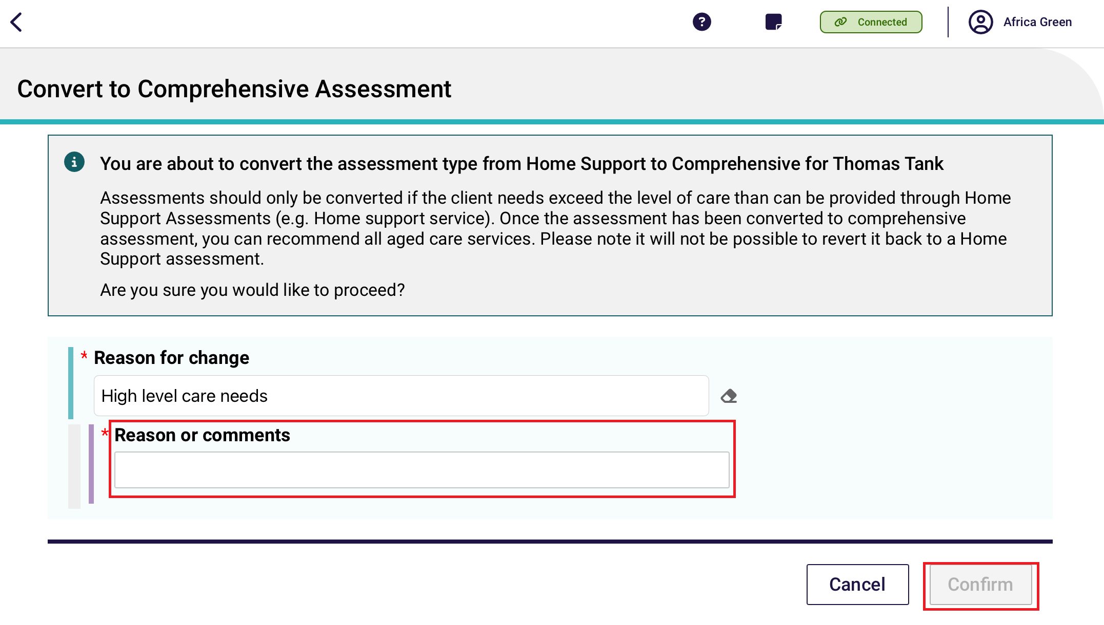
- The assessment will then be converted to a comprehensive assessment. To confirm, go back to the dashboard and refresh the client card.
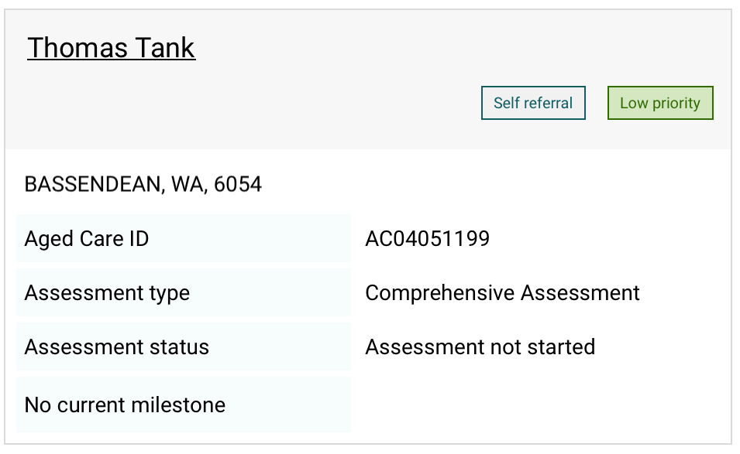

Referrals, reviews and creating an offline client for assessment
Client referrals can be downloaded for all referrals that have been assigned to you in the assessor portal. When downloaded to your device, the assessment, client profile, notes tab and attachments tab will pre-populate with information collected during screening and previous assessments (if applicable).
Similarly, client reviews can be downloaded for all reviews that have been assigned to you.
An internet connection is needed to download client referrals and reviews to a compatible device. The App can store up to 50 clients at any one time.
You can also create and save an offline client to your device whilst offline and conduct an assessment and commence a support plan. However, you will require an internet connection to conduct a review.
Once re-connected to the internet, the offline client can be registered or linked to an existing client, prior to uploading the assessment and support plan information to the assessor portal.
! | When you download a client’s referral or review to your device, the client record and the assessment will be locked in the assessor portal and remain locked until you Upload the assessment or review, or if you remove the referral/review from your device.  Referrals and reviews can be removed via the App or the assessor portal.
Any client referrals and reviews that are downloaded to your device will appear in the App section of the assessor portal, under Downloaded Referrals.
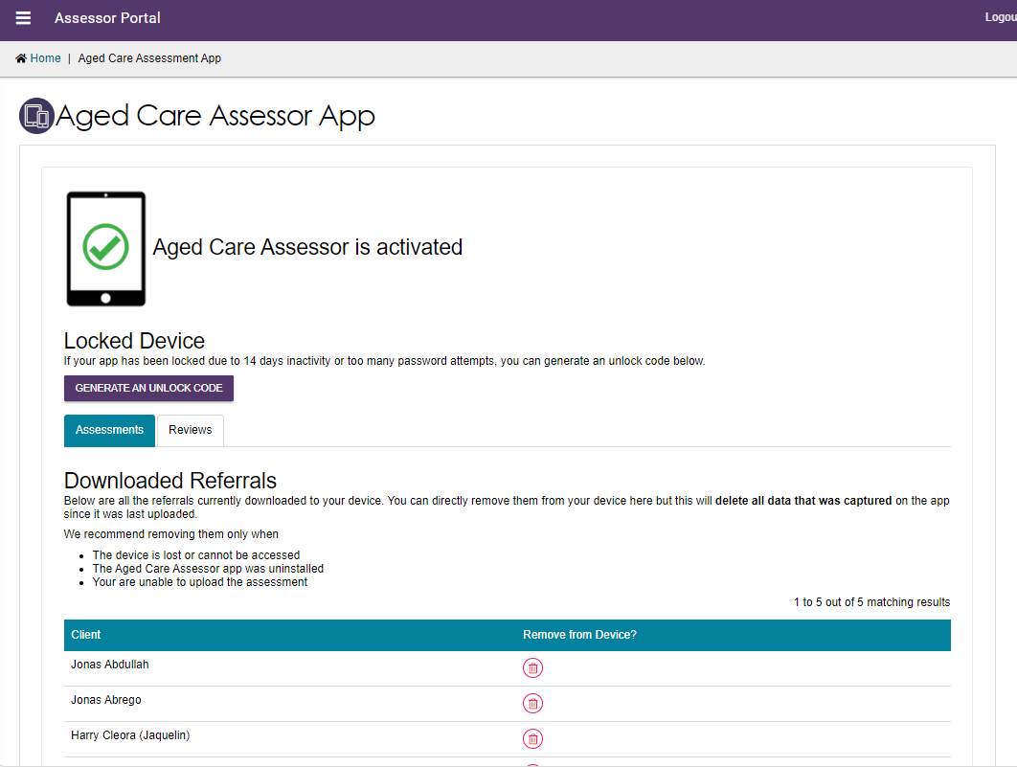

! | A person with the Team Leader role in the assessor portal can reassign client referrals that have been downloaded.  If a downloaded referral is reassigned to another assessor, any data entered on the device whilst offline will not be able to be uploaded and will be discarded by the App. To retain data entered offline, upload the assessment to the assessor portal prior to re-assigning the referral.  Needs assessors will also receive a notification in the assessor portal informing them when a downloaded referral has been re-assigned to another assessor.

7.1 Navigating between referrals and reviews
The App’s dashboard will display your assessment outlet/s referrals and their statuses:
- Triage
- Urgent Services
- Not started
- In progress
- Review.
To navigate between each view, use the side menu.
- After logging in to the app, the Dashboard page displays. Select the outlet to open and view your referrals.
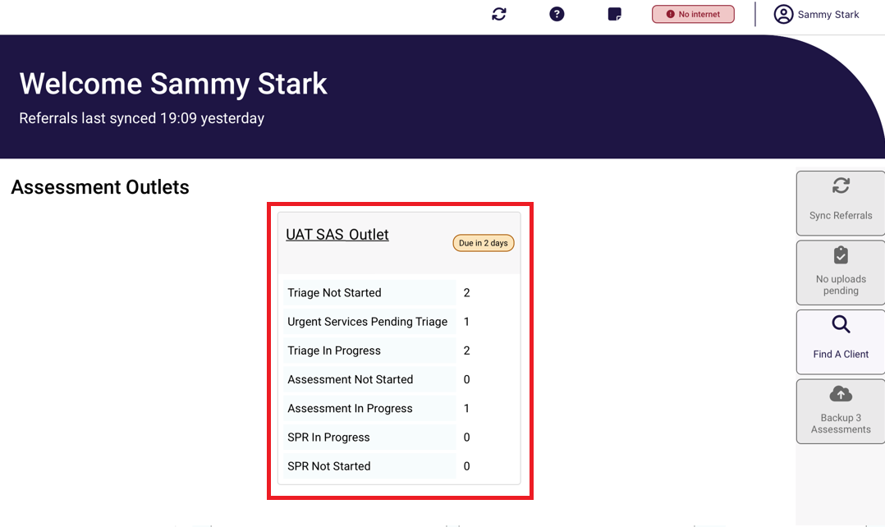

- Once selected, the view will display all referrals for that outlet.
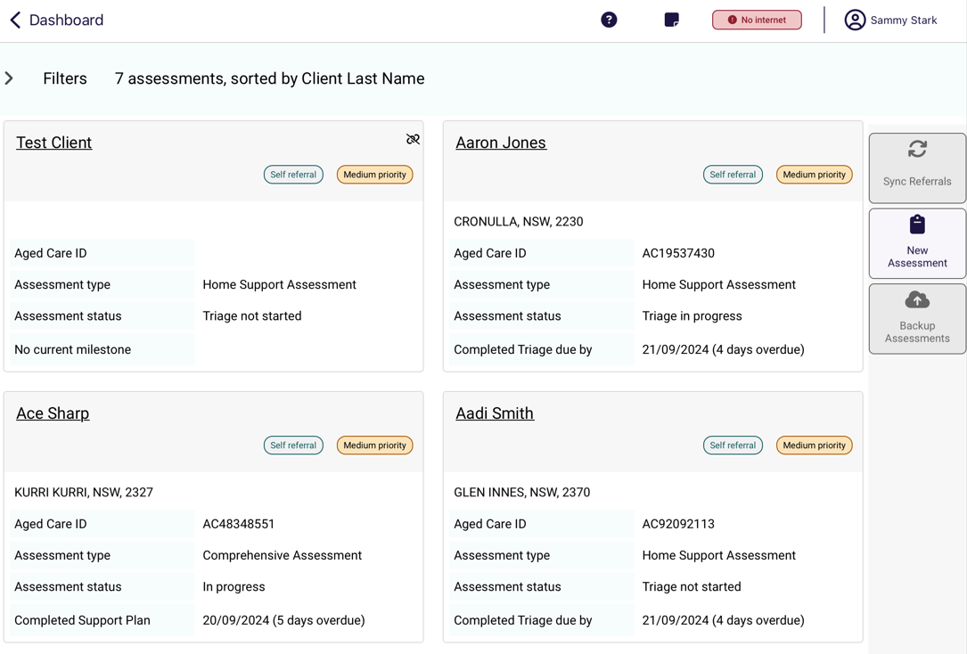
- To filter referrals, select the Filter drop-down. You can filter referrals by:
- Keyword
- Order
- Status
- Priority
- Assessment type.
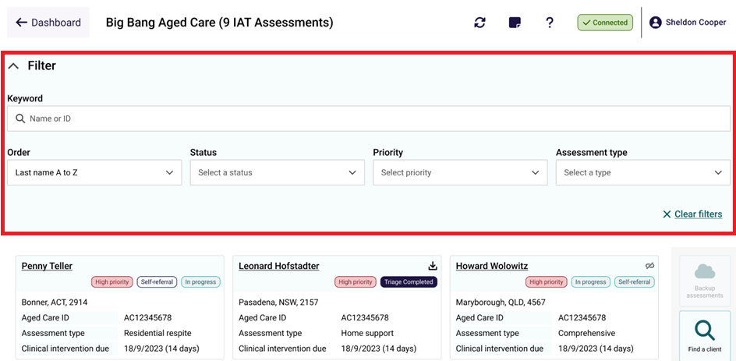

7.2 Downloading a client’s referral or review
Follow the below steps to download a client’s referral for assessment or support plan review. You must be connected to the internet.
- Open and log in to the app with your password.
- The Dashboard page displays. Select your outlet. In your outlet, client referrals and review cards will appear together in alphabetical order (by last name). Referrals for Comprehensive, Home Support, Residential Respite assessments and Support Plan Reviews can be identified by the referral Assessment type field.
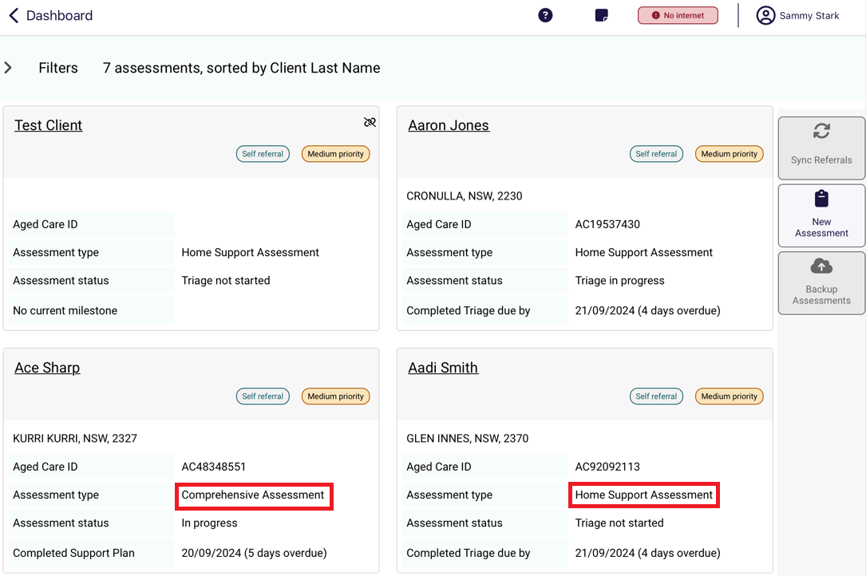
- To ensure that you are viewing the most up to date list of referrals/reviews assigned to you, select Sync Referrals on the righthand side of the page when you are connected to the internet. If you cannot view the client’s referral/review card on the Dashboard, ask your Team Leader to ensure it has been assigned to you, or refer to the Troubleshooting and diagnostics section.
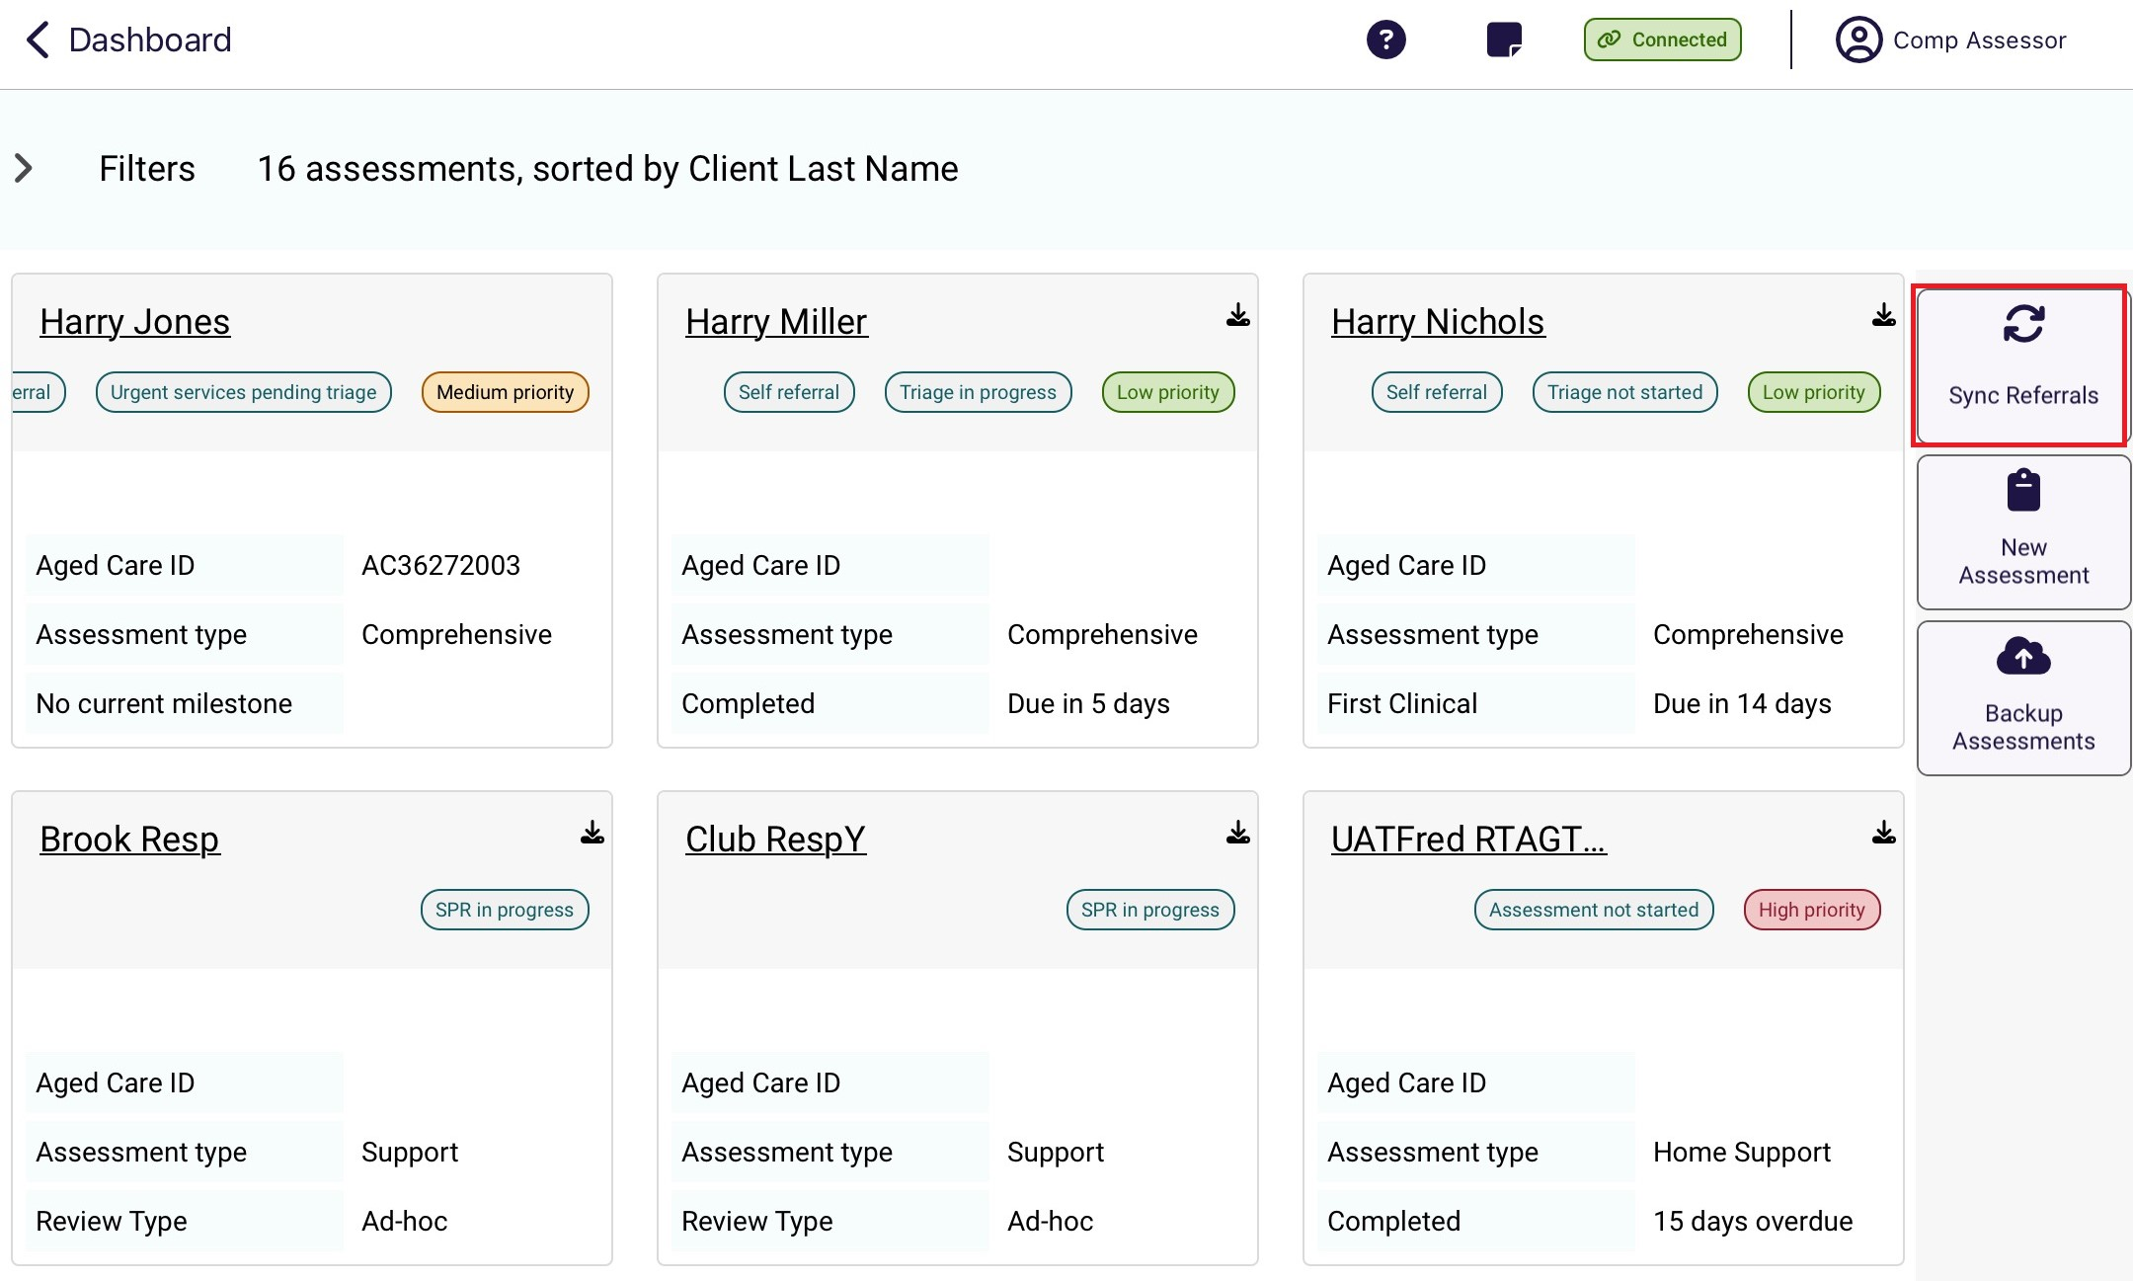
! | The visual indicator on the referral card identifies how a referral is tracking against the next relevant Key Performance Indicator (KPI) milestone (for example - completed support plan or finalised support plan).
- Locate the client referral/review card you want to download, then select the Download icon.
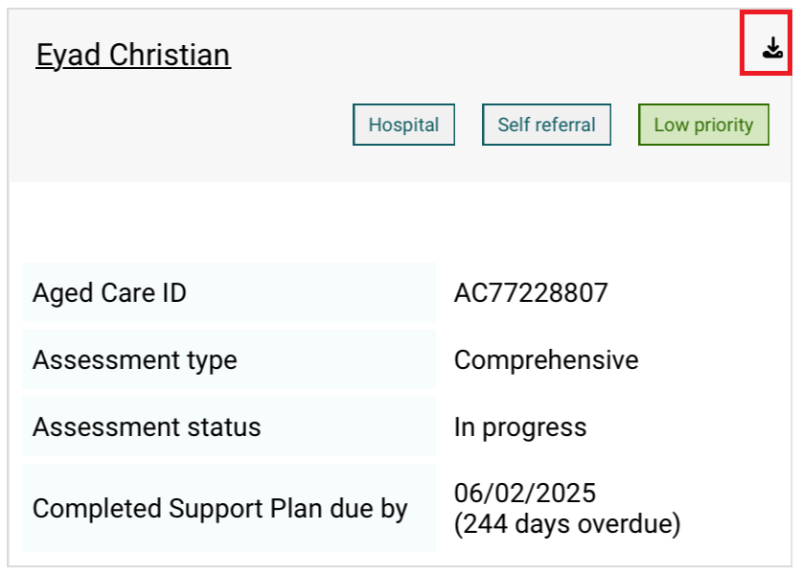
- Once selected, the downloaded assessment will show the progress of downloading this to the device. When all are downloaded, select + Open assessment.
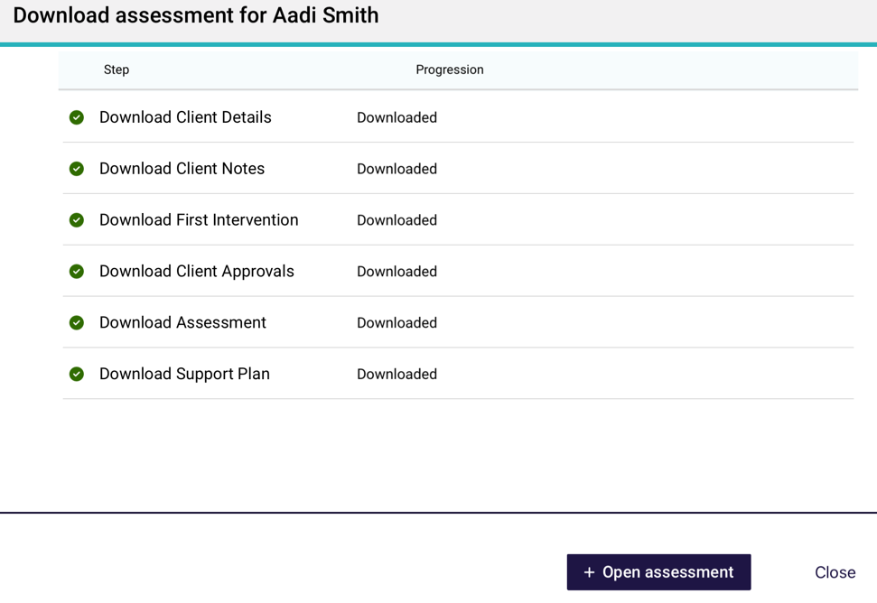
If the download fails, it will show a status of Failed. It will give you the option to either try again or download it later.
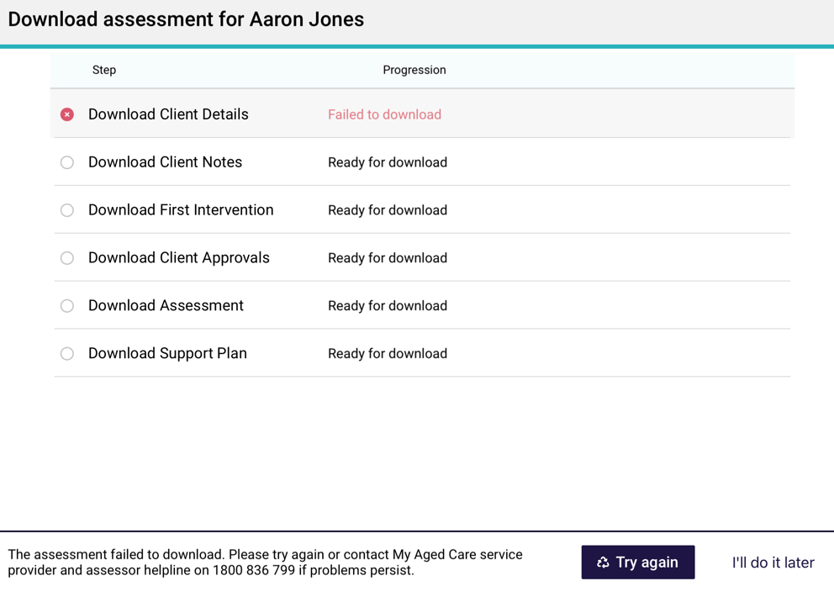
- When downloading referral cards, you will be asked if you want to pre-populate the assessment with the latest assessment or screening information.
On the next screen you will be asked if you would like to pre-populate the IAT questions from previously collected information.
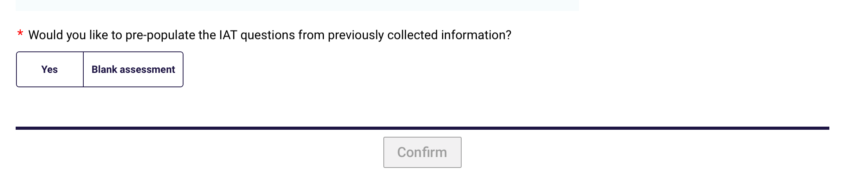
Select Yes or Blank Assessment. If you select Yes, the assessment form will be populated with the information contained in either the latest assessment or the screening if an assessment has not been captured. You will be able to select which assessment information to use. Once selected, click Confirm.
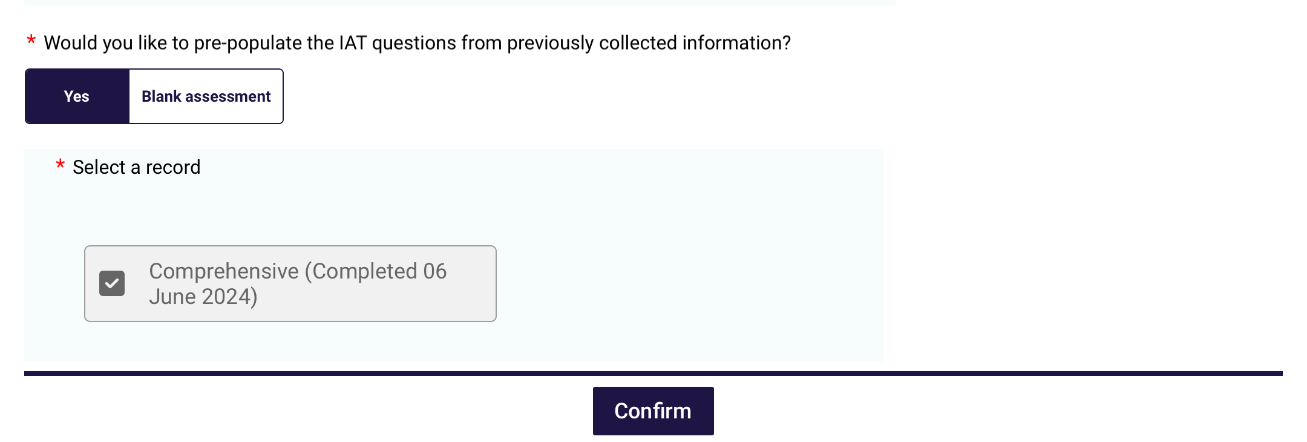
! | A needs assessor only can select whether they would like to start the assessment pre-populated or as a blank assessment once.  A needs assessor will still have the ability to clear page information from within the assessment.
- Once you have selected the client referral card a download window will appear. You can view the progress of the download.
When the client’s referral/review has successfully downloaded, the download icon will disappear, and when you select the client card you will have the option to Start triage, Refer urgent services to commence their assessment or review. You will also be able to Remove from device, or Flag End-Of-Life Pathway.
You will now be able to:
- view client information (Viewing and adding client information)
- set up support relationships (Registering a support person)
- complete identity verification (Completing identity verification); and either
- conduct triage (Completing Triage questions); and
- conduct the assessment (Undertaking assessments), or
- conduct a review (Conducting support plan reviews).

7.3 Creating an offline client
You can complete an offline assessment for a client who is not assigned to you in the assessor portal by creating and saving a client record locally to your device.
This could occur in a variety of circumstances; for instance, you are in a client’s home undertaking an assessment offline and you determine that their partner or someone else living at the same address, who may not be registered with My Aged Care, also requires an assessment.
This function is not available with support plan reviews.
To create an offline client on the App whilst offline, follow the steps below.
! | Where possible, you should always attempt to confirm whether a person is registered with My Aged Care prior to creating an offline client in the App. If a client already has an assessment in progress, you will not be able to refer this client to your outlet and consequently be unable to upload and complete the assessment.  If the client has not been referred to you and does not have an in-progress assessment, and you can:  - Refer this client to yourself in the assessor portal if the reason for the assessment is either In-hospital, remote assessment, First Nations or Homeless or at risk of. This process is described in the Assessor Portal User Guide 1 – Registering and referring clients for assessments.  - Facilitate a referral for the client to your organisation for a reason outside those listed above by calling the My Aged Care service provider and assessor helpline on 1800 836 799. This must be done before you can upload the assessment to the assessor portal. You can still undertake the assessment offline if no internet connection is available.
- Open and log in to the App with your password. The Dashboard displays with your outlet and referrals. Note the Connectivity indicator on the top right of the screen is showing a red No Internet connection icon with a chain, which means the app is disconnected from the internet.
Select Find A client on the right hand side of the Dashboard.
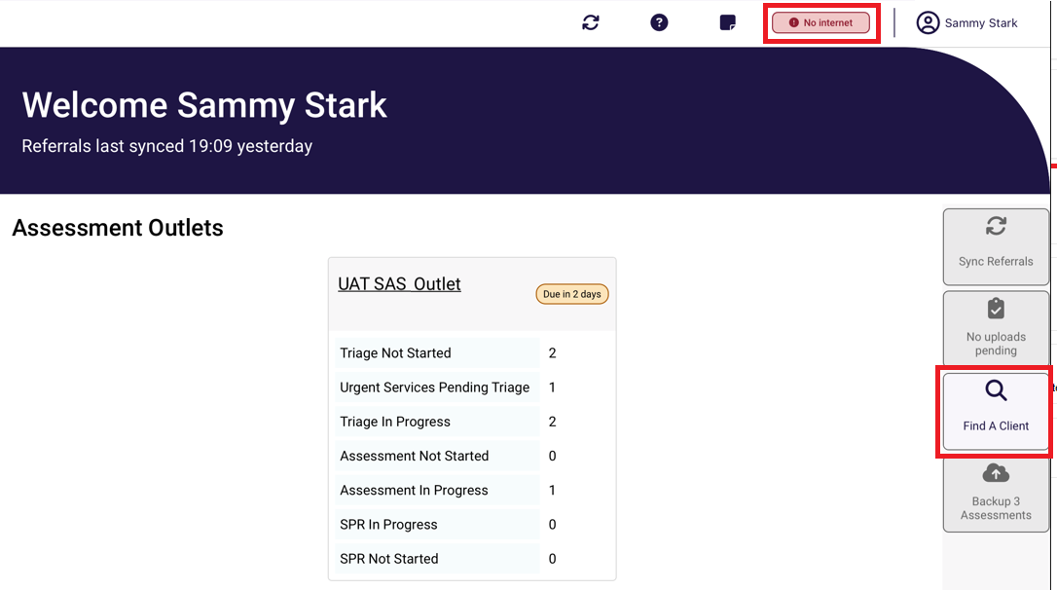
- A message will display notifying you that you are not connected to the internet.
Select Create Offline Client.
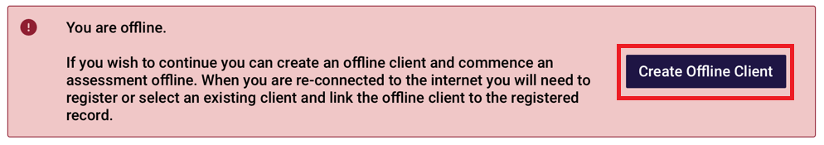
- A blank client record will be displayed. Enter all mandatory client details as indicated by a red asterix on the right. Select Save to save the client locally to your device.
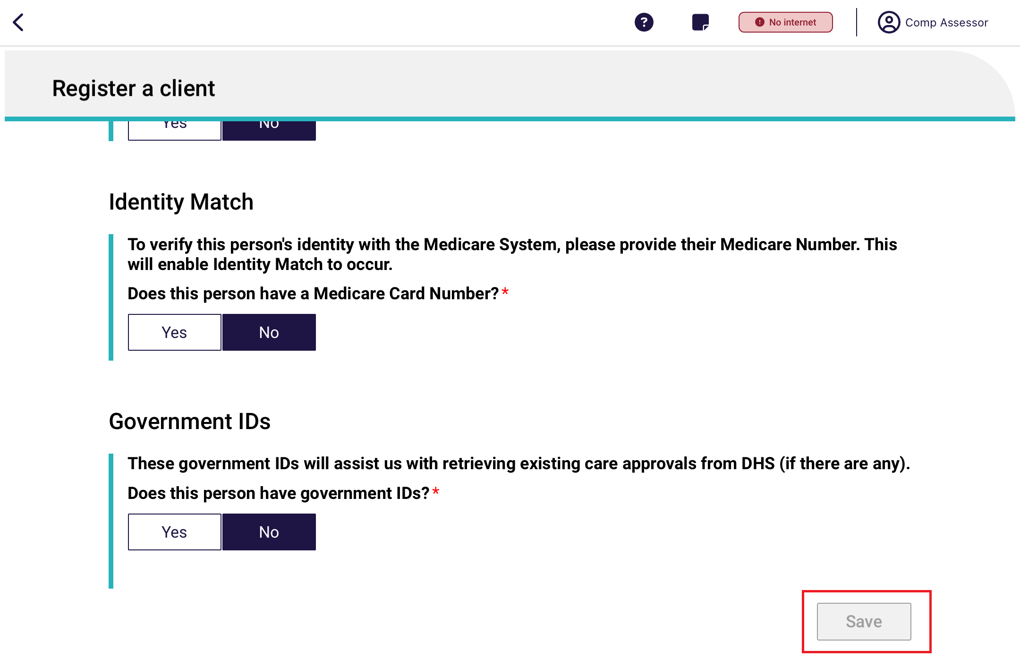
- Select an Assessment type for the client from the drop-down menu and the Outlet that you want to assign to complete, then select Save.
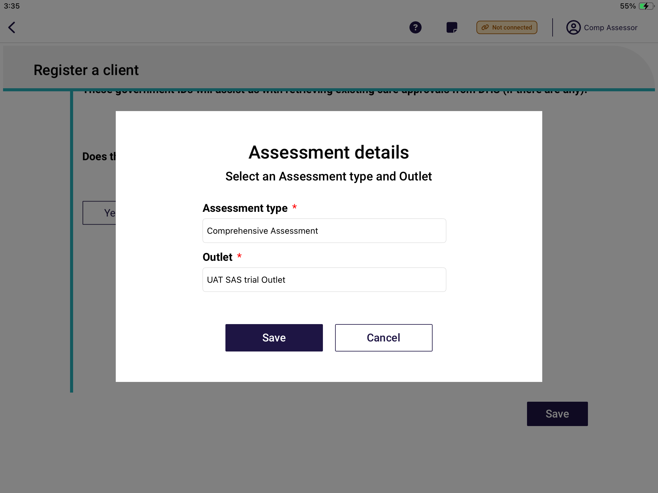
- The offline client’s referral will display on the Dashboard. Select the Outlet and the client’s record will be displayed. You will now be able to:
- enter additional client profile information (Viewing and adding client information)
- undertake triage (if a Triage Delegate)
- undertake an assessment (Undertaking assessments); and
- commence developing the client’s support plan (Developing a support plan).
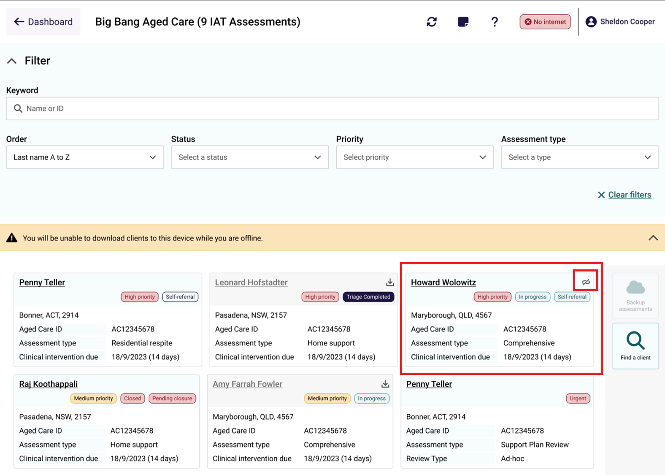
! | Clients created offline will have a visual indicator to identify that they have been created locally to the device.  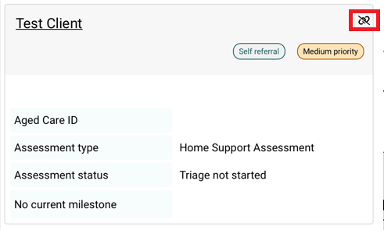

Viewing and adding client information
You can view client information previously collected for downloaded assessment referrals, downloaded support plan reviews or offline clients (saved locally to the device using the Creating an offline client process).
To view client information:
- Open and log in to the App.
- The dashboard page displays. Select your outlet. Once in the outlet, select the client’s name in the client card to navigate to the client’s details.
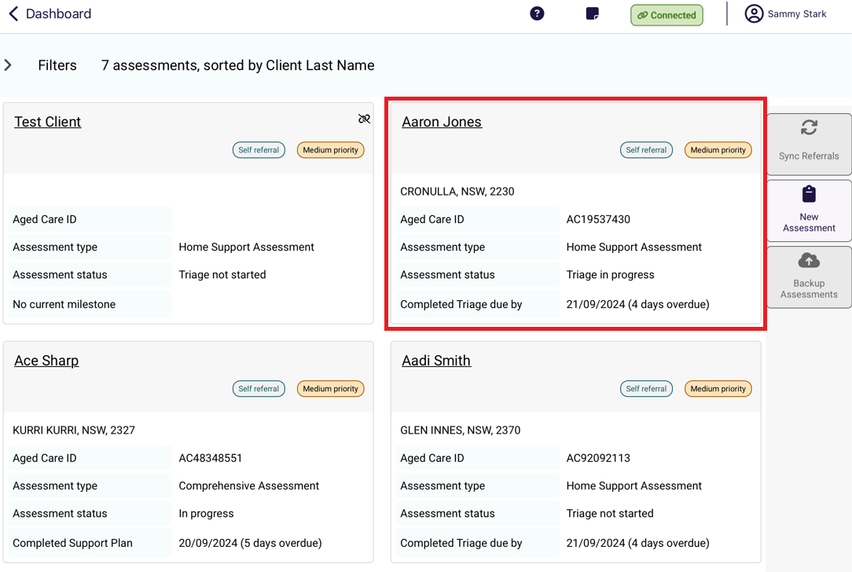
- The Client Profile page displays.
Alternatively, you can access client details within the client’s assessment or review by selecting the client link at the top left corner of the page.
You can toggle between the client, assessment and support plan without losing any information.
! | The following screenshots are from a downloaded assessment referral. The client information is the same when in a downloaded support plan review.
The Client profile page contains information from the client record including:
- personal information (name, date of birth, etc.)
- communication requirements
- identity documents
- identity status
- health insurance.
! | Client profile information can be edited from this section. Any information that is updated from the App will overwrite the profile information that is in the client record when uploaded to the assessor portal.
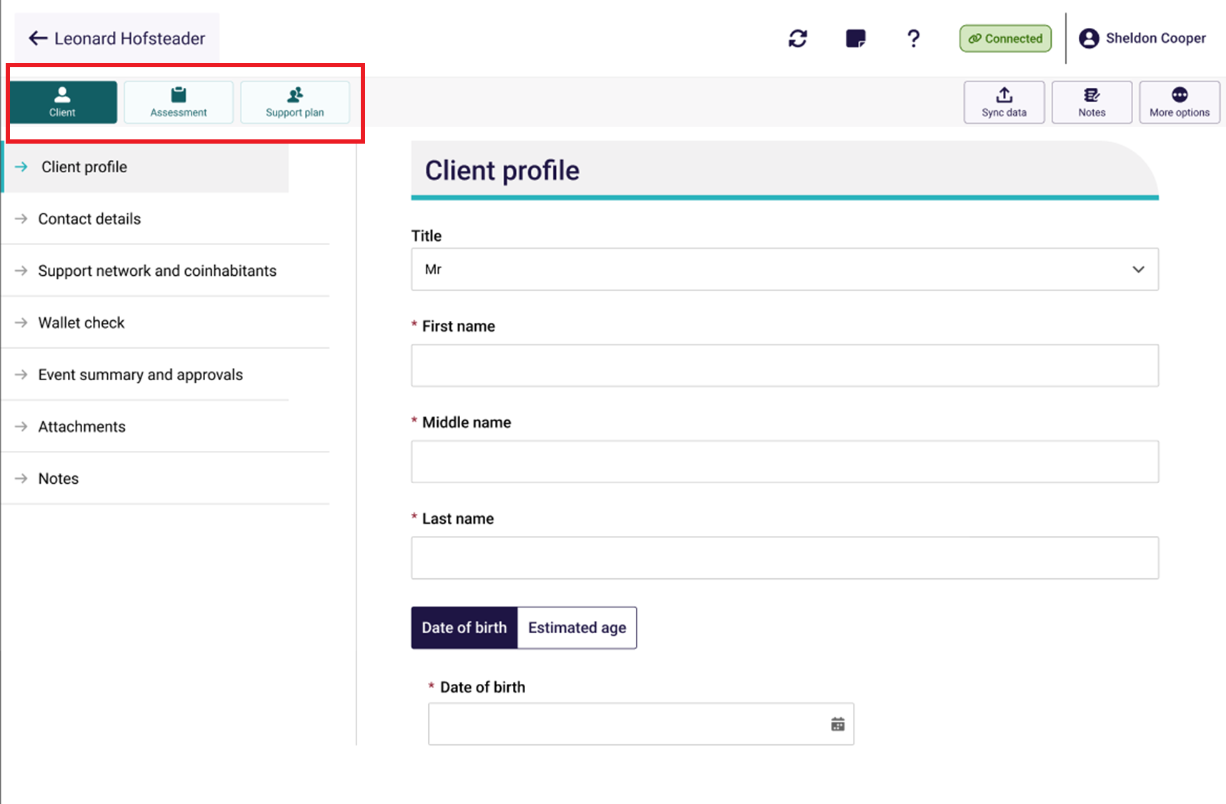
! | When all mandatory client profile information has been completed, a tick will appear next to the section. This information must be completed to generate assessment outcomes at the completion of the assessment.  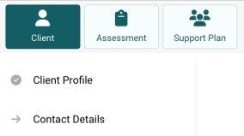

8.1 Contact Details
The Contact details page displays the client’s contact information, mobile and home numbers, email address, preferred contact method and address details. Needs ssessors can add and/or edit contact infromation and configure notification preference (SMS and/email) in the Contact details section. To prompt SMS notifications for a client and their support network or supporter, follow the steps below.
- Obtain Consent to send SMS and email about the client, then add mobile phone number. Select the Verify button. This will send a six digit code to the recipient’s mobile number.
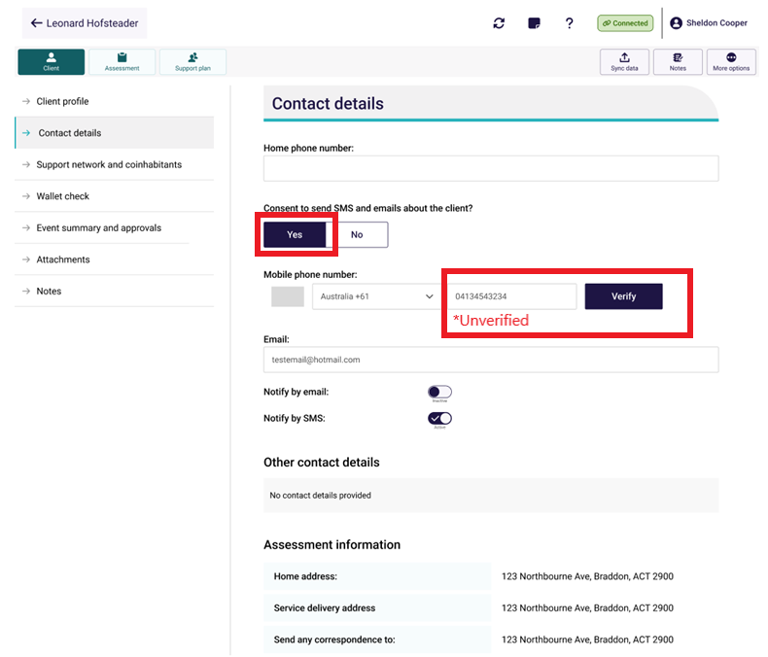
- Enter the six digit code and select Confirm code.
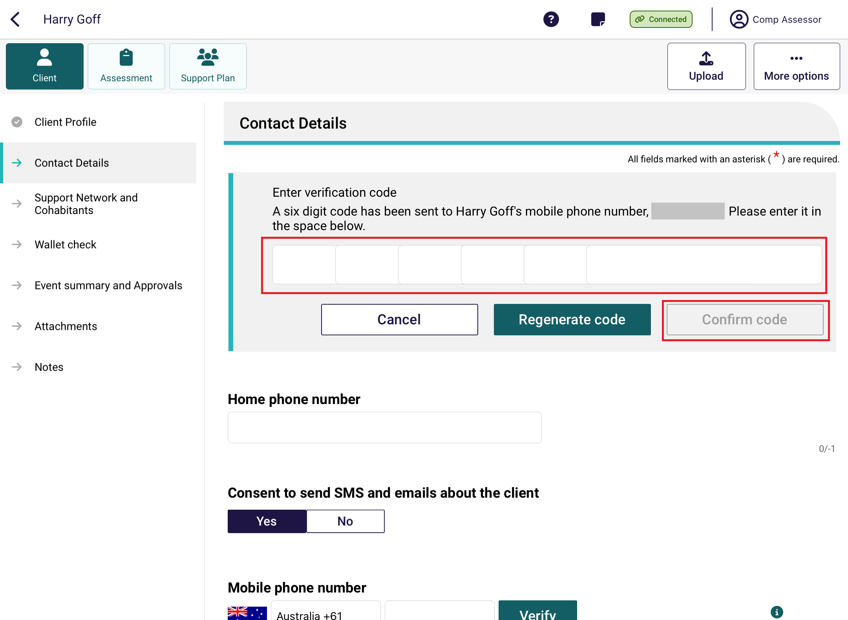
- Once the number has been verified, to set SMS notification toggle on Notify by SMS. To remove a preference you can select the toggle to remove the preference.
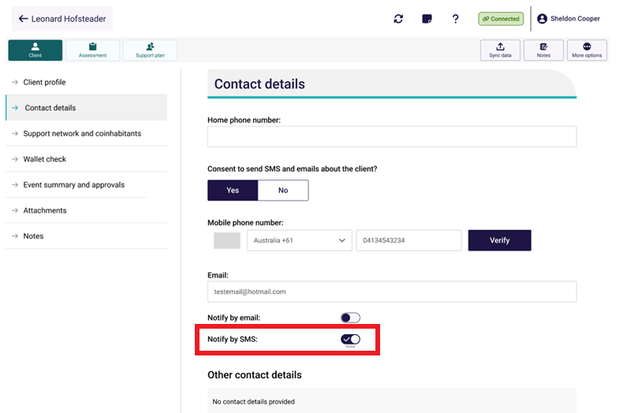

8.2 Support Network and Cohabitants
The Support Network and Cohabitants page displays the client’s supporters, the people they support and other relationships (the support network). The process for setting up support network relationships is explained in Registering a support person section.
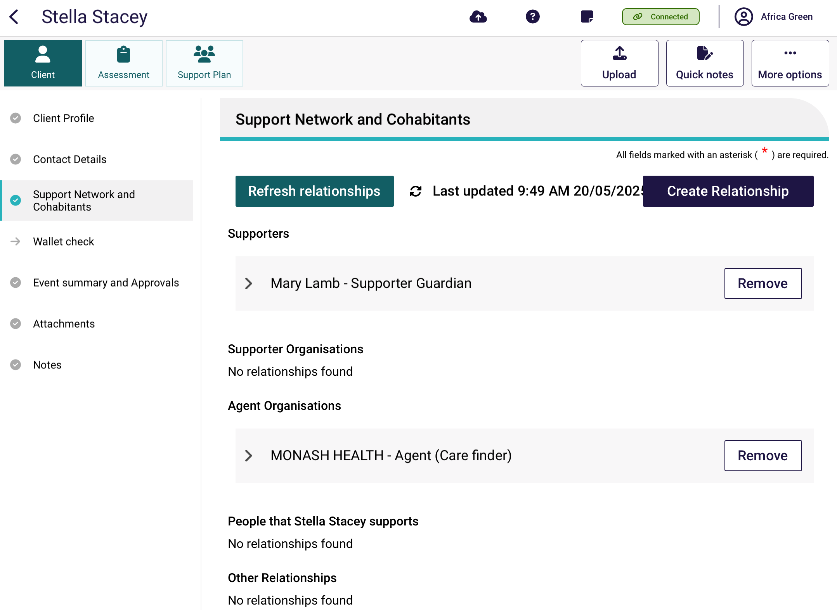

8.3 Wallet Check
The Wallet check page displays the status of the wallet check. This process is explained in the Completing Identity Verification section.
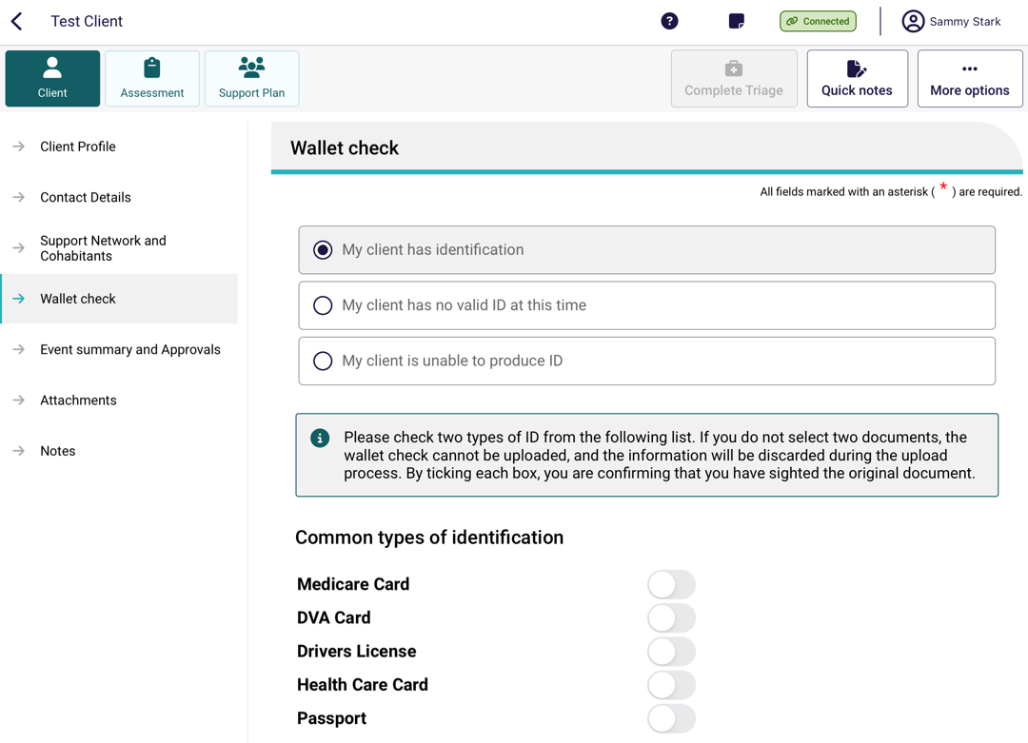

8.4 Event Summary and Approvals
The Event Summary and Approvals page displays information about screening and previous assessments (if applicable). It will also contain information about a client’s current Approvals, services in place, existing classification and the priority, if applicable.
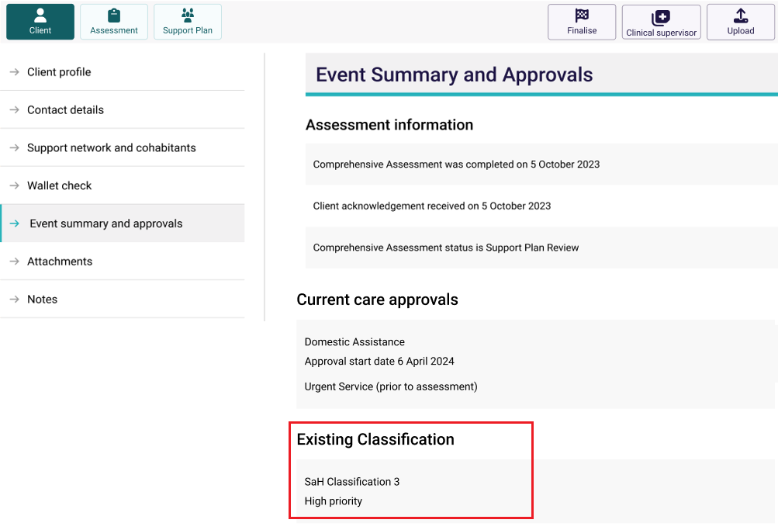
! | Transitioned Home Care Package Levels  From 1 November 2025, All clients with approved Home Care Packages prior to 1 November 2025 will be transitioned to Support At Home services. This means that:  In the Existing Classification section of the Event Summary and Approvals page, there will be no Home Care Package displayed. The approval will display as Transitioned HCP Level X instead.  Home Care Packages will still be displayed under the heading Past Packages.  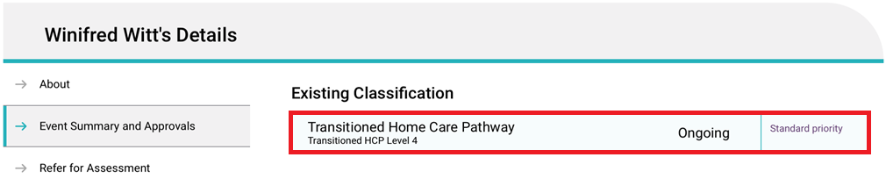
! | Short Term Restorative Care, Restorative Care Pathway and other transitioned classifications  For clients that have an STRC approval and have commenced services prior to 1 November 2025, STRC approvals and service delivery information will continue to be displayed in the App as per current functionality on the Event Summary screen and approvals screen.  For clients that have an STRC approval, and have either commenced service between 1 November 2025 and 23 February 2026, or has not commenced service by 23 February 2026:  a) Their STRC approval and service delivery information will continue to be displayed in the App on the Event Summary screen and approvals screen.  b) They will be eligible to transition to the following classifications after a reassessment:  - Support at Home ongoing  - End of Life pathway  - Restorative Care Pathway  - A different Assistive Technology/Home Modification tier.  c) They will be eligible to transition to the following classifications after a Support Plan Review:  - Second unit of Restorative Care Pathway  - End of Life pathway  - A different Assistive Technology/Home Modification tier.
On this page, for Support at Home services, assessors can view all active existing classifications, including multiple active classifications within the same category (e.g., multiple Assistive technology or Home modifications entries). They can view the priority level for each classification and service. They can also view approval start and end dates.
This ensures assessors have access to the most up-to-date and complete information about the client's approved services and priority categories, supporting accurate and informed care planning.
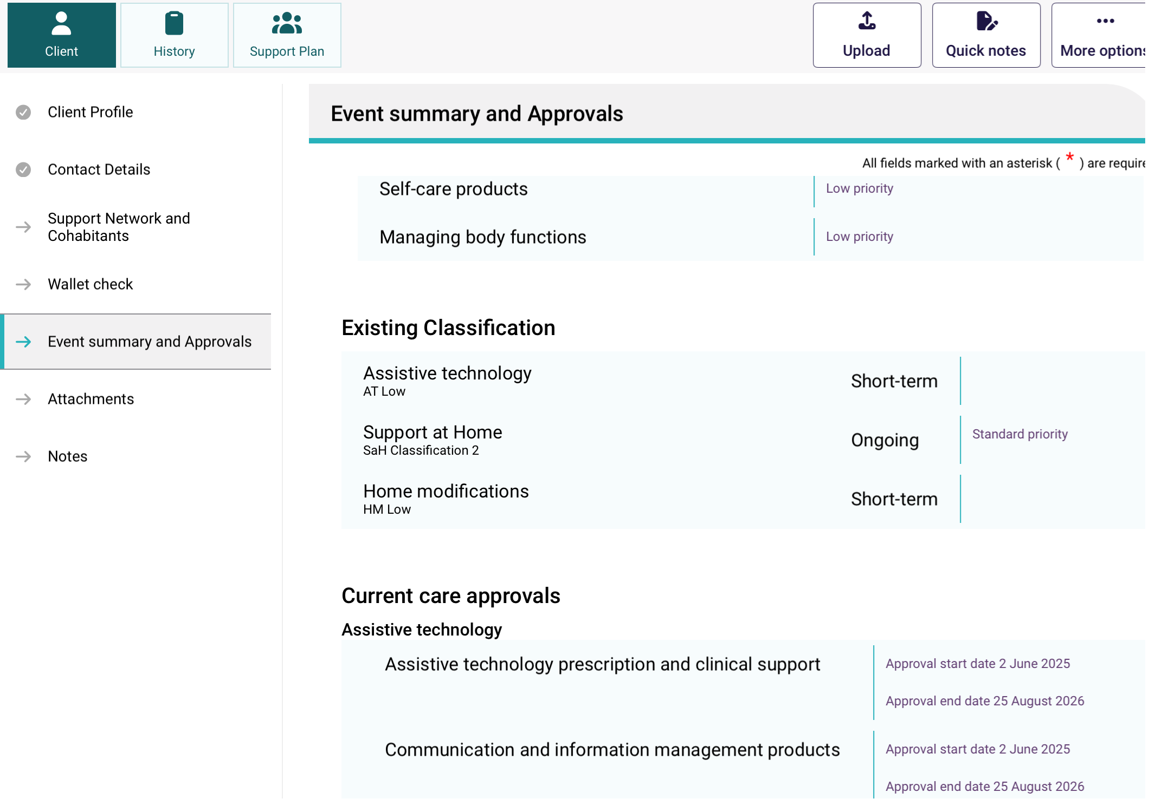
Assessors can view a client’s Assistive technology (AT) and Home modifications (HM) classification and priority category details after an assessment has been completed and approved. If the client has been recommended for AT or HM services, their classification and associated priority category will be displayed under the Existing Classification section, supporting informed decision-making for Support at Home aged care services.
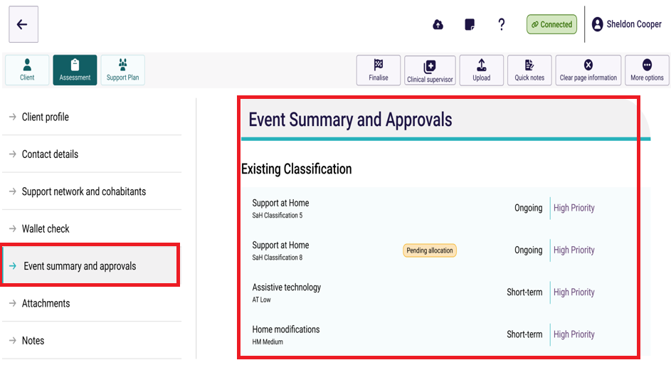

8.5 Attachments
The Attachments page enables you to view client attachments and add attachments. This includes Notice of Decision letters (approval letters and non-approval letters).
- To view an attachment, select the hyperlink name of the attachment name. A new page opens, and the attachment will be visible.
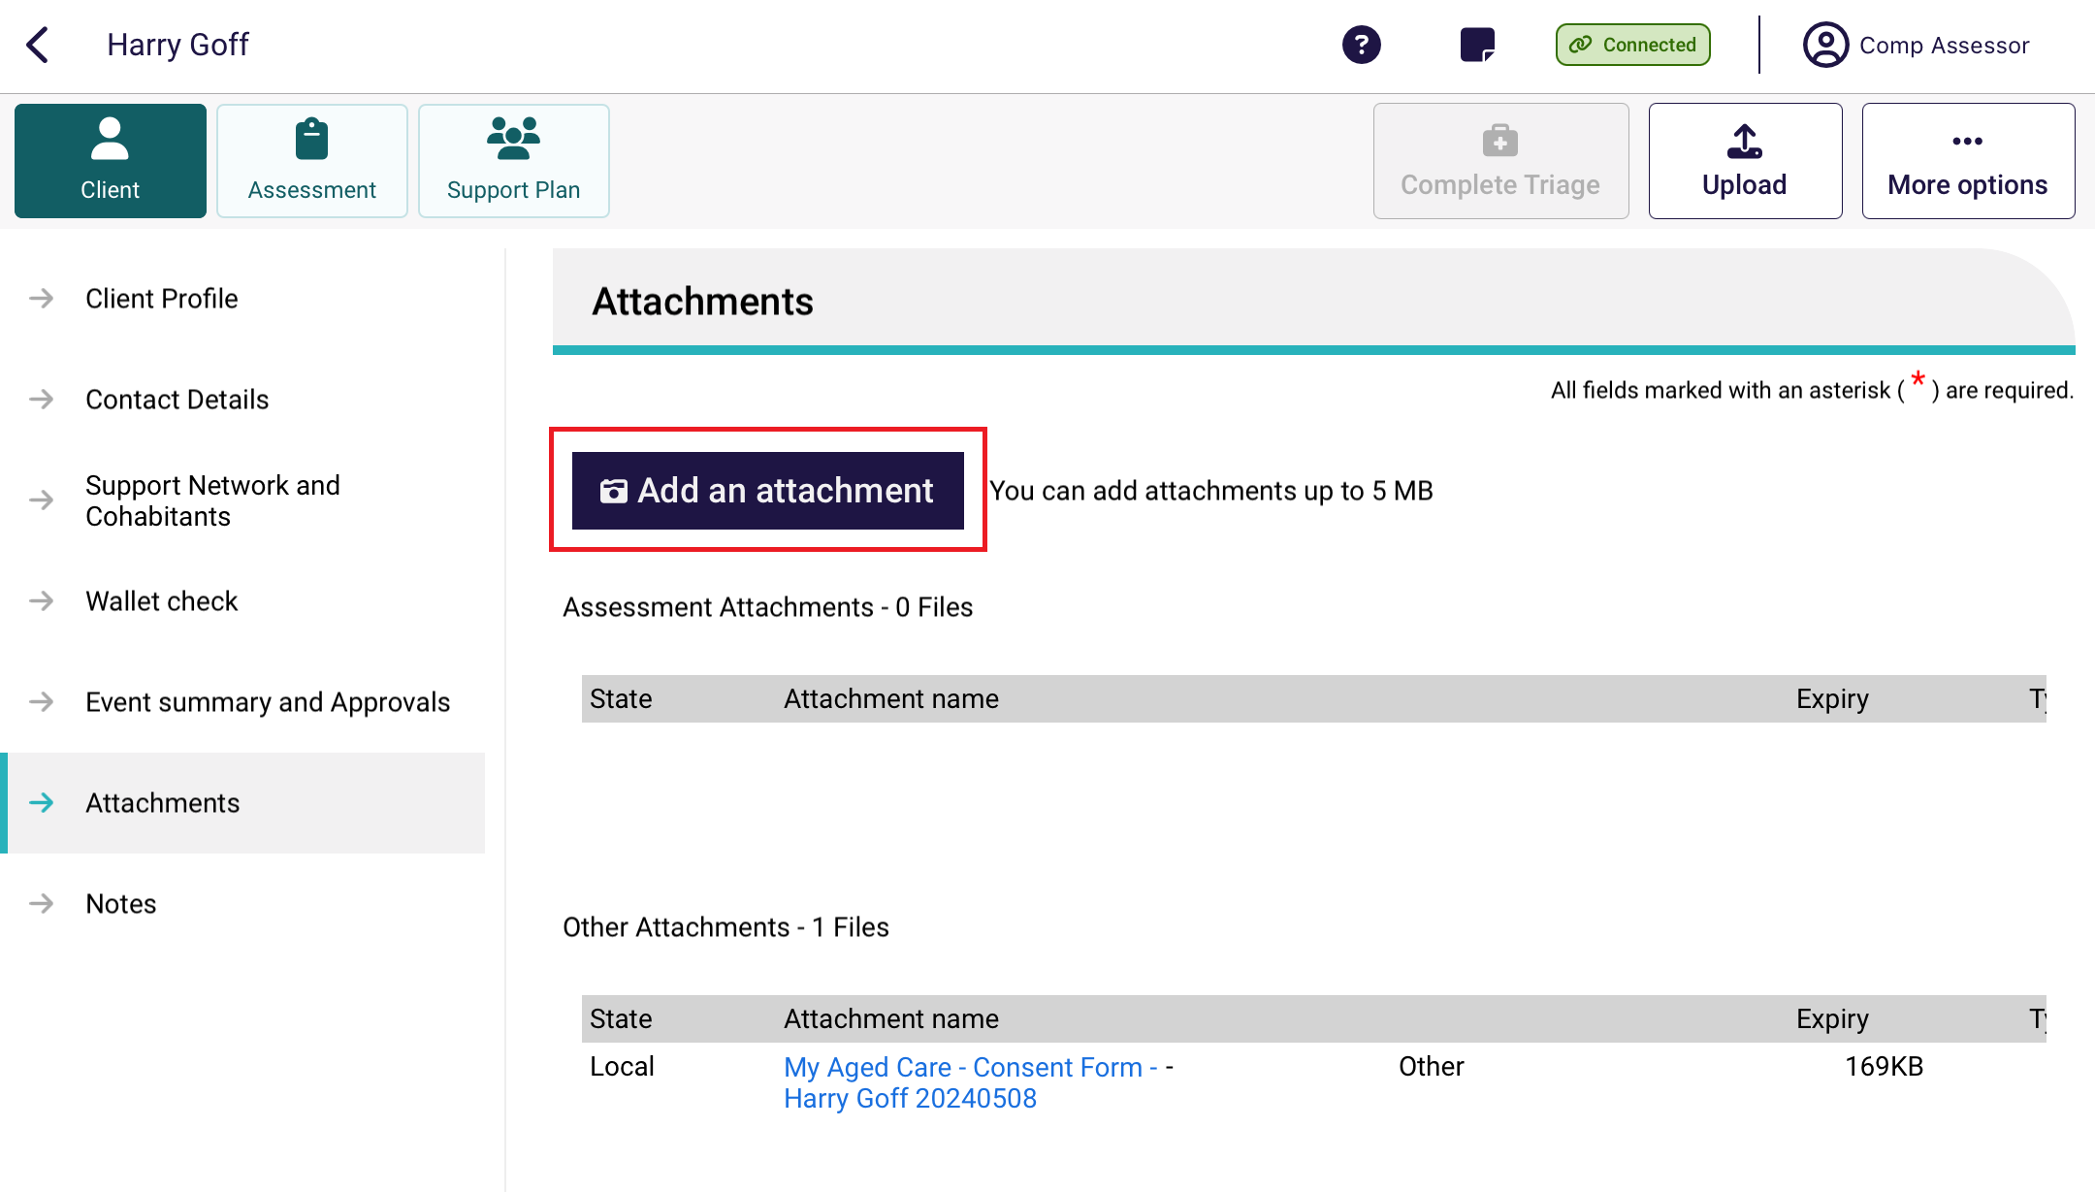
- Selecting Add an attachment will open a new page where you can record the name, type and description of the attachment. The Types of attachments that can be added match those available in the My Aged Care assessor portal.
! | Comprehensive and Home Support assessors can attach the following attachment types:  - Approval letter sent to client  - Non-approval letter sent to client.  Other attachment types available include:  - Assessments - Allied Health Assessment, Assessment Tool, Prior Assessment  - Application Form  - AT (Assistive technology) prescription and quote  - Clinical Notes  - Delegate Nomination Form and Delegate Nomination Support  - Discharge Summary  - End-of-Life Form and other [documentation]  - HM (Home modifications) prescription and quote  - Inbound referral information  - Letters - Ineligible for Assessment, by Medical Practitioner  - Legal documentation  - Medication Summary  - Offline Approval Form, offline Notes  - Other  - Plans: Care Plan, Action Plan – External, Occupational Therapy Plan, Prior Support Plan, Support Plan – External  - Relevant Medical Summary  - Sensitive Attachment, sensitive client status  - Specific Service Requirements  - Wound Care Plan.

An Non-approval letter attachment type example is shown below. Select Done after choosing the attachment type. Once you have recorded the details, you can select Capture photo, which will open your device’s camera app.
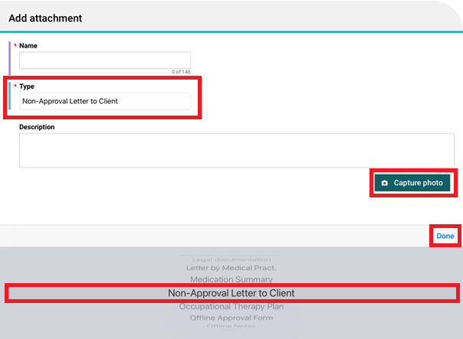
- Once you have taken the photo, you will be given the option to either Retake or Use Photo. If you are happy with the attachment, select Save to record.
! | When uploading an attachment, it is crucial to ensure that the document is intended for the correct client. Uploading an attachment to the wrong client's file can lead to a breach of privacy. Always double-check the client details before proceeding with the upload.  If you are uncertain about the client's identity, please refrain from uploading the document and seek clarification. This precautionary measure helps maintain the integrity of our service and protects client privacy.
- The attachment will display in the Attachments page, under the appropriate section (such as ‘Assessment Attachments’).
Any attachments added whilst offline will also appear in the Attachments tab of the client record when the assessment is uploaded to the My Aged Care assessor portal.
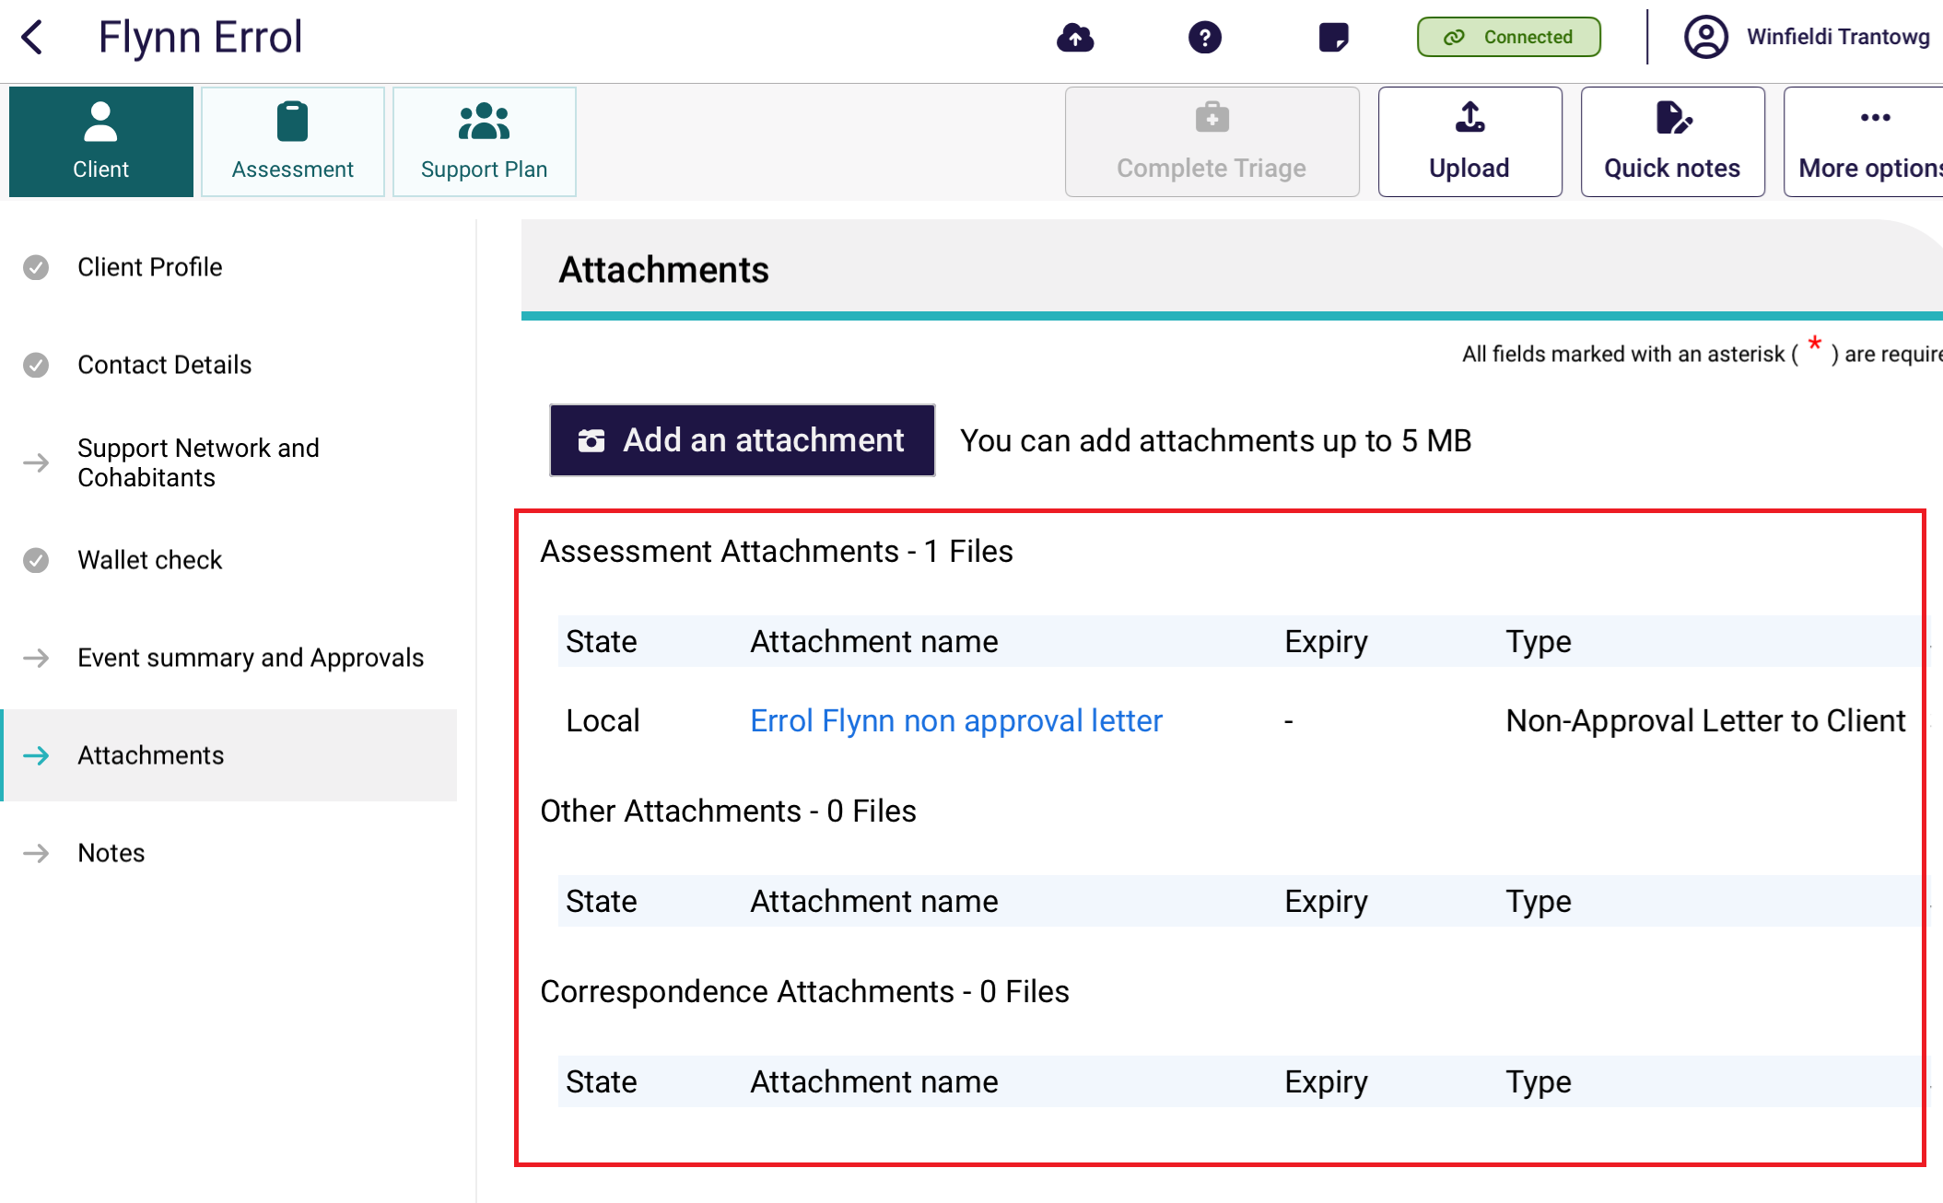
! | The attachment image will only save in the App. For security purposes, the image will not be saved locally to the device.  You will need to enter a Name and a Type of image (for example, Power of Attorney), which will be displayed in the My Aged Care assessor portal. You can also add a description for the attachment in a free text box.

8.6 Notes
The Notes page enables you to add and view Client notes. The Note types available match those available in the My Aged Care assesor portal:
- Observations
- Gender Identity/Sexual Preference
- History of Experiences
- Cultural/Religious
- Other
- Preference
- Sensitive Notes
- Client Story.
To add a Note:
- Select Notes from the client record, and select Add A Note.
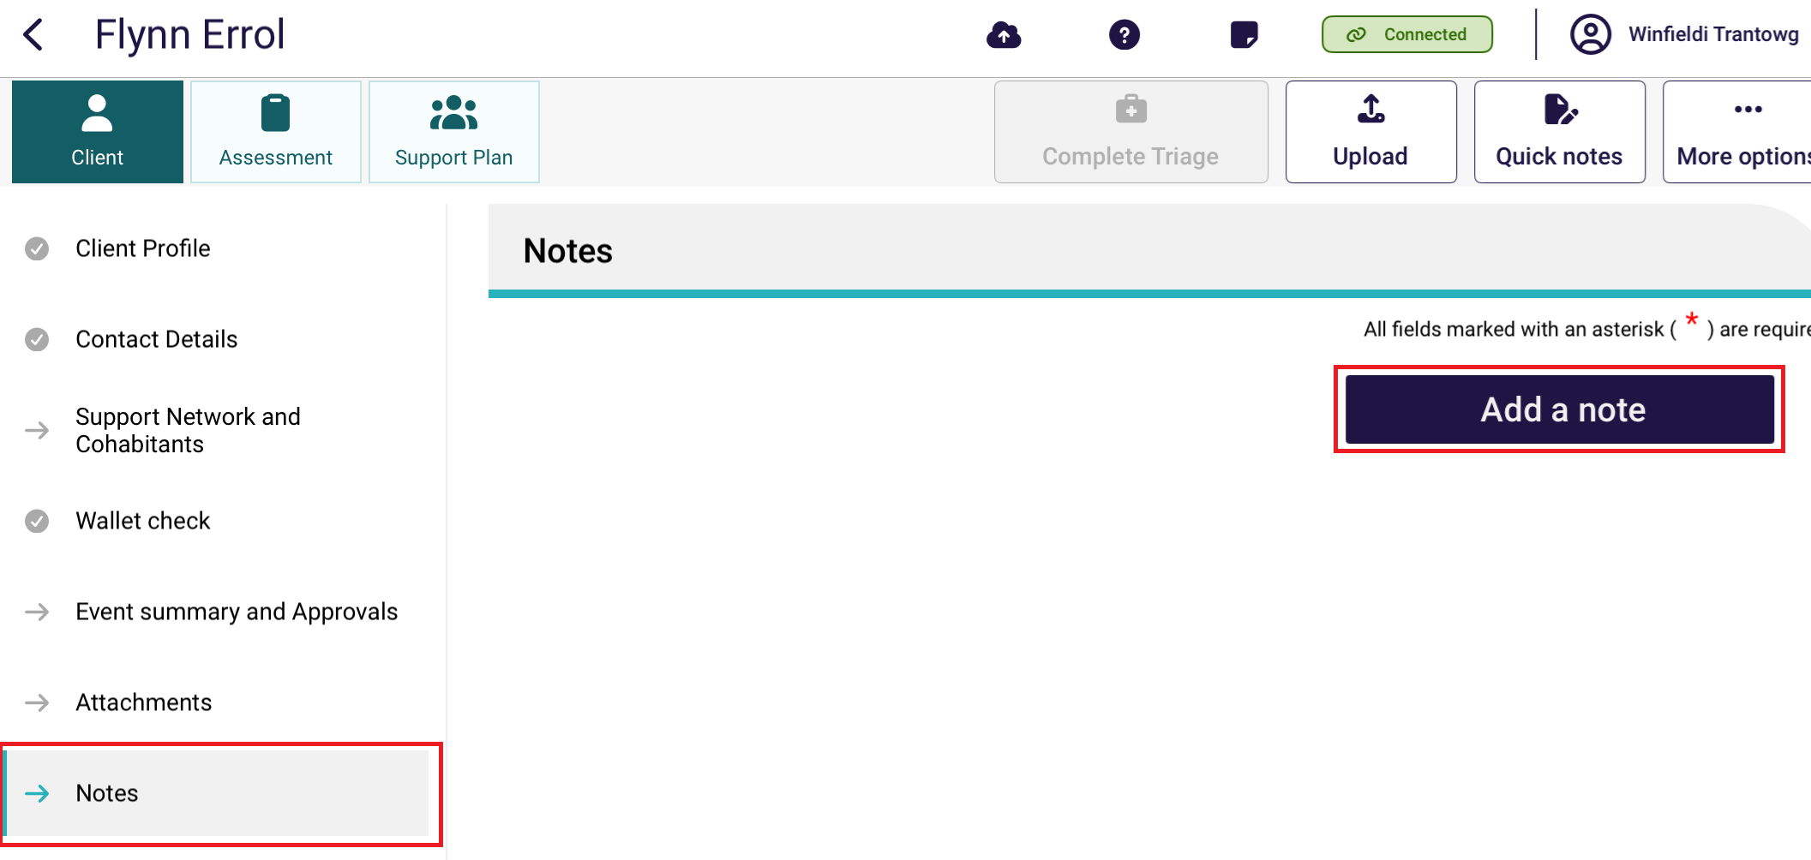
- Select the most appropriate Note type from the drop down menu.
Add an end date for the note if applicable. Once added you are able to edit or delete it using the Calendar or the Eraser icons.
Enter a description for the note.
Finally, select Save.
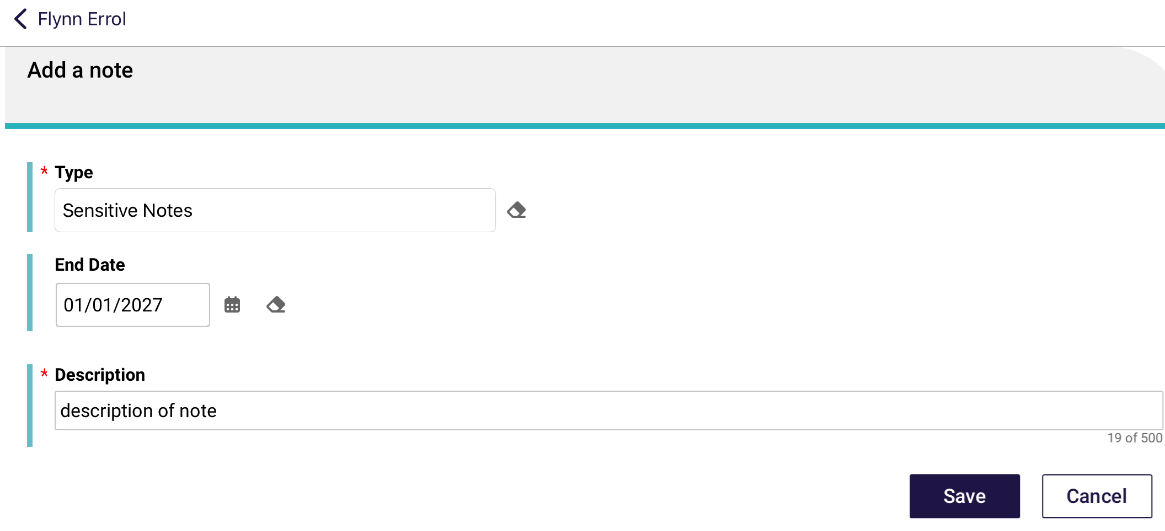
- These notes will be visible in the Notes tab on the client record when the assessment is uploaded to the My Aged Care assessor portal. Clients (and their support network) will only be able to view Client story and other notes.
! | When needs assessors add a sensitive note about a client, all service providers who are sent a referral will see a flag informing them that there is a sensitive note about the client and instruct them to call the My Aged Care contact centre or the Needs assessor for more information.
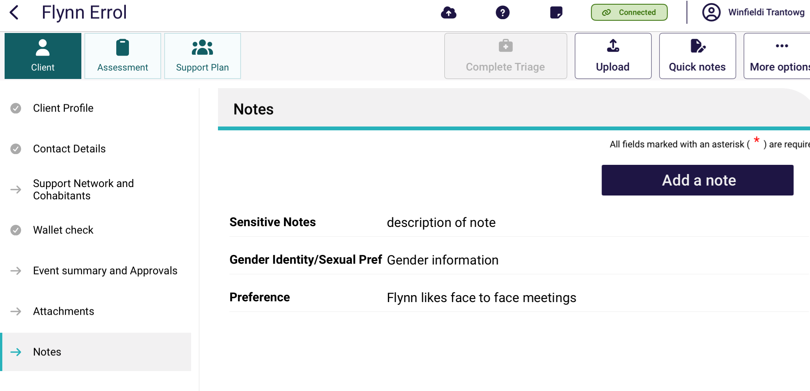

Registering a support person
! | The Aged Care Act (2024) is in force from 1 November 2025. The supporter role and the supporter guardian role in the new Act replaces the existing regular representative and authorised representative relationships in My Aged Care.  On 1 November 2025, representative relationships that are active in My Aged Care, and have not opted out, will transition to supporter relationships.
You can view pending and active support people, people that the client supports and other relationships on the Support Networks and Cohabitant page.
You can:
- create a relationship for an individual supporter or supporter lite
- create a relationship for a supporter organisation
- create a relationship for a carer or other types of support people
- create a relationship in offline mode
- activate a pending relationship
- remove a support relationship.
For more information on the types of support relationships that can be created, refer to My Aged Care – Assessor Portal User Guide 2 – Registering support people and adding relationships.
! | A warning symbol will be displayed next to the Support Network and Cohabitants menu item when a client has pending supporters that need to be confirmed.

9.1 Creating a relationship for an individual supporter or supporter lite
! | From 1 November 2025, relationships with individual agents cannot be created.
You must be connected to the Internet.
! | If you are offline, you can create a local record in Offline mode and register the record when you go back Online. Go to Creating a relationship in offline mode to complete this process.
- On the client’s Support Network and Cohabitants page, select Create Relationship.
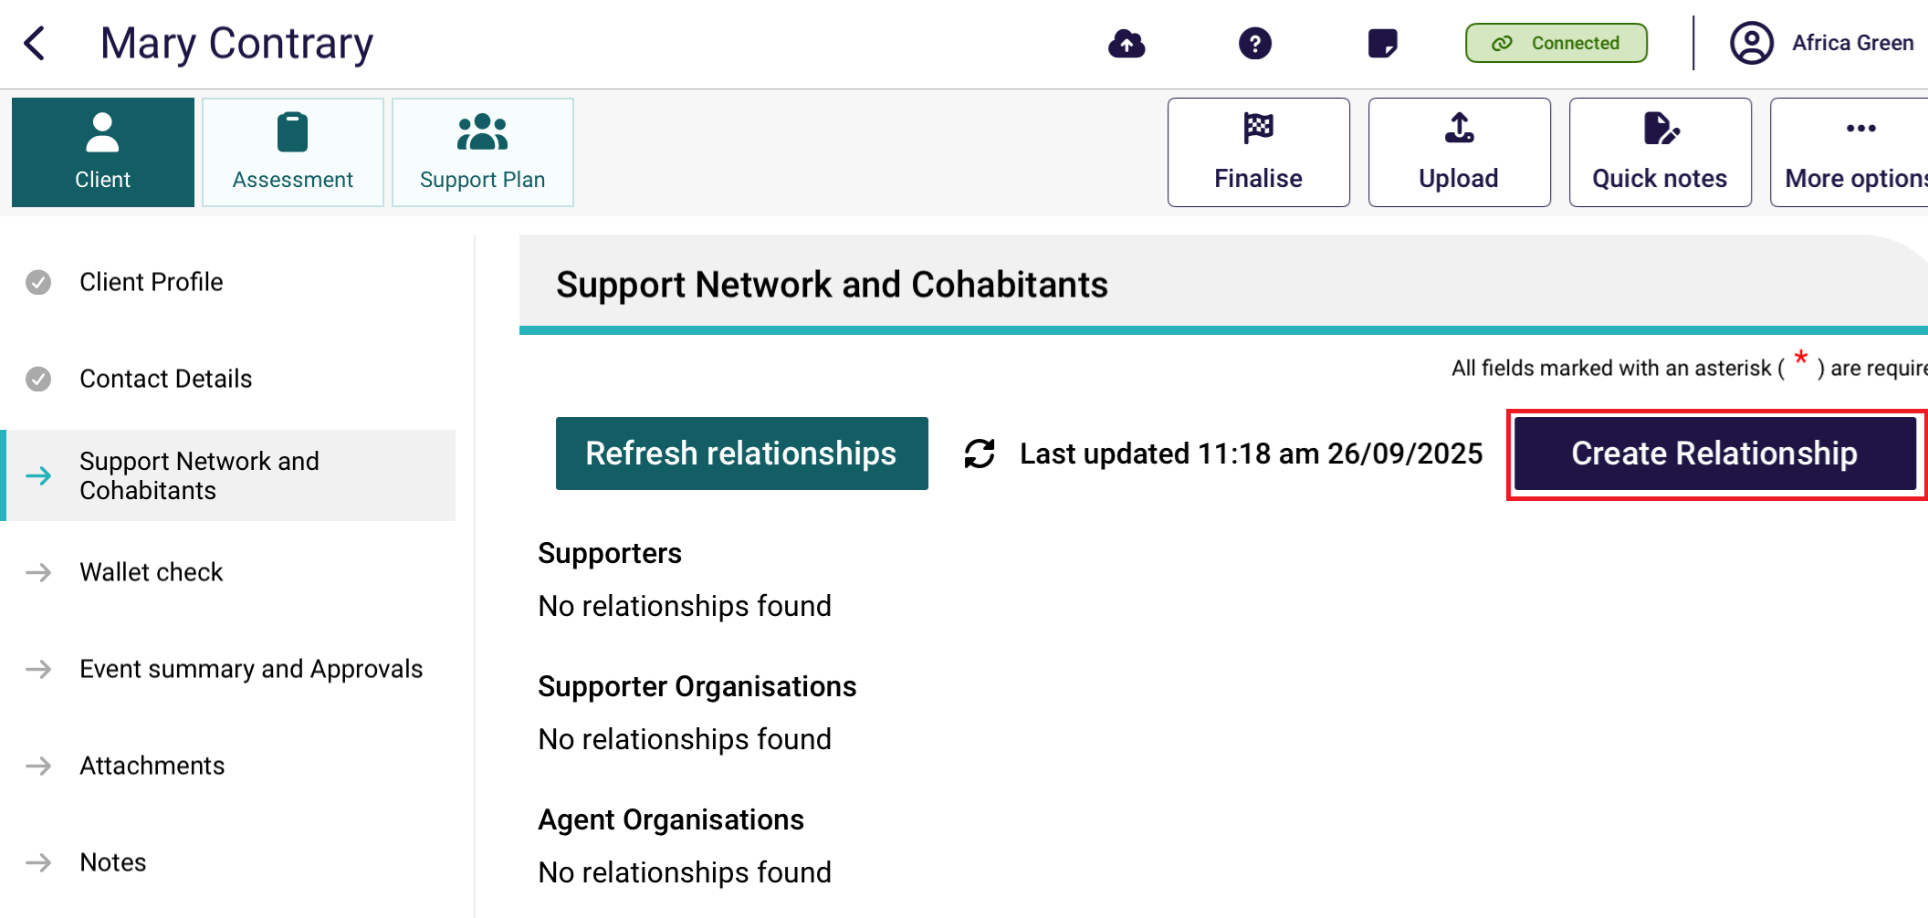
- In the Create Relationship page, choose a relationship to establish for the client. In this case it would be Supporter.
Depending on the relationship chosen, the following steps may vary.
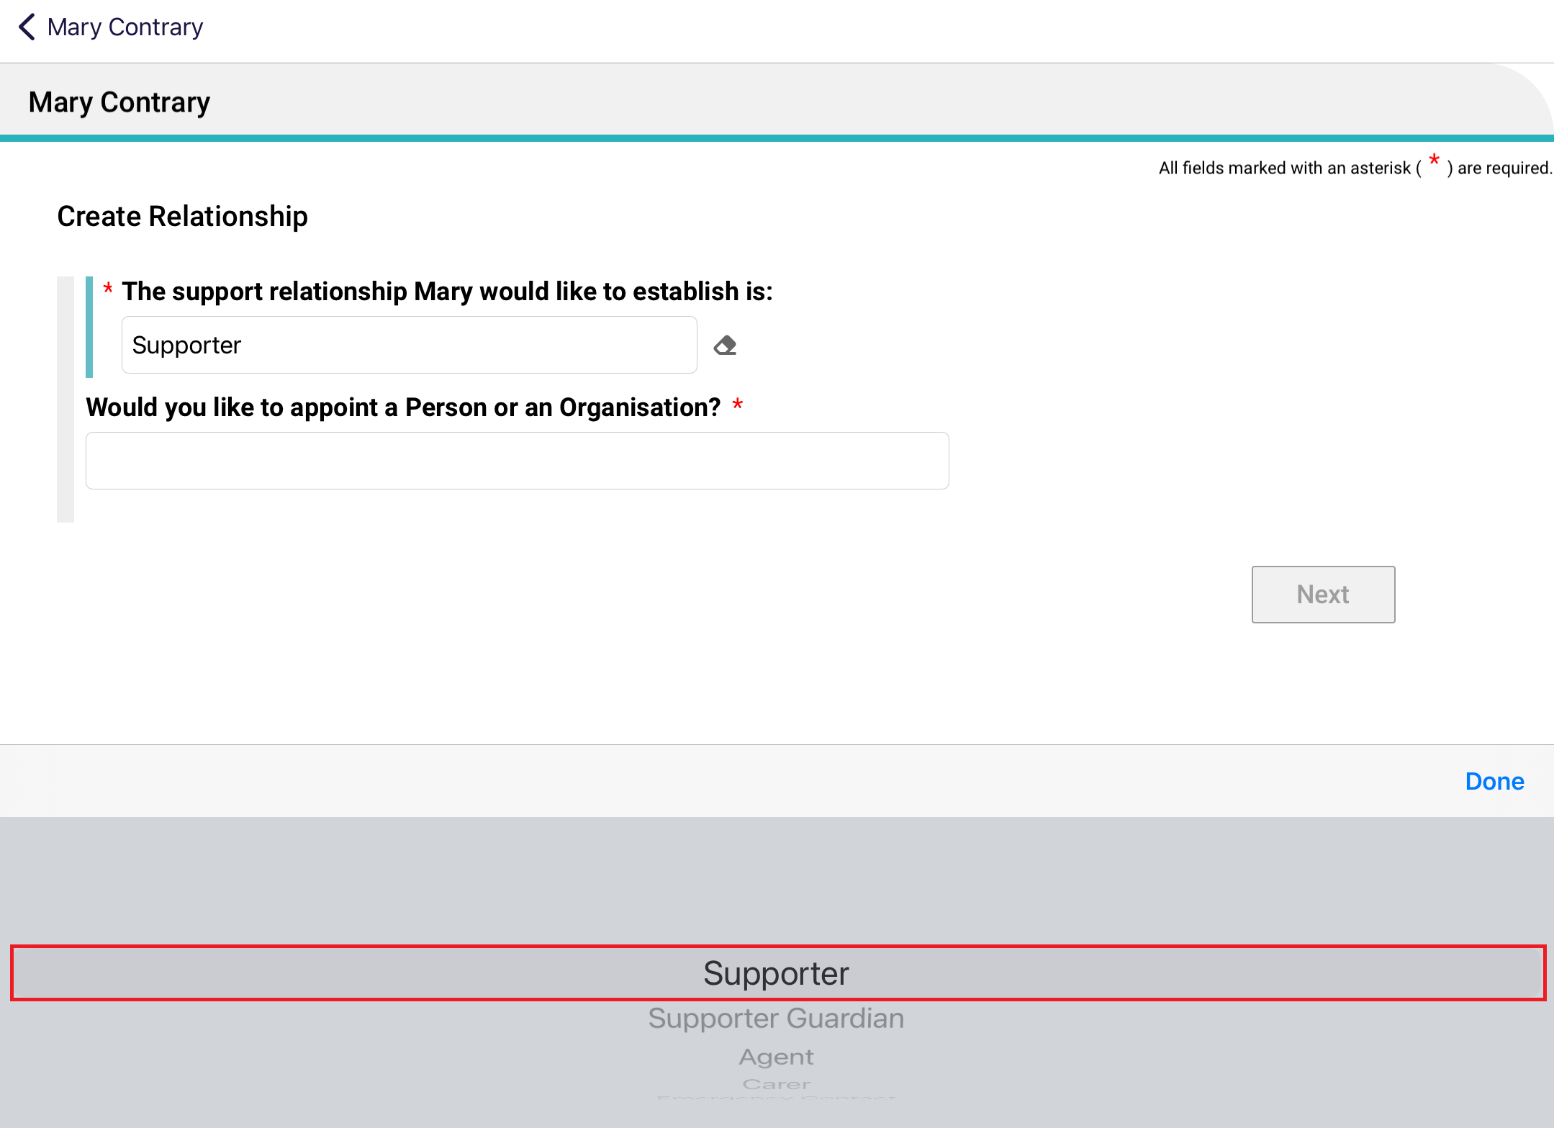
- For Would you like to appoint a person or an organisation?, choose Person: someone who is not part of a support organisation e.g. A family member, then select Next.
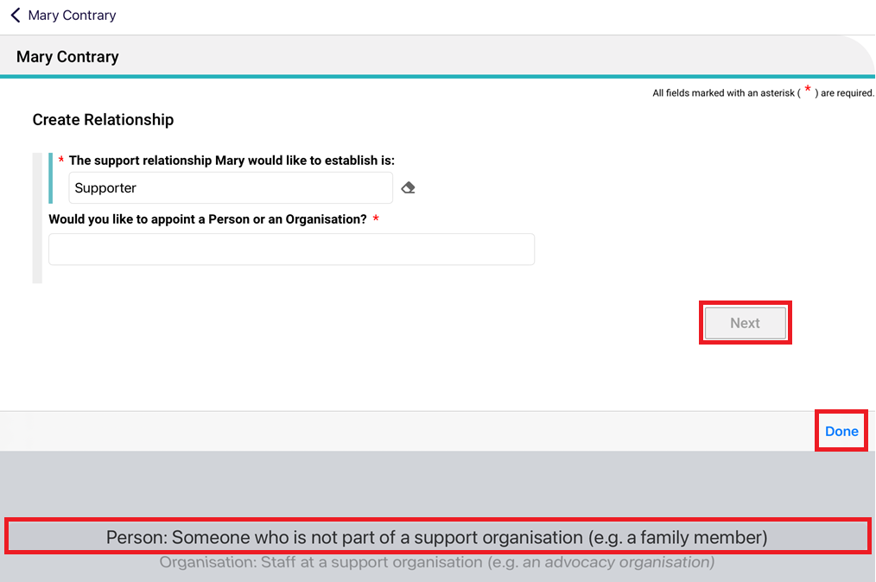
- Select Yes or No to the question Is this person present (in person or by phone/video call) with the client?, then select Next.
If No, you will also be asked whether the client has a complete Appointment of a Support Person Form or Appointment of a Support Organisation Form with them.
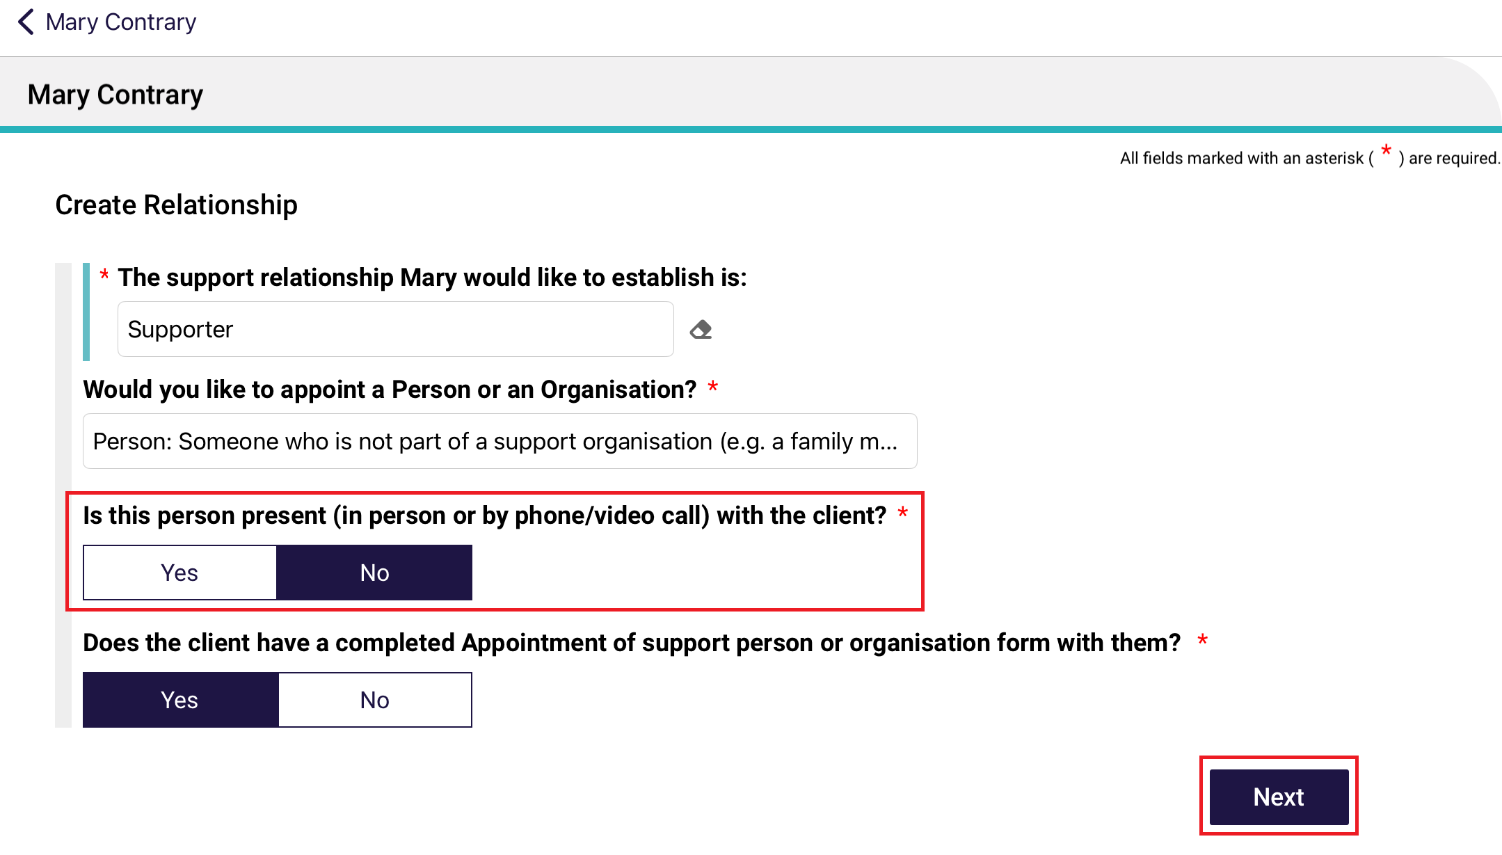

! | If the supporter is not present with the client, and they do not have a completed Appointment of a Support Person Form then the relationship cannot be created.  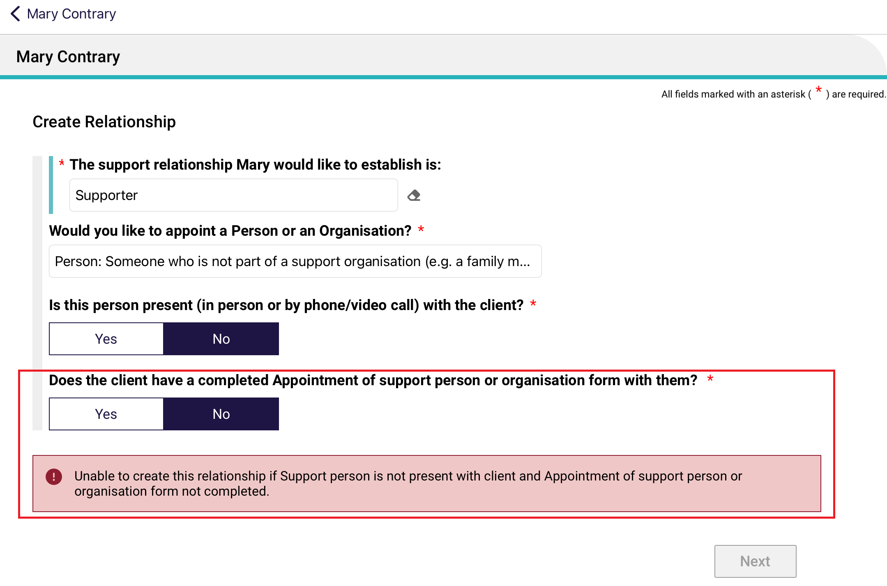
- After answering the above questions satisfactorily, the Find a Support Person page appears.
Enter the last name and first name of your supporter, and select Search. This is to ensure that there are no duplicate record being accidentally made in the My Aged Care system.
Then, go to the next step (Step 6) if there are no records found, or go to Step 6B if there are matching record/s.
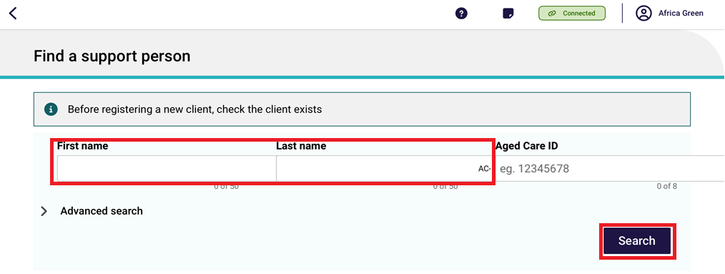
- If there are no records found, you can continue to register this supporter in the My Aged Care system, by selecting Create Supporter Relationship.
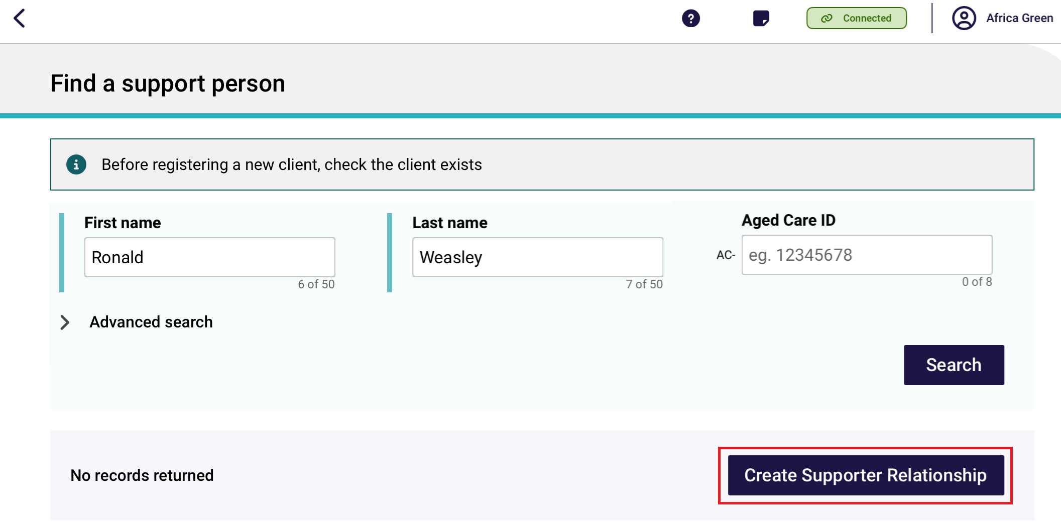
There are five pages in the Register a Supporter section: Personal Details, Address Details, Identity Match, Attachments, and Details and Consent. Enter all mandatory fields in each of the five pages until the Register button turns blue. Then, select Register.
Refer to steps 7 to 9 for more information on the Attachments page and the Details and Consent page.
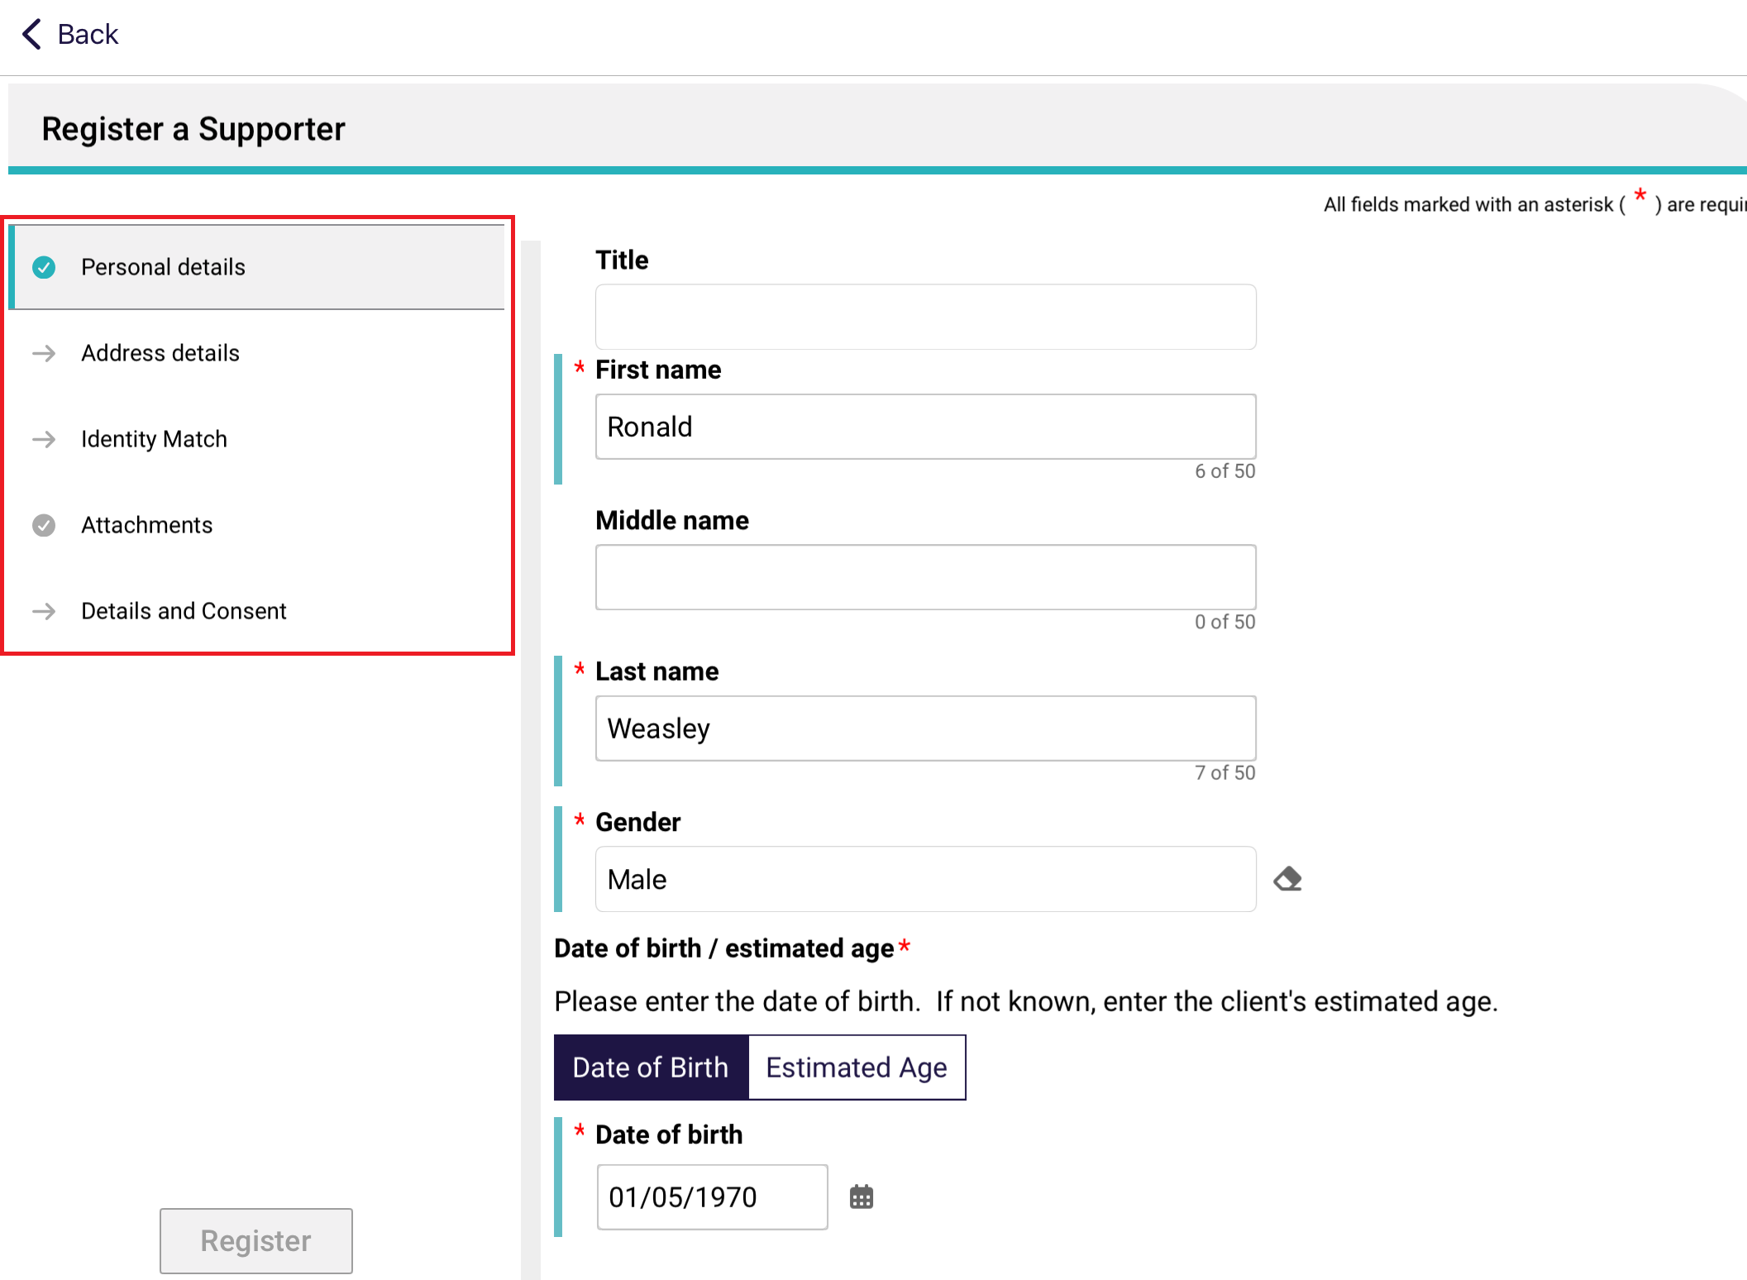

6B. If matching records are found, be sure to select the correct matching record.
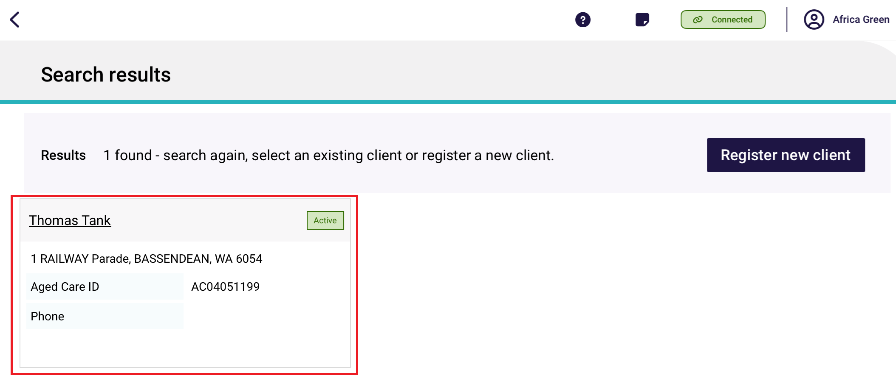
The Support Person’s details page appears. Double check that it is correct, then select Attachments.
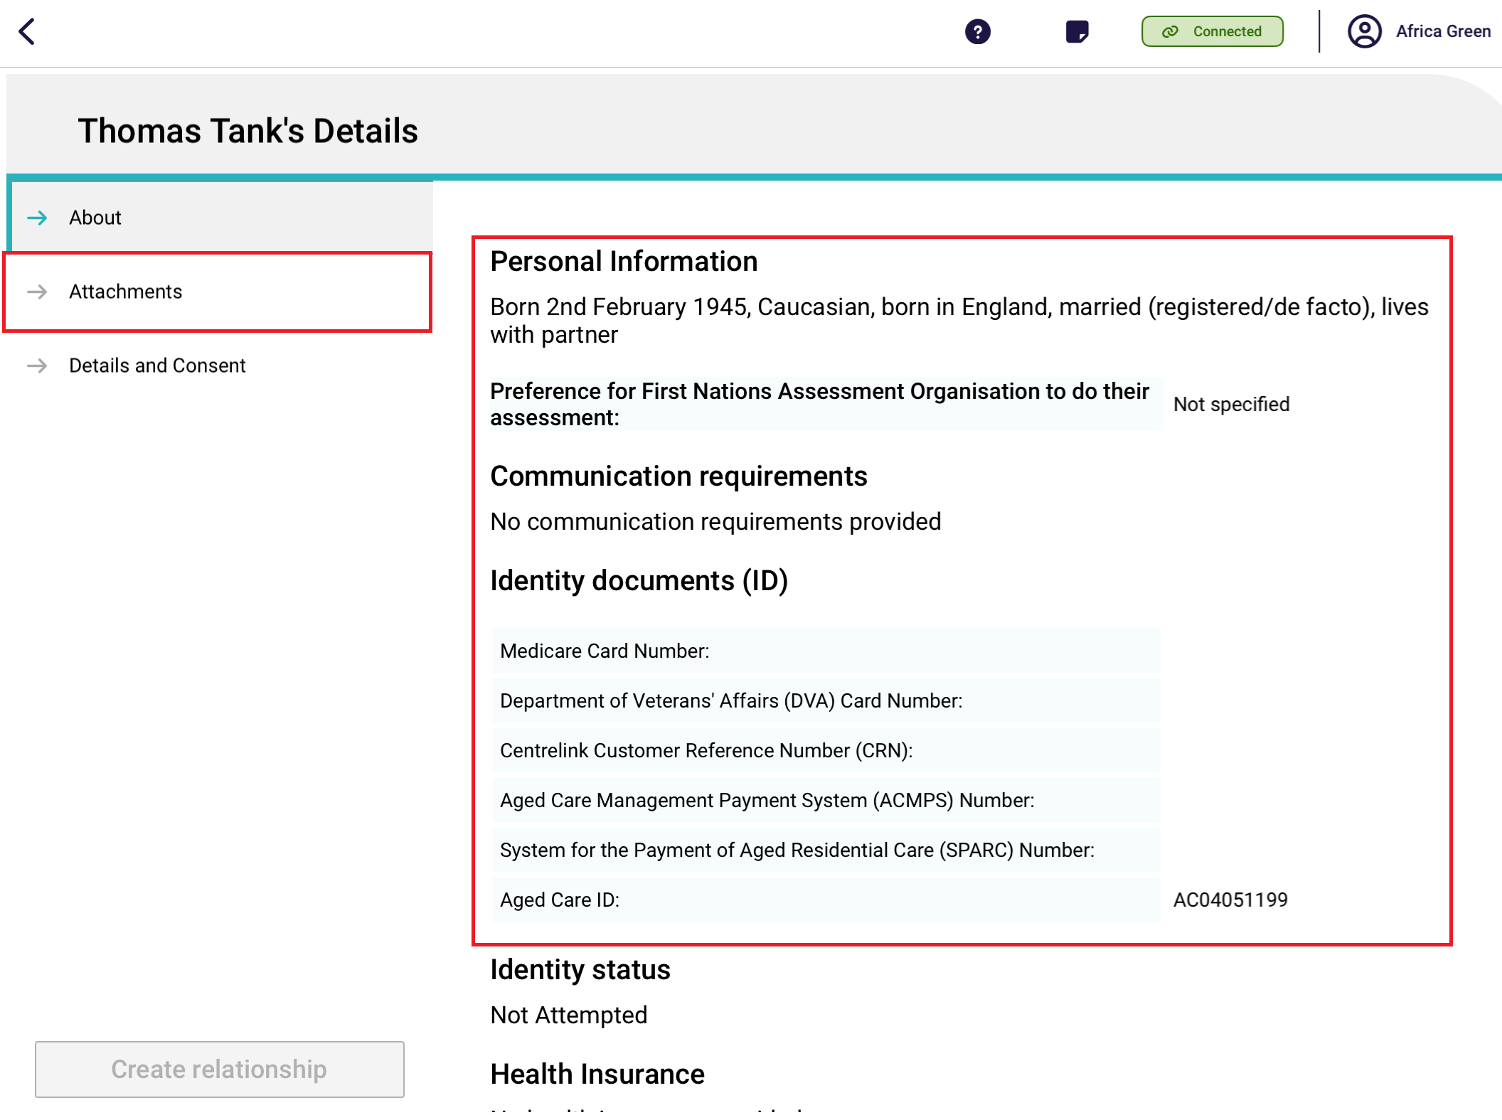
- The Attachments page appears. Add the appointment of support person form by selecting Add an image.
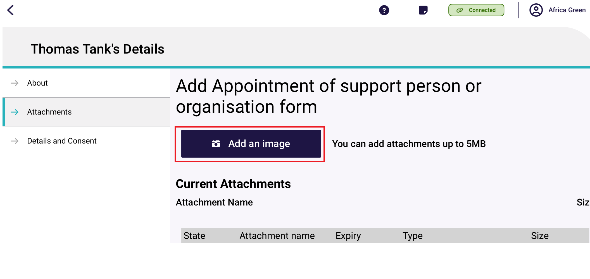
Name the image.
The pre-selected Type is ‘Appointment of Support Form.’ Select Done, and the Type text box will be filled.
Then, select Capture photo to take a picture of the form.
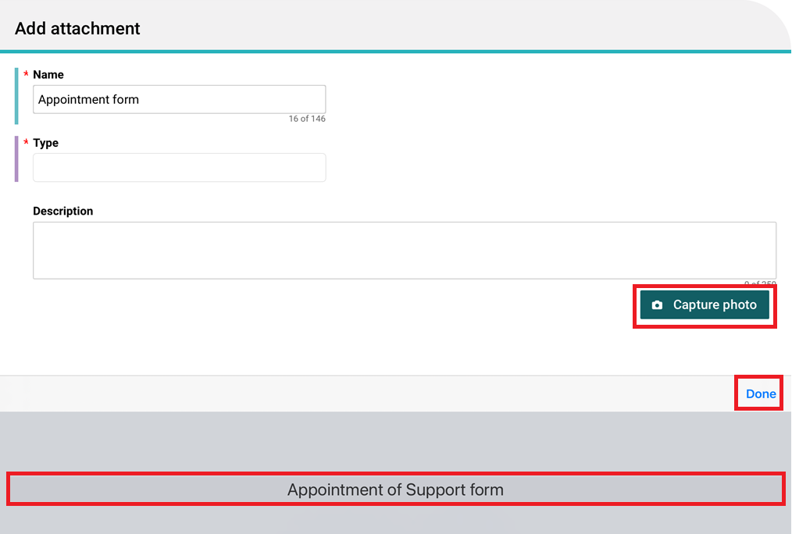
Finally, the Form appears in the Current Attachments section.
Next, go to Details and Consent.
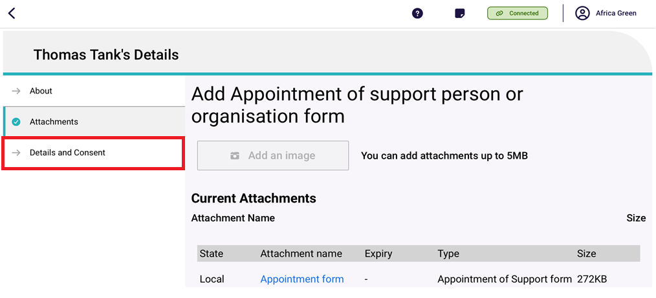
- The Details and Consent page appears.
Complete all mandatory fields in the Details section, including Relationship type (Child, Parent, Spouse/Partner, Neighbour, Friend or Other) and start date of relationship.
Error messages will continue to display until all mandatory fields are completed correctly.
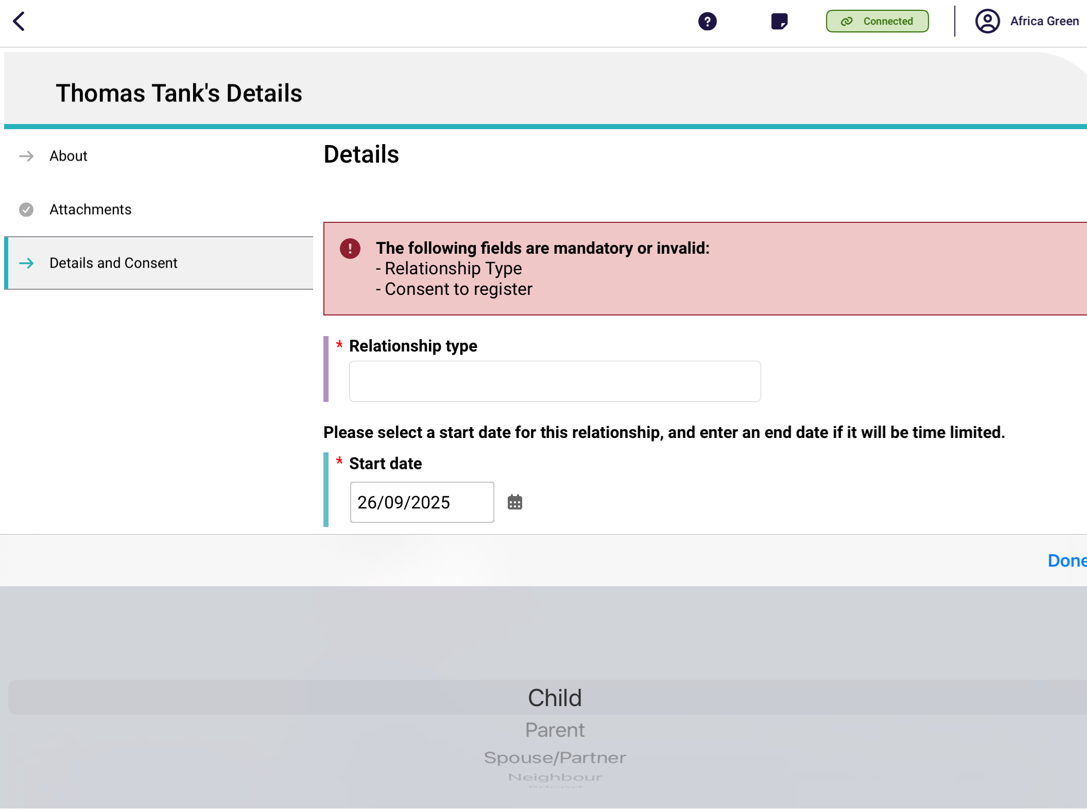
Toggle Yes or No in the Client Consent and Supporter Consent sections.
As every response is defaulted to No initially, there will be error messages about not being able to submit the relationship request. As soon as appropriate responses are entered, these error messages will disappear.
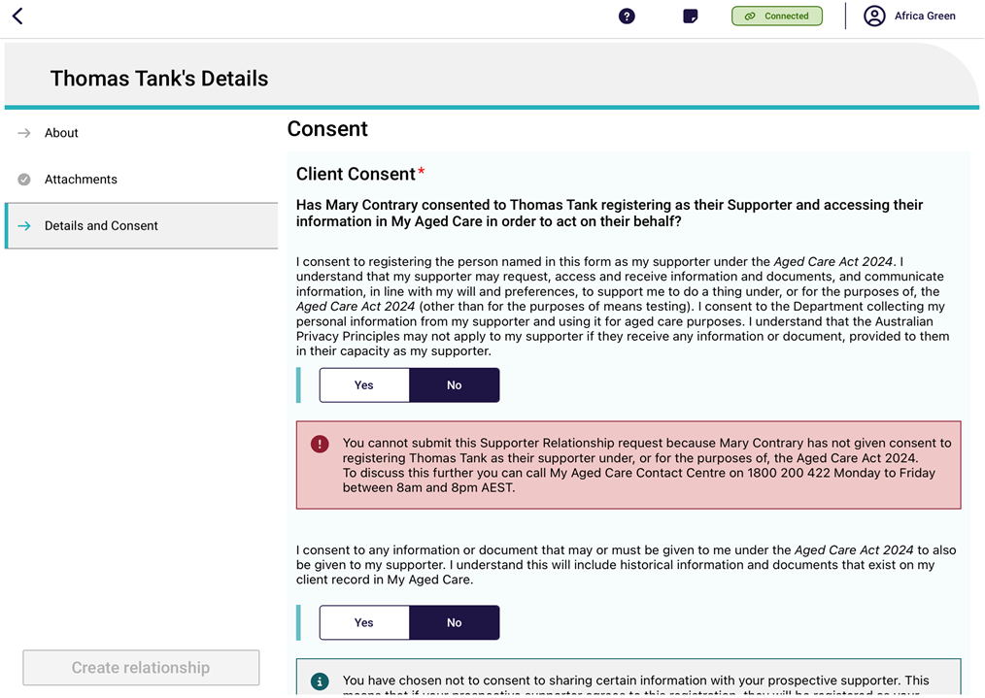
Towards the bottom of the consent toggles, there are links to view the duties of a supporter, and the terms and conditions of registering.
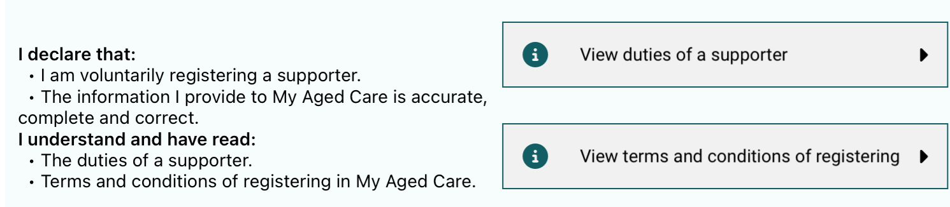
Scroll down to the Support Consent section, and toggle Yes or No to Has this support person consented to register
If Yes is selected, then toggle Yes or No to Does this support person have a conflict of interest?
Finally, the supporter can also view the duties of a supporter and the terms and conditions of registering by selecting their corresponding Information buttons.
Then, select Create Relationship.
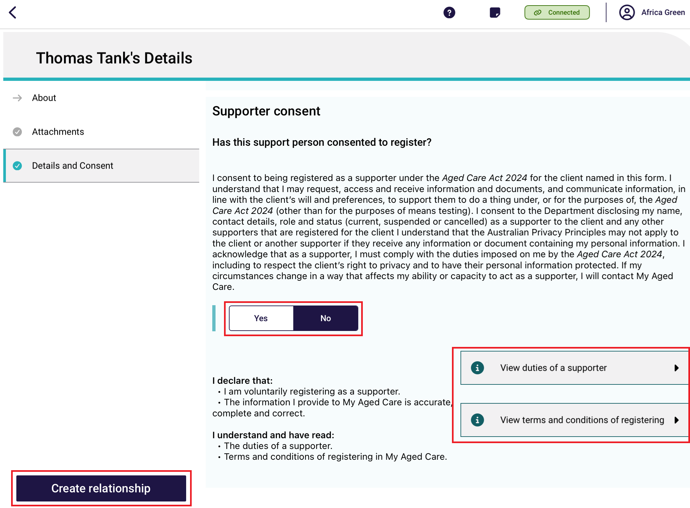
! | You must obtain the following consent before you can set up an active supporter relationship:  - supporter’s consent to register with My Aged Care (this will create a Supporter record)  - supporter’s consent to support the client  - client’s consent to be supported by the nominated supporter.  Please note, consent is not required for Supporter Guardian relationships.
! | A pending relationship is created if:  - either the client or supporter do not provide their consent for the relationship to be set up (applicable for individual supporters only)  - the start date of the relationship is in the future  - a Supporter guardian relationship is being created.  To activate a pending relationship, go to Activating a pending relationship.
! | If a supporter declares a conflict of interest in being registered in a support relationship, you will not be able to submit this support relationship request via the App. To discuss this further, please call the My Aged Care contact centre.
- An information banner displays. Select Go Back, then the new supporter relationship will be displayed as an expandable banner on the Support Network and Cohabitants page.
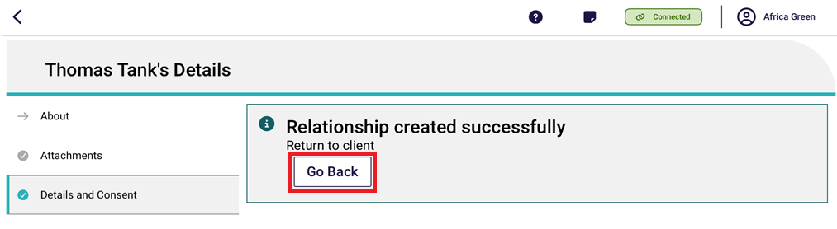
The below image shows a Pending Supporter relationship who is a friend of the client.
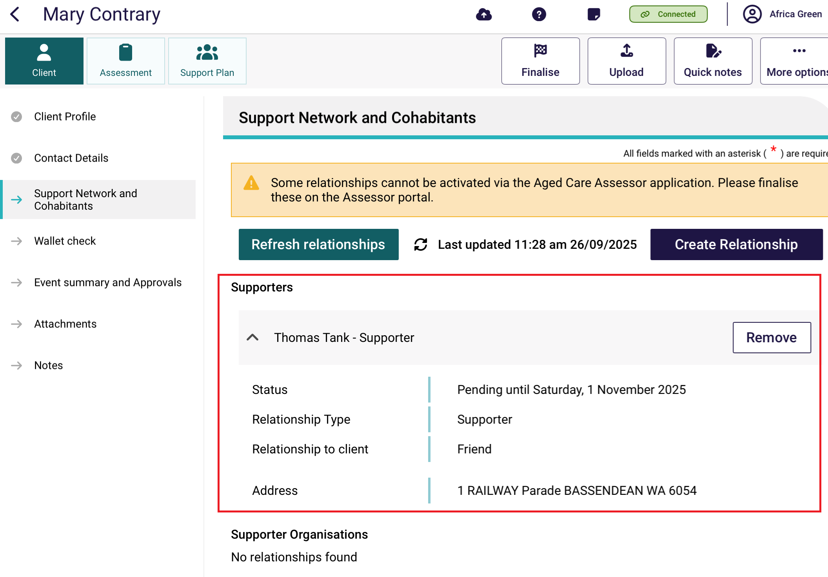
The below image shows an Active Supporter Lite relationship.
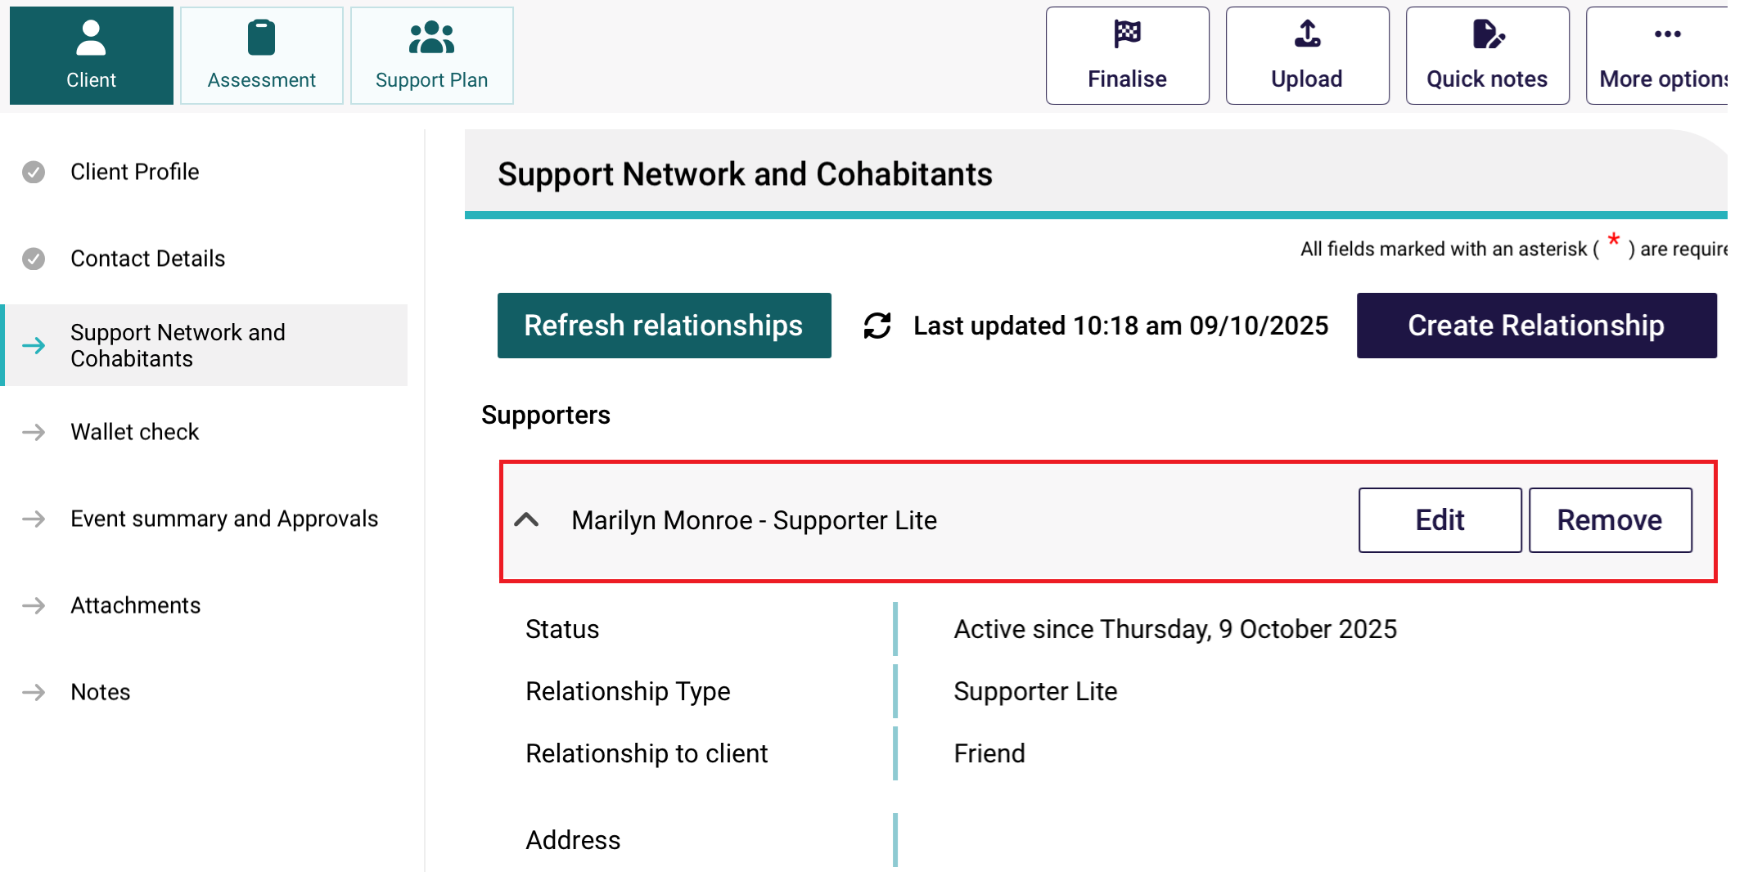

A Supporter Lite relationship is a type of Supporter relationship where the client did not consent to any information or document that may or must be given to the client under the Act to also be given to their supporter.
There will be an information message confirming that you will be setting up a Supporter Lite relationship.
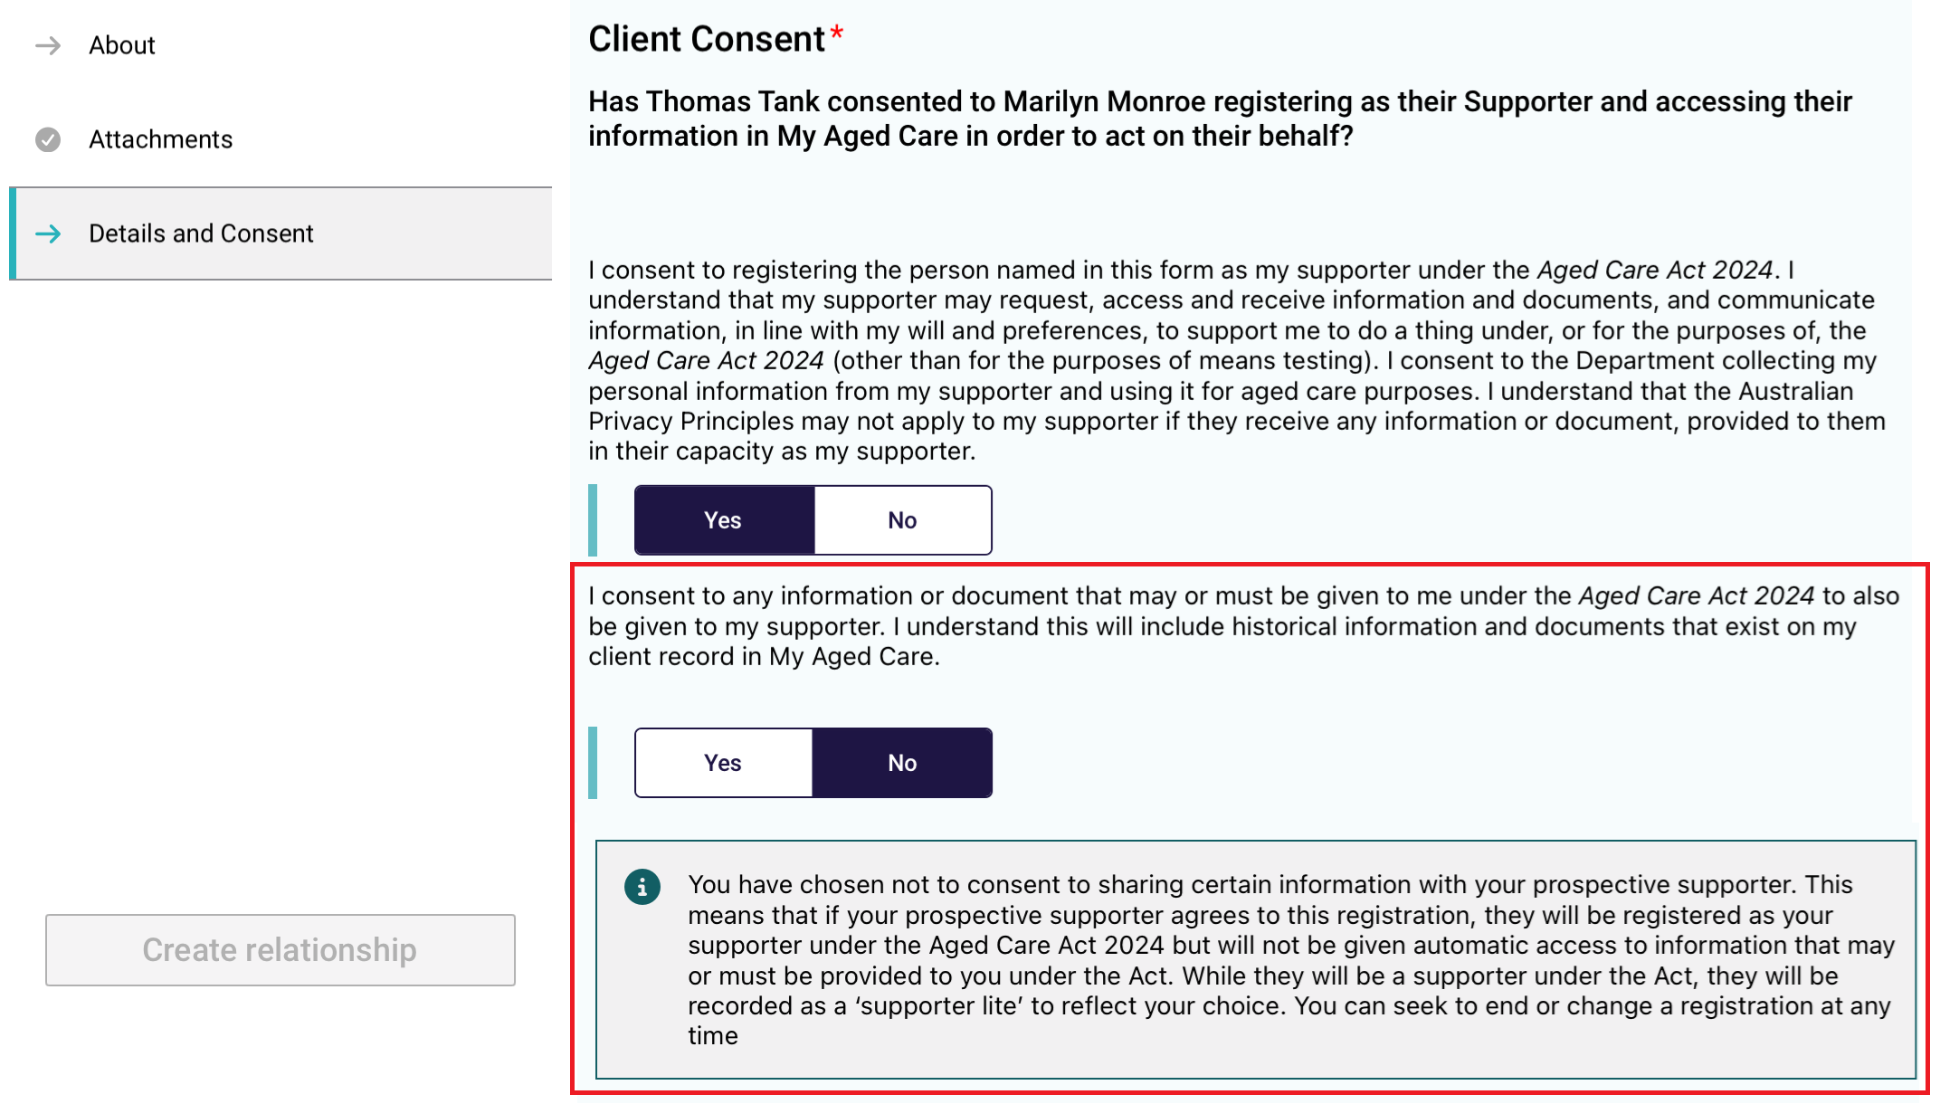

9.2 Creating a relationship for a supporter guardian
You must be connected to the Internet.
! | If you are offline, you can create a local record in Offline mode and register the record when you go back Online. Go to Creating a relationship in offline mode to complete this process.
- On the client’s Support Network and Cohabitants page, select Create Relationship.
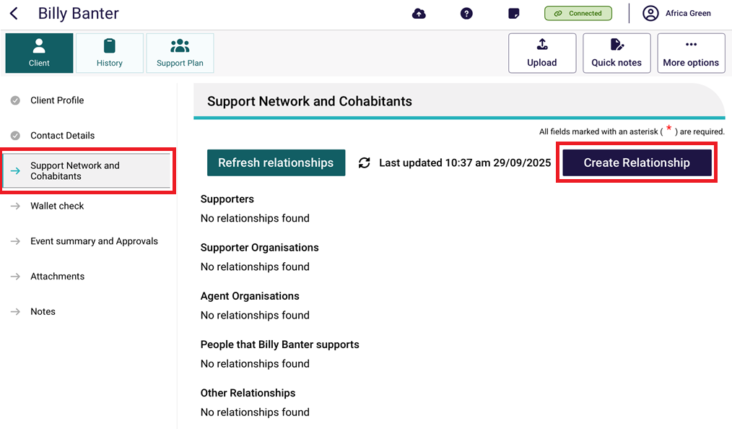
- In the Create Relationship page, choose a relationship to establish for the client. In this case it would be Supporter Guardian.
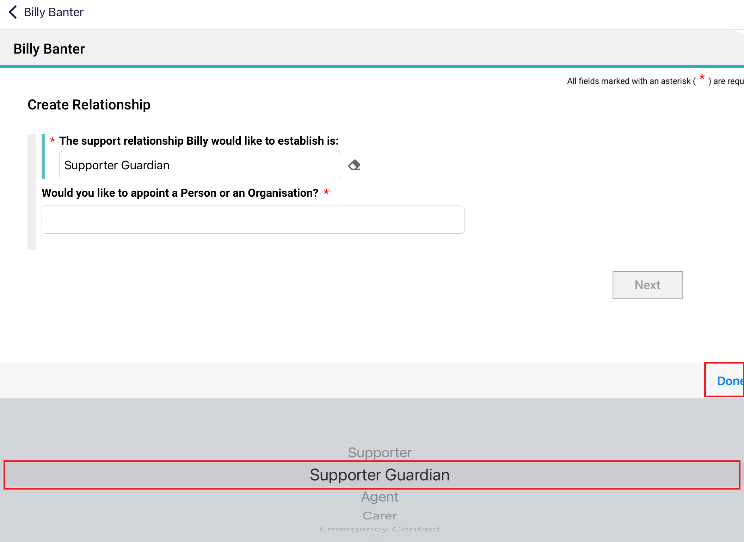
- For Would you like to appoint a person or an organisation?, choose Person: someone who is not part of a support organisation e.g. A family member, then select Next.
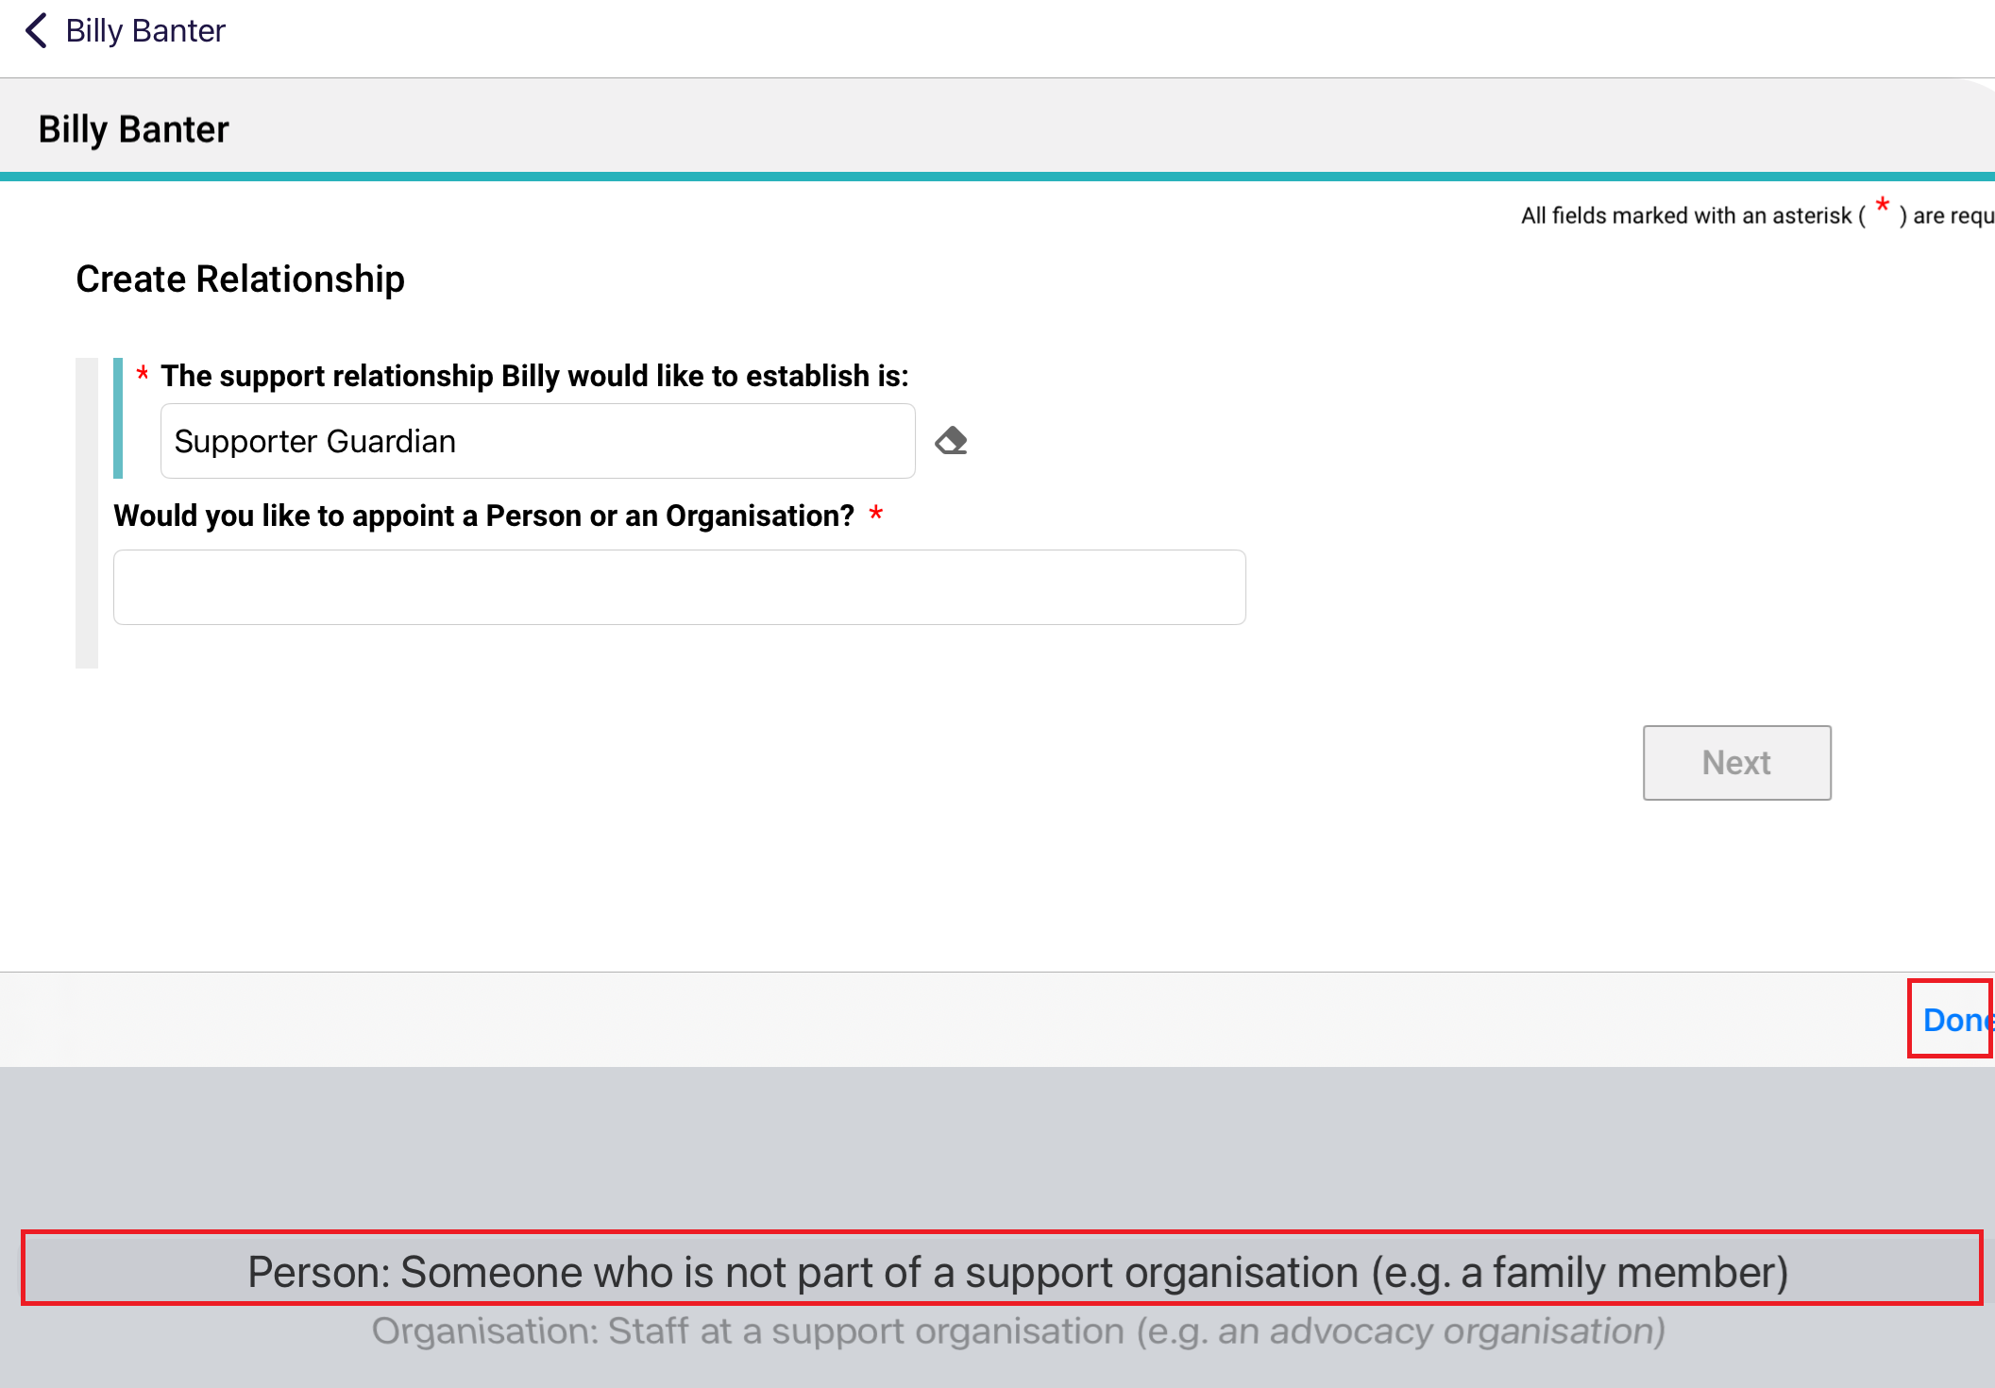
- Select Yes or No to the question Is this person present (in person or by phone/video call) with the client?, then select Next.
If No, you will also be asked whether the client has a complete Registration of a Supporter Form with them.
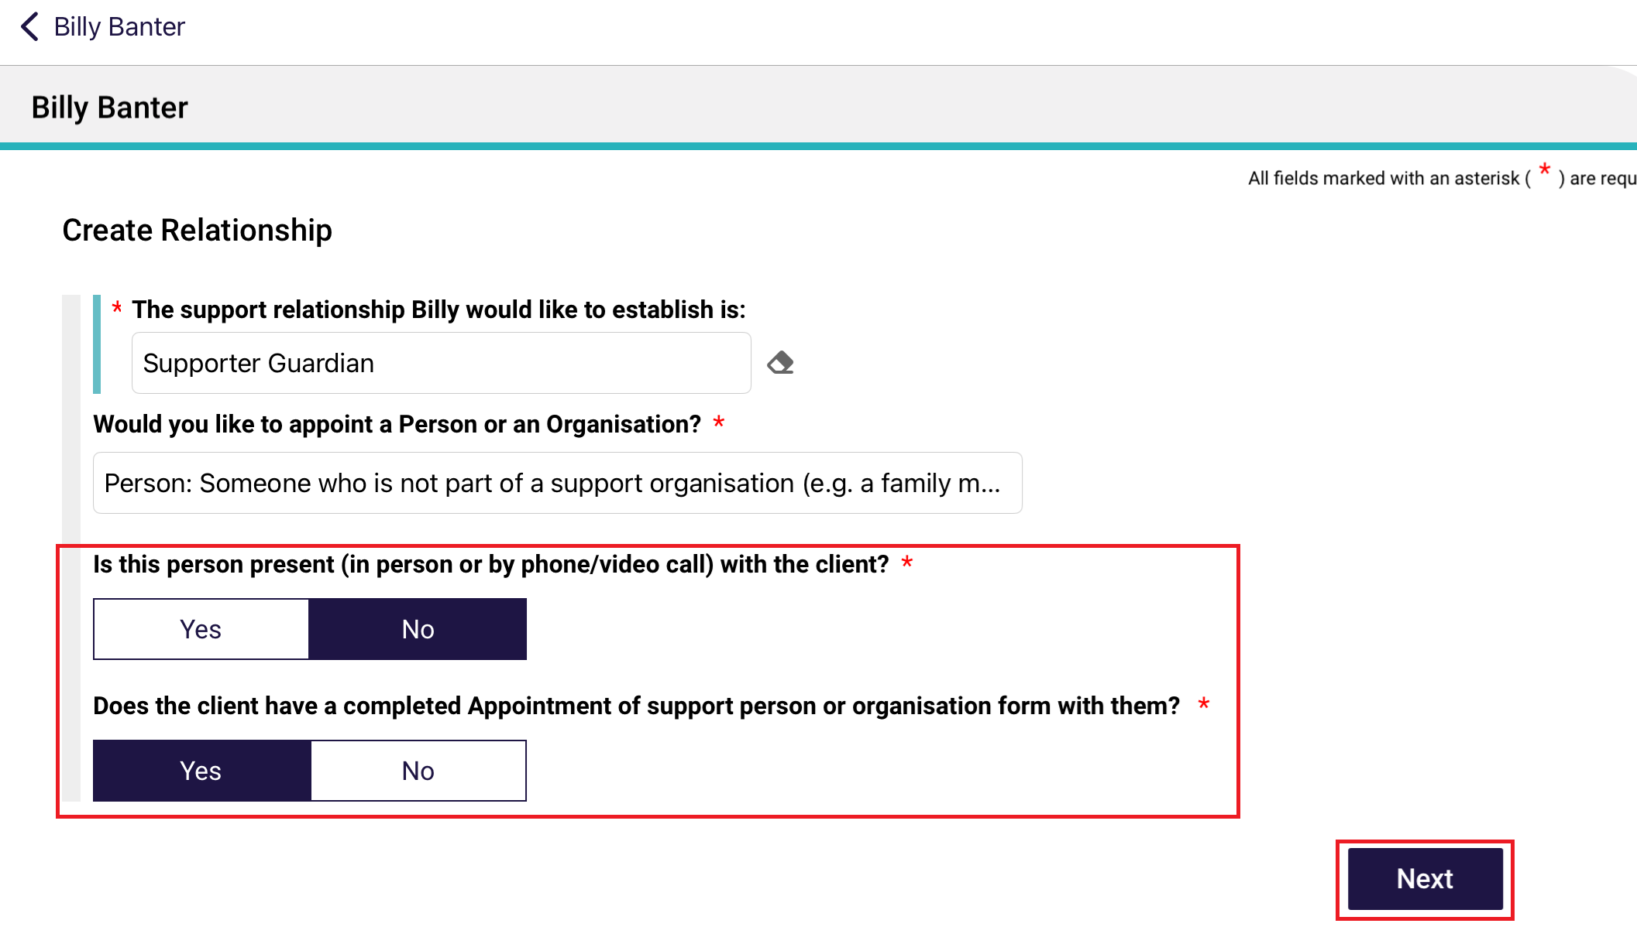
! | If the supporter guardian is not present with the client, and they do not have a completed Registration of a Supporter then the relationship cannot be created.  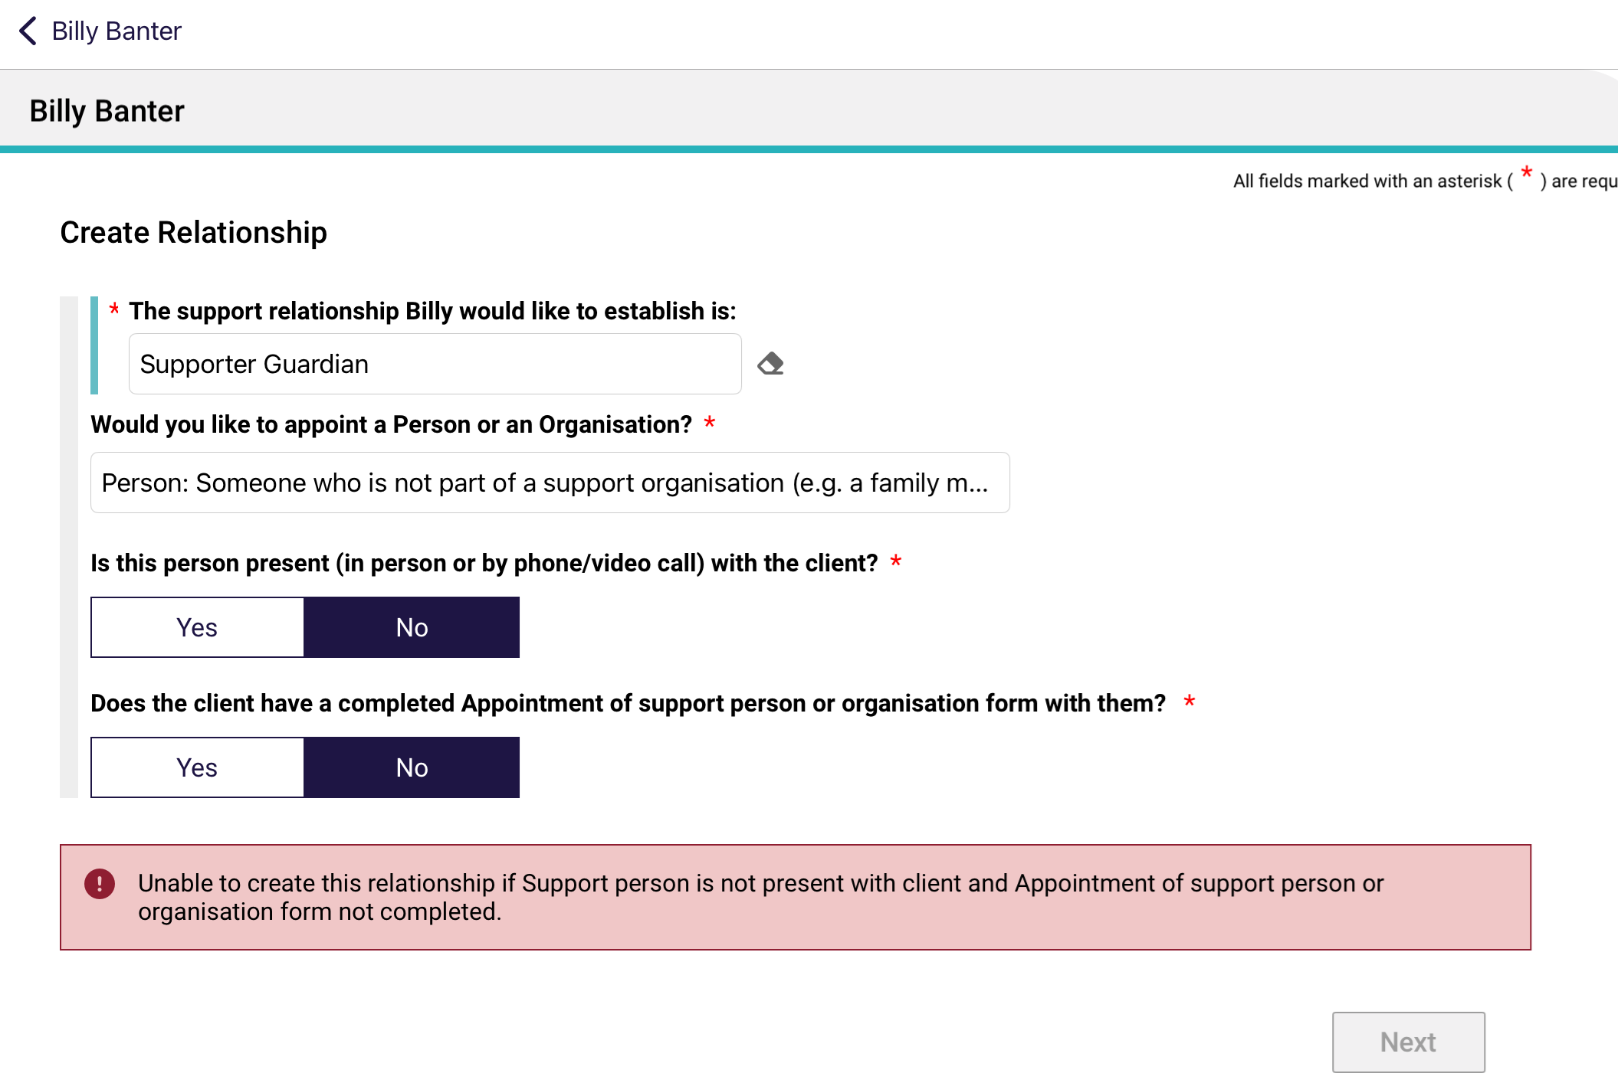

- After answering the above questions satisfactorily, the Find a Support Person page appears.
Enter the last name and first name of your supporter, and select Search. This is to ensure that there are no duplicate record being accidentally made in the My Aged Care system.
Then, go to the next step (Step 6) if there are no records found, or go to Step 6B if there are matching record/s.
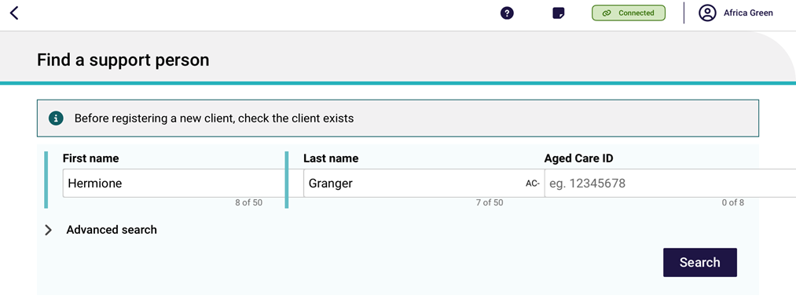
- If there are no records found, you can continue to register this supporter in the My Aged Care system, by selecting Create Supporter Relationship.
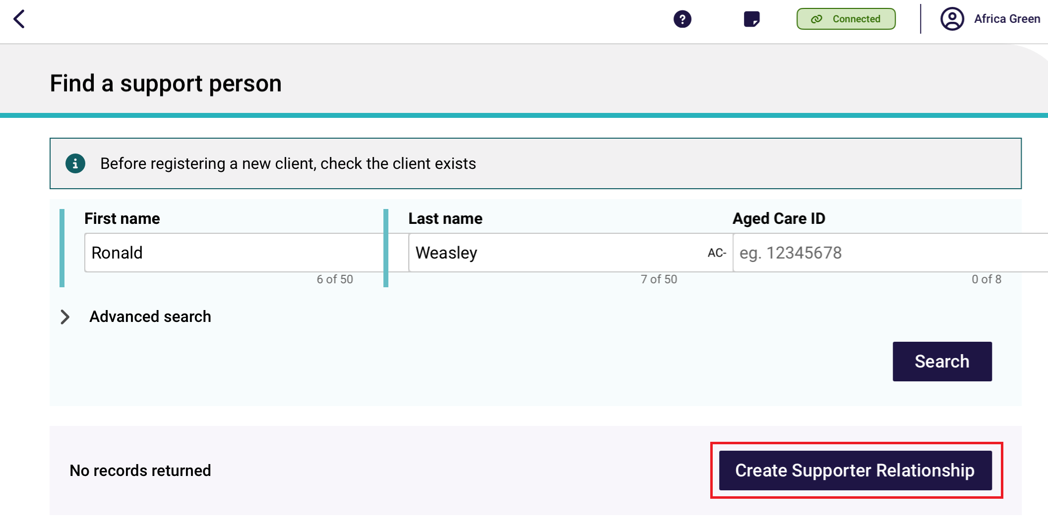
There are five pages in the Register a Supporter section: Personal Details, Address Details, Identity Match, Attachments, and Details and Consent. Enter all mandatory fields in each of the five pages until the Register button turns blue. Then, select Register.
Refer to steps 7 to 9 for more information on the Attachments page and the Details and Consent page.
6B. If matching records are found, be sure to select the correct matching record.
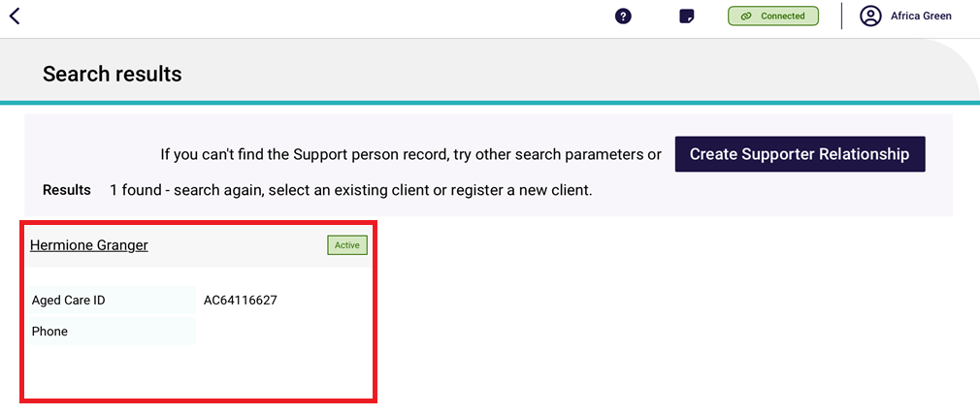
The Support Person’s details page appears. Double check that it is correct, then select Attachments.
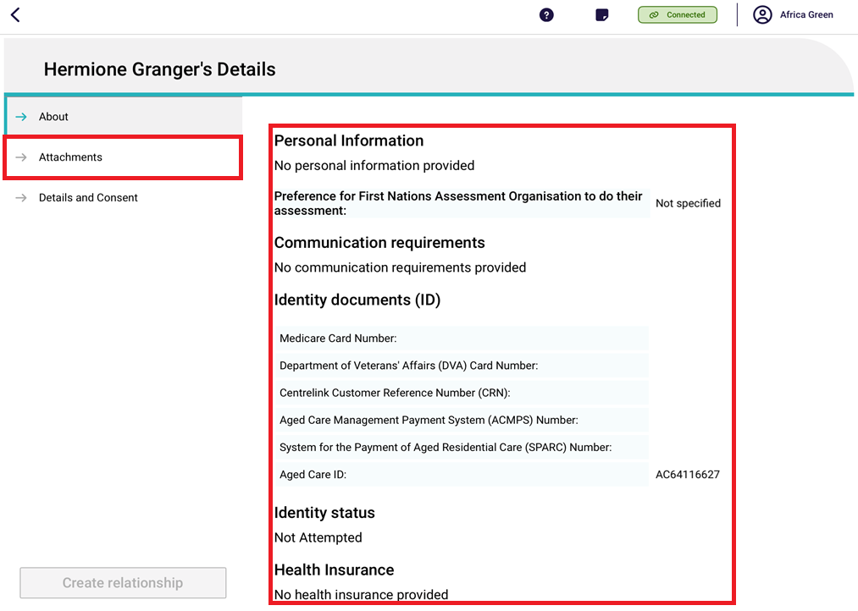
- The Attachments page appears. Add the appointment of support person form by selecting Add an image.
Supporter Guardian relationships require appropriate legal and/or medical documentation. These documents can be added via the Assessor Portal, after the relationship is created, during the activation stage.
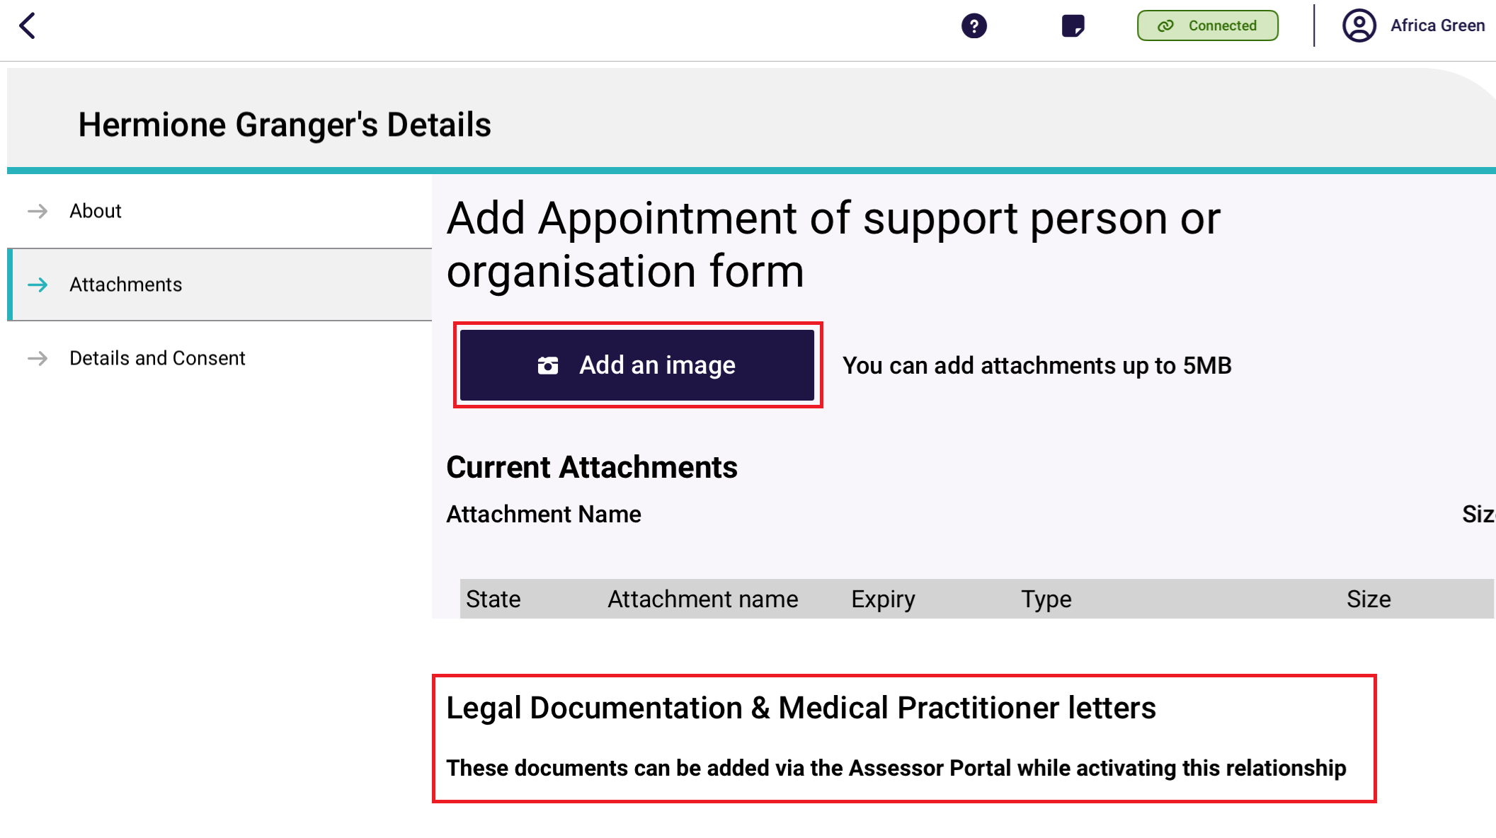
Name the image.
The pre-selected Type is ‘Appointment of Support Form.’ Select Done, and the Type text box will be filled.
Then, select Capture photo to take a picture of the form.
Finally, the Form appears in the Current Attachments section.
Next, go to Details and Consent.
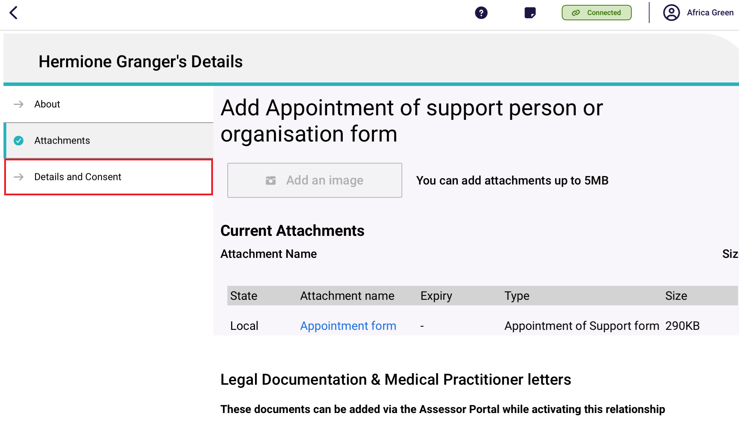
- The Details and Consent page appears.
There is a information banner reminding that Supporter Guardian relationships can only be created in Pending status.

Complete all mandatory fields in the Details section, including Relationship type (Child, Parent, Spouse/Partner, Neighbour, Friend or Other) and start date of relationship.
Error messages will continue to display until all mandatory fields are completed correctly.
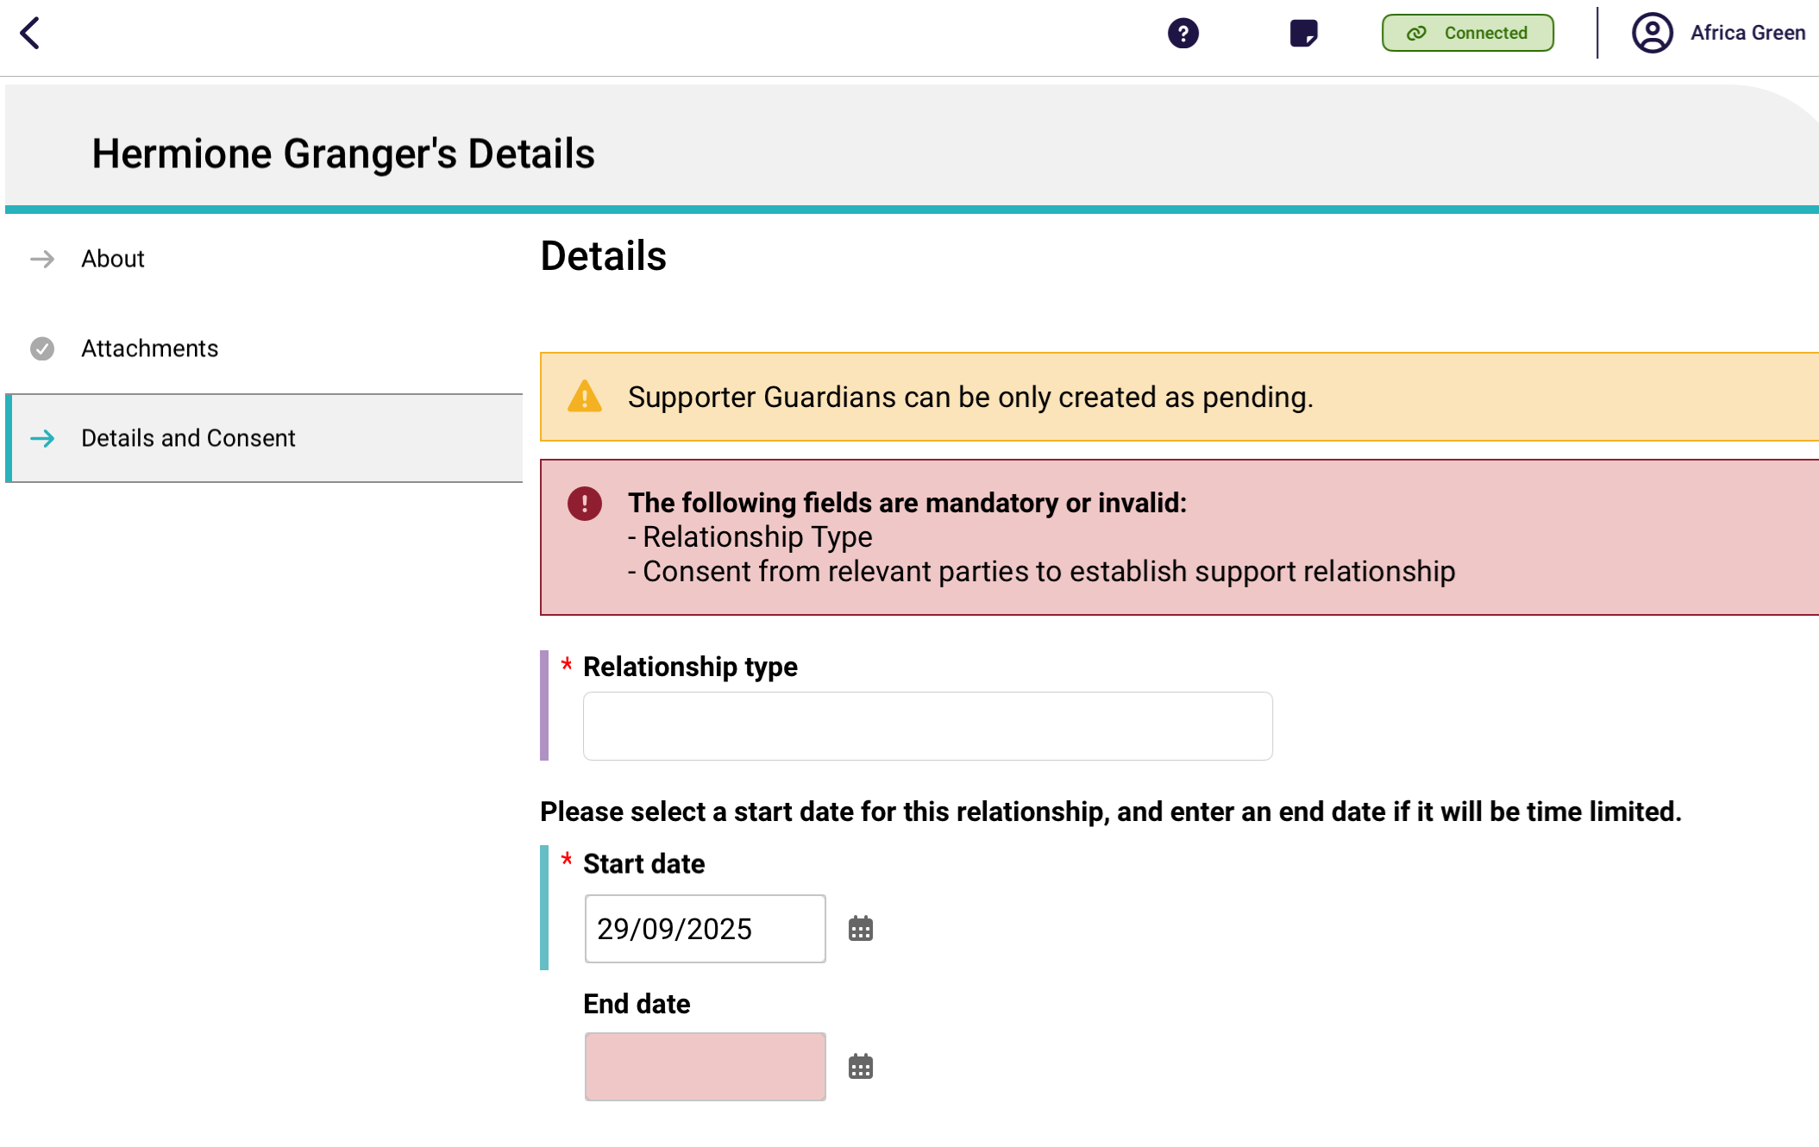
Scroll down to the Consent section.
For supporter guardian relationships, the client’s consent is not required, therefore only the Supporter Guardian consent section appear. Toggle Yes or No to Has this support person consented to register?
If Yes is selected, then toggle Yes or No to Does this support person have a conflict of interest? If there is a conflict of interest, enter the description at the text box that appears.
Finally, the supporter can also view the duties of a supporter and the terms and conditions of registering by selecting their corresponding Information buttons.
Then, select Create Relationship.
! | Consent is not required for Supporter Guardian relationships.
! | All Supporter Guardian relationships made in the app will be Pending.  To activate a pending relationship, go to Activating a pending relationship.
! | If a supporter declares a conflict of interest in being registered in a support relationship, you will not be able to submit this support relationship request via the App. To discuss this further, please call the My Aged Care contact centre.
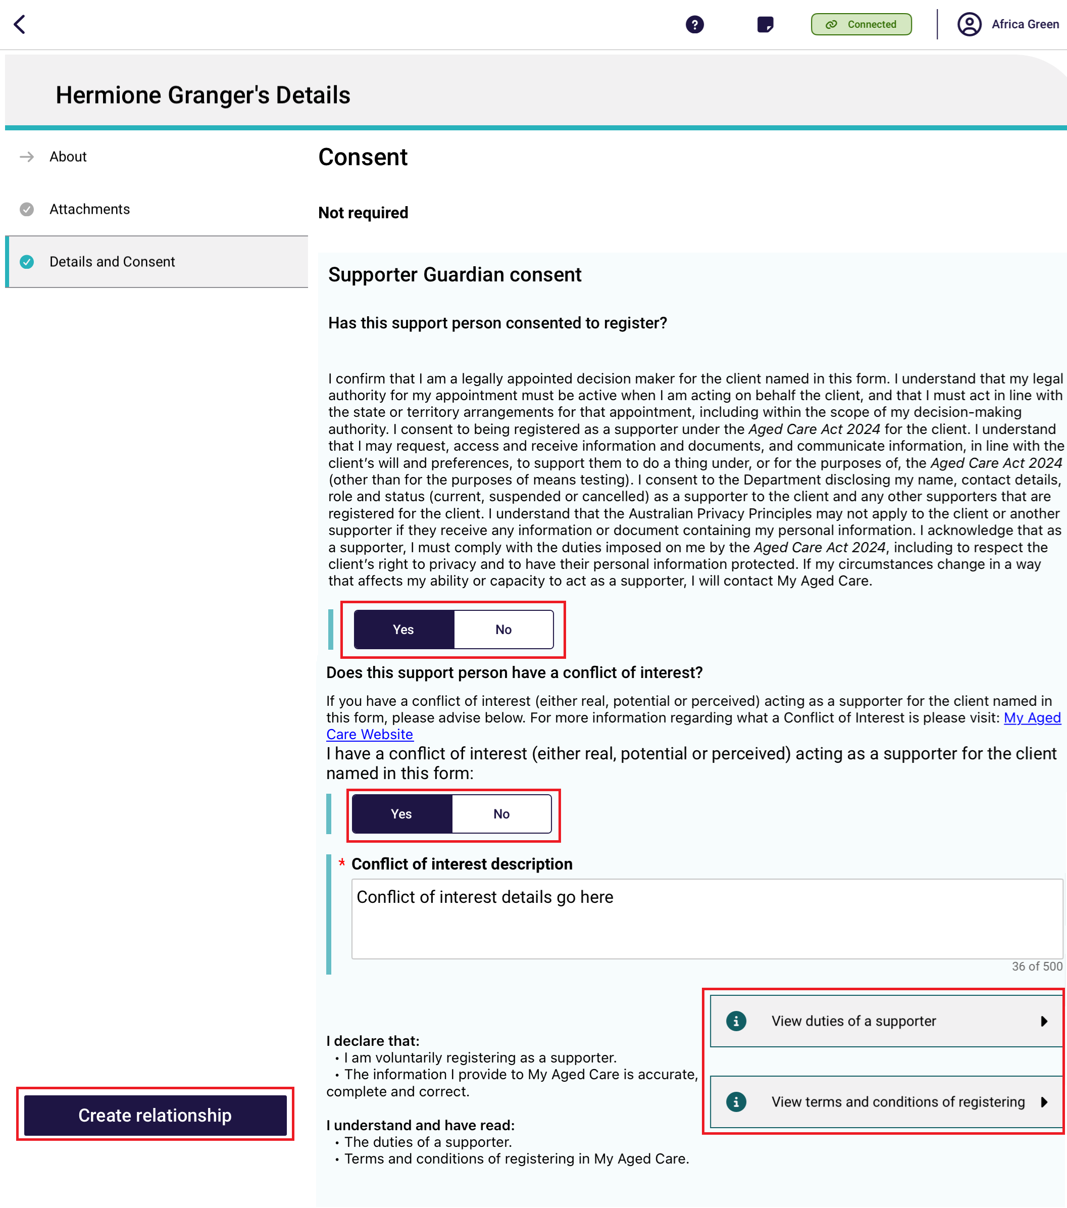
- An information banner displays. Select Go Back, then the new supporter relationship will be displayed as an expandable banner on the Support Network and Cohabitants page.
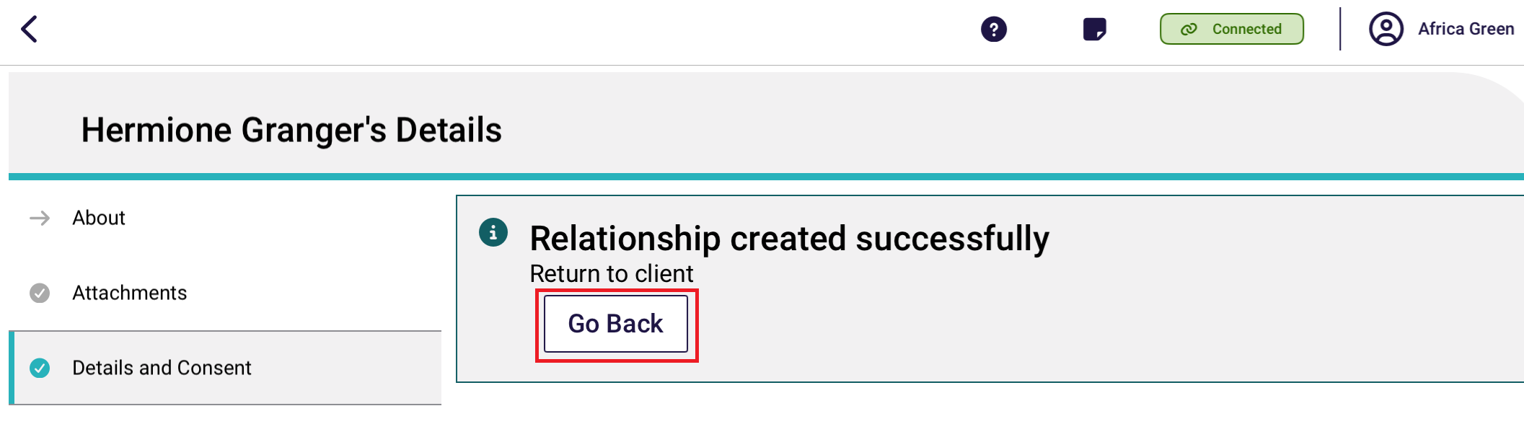
This example shows a Pending Supporter Guardian relationship who is a child of the client.
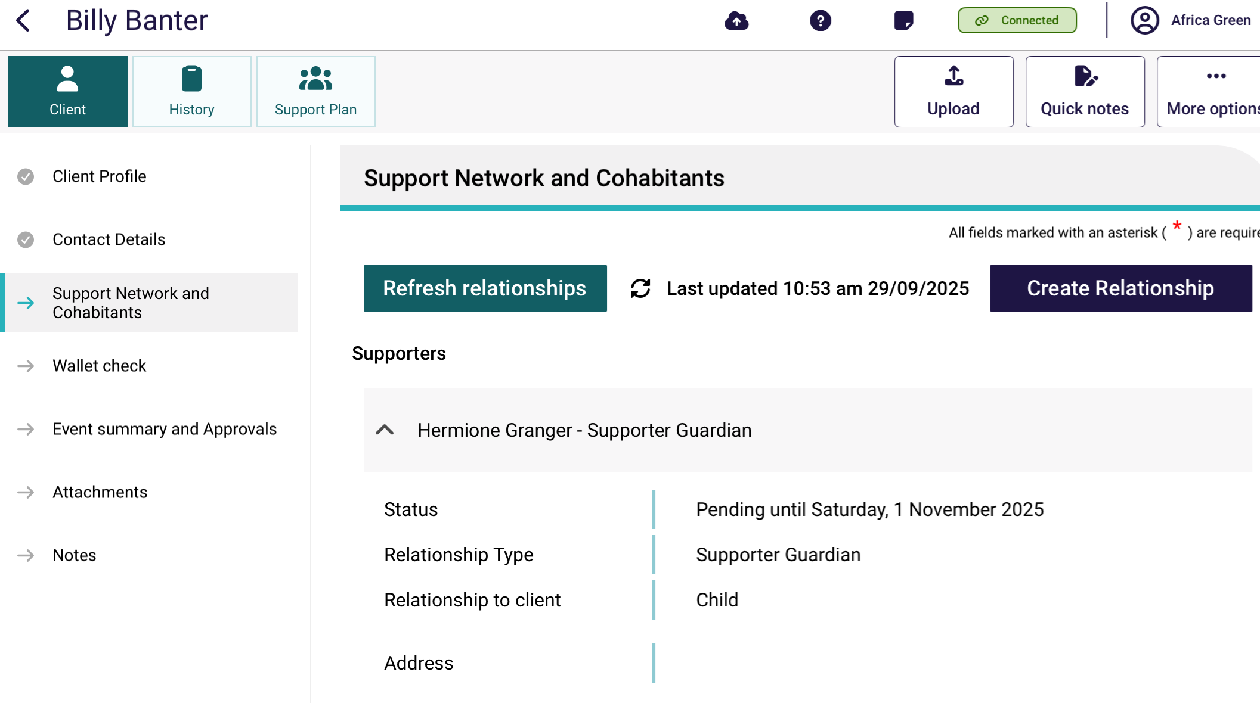

9.3 Creating a relationship for a supporter organisation
This section describes four different supporter organisation relationship types that can be created:
- Supporter Organisation – Supporter
- Supporter Organisation – Supporter Lite
- Support Organisation – Supporter Name – Supporter
- Support Organisation – Supporter Name – Supporter Lite.
A (full) Supporter Organisation – Supporter relationship has:
- Client’s consent to registering the supporter organisation as their supporter.
- Client’s consent for any information given to them to be also given to their supporter organisation.
- The Supporter organisation consents to being registered as a supporter to the client, who may or may not have a conflict of interest.
A Supporter Organisation – Supporter Lite relationship has:
- Client’s consent to registering the supporter organisation as their supporter.
- The Supporter organisation consents to being registered as a supporter to the client. The organisation may or may not have a conflict of interest.
- No client consent to share information with their support organisation.
A Supporter Organisation – Supporter Name – Supporter relationship has:
- Client’s consent to registering a particular supporter/staff member within the supporter organisation to be their supporter.
- Client’s consent for any information given to them to be also given to their supporter/staff member (only).
- No direct relationship between the client and the supporter organisation.

A Supporter Organisation – Supporter Name – Supporter Lite relationship has:
- Client’s consent to registering a particular supporter/staff member within the supporter organisation to be their supporter.
- No client consent to share information with their supporter/staff member.
- No direct relationship between the client and the supporter organisation.
- On the client’s Support Network and Cohabitants page in Client Details, select Create Relationship.
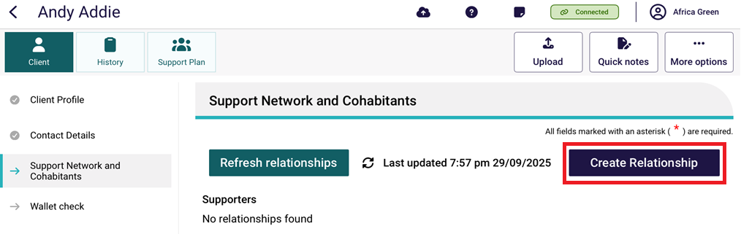
- In the Create Relationship page, choose a relationship to establish for the client. In this case it would be Supporter.
The next question Would you like to appoint a person or an organisation? appears. Choose Organisation: staff at a support organisation (e.g., An advocacy organisation).
Then, select Next.
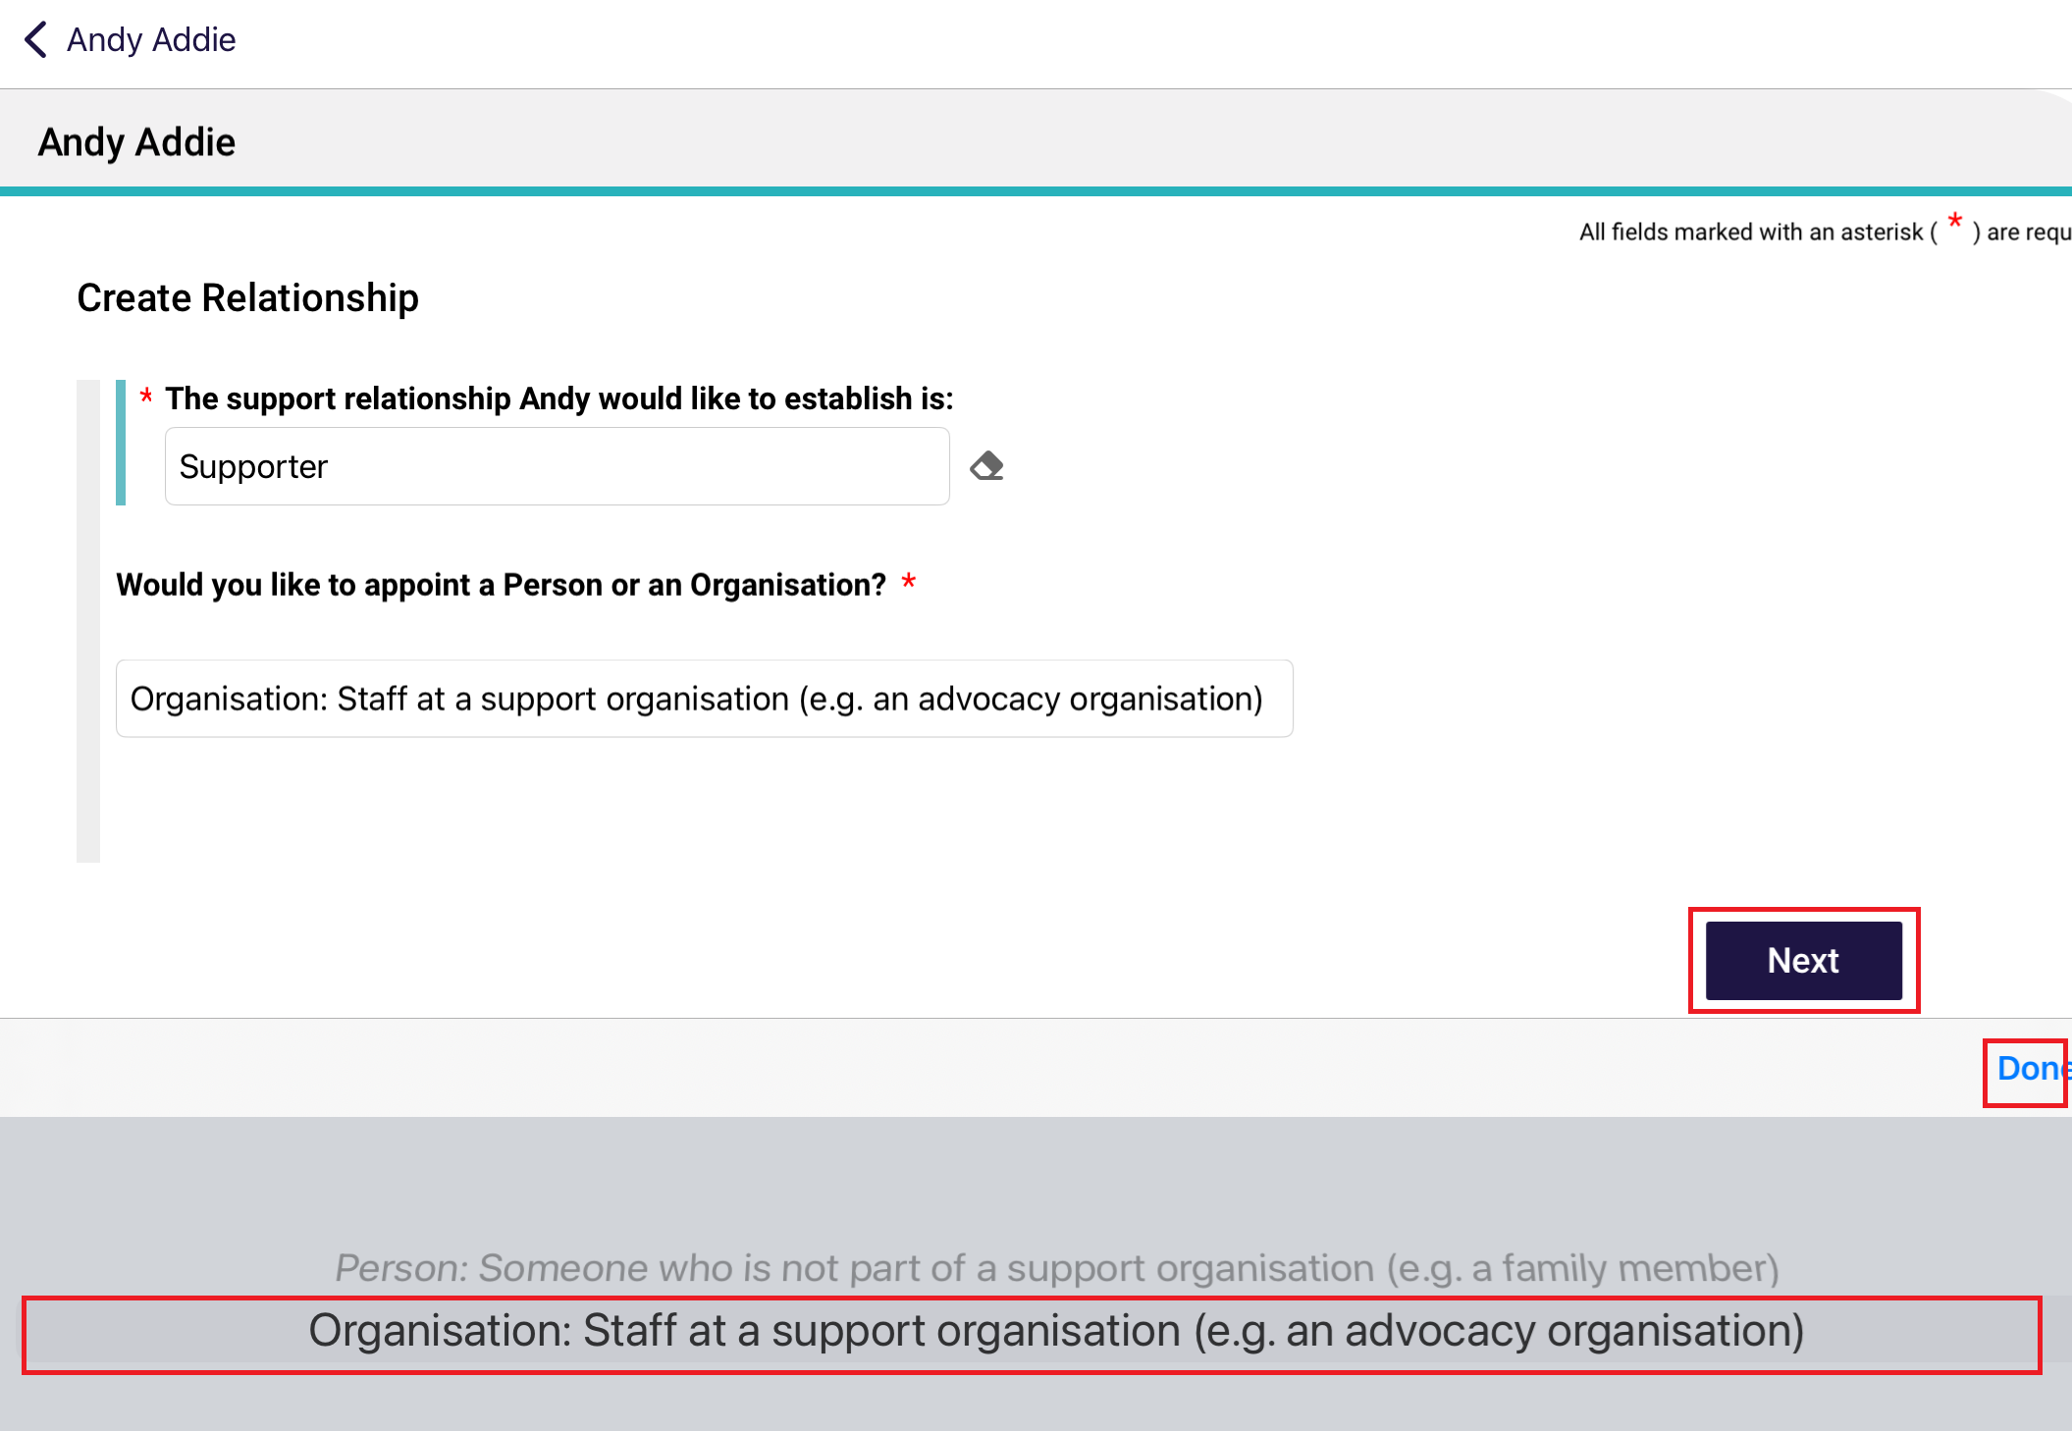

- Search for the support organisation by either entering their name, or postcode and/or distance away from the postcode, selecting the correct locality from the drop down menu that appears, then select Search.
In the Postcode section, you can also search by Suburb name.
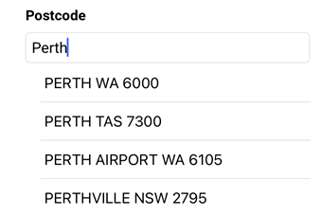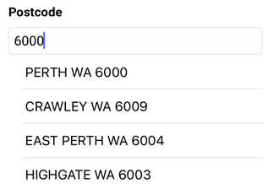
Search by Organisation Name Example
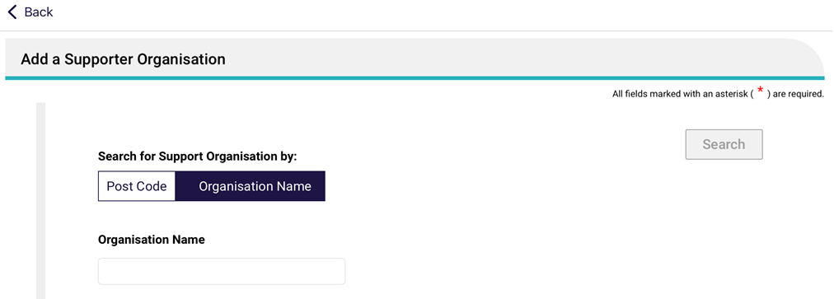
Search by Distance and Postcode Example
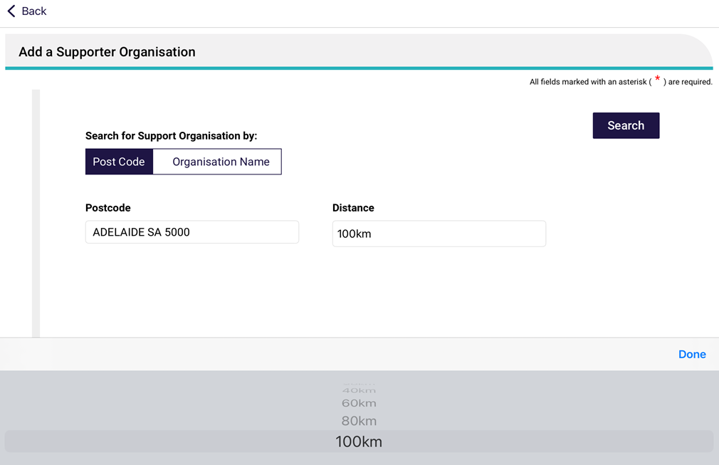
- Select the supporter organisation’s card.
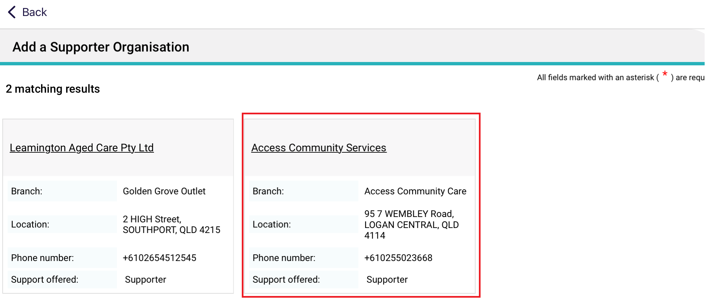
- The organisation details are displayed in the About section of the Organisation Details page. Double check that it is correct, then select Attachments.
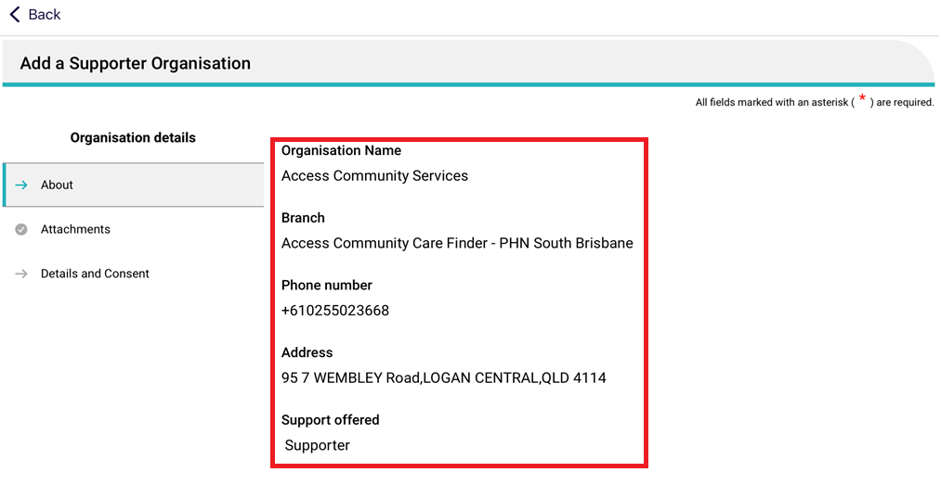
- The Attachments page appears. Add the appointment of support organisation form by selecting Add an image and taking an image of the form from your device. Name the image and its name will appear under Current Attachments. Then, continue to the Details and Consent page.
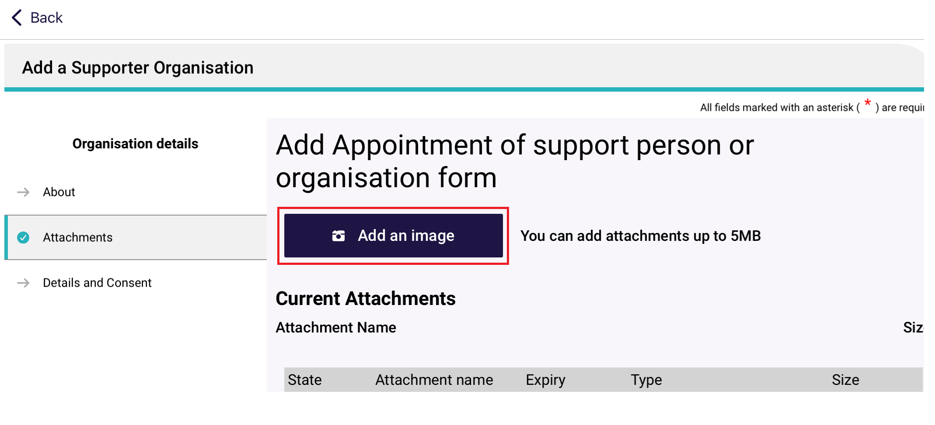
- The Details and Consent page appears.
Fill out all mandatory fields in the details section, including the start date of the relationship.
When this page first appear there will be an error message saying that there are mandatory fields to complete or invalid fields. This error message will continue to display until all mandatory fields are completed correctly.
All supporter workers of this organisation will be able to assist the client. However if the client only want to work with one particular person, enter their name in the Full name of the support person section.
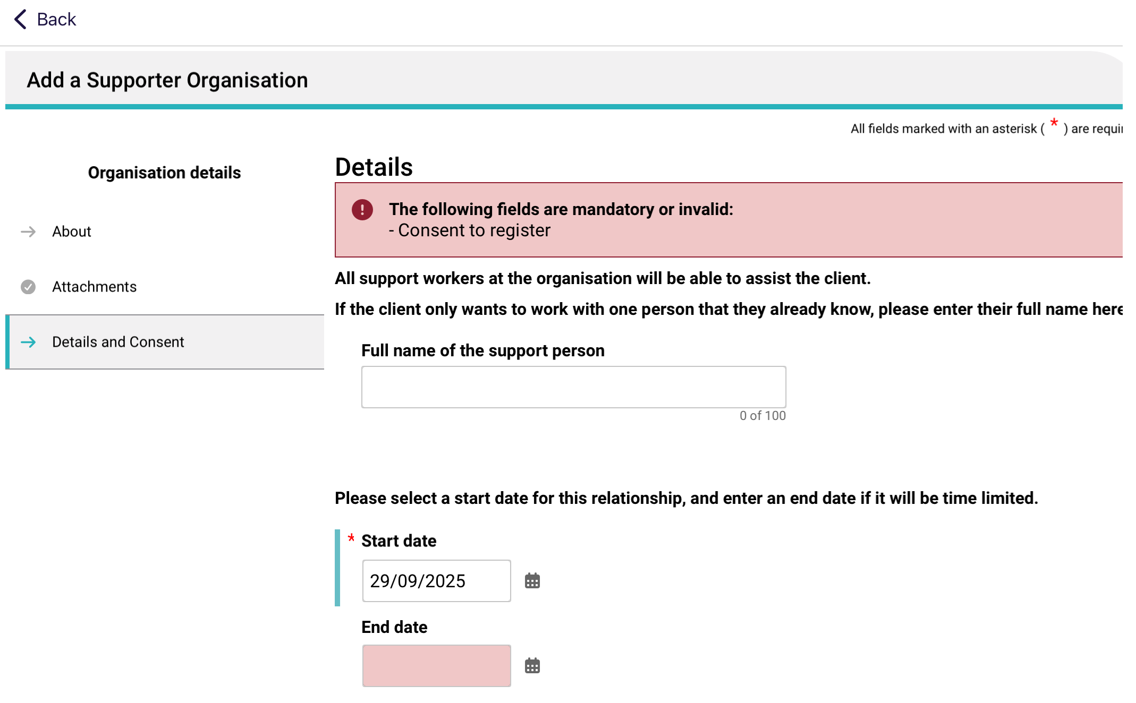
- Scroll down to the Client Consent section.
There are two sections to the Client consent: the top section describes the consent to registering the supporter organisation as the client’s supporter. The bottom section describes consent to share any information given to the client to be also given to the supporter organisation.
When this page first appears, both consent toggle defaults to No. This means that their corresponding information message or error message also displays. As soon as appropriate responses are entered, these messages will disappear.
Select Yes or No to both consent toggles.
The top client consent must be Yes for the supporter organisation relationship to be created.
The bottom client consent can be Yes or No. If No, then a Supporter Lite relationship will be created.
At the bottom of the client consent section, there are links to view the duties of a supporter, and the terms and conditions of registering.
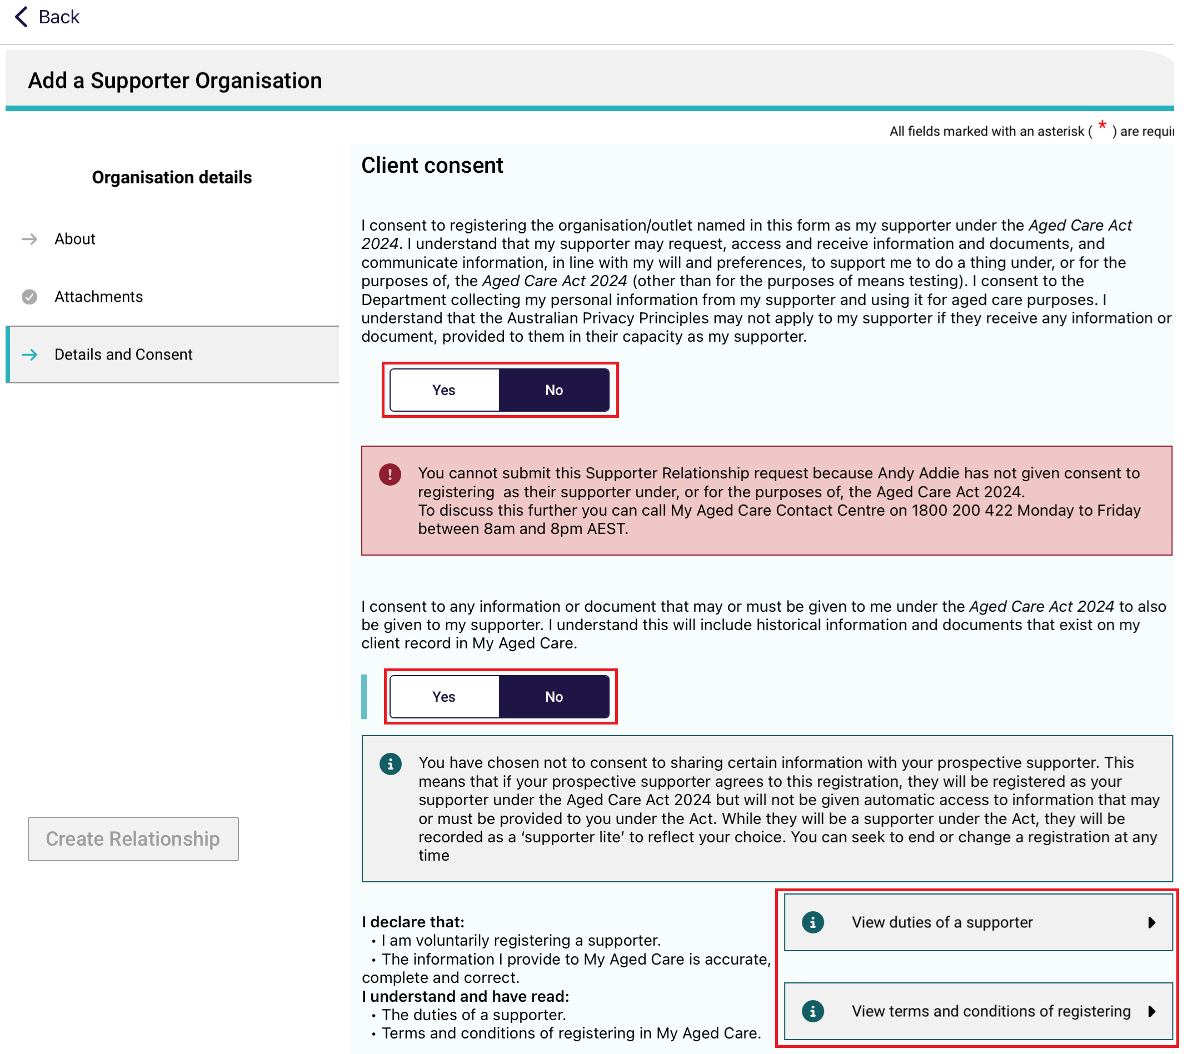
If a particular supporter was nominated, then the name of that supporter is displayed in the Consent declaration instead.
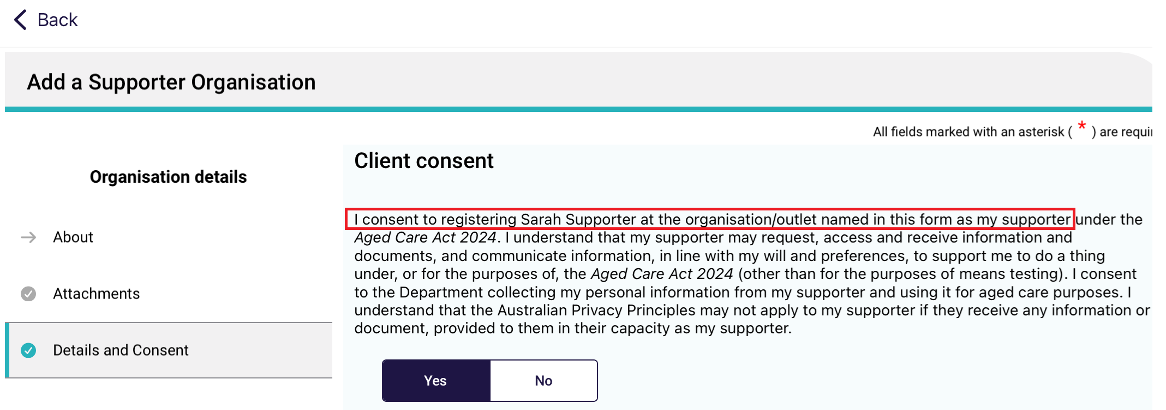
- Scroll down to the Supporter Consent section.
Toggle Yes or No to that the supporter organisation consents to being a supporter for the client.
If Yes is selected, then toggle Yes or No to Does this support person have a conflict of interest? If there is a conflict of interest, enter the description at the text box that appears. Note that this question applies to both the supporter organisation and/or to the particular supporter inside the supporter organisation, depending on whether a particular support person was named.
Finally, the supporter can also view the duties of a supporter and the terms and conditions of registering by selecting their corresponding Information buttons.
Then, select Create Relationship.
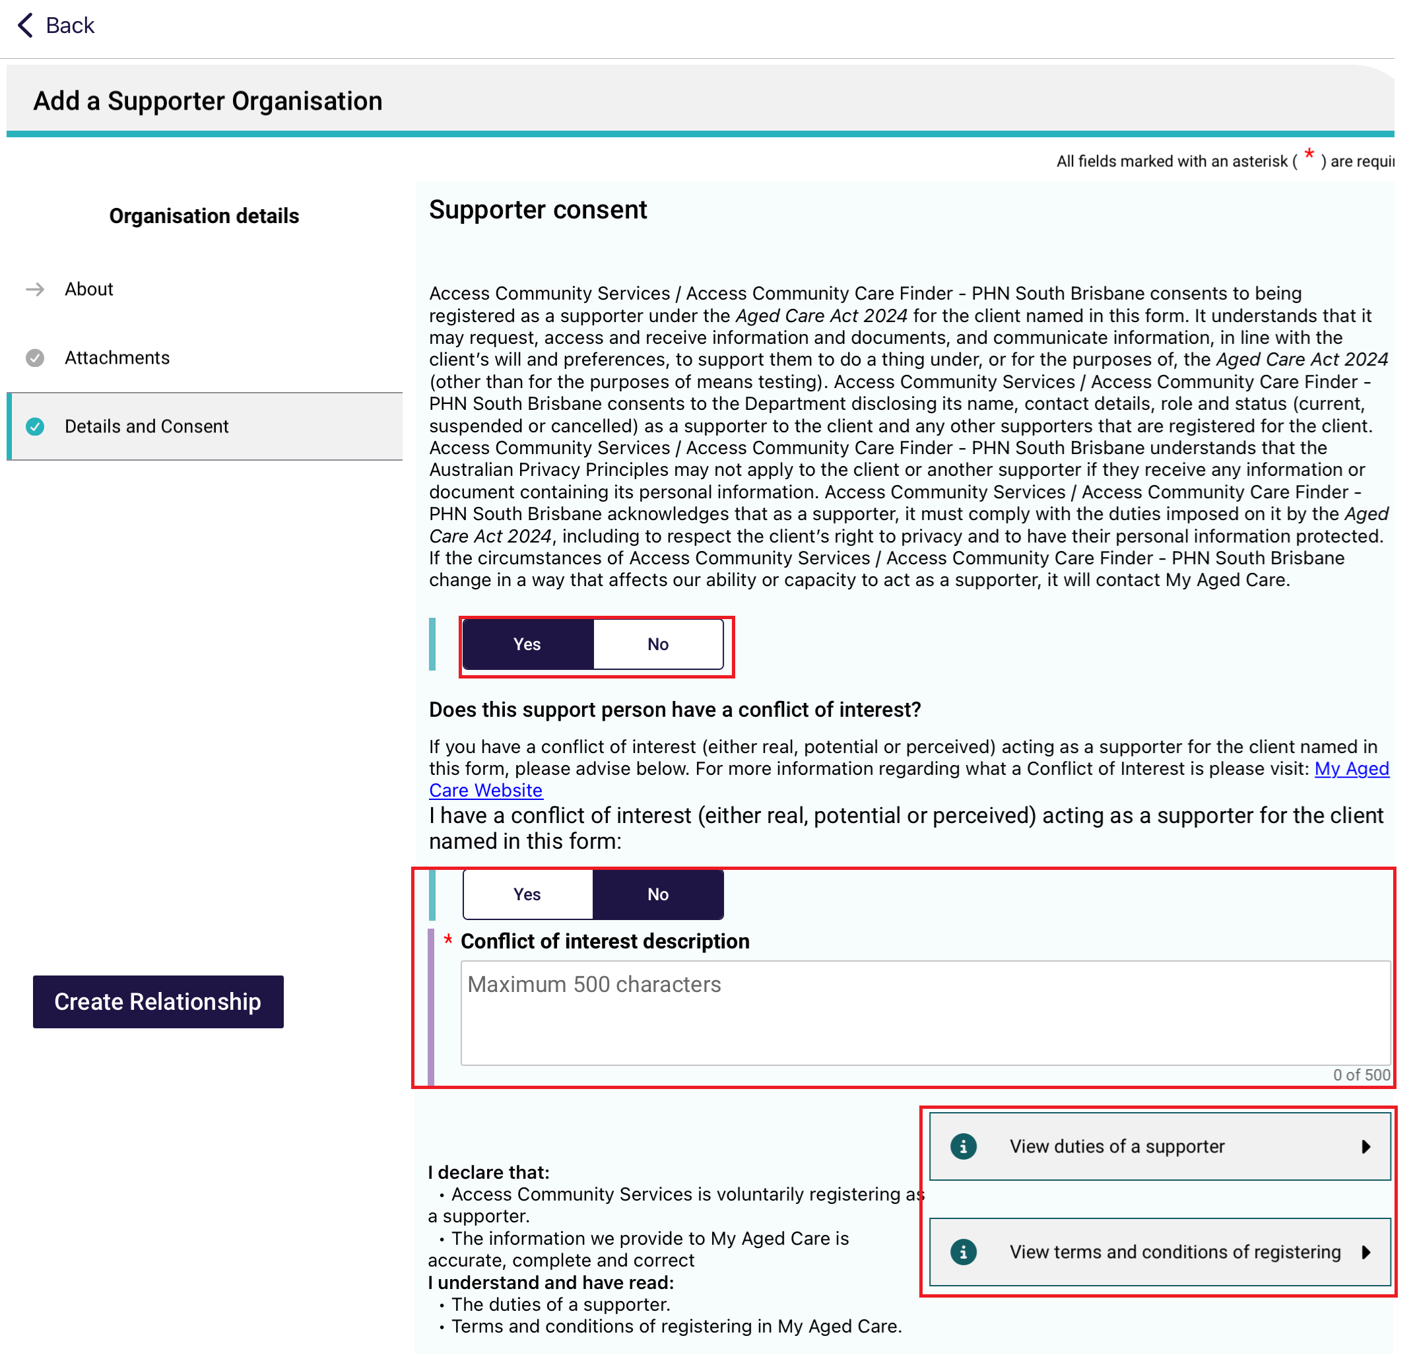
- The organisation relationship is created. Select Go Back to return to the client record.
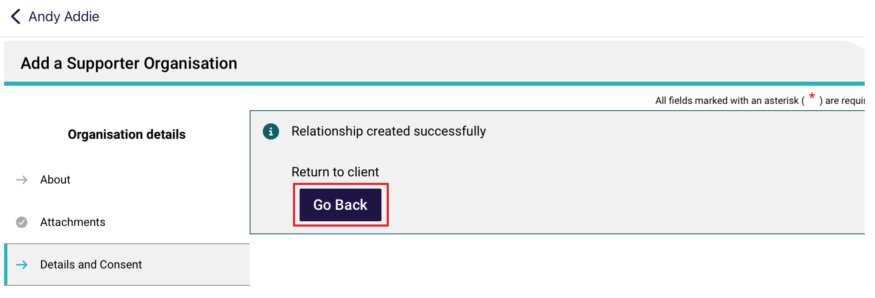
- Once on the client’s record, the new organisation relationship will be visible. There are four possible types of outcomes:

- Supporter Organisation – Supporter
- Supporter Organisation – Supporter Lite
- Support Organisation – Supporter Name – Supporter
- Support Organisation – Supporter Name – Supporter Lite.
Supporter Organisation relationships appear underneath the Supporter Organisations heading as [Supporter Organisation Name] – Supporter. It is created in a Pending status, and able to be activated or removed by selecting the Activate and Remove buttons respectively.
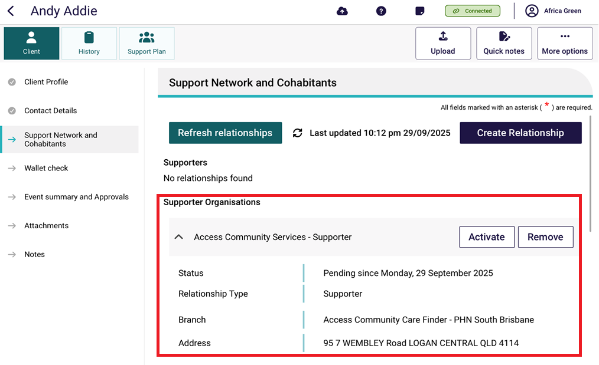
Support Organisation – Support Lite relationships are created in a Pending status and requires approval of a delegate to become Active. The relationship can be removed.
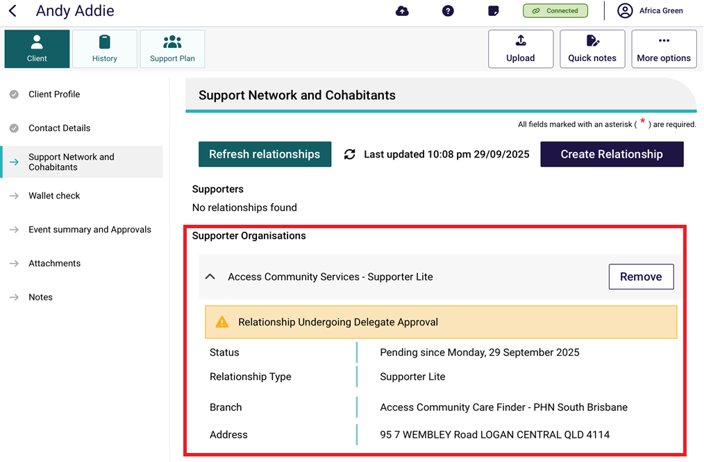
Support Organisation – Supporter Name – Supporter relationships are created in a Pending status and requires activation in the Assessor Portal rather than this app. The relationship can be removed.
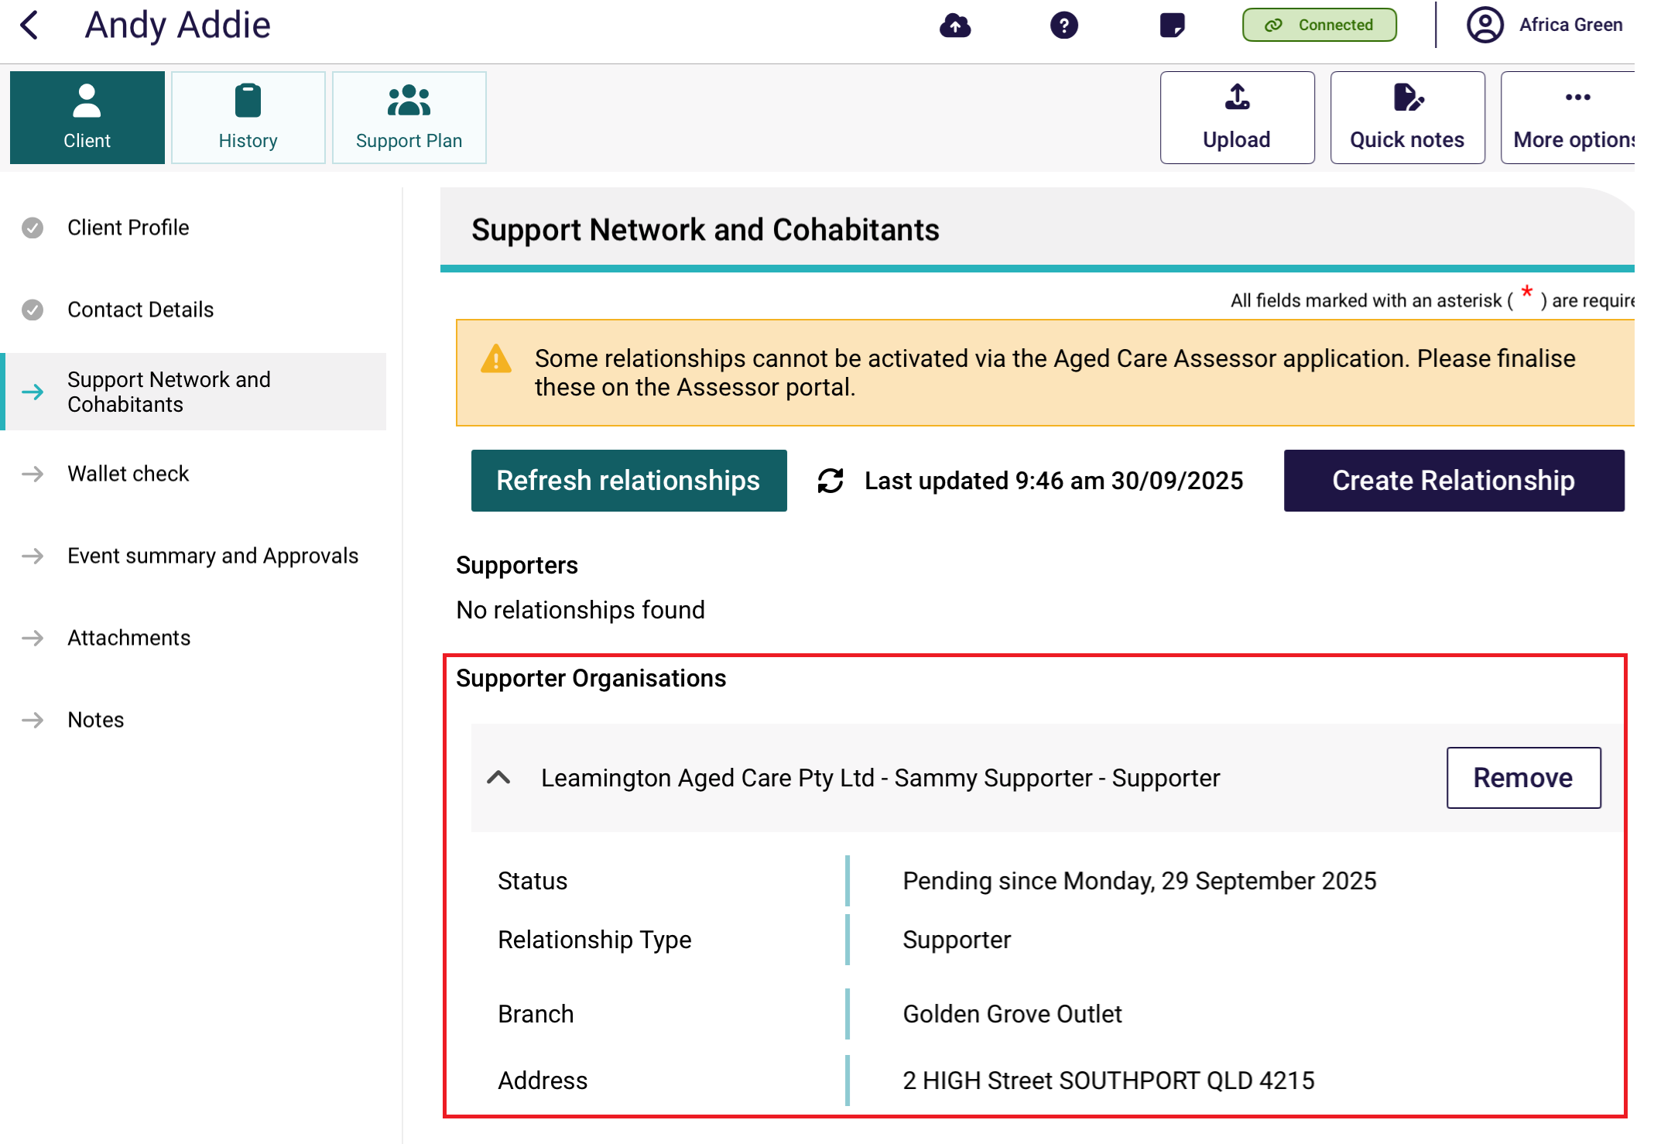
Support Organisation – Supporter Name – Supporter Lite relationships are created in a Pending status and requires activation in the Assessor Portal rather than this app. The relationship can be removed.
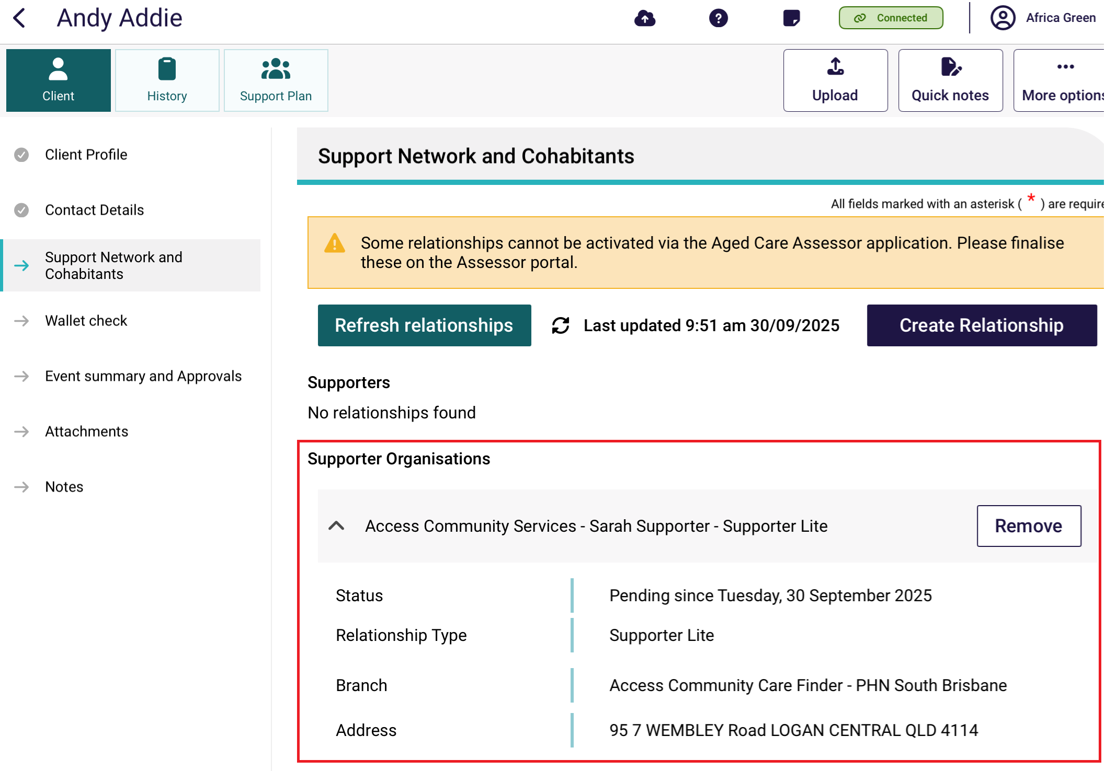

Creating a relationship for an agent organisation
- On the client’s Support Network and Cohabitants page in Client Details, select Create Relationship.
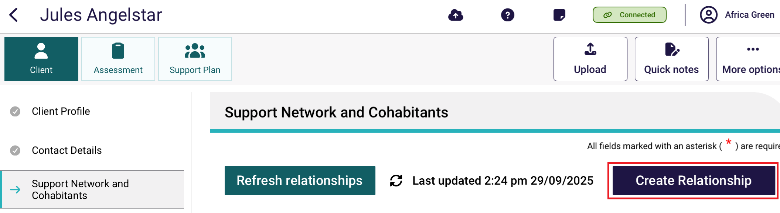
- In the Create Relationship page, choose a relationship to establish for the client. In this case it would be Agent, then select Next.
! | Individual agent relationships cannot be created in the Aged Care Assessor App, therefore when Agent is selected, it will be defaulted to Agent Organisation.
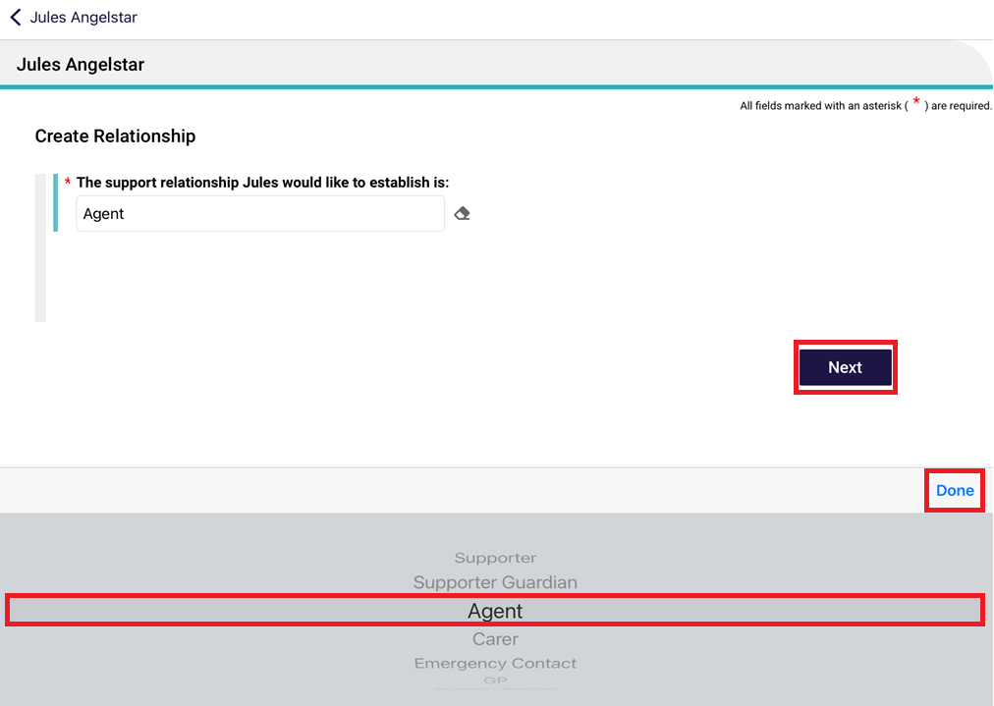
- Search for the agent organisation by either entering their name, or postcode and/or distance away from the postcode, then select Search.
Organisation Name example
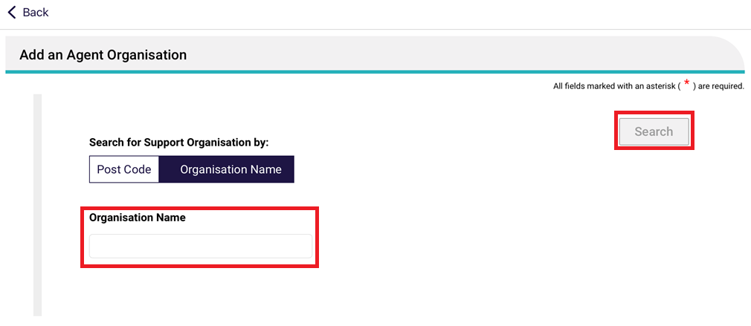
Postcode and Distance example
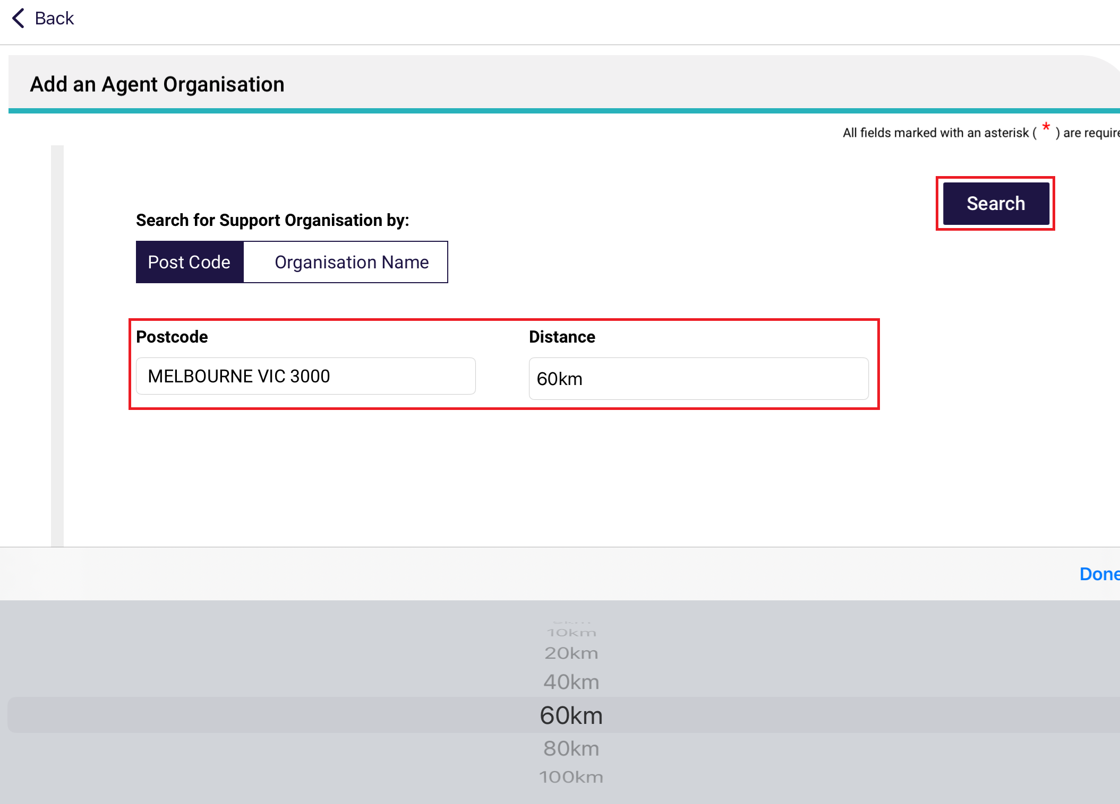
- Select the agent organisation’s card.
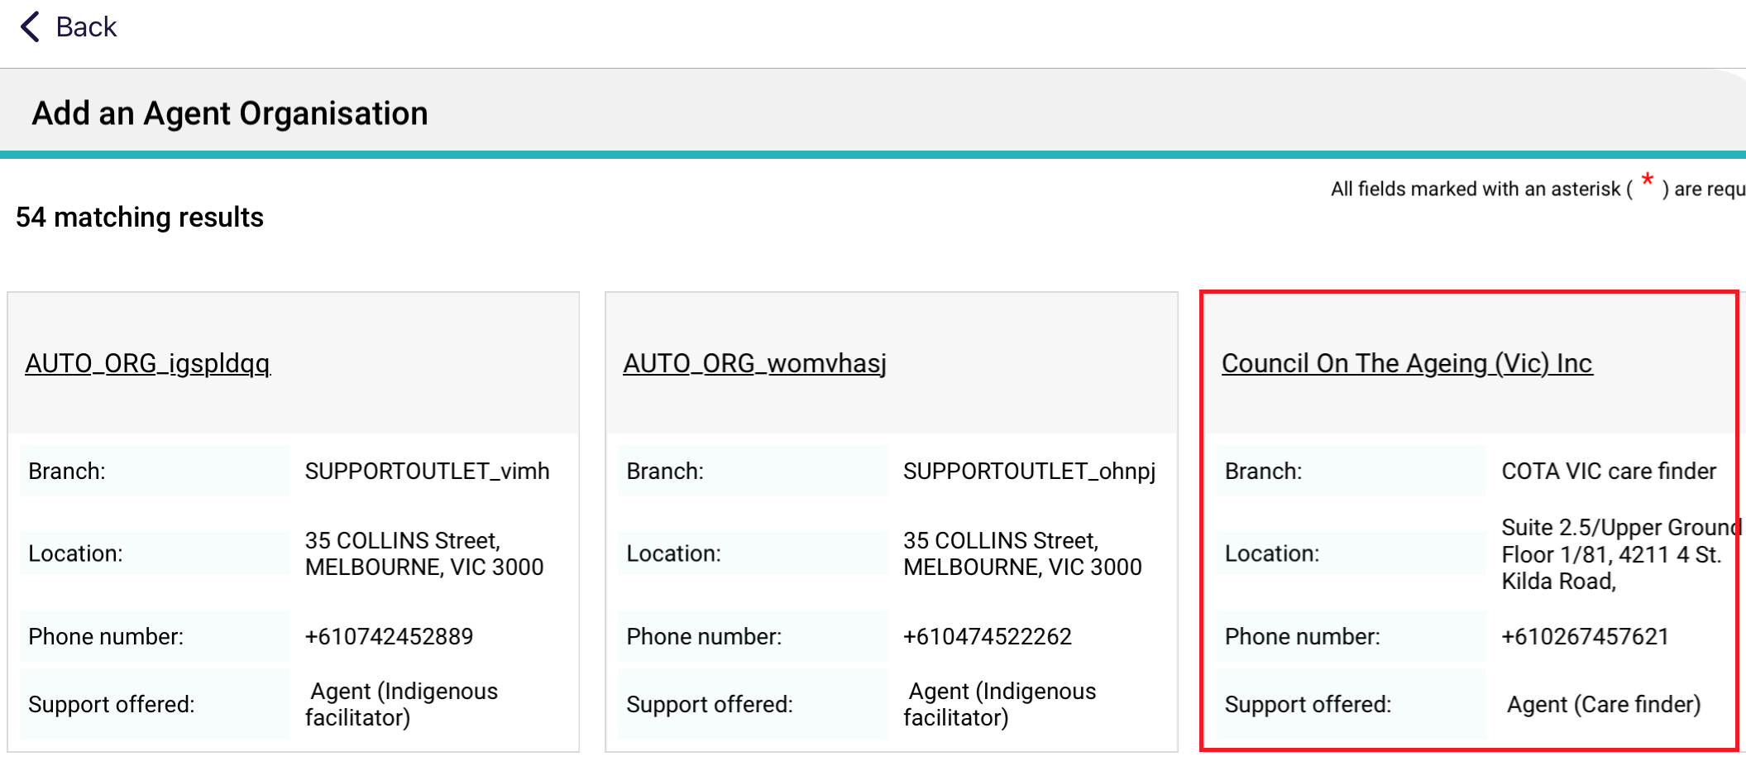
- The agent organisation’s details display. Make sure the details are correct, then go to the Attachments page.
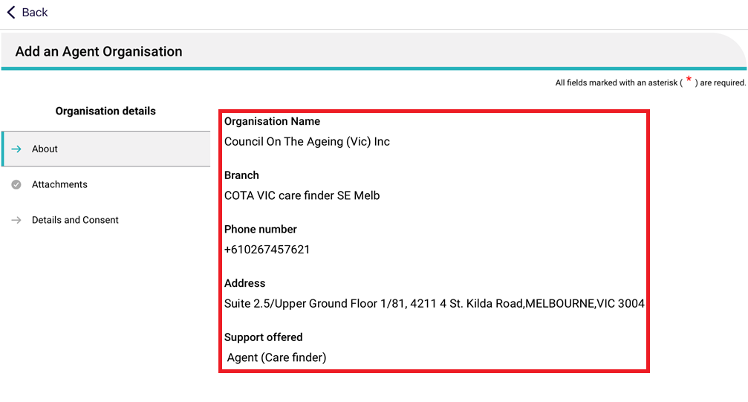
- The Attachments page appears. Add the appointment of support organisation form by selecting Add an image and taking an image of the form from your device. Name the image and its name will appear under Current Attachments. Then, continue to the Details and Consent page.
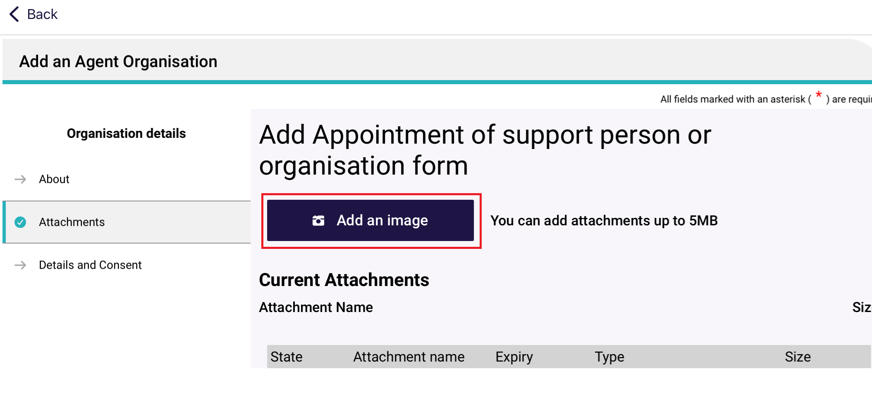
- The Details and Consent page appears.
Fill out all mandatory fields in the Details section, including type of support required, and the start date of relationship.
Error messages will continue to display until all mandatory fields are completed correctly.
For Support Required, select the listing from the drop down menu, then select Done. This will then display in the text box. These values come directly from the agent organisation chosen from Step 4 and therefore may have more than one value displayed.
All agents at the agent organisation will be able to assist the client. Optionally, you can nominate the full name of one agent, in the Full name of the support person section.
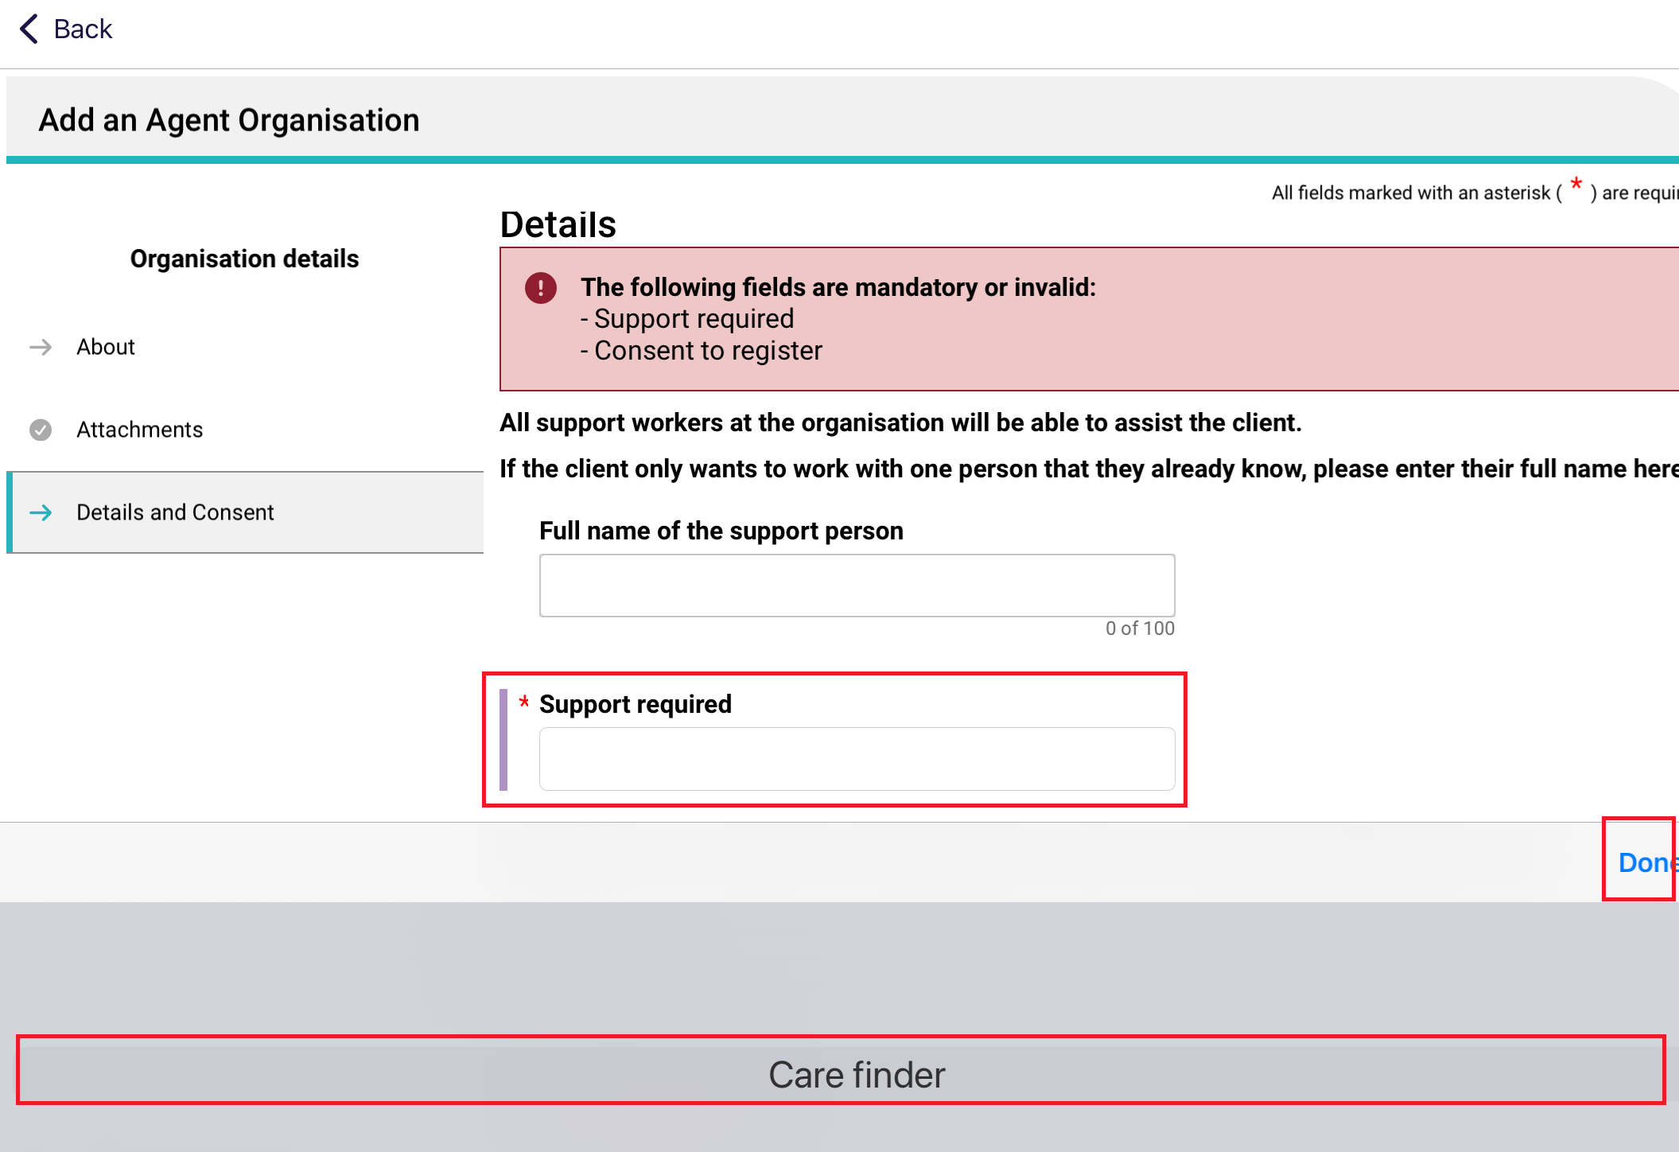
- Scroll down to the Consent section.
There are two sections: The client’s consent at the top, and the agent organisation’s consent at the bottom.
Select Yes or No at the Client toggle, followed by the Agent Organisation toggle.
The client must consent for the agent organisation relationship to be created. The agent organisation may consent now, or later. The Create Relationship button will activate once the conditions are satisfied.
Then, select Create Relationship.
! | A Pending agent organisation relationship is created when the client consents but the agent organisation do not consent.
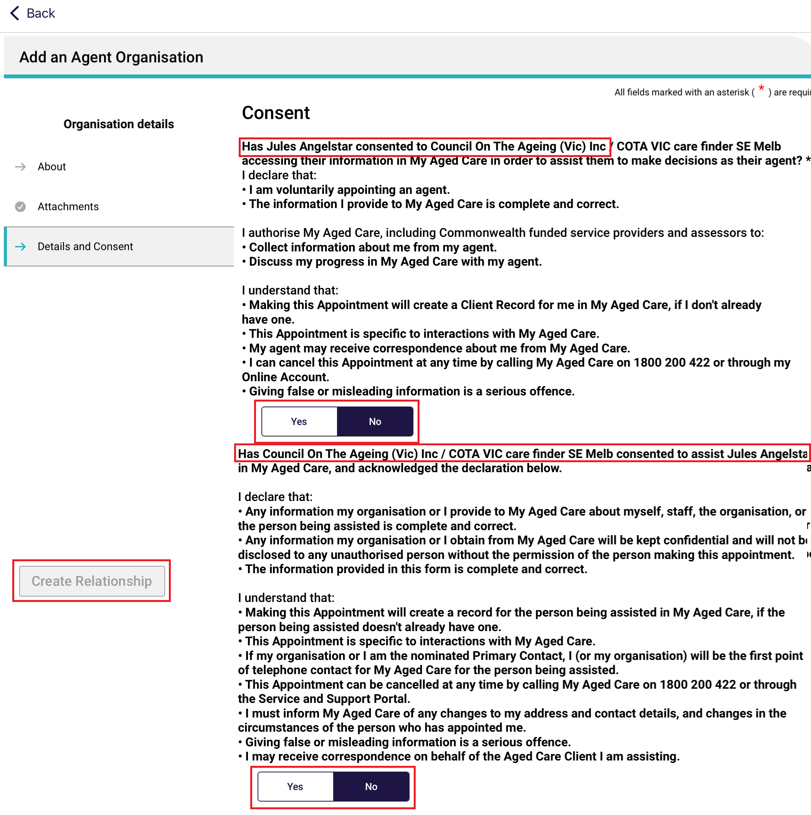
If a particular agent was nominated, then the name of that agent is displayed in the Consent declaration instead.
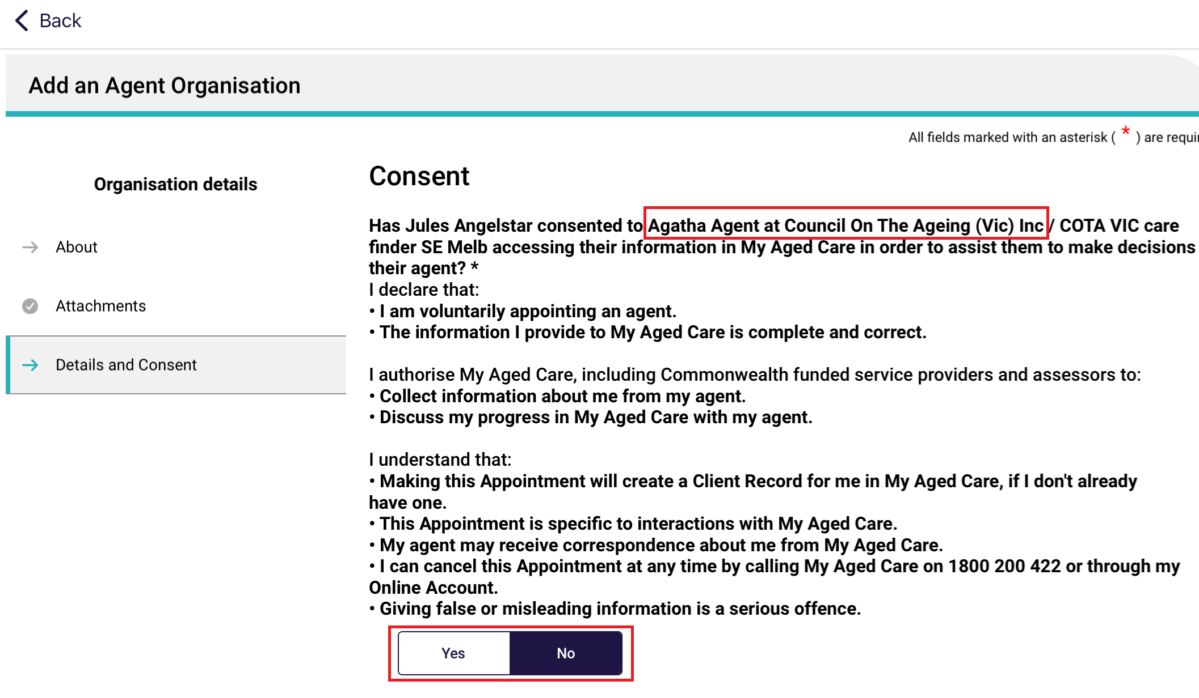
- The agent organisation relationship is created. Select Go Back to return to the client record.
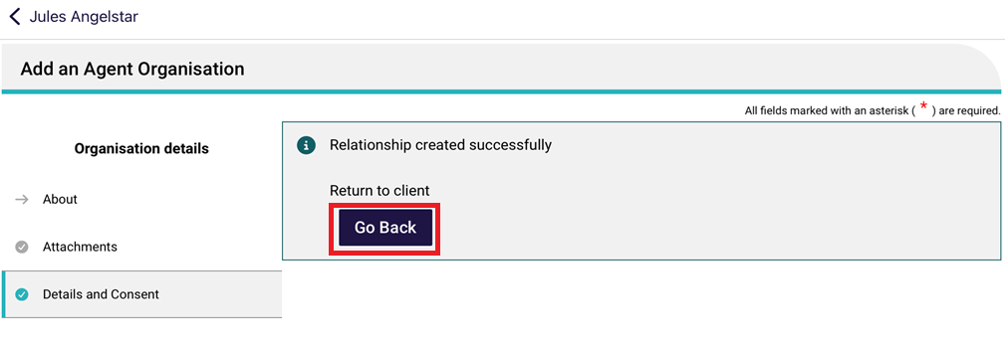
- Once on the client’s record, the new agent organisation relationship will be visible.
Some relationships cannot be activated via this app. An information banner will appear at the top section of the Support Network and Cohabitants page. Please finalise these on the Assessor portal.
This example shows a Pending agent organisation relationship with a particular agent named Agatha Agent.
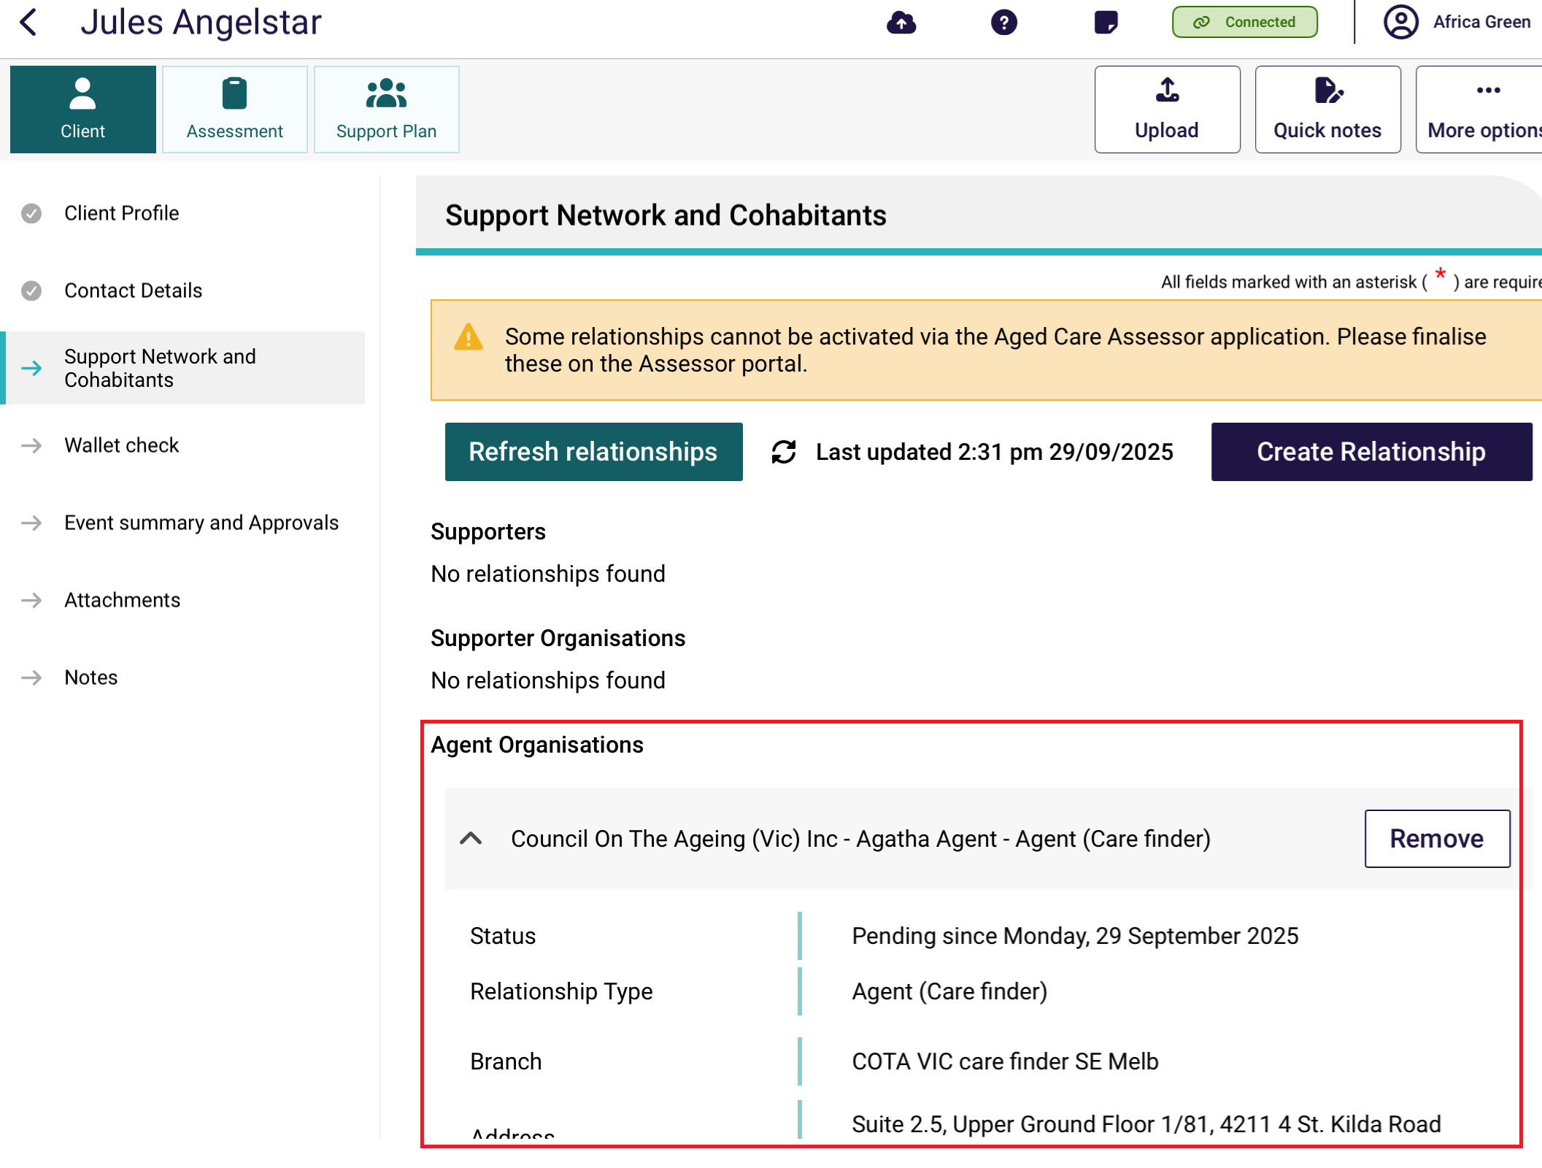

9.5 Creating a relationship for a carer or other support people
You can create a relationship for the client with a carer, emergency contact, GP (General Practitioner) or support person.
Please note, the support person does not have to be present, and consent is not required.
- On the client’s Support Network and Cohabitants page in client details, select Create Relationship.
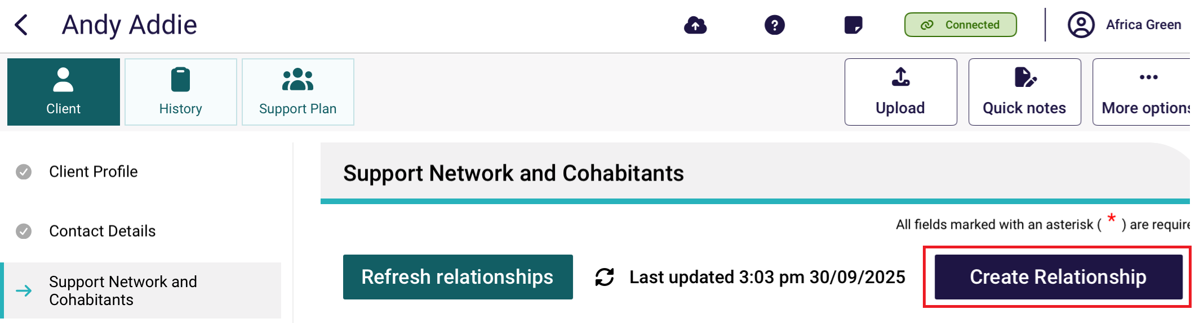
- In the Create Relationship page, choose a relationship to establish for the client. In this case it would be Carer, Emergency Contact, GP or Support Person.
Then, select Next.
! | The below screenshots refer to creating a Carer relationship. Depending on the relationship chosen, the following steps may vary.
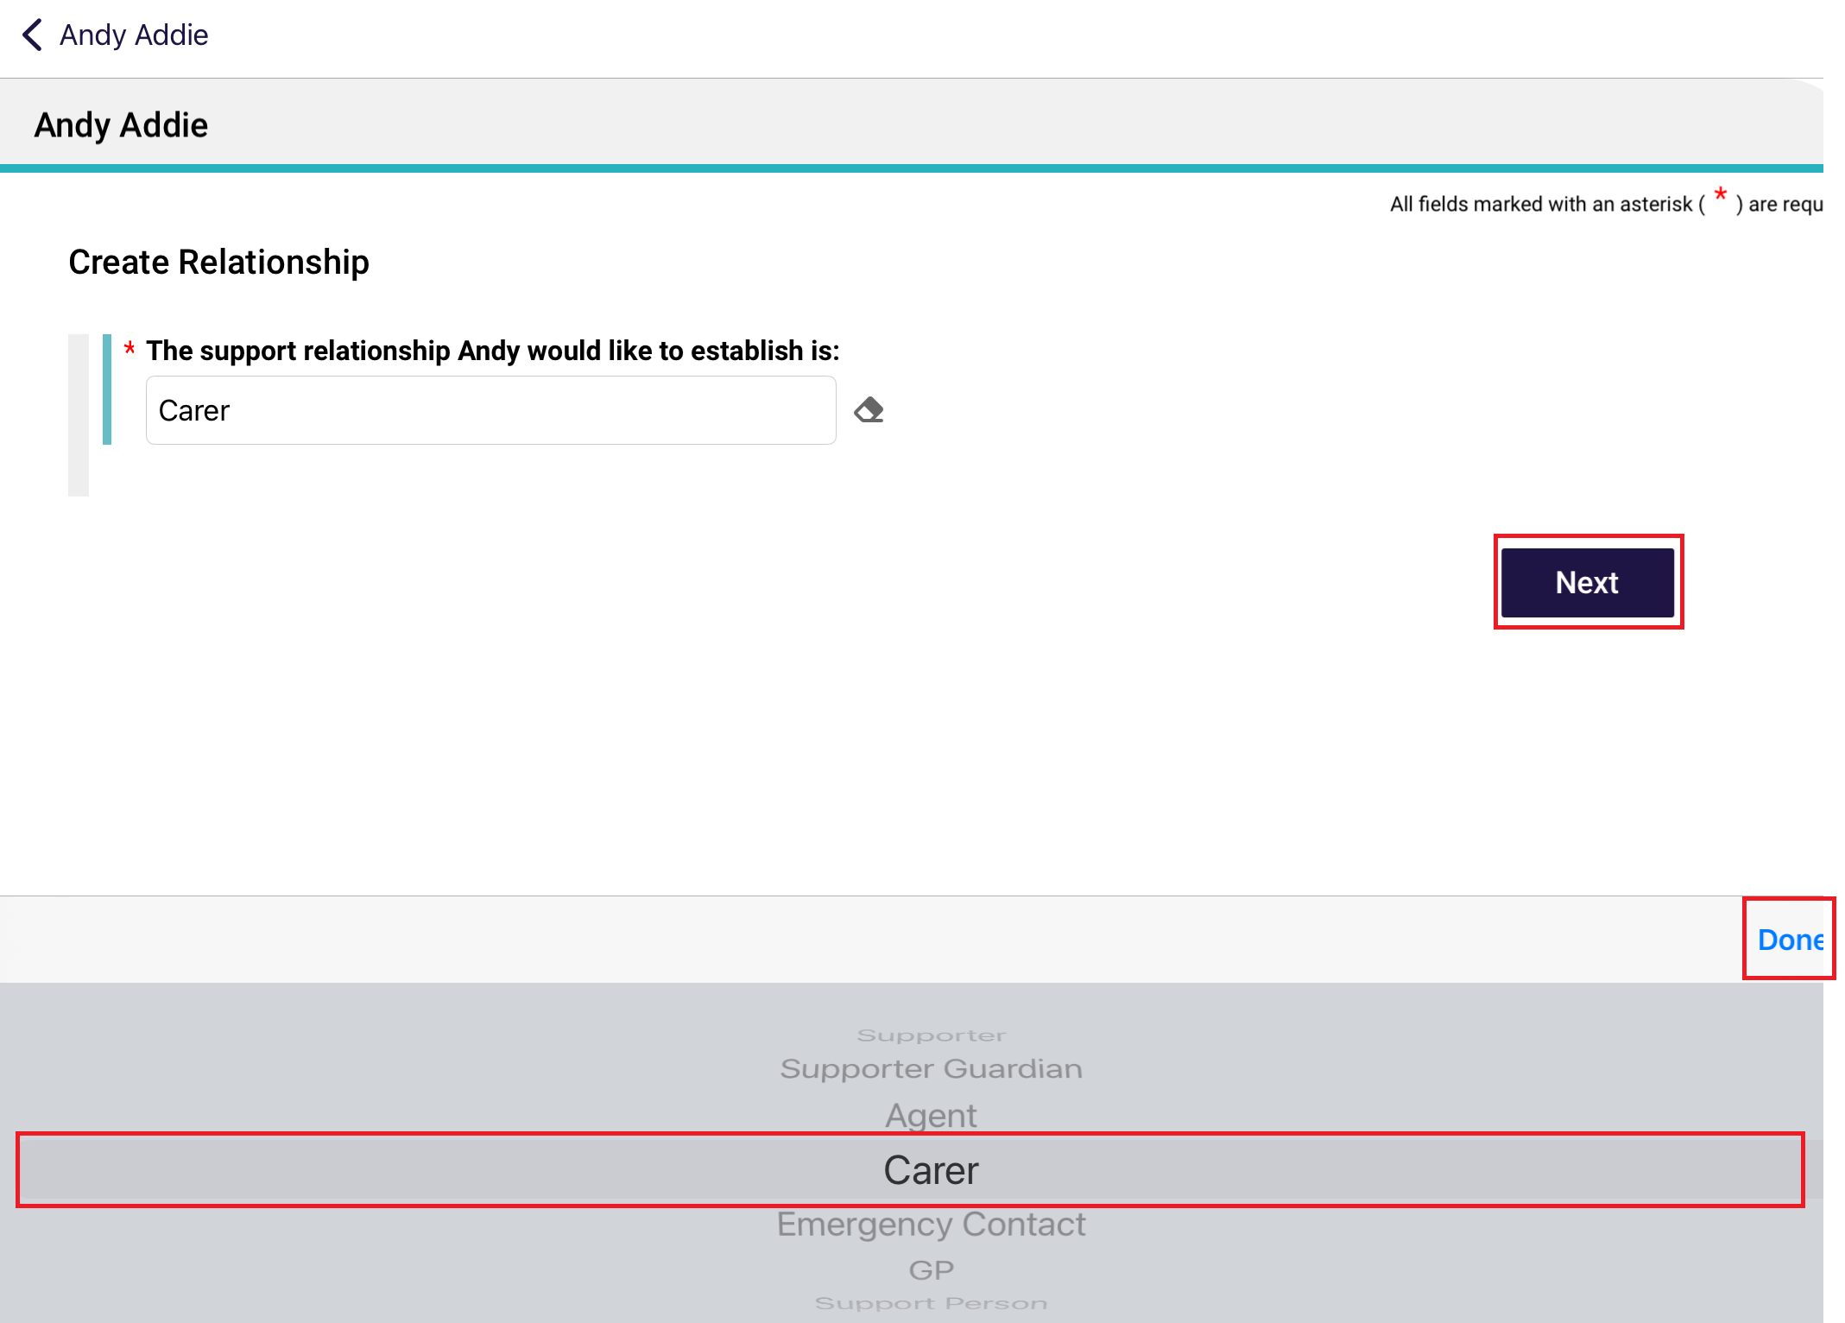
- Search for your support person by entering Last name, First name and/or Aged Care User ID, then select Search. You can also select Advanced search. (Searching is unavailable for Emergency Contacts. Go to Step 4A to the Save a Support Person page instead.)
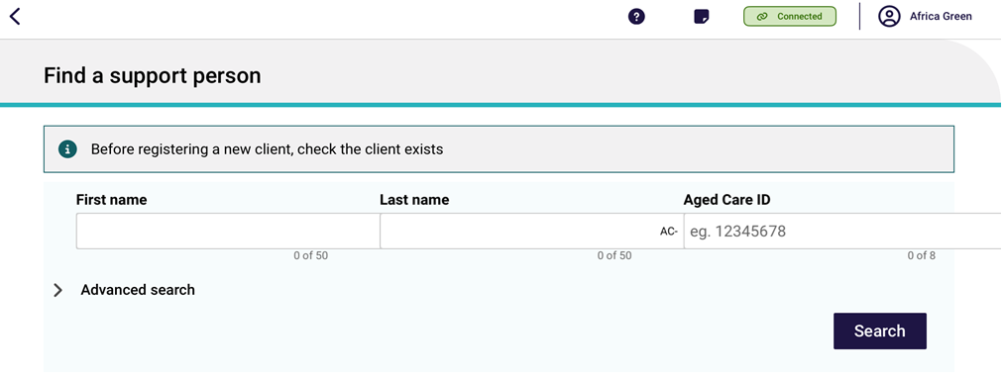
- Select your support person, then go to step 5.
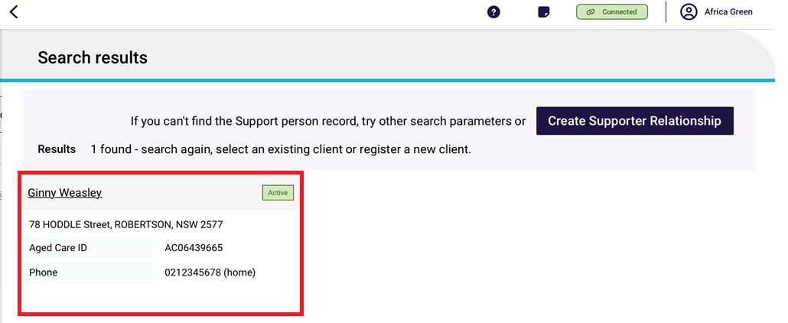
If you cannot find the support person’s record, try other search parameters or select Register a Support Person, then go to step 4A.
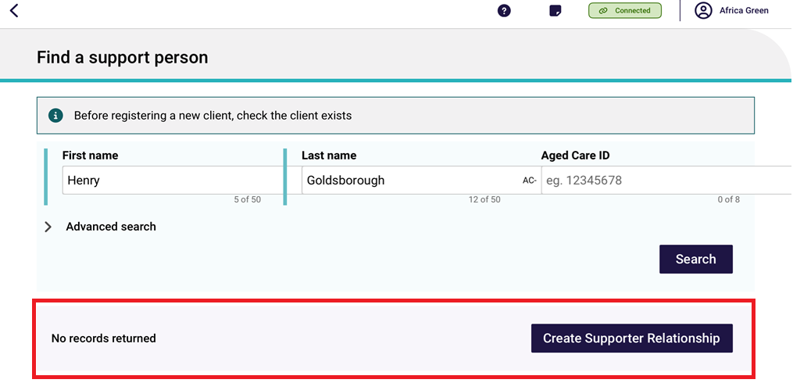
4A. To register a new support person, Enter all mandatory fields in each of the pages shown with red asterixes, and until the Register button turns blue. Then, select Register and go to Step 8.
The number and type of pages will vary depending on the relationship being created.
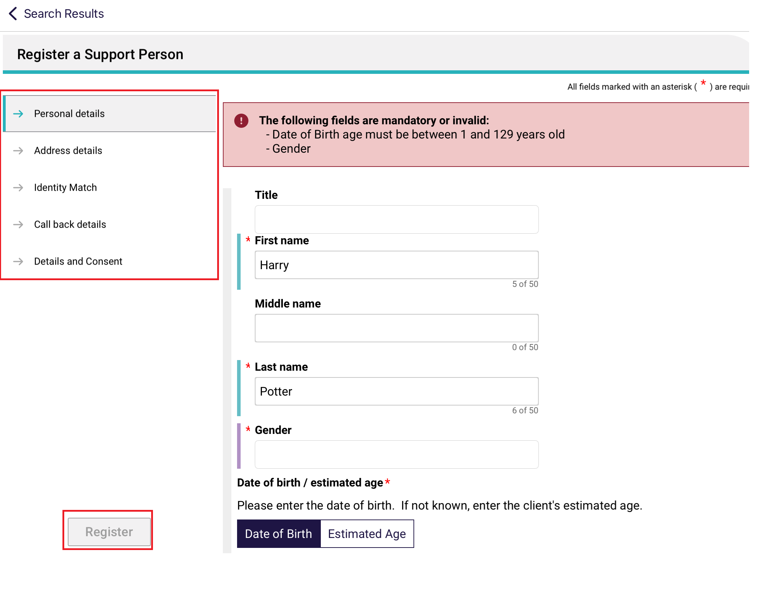
! | Complete the Call Back Details page to register a Carer relationship.  To be able to request call back from Carer Gateway and/or National Dementia Helpline, the client’s home address and at least one contact number is required. This is entered in the Address Details page.  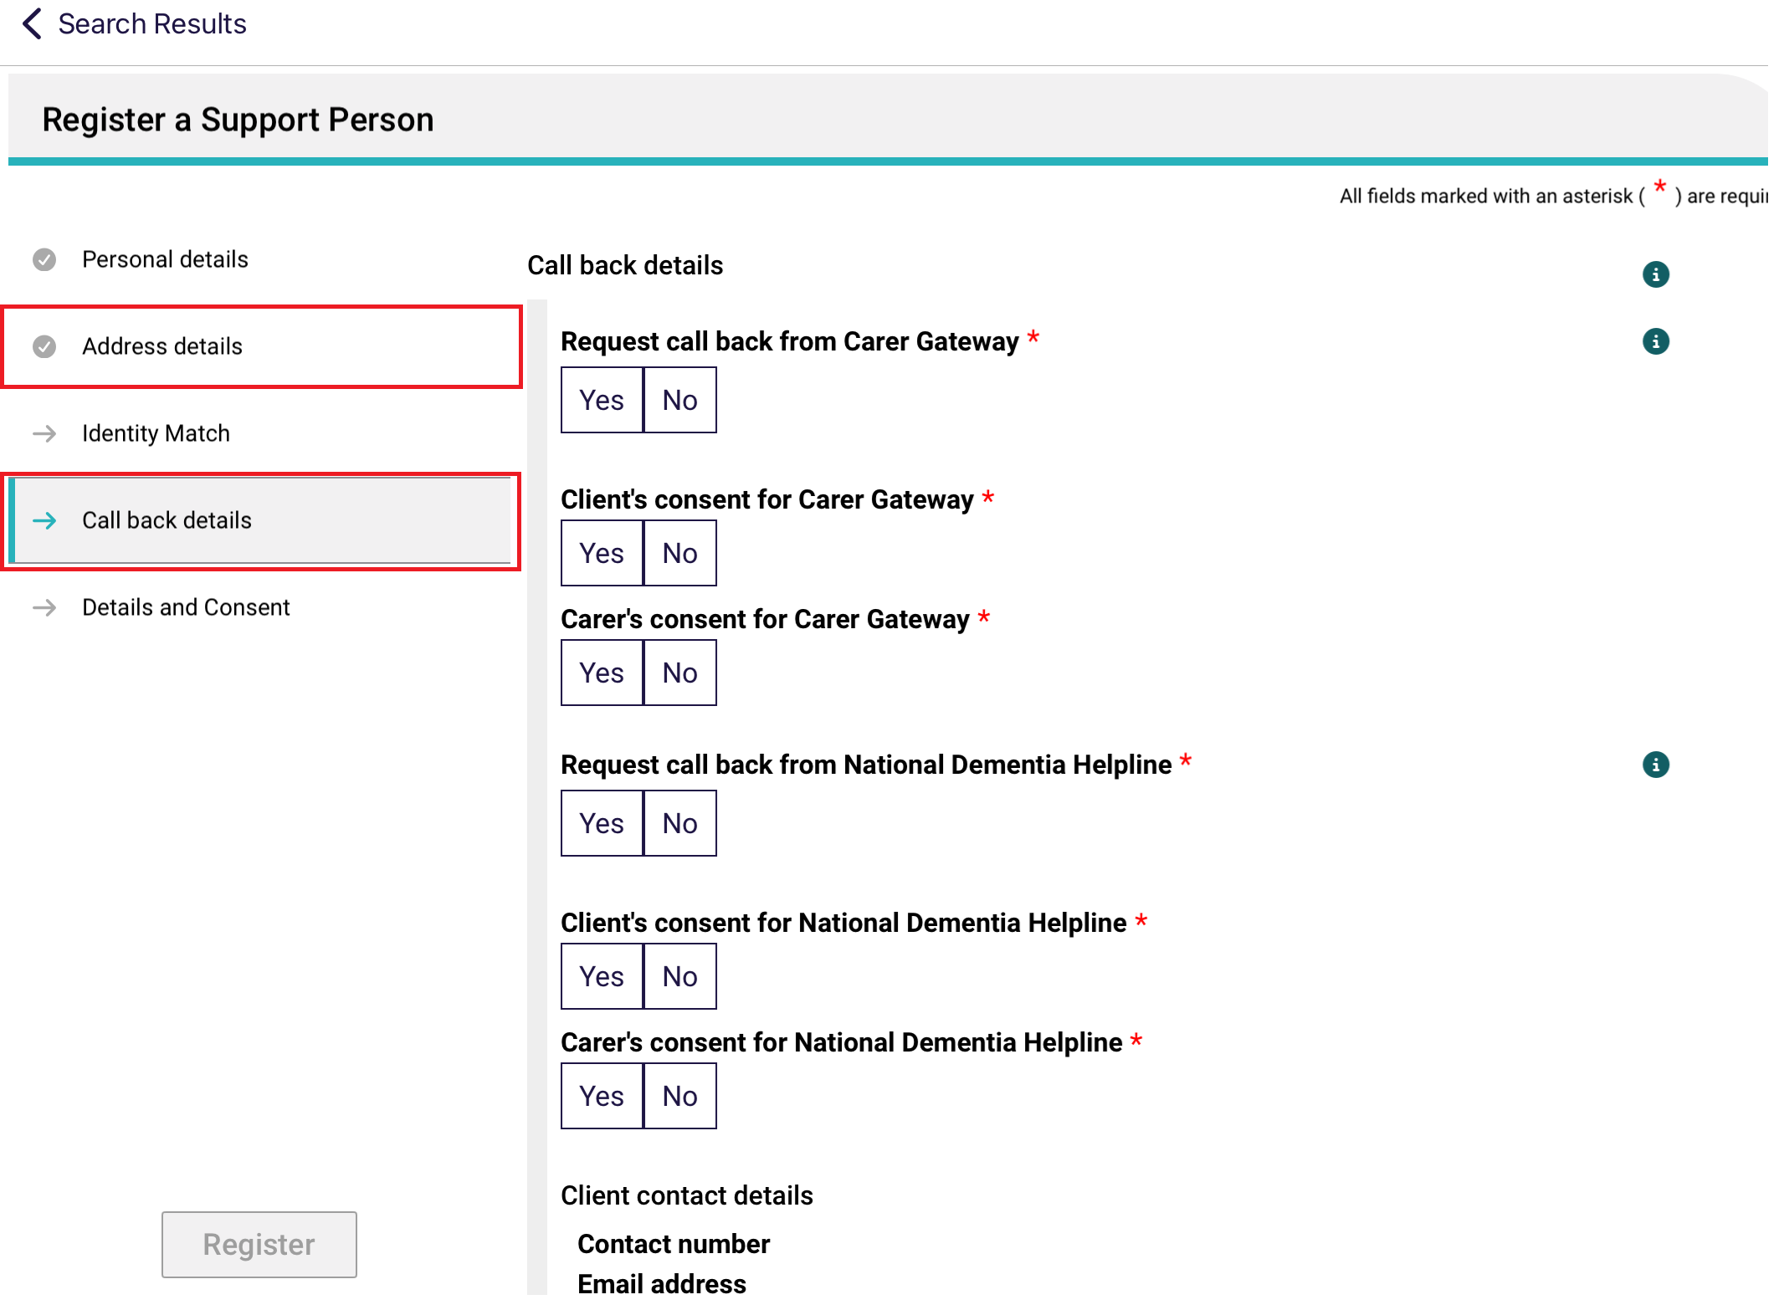
- Once you have selected the supporter’s record from Step 4, the About page appears.
Double check the details are correct (including contact details), then go to the Call Back Details page.
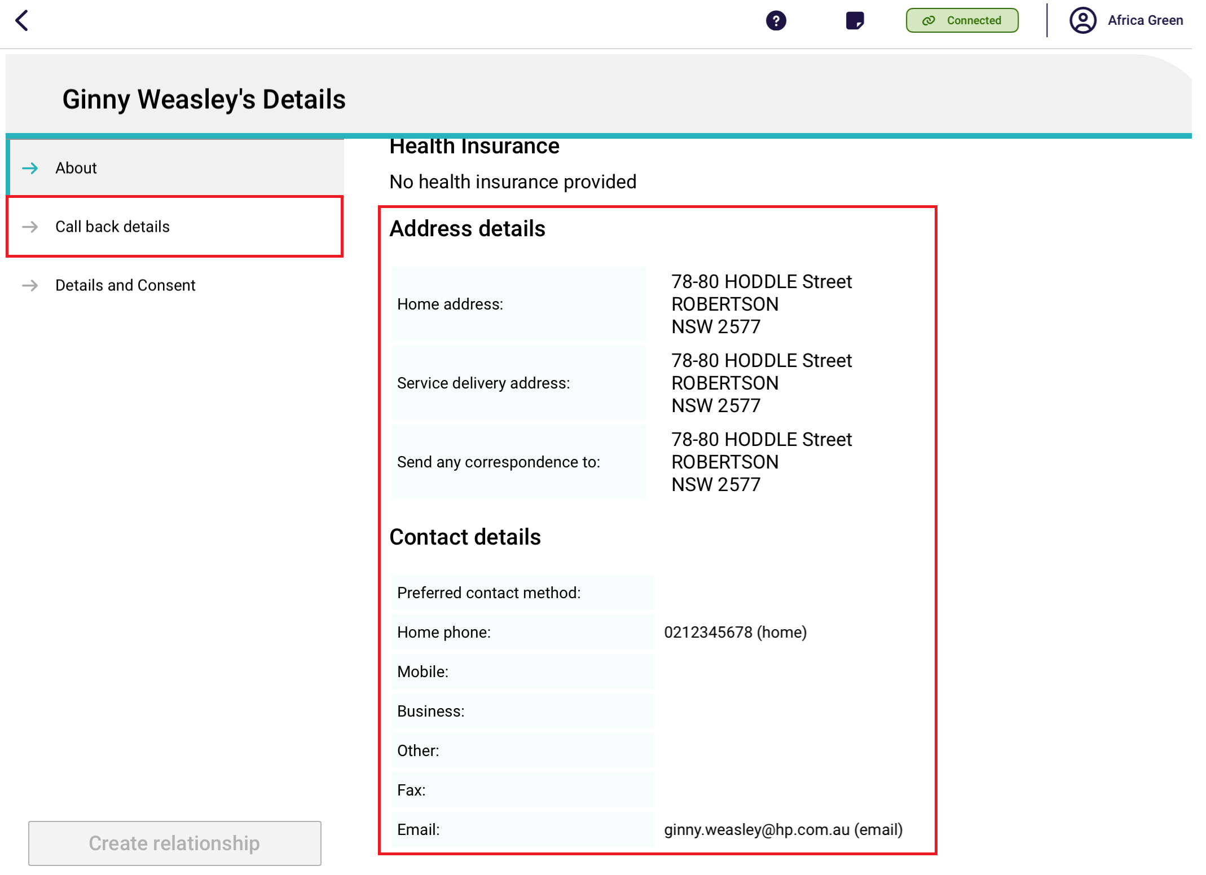
- The Call Back Details page appears.
! | Complete the Call Back Details page to register a Carer relationship.  This page is not applicable to other relationship types.
To be able to request call back from Carer Gateway and/or National Dementia Helpline, the home address and at least one contact number of both the client and the carer are required.
These details are also required in order to progress to the Details and Consent page and to finish creating the Carer relationship.
If there are such details missing, the carer or client may need to go back to their own client profile to update the details (for example in their My Aged Care Online Portal), before coming back here to finish making the relationship.
Fill in all mandatory fields and go to the next page, Details and Consent.
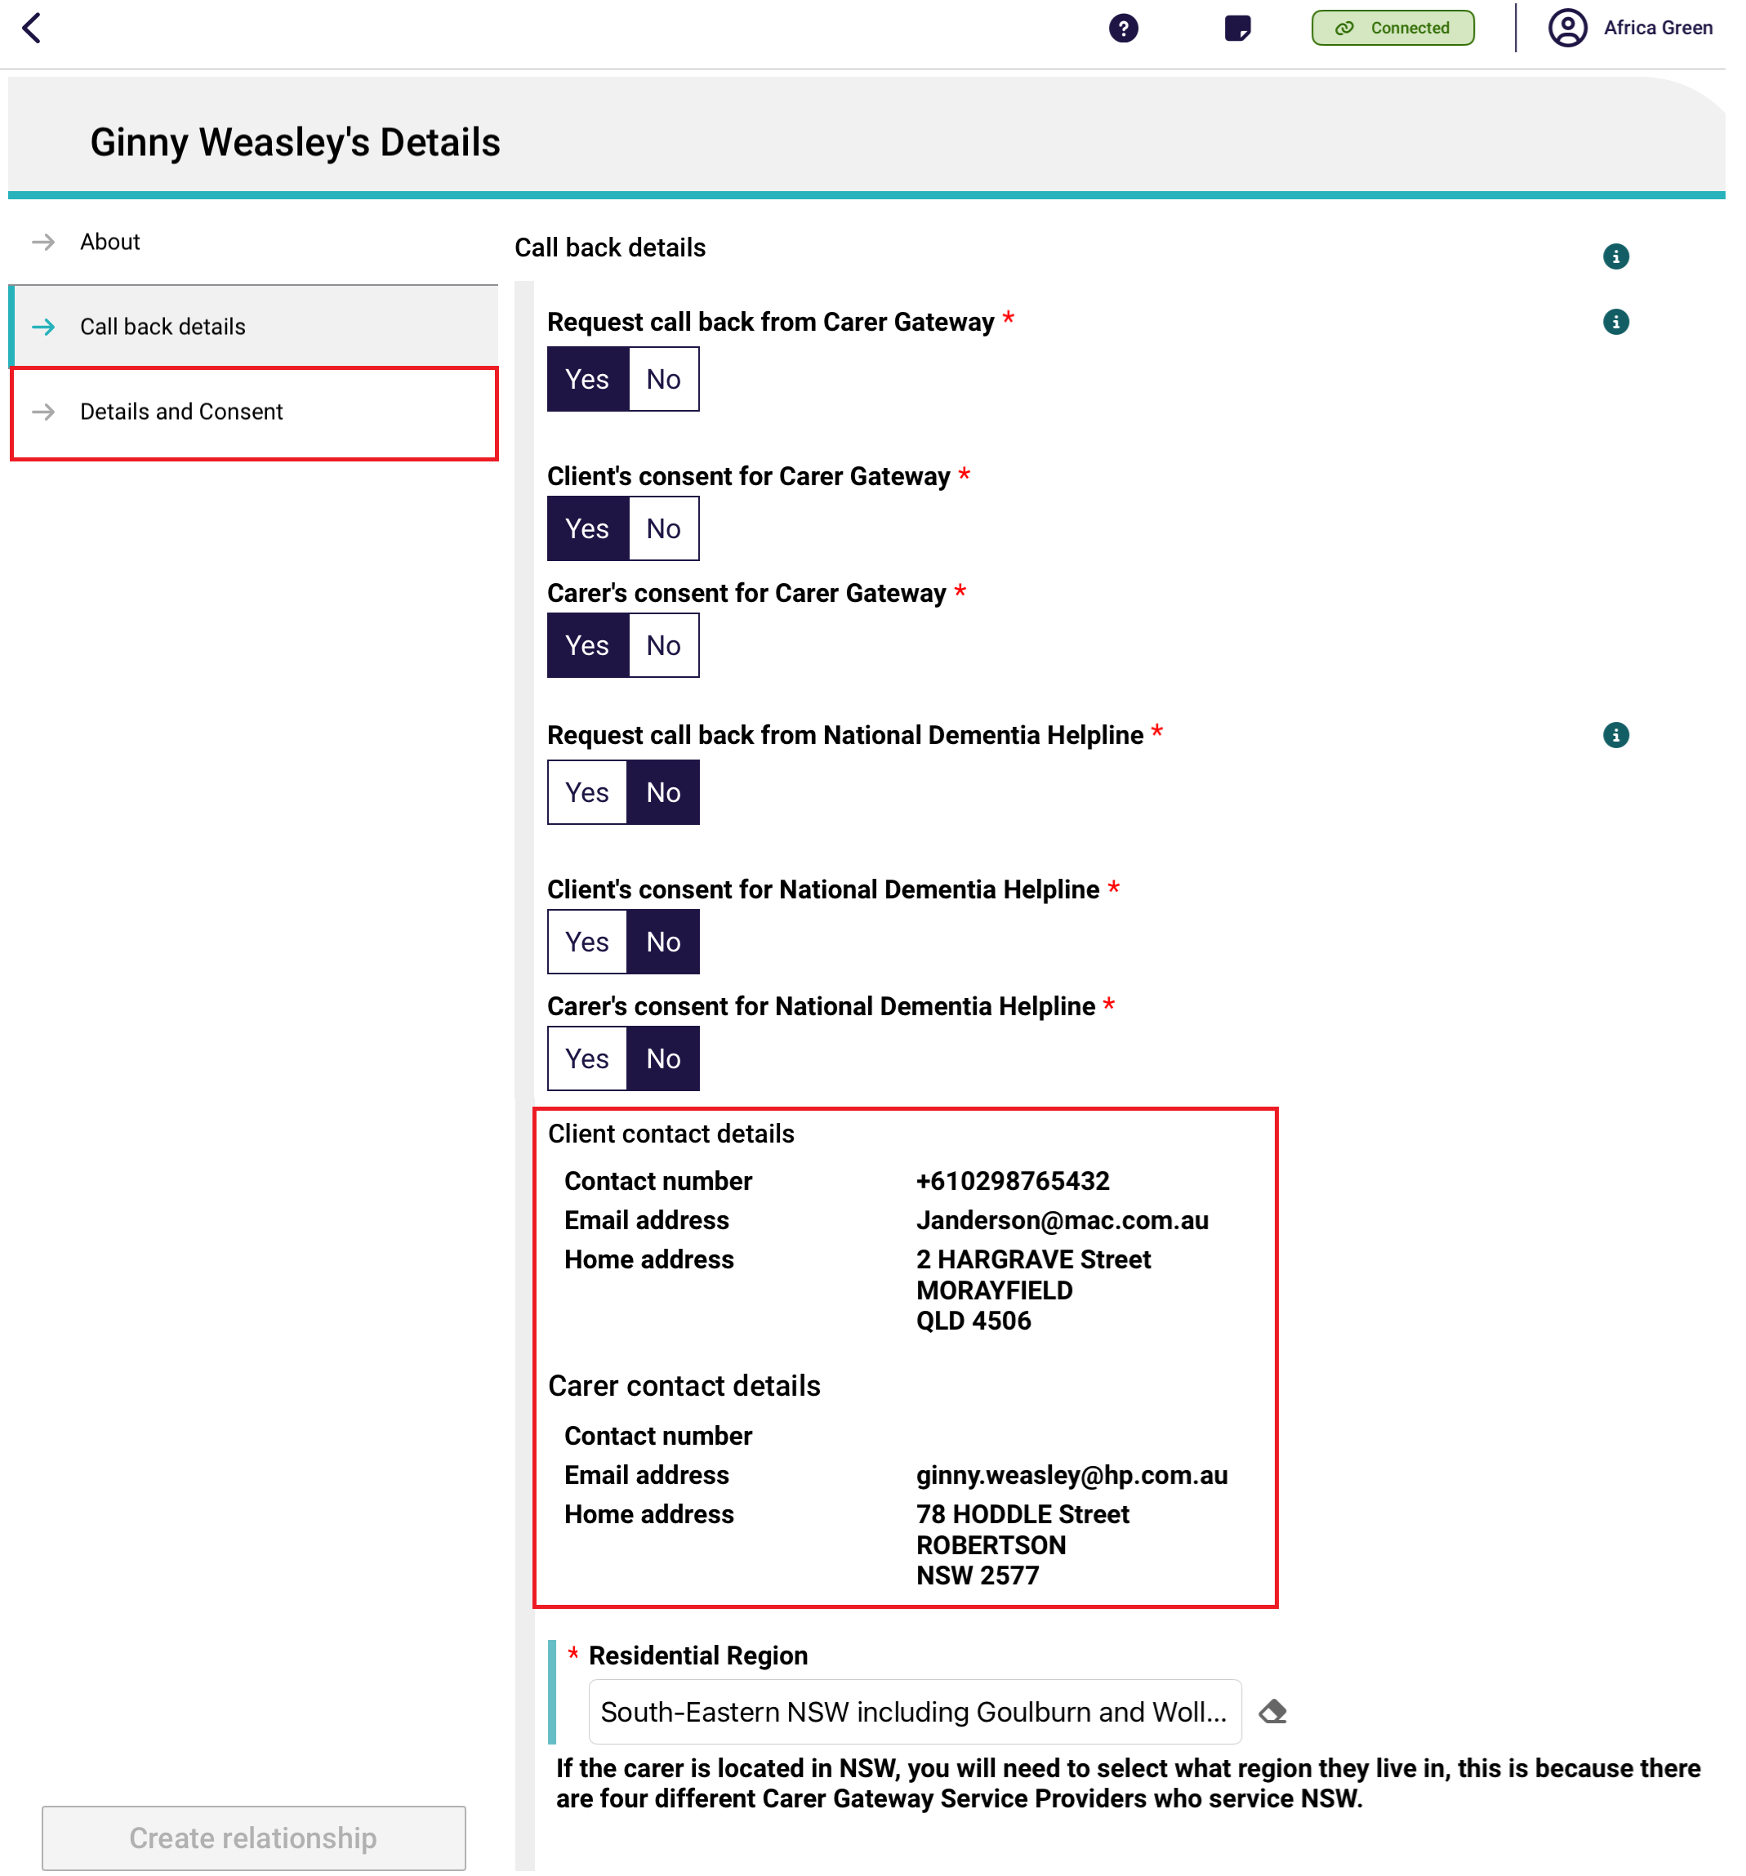
- The Details and Consent page displays. Fill in all mandatory fields, then select Create relationship. There is no consent required for a Carer relationship.
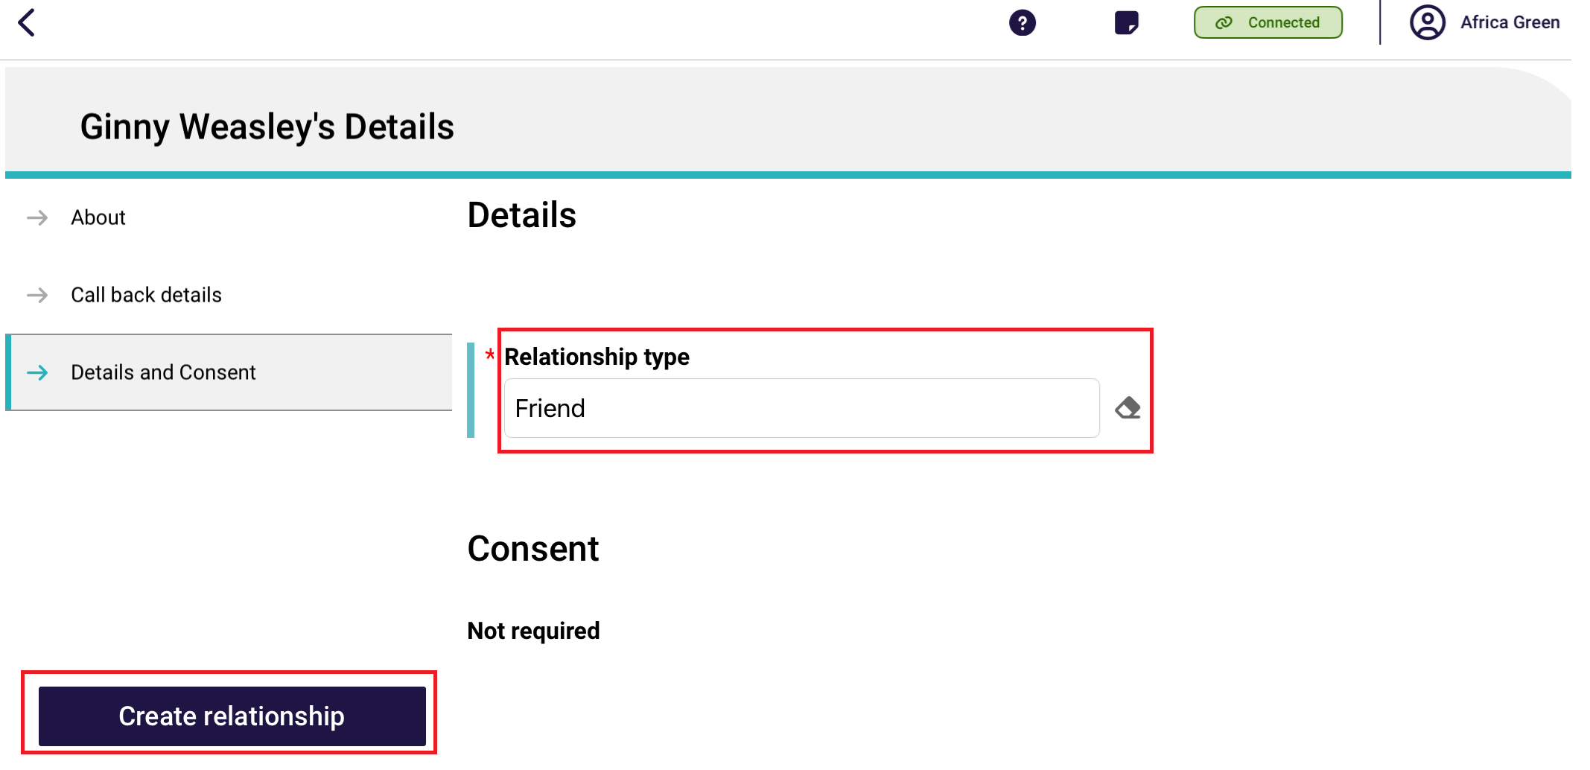
! | There is no Consent section for an Emergency Contact relationship or a Support Person relationship.  There are no Details or Consent sections for a GP Relationship.
- The relationship is now created successfully. Select Go Back.
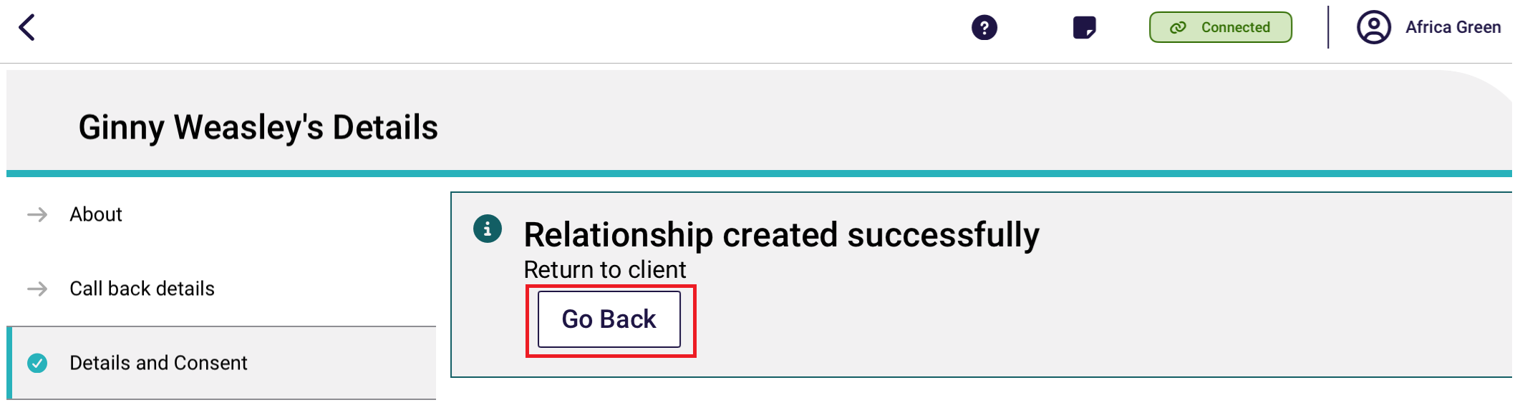
- The support person relationship is now displayed on the client’s Support Network and Cohabitants page.
In the case of a carer relationship, there are additional buttons: Request call back which registers call back consent, Edit, and Remove.
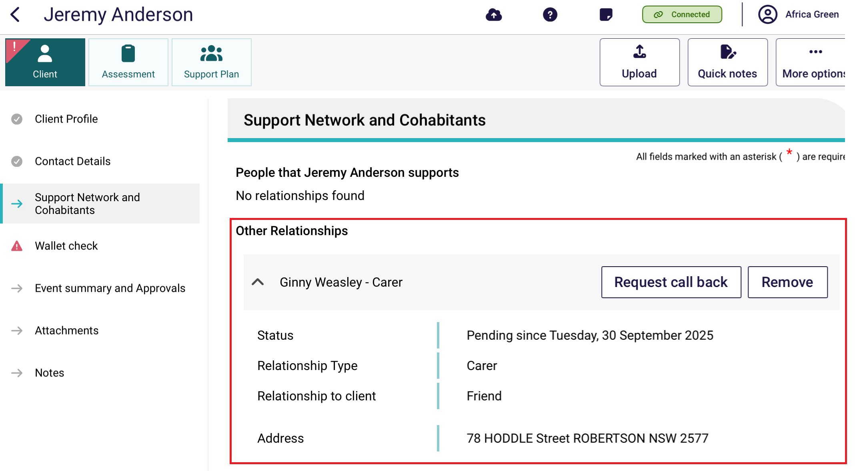
The below images show examples of other relationships, such as Emergency Contact, GP and Support Person. 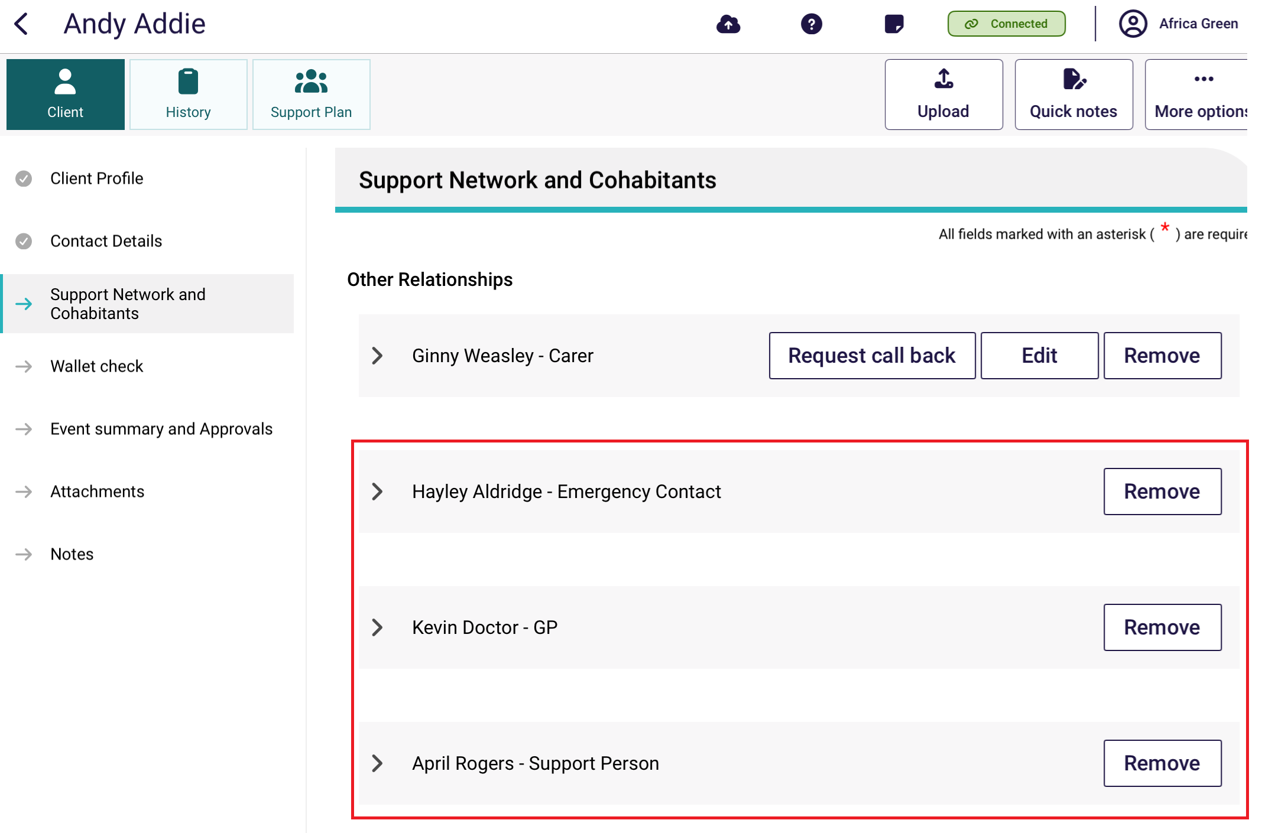

9.6 Creating a relationship in offline mode
To create a supporter relationship while the App is in offline mode, follow the steps below.
! | You must be online to register and set up a relationship. Any support people created offline will be saved locally to your device. Relationships created offline will have a visual indicator to identify that they have been created locally to the device.  You must register the relationship before you can upload the assessment. To do this select Register against the local record and follow step 4A in Creating a relationship for a carer or other support people.
- Navigate to the Support Network and Cohabitants section and select the Create Relationship button.
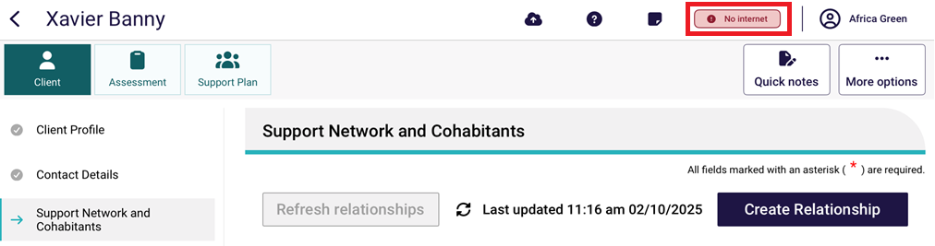
- Fill in all the supporter’s mandatory information until each page has a tick next to it as per the instructions in the section Creating a relationship for an individual supporter or supporter lite or Creating a relationship for a carer or other support people.
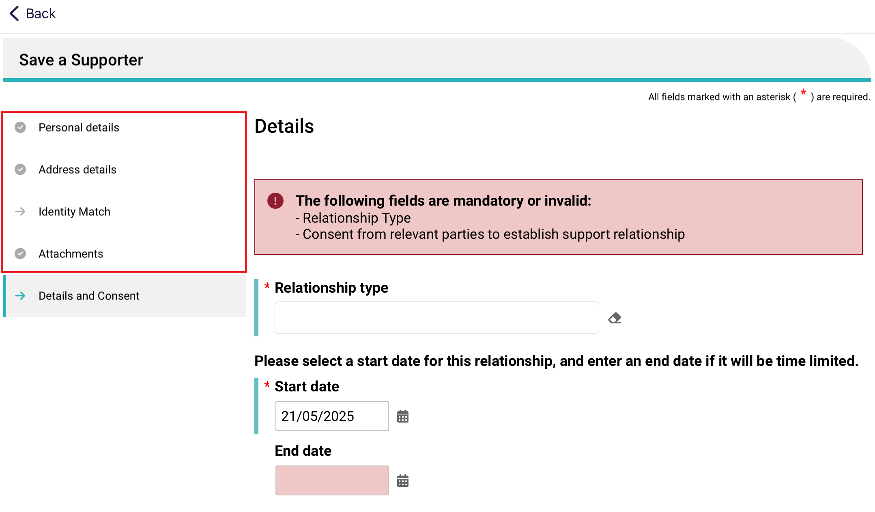
- In the Details and Consent page, toggle Yes or No for each person’s consent and conflict of interest details as appropriate. Then, select Save.
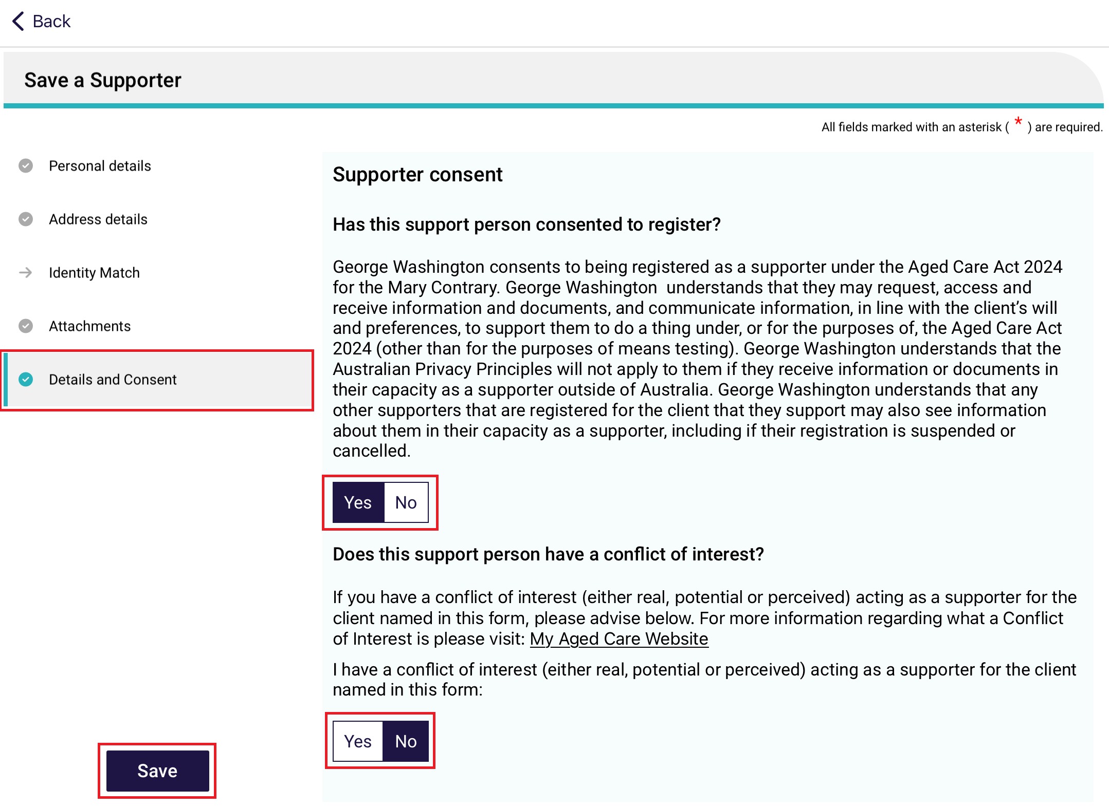
! | Supporter Guardian relationships are created as Pending only. Use the Assessor Portal to complete activating the relationship.
- A banner – Local Relationship saved successfully appears. Select Go Back.
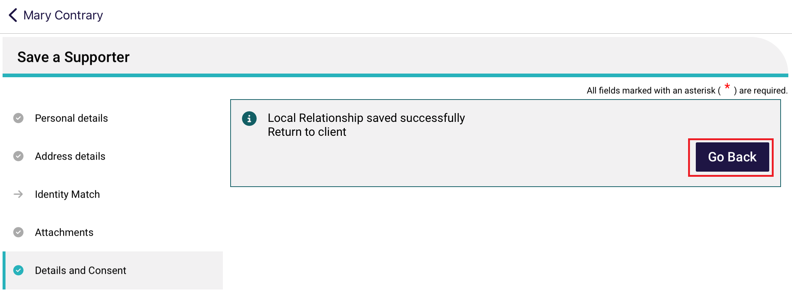
- The new supporter relationship will appear on the Relationships and cohabitants page.
In the case of supporter guardians, a banner appears: Some relationships cannot be activated via the App. Please finalise these on the Assessor portal.
! | Relationships made while offline will need to be established when the Internet is available.
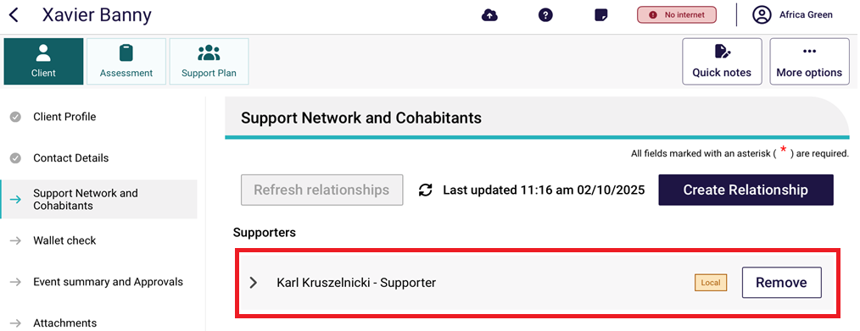

Establishing an offline relationship
- To activate (establish) offline relationships, you will need to make sure there is Internet connectivity by checking for the Connected symbol at the top right of the App screen.
Then, select the Establish Online button next to the offline (local) relationship listing.
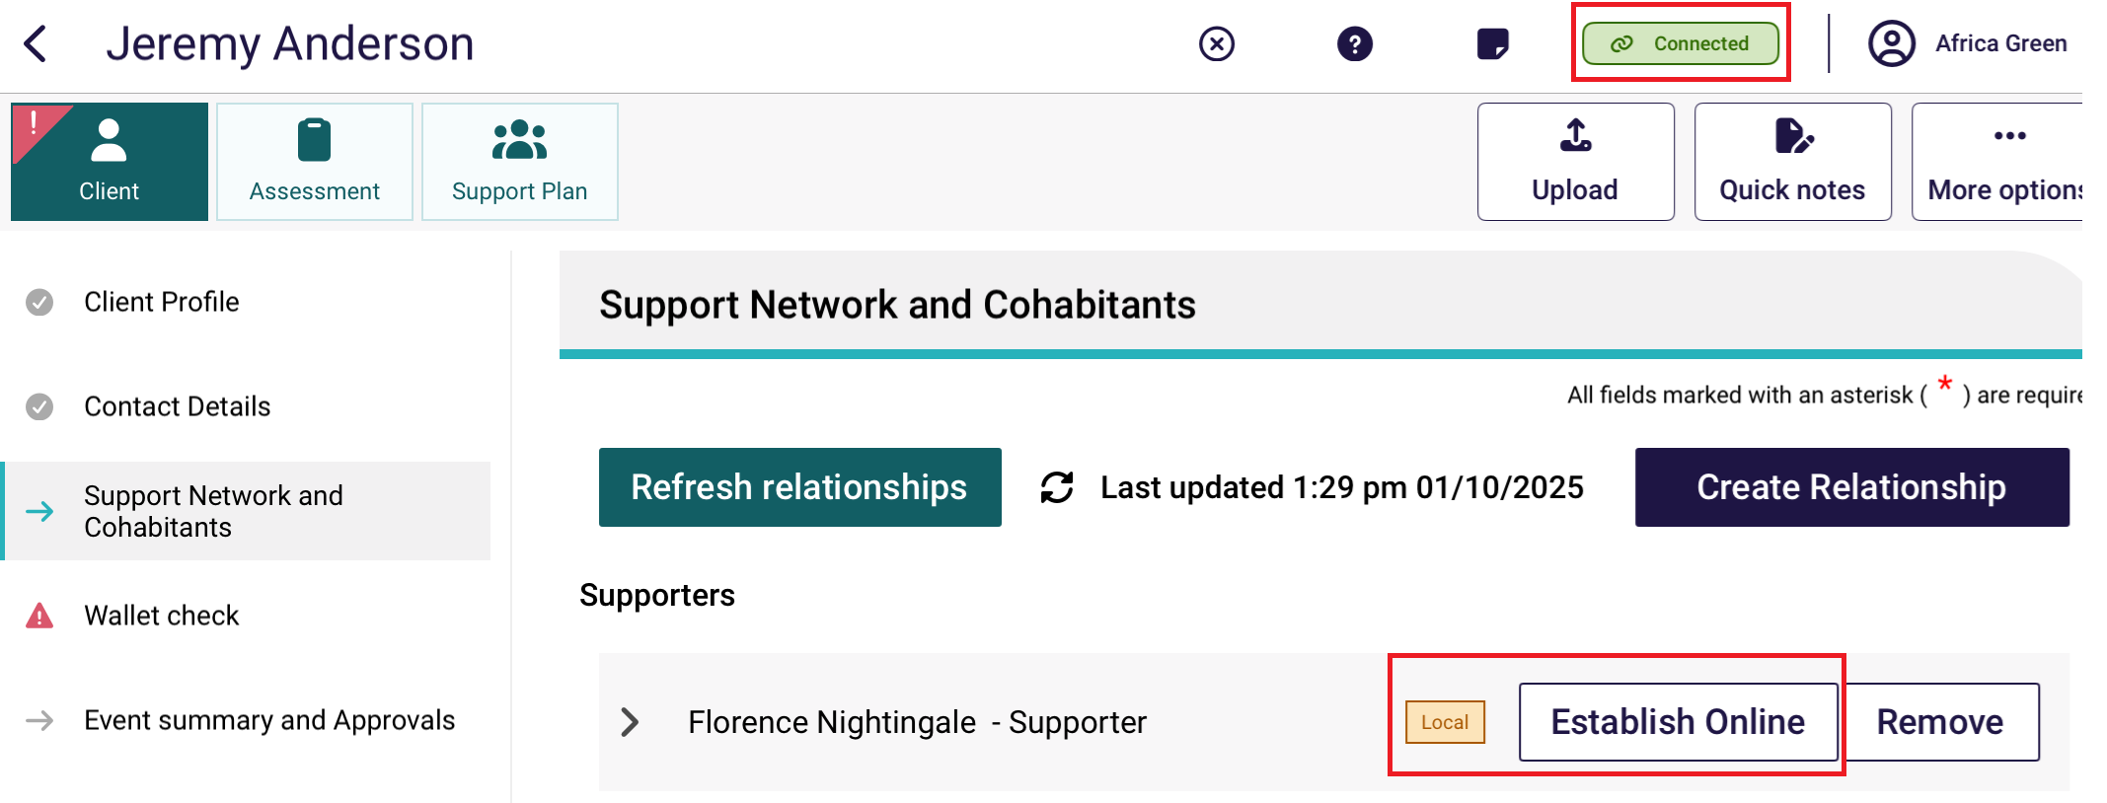
- The Register A Supporter screen appears.
The App will now look for duplicate records in My Aged Care.
If there are duplicate records, an Information message appears at the top of the page. Select View Potential Matches.
If there are no duplicate matches, continue to Step 4.
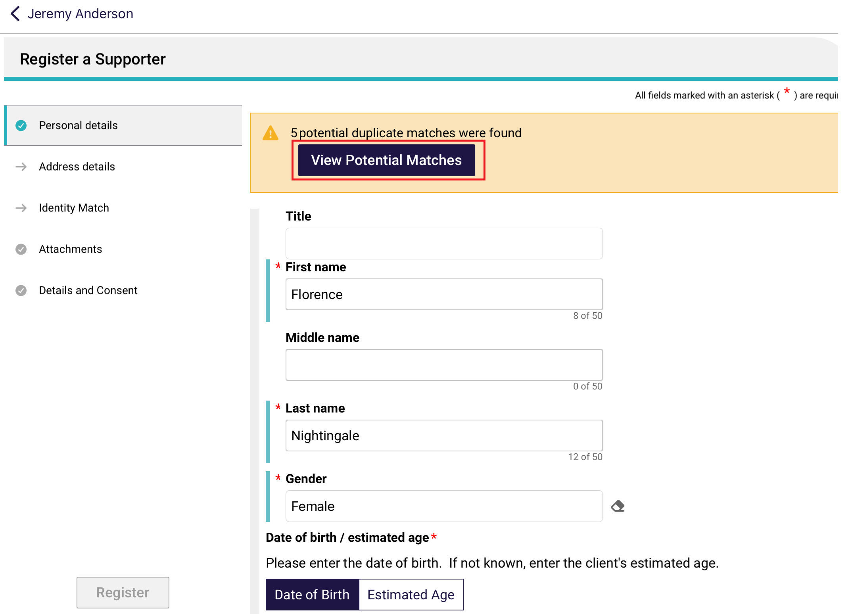
- The Review Potential duplicate client page appears. Review each duplicate by selecting each record listed on the left column under the Client details heading. If you find the correct existing record, select the corresponding View existing record button. Otherwise select the Use new record button.
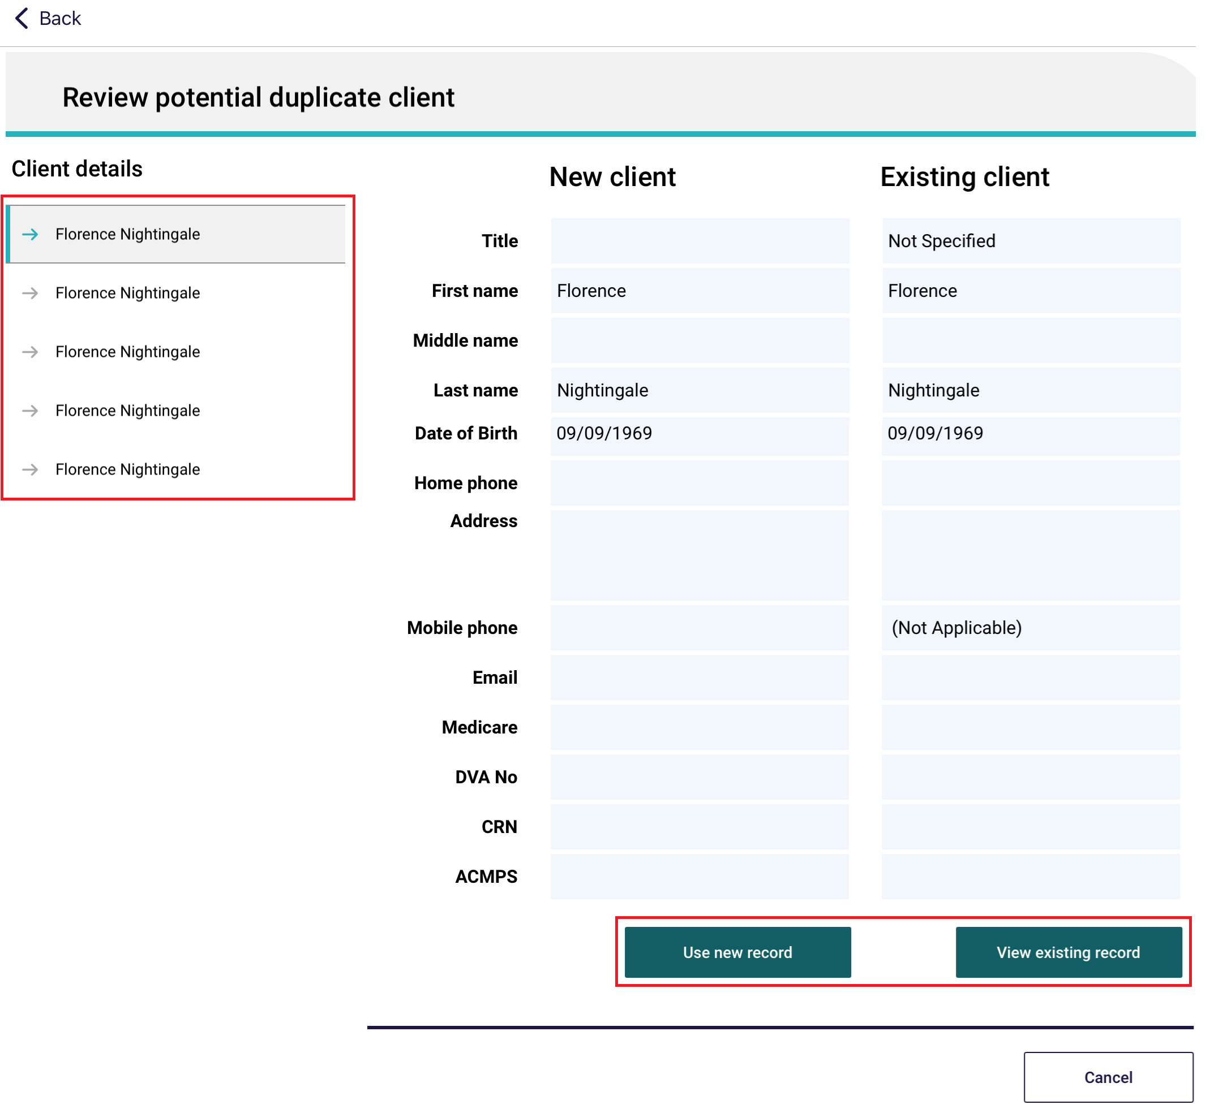
- For new client records, there are five pages in the Register a Supporter section: Personal Details, Address Details, Identity Match, Attachments, and Details and Consent.
For existing records, there may be fewer pages to review – usually About, Attachments, and Details and Consent.
Ensure all mandatory fields are entered or updated in each page until the Register button or the Create Relationship button turns blue. Some of these fields may have been pre-filled based on what you have entered whilst the relationship was offline.
Then, select Register, or Create Relationship.

Existing Record example
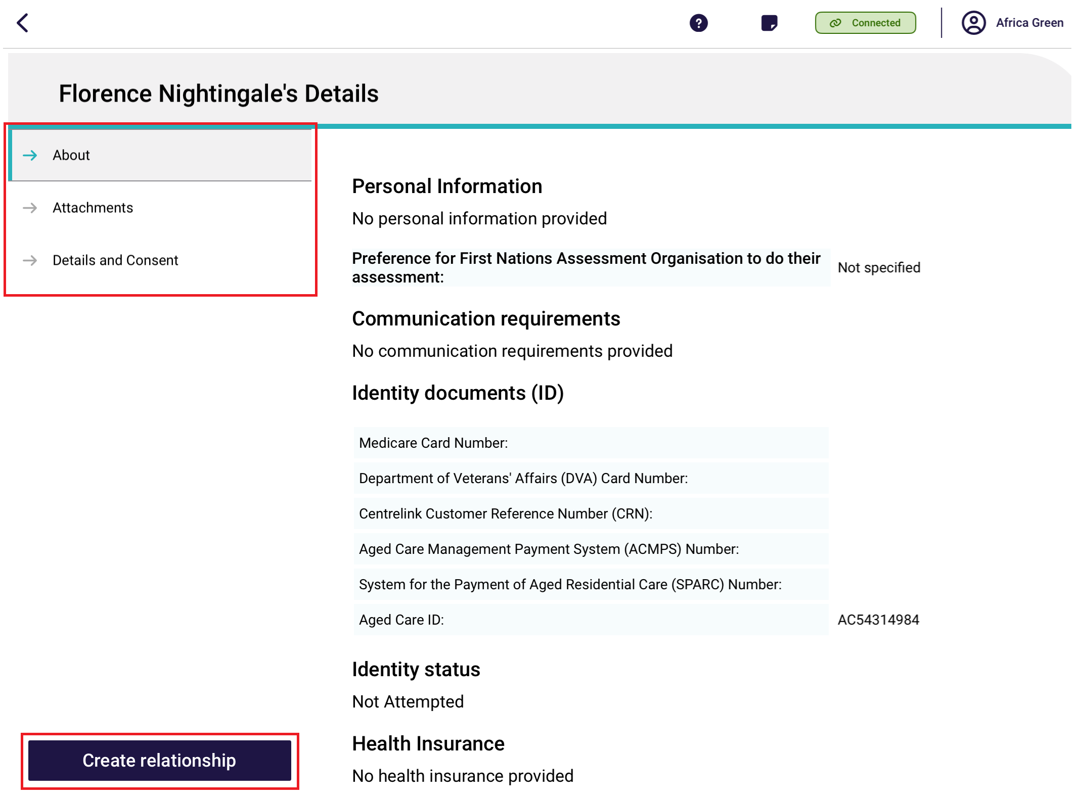
New Record Example
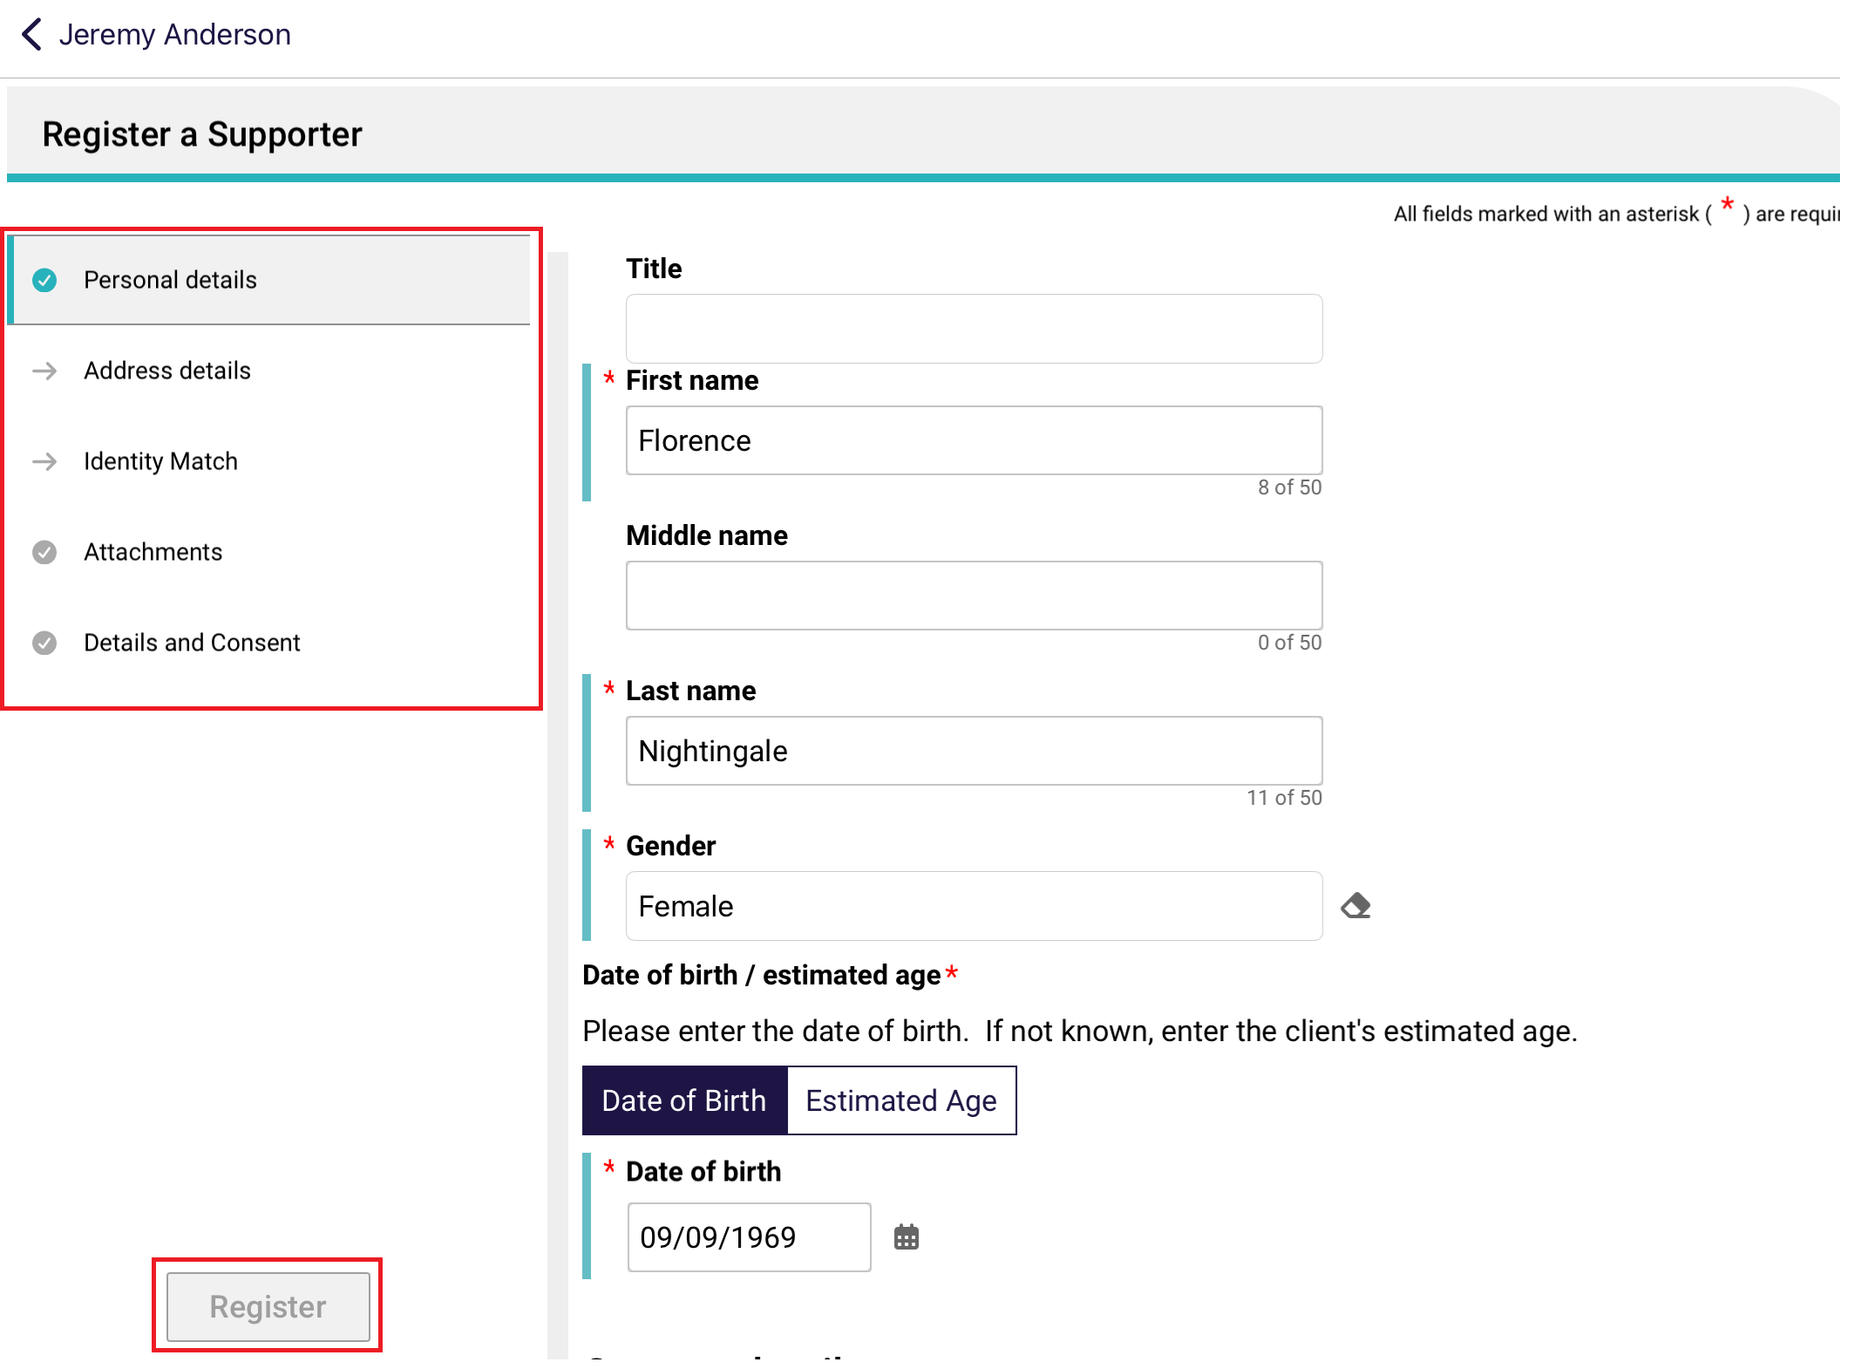
! | For information on how to fill out each page during the Register A Supporter process, refer to the subheadings relating to each type of relationship in Registering a support person.

9.8 Activating a pending relationship
A Pending Relationship is created on a client’s record if:
- the older person or their supporter do not provide their consent for the relationship to be set up
- the start date of the relationship is in the future
- a supporter guardian relationship is being created.
To activate a pending relationship, follow the steps below. You must be connected to the Internet.
- In the client’s Support Network and Cohabitants page, select Activate.
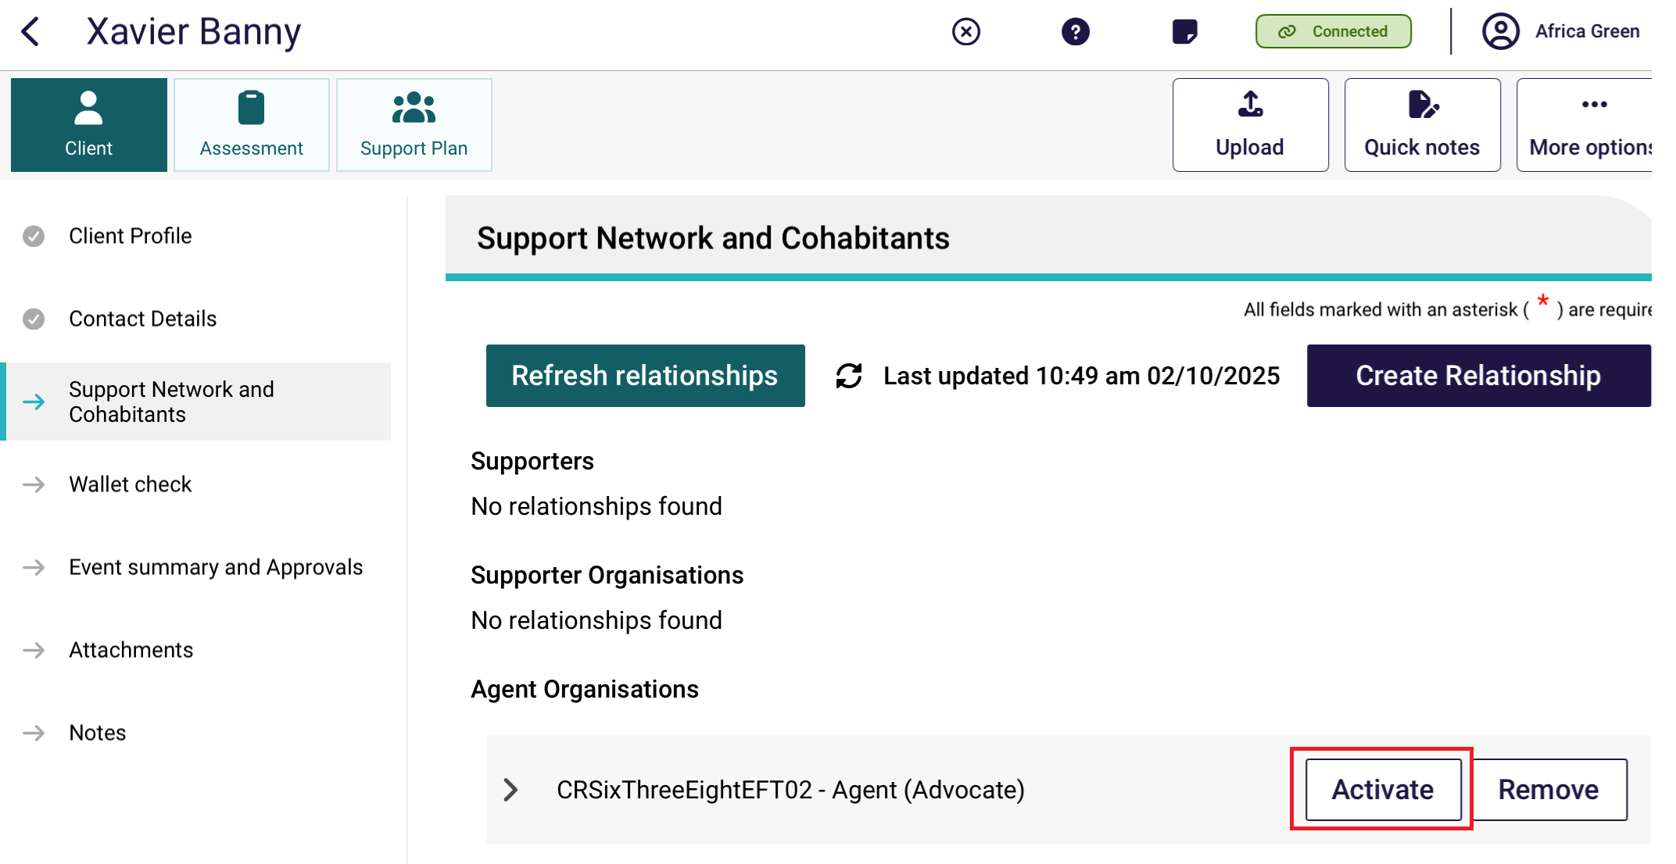
! | Some relationships cannot be activated via this app. Please finalise those on the Assessor Portal instead. These relationships will have a warning banner on top of the page:
- From the Activation page, Check that the information is still correct and update if required.
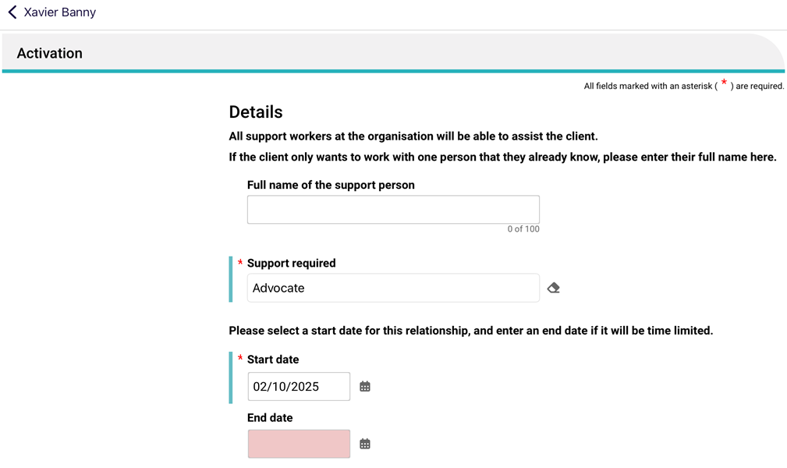
- Scroll down to the Consent section. Update the supporter’s consent as required then select Activate.
(All parties must select Yes to their consent section for the relationship to activate.)
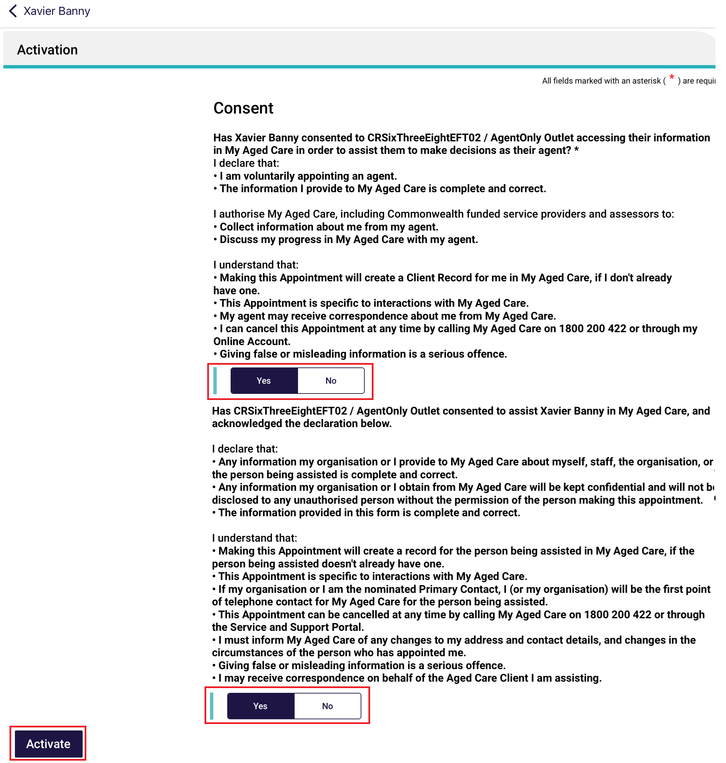
- The Activation page will then change to display a banner which confirm that the relationship has been successfully activated. Select Go Back.
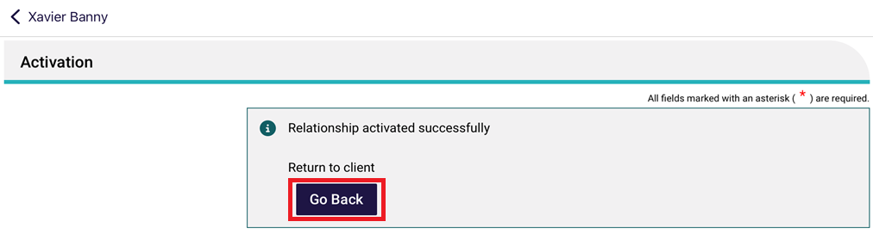

- The relationship will now show as active in the client’s support network and cohabitants tab.
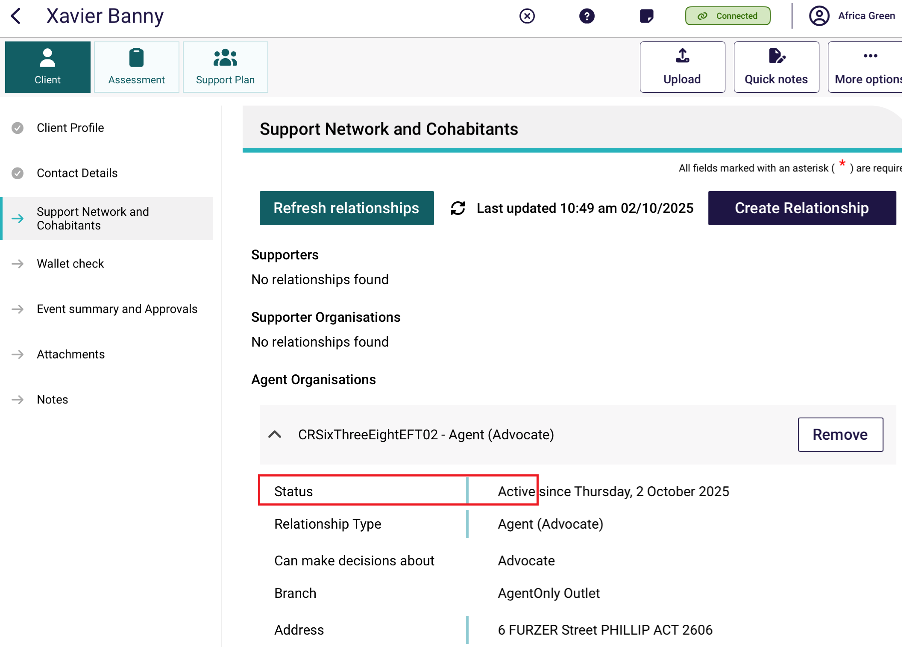

9.9 Removing a support relationship
To remove an active or pending relationship:
- Select the Remove button on the support relationship’s listing in the client’s profile.
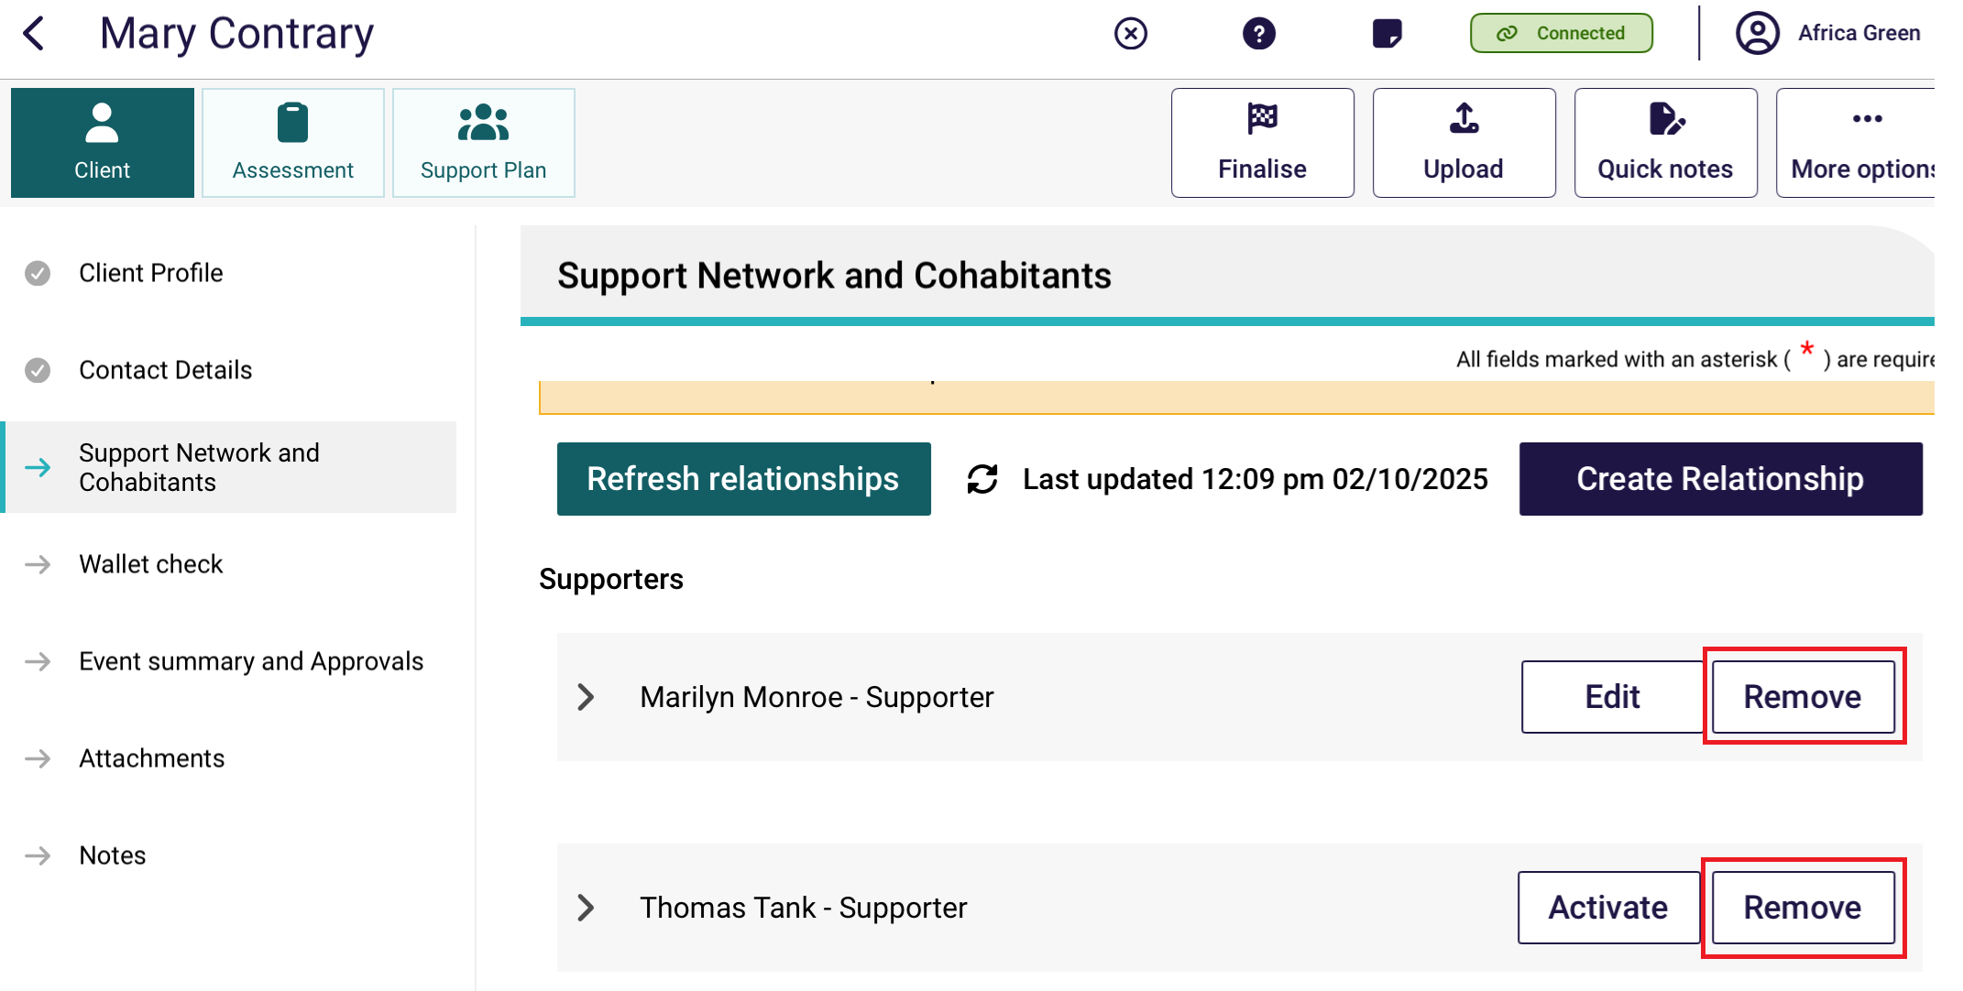
- Select Remove on the next page. Some relationships require a reason, such as Appoint Another Supporter, No Longer Required, Other, Unable to Fufill Duties, or Unaware of Relationship.
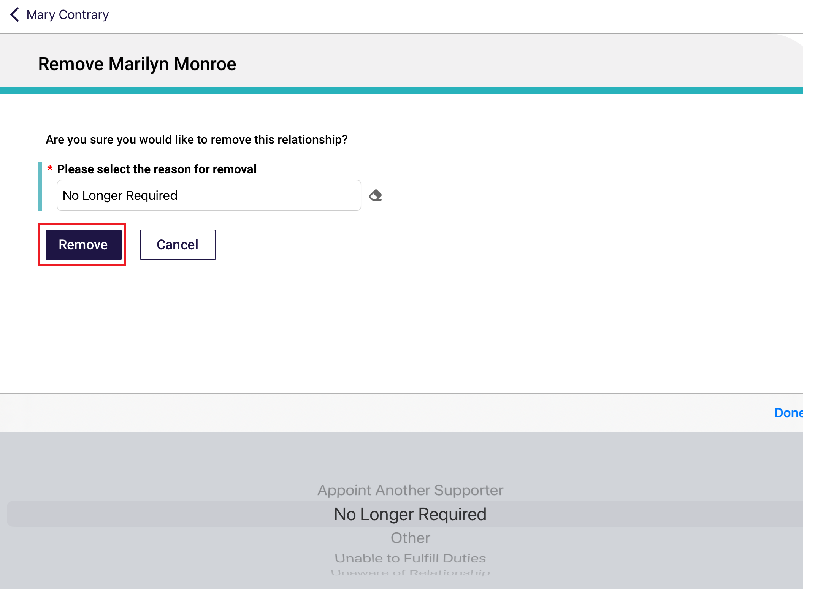
- Removed relationships will show under the Declined and ended relationships section in the Support Network and Cohabitants section.
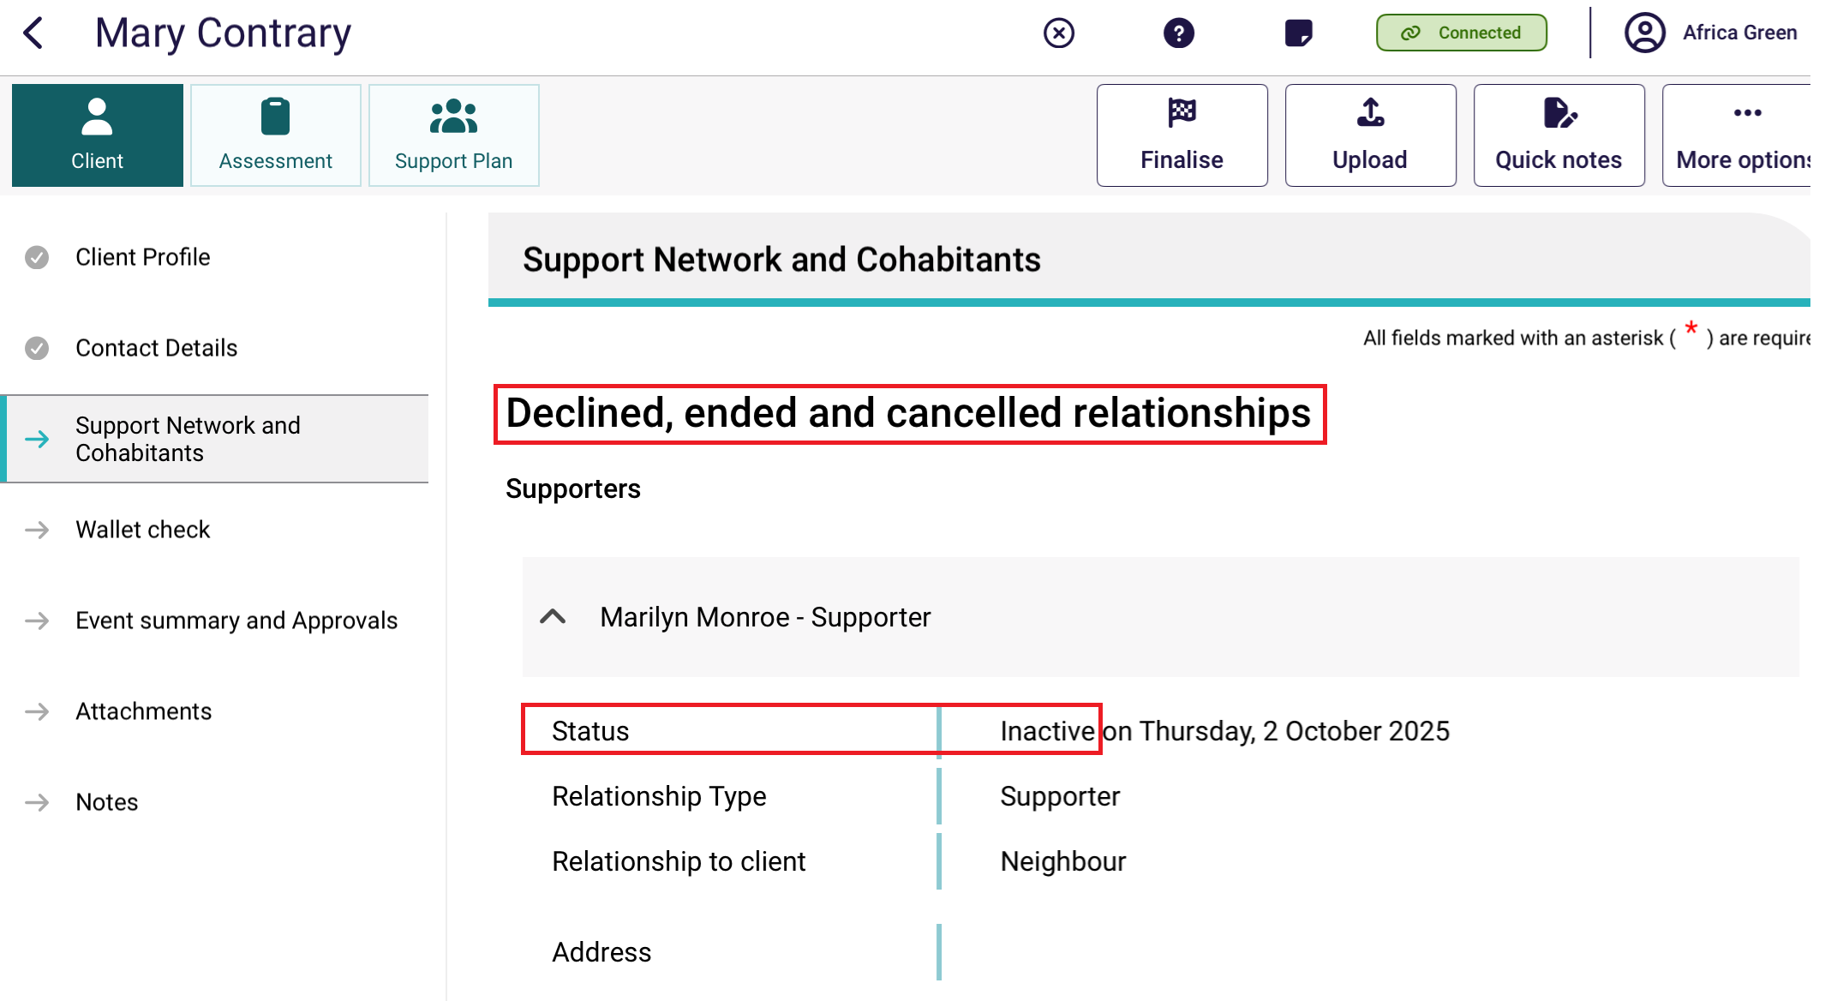

Completing identity verification
To conduct identity verification (a wallet check), follow the steps below.
- Open and log in to the App with your password, following the process in Signing in to the App after activation. The Dashboard will be displayed. Select the client’s name on the referral card.
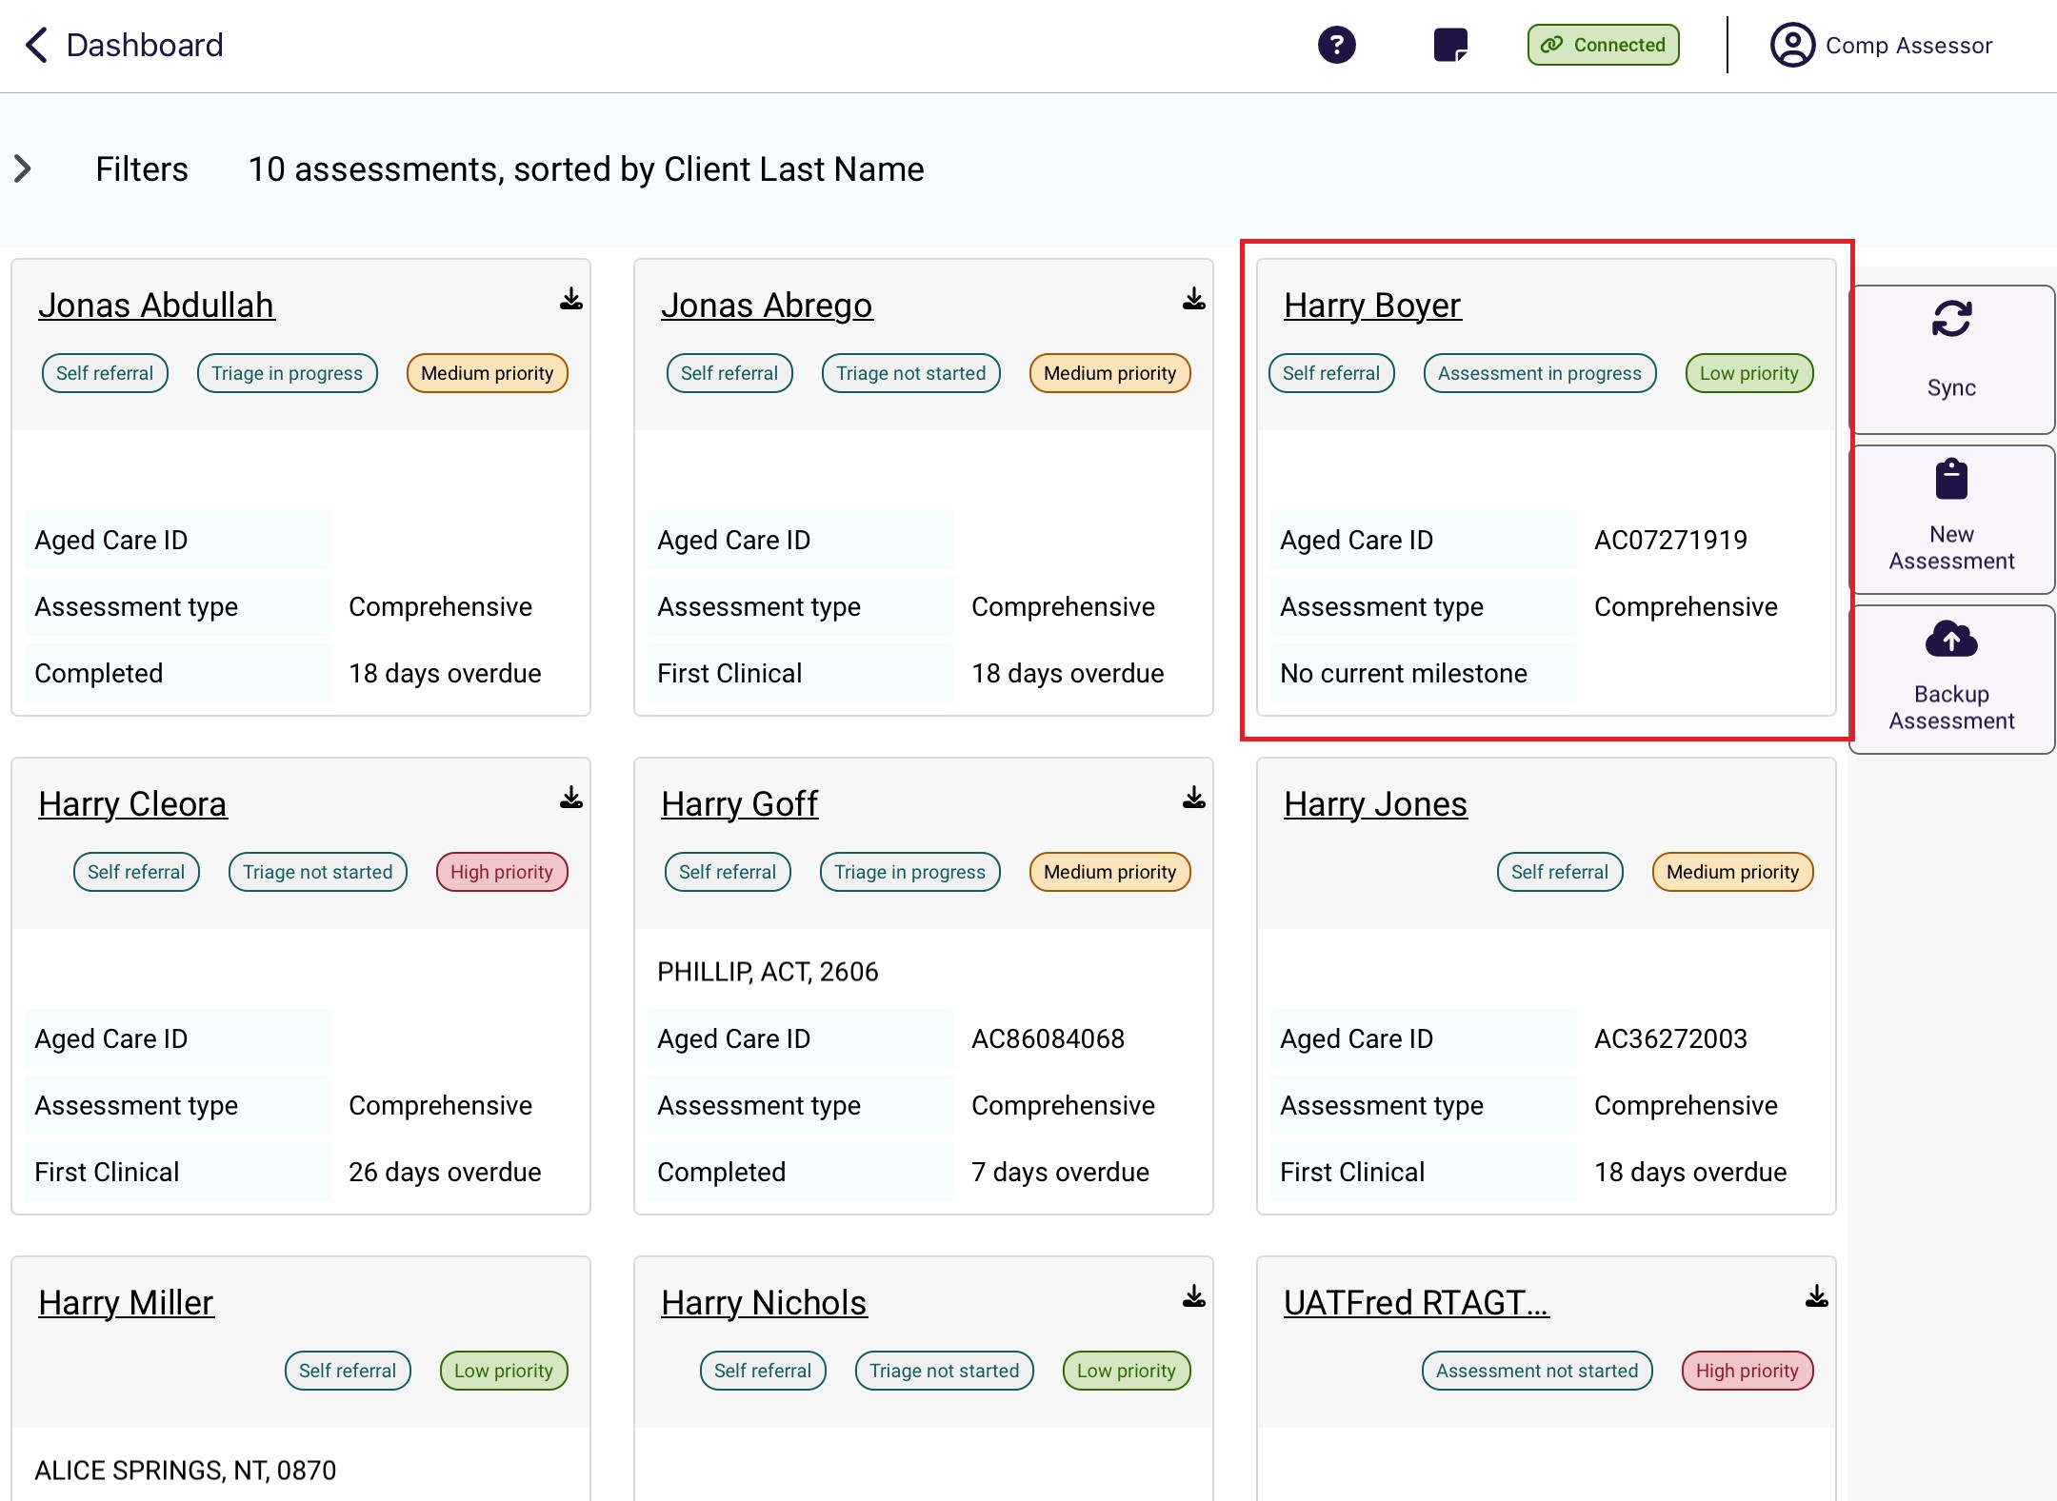
- Select Wallet check. The status of the wallet check will be displayed. To conduct a wallet check select Conduct a wallet check.
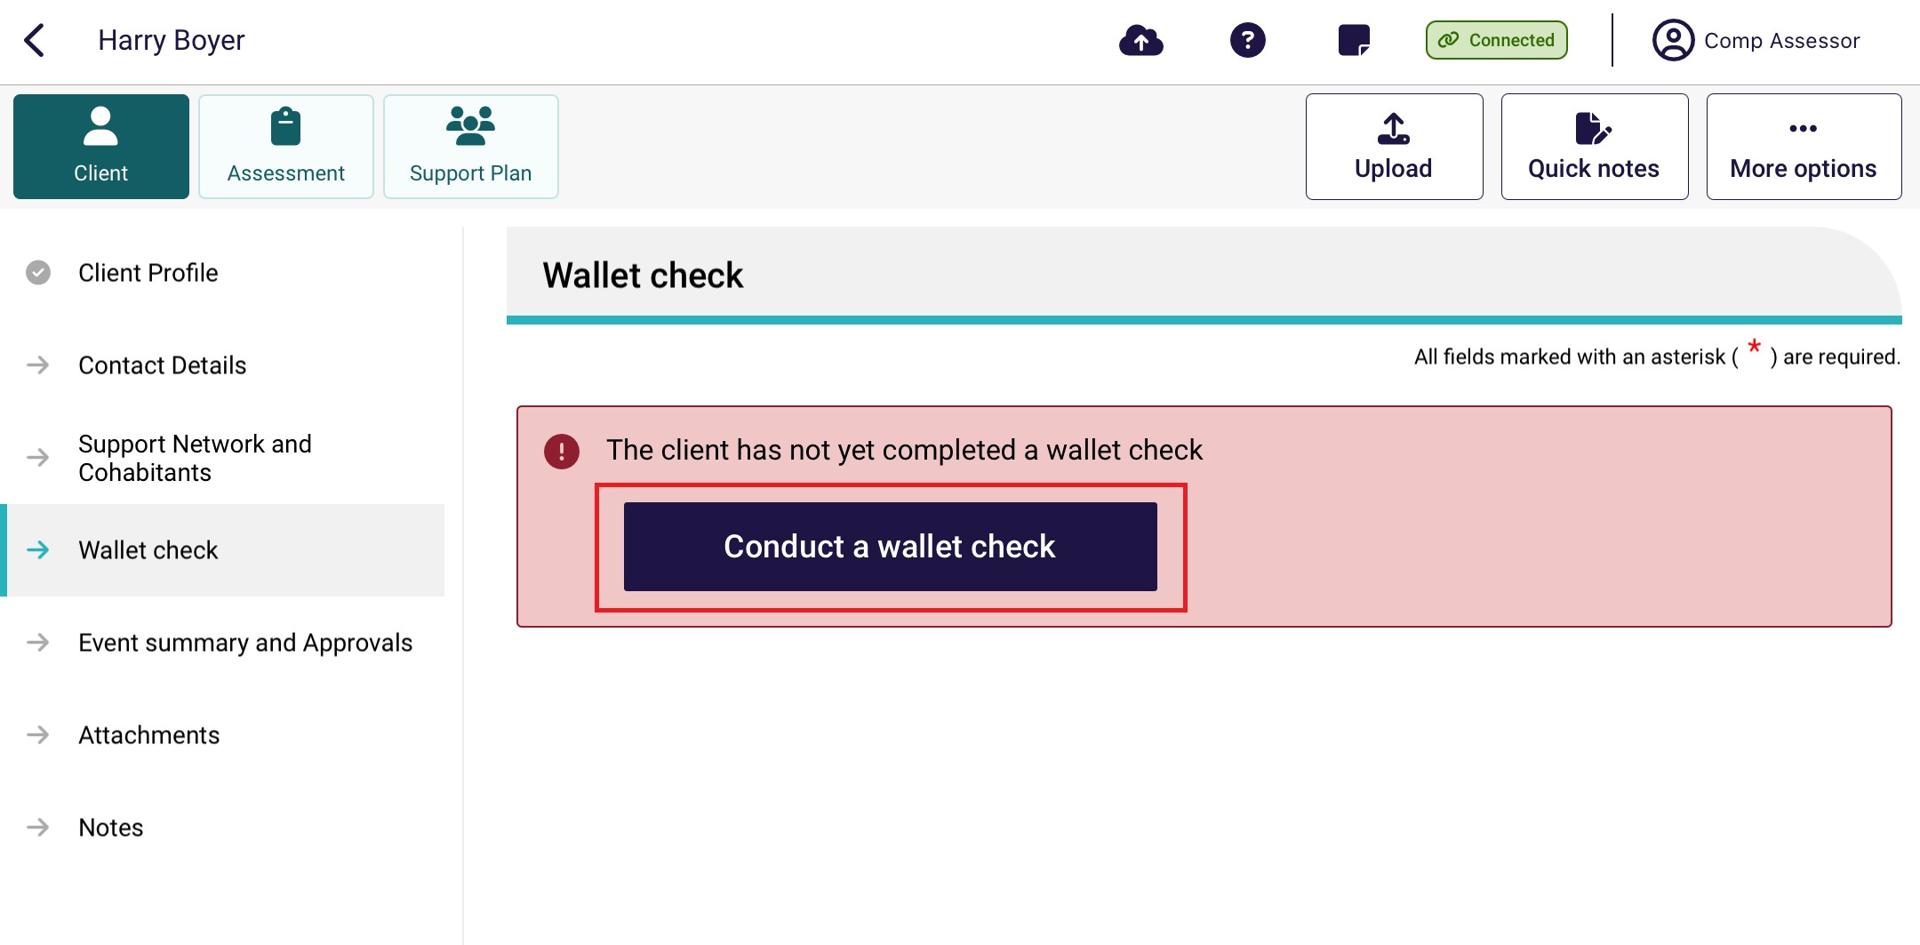

- A page is displayed to record whether the client has identification that will allow you to complete the process.
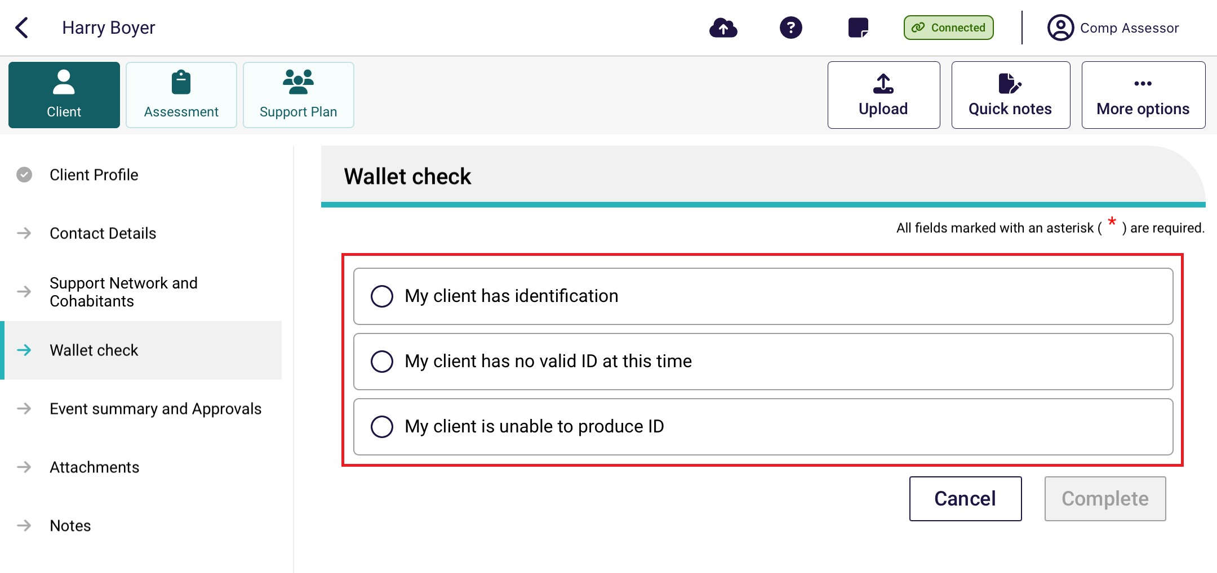
If you have selected:
- My client has identification, go to step 4.
- My client has no valid ID at this time you will receive a message confirming that a wallet check should be completed at a later date. Go to step 5.
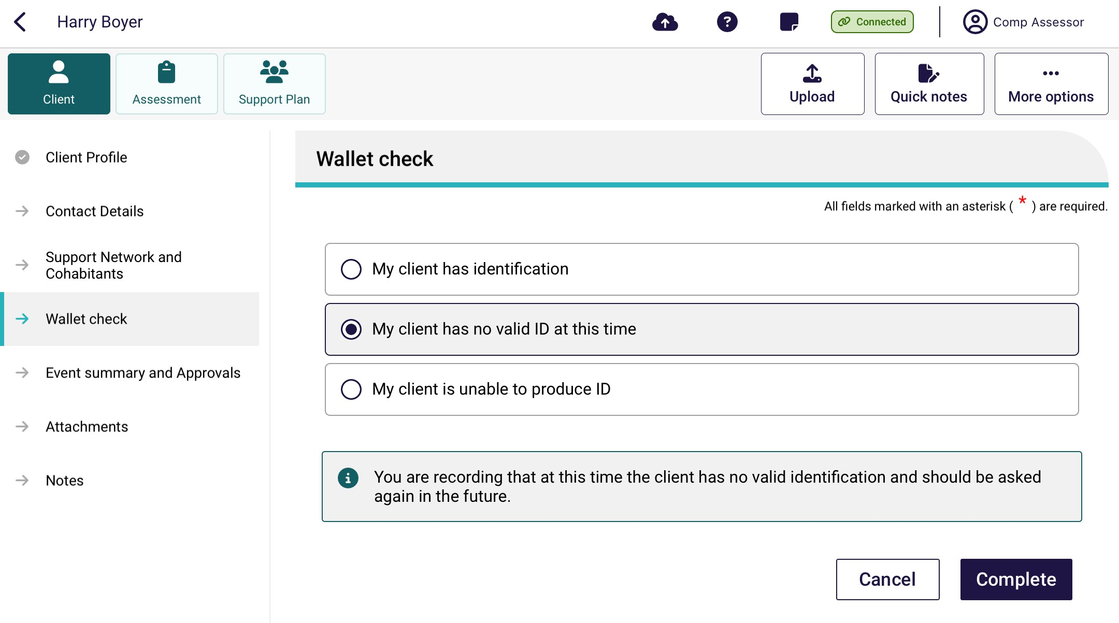
- My client is unable to produce ID, a message will be displayed to record that you are unable to complete the wallet check and that it will not be able to be completed at a future date, go to step 5.
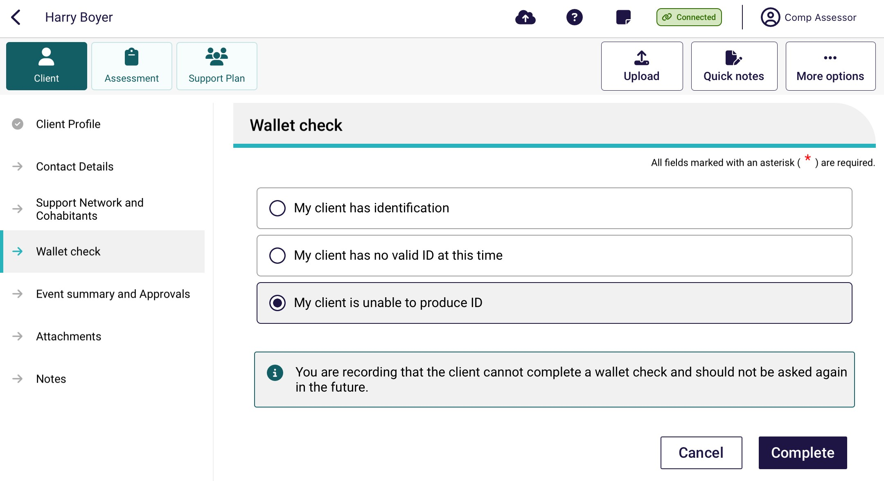
- The page will be expanded to allow you to record the type of documentation sighted, and the date that you performed the wallet check. You will need to sight at least two types of identification to complete the wallet check.
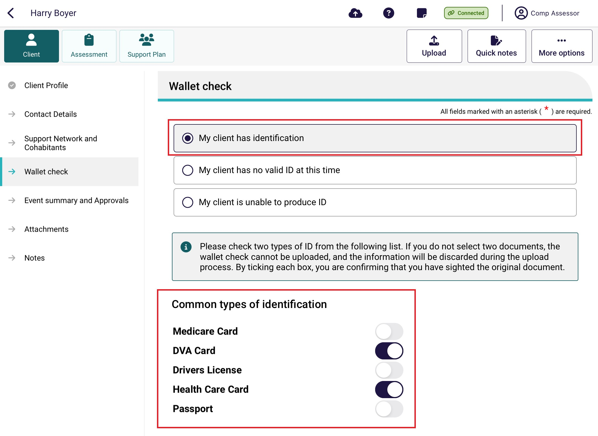
! | Select Show more types of identification that can be sighted to display additional identity documents that may be used for identity verification, for example, Birth Certificate, Australian Aged Pension, Pensioner Concession Card etc.

- Select Complete.
- If you successfully completed the Wallet check, an information message will display to confirm that the Wallet check has been completed.
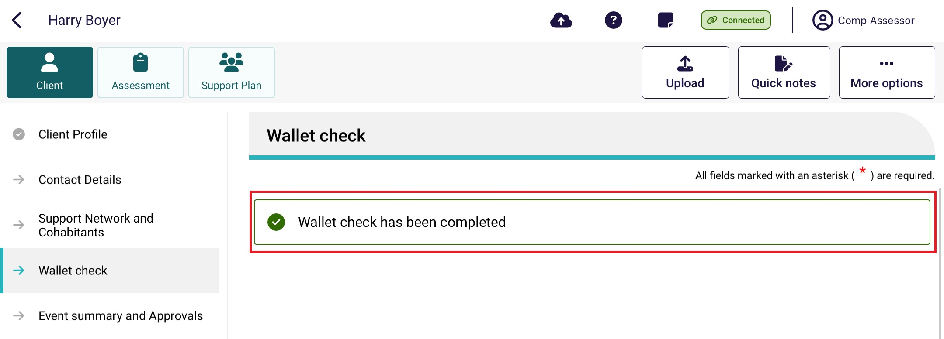
! | If you are unable to sight two identification documents (e.g. the client does not have valid ID), a reminder to complete a wallet check will display on the client record until a wallet check can be completed. This will not prevent you from completing an assessment.

Undertaking assessments
Needs assessors can use the App to:
- undertake assessments for client’s referrals they have downloaded
- undertake assessments for offline clients they have saved locally to their device
- undertake Residential Respite Assessments.
! | The App will display the same sections of the assessment that are available for assessors in the My Aged Care assessor portal.
The steps to undertake an assessment on the App are as follows.
- Open and log in to the App, following the process in Signing in to the App after activation. The Dashboard will be displayed. Then, select the client’s name that you are wishing to assess.
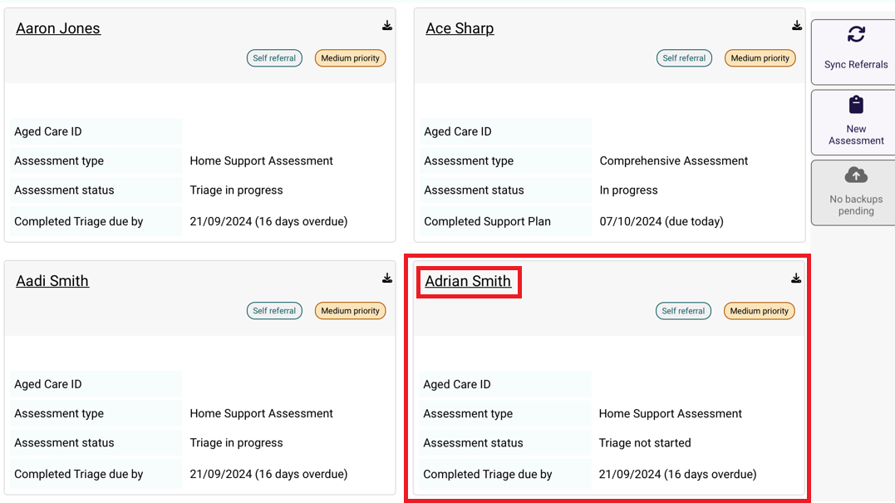
- Select Start Assessment.
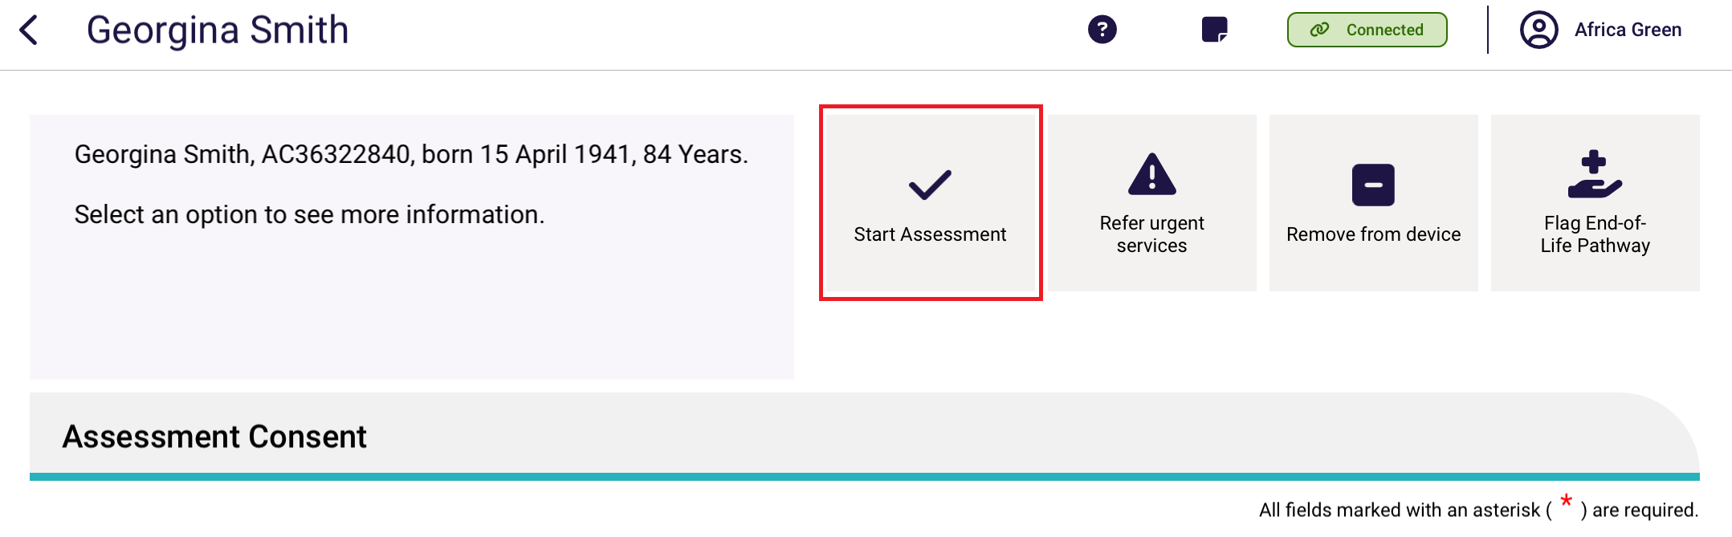
- Select the relevant radio box for who has provided consent to the assessment as well as if you would like to pre-populate the IAT questions or start a blank assessment. Then select Confirm.
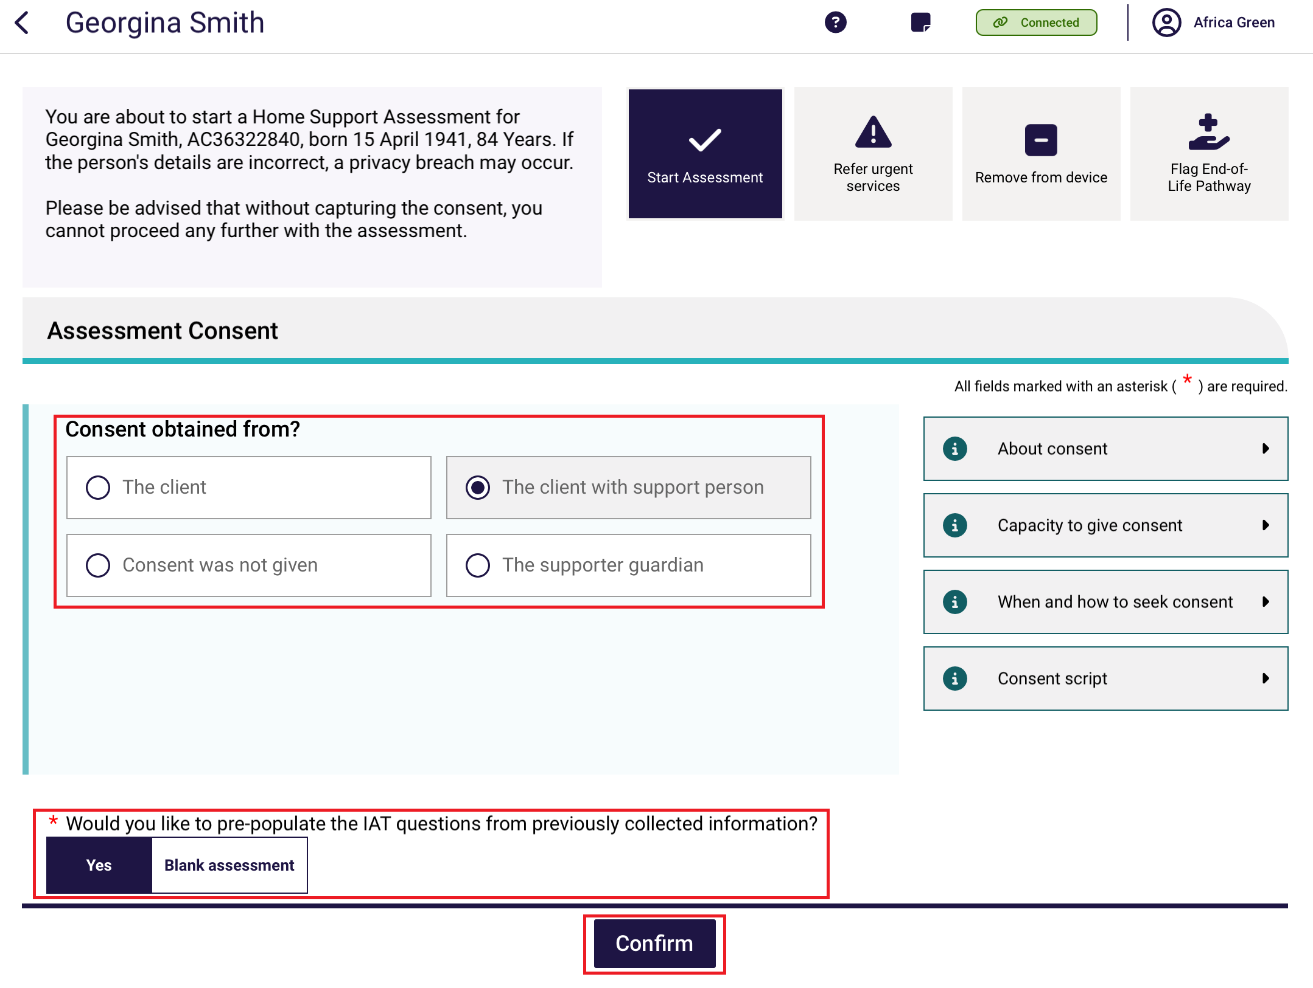
- The Assessment Details page will display, and the assessment can be commenced from here.
For comprehensive assessors, the First Intervention of a Clinical Nature page will display.
Mandatory fields are identifiable by red asterisks, and prior to completing mandatory information a red triangle will display in the top right-hand side of the box. Once a mandatory question is answered, this triangle disappears. This feature helps to identify whether all mandatory questions have been answered in each section.
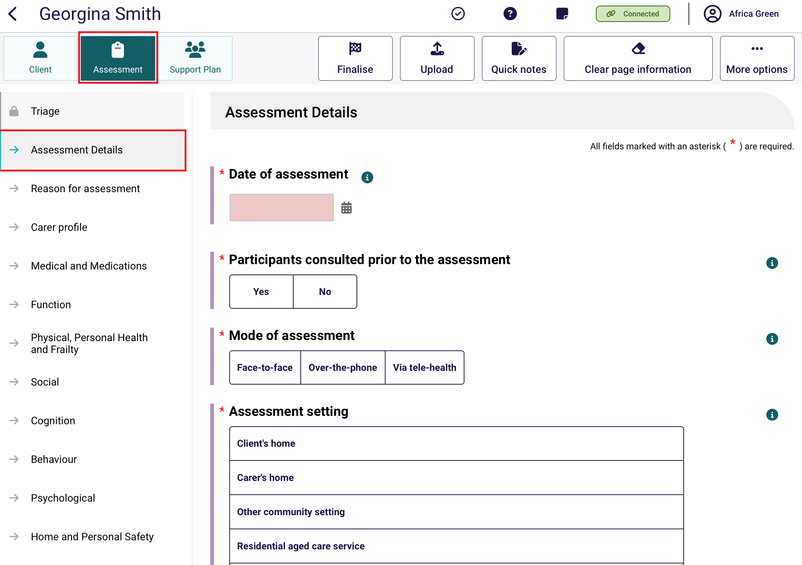
At the bottom of each page, Select the toggle to acknowledge that you have reviewed the information on the page and confirm that it is correct. Select Next to navigate to the next section of the assessment in the App.
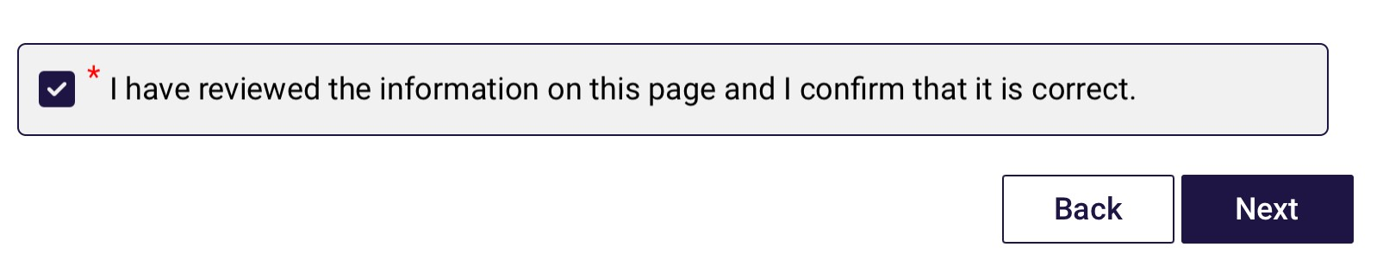
! | Cancelling an assessment  You can cancel an assessment from any screen within the App. Select More options from the top right of any screen, then select Cancel assessment from the pop up that appears.  If you cancel an assessment within the App, your team leader will receive a notification once you have internet connection, and your device has synced with the assessor portal.  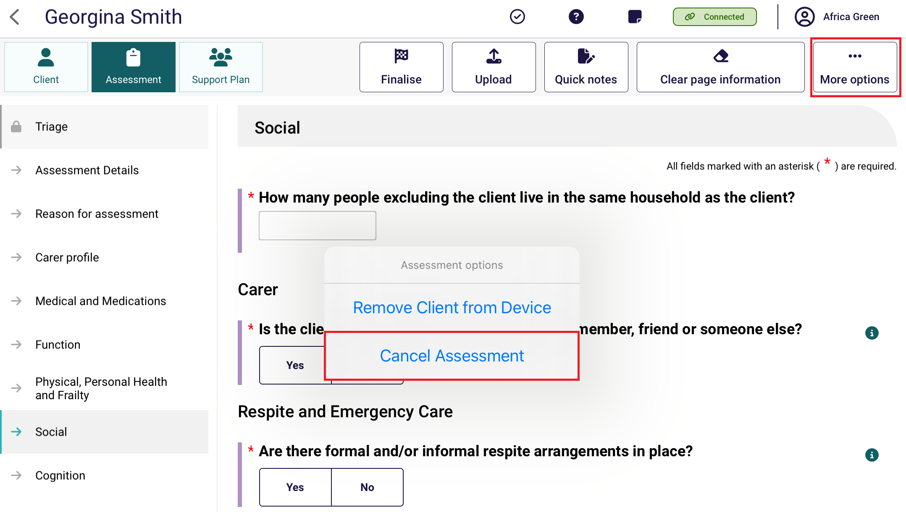
! | Field text limits  There are character limits for free-text fields. The character limits will display at all times. Ensure that you do not exceed these character limits while undertaking the assessment.  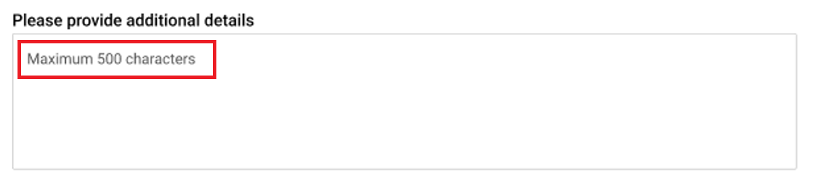

! | Clearing information  Selecting Clear page information on the top right of any screen will clear any information entered on the current page of the assessment that the Needs assessor is working on.  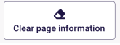
- Progress through the sections identified in the Assessment menu. Similar to the My Aged Care assessor portal, a mandatory confirmation box must be completed at the bottom of each section.
A tick will appear beside the relevant section in the Assessment menu when all mandatory questions for that section are complete.
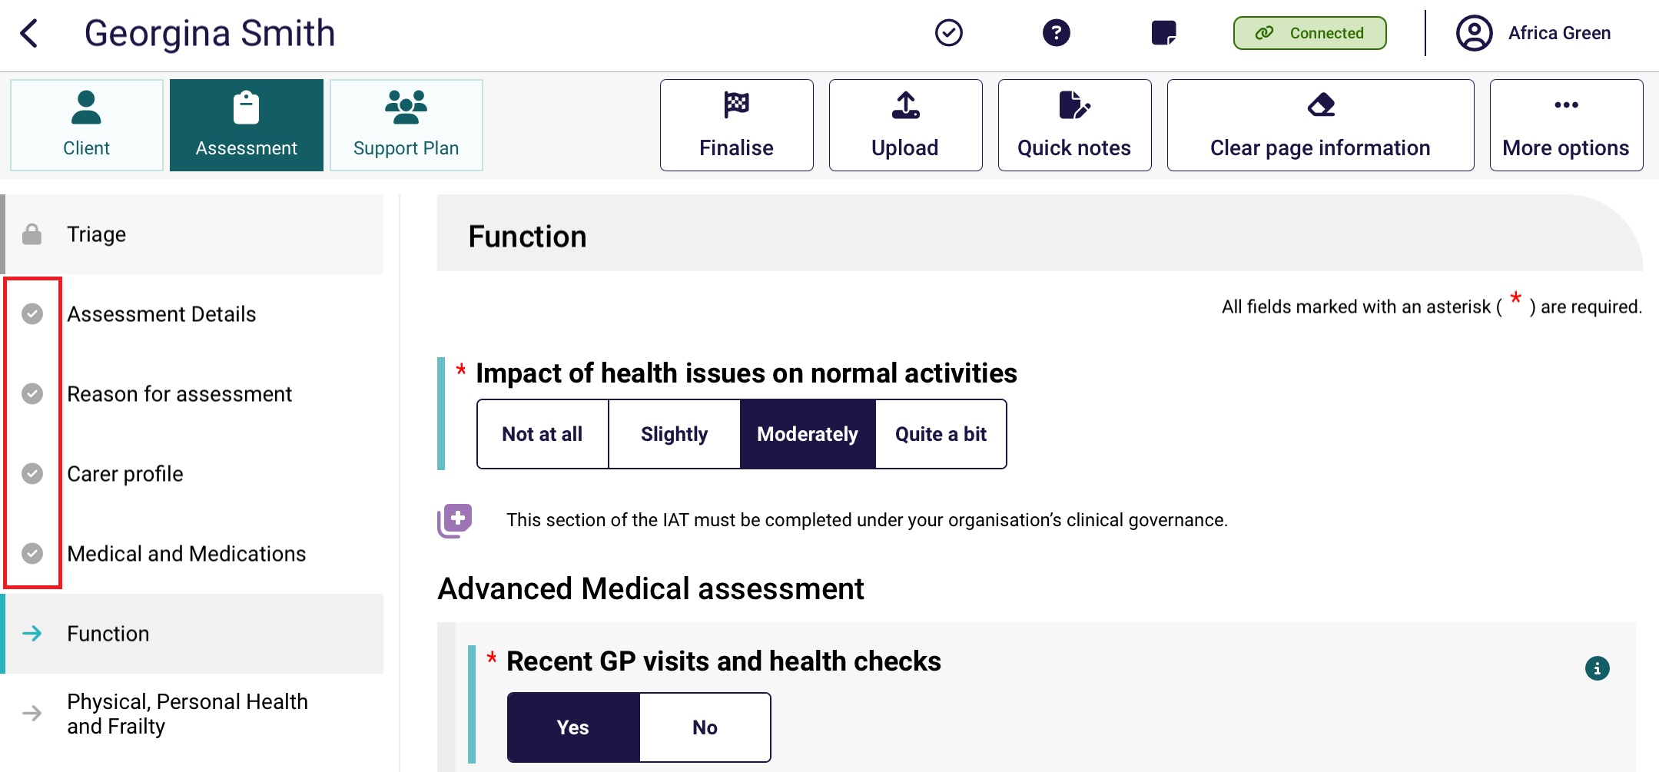
- While progressing through the assessment, needs assessors may choose to use the Quick notes feature, which allows notes to be recorded on the App.
These notes could be sensitive in nature or may be notes that are for later reference during the assessment process.
Select Quick notes at the top right corner of the assessment screen to enter.
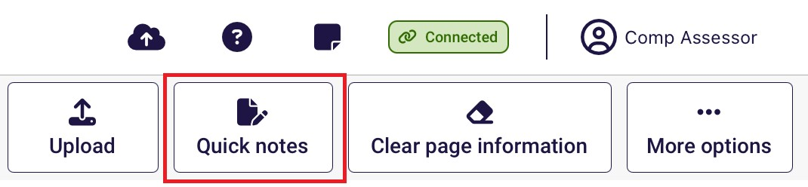
- Select Done to return to the assessment.
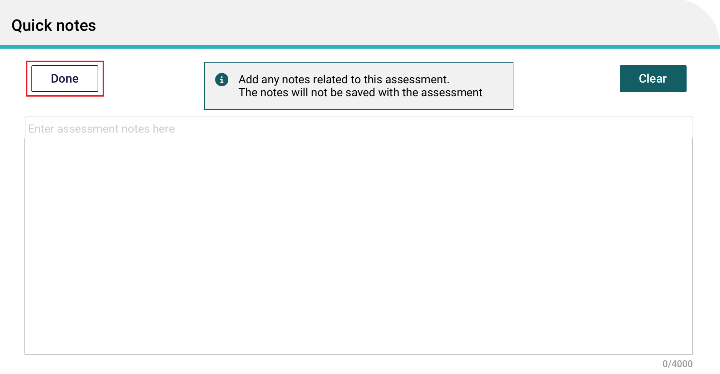
! | Information captured in this section will not be uploaded to the assessor portal.
- To add health conditions in the App, follow the same process as the assessor portal. Up to ten health conditions can be added in an assessment. To add a health condition select Add health condition.
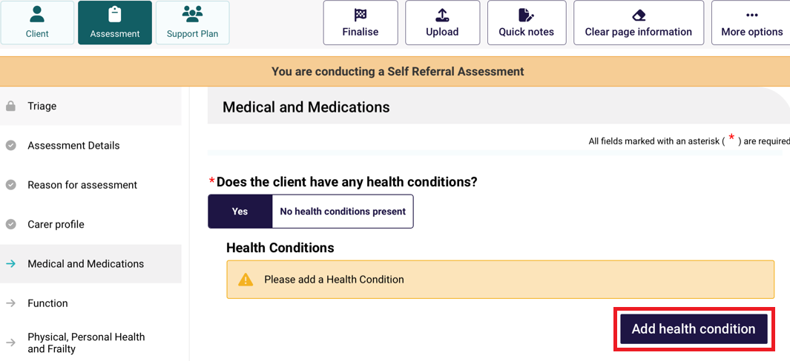

From the Health condition page, you can then search by the condition name, code list of Health conditions or select by disease category. Select Save and close to add the health condition.
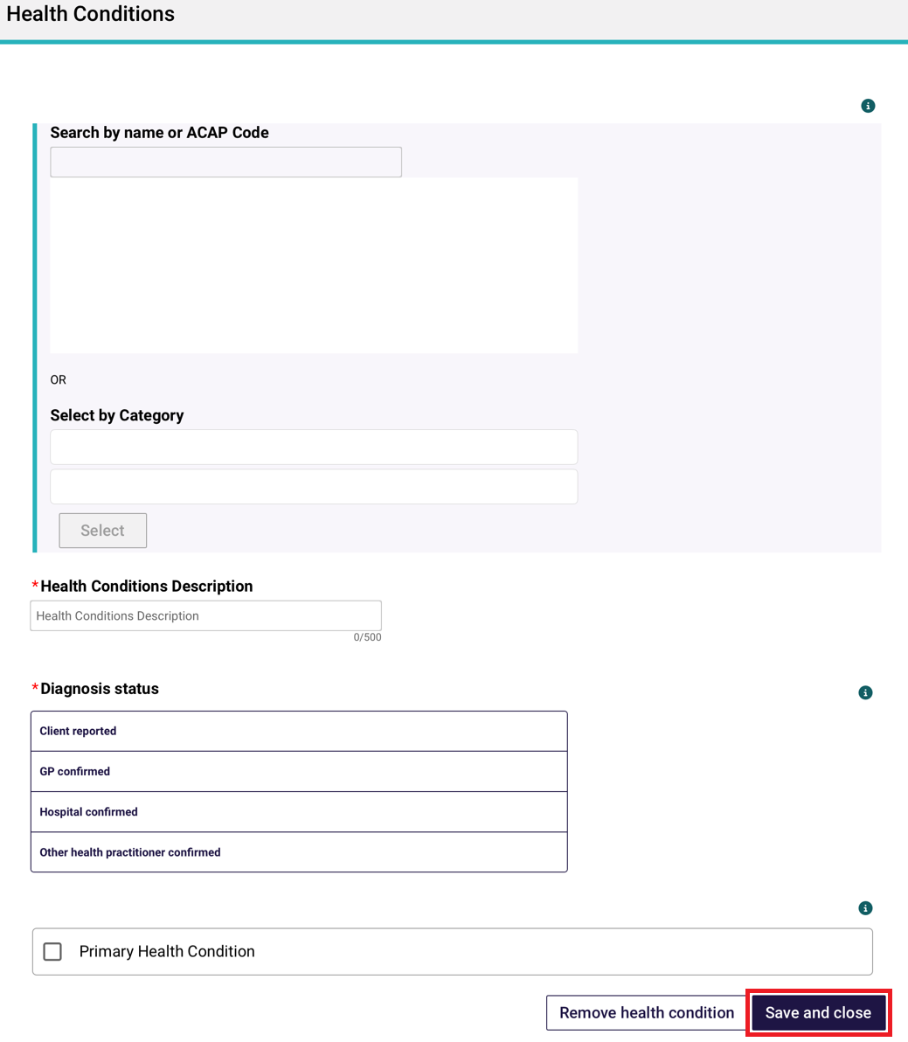
- In the IAT assessment, validated assessment tools and questions will trigger based on the information recorded by the needs assessor during the assessment. These validated assessment tools are now integrated into the tool, and it will be listed automatically under the relevant section of the assessment that you are completing with the client.
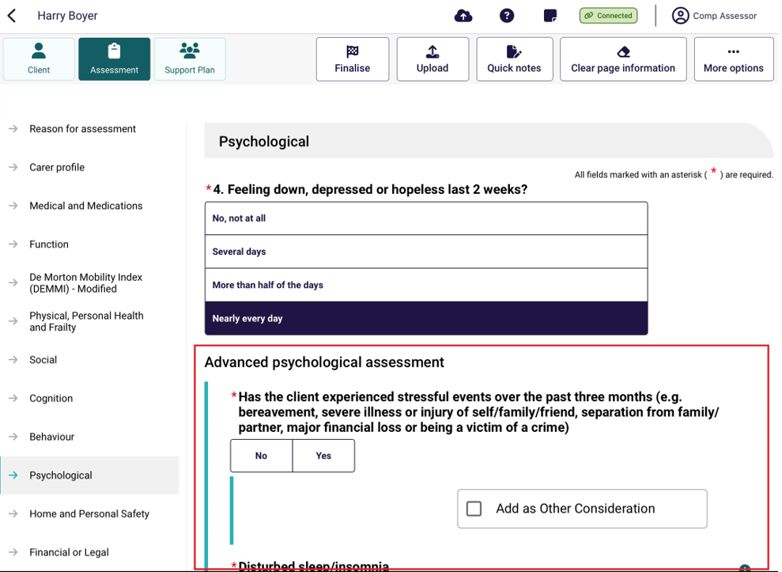
! | You should review the MAClearning element Validated Assessment Tools in Practice for further guidance on how and when to administer them with a client during the assessment.
- Threshold questions are also used throughout IAT to trigger moving the assessment into clinical/comprehensive areas. These questions are identified by a purple icon with text outlining the need for completion under your organisation’s clinical governance.
For non-clinical needs assessors, these questions can only be completed with clinical attendance. To proceed in answering these questions under supervision, non-clinical needs assessors must select the Clinical Supervisor button from the top banner.
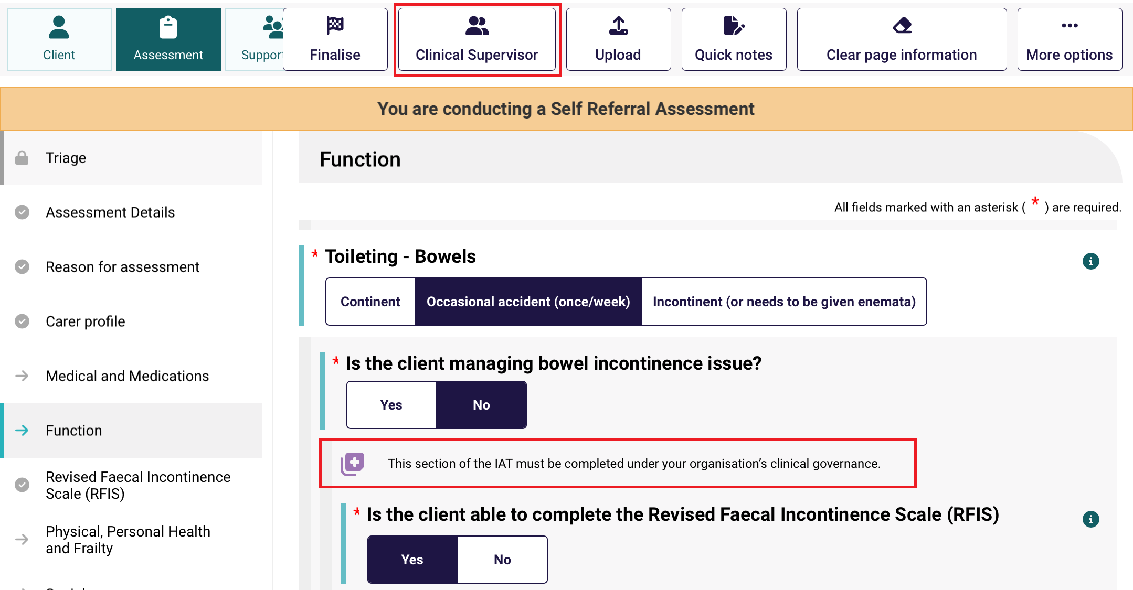

Non-clinical needs assessors must then confirm if they are completing the questions under clinical attendance and select the supervising assessor from the list. Once completed, select Confirm to continue. You will be re-directed back to the assessment when you can proceed to complete the assessment with clinical attendance.
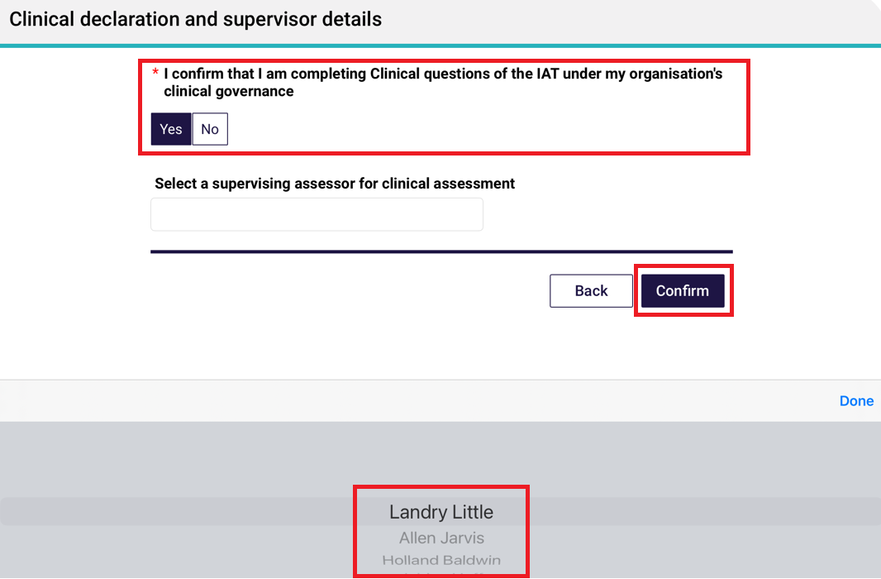
- As needs assessors are progressing through the assessment they can indicate which Needs (Functional needs, Other considerations, Complexity Indicators) and some recommendations to be addressed in the support plan, by selecting Add as Functional Need, Add as Complexity Indicator, Add as Other Consideration and Add as recommendation next to the relevant question.
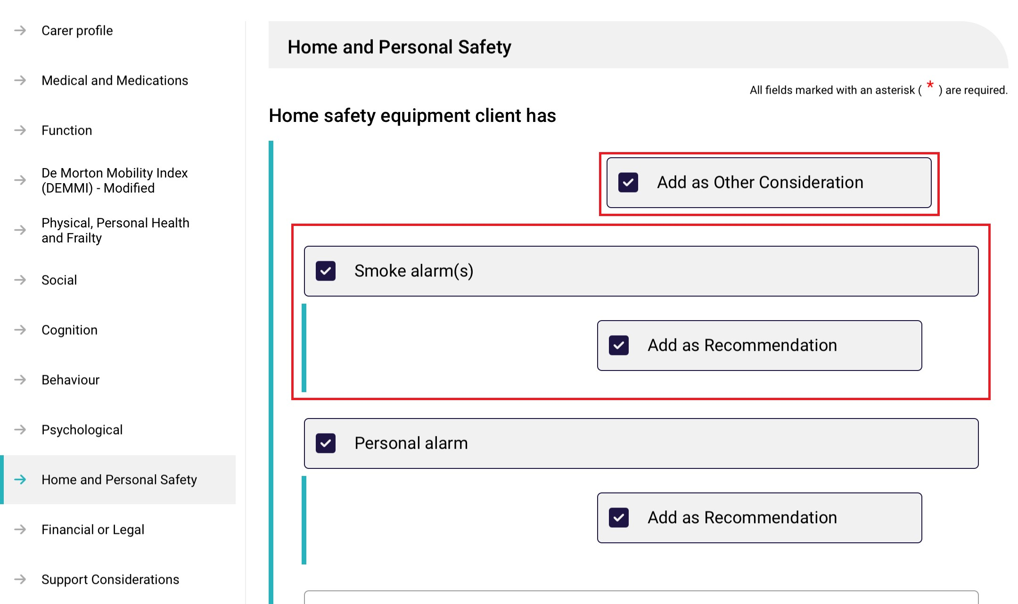

- In the Support Plan section of the app, any functional needs, other considerations and complexity indicators are displayed in the Identified Needs sub-section.
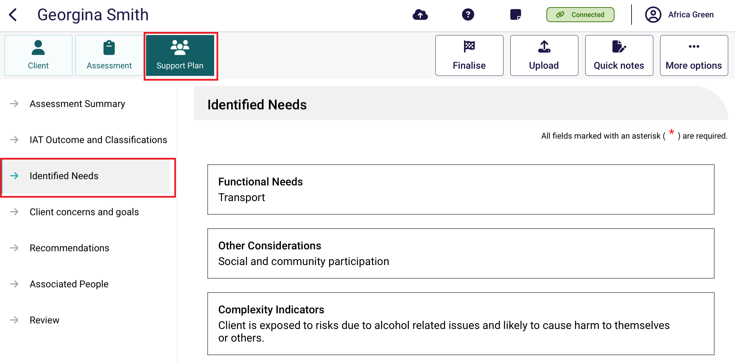
Go to the Recommendations sub-section to view and add recommendations.
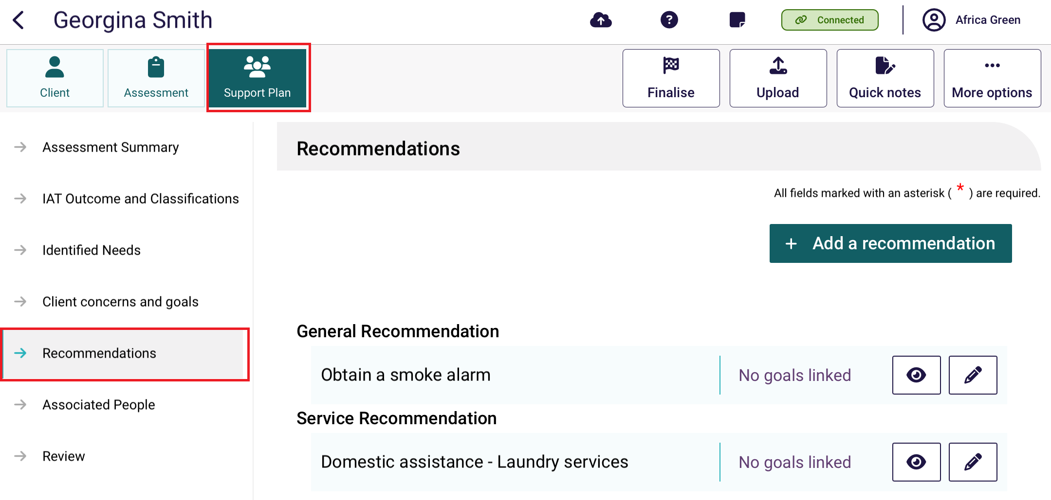
- To finalise the assessment, select Finalise at the top of the assessment screen.
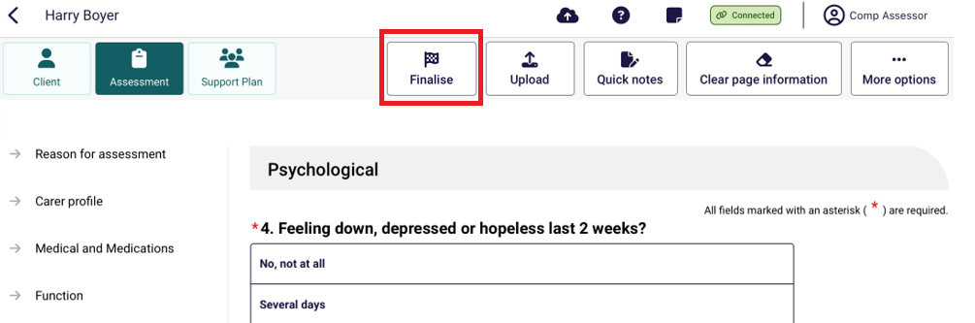

- After selecting Finalise, record the consent to refer services from the client, or the client with support person, or the supporter guardian (registered supporter), or that the consent was not given.
More information about consent, capacity to give consent, when and how to seek consent, and the consent script are available by selecting the information buttons on the right hand side of the page.
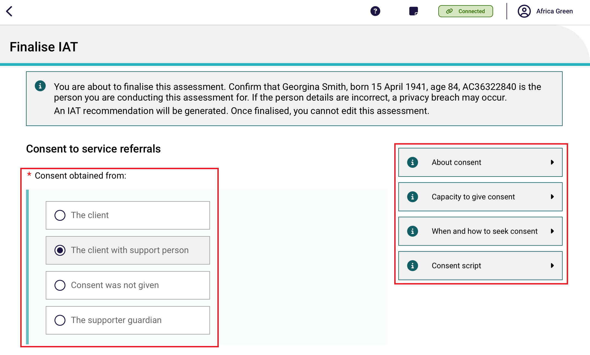
- The client can opt to share their Support Plan via their My Health Record. Select Yes or No based on the client’s response.
Then, select whether the consent was obtained from the client or the supporter guardian. If consent was obtained from a supporter guardian, you will also be required to enter their first name before proceeding.
Select Finalise to continue. Please note, you will only be able to select Finalise once all mandatory fields have been completed.
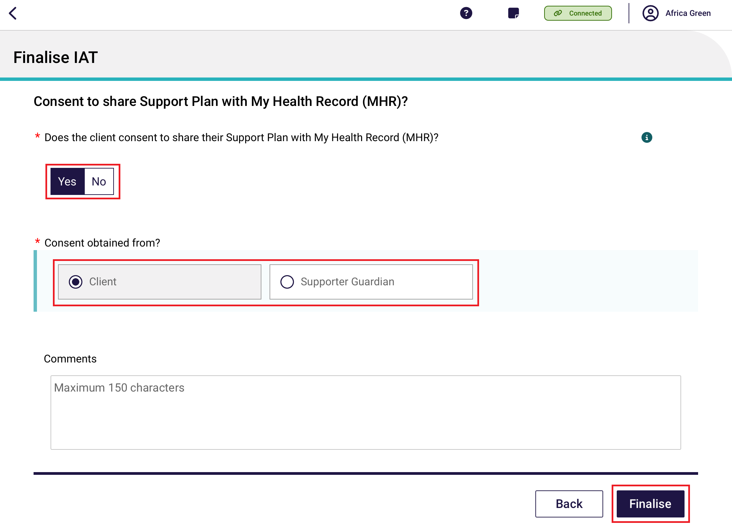
- A pop-up will then display asking you to finalise the assessment. Please note once you finalise the assessment it cannot be edited. Select Finalise to continue.
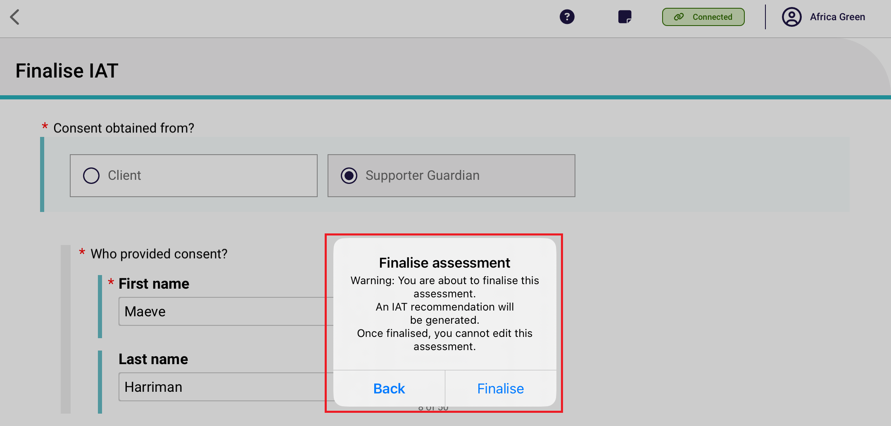

Developing a support plan
At any point after a client’s assessment has been commenced, their support plan can be created and developed within the App.
! | Needs assessors will still be required to upload client assessment and Support Plan information to the assessor portal in order to submit to the delegate for approval or match and refer for services.
The sections of the support plan in the App are aligned with the support plan tabs in the assessor portal, and needs assessors can record:
- assessment summary
- IAT outcome and classification
- identified needs
- concerns and goals
- recommendations
- associated people
- Review.
! | For further guidance on completing a client’s support plan, follow the steps outlined in the Assessor Portal User Guide 7 completing a support plan and support plan review.
- To commence a support plan for a client who you are assessing, select the client card, and select Support Plan from the top left menu. The Assessment summary will display.
The Assessment summary will be pre-filled with information captured during the assessment.
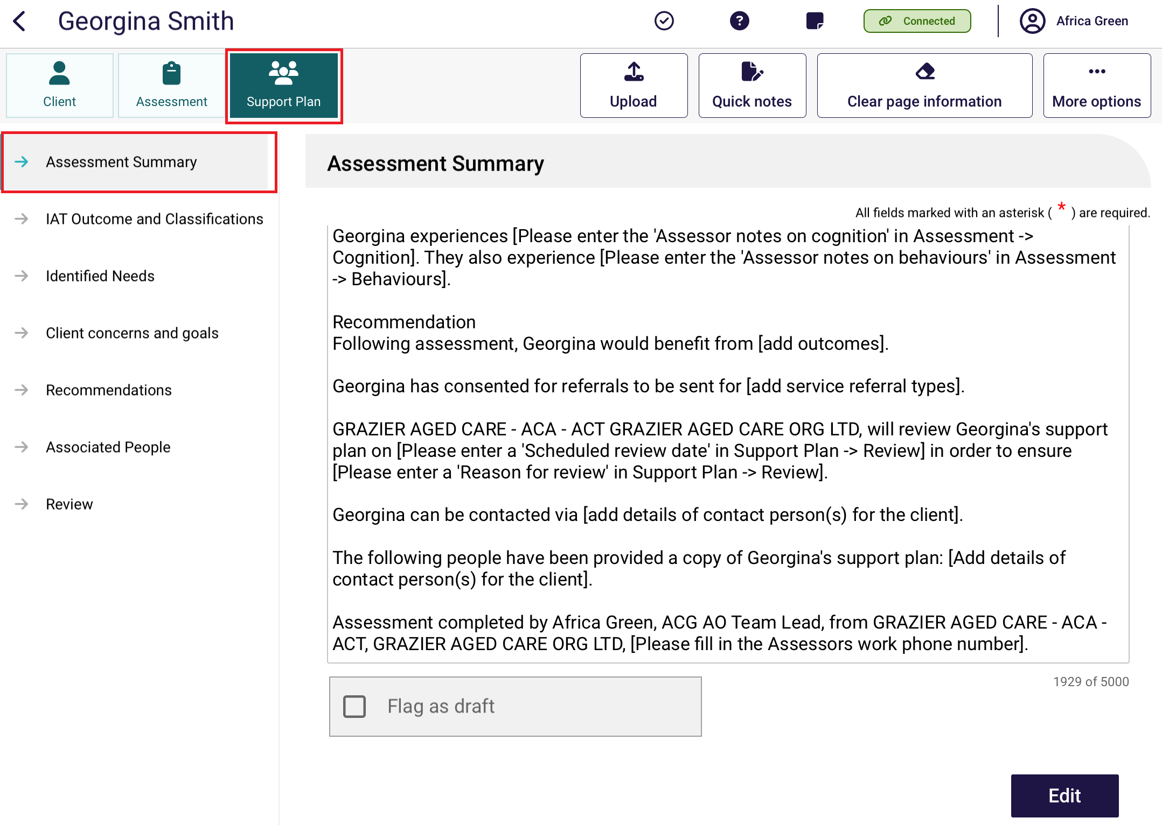
- To edit the assessment summary, select Edit.
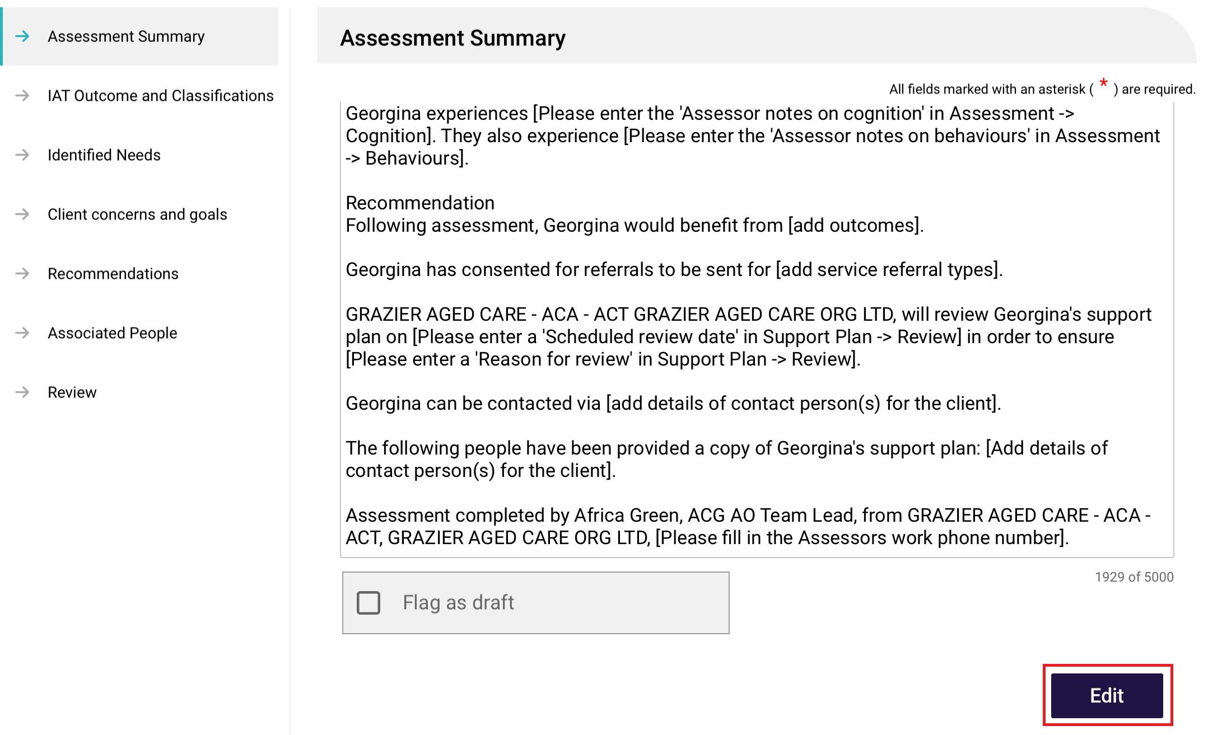
- Select Confirm Edit at the pop up that appears. Note that once you start editing the assessment summary, you will no longer be able to pre-populate information from the assessment.
You will then be able to Flag as draft by the toggle function.
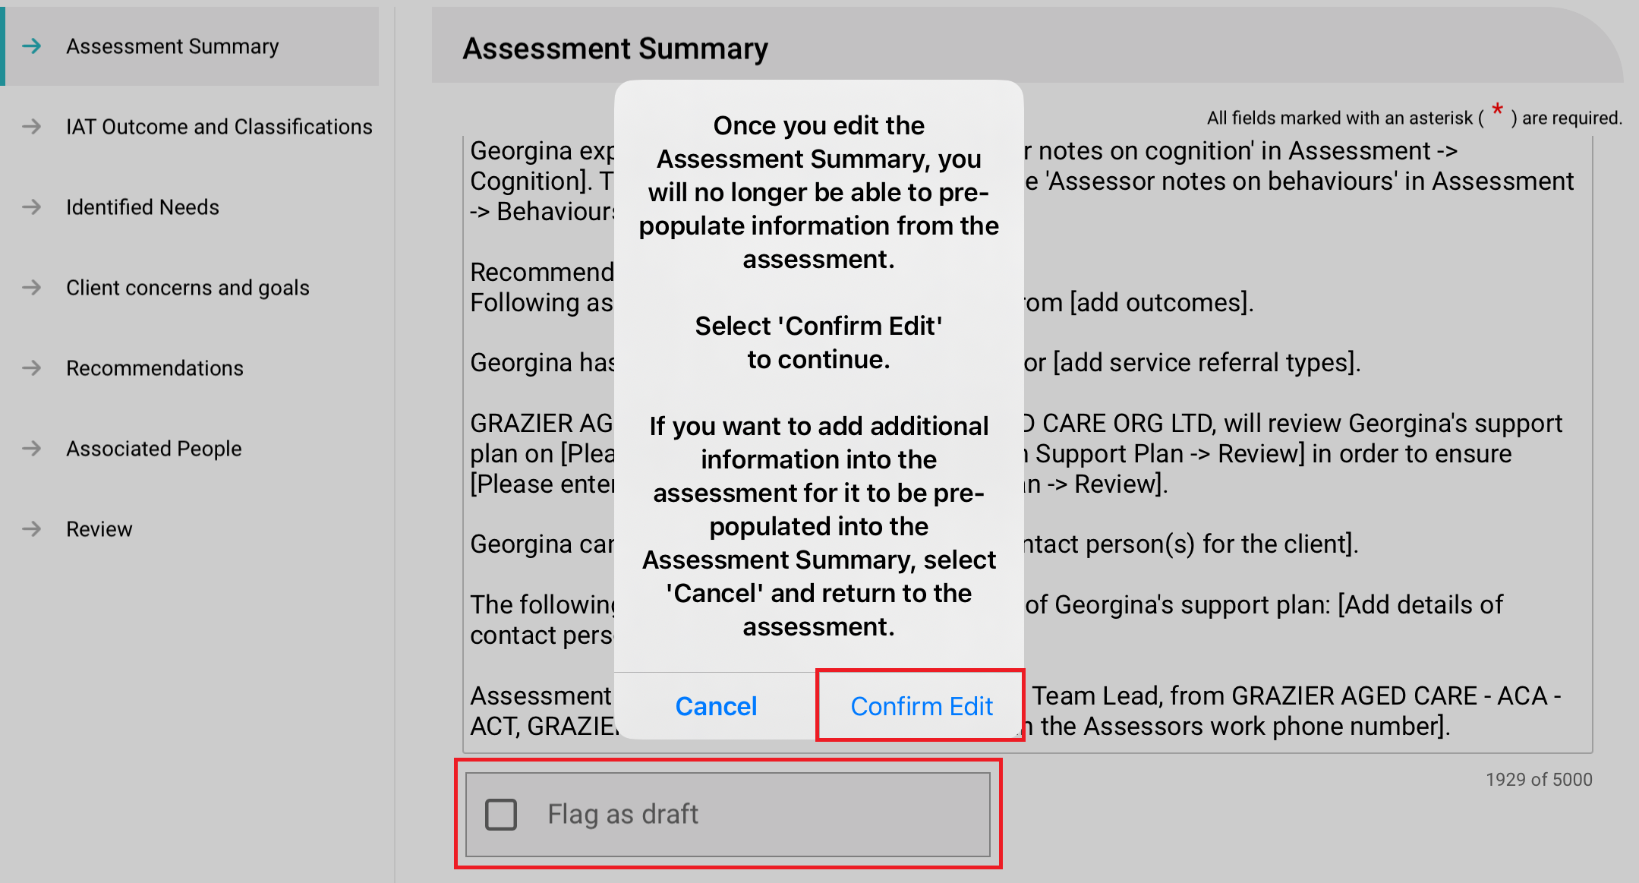
There will be a D icon next to the Assessment Summary menu, to remind users that the assessment summary is a draft and should be completed prior to uploading to the assessor portal.

IAT outcome and classifications
In the Support Plan Tab, IAT Outcome page, needs assessors can view a suggested support recommendation for the type of care the client may require. The IAT algorithm will draw on assessment responses and the client's current care approvals and recommend an Aged Care program or care pathway.
If the IAT assessment has not been finalised, then the IAT Outcome will display as Pending finalisation.
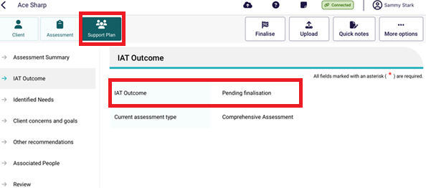
Once the IAT assessment has been finalised the IAT Outcome will display. You will be able to Accept or Override the IAT outcome by selecting the corresponding button.
! | The IAT will allow an ongoing Support at Home Classification to be overridden to a different ongoing classification level. However, assessors must not undertake this action and delegates must not approve assessments where this occurs. An ongoing SaH classification outcome cannot be overridden to an ongoing lower or higher SaH classification outcome (in line with section 81-10 of the Aged Care Rules).
Sometimes, other buttons are available, such as No Care Type under the Act.
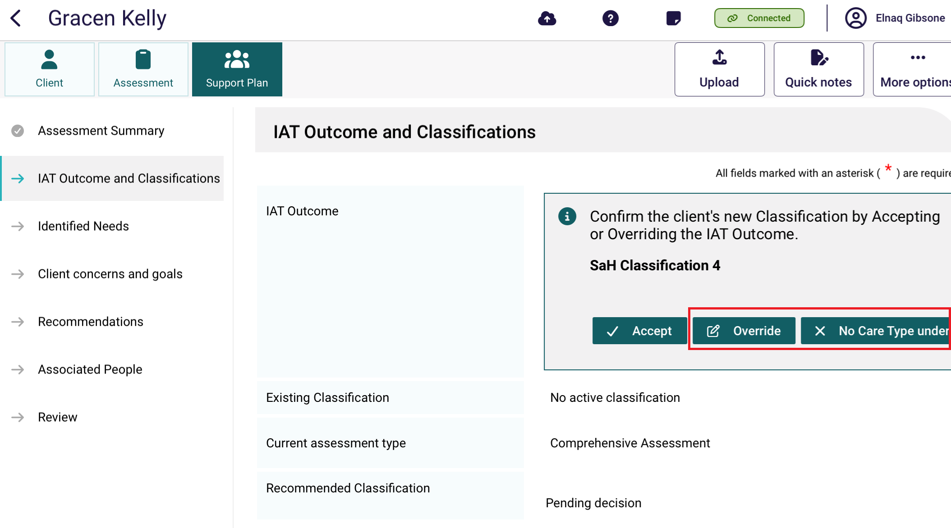
The below image shows an example of an overridden IAT outcome. It is stated in the Recommended Classification section. There is also an Override Reason section, and an Override reason description section.
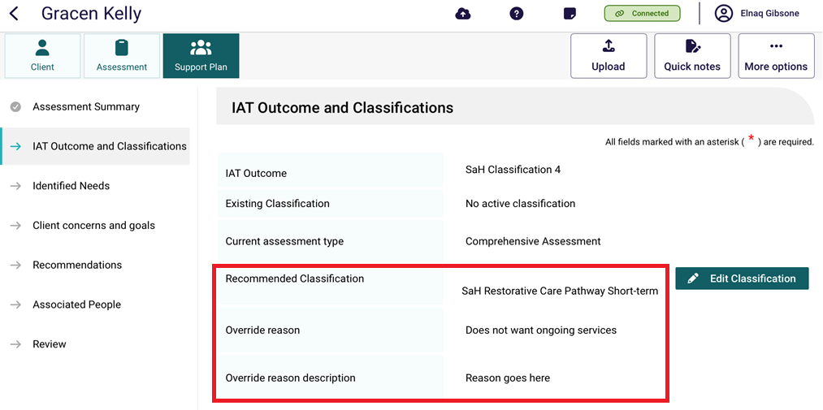
For Home Support Assessments, you must convert it to Comprehensive Assessment before choosing to accept or override the IAT outcome given.
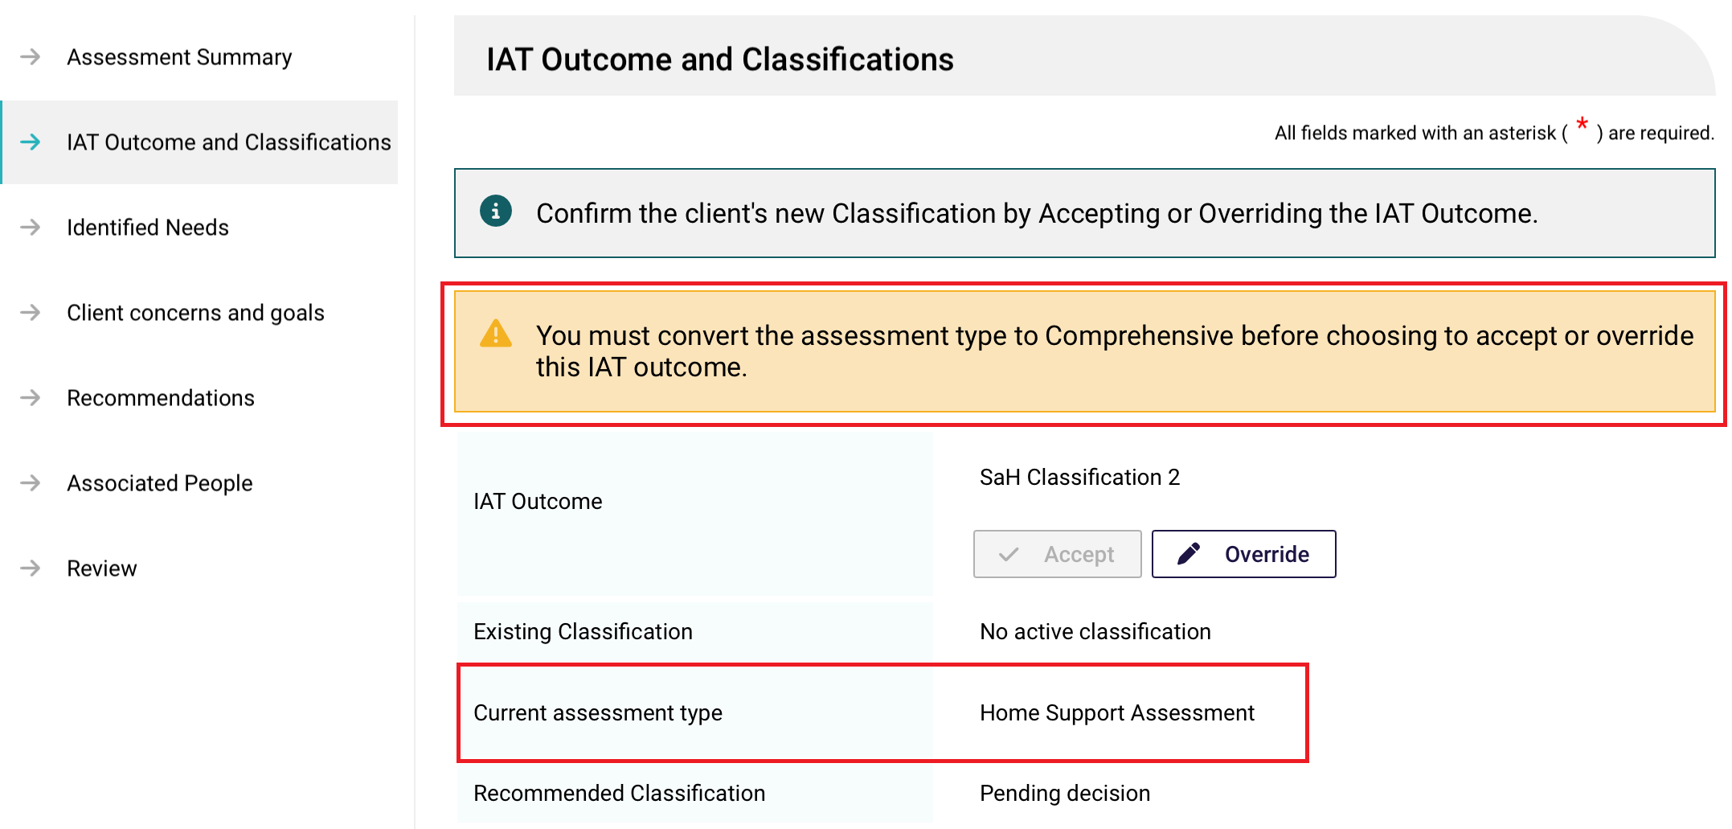
Once a Support at Home Classification, End-Of-Life Pathway or Restorative Care Pathway is accepted, their associated service group recommendations will be pre-populated in the Recommendations page.
The below image shows the Recommendations page of a client who has been assessed for the Restorative Care Pathway. This page contains a list of pre-populated Restorative Care services, grouped under service types, for the assessor to view or edit. For example, there are three services under the Domestic Assistance service type: general house cleaning, laundry services, and shopping assistance.
! | For more information on the services and service types available refer to Support at Home program | Australian Government Department of Health, Disability and Ageing.
You can select service/s under each service type available for the classification to view (eye icon) or edit (pencil icon).
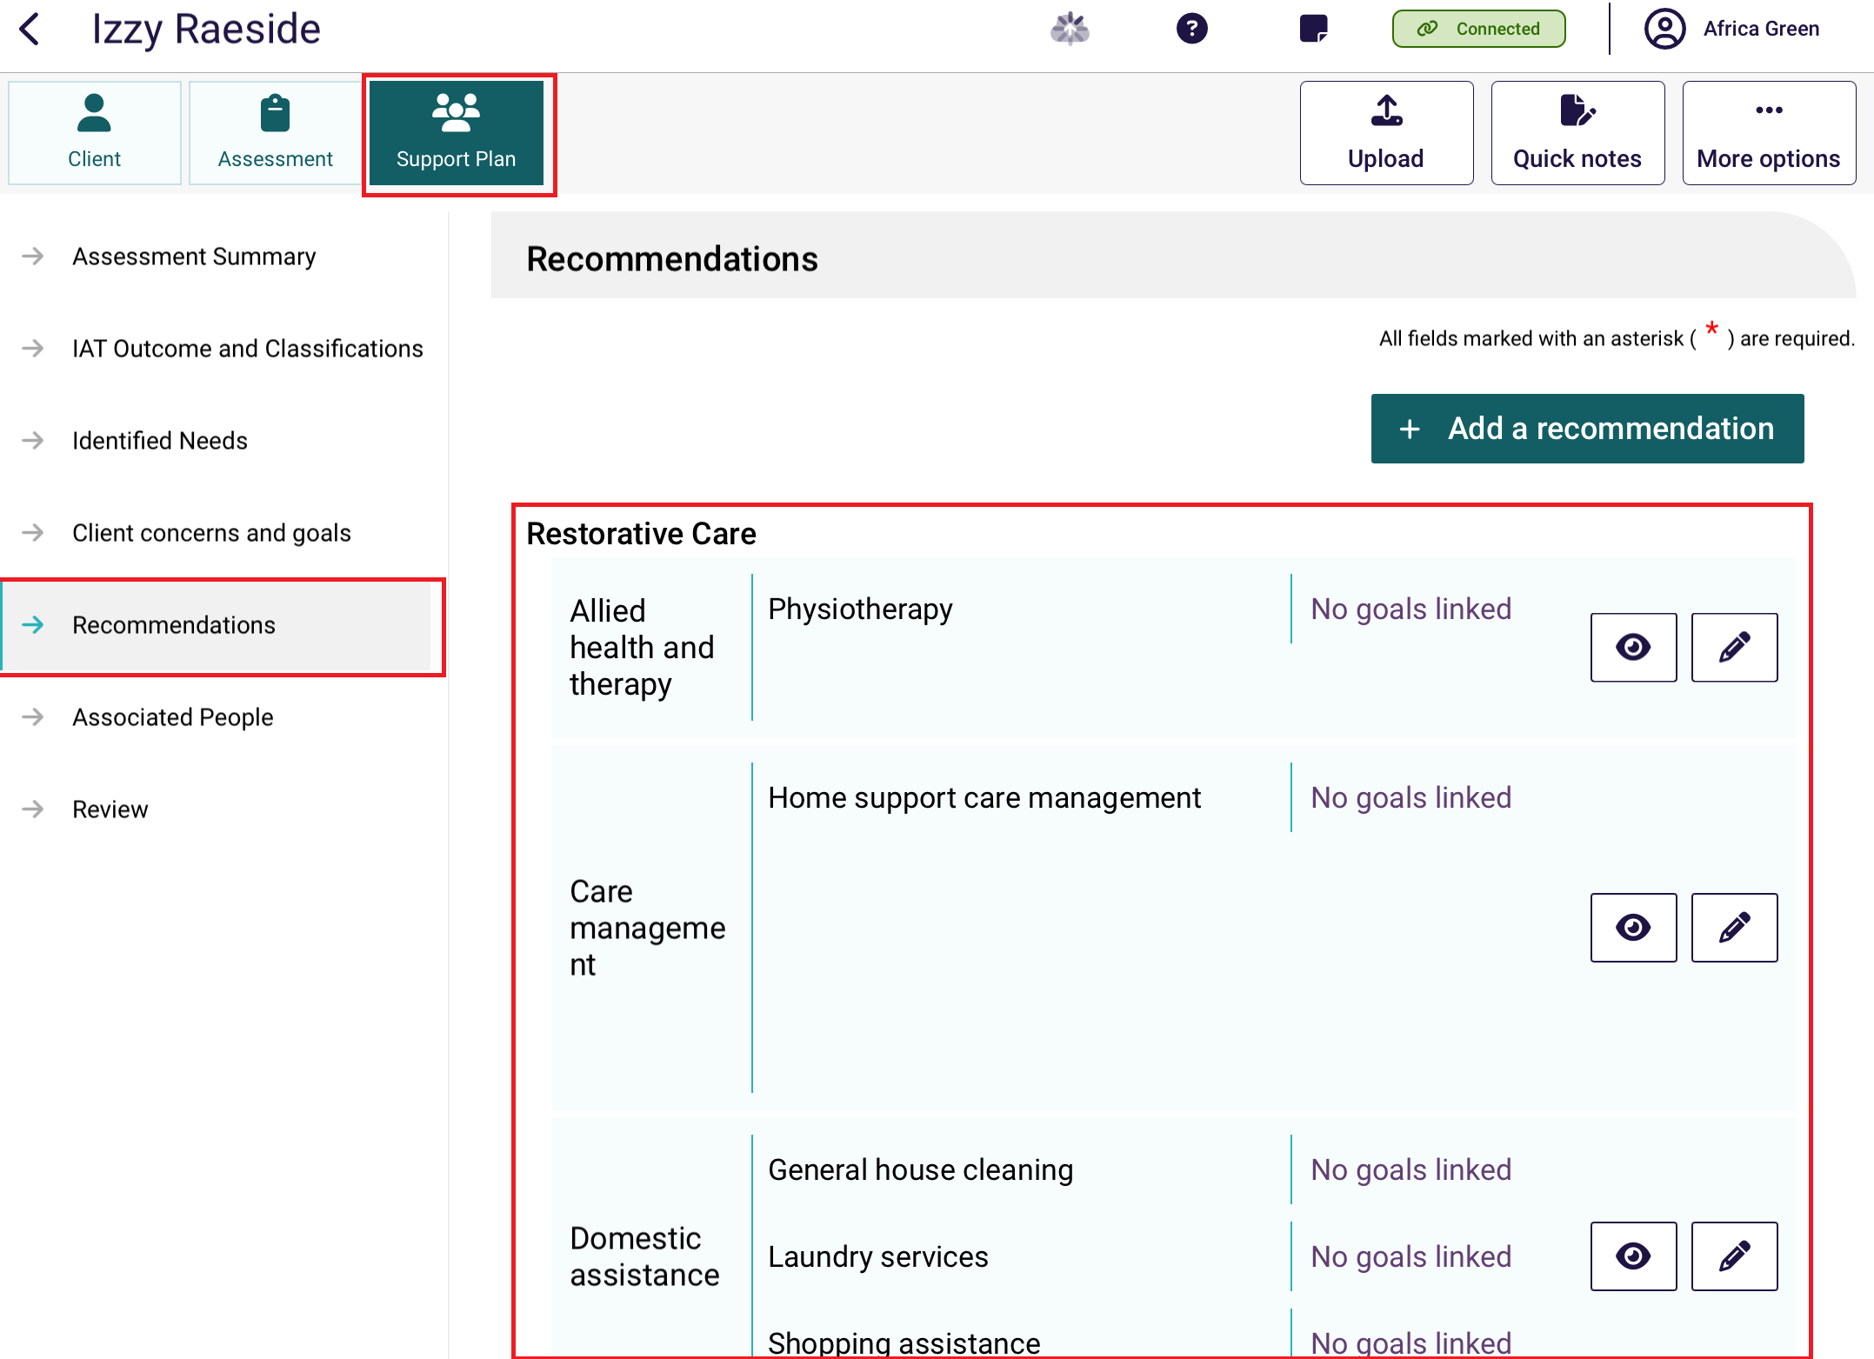
On the Editing [service name] page, tick the required service/s, then enter the recommended service frequency and service intensity (eg. 2 hours per day). For some services, you can input an ‘other’ value.
You can also link goals here. Finally, select Save.
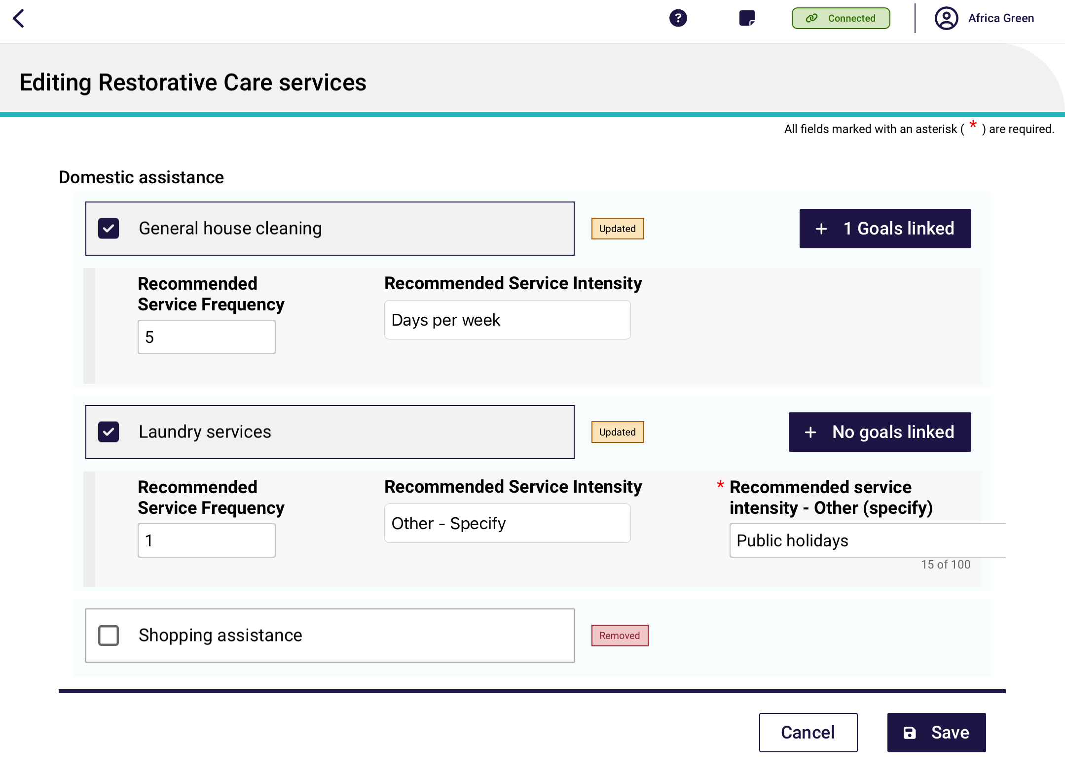
Once the desired recommendations are selected, edited and saved, the Recommendations page re-appears, with only the services that you have added displayed.
! | Assessors must first make a Classification recommendation—after finalising the Integrated Assessment Tool (IAT) before they can add Recommendations to the Support Plan. This ensures that all decisions are informed by the outcomes of the IAT, maintaining consistency and accuracy in the client's care planning process. The Support Plan section will remain locked until a classification recommendation is recorded. For more information refer to the Adding concerns, goals and recommendations section.  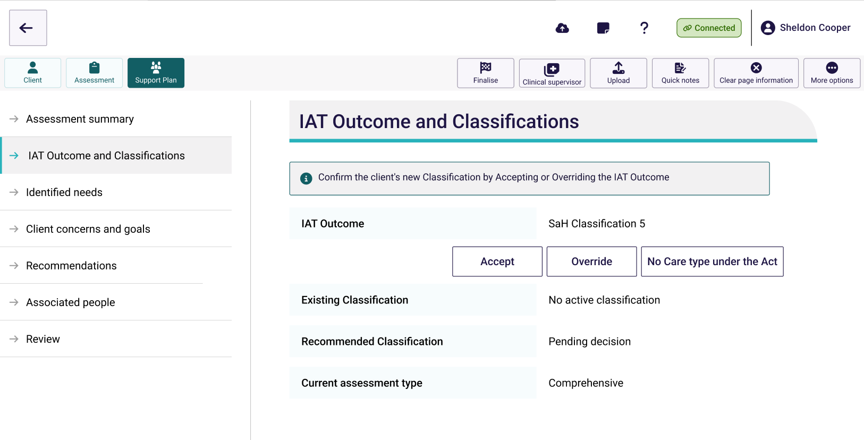

13.1 Convert to Comprehensive Assessment
If required, home support assessments can be converted to a comprehensive assessment after the IAT assessment has been finalised.
If an assessment is triaged as a home support assessment and the following service/s are recommended, the assessment will then need to be converted to a comprehensive assessment under the supervision of a staff member who holds a clinical assessor role in the My Aged Care Assessor Portal.
- Residential care
- Support At Home classification
- Restorative Care pathway
- End-of-Life pathway.
In the App, a warning banner appears:
To convert, select the More options button followed by Convert to Comprehensive Assessment.
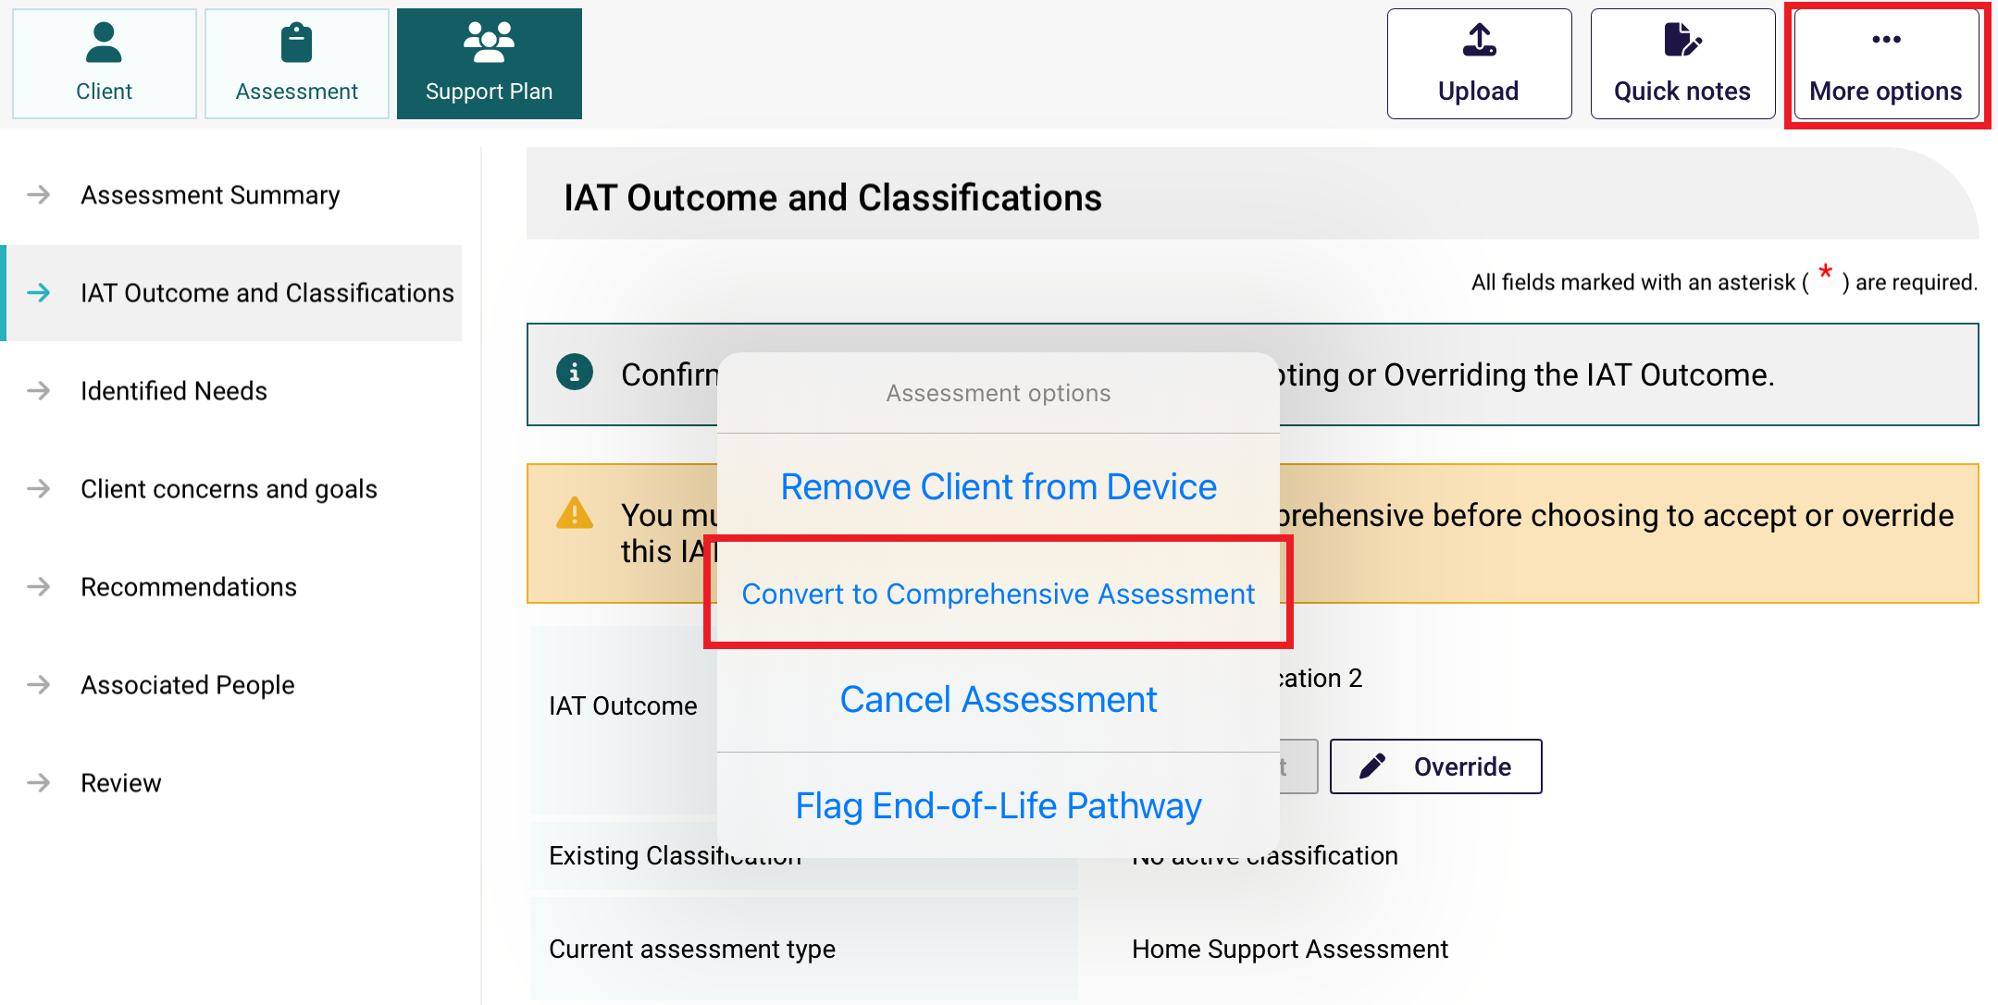
From the Convert to Compressive Assessment page, enter the reason or comments for converting the assessment. Please note the reason for change will be auto-populated to ‘High level care needs’.
Put in your reason or comments, then Select Confirm to convert the assessment.
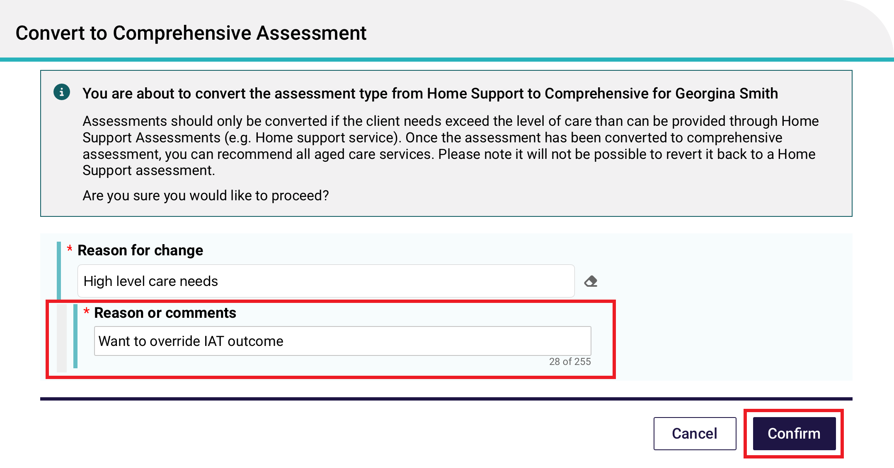
The IAT Outcome tab will then display that the assessment has been converted to a Comprehensive Assessment.
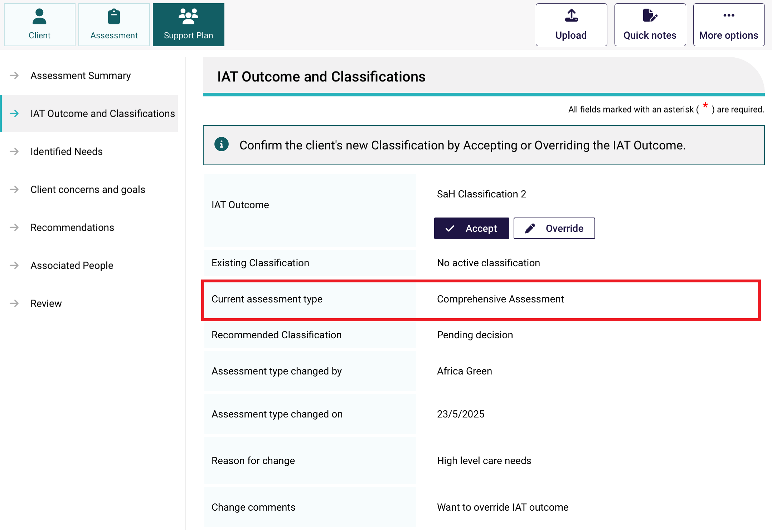

13.2 Edit (Override) Recommended Classification
Assessors can edit or override a system generated IAT Outcome if they have made a mistake or if they are recommending the following:
- Support at Home Restorative Care Pathway
- Support at Home End-of-Life Pathway
- Transition Care Program
- Permanent Residential Care (without ongoing in-home services)
- Residential Respite Care (without ongoing in-home services).
For the SaH Restorative Care Pathway (RCP), this can apply to both initial assessments and reassessments, and to transitioned and non-transitioned clients.
- Select the Edit button next to the IAT outcome, or the Override button, to edit the recommended classification. This can also be done during the support plan review stage.
Edit Classification button appears when viewing an accepted IAT outcome.
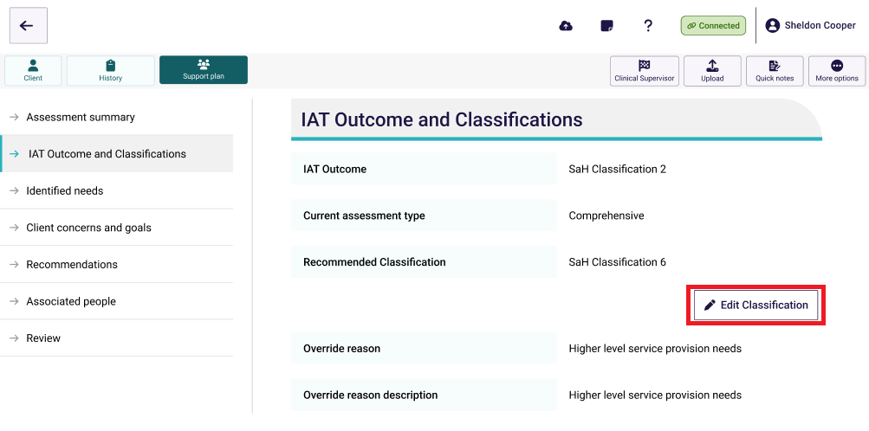
Override button is available during the initial acceptance of an IAT outcome.
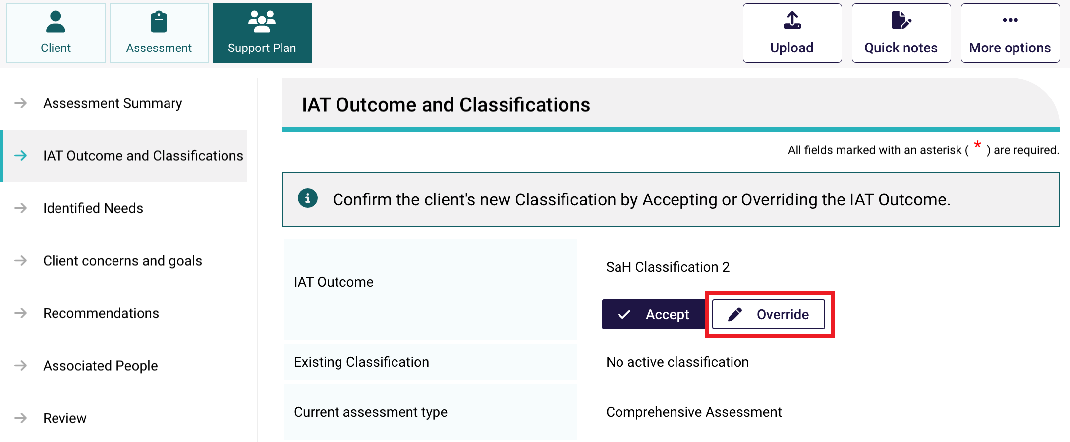
- In the next page, select the new recommended classification, override reason and the reason description, then select Save.
! | The IAT will allow an ongoing Support at Home Classification to be overridden to a different ongoing classification level. However, assessors must not undertake this action and delegates must not approve assessments where this occurs. An ongoing SaH classification outcome cannot be overridden to an ongoing lower or higher SaH classification outcome (in line with section 81-10 of the Aged Care Rules).
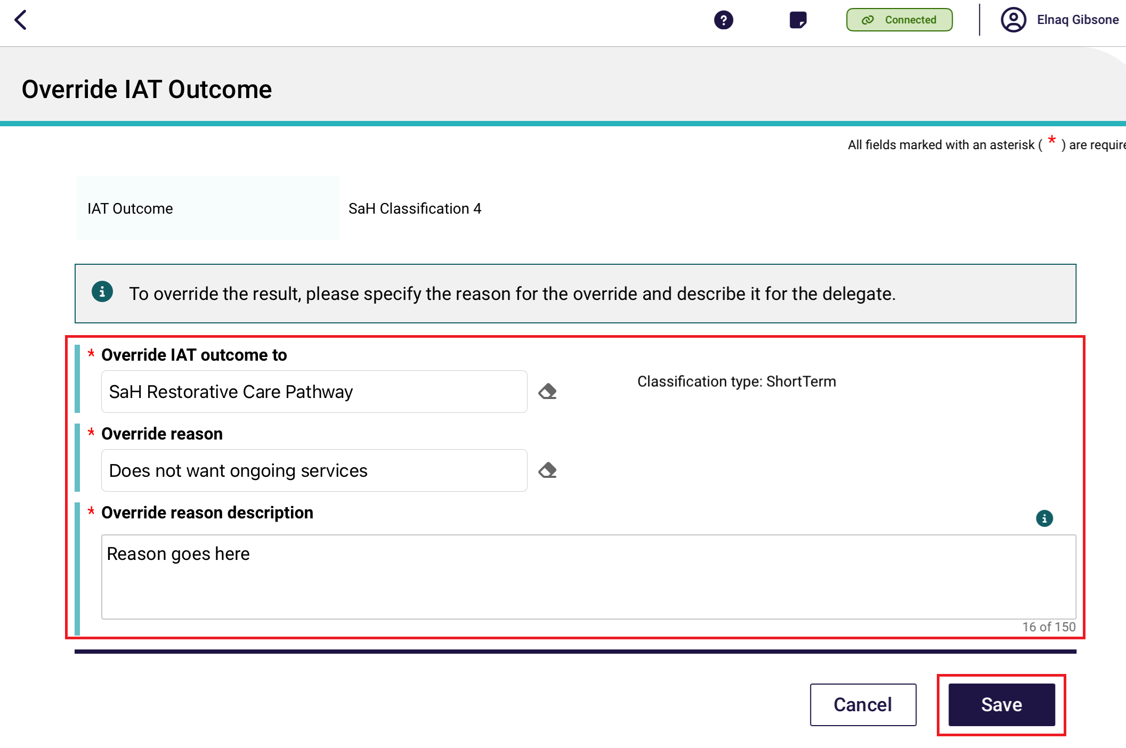
- A confirmation pop up appears. Select Confirm to acknowledge that some recommendations may be removed as a result of changing classification, and this will require your recommended services to be added again.
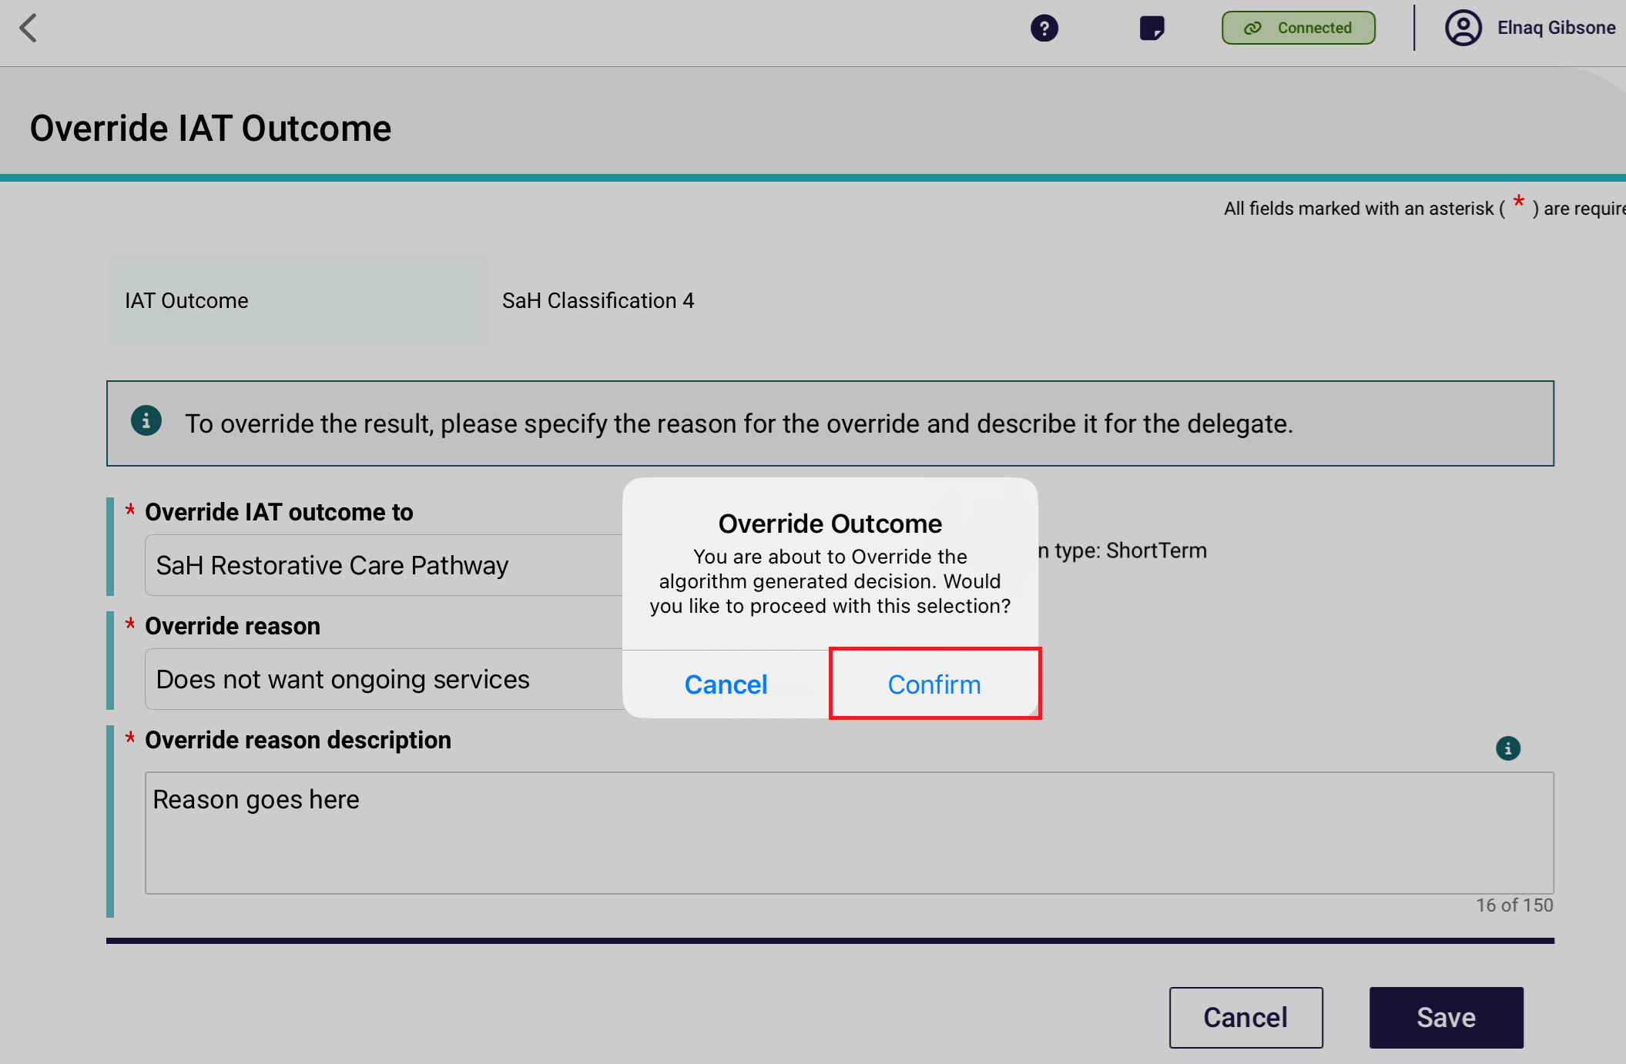
The Assessor will be unable to override from a SaH Classification to SaH End of Life Pathway if the client is not flagged as End-of-life and required documentation is not provided. In these cases, an applicable error message will be displayed. The below screenshot shows an example of an error message shown when overriding is not possible.
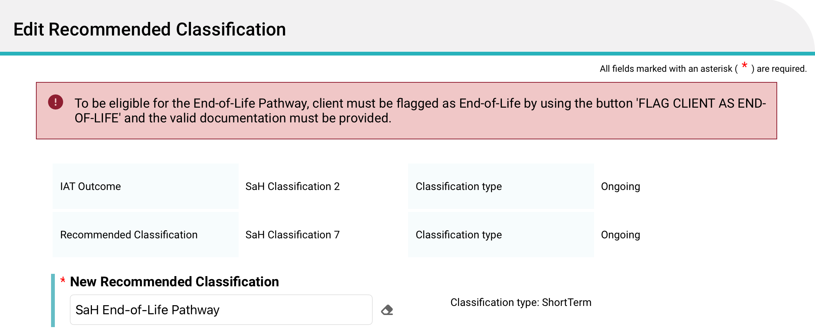
- The new recommendation will display in the Recommended Classifications section of the IAT Outcome and Classifications page.
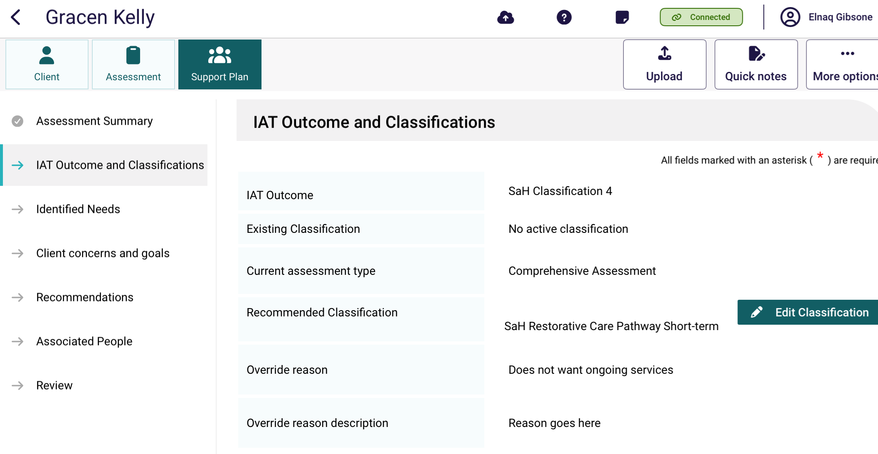

Adding concerns, goals and recommendations
When developing a client’s support plan in the App, Areas of Concern and Goals, and Recommendations can be added in the Concerns and goals and Recommendations section of the Support Plan.
- To add an area of concern, select + Add an area of concern.
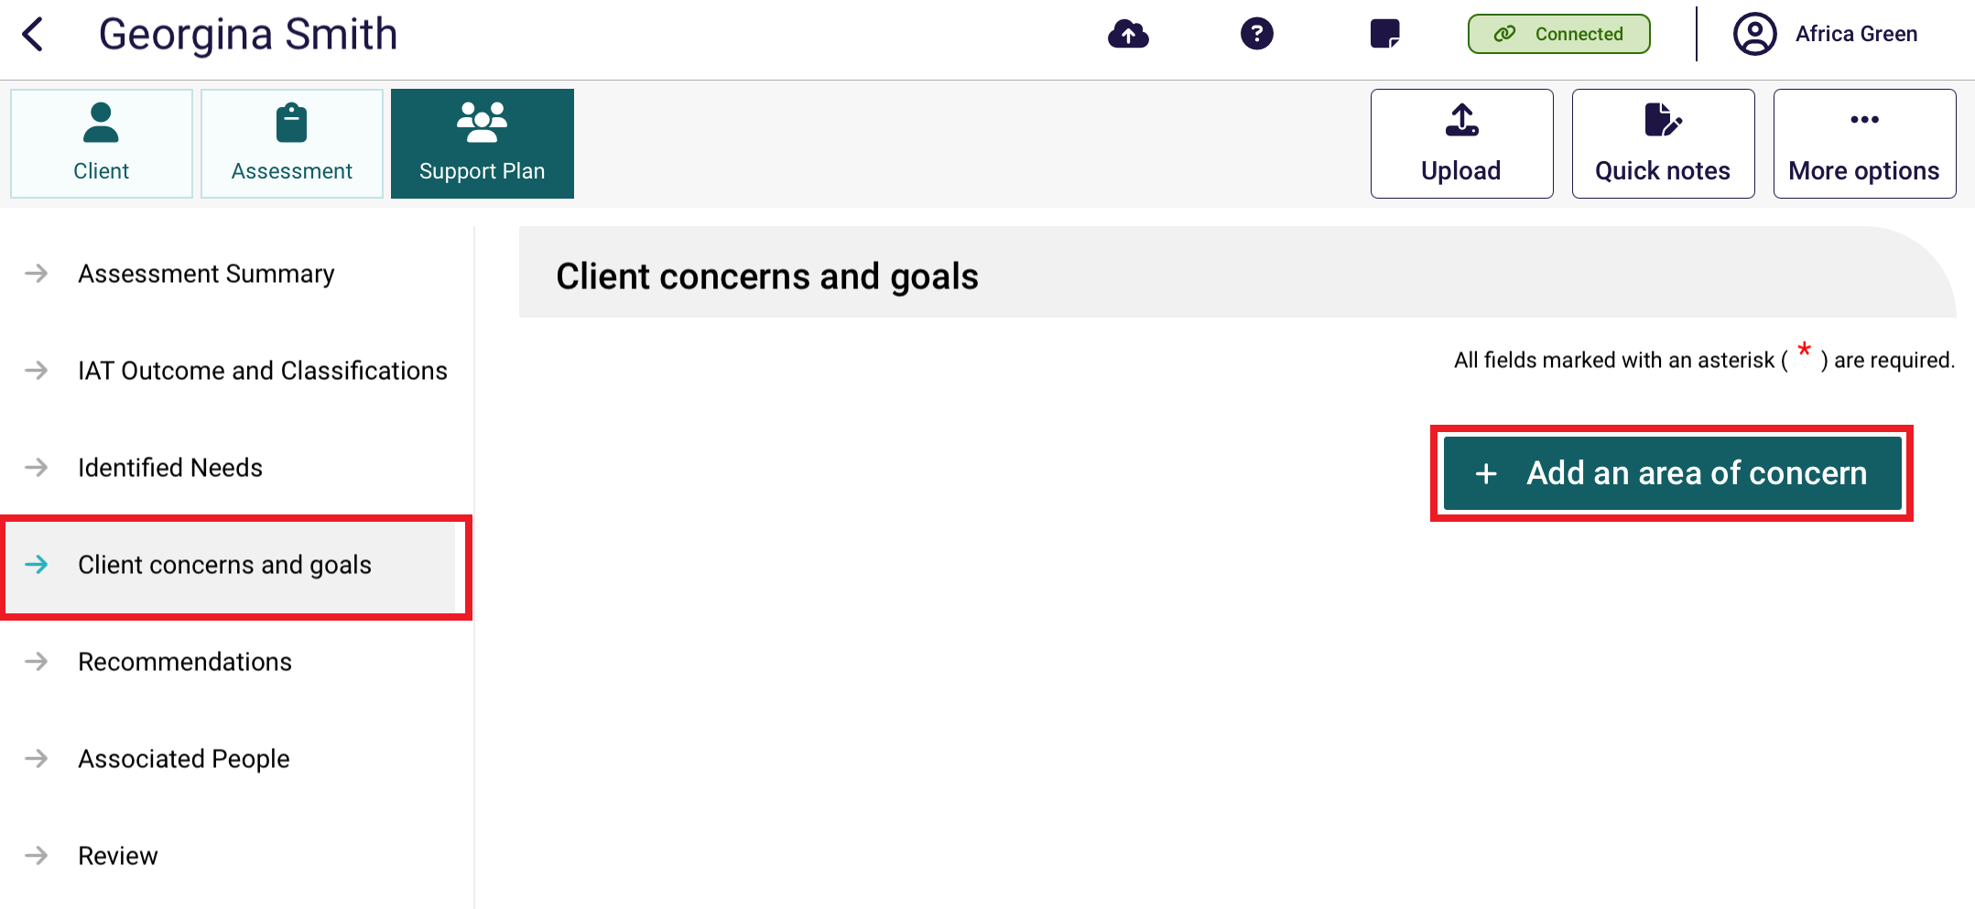
- Enter in What is the area of concern and click +Save. You can add a goal at this stage by selecting the ‘+ Add a goal’ button (refer to Steps 4 and 5), or during editing later on. Please note you will only be able to save the concern once all mandatory information has been entered.
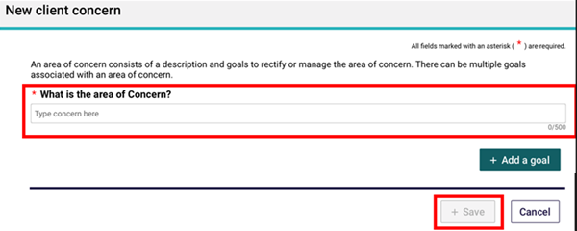
Select Edit to update or delete the area of concern or change the order of areas of concern using the arrow buttons (▲▼) where you have added multiple concerns. Select X to delete the concern.
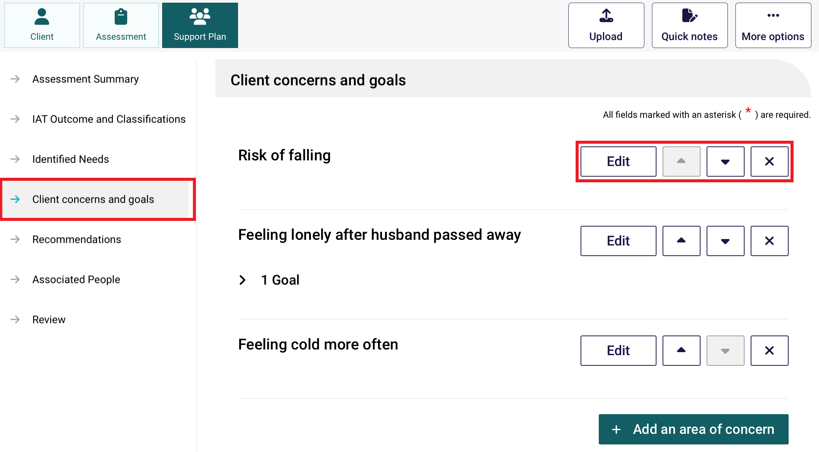
- To add a goal to a recommendation, select + Add a goal from the relevant area of concern and then select + Save.
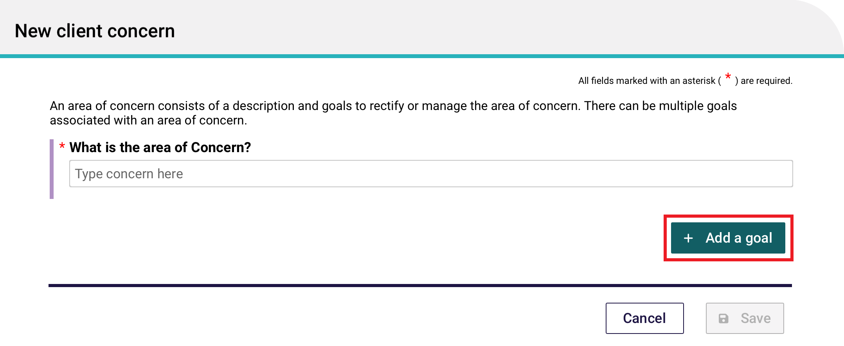
- At the Adding A Goal page, enter what the goal is along with other key information such as what domain the goal relates to, the client’s current strengths and abilities in relation to the goal and their motivation to achieve it. At the Recommendations section of the page, you can select + Add A Recommendation, or If the client already had recommended classifications (from the IAT Outcome and Classifications page), then these classifications will be automatically filled out, ready to be viewed (eye icon) or edited (pencil icon). Once completed select + Save.
Adding A Goal page with the + Add A Recommendation Button
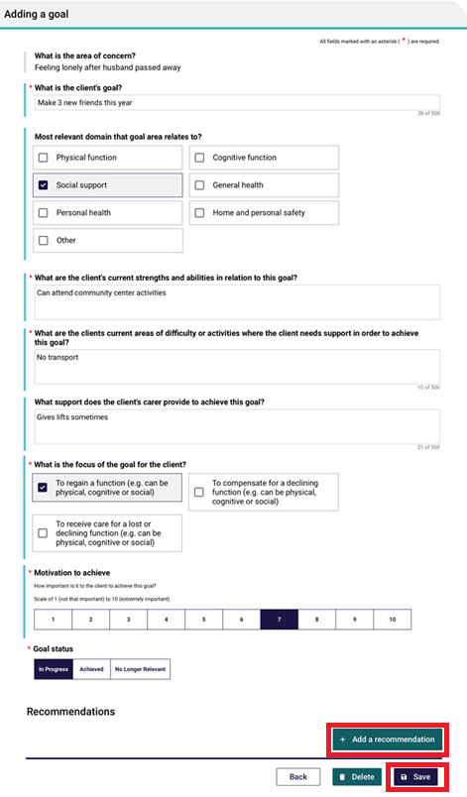
Excerpt of Adding A Goal page with recommendations pre-filled
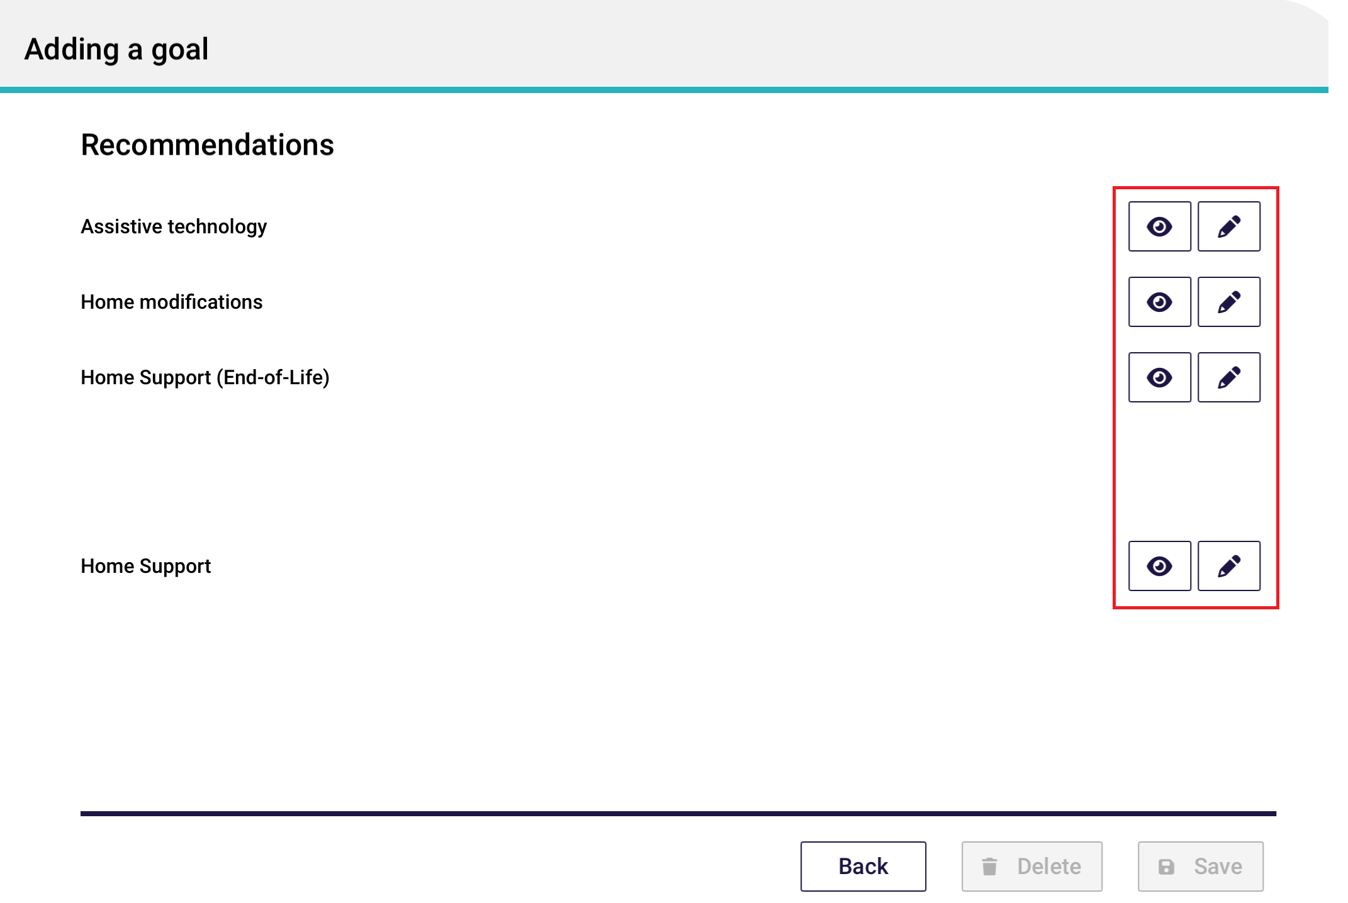
Recommendations can also be added after the completion of the Areas of Concern and Goals in the Recommendations section.
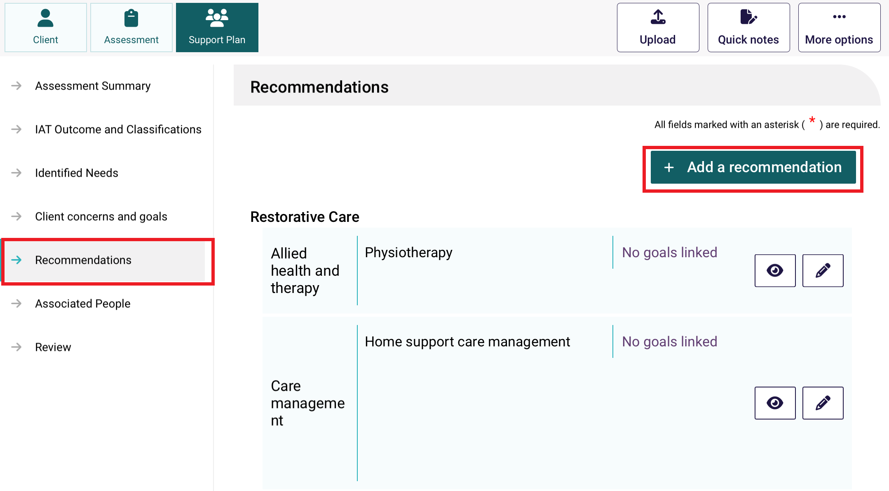
- When viewing the Recommendations page, assessors can view the latest recommended Ongoing classifications, even if the client has multiple active existing classifications within the same category. This ensures assessors have access to the most current and relevant information about the client’s service needs and priority status, supporting accurate and timely decision-making for Support at Home aged care services.

Additionally, If the client was approved for a Restorative Care Pathway classification, after a Support at Home classification is approved, assessors can view both the RCP and the SaH classifications,
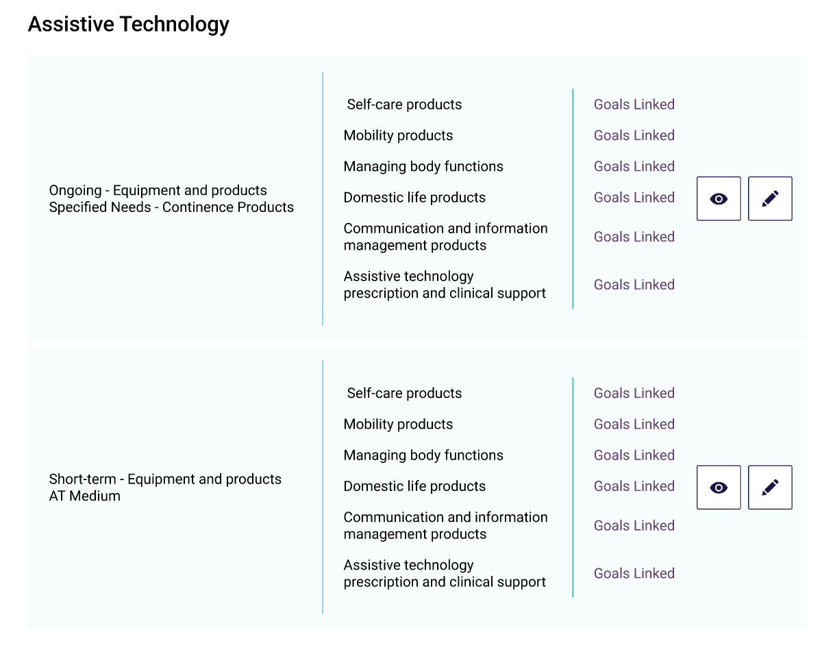
- The corresponding recommendations available for each assessment type will display for the client in the Recommendations section. Recommendations that cannot be added (generally due to other recommendations that have been added) will be indicated in light grey text and any links will become inactive.
Home Support assessment:
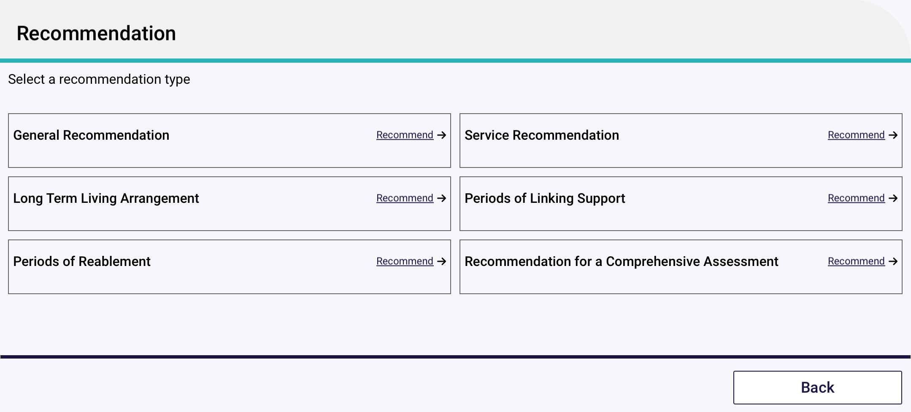

Comprehensive assessment:
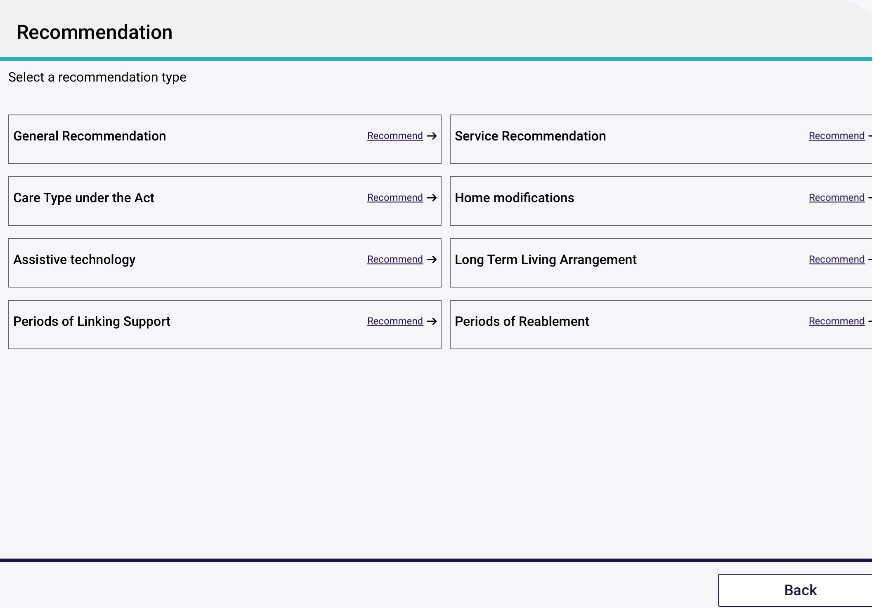
- For some pathways, the recommendations will be pre-filled for the assessor to review and/or edit if necessary. Below is an example screenshot of services available under the restorative care pathway:
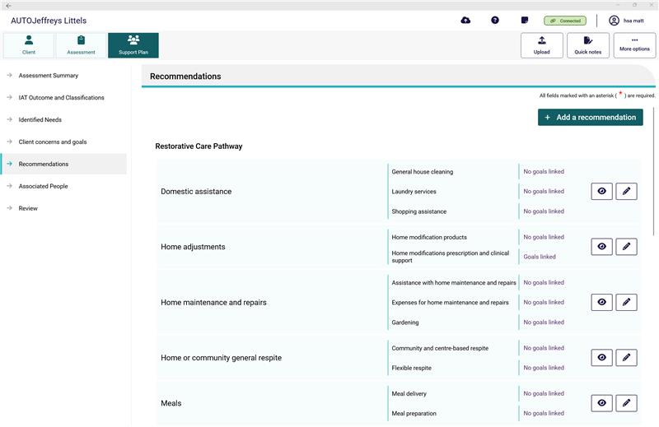
- When available, add any service recommendations or care types under the Act. Similar to the assessor portal, goals can be linked to some recommendations.
When finished, don’t forget to select Save at the bottom of the recommendation page.
! | If a client is under the aged of 65, several additional entry fields will appear to document their exceptional circumstances.

! | If it is determined that a client has a high priority for a Support at Home service, you are required to answer all mandatory questions and provide your reason or comments using the available comment field.
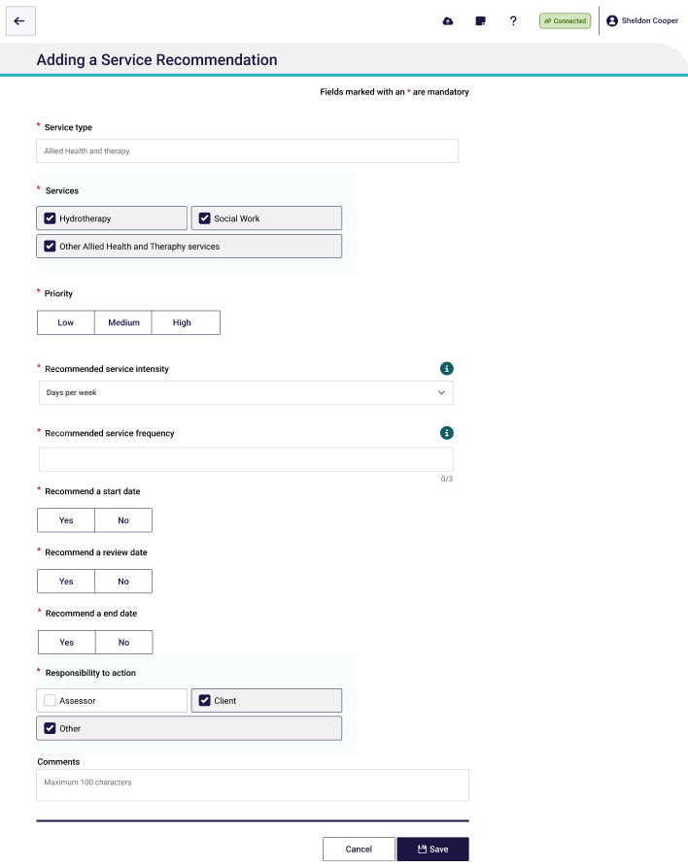

- Once you have made all your recommendations, you will be able to view these in the Recommendations section. The Recommendations section will display all recommendations made during the development of the Support Plan, where the Client concerns and goals will only display recommendations linked to goals.

14.1 Recommendation Types
There are 8 recommendation types available from the App. Not all will be available depending on the client’s assessment outcome.
If CHSP, National ATSI Aged Care Program, or Multi-Purpose Service – Residential is recommended, then the assessor will not be able to choose No Care Approval or No Change to Existing Care Approvals. These two selections will not be displayed.
If No Care Type under the Act, No Change to Existing Care Approval, or No Care Approval is recommended, then the assessor will not be able to add any service recommendations. The ‘Add A Recommendation’ button will be disabled.
Recommendation Type | Choices available
General Recommendation | Free choice
Service Recommendation | Allied health and therapy  Assessment  Case Management  Client care coordination  Community cottage respite  Domestic assistance  Equipment and products  Hoarding and squalor assistance  Home adjustments  Home maintenance and repairs  Home or community general respite  Meals  Multi-Purpose Service – Residential  National ATSI Aged Care Program  Nursing Care  Personal Care  Social support and community engagement  Specialised support services  Therapeutic services for independent living  Transport
Care Type under the Act | (No Care Approval*)  Residential Permanent  Residential Respite Care  Transition Care
No Care Type under the Act*  No Change to Existing Care Approval*  No Care Approval* | *If these recommendations were made, then the assessor will not be able to add any service recommendations. The ‘Add A Recommendation’ button will be disabled.
Home modifications | Home adjustments (Service available according to Short-term or Ongoing Classification, and Low, Medium or High Tier)
Assistive technology | Equipment and Products (Service available according to Short-term or Ongoing Classification, and Low, Medium or High Tier)
Long Term Living Arrangement | Hospital  Independent living within a retirement village  Other community  Other institutional Care  Private residence  Residential aged care service  Supported community accommodation
Period of Linking Support | N/A
Periods of Reablement | N/A

14.2 Support At Home Service Recommendations
The Support At Home Program offers services in three service groups: Assistive technology, Home modification, and Home Support.
If the client has a Support At Home (SaH) classification in their IAT Outcome and Classifications page, then all available Support At Home services that satisfies the client’s classification will appear in the Recommendations page (except for Assistive technology and Home modifications which are added separately)
This table lists the Support At Home services:
Support At Home service type | Support At Home service
Care management | Home support care management
Domestic assistance | General house cleaning  Laundry services  Shopping assistance
Home maintenance and repairs | Assistance with home maintenance and repairs  Expenses for home maintenance and repairs  Gardening
Home or community general respite | Community and centre-based respite  Flexible Respite
Meals | Meal delivery  Meal preparation
Nursing care | Enrolled nurse clinical care  Nursing assistance clinical care  Nursing care consumables  Registered nurse clinical care
Nutrition | Nutrition supports
Personal care | Assistance with self-administration of medications  Assistance with self-care and activities of daily living  Continence management (non-clinical)
Social support and community engagement | Accompanied activities  Assistance to maintain personal affairs  Cultural support  Digital education and support  Expenses to maintain personal affairs  Group social support  Individual social support
Transport | Direct transport  Indirect transport
The below image shows some Home Support recommendations in the Recommendations page. Select the View (eye) button next to any one of these services, to view all services. Select the Edit (pencil) button next to any one of these services, to edit any available service.
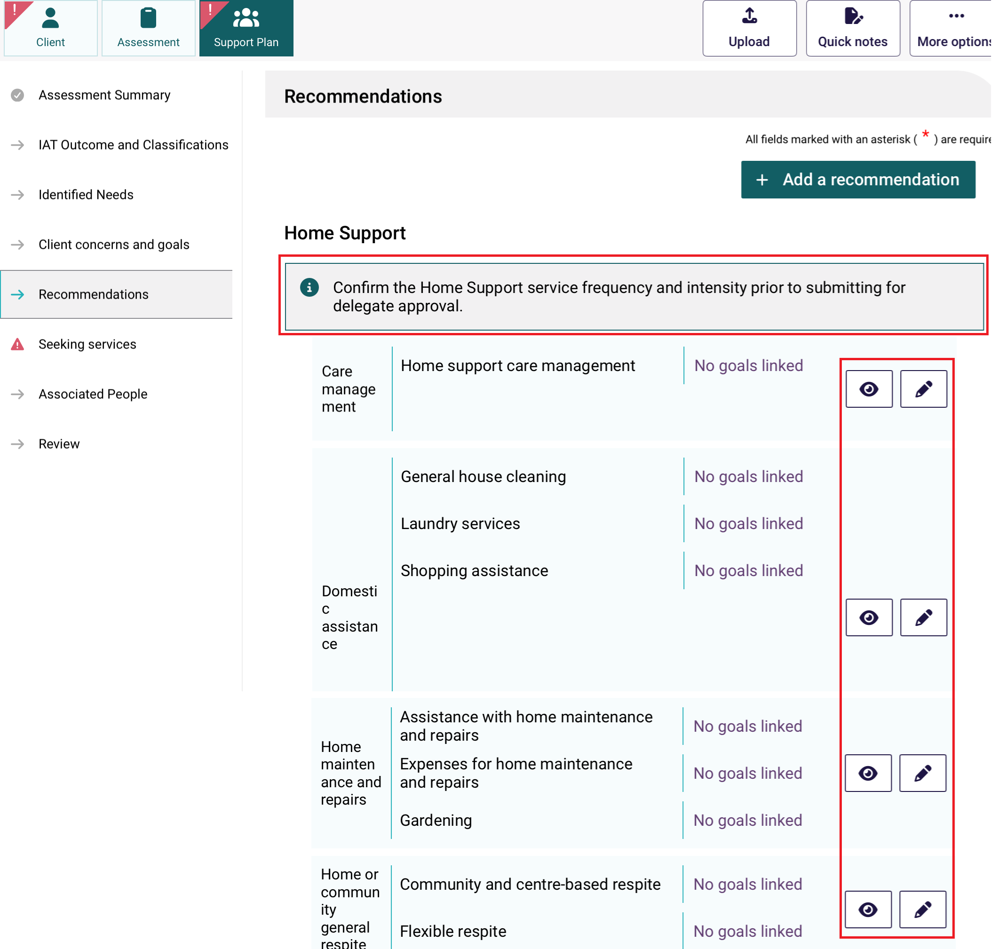
To successfully submit the Home Support recommendation for delegate approval, each service that the client will use will need to be fully completed, including service frequency and intensity.
To input service frequency and intensity, select any Edit button to open the Editing Home Support Services page.
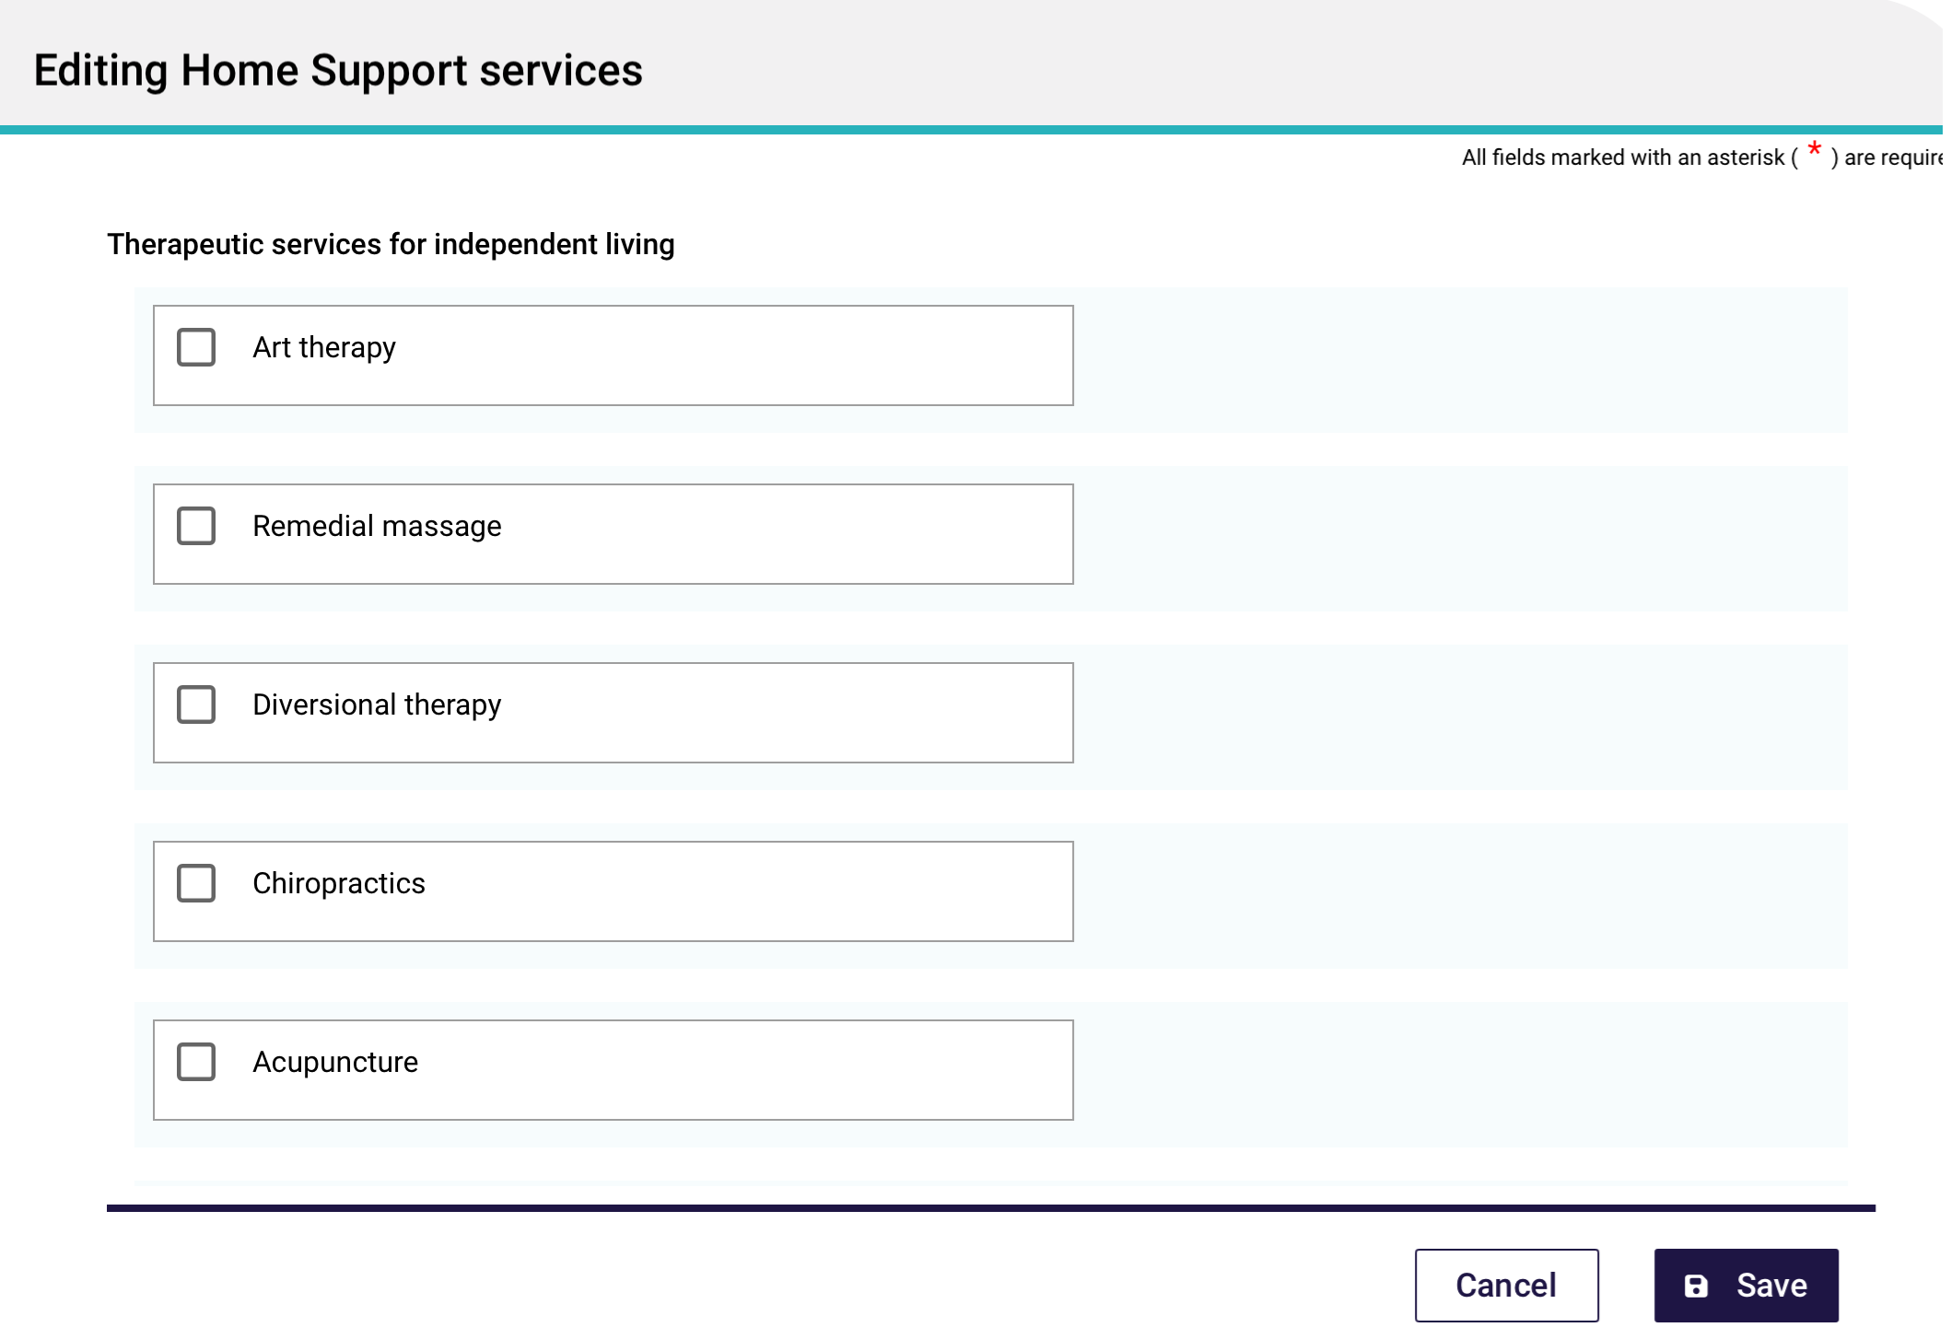
Scroll down to the desired service.
Firstly, go to Recommended Service Intensity and select a suitable value from the drop down menu provided, then select Done.
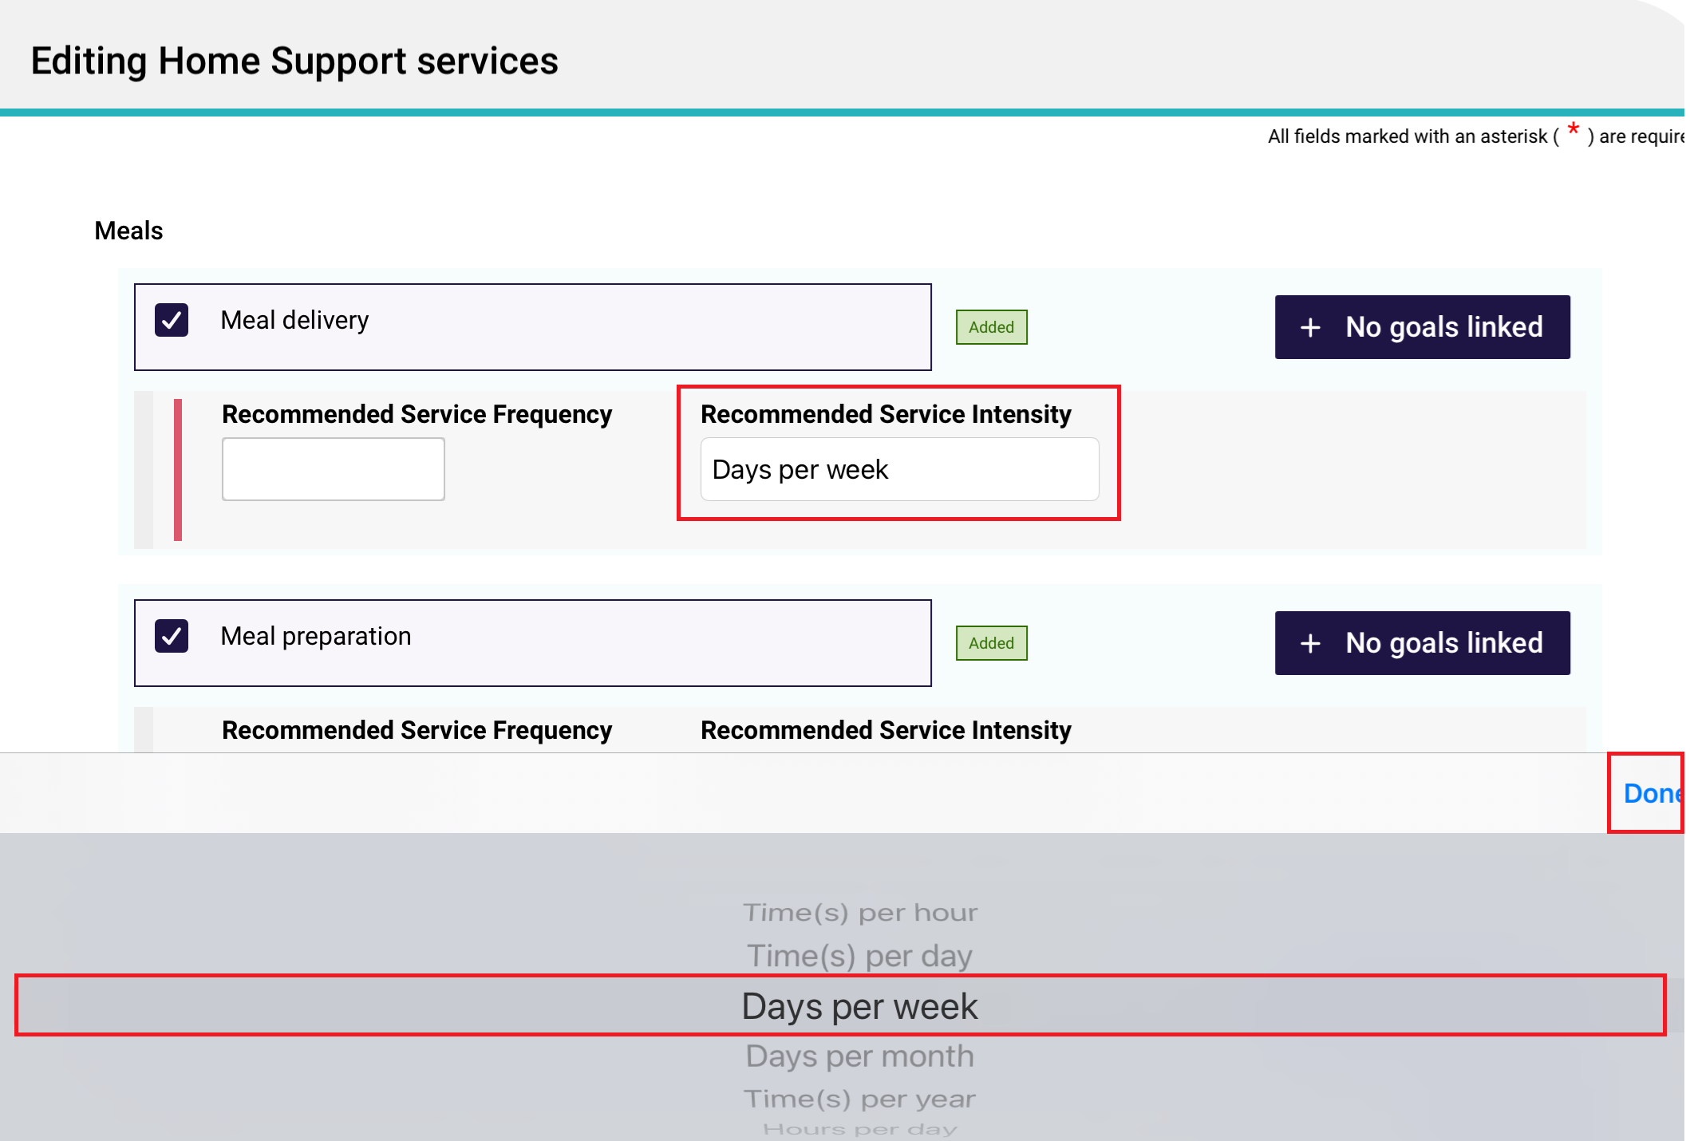
The available service intensities are:
- Time(s) per hour
- Time(s) per day
- Days per week
- Time(s) per year
- Hours per day
- Hours per week
- Hour(s) per year.
Then, input an suitable number in the Recommended Service Frequency section. For example, if the Recommended Service Intensity is Days per week, then the Recommended Service Frequency can only be a number from 1 to 7.
Once all values are properly entered, the red vertical line against each service will disappear, leaving a grey vertical line instead.
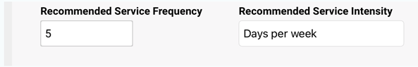
If you have a non-standard service intensity, Select Other – Specify in the Recommended Service Intensity section. Then, enter the service intensity in the Recommended service intensity – Other (specify) section that will appear on the right of the screen. Finally, enter the Recommended service frequency.
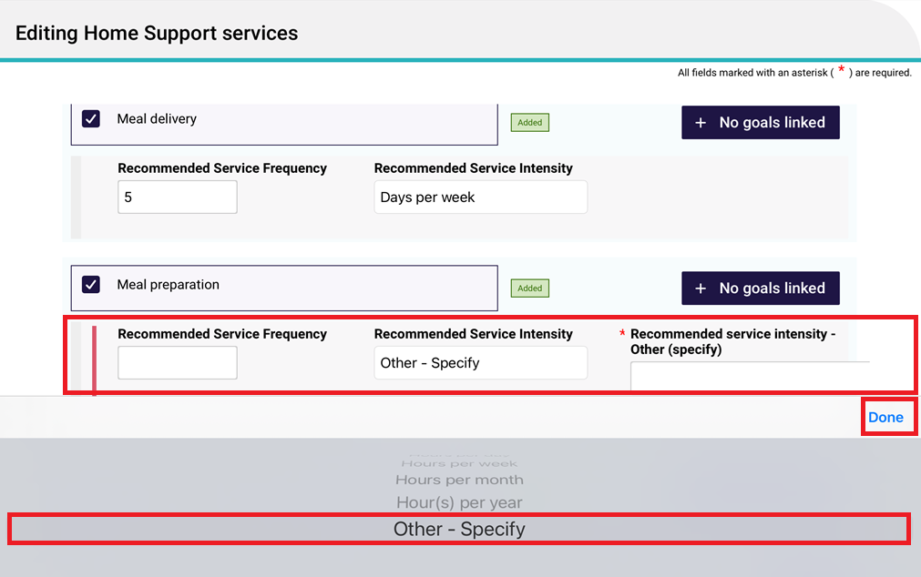

14.2.1 Adding an Assistive technology (AT) recommendation
When an Assistive technology recommendation is approved, it is also known as a Support At Home AT Classification.
Please note that Assistance dogs are classified under the Ongoing classification type of assistive technology. It is known as ‘Specified Needs – Assistance Dogs’.
Follow these steps to add an AT recommendation:
- Go to the Support Plan tab, then the Recommendations page. Select + Add A Recommendation.
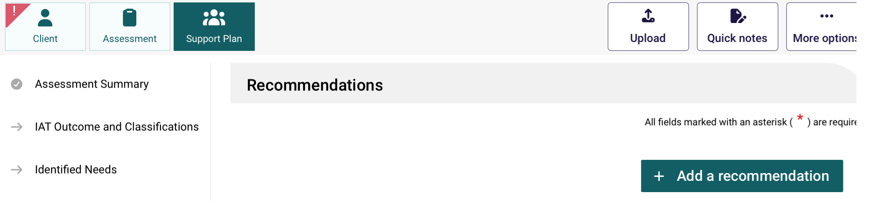
- Select Assistive Technology from the list of recommendation types.
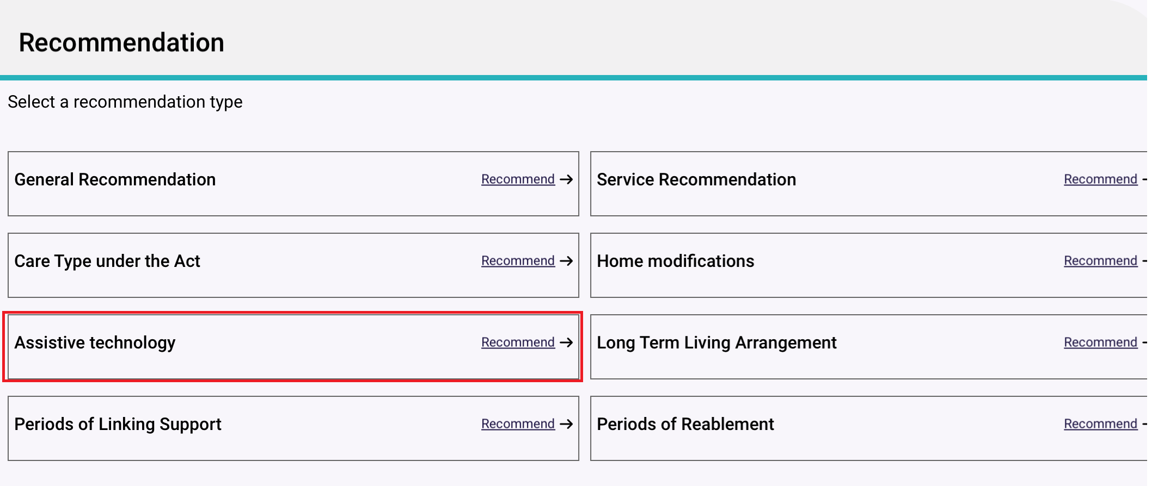
- The Adding Assistive Technology service page appears.
Select the Classification Type (Ongoing or Short-term) from the drop down menu that appears.
If the classification type is Short-term, select the technology tier (AT Low, AT Medium, or AT High) from the drop-down list. If it is Ongoing, assistance dogs is available under the Specified Needs section. An example of each type is displayed below.
A number of services associated with the recommendation will be able for you to choose or delete. These services appear based on your answer and the outcome of your client’s assessment, such as tier, specified needs, and service type.
Select service/s using the tickbox/es. At this stage you can also link goals to each service by selecting the ‘No goals linked’ button.
AT Short Term Classification Example
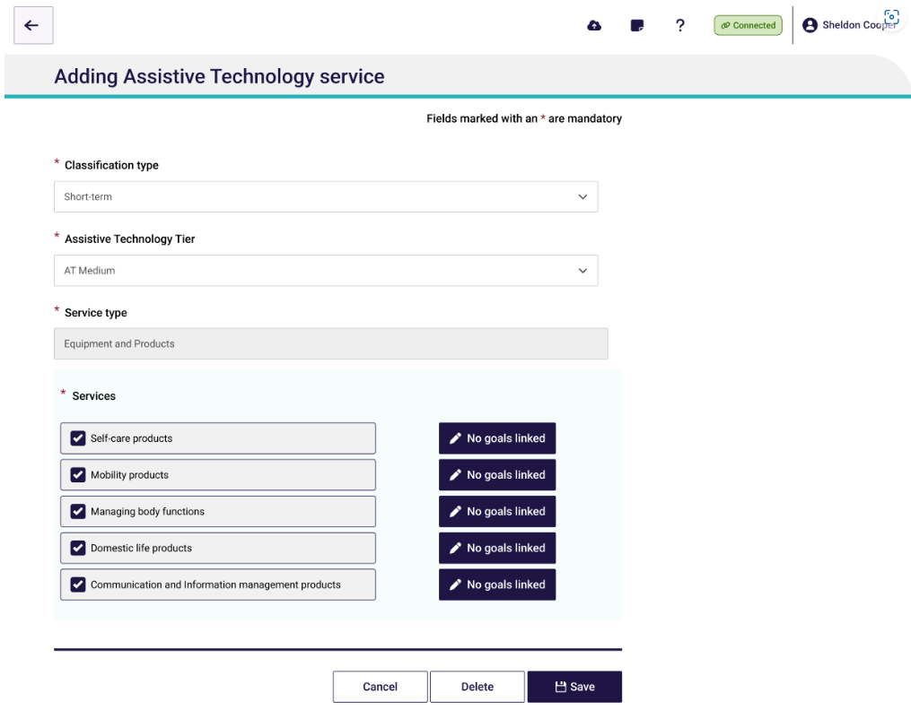
AT Ongoing Assistance Dogs example
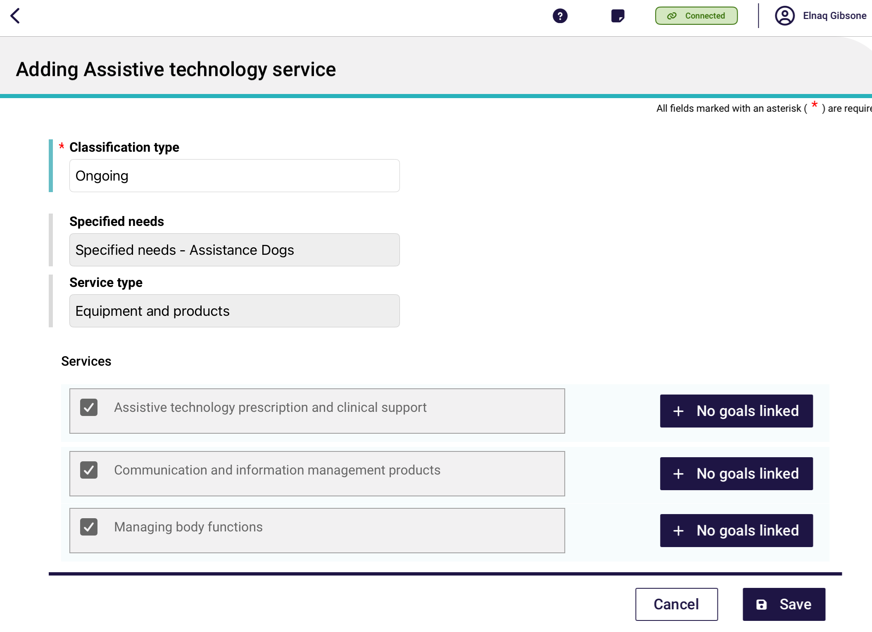
- Select Save to return to the IAT Outcome and Classification page.
Your service/s will be added to the Recommendations tab under the Assistive technology section. You can view the services in more detail using the View (eye) icon, or edit the services using the Pencil icon.
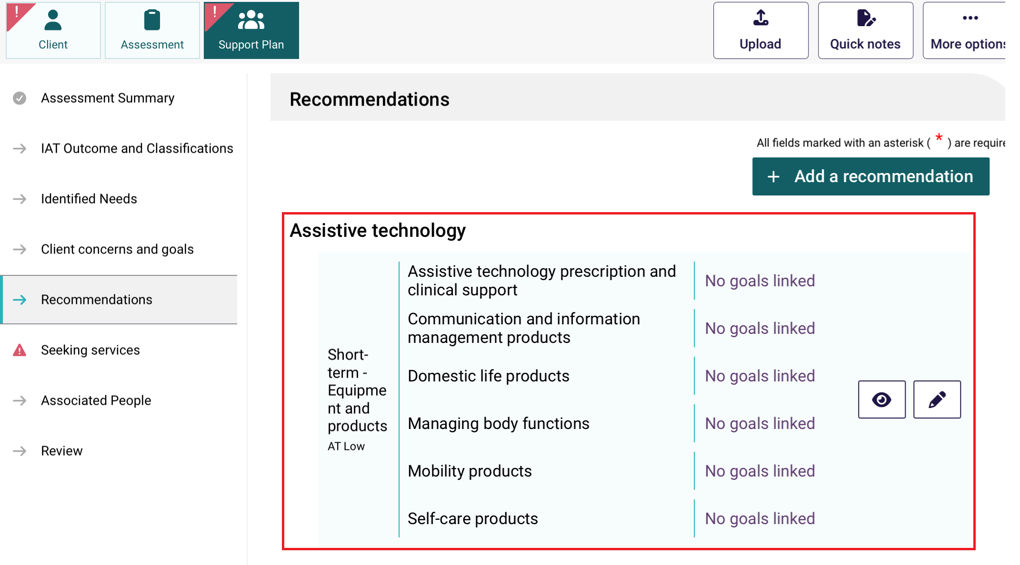

14.2.2 Adding a Home modifications (HM) recommendation
When a Home modifications recommendation is approved, it is also known as a Support At Home HM Classification.
Follow these steps to add a HM recommendation:
- Go to the Support Plan tab, then the Recommendations page. Select + Add A Recommendation.
- Select Home modifications from the list of recommendation types.
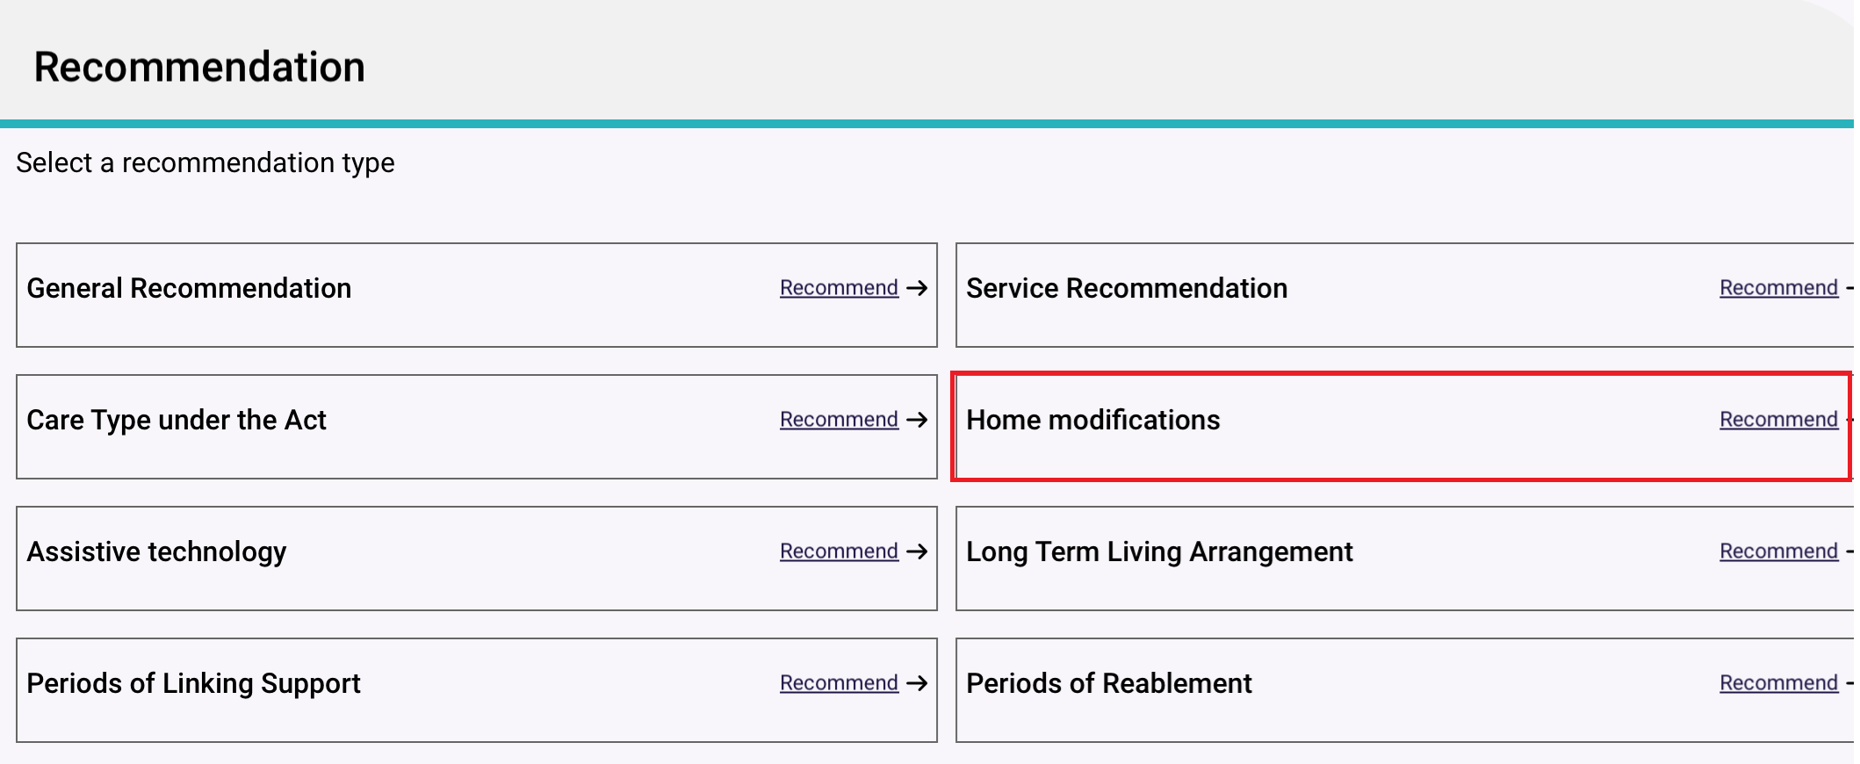
- The Adding Home modifications service page appears.
The Classification Type (Ongoing or Short-term) is pre-filled.
Select the Home modifications Tier (HM Low, HM Medium, or HM High) from the drop down menu that appears.
Select service/s using the tickbox/es. At this stage you can also link goals to each service by selecting the ‘No goals linked’ button.
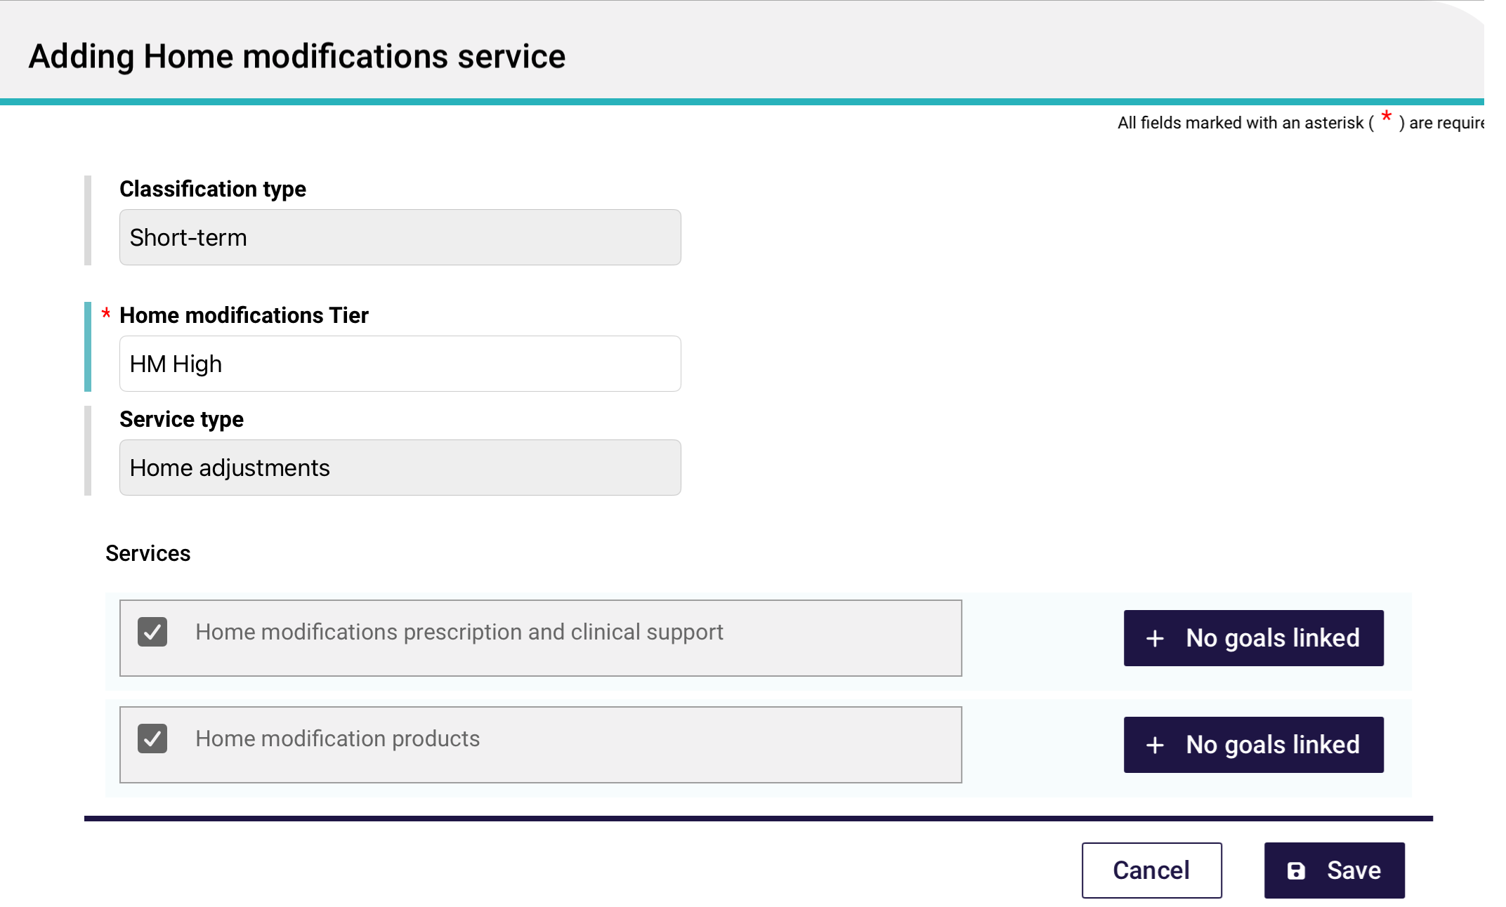
- Select Save to return to the IAT Outcome and Classification page.
Your service/s will be added to the Recommendations tab under the Home modification section. You can view the services in more detail using the View (eye) icon, or edit the services using the Pencil icon.
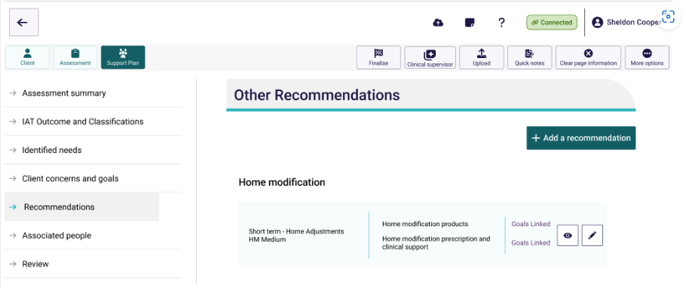

14.3 Adding Seeking Services Preferences
Assessors can use the App to indicate whether their client are seeking Home Support services and/or Home modification and/or Assistive technology services through the Support At Home program.
This function is for clients recommended or approved for Support at Home (SaH), Assistive Technology (AT), and Home Modifications (HM) only.
If the client is approved or recommended for the End of Life Pathway or the Restorative Care Pathway, a message will display indicating that the client will be automatically placed and no Seeking Services preference is required.
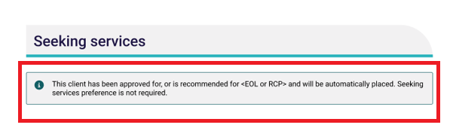
Follow these steps to add seeking services:
- Open the Client’s assessment record and navigate to the support plan section.
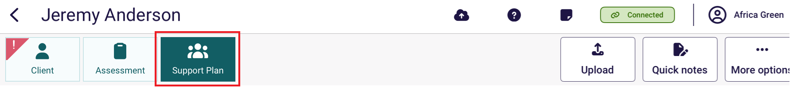
- Check if the client is eligible to add seeking services, by going to the IAT Outcome and Classifications page.
Seeking Services preferences will only be available if the client has:
- An Approved Classification from a prior assessment, or
- A Recommended Classification in the current assessment.
Eligible classifications include:
- Support at Home (SaH)
- Assistive Technology (AT)
- Home Modifications (HM)
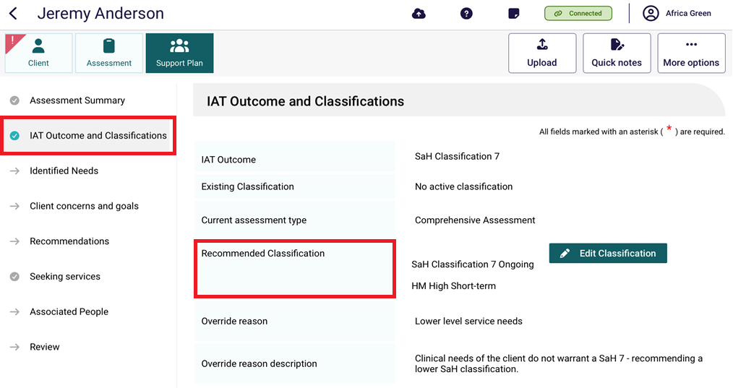
- If the client is eligible, go to the Seeking Services page.
Depending on the client’s classification, only the relevant service section (e.g., Support at Home, Assistive Technology, or Home Modifications) will be visible.
If no eligible classifications are present, this section will be hidden and display: “There are no preferences for Seeking services at this time.”
If the client wants to seek services, toggle Seeking services under the relevant service’s heading.
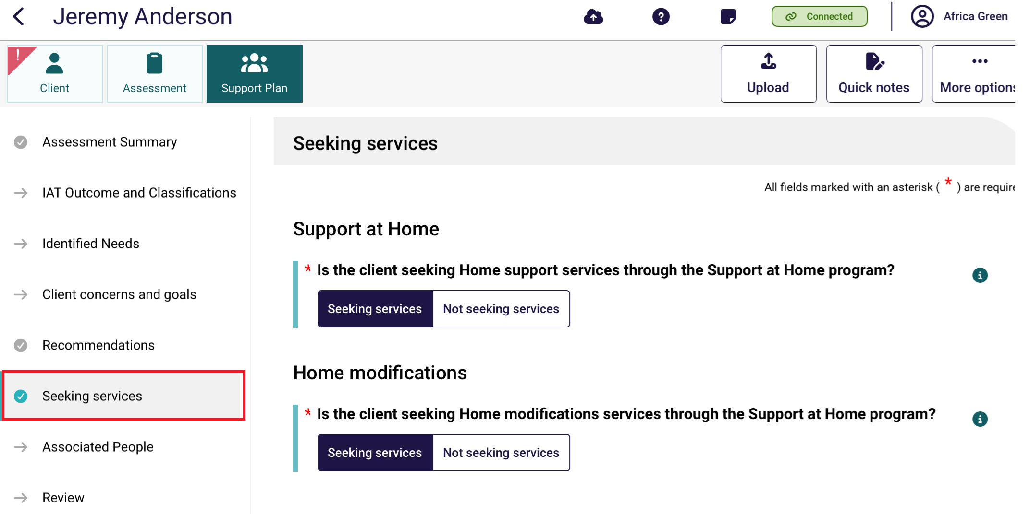
If Not seeking services is selected, assessors must choose a reason from a dropdown. If Other. Please specify or Deceased is selected, a text box will appear for further details.
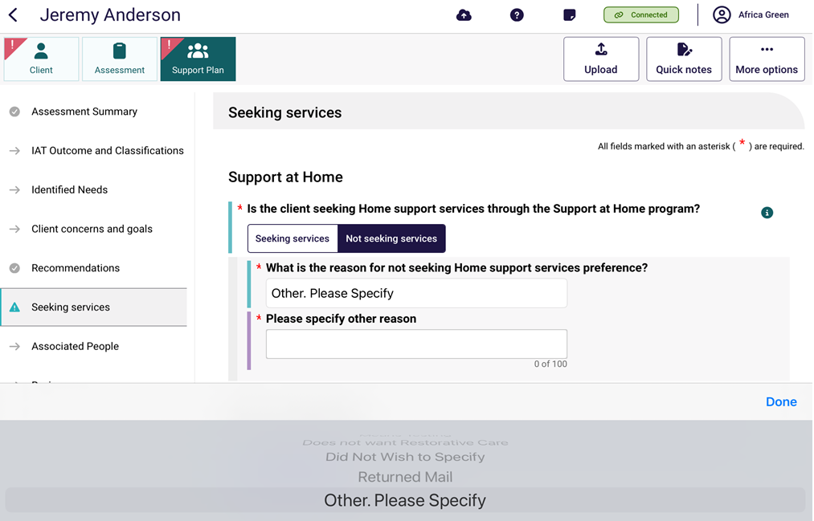
- For each visible sub-section, all compulsory fields must be filled out. When the page is complete, there will be a green tick next to the Seeking Services page on the side menu. You can then navigate to another section of the app.
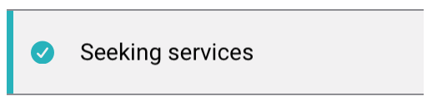

14.4 Editing a Goal
You can edit a goal before uploading an assessment, support plan or during a support plan review if the recommendation is not already in place with a provider.
- Go to the support plan and then go to the Client concerns and goals page. Expand the concern listing, and select the Edit (pencil) icon on the right of the desired goal.
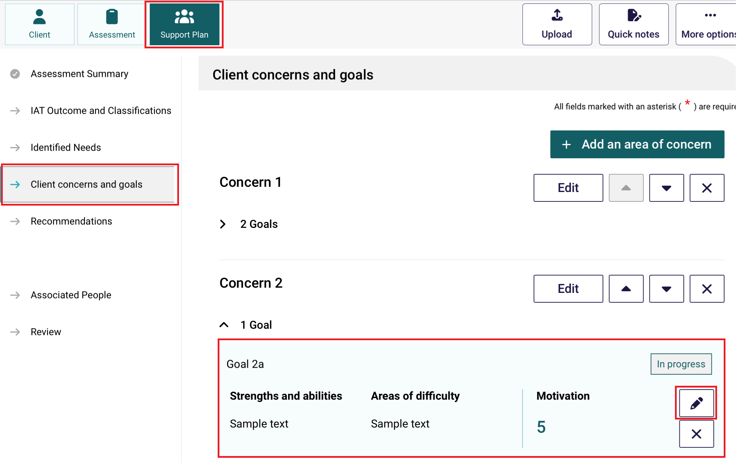
Alternatively, select the Edit icon to the right of the Concern.
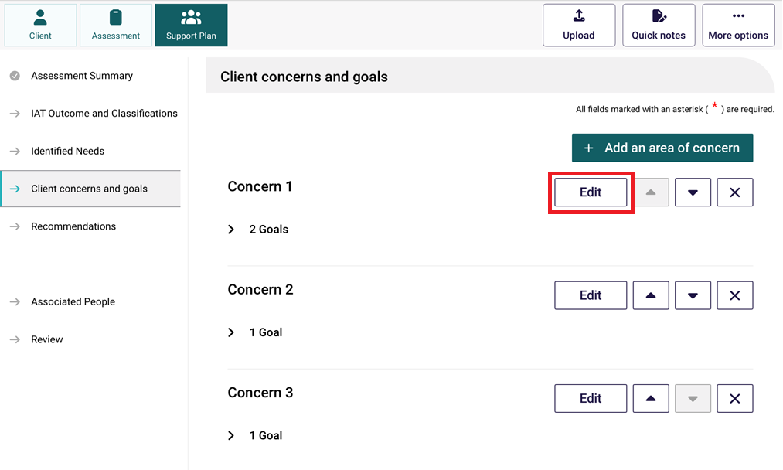
The Editing a client concern page appears. Expand the goal listing, and select the Edit (pencil) icon on the right of the desired goal.
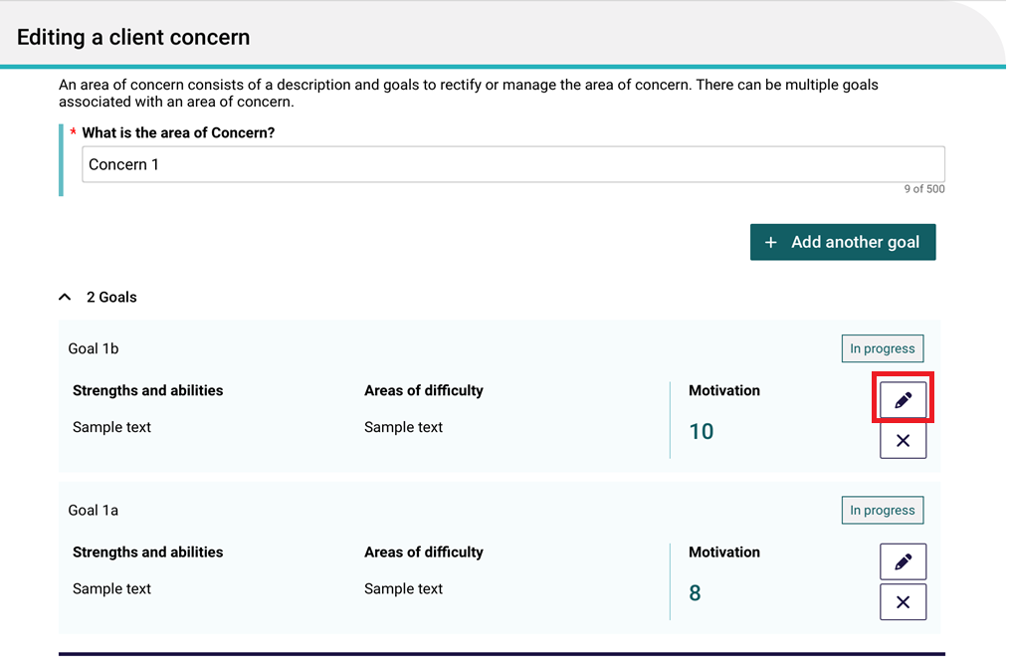
- The Editing A Goal page appears.
Make sure all the mandatory fields are complete. These include:
- What is the client’s goal?
- What are the client’s current strengths and abilities in relation to this goal?
- What are the client’s current areas of difficulty or activities where the client needs support in order to achieve this goal?
- What is the focus of the goal for the client? (To regain a function, To receive care for a lost or declining function, or To compensate for a declining function)
- Motivation to achieve (Scale of 1 to 10)
- Goal status (In progress, Achieved, or No Longer Relevant)
- Link goals to a recommendation. This is done at the Recommendations section of the Editing a Goal page.
Select the Edit (pencil) icon next to the pre-filled recommendation if this exists. The Pre-filled recommendation comes from the client’s Recommended Classification from the IAT Outcome and Classifications page.
Alternatively, select the + Add a Recommendation button at the bottom right of the page to add a recommendation that will be linked to this goal.
! | Always edit the pre-filled recommendations first if it is available.
- Finally, select Save at the bottom of the page.

14.5 Linking Goals to Recommendations

Clients with Recommended Classifications
If the client has a Recommended Classification in the IAT Outcome and Classifications page, then this classification will appear as a pre-filled recommendation, in the Editing A Goal page.
To Link Goals, ensure that there are goals available to edit.
- From the Editing A Goal page, select the Edit (Pencil) icon to the right of the pre-filled recommendation.
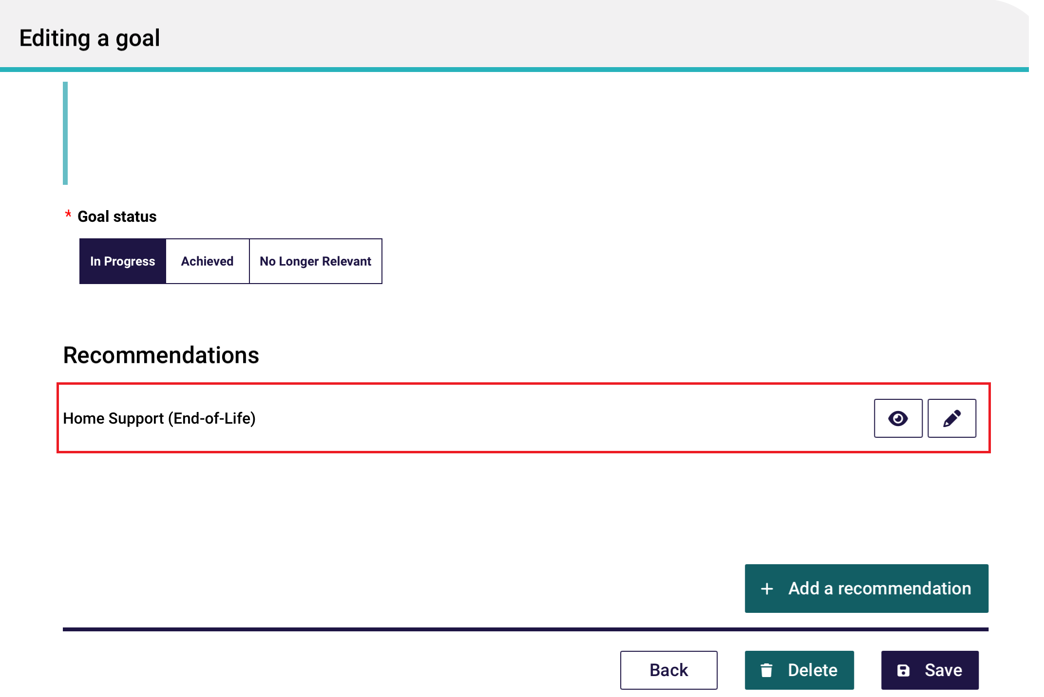
- The Editing [Recommended Classification] services page will appear.
Using Home Support services as an example, scroll down to the desired service. Ensure that the Recommended Service Intensity and Recommended Service Frequency are filled out before selecting + No goals linked. Otherwise, goals will not be linkable.
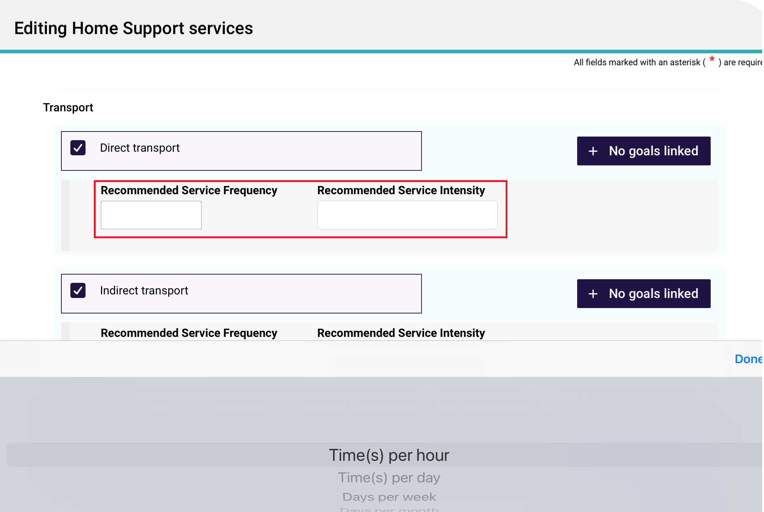

- After selecting + No goals linked, the Link Goals to [Service] page appears.
Select the concern/s that fit the goal, then select Select.
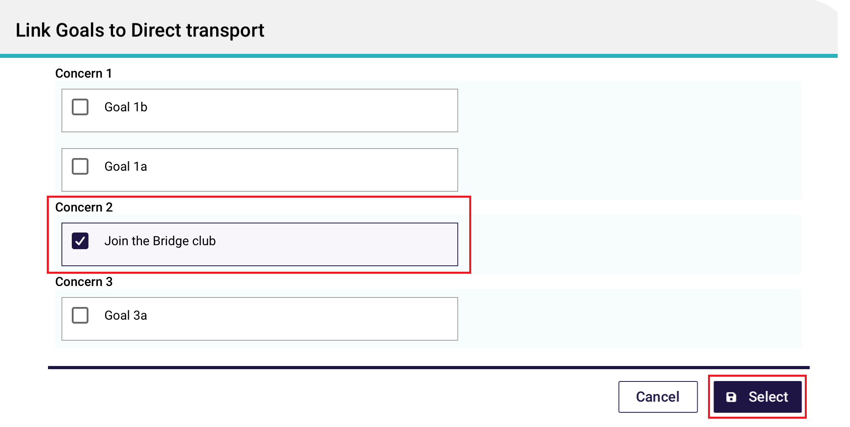
- Now the service has 1 goal linked and has an Updated status.
Repeat the above steps to link the same goal to another service if required.
Then, Select Save.
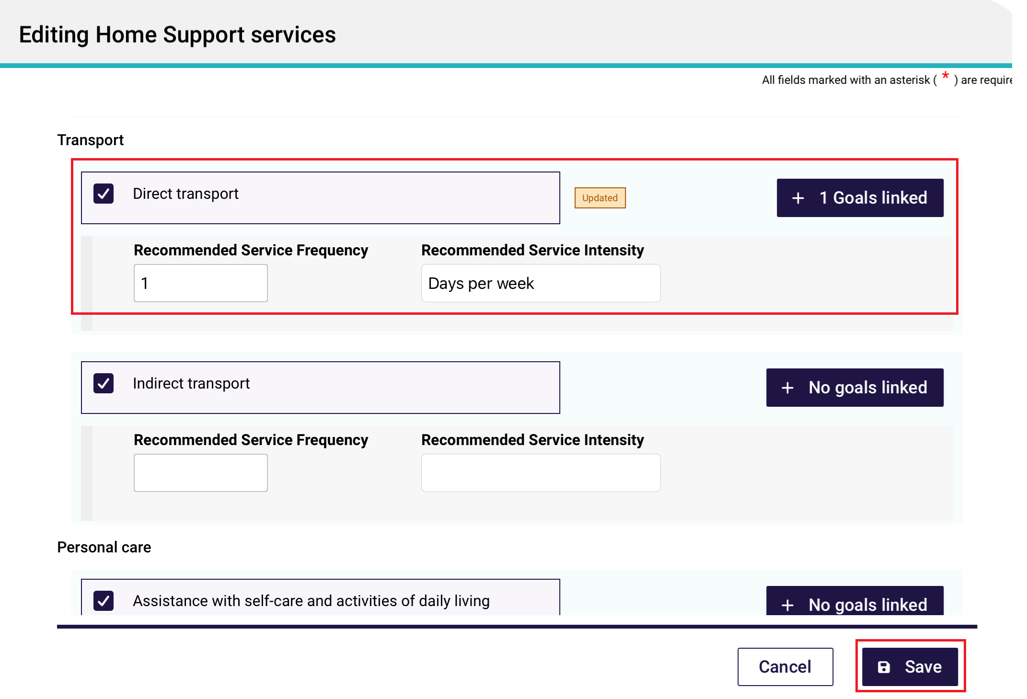
- The Editing A Goal page now shows the linked goal underneath the pre-filled recommendations heading.
You can now link more goals to the pre-filled recommendations, or select + Add a recommendation for other types of recommendations.
Finally, select Save.
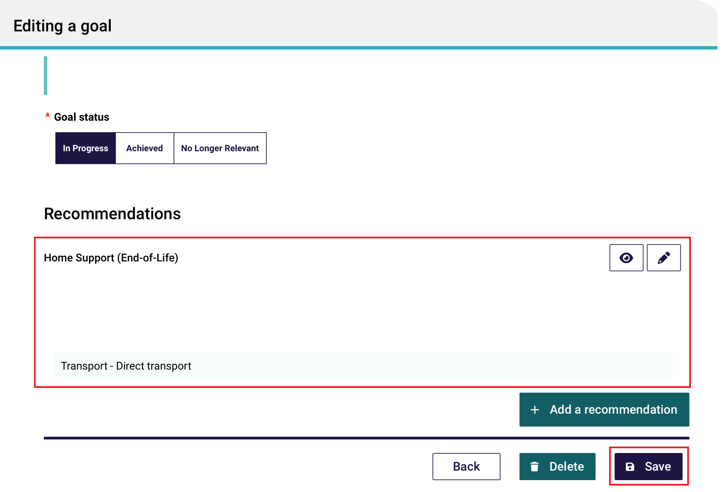
- The Recommendations page now shows your goals linked to the recommendation or service.
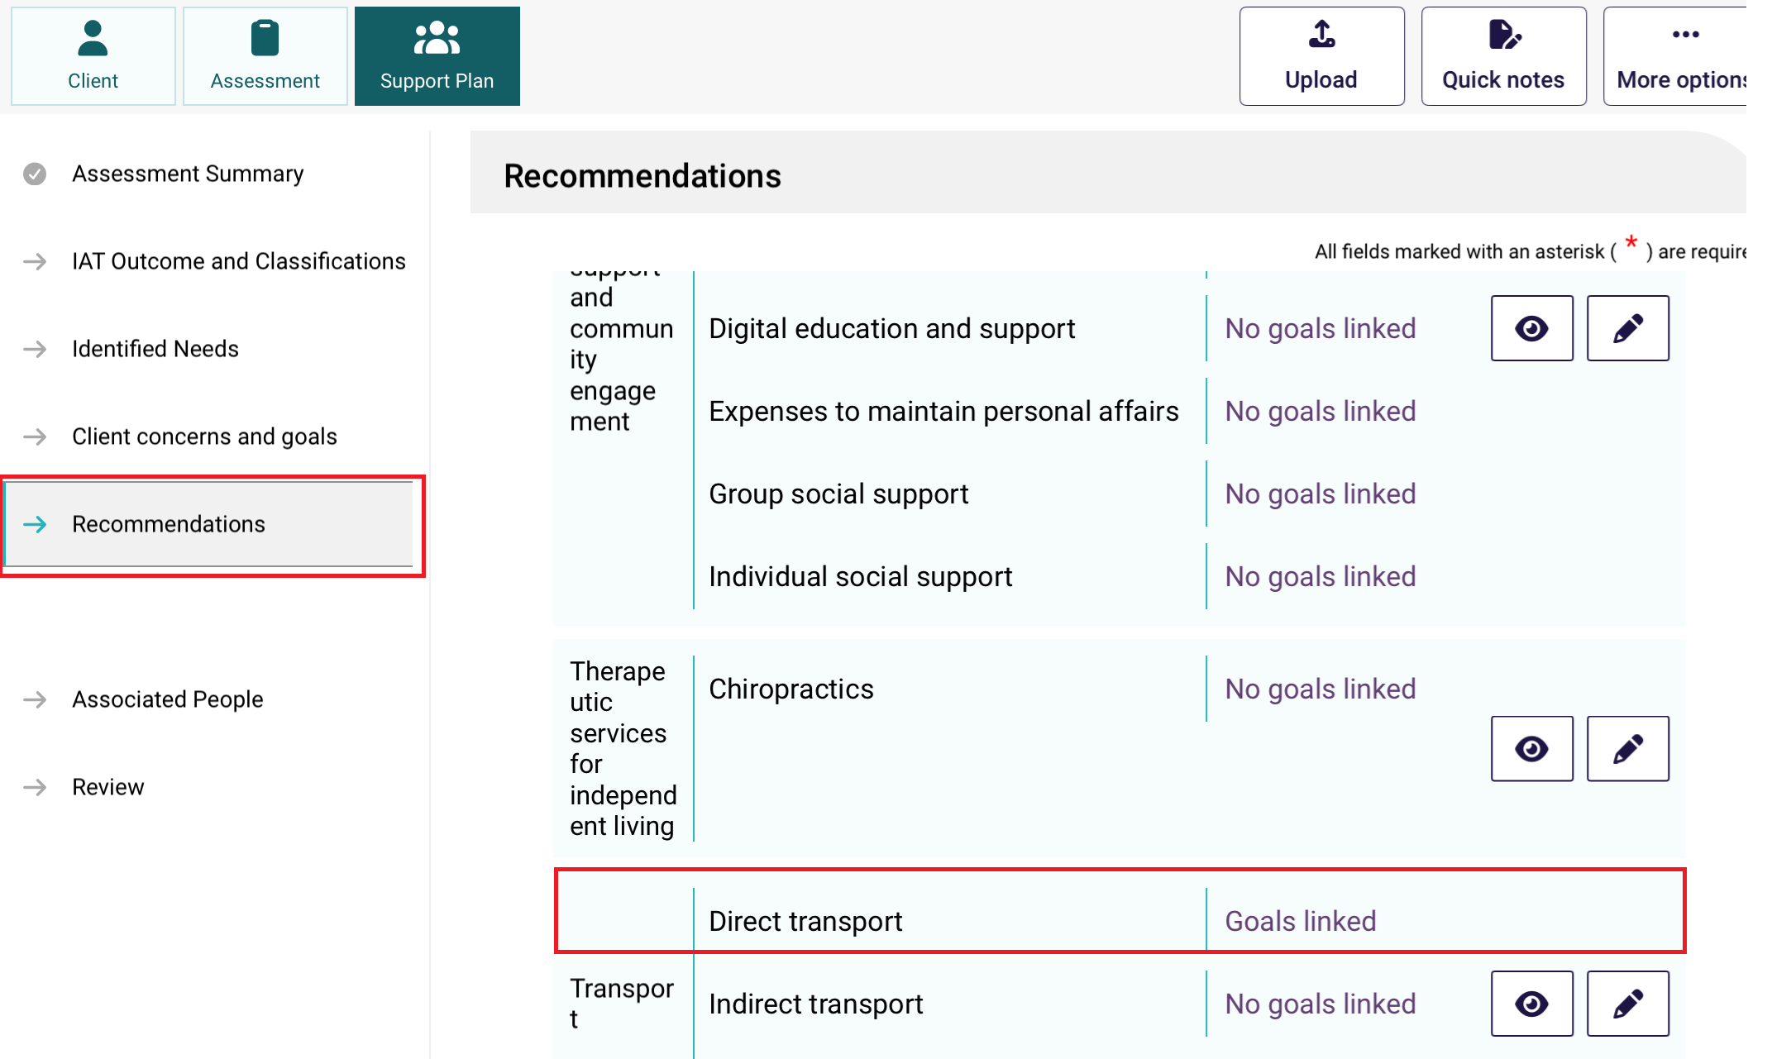

Clients without Recommended Classifications
To Link Goals, ensure that there are goals available to edit.
Clients that do not have any Recommended Classifications or pre-filled Recommendations will have their Editing A Goal page looking like the screenshot below.
- From the Editing A Goal page, select + Add a recommendation
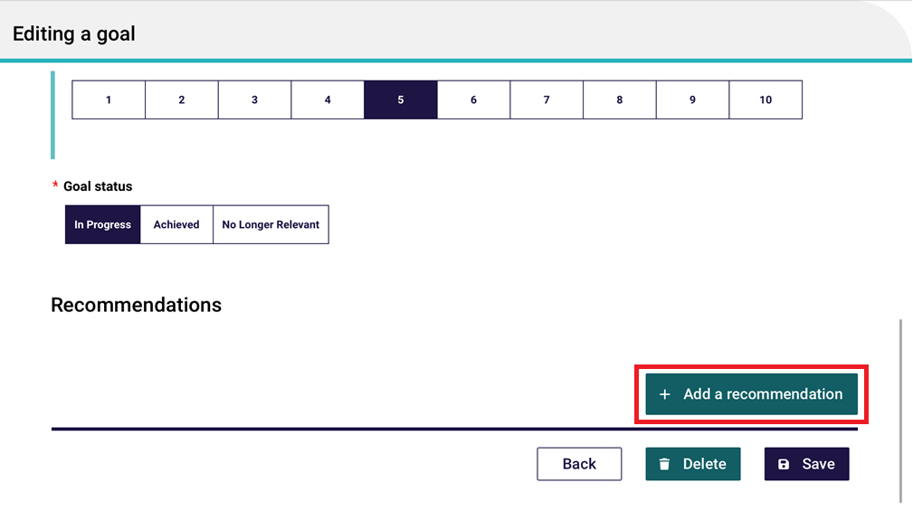
- The Recommendation page appears. Select the recommendation.
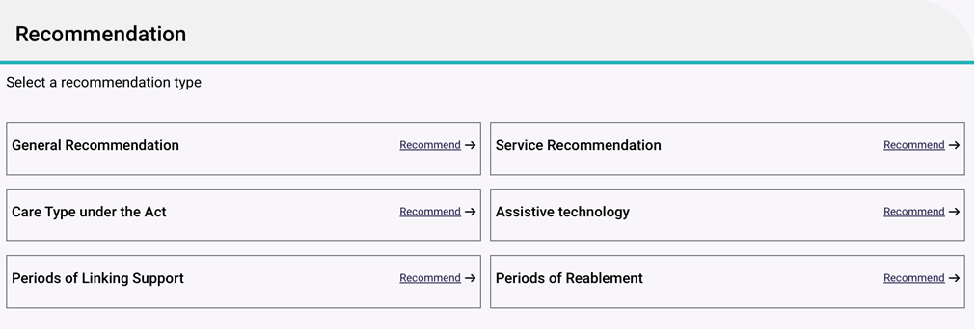
Ensure there is no duplication of recommendations or services, or a warning message will be displayed.
- Ensure that all compulsory fields are filled out and then select Save.
Note that this goal is already associated with the recommendation.
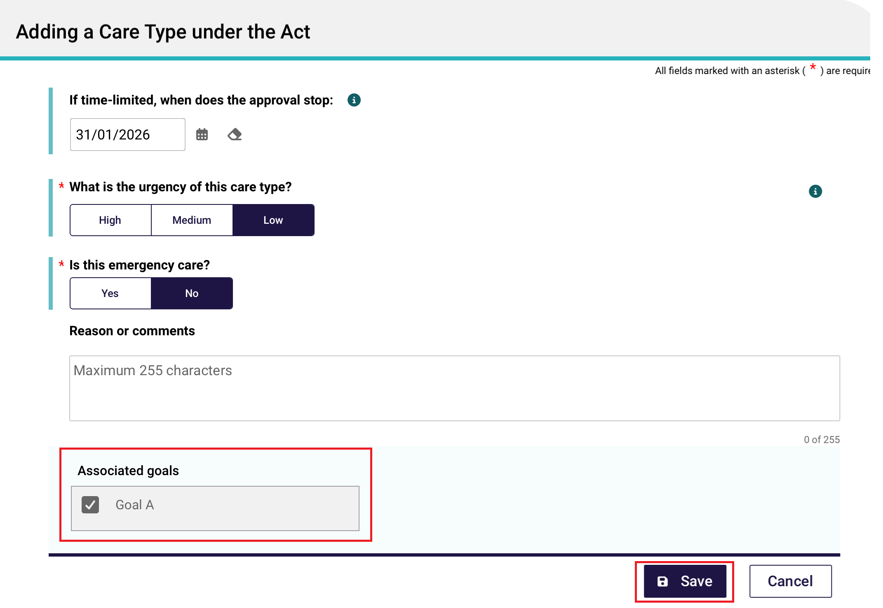
- You will be taken back to the Editing A Goal page.
Any of your linked recommendations will display under the Recommendations heading, and then underneath each recommendation’s sub-heading.
At this point you can View these recommendations again, Edit them, or add another recommendation altogether by selecting + Add a recommendation.
Finally, select Save.
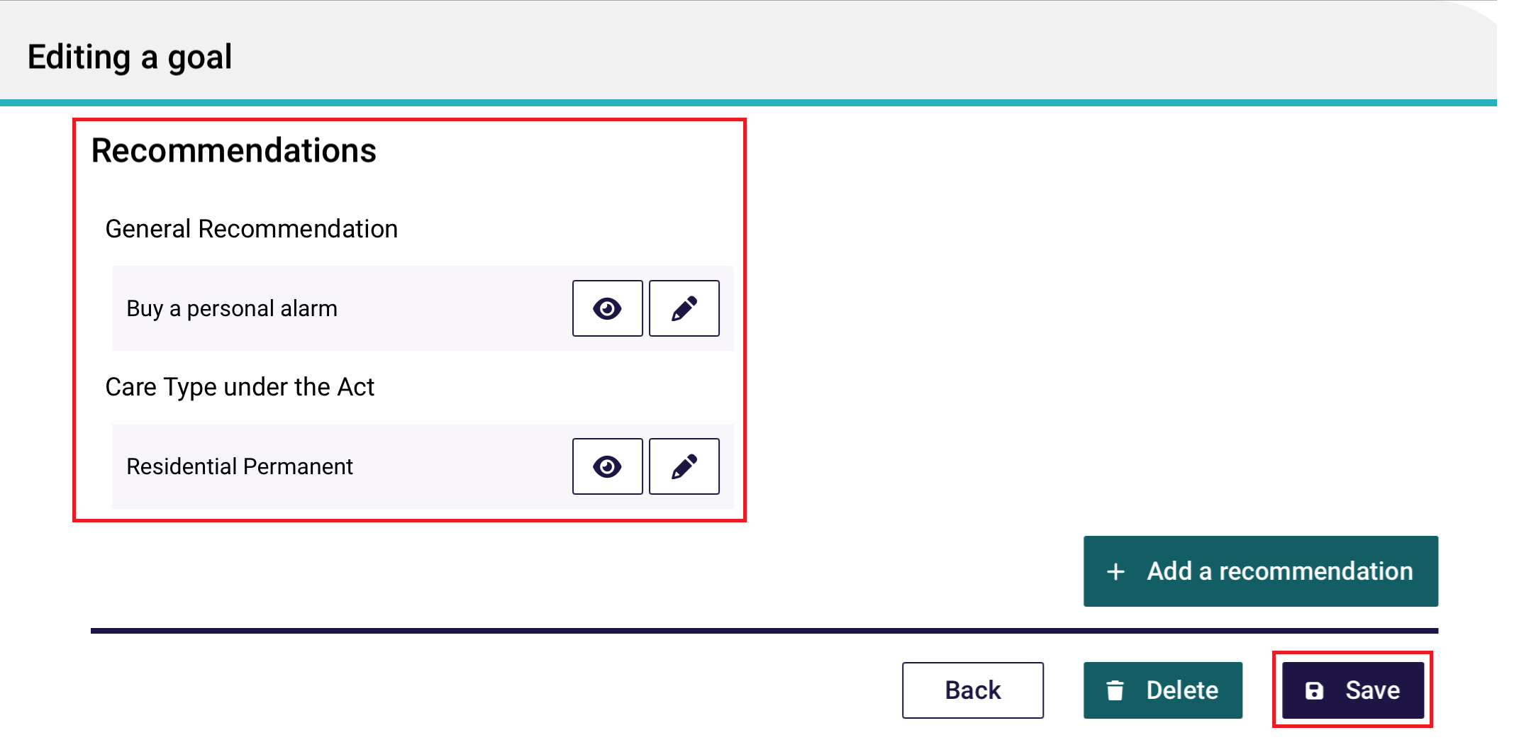
- The Recommendations page now shows your goals linked to the recommendation or service.
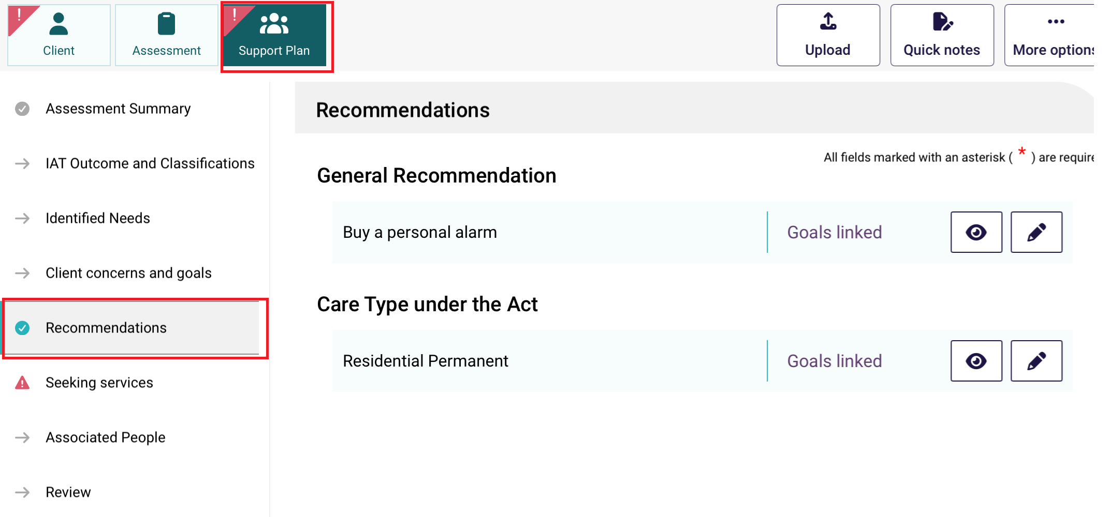

Uploading assessment and support plan information to the assessor portal
! | The device must be connected to the internet to upload an assessment.

Uploading assessment and support plan information for downloaded assessments
To upload assessment and support plan information for a client whose referral you have downloaded and assessment you have undertaken on the App, follow the steps below.
- For the assessment you wish to upload, select Upload from either the Client, Assessment or Support Plan sections.
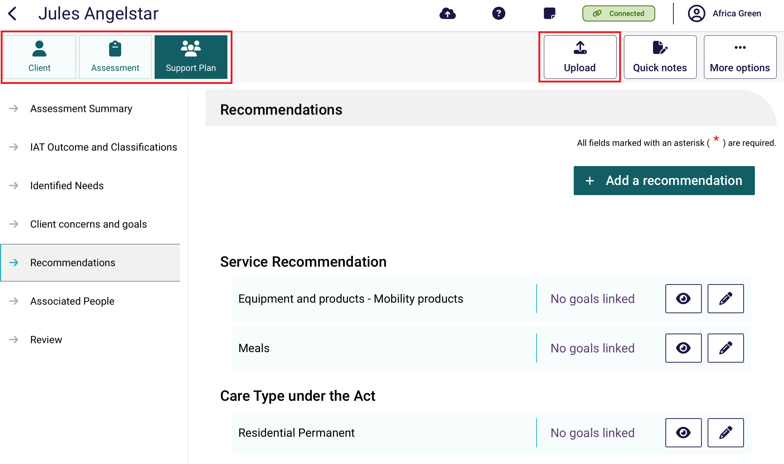

! | If not connected, the Upload button will not be available.  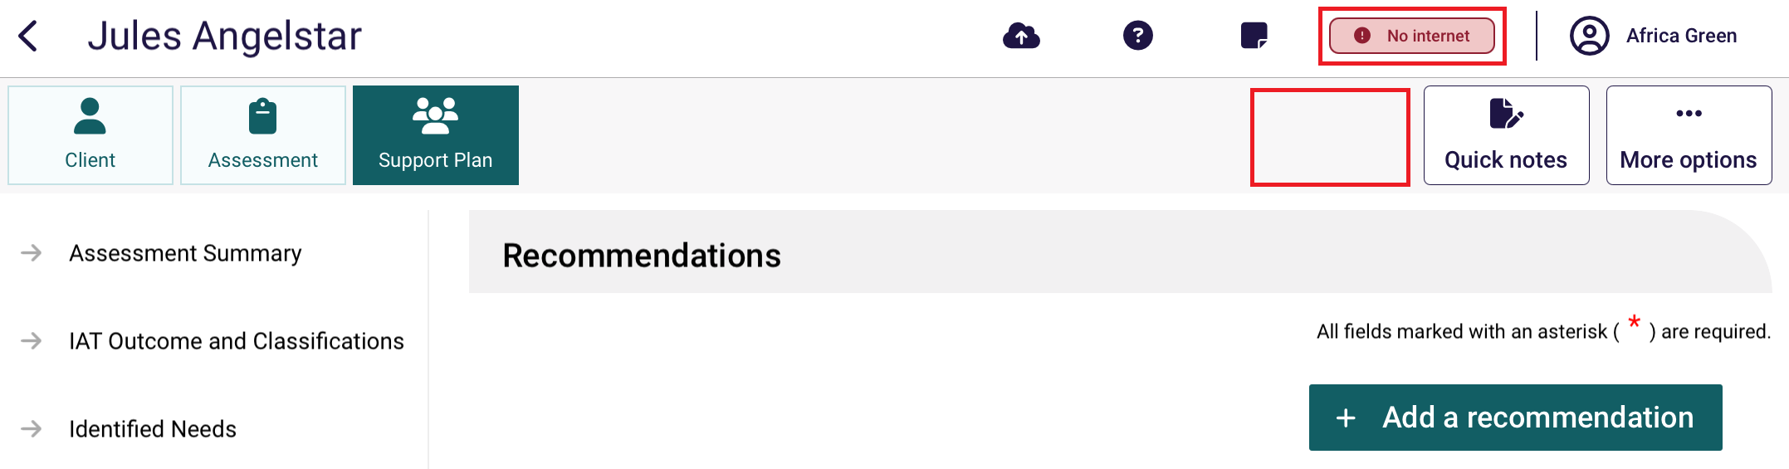
The Upload Assessment page will display. Address any incomplete sections if required by selecting Cancel and uploading again at a later time.
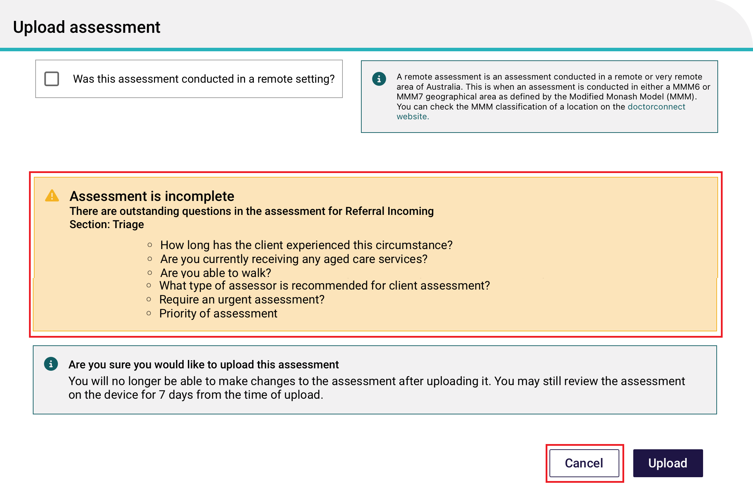
! | Incomplete or invalid questions will not prevent you from uploading the assessment. However, you will need to complete all mandatory questions before you can complete the assessment in the assessor portal.  You will not be able to upload the assessment if the Assessment summary exceeds 5,000 characters.
- If your face-to-face assessment was conducted in a remote location, you should ensure that the Remote Assessment indicator is selected before the assessment is uploaded. To determine if an assessment is conducted in a remote location, please review the information provided within the help icon.
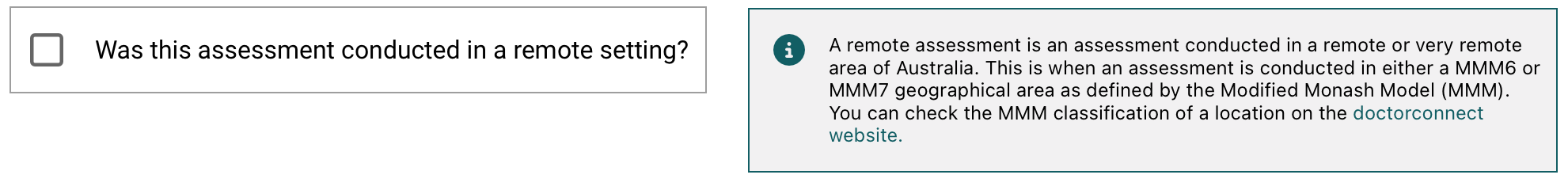
- Select Upload, and then select Confirm in the pop-up window.
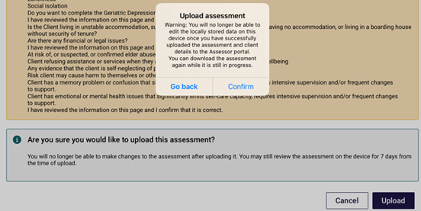
- The assessment will now be uploaded to the My Aged Care assessor portal. The information you added as part of the assessment will automatically populate the corresponding fields, where applicable, in the assessor portal and will display as Pending Uploads on the Dashboard in the App.
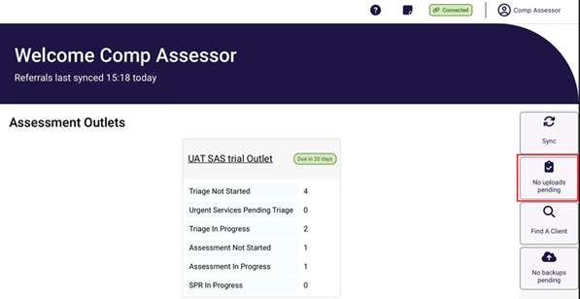
- Once you have uploaded the client’s information to the assessor portal, you can remove the client locally from your device. From now on, the client’s referral and assessment is only viewable through the portal. The only way to interact with the client record using the App is to download the client’s referral again.

Uploading assessments for offline clients
To upload assessment information for offline clients’ assessments created on the App when not connected to the internet, the offline client will need to be registered locally or linked to an existing client record.
Following the client’s registration, needs assessors can self-refer clients for assessment before uploading the assessment.
! | If the client already has an in-progress assessment, you will not be able to upload the assessment. This should be confirmed prior to starting the assessment for an offline client.  For more information regarding this process please refer to the My Aged Care – Assessor Portal User Guide 1 – Registering and referring clients.

15.3 Locally registering an offline client
If you do not have a referral assigned to you for an offline client saved locally to your device, you will need to register the client and arrange for a referral to be issued and assigned to you. This process can only be done when connected to the internet.
! | If you have a referral assigned to you for the offline client you wish to upload to the assessor portal, follow the steps in Linking offline clients and assessments.
Once the offline client has been registered and a referral has been assigned to you in the assessor portal, you can link the offline client to the assessment referral and upload the assessment to the assessor portal.
Follow the steps below to locally register an Offline client.
- Select the Offline client that you wish to register from your Dashboard.
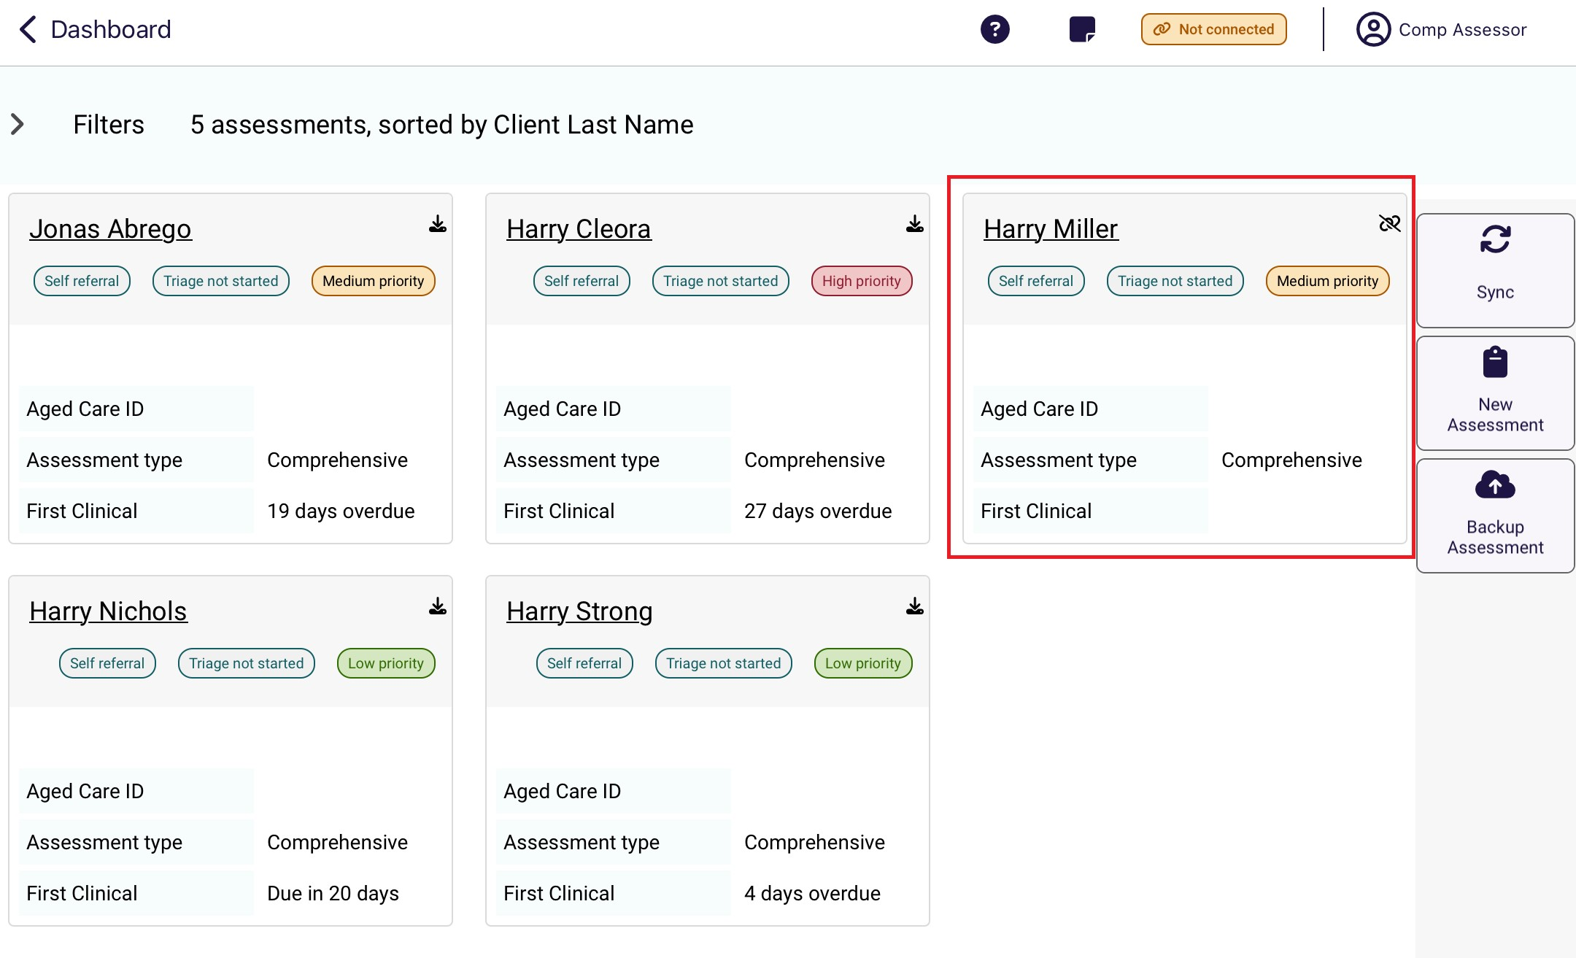
- Select More options, then Register Client at the pop up.
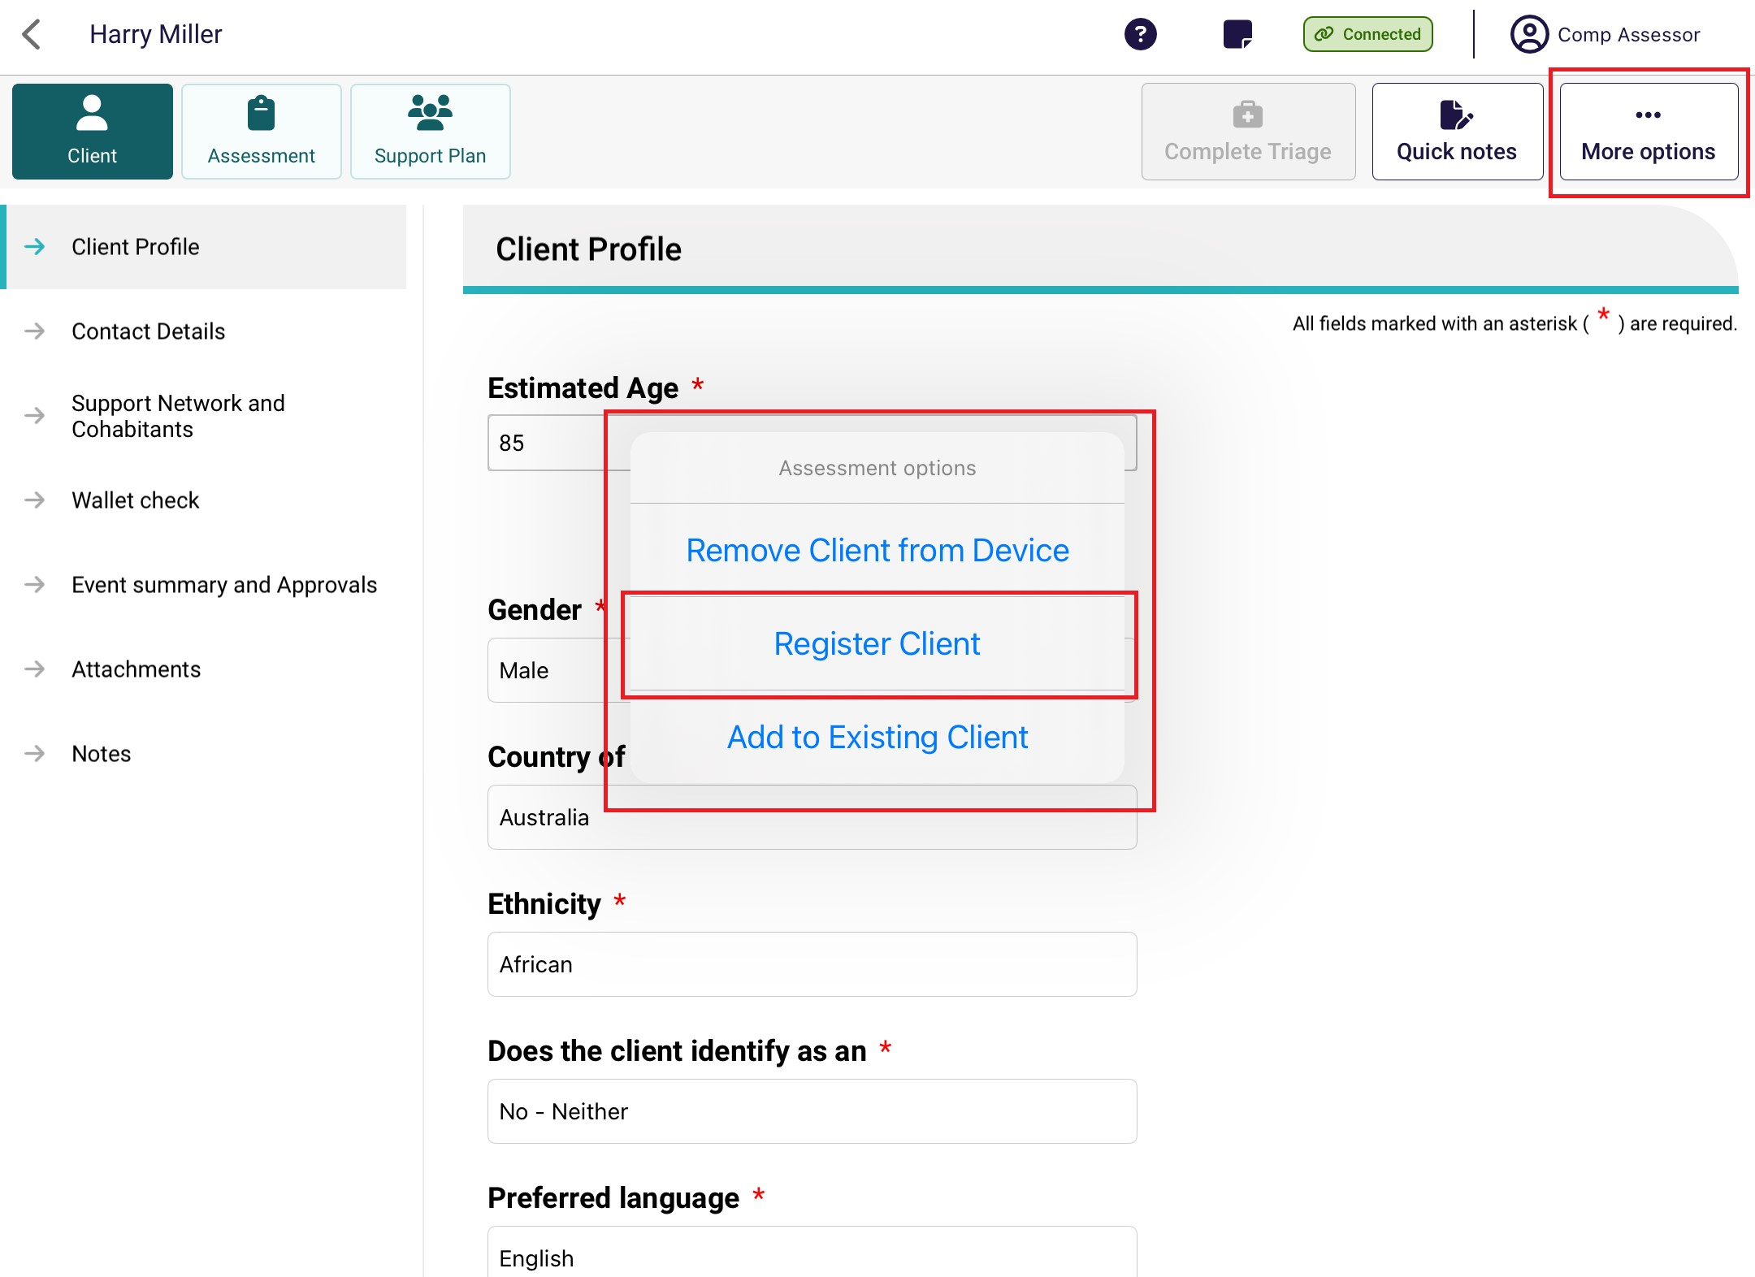
- The App will do a real-time check for any potential duplicates. Select View Potential Matches to view the possible matching client records.
If there are no matches, select Register and proceed to step 5.
! | If there are any potential duplicate matches found, you will be required to view these records prior to registering the new client to avoid creating a duplicate client record in My Aged Care.
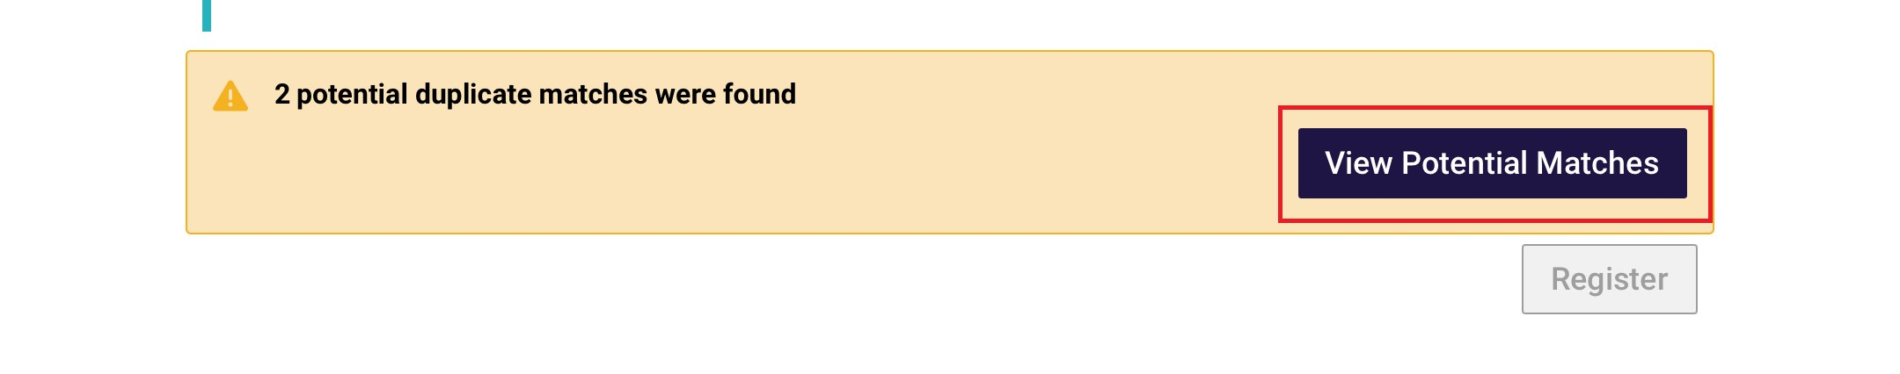
The list of potential duplicate matches will be displayed on the left side of the screen in list view. Select each record to see a visual comparison of client details against the client record being registered.
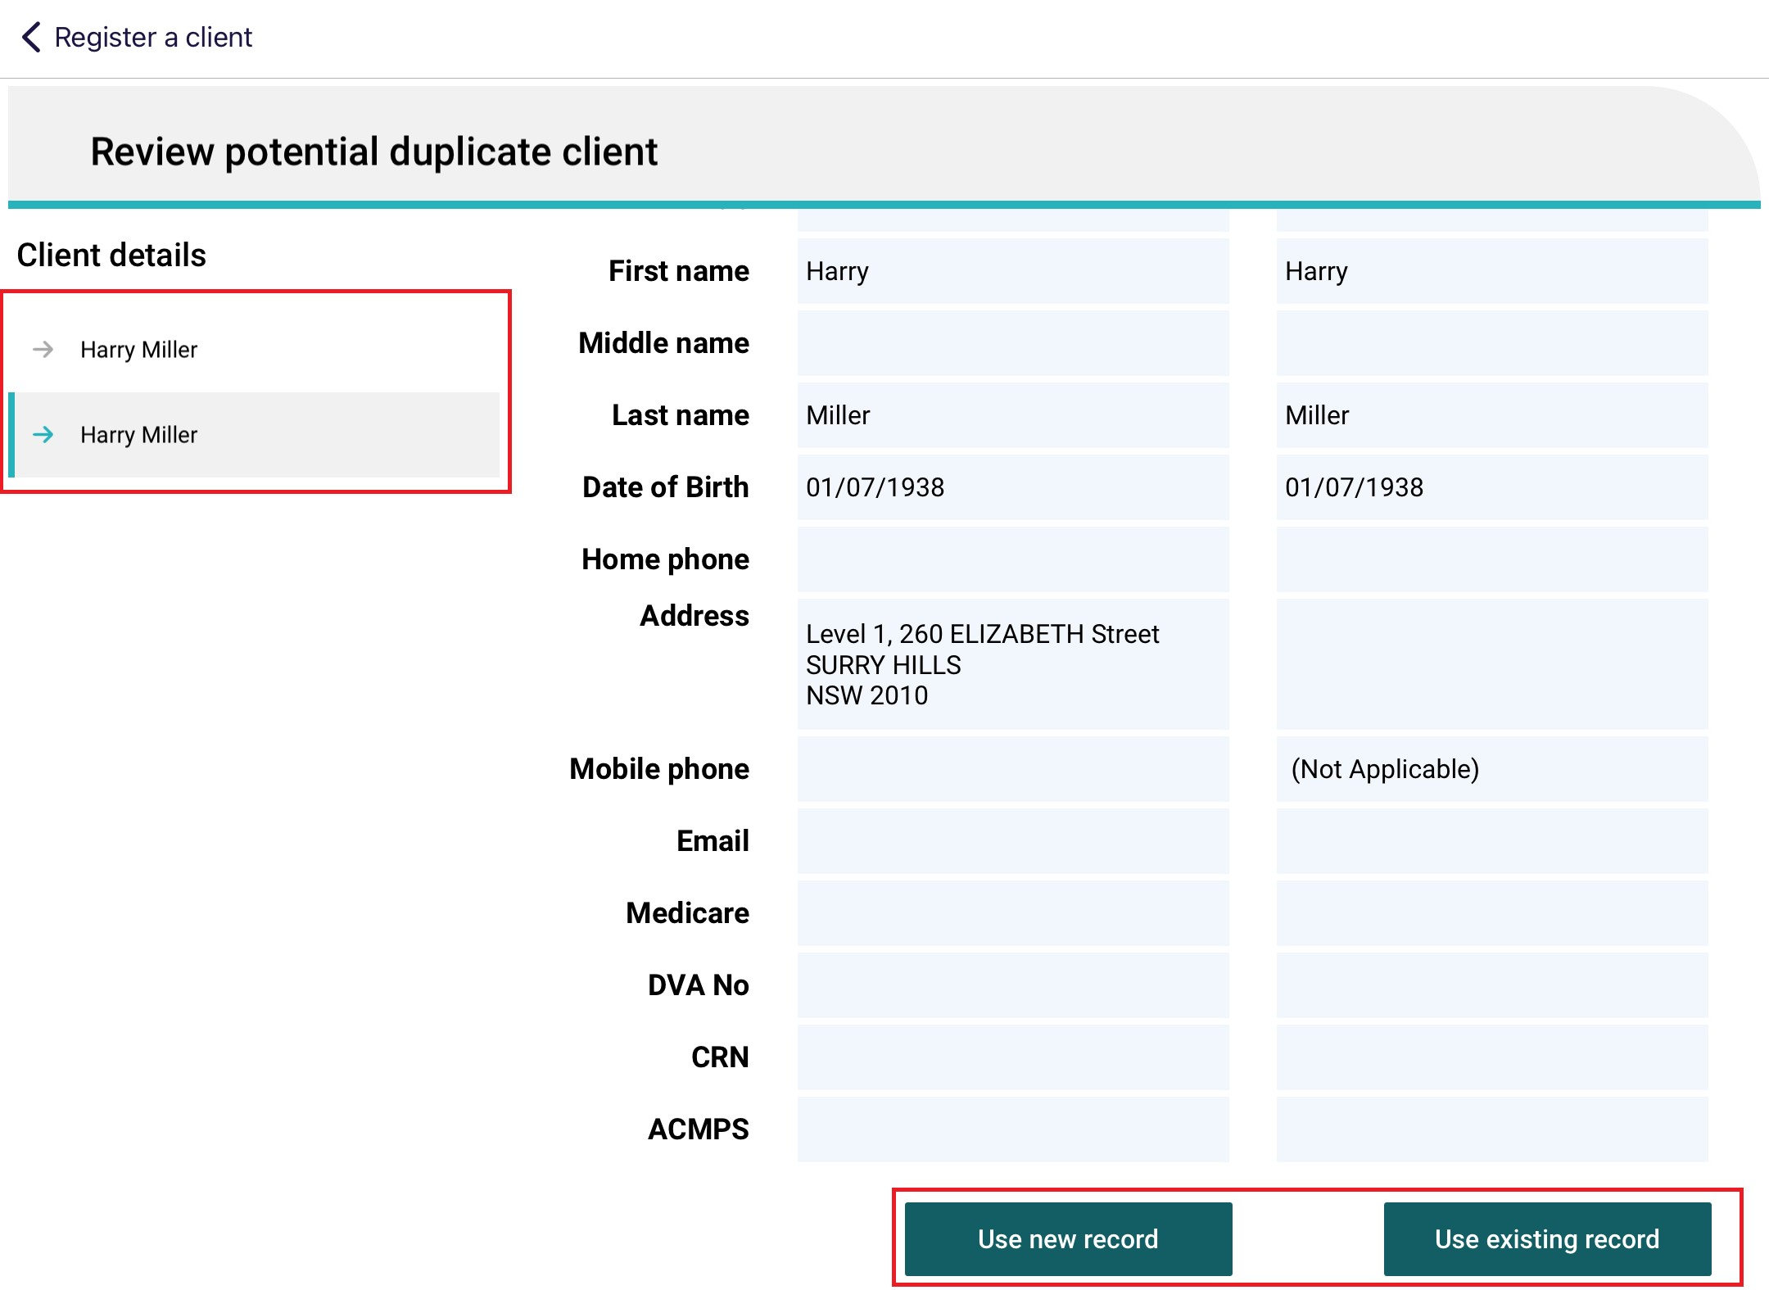
If none of the potential duplicate matches are the client you are registering, select Use new record to complete the registration process: you will need to indicate client consent to register prior.
If you wish to use the matching record, select Use existing record.
- Where any client demographic information conflicts between the two records being merged, you must select which information to retain before saving.
The Online record is the record that already exists in My Aged Care, and Captured offline is the offline client saved locally to your device.
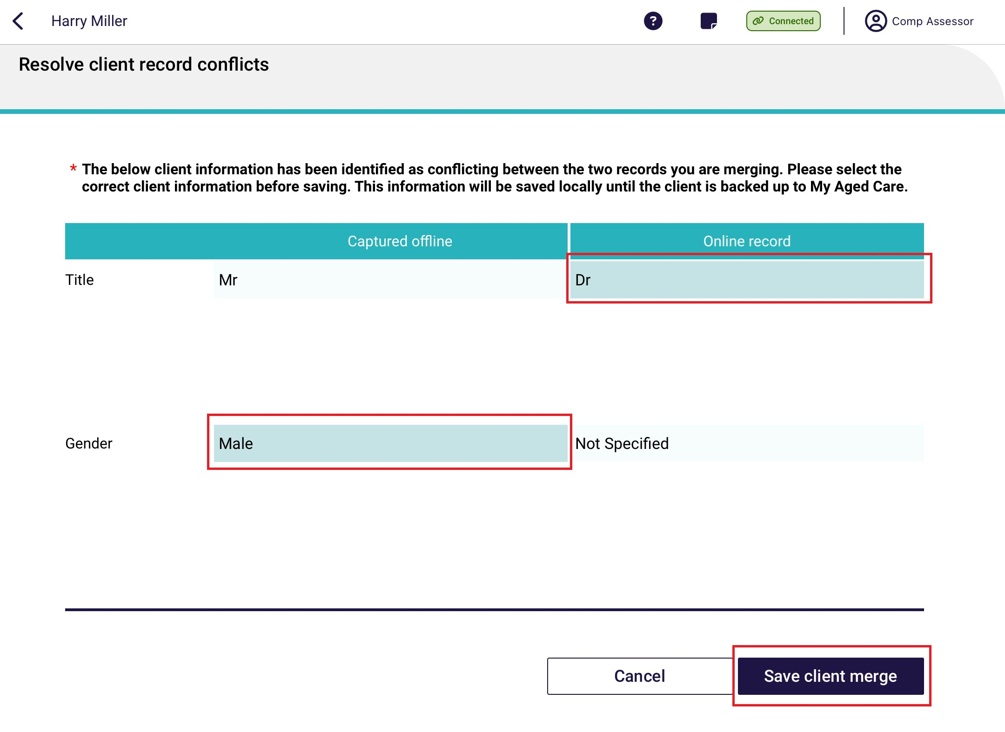
! | It is important to view any potential duplicate records prior to registering a new client to prevent the creation of duplicate client records in My Aged Care.
- Once the offline client has been successfully registered or linked to an existing record, the client details page will display.
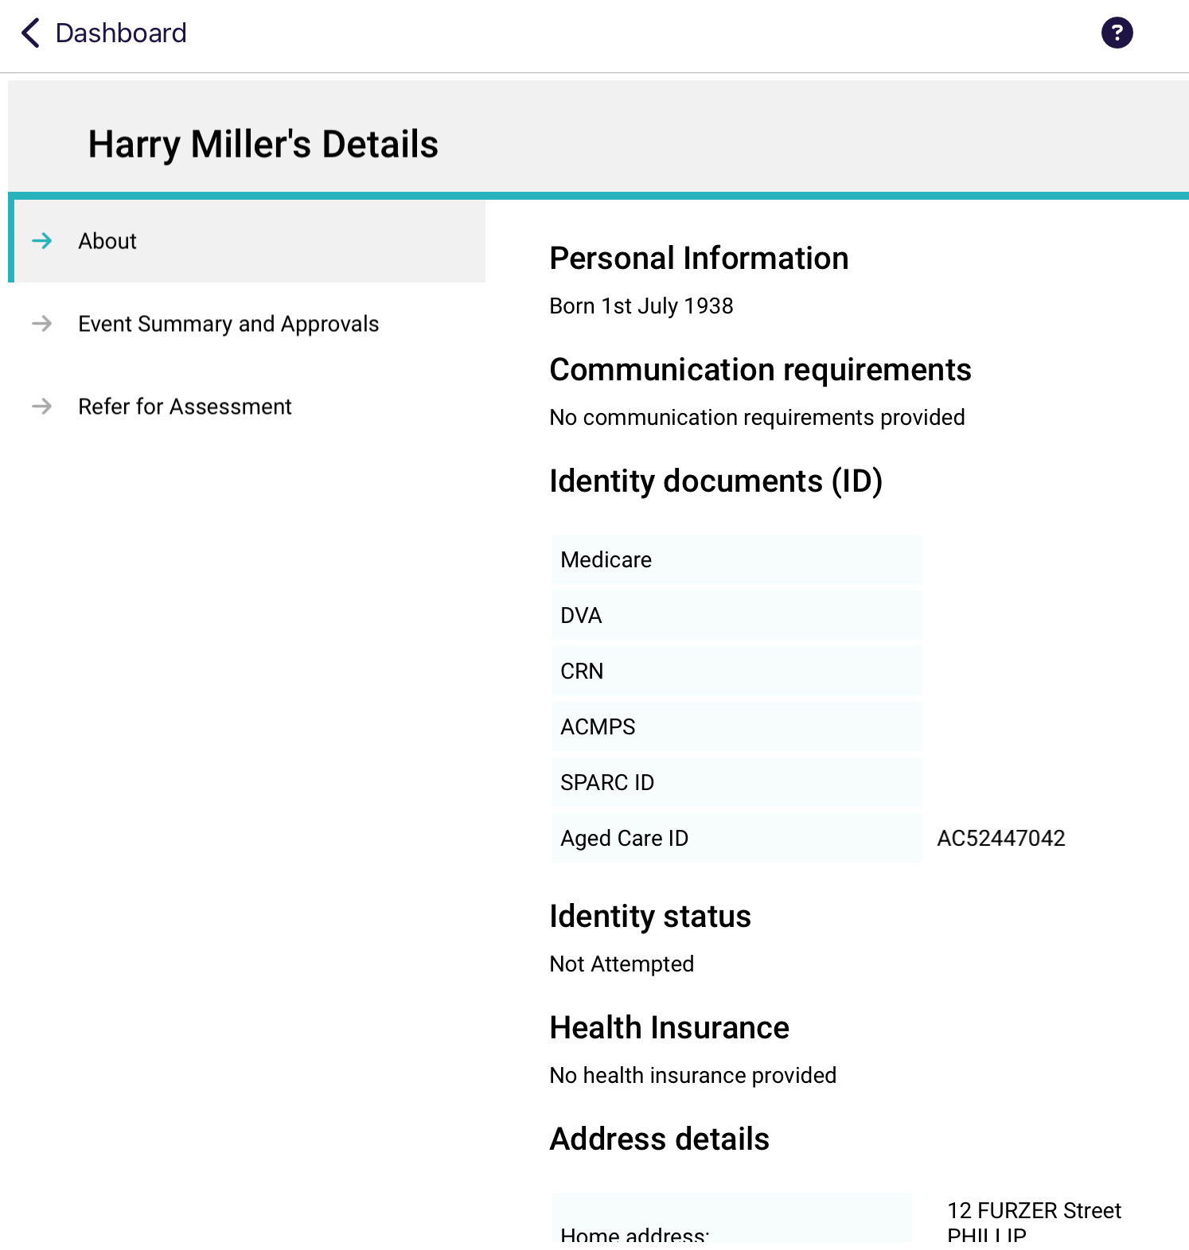
To upload the client to the assessor portal, you will need to link the client to a referral, by either self-referring clients for assessment to automatically link the client’s assessment information prior to uploading or facilitating a referral for assessment prior to linking to the registered client.

15.4 Linking offline clients and assessments
Before uploading the assessment, you will need to link the offline client (locally registered or saved) to an existing client in My Aged Care.
- In the Offline client’s assessment, select More Options, then select Add to Existing Client at the pop up that appears.
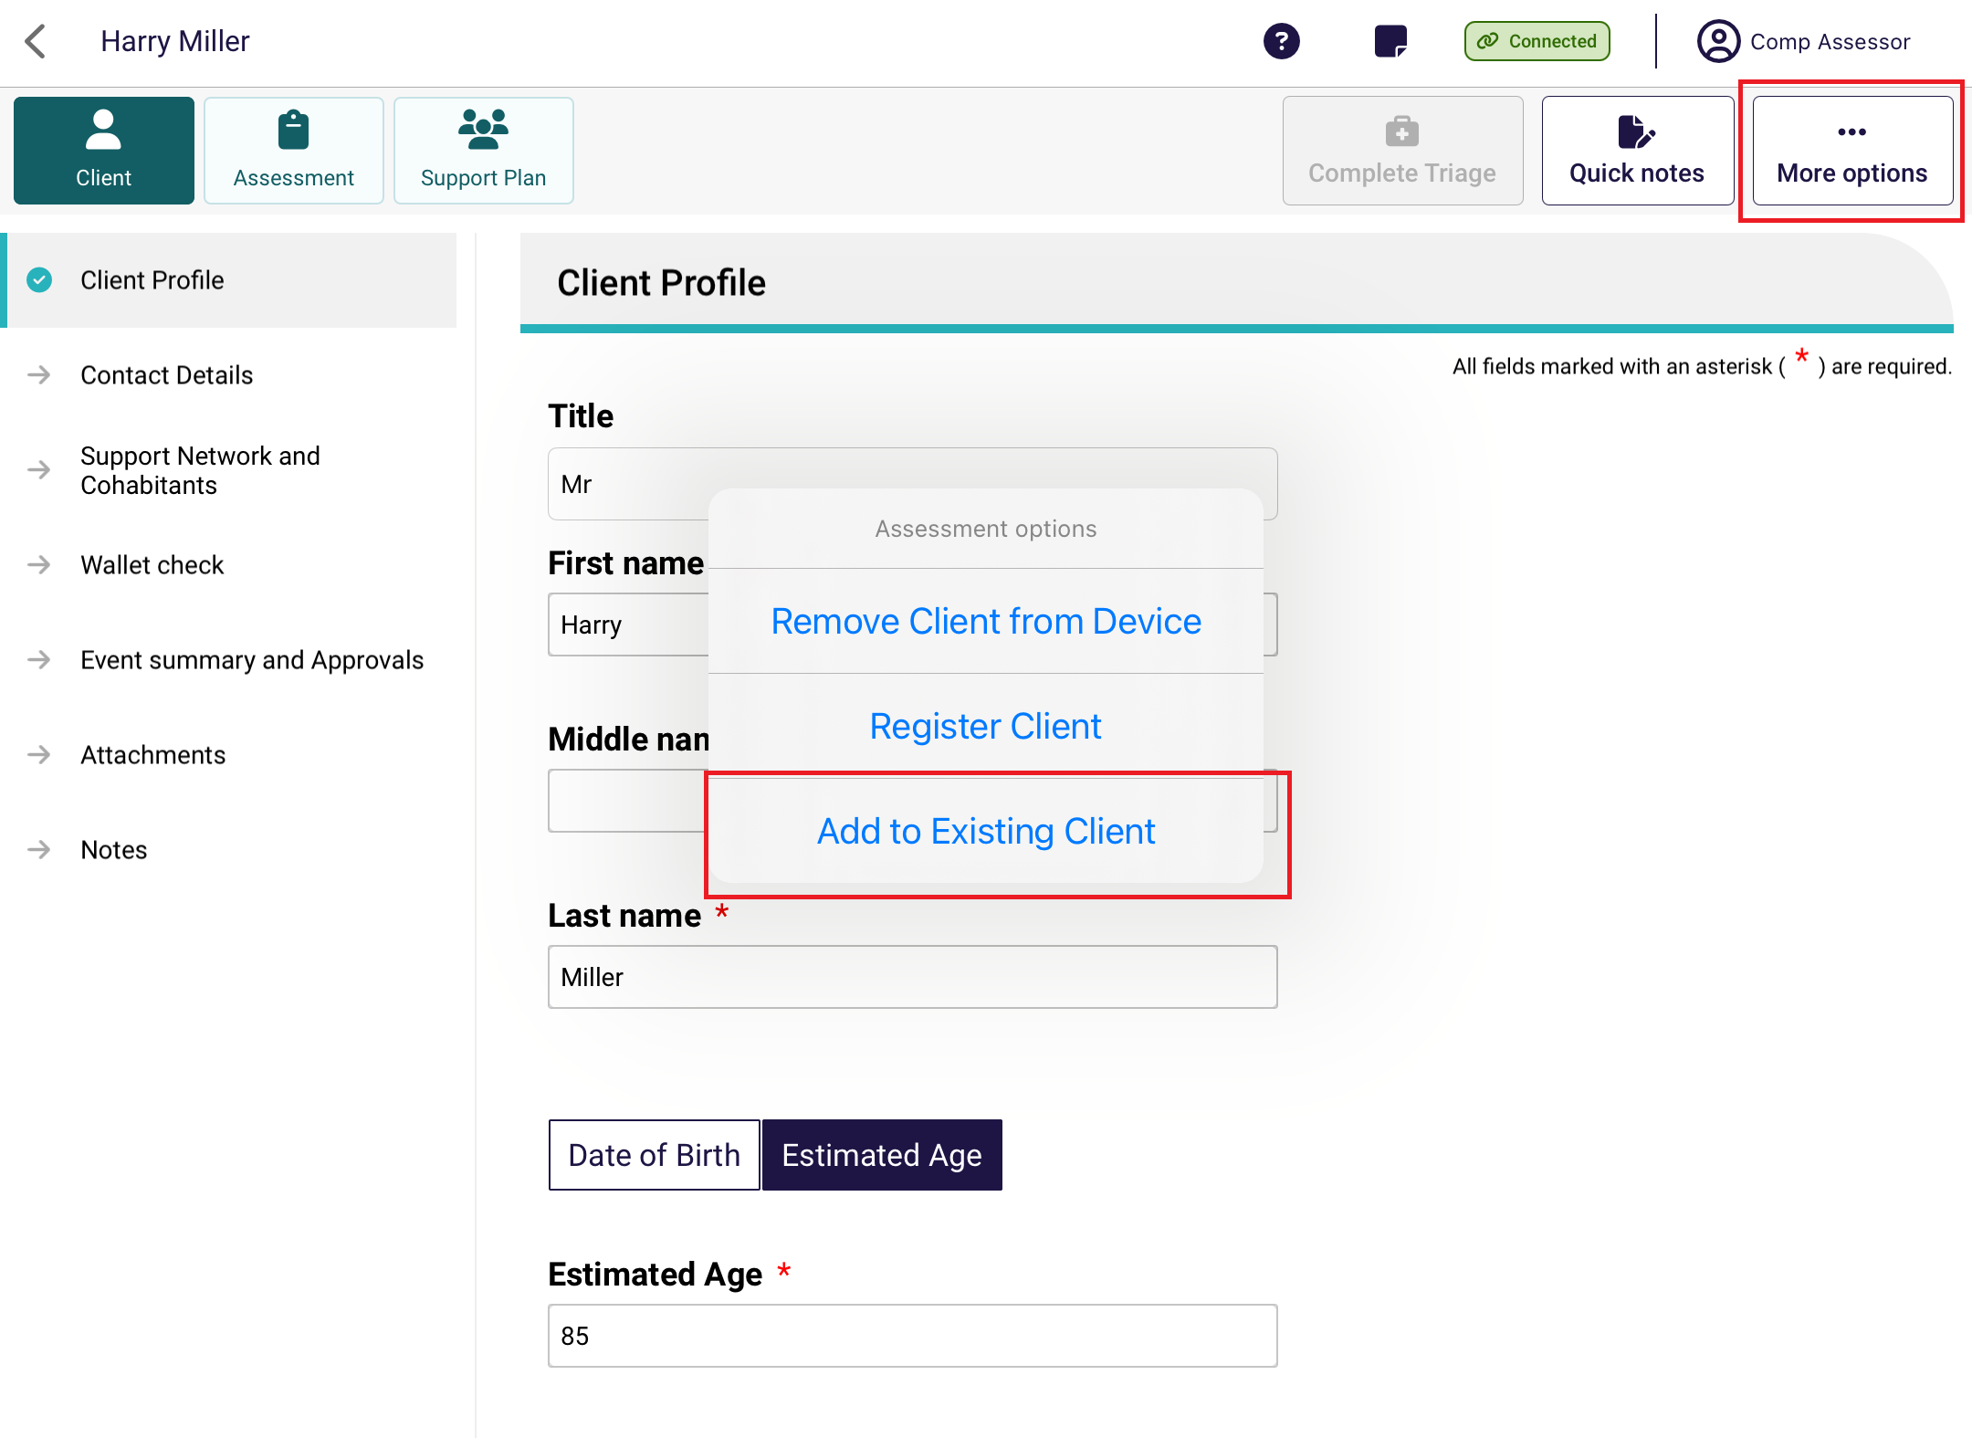
- You will be prompted to call 1800 836 799. Select Yes if you have:
- Already contacted the My Aged Care contact centre, and had a referral sent to your organisation and assigned to you, or
- Self-referred a client to your organisation.
! | Needs assessors can select Self refer if the reason for assessment is in-hospital, remote assessment, First Nations or homeless or at risk of, and there is no existing referral for the client downloaded to their device.  For all other referrals, needs assessors are advised to call the My Aged Care service provider and assessor helpline on 1800 836 799.
! | A person assigned the Team Leader role in the assessor portal will need to accept the referral and then a Triage Delegate can conduct triage or assign it to another Triage Delegate for triage. Once triage is completed and the assessment has been assigned to you then it will appear in your assessments queue in the assessor portal.
- A list of existing clients that you can transfer the assessment information will appear. Select the name of the client, then select Continue.
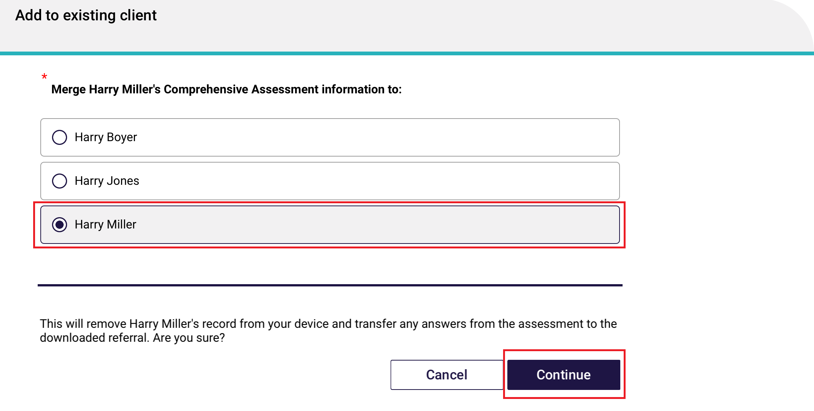
The assessment information collected about the offline client will now be transferred to the existing client, and the assessment can be uploaded to the My Aged Care assessor portal, following the process in Uploading assessment and support plan information for downloaded assessments.

Conducting Support Plan Reviews
Needs assessors can use the App to:
- conduct Support Plan Reviews for clients’ reviews they have downloaded
- conduct a Support Plan Review for a client they have previously assessed.
The steps to undertake a review on the App are as follows.
! | To conduct a Support Plan Review (SPR), you must have the client assigned to you in the Assessor Portal before completing the SPR in the App.

Downloading a Support Plan Review
- Open the App and navigate to the main dashboard. Search for the client using filters or sort function.
If all clients’ details are synchronised and downloaded from the Assessor portal, go to Completing a support plan review.
- If the client’s details are yet to be downloaded from the Assessor Portal, there will be a Download icon at the client card. Click on the client card to download the Support Plan Review.
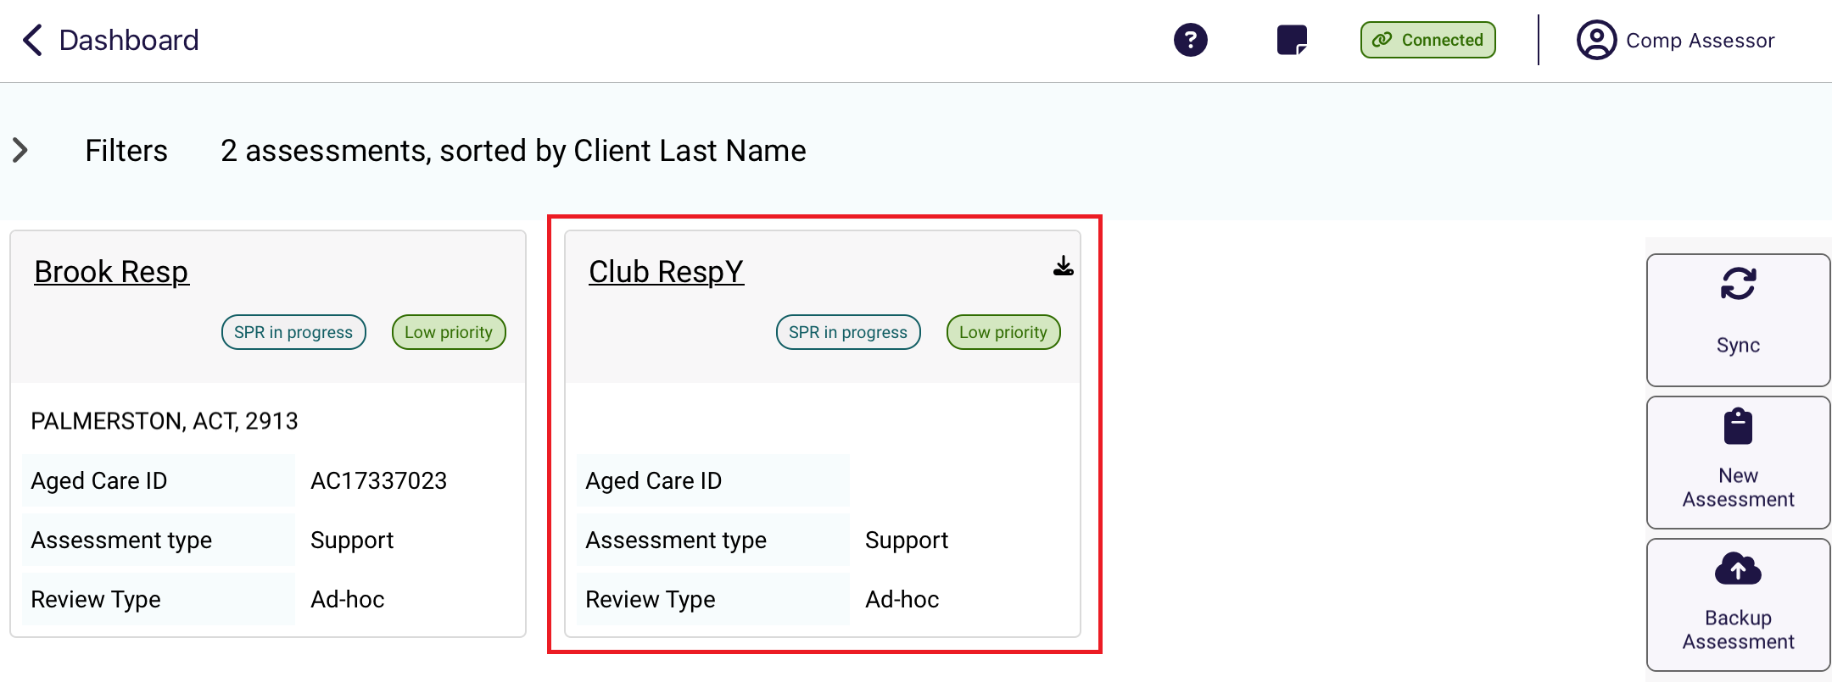
- The client tile will show the download in progress.
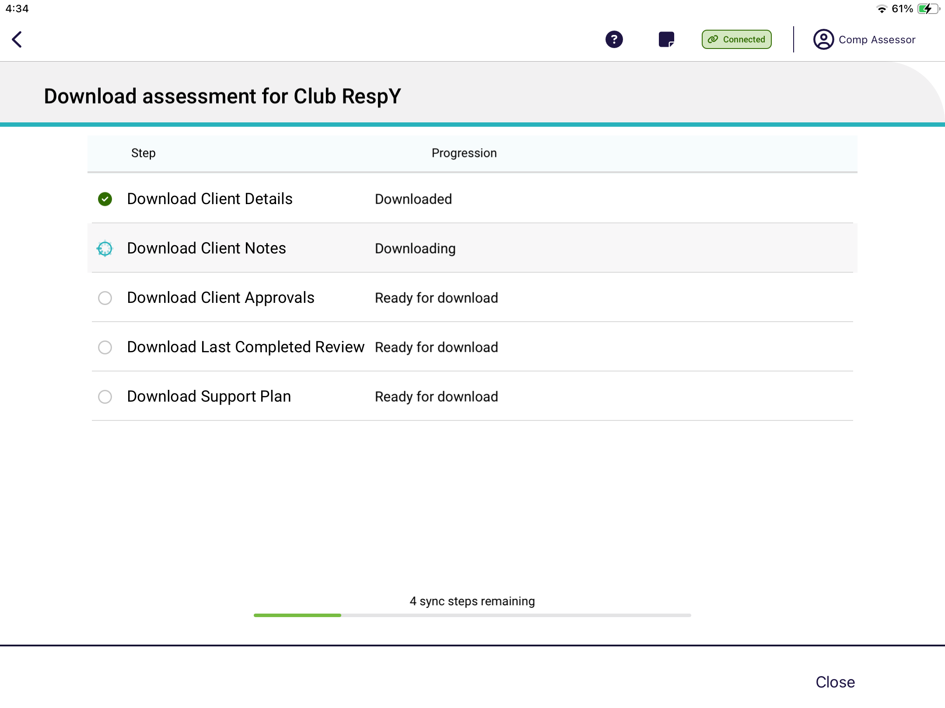
This is the page that shows the download progress of the Support Plan in detail. Select Close to return to the Dashboard.
- Once downloading is finished, you will be able to click Open assessment to continue or return to the dashboard.
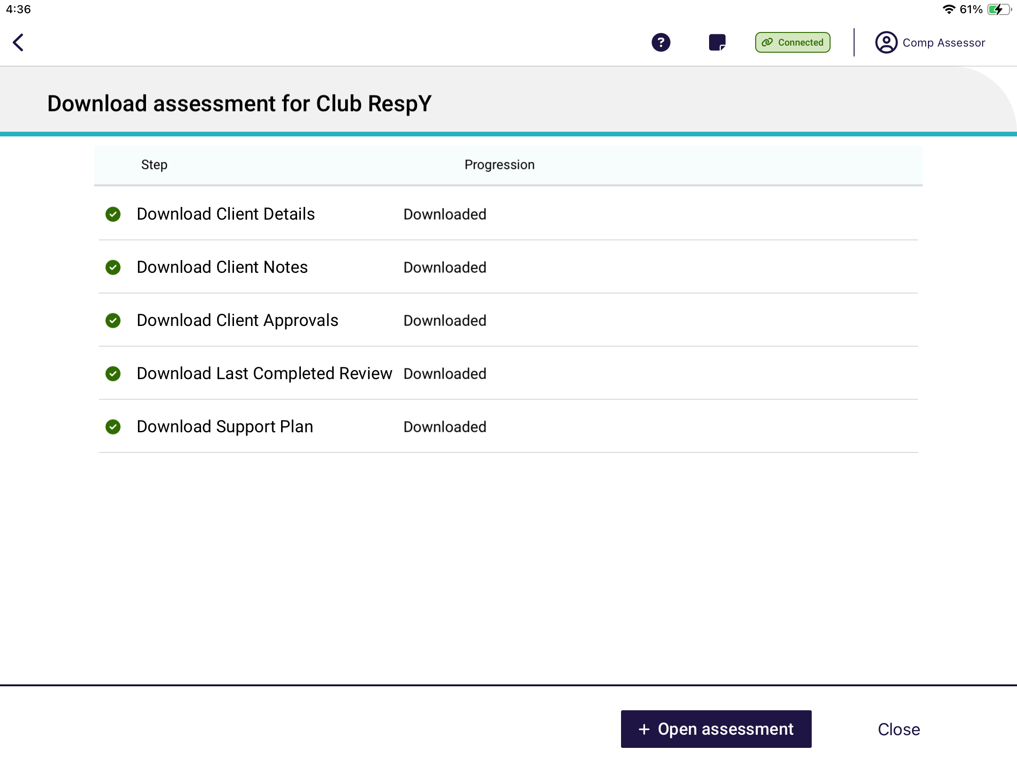

16.2 Completing a Support Plan Review
- Select the client’s card from the Dashboard.
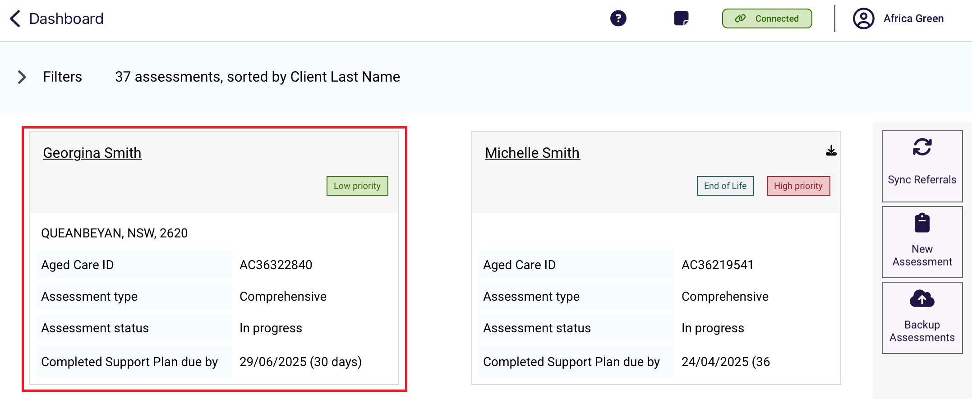
- Select the ‘Support Plan’ button.
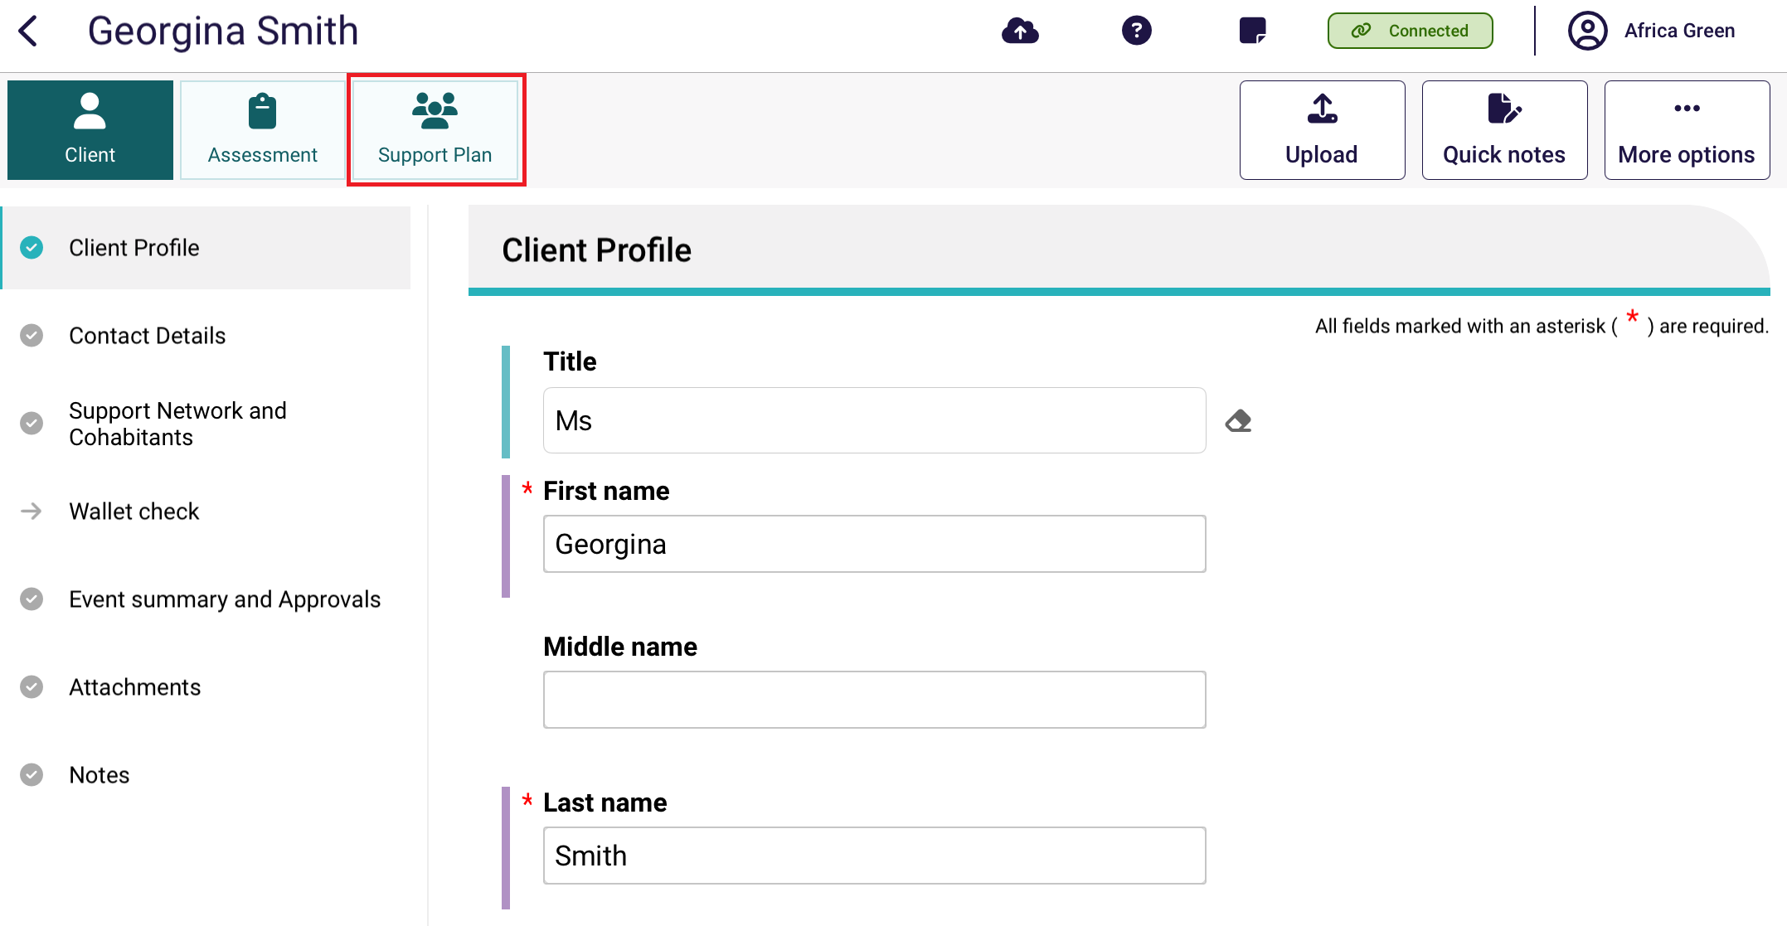
- The Support Plan Review page will display.
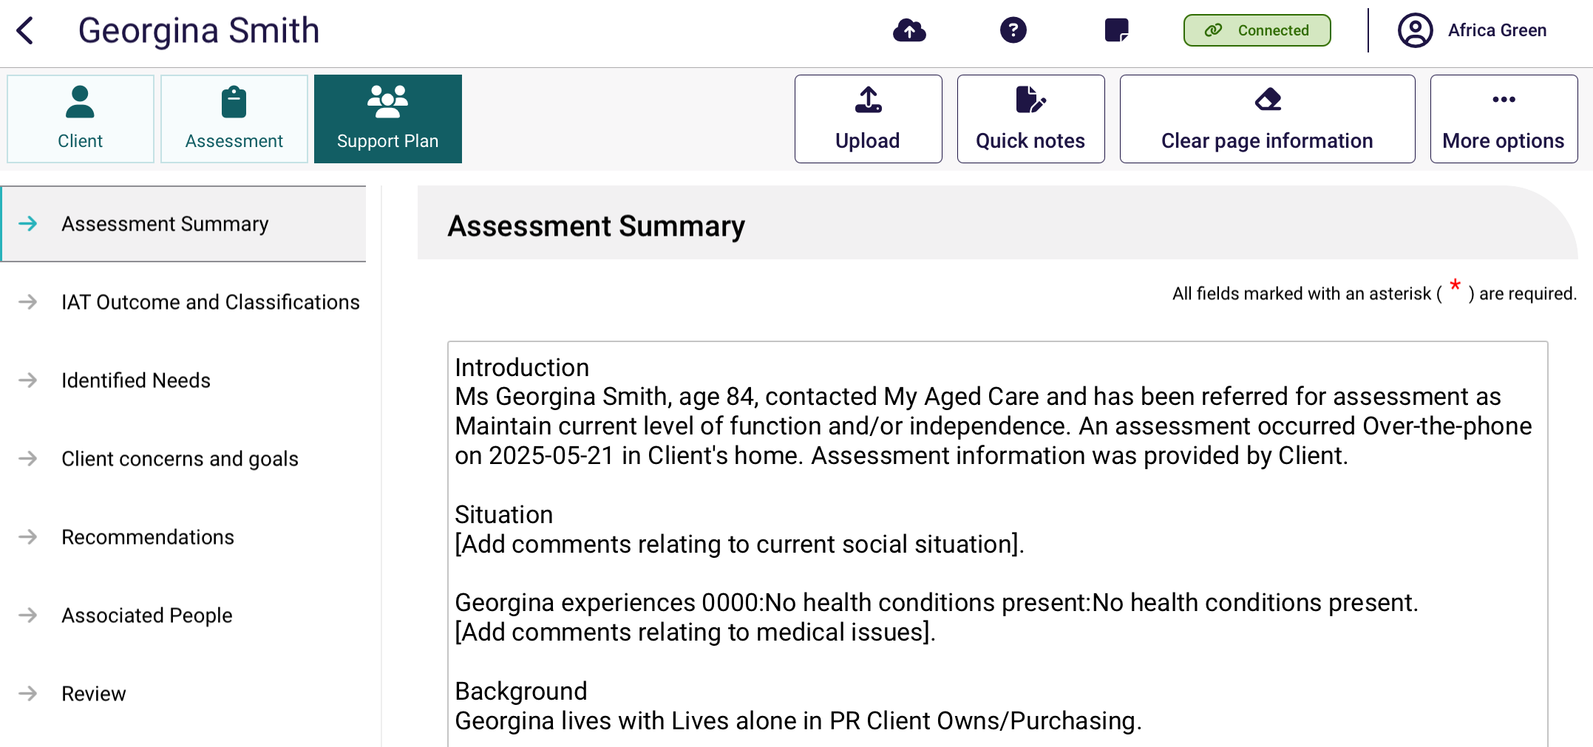
Before starting the review, you can view the client’s support plan and review history (if applicable) by navigating to the History page.
In the History page, you can see details of the client’s Last Completed Review. The support plan review request and outcome details will be displayed only if the client has previously had a review completed.
You can also start the review from the History page.
You can also view the client’s:
- last completed review
- assessment summary
- identified needs
- client concerns and goals
- recommendations.
- As well as viewing this information, you can schedule a future support plan review in the Support Plan tab.
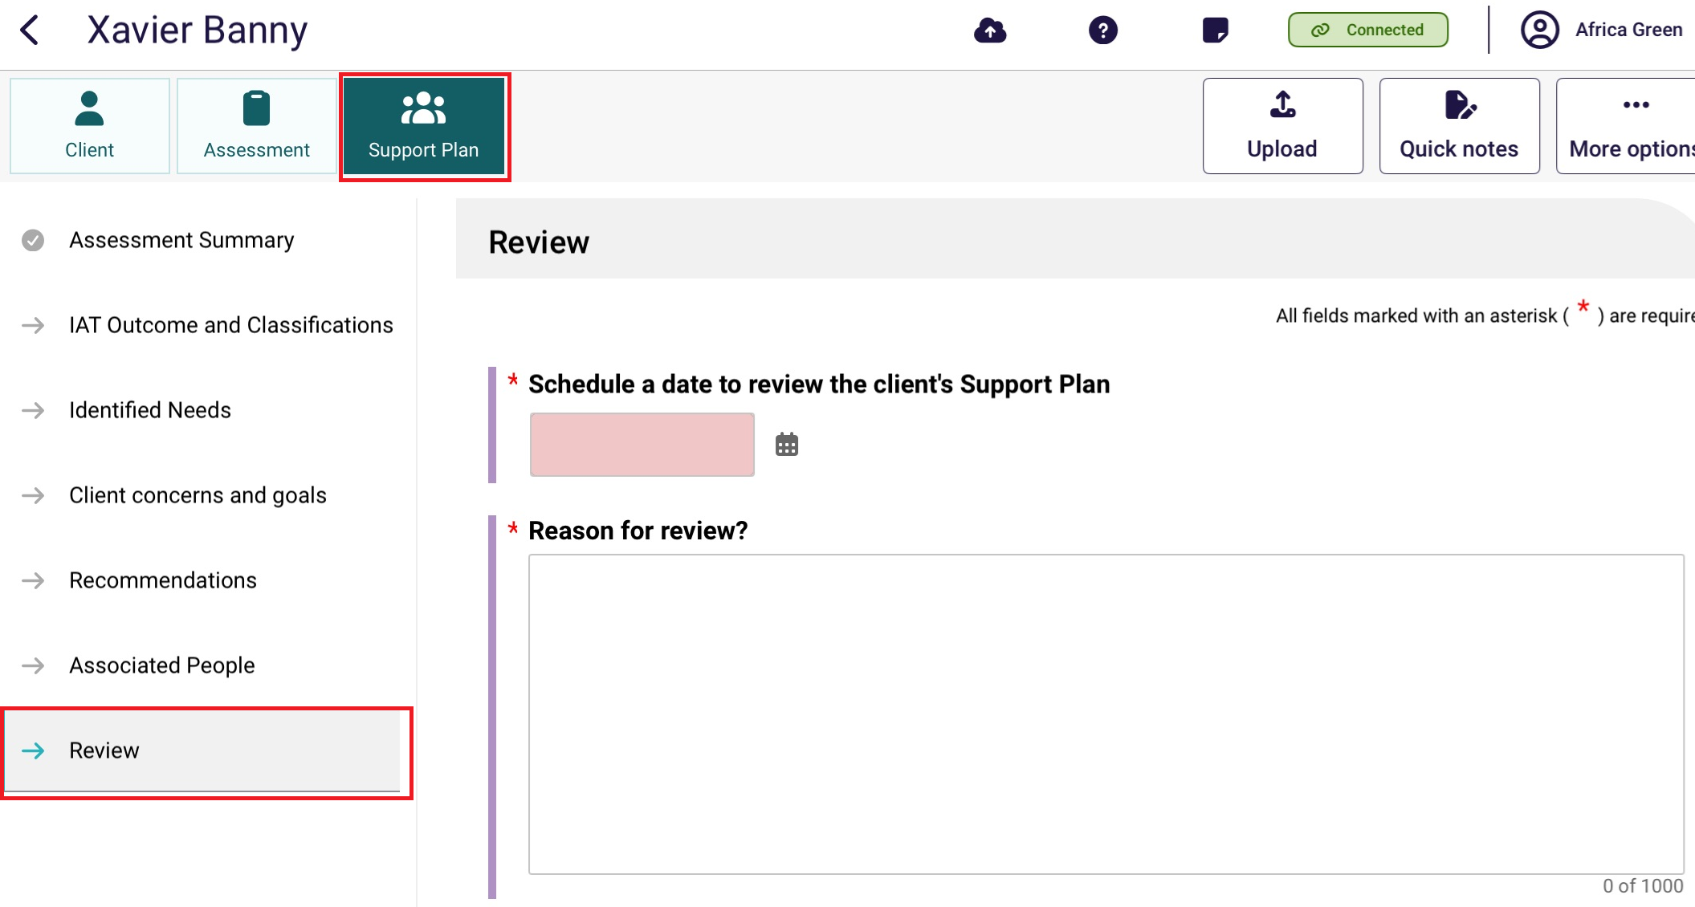
- Navigate to each of the pages in the support plan to start the review. Once selected, the review will load which will allow you to edit the client’s support plan.
! | During the Support Plan Review, needs assessors can add general and service recommendations, Long-Term Living arrangement, and Periods of Reablement and Linking Support.  Assessors can recommend a second Restorative care record to a Support At Home Restorative Care Pathway. The second unit is subject to the number of available RCP places for any given financial quarter. For more information refer to Support at Home program manual – A guide for registered providers.
Once the support plan is edited, the Recommendations section will display all recommendations made during the Support Plan edit. This means that any new recommended aged care records linked to the displayed classification (Support at Home, or End-Of-Life) will appear instead of the originally approved aged care records.
! | During the Support Plan Review, if the client’s recommendation is a Support at Home classification or a Transitioned Support at Home classification, assessors can reset (override) the classification to Support At Home End-Of-Life Pathway. This will need to be done after End-of-life documents are verified, and before submitting the Support Plan Review.  Conversely assessors can also override a End-Of-Life Pathway recommendation to a Transitioned Support at Home classification.
- Once the review is complete and all sections have been updated, you can upload the review, similar to uploading assessments and support plan information.

Completing the match and refer process and finalising the assessment or completing the review
To complete the support plan and Support Plan Review, refer to the My Aged Care – Assessor Portal User Guide 7 – Completing a support plan and support plan review
Or to complete the match and refer process and finalise the assessment, refer to the My Aged Care – Assessor Portal User Guide 8 – Referring for services
! | If you have undertaken an assessment using the App, you will need to contact the client to develop the client’s support plan, confirm their referral preferences and obtain their consent to send referrals for service.

Removing assessments and reviews from the device
You may choose to remove client details from your device to increase storage space and allow for easier navigation from the App Dashboard. To manually remove client details from the device, follow the steps below.
! | Removing a client record from the device will permanently delete any assessment or review information recorded on that device and that has not been uploaded to the assessor portal.
- Open the App. The dashboard page will be displayed, select your outlet that contains the client’s assessment. Once in the outlet, search and select the client card.
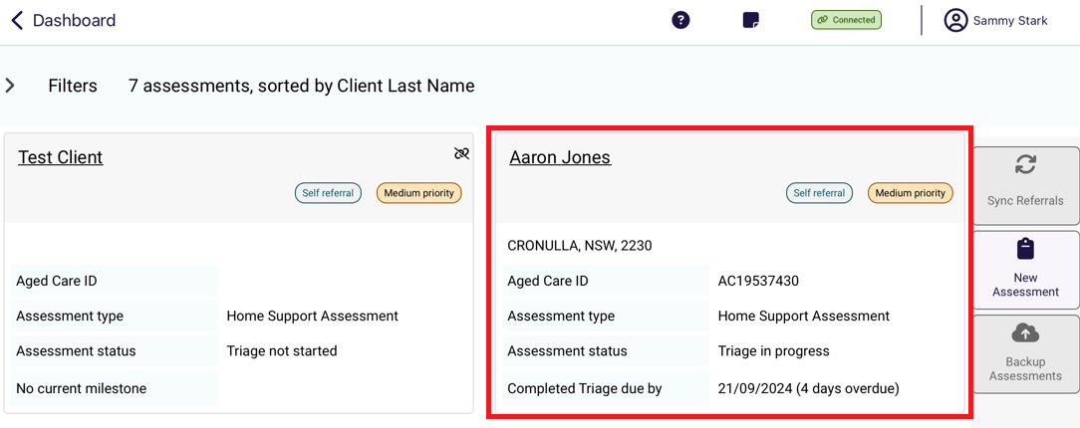
- From any page in the client’s record, you can remove the record from the device by selecting More options and then Remove Client from Device from the pop up.
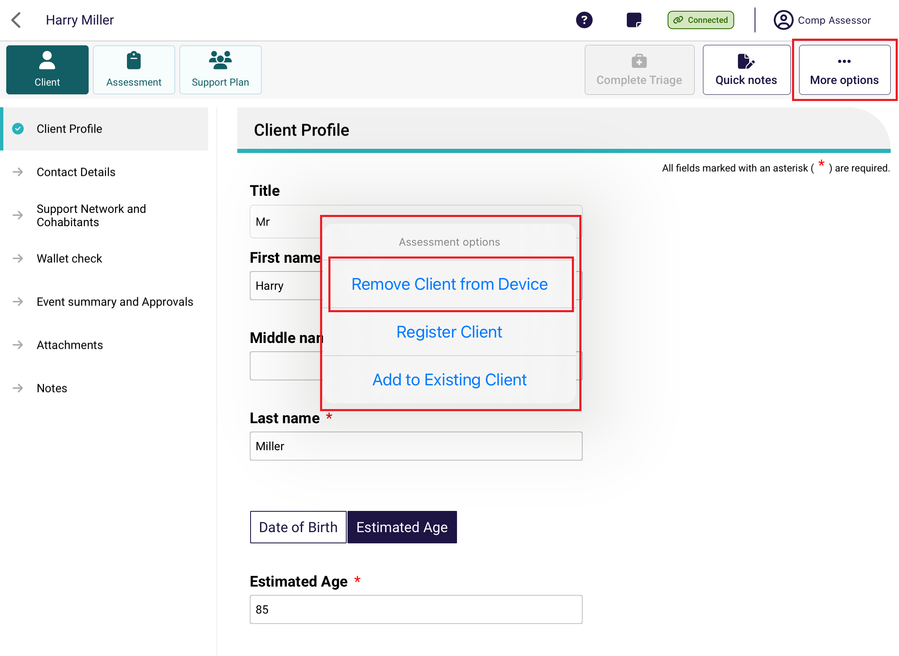
Select Remove Assessment to remove the record.
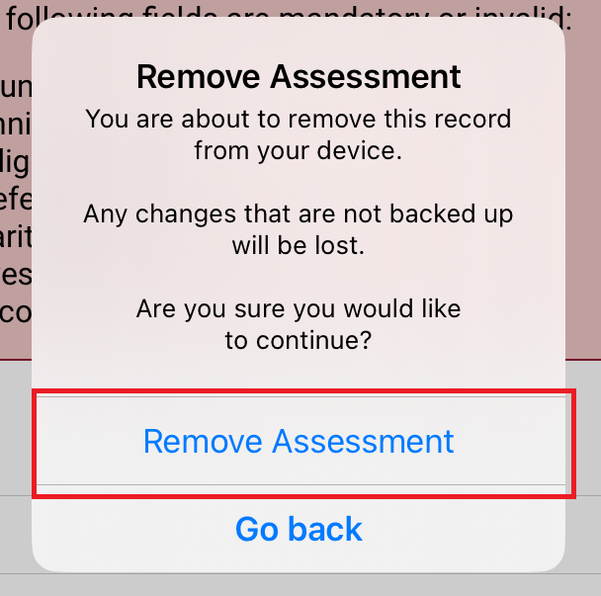
! | Clients with uploaded assessments will still appear in the app when you select Refresh until you complete the client’s support plan in the assessor portal.

Completing a Residential Respite Classification Assessment
! | Unlike Support Plan Reviews and Comprehensive assessments, Residential Respite Assessments can only be completed from the App. If you are using a PC or Laptop to complete the assessment, a Windows compatible (sideloaded) version of the App is available.
Residential Respite Assessments are an assessment of the care recipient’s mobility utilising the Modified de Morton Mobility Index (DEMMI-modified). Respite Classifications are used to determine the level of subsidy Residential Service Facilities will receive for the care of Respite clients under the Australian National Aged Care Classification (AN-ACC) funding model.
There are 12 tasks in DEMMI-modified, select one rating only for each of the twelve tasks that best matches the resident’s capabilities.
The DEMMI-modified is an instrument that measures the mobility of older people across clinical settings. It is preferably based on direct observation of the resident. However, it is not appropriate to ask a resident to complete tasks if there is a falls risk or risk of causing distress to the resident. The clinical needs assessor should use their clinical judgement to evaluate if the DEMMI-modified can be undertaken and at what point the assessment should cease.
The four DEMMI domains are:
• bed mobility
• chair
• static balance (no gait aid)
• walking.
Only clinical needs assessors who have completed training in DEMMI-modified based respite assessments under the AN-ACC funding model can assess clients using the DEMMI-modified.
For information on the DEMMI–modified tool, refer to the AN-ACC Reference Manual.
To complete the DEMMI–modified in the App first an assessment must be downloaded to the App. Refer to Self-Refer a Care Recipient for a Residential Respite Assessment or Complete an assigned Residential Respite Assessment Referral for guidance.
Clinical needs assessors can use the App to:
- conduct a Residential Respite Classification Assessment they have downloaded
- self-refer Residential Respite Classification Assessments
- reject Residential Respite Classification Assessments.

19.1 Refer for a Residential Respite Assessment
! | Unlike Support Plan Reviews and Comprehensive assessments, Residential Respite Assessments can only be completed from the App. If you are using a PC or Laptop to complete the assessment, a Windows compatible (sideloaded) version of the App is available.
- Open and log in to the App. Select Find A Client from the dashboard. You can follow the steps set out in the section Finding a client.
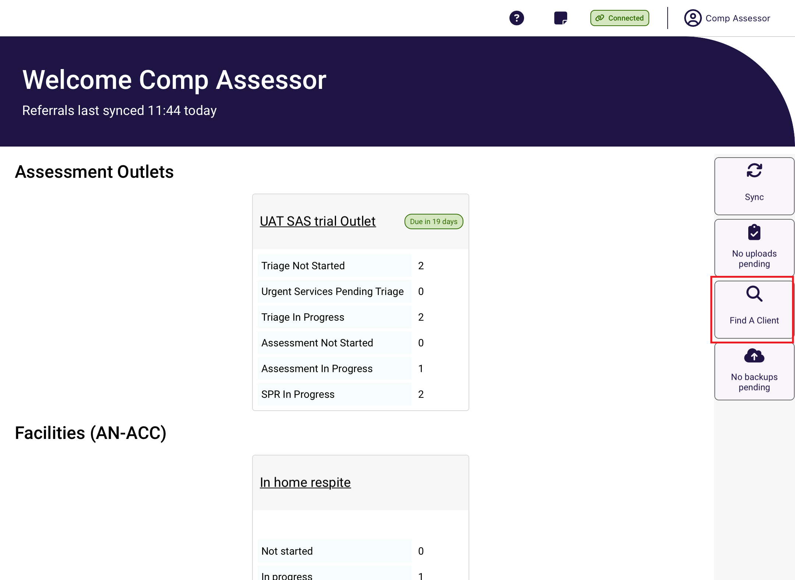
- Search and open the client’s record.
Once you are in the client’s record, confirm that the personal details are correct. Then, select Event Summary and Approvals and ensure that the client has a current Residential respite care approval.
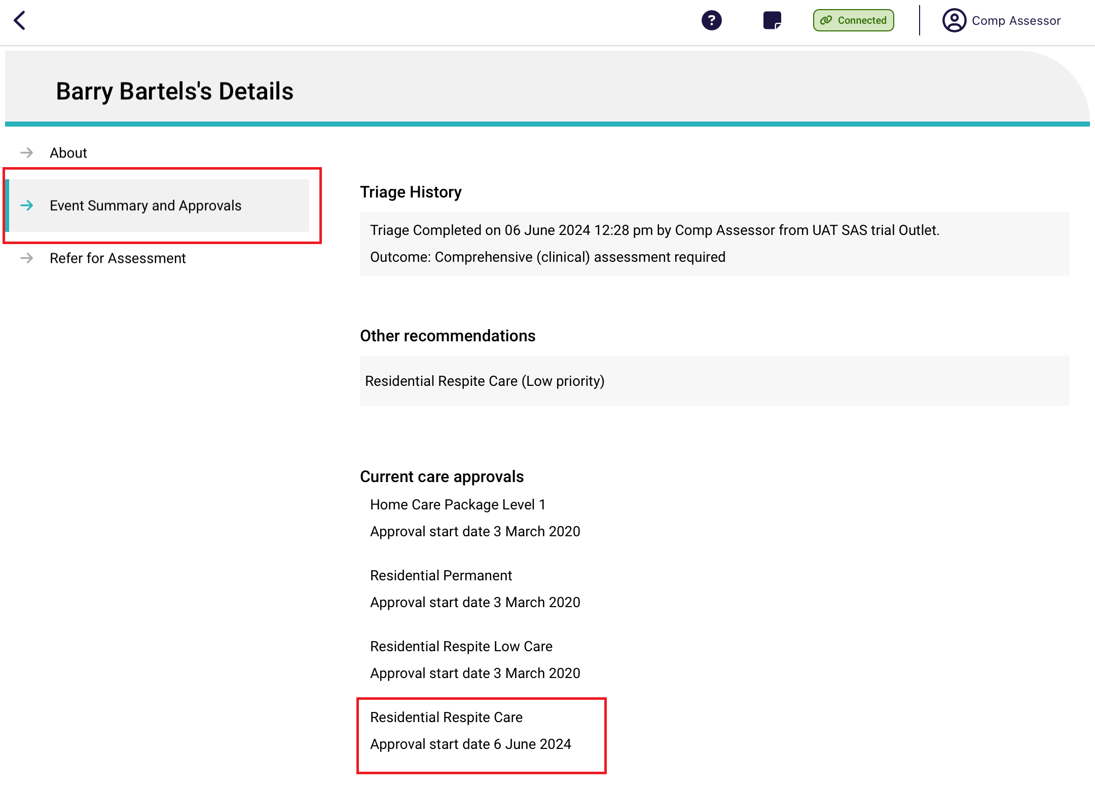

- Go to the Refer for Assessment tab, and select the type Residential Respite Assessment.
Input an Assessment date, ensure the assessment date is the date that you conducted the assessment. The Assessment date may impact the effective date of the classification that is generated and subsidy paid to the provider.
Confirm the correct Assessment Setting is selected and once the details are correct and click Create Referral.
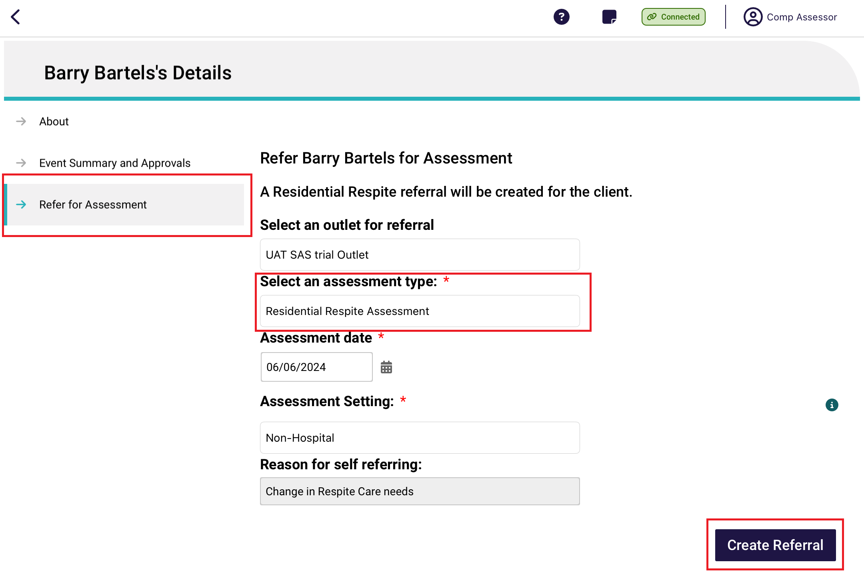
A confirmation screen appears, confirming that the referral was created successfully. Click the Go Back button to return to the Dashboard to the downloaded client that you have self-referred.
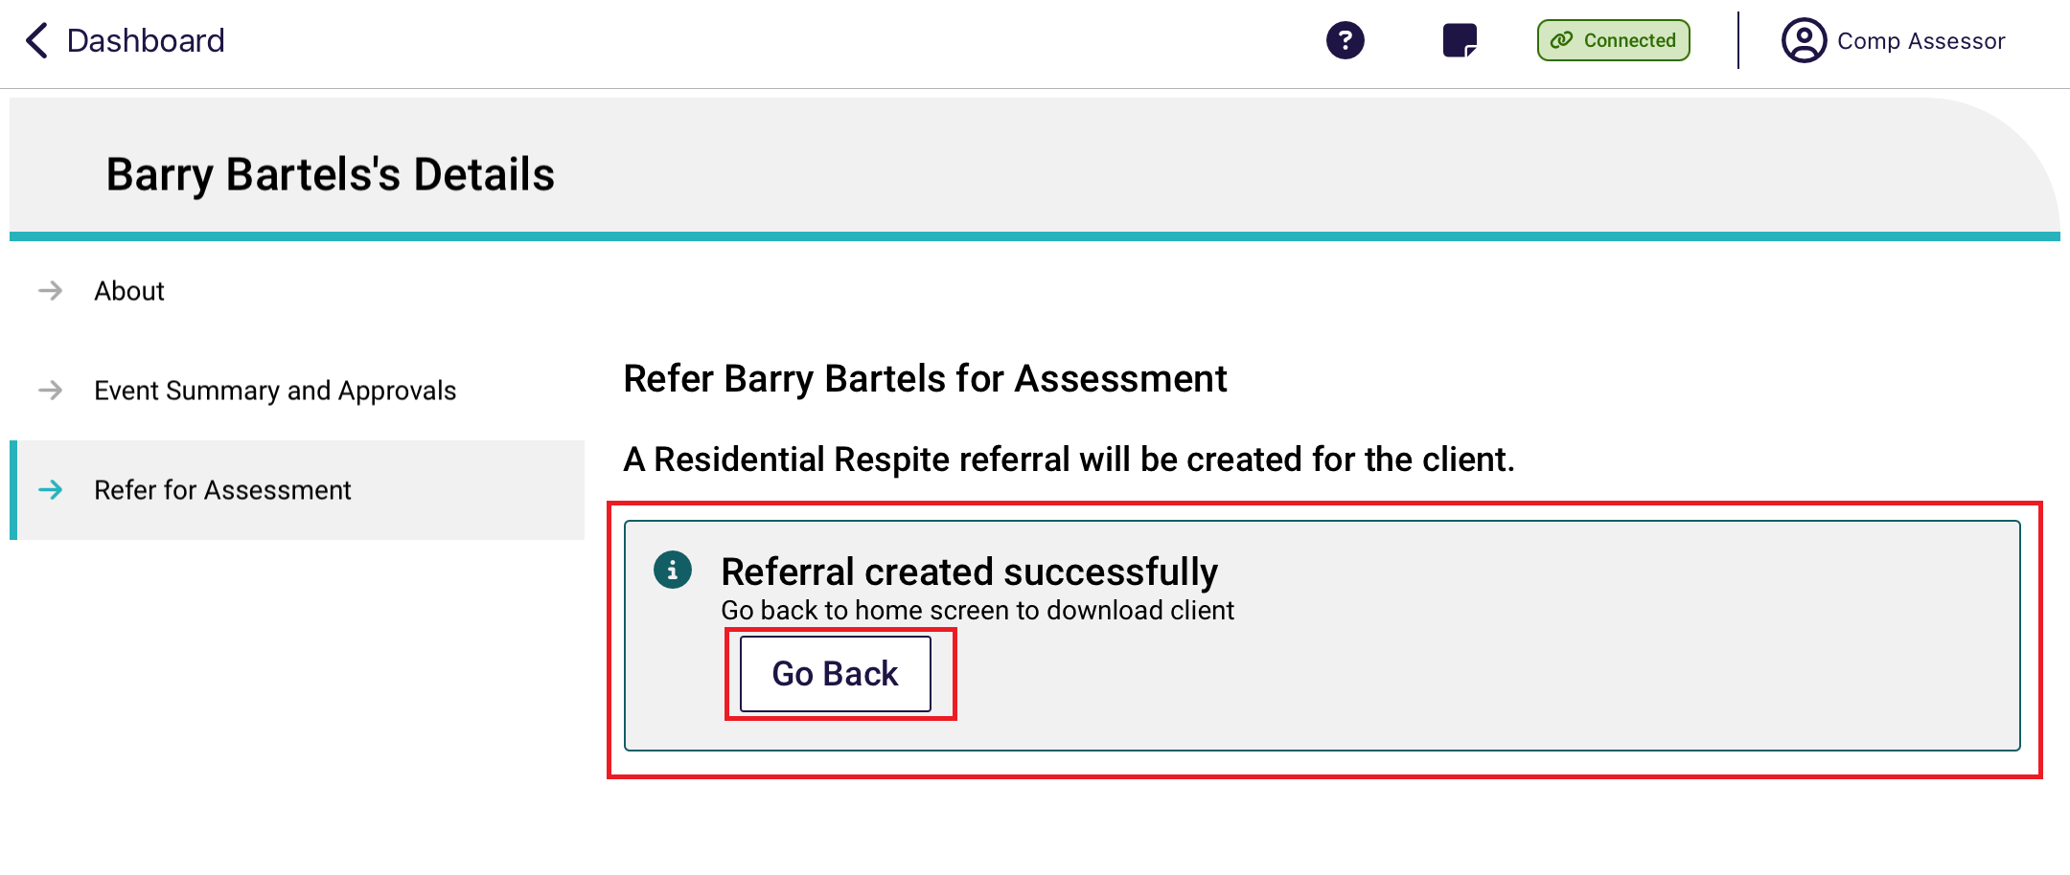
Refer to Starting an assigned Residential Respite Assessment Referral on how to complete the DEMMI-modified.

19.2 Starting an assigned Residential Respite Assessment Referral
Residential Respite Assessments that have been assigned to you by your Team Leader will automatically appear on your App. To access your assigned Residential Respite Assessments, navigate to the Dashboard and click on your outlet.
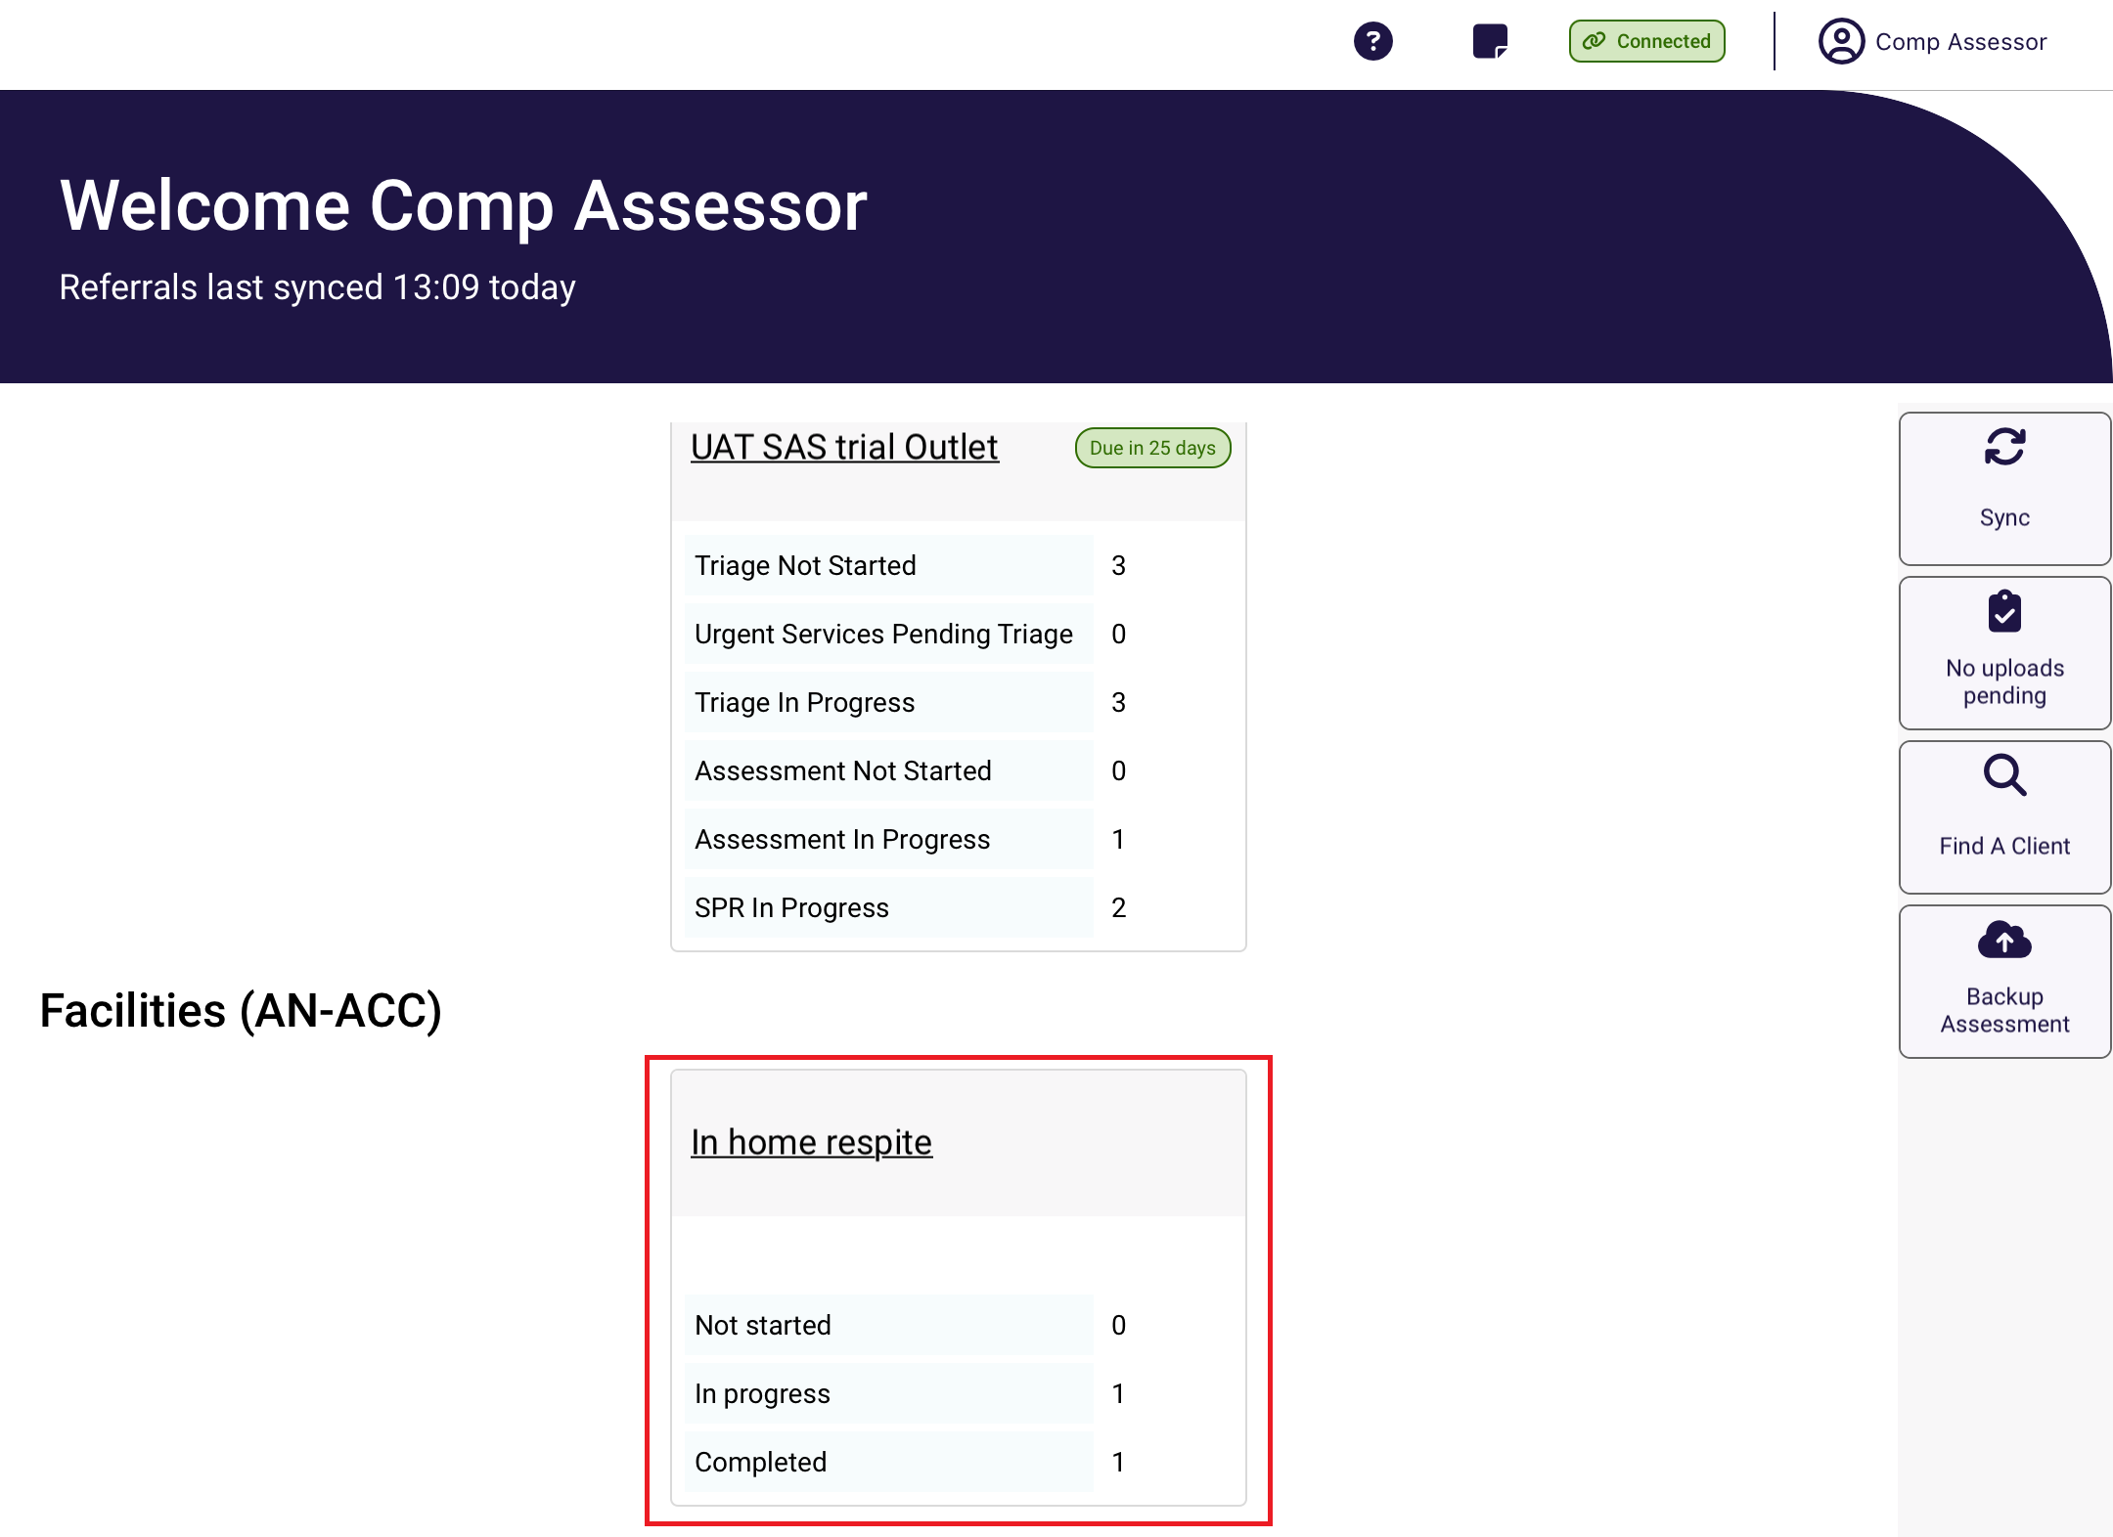
To complete the assessment, click on the client’s card to download the assessment to your device.
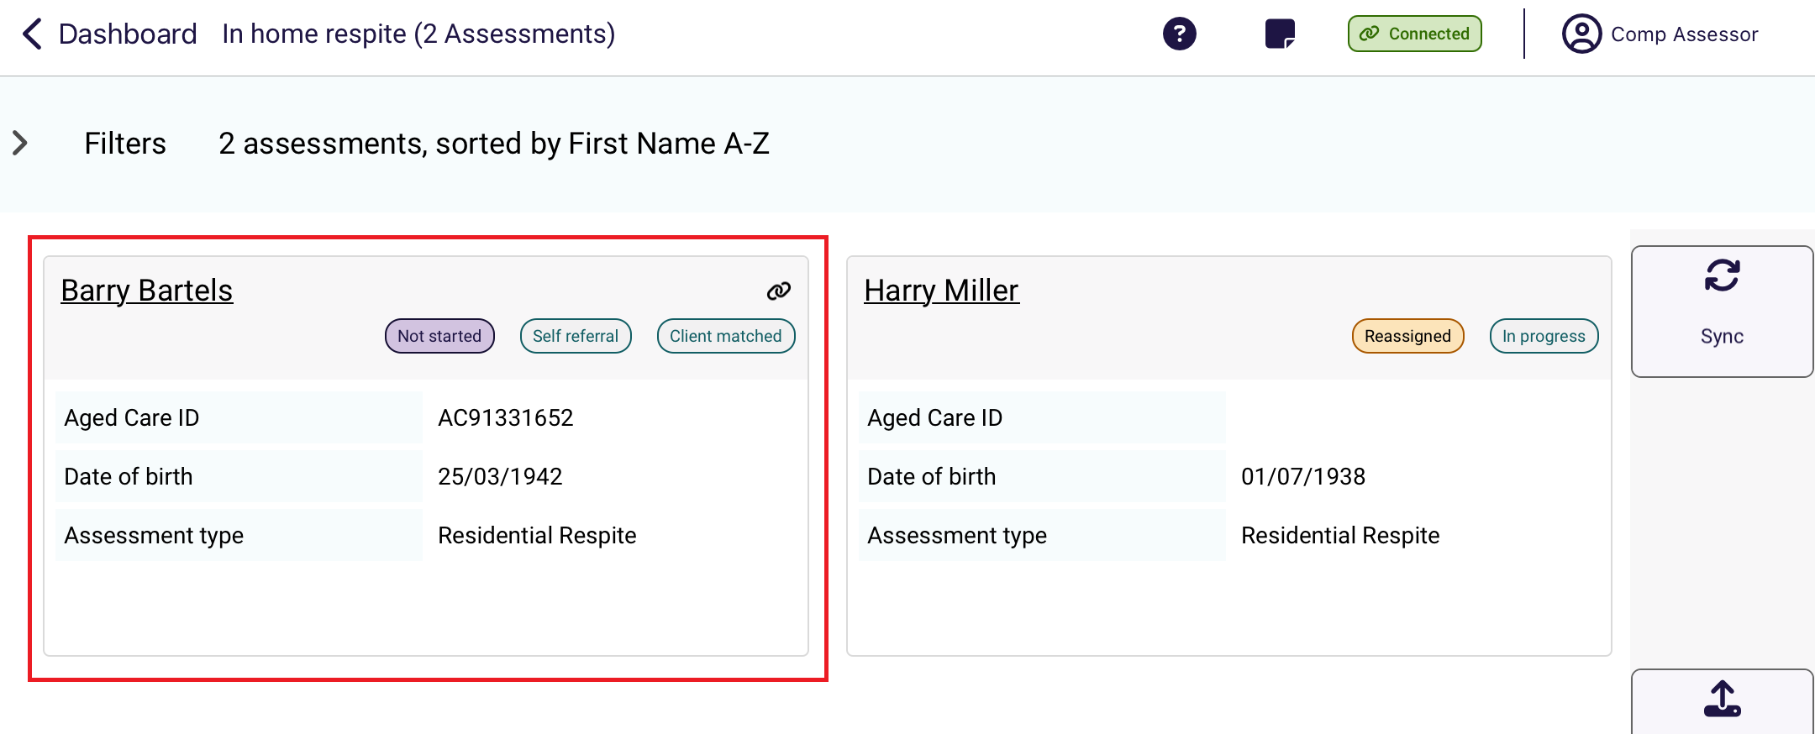
Select Start Assessment.
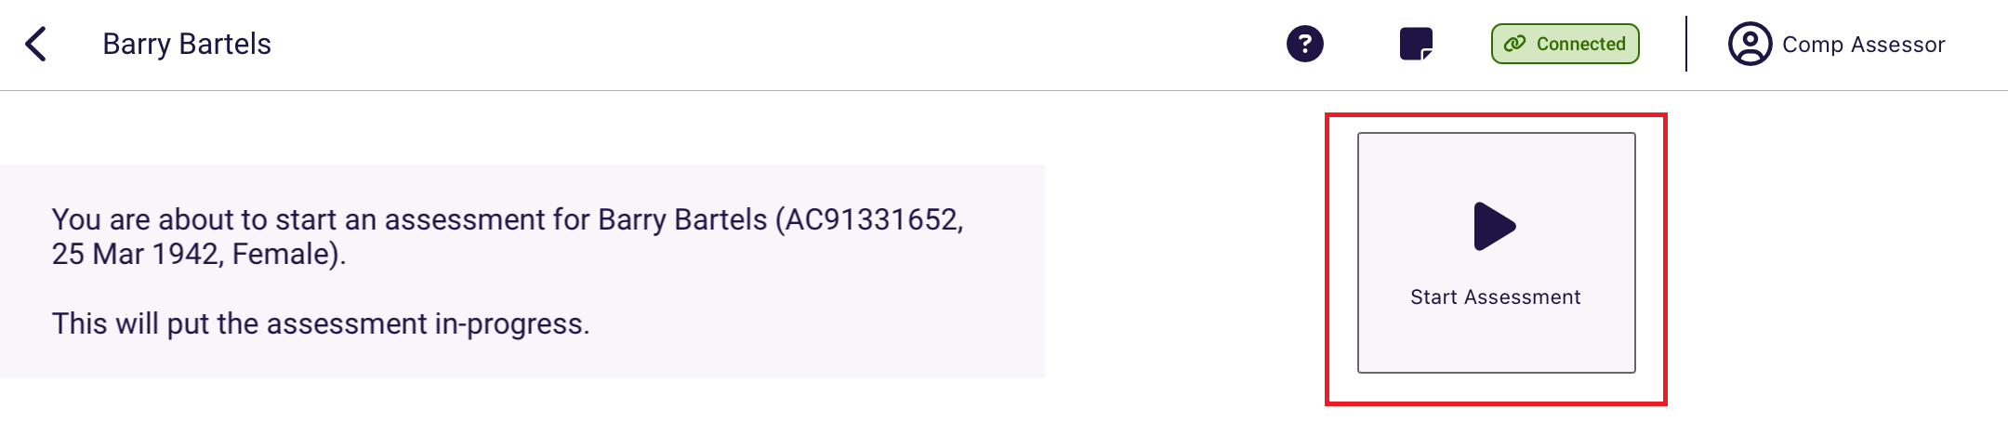

Completing a Residential Respite Assessment
- Confirm the client details are correct by reviewing the Identification and assessment details section.
- Select the de Morton Mobility Index (DEMMI) – Modified tab to complete the Modified DEMMI Assessment.
Select the question mark to display tool help. This will provide guidance on how to complete the assessment. Complete all mandatory fields until the page has a tick next to it.
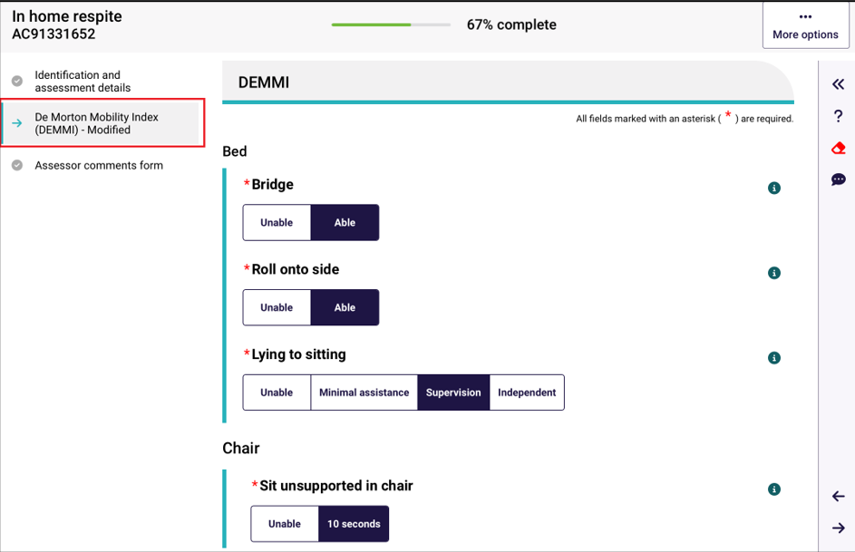
- Tool tips are available by selecting the information icon in the top right-hand corner of each question.
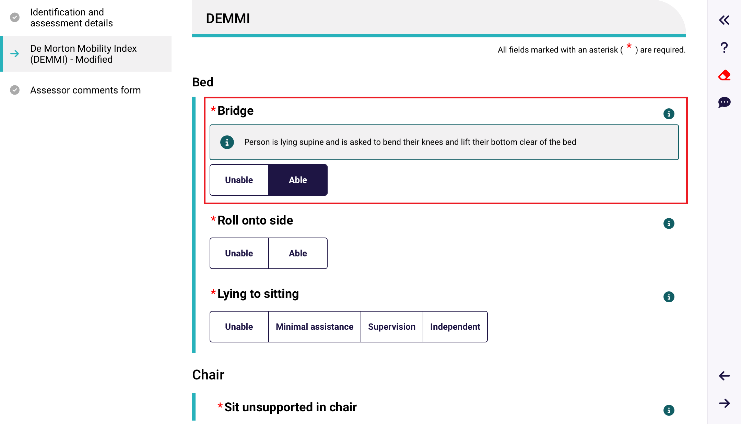

- Once the assessment is complete you may add comments, these comments will be stored with the assessment and can be viewed by the department if needed.
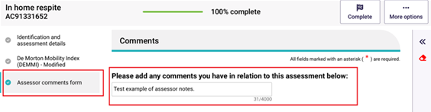
Once the assessment is complete select the Complete button.
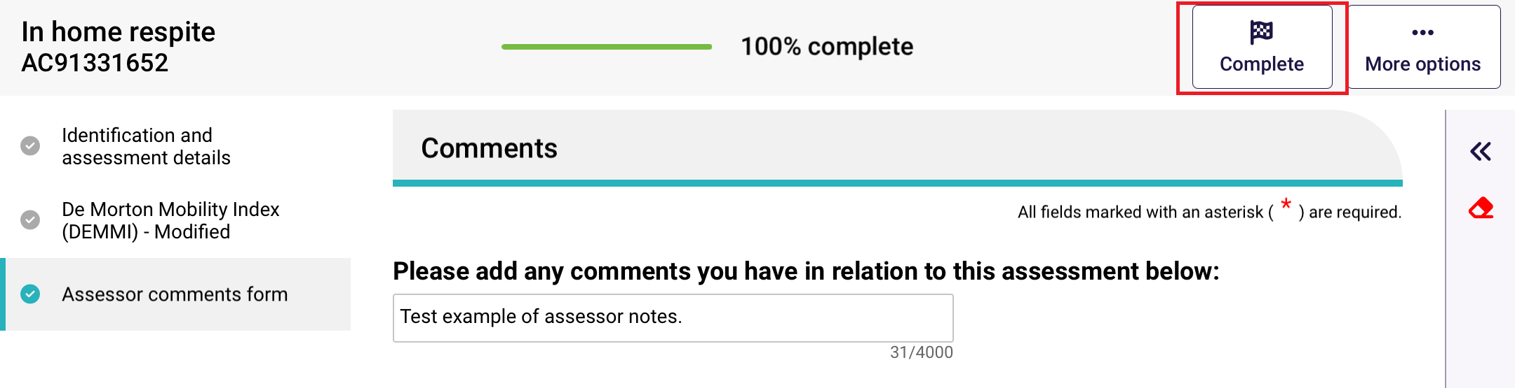
- Select Complete Assessment at the next screen. This will submit the assessment and generate a classification for the client, there is no further action required.
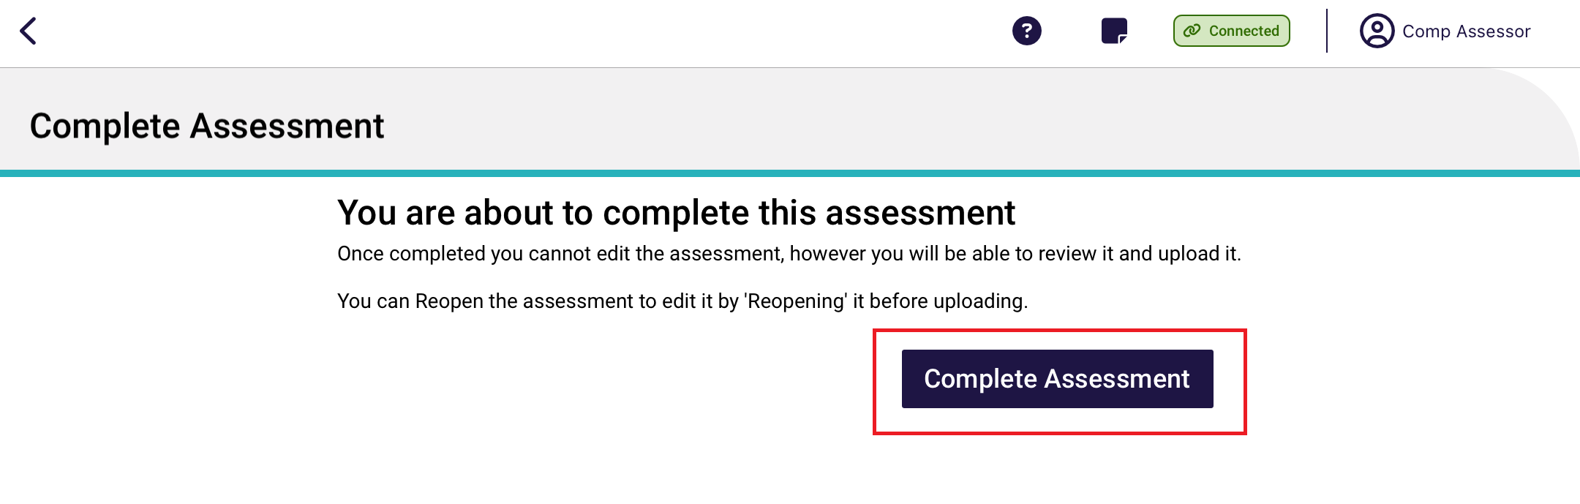
- Following this you will be re-directed to the Upload Assessment page. Select Upload.
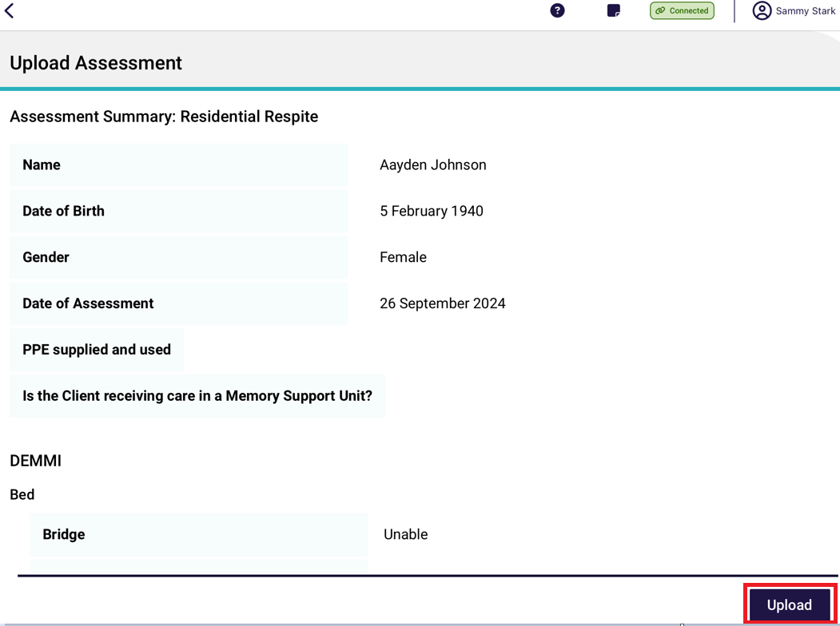

Rejecting a Residential Respite Assessment
If a Team Leader assigns a residential respite assessment to you, you can choose to reject it.
- Open and log in to the App, download and open an assessment. Select actions in the top right corner, then select Reject Referral from the pop up.
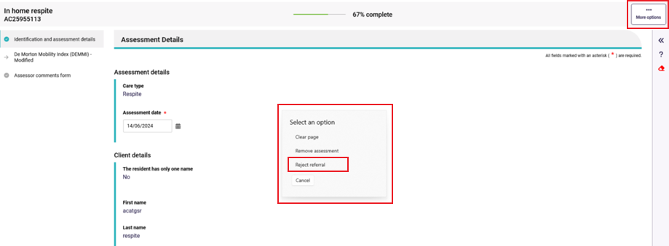
- Select the appropriate rejection reason, this may be either Client Deceased, Entered a residential facility (Refer to Step 3), or Other (below). Please note, for the reason Client Deceased please contact your team lead or the My Aged Care contact centre to complete the process.
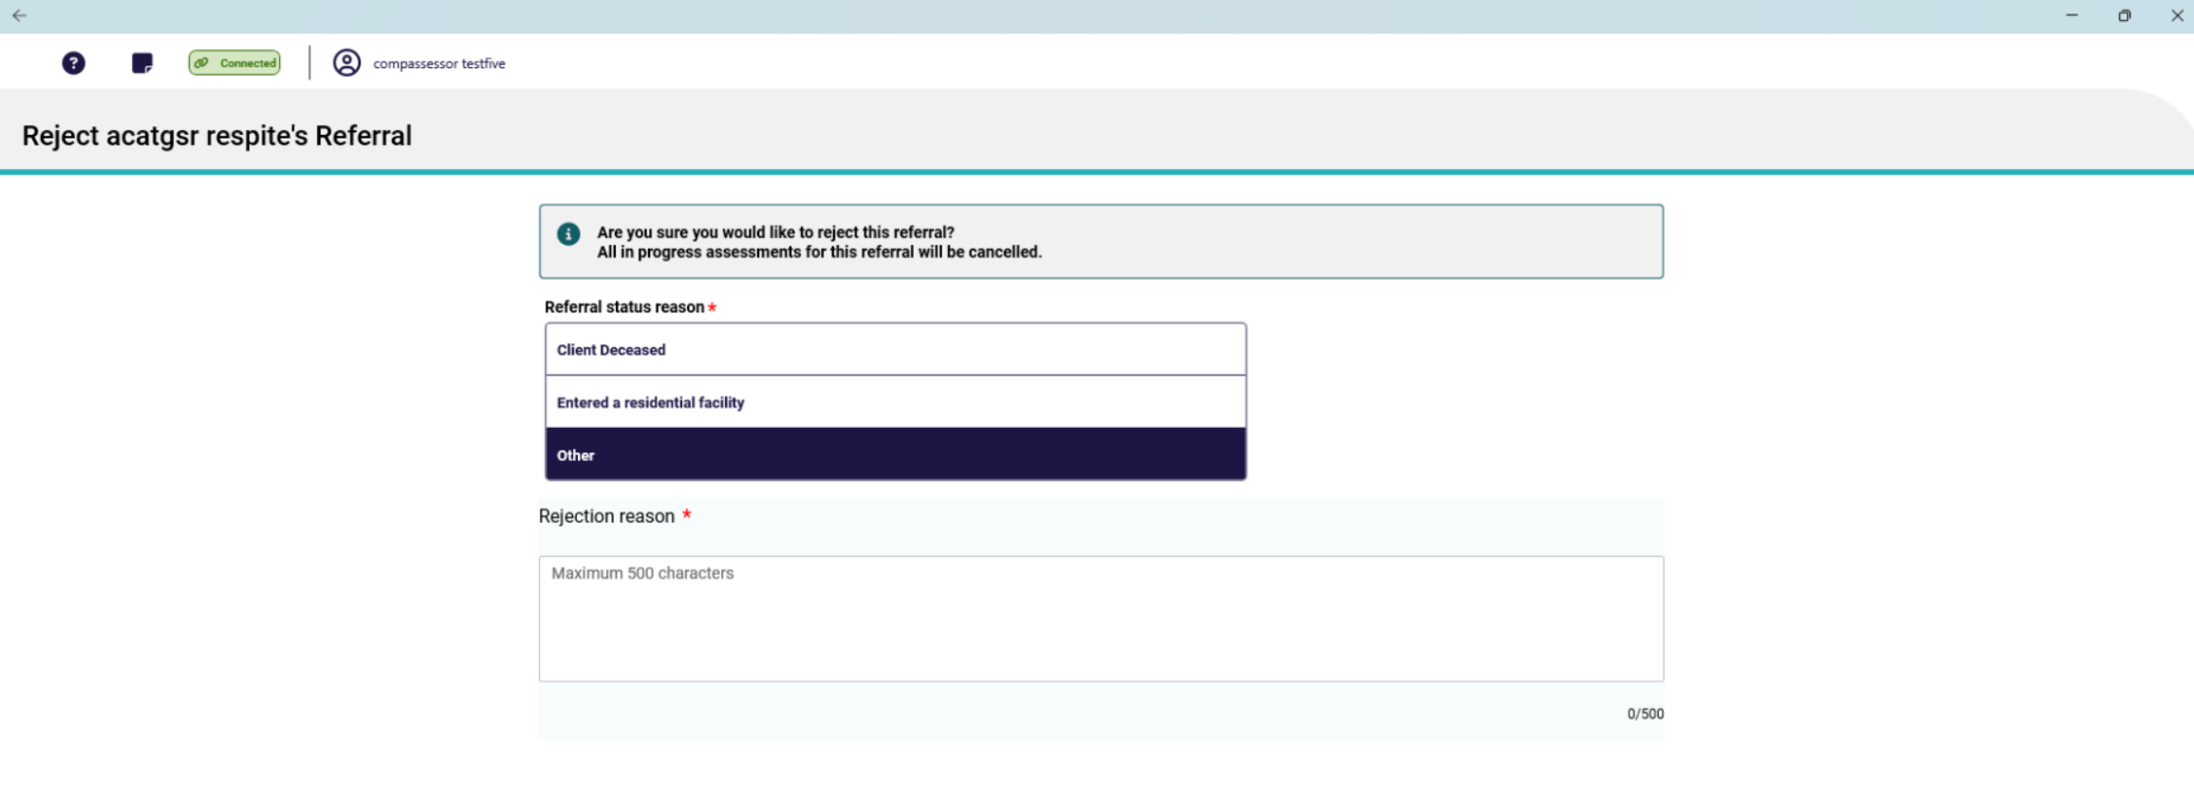
- If the client has entered a residential service facility, please select Entered a residential facility. These referrals will now be assigned to an appropriate RFA Organisation.
The options provided are either searching by residential facility name or suburb/postcode; Or if you are unsure, please select Unsure and a departmental officer will be assigned the referral manually.
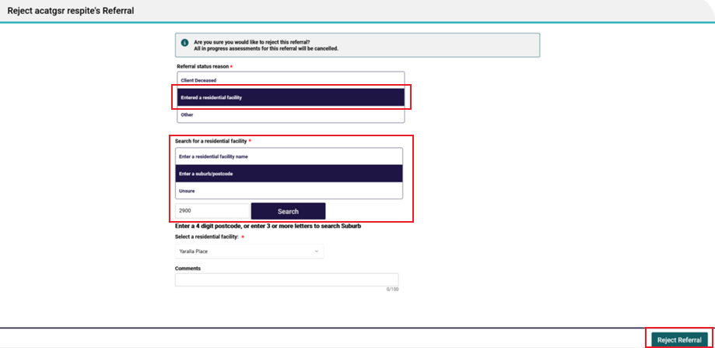
- Once all the criteria have been entered select Reject Referral. The referral will now be rejected, there is no further action needed.
- Residential Respite Assessments for clients who have entered a residential facility are to be completed by Residential Funding Assessors. If a client has entered a Residential Facility, reject the referral due to Entered a residential facility by completing the following steps:
  - Select Entered a residential facility.
  - Either enter a residential facility name, enter a suburb/ postcode or if you are unsure select Unsure.
  - Select Search.
  - Scroll down until the applicable Residential Facility has been highlighted and select done.
! | You can upload an assessment to the My Aged Care assessor portal from the App without answering all mandatory questions. However, you will need to complete all mandatory questions before you can complete the assessment in the My Aged Care assessor portal.  Clinical needs assessors are expected to contact the client to confirm the outcome of the assessment, discuss the client’s service preferences, and obtain consent to send referrals for service.

Part C – Residential aged care funding assessments (RAC funding assessors)

Conducting an RAC funding assessment
! | ‘Assessment’ in part C refers to residential aged care funding assessments completed by residential aged care funding assessors who complete assessments using the Australian National Aged Care Classification (AN-ACC) assessment tool.

20.1 Find a client
- On the Facilities page, all assessment referral/s that have been assigned to you will be listed. Scroll up and down to view more facilities and clients. Select a facility to display all referrals for that Facility that are assigned to you.
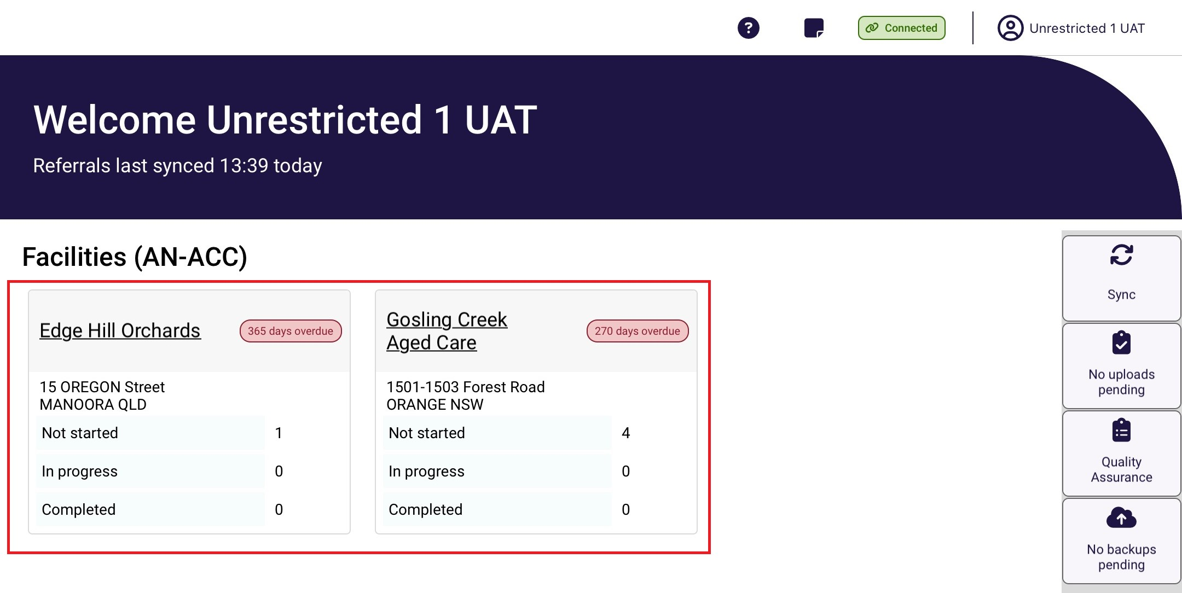
- Once you have clicked on the facility you are wanting to assess in, the resident referrals for this facility will be displayed. Scroll up and down the page to locate the resident you wish to assess or use sort and filter options to narrow the number of residents being displayed.
! | If you are not connected to the internet, only referrals that have been previously downloaded will be available. It is recommended that you sync your device daily before commencing.
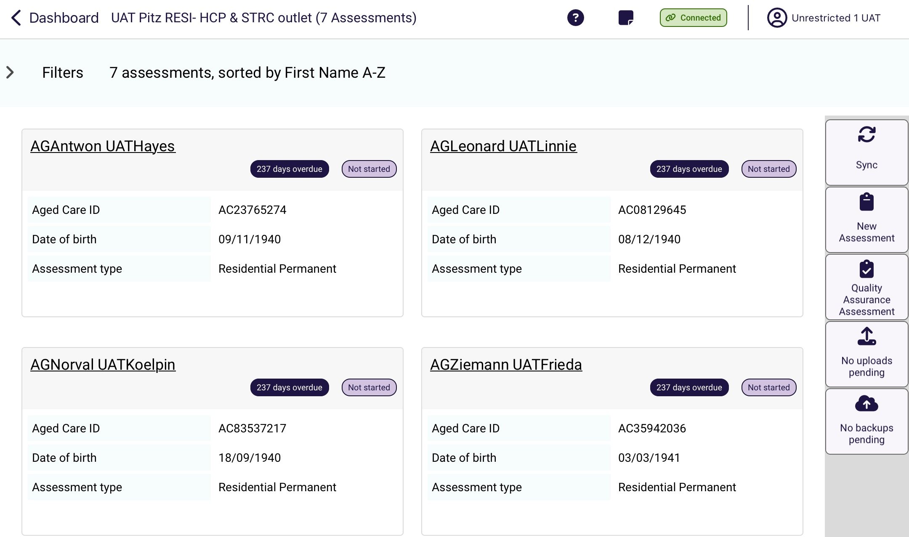
You can filter or order referrals in the following ways:
- filtering on keyword for example First Name, Last Name or Aged Care ID
- filtering on the Status (Assessment status)
- filtering Assessment type
- order on First Name or Last name in ascending or descending alphabetical order
- sorting on due or departure date in ascending or descending order.
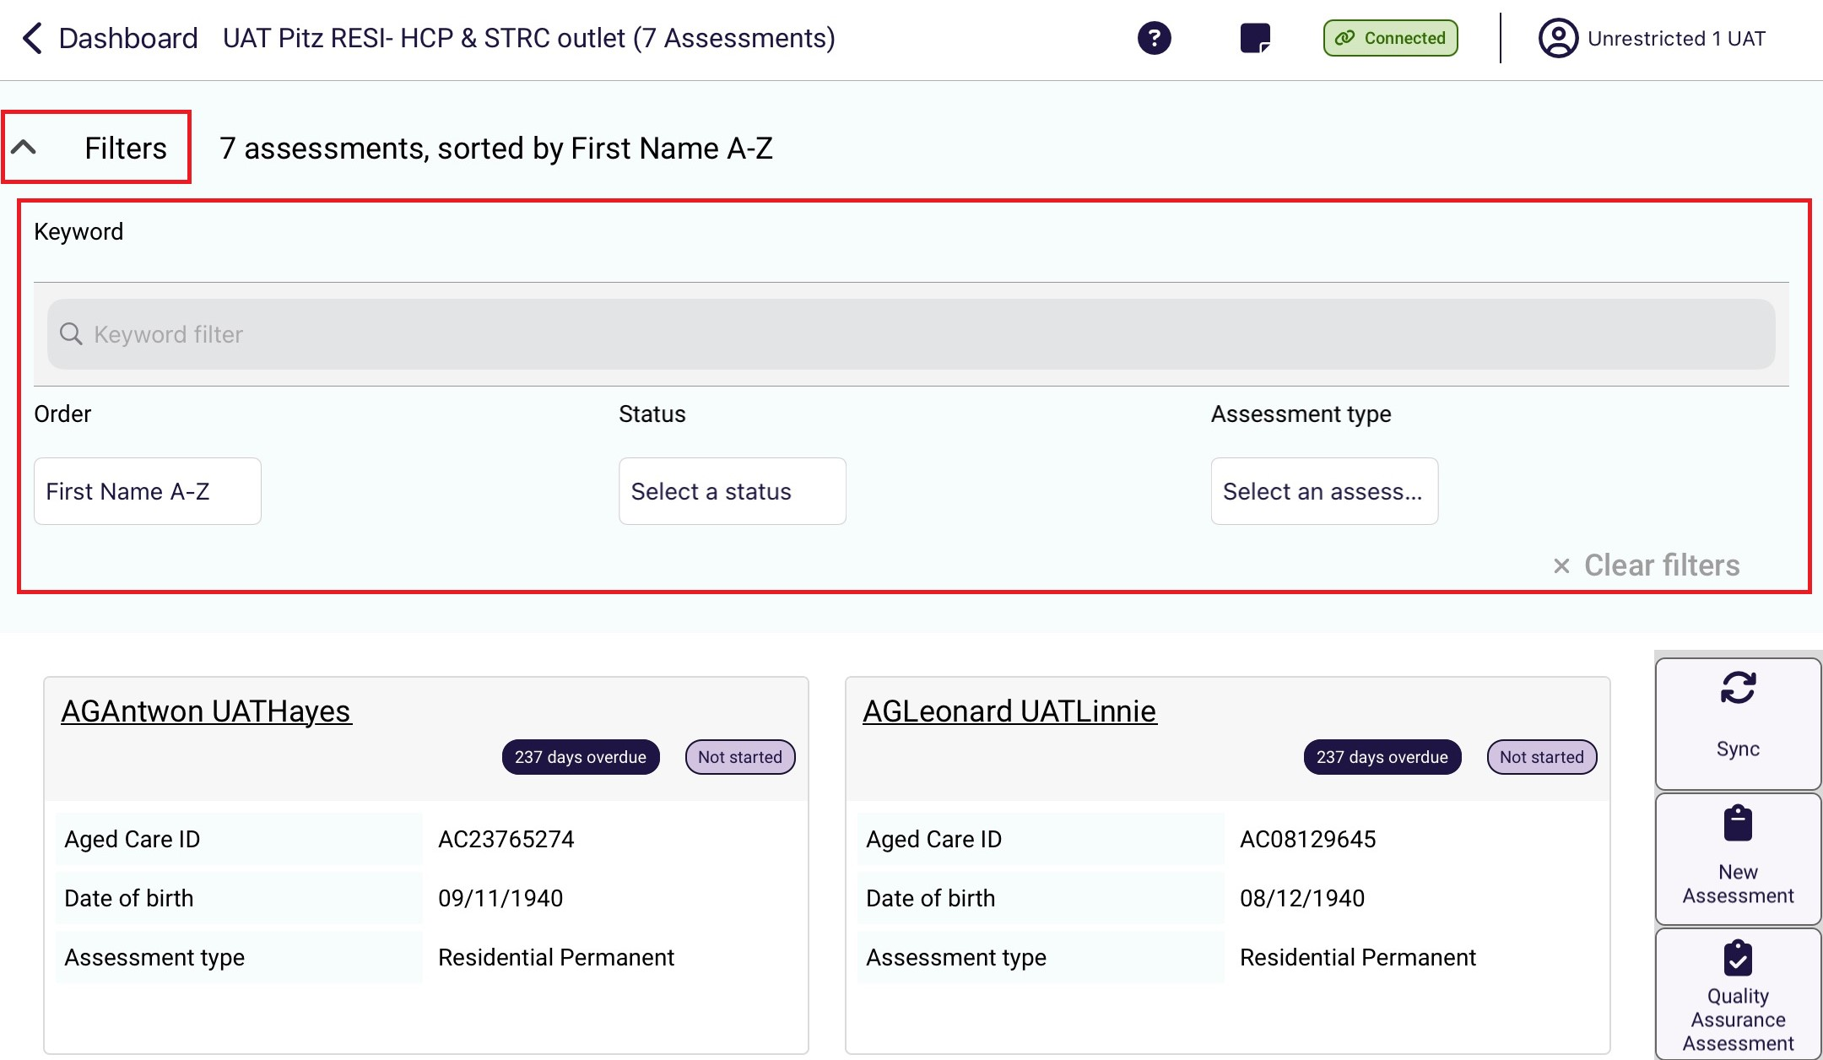
Select the Filter dropdown to expand the filter menu. It displays the Sort By option and Filter options. The Filter option text box is an active search. It will refine results when typed.
In the following example, the residents are sorted by Last name in ascending alphabetical order, and any residents’ names that contains “Ra” will appear.
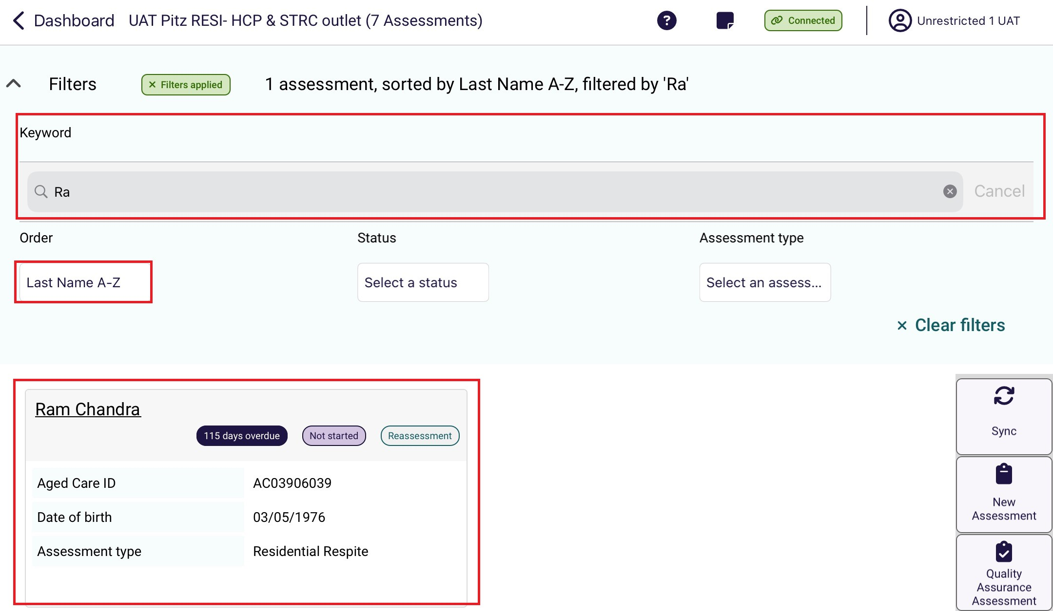
- Select the resident’s record.
Depending on the resident’s assessment status, selecting the record will either start the assessment, or will be directed to the first page of the assessment in progress.
Start of an assessment
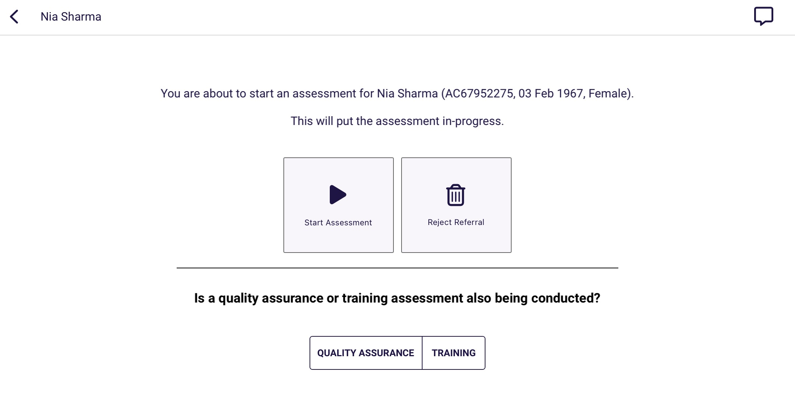

Assessment in progress
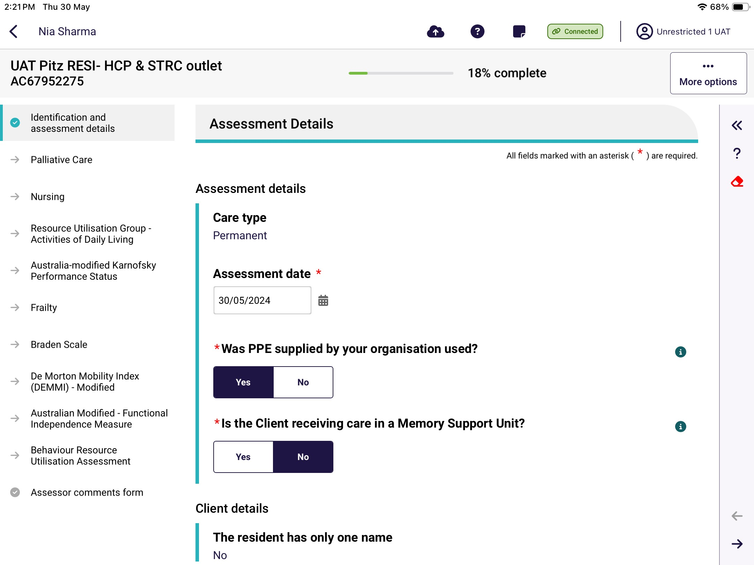

20.2 Self-Referral
! | Prior to conducting a self-referral, RAC funding assessors should contact the department.
RAC funding assessors can self-refer the assessment when they identify a resident in a service or facility that does not have an assessment referral. This could happen if the resident has entered care since the time of the assessment referral being issued.
- Select New Assessment on the right-hand side in the facility dashboard menu.
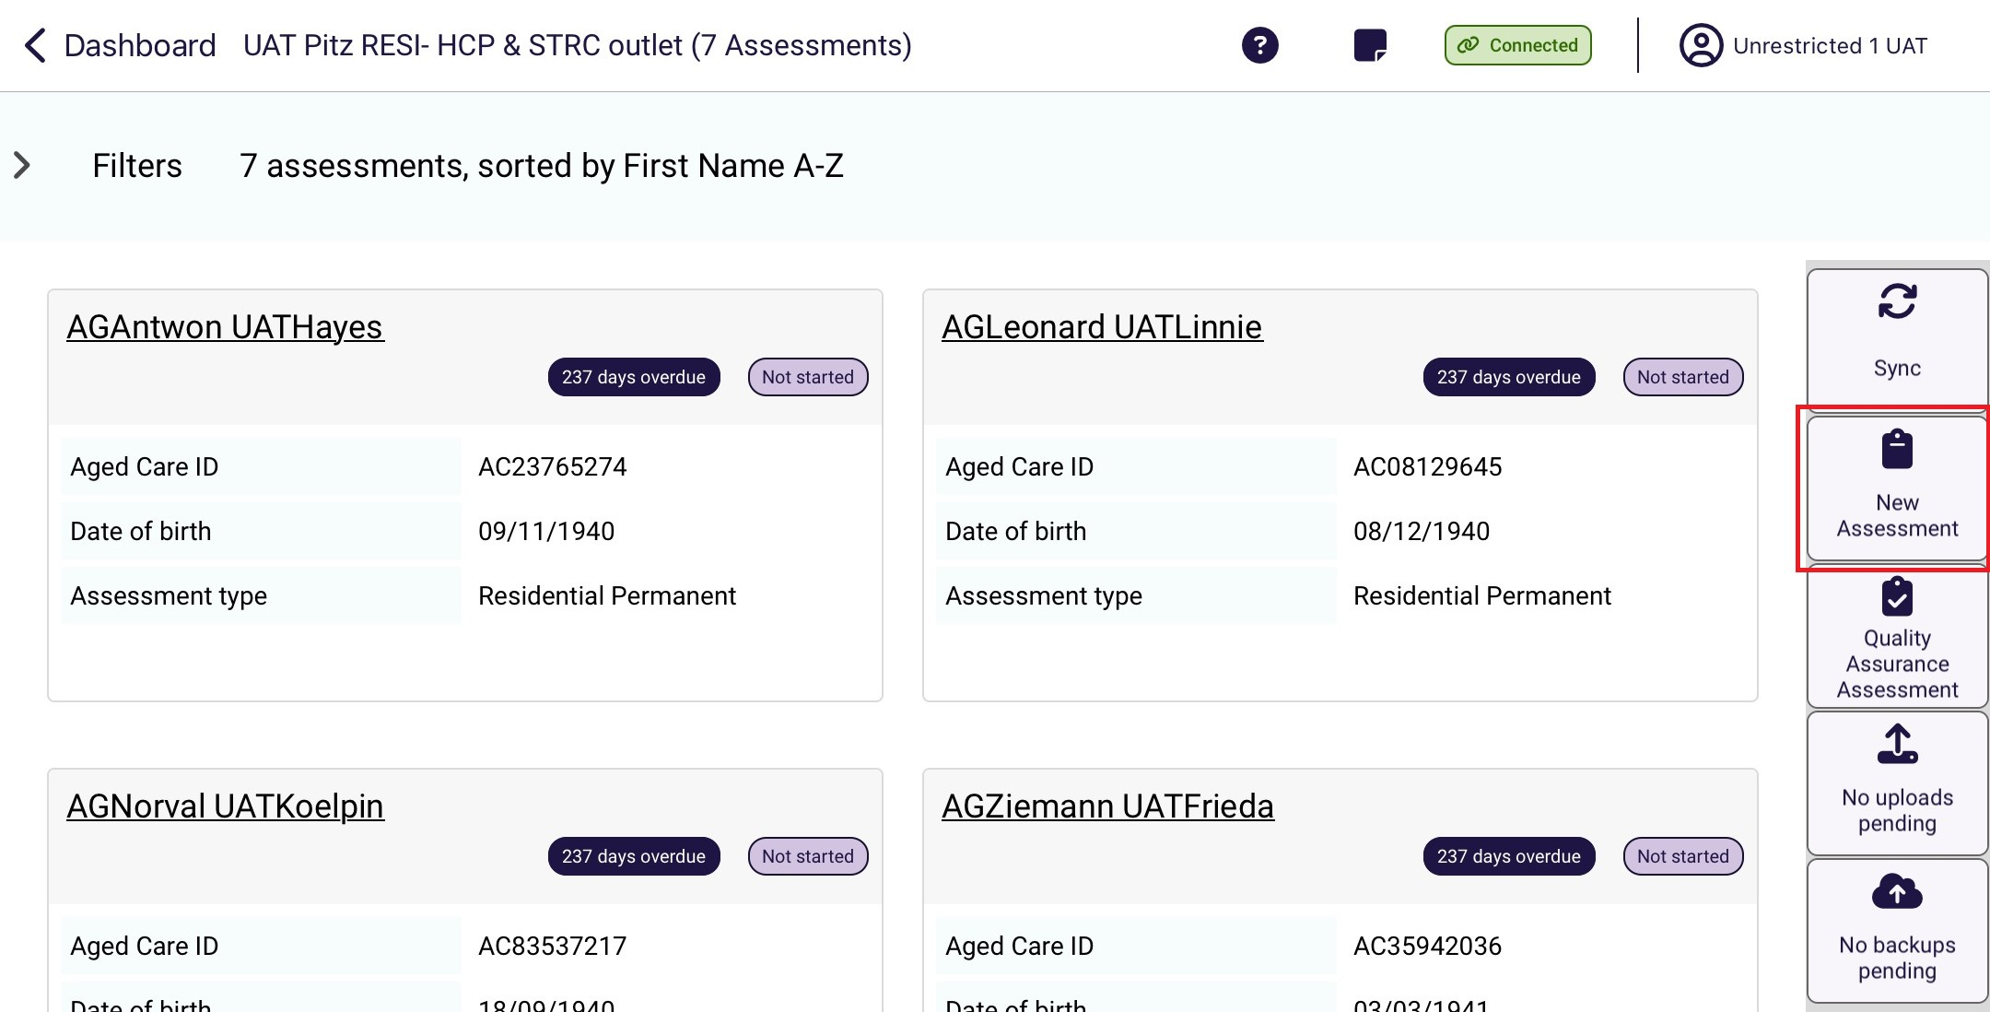
- The New assessment screen appears. Enter the resident’s My Aged Care client identifier (AC ID) and select Search. The service provider will be able to provide the AC ID for the resident.
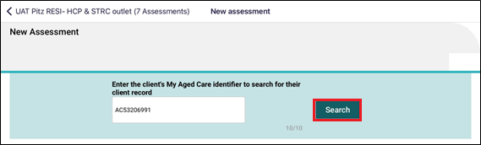
- Check the details of the search result. If the details are correct, select the record to start the assessment.
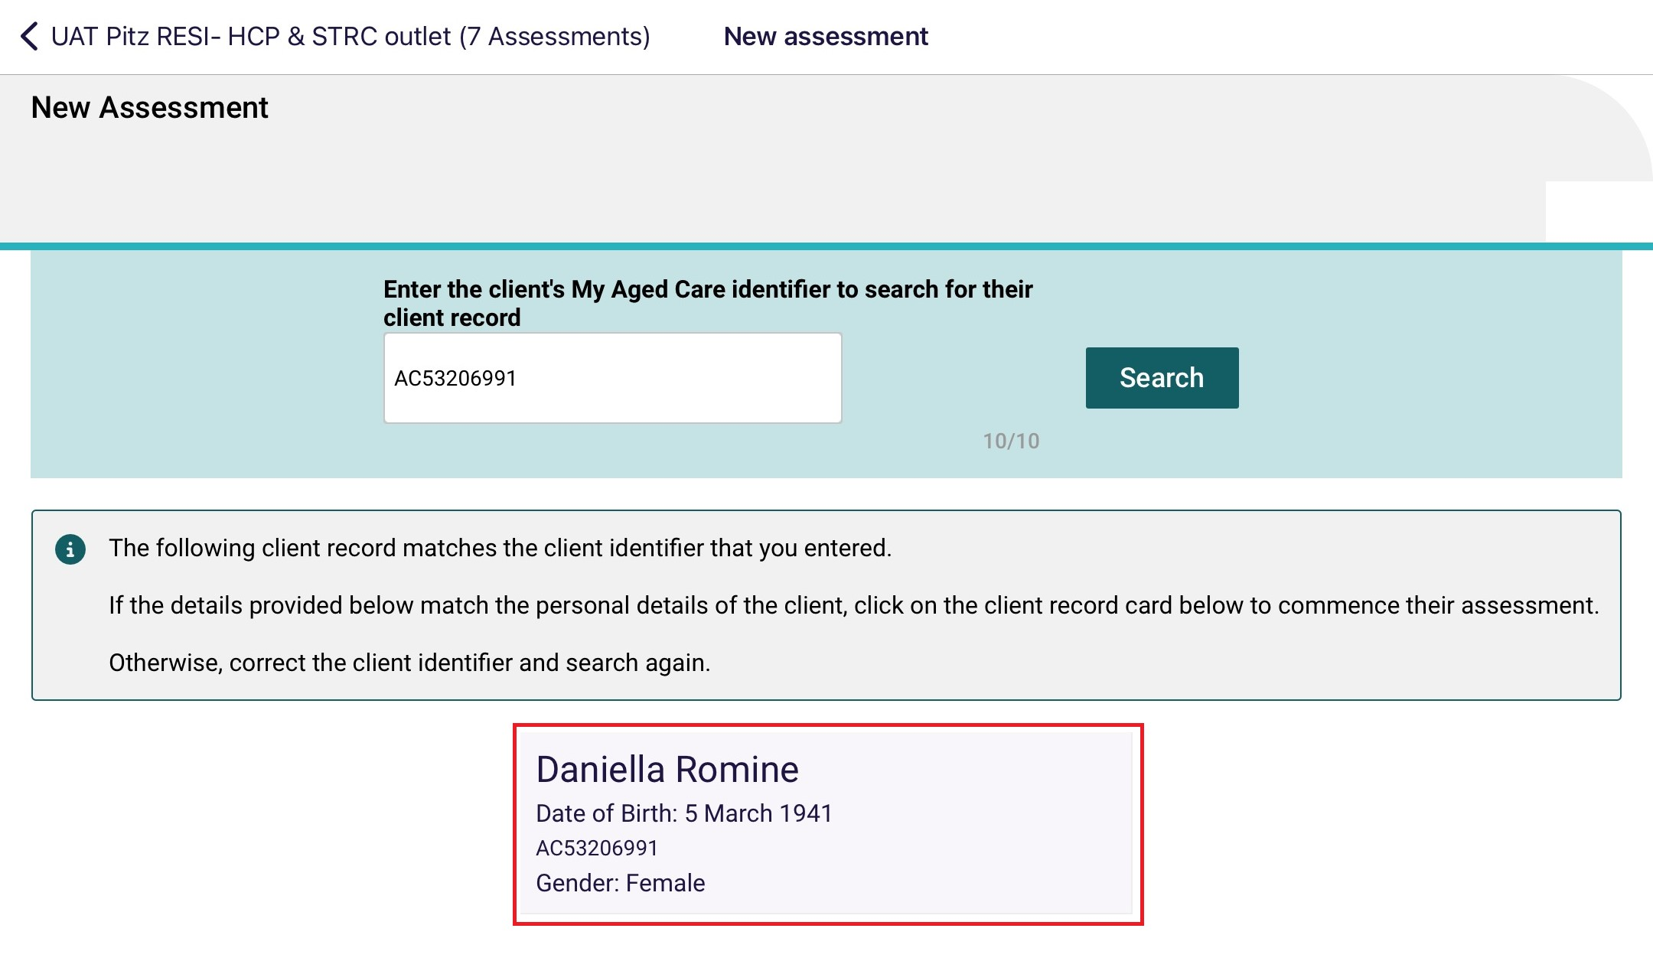
- If required, fill in any mandatory fields in the Add Client page, by selecting the appropriate options. Mandatory fields are shown by a red line over the field name and a red asterisk.
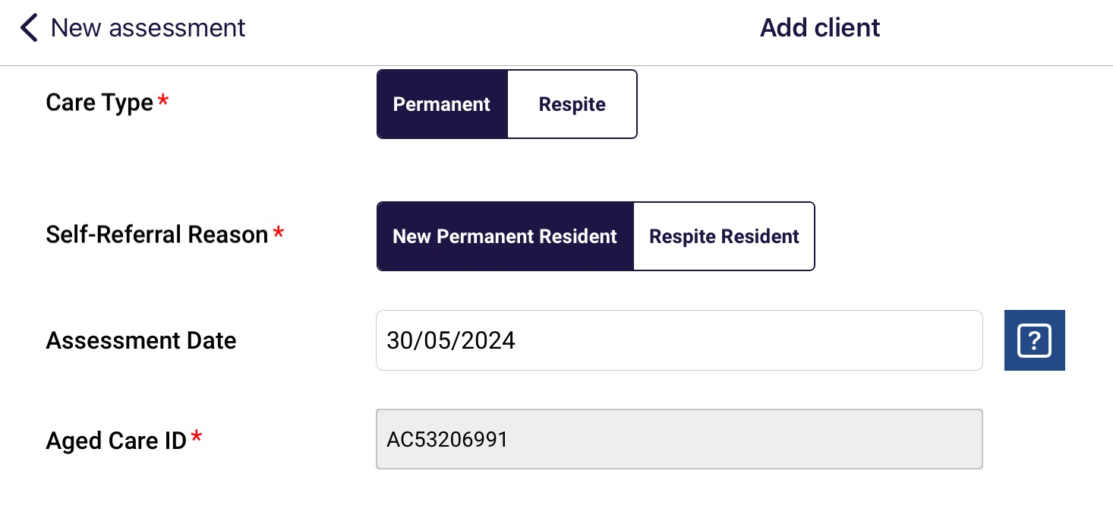
- Once all mandatory fields are complete, select Start Assessment.
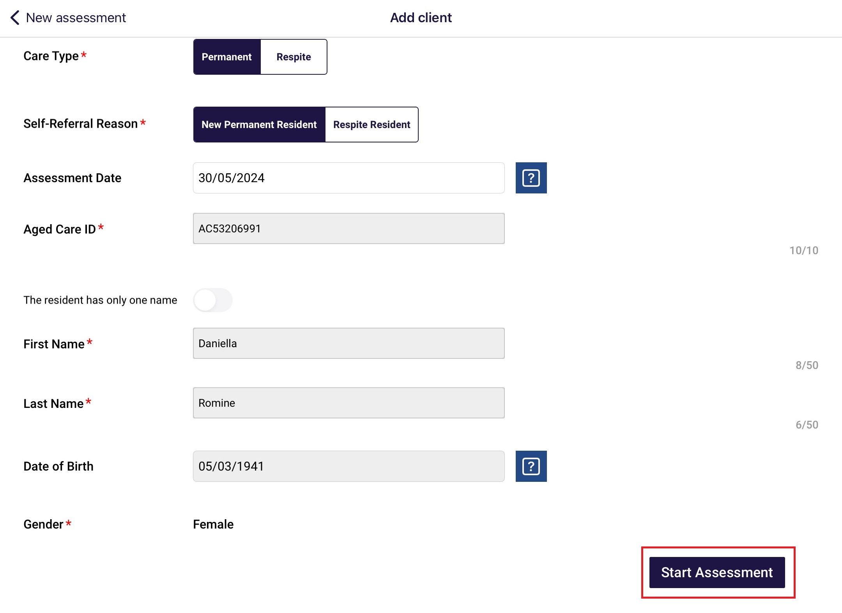
- The client record will now appear in the main menu under the status of In-progress. You can use the filter function to highlight all the assessments with this status.
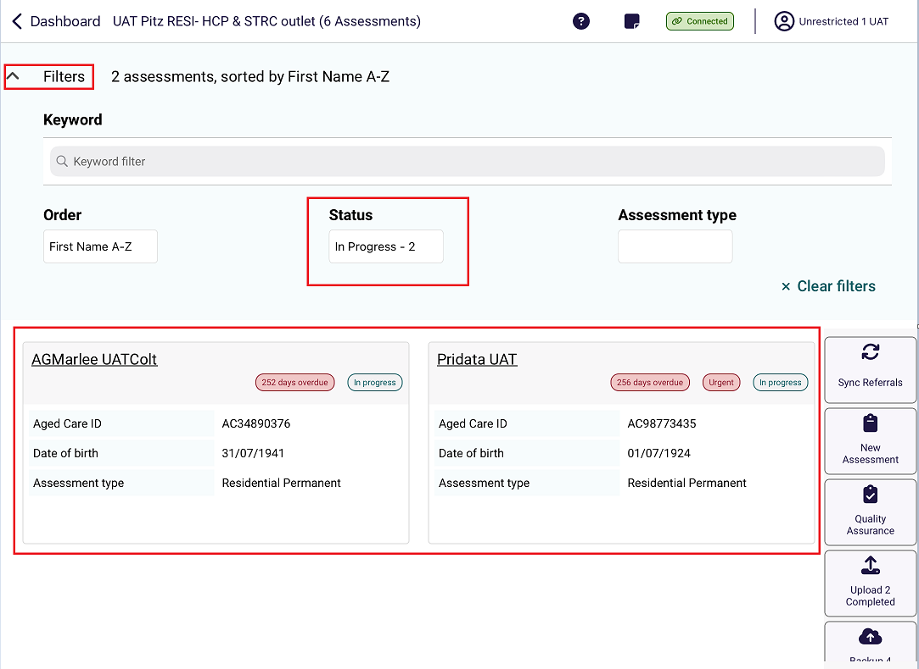

20.3 Undertaking Assessments
The steps to undertake an assessment on the App are as follows.
! | For comprehensive information on how to complete the clinical component of the assessment, refer to your AN-ACC Assessor Manual.
- Open and log in to the App, following the process in Find a Client, locate the resident you wish to assess and open their assessment referral.
- Complete each page of the assessment which includes clinical tools.
The below screenshot shows a typical page in an assessment.
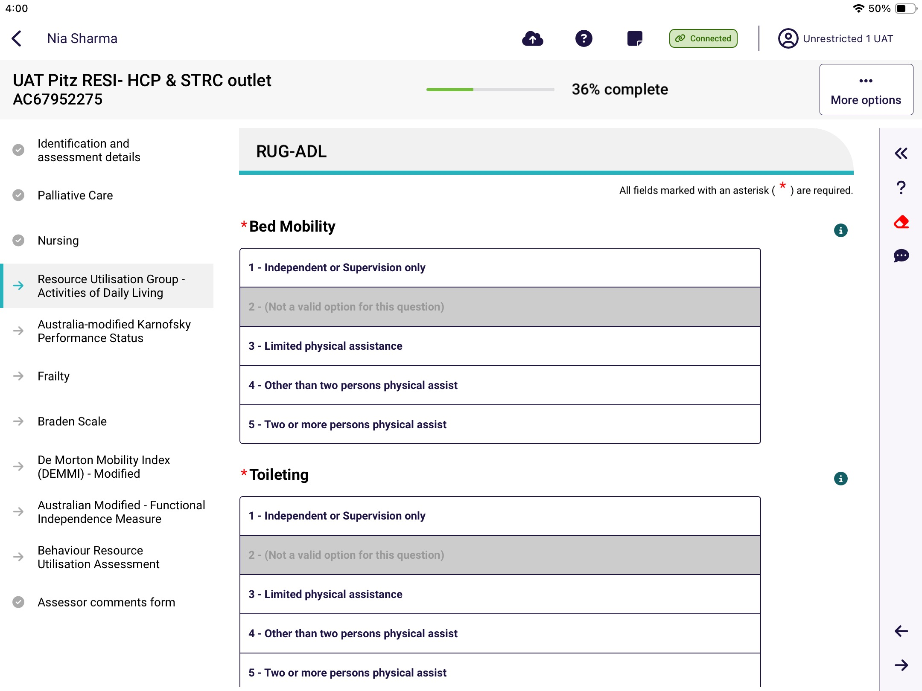
As you complete each section, the progress bar shows grey ticks for each completed and teal arrows for in progress or incomplete sections.
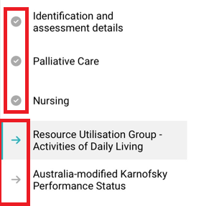

There is an overall assessment progress percentage complete indicator at the top of the screen.

Select a specific clinical tool or page by selecting the associated tab.
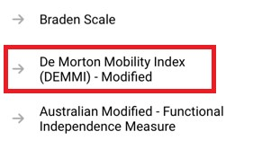

Select the information icon next to each question, to find out more information about the question.
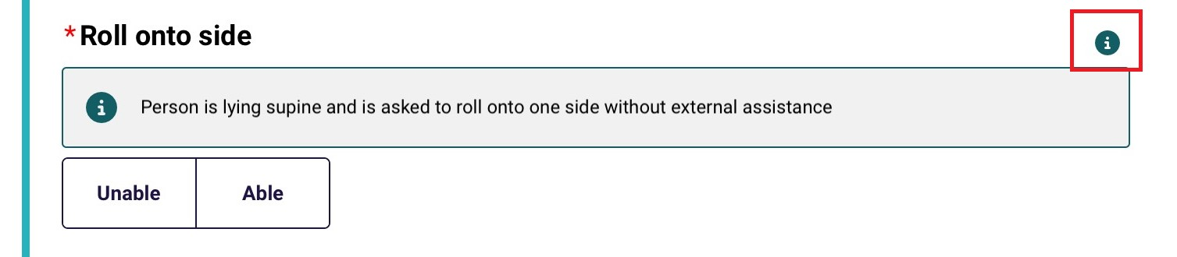
! | You must fill out all mandatory questions. Mandatory fields are shown by a red line over the field name and a red asterisk.
Select the double chevron << on the top right side of the screen to expand the menu and to navigate to the previous and next sections.
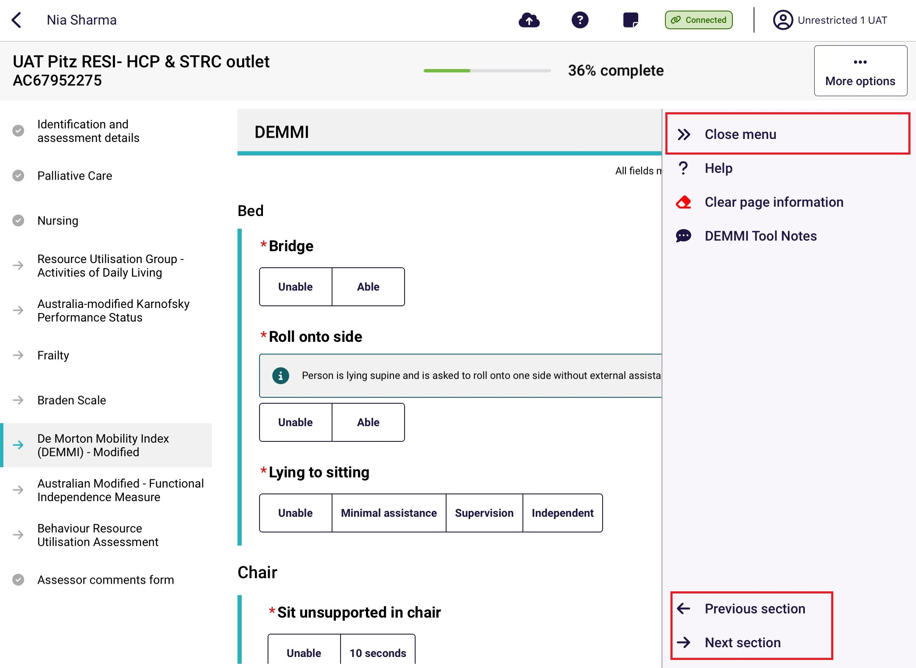
In this menu you can also select? Help to display more detailed information about that page or tool. It will open on another screen. Select Close to return to the assessment.
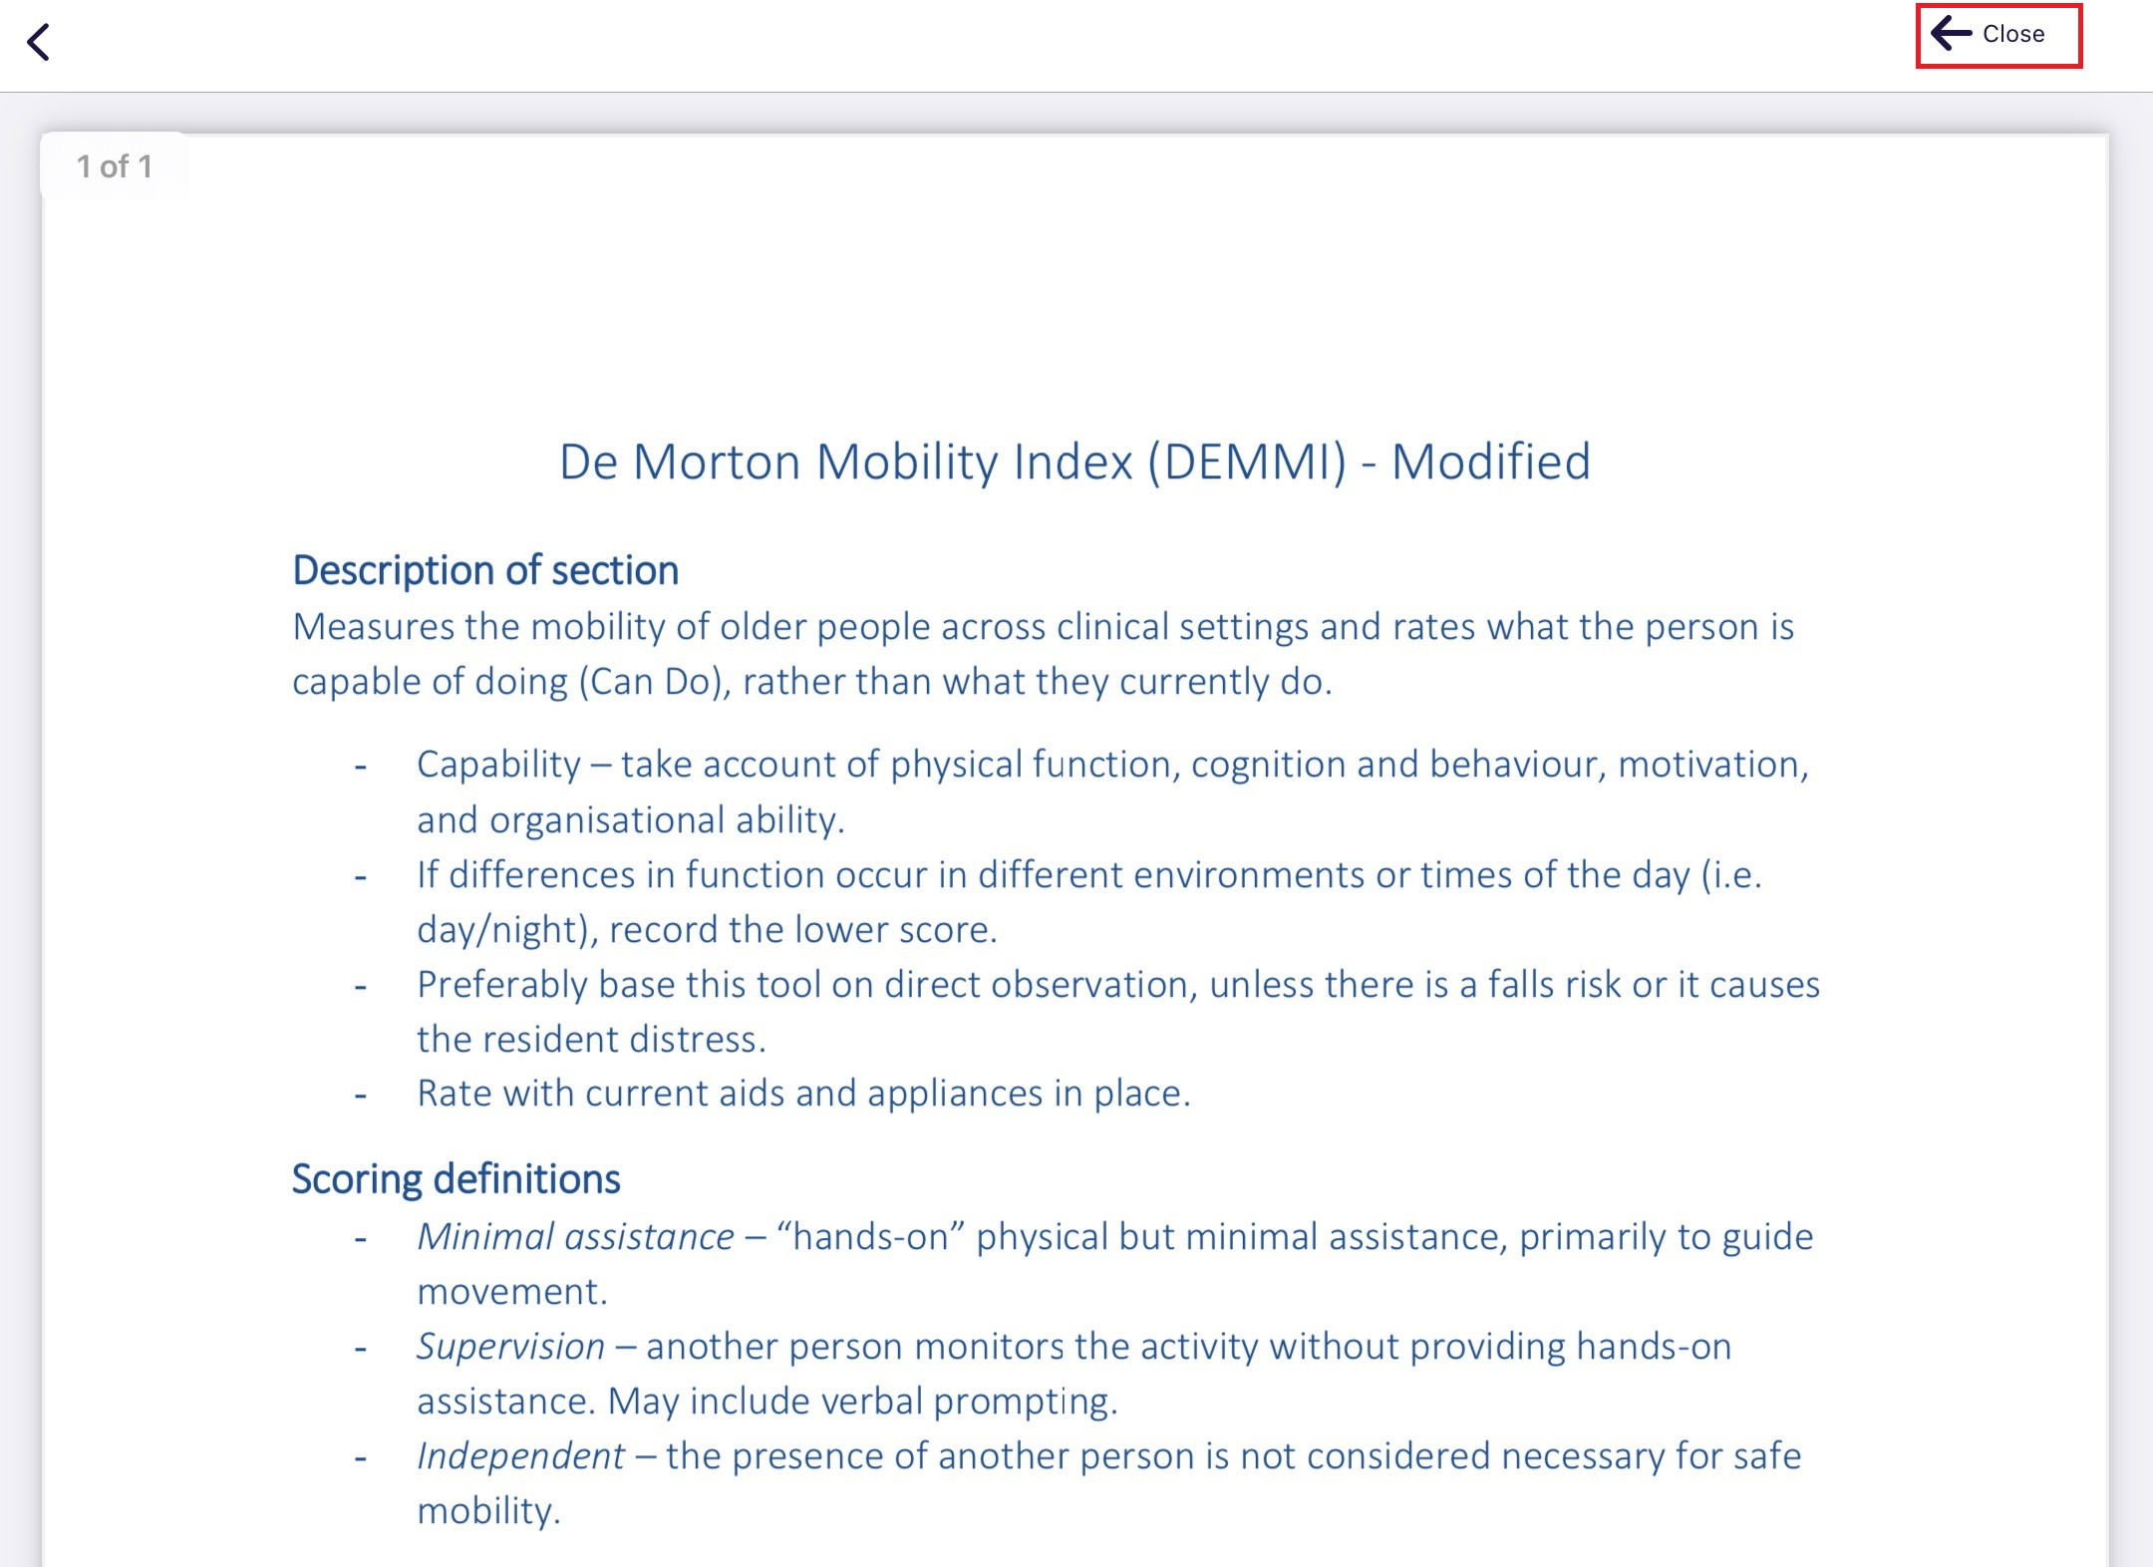
On each tool, there is a notes section where you can enter notes or comments.
Selecting the speech bubble icon  next to this section will expand the comments section.
Any comments made here are for your own reference and will not be uploaded with the assessment.
The below screenshot example shows the AM-FIM Tool Notes page.
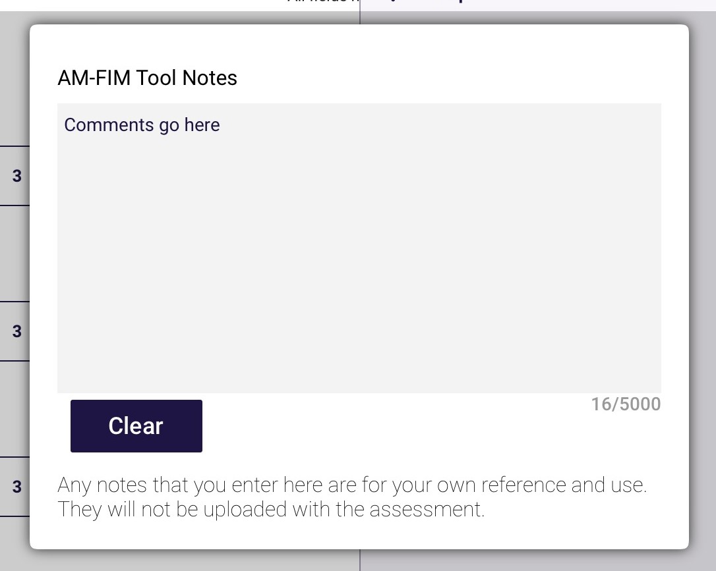
With some notes sections there is an additional informationsection. It gives additional information to that in the Help sections.
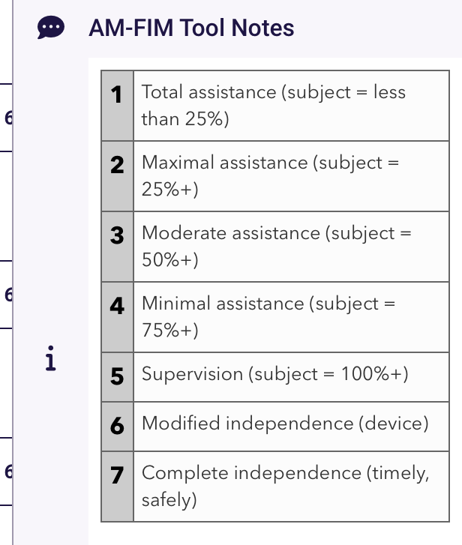
Finally, there is a Clear page information section denoted by the red eraser icon. Select this and then select Clear answers at the pop-up, to permanently erase answers.
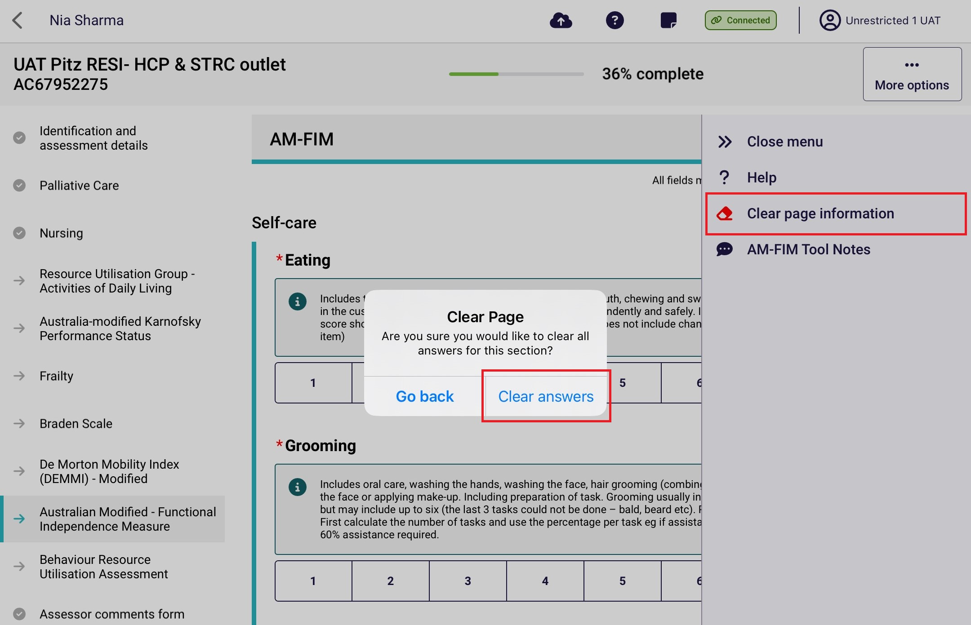

Undertaking Quality Assurance and Training Assessments
RAC funding assessors can conduct Quality Assurance and Training assessments in the App. There are two methods available.
! | Quality Assurance and Training assessments cannot be undertaken on self-referred assessments.

21.1 Sharing referral details with the assessor undertaking the assessment
The unrestricted RAC funding assessor is assigned to undertake the assessment.
- Out of your facilities, select the facility where the resident being assessed lives.
- Next, select the client.
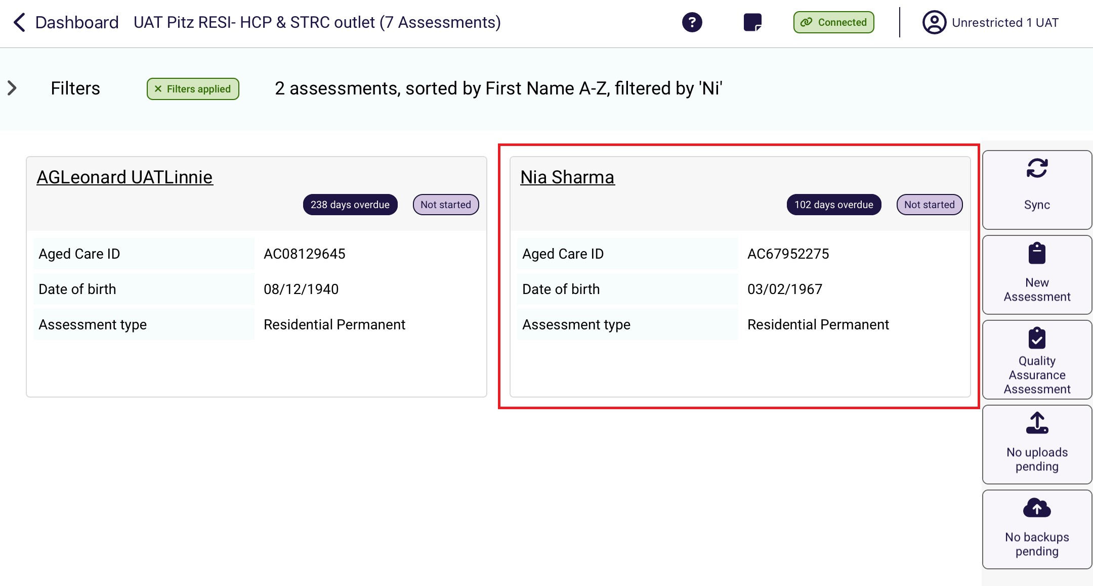

- A Pre-assessment screen appears. The assigned assessor can select if a Quality Assurance or Training assessment is also being conducted.
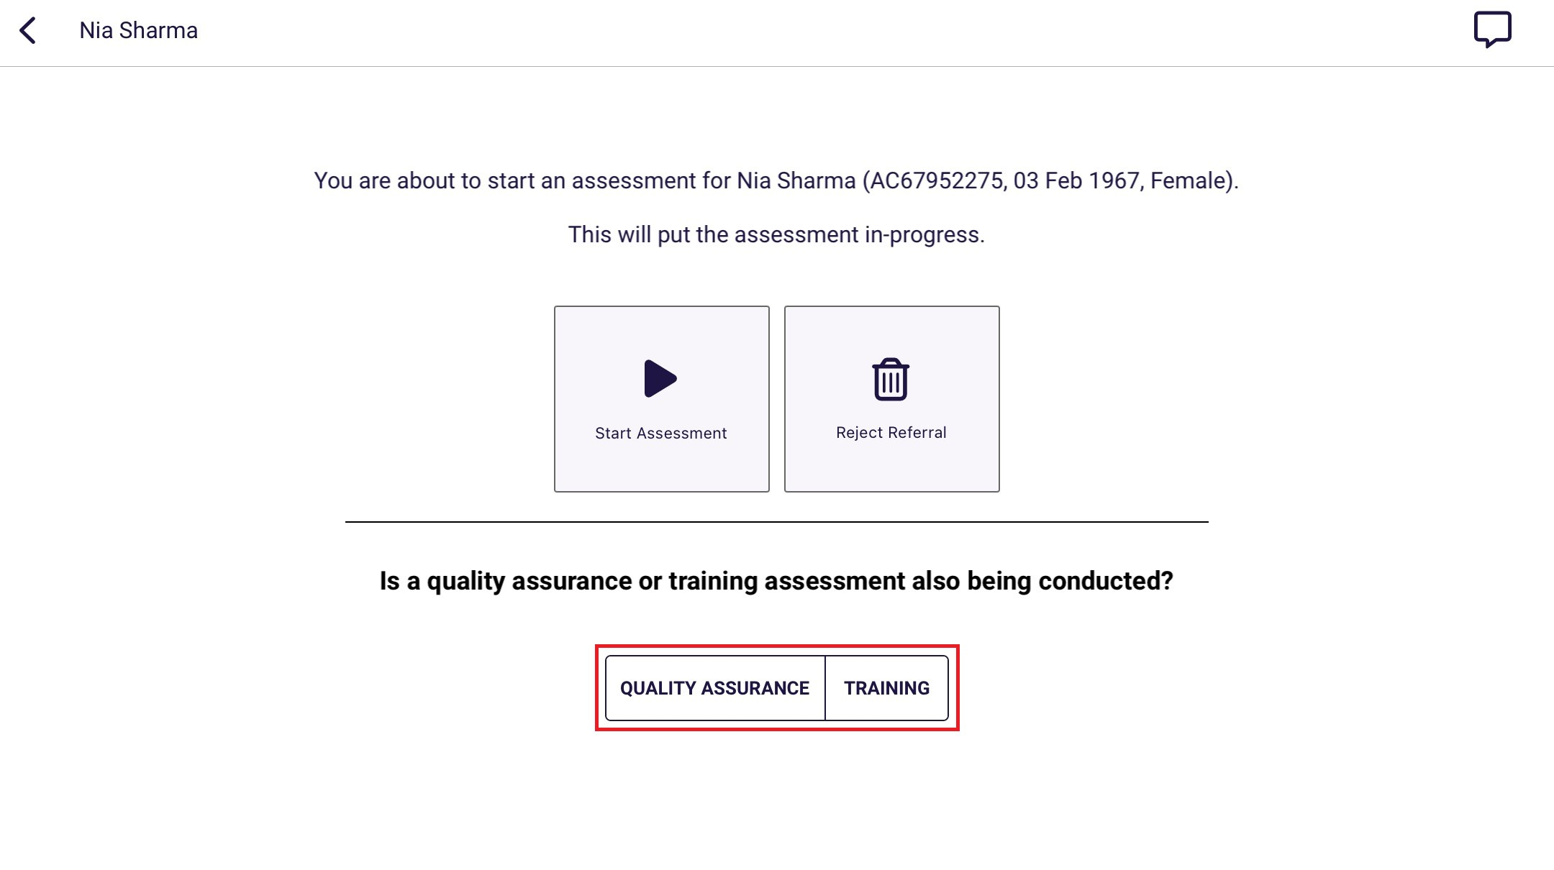
- The assessment details to be shared will be displayed. The RAC funding assessor that will be conducting the Quality Assurance or Training assessment must scan the QR code or enter the Referral ID on their device.
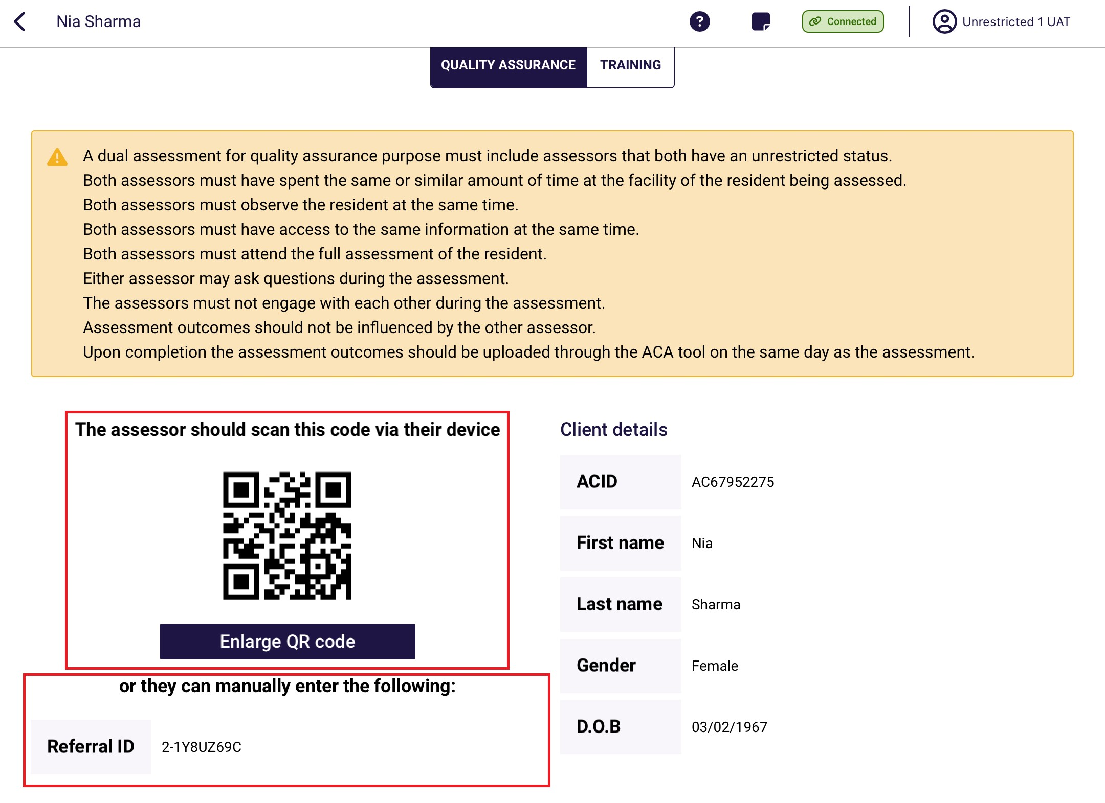

Alternatively, referral details can also be shared after starting an assessment. On the assessment page, select the ellipses (three dots) and select Share referral details at the pop-up.
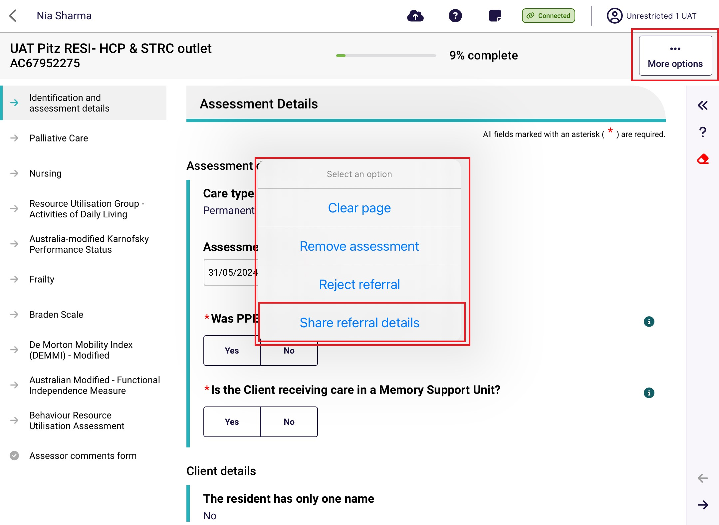
In the Share referral details screen, select the Quality Assurance or Training options.
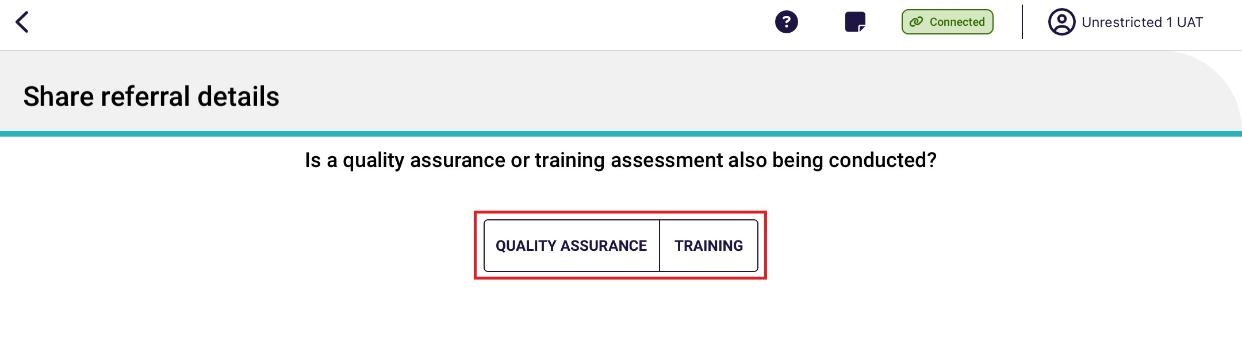
! | Referrals can only be shared by the assessor assigned to undertake the assessment. Referrals cannot be shared after the assessment is finalised and uploaded.

21.2 Scanning referral QR code or entering the referral ID
- Select the appropriate assessment button under Quick Actions in the main menu.
! | The Quality Assurance and Training buttons visible will be dependent on the role of the user.
Senior RAC funding Assessors undertaking a Quality Assurance will need to select the Quality Assurance button, or if conducting a Training assessment, select the Training button.
A RAC funding assessor (Restricted) undertaking a Training assessment will need to select the Training button.
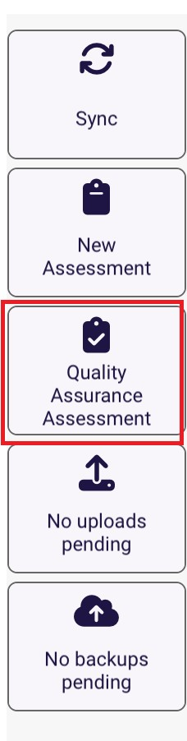
- Select either to Scan the QR code generated on the device of the RAC funding assessor that will undertake the assessment, or enter the Referral ID. Then select Search.
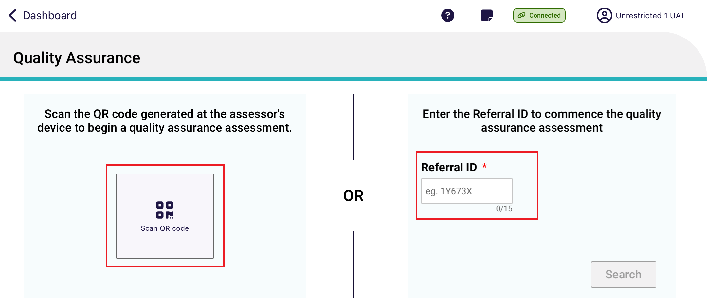

After the Referral ID is successfully matched, confirm the client’s details before starting the Quality Assurance or training assessment.
If the RAC funding assessor has been unable to successfully match the Referral ID, this could be due to a connectivity issue or the referral ID is not valid. If there is a connectivity issue a local (offline) assessment can be undertaken.
- The Quality Assurance or Training assessment screen will now appear. A banner at the top of the screen indicates the type of assessment type that is being undertaken. The below screenshot shows the Quality Assurance assessment example.

! | RAC funding assessors that have started a Quality Assurance or a Training assessment will not have the ability to reject the referral, but can remove the assessment.

21.3 Local (Offline) Assessments
Assessments could be done offline if there is an issue with internet connectivity. This applies to normal assessments as well as Quality Assurance and Training assessments. However, the assessment cannot be uploaded to the My Aged Care system until the client details that were entered whilst offline are successfully matched with a client record in the system.
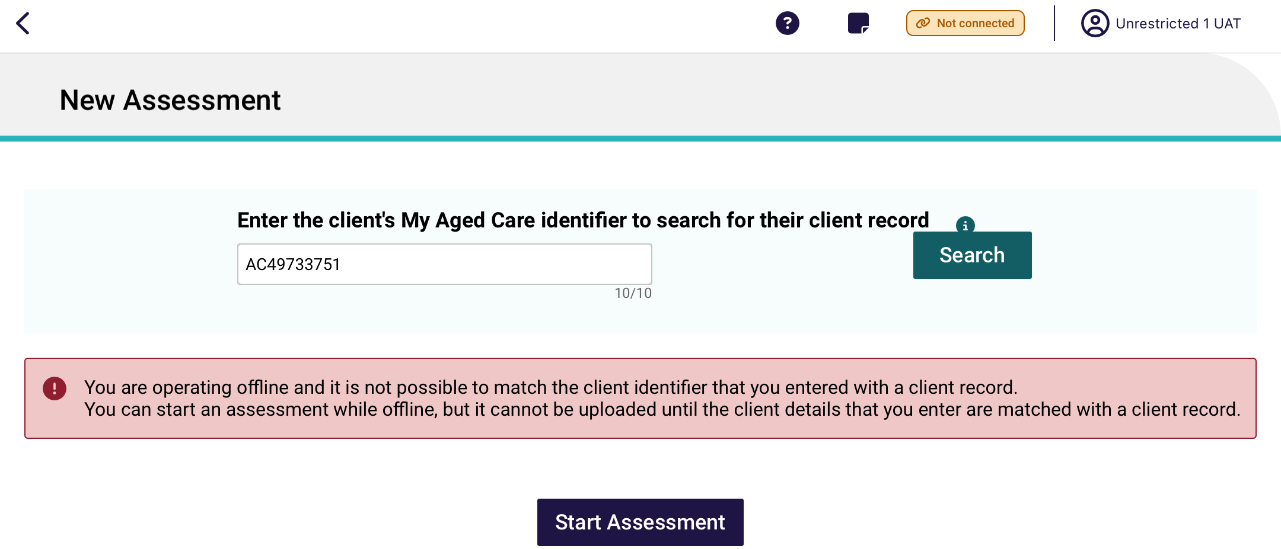
After starting a local assessment, you will be required to complete all mandatory fields including assessment details and client details.
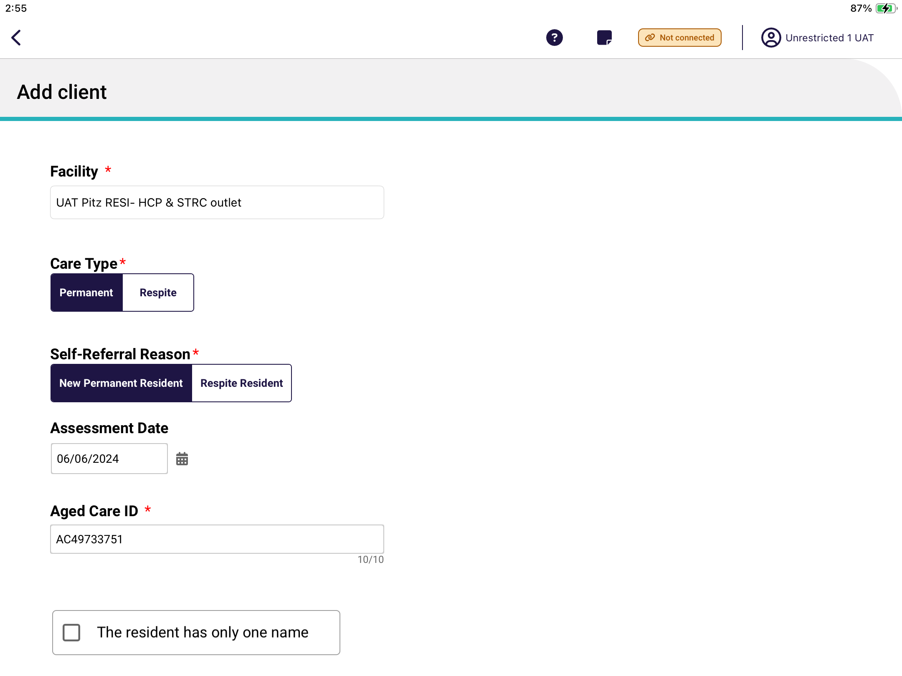
Once back online and connected to the internet, you will be required to match the local assessment will the correct Referral ID after commencing the assessment. This can be done when they have internet connectivity and selecting the Matched client button.
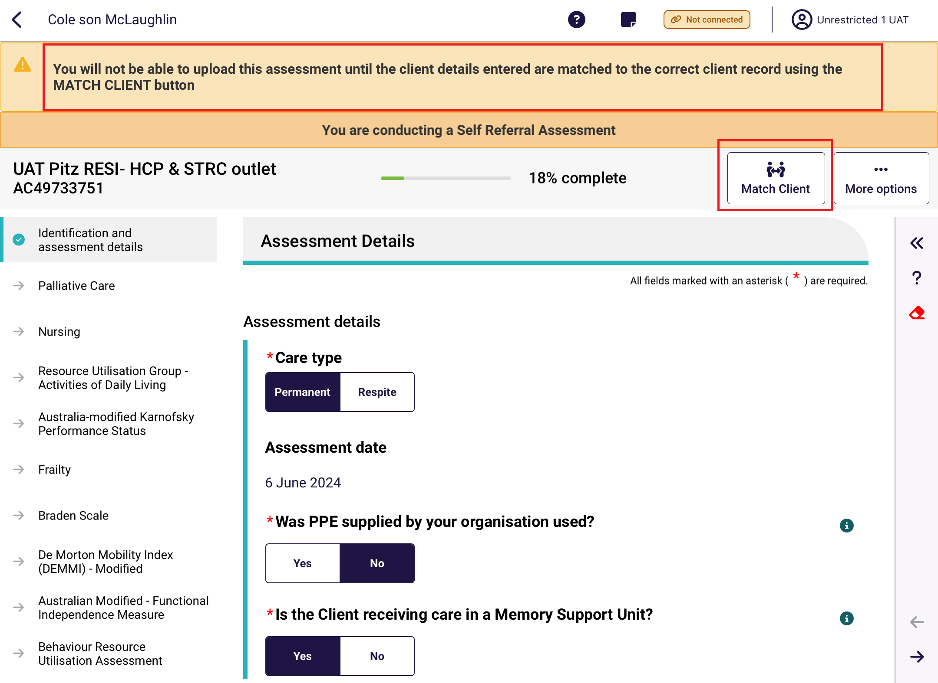
If the details do not match, you will need to go back and update the details to match or choose which details to use if the client ID is matched correctly. You will not be able to click Confirm unless the details are corrected.
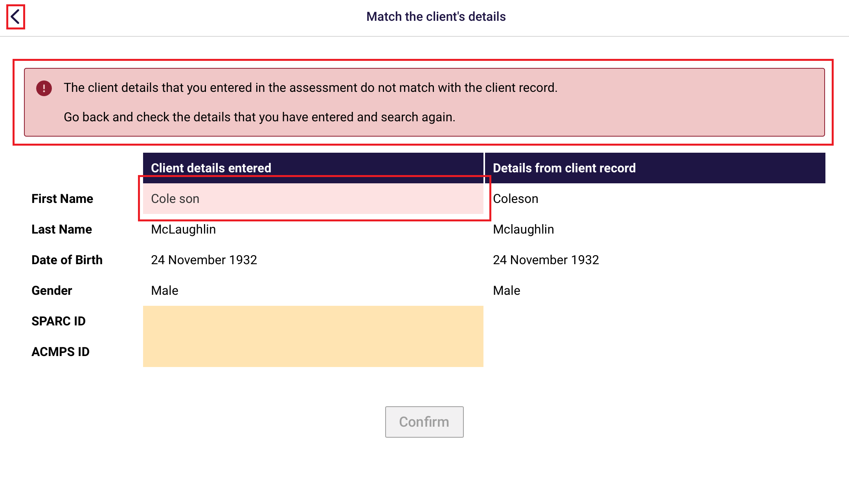
Once the details match, select Confirm, and continue with the rest of the assessment.
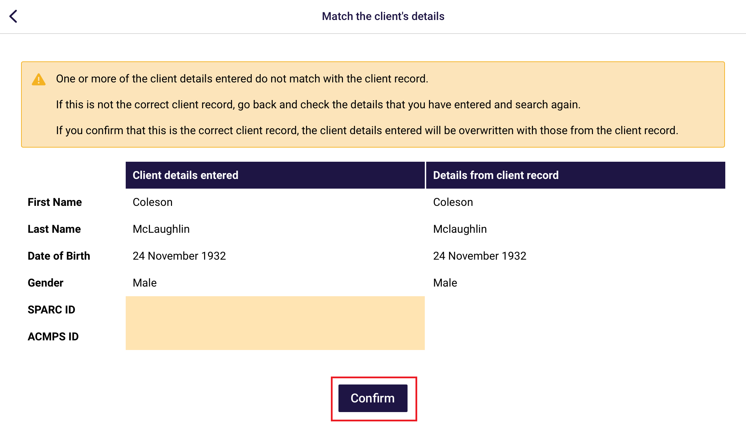

22. Completing, re-opening and uploading assessments

22.1 Completing an assessment
If there are any pages that are incomplete or needs review, the progress bar will be under 100% and the page that has not been completed will not show a tick icon.
- Select each of the pages that have an arrow to complete.
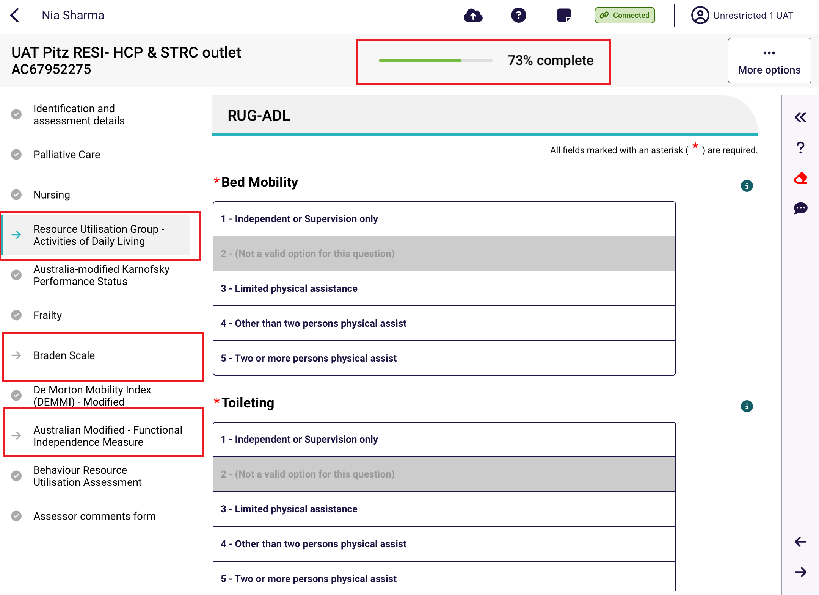
- If your input has contradicted a previous input in another tool, you will be shown the following warning. You will be able to choose to amend either the input that you have just created or the other contradicted input.
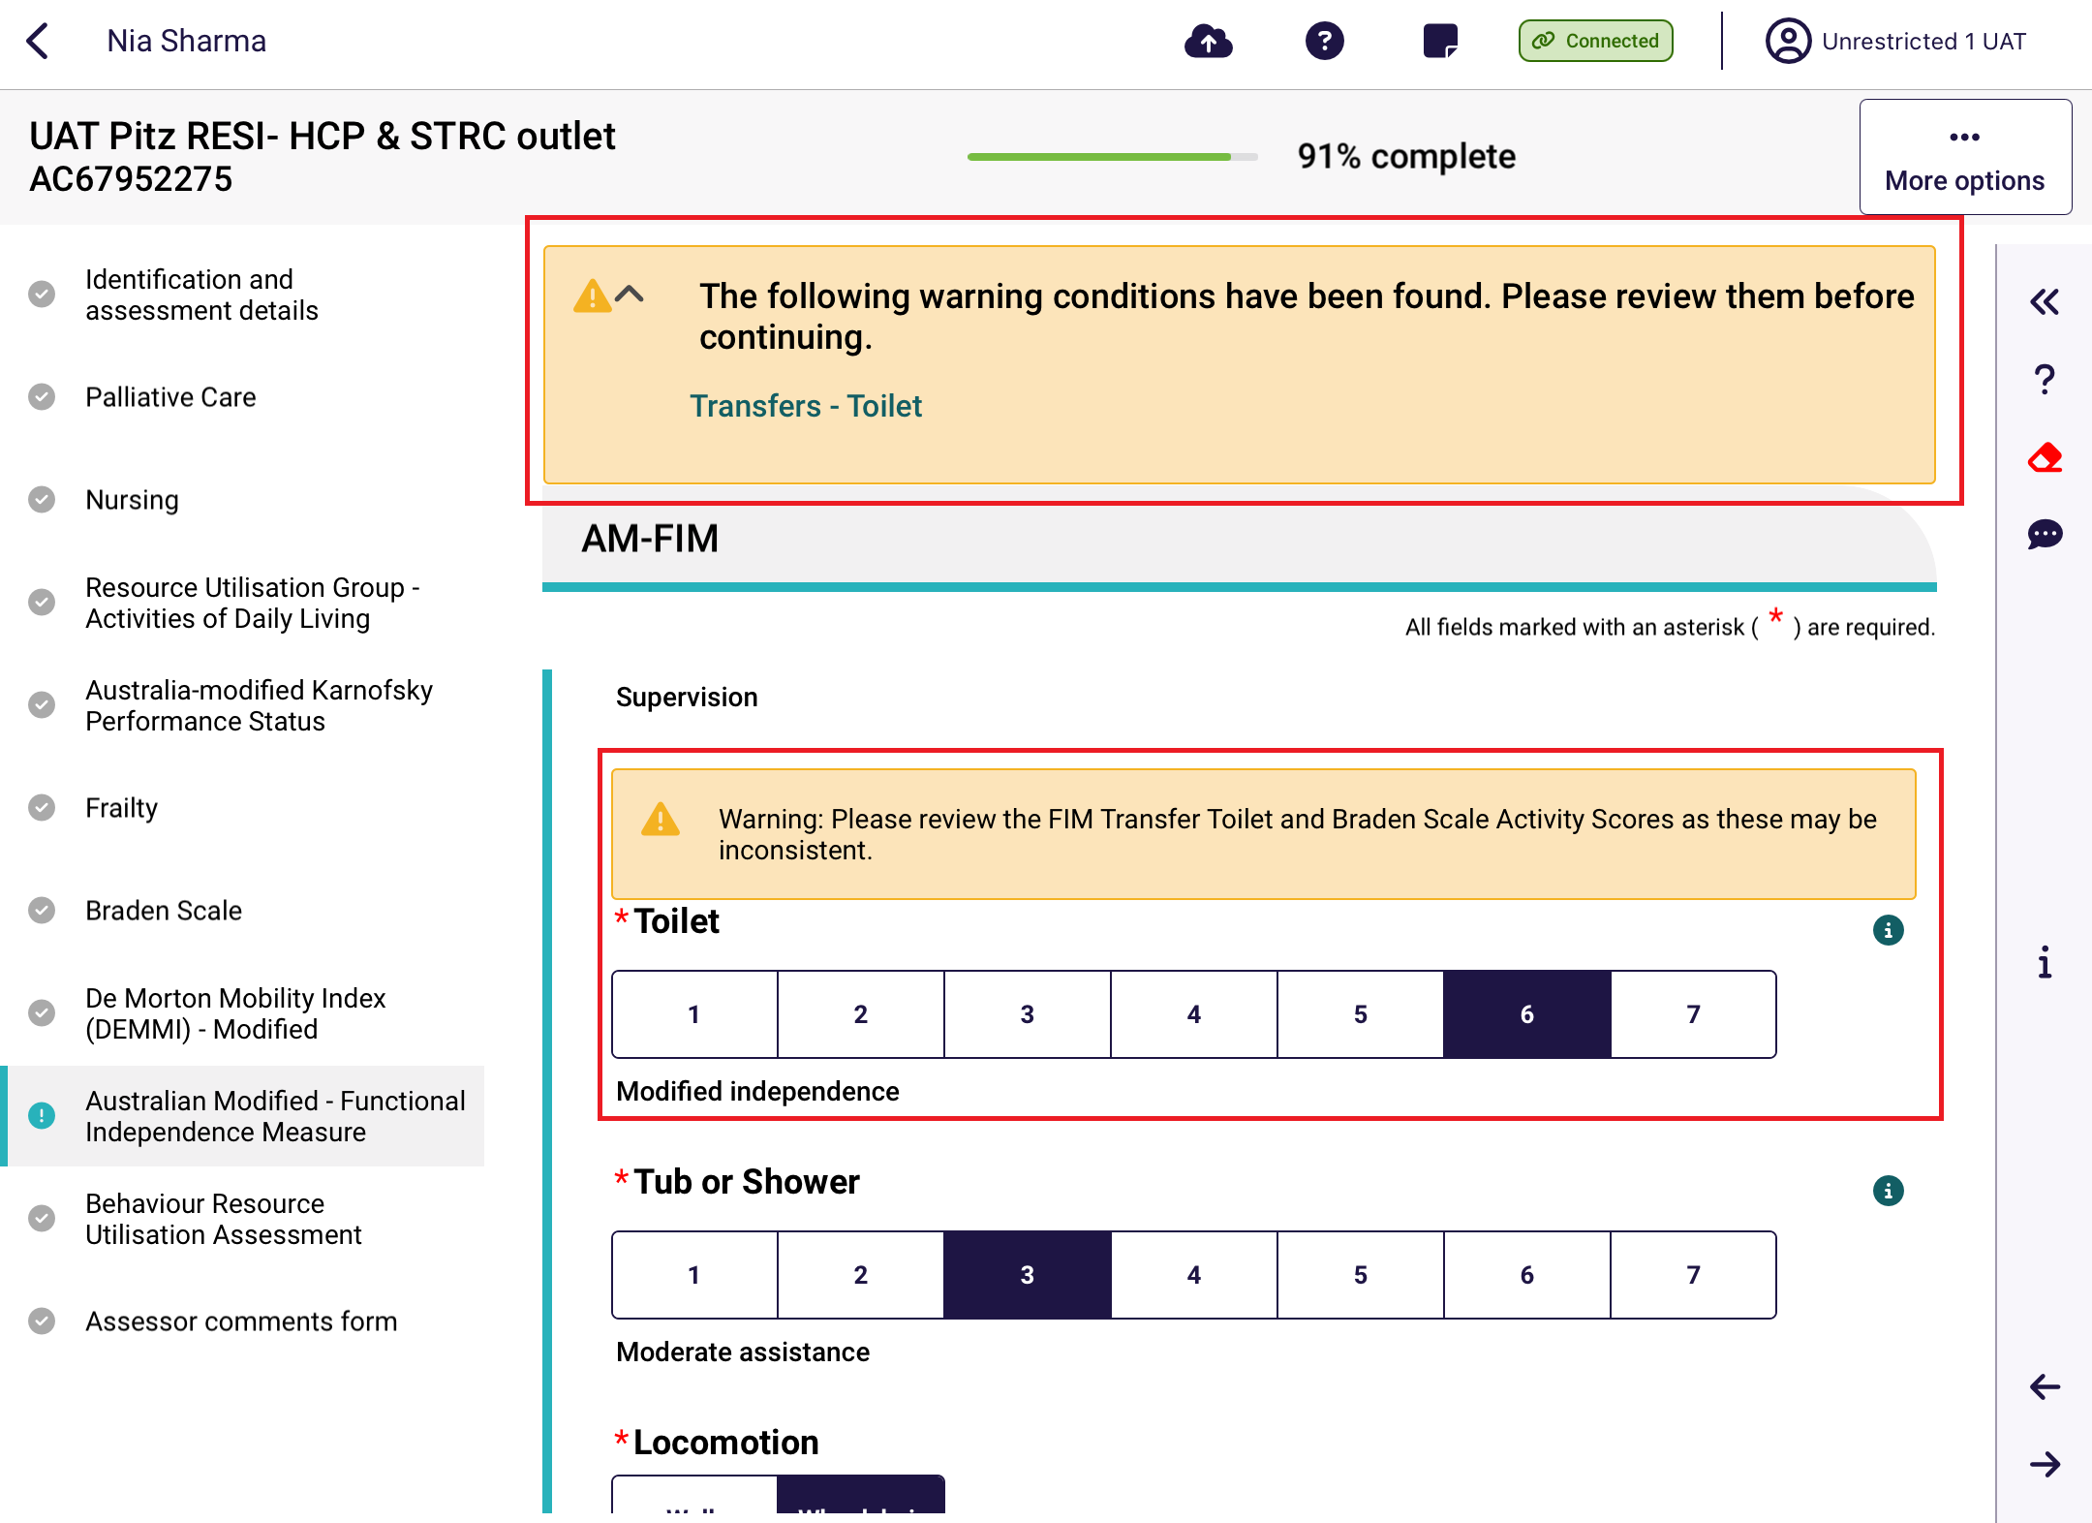
Once all pages are complete (tick icons) and the progress bar is showing 100% completed, select Complete on the top right.
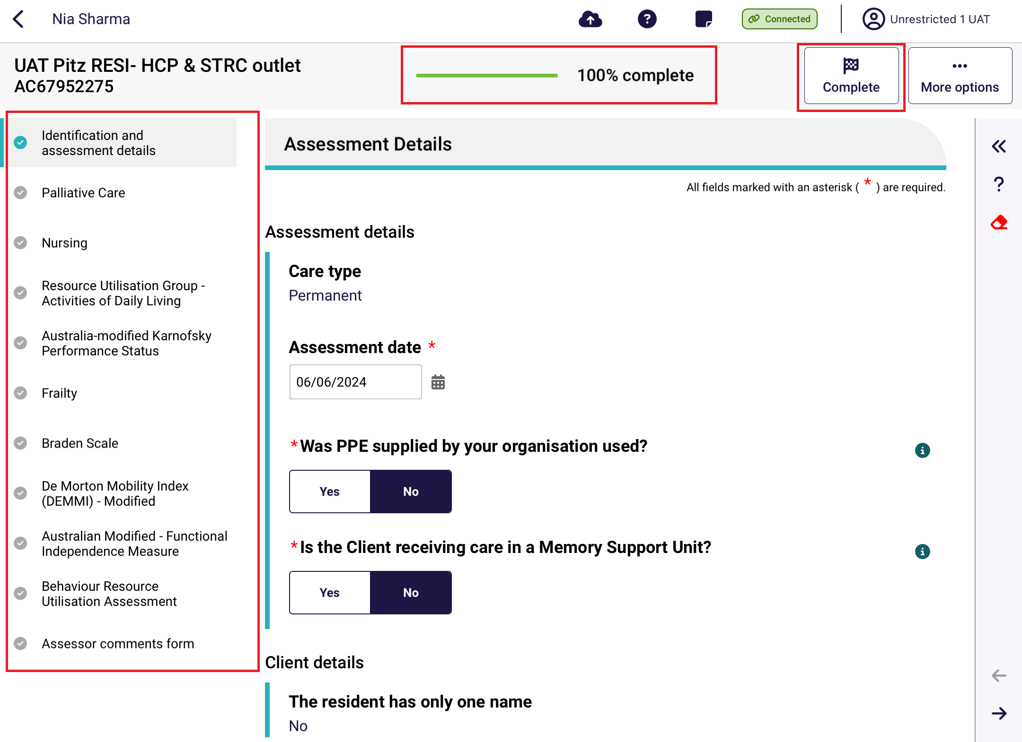
- Select Complete Assessment again to confirm.
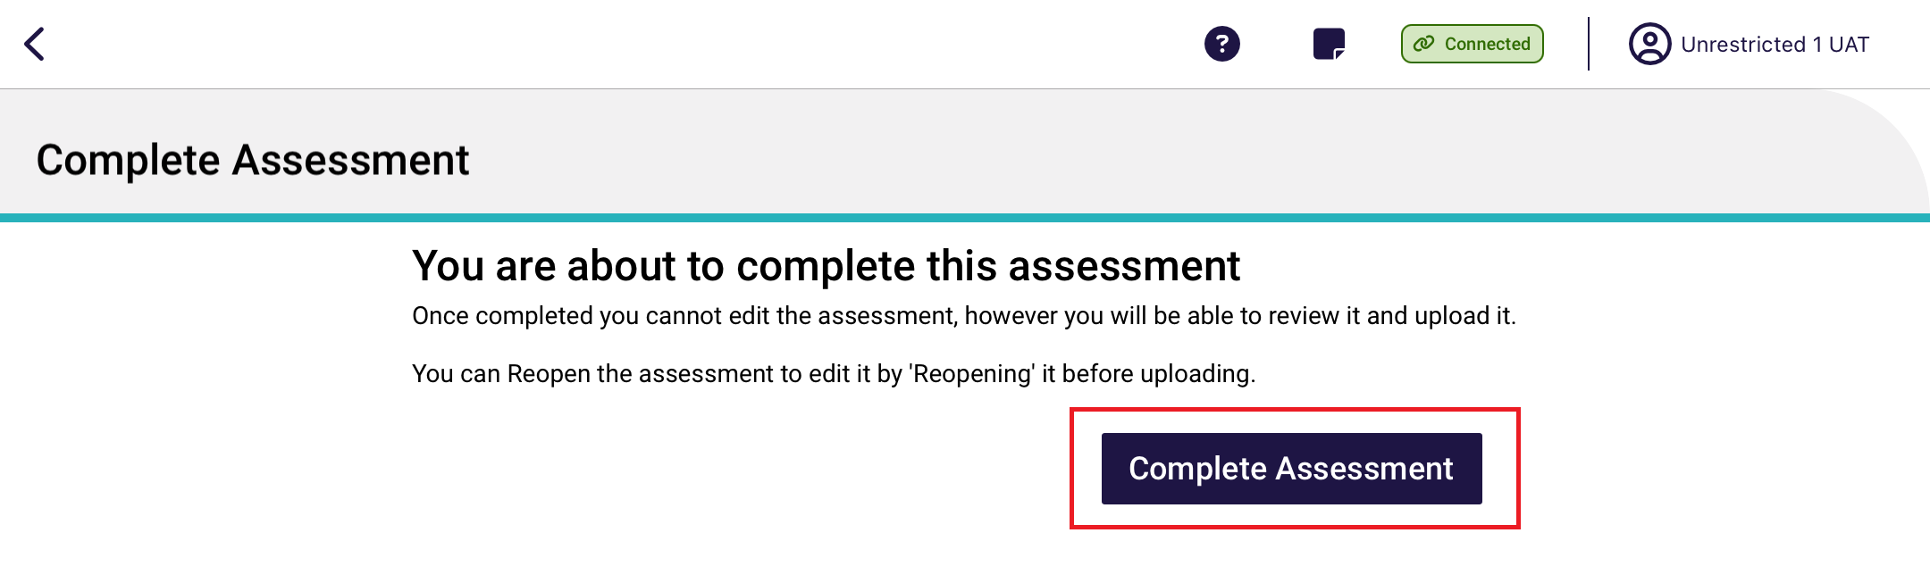
- A summary of the assessment appears. Scroll to the bottom and then select Upload. The assessment will remain in the completed status until either the Upload button is pressed or automatically uploaded after 7 days.
After upload, the assessment will disappear from the In-progress assessments section of the main menu.
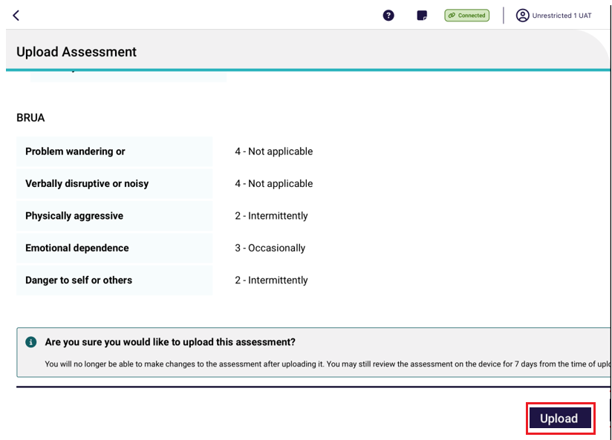

22.2 Re-opening a completed assessment
An assessment that has the status of Completed or Uploaded can be reopened, but only Completed assessments can be reopened for edits. Uploaded assessments can be reopened for view only.
- To reopen a complete assessment, select the Facility, then select Completed. Select the assessment to reopen.
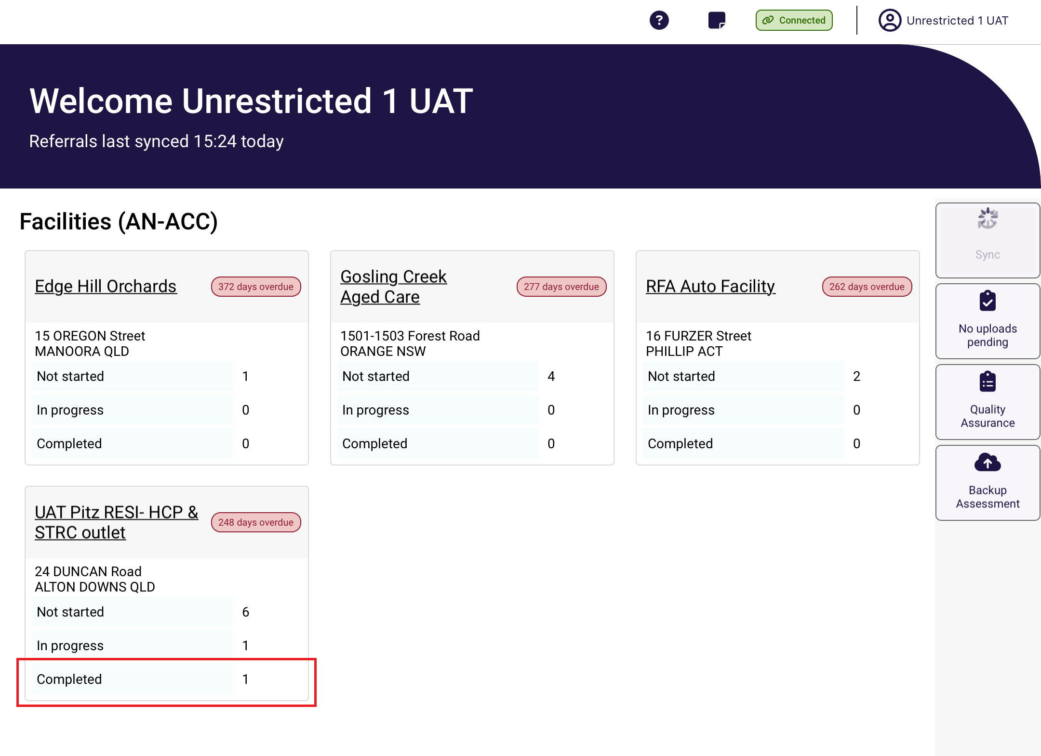
! | Assessments with a 100% progress completed indicator will still appear in the In-progress assessment section of the main menu. These assessments are technically complete but is not officially in the Completed status until the Complete Assessment button is selected.  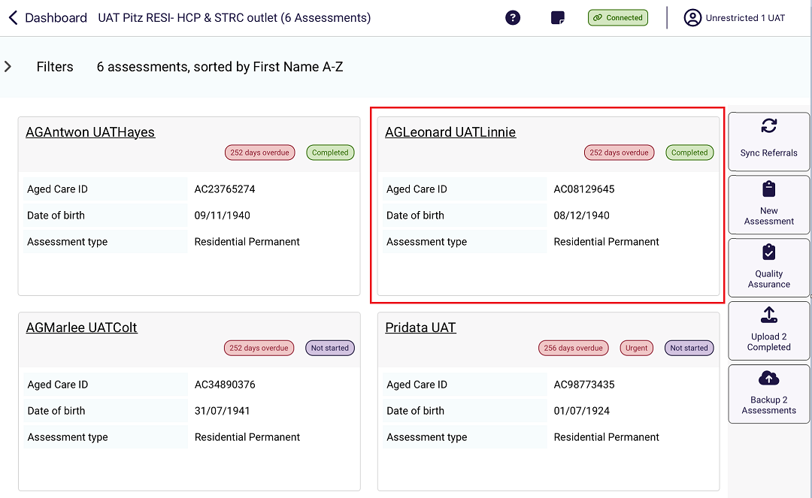
The selected assessment displays. Select Reopen.
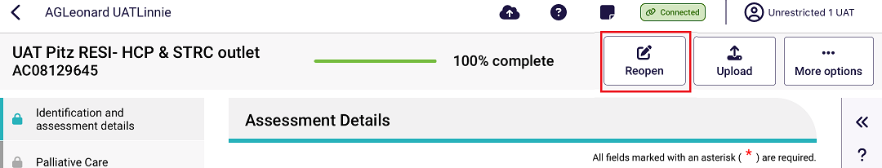
- The completed assessment will be reopened for edits. It will need to go through the process for Completing an assessment again.

22.3 Re-opening an uploaded assessment
! | Once the assessment has been uploaded you are unable to reopen and edit the assessment.  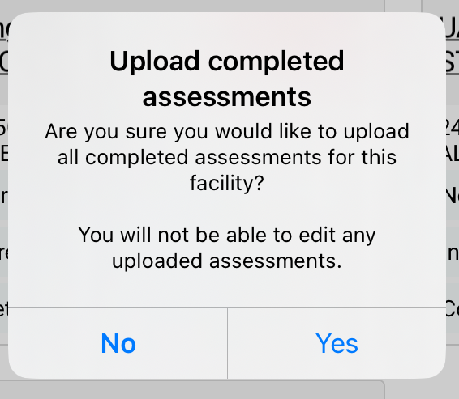

22.4 Uploading Assessments
RAC funding assessors can upload assessments once they are complete. The assessment will remain in the completed status until either the Upload button is pressed or automatically uploaded after 7 days. After upload, the assessment will disappear from the In-progress assessments section of the main menu and will move to the Uploaded section of the Facility’s page.
! | You must have an active internet connection to upload the assessment.  If you do not have an active internet connection, the completed assessment will be saved on your device for 7 days and uploaded when you enter an internet service area.
- After completing the steps in Completing an Assessment, a summary of the assessment appears. Scroll to the bottom and then select Upload.
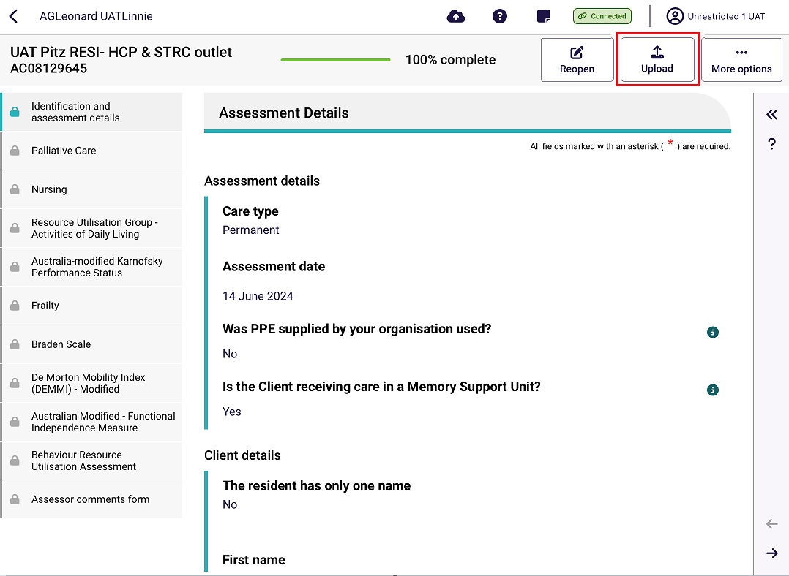
- After going to the Facility page and selecting Completed, all completed assessments can be uploaded at once by selecting Upload [number] Completed.

Removing Assessments and Clearing Assessment Data
! | Removing an assessment from the device will permanently delete any assessment information recorded on that device.
! | Completed but not yet uploaded assessments cannot be removed.
! | Removing an uploaded assessment from your device does NOT remove the data from My Aged Care.

23.1 Removing an uploaded assessment
To remove an uploaded assessment:
- Open the uploaded assessment that you wish to remove. See the Find A Client section for more details.
- Select the More options button in the top right hand side.
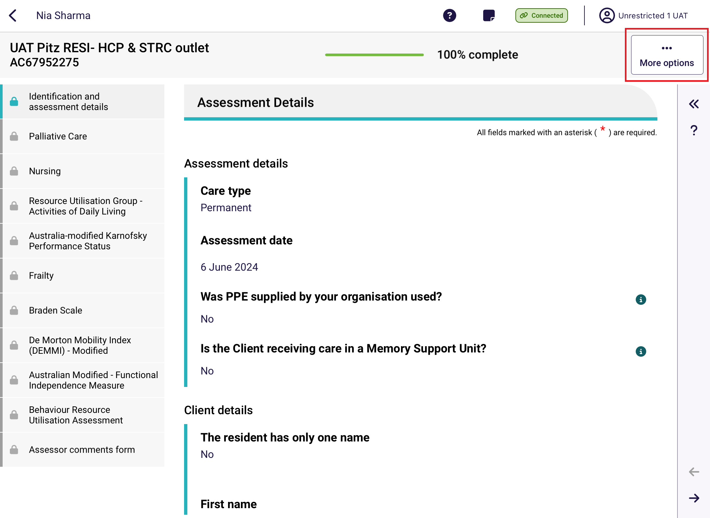
- Select Remove assessment from the pop-up. This will NOT remove the assessment data from the department’s system.
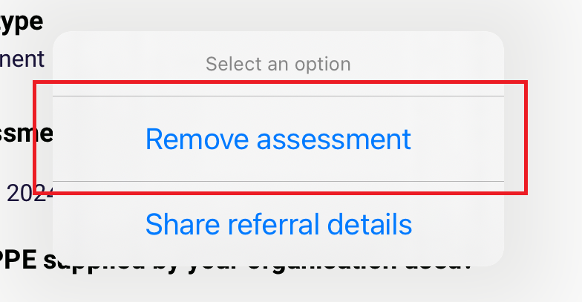

23.2 Removing an in-progress assessment
To remove an in-progress assessment:
- Open the assessment that you wish to remove. Refer to the Find A Client section for more details.
- Select the More options button in the top right corner of the app.
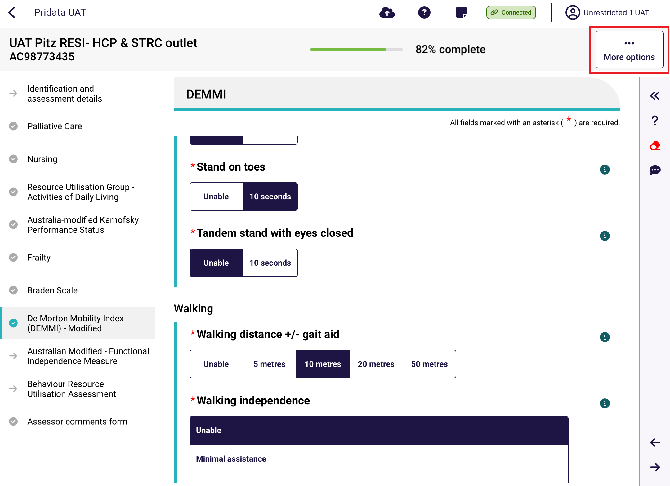
- Select Remove assessment from the Select an option pop-up.
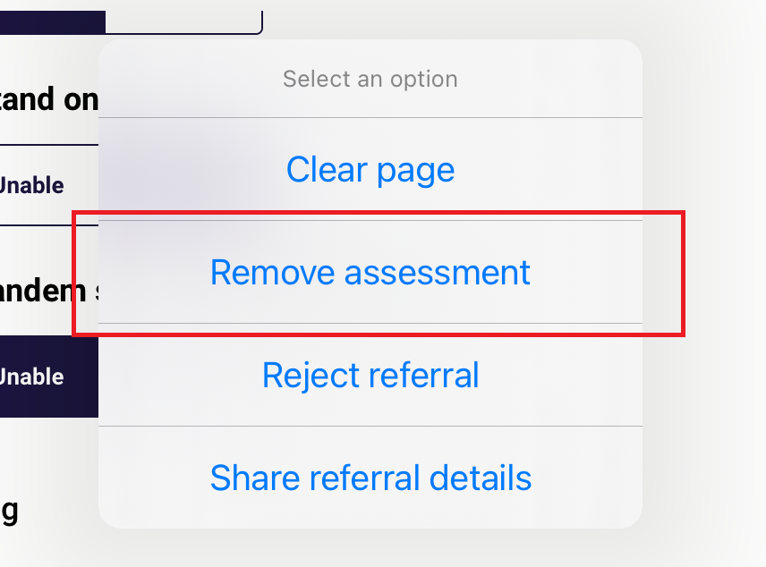
- Select Remove assessment from the Remove Assessment pop up.
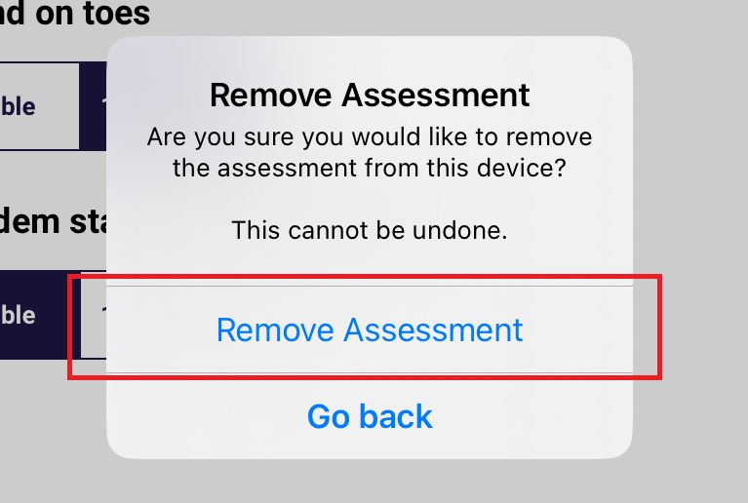
- The assessment will be removed. If you choose the same client again from the Facilities page, you will be prompted to start a new assessment. ALL data will have been removed.

23.3 Clear Uploaded and Not Started assessments
For not started or uploaded assessments, to clear them they will either require to be manually removed by following the steps set out in Removing an uploaded assessment or will automatically be removed 7 days after successfully uploading.
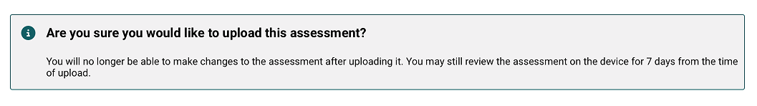

23.4 Rejecting a Referral
RAC funding assessors may reject a referral if a Resident is not available to be assessed. Please note that for self-referred assessments, you will not be able to reject the referral.
- Go to the Resident’s client card to display the Start Assessment screen. Then, select Reject Referral.
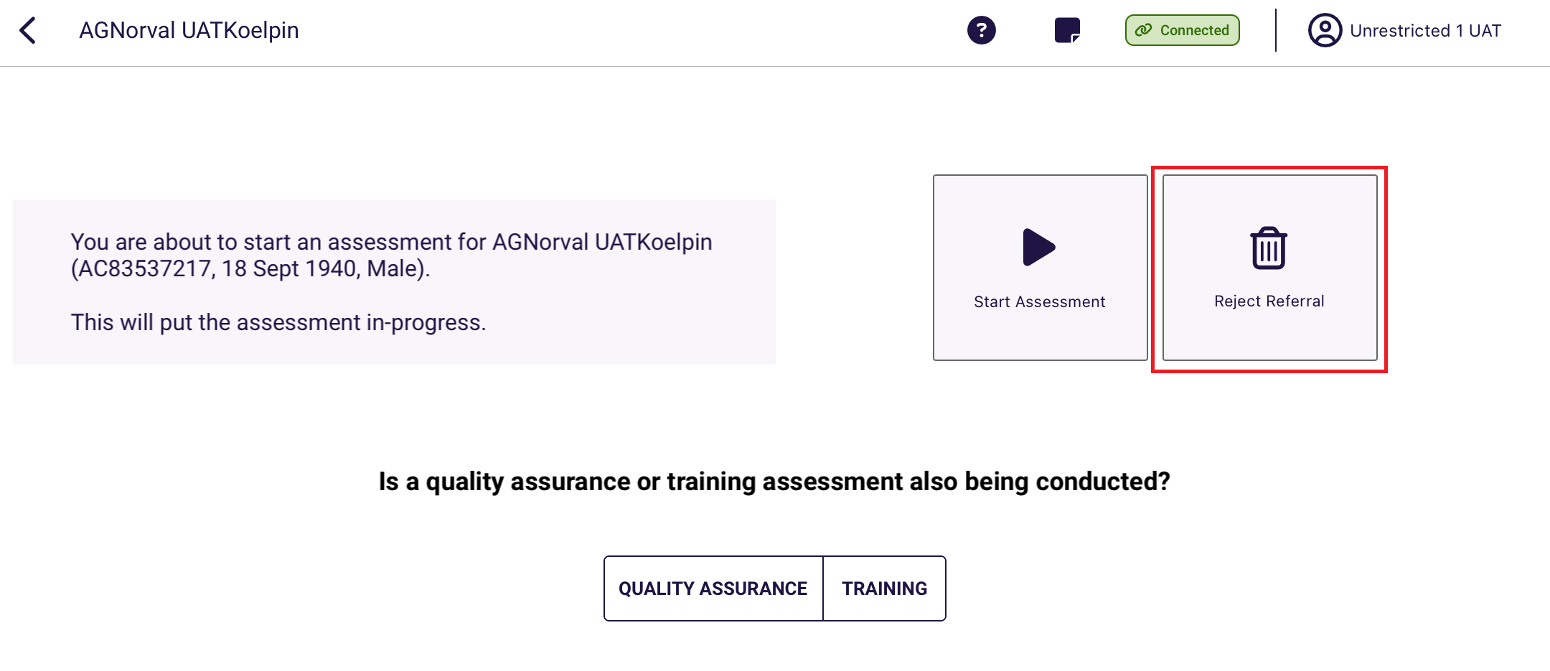
- Select the reason for the rejection. Choose from Client Deceased, Client Unavailable, or Other. Please note that for Residential Respite referrals option of Client has exited facility will be available instead of Client Unavailable.
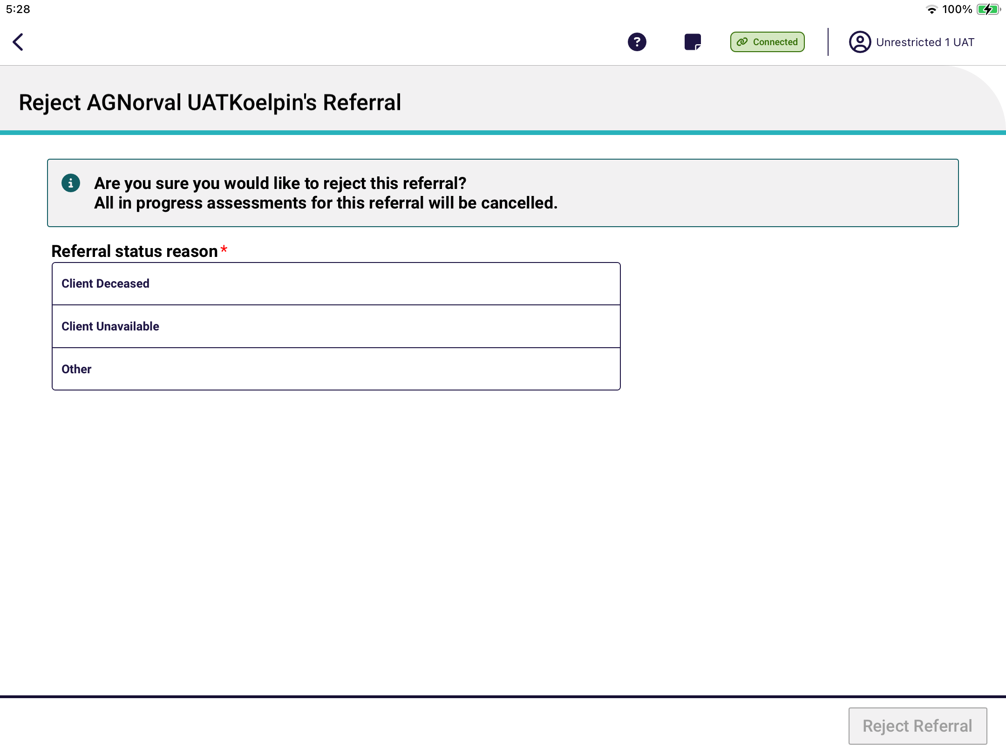
- Client Deceased
Select the client’s deceased date if known, then select Reject Referral.
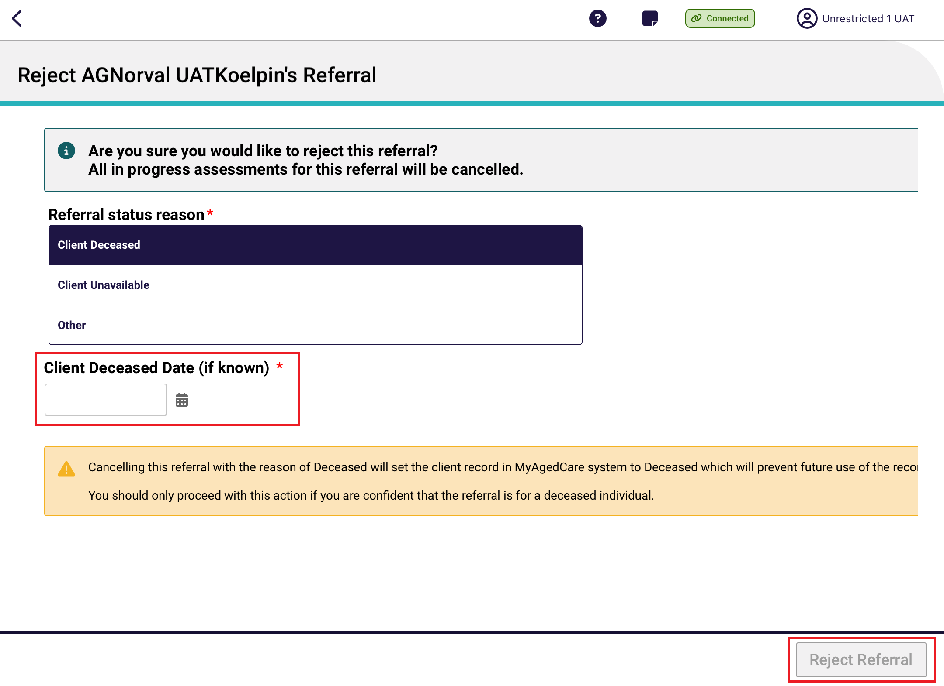
- Client Unavailable
Client unavailable should be selected if the client is currently unavailable for some reason, for example is in hospital but is expected to return to the service or facility at some point of time in the future. Select Reject Referral.
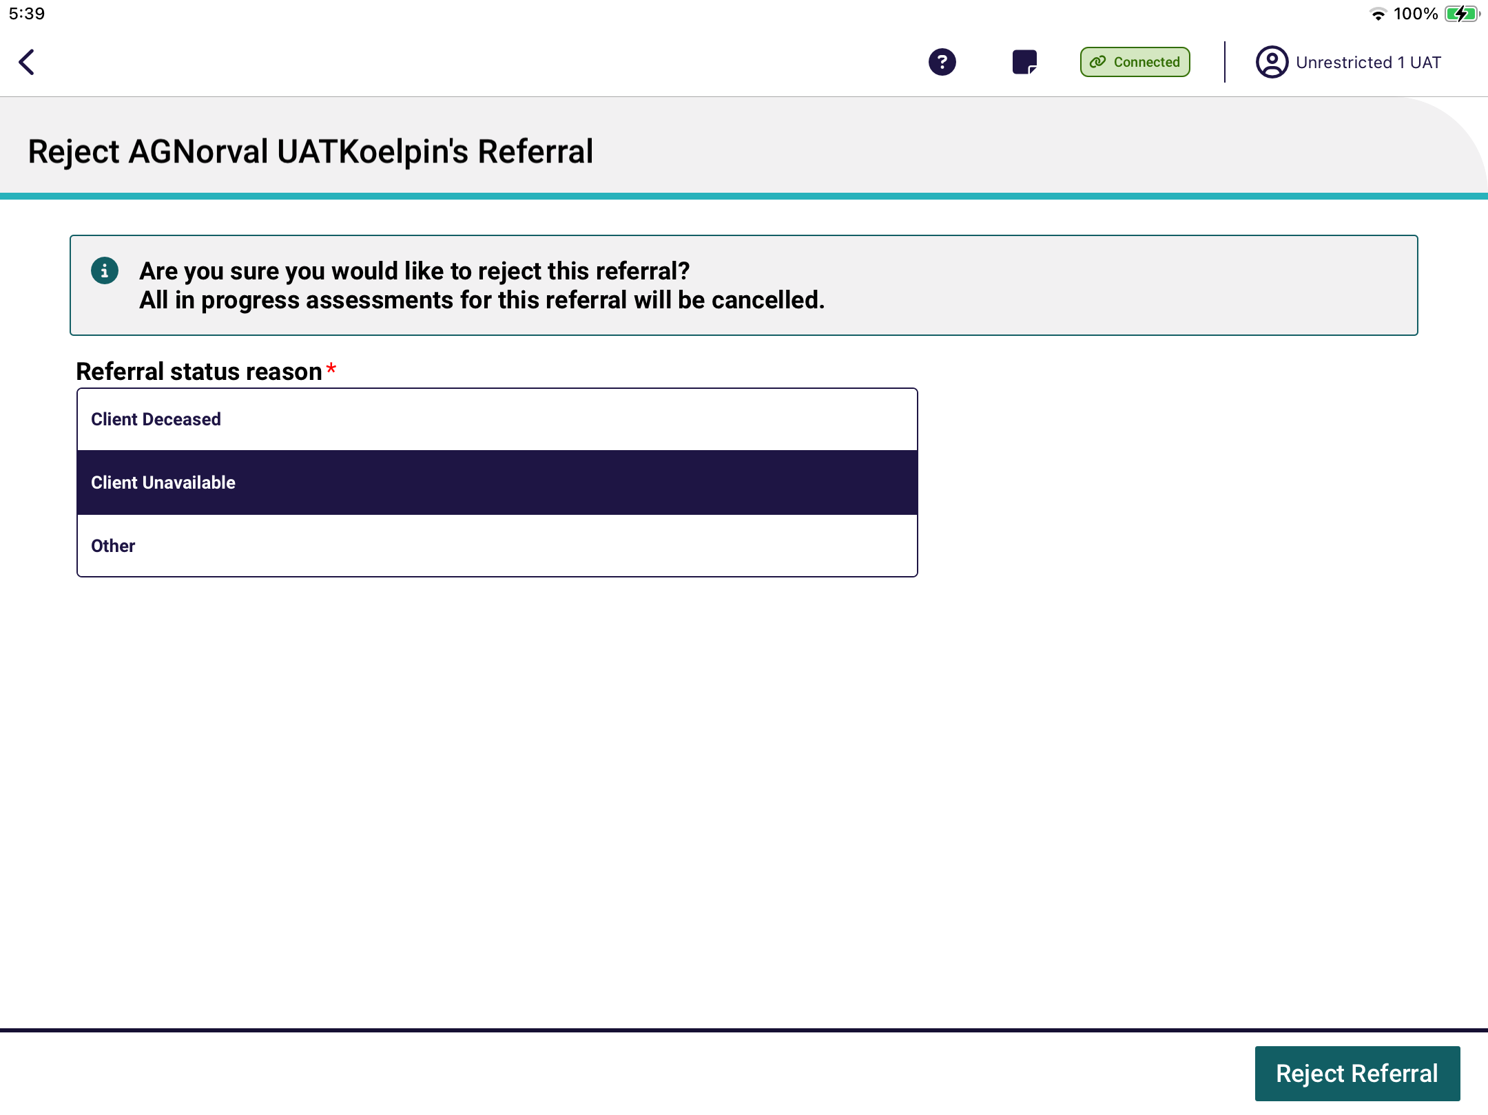
- Client has exited facility
This option is available for Residential Respite referrals only. Select Reject Referral. This option will transfer the referral to an assessment organisation at the client’s registered home address.
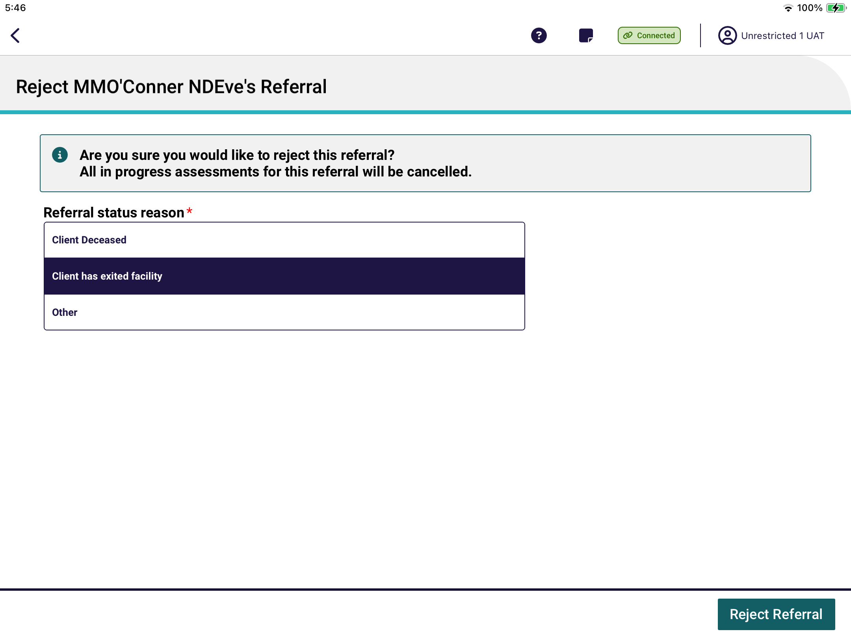
- Other
If the assessment cannot be completed for any other reason, select Other and enter the reason in the textbox. You must enter a reason in Rejection reason before you will be able to reject the referral. Then, select Reject Referral.
An example of this would be if the resident has returned to their home in the community.
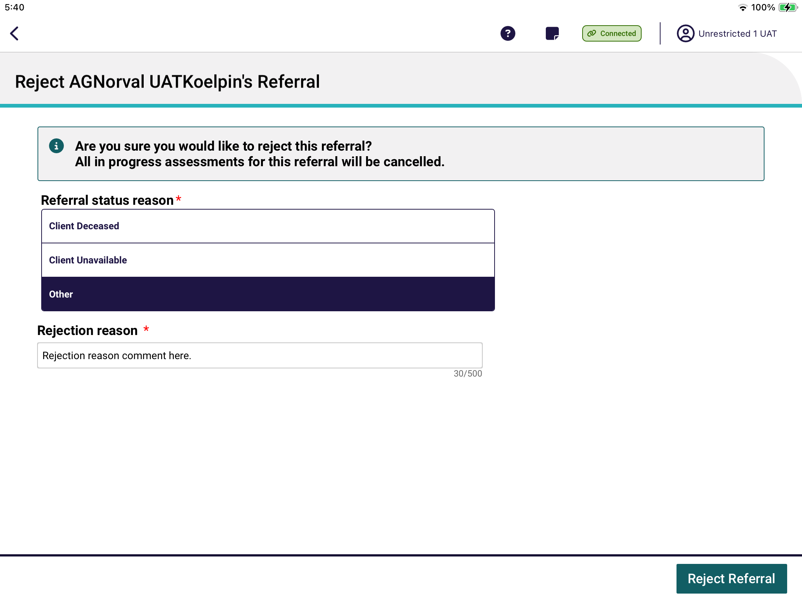

24. Appendices

24.1 Sideloaded App for Organisations
Some organisations who would like to use the App on a Windows device outside the Windows App Store, via a manual installation process with a downloaded installation file known as sideloading. The app files for Windows are available to sideload onto a Windows device running Windows 10 or above. This is to allow for businesses that have a restricted IT environment to install the app without going through the Microsoft Store.
Download the sideloaded App from the department’s website.
My Aged Care recommends the use of the Microsoft sideloading documentation to install the app.
The suffix of the version number ends with a number one. For example: v30.0.0.1
The icon and splash screen for the Aged Care Assessor app appears as follows:
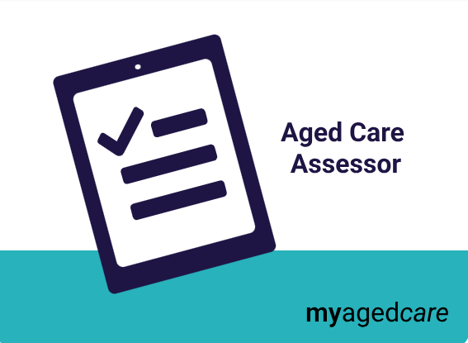

Upcoming releases
Unlike apps in the Microsoft Store, Apple App Store and Android Play Store which include automatic updates, Sideloaded apps have no automatic updates, therefore each sideload version update will require a manual installation.
The department will notify assessment organisations of a new release at least 2 weeks prior to the release of the application. They will also be notified when the new version is available and by what date all their users should be using the new version of the app.

Frequently Asked Questions
- When do I need to install the new release of the app onto my organisation’s devices?
The new version of the app should be installed on your users’ devices within 1 week from the release of the new version. Once the new release of app has gone live, users will not be able to begin any new assessments until they have been upgraded to the latest version.
- How will my organisation’s sideloaded app users be supported by the department?
If you have installed the Aged Care Assessor App via the sideloading method, the department will continue to support users for issues within the application. We may refer you to contact your organisation’s IT area if we believe the issue is related to your organisation’s setup.
- What happens if I don’t upgrade my sideloaded app to a new version when it is released?
When a user doesn’t accept the updated version of the App from the Microsoft Store, they will not be able to download or access any new referrals on their device. This same restriction will happen for users who have sideloaded the application and don’t have the latest version available.
- What should I do if I have any issues with using my sideloaded app?
Please email your organisation’s IT area and include: description of the issue, screenshot/s of the issue, and description of where the issue is during your assessment or other use of the app.

24.2 End-of-Life Pathway
An assessor can choose to flag that a client is using the End-of-Life pathway. This is available at the following times:
- during referral and self-referral
- before triage
- before assessment starts
- during the assessment
- before the support plan review starts
- during the support plan review.
For Transitioned Home Care Package clients that were flagged on the End-of-Life pathway but no longer requires it, assessors can revert this decision, back to the previous Transitioned Home Care Package classification.
To flag the End-of-life pathway:
- Select the ‘Flag End-Of-Life’ option during referral. Alternatively select the ‘Flag End-of-life Pathway’ button before triage, before assessment starts, and at the start of support plan review.
During Referral
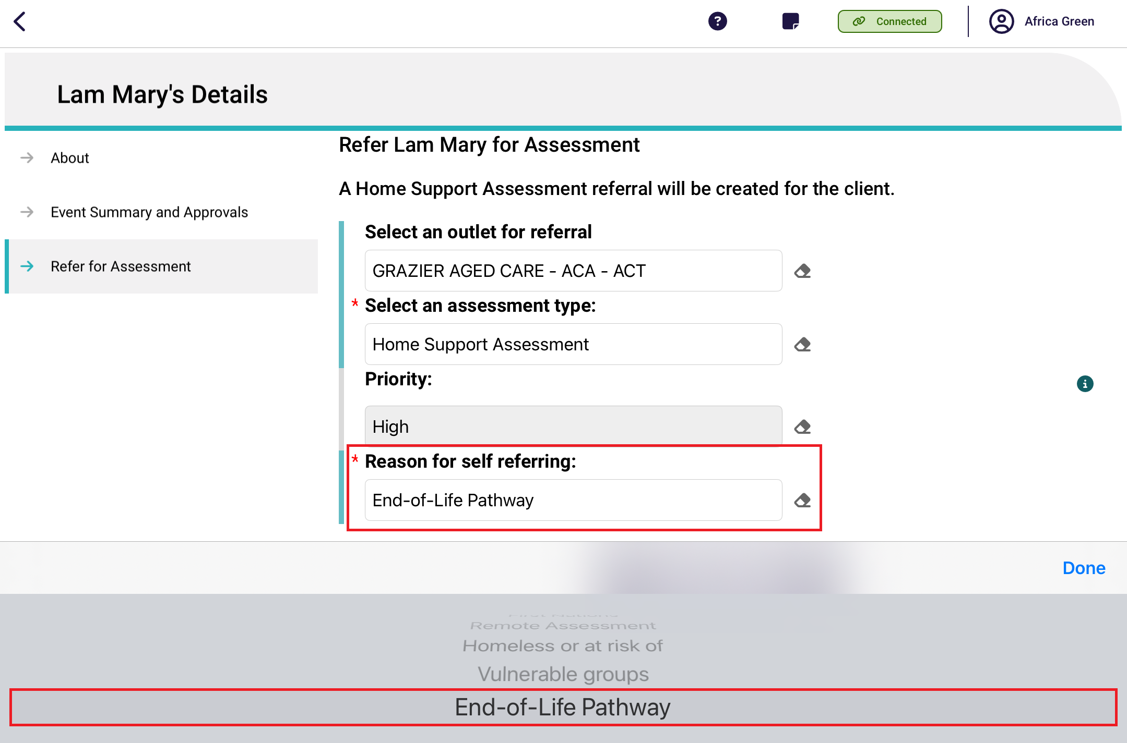
Before Triage
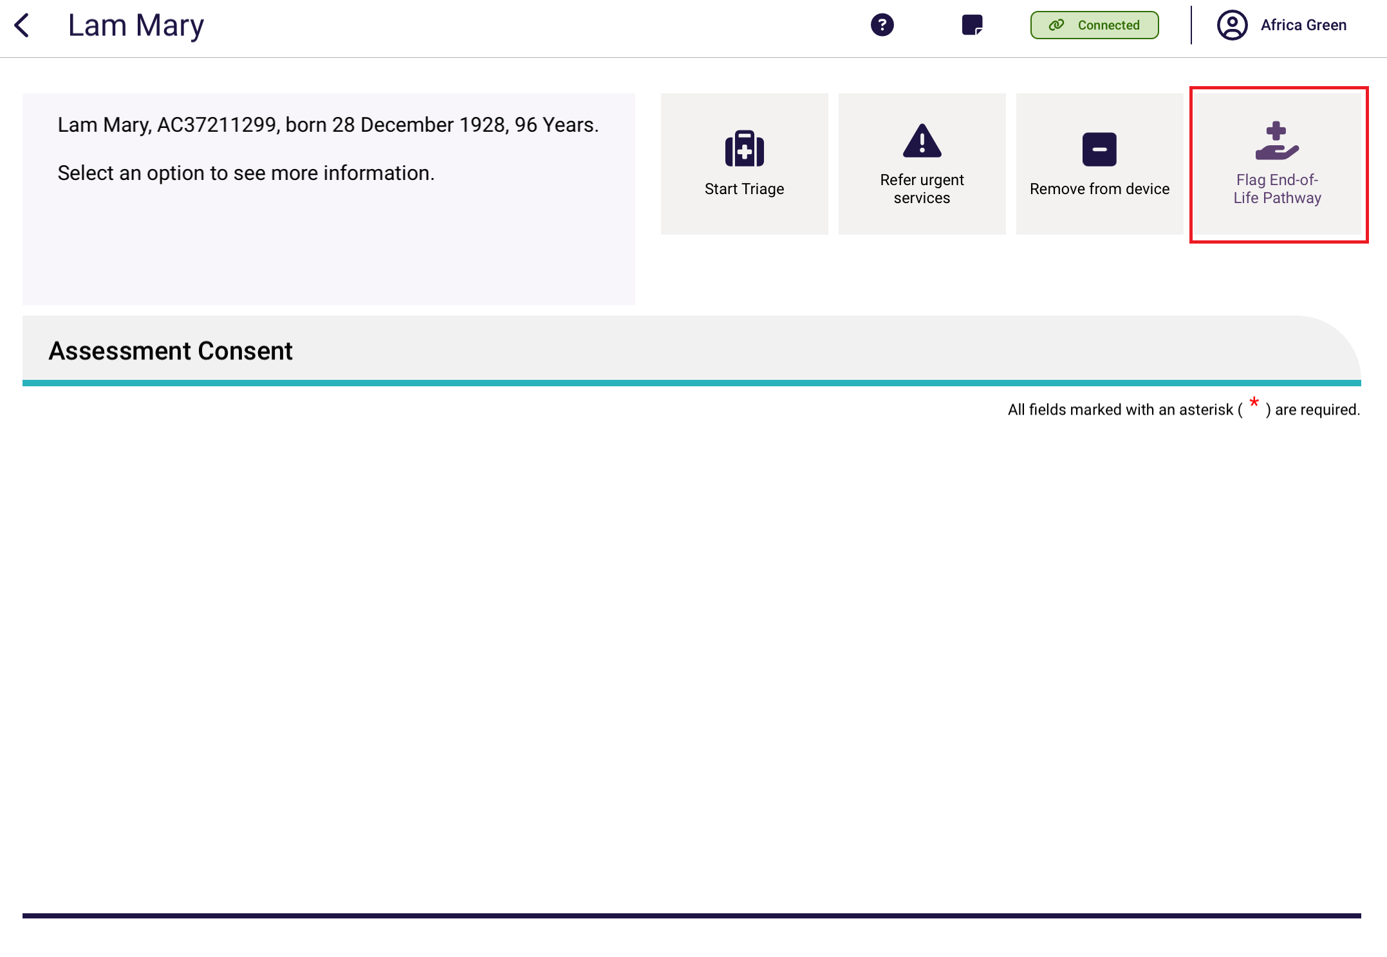
The flag is also available when the IAT assessment is finalised and during the support plan review, by selecting More Options and then selecting Flag End-of-life pathway.
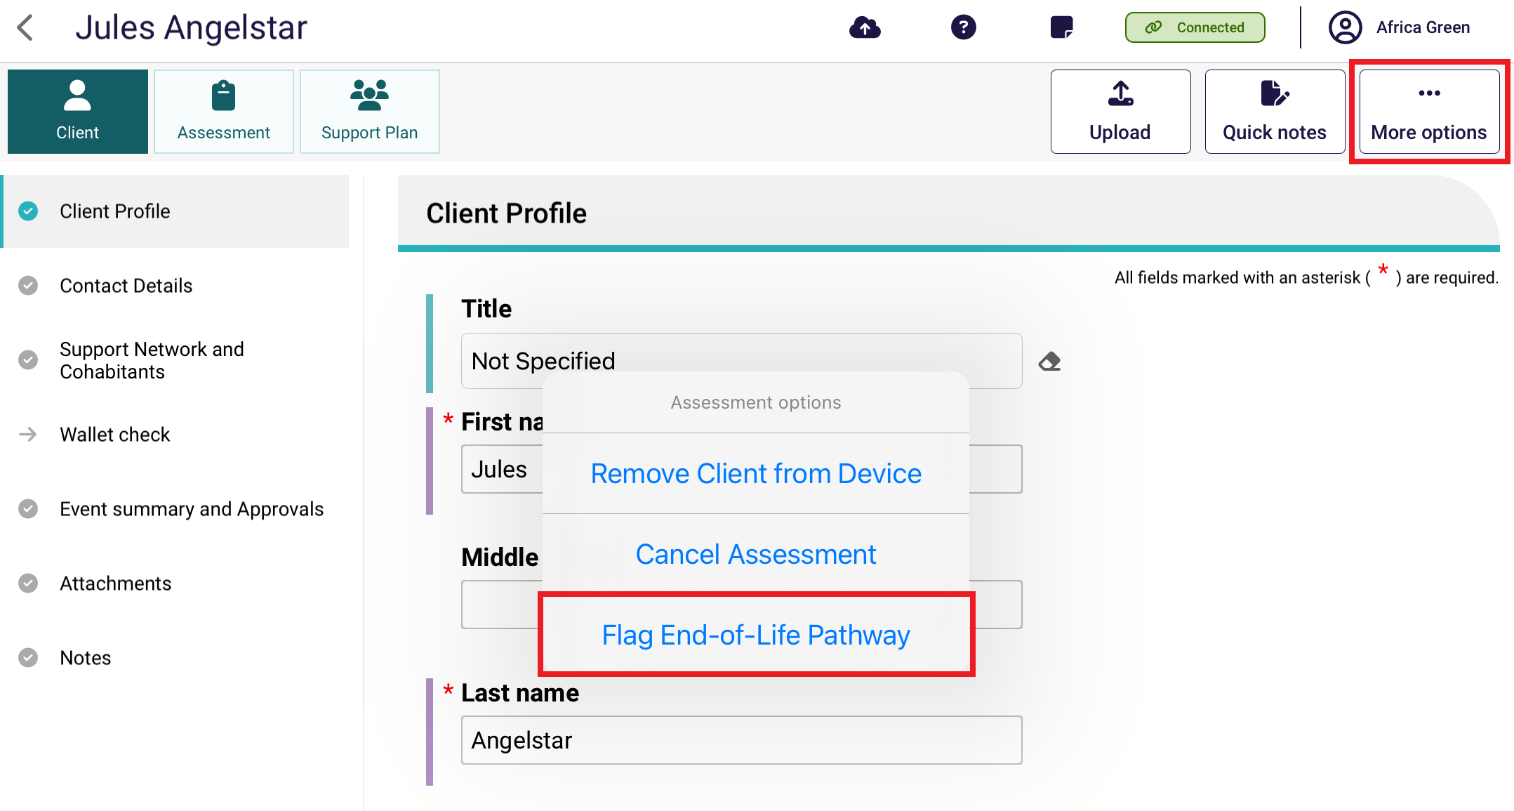
- The End-of-Life Pathway page appears.
In here you can:
- select the tickbox to start the End-of-life pathway. This will also set the priority to High (Or Urgent for Support Plan reviews)
- attach the End of Life Form, and/or others
- validate End-of-life forms, and select the form verification status
- add details as free text.
Select Confirm to finalise the pathway.
! | Assessors must verify End-of-life documentation before submitting the Support Plan or Support Plan Review for delegate decision.
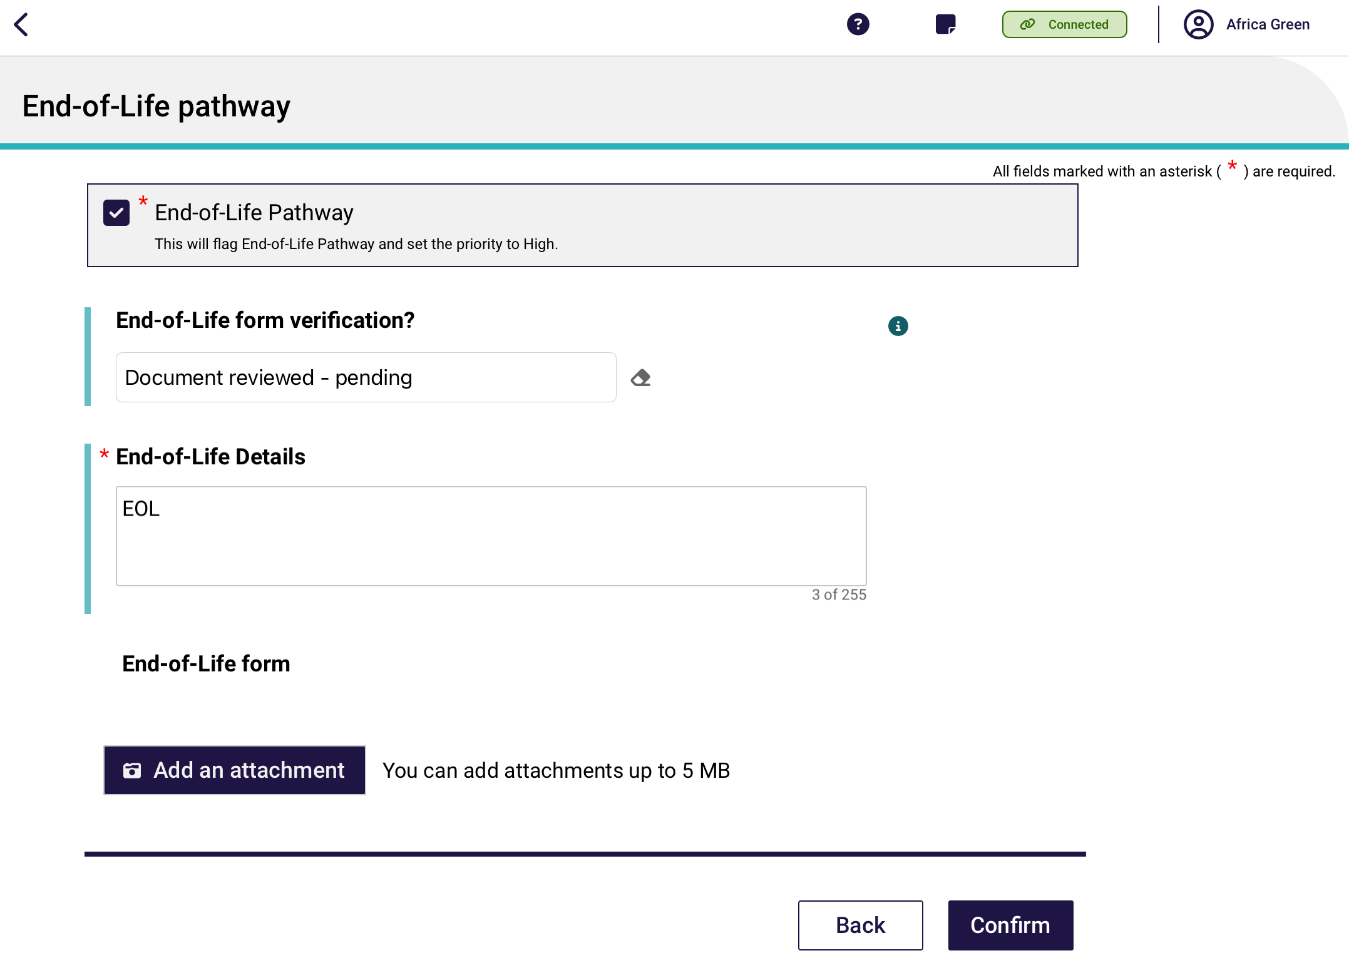
- Assessors can also attach End-of-life documentation at the Attachments page of the Client Record.
Select the Add an attachment button.
There are two types of attachments available: End of Life Form, and End of Life – Other.
When attached successfully, go to the client’s Attachments screen, then to the attachments section, to view them.
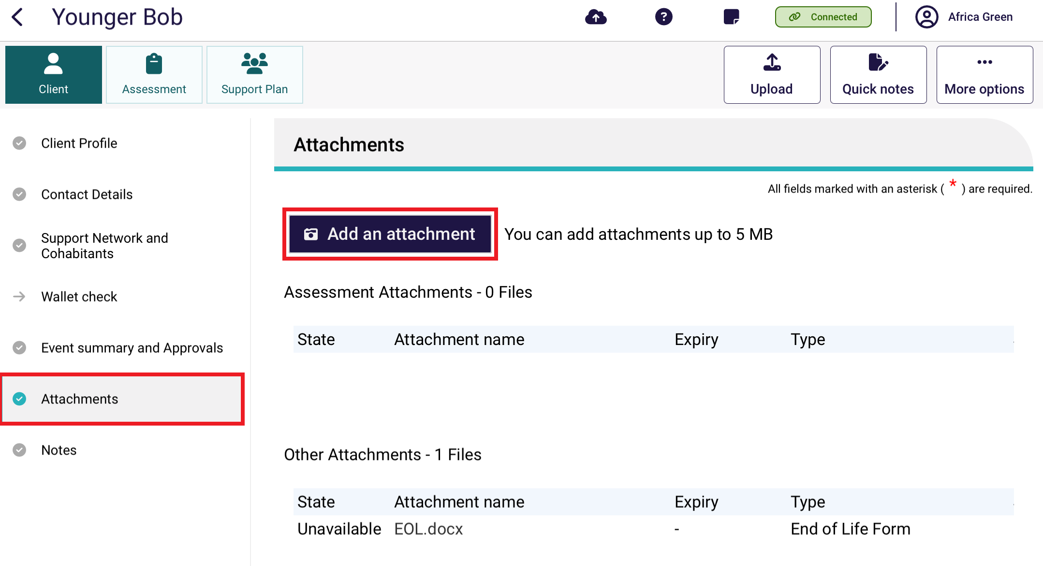
- Assessors can also validate End-of-life documentation at the following times:
- before triage
- before assessment starts
- during the support plan
- during support plan review.
For before triage or before assessment starting, validate by selecting the Validate End-of-Life documents button.
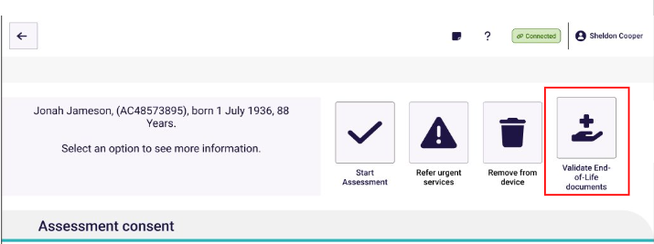
If the IAT assessment is finalised or you are during the support plan review, you can select More Options, then select Validate End-of-Life Pathway.
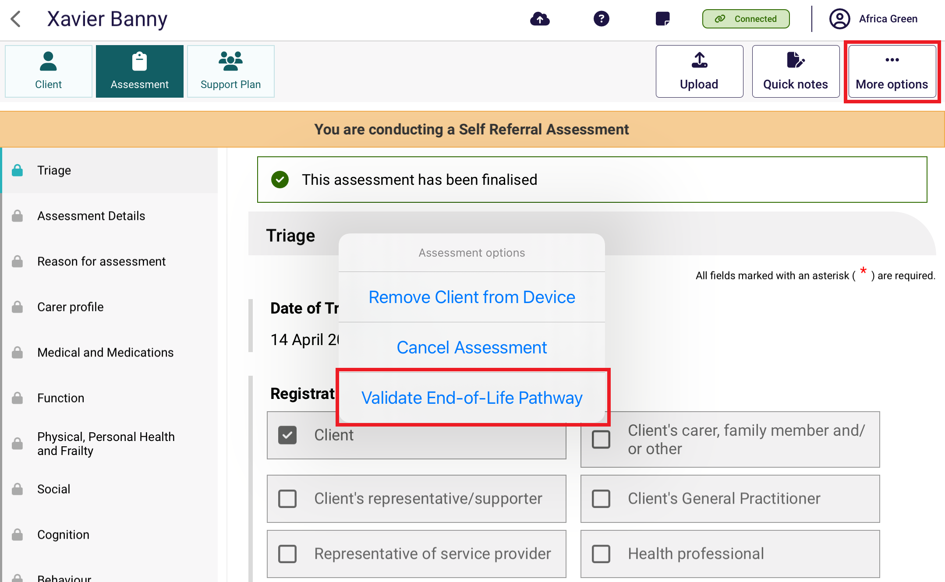
- Once the End-of-Life pathway is finalised, the assessor’s dashboard will show an End of life badge.
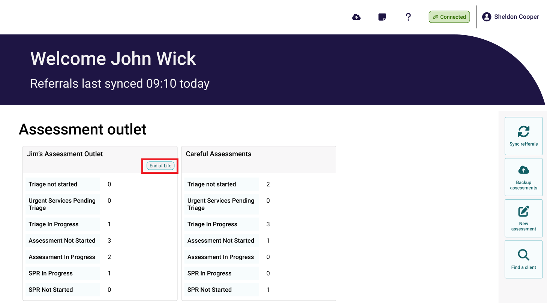
- You can use the ‘End of life’ keyword whilst searching for clients and assessments.
There will be an End of Life badge associated with the Client Record. All End-Of-Life flagged assessments and support plan reviews have a High priority.
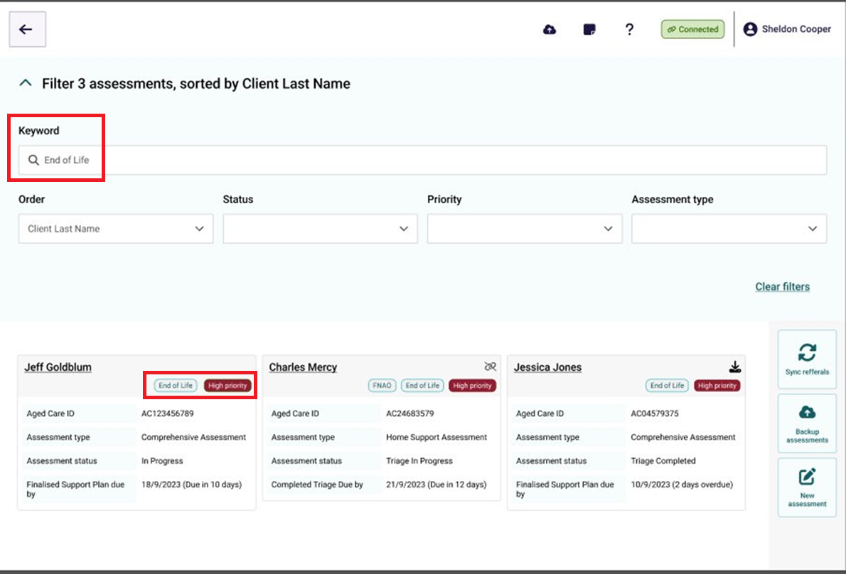

24.3 Troubleshooting and diagnostics
The troubleshooting and diagnostics functionality assists the My Aged Care service provider and assessor helpline with diagnosis and resolution of issues in coordination with the support teams in the Department of Health, Disability and Ageing. These functions are accessed from the Profile icon on top of the navigation menu.

Information about the current downloaded version of the Aged Care Assessor App is displayed, and assessors can also Check connectivity, Change password, Use advanced logging or Submit feedback from this screen.
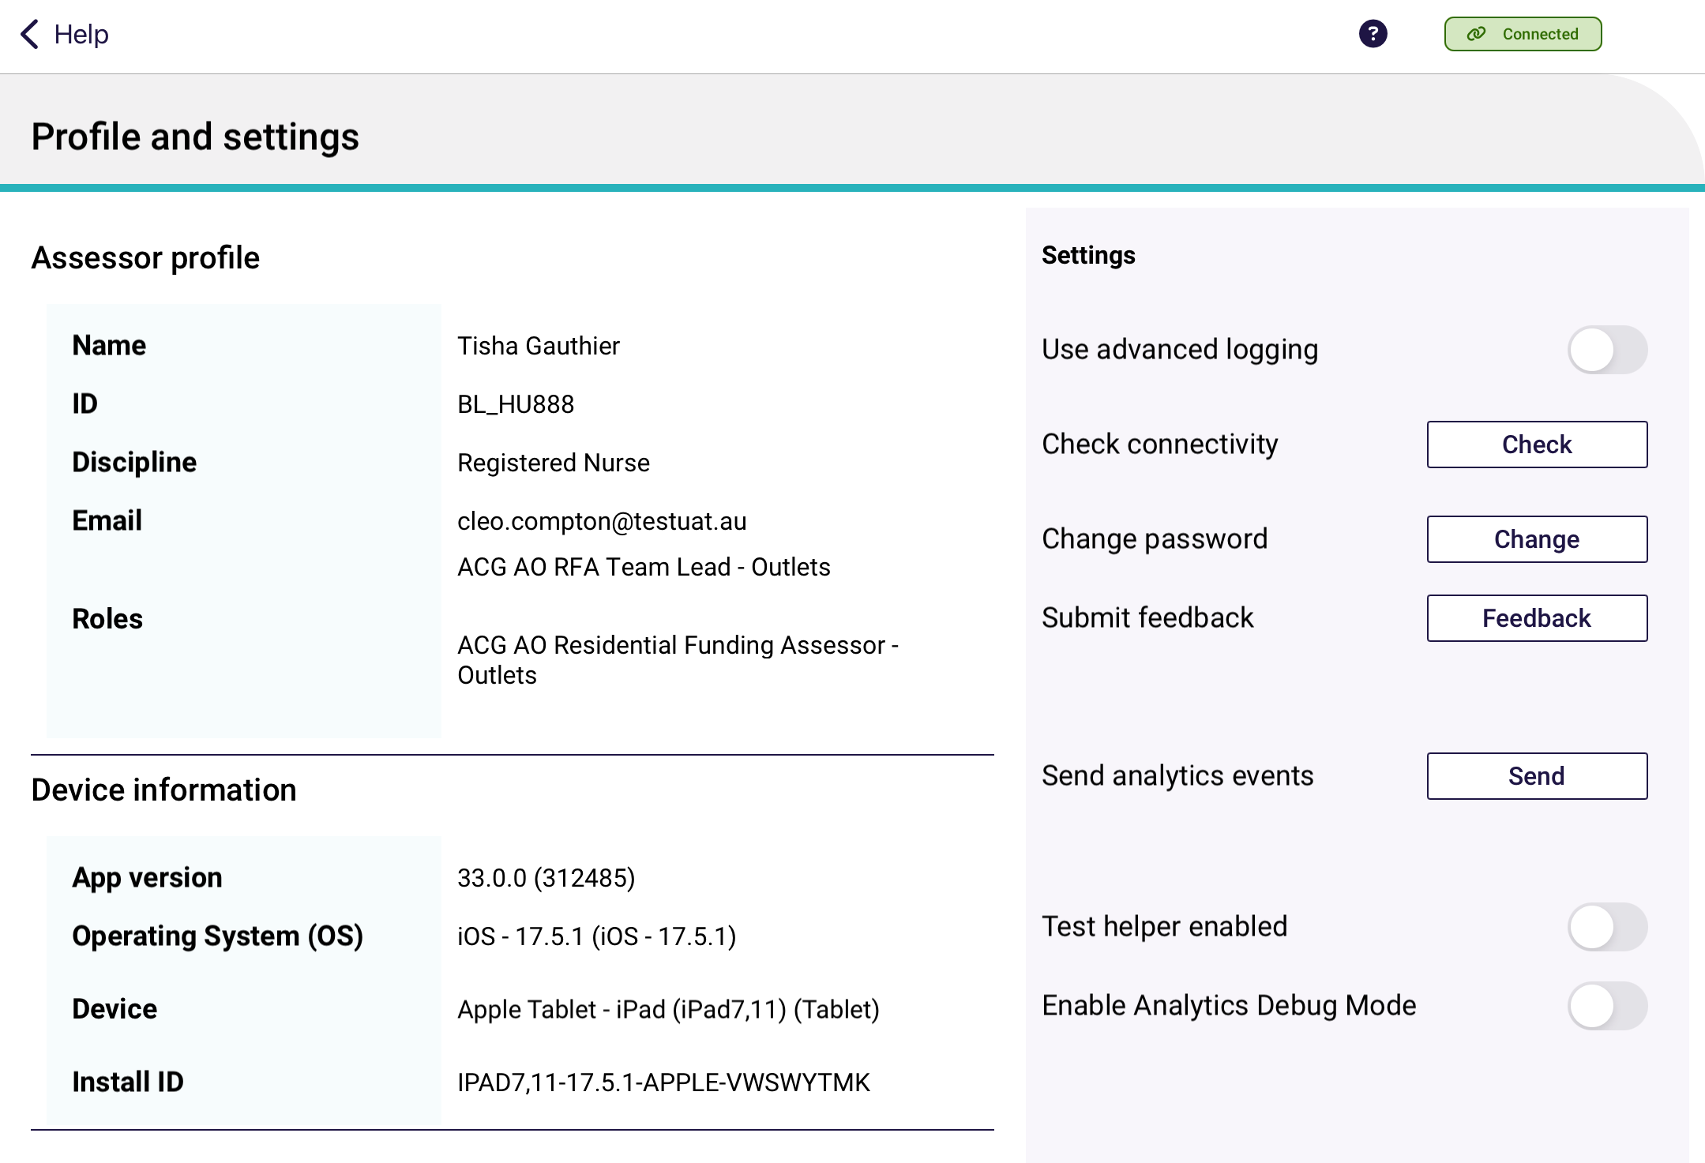
If you experience connection issues whilst using the App, you can check for issues by selecting Check connectivity. Any connection issues will be displayed. There are also quick suggestions provided to help with connectivity issues. Proxy settings can also be updated if it is a requirement from your organisation.
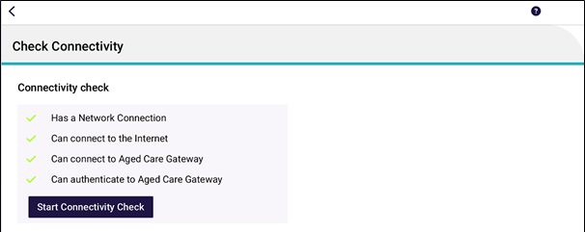

If you experience technical issues whilst using the App, you can choose to share your App device logs and diagnostics. This will assist the support teams to more easily identify, analyse, diagnose and resolve any issues. To do so, toggle ‘Use Advanced Logging’. This will display the View Logs button.
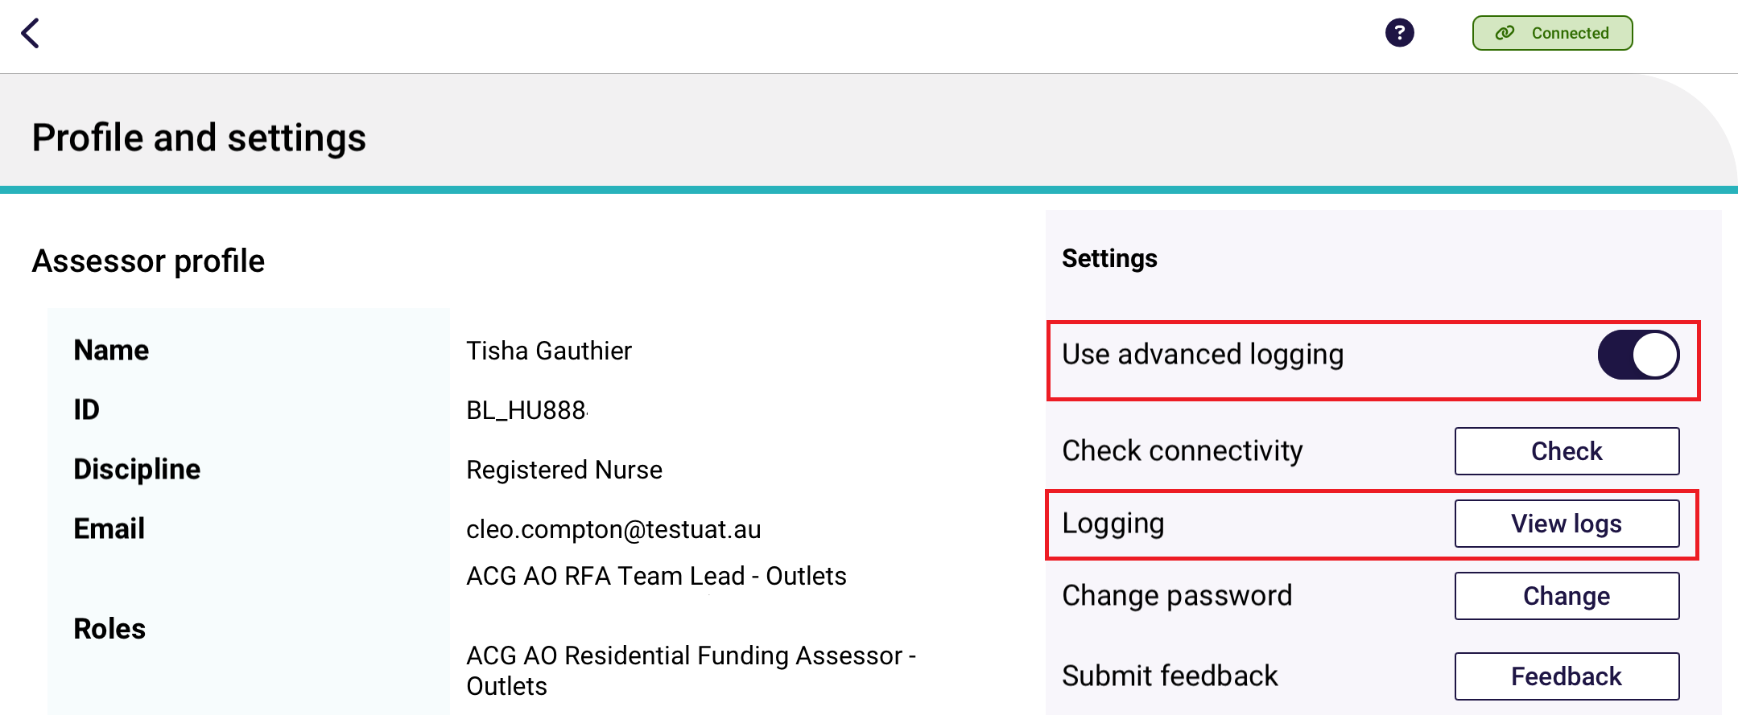
The logs contain detailed information regarding the specific problem, and traceable steps that have been taken to reach the problem point. This information will be able to be accessed by the department for diagnosis.
