Sparked Program Review
Evaluation Report 2023–2025
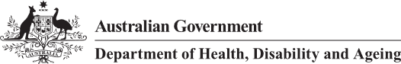

Executive Summary
This Report provides an independent phased review of the Health Level Seven (HL7) Fast Healthcare Interoperability Resources (FHIR) Accelerator Program (Sparked) to measure and evaluate its progress and level of success. The program has been reviewed with feedback points over an 18-month period.
Sparked commenced in mid-2023 to fast-track standards development of FHIR resources to support conformance and implementation of digital health systems in Australia. That is, a focussed program activity on developing and maturing the standards that are required to support digital health system interoperability in Australia. The Department’s investment in Sparked is aimed at accelerating the development and adoption of FHIR standards in Australia, as the recognised global best practice for electronic health data interoperability.
The FHIR standards developed through Sparked will contribute to sector interoperability by enabling consistency in how data is captured, categorised, and exchanged both within and between software solutions used throughout the healthcare sector in Australia.
Sparked is a funded program of the Department of Health, Disability, and Ageing (the Department) in partnership with the Commonwealth Scientific and Industrial Research Organisation (CSIRO), the Australian Digital Health Agency (the Agency), and HL7 Australia (HL7 AU). CSIRO plays a key role as the program lead and coordinator of the activity. The Sparked program is subject of this review at the end of its initial two-year program from 2023-2025.
This review has occurred over an 18-month period with three engagement points – an initial baseline (early 2024), a mid-point (late 2024), and now the final review (mid-2025). It included external consultation at all three points including stakeholder interviews, targeted surveys, and small workshops. Additional market observations were made, noting publicly available information including media reports, press releases, product demonstrations, and event highlights as visible evidence of FHIR awareness, adoption, and use.
Key points from the evaluation:
- Community Engagement and FHIR Awareness – Sparked has been successful in its community–building approach and in engaging with industry and clinical audience to participate in foundational FHIR standards development. The program has assisted in highlighting and creating awareness in FHIR and standards across the sector.
- Standards Development and Accelerator Model - innovative model to fast-track and enhance existing standards development processes and capability. Contributors noted that Sparked was a great example of co-design to engage a wide audience to participate. The Australian Government’s visible presence and commitment was a critical element to program success.
- Program Delivery and Outputs – Stakeholders agreed the program was well run and coordinated, with incremental improvements made during development. Standards outputs are fit-for-purpose. Some challenges were noted with ongoing participation in the program because of high contact requirements involved with the accelerator model.
- Governance and Operating Model – a Target Operating Model has been developed and is awaiting publication. There has been no confirmation on sustainability of ongoing model yet. The standards development governance and processes were refined during the program. Questions remain on the overall governance and endorsement of standards against other program activities and approvals which are still in progress.
- Adoption and Use – There is some progress towards FHIR adoption and capability in the market. However, industry is looking for direction and / or incentives for change to create certainty for investment in FHIR-enabled products. State and Territory jurisdictions are looking to transition to FHIR over time, balancing against other priorities and with budget constraints to be managed. Testing and conformance regime for FHIR-capable products is still to be clarified as the market continues to mature and understand an evolving regulatory and compliance model.
The following program outputs were observed during the evaluation showing significant progress and development across the two years. These, together with insights captured through incidental feedback, have created a strong foundation of national infrastructure and program enhancements that extend beyond the evaluation timeframe:
- Australian FHIR Management Framework (AFMF) – Published August 2023
- Australian FHIR Coordination Committee (AFCC) – Established December 2023
- Australian Clinical Data for Interoperability (AUCDI)
  - Release 1 – June 2024
  - Release 2 – June 2025
- AU Core FHIR Implementation Guide (AU Core) Release 1 – February 2025
- Australian eRequesting Data for Interoperability (AUeReqDI) Release 1 – October 2024
- Australian eRequesting FHIR Implementation Guide (AUeReq IG) Release 1 – August 2025 (Draft for ballot)
- Australian Patient Summary FHIR Implementation Guide (AU PS) Release 1 – Progress on track – July 2025
- Testing and Tooling Services – Established March 2024 (Ongoing)
- Radiology Referral FHIR ValueSets – Published to the National Clinical Terminology Service (NCTS) – June 2025
- Pathology Request FHIR ValueSets – Published to NCTS – June 2025

Diagram 1: Sparked program outputs over two years

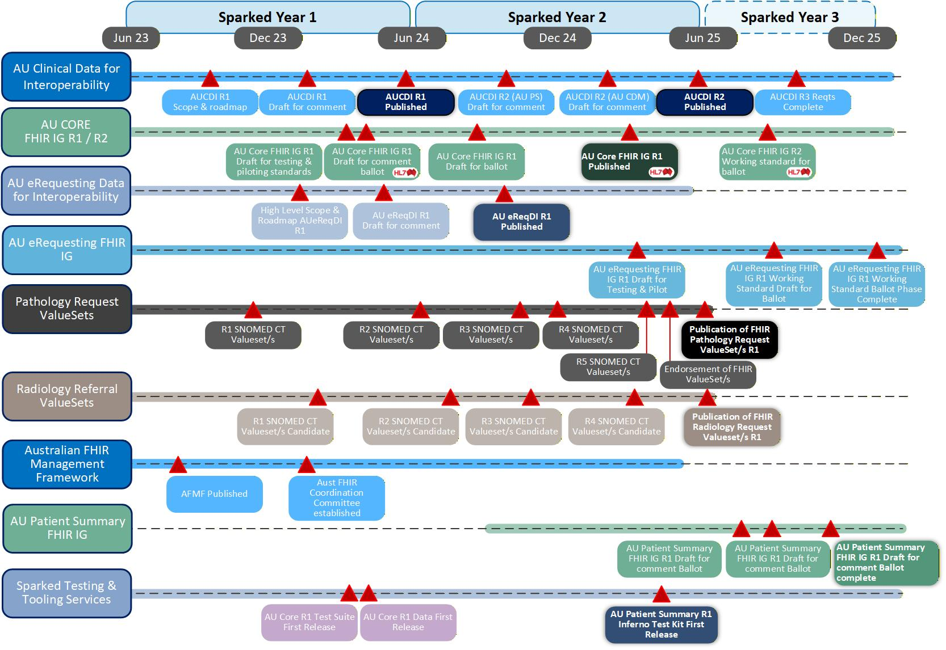
Overall, the Sparked program has been successful in delivery of a department–led standards program, building consensus on digital health standards in a complex and diverse multi–stakeholder environment. Challenges remain about setting up the next steps to support and drive industry adoption and use.
The Review team thank all the contributors and organisations who provided their time and insights in the review process over the last 18 months.

Table of Contents
Executive Summary ii
1. Introduction 1
1.1. Purpose of the Report 1
1.2. The Sparked Program 1
1.3. Strategic Context 2
1.4. Sparked Objectives 3
1.5. Outputs 3
1.6. Requirements of the Review 4
2. Undertaking the Review 5
2.1. Framework and approach 5
2.2. Engagement and Consultation 7
2.3. The three review points 10
3. Findings of the Review 13
3.1. Community Engagement and Awareness of FHIR 13
3.2. Standards Development and Accelerator Approach 15
3.3. Program Delivery and Outputs 17
3.4. Governance and Operating Model 19
3.5. Adoption and Use 21
4. Visible Achievements 23
4.1. Increased FHIR awareness and building community 23
4.2. Fast tracking standards development 24
4.3. Market change and adoption 26
5. Lessons Learned 28
5.1. Recommendations 28
6. Summary 30
Appendix A. Glossary 32
A.1. Core Abbreviations 32
A.2. Key Technical Terms 32
A.3. Program-Specific Terms 33
A.4. Healthcare Context Terms 33
A.5. Regulatory and Governance Terms 34

Introduction

Purpose of the Report
The purpose of this Report is to document the results and findings of the HL7 Fast Healthcare Interoperability Resources (FHIR) Accelerator Program (Sparked) Review.
The Sparked Review was an independent evaluation run over 18 months, commissioned by the Department of Health, Disability, and Ageing (the Department) to report on the ongoing outcomes and success of the program.
Purpose – Report to document the results and findings of the Sparked FHIR Accelerator Program (Sparked).

The Sparked Program
The Sparked program is an initiative established to help shape the future of Australian healthcare. Sparked was funded by the Australian Government to deliver foundational FHIR standards over two years (2023-25), with a goal to improve the accessibility of real-time health information nationally, a vital component for a connected Australian healthcare system.
Sparked has established a community comprising of Australian Government and jurisdictional government departments, agencies, and groups; technology vendors; health provider organisations; standards organisations; peak bodies; consumer advocacy groups; clinical practitioners; health professionals; and digital health and FHIR domain experts. These cohorts have joined to accelerate the creation and use of national FHIR standards in health care information exchange in Australia.
Sparked is led by the Commonwealth Scientific and Industry Research Organisation (CSIRO) Australian eHealth Research Centre which acts as a coordination point, in partnership with the Department, Australian Digital Health Agency (the Agency) and HL7 Australia (HL7 AU).
Defined - Sparked is a partnership and community led program to accelerate the creation and use of foundational FHIR standards in healthcare information and data exchange in Australia.

Strategic Context
The National Digital Health Strategy 2023-2028, the Commonwealth Digital Health Blueprint and Action Plan 2023-2033 the National Healthcare Interoperability Plan 2023-2028 Aged Care Data and Digital Strategy 2024-2029, and associated initiatives all outline the importance digital health capabilities play in “delivering a more person centred, connected, and sustainable health system.”
The Blueprint highlights this importance by stating its vision: “trusted, timely and accessible use of digital and data underpins a personalised and connected health and wellbeing experience for all Australians.”
To have this outcome we need a health system that can easily share data and information across the many settings of the Australian healthcare environment. Without this, these capabilities, data and information may remain locked in silos and not easily shared – to the detriment of patient care.
Standards are enablers that allow information systems to communicate with each other – thus creating interoperability. When software vendors implement common data standards in their products, and when systems adopt the same standards, the healthcare sector can confidently share data and information. This enhanced sharing capability can build trust to inform and assist in decision making.
Unfortunately, standards development has often been an almost voluntary exercise in Australia, with standards bodies and experts devoting personal time and commitment to drive a common cause of better digital health system use and application. Although progress was being made, the pace was very slow and the adoption of standards across the sector was uneven.
The Australian Government’s investment in the Sparked program is aimed at accelerating the development and adoption of FHIR standards in Australia, as the recognised global best practice for electronic health data interoperability. Sparked provides the accelerator to the standards development process, pushing the pace and reach of digital health standards to much higher levels.
Context – without interoperability standards, healthcare remains inefficient, error-prone, and unable to fully leverage digital transformation to improve outcomes whilst reducing costs. The Sparked program was tasked with accelerating FHIR standards development for Australia.

Sparked Objectives
The overall objectives of Sparked were to run a program over an initial two-year period to prove and achieve:
- Accelerator model – Implement an Australian HL7 FHIR accelerator program, based on the US HL7 FHIR Accelerator model to swiftly deliver foundational FHIR interoperability standards to enhance data exchange, support integrated care, and improve healthcare efficiency.
- Community Building – Drive collaboration and consensus around the standards by engaging diverse stakeholders—including government bodies, healthcare providers, industry representatives, clinicians, and consumers—to collaboratively develop broadly supported and practical interoperability standards.
- Standards Development – Enhance the Quality and Safety of patient care through the development and adoption of clinically robust standards that improve the accuracy of healthcare data, support clinical decisions, and enable safer, higher-quality patient care.
- Adoption and Use – Create open standards to foster change and innovation in the healthcare sector. Open sharing of standards, tools, and resources, empowering the standards community to develop new applications and services based on transparent, interoperable foundations.
- Governance – Establish and maintain governance structures and processes characterised by transparency and accountability, promoting trust and ensuring long-term viability and effective management of interoperability standards.
- Operating Model – ensure scalability and sustainability in Sparked program operational models supported by funding, resources, workforce capability, and knowledge management.
Objective – Sparked to deliver an accelerated digital health standards development model for FHIR using a community building and participation model in development, particularly as it relates to clinical input to technical digital health standards.

Outputs
The Sparked Program is being delivered in collaboration with the stakeholder community using the Australian FHIR Community Process (AFCP) overseen by HL7 AU. The program was tasked in delivering the following foundational standards and associated guides localised for the Australian healthcare sector (FHIR AU):
- Australian Clinical Data for Interoperability (AUCDI)
- Australian eRequesting Data for Interoperability (AU eReqDI)
- AU Core FHIR Implementation Guide (AU Core)
- AU eRequesting FHIR Implementation Guide (AU eRequesting IG)
- Pathology and Radiology Referral Sets (SNOMED CT ValueSets)
Additional activities were incorporated into the program in July 2024 including:
- Planning towards a digitised Chronic and Complex Conditions Management Plan
- Planning towards an Australian Patient Summary FHIR Implementation Guide (AUPS) – aligned to International Patient Summary (IPS) and AU Core standards
- Planning towards digitising the capture of reason for health encounter in clinical systems.
The development of FHIR AU specifications creates standard mechanisms for continuous real-time data exchange and moves Australia towards digitally enabled healthcare, thereby improving interactions between health services across all states and territories and supporting a modern Australian health system.
Output – Sparked program to deliver foundational FHIR standards and specifications including AU Core and AU eRequesting implementation guides, as well as pathology and radiology referrals data sets, planning for standards towards chronic disease management plans and an internationally aligned Patient Summary.

Requirements of the Review
The review tracked the Sparked program along 18 months of progress by engaging at an initial baseline, midpoint, and a final review, gathering industry, key stakeholder, and participant feedback through targeted consultation providing insights. The review had two primary objectives to:
- Evaluate the collaborative standards development process delivered by the program and the required deliverables.
- Evaluate the operating model that has been put in place to ensure sustainability going forward.
Other areas to be considered through the review were whether the:
- Program is supporting the Australian Government’s objectives to achieve interoperability and increasingly connected care.
- Operational model and process provide an appropriate approach for establishing a nationally sustainable model for standards development.
- Outcomes achieved and lessons learned for a model of successful community engagement, adoption and on-going use.
- End deliverables are fit for purpose and are able / or are being successfully used and / or adopted.
Review requirement – to evaluate the Sparked collaborative standards development process is a successful approach for ongoing standards development, and the associated operating model is scalable and sustainable moving forward.

Undertaking the Review
The Review tracked the Sparked program over the two years (2023-2025), coming in at three points in time. Review points engaged with participants and key stakeholders on the Sparked program and its overall progress toward stated outcomes.
- Initial Review – establish review framework and approach for the end-to-end evaluation and gather initial feedback on current environment as a baseline for ongoing review.
- Midpoint Review – understand progress of the Sparked program and insights for contributing to and supporting national interoperability, standards development, and enduring work of the program.
- Final Review – evaluate the overall impacts and progress of the Sparked program regarding overall standards development, FHIR standards delivered, standards governance and operating model, and health sector adoption and use of the standards.
Diagram 2: Sparked review timeline
The review maintained a focus on the broader impacts and capture of information which will be useful for future program investment and industry development.
Review – tracked the Sparked program over the two years, with three separate review points with regular feedback.

Framework and approach
The evaluation methodology sought to address key questions aligned to the overall outcomes of the program, consider the key objectives of Sparked:
- Sparked Accelerator Model – Did it work effectively? Was it a good model to fast-track standards to drive policy outcomes?
- Community Engagement Profile – Was there strong engagement, participation, and increased awareness of standards from contributors and community?
- Standards Development – Did it enhance the standards development process? What was the experience for participants? What were the learnings?
- Program Delivery – Did the program deliver to its goals? Are the outputs fit for purpose?
- Governance and Operating Model – Is there clear governance? Is the operating model appropriate? Is the program sustainable?
- Adoption and Use of FHIR - What effect has Sparked had? Is there visible evidence of adoption of FHIR standards? Are there use cases?
The methodology informed the question sets for consultation and identified any gaps in data to inform program evaluation outcomes. The engagement gathered mainly qualitative feedback from stakeholder consultation. Additionally, it gathered any quantitative inputs where there was available evidence of delivery and adoption in the public domain such as media reports, client use cases, or product functionality demonstrations.
Questions posed were asked around the key areas in the figure below.
Diagram 3: Evaluation methodology for Sparked Review
As the review progressed key themes in feedback were captured to provide ongoing insights back to the Sparked program and its partners. This included insights that might inform or assist decisions being made in the Sparked program as a new model of rapidly developing and delivering FHIR digital health standards.
Evaluation framework sought to answer key questions to support the overall desired outcomes of the Sparked program. Feedback was mainly qualitative through consultation with supportive quantitative evidence gathered through publicly available information in product statements, media releases, technology demonstrations, etc.

Engagement and Consultation
Consultation was the key approach to gathering data and feedback to support the review of the Sparked program and its progress at the review points. Noting that the Sparked program is a community–building model to deliver standards development, the engagement and consultation approach included a range of stakeholders including:
- Sparked program partners and active participants including members of the Clinical Design Group (CDG) and Technical Design Group (TDG) operating within the program. These are the developers and implementers of the drafted FHIR standards.
- Broader Sparked program participants including Founding members, participants, and event attendees. The people are contributors to the FHIR standards development process.
- Broader Sparked program community including registered Sparked program members who may not be able to attend and participate in workshops and events, and others in industry who are observing the program with interest. Observers and interested stakeholders.
- Overall health sector and key stakeholders who are not currently participating and may not be aware of the Sparked program or FHIR standards.
There are various levels of participation and awareness across these stakeholder groups, and the review sought to gather feedback from across the spectrum of organisations and people that ultimately contribute to the success of the program when standards are adopted and used.

Diagram 4: Sparked Program stakeholder view – Aug 2025
The review also sought to include stakeholders with different levels of decision–making authority to ascertain various points of view against other priorities in the business and delivery of healthcare.
The review captured feedback from a range of people, from interested parties, to influencers, to decision makers.
Diagram 5: Level of decision making – Sparked stakeholder
Consultation approach included:
- Targeted 120+ separate stakeholder interviews including Sparked Program Partners, Founding Members, active participants, technical / clinical working group members, community members, other stakeholders not involved in Sparked.
- Survey data results from Sparked stakeholder surveys
- Interactive workshops
  - a range of industry participants and vendors
  - private health providers, peak bodies, allied health, GPs etc.
  - digital health start-ups.
Consultation gathered feedback from key participants and stakeholders within and around the Sparked program, used surveys to gather sentiment information, and ran workshops looking for a balanced view through shared discussion. Interviews with others not directly involved in Sparked were also used to provide external views from those on the periphery or observing Sparked program activity.
Stakeholder engagement initially focused on Sparked partners and active participants and then progressively moved out to Founding members, peak bodies, broader industry, and other stakeholders not participating or actively aware of the Sparked program.

The three review points
Capture of data and reporting has occurred at the three review points. Interim reports have been delivered to the Department and the Sparked program partners to provide insights and to inform on the results of the consultation and program sentiment among key stakeholders. Reports were delivered at:
- Baseline Review – Early 2024 (Internal guidance for program)
- Midpoint Review – Late 2024 (Internal guidance for program)
- Final Review – Mid 2025 (Externally published report)
The insights provided through industry and health sector participation in the review have contributed to the evolution and maturing of the program. The sections below note themes from each of the review stages.
 | Baseline Review Themes  2024 Early Q1 |  | Review focus | Stakeholders |  | Consultation
 |  |  | Establish a baseline with key stakeholders prior to and once Sparked commenced. | Standards and FHIR professionals, those involved in Sparked, and relevant industry bodies and experts. |  | 40 interviews
 | Baseline Review topics
- How well was the Standards development process working prior to Sparked?
- What are your expectations of Sparked?
- What is your view on fast-tracking standards development?
- How should we be measuring success of the program?
- What does the Australian Government need to do to accelerate adoption of FHIR standards?
 | Baseline Review insights
- The Sparked review contributors indicated a strongly favourable view of the program at the early stage. There was very strong support for the goals and approach from the program, and enthusiasm from the burgeoning cohort of digital health standards creators who have become the Sparked community.
- The accelerator model for standards development in Sparked is proving to be highly effective at progressing towards R1 of AU Core and AUCDI.
- Most stakeholders stated AU Core is critical to success of the agenda moving forward, although noting that eRequesting is where there will be initial value.
- A range of examples highlighted by software industry. SMART on FHIR forms is one area where industry uptake could quickly occur. Software vendors still need to see clear value proposition and the business case for change.
- Challenges remain for digital health interoperability at a broader level and Sparked will not address the systemic structures that can stymie data sharing and better-connected care.
- The collection of digital health experts who are engaged with Sparked have formed into the core of a motivated and engaged workforce who are collaboratively building the standards that will underpin the future of connected digital health in Australia.
Midpoint Review Themes  2024 Late Q3 |  | Review focus |  |  | Stakeholders |  | Consultation
 |  | Identify key themes and feedback to inform the current operation of the Sparked program, as well as the future for standards development, FHIR adoption, and system interoperability across healthcare |  |  | Sparked contributors, FHIR and digital health experts, existing and new participants, peak bodies, professional colleges, and Government agencies -Federal, State, and Territory |  | 59 direct interviews  20 survey responses
Midpoint Review topics
- How well is standards development working after Year 1 of Sparked?
- How important are FHIR AU standards for healthcare information sharing?
- How effective has Sparked been in building standards and a community for interoperability?
- To what extent are you using (or planning to use) FHIR AU Core standards?
- Once standards are available what would you require to support to implementation?
- How should we measure success of Sparked?
- What else does the Australian Government need to do to drive adoption of FHIR standards?
- What is missing that would hinder success for the Sparked program?
Midpoint Review insights
- At its midpoint the Sparked program is progressing on track with its outputs. The program is positively received across stakeholders consulted and was noted for its energy and coordinated engagement in building a community–led approach to digital health standards development.
- Feedback from stakeholders highlighted the maturing of the program as people become more experienced with its operation and approach to standards development.
- The level of activities and amount of voluntary time involved was raising significant concerns for some stakeholders in regular and ongoing participation.
- There is a need for an overall roadmap showing where the Sparked FHIR AU standards development program fits with other government programs.
- Questions were raised if there was appropriate consultation for priority areas and defining workflows?
- Majority of stakeholders agree that Sparked needs to continue after the two years in some shape or form. There was consensus of moving to an implementation approach and supporting use cases and adoption

Endpoint Review Themes  2025 Q2/Q3 | Review focus | Stakeholders | Consultation
Endpoint Review Themes  2025 Q2/Q3 | Assess the success and impact of Sparked with Partners, founding members, participants, and external observers | Sparked partners.  Founding members. Others participating or observing | 40 Interviews, individual and three workshops.  Total of 56 contributors
Endpoint Review topics
- Has the process of standards development through Sparked been successful?
- Is there anything you would include or change?
- Is there visible progress now from when Sparked commenced?
- Do the Sparked program deliverables have meaningful impact towards national interoperability?
- Are there visible changes with you and your organisation because of Sparked?
- Are you implementing or applying the FHIR standards developed in Sparked?
- Do you have a view on if and how the program should operate moving forward?
- Is there anything else the Australian Government should do to support achieving the outcomes?
Endpoint Review insights
- Sparked has been successful in its community–building approach and engaging industry particularly as it relates to clinical input into technical standards.
- Accelerator model is a great model in co-design to fast track FHIR standards development.
- Stakeholders agreed the program was well run and coordinated, with incremental improvements made during development. Standards outputs are fit-for-purpose.
- A Target Operating Model has been developed and is awaiting publication. There has been no confirmation on sustainability of an ongoing model yet.
- There is some progress towards FHIR adoption and capability in the market. However, industry is looking for direction and / or incentives for change to create certainty for investment in FHIR-enabled products.
- State and Territory jurisdictions are looking to transition to FHIR over time, balancing against other priorities and with budget constraints to be managed.
- Testing and conformance regime for FHIR-capable products to be clarified as the market continues to mature and understand an evolving regulatory and compliance model.
- The Sparked program has been a success in delivery of a department –led program delivering consensus on standards in a challenging multi-diverse stakeholder environment. Questions remain about setting up the next steps to support and drive industry adoption and use.

Findings of the Review
The outcomes of the review can be presented in five key areas, aligned to the evaluation outcomes initially identified in the Sparked program. These areas also represent key themes in feedback from consultation.
- Community Engagement and Awareness of FHIR
- Standards development and Accelerator Approach
- Program Delivery and Outputs
- Governance and Operating Model
- Adoption and Use
Each area is a critical component to the ultimate success of the Sparked program.

Community Engagement and Awareness of FHIR
The Sparked program was tasked with fast-tracking FHIR standards development via building a community to participate and contribute to the process and to engage on broader interoperability adoption and use through being involved.
There has been consistent feedback through the course of the review that the Sparked program has been highly effective in building an engaged and enthusiastic community of contributors and supporters.
People involved have a positive experience in attending, participating, and the excitement of contributing towards a broader healthcare policy outcome. Participants have noted the community spirit and the requirement for working together to get this challenging area moving ahead. Sparked has provided the vehicle for this community led collaboration approach to standards development.
The Sparked community has grown rapidly over the first two years and is constantly gaining more interested people and organisations. Sparked has seen good representation from clinical, technical, policy, vendors, representative groups, and clinical colleges. The program publishes a publicly accessible Program Status report via their webpage⁸ with community metrics; July 2025 update provided below as example.

Diagram 6: Sparked Dashboard – July 2025
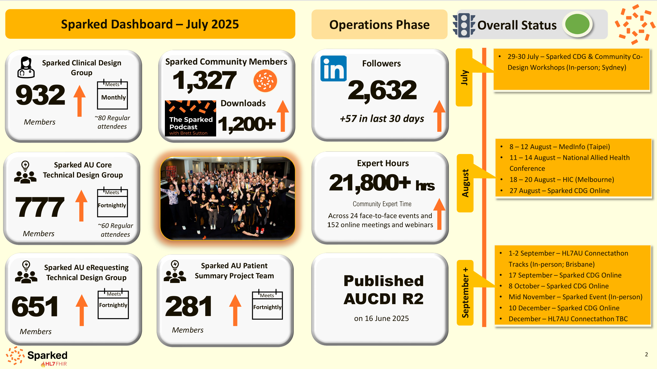
Diagram 7: Sparked Community Growth – Aug 2023 – Jun 2025
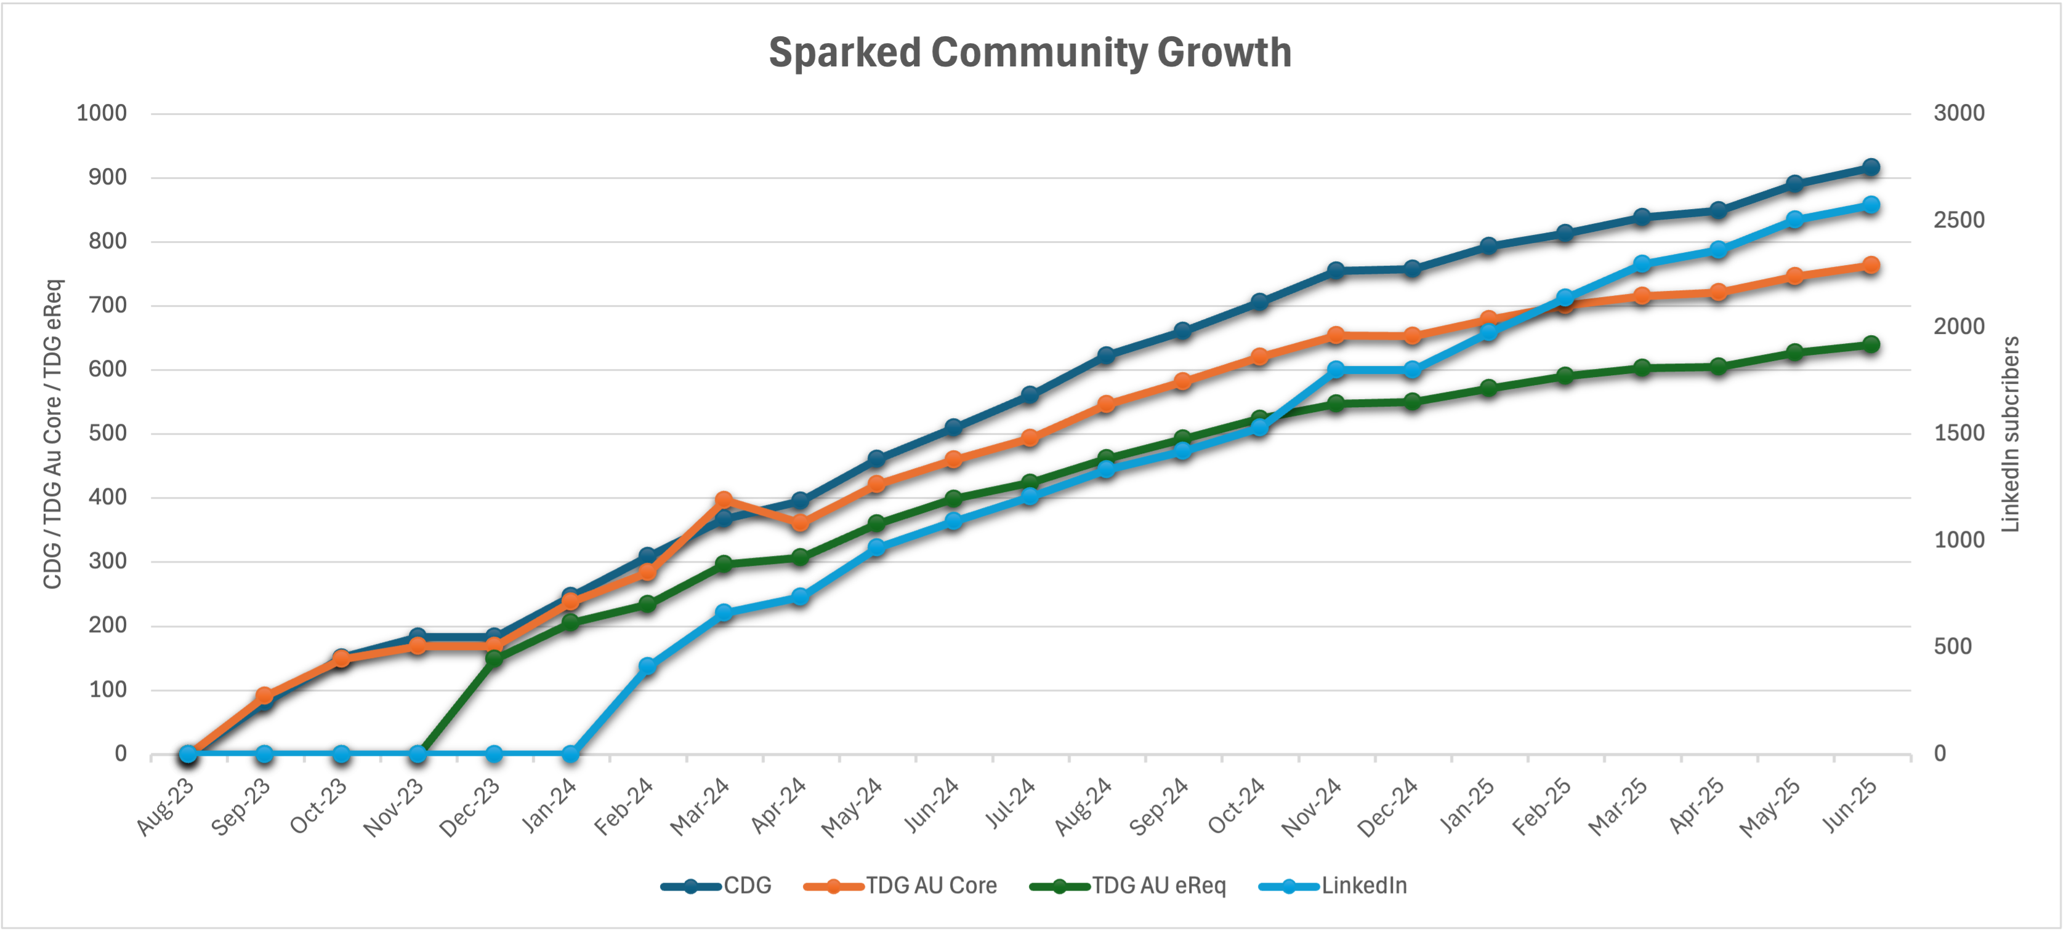
In addition, the profile and activity involved with the Sparked program has notably increased awareness across healthcare and the vendor market regarding FHIR standards and the requirements to include them in their plans and procurement.
Regular communication from the Australian Government at events and marketing, as well as visible program work completed by Sparked has contributed to lifting the awareness of the importance of standards. The model of community building and open transparent development has allowed a wide range of people and groups to participate. Until Sparked launched, this would not have been possible at such a broad scale and speed.
Questions raised through consultation included:
- While the Sparked community was well-represented from separate groups and stakeholders, there were questions from some people interviewed about groups who were not present. This included several key vendors and representative groups who were given the opportunity to participate, but for various reasons either chose not to or opted to observe the program's progress. This might create concerns about appropriate consultation and endorsement of Sparked program outputs and drafted standards. As standards evolve through successive iterations, it may be necessary to incorporate further accommodations to address broader use cases and implementation requirements.
- How we reach the broader health sector regarding the importance of standards and FHIR in system interoperability and information exchange across healthcare. This is a larger issue which forms part of the National Digital Health Strategy 2023-2028, and the recently announced Health Connect Australia initiative.
- Maintaining levels of participation – as an HL7 accelerator program there has been a high level of activity and ongoing engagement, which has meant resourcing challenges for ongoing involvement for organisations and companies in support. Whilst many have contributed their time and resources to move towards a common outcome, it is becoming increasingly difficult to maintain the level of involvement due to associated cost and business priorities.

Community Building | Awareness Summary:
“Sparked has been an icebreaker for bringing health system interoperability, FHIR, and standards to the forefront.”
Australian Standards organisation leader
- Majority of participants and attendees of Sparked agreed it is a great program to bring industry together in important and difficult work.
- Program increased awareness of FHIR standards and their importance.
- Good representation of different stakeholders involved – clinical, technical, policy, vendors, representative groups and colleges, etc.
- Some commentary highlighting groups and people who were not participating - who is not in the room?
- Questions on how we reach the broader health sector?

Standards Development and Accelerator Approach
Fast track standards development through an accelerated and community–led process leveraging off standards development expertise, groups, and methodologies.
Through consultation and feedback the Sparked model has been applauded by stakeholders for its innovative accelerator approach to fast-track standards development. It was highlighted as a good example of industry engagement and co-design in delivering on an Australian Government policy initiative.
The level of government participation and support to the program has also been acknowledged as a major contributor for success. The visible presence of key government stakeholders and senior executive, which in turn brought senior executive from industry and research, combined with the community–led approach has demonstrated that there is a shared and enduring commitment to achieving the desired policy outcomes.
The process of standards development managed by HL7 AU has benefited from the Sparked model, with the process maturing over the course of the program. Standards management is an important capability for the sector and Sparked is contributing to strengthening the functions to manage ongoing requirements for a national digital health operating environment. By fast tracking standards development and running processes regularly, these standards development processes have been refined, made more efficient, and involved additional people who have become familiar and proficient in the development and governance process. There is acknowledgement that further strengthening of HL7 AU capabilities and across the sector will help to host and maintain ongoing standards development. The Sparked program has been an important contributor to getting things moving.
The accelerator model provided the time–bound commitment and focus to keep the program on track and participants engaged. Some stakeholders highlighted challenges with the level of commitment required, but none of the contributors faulted the program’s accelerator model approach that supports collaboration and participation. Contributors knew things were happening and the program schedule. Opportunities were there to participate, but not at the detriment of delaying the outcomes and time commitments.
Several operational process items were raised through consultation which were relayed back to the Sparked program and partners. It is understood that these will be considered as part of continuous improvement within the program. The items included:
- Having an equal voice in the room – at events it was suggested that there are potentially some stronger voices than others, and that some people may feel like they may not be heard. Examples include consumer voices and other affiliated healthcare stakeholders who may not have the technical expertise or clinical title to present their views confidently.
- Leveraging existing starting points – some feedback related to the starting point in standards development and using existing standards and regulatory requirements already in place, whether that be internationally or locally. Examples included gender requirements, existing data governance and national minimum dataset reporting requirements already embedded and managed in healthcare. Are there knowledge sources that could give a good baseline?
- Pace and commitment - Questions were raised on how long Sparked could sustain the fast-track activity and keep active participation once the two-years is complete. These are considerations in a broader governance and operating model.
- Replicating elsewhere – There has been interest from other countries in the adoption of the Sparked accelerator model. It is an example of how to fast-track and progress FHIR standards development in those countries. Replicating this program in other countries and regions highlights the ‘word of mouth’ success of the program approach.

Standards Development | Accelerator Approach Summary:
“The Sparked accelerator model has been a great example of government supported co-design, driving to an outcome in a challenging policy and technical area. It should be considered in other policy areas.”
Leader private healthcare industry body
- Almost all participants agreed that Sparked is a great exercise to involve industry and key stakeholders in a standards development process.
- Great example of a co-design process which created momentum and ways to work towards consensus.
- Government presence and participation are key features in showing strong commitment.
- The program matured existing standards development processes and skilled up additional people with new expertise in standards.
- Concerns raised over voting in workshops – people finding voice to express their thoughts against others. The Program accommodated and adjusted over time as part of continuous improvement.
- Level of activity needed created barriers for some to participate effectively.
- Participants agreed that accelerator model driving to deadline was important to keep people engaged. People believed they were working to an important outcome.
- Other countries are interested in the Sparked accelerator model to highlight and fast-track their own standards development.

Program Delivery and Outputs
Deliver the AU Core and AU eRequesting standards ready for their adoption and re-use across the health sector.
The Sparked program has delivered its key outputs on time and to a quality ‘fit-for-purpose.’ Sparked has been positively received by the stakeholders consulted, and people continue to acknowledge the level of work, event coordination and energy it has taken to put FHIR on the radar and gather industry support and participation. Standards development is a sometimes-challenging space full of definitions, categories, and workflow requiring consensus and decisions. Keeping people engaged is a critical component in program delivery and change management.
People agree also that the program was well delivered and run noting that improvements were made over time as the program matured. Sparked got into its stride with the multiple engagement events, as well as building the documentation and standards drafting, review, and balloting processes. People agreed that the standards and associated documentation are ‘fit-for-purpose’ and usable.
Whilst processes have evolved and continually refined over the 18-24 months to enhance program delivery there are still several issues identified by some stakeholders, including:
- Scope of Sparked program – the program had a specified scope around standards development, and this has meant limited value for some industry participants that would like to see more work in their subject matter area. People do understand the priority of addressing AU Core, eRequesting, Patient Summary but would like activity to move into other areas as well. There is a feeling of limited involvement in areas such as allied health and genomics, which left some questioning the value of being involved.
  - A suggestion was made for Sparked to potentially commission working groups to work on subject matter areas whilst other core work occurred. This might be a way to keep industry people engaged in the program and have some meaningful participation and progress in these other areas whilst completing foundation standards work in parallel. The Sparked accelerator model has evolved to manage the broad scope of work moving forward. The program has already introduced Clinical Focus Groups to provide forums for contributors to provide targeted input in support of the more general Clinical Design Group.
- Level of practical examples – it was suggested that the program could shift more to engaging on testing and implementation to increase number of vendors demonstrating actual working examples and functionality. Whilst it is good to have developed and documented standards as a key outcome, more demonstration of actual working examples would benefit overall outcomes and perceptions of success.
- Joining in-flight – Some participants found it difficult to join Sparked mid-way through the program, as there is assumed knowledge. Some thought it may be useful to have a brief onboarding session with new participants just to get them up to speed with the programs progress. There is a lot of detail within the program and it can be overwhelming to absorb for newcomers. With better induction people can then join discussion with more context and understanding on what is going on.

Program Delivery and Outputs Summary:
“Sparked leadership and team have delivered the accelerator program well with standards drafted ready to implement.”
Senior clinical representative healthcare vendor
- All people interviewed agreed that the program was well delivered and run, noting that improvements were made over time as the program matured.
- There was a lot of activity and documented detail that was well managed over time to provide the opportunity for people to participate.
- Challenges in participation were created by short timeframes associated with the accelerated model – where people could not contribute because of other priorities or commitments.
- Some participants found it difficult to join midway through the program because of the level of detail and assumptions in understanding.
- People interviewed agreed that the drafted standards are fit-for-purpose.
- Challenges noted across working to scope i.e. AU Core example. Foundational FHIR standards do not cover all areas which may need standards for interoperability.

Governance and Operating Model
Sparked - through its partners - contribute to and develop a Target Operating Model, including governance, sustainability, and extensibility of the standards development approach for national digital health standards.
Sparked has operated as a partnership between the Agency, HL7 AU, CSIRO, and the Department. As part of that partnership a broader governance and operating model was developed through the course of the first two years. Governance in this area relates closely to the Agency’s Standards Advisory Group, the new Health Connect Australia initiative, and the role of HL7 AU as the nominated standards development group.
A Sparked Operating Model was completed as part of the program outputs in June 2025. The operating model is under review awaiting publishing. Ongoing governance remains a question in community around clarity for Sparked. Some key points raised from stakeholders included:
- Endorsement of standards – questions regarding where the appropriate decision point is to endorse and approve standards for broader industry use? Industry is looking for clarity on decision points and timing of when to plan and factor in health sector changes. Whilst some vendors are making changes and trialling already, all industry will be required to update to a consistent standard once released. This endorsement affects investment decisions for vendors and adoption decisions for healthcare providers and organisations.
- Legislative and regulatory change – there is understanding that there may be legislative / and regulatory changes to formalise standards use in the sector. Again, the broader health sector from both industry and health provider viewpoints are seeking clarity on these changes and their associated impacts.
- Alignment to other standards governance – with multiple regulations and standards required across health sector and technology implementation and use, it would be beneficial to get a view of how all standards relate to each other and broader governance and alignment across government. Data governance was one example which was raised; this is presently overseen by the Australian Institute of Health and Welfare (AIHW) for healthcare metadata, data capture and reporting (METEOR). Sparked standards AU Core and AUCDI also have detail on data capture and sharing, and there is an open point on standards primacy in such areas.
- Sustainability – no comment can be made about sustainability, as the Sparked Operating Model is not released and available to key stakeholders to make an informed decision. It is understood that this will continue to evolve and be resolved as the program moves forward.

Governance and Operating Model Summary:
“Having a clear statement of how these FHIR standards relate to other standards will help a lot in getting engagement and industry commitment”
Leader healthcare industry solutions provider / vendor
- Target operating model has been developed with key partner stakeholders as an outcome of the Sparked program operation and experience.
- Standards groups, government, and some industry representatives enhanced their capability and matured their processes because of the program.
- Questions raised by industry and other stakeholders on governance, endorsement of standards, requirements to use in the short, to medium, and long term.
- Was there appropriate participation and consultation involved in the process to endorse standards and get broader healthcare groups and settings involved?
- How does the Sparked FHIR standards development align with other standards groups in Government?

Adoption and Use
Influence and contribute to the development, adoption, and use of FHIR standards within the community and across the broader health sector.
There is acknowledgement of how far standards have come with Sparked and FHIR, and this progress is directly attributed to the Sparked program and related interoperability work with the Agency. However, there is also awareness that the sector still has some way to go to move towards adoption and use in the market.
There have been a number of FHIR Connectathons, Sparked testing events, and demonstrators, which are useful to validate functionality and showcase software capability in FHIR. There is also evidence of many vendors announcing the adoption of FHIR capability into their products. However, industry vendors are looking for clarity and consistency in what is expected in the future market conditions and requirements, as well as flagging the value from incentives to implement functionality and FHIR capability. Currently industry stakeholders have indicated that basic FHIR capability for their products can be planned but will potentially be built into cost for clients in future implementations and upgrades.
Although there have been encouraging product demonstrations of FHIR-enabled software platforms at Sparked events, there are still only limited examples implemented into the market. It has been suggested from consultation that a greater shift to balance Sparked related activity to driving software demonstration rather than documenting standards might assist in moving the industry forward to adoption and use.
Key challenges include:
- finding that next step for implementing use cases, with clients asking for uplifted functionality from software vendors, as well as
- vendors waiting for funding in the market or new customers willing to pay to align their products to new FHIR standards.
There is a lot of goodwill in building FHIR capability into strategies, road maps, and product development; however, there will need to be consideration for activating and supporting the next steps. Clarity and consistency in Government policy, communication, and program alignment will assist with investment decisions by vendors and health providers alike.
For example, State and Territory jurisdictions who are big purchasers in digital health solutions are still slow to move to FHIR as they deal with internal technology, priority, and budget constraints. These factors position them as supportive but potentially requiring a longer runway to transition and implementation.
Although the jurisdictions have a strong commitment to the Sparked program as part of the national digital health environment, planning for adoption of the program outcomes is at a preliminary stage, with incremental and prioritised activities on the forward path. Noting the significant effect of large public health organisational strategy on other parts of the health sector, support for jurisdictions and large providers to develop transition strategies and plans would be valuable to ensure strategic alignment and change across the provider part of the sector (both private and public).
Testing and conformance for FHIR-enabled products is an area that was raised as needing consideration. If the Australian health sector is serious about driving and implementing standards, how do we ensure that software is compliant and conformant to the latest standards for appropriate and safe use?
There are already a range of processes and tools available that allows for testing and conformance activity, and this can inform future development to support appropriate testing of FHIR-enabled products implementing Sparked standards.
Tools such as the Inferno AU Core test kit are useful for testing FHIR API conformance against the relevant FHIR IG, and there are also tools for more end-to-end conformance and profile testing available through organisations like IHE Australia. Greater clarity on testing and conformance regime would be beneficial as standards governance and operating model matures.

Adoption and Use Summary:
“There is a lot of good will in standards development. However, there will need to be consideration for activating and supporting the next steps”
Senior jurisdictional representative
- Connectathons, testing events, demonstrators are good events to test software capability in FHIR. Many vendors are announcing FHIR capability.
- However, industry vendors are looking for incentives to implement functionality and FHIR capability – or will build in that cost for the next client.
- Clarity and consistency in Government policy, communication, and program alignment will assist with investment decisions by vendors and health providers.
- State jurisdictions and acute healthcare sector are focused primarily on their own challenges, implementations, and integrations and are tactically transitioning to FHIR iteratively.
- Testing and conformance - how to ensure that software is compliant and conformant to the latest standards for appropriate and safe use.

Visible Achievements
This section notes some of the visible achievements to date which can either be directly or indirectly attributed to the Sparked program. There may be others which emerge as the program continues.

Increased FHIR awareness and building community
The Sparked program approach to FHIR awareness raising, community building, collaboration, and participation model for standards development has provided the opportunity for grassroots–led engagement across the health sector on the importance of information and data sharing in improving outcomes. Sparked and its brand has been recognisable as a program working on these important outcomes.
The Sparked community has steadily increased over the course of the program, with additional organisations and companies joining as registered founding members, joining founding partners (the Department, the Agency, HL7 AU, and CSIRO). Commitment to the program has been to recognise the desire and efforts to move healthcare forward with foundational digital health standards and be part of the change.
Anecdotal evidence flagged in consultation where Sparked outputs are being used or contributing to organisation change include:
- ~1300+ registered members and still growing as Sparked continues.
- ~120+ registered founding member and supporting organisations in Sparked and growing.
- 100% of stakeholders engaged through this review (including those contributors not registered or participating in Sparked) were aware of the Sparked program, FHIR, and what it was trying to achieve at a high-level.
- Increased FHIR awareness through market observations that FHIR has entered the general vernacular when talking about health IT. This was not the case in 2023 when Sparked commenced. The Sparked brand and associated marketing are a large contributor to industry awareness of FHIR and associated changes.
- International interest in Sparked, FHIR, and what Australia is achieving through the program. Collaboration with other countries built off the success of the program in Australia would be great recognition of the success of the program and lifting FHIR awareness and capability.
- Ongoing FHIR training being sponsored and supported by the Agency.
Sparked has been successful in building a growing and collaborative community which allows participation in FHIR standards development. FHIR awareness is continuing to increase across the health sector because of the Sparked program, its brand, and associated marketing.

Fast tracking standards development
The Sparked program accelerator approach has been critical to action standards development in an area which has traditionally been iterative, deliberate, and often slow in nature. This was mainly due to limited government and policy attention and priority in standards, meaning that work was mainly supported by industry experts and voluntary efforts.
The accelerator approach through Sparked has allowed for the fast tracking of existing standards development processes and governance mechanisms to get foundational standards defined, developed and agreed upon through a participation and industry engagement model.
Visible benefits and progress which can be seen because of Sparked include:
- Enhanced maturity of processes and capability in standards development as has been a direct result of Sparked. It has allowed for stress testing and refinement of existing processes managed by HL7 AU to deliver to national standards development requirements.
- This includes expanding the standards expert group to new people who have gained interest and experience through the Sparked program, particularly in the Clinical Design Groups (CDG) and Technical Design Groups (TDG). Participation across all of these groups is strong and growing.
Building expert capability in FHIR standards is critical as standards become integral to the future of digital health systems and interoperability in healthcare. HL7 AU is now building and enhancing its own capability as a direct result of Sparked. This will form part of the Governance and Operating Model moving forward.
- Program delivered and published its outputs to schedule. This is acknowledged as an important outcome is an area which is challenging to define and reach consensus such as digital health and information exchange. Outputs that have been delivered include:
- Australian FHIR Management Framework (AFMF) – Published August 2023
- Australian FHIR Coordination Committee (AFCC) – Established December 2023
- Australian Clinical Data for Interoperability (AUCDI)
      - Release 1 – June 2024
      - Release 2 – June 2025
- AU Core FHIR Implementation Guide (AU Core) Release 1 – February 2025
- Australian eRequesting Data for Interoperability (AUeReqDI) Release 1 – October 2024
- Australian eRequesting FHIR Implementation Guide (AUeReq IG) Release 1 – August 2025 (Draft for ballot)
- Australian Patient Summary FHIR Implementation Guide (AU PS) Release 1 – Progress on track – July 2025
- Testing and Tooling Services– Established March 2024 (Ongoing)
- Radiology Referral FHIR ValueSets – Published to NCTS – June 2025
- Pathology Request FHIR ValueSets – Published to NCTS – June 2025
Diagram 8: Sparked program outputs over two years
Diagram 9: FHIR Standards delivery via Sparked
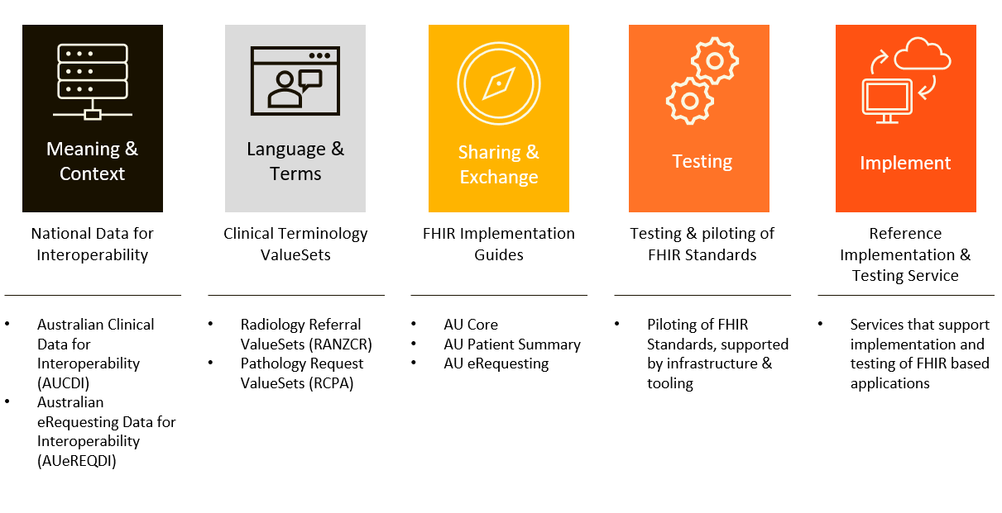
Sparked has enhanced and fast-tracked standards development in an area which has traditionally been iterative and slow. It has created a model to define and set standard implementations of digital health systems to support interoperability and information / data sharing across healthcare.

Market change and adoption
While progress toward market change and adoption remains limited, it is increasingly evident through a growing number of tangible use cases for FHIR-enabled products. Across Australia, companies are reporting enhanced FHIR capabilities, with new features being introduced into products, alongside demonstrations, pilot testing and client cases. These include:
- 75+ companies reported having FHIR capability - many of these companies have a version of FHIR which need to be further localised with AU Core standards as they are steadily introduced. Vendors include: Alcidion, Australian Clinical Labs, Best Practice, CSIRO, Healius, HealthLink, InterSystems, Magentus, MediRecords, Oracle Health, Sonic Healthcare, Telstra Health, Touchstone Lifecare, and Whitefox (observed in the Adelaide Showcase February 2025). There are others not reported in this list or who are currently introducing FHIR capability into their products.
- Up to 15 products/projects testing – as reported in HL7 AU Connectathons, Product Demonstrators, and Showcasing. These projects are technical demonstrations of products interoperating and sharing data between systems. “Standards in Action” demonstrations (Sparked Symposium May 2025) showcased were:
  - Best Practice & Oracle
  - Telstra Health
  - Magentus with Sonic Healthcare, Australian Clinical Labs and Healius
  - Intersystems
- 10+ number of media reports being reported in industry news on digital health included Pulse IT, Healthcare IT News, IT News etc. A number highlighted below:
  - Alcidion Mya precision story – PulseIT (13 May 2025)
  - Middleware story New Zealand – PulseIT (9 May 2025)
  - Centrik story – (25 January 2025)
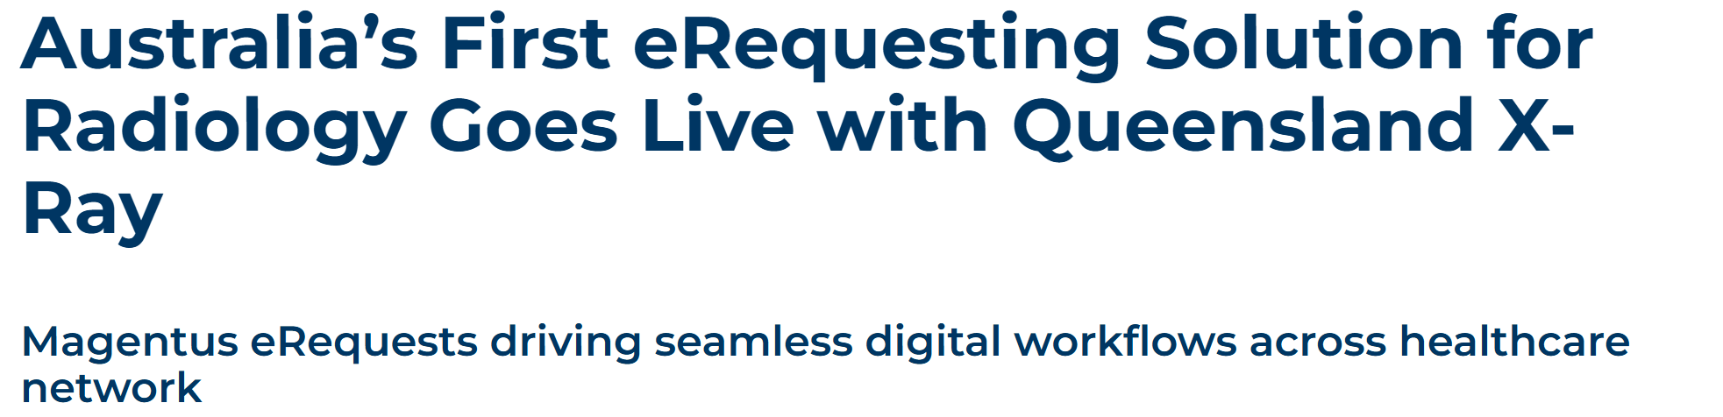
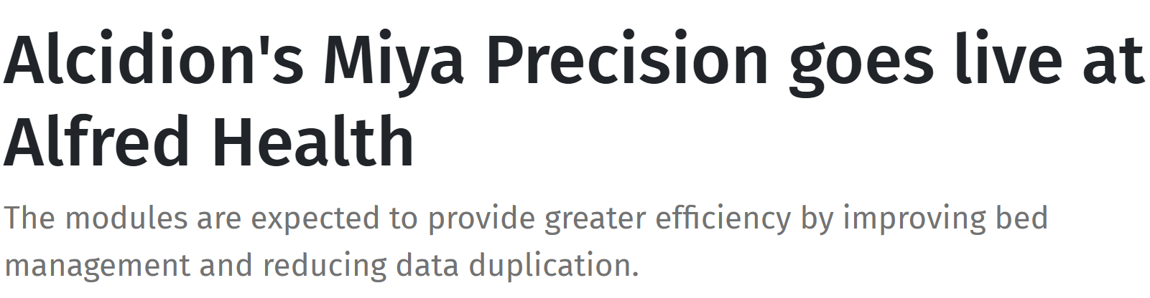

Sparked has influenced broader market uptake, adoption, and use of FHIR standards and capability. The market is still maturing and evolving to these interoperability standards but there is visible evidence of early progress in industry adoption, piloting, and testing of FHIR in Australia.

Lessons Learned
Consultation key themes and lessons learned have been captured through stakeholder engagement. The experience of running and participating in the Sparked program has highlighted that:
- The Sparked accelerator has been highly effective in forming a vibrant community and building detailed draft standards through a collaborative process.
- Clinical design and technical design streams have worked well to gather the clinical input for the core areas and to rapidly produce technical standards for ballot.
- Developing standards is a fundamental foundation, but interoperable solutions need many other elements that are not in scope for Sparked. How will these be addressed? There needs to be a programmatic view of standards requirements and roadmap of strategic projects to create market certainty to support change.
- Vendors need confidence that investing for interoperability will grow business. Health provider organisations need a marketplace of trusted and standards-based interoperable solutions to buy from. Clinicians need confidence that health information shared through interoperable systems connected with FHIR is fit for purpose. Sparked is central to this space, but more is needed in relation to other standards, strategies, and plans.
- Standards adoption may need mandate and incentives. The Sparked community are looking to the Australian Government for guidance and certainty.

Recommendations
This review can highlight some key lessons to date from the Sparked program in support of the move towards a more interoperable digital health environment in Australia:
- Government direction - While the Australian Government has been actively involved in Sparked, a national FHIR Standards Roadmap would assist a range of stakeholders to be confident in committing to invest in change. Statements could set out themes or directions noting the multi-year requirements and incremental change in market maturity of products with adoption and use of the standards developed through the Sparked program.
- Need for a broad-based narrative - a narrative landscape would help to activate health sector change and adoption and use of FHIR standards. Too easily this standards work can quickly descend to a technical level. Whilst the technical level is important in driving and defining standards, there needs to be a better story to engage health service executive and managers, a broader set of clinicians, and consumers alike.
- Policy statement – several stakeholders mentioned the need for a policy statement from the Australian Government on how the standards will be used and managed. Will it be a mandatory requirement? Will there be incentives to implement? What are the next priority areas?
- Moving in one direction –the need for Government to move collectively towards the FHIR standard requirements has been raised in the rounds of consultation. The market requires consistency across government initiatives, reporting requirements, and procurement. Release of a national FHIR Standards Roadmap from the Australian Government could address these concerns.
The Sparked model has been successful in drafting standards, but more is required to encourage adoption and implementation of the standards across the market. There is a role for adjacent work to connect Sparked standards with the implementers, adopters, clinicians and consumers in the Australian health sector.

Summary
The Sparked Review tracked the Sparked program over an 18-month period, with three engagement points to gather stakeholder feedback and market adoption. The review provided feedback to the Department, Sparked, and other partners on the progress of an innovative model in standards development for digital health.
This Sparked review report consolidates and summarises key themes and different feedback points over that time to inform on outcomes and possible next steps. It has also provided a complementary engagement process for the Sparked community and stakeholders to provide input and feedback on the program and broader outcomes being sought – i.e. developed FHIR standards to be adopted to support interoperability of digital health systems in Australian healthcare.
- Community Engagement and FHIR Awareness – Sparked has been successful in its community–building approach and in engaging with industry and clinical audience to participate in foundational FHIR standards development. The program has assisted in highlighting and creating awareness in FHIR and standards across the sector.
- Standards Development and Accelerator Model - innovative model to fast-track and enhance existing standards development processes and capability. It is a great example of co-design to engage a wide audience to participate. The Australian Government’s visible presence and commitment is a critical element to success.
- Program Delivery and Outputs – Stakeholders agreed the program was well run and coordinated, with incremental improvements made during development. Standards outputs are fit-for-purpose. Some challenges were noted with ongoing participation in the program because of high contact requirements involved with the accelerator model.
- Governance and Operating Model – a Target Operating Model has been developed and is awaiting publication. There has been no confirmation on sustainability of ongoing model yet. The standards development governance and processes were refined during the program. Questions remain on the overall governance and endorsement of standards against other approvals and program activities which are still in progress.
- Adoption and Use – There is some progress towards FHIR adoption and capability in the market. However, industry is looking for direction and / or incentives for change to create certainty for investment in FHIR-enabled products. State and Territory jurisdictions are looking to transition to FHIR over time, balancing against other priorities and with budget constraints to be managed. Testing and conformance regime for FHIR-capable products to be clarified as the market continues to mature and understand an evolving regulatory and compliance model.
Overall, the Sparked program has been a success in delivery of a department–led program delivering consensus on standards in a challenging multi-diverse stakeholder environment. Challenges remain about setting up the next steps to support and drive industry adoption and use.
The Review team thank all the people and organisations that contributed their time and insights in the review process over the last 18 months.
- Glossary
  - Core Abbreviations
ADHA - Australian Digital Health Agency (also referred to as "the Agency")
AFCP - Australian FHIR Community Process - The collaborative framework overseen by HL7 AU for developing FHIR standards in Australia
AIHW - Australian Institute of Health and Welfare - Organisation responsible for healthcare metadata, data capture and reporting (METEOR)
AU Core - Australian Core FHIR Implementation Guide - Foundational FHIR standards for Australia
AUCDI - Australian Clinical Data for Interoperability - Data set defining core clinical information requirements
AUeReqDI - Australian eRequesting Data for Interoperability - Standards for electronic requesting/referrals
AUPS - Australian Patient Summary Implementation Guide - Aligned to International Patient Summary standards
CDG - Clinical Design Group - Working group within Sparked focused on clinical requirements
CSIRO - Commonwealth Scientific and Industrial Research Organisation - Lead organisation coordinating the Sparked program
DHDA - Department of Health, Disability, and Ageing (also referred to as "the Department")
FHIR - Fast Healthcare Interoperability Resources - Global standard for electronic health data exchange
HL7 - Health Level Seven - International standards organisation for healthcare information exchange
HL7 AU - HL7 Australia - Australian chapter of HL7 responsible for local standards development
IHE Australia - Integrating the Healthcare Enterprise Australia - Organisation providing conformance and profile testing
IPS - International Patient Summary - Global standard for patient summary documents
METEOR - Metadata Online Registry - AIHW's system for healthcare metadata standards
NCTS - National Clinical Terminology Service - Australia's terminology service
RCPA - Royal College of Pathologists of Australasia
RANZCR - Royal Australian and New Zealand College of Radiologists
SNOMED CT - Systematized Nomenclature of Medicine Clinical Terms - Clinical terminology system
TDG - Technical Design Group - Working group within Sparked focused on technical implementation
  - Key Technical Terms
Accelerator Model - Fast-track approach to standards development that compresses traditional timelines from years to months
Balloting - Formal voting process for approving draft standards within the HL7 community
Clinical Focus Groups - Specialized working groups targeting specific clinical domains or use cases
Connectathons - Testing events where multiple systems demonstrate interoperability using FHIR standards
Conformance - The degree to which a system or implementation adheres to specified standards and requirements
Demonstrators - Sandbox environments or prototype systems that showcase FHIR functionality
Digital Health Interoperability - The ability of different healthcare information systems to exchange and use data effectively
Implementation Guide (IG) - Detailed technical documentation explaining how to implement FHIR standards for specific use cases
Interoperability - The capability of different information systems to communicate, exchange data, and use information effectively
Profile Testing - Validation that FHIR implementations correctly follow specified data structures and constraints
Standards Development - The collaborative process of creating technical specifications for data exchange and system integration
Target Operating Model - Strategic framework defining how the Sparked program and standards development will be sustained long-term
ValueSets - Predefined collections of coded values (like SNOMED CT codes) used to standardise clinical terminology in FHIR
  - Program-Specific Terms
Founding Members - Organisations that have formally committed to supporting and participating in the Sparked program
Sparked Community - The broader network of participants, observers, and stakeholders involved in or following the program
Sparked Dashboard - Public reporting mechanism showing program metrics and community growth
Standards in Action - Demonstration sessions showing practical implementations of Sparked FHIR standards
Testing Events - Technical validation sessions where systems are tested for FHIR compliance and interoperability
  - Healthcare Context Terms
Allied Health - Healthcare professionals other than doctors and nurses (e.g., physiotherapists, occupational therapists)
Clinical Colleges - Professional medical organisations representing specialist medical practitioners
eRequesting/eReferrals - Electronic systems for requesting tests, procedures, or specialist consultations
Health Provider Organisations - Healthcare delivery organisations including hospitals, clinics, and health services
Peak Bodies - Industry associations representing specific healthcare sectors or professions
State and Territory Jurisdictions - Australian state and territory health departments responsible for public health services
  - Regulatory and Governance Terms
Endorsement - Formal approval of standards for broader industry adoption
Legislative/Regulatory Change - Potential legal requirements that may mandate use of specific standards
Mandate - Regulatory requirement compelling adoption of specific standards or practices
Standards Advisory Group - ADHA committee providing governance oversight for digital health standards
Standards Primacy - The hierarchical relationship and authority between different standards frameworks

https://sparked.csiro.au/
https://aehrc.csiro.au/
Discover the National Digital Health Strategy (2023 - 2028)
The Digital Health Blueprint and Action Plan 2023–2033 | Australian Government Department of Health, Disability and Ageing
National Healthcare Interoperability Plan
Aged Care Data and Digital Strategy 2024–2029 | Australian Government Department of Health, Disability and Ageing
HL7 Australia - Australian FHIR Community Process Home - HL7 Australia — Australian FHIR Community Process - Confluence
Ref https://www.digitalhealth.gov.au/national-digital-health-strategy
Ref https://www.digitalhealth.gov.au/health-connect-australia
Metadata Online Registry (METEOR) - Australian Institute of Health and Welfare
Connectathons - FHIR - Confluence
Events for September 2025 – Sparked
Public Test Servers - FHIR - Confluence
Ref https://inferno.hl7.org.au/test-kits/au-core/
https://iheaustralia.online/#
https://sparked.csiro.au/#FoundingMembers
https://www.digitalhealth.gov.au/healthcare-providers/training-and-support/fhir-training-courses
https://sparked.csiro.au/index.php/clinical-design-group/
https://sparked.csiro.au/index.php/technical-design-group/
List of companies that use FHIR in Australia | TheirStack.com
Miya Precision boost for information sharing - Pulse+IT
Middleware New Zealand - Pulse+IT
Centrik - Pulse+IT
eRequest solution goes live with Queensland X-Ray - Pulse+IT
SQL on FHIR makes health data analytics easier - Pulse+IT

