Medicare Benefits Schedule (MBS) Eating Disorders Fact sheet for Health Practitioners

Eating Disorders MBS items
In 2019, the Australian Government introduced 64 new MBS items to support a model of best practice evidence-based care for patients with anorexia nervosa, bulimia nervosa, binge eating disorder (BED) or other specified feeding and eating disorders (OSFED) who also meet eligibility criteria. These items were established in response to the recommendations of the Medicare Benefits Schedule Review Taskforce. Telehealth items (which includes phone and video services) were also introduced during the COVID-19 pandemic.
Eligible patients can access the eating disorders MBS items through an Eating Disorder Treatment and Management Plan (EDTMP), which provides Medicare benefits for up to 40 psychological and 20 dietetic services over a 12-month period. Eating disorder services under the EDTMP are generally provided based on the patient’s treatment needs and the appropriate focus, setting and intensity of response based on a stepped model of care (nedc.com.au/national-strategy/system-of-care).

Patient Eligibility
A GP will generally be able to determine a patient’s eligibility for an EDTMP based on the criteria outlined in MBS Online explanatory note AN.36.1, and develop a plan according to the patient’s specific needs and circumstances. However, if a second consultation is needed, the GP may give a referral to a consultant psychiatrist or paediatrician for assessment, as well as for the development and management of an EDTMP.
The health professional developing the plan must ensure that the patient is eligible, and the plan is valid for the patient to receive a benefit for psychological and dietetic services. It is best practice for the practitioner to perform a comprehensive physical assessment to facilitate ongoing patient management and monitoring of medical and nutritional status.

Referral and review process
A current EDTMP and a valid referral are required to claim an MBS benefit for an eating disorder mental health or dietetic service. There is no standard referral template; however, all referrals must be signed and dated by the referring practitioner. For details on the required information, please consult MBS Online
Once an EDTMP is in place, the 12-month period commences and the patient is eligible for an initial course of treatment of up to 10 eating disorder psychological treatment services. The patient will also be able to access 20 dietetic services as part of the initial course of treatment.
On the completion of each 10 sessions under the EDTMP, the treating health professional must provide a written report to the referring medical practitioner. The written report must include information on:
- Any assessments carried out on the patient;
- Any treatment provided; and
- Recommendations on future management of the patient’s disorder.
The referring practitioner will then conduct a review to assess the patient’s need for further services. The patient will need this review to access the next 10 psychological services on the EDTMP. For the 20-service review, the patient will require a formal specialist (psychiatrist or paediatrician) review in addition to the GP review to gain access to the next 10 psychological services on the EDTMP. For a visual flowchart on the EDTMP please see Attachment A.
For all eating disorder patients an EDTMP expires 12 months from the date of issue. After the initial 12-month period, a patient will require a new EDTMP to continue accessing eating disorder services.
A patient’s family and/or carers should be involved in treatment planning and reviews where appropriate. The family can be involved in care options throughout the diagnosis and assessment and are often the support unit that helps to bridge the gap between initial diagnosis and eating disorder specific treatment.

Eating Disorder Treatment Options
The following eating disorder treatment options are eligible under an EDTMP:
- Family-based treatment for eating disorders
- Adolescent-focused therapy for eating disorders
- Cognitive behavioural therapy for eating disorders
- Specialist supportive clinical management for eating disorders
- Maudsley Model of Anorexia Treatment in adults
- Interpersonal therapy for bulimia nervosa and binge eating disorder
- Dialectical behavioural therapy for bulimia nervosa and binge-eating disorder
- Focal psychodynamic therapy for eating disorders.
Further information available at https://nedc.com.au/eating-disorders/treatment-and-recovery/treatment-approaches.

Overview of MBS Items
Service | Eligible practitioner | MBS items
Initial Assessment and Preparation of a Plan | GPs  Prescribed medical practitioners  Consultant psychiatrists (with GP referral)  Consultant paediatricians (with GP referral) | Face-to-face  10 items (90250-90257 and 90260-90261)  Video  10 items (92146-92153 and 92162-92163)
Provision of psychological services  (GPs, prescribed medical practitioners, psychiatrists and paediatricians) | - GPs and prescribed medical practitioners who are eligible under the Services Australia Register to deliver mental health focussed psychological strategies, and meet the training and skills requirements as determined by the General Practice Mental Health Standards Collaboration.  - Consultant psychiatrists  - Consultant paediatricians | Face-to-face  8 items (90271-90278)  Telephone  4 items (92194, 92196, 92198, and 92200)  Video  4 items (92182, 92184, 92186, and 92188)
Provision of psychological services  (Allied health professionals) | - Eligible clinical psychologists  - Eligible psychologists  - Eligible social workers  - Eligible occupational therapists.  Allied health professionals must meet one of the following requirements to provide an eating disorder psychological treatment service:  - general registration in the health profession of psychology with the Psychology Board of Australia; or  - registration in the health profession of occupational therapy with the Occupational Therapy Board of Australia; or  - membership of the Australian Association of Social Workers (AASW). | Face-to-face  24 items (82352, 82354-82355, 82357-82360, 82362-82363, 82365-82368, 82370-82371, 82373-82376, 82378-82379, 82381-82383)  Telephone  8 items (93110, 93113, 93118, 93121, 93126, 93129, 93134, 93137)  Video  8 items (93076, 93079, 93084, 93087, 93092, 93095, 93100, 93103)
Provision of dietetic services | - ‘Accredited Practising Dietitian’ as recognised by the Dietitians Association of Australia (DAA). | Face-to-face  1 item (82350)  Telephone  1 item (93108)  Video  1 item (93074)
Reviews (after every 10 sessions) | GP reviews (After every 10 sessions)  - General practitioners  - Prescribed medical practitioners  Specialist reviews (20-session mark)  - Consultant psychiatrists  - Consultant paediatricians | Face-to-face  4 items (90264-90267)  Telephone  2 items (92176 and 92177)  Video  4 items (92170-92173)
Note: These eating disorder items are available to patients in the community. They do not apply to services provided to admitted (in-hospital) patients.
For further information regarding health practitioner eligibility please visit the MBS Online website or the following legislation:
Federal Register of Legislation - Health Insurance (General Medical Services Table) Regulations 2021
Federal Register of Legislation - Health Insurance (Section 3C General Medical Services – Allied Health Services) Determination 2024

Other MBS services that can be used alongside the EDTMP
An eligible patient under an EDTMP may also access Mental Health Treatment Plan (MHTP) and the GP Chronic Conditions Management (GPCCM) plan dietetics services if they meet the eligibility requirements. This includes:
- Services under the Better Access Initiative
  - Medical practitioner items (2721, 2723, 2725, 2727, 283, 285, 286, 287)
  - Clinical Psychologists - Group M6 – Psychological Therapy Services (80000, 80002, 80005, 80006, 80010, 80012, 80015, 80016, 80020-80025)
  - Group M7 – Focussed Psychological Strategies (Allied Mental Health)
    - Subgroup 1 – Focussed psychological strategies health services (80100, 80102, 80105, 80106, 80110, 80112, 80115, 80116, 80120, 80121-80123, 80125, 80127-80131, 80135, 80137, 80140, 80141, 80145-80148, 80150, 80152-80156, 80160, 80162, 80165, 80166, 80170-80175)
    - Subgroup 2 – Psychological therapy health, focussed psychological services and eating disorder case conference services (80176-80178)
- Dietetic services under Group M3* (10954)
All MHTP and Group M3 services accessed will count toward the total 40 psychological and 20 dietetic sessions under an EDTMP. To access the above services a patient must have met all eligible criteria, including having the relevant plan(s) in place. The Department does not encourage patients to have more than one plan at the same time. However, in exceptional circumstances, a patient with co-occurring mental health issues may require another plan to access the particular service required. For further information please see Fact sheet for Professional: Mental Health Care under a Mental Health Treatment Plan and an Eating Disorder Treatment and Management Plan.
*Please refer to section 1.1.3 Items in Group M3 for allied health services under Chronic Disease Management services at: Federal Register of Legislation - Health Insurance (Section 3C General Medical Services – Allied Health Services) Determination 2024
Involvement of family members
For family-based treatment, the patient is required to attend the session/s to receive rebates under Medicare, as they are the one eligible.
Should a family member require support themselves, they should discuss their own eligibility for a MHTP.
Case conferencing items:
From 1 July 2023, new MBS items became available for eligible providers to co-ordinate and participate in mental health case conferences for patients being treated under an EDTMP. The addition of these items came from the recommendations from the Australian Government’s Better Access Initiative evaluation report, the Productivity Commission Inquiry Report into Mental Health, and the House of Representatives Select Committee Inquiry into Mental Health and Suicide Prevention.
Several criteria must be met to claim the related MBS case conferencing items:
- A GP, prescribed medical practitioner, psychiatrist, or paediatrician organises and coordinates the case conference
- At least two other members of the multidisciplinary team attend the case conference
- The patient agrees to the case conference taking place and to the participation of all attending health professionals.

Training
Training is essential to equip practitioners with the knowledge and skills needed to identify and safely treat someone at risk of, or suffering from an eating disorder. The following organisations provide training which may assist practitioners to meet the workforce competency standards: https://nedc.com.au/eating-disorder-resources/find-resources/show/workforce-core-competencies-a-competency-framework-for-eating-disorders-in-australia:
- The Australia and New Zealand Academy of eating disorders (ANZAED) - PD Hub - ANZAED and Becoming Credentialed
- InsideOut Institute – eLearning
- National Eating Disorders Collaboration - NEDC eLearning
- NEDC Approved Training
- NEDC Workforce Development Hub
This list is not exhaustive but has been included to provide examples on the types of training available which may assist practitioners to upskill in this area.

Further information
Further information is available at www.health.gov.au or by calling Services Australia on 132 150 (for providers) or 132 011 (for patients).
Mental Health professionals should refer to the item descriptors and explanatory notes on MBS online.
Comparison between different Plans: Link to factsheet
The GP Hub provides information and digital tools to build GP knowledge, confidence, and skills. Tools available support evidence-based screening, assessment, diagnostic decision-making, treatment, and management to people with EDs.
The Hub provides the following tools:
- Link to the treatment services databases and treatment team builder.
- Evidence-based eScreener and eAssessment.
- Practice management toolkit.
- Option to prescribe and link patients with the eTherapy platform.
- A clinical decision support tool.
Practitioners can also access the Eating Disorder Examination Questionnaire at https://www.credo-oxford.com/pdfs/EDE_17.0D.pdf
Templates (InsideOut Institute):
Eating Disorder Care Plan (EDP)
Eating Disorder Care Plan (EDP) Review
Please note that the information provided is a general guide only. It is ultimately the responsibility of treating practitioners to use their professional judgment to determine the most clinically appropriate services to provide, and then to ensure that any services billed to Medicare fully meet the eligibility requirements outlined in the legislation.
This factsheet is current as of the last updated date shown below and does not account for MBS changes since that date.

Attachment A – EDTMP Treatment Flowchart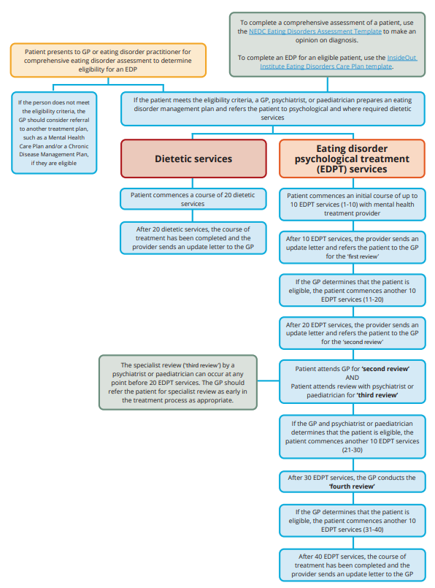
National Eating Disorders Collaboration (2024) Treatment under an EDTMP – Flowchart,
Eating Disorder Treatment and Management Plans.

