GP Training Incentive Payments

Fact Sheet and FAQs
From semester one, 2026, GP and Rural Generalist (RG) registrars enrolled in a Commonwealth-funded GP or RG training pathway will have access to a salary incentive, study leave incentive and parental leave incentive. Eligible training programs include the Australian General Practice Training (AGPT) Program and Remote Vocational Training Scheme (RVTS).
The incentives aim to encourage doctors to specialise in general practice or rural generalism. For more information about the incentives, please refer to the GP Training Incentive Payments Policy or contact the training providers – the Australian College of Rural and Remote (ACRRM), Royal Australian College of General Practitioners (RACGP) or RVTS Ltd.

Salary incentive – at a glance
Purpose | To support registrars as they enter GP or RG training and commence placements in community-based primary care.
Eligibility | Doctors must:  - Be enrolled in the AGPT or RVTS; and  - Have started (or continuing, for AGPT registrars) their first core training term in community-based primary care from semester one, 2026 or later.
Exclusions | - Registrars not in active training  - Previous recipients of the Commonwealth salary incentive or a state GP training incentive payment
Payment rate | $30,000 (pro-rata)
Application | Registrars will apply through their training provider with a declaration.
Withdrawing from GP training | Withdrawing registrars will be assessed on a case-by-case basis and they may be required to repay the salary incentive.

Study leave incentive – at a glance
Purpose | To support registrars while they study for and attend exams and attend relevant professional development activities.
Eligibility | Doctors must:  - Be enrolled in the AGPT or RVTS; and  - Have commenced GP training, subject to exclusions.
Exclusions | - Registrars are already entitled to study leave (or equivalent) with their current employer  - Registrars not in active training  - Registrars in an extension assessment term or awaiting fellowship or fellowship examinations
Payment rate | Training term | Hourly rate | Weekly rate
Payment rate | GPT1/CGT1 | $60.67 | $2,305.46
Payment rate | RVTS Year 1 | $64.38 | $2,446.44
Payment rate | GPT2/CGT2 | $68.09 | $2,587.42
Payment rate | GPT3/CGT3/RVTS Year 2 and above | $72.71 | $2,762.98
Provision  (*duration of provision is pro-rated) | Training term/year | Provision*
Provision  (*duration of provision is pro-rated) | RVTS Year 1 | 5 days or 38 hours  Note up to 2 days can be claimed for structured activities that occur outside of work hours.
Provision  (*duration of provision is pro-rated) | GPT1/2, CGT1/2, RVTS Year 2
Provision  (*duration of provision is pro-rated) | GPT3/ES, CGT3/4, RVTS Year 3
Provision  (*duration of provision is pro-rated) | ARST, AST (or equivalent)
Application | - Request leave from employer or notify their training placement (if applicable).  - Apply for incentive through training provider with a declaration and the required evidence. This may be done at the end of the semester or separately after each study leave instance.

Parental leave incentive – at a glance
Purpose | To support registrars for the birth, adoption or long-term fostering of a child from 1 January 2026.
Eligibility | Doctors must:  - Be enrolled in the AGPT or RVTS; and  - Have commenced GP training, subject to exclusions.
Exclusions | - Registrars already entitled to paid parental leave with their employer  - Registrars not in active training, unless on approved parental leave from their training provider.  - Registrars who have previously claimed paid parental leave for the same child or children  - Registrars commencing leave while on extension term  Exceptional circumstances may apply, refer to policy for details.
Payment rates (*hourly rate is pro-rated) | Training term | Hourly rate* | Weekly rate*
Payment rates (*hourly rate is pro-rated) | GPT1/CGT1 | $60.67 | $2,305.46
Payment rates (*hourly rate is pro-rated) | RVTS Year 1 | $64.38 | $2,446.44
Payment rates (*hourly rate is pro-rated) | GPT2/CGT2 | $68.09 | $2,587.42
Payment rates (*hourly rate is pro-rated) | GPT3/CGT3/RVTS Year 2 and above | $72.71 | $2,762.98
Provision | - Primary caregiver – 20 calendar weeks  - Secondary caregiver – 2 calendar weeks
Timing | Must be taken in a single continuous period and can be accessed:  - Up to 6 weeks before the expected birth  - Up to 1 week before adoption or long-term fostering  - Up to 24 months after the child’s birth or placement  - Up to 20 weeks before the expected birth in the case of stillbirth or infant death
Application | - Request leave from employer (or notify their training placement) as early as possible and no later than 10 weeks before leave begins.  - Apply for incentive through training provider with a declaration and the required evidence.
Interactions with other payments | Registrars should consider their individual circumstances for eligibility for other available programs.  Note the parental leave incentive may impact work test and income test eligibility for the Commonwealth Parental Leave Pay Scheme.

Frequently Asked Questions
General payment information
Are all GP and RG training pathways eligible for the incentive payments?
You are eligible if you are on a Commonwealth-funded GP or RG training pathway, such as the AGPT and RVTS. Other pathways are not eligible.
How are the incentive payments being administered? Will it be paid through my employer?
Your employer is not responsible for paying the incentive payments. For AGPT registrars, the incentive payments will be administered through Services Australia via the National Consistent Payment (NCP) Framework. For RVTS registrars, the incentive payments will be administered by RVTS Ltd.
Are there any location requirements to access the incentives?
No, there are no location requirements for these incentives.
Can International Medical Graduates (IMGs) access the incentive payments?
Yes, if you meet the eligibility criteria, your IMG status does not affect your access to the incentives.
How often will the incentives be paid?
The incentive payments will be made monthly in arrears.
How do I apply for the incentive payments?
For the salary incentive, you must submit a declaration to your training provider to activate payment.
For the study and parental leave incentives, you must first seek approval from your employer to take time away from work. You can then apply through your training provider, using the required application form. You may have to provide supporting evidence.
Do I have to pay tax on the incentive payments?
Yes, the incentive payments are considered assessable income. You should seek independent advice from a qualified tax professional to understand the impact on your individual financial circumstances.
Will superannuation be paid on the incentive payments?
No, these payments are incentives, not employment entitlements, so money will not be paid on your behalf into your superannuation fund. However, the study and parental leave incentive payments include an amount equal to superannuation, which you can choose to contribute to your superannuation.
I commenced GP training in 2025. Am I eligible for the incentives?
Yes, the study and parental leave incentives will be available to all new and continuing registrars from 2026. If you have not completed your first core training term in community-based primary care before 2026, then you may also be eligible for the salary incentive.
I am participating in a Single Employer Model (SEM) trial. Am I eligible for incentive payments?
Yes, as long as you meet the eligibility criteria, you are eligible for the incentives. However, if you are already entitled to study leave and paid parental leave through your employer, you may not be eligible for those specific incentives.
I am an Australian Defence Force (ADF) registrar. Am I eligible for incentive payments?
Yes, as long as you meet the eligibility criteria, you are eligible for the incentives. However, if you are already entitled to study leave and paid parental leave through your employer, you may not be eligible for those specific incentives.
Who should I contact if I have any application questions or payment queries?
Contact your relevant training provider in the first instance for any application or payment related enquiries.
Salary incentive
I received one of the state GP training incentives. Am I still eligible for this salary incentive?
No, if you have received a state GP training incentive (i.e. the Victorian Government’s GP Grant Program or Queensland Government’s GP Trainee Incentive Scheme), you are not eligible for the Commonwealth salary incentive.
If I withdraw from the training pathway, will I have to pay back the salary incentive?
The Department of Health, Disability and Ageing will assess each program withdrawal on a case-by-case basis to decide if you will be required to repay the salary incentive.
I am re-enrolling into an eligible GP or RG training pathway. Am I still eligible for the salary incentive?
No, if you have already received the salary incentive, either in full or partially, you cannot receive it again.
I work part-time. How will that affect the salary incentive?
The salary incentive payments are pro-rated based on your full-time equivalent (FTE). You will still receive the same total amount as a full-time registrar but your payments will be spread out over a longer period according to your FTE.
The diagram below shows how the salary incentive will be worked out as pro-rata.
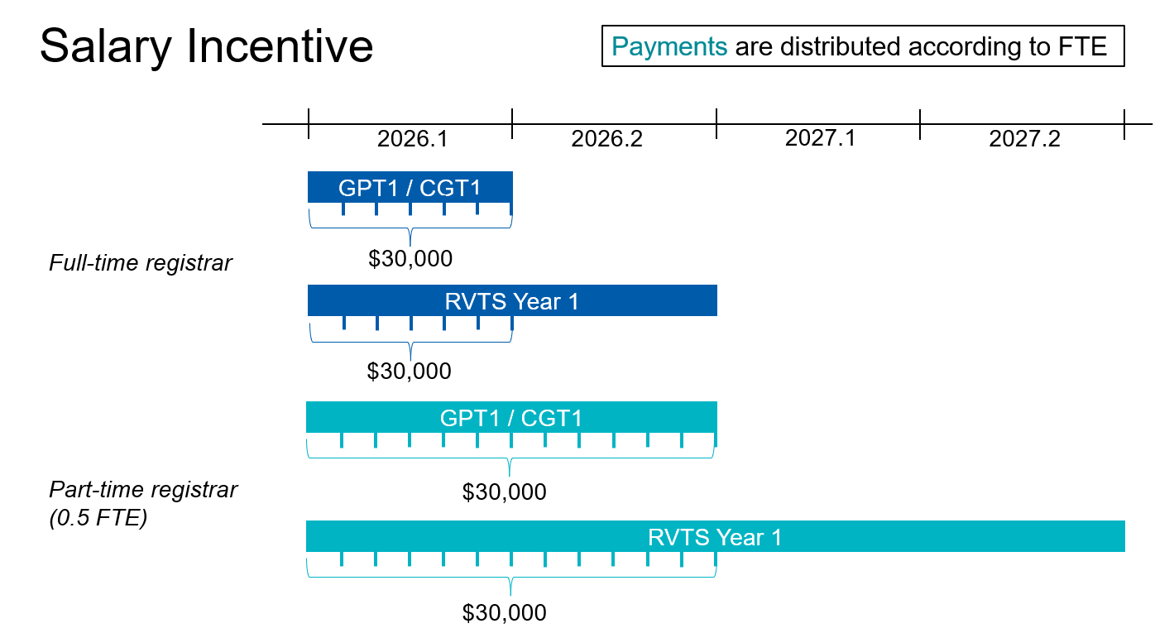
Study leave incentive
I work part-time. How will that affect the study leave incentive?
The distribution over time of the study leave incentive provision is pro-rated based on your FTE. In other words, it is allocated proportionally across the longer duration of training for part-time registrars. You will have access to the same total of 5 days as a full-time registrar but the provision will be spread out over a longer period according to your FTE. The hourly or daily rate of payment remains the same for full-time and part-time trainees.
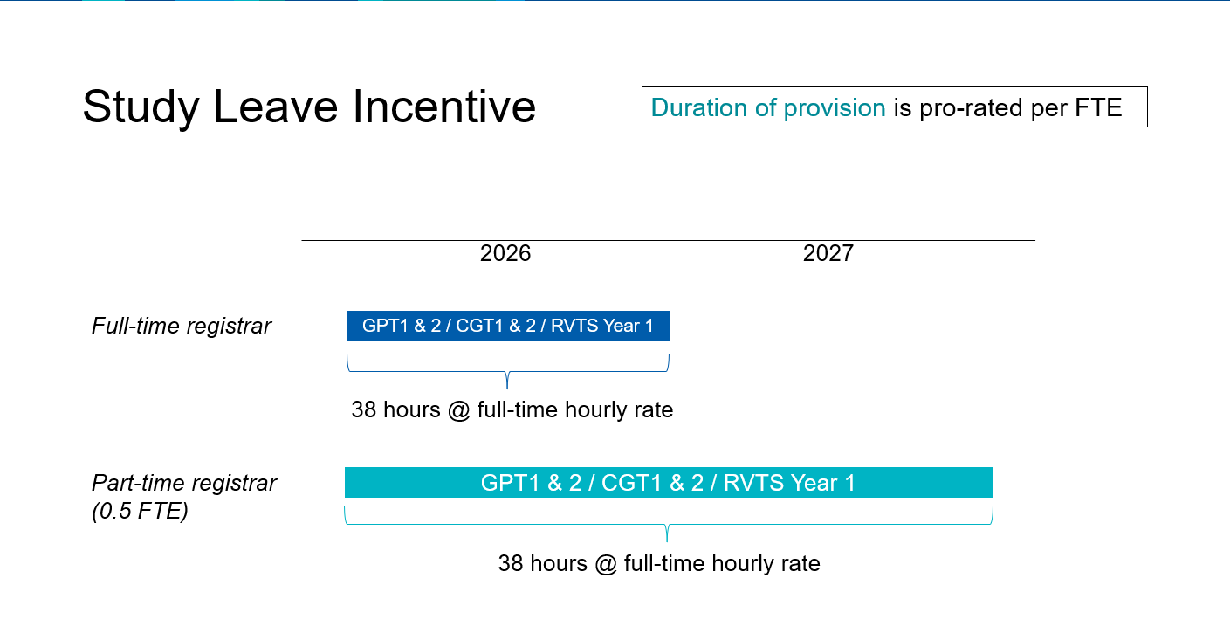
The diagram below shows how the study leave incentive will be worked out as pro-rata.
Do I need to wait to accrue my 5 days of study leave incentive before I can access it?
You will have access to the full 5-day study leave incentive provision from the start of your training year. This gives you the flexibility to use the incentive in a way that best supports your study needs.
Can the study leave incentive accrue over my entire training program and be paid out?
No, you cannot carry over or cash out unused study leave incentive payments. The provision is limited to each training year and must be used within that year. Any unused portion will be forfeited.
What happens to my study leave incentive payments if I progress to the next training term?
Your study leave incentive payments will be paid at the corresponding rate for the training term in which you took your leave, not the date you submitted the application.
It is difficult for me to take time off work for study leave. Can I still access the study leave incentive?
Yes, you can claim up to 2 days per training year for relevant structured study activities outside of work hours. You will have to provide supporting evidence. You cannot claim the study leave incentive for self-directed study outside of work hours.
Can I take all my study leave incentive at once?
Yes, if approved by your supervisor and employer.
Parental leave incentive
If I start my parental leave before the agreement comes into effect in 2026, will I still be eligible for the parental leave incentive?
If you are a primary caregiver on parental leave in the 18 weeks prior to the commencement of this policy (i.e. from 28 August 2025), you may be considered for a portion of the parental leave incentive. You will have to apply for exceptional circumstances through your training provider.
Can I take the parental leave incentive payments at half-pay to extend my leave period or in multiple blocks?
No, the incentive cannot be taken at half-pay to extend the leave period. The parental leave incentive must be taken in a single continuous block. Any unused incentive will be forfeited.
I work part-time. How will that affect the parental leave incentive?
All eligible registrars of the same caregiver status can access the same number of calendar weeks. However, the payment amount will be pro-rated based on your FTE at the time of application.
The diagram below shows how the parental leave incentive will be worked out as pro-rata.
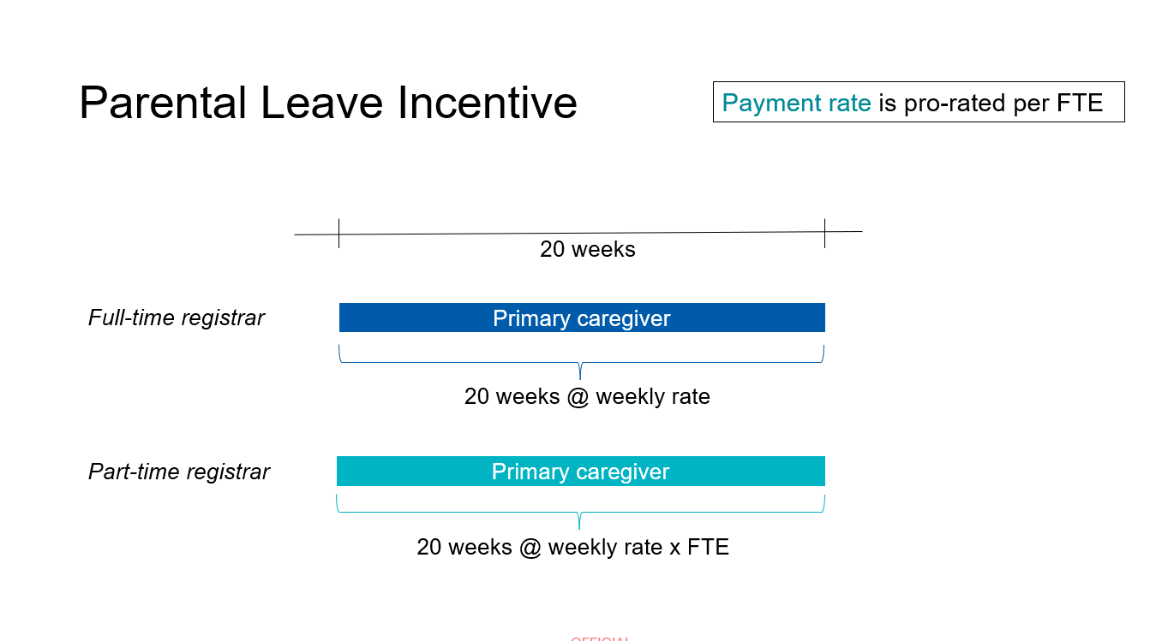
What happens if the NTCER payment rate increases while I’m on parental leave?
Your parental leave incentive payment rate will be adjusted to reflect any rate changes from the date of effect. However, you will remain on the rate applicable for the stage of training you were at when you started your parental leave.

Is the parental leave incentive the same as the Commonwealth Parental Leave Pay (PLP) scheme?
No, the GP training parental leave incentive is complementary to, and not a replacement for, the Commonwealth PLP scheme. Depending on your individual circumstances, the incentive may impact your work test and income test eligibility for the PLP scheme.

Version details
Version | Date | Description of revision
1.3 | January 2026 | New diagrams of pro-rata arrangements and clarification of processes for registrars who are not employees
1.2 | November 2025 | Clarification of pro-rata arrangements for study and parental leave incentives
1 | October 2025 | First release

