Business to Government (B2G) Developer Portal User Guide
November 2024
Version 2.8
This Business to Government (B2G) User Guide aims to support software vendors and developers to interact with the Department of Health and Aged Care.
This guide provides information on how to register an organisation and add users, navigate the Developer Portal, and request and test mock Application Programming Interfaces (APIs).

Contents
1. What is Business to Government (B2G)? 3
1.1 Purpose 3
2. Accessing the B2G Developer Portal 3
2.1 Register your Organisation 3
2.2 Logging in with Digital ID 6
2.3 Navigation for a Logged in User 9
2.4 Invite Additional Users for your Organisation 11
3. Using the B2G Developer Portal 15
3.1 The Organisation Management Screen 15
3.2 Existing Users 15
3.3 Removing Users 16
3.4 Updating your Profile and Setting 17
3.5 System Updates 17
3.6 Managing APIs 18
4. Application Program Interface (API) 21
4.1 Interacting with APIs from within the Developer Portal 23
4.2 Authentication with the B2G Gateway 26
5. Conformance Management 28
5.1 Registering your software 28
5.2 Software Versions 30
5.3 Organisation Requests – API Tests and Conformance Submissions 32
6. Troubleshooting Tips 35
6.1 Deleting your Cache 35
6.2 Digital ID 38
7. Further Information 38

What is Business to Government (B2G)?
The Department of Health and Aged Care (the Department) Business to Government (B2G) Developer Portal aims to provide connections for direct information sharing between government and aged care providers and allows aged care workers to spend less time on administrative tasks and more time on delivering quality care to older Australians.
B2G enables software vendors to log-in, register, and authenticate against mock application programming interfaces (APIs) as part of the Department’s commitment to the ongoing staged co-design with the Sector.
Future releases will focus on enhanced capability including availability of additional APIs.

Purpose
This User Guide has been designed to support software vendors and developers:
- interact with the Department
- learn how to register an organisation
- navigate the Developer Portal
- request and manage APIs required to support information integration requirements for reporting.

Accessing the B2G Developer Portal
To access the Developer Portal an Organisation must first register and assign an administrator who will be able to invite a developer or secondary administrator.
Additional information in relation to these roles is included in section 2.4 Invite additional users for your organisation.
If your organisation is already registered, proceed to section 2.2 Logging in with your Digital ID (such as myID).

Register your Organisation
From the landing page click on Register and complete the form.
- Register your organisation:
Enter your organisation’s ABN number and click Verify.
Once a valid ABN has been entered you must enter your organisation’s website address and select your organisation’s industry from the drop-down menu. Industry relates to your primary business activities.
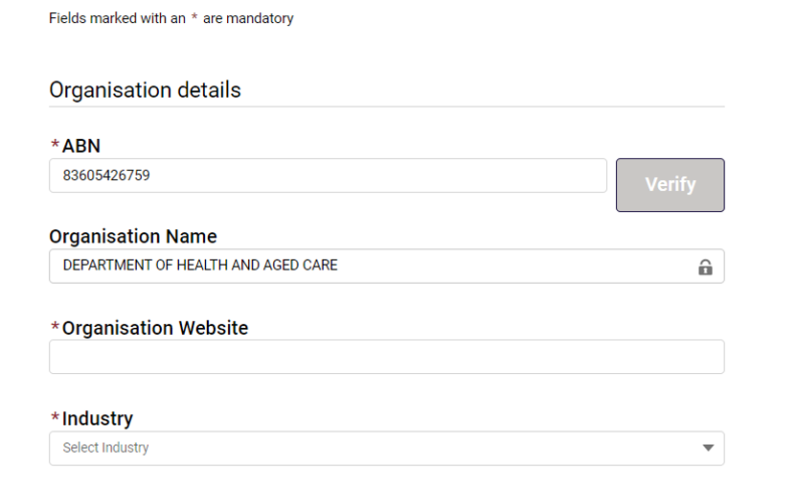
- Assign an administrator:
The administrator can manage other users on your account. The Administrator is required to have two emails: the Primary Email (preferred email for communication) and the RAM email (the email used for your RAM account)
The details required to register an administrator are:
- First name
- Last name
- Primary email
- RAM email
- Primary contact
Your RAM email address must align to the business email address registered with the Organisations Relationship Authorisation Manager (RAM). If the user’s email addresses do not match within both systems, the user will not be able to log into the B2G Developer Portal.
Please note:
Fields marked with * are mandatory.
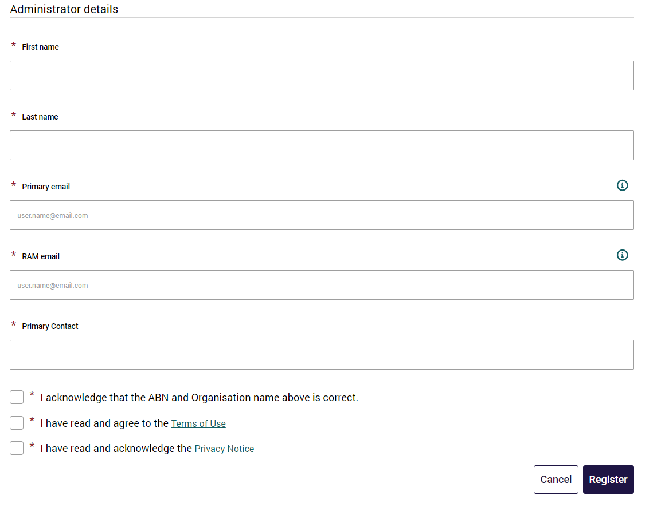
- Terms of use and Privacy Notice:
When registering for the first time, you will be asked to acknowledge that the ABN and organisation name are correct.
Confirm that you have read and agree to the Terms of Use and read and acknowledge the Privacy Notice.
If you agree to the Terms of Use and read and acknowledge the Privacy Notice, select the tick boxes and follow the prompts.
Please note:
If you do not agree to the terms of use or acknowledge the privacy notice, you will not be able to complete your registration.
- You will receive confirmation that your registration form has been successfully submitted.
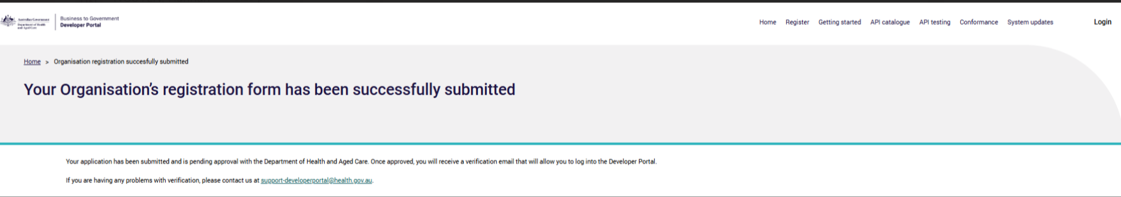
- The Department will review your request and notify you by email once your account has been activated or declined.
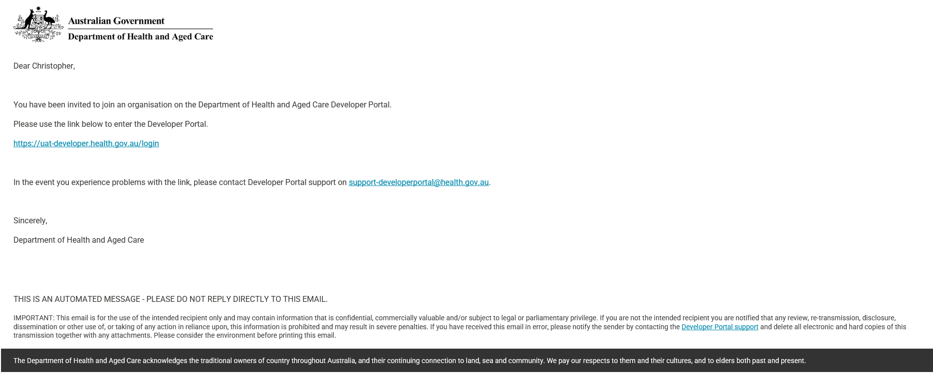
Once activated, an administrator of a registered organisation can manage the users in their account and request access to APIs offered by the Developer Portal.
If declined, you can contact the Department at support-developerportal@health.gov.au to discuss further.
For any issues, refer to the Troubleshooting Guide: Login Support for assistance.

Logging in with Digital ID
It is a standard practice across government to use Digital ID to identify users. Digital ID lets you prove who you are and securely sign in to participating online services, such as RAM and B2G developer portal, removing the requirement for usernames and passwords. Your Digital ID is used to validate your identity allowing you to commence using and exploring the Developer Portal. We do not store or use any information from your Digital ID (such as myID) and cannot view or update any of your linked services. You’re in control and your personal information is only shared with your consent. For more information on Digital ID please visit www.digitalidsystem.gov.au.https://www.mygovid.gov.au/
B2G is accessed by using Digital ID authentication services.
Digital ID is software that authenticates users who require access to Australian Government websites and services.
The Relationship Authorisation Manager (RAM) works with Digital ID authorising you to represent your organisation(s). RAM will work behind the scenes to verify you are allowed to access the Developer Portal, when you use the Digital ID login pathway.
If you have any queries relating to Digital ID or RAM, refer to your internal onboarding reference materials, or visit the Digital ID website, myID website, or the RAM website.
RAM Administrators and Principle Authorities require a Digital ID proofing level of standard and above.
To log into the Developer Portal with your Digital ID, complete the following actions:
- Open the URL: https://developer.health.gov.au/ to access the Developer Portal.
From the landing page select Login from the navigation bar.
- On the Select your identity provider screen, select your Digital ID (myID previously myGovID) provider. Currently only myID is available to use with government online services. More options will be available in future.
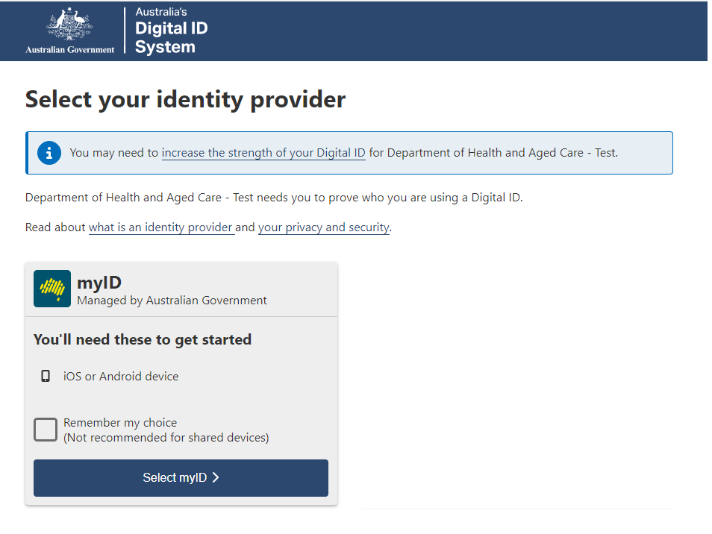
- Enter your myID email address, then select the Get code button.
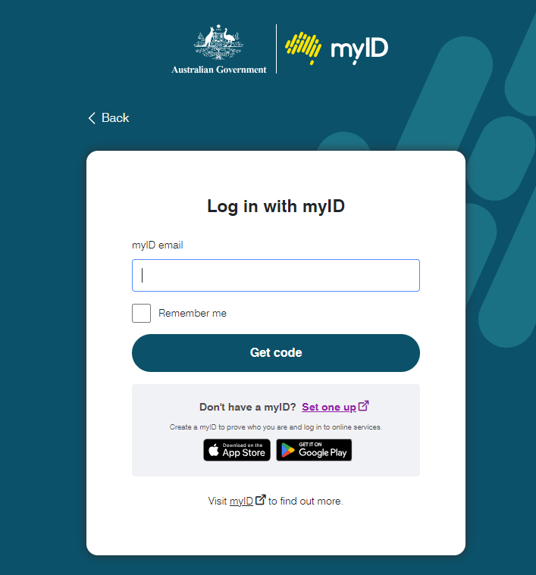
- The myID Authentication screen will display and provide instructions to verify your myID.
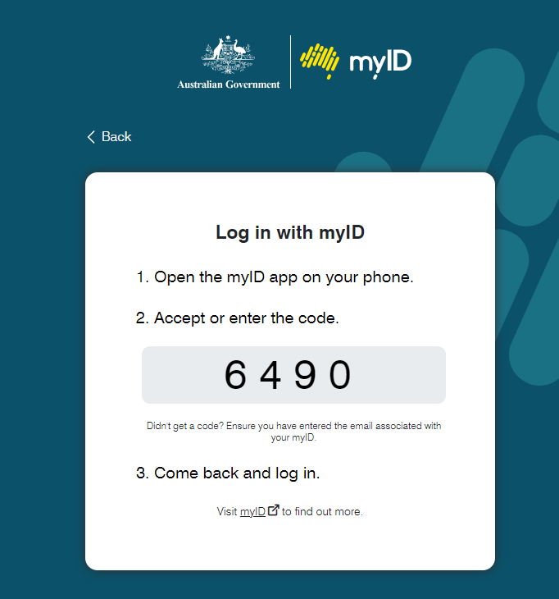
- If you work for multiple organisations:
Some users may work for multiple organisations. When this is the case, RAM will provide a list of organisations at the end of the Digital ID log in process.
If this does not apply proceed to step 7.
To select the organisation you want to log in for, complete the following actions:
- In the Relationship Authorisation Manager screen, select the radio button of the authorised organisation you want to access.
- Select the Continue button.
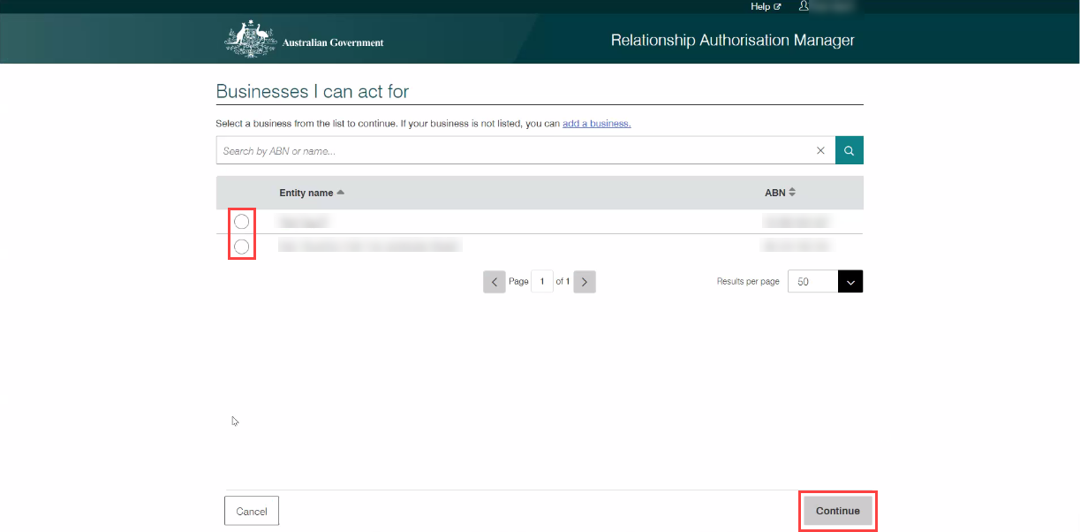
- The B2G Developer Portal landing page will display.
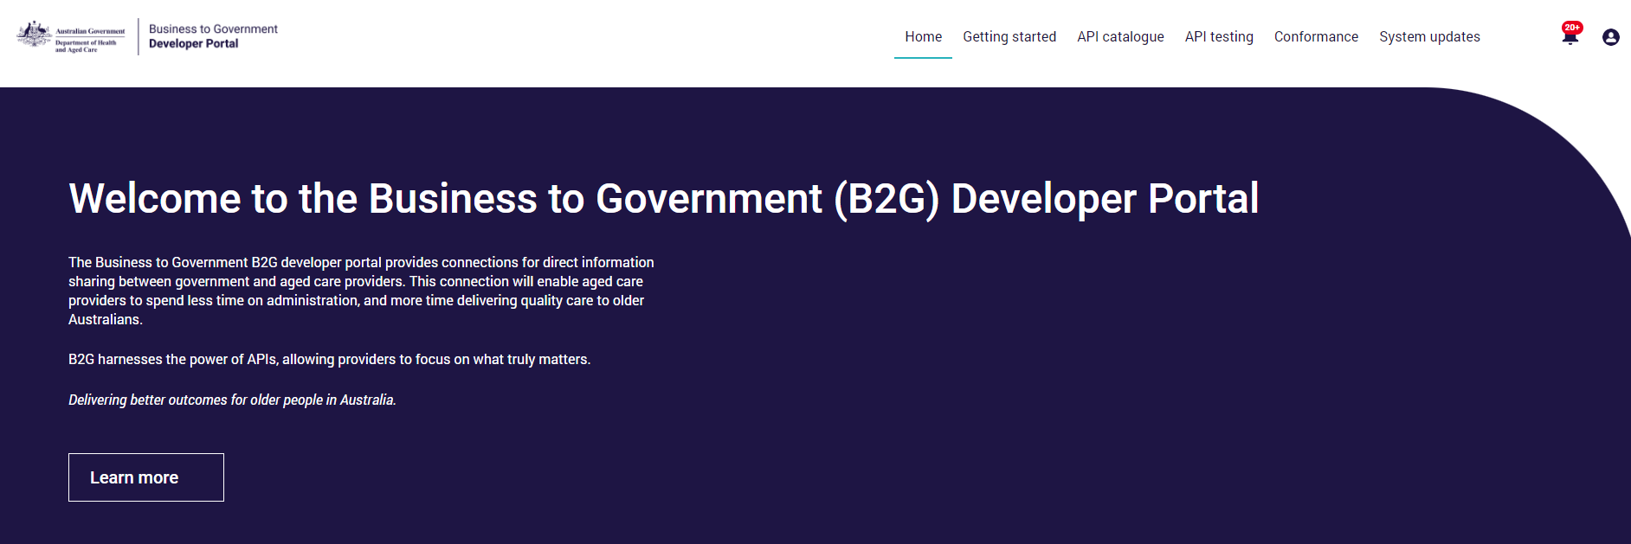

Navigation for a Logged in User
Once logged in, you can navigate through the Developer Portal by using the:
- Top navigation bar which provides access to the Home page, Getting started, API catalogue, API testing, Conformance, and System updates.
- Login button which displays an additional pop-out menu for registered users to manage access and settings:
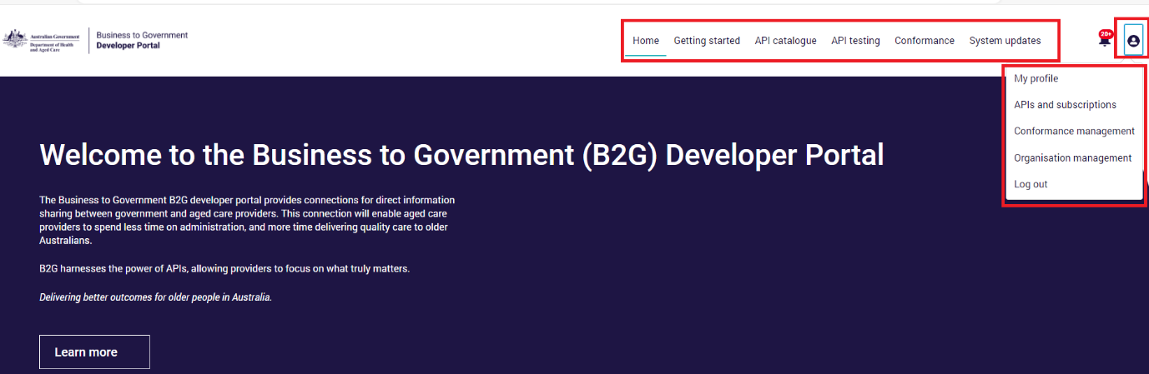
Menu Button | Description
System updates | Provides information of any known issues and scheduled maintenance.
My Profile | Users can update their email address, language, location and timezone.
APIs and Subscriptions | View the APIs that you have requested access to, check the status of the request, view the associated API credentials and unsubscribe at any time.
Conformance Management | Software that has been developed to consume APIs must be registered by an Organisation Administrator and successfully complete testing and conformance assessments.
Organisation management | Add / remove users for the Organisation (the Organisation Management page is only visible to an administrator role).
Notifications Icon | This is where developers receive notifications. This could be advice on system updates, API test results, submission notifications, and requests for additional information.  Messages will remain active in the notification icon until users have read the notification.
Log out | Log out of the system.
You can also follow the Continue your Journey steps to the manage access, conformance and API catalogue:
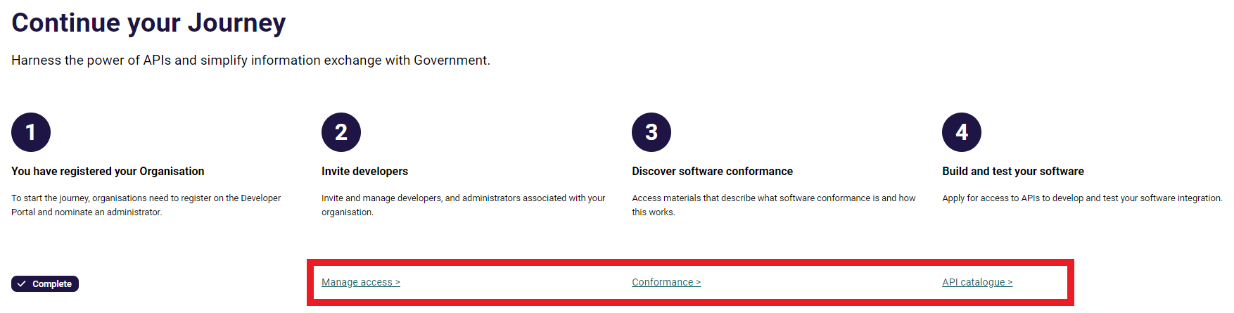

Invite Additional Users for your Organisation
Administrators can add new users to the Developer Portal. The roles that can be assigned to a user are:
Role | Description
Administrator | This role manages your organisations access to the portal. Administrator access is the highest level of access. It allows you to:  - manage access for all organisational users including developers  - manage your software and software versions  - submit API Testing and Conformance Assessment requests.  You may choose to have more than one administrator.
Developer | This role allows users to:  - explore the APIs in the catalogue.  - request access to APIs and manage API keys.  This role is not responsible for account administration.
- To invite users, from the landing page, step 2 in the journey will take you to the Organisation management page.
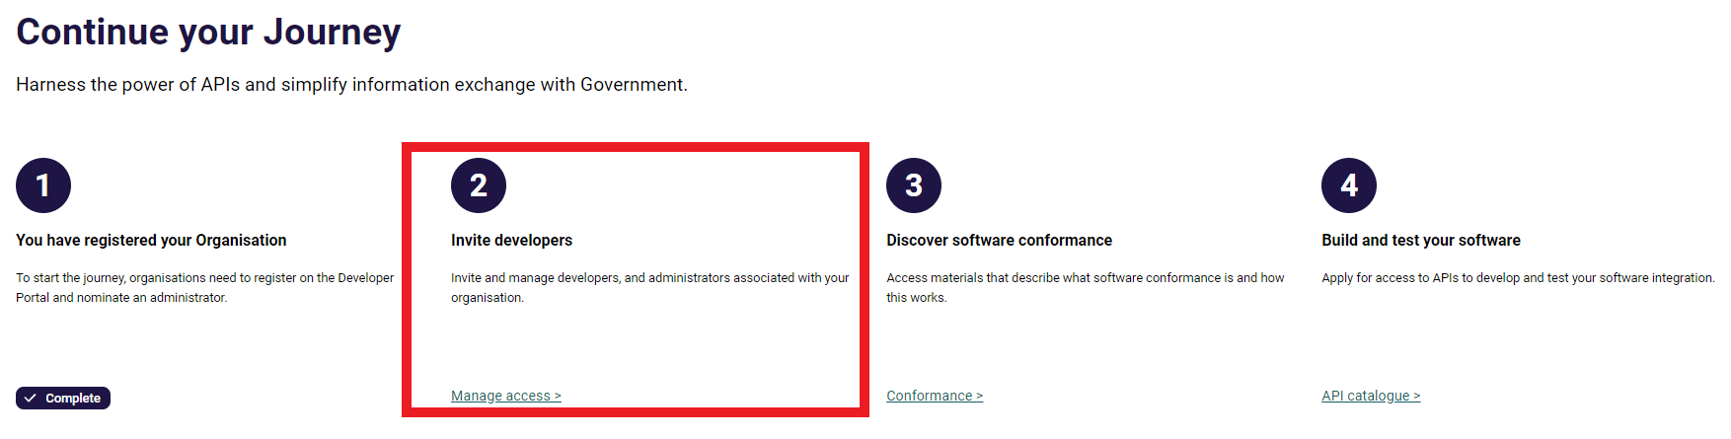
- Select Add a user from the Organisation members table.
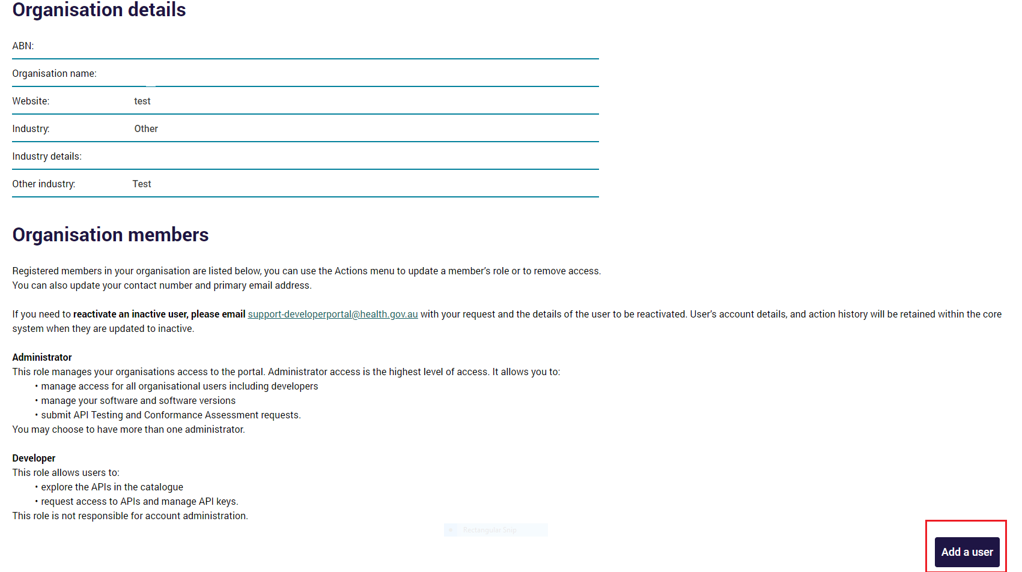
- Add the details of the user you are creating ensuring the email address is the same as the email associated with your organisation in RAM and select the radio button for the role type.
When adding a new user, you will be asked to confirm:
‘By adding a new user you acknowledge that you have obtained the individual’s consent to share their personal information with the Commonwealth through the Developer Portal and have drawn their attention to the Privacy Notice.’
If you acknowledge you have obtained consent, select the tickbox and follow the prompts.
- Select Invite
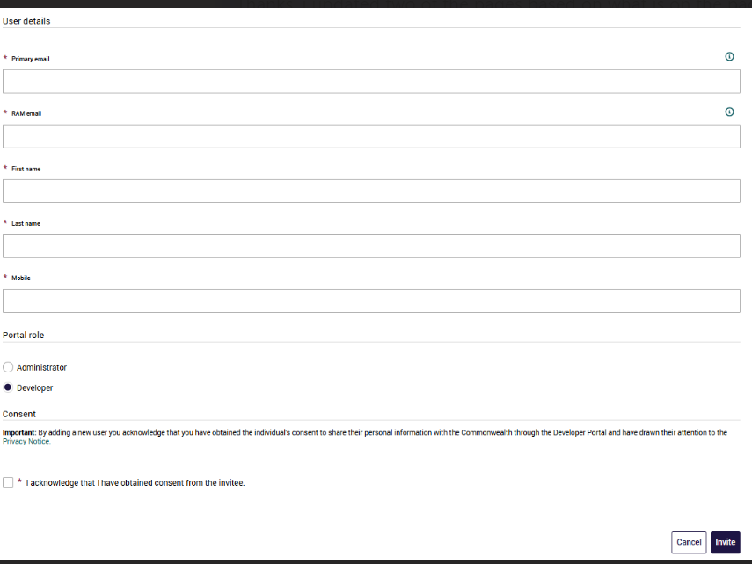
Please note:
You will need to acknowledge you have obtained consent and have drawn their attention to the Privacy Notice to invite a new user.
- If you need to reactivate an inactive user, please email support-developerportal@health.gov.au with your request and the details of the user to be reactivated. In the event of a user’s account being made inactive, action history is retained by the core system.
- Users added by their administrators will receive a welcome email inviting them to join their organisation on the Developer Portal.
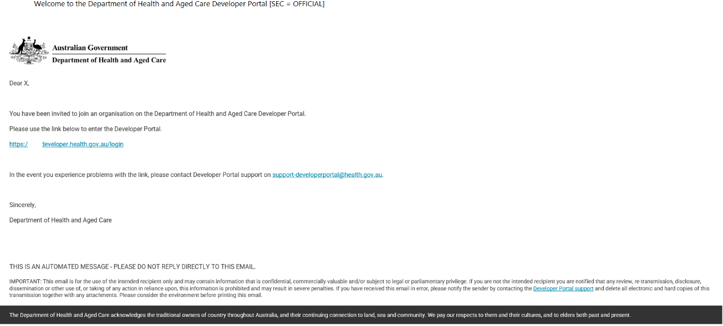
- To log in for the first time, the user must click the link included in the welcome email and then follow the steps described in section 2 of this guide.

Using the B2G Developer Portal
To view the features that follow, you must be a registered user.
The Developer Portal allows you to add additional users, edit user access roles, and view your API requests and subscriptions.

The Organisation Management Screen
The Organisation management screen is where you will perform administrative functions, such as adding users and editing user access roles.
Only a user that has been assigned with administrator access to the Developer Portal will be able to carry out this administrative function.
To access the Manage users functionality, complete the following actions:
- As a logged in user, click the Login icon and select Organisation management from the drop-down list.
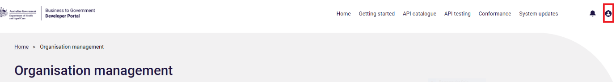
The Manage users table will display.

Existing Users
If you enter an email address for a user who has already been added to B2G you will receive the following message.
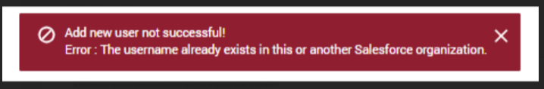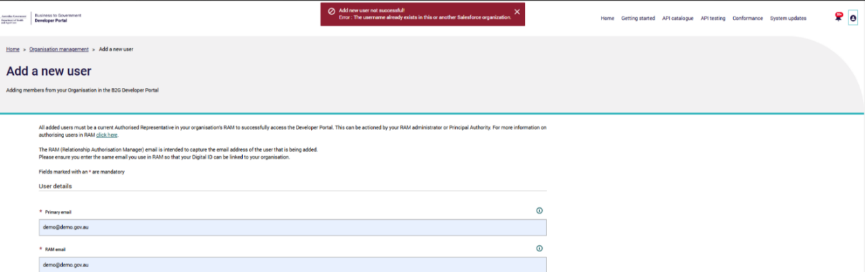
If you receive this error message, you can:
- Check the Organisation management members table to confirm that they have been invited to the Developer Portal and are a member of your organisation.
- Contact the user and confirm if they have already received a 'welcome email' and followed the prompts within the email. The email may be located within the users ‘junk’ mail folder.
If you can not see the user within the members table or the user did not receive the welcome email, contact the Department by emailing:
support-developerportal@health.gov.au.

Removing Users
Administrators can remove users from the Developer Portal. Removing a user takes away their ability to access the Developer Portal, however it should be noted that the user’s account details, and action history will be retained within the core system.
To remove a user, complete the following actions:
- From the members table select the user you wish to remove by clicking the action link for that user.
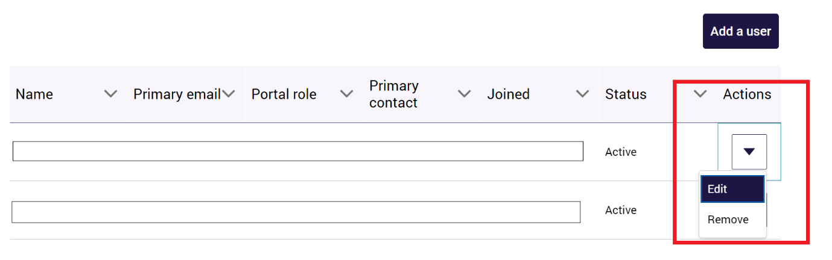
A pop-up will display advising you are removing this user at this level of your organisation and that the action cannot be undone. If you wish to proceed, select Confirm.
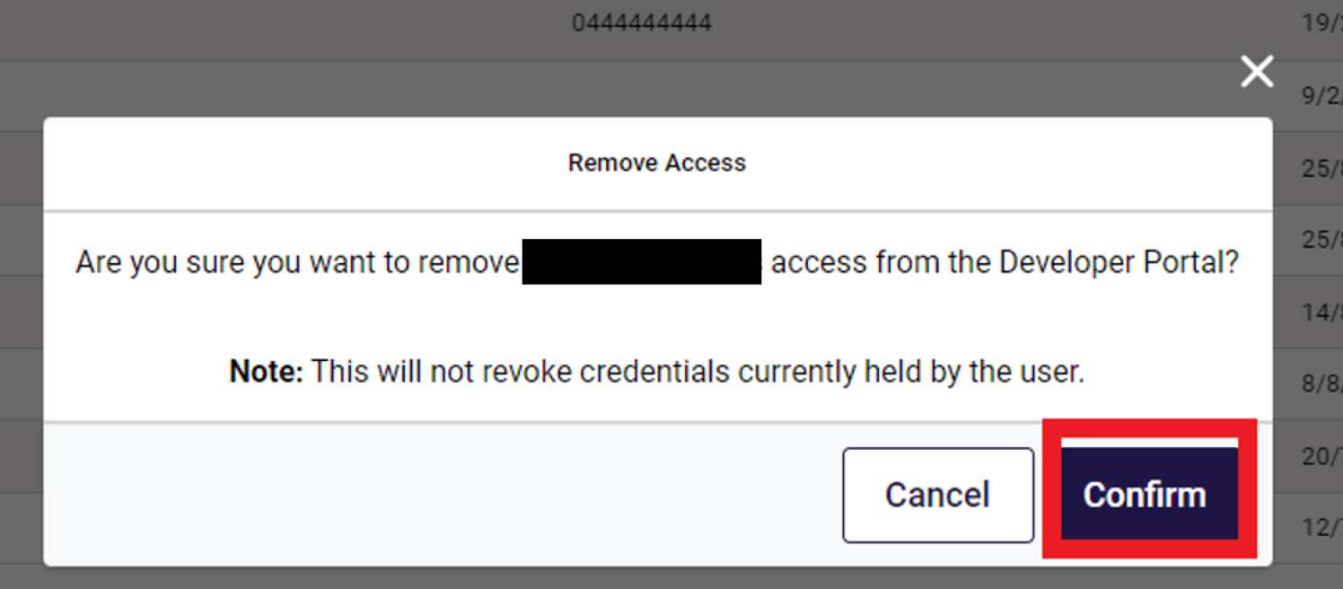
The Manage organisation screen will display again and the user will no longer be listed in the table.
If you need to add a user that was previously removed contact the Department by emailing support-developerportal@health.gov.au.

Updating your Profile and Setting
All Users can update their email address, language, location and timezone by navigating to profile and settings.
Once you have entered the new information select Save.
The email address must always be the same as the one used in RAM.
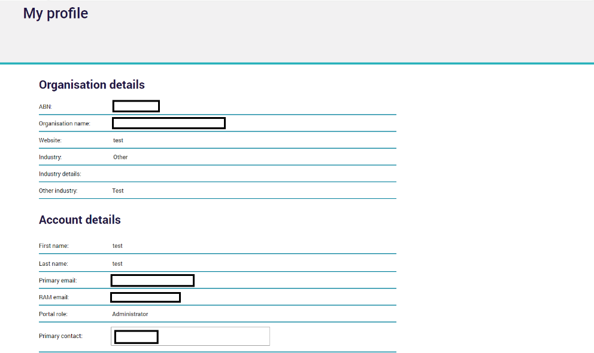
If you experience any issues with login, contact the Department by emailing support-developerportal@health.gov.au.

System Updates
The Developer Portal will be unavailable at certain times for essential system maintenance. We encourage you to check this page to keep informed of any known issues and scheduled updates.
You can check for any system updates before logging in by selecting the system updates icon from the menu at the top of the Developer Portal home page.
Once logged in you can subscribe to system updates, keeping up to date with changes and outages impacting the portal.
You can filter system updates/outages by selecting Outage or Schedule Maintenance from the drop down box below.
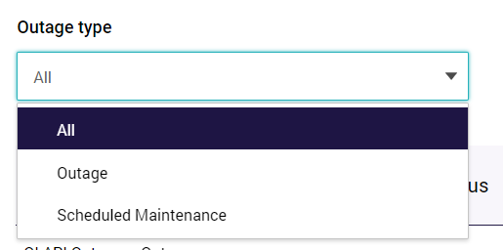

Managing APIs
All users will be able to request access to APIs and manage their subscription.
From the landing page, click on the login icon and select the API and subscriptions option.
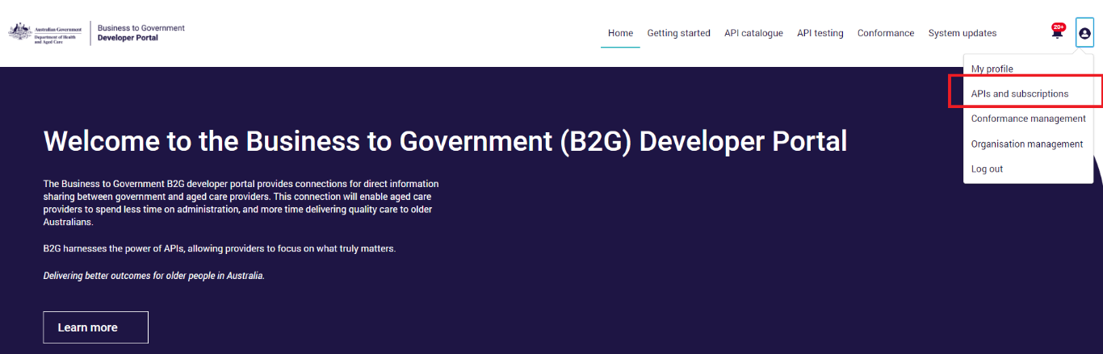
From the API and subscription page you will be able to:
- Check the status of the API that has been requested.
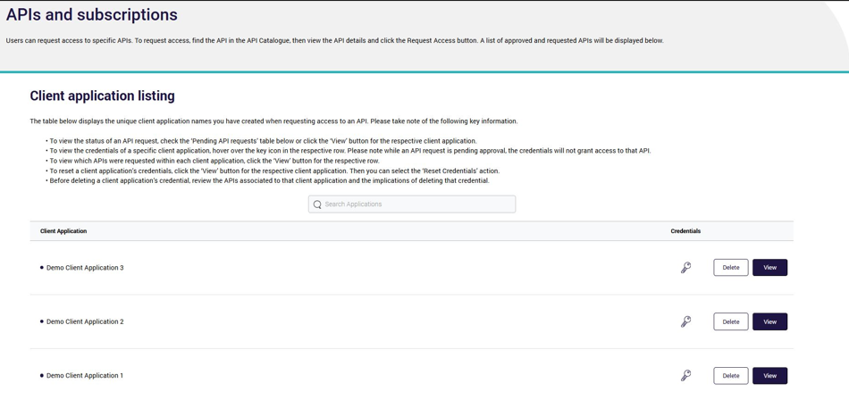
- Application details will be displayed on the Application details page.
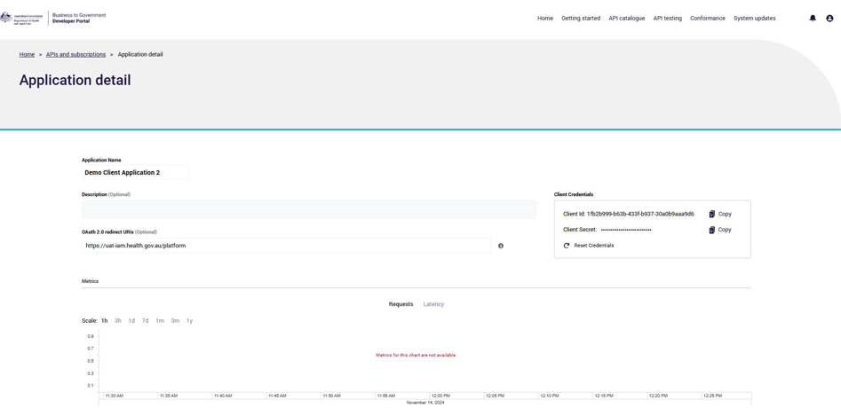
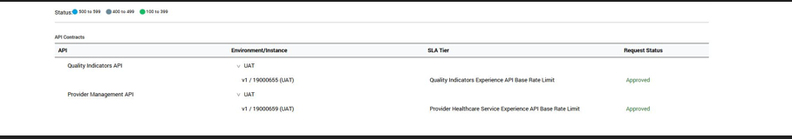
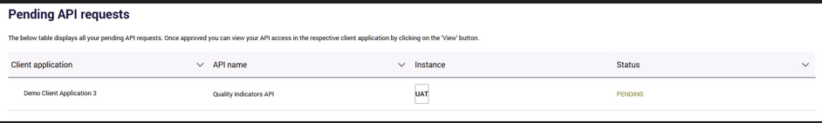
- Manage your subscriptions. To unsubscribe from a subscription, select unsubscribe from the action column in the table.
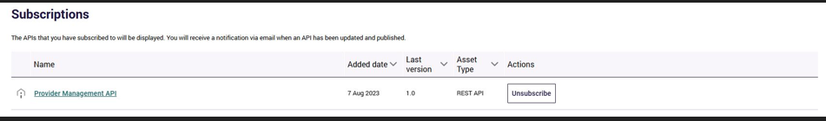

Application Program Interface (API)
The Developer Portal API catalogue will display a tile for each API that is available.
You can view details to access information on how individual APIs work and select the Request Access button for registered users.
The APIs are available for discovery and may be available for testing via a sandbox service or an integration environment, but users should expect the Department to make changes based on feedback and continued refinement.
Feedback from developers is actively sought and should be sent to:support-developerportal@health.gov.au.
Additional statuses will be introduced to show when the API is ready for use or superseded.
- To view the APIs available, from the Developer Portal landing page, select the API Catalogue.
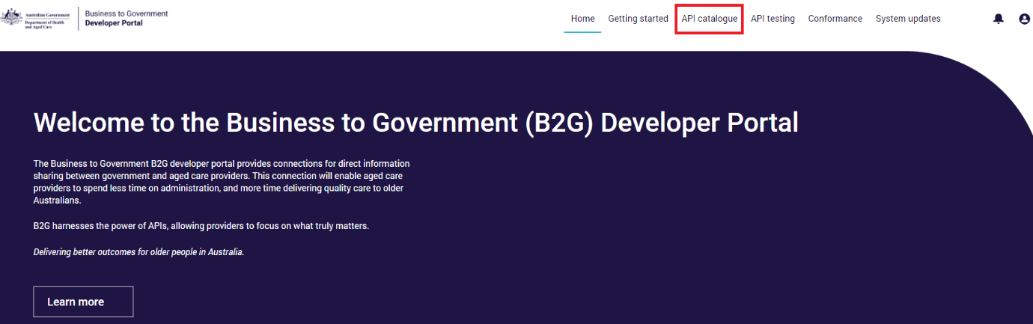
- The catalogue screen will display the API tiles available.
Select the tile and click View Details.
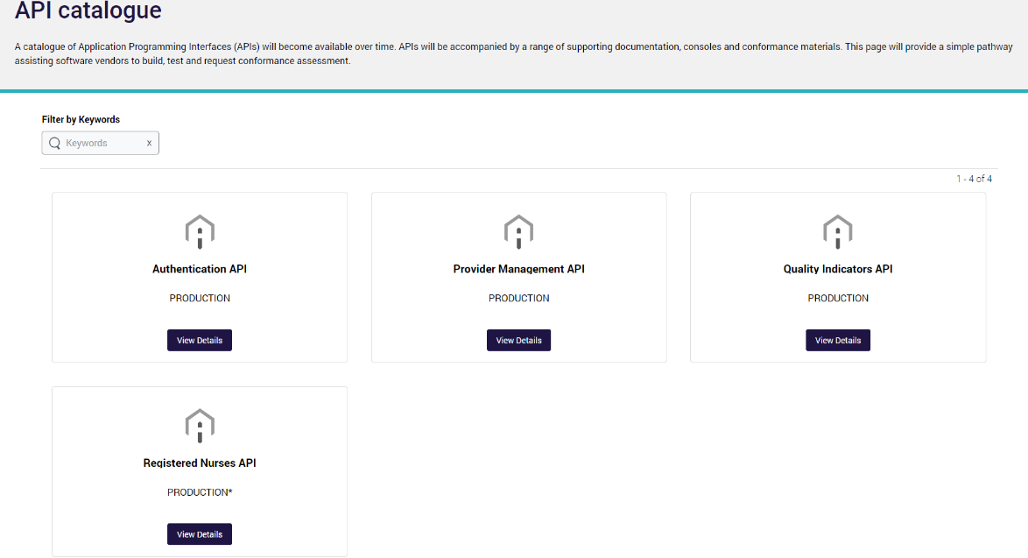
The API Documentation and API Console tabs will be displayed. If you scroll to the end of the page you can subscribe to the API and receive notifications of changes and updates.
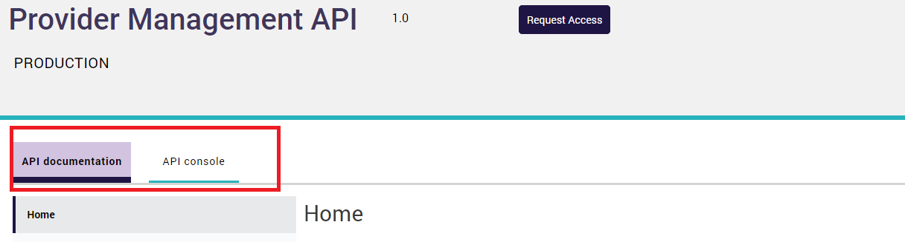
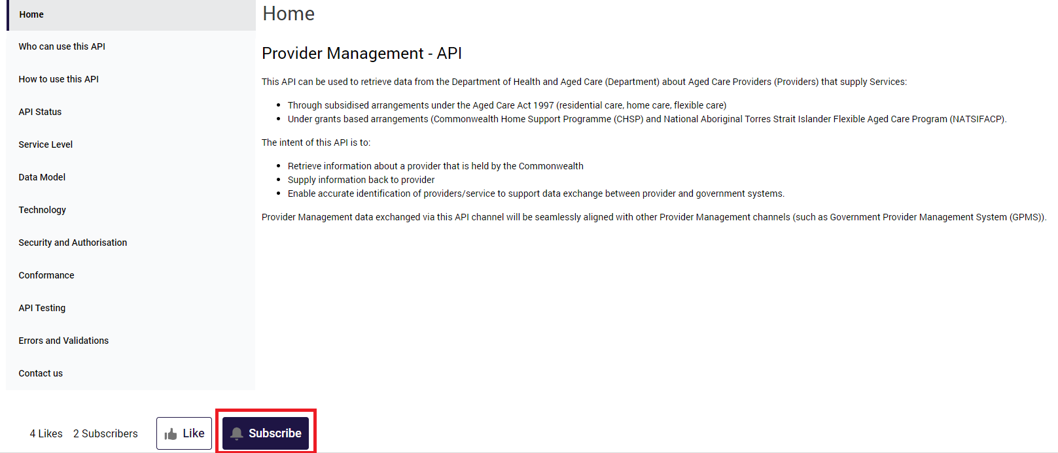
- The API Documentation tab provides you with an overview of the API selected, who can use this API, and how to use this API.
- The interactive API console component provides you a summary of the API endpoints and enables users to test relevant methods against a mock instance of the API.
- You can also export the API specifications in RAML (RESTful API Modelling Language) and OAS (OpenAPI Specification) for use in your development activites.
The subscribe button provides you with notifications when updates or changes are made to the API.
- If you would like to proceed, you can request access to the API selected which will then be reviewed by the Department.
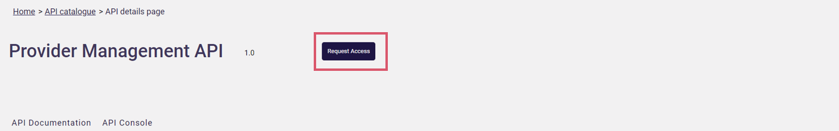
The request access form will display. Complete the fields as shown:
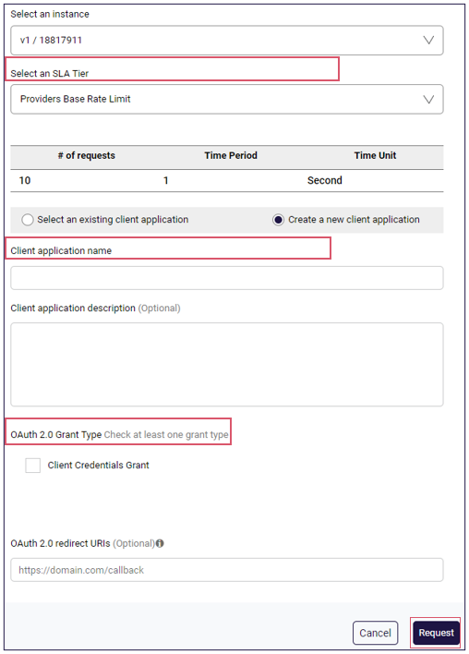
Please note:
If you encounter technical errors, contact the department via support-developerportal@health.gov.au.

Interacting with APIs from within the Developer Portal
- From the API Console tab, select the API you would like to interact with:
- Select an Endpoint from within the dropdown menu.
- Select the method you would like to test a mock API call with and select GET.
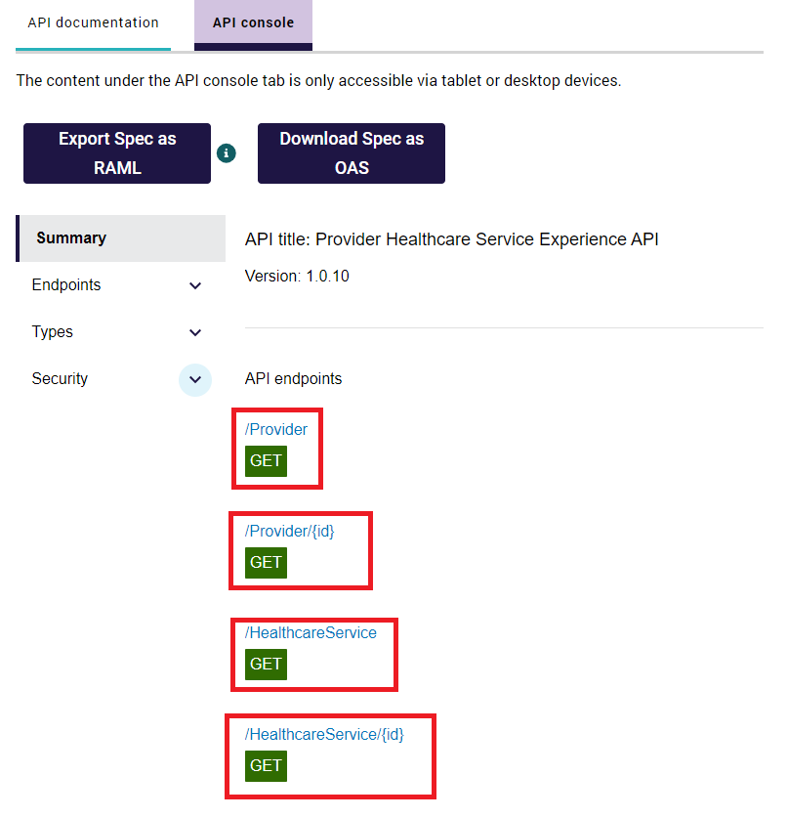
You will be provided with:
- Code examples.
- Header Information (authorisation, transaction_id).
- Response codes and their meanings.
- Information about the body structure including payload examples and field information.
On the right hand side, you will have access to create a mock API call using the Developer Portal.
If any query parameters or headers are required, these will appear under Query Paramaters or Headers.
The Authorisation field and transaction_id will be pre-propulated.
- Once required fields have been populated, click send to submit the call.
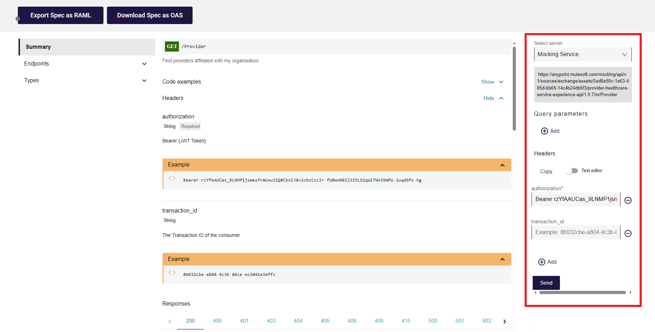
A successful GET operation against either the Provider or Service API will result in one of the below payloads (respectively) and will be accompanied by a HTTP Response Code of 200
Definition as follows: Successful responses
200 OK
The request succeeded. The result meaning of "success" depends on the HTTP method:
- GET: The resource has been fetched and transmitted in the message body.
- HEAD: The representation headers are included in the response without any message body.
- PUT or POST: The resource describing the result of the action is transmitted in the message body.
- TRACE: The message body contains the request message as received by the server.
Sample Response ‘Hello world’ will be provided.
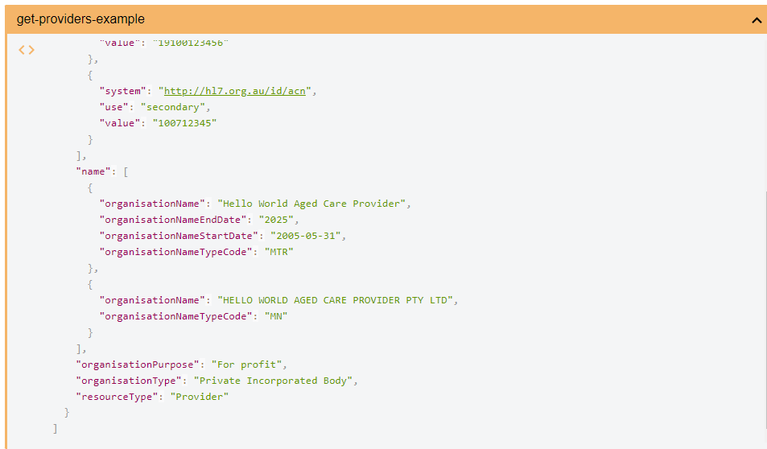
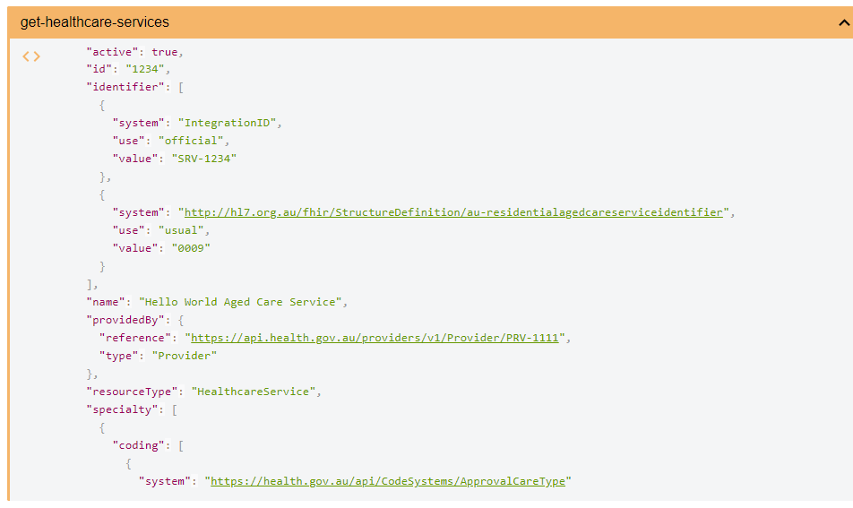

Authentication with the B2G Gateway
The Authentication will enable portal users to authenticate with the B2G Gateway, by acquiring a valid access token from the Department’s Authorisation Server for access to protected API resources.
This access token is provisioned using the OAuth 2.0 Grant Flow type.
The Authentication API supports the Client Credentials Grant Flow Type to generate an access token with two methods.
The first uses the ‘Client_Secret_Post’ authentication method (client credentials). This method allows Developers to generate an access token to interact with test APIs in the Software Vendor Testing (SVT) environment.
The second uses the ‘Private_Key_JWT’ authentication method to support JWT Bearer (signed JWT instead of client credentials). This method allows:
- Service Providers to generate an access token to interact with Department APIs in Production.
- Developers to prove that their software can interact with the Department APIs in SVT.
Further information can be found at https://developer.health.gov.au/s/apis.

Conformance Management
Conformance is a mandatory step in the Business to Government (B2G) Gateway onboarding process. It seeks to ensure the safe and secure use of the B2G Gateway by software products and their users. You can refer to the Conformance page and download Conformance documentation to understand conformance in more detail, including:
- Conformance Assessment Scheme
- Conformance Model
- Conformance Profiles
- Conformance Test Specifications
- Conformance Assess
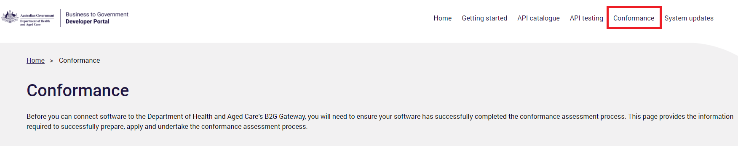

Registering your software
Before you can supply API test results or request a conformance assessment, you will need to ensure you have registered your active software product with the Department. A software record can have multiple active versions. Your assigned organisation administrator will be able to register new software versions and include change summary information, such as release notes, to provide an overview of the version update.
- As a logged in user select Conformance Management from the menu
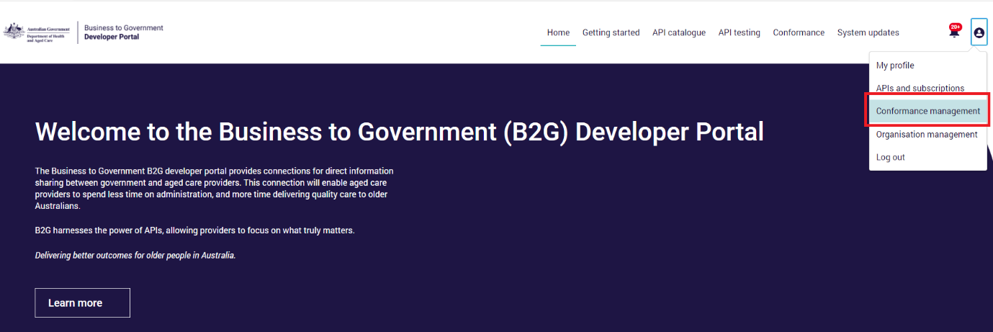
- From the Conformance Management page, select register software from the software conformance register table
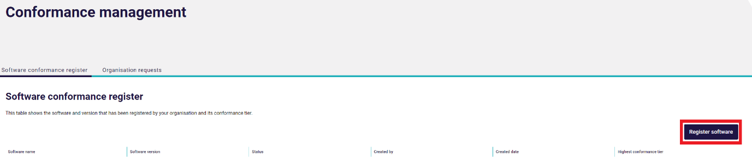
Complete the form. The details required are:
Software Name | Name of active software to be registered.
Software Version | Please provide your software version number, for example if you use the semantic version standard then only provide the Major and Minor values (e.g. 2.1). We require at least your Major and Minor version number.
Software Type | Select the functional type your software covers. To select multiple values, hold ‘CTRL’ + CLICK, if other please specify.
Functional Summary | Please provide a high-level summary of the software's functionality. Max 5000 characters.
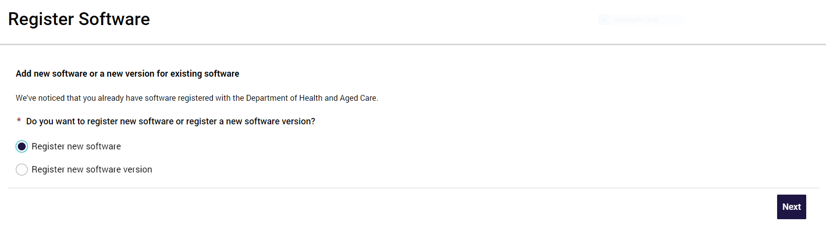
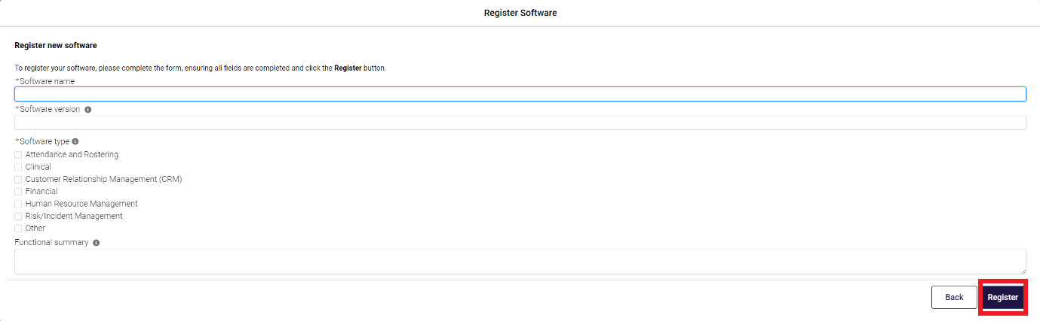
- Once registered, the software and version will be assigned a persistent ID (GUID). This GUID must be used within the Authentication API and will be verified against the Department’s software register.
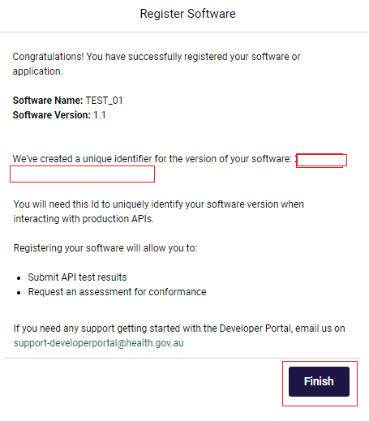
- The table will show the software and version that has been registered by your organisation and its conformance tier.
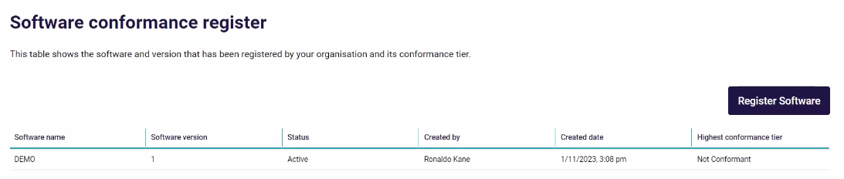

Software Versions
A software record can have multiple active versions. Your assigned organisation administrator will be able to register new software versions and include change summary information, such as release notes, to provide an overview of the version update.
- From the Conformance Management page select Register software.
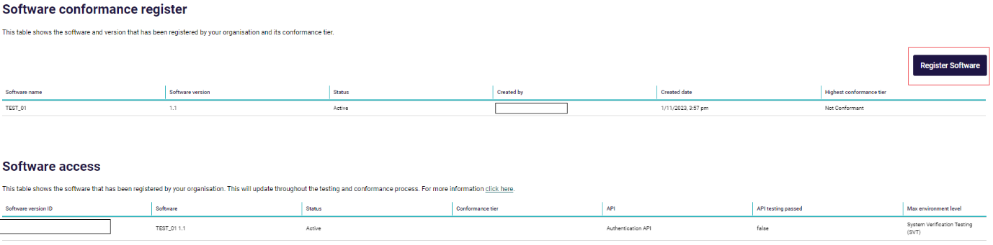
- Select register new software version then click the next button.
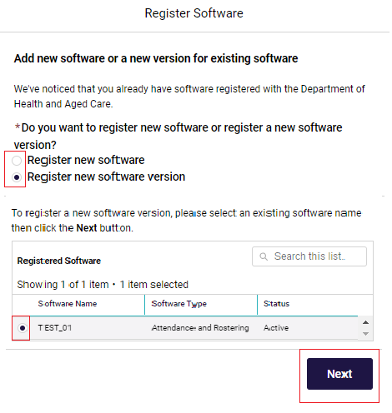
- Complete the mandatory fields for version and summary of changes.
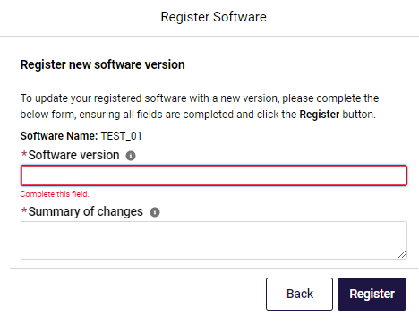
- You will receive notification of a successful registration and the software and version will be assigned a persistent ID (GUID).
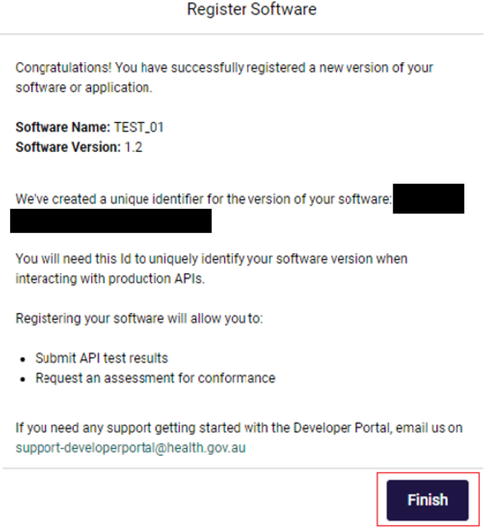
- Updated table for new version of software will be shown.
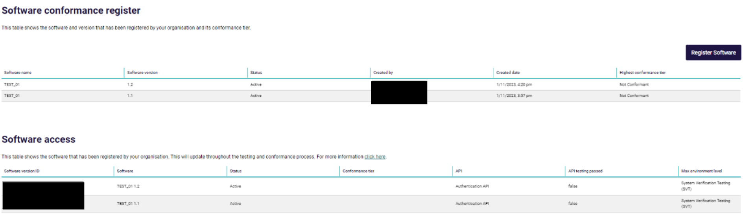

Organisation Requests – API Tests and Conformance Submissions
Once your software has been registered and you are ready to access the APIs you must provide testing evidence for your software against the API you wish to utilise. Similarly, if you have completed testing and wish to apply for Conformance Assessment you will also follow this process.
- From the Conformance Management page, select Organisation requests tab and select the New Request Button.
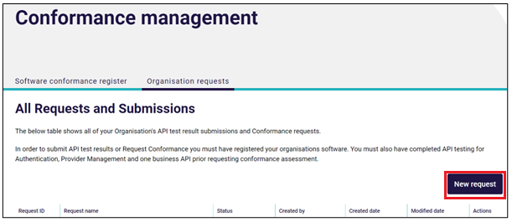
- Choose from Submit API Test Results or Request Conformance Assessment.
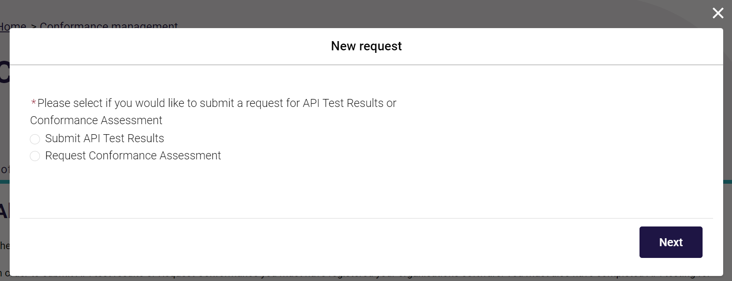
- If you have selected API Test Results you must select the API which you are submitting test results for and the software, you are submitting for.
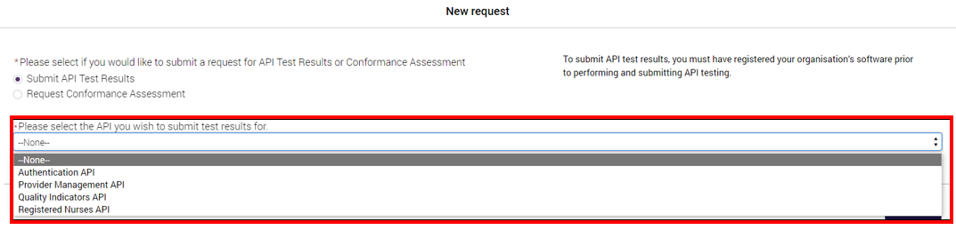
- Alternatively, if you select Request Conformance Assessment you must select the Conformance tier you wish to apply for and the software you are requesting for.
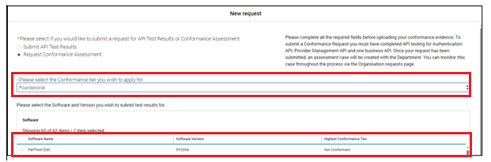
- For both paths you must upload supporting documents for review
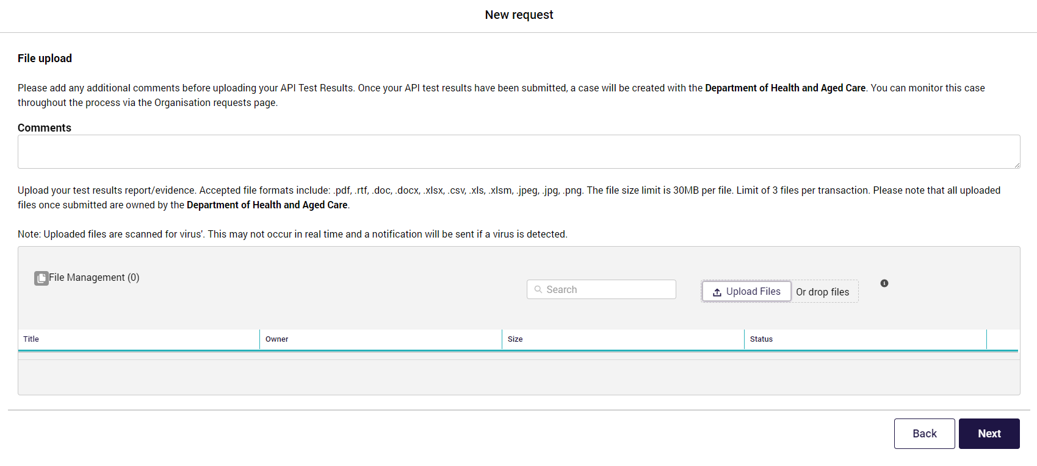
- Finally review the information you entered, read and accept the terms of use and select submit.
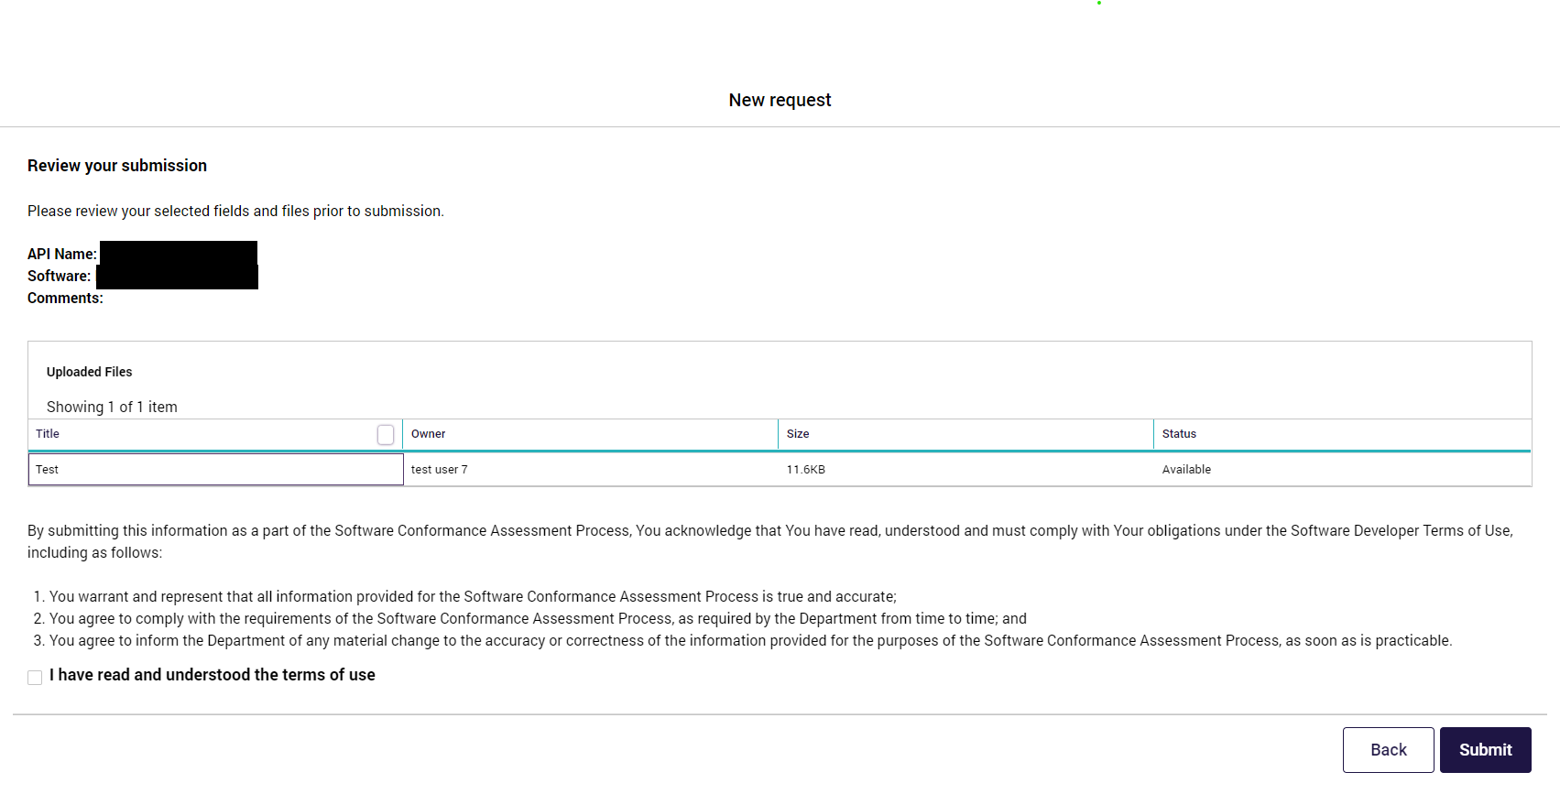

Troubleshooting Tips
If you are experiencing difficulties logging into B2G, there are some things you can do to help determine the root cause and actions to resolve.

Deleting your Cache
If the B2G Developer Portal doesn’t appear to be loading correctly you may need to delete the cache in your browser.
Deleting your Google Chrome cache
To delete the cache in Google Chrome, complete the following actions:
- Select the Customise and control Google Chrome button.
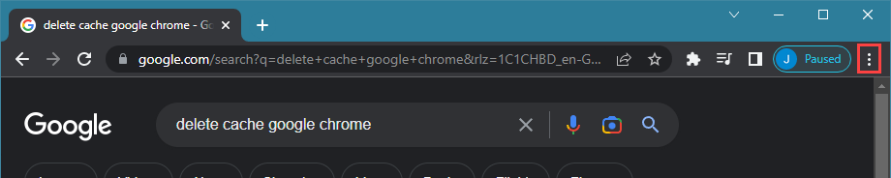
- In the drop-down list that displays, select More tools.
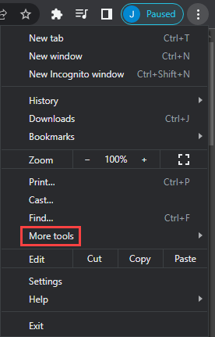
- Select Clear browsing data.
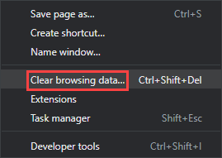
- In the Clear browsing data window, select the Clear data button.
Deleting your Microsoft Edge cache
To delete the cache in Microsoft Edge, complete the following actions:
- Select the Settings and more button.
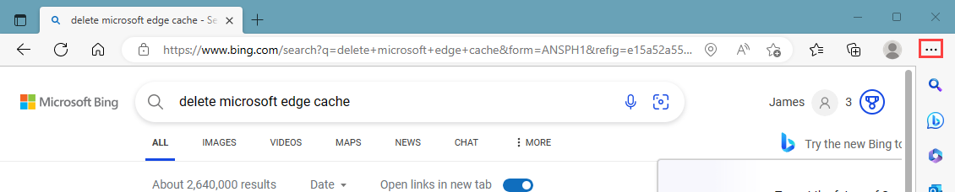
In the drop-down list that displays, select Settings.
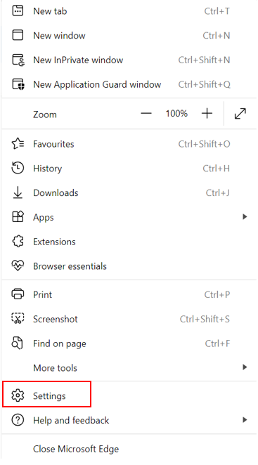
- In the Settings screen that displays, select Privacy, search, and services.
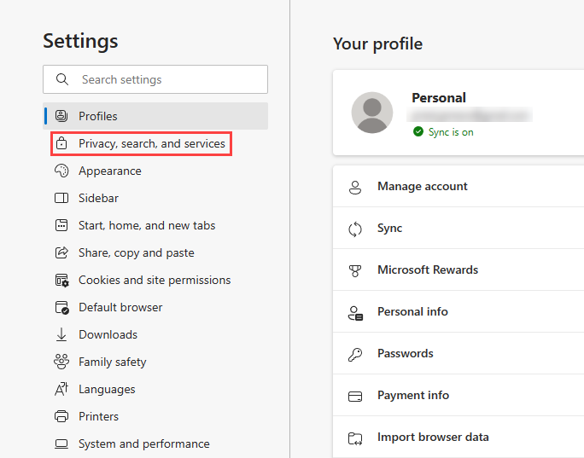
- In the Clear browsing data section, select the Choose what to clear button.
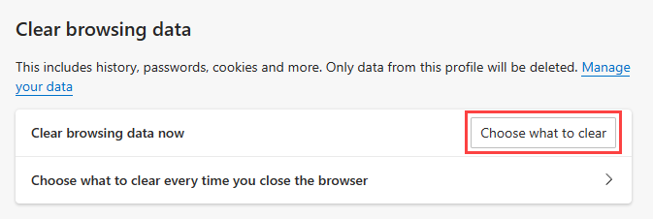
- In the Clear browsing data window, select the Clear now button.
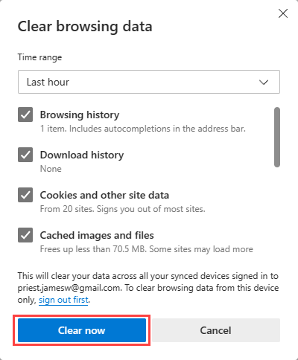

Digital ID
If you encounter any issues with logging in with Digital ID follow these tips to resolve the issue:
- Navigate to your browser settings and delete your browser cache. Before attempting to log back in, ensure that all browser windows are closed and you start a new session in your chosen web browser.
- Contact your organisation’s technical support to check your Digital ID is correctly associated with your organisation.
- Contact us on support-developerportal@health.gov.au for further advice.

Further Information
To contact the B2G team, email: support-developerportal@health.gov.au

