Communication toolkit
2026 Residents’ Experience Survey
This toolkit provides materials to help residential aged care providers and consumer peak bodies communicate with residents, their families and carers about the Residents’ Experience Survey.

What’s in this toolkit
- Key messages
- Editorial content
- Booklet
- Video

Audience
- Aged care residents, their families and carers
- Aged care workers and providers

Call to action
We recommend including the following call to action in communication materials:
- If you have questions about the Residents’ Experience Survey, please ask the staff at your aged care home or the survey team.
- To find out more, read the Residents’ Experience Survey: A guide for older people in residential aged care booklet or watch the video.

Key messages
Use these key messages to communicate with residents, their families and carers and answer their questions about the Residents’ Experience Survey.

About the survey
- The 2026 Residents’ Experience Survey is underway at aged care homes across Australia.
- The Australian Government undertakes the Residents’ Experience Survey each year to understand what residents feel is working well and where providers might need to improve.
- The new Aged Care Act, including the Statement of Rights and Aged Care Quality Standards, puts you at the centre of your aged care. The Residents’ Experience Survey is a way for you to give feedback.
- The survey is an opportunity for you to share your views on the care you receive at your aged care home.
- Your views and experiences are important. At least 20 per cent of residents at each aged care home are randomly selected to voluntarily participate. This makes sure anonymity is protected and that views are captured from a broad range of residents.
- The survey is run by an independent and experienced survey team from Access Care Network Australia (ACNA). This ensures that people feel more comfortable to give honest feedback.
- In 2026, staff from ACNA will visit your aged care home to conduct the survey.
- From <insert date> to <insert date>, staff from Access Care Network Australia (ACNA) will visit <insert name of your aged care home> to conduct the survey.
- The independent survey team is trained and experienced in talking with older people, including those with dementia, and conducting surveys in a safe manner.
- The survey team is trained and experienced in engaging with people from diverse backgrounds and living experiences, including Aboriginal and Torres Strait Islander people, culturally and linguistically diverse, veterans, care leavers, LGBTIQ+, people living with disability and those who have experienced homelessness and forced adoption.
- Survey team members have National Police and Working with Vulnerable People checks and are vaccinated against COVID-19 and influenza.

How the Survey works
- If you are invited to do the survey, the survey team will ask for your consent to take part. Taking part is voluntary.
- To respect your comfort and right to anonymity, workers will not be present when the survey is carried out.
- Your name will not be connected to your responses. No one at your aged care home or the government will be informed of your participation or the answers you give.
- To respect your privacy, the survey takes place in private where the conversation cannot be overheard.
- You can have someone you trust with you during this survey if you wish, such as a family member, friend or registered supporter. The survey team can arrange an interpreter and other supports to help you participate.
- Where an older person is unable to participate, a family member or other person may be able to complete the survey for them if it is within the scope of their legal authority.
- The survey takes between 10 and 30 minutes to complete and includes 14 questions. Topics include food, staff knowledge, how residents feel they are treated, what’s good and any suggestions for improvement.
- The survey team will collate de-identified responses into a report for your home. This report helps your provider understand what is going well and where they need to improve.
- The survey results also inform the Star Ratings for your home through the Residents’ Experience rating. Resident feedback accounts for 33 per cent of the overall Star Rating for each home.
- You can view the survey results for aged care homes using the Find a provider tool on the My Aged Care website.

Editorial content

Guidance
This suggested content can be used in a newsletter or other publication for your residents.

2026 Residents’ Experience Survey
From <insert date> to <insert date>, staff from Access Care Network Australia (ACNA) will visit <insert name of your aged care home> to conduct the annual Residents’ Experience Survey.
The survey team is trained and experienced in talking to older people with diverse needs and backgrounds, including those with dementia.
The survey is an opportunity for you to share your views on the care you receive at your aged care home.
The survey takes between 10 and 30 minutes to complete and includes 14 questions. Topics include food, staff knowledge, how residents feel they are treated, what’s good and suggestions for improvement.
Residents are randomly selected to take part. If you are invited to do the survey, the survey team will ask for your consent. Taking part is voluntary.
If you agree to participate in the survey, you can have someone you trust, like a family member or a registered supporter, to join in person or by telephone.
The survey team will give a report to your home. This report helps your provider understand what is going well and where they need to improve.
Your name will not be connected to your responses. No one at your aged care home or the government will be informed of your participation or the answers you give.
If you have any questions, please ask our staff or the survey team for more information.

Booklet

Guidance
You can give this booklet to your residents, their families and carers, and staff to help them understand what to expect.
The booklet is available in 19 languages and Easy Read.
Residents’ Experience Survey: A guide for older people in residential aged care
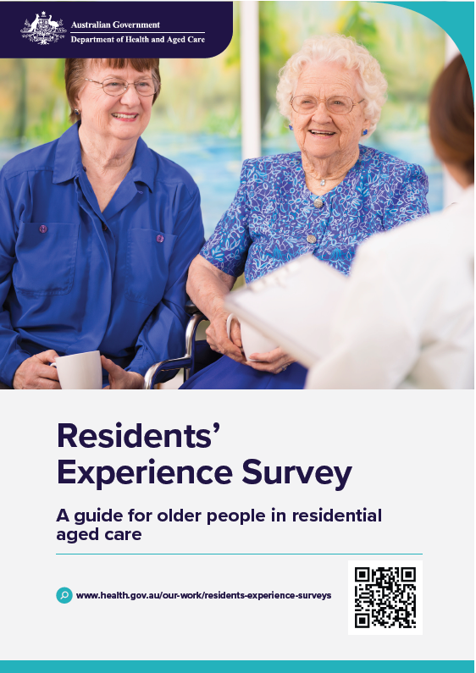

Video

Guidance
You can show this video to your residents, their families and carers, and staff to help them understand what to expect.
The video has subtitles in 19 languages.
Watch or download:
Residents’ Experience Survey: A guide for older people in residential aged care
